Initial Documentation
April 10, 2014

T100 Watch Dog
Autonomous Surveillance Robot

Department of Electrical Engineering & Computer Science
University of Central
Dr. Samuel Richie
Senior Design I

Ismael Rivera (Computer) | ismaeljrivera@knights.ucf.edu
Journey Sumlar (Electrical) | sumljf@knights.ucf.edu
Chris Carmichael (Electrical) | Carmichael.Chris@knights.ucf.edu
Warayut Techarutchatano (Computer) | Warayut@knights.ucf.edu

Narrative Description

The goal of this project is to design a portable and low power autonomous robot that will be able to track a human in a specific room/area. The robot will utilize a regular color webcam along with a thermal imaging camera. Each camera will be toggled depending on the light conditions of the room/area. Sensors will be utilized to detect obstacles that the robot will encounter and help the robot find a new path to prevent the found obstacles. In addition, the robot will have a Wi-Fi radio that will allow it to connect to the Internet allowing it to send/receive messages.

During idle time, the robot will be on its charging station which will be an induction pad. This induction pad will serve as the robot’s home. Once its task is completed or the battery is low, the robot will return to its home automatically to recharge once again. When the robot is in idle mode, the camera will be waiting for any movement to occur. Any movement will trigger the robot to become active.

The robot will be autonomous but the user will have the ability to control it via an Android App. Using internet connectivity, the robot will be able to send a screenshot of the object that it has detected and triggered it to become active. As an option, the user can receive a video feed of what is actually occurring along with audio. In addition to being able to receive video and audio feeds, the user will be able to send voice commands which will be transmitted through the robot’s speaker.

Project Motivation

According to the FBI’s Uniform Crime Reporting Program, in 2012 there were 2,103,787 burglaries. 85% of these residential breakins occurred when the homes were unoccupied. Currently, homeowners can get an alarm system that will triggered when any door or window is opened. The disadvantage to this is that there’s an installation fee along with a monthly fee. A lot of people cannot afford these fees since it’s out of their budget. Our goal is to create an affordable security ‘assistant” for your home/apartment and make it possible for the people that cannot afford the monthly fees of a regular alarm. As a result, this will give the opportunity to everyone to have peace of mind when they leave their home and enjoy their day without any worries.

Source: FBI UCF, HSMC

Goals and Objectives
In technical terms, there are many objectives. Ultimately, we are trying to build an autonomous surveillance robot. The robot will automatically detect a person and will be able to follow them. Detection can be achieved by the use of different image sensors embedded onto the robot. During the day, Human detection will be achieved by a conventional webcam. Night detection will be achieved by using a thermal camera. After detecting a Human, the robot will transmit video feed to a mobile device and talk to the person. If the robot is interacting with more than one person, the user will be able to tell the robot which human to detect. If someone is running towards the robot, it will run away to safety.

Project Specifications

Parts | Specific Requirements
Robot Chassis | Load capacity up to 15lbs
Conventional Webcam | Non-HD
Thermal Camera(pending) | N/A
Battery | 6v-12v
Wifi Transmitter | 802.11 a/b/g/n
Speakers | Auxiliary Powered
Microcontroller | ARM/FPGA
LED | Best quantity in a pack
Misc. | Wires, Resistors, Breadboard, etc

Project Budget

Parts | Price
Robot Chassis | $260
Conventional Webcam | $30
Thermal Camera(pending) | ($950)
Induction Pad & Battery | $50
Wifi Transmitter | $10
Speakers | $15
Microcontroller | $50
LED | $5
Misc. | $20
Total w/ Thermal Device | $1390
-
The big component of our budget is the thermal imaging device. It’s an expensive device that we are very much interested in. Currently, we are looking at the company called DRS Technologies and they have an open competition for students which will also supply the device for the contestants. The competition is called Student Infrared Imaging Competition (SIIC) and an award is offered to the winner. We are planning to enter the competition with our project and hope to get sponsored, which will include the thermal imaging device at free cost. In case we don’t get the sponsorship, the cost will be divided among ourselves.

Block Diagrams (To be Acquired/Research)
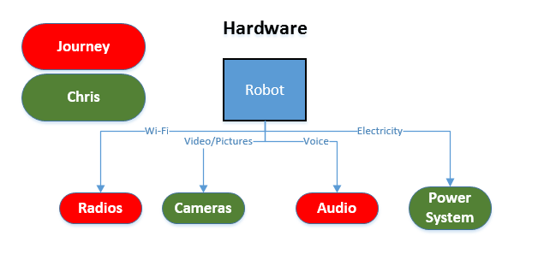
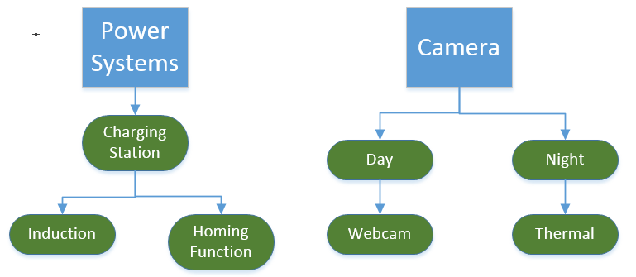
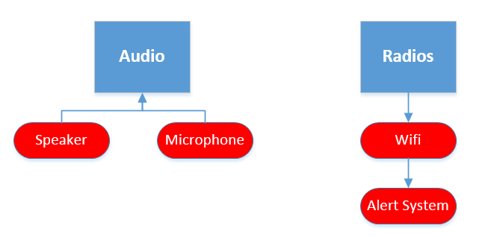
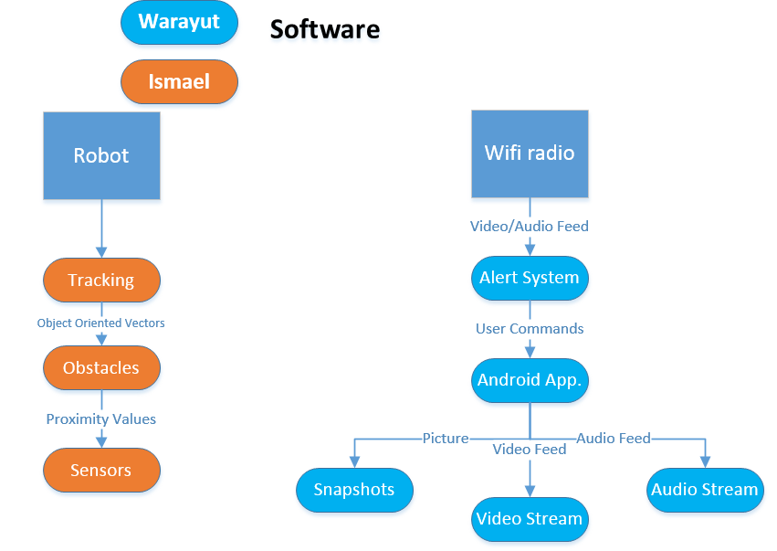

Project Milestones

Spring 2014 | Summer 2014
- Research/Development  - Select the necessary parts  - Obtain all the needed parts  - Have schematics done  - Wireless Communication  - Design GUI  - Android App Prototype  - Operational power and control system  - Research Paper | - Working Prototype  - Communication between Android App and Robot  - Complete GUI  - PCB Board  - Testing/Integration  - Completed Project  - Documentation

