

A system for powering a video game console through monitored exercise

Team Members:
Cody Burdette
Christopher Campbell
Pamela Caraballo
Sean Varela
Group 4: Team CALBOX 360

Table of Contents
1 Executive Summary 7
2 Battery Management System 10
3 Battery 12
3.1 Lithium Ion battery 13
3.2 Lead-acid Batteries 14
3.3 Battery Selection 17
4 Generator 20
4.1 Alternator Option 20
4.2 DC Generator Option 20
4.3 DC motor 21
4.3.1 Brush-type 22
4.3.2 Brushless 22
4.3.3 Voltage rating 23
4.4 Generator Selection 24
4.5 Driving the Generator 27
4.6 Driving Solution Testing 29
5 Circuit Protection 30
5.1 Conditioning Power Flow from Generator to Battery 30
5.2 Conditioning Power Flow from Battery to Generator 31
5.3 Generator Monitoring 32
5.3.1 Measurement Scale 34
5.3.2 Challenges to State of Charge 35
5.4 Caloric Count 35
5.5 Caloric Burn 37
6 DC-DC Buck-Boost 38
6.1 Non-Isolated DC-DC Converters 38
6.1.1 CCM Buck-Boost 38
6.1.2 DCM Buck-Boost 39
6.2 Isolated DC-DC Converters 40
6.2.1 Flyback Converter 41
6.2.2 Cuk Converter 42
6.3 Synchronous Buck-Boost Converter 43
6.3.1 Current-mode Control of Synchronous Rectifier 43
6.4 Non-Inverting Buck-Boost Converter 44
6.4.1 Buck Converter Implementation 45
6.4.2 Boost Converter Implementation 46
6.5 Design Considerations 47
6.5.1 Converter Nonidealities 49
6.5.2 Component Selection 51
6.5.2.1 Inductors 51
6.5.2.2 Capacitors 51
6.5.2.2.1 Bypass Capacitor 52
6.5.2.3 Diodes and MOSFETs 53
6.5.3 PCB Grounding 54
6.5.3.1 Star Ground 55
6.6 System Losses 56
6.6.1 Wire Resistance 56
6.6.2 Resistors 57
6.6.3 Switching Losses 57
6.6.4 Switched-Mode Power Supplies 58
6.7 Proportional-Integral-Derivative Controller 58
6.7.1 Right-Half Plane Zero and Pole 60
6.8 Average Model for a Buck-Boost 61
7 Feedback Operation 62
7.1 Digital Control 62
7.2 Pulse-Width Modulator 63
7.3 Power Factor Correction 63
7.4 Input Filter 64
7.5 Digital Signal Processors 64
7.6 Designing the Feedback Loop 65
7.6.1 Maximum Input Voltage Open-Loop Design 67
7.6.2 Maximum Input Voltage Closed-Loop Design 71
7.6.3 Minimum Input Voltage Open-Loop Design 73
7.6.4 Minimum Input Voltage Closed-Loop Design 76
7.7 Compensator Design 78
8 AC Analysis 80
8.1 Power Stage 80
8.2 Compensator 82
8.3 Loop Gain 83
8.3.1 Switching 84
8.4 Closed Loop 88
8.4.1 Output Voltage Ripple 88
9 Microcontroller 91
9.1 Overview 91
9.2 Topology 91
9.3 Types of Microcontroller 92
9.3.1 AVRs 92
9.3.1.1 The Arduino platform 93
9.3.2 PICs 94
9.4 Choice of Microcontroller 95
10 Liquid Crystal Display 96
10.1 Overview 96
10.2 The HD44780 Character LCD chipset 96
10.3 The Arduino and the HD44780 96
11 Wireless Communications 98
11.1 Overview 98
11.2 The Zigbee Standard 98
11.3 XBee and the Arduino 99
11.3.1 XBee Shield 100
11.4 Communications 100
11.4.1 Configuring the XBee Module 100
12 Calorie Calculations 103
13 Microcontroller Design 105
13.1 Inputs into the Arduino USB Board 105
13.1.1 Input from the Generator/DCDC Regulator 105
13.1.2 Input from the Battery 106
13.2 Outputs from the Arduino 108
13.2.1 Output to the LCD Module 108
13.2.2 Output to the XBee module 110
13.3 Data types and Functions 111
13.3.1 Data types 111
13.3.2 Functions 112
14 Software 113
14.1 Overview 113
14.2 Code Platform 113
14.3 Targeted System 114
14.4 Software Requirements Specifications 115
14.5 UML 116
14.5.1 Class Diagrams 116
14.5.1.1 Session Class 116
14.5.1.2 XMLDataStore Class 116
14.5.1.3 SerialCommunication Class 116
14.5.1.4 MainWindow Class 117
14.5.1.5 MainWindow XAML 118
14.6 Activity Diagram 120
14.7 Sequence Diagram 121
15 Console Power Usage 122
16 DC-AC Inverter 123
16.1 Modified Sine Wave 123
16.2 Testing 124
17 Instructions for Build 126
17.1 Preparations 126
17.2 Build 126
17.3 Test Plan 127
17.3.1 DC-DC Converter 127
17.3.2 DC-AC Inverter 127
17.3.3 Generator curves 128
17.3.4 Charging the battery 129
17.3.5 Software Testing 129
17.3.5.1 Test Environment 130
17.3.5.2 Test Users 130
17.3.5.3 Issue Management 130
17.3.5.4 Test Cases 131
18 Project Summary 132
18.1 Design Summary 133
19 Suppliers 135
20 Budget & Financing 136
21 Project Milestones 138
21.1 Possible Expansions 139
22 Appendix 140
22.1 Figures 140
22.2 Tables 142
22.3 Permissions 143
23 Works Cited 144

Executive Summary
The process of the CALBOX begins with our user Moby, and the energy he creates when pedaling. The end result is that this energy charges a 12 volt battery, which then dissipates it to the Microsoft XBOX 360 to allow for game play. When Moby first began his experience with the CALBOX he was seeking a way to stay in shape for personal benefit, but discovered through the process of integrating the CALBOX into his life that it would be not only a fun system to keep up with, but also a good way to help the environment.
The system was first developed as a solution for overweight children, and as a method to combat rampant obesity in the product’s market population. It also provides a means of the average user to provide a diversified energy solution for his or her home. While not being able to produce the power needed to replace the whole profile for a home, the CALBOX is capable of producing enough power, from the simple synergistic approach of maximizing efforts, to power electronics like televisions, video game consoles, refrigerators, and much more.
The primary goal of the CALBOX is for it to be an efficient at-home energy solution. The National Resources Defense Council (NRDC) estimates that video game consoles consume 16 billion kilowatt-hours per year. This amount of electrical power rivals that of the entire city of San Diego, California, a city of over 3 million residents.
The CALBOX alleviates this burden on a large scale by completely removing the console from the grid; this effectually removes 125 kW-h of electricity per console per year from the power grid. The power produced is fueled solely by the excess energy accumulated in Moby. Using this energy also results in a diversification of the power generation portfolio of a user’s home. It is a positive step in integrating other forms of energy including solar and wind.
Even though the CALBOX is designed for the XBOX 360, the design is versatile enough to be used with multiple systems. The basic principle behind the machine is very simple. When Moby rides the partially assembled CALBOX, he is converting potential energy stored in chemical bonds in his muscles and body to kinetic energy exerted on the pedals of the device. This kinetic energy transfers to the DC generator which in turn begins to generate electricity when enough power is invested.
This electricity meets with a DC-DC voltage converter that transfers the energy to a lead-acid battery for storage. The converter ensures that Moby, in his exercise, does not generate too much power, which would result in a malfunction of the battery. This system also has protection systems in place to remove the possibility of using the system’s motor as a load, and also to diver over current to a load that can assume the quick spurts of necessary dissipation that can be caused by sprinting on the CALBOX. Figure 1 shows an artist’s rendering of the CALBOX 360.
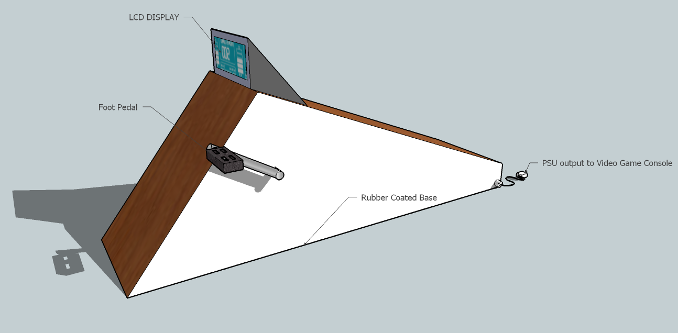
Figure 1 - CALBOX prototype vision 1
Ideally, the CALBOX would have a one to one ratio on the calories burned to the amount of time Moby can play the game console. To obtain a constant voltage output, and make sure it stays in the correct range a DC-DC switched-mode power converter from the generator to the battery is used. The design is based off of the Buck-Boost inverter. This ensures that whether Moby is not driving enough power, or if he is creating too much, that we will ultimately achieve the desired output.
The second point at which the electricity is altered will be as it makes its way from the battery to power the game console. The power supply unit of the XBOX needs to receive an AC voltage source of 120 volts at 60 Hertz. This is the normal output power from American outlets. The XBOX is rated at 203 Watts, which means this is the maximum power the device will ever require for an operation. We will need a DC-AC inverter to convert the 12VDC from the battery to a 120VAC source for use by the XBOX.
On a 60 minute bike ride a person in great shape can average 100-150 Watts of power. This basically means that at best, Moby will likely achieve a 2:1 ratio of cycling time to game time. In short bursts, it is possible to output 200-400 Watts from pedaling the bicycle.
The CALBOX is a product with a dedicated group of designers committed to the efficiency, comfort, and enjoyment of the system. The production chain is decentralized. That is, instead of using a pyramidal leadership hierarchy, the team naturally evolved to a situational leadership model. The product development was tracked with weekly meetings and using a new collaborative management tool, Google Wave. An example of the uses of Google Wave is shown in Figure 2.
Google Wave allowed the team to coordinate member-with-member efforts as well as quickly inform the team of design changes and hold virtual meetings with a traceable history and conversation log. Using Wave increased the productivity of the team and by effect also increased the design quality of the CALBOX. Another system that was used was Dropbox. Dropbox is a software tool that backs up data files to a web server, and all of the participants of the drop box. This way all of the files are instantly replicated on the computers of the entire design team. The following is a display of the Wave environment.
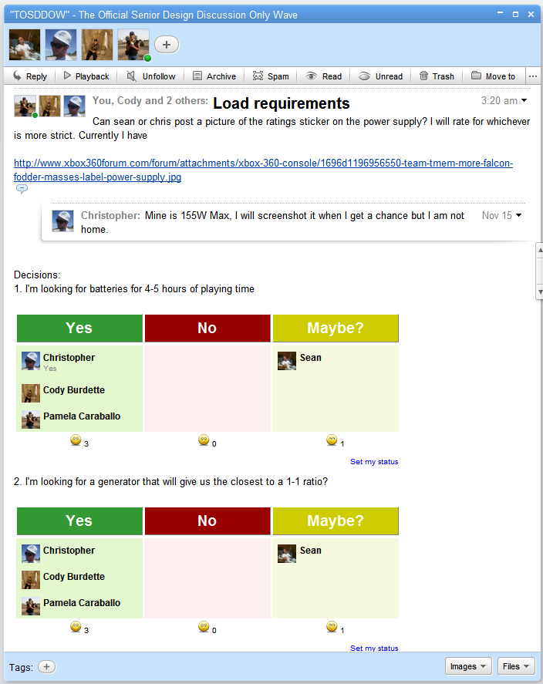
Figure 2 - Wave collaboration
The CALBOX 360 is designed to fit in the comfort of any home, be it a small condo with little room to spare or a house with a dedicated entertainment space. It can be easily used from most chairs and couches. With only one protruding cable, the plug to the XBOX, it is not an eyesore or a tripping hazard. With this product, a user can have both the satisfaction of being a responsible and healthy individual, but also a contributing member of society.

Battery Management System
The premise of the CALBOX is for the user to be able to convert a user’s caloric exertion to energy usable by the load, the video game console. For this to be possible, a viable solution that is convenient for the user is to store this energy in a battery. Due to the delicate nature of holding and managing the chemical bonds that allow a battery to function for its entire rated lifetime a battery management system (BMS) will be in place for the CALBOX’s purposes.
“The basic task of a Battery Management System (BMS) is to ensure that optimum use is made of the energy inside the battery powering the portable product and that the risk of damage to the battery is prevented. This is achieved by monitoring and controlling the battery’s charging and discharging process.”
In the Figure 3 below, a standard battery management system is detailed. This type of system is used mainly in small electronics like cell phones and PDAs. In these systems, a set of integrated circuits that is optimized for the device usage is custom made for the purposes. The CALBOX system will differ from this due to the lack of need for high precision measurement with the prototype model, although these concessions can later be designed.
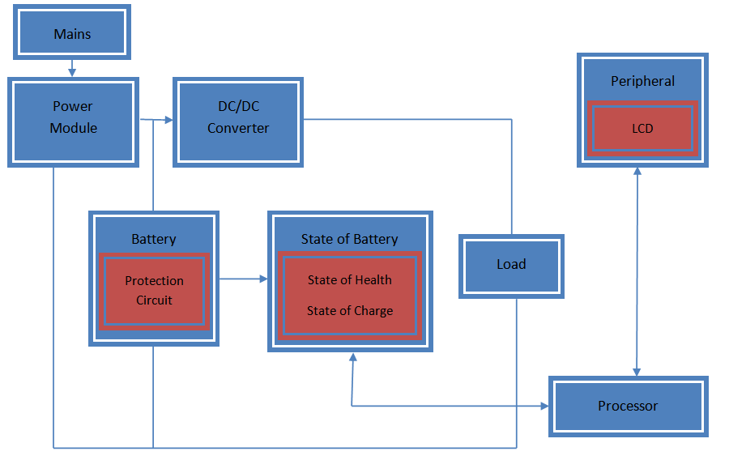
Figure 3 - General diagram of a battery management system
The main difference between the CALBOX BMS and the BMS on most devices is that the CALBOX BMS is a fairly linear system. That is, one component leads to the next without feedback. The load cannot run while the battery is charging, and the load cannot run directly from the power module. The power module cannot directly charge the battery, and so on. The other major difference is the State of Health states. The extra features added a level of complexity that the team felt was unnecessary for the purposes and length of use of the primary prototype. This is detailed in Figure 4 below.
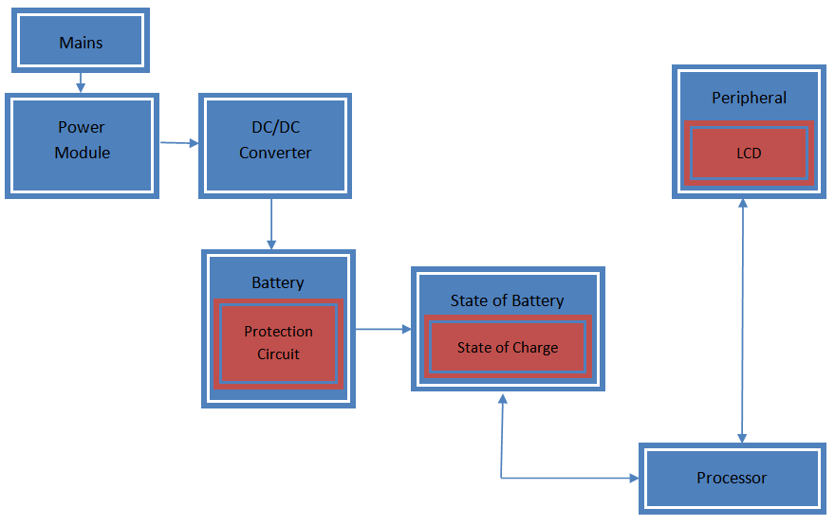
Figure 4 - CALBOX Battery Management System
For the purposes of the CALBOX, the “MAINS” is the where the power is coming from the generator. In essence, the main power driver for the system is actually the end user. The power module will be the charging device for the battery. Since the generator will output a constant DC signal, the regulating device is a DC-DC converter for the purposes of charging the battery. The state of health is necessary for the discharge algorithm that dictates that state of charge of the battery. The team has decided to remove this component because the amount of use and span of time that the primary CALBOX is being designed for does not warrant the need for the state of health status. A constant “new battery” value will be used instead.
The state of charge will be reported to the user through the use of an LCD display. This display will be fed by a processor that will also calculate the state of charge. Whereas in other systems the load falls under the jurisdiction of the BMS, the load for the CALBOX is separated by a DC-AC inverter which isolates the load from the BMS. Although the internal power that the DC-AC inverter uses for its own purposes comes from the battery, it is removed from the system because its purpose is not that of a load.

Battery
A variety of considerations need to be taken into account when selecting a battery solution for the CALBOX system:
- The premise of the system is for the user, Moby, to provide the charge inside the system himself
- Moby should be able to store energy even if he does not use his console
- Since the CALBOX is a “green”, responsible energy management system, it is in the interest of the environment for as little waste as possible to be produced. A reusable battery should be considered.
- Maintenance-free rechargeable batteries would be optimal, considering the user range fort the expected market of the CALBOX system is the 10 to 25 years old market
- The time rating of the battery should allow the user to store up to 5 hours of game time for the XBOX 360 at full load
- The battery’s technology should allow for partial charges and partial discharges, as well as a tolerance for overcharging
- The battery’s technology should allow for a variety of temperatures in a ±20°F band from ambient of 70°F to accommodate for any enclosing structure designed for the CALBOX and for subsequent ventilation
- Cost effectiveness of the system should be at a maximum, so as to make the CALBOX a competitive console accessory in the long run
An analysis of the differing technologies will reveal what the best option for the design is. In consideration are lithium-ion batteries, for their widespread use in consumer electronics such as laptops, wet-cell lead acid batteries for their uses in off-grid reliability power backup systems, and valve regulated lead acid batteries, or sealed batteries for their convenience and use in motor sport vehicles and domestic emergency power applications.
Other considerations that are important to the battery decision is the discharge characteristic of the battery. Since most batteries should only be discharged to a 70% or more of nominal voltage the discharge trend becomes important. According to Ohm’s law, the power deliverable by a battery varies as shown in Equation 1.
$$\left(1\right) P=\frac{V^{2}}{R}$$
In this equation, R is the internal resistance of the battery as well as the equivalent resistance of the load. The voltage also follows a variable trend, so that the effective power deliverable to the load is changed, as seen in Equation 2.
$$\left(2\right) P=\frac{V^{2}(t)}{(R_{I}(t)+ R_{L})}$$
Most battery discharge characteristics are non-linear and depend on the chemical composition and technology of the battery. The longevity of the battery, as in the capacity of it, is also dependent on these physical characteristics. There are limitations to each technology.

Lithium Ion battery
Lithium-ion batteries have a very high energy density relative to other battery technologies. Table 1 below has a comprehensive analysis of the lithium-ion advantages and disadvantages. While they boast a specific energy of 90-110 Wh/kg, other common rechargeable batteries like nickel-cadmium and nickel metal hydride exhibit 30-60 Wh/kg and 50-90 Wh/kg respectively.
Advantages | Disadvantages
Lightweight | Intermittent volatility
Do not need complete discharge before recharging | A complete discharge will ruin the battery completely, this highlights the importance of the battery management system
Most batteries have 500-1000 charge-discharge cycles | Li-ion batteries are more expensive per watt-hour than other battery technologies
Does not lose as much charge over time as other battery types | Battery life is very sensitive to heat. It would be crucial to maintain good ventilation with a Li-ion battery
Table 1 - Li-ion evaluations
A detailed comparison of the different technologies is listed in Table 2. Lithium ion batteries achieve this by incorporating the highly reactive lithium ion into their chemistry, making it possible to hold more charge per atom than other battery chemistries. These ions are coupled with Carbon atoms to make the battery light weight. Most lithium ion batteries have built-in temperature sensors, a regulator circuit, a voltage bus (for the many cells in one battery), and a battery charge state monitor. These are all in place to protect the battery because of volatility issues.
Battery system | NiCd | NiMH | Li-ion
Average operating voltage (V) | 1.2 | 2.3 | 3.6
Energy density (Wh/I) | 90-150 | 160-310 | 200-280
Specific energy (Wh/Kg) | 30-60 | 50-90 | 90-115
Self-discharge rate (%/month) at 20°C | 10-20 | 20-30 | 1-10
Cycle life | 300-700 | 300-600 | 500-1000
Temperature range (°C) | -20 – 50 | -20 – 50 | -20 – 50
Table 2 - Common electronics rechargeable batteries comparisons*
Another battery technology that is regularly used in applications is the lithium-ion polymer battery. This battery has the same chemical composition as the traditional Li-ion. The major difference is that instead of the cells holding in the electrolyte as a solvent, the inner composition of the battery cell is a solid polymer. This makes these batteries cheaper to manufacture. However, these batteries rarely exceed capacity values of other comparable size packages (low energy density) and are extremely volatile. Each individual cell’s charge must be monitored and each must be charged in balanced quantum increments. This technology’s sensitivity and low energy density is the reason why the design team ruled it out as an option, although it is commonly used in hobby projects.

Lead-acid Batteries
There are two kinds of lead-acid batteries. The first kind is a cranking or starting battery and it is used primarily in motor vehicles for delivering high amperage levels for short periods of time at the vehicle’s start. Physically, this battery contains a higher density of thin lead plates that assist it in performing this function. The second kind is a deep-cycle lead acid battery. The deep cycle variety has thicker plates, which allow it to withstand the physical demands of a charge-discharge cycle. This type of battery is used in marine and electric vehicle applications.
Each kind of lead acid-battery has three categories. Wet cell lead acid batteries have lead plates impregnated with a sulfuric acid electrolyte solution. This solution is typically 65% water. As the battery discharges, the sulfuric acid in the solution bonds to the lead plates. As it recharges, the sulfuric acid bonds are pried apart and the acid returns to the solution. This process decomposes the plates and causes a sediment buildup in the battery. Over time, this buildup will cause the various cells to short together, killing the battery. This type of lead acid battery has been around since 1859, and is still very popular. It is also the least expensive of the lead acid technologies.
The second kind of lead acid technology is the gel cell. This type of battery would be ideal for the CALBOX because it requires little to no maintenance. Since the CALBOX is a system that is marketed for young adults, and considering the safety concerns intrinsic with all batteries, this is a very attractive feature of this technology. The gel cell is a VRLA (valve regulated lead acid) and the solution found in wet cells is mixed with a silica content that makes the solution a gel, and thus immobile. This keeps the battery from spilling issues that are more common to the wet cells. This also allows the battery to be used in varying positions, although they should not be charged in any but the upright position. Because of the gel interior, this type of battery is more resistant to vibration-heavy applications. The trade off is that this battery is more sensitive to overcharge situations, and has a lower charging voltage than most lead acid batteries.
The third subcategory is the AGM (Absorbent Glass Mat). Depending on the orientation and geometry of the cells internal to the battery, it can be a traditional AGM or a “spiral wound.” The electrolyte in this type of battery is held by a mat of glass fibers. Because of these mats, the lead plates are relieved of the duty of holding up their own weight. This gives more flexibility in the design and application of this battery. The mats and plate proximities also reduce the internal resistance of the battery. Good for deep-cycle applications, these batteries can be discharged and recharged quickly and feature the highest energy density of the lead acid batteries. The AGMs are also the most expensive.
Another consideration is whether the battery is a deep-cycle battery or a starter battery. Starter batteries are common and are used in vehicles. Deep cycle batteries are used in backup power systems and in RVs and boats as power sources. They are made of the same chemical profile, but their optimization at manufacture is different. A car battery, or starting battery, has a lot of plates to increase the surface area of the lead plates with the electrolyte and this way be able to provide large amounts of current for turning the motor when the car is started. After the motor runs, the alternator provides the vehicle’s power and the battery is recharged but otherwise untouched. A deep-cycle battery, on the other hand is optimized to provide a constant current for a long period of time. This is more aligned with the needs of the CALBOX system. In the table below is a comparison of the technologies, all taking in mind a deep-cycle design.
 | Wet Cell | Gel | AGM
Cost | Least | Medium | Most
Maintenance | Some wet cell batteries need to be re-watered and their specific gravity checked with a hydrometer. | None | None
Cooling time | Yes | None | None
Lifetime | Longest | Shortest | Long
Charging sensitivity | Modest | Highest | High
High-temperature operation | Worst | Best | Moderate
Low-temperature operation | Worst | Best | Moderate
Safety | Electrolyte can spill and corrode | Safe | Safe
Venting | Must be vented or placed outside | None | None
Mounting | Upright only | Any | Any
Table 3 - Lead acid batteries comparison
The load has a specific amperage requirement that will be critical for operation. Its voltage requirements will be more easily provided for with the use of voltage transformers. Figure 5 below shows some common time vs. current discharge trends for lead acid batteries. The batteries below are of the various lead acid technologies but all are manufactured by Universal Power Group.
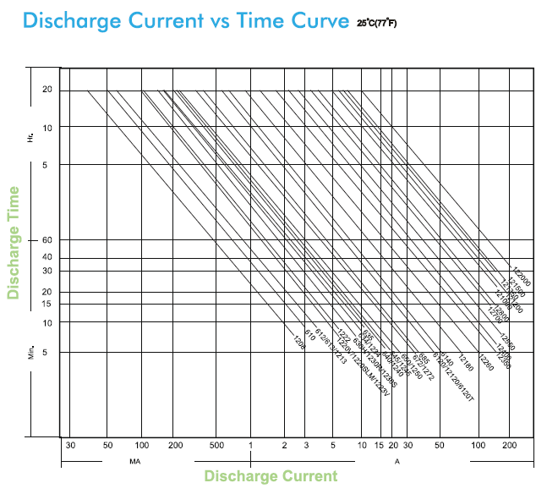
Figure 5 - Lead acid batteries common discharge times per discharge currents*
Programming the state of charge response system will depend mostly on the terminal voltage reading device. Below in Figure 6 are some references for common voltage vs. discharge time comparisons. The constant C is the nominal current for the particular battery. The CALBOX will be designed for an approximate 5 hrs of use.
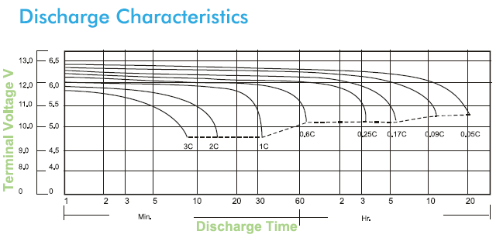
Figure 6 - Common lead-acid batteries' discharge characteristics*
Figure 7 is a marriage of Figure 5 and of Figure 6. Choosing the correct battery solution will depend on the particular current and voltage curves that will best fit the requirements of the load, while figuring in a lowest-cost option. The final discharge voltage is important for battery control purposes. As discussed in the Battery Management System section, the system must provide the user a way to know when to begin charging the batteries again. Reading a signal for the voltage level is dependent on the current drawn.
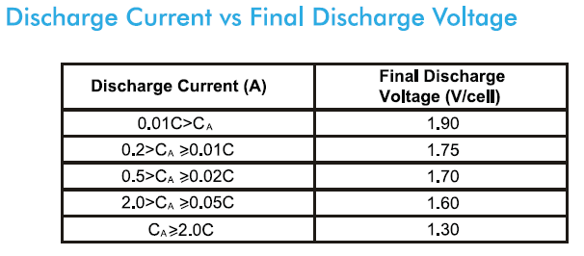
Figure 7 - Effect of discharge current on discharge voltage for lead acid batteries*

Battery Selection
The battery selected for the design is the 12V 35Ah Sealed Lead Acid Battery Universal UB12350 Group U1. It is an AGM battery with B2 Internal Threaded Post leads. Internally, the AGM is made of the glass mat composite that allows it to have extended life and no corrosive leaking from the terminals. The manufacturer model number is 45976. The table below summarizes these details.
Characteristic | Value
Output Voltage | 12V
Amperage | 35Ah
Brand | UPG
Chemistry | Absorbent glass mat
Battery Size | Group U1
Length | 7.68”
Width | 5.16”
Height | 6.14”
Terminals | B2 internal threaded post
Model Number | 45976
Table 4 - UB12350 battery details
The battery was chosen for a combination of its attributes. The battery is essentially maintenance-free yet features high cranking amps useful for battery reuse. The rated capacity of the battery is 35Ah, but this is variable dependant on the load current. The inverter that will use the charge the battery for the load will consume a max of 3.84A of current. A rated approximation for this is a 3.26A load rating in which the manufacturer estimates the capacity to down-rate to 32.55Ah. This rating however gives the battery a 10 hour discharge time. For the CALBOX at max load, it can be estimated at least 8 hours of running time can be predicted.
Although the CALBOX design requirements shoot for a 5 hour operability time, the battery has been scaled to double that capacity for the following reasons:
- An extension of the project could be, after optimization of the single-load XBOX 360, would be to run all loads from the CALBOX system. All loads include the television console that the video game console needs to operate, as well as lights and peripherals.
- The double-rated battery will also allow there to be more than one user.
- The larger battery will also make the system less susceptible to overload and battery damage by over-discharge.
Comparing it to a battery that is 9Ah smaller, a 26Ah battery, the UB12350 has a charging current that is 3.15A bigger at the maximum side where the 26Ah battery could only handle 9.1A. The control voltage for charging however remains relatively the same. Optimum charge for frequent-use charge-discharge cycles is 14.5-14.9VDC. For floating use however, the control charge voltage is recommended to be between 13.6-13.8VDC.
The CALBOX system will feature a battery charge scale that warns the user of a full charge level as well as a low charge warning, along with incremental battery charge percentages that are calculated from the real-time voltage of the battery. Using a microprocessor and a voltage divider circuit to scale down the signal from the battery to something the microprocessor can measure, the signal trend for determining the charge of the battery. Also the approach to full charge and approach to low charge levels will be tracked using the following discharge characteristic curve. Figure 8 shows this.
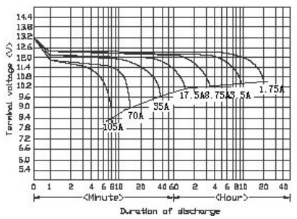
Figure 8 - Discharge characteristic of UB12350
The above curves were determined at an operating temperature of 77° F or 25° C. The CALBOX is expected to dissipate heat, but it will not be enough to change the properties of the battery load curves. However, if the system is encased, then ventilation will need to be provided because the temperature of the battery will drastically affect the load characteristics. Although the system is designed to provide the maximum load current that could be experienced, in actuality regular operation will be 70% or less of rated capacity.

Generator
The generator is the device that converts the bicycle for the CALBOX system into a power delivering contraption. In essence, it converts mechanical energy into electrical potential through electromagnetic induction. There are several kinds of generators, and the most common to recognize is a regular gas generator. In these generators combustion releases the energy stored chemically in fossil fuels and converts it to electrical energy. The major difference between this generator and the generator for the design is the fuel source. The CALBOX runs on the organic chemistry of the user’s body. When the user mounts and propels the generator system, chemical energy stored in his muscles will activate the generator picked for the system. There are two practical options for the generator for the CALBOX, an alternator, and a motor.

Alternator Option
An alternator is a device that uses a rotating magnetic field to produce an AC electrical signal. There are three requirements to producing electricity: a magnetic field, a conductor, and relative motion between the conductor and the magnetic field. Most commonly this is achieved by rotating a magnet inside of a fixed coil of conductors wrapped around an iron core. The field passes through the conductors, which generates electrical current as mechanical movement causes the magnet rotor to turn. The rotating field creates an alternating AC current in the conductors. In large systems there are three magnets offset in such a way to create three phases one third of a period in separation.
In an alternator adequate for the CALBOX, the magnets are real permanent magnets. In other systems they are created by running a DC signal though slip rings. The advantage of permanent magnet machines lies in not needing to use energy in energizing the magnet. Since the magnet’s intensity is constant, the voltage developed by the alternator depends solely on the speed of rotation of the rotor.
Alternators are a viable option for the CALBOX system because they are substantially less expensive than other generator technologies. Permanent magnet alternators are more expensive than other kinds of alternators, but at the size and needed capacity of the CALBOX system, the price difference is well worth the stability and reliability of the permanent magnet system.

DC Generator Option
The other applicable technology is the DC generator. A DC generator can be made by rotating a coil of wire through a magnetic field. The current in the coil comes from brushes that make contact with a split ring that the coil is attached to. The forces from the magnetic field cause mechanical torque on the coils. Ideally the magnets used to induce the magnetic field are opposite each other as well as equal. The coil itself can be thought of as an electric dipole. The split in the ring causes the current to reverse at the point where the magnets provide the least amount of torque to the system. This in effect causes a full-wave rectified signal to be created by the DC generator. The signal is further rectified to excite a DC signal.
It is very important to note that a DC generator is essentially a DC motor run backwards. If instead of turning the coils via mechanical force and causing an electrical current in the wires, an electrical force was applied to the magnet terminals, the magnetic field would convert the electrical energy into mechanical energy and turn the rotor of the motor.
There are advantages and disadvantages to both kinds of technology. The main disadvantage with an alternator is that inherently the technology produces an AC signal. This signal will need to be rectified. This represents power losses in the system of electronics that need to be used to change the properties of the power signal to one that allows the battery to charge. The battery charges with a current of 12.1A or less, with 14.5VDC potential driving the charge curve.
The disadvantage of a DC motor is that since it is a motor, and not a generator, they are not as efficient running backwards in generator mode as they are running in motor mode. Another disadvantage is that voltage conversion in DC is also inefficient. On the relatively low-power application of the CALBOX however, these disadvantages are negligible. For these reasons the preferable generator would be a DC motor.

DC motor
Picking the correct size and technology DC motor is also very important. There are five characteristics to keep in mind when selecting a DC motor. On the physical end of things, the size of the motor is important depending on the application. For the CALBOX’s end-user design goal, the motor should not be larger than the battery. The battery itself is already a 18lb box. Another important characteristic is the torque necessary to spin the motor. If the torque on the shaft of the generator does not exceed the minimum requirement for the particular generator there will not be an induced field.
There is also a phenomenon referred to as core losses that can be experienced with a DC motor. Hysteresis and eddy current caused by the magnetic field can make the temperatures inside of the engine rise. Because power dissipates with a cubic relationship to the current being consumed, these losses quickly add up. The heat also causes resistance in the motor windings to increase, again making energy efficiency less achievable.
The particular magnet used in the manufacture of the motor. Traditionally, ceramic or ferrite magnets were used, and are still used in applications for automobiles and where cost must be kept at a minimum. Newer motors use rare-earth magnets. Although there are advantages to the new magnet implementations, it is easier to damage these magnets by running them at high temperatures. Over time the magnets will become weak and unable to sustain the required power production.
Heat generation and dissipation is not predicted to be a problem with the CALBOX system. The old magnets however, also suffer from running them at peak loads. This is not suspected to be a problem because when the battery the generator will charge is at maximum charging current, the motor will still be able to exceed this current. A Protection system must be put in place to ensure that the motor will not exceed the battery’s charging capacity. All these things being held equal, there are two major motor architectures that can be purchased for the CALBOX system.

Brush-type
The brush-type motor is normally used in applications that are below 5,000 RPM. The speed largely depends on the diameter of the rotor that will be used in the application. The motors need maintenance however, as the brushes wear out with use. The brushes degrade at a faster rate depending on the speed of operation of the motor. The speed at which the brushes can be rotated is dependent on the material. Silver compound brushes can handle 650 fpm (feet per minute) while paliney brush applications are normally below 50 fpm.
There are many factors that determine the correct or proper technology for the brushes. Things like voltage, current density, power dissipation, and arcing need to be taken into account when the motor is being designed. Applications above 15VDC will cause faster rates of corrosion for the brushes as well.
The CALBOX battery charges at a voltage of 14.5 VDC, so a brush-type motor would not be inconvenienced by the voltage requirements. Although the brush-type generators have a lot of upkeep that is inherent in their design, they are also smaller than a comparable brushless design. They do not require the control electronics that are necessary in brush-less systems.

Brushless
In a brushless motor it is important to note that the inherent lack of brushes that neither the brushes nor the commutators that are found in the brush-type generators will limit the speed of operation of these devices. Also because of this, brushless motors can be used in a range of speeds considerably more dynamic than with a brush-type motor. While the brush-type is limited to about 5000 RPM, a brush-less motor can easily achieve and exceed 60,000 RPM.
Since the mechanical commutators that are found in the brush-type system are not in the brushless system, one will find instead an electronic switching system that will require a position feedback signal from sensors within the motor. This requirement in effect guarantees that the induced magnetic field will always produce useful torque.
A control system composed of armature windings and power transistors is driven by current and voltage level. These motors are also normally made of an external wound armature with a rotor made of permanent magnets. This design is more efficient at heat dissipation because it will conduct eternally through the motor shell instead of kept internally and diffused through the motor housing and conducted through the shaft.

Voltage rating
DC motors are available in a variety of voltage and amperage ratings. The tradeoff between a higher voltage rating and a lower one comes in the way of amperage. In essence it is possible to generate the same power with a 12 VDC generator and a higher voltage generator. A generator producing 12 VDC on average can also produce about 14 A. A generator creating a potential in the order of 200 VDC will normally produce 2-3 A. Another tradeoff is the RPMs that a generator requires to produce a certain voltage. In general, there is a linear relationship between how fast it must be spun and the voltage potential it generates. If you want to produce a high voltage signal, a significantly higher RPM must be provided at the shaft terminal. Figure 9 is an example of a simulated 180 volt and a 12 volt DC permanent magnet motors and how much voltage they can generate when used as generators. The experiment was conducted using a constant 2000 RPM supply.
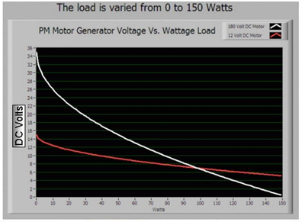
Figure 9 - Experiment between 12 VDC and 180 VDC motor
As can be noted from the above figure, at low loads the 180 VDC motor (in white) is clearly a lower RPM solution, but it will be substantially more difficult to pedal. On the high end, the 180 VDC’s voltage becomes almost non-existent, and the RPMs necessary for providing this relationship are almost unattainable for the target audience of the CALBOX.
For these reasons it is more practical for the design to get a motor rated as closely as possible to the operational voltage of the system. Most inverters operate at 12 VDC, the battery to be charged is a 12 VDC battery, and many common loads are 12 VDC, like laptops, phone chargers, and other electronics. A 12 VDC motor is more practical; however care must be given to ensure that the amperage requirements of the motor are not exceeded.
When run in reverse, the motor will generate substantially more heat. The heat can easily damage the brushes and permanent magnets within the motor. A test plan will determine what the most optimal operation speed for the motor selected for CALBOX use. It is important to keep in mind that it is estimated that an adult in good shape can average 150 Watts of power. One option to keep the motor cool is to install a fan on it. Conveniently, the CALBOX already produces power to run a fan.

Generator Selection
Four motors were considered for the applications of the CALBOX. These were considered in no small part due to the considerations detailed in the previous page. Two different companies that are manufacturers make reliable motors that fit into the description and parameters that are envisioned for the CALBOX. There are also two models that were considered for each. Table 5 compares the lower end models.
The main reason for considering the Dayton 4Z143 is that it is only capable of producing a maximum of 12.18 amps if run in reverse. This of course, will not be the case, since motors are less efficient running in reverse than they are running a load. The reason this is advantageous is because the max current that the battery can handle as an input is 12.1 A. This means that using this motor would reduce the complexity of the CALBOX system because over current protection would not be needed for the battery because the generator would be incapable of producing an over current situation.
The next-in-line model for the Dayton series is the 4Z529 motor. This larger motor is a very interesting choice because it has the same size mounting faces as the 4Z143. It also has the potential to deliver more amperage than the 4Z143 model which would theoretically allow the design team to design a CALBOX system that is closer to optimum charging capacity than the other model would be capable of. The closer we can get to the max charging current for the battery, the closer the ratio will be between riding time and play time on the load end.

 | Dayton |  | Leeson
 | 4Z143 | 4Z529 | M1120044 | M1120046
Item | DC Motor | DC Motor | DC Motor | DC Motor
Motor Type | Permanent Magnet | Permanent Magnet | Permanent Magnet | Permanent Magnet
Enclosure | Totally Enclosed Non-ventilated | Totally Enclosed Non-ventilated | Totally Enclosed Non-ventilated | Totally Enclosed Non-ventilated
HP | 1/7 | 1/6 | .14 | .16
HP @ Higher Volts | ¼ | 1/3 | ¼ | .33
Nameplate RPM | 1750 | 1800 | 1750 | 1800
“ RPM @ Higher Volts | 3580 | 4200 | 3500 | 3900
Voltage | 12/24 DC | 12/24 DC | 12/24 VDC | 12/24 VDC
Full Load Amps | 12.18 | 14.15 | 13 | 14
Full Load Torque (In.-Lbs.) | 5.63 | 5.84 | 5.125 | 5.875
NEMA/IEC Frame | Nonstandard | Nonstandard
Mounting | Face/Base | Face/Base | SQ. Flange | SQ. Flange
Thermal Protection | None | None | None | None
Insulation Class | B | B | F3 | F3
Bearings | Ball | Ball | DN | DN
Ambient (C) | 40 | 40 | 25 | 25
Rotation | CW/CCW | CW/CCW | CW/CCW | CW/CW
Overall Length (In.) | 8.39 | 9.39 | 8.95 | 9.45
Length Less Shaft (In.) | 6.89 | 7.89 | 7.38 | 7.88
Shaft Dia. (In.) | 0.50 | 0.50 | 0.468 | .468
Shaft Length (In.) | 1 ½ | 1 1/2 | 1.50 | 1.50
Base Mounting O.C. (In.) | 6.42 x 2.00 | 7.42 x 2.00 | 6.92 x 2.00 | 7.42 x 2.00
Face Mounting O.C. (In.) | 2.625 x 2.625 | 2.625 x 2.625 | 3.16 x 2.88 | 3.16 x 2.88
Brush Type | External | External
RPM Range | 1400-1800 | 1400-1800 | 1750-3500 | 1800-3900
Standards | UL Recognized (E47479) | UL Recognized (E47479) | UL | UL
Price | $215.00 | $239.25 | $173.16 | $178.88
Table 5 - Generators under consideration
The two Leeson models are more common than the Dayton models. They feature low-maintenance brushes that can be replaced without opening the casing for the motor. Since they are more easily found in retail markets, replacement parts would inherently be easier to find. The Leeson M1120044 is the smaller of the two considered models and is the Leeson equivalent to the Dayton 4Z143.
The M1120044 has an RPM range of 1750 to 3500, which is lower than the 4Z143. Although RPM ratios can be achieved on the bike-style implementation of the CALBOX through a system of gears, there are losses associated with these systems that the design team would like to avoid. More importantly, gear systems also tend to misalign and chains are difficult to size properly. Although the difference in RPMs is not substantial, it has another tradeoff-- torque. The lower RPM, for the same pedal speed results in the increased amperage rating difference between the two models as well. The Leeson is a more efficient motor.
The final model under consideration is the Leeson M1120046. It is comparable to the Dayton 4Z529. While both are 1/6 HP models at the 12 VDC generation point, the Leeson features more torque while the Dayton has a better amperage generation rating. The tradeoff however is measured by the RPM ratio.
The Dayton has to spin disproportionately faster than the Leeson to achieve a marginally higher amperage throughput. Another reason to consider the Leeson M1120046 is that it has previously been proven to be a successful motor for implementing with pedaling power designs such as the CALBOX.
The insulation class for the two manufacturers also differs. For a class B NEMA insulation, the nominal temperature is considered 40° C with an allowable 80° C rise in temperature at full load capacity and a 10° C hot-spot increase. This put the insulation rating of the Dayton systems at 130° C or 266° F. The Leeson motors, being class F certified, can operated at up to 155° C or 311° F. This substantial difference is considered a metric because it is a good measuring point for where the efficiencies of the motor will start to break down due to temperature. The Leeson motors have a higher stamina in this regard.
The price point of the four motors is also substantially different. Both Dayton models are more expensive than both Leeson models. That is to say that even the low-end Dayton model is more expensive than the high-end Leeson model. The cost difference is not evidently justifiable. In every respect that is applicable or a measureable metric for determining the appropriate motor for the CALBOX, the two Leesons beat out the Dayton models. It is for these reasons that the Leeson M1120046 was chosen.
The M1120044, although cheaper, and just as suitable for the CALBOX as the M1120046, is only marginally cheaper ($5 which is 2.8% of the price of the M1120044) it provides approximately 8% less current than the M1120046, which in economic analysis made less sense to refrain from investing in. The table below shows the decision matrix used by the design team to pick the appropriate generator solution.
TIER 1 | Decision qualifiers (1 point each)  - Highest amperage  - Best RPM ratio  - Best insulation  - Best maintenance/repair options | Dayton 4Z143 | Dayton 4Z529
TIER 1 |  | 0 | 1
TIER 1 |  | Leeson M1120044 | Leeson M1120046
TIER 1 |  | 2 | 1
TIER 2 | Decision qualifiers (1 point each)  - Best cost efficiency  - Most achievable charging efficiency | Leeson M1120044 | Leeson M1120046
TIER 2 |  | 0 | 2
Table 6 - Decision matrix for generator selection

Driving the Generator
There exist two options for driving the generator. The method used can affect noise levels, efficiency levels, safety considerations, budget ceilings, and fabrication considerations. The two main options are a direct drive style tire to shaft approach, and a belt-to shaft approach. There are advantages and disadvantages to each. Figures 10 and 11 below demonstrates the tire-shaft approach.
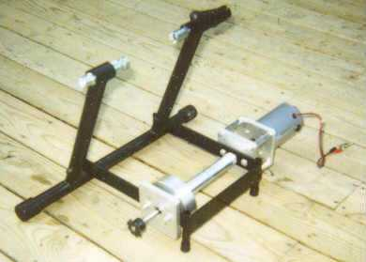  Figure 10 - Drive shaft assembly | 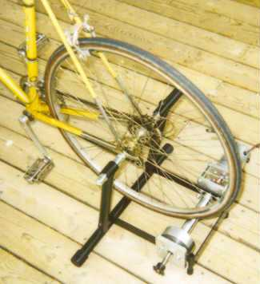  Figure 11 - Wheel-driven option
The above figures disclose the wheel-driven option. The advantages of this system are plenty. Because the wheel itself is not altered the bicycle device can be used in both recreational outdoors activities, and simply be a required piece of the design for any user wishing to implement a CALBOX as a part of either a healthy lifestyle or a diverse home power profile. The other advantage is that the user can use any wheel-driving device he or she wishes to use. With perceptively less moving parts than a drive belt scenario, this method is also safer. It is not unusual for long garments to get caught in bicycle belts, and this would not be any different. One final advantage is that the ratio between the bike and the rotor of the generator can be adjusted by simply changing the wheel. Equation 3 will detail the relationship between the wheel radius and the RPM on the high speed end.
$$\left(3\right) sR=Sr,$$
where s and R are the RPM and radius on the wheel side, respectively, and S and r are the RPM and radius on the high speed shaft side. For the typical bike tire of a 29” diameter and a relaxed RPM of 60, Equation 4 can be used.
$\left(4\right) 60*\frac{29"}{2}=S*\frac{\frac{1}{2}"}{2}$
Solving for$S$, we can determine the high speed rotations per minute to be 3,480 RPM. This is more than enough turns ratios for running the generator. More realistically however, the rotor diameter will be anywhere from 1 to 2 inches, which will reduce the above estimated output to 1,740 RPM and 870 RPM respectively. The diameter of the rotor drastically affects the ratio.
The disadvantages are also plenty. This design is less efficient than a belt-driven design because at high RPMs the wheel surface area contact with the shaft will be smaller than it is at low RPMs. There will also be heat generated between the rubber and the metal shaft, resulting in heat release and lower efficiency of power conversion.
The largest disadvantage to this method however is the fact that it requires machining a shaft to fit the shaft on the motor so that it will be stable and useable with the bicycle wheel. Metal fabrication can be a very expensive and time consuming process. It is also well out of the scope of an electrical engineering education. Finally, noise concerns with this method have also been raised. It is possible to produce a whistling noise with this approach.
The second method is the drive belt approach. With this method, the rubber tire and inner tube of the wheel must be removed. A link chain is fitted between the wheel and a gear attachment to the generator shaft. Like before, the ratios would be determined by the radii of the two connecting circles. Figure 12 below demonstrate the drive belt approach.
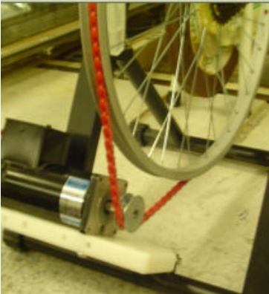
Figure 12 - Drive belt option
One of the advantages to this method is reduced noise. Another commonly touted advantage is the increased efficiency at higher wattage outputs. This is believed to be due to the higher deliverable torque into the motor system by the grips of the chain belt. This method also has concerns associated with it due to the extra chain. It is a concern that it might pop off, or become a hazard for small children.

Driving Solution Testing
The CALBOX design team has decided to commit to neither option at this level of the design. Instead, both options will be tested before a final product solution is implemented. Available data on the usability of either method is non-scientific and inconsistent. Testing the final bike solution and the ratio that will be achievable once all of the physical components are available will be the best solution. Measurement of RPM on the low speed side can be achieved by placing a light plastic tab in the chain or wheel, and counting the amount of times it makes the full rotation around the wheel. From the previously discussed equation in the driving the generator section, the RPM on the high speed side of the device can be measured.

Circuit Protection
On the generator side of the battery current is capable of flowing in two directions. In the first scenario it can flow, as is expected and desired, from the generator to the battery in conditions that are adequate for charging the battery. The other scenario is an undesired one in which the battery will behave as a voltage source for the motor during periods of inactivity on the CALBOX. In this situation, the current will flow from the battery to the motor, causing it to spin as motors are wont to do. This situation is not desired, as the battery will discharge while idling. There is also a second flavor to the first scenario.
While the user is bicycling he or she might experience a burst of energy and create a surge of power of up to 400 W. At 12 VDC, 400 W is 33 A calculated by using Ohm’s law. While this is surely entirely too much current for a 12 VDC motor, it is also too much current for the battery to absorb. For these two reasons there must be circuits in place to prevent the above described scenarios. The same solution cannot be used for both directions of current flow. In one case there is an over power situation, in the other an unintended load. Figure 13 provides a block diagram of the system.
Figure 13 - Protection system

Conditioning Power Flow from Generator to Battery
As previously mentioned in the Battery section, there is a maximum current which the battery can charge at before it is in danger of an over current or over charge situation which the battery will incur permanent damage or a decrease in capacity. To protect the battery during intermittent moments of high power output it is necessary to divert this excess power to a load other than the battery. Generally, the link between the generator and the battery is a charge controller. This controller is responsible for three things.
- Providing current from the generator to the battery for charging
- Providing a charge indicator signal for state of charge processing algorithms
- Diversion load management
In the case where the controller needs to divert the current, all power to the battery is cut off and a new load is switched into the system. This new load can be any high power, preferably DC load. It is possible to use heating elements or large lights as diversion current loads. For a peak of 400 W, while neither diversion load provided as an example seems like a useful application of this excess power, it must be understood they are not meant for continuous loading. These loads are temporary until the user resumes normal operating levels.
When a sophisticated charge controller is not being used, it is possible to control this current with a relay switch. Relay switches are designed for switching the current flowing in one circuit to flow in a different circuit. They are implemented in electric protection systems normally but there exist both pneumatic and hydraulic versions. All relays have a sensor, an electric coil powered by either an AC or DC signal. The coil controls the armature, which is an arm that will flip a switch to either open or closed depending on its normal status. This armature is excited by an induced magnetic field in the coil.
The type of relay must be chosen in accordance with the type of load it must power. For the application of the CALBOX the load will be resistive. Resistive loads are heaters, lights, anything with an element that is excited by real power. The relay also depends on the type of current passing through the circuit. Depending on an AC or DC load, the relay must have different contacts.
The appropriate relay for the design would be a make before break model, or MBB. This kind of relay will make a contact with the discharge load before releasing the battery. The diversion load can then be any kind of DC load. As mentioned before, a large LED light bank, or a heating element. One option is to have a large LED rope light, for which power is rated at 8 W per foot. This light can be a reward for the user when he or she goes on a sprint. This is a great motivator.
The relay will connect to a standard plug for use with any diversion load under interest. Another option is to extend the system from only being able to provide power for the battery charging. If a switch or contactor is used instead of the standard relay, the user can effectively transform the CALBOX into any kind of driver. It can be used for washing machines, televisions, and any other number of loads that can run from DC power.

Conditioning Power Flow from Battery to Generator
The battery will cause the motor to spin and in effect see it as a load if the motor is not protected from current flow from the battery to the generator. This however is a much simpler solution than controlling the power flow in the other direction. Since there is no case in which the battery will need to provide power for the motor, a device that blocks current in one direction is all that is necessary. This device can be a high capacity diode. The diode, commonly referred to as a “blocking” diode, is essentially a normally-open gate once forward biased. If reverse biased, i.e. battery potential is higher than generator voltage, the diode will block the reverse bias. A zener diode cannot be used for this purpose because it can operate in reverse bias voltage.

Generator Monitoring
The main system for predicting the rate of charge for the battery will be the generator voltage output. A time averaged method of measurement will be used because the rate of change of the generator voltage can be highly variable. The Arduino microcontroller that is the main processor for the CALBOX system is capable of measuring a voltage by comparing it to an internal voltage reference of 1.1V. The generator however, can output up to 24VDC. Figure 14 shows the relationship between the physical spinning of the bicycle wheel and the generator output. It is adapted from data by pedalpowergenerator.com.
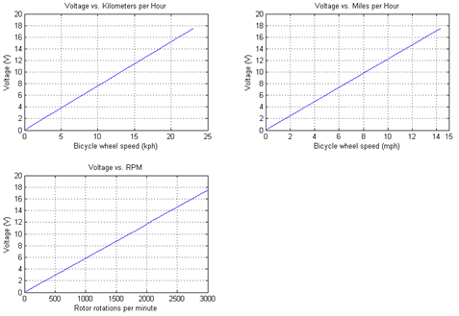
Figure 14 - Voltage output for Leeson M1120046
It is imperative to note that the above linear trend is a filtered time average data set. It is also measured after a capacitor filter of 4 farads. The trend is quite noisy and irregular, however the trend is undeniable. At the higher end of voltage to RPM, the user is exercising his or her body at a rate that is unsustainable. More realistically, the user will be pedaling at a voltage rating of 14-15 volts, which relates to approximately 2300 RPM. The battery charges at this voltage.
This voltage however is far too high for the Arduino to measure. The application of measuring the generator voltage is further made difficult because of the high current throughput of the generator. The Arduino has a current limit of 40mA input. The generator can easily produce currents in excess of 13 A. For this reason, a voltage divider in line with a buffer is used for data filtering into the microprocessor. Figure 15 below shows an experiment that demonstrates the possibility of scaling the voltage and using a current to voltage converter to regulate the signal current to something that is measureable. It does not model the exact system of the CALBOX.
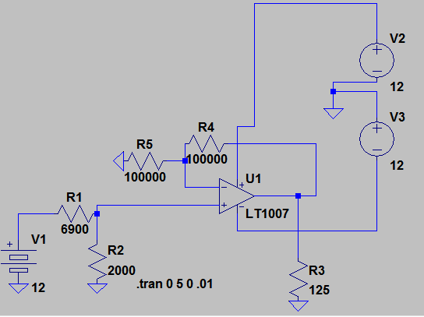
Figure 15 - Voltage divider circuit with current to voltage converter
The following figures prove that the regulation of the voltages is possible. The R3 load in the circuit above represents the impedance of the Arduino analog in pin that will be used for modeling. In Figure 16 below, the green line is the battery voltage, the blue is the voltage divider correction, and the red is the final voltage at the pin. Figure 17 shows that the current does not exceed the required specification.
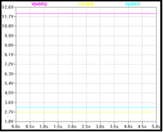  Figure 16 - Voltage drops | 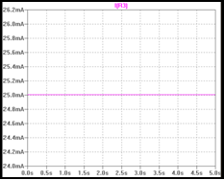  Figure 17 - Current flowing into analog pin
Of course, as the battery voltage decreases or increases with charge or discharge, the waveform will vary. However, the thresholds of the previous design limit the changes in the circuit from exceeding the ratings on the analog in pin. Hand in hand with this assessment is that this measurement is for the state of charge algorithm discussed in the Battery section. It is also necessary for determining when the user has fully charged the battery, as well as the foothold for a warning system for when the battery is discharged.

Measurement Scale
After the voltage from the generator is downscaled to a level that can be read by the microprocessor the data must be interpreted so that the correct state of charge can be calculated. The Arduino has a count resolution of 1024. It counts up and compares the voltage to the internal reference of the chip. The internal reference is 1.1V.
It is also possible to provide a voltage reference for the chip. One option is to use ground potential as the reference. This will make the measurement of the voltage simpler to count up from. The problem faced with this option is that it is possible for the ground plate to have a noise signal that will interrupt the accurate measurement of voltage. The following table shows the metric for determining the relation between measured voltage and generator voltage output.
KPH | RPM - Generator | Voltage Level | Analog In reading
0 | 0 | 0.0000 | 0.0000
1 | 130.4348 | 0.7609 | 0.1739
2 | 260.8696 | 1.5217 | 0.3478
3 | 391.3043 | 2.2826 | 0.5217
4 | 521.7391 | 3.0435 | 0.6957
5 | 652.1739 | 3.8043 | 0.8696
6 | 782.6087 | 4.5652 | 1.0435
7 | 913.0435 | 5.3261 | 1.2174
8 | 1043.478 | 6.0870 | 1.3913
9 | 1173.913 | 6.8478 | 1.5652
10 | 1304.348 | 7.6087 | 1.7391
11 | 1434.783 | 8.3696 | 1.9130
12 | 1565.217 | 9.1304 | 2.0870
13 | 1695.652 | 9.8913 | 2.2609
14 | 1826.087 | 10.6522 | 2.4348
15 | 1956.522 | 11.4130 | 2.6087
16 | 2086.957 | 12.1739 | 2.7826
17 | 2217.391 | 12.9348 | 2.9565
18 | 2347.826 | 13.6957 | 3.1304
19 | 2478.261 | 14.4565 | 3.3043
20 | 2608.696 | 15.2174 | 3.4783
21 | 2739.13 | 15.9783 | 3.6522
22 | 2869.565 | 16.7391 | 3.8261
23 | 3000 | 17.5000 | 4.0000
Table 7 - Generator RPM to voltage and voltage read in relation

Challenges to State of Charge
Normally, this function is also controlled by a charge controller. It is the goal of the design team to monitor the CALBOX system with high-fidelity commercial systems and fine tune the readings from the measurement system until they correlate with proper values. One of the difficulties of this measurement system is in the inherent construction of the batteries.
Sealed lead acid batteries are more commonly measured with hydrometers to determine the gas and electrolyte levels within the battery. This is an accurate rendition of the charge of the battery. The problem with this approach is that the battery chosen for the CALBOX is the UB12350. It is a AGM sealed lead acid battery, so not only would a hydrometer be useless, since it is a sealed composite, it is also a solid interior, so it would be doubly ineffective even if the battery was not sealed.
Another large factor in measuring the charge on a battery is the battery temperature. As the battery gets heated, it is more capable of retaining capacity. The following chart shows the relationship between retained capacity and ambient temperature. The disadvantage in this behavior is that at colder ambient temperatures, the battery substantially crippled by the lack of heat. Figure 18 below shows the correlation.
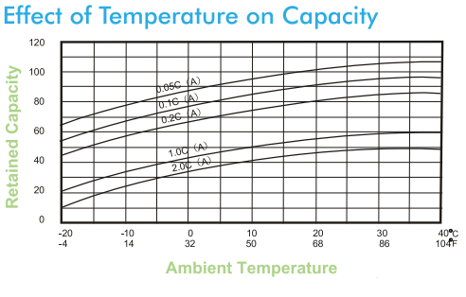
Figure 18 - Effect of temperature on capacity

Caloric Count
The CALBOX system records the caloric burn of a session in the user’s computer using a wireless data transmission interface with the platform. To be able to provide feedback to the user about the amount of calories they are consuming, the CALBOX must be able to measure an electrical potential generation from the generator and use that to compose a profile for the user that provides an accurate measure of the electrical power generated vs. the amount of power that the user must put into the system.
The generator voltage developed is then tied to the user by using a system of multipliers that implies the users’ level of fatigue. There are five different stages of fatigue that the user could be operating at: rest, low to moderate, moderate, medium, medium, and high. Each is determined by the speed at which the wheel of the bicycle is spinning. The measurement is done in miles per hour, which is measured by converting the wheel’s rotations per minute to a length by multiplying by its circumference. Most bike wheels are 29” in diameter.
The table below aims to correlate the MET rating for a particular speed on the CALBOX with a multiplier for the energy being expended by the user. The yellow zone represents a level of low stress, and the cart continues the color gradient to symbolize the increasing stress. The levels range from 0.9 MET at sleep rate, to 18 while running at 10.87 mph. These MET measurements will be used as a multiplier, with a recorded user weight, to calculate how many calories have been burned by the user.
KPH | MPH | RPM - Generator | METs | Intensity
0 | 0 | 0 | 1 | Rest
1 | 0.621371 | 130.4348 | 4 | Low to Moderate
2 | 1.242742 | 260.8696 | 4 | Low to Moderate
3 | 1.864114 | 391.3043 | 4 | Low to Moderate
4 | 2.485485 | 521.7391 | 4 | Low to Moderate
5 | 3.106856 | 652.1739 | 4 | Low to Moderate
6 | 3.728227 | 782.6087 | 4 | Low to Moderate
7 | 4.349598 | 913.0435 | 4 | Low to Moderate
8 | 4.97097 | 1043.478 | 4 | Low to Moderate
9 | 5.592341 | 1173.913 | 4 | Low to Moderate
10 | 6.213712 | 1304.348 | 4 | Low to Moderate
11 | 6.835083 | 1434.783 | 4 | Low to Moderate
12 | 7.456454 | 1565.217 | 4 | Low to Moderate
13 | 8.077825 | 1695.652 | 4 | Low to Moderate
14 | 8.699197 | 1826.087 | 4 | Low to Moderate
15 | 9.320568 | 1956.522 | 4 | Low to Moderate
16 | 9.941939 | 2086.957 | 4 | Low to Moderate
17 | 10.56331 | 2217.391 | 6 | Moderate
18 | 11.18468 | 2347.826 | 6 | Moderate
19 | 11.80605 | 2478.261 | 6 | Moderate
20 | 12.42742 | 2608.696 | 8 | Medium
21 | 13.0488 | 2739.13 | 8 | Medium
22 | 13.67017 | 2869.565 | 8 | Medium
23 | 14.29154 | 3000 | 10 | High
Table 8 - Generator RPM to intensity relation

Caloric Burn
While the Caloric Count section discussed the system that the CALBOX software uses to account for calories, it is important to understand another relationship between caloric consumption and real power production. It will be a necessary testing implementation to ensure that the CALBOX caloric output algorithm is correct.
Watts is a unit of power, while a calorie is a unit of energy. The difference is in the measurement of time as a metric for the intensity of the power dissipation. It is possible to relate watts to calories by using the following simple procedure by first converting watts to watt-hours.
Once a measure of watt-hours is achieved, this can be converted to watt-seconds by using dimensional analysis and the fact that there are 3600 seconds in an hour. This measure, watt-second, is of the same unit as the Joule. There is a direct conversion from Joules to calories that is given by Equation 5.
$$\left(5\right) 1 cal=4.184 Joules$$
For simplicity, food items are labeled in kCal. So in reality, a calorie labeled on a food source is 1000 times as large as it suggests. If a conversion between the two values is reconsidered we get the following relationship in Equation 6.
$$\left(6\right) 1 kCal=0.004184 Joules$$
The end user will be able to monitor the power output he or she is delivering to the CALBOX by using the included instrumentation logs or by using a power analyzer that measures wattage. Due to various variants and inefficiencies related to the generator option and running a motor backwards, the actual ratio of power exerted by the user and power that actually makes its way to the batter is given by the following relationship in Equation 7.
$${\left(7\right) P}_{user}=4*P_{battery}$$
This means that the user must expend 4 times the power he or she delivers to the battery. The design of the CALBOX software will take this into consideration. Further testing using medical equipment and measuring heart rates and metabolic rates will ensure the accuracy of this estimate derived from data. The user must be aware, however, of this situation and realize that the power measured at the generator is less than the power the user actually goes through.

DC-DC Buck-Boost

Non-Isolated DC-DC Converters
Non-isolated switching regulators are a very common topology type due to the simplicity and low cost. Non-isolated topologies are sufficient for the CALBOX because later in the system will exist a DC-AC isolated transformer which will supply the electrical isolation necessary. The cost of a non-isolated topology is also a factor in its preference, high frequency transformers are high cost. The necessity for a transformer to handle high voltage will not exist in the CALBOX due to the heavy testing and precautions taken to determine the maximum voltage a user may supply during cycling peaks. High voltages are beyond the realm of man cycling power.
In the non-isolated buck-boost converter, all bucking and boosting is doing analogously by the components traits and the switching of D1 and M1 to control the duty cycle. One major disadvantage of the non-isolated basic buck-boost topology show below is the inverted output. This inverted V_{O} will be resolved to the proper output polarization by a unique control method. Figure 19 shows the circuitry involved in a basic Buck-Boost.
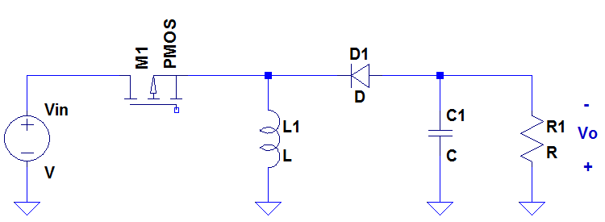
Figure 19 - Basic Buck-Boost Topology
There are two modes for the buck-boost topology to operate in, continuous conduction mode (CCM) and discontinuous conduction mode (DCM). These two modes are similar in operation, but have some differences that will make choosing one over another, an easy choice.

CCM Buck-Boost
When it comes to regulated switched mode power supplies, DC-DC converters are commonly used. An unregulated direct current voltage input from the rectified line will fluctuate from changes in the magnitude. Switched-mode DC-DC converters are used to convert a fluctuating input DC voltage that is unregulated to a preferred output level. The buck-boost provides the flexibility to either increase or decrease the supply. Since both the input and output currents are pulsating, low ripple levels are a challenge to achieve using the buck-boost.
The mode of operation is dependent on whether the inductor current of L1 in Figure 19 will reach zero before the MOSFET M1 is switched. In the continuous conduction mode (CCM), at the time t=0, it is assumed that inductor current increases from its minimum value not equal to 0 (I_{Lmin}) to the maximum inductance (I_{Lmax}). With the switch closed (on), the inductor current starts increasing from this minimum value. In this first mode, the diode is reverse biased (off). With the diode off, the capacitor linearly dissipates its contained charge onto the load. The inductor current continues to increase linearly until the switch is made off.
A pulse-width modulation is used to control the switching. Once the switch is turned off, the diode is forced into forward biased mode thus turned on. In this second interval of time, the inductor current is depleted linearly across the capacitor from (I_{Lmax}) to (I_{Lmin}) and the load drops in charge. The inductor current decreases until the switch state is change again or until it reaches zero which is not a possibility in the CCM mode, therefore before the inductor current reaches zero, the switch state is changed again where the cycle repeats continuously. This relationship is shown below in Figure 20.
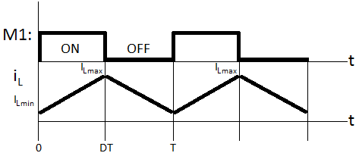
Figure 20 - CCM Inductor Current

DCM Buck-Boost
For the discontinuous mode of the buck-boost converter, the first two subintervals remain graphically similar to the inductor current in the CCM mode shown in Figure 20 except shifted down to where by I_{Lmin} where I_{Lmin}=0. In DCM, there exists a third interval within the period T after the inductor reaches zero. The inductor current attempts to decrease negatively into negative but the diode cannot conduct in the opposite direction therefore the current stays at zero. The third interval comes to an end when the switch goes is turned on again as shown in Figure 21. The first interval in DCM starts to increase from 0 and not the minimum value as it did in CCM.
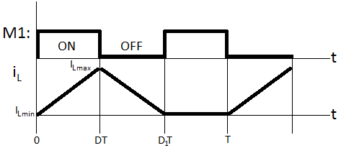
Figure 21 - DCM Inductor Current

Isolated DC-DC Converters
Converters in which use an electrical isolation transformer in their topology are known as isolated DC-DC converters. Isolated converters are necessary for different applications and to meet certain standards. Providing a barrier of isolation between the source of power and the load is usually needed to meet safety specifications such as those specified by the “Underwriters Laboratories (UL).” Isolation, if necessary, should be present between all power sources and loads; therefore this isolation should be present in both the control loop and the power stage. A block diagram an isolated converter can be seen in Figure 22. This offered electrical barrier between the input and the output by use of a high frequency transformer provides safety in applications where the regulator is close to user access. The barrier transformer is also capable of withstanding high voltage spikes.
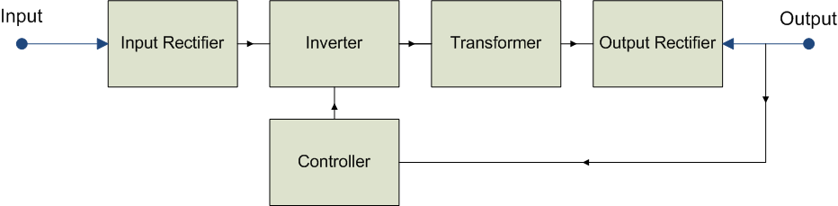
Figure 22 - Isolated converter block diagram
In the power stage, isolation is normally created by a transformer. Transformers are known to provide enough dielectric isolation between the power and load. The main advantage of using an isolated converter with a transformer is the reduction of stress on the duty cycle and switching. Another benefit of the transformer is its capability to provide input to multiple loads. In an application where an extreme increase from the input to the output is necessary, limitations in switching to control the duty cycle may prevent this. In an isolated converter with a 1:20 turn ratio from the transformer windings, the input could be amplified by a factor of 20 and the duty cycle could boost the remaining factor with ease and less stress. Transformers can increase cost and size. Cost and size disadvantages can outweigh the benefits of the transformer if its advantages are not of significance.
In the control loop, this isolation can be handled by an opto-coupler. An opto-coupler is a better form of providing isolation in the controller over a transformer because it reduces the complexity of the circuit and also reduces cost. A down-side to using an opto-coupler is its low bandwidth limitations since it presents an extra pole in the control loop. This problem is more important in high frequency applications rather than in low frequency applications such as the one that is being used for the CALBOX which switches in the order of kHz. The opto-coupler contains a photo-transistor which limits the bandwidth so severely. Opto-couplers are designed with a very large base capacitance in the order of picofarads (${10}^{-12}$) which is amplified to the order of nanofarads (${10}^{-9}$) by the Miller effect. This compensation coupled with a resistance, creates a pole in the transfer function that must be taken into account and considered in the design of the control loop.

Flyback Converter
The Flyback is an isolated version of the buck-boost converter. The Flyback uses a coupled inductor arrangement with a turn ratio to mimic a transformer. When the transistor M1 in Figure 23 is switched on, the current builds up in the primary inductor winding and energy is stored in the core. This energy is then released to the output inductor winding after being multiplied by the turn ratio, $n_1/n_2$. Other topologies utilize standard transformers and couple the energy directly during the on-time of the transistor, ideally storing no energy. Since all the output power of the Flyback has to be stored in the core as$(Li^2)/2$, the size and cost will be much greater than in the other topologies, where only the energy of the excited core is stored. The core energy when excited is normally small although the transformer size is one of the major drawbacks of the Flyback converter. In Figure 23, the inductor L1, is the magnetizing inductance serving the purpose of draining the L2 voltage during the second mode when M1 is off.
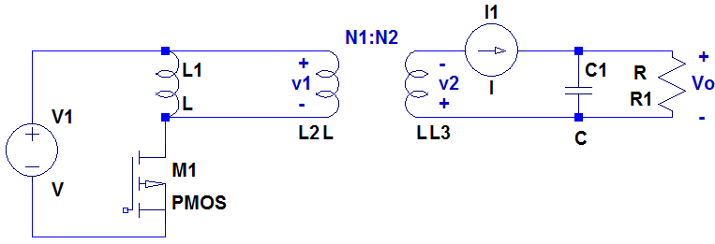
Figure 23 - Flyback Converter Topology
To get sufficiently high stored energy, the Flyback primary inductance L2, has to be significantly lower than required for a real transformer since high peak currents are needed. To accomplish having lower energy storage in the primary inductance, the core is gapped. The gap reduces the inductance and majority of the high peak energy is stored in the gap. Storing the high peak energy in the gaps also reduces the transformer saturation. In the Flyback converter, the secondary inductance is in series with the output diode when the current is delivered to the load. Each output only requires one diode and output filter capacitor. The Flyback is ideal for generating low cost, multiple output supplies as explained in the benefits of isolated converters.
Flyback converters can be lower cost and smaller in size than other isolated topologies because of the magnetized inductor pair acting as a transformer, which also allows the size to be much smaller. A couple other noticeable benefits of the Flyback are its capability to output to multiple loads and its ability to generate high voltage output, neither of which is necessary in the case of the single 12V battery low voltage output of the desired converter. The Flyback topology outputs to a positive polarity unlike to the basic buck-boost. If the CALBOX would be developed in the future to charge multiple batteries, then the Flyback would most likely be the number one option among available topologies.

Cuk Converter
The Cuk converter in Figure 24 can be combined by cascading a combination of a buck and a boost converter. Like the Flyback explained above, the Cuk utilizes magnetically couple inductors. The front end of this converter is a boost and the back end is of a buck therefore similar yet reversed form of the buck-boost. This converter uses two switches, two inductors, a capacitor to store and transfer energy from the input to the output, resulting in a higher level of complexity.
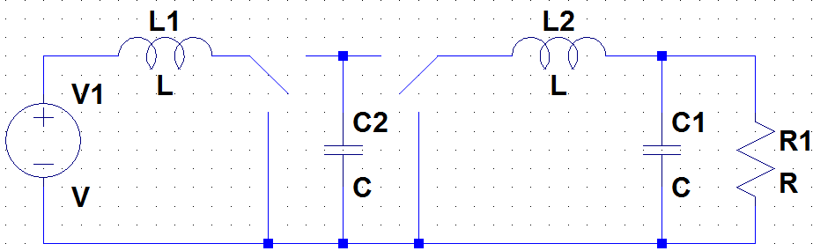
Figure 24 - Cuk Converter Topology
Like the buck-boost, the gain of the Cuk converter can be less than, equal to, or greater than 1, with a positive output polarity. The major advantage of this converter is that the input inductor and the output inductor can be coupled on one magnetic core structure such that with the proper core gap design, the input and output switching currents can be made zero. Disadvantages of the Cuk converter are a high number of reactive components and high current stresses on the switch, diode and the capacitor.

Synchronous Buck-Boost Converter
Synchronous rectification is useful with inverting topologies that generate negative voltages. In synchronous buck-boost converters, the Schottky diode is replaced by a NMOS transistor. Synchronous rectification increases the efficiency of the circuit because the resultant voltage drop across the MOSFET is less than the forward voltage drop across the Schottky diode. This synchronous switching operates in the third quadrant as a result of the current flowing from the source to the drain causing a negative bias across the switch. A positive voltage is held at the gate of the device improves the channel. The control and driver circuits synchronize the timing of both MOSFETs with the switching frequency.
The synchronous pulse width modulation (PWM) controller regulates the output voltage by modulating the interval of conduction on both MOSFETs. Under light low resistant loads, the control block turns off the MOSFET emulating a diode. Using discrete MOSFETs causes variable delays when rectified synchronously. This variable delay is caused by the variation in the gate and threshold charge between the MOSFETs. Standard control circuit topologies compensate for the variations by delaying turn on of the lower MOSFET until after the gate voltage of the upper MOSFET is below the threshold charge. Because the lower MOSFET waits for this voltage in the upper MOSFET to drop, a dead time is created where neither of the MOSFETs conducts. Common designs use this method to delay to the turn on of the main switch. A typical design delays discrete MOSFET conduction with a 60-nsec dead time and limits switching frequency to 300 kHz.

Current-mode Control of Synchronous Rectifier
Current-mode control of a synchronously rectified converter allows the converter to respond to changes in the voltage from the line without a delay. The output inductance can be decreased to increase the converter's response to conditions where the load is changing. There are some disadvantages of using the current-mode control method; it is sensitive to noise in the control loop and it requires two feedback loops, a current inner loop and a voltage outer loop, which complicate the design. Another downside is that controller uses a current-sensing resistor in series with the output inductor. The current-mode converters efficiency is also dropped from the current-sensing resistance dissipating power.
In deciding whether to use a diode or the synchronous rectifier technique, there are some comparisons which make choosing the design method easier. The signal of the gate drive is important in calculating a synchronous rectifier’s efficiency gain. The dead-time delay as previously mentioned is another negative to this method. Switching must not overlap and thus dead-time is necessary, dropping efficiency. The MOSFET used in the synchronous rectified contains a vital parasitic diode that can act as a clamp, catching the negative inductor voltage swing during this dead time. Even though this diode is necessary, it drops efficiency of the circuit because of its losses and slow speed. This drop in efficiency can be between 1% and 2%. To achieve the most efficiency in the design, a Schottky diode can be placed in parallel with the synchronous rectifier MOSFET, conducting only during the dead time.
A Schottky diode in parallel with the body diode turns on at low voltages, assuring that the body diode never conducts. A Schottky diode used in this way can be smaller and less expensive than a Schottky that is normally required because the average diode switching is slow. Schottky diodes usually have peak current ratings much greater than their DC current ratings which make preferred in many applications. Conduction losses during the dead time can become significant at high switching frequencies. When load current is light, the inductor current discharges to zero, becoming discontinuous.

Non-Inverting Buck-Boost Converter
The buck-boost topology allows the converter to operate in three different modes: buck-boost, buck, or boost. The system begins in the standard buck-boost mode, and then adjusts to the values it receives to determine whether to buck or boost the voltage level from the input. A standard buck-boost converter will output an inverted voltage. To avoid this, Figure 25 shows a modified buck-boost converter. In this figure, two n-channel MOSFETS are used as the switches, with PWM1 and PWM2 driving its respective switch.
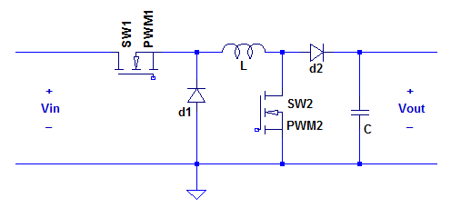
Figure 25 - Modified buck-boost converter
The different control modes are determined based on the different combinations of switches SW1 and SW2 driven by their respective PWM signals. The following table lists the operating modes along with the conditions that allow each to occur.
Operating Mode | SW1 (PWM 1) | SW2 (PWM 2)
BUCK | OFF | OFF
N/A | OFF | ON
BUCK-BOOST | ON | OFF
BOOST | ON | ON
Table 9 - Control modes for modified buck-boost converter
It can be seen from this table that an operating mode with SW1 off, and SW2 on, is unattainable. Neither in buck nor boost converters does this condition occur, so methods must be used to make sure this situation does not occur. There are multiple steps that can be done to avoid this case. First, keeping the frequency of each PWM signal the same will allow for better control when synchronizing the two signals. Second, the duty cycle D1 of the PWM1 control signal must be greater than that of the PWM2 control signal, or D2. Lastly, SW1 should be enabled prior to SW2, and SW1 should be disabled after SW2. Figure 26 displays the timing that the two PWM signals should follow.
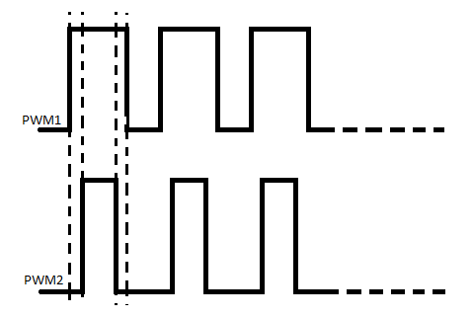
Figure 26 - Duty cycles for PWM signals
The duty cycle for the PWM signal driving SW1 (PWM1) will be referred to as D1, and D2 will represent the duty cycle for PWM2. The voltage drop across the diodes will be labeled as V_{d1} and V_{d2}. Neglecting the saturation voltages of the switches, the output voltage is given by Equation 8.
$$\left(8\right) V_{out}=\frac{V_{in}*D1-V_{d1}*\left(1-D1\right)}{\left(1-D2\right)-V_{d2}}$$
This equation is made up of the output voltage equations from each different mode. These modes are explained in detail in the following sections.

Buck Converter Implementation
When switch SW2 is off and SW1 is receiving a signal from the feedback loop, the circuit acts like a buck converter. The only difference from a standard buck is that there is an added diode, d2, which will drop the voltage more. To view this circuit, SW2 will be replaced by an infinite resistance (open) in Figure 27.
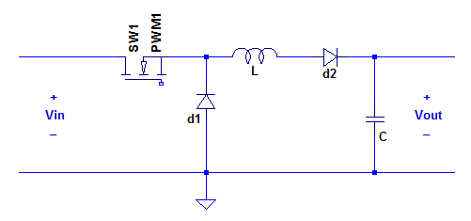
Figure 27 - Buck converter implementation
The output voltage in this case is represented by Equation 9.
$$\left(9\right) V_{out}=V_{in}*D1-V_{d1}*\left(1-D1\right)-V_{d2}$$
It is commonly assumed that the voltage drop across a diode is 0.7 V. The output voltage of our system is known to be 14.8 V, and the maximum input voltage that will be accepted will be 25V. Substituting these values into the above equation makes it possible to solve for D1, as shown in Equation 10.
$$\left(10\right) D1=\frac{V_{out}+V_{d1}+V_{d2}}{V_{in}-V_{d1}}$$
$$D1=0.667$$
This value puts a limit on how long the switch SW1 can be on for during one period. Since switch SW2 is off during this period, the converter can act as either a buck or a buck-boost in this mode. Anytime the input voltage is above the output voltage of 14.8 V, the converter will act as a buck. However, for small instances where the input voltage dips slightly below the output voltage level, it can also act as a boost. This is beneficial for times when the user’s energy exertion momentarily dips. Instead of switching immediately to boost mode, the converter will stay in buck mode. This way, if the user’s productivity regains suddenly, minimal work has been done in the converter, as it remained in the same mode of operation.

Boost Converter Implementation
When switch SW1 is on and switch SW2 receives its PWM signal from the feedback loop, the circuit acts as a boost converter. The switch SW1 in this case acts as a short. The diode d1 can be ignored as it will be reverse biased. Hence, the diode will be replaced by an infinite resistance (open), like the switch SW2 was in the buck converter implementation. This change is shown below in Figure 28.
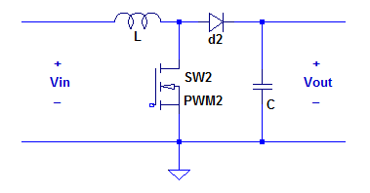
Figure 28 - Boost converter implementation
With the duty cycle of this phase represented as D2 and the voltage drop across the diode d2 is V_{d2}, the output voltage is represented in Equation 11.
$$\left(11\right) V_{out}=\frac{V_{in}}{\left(1-D2\right)}-V_{d2}$$
Again, the common value of 0.7 V will be used for V_{d2}, and the output voltage is known to be 14.8 V. The lowest value the converter will accept from the generator will be 5 V. Substituting these values into the equation and rearranging it, D2 can be obtained through Equation 12.
$$\left(12\right) D2=1-\frac{V_{in}}{V_{out}+V_{d2}}$$
$$D2=0.677$$
Though this value is similar to that calculated for the duty cycle in the buck mode, it is very important that D2 < D1 always. If ever switch SW2 is on while SW2 is off, it would have damaging effects on the converter. Unlike the buck derivation, this boost cannot operate as a buck-boost converter. This is so because switch SW2 needs to be off in order to implement a buck. Using Kirschoff’s Voltage Law, it can be seen that if SW2 is off, then V_{out} would follow V_{in}. There would be voltage drops across the inductor and diode, but the input and output voltages would still be linearly related. Therefore, it would be impossible to buck the input voltage, or to boost it for that matter.

Design Considerations
The converter can operate in both CCM and DCM when diode-switching is in use, but only in CCM when the synchronous switching is in use. The voltage gain for a buck-boost converter is shown in Equation 13 where D is equal to the duty cycle. The voltage gain for the buck-boost is negative therefore the buck-boost is an inverting topology when used without isolation. The duty cycle is equal to the on time over the switching period or (t₁-t₀)/T. The basic topology was presented in Figure 19. The switching network within the buck-boost is comprised of the MOSFET M1 and the diode D1, the buck-boost converter is a second-order converter comprised of two energy storage elements which are the inductor L1 and the output capacitor C1. The voltage gain is shown in Equation 13.
$$\left(13\right) \frac{V_{0}}{V_{IN}}=-\frac{D}{1-D}$$
Three different cases arise from analyzing the relationship between the voltage gain and the duty cycle in Equation 13. When D<.5 the output is lower than the input thus acting as a Buck converter, when D>.5 the output is greater than the input voltage hence acting as a boost converter and when D=.5 the output is equal to the input therefore acting as a unity gain. For example, if the Period (T) is 20 microseconds and the on time ($t_{1}-t_{0}$) is 15 microseconds, then D=15/20=.75. Assuming $V_{IN}$=5V then $V_OUT/V_IN=(.75)/(1-.75)=(.75)/(.25)=3*5=15V$.
The circuit below in Figure 29 is the basic buck-boost topology shown above with a pulse motivated voltage source powering the switching MOSFET. As shown in Figure 29 to the right of V2, the T_{period}(s)=T=20u=20$μs$ and T_{on}(s)=$t_{1}-t_{0}$=15u=15$μs$, therefore considering the circuit to be lossless (ideal), the output should be 15V when initially providing just 5V as solved above.
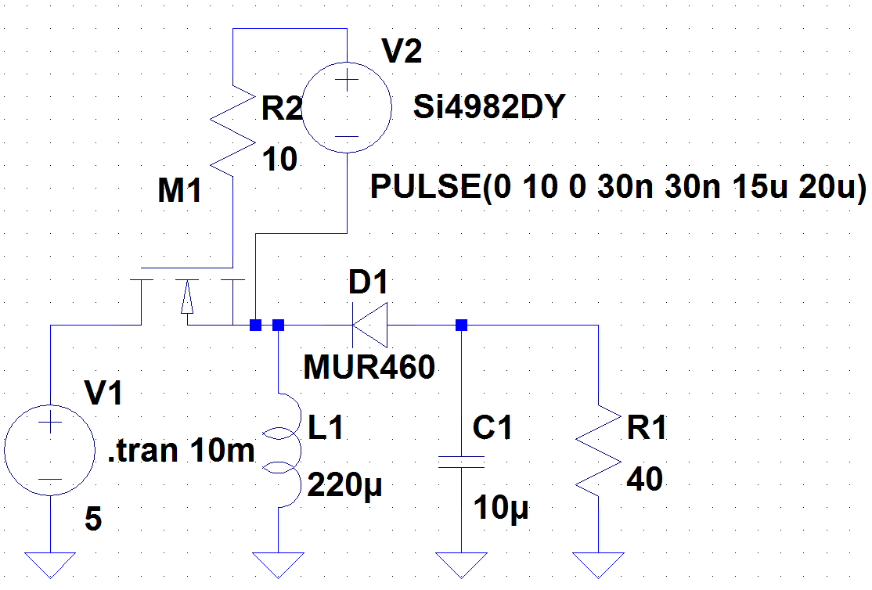
Figure 29 - Basic Buck-Boost with Basic MOSFET Driving
Very large output capacitors are needed, also known as filtering capacitors. These filtering capacitors are typically up to eight times larger than those of other topologies that only need to decrease such as the buck converter. The switch also needs to be capable of conducting high peak currents and able to support the higher summed voltage from the input voltage and the voltage provided to power the switch. There are a different form and component options considering the switching of the converter that will be discussed in greater detail.
The larger the capacitor (C1) value, the smaller the output ripple hence the more constant steady V_{out}. Ideally the filtering capacitor is very large, but in the capacitor value is chosen should offer enough ripple minimization as necessary because larger capacitors tend to be slower and larger capacitors also increase cost. The voltage should settle approximately and not exactly at the sought out voltage because of nonideal component properties such as switching losses and power losses; thus, this should be considered when designing the duty ratio. It should be noted that the output will be negative, as mentioned earlier. As a result, an inverting output polarity shall be taken for convention-sake for the time being.
To calculate the voltage gain in Equation 13, the volt-second principle was adopted. In calculating an inductor value, the critical inductance value L_{critical} will be the value that separates DCM and CCM mode. Choosing L<L_{critical} will provide you with a DCM operating converter and choosing L>L_{critical} will be a CCM operating converter, so in order to assure CCM operation, it is common for L=10L_{critical}. The equation for L_{critical} is provided below in Equation 14.
The capacitance calculated in Equation 15 is the minimum capacitance value necessary to limit the output voltage ripple lower than V_{C}/V₀. Some other considerations in designing a buck-boost are that the switch must be selected for maximum input voltage and maximum inductor current while the diode must handle load current and load voltage.
$$\left(14\right) L_{critical}=\frac{R{\left(1-D\right)}^{2}}{2f}$$
$$\left(15\right) C=\frac{D}{\frac{RfV_{c}}{V_{0}}}$$

Converter Nonidealities
Depending on the application and power levels, the inclusion of some parasitic effects of both components and devices is very important to the design for acceptable performance. It is important to consider these effects in order to appropriately predict and design the output voltage and efficiency. Some of the non-idealities are listed below and presented in Figure 30:
- Inductor resistance (r_{L})
- Transistor and diode voltage drops (V_{q}, V_{d})
- Switching and conduction losses (r_{sw})
- the equal series resistance of the output capacitor (r_{ESR})
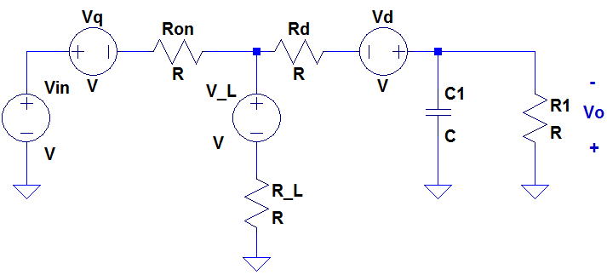
Figure 30 - Buck-Boost with Converter Non-Idealities
The r_{ESR} is important to include since its presence affects the design of the closed-loop compensator to stabilize the converter. The total power loss consists of the loss of power as a result of conduction, switching and magnetics. The magnetic losses result from the inductor element, R_{L}, which also known as the Direct Current Resistance (DCR). The switch resistance losses result from the MOSFET, R_{on}. Figure 31 below shows the circuit with equivalent resistance.
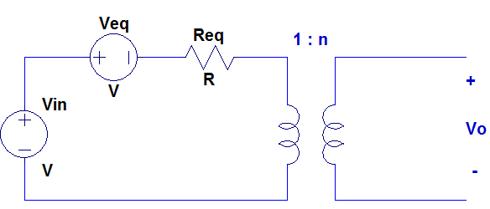
Figure 31 - Buck-Boost with Equivalent Resistance
The diode voltage drop, V_{D}, is accounted for unless the synchronous switching topology is used. The buck-boost including a transformer model and the equivalent resistances, R_{eq}, is shown in Figure 31. Equations 16, 17 and 18 below describe the voltage gain, along with the resistive and voltage equivalents.
$$\left(16\right) n=\frac{D}{1-D}$$
$$\left(17\right) r_{eq}=\left(\frac{r_{on}}{D}\right)+\left(\frac{1-D}{D^{2}}\right)r_{D}+\frac{r_{L}}{D^{2}}$$
$$\left(18\right) V_{eq}=V_{Q}+\left(\frac{1-D}{D}\right)V_{D}$$
In the equations above, the r_{eq}, V_{eq} and n are defined for a buck-boost that contains a 1:n turn ratio such as Figure 31. If the an isolated converter was evaluated for this equivalent resistance and seen in Figure 31 then the turn ratio would be n₁:n₂ and Equation 16 would be n₂/n₁=D/(1-D).

Component Selection

Inductors
The minimum inductor value needed for the system is a function of the period, voltage drop across the diode d1, output voltage, duty cycle D1, and the output current. All of these elements are in the numerator, except for the output current. Since the maximum values of these parts that comprise the numerator is needed, the D1 from Equation 10 is useful. The output voltage is set at 14.8 V, and the voltage drop across the diode is assumed to be 0.7 V. The switching frequency of the system is set to 400 kHz, making the period (T = 1/f) equal to 2.5 μs. Since the output current is in the denominator, the smaller this value will lead to a safer system evaluation. Therefore, 0.1 A is used here for the output current. Using these values in Equation 19 provides the minimum value needed for the inductor:
$$\left(19\right) L_{min}=\frac{T*\left(V_{d1}+V_{out}\right)*(1-D1)}{2*I_{out}}$$
$$L_{min}=65 μH$$
A value close to this will be chosen for this system. A common purchasable component value in this range was found to be 62 μH. Since this value is lower than the minimum calculated inductor value, the system will operate in DCM under circumstances of light load. The effect of this operating mode is that it will prevent the inductor current from dropping below zero. This is what would happen if it were operating in CCM. At light load, it is beneficial to operate in DCM, as a negative inductor current would lead to an unwanted negative power. Therefore, by choosing a lower valued inductor, the system becomes more efficient.

Capacitors
In order to find the minimum acceptable value for a capacitor, the period, output current, duty cycle D1, and output voltage are needed. The maximum current that can be used to charge the battery at constant voltage is 9.1 A. Allowing room for error, 10 A will be used as the output current. Duty cycle D1 is known from Equation 10 to be 0.667. Output voltage remains at 14.8 V, and the period is still 2.5 μs. The minimum capacitance is figured in Equation 20.
$$\left(20\right) C_{min}=\frac{100*I_{out}*\left(1-D1\right)*T}{V_{out}}$$
$$C_{min}=56 μF$$
Multiplying this value by five will approximately provide our system needing an output capacitor of 281 μF. This will lead to a lower output voltage ripple. After observing common available parts, 280 μF is the value chosen for the capacitor.
There are three general classes of capacitors: simple dielectric capacitors, electrolytic capacitors, and double layer capacitors. Dielectric capacitors are formed with parallel plates and an insulator, and are the most basic type. Electrolytic capacitors are formed by oxidizing a metal surface (usually aluminum or tantalum) and mixing this with a liquid or solid electrolyte. Double layer capacitors maintain a large charge separation over a very short distance due to the chemical properties of a polar molecule. There also exist feedthrough capacitors, which provide reduced wire inductance.
The insulating material used to make a capacitor is a key factor in the components performance. To obtain a high value of capacitance, thin insulation, as well as other factors is needed. Single-layer structures commonly carry capacitance levels of up to 5 μF. It is also possible to produce a multilayer structure, but devices of this type above 20 μF tend to be expensive. Since the system calls for capacitors of values up to 280 μF, these single-layer types will not be ideal. The thinner the insulation of a capacitor will lead to an increase in capacitance. However, it is almost impossible to manufacture or handle the material once it falls below a certain thickness. Therefore, the use of thin films to obtain high capacitance values is limited.
From this, it can be seen that electrolytic capacitors are advantageous for this system. Unlike simple dielectrics, electrolytic capacitors form the insulation in a direct way. Rather than placing the insulating material between parallel plates, the process of forming an electrolytic capacitor begins by breaking down the metal by oxidizing it. To provide electrical contact across the outside of the oxide layer, an electrolyte is inserted. Capacitance is thus created between the metal and the electrolyte. The part is made complete by encasing it in epoxy or sealing it in a can.
The surface area of an electrolytic capacitor is large, which produces a large ratio of the area per distance. This is why this type of capacitor is favored. The thickness of the oxide layer can be controlled by changing the time spent in the oxidation state. This makes it possible to trade off voltage ratings and capacitance values. While dielectrics are rarely rated at less than 50 V, electrolytic parts are commonly rated at 6 V, which is much closer to the voltage values dealt with in the system. When choosing which capacitors to obtain, it is important to look at the specifications, as manufacturers usually specify dc leakage currents.

Bypass Capacitor
For the buck-boost converter, an inverting topology, there are very important differences between the continuous and discontinuous operating modes. Designs which are stable in the discontinuous mode of operation may become unstable when too much load current is presented, forcing it to operate in the continuous mode. When too much load current is provided, the feedback loop may contain a right-hand-place zero. A bypass capacitor from V_{IN} to ground should be used across the input. Bypass capacitor common values are 1 µF and .1 µF where 1 µF is used for lower frequency high current situations and the .1 µF capacitors are used for high frequency uses. With regards to the buck-boost converter, the current is as of now assumed to range from .1A to 10A where 10A is taken as a precaution. It is in good practice to overestimate specifications to ensure stability. The designer is also using a frequency of 200kHz which is classified as low frequency therefore the figure below takes the standard topology of the buck-boost and adds a 1 µF bypass capacitor at the input. A buck-boost with an implemented bypass capacitor is show in Figure 32.
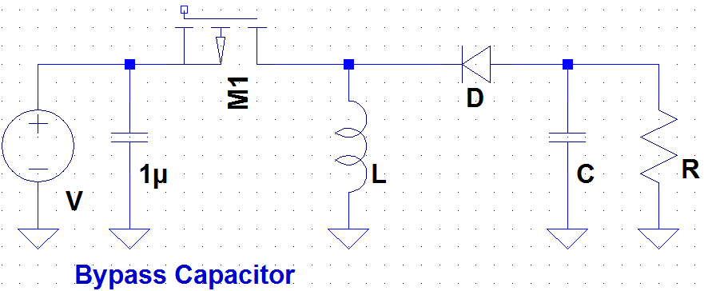
Figure 32 - Bypass Capacitor

Diodes and MOSFETs
One way to increase the efficiency of switched-mode power supplies is by using synchronous rectifiers. By inserting a low-resistance conduction path across the diode rectifier, these devices improve power-conversion efficiency. Metal-oxide-semiconductor field-effect transistors (MOSFETs) are commonly used for these switches. Switching speed, efficiency goals, and temperature constraints all play a part in selecting a MOSFET. N-channel MOSFETs are more preferred than p-channel as they typically contain half the on-resistance than that of a p-channel device. A great benefit to using these devices is that by driving the gate with a 5 V source, the gate loss, and therefore total loss in the device, can be reduced.
The converter’s efficiency is also a determining factor for choosing diodes. Schottky diode selection is based on the reverse-leakage and forward voltage drop characteristics. The diode’s forward voltage becomes an issue with a decreasing output voltage drop. For this system though, the output voltage will ideally remain constant, therefore eliminating this issue. To further increase efficiency of the system, a Schottky diode can be place in parallel with the synchronous rectifier. This diode will conduct while the switch is off. This provides a smaller and cheaper method than what a simple circuit requires.

PCB Grounding
Ground wiring can often limit the performance of the system of components placed onto the printed circuit board. In the designers application where efficiency is vital, proper layout techniques must be understood to leave as little unused power as possible. Learning improved methods will help avoid PCB layout problems as well as improved overall system performance. A layout concept known as “star grounding” will be introduced, explained and used. Ground is used as a reference for linear circuits and as a return for power systems. Elements such as power amplifiers and switching regulators use ground as a return. The ground can also be used as a shield to prevent electromagnetic noise propagation. As a result of all these various uses the ground serves, the method used in laying out the circuit plays an important role in preventing interference across areas of the board.
The finite parasitic ground resistance of the path between components carries a voltage drop when the connection carries a current. Due to this voltage drop between components and different areas of the boards, element placement is proven again to be important. Figure 33 below displays a block diagram of the circuit placement.
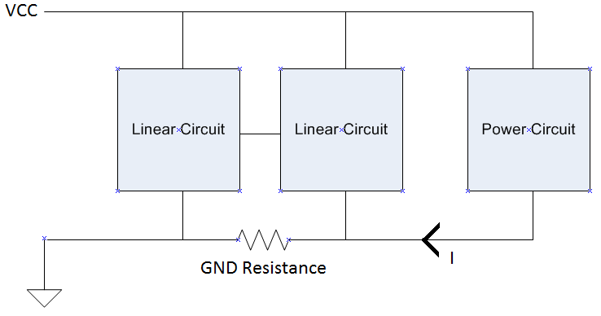
Figure 33 - Common Circuit Placement
Because of the voltage drop that is created across the connections, the local ground assumes a voltage other than zero. The voltage drop across the parasitic resistance in the case of a power component such as a switching regulator which is time varying, noise can be created and accumulate across the board which affects overall voltage accuracy and desired output voltage. Current and resistance are directly related and since the ground resistance is generally low, large inductively induced currents can be easily created. These induced currents accumulate into large loop currents and respectively stimulate noise.

Star Ground
Selection of the ground junction point which is used as a reference is the key. Parts of the circuit which provide power to the rest of the circuit are particularly more important as they supply current for the entire circuit. Carefully evaluating the current flow throughout a circuit and understanding its path is necessary to choose the path of return currents and location of the junction point. Choosing this junction point wisely minimizes the voltage drop across the parasitic resistance and in turn decreases the voltage offset. Reducing the voltage offset has a positive effect on the noise in the return paths.
When using the star ground technique, a common placed point to which all grounds will be connected is chosen such that they radiate outwards to the rest of the board. Local star grounds can be created becoming local grounds for any sub-circuit portion of the board. These local star grounds must be directly connected to the main star ground. Ideally, the main should be the only star in direct connection with all the components on the board as to prevent interference caused through current generation. This becomes very difficult to physically accomplish thus sub-star systems (local stars) become a closely acceptable alternative. These stars have time variable ground reference potentials. Although not ideal, if placed properly, this layout format can still provide drastic improvement. Figure 34 provides a view to the properties of this technique.
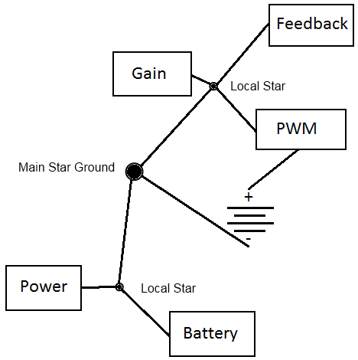
Figure 34 - Star Ground Technique
A star ground technique ensures that the highest performance is achieved versus former grounding habits. Voltage feedback signals are sensitive to noise and the resistors must be routed separately from the high current paths. The star ground scheme helps eliminate ground noise problems previously existent and reduce the substantial parasitic resistance in the printed circuit board traces. The spacing between the traces should be determined by the maximum working voltage and the coating. The minimum width of the traces and spacing between them are limited by fabrication capabilities of the equipment and should commonly be around 6 mils.
When placing the buck-boost components onto the PCB board, certain components should be kept distant from each other especially in high current applications such as that necessary in the CALBOX 360. Parasitic inductance is a negative product of high switching frequencies that careful component placement can avoid. These high parasitic inductances can cause high voltage spikes at input and output lines. The input (bypass) capacitor should be placed very close to the positive input voltage node. Lines connecting the input capacitor, inductor and diode should be heavy metal traces for improved performance. Shielded cores for better EMI results can make a significant difference. To avoid flux intersection, the feedback circuit should be wired away from the inductor.

System Losses
The behavior of energy storage elements is very important in power electronics. It is difficult to achieve ideal component values due to the high and rapidly changing voltages and currents in a converter. This leads to losses within the system. There are a few common nonideal effects. Wires have resistance and inductance, coils of wire have capacitance between turns, and insulators have leakage resistance. Because of resistive losses, capacitors are made with temperature and current ratings. Ignoring losses can lead to a component failure within the system.

Wire Resistance
An important aspect in making sure the system losses are not too high is to evaluate the wire resistance that will be encountered. This resistance can limit the system due to the heavy amount of power being handled in such small volume. The equation R = pl/A determines resistance of a wire based on its length and cross-sectional area, with p representing the resistivity of the substance. The system will likely only encounter wire issues when dealing with the inductors. The converter will be a copper plated circuit board, thus eliminating almost all of the losses like those formed by external wires.
Copper wire in this country is sized according to the American Wire Gauge, or AWG. It can be assumed that #18 wire has a diameter of 1mm (actual diameter is 1.02 mm). Every three sizes down from this, the gauge number approximately doubles the wire area. Therefore, #15 wire has twice the area of #18; #12 has four times that of #18, and so on. The same trick works the other way, as #21 wire has half the area of #18, and #24 has one fourth the area of #18 wire. With a diameter of 1 mm, #18 wire has an area of 7.85 x 10⁻³ cm². This allows the wire to handle between 0.8 and 8 amps of current. North American commercial wiring practices this process, as #14 wire is used for a 15 A circuit, and #12 wire is used for a 20 A circuit.
To initiate testing with these component values, MATLAB is used to obtain Bode plots of the magnitude and phase for different values of the system. The first test was done on the power system, with the switching frequency of 200 kHz. This lead to out of range values for magnitude and phase. Therefore, the switching frequency was doubled to 400 kHz to give more appropriate values for L and C, ultimately resulting in an acceptable power system. MATLAB will be used to follow through on further calculations, which will enable the feedback loop to be designed accordingly.

Resistors
Different from other parts in a power electronic system, the purpose of resistors is to dissipate energy, rather than store it. Resistors are necessary for carrying out the control-related functions of a power converter. There are different types of these components that are used for different purposes. Composition types have become less popular in time due to their lack of precision and they are easily affected by moisture and other environmental factors. For high power operation, wire-wound resistors are often used. These types carry high inductances though, which cause problems when applied to power electronics. Because of this, film type resistors will be used to populate the circuit board of the system. These resistors are often rated for 1 W or less, so circuit design will have to be very precise to dissipate the power of the system correctly.

Switching Losses
Semiconductor devices are susceptible to very large power losses that can occur instantaneously during switching transitions. These losses can be significant even though the switching times are short. The charge on the gate of a MOSFET determines the conducting state of the device. This charge controls whether the transistor is in the on or off state. Both switching times and switching losses are therefore influenced by the controlling charge. Along with these losses, energy stored in the MOSFET can be lost during switching transitions.
Since the switching times are short, it is safe to assume that the current across the inductor is constant during the entire transition where t₀ < t < t₂. The length of the interval (t₁ – t₀) represents the time it takes for the gate driver to charge the MOSFET. Here, the switch M₁ is on while switch M₂ is off and the voltage v_{M1} must rise from 0 to mimic the input voltage, v_{in}. The transistor current i_{M1} is constant and equal to the inductor current i_{L} during this phase. When t = t₁, v_{S} = v_{in}, and the current starts to transfer from M₁ to M₂. This interval (t₂ – t₁) is the time it takes the gate driver to discharge the MOSFET, and thus turn the switch off.
To evaluate the instantaneous power p_{M1}(t) dissipated by the first switch, multiply v_{M1}(t) by i_{M1}(t). It can be seen in Equation 21 that the power in the MOSFET linearly increases as time goes from 0 to t₁, and linearly decreases from time t₁ to t₂. Maximum power occurs when the transistor voltage matches input voltage, and its current matches the current across the inductor. The area under the curve represents the energy lost E_{off} during the turn-off transition, shown in Equation 21.
$$\left(21\right) E_{off}=\frac{1}{2}v_{in}i_{L}(t_{2}-t_{0})$$
When this process is reversed, the transistor turn-on waveform can be created. During one complete switching period, the average power loss due to switching is shown in Equation 22.
$${\left(22\right) P}_{sw}=\frac{1}{T_{s}}\int{p_{M1}\left(t\right)dt=(E_{on}+E_{off})f_{s}}$$
where E_{on} represents the energy lost during the turn-on transition. This equation shows that the switching loss P_{sw} is directly proportional the switching frequency f_{s}.

Switched-Mode Power Supplies
The goal of the DC-DC converter in the CALBOX system is to take an unregulated voltage input, and produce a stable output voltage. This is necessary to effectively charge the battery. Conventional linear power supplies typically provide 40%-50% efficiency. Instead of this, a switched-mode power supply (SMPS) will be implemented because switches have efficiency ratings between 60%-90%. Along with high efficiency, they also generate less heat, can better regulate voltage, and are generally smaller in size and weight. Also, an SMPS is capable of outputting the correct voltage even when receiving low input voltage. This will allow the system to maximize the users’ efforts on the bike, so that even when pedaling slowly, power is still generated.

Proportional-Integral-Derivative Controller
PID controller has three components. The first component of the PID controller is the proportional control which is multiplied by the current error. The proportional branch, which is also known as gain, makes these multiplied errors proportional to a given value. A high proportional gain can dramatically change the output and if the error is too large, then the system could become unstable. If the gain is too low then oscillations can result from the dynamics, possibly causing a permanent error which is known as a “steady-state error.” The proportional branch of the PID controller can be seen below in Figure 35.
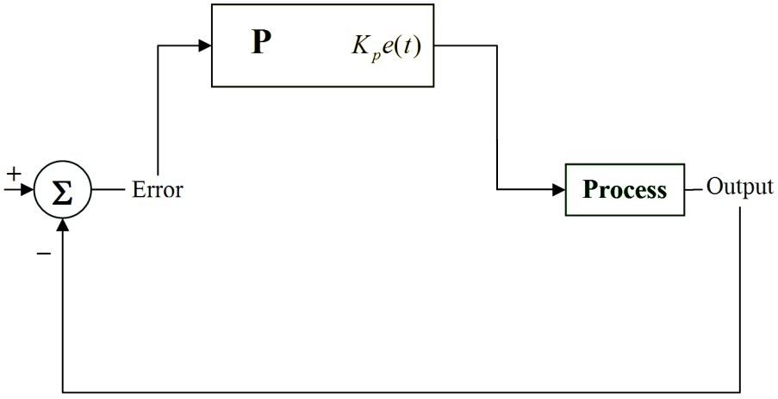
Figure 35 - Proportional gain
The second component, the integral control branch, takes into account the error history. By taking the history of error into account, the integral control keeps adding the value of the error over a period of time. This integral of error, removes the steady-state error that was previously an issue in the proportional gain by the time the system is at its final state. When there’s a long transition, the controller integrates over this longer period, hence causing “integral windup.” With integral windup, the system goes beyond the desired reference voltage. After the overshoot, the system should recover back to the reference. The integral block diagram is shown in Figure 36.
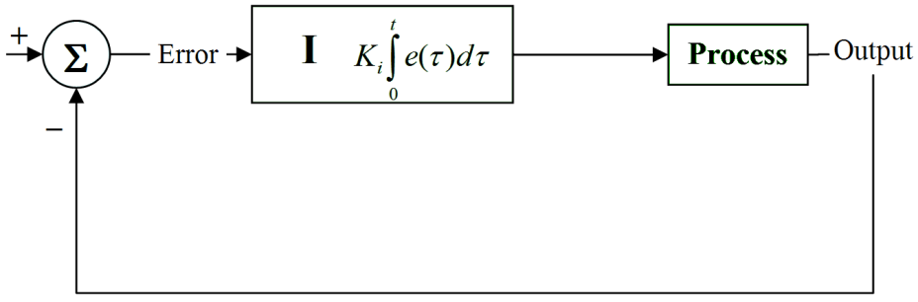
Figure 36 - Integral control
The third component of the PID is a derivative control, Figure 37, which is based on the rate of the error. It is an indicator of how the error acts based on the rate. The derivative control is an indicator of how the error is going to act in the future and evolves with this rate of change. This capability to predict the future allows the system to react faster to changes. Because the system can now react faster to changes, the system can also be made unstable. Another drawback to the derivative is that it is sensitive to noise. It is normal for the derivative to be left out of the controls to a converter, thus making the controller only a PI. The derivative branch is shown below.
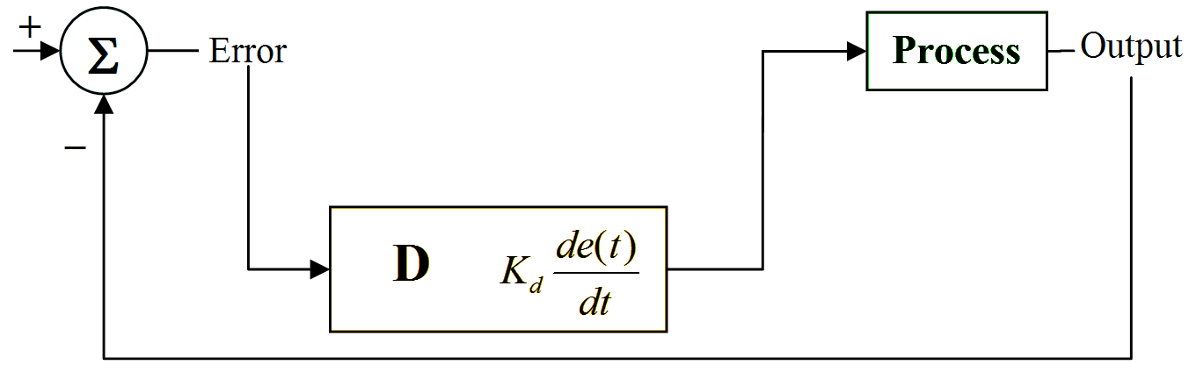
Figure 37 - Derivative control
The summation of these three components of the PID controller is outputted to the plant. The PID controller can only handle systems with one input and one output. A common issue with the PID control method is that it is linear and the in non-linear systems, the PID loop is variable. Since noise is generated from the derivative function, a low-pass filter is commonly used to remove this noise. The derivative control can be canceled out completely using a low-pass filter therefore the PID controller will only act as a PI controller. The CALBOX 360 is a single input single output system. The full PID controller is ideal for the CALBOX 360 DC-DC buck-boost converter (Plant). Figure 38 is a block diagram of how the PID controller is incorporated into the system.
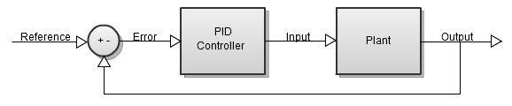
Figure 38 - PID Controller Block Diagram

Right-Half Plane Zero and Pole
For the buck-boost converter, the designer will be using is a particular type of switch-mode converter that does contain a RHP zero in the control-to-output transfer function. Because the buck-boost has a RHP pole it is known as a nonminimum-phase system. Characteristic to the RHP zero is that it will increase the loop gain and decrease the loop phase, which would make the corresponding converters more susceptible to instability without the proper control design actions. The effect of RHP zero cannot be removed. The RHP zero limits the achievable maximum control bandwidth at the frequency of the RHP zero, and even lower if proper phase and gain margins are to be obtained. The RHP determines the minimum control bandwidth for stability to exist. As a consequence, the control bandwidth will be designed as high as possible to minimize the possible load-imposed stability problems.

Average Model for a Buck-Boost
The small signal model for a buck-boost must be analyzed in order to design a controller and simulate the pulse-width-modulation (PWM). As previously stated, for the designers application, the buck-boost will be analyzed in the CCM mode. Three changes which constantly occur in application are the load current changes, input voltage and duty cycle proportionally. The step response of the output voltage will be analyzed using Matlab and simulated using LT Spice. A PID controller will be used to decrease error and gain stability.
A transfer function must be derived for the PWM converter in open loop and closed loop at maximum voltages in order assure stability which is the primary goal. To test for this stability, the bode plots will be analyzed at different cases:
- Maximum input voltage
  - Minimum output current
  - Maximum output current
- Minimum input voltage
  - Minimum output current
  - Maximum output current
Minimum phase systems have transfer functions with neither poles or zeros in the right hand s plane. When using the stability analysis using the bode plot, the PM (phase margin) and the gain margin have to be positive for a minimum-phase system to be stable.

Feedback Operation
To charge the battery efficiently, a constant voltage input is necessary. This is what makes the dc-dc converter a necessity in this system. Though the input voltage will change depending on the speed at which the user cycles, the voltage is regulated through the buck-boost circuit, and is constant at the output. Therefore, the converter system requires feedback to ensure that the battery charges at the correct voltage level. This voltage level will be known as the reference voltage, or v_{ref}. The feedback system will vary the duty cycle to make the output voltage equal to the desired reference value. It is important to have a feedback system that will regulate the output voltage accurately. To do this, the system must be immune to changes or disturbances in the input voltage or in the load current. In order for certain properties (transient overshoot, settling time, and steady-state regulation) to meet specifications, the feedback system must be stable.
Before the feedback system is designed, the open-loop converter must be analyzed as it is the basis for the models used in the control design. The open-loop behavior can be observed when the external feedback from the controlled output voltage has no affect on the converter. Whenever the feedback loop is open, the converter will operate in open loop. This is true even if the converter contains internal feedback or feed-forward loops that change its dynamic behavior.
The feedback system is made up of a compensator, a pulse-width modulator (PWM), and a transistor gate drive. There are three main types of compensators: the lead (PD), lag (PI), and combined (PID). The purpose of this device is to take the output voltage of the system and set it equal to the reference voltage. This signal is then fed into the PWM, which controls the duty cycle in the power transistor. The PWM receives an analog control signal, and creates a duty cycle that is proportional to this voltage. The output of the PWM is a periodic logic signal, which is sent through the transistor gate driver and received by the MOSFET.

Digital Control
Historically, analog integrated circuits have been used to control power electronics converters. Though these devices are usually cheap and simple, they are sensitive to noise, temperature, and aging. Digital controllers have become more popular over the last few decades. This technology is beneficial as it is smaller and faster than analog types. Digital control also carries a great advantage, in that it is able to adjust the supply voltage in order to minimize the total power consumption. Along with these, other advantages of digital control include:
- Reduced electromagnetic interference levels (EMIs)
- Simple circuit configuration, which automatically adjusted control variables and parameters
- Flexibility in changing a controller is made easier as it requires changes in software only, thus avoiding hardware alterations
Although digital control will provide the CALBOX system with adequate feedback to produce the desired output voltage, challenges still arise in its design.

Pulse-Width Modulator
Since there can only be one discrete value of the duty cycle for every switching period, the PWM must sample the continuous input signal it receives from the compensator. The sampling rate will be equal to the switching frequency f_{s}. This process of sampling will contain the frequencies of the ac variations. The bandwidth of the control system must be sufficiently less than the provided reference of f_{s}/2, which represents the Nyquist rate. The PWM can also be altered by high-frequency variations in the control signal. To avoid this, it is best to eliminate significant components at the switching frequency or higher. This will result in a feedback system with less noise.

Power Factor Correction
A key element of power electronic devices is that they rapidly switch the current on and off, causing disturbances. However, DC-DC converters have the advantageous capability of making any switching load appear as a resistive load. Therefore, the line current is drawn at a proportional rate to the line voltage.
The system load can be either linear or nonlinear. In general, nonlinear loads will cause issues, such as the creation of harmonics and electromagnetic interference (EMI), high losses, and reduced maximum power capability from the line. This can be fixed by making the load act as a resistive element by using Power Factor Correction (PFC). Circuits using PFC contain many advantages. Among them are a better source efficiency, lower conducted EMI, reduced peak current levels, and the ability to act as a filter for conducted EMI testing. However, introducing a PFC circuit will increase the complexity of the design as well as affect the reliability of the system due to the addition of parts. These factors must be accounted for though, as PFC will provide an overall benefit to the system.
The positioning of a PFC circuit is key in how it affects the system. Output PFC circuits are placed between the load and power supply. They are useful in systems that contain a highly reactive load, which the CALBOX system does not, as a battery acts as the load. Instead, input PFC will be used, as it is the common type used in switched-mode power supplies (SMPS). Also common in SMPS are active PFC circuits, which are able to achieve a power factor of more than 99%. These are more preferred than passive PFC circuits, which are commonly comprised of inductors and capacitors.
Superior to both active and passive PFC circuits are the high switching frequency topologies. Most major manufacturers support these with control integrated circuits. They’re many advantages include low weight, accurate voltage control, low line harmonic distortion, wide operating voltage range, and easy design. This type of topology is more intricate than passive and active ones, but the benefit of being able to achieve power factor of almost unity makes this type ideal for the CALBOX.

Input Filter
Aside from efficiency, the main aspect that will be tested in the system will be the electromagnetic interference (EMI). Any nearby electronic equipment is at risk if there exists too large of high-frequency current harmonics. Standards have thus been implemented to limit the amplitudes of these harmonics. Amplitudes of less than 100 μA are typically required. To regulate the EMI, an input filter is added at the input of the switching converter. The purpose of the filter is to ease the switching harmonics that occur in the input current waveform. The input filter can also make the system more reliable by protecting the converter and load from the changes in the input voltage.
A low pass filter is capable of sufficiently regulating the current at this point in the system. Without the filter, the input current matches that of the current across the switch. Therefore, the input current increases with the switch on, but is zero when the switch is off. The LPF will change this by splitting the current. While the switch current will still follow the previously mentioned pattern, the filter has smoothed the input current. In order to design an efficient converter that meets EMI standards, this filter must be taken into consideration as the dynamics of the system change with its presence.

Digital Signal Processors
To provide faster operation and quicker analog-to-digital converters, a digital signal processor (DSP) can be used for the system controller. The chips are generally square, with leads on all sides, which need to be soldered onto the printed circuit board (PCB). As soon as the DSP chip receives power, it is able to execute the programmed codes in phase with clock signals. The purpose of the DSP is to produce the desired digital output signal from the received signal.
The procedure begins with the sampling of input signals from the hardware pins. The chip then uses an analog-to-digital converter to extract a digital signal from the sampled signal. Calculations are carried out produce digital results from the converted data. Lastly, the digital results are converted into desired analog signals through digital-to-analog converters. The system specifications will provide the information needed for designing the software for the chip.
Manufacturers commonly provide important information about their DSP chips, such as available data types, dedicated multiplier, and built-in internal architectures. In order to select an appropriate device, many factors must be taken into consideration. The DSP will have one input, coming from the converter output, and two outputs, one for each of the switches. As previously discussed under the Digital Control section, digital signals will be used as opposed to analog. More research is needed to find the voltage and current ranges for each input and output port.
Based on the control routines, how many operations needed for the controller must be determined. That is, whether integer, fixed point, and/or floating point will be used in the software design. When comparing DSPs, it is important to acknowledge how many millions of instructions per second (MIPS) are available. In general, more MIPS are needed for faster control periods. Tracking the number of instructions performed during the control period will provide good insight for this aspect.
Memory is another important factor, as the size and types of data and program memory will establish how much memory will be needed. Specific functions such as a timer, external interrupt request, analog-to-digital converter, PWM output, and communication protocol will also be necessary from the DSP chip. All of these aspects, as well as cost, physical dimension, and soldering conditions must be looked at when deciding upon a specific DSP chip. The datasheets of the devices must be investigated in order to ensure the system will utilize the DSP properly. Hardware data manuals will be a useful tool in determining if a chip has a sufficient enough architecture to support the software of the system.

Designing the Feedback Loop
The feedback loop is comprised of multiple parts. First, the signal from the system output is multiplied by a sensor gain, which will be set at 0.5. This value is attained by dividing the reference voltage, 7.4 V, by the output voltage of the system, 14.8 V. The difference between the signal after multiplied by the gain and the reference voltage is the error signal V_{e}. This error will be fed into the compensator, which in turn passes a voltage to the PWM. The final output from the feedback loop comes from this PWM and is passed onto the transistor gate drives of the MOSFETs and determines the duty cycle of the system. The following table lists the standard values to be used in the calculations for the different system parameters.

Minimum input voltage | V_{in,min} = 5 V
Maximum input voltage | V_{in,max} = 25 V
Voltage Oscillation | V_{osc} = 3 V
Minimum output current | I_{out,min} = 0.1 A
Maximum output current | I_{out,max} = 10 A
Power system inductor | L = 62 μH
Output capacitor | C = 280 μF
Open-loop resistance | R_{min} = 1.27 Ω
Closed-loop resistance | R_{max} = 148 Ω
Period | T = 2.5 μs
Crossover frequency | f_{c} = 40 kHz
Frequency of zeros | f_{z1} = f_{z2} = 8 kHz
Frequency of first pole | f_{p1} = 200 kHz
Phase margin | PM = 45°
Table 10 - System parameters
The voltage values have been selected based on what an average person can obtain by biking. An average rider will exert most of their power to output 20 V, so the maximum voltage of the system is set slightly higher than this to make sure the efforts of the user are not wasted. Voltages below 5 V are neglected as the user is virtually at rest at these levels. Voltage oscillation (V_{osc} = 3 V) is estimated to allow for instances where the system output is slightly off of the desired output. For minimum input current, 0.1 A is chosen to represent the smallest output current the system will encounter. This is used purely for calculation purposes, as the absolute minimum output current is zero, based on when the system outputs nothing. As explained previously in the ‘Component Selection’ section, 10 A is chosen to represent the maximum current.
The resistance (R_{min} = 1.27 Ω) is chosen to represent an open loop system, which would virtually have no load. In the case of the closed loop system, Ohm’s Law (Equation 23) will be used to calculate the maximum resistance.
$$\left(23\right) V=IR$$
Rearranging the equation to solve for R will put the current in the denominator. Therefore, to account for the maximum resistance value, the smallest current value (0.1 A) will be used. Dividing the output voltage (14.8 V) by this current value will lead to a maximum resistance of 148 Ω for the system.
The inductor and capacitor values were found in the previous section ‘Component Selection’. It was found out in the previous section that 400 kHz is a suitable switching frequency. Since the period is equal to 1/f_{s}, this leads to the period being T = 2.5 μs. The crossover frequency is set to 40 kHz; two zeros, each at 0.2*f_{co}, or 8 kHz, and a pole at 5*f_{co}, or 200 kHz. For best performance, the PM should be between 30° and 60° ideally. Based on this information, an ideal phase margin of 45° has been chosen. The values in this table will be used to help understand how the system operates in the four extreme cases.

Maximum Input Voltage Open-Loop Design
Four different systems will be studied to ensure the most efficient values are chosen for all the components that comprise the feedback loop. The first one that will be observed is the system of maximum voltage at no load. These values are taken from Table 10 to be V_{in,max} = 25 V and R_{min} = 1.27 Ω. Before addressing the feedback loop, the transfer function of the power stage is looked at in Equation 24.
$$\left(24\right) P\left(s\right)=\frac{V_{in}}{V_{osc}}*\frac{0.5R}{s^{2}LCR+sL+R}$$
where $\frac{V_{in}}{V_{osc}}$ represents the PWM. The inductance (L = 62 μH) and capacitance (C = 280 μF) values have been taken from Table 10. MATLAB can be implemented to carry out this transfer function and plot the transfer function. The code works as shown below with comments about the purpose of each stage.
num = 0.5*R*V_in/V_osc %Numerator of power stage transfer function
den = [L*C*R L R] %Denominator of power stage stransfer function
Pwr_tf = tf(num, den) %Outputs transfer function
P = bodeplot(Pwr_tf) %Gives bode plot for transfer function
P = gcr %Allows changes to be made to plot
P.AxesGrid.Grid = 'on' %Turns grid on
P.AxesGrid.Xunits = 'Hz' %Changes X-axis from rad/sec to Hz

This is the same process that will be used to plot the transfer functions for the compensator and for the system as a whole in the following sections. Using this code to plot the transfer function, Figure 39 shows the magnitude and phase of the power system under the conditions of maximum input voltage in an open loop:
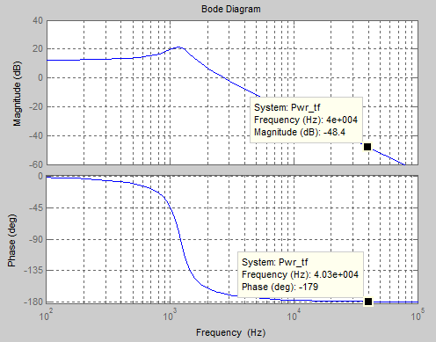
Figure 39 – Power system with maximum input voltage in open-loop
Along with this information, other values are chosen in order to design the PID compensator. Taking the phase margin (PM = 45°, from Table 10) allows for the gain K and second pole to be found. The phase margin along with the phase of the power system ($∠P=-179°$, from the above plot) can be used to determine the phase of the compensator ($∠G$). This is computed in Equation 25.
$$\left(25\right) ∠G=-180°+PM-∠P$$
$$∠G=44°$$
This value, along with the previously mentioned values will allow for Equation 26 to be used to find the second pole of the feedback system:
$$\left(26\right) {∠G}_{ωco}=\tan^{-1}\left(\frac{ω_{co}}{ω_{z1}}\right)+\tan^{-1}\left(\frac{ω_{co}}{ω_{z2}}\right)-\frac{π}{2}-\tan^{-1}\left(\frac{ω_{co}}{ω_{p1}}\right)-\tan^{-1}\left(\frac{ω_{co}}{ω_{p2}}\right)$$
To convert the frequencies from Hz to rad/sec, each is multiplied by 2π. Rearranging the equation, Equation 27 solves for ω_{p2}.
$$\left(27\right) ω_{p2}=\frac{ω_{co}}{\tan\left[\left(-\left(∠G-180\right)*\frac{π}{180}\right)+\tan^{-1}\left(\frac{ω_{co}}{ω_{z1}}\right)+\tan^{-1}\left(\frac{ω_{co}}{ω_{z2}}\right)-\frac{π}{2}-\tan^{-1}\left(\frac{ω_{co}}{ω_{p1}}\right)\right]}$$
$$ω_{p2}=1.1753*{10}^{6} rad/sec$$
Dividing this value by 2π, the second pole lies at the frequency 187.055 kHz. Next, the gain of the feedback loop will be found (Equation 28) from all the frequency values, along with the magnitude of the power system (Equation 29, -48.4, from Figure 39):
$$\left(28\right) 20log\left|G\right|=-20log\left|P\right|$$
$$\left(29\right) 20log\left|G\right|=20logK+20log\sqrt{1+({\frac{ω_{co}}{ω_{z1}})}^{2}}+20log\sqrt{1+({\frac{ω_{co}}{ω_{z2}})}^{2}}$$
$$-20logω_{co}-20log\sqrt{1+({\frac{ω_{co}}{ω_{p1}})}^{2}}-20log\sqrt{1+({\frac{ω_{co}}{ω_{p2}})}^{2}}$$
Substituting Equation 28 into Equation 29, Equation 30 is used to solve for K.
$$\left(30\right) K={10}^{(-\left|P\right|-20log\sqrt{1+({\frac{ω_{co}}{ω_{z1}})}^{2}}+20log\sqrt{1+({\frac{ω_{co}}{ω_{z2}})}^{2}}-20logω_{co}-20log\sqrt{1+({\frac{ω_{co}}{ω_{p1}})}^{2}}-20log\sqrt{1+({\frac{ω_{co}}{ω_{p2}})}^{2}})}$$
$$K=2.6515*{10}^{6}$$
With these newly obtained values, a PID compensator can be designed to fit the power system. The transfer function for the compensator is found in Equation 31.
$$\left(31\right) G\left(s\right)=K*\frac{\left(1+\frac{s}{ω_{z1}}\right)\left(1+\frac{s}{ω_{z2}}\right)}{s*\left(1+\frac{s}{ω_{p1}}\right)\left(1+\frac{s}{ω_{p2}}\right)}$$
Using MATLAB, the magnitude and phase of the compensator can be seen in Figure 40.
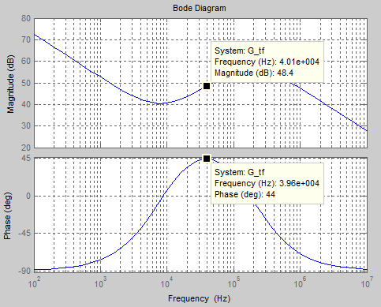
Figure 40 – Compensator with maximum input voltage in open-loop
It can be seen from the labeled values in the plot that the compensator is properly designed for this system, under the circumstances of maximum input voltage and virtually no load. From Equation 28, it is known that the magnitude for the compensator is equal in magnitude to that of the power system, but with the opposite sign. Since the magnitude of the power system has been previously determined to be -48.4 dB, this figure correctly proves the magnitude of the compensator to be +48.4 dB. This figure also proves the compensator has been designed correctly as the phase 44° is identical to the calculated phase from Equation 25.
With the power system and feedback loop already analyzed, the magnitude and phase of the entire loop can be observed. This is done by multiplying the transfer functions of the power system and compensator together, resulting in Equation 32, representing the transfer function of the entire system:
$$\left(32\right) T\left(s\right)=\left(\frac{V_{in}}{V_{osc}}*\frac{0.5R}{s^{2}LCR+sL+R}\right)\left(K*\frac{\left(1+\frac{s}{ω_{z1}}\right)\left(1+\frac{s}{ω_{z2}}\right)}{s*\left(1+\frac{s}{ω_{p1}}\right)\left(1+\frac{s}{ω_{p2}}\right)}\right)$$
This transfer function, when put into MATLAB, outputs the following Bode plot, shown in Figure 41.
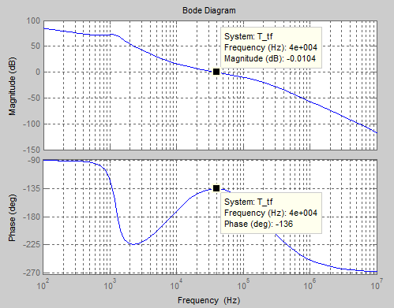
Figure 41 – System with maximum input voltage in open-loop
From this plot, it is seen that the magnitude at the crossover frequency is very near zero, which is the defining characteristic of the crossover frequency. To assess the phase of the system, the Equation 33 is used.
$$\left(33\right) ∠T_{ωco}=-180°+PM$$
Plugging in the 45° used for the phase margin, leads to a phase for the entire system of -135°. The phase of the system in the above plot is almost equivalent to the value calculated here. With all of these calculated values, the system is now able to be simulated using the LT Spice program.

Maximum Input Voltage Closed-Loop Design
The second case that will be looked at will be that of maximum input voltage in a closed loop system. The highest value that will be accepted by the system is known from Table 10 to be V_{in,max} = 25 V. Other values taken from Table 10 are L = 62 μH, C = 280 μF, T = 2.5 μs, and V_{osc} = 3 V. Looking at the transfer function of the power stage from Equation 24, the only value that will be changed from the previous case is the resistance. The resistance of 1.27 Ω from the open loop case is replaced by a 148 Ω resistor, as listed in Table 2. The following Bode plot displays how this affect takes place in Figure 42.
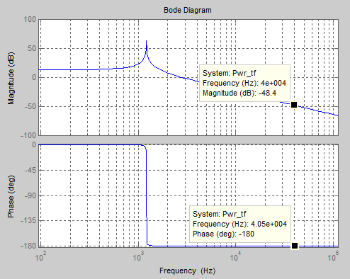
Figure 42 - Power system with maximum input voltage in closed-loop
Comparing this figure to the bode plot of the power system with maximum input voltage in open-loop (Figure 39), it can be seen that the shapes have changed, but the values at the crossover frequency of 40 kHz have remained almost the same. The magnitude is still -48.4 dB, and the phase has only changed 1°, from -179° to -180°. Applying this value along with the phase margin as given in Table 10 to Equation 25 will give the phase of the comparator in this system to be$∠G=45°$. This value can be used in Equation 27 to get the frequency of the second pole for this system. After converting from radians per second, the result is f_{p2} = 204.44 kHz. With this change of the pole also comes a change in the gain. The new gain for the compensator using Equation 30 to be K = 2.6420 x 10⁶. Plugging these values into the transfer equation (Equation 31) will yield the following Bode plot for the compensator (Figure 43).
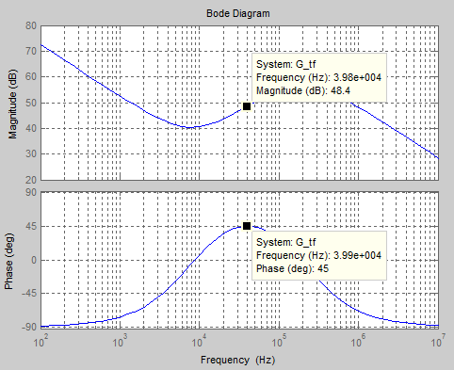
Figure 43 - Compensator with maximum input voltage in closed-loop
This plot justifies the claims of this system thus far, as the magnitude of the compensator is equal in magnitude and opposite in sign to the magnitude of the power system. The phase of the compensator in this figure agrees with the calculated value. The last step of analysis is to get the transfer function of the entire system (Eq. 32) by evaluating the product of the respective transfer functions for the power system and compensator. Solving in MATLAB, the Bode plot (Figure 44) that follows is the outcome.
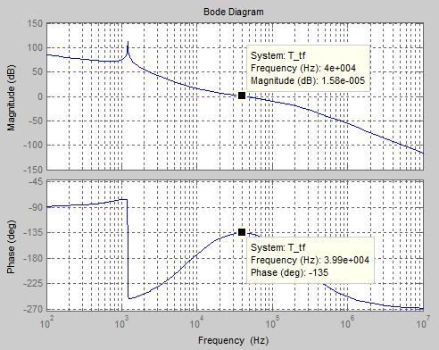
Figure 44 - System with maximum input voltage in closed-loop
It is seen from this figure that the magnitude of the entire system is properly evaluated at zero. Also, the system phase is correct as -135° as proven by Equation 33. This concludes the section for understanding how the system would operate under the condition of maximum input voltage. It is noted that the system changed very insignificantly between the two cases. This is due to the fact that resistance does not much affect in the power stage. To observe this, the transfer function from Equation 24 can be rearranged by dividing by resistance R, as shown in Equation 34.
$$\left(34\right) P\left(s\right)=\frac{V_{in}}{V_{osc}}*\frac{0.5}{s^{2}LC+s\frac{L}{R}+1}$$
This modification highlights how minimal the effects of the resistance are in the system. The next two cases will deal with a different input voltage, which appears to have more weight.

Minimum Input Voltage Open-Loop Design
Next, the two cases where the system will receive minimum input voltage will be tested. It can be seen that there was little difference between the two systems solved for maximum input voltage. Only the resistance was changed between those two cases. Now that the input voltage is changing, it is hypothesized that this will change the system parameters more significantly. Plotting the transfer function for the power stage (Eq. 24) in MATLAB will produce the following (Figure 45).
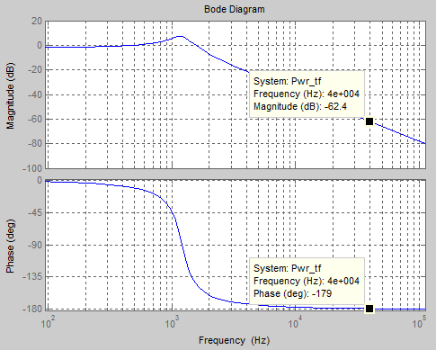
Figure 45 - Power stage with minimum input voltage in open-loop
Comparing this plot to that of the open-loop system with maximum input voltage (Figure 39), it is noted that the magnitude has changed considerably. The phase, however, has remained the same. This means that the phase of the compensator will be the same, or $∠G=44°$. Since this phase is the same, the second pole can be assumed to be equal as well, and is therefore located at f_{p2} = 187.055 kHz.
As previously stated, the magnitude has changed, and is -62.4 dB for the power stage in this system. This will lead to a different gain needed for the compensator in this system. Substituting this new value of magnitude into Equation 30 will show that the compensator requires a gain of K = 1.3289 x 10⁷. This is larger than the previous gain values by a factor of 10. To see how this affects the system, the transfer function for the compensator (Eq. 31) is plotted. This is shown in Figure 46.
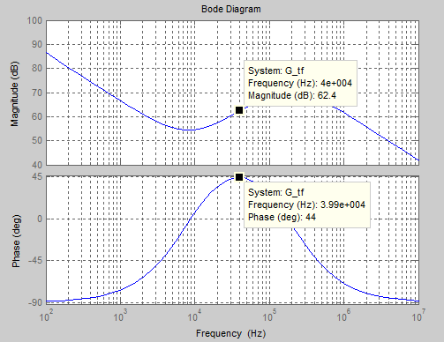
Figure 46 - Compensator with minimum input voltage in open-loop
Comparing this plot to that of the open-loop system under maximum input voltage (Figure 40) shows that the two plots have virtually the same shape. The only change is in the magnitude. At the crossover frequency, the magnitude of the compensator is 62.4 dB, and the phase is 44°. With the power system and compensator evaluations complete, the transfer functions for each are used as before to produce the transfer function for the entire system (Eq. 32). This overall transfer function is visible in the following Bode plot (Figure 47).
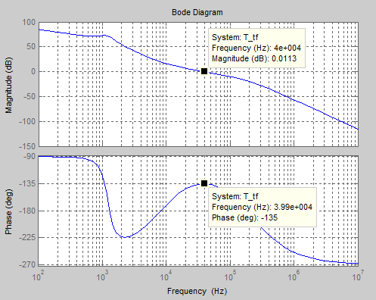
Figure 47 - System with minimum input voltage in open-loop
Again, a familiar shape is seen and similar values as well. The magnitude of zero and phase of -135° shows that the system has been designed correctly under the given parameters.

Minimum Input Voltage Closed-Loop Design
The last case that is yet to be evaluated is the closed-loop design of the system when it receives minimum input voltage. The only difference between this closed-loop system with the open-loop one is the resistance. When designing the system for maximum input voltage, this change in resistance had little effect. To see how it will affect the system with minimum input voltage, the first thing to look at is the transfer function of the power stage (Eq. 24). The following Bode plot (Figure 48) displays the changes undergone in the power stage.
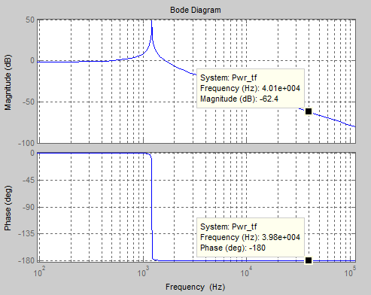
Figure 48 - Power stage with minimum input voltage in closed-loop
The magnitude, when compared to the prior case in open-loop, is the same, and the phase has changed by one degree. This is exactly the same change that took place from open-loop to closed-loop for the cases of maximum voltage. The phase of the compensator will change one degree from the open-loop case, to $∠G=45°$. This slight change has an effect on the second pole frequency, making it f_{p2} = 204.44 kHz from equation 27. This will lead to a new gain value for the compensator. Using Equation 30, the gain is found to be K = 1.3242 x 10⁷. These values are used in Equation 31 to get the transfer function for the compensator, which is plotted below in Figure 49.
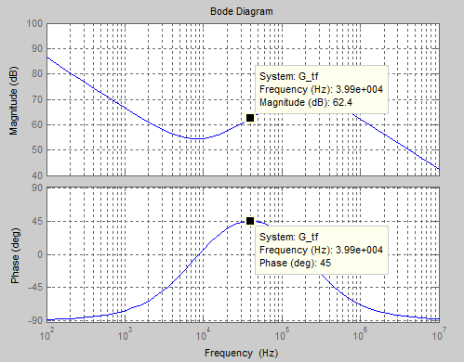
Figure 49 - Compensator with minimum input voltage in closed-loop
The shape of this Bode plot is a familiar one, and the values for the magnitude and phase of the compensator are highlighted at the crossover frequency. The magnitude is 62.4 dB and the phase is 45°. The transfer function of the entire system is shown below, and is obtained through the same process as before, by multiplying together the transfer functions of the power stage and the compensator, shown in Figure 50.
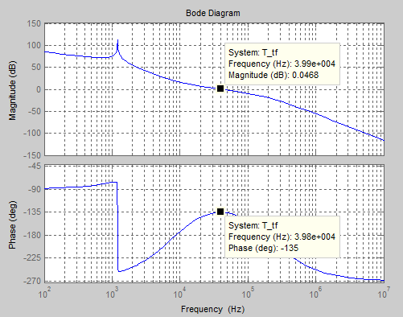
Figure 50 - System with minimum input voltage in closed-loop
The magnitude of the system is zero at the crossover frequency and the phase is -135° at this point. This is backed up by the calculations carried through in these sections. This concludes the evaluations of the system under all four extreme cases.

Compensator Design
Now that the system has been studied in the extreme cases, the resistor and capacitor values for the compensator can be found. The first two zeros have been assumed, as well as the first pole. The gain K and the second pole are what changes in each case. The table below lists the different values for these variables in each case.
 | Maximum voltage input |  | Minimum voltage input
 | Open-loop | Closed-loop | Open-Loop | Closed-Loop
f_{p2} (kHz) | 187.055 | 204.44 | 187.055 | 204.44
K | 2.6515 x 10⁶ | 2.6420 x 10⁶ | 1.3289 x 10⁷ | 1.3242 x 10⁷
Table 11 - Second Pole and Gain for extreme cases
The design of the compensator involves the use of three capacitors, three resistors, and an operational amplifier. Equations 35 - 39 will provide this information, based on the zeros, poles, and gain of the compensator.
$$\left(35\right) f_{z1}=\frac{1}{2πR_{2}C_{2}}=8000$$
$$\left(36\right) f_{z2}=\frac{1}{2πC_{3}\left(R_{1}+R_{2}\right)}=8000$$
$$\left(37\right) f_{p1}=\frac{1}{2πR{}_{2}\left(\frac{C_{1}C_{2}}{C_{1}+C_{2}}\right)}=200,000$$
$$\left(38\right) f_{p2}=\frac{1}{2πR_{3}C_{3}}=187,055$$
$$\left(39\right) K=\frac{1}{R_{1}\left(C_{1}+C_{2}\right)}=2,642,000$$
The values for the second pole and the gain have been chosen as their lowest respective values from Table 11. These values are chosen as such to provide the compensator with the highest valued components, which in turn will ensure stability for all of the extreme cases, and therefore for the system as a whole. Since there are six variables and only five equations, R₁ is assumed to equal 1000 Ω. The values are listed in Table 12.

Resistance |  |  | Capacitance
Component | Calculated | Actual | Component | Calculated | Actual
R₁ | 1000 Ω | 1 kΩ | C₁ | 15.14 pF | 15 pF
R₂ | 54.751 kΩ | 54.9 kΩ | C₂ | 363.361 pF | 360 pF
R₃ | 44.679 Ω | 44.8 Ω | C₃ | 19.0435 nF | 20 nF
Table 12 - Resistor and Capacitor values for Compensator
The values solved from the set of equations (Equations 35 - 39) are listed in the column ‘Calculated’. The common values that will be used for designing the compensator are listed in the column ‘Actual’. The actual values will be used to carry out the simulation in LT Spice.

AC Analysis
After completing the calculation of the values for the plant circuit and the controller, AC analysis will be performed on different stages. The power stage is examined in the buck case using the highest possible input voltage. The 25 V input voltage will be analyzed to represent the highest extreme end of the spectrum. For the 25 V input voltage, the power stage will b simulated using the close and open loop load resistances. The compensator will be implemented and its magnitude will be plotted. The loop gain and phase will be graphed. Finally, the simulated closed loop will be analyzed.

Power Stage
The power stage of the converter consists of the topology not including switching. This power stage is best assumed in the buck case where SW2 is open and the voltage is taken at the node V₁ after SW1 as represented in Figure 51. The power stage also has the diode D2 in a forward bias mode and for simulation purposes the input voltage will be driven by an AC sweep.
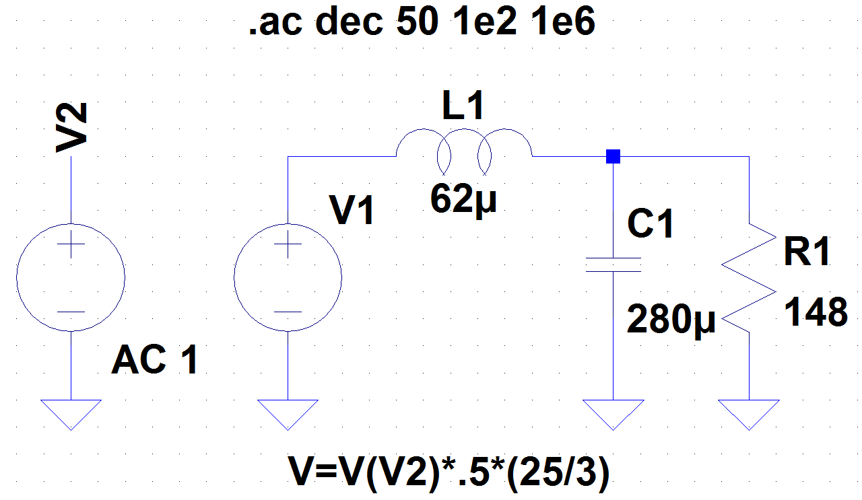
Figure 51 – Closed loop power stage
It is understood that the reference voltage is being taken to be 7.4 V, half of the ideal output battery charging voltage; therefore in the power stage the swept AC signal is multiplied by .5 to represent this gain and the PWM. The pulse-width-modulation is V_{IN}/V_{OSC} = 25/3. A 148 Ω load resistance is assumed to represent the extreme case of the closed loop. The plotted magnitude and phase of the power stage is presented in Figure 52.
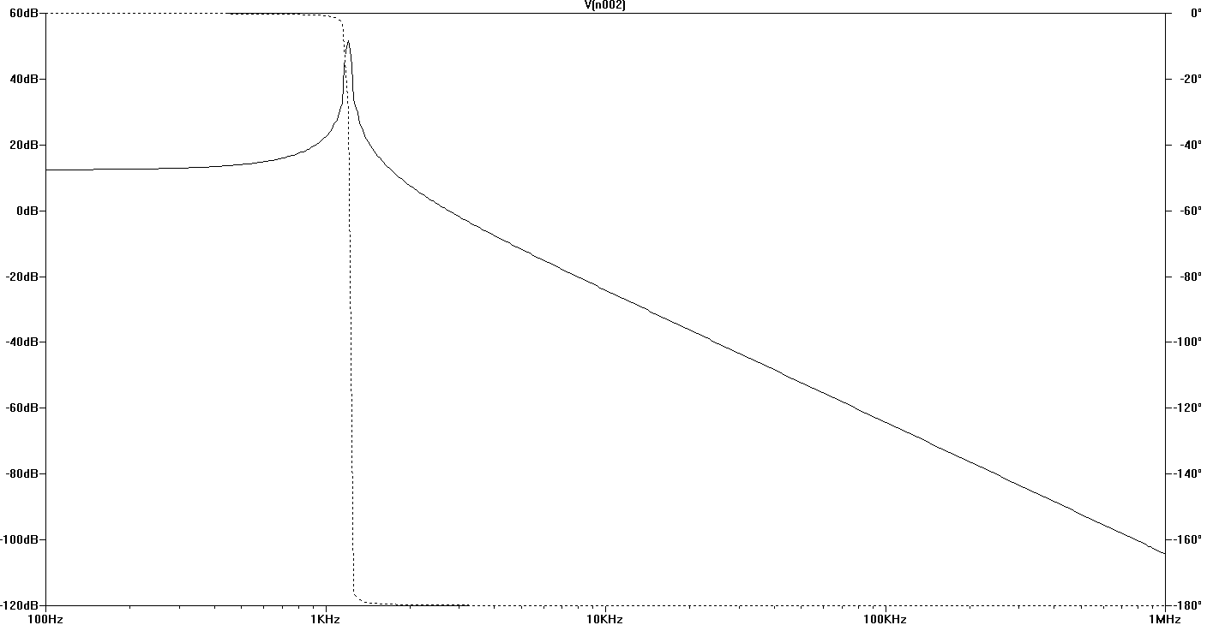
Figure 52 - Power stage magnitude and phase
The same power stage circuit is taken with the minimum output resistance of R_{O}=1.27 thus representing closest to the open loop mode of the buck-boost. This AC swept circuit is shown below in Figure 53.
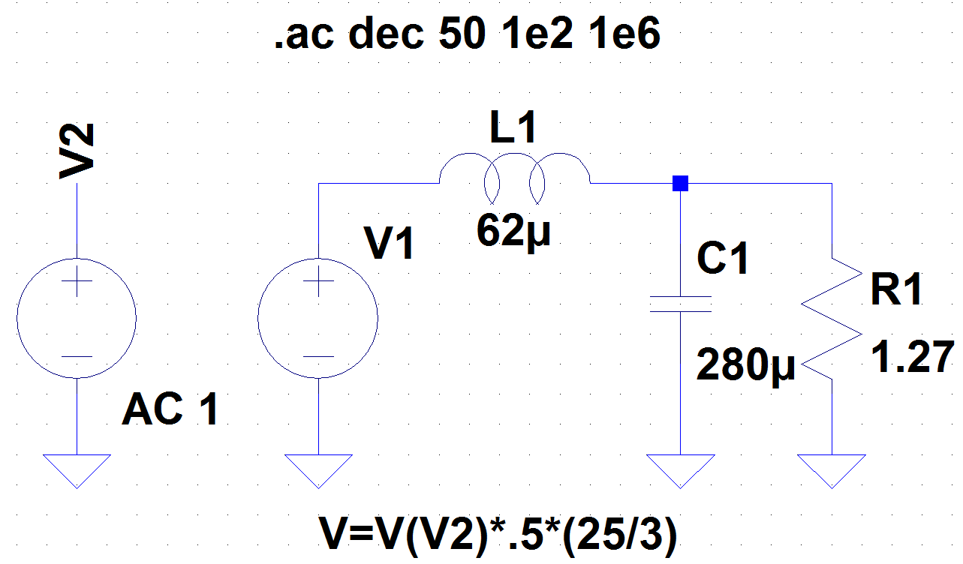
Figure 53 - Open loop power stage
The AC analysis of the circuit is performed as a decade sweep in LT Spice with 50 points per decade and a start to stop frequency of 100 Hz to 100,000 Hz. This simulation command is shown in the upper line by .ac dec 50 1e2 1e6. The x-axis of the magnitude and phase plots in Figure 52 and Figure 54 is the frequency axis in Hz, where the y-axis is measured in decibels (dB.)
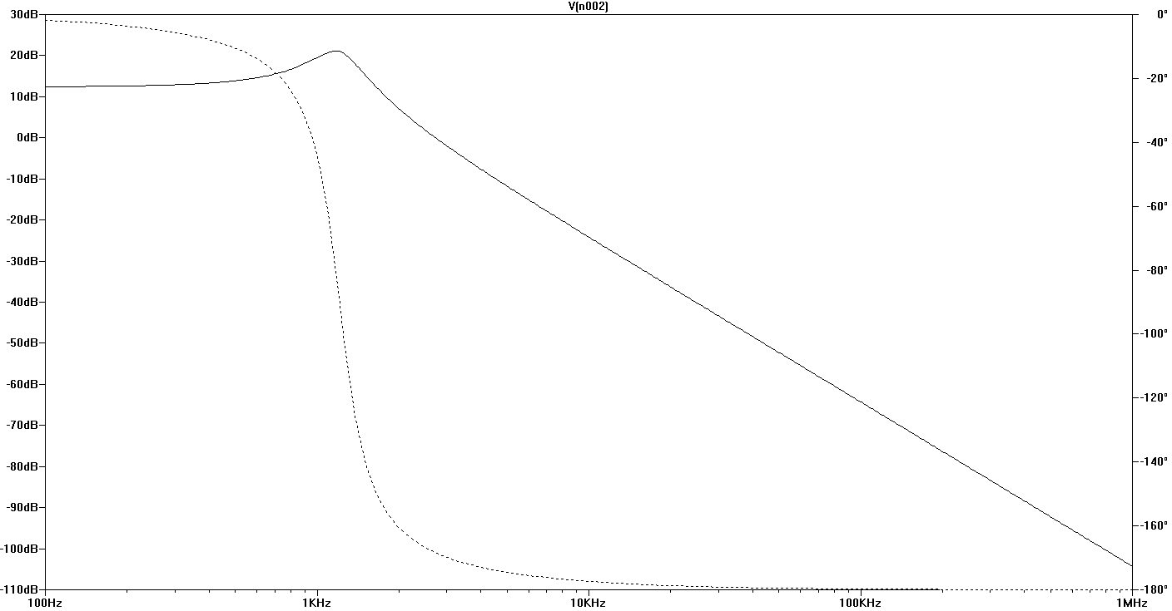
Figure 54 - Open loop power stage
These Bode plots provided from the power stages in both the open loop and closed loop cases; provide exact information about the gain and phase for this specified frequency range. They commonly assist the designer in selecting a compensator structure that lead to the proper phase margin and crossover frequency. The power stage is a discrete model that can be used to get estimates of transient performance. It becomes an inevitable consideration in assuring a system’s stability.

Compensator
Using the SISO design tool, Single-Input Single-Output, is a GUI based interactive compensator designer. SISO uses Bode diagram, root locus diagrams and Nyquist techniques to help the user generate a stable compensator. It offers various compensator architectures similar to the one shown in Figure 55.
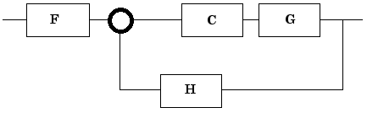
Figure 55 - Compensator architecture
Now that the power plant has been analyzed, the compensator will be analyzed individual using the previously calculated values to examine the V_{error}. The compensator uses the poles and zeros to ensure stability when the loop is closed. Figure 56 displays the circuitry involved in the compensator.
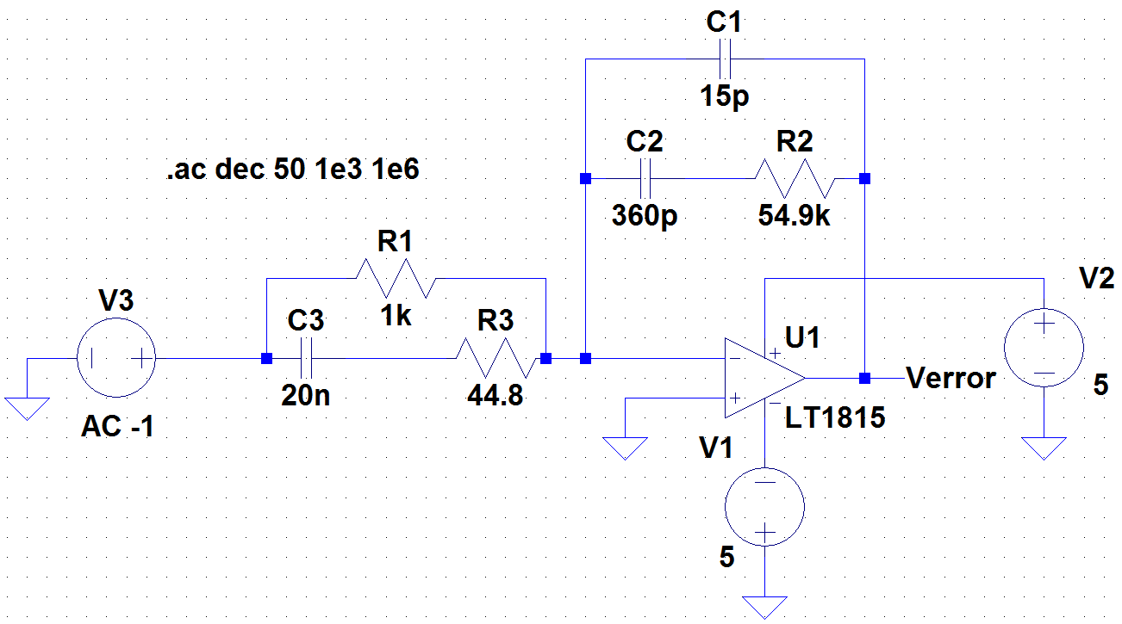
Figure 56 – Compensator
The compensator ensures the stability in a closed-loop feedback system. The phase shift at unity gain is normally stable between 30° and 60°. The compensator is commonly known as the error amplifier, it shapes the frequency response as it pleases the phase margin. Common practice is to choose the crossover frequency to be around 20% to 25% of the switching frequency. The phase and magnitude of the compensator is shown below in Figure 57.
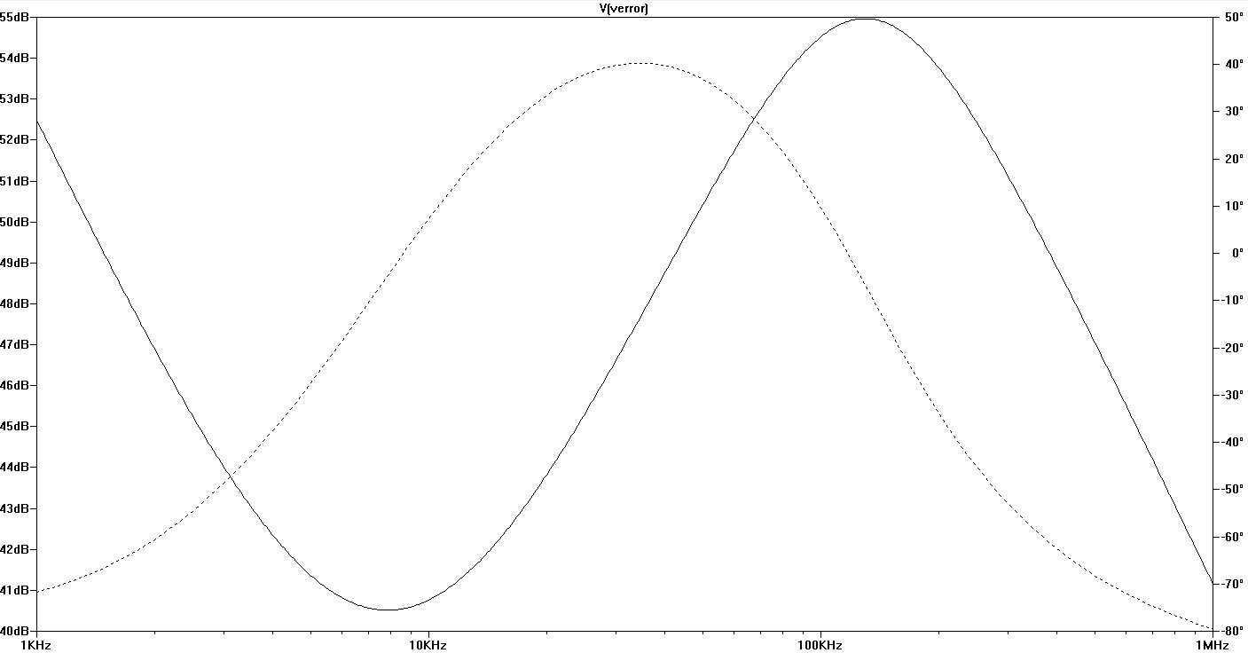
Figure 57 - Compensator magnitude and phase
The phase response of the compensation network in Figure 57 is used when the slope of the open-loop magnitude response of the converter at the unity-gain is at a crossover frequency of -20 dB/decade. In Bode plots, a zero introduces a phase lead while a pole in the denominator introduces a phase lag.

Loop Gain
Plotting the loop gain and phase takes the power stage and compensator from Figure 51 and Figure 56 and combines them into one simulation. The power stage of the buck-boost was previously simulated using an AC to sweep to control the input voltage, but in the combined loop gain, the input voltage is retrieved from the compensator error. The error amplifier stays similar to Figure 56. The loop gain is an important tool for analyzing the stability of the system, its primary benefit and use, and is displayed in Figure 58.
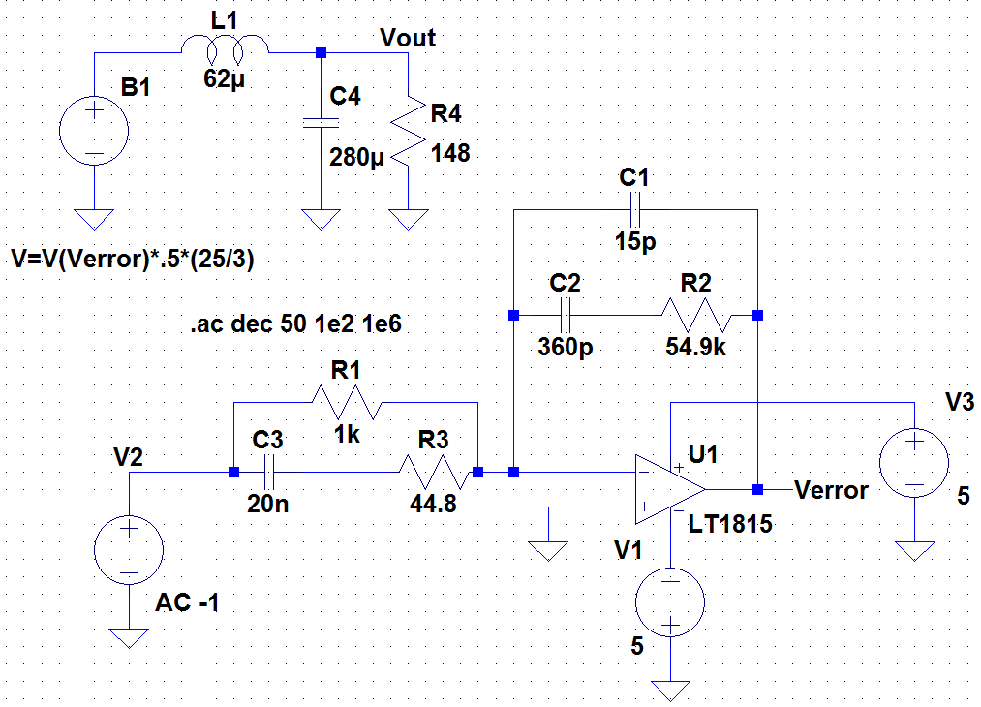
Figure 58 - Loop gain
The loop gain is developed to quantify the gain of the system using the feedback loops. The loop gain is the response to a disturbance leading to that disturbance. With a given compensator, changing any given component may significantly affect stability of the converter. Therefore the values of these resistances and capacitances, despite having been calculated for the particular case, may be changed if stability could be increased. If the output filter capacitor was changed in a power stage of the circuit then not only would the stability of the system be changed considerably, but the compensator would have to be redesigned for these changes.
The phase indicates how stable the converter is. The majority of loop gain usage to determine and change stability is based on experience. The designers are working in practicing the generation of the loop gain using the SISO tool from the MATLAB suite to better adjust the poles and zeros to manufacture a stable efficient compensator.

Switching
There are two PWM drivers; both of them use saw-toothed pulses in conjunction with the V_{error} from compensator to output a modified square wave with an adjusted duty cycle. The new duty cycle is adjusted respectively based on the error and sent back as a new modified pulse control of SW1. This form of recovery using switching allows the system to stabilize at the desired output. This also minimizes the ripple as necessary. How the driver works is shown in Figure 59.
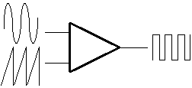
Figure 59 - PWM driver
The pulse controlling Vsaw1 is a modified square wave. The square wave is modified by adjusting the T_{RISE}(s) and the T_{FALL}(s). The T_{RISE}(s) is set 4.9µs, a large period of time compared to the period which is 5µs. The T_{FALL}(s) was set to 10ns which provides a sharp return to zero. Since there are two switches in the modified buck-boost being implemented for the CALBOX, the switches must be set controlled correctly to get output the correct duty cycle into the power stage of the system. The switching pattern that must be achieved was shown in Figure 26. This switching configuration would be difficult to simulate correctly, so the saw wave (Vsaw1) to output (Vsw1) relationship had to be understood.
The square wave (switching) rises at the instance the saw starts rising continuously for the time in which the pulse is being injected into the op-amp. The vertical axis of Figure 60 is the voltage on; this voltage plays a large role in getting the proper switching. Since the square wave is a product of the saw-tooth wave, getting the correct T_{RISE}, T_{PERIOD} and T_{DELAY} are the three important variables to getting the correct switching. The best method to get the switching of SW2 within the on time of SW1 through multiple cycles and not just the first can be analyzed below in Figure 61.
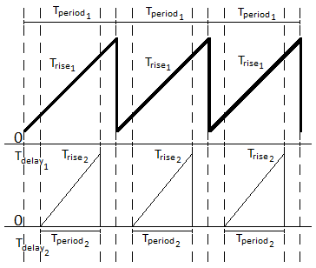
Figure 61 - Saw-tooth relationship attempt 1
The above scheme was initially adopted to try and achieve the switching theme in Figure 26, but the problem realized was that the delay was a one-time initial shift therefore the saw wave would actually be as represented in Figure 62.
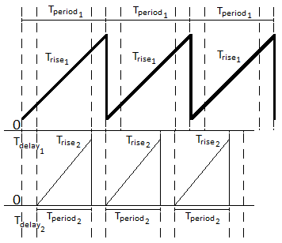
Figure 62 - Improper switching result from saw-tooth attempt 1
The problem above is easily noticed, after just 1 cycle, the 2nd saw wave was shifted negatively by T_{delay 2} and this would continue at n*T_{delay 2} where n = cycles. The next attempt would involve providing a T_{delay 1} not equal to 0 as in attempt 1 and changing T_{delay 2} to twice T_{delay 1}. This change to the delay corrects most of the problem except for one unforeseen difference that results from the square to saw relationship in Figure 60. The changes incorporated in the two PWM circuits reflect the switching relationship below (Figure 63) which accurately echoes the simulated results.
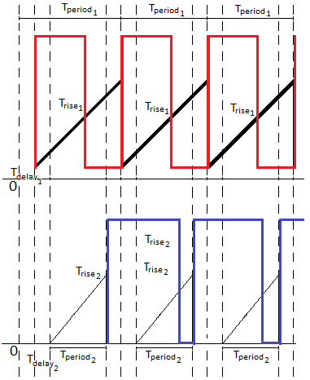
Figure 63 - Proper switching
Calculating the means of controlling both switches simultaneously was a simple but very important achievement. During trail of the different switching attempts and methods, the difference in the desired output was apparent. Although the switching was correct, the use of it was done in reverse. SW1 actually assumed the square wave within that of SW2. To resolve this issue, the values were flipped on the switches.

Closed Loop
The closed loop system incorporates the loop gain and the MOSFET PWM controllers into one combined circuit where every part depends on the other. The formerly reviewed loop gain consists of the compensator and the power stage which were controlled by a sinusoidal source with disregard of the switching. Previously, the compensator had no reference voltage to compare to and now compares the filtered output of the analogue converter after a .5 gain with 7.4 or half of the desired final output voltage.
The full closed loop implementation is displayed in Figure 65
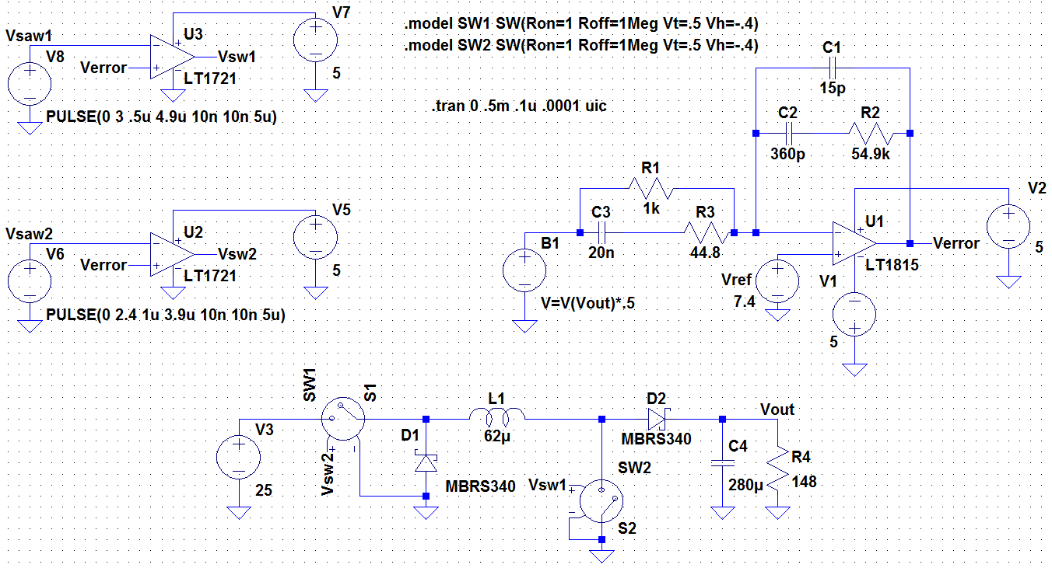
Figure 65 - Closed loop complete system

Output Voltage Ripple
Ideally, the output voltage has no ripple, the entire output current from the inductor passes through the filtering capacitor in parallel to the load. The value of the capacitor is an important parameter in any design because it affects the total design of the system. Aside from the design, it also affects the overall size of the system as well. It determines how much of the ripple from the switches is being filtered out. The 280µF capacitor chosen for the converter is very large, reducing most of the ripple similar to ideal. This option may be changed to a lower capacitor size in the future to a tolerable voltage ripple.
The current cost of the chosen capacitor C4 is $40 per component. This is very expensive and must be considered. The voltage ripple (Figure 66) can be examined with at different filtering capacitor sizes to show the effects on the output voltage ripple.
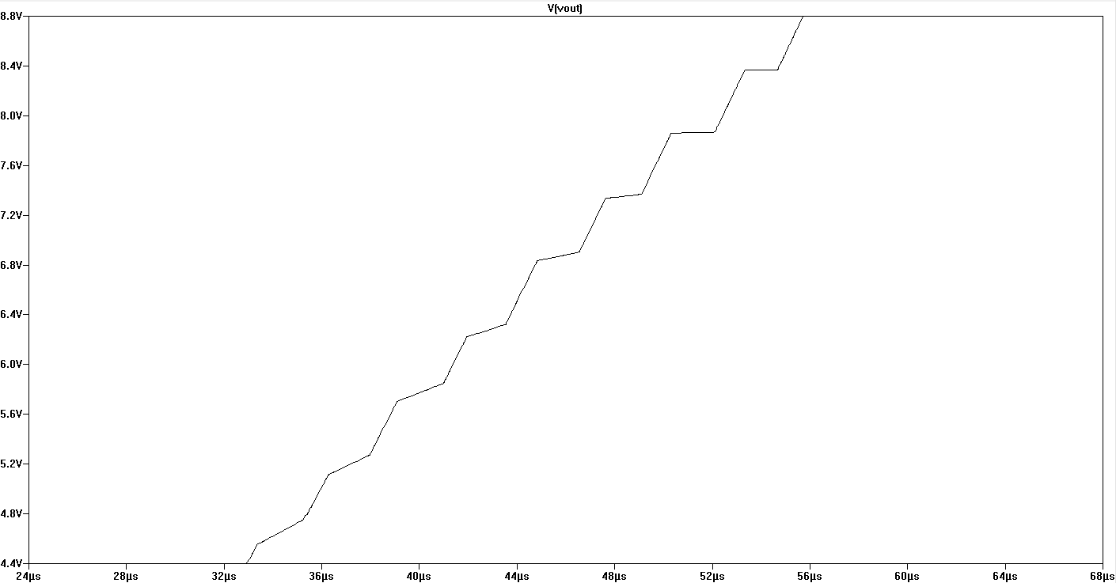
Figure 66 – 20uF output voltage ripple
The spice simulation in Figure 66 shows the ripple with a 20µF capacitor. The ripple in this simulation is tolerable but the design team prefers a closer to ideal case for the output of the circuit. Figure 67 below shows the difference in the voltage ripple for the case used in the CALBOX 360. The voltage ripple is noticeably much smaller that the first.
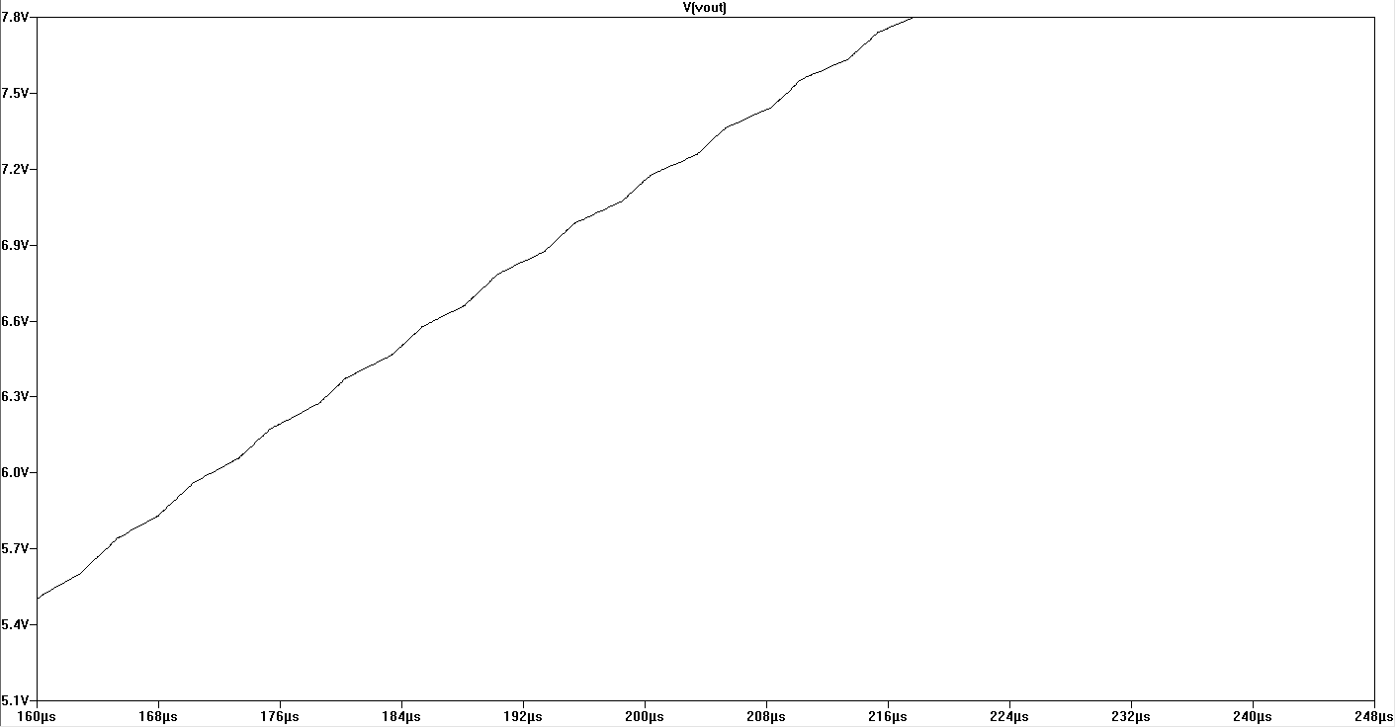
Figure 67 - 280uF output voltage ripple
Measuring across the output of the analog circuit will show the climb to the desired voltage and the reading after settling. The voltage will initially overshoot its destination but self-correct. This output voltage is represented in Figure 68.
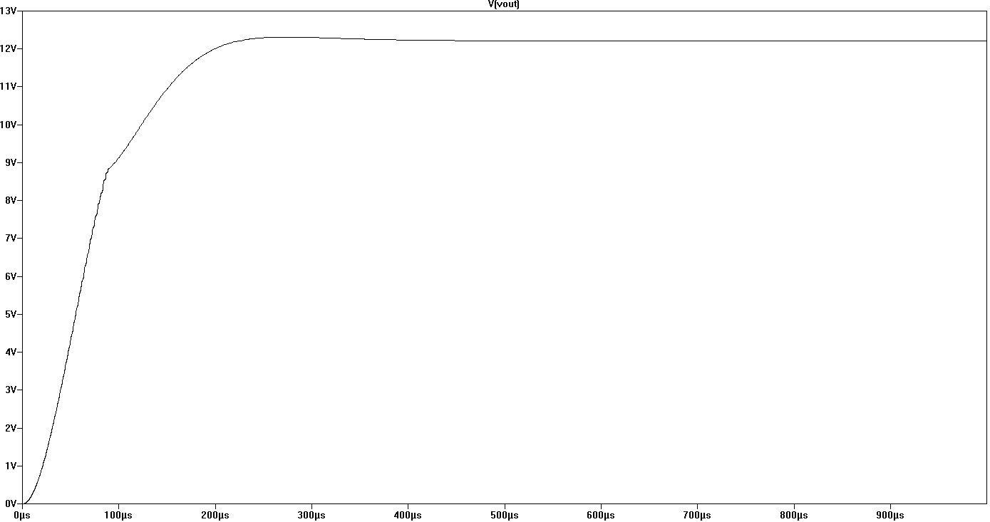
Figure 68 - Output voltage of the system
In Figure 68, the voltage settles down at 12.4 Volts which is less than the original cautiously chosen 14.8 V. The system has to be reexamined as whole, part by part to determine why the output is less than desired. Various changes may be necessary and all new calculations to assure new stability in a new case would be done. Overall, the system for the DC-DC buck-boost has been designed properly and complete.

Microcontroller

Overview
The microcontroller(s) in the CALBOX360 will interface with the various components, produce mathematical calculations, provide timing operations, and otherwise be the middle man between our power components and our user. Most common microcontrollers have integrated Flash, EEPROM, and SRAM allowing programs, memory, and registers to be stored for immediate or future use.
The microcontroller(s) will need to take input in the form of voltages and current from the DC/DC regulator and the Battery Management System (BMS) in order to calculate caloric loss and battery state of charge (SoC). It will forward these calculations to the local LCD in a form clearly understandable to the user. It will also have to forward this information to the integrated wireless transmitter component that will in turn forward this to our wireless receiver on the server side.
Inputs | State of charge of the Battery (voltage)
Inputs | Voltage from Generator
Calculations | Time left on battery
Calculations | Calories burned
Calculations | Calories burned for total session
Calculations | % Battery charge
Outputs(LCD) | Calories burned
Outputs(LCD) | % Battery charge
Outputs(Wireless Module) | Calories burned for total session
Outputs(Wireless Module) | Total time of session
Table 13 - I/O overview

Topology
The overall role over the microcontroller is described above is best represented in Figure 69. The diagram clearly shows the desired inputs and outputs coming out of each of the power modules, and outputting results to their respective modules.
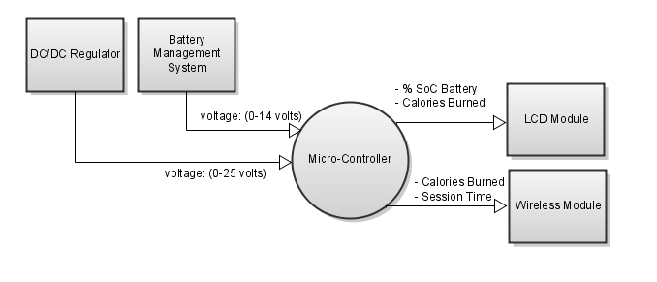
Figure 69 - Microcontroller Topology

Types of Microcontroller
A variety of microcontrollers exist that would suit the purposes of this project. Considerations for choosing a proper microcontroller include the following:
- Cost
- Specifications
- Programmability
- Development Boards
- Platform popularity and accessibility
The two major houses of competing microcontrollers include the Microchip PIC family and the Atmel AVR. A decision of what type of microcontroller that will be chosen by the designer will be made from looking at these two families and a comparing the considerations that are most relevant to the project.

AVRs
The Atmel AVR is an 8-bit RISC single chip microcontroller developed by Atmel and is heavily used in small to medium sized projects and devices. They feature low power, high performance, with a single cycle instruction RISC CPU.

The most common group of Atmel AVRs consists of the megaAVR (ATmega), which specifications fall into the following ranges:
Program Memory | 4-256kB
Pins | 28-100
Features | Extended instruction set, Extensive peripheral set
Table 14 - megAVR specification range
Under this group, there exists the ATmega48PA, ATmega88PA, ATmega168PA, ATmega 328P. These are the favored microcontrollers of the megaAVR family for many development platforms such as the Arduino chipset. These would be prime candidates for our microprocessor selection. These chips all offer the same instructions and peripheral support and only differ in their memory specifications and boot loader support.

Device | Flash | EEPROM | RAM
ATmega48PA | 4K Bytes | 256 Bytes | 512 Bytes
ATmega88PA | 8K Bytes | 512 Bytes | 1K Bytes
ATmega168PA | 16K Bytes | 512 Bytes | 1K Bytes
ATmega328P | 32K Bytes | 1K Bytes | 2K Bytes
Table 15 - Memory size summary for ATmega series
The ATmega328P is the most recent and provides the best specifications, and with each chip only costing a few dollars, the price is not an issue. Therefore, if an AVR microcontroller would be used it would most likely be the ATmega328P for these reasons.

 | Speed | Voltage | Flash | EEPROM | RAM
ATmega328 | 20Mhz | 1.8V-5.5V | 32K Bytes | 1K Bytes | 2K Bytes
Table 16 - Chosen microcontroller specifications

The Arduino platform
The Arduino is a development platform providing a programming and IO interface to the Atmel AVR series of microcontrollers. The platform gives the user an IDE (Integrated Development Environment) in which the board can be programmed using a C/C++ based programming language. It also provides a USB interface to which the host computer can communicate with the Arduino hardware controller, allowing easy programming of the ATmega AVRs as well as a serial communications between host and Arduino.

The main advantages of using the Arduino board in relation to the designer’s needs include:
- Popularity and community: a wealth of open source code to reference.
- Modularity: A number of modules, or shields, exist that extend the feature set of the Arduino. These include wireless data transmission (Wi-Fi, Zigbee) shields, Ethernet shields, LCD modules, potentiometers, LEDs and more. All which have supported code libraries already created for use.
- Price: $20-$30 price range with a ATmega microcontroller already included means that multiple Arduinos can be used in one project if necessary.
- Programmability: With its easy to use IDE, common C/C++ language, and already available code libraries, more time can be spent on implementation than designing.
- Serial interface: The included libraries and hardware support for serial communications allows for RS-232 transmissions between the Arduino hardware controller and a host. Other code platforms can access this serial connection on the host such as Java, and C#, giving the user a way to create user interfaces and applications that communicate with the Arduino either wirelessly or through the USB connection.

There exist many versions of the Arduino board, official and open source versions, with the Arduino Duemilanove being the most recent official USB board. As seen in Figure 70 below, it provides all the needed components for the designers’ specifications including: multiple analog input pins, USB I/O for easy programming, 5V and 9V for powering itself and other external components, expansion pins for attaching shields, such as the XBee shield module, and serial send and receive pins for sending serial data to an external device.

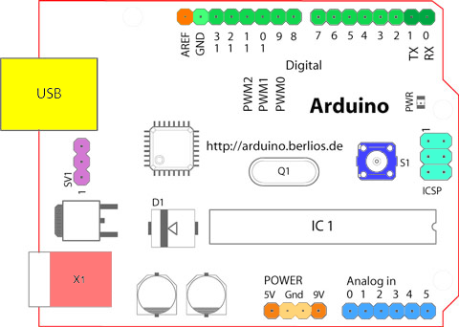
Figure 70 - The Arduino Duemilanove USB board layout

PICs
The PIC family of microcontrollers is a series of chips developed by Microchip Technology. They are generally referred to as 14-bit core microcontrollers, but some of the latest series have 16bit or even 24 bit cores.
The 16F series PIC microcontrollers were considered the go to chip for hobbyists and embedded devices for a long time, and they still do exist in modern iterations with flash memory. As of today, most PIC embedded designs are done with the 18F series which feature high performance, and extended memory capable of handling most small electronics based projects. These are what many consider the direct competitors to the Atmel AVR ATmega chips. A list of 18F series chips sold by Microchip Technology currently are listed below
Device | Flash | EEPROM | RAM
18F252 | 16K Bytes | 256 Bytes | 1K Bytes
18F442 | 8K Bytes | 256 Bytes | 1K Bytes
18F452 | 16K Bytes | 256 Bytes | 2K Bytes
18F4550 | 13K Bytes | 256 Bytes | 2K Bytes
Table 17 - 18F chip options
The prime choice would of course be the one with the highest performance and on board flash and memory. The 18F4550 device would be the optimal choice if the PIC family of chips is chosen as the microcontroller component.
Other considerations include the microcontroller’s community support, very helpful in finding informational resources, its available development platform, programmability and price. The PIC family has high marks on all of these except its development platform. It doesn’t have a complete platform that the AVRs have with the Arduino. The PICs also require the designer to have a fair knowledge of assembly in addition to the C/C++ programming language.

Choice of Microcontroller
Although the competing PIC 18F series and the AVR ATmega series chips hardly differ in the performance and memory specifications, the designers have decided to go with the ATmega series due mainly because of the Arduino platform. This platform will allow the designers to create a complete working system with widely available resources and libraries that support a wide array of external display and wireless modules. It also provides a greater focus on the code and development rather than wiring and PCB design.

Liquid Crystal Display

Overview
The purpose of an LCD serves to present the user with relevant information to their current active session. The LCD will take inputs from the microcontroller and present the user with the following information in an obvious and understandable way:
- Calories burned so far during a session:
  - Calories being a form of energy, a function will be devised to calculate calories burned by a function of time, and voltage/current outputs from the power components. This will be presented as a number that will increment in time intervals with a final value presenting to the user at the end of a session.
- State of charge of the battery:
  - In most Battery Management Systems, a range of voltages being produced by the battery can be measured to provide a state of charge. This will presented in a percentage format or from a color state from a LED. This may have to be presented to the user at all times to give a warning to when the battery will completely discharge and shutdown the system.

The HD44780 Character LCD chipset
The Hitachi HD44780 chipset is an industry standard character LCD commonly used in embedded devices. They come in a variety of sizes MxN, where M is the number of columns or characters for that for that row, N is the number of rows. Common Sizes include 8x1, 16x2 and 20x4. For the purposes of this project, the designer chooses to use incorporate a 16x2, with each required information string displayed on its own line.

The Arduino and the HD44780
The Arduino board has a built in library called LiquidCrystal for communicating with the HD44780, which simplifies the design process as it removes programming of the low level registers, and is all handled through the Arduino board and high level C/C++ language. A potentiometer can be used to change the contrast level of the LCD and exists between the 5v power source on the Arduino board and the LCD module. The Arduino board and the LCD module are shown, connected, in Figure 71.
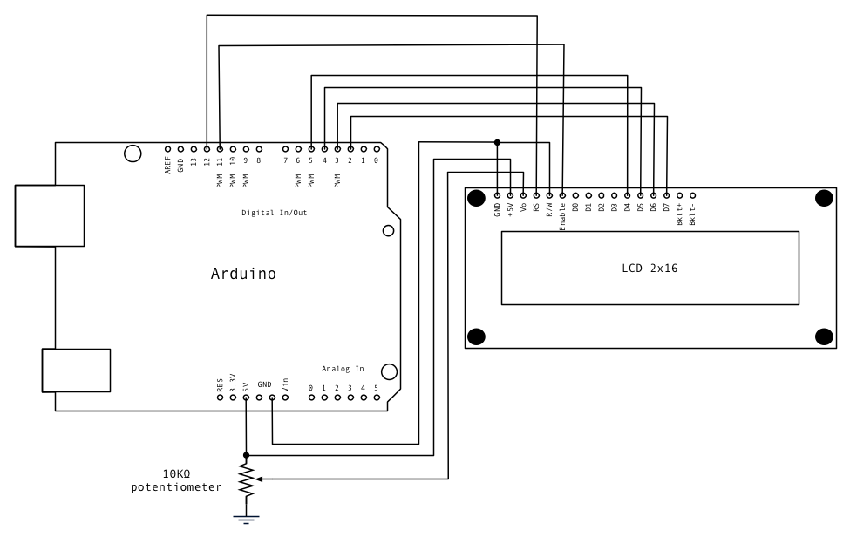
Figure 71 - Arduino board and a 16x2 LCD Module circuit layout with a potentiometer

Wireless Communications

Overview
There must exist a communication link between the central microcontroller platform and a software application running on an external laptop or desktop as to send data pertaining to the user’s session to a database. As the designer would like to keep the main CALBOX360 housing un-tethered except to the video game console, wireless communications based on IEEE wireless protocols is the obvious choice.
The wireless protocol and compatible device should provide the following:
- Low power usage: As a small battery (9V, multiple 1.5V battery) will be providing power, it is imperative that a wireless solution that requires very small power usage is used.
- Low cost
- Serial communication: Compatibility with the RS-232 standard is required as it will be used to send session data, voltage information, etc…
- Range: Normal household ranges (50-100 meters)

The Zigbee Standard
Zigbee is a networking standard based on the IEEE 802.15 protocol, more specifically the 802.15.4. It is characterized for having very low power usage due to a low data rate, low cost, and considerable range compared to other standards based off the 802.15 protocol such as Bluetooth. It is commonly used in low power mesh networks, supporting nodes up to 65,000, with the ability to self heal and encrypt these networks. Zigbee based chipsets are also common in sensor monitoring, automotive, and home automation applications. The Zigbee stack can be seen in the Figure 72.

Figure 72 - The Zigbee stack
Low power usage in the ranges of the 1mW scale, low cost of approximately $12.00 a chipset, ranges that provide 100 meters inside and 300 meters(clear line of sight), and ability act as a serial pass-through, all requirements are sufficiently satisfied. The Zigbee protocol and devices excel in all other areas over other similar technologies when compared to the designer’s intentions.

XBee and the Arduino
The XBee module is a Zigbee derivative radio module from MaxStream and operates in the ISM 2.4 GHz band (unlicensed). It follows all standards set forth by the 802.15.4 protocol. It has the specifications in Table 18.
Indoor Range | 100 feet (30 meters)
Outdoor Range (line-of-sight) | 300 feet (100 meters)
Transmit Power | 1 mW
Receiver Sensitivity | -92 dBm
Width | 1.8 inches
Height | 0.83 in
Length | 2.87 in
Weight | 1.60 oz
Table 18 - XBee specifications

XBee Shield
The XBee wireless module can be connected easily to the Arduino platform through use of the XBee Arduino Shield. It provides a hardware interface between the Arduino and the XBee module which fits on top of existing pins on the Arduino without having to wire a separate circuit board. It will automatically power and step down the 5V rail voltage on the Arduino to 3.3V for the XBee module, as well connecting the Serial Receive (RX) and Serial Transmit (TX) pins on both the XBee module and the Arduino. It also has the ability to place the XBee in USB mode for programming or XBee mode for wireless communications, through jumper pins. This will need to be used fairly often when developing and testing code and communications. Both the XBee shield and module are shown below in Figure 73.
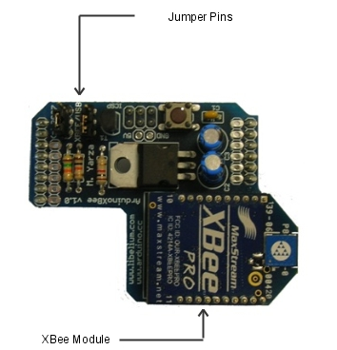
Figure 73 - XBee shield with an XBee module attached

Communications

Configuring the XBee Module
XBees operate in one of two modes: Either AT mode or API mode. For the purposes of the project, the designers will place the XBees in AT mode, or serial pass-through mode, and have the XBee just pass through the serial data coming out of the Arduino wirelessly to the another XBee connected to the PC through a Serial to USB interface.
For two XBees to communicate with each other they must have matching PANIDs, serial baud rates, and their respective receive/send channels must match, as in the sender channel on one must match the receiving channel on the other. The PAN ID is 4 digit HEX number used to a set an ID for a Personal Area Network, in which any XBees with matching PANIDs will join. The baud rate must also be set to match with any of the following rates: 2400bps, 4800bps, 9600bps, 19200bps, 38400bps, 57600 bps, 115200 bps. The designer’s decided to use the 57600bps rate, which is comparable to a 56k modem. Speed is not high priority, there will only be a small string of serial data being sent in the order of a few bytes a second.
The devices must be configured with either a standard serial terminal and serial modem commands, or software such as the X-CTU program from MaxStream, the creators of the XBee. The X-CTU provides a graphical user interface for sending AT commands which read and write to the configuration registers on the XBee module. It also has the ability to update the firmware on the connected device. The GUI can be seen in Figure 74 below modifying the PAN ID to a desired value.
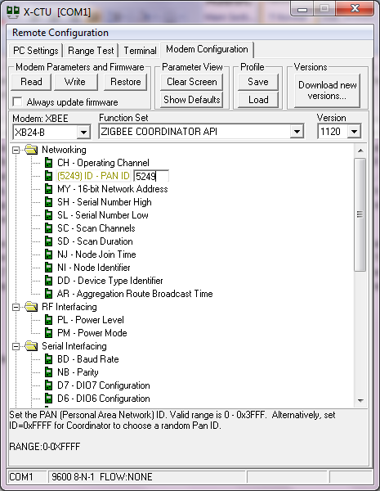
Figure 74 - X-CTU GUI
By default, XBee modules are able to communicate with each other in AT mode out of the box. So that wireless communications belonging to the CALBOX360 are not interfered by another XBee network, the default values will be changed to specified values. The PAN ID, destination address, and receive address are all 16 bit numbers represented by 4 digit hexadecimals. The values needing to be changed are in the table below.
 | XBee on the Arduino |  | XBee on Computer
Name/Description | Default Value | New Value | Default Value | New Value
PAN ID | 3332 | 5249 | 3332 | 5249
MY: Source Address | FFFF | 10 | FFFF | 11
DL: Dest Address | 0 | 11 | 0 | 10
BD: Baud Rate | 3(9600) | 6(57600) | 3(9600) | 6(57600)
Table 19 - XBee modifications
Entering these values into X-CTU, the values are written to the registers and the XBee’s should now be able to communicate with each other. In each PAN network, there is always one coordinator Zigbee device. The coordinator is what sets the PAN ID and initializes the network. Once the PAN ID is set it is what allows other routers and end devices to connect. Routers can be other Zigbees and they can allow end devices and other routers to connect to the PAN. End devices can also be other Zigbee modules, computers or sensors. These end devices must be able to buffer their data, so that when they return to communications with a coordinator from either not being in range, or asleep, they will send whatever is in the buffer. The coordinator and end device mode is set through AT commands using X-CTU.
The coordinator in the CALBOX360 system will be the XBee connected to the shield, connected the Arduino, while the receiver node will be an XBee module connected to an XBee USB Explorer through USB. The XBee USB Explorer is a chipset that provides 3.3 V power through the USB power rail, as well as a serial interface through the same bus.

Calorie Calculations
The CALBOX360 requires a method for calculating caloric expenditure in human beings through the exercise of pedaling. A calorie can have many definitions in the physical sciences, but for the purpose of weight loss and exercising it is usually defined as a unit of measurement for the amount of energy food provides, and a measure of the amount of energy expended through physical activity. The second definition will be the most pertinent to the designer’s calculations.
A person’s metabolic rate is average expenditure of calories from everyday activities including sleeping. An exercise calorie, or the calories burned through any physical activity such as walking, jogging, running, bicycling, or jump-rope are categorized by their level of intensity in the form of a unit of measurement called METs, or Metabolic Equivalent of a Task.
A MET can be defined as a metabolic unit that expresses the amount energy, specifically oxygen, expended at rest or at sleep. Any physical activity with energy expenditure greater than that of rest will have a MET level that is a multiple of 1. Below is a chart with various activities and their MET level.
METs | Activity
1 | sitting quietly and watching television
2 | walking, less than 2.0 mph, level ground, strolling, very slow
3 | loading /unloading a car
4 | bicycling, < 10 mph, leisure, to work or for pleasure
5 | tennis, doubles
6 | skiing, downhill, moderate effort, general
7 | climbing hills with 0 to 9 pound load
8 | rock or mountain climbing
9 | running, cross country
10 | swimming laps, freestyle, fast, vigorous effort
11 | running, 6.7 mph
Table 20 – Various activity METs chart
For the purposes of measuring the intensity level of the pedaling done on the CALBOX360, the designer’s determined to have six ranges of pedaling intensity associated to 6 ranges of MET levels. When a user is not pedaling, they are at rest and there for have an MET level of 1, for all other pedaling intensities the METs levels are given below.
METs Level | Pedaling Intensity
1 | No pedaling, at rest
3 | Low Intensity
5 | Low to Medium Intensity
7 | Medium Intensity
9 | High Intensity
11 | Very High Intensity
Table 21 - Pedaling METs
Using a METs value, the number of calories burned or expended can then be calculated using Equation 40.
$$\left(40\right) Calories Burned=\frac{METs×3.5×Weight(kg) }{200}×Minutes$$
Since the designers will not include a way to input a users weight, the average weight of a college student will be used, 155 lbs. If a student pedals for 60 minutes with a high intensity they will have burned 629 calories.
Calculating the calories burned using a MET approach circumvents measuring wattage and converting to calories. However, the efficiency of the system makes it so that 75% of the user’s calories are lost in heat dissipation and other losses. For this reason, and through the evaluation of empirical data, it has been estimated that approximately only 25% of the user’s energy is actually transferred to the battery. Taking this into consideration, Equation 40 is altered, and Equation 41 relates calories to the CALBOX.
$$\left(41\right) CALBOX Calories= \frac{METs×3.5×Weight(kg) }{200}×Minutes×4$$

Microcontroller Design

Inputs into the Arduino USB Board
For the purposes of measuring pedaling intensity and battery charge, the designers need to be able to measure the voltage outputting from the generator and the battery. These can be measured with specific analog pins on that Arduino board. The analog pins on the board can map input voltages between 0 and 5 volts and returns those readings into a 10bit digital integer value from 0 – 1023 using the analogRead(x) function, where ‘x’ is the pin being analyzed. Each single increase in value between 0 and 1024 represents 4.9 mV.
The analog pins can only take in a maximum of 5 volts and 40mA, so the voltages must be scaled down using a voltage divider in both cases. The generator, in its maximum output state will produce 24 volts and the battery will output a maximum voltage of 13.2 volts. The maximum battery voltage may change if the designers decide to change the type or size of battery. This battery voltage also indicates a fully charged battery. Nominal voltage will hover around 12 volts.
These values are then compared against either a METs intensity range chart for the generator values, or a battery charge percentage chart for the battery input through a C code program on the Arduino.

Input from the Generator/DCDC Regulator
Pedaling will cause the DC generator to generate anywhere from 0 to 24 volts. After this voltage is scaled down to somewhere between 0 to 5 volts using a voltage divider, the positive input will be connected to the analog ADC pin 0 and a common ground. The pin will be initialized in the Wiring C program and set to read a voltage between 0 – 5 volts as an ‘int’. It then must be multiplied by .0049mV and casted as a float to get a high precision of total millivolts. A sample function to read the voltage in Wiring C code is shown in Figure 75.
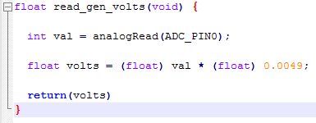
Figure 75 - Voltage readings
This voltage is sampled with a frequency of 1Hz, or 1000 milliseconds, and compared to a METs intensity charge. Voltages that fall within preprogrammed ranges are assigned a METs value to be used to calculate the amount of calories that are burned per minute. The values for calculating the METs number are shown in Table 8.
A function to calculate the calories burned per second will be implemented derived from the Equation 40. All variables in the function can be initialized as ‘int’ due to not needing any high precision and that Wiring C ‘int’s can provide a number between -32,768 to 32,767, more than enough for any of the variables in the calculations.
Using the METs/Voltage table as a reference, a dynamic METs value can then be obtained with the calcMETS(float) function. The calcMETS(float) function will take in the number of volts an return a number of calories burned that second. Another function caloriesBurned() will return an ‘int’ that will give the amount of calories burned per second. This value will be continuously be incremented at the same rate as the voltage is sampled (every 1 second) to give a total amount of calories burned per session (totalCalsBurned). This value will be used to update the LCD at 1 second intervals. This value will also be used to send to the software application listening over a serial connection with the XBee Zigbee modules at the end of a session.
In summary, the high level flow of calculating calories burned from a voltage input is as follows:
- Initialize variables and pins: analog pin 0 (ADC_PIN1) in setup phase of the Arduino code
- In the main loop of the Arduino code, read the scaled voltage from analog pin 0 using readV_gen(void) function.
- Use the voltage float returned from the generator and pass it into the calcMETS(float) function to obtain a METS intensity value, based off preprogrammed values.
- Use the the METs number returned from calcMETS() to calculate the calories burned per second using the calcCalsBurned().
- As the program loops, the calories burned will be continually incremented.
- Every second the total calories burned so far is displayed to the LCD.

Input from the Battery
The Arduino will serve the role as the microcontroller in the Battery Management System. It will need to properly calculate the state of charge of a battery in percentage form. To achieve this, a measurement voltage value will be obtained from the battery and read by the analog pin 1 on the Arduino board. This voltage, like the voltage from the battery, will need to be scaled down to a reading between 0-5V. The voltage coming from the battery can be anywhere from 0 – 13.6V on max load, so a simple voltage divider will be used to scale down this voltage to levels the Arduino can accept.
Based on discharge levels over time provided by the battery manufacturer, the designers are able to determine a proper voltage scaling chart that will approximate the state of charge of the battery. Based on this Figure 8 - Discharge characteristic of UB12350, a table with a range of voltages and corresponding battery charge percentages is presented in:
Percent Readout | Open Circuit Voltage (VDC) | Scaled Voltage (VDC) | Comments
100% | $$12.3 ≤V <13.2$$ | $$4.55 ≤V <4.88$$ | Max voltage to be limited to 13.2VDC
90% | $$12.1 ≤V <12.3$$ | $$4.48 ≤V <4.55$$ | Linear voltage discharge range
80% | $$12.0 ≤V <12.1$$ | $$4.44 ≤V <4.48$$ | Nominal voltage
70% | $$11.6 ≤V <12.0$$ | $$4.29 ≤V <4.44$$
60% | $$11.4 ≤V <11.6$$ | $$4.22 ≤V <4.29$$
50% | $$11.2 ≤V <11.4$$ | $$4.15 ≤V <4.22$$
40% | $$11.0 ≤V <11.2$$ | $$4.07 ≤V <4.15$$
30% | $$10.8 ≤V <11.0$$ | $$4.0 ≤V <4.07$$ | Estimated at max load 60 minutes remaining of game play
20% | $$10.7 ≤V <10.8$$ | $$3.96 ≤V <4.0$$
10% | $$10.6 ≤V <10.7$$ | $$3.92 ≤V <3.96$$
0% | $$10.5 ≤V <10.6$$ | $$3.88 ≤V <3.92$$ | Conservative shut-down voltage
Table 22 - User state of charge readout breakdown
The microcontroller will read the voltages at a 1Hz (1 second) sampling rate using the readV_batt(). Since voltages could fluctuate, a filter function will be used to average in the last 10 voltage readings to give a percentage update at 10Hz. The voltages will be stored in an array of size 10 floats. As a second passes the oldest value in the array is bumped off, and the newest reading is added. In addition to averaging, the filter will check the latest number against the values it already has, if that value falls out of a 50% threshold, it will be ignored, since this is most likely an outlier and voltage fluctuation. The function will return the last 10 voltages readings as a single averaged float, and this will be checked against the pre programmed voltages vs. percentages with the calcBattPercent() function.
In summary, the high level flow of reading data from the battery is as follows:
- Initialize variables and pins: analog pin 1 (ADC_PIN1) in setup phase of the Arduino code
- In the main loop of the Arduino code, read the scaled voltage from analog pin 1 using readV_batt(void) function.
- Take the returned value from readV_batt(void) and calculate and add it to the last index of the battVoltArray[10] array using filterBattVoltage(battVolts) function.
- filterBattVoltage() function averages the last 10 voltages and returns voltage. If a voltage does not fall within a 50% threshold, it is ignored and not added to array.
- The result of the filterBattVoltage() is passed into the calcBattPercent() function and a percentage is calculated based on preprogrammed values.
- Percentage is presented to LCD functions
- Program loops, and continues to add voltages to the filter array every second.

Outputs from the Arduino
To give the user feedback from their pedaling sessions, both as they ride and over time using software, the Arduino needs to output to a local LCD on the system and over serial using an XBee wireless module to an external Windows PC. The LCD will provide instant feedback data such as State of Charge of the battery; calories expended so far at the current moment in time, and estimated total calories for the entire session.
To provide multiple session information to the user, an XBee Zigbee shield will be used as a wireless serial interface to send session data after each session to an external computer. It will transmit data from one XBee coordinator connected to the Arduino to another XBee module connected to a Windows PC through an XBee USB Explorer.

Output to the LCD Module
The chosen LCD module is the Hitachi HD44780 chipset. The Arduino platform uses a built in library to send numbers, characters, and strings to any device with this chipset, providing a very easy way to update the data that needs to be displayed to the user. The LiquidCrystal Library consists of the following functions that are needed to display the data:
- LiquidCrystal( )
- begin( )
- clear( )
- print( )
- setCursor( )
The LiquidCrystal() function will initialize a variable of type LiquidCrystal. It takes in the pins of the LCD device and maps them to the Arduino pins. It would resemble the following for the particular chipset we are using: LiquidCrystal lcd(12, 11, 5, 4, 3, 2); Where 12 is the RS pin, 11 is the enable pin. Arduino pins 5-2 are mapped to digital pins on the LCD D4-D7 respectively. This gives us an object called ‘lcd’ that now be called to start sending data.
The begin() function will allow the designer to set the amount of rows and columns of the HD44780 chipset. The designers have chosen a 16x2 character chipset, so this would be initialized using: lcd.begin(16,2); where 16 is the amount of columns in the display, and 2 is the amount of rows.
The clear() function will clear any characters currently displayed on the LCD. So that nothing stored in the memory of the LCD is displayed when a new session is initialized, the lcd.clear() function will be invoked at the beginning of each session.
The setCursor() function allows the cursor to be moved to a particular row or column. This will be useful in setting the characters to be written to the LCD without having to refresh the display completely every time something needs to be drawn. Initially the only two phrases will be drawn at the start of the session; “Cals Burned:” on row 0, starting at column 0 (rows and columns are initialized at 0) and “Batt Charge:” on row 1, starting at column 0. As “Cals Burned:” consists of 12 characters, to update the calories burned value as time passes, the setCursor() will appropriately start with row 0, column 13, giving 4 characters left to show the total calorie expenditure. The same practice follows with “Batt Charge”, although it will take in row 1, and column 12 as parameters.
The print() function is what allows the Arduino to print strings, longs, ints, char, and bytes to the LCD. It will take in any variable and print the value it currently holds. This will be used to not only print our main title values, “Cals Burned:” and “Batt Charge”, but it will continuously be printing the values of the calories burned so far, and the battery charge, based on the values obtained from those corresponding functions.
In summary, the high level flow of printing to the LCD will follow the following structure.
- Initialize lcd variable using Liquid.Crystal() and set appropriate pins
- Initilize the rows and columns that the LCD device is capable of using lcd.begin(m,n), where ‘m’ is the column, and ‘n’ is the row.
- setCursor to column 0, row 0 in the setup phase of the Arduino code
- Print “Cals Burned:” using lcd.print(string) in the setup phase of the Arduino code
- setCursor to column 0, row 1 in the setup phase of the Arduino code
- Print “Batt Charge:” using lcd.print(string) in the setup phase of the Arduino code
- As the calsBurned variable increases in the main loop of the Arduino code, setCursor to column 13, row 0, and use lcd.print(int) to print this value.
- As the batterCharge variable decreases in the main loop of the Arduino code, setCursor to column 13, row 0, and use lcd.print(int) to print this value.
- Repeat printing in main loop until session is over.

Output to the XBee module
As stated before, the local Arduino XBee module will act as a serial pass-through. This will be done through using the built in serial controls on the Arduino. Before a serial connection can be established between XBees, they must be paired together and be a part of the same PAN (See). There does not need to be any specific XBee libraries included since the XBee module is attaching directly to the RX (pin 19) and TX (pin 18) serial transfer pins of the Arduino through the XBee shield. The serial functions to be used include:
- Serial.begin(long): Initializes the serial baud rate depending on the parameter passed in. This will be set to 57600.
- Serial.println(str): This will print data passed in to the serial port followed by a carriage return.
The session data collected from the functions related to session time and calories burned need to be combined and packetized. The designers expect no session to ever exceed 9999 minutes and 9999 calories, so each respective datagrams will have 4 digits. To signify the end of the packet, a period (“.”) will be used and a new line will be printed. The format of the packet is shown below:
Calories Burned | Time | Escape character
0123 | 4567 | .
Table 23 - Packet format
The serial packet will be sent over as a string, so values obtained must be converted and in the case where they are not 4 digits, must be padded with zeros. In example would be receiving 200 calories burned with a session time of 40 minutes. The padString(int) function would be able to take in both int values and convert them to a 4 character string with padded zeros in front of the 200 and 40. These two values would be then passed into the formatPacket(int,int) function, which would concatenate both strings into one larger string, and add a ‘.’ character to the end. The resulting string would then be as follows: ‘02000040.’ This packet would now be ready for transmission and can now be sent using the Serial.println(str) command.
Since the packet should be sent at the end of a session, the system should determine when that is. The system will have no start and end button input to let the user signify a session end, so a idle check must be implemented. If the system has detected no significant voltage from the analog pins for at least 60 seconds, the system should then initiate a session end, and send the session packet over serial to the listening XBee. Similar to the method to check the filtered battery voltage, the system will store the last 60 readings of voltage data from the analog pins, and store them in array. If the array has 60 indexes and the average value of all the indexes of the array is less than .3 volts, the system will determine that the user is no longer pedaling and send the message over serial.
In summary, the flow of sending session data to a receiving XBee is as follows:
- Initialize the baud rate of the serial connection in the setup phase of the Arduino code using the Serial.begin(57600) function.
- Determine if the system is idle by using the idleCheck() function, in the main loop of the Arduino code.
- If the idleCheck() function returns true, the session has been determined to have ended, and the packet is prepared.
- Accumulated values from calsBurned and sessionTime are passed through the padString() function which converts their values to strings, and pads any needed chars with zeros.
- Resulting values from padString() are passed into the formatPacket() function to combine them and add the escape character. The resulting string is now ready for transmitting.
- The string is then sent over serial using the Serial.println(sessionPacket).
- System goes idle and waits for next session to begin.

Data types and Functions
Below are all the functions and variables deemed necessary for the system to operate under specifications. Functions and libraries standard to the Arduino platform are not included:

Data types
Variable | Data Type
totalSeconds | int
seconds | int
calsBurned | int
battVolts | float
battVoltArray[10] | array[float]
genVolts | float
totalMins | int
calsBurnedString | string
sessionTimeString | string
sessionPacket | string
idleVoltArray[60] | Array[float]
Table 24 - Microcontroller variables and data types (Wiring C)

Functions
Functions Name | Description | Returns (data type: description)
readV_gen(analog pin 0) | Read voltage from generator | float: Voltage from the generator
readV_batt(analog pin 1) | Read voltage from battery | float: Voltage from the battery
calcCalsBurned(metValue) | Calculate calories burned per minute | int: Calories burned per second
calcMets(readV_gen()) | Calculates a METs value from a given volts | int: METs value between 1 – 11.5
secs2Mins() | Calculates the number of minutes given a number of seconds | int: Minutes
mins2Secs() | Calculates the number of seconds given a number of seconds | int: Seconds
filterBattVoltage(battVolts) | Calculates the average voltage for the past 10 seconds. | float: Filtered voltage
calcBattPercent() | Calculates a State of Charge percentage from a given voltageReading | int: Battery Charge percentage
padString(int) | Generates a 4 char string padded with zeros if necessary from an int value | String: of size 4 containing parameter array padded with zeros to the left
formatPacket(calsBurned,totalMins) | Formats a packet to be sent over serial from values obtained from readings. | String: of size 9 containing the calories burned and total minutes as a packet with a ‘.’as an escape character.
idleCheck() | Checks the average of all values the idleVoltArray and determines if the system is idle. Array must be full. | Boolean: returns true if the system is idle, or false if it is still being used.
Table 25 - Microcontroller functions

Software

Overview
The software components of the CALBOX360 system will provide the user with a graphical representation of their past sessions on a host computer with an XBee modules attached. The Software will listen to serial communications between the XBee modules on the host computer side and the Arduino side, and will receive information containing total calories burned for that session and a timestamp.
The GUI will provide a list of all recorded sessions and their respective information, as well a line graph of past sessions over a span of time providing a user a visual representation of their progress and calories burned over time spans of weeks and months. A prototype GUI is displayed in Figure 76 below:
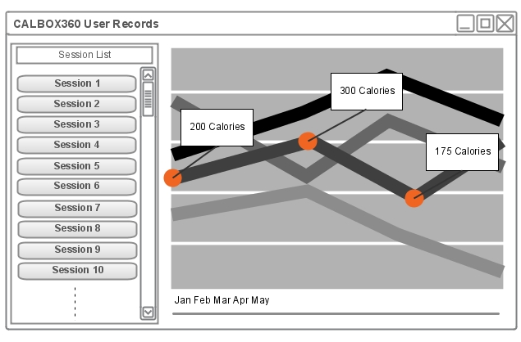
Figure 76 - Prototype GUI

Code Platform
The designer’s have decided to use Microsoft’s Windows Presentation Foundation (WPF) as the platform behind the software. WPF is a platform for creating graphical user interfaces built upon DirectX, allowing coders to implement modern UI features such as transparency, gradients, animations and 3D graphics through the use of the XAML markup language in conjunction with Microsoft’s objected oriented C# programming language.
A main advantage of using WPF is the ability to separate the GUI design from the back end functional code implementation. This allows for the general feel of the GUI to be prototyped and implemented through the XAML markup language without needing any functional code. This is important aspect in creating a rich and easy to use interface without having to debug functional code at the same time.
WPF includes the following features important to the designers:
- Graphical Services: Vector graphic support; good for multiple resolutions and DPIs. Many built in controls for buttons, list boxes, graphs/charts.
- Data Binding: Important in able to update the GUI elements with data stores in the application dynamically and instantaneously.
- Animations: Ability to implement rich animated content with limited functional code
- Templates: Grants the ability to apply overall templates and inheritances, giving the GUI a uniformed looked that can be updated dynamically.
- Layout: Provides layout controls for implementing organized layouts, allowing programmers to embed layouts within layouts.
- Rich Text: Includes rich text controls, giving the programmer total control of fonts, and access to the OpenType feature set.

Targeted System
Since the designers have chosen to use WPF as the platform for the software application, any PC with Microsoft Windows operating system that supports the latest .net Framework will be compatible. Windows operating systems have a very high penetration rate in U.S. households, so any user should have access to a PC that will launch the software. The designers recommend any PC with modern hardware, such as having at least 1GB of RAM, at least a 2 GHz single core processor, and enough free hard disk space to install the application. The PC will also need an open USB port. Below is a table with the designer’s recommended hardware and software specifications.

Hardware | Processor | 2 GHz single core Intel or AMD processor
Hardware | RAM | 1GB of physical RAM
Hardware | Hard Disk space | Up to 100MB of free hard disk space
Hardware | Video Card | Onboard video processor
Hardware | I/O ports | At least one free USB port
Software | Operating System | Windows XP SP2, Windows Vista, Windows 7, Windows Server 2008, Windows Server 203
Software | Additional Software | .NET framework 3.0 SP1
Table 26 - Recommended specifications

Software Requirements Specifications
Listed below are the Software Requirement Specifications for the software portion of the CALBOX360 system. These were determined through active discussion and questioning between designers of what the application needs to achieve.
SRS # | Requirement Description
SRS01 | The system must be able to accept serial communications from a set serial port.
SRS02 | The system must be able to understand and parse communications received from the serial port into usable data.
SRS03 | The system must be able to resume communications with a serial port if it has been changed or reset.
SRS04 | The system must be able to store session data in a recoverable and permanent way
SRS05 | The system must be able to take session data and present the data to the user in a readable and intuitive way.
SRS06 | The system must be able to list all previous sessions completed by the user in a visible and organized list
SRS07 | The system must be able to take all sessions and interpret them in a graphical way such as a line graph
SRS08 | The system must be able to let the user see at least the last 5 sessions on the graph
SRS09 | The system must be able to listen to communications after the user has performed actions and add sessions to stored data
SRS10 | The system must be able to let the user change the serial port for which the which communications will be obtained from
SRS11 | The system must allow the user to update the GUI with newly received sessions while the application is running
SRS12 | The system should be stable and not have performance issues
Table 27 - List of Software Requirements Specifications

UML

Class Diagrams
Below are the individual classes for the software application that have been designed to meet the requirements of the system. The 4 classes that will be included are Session, fXMLDatastore, SerialCommunications, and the MainWindow class.

Session Class
The Session class provides the ability for the application to create sessions with the appropriate information. This data includes: a session ID, timestamp of the session, calories burned for that session, and the total time in minutes of that session. The class contains methods to set and get each of the properties listed above and a constructor to initialize all properties. The class is instantiated by the XMLDataStore class.
C# Namespaces referenced: None

XMLDataStore Class
The XMLDataStore class allows for the interaction with the XML file used for data storing. This data store will hold all the sessions and its data in an XML format. The XMLDataStore class has an attribute containing the file name and an attribute for the XML document object. The class has a method that will first attempt to check if an XML document exists and if it doesn’t it will create a new XML file with the appropriate header. Sessions will exist as nodes in the XML file with all the necessary data. The class will de-serialize all the session nodes and instantiate objects to populate the session list in the main class. When a new session is sent over serial, a new node will be appended to the end of the XML file with the newly received data.
C# Namespaces referenced:
System.Xml, System.IO

SerialCommunication Class
The SerialCommunication class is largely responsible for handling serial communications received over a serial communications port on the local computer. It will select and open the proper port and be able to start receiving data. A serial communications object will be created and assigned the proper connection information such as baud rate, parity, port name, and com port. Data will be received as a packet that must be parsed by a method in this class to extract the calories and session time information. If any data exists in the serial buffer it will be first cleared, as the system will only be designed to be accepting new session information while it is actively listening, as to not have multiple older sessions be populated at a time while the program was not running. The XMLDatastore class will be instantiated in this class in order to pass each session’s data when received to the XML data store.
C# Namespaces referenced:
System.IO.Ports.SerialPort

MainWindow Class
The MainWindow will be the main class in the application and will be responsible for creating an initializing the graphical user interface, as well loading instantiating the serial communications class. It will first initialize the XAML file used to create the GUI which includes a listbox control, a chart control, button controls, menu, and layout controls. The listbox control will be used to populate a vertical list of all previously recorded sessions. The chart control will be used to populate the line graph with data from previously recorded sessions. A button control will be used to update the current session list and line graph with any new sessions that may have been received since application was loaded. A dropdown control will be used to select the COM port for which the serial device is connected to.
C# Namespaces referenced:
System.Windows.Controls.DataVisualization.Charting, System.Windows.Controls, System.Windows.Data, System.Windows.Documents, System.Windows.Input, System.Windows.Media, System.Windows.Media.Imaging, System.Windows.Shapes, System.Text

The class diagram for all the classes can be seen in Figure 77 below. It shows the composition of sessions from the XMLDatastore class as a 1 to many. It also shows the SerialCommunications class as an aggregation of the MainWindow class. All known variables, datatypes, constructors, and methods are listed in their respective classes and shown as public or private. Any method standard to the C# library is not included.

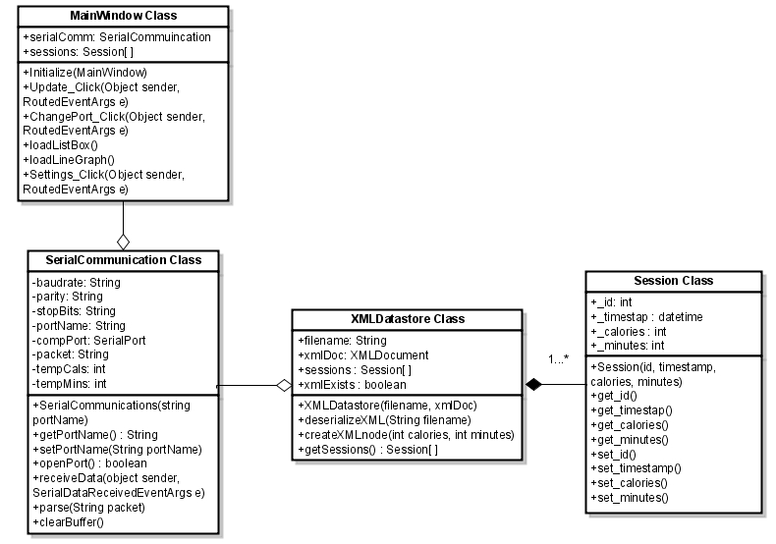
Figure 77 - Class Diagrams

MainWindow XAML
The XAML file will be responsible for the layout, design, and visual attributes of all the controls in the application. The designer’s approach will be to include base grid, a vertical stack panel control to hold a menu bar and another main content grid, a horizontal stack panel inside the main content grid, a list box, and a chart control with line graph attributes. A heavily simplified layout structure of the XAML is pictured in Figure 78 below.
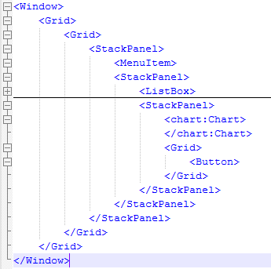
Figure 78 - Layout Structure
This XAML code expanded produces a skeleton GUI without the need for any of the functional code behind it. The expanded code produces the following application (Figure 79) when compiled.
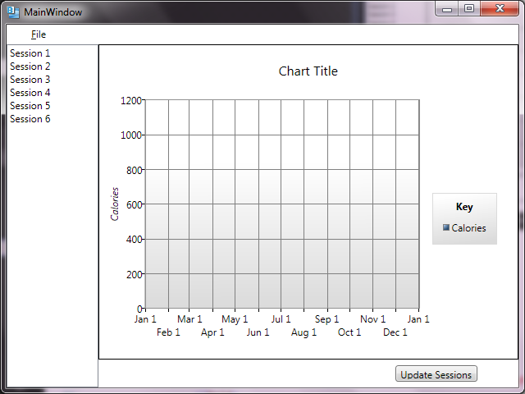
Figure 79 - Skeleton application

Activity Diagram
The activity diagram shows the flow of activities from when the software portion of the CALBOX360 system is first loaded, as shown in Figure 80.
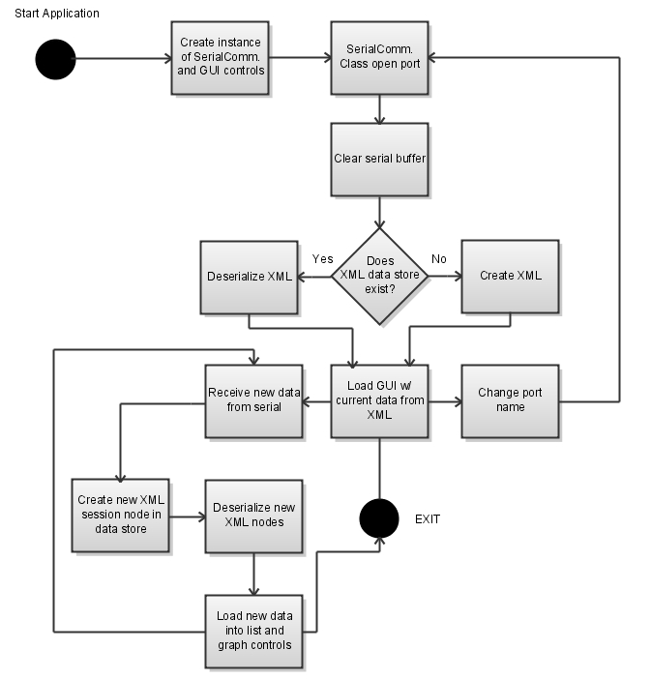
Figure 80 - Activity Diagram

Sequence Diagram
The sequence diagram (Figure 81) shows the interaction between the user and all the classes in the application. All known loops are shown.
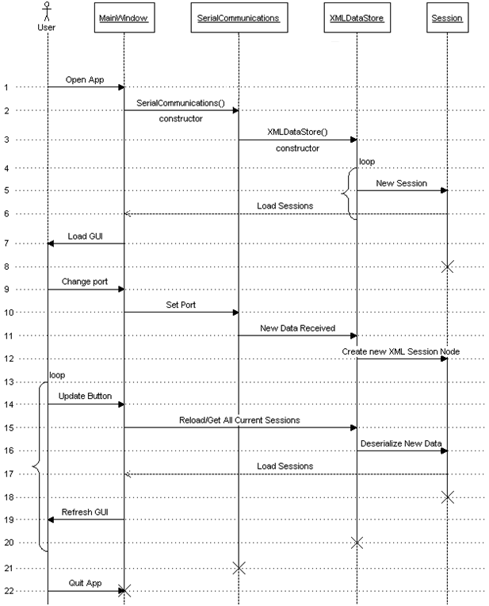
Figure 81 - Sequence Diagram

Console Power Usage
It is known that the goal of the CALBOX 360 is to power a load for a monitored period of time. The load to be charged by the storage medium is an XBOX 360 gaming console. To power this load, the designer must first understand the load requirements and power usage at different modes of operation. The listed requirements of the AC adapter power brick are:
- Input AC: 100-127 V ~4 A, 47-63 Hz
- Nominal output DC: 150 W
Some testing using a Kill-A-Watt has shown how much power the XBOX can consume. This testing was calculated using an XBOX power supply with a DC output of 175 W. The console that will be used in the design has a maximum DC output of 150 W therefore the previously performed testing can be proportionately related and represented in Figure 82 below.

Figure 82 - XBOX 360 power consumed
Additional power usage can be assumed for peripherals such as wireless and wired controllers. Wired controllers are connected by a 5 V USB connection and receive the standard 500 mA that universal serial bus is capable of providing. Wireless controllers receive slightly more power and can be assumed to be less than 3 W. The designer will assume a higher power level than consumed during the testing to assure stability even in the worst case, thus 200 W power will be used.

DC-AC Inverter
These AC-DC inverters can convert low voltage DC from a battery to a 115 VAC household power. Because the designer is using 200 W as the reference power the load will consume, an inverter should be selected capable of supplying a continuous power greater than this 200 W. Common inverters are available in 200 W continuous, 400 W continuous and above. Considering stability and cost, a 400 W continuous power inverter was decided on. The inverter chosen for the purposes of this project is a Black & Decker 400 W Power Inverter. Additional benefits to choosing the Black & Decker power inverter were its availability at a local market and its inclusion of a 5 VDC output in the USB form factor.
The ability to purchase the inverter locally allows for easy return if the design team deems the inverter insufficient. The 5 V USB female header allows for the Arduino microcontroller to be powered via this outlet, making the need for an additional powering method pointless. The input cables to the inverter are battery clip cables which perfectly suit connecting the inverter to a battery like will be done. Some important specifications for the inverter are:
Maximum Continuous Power: | 400 W
Surge Capacity: | 800 W
Input Voltage: | 12.8 V
Output Voltage: | Approximately 115 VAC RMS 60 Hz
Low Voltage Alarm: | < 11 VDC
Low Voltage Shutdown: | 10.8 VDC
Wave Form: | Modified Sine Wave
Maximum Output Current: | 3.42 A
Table 28 - Black & Decker power inverter specifications
One important specification from the figure above is the low voltage shutdown of the inverter which lines up perfectly with the voltage the design team has deemed as the lower limit of charge before a 12 V storage element is damaged. The inverter outputs a modified sine wave of 115 RMS VAC to female connector.

Modified Sine Wave
This AC waveform from the output of the inverter is known as a modified sine wave. A modified waveform is a stepped square wave manipulated to emulate a sine wave. A representation of the modified sine wave is represented below in Figure 83.
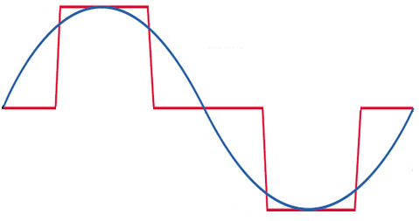
Figure 83 - Modified sine wave
This waveform is suitable for most AC loads, including both linear and switching power supplies present in electronic equipment such as the XBOX console.

Testing
A standard 12 V car battery was used for basic testing of the DC-AC inverter in order to test the load to assure that the XBOX is capable of being charged from this medium. In an attempt to measure the current traveling from the Black & Decker DC-AC inverter to a 12 V battery, a volt-meter was connected in series in its current mode. This configuration can be seen below in Figure 84.
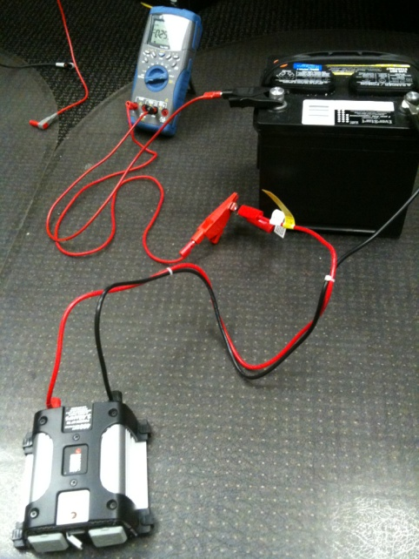
Figure 84 - DC-AC inverter system
The volt-meter displayed a current of 0.2584 A with no load connected to the DC-AC inverter as shown below in Figure 85. The Agilent volt-meter used in this testing has a 10 A current limit and with the DC-AC inverter capable of drawing very high amperage from the battery as necessary to power the load, the designer started with light loads such as a 5 V USB cable that could charge a phone. This light load would require very little current to power and still prove the inverter is working. Figure 86 shows the new current displayed from the Agilent volt-meter showing the increase this proving the successful operation of the inverter.
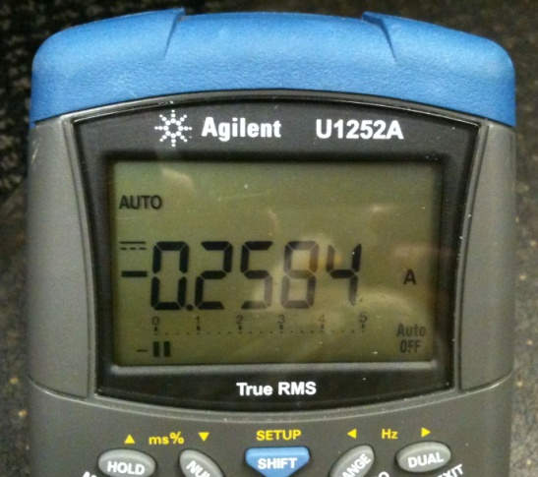  Figure 85 - Current with no load | 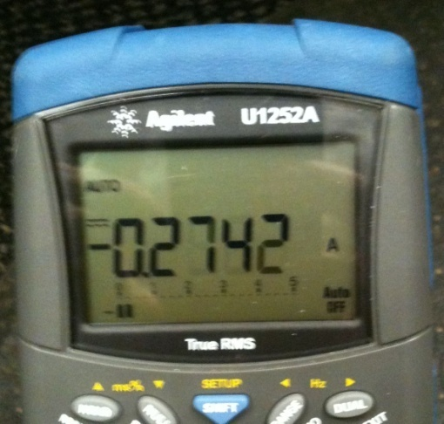  Figure 86 - Current with 5 V load
The designer would unfortunately be unable to use this technique to determine the current drawn from the battery for heavier loads due to current limits. High current would be drawn from the battery to compensate for the low 12 V in order to provide the continuous power required from the load connected.
A 3.4 A load was connected to the inverter which falls right into place with the 3.43 A current limit supply. This load was a power supply brick for a laptop and before connecting the laptop, the designer probed the voltage on the output cable of the power brick to assure safety. The volt-meter gave very inaccurate readings of the voltage. It turns out that the modified sine wave produces an RMS voltage of 115 V and that most AC volt-meters are sensitive to the average value of waveform rather than the RMS value. They are calibrated for RMS voltage under the assumption that the waveform is a pure sine wave and not modified as in this case. Most meters cannot read the RMS voltage of a modified sine wave as in the current case.
Trusting the specifications and fault protection of the DC/AC inverter as well as the requirements of the XBOX power supply, the console was connected to the inverter to test in different modes of operation. The XBOX powered successfully and first placed into the video mode where a DVD could play requiring less power than both game play and the dashboard. The XBOX played the movie successfully with no problems, outputting audio also. The XBOX was also able to play games successfully. This information allows the design team to be aware of the load and design all other components of the project with it in mind.

Instructions for Build

Preparations
The first preparation is to assemble all of the parts. The most difficult to acquire piece of equipment will be a reverse recumbent bicycle. This driving vehicle was chosen because the dimension profile is very adequate for the design. More parts include the generator, blocking diode, inverter, battery, and charge unit.
The next preparation is to wire the protection system for the generator. The front face mount must be removed from the unit, and the blocking diode installed by providing for a method to hold the wiring in place, and a heat sink for the large diode. Replacing all of the generator knockouts is important to ensure that no pieces left inside of the generator will short out if left inside.

Build
The bike must be refitted to specifications for the CALBOX application. It must be placed on a mount to lift the driven wheel off of the ground to allow for it to freely rotate. At the same time the front wheel must be placed on a level surface and tilted, so that the user does not feel vertigo while the rear wheel is lifted. The driven wheel must be stripped of rubber lining and inner rim. The drive belt will be selected and adjusted to a length that is adequate for the diameter of the wheel and reaching the generator.
The relay and diversion system must be installed on the generator. The relay will feed an outlet box that will allow the user to choose a load to divert to. Making this a plug in box will be the most adaptive method. It must be kept in mind by the designers however to advice on the particular loads that are acceptable. Not all systems are friendly to DC power signals. Acceptable loads include LED lights, which are not recommended because of their power efficiency, heating elements, and flood lights.
The generator must be mounted on the bike rack using a fabricated plate or similar system. The motor must not vibrate while in operation, but must be close enough to the driving wheel to make it so that losses in the driving belt are minimized. Making the system as compact as possible will also make it difficult to have a misalignment and have the chain trip or break. The proper tension must be maintained. The electric leads of the generator must be wired to the battery. The proper care must be taken so as to avoid shorting the leads or causing undue exposure to the wires for the user.
An adaptor piece must be acquired for attaching the driving belt to the bicycle tire. After the bicycle and generator are attached to the bike rack, the driving belt can be installed. Special belts can be adjusted by removing and reattaching linking tabs. Other chains made of links can be machined to be refitted. If a direct-drive testing setup is being used, the tire remains on the tire frame, and the generator shaft is driven directly from the rubber contact with the shaft of the generator and its rotor.
Finally, the DC/DC converter must be wired in to the circuit to be able to charge the batteries. And the inverter connected to the battery supply for the running of the load. The load is connected to the inverter since it is an AC load while the battery provides a DC signal. The load must be attached to the inverter. It is recommended that the battery is already charged for this initial assembly.

Test Plan

DC-DC Converter
In order to test the DC-DC converter, Petra Solar has offered the use of their equipment. A DC source can be used to act as the signal being received from the generator. The Lambda device can output up to 63 VDC, which is more than enough. The maximum voltage input the converter is built for is 25 V. Along with being able to set the voltage level on this device, the current can also be controlled. In this way, the power input can be monitored and then compared to the output power to allow observance of the system’s efficiency.
Both the input and output of the converter can be evaluated using the Yokogawa device. This machine is capable of monitoring four different things at once. Two will be used for the purposes of this testing, one for the input, and one for the output. The Yokogawa screen can display various different features. The ones that will be most important for this system will be the voltage and current levels. Also, the frequency, power, and efficiency can also be displayed.
An aspect that is important to consider for all electrical devices is how it handles different temperature levels. With the converter, generator, battery and inverter all being in close proximity, heat could affect certain parts of the system. Two things can be done to test this. Again, the use of Petra Solar’s equipment will aid for these uses. First, a thermal camera can be used to view the converter to see if any parts heat up during operation. Second, a thermal chamber can be used to test how the device operates under different temperatures. The chamber set up is ideal, as it allows for the Yokogawa and Lambda to be connected, so testing can take place while the converter is at the specified temperature testing.

DC-AC Inverter
Though the DC-AC inverter is being purchased by an outside source, testing can still be done to see how efficient the Black & Decker inverter is. The testing will be implemented similarly to how the DC-DC converter is tested. The only difference is that instead of connecting a DC source to the input, an AC source will be used. This is also being provided by Petra Solar. This AC source will be used to mimic the output of the battery, which will be the input to the inverter. Since the output of the inverter is just an outlet, a custom-made part that has a plug on one end will be used. The wire for this plug will be opened and connectors such as banana clips will be attached to the other end. In this way, the Yokogawa can be used to monitor the output of the inverter.
The thermal chamber will be used to test the inverter under certain temperatures. Since the device is rated for what temperatures it can operate at, this temperature range will not be exceeded. Also, this range will provide a good basis for what temperatures the DC-DC converter should be able to handle. Since the device is post-production, and therefore all the circuitry is enclosed, the thermal camera will be obsolete for testing this device. The Yokogawa will provide significant information about the system.
The input voltage and current can be changed to observe the output power of the inverter. This is very beneficial, as the XBOX operates at different wattage levels depending on its purpose at the time. For instance, the amount of power needed to play a DVD on the gaming system is different from how much is needed to play a game. By mimicking the different output power levels that will be encountered, the different input power levels can be noted. These can in turn be used to find out the speed at which the battery will discharge for the different modes. This information can then be provided to the user, so it is known how much time they will have on the XBOX specific to the use of the console.

Generator curves
The generator can be tested by running it instead of with a variable drive, like a human engine would be, i.e., the user, with a constant drive. This means that the motor turned generator that will be used with the CALBOX will be driven, for testing purposes, with an adjustable motor. Being able to adjust, and know without doubt, the speed that the motor is turning the generator at is crucial in determining the power curve for the generator.
Using a commercial meter, the power curve can be verified as the speed of the motor is ramped up to a maximum of 3800 RPM on the generator side. This is an important thing to note. Because a turns ratio can be used to scale up the speed of the motor, a smaller, less powerful motor can be used to test the generator.
The power curve generated will serve as a calibration tool for the software measurement that is being introduced with the DC/DC converter that is being implemented in the design. Measuring the discrepancies in the measurements between the commercial equipment and the on-board in-house design equipment will allow the design team to redesign the measurement tool to levels required for accuracy. Figure 87 below shows the test plan.
Figure 87 - Generator power curve test plan

Charging the battery
The battery can be charged with a commercial SLA battery charger. Monitoring the power output from the charger, over time, and taking into consideration the specified efficiency rating by the charger manufacturer, it will be possible to measure the charging properties of the battery from an ideal perspective.
From this measurement data matrix, it is then possible to test the battery with the designed DC/DC converter and the CALBOX generator. This second test must be done with the testing motor described in the Generator Curves testing. In this way it will be possible to determine the charging profile of the generator, and determine the best speed at which the generator is most effectively charging the battery.
It will be necessary to remove the aforementioned protection systems while doing this test since it too will consume some power and cause the test results to be skewed. The battery charge curves determined with the first test and with the second can each respectively be compared with the battery manufacturer charging curves.

Software Testing
The object of the test plan is to identify activities that will help produce an application with acceptable performance, usability, and functionality. Through creating test cases, identifying problem causing bugs, and thorough unit testing, the designers hope to create an application that is intuitive as well as functional.

Test Environment
The test environment will be any Windows Operating System that supports the .NET 3.0 Framework. It would also include any machine that is falls within in the recommended hardware specifications listed in Table 26.

Test Users
Test users will initially include the main application programmers and team members. As application development progresses, independent users not associated with the system’s development will be asked to test software and provide feedback. If bugs are found by users they will be recorded (create issue ticket with note that this was found by a user and not a team member)and be sent back to development for fixing.

Issue Management
When issues are found, they will be categorized, prioritized described, and stored in a table of issues visible to all team members. When a solution to an issue is found, its fix is implemented back into the final code by priority. Priority is categorized based on the following criteria shown in Figure 88.

Figure 88 - Issue Priority
Critical issues are the first to be analyzed and fixed. If all Critical issues are found and solved, fixes to intermediate issues will be then actively sought. After both critical and intermediate issues are both found and solved, any low priority issues can then be addressed.

Test Cases
The following test cases have been deemed important to initial testing based on knowledge of the system.
Test Case # | Test Case Description | Expected Results
TC01 | Launch program w/ XML data stored | Launches w/o error and displays data in list and graph form
TC02 | Launch program w/o any XML data stored | Launches w/o error and displays empty list and graph
TC03 | Change port name through settings | COM port changes and serial data communications link still exists
TC04 | Receives new data over serial | New data is received in the expected format
TC05 | Receives multiple new packets over serial | New data is continually received and updated to XML
TC06 | Packet is parsed correctly | Parsing function correctly parses session packet received over serial
TC07 | Initial XML document is created if none exists | New XML file can be seen created with proper headings in file system
TC08 | XML session nodes are correctly appended to existing XML session | New nodes can be seen in the XML file on the file system
TC09 | Session data is deserialized correctly | Session nodes are formatted correctly in XML file on file system
TC10 | Clear buffer | When application first starts buffer should be cleared of old sessions
TC11 | Update button is clicked | GUI should be refreshed correctly with new GUI data
TC12 | Program Closes | Application closes w/o any errors in a timely fashion
TC13 | Check GUI elements | All GUI elements are displayed correctly w/o any graphical glitches
TC14 | Check all UI interaction objects | All buttons, menu items, and Window controls perform their respective actions
Table 29 - Test Case Descriptions

Project Summary
The CALBOX is a combination energy solution and entertainment console accessory. While designed for youths and adults that spend above average amounts of time using video game consoles, in particular the XBOX 360, it can be used by any user for recreational purposes while at the same time conserving the energy that the user is spending.
The CALBOX consists of five major systems. The first is the actual device interface with the user. This canvases the seat and its orientation, as well as the aesthetic attractiveness of the CALBOX. The next system is the power generation system. This includes the generator and the battery charging system. Included is also the drive wheel and energy transfer device, chain or direct drive, attached to the generator. The third system is the load system.
The battery also falls into this system. While it can be argued that the battery is a part of the generation scope, it is in fact a load to the generation system. The load system is composed of the DC/AC inverter used to drive the load, the XBOX 360. The fourth system is the monitoring devices that allow the CALBOX to process data, and transmit it to the user’s end-computing system for interpretation. The Arduino microprocessor and the XBee wireless transmitter are part of this design. A software interface package allows the user to track and record his or her progress with the CALBOX.
The final system is a combination of failure prevention devices that protect the components of the overall system from damaging each other. This is possible if the generator overcharges the battery, if the battery reverse-powers the generator, if the XBee pollutes the Arduino with noise, and other various points of failure that can be prevented.
There are significant challenges to implementing the CALBOX design. The most prevalent of these issues is the inefficiency of the system. Estimations show that the user will burn approximately four times as much energy as is transferred to the system. Optimizing this ratio will be the most time-consuming of the processes undertaken by the designers.
Another challenge is the software system. The XBee produces significant amounts of noise that could interfere with the processing abilities of the processor. Another issue concerning the processor is the difficulty in accurately measuring the state of charge of a lead acid battery. The limitations of the device further make this issue difficult. The disconnect between amperage and voltage generated with deliverable power to the processor requires accurate scaling of the signal that will provide information to the processor.
All issues taken into consideration however, the CALBOX is a sound system. Even the inefficiency can be justified by the argument that free power is better than no power. Being able to harvest even a portion of power wasted is an economically advantageous situation. Over a lifetime, this energy savings, as well as other immeasurable gains in health and environmental responsibility, add up to proportions that make the CALBOX an attractive addition to any home.

Design Summary
The system design is made up of various parts that interconnect to deliver power generated by the user to the XBOX 360 gaming console. The main components are the DC generator, the DC/DC converter, the Arduino, the XBee module, and the DC/AC inverter. The block diagram in Figure 89 shows the flow of energy through the system.
The CALBOX 360 system is a user-powered device that receives no external energy from the utility grid, or any other outside source. The user powers the system by pedaling the rotary device, just as one would use a bicycle. This kinetic energy from the user is transferred to mechanical energy and feeds into the DC generator. This generator provides the voltage needed to drive the DC-DC buck-boost converter, which in-turn charges the battery. Before the signal is received by the battery, it goes through different stages to ensure proper charging is done.
The converter makes use of two switches to regulate the voltage in the system. These switches pass the signal to the output, as well as into the feedback loop. The output voltage is compared to the reference voltage, and the difference between these values is sent out as the voltage error. The error signal is delivered to two different op-amps, which use the signal to determine the duty cycles of the two switches. These duty cycles will control the converter to either step up or step down the voltage to reach the proper output voltage level.
The output from the DC/DC regulator sends two voltage signals, one to the battery, and the other to the DC/AC inverter. This is how the battery charges. The power from the battery is run through the inverter to transfer the voltage to AC in order to be used commercially. For this project, this AC voltage will pass through a power brick, and then supply the XBOX 360 with the energy needed to run the console.
Along with providing power to the DC/DC converter, the DC generator will also provide power to the Arduino. The Arduino microcontroller keeps track of all the data for the user, and uses the XBee module to deliver the information to a computer through the use of USB. The Arduino also receives voltage from the battery. The generator provides the microcontroller with the positive voltage, while the battery supplies the negative.
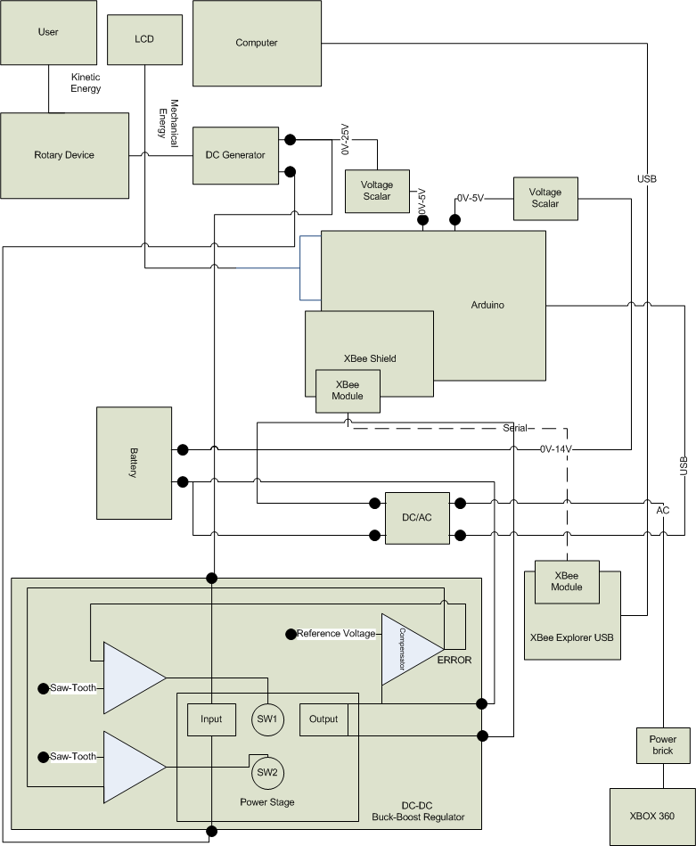
Figure 89 - Block Diagram for CALBOX 360

Suppliers
The equipment required to print circuit boards is not readily available for this project. Because of this, the designs for the dc-dc converter will be sent out to Advanced Circuits for printing. After researching different locations that offer this service, this company provides everything needed, and at a good price. They offer discounts for students, and make it possible to order the necessary 2-sided boards for $33 each. Also, there is no minimum for ordering, making it possible to order only one board. All orders sent to Advanced Circuits undergo an engineering file review prior to fabrication. Their free pre-order file review will indicate any problem that can be fixed by the company, or those that need to be reviewed by the customer.
Advanced Circuits has a more than sufficient support staff, offering live engineering help available 24 hours a day via their tech line. They also offer for free their own PCB layout software. Through this software, specific components can be chosen, even through specific manufacturers, and can be designed as specifically as necessary. Along with all of these benefits, Advanced Circuits is also eager to help with costs, by offering sponsorships for projects. This company has great offers for students, and appears to have a good relationship with them as well. Not only will they act as a supplier, but as a consultant as well.
The most important aspect of getting the board made by this outside source is that it will provide the entire wiring path for the circuit. By choosing to receive a 2-layer board, the copper layer underneath the surface of the board will provide a place for this to be done. The larger components, such as inductors and op-amps, will need to be placed on the board by Advanced Circuits. The smaller components, like the capacitors and resistors, can be attached using soldering equipment available. These tools will allow for the board to be fully populated by placing the missing pieces post-production into the correct areas. Since the path has already been put in place during manufacturing, once the components are on the board, the circuit should be complete.

Budget & Financing
The main costs for this project will be covered by a generous sponsorship from Progress Energy, which will cover up to $1500 in expenses. Along with this, the company Petra Solar that Sean Varela and Cody Burdette work for will provide most of the equipment to be used for testing. These devices will include a DC-source, AC-source, Yokogawa analyzer, thermal chamber, and a battery charger. The expenses for all the parts that will make up the system are listed in the table below.
Component | Total Cost
Leeson M1120046 DC Generator | $190
12 V 35 Ah Lead Acid Battery | $100
Black & Decker DC-AC Inverter | $50
Arduino Duemilanove Microcontroller | $30
Liquid Crystal Display | $12
XBee Chips (2) | $46
XBee Shield Kits (2) | $12
XBee Explorer USB | $25
XBOX 360 Gaming Console | $200
Circuit Board Printing (3) | $100
DC-DC Converter Components | $325
Building Materials | $100
Miscellaneous Components | $100
Total Expenses | $1601
Table 30 - Project Expenses
The prices listed in this table are the total cost of all the parts, including shipping. The price for getting the board printed is based off of three boards, as they are $33 apiece. The building materials will include all things necessary to create the holding cell for all of the various parts of the system. This is pending change, based on whether the designers build it themselves, or if it is outsourced to be manufactured elsewhere. Miscellaneous components will comprise solder, wire, AC power supply for the XBOX, a USB standard A to B, among other parts. The extra power supply is necessary for the XBOX as one will be stripped in order to correctly test current flow from the inverter to the console. Evaluating the total expenses shows that the Progress Energy sponsorship might be enough to finance this project. If it isn’t, the remaining costs will be split evenly amongst the four group members. The components for the DC-DC converter have been summed together based on prices from Digikey.com. A more precise look at these costs is contained in the following table.

Component | Manufacturer | Price per Unit | Total Cost
15 pF Capacitor | Vishay | 0.076 | $0.76
.02 μF Capacitor | Murata | 0.66 | $6.60
360 pF Capacitor | Murata | 0.086 | $0.86
280 μF Capacitor | Cornell | 40.28 | $201.40
44.8 Ω Resistor | Vishay | 0.238 | $2.38
1 kΩ Resistor | Vishay | 0.48 | $4.80
54.9 kΩ Resistor | Vishay | 0.083 | $0.83
62 μH Inductor | API Delevan | 2.77 | $27.70
MOSFET | STMicroelectronics | 1.92 | $38.40
Schottky Diode | Texas Instruments | 1.37 | $27.40
Total Expenses |  |  | $311.13
Table 31 - DC-DC Converter Component Expenses
Because components are sometimes unavailable for purchase, the plan is to buy more than is needed to populate one board. This way, if during testing, certain components fail or get destroyed, backup supplies will be readily available. For most of the components, 10 of each were chosen. For the MOSFETs and Schottky diodes, 20 each will be ordered, since one board will use two of each. Only five of the 280 μF capacitors will be purchased due to this components high cost. This is the output capacitor of the system and needs to be large in order to keep the output stable.

Project Milestones
The goals and objectives for this project can be divided into two sections. The first section deals with all the hardware of the system. This comprises the DC-DC converter design, DC generator, bicycle, and the AC-DC inverter. Most of the design and testing will be done on the DC-DC converter. The second section involves the software that will provide the user with battery and calorie information and also transfer information to the computer. The timeline for the objectives of these sections is contained in Figures 90 and 91 below.
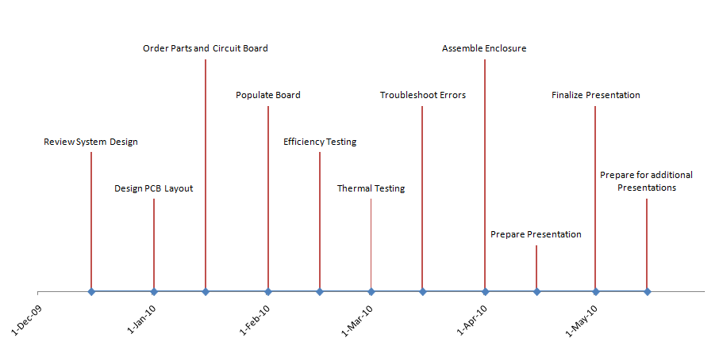
Figure 90 - Hardware Milestones
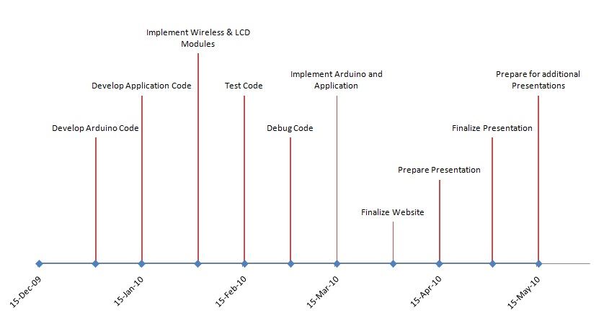
Figure 91 - Software Milestones

Possible Expansions
The CALBOX system is originally designed to power an XBOX through the use of a battery, which is charged from the energy used to ride a stationary bicycle. Simple changes to the system could be to switch the load. That is, instead of powering an XBOX, maybe power a different gaming console, such as the Nintendo Wii. It is possible to power different devices through this system, but changes would have to be made. An XBOX need a maximum of 200 W to operate at its peak, while the Wii only needs 60 W or power. Because of this, a different DC-AC inverter would likely be used for other applications of the system.
Another possible change that could be made is to the DC-DC converter. Instead of using a non-isolated system, a Flyback converter could be used. This would provide much more power to the system, due to the use of a transformer. This would make it possible to run various different devices off of the system. It could be possible to have a system with such a converter to power a gaming console, as well as the television that the console is hooked up to.
Expansions related to the microcontroller components would include a higher quality LCD, letting the user input their own weight and age, and more robust battery state of charge calculation. A higher quality LCD would allow the system to display colorful and animated data representations of the battery charge and calories burned. If the system would provide the inputs for the user to enter their own weight and age through a number pad expansion, the system would be able to calculate a more accurate number of calories burned. The system would also benefit from a more accurate method of calculating the state of charge of the battery. An external battery charge IC could be purchased and provide a more detailed reading of a lead acid battery to the microcontroller.
Expansions related to the Software would include providing real time data from pedaling to a dynamically updating graph. This could map the users exercise intensity as the session progresses. The system could also include support for multiple users, so that more than one person would have their information stored and presented.

Appendix

Figures
Figure 1 - CALBOX prototype vision 1 8
Figure 2 - Wave collaboration 9
Figure 3 - General diagram of a battery management system 10
Figure 4 - CALBOX Battery Management System 11
Figure 5 - Lead acid batteries common discharge times per discharge currents* 16
Figure 6 - Common lead-acid batteries' discharge characteristics* 16
Figure 7 - Effect of discharge current on discharge voltage for lead acid batteries* 17
Figure 8 - Discharge characteristic of UB12350 18
Figure 9 - Experiment between 12 VDC and 180 VDC motor 23
Figure 10 - Drive shaft assembly 27
Figure 11 - Wheel-driven option 27
Figure 12 - Drive belt option 28
Figure 13 - Protection system 30
Figure 14 - Voltage output for Leeson M1120046 32
Figure 15 - Voltage divider circuit with current to voltage converter 33
Figure 16 - Voltage drops 33
Figure 17 - Current flowing into analog pin 33
Figure 18 - Effect of temperature on capacity 35
Figure 19 - Basic Buck-Boost Topology 38
Figure 20 - CCM Inductor Current 39
Figure 21 - DCM Inductor Current 40
Figure 22 - Isolated converter block diagram 40
Figure 23 - Flyback Converter Topology 41
Figure 24 - Cuk Converter Topology 42
Figure 25 - Modified buck-boost converter 44
Figure 26 - Duty cycles for PWM signals 45
Figure 27 - Buck converter implementation 46
Figure 28 - Boost converter implementation 47
Figure 29 - Basic Buck-Boost with Basic MOSFET Driving 48
Figure 30 - Buck-Boost with Converter Non-Idealities 50
Figure 31 - Buck-Boost with Equivalent Resistance 50
Figure 32 - Bypass Capacitor 53
Figure 33 - Common Circuit Placement 54
Figure 34 - Star Ground Technique 55
Figure 35 - Proportional gain 59
Figure 36 - Integral control 59
Figure 37 - Derivative control 60
Figure 38 - PID Controller Block Diagram 60
Figure 39 – Power system with maximum input voltage in open-loop 68
Figure 40 – Compensator with maximum input voltage in open-loop 69
Figure 41 – System with maximum input voltage in open-loop 70
Figure 42 - Power system with maximum input voltage in closed-loop 71
Figure 43 - Compensator with maximum input voltage in closed-loop 72
Figure 44 - System with maximum input voltage in closed-loop 73
Figure 45 - Power stage with minimum input voltage in open-loop 74
Figure 46 - Compensator with minimum input voltage in open-loop 75
Figure 47 - System with minimum input voltage in open-loop 75
Figure 48 - Power stage with minimum input voltage in closed-loop 76
Figure 49 - Compensator with minimum input voltage in closed-loop 77
Figure 50 - System with minimum input voltage in closed-loop 77
Figure 51 – Closed loop power stage 80
Figure 52 - Power stage magnitude and phase 81
Figure 53 - Open loop power stage 81
Figure 54 - Open loop power stage 82
Figure 55 - Compensator architecture 82
Figure 56 – Compensator 83
Figure 57 - Compensator magnitude and phase 83
Figure 58 - Loop gain 84
Figure 59 - PWM driver 85
Figure 60 - Saw to Square Relationship 85
Figure 61 - Saw-tooth relationship attempt 1 86
Figure 62 - Improper switching result from saw-tooth attempt 1 86
Figure 63 - Proper switching 87
Figure 64 - PWM switching 87
Figure 65 - Closed loop complete system 88
Figure 66 – 20uF output voltage ripple 89
Figure 67 - 280uF output voltage ripple 89
Figure 68 - Output voltage of the system 90
Figure 69 - Microcontroller Topology 92
Figure 70 - The Arduino Duemilanove USB board layout 94
Figure 71 - Arduino board and a 16x2 LCD Module circuit layout with a potentiometer 97
Figure 72 - The Zigbee stack 99
Figure 73 - XBee shield with an XBee module attached 100
Figure 74 - X-CTU GUI 101
Figure 75 - Voltage readings 105
Figure 76 - Prototype GUI 113
Figure 77 - Class Diagrams 118
Figure 78 - Layout Structure 119
Figure 79 - Skeleton application 119
Figure 80 - Activity Diagram 120
Figure 81 - Sequence Diagram 121
Figure 82 - XBOX 360 power consumed 122
Figure 83 - Modified sine wave 124
Figure 84 - DC-AC inverter system 124
Figure 85 - Current with no load 125
Figure 86 - Current with 5 V load 125
Figure 87 - Generator power curve test plan 129
Figure 88 - Issue Priority 130
Figure 89 - Block Diagram for CALBOX 360 134
Figure 90 - Hardware Milestones 138
Figure 91 - Software Milestones 138

Tables
Table 1 - Li-ion evaluations 13
Table 2 - Common electronics rechargeable batteries comparisons* 13
Table 3 - Lead acid batteries comparison 15
Table 4 - UB12350 battery details 17
Table 5 - Generators under consideration 25
Table 6 - Decision matrix for generator selection 26
Table 7 - Generator RPM to voltage and voltage read in relation 34
Table 8 - Generator RPM to intensity relation 36
Table 9 - Control modes for modified buck-boost converter 44
Table 10 - System parameters 66
Table 11 - Second Pole and Gain for extreme cases 78
Table 12 - Resistor and Capacitor values for Compensator 79
Table 13 - I/O overview 91
Table 14 - megAVR specification range 92
Table 15 - Memory size summary for ATmega series 93
Table 16 - Chosen microcontroller specifications 93
Table 17 - 18F chip options 95
Table 18 - XBee specifications 99
Table 19 - XBee modifications 101
Table 20 – Various activity METs chart 103
Table 21 - Pedaling METs 104
Table 22 - User state of charge readout breakdown 107
Table 23 - Packet format 110
Table 24 - Microcontroller variables and data types (Wiring C) 111
Table 25 - Microcontroller functions 112
Table 26 - Recommended specifications 115
Table 27 - List of Software Requirements Specifications 115
Table 28 - Black & Decker power inverter specifications 123
Table 29 - Test Case Descriptions 131
Table 30 - Project Expenses 136
Table 31 - DC-DC Converter Component Expenses 137

Permissions


Works Cited
"12 Volt DC to AC Inverter." DC AC Power Inverters. Web. <http://www.dcacpowerinverters.com/12_volt_power_inverters.html>.
Ambatipudi, Ravindra. “Design of Isolated Converters Using Simple Switchers.” Web. <http://www.national.com/appinfo/power/files/f17.pdf>
“AN2389 Application Note: An MCU-Based Low Cost Non-Inverting Buck-Boost Converter for Battery Chargers”. STMicroelectronics, 2007. Web. <http://www.st.com/stonline/books/pdf/docs/12476.pdf>
“AN-42036 PCB Grounding System and FAN2001/FAN2011 High Performance DC-DC Converters.” 05 Apr. 2005. Web. <http://www.fairchildsemi.com/an/AN/AN-42036.pdf>
Ang, Simon S. Power-Switching Converters. New York: Marcel Dekker, Inc., 1995. Print.
"Arduino - ArduinoXBeeShield." Arduino - HomePage. Web. <http://arduino.cc/en/Guide/ArduinoXBeeShield>.

Basso, Christophe, Stephanie Conseil, and Nicolas Cyr. "Analyzing power-supply stability in a multi-loop system| Power Management DesignLine." Power Management Design Resource for Electronic Engineers | Power Management DesignLine. Web. <http://www.powermanagementdesignline.com/208404037?printableArticle=tr ue>.

Batarseh, Issa. Power Electronic Circuits. John Wiley & Sons, Inc., 2004. Print.
"Battery Tutorial | BatteryStuff.com." Motorcycle Batteries, ATV, Car, Marine, and Solar Battery Products | BatteryStuff.com. Web. <http://www.batterystuff.com/tutorial_battery.html>.
"BLACK & DECKER at Lowe's: Power Inverter." Lowe's Home Improvement: Buy Kitchen Cabinets, Paint, Appliances & Flooring. Web. <http://www.lowes.com/lowes/lkn?action=productDetail&productId=284081- 46965- PI400AB&detail=&lpage=none>.

"Bode Diagram Design :: Designing Compensators (Control System Toolbox")." The MathWorks - MATLAB and Simulink for Technical Computing. Web. <http://www.mathworks.com/access/helpdesk/help/toolbox/control/getstart/f2 -1043814.html>.

Brain, Marshall. "HowStuffWorks "How Lithium-ion Batteries Work"" Howstuffworks "Electronics" Web. <http://electronics.howstuffworks.com/lithium-ion- battery.htm>.
"C# Tutorials - Serial Port Communication In C# | DreamInCode.net." Programming and Web Development Help | DreamInCode.net. Web. <http://www.dreamincode.net/forums/showtopic35775.htm>.

"Calculating Caloric Goals." Healthline - Health Search Engine and Medical Information. Web. <http://www.healthline.com/hlbook/dia-calculating-caloric-goals>.

"Character LCD Module 16x2 RGB Backlight." NKCelectronics.com: BEST PRICED Arduino boards, Freeduino, IC PCB adapters, Connectors, Pin Headers. FAST GLOBAL SHIPPING. Web. <http://www.nkcelectronics.com/character-lcd- module-16x2-rgb-backli162.html>.

Cheng, Ying. "Predict Loop Gain in Buck Converters." EE Times - India 1-15 Mar. 2008. Web. <http://www.eetindia.co.in/ARTICLES/2008MAR/PDF/EEIOL_2008MAR01_ POW_TA.pdf?SOURCES=DOWNLOAD>
Coad, Noah. "SerialPort (RS-232 Serial COM Port) in C# .NET - #region Coad's Code." MSMVPS.COM. 23 Mar. 2005. Web. <http://msmvps.com/blogs/coad/archive/2005/03/23/39466.aspx>.

Dantre, Tapan. "CodeProject: Serial Communication using C# and Whidbey. Free source code and programming help." CodeProject. Free source code and programming help. 19 Oct. 2004. Web. <http://www.codeproject.com/KB/cs/serialcommunication.aspx>.

"Delay's Blog : Silverlight Charting gets a host of improvements [Silverlight Toolkit December 08 release now available!]." MSDN Blogs - Blogs. Web. <http://blogs. msdn.com/delay/archive/2008/12/09/silverlight-charting-gets-a-host-of- improvements-silverlight-toolkit-december-08-release-now-available.aspx>.

"Documentation for MathWorks Products." The MathWorks - MATLAB and Simulink for Technical Computing. Web. <http://www.mathworks.com/access/helpdesk/ help/toolbox/control/getstart/f2>.

Hagen, Mark. "Utilizing a Digital PWM Controller to Monitor the Health of a Power Supply." 13 Oct. 2008. Lecture.

“How-to: Setting up XBee ZNet 2.5 (Series 2) Modules.” Web. <http://blog.kevinhoyt.org/wp-content/XBee-setup.pdf>.
"Electric motors and generators." Physics animations and film clips: Physclips. Web. <http://www.animations.physics.unsw.edu.au/jw/electricmotors.html# generators>.
Emadi, Ali, Alireza Khaligh, Zhong Nie, and Young Joo Lee. Integrated Power Electronic Converters and Digital Control. Boca Raton: CRC, 2009. Print.
Erickson, Robert W., and Dragan Maksimovic. Fundamentals of Power Electronics (Second Edition). New York: Springer, 2001. Print.
Feare, Tom. "Wet-cell or maintenance-free battery? - 4/1/2001 - Modern Materials Handling." Modern Materials Handling - Productivity solutions for distribution, warehousing, manufacturing. Web. <http://www.mmh.com/article/CA68733.html>.
Heinzle, Lukas and Stephan Synkule. “Measurement of Step-Down DC/DC Converters with Bode 100.” <http://www.omicron-lab.com/fileadmin/assets/ application_notes/AP_Note_Linear_DC_DC_converter_V1_5.pdf>
"How Much Power Does Your Xbox 360 Use?" News, Games and Forums for the Xbox 360. Web. <http://www.planetxbox360.com/article_1288/ How_Much_Power_Does_Your_Xbox_360_Use>.

"HowStuffWorks "What is the difference between a normal lead-acid car battery an"" Howstuffworks "Auto" Web. <http://auto.howstuffworks.com/question219.htm>.
"Initialize SISO Design Tool - MATLAB." The MathWorks - MATLAB and Simulink for Technical Computing. Web. <http://www.mathworks.com/access/helpdesk/ help/toolbox/control/ref/sisotool.html>.

Krein, Philip T. Elements of Power Electronics. New York: Oxford. 1998. Print
Kumar, Swagat. "Frequency Domain Analysis Using Bode Plot." Control Systems Laboratory, IIT Kanput. 11 July 2005. Lecture.

"Layout Considerations for Non-Isolated DC-DC Converters - Maxim." Analog, Linear, and Mixed-Signal Devices from Maxim/Dallas Semiconductor. Web. <http://www.maxim-ic.com/appnotes.cfm/an_pk/735/>.

Lee, Julie JoAnn. "Analysis of a Small-Signal Model of a PWM DC-DC Buck-Boost Converter in CCM." DRC Home. Web. <http://drc.ohiolink.edu/handle/2374.OX/19651>.

"ListBox in WPF." C#, Visual Studio 2008, Silverlight, ASP.NET, WPF, WCF, WF, and Windows Vista Community. Web. <http://www.c-sharpcorner.com/ UploadFile/mahesh/WPFListBox08252008100659AM/WPFListBox.aspx>.

"Low Battery Indicator -." Chiphacker. Web. <http://chiphacker.com/questions/77/low- battery-indicator>.

Mannas, Steve. "Analysis of Closed-Loop DC-DC Converters Page of." Power Electronics Technology Magazine Online | power electronics engineer, IEEE, battery, power supply Page of. Web. <http://powerelectronics.com/mag/power_analysis_closedloop_dcdc/>.

Partington, Rebecca. "What is a Wet Cell Battery?" WiseGEEK: clear answers for common questions. 13 Oct. 2009. Web. <http://www.wisegeek.com/what-is-a- wet-cell-battery.htm>.
Pop, Valer, Dmitry Danilov, Peter H.L. Notten, Henk Jan Bergveld, and Paul Regtein. Battery Management Systems: Accurate State-of-Charge Indication for Battery-Powered Applications. Eindhoven: Springer, 2008. Print.
Salah, Wael A. Y. “Development of Multistage Cuk Converter for PV Voltage Regulation.” Apr. 2007. Web. <http://eprints.usm.my/9625/1/DEVELOPMENT_OF_ MULTISTAGE_CUK_CONVERTER_FOR_PV_VOLTAGE_REGULATION.pdf>
"Specs - XBee." Digi International - Making Wireless M2M Easy. Web. <http://www.digi. com/products/wirelessdropinnetworking/XBeeadaptersspecs.jsp#dimensions>.

"TYPICAL ACCESSORY CURRENT DRAW." ICARumba - Auto repair, car services and automotive shops. Web. <http://www.icarumba.com/shared/content/Library/ encyclopedia/ch11/11fig16.html>.
Universal Power Group. Sealed lead-acid Battery: Model #UB12350 (AGM) UPG#D5722. Universal Power Group. Print.
"XBee Adapter." Limor. Web. <http://www.ladyada.net/make/XBee/wiring.html>.

"XBEE Basics - Community Tutorials." Trossen Robotics Community. Web. <http:// forums.trossenrobotics.com/tutorials/how-to-diy-128/XBee-basics-3259/>.

XBee Explorer. Computer software. Sparkfun. Vers. 12. Web. <http://www.sparkfun.com/datasheets/Wireless/Zigbee/XBee-Explorer.pdf>.

"XBee Shield to XBee Shield Communication." Liquidware Antipasto. 2 Jan. 2009. Web. <http://antipastohw.blogspot.com/2009/01/XBee-shield-to-XBeeshield.html>.

"ZIGBEE specification." Communication protocols at John's specifications. Web. <http://www.specifications.nl/zigbee/zigbee_UK.php>.

Pop, Valer, Dmitry Danilov, Peter H.L. Notten, Henk Jan Bergveld, and Paul Regtein. Battery Management Systems: Accurate State-of-Charge Indication for Battery-Powered Applications. Eindhoven: Springer, 2008. Print.

