

A system for powering a video game console through monitored exercise

Team Members:
Cody Burdette
Christopher Campbell
Pamela Caraballo
Sean Varela
Group 4 : Team CALBOX 360

Narrative
The CALBOX 360 begins its inception in a climate, both rhetorical and actual, that presents a variety of challenges that can all be addressed simultaneously. The CALBOX 360 is an experience-enhancing device that addresses many of the problems being faced by the American population.

Energy inefficiency

Obesity

Financial recession

For ease of explanation, let’s follow the CALBOX from the design stage including the considerations of its criteria to a day in the life of the CALBOX, through the experiences of Moby, the CALBOX’s first user. The concept begins with a bicycle, that traditional symbol of childhood freedom and exaltation. This bicycle is retrofitted for the practicality of the indoors. Tracing its components leads the eye to the peculiar fixture attached to the bicycle. A DC generator is made a part of the rear wheel structure.
When Moby rides the partially assembled CALBOX, he is converting potential energy stored in chemical bonds in his muscles and body to kinetic energy exerted on the pedals of the device. This kinetic energy transfers to the DC generator which in turn begins to generate electricity when enough power is invested. This electricity meets with a DC-DC voltage converter that transfers the energy to a lead-acid battery for storage. The converter ensures that Moby, in his exercise, does not generate too much power, which would result in a malfunction of the battery. At this stage it is evident that Moby’s goal is not simply to generate electricity for the sake of generating electricity. Moby has a mission to charge a battery.
The battery is not the ultimate destination for the energy that Moby has generated. This energy in fact has the ultimate destiny of powering a video game console, namely the Microsoft XBOX 360. To do this however, it needs to transcend its current DC status and become a single-phase AC signal. It accomplishes this by passing through DC-AC inverter. The signal now becomes adequate for the power supply unit of the video game console to operate.
The CALBOX addresses all of the above issues. The primary goal of the CALBOX is for it to be an efficient at-home energy solution. The National Resources Defense Council (NRDC) estimates that video game consoles consume 16 billion kilowatt-hours per year. This amount of electrical power rivals that of the entire city of San Diego, California, a city of over 3 million residents.
The CALBOX alleviates this burden on a large scale by completely removing the console from the grid; this effectually removes 125 kW-h of electricity per console per year from the power grid. The power produced is fueled solely by the excess energy accumulated in Moby. Using this energy also results in a diversification of the power generation portfolio of a user’s home. It is a positive step in integrating other forms of energy including solar and wind.
Because the CALBOX runs from Moby’s excess calories, it also meets the second design requirement – a method of combating obesity. The CALBOX system incorporates two software control environments. The first one controls various characteristics of the battery. This covers the charge, the current input and output, current and voltage protection, and other statistics necessary as input parameters for the second software environment.
This control center will receive its data wirelessly and be hosted on Moby’s personal computer. Here a log of each time Moby utilized the CALBOX is kept along with caloric burn statistics, time remaining for play time, projections on how much Moby needs to ride to play for a certain amount of time, a warning system for when battery charge is low, and options for integrating a social networking component so that Moby and his friends can compare their CALBOX statistics, have races and coordinate their online gaming experiences.
For the success of the CALBOX as a tool readily accessible for the common household it must make economic sense as an investment. Although the quality of the materials must ensure that its function is guaranteed for a certain lifetime the device must also be able to be competitively priced as most video games and their respective controllers are priced, considering it will be marketed as a video game accessory.
The CALBOX 360 is designed to fit in the comfort of any home, be it a small condo with little room to spare or a house with a dedicated entertainment space. It can be easily used from most chairs and couches. With only one protruding cable, the plug to the XBOX, it is not an eyesore or a tripping hazard. Although not light weight, small roller wheels with breaks are part of the encasement, making it easy to roll out of the way when not in use.

Specifications
The process of the CALBOX begins with our user Moby, and the energy he creates when pedaling. The end result is that this energy charges a 12 volt battery, which then dissipates it to the Microsoft XBOX 360 to allow for game play. Ideally, we would like to relate the calories burned to the amount of time Moby can play the game console. However, we will be unable to include these figures, as they will change for each different user of the CALBOX. The problem is that the amount of calories a user will burn depends on their weight. For example, a person who weighs 200 pounds will burn approximately 500 calories if they bike vigorously for 30 minutes. Meanwhile, a 150 pound person will only burn about 375 calories in that time at that same pace. So although we are unable rate the product prior to purchase, we will be able to give this feedback once the user enters their weight.
The electricity in the CALBOX system will be altered at two different points. First, coming from the generator to the battery, the unregulated DC voltage will need to become a constant DC signal of 13 – 15 volts. A common lead-acid battery is fully charged when the open circuit battery voltage is 12.7 volts. To obtain a constant voltage output, and make sure it stays in the correct range, we will design a DC-DC switched-mode power converter. We will base our design off of the Buck-Boost inverter. This ensures that whether Moby is not driving enough power, or if he is creating too much, that we will ultimately achieve the desired output.
The second point at which the electricity is altered will be as it makes its way from the battery to power the game console. The power supply unit of the XBOX needs to receive an AC voltage source of 120 volts at 60 Hertz. This is the normal output power from American outlets. The XBOX is rated at 203 Watts, which means this is the maximum power the device will ever require for an operation. We will need a DC-AC inverter to convert the 12VDC from the battery to a 120VAC source for use by the XBOX. For this aspect, we will look at solar power research, as they use the same type of device to feed energy into the grid.
On a 60 minute bike ride a person in great shape can average 100-150 Watts of power. This basically means that at best, Moby will likely achieve a 2:1 ratio of cycling time to game time. In short bursts, it is possible to output 200-400 Watts from pedaling the bicycle. This tells us that we want to design/purchase a DC generator with a maximum output power of at least 400 watts, and a nominal power output of 150 watts. These values will allow us to keep our losses at a minimum. All of these specifications are meant to keep our system efficient. With the different phases we have, keeping our device efficient will be a great challenge.

Block Diagram
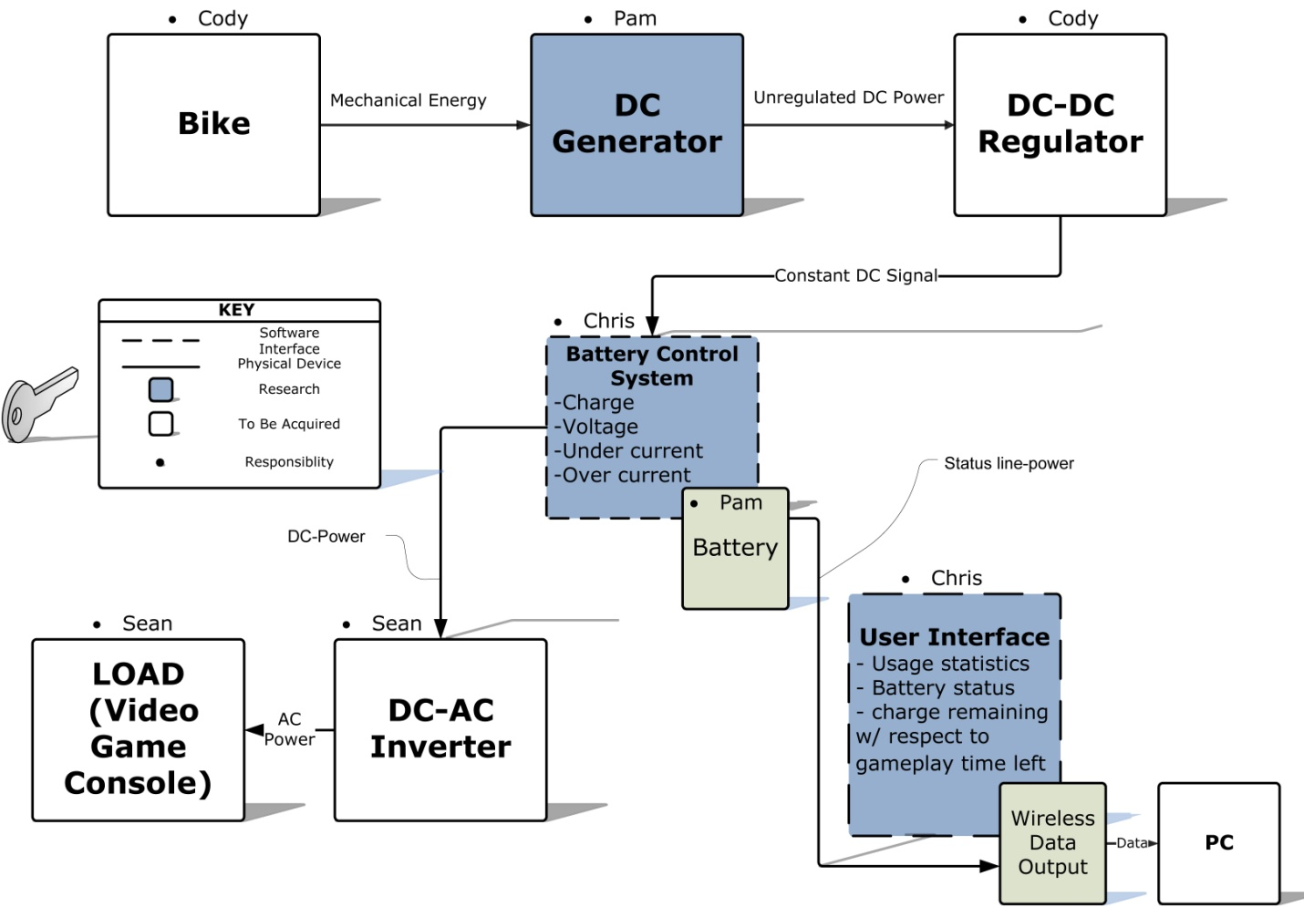

Prototype
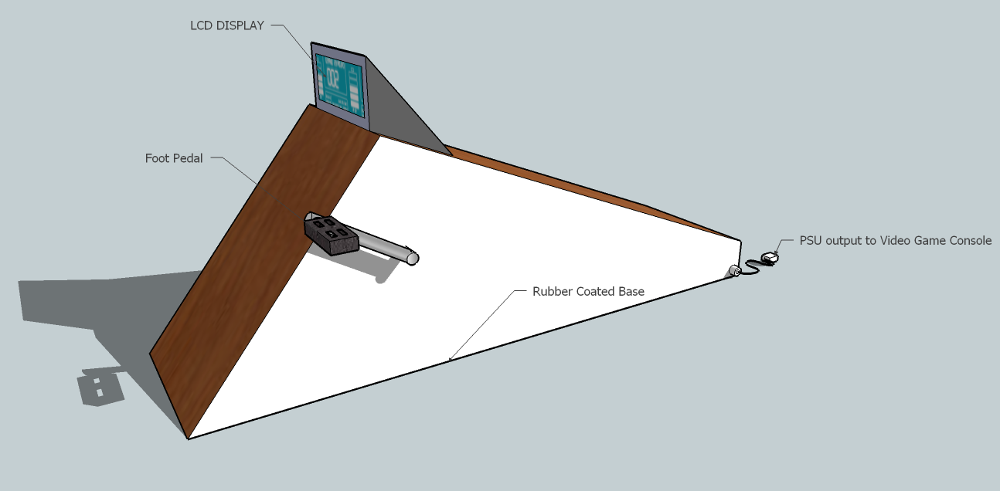

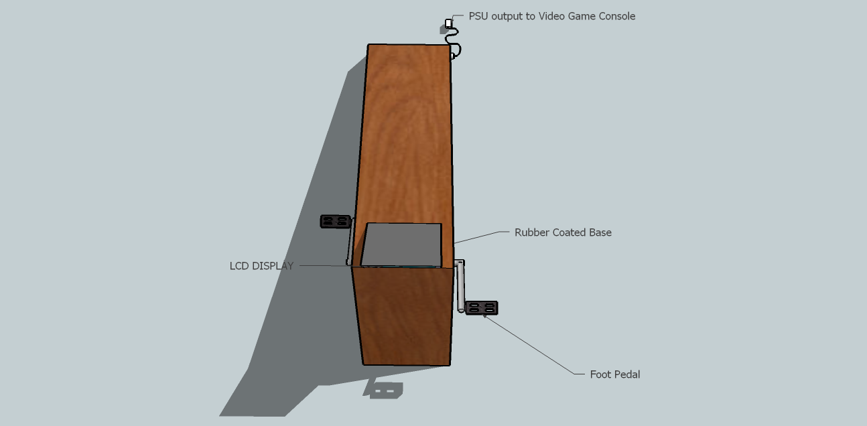

Display GUI Mockup


Budget & Financing
Financing for the CALBOX 360 is currently in the early stages of fundraising. We are researching options through each of our personal employers to support our project and its costs. Pamela Caraballo currently works at Siemens Co., where it may be possible for them to sponsor our project due to its alternative energy focus. Cody Burdette and Sean Varela both work at Petra Solar, a UCF affiliated Solar Power Company, which focuses in power electronics. We are also requesting a Progress Energy backing of $1500.00 in exchange for power focused projects such as ours and additional presentations of the finalized project.
In the scenario that we are unsuccessful in gaining sponsorship, our individual donations toward the combined budget totals, but is not confined to, $1000.00. The combined budget split amongst each of us is as follows:
Sean Varela - $250.00
Christopher Campbell - $250.00
Pamela Caraballo - $250.00
Cody Burdette - $250.00
Milestones
