Semiconductor Test Laboratory Improvements for High Temperature, Low Temperature, and High Frequency with Electronically Switchable Load
Jomah Fangonilo, Sean Hughes, Shawn Sickel, Antony Stabile

School of Electrical Engineering and Computer Science, University of Central Florida, Orlando, Florida, 32816-2450

Abstract – The objective of this project is to improve upon the existing semiconductor lab by incorporating new equipment, finding and developing software, and interfacing the components around the central computer (known as the Data Acquisition System) in order to allow for user to monitor and make measurements remotely. Since some equipment was already connected, it is important to ensure that all of the equipment is working properly, measuring devices in multiple configurations, and ensuring a user-friendly environment for semiconductor and RF device analysis.
Index Terms – Cryogenic, Relays, Scattering Parameters, Semiconductor Device Testing, Thermal Factors, Thin Films

I. Introduction
The Nano/MEMS Laboratory in UCF’s Harris Engineering Center room 406 was set up in 2008 to assist students and professors in semiconductor testing. Currently, seventeen major hardware components work together to provide a wide range of testing functionality to provide users an array of data measurement options with much room for future expansion. All of these components fall into three major systems: Room Temperature System, Low Temperature System and the Data Acquisition system. The Room Temperature System contains a large probing station coupled with several testing devices used to measure semiconductor devices such as MOSFET wafers, MOS capacitors, diodes, resistors and BJTs at approximately 300 K. The Low Temperature System consists of components that produce cryogenic temperatures in a cold head chamber testing device. Both of these systems are interfaced into a central computer in the Data Acquisition System, meant to increase the laboratory’s usability to students and those being introduced to the field of semiconductors. Through the Interactive Characterization Software (ICS) package from Metrics Technologies, many of the testing devices can be controlled through the Data Acquisition System alone, bypassing the need to configure the hardware manually. While these systems are currently fully functional, a few additions are slated for the project, including a High Temperature Precision System, a High Frequency Testing System, and an Electronically Switchable Load.

II. High Temperature System
The High Temperature System is an addition to the Room Temperature System, consisting of a controllable heater which can test semiconductor devices. This system allows the user to control the temperature of the system with great precision at temperatures ranging from 0° C to 200° C. This complements the Low Temperature System, allowing users to test semiconductor devices in a wide range of temperatures.
A. Components
The High Temperature Test System itself is very similar in design and operation to many typical probing stations, with the exception of the stage and its controller. Fig. 1 illustrates the major discrete components required for the High Temperature Test System. Several components (disc heater, microscope, and probing stage) of the High Temperature system can be taken from the existing test systems while a few new parts had to be purchased and implemented (RTD, controller, miscellaneous wiring).
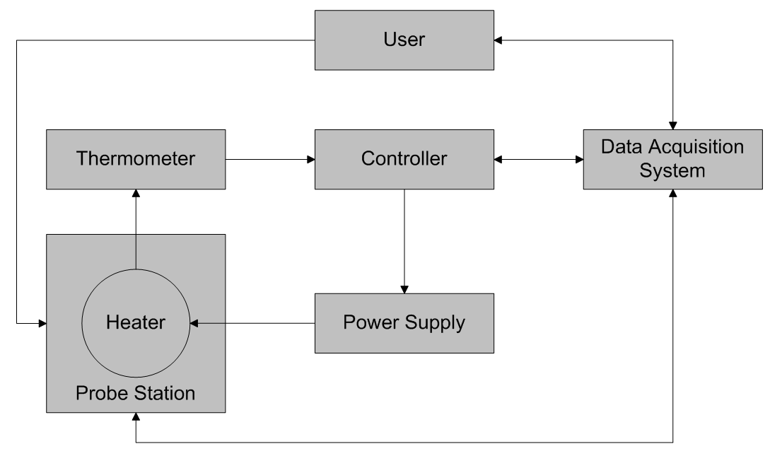

Fig. 1. High Temperature System block diagram

Fig. 1 highlights the main components of the High Temperature System. Note that the user need only interact with the Data Acquisition System to receive the measurements and outputs of the system. This feature ties into the main goal of having a user-friendly system for future students working in the lab. This setup allows for essentially identical operation with regards to the Room Temperature System with the added functionality of temperature control.
B. Resistance Temperature Device (RTD)
The resistance temperature device was the thermometer device chosen for the system. Two other device types were also considered, namely thermistors and thermocouples. However, it was determined that RTDs were the ideal thermometer device for the application given several requirements. These requirements dictate that the system must be able to 1) test devices up to 250° C, and 2) have an accuracy of ±1.5° C.
Thermistors, while extremely accurate (±0.2° C error), lacked the required temperature range for the project, only capable of reaching maximum temperatures of 150° C. This limitation alone was enough to discard thermistors as a viable option for the High Temperature System. On the other hand, thermocouples and RTDs were more than capable of reaching the required temperatures and had relatively similar accuracies. Upon further investigation of Omega’s available options, it was clear that Omega’s RTDs and thermocouples are comparable in price and performance. However, Omega states that their RTDs will typically have a longer lifespan and be more stable over their lifetime. Because of this, it was ultimately decided to use Omega’s model SA1-RTD-B Resistance Temperature Device.
C. Controller
To allow for the user to control the temperature of the platform, a temperature controller was required for the available heater, which has its own specifications. The specifications for the Chromalox A-10 Disc Heater are shown in Fig. 2.
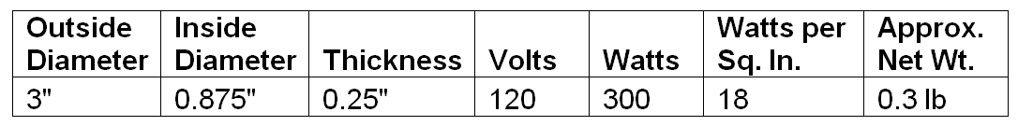

Fig. 2. Chromalox A-10 Disc Heater specifications

As seen in Fig. 2, the heater is rated at a certain voltage and power. Measuring the resistance between the two ports of the heater yielded a resistance of 48Ω. Given the power equation (1), we can then calculate the current flowing through the heater when active.

(1)

This yields I = 3A given P = 300 W and V = 120 V.
While Omega has a wide range of temperature controllers available, the only main requirement for the controller was that it was compatible with the RTD model SA1-RTD-B and the Chromalox A-10 Disc Heater. Most of Omega’s controllers proved to be overqualified, and their most economical controller model proved to be more than capable of meeting the requirements. The CN7533 is a simple switching controller without an independent power source for the disc heater rated at a maximum load of 250 VAC, 5A resistive load. Options for an independent power source were available, but would bring the overall cost of the system up significantly for a small convenience.
Fig.3 illustrates the wiring schematic for the CN 7533 controller. From Fig. 6, it is clear that the CN7533 transmits in RS485. To properly communicate with the Data Acquisition System, an RS485 to RS232 converter was needed, since the two drivers operate at difference voltages. To serve this purpose, the Speco RS232485C convertor was used to allow the controller to communicate with the Data Acquisition System.
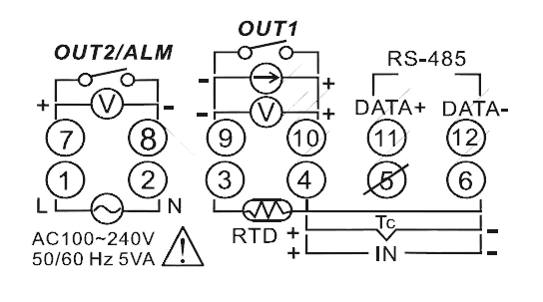

Fig. 3. CN7533 wiring schematic

Another convenient feature of Omega’s CN7533 is its free software. Again, this aligns with the concept of a user-friendly system, allowing the user to control set the heater to the desired temperature through the Data Acquisition System alone. Fig 4 illustrates the CN7833 software.

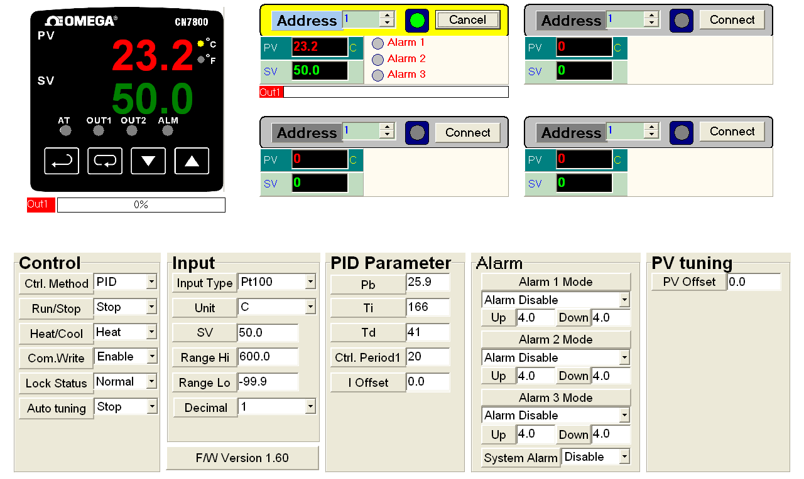D. MOSFET Testing
Fig. 4. CN733 software GUI
Testing will involve measuring the effects of high temperatures on MOSFETs. Trials will include room temperature tests at approximately 23° C and at 50° C, 100° C, 150° C, and 200° C.

III. Low Temperature System
A. Introduction
The purpose for this research was to investigate the effects temperature has on different devices, and also to show the importance of devices that can operate at low to cryogenic temperatures efficiently. The low temperature testing station is capable of testing semiconductor devices from room temperature (~300K) to cryogenic temperatures (below 123K). The Equipment setup in the testing lab is capable of temperatures as low as 18K.
B. Reason for Testing
Testing devices such as MOSFETs will provide an understanding of how temperature affects the IV characteristics of a device as it changes from 300K to cryogenic temperatures. In an n-channel FET device, it will be observed that the performance of the device increases. This is to say, for less amount of input voltage, you return larger gains in current in respect to the voltage.
Each step in the IV curves will begin to change as the temperature lowers from room to low temperatures. After a certain temperature (~80K) the silicone in the MOSFET will begin to break down, and there will no longer be a connection between the gate and other components of the device, so the impedance of the device will go to infinity.
Environmental conditions can also be a reason to test a certain extremes in temperatures. Electronics are normally made to operate near room temperature in order to continue to operate at the specified performance levels. This usually requires a level of ventilation for the electronic components in order to achieve this, or sometimes machines to push water past the electronics in order to maintain temperatures.
NASA has put a large amount of resources into determining which components would be best suited to work in the frigid conditions of space. Most of their tests were done on large components made up of arrays of electrical components, some not best suited for space. Some electronics have to be heated in order to operate. As energy in space is very important, it is necessary to eliminate wasteful energy consumption as much as possible. Having the proper types of electronics that won’t 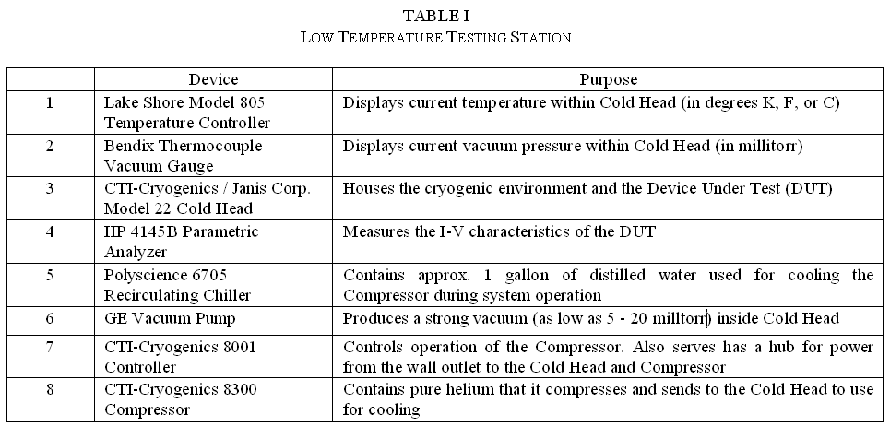suffer from freeze-out is vital to the space program, and to furthering the improvements made on earthbound electronics.
Extreme conditions such as the desert would require massive amounts of cooling, while conditions near any of Earths poles, we would observe a change in performance and have to develop devices designed to run in these locations. This is another key reason to have cryogenic testing equipment available to test devices that will run in those conditions.
C. Semiconductors at Low Temperatures
The conductivity of semiconductors is very much less than that of metallic conductors. In metals the conductivity rises as the temperature lowers, while in a semiconductor the conductivity lowers as the temperature is reduced. In a metal there is a very large constant number of conduction electrons available at all temperatures, and the conductivity is largely determined by the collision of these electrons with the crystal lattice.
In metals, increased conductivity at low temperatures is due to a small number of electron collisions. However, in semiconductors, the number of electrons or holes available to carry change is small and varies considerably with temperature. Any change in conductivity is more due to a change in the number of charge carriers than to a change in their collision behavior.
Another effect of temperature change on a semiconductor is a variation in the energy band gap, or “Eg”. The energy band gap in a semiconductor is small because, at room temperature the thermal energy available in a material is good enough in order to excite a significant number of electrons across the gap to the vacant band. This leaves a corresponding number of holes in the filled band. In semiconductors, there is approximately a 10% change in size of the gap between the conduction band and valence band when the temperature fluctuates from 300 Kelvin to 0 Kelvin. The energy band gap of most semiconductors increase with the decrease of temperature, and a comparison can be seen as the temperature goes from 300 Kelvin to 0 Kelvin.
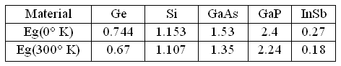

Table 5 Energy Band Gap in eV from 0° K to 300° K

Silicon-based MOSFETs and particularly CMOS can function better at low temperatures as opposed to bipolar transistors. For low temperatures, enhancement mode CMOS integrated circuits are used because they are expected to give the best overall performance in high speed/high density electronic systems and because their performance improves with decreasing temperatures.
In regards to Silicon-based MOSFETs, majority carrier devices demonstrate reduced leakage current and reduced latch-up susceptibility at low temperatures. Also, majority carrier devices show higher speed resulting from increased carrier mobility and saturation velocity.
The low temperature limit is typically determined by the ionization energy of the dopants. Dopants usually require some energy to ionize and produce carriers in the semiconductor. This energy is usually thermal, and if the temperature is too low, the dopants will not be sufficiently ionized and there will be insufficient carriers. This result is a condition called “freeze-out”.
The various effects described above can be illustrated in a graph, shown below, which roughly correspond to how a device given the doping levels will act in response to the
temperature changes in the device. This can be shown below in Fig. 6.

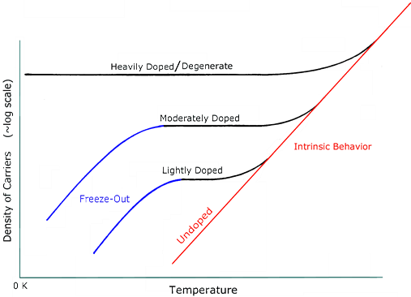

Fig. 6. Freeze-Out Doping [2]

There are additional effects that allow devices to operate below their “freeze-out” temperature. If the semiconductor is doped at a particular concentration, it can attain degeneracy. Degeneracy is a condition in which the dopants do not require energy for ionization. This happens in n-GaAs at a low doping concentration, approximately 1016 cm-3 , while Si degenerate doping requires a much higher concentration (~1019 cm-3 ). However, if this device were a bipolar transistor, operation of the device would cease well above the “freeze-out” temperature.
D. Equipment
The Low Temperature testing station is made up of eight main components which will be briefly described in Table I.

IV. High Frequency Test System
In this portion of the lab the students will measure the high frequency response of RF(radio frequency) devices. RF includes a range of frequencies from about 30 kHz to 300 GHz. The high frequency response of a device includes its s-parameters and its impedance plotted on a smith chart. The High Frequency Testing System includes a Vector Network Analyzer (HP8720B, which reads a wide spectrum from 130 MHz to 19.99 GHz) which finds this by applying a range of frequencies into the device, and reads the s-parameters of the device. The S parameters are elements of the scattering matrix, which are characteristics of the electrical behavior of a device or change in medium. These behaviors refer to the frequencies and amplitudes which get reflected and transmitted through the device. The matrix is written as:
.
Through the input port reflection coefficient (S11), reverse and forward voltage gains (S12,S21), and output port reflection coefficient (S22), the scattering matrix can be used to find the relationship between incident and reflected power waves, as well as distribution or the split of power.
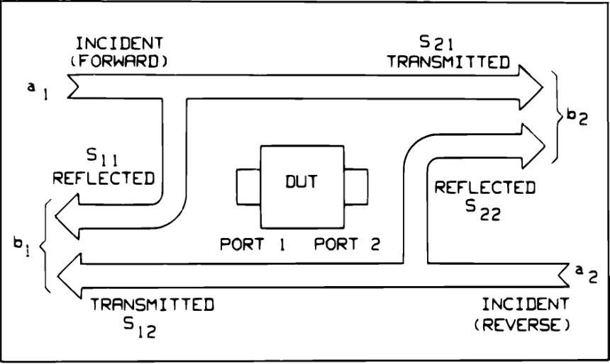
Fig. 7. S Parameters of a Two Port Device

Separately, the smith chart is a graphical tool used to help solve problems including transmission lines and matching circuits. The load’s normalized impedance is plotted on the smith chart, in reference to the input transmission line’s characteristic impedance. At unity, the load or transmission line is matched(to 50 ohms) and no reflection should be present, which is located in the center of the graph when plotted. The smith chart allows the user to analyze effects of different impedances, real or imaginary, including phase angle and its reflection and transmission coefficients.
All RF devices, such as wi-fi antennas, microwave amplifiers, filters, power dividers, and couplers, are designed to operate at certain desired frequencies. Ideally, the device should have no reflection (insertion loss) at its desired operating frequency, and have high reflection at all other frequencies, (to eliminate noise) assuming that transmission is desired.
Currently, the University of Central Florida is in possession of a high frequency testing lab with many elements, including a Vector Network Analyzer that reads up to 110 GHz. This lab is valued roughly at $250,000 dollars, so access is granted only to a handful of qualifying individuals. The RF and microwaves laboratory also has several Vector Network Analyzers, but students may not use them without approval by the supervising professor of the laboratory, and the accompaniment of an appointed Graduate Student Assistant. Due to the exclusivity of the equipment, the incorporation of the High Frequency Testing System to this laboratory is an important step towards building a better and more versatile learning facility for students and instructors.
The Vector Network Analyzer is used to read the frequency response of coaxial SMA devices, and is also interfaced to the Data Acquisition system. Users will have the option to operate the instrument manually, or perform analysis and record data from the main computer with the Data Acquisition system.
A. Data Acquisition
Due to the age of the instrument at hand, the conventional methods of collecting data from the instrument, including a disk drive or directly with a computing running a BASIC 2.0/3.0 operating system are unavailable and impractical. It was decided that the most efficient and user-friendly design for the Data Acquisition System would be to use a compatible USB/GPIB interface controller, and develop our own software interface that communicates with the instrument, acquires data, and processes the data for the user.
The hardware required for the interfacing of the Vector Network Analyzer to the Data Acquisition System was the Agilent 82357B USB/GPIB Interface. This was accompanied by the drivers and software for the instrument (VNA) to be recognized by the central computer.
The software interface was written in visual basic, and displays a series of menus and buttons for the user to navigate through the main functions of the instrument. The software also features a command line which lets the user send any command that wasn’t programmed to the GUI (Graphical Unit Interface), which provides access to any and all of the instrument’s features and options. The help menu can be referenced to see all of the available commands and instructions for the instrument.
The Software allows the user to set up and perform a calibration, navigate between active channels, select any of the desired parameters and display formats, and acquire the data. The GUI is organized in a user-friendly manner so that users unfamiliar with the front panel of the instrument can easily acquire useful data pertaining to the DUT (Device Under Test). Once the data is gathered and the figures are produced, the software presents five optional markers which can be placed at data points to show the values at the specific frequencies.

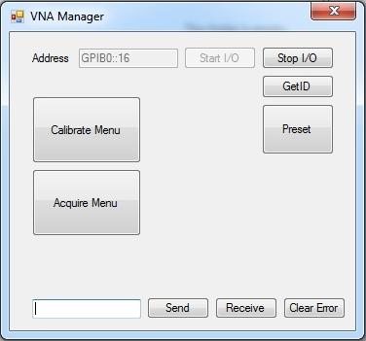
Fig. 8. VNA Manager Main Menu

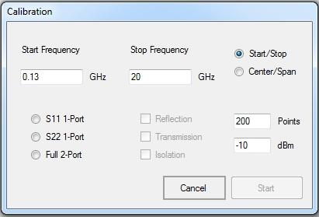
Fig. 9. VNA Manager Calibration Menu

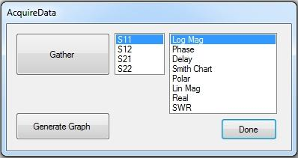
Fig. 10. VNA Manager Acquire Data Menu

V. High Frequency Switchable Load
Because of the youth of the nanotechnology lab, it is necessary to perform many tests on the different devices in order to test them and be certain that they are performing properly. The three different testing environments that may have loads constructed for them are low-temperature, high-temperature, and high frequency. However, due to the spatial constrains within the cooling chamber, it is not feasible to design a switchable load for the cold-temperature environment. Due to the fact that the parameters analyzed in the high frequency environment are very different from those analyzed in the high-temperature environment, it is not appropriate to design loads for both of these devices. To that end, since the high frequency testing environment is the newest addition to the lab, an RF electronically switchable load will be designed, and analyzed with the high frequency parameter analyzer. The switchable load designed for the high frequency network analyzer was designed in the following modules: an analog multiplexer circuit, a digital state transition circuit, and an LED display.
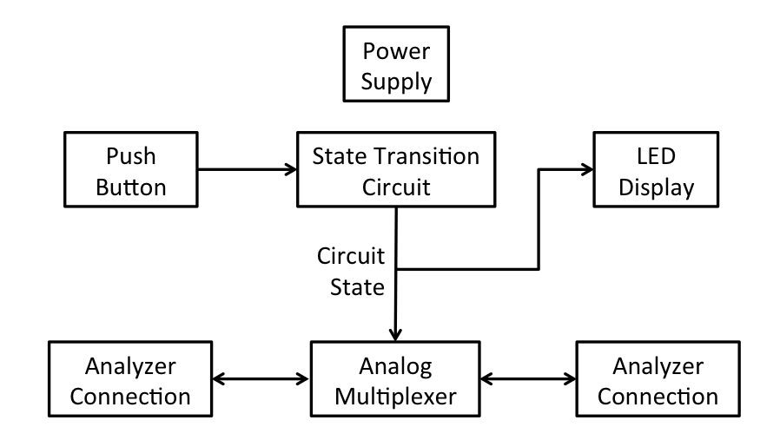
Fig. 11. Switchable Load Block Diagram
A. Analog Multiplexer
The main factor for performance in the analog multiplexer is low impedance across a wide frequency range. From an inspection of various data sheets, it was found that CMOS relays tend to attenuate heavily in the 300 MHz region, inductive relays may operate as high as 3 GHz, and MEMS relays may operate as high as 15 GHz. Given this, CMOS relays are impractical for this application, since the high-frequency testing equipment that will be used has a minimum required frequency of 300 MHz. While MEMS relays have a significantly better range of frequencies which it may operate under, they tend to cost between $250-$300, while inductive relays are within the $5 range. In order to multiplex and de-multiplex four loads, six relays are required. Though the ability to test in higher frequencies is interesting, the cost for MEMS relays is prohibitive, and as such, inductive relays will be used. For this application, the best value inductive relay was the Omron G6Z High-Frequency Relay. This relay has two load lines, and uses a voltage-controlled switch to choose between the two. The switch requires a 5V DC signal to change from one load to the other.

B. Digital State Transition Circuit
The control lines to the multiplexer and decoder from the analog multiplexer circuit required a state transition schema that cycles from 0 to 3 in 2-bit binary. This was implemented by developing a simple modulo 4 counter. For simplicity, this counter was implemented using D flip-flops.

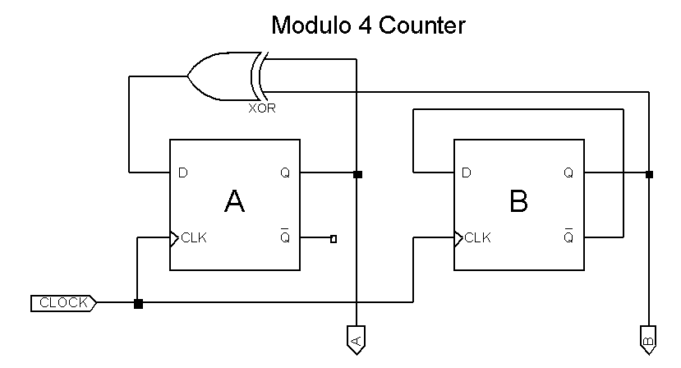
Fig. 12. A Modulo 4 Counter. The values A and B represent the two bits of the counter, and the input CLOCK is the output from a debounced push button interface.
C. LED Display
The LED display used for the switchable load was a simple seven-segment display, which received the control signals from the digital state transition circuit and converted them to the decimal digits 1 through 4. This was done using an array of logical gates using the following logical equations. A and B refer to the control signals, and a through g represent the seven segments of the display.

- a = A ⊕ B
- b = TRUE
- c = A + B’
- d = a
- e = A’ • B
- f = A • B
- g = A + B
D. Loads
Since the loads that will need to be tested with the high frequency network analyzer are highly variable, the electronically switchable load was designed such that various packaged loads may be connected to the switchable load via coaxial connection. One major application of this functionality is the decrease in calibration time. Since the high frequency network analyzer must be calibrated for each frequency range, the process of calibration can be tedious. However, if all the required standards for a calibration process are already connected to the switchable load, the process is greatly expedited, especially when used in conjunction with the software described earlier.
E. Printed Circuit Board
Several considerations were made in the design of the printed circuit board for the switchable load. The first and foremost consideration was the layout of the various relays and the 50-ohm microstrip transmission lines that connected them. In order to minimize RF interference, the relays were placed at least 0.6” away from each other, and separate from the other various components of the switchable load. The inputs to the circuit were placed on the left and right sides of the circuit board and the various loads can be connected to the four pairs of coaxial connections on the bottom of the board. The bottom of the board is filled with a copper pour in order to minimize loss through the board.
VI. Conclusion
This project focuses on filling the need for a comprehensive semiconductor testing laboratory at UCF. Such a laboratory is aimed at enhancing student knowledge of semiconductor devices and testing procedure. This group is tasked with the responsibility of adding to this laboratory, facilitating the completion of a comprehensive research center. To aid in the future endeavors of students wishing to learn more about semiconductors, the capabilities of the laboratory are being extended in developing a High Temperature Test System, enhancing the Low Temperature Test System, developing the High Frequency Testing Station, and producing an electronically switchable load for these systems.

Acknowledgement
The authors wish to acknowledge the assistance and support of the sponsors of this project, Dr. Vikram J. Kapoor and Dr. Kalpathy B. Sundaram. In addition, the authors would like to thank Dr. Parveen F. Wahid for graciously accepting to join the review board the final project, as well as Dr. Arthur Weeks, Dr. Donald Malocha, and Dr. Elena Flitsiyan for their assistance and support.

Jomah Fangonilo is receiving his BSEE in Electrical Engineering in the Spring of 2011. He is currently an intern at General Dynamics, but is looking to move into the field of semiconductors, possibly returning for graduate education should the opportunity arise.

Sean Hughes, a senior student of the electrical engineering department at the University of Central Florida. Going to pursue a working career the power systems and seek a master’s degree.

Shawn Sickel is receiving his BSEE from the University of Central Florida and hopes to pursue a career in RF device design or power systems, and also pursue a graduate degree in Electrical Engineering with a focus in electromagnetics and optics.

Antony Stabile is an Electrical Engineering student at the University of Central Florida, as well as a member of the UCF programming team. He plans on continuing his education at UCF, pursuing a graduate degree in Electrical Engineering with a focus in signal processing.

