Semiconductor Test Laboratory Improvements for High Temperature, Low Temperature, and High Frequency with Electronically Switchable Load

Group 2

Jomah Fangonilo
Sean Hughes
Shawn Sickel
Antony Stabile

Project Sponsors:
Dr. Vikram J. Kapoor
Dr. Kalpathy B. Sundaram

EEL 4914: Senior Design I
December 6, 2010

Chapter 1: Introduction 1
1.1. Executive Summary 1
1.1.1. Introduction 1
1.1.1.1. High Temperature System 1
1.1.1.1. Low Temperature System 1
1.1.1.2. High Frequency System 2
1.1.1.3. Electronically Switchable Load 2
1.2. Motivation 2
1.3. Goals and Objectives 3
1.3.1. Laboratory Manual 3
1.3.2. Laboratory Equipment 3

Chapter 2: Administrative Content 5
2.1. Budget and Financing 5
2.1.1. Budget 5
2.1.2. Sponsor Approval 5
2.1.3. Current Needs 5
2.1.3.1. High Temperature System 5
2.1.3.2. Low Temperature System 6
2.1.3.3. High Frequency System 6
2.1.3.4. Electronically Switchable Load 6
2.2. Milestone Timeline 7

Chapter 3: High Temperature Semiconductor Testing System 8
3.1. Introduction 8
3.2. Room Temperature Semiconductor Test System 8
3.2.1. Introduction 8
3.2.2. Laboratory Devices 8
3.2.2.1. Micromanipulator 6000 Probe Station 8
3.2.2.2. Measurement Devices 9
3.2.2.2.1. HP 4145B Semiconductor Parameter Analyzer 10
3.2.2.2.2. HP 4280A 1MHz C Meter / C-V Plotter 10
3.2.2.2.3. HP 4140B pA Meter / DC Voltage Source 10
3.2.2.2.4. HP 4275A Multi-Frequency LCR Meter 10
3.2.2.2.5. HP 4083A Switching Controller 11
3.2.2.2.6. Data Acquisition System 11
3.3. High Temperature Test System Design 11
3.3.1. Introduction 11
3.3.2. Applications 11
3.3.3. Specifications 12
3.3.1. Micromanipulator Company Upgrade Option 13
3.3.2. Component Design 14
3.3.2.1. Probe Station 14
3.3.2.1.1. Introduction 14
3.3.2.1.2. Requirements 14
3.3.2.1.3. Heater Specifications 14
3.3.2.1.4. Platform Assembly 15
3.3.2.1.5. Introduction 16
3.3.2.2. Thermometer Device 16
3.3.2.2.1. Specifications 16
3.3.2.2.2. Design Considerations 17
3.3.2.2.3. Thermistor 17
3.3.2.2.3.1. Introduction 17
3.3.2.2.3.2. Omega Thermistor Specifications 17
3.3.2.2.3.3. SA1-TH-44000 Series Thermistor 18
3.3.2.2.3.4. Other Models 19
3.3.2.2.3.5. Conclusion 20
3.3.2.2.4. Thermocouple 20
3.3.2.2.4.1. Introduction 20
3.3.2.2.4.2. Omega Thermocouple Specifications 21
3.3.2.2.4.3. SA1XL Series Thermocouple 22
3.3.2.2.4.4. HFS Series Thermocouple 23
3.3.2.2.4.5. SA1 Series Thermocouple 24
3.3.2.2.4.6. SA2 Series Thermocouple 25
3.3.2.2.4.7. Other Models 26
3.3.2.2.4.8. Conclusion 27
3.3.2.2.5. Resistance Temperature Detector 27
3.3.2.2.5.1. Introduction 27
3.3.2.2.5.2. Omega RTD Specifications 28
3.3.2.2.5.3. SA2C & SA2F Series RTD 29
3.3.2.2.5.4. SA1-RTD Series RTD 29
3.3.2.2.5.5. SA1-RTD-B Series RTD 30
3.3.2.2.5.6. Other Models 31
3.3.2.2.5.7. Conclusion 32
3.3.2.3. Controller 32
3.3.2.3.1. Introduction 32
3.3.2.3.2. Specifications 33
3.3.2.3.3. Design Considerations 33
3.3.2.3.3.1. CN7500 Series 34
3.3.2.3.3.2. CN7800 Series 34
3.3.2.3.3.3. CN1501 Series 35
3.3.2.3.3.4. Conclusion 35
3.3.2.4. Decision Matrix for Thermometer and Controller 35

Chapter 4: Low Temperature Semiconductor Testing System 37
4.1. Introduction 37
4.2. Reason for Testing 37
4.2.1. Semiconductors at Low Temperature 38
4.2.2. Wirebonding MOSFET 41
4.2.3. Advantages of Lower Temperatures 41
4.2.4. Zinc Oxide Doped with Aluminum 41
4.2.5. Thermal Stability of ZnO:Al 42
4.2.6. Producing Cu Strips on ZnO:Al 43
4.2.7. Analyzing the ZnO:Al Copper Strips 47
4.2.7.1. Specifications 48
4.3. System Design 49
4.3.1. System Hardware 49
4.3.1.1. Lake Shore Temperature 805 Controller 50
4.3.1.1.1. Purpose 50
4.3.1.1.2. Operation 51
4.3.1.2. Bendix Thermocouple Vacuum Gauge 52
4.3.1.2.1. Purpose 52
4.3.1.2.2. Operation 52
4.3.1.3. CTI-Cryogenics / Janis Corp. Model 22 Cold Head 53
4.3.1.3.1. Purpose 53
4.3.1.3.2. Operation 53
4.3.1.3.3. Device Testing 54
4.3.1.3.4. Specifications 54
4.3.1.4. Polyscience 6705 Recirculating Chiller 56
4.3.1.4.1. Purpose 56
4.3.1.4.2. Operation 56
4.3.1.4.3. Specifications 57
4.3.1.5. GE Vacuum Pump 57
4.3.1.5.1. Purpose 57
4.3.1.5.2. Operation 57
4.3.1.6. 8001 Controller Monitor 58
4.3.1.6.1. Purpose 58
4.3.1.6.2. Operation 58
4.3.1.6.3. Power Requirements 58
4.3.1.7. 8300 Compressor 59
4.3.1.7.1. Purpose 59
4.3.1.7.2. Operation 59
4.3.1.7.3. Specifications 59
4.3.1.7.4. Helium Cartridge 59
4.3.1.7.5. System Workflow 60
4.4. Operation of Low Temperature Station 61
4.5. Future Experiments 62
4.5.1. Introduction 62
4.5.2. Equipment 62
4.5.2.1. Low Temperature Station Probes 62
4.5.2.2. Specifications 62
4.5.3. Graphene 64
4.5.4. Silicon Germanium 66
4.5.5. Silicon Carbide 67

Chapter 5: High Frequency Testing System 69
5.1. Introduction 69
5.2. Reasons for Testing 70
5.3. High Frequency Testing System 70
5.3.1. Introduction 70
5.3.2. Device Hardware and Software 72
5.3.2.1. Vector Network Analyzer 72
5.3.2.2. Test Port Cables and SMA Connectors 72
5.3.2.3. Probing Station 73
5.3.2.4. High Frequency Microprobe 73
5.3.2.5. Microwave Probe Holder 75
5.3.2.6. Calibration Kits 76
5.3.2.7. Interfacing 77
5.3.2.8. HP-IB/GPIB Remote Programming 77
5.3.3. Device Operation 78
5.3.3.1. Introduction 78
5.3.3.2. LINE Switch and CRT Display 78
5.3.3.3. Active Channels Key Block 80
5.3.3.4. Entry Key Block 81
5.3.3.5. Stimulus Key Block 82
5.3.3.6. Response Key Block 83
5.3.3.6.1. Calibration Introduction 86
5.3.3.6.2. Calibration Procedure 88
5.3.3.7. Instrument State Key Block 90
5.3.4. Test Process 93

Chapter 6: Electronically Switchable Load 94
6.1. Introduction 94
6.1.1. Design Specifications 94
6.1.2. Design Goals 94
6.2. Design 95
6.2.1. Analog Multiplexer Circuit 95
6.2.1.1. CMOS Switches 95
6.2.1.2. Inductive Relays 96
6.2.1.3. MEMS Relays 97
6.2.1.4. Analog Multiplexer Choice 98
6.2.1.5. Multiplexer Layout 99
6.2.3. Digital State Transition Circuit 101
6.2.4. LED Display 103
6.2.4.1. LED Decoder 103
6.2.4.2. Seven Segment Display 104
6.2.4.3. LED Display Choice 107
6.2.5. Power Supply 109
6.2.6. Impedance Analyzer Interface 110
6.2.7. Design Summary 111
6.2.8. Parts Required 111
6.3. Printed Circuit Board 112
6.3.1. PCB Materials 112
6.3.2. Integrated Microstrip Design 112
6.3.3. 6.3.3 PCB Layout 116
6.4. Assembly 118
6.5. Testing 118
6.6. Cost 118
6.7. Conclusion 119

Chapter 7: Conclusion 120

Chapter 1: Introduction
  - Executive Summary
    - Introduction
The Nano/MEMS Laboratory in UCF’s Harris Engineering Center room 406 was set up in 2008 to assist students and professors in semiconductor testing. Currently, seventeen major hardware components work together to provide a wide range of testing functionality to provide users an array of data measurement options with much room for future expansion. All of these components fall into three major systems: Room Temperature System, Low Temperature System and the Data Acquisition system. The Room Temperature System contains a large probing station coupled with several testing devices used to measure semiconductor devices such as MOSFET wafers, MOS capacitors, diodes, resistors and BJTs at approximately 300 K. The Low Temperature System consists of components that produce cryogenic temperatures in a cold head chamber testing device. Both of these systems are interfaced into a central computer in the Data Acquisition System, meant to increase the laboratory’s usability to students and those being introduced to the field of semiconductors. Through the Interactive Characterization Software (ICS) package from Metrics Technologies, many of the testing devices can be controlled through the Data Acquisition System alone, bypassing the need to configure the hardware manually. While these systems are currently fully functional, a few additions are slated for the project, including a High Temperature Precision System, a High Frequency Testing System, and an Electronically Switchable Load.
      - High Temperature System
The High Temperature System will be an addition to the Room Temperature System, consisting of a controllable heater which can test semiconductor devices. This system will allow for the user to control the temperature of the system with great precision at temperatures ranging from 0° C to 200° C. This will complement the Low Temperature system, allowing users to test semiconductor devices in a wide range of temperatures.
      - Low Temperature System
The Low Temperature Test system is made up of many components, which create a testing environment of 300 K down to ~18 K. This allows semiconductors to be tested to their limits, as most will not function, or “freeze-out,” which most BJTs experience MOSFETs are most suitable for this working in such extreme environments.

      - High Frequency System
The addition of the High Frequency Testing System includes a Vector Network Analyzer with a frequency range from 130 MHz to 20 GHz, and the hardware and software to interface the system to the central computer in the Data Acquisition System. Once the High Frequency Test system is set up, tests may be conducted manually through the front panel of the instrument or through a computer controller via software programmed by the group. This system will be used to read the S parameters of packed or on-wafer RF devices. Packaged devices will be read with a pair of coaxial test port cables, and on-wafer devices will be read through the probing station which is also used for the Semiconductor Test System. The test system will also have the option to print measured data from the Vector Network Analyzer.
      - Electronically Switchable Load
To further the testing of the high-frequency analysis environment, a printed circuit board will be fabricated. This printed circuit board will be required to cycle through a variety of different loads that would be appropriate for testing on the HP 8720B Vector Network Analyzer. The switching component will be electronically controlled, and will be triggered through a pushbutton interface.
  - Motivation
Originally, Dr. Sundaram and Dr. Kapoor approached the senior design I group in early fall session of 2010 with an interesting idea for a senior design group. The group would design, setup, and test the variety of equipment within the lab. After sitting down and talking with Dr. Sundaram and Dr. Kapoor, it was clear that this was more than just a senior design project; this was an opportunity to learn valuable skills, and work closely with individuals who have worked with several professional organizations, and to grant a deeper understand of what it means to be an engineer.
The group was instructed that many devices would be used through our design. During their presentation, the devices to be used are to include:
- CTI-Cryogenics system with include a Cold Head, 8300 Liquid Helium Compressor and 8001 Controller
- HP 4145B Semiconductor Parameter Analyzer
- HP 8720B Vector Network Analyzer
- Micromanipulator Model 6000
It was also explained that the total worth of the lab in excess of $300,000. All of this equipment was to be used to help students further their knowledge of semiconductor devices.

  - Goals and Objectives
The goals and objectives presented by the sponsors were to be completed within two semesters, the first semester being the design, and the second semester for experimenting with the designed components designed in the first semester.
The goal was simple: turn the pre-existing lab into a more complete lab by incorporating new equipment, finding or developing software, and interfacing the components around one central computer so experiments would run remotely. Since some equipment was already connected, it is important to ensure that all of the equipment is working properly, measuring devices in multiple configurations, and ensuring a user-friendly environment for semiconductor analysis.
One of the largest objectives was to incorporate the High Frequency analyzer into the current array of machines. This would require a new method of interfacing the machine, along with new software to properly record and plot data to the computer terminal, so data could be analyzed or compared against other data.
In addition, the High Temperature System would add an extended range of testing capabilities to the lab. The High Temperature System in conjunction with the Low Temperature System grants users with the capability of testing semiconductor devices from 18K – 500K.
    - Laboratory Manual
As in the last group that worked on the lab, this group will produce another lab manual to provide new users with a comprehensive tutorial on the added equipment. It should give user unfamiliar to the equipment a structured format to learn each station, without having to read through the user manuals for every piece of equipment. Select devices in Table 1.1 will be demonstrated for the user to provide hands-on experience so the user will not be overwhelmed with the amount of devices available. The manual will include a step-by-step walkthrough for each the high/room temperature station, low temperature station, and high frequency station.
    - Laboratory Equipment
While the group is not responsible for every piece of equipment in the lab, Table 1.1 lists the various pieces of equipment available for use in the various projects. Any of these components are accessible by the group for whatever reason.

Brand | Equipment Description | Quantity
Keithley | 177 Microvolt DMM | 3
Keithley | 169 Multimeter | 1
Keithley | 181 Nanovoltmeter | 1
Keithley | 224 Programmable Current Source | 1
Keithley | 172 Autoranging DMM | 1
Spencer | 432716 Microscope | 1
Veeco Instruments | FPP-5000 4-point Probe | 1
GRA-LAB | Universal Timer Md. 171 | 2
HP | 54503A 500 MHz Digitizing Oscill. | 1
HP | 214B Pulse Generator | 1
HP | 1740A Oscilloscope | 1
Olympus | BH2 Microscope | 1
Olympus | TGH Md. 203211 | 1
Keithley | 150A Microvolt-Ammeter | 1
Specialty Coating Sys | P6204-A | 1
HP | 4061-A Semiconductor/Comp. Test | 1
Micromanipulator Co, | Model No. 6000 Microscope | 1
HP | 7470A Plotter | 1
HP | 8720B Network Analyzer | 1
Heathkit | Digital Design Exp. Mdl ET-3200 | 1
Heathkit | Digital Design Exp. Mdl ET-3100 | 1
HP | 4145B Semiconductor Parameter Analyzer | 4
EG&G | Lock In Amplifier Mdl 5210 | 2
HP | Accessories for 16055A | 1
HP | Accessories for 16058A | 1
Tektronix | Curve Tracer 577 | 1
Tektronix | Standard Test Fixture 177 | 1
HP | 16058A Test Fixture | 1
HP | 16055A Test Fixture | 1
Keithley | Electrometer 602 | 1
Barnstead | Thermolyne HP72625 | 1
Boonton Electronics | Capacitance Meter Mdl. 72B | 1
CTI-CRYOGENICS | Controller 8001 | 1
CTI-CRYOGENICS | Compressor 8300 | 1
CRYODYNE | M22 | 1
Bendix | Thermocouple Vacuum Gauge | 1
HP | 34401A Multimeter | 1
HP | 3312A Function Generator | 1
Table 1.1 – Lab Equipment List

Chapter 2: Administrative Content

  - Budget and Financing
    - Budget
Due to the nature of the project’s sponsorship, budgetary concerns were mostly minimized. While the sponsors of the project were to provide the funding for the entire project, the best value model was expected. That is, using components that provided the required performance at the lowest cost. Thus, extensive research must still be done to determine the best possible components that would meet the basic specifications at the best price. In short, the components that would be purchased will ideally have the best possible performance to price ratio.
    - Sponsor Approval
Upon identification of a need in the laboratory, group members will submit a detailed overview of the needed components to the sponsors. Upon further review by both the sponsors and the group, a decision will be made to purchase parts at the discretion of the sponsors. The notion of best value will always be considered, and the sponsors reserve the right to decline a purchase request if it is deemed to be in violation of best value.
    - Current Needs
While research still needs to be done to determine the proper parts needed to add the desired functionality to the lab, several key components have already been targeted for purchase. Ideally, these first components will be assembled as soon as the next phase of the project arrives.
      - High Temperature System
Table 2.1 lists the needed components to implement the High Temperature System previously outlined. All parts listed are to be purchased from Omega Engineering, and does not include shipping costs.
Item | Unit Price | Quantity | Total
SA1-RTD-B Resistance Temperature Device | $ 31.67 | 3 | $ 95.00
CN7533 Controller | $ 97.00 | 1 | $ 97.00
 |  |  | $ 192.00

Table 2.1 – Required Components for High Temperature System

      - Low Temperature System
Components required for this system are currently in the research phase.
      - High Frequency System
While the research for the required components for this system is mostly complete, an accurate estimate of its costs could not be determined. It appears that many components, including the flexible cables are legacy components which are not readily available. It appears that these components may be hard to acquire at a reasonable price. Alternatives are currently being considered.
      - Electronically Switchable Load
Table 2.2 lists the needed components for the electronically switchable load. The cost of the printed circuit board cannot be appraised until time of ordering. All components are to be purchased from Digikey.
Item | Unit Price | Quantity | Total
G6Z-1PE High Frequency Relay | $ 6.15 | 6 | $ 36.90
HEF4555 2 to 4 decoder | $ 0.63 | 1 | $ 0.63
LM2575 5V Voltage Regulator | $ 3.26 | 1 | $ 3.26
4584 Hex Schmitt Trigger | $ 0.71 | 1 | $ 0.71
4070 Quad XOR gate | $ 0.77 | 1 | $ 0.77
4071 Quad 2-input OR gate | $ 0.51 | 1 | $ 0.51
4081 Quad 2-input AND gate | $ 0.50 | 1 | $ 0.50
4013 Dual D-type flip-flop | $ 0.51 | 1 | $ 0.51
9V Battery | $ 2.00 | 1 | $ 2.00
Housing, 9V Battery | $ 1.30 | 1 | $ 1.30
LED, 1.2V @ 20mA | $ 0.19 | 4 | $ 0.76
Inductor, 330 uH | $ 1.33 | 1 | $ 1.33
1N4819 Schottky Barrier Rectifier | $ 0.54 | 1 | $ 0.54
Right-Angle Female Coax Connector | $ 4.21 | 2 | $ 8.42
Seven-Segment Display | $ 3.24 | 1 | $ 3.24
PCB pushbutton switch | $ 1.36 | 1 | $ 1.36
Printed Circuit Board | $ 300.00 | 1 | $ 300.00
 |  |  | $ 362.74

Table 2.2 – Required Components for Electronically Switchable Load

  - Milestone Timeline
Fall 2010
- 09/22/2010 – Submit the Initial Project and Group Identifications document
- 09/29/2010 – Meet with Dr. Kapoor to initialize learning of the low temperature testing station
- 10/06/2010 – Each team member understand each of their stations and begins teaching each member the specifics, safety conditions, and proper operating procedures of the apparatuses
- 10/07/2010 – Begin setup of all major hardware components: HP 8720B Network Analyzer, low temperature, and room temperature devices
- 10/27/2010 – Final setup of semiconductor hardware and being design of the necessary software that will be interfaced with the hardware testing: HP 8720B Network Analyzer, low temperature, and high temperature equipment to display the desired results
- 12/6/2010 – Submit completed Senior Design Project Documentation
Spring 2011
- 01/10/2011 – Class begins, initial assemblies started
- 02/16/2011 – Finish design of acquisition software and begin designing experiments to further test the equipment
- 03/16/2011 – Run designed experiments and compile a lab manual of the tested experiments for future testing, and to include in final senior design project
- 03/31/2011 – Complete writing of experiments and begin preparation of senior design final presentation
- 04/26/2011 – Complete preparation of Senior Design project

Chapter 3: High Temperature Semiconductor Testing System

  - Introduction
The Room Temperature System currently implemented is capable of characterizing the physical properties of many common PN junction diodes, Schottkey diodes, MOSFETS, MOS capacitors, and BJTs, as well as developing devices such as Silicon Germanium or Silicon Carbide based diodes and transistors. The system is composed of two separate hardware subsystems, the I-V and C-V Test System, which are both capable of measuring the entire range of DC and physical measurements needed to characterize the semiconductor devices under testing.
In its current state, the Room Temperature Testing System does not have any capabilities to control the temperature of the testing station. Adding a controllable temperature system will allow for greater flexibility in testing under a wide array of temperatures that is otherwise unavailable under the system in its current implementation.
  - Room Temperature Semiconductor Test System
    - Introduction
The C-V and I-V Test System is partly comprised of the HP4280A 1MHz and the HP4145B Semiconductor Parameter Analyzer interfaced to the Data Acquisition System’s central computer through a National Instrument General Purpose Interface Bus (GPIB) controller. Respectively, these two instruments function independently as an I-V or C-V test instrument. In addition, the HP4041B pA Meter / DC Voltage Source, HP 4275A Multi-Frequency LCR Meter, and HP4083A Switching Controller (collectively known as the HP4061A Semiconductor / Component Test System) serve to allow a full range of measurement capabilities with the Micromanipulator Model 6000 Probe Station. This existing system can be modified and connected to a new high temperature testing system to further augment the laboratory’s measurement and testing capabilities.
    - Laboratory Devices
      - Micromanipulator 6000 Probe Station
The root of the Room Temperature system’s measurement capabilities comes primarily from the Micromanipulator Model 6000 Probe Station. The probe station is a three component instrument consisting of a compound optical light microscope, adjustable stage, and various probing elements. Figure 3.1 illustrates current setup of the probe station and its individual parts. The stage is a grounded chuck which holds the device under test. The stage is manipulated by the horizontal stage positioners, which grant the stage movement on 2 axes as well as rotational movement. The platen facilitates the use of various probing devices used to physically make connections to the device under test.
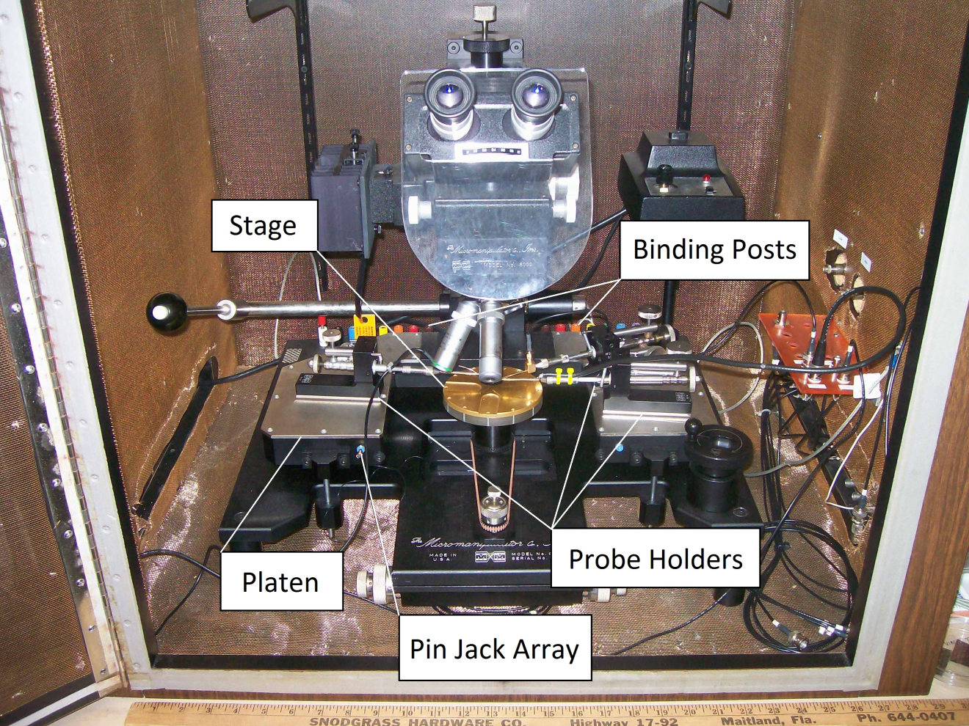

Figure 3.1 – Micromanipulator 6000 Probe Station
Traditionally, the probe leads are connected to the pin jack array, which are internally connected to the binding posts. While this connection is ideal for the use of a curve tracer, connections to the other measurement devices are required. In this system, probe leads terminate in BNC connectors which connect to the measurement devices in the Room Temperature System.
      - Measurement Devices
While the probe station provides the means to measure semiconductor devices, it alone is incapable of independently measuring and reporting a device’s properties. Therefore, the probe station is supplemented by C-V and I-V Test System. Thus, the probe station is supplemented by several semiconductor measurement devices, including the HP4280A 1MHz C Meter/ C-V Plotter, HP4145B Semiconductor Parameter Analyzer, HP4141B pA Meter / DC Voltage Source, HP4275A Multi-Frequency LCR, and the HP 4083A Switching Controller. Each of these devices contributes to the overall measurement capabilities of the Room Temperature Test System.
        - HP 4145B Semiconductor Parameter Analyzer
The Hewlett Packard Semiconductor Parameter Analyzer is extremely useful for semiconductor device characterization. It is a fully automatic testing instrument designed to measure the DC characteristics of a wide array of semiconductor devices. Used in Industry, it provides real-time feedback on wafer evaluation. The HP4145B consists of an assortment of high precision current and voltage sources and meters, which are in turn supported by software to enhance usability.
        - HP 4280A 1MHz C Meter / C-V Plotter
The Hewlett Packard 4280A 1MHz C Meter / C-V Plotter is an instrument capable of plotting capacitance-voltage (C-V) and capacitance-time (C-t) measurements. An update to the Hewlett Packard 4140 pA Meter / DC Voltage Source, HP4375A Multi-Frequency LCR Meter, and the Hewlett Packard 4083A Switching Controller, which can also produce C-V plots, the HP4280A is well suited to more specific applications and is much more compact, capable of doing the work of those three instruments. The HP 4280A can be upgraded, expanded and paired with other instruments through the GPIB IEEE-488 cabling with the HP4515B, allowing it to extract both current-voltage (I-V) and C-V plots.
        - HP 4140B pA Meter / DC Voltage Source
As the name suggests, the HP4140B pA Meter / DC Voltage Source is capable of measuring exceptionally small currents, down to the picoamp range. The HP4140B has a resolution of up to one thousandth of a picoamp, making it highly valuable in leakage current measurements.
The HP4140B also contains two DC voltage sources. The sources can be programmed together to work simultaneously when measuring and testing a device. DC Voltage source “A” is capable of generating voltage in a step or ramp cycle. The voltages can be stepped at differing intervals or ramped with differing slopes at a wide range. This flexibility makes it highly suited for many different tests.
The pA meter used in conjunction with the voltage sources results in very precise and effective testing of a number of characteristics including, but not limited to, diode and FET curves, threshold voltages, and leakage currents, granting the user a wide array of testing capabilities.
        - HP 4275A Multi-Frequency LCR Meter
The Hewlett Packard 4275A is capable of testing inductance, capacitance and resistance at multiple frequencies. Since the HP4280A is incapable of making measurements at frequencies other than 1 MHz, the HP4275A is the sole instrument capable of measurements at a wide range of frequencies. A variable frequency testing instrument allows for users to view capacitance responses over a wide range of frequencies.
        - HP 4083A Switching Controller
The Hewlett Packard 4083A Switching Controller is simply a control device that switches between the HP4140B and the HP4275A. It can be manually controlled to allow for I-V or C-V measurements, or frequency tests. The HP4083A also has available outputs to control other devices, such as probes or timers.
        - Data Acquisition System
The Data Acquisition System currently implemented acts as a focal point for the entire laboratory. It connects and interfaces all the instruments to a centralized system, which communicates between the instruments and lab computer. The computer does so through the General Purpose Interface Bus (GPIB), which is enabled by the software provided by National Instruments. The DAS’s main purpose is to help the user analyze logged data. It contributes to allowing users to maintain reliable high performance laboratory operation.
  - High Temperature Test System Design
    - Introduction
While the Room Temperature System in its current state is capable of testing semiconductor devices at room temperature, as currently implemented, it does not have any capabilities to control the temperature of the testing station. As seen in Figure 3.1, the chuck (stage) has no temperature controls, allowing for variances in temperature that do not allow for precise temperature-based measurements. One of the focuses of this project is to create a controlled temperature environment for the laboratory. The Low Temperature System already partially implemented is just one step towards this goal. To finally realize a high temperature would be another step in achieving this goal.
    - Applications
The addition of a High Temperature System to the currently existing Room Temperature System provides a wider array of testing capabilities to the laboratory. In a broader sense, the fields of environmental testing, performance improvement, failure analysis are a few where there is a need for semiconductor analysis under high temperatures. In short, there is plenty of undiscovered potential in semiconductor testing at high temperatures. Cutting edge research in this field goes into understanding how electronics behave under extreme conditions.
    - Specifications
To realize a High Temperature Test System, the platform;
- should be capable of testing devices up to 200° C,
- should have an accuracy of ~±1° C,
- should be controllable though a feedback system,
- should be similar in operation to the Room Temperature System,
- should be interfaced to the existing Data Acquisition System,
- should require minimal interaction with components other than the Data Acquisition System,
- should use components with the best value,
- should use components readily available in the lab.
Many of these requirements were chosen simply by virtue of practicality. A system capable of testing at extremely high temperatures in addition to being extremely expensive is simply impractical considering the currently facilities. Without a serious overhaul of the laboratory, working at over 200° C would also prove to be a safety hazard. An accuracy of ±1° C is required to maintain consistent standards in testing. As a testing station, any sort of deviation of greater than ±1° C will decrease the quality and reliability of tests conducted on the system.
To add a level of automation similar to how the Data Acquisition System automates measurements, a feedback control system will be needed to control the heater’s temperature. The hot plate should have a controllable power source which can be automatically configured to bring the heater to the desired temperature. To accomplish this, a thermometer will measure the plate’s temperature and relay that back to the controller which then adjusts how much power flows through the heater. Again, since the framework for the Probe Station and Data Acquisition System already exists, the design for the interface between the Controller and Data Acquisition System will also be required. Figure 3.2 illustrates the block diagram for the system.
To maintain a best value means to use the least costly components to achieve the requirements. Naturally, this leads to using components available in the lab when possible. Since the laboratory already has a microscope, heater, platform and probes and that could be used for the testing station, there is no foreseen need to purchase parts for the probe station. However, these parts will need to be integrated together in such a way that it functions like the Micromanipulator Model 6000 Probe Station.

Figure 3.2 – Block Diagram for High Temperature System
    - Micromanipulator Company Upgrade Option
One option is to simply upgrade the Micromanipulator Model 6000 Probe Station with several components made by the Micromanipulator Company. The Micromanipulator Company not only manufactures probe stations and probes, but a whole host of peripherals that were made specifically to establish a high temperature testing station. The Micromanipulator 6000 can be outfitted with a special thermal chuck (Figure 3.3) that can be controlled with their pcTC Thermal Chuck Control Software, which in turn is readily integrated with existing software in the Data Acquisition System.
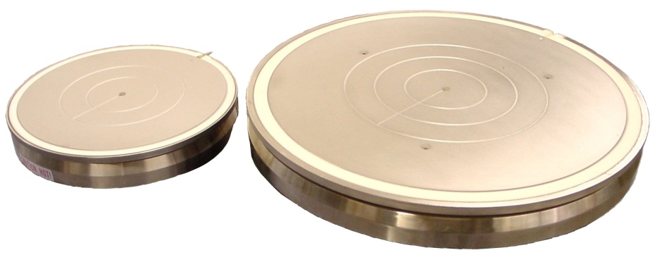

Figure 3.3 – 200mm & 300mm H1000 Series Thermal Chucks

(Permission granted by the Micromanipulator Company)

However, while convenient, this option proved to be far too expensive. Upon further research, it was determined that a full upgrade of the system would cost well over $10,000. While this would provide a state-of-the-art upgrade to the laboratory, this option is too cost-prohibitive. It may be an option considered in the future, however.
    - Component Design
      - Probe Station
        - Introduction
Upon initial inspection of the available equipment and research into available options, considerations were made to simply upgrade the Micromanipulator Model 6000 with factory-made components. The Micromanipulator Company manufactured thermal chucks that could readily be installed into existing hardware, along with heat controllers, cooling systems and compatible software for the Data Acquisition System. However, this option proved to be far too cost-prohibitive, even with sponsorship funds. Thus, a set of other parts would need to be assembled to construct a new probe station.
        - Requirements
Since the project is restricted to using only available components when possible, that essentially makes up the bulk of the probe station’s requirement. When fully built, the probe station;
- should use components available in the lab,
- should operate in the same manner as the Micromanipulator Model 6000 probe station,
- should be in close proximity to the Room Temperature System.
        - Heater Specifications
Figure 3.4 illustrates the Chromalox A-10 heater available in the lab. The Figure is captioned by the markings on the heater which are obscured by a layer of rust. The heater is specified to achieve 120 V at 300 W, giving it a resistance of 48 Ω and making to capable of drawing 3 A. This specification is important when choosing the proper heater as it needs to be able to send at least 3 A through the heater to utilize its maximum potential.
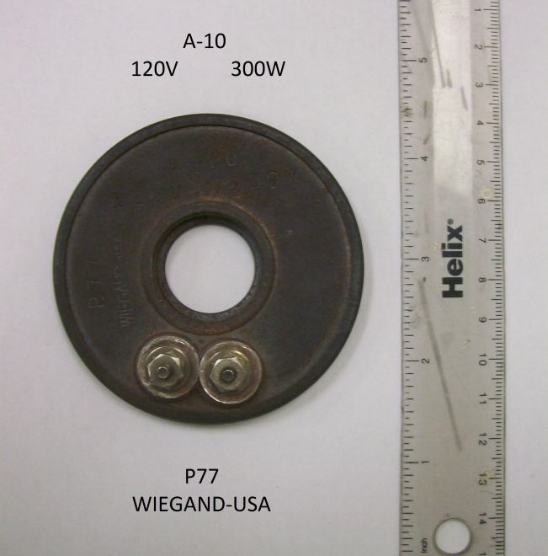

Figure 3.4 – Chromalox Heater
Table 3.5 further outlines the heater’s specifications, and its physical properties, including size. This is important when selecting the proper thermometer device, as it needs to be able to fit on the heater’s surface.
Outside Diameter | Inside Diameter | Thickness | Volts | Watts | Watts per Sq. In. | Approx. Net Wt.
3" | 0.875" | 0.25" | 120 | 300 | 18 | 0.3 lb

Table 3.5 – Chromalox A10 Specifications
        - Platform Assembly
Figure 3.6 illustrates the stage assembly and the microscope in its current state. The hot plate is the equivalent to the stage in the Micromanipulator Model 6000 and includes a vacuum tube to hold the device under test in place. The heater is in direct contact with the hot plate underneath it and will be connected to the controller through leads underneath the platen, where the probe holders will be mounted.
The microscope itself can be placed directly over the stage where the device under test will be placed. Though not as strong as the microscope in the Micromanipulator Model 6000 Probe Station, it is adequately powerful enough to view semiconductor devices on the micron scale.
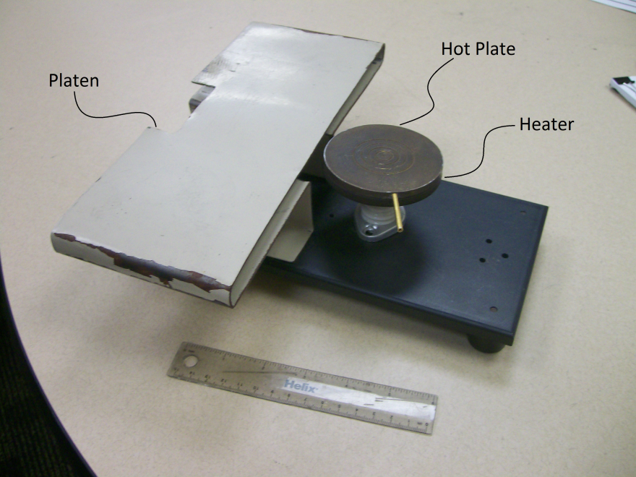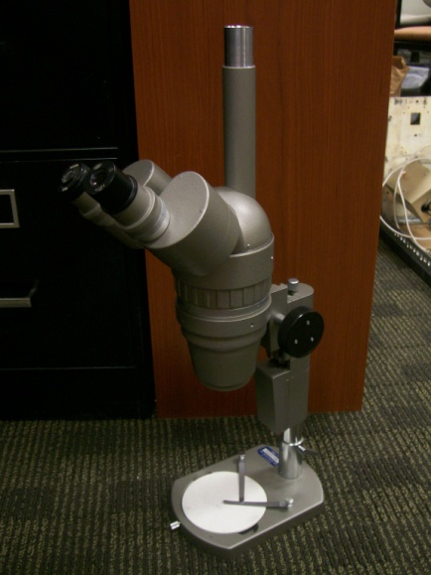

Figure 3.6 – Partial Stage Assembly
        - Introduction
The most integral part of the High Temperature Testing System next to the heater is arguably the thermometer that will relay the heater’s temperature to the controller. The thermometer device must not only maintain functionality, at high temperatures, but must be accurate to a specified tolerance.
      - Thermometer Device
        - Specifications
To accurately relay the heater’s temperature back to the user, some sort of thermometer device is required. The device;
- should be capable of measuring up to 200° C,
- should be accurate to ~±1° C,
- should not alter the measurements made on the device under test,
- should not irreversibly modify the heater,
- should be stable,
- should have the best value to meet other specifications.
In addition to the requirements listed in 3.3.3, there are two additional requirements for the thermometer alone. The heater itself is what needs to be monitored, and as such, the thermometer must be capable of measuring the temperature of the heater. Physically modifying the heater or any of the laboratory devices in a way that cannot be reversed should be avoided to prevent damaging any laboratory components. The thermometer also should not interfere with measurements taken on the device under test. In addition, the thermometer device should be relatively stable, and long-lasting to maintain the user-friendliness of the lab.
        - Design Considerations
From the beginning, there were several possible device types that were considered. Choices included thermocouples, resistance temperature detectors (RTD), or thermistors, which all appeared to be viable options for a thermometer device. Considering the need for a singular device, only one could be chosen. In each of the following sections, the merits of each device are evaluated and compared along with their limitations to decide the best option for this application.
Omega is a well-known process measurement and control company which has a wide selection of relatively inexpensive temperature control and monitoring tools, including thermistors, thermocouples, and RTDs. Upon the urging of the project’s advisors, all purchases were to be made from Omega, limiting the need to do extensive research for other options outside of Omega.
While Omega has a wide range of these thermometer devices, to analyze the merits of every device would be unnecessary and excessive. To narrow down the available choices, only surface mounted models with no need for additional hardware (i.e. screws, bolts, cement, etc), and devices that will be small enough to mount on the underside of the heater will be discussed.
        - Thermistor
          - Introduction
A thermistor is a type of resistor, typically made from a ceramic or polymer, whose resistance varies significantly in accordance with its temperature. While standard resistors exhibit this behavior, the thermistor does so in a greater manner, and is therefore more readily measured. In addition to being used as temperature sensors and self-regulating heating elements, thermistors are also widely used as inrush current limiters and self-resetting overcurrent protectors. Figure 3.7 illustrates the thermistor symbol used in a circuit.
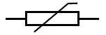

Figure 3.7 – Thermistor Symbol
          - Omega Thermistor Specifications
Again, since Omega has a wide selection of thermistors, only surface mounted models with no need for additional hardware will be considered, to reduce the number of options available. Given that no irreversible modifications should be made to the current equipment, this decision reduces the need to go into excessive detail into Omega’s many thermistor models.
In general, Omega’s selection of thermistors have roughly the same operating temperatures and tolerances, with the main distinctions between thermistor models being their mounting methods, size and prices. Table 3.8 shows a sample specification table out of Omega’s selection of thermistors.
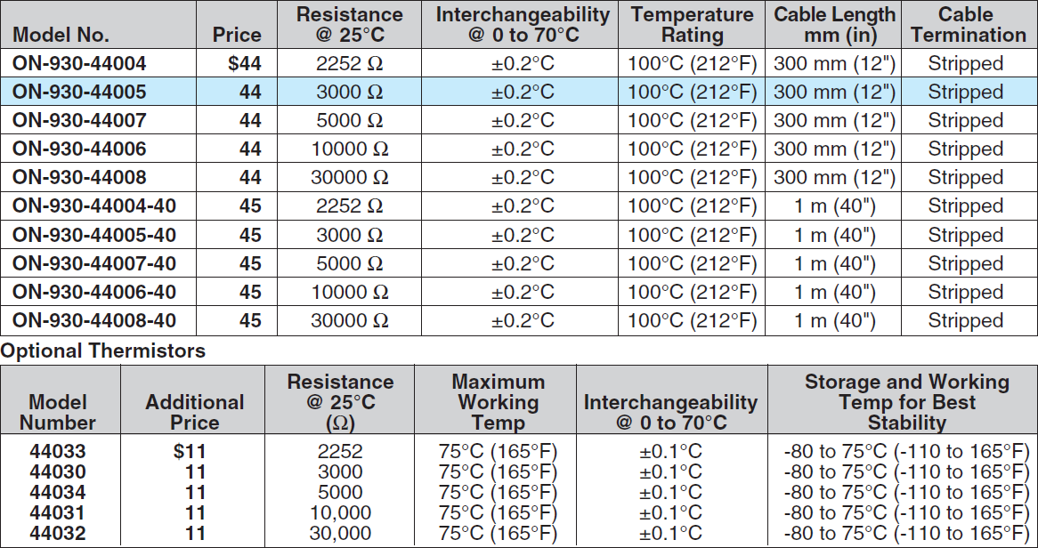

Table 3.8 – General Omega Thermistor Specifications

(Permission granted by Omega)
The sample Table 3.8 shows that Omega thermistors have a maximum operating temperature of 100° C (some models have a maximum recommended operating temperature of 120° C) with tolerances of ±0.2° C. An option also exists to reduce that tolerance to ±0.1° C, increasing the price and reducing the maximum operating to 75° C. The prices of their thermistors are also affected by length of wire and its resistance. Neither specification is particularly important for this application, and will not make any impact in the decision process.
          - SA1-TH-44000 Series Thermistor
The SA1-TH-44000 series thermistor illustrated in Figure 3.9 is the only surface mounted option available from Omega that does not require any additional hardware. It is mounted onto a surface using a self-adhesive (SA) pad.
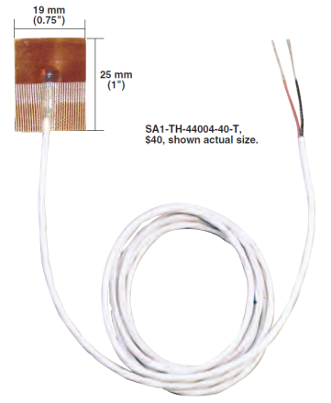

Figure 3.9 – SA1-TH-44000 Thermistor

(Permission granted by Omega)
While the SA1-TH-44000 series surface mounted thermistors have ±0.2° C accuracy, far surpassing the accuracy requirement, its maximum working temperature is only up to 120° C, far below the range requirement. The unit price for the SA1-TH-44000 series thermistor is $40. An option is included that increases accuracy to ±0.1° C, but also reduces the range to 75° C. Table 3.9 illustrates the SA1-TH-44000’s specifications.
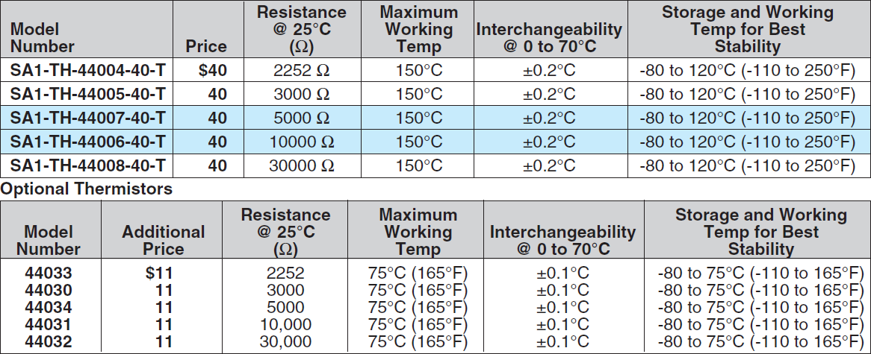

Table 3.10 – SA1-TH-44000 Specifications

(Permission granted by Omega)
          - Other Models
Table 3.11 lists the other available options for thermistors. The ones noted as requiring cement had no self-adhesive properties, requiring extra materials to properly mount onto a surface. In addition, none of these alternatives provided any significant advantages over the models which came with their own adhesive.
Thermistor Model | Reason Eliminated
TH-44000 Series | Requires cement
ON-930 Series | Requires bolt or cement
ON-950 Series | Requires threaded hole
ON-409 & ON-909 Series | Requires cement
OL-709 Series | Requires cement
ON-401 & ON-402 Series | Requires cement
OL-701 & OL-702 Series | Requires cement
OL-901 Series | Requires cement
OL-729 Series | Requires cement
ON-408 Series | Requires cement
OL-708 Series | Requires cement

Table 3.11 – Eliminated Thermistor Models
          - Conclusion
In short, only two viable thermistor models are available from Omega. Table 3.12 compares their differences. While they fail to meet the maximum temperature requirement, they have astounding accuracy, capable of tolerances as low as ±0.1° C. While their unit prices are quite steep compared to thermocouples and RTDs, neither option can compete with a thermistor for applications requiring high accuracy at lower temperatures.
Thermistor Model | Maximum Temperature | Accuracy | Unit Price
SA1-TH-44004-40-T | 150° C | ±0.2° C | $40
SA1-TH-44033-40-T | 75° C | ±0.1° C | $51

Table 3.12 – Thermistor Comparison
        - Thermocouple
          - Introduction
A thermocouple is a junction between two metals that produces a voltage related to the temperature difference between the metals. Figure 3.13 illustrates the general thermocouple model. In addition to temperature measurement and control, it can be used to convert heat into electrical power. There are many different properties to consider when deciding on the proper thermocouple for a given application.
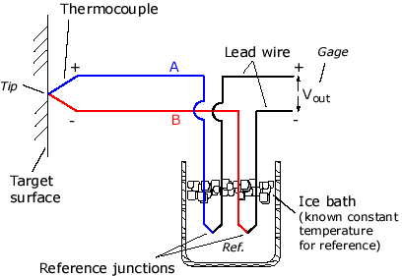

Figure 3.13 – General Thermocouple Schematic
          - Omega Thermocouple Specifications
Thermocouples are defined by their alloy types and are denoted so by their ANSI Code. As seen in Table 3.14, thermocouples have a much wider range of measurable temperatures than the specifications require, and also have much higher accuracy tolerances at those temperatures. Some of the models have acceptable tolerances of ±1° C or less at its maximum rated temperature, with the rest having slightly higher tolerances of ±1.1° C at its maximum rated temperature.
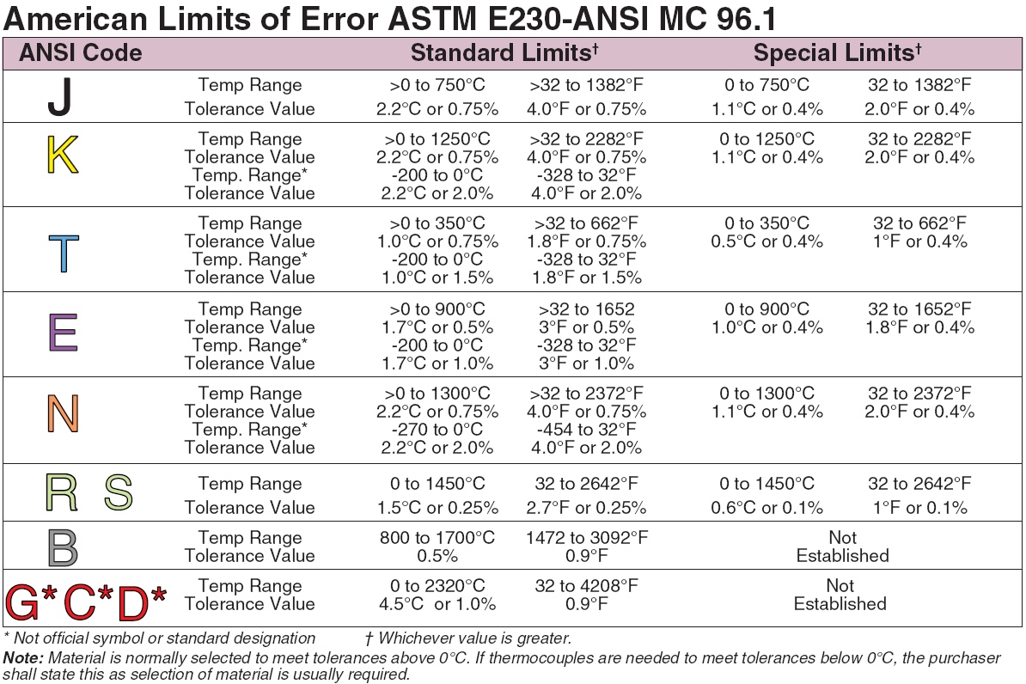

Table 3.14 – Thermocouple Tolerances by Type

(Permission granted by Omega)
Given the percentage-based tolerance, at 200° C, not all thermocouples have identical tolerances. Table 3.4 outlines the varying tolerances based on what alloy is used. Note that of the calculated and given tolerances, the higher one is taken as noted in Table 3.14.
Alloy Type | Standard Limit of Error | Special Limit of Error
J type | 1.5° C | 1.1° C
K type | 2.2° C | 1.1° C,
T type | 2.2° C | 0.8° C,
E type | 1.0° C | 1.0° C,
N type | 2.2° C | 1.1° C,
R type | 1.5° C | 0.6° C,
S type | 1.5° C | 0.6° C.

Table 3.14 – Thermocouple Tolerances by Type at 200° C
Thermocouples made with Special Limits of Error wire have lower tolerances, but require modification of the thermocouple leads. However, it is clear from Table 3.14 that an E-type thermocouple would provide the tolerance to meet ±1° C at 200° C regardless of the wire chosen.
          - SA1XL Series Thermocouple
The SA1XL series thermocouple illustrated in Figure 3.15 is the first viable option for a thermometer device. It is capable of reaching 260° C without any additional parts and comes in type J, K, T, and most importantly, E alloys, which achieves a tolerance of ±1° C at 200° C.
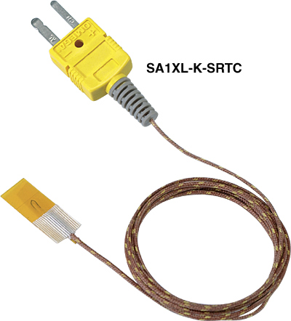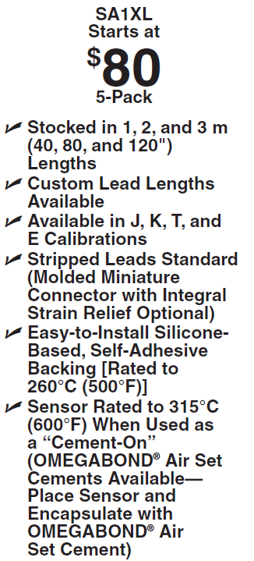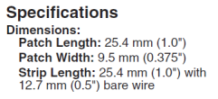

Figure 3.15 – SA1XL-(*)-SRTC Thermocouple

(Permission granted by Omega)
As seen in Figure 3.15, the most basic SA1XL model comes at a unit price of $16 ($80/5). The price increases for longer wire or an SMP connection, neither of which are required. One meter of wire is more than enough wire, as the work stations will be relatively close to each other.
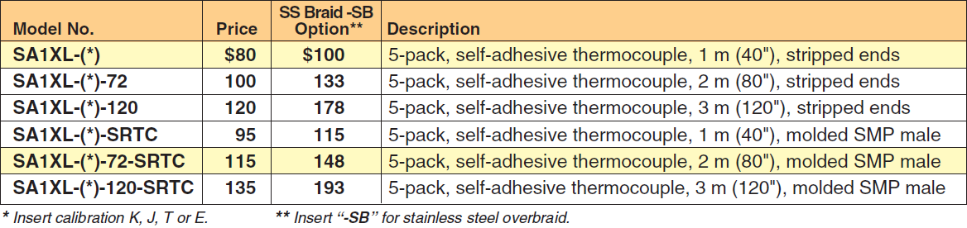

Table 3.15 – SA1XL Thermocouple Specifications

(Permission granted by Omega)
          - HFS Series Thermocouple
The HFS series thermocouple illustrated in Figure 3.16 appeared to be another viable thermocouple option. However, its upper temperature limit is only 150° C, below the 200° C requirement.
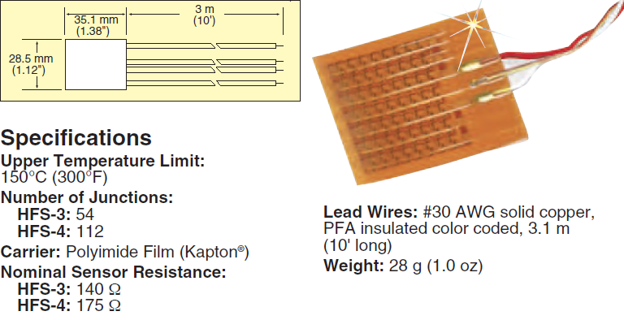

Figure 3.16 – HFS-4 Thermocouple

(Permission granted by Omega)
Table 3.17 shows that the HFS series is only available in type K alloys, which have a tolerance of ±2.2° C at 200° C. While it can be improved to ±1.1° C, its base unit price is already $230, making this option much less viable than other devices. Upon further inspection, this model’s price tag can be attributed to its more specialized application. While it is capable of doing a simple temperature measurement, it is more specifically geared toward measuring heat transfer rather than temperature. In addition, it does not require a temperature junction, unlike most thermocouples.
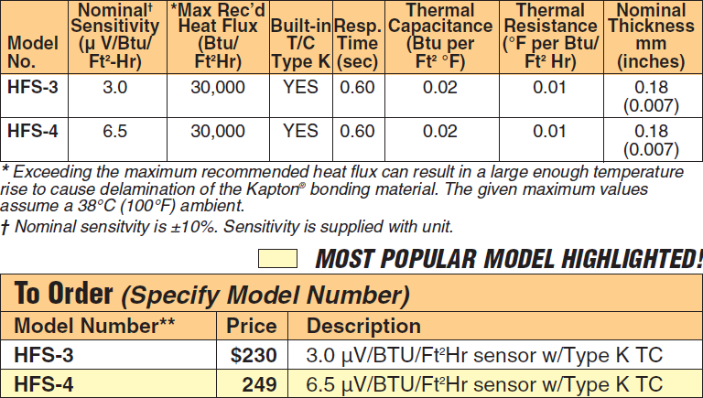

Table 3.17 – HFS Thermocouple Specifications

(Permission granted by Omega)
          - SA1 Series Thermocouple
Another model, the SA1 series thermocouple illustrated in Figure 3.18, comes in the E type alloy, meeting the accuracy requirement. However, they are only rated to 175° C, because of the laminate and adhesive used to mount the thermocouple.
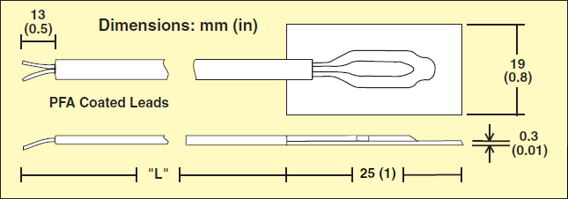

Figure 3.18 – SA1 Thermocouple
(Permission granted by Omega)
The base unit price for the SA1 series thermocouple comes to $12 as see in Figure 3.19. Again, models with longer wires or an SMP connector are available, but not needed. Again, SA models indicate a self-adhesive application for any clean surfaces.


Figure 3.19 – SA Series Surface Mount Thermocouple Specifications

(Permission granted by Omega)
          - SA2 Series Thermocouple
The SA2 series thermocouple illustrated in Figure 3.20 is the fourth option for thermocouple devices. The SA2F model is designed to mount on flat surfaces, while the SA2C model is designed to mount on curves surfaces like pipes. It meets the temperature range requirement, capable of testing surfaces up to 200° C.
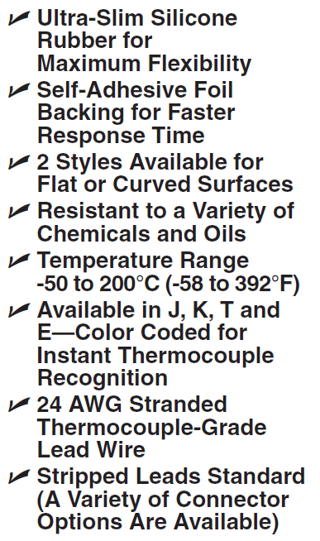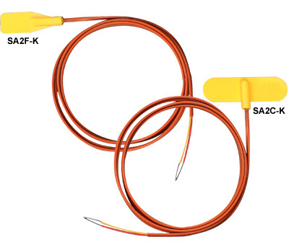

Figure 3.20 – SA2F-K & SA2C-K Thermocouples

(Permission granted by Omega)
As seen in Table 3.21, the unit price for either the SA2C or SA2F is $30 and can be made with E type alloys, meeting the accuracy requirement
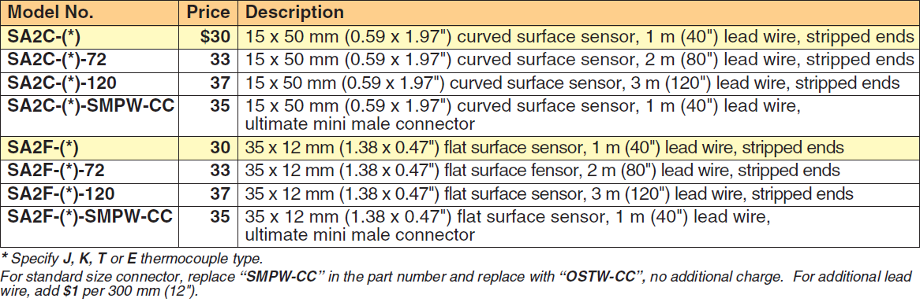

Table 3.21 – SA2 Thermocouple Specifications

(Permission granted by Omega)
          - Other Models
Table 3.22 lists other surface mounted models available on Omega’s website. Both the WT and WT-(*)-HD Series required mounting using bolts, which would require irreversible modification to the heater.
Thermocouple Model | Reason Eliminated
WT Series | Requires bolt
WT-(*)-HD Series | Requires bolt

Table 3.22 – Eliminated Thermocouple Models
From Figure 3.23, the WT series and WT-(*)-HD series thermocouples are shown to have washer assemblies, making them unsuitable for a surface application without modifying the heater.
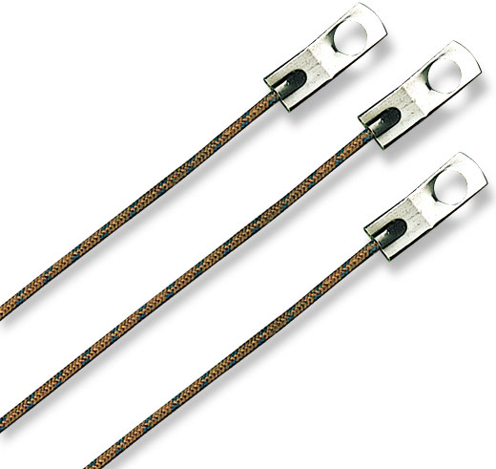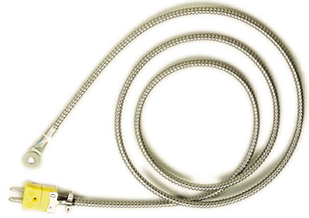

Figure 3.23 – WT & WT-(*)-HD Series Thermocouples

(Permission granted by Omega)
          - Conclusion
Table 3.24 compares the individual thermocouples discussed above. From here, it is determined that there is no clear winner in the thermocouple division. The SA1XL thermocouple beats out the SA2 thermocouple in price and maximum temperature, but is outclassed by the SA1 in price at a cost of maximum temperature. The HFS series is clearly to be dropped for consideration, as it does not meet any requirements and is much more expensive.
Thermocouple Model | Maximum Temperature | Accuracy @ 200° C | Unit Price
SA1XL Series | 260° C | ±1° C | $16
HFS Series | 150° C | ±2.2°C | $230
SA1 Series | 175° C | ±1° | $12
SA2 Series | 200° C | ±1° C | $30

Table 3.24 – Thermocouple Comparison
Compared with thermistors and RTDs, thermocouples have the widest operating range and lowest cost. However, their accuracy cannot compare to the accuracy of a thermistor, and they typically have a much shorter lifespan compared to RTDs.
        - Resistance Temperature Detector
          - Introduction
The resistance temperature detector (RTD), also commonly known as resistance thermometers or resistive thermal devices is an option similar to the thermistor in that they exploit the predictable change in the resistance of some materials with changing temperature. They are different from thermistors in that they are almost always made of platinum using thin film technology. Thus, they are often called platinum resistance thermometers (PRTs). A 3-wire RTD is illustrated in Figure 3.25
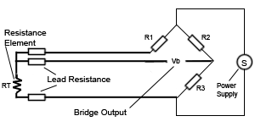
Figure 3.25 – Three-wire RTD Schematic
          - Omega RTD Specifications
Thin film RTDs come in four different classes; AA, A, B, and 1/10B. Table 3.26 illustrates the temperature ranges of the four different RTD classes. As we can see, the Class 1/10B and AA RTDs fail to meet the range requirement of 200° C, while the Class A and B RTDs exceed the requirement.
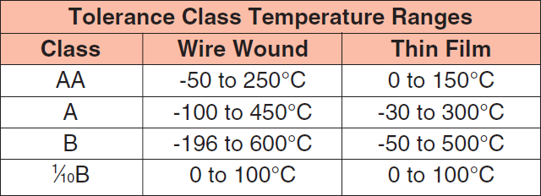

Table 3.26 – RTD Temperature Ranges
(Permission granted by Omega)
Table 3.27 illustrates the tolerances of each of the classes. Similar to the thermocouple, the accuracy of the RTD decreases at higher temperatures. At 200° C, Class AA RTDs have an accuracy of ±0.43° C, Class A RTDs have an accuracy of ±0.55° C, and Class B RTDs have an accuracy of ±1.30° C.
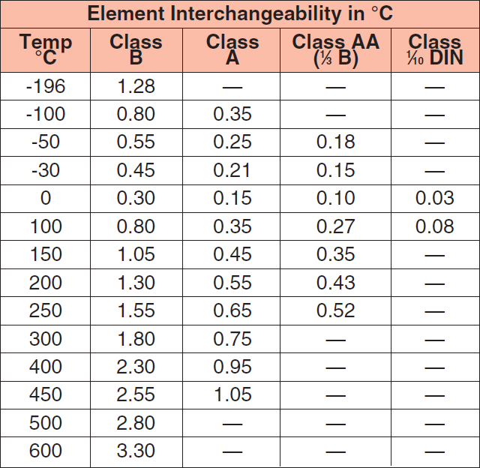

Table 3.27 – RTD Temperature Tolerances
(Permission granted by Omega)
Again, Omega has surface mounted RTD models available and like Omega’s thermocouples, some require additional hardware to mount. Thus, only surface mounted models which do not require additional hardware will be considered.
          - SA2C & SA2F Series RTD
The SA2C and SA2F series RTDs shown in Figure 3.28 differ in their mounting shape. Similar to the SA2 thermocouple, The SA2C series is intended for curved surfaces such as pipes while the SA2F series is intended for flat surfaces. A four wire split will dictate the need for a controller that can take a 4-wire RTD input, to be discussed later.
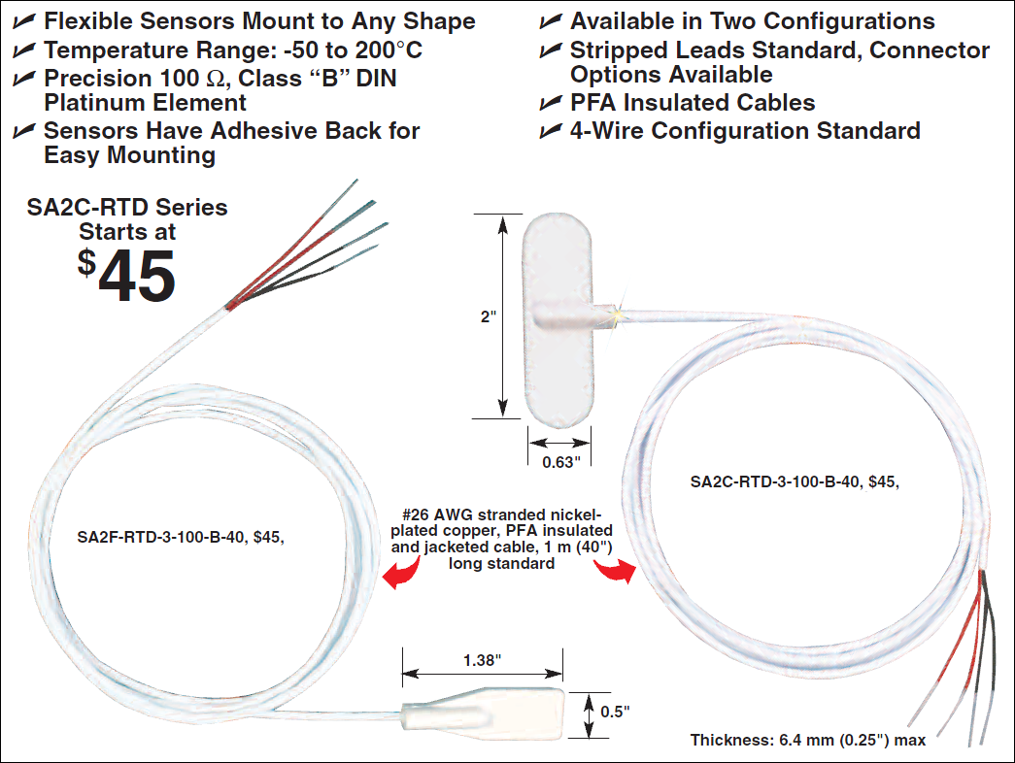

Figure 3.28 – SA2C & SA2F RTDs

(Permission granted by Omega)
Table 3.29 lists the SA2 RTD’s specifications. For Class B tolerances, the base unit price is $45. Again, additional wire length can be added for an additional cost, not required for this application. SA2 RTDs with Class A tolerances can be bought for an additional $7.
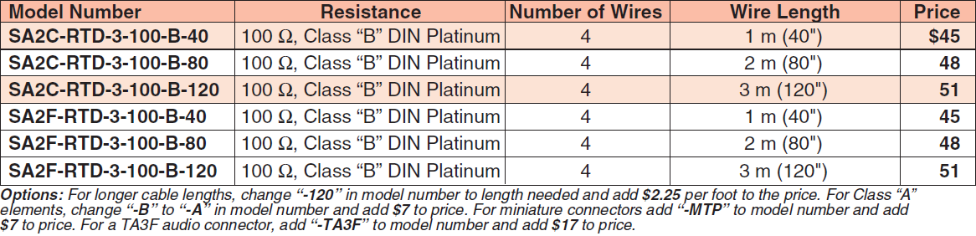

Table 3.29 – SA2 RTD Specifications

(Permission granted by Omega)
          - SA1-RTD Series RTD
The SA1-RTD series RTD illustrated in Figure 3.30 is another of Omega’s self-adhesive model thermometer devices. It has a maximum operating temperature of 260° C. It comes in Class A, giving it a tolerance of ±0.55° C at 200° C. It also comes in 3-wire or 4-wire models.
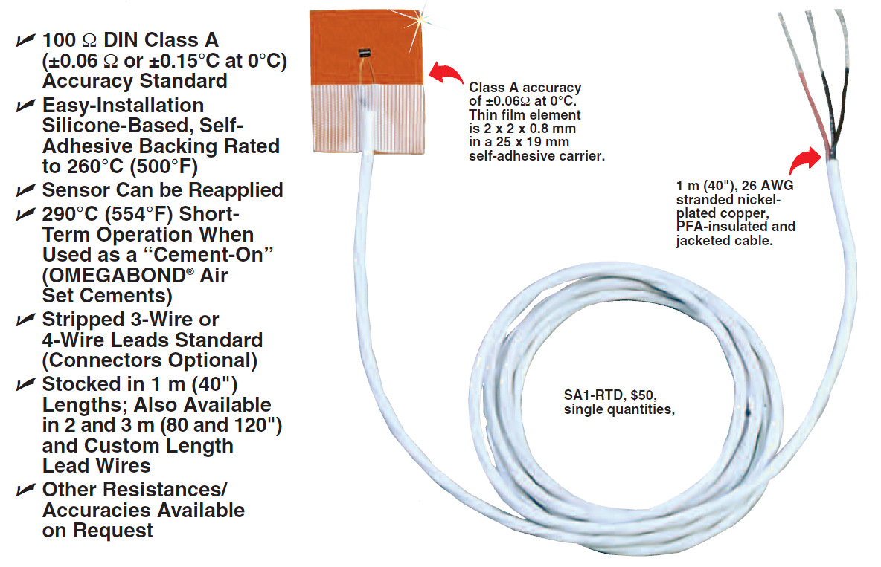

Figure 3.30 – SA1-RTD

(Permission granted by Omega)
As seen in Table 3.31, The SA1-RTD comes at a base price of $50. Options to increase the number of lead wires, lead wire length, and add MTP or TA4F connectors exists at an additional cost. Again, none of these features are required, but the number of lead wires available may come into consideration when choosing the proper controller.
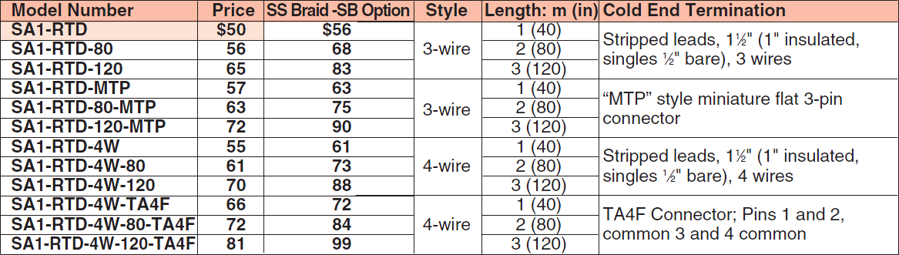

Table 3.31 – SA1-RTD Specifications

(Permission granted by Omega)
          - SA1-RTD-B Series RTD
The SA1-RTD-B series RTD illustrated in Figure 3.32 is essentially identical in construction to the SA1-RTD. However, it comes in Class B tolerances instead of Class A, giving it an accuracy of ±1.3° C at 200° C.
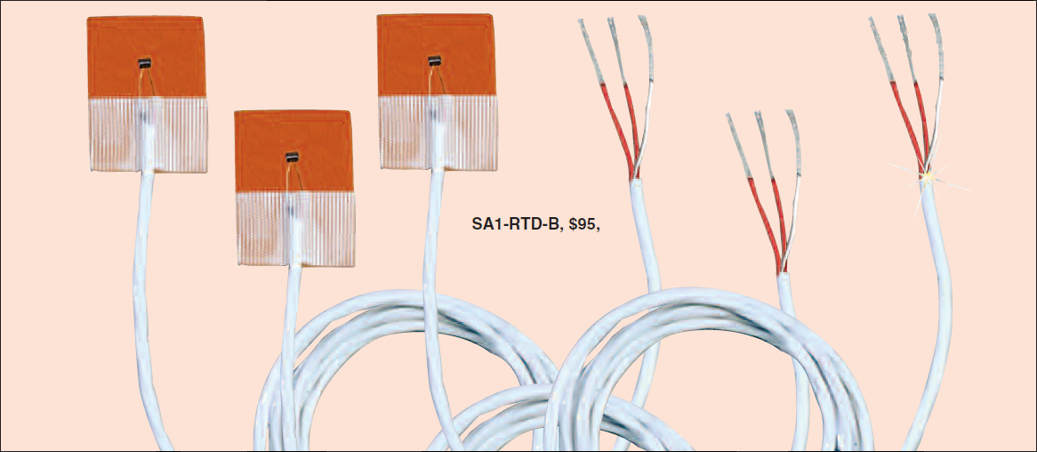

Figure 3.32 – SA1-RTD-B RTDs

(Permission granted by Omega)
As seen in Table 3.33, the unit price for the SA1-RTD-B is $31.67. No option exists for extra lead wires, but the option to increase wire length and add connectors is available.
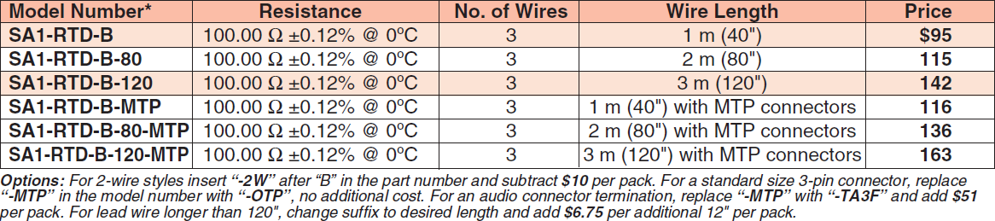

Table 3.34 – SA-RTD-B Specifications

(Permission granted by Omega)
          - Other Models
Table 3.33 lists the surface measurement RTDs that were eliminated early on to limit the number of devices considered. All of the models listed required additional materials with no significant advantages over the other models.
RTD Model | Reason Eliminated
HSRTD Series | Requires cement
RTD-(*)-1PT100K2515 Series | Requires cement
RTD-(*)-1PT100K2528 Series | Requires cement
RTD-(*)-F3102 Series | Requires cement
RTD-(*)-F3105 Series | Requires cement
RTD-2 (Class B) Series | Requires cement
RTD-809 Series | Requires cement
RTD-830 Series | Requires bolt or cement
SRTD-1 & SRTD-2 Series | Requires threaded hole

Table 3.34 – Eliminated RTD Models
Figure 3.35 illustrates a couple of the eliminated RTD models. They have washer and bolt assemblies which would require modification to the heater. The RTD-830 also has the option for a cement-on application, but would bring up its cost. It has a greater unit price than the ones fully discussed, with no appreciable advantages.
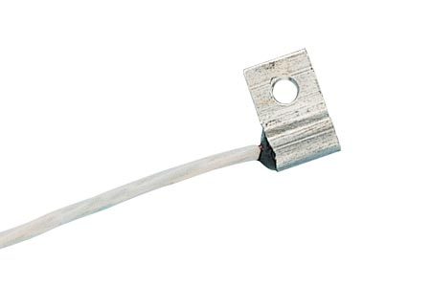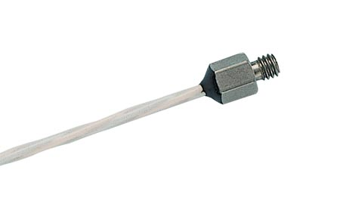

Figure 3.35 – RTD-830 & RTD-850 Series RTDs

(Permission granted by Omega)
          - Conclusion
Table 3.36 compares the RTDs discussed above. All of the RTDs met or exceeded the required 200° C temperature test range. All the B Class models have a higher tolerance than required, while the tolerances of the A Class models were much lower. While their prices were fairly similar, the SA1-RTD-B was the least expensive. Though these RTDs are priced higher than thermocouples that meet the same requirements, RTDS tend to have longer lifespans than the thermocouples, resulting in lower maintenance costs over time.
RTD Model | Maximum Temperature | Accuracy @ 200° C | Unit Price
SA2F-RTD-3-B-40 | 200° C | ±1.3° C | $45
SA2F-RTD-3-A-40 | 200° C | ±0.55° C | $45
SA1-RTD | 260° C | ±0.55° C | $50
SA1-RTD-B | 260° C | ±1.3° C | $32

Table 3.36 – RTD Comparison
      - Controller
        - Introduction
The root of the high temperature system’s automation comes from the controller. Omega has a wide variety of controllers that can not only control the temperature of a heater, but can also warn the user of overheating, control the speed at which a heater reaches its target temperature, among other things.
        - Specifications
When deciding on a controller, again the purchase was to be made from Omega. Conveniently, Omega manufactures controllers that are easily interfaced with their thermometer devices. It was decided that the controller;
- should be capable of bringing the heater to 200° C,
- should be able to process the input of an RTD (2-, 3-, or 4-wire), E-type thermocouple or thermistor,
- should allow the user to manually control the temperature,
- should be capable of expressing the measured temperature in Celsius or Fahrenheit,
- should have at least two control outputs,
- should have an on-off control algorithm,
- should have its own software package or be capable of being programmed
- should have the best value to meet other specifications;
        - Design Considerations
Since Omega manufactures controllers specifically designed for their devices, it was clear that the only further considerations that needed to be made included what features were desired. It had to be compatible with whatever thermometer devices were being considered. Table 3.37 lists the number of wire leads for the chosen RTDs. Controller models are configured to accept a certain number of wires, so ideally, the controller would be able to handle all wire configurations for and RTD, and be capable of taking thermocouple and thermistor inputs for flexibility and future expansion.
RTD Model | Wires
SA2 | 2
SA2C & SA2F | 4
SA1-RTD | 3
SA1-RTD-B | 3

Table 3.37 – Leads per RTD Model
The controller also has to be able to control the temperature of the heater automatically upon user input. Of course, the user should be able to control the temperature manually if desired. To create feedback system, the controller also requires having at least two control outputs, which would be connected to the two terminals on the heater. Due to the simplicity of the system, only a simple on-off trigger is required. In addition, a software package would be ideal for the controller, but at the very minimum it would need to have some way to interface into the Data Acquisition system.
Upon first glance, it was clear that a wide selection of Omega’s controllers supports thermocouples and RTDs. However, very few models supported thermistors. Many of Omega’s RTD / thermocouple controllers met the basic requirements (200° C, two outputs, manual control), so only the most inexpensive options would be considered.
          - CN7500 Series
The CN7500 Series controller seen in Figure 3.37 is the first of two RTD / thermocouple models considered. It features at $97 and is compatible with 2- and 3-wire RTDs, and K, J, T, E, W, R, S, B, L, and U type thermocouples.
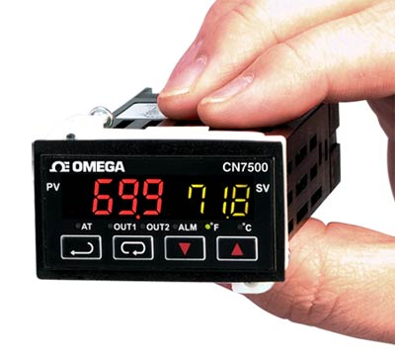

Figure 3.37 – CN7500 Series Controller

(Permission granted by Omega)
          - CN7800 Series
The CN 7800 Series controller seen in Figure 3.38 is also capable of processing RTD / thermocouple inputs. It features at $108 and is compatible with 2- and 3-wire RTDs, and J, T, E, W, R, S, B, L, and U type thermocouples. It also features analog outputs but lacks convertible output types.
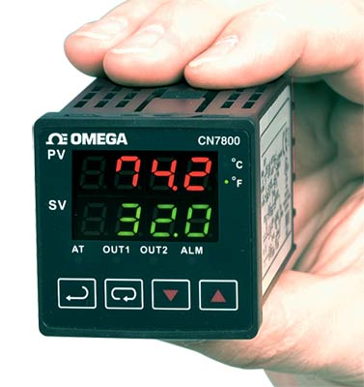

Figure 3.38 – CN7800 Series Controller

(Permission granted by Omega)
          - CN1501 Series
Since neither the CN7500 nor the CN7800 controllers support thermistor inputs, another controller had to be considered. The CN1501 seen in Figure 3.39 fits this description. While capable of RTD, thermocouple and thermistor inputs, each model in the series is compatible with only one input type, severely limiting its flexibility. At a price tag of $245 for the most basic model, this model likely means that thermistors are other of the question as a temperature device.
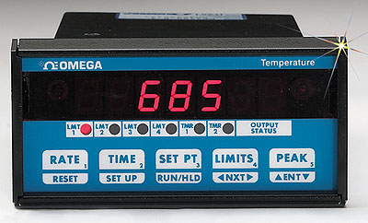

Figure 3.39 – CN1501 Series Controller

(Permission granted by Omega)
          - Conclusion
Omega’s wide selection of controllers left little need for in-depth analysis of each model. Since even the most inexpensive controller model was capable of meeting the basic requirements, the CN7500 Series controller is the clear choice for the heater’s controller. An option for an analog output instead of a convertible output for an additional $11 did not justify opting for the CN7800 over the CN7500. Choosing either of these models would have been a better choice over the CN1501 Series controller because of its lack of flexibility. Having only one compatible device type per controller is far too limiting for its hefty price tag.
      - Decision Matrix for Thermometer and Controller
Table 3.40 shows the comparisons for each device with its controller in ascending order based on price. The need to use the CN1501 for any of the thermistor options clearly drives up its cost, while the sheer cost of the HFS thermocouple makes it the most expensive option. Based only on price the SA1 Series thermocouple would be the clear choice. However, its maximum operating temperature of 175° C makes it less appealing. Between the SA1XL and the SA2 Series thermocouples, the SA1XL Series is the clear winner. Its lower price tag and higher maximum temperature at the same accuracy makes the comparison easy.
The decision between the SA1XL Series thermocouple and the SA1-RTD-B Series RTD is a bit more complicated. At first glance, the thermocouple outclasses the RTD. With the RTD’s lower accuracy and higher unit price, the decision would be clear if not for one factor not quantified so far. While Omega does not specify the expected lifespan of each device, research indicates that RTDs will generally have a longer life given identical operating conditions. A device’s lifespan not only affects the platform’s maintenance cost, but would inconvenience users. With this in mind, the ultimate design decision will be to use the SA1-RTD-B.
Thermometer Model | Maximum Temperature | Accuracy | Unit Price | Controller Price | Total
SA1 Series | 175 C | ±1° C | $12 | $97 | $109
SA1XL Series | 260 C | ±1° C | $16 | $97 | $113
SA2 Series | 200 C | ±1° C | $30 | $97 | $127
SA1-RTD-B | 260 C | ±1.3° C | $32 | $97 | $129
SA2F-RTD-3-B-40 | 200 C | ±1.3° C | $45 | $97 | $142
SA2F-RTD-3-A-40 | 200 C | ±0.55° C | $45 | $97 | $142
SA1 RTD | 260 C | ±0.55° C | $50 | $97 | $147
SA1-TH-44004-40-T | 150 C | ±0.2° C | $40 | $245 | $285
SA1-TH-44033-40-T | 75 C | ±0.1° C | $51 | $245 | $296
HFS Series | 150 C | ±2.2° C | $230 | $97 | $327

Table 3.40 – Device Comparison

Chapter 4: Low Temperature Semiconductor Testing System

  - Introduction
The purpose for this research was to investigate the effects temperature has on different devices, and also to show the importance of devices that can operate at low to cryogenic temperatures efficiently. The low temperature testing station is capable of testing semiconductor devices from room temperature (~300K) to cryogenic temperatures (below 123K). The Equipment setup in the testing lab is capable of temperatures as low as 18K.
  - Reason for Testing
Testing devices such as MOSFETs will provide an understanding of how temperature affects the IV characteristics of a device as it changes from 300K to cryogenic temperatures. In an n-channel FET device, it will be observed that the performance of the device increases. This is to say, for less amount of input voltage, you return larger gains in current in respect to the voltage.
Each step in the IV curves will begin to change as the temperature lowers from room to low temperatures. After a certain temperature (~80K) the silicone in the MOSFET will begin to break down, and there will no longer be a connection between the gate and other components of the device, so the impedance of the device will go to infinity.
Environmental conditions can also be a reason to test a certain extremes in temperatures. Electronics are normally made to operate near room temperature in order to continue to operate at the specified performance levels. This usually requires a level of ventilation for the electronic components in order to achieve this, or sometimes machines to push water past the electronics in order to maintain temperatures.
NASA has put a large amount of resources into determining which components would be best suited to work in the frigid conditions of space. Most of their tests were done on large components made up of arrays of electrical components, some not best suited for space. Some electronics have to be heated in order to operate. As energy in space is very important, it is necessary to eliminate wasteful energy consumption as much as possible. Having the proper types of electronics that won’t suffer from freeze-out is vital to the space program, and to furthering the improvements made on earthbound electronics.
Extreme conditions such as the desert would require massive amounts of cooling, while conditions near any of Earths poles, we would observe a change in performance and have to develop devices designed to run in these locations. This is another key reason to have cryogenic testing equipment available to test devices that will run in those conditions.
Companies such as IBM began experimenting with cooling devices such as their high end servers in order to achieve increase performance with any chip that was out in the market. They effectively increase the performance of all the computer processors at the time, and had them operate much higher than originally specified, and when new technology emerged, they would do the same with that technology. With this, not only would they be able to run faster, but with the lower temperatures, they were able to prolong the lifespan of their devices through this. IBM was one of the first companies to incorporate a refrigerant system into their computer systems. Even though they systems were not super cooled, they did achieve substantial performance increases by removing enough heat to drop core temperatures to -40 °C (~233 °K) [8].
    - Semiconductors at Low Temperature
The conductivity of semiconductors is very much less than that of metallic conductors [12]. In metals the conductivity rises as the temperature lowers, while in a semiconductor the conductivity lowers as the temperature is reduced. In a metal there is a very large constant number of conduction electrons available at all temperatures, and the conductivity is largely determined by the collision of these electrons with the crystal lattice.
In metals, increased conductivity at low temperatures is due to a small number of electron collisions. However, in semiconductors, the number of electrons or holes available to carry change is small and varies considerably with temperature. Any change in conductivity is more due to a change in the number of charge carriers than to a change in their collision behavior [12].
Another effect of temperature change on a semiconductor is a variation in the energy band gap, or “Eg”. The energy band gap in a semiconductor is small because, at room temperature the thermal energy available in a material is good enough in order to excite a significant number of electrons across the gap to the vacant band [12]. This leaves a corresponding number of holes in the filled band. In semiconductors, there is approximately a 10% change in size of the gap between the conduction band and valence band when the temperature fluctuates from 300 Kelvin to 0 Kelvin [13]. The energy band gap of most semiconductors increase with the decrease of temperature, and a comparison can be seen as the temperature goes from 300 Kelvin to 0 Kelvin [13].
Material | Ge | Si | GaAs | GaP | InSb | InP
Eg(0° K) | 0.744 | 1.153 | 1.53 | 2.4 | 0.27 | 1.41
Eg(300° K) | 0.67 | 1.107 | 1.35 | 2.24 | 0.18 | 1.27

Table 4.1: Energy Band Gap in eV from 0° K to 300° K
Silicon-based MOSFETs and particularly CMOS can function better at low temperatures as opposed to bipolar transistors [1]. For low temperatures, enhancement mode CMOS integrated circuits are used because they are expected to give the best overall performance in high speed/high density electronic systems and because their performance improves with decreasing temperatures [9].
In regards to Silicon-based MOSFETs, majority carrier devices demonstrate reduced leakage current and reduced latch-up susceptibility at low temperatures. Also, majority carrier devices show higher speed resulting from increased carrier mobility and saturation velocity [1].
The low temperature limit is typically determined by the ionization energy of the dopants. Dopants usually require some energy to ionize and produce carriers in the semiconductor [2]. This energy is usually thermal, and if the temperature is too low, the dopants will not be sufficiently ionized and there will be insufficient carriers. This result is a condition called “freeze-out” [2].
The various effects described above can be illustrated in a graph, shown below, which roughly correspond to how a device given the doping levels will act in response to the temperature changes in the device. This can be shown below in Figure 4.2.

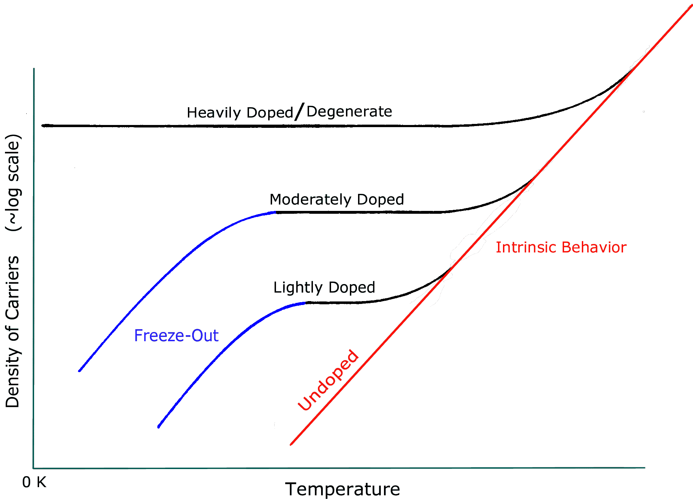

Figure 4.2 - Freeze-Out Doping

Permission by Extreme Temperature Electronics
There are additional effects that allow devices to operate below their “freeze-out” temperature. If the semiconductor is doped at a particular concentration, it can attain degeneracy. Degeneracy is a condition in which the dopants do not require energy for ionization. This happens in n-GaAs at a low doping concentration, approximately 10¹⁶ cm⁻³ , while Si degenerate doping requires a much higher concentration (~10¹⁹ cm⁻³ ). However, if this device were a bipolar transistor, operation of the device would cease well above the “freeze-out” temperature.
Ordinary Si bipolars (Si BJTs) suffer a rapid decline in gain with cooling and are unusable below about 100 K. This is not a result of freeze-out, but of low emitter-base injection efficiency. This effect can be avoided by adjusting the band gaps through "bandgap engineering" as in heterojunction bipolar transistors (HBTs), such as those based on SiGe.
HBTs have demonstrated operation down to very low cryogenic temperatures and show increased performance on cooling. On the other hand, conventional homojunction Ge and GaAs bipolar transistors have also been reported to operate to very low cryogenic temperatures [2].
BJTs on the other hand don’t make good candidates to use at low temperatures. Figure 4.3 shows the current gain of a BJT, which the current gain lowers with the decreasing temperature.
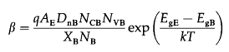

Figure 4.3 - Current Gain of BJT
Also, with increase Beta for increasing temperature is partially responsible for the thermal runaway since it represents a positive feedback between the collector current and temperature [6]. This can also be observed with the equation kT/q for thermal current, whereas at room temperature ~26mA, while the temperature rises, so does the current. The conventional bipolar devices do not perform well at 77 °K, due to band gap narrowing between the emitter and the base, increased base resistance due to freeze-out, and increased base transit time due to reduced diffusivity, which results in a very poor current gain (Beta) [6].
Bipolar devices are minority carrier device and the strong reduction of minority carrier lifetime deceases the diffusion length of the carriers injected into the base, reducing the collector current and increasing the base current [7]. This reduces the collector-base current amplification (Beta) [6]. If base doping is increased while decreasing emitter doping band gap narrowing would be reduced along with freeze-out, a similar technique used it MOSFET devices to prevent freeze-out.
For low temperatures, the device design is less important than the other factors above in 14 and 15. The primary concerns are freeze-out and its effects [2]. Although Si MOSFETs can be used to the lowest temperatures, certain design features are needed if anomalies, such as the "kink" effect and hysteresis, are to be minimized at deep cryogenic temperatures (below Si freeze-out at approximately 40 K) [2]. These and other effects arise from charge trapping, which becomes increasingly troublesome as temperature decreases. Operating bipolar transistors at cryogenic temperatures always requires special designs and/or materials, a prevalent approach being the use of heterostructures [2].

    - Wirebonding MOSFET
During aluminum wedge wire bonding, a clamped aluminum wire is brought in contact with the aluminum bond pad. Ultrasonic energy is then applied to the wire for a specific duration while being held down by a specific amount of force, forming the first wedge bond between the wire and the bond pad. The wire is then run to the corresponding lead finger, against which it is again pressed. The second bond is again formed by applying ultrasonic energy to the wire. The wire is then broken off by clamping and movement of the wire [9].


Figure 4.4: Aluminum Wirebonding

(Permission Pending)
    - Advantages of Lower Temperatures
- Increased average carrier drift velocities (even at high fields)
- Steeper subthreshold slope, plus reduced subthreshold currents (channel leakages) which provide higher noise margins
- Higher transconductance
- Well-defined threshold voltage behavior
- No degradation of geometry effects
- Enhanced electrical line conductivity
- Dramatic increase in allowable current density limits (i.e., diminished electromigration concerns)
    - Zinc Oxide Doped with Aluminum
Aluminum doped zinc oxide (ZnO:Al) is commonly used as transparent front contact in thin film solar cells [3]. The type being tested is the absorber layers is deposited glass coated with the transparent front contact. This offers the technological advantage of easier and more reliable encapsulation and therefore lower costs [3]. During deposition, the front contact is exposed to temperatures in the range of 550 °C, which under these conditions the electrical properties of ZnO:Al layers are expected to deteriorate.

Nevertheless, the sheet resistance of the front contact should be below 10ohms for high efficiency solar cells. This is just a theoretical number for maximum efficiency, and not a number physically tested in the lab.
Cu(In,Ga)Se2 (CIGS) photovoltaic (PV) cells require a highly conducting and transparent electrode for optimum device performance. ZnO:Al films grown from targets containing 2.0 wt.% Al2O3 are commonly used for this purpose. Maximum carrier mobility of these films grown at room temperature are ∼20–25 cm²V⁻¹s⁻¹ [4]. Therefore, relatively high carrier concentrations are required to achieve the desired conductivity, which leads to free carrier absorption in the near infrared (IR).
Lightly doped films (0.05 – 0.2 wt.% Al2O3), which show less IR absorption, reach mobility values greater than 50 cm²V⁻¹s⁻¹ when deposited in H2 partial pressure. We incorporate these lightly doped ZnO:Al layers into CIGS PV cells produced at the National Renewable Energy Laboratory (NREL) [4]. Preliminary results show quantum efficiency values of these cells rival those of a past world-record cell produced at NREL that used 2.0 wt % Al-doped ZnO films. The highest cell efficiency obtained in this trial was 18.1% [4].
ZnO highly n-type doped with Al, Ga or In is transparent and conductive (transparency ~90%, lowest resistivity ~10⁻⁴ Ω·cm^{[55]}). ZnO:Al coatings are being used for energy-saving or heat-protecting windows. The coating lets the visible part of the spectrum in but either reflects the infrared (IR) radiation back into the room (energy saving) or does not let the IR radiation into the room (heat protection), depending on which side of the window has the coating [5].
    - Thermal Stability of ZnO:Al
Figure 4.4 presents the relative changes of the electrical properties of the ZnO:Al layers after annealing at 550 °C [4]. The changes in the resistivity strongly depend on the RF power density, but also the relative temperature. In the low power system the resistivity is increased up to 800%, in contrast, highly stable layers with increments of less than 20% are observed in the intermediate range of power densities. Layers deposited in the regime of high power density show higher increments between 40 and 200% [4]. The behavior of the resistivity is mostly related to the carrier density. Losses of up to 80% are observed for layers grown at low and high RF power, whereas smaller loss is observed in case of layers grown in the intermediate regime of power density. The mobility is affected by annealing only in the case of room temperature deposited layers. At low RF power density these layers exhibit a decrease of more than 80 %, whereas the films grown at high RF power density actually show an increase in the mobility of up to 60%. This increase compensates the effect of the charge carrier loss which leads to a moderate overall increase in resistivity of 20-40 % for layers grown at room temperature and high power density. The layers deposited at elevated temperatures do not show this behavior, uniform loss of about ~30 % of the initial mobility is observed [4].

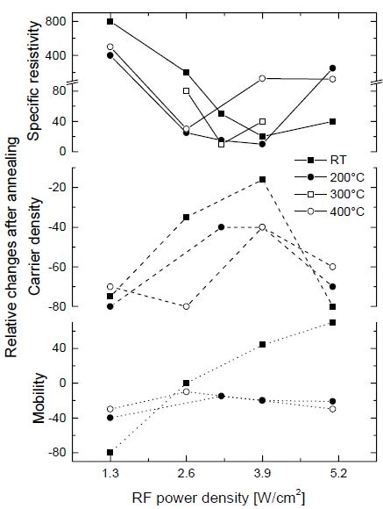
Figure 4.5 - Relative Changes After Annealing (Permission by A.N. Tiwari – Stability of Transparent ZnO Front Contacts for Cu(In,Ga)Se2 Superstrate Solar Cells)
    - Producing Cu Strips on ZnO:Al
In order to test with the ZnO:Al film that was deposited on glass sheets, the material was needed to be cut into 1 inch pieces so it could be fit into the garret that will house the glass strip until Cu is deposited onto the film side. It is necessary to deposit the copper so testing can be done at room temperature, low to cryogenic temperatures, and possible high temperatures.
This procedure was done inside the clean room at UCF located in Engineering 1 Building. Bob guided this procedure through and provided steps to complete the process, and is shown below:

Preparing the glass strips can easily be achieved. Place foil where copper is not desired, and everything else within the test chamber will be coated with copper. For example, if you want a .5mm strip of copper on each end of a test material, leave .6mm uncovered, as you need to leave a 0.1mm for where it will rest inside the depositor. This is illustrated in Figure 4.6:

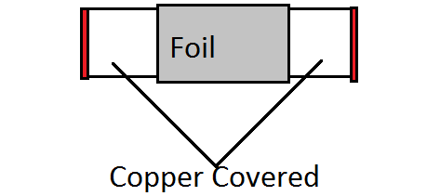

Figure 4.6 - Test Sample
- Located behind the clean room is the Nitrogen that cools the device during testing. This must be turned on before the experiment.
- Verify all systems are set to default, which would be indicated by all switches on the control panel being in the up position as shown Figure 4.7

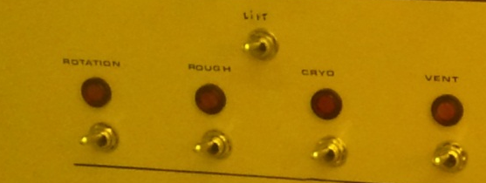
Figure 4.7 - Control Panel Default Position

- Next, introduce nitrogen (N2) into the evaporation chamber. At this point, the pressure should equalize in the Bell Jar, which the N2 removed the vacuum on the cylinder
- Then the lift switch can then be activated to life the top off of the Bell Jar chamber to reveal the area where the copper and devices to be coated can go

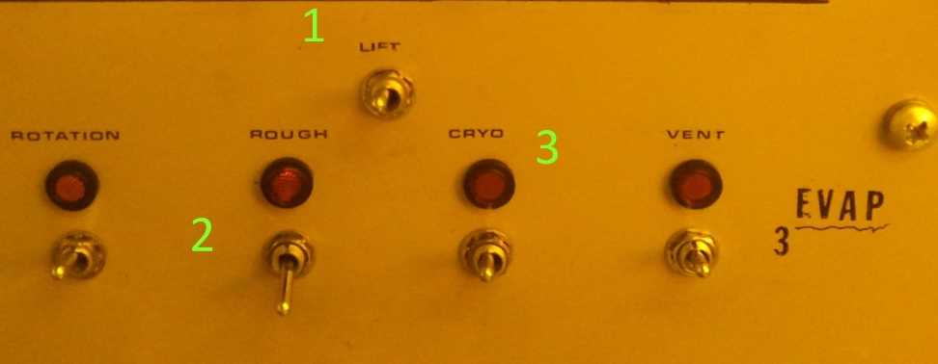

Figure 4.8 - Cryo Control Panel

 | Switch | Function
1 | Lift | Lift the top from the Bell Jar
2 | Rough | Rough vacuum pump, to pull pressure down to 10⁻² torr
3 | Cryo | Cryo pump, take pressure inside Bell Jar down to 5x10⁻⁵ torr

Table 4.9 - Cryo Control Panel Functions
- Measure the amount of copper that is required to be deposited onto the surface of the ZnO:Al film
- Remove the cylinder (Bell Jar) to inspect the surface of the seal located on the bottom. Make sure it is seated properly
- Place the copper that was measured into the moly boat, which is made of molybdenum. Molybdenum is a great material to use for this, because it has a relatively high melting point (600 °C), which of naturally occurring elements, is only rivaled by tantalum, osmium, rhenium tungsten and carbon. The boat provides a great surface for the copper to sit until later heated
- The moly boat is then clamped between two probes with the copper placed on top.
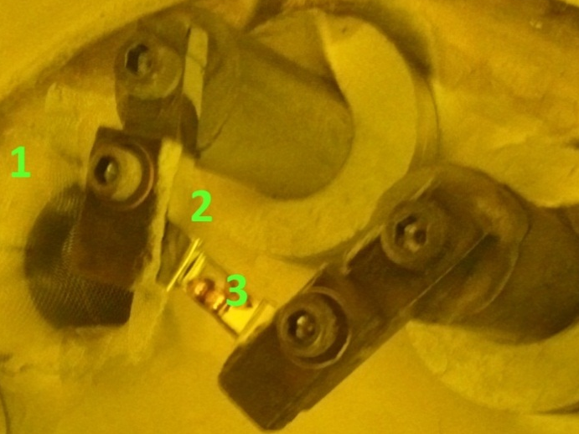

Figure 4.10 - Molybdenum with Copper Placed
# | Description
1 | Probe arm that holds the Molybdenum
2 | The moly boat (Molybdenum)
3 | Copper inside the Molybdenum boat
Table 4.11 - Evaporation Process

- Place test samples into the garret, located at the top of the machines, labeling the samples

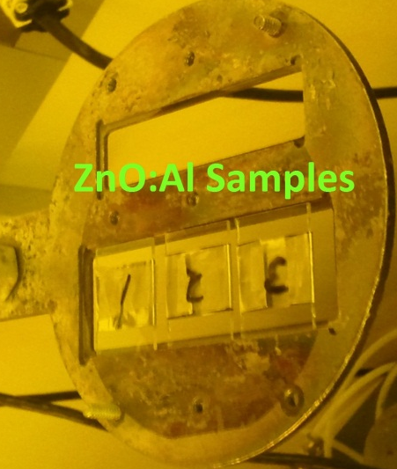

Figure 4.12 - ZnO:Al Test Samples
- Replace the bell jar, making sure not to disrupt the seal at the bottom of the jar
- Press switch 1 to lower the top back onto of the bell jar
- Rough the system by switching switch 2. This step evacuates the bell jar to roughly 10⁻² torr in ~5 min
- Close roughing switch, and open the Cryogenics switch (3). At this point, the pressure within the bell jar will reduce rapidly, well below the gauge attached to the roughing pump. You must look at the 307 Vacuum gauge, and ensure the pressure is dropping, otherwise a leak in the system is present and the machine must be shutdown.
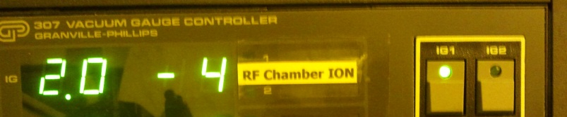

Figure 4.13 - 307 Vacuum Gauge Controller
- This pressure must drop down to 5x10e⁻⁵ before heating of the copper can begin which takes ~33min
- Turn on variac machine and turn the current up to 30A and hold for 1 min. This allows the molybdenum to heat up along with the copper
- Once 1 minute has passed, continue to raise the current until you note that the copper has begun to melt. WARNING: OBSERVING THIS DIRECTLY MAY CAUSE BLINDNESS. WEAR PROTECTIVE EYEWEAR TO SHIELD YOUR EYES FROM THE BRIGHT LIGHT PRODUCE!
- After reaching 72A, the copper completely evaporated and coated everything inside the bell jar, including our samples, which was the desired result
- While heating the copper, the pressure in the bell jar does increase, which must be watched, and current lowered if it exceeds a safe range of operation
- The variac machine is turned off, and left to cool for 1 minute.
- A very low amount of N₂ gas is introduced into the bell jar to bring atmospheric pressure back to the jar
- After cooling, the system can then be lifted, and the test sample can then be taken from the garret

Figure 4.14 shows one strip of ZnO:Al before the coating process, and 3 after the process has completed. An analysis that follows will show the final step, or height of the copper.
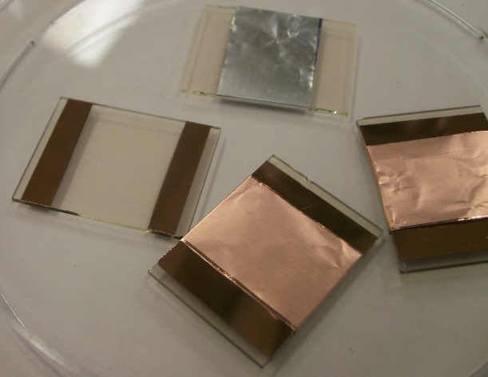

Figure 4.14 - Copper Deposited ZnO:Al Strips
A variac machine is essentially a variable transformer, with an adjustable frequency, adjustable voltage, and an adjustable current. The one used in the lab does not need to be extremely precise since the current is only changed to find the melting point, sweeping in the range of 0-130A. The copper sample evaporated at 72A.
    - Analyzing the ZnO:Al Copper Strips
The analysis of the strips cannot be done with the classic hand tools, and must be done on devices that can be measure down to the nanometer. One such device is an Optical Profilometer. Veeco Wyko NT 3300 Profiling System, a non-contact optical profiler, utilizes two technologies to measure a wide range of surface heights. Phase-shifting interferometry (PSI) allows measurement of smooth surfaces and small steps, while vertical scanning interferometry (VSI) allows measurement of rough surfaces and steps up to several millimeters high.

      - Specifications
- Model: NT3300
- Capable of handling up to 8"/200mm wafers
- Non-contact sub-micron Optical Profiler for 3D Surface Metrology
- 8” Auto XY with 0.5 uM encoder / Auto TT
- PC Computer with Windows XP Software and Stitching,
- Wyko Vision 32 Software
- Vertical resolution as low as 0.1 nm
- XY Tilt
- Motorized Z Axis Focus
- Fast Z Focus
- Pentium computer system & Windows XP
- Keyboard controller with trackball & Joystick
- 0.1um resolution XY table with 63.5mm x 63.5mm bondable area
- IX-5 Interferometric objective
- IX-50 Interferometric objective
- Alignment FOV lens
- 0.40X FOV lens
- 0.75X FOV lens
- 1.0X FOV lens
- System Monitor
- Vibration Isolation Table
Figure 4.15 shows the optical profilometer that was used in the analysis of the ZnO:Al with copper strips evaporated onto it.
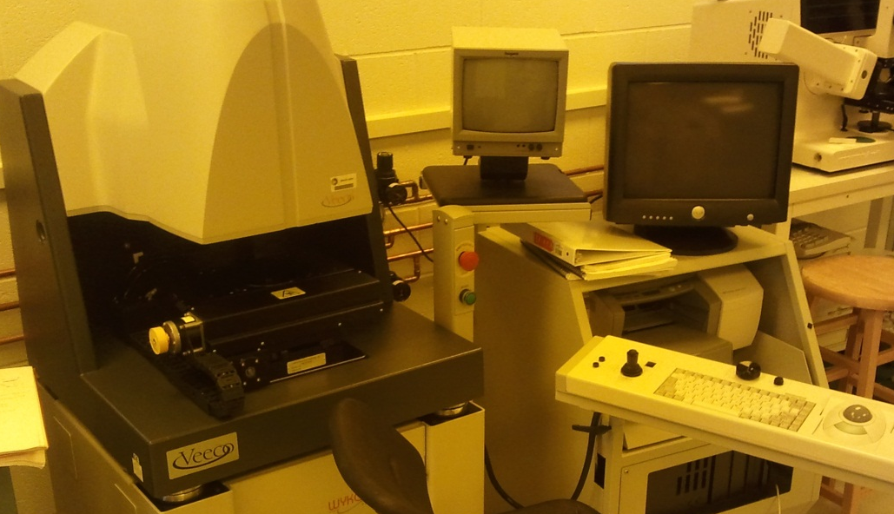

Figure 4.15 - Veeco Wyko NT 3300 Optical Profilometer
Figure 4.16 is the output from the Veeco Wyko NT 3300 Optical Profilometer. From Figure 4.13 shows the height of the copper strips, or step, to help with the electrical conductivity/resistivity that will be obtained when measuring the device in the lab. The final thickness of the layer of copper amounts to 1470nm.
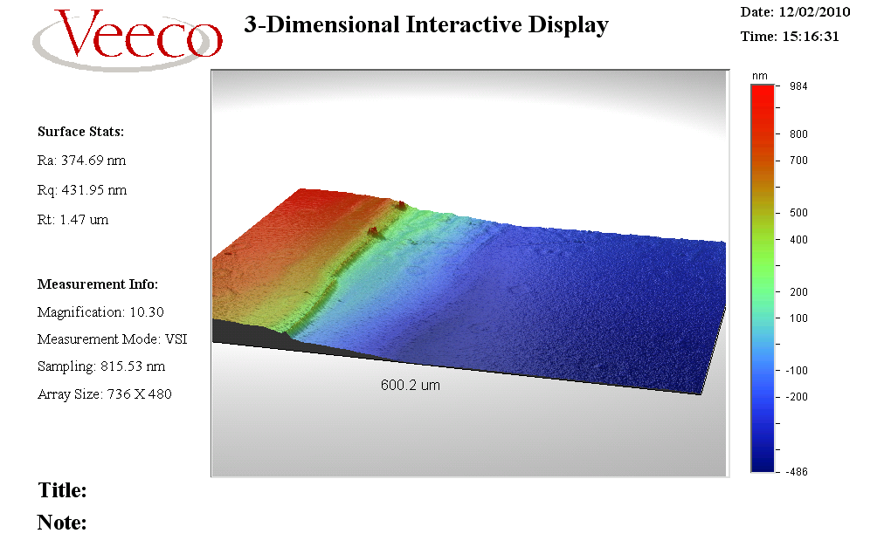

Figure 4.16 - Veeco 3-D Interactive Display
  - System Design
The low temperature testing station is made up of many machines to achieve cryogenic temperatures that are networked to one computer to provide a flow of data that can be easily read by the user to interpret performance of the device tested. The devices used to achieve this are as follows.
    - System Hardware
Figure 4.18 shows the configuration of the Low Temperature System and each of its components. Table 4.17 gives a list of those components, corresponding to Figure 4.18 and gives the purpose of each.
 | Device | Purpose
1 | Lake Shore Model 805 Temperature Controller | Displays current temperature within Cold Head (in degrees K, F, or C)
2 | Bendix Thermocouple Vacuum Gauge | Displays current vacuum pressure within Cold Head (in millitorr)
3 | CTI-Cryogenics / Janis Corp. Model 22 Cold Head | Houses the cryogenic environment and the Device Under Test (DUT)
4 | HP 4145B Parametric Analyzer | Measures the I-V characteristics of the DUT
5 | Polyscience 6705 Recirculating Chiller | Contains approx. 1 gallon of distilled water used for cooling the Compressor during system operation
6 | GE Vacuum Pump | Produces a strong vacuum (as low as 5 - 20 milltorr) inside Cold Head
7 | CTI-Cryogenics 8001 Controller | Controls operation of the Compressor. Also serves has a hub for power from the wall outlet to the Cold Head and Compressor
8 | CTI-Cryogenics 8300 Compressor | Contains pure helium that it compresses and sends to the Cold Head to use for cooling

Table 4.17 - Equipment List

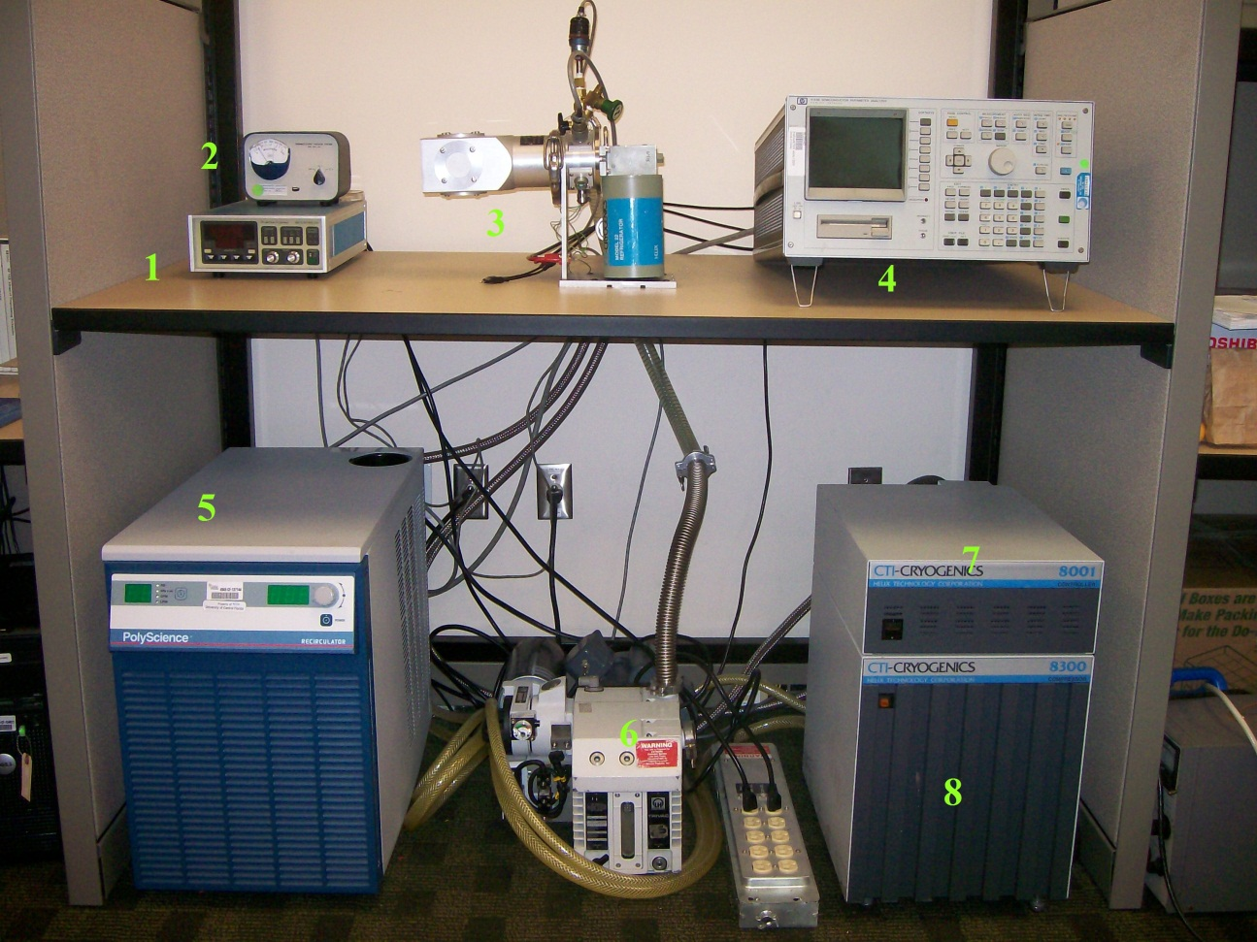

Figure 4.18 - Low Temperature System Layout
      - Lake Shore Temperature 805 Controller
        - Purpose
The reason for this device used is to accurately find the correct temperature of the Cold Head while the device is being operated. This will allow students to make accurate recording of the semiconductor characteristics at those temperatures during experimentation. The temperature controller also allows heating of the Cold Head in order to maintain a temperature you would wish to test at.
        - Operation
This device is simple to use, and for the intention of only showing accurate temperatures of the device being tested; only a few steps need to be taken:
- Power on the device with the green power button located on the front of the device.
- Select Sensor A to show the temperature inside the cold head.
- The temperature can then be observed on the LED display.
- Press the HEAT button to heat the head in the power down operation. Adjust the GAIN knob to adjust how much heat is applied to the Head.

# | Button | Function
1 | Unit Selector Knob | Selects between Kelvin, Celsius, Fahrenheit or senor units (volts or resistance)
2 | Annunciate Sensor | Select sensor A or B for display sensor
3 | Display Sensor | Display sensor reading in units selected
4 | Heater Power | Full Scale sensor from Low, Med, High
5 | Percent Power Meter | Power out equals meter reading times range selection times 25 watts with 25 ohm heater
6 | Control Sensor | Annunciator A or B as selected on rear panel
7 | Power Switch | On or Off
8 | Variable Gain | Proportional Gain Control
9 | Variable Reset | Integral control with off detent
10 | Digital Set Point | Annunciators for decimal points
11 | Sign Selector | Sets + or -

Table 4.19 - 805 Temperature Controller Front Face

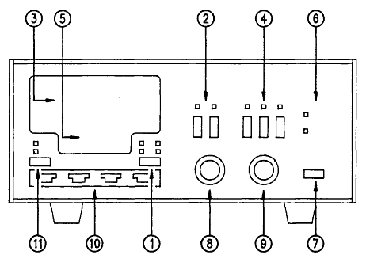
Figure 4.20 - 805 Temperature Controller – Front Panel - Copyright Lake Shore Cryotronics, Inc. Used with permission
      - Bendix Thermocouple Vacuum Gauge
        - Purpose
This device is used to show the amount of vacuum that is currently inside the Cold Head. The units of measurement are in millitorrs, ranging from 0 - 1000. For the entire machine to begin cooling properly, the pressure inside the head must be at ~15militor. This can be reached in 10 – 15 minutes.
        - Operation
- Make sure the machine is connected to the cold head to accurately read the pressure inside the unit.
- Select TC1 to read from the Cold Head. TC2 is not currently connected to anything, and would read atmospheric pressure without the aid of a connection.
- Read the measurement to observe decompression of the unit.

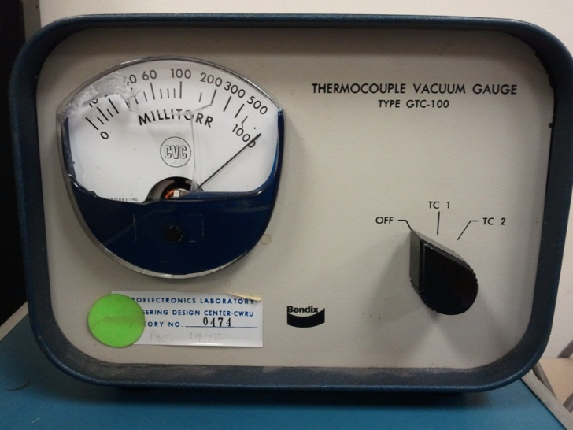
Figure 4.21 - Bendix Thermocouple Vacuum Gauge

      - CTI-Cryogenics / Janis Corp. Model 22 Cold Head
        - Purpose
This element of the testing equipment is what houses the device to be tested and provides an environment suitable to produce correct and accurate results from our devices. This device is connected directly to each other piece of test with exemption of the Polyscience Recirculating Chiller to provide an environment that allows us to accurately test semiconductor devices at cryogenic temperatures.
        - Operation
- Helium that is pressurized in the CTI-Cryogenics 8300 Compressor is provided to the Cold Head
- The Cold Head uses this inside the evacuated vessel
- The helium is used in the Cold Head to provide a drop in temperature, the helium is heated by this, and then recirculates though the 8300 Compressor
- The helium is then recompressed, back to high pressure, and sent back to the Cold Head to continue in the transfer of heat away from the device
- The energy required to recompress the helium to bring it back to a usable state requires the compressor to exert energy, which produces heat, which the recirculating chiller pulls that heat away by means of water running past the devices in the compressor which are generating that heat

This process will continue until the Cold Head has reached its lowest temperature, and hold that temperature until the user requires it to change.

        - Device Testing
To initialize low temperature testing of a semiconductor device, the wafer or packaged device must be electrically connected to the to the test equipment. To connect a device to the HP 4145B Semiconductor Parameter Analyzer, the device must be connect to the pins located inside the cold head, which the connection on the top platform must correspond to the connections on the bottom platform which wire 1 should connect to the Source of the device (MOSFET), wire 2 must connect to Gate, and wire 3 connected to Drain. The Figures below will show this. Those wires run through the banana cables connected directly to the HP 4145B.
        - Specifications
The Cold Head is separated into two stages, and according to the user manual, the first stage can provide temperatures in the range of 60 to 120K while the second stage a 10-20K environment. The reason there are two stages for testing is because most electronics will not operate at the low temperatures of stage 2. With this you could operate an electronic device in stage 1, and run the device which can run in lower temperatures in stage two. This will allow the device to start up, and then the component being tested in stage 2 can be cooled to 10-20K and results calculated from this. The wiring configuration of the Cold Head is as follows in Figure 4.17:
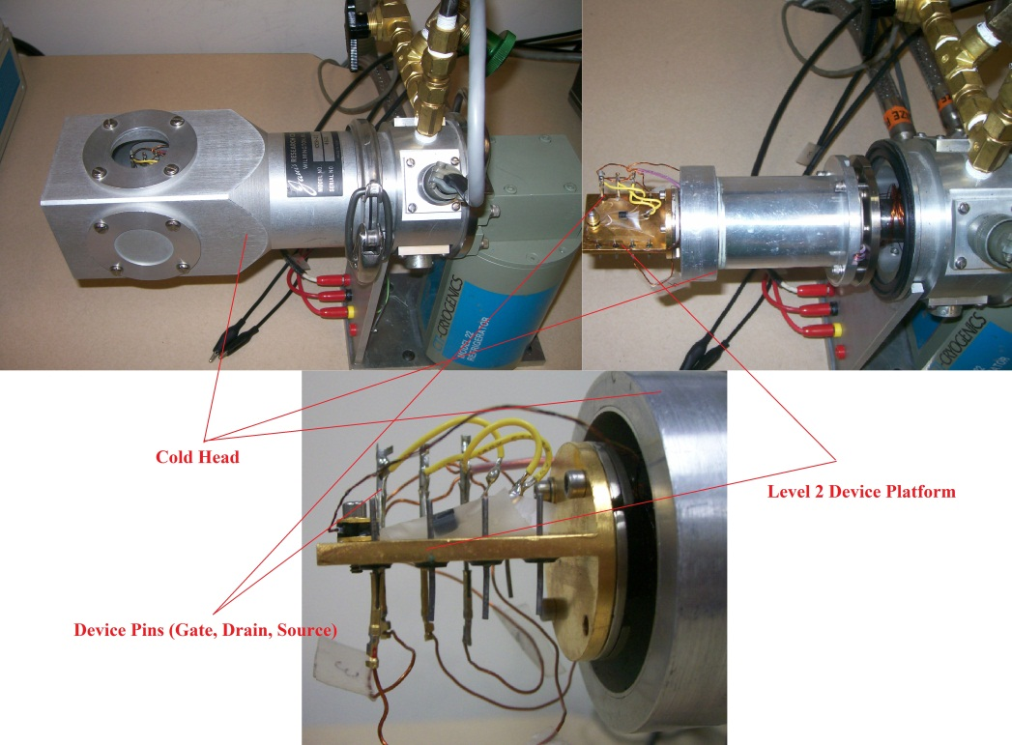

Figure 4.22 - Cold head Electrical Wiring
The Model 22 CTI Cryodyne Refrigerator System is a closed-cycle helium refrigeration system based on the Gifford-McMahon thermodynamic cycle. It is available in both single and two stage configurations to suit a variety of applications that require a compact cryocooler. The Cryodyne Refrigeration system consists of a refrigerator assembly, compressor assembly and customized installation kit consisting of flexible interconnecting gas lines and refrigerator cable ranging from the standard 10-foot separation length up to 300-foot lengths.
 | Device | Function
1 | Cold Head Shroud | Encases device to be tested; insuring a sealed environment
2 | GE Vacuum Pump Valve | Provides a switch between the GE Vacuum pump and the Cold Head
3 | Cold Head Pressure Knob | Allows pressure inside the Cold Head to equalize with the surround environment
4 | 805 Temperature Controller Probe | Provides accurate temperature of device inside the Cold Head
5 | CTI-Cryogenics Refrigerator | Pumps helium into the cold head
6 | Benix Thermocouple Vacuum Gauge Sensor | Provides accurate data on pressure inside the Cold Head

Table 4.23 - Cold Head Components
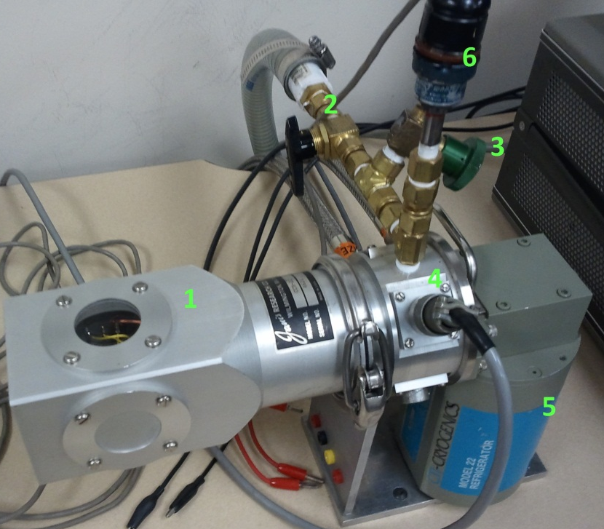

Figure 4.24 - CTI-Cryogenics / Janis Corp. Model 22 Cold Head

      - Polyscience 6705 Recirculating Chiller
        - Purpose
A recirculating chiller’s purpose is to provide cool water to absorb or pull the heat away from the compressor, as it produces a large amount of heat during operation. The chiller contains deionized water which once on, constantly moves water through piping from the chiller to the compressor where copper piping runs along points within the compressor which heat up, and would degrade performance if this unit was not present.
        - Operation
The recirculating chillers operation is simple to master, as it only contains a few buttons. The main power switch must be flipped to the on position before any changes or operation of the machine can begin. Figure 4.25 illustrates the function of each button on the unit.
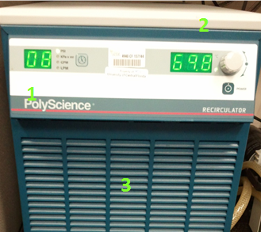

Figure 4.25 - PolyScience 6705 Recirculating Chiller
 | Button | Function
1 | Pressure Control | Rated in PSI, keep between 6-9psi
2 | Temperature Control | Rated in °F, keep ~70 °F
3 | Intake | Cools radiator to cool water to cool 8300 compressor

Table 4.26 - Function of Polyscience 6705 Recirculating Chiller

- Main Power Switch: Located on the back of the unit, must be flipped to I to operate.
- Power Button: Press to initiate the systems automatic circulation of water through the recirculator and the compressor.
- The pressure of the system, rated in PSI, should remain between 6 and 9psi throughout the experiment. To modify, press the button next to the displayed psi, and adjust with the control knob.
- Water Temperature: The temperature of the water is displayed at the right. This number should be at 70 Deg. F during operation. To adjust, press the knob in, and turn the knob until the proper temperature is achieved.
- During operation, the system will push large volumes of air through the system, and should continue to do so, and will indicated that the system is running.

        - Specifications
The Polyscience Recirculating Chiller’s purpose is to pull the warm water away from the 8300 Compressor as it cool down the cold head, and return cool water to help in the recompression of helium. It achieves this by using a 1:1 ratio of distilled water to antifreeze totaling 1gal which is stored in the reservoir and is continually recycled through the system during operation. Due to the higher cooling capacity needed, a 220V outlet is needed to power the device.
      - GE Vacuum Pump
        - Purpose
This unit works in direct conjunction with the Bendix Vacuum Gauge, and provides the ability to produce a vacuum inside the Cold Head. After turning on the pump, it will run for the remainder of the experiment in order to maintain such a low temperature of the test material, and to ensure no condensation accumulates on the testing material.
        - Operation
- Being by turning on the machine with the toggle switch located on the center top of the machine.
- Turn the Black valve to the open position to being producing a vacuum inside the testing camber.
- Leave the machine on for the duration of the experiment. In certain situations it may be necessary to continue to leave the pump on until the cold head returns to room temperature.

      - 8001 Controller Monitor
        - Purpose
The 8001 acts as the regulator portion of the compressor unit, and also acts as a constant power source to insure no power fluctuations occur during operation of these devices. This is used in tandem with the 8300 Compressor and both power on at the same time.
        - Operation
Operation of the controller directly is not necessary for most users unless a temperature lower then what it is normally set at is required. There are three different power rangers that the controller operates at which are listed in Table 4.28.
Power Switch Position | 60 Hz | 50 Hz
Low | 198 – 220 VAC | 180 – 210 VAC
Medium | 220 – 240 VAC | 210 – 220 VAC
High | 240 – 250 VAC | N/A

Table 4.28 - Operating Power Ranges
        - Power Requirements
Figure 4.29 shows the power requirements for the 8001 and the 8002 Controller, which only the 8001 is used.

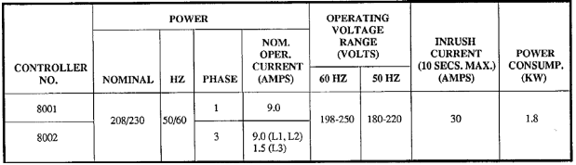
Figure 4.29 - Power Requirements of 8001/8002 Controller
The power requirement of this controller, a 220V outlet is needed to operate this device.

      - 8300 Compressor
        - Purpose
This is the heart of machine is the ability to produce the cryogenic temperatures required to accurately test the devices such as MOSFETs to their full potential. This houses a cartridge which contains compressed helium gas, which is powered by the 8001 Controller to provide cryogenic cooling temperatures to the Cold Head.
        - Operation
Located the power button on the front of the device and insure that the power button is on before turning the 8001 Controller. This will insure no power issues during the powering on of the machine.
        - Specifications
The 8300 has specific cooling water needs which can be found in the user manual, but are provided below. The cooling needs are easily met by the Recirculating Chiller, as it can be adjusted to provide temperatures in the negative degrees Celsius.
 | Water Temp  Inlet | Water Temp  To Outlet | Water Pressure | Water Flow  (gpm) | Water pH | CaCO3  Conc.  (ppm)
Optimal | 50 °F | 70 °F | 3.5 psid | 0.5 | 6 – 8 | <75
Max/Min | 4 °C (min) | 32 °C (max) | 100 psig | - | - | -

Table 4.29 - Cooling Requirements for 8300 Compressor
        - Helium Cartridge
This cartridge is what is used to provide the cryogenic temperatures that the Cold Head reaches under use. As the name implies, the Helium Filtration Cartridge is a device that contains 99.999% pure helium set a pressure that reads 245 psi on the 8300 Compressor once connected. The Compressor was designed to operate most efficiently when both of these characteristics are met; otherwise its efficiency will not be as high as possible. Figure 4.30 shows the dimensions and location of the Helium Filtration Cartridge

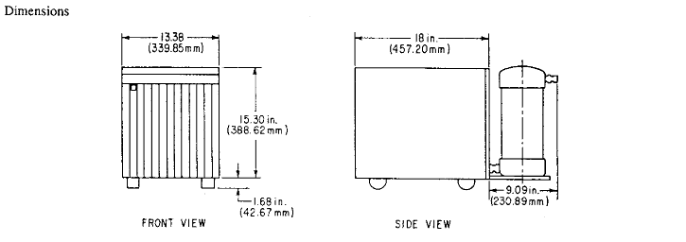

Figure 4.30 - Helium Container and Compressor Setup
        - System Workflow
There are many pieces that connect to this device, which is best shown in Figure 4.31. This device is intimately connected with the 8001 Controller to provide steady power to the device to operate within the specified range. The Compressor is also connected to the Recirculating chiller (not pictured) to provide the cooling power for the Compressor, which would be connected to the Water In/Out.
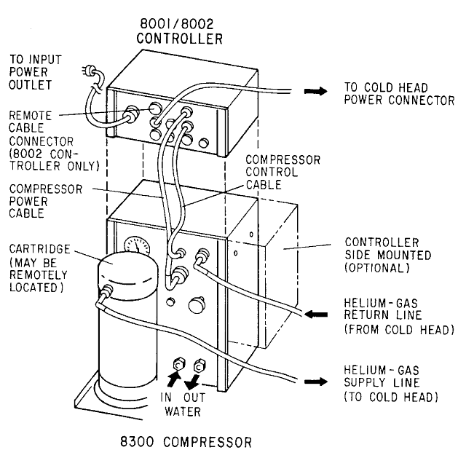

Figure 4.31 - System Workflow 8001 Controller/8300 Compressor

While this diagram only shows a small amount of the components that go into this piece of equipment, the assembly is completed by combining an array of different fittings to connect all the different devices together and complete a secure fitting on each segment of hoses and lines. Each line must be torqued down to a certain specification to ensure leaks do not form.
  - Operation of Low Temperature Station
The operation of the low temperature station would being with the user attaching the device to the Cold Head correctly, which would entail connecting the device to the proper wires, and also applying thermal compound to the device to ensure a proper mating of the two surfaces. The thermal compound allows heat transfer between the two surfaces to be efficient by filling the void between the two. After closing the and clamping the Cold Head, the Bendix Vacuum Gauge is to be turned on, and the GE Vacuum pump can be turned on. After doing so open the valve that connects the two together. Wait ~10 minutes until the pressure inside the Cold Head reaches 60 millitor.
After this point, the 805 Temperature Controller can be turned on, and sensor A activated. Turn on the Recirculating Chiller, and allow to run for a few seconds. Ensure that the pressure on the chiller read between 6-9psi, and the temperature reads 70 °F. After this point the 8001 Controller can be turned on, which will automatically enable the 8300 Compressor and begin pumping the pure helium into the Cold Head, recycling it after it performs its work to be recompressed by the 8300 Compressor. The 805 Temperature Controller will monitor the temperature the Cold Head is reaching, and should already be showing a decrease in temperature. If for any reason the temperature is not decreasing, turn off the 8300 Compressor to check for leaks.

The 6705 Recirculating Chiller removes the heat that the 8300 Compressor produces as an effect of cooling the Cold Head. This process takes ~1.5 hours to reach a temperature of 19 °K.
To turn off the system, the 8001 Controller must be switched off. After ~15 seconds the 6705 Recirculating Chiller can be switched off. Close the valve leading to the GE Vacuum Pump, and switch off the pump. On the 805 Temperature Controller, switch the heater on Hi, and monitor the temperature change, and observe the pressure as recorded by the Bendix Thermocouple Vacuum Gauge. As the temperature raises, the pressure will increase. If the pressure reaches above 600 millitorr during heating, turn the GE Vacuum Pump on and open the valve. This will have to run until the end of the heating process.
The reason for this is if there is an atmosphere inside the Cold Head while the temperatures are below that of the surrounding are, condensation will form within the Cold Head, and on the device being tested. If this happens, most of the equipment will be damaged. There could also be a leak in the system that is allowing the pressure to increase inside the Cold Head.
After the temperature has returned to room temperature (~295 °K), the pressure inside the Cold Head can be equalized with the outside pressure, and can be done so with the knob located near the vacuum valve (a loud noise of the rush of air back into the Cold Head will be heard). After this, the clamp can be removed, and the device tested can be removed.
  - Future Experiments
    - Introduction
As the semester progresses, or as the lab switches over to a new group, it would be very beneficial for students to further their understanding in a large variety of new materials that are coming to the for-front of the industry. The few listed would be very beneficial to both the lab, and the student.
    - Equipment
      - Low Temperature Station Probes
In the future it would be nice to have a low temperature probing tools, such as ones on the Room Temperature station, eliminating the need for packaged devices to test semiconductors such as Lake Shore Model CPX-VF Superconducting Magnet-Based Vertical Field Cryogenic Probe Station. This station can test from 2 K to 400K and from DC to 67 GHz, this would cover a great temperature range as well as a large frequency range.
      - Specifications
- 25 kOe (2.5 T) vertical field superconducting magnet
- High stability operation from 2 K to 400 K
- Sample can be maintained at room temperature while system cools, reducing potential for condensation
- Multiple radiation shields optimized to minimize cryogen consumption
- Sample stage with ±5° in-plane rotation
- Measurements from DC to 67 GHz
- Optional high vacuum to 10⁻⁷ torr
- Accommodates up to 51 mm (2 in) diameter wafers
- Configurable with up to six thermally anchored micro-manipulated probe arms
- Probe arms with 3-axis adjustments and ±5° theta planarization
- Cables, shields, and guards minimize electrical noise and thermal radiation losses
- Options and accessories for customization to specific research needs
While this is a great piece of equipment, the price does not justify it. Integrating the current equipment would be the best way to manipulate silicon wafers. The Model TTPX Cryogenic Probe Station is a top mount station, where refrigerant would have to be connected to the station; the user would have probes to use to test even entire wafers (up to 51mm or 2in in diameter).
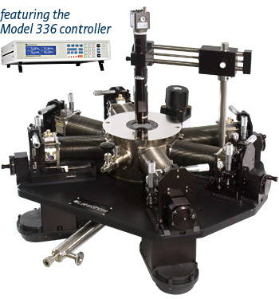

Figure 4.32 - TTPX Cryogenic Probe Station

(Copyright Lake Shore Cryotronics, Inc. Used with permission.)
Figure 4.33 is an outline that provides the scope of future devices desired to be tested. All the possibilities included are important to test, and give viable alternatives to silicon as the primary driver in the market today. Each have benefits and drawbacks, but in the near future, and with the help of this lab, we can engineer those drawbacks as possible advantages to each specific technology. Our pursuit of knowledge will help further the understand of each technology, and help drive the development of the FET, and bipolar industry.

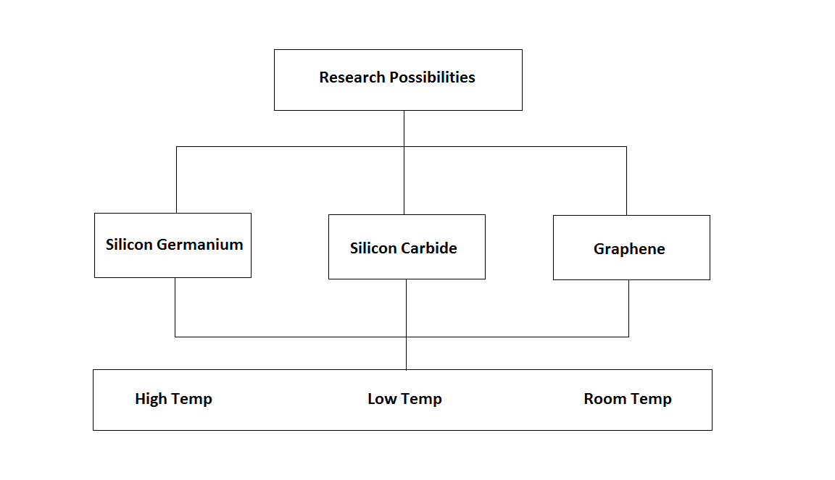
Figure 4.33 - Future Research Opportunities Outline

Currently, each technology has been crafted into a useable device in today’s market with exemption to grapheme. Graphene a few years ago was only thought to be graphite, pencil led, but after looking closer at this, it was discovered that graphite is made up of many layers, and if the graphite is less than 10 layers tall, it is known to be graphene, a great structure to conduct electricity.
This is a great candidate as a semiconductor, because it is just above silicon on the periodic table therefore it shares many of the same properties and qualities as its much older brother silicon. Since graphene conducts electricity much more easily than silicon, it leaves many to wonder why the question was not, “why not graphene,” but rather “why silicon in the first place?”
One interesting quality is that graphene can be combine with silicon to create a hybrid of the two, giving the composite material much greater flexibility, while keeping the same general structure of silicon based devices, to give it the best of both worlds.

    - Graphene
Testing with Graphene would be wonderful to test, as the ability to carry charge carriers at speed dwarfing those possible in silicon is possible at room temperatures, it would be interesting to analyze what speeds would be observed at low to cryogenic temperatures.
Perhaps this would lead to even quicker switching than its properties of being a superfast switch in data processing. Graphene can be used on many more surfaces than silicon, since it can bend, a quality silicon does not have. Graphene can be made to be put on paper, walls, clothing, and cover large areas easily.

Graphene can be made into tubes, wires, or many other shapes, but in the microprocessor realm, will probably complement silicon as opposed to overtaking it, at least until electrical engineers find a way around some problems. Graphene is ambipolar, while silicon is not, which means regardless of whether a positive or negative gate voltage is applied, it will let the current go through. Researchers at MIT have demonstrated a grapheme FET as a frequency multipliers, which double the frequency of an electromagnetic signal in radio communications and other applications. This can be shown in Figure 4.34.
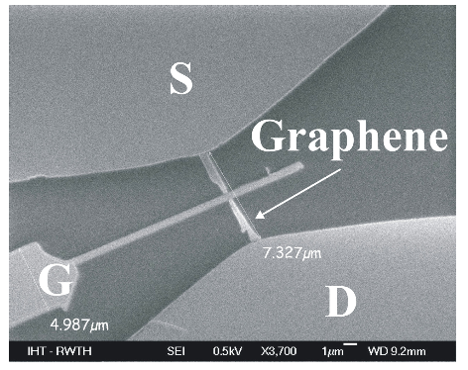

Figure 4.34 - Graphene FET
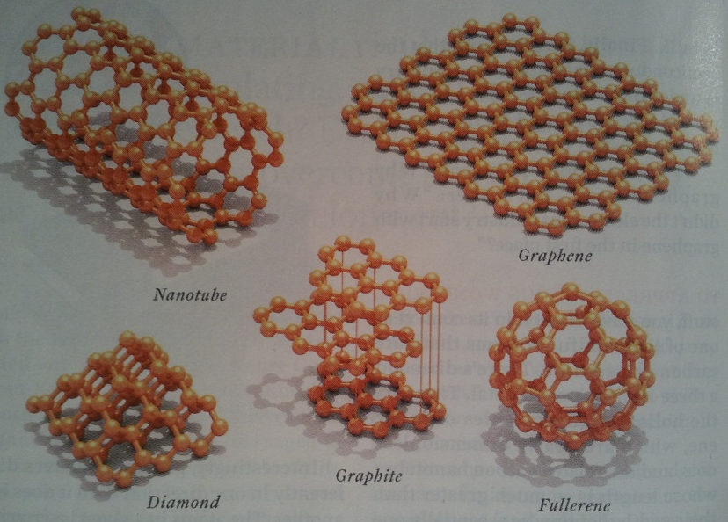

Figure 4.35 - Graphene Shapes (Permission Pending)
A combination of silicon and grapheme may be the future of FETs and other electronic devices, which would provide a great improvement in speed and flexibility over a wide range of applications.
IBM has established a new record in the ultra-high-speed transistor design, by unleashing a graphene-based processor that can perform at 100 billion cycles a second, i.e. 100GHz, almost four times the existing experimental graphene-based processors.
With this breakthrough revelation, Big Blue has just showcased the fact that graphene-based processors can indeed be produced in a wafer-style manner, paving the way for large scale production of these high speed processors [12].
This implies that these graphene-processors could well form the foundation high-end signal processing machinery, enhancing the quality of video and audio recording, medical imaging, as well as radar processing [12].
IBM carried out the work on behalf of the US Defense Advanced Research Projects Agency, better known as DARPA, under the project to develop high-profile radio frequency (RF) transistors, and the information about the programme is published in the 5th February issue of the journal Science [12].
The research paper noted that the highly touted 100GHz field-effect transistor exploits the high carrier mobilities of graphene, which includes one atom-thick sheet of carbon atoms fabricated on Silicon substrate [12].
With this research discovery, it would be possible to test such devices under cryogenic temperatures. Requests have gone out to such developers for a test same that can be tested under these conditions, but no reply has come through up to this point. Further attempts will be made to obtain a test sample to test with.
    - Silicon Germanium
Another great candidate for low temperature testing would be Silicon Germanium. Low temperatures present a problem for most electronics, as most do not function at temperatures below 77 °K. Silicon Germanium has the quality of operating at temperatures of 4 °K. Because of this quality, it would be a great pick to use in deep space exploration, since it would not require external heating in order to operate.
In 2006, IBM managed to transform this idea into a transistor. Despite having to operate the transistor at cryogenic temperatures, they were able to push the performance to above a frequency of 500 GHz. The silicon-germanium heterojunction bipolar transistors built by the IBM-Georgia Tech team operated at frequencies above 500 GHz at 4.5 °K – a temperature attained using liquid helium cooling [10]. At room temperature, these devices operated at approximately 350 GHz [10]. According to IBM, since the wafers are using 200-millimeter, older un-optimized mask set, simulation suggest that the technology could ultimately support much higher (near-Terahertz) operational frequencies at room temperatures with the next generation of this material (currently being 4th generation) [10]. While not practical, it well exceeded the theoretical limit of this combination of elements. IBM’s next attempt is to use this in integrated circuit fabrication, to produce large volumes of this at low cost.

Another interesting application for silicon germanium would be in the use as nanowires. Nanowires, which measure from a few tens to a few hundreds of nanometers in diameter and up to sever millimeters in length could help speed the development of smaller, faster more powerful electronics [11].
These nanowires can be used as defect-free and atomically sharp at junctions, a critical requirement for making efficient transistors out of the tiny structures. The sharper the interface between the material layers, in this case, just one atom, or close to one atom thick, the better the electronic properties [11]. Jet propulsion labs use silicon-germanium to power satellites, and now have are researching this for use in automobiles, since the nanostructure is a thermoelectric, in which heat is converted into electricity.
Georgia Tech, along with assistance from NASA, designed, and fabricated a 16-channel sensor interface (Figure 4.36), developed for NASA using silicon-germanium microchips by an 11-member team.
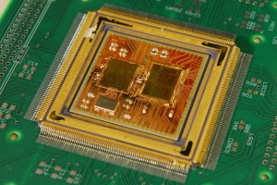

Figure 4.36 - 16-Channel Silicon-Germanium Microchip
This research was critical in devices for deep space missions, with devices that can handle 120 °C down to -180 °C. This would prove variable, as the Mars Exploration Rovers use several kilometers of cable that lead into a warm box, if these new electronics were to be used, it would reduce cabling, weight, complexity and energy use significantly.
    - Silicon Carbide
The large performance gains made possible by SiC's high-temperature high-power capabilities offer economically large performance benefits to the aircraft, automotive, communications, power, and spacecraft industries. The tremendous advantages of SiC electronics in these specific applications are slowly becoming a reality. SiC's immature crystal growth and device fabrication technologies are being developed, but they are not yet sufficiently developed to the degree required for reliable system incorporation. Developing and maturing SiC technology to the point that it is ready for widespread system insertion is the focus of increasingly intense research efforts at laboratories around the world.
While silicon-carbide might not be the best to use in MOSFET devices, such as power MOSFETs, due to the heat of the chip degrading the performance, they could be used in Junction Field Effect Transistors (JFETs) where they would be exposed to temperatures in the range of 25 °C to 600 °C (as reported by NASA), a wide range of temperatures, and in Op-amps, and sensors.
The range of temperatures would make this an ideal component inside high temperature environments, while maintaining peak performance without having to be cooled, costing more energy to do. One finding with JFET devices was that at the very high operating temperatures, the device did work properly, but with much lower ratings and gains. Other experiments have shown that using silicon carbide has allowed Schottky Barrier and PiN Diodes to work properly at high temperatures. However, these two diodes both show problems just as the JFET does when experiencing the high thermal environments.
Researchers have already begun to examine these obstacles and present new solutions. One unique method is the combination of two existing solutions in the diode field. Each high temperature device has shown to exhibit undesired properties. However, the fusion of the two designs into another hybrid model has shown to eliminate the poor characteristics of both diodes. The Schottky Barrier diode gave high leakage currents and conversely the PiN diode operated poorly during switching. However, the combination of the two devices both eliminated the high leakage current and poor switching by taking the best qualities of each individual device. The result was a highly effective diode that worked very well at high temperatures.

Chapter 5: High Frequency Testing System

  - Introduction
In this portion of the lab the students will measure the high frequency response of RF(radio frequency) devices. RF includes a range of frequencies from about 30 kHz to 300 GHz. The high frequency response of a device includes its s-parameters and its impedance plotted on a smith chart. The High Frequency Testing System includes a Vector Network Analyzer which finds this by applying a range of frequencies into the device, and reads the s-parameters of the device. The S parameters are elements of the scattering matrix, which are characteristics of the electrical behavior of a device or change in medium. These behaviors refer to the frequencies and amplitudes which get reflected and transmitted through the device. The matrix is written as: $S=[\begin{matrix}S_{11} & S_{12} \\ S_{21} & S_{22}\end{matrix}]$. Through the input port reflection coefficient (S11), reverse and forward voltage gains (S12,S21), and output port reflection coefficient (S22), the scattering matrix can be used to find the relationship between incident and reflected power waves, as well as distribution or the split of power. The S parameters and flowgraph showing signal flow of a two port device can be seen in Figure 5.1 below:

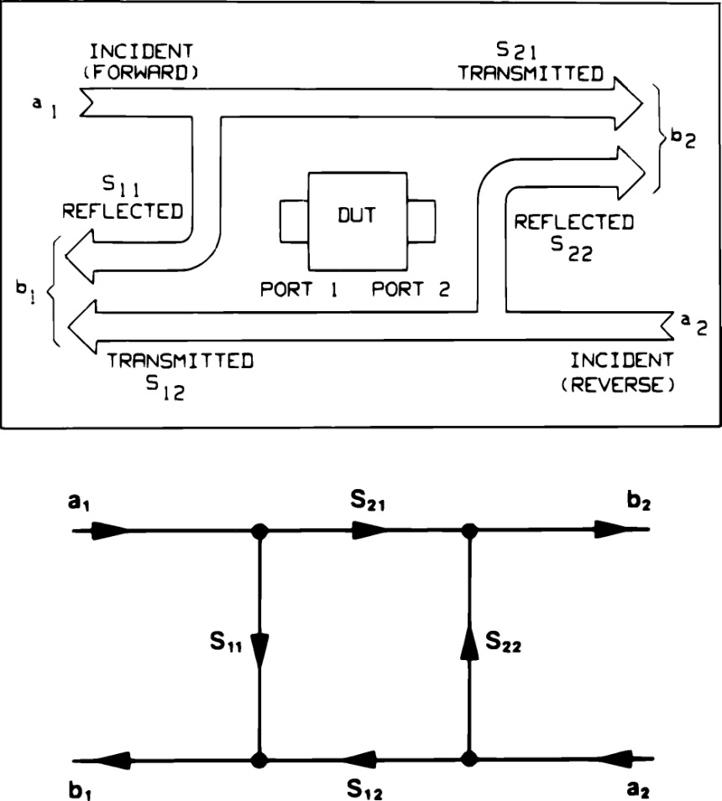
Figure 5.1 - S Parameters of a Two-Port Device
The above Figure came from [12]
Separately, the smith chart is a graphical tool used to help solve problems including transmission lines and matching circuits. The load’s normalized impedance is plotted on the smith chart, in reference to the input transmission line’s characteristic impedance. At unity, the load or transmission line is matched and no reflection should be present, which is located in the center of the graph when plotted. The smith chart allows the user to analyze effects of different impedances, real or imaginary, including phase angle and its reflection and transmission coefficients.
The High Frequency Testing System consists of the HP 8720B Vector Network Analyzer, and will be interfaced to the main computer to the Data Acquisition system. The high frequency testing system of the laboratory will grant users access to the frequency characteristics of devices under test. The addition of the new system will increase the laboratory’s versatility and purpose. Currently, the University of Central Florida is in possession of a high frequency testing lab with many elements, including a Vector Network Analyzer that reads up to 110 GHz. This lab cost the university roughly $250,000 dollars, so access is granted only to a handful of qualifying individuals. Also, the RF and microwaves laboratory has several Network Analyzers, and students may not use them without approval by the supervising professor of the laboratory, and the accompaniment of an appointed Graduate Student Assistant. Such an appointment may take weeks to procure. The incorporation of the High Frequency Testing System to this laboratory is an important step towards building a better learning facility for students and instructors.
  - Reasons for Testing
Most RF devices are designed to operate at certain desired frequencies. Ideally, the device should have no reflection at its desired operating frequency, and have high reflection at all other frequencies (to eliminate noise). A high frequency band pass filter is a good example of such device. At lower frequencies, capacitors and inductors were used to design resonant frequencies that blocked or allowed signals to pass. At high frequencies, the reflection and transmission coefficients are designed to rise or drop at the desired points. Using the vector network analyzer, the device’s behavior can be analyzed over a wide spectrum. The vector network analyzer will clearly show the points or frequencies at which the device allows transmission or reflection.
  - High Frequency Testing System
    - Introduction
The Vector Network Analyzer will be used to read the frequency response of coaxial SMA devices and on-wafer probable devices, and will also be interfaced to the Data Acquisition system. Users will have the option to operate the instrument manually, or perform analysis and record data from the main computer with the Data Acquisition system. The design block diagram of the High Frequency Testing System design is shown below in Figure 5.2, showing both modes of analysis.
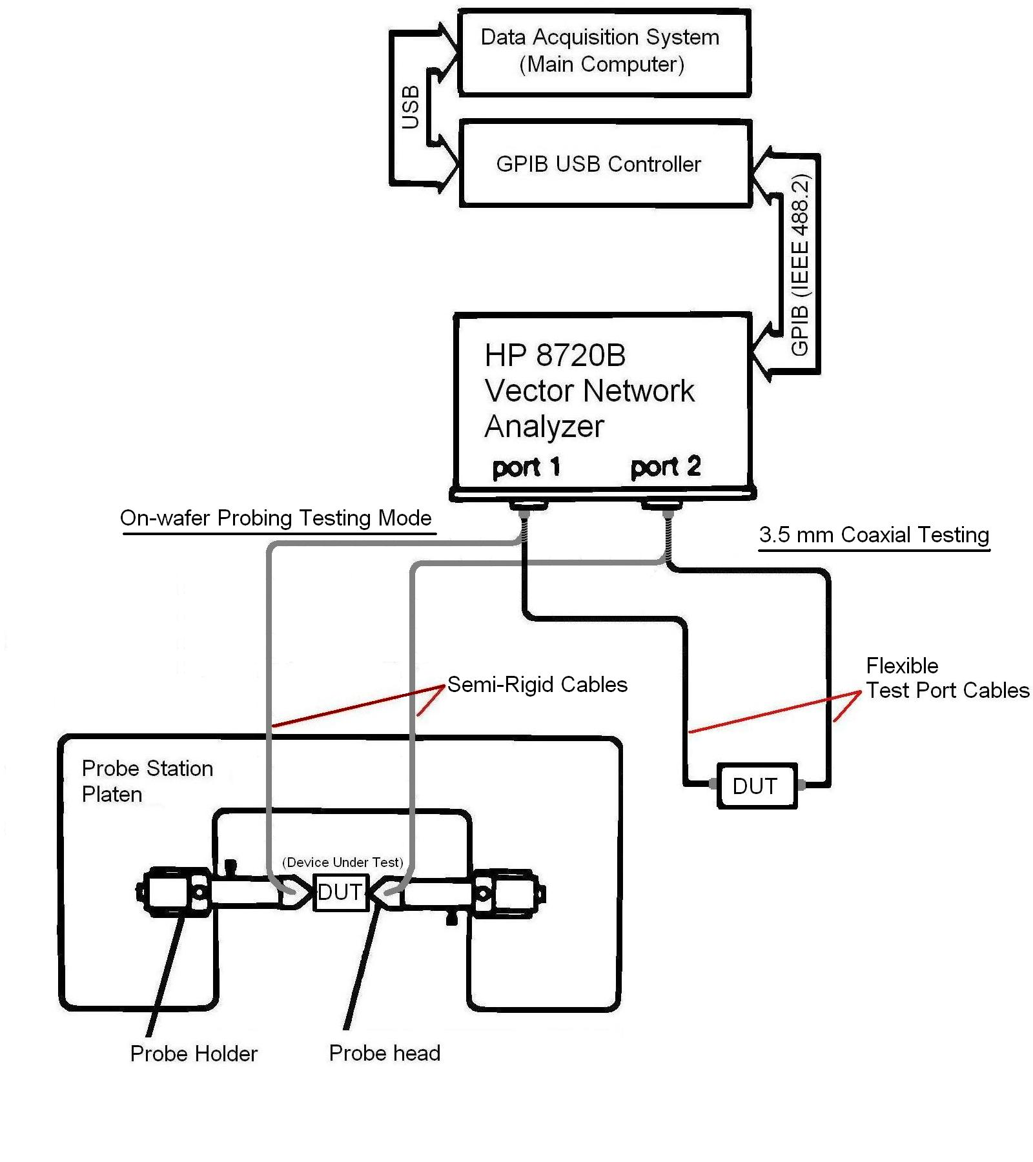

Figure 5.2 - Block Diagram of the High Frequency Testing System
(Note- only one testing mode can be connected at a time)

    - Device Hardware and Software
      - Vector Network Analyzer
The Hewlett Packard 8720B Vector Network Analyzer is a powerful and useful tool for high frequency testing. Its function includes reading amplitude and phase characteristics of incident and reflected waves or signals. “Trace math, data averaging, trace smoothing, electrical delay, and accuracy enhancement provide performance improvement and flexibility.” [12] All of the instrument’s features are easily accessible through the hardkey and softkey interface of the front panel. The front panel view of the HP 8720B Vector Network Analyzer is shown in Figure 5.3.
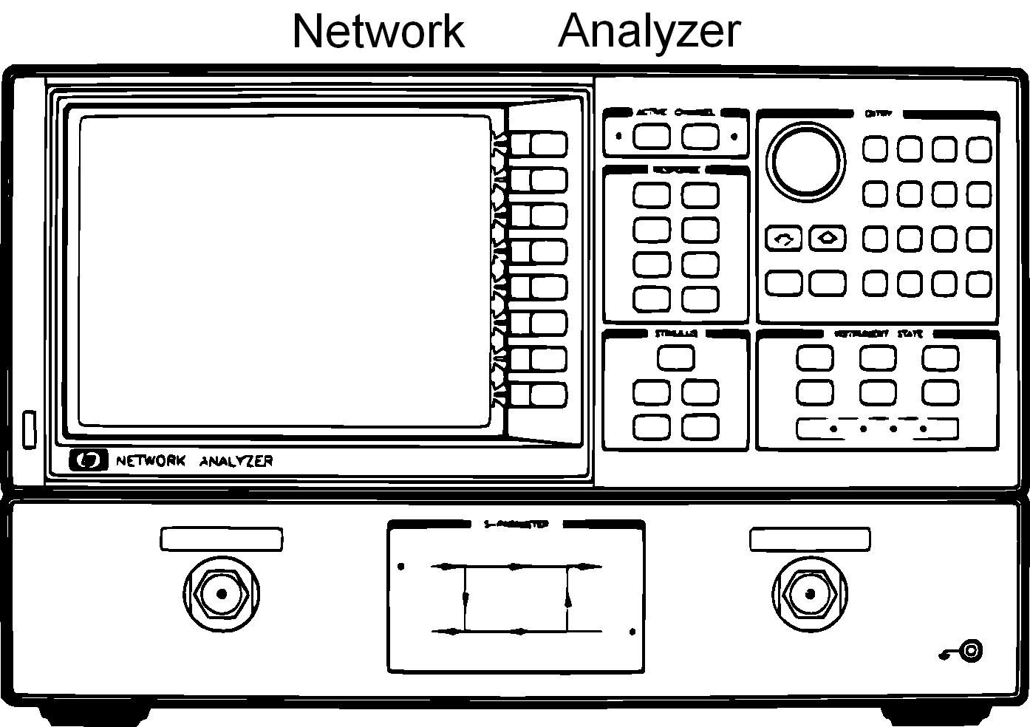

Figure 5.3 - Front panel view of HP 8720B Vector Network Analyzer [12]
      - Test Port Cables and SMA Connectors
These are the cables that interface the Device Under Test and the Vector Network Analyzer with coaxial transmission lines. The thick black cable is an HP 85131E 3.5 mm Flexible Test Port Cable, and is designed to work up to 26.5 GHz, and is 38 inches in length. The other is made by SEMFLEX, 4 feet in length, and all other specifications are unknown since all of the labeling is faded from the cable protection. It is a semi-rigid cable, the preferred type of cable for microprobing applications, where movement is minimal. Research will be done on multiple cables from the RF laboratory to find any degradation in performance near the company’s common performance cutoff frequencies. When connecting the test port cables to a device, it is desired to have male and female connections. Along with the calibration standards, some common SMA connectors, 2.92 mm and 3.5 mm, are available for any device port end mismatches. Below is Figure 5.4, a photo of the test port cables currently in the laboratory’s possession.
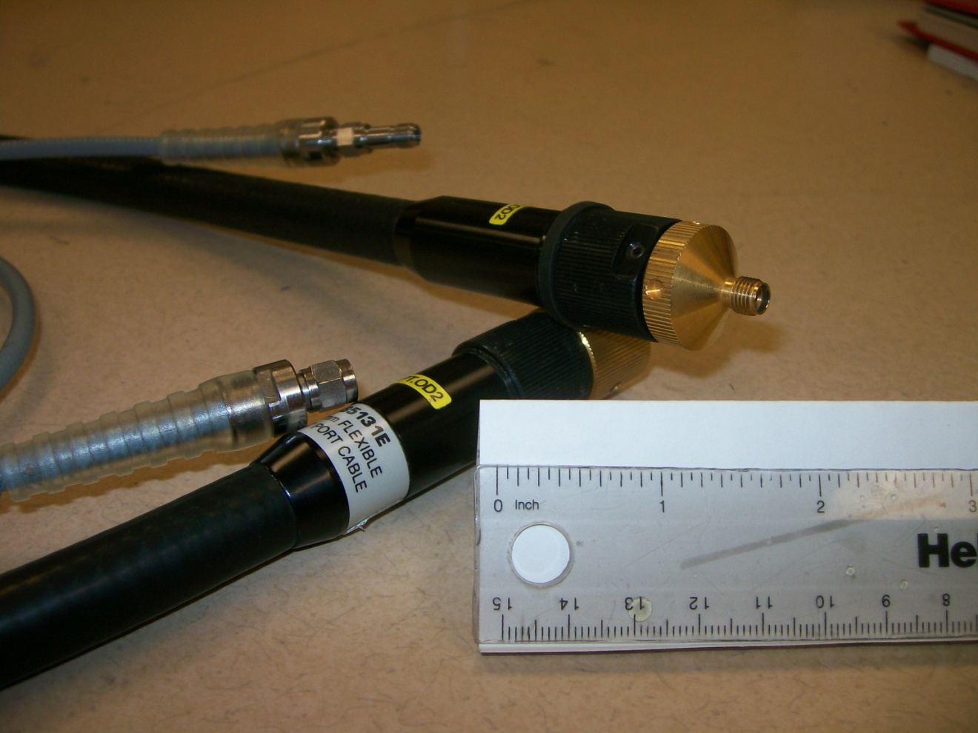

Figure 5.4 - HP 85131E Flexible Test Port Cable(Black) and SEMFLEX Semi-Rigid Test Port Cable(Grey)
      - Probing Station
In order to test the high frequency response of on-wafer probable devices, some design changes on the probing station were necessary. These changes included selecting more suitable components for the micromanipulator, probe arm, and microprobe for high frequency applications, as shown in Figure 5.2.
      - High Frequency Microprobe
In the application of high frequency analysis, the single probe tip microprobe used for the High/Room Temperature Precision System fails to perform. The tri point Cascade Microtech WPH-205-150 Microprobe includes coplanar transmission lines that carry the signal between the coaxial connector and the probe tip contacts. The microprobe makes the transition between the coaxial transmission line and coplanar transmission line internally. These specifications were referenced from [13]. Figure 5.5 below shows the microprobe component described above:
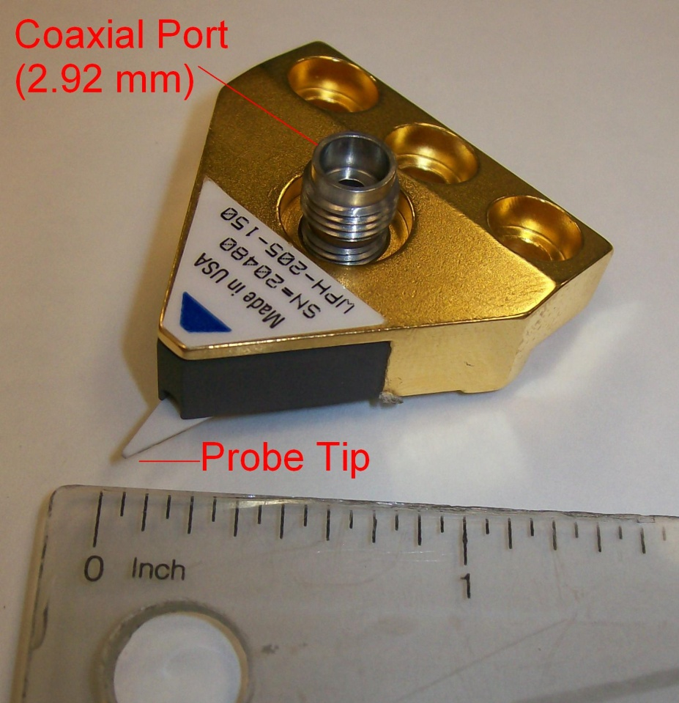

Figure 5.5 – Cascade Microtech WPH-205-150 Microprobe
The probe tip of the microprobe is configured as a GSG three-contact probe, with contact centers 150 microns (5.9 mils) apart. Due to the sensitivity and size of the probe tip, the Microwave Probe Holder must be precise and handled with care. The probe tip configuration can be seen in Figure 5.6 below:
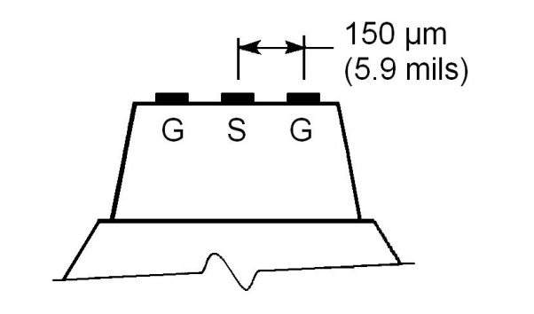
Figure 5.6 Cascade Microtech WPH-205-150 Microprobe Tip Configuration
      - Microwave Probe Holder
The appropriate probe holder for operating the selected high frequency microprobe, the Cascade Microtech Microwave Probe Holder, was selected based on its compatibility and similar features to the Semiconductor Testing System’s single point manipulator probe holder, which is operated manually and utilizes a magnetic base to secure itself to the probe station. The magnetic base allows operators to easily swap between manipulator probe holder types, increasing the versatility of the probe station. All of the adjustment knobs allow precise articulation of the probe head’s position from under a microscope. Below, in Figure 5.7, the probe holder is shown:
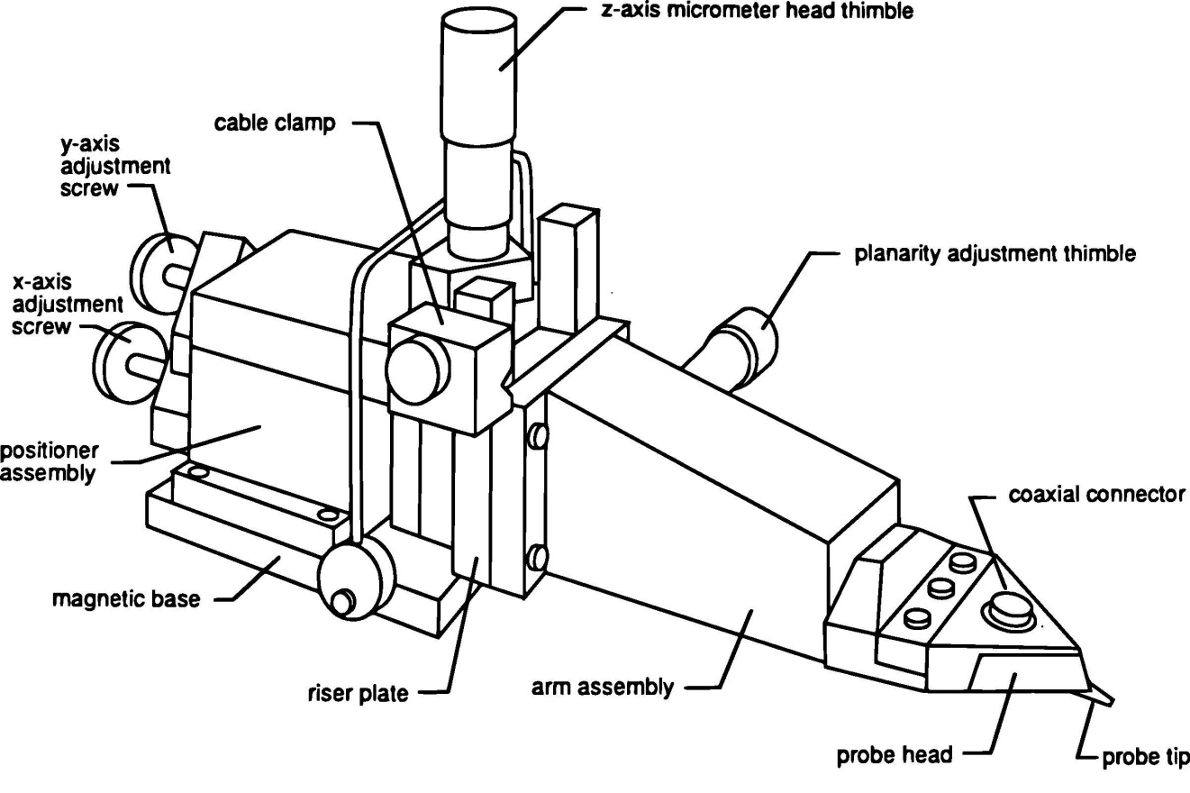

Figure 5.7 Cascade Microtech Microwave Probe Holder and Microprobe(Permission Pending from Cascade Microtech Inc.)
      - Calibration Kits
Before every use, the Vector Network Analyzer requires a rigorous calibration. More details and procedure are discussed in section 5.3.3.6.1. For coaxial analysis, the HP 85052D 3.5 mm Economy Calibration Kit is utilized. The Economy Calibration Kit contains precise and fragile impedance standards and some common SMA adaptors to allow connections of the calibration standards to mismatched sex cables, as mentioned above. The calibration kit is shown in Figure 5.8.
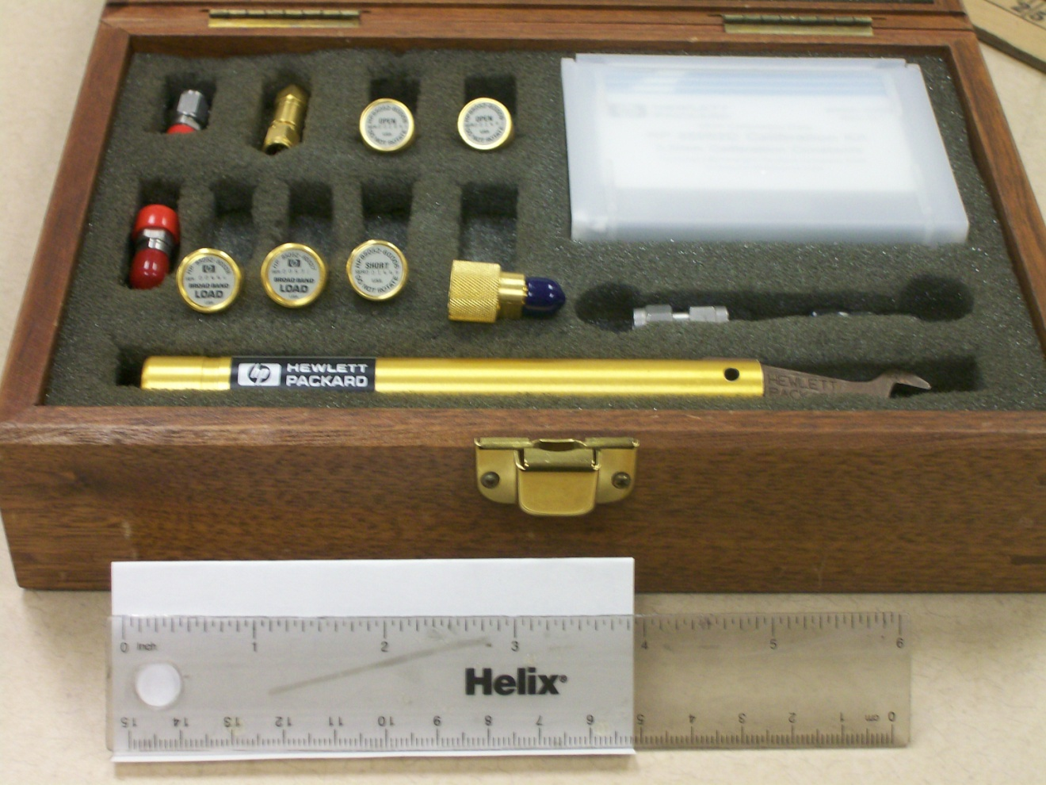

Figure 5.8 - HP 85052D 3.5 mm Economy Calibration Kit
When calibrating the Vector Network Analyzer with the Cascade Microtech Microprobe, a different set of impedance standards is required. Since the instrument must be calibrated to the tips of the transmission lines in order to analyze the target Device Under Test accurately, a set of on-wafer impedance standards on a substrate must be available for probe calibration. “Designed with small geometry tantalum nitride resistors on a low loss, highly polished sapphire substrate, the ISS(Impedance Standard Substrate) provides nearly ideal calibration elements for all cascade probes up to 50 GHz.” [14] The substrate features many more calibration standards than the 3.5 mm calibration kit to eliminate the need to replace the ISS from normal wear damage, discussed in section 5.3.3.6.1.
      - Interfacing
The hardware interface to the HP 8720B Vector Network Analyzer will be made with an IEEE 488.2 GPIB connection to a GPIB-USB Controller, which will then be connected to the computer via USB. The connection will allow data transfer, giving the user the ability to perform measurements and record data from the computer. Two design options are available to implement, but the main priority for this system is functionality. Currently the computer has a National Instruments GPIB-USB controller which is being used to interface the Semiconductor Testing System, but the software is limited to an outdated version of Labview. The other option is to purchase a separate GPIB/USB controller made by Agilent(HP 82357B), and use Agilent’s I/O Libraries Suite 15.0. Keeping in mind that the High Frequency Testing System will be used by operators unfamiliar with the programming and interfacing process, it was determined that the main design objective is to build a system that is easy to learn to operate. After much research it was determined that using the newer Agilent I/O Libraries Suite 15.0 would prove to be most user friendly for both the user and the programmer. In order to get the interface running correctly, some visual basic code will need to be developed.
Since the printer is located on the other GPIB/USB controller, it will have to be manually disconnected and connected onto the Agilent GPIB/USB controller to be used. It is a possibility that joining the two GPIB/USB controllers with a GPIB IEEE488.2 cord may allow the High Frequency Test System to operate flawlessly, and eliminate the need to disconnect the printer from the other bus. Joining the buses would add the Vector Network Analyzer to default address 16, which would not interfere with the other test system’s device communication. The possibility for this design to fail, however, comes from the fact that there will be two separate connections to the computer controller, when only one can be active at a time. The default computer controller address for GPIB/USB interfaces is address 21, and if any data is received by the inactive port to the bus, the listening end of the computer’s active GPIB controller connection may receive partial or corrupted data.
      - HP-IB/GPIB Remote Programming
Even though the HP 8720B is an old device, the same methods are used today for the GPIB(General Purpose Interface Bus, formerly known as HP-IB(Hewlett-Packard Interface Bus)) remote programming. All actions that can be performed from the front panel of the instrument have appropriate programmable codes, which generally incorporate the first three to four letters of each word of the action. Modern interface programs utilize visual based programming, which is structured to look similar to a data flow diagram, in which data flows through each node or block that represents an action or function. This High Frequency Testing System will be configured with the HP 8720 in Talker/Listener mode, in which the main computer controller directs all operating commands to the peripheral devices, which include the Vector Network Analyzer and the printer, further explained in section 5.3.3.7. Next semester, when the GPIB/USB controller and the software is attained, all programming will be addressed and the user interface of the application will be arranged in a clean and user-friendly display that gives operators access to all capabilities from the front panel of the Vector Network Analyzer.
    - Device Operation
      - Introduction
By processing the magnitude and phase of transmitted and reflected waves of a network, the Vector Network Analyzer measures the S parameters of passive and active networks. Once the S parameters have been calculated and displayed, the internal computer of the instrument can easily derive other characteristics of the DUT’s network, such as SWR (Standing Wave Ratio), return loss, group delay, and impedance. [15] When filter and amplifier design laboratories and manufacturers fabricate prototypes, a Vector Network Analyzer is used to verify its physical frequency response.
      - LINE Switch and CRT Display
It is important to understand the function and purpose of the various sets of keys on the front panel of the HP8720B. The LINE Switch key controls the AC power to the instrument. When the switch is set to 1, the instrument is on, and when set to 0, the instrument is off. The hardkeys, which have fixed functionality, on the front panel are grouped by function and provide access to menus which are displayed on the CRT display. Once a menu is accessed, the operator can further navigate through options for the particular function’s menu, using the softkeys, which do not have fixed functionality. The eight softkeys to the right of the CRT screen correspond to the softkey labels displayed next to it, and provide access to additional functions of the Vector Network Analyzer. The use of the softkeys is vital to calibration, measurement setup, and function selection.
Across the CRT is the Data Display Area, and the location where all of the plots, measurement data, softkey labels, and all other information is displayed. The Status Notations Area, displayed on the left edge of the CRT, shows codes corresponding to the current states of the different functions for the channel. The different status codes and their meanings are shown in Figure 5.9.
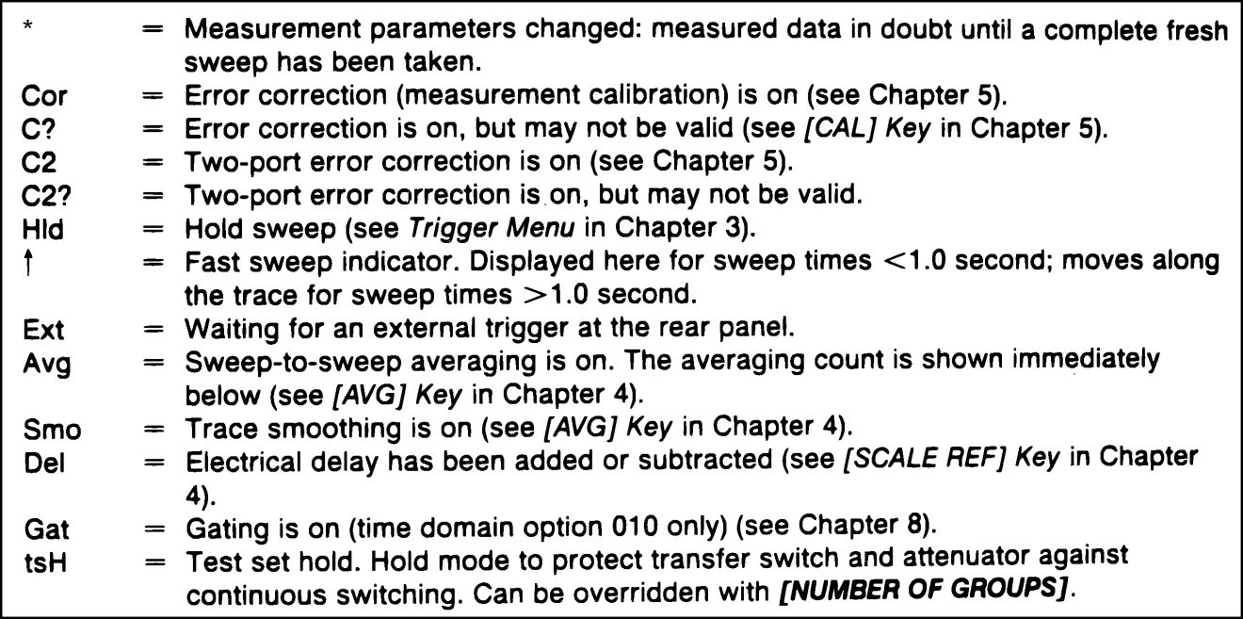

Figure 5.9 – HP 8720B Status Notation Codes [12]
The Active Entry Area of the CRT display shows the currently active function and its value. The Message Area displays any error messages or notifications. Above the Message Area, the Title is displayed, which is defined by the operator, through the Title Menu softkey after pressing the Display hardkey. The Active Channel Area displays the number of the channel that is currently active. The Measured Input(s) Area displays which input is being measured. The Format Area states the current display format of the data being measured, generally in units of the parameter being measured. The Scale/Div Area displays the current scale of the display. “10 dB” in this area denotes that the change in vertical gain is 10 dB per each horizontal line intersected. The Reference Level Area defines the value of the reference line on a Cartesian plot, or the outer circle on a polar plot. Physically, the reference is also shown on the plot by the presence of a small red triangle, on the left margin of the plot for channel 1, and on the right margin of the plot for channel 2. The Marker Values Area shows the values of the active marker, inappropriate units. The Marker Stats/Bandwidth Area displays statistical marker values of functions determined by the operator. The Pass/Fail Area displays the pass or fail status of the Device Under Test, compared to limits also set by the operator. [12] This display layout generally corresponds to the Cartesian format display mode, shown below in Figure 5.10, which also denotes the LINE Switch(1) and Softkeys(3).
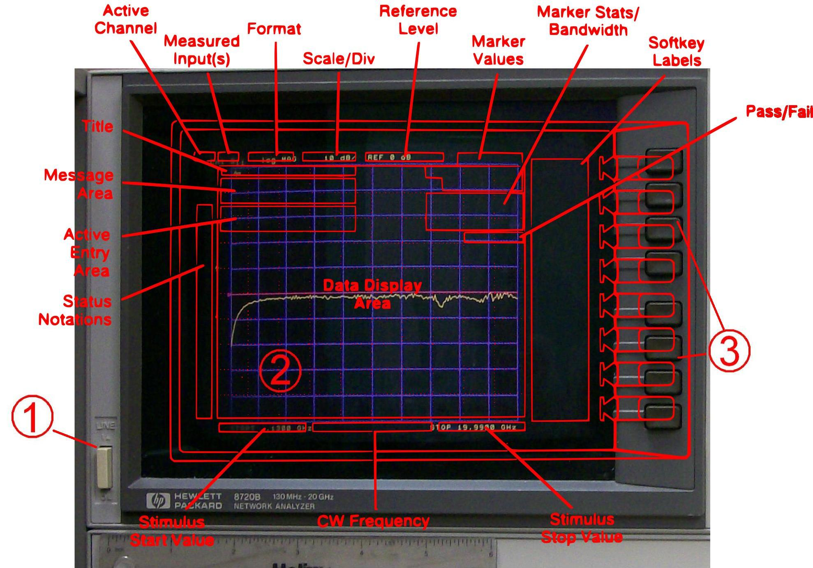

Figure 5.10 - HP 8720B LINE Switch(1), CRT Display(2), Softkeys(3), and general CRT Display Areas for Cartesian Plots(Permission Pending from HP/Agilent)
      - Active Channels Key Block
The HP 8720B features two independent channels for measurement. The user has the option to measure and display one or both sets of data at once. Any measurement specific parameters or functions will only be applied to the active channel. The front panel hardkeys [CH 1] and [CH 2] in the Active Channel key block are used to select which channel is active, and display which channel will be controlled by the user. The active channel is flagged by an LED next to the corresponding channel hardkey. The HP 8720B features the ability to trace and display both the active and inactive channels, either in separate plots, dividing up the Data Display Area, or in a single overlaid plot. Figure 5.11 below show the Active Channel Keys:
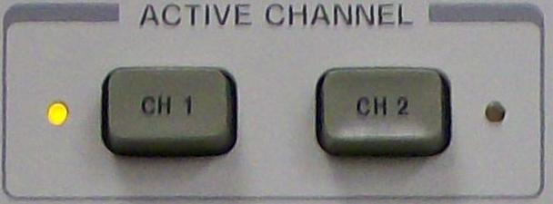

Figure 5.11 - HP 8720B Active Channel Hardkeys (Channel 1 Active)
      - Entry Key Block
The Entry key block is an important set of keys used to enter numeric values and units. Also within the Entry key block are the step keys and the rotating knob. In conjunction with the other front panel hardkeys and softkeys, the entry block is used to change active entry values, limit values, and active marker values. Users have the freedom to implement these changes with the numeric keypad, knob, or step keys, interchangeably. First, however, a function must be set to the active function to be modified. Below is a photograph of the Entry key block, in Figure 5.12:
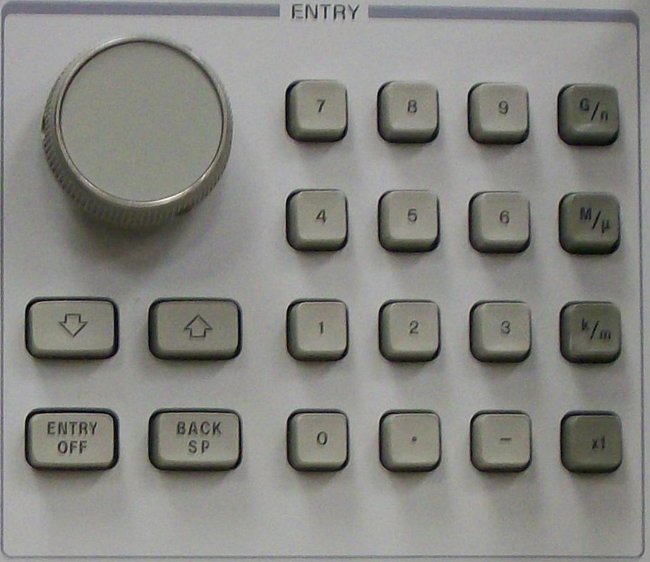

Figure 5.12 - HP 8720B Entry Key Block
The Numeric Keypad: These keys are used to enter specific numeric values, and include the decimal point key and the minus sign key. When a value is entered, the value must be followed by a units terminator.
The Units Terminator Keys: The four keys in the rightmost column of the Entry key block. An entry of values from the numeric keypad requires the user to specify the units using the units terminator keys for completion. Until an entry value is terminated using a units terminator key, the entry is incomplete, which is shown by a data entry arrow “←” pointing at the last entered digit in the Active Entry area of the CRT display. Once a unit is specified, the units replaces the arrow and the entry is complete. Beginning from the top, the [G/n] key is used to enter Giga/nano(10^9 / 10^-9) units, the [M/µ] key is used to enter Mega/micro(10^6 / 10^-6) units, the [k/m] key is used to enter kilo/milli(10^3 / 10^-3) units, and the [x1] key is used to enter all basic units(Hz, seconds, dB, dBm, volts, or degrees) and serves as a general Enter function, for numeric entries which do not require units.
The Knob: Turning the knob allows the user to make continuous adjustments of the current values for many functions, such as plot frequency and scale. When a value is adjusted with the knob, the user is not required to specify a units terminator.
The Step Keys: By pressing these buttons labeled with up and down arrows, the active function’s values are stepped up or down, in increments of 1, 2, or 5. Similar to the knob, the step keys do not require a units terminator.
ENTRY OFF: This key exits entry mode and clears the Active Entry Area display before plotting, which also prevents the user from accidentally changing values from touching any keys or knobs on the front panel.
BACK SPACE: This key is used to delete the last digit entered from the numeric keypad.
      - Stimulus Key Block
The HP 8720B provides a source signal with a wide default frequency range from 130 MHz to 20 GHz. Users are capable of changing source signal characteristics such as range, sweep time and resolution, sweep type, power level, and number of data points read by using the Stimulus key block, which is shown below in Figure 5.13:
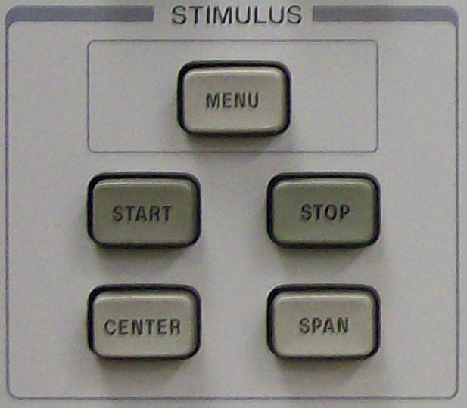

Figure 5.13 - HP 8720B Stimulus Key Block
START: By pressing this key the user is able to define the start frequency of the source signal into the Device Under Test.
STOP: Similar to the START key, the STOP key allows user to define the stop frequency of the source signal. When either of these keys is pressed, its function becomes to active function and is ready to be set with the Entry keys block.
CENTER: By pressing this key the center frequency of the source signal can be set by the user.
SPAN: This key allows the user to set the span or frequency range about the center frequency set above.
MENU: This key displays the Stimulus Menu, which provides access to other stimulus function menus(other than START, STOP, CENTER, and SPAN) displayed on the softkey labels. Some of the main functions and menus found in the stimulus menu include Power, Sweep Time Manual/Auto, Trigger Menu, and Number of Points. Selecting the POWER softkey sets the active function to be power level, allowing the operator to set the output power level of the source signal anywhere between -10 dBm to -65 dBm, in 5 dB steps. If the SWEEP TIME MANUAL or SWEEP TIME AUTO softkey is selected, the operator is able to set the sweep time(manual), or set the instrument to automatically adjust the minimum sweep time for the set frequency range(auto). If the TRIGGER MENU softkey is pressed, the operator enters the trigger menu, where the type and number of the sweep trigger is selected. If the NUMBER OF POINTS softkey is pressed, the operator is able to select the number of data points that the instrument reads from the frequency sweep. Having fewer data points allows for a faster sweep time, but will show less detail in the trace.
      - Response Key Block
After the source signal has been set by using the Stimulus key block, the Response keys block is used to command the active channel’s measurement and display functions. These keys are used to display various softkey menus that set display mode and format, markers, and calibration. Below, the Response key block is shown in Figure 5.14:
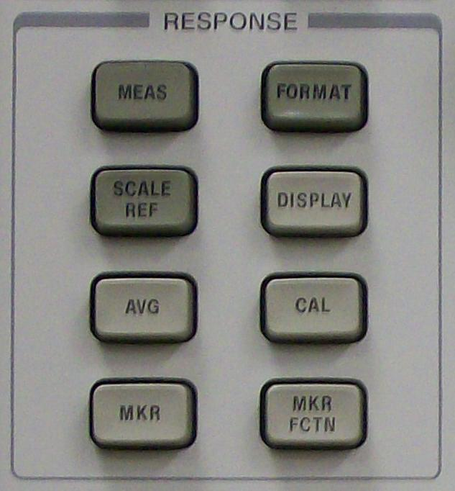

Figure 5.14 - HP 8720B Response Key Block
MEAS: This key directs the user to the S parameters measurements menu that displays the different reflection and transmission measurements that correspond to the appropriate S parameter. The menu also features a conversion menu that allows the user to display equivalent complex impedance or admittance values for the S parameters.
FORMAT: This key directs the user to a menu used to select the display format for the data being measured. The available data display format options include LOG MAG, which displays the log magnitude format of magnitude-only data such as insertion loss, return loss, or absolute power on a Cartesian plot, PHASE, which plots phase shift versus frequency on a Cartesian plot, DELAY, which plots network response versus time, SMITH CHART, which plots the relative impedance of the DUT on a smith chart, POLAR, which plots linear magnitude and phase, LIN MAG, which plots unit-less data such as reflection/transmission coefficient magnitudes in linear magnitude format on a Cartesian plot, REAL, which displays only the real values of measured data on a Cartesian plot, and, finally, SWR which uses the measured reflection coefficient to solve for its corresponding Standing Wave Ratio on a Cartesian plot.
SCALE REF: Pressing this key displays the Scale Reference Menu. Using the softkey options, this menu can be used to set the vertical axis scale along with the reference line value and position.
DISPLAY: Pressing this key displays the Display Menu. The Display Menu offers display adjustments and access to memory math functions. The most fundamental option in this menu is the Title Menu, which can be used to assign a title to the active channel, and is printed or plotted with the data. As presented earlier with the Active Channels key block, the HP 8720B features two separate channels of measured data and settings. Both channels can be displayed in an overlapping plot or on two separate plots with a split display. Also, by selecting either the [DISPLAY: DATA] or the [MEMORY] softkey, the user can toggle between viewing current measurements or trace memory for the active channel. The Data and Memory option is used to display both current data and memory trace for the active channel. The display menu also features memory math functions such as [DATA/MEM], which divides the data by the memory and plots the result, [DATA-MEM], which subtracts the memory trace from the data, and [DATA→MEM], which is selected to store the current measured data into the memory of the active channel. Lastly, the Adjust Display Menu is used to adjust the immediate display properties of the CRT display, with functions including intensity, background intensity, modify colors, default colors, save colors, and recall colors.
AVG: The HP 8720B Features three different techniques for noise reduction. Pressing the AVG key displays the averaging menu that is used to enable some or all of the noise reduction techniques. The Averaging technique runs multiple frequency sweeps and averages the measured data at each point to reduce noise error. The Smoothing technique averages the measured channel data with nearby portions of the trace. This technique is computed on a single sweep, so the waveform isn’t necessarily being corrected to a higher accuracy, but altered to be less jagged. The IF Bandwidth Reduction technique lowers the receiver input bandwidth, which eliminates odd harmonics and higher frequency spectral noise. The above techniques performance and effects are shown in Figure 5.15(a-c).
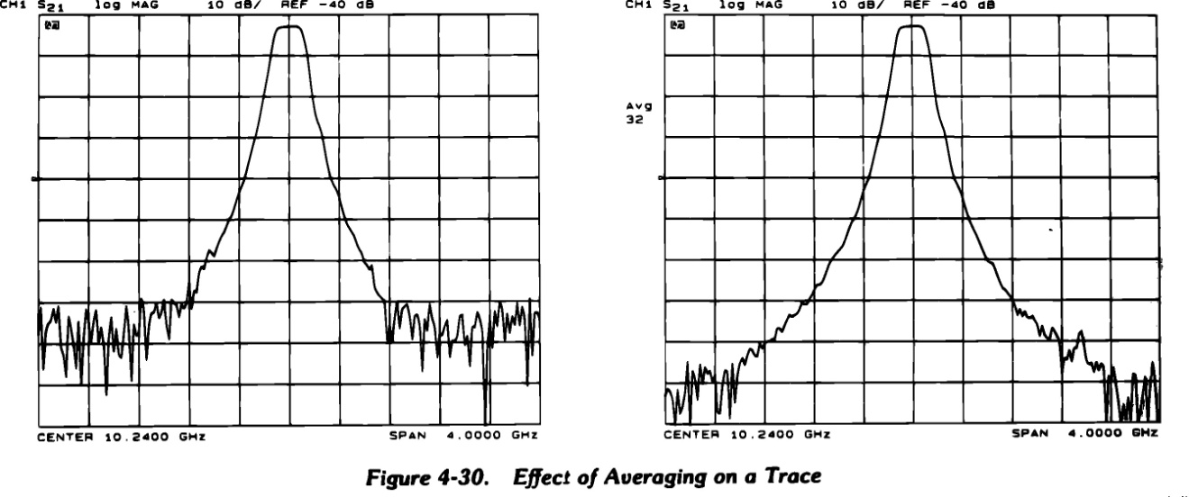
Figure 5.15a
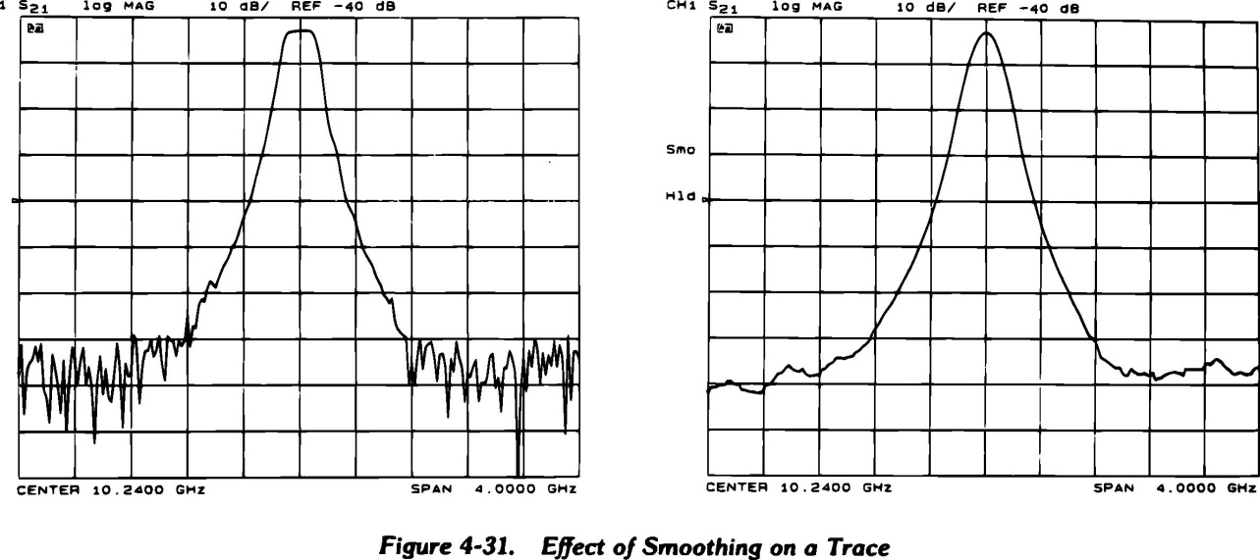

Figure 5.15b
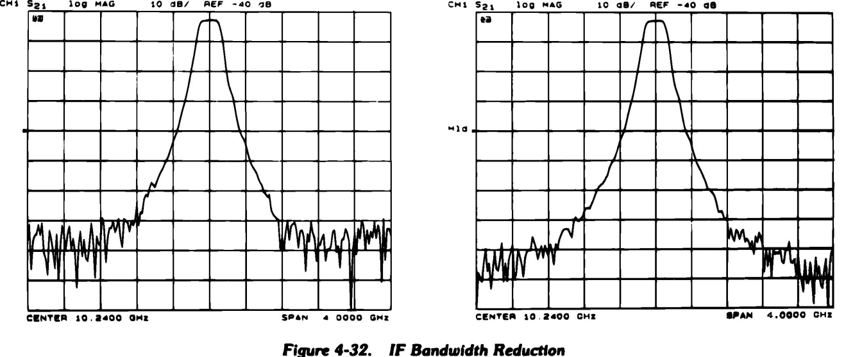

Figure 5.15c - HP 8720B Noise Reduction Technique Effects
(Permission pending by HP/Agilent)
CAL: By pressing this key, the CRT will display the calibration menu.
        - Calibration Introduction
The vector network analyzer must be calibrated before each use, and may need to be recalibrated if used for even as long as 30 minutes. The nature of high frequency signals and its susceptibility to small changes requires as much precision as possible. When the machine is powered on, the device defaults its ports to read at the port interface of the device. The device however, will be connected to the device under test with a pair of 3.5 mm test port cables. The proper rigorous calibration will remove the noise and unwanted response from the cables, so the device analyzes signal activity at the ends of the cables, instead of the beginning of the cables, which would result in noise and great phase error.
For calibrating the instrument with the use of the microprobes, an Impedance Substrate Standard(ISS) with fabricated calibration standards is required. The appropriate ISS for the available Cascade Mircotech WPH-205-150 Microprobes is a p/n: 101-190. The substrate features 40 Thru, Short, Load, and 8 Open impedance standards. The microstrip configurations of each type of standard are shown below in Figure 5.16.
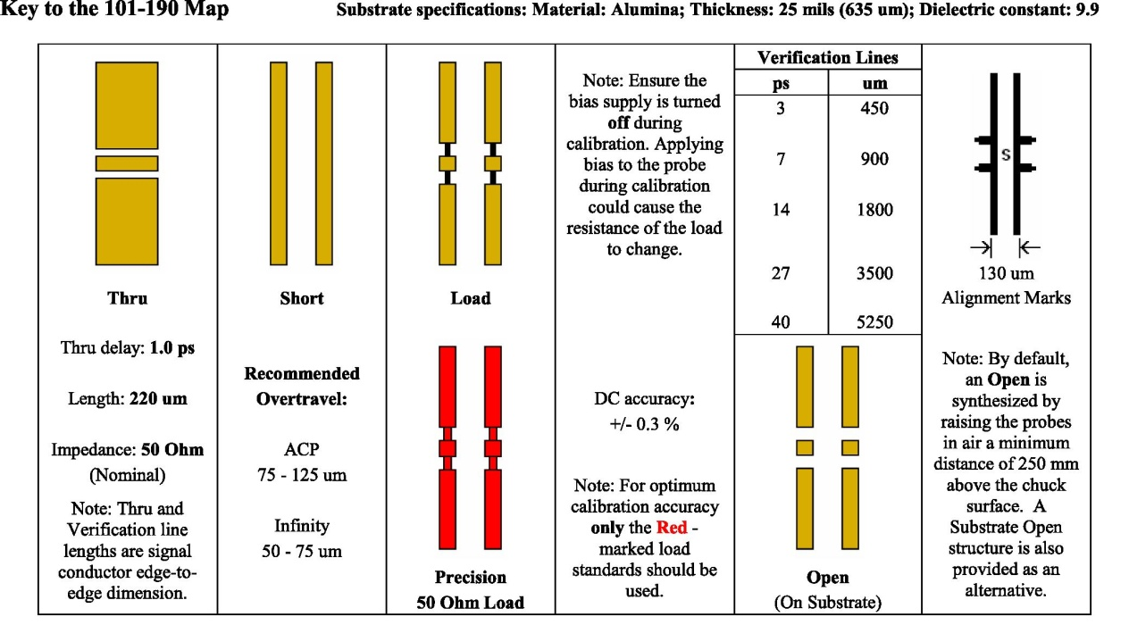

Figure 5.16 - Cascade Microtech P/N: 101-190 ISS key
(Permission Pending by Cascade Microtech, Inc.)
The proper 85052D 3.5mm economy calibration kit, which includes specific calibration standards with responses that are hard coded into the machine was provided and used. Though some of the components are labeled OPEN or SHORT, they are instead very precise and delicate (and expensive!) capacitors and inductors, and must be handled carefully.
It is important that the calibration kit standards are never dropped or rotated when being connected to the test port cables. For any device under high frequency testing, only the rotating part of the adaptor can be spun, to minimize friction or movement that may cause wear or damage to the component. To ensure a valid connection, a torque wrench is supplied, and when used correctly, the torque wrench will ‘break’ when enough torque is applied. The proper procedure to create a valid connection between the microprobes and the ISS begins with the placement of the probe tips onto the ISS initially on the substrate, at the referenced position noted X. Then, the probe arm is manipulated to raise and slide the probe tips across and above the substrate until the referenced position Y is reached. The purpose of the initial contact step at referenced position X is to ensure the plane of the microprobe tips is parallel with the plane of the substrate. The referenced planes and correct placement of microprobe tips is shown in Figure 5.17.
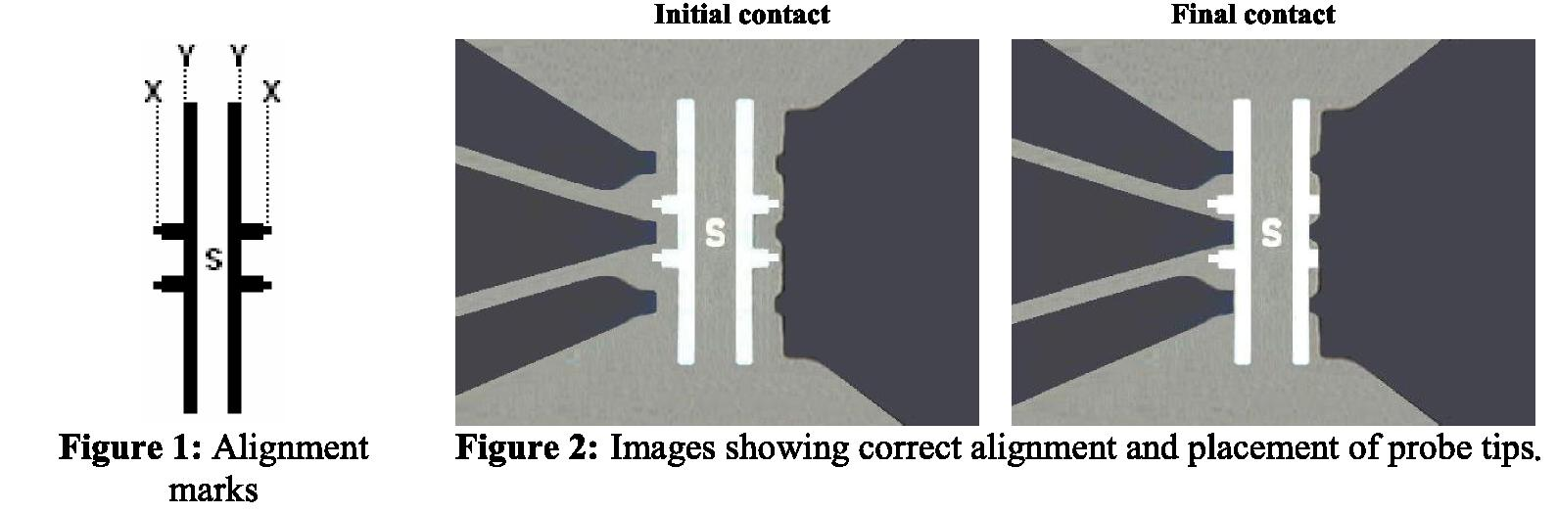

Figure 5.17 - Proper Placement of Probe Tips.
(Permission Pending by Cascade Microtech, Inc.)
        - Calibration Procedure
The calibration procedure may be performed as directed in the following steps.
i. Power on the HP 8720B Network Analyzer, and wait for the machine to initialize. Then, press the [CAL] key which will lead to a series of menus that direct the user through the calibration process. Pressing the [CAL] key will then place the user in the Correction Menu. The second from last option will specify the calibration kit that will be used, and should default to the 3.5mm calibration kit available.
ii. Next, select the [CALIBRATE MENU] softkey option, and the user will see the Calibration Menu. From the Calibration Menu, the user will select the [FULL 2-PORT] softkey option. This will lead the user to the calibration measurements menu. From here, it can be seen that there are three stages to the calibration: [REFLECT’N], [TRANSMISSION], and [ISOLATION].
iii. First, select the [REFLECT’N] softkey option. The user will then see a menu with three pairs of options: (S11) OPEN, SHORT, LOAD, and (S22) OPEN, SHORT, LOAD. Connect the calibration standards labeled “OPEN” to both test port cables. One male and one female are supplied, and should fit accordingly to the test port cables. By carefully connecting them and making sure not to rotate the bulb of the calibration standards at all, carefully use the torque wrench to ensure a valid connection. Once both “OPEN” calibration standards are connected and the trace settles, select (S11)OPEN and (S22)OPEN to complete the measurements. The data is saved for calculations at the end of the reflection calibration. The menu will have the completed portions’ softkey options underlined, and the calibration standards may be carefully removed with the torque wrench, making sure that the component does not rotate.
iv. Next, connect the SHORT circuit calibration standards to the cables, and perform the same procedure as done for the OPEN standards. The menu will also underline the (S11)SHORT and (S22)SHORT softkey options to show completion. Disconnect the calibration standards, and connect the LOAD standards. Once the LOAD standards are correctly applied, select the LOADS softkey, and from the Loads Menu, select [BROADBAND], which specifies the type of load being used from the calibration kit. After both load standards are measured and removed, select [REFLECT’N DONE] to finish the first stage of the full 2-port calibration. This action computes and stores the reflection coefficients, and returns the user to the two-port calibration menu and the [REFLECT’N] softkey option will be underlined. If, for some reason the [REFLECT’N DONE] softkey option is pressed before completion of all measurements, the message “CAUTION: ADDITIONAL STANDARDS NEEDED” is displayed.
v. Next, select [TRANSMISSION] to proceed to the second stage of the calibration. Connect the test port cables directly together without any adaptor medium. When the trace settles, press [FWD. MATCH THRU] to measure S11 load match. The softkey option will then be underlined. Next, press [REV. TRANS. THRU] to measure S12 frequency response. The softkey option will be underlined upon completion. Next, press [REV. MATCH THRU] to measure S22 load match. Once the softkey option is underlined, select [TRANS. DONE] to compute and store the transmission coefficients. Now the user should be back to the two-port calibration menu, and the [TRANSMISSION] softkey is underlined.
vi. The final calibration stage, isolation, may be omitted if desired. The isolation calibration removes crosstalk noise between the test ports. This noise is in the range of -100 to -120 dB, and isn’t significant unless the device under test has very high insertion loss, or reflection. If isolation calibration is not required, select the [OMIT ISOLATION], then [ISOLATION DONE]. To perform the isolation calibration, select the [ISOLATION] softkey option and connect the broadband loads back to the ends of the test port cables. For this calibration stage, it is important to increase averaging in the measurements to reduce the noise in the measurements. Press [AVG], then [AVERAGING ON]. Then, return to the isolation calibration menu by pressing the [CAL], [RESUME CAL SEQUENCE], and [ISOLATION]. Next, press the [FWD ISOL’N ISOL’N STD] and [REV. ISOL’N ISOL’N STD] to measure and average S21 and S12 isolation over 16 sweeps. Both softkey options will be then be underlined. Next, turn averaging off by pressing [AVG] then [AVERAGING OFF]. To complete the calibration sequence, return by pressing [CAL] and then [RESUME CAL SEQUENCE], and select [DONE 2-PORT CAL]. The instrument will compute and store the calibration coefficients, and the corrected trace will be displayed. If the softkey option is selected without measuring all of the stages completely, the message “Caution: ADDITIONAL STANDARDS NEEDED” is displayed. The following Figure 5.18 illustrates the effects of the full 2-port calibration and why it is necessary to test with error correction:
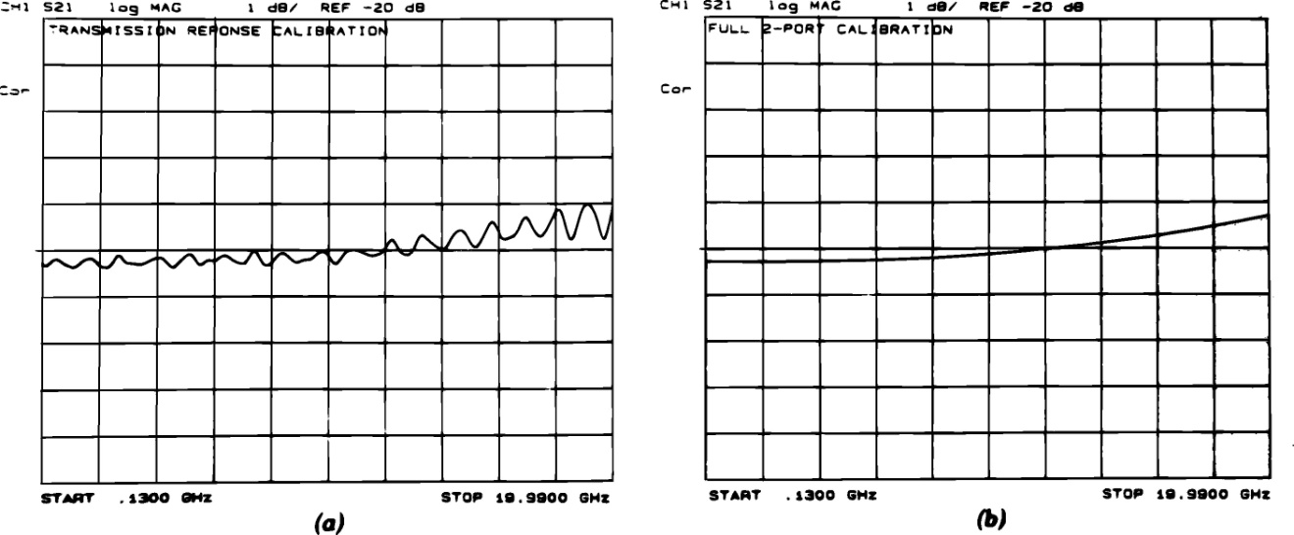

Figure 5.18 - HP 8720B Response vs. Full Two-Port Calibration
(Permission pending by HP/Agilent)
MKR: This hardkey from the Response Key Block of Figure 5.14 enables the use of one to four active markers per channel on the CRT display. Markers have a stimulus value, or its x-axis location, and a response value, or its y-axis location. The response value of an active marker is constantly displayed in the Marker Values Area of the CRT display. The Marker menu is used to turn markers on or off and change the active marker if multiple markers are turned on. This menu also has the feature to place a fixed reference marker at the active marker’s current location, future marker values read relative to the fixed marker.
MKR FCTN: Pressing this key displays the Marker Function Menu, which can be used to easily change stimulus start and stop values, stimulus center and span, and also set reference and delay values. Marker locations can be manipulated by rotating the knob or by entering values into the numeric keypad. Using the markers to modify measurement parameters can be a quicker process than proceeding through the previously discussed Stimulus Key Block. The Stats on/off function toggles the display of statistical data of the trace between the reference marker and the current marker location. The statistical data is displayed in the Marker Stats/Bandwidth Area of the CRT display. The Marker Search menu allows the user to quickly locate and read the value of characteristic points, such as max, min, target(a specified value), or width value.
      - Instrument State Key Block
All of the key blocks discussed so far have pertained to channel-dependent functions including, but not limited to, channel selection, stimulus setup, measurement setup, data display and plot format setup, error correction setup, noise reduction setup, and statistical analysis and calculation setup. The Instrument State key block contains the hardkeys which provide the use of channel-independent system functions. Also, the key block features GPIB status indicator lights to display the system’s current status. Photograph Figure 5.19 shows the Instrument State key block.
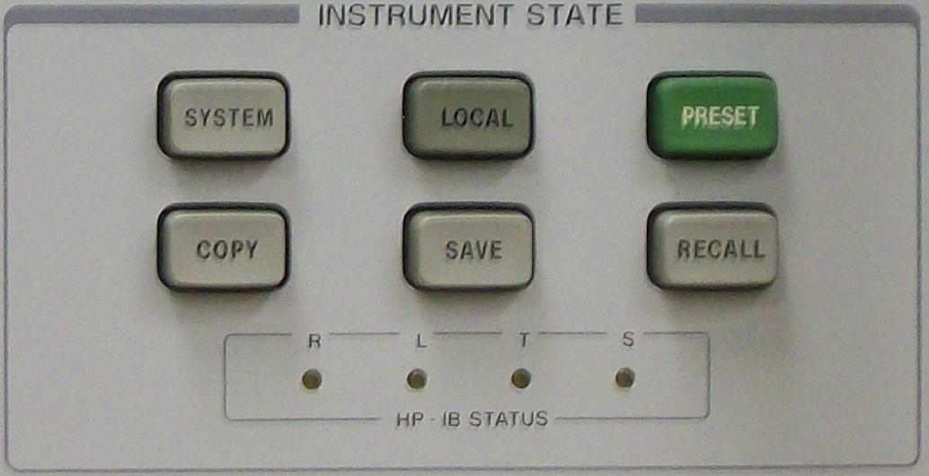

Figure 5.19 - HP8720B Instrument State Key Block
LOCAL: Pressing this key displays the HP-IB Menu, and is used to bring the analyzer back to front panel operation mode(local mode) from remote operation mode. In remote operation mode, a computer controls the functions of the network analyzer over a GPIB/USB controller(General Purpose Interface Bus, formally known as HP-IB, Hewlett-Packard Interface Bus), and the front panel hardkeys are disabled, except for the LOCAL key. When the Vector Network analyzer is in local mode, it can be operated manually even if it is still connected to the GPIB controller. The LOCAL key is disabled, however, if a local lockout is enabled, a remote operation command that disables the hardkey.
Three separate HP-IB modes are available from HP-IB Menu via softkey selection. The System Controller mode of GPIB operation allows the Vector Network Analyzer to control compatible peripheral devices, such as a printer/plotter, without the remote operation of a computer. Though this mode requires no programming, the GPIB addresses in the address menu must match the addresses set in the other instruments. The default mode is the Talker/Listener mode. In this mode, the computer communicates with the Vector Network Analyzer and the other devices over the GPIB controller. The controlling computer sends instructions and receives data from the Vector Network Analyzer, and has access to all features of the instrument that are accessible from the front panel, except for the LINE Switch and internal tests. The term talker denotes a device that can send out data when addressed to talk, and the term listener denotes a device that receives data when addressed to listen. Lastly, in the Pass Control mode, the computer is the system controller, but can pass control of the bus to the Vector Network Analyzer temporarily to complete a task. The computer regains control of the devices when the action is completed by the Vector Network Analyzer.
HP-IB Status Indicator Lights: The illuminated light displays the system’s current operating status. The light under “R” corresponds to remote operation, “L” corresponds to listen mode, “T” corresponds to talk mode, and “S” corresponds to service request.
SYSTEM: By pressing this key, the System Menu is displayed, which presents two more menus, the Service Menu, and the Limit Menu. The Service Menu is navigated when the instrument requires service due to any hardware or software failure. The Limit Menu allows the user to draw limit lines on the CRT to compare measured data with defined limits. If the response of a device exceeds a limit, the failed limit line will blink and a FAIL message will appear on the screen.
COPY: This key displays the Copy Menu, which is used to control an external printing device over the GPIB connection. To print with the device without a controlling computer, set the Vector Network Analyzer to System Control mode, and verify that the address of the plotter matches its address in the address menu. The default address of a plotter is 05, and the default address for a printer is 01. The PRINT [STANDARD] option copies the image across the CRT display and sends it to the printer. Selecting the PLOT option plots image across the CRT onto the plotter. The plotter has higher resolution than the printer, but is unable to print frequency list/limit tables. If the SELECT QUADRANT option is chosen from the Copy Menu, the user can choose to draw quarter page plots, which are only compatible for use with the plotter. The DEFINE PLOT option from the Copy Menu directs the user to the Define Plot Menu, where there are various options that remove certain elements seen on the screen from the plot, including data, memory, graticule, text, and marker. The last two options in the Define Plot Menu, Scale Plot and Plot Speed, allow the user to select and define a reduction or expansion of the plot scale, and set the plot speed, either fast(default) or slow(used for plotting with greater accuracy). The Configure Plot menu is used to choose which pens to use on the plot, and the type of line to be drawn for data and memory traces. Selecting the PRINT/PLOT SETUP menu option from the Copy Menu is where the user defines the printer to be either a color printer, or a non-color printer. Selecting the LIST VALUES option from the Copy Menu displays the Screen Menu. The screen menu is used to copy tables of the values displayed on the screen. The PRINT and PLOT options appropriately produce hard copies of the tabled values shown across the CRT screen. The PAGE option shows the next page of tabled values onto the CRT screen. Once finished with the list view, the RESTORE DISPLAY option is used to return to the measurement display screen.
SAVE: Pressing this hardkey displays the Save Menu, which contains all menus used for saving current instrument states into internal memory as well as onto an external disc. An instrument’s state includes variables such as calibration sets, measurement data, and operating mode data. Calibration sets will remain through an instrument preset, but measurement data and operating mode data will be lost. Also, all instrument state data is lost when the Vector Network Analyzer is turned off, so storing instrument data into the internal memory of the instrument is very useful, and eliminates the need to perform many full two-port calibrations for any reason. The Save Menu presents options to save, clear data, and assign a title to any of the five internal registers. Also, all register save actions are applicable to a compatible external disc device over a GPIB connection.
RECALL: Allows the user to access menus used to read and load stored information from internal registers and files from an external disc onto the Vector Network Analyzer.
    - Test Process
The main aspect of this portion of the laboratory is the test and measurements of S parameters for active and passive RF devices. Providing a reliable and user-friendly system that achieves those tasks is the main goal for the High Frequency Test System. All of the HP 8720B’s functions involved in the test process are explained in detail in section 5.3.3. The test process is as follows, for manual instrument operation:
- Power on the Vector Network Analyzer.
- Once the instrument has initialized, define the source output signal via the Stimulus Key Block.
- Configure measurement parameters and/or markers with the Response Key Block.
- Perform the full two-port calibration, or load an appropriate instrument state. If the calibration was performed, save the instrument state for future use or if an instrument preset is executed.
- Connect the DUT to the ports of the Vector Network Analyzer.
- Measure the data with markers and marker functions.
- Output the measured data either to the Data Acquisition system or the printer on the GPIB.

Chapter 6: Electronically Switchable Load

  - Introduction
Because of the youth of the nanotechnology lab described within the report, it is necessary to perform many tests on the different devices in order to test them and be certain that they are performing properly. The three different testing environments that may have loads constructed for them are low-temperature, high-temperature, and high frequency. However, due to the spatial constrains within the cooling chamber, it is not feasible to design a switchable load for the cold-temperature environment. Due to the fact that the parameters analyzed in the high frequency environment are very different from those analyzed in the high-temperature environment, it is not appropriate to design loads for both of these devices. To that end, since the high frequency testing environment is the newest addition to the lab, an RF electronically switchable load will be designed, and analyzed with the high frequency parameter analyzer.
    - Design Specifications
- Must be portably powered.
- Must be able to switch between at least 4 different loads.
- Must be assembled on a printed circuit board.
- Must have an integrated display of some sort to indicate which load is currently active.
- The switching component must have a very small impedance, so as to not interfere with the testing of the microstrip.
- Switch will be operated with a push-button interface, which should be stable.
- Must have a cut-off frequency greater than 2 GHz.
- Must be able to interface with an impedance analyzer through a coaxial connection.
    - Design Goals
With these in mind, the design is broken up into the following modules:
- Analog multiplexer circuit
- Push-button interface
- Digital state transition circuit
- Led display
- Power supply
- Impedance analyzer Interface
The goal of the following design will be to maintain a reasonably low cost while attaining the desired performance characteristics. A block diagram of the above characteristics is shown in Figure 6.1
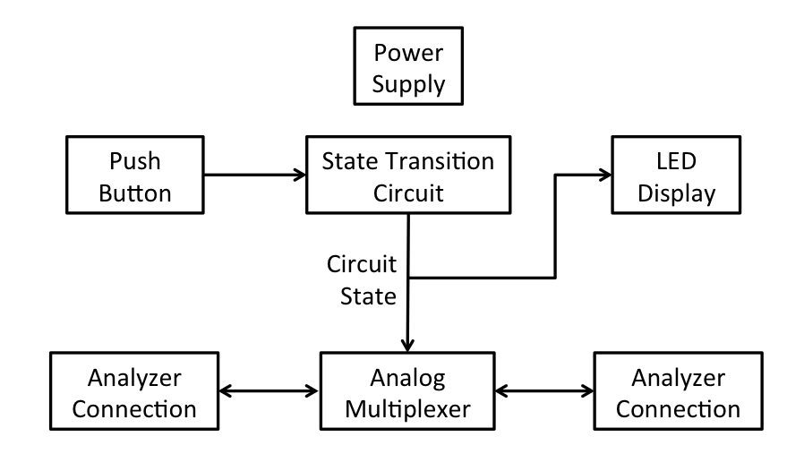

Figure 6.1 – Switchable Load Block Diagram. Connections are not shown from the power supply since all components are dependent on it.
  - Design
    - Analog Multiplexer Circuit
The first element required in designing an electronically switchable load is the analog switch itself. The goals in designing an electronic switch include:
- Very low impedance
- Reasonably fast switching time
- Bi-directionality, so that current may flow equally in either direction on an active element.
- Good frequency response, so that testing at high frequencies is possible.
There are several technologies currently present which achieve this goal. The three considered here are CMOS switches, inductive relays and MEMS relays. In the sections that follow, each technology will be briefly described to an extent that their benefits regarding this project may be considered, and their merits and disadvantages with respect to this project shall be discussed.
      - CMOS Switches
The first that will be considered is a CMOS switch as shown in Figure 6.2.
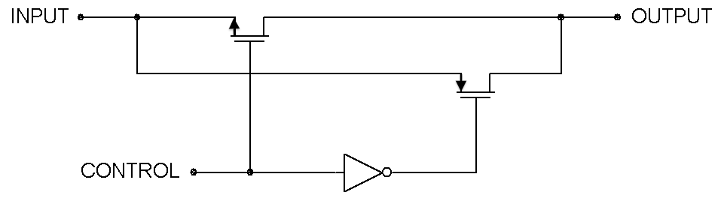

Figure 6.2 – A CMOS switch. The switch is active when CONTROL is at logical high, and inactive at logical low.
By having a CMOS configuration, it is possible to create a near zero impedance bi-directional line, which will be optimal for connecting the load. Because of the bi-directionality, an identical circuit may also be used to demultiplex the impedance line. CMOS has the added benefit of having a very low power draw, allowing for long portable life of the switchable load. This is an important consideration, since the switchable load should have a fairly strong battery life so that multiple experimental readings may be done. Further, transistor based technology is very common in modern electronics, and as such has a very low cost. Solutions incorporating CMOS technology for analog multiplexing are often sold as integrated circuits, further adding to the ease of implementation.
The downside to this technology is that it is based on MOSFET devices, which have significant impedances under high-frequency environments. Since the switchable load must operate at least at 2 GHz, this greatly decreases the feasibility of CMOS switches for high-frequency switchable load applications.
      - Inductive Relays
Inductive relays function by harnessing the magnetic field generated when current is passed through an inductor. This magnetic field is used to physically move a metal contact to a different position.
Because inductive relays are formed from fairly simple components, their fabrication is fairly inexpensive. Also, as there are no active elements that interfere with the load line (as in CMOS technology), the frequency response maintains low attenuation for a much wider range than would be found in a CMOS switch.

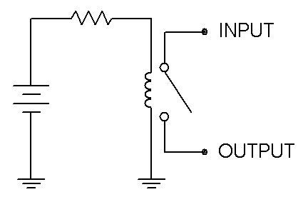

Figure 6.3 – An inductive relay. As the inductor generates a magnetic field, the switch will be pulled closed.
Inductive relays have the downside of having physically moving parts at the core of the technology. This means that lifetime of these components are less than what would be found in a solid-state based solution. Also, a significant current is required to power an inductive relay, which could result in an insufficient battery power lifetime. Since inductive relays are less frequently required, they commonly exist in a binary switch configuration, which would require multiple relays to implement a multiplexer.
      - MEMS Relays
MEMS (Micro-Electrical Mechanical Systems) relays function quite similarly to inductive relays, but rely on electro-static attraction rather than magnetic force to depress a contact, which may be fabricated from a number of materials, most commonly silicon or metal.
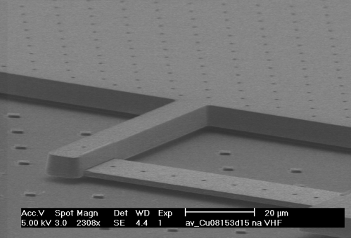

Figure 6.4 – a MEMS relay. The thin bar in the foreground is the moving portion of the relay, which either makes contact with the plane below it or the arm extending from the plane in the background to switch between two circuits. Permission Pending.
MEMS relays, like inductive relays, have no active components that go across the load line, allowing this technology to have an excellent frequency response over a very wide range of frequencies. Also, because the switch contact is created from an electrostatic attraction, very small amounts of energy are required to maintain a switched position, making this ideal for portable applications where power consumption is an issue.
Like inductive relays, MEMS relays also utilize the physical movement of internal components, which causes them to have a somewhat diminished lifetime when compared against CMOS switches. Due to the youth of the field of MEMS relay development, along with their micro-scale technology, these relays tend to be significantly more expensive. These would also require multiple relays in order to implement a multiplexing circuit.
      - Analog Multiplexer Choice
The main factor for performance in the analog multiplexer is low impedance across a wide frequency range. From an inspection of various data sheets, it was found that CMOS relays tend to attenuate heavily in the 300 MHz region, inductive relays may operate as high as 3 GHz, and MEMS relays may operate as high as 15 GHz. Given this, CMOS relays are impractical for this application, since the high-frequency testing equipment that will be used has a minimum required frequency of 300 MHz.
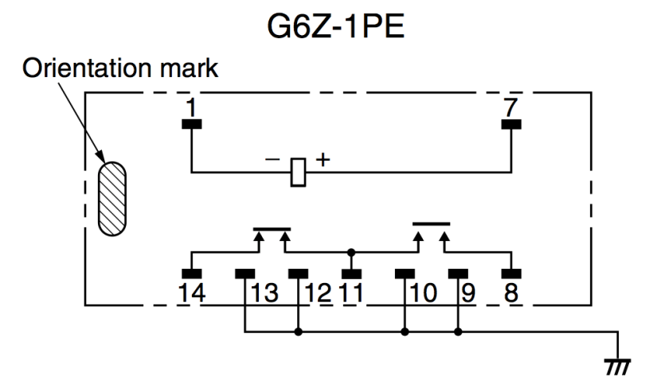

Figure 6.5 – The G6Z Relay Pin Assignment Diagram, showing that a single control signal will switch between two possible circuits. When extending this circuit to switch between multiple loads, the output terminal of one switch (pin 11) will be connected to an input terminal of another switch (pins 8 or 14). Pin 1 will be connected to ground, and the control pin (7) will connect to the output of the state transition circuit. Permission Pending.
While MEMS relays have a significantly better range of frequencies which it may operate under, they tend to cost between $250-$300, while inductive relays are within the $5 range. In order to multiplex and demultiplex four loads, six relays are required. Though the ability to test in higher frequencies is interesting, the cost for MEMS relays is prohibitive, and as such, inductive relays will be used.
For this application, the best value inductive relay is the Omron G6Z Surface-Mounting High-Frequency Relay. This relay has two load lines, and uses a voltage-controlled switch to choose between the two. The switch requires a 5V DC signal to change from one load to the other.
      - Multiplexer Layout
The multiplexer created from the G6Z relays will be in a binary tree configuration, where N loads require 2^{N} - 1 relays. To minimize any interference between the various loads, a similar structure will be used to demultiplex the circuit. Therefore, the six required relays should be placed in a configuration as shown below in Figure 6.6.
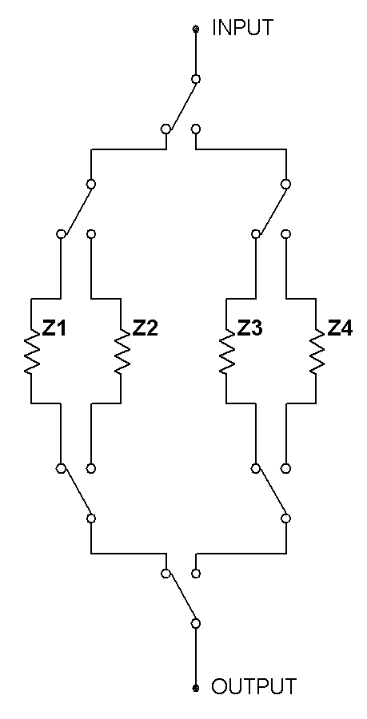

Figure 6.6 – A multiplexer created from a binary tree configuration of switches. Z1 through Z4 represent the various loads that will be switched between. The impedance analyzer will be connected to the labels ‘input’ and ‘output’

6.2.2 Push-button Interface
To control this switchable load, a push-button interface will be used to cycle through the varying states. It is desired to have a push button which will provide a pulse of high voltage when pressed, and otherwise a grounded low-voltage level. An implementation of this can be seen in Figure 6.7.
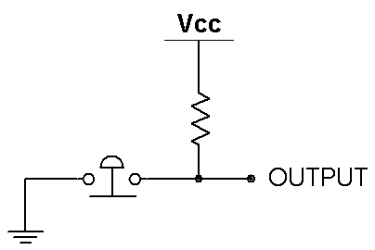

Figure 6.7 – A simple push-button. When contact is made, the output is connected to ground; otherwise the output is at Vcc.
While this circuit will correctly pulse with high-voltage, it will be unstable, as push-button interfaces have a period of instability when contact is first made, which causes them to undergo several pulses in a very rapid time frame. To correct this problem, the button will need to be filtered through a debouncing circuit in order to ensure that only one pulse is generated from a button press.
The first solution considered is the incorporation of an integrated circuit solution. Integrated circuit solutions to this tend to be very precise, and would provide excellent stability when operating the push button.

Figure 6.8 – Operational circuit for the MAX6816. The debounced output shown here would be used as a clock input for the digital state transition circuit. Permission granted by Maxim.
A second solution would be to rearrange the circuit in Figure 6.7 to incorporate a capacitor, which will slow the transition between logical low and high voltages as seen in Figure 6.7. In order to ensure an edged transition from logical low to high, this can be padded with an inverting Schmitt trigger that will turn the exponential waveform that would normally be seen from an RC circuit into a rectangular pulse waveform.
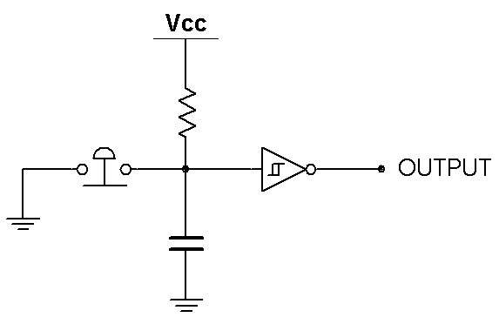

Figure 6.9 – An improved push-button. When contact is made, the circuit will discharge and the Schmitt trigger will output logical high. When contact is broken, the reverse will occur, outputting logical low.
It is necessary when implementing this circuit to use an RC value such that it surpasses the debounce period, while still allowing adequately rapid button presses. For the purposes of this project, values of R and C will be 10 kΩ and 1 μF, yielding a time constant of 100 milliseconds, which should be both long enough to avoid bouncing effects, and short enough to not cause an operator significant delay in operation.
Because of the high additional cost a debouncing IC will impose, an RC solution with a Schmitt trigger will be used. The Schmitt trigger to be used is the 4584 Hex Schmitt Trigger.

    - Digital State Transition Circuit
The control lines to the multiplexer and decoder from the analog multiplexer circuit will require a state transition schema which will cycle from 0 to 3 in 2-bit binary. This can be implemented by developing a simple modulo 4 counter. Given current state (A, B) and future state (A⁺, B⁺), where A is the most significant bit, the state transition diagram and corresponding truth table for a modulo 4 counter is shown in Figure 6.10. Because the initial state of the circuit upon initial power-on is not important, it will be left to the pseudo-random trace signals in the circuit to determine what the first state is upon activation.
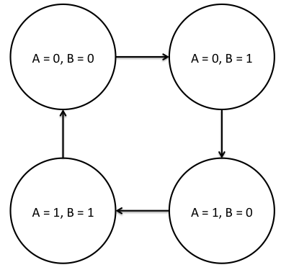
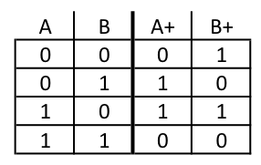

Figure 6.10 – A Modulo 4 counter state transition diagram and truth table. A and B represent the current output values, while A+ and B+ indicate the output values on the next positive clock edge.
From this table, the following equations for the counter are deduced:
- A⁺ = A XOR B
- B⁺ = B’
For simplicity, these will be implemented using D flip-flops. An implementation of these equations using D flip-flops is shown in Figure 6.11.
The D flip-flops that will be used should be positive edge triggered in order to match the push button output that has been considered, and for convenience, should include the inverted output in order to reduce the number of parts required. The 4013 Dual D flip-flop achieves all of these, and also contains two flip-flops on a single IC.

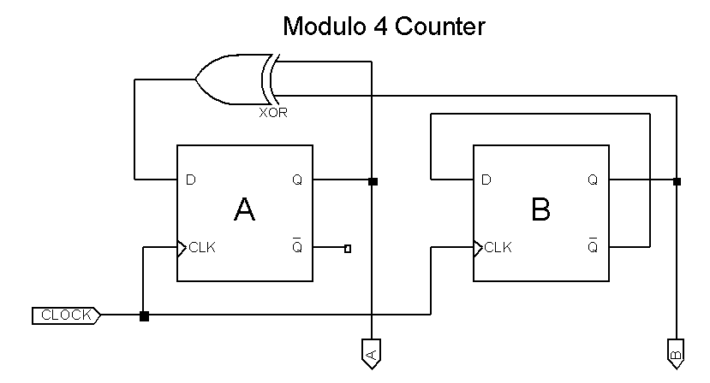

Figure 6.11 – A Modulo 4 Counter. The values A and B represent the two bits of the counter, and the input CLOCK is the output from the debounced push button discussed in 6.2.2. Because the D-type flip-flops have both an output and an inverting output, there is no need for any explicit inverters in the switchable load design.
Though IC solutions for modulo counters do exist, they will not be used because of their associated cost, as well as the difficulty of locating a modulo counter IC that counts to the exact required value.
    - LED Display
There are two options possibilities that will be considered for the LED display that will indicate which portion of the circuit is active. The first is a simple LED that will be placed next to each load on the circuit to indicate which is active. The second is a seven-segment display that will cycle through the values 1-4 to indicate which of the components are active.
      - LED Decoder
Since the control lines A and B already cycle through the 4 possible states, a simple demultiplexer/decoder can be used to control the led display, using A and B as decoder control lines. A typical circuit for this is shown in Figure 6.12.
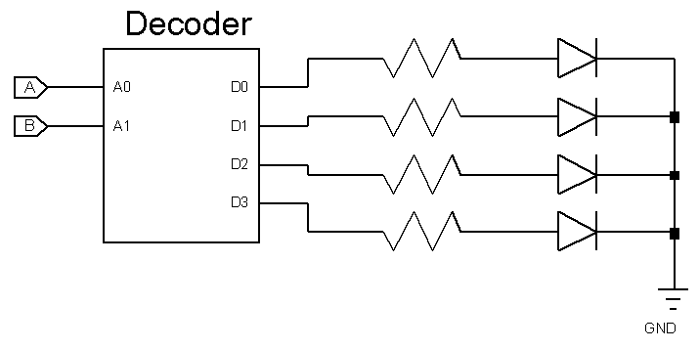

Figure 6.12 – An LED decoder. The select lines A and B are received from the modulo 4 counter, which turns the appropriate output D0 through D3 to logical high, causing current to flow through the diode. Most decoders that may be purchased are inverting, requiring a change in diode direction, as well as changing the ground terminal to Vcc.
For simplicity, the decoder that will be used is the HEF4555, since it is a non-inverting configuration. Assuming that the diodes are 1.2V @ 20mA LEDs, the resistors will be 220Ω for optimal current, so that the diodes are as bright as possible without risking an excessive current supply that would cause the diode to fail.
      - Seven Segment Display
For the LED display to be a seven-segment display, the A and B control lines from the state transition circuit must be decoded into values for each of the seven segments that will be used. Figure 6.m shows a typical pairing between an IC 7 seven-segment display, and the corresponding light that is activated by each pin. Each of these pins will also have to be connected to a resistor, to provide an appropriate amount of current so that the LEDs do not burn out. Given that the LEDs in the seven-segment display are standard 1.2V @ 20mA LEDs, the best resistor value is a 220Ω resistor, rated for at least 0.1W power dissipation
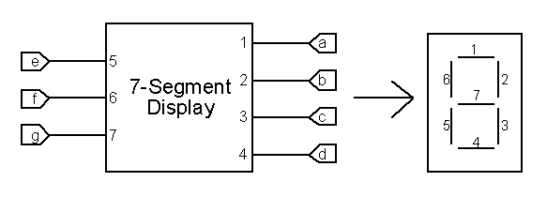

Figure 6.13 – A 7-Segment Display. Given input values a through g, lights 1-7 are correspondingly lit.
It is worth noting here that the labeling convention for various seven-segment displays may vary based on the manufacturer of the given display. Therefore, while the derived logical circuits will still be valid, they may need to be translated for application onto the display being implemented
The values that this seven-segment display will need to realize are one through four. The corresponding segments that are lit for each of these values are:
- One: 2, 3
- Two: 1, 2, 4, 5, 7
- Three: 1, 2, 3, 4, 7
- Four: 2, 3, 6, 7
The corresponding state transition diagram and truth table for these values is shown in Figure 6.n. Also included in Figure 6.n is the karnaugh map corresponding to each value a-g. The Karnaugh maps are organized such that the state (AB) is shown in standard K-map configuration; that is, starting at the top left and rotating clockwise, the states are {00}, {10}, {11}, {01}.
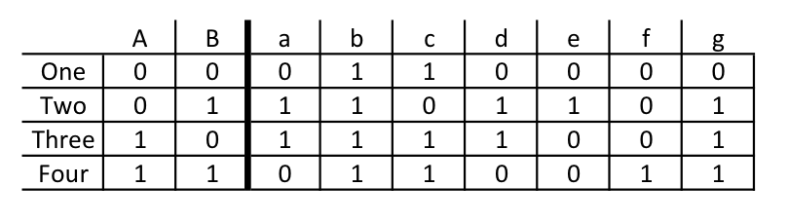
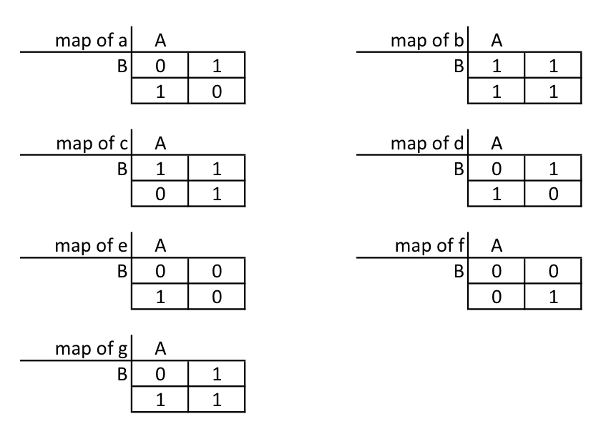
Figure 6.14 – Seven-segment display truth table and corresponding Karnaugh maps.
From the derived Karnaugh maps, the following canonical sum-of-product equations may be easily deduced:
- a = (A’ • B) + (A • B’)
- b = TRUE
- c = A + B’
- d = (A’ • B) + (A • B’)
- e = A’ • B
- f = A • B
- g = A + B
Some of these equations may be reduced, yielding the following minimized set of equations.
- a = A ⊕ B
- b = TRUE
- c = A + B’
- d = a
- e = A’ • B
- f = A • B
- g = A + B
A realization of these equations is shown in Figure 6.15.
While there do exist IC solutions to convert a binary coded value into a corresponding seven-segment display signal, they are not appropriate for this project. This is because IC solutions would convert signals 0-3 to 0-3, where here it is desired to convert input signals 0-3 into output signals 1-4. In order to use one of these ICs, the 0-3 would have to pass through an ‘add one’ circuit, which would be just as cumbersome as, but more expensive than decoding the signal without an IC.
The input signals A’ and B’ may be acquired directly from the D flip-flops that were used to generate the signal, and the inverter tied to ground may alternatively be a direct connection to Vcc. With these alterations, the seven-segment display signals may be produced with only two AND gates, two OR gates, and a single XOR gate. While the variety of gates, and therefore the number of integrated circuits required could be reduced by applying various Boolean algebra axioms to the final equations, that will be omitted for this project due to the low cost associated with 4000 series CMOS logical gates.
      - LED Display Choice
Both the LED display solutions described above have merits. The LED decoder/demultiplexer allows for a physical location on the circuit to be indicated, which could be useful should repairs need to be made to the multiplexing circuit. The seven-segment display, on the other hand, does not show any information about the location of the active circuit, but can show an indicating number, which can then be looked up to determine which load is active, and what characteristics that load should have. Because both of these solutions have different benefits, and each is relatively cheap to implement, both LED solutions discussed here will be used.
When placing the LEDs for the direct indicator display, it will be important to position them in such a way that does not interfere with the sensitive high-frequency circuitry and microstrips. Because of this, the lowest available voltage LEDs will be used, to minimize any impact it may have on the remaining circuitry. These considerations are not as important for the seven-segment LED display, since it may be placed in a removed location from the high frequency portion of the circuitry. Aesthetics is not particularly important with regards to the design of the high frequency switchable load, so the cheapest color LEDs, most likely red, will be used for both the indicator lights that will go adjacent to the various loads, as well as the seven-segment display.
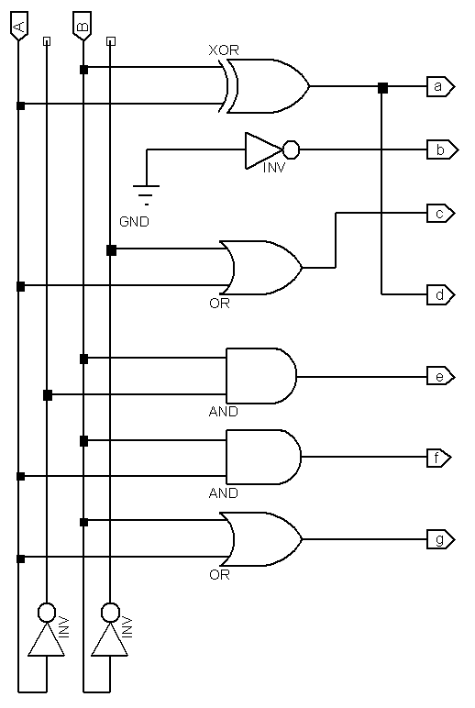

Figure 6.15 – Seven-segment display logic diagram. Since outputs ‘a’ and ‘d’ have the same equation, they are tied to the same output. Also, for stability purposes, ‘b’ is tied to an inverted ground signal since it is always true. Alternatively, it may be connected directly to Vcc.

    - Power Supply
In the switchable load, power will have to be transferred to the push-button circuit, the state transition circuit, and the LED display circuits. It is worth noting that power is not supplied directly to the analog multiplexer circuit, because the voltage that activates the switches is provided by the control signals from the state transition circuit. In order to maximize performance of the analog multiplexer, the control signals should output a 5V DC signal. This means that the circuit should be run using 5V logic components, which are common. To provide power to this circuit, therefore, it is required to have a 5V DC power supply.
Due to the fact that there are 5V standalone batteries are not commonly sold, and that the supply voltage should be stable, a 5V voltage regulator in conjunction with a battery. For this project, a 9V battery will be used, since it provides the necessary input voltage to a voltage regulator while being relatively inexpensive. Furthermore, 9V batteries tend to have a longer lifetime per cost, relative to smaller batteries that might be used, such as multiple AA or AAA size batteries. Two different common 5V regulators were considered for this project: the LM2575 and the LM7805 voltage regulators.
The LM7805 voltage regulator is a simple three-terminal voltage regulator which, when in its standard configuration, requires only two external elements. It requires a heat sink to operate safely, and can provide an output current of at least 0.5A. It also provides thermal overload and short-circuit protection, which will be beneficial for protecting the powered elements from damage through use. They commonly cost around $2.
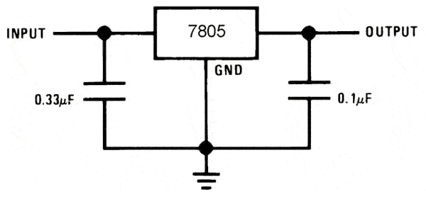

Figure 6.16 – An LM7805 in its standard operating configuration. Output will be a constant 5V provided that Input is at least 7.5 V.
The LM2575, on the other hand, requires four external components in standard configuration, but is rated for at least a 1A output current. Furthermore, it does not require a heat sink in many situations. Like the LM7805, the LM2575 has circuit protection features to prevent overloading and short-circuiting. The LM2575 is more expensive than the LM7805 at a cost of around $4, but since only one will be required, the difference is negligible for this application.

Figure 6.17 – An LM2575 Voltage Regulator in its standard operating configuration. It has the additional requirement of a diode and an inductor, which aid in voltage regulation. Permission Pending.
Because the LM2575 will not require a heat sink in order to operate effectively, and that it provides a greater maximum output current, it will be used as the voltage regulator for the switchable load.
    - Impedance Analyzer Interface
The impedance analyzer connects to various loads with a coaxial connection. In order for the switchable load to connect to the impedance analyzer with the greatest ease, it should have two female coaxial connections. In order to minimize any strain on the board, these will be right angle connections. Also, it should be ensured that the coaxial connectors do not attenuate until over 3GHz, so that they do not limit the functionality of the switchable load. Any gold-plated coaxial connector should achieve this bandwidth.
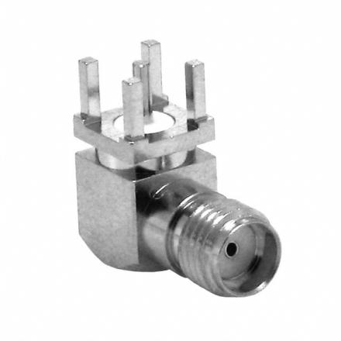

Figure 6.18 – A typical female right angle PCB mountable coaxial connector, included here to indicate which precise coaxial connection is to be used. Permission Pending.
    - Design Summary
The multiplexing circuit will functionality will be carried out by OMRON G6Z series inductive relays. These will be driven by a state transition circuit ran as a modulo 4 counter. The base of the modulo 4 counter will be two D flip-flops, and the clock input will be a standard push-button interface, passed through a MAXIM MAX6816 debouncing IC. The output from the state transition circuit will not only drive the multiplexer, but will also feed into an LED display, consisting of both a demultiplexer/decoder that will drive four LED lights, as well as a seven-segment display which is controlled by an assembly of logic gates. This entire schematic will be powered by a 9V power source, which will be passed through an LM2575 voltage regulator to create a constant 5V source. The input and output of the analog multiplexing circuit will be connected to two right angle female coaxial connectors to allow the switchable load to interface to an impedance analyzer for testing. The loads themselves will be designed within a PCB layout software, and printed directly onto the printed circuit board on which all of these components will be assembled.
    - Parts Required
Below is a complete list of the parts required for the switchable load, categorized by integrated circuit and other parts. Parts not included in this list are resistors and capacitors, as they will all be printed onto the circuit board directly. Also, the loads that will be tested by the impedance analyzer are not included, since they are also designed and printed directly onto the printed circuit board.

Integrated Circuits
- Six OMRON G6Z-1PE High-Frequency Relays
- One HEF4555 2 to 4 decoder
- One LM2575 5V Voltage Regulator
- One 4584 Hex Schmitt Trigger
- One 4070 Quad XOR gate
- One 4071 Quad 2-input OR gate
- One 4081 Quad 2-input AND gate
- One 4013 Dual D-type flip-flop

Other Parts
- One 9V battery, with housing
- Four LEDs, rated at 1.2V @ 20mA
- One 330 μH inductor
- One 1N5819 Schottky Barrier Rectifier
- Two SMA Right-Angle gold-plated female coaxial connectors
- One Seven-Segment Display, rated at 1.2V @ 20mA
- One PCB Pushbutton Switch
  - Printed Circuit Board
In the design of the printed circuit board, there are three design goals that need to be met:
- Design the materials for the PCB to maintain strong frequency response up to at least 3 GHz.
- Design four different integrated microstrips.
- Orient the various parts in a logical fashion, while making sure to place the appropriate indicator LEDs next to their corresponding microstrip.
    - PCB Materials
In modern printed circuit boards, there are two bulk materials that make up the PCB: the conducting layers and the insulating dielectric layers. In almost all applications, the conducting layers are made of copper, which provides a good enough frequency response for most applications. The insulating layer may be made from a variety of materials, however. The most common dielectric used in printed circuit board fabrication is FR-4, a glass reinforced sheet of epoxy. Some brands, including Rogers brand dielectrics, are more expensive and do not consist of woven materials. These are, however, more expensive than FR-4. In spite of the additional expense, one of these more expensive materials must be considered, since FR-4 begins to dissipate energy as the frequency enters the GHz range, as well as lose dielectric strength.
For this application, the Rogers RO4003 Laminate will be used. This is a similar material to FR-4, but due to a more strict manufacturing process it mains a low insertion loss level over a wide frequency range, making it optimal for the switchable load.
    - Integrated Microstrip Design
There are a variety of different stripline loads that may be created for applications within a switchable load. These may range from simple loads, such as a microstrip, to a variety of different loads, including filters and waveform transformers. An example of a hairpin filter is shown in Figure 6.19.
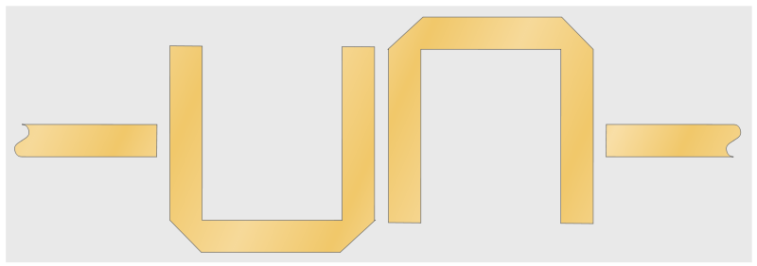

Figure 6.19 – A hairpin filter. This is an example of a more complicated stripline application. The applications in this switchable load will be limited to microstrips and wave transformers.
Since this is circuit is connected in a 50Ω configuration, any connections that occur within the circuit should also have a matching characteristic impedance. A sample design, along with a circuit simulation is shown in Figure 6.20.
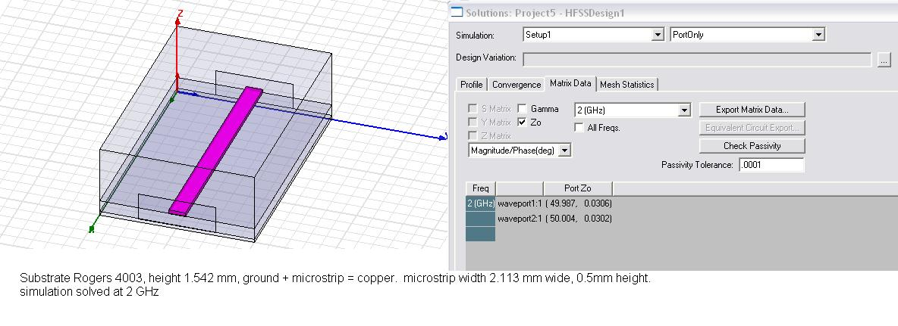

Figure 6.20 – a 50Ω microstrip. Since this circuit has little impact on RF applications, it is ideal for inter-component connections within the PCB
It is worth noting here that the dimensions for the microstrip shown in Figure 6.20 are particular to several factors, including the type of dielectric used, the thickness of the dielectric, the location of the microstrip within the dielectric, and the height of the layer of the conductor. The values shown in Figure 6.20 were chosen to simulate as closely as possible the parameters that the actual switchable load will have.
Another microstrip application that will be utilized in the final switchable load is a quarter wave transformer. Figure 6.21 shows a typical unmatched impedance, and the corresponding reflection that occurs across all frequencies. The quarter wave transformer is used to smooth the transition between two unmatched impedances, so that less reflection occurs.
It is important when designing high-frequency circuitry to maintain low reflection through inactive elements, such as wiring between elements. As is shown in Figure 6.21, a 9 to 10 dB attenuation occurs across the mismatched microstrips. The circuitry purchase for the high frequency portion of the circuit, including both the relays and the analyzer interface are 50Ω characteristic impedance elements, so 50Ω characteristic impedance microstrips will be used to connect the different relays to each other. In order to demonstrate a circuit which has full transmittance, one of the chosen load lines will also be a 50Ω microstrip, which should, under ideal conditions, have no reflection.

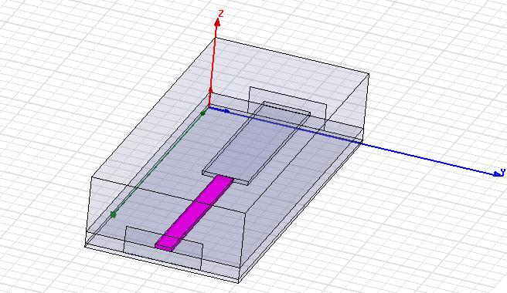
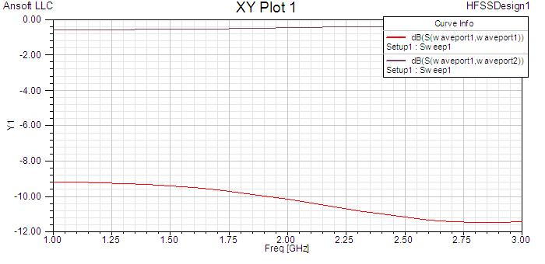

Figure 6.21 – Unmatched impedance. Note that there is a fairly constant amount of reflection across all frequencies. The thinner portion has a characteristic impedance of 50Ω, and the larger portion has a characteristic impedance of 35Ω.
By matching the impedances between the two microstrips, more useful reflection characteristics may be obtained. The formula to find the quarter wave impedance, given two other impedances is to find their geometric mean:

Z_{QWT} = (Z_{O} * Z_{L})^{1/2}
The length of the quarter wave transformer should, under ideal conditions, have a length equal to one quarter the wavelength of the frequency that is to be reflected. A first attempt at obtaining a 2GHz quarter wave transformer is shown in Figure 6.21. A reflection frequency of 2 GHz was chosen because it adequately captures high frequency characteristics, which still remaining within the operating region of the electronically switchable load, which had a maximum rated frequency of 3 GHz.

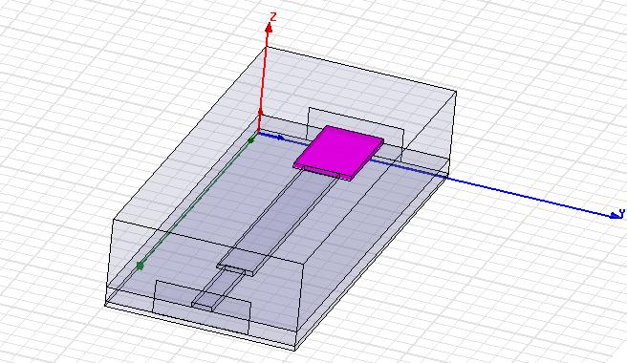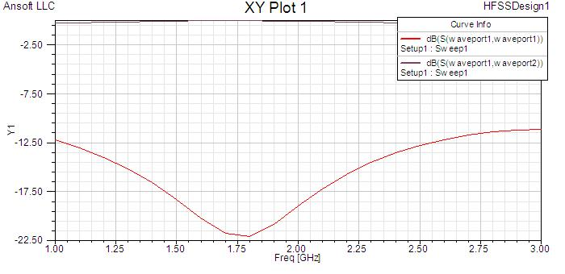

Figure 6.22 – a Quarter Wave Transformer. Though the target frequency was 2 GHz, the actual frequency of this transformer was 1.75 GHz. It is worth noting the rapid attenuation and rebound that occurs at the quarter wave transformer’s level, unlike a simple mismatched which has a general attenuation.
By tweaking the length of the quarter wave transformer, it is possible to have it actually center on 2GHz. An example of an improved quarter wave transformer is given in Figure 6.23.

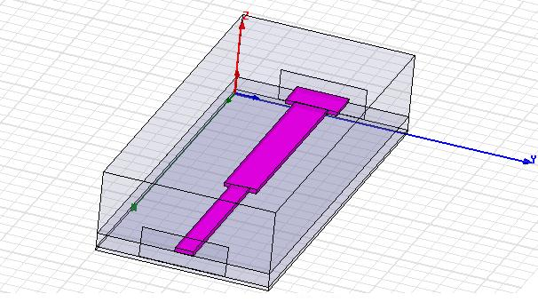
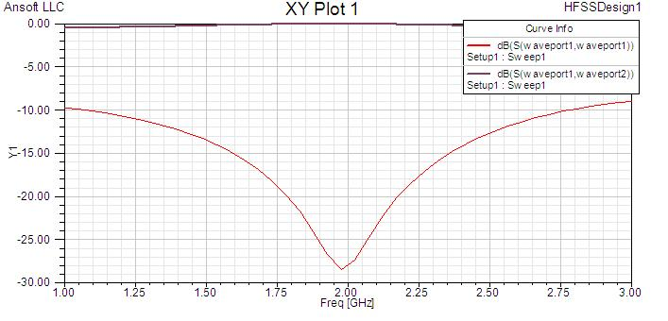

Figure 6.23 – an improved quarter wave transformer. By altering the dimensions of the quarter wave transformer, a 2 GHz transformer was synthesized in this simulation.
    - PCB Layout
It is the goal of a PCB layout to try to have components as compact as possible, in order to reduce the surface area required on the PCB. One possible configuration of the printed circuit board for the switchable load is shown in Figure 6.24 The printed circuit board shown here only uses standard 50Ω microstrips as loads, but in actual fabrication and operation, more interesting loads may be used, such as the ones discussed above.
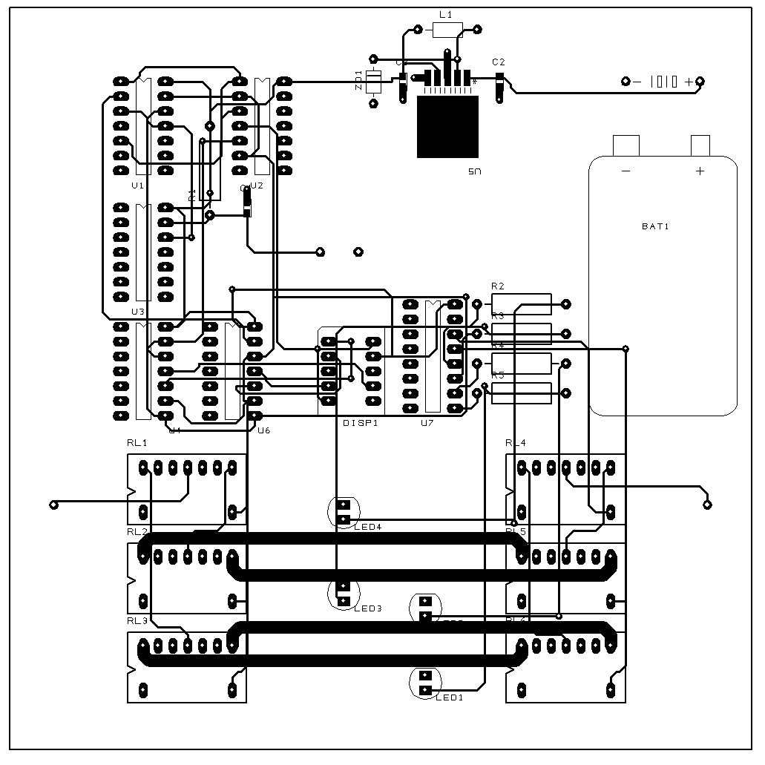

Figure 6.24 – A sample layout for the PCB switchable load. The thicker lines on the bottom of the circuit are the microstrips that may be altered to the desired user specifications. Also, depending on the size of the 9V battery harness purchased, it may be necessary to modify that portion of the circuit in order to have an adequate amount of room for the rest of the circuit.

  - Assembly
In order to prevent the accidental destruction of circuit elements, each of the sub-circuits will first be assembled on a solder-less breadboard. Once each of these circuits has been verified to function correctly, it can be determined that the circuit will function properly, with the exception of any unforeseen errors in the microstrip application and design. Once this phase of assembly and preliminary testing is completed, the printed circuit board will be ordered. The various circuit elements will be soldered onto the printed circuit board, which will at that point be ready for final testing on the high-frequency parameter analyzer. Should any failure occur at this point, it should be relatively easily to isolate, since any defective microstrips or microstrips that do not perform as they were designed will be easily located. Unfortunately, since the microstrips are printed directly on the board, should there be an error, it will not be fixable.
  - Testing
In order to determine whether or not the switchable load is or is not a success, it must be subject to testing. To test the switchable load, a series of tests will be performed using the lab’s high-frequency parameter analyzer. These tests will verify the correct function of the switchable load, and may also be used to verify the operation of the parameter analyzer itself, which is in its first semester of operation. The switchable load will be considered successful if, during testing, it demonstrates the following behaviors:
- Characteristic response for each of the given loads is shown for frequencies up to 3GHz, the maximum rated frequency for the analog multiplexer.
- The push-button successfully causes the characteristic of the switchable load to cycle between the four loads created.
- The LED display shows a light next to the active load at any instant.
- The seven-segment display counts from one to four, indicating which of the loads is currently active.
Given the parameters chosen during the design of the circuit, the switchable load should have a low insertion loss for frequencies up to 3 GHz, and should be able to switch between two loads more rapidly than the user could reasonably switch the button.
  - Cost
Following in Figure 6.25 is a spreadsheet of the expected cost of the assembly of the switchable load. It should be noted that these prices do not include shipping. Also, the printed circuit board cannot be appraised for cost until the time of ordering. Most component costs are listed according to their price on parts.digikey.com.

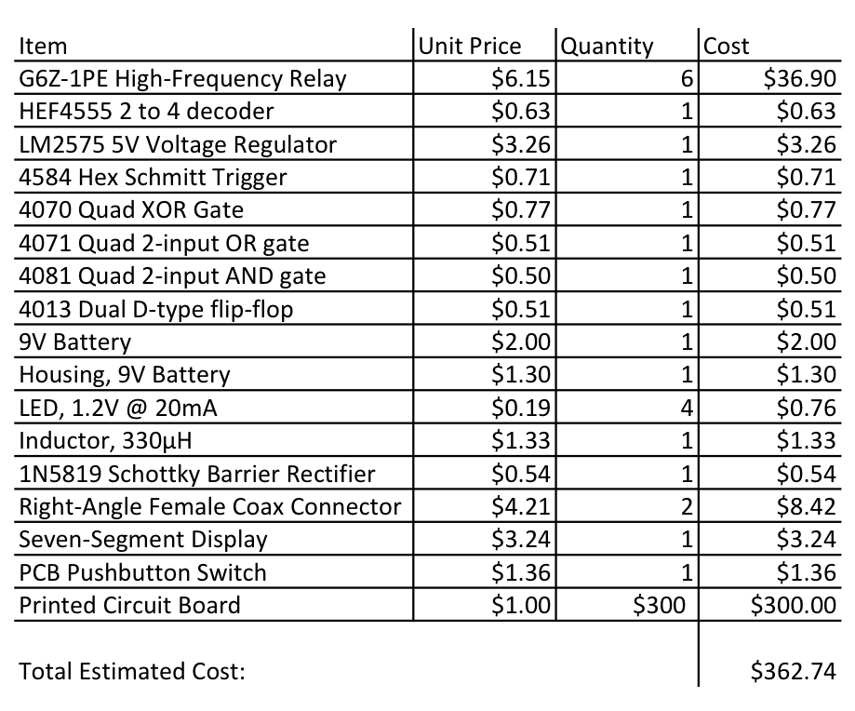
Figure 6.25 – The different parts required for the switchable load, and their expected costs.
  - Conclusion
By breaking the task of designing a switchable load into several different components, an initially fairly daunting task was turned into several manageable modules. The primary module was an analog switch that selected the RF load to be analyzed. The remainder of the circuit was a series of support modules, such as counters and LED outputs in order to facilitate the circuit functions. After the circuit was completely designed, a printed circuit board was constructed to house the designed schematic. A variety of different microstrip loads were considered for the load to be switched, including 50Ω characteristic microstrip, a mismatched pair of microstrips, and a quarter wave transformer. Finally, a testing schema was established in order to determine whether or not the electronically switchable load is a success.

Chapter 7: Conclusion
This project focuses on filling the need for a comprehensive semiconductor testing laboratory at UCF. Such a laboratory is aimed at enhancing student knowledge of semiconductor devices and testing procedure. This group is tasked with the responsibility of adding to this laboratory, facilitating the completion of a comprehensive research center. To aid in the future endeavors of students wishing to learn more about semiconductors, the capabilities of the laboratory are being extended in developing a High Temperature Test System, enhancing the Low Temperature Test System, developing the High Frequency Testing Station, and producing an electronically switchable load for these systems.

APPENDIX A: BIBLIOGRAPHY
[1] [Gerber, 1997] Operation of High Voltage Converter at Cryogenic Temperatures pp. 463-470, Orlando, FL 1997
[2] [Kirschman, 2001] Extreme-Temperature Electronics Newsletter Issue #1 http://www.extremetemperatureelectronics.com/index.html, April 26, 2001
[3] [Tiwari ,2006] Institute of Quantum Electronics, Thin Film Physics Group, Technoparkstr. 1, CH-8005 Zurich, Switzerland
[4] Photovoltaic Specialists Conference, 2008. PVSC '08. 33rd IEEE 11-16 May 2008, 978-1-4244-1640-0
[5] [Klingshirn,2007] ZnO: Material, Physics and Applications".ChemPhysChem 8 (6): 782. doi:10.10 02/cphc.
[6] [Gutiérrez-D, 98] Low Temperature Electronics: Physics, Devices, Circuits, and Applications 1998
[7] [Lengeler, 1974] Semiconductor devices suitable for use in cryogenic environments, Aug 1974
[8] [Schmidt, 2000] Electronics Cooling, http://www.electronics-cooling.com/2000/09/low-temperature-electronic-cooling/, September 2000
[9] [Si FarEast, 2006] http://www.siliconfareast.com/wirebond.htm
[10][GaTech,2006] http://www.physlink.com/news/060622Transistor500GHz.cfm, June, 22, 2006
[11] [UCLA, 2010] http://www.ms.ucla.edu/research/research-highlights/research-archive/2010/new-silicon-germanium-nanowires-could-lead-to-smaller-more-powerful-electronic-devices 2010
[12] [Hewlett Packard, 1989] Hewlett Packard (1989). HP 8719A HP 8720B Microwave Network Analyzer Operating Manual. Hewlett-Packard Company, 1400 Fountaingrove Parkway, Santa Rosa, CA 95403
[13] [Cascade Microtech, 1992] Cascade Microtech (1992). Microwave Probe Care and Cleaning Instruction Manual. Cascade Microtech, Inc. 14255 S.W. Brigadoon Court Beaverton, OR 97005
[14] [Cascade Microtech, 1988] Cascade Microtech (1988). Cascade Microtech Product Catalog. Cascade Microtech Inc. , P.O. Box 1589, Beaverton, OR 97075
[15] David Pozar, Microwave Engineering [3rd Edition], 978-0-471-44878-5, Copyright © 2005 John Wiley & Sons, Inc., pp. 182-183, 2005

APPENDIX B – Permission E-mails
Maxim IC
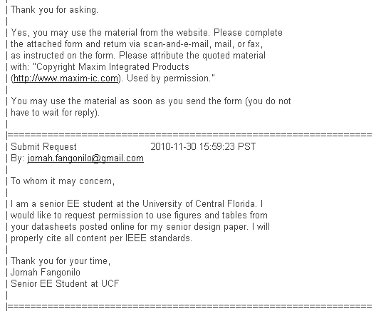

Cascade Microtech


The Micromanipulator Company


Omega Engineering
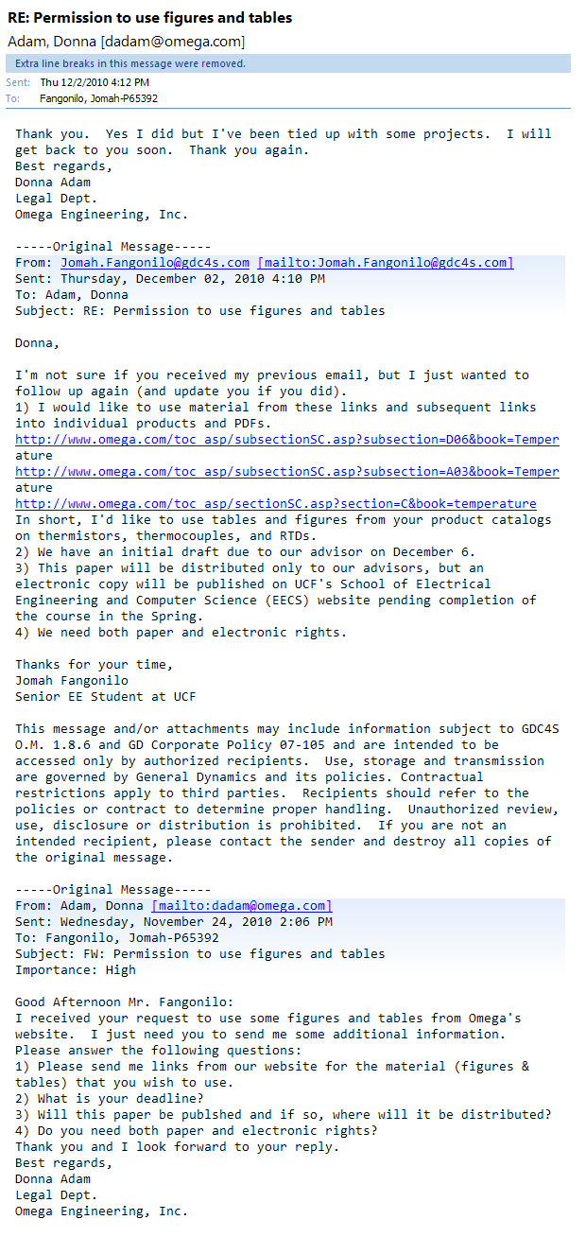

Extreme Temperature Electronics
