Automotive MTS
Group 6
Alan Beauchamp
Devon Jackson
Justin Ewing
Sponsor: Dr. Ali Gordon

Description
Mechanical Engineering is a platform that largely focuses on physics and material science for the analysis, design, manufacturing, and maintenance of mechanical systems.” The emphasis is on systems. For analysis, mechanical like to use electrical systems to ease their workload and calculations. Why would you need to lift a finger when a computer can lift it for you? Many different systems have been designed for a multitude of applications for mechanical engineers. Many of these same systems only do the bare minimum for what the mechanical engineers need to do.

Dr. Ali Gordon’s materials laboratory has a series of material testers that test a range of variables from, stress, strain, torsion, temperature, elasticity and many other material properties. These machines come in a wide variety of shapes and sizes with all of the functions listed above and more. Currently these systems are very costly and use proprietary software. Dr. Gordon explained that the in order to run an experiment, one must have a computer connected to the system for the entire duration of the experiment and it must not be touched during that time. One machine was running for a week’s time at the time of our visit and took up one entire computer to the point that if the computer were disturbed, they would lose all of the results of the experiment in progress. The computer was reporting real time results, but that was one computer in the laboratory that couldn’t be used for anything else.

Dr. Gordon mechanical engineering students are building miniature stress and strain systems. We are tasked to design a low cost and open-source universal control that could be automated these systems taking away the need for any user interaction after the set-up. These systems will also run without being connected to a computer. Our controller programmed on a computer, have the computer taken away and then run independent of a physical connection while still collecting all pertinent data. The control would have a computer interface that would be able to link with a computer system and distribute the raw data that his mechanical engineering students can analyze.

From this, we determined that we need to design and program a low-cost, portable controller/Interface box using various components such as a microcontroller that would receive a data sheet from the user and implement it over an extended amount of time. The controller/Interface would be able to fit on a lab table alongside a laptop, next to the material tester. The sensors will be able to accurately measure displacement, pressure and temperature. It will be also have a push button controller on the microcontroller to manually change settings in mid experiment. The push button controller will consist of few buttons to control the physical machine settings. It should have the ability to start the machine manually, pause the machine mid-experiment, edit the input information, and restart the system with the new information.

..

Specifications
- Microcontroller - (6 sq. in. at base)
- Automatic Command/data retrieval for 1 year
- Work without a computer connection
- Must be able to pause/re-edit/resume
- Interfacing accessible on web (Linux, Windows)
- Thermal Couple- measure temperature accurate to 5º
- Load Cell- measure force accurate to 1% in N
- Must be able to data dump to or read data from USB
- Must be able to manually control entire experiment from box
- Must be able to program experiment from computer connection
- Must be able to last 4 hours on battery power
- Control two material testers simultaneously

Block Diagram
Force
And
Temperature

Automatic Strain Tester
Strain/Stress Data
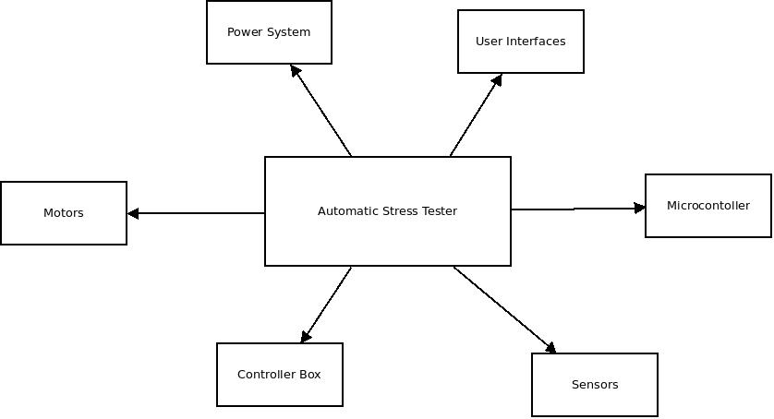
Block Name: Automatic Strain/Stress Tester
Administrator: Group 6
Inputs: Stress Test formula or data sheet
Outputs: Strain, Temperature
Description:
Test equipment that allows tests that can be ran for week, months or years without user interaction.

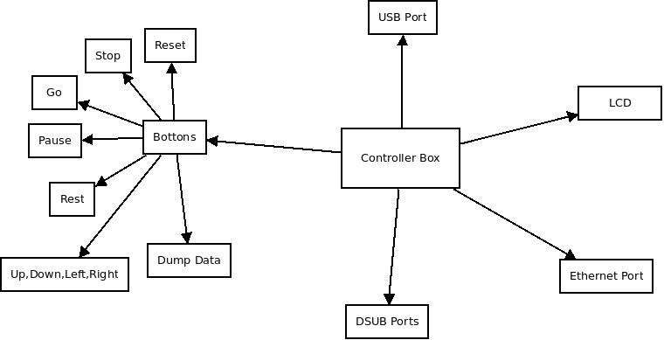

Block Name: Controller Box
Administrator: Devon
Inputs: User, motor, sensor inputs
Outputs: LCD, Data from sensors
Description:
The controller box will connect to the sensors, motors through the DSUB interface. It will use a button and/or pc interface to interact with the user. Showing necessary outputs through the LCD.

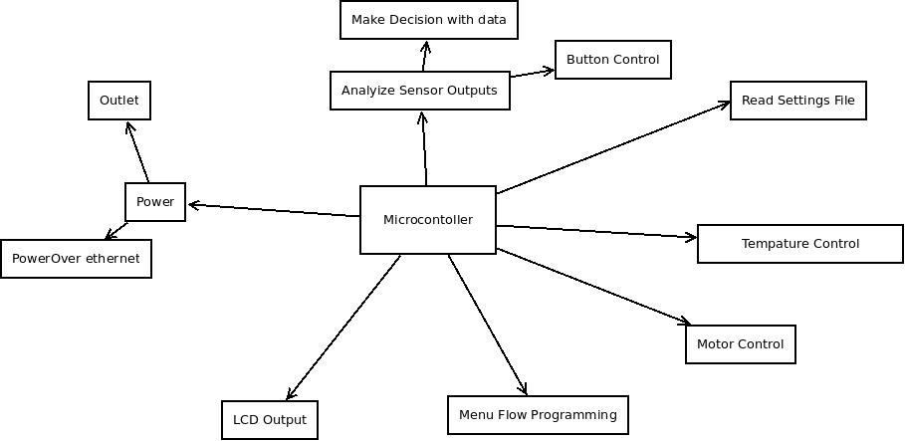
Block Name: Microcontroller
Administrator: Alan
Inputs: Digital and/or Analog signals from components
Outputs: Component Control
Description:
The microcontroller will be the brains of the complete system.

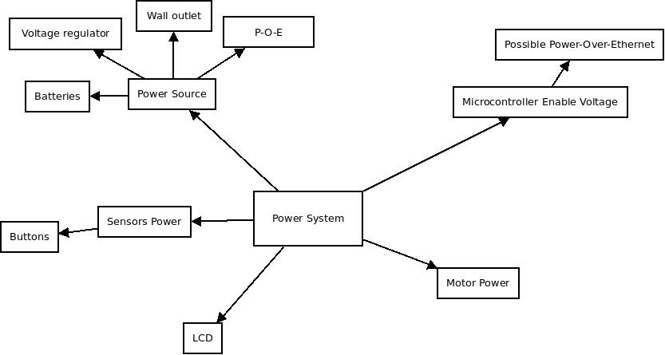
Block Name: Power Systems
Administrator: Justin
Inputs: AC/DC voltage
Outputs: Correct voltage to each component of the system
Description:
Allow for each component to receive the correct voltage it needs to operate. Also protect components such as the microcontroller from getting blown.

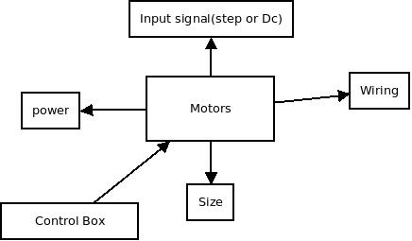
Block Name: Motor
Administrator: Devon
Inputs: DC voltage or Step
Outputs: pressure applied to object
Description:
The motor will be use to apply a force to a test specimen, which then will be read by the strain gauge and analyzed.

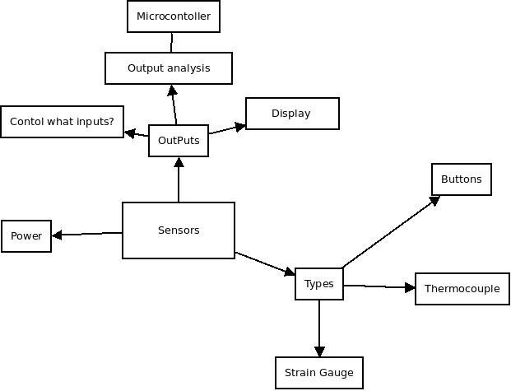
Block Name: Sensors
Administrator: Justin
Inputs: Environment
Outputs: Analog or Digital signal
Description:
Analyze environment inputs and make decision accordingly

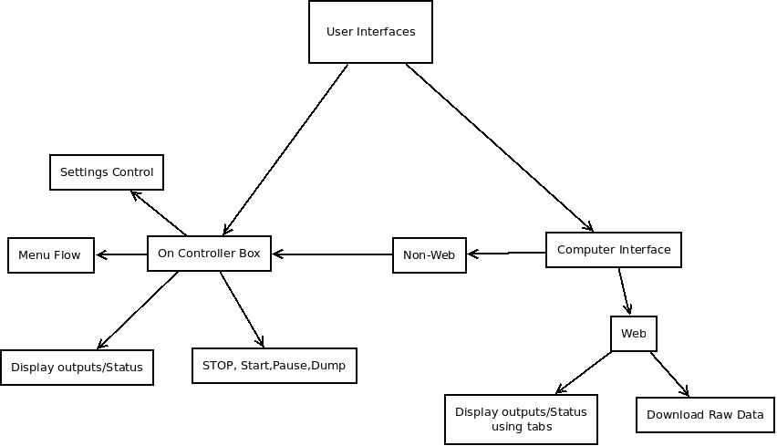
Block Name: User Interface
Administrator: Alan
Inputs: User
Outputs: Information and Analysis
Description:
The user will interact with the device through these interfaces.

Part | Price | Quantity
Microcontroller | 5.00 | 1
Microcontroller Development Board | 30.00 | 1
Thermocouple | 13.00 | 1
Backup Battery | 7.00 | 3
Test Motor | ? | 1
LCD 16x2 | 15.00 | 1
Protype Strain Gauge | 14.00 | 1
Box | 20.00 | 1
D-Sub Connector | 1.00 | 2
USB Cable | 5.00 | 1
Ethernet Cable  (optional) | 6.00 | 1
MagJack (optional) | 2.00 | 1
PCB | 51.00 | 3
Resistor | 1.00 | 5
Capaicators | .99 | 1
Load cell
100 lb Force Sensor | 17.00 | 1
Crystal Clock Oscillator Module | 5.00 | 1
Project Budget and Financing

Project Milestone

Fall
- Research on MTS Insight Electromechanic al Testing System
- All classes , functions, procedures, and methods for software design
- Design power circuit
- Research the inputs and outputs of all sensors
- Design microcontroller
- Research motors and signals
- Design Data Acquistion Loop
- Final Schematic of All compenents connected
Spring
- Build design
- Test Design
- Observe Results
- Make adjustments
- Make sure it fits the goals and specifications
- Make Web interface
- Prepare Presentation

