Materials Testing Equipment Controller (MTEC)
Senior Design Final Project Documentation

GROUP 9

Group Members:
Francis Bato
Bishoy Botros
Erich Dondyk
Matt Nguyen

Sponsor:
Dr. Ali P. Gordon



Table of Contents

1- Executive summary 1

2- Definition
2.1 Motivation 2
2.2 Goals and Objectives
2.2.1 Microcontroller 3
2.2.2 Load Cell 5
2.2.3 Control Interface 5
2.2.4 Motor Control 6
2.2.5 Display 7
2.2.6 Storage 8
2.2.7 Software: Controller Operating System 9
2.2.8 Software: GUI 9
2.2.9 Performance 9
2.2.10 Portability 10
2.2.11 Compatibility 10
2.2.12 Enclosure 11
2.2.13 Durability 12

3- Requirements
3.1 Motor Control 13
3.2 Sensor Intake 14
3.3 GUI Controls 14
3.4 Information Display 15
3.5 Control Interface 15
3.6 Compatibility (Mac, Windows) 15
3.7 Data Management (storage) 16
3.8 Stand Alone Operation 18

4- Research
4.1 Hardware
4.1.1 Microcontroller 21
4.1.2 Load cell 23
4.1.3 Temperature Sensor (PID) 25
4.1.4 Clip Gage 25
4.1.5 Motor & Control 27
4.1.6 Display 41
4.1.7 Data Connectivity
4.1.7a Flash Memory 53
4.1.7b USB 55
4.1.7c Wi-Fi 58
4.1.8 Power Supply 61
4.1.9 Enclosure 61
4.2 Software
4.2.1 Embedded Software 64
4.2.1a Block Diagram 65
4.2.1b Programming Sensors 65
4.2.2 GUI 66

5-Design
5.1 Hardware
5.1.1 Microcontroller 74
5.1.2 Sensors 77
5.1.3 Motor & Control 78
5.1.4 LCD Display 82
5.1.5 Data Connectivity (SD Card) 87
5.1.6 Power Supply 87
5.1.7 Enclosure 91
5.2 Software
5.2.1 Sensor Interpretation 92
5.2.2 GUI 93

6 Design Summary 98

7 Testing
7.1Hardware
7.1.1 Sensors 108
7.1.2 Motor Control / Feedback 109
7.1.3 Storage Output 110
7.2 Software
7.2.1 Debugging GUI 111

8 Administrative
8.1 Milestone 113
8.2 Budget 115
8.3 Conclusion and Project Summary 115
8.4 MTEC User Manual 116

9 Appendices
9.1 Bibliography I
9.2 Image Permissions III

List of Figures

Figure 3.8.1 18
Figure 3.8.2 18
Figure 3.8.3 19
Figure 3.8.4 19
Figure 3.8.5 23
Figure 4.1.2.1 26
Figure 4.1.4.1 26
Figure 4.1.4.2 27
Figure 4.1.5.1 27
Figure 4.1.5.5 31
Figure 4.1.5.7 33
Figure 4.1.5.9 35
Figure 4.1.5.10 36
Figure 4.1.5.11 38
Figure 4.1.5.12 39
Figure 4.1.5.13 41
Figure 4.1.6.1 42
Figure 4.1.7a.1 53
Figure 4.1.7a.2 55
Figure 4.1.7b.1 56
Figure 4.1.7b.2 57
Figure 4.1.7c.1 59
Figure 4.1.7c.2 59
Figure 4.1.9.1 62
Figure 4.1.9.2 62
Figure 4.1.9.3 63
Figure 4.2.1a.1 65
Figure 4.2.2.1 69
Figure 4.2.2.2 70
Figure 5.1.1.1 76
Figure 5.1.1.2 76
Figure 5.1.2.1 77
Figure 5.1.2.2 78
Figure 5.1.3.1 79
Figure 5.1.3.2 79
Figure 5.1.4.1 83
Figure 5.1.4.2 84
Figure 5.1.4.3 85
Figure 5.1.4.4 86
Figure 5.1.6.1 88
Figure 5.1.7.1 91
Figure 5.2.1.1 92
Figure 5.2.1.2 93
Figure 5.2.2.1 94
Figure 5.2.2.2 95
Figure 5.2.2.3 96
Figure 6.1 98
Figure 6.2 100
Figure 6.3 101
Figure 6.4 102
Figure 6.5 106
Figure 6.6 107
Figure 7.1.1.1 108
Figure 7.1.1.2 109
Figure 7.2.1.1 111
Figure 7.2.1.2 112
Figure 8.1.1 114
Figure 8.4.1 116
Figure 8.4.2 117
Figure 8.4.3 117
Figure 8.4.4 118
Figure 8.4.5 118
Figure 8.4.6 118

List of Tables

Table 3.7.1 17
Table 4.1.1.1 21
Table 4.1.2.1 24
Table 4.1.5.1 40
Table 4.1.6.1 44
Table 4.1.6.2 46
Table 4.1.6.3 50
Table 4.1.6.4 52
Table 4.1.7c.1 60
Table 4.1.8.1 61
Table 4.2.2.1 68
Table 4.2.2.2 68
Table 4.2.2.3a 70
Table 4.2.2.3b 71
Table 4.2.2.4 71
Table 4.2.2.5 73
Table 4.2.2.6 73
Table 5.1.1.1 74
Table 5.1.1.1 75
Table 5.1.3.1 81
Table 5.1.4.1 86
Table 5.1.7.1 91
Table 6.1 100
Table 6.2 100
Table 6.3 103
Table 6.4 105
Table 8.1.1 113
Table 8.2.1 115

1- Executive Summary

The Materials Testing Equipment Controller (MTEC) is a device intended to control a testing apparatus that simulates the forces exerted by the human foot while in motion. The purpose of this equipment is to test the material qualities of the orthopedic inserts used by veterans who have developed deformities. Eight actuators will be used to provide the desired loads in the material while eight load cells measure how the material reacts to these stressed. This project, sponsored by the University of Central Florida Department of Mechanical, Material, and Aerospace Engineering, will be implemented in the research laboratory of Dr. Ali Gordon.

The MTEC will be able to interact with a computer through which the equipment’s instructions will be loaded. Throughout the test, the user must be capable of controlling the device through a user interface. Also, information relevant to the test and the status of the testing equipment must be made available to the user at all time during operation. All information acquired in the test will be temperately stored in the device. The user will be able to extract this data for later analysis through the use of a flash drive or through a computer connected to the device. Because the MTEC is a custom made controller, all new users will be unfamiliar with its configuration. Therefore, the user interface must have a small learning curve.

In order to achieve the desired level of functionality, the MTEC design will require the integration of several key components. A microcontroller will be at the center of the device. All other subcomponents will be operated and coordinated through the MCU. Because the testing equipment will use eight actuators, the microcontroller will be capable of operating each one separately. Also, it will collect data from all eight load cells and use it as the feedback for the control system driving the actuators. Most importantly, however, it will store this data inside the memory of the device. A USB port will be incorporated to connect the flash drive through which data will be extracted. A display will be incorporated with the microcontroller to allow the user to see the status of the experiment and testing equipment at all time during operation. Some basic user interface will be made available to the user to control the basic operations of the MTEC. A graphical user interface (GUI) will be developed to facilitate the data input process through the computer. Finally, because the device will be operated in a laboratory environment in which damage may occur, all the previously mentioned components will be fit into a sturdy enclosure capable of withstanding a direct strike.

The project will require two semesters to complete. During the first semester, all the research and design will be addressed. Also, acquisition and testing of some components will begin. During the second semester, an actual prototype of the device will be build and test. Most importantly, any modifications necessary to make the device meet the requirements specified in this document will be addressed.

2- Definition

2.1 Motivation

The idea behind the “MTEC” was originated after a presentation that was given about material testing by Dr. Gordon, who is one of the professors in the department of mechanical engineering. It has been shown that there is a lack of material testing equipment in universities, not the big equipments that cost Hundreds Thousands of dollars, but small ones that are considered table-tops which could be used by students in their own labs. The aim was to design a table-top mechanical device and a control box that manages that mechanical device. The table top mechanical device will be built by a group of mechanical engineers and the control box, the “MTEC”, will be created by a group of electrical engineers. Of course, an interaction has to happen between the two groups in order to cover all the requirements and the specifications of the project which is similar to a real life work environment where more than one field of engineering come together to achieve one objective. Therefore, it was considered a good idea to be in charge and become the first generation group of allowing such a device to exist at the University of Central Florida for the mechanical engineering department.

The concern for the electrical group is not the mechanical table-top device but the control box, or as the group called it the “MTEC” which stands for Material Testing Equipment Controller, that drives that mechanical device and allows the user to input and output data to a computer. It was also favored that the user would be able to use the MTEC without being hooked up to a computer at the same time. In this way, the MTEC has to have the ability to take an input file from the user and process it without having a computer connected to it, i.e. wirelessly.

The main goal of our project is to create a portable, light weight microcontroller that has the ability to control the material testing apparatus and its results by displaying them on a monitor. In doing that, the microcontroller has to be able to take the feedback from the sensors that are connected to the material testing apparatus and convert those feedbacks to actual readings on a monitor that allows the user to collect information about the materials being tested. The information taken from the sensors could be things like temperature, pressure, strain of the material. Another aspect for the microcontroller is to control the movement of the motors that drive the material testing equipment; in other words, controlling the stress and the stretching on the material being tested.

In addition to what was previously mentioned, the microcontroller has to have some kind of a connection, a USB or SD card for example, to allow the user to collect information from the microcontroller directly. This way the user can save graphs or readings on a flash drive. Also, it was mentioned several times by the sponsor of this project the importance of having a graphical user interface, a “GUI”, to make it easier on the user to read and interpret the data or the outcomes of the experiments and the tests. Software will extensively be used implementing in more than one language if necessary.
2.2 Goals and Objectives

2.2.1 Microcontroller

For the Materials Testing Equipment Controller (MTEC), the most important component that will drive the device is the microcontroller, which controls all the incoming and outgoing signals. Without the microcontroller, the MTEC would not be able to accomplish any of the required calculations needed to process the following information obtained from the load cell and interpret it in the form of a readable such as a load, time chart.

Initially, the MTEC was required to obtain information from three different sensors which would describe different aspects of a material: elasticity, tensile strength, displacement, load, and reaction to temperature. The corresponding sensors included the load cell, clip gage, and thermal sensor. From the three sensors, the MTEC would be able to receive three different inputs of information, converting the data from analog form to digital form. The microcontroller would be able to use the digital information from three different processes and analyze the data through numerous algorithms written within the microcontroller’s assembly to store data related to that would be useful to the user. For the user, the MTEC would be able to display the analyzed data onto the touch screen LCD display by reading the data stored onto the flash memory and interpreting the information.

However, the scope of the MTEC’s application has changed during recent developments halfway into the fall semester. The sponsor has slightly changed the use of the application of the MTEC to relate towards orthopedic shoes. The user must be able to apply a stress test towards the orthopedic sole of the shoe. For this, instead of the three different types of sensors, the range of data gathered has narrowed down to only one type of sensor, the load cell. To simulate daily stress of an average person on an orthopedic material, the sponsor has decided to use an array of up to eight load cells to gather a generic representation of the weight distribution onto any material. In conjunction with linear actuators, the MTEC in a realistic simulated environment. Now that the MTEC only relies on one type of sensor, it must be able to acquire data from eight several sensors all at once. The microcontroller must be able to handle many processes simultaneously to operate in an efficient and correct manner.

Whichever method the MTEC operates, whether with three different types of sensors or multiples of a single type of sensor, the need for it to process multiple tasks is an integral part in operating the MTEC for its required objective. In addition to storing information gathered from multiple sensor locations, the MTEC must be able to store the data simultaneously with the inclusion of the recording new, current data as well. A complete loop of old and new information must be constantly occurring in order to accurate record the results of the testing experiment.

Another integral system process that the MTEC relies heavily on is the interpretation of the stored data. A useful feature that the sponsor would like to implement in the MTEC is an analytical feature which uses the information from the sensors and plots the data onto a load/time chart. This allows the user to view a current or previous testing experiment and quickly analyze the experiment’s trend on a material.

Programming for the MTEC includes numerous tasks which interprets, stores, moves, and displays data. Proper integration between the hardware and software of the LCD touch screen display is important when choosing a microcontroller as many cannot handle the processing power required to processing data as well as projecting it on the LCD display. Microchip offers a variety of microcontrollers (16 bit or 32 bit) which allow the integration of an LCD display screen. Not only does the microcontroller have to be able to display information, but it must receive feedback from the touch screen surface built on top of it. As the user interacts with the touch screen interface, each touch relays an analog signal which is used to coordinate movements from the LCD screen and point to a specific operation on a given frame of the interface.

The amount of memory allocated for temporary data storage is important in the selection of microcontroller for the MTEC. There are many processes that will be occurring simultaneously as the MTEC is operating. Such data will need to be temporarily interchanged between states of storage and input. The amount of data needed to be stored temporarily ultimately is the choosing factor when deciding on a microcontroller. Depending on the amount of data being written and simultaneous interactions between the input and output, memory size allocation will be proportional to the amount of processes and complexity of each process.

Many of the inputs located on the MTEC will be of analog format. Therefore, in order for the MTEC to interpret the data, the group will need to consider an analog to digital converter, or ADC. In order to simplify design, the MTEC’s microcontroller will need to be built into the microcontroller, rather than having several ADC modules to convert every signal. Analog signals will vary in application as initial design specifications required analog signals incoming from load cells, clip gages, and temperature sensors; now, analog will come from eight different load cells, as well as from the temperature interface.

In order to control the linear actuators which will provide feedback information relating to the load cells, three different methods may be available for the MTEC to utilize. The MTEC”s microcontroller must be able to output, according to the input, a controlled output voltage, variable current control, or a pulse width modulation to incur changes within pressures through each linear actuator. These methods will differ depending on the choice of microcontroller and linear actuator. Both must be meticulously thought out to ensure the most efficient and user friendly design.

2.2.2 Load Cell

The MTEC’s original idea was to utilize the load cell to measure the force of an object being stretched. A tensile force will be measured as the MTEC’s machinery is clamped to the material and trying to stretch it in opposite directions. The load cell’s purpose is to read in the force of the pressure when applied to the material and then have the data recorded for the user. In order to do so, the load cell must be able to be connected and its output must be converted to the MTEC so the MTEC can make use of it before the user can record it.

The sponsor has changed the application of the MTEC, but the load cell is still needed for the same purposes. Instead of measuring the stretching force of the material, it will be measuring the compressing force, as a linear actuator attached to it will apply a desired measured motion. The load cell will constantly send information on the force of the material as it deforms over time due to a constant pressure that is applied to it.

2.2.3 Control Interface

In order to operate the MTEC throughout a test, a method of interfacing with the device is necessary. The user must be able to input the commands start, pause, and stop at all times through this interface. By pressing the start button, the user must be able to begin the test. Whether the test has been stopped, paused, or it is starting from the beginning, this command must direct the MTEC to start or resume the operation of the testing equipment. The pause button must temporarily discontinue the operation of the testing equipment. However, when in the pause status, the user must be able to resume data acquisition by pressing the start button. Finally, the stop button must be able to command the MTEC to discontinue all operations of the testing equipment. Most importantly, this command must finalize the test and allow the user to collect the data acquired throughout the experiment.

The device interface must be easily understandable. Because the MTEC is a custom made controller all new users will be unfamiliar with the controls of the device. As a result, it is important that the user becomes capable of operating the MTEC in little time. To achieve this, the command buttons must be arranged in an easily understandable configuration and their purpose must be self explanatory. In addition, the controls must be fairly visible. A user unfamiliar with the MTEC must be able locate the controls quickly. Finally, the buttons must be sufficiently large and spaced apart to allow for quick user accessibility while dismissing the probabilities of inputting a mistaken command.
2.2.4 Motor Control

As the original idea of the project was introduced, it was mentioned that the device or the control box should allow the user to input a force/displacement history file into it and work accordingly in managing the mechanical device. The mechanical device will contain a beam or something similar to allow for up and down movement which in accordance applies pressure on the material under testing or applies tension by pulling it. Therefore, it was necessary to introduce the idea of motors and motor control into our research since it will allow for such pressure and tension to be performed.

Precautions have to be taken in choosing the motor and the motor control board. For example, the motor will have to small in size in order to fit into the portable MTEC device. Besides, it will have to be powerful enough to control such pressure and tension action several times in one test. It’s also very important for the motor to be controlled by a microcontroller through either a control board or a circuit that connects between the motor and the microcontroller. Feedback is very well considered for the motor as it might be required to adjust the position of the motor movement according to the readings taken back from the sensors used in the project. The feedback is done through a load cell sensor connected to the mechanical device. The load cell is a simple senor that gives reading for how much force is applied towards the material under testing. The control box of the project should then take that reading from the load cell in terms of voltage input and display it to the user. The action that the motor should take next relies on the feedback reading from that load cell. The motor chosen should subsequently work in conjunction with the load cell chosen.

Based on the previous objectives, the motor to be chosen has to be small in size and effective in producing these sudden changes that are in the force history file of the user and yet be powerful enough to produce the desired applied force on the material being tested. The motor also has to be controlled by a computer program, written in a desired language like C for example, through the use of a microcontroller ship; therefore, in searching for the motor, one has to have in mind that it will be controlled by a motor control circuit not by a switch or just a voltage applied. Another objective for the motor is that it has to be able to produce enough force up to approximately 50 pounds of pressure on the material being tested.

Another important factor is the motion itself that will be applied. According to the basic understanding of the mechanical device, the motion required is up and down kind of motion. No rotational motion will be involved in testing the material. The up and down motion that the motor will provide will either apply a force on the material under testing as in a pressing motion or will extract the material tested by applying tension to it in the opposite direction. So, in searching for the motor, one has to have in mind that it will be a vertical motion that is applied by the motor. If a rotational motion is to be chosen, then adjustments have to be made to allow for one direction motion to run the experiments on the material.

2.2.5 Display

To effectively operate the MTEC the user must be able to receive some feedback of the operation of the device through some form of display. The complexity of the information that must be delivered would determine the type of display implemented. However, regardless of this factor, the display must be able of notifying the user of the status of the testing equipment before, during, and after a test.

Prior to the start of the test, the display must indicate the current status of the testing equipment. That is, the user must be able to see if the device is ready to execute an instruction set. Immediately after an experiment begins, the display must notify the user there is an ongoing test. Also, it must show if the user inputs the pause or stop command. Most importantly, however, it must show information relevant to the status of the experiment such as the duration of the test, time remaining in the test, instruction being currently executed, and data being acquired. After the test, the display must notify the user that the experiment has concluded.

Because of the limited budget available to develop the MTEC, reducing the prototype’s price is an area of interest. Therefore, as in every other component in the device, the price of the display must be as low as possible. The MTEC would be used in a laboratory environment in which there is a large probability of physical damage. As a result, one of the most principal characteristics of the displays is that it must be roughed and durable. The display, being one of the most exposed components of the device, must be able to withstand direct strikes and shocks. Also, it must have the capability of further development if deemed necessary throughout the development process.

There are several physical requirements the display must be able to meet to be a good match for the MTEC. These requirements include but are not limited to: low power consumption, standardized electrical parameters, and backlight capability. Because the MTEC would be powered by an uninterrupted source, a wall outlet, low power consumption is not a crucial characteristic of the display. Nevertheless, reducing operational cost, and therefore power consumption, is an area of interest. Also, to facilitate the design of the power supply and the integration process, the display must have standardized voltage and current requirements that complement those of other components in the device. Even though the MTEC would be mostly operated in a control environment, there is a possibility it will be exposed to a field environment at more extreme temperatures. As a result, the display must be able to function within the limits of these extreme temperature ranges. Finally, to be able to use the MTEC in a darker environment and to make data delivered to the display more visible, the display must have backlight capabilities.

2.2.6 Storage

For the MTEC, data storage is crucial to the application towards various experiments. As the MTEC progresses through each experiment, data is collected from sensors into the MTEC and is placed onto a storage device for later use. It is important for the user to be able to access during all times of an experiment. According to the sponsor there are several instances in which the MTEC should be able to recall data.

Preliminary data is called into the experiment in the form of initial conditions and expositional experimental data. The user has multiple ways of inputting the initial conditions through the use of storage devices: flash drive, SD card, or embedded flash memory. One method of storing test data for initial experiment startup is through the use of USB flash drive. Data is written onto the flash drive through the use of a host computer (interfaced through our proprietary software). Additionally, the same method can be applied towards the use of an SD card. Finally, a more direct method of accumulating data is the USB-COM method and the integration of embedded flash memory. The user must directly interface the MTEC to a host computer through a USB 2.0 interface and transfer initial transfer conditions into a built-in flash embedded memory system. Once initial conditions have been started on the MTEC, stored data must be available to use through the MTEC on the LCD display. In addition to the embedded flash memory system, Wi-Fi connectivity offers an alternative method of storing data, allowing the data to be viewed directly from the MTEC onto the host computer wherever Wi-Fi connectivity applies.

Additionally, during the experiment, the user may want to view current experiment data, thus enabling a live view mode. The current mode allows the user to view current statistics on the current experiment. Data is displayed on the LCD screen via touch interface and can view load versus time graphs on any of the sensors in use.

Lastly, all gathered data from each experiment is packaged onto any (or all) of the installed storage devices: USB flash drive, SD card, or embedded flash memory. Depending on the user’s preference, he or she may be able to choose the settings of storage output for each experiment. Settings will be located on the touch interface and integrated through the UI. Once completed, USB flash drive or SD card may be removed and transferred onto the host computer for further evaluation by the user. Also, data located on the embedded flash memory system can be accessed using the USB-COM enumeration method or Wi-Fi connectivity method by the host computer as well.

Memory storage provides an important aspect of the MTEC and will affect the user experience. Adding a versatile means of storing data allows for the most efficient and flexible means of implementing the MTEC towards its objective of material testing.

2.2.7 Software: Controller Operating System

Due to the coding environment of this project, there will be an operating system needed to develop and utilize the software developed for the microcontroller. Language-wise, C would be the choice for programming and also the program most familiar to code with (Dev C++) is only available for Windows. Even so, this is just considering the coding environment, so it is for the programmer’s comfort. As for the user, the objective is to allow the MTEC to interact with both Windows and Mac OSX operating systems. The MTEC has to be able to make a serial connection with either one and be able to run its display.

The microcontroller should only be concerned about the programming, as it will host the software needed to interact with the MTEC’s other components such as the load cell and the LCD touch screen.

2.2.8 Software: GUI

With the use of a touch screen to serve as both a set of controls for the MTEC as well as a display of the data as the material is being tested, the user should be capable of interacting with the MTEC. There will be a control layout for the user to interface with in controlling the MTEC as if it were a set of real buttons/triggers that were to start and stop a machine. The GUI should be able to indicate to the user the settings of the MTEC and what needs to be accomplished or what errors are present that need to be fixed in order to have the MTEC running. The GUI should be able to display the results of the MTEC in real time as the operation runs and then gives a final display of the average. Also the user should be able to pinpoint any time and analyze how much the force was applied to.

2.2.9 Performance

One the primary goals of the MTEC design is to be able to satisfy the user's expectations while controlling the testing equipment. Therefore, at no the time should the user fail to maintain a desired operation pace due to technical shortcoming. To achieve this level of satisfaction, the device must be able to perform all its predetermined functions quickly and effectively. A sufficiently powerful microcontroller capable of managing the necessities of all the individual components of the device must be implemented. All operational software must be design as to demand the minimum amount of memory allocation. Finally, the instruction set inputted by the user and output data gather during the experiment must be formatted in a way that minimizes storage space.

Achieving a sufficiently high level of performance is not limited to the physical characteristics of the MTEC components only. It is also affected by how efficiently the user is able to control the device. A well design user interface will allow the user to control the MTEC more efficiently and, as a result, increase the overall performance of the system. To achieve this, the controls must be made readily available to the user at all times. All relevant commands must be visible, accessible, and arranged in a optimal configuration. Also, the data display data must be easily interpretable by the user. Finally, exporting and importing data into and from the MTEC must be a straight forward procedure that requires little effort from the user.

2.2.10 Portability

Before the MTEC, material testing equipment was restricted to an immobile station bounded by a computer and its testing environment. What the MTEC wants to achieve is a more versatile experience for the user. Easier for research purposes, the MTEC is meant to become a flexible tool in testing (long or short) periods of materials. Previous material testing proved to be rather difficult in that the host computer was always connected to the testing instruments, as they gathered information from the testing environment. If the host computer was to disconnect from the experimental environmental, valuable data could be lost and the integrity of the experimental data would be incomplete.

In order to combat proprietary software restrictions and immobile research methods, the MTEC can be easily relocated per testing environment. Built smaller than a personal computer, lightweight, and flexible in connectivity, the MTEC gives the user a versatile tooling system in gathering data. The user will be able to set the conditions for an initial test through the host computer from anywhere. As long as the data can be collected to a storage media, that data can be transferred to the MTEC. From there, the MTEC will remain with the testing environment to relay data from the input sensors. Once testing is complete, the MTEC can be removed from the testing environment and data can be extracted at a later time. Additionally, the MTEC can stay connected to the experiment environment directly and the storage media can be moved to and from the MTEC for ease of use.

2.2.11 Compatibility

The MTEC, even though it is a standalone, will also be able to connect to other computers in order to display the results from the sensors running in the MTEC’s operation after the programming of the microcontroller has converted the sensor’s output into read friendly data.

2.2.12 Enclosure

The enclosure of the MTEC provides a safe housing for the internal electrical components from weathering. Following a very simple design, the MTEC is encased in a rectangular base shape with the front face slanted down towards base closest towards the user. This feature allows the MTEC LCD display to be seen at the optimum viewing angle. The user will be able to glance at the MTEC and read the display without much effort. Because of the simplified design for the housing of the MTEC, construction for the enclosure will provide for the most basic construction methods from generic, basic shapes.

The enclosure has several characteristics that it must meet before acceptance into final prototyping. Possible factors which may be considered for the housing of the MTEC include a compounded plastic body with rubber sides to prepare for wear and tear. The rubber sides can especially protect unpredictable impact. Another aspect of the MTEC will be its ability to withstand changes within its current system. As user activity increases over time, many functions may be realized in order for the MTEC to function effectively. By installing the main PCB into an easy to use housing, the user may be able to remove, install, or modify any of the components depending on its use. The housing may be divided into sections; the halves allow the user to open the top of the MTEC and examine the inner workings while keeping the main PCB intact. Once the internal compartment is available for modification, additional components can be maintained. Ideally, housing supports would enhance stability within the enclosure between the interior walls and PCB. Easy to access screws would secure the faces together in place and allow access for internal modification as well. The screw location would lie flush with surface as to not create friction with the operating surface.

The material used for the enclosure is important when designing the housing. The MTEC will contain numerous amounts of sensitive electrical equipment which will need to be protected from the rigorous testing environment. Preferred materials for the enclosure of the MTEC must be flexible, durable, and electro-static proof. A composite of plastics will suffice for durability. Many forces will be bombarding the MTEC through its various inputs. An important aspect is the location of various MTEC components. By making sure the cut outs of for multiple inputs can degrade the stability of the face side. If one side is overloaded face modifications, it may prove to be instable when a given force is pushed onto it. When building the MTEC, each face should be able to withstand forces at each component location without any cracking. Slight bending may be allowed as long as its elasticity does not give in too much. Structural stability should follow that of any handheld device, sturdy (due to its portability).

2.2.13 Durability

Overall durability is important for the MTEC. While testing materials undergo rigorous conditions, the MTEC itself may be placed upon environment in which forces cause distress upon its surface. With numerous activity on the MTEC, the user will be interacting with the MTEC in multiple ways. Interfacing the sensors to the sensor jacks will lay forces upon the rear side of the MTEC face. Whether with three inputs or eight inputs, the second configuration will accumulate the most force onto the back side of the MTEC.

Location of the eight sensor jacks must be well placed, as having the sensor jacks too close may degrade surface stability, causing the surface to break after several uses. Adequate support to the rear side of the MTEC will be important in reinsuring durability when in use. The SD card slot located in the front will consume a small amount of surface for implementation. The slot will require the least support of all component inputs but must not be forgotten as the slot must endure constant pressure from the user as he or she inserts removes the SD card from the slot. Failure to remove the SD card from its slot will corrupt overall usability.

Another important aspect of durability among the housing’s faces would be the face including the LCD display. Multiple forces and intermittent use with the LCD touch screen display will prove to be worthy of extra internal support when installing the LCD display. Connection between the LCD module and the housing must create a seal which would not allow any foreign object debris to disrupt or cause damage to any internal working.

Quality control with the each electrical component must be carefully reviewed. To ensure longevity of the MTEC, high quality parts must be chosen between plethoras of available parts. For general MTEC use, experiment times may vary depending of the material and given conditions. According to the sponsor, material testing may take a few minutes to several months. It is imperative that the MTEC can endure long processes in which data is being collected constantly. If the MTEC were to fail between the start and finish of an experiment without knowledge of the user, time would be wasted as data would be needed to be taken in a timely manner. The user would thus restart the experiment in the hope that the MTEC would operate reliability. If the correct supplier quality and component quality check is given proper investigation, the MTEC will become a fully realized, dependable tool in material testing data acquisition. All parts would be given proper inspection as if one component fails; all other process dependable on each other, the data would be deemed corrupt and unusable.

3-Requirements

3.1 Motor Control

When the project was first introduced, the first requirement that was mentioned by our sponsor was to control a force history file given by the user to the control box. The control box should take that file from the user and has a sense of memory to keep this file history and let the mechanical device work accordingly while not connected to a computer. Accordingly, the control box should contain a specific motor suitable enough for this kind of application. It also has to be small enough, powerful, and accurate enough to perform well with all the changing that the force history text file contains.

Another important aspect for the microcontroller is the ability of reading feedback. The feedback is then converted back to the motor to accommodate any changes required for the motion of that motor. The feedback is done through a load cell sensor connected to the mechanical device. The load cell is a simple senor that gives reading for how much force is applied towards the material under testing. The control box of the project should then take that reading from the load cell in terms of voltage input and display it to the user. The action that the motor should take next relies on the feedback reading from that load cell. The motor chosen should then work in conjunction with the load cell chosen.

Based on the previous requirements, the motor to be chosen has to be small in size and effective in producing these sudden changes that are in the force history file of the user and yet be powerful enough to produce the desired applied force on the material being tested. The motor also has to be controlled by a computer program, written in a desired language like C for example, by the use of a microcontroller ship; therefore, in searching for the motor, one has to have in mind that it will be controlled by a motor control board not by a switch or just a voltage applied. Another requirement for the motor is that it has to be able to produce enough force up to approximately 50 pounds of pressure on the material being tested. The input voltage for such types of motors could be around 5 or 12 volts which is enough to run small motors for this kind of application. Of course sensitivity to the feedback readings taken will depend also on the load cell chosen for reading the force applied on the material. The computer program as well as the microcontroller chosen for the project will also have a big effect on how smooth the motor will run; therefore, the program and the microcontroller have to be sophisticated enough to accurately adjust the motor turns.

Another important factor is the motion itself that will be applied. According to the basic understanding of the mechanical device, the motion required is up and down kind of motion. No rotational motion will be involved in testing the material. The up and down motion that the motor will provide will either apply a force on the material under testing as in a pressing motion or will extract the material tested by applying tension to it in the opposite direction. So, in searching for the motor, one has to have in mind that it will be a vertical motion that is applied by the motor. If a rotational motor is chosen, then it will have to be changed to a bidirectional vertical motion through the use of some type of gearing assembled by the mechanical engineers.

3.2 Sensor Intake

One of the major purposes of the MTEC is to be able to read in and display the data from the sensors as they are operating with the actual testing material. The original MTEC project required 3 sensors: the load cell, temperature sensor, and clip gage. The load cell was to provide data on the maximum force on the material being pulled apart, the temperature sensor was to keep track of how much the tested material was heating up to, and the clip gage was to measure the length of the material as it is being stretched. All this data must be gathered into the microcontroller so the software can apply the data values into equations to properly format the result to display for the user to view and also to store into a .txt file for portable storage.

An issue with the sensors is that their output is sent in the form of an analog signal, whereas the microcontroller needs it in a digital form to be properly read. An analog-to-digital converter would be needed to make the conversion as well as provide a filter for any noise in the sensor output’s signal. With the combination of the converters and sensors, they need voltage power to operate. Fortunately, most of the sensors only need up to a maximum of 5V to run while the load cell can take up to 10V+ for excitation.

3.3 GUI Controls

Not only is the touch screen for providing a real-time display for the sensors, but it also must be able to interact with the microcontroller to control when and/or how the sensors on the MTEC are to operate. There should be an option to start and stop any part of the MTEC at any given time. A pause option should not be included, as it would render the results inaccurate unless the entire process is restarted from the beginning. The GUI must also be able to provide a means for the user to input data/values to set up specific parameters for any or all experiments. Basically, the GUI must be able to simulate what a physical control panel should do.

The design of the GUI must be clear to the user. The menus on the touch screen must be indicated clearly of the controls of the MTEC. Any touch option must be of decent size, especially not too small where nearby buttons are at risk of being pressed on accident. Also the user should have the option to upload data from a removable storage onto the microcontroller so the data can be referred back onto the display and be able to acquire the parameters incase a duplicate of an experiment is needed.

3.4 Information Display

The operation of the MTEC requires constant feedback to the user before, during, and after a test. Before the experiment, the display must show the status of the testing equipment. That is, the user must be able to see if there is an instruction set already loaded in the device ready to be executed. Also, if necessary, it must notify the user that data gathered during a previous experiment will be lost if a new test is begun. During a test, the display must show the current status of the system. In other words, show if there is an ongoing test or if the user has inputted the pause or stop command. Most importantly, however, it must show test status information such as the duration of the test, time remaining in the test, instruction being currently executed and output information being recorded. At the end of the test, the display must notify that the instruction set has been completed and all the acquired data has been stored. It must also inform the user the procedure to extract the output data.

Some information must be displayed in the graphical user interface (GUI) before and after the test. Prior to the start of the test, the connection status between the computer and the MTEC must be shown. Also, the user must be able to see the instruction set that will be executed by the testing equipment. Status notifications when the instruction set has been successfully imported to the MTEC or when there have been an error during data transfer must be shown in the GUI as well. After the test, if desired by the user, all acquired information must be displayable in the GUI for later analysis.

3.5 Control Interface

A method to interface with the device is required to operate the MTEC throughout a test. This method must allow the user to enter the commands start, pause, and stop at all times. By pressing the start button, the user will be able to start or resume the test. This command must direct the MTEC to start or resume the operation of the testing equipment whether the experiment is starting from the beginning, has been stopped, or has been paused. The pause button must discontinue the operation of the testing equipment and therefore, data acquisition temporarily. However, the user must be able to resume data acquisition when the device has been pause by pressing the start button. Finally, the stop command finalizes the test and allows the user to collect the data acquired throughout the experiment. Therefore, any instructions still to be executed are discontinued after pressing the start button.

3.6 Compatibility (Mac, Windows)

An option for the MTEC is to be able to connect to a computer to display the data. Windows has generally been the mostly used OS, but the Mac OSX has become very prominent, so it is evident to develop the MTEC’s capabilities for both systems. It is a given that there will be a display option for both Windows and Mac as the programming language of choice, C, is capable of being run on both operating systems, if not for tweaks to accommodate the different OS’s. As far as developing the software of the microcontroller itself, the programming will be done in a Windows down due to more familiarity. The end product of the software will continue to have both OS’s, first Windows and then Mac afterwards.

As far as the system requirements, for Windows, the MTEC should be able to work with Windows XP, Vista, and 7 while for Mac OSX, it should run in Tiger, Leopard, and Snow Leopard. The data display should not require a lot of processing speed or power to run.

3.7 Data Management (Storage)

In terms of application, the MTEC will need to record massive amounts of data per experimental session. Primarily, the MTEC will need to copious amount of storage capacity to ensure all data can be read from each testing case. Basically, data storage can range within the extremes the storage modules can be compatible with. Depending on the type of storage, whether USB flash disk or SD card, the user will be able to increase data storage.

Minimum requirements for the MTEC will consist of two different parts. One part will include the temporary memory. Intermediate data that will be processed through the microcontroller is a characteristic located on the microcontroller. The MTEC will required a larger amount of flash memory due to the multiple processes occurring within the MTEC environment. Depending on the choice of the microcontroller and manufacturer, along with microcontroller features, memory allocation for the microcontroller will narrow down choices between the microcontroller families and model types.

The latter part of the data management includes permanent data storage from the experiment. This information includes sensor inputs and user input. The initial conditions to begin the experiment must located onto the storage device. In addition to the initial condition test data, to begin the experimental session, data from the sensor must be collected as well. As the testing progresses, the MTEC must have the capacity to contain data from each session. Theoretically, test data remains unlimited and cannot reach a max file limit size. Because of such novel application towards testing material data acquisition, initial testing will be brief to gage a linear model of capacity usage to test duration. Once capacities can be predicted, data storage management can be implement to a recommended size.

With overall data management, data rates and memory wear will be key factors in determining specific storage media. Storage media will not only need to be large in space, but must have high performance characteristics. With incoming data relaying through sensors into the MTEC, data rates will need to be up to par to perform efficiently with the device. The information of Table 3.7.1 compares adjusted rates to that of a 1.2 Mbit/s of a CD-ROM drive speed. MTEC data speed can theoretically reach up to speeds of the 200x rating, according to the 2.0 specification class of embedded flash memory systems. Memory wear out will play an important role in the selection of the data management. Memory rated for long lasting use will be preferred depending on the use of the information collected from the MTEC. However, the longer lasting memory with the maximum count of read and writes are ideal for MTEC use.

Rating | Write Speed  (Mbit/s) | Write Speed  (MB/s)
6× | 7.2
10× | 12.0
13× | 16.0 | 2
26× | 32.0 | 4
32× | 38.4 | 5
40× | 48.0 | 6
66× | 80.0 | 10
100× | 120.0 | 15
133× | 160.0 | 20
150× | 180.0 | 22
200× | 240.0 | 30
266× | 320.0 | 40
300× | 360.0 | 45
400× | 480.0 | 60
600× | 720.0 | 90

Table 3.7.1 Embedded Flash Memory Write Speeds

For SD card use, cards can range up to 32 GB. For the normal SD card use, the MTEC application will be able to utilize any of the ranges available by suppliers to the average consumers. Depending on cost and utility, data capacity is up to user input, since the SD card slot allows for maximum storage space utility of up to 32 GB.

Another method of data storage management includes the use of embedded flash memory. Such sizes do not compare to that of any removable storage media which is why the user may be limited to certain experimental use. Testing durations will be decreased but will include connectivity through USB-COM or Wi-Fi. Some manufacturers even implement use of embedded SD card use, which can be classified as an embedded storage method.

For USB flash drive use, certain capacities will depend on process management through the coding of the MTEC. Depending on the type of file system being used, if the MTEC uses a FAT 32 file system, maximum file sizes limit the user for up to 2GB and even an increased limit of up to 4GB with 64 KB clusters. This file limitation will alter programming in processing data from the sensor input. If algorithms are in place to separate large files sizes in increments of at 2GB, larger USB flash drive may be used in conjunction with the MTEC.

3.8 Stand Alone Operation

For the MTEC, there are three operating stages that the device can cycle through when interfacing with the user. When the MTEC is in operational mode, it can interface with two environments, host computer and testing environment. Initially, the MTEC will begin with the user.

Figure 3.8.1 Preliminary Operation

Initially, the MTEC will require user input for testing to begin, accomplished through the host computer. The host computer is the gateway in which the user can communicate with the MTEC, setting experimental initial conditions such as start and stop time of the experiment as well as set data capture modes through SD card, USB flash drive, or even Wi-Fi.

Figure 3.8.2 MTEC Operation

Once the MTEC parameters are set by the user through the host computer, the MTEC can then be connected to the testing environment. Sensor connections must be made to the MTEC from the testing environment to the MTEC. The user must decide on data storage: SD card, USB flash drive, or Wi-Fi. After the user has made necessary preparations, the MTEC may be initiated to start material testing. Preparation of MTEC initial conditions and interaction between the testing environment and MTEC can be classified as half a cyclic usage of the MTEC in material testing.

After the first half of a sequence use of the MTEC, there are three different ways in which the MTEC can finish the cyclic usage. In order for the user to fully realize the MTEC’s potential, he or she must choose the way in which its interaction suits each testing experiment.

The MTEC can be used in a generic method in which it is connected back to a host computer in order for the testing data to be extracted from its previous testing experiment. The type of operation allows the MTEC to act a vessel to transmit data from the environment to the user in a practical form. In order for the process as shown in Figure 3.8.3, the testing experiment should be complete. Only when the testing experiment is completed, will the MTEC be able to disconnect from the environment. This will allow for a complete and accurate set of data to be available to the user. The type of media to be interchanged between the user and the MTEC is determined prior to the experiment’s introduction. This method cannot changed be unless stated within MTEC usability interface.

Figure 3.8.3 MTEC User Interaction A

Another method of the user interaction occurs during the testing phase. Throughout the experimental phase, the user may want to maintain communication with the progress of the testing environment. Interaction shown in Figure 3.8.4, show the user dynamically interacting with the MTEC during testing phase in order to obtain data shown on its LCD display such a load versus time graph. Many other implementations can be sourced from the MTEC depending on future needs by the sponsor. The act of the dynamically interacting with the MTEC is a main element that the sponsor would like to see designed into the MTEC, as the user must be able to evaluate each testing experiment and compare to predicted hypotheses.
Figure 3.8.4 MTEC User Interaction B

The final way in which the stand alone operation of the MTEC can be realized to the user is through an independent observation method. This mode can occur both before, after or during testing phases.
Figure 3.8.5 MTEC User Interaction C

With the use of an operation control unit located on the LCD display of the MTEC, the user may be able to stop, pause, or resume the testing. The dedicated display will allow the user to review testing data at or away from the testing environment. By using the pause feature, the user can disconnect the MTEC and review current test data within the data storage of the MTEC. Once analyzed, the user may reconnect sensor inputs and resume testing. If the user were to review previous testing data, the user may store previous testing files onto the MTEC’s data storage system and utilize the data analysis tool that will available on the MTEC user interface. This allows the user a standalone operation which does not need a host computer or testing environment to function. The MTEC acts as a workstation in which data can be interpreted as long as the data was initially collected packaged by the MTEC.

With several ways in which the device can interact with the user, the MTEC will serve as a multipurpose tool in gathering and analyzing data in field of material testing.

4-1 Research

4.1 Hardware

4.1.1 Microcontroller

One of the very difficult tasks of this project was choosing the microcontroller that would allow the application to work. The reason behind the complexity of choosing a microcontroller was because it should of work for all the parts of the project. All components that included data transfer, LCD in addition to the motor and the sensors should be managed by one microcontroller. The work is divided in a way that allows every individual involved in this project to do their own search about the requirements of a microcontroller related to the part they are in charge of.

The PIC, the ATMEL, the Motorola 68HC, and the Basic Stamp were all types of microcontrollers that were considered for the application at hand. One generalization is that the microcontroller chosen has to allow for C programming language. The PIC microcontrollers are considered small, fast, and inexpensive with strong I/O capabilities. PIC stands for "Peripheral Interface Controller". The PIC is a RISC (Reduced Instruction Set Computer) design, with only thirty odd instructions to remember; its code is efficient, and easy to understand allowing it to run with typically less program memory than its larger competitors. The PIC micros are found in many projects that include motor controls, sensors, and a lot of other applications that require programmable logic. Figure 4.1.1.1 shows the advantages and disadvantages of the two most popular brands of microcontrollers.

AVR | PIC
Available in DIP Package | Available in DIP Package
$8.17 (40 pins) | $10.35 (40 pins)
Programmable with C | Programmable with C
Free IDE | Free IDE
$80 Development Board | $40 Development Board
Beginner's Development Board | Advanced Development Board
Few Extras | Many Extras

Table 4.1.1.1 Microcontroller Comparison

To control the speed of a motor, the chosen MCU must have at least one pin with pulse width modulation (PWM). Most microcontrollers have that to a varying extent, if the PWM pin isn’t found then a separate circuit with a 555-timer will be used to generate a PWM wave. The price of the microcontroller chip is cheap, around few dollars, but the concern is about the programming kit and the development board that come with it since they are expensive. Having to replace the programming kit or the development board will affect the budget of the project so care should be taken in choosing the MCU.

All microcontrollers consist of several major units to consider for applications. The parameters to consider include the number of input/output ports in an MCU; the control pins as far as reset, power, and clock; the processor speed; the memory that it can hold for RAM, ROM, and EEPROM; the serial and parallel ports; the analog-to-digital (ADC) and the digital-to-analog (DAC) converters.

The 8-bit microcontrollers of the PIC family are divided into four groups; each group has a variety of components that provide built in features. The first family, the PIC10, is a low end family. These MCUs are made by Microchip technology and considered low-cost devices with high performance. They are 8-bit, fully static, flash based CMOS microcontrollers. They use RISC architecture with only 33 single-word instructions that are easy to use and easy to remember which reduces the development time.

The second family, the PIC 12, is called a mid-range family. These MCUs can have up to 64 pins with voltage operating from 1.8v to 5.5v. A variety of analog and digital peripherals are included like SPI, USART, and I2C. They also contain analog-to-digital channels and EEPROM data memory.

The third family is the PIC16. They have flash memory ranging from 3.5 to 14 kilobytes. The RAM is up to 256 bytes. A mix of peripherals is included like EUSART, CCP and onboard analog comparators. These devices are well suited for applications that need more code space or I/O pins, and are also good in increasing system performance and code efficiency by employing hardware motor control and communications capability.
The fourth family is the PIC 18. They contain multiple internal and external interrupts for high end applications. They are the highest 8-bit chips as far as performance. The PIC 18 family provides up to 16 MIPS and linear memory and is considered the most popular for applications that require C programming.

After knowing some of the major difference between the PIC families, the next step was to limit down the choices to one PIC microcontroller. In order to do that, attention was required to the number of I/O pins, program memory size and type whether ROM, EPROM, or FLASH, timers and CCPs and their uses, the interrupt sources and their functionality, the analog inputs and the need of ADC, the serial communication interface like USART, SPI for data transfer. The MPLAB IDE supports the programming of all 8-bit PIC microcontrollers.

The following types are considered good for the project and they also support serial communication peripherals with good memory sizes: PIC 18F2320, PIC 18F6520, PIC 18F8621, PIC 18F8720.

4.1.2 Load Cell

The load cell is a sensor for measuring force. It reads out the force by reading in the pressure that is applied on to it (in the case of the MTEC: between the linear actuator and the footpad) and also the applied excitation voltage. The load cell also has a strain gauge that reads in the pressure being applied to it as a force, normally in pounds. The strain gauge of the load cell is what converts the strain, or force that is being applied onto the load cell, into an electrical signal that can be read and translated into the data in pounds and/or Newtons force that the user needs to read. Before actually reading the signal from the load cell, an instrumental amplifier is needed to filter out any noise and make the signal usable as the load cell gives its data in milli-volts.
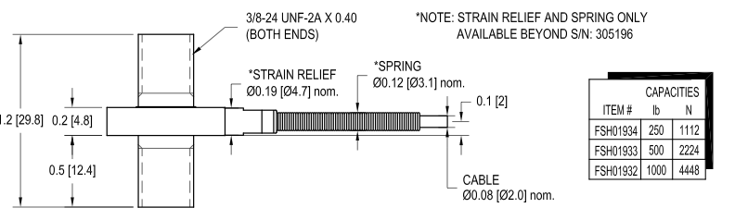

Figure 4.1.2.1 Load Cell

Generally, most load cells should function the same way so just picking anyone would suffice, just so long as it is a compressive load cell. Due to the nature of our version of the MTEC, the workload will be fairly light, so there would not be much concern over what the max capacity is that the load cell can take. However, an issue would lie upon the linear actuator. The load cell will be connected to the linear actuator in order to read in the force after the linear actuator applies the motion into the material to create the compressive force. The load cell that will be used was shown to us through the sponsor. From Futek, the LCM200 is a tension and compression load cell priced at $575.00 USD.

The LCM200 is capable of measuring both tension and compression. A positive output indicates a tensile pressure while a negative output signifies a compressive pressure. As the linear actuator is pushing the load cell into the material, a negative output will be read and translated from the sensor. The LCM200 has a capacity of 250 lb. which we will assume to be enough assuming the average human weight to be applied will be less.

A plus for the LCM200 is that it is a miniature-type load cell, perfect for a small-scale project like the MTEC. The load cell would and should not take up a lot of space, especially considering the potential of having a total of 8 with possibly being in a relatively close proximity. Also the force capacity of up to 250 lbs. is efficient enough for the MTEC. The load cell’s electrical output tends to be very small therefore an electronic amplifier is needed. Once the output is in a more ample form, the signal will be better read by the microcontroller to be translated. The load cell is capable of reading both tension and compression. Reversing the current voltage will switch between the two.

LCM200:

Rated Output | 1mV/V nom (250 lb); 2mV/V nom.
Safe Overload | 150% of R.O.
Zero Balance | +/- 3% of R.O.
Excitation (VDC or VAC) | 15 MAX
Bridge Resistance | 350 Ω nom.
Nonlinearity | +/- 0.5% of R.O.
Hysteresis | +/- 0.5% of R.O.
Nonrepeatability | +/- 0.1% of R.O.
Temp. Shift Zero | +/- 0.1% of R.O. / °F [0.018% of R.O./ °C]
Temp. Shift Span | +/- 0.2% of LOAD / °F [0.036% of R.O./ °C]
Compensated Temp. | 60 to 250°F [15 to 121°C]
Operating Temp. | -60 to 285°F [-50 to 140°C]
Weight | 0.6 oz [17 g]
Material | 17-4PH S.S.**
Deflection | 0.002 [0.05] nom.
Cable | #29 AWG, 4 Conductor, Spiral Shielded Teflon Cable 10 ft [3 m] long
Accessories and Related Instruments Available Calibration (STD | 5 pt. TENSION; 60.4 KΩ SHUNT CAL. VALUE  100KΩ FOR 250 lb SHUNT CAL. VALUE
Calibration Test Excitation

Table 4.1.2.1 Load Cell Specifications

4.1.3 Temperature Sensor (PID)

The temperature sensor was required for use to measure the temperature inside the furnace of the MTEC as the material being tested is being heated. Temperature sensors also give an electrical signal of its readings. The voltage read has a value proportional to the temperature that is stressing onto the sensor. The LM35 is a common temperature sensor in use that provides an accuracy of +/- 0.8 °C and does not require any calibration. The sensor only requires a low voltage of up to 5V to run and has a sensitivity of 10mV per 1 °C, meaning the voltage signal changes linearly with the temperature. The error of the temperature sensor is really low because it has a fixed range of 0 to 100 °C the LM35 provides its data in analog signal form, so it also needs to be converted to digital before actual use. An issue with the temperature sensor would be its reusability, to be clear that its readings stay consistent after each use. The electrical signal from the sensor can be easily translated into the correct format. The output voltages of temperature sensors increase linearly increase and decrease with the changes in the temperature. The software inside the microcontroller will calculate the translation from the signal to a correct format data.

The temperature sensor has no special function for the MTEC other than measuring temperature. It will be placed inside the furnace in close proximity of the material being tested as to get a reading of the temperature of the material itself being stressed from the heat of the furnace. The sensor, being enclosed inside the furnace, will need its wiring setup to come outside of the furnace to be able to send its electric signal as well as get its voltage to be powered.

4.1.4 Clip Gage

Another property of the MTEC is to be able to pull apart the tested material to see how far it can be stretched by taking the difference from before and after the material is stretched to its limit. The material is being held by 2 clamps on the side, the edges of the clip gauge will be set upon those clamps to measure the distance of the material in between.

There are different kinds of extensometers. While they all are clearly for measuring distance, there are different methods, each having their own desirable qualities for this project. The main goal is to be able to get an accurate reading as possible, but to be able to design the extensometer with the MTEC without interfering with the other sensors in the setup. The main 2 setups for the extensometers are contact and non-contact. The names are self-explanatory in that the contact extensometer makes physical contact with the objected to be measured, so any changes in the distance will be read as the extensometer is changed. Non-contact extensometers have no need for any arms or clips to measure. Either design presents different advantages, but the main considerations will be its set up and interaction with the other sensors and furnace and its accuracy.
Contact

There are two kinds of contact extensometers that are available. The clip-on extensometer uses 2 clamps on opposite sides of the object and the sensor arm extensometer. The clip-on is one of the earliest models of the extensometer, so it has a common familiarity of use. Otherwise, the main problem with it is that due to its positioning on the material, even though the measurements it gives are very accurate, the extensometer can have an effect on the object, especially if it’s small or fragile. Sensor arms use a motor system to apply measurements, so the actions in measurement are easier to reiterate. The arm set up also prevents any effect on the object itself, preventing error in measurement. The sensor arm extensometer comes with low signal noise which helps the analog to digital converting process.

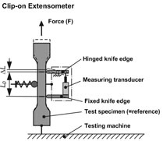

Figure 4.1.4.1 Clip Gage: Clip On
Reprinted with Permission from http://www.laboratoryequipment.com

Non-Contact

The non-contact extensometers also come two different forms. The laser extensometer radiates on the material with a laser and reflects back for data and the video extensometer records frame by frame, as the material length is being changed or altered. The laser extensometer fits the description for the MTEC in that the material will undergo tension. There is no mention of compression also in the MTEC’s original description. The laser extensometer shines a laser onto the surface of the material and the reflection is read by a CCD (charge-coupled device) camera that calculates the results. The calculated results will be connected to the microcontroller for further translation by the software to display the final result’s form for the user. The laser extensometer can view less than a micrometer in resolution and can reach up to about less than a meter. The furnace that will hold the material will not be of such a size, so limits in the reading range is not an issue.
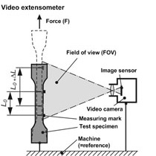

Figure 4.1.4.2 Clip Gage: Video sensor
Reprinted with Permission from http://www.laboratoryequipment.com

Like the laser, the video extensometer can also reach a low resolution. This extensometer is essentially a camera that records frames of the material while it is in the process of being stretched and the difference in size is determined by comparing the edges from the objects on the frames at the beginning and end of the process. The downside to the video extensometer is the amount of preparations needed to set up the process. The material must be shaped properly and have markers so the sensor can pinpoint the edge differences easier. Also calibration must be done for every new material by using a proxy test material that has similarities to prep the sensor for reading.

4.1.5 Motor & Control

To begin the research phase for motor and motor control, a drawing of a possible design for the motor was made to illustrate how the motor control circuit could be done. As shown in the figure below (Figure 4.1.5.1), sensors should be connected to the main MTEC microcontroller in order to give feedback to the system. From the main control box an output is given to a motor controller based on the feedback taken from the sensors. The output given to the motor controller could be in terms of voltage or current. Consequently the motor should work accordingly to what was given to it by the motor controller. So, the motor controller is working as a connection between the actual motor and the main control device or it could also be replaced by a simple circuit that connects the motor directly to the microcontroller if possible.

Motor

Motor
Controller

MTEC

Main
Controller

Sensors

Figure 4.1.5.1. Illustrative figure for possible design

Different types of motors and motor control circuits were searched to see which one would be more acceptable for the functioning of the control box. Before excluding any types of motors, almost all the possible kinds that could be used towards the project were searched in order to narrow down to one type of motor and one circuit design for motor control. In general there are two types of motor that could be considered for the application at hand, AC and DC. The search also included servo-motors, brushed and brushless DC motors, AC motors, linear actuators, and stepper motors.

According to Freescale Semiconductor website, different motor types are used towards applications for appliances and small devices that need motor control. The DC brushless motors are more favorable to consumers than the brushed ones. The AC induction motor (ACIM) and the permanent magnet synchronous motor (PMSM) are still used but for bigger machines like dishwashers, dryers, compressors, or elevators. The website tutorial on motor control listed the typical applications for the different kinds of motors. For example, DC motors are used in shavers and drills; brushless DC motors (BLDC) are used for refrigerators, freezers, fans, air conditioners; switched reluctance motors are used for vacuum cleaners.

In choosing the microcontroller (MCU), it was advisable to consider what application is needed exactly, which peripheral features, the type of load whether stable or unstable load, the speed required, the direction of motion, and of course the cost of the unit. Another consideration is that it could be used for several motors (up to eight) of the same type.

AC Motors

The AC (alternating current) motors are divided into two categories, the asynchronous type that uses induction and the synchronous type. The induction motors operate near the frequency of the input source if driven by an AC source with a frequency that is fixed. The synchronous type will operate at the same frequency of the input source. As the input frequency is changing, the speed of the motor will change accordingly considering the load. To drive AC motors using microcontrollers, one has to have a half H-bridge for every phase of the motor in connection between the MCU and the motor; and consequently, it will probably need 6 PWM pins for control since it’s a three phase motor. Of course, it will be a problem if multiple motors are to be driven and controlled by the same microcontroller.

The AC induction motors (ACIM) are more favorable to use with no noise, which is quite an advantage. Most of the applications are towards big machines like dryers and dishwashers. Synchronous AC motors are also used but they are more complex and more expensive. Is seems that the AC motor types will be completely excluded for the project since they are more complex to control and not really needed for the small application of the MTEC design.

DC Motors

To control DC (direct current) motor types, basic principles are to be considered. A simple voltage applied as input will do the job of making the DC motor starts turning. Pulse width modulation (PWM) is recommended for motion control as it drives the motor by giving it the effect of a sinusoidal wave, typically less than 20 kHz for a frequency. Position detection could also be a factor for some types of motor; for example, the Most of the DC motors require position feedback while stepper motors do not necessarily need any feedback since the original motion is controlled via taking small steps. Fault inputs could be useful in finding out the errors as the motor is in motion. The current or voltage going into the motor could be read and fed back to the microcontroller to adjust the motor positioning or motion accordingly. As input voltage increases, the speed of the motor increases accordingly. The amount of torque is controlled by controlling the current going in and the direction is determined by the direction of the current.

For simple DC motor control, Pulse Width Modulation (PWM) could be used to drive the motor and control its speed in one direction. To have control in two directions, an H-Bridge should be used in conjunction with the PWM to drive the motor in two directions. In spite of the simplicity of driving DC motors, Brushed DC motors have some disadvantages. They are costly to maintain due to brush wear, they are electrically noisy; heat is generated in the armature of the motor and is difficult to remove, and there is also friction loss associated with the mechanical parts. As a result, Brushless DC motors are more favorable to use in applications but they might require more PWM pins for control. Based on what’s related to DC motors, it could be useful to have small DC motor controlled by a microcontroller for the project at hand. Since motion is needed in two directions, then an H-bridge circuit could help as a connection between the microcontroller and the motor for switching.

A brushed DC motor is connected to a microcontroller (MCU). The interface example of this DC motor is shown on the Freescale Semiconductor website under the Motor Control section. The circuit is a very good example in illustrating a possible interface of a brushed motor with a microcontroller. The connection between the motor and the MCU is through another circuit, the Analog Power ASIC, as shown in the figure. A feedback is going from the motor to the microcontroller directly through an encoder. This feedback is used in the microcontroller to adjust for the speed of the motor. Another feedback comes from the current sensing block in the analog circuit to the analog to digital converter (ADC) pin in the MCU to adjust for the current control coming out of the microcontroller. Current is then driven into the motor by the use of the PWM.

The major point to be learned from all this is that the DC motors must have feedback to control for speed and current; this cause a bit of more complication to the entire project if we were to consider hooking up eight motors in parallel. Also, more connecting circuits will have to be implemented with more passive components to realize the analog connection between the motors and the microcontroller.

Servo-Motors

Servo motors have internal gear based transmission system and internal electronic control that could control the position of the motor’s head allowing it to rotate around a fixed point. Direct current could be used to control the circular motion. The motion is usually between zero and 180 degree, some servos could go up to one full revolution (0-360 degree). Regardless of their small sizes, servo motors are very useful for high torque applications; the rotational arm of the servo motor can hold a decent amount of weight and moves it around a fixed point. Servo motors come very useful in positioning applications controlled by a persistent pulse train. Due to their small sizes and their large angular torque, servos are used in many robotics applications. They operate in a closed loop with feedback; therefore, they are very accurate in position control. One possible consideration to be made is that the required current is to be proportional to the weight of the load that they carry. Servos could be controlled like DC motors by sending a square wave input to the wire of the motor and according to the pulse width of the wave, the angle to which the motor will move will be set. For example, a 1.5 ms pulsed square wave sent to the motor will move it to 90 degrees, while a 2 ms pulsed square wave sent will result in a movement of a 180 degrees.

Servo motors are a type of electromechanical actuators that do not rotate continuously like DC/AC or stepper motors; rather they are used to position and hold some object where continuous rotation is not required so they are not used to drive wheels like regular DC motors. The servo can be commanded to rotate to a particular angle for example, a 30 degree, and hold its position and could also be adjusted according to error feedback mechanism. As a result, they are mostly used to control the steering of RC cars, robotics arms and legs.

Unlike servo motors, stepper motors operate in an open loop which means that they do not require feedback for controlling the position. Moreover, stepper motors do not have a rotational limit to one revolution as in the case of servos and they are usually cheaper than servo motors. One good advantage of servo motors is that they are easy to control using a microcontroller without the need for an h-bridge in between, only a control signal is needed to be feed to the servo to position it to any specified angle. If a square wave is used like a PWM for example, then after considering the frequency desired for the servo, the duty cycle of the square wave controls the angle. In other words, the width of the positive pulse controls how far the servo will rotate. Most servos simply come with three wires for voltage, ground, and control. A possible design is illustrated in Figure 4.1.5.5. It shows controlling the servo motor with a PIC microcontroller using one of its PWM pins. The detailed control over the exact rotational motion will depend on the programming of the MCU.
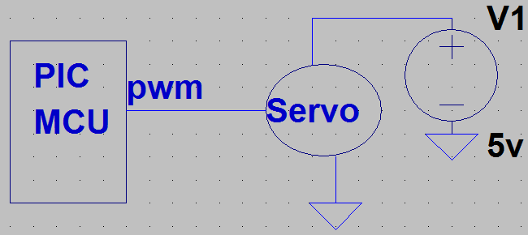

Figure 4.1.5.5 Servo Motor controlled by a PIC Microcontroller

Stepper Motors

Stepper motors are considered permanent magnet motors. They come into different types based on the steps required to take in every rotational movement. These types of motors can perform full steps, half steps, or even micro steps. For a full-step stepper motor, two phases will alternate on and off giving four steps lagging each other by 90 degree; they could also reverse the polarity which reverses the direction of motion into a counterclockwise movement. The half-stepper motor has eight steps instead of four since the second phase is turned on before the first phase is turned off. Unlike most of the DC motors, stepper motors do not require feedback to control their positioning or rotation, as the stepping inputs are controlled via the microcontroller without the need of any feedback to adjust for errors. Stepper motors are small and compact and could be very useful for small devices and low torque applications.

The control over the direction of rotation for the stepper motor is simply done by reversing the voltage applied. Once the phase relationship between the two coils is reversed, the motor will rotate in the opposite direction. The transition of the square wave for example will cause the motor to move taking small steps. The size of this step is dependent on the stator teeth arrangement but a common value is 1.8 degree or 200 steps per one revolution. The speed of the stepper motor is controlled by varying the frequency of the square wave input to the motor coils. Because stepper motors can be driven with square waves, they are easily controlled by inexpensive digital circuitry and do not even require PWM. However, by utilizing power modulation techniques to change the square waves into sine and cosine waveforms, a better step resolution could be achieved. This is called "micro-stepping", where each small change in the sine and cosine levels constitutes one micro step. The ‘micro-stepping’ also depends on how sensitive the stepper motor is to the small variations of the sine or cosine waves. Theoretically, there is no limit to the position resolution achievable with micro-stepping, but in reality, it is limited by the motor mechanical and electrical tolerances. Some stepper motors are designed specifically for micro-stepping, and consist of tightly matched impedances between the coils, and tighter machining tolerances on the stator teethes to allow the motor to be sensitive enough for picking the micro steps but the disadvantage is that they come with higher costs.

In general, stepper motors are powered by running an electrical current into the motor, small sizes could be run with currents on the order of milliamps. The motor runs accordingly with discrete rotational steps, unlike the DC motor where it runs in continuous rotational movement. Stepper motors can accept the input current from supply sources as well as from microcontrollers as long as the current is properly controlled in a way that doesn’t interfere with the electromagnetic waves of the motor. Therefore, pulsed waveforms should follow a correct pattern to drive the motor.

The following example is taken from an article written by Matthew Grant about how to drive a stepper motor using HCS12 microcontroller. The goal is to reach half-stepping for the rotational movement. To start, let four input currents go into the two coils of the motor. Two input signals for coil A, and two input signals for coil B, where there is a positive and negative input signal for every coil. Even though, every input signal of the four signals is from 0 to 5 volts coming from the microcontroller, the total effective signal for coil A and B is from -5 to 5 volts as if it’s giving the shape of a sinusoidal wave with amplitude -5 to 5 volts going into each one of the two coils. When the input for coil A is high while the input for coil B is low, the motor turns accordingly giving a half step rotational motion. Depending on how many state changes for coil A and B, the steps that the motor will take to make one revolution of motion will vary accordingly. In order to reach eight steps for one cycle, the input currents for coil A and B have to allow for 8 state changes so that every transition in the motor movement corresponds to one state.

It is shown in Figure 4.1.5.7 how the eight transitional states are accomplished for coils A and coil B; the input signal for the current alternate between high, zero, and low for every coil. For every time section, for example from 0 to 1, there will be a change for the digital inputs coming from the microcontroller pins. The change is limited as shown in the figure to eight states which correspond to the eight steps that the motor will take to rotate for one full cycle, i.e. from 0 to 360 degrees. As the number of states changes, the number of steps that the motor takes will change accordingly; this allows for better control over the motor turns as long as the stepper motor is sensitive enough to accept the quick changes for the input currents which result in what’s called as Micro-Stepping. The micro-stepping implementation could give better movement with low noise, low vibration, and smooth transitions between movements. The waveform of the input current will take a very close form of a smooth sine wave.

The stepper motor is assumed to have four pins and it’s a two-phase Permanent Magnet Stepper Motor with two poles. The input voltage of the motor is assumed to go from -5 to +5 as explained earlier and the motor should accept a current of 1-20 milliamps. The microcontroller should have accordingly four pins capable of inputting a current between 1-20 milliamps out of each pin. The port pins for the HCS12 are suitable for this type of stepper motor. The microcontroller has registers for logic control of the I/O pins or port pins. Hence, we can select register U for example for logic control of the four I/O pins or the four port pins. Half the bits (4 bits) of that register will control the four pins connected to the motor coils. To control port U, bits U0, U1, U2, and U3 are used. Pins U0 and U1 are used for input current to coil A; pins U2 and U3 are used for input current to coil B for example. After making the 4 connections to the motor coils and with the understanding of logic control, the 4 bits of register U could now be used to produce the waveform needed to drive the stepper motor as shown above in Figure 4.1.5.7. The program will be dealt with as a state machine where every set of the bits in register U will correspond to a particular state. For example, let the initial state for the register U contain the hex number 00 and then set the next state to hex 01 as the input signal for the current will reach the corresponding coil and results in taking a rotational step. The stopping time where the motor reaches a state of braking is controlled by a delay loop in between the changing states. The longer the delay loops the better response on the motor side. For the motor to turn in the opposite direction, the current going into the coils should be switched, in other words, the pin connections should be reversed. An H-bridge circuit in between the motor and the microcontroller can do the job of switching the polarity without the need of reversing the microcontroller connections whenever needed.

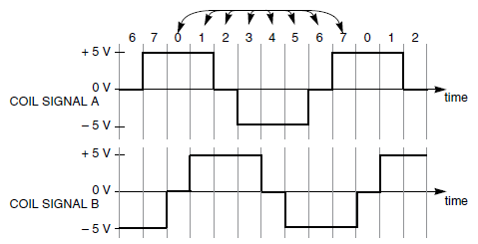
Figure 4.1.5.7 Different States with Discrete Transitions

Now that the section of how to drive a stepper motor with a microcontroller is well understood, the next step is how to apply this mechanism using the HCS12 microcontroller using the port pins to drive a current into the motor coil. At first, general assumptions have to be made on both the MCU and the motor because every algorithm written will vary with changing either the MCU or bringing a different type of Stepper motors.

So far, it seems that the stepper motors stand on top of the list for the application of the MTEC project. It’s very easy to understand its functionality and it’s very well compatible with digital circuitry. The control over the turns or the steps that the motor can take allows the user to control over the pressure of the load which is the main focus of the project. The stepper motor will be very helpful in achieving the goal of pressing on the material under testing giving it few more pushes as needed when more rotational steps are taken. The opposite is also true for pulling on the material. A relationship between the rotational movement of the motor and the vertical motion of the load should be found to simplify the process for the user. Another big advantage is that stepper motors could be used in open-loop position control applications without the need of feedback control over the current or speed which reduces the number of analog circuits implemented for feedback and simplifies the circuitry when it’s implemented on a PCB board. In contrast, DC motors must have feedback control circuits since there is no control over the rotational movement of the motor. This adds some complexity because compensation has to be done for overshooting a desired position and more analog circuits will have to be implemented and will have to work along with the chosen microcontroller.

The example shown in figure 4.1.5.8 below is taken from the Freescale Semiconductor website. It’s illustrating a possible interface for a stepper motor and a microcontroller. On the left side of the figure, four PWM pins are used to connect to a middle circuit and then from this middle circuit come out four wires to connect to the two coils of the motor, each coil has a positive and a negative input. The middle circuit consists of two H-bridges, one for each coil, that work as a switch for the direction of the input current to the coils. In other words, the H-bridge circuits change the voltage polarity and as a consequence, the motor will turn in the opposite direction. A different possible circuit is done by connecting two stepper motors to a microcontroller through a dual H-bridge drive. The driver is connected to the MCU using the serial peripheral interface pin (SPI). The waveform of the current going into the coils for any of the two circuits has the shape of a sinusoidal wave.

Linear Actuators

Another type of motors to be considered for the project is the linear actuators. They are another form mostly driven by DC motors that can provide rotational motion. The gearing and the cams inside the actuator are used to transform the rotary motion to a linear motion. This type of motors was the most favored to the sponsor of the project and it’s probably the one that will be used for the application at hand. Based on the energy source, linear actuators are categorized primarily as electromechanical, mechanical, pneumatic and hydraulic. Both pneumatic and hydraulic actuators utilize the pressure pushing against a piston to produce force. In the case of hydraulic actuators pressure arises in the form of compressed liquid and in the case of pneumatic actuators in the form of gas. Mechanical actuators convert one type of motion into another. In the case of linear mechanical actuators rotational motion is converted into linear using gears or screws. Electro-mechanical linear actuators utilize motors to produce rotational motion which is then converted into linear motion using screws, gears or other mechanical elements.
Linear electric actuators also vary in the way how the motor is integrated into the
actuator body. Some actuators have the motors attached on the side, beside the main body
and others have the motor integrated within the body in line with the rod. It was favored not to use the one with the motor attached to the side to account for the upgrade of having eight actuators in parallel to each other and to limit space used to a smaller area.

Regardless of the type, all actuators require a power input and a control circuit. Simple
control circuits contain only a power supply and a 3-way switch like in the case of all motors. The switch could perform a forward, reverse, and brake action. If the actuator utilizes a DC motor then it will require a DC power supply. Depending on the application, the power supply can be chosen to take AC power from a standard 110V (or 220 V) circuit or it can be powered by batteries. Some higher power actuators utilize AC motors and can be powered directly from the AC circuit without a power supply.

The mechanical power Pm of a linear actuator is given by a relationship between its velocity (or speed S) and its applied load (or Force F). In other words, Pm = F * S. The relationship means that at higher speeds the actuator can only move a lighter
load than at a lower speed. If a heavy load is applied, the actuator will move slower to preserve the relationship to a fixed mechanical power value.

Linear actuators are chosen based on the stroke length, the gear ratio, the voltage applied or desired to run the specific actuator, and the maximum load that the actuator can hold. Another important relationship is between the voltage V and the current I drawn by the actuator. The current and the voltage define the relationship for the electric power (Pe) consumption which should be considered especially in the case of using batteries. The proportionality for the electric power is: Pe = V * I. The relation means that for a fixed gear ratio, if a heavy load is applied then a higher current value is needed to let the actuator lift that heavy load. The opposite is also true in the case of pushing a load. So, in order to get to the maximum load lift, the maximum current should be applied as an input to the actuator.

The charts below in Figure 4.1.5.9 and Figure 4.1.5.10 represent the formulas explained for general actuator types. The speed vs. load chart shows inverse relationship to illustrate that the heavier the load, the slower the speed. The current vs. load chart shows a direct proportionality to illustrate that the heavier the load, the more current required to move it. Different gear ratios are also shown in the figures. A higher gear ratio will give more torque applied to the load; consequently, the actuator will push or pull with more force given to the load. Of course speed has to be considered if a higher gear ratio is chosen since the more force the less speed.
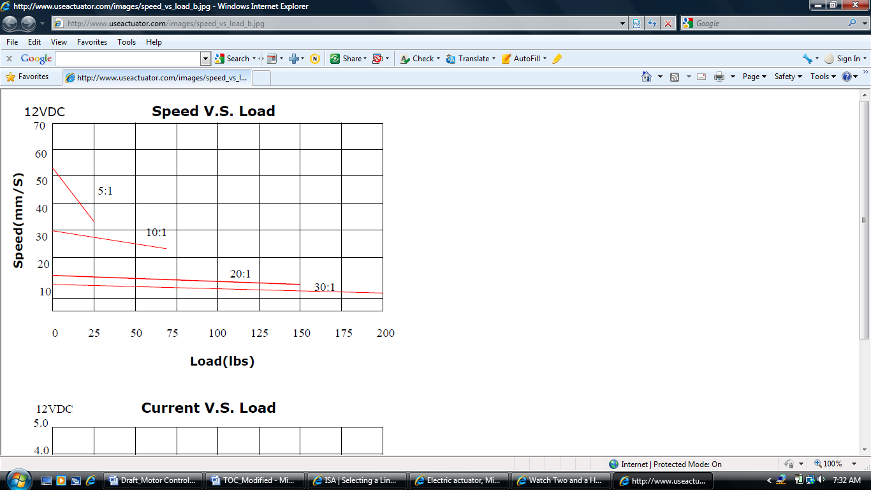
Figure 4.1.5.9 Typical chart (speed vs. load)

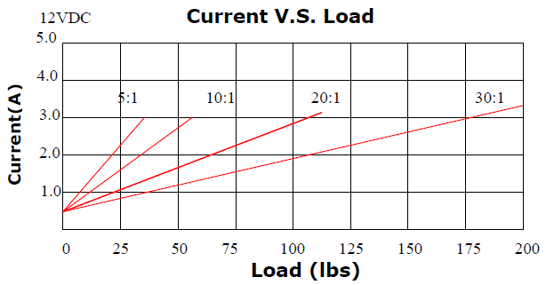
Figure 4.1.5.10 Typical chart (current vs. load)

A very important factor that should be considered regarding linear actuator is the usage time or in technical wording the duty cycle. The duty cycle indicates both how often an actuator will operate and how much time there is between operations. The duty cycle is listed among the specifications for linear actuators. It signifies how long the actuator should run before it comes to a complete brake. For example, a 20% duty cycle means that the actuator could only be used for 20% of the time; 2 minutes of continuous use should be followed by 8 minutes not in use. If duty cycle is increased, either load or speed must be reduced.

Firgelli automation was considered the number one source provider for linear actuators in this project. The website contains a lot of information and a variety of actuator types and it will probably be the one to order from. All Firgelli linear actuators use a lead screw driven by a PMDC motor to create linear motion from a DC voltage. So, by applying a voltage input the actuator will start moving, when power is removed they will hold their position. If a force large enough to overcome the internal friction is applied, the actuator will back drive.

A simple basic actuator comes with only two wires for positive and negative input voltage. Voltage could vary to be 5, 6, 12, or 24 volts. If positive voltage is applied, the actuator stroke starts to move up until it reaches the maximum length. If the voltage polarity is reversed, it goes back down to its place. So a simple up and down movement is achieved by linear actuators. If the stroke of the actuator where to end on top of a load cell then a force pushed down onto the material could be measured. Slowing down the actuator is done by lowering the voltage input that drives it. The voltage specified on an actuator datasheet is its maximum. If a lower voltage is used, the actuator will move more slowly and push less force.

A voltage regulator could do the job of lower the input voltage and consequently control the speed of the actuator stroke. Another way is to use a PWM wave and adjust for the duty cycle needed as it will affect the speed of the stroke and also how far it will reach. A consideration is taken regarding the minimum voltage required to overcome the friction inside the actuator, it will also depend on the load attached to it.

The price of linear actuators could go up to hundreds of dollars, but there are some decent ones for around $75. A consideration should be taken when it comes to ordering actuators. It could take the manufacturer some time to put the actuator together according to the chosen configurations as not all different actuators types are in stock and based on the user choice, the manufacturer will start configuring all these choices together.

Safety Tips: there are several techniques that are recommended to ensure a longer life for the actuator used. Limiting the control signal ensures that the actuator never impacts the end stops. To prevent failures, static safety procedures are implemented when handling the actuators. A clean and well regulated power supply will help reduce the noise in the system and also reduces the chance of having an over voltage damage. Some actuators come with internal limit switches, mostly the S type, to ensure that the actuator never hits the end point but excess loads can still cause damages along the stroke. Another technique to prevent overloading is to clamp the current to a safe level. Since these actuators utilize PMDC motors, current is directly proportional to the force generated. Limiting the current will reduce the impact of a stall or overload condition.

Actuators with P type have an extra feature that allows the device to live longer and limits the damages. They contain a potentiometer inside that is used for position feedback control. This feature allows the user to ensure that the actuator will never reach its end limit. It also allows for accurate adjustments to the level of how far the stroke will extend. The potentiometer inside the actuator adds about three wires to the device, two of these wires are for positive and negative references and the third one is a wiper that runs over the resistor and consequently controls the voltage to a limited value. Even though, the project is requiring the control over the force applied, the actuator with position feedback was recommended by the sponsor for future upgrades and modifications.
In going back to the project requirement, if an actuator is to be chosen, then it will have to have the ability to be controlled by a microcontroller. It will be allowed to reverse its linear motion by connecting an h-bridge to it that allows for switching polarity as in the case of regular DC motors. A position feedback of where the stroke ends doesn’t need to be taken as an input to the microcontroller since the feedback for the applied force will be taken from the load cell attached to the actuator. A desired force could be reached accordingly. The compact miniature size is also another important factor to be considered when it comes to applying eight of them in parallel to each other.

PWM

In general, phase angle control provides a very inexpensive method to control the average voltage of an AC source. As the pulse is moving towards the sine wave, the maximum voltage is reduced gradually. However, the low frequency ac waveform presented to the motor will create some torque ripple and noise. All universal motors operated from an AC source will have some torque ripple. For a permanent magnet DC motors, a rectifying process takes place limiting the voltage to drop down to zero and then gradually move up to the maximum again.

For pulse width modulation, one phase pulse width modulation (PWM) consists of one signal modulated by a sine wave. The duty cycle or high time is proportional to the amplitude of the sine wave. The effective average voltage over one cycle is the duty cycle times the peak to peak voltage. Thus, the average voltage follows a sine waveform going to the circuit. In fact, this method depends on the motor inductance to integrate out the PWM frequency.

Pulse Width Modulation is the technique used to generate analogue signals from a digital device like an MCU. PWM is considered a very common method to control the speed of motors; therefore a research was done on generating the PWM wave that will come useful in controlling the speed for the chosen motor. It is the process of switching the power to a device on and off at a given frequency, with varying on and off times. These on and off times are referred to as "duty cycle". The diagram below in Figure 4.1.5.11 shows the waveforms of 10%, 50%, and 90% duty cycle signals.

As seen in the diagram, a 10% duty cycle signal is on for 10% of the wavelength and off for 90%, while a 90% duty cycle signal is on for 90% and off for 10%. These signals are sent to the motor at a high enough frequency that the pulsing has no effect on the motor. The end result of the PWM process is that the overall power sent to the motor can be adjusted from off (0% duty cycle) to full on (100% duty cycle) with good efficiency and stable control.

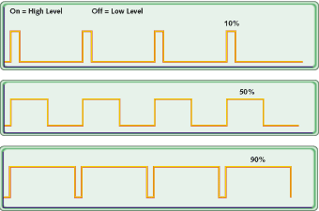

Figure 4.1.5.11 Duty cycle diagram

In the case that the chosen microcontroller would not have enough PWM pins to provide control for eight motors; then a PWM wave could be generated using a 555-timer as in the example that follows. The schematic in Figure 4.1.5.12 shows the generating of the PWM wave using the 555-timer to drive a DC motor.

The pin configuration for the 555-timer is shown in table 1 with the explanations of the purpose of every pin in coordination with the schematic circuit for the PWM generation that is shown in figure below; the reset pin is connected to +V, so it has no effect on the circuit's operation. When the circuit powers up, the trigger pin is LOW as capacitor C1 is discharged. This begins the oscillator cycle, causing the output to go HIGH. When the output goes HIGH, capacitor C1 begins to charge through the right side of R1 and diode D2. When the voltage on C1 reaches 2/3 of +V, the threshold (pin 6) is activated, which in turn causes the output (pin 3), and discharge (pin 7) to go LOW. When the output (pin 3) goes LOW, capacitor C1 starts to discharge through the left side of R1 and D1. When the voltage on C1 falls below 1/3 of +V, the output (pin 3) and discharge (pin 7) pins go HIGH, and the cycle repeats. Pin 5 is not used for an external voltage input, so it is bypassed to ground with a 0.01uF capacitor.

For the configuration of R1, D1, and D2, the capacitor C1 charges through one side of R1 and discharges through the other side. The sum of the charge and discharge resistance is always the same; therefore, the wavelength of the output signal is constant. Only the duty cycle varies with R1. The overall frequency of the PWM signal in this circuit is determined by the values of R1 and C1 and it is set to 144 Hz in the schematic circuit shown in figure below.

The components values could be changed to obtain other frequencies according to the formula. Frequency = 1.44 / (R1 * C1); the discharge pin is used to drive the output. In this case, the output is an IRFZ46N MOSFET. The gate of the MOSFET must be pulled high as the discharge pin is open collector only. Being an N channel MOSFET, the IRFZ46N will conduct from drain to source when the gate pin rises above 4 volts or so. It will stop conducting when the gate voltage falls below this voltage. The configuration of the output also serves to invert the signal from the 555 circuit.

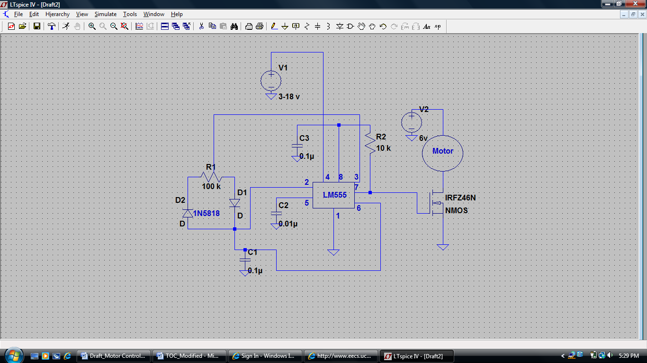

Figure 4.1.5.12 Generating PWM wave using LM555 timer

PIN | DESCRIPTION | PURPOSE
1 | Ground | DC Ground
2 | Trigger | The trigger pin triggers the beginning of the timing sequence. When it goes LOW, it causes the output pin to go HIGH. The trigger is activated when the voltage falls below 1/3 of +V on pin 8.
3 | Output | The output pin is used to drive external circuitry. It has a "totem pole" configuration, which means that it can source or sink current. The HIGH output is usually about 1.7 volts lower than +V when sourcing current. The output pin can sink up to 200mA of current. The output pin is driven HIGH when the trigger pin is taken LOW. The output pin is driven LOW when the threshold pin is taken HIGH, or the reset pin is taken LOW.
4 | Reset | The reset pin is used to drive the output LOW, regardless of the state of the circuit. When not used, the reset pin should be tied to +V.
5 | Control Voltage | The control voltage pin allows the input of external voltages to affect the timing of the 555 chip. When not used, it should be bypassed to ground through a 0.01uF capacitor.
6 | Threshold | The threshold pin causes the output to be driven LOW when its voltage rises above 2/3 of +V.
7 | Discharge | The discharge pin shorts to ground when the output pin goes HIGH. This is normally used to discharge the timing capacitor during oscillation.
8 | +V | DC Power - Apply +3 to +18VDC here.

Table 4.1.5.1 Description and purpose of pins for LM555 used to generate PWM.

H-Bridge

The H-bridge circuit is another important part to consider for motor control. It will be connected in between the motor and the microcontroller to provide switching for the up and down movement or the clockwise and the counter-clockwise movement in the case of rotational motor. It simply acts as a switch to reverse the voltage polarity going into the motor resulting in a movement in the opposite direction. The H-bridge could be used with most DC and AC motors, it could also be used with linear actuators.

To build an H-bridge, transistors like BJT’s or MOSFET’s could be used. A simple schematic diagram for an H-bridge example is shown in Figure 4.1.5.13. Four NPN transistors are used with four resistors that should be of the same value, 1 kΩ for example. A voltage of 5 volts is used to turn on the circuit, and the motor is connected in between the transistors as shown in the figure. To be specific, components like 2N2905A could be used for Q1 and Q3 while 2N2219A could be used for Q2 and Q4. The inputs for the H-bridge are two digital pins from a PIC microcontroller. When inputs A and B are equal (either 0 or 1), the motor doesn’t run. When A = 1 and B = 0, the motor turns in one direction; when A = 0 and B = 1, it turns in the opposite direction. Considerations should be taken in determining how much stalled current could be tolerated by the circuit with no problems.

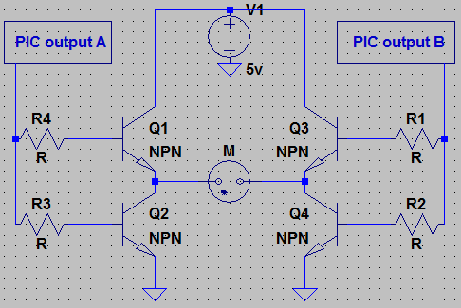
Figure 4.1.5.13 H-bridge circuit to provide on/off switching

4.1.6 Display

In order to satisfy the desired display requirements of the MTEC, there were a variety of options considered. The complexity of the LCD display is directly related to the complexity of the information that must be shown. Because of this, choosing the appropriate display is a compromise between technical aspects, economical aspects, and the user's necessities. However, regardless of these factors, the display must be able to meet the following requirement: it must be capable of showing the status of the test being performed.

A display system that was initially considered consisted of a simple array of status LEDs similar to those found in modern electronics to show electrical connectivity, data reception, and other basic status conditions. This system would be comprised of several LEDs of different colors placed on top of the enclosure. A white LED would indicate if the MTEC was turned on. A red LED would indicate when there was a test in progress. A green LED would indicate when a test was completed. An array of LEDs would be used to display time progress and/or time remaining on the test. Finally, a yellow LED would indicate if the test was pause by the user or by some technical factor. Figure 4.1.6.1 shows a possible configuration of this LED display system.

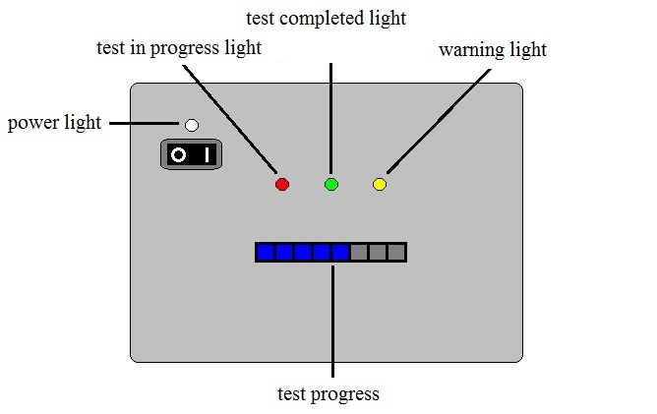

Figure 4.1.6.1 Configuration of LED Display System

This system, although inexpensive and easy to implement, has several crucial problems. It is unable to accurately displaying the time remaining on the test. Most importantly, however, other than a limited test status summary, no additional information can be provided to the user. This made this display system an unsatisfactory option for the desired MTEC requirements and, as a result, no further research was done.

In order to provide the user with a satisfactory amount of information throughout the test, it was determined that an LCD display would be the best choice. However, there are many variations to this type of display readily available in the market. The three types of LCD displays that meet all the previously described requirements and, therefore, were considered for implementation in the MTEC were the alphanumeric LCD display, the graphical LCD display, and the graphical LCD display with touch screen. Each of these display types had a unique set of advantages and disadvantages that were thoroughly explored.

When contemplating which LCD displays to use in the MTEC, there were several key factors carefully considered. Even though these three display types were capable of providing the user with a sufficient amount of information relevant to the test being performed, some have the possibility of further development than others. Considering that the sponsor has a limited budget available for the development of the device, reducing the prototype’s price was one of the group's goals. Therefore, as in every other component in the device, low cost was desired. Perhaps one of the most important factors considered when researching the LCD displays was durability. The MTEC would be used in a laboratory environment in which there is a larger chance of physical damage. The LCD display, being one of the most exposed components of the device, must be able to withstand strikes and shocks.

Besides the previously described factors, there were several physical specifications considered which included: power consumption, electrical operation requirements, and backlight availability. Because the MTEC would be powered through a wall outlet, power consumption was not a crucial aspect when researching the displays. However, reducing operation cost, and therefore power consumption, was an area of interest. Also, voltage and current requirements of the display would be of great importance when designing the device’s power supply. Therefore, choosing a display with standardized voltage and current requirements was desired as it would make the design of the power supply and the integration process less challenging. Even though the MTEC would mostly operate in a laboratory environment at reasonable temperatures and humidity levels, there is the possibility of implementation in a less than ideal field environment. As a result, the operational temperature range of the display was considered. Finally, backlight capabilities would make using the MTEC in a darker environment possible. Most importantly, however, it would make data delivered to the display more visible which is a convenience users would appreciate.

Initially, research was directed towards the alphanumeric LCD display. This type of display exhibited a unique set of advantages over the graphical LCD and graphical LCD with touch screen displays. Because they are commonly used by hobbyists and engineers for a wide array of applications, there are literary thousands of options available in the market ranging in price, variety of displayable characters, and number of display lines. Also, the large demand for these displays has driven microcontroller manufacturers to facilitate incorporation. As a result, alphanumeric LCD displays are heavily standardized. This, from a designer's point of view, is beneficial because there is more implementation information readily available to assist in the incorporation process.

The availability of alphanumeric LCD displays in the market also translates into considerably lower prices than the other LCD displays researched. It is also beneficial from a logistic point of view as it facilities the acquisition process. But perhaps the biggest advantage of alphanumeric LCD displays is their reliability and durability. These types of displays are implemented in devices used in many different type of environment. As a result, they are generally design to be very sturdy and durable.

An attractive characteristic of alphanumeric LCD display is their extremely low power consumption. Although this parameter varied slightly from model to model, it was never greater than 250mW throughout the research. For displays with backlight the power consumption of the LEDs was also very small, usually 25mW to 35mW. Operating voltages varied among different alphanumeric LCD displays. However, 5V appeared to be the standard among most models. Research on other components of the MTEC revealed that 5V would be the operating voltage for several primary components. Therefore, this characteristic would further facilitate implementing the display with the power supply.

For most alphanumeric LCD displays considered, operating temperature ranged from -40 degrees Celsius to +80 degree Celsius. The MTEC would most likely be used in an ideal environment with low humidity and a temperature ranging from +25 degree Celsius to +30 degree Celsius. However, realistic temperatures of extreme environments in which the MTEC could be used range from -10 degrees Celsius to +40 degrees Celsius. For either case, this type of LCD displays would be capable of operating properly.

Backlight availability generated by standard LEDs was common among alphanumeric LCD displays. Some manufacturers even offered the option of different backlight colors for the same display model. The ability to turn off the backlight to conserve energy was also a commonly available feature among these displays.

Alphanumeric LCD displays have a few key disadvantages when compared with graphical LCD displays and graphical LCD display with touch screen. As the name implies, this type of display is capable of only generating alphanumeric characters. This would significantly limit the complexity of the data that can be delivered to the user. Also, this type of LCD display is not capable of showing a large amount of information at once. Displays are typically limed to 4 lines, each usually containing no more than 20 characters. Even though there are several options to work around this issue, such as allowing the user to scroll between pages, most of them often sacrifice convenient some level of convenience. Table 4.1.6.1 summarizes the advantages and disadvantages of implementing alphanumeric LCD displays.
Advantages | Disadvantages
Compatible Most MCUs | Limited Display Capabilities
Easy to Incorporate | Small Size
Easy to Program | No Further Development
Incorporation Help Available
Durable
Shock Resistant
Available with Backlight
Low Power Consumption
Table 4.1.6.1 Advantages and Disadvantages of Alphanumeric LCD Displays
The next display to be researched was the graphical LCD display. This type of display is, in many aspects, similar to the alphanumeric LCD displays. Just like the previous, they are a favorite among hobbyists and engineers. However, it is mostly implemented in more advance applications. Even though the number of options available in the market is more moderate, there is still a very large selection ranging in size, resolution, and price. The wide use of this type of display has driven microcontroller manufacturers to facilitate incorporation. As a result, graphical LCD displays are compatible with most popular microcontrollers. Even though they are not as heavily standardized as alphanumeric LCD displays, there are some favorite standards commonly used in embedded applications. This beneficial aspect of graphical LCD displays makes implementation information readily available to assist in the incorporation process.

The cost of graphical LCD displays is slightly higher than that of alphanumeric LCD displays. However, the price is still of little significance when compared with other components of the MTEC. This type of display is often implemented in devices used in wide array of environment, some of which could be hostile for electronic devices. Therefore, sturdiness and durability are characteristic with this type of display.

One area in which the graphical LCD display differs from alphanumeric LCD display is power consumption. Because this type of display comes in modules containing several components, power requirements are usually more demanding. Graphical LCD display modules have one or several control ICs for which consumption usually equals that of a small microcontroller. Although this parameter varies significantly among different displays, for the models considered it was often close to 30mW. The part of the display module that consumes the largest amount of power is the display itself. As the size of the display increased, this value increases significantly. For displays that met the preliminary estimates of size requirements, this value was often more than 300mW. Modules having backlight capabilities usually require an additional 25mW to 35mW. In total, the power consumption of the graphical LCD displays is usually between 400mW and 500mW. Although this is twice as much as that of the alphanumeric LCD displays, it is insignificant when considered from a general perspective.

The operating temperature for almost all the graphical LCD displays considered ranged from -20 degrees Celsius to +70 degree Celsius. Even though the MTEC would be mostly used in an ideal environment with low humidity and a temperature ranging from +25 degree Celsius to +30 degree Celsius, extreme temperatures to which it could be exposed during operation range from -10 degrees Celsius to +40 degrees Celsius. This type of LCD displays is capable of comfortably operating under all scenarios considered.

Backlight availability is common among graphical LCD displays. Some manufacturers even offer the option of different backlight colors for the same display model. The ability to turn off the backlight to conserve energy is also a commonly available feature among these displays.

Graphical LCD displays had several drawbacks when compared with alphanumeric LCD displays. In order to accommodate for the complexity of the information this type of display is capable of showing, display controls are often incorporated into the LCD screen module. There are several popular control architectures available and, as a result, the assembly language used to program the different controllers is slightly different. Unfortunately, these controllers cannot be programmed with a higher level language, such as C or C++, because there are no compilers available. Learning to effectively use these different assembly languages could add a significant amount of time to the incorporation process. Also, the programming necessary to display the desired data and graphics is much more intensive than that of the regular alphanumeric displays.

The complexity of the graphical LCD display modules would make incorporation with the microcontroller more challenging. Although most popular microcontrollers are designed to allow the integration of this type of display, the pin interface requirements would have to be carefully considered before choosing a specific model. Using a graphical LCD display would also affect the power supply design. Because this type of display has several active components within the module, each with different power requirements, meeting such specifications would increase the complexity of the power supply's circuitry.

Regardless of the previously mention disadvantages, the graphical LCD display has several promising characteristics. There are virtually no limitations to the complexity of the information displayable. This promising characteristic allows for further development than in an alphanumeric display. Also, it allows for the possibility of future adjustments if deemed necessary by the user. Table 4.1.6.2 summarizes the advantages and disadvantages of implementing graphical LCD displays.

Advantages | Disadvantages
Unlimited Display Capabilities | Difficult to Incorporate
Can be Further Developed | Difficult to Program
Compatible with Most MCUs | Complicated Electrical Requirements
Found in the Desired Size
Incorporation Help Available
Durable
Shock Resistant
Available with Backlight
Low Power Consumption
Low Cost
Large Variety Available
Readily Available

Table 4.1.6.2 Advantages and Disadvantages of Graphical LCD Displays
There are several types of touch screen technologies currently used throughout the technological landscape. Each of these technologies has a unique set of advantages and disadvantages that distinguish them from the other. Before researching the specifics of the graphical LCD display with touch screen, it was necessary to consider these different technologies and which would better suit the MTEC’s requirements. Although there are small variations among the touch screens currently implemented in popular applications, all touch screens can be placed inside one of the following categories: surface acoustic wave, infrared, strain gauge, optical imagining, dispersive signal, acoustic pulse recognition, capacitive, and resistive.

The surface acoustic wave, SAW, technology is among the most advance touch screen types available in the market. It is currently used in ATM machines, information kiosks, computer based training, and other public indoor environments. This type of touch screen works by placing an array of transmitter and receiver transducers in opposing sides of a screen, both in the x and y directions. The transmitter transducers emit ultrasonic wave across the surface of the screen which are picked up by the receiver transducers. If an obstacle, such as a digit, it placed in the glass, the ultrasonic wave is distorted. The receiver transducer is capable of detecting this obstacle and its position by interpreting the disturbances in the waves.

Because the display area of surface acoustic wave touch screens has no components within, visibility, image resolution, and clarity is characteristic of this technology. Also, the fact that the screen itself is simply a glass makes this type of touch screen long lasting regardless of constant use. Unfortunately, there are several key disadvantages with surfaces acoustic wave touch screens. Because this type of touch screen cannot be completely sealed, they are often susceptible to dirt, dust, water, and any other impurities. Also, these contaminants can scatter the ultrasonic waves and, therefore, interfere with the correct functioning of the touch screen. The complexity of this type of touch screen makes it fairly expensive and difficult to find. And, because they are often made for larger machines, there are virtually no surface acoustic wave touch screens available for embedded systems. All these factors made this type of touch screen an impractical option for the MTEC.

Infrared touch screen technology is, in many aspects, similar to surface acoustic wave technology. Currently, it is mostly used in high traffic public locations. This type of touch screen works by placing an array of crossing infrared LEDs and photodetectors in opposing sides of a glass surface, both in the x and y direction. If an obstacle, such as a digit, it placed in the glass, the light beam produced by the LEDs is interrupted. The controller is capable of locating the position of the obstacle by interpreting the light variations in the photodetectors.

Just like the SAW touch screens, infrared touch screens have no components within the display area which makes image clarity, visibility, and image resolution optimal. This type of technology can detect fingers, gloved fingers, pens and any other form of input. Also, it allows for the possibility of completely sealing the display area which makes implementation in indoors and outdoors applications possible. Because the screen itself is simply a glass, these screens are very durable and rugged. However, infrared touch screens have several characteristics that disqualify them as a possible candidate for the MTEC. Because these are some of the most advanced touch screens available in the market, their cost is extremely high and there are not many options available. Also, this type of touch screen in often made for large sized application. As a result, there are almost no models available that would suit the desired estimated dimensions of the MTEC.

The string gauge touch screen technology is among the oldest a most rudimentary touch screen technologies available. Currently, there are not many applications that implement this type of touch screen. It consists of strain gauges placed in all corners of the screen. When something, such as a digit, touches the screen, the controller is capable of locating the position of the disturbance by interpreting the differences among the forces read by the strain gauges.

String gauge touch screens have no components within the display area. This increases the clarity and visibility of the image being displayed. This type of technology is also capable of detecting virtually any form of input that can excerpt a sufficient force on the screen, which is approximately 2 N. However, the main advantage of infrared touch screen is their roughness and durability. Their simple design allows them to be extremely resilient. In fact, this characteristic makes them ideal candidates for devices vulnerable to vandalism. Implementation in environments exposed to weather is possible as this type of technology also allows for the possibility of completely sealing the display area. As a result, implementation in outdoors applications is possible. Unfortunately, sting gauge technology has some significant disadvantages over the other technology. This type of touch screen is susceptible to vibration or shocks. This is an undesired characteristic for a device used in a laboratory setting. Most undesirable, however, is the fact that they are one of the most uncommon touch screens available. This makes them expensive and nearly impossible to find one on the desired size. As a result, this type of touch screen was disqualified as a possible candidate for the MTEC.

Optical imagining, dispersive signal, and the acoustic pulse recognition technologies are relatively new developments. Optical imagining relies on using cameras to detect shadows created when contact with the screen occurs. On the other hand, the dispersive signal and acoustic pulse recognition technologies use sensing elements to detect a mechanical reaction generated when touching the screen during operation. All these technologies allow for any form of input. Also, they provide excellent clarity and visibility as there are no components within the display area. Unfortunately, none of these technologies is fully developed yet. As a result, there are practically no devices available in the market and, for those available, prices are extremely high. Therefore, none of these technologies were further considered as possible options for the MTEC.

The capacitance technology is one of the most widely used touch screen technologies in the market. It is commonly implemented by a wide array of popular applications such as MP3 players, cell phones, and computer monitors. This type of touch screen consists of a transparent insulator, such as glass, coated with a transparent conductor, such as indium tin oxide. Because the human body is a conductor, if a digit touches the surface of the screen, it creates a distortion in the electrostatic field of the screen. This distortion is measurable as a alteration in the screen's capacitance. There are multiple methods available that can be used to locate the position of the capacitance disturbance which include: surface capacitance, projected capacitance, mutual capacitance, and self capacitance.

Because of their popularity, capacitance touch screen technology has become one of the most affordable options available in the market. They come in a wide variety of sizes and complexities. Because the conductive coating currently implemented is almost completely transparent, visibility, image resolution, and clarity is characteristic of this type of screen. Also, the conductive coatings currently used are very rouged which makes this type of screen fairly durable and resilient to environmental factors such as dirt, dust, and water. However, there are a few tradeoffs that must be brought to attention when considering implementing a capacitance touch screen. In order for a capacitance change to occur, a conducting object must touch the screen. Therefore, it cannot be operated with gloved hands, pencil, or other non-conducting materials. Also, accuracy is not characteristic with this type of display. Even though there are several reliable positioning technologies available, all the reasonable priced options exhibit some performance tolerance.

The resistive touch screen technology is perhaps the most widely used type of touch screen. There are literary hundreds of models available in the market. This technology is commonly implemented by a wide array of popular applications, often embedded systems, such as cell phones, e-readers, and GPS devices. Resistive touch screens consist of several layers, two of which are electrically conductive and separated by a narrow gap. When an object, such as a digit, touches the screen, the two conducting layer are connected. The screen then becomes a voltage divider and the controller is capable of detecting the location of the disturbance by interpreting this information.

Because of their popularity, resistive touch screens are often the most affordable option. There are models of all sizes, configurations, and complexities readily available in the market. This technology allows for inputs from virtually any object. Fingers, gloved fingers, and pencils can all be used to successfully operate resistive touch screens. Because this technology allows for the possibility of a completely sealed display, resistive touch screen are fairly durable and resilient to environmental factors such as dirt, dust, and water. Therefore, implementation in indoor and outdoor environments is possible. This type of screen also provides a larger degree of accuracy than the other popular technology, capacitance touch screen. However, there are a few disadvantages to implementing this technology. Because the display area has microscopic components within, some light scattering occurs. As a result, visibility, image resolution, and clarity is not as great as that of the other technologies researched.

The price and size limitations of the MTEC were the most decisive factors in the selection of a touch screen technology. Surface acoustic wave touch screens were too delicate for the possible environments in which the MTEC could be operated and most are too large for the desired size specifications. Infrared touch screen were far too expensive for the project's budget and difficult to find on the desired size. Because strain gauge touch screens are design for specialized application, it proved nearly impossible to find any available models in the market. The optical imagining, dispersive signal, and acoustic pulse recognition touch screen were a very young technology. This made it impossible to find any available models in the market. Capacitive and resistive touch screens were the only realistic options. Both were affordable, rouged, durable, readily available on the desired size range, and, most importantly, capable of performing the necessary tasks effectively. Table 4.1.6.3 summarizes the characteristics of the different touch screen technologies and compares them among each other.

Technology | SAW | Infrared | Strain Gauge | Capacitive | Resistive
Durability | 5 years | 5 years | 7 years | 3 years | 5 years
Stability | Higher | High | Higher | Medium | High
Transparency | Good | Good | Good | Regular | Bad
Installation | Hard | Hard | Hard | Medium | Easy
Input | Digit | Digit | Anything | Conductive | Anything
Light-resistance | Good | Bad | Good | Bad | Good
Response Time | 10ms | <20ms | <20ms | <15ms | <10ms
Following Speed | Low | High | Low | High | High
Excursion | Small | Big | Big | Big | No
Display Option | CRT/LCD | CRT/LCD | CRT/LCD | CRT/LCD/LED | CRT/LCD
Weatherproof | Regular | Regular | Good | Good | Good
Desired Size | No | No | No | Yes | Yes
Availability | Medium | Low | Low | High | High
Price | Medium | High | High | Medium | Low

Table 4.1.6.3 Touch Screen Technologies Summary

Resistive touch screens excelled over capacitive touch screens in several areas of importance. This technology was considerably better in all the relevant technical areas with the exception of image clarity. However, for an embedded application such as the MTEC, the image quality produced by this type of screen would be more than sufficient. The main advantage of resistive touch screens over the capacitive touch screens is the much lower price. Equally important, is the fact that availability is greater and the incorporation process is easier. All these characteristics made resistive touch screens the best match for the MTEC's design. And, as a result, all further research was directed towards displays containing this type of technology.

The last display researched was the graphical LCD display with resistive touch screen. In many ways, this type of display is identical to the graphical LCD displays. This is because they are essentially composed of a graphical LCD display with a touch screen adhered to the surface. Of all the displays research, this was by far the least common. The popularity of touch screens as a whole has only exploded recently. As a result, there are not nearly as many options available in the market as there are for alphanumeric or graphical LCD displays. Also, the available options are not as diverse as in other cases. Most models are limited to a resolution of 128 by 64 or less. Fortunately, incorporating this type of display with most popular microcontrollers is fairly standard. With the exception of the actual touch screen, the incorporating process of the display itself is identical to that of a graphical LCD display. For the resistive touch screen, incorporation with most popular microcontrollers is relatively simple.

Of all the displays considered, graphical LCD displays with resistive touch screen are the most expensive. This is due to the fact that they are a relatively new technology with less available options in the market. As a result, finding a display that meets all the predetermined requirements would be more difficult. Just like graphical LCD displays, this type of display is implemented in devices used in wide array of environment. As a result, they are sufficiently sturdy and durable.

The power consumption of graphical LCD displays with touch screen is very similar to that of regular graphical LCD displays. Although this parameter varies from model to model, it was always less than 500mW for a display of reasonable size. The LEDs of the models with backlight consumed 30mW in average. Therefore, power consumption originated from this type of display is of little significance when considered from a general perspective. Even though operating voltages varied for the different components in the module, most logic components could be operated at 5V. This would simplify the power supply design process as this standard is likely to be used in several other components of the MTEC.

For most models considered, the operating temperature of graphical LCD displays with touch screen ranged from -30 degrees Celsius to +70 degree Celsius. Because the MTEC would be operated in a laboratory environment at a fairly stable temperature between +25 degree Celsius and +30 degree Celsius, temperature is not a determining factor on the design. However, because there is the possibility the MTEC could be used in an uncontrolled environment, extreme climate temperatures for the state of Florida were taken into account. But, even after considering temperatures ranging from -10 degrees Celsius to +40 degrees Celsius, this type of display would be able to operate properly comfortably within the limitation.

Almost all graphical LCD displays with touch screen have backlight. This light is generated by standard LEDs of arbitrary colors. Some manufacturers even offer the option of different colored backlight for the same display model. The ability to turn off the backlight to the user's discretion is also a fairly common feature among this type of LCD display.

Although it may appear that graphical LCD displays with touch screen have many shortcomings when compared with the other types of LCD display researched, there are a few key advantages that distinguish them. First of all, the entire user interface is handled through the screen itself. No further components need to be incorporated to the microcontroller. Secondly, because the user interface configuration is programmed in the display, modifying the control configuration to better meet the user's needs is much more convenient as it requires no physical alterations to the device. Finally, incorporating this type of display to a microcontroller is comparatively simple. Connecting and programming the display is an almost identical process to that of a regular graphical LCD display. Incorporating the resistive touch screen only requires connecting it to four pins found in most popular microcontrollers. Table 4.1.6.4 summarizes the advantages and disadvantages of implementing this type of display.

Advantages | Disadvantages
Eliminates Controls | Difficult to Incorporate
Unlimited Display Capabilities | Difficult to Program
Can be Further Developed | Complicated Electrical Requirements
Compatible with Most MCUs | High Cost
Found in the Desired Size | Small Variety Available
Incorporation Help Available | Difficult to Acquired
Sufficiently Durable
Shock Resistant
Available with Backlight
Low Power Consumption

Table 4.1.6.4 Advantages and Disadvantages of LCD Displays with Touch Screen

4.1.7 Data Connectivity

Capturing data is a vital component in the application of the MTEC. As the MTEC conducts testing on a material, data is transmitted from the sensors and recorded into memory based component to which the user analyze and refer to at a later time. Such applications require easy, reliable, and portable methods of transmitting and storing data. Investigation in data transmittal arrived into three possible candidates for data output for the MTEC: USB connectivity, flash memory, and Wi-Fi Connectivity.

4.1.7a Flash Memory

Data transmission is important to the implementation of the MTEC. Flash memory provides a useful means of storing data for the MTEC. Consumer devices in which flash memory is widely used include desktops, laptop computers, PDAs, GPS systems, MP3 players, digital cameras, cell phones, and various portable electronics. Such versatility leads the group to believe the application of flash memory necessary for the MTEC to be practical. Our sponsor, Dr. Gordon, prefers the MTEC to be able to act as a standalone device, separate from a desktop computer, which can interpret user input parameters, measure and record the corresponding results.

One method of data connectivity is the use of a Secure Digital (SD) card format. This non-volatile memory card is widely used in various applications in which data must be collected portably. Other competing flash memory formats that were in consideration included CompactFlash (CF), Memory Stick (MS), MultiMediaCard (MMC), XD-Picture Card (xD) and SmartMedia (SM).

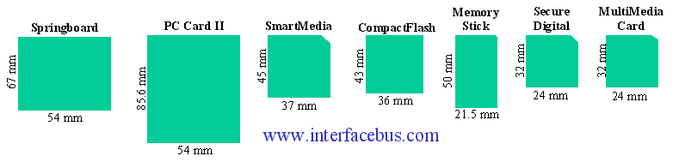

Figure 4.1.7a.1 Different Types of Flash Memory Cards
Reprinted with permission from http://www.interfacebus.com/

Execution became the primary focus as different ways were searched to incorporate a storage device that would be able to record the amount of the data needed per situation. The SD Card interface proves to be a prime candidate for the MTEC, primarily for its reliability, portability, ruggedness, cost, and ease of use.

Many SD card manufacturers offer warranties on their Flash storage devices which guarantee their devices are free from defects in material and workmanship, providing security in knowing that data can be dependably stored for analysis. The SD card is a form of solid state memory which does not contain any moving parts which disqualify it from any mechanical failures that hard disk drives may be prone to. Also different from hard disk drives, solid state memory run at a much cooler operating temperature due to the lack of moving parts. A cooler operating temperature provides for more stability under normal operating conditions. Not only does solid state provide for a cooler nominal temperature but runs silently which may affect the user environment depending on his or her situation.

The physical form factor of the storage device plays an important role in its function. The SD provides a small physical footprint in which the user can easily move the MTEC from one testing environment to another without much effort. Providing for a lighter device reinforces the portability aspect the group is trying to achieve. The user would also be able to archive and store multiple volumes of data easily through the small storage device. SD cards are effortlessly exchanged between different MTEC’s, testing environments, or between different computers which allows for parallel testing of multiple materials in different testing environments, allowing for efficient analysis under time constraint situations.

According to Kingston Technology, their flash memory storage devices types also include Error Correction Code (ECC) checking to detect single-bit errors, having a rated error of less than one (1) bit in 1,000,000,000,000,000 bits read (1 bit per 1015 bits read) on their CompactFlash cards. Also Kingston flash data retention featured on several flash storage devices allow for up to 10 years of long-term data preservation which is plenty for material testing relevance.

Lastly, storage capacity proves to be an essential factor in data logging. As the user goes through multiple tests each with varying parameters and materials, a significant amount of data is accumulated with which the user may need to analyze. The high capacity of the SD card will allow the user to maintain large amounts of data at a time per SD card, reducing costs in purchasing multiple storage devices. The SD cards come in various sizes ranging up to 4 GB. Another format called SDHC, Secure Digital High Capacity, is rated from 4GB to 32GB capacities but unfortunately is not fully compatible with all SD adapters. Additionally, there is the SDXC (Secure Digital Extended Capacity) format which can theoretically have a capacity of up to 2TB. For the purpose of testing and design, a 2GB to 4GB SD card is sufficient with the amount of data that will be collected for initial testing as well as offer a more realistic price option, as capacity is proportional to cost. If the user needs larger capacities for longer testing period, it would be easier to swap out different SD cards for each testing requirement.

An alternative to the Secure Digital (SD) card format is through embedded flash memory chips which physically stay within the circuit. Located on the PWB, embedded flash memory provides faster read and write speeds but does not allow for any storage expansion. Data communication would be also be implemented through an auxiliary, external system which would take data stored on embedded flash memory and would carry data through supplementary transport line. Although embedded flash memory provides better performance, data transferability requires a supplementary interface between communicating devices (computer-to-MTEC).

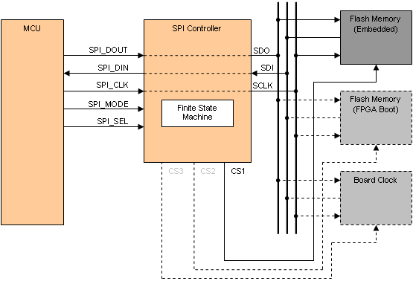

Figure 4.1.7a.2 Microcontroller to flash memory communications
Reprinted with permission from http://www.altium.com/

4.1.7b USB

According to the specification requirements set by the sponsor, there must be a means of data communication between the MTEC and a computer. Communication is vital to the operation of the MTEC as it provides the user to input testing parameters for each testing experiment as well as supply the user with feedback information regarding an occurring or complete experiment. Once the user has downloaded the experimental data, it is analyzed accordingly to any computer equipped with the MTEC’s supplemental software. There are two different ways to achieve total connectivity between the MTEC’s interface to a nearby computer through USB (Universal Serial Bus).

One way to traffic data between two devices is to integrate flash drive support into the MTEC. Adding flash drive support works by inputting initial conditions through the proprietary MTEC software on a local computer. The software packages the incoming data into a readable format in which the MTEC can perceive the initial conditions to run a given experiment. Once initial conditions are set onto the external flash device, the user may transfer the device to the MTEC where an external USB female slot allows the MTEC to receive the experiment constraints to begin testing. This function is similar to the way SD card implementation would be used.

Two different components provide the MTEC with USB flash drive support: VNC1L Vinculum Controller by Future Technology Devices International and MICROCHIP’s AN1145 (which is supported by various PIC© microcontrollers).

Figure 4.1.7b.1 MTEC Using PIC32 Block Diagram

USB flash drives allow for a simple, easy way of transmitting data from the MTEC to the local computer and vice versa. Through the use of application AN1145 for supported Microchip processors (16 and 32-bit), USB embedded host allows embedded systems to use USB flash drives natively allowing for unrestricted data storage. The application of the MTEC outlines that of a data logger, recording information back from sensors in which a load is applied to a specific material. According to Microchip, the file system that is utilized is provided through the installed application which allows the mass storage client driver for communication, permitting interfacing to the flash drive.

A design similar will be used in implementing a USB “A connector” to the MTEC. This will allow the user to directly connect a flash drive to the MTEC. From here, the user can accomplish multiple objectives through the use of USB connectivity. A primary use of the USB flash drive can input initial conditions for the MTEC. The user will be able to start a materials test session without the use of a host computer. With such feature, the user is able to initiate any testing from anywhere as long as the initial conditions can be set onto the flash drive being use. Once connected, the user must keep the flash drive intact with the MTEC. The MTEC uses its capacity to record numerous amounts of data from each testing session. Sensor information is interpreted from the experiment and will be relocated on the flash drive. The user is able to move data back and forth from the MTEC to any host computer at any time as long as the proper commands are given to pause each session in between an action.

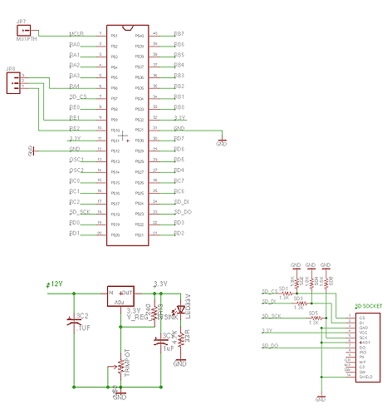
Figure 4.1.7b.2 SD Card Schematic

By taking advantage of the VNC1L Vinculum controller, the MTEC allows another means of interfacing the microcontroller with fully functioning USB 2.0. Using the Vinculum controller allows more versatility in choosing a microcontroller to centralize the design around. Rather than using application AN1145, only available on specific microcontrollers, VNC1L expands the selection of microcontrollers. A separate co-processor adds within the integrated circuit to accommodate the file system along with onboard memory. Basically an extension of the primary microcontroller, the VNC1L costs more than the alternative. Not only does cost becomes an additional factor, optimization of the hardware placement becomes an issue as physical space within the MTEC becomes cluttered with components.

Although both components allow for the integration of USB flash drives to the MTEC, various factors are taken into account such as cost, complexity, practicality, reliability, and ease of use.

Another method of USB connectivity is to create a port in which the computer may communicate through. The user connects a USB cable from the MTEC to a computer; instantly, the computer would recognize the MTEC as external hardware in which a COM port would be assigned to the MTEC. Such methods are readily available through PIC18, PIC24, and PIC32 families of MICROCHIP. The proposed USB-COM method allows direct data interpretation from the user to the MTEC but requires close proximity between the computer and MTEC at all times, reducing convenience.

4.1.7c Wi-Fi

Another method of transforming data from the MTEC to the user is one popularly found on all modern laptops, Wi-Fi. Adding the capability of Wi-Fi to the MTEC allows the user adaptability when moving around the location of the test. The user is able to monitor current material test as well as others around the proximity. When considering Wi-Fi, one must consider two different modes in which the Wi-Fi can be applied to the MTEC: infrastructure and Ad Hoc mode.

In infrastructure mode, the MTEC connects directly to a wireless access point, which is hard lined to a broadband modem. The following setup permits wireless Internet connectivity to the MTEC. The user may then configure a network setup in which the MTEC communicates wirelessly with a remote server to store information from the current materials test. Web based solution requires the user to view the necessary information where he or she has Internet access. Also, multiple users can easily view the same information all at once, promoting parallel workflow among work groups. As material testing may run for long periods (up to several months), close maintenance is not needed as data is being collected to the MTEC and uploaded to a remote server. As rapid expansion of available Wi-Fi internet access becomes readily available, remote data access may serve a more practical, broad use in the new future.

Additional features seem boundless as the use of Wi-Fi can allow the MTEC to reach other characteristics seen in other household applications. If the user needs a physical copy of the data collected from the sensors located at the testing environment, he or she may be able to connect to any Wi-Fi enabled printer and print a copy of the data. Data can be presented in multiple ways to the user. Point specific data can display load at a certain point in time, giving the user an idea of typical load and creating a function to predict future loads.

Another possible feature that attributes to the MTEC allows the user a wireless storage device. Many top rated network routers include the capacity to add network storage device simply through USB. The MTEC interfaces with the network router to upload data to the router. This creates an alternative data output path for the user, increasing storage data to unlimited amounts.

Additionally, Ad-Hoc mode is another wireless solution that demonstrates usefulness in the function of the MTEC. Although Ad-Hoc mode requires close proximity when computing, it offers relative flexibility between the user and the MTEC compared to the wired alternative. In laboratory work, multiple instances of material testing may occur in which the user may need to collect and monitor data from various sources. If given the Ad-Hoc method, multiple MTECs are able to connect to a single network under which developed software would allow smooth interfacing between all instances of the MTEC. Data is collected simultaneously and analyzed on a single computer without the need of moving from each MTEC workstation, saving time, and money. Ad-Hoc solution requires no wireless internet access point to transmit the data through and little hardware prerequisites other than an interfacing computer and corresponding MTECS.

Figure 4.1.7c.1 Ad-Hoc Mode with the multiple MTECs

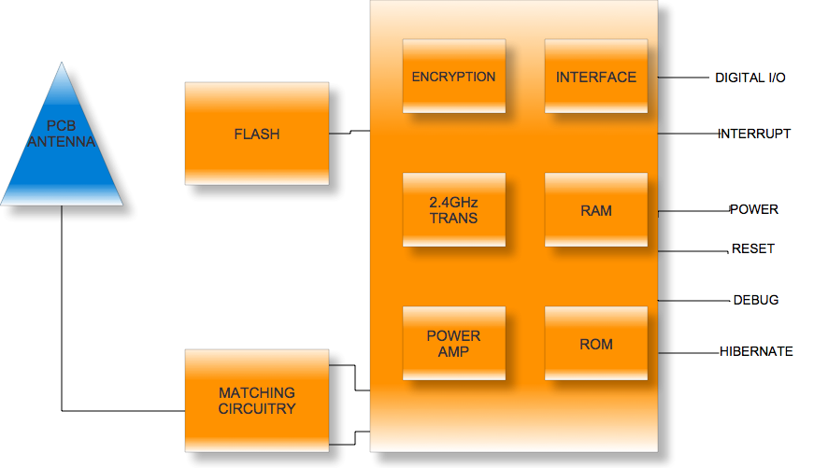

Figure 4.1.7c.2 Microchip’s Certified Embedded Wi-Fi Transceiver Module

In order to utilize wireless communication in the MTEC design, components that provide the necessary Wi-Fi function must be investigated. Microchip offers several components in which many can use in the embedded system design with their 8, 16, or 32-bit microcontrollers. Many of the components accomplish the same goal, to provide designers direct connection to the internet through their embedded modules. Both 802.11 b/g standards are accepted. According to Microchip, the MRF24WB0MA/MB module controls MAC and is connected to the host MCU through an SPI port. There are many reasons to choose these components as they offer simplistic integration into the embedded system profile. Microchip boasts low power consumption throughout their Wi-Fi module as well as low system requirements.

The difference between the MRF24WB0MA and the MRF24WB0MB resides in the PCB layout. Both offer the same applications but the MA model consists of a built in PCB antenna while the MB model supports the use of external antennas. Advantages in a built in antenna on the PCB include the reduction of cost, however, reception may not compare to that of an external antenna which can be reoriented to gain better signal depending on the location. Draw backs, cost and performance, must be considered when choosing between the two models.

Comparatively, the ZG2100M and the ZG2101M are similar models and mirror the MRF24WB0MA and the MRF24WB0MB, respectively. However, according to Microchip website, the following differ in terms of TCP/IP Stack.

TCP/IP Stack and Modules | TCP/IP Stack
TCP/IP Stack and Modules | v5.20 | v5.25+
ZG210x | Yes | N/A
MRF24WB0Mx | Yes | Yes

Table 4.1.7c.1 Comparison of Modules MRF24WB0MA vs ZG2100

The ZG2100M and the ZG2101M are older generation models which may not support newer features that are maintained in the MRF24WB0MA and the MRF24WB0MB. For this purpose, Microchip recommends not to implement the ZG2100M and the ZG2101M in newer designs.

Specific features of these modules include everything necessary for wireless communications in conjunction with Microchip’s microcontrollers:

- Compatible with PIC18, PIC24, PIC32 microcontrollers
- IEEE 802.11b compliant (compatible with b/g/n routers)
- Supports infrastructure and Ad-Hoc networks
- License Free TCP/IP stack support
- WEP, WPA, WPA2 security protocols

In order to start development with any of the models, one must also acquire a development board with broad support. The AC164136 is a daughter board (retails for $59.99) which is compatible with the MRF24WB0MA and can attach to the Explorer 16 and PICDEM.net™ 2 boards for development with PIC microcontrollers. In any case regarding Wi-Fi connectivity, cost is a driving factor in the final design of the MTEC.

4.1.8 Power Supply

Another important part of the project that was left until the end is the power supply section. In order for all components to work, power needs to be generated and transferred to all the components of the project to make it work. The table shown next as Table 4.1.8.1 illustrates all the components of the project and the minimum voltage required for operating.

Component | Power Requirement
Microcontroller | 5v DC
Motor | 6v DC
LCD display | -18.5v DC
LM-555 | 3-18v DC
USB | 5v DC
SD | 3.3v DC
Load Cell | <15v DC
LCD Backlight | 3.1v DC
LCD Display Logic | 5v DC

Table 4.1.8.1 Input power for components of the MTEC

One way to do this is connecting all these components to a voltage generator like in the electronics lab. Due to the absence of oscillators and voltage generators, another way has to be founded to provide power to the device and its components through a wall outlet. A wall gives an AC voltage of 120v and the goal would be to transform this voltage to a lower one through a transformer and then use a rectifier to moderate the voltage to the desired DC voltage required to run the device and its components. If a transformer of a scale 1:10 is used, the power will drop down to 12 volts which will cause a problem for the LCD display since it needs a voltage of about -18. Alternatives should be found and the power supply might use more than one transformer but it will cause a problem in the size of the control box since the power supply will be attached to the device in one housing enclosure.

4.1.9 Enclosure

Once individual components have been implemented, housing will be needed to contain all the necessary components of the MTEC. Electronic components will need a secure place in which foreign object debris (FOD) cannot degrade or alter the sensitive circuitry located on the printed circuit board. Also, housing serves as an insulator to the components so that they prevent shock and do not short other components. For the use of the MTEC, it was decided to utilize a standardized enclosure. Custom housings tend to be very expensive depending upon the manufacturing technique used to create them. Custom enclosures mass produced offset manufacturing costs; for the MTEC, it will need to use a simple, cheap housing that readily available to purchase.

Initially, the MTEC was thought to consist of hardware dedicated input system for the user to generate input conditions to start each testing session. Prototype designs may change slightly as now design requirements will not include the keypad, allowing for a larger screen. Due to specific recommendations, a software dedicated control system will be implemented with the user interface located on the LCD touch screen. The plane facing the user will reduce in component surface space. Fewer components on the physical plane will require a simplistic design for implementation. With more components, design must consider reinforcement upon the working face due to heterogeneous in structure integrity.

As seen in Figures 4.1.9.1 to 4.1.9.3, the MTEC prototype is encased in a simple rectangular base with the closest edge towards the user slanted near the bottom face. The shape allows the embedded LCD display to be within a comfortable viewing angle to the user, as if the MTEC were lying on a flat surface. The design had been carefully structured to be cost effective and uncomplicated. One, that if needed, be could be constructed from scratch materials, or pieced together by an existing, similar housing.
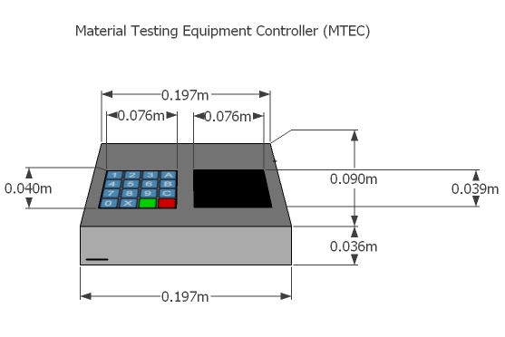
Figure 4.1.9.1 Front View MTEC Prototype A
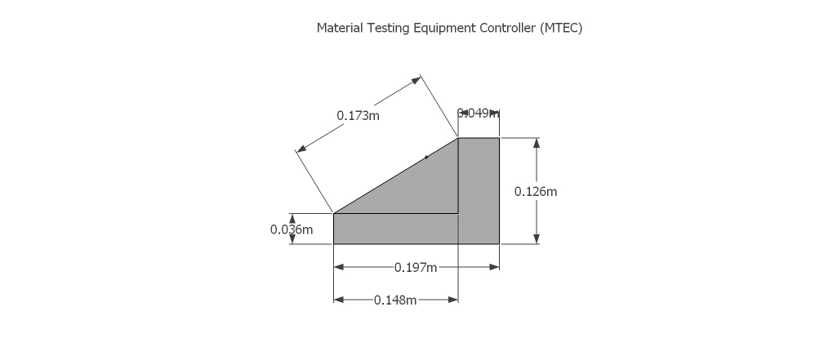
Figure 4.1.9.2 Side View MTEC Prototype A
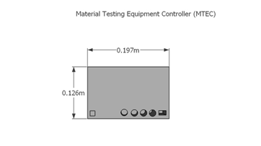
Figure 4.1.9.3 Back View MTEC Prototype A

The dimensions of the MTEC may vary depending on the final design of the printed circuit board, but will stay within the dimensions specified in the CAD illustration. The height may range up to 0.126 meters tall. For design purposes, the height should be minimized in order to reduce the size of production costs and especially weight. The lighter the MTEC, the more portable it will be. One of the major goals for the MTEC underlines portability as a main factor. As for the length, the MTEC may actually be produced at a smaller length of 0.197 meters. At first the design included the use of a keypad for the parameter input for the user. From the conception of the design plan to the actual design phase, the application has changed slightly. At first, the MTEC was viewed to be a standalone device which would allow the user to input testing parameters without the use of a computer, giving the user complete freedom from using a host computer. Now, the MTEC would prove to be supplemental in the interfacing of a computer and a testing environment. As shown in Figure 4.1.9.1, the keypad was located beside the touch screen LCD display. Now, to simplify the design and reduce cost, the keypad has been extracted to provide a dedicated touch interface so the user will rely on the display. This will provide for a simplistic approach toward user interfacing. With less face components located on the top panel, the MTEC’s total volume can be reduced.

Depending on the number of components, depth dimensions are subject to change as well due certain testing applications. In Figure 4.1.9.3, there are four sensor jacks that line up near the bottom of the MTEC. The MTEC may have to incorporate an additional four sensor jack inputs to fulfill design requirements of the sponsor who would prefer up to eight simultaneous load cells gathering data from a single material. This may prove difficult depending on the space given by the PCB board and how the hardware may mount with the selected enclosure. Not only will there be an additional sensor inputs, the SD card sleeve will be located on the front face of the MTEC. This location will be necessary to take note of as it will align with the CAD illustration of MTEC application and design. Other features that were not included at the time of the MTEC illustration are external Wi-Fi antenna support, USB flash drive support and USB-COM enumeration support.

Traditionally, with the current design, the plan was to have access to an external power source located near the back face of the MTEC. Whether or not the power source will be located externally or internally depends on available components and current weight distribution. Locating the power source within the MTEC would increase weight dramatically as well as increase internal temperature as power transformers generate copious amounts of heat when operating. PCB design will alter depending on the location of the power source and various components. USB flash input and USB-COM ports can be added on any of the sides--as the user would most likely place the MTEC adjacent to a testing environment due to sensor inputs. The Wi-Fi component, if available, will lie near the parameter of the PCB to allow for best reception. If external antenna support is included, output will reside towards the top of the backside of the MTEC so to not barricade itself towards any of sensor inputs.

Currently, the LCD display cannot fill the width of the top face for the user to interact with. The PCB board containing the microcontroller as well as any supplemental modules will create the basis of the bottom panel. Reinforcement of the top panel will prove to be important as well. Since the user interface relies heavily on the pressure applied to the LCD touch screen, MTEC must be able to handle the stresses of full load interaction for countless experiments. The longevity of the MTEC is vital within the design goals.

Assembly of the enclosure must be sturdy, as work conditions may be unpredictable depending on each test condition. The user will move the MTEC from several different workstations, so the base holding the entire component must be resilient to friction from other surfaces. Construction material of the housing can be not limited to acrylonitrile-butadiene-styrene (ABS), aluminum, or polycarbonate. ABS provides a solid candidate for the enclosure as it is strong, rigid, commonly available, and very durable. Other characteristics that can be applied to the housing are electromagnetic shielding, or non-flammability. For the purpose of the MTEC, electromagnetic shielding and flame retardant material is relevant in testing load on a material. Depending on available resources, however, a dark opaque housing will suffice. The main constraining factor limiting enclosure sizes is the LCD display dimensions as well as the maximum PCB size for the circuit design.

4.2 Software

4.2.1 Embedded Software

The MTEC will have several software parts corresponding to the items that will be used. The overall aspect of the software in this project is about reading in and translating data, as well as being able to display the data in a useful form for the user to read. There will also be some interaction as far as controlling the MTEC itself.

4.2.1a Block Diagram

The MTEC presented to us required several sensors such as the clip gauge, load cell, and thermometer. The primary location of the software, as well as where the data comes in, will be the microcontroller. The sensors give us the data in the form of electrical signals in analog voltage sent into the MTEC. Once the voltage is converted to digital, the software can be translated into data in terms that we would be familiar with such as Celsius/Fahrenheit or Newtons/Pounds. The readable data is then sent to the LCD touch screen. As far as the display on the touch screen, the data may be graphically displayed in real-time and/or give us the final reading. The data is also stored in a text file and may be stored in some removable storage such as USB and/or SD card if there is one connected to the MTEC.
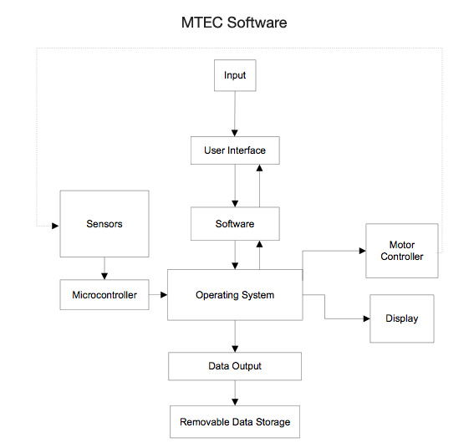
Figure 4.2.1a.1 MTEC Software Block Diagram

4.2.1b Programming Sensors

Bloodshed Dev C++ 4 is the current IDE to be used in developing the software. It is capable of developing programs in C language (as well as C++ if needed later on), which will be used to program the sensors. Dev C++ can also compile programs, which will be useful for test simulations before the software is finally loaded into the MTEC’s microcontroller. The IDE does not use up a lot of memory, so anybody in the group will be able to run it and be able to work on the code.

Dev C++ comes with its own libraries with various functions that will be useful in programming the sensors. If need be, we can also develop our own functions and libraries. Also, if there are any errors encountered, the IDE has a window that lists the errors and their locations. The text is color-coded so it becomes easier in the programming process, which is especially useful to find errors after a failed attempt at compiling the program.

To read the sensors in the microcontroller into a readable format for the user, there needs to be a conversion as the reading directly from the sensor is in analog form. Once an analog-digital converter converts it into digital voltage, the microcontroller takes in the data and the software reads it and applies some mathematical equations to convert the digital voltage into the data that the user is looking for.

Temperature Sensor

The temperature sensor is the easiest to convert and read. For the LM35 temperature sensor, the indicated temperature is read as 1 degree °C per 10 mV. With most sensors, the LM35 needs 5V to be powered, but will also return an output in the range 0V to 5V. The analog-digital converter gives its own range corresponding to what the LM35 directly brings in. With a range of values of 0 to 1024 corresponding to the 0V to 5 V from the sensor, the wider range of integers gives a more accurate conclusion of the temperature readings from the input. After the new value from the converter is determined, the program will run it through a series of equations to convert from the digital-voltage form to a temperature reading form, and afterwards, will be displayed on the touch screen can also be saved onto an SD card in a .txt file.

Load Cell

The load cell is meant to give the user a reading of the force being applied onto it. Similarly like the other sensors, the load cell gives its readings in the form of voltage to be converted. For the process of reading the load cell, it’s rated output, excitation voltage, and sensitivity, and maximum weight yield will be needed. The most work in conversion, again, is in the software doing the calculations with the values it is given with the properties of the load cell. The load cell’s readings will be in mill volts will be multiplied by the indicated maximum weight yield to acquire a value in volt-pounds. The new value is then divided by the sensitivity, which will be in mV/V, and also divided by the excitation voltage that is set into the load cell.

4.2.2 GUI

The main advantage of using the touch screen for this project is that its entire development is in the software. As far as controls are especially concerned, the interface can be changed in the code, which is more desirable than altering a physical control interface for the MTEC. The option for a physical control panel may be available, but the possibility a software control is advantageous as all the information and control would be in one place. The flexibility of change of the code makes the GUI more desirable and convenient during the design process.

Touch screen programming should be treated the same as handling mouse events, so C would be used because it has mouse event handling functions. The user must be able to interact with the interface by pressing on the screen with their finger, which is the equivalent of a mouse click. The GUI includes buttons to be able to control various aspects at the convenience of the user, including going through different menu pages for various jobs. The layout of the GUI should make navigating through the pages straightforward. Unless any additional information is needed, the layout of access of the pages corresponds with the actions of the user and MTEC along with the incoming data and any control settings. Any switching through pages should not interfere with the MTEC as it operates unless an option to halt or alter the operation is pressed or available. Color settings are kept to a minimal as extravagant colors are unnecessary. The page designs should be simple and straightforward.

The GUI must also be able to provide a means for the user to read data given from the sensors (mainly the load cell) as well as simulate the manual controls of the MTEC as it is unsure if there will be just the physical work interface or both the physical and the simulated version. The layout should make it obvious to distinguish between operational buttons, page/menu buttons, or data access buttons. Here, placement is important to group everything into its proper area as best as possible to avoid confusion. This brings another point about the menu pages, as they should also be distinguishable from each other to avoid issues of being on the wrong page. If possible, the entire layout may be better to group all operations in their respective pages rather than mixing different controls on the same page.

In the software for touch screen, there are two levels of access that the user can have to have an effect on what is on display. For direct control, the user has full manipulation of what appears on the screen. Different objects can be added on to the touch screen display such as lines and shapes, and also there are controls to those shapes such as changing the size, altering the shape, rotating, and even filling in the shape. Scroll abilities can be added if there is more information to display than the touch screen can show at one time. The GUI is the other level of access. Here, it describes the way the layout of the interface is managed. The graphics.h library will be put into intensive use as it carries the functions necessary to draw out interface.

The draw functions in Table 4.2.2.1 allow the user to draw any shape on the LCD screen. Also usable for the touch screen, different shapes can be made to indicate hierarchies in the layouts such as buttons or menus. The shapes can dictate the touch areas that the user can see where to press to activate any action on the menu screen. The line function would be good for dividing the layout into sections such as functions and information. The rectangle function is good to use to be buttons or menu boxes. All other functions such as the fill functions can be used to highlight more detail into the touch screen controls and display.

Draw Functions I
- void fillpoly(int n_points, int* points);
- void floodfill( int x, int y, int border );
- void line( int x1, int y1, int x2, int y2 )
- void linerel( int dx, int dy );
- void lineto( int x, int y );
- void pieslice( int x, int y, int stangle, int endangle, int radius );
- void putpixel( int x, int y, int color );
- void rectangle( int left, int top, int right, int bottom );
- void sector( int x, int y, int stangle, int endangle, int xradius, int yradius );

Table 4.2.2.1 Drawing Functions in graphics.h library

Draw Functions II
- void fillpoly(int n_points, int* points);
- void floodfill( int x, int y, int border );
- void line( int x1, int y1, int x2, int y2 )
- void linerel( int dx, int dy );
- void lineto( int x, int y );
- void pieslice( int x, int y, int stangle, int endangle, int radius );
- void putpixel( int x, int y, int color );
- void rectangle( int left, int top, int right, int bottom );
- void sector( int x, int y, int stangle, int endangle, int xradius, int yradius );

Table 4.2.2.2 Drawing Functions in graphics.h library

Text Mode

The mouse functions can be represented in different display modes, text and graphics. In text mode, the visible material on the screen is shown as keyboard characters and then some. The option to encase certain information in boxes is also available to highlight the controls and data. In text mode, the memory usage is lower therefore not much power is needed to handle it due to its simplicity. It would also be easiest to manipulate how the interface should look through the code in text mode, as it is more limited in editing properties than in graphics mode. Figure 4.2.2.1 shows the basic setup of the front page MTEC menu in text mode.

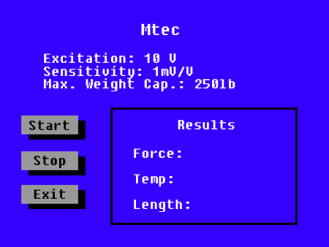

Figure 4.2.2.1 Text mode display

Text mode gives a very simple display, so the layout would generally appear clean. There is not too much detail to work with besides text, buttons, and result boxes, so there would not be any need for lengthy codes for detail.

Graphics Mode

Graphics mode has a much deeper ability of representation and display at the user’s disposal to edit and use. Where text mode is limited to basically characters and boxes, in graphics mode, images can be edited and displayed for design and usage of the GUI. Button images can be designed by the user and placed into the interface as an indication that they are buttons and that they have a function that is activated when pressed upon the corresponding spot on the touch screen. The visual design of the layout is more at the disposal of the editor to edit or change at their discretion. Also, actual graphics can be generated, so the number of ways to display the incoming data from the sensors is plenty. Graphs can be generated to display real time information of the incoming data so the user can have an idea of how the experiment is working in the MTEC. Due to a more complex display for the interface, a lot more memory would be required compared to using text mode and the reaction times would be slower because of the time needed to load all the graphics for each page throughout the menus. Figure 4.2.2.2 shows how the display can look if used in graphics mode. The Start, Stop, and Options buttons should be sizable enough so the user can easily press, and the larger box would display the finished results for the user to record.
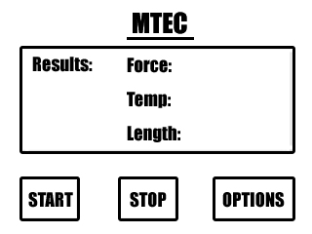
Figure 4.2.2.2 Graphics mode display

Table 4.2.2.3 shows a list of the functions available for the user to control how the windows and graphics interact with each other. These functions are important in implementing the layout of the menus with the operational controls of the MTEC and other functions such as setting the output destination to USB or SD card. In order to utilize these functions, the graphics mode needs to be set to active.

Window/Graphics Functions I
- void closegraph( int wid=ALL_WINDOWS );
- void detectgraph( int *graphdriver, int *graphmode );
- void getaspectratio( int *xasp, int *yasp );
- char *getdrivername( );
- int getgraphmode( );
- int getmaxmode( );
- char *getmodename( int mode_number );
- void getmoderange( int graphdriver, int *lomode, int *himode );
- void graphdefaults( );
- char *grapherrormsg( int errorcode );
- int graphresult( );
- void initgraph( int *graphdriver, int *graphmode, char *pathtodriver );
- int initwindow( int width, int height, const char*

Table 4.2.2.3a Windows and Graphics Functions

Window/Graphics Functions II
- title="Windows BGI", int left=0, int top=0, bool dbflag=false, bool closeflag=true );
- int installuserdriver( char *name, int *fp ); // Not available in WinBGI
- int installuserfont( char *name ); // Not available in WinBGI
- int registerbgidriver( void *driver ); // Not available in WinBGI
- int registerbgifont( void *font ); // Not available in WinBGI
- void restorecrtmode( );
- void setaspectratio( int xasp, int yasp );
- unsigned setgraphbufsize( unsigned bufsize ); // Not available in WinBGI
- void setgraphmode( int mode );
- void showerrorbox( const char *msg = NULL );

Table 4.2.2.3b Windows and Graphics Functions

Table 4.2.2.4 below shows the values for different functions showing the initiation of graphs using three different settings: graph driver, graph mode, and path to driver. All are in the initgraph ().

Setting
*graphdriver | Reads the integer to determine what graphics driver to use
*graphmode | Reads the integer to determine the initial graphics mode
*pathtodriver | Reads the directory for graphics drivers

Table 4.2.2.4 Values for initgraph()

Mouse Events for Touch Screen

As mentioned earlier, programming how the touch screen works is similar to working with a mouse. The way the mouse is used to click, press, and hold on the screen, whether where it is clicked is for a function or menu navigation, is how a press of the user’s finger on the screen will be programmed. The location of where the interface of the screen would have to be calibrated with the digital side of the GUI. For the GUI of the MTEC, the usability on the user’s part will be limited to just pressing on the screen. Buttons will only need to be pressed once, so there will be no option to keep any button or other to be pressed on hold, as it is unnecessary.

Table 4.2.2.5 shows all the different functions for the mouse and their corresponding values for the AX registers. Since the MTEC will involve a touch screen, the actual mouse is not needed since all the work is done by the touch of a finger. In that case, the function to show the mouse pointer will not be needed as the mouse does not need to be seen, so the function to hide it will be used so it does not interfere with the user’s experience while working on the screen. The mouse position function will be useful in indicating the areas that are pressed on the screen and if it corresponds with any button or menu option on the GUI. The mouse button press function will be one of the most important as it will be the indication that a finger has been pressed on the screen. More so, the only indications that will be of use are when the left button is pressed and if there is no button pressed, as there will only be one finger involved. Setting the horizontal and vertical limits may not be needed, so will not be used in the code.

With the mouse functions, the user will be able to emulate the click of a human interface device such as a mouse or tablet pad. As the user utilizes the LCD touch screen of the MTEC for material testing use, he or she will need to interface with the display directly without the use of additional equipment. Thus implementing a touch screen display allows for a standalone function and a reduced cost in obtaining hardware for experimentation.

The functions in Table 4.2.2.6 set the properties of the text that will be displayed on the touch screen menus. Being able to use textheight() and textwidth() to set the size of the text on the screen will help give flexibility in designing the menu layouts. Settextstyle() will be useful in setting the font best suited for display for the user to read.

As far as touch screen templates go, there are projects online made available that can be used in various ways to display information on the touch screen. The essentials would be the labels (i.e. Force, Time, etc), buttons, and even real-time graphs.

There are 4 wires for the actual interfacing for the touch screen that correspond to the x and y values on the screen when finger contact is made. The display has it’s own built in fonts, but we may also create our own fonts for our desired interface. The button can be sized however we see fit.

Input | Function | Return
AX = 0 | Mouse Status | AX = FFFFh if mouse support available  AX = 0 if mouse not available
AX = 1 | Show Mouse | N/A
AX = 2 | Hide Mouse | N/A
AX = 3 | Mouse Position | CX = X Coordinate  DX = Y Coordinate
AX = 3 | Mouse Press | BX = 0 No key pressed  BX = 1 Left button pressed  BX = 2 Right button pressed  BX = 3 Center button pressed
AX = 7  CX = Max_X1  DX = Max_X2 | Set Horizontal Limit | N/A
AX = 8  CX = Max_X1  DX = MAX_X2 | Set Vertical Limit | N/A

Table 4.2.2.5 AX registers for mouse functions

Text Functions
- void gettextsettings(struct textsettingstype *texttypeinfo);
- void outtext(char *textstring);
- void outtextxy(int x, int y, char *textstring);
- void settextjustify(int horiz, int vert);
- void settextstyle(int font, int direction, int charsize);
- void setusercharsize(int multx, int divx, int multy, int divy);
- int textheight(char *textstring);
- int textwidth(char *textstring);
- extern std::ostringstream bgiout;
- void outstream(std::ostringstream& out=bgiout);
- void outstreamxy(int x, int y, std::ostringstream& out=bgiout);

Table 4.2.2.6 Text Functions

5- Design

5.1 Hardware

5.1.1 Microcontroller

Perhaps one of the most difficult tasks of the design process was choosing a microcontroller. Because of the complexity of the MTEC, it was virtually impossible to select a microcontroller without addressing the design specifications of every other component of the device before. After achieving this, however, it was still difficult to narrow down the options because of them many microcontrollers available in the market. Table 5.1.1.1 compares several popular microcontrollers considered for implementation in the MTEC.

Specs | Atmega328 | PIC 16F87X | PIC18FXX2
Pins | 28 | 28 - 40 | 40 – 44
I/O | 23 | 33 | 12
ADC | 8-channel 10-bit | 5 or 8 channel 10-bit | 8
Voltage | 1.8 – 5.5v | 4 – 5.5v | 2 - 5.5v
USART | Yes | yes | Yes
PWM | Yes | yes | Yes
Timers | 3 | 3 | 4
EEPROM | 1 k | 256 * 8 bytes | 256 bytes
Program Memory | 32 k bytes | 14.3 k bytes | 32 k bytes
Source/Sink Current | 20 mA | average | Average
Max Clock Rate | 20 MHz | 20 MHz | 20 MHz

Table 5.1.1.1 Microcontrollers Comparison

From this comparison it was determined the PIC microcontrollers, manufactured by Microchips, would be the best match for the MTEC. This type of microcontrollers is well known for their low price, high performance, and practicality. Among engineers, this brand of microcontrollers is a popular choice for embedded applications. However, because of their easily applicable design, they have become a popular choice among hobbyists and electronic enthusiasts.

To be able to address the complexity of the MTEC design, it was determined PIC18 MCU would be the best choice. This family of microcontrollers is a very popular choice in embedded application of this magnitude because of their low price, and high performance. Because of the memory requirements necessary to operate the multiple actuators, the load cells, and the display, it was determined a MCU from the PIC18LF series would be adequate. This series contains the most efficient microcontrollers in the PIC18 family.

Choosing the best match from the dozens of PIC18LF available was an arduous task. It was determined that, in order to for the MTEC to the performed all the necessary tasks simultaneously during operation, a microcontroller with a large among of memory would be required. To satisfy these requirements, the PIC18LF46K22, shown in Figure 5.1.1.1, was chosen as the microcontroller of the MTEC. It was determined this particular model is powerful enough to perform all the desired tasks of the device during operation. Also, that it is capable of effectively handling all the subcomponents of the device during operation. Table 5.1.1.2 summarizes the features of the PIC18F452.

Features | PIC18F452
Operating Frequency | DC - 40 MHz
Program Memory (Bytes) | 64 KB
Program Memory (Instructions) | 32768 KB
Data Memory (Bytes) | 1536
Data EEPROM Memory (Bytes) | 256
Interrupt Sources | 34
I/O Ports | Ports A, B, C, D, E
Timers | 4
Capture/Compare/PWM Module | 5
Serial Communication | MSSP, Addressable USART
Parallel Communications | PSP
10-bit Analog-to-Digital Module | 24 input channels
RESET (and Delays) | POR,BOR, RESET Instruction, Stack Full, Stack Underflow (PWRT, OST)
Programmable Low Voltage Detect | Yes
Programmable Brown-out Reset | Yes
Instruction Set | 75 Instructions
Packages | 40-pin DIP, 44-pin PLCC, and  44-pin TQFP

Table 5.1.1.2 Features of the PIC18F452
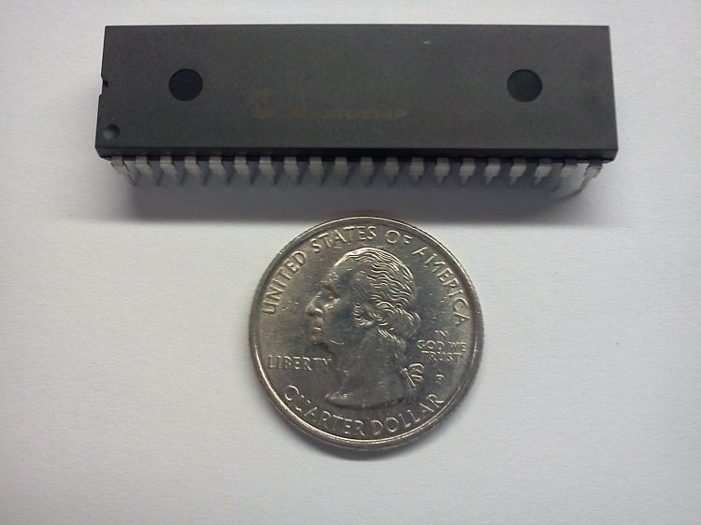

Figure 5.1.1.1 PIC18F452 DIP Package

Another determining factor behind choosing this particular model was its large amount of pins. Because of the many components required to meet the design requirement of the MTEC, it was determined that a microcontroller with a significant amount of pins would be necessary. At 40 pins, the PIC18LF46K22 was capable of meeting the design's requirements. Figure 5.1.1.2 summarizes the vast pin variety found in the PIC18LF46K22.

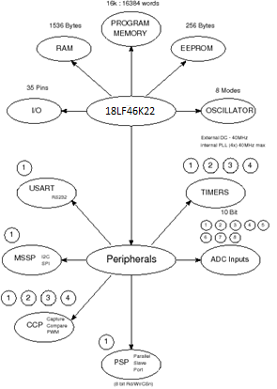

Figure 5.1.1.2 Pin Summary of PIC18LF46K22
Reprinted with permission from http://www.best-microcontroller-projects.com
5.1.2 Sensors

As far as the final MTEC will go, the load cell will be the only sensor used. The sensor will be giving the user the main data s/he is looking for when using the MTEC in the application for the pressure applied on materials and how much the material is affected over time by the strain of the pressure. The load cell will be taking in pressure and sending out an electrical signal that can be translated into numerical data to indicate the force that was applied to it. The linear actuator will be the active motor that will cause the motion of applying pressure to the load cell with the material. Once there is pressure on the load cell, a strain gauge fabricates under the pressure and turns the pressure into an electrical signal.

Figure 5.1.2.1 shows a wheat bridge circuit, which is where the output of the load cell goes before going into the microcontroller. The excitation will be the power supplied to the load cell. The maximum voltage for the excitation of the LCM200 is 15 VDC that will be administered to the load cell to be powered. The load cell will have to be powered while the touch screen portion of the MTEC boots up so the software can load up the GUI for the user to begin using the MTEC. Once the MTEC starts running, the load cell will constantly be sending its output signal throughout the operation to the microcontroller so the user can see the changes in force throughout the process. The load cell is capable of measuring both tensile and compression forces, but for this MTEC project, only compression is needed. The load cell’s tensile and compressive outputs are opposites of each other. If tensile force is being applied to the load cell, it sends out a positive voltage. For the compressing force that this project needs, the opposite would be read instead, so a negative voltage signal would be what’s being sent to the microcontroller.

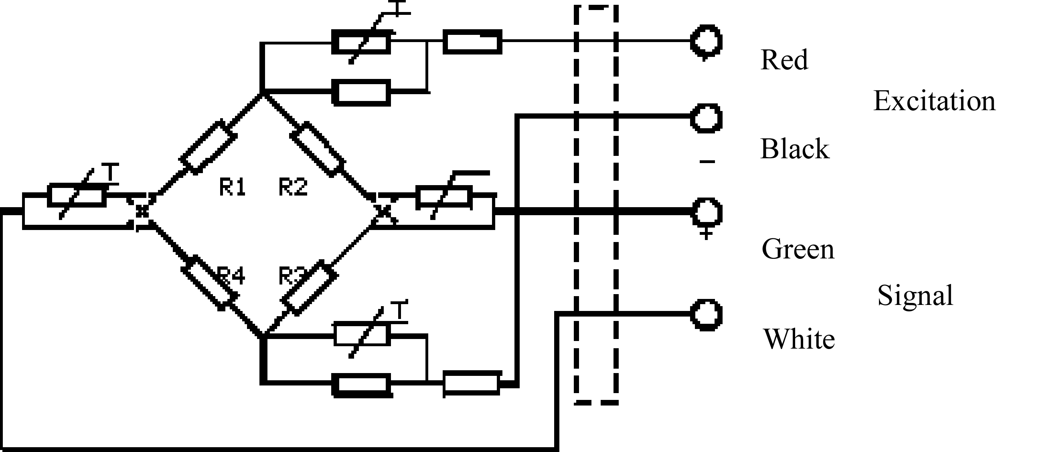

Figure 5.1.2.1 Wheat bridge circuit for load cell

Figure 5.1.2.2 shows the direction the MTEC experiment should go. The LCM200 is in conjunction with the linear actuator to apply the force. While force is occurring, the LCM200 starts sending out analog electric signals, which the analog-to-digital converter will convert the analog voltage to digital voltage. After the conversion, the microcontroller will receive the incoming voltage that came from the load cell and the controller will run the software to send to display for the user.
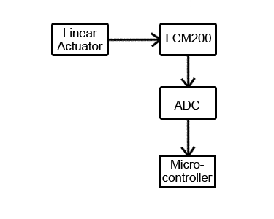
Figure 5.1.2.2 Sensor Interface Block Diagram

5.1.3 Motor & Control

To finalize the project paper, one type of motor had to be chosen for the application at hand. Among all the actuators types, the miniature linear actuator was very favorable to the application. The L12 type made by Firgelli automation seemed to be a good choice especially for its size. The project needed something small and compact like the L12 type. It is designed to move, push, or pull loads along its full stroke length. The speed of travel is determined by the gearing of the actuator and the load or force the actuator is working against at a given point in time. When power is applied to the actuator, it starts to move, if the power is reversed, it moves in the opposite direction. When power is totally removed, the actuator stops moving and holds its current position unless the applied load exceeds the back drive force, in which case the actuator will back drive and its life span might be shortened. Stalling the actuator under power for short periods of time (several seconds) should not have a big effect on the actuator.

In making the model selection for the L12, several factors had to be considered before ordering. Stroke length in millimeter is for how far the actuator should stretch at full power. Gear ratio is related to the amount of force that it can push or pull. It’s very much related to the speed/load graph shown in figure below. Voltage is another factor, even though there are only two choices, 6 and 12 volts. The last factor is the hardest one and it’s about the controller option, there are five to choose from.

In general, the specifications for the L12 regarding gear ratio has three to choose from: 50, 100, and 210. The only one that would fit the project is the 210 one since the desired maximum force needed to be applied is about 25 pounds and the 210 gear ratio for the L12 actuator gives about 150 Newton which is approximately 33 pounds of force. Of course, with the maximum gear ratio and maximum load, comes the slowest speed of 5 mm/s at no load according to the specs shown in Figure 5.1.3.1 and Figure 5.1.3.2.

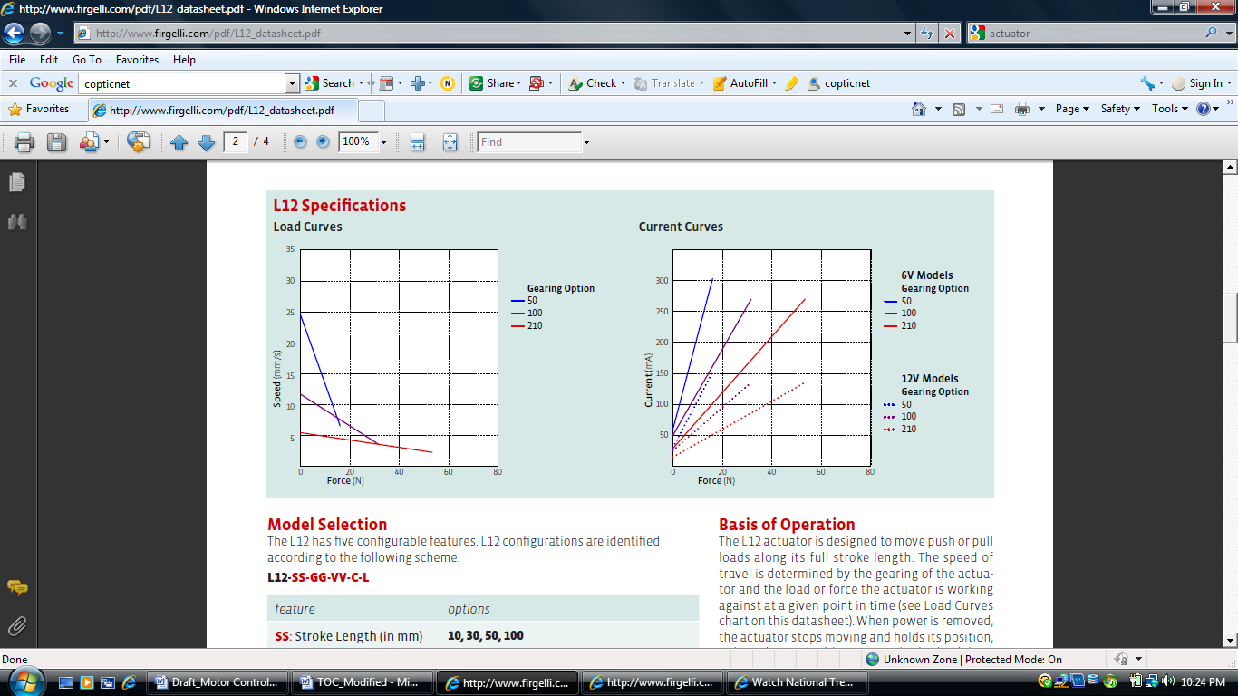

Figure 5.1.3.1 Specs for load curves for the L12 linear actuator
Permission pending from Firgelli Automation

Figure 5.1.3.2 Specs for current curves for the L12 linear actuator
Permission pending from Firgelli Automation

According to the specs sheet, all the L12 actuators come with a lifetime of about 1000 hours at the rated duty cycle. If precautions are taken towards the safest handling procedures towards the actuator, it could last even longer than that. The most important things are not to let the current stall for a long time and not to give more load than its back drive force listed on the datasheet. The duty cycle of the L12 is 20%, so care should be taken in not let run for longer than 20% of the time period. The maximum stalling current is 450 mA for 6 volts and 200 mA for 12 volts.

Aside from the gear ratio, the voltage, and the stroke length, the controller option was the hardest to select since the L12 comes with five different choices. The different types for the controller are: B, S, P, I, and R. Option B is for basic two-wire open loop interface with no position feedback and no limit switching included. Option B is the simplest among all the others; it comes with only two wires to connect for voltage and ground. It was completely excluded since the manufacturer stopped its production. The second option that is very close to the basic type is the S option. It comes with a limit switching feature at the stroke end points. This limit switching feature will stop the power going to the actuator when it comes to within 0.5 mm of its fully-retracted or fully-extended stroke endpoints. Option S for limit switching also comes with two wires for voltage and ground connections.

Option P is for a simple analog position feedback signal. This type has a potentiometer included in it. The position feedback is an analog signal that could be used as an input to an external controller to monitor the actuator stroke position. This option comes with three extra wires other than the two basic ones for V+ and ground. Two of those three extra wires are used for positive and negative reference rail for the potentiometer; the third wire is used as a sliding wiper or a position signal.

Option R is for RC linear servo. The R actuators or linear servos are used as a direct replacement for regular hobby servos and it was excluded from our choices since it could be replaced by option I which has a feature that implement RC servo interface mode.
Option I is the one that was chosen for the project because more than one method could be applied in using this actuator. In addition, upgrades and modification could be done in the future on the same actuator. This particular type has an integrated controller in it. The included controller is not user programmable. On the other hand, this particular actuator could be controlled directly with an external microcontroller without the need of an intermediate circuit in between the MCU and the actuator. It also provides four supported interface modes to drive its stroke. It comes with six wires for connections; two of them are for voltage and ground as usual, the other four wires are used for current input signal, voltage input signal, position feedback signal, and RC input signal.

When power is applied to the actuator, it will scan the three input wires for a valid input signal whether it’s a voltage, a current or RC input according to the four interface modes. When a valid signal is detected, the actuator will self configure to the corresponding interface mode and all the other modes will be shut off.

For the voltage interface mode, wire two is used for input voltage between 0 and 5 volts depending on how far the actuator stroke should be stretched. Position feedback on wire three could also be used for reference as the signal is linearly proportional to the actuator position. The current interface mode is used on wire one for a current input signal between 4 and 20 mA. The RC servo interface mode is wire four and uses CMOS logic for. This mode is for all servo-like applications and uses a voltage input signal of 5 volts positive pulse width signal. The fourth mode, and it’s also the most favored, is the PWM mode that allows control over the actuator using a single digital output pin from an external microcontroller. The desired actuator position for this L12 type is encoded as the duty cycle of a 5-Volt 1 kHz square wave on wire two of the actuator. The percentage of the duty cycle of the wave sets the actuator position to the same percentage of full stroke extension. The waveform must be from 0 to 5 volts in order to achieve a full stroke range.
According to all the previous considerations, the model selection for the L12 is as follows: L12-50-210-06-I. The number 50 is stroke length in millimeter, 210 is the maximum gear ratio that the L12 offers, 06 is the voltage, and option I is for the integrated controller type. All the other specs and data for this actuator are shown in Table 5.1.3.1.

Gearing option | 210
Peak Power Point | 45 N @ 2.5 mm/s
Peak Efficiency Point | 18 N @ 4 mm/s
Max Speed (no load) | 5 mm/s
Back drive Force | 150 N
Stroke option | 50 mm
Weight | 56 g
Positional Accuracy | 0.3 mm
Max Side Force | 15 N
Feedback Potentiometer | 2.75 kΩ/mm ±30%, 1% linearity
Duty Cycle | 20%
Lifetime | 1000 hours at rated duty cycle
Operating Temperature | -10 to +50 Celsius
Storage Temperature | -30 to +70 Celsius
Audible Noise | 55 dB at 45 cm
Stall Current | 450 mA at 5V & 6V, 200 mA at 12V

Table 5.1.3.1 the L12 Specs and Data
5.1.4 LCD Display

To effectively operate the MTEC it was determined some form of display is needed. Such display is supposed to notify the user the status of the testing equipment at all times during its operation. Before starting an experiment, the display must show the status of the testing equipment and the instructions to be executed. After completing these instructions, or after the stop command has been entered, the display must notify the user that the experiment has concluded. The primary function of the display, however, is to inform the user about the condition of the experiment as it progresses. As the MTEC operates the testing equipment, the display must be capable of showing information relevant to the status of the experiment such as time remaining on the test, instructions being currently executed, and data being acquired. Also, the user must be able to see if there is an ongoing experiment or if the stop or pause commands have been entered. To be able to address all these requirement, it was determined a LCD display would be necessary.

As in every other component, reducing the price of the LCD display is of great interest. Because the MTEC would be used in a laboratory environment, resistance to physical damage and vibrations is also necessary. The display, being one of the most exposed components of the device, must be able to withstand a direct strike. However, one the most important characteristics the displays must have is durability. Developing this device is an lengthy and expensive process for the sponsor. It is essential the display, along with the rest of the MTEC, is capable of being operational for a many years. Finally, the display must have the capability of further development if deemed necessary by the user or sponsor. This particular characteristic disqualifies the alphanumeric LCD displays as viable option because of their very limited development range.

To be able to satisfy the necessities of the MTEC, the display must meet all the following physical requirements: low power consumption, standardized electrical parameters, and backlight capability. Because the MTEC is powered by a wall outlet, the power consumption of the display is not a decisive factor. That being said, reducing operational cost is desired. Therefore, a display with low power consumption would be ideal. Also, a display with standardized operational currents and voltages would facilitate the design of the power supply. If the MTEC is used in a field environment, operational temperature of the display would play a crucial role in implementation of the device. As a result, the display must be able of function within the limits of realistic temperatures it could be exposed to. Finally, because the MTEC might be used in a badly lit environment, the display must have backlight capabilities. This would also make data more visible which would facilitate operation.

To satisfy all the requirements previously mentioned it was determined a alphanumeric LCD display would be necessary. This type of display is capable of showing all the necessary information at the desired complexity level. Most importantly, however, it is capable extensive development. If desired by the sponsor or the user, the information displayed can be modified at any time during design process. Because parallel LCD displays are far less expensive than graphical LCD displays or graphical LCD displays with resistive touchscreen, their price significantly reduces the final cost of the device. This type of display is resilient to vibration and moderate physical strikes that may occur in a laboratory setting.

Parallel LCD displays meet all the desired technological characteristics as well. The power consumption on this type of display is incredibly small. For displays within the desired size range, it is approximately one tenth of a watt. Also, backlight is a standard feature among these displays. The ability to turn off the backlight LEDs is possible thorough a small modification in the circuitry of the device. Electrical requirements also meet the desired specifications. Even though there are some variations on the operational voltages and currents of different components within the display module, most logic components and backlight LED could be operated within the standards of other parts of the MTEC. Common operational temperature ranges are more than sufficient for realistic environmental extremes.

The actual parallel LCD display chosen for implementation in the MTEC is shown in Figure 5.1.4.1.

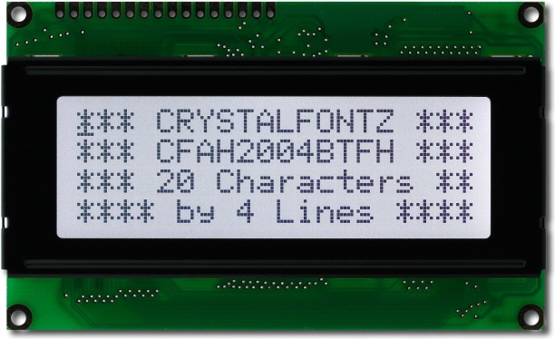

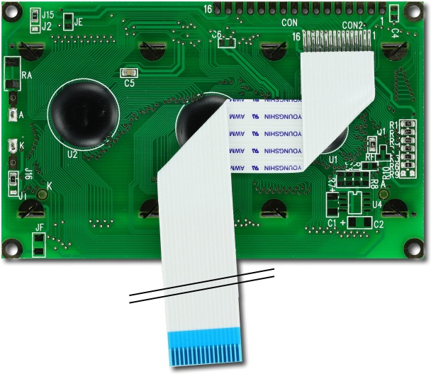

Figure 5.1.4.1 Model CFAH2004BTFH manufactured by Crystalfontz
Reprinted with permission from http://www.cyrstalfontz.com

The model CFAH2004BTFH manufactured by Crystalfontz possesses all the desired characteristics. With its 20 by 4 resolution, it is capable of displaying a lot of information in a single screen. Its display area of 77 mm by 25.2 mm makes it sufficiently large to show all the information relevant to the test. Also, with an overall module size of 98 mm by 60 mm, fitting this part into the enclosure of the device would not be difficult.

The CFAH2004BTFH requires several different voltages to function. All the logic components within the module operate between 3.3 V and 5.5 V. This operational voltage is common among several other components in the MTEC. However, the LCD display itself requires 4 V to function. The LEDs used for backlight operate at different voltages as well. The white backlight requires approximately 3.5 V and, more importantly 48 mA. Because the electrical operating requirements are similar to those of others components already implemented, a small modification in the power supply is sufficient to deliver the logic and backlight LEDs the necessary power. A 31.5 Ω resistor in series with a 5 V node is sufficient to achieve this purpose. Figure 5.1.4.2 shows the previously described configuration.

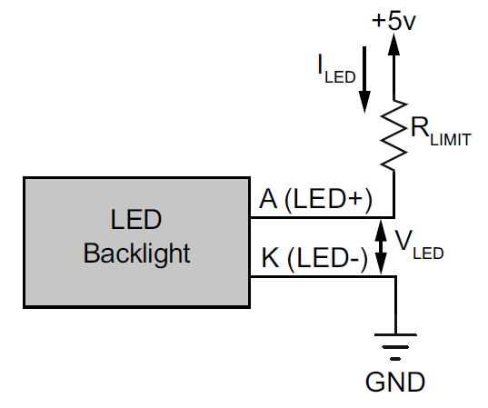

Figure 5.1.4.2 LCD Module Backlight Configuration
Reprinted with permission from http://www.cyrstalfontz.com

In order to deliver the 4 V required to operate the contrast of the display, a trimmer potentiometer is implemented. One end is of the trimmer is connected to the 5 V supply node while other end is connected to ground. The wiper of the trimmer is connected to pin 3, V0, of the display module. This allows the user to manually alter the contrast of the display to his/her preference after product delivery. Figure 5.1.4.3 illustrates the previously described configured.

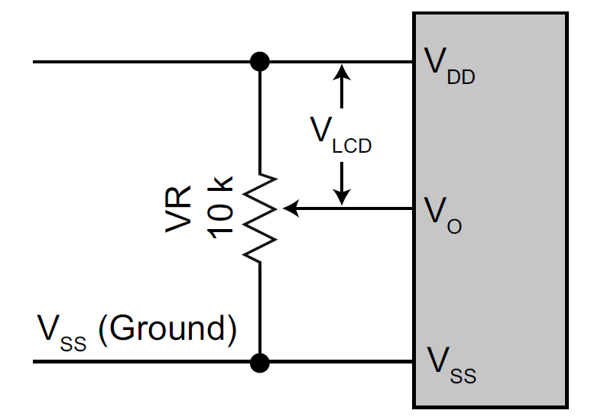

Figure 5.1.4.3 LCD Module Contrast Configuration
Reprinted with permission from http://www.cyrstalfontz.com

This particular model has an operation temperature ranging from -20 degree Celsius and +70 degree Celsius. However, its storage temperature ranges between -30 degree Celsius and +80 degree Celsius. To accommodate both limitations, it will be assume that the temperature range of the CFAH2004BTFH is that of the smaller limit of both ranges. That is, the temperature range in which this display module can be handled is between -30 degree Celsius and +70 degree Celsius. Even so, this operation range is more than sufficient for any environmental temperature reached within continental United States.

There are several onboard ICs used for communication between the module and the microcontroller. Several of those ICs are connected to output pins that will connected to the microcontroller later on. The most important IC found in the module is the display controller. The CFAH2004BTFH comes with a HD44780 controller incorporated within. The primary function of this controller is to provide the necessary interface between the video RAM, which is used to allocate all the text and graphics, and the microcontroller. Also, it generates all the data and timing signals used by other components within the module.

Because the HD44780 is more than capable of handling all the display necessities of the MTEC, the module is implemented through the onboard display controller. This reduces cost as no extra component will be purchased. Also, reduces the size of the circuit. Most importantly however, it facilitates the incorporation process as no further development will be required to accommodate an external display controller. In this configuration, there are more pins connecting the LCD module to the microcontroller.

Interfacing the CFAH2004BTFH to the MCU requires sixteen pins. Pins Vss, Vdd, V0, A, and K are used for the electrical requirements of the module. VSS and VDD power all the logic components of the device as well as the display. Pins V0 is used for the display contrast. Communication between the microcontroller and the LCD module is handled through the control pins RS, R/W, and E. Finally, pins DB0 to DB7 serve as the 8-bit data bus connecting the MCU and the HD44780. Table 5.1.4.1 lists this pin interface between the module the MCU, their function, and their requirements.

Pin | Symbol | Type | Description | Specifications
1 | Vss | Ground | Ground | 0 V
2 | Vdd | Power | Power supply | +5 V
3 | V0 | Power | Power supply for LCD driver | V0= +1.0V typical
4 | RS | Control Line | Register selection input | H: data register L: instruction code
5 | R/W | Control Line | Read and write. | H: RD L: WR
6 | E | Control Line | Read/write enable signal. | H: read data H→L: write data
7 | DB0 | Data Line | Data bus | LSB
8 | DB1 | Data Line | Data bus
9 | DB2 | Data Line | Data bus
10 | DB3 | Data Line | Data bus
11 | DB4 | Data Line | Data bus
12 | DB5 | Data Line | Data bus
13 | DB6 | Data Line | Data bus
14 | DB7 | Data Line | Data bus | MSB
15 | A | Power | Backlight supply voltage | +5 V
16 | K | Ground | Backlight ground | 0 V

Table 5.1.4.1 Display Module Pin Interface

All the previously mention pins are connected to the standard digital pins found in all common microcontrollers. This makes the design process easier as microcontroller choices are not limited by display requirements. Figure 5.1.4.5 shows a simulation of the display module incorporated to a typical microcontroller.

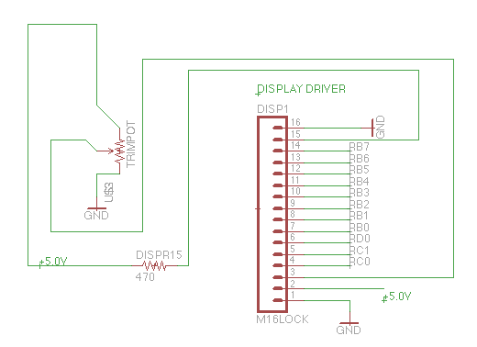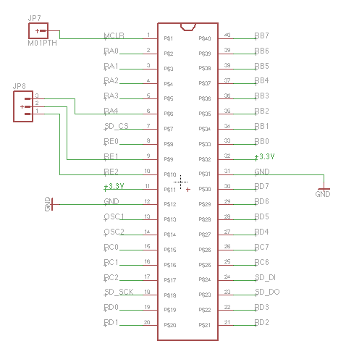

Figure 5.1.4.4 PIC18LF46K22 Interface with the Display Module

5.1.5 Data Connectivity

SD Card

In order to fully utilize the MTEC’s full potential of data connectivity, the addition of SD card functionality is included in design. For full SD integration into the MTEC, and SD socket must be incorporated onto the PCB board. For prototyping purposes the group is using an SD card breakout board provided by Sparkfun.

Introducing the SD card interface with the MTEC must run through SPI mode by the microcontroller. SPI provides a way to transmit data serially back and worth between the MTEC and the SD card. In SPI mode the maximum clock rate is 25 MHz. The speed must be considered when interfacing with a microcontroller of a certain operating frequency. Depending if the frequency is out of tolerance of the microcontroller, data will be unusable to the user.

Providing power to the SD card interface is important for use. The input voltage of the SD card module will be 5V from the microcontroller to the data I/O ports of the SD interface; however, the SD card needs 3.3V to operate. The socket provided will allow the following connections: COM, WP, CD P9, IRQ, DO, GND, CLK, VCC, DI, and CS. Connections will be made from the SD card socket to the microcontroller at pins CS, DI, CLK, DO, CD, and WP. Chip select will connect to the microcontroller. Serial data in and serial data out will provide transportation of information between the experiment and the SD card. Serial cock, card detect switch, and write protect detect switch also interacts with the microcontroller. Fortunately, only four main lines allow the SD card to communicate with our microcontroller: data in (DI), data out (DO), SD clock (SD_CLK), and chip select (SD_CS).

The SD card is one of the main sources of data transfer of the MTEC that allows the user to store the data remotely to be read elsewhere on any other computer device. Interfacing the SD card requires a simpler connection design than the USB to be implemented into the MTEC. By exploring data connectivity options through the MTEC, a better experience will be provided to the user when executing material tests.

5.1.6 Power Supply

For the MTEC, a vital component in the application of material testing is the power source. The impertinent fact for the MTEC is that it relies on the source to operate. As the user uses the MTEC for material testing experiments, key factors in reliability will test the build quality of the MTEC. In conjunction with the components of data storage space, the power supply will serve as the overall piece that drives the machine as a whole. When considering the makeup of the power supply there are two key elements in which we can base the foundation of its power plant.

The primary idea for a permanent power source has been the default selection for the MTEC’s application in material testing; however, a separate, replaceable battery source is also another viable solution depending on each situation. With the primary source of a permanent power supply, the MTEC will gain the most reliability in terms of a constant drive towards all the components. Many of the negative factors that are attributed to a battery source power supply do not apply as the permanent source would connect the MTEC to a 120V AC outlet. A diagram is shown in figure 5.1.6.1

Figure 5.1.6.1 Power Supply Block Diagram

With the permanent power supply, voltage would most likely be stepped down to a nominal operating value depending on the configuration of the components. The alternating characteristic would be rectified to a DC format so that the input supply to the MTEC would be constant. The rectifier component would be designed according to the characteristics defining the load of the MTEC. The rectifier must be able to convert the 120V AC output of the outlet to a DC output into the MTEC of about 5, 10 or 12V DC depending on the series configuration of the MTEC.

Before the voltage from the outlet can be useable to the application of the MTEC, it must first be stepped down to a voltage closer towards an operable value. An isolated transformer must be used in order to obtain the result needed for the MTEC to work. Multiple configurations may work but the MTEC will use the design in order to minimize cost and time dedicated to research and development. The transformer must be able to step down a 120 VAC down to a magnitude of 5, as most of the components operate at around 5 volts. It must be isolated to ensure damage is contained on either side of the transformer rather than affecting both circuits.

The location of the transformer is an aspect of the MTEC that must be carefully considered if the design calls for an efficient and cost effective method. High voltage running through unprotected circuits can cause extensive damage to the components of the MTEC. Especially with the transformer, major power losses take the form of the dissipated heat. Through correct, efficient design, heat dissipation can be reduce with the right components and low current through the lines. Heat will, however, will be dissipated as ideal transformers do not exist in real world applications. In order for the MTEC to manage the characteristic there are two solutions in which heat can be distributed through the MTEC safely.

The first design consists of the transformer built into the MTEC. With this design, the transformer will physically take space within the enclosure of the MTEC. Heat would flow within the MTEC’s housing which causes a problem. In order for heat to not build up within the MTEC and cause operating temperatures to increase, an exhaust fan setup must be implemented similar in a tower PC setup. Since hot air rises, an exhaust fan setup would be ideal near the top half the MTEC. Further design would require an edit to the housing allowing an opening to expel hot air from the power supply. The power supply itself would be located a distance further away from the main PCB as to not cultivate high temperatures around core elements. Further supports would need to be included in the overall structural design in order to house the exhaust fan properly. Also, the inclusion of an auxiliary circuit for the exhaust must be taken into account with the inclusion of the costs for materials.

An alternative design requires the supply to be located externally on the input line. Similar design can be seen in the application of laptop power supplies. In order to increase portability, laptop manufacturers externally extricated internal power supply design and utilized the current design. Heat dissipation is not an issue when discussing optimum air within the enclosure of the MTEC. A similar design can be implemented into the MTEC. By incorporating the transformer on the input line, most of the heat becomes irrelevant towards the PCB and core elements. Implementation would be easy as obtaining the correct step down ratio of input line to output and obtaining a input adapter to interface our input line with the MTEC. Replacing the input line would be easy as purchasing one from any electronic department store. Once the transformer has been finalized in design, the input voltage must be process through the regulator to be usable through the MTEC.

The regulator is an important subcomponent of the power supply. With the regulator, it creates a usable voltage that the MTEC can use without damaging the integrity and surpassing tolerances of each individual component. The regulator must be a long lasting, reliable part within the MTEC as provides protection from fluctuating voltage and abnormal power surge. If the regulator were to fail on the MTEC during an experiment, disastrous consequences can occur harming the user, testing environment, and invalidating testing data. Requirements for the regulator must be safe for use in household applications, since the input will require voltage from the outlet rated at an alternating fashion.

Surge protection is important as variances within the voltage inline to the MTEC do not occur at a constant rate. With the selection of the voltage regulator, it is important to find one that features surge protection as well in order to ensure maximum safety for the user and the MTEC. If the regulator does not feature surge protection inherent within the component, an external may be used in series with the MTEC’s input in order to regulate abnormal perturbations within the input.

Another characteristic the power supply must address is thermal protection. With the input voltage at 120 V AC, power is dissipated in many forms, one of which is thermal dissipation. This type of dissipation works in combination with providing power to the MTEC. As current is being provided from the inline voltage to the MTEC, the power generated does not fully translate into usable power for the MTEC, power losses in thermal dissipation is important to keep in mind. Thermal dissipation is an inevitable characteristic that one must work with but can be reduced using higher quality equipment and efficient design. Staying aware of thermal dissipation must take in consideration with the overall design of the MTEC, as certain component will need to operate in nominal operating temperatures. Once a component reaches out of the nominal operation temperature, longevity of the component decreases and failure rate increases.

When addressing main power supply solution, an alternative design concept creates a useful choice towards permanently supplied power. Instead of connecting the input line of the MTEC to an outlet of 120VAC, the MTEC can be powered through batteries. By powering the MTEC through batteries, a rectifying circuit is not needed. The batteries act as a reservoir of energy for the MTEC to use, supplying DC voltage. The DC voltage does not need to be rectified, however, the amount of energy needed to be powered to the MTEC before the batteries are drained become an issue. By adding battery operation, the MTEC gains freedom to be moved around anywhere near the testing environment or the host computer. The user may interact with the MTEC without the need of an outlet.
Another variation of a battery powered MTEC consists of a rechargeable battery version. This version contains two variants, one where the battery is externally charged and the other relies on a line coming from the battery to an outlet. If the batteries are removable, the user is allowed freedom to charge the batteries at a remote location while another set allows the MTEC operate. The other method includes a built in battery function, where a recharging station located at an available outlet store energy in its battery during off-experiment times. The only drawback when considering a battery operable MTEC is the time management used for each testing experiment. Depending on each experiment, the period of time per each testing environment might be unknown, so the user may be able to predict discharge times of the MTEC. When implementing battery use, the MTEC would be reinforced with a battery indicator, allowing the user to gage the amount of time left for discharge of the batteries. Tests can last for months, according to our sponsor, so a long lasting battery as well as low power consumption design for the MTEC must be implemented for an efficient use of the MTEC along with batteries.

By combining both options line in voltage source and battery operation, the MTEC may be able to achieve a hybrid solution reaping benefits from both methods. The MTEC would be able run from power out of an outlet. If power were to be interrupted, the backup battery would act as an uninterruptable power supply to the MTEC, allowing material testing to continue without disruption. The hybrid would be able to switch between the two methods, if no battery were available, power line in would suffice and vice versa. A negative towards the hybrid power solution to the MTEC is implementation in design (requiring more time) and cost of materials. The hybrid powered MTEC is basically two auxiliary power supplies meshed into one circuit. Both would require time to develop and money to achieve.

5.1.7 Enclosure

The MTEC is a device that is used in conjunction with material testing. For the user, MTEC will provide a means to ensure that data can be transmitted from testing environment to analysis through a simple, easy to use process. To certify that data can be transferred reliably to the end user, the MTEC must be built according to standards that allow the greatest product longevity. Not only will the MTEC rely on high quality inner components, but also the enclosure must match if not exceed that of the inside. The enclosure is important to guarantee protection for the internal workings of the MTEC.
When choosing an enclosure for the MTEC, there are multiple factors, which must be considered. Overall build quality of the structure is important when matching function with form. The National Electrical Manufacturer’s Association or NEMA sets the standard for many electrical equipment enclosures. Listed in Table 5.1.8.1 are a few NEMA type enclosures, which can be associated with the MTEC. For the application of material testing, the MTEC can utilize NEMA Type 1 enclosure. Although, depending on testing environments, NEMA Type 2, 3, and 3S may be useful.

The picture shown in the following figure (Fig 5.1.7.1) is of the enclosure bought from Newark.com for $16; the inside of the box is of the same dimensions of the PCB to be mounted inside of it.
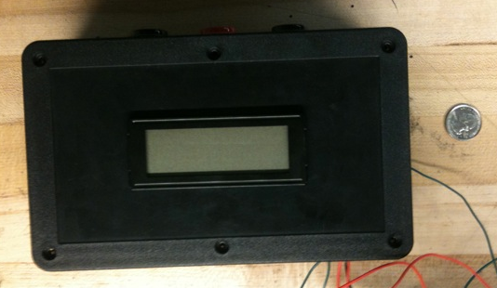
Figure 5.1.7.1 Enclosure

NEMA Type | Definition
1 | General-purpose. Protects against dust, light, and indirect splashing but is not dust-tight; primarily prevents contact with live parts; used indoors and under normal atmospheric conditions.
2 | Drip-tight. Similar to Type 1 but with addition of drip shields; used where condensation may be severe (as in cooling and laundry rooms).
3 and 3S | Weather-resistant. Protects against weather hazards such as rain and sleet; used outdoors on ship docks, in construction work, and in tunnels and subways.

Table 5.1.7.1 NEMA Applicable MTEC Enclosure Types
For the purpose of Senior Design, the group has chosen an enclosure provided by Pactec, their enclosure is modeled the PT-10 Kit. The kit is derived from a keyboard enclosure, perfect with the use of the MTEC, as the user will gathering information from the MTEC on a desktop setting. There are gray panels located on the top and back faces. The panels can be used for connectors, displays, LEDs, keypads, overlays, and membrane switches. External dimensions are measured at 200.7 x 279.4 x 76.2 mm, which is relatively similar to our initial CAD design. Benefits of the enclosure include modifiable panels conveniently located where the vital interfacing parts have been placed, PCB mounting interface within the housing, price, and availability. Interfacing components are available for the user at the back the enclosure, while the LCD display can be placed on the top face, which will be mounted using a custom mount. The price for the enclosure is $28.20. Pactec is located in Sarasota, Florida resulting in a 3-4 business day shipping rate at $9.95 via FedEx. The overall cost of obtaining the enclosure accumulates to $38.15 without FL tax.

5.2 Software

5.2.1 Sensor Interpretation

For the final revised version of the project presented to the group, the temperature sensor and clip gage/extensometer are no longer a part of this MTEC. The main focus has become the LCM200 load cell. The load cell outputs an electric signal that the microcontroller will obtain and convert into data. Figure 5.2.1.1 shows the flow diagram of the data being sent.
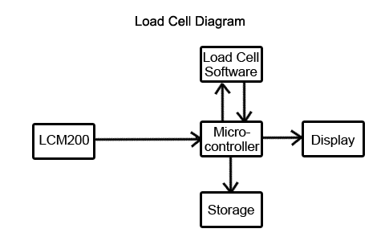
Figure 5.2.1.1 Load Cell diagram of data output flow

The sensor interpretation is done mathematically in the software after the microcontroller acquires the sensor’s output to be read. To read the load cell, the program needs the output in the form of a digital signal. The readings are normally in milli-volts once they get to the microcontroller. The program just needs to take the output value and plug it into a series of equations to be converted into pounds. The equation also needs the rated output, excitation voltage, and sensitivity, and maximum weight yield of the load cell as properties given from the LCM200’s specifications in the equation. The following labels represent the corresponding values needed to fill into the equations to be solved for will be used in the code for the software. Since they are all just values, they will be treated as doubles in order to take into account any decimals in the numbers. Figure 5.2.1.2 shows how the flow math works in solving for the final result in pounds.

- lc_reading - Output value from load cell (mV)
- max_weight - Maximum weight capacity (lbs)
- sensitivity - Rated output of the load cell (mV/V)
- excitation_voltage - Applied voltage to load cell (V)
- volt_pounds - Calculated value (V*lbs)
- force_pounds - Result of force in pounds (lbs)
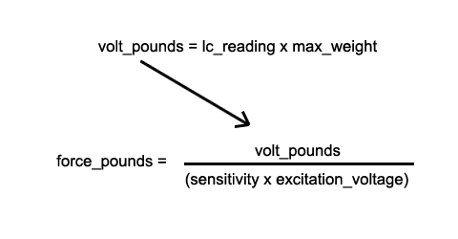
Figure 5.2.1.2 Equations to solve for results in pounds

Aside from the lc_reading, which is given to us, and the volt_pounds and force_pounds, which are has calculated, the other labels already have set values provided from the specifications of the LCM200 as the load cell’s properties as seen in Figure 5.2.1.2. Once force_pounds been calculated, the result will display on the touch screen and the user has an option to save as a .txt file onto a removable storage.

5.2.2 GUI

For the GUI of the MTEC, the touch screen display should be designed in an easy format that looks appealing and not confusing. Aside from the MTEC, the user will be staring at the screen the most and should be able to press on the screen and apply commands without any issue such as accidentally clicking a nearby button. Before the actual coding begins for the menus, the options and layout must be determined. Figure 5.2.2.1 is demo display of what the control menu of the MTEC menu display would look like.

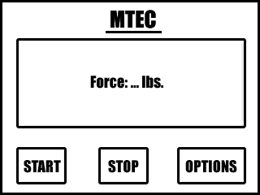

Figure 5.2.2.1 Mock-up of control menu on touch screen display

For the touch screen, the display on the screen is limited to black characters, so the colors seen from the text and graphics modes are not going to be present. This mock-up is just the front of the view. The Start and Stop buttons should send a signal to start and stop the MTEC. While the MTEC is running, the text in the biggest box should read, “Running…” When the stop button is pressed, it should read, “MTEC Stopped,” and then blank. If the MTEC finishes with the material, the resulting force should be displayed. The screen is big enough to present more than just the resulting force, but the other sensors will not be needed for the current MTEC project. The space is still there regardless for any other values that need to be displayed. The Options menu will display a whole new menu from the front page. The MTEC should be able to save the data just read from the sensors into a .txt file that can be stored on a USB/SD card connected.

Boot Up

When the MTEC first boots up, there will be pre-requisites checked so the GUI can display the current settings of the MTEC before any operations are performed. Before the MTEC should run, the entire machine should be properly set up and connected so the software end can verify that it is ready to be used. So before the control display from Figure 5.2.2.1 would appear before the user, the touch screen would display a list of settings for the user to take note of when operating with MTEC on the touch screen such as:

- Load Cell status: Connected or Disconnected
- Linear Actuator Status: Connected or Disconnected
- USB Status: Mounted or Not Mounted
- SD Card Status: Mounted or Not Mounted

If either the load cell or linear actuator are read as disconnected, then the GUI will not load up the control menu and notify the user that they cannot continue until everything is properly connected. In order for the load cell or linear actuator to read, ‘Connected,’ the touch screen controller will read from the microcontroller the voltage value ready to power the MTEC’s components. If at any point the microcontroller returns a value of 0 for any of the sensors or motor controls, it indicates that the MTEC will not properly run if not everything is ready. When the start button is pressed in the control menu, everything should be expected to work in functioning order, if not, then the results displayed will be inaccurate, so it is imperative that before powering on the MTEC, that everything be connected and the power source be ready, so when the MTEC is turned on, the touch screen will recognize that everything is set and ready to be run and will give the user control of the operations and way to edit any other options. Figure 5.2.2.2 presents a visual of the process in what the MTEC should check before continuing forward with any other option all the way to the end.

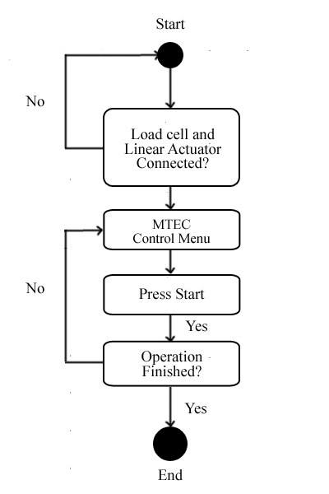
Figure 5.2.2.2 Activity Diagram 1 of regular MTEC operation

The material testing equipment controller relies on these two separate processes in order to fully function and deliver results to the user. Once the operation of the MTEC is finished, the user is granted several options in order to print and store the data that was recorded throughout the process. Giving the user a variety of options to output data will provide an easier experience when material testing. High activity processes must be accountable by the MTEC; design requirements must allocate a certain level of performance when implementing these functions.
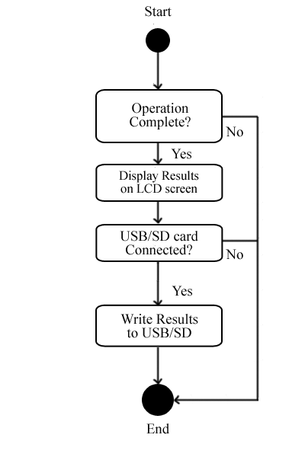
Figure 5.2.2.3 Activity Diagram 2 of regular MTEC operation

The figure also shows the flow of how the output, both from the sensors and the translated output of the results would go depending on the settings that the user edits through the options menu. The user has control of whether or not the finished data should be copied onto removable storage. If neither a USB flash drive nor SD card are plugged in to store the information, then the MTEC will not run the functions to write for removable storage since there would not be a receiver. If the Stop button were pressed, then no results would appear on screen, but instead a notification that the operation has been halted and that the experiment should be reset. The user should be able to refer back in time and see the current forces that were applied from start up until the halt. From that point, the user can still copy the data onto connected removable storage, but the document will read that process was halted prematurely.

External Display

In order to display the data onto another screen, for example, from a computer (ie. PC), there needs to be serial or parallel communication connection between the microcontroller and the computer. LabView is a program that would be able to interact with the microcontroller. The software is available for both Windows and Mac OSX, so it is capable of using either OS to display the data so long as there is the USB connection between the microcontroller and computer.

6-Design Summary

A complete block diagram for the entire design of the MTEC is shown in figure 6.1. The chosen microcontroller will connect all the separate parts of the project. The MCU will connect to the SD card, the USB, the LCD screen, and the linear actuator. The load cell will give the feedback input for the device to adjust the motion of the actuator accordingly.
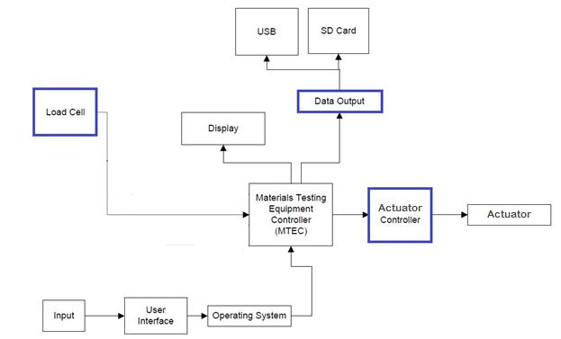

Figure 6.1 MTEC final design diagram

Display

The graphical LCD display with resistive touch screen chosen for implementation in the MTEC is the CFAH2004BTFH, manufactured by Crystalfontz electronics. This display comes in a modular format containing several operational components. Its display area of 77 mm by 25.2 mm makes it an ideal match for the requirements of the device. This particular model has an operation temperature ranging from -20 degree Celsius to +70 degree Celsius. However, its storage temperature ranges from -30 degree Celsius to +80 degree Celsius. To accommodate both limitations, it is assumed the temperature range in which this display module can be handled is between -30 degree Celsius and +70 degree Celsius.

The module uses several different operational voltages to function. All the logic components operate with 3.3 V. The LCD display itself requires 4 V to function. The LEDs used for backlight operate at different voltages depending of the color used. The white light option was chosen because it consumes less energy. In this configuration the LEDs require 3.3 V and 48 mA to operate. Because the electrical operating requirements are similar to those of others components already implemented, a small modification in the power supply was sufficient to deliver the logic and backlight LEDs the necessary power. However, delivering the 4 V required to operate the display required a trimmer.

The CFAH2004BTFH comes with a HD44780 display controller incorporated. The primary function of this controller is to provide the necessary interface between the video RAM and the microcontroller. Also, it provides all the data and timing signals used by other components within the module. There are two ways in which CFAH2004BTFH can be implementation, one incorporating this onboard display controller, the other bypassing it. Because the CFAH2004BTFH is more than capable of handling all the display necessities of the MTEC, the module will be implemented with the onboard display controller option. This will reduce cost as no extra component will be purchased. Also, it will facilitate the incorporation process as no further development will be required to accommodate an external display controller.

In the chosen implementation configuration there are 16 pins interfacing the module to the PCB. Pins Vss, Vdd, and V0 are used for the electrical requirements of the module. Vss and Vdd power all the logic components of the device as well as the display. Pin V0 is used by the display for contrast adjustment. Communication between the microcontroller and the LCD module is achieved through the control pins RS, R/W, and E. Finally, Pins DB0 to DB7 serve as the 8-bit data bus connecting the MCU and the HD44780.

Besides the 16 pins previously mentioned, there are 4 additional pins used to interface the push buttons. Pin LEDA and LEDK are used to power the backlight LEDs. Pins A1, A2, A3, and A4 connect the push buttons to the microcontroller. These 4 pins are not found in the array of pins at the side of the module. Instead, they are found in a flat ribbon cable protruding directly from the side module which is adhered on the top of the display.

Motor

The L12 type made by Firgelli automation seemed to be a good choice especially for its size. The project needed something small and compact like the L12 type. It is designed to move, push, or pull loads along its full stroke length. The speed of travel is determined by the gearing of the actuator and the load or force the actuator is working against at a given point in time. When power is applied to the actuator, it starts to move, if the power is reversed, it moves in the opposite direction. When power is totally removed, the actuator stops moving and holds its current position unless the applied load exceeds the back drive force, in which case the actuator will back drive and its life span might be shortened.
The following figure (Fig. 6.2) shows the used actuator model from Firgelli.com. the other actuators could be around the same size also but might be varied in the maximum applied force, one could go up to 33 lbs and another one could go up to 50 lbs or 100 lbs. The total applied forces by the eight actuators should add up to be 500 lbs. It’s the total force exerted on the material being tested.

Table 6.1 shows the different specifications for the linear actuator chosen for the project. The size was an important factor to consider since all the actuators have to fit within a fourteen inches box.

Model | L12-50-210-06-I
Stroke Length | 50 mm
Gear Ratio | 210 giving up to 150 N ≈ 33lb
Voltage | 6 volts
Interface | I interface for microcontroller

Table 6.1 Actuator Model Specifications

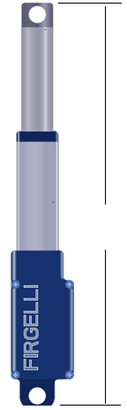
30 cm
Figure 6.2 MTEC actuator model
Reprinted with Permission from http://Firgelli.com

Figure 6.3 shows the displacement transducer that will be used to measure the linear displacement of the material being tested. Table 6.2 shows some of the specifications that were required for the consideration of data acquisition.

Model | LD621
Input Voltage | 10 – 30 volts @ 100 mA
Output voltage | 0 - 10 volts
Displacement | 0 – 15 mm

Table 6.2 LVDT specifications
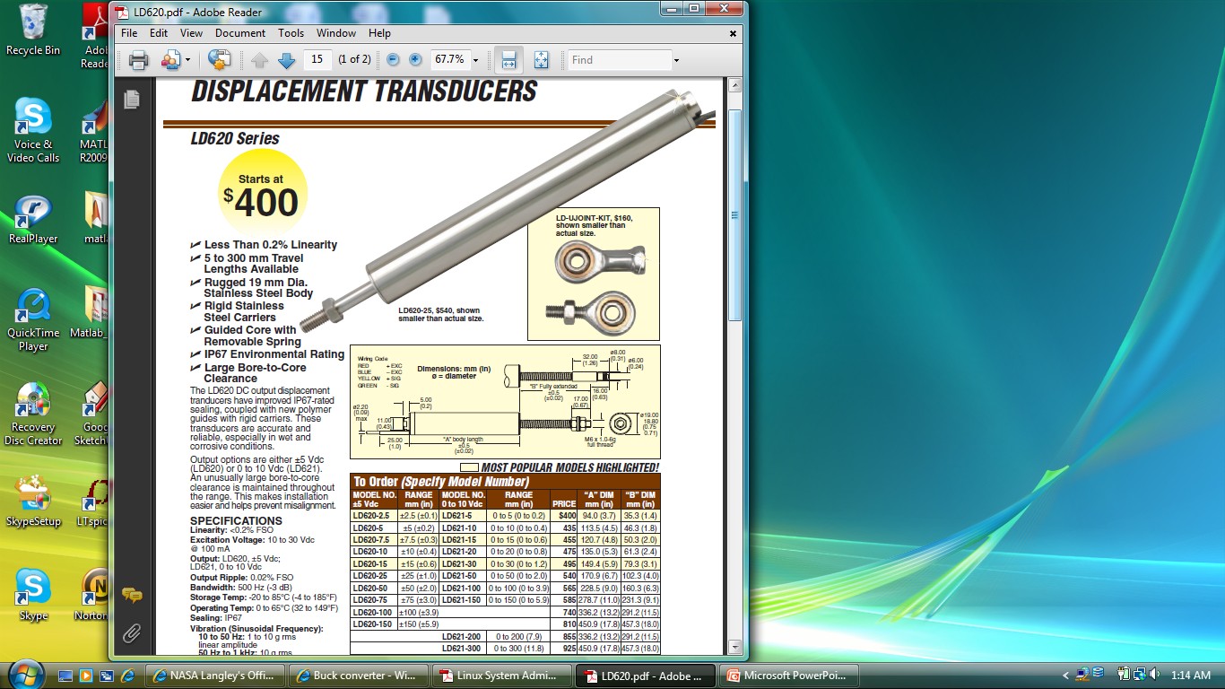
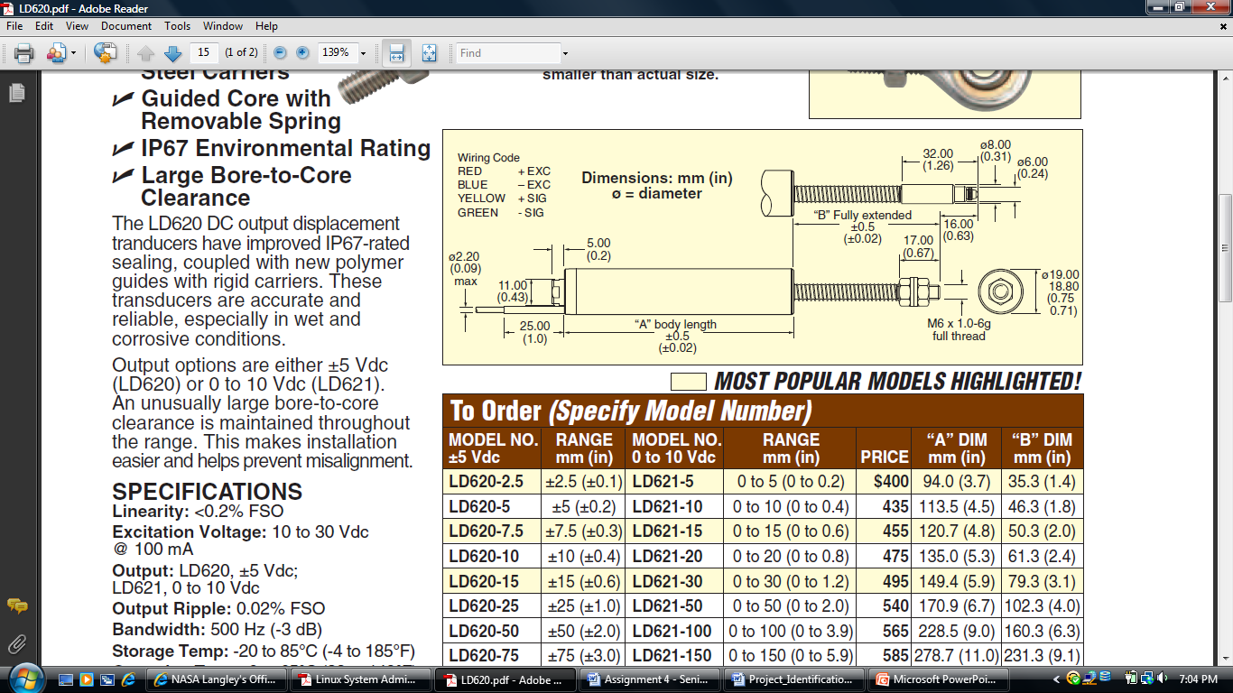
Figure 6.3 Displacement Transducer
Reprinted with permission from http://Omega.com

Power Supply

It will be necessary to design a multi-load power supply to run the system. To accomplish this task, a source option must be acquired that meets the voltage and current requirements of the system. In addition, software for design purposes must be explored and the best solution chosen. The main source will come from the wall outlet that provides 120 volts AC and then it will be transformed through two transformers to supply the voltage for all the components of the project. The problem is due to the variety of components that need power so just getting a lower voltage through the transformer will not be enough. Rectifiers along with voltage regulators will be used to adapt the voltage down to the specifications of every device included in the MTEC.

The choice for a power supply would be to use the standard US wall outlet with a 120/240V, 60Hz output. This can be turned into a desired DC input, but would require the creation of an AC/DC converter circuit or purchase of one. It would also need to step down the voltage greatly from 120/240V to prevent any unwanted destruction of the MTEC components. This could be done with resistors attached to the converter circuit or by using transformers. The use of such would also add increased risk of electrocution as the converter circuit would ideally be attached to the user so the only thing that would not be attached to the user is the power cord itself. Because of the inherent danger associated with using wall outlet power and the low consumption nature of our devices this will be largely an auxiliary choice. Also, there is a portability issue associated with this option.

As seen in the block diagram of figure 6.4, the main voltage provider is the wall outlet giving an AC of about 120 volts. The voltage will be brought down through the use of regulators or AC/DC converters to the limitations of every component included in the MTEC. The LCD has three inputs as shown in the figure. One input would be for IC display controller taking 5 volts DC, one is for the LCD itself that needs exactly -18.5 DC voltages, and one input is for the LED, for the back light that requires 3.1 DC voltages. For the data transfer components, each one of them requires a separate input voltage.

The SD card requires a DC voltage of 3.3 volts and the USB requires a Dc input of5 volts. The load cell used will require a variable input voltage up to 15 volts and it could work with either AC or DC inputs. The linear actuator chosen has an input voltage requirement of 6 volts DC. The last input voltage requirement and probably the most important is the microcontroller one and it takes 5 volts DC input. Adjustments will be made accordingly using linear regulators and switching regulators to provide accurate voltage inputs to every component in the MTEC.

There are many ways to convert the power from the wall outlet to pertain to the different parts. Step down transformers could be used to reduce the voltage from 120VAC to a target voltage of 20V. Through the use of linear regulators and switch regulators, a smaller voltage can be supplied to each of the individual components of the MTEC. It is important that each component is supplied with a regulated voltage without perturbation in order to ensure operating stability and component integrity.

Table 6.2 below shows the advantages and the disadvantages of using switching regulators versus linear regulators. LM 7805, LM7806, and LM 317 are all used to provide power to the digital components that require 5, 6, and 3.3 volts. The adapter used is a wall adapter that takes 120 volts from the wall and converts to +12 volts DC and then provide power to all the regulators.
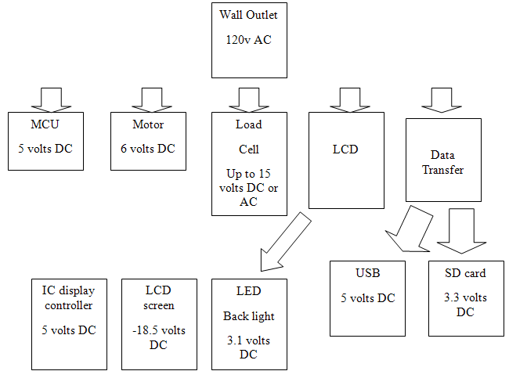

Figure 6.4 MTEC Power Supply

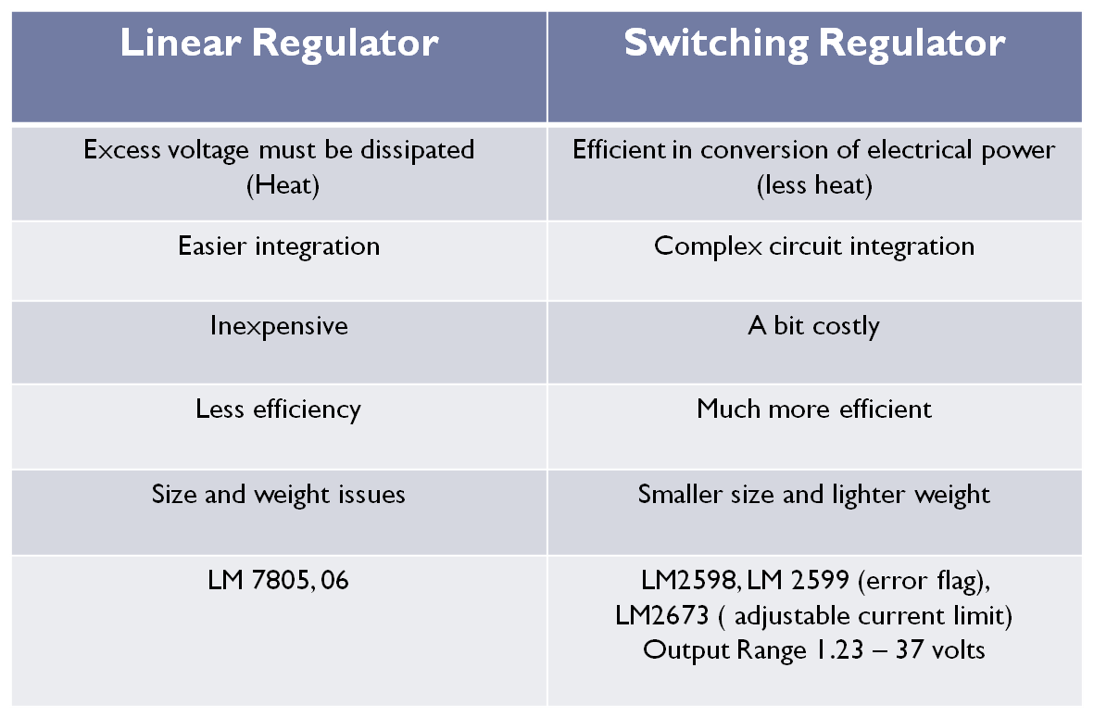
Table 6.3 Switching and Linear Regulators

Data Management

The MTEC is a device in which data is constantly streaming towards the end user during a testing environment sequence. In material testing, it is important for the user to rely on the equipment he or she uses. In order to improve data gathering, the sponsor has envisioned a device that could be run independently of the host computers. The MTEC provides storage for important information, which can be viewed and analyzed at the discretion of the end user. In order for the MTEC to fulfill its current objectives, data storage remains an important aspect of the MTEC. By reaching goals towards SD and USB interfacing, the MTEC can become a more useful tool in material testing and provide a more whole and easier experience compared one bounded by proprietary hardware.

SD interface

In order to integrate an SD card interface, an SD socket must be obtained from any available manufacturers. Sparkfun provides a plethora of high quality electrical components and will allow the MTEC to utilize its SD socket component. SD card interfacing will take advantage of the microcontroller’s SPI (serial peripheral interface); data will be read from the SD card to the microcontroller or written from the microcontroller to the SD card. The SD card will need a 3.3V input voltage from the power supply and will need connections at pins CS, DI, CLK, DO, CD, and WP between the socket and the microcontroller.

Another component that the MTEC will rely on storing data is the USB module. There are two different ways the MTEC can take advantage USB. One method applies the VNC1L component of FTDI, which allows USB interaction between almost any microcontroller using a UART, SPI, or FIO MCU interface. This proves useful as the MTEC can benefit through the use of a wide variety microcontrollers on the market. Prototyping will call on the VDIP1, also produced by FTDI. It is a dual inline pin designed using the VNC1L base for development purposes. This allows the flash drives to interact with the MTEC using a connector “A” type (standard by all USB flash drives). Full implementation can be seen in schematic form in Figure 4.1.6b.2. An alternative to using the USB flash drive method consists of a USB-COM method, which is in further development. The alternative allows for a direct connection between the MTEC and a host computer; the host computer recognizes the MTEC as a COM-port allowing data flow between the two devices. Interfacing the MTEC and the host computer will rely on a USB connector “B” type.

Wi-Fi offers a complete data output scenario for the MTEC as accomplishing wireless communication will offer a full range of data connectivity options. As development increases and budget allows for full implementation, Wi-Fi may be added as an optional component. Using Microchip’s MRF24WB0MA module, Wi-Fi can be implemented with PIC18, PIC24, or PIC32 microcontrollers.

The enclosure provides protection and support for fragile internal components of the MTEC. Depending on each testing environment, the MTEC must be able to stand unpredictable conditions; the housing must be able to mount several components: PCB, LCD display, sensor inputs, and interfacing ports. The enclosure must be easy access to the user for physical inspection or debugging. Figure 5.1.8.1 is the prime candidate for MTEC housing as it uses screws to secure the top and bottom half together. Overall design shows very similar characteristics to the CAD mockup of the MTEC (as seen in Figure 4-1 to Figure 4-3). Top and read faces are modifiable, allowing LCD display mount on the top and rear ports on the backside. Housing interior features a PCB mount through four screws, which should be able to secure the PCB safely within the enclosure. Price of the enclosure remains reasonable within budget ($38) and is available through Pactec Enclosures.

There are two components to the software that make this project, the sensor controller and the GUI. The software components interact with the data of the sensors and also the display menus that the user will be looking at and controlling from.

The sensor controller reads the incoming digital voltage signal from the load cell to the microcontroller and runs its calculations to convert the voltage value into force in pounds that the user needs. The user should be able to control when to Start and Stop this operation from the touch screen, so all the user does is press Start and then wait for the operation to finish. As the operation is going, the results of the process are constantly recorded through time.

The software uses C language for the code to be written in for its ease of use and familiarity. For calculating the sensors, basic C and math is integrated to calculate the desired values.

lc_reading | Output value from load cell (mV)
max_weight | Maximum weight capacity (lbs)
Sensitivity | Rated output of the load cell (mV/V)
excitation_voltage | Applied voltage to load cell (V)
volt_pounds | Calculated value (V*lbs)
force_pounds | Result of force in pounds (lbs)

Table 6.4 Labels for Calculating Load Cell data

If the process completes and is not prematurely stopped, then the user has the option to write the data onto a .txt file and be saved on a USB drive or SD card. The software would check and see if either removable storage is connected to the MTEC, and if not, then the user would be denied the task of writing on the external.

There is also an option to display the results onto an external computer. The means used are through serial communications. Both Windows and Mac OSX computers are able to interact with the MTEC.

The GUI heavily uses the xlcd.h library to be able to perform functions that will be displayed onto the LCD touch screen. The draw functions allow the user to edit what and how objects appear on the screen to act as the buttons or menus of the screen interface. The windows/graphics functions are for manipulating the graphics on the screen, how they work and interact with one another. Basically, the function does some basic management with the interface. The text functions allow the user to edit how the text looks, whether it’s the font, size, or spacing.

In order to interact with the GUI through touch screen, mouse functions are utilized. Operating with touch screen is the same concept as using a mouse, except that touch screen; there is no need for an icon to be dragged since everything is pressed. Otherwise, the mouse’s click properties are the concept used for touching on the screen.

PCB Design

The design for the PCB was split onto two boards, one for digital and then one for analog. The digital board shows the digital components as far as the MCU and all its components, the power is also put on this main board along with the main power jack. The analog circuit for the load cell amplification is duplicated eight times for eight load cells and the divider is duplicated two times for the two LVDT used in this project.

In figure 6.5, it’s shown the Schematic and board for the digital PCB; in figure 6.6, it’s shown the schematic and board for the analog

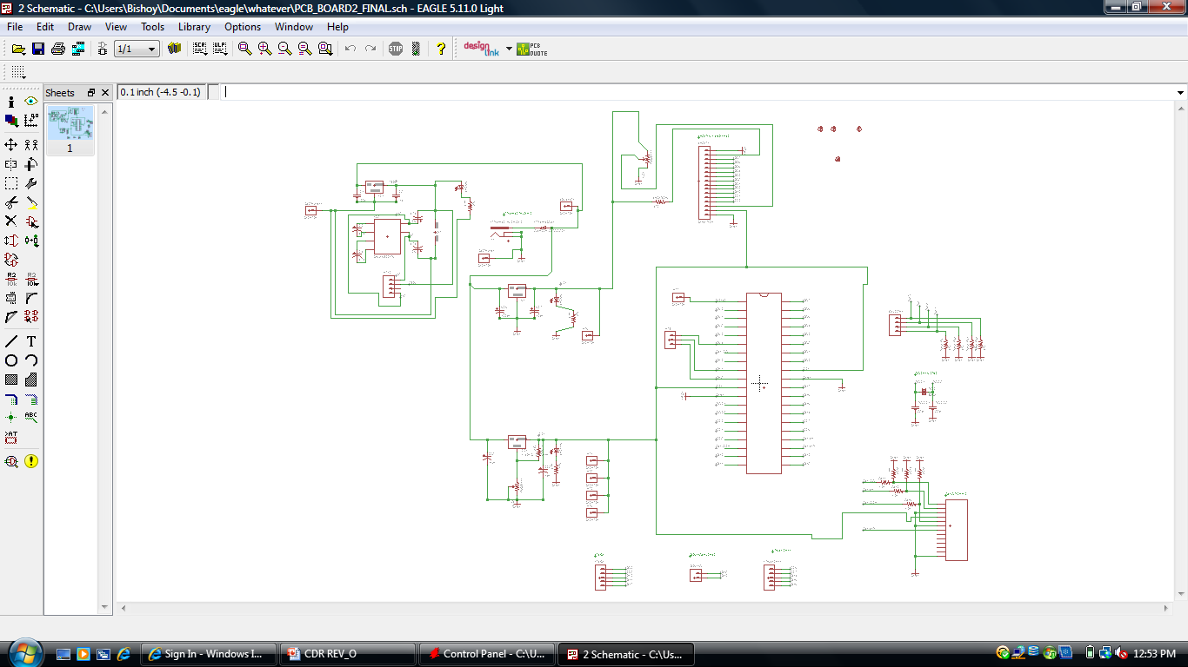

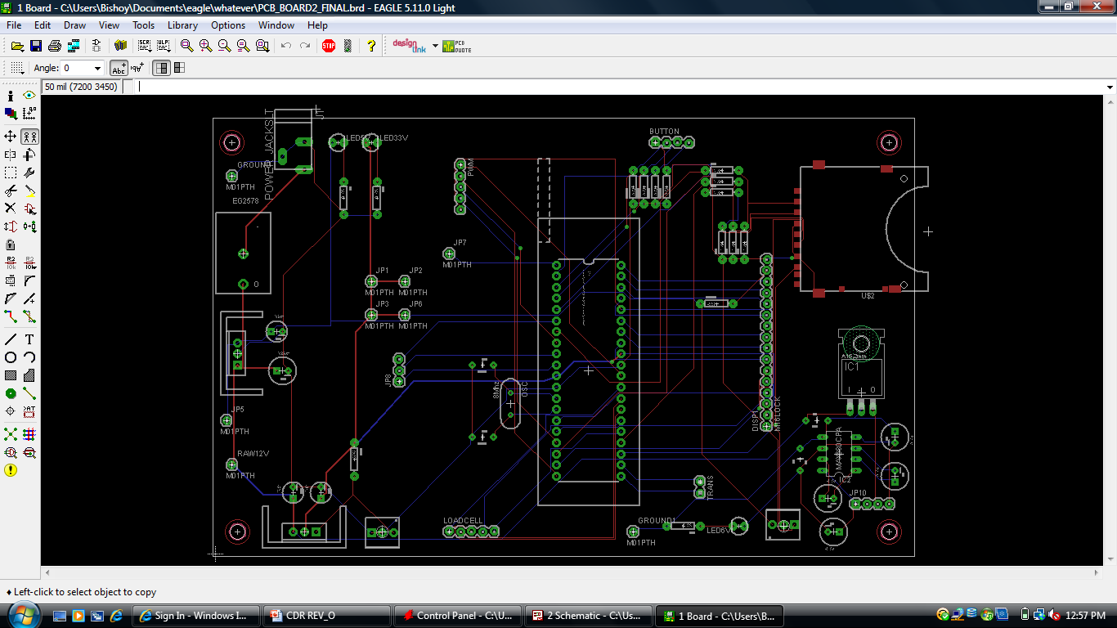
Figure 6.5 Schematic and Board for Digital PCB

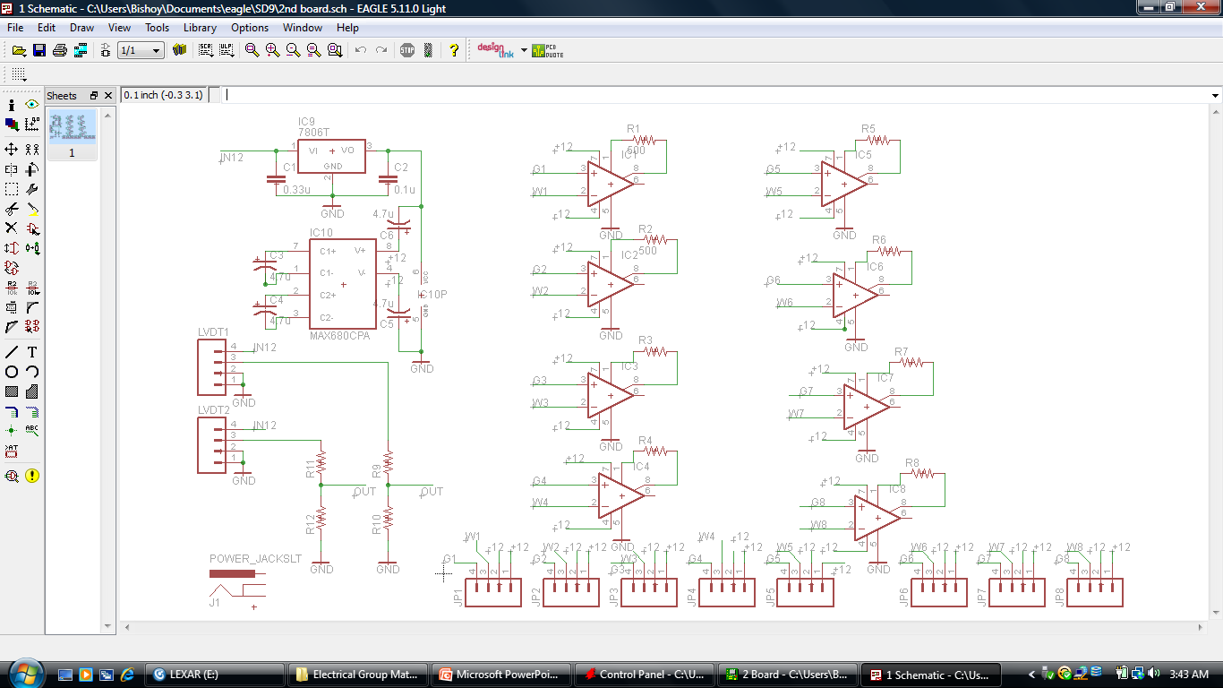

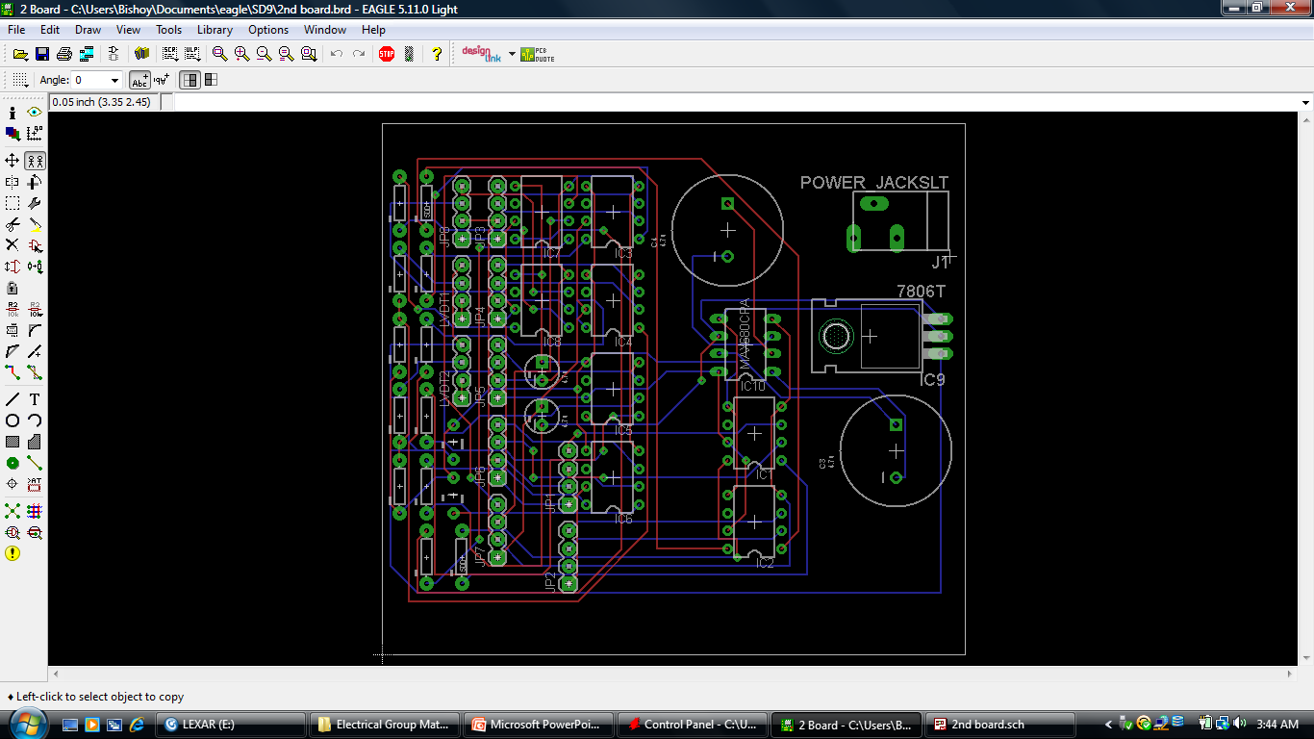

Figure 6.6 Schematic and Board for Analog PCB

7-Testing

7.1 Hardware

7.1.1 Sensors

For testing the sensors, the load cell needs to be sending out its voltage data. The load cell was to be tested with the microcontroller with the LCD touch screen connected. While both are powered on, the display should read from boot up that the load cell Is being powered. Afterwards, pressure is applied to the load cell. The display should show the force being applied.

After the test of the load cell is done, next would be to conjunction it with the linear actuator to make sure the linear actuator is having an effect on the load cell.

The Chart in figure 1 shows an actual test done for the Load cell response and the corresponding voltage after amplification. The output is then taken to the ADC pins of the PIC microcontroller to convert to digital readings.

Figure 7.1.1.1 Testing Load Cell after amplification

The next figure (Fig. 7.2) shows the response of testing the LVDT. The output voltage goes through a voltage divider using the LF351 op-amp to reduce down the voltage from maximum of 10 volts to a maximum of 3.3 volts for the ADC pins of the MCU.

Figure 7.1.1.2 Testing LVDT Response

7.1.2 Motor Control / Feedback

When it comes to testing the motor or the linear actuator, feedback has to be considered in order to give the right output. After connecting the microcontroller to the actuator, it should be very easy to notice that if a pulse width modulated input is run into the actuator; it will make it move up and down depending on the polarity of the wave and also on the duty cycle of this PWM wave. The up and down movement will apply a force on the material being tested. This force will be measured by the use of the load cell that’s connected to the linear actuator. If the duty cycle of the wave is 50%, the actuator should move only half way at no load. Speed will decrease when the actuator starts to push on the material right after it touches it at the end of the actuator.

To fully test the device, as far as motor control is concerned, the feedback from the load cell has to be read in the microcontroller and then interpreted to the user in terms of how much force is applied, in Newton, on the material being tested. The microcontroller should display the reading of the load cell, through the GUI, in terms of force vs. voltage type. As force is being applied on the material by the actuator, the load cell will give a higher voltage reading to the MCU following a linear relationship with how much force is being applied. Once the desired force that the user wanted to apply on the material is reached, the actuator will receive a stop signal until the user changes the force input to another value. Force values are not going to be entered as separate values but instead it’s going to be in the form of a force history file. The force history file will be taken through software and interpreted in a way that allows the program in the microcontroller to be applied. The level of the actuator stroke will keep on adjusting accordingly based on the values that the force history file contains until the user decides to either pause or stop the operation.

7.1.3 Storage Output

When creating a prototype of the MTEC, it is important to examine and analyze each component to ensure each module is properly communicating with the rest of the system. Initial testing will require a structured, definite way for the user to check each component it working to nominal conditions.

First, all the proper connections must be tested to guarantee a complete circuit is being made. Improper connections could result in disaster as a short can incapacitate a component or series of components, or even cause injury to the user. By checking all connections, the user can work safely when testing each component. Especially with components that constantly interface with data, the user, and testing environment it is important that all connections are fit to specification so that there is minimal chance of data corruption. Depending on the SD card component, input voltage must be measured to exact specification required for the SD card slot to operate. A sample SD card slot, which will be used in prototyping, requires a 3.33V input. The components consists of pins labeled as “CS”, “DI”, “VCC”, “CLK”, “GND”, “DO”, “IRQ”, and P9” corresponding to pins 1, 2, 3, 4, 5, 6, 7, and 8. Using a multimeter, a voltage reading of 3.33V should be found at pins 1,2,3,4,6 and 7. This can be accomplished by setting the positive lead of the multimeter to a corresponding pin aforementioned above with the negative lead grounded to pin 5. By ensuring all connections are receiving the correct values, the component has the ability to operate correctly. Next, tests for continuity must be maintained in order to realize full communication between the SD interface and microprocessor is enabled. All physical connections from the SD card interface to the microcontroller must be check with a “continuity check” mode of the multimeter.

For the USB module of the VDIP1 Vinculum VNC1L module (testing is very similar to that of the SD card interface). Input and output voltages must be verified. It is important to note that the USB module requires only a single 5V supply input. Then, the auxiliary output must be rated at a 3.3V and 200mA. Later, continuity check must ensure that a line of communication is established between MCU and the flash drive in order for complete data transfer.

After physical checks are made on the SD card and USB interface, software verifications must be met in order to ensure a fully capable system. Through software, the MTEC implements a self-check system within the user interface. This consists of a test file, which will be coded as a subroutine into the system; it will write on the output data ports. Because the contents of the test file are known prior to output, we will be able to compare the results located on the SD card and the original. Once data output has been verified, application test will be performed on the MTEC. Assuming sensor input and processing is calibrated beforehand, a known force will be applied to MTEC’s load sensors. The MTEC processes the data and writes it onto an SD card during the test session. The user must be able to verify the contents of the SD card to match the controlled test experiment. Once data matches between input and output, the user has reached gain in output connectivity through an SD card interface.

7.2 Software

7.2.1 Debugging GUI

The GUI needs to be tested so the user can deal with the interface, and that the functions in the menus are working properly. All the menus and layouts should be in place and all the buttons should point to the right task location. Testing the GUI would involve pressing every single button in every single menu of the MTEC GUI. All the navigation buttons should allow the user to see all subsequent menus from the front menu page. The user should be able to go back and forth in between pages. If the user sets any options, the options should stay in place when the user exits and/or returns to the options screen for checkups or further edits.

Each button should be carefully tested one at a time. The buttons should be tested for any situation that could possibly happen, such as pressing the Stop button while the MTEC is operating, or if it is not. Every possible occurrence of when a button is pressed needs to be handled properly so that one button’s function does not interfere with another’s or even the MTEC operation if it’s running.

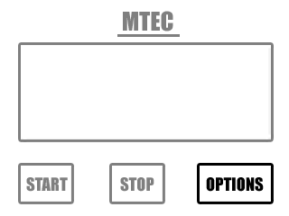
Figure 7.2.1.1 Control Menu
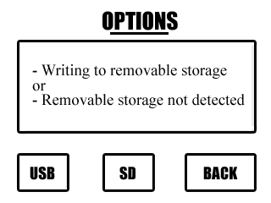
Figure 7.2.1.2 Options Menu

Figure 7.2.1.2 shows two menu layouts, the front control menu and the options menu. If the Options button is pressed in the front control menu, then the Options menu should replace it on the display. The USB and SD buttons are the user’s choices to copy the data to a removable storage. Currently in the box display for the Options menu is the two indications that the user will read when they press the buttons. If the storage devices are connected, then the screen will read that it is currently writing and when finished, it will indicate that the writing is finished and will display the filename and on what device was used. If the storage device selected is not available, then the screen will indicate that it is not detected and to connect and try again.

8 Administrative

8.1 Milestone

Project Part | Start Date | End Date | Duration (Days)
Research Microcontroller | 13-Sep-10 | 6-Oct-10 | 17
Research Sensors and Motor Controller Incorporation | 13-Sep-10 | 13-Oct-10 | 22
Acquire Microcontroller, Sensors, and Motor Controller | 13-Oct-10 | 23-Oct-10 | 8
Research Display, Controls, and Outputs Incorporation | 13-Oct-10 | 3-Nov-10 | 15
Microcontroller Programming | 13-Oct-10 | 5-Feb-11 | 83
Test Microcontroller with Sensors and Motor | 25-Oct-10 | 30-Oct-10 | 5
Acquire Display, Controls, and Outputs | 3-Nov-10 | 13-Nov-10 | 8
Test Microcontroller with Display, Sensors, and Outputs | 15-Nov-10 | 20-Nov-10 | 5
Research PCB Design | 22-Nov-10 | 11-Dec-10 | 15
PCB for First Prototype | 13-Dec-10 | 25-Dec-10 | 10
Assemble First Prototype | 27-Dec-10 | 1-Jan-11 | 5
Test First Prototype | 3-Jan-11 | 15-Jan-11 | 10
Fix First Prototype Issues | 17-Jan-11 | 5-Feb-11 | 15
GUI Programming | 31-Jan-11 | 20-Apr-11 | 57
Body for Final Prototype | 7-Feb-11 | 5-Mar-11 | 20
PCB for Final Prototype | 21-Feb-11 | 9-Mar-11 | 12
Assemble Final Prototype | 9-Mar-11 | 16-Mar-11 | 5
Fix Final Prototype Issues | 16-Mar-11 | 6-Apr-11 | 15
Test Final Prototype | 16-Mar-11 | 20-Apr-11 | 25
Table 8.1.1 Milestone

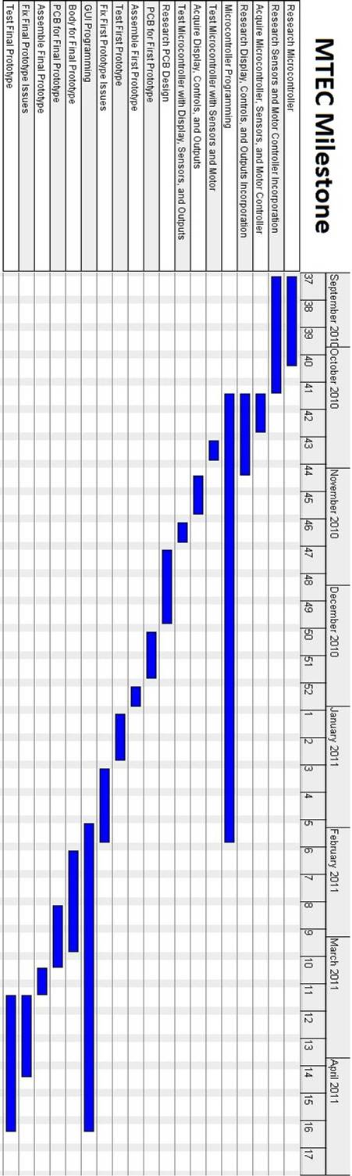

Figure 8.1.1 Gantt Chart
8.2 Budget

The budget of the MTEC was altered from the first draft after all the research and details of the project were finalized. Originally the estimated budget to be around $400, but there was missing parts that were not thought of until the research portion was delved deeper into. The biggest change to be noted is that the load cell that was picked is much more expensive than planned. Along with the prices of the other parts being finalized, the budgeting moves up to $881.13, which is over double the original estimated budget.

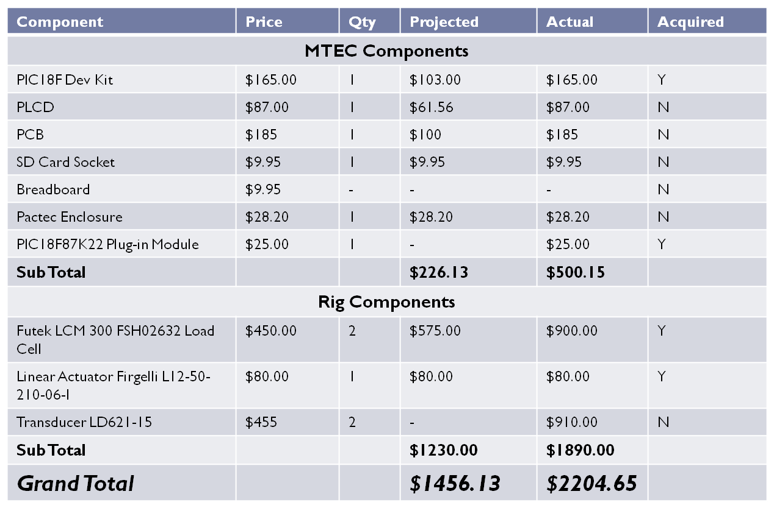
Table 8.2.1 Budget

8.3 Conclusion and Project Summary

It was the goal of the group to learn about the design and implementation of electronic devices. The Materials Testing Equipment Controller (MTEC) allowed us to gain experience in this area of interest. Researching and designing the actual device have proven a exiting process. Because there are many aspects to designing a controller such as the MTEC, each member has become specialized in one or two of projects requirements and how to address them. However, all the members of the group have learned the essentials of the components necessary to make this device and how to incorporate them.

Perhaps the most important aspect of designing the MTEC has been the development of the interpersonal and professional skill of each group member. This project has introduced us to the engineering process. How defining, researching, designing, prototyping, and testing are essential to any engineering task. Also, how each of the steps in this engineering process affects each other. Interacting with the sponsor has also proven an unexpectedly educative task. Because this project is being financed by the University of Central Florida Department of Mechanics, Materials, and Aerospace Engineering, the design of the project has been made to the specifications of the sponsor, Dr. Ali Gordon. This introduced the group to the challenges of interacting with a client or boss in the engineering profession. This project also demonstrated how interaction among the members of the group is a key aspect of the engineering process. Communication among the members of the group has proven specially instructive. It has been interesting to observe how the project benefits from the experiences and expertise of each member. Also, how proper communication greatly facilitates the design process.

The MTEC is a device design for a very specific purpose, controlling a material testing equipment. Therefore, the device will be able of meeting all the necessary requirements of the testing equipment without exceptions. To be able to achieve the desired level of functionality, the MTEC will simulate a human foot while in motion by controlling up to eight actuators individually. Also, it will able to read and interpret the information provided by eight load cells connected to the actuators. This information will be used as feedback to the control system operating the actuators. Most importantly, however, it must be stored in the device for later analysis. The user will be able to extract this data through a USB flash drive. The instruction set executed throughout a test will be directly loaded to the MTEC through an external computer. In it, a graphical user interface (GUI) will facilitate inputting the test instructions. Also, it will serve as a platform for rough data analysis. Because the MTEC will be implemented in a laboratory environment in which damage may occur, all the components will be fit in an enclosure capable of resisting physical strikes and shocks.

8.4 MTEC User Manual

Getting To Know the MTEC

The Material Testing Equipment Controller (MTEC) is a device used in the process of testing material for a myriad of properties. The MTEC allows the user a cheap, reliable, and expandable system that would otherwise cost the user upwards in thousands of dollars. The MTEC uses a combination of components in order to record data: enclosure, LCD display, SD card interface, power supply, button interface, and sensor interface.

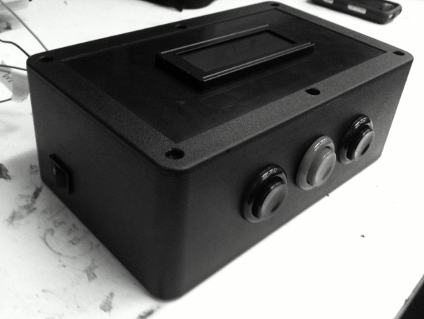
Figure 8.4.1 MTEC Isometric View
Layout

The MTEC’s enclosure is of a standard rectangular shape. Throughout the user manual, each surface of the enclosure will be mentioned as a face with the buttons indicating default orientation towards the user. Three buttons will be used when interfacing with the MTEC—each with their on function. Start/Pause button is located on the left. In order to initiate MTEC operation or confirm a selection through the MTEC interface, the Start/Pause is used. During operation, the Start/Pause can be used to momentarily pause operation until it is pressed again to resume operation from the pause state. The middle button is the Stop button. It allows the user to halt an ongoing operation. The Stop button is only active during active testing. It will reset the user to the start menu. The final button located on the right is the Mode Select button. It allows the user to pick between Mode 1 and Mode 2. The Mode Select button is only active during the start screen. The button interface is located on the front face of the MTEC, while the opposite face will be referred to the rear face. The LCD display is located on the top of the MTEC and the SD card slot is on the right face.

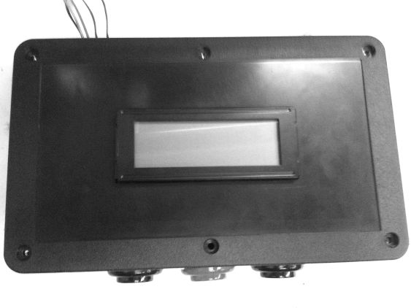
Figure 8.4.2 MTEC Top View

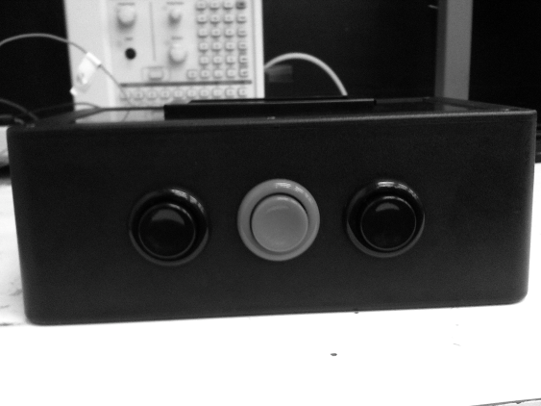
Figure 8.4.3 MTEC Front View

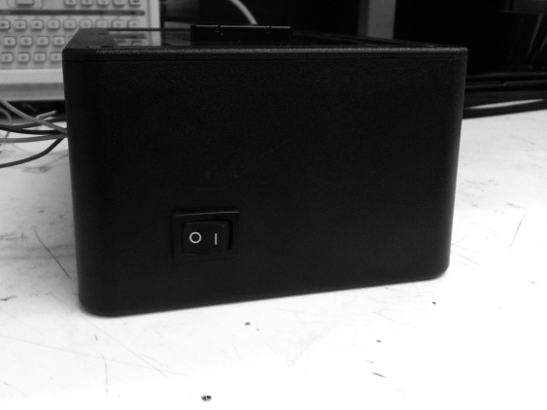
Figure 8.4.4 MTEC Side View

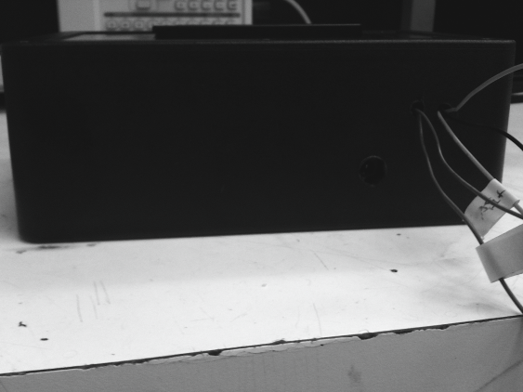

Figure 8.4.5 MTEC Back View

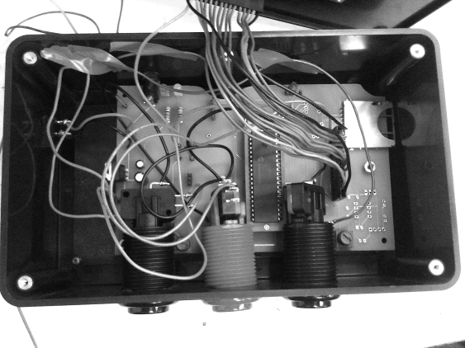

Figure 8.4.6 MTEC Interior View

MTEC Setup

Using the included software, the SD card must be setup correctly in order for the MTEC to operate accurately. Follow the onscreen directions indicated in the bundled software to setup the MTEC. Once completed, CON001.TXT will be created on the SD card. This file contains instructions the MTEC will carry out to act as a stand-alone device. Once verified on the SD, insert the SD card into the MTEC.
Powering the MTEC

There are currently two variants of the MTEC; both operate the same but one does not include the SD card interface while the full-featured MTEC includes SD card interfacing. There are two different ways the MTEC can be powered on. Both require a standard wall wart adapter, which delivers a 12V input to the MTEC for operation. Connect the 12V wall wart adapter to the MTEC. The power supply input is located near the rear left corner of the MTEC. Depending on the availability of a power button, a rocker switch will be provided in the rear left corner to supply the MTEC with power. If no rocker switch is available, the MTEC will boot automatically once the power adapter is in place. The user will notice and LED indicator of the power status near the power adapter. Note: Make sure the SD card is inserted into the MTEC and verify the configuration file (CON001.TXT) to ensure proper operation.

Mode Selection

Upon power up, the MTEC prompts the user with a welcome screen, initializing the components. Once initialization is complete, the screen continues onto the start screen. The screen allows the selection between two modes: Mode 1 and Mode 2. The mode can be toggled using the Mode Select button, located on the right of the Stop Button. Once the mode is selected, MTEC operation can begin by pressing the Start/Pause button located to the left of the Stop Button.

Mode 1: (Testing and Data Acquisition) Input parameters located on the SD card are used to control a series of linear actuators. Results are logged by load cells connected to the MTEC and are recorded for further analysis on the SD card. Mode will end with initial parameters are fulfilled, duration time has expired, or a manual user cancellation.

Mode 2: (Data Acquisition only) No input parameters are needed. Load cells and/or transducer(s) are connected to the MTEC. Results are logged by the MTEC and recorded onto the SD card. Mode will end when duration time has expired, or a manual user cancellation.

MTEC Operation

Upon selection of the mode, the runtime screen will display on the screen. The screen will indicate various fields of testing information for the user.

Mode 1: (Testing and Data Acquisition) Several information fields will be displayed during Mode 1. Elapsed time will be displayed on the screen. This indicates how long the experiment has been running since initiation. In addition to elapsed time, target value is also displayed. Target value is obtained from the configuration file located on the SD card. As the MTEC begins testing, a target value is stored. The MTEC adjusts the output of the linear actuator to obtain the target value. Once the target value is acquired, the next is transferred into queue. The process repeats until experiment termination. The final field that is displayed is the actual value. Actual value is the current value sensed by the load cell. Once actual and target value match, the MTEC’s algorithm proceeds to the next target value.

Mode 2: (Data Acquisition only) Mode 2 display screen is similar to that of Mode 1with the exception of the target value. Elapse time will be displayed, the same as Mode 1, along with the actual value displayed—originating from either load cell or transducer.

Data Analysis

Upon completion of the MTEC operation, the MTEC will display an operation competed screen. Once this is displayed, the user can safely remove the SD card and analyze the recorded data. The SD card, compatible with Windows or Mac, will now contain two files (CON001.TXT and TEST001.CSV). The MTEC creates TEST001.CSV during MTEC operation and records raw values from the sensors, allowing the user to verify and calibrate test data. CSV files can be easily imported into Microsoft Excel for further data analysis and visual representation of test results.

Troubleshooting

Why isn’t the MTEC turning on?
Make sure the power adapter is compatible with female connector on the PCB. Also, check that the input voltage is at around 12V.

I turn on the MTEC, but nothing happens.
There are several factors that can affect initialization.
- Verify that the SD card is not corrupted. (for Mode 1) If so, repair the SD card using Windows or Mac’s included utility.
- Make sure the SD card is inserted into the MTEC.
- Make sure the CON001.TXT is not corrupted (for Mode 1). If so, recreate the test experiment using the included software.
- The display connection may be loose or connector polarity may be reversed. Check the input voltage and ground connection for the display. The display runs on an input voltage of 5V.
- Adjust the potentiometer of the display. Contrast may be too light to see text.

The buttons are not responding.
Arcade buttons include a latching mechanism that helps reduce the debouncing effect –short ripple of current that forms when a mechanical switch is pushed, making short contacts. A delay subroutine is added in software, which compensates for the effect but does not completely resolve it. Making a swift deliberate press on the button interface can reduce any lack of response from the button. Also, check the button connections using the given schematics.

The actual values recorded during testing are way off the anticipated values.
The built-in analog-to-digital converter can use an internal/external voltage reference. Check the voltage reference and make sure it matches that included in the source code. Calibration can occur if an experienced user can manipulate the source code to use an external ADC reference source, or offset the calculated values from the raw values obtained by the MTEC.

After completing an MTEC operation, I insert the SD card and nothing happens. I think the SD card is corrupted.
Make sure the MTEC has fully closed all initializations as the MTEC operation completion screen displays. Premature ejection of the SD card during an operation or before MTEC’s closes all ports can corrupt TEST001.CSV. Once an SD is corrupted, repair using Windows or Mac’s repair utility and start test over.

What happened to my previous set of data? I had completed an MTEC operation before, but after starting a new operation, it is gone.
The MTEC can handle two files at a time—with the names CON001.TXT and TEST001.CSV. Having those files prior to an MTEC operation will cause a new TEST001.CSV to be overwritten with each new test. Make sure you archive your file after each test to ensure backup and proper test data association.

Bibliography
[1]Freescale Semiconductor website. “Motor types tutorial” [Online]. Available: http://www.freescale.com/webapp/sps/site/training_information.jsp?code=WBT_MOTORCONTROL_TUT

[2]Peter pinewski, Mike Steffen, “Motor Control part 1”. [Online]. Available: http://www.freescale.com/files/ajax/flvplayer/flashvideoplayer.html?video=/files/graphic/other/FTF2008/Video/AZ131.flv

[3]Matthew Grant, “Quick Start for Beginners to Drive a Stepper Motor”. [Online]. Available:http://www.eetasia.com/ARTICLES/2007APR/PDF/EEOL_2007APR18_CTRLD_EMS_AN.pdf

[4]Brain, Marshall, “How Microcontrollers Work”. [Online]. Available: http://electronics.howstuffworks.com/microcontroller2.htm

[5]Dynetic Systems, “Brushless vs. Brushed”. [Online]. Available: http://www.dynetic.com/brushless%20vs%20brushed.htm

[6]Firgelli Automation website. “Linear Actuators”. [Online]. Available:

[7] Dart, Fred. “Interfacing A USB Flash Drive to A PIC Microcontroller,” ftdichip.com Sept. 17, 2010. [Online]. Available:
http://dataweek.co.za/news.aspx?pklNewsId=26407&pklCategoryID=34. [Accessed Nov. 14, 2010].

[8] Future Technology Devices International Ltd, “Vinculum VNC1L Embedded USB Host Controller IC Datasheet,” VNC1L datasheet, July, 2006. [Revised Aug 2010].

[9] Clarke, Aaron. “Add USB Host Support To Your MCU Design,”blog.embeddedcoding.com, Aug. 27, 2010. [Online]. Available: http://blog.embeddedcoding.com/2010/08/add-usb-host-support-to-your-mcu-design.html. [Accessed Nov. 14, 2010].

[10] Phillips, Stu. “Making USB Connected PIC Projects Easy!” 1vc.typepad.com, Jan 20,2010. [Online]. Available: http://1vc.typepad.com/ethergeist/2010/01/making-usb-connected-pic-projects-easy.html. [Accessed Nov. 14, 2010].

[11] Microchip Technology Inc., “IEEE 802.11 – Wi-Fi,” Microchip Technology Inc.,[Online] Available:http://www.microchip.com/stellent/idcplg?IdcService=SS_GET_PAGE&nodeId=2884. [Accessed Nov. 14, 2010].

[12] M. Dripke, Z. GmbH, and C. KG, “Materials Testing: Choosing the Right Extensometer,” laboratoryequipment.com, Feb. 6, 2009. [Online]. Available: http://www.laboratoryequipment.com/article-the-right-extensometer-0902.aspx. [Accessed Nov. 12, 2010].

[13] A. Pathania, “Mouse Programming in C,” cprogrammingreference.com, Feb. 1, 2007. [Online]. Available: http://www.cprogrammingreference.com/Tutorials/Advance_Tutorials/mouseprogramming.php. [Accessed Nov. 23, 2010].

[14] P. Gill, “How to Convert a Load Cell Reading into Total Weight,” ehow.com, May 6, 2010. [Online]. Available: http://www.ehow.com/how_6082377_convert-cell-reading-total-weight.html. [Accessed Nov. 18, 2010].

[15]A. Gupta, “Interfacing LM35 Temperature Sensor with Pic Microcontroller,” extremeelectronics.co.in, Jul. 25, 2010. [Online]. Available: http://extremeelectronics.co.in/microchip-pic-tutorials/interfacing-lm35-temperature-sensor-with-pic-microcontroller. [Accessed Nov. 12, 2010].

[16]“Text mode,” wikipedia.org, Oct. 2010. [Online]. Available: http://en.wikipedia.org/wiki/Text_mode. [Accessed Nov. 20, 2010].

Image Permissions

 | show details 15:49 (1 minute ago)
  Francis Bato
  to interfacebus.c.
Hello,
I am an Electrical Engineering student currently working on my senior design project documentation. May I reproduce the following image located at "http://www.interfacebus.com/Memory_Card_Sizes.gif". Let me know if you have questions.

Thank you,

Francis Bato
University of Central Florida Student

 | show details 15:56 (3 minutes ago)
  Leroy Davis
  to me
I don't see a problem with that. Please leave the site name in the gif.
Leroy
- Show quoted text -
--
http://www.interfacebus.com/
http://interfacebus.blogspot.com/
http://serial-interface-buses.blogspot.com/
http://sites.google.com/site/interfacebus/
http://knol.google.com/k/computer-buses#
http://www.serialphy.com/

Hello,
I am an Electrical Engineering student currently working on my senior design project documentation. May I reproduce the following image located at "http://wiki.altium.com/download/attachments/3080252/SPIComms.png?version=1&modificationDate=1226743826419". Let me know if you have questions.

Thank you,

Francis Bato
University of Central Florida Student
Dear Francis,

Thank you for checking with us regarding permission to use this image. I am happy for you to reproduce it.

All the best with your project.

Regards,
Karen
Karen Beard
Manager, Product Release
-----------------------------------------------------------------------------
Altium Ltd.
3 Minna Close
Belrose NSW 2085 Australia
Tel: +61 2 8622 8116
Fax: +61 2 8622 8140
www.altium.com
-----------------------------------------------------------------------------
This email message, including any attached files, is confidential and intended solely for the use of the individual or entity to whom it has been addressed. Altium prohibits the right to publish, copy, distribute or disclose any information contained in this email, or its attachments, by any party other than the intended recipient. If you have received this email in error please notify the sender and delete it from your system.
-----------------------------------------------------------------------------
- Show quoted text -

 | hide details 10 Nov (2 days ago)
   | from | Francis Bato<batofdb@gmail.com>
  to |  | lit_inquiry@microchip.com
  date |  | 10 November 2010 21:16
  subject |  | Copyright Permission Senior Design
  mailed-by |  | gmail.com
Hello,
I am an Electrical Engineering student currently working on my senior design project documentation. May I reproduce the following image located at "http://eecatalog.com/images/usb/2008/pg_8.jpg". Let me know if you have questions.

Thank you,

Francis Bato
University of Central Florida Student

Hello Francis,

you may reproduce or use the material as long as it is not edited in any way. You do not need Microchips' express permission as long it is for personal, Academic or non-profit use. Here is a link to the Copyright permissions on the Legal page of our website.

http://www.microchip.com/stellent/idcplg?IdcService=SS_GET_PAGE&nodeId=487&param=en023282

Thanks for asking,

Regards,

lit_inquiry@microchip.com
Microchip Technology Inc
Chandler, AZ

From: Francis Bato [mailto:batofdb@gmail.com]
Sent: Fri 11/12/2010 3:27 PM
To: Lit_Inquiry
Subject: Copyright Permission Senior Design
- Show quoted text -

 | show details 10 Nov (2 days ago)
  Francis Bato
  to admin1
Hello,
I am an Electrical Engineering student currently working on my senior design project documentation. May I reproduce the following image located at "http://archive.electronicdesign.com/files/31/35737/figure1.jpg". Let me know if you have questions.

Thank you,

Francis Bato
University of Central Florida Student
Subject: Copyright Permission Senior Design
From: Francis Bato <batofdb@gmail.com>
Date: December 4, 2010 12:31:42 AM EST
To: chipshop@ftdichip.com

Hello,
I am an Electrical Engineering student currently working on my senior design project documentation. May I reproduce the following image located at "http://apple.clickandbuild.com/cnb/shop/ftdichip?imageID=195&op=imgLib-viewImage"? Let me know if you have questions.

Thank you,

Francis Bato
University of Central Florida Student
Subject: Copyright Permission Senior Design
From: Francis Bato <batofdb@gmail.com>
Date: December 3, 2010 8:22:15 PM EST
To: marketing@sparkfun.com

Hello,
I am an Electrical Engineering student currently working on my senior design project documentation. May I reproduce the following image located at "http://static.sparkfun.com//images/products/00204-01-L_i_ma.jpg". Let me know if you have questions.

Thank you,

Francis Bato
University of Central Florida Student

Subject: Copyright Permission Senior Design
From: Francis Bato <BATOFDB@GMAIL.COM>
Date: December 3, 2010 6:49:14 PM EST
To: moreinfo@pactecenclosures.com
Hello,
I am an Electrical Engineering student currently working on my senior design project documentation. May I reproduce the following image located at "http://www.pactecenclosures.com/images/PT-10.jpg". Let me know if you have questions.

Thank you,

Francis Bato
University of Central Florida Student

Greetings,

My name is Nghia Nguyen, and I'm a student at the University of Central Florida currently taking my senior class. I'm writing to request permission to include the diagrams (http://www.laboratoryequipment.com/uploadedImages/Technologies/Instrumentation_and_Equipment/le92web_zwick_Fig%204.jpg) in my paper. The diagrams are useful images for reference to be included in the research paper I am writing as well as when my group gets to the project.

Thank you in advance,
Nghia Nguyen
n.mattnguyen@gmail.com

Greetings,

My name is Nghia Nguyen, and I'm a student at the University of Central Florida currently taking my senior design class. I'm writing to request permission to include the diagram (http://www.china-loadcells.com/Tension-Load-Cell/bh-3.jpg) in my paper. The diagram is a good image to be used as reference to be included in the research paper I am writing as well as when my group gets to the project.

Thank you in advance,
Nghia Nguyen
n.mattnguyen@gmail.com

