Dynamic Animation Cube II



Group 5
Timothy Foard
Adam Heeren
Sommer Marsh
Brian Zei
Due Date: December 6, 2012
Table of Contents:
- Executive Summary 1
- Project Description 4
  - Motivation and Goals 4
  - Objectives 7
  - Requirements and Specifications 10
- Research Related to Projects and Products 16
  - Existing Project So Far 16
    - Basic LED Cube 17
    - LED Drivers 19
    - Decoders 21
    - Microcontroller 23
    - LED’s 24
    - Structure 27
  - Component Research 32
    - Power Supply Unit (Sparkfun Electronics) 32
    - Housing 33
      - Extruded Acrylic 33
      - Cast Acrylic 35
      - Glass 36
      - Housing Decision 37
    - Structural Improvements 38
      - Acrylic 38
      - Wood 39
      - Aluminum 40
      - Base 40
      - Structural Decision 41
    - Microcontroller 41
      - Stellaris LM3S8962 (Texas Instruments) 41
      - AVR AT32UC3C2512C (Atmel) 44
      - Microcontroller Decision 47
    - Controllers 48
      - Microsoft Kinect 48
      - Nintendo Wii 49
        - Remote 49
        - Nunchuk 51
      - Controller Decision 53
    - LED Drivers 53
      - TLC Driver (Texas Instruments) 54
      - STP24DP05 Driver (STMicroelectronics) 56
      - STP1612PW05 Driver (STMicroelectronics) 58
      - LED Driver Decision 60
    - Software Architecture 61
      - Programming Language 62
        - Java 62
        - C 62
        - C++ 63
        - C# 63
      - Code Libraries 63
    - Decoder/Demultiplexer 69
      - CD74HC4514 (Texas Instruments) 69
      - 74HC154; 74HCT154 (NXP Semiconductors) 70
      - Decoder Decision 72
    - Ribbon Wire Connectors (Pacific Custom Cable) 72
- Hardware and Software Design Details 73
  - Initial Details and Schematics 73
  - Software Design 74
    - Control Unit API 76
    - Games 79
    - Controller Integration 88
  - Circuit Board Requirements 82
  - System Integration 83
    - LED Drivers 85
    - Controller 88
    - Power Supply 89
  - Hardware and Software Design Summary 90
    - Simulation 92
      - Cube 92
      - Controller 94
    - Applications 94
      - Rubik’s Cube 94
      - 3D Pong 98
      - Tetris 100
      - Animations 101
      - The Game of Life 103
    - Test Plan 104
      - Test Environment 105
      - Initial Test 105
      - Cube 108
        - Test Case 1 108
        - Test Case 2 109
      - Controllers 109
        - Test Case 1 109
        - Test Case 2 110
      - Drivers 110
        - Test Case 110
      - Software 110
        - Test Case 1 111
        - Test Case 2 111
        - Test Case 3 111
- Administrative Content 112
  - Milestones 112
  - Budget and Finances 113
  - Group Member Biographies 115
    - Timothy Foard 115
    - Adam Heeren 116
    - Sommer Marsh 117
    - Brian Zei 118
  - Division of Labor 119
- Conclusion 121
- References 123
- Appendix 125

List of Figures:
Figure 1: The Dynamic Animation Cube I 5
Figure 2: Benchmark Dates for Spring 2013 8
Figure 3: 16X16X16 LED Cube 17
Figure 4: Dynamic Animation Cube I LED Driver Schematic 20
Figure 5: Dynamic Animation Cube I Decoder Schematic 22
Figure 6: Lattice of LEDs 25
Figure 7: Dynamic Animation Cube I Supports 28
Figure 8: Dynamic Animation Cube I Structure 29
Figure 9: Dynamic Animation Cube I Base 30
Figure 10: Dynamic Animation Cube I Base 31
Figure 11: Nintendo Wii Remote Button Layout 50
Figure 12: Nintendo Wii Nunchuk Pin Layout 52
Figure 13: Nintendo Wii Nunchuk Button Layout 53
Figure 14: Pin Layout for TLC5941 55
Figure 15: Pin Layout for STP24DP05 57
Figure 16: Dynamic Animation Cube II System Block Diagram 74
Figure 17: Microcontroller State Diagram 80
Figure 18: AT32UC3C2512C Microcontroller Schematic 83
Figure 19: Pin Layout for AT32UC3C2512C 85
Figure 20: Dynamic Animation Cube I LED Driver Array 86
Figure 21: LED Drivers Schematic 87
Figure 22: Single LED Driver Schematic 88
Figure 23: Wii Nunchuk Interface Schematic 89
Figure 24: Board Power Supply Schematic 90
Figure 25: Full Schematic of the Dynamic Animation Cube II 91
Figure 26: Example of Move Operation in Rubik’s Cube Game 96
Figure 27: Initial Testing 106
Figure 28: Initial Testing 108
Figure 29: Milestone Dates for the Dynamic Animation Cube II 112
Figure 30: Sparkfun Permission 125
Figure 31: Michael Alberts Permission 125
Figure 32: Atmel Permission 126
Figure 33: STMicroelectronics Permission 126
Figure 34: Texas Instruments Permission 127
List of Tables:
Table 1: Power Supply Pricing 32
Table 2: Physical, Mechanical, and Optical Properties of Acrylic 34
Table 3: Extruded Acrylic Sheets Pricing 35
Table 4: Cast Acrylic Sheets Pricing 36
Table 5: Cast/Extruded Acrylic Rods Pricing 39
Table 6: GPIO Rise and Fall Time 46
Table 7: Microcontroller Parameter Comparison 48
Table 8: DF0/DF1 Settings 58
Table 9: Resistance vs. Current 60
Table 10: LED Driver Pricing 61
Table 11: AST Interface 64
Table 12: Debug Macros and Functions 65
Table 13: Dynamic Memory Allocation 65
Table 14: FIFO Interface 66
Table 15: GPIO Interfaces 66
Table 16: Sleep Manager Interfaces 67
Table 17: SPI Interfaces 68
Table 18: Timer/Counter Interfaces 68
Table 19: TWI Interfaces 69
Table 20: 4-to-16 Decoder Truth Table 71
Table 21: Decoder Pricing 72
Table 22: Ribbon Cable Connector Pricing 72
Table 23: API Field Descriptions 77
Table 24: Internal Addressing Methods 78
Table 25: Microcontroller State Machine Description 81
Table 26: Input Format from Wii Nunchuk 82
Table 27: LED Testing Options 93
Table 28: Initial Testing Data 107
Table 29: Financing 115

1. Executive Summary
In the length of this paper, Group 5 of the University of Central Florida’s Senior Design I class for Computer and Electrical Engineers will define specifications, present research related topics, and outline the retrofit of the Dynamic Animation Cube; an existing three dimensional light emitting diode cube that was constructed as part of a previous senior design course at the University of Central Florida. In order to understand the motivation behind undertaking such a task, Group 5 will provide a brief introduction to the existing Dynamic Animation Cube including its current functionality, construction, and hardware. Group 5 is made up of four members, three of which are students in the Electrical Engineering program at the University of Central Florida and the remaining member is a Computer Engineering student.
Undertaking an existing project for Senior Design is not the typical protocol in such a course for graduating engineering students. Group 5 members considered their options carefully before settling on taking over the Dynamic Animation Cube. Due to the construction of the cube already being completed, Group 5 had to brainstorm possibilities for the Dynamic Animation Cube II that would warrant the use of two semesters and the hardware repercussions that would be necessary to redesign for compatibility. Possibilities included full simulated animations and multiplayer interactive games. Ultimately Group 5 decided to implement a virtual Rubik’s Cube that will be solved by a user using some sort of handheld controller.
The original project was done by a group of four members; Michael Alberts, Joseph Clark, Arnold Li, and Isaiah Walker. Two group members obtained Electrical Engineering degrees while the other two obtained Computer Engineering Degrees. The Dynamic Animation Cube was funded by the department of Electrical Engineering and Computer Science with a budget of $800 under the condition that the finished product would remain the property of the University of Central Florida’s department of Electrical Engineering and Computer Science to be put on display as a piece of artwork in one of the engineering buildings on campus.
The Dynamic Animation Cube designed and built by the aforementioned group members during a previous senior design class has a resolution of 16(L) * 16(W) * 16(H). The light emitting diode cube measures roughly three feet long, three feet wide, and four feet tall. The Dynamic Animation cube houses 4,096 light emitting diodes which hang down from eight 2(inch) * 1(inch) wooden rods. Other than these wooden rods, there is no internal structural support for the Dynamic Animation Cube light emitting diodes. The light emitting diodes fall upon an acrylic sheet that serves as the base of the Dynamic Animation Cube.
The Dynamic Animation cube was previously designed to be only a visually pleasing piece of artwork. Group 5 plans to retrofit the cube to include a user functionality that will allow the user to complete the popular Rubik’s Cube or even possibly allow multiple users to interact simultaneously to implement an interactive multiplayer game.
The objective of Group 5’s retrofit to the Dynamic Animation Cube is to implement a user interface in order to make the cube interactive and not just a stand-alone piece of artwork for viewing pleasure as well as to redesign necessary components to conform to this new design goal. The Dynamic Animation Cube II will be capable of displaying 3-dimensional images in a way such that the rapid repeat of a command is not noticeably distracting to the human eye. The Dynamic Animation Cube II, at the discretion of the University of Central Florida’s department of Electrical Engineering and Computer Science, will be put on display in one of the three engineering buildings on campus for the students of the university to enjoy.
The design of the Dynamic Animation Cube II will be roughly 3.5 feet long, 3.5 feet wide and 4 feet tall (including the housing and base.) The light emitting diodes will be constructed in such a manner that a matrix structure with the resolution of 16(L) * 16(W) * 16(H) will be utilized and structural supports implemented. The retrofitted Dynamic Animation Cube II will retain the use of the 4,096 light emitting diodes that are currently assembled in the senior design lab. The design of the cube includes housing all the way around and a base that will enclose the entire structure and hardware in such a way to allow easy access in the event that repairs are required. The Dynamic Animation Cube II is going to hang from the ceiling of which ever building is chosen for display, so all of the hardware will be encased within the base of the cube. The cube design includes a structural support system for the light emitting diodes that will provide stress relief as well as provide level structures to give the cube its shape.
During the research phase of the design of the Dynamic Animation Cube II, Group 5 has come across several methods for implementing the specifications outlined within the contents of this paper. The major design blocks included figuring out multiplexing logistics by using light emitting diode drivers, finding a suitable user controller, structural system implementation, and code writing.
Group 5 has compiled a massive amount of research on microcontrollers, user controllers, structural elements, code libraries, and code languages as well as sifted through the large amount of information available on the original Dynamic Animation Cube. From this research Group 5 can confidently assert that the Dynamic Animation Cube II will conform to several distinct parameters in its final state. The physical cube will be sized at roughly 3.5 feet length * 3.5 feet width * 4 feet height. The cube’s structure will comprise of more than 4,000 light emitting diodes.

2. Project Description
Throughout the research phase of the Dynamic Animation Cube II project Group 5 quickly discovered the need to clearly define the end goal of this endeavor. It is only with this definition that the group can collectively and efficiently work toward achieving such set goal. Through research and intuition Group 5 has established this clearly defined end goal that represents the Dynamic Animation Cube II. Contained within this Project Description lies the aforementioned goal along with the motivations behind choosing this project, objectives for the prototyping, and the requirements and specifications of the completed Dynamic Animation Cube II.
2.1 Motivation and Goals
The Dynamic Animation Cube was initially designed as part of the Senior Design I course that took place in Spring 2012 and was then constructed as part of the follow up Senior Design II course that took place in Summer 2012. A senior design project completed at Boston University caught the previous group’s attention and the group sought to design a similar project with enhanced capabilities on a larger scale. The seniors that participated in the Dynamic Animation Cube project all graduated and moved away when the Summer semester ended and the finished product was never functional to its original specifications. In fact, the previous senior design group to work on the Dynamic Animation Cube was not able to get the 16 * 16 * 16 configuration of the cube to function with simulated animations under all circumstances. Instead, the group successfully implemented similar functionality on a much smaller prototype cube which was sufficient to pass the course and go on to graduate from the University of Central Florida. The previous group members to work on the Dynamic Animation Cube secured funding in the form of $800 from the University of Central Florida’s department of Electrical Engineering and Computer Science to construct the cube so long as the cube would remain property of the university and go on display in one of the engineering buildings that are on campus. Shown below in Figure 1 is the Dynamic Animation Cube I as provided by the previous senior design group to complete the project.
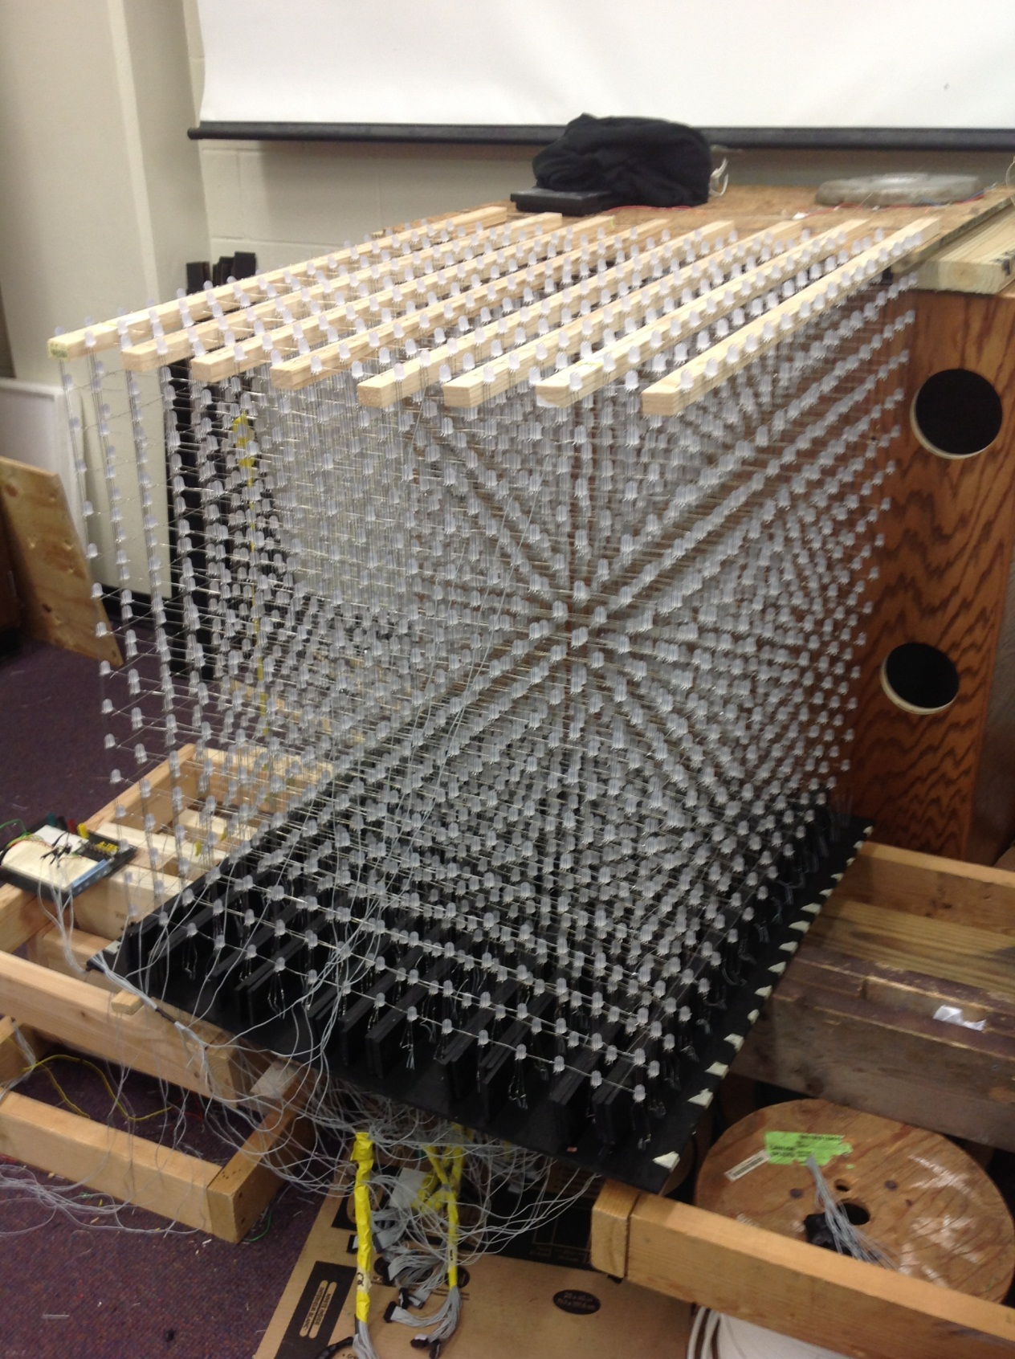
Figure 1: The Dynamic Animation Cube I, as supplied by previous group
During the initial research phase of the Senior Design I course that Group 5 was part of, it came to light that several project ideas would be pitched by local companies throughout the first several weeks of the semester. During this time, Dr. Richie pitched the idea of over taking the Dynamic Animation Cube with the possibility of receiving sponsorship from the University of Central Florida’s department of Electrical Engineering and Computer Science. Over the following couple of weeks several other sponsored projects were pitched by members of several local companies. Group 5 was formed on the day that project ideas were to be finalized and incomplete groups pitched their ideas to all other students without a group or a project idea. Group members Adam Heeren and Brian Zei pitched the idea of taking over the Dynamic Animation Cube and fellow colleagues Timothy Foard and Sommer Marsh decided to rise to the challenge.
Due to the Dynamic Animation Cube already existing, Group 5 had a few initial obstacles to overcome before deciding to proceed. After several discussions that pertained to the future of the Dynamic Animation Cube and Group 5’s involvement in its future the group came to the conclusion that the Dynamic Animation Cube would become not only a visually pleasing piece of artwork that hangs in one of the universities engineering buildings but also incorporate some sort of user interactive capability.
Due to the capabilities that Group 5 was looking at for the Dynamic Animation Cube II, the idea of seeking out funding from the University of Central Florida’s department of Electrical Engineering and Computer Science was most logical. The project was approved for a $1500 budget from the Electrical Engineering and Computer Science department from the University of Central Florida after direction from Dr. Richie. This funding was a key deciding factor in the continuation of the Dynamic Animation Cube project for Group 5. In addition to the sponsorship, the idea of having the Dynamic Animation Cube on display for future engineering students at the University of Central Florida helped the group decide to retrofit the Dynamic Animation Cube.
The goals of the Dynamic Animation Cube II will be based on the physical parameters placed upon the cube’s size, the implementation of a structural support system as well as an encasing for the entire cube, and the functionality of the final product. The physical parameters that will guide the retrofit of the Dynamic Animation Cube will be a length of 3.5 feet, a width of 3.5 feet, and a height of 4 feet. The existing configuration of the Dynamic Animation Cube allows for the light emitting diodes to be arranged in a way such that the cubic form has a pixel pitch of roughly forty centimeters. There is currently no structural support system within the Dynamic Animation Cube’s structure that provides any form of stress relief. The Dynamic Animation Cube II will contain a grid of supports that will allow the cube to maintain its cube shape. In addition to the stability additions introduced in the design of the Dynamic Animation Cube II, a base and actual housing unit will be manufactured. The Dynamic Animation Cube will be suspended from the ceiling of one of the several engineering buildings on the University of Central Florida’s campus and the housing the prevent wear and tear from deteriorating the integrity of the Cube. The base of the Cube will provide the necessary storage to house the hardware that controls the cube and will allow for easy access in the event that maintenance or repairs to the Dynamic Animation Cube II become necessary. When completed, the Dynamic Animation Cube will function as a Virtual Rubik’s Cube and will allow the user to virtually solve the puzzle using some sort of hand held controller.
Since the Dynamic Animation Cube already exists the timeline of completion dates changes a little for Group 5. It is the group’s hope that all stability and structural improvements are completed by the end of February 2013 which will allow for testing of the Dynamic Animation Cube II’s capabilities, troubleshooting, and redesign throughout the months of March 2013 and April 2013.
2.2 Objectives
Senior Design projects in the Department of Electrical Engineering and Computer Engineering require such effort that is it often recommended that only Senior Design II is taken during the last semester of a student’s academic career. This is not the case for any member of Group 5. Due to the time constraints that each member will be facing while juggling the Dynamic Animation Cube II with other classes, homework, and projects the group decided to complete a very specific outline of events that would dictate whether the group was on track for successful completion of the Dynamic Animation Cube II. As seen in Figure 2the group has outlined the major benchmarks that lie in the Spring 2013 semester that will need to be completed.

Figure 2: Benchmark dates for Spring 2013 Semester
The objectives contained within the remainder of this section reflect a collaborative effort of what Group 5 plans to accomplish through the completion of the Dynamic Animation Cube II. Through the completion of the Dynamic Animation Cube II, Group 5 plans to successfully implement a user interface controller in order to control the applications the group has researched incorporating into the functionality of the Dynamic Animation Cube II. In order to accomplish this, the light emitting diode driver boards will need to be redesigned to conform to the new design requirements for the Dynamic Animation Cube II. In addition to the new capabilities of the cube, Group 5 plans to enhance the overall structural stability of the cube by introducing a grid like system of rods that will maintain the Dynamic Animation Cube II’s shape.
Undertaking this project was done so with a learning objective in mind as well. Senior Design courses are meant to push the limits of the student’s current understanding and broaden his or her knowledge base. Group 5 knew that taking over this project would require large amounts of research into unknown topics but also large amounts of research into the existing project. Not being the originators of the project, Group 5 had to rely on the hope that the previous group’s Senior Design documentation was thorough and most important; accurate. The previous group not only had incomplete information on most topics, it also has inaccurate information about their finished product. It was a challenge to get to a comfortable understanding of the current Dynamic Animation Cube but just this was a very large objective throughout the course of the Senior Design I semester.
As summarized earlier, there are several physical parameters that Group 5 plans to use as guidelines throughout the entirety of the Dynamic Animation Cube II project. First, and foremost, the cube will have at most, a resolution of 16(L) * 16(W) * 16(H). This objective will limit the actual dimensions of the cube to a manageable size and ultimately a manageable weight as well. Limiting the resolution of the Dynamic Animation Cube will also limit the physical size of the cube. Group 5 would like to keep the size of the cube to roughly 3.5 feet long, 3.5 feet wide and 4 feet tall. This objective will ensure that the cube can be transported and managed with a considerable amount of ease. The stability additions will provide a solid structure to the cube and make managing the cube that much easier.
The undertaking of the Dynamic Animation Cube requires that Group 5 become adequately familiar with the operation, control, and function of light emitting diodes. Since this project was inherited, Group 5 did not get to choose the light emitting diode that was used to produce the Dynamic Animation Cube. This required group members to research the existing hardware that was used in the production of the Dynamic Animation Cube. This research included operation and control of specifically the light emitting diodes used in the Dynamic Animation Cube. In addition, Group 5 must become acquainted with design of a printed circuit board. The only stipulation placed upon a senior design group is the necessity of design of a printed circuit board to go with any proposed project. This stipulation mandates that each and every graduation Electrical or Computer Engineer has experience with printed circuit boards and their applications. The use of a microcontroller will also be essential in the final functionality of the Dynamic Animation Cube II. The use of a microcontroller mandates that each member of Group 5 become familiar with the implementation of microcontrollers in a design environment.
The final sets of objectives that Group 5 must consider are the fiscal and temporal objectives of the Dynamic Animation Cube II. First and foremost, the fiscal objective within the Dynamic Animation Cube is to remain within the budgeted $1500 that has been provided in the form of sponsorship from the University of Central Florida’s department of Electrical Engineering and Computer Science. The budgeting of all hardware totals less than $1000 which gives the group a large amount of budget untouched in case a redesign is needed or supplemental parts are required. Within the constraints of the Spring 2013 school semester there will be a necessary amount of time management needed from Group 5. It will be expected that each team member spend anywhere between ten and twenty man hours each week on either hardware or software related development of the Dynamic Animation Cube. Group 5 budgets a total of up to 800 man hours to complete this project.
The fulfillment of the Dynamic Animation Cube II project will require that each of the aforementioned objectives is considered throughout the entirety of the project. The project requires that decisions are made consciously and the most effective and efficient decision is made. Group 5 will accomplish this using an open door communication policy so that concerns can be voiced and addressed in a timely manner such that a direction going forward can be determined. The group will need to stay within the constraints of the physical size and the resolution of the Dynamic Animation Cube. The objectives outlined in the previous paragraphs will ensure that Group 5 furthers their understanding and knowledge base of light emitting diodes, printed circuit board design and construction, and microcontroller applications throughout the completion of the Dynamic Animation Cube II. In addition, Group 5 has outlined a monetary budget of $1500 and up to 800 man hours to successfully implement the Dynamic Animation Cube II project.
2.3 Requirements and Specifications
The overpowering force behind the requirements and specifications set forth for the Dynamic Animation Cube II is the aforementioned objectives. It is easily seen that these objectives will guide each decision that Group 5 encounters throughout the length of the project. The definition of project requirements and specifications that will ultimately define the Dynamic Animation Cube will more clearly dictate how the objectives will be met.
- Cube size: 3.5 feet * 3.5 feet * 4 feet (L * W * H)
- Visible sides: 5 sides
- Light Emitting Diode type: RGB
- Pixel Resolution: 16 * 16 * 16 = 4,096
- Case Construction: Transparent
- Working Temperature: 50 – 104 ºF
- Working Humidity: 10-80%
- Working Voltage: AC 110V-230V
- Application’s: Rubik’s Cube
The first specification to be considered is the physical size and constraints of the cube. The group has determined without question that due to the fact that the cube will need to be transported in order to be displayed in one of the engineering buildings on the University of Central Florida’s campus that the cube needs to be limited to certain physical dimensions that will allow for easily manageable transportation. In addition to the transportation, Group 5 also recognizes that in order for the user to get the best experience with the Dynamic Animation Cube II, that the size of the cube must be limited. Since the Dynamic Animation Cube already exists, the group used the previous groups sizing dimensions to guide the retrofit of the Dynamic Animation Cube II. The final dimensions of the cube were settled upon to be 3.5 feet long, 3.5 feet wide and 4 feet tall. These dimensions will confine the size of the Dynamic Animation Cube II to an easily manageable size and weight when it is time to transport the cube to its final display building, as designated by the department of Electrical Engineering and Computer Science at the University of Central Florida. This physical constraint will also allow for maintenance or repairs to occur in the event that either is needed. In addition to the height of the actual light emitting diode lattice, the height contribution from the base of the base of the cube must also be considered. The group has determined that an additional six inches shall be given to the height dimension of the cube in order to account for the needed space in cube to house the necessary controlling hardware for the Dynamic Animation Cube II.
In order to obtain an aesthetically pleasing Dynamic Animation Cube II the group had to consider several factors when deciding on the number of visible sides of the cube. It was a unanimous decision to retain the previous group’s idea of only having five visible sides to the cube. This configuration will allow the base of the cube to house the hardware necessary for the cube to function. Group 5 decided to also maintain the previous group’s assertion that in order to maintain an aesthetically pleasing final product that it would best serve the cube to have an opaque base which will hide the contents of the base to users. This feature will add to the viewing pleasure of users as well as protect the hardware from wear and tear and accidental damage from users. The group also took into consideration whether or not there will be a front side of the cube, which would provide optimum user interaction. Again, Group 5 decided unanimously to create the Dynamic Animation Cube II in a manner such that from any one side of the cube the experience would be equally as great.
Many constraints of Group 5’s Dynamic Animation Cube II were defined by the previous group. The Dynamic Animation Cube that currently exists consists of more than 4,000 red, green, and blue light emitting diodes. Due to the fact that the Dynamic Animation Cube already exists, Group 5 decided to stick with the current red, green, and blue light emitting diodes that were already procured and soldered together as part of the previous group’s efforts.
“The decision to use light emitting diodes with multiple color capabilities is more difficult to design [with], but would allow for more vibrant and diverse animations. The selection of Red, Green, Blue light emitting diodes will, however, provide its own set of challenges. First, it will extend the complexity of the soldering and coding for the Dynamic Animation Cube. The coding is an issue of particular interest because it is not only the complexity of the code this is amplified by the selection of Red, Green, Blue light emitting diodes but [it] will also increase the size of the code to be implemented, raising concern for memory issues. However, the complexity of the individual light emitting diodes will not be the most hindering aspect of the design, but rather the sheer number of light emitting diodes to be implemented.” (Dynamic)
The Dynamic Animation Cube completed by a previous senior design group has a resolution of 16 * 16 * 16. Because Group 5 is simply taking over the Dynamic Animation Cube from this previous group, it made more than enough sense to maintain the resolution of the Dynamic Animation Cube II at the same 16 * 16 * 16 resolution. Knowing the resolution of the cube made it possible for the group to get an exact resolution of the resulting Dynamic Animation Cube II that will be displayed in one of the engineering buildings on the University of Central Florida’s campus. It’s easy to obtain the number of light emitting diodes that comprise the Dynamic Animation Cube and the total number of light emitting diodes within the cube’s structure is 4,096. With this amount of light emitting diodes needed, the previous group procured at minimum 4,096 light emitting diodes as a base for the structure of the Dynamic Animation Cube. It is unknown how many of the light emitting diodes that were purchased by the previous group were either defective upon arrival or were damaged during the construction process of the Dynamic Animation Cube. The light emitting diodes will provide the Dynamic Animation Cube II a lattice structure from which the housing and base will be based on.
The Dynamic Animation Cube II will comprise of more than 4,000 light emitting diodes. These Red, Blue, Green light emitting diodes will be soldered together using solder material to form a delicate lattice structure that will be very vulnerable to outside influence as well as every day wear and tear. The delicate structure will have a stable framework that will provide stress relief to the solder material that holds together each of the light emitting diodes. The Dynamic Animation Cube II will be put on display at the discretion of the University of Central Florida’s department of Electrical Engineering and Computer Science. For this purpose, the group decided that in order to ensure the Dynamic Animation Cube II is available for many future engineering students at the University of Central Florida to enjoy that some sort of housing would be essential to the livelihood of the completed project. The group decided that durability would be most important since the Dynamic Animation Cube will be hanging from the ceiling of one of the engineering buildings on the University of Central Florida’s campus. In addition to durability, strength and transparency were also considered in order to make a decision about what kind of casing would enclose the finished Dynamic Animation Cube II. With these items in mind, the group decided to use cast acrylic sheets to encase the Dynamic Animation Cube II. In addition to the enclosure that will house the cube, Group 5 will create an infrastructure within the light emitting diode array in order to maintain stability of the entire Dynamic Animation Cube II. For this inner infrastructure system, the group decided to go with cast acrylic rods which will prove to be stronger and less flimsy than extruded acrylic rods. The final housing related issue that the group faced during the research phase of the project was figuring out how to house the necessary hardware within the entire structure of the Dynamic Animation Cube II. Group 5 decided to create an enclosed base to the cube with a dark shade of acrylic that will house this hardware and any other necessary items.
In order to determine what the feasible working temperature that the Dynamic Animation Cube II will operate in, the group had to define the possible locations that the cube could be placed in by the University of Central Florida’s department of Electrical Engineering and Computer Science. While the exact location that the department could choose is not known, the group can confidently argue that the Dynamic Animation Cube II will be displayed within one of the engineering buildings on the University of Central Florida’s campus. Located within a building on the University of Central Florida’s campus, the Dynamic Animation Cube II will be subjected to normal ambient settings. The buildings on the University campus are all climate controlled at all times. This in itself provides adequate justification that the Dynamic Animation Cube II will be subjected to the typical ambient temperature of anywhere within the seventy degrees Fahrenheit to eighty degrees Fahrenheit marks. Because of these likely conditions the group feels comfortable to set working temperatures to the margin of: 50°F - 100°F which will provide a large margin of error if for an unforeseen reason, the temperature fluctuates in whichever location the department of Electrical Engineering and Computer Science designates the Dynamic Animation Cube II will reside after its completion.
Electronic devices are subject to many factors within the operating environment in which they reside. One of the key factors that contribute to the correct operation of electronics devices is humidity in the surrounding area. Because the functioning humidity level can affect the operating conditions of many electronic devices the group had to consider the environment in which the Dynamic Animation Cube II might be reside after its completed in the Spring of 2013. Located within a building on the University of Central Florida’s campus, the Dynamic Animation Cube II will be subjected to normal ambient settings, which will contribute to a lower humidity level, on average for the typical operating environment. The majority of electronic components are rated on the high end of the humidity spectrum and the group feels confident that the working humidity level of 10-80% will be easily attainable. As stated previously, many electronic devices are rated for similar working humidity levels.
The Dynamic Animation Cube II will be on display in one of the University of Central Florida’s engineering buildings at the discretion of the department of Electrical Engineering and Computer Science. It relies on this knowledge that the group decided to design the Dynamic Animation Cube II to run through the use of a single standard 120 Volt socket. The group decided to implement a smaller scaled power supply in order to fit the hardware into the designated space in the base of the cube. While picking a power supply from the smaller end of the spectrum, the group also took into account that the power supply will need to be able to power the more than 4,000 light emitting diodes that are part of the Dynamic Animation Cube II. With such a large number of light emitting diodes to power, many considerations need to be given to the selection of the power supply.
The Dynamic Animation Cube II will implement a more complex projection than the Dynamic Animation Cube previously completed by a senior design group at the University of Central Florida. The group will be implementing the idea of a Rubik’s Cube solving puzzle into the project through the use of software design. The code will allow the user to use some sort of handheld remote to select either a row or column of the Rubik’s Cube and then to rotate only that specifically selected row or column in an effort to eventually solve out the Rubik’s Cube. The user will also be able to rotate the entire cube in order to be able to see different sides of the cube without having to walk around the Dynamic Animation Cube. This feature will also be helpful since there will only five visible sides to the Dynamic Animation Cube. The bottom side of the cube will not be visible to the user due to the dark color of the base enclosure that will house all of the necessary hardware for the Dynamic Animation Cube to run. The feature of being able to rotate the entire cube in order to view different sides will allow the user to better see which tiles need to be manipulated in order to solve out the entire puzzle (Dynamic.)
All of the aforementioned requirements and specifications detail the Dynamic Animation Cube II on the grand scale. In order to ensure the functionality of Group 5’s design, it will be of upmost importance that these specifications be considered when making any altering decisions to the Dynamic Animation Cube II designs. The Dynamic Animation Cube II will need to conform to a physical size of roughly 3.5 feet long, 3.5 feet wide and 4 feet tall (including the housing and base.) The cube will have 5 visible sides, Red, Green, Blue light emitting diodes, a resolution of 16 * 16 * 16, a stable infrastructure that will provide the basic shape of the Dynamic Animation Cube II, and an enclosure that will protect the delicate structure from outside manipulation. The Dynamic Animation Cube II will have a working temperature between 50°F - 100°F and be able to operate anywhere within a 10-80% humidity range. The Dynamic Animation Cube will be able to function from a standard 120 Volt socket. The end result of the Dynamic Animation Cube II will be a solvable Rubik’s Cube puzzle for future engineering students at the University of Central Florida to enjoy.

3. Research Related to Projects and Products
The undertaking of the Dynamic Animation Cube project required the group to do a vast amount of research. The research topics of most interest were the existing Dynamic Animation Cube, existing similar projects and commercially available products, and the areas of improvement that the Dynamic Animation Cube II could potentially improve upon. Through the extensive amount of research that Group 5 conducted, it was discovered that there are quite a few commercially available products that function as the Dynamic Animation Cube was intended to. In addition, this type of cube construction has also been attempted by senior design groups at other universities around the country. However, the scale by which the Dynamic Animation Cube II will be constructed surpasses the scale of many of the commercially available products as well as the other senior design groups that have attempted this sort of project. In addition to the larger scale that the Dynamic Animation Cube II will have over the several other designs available, the Dynamic Animation Cube II will function at a higher level than all of these other products. This functionality will include a user interface that will allow for the user to complete the Rubik’s Cube puzzle.
3.1 Existing Project So Far
During the spring and summer semesters of 2012, the University of Central Florida’s Senior Design Group 1 started to build the Dynamic Animation Cube. The purpose of the project was to create a medium that could clearly feature animations and three dimensional images, while also showing how much the members of the group learned throughout their years at the university. This project was more ambitious than most like it in that other people before built cubes that only contained an array of eight by eight by eight light emitting diodes. Group 1 on the other hand, decided to try to create a sixteen by sixteen by sixteen cube that would give better resolution to any pictures they chose to implement. A picture of the completed cube can be seen below in Figure 3.
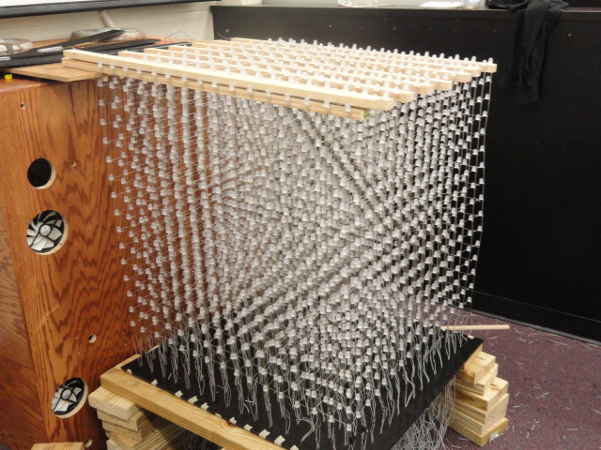
Figure 3: The full 16X16X16 Dynamic Animation Cube (Used with permission from Michael Alberts, see Appendix A)
3.1.1 Basic LED Cube
Group five will be taking over the Dynamic Animation Cube previously started by group one of the spring/summer 2012 semesters of the University of Central Florida’s College of Engineering and Computer Science’s Senior Design program. The cube is a sixteen by sixteen by sixteen cube made of light emitting diodes that is made to show three dimensional images and animations. The previous group got the idea to build this project from similar designs on the internet.
Instructables gives a good example of how to create a light emitting diode cube. The basic light emitting diode cube is an eight by eight by eight cube whose instructions can be found on many different websites. In order to start, it is recommended that the builder have a basic knowledge in electronics, soldering skills, and how to write in C code. The component lists call for 512 light emitting diodes for the structure, several different resistors and capacitors, ribbon cable, a microcontroller, a five volt power supply, a base, and miscellaneous plug, pins, and sockets.
One of the special things about the light emitting diode cube is the addition of the third dimension for picture display. This feature creates an interesting situation in that most two dimensional displays only need to worry about stacking pixels closely in order to create a clearer image. The cube on the other hand needs to be partially see through so that the pixels in the middle can be seen from any side. Therefore when building the cube, it is necessary to keep the light emitting diodes far enough apart so as not to sacrifice voxel fidelity. Unfortunately, most light emitting diode cubes end up showing a display in relatively low resolution than other forms of display.
A normal eight by eight by eight light emitting diode cube will contain a total of 512 LEDs. As such, it is impractical to connect every single on to the microcontroller, as it would be necessary to have a controller with 512 input/output ports with 512 wires between the cube and controller. Therefore, the spectacle known as persistence of vision is depended on in order to fool anyone viewing the cube.
Persistence of vision is an optical property that means when a light emitting diode flashes quickly in front of a person’s eyes, the image stays in the retina for a bit of time after the light turns off. This allows the designer of the cube to flash each layer of the cube one at a time, so that the three dimensional image is really only made up of several two dimensional images being stacked on each other. In electronics, this feature is known as multiplexing. Therefore, the microcontroller only needs to have sixty-four input/output ports, plus eight per layer.
The cube itself is built by setting up several layers and columns of light emitting diodes. Each light comes with a negative and positive leg, also known as a cathode and anode respectively. When building the cube, each light emitting diodes’ cathode leg is soldered to every other cathode leg in the same layer. The same goes for every anode leg, except these are soldered to each other one in the same column. The sixty-four columns are then connected to the microcontroller through a wire. The current through each layer is then regulated by a transistor that turns allows current to flow through and only light the specific layer that it controls.
The next step is setting up a system of multiplexers in order to send all of the information necessary. This will make it so that only eleven input/output lines will be needed to run sixty-four outputs. The other option is to create a serial-in-parallel-out shift register. This works by reading in all data at once, and whenever the clock signal activates from low to high, the data in each bit is shifted to the next position to the right. This is somewhat useful in that it only requires nine input/output lines on the microcontroller.
An important part to consider is the power supply needed. Although each light emitting diode needs very little current in order to run, there will normally be sixty-four of these on at a single time. Therefore, during calculations it is necessary to measure the current passing through with a five volt supply, multiply that number by sixty-four, and add around twenty-five to thirty milliamps for the rest of the system. The electronics should be monitored during this process to make sure none of the parts become too hot and burn out.
Once everything is prepared, the next step is to begin construction. Starting with a flat, sturdy board, drill holes in the correct spacing for the light emitting diodes that will provide the best voxel resolution. Then set up every diode in an eight by eight square, keeping the same spacing used on the board. Solder each cathode leg to the next one in line and add a bracing system when completed. Remove the lights carefully from the board and repeat until every layer is done. Once the layers are completed, begin soldering the anode legs of each light emitting diode to the anode of the diode directly below it.
Once the structure of the cube is built, it is time to connect the base, cathode risers and cables. When done, the hardware pieces can be connected together. Each component that the previous group used is referenced below. After completion, the light emitting diode cube is ready to be programmed with whatever animation or image the creator would like to show (LED.)
3.1.2 LED Drivers
The type of light emitting diode drivers that the previous project owners, according to their documentaion, originally used was the Texas Instruments TLC5941. There were three different methods that they considered implementing, each with a different ratio of frame rate to general purpose input/outputs. Eventually the group decided to go with three sets of sixteen drivers lined up in series, as shown in Figure 4. By using this method, they were able to use the least amount of general purpose input/output pins, but sacrificed clock cycle time. In total, the entire driver system required 256 clock cycles to read the inputted data plus one additional cycle for the latch that transmitted the data to the cube. This method also gave the group the most control of the whole system when implementing commands to the diodes. The types of general purpose input/output pins necessary for the drivers were:
- 3TLC 5941 Serial Data Lines
- 1 TLC 5941 Serial Ground Control Line
- 1 TLC latch Enable Bus
- and 1 TLC Output Enable
giving a total of 6 general purpose input/output pins.
Figure 4: 3 sets of 16 LIGHT EMITTING DIODE Drivers
(used with permission from Michael Alberts, see Appendix A)

Each light emitting diode drivers was fed information about certain areas of a layer and which light emitting diodes on the board to power up. Once the signals were put into an array, the different drivers held all of the necessary information in order to power and entire layer. The drivers were divided up into three separate rows that each controlled a single color in the diodes with each driver controlling each layer. The layout of the board made it easy to set up arrays and read the schematic.

The drivers were then connected to a Stellaris microcontroller that could be run in two different modes depending on need. In the first mode, serial communication was used to change the states of the light emitting diodes. By reading in the data from the computer, the Stellaris clocks in each layer on at a time, then multiplexes the data together in order to start showing the 3D images on the Dynamic Animation Cube. With the second mode, the Stellaris communicates with the Cortex M3 processor so read in animations without needing the computer. This method was the more appealing as it allowed the group to create a model that could operate on its own without need of an external processor to provide image and animation data (Dynamic.)
3.1.3 Decoders
The next piece of hardware that the group decided to use was a CD74HC4514 4-to-16 line decoder, shown in 5. With this device, when the enable pin was set to low, the output could be displayed without needing to rely on inputs, thereby keeping it at the previous input entered. Conversely when the enable was set to high, the decoder would read in from the controller General purpose input/output pins and set the cube for the correct output.
Figure 5: 3 4-to-16 decoders (used with permission from Michael Alberts, see Appendix A)
One of the benefits to using this specific device was the option to run it as a decoder or a multiplexer. Although the actual project did not call for use of a multiplexer, the group decided that the need may show up in the future, and by having a part that could play multiple rolls, it would be easy to switch modes without it being necessary to add or change parts. Also, the sixteen outputs of the device synced up with the driver in a desirable way so that the entire cube could be run with only a few decoders.
The device also has a built in balanced propagation delay, allowing for smoother communication and less chances of errors appearing in the system. This made it so that with all of the different means of communication present, there would be a much smaller chance of erroneous bits and latch triggering during transition time.
Another plus to using this device over others was a significant drop in power usage as well as higher immunity to noise. With these features, powering several thousand light emitting diodes, a microcontroller, and all the other parts made any drop in power need acceptable. The noise immunity would allow problems caused by noise to occur much less frequently. This included altering input data, distorting the latch signal or enable pins, or not reading all of the input data and not lighting part of the cube. The microcontroller itself included some noise reduction, but having another component with this capability lessened the stress on the controller (Dynamic.)
3.1.4 Microcontroller
The microcontroller the previous group decided to use was the Texas Instruments Stellaris LM3S8962. This version of controller operates at 50MHz as well as storing up to 256KB of memory. The group could also program the Stellaris with a large choice of programming libraries, allowing for more versatility with code. The core of the processor was a 32-bit ARM Cortex-M3 which could handle interrupts with relative easy. It achieved this through the use of an “Integrated Nested Vectored Interrupt Controller” which responded to interrupts quickly, at about a total of twelve clock cycles. This was good in the fact that the Dynamic Animation Cube’s serial communication system used a high amount of clock cycles and taking up less was a good decision to make. The interrupts could also be controlled one of two ways: through the light emitting diode drivers latch enabler, or the 16-bit system clock included in the system itself.
The fact that the microcontroller could be run at 50MHz was also a good feature to have. Although the light emitting diode drivers were being run with a 14.7456MHz crystal, it was possible that in the future the group would find a way to operate the cube at frequencies that high. Also, having its own built-in memory system would allow the controller to read in and store as much data that was needed to run the states of the light emitting diodes.
The Stellaris also possessed a total of 42 General purpose input/output pins , more than enough to control the entire cube and still have some left over. In addition to this, the controller came with a feature that allowed for quick toggling between IOs in only two clock cycles, again cutting down on the amount necessary for the system to run.
Another method the controller implements to save space is through the use of bit-banding. This method takes a full word in memory and maps it to a single bit, similar to pointers in programming. With this process, animations written in C code could be translated into assembly code and sent to the M3 efficiently. This was also done completely independently by the Stellaris, lightening the load on the programmer from having to make sure the system was in place.
The device also came with two other useful features. The universal asynchronous transmitter/receiver allowed for communication along transmitting and receiving lines from the controller to the cube in a serial manner. The synchronous serial interface on the other hand was used to send information bits to the drivers with a programmable bit rate. This would allow for a variety of frame sizes, from 4 to 16, to be implemented, so instead of using 3 sets of 16 drivers, the group would be able to use 16 sets of 3 drivers. Doing this cut the amount of clock cycles necessary from 256 down to 48. This could also be changed around to take advantage of the extra General purpose input/output pins , meaning the image eventually shown on the cube could be a smooth, flawless image instead of a choppy one (Dynamic.)
3.1.5 LED’s
The previous group decided to use a four pin, five millimeter light emitting diode that had many useful features that the group found appealing, which can be seen in Figure 6. To start, all the light emitting diodes shared a common cathode. This meant that when connecting all of the light emitting diodes together in the cube shape, the group only needed one ground line for each light instead of one for each color. This also simplified issue checking, allowing the group to look at only one wire for the problem instead of three. This made it so that if one color of anlight emitting diode was not illuminating, only the wire for that color had to be fixed while the ground could be left alone.
Figure 6: Lattice of LEDs (used with permission from Michael Alberts, see Appendix A)
The second feature of the light emitting diodes is that all of them could emit red, blue, and green. This was perfect in the fact that while most cubes work with only a single color, the Dynamic Animation Cube would be able to shown several kinds of vibrant colors. It also would allow for the images and animations implemented to be displayed in colors that would more easily exhibit the complexity of the cube. The only issue with this design is that the code necessary would have to incorporate one value of each hue, rather than a single one.
The fact that the light emitting diodes were only five millimeters was also a plus. It meant that the lights themselves would take up very little space and allow the group to consolidate the total size of the cube itself. This would eventually bring up another issue with how big to make the cube. If the group made it too large, transportation would be a problem, specifically with trying to move it through doors. On the other hand, if they made it too small, any 3D image the cube would try to display would look more like a conglomeration of lights than an actual picture.
A minor issue that the group noticed with the light emitting diodes was the fact that the casing was water clear. This could cause a picture with multiple colors, because if the light emitting diodes became too bright, the animation might have blurred together instead of being a coherent image. This could be solved in a few different ways though. Either the group could frost the lights by hand, dulling the amount of light being emitted slightly, or lowering the input voltage to a point that the lights would not be so intense.
The light emitting diodes themselves required 20mA of current per bulb. This meant that to power the entire Dynamic Animation Cube at one time, the system needed about 82 amps total. The good thing is that nothing the group was doing required every diode to be lit at the same time. The most they foresaw needed at once was one layer, which only required around five amps, a drastic cut back. This was beneficial in the fact that it made efficient use of the current being fed into the cube, and allowed for the possibility of turning on a few more layers if the image or animation would need it.
Another major plus is the life rating of each bulb. Every light emitting diode has a lifetime of about 100,000 hours, meaning if the cube was left running and never turned off, the light emitting diodes would last for about eleven and a half years. This lifetime also only refers to the amount of time until the diodes lose around 30% luminosity, which means that each light lasts even longer than that. This feature is beneficial in the fact that if the cube is only powered on for a part of the day, it will continue to work for a few decades before any of the light emitting diodes actually need replacing. And even if something happens and a diode burns out earlier than expected, it would be a simple matter to change it out as long as the lights were not space too closely together.
The viewing angle of the light emitting diodes was also rated well for what the group needed. If the degree of the angle was too high, the light would be too spread out, making the image difficult to see. Conversely, if the angle was set too small, the image would suffer in that it could only be perceived from certain places, making any 3D pictures and animations less effective. The viewing angle of the Light emitting diodes chosen was set to 25 to 35 degrees, which was sufficient for the group’s needs.
The internal luminosity rating of 4000 mill candela was also sufficient for what the group had in mind. This would allow the cube to be displayed in normal lighting without taking away from the experience, as well as making display in a dark room even better. The best conditions for viewing though would possibly be in a room that is only dimly lit because 4000 Light emitting diodes in a dark room may become a little too bright.
The final benefit to each light emitting diode was that the only weighed one gram each. Although this is light, the entire cube incorporated 4096 diodes, which makes the weight of the lights alone over four kilograms. This became important in the fact that with soldering and wiring included; the base that was chosen had to be stable and strong enough to hold up the entire weight of the cube (Dynamic.)
3.1.6 Structure
The existing Dynamic Animation Cube I that was completed by a previous senior design group that passed through the University of Central Florida’s Electrical Engineering and Computer Engineering programs was documented to be much more impressive than it really end up to be. The previous group took on the project and was provided a generous amount of funding to be allocated for the production of the Dynamic Animation Cube. The use of this funding did not however fund any sort of internal structure for the Dynamic Animation Cube I. The entire cube is not encased in any sort of protective cover and there are no internal supports that hold the Dynamic Animation Cube I to it’s cube shape other than the soldering material that was used to create the Dynamic Animation Cube I. Show below, in Figure 7 is the only form of support that the previous group gave to the Dynamic Animation Cube I. The supports are in the form of eight, two inch by one inch wooden rods that are drilled into a stationary box behind the structure of the cube. These supports are what allow the light emitting diodes to be soldered together and the rest of the cube shape is then formed downward and using solder material the light emitting diodes are soldered together downward to form the delicate lattice structure that the Dynamic Animation Cube is.
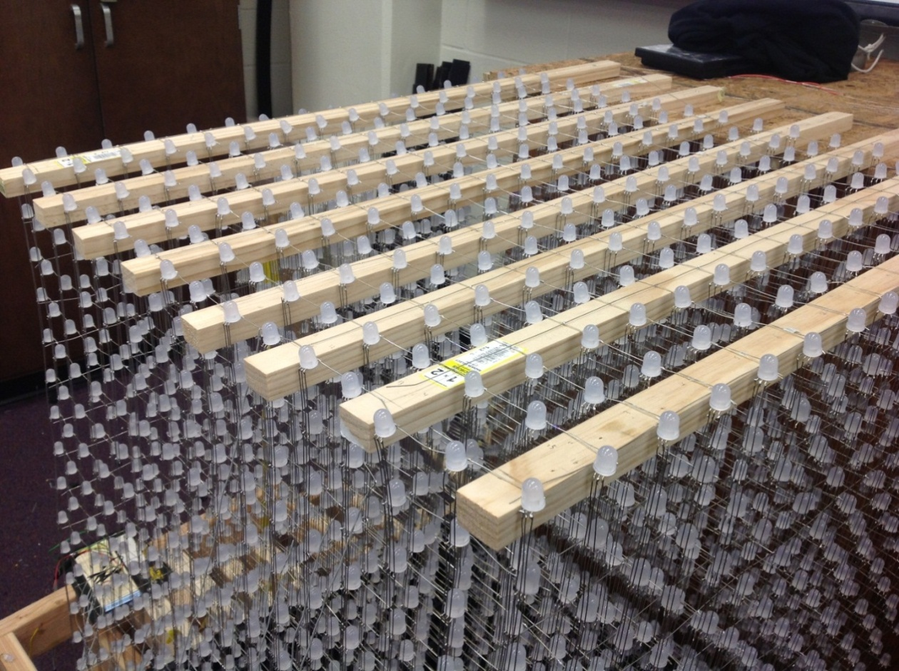
Figure 7: The supports that give the Dynamic Animation Cube I it’s only form of structural support.
The Dynamic Animation Cube I uses a system of eight, two inch by one inch wooden rods. These eight wooden rods are the only form of structural stress relief provided in the design of the Dynamic Animation Cube I.
One oversight that the previous group that completed the Dynamic Animation Cube I project overlooked was the use of an internal structural system to support the delicate lattice structure formed by the arrays of light emitting diodes. The only supports that keep this delicate structure in tact are the eight, two inch by one inch, wooden rods that the entire structure hangs from. These light emitting diodes are held together by the soldering material used to connect each of the individual lights. The lack of structural integrity in the Dynamic Animation Cube I provides a very shaky cube. Shown below, in Figure 8 is a close up view of the lack of structural support in the delicate lattice structure that makes up the Dynamic Animation Cube I. Since the Dynamic Animation Cube I was constructed for the purpose of display as a piece of artwork within one of the engineering buildings on the University of Central Florida’s campus, the lack of as structural support system within the delicate array of light emitting diodes would make it very difficult to transport the cube to its final display location somewhere on the University of Central Florida’s campus. In addition to a less than ideal transport situation the Dynamic Animation Cube I would be subjected to any number of unforeseen conditions while being transported to an unknown location. The lack of an internal structure to help the cube retain its shape was the most important improvement that Group 5 could give to the Dynamic Animation Cube I.
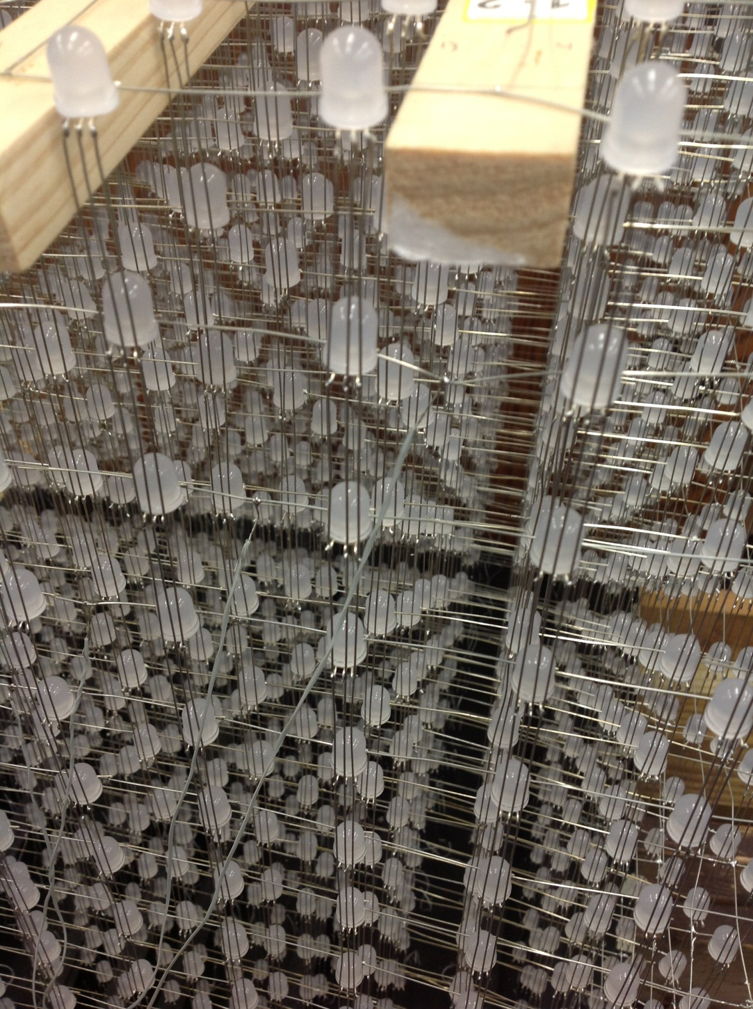
Figure 8: A close-up view of the Dynamic Animation Cube that demonstrates the last of the use of any sort of internal structural system.
The structure of the previously completed Dynamic Animation Cube I project seemed to be a last minute compilation of thoughts from the previous group that worked on the Dynamic Animation Cube. The base of the Dynamic Animation Cube I is a piece of black acrylic. This piece of acrylic has a series of holes drilled in it just large enough to fight the wire for each of the downward streams of solder material to fit through. The previous grouped outfitted the base of the structure with cut up pieces of acrylic in order to provide some sort of stability within the different downward sections of light emitting diodes. The base of the cube does not have any sort of compartment for the essential hardware for the Dynamic Animation Cube’s operation to be concealed from sight during operation. This configuration is not only astatically unattractive but also not practical for the cube’s intended use. The cube is meant to be put on display in one of the engineering buildings on the University of Central Florida’s campus. Shown below, in Figure 9 is the construction of the base of the Dynamic Animation Cube as provided by the previous group that completed the Dynamic Animation Cube project at the University of Central Florida.
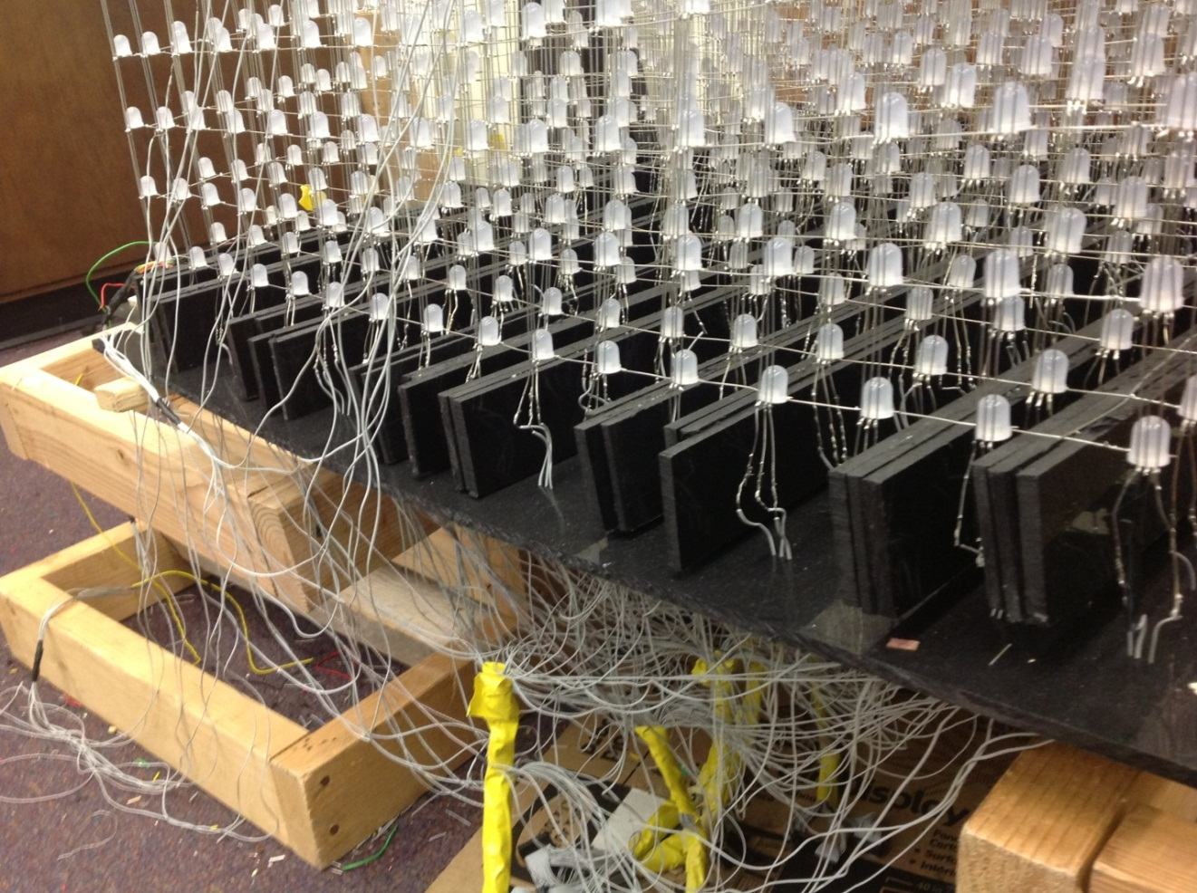
Figure 9: The base of the Dynamic Animation Cube, as provided by the previous group
As shown, the Dynamic Animation Cube does not have a stable base. Due to the construction of the cube and the fact that it’s only stability is provided by eight, two inch by one inch wooden rods nailed into a box at the back of the cube, there is no sort of support at the base of the cube. The base sags down beneath the two temporary supports provided during the construction of the cube. Due to the haste of the last group to work on the Dynamic Animation Cube, construction of the light emitting diode array was not given the amount of care that it should have been. The haste that the previous group demonstrated during the construction of the Dynamic Animation Cube contributed to the lack of stability in the design. The base of cube, as shown in Figure 10 is supported on both sides by what were supposed to be temporary supports to aid in the construction of the Dynamic Animation Cube. Unfortunately due to poor construction and lack of structural integrity the Dynamic Animation Cube is not capable of standing without the use of these once thought to be temporary supports in addition to the rough looking box structure that stands behind the cube.
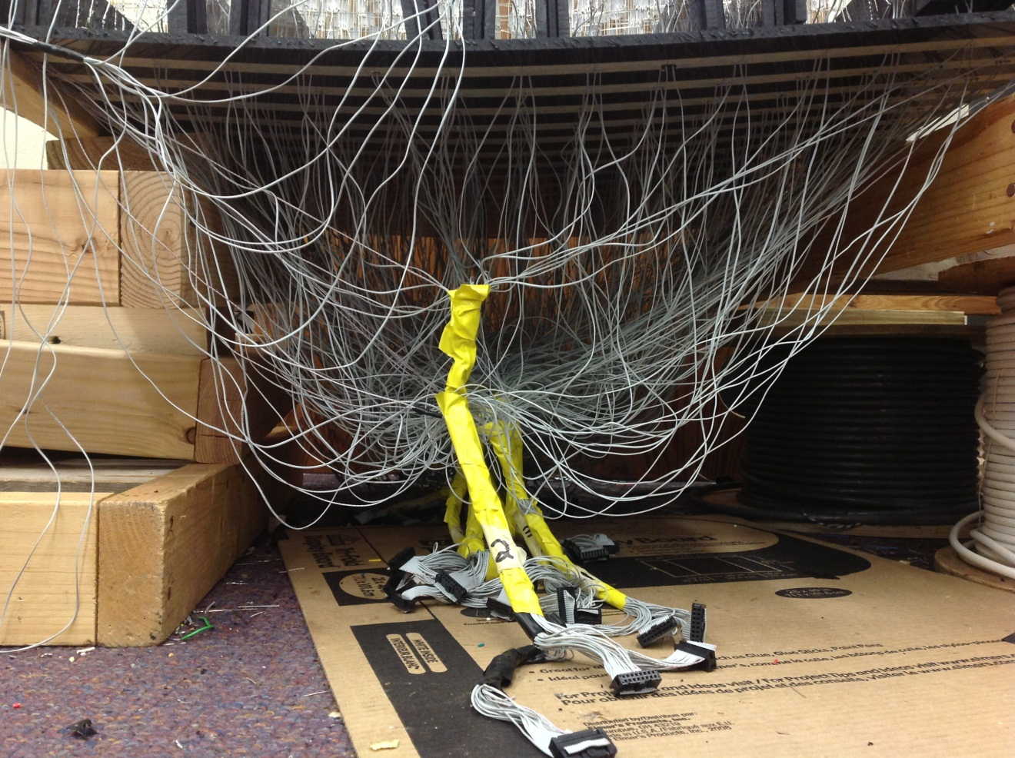
Figure 10: A close up view of the base of the Dynamic Animation Cube I

3.2 Component Research
The following section will describe the types of hardware and software architecture that group five will consider using in the Dynamic Animation Cube II. These pieces will be crucial to the success of the project in that each part must work fluidly with each other part so that the cube will work correctly. This will also show the knowledge of the group members by allowing them to choose components that are necessary without wasted space or cost.
3.2.1 Power Supply Unit (Sparkfun Electronics)
In order to power the Dynamic Animation Cube II, group 5 has many options available to them. The best kind to use will be one that plugs into a wall outlet and converts the voltage to 5 volts DC. Luckily, there is no shortage to power supply units that can accomplish this goal.
The one that looks the best to start with is a Sparkfun Electronics Breadboard Power Supply 5V/3.3V. According to the Sparkfun website, this unit comes with the additional feature to be run a 3.3 volts instead of five incase the group decides that a lower voltage will be better for the system overall. The size of this components is also only 1.25X1.25", which is convenient as its small size will save a lot of space in the overall project.
The other necessary piece of the power supply unit will be a wall adapter that can provide a constant output power. There is also no shortage of these, so the group will look at using one that provides a five volt output and two amp output to start with. Hopefully this will give ample current for the system in order to power every part of the Dynamic Animation Cube II that the group needs it to. If, after testing the devices with this amount, the current proves to be too strong, the group can fall back to a lower amp output adapter. Shown below, in Table 1 is the pricing for the power supply’s Group 5 considered using (Breadboard.)
Component | Price
Breadboard Power Supply | $9.95
5V, 2A adapter | $16.28
4-6V, 1A adapter | $8.66
Table 1: Power supply pricing

3.2.2 Housing
For the Dynamic Animation Cube II the group unanimously decided to take more seriously the idea of protecting our finished product. All of the group’s efforts will be for not if the cube is not properly protected by a strong and durable material. It will be imperative to the lifetime of the Dynamic Animation Cube II that the cube is protected in a manner that will allow for little to no destruction due to the ambient setting that the department of Electrical Engineering and Computer Science ultimately decides to place the cube within. This outer protection will encase the entire Dynamic Animation Cube II and will provide the necessary protection from the ambient environment to ensure proper functionality of the cube.
The group researched several different materials when considering which material would be best suited for use as the housing for the Dynamic Animation Cube II. During the research phase of the project, the group considered sheets of extruded acrylic, cast acrylic and glass to ultimately encase the Dynamic Animation Cube II. These sheets will meet at ninety degree angles to form a cube around the finished Dynamic Animation Cube II. These sheets will be beveled at forty five degree angles and then the sheets will be bonded together using an industrial grade acrylic bonding agent.
3.2.2.1 Extruded Acrylic
Polymethyl Methacrylate, Extruded or more commonly known as extruded acrylic is a strong and very durable material commercially available. Extruded acrylic is very easy to obtain and is used for a very large number of applications. It is most commonly used when a very high strength to weight ratio is needed. For the purposes of the Dynamic Animation Cube II, the group is looking for a strong, durable material that will be least susceptible to outside elements while on display at the University of Central Florida. There are several benefits to using an extruded acrylic. These benefits have been outlined to be transparency, strength to weight ratio, and cost.
Most important to the group is that the Dynamic Animation Cube II be encased in an aesthetically pleasing manner that will provide a visually pleasant experience when interacting with the Dynamic Animation Cube II. With this in mind, the group researched using extruded acrylic sheets as a material for the purpose of the housing of the Dynamic Animation Cube II. Extruded acrylic sheets are first and foremost transparent. This feature will allow viewing of the Dynamic Animation Cube II to be unobstructed by opaqueness. It is important to the group that the cube be encased in a very clear and unclouded material that will enhance all of the user’s experiences with the Dynamic Animation Cube II.
Extruded acrylic sheets offer unusually high strength to weight ratios. Shown below, in Table 2 is a table of features of extruded acrylic sheets. Extruded acrylic sheets are manufactured using a process that pushes the liquid form of the plastic through large rollers which are pressed into large sheets as the liquid plastic cools. These features include physical properties of extruded acrylic when tested against the American Society for Testing and Materials standards.
PHYSICAL PROPERTIES | UNITS | ASTM | RESULTS
Density | lb/in³ | D792 | 0.043
Water Absorption (24 hrs) | % | D270 | 0.3
MECHANICAL PROPERTIES | UNITS | ASTM | RESULTS
Tensile Strength @yield | psi | D638 | 8k-11k
Compressive Strength | psi | D695 | 11k-19k
OPTICAL PROPERTIES | UNITS | ASTM | RESULTS
3mm Transparent Clear Transmittance Total | % | D1003 | 92
Table 2: Physical, Mechanical, and Optical properties of interest for extruded acrylic sheets
Extruded acrylic sheets are the most economically priced sheets in the acrylic family. Sheets of extruded acrylic can be procured from a wide range of companies which demands that companies offer competitive prices. The fact that extruded acrylic sheets are offered in such a large number of colors at various thicknesses at competitive prices is what led Group 5 to consider this material for use as the exterior housing for the Dynamic Animation Cube II. Shown below, in Table 3 is a price table that shows a variety of thicknesses of extruded acrylic and the corresponding price with several commercial suppliers of the product.

COMPANY | SIZE (INCHES) | THICKNESS (INCHES) | PRICE
Professional Plastics | 36 x 48 | .22 | $101.94
Professional Plastics | 36 x 48 | .25 | $113.63
Professional Plastics | 36 x 48 | .375 | $175.85
ePlastics | 48 x 48 | .177 | $93.93
ePlastics | 48 x 48 | .236 | $115.50
ePlastics | 48 x 48 | .354 | $207.98
US Plastic Corp | 48 x 48 | .177 | $100.25
US Plastic Corp | 48 x 48 | .220 | $115.88
US Plastic Corp | 48 x 48 | .354 | $209.12
Table 3: Pricing table for several thicknesses of extruded acrylic sheets
3.2.2.2 Cast Acrylic
Polymethyl Methacrylate, Cast or more commonly called cast acrylic is a strong and very durable material commercially available. Cast acrylic is very easy to obtain and is used for a very large number of applications. It is most commonly used when a very high strength to weight ratio is needed. For the purposes of the Dynamic Animation Cube II, the group is looking for a strong, durable material that will be least susceptible to outside elements while on display at the University of Central Florida. There are several benefits to using a cast acrylic. These benefits have been outlined to be transparency, strength to weight ratio, and durability.
Most important to the group is that the Dynamic Animation Cube II be encased in an aesthetically pleasing manner that will provide a visually pleasant experience for users interacting with the Dynamic Animation Cube II. With this in mind, the group researched using cast acrylic sheets as a material for the purpose of the housing of the Dynamic Animation Cube II. Cast acrylic sheets are first and foremost transparent. This feature will allow viewing of the Dynamic Animation Cube II to be unobstructed by opaqueness. Cast acrylic has a transparency very similar to glass. It is important to the group that the cube be encased in a very clear and unclouded material that will enhance all of the user’s experiences with the Dynamic Animation Cube II.
Cast acrylic is what is used to make the name brand of acrylic known as Plexiglass. Cast acrylic is known to be even stronger than extruded acrylic and this is due to the manufacturing process of each of the types. As stated before, extruded acrylic sheets are manufactured using a process that pushes the liquid form of the plastic through large rollers which are pressed into large sheets as the liquid plastic cools. In comparison, cast acrylic sheets are manufactured by pushing the liquid form of the plastic into molds and then heating the plastic into one solid sheet. This cell cast acrylic has a tendency to be a better, higher quality than extruded acrylic and tends to be stronger. The extruded acrylic is often softer when compared to cast acrylic; it usually contains some sort of impurities, and is more susceptible to scratching.
Cast acrylic sheets are more expensively priced than extruded acrylic sheets. Sheets of cast acrylic can be procured from a wide range of companies which demands that companies offer competitive prices. The fact that cast acrylic sheets are offered in such a large number of sizes at various thicknesses is what led Group 5 to consider this material for use as the exterior housing for the Dynamic Animation Cube II. Shown below, in Table 4 is a price table that shows a variety of thicknesses of cast acrylic sheets and the corresponding price with several commercial suppliers of the product.
COMPANY | SIZE (INCHES) | THICKNESS (INCHES) | PRICE
Professional Plastics | 36 x 48 | .22 | $79.72
Professional Plastics | 36 x 48 | .25 | $114.57
Professional Plastics | 36 x 48 | .375 | $180.06
ePlastics | 48 x 48 | .177 | $119.15
ePlastics | 48 x 48 | .236 | $136.89
Interstate Plastics | 48 x 48 | .236 | $117.72
US Plastic Corp | 48 x 48 | .375 | $171.80
US Plastic Corp | 48 x 48 | .354 | $209.12
Table 4: Pricing table for several thicknesses of cast acrylic sheets
3.2.2.3 Glass
The Dynamic Animation Cube II will need to be housed in a strong and durable material that will be able to be transported and suspended from the ceiling of one of the engineering buildings on the University of Central Florida’s campus. The group unanimously decided that glass would be too delicate a material for the applications that the group is considering. There are a large number of alternatives to glass on the market today and most of them are much more durable and offer many more incentives to use for our purposes. Glass is more expensive, heavier, and more difficult to manipulate for the groups applications.
3.2.2.4 Housing Decision
The group has decided to use cast acrylic sheets to encase the Dynamic Animation Cube II. The group unanimously decided that even though cast acrylic sheets are priced higher than extruded acrylic sheets, that the benefits more than outweigh the higher cost of materials. As stated previously, cast acrylic sheets are manufactured by pushing the liquid form of the plastic into molds and then heating the plastic into one solid sheet. This cell cast acrylic has a tendency to be a better, higher quality than extruded acrylic and tends to be stronger than extruded acrylic sheets.

3.2.3 Structural Improvements
The Dynamic Animation Cube II will comprise of more than 4,000 light emitting diodes. These Red, Blue, Green light emitting diodes will be soldered together using solder material to form a delicate lattice structure that will be very vulnerable to outside influence as well as every day wear and tear. The delicate structure will have a stable framework that will provide stress relief to the solder material that holds together each of the light emitting diodes. The Dynamic Animation Cube II will be put on display at the discretion of the University of Central Florida’s department of Electrical Engineering and Computer Science. For this purpose, the group decided that in order to ensure the Dynamic Animation Cube II is available for many future engineering students at the University of Central Florida to enjoy that some sort of housing would be essential to the livelihood of the completed project. The group decided that durability would be most important since the Dynamic Animation Cube will be hanging from the ceiling of one of the engineering buildings on the University of Central Florida’s campus. In addition to durability, strength and transparency were also considered in order to make a decision about what kind of casing would enclose the finished Dynamic Animation Cube II. With these items in mind, the group decided to use cast acrylic sheets to encase the Dynamic Animation Cube II. In addition to the enclosure that will house the cube, Group 5 will create an infrastructure within the light emitting diode array in order to maintain stability of the entire Dynamic Animation Cube II. For this inner infrastructure system, the group decided to go with cast acrylic rods which will prove to be stronger and less flimsy than extruded acrylic rods. The final housing related issue that the group faced during the research phase of the project was figuring out how to house the necessary hardware within the entire structure of the Dynamic Animation Cube II. Group 5 decided to create an enclosed base to the cube with a dark shade of acrylic that will house this hardware and any other necessary items.
3.2.3.1 Acrylic
Extruded acrylic rods are the most economically priced rods in the acrylic family. Rods of extruded acrylic can be procured from a wide range of companies which demands that companies offer competitive prices. The fact that extruded acrylic rods are offered in such a large number of colors at various thicknesses at competitive prices is what led Group 5 to consider this material for use as the internal structural system for the Dynamic Animation Cube II. Extruded acrylic rods are available in both cylindrical rods as well as square rods. Both shapes of extruded acrylic rod are available at several thicknesses as well as lengths.
Cast acrylic is what is used to make the name brand of acrylic known as Plexiglass. Cast acrylic is known to be even stronger than extruded acrylic and this is due to the manufacturing process of each of the types. As stated before, extruded acrylic sheets are manufactured using a process that pushes the liquid form of the plastic through large rollers which are pressed into large sheets as the liquid plastic cools. In comparison, cast acrylic sheets are manufactured by pushing the liquid form of the plastic into molds and then heating the plastic into one solid sheet. This cell cast acrylic has a tendency to be a better, higher quality than extruded acrylic and tends to be stronger. The extruded acrylic is often softer when compared to cast acrylic; it usually contains some sort of impurities, and is more susceptible to scratching. Cast acrylic rods are only available in cylindrical rods. Cylindrical acrylic rods are available at several thicknesses as well as lengths.
Cast acrylic rods are more expensively priced than extruded acrylic rods. Cast acrylic rods can be procured from a wide range of companies which demands that companies offer competitive prices. The fact that cast acrylic rods are offered in such a large number of sizes at various thicknesses is what led Group 5 to consider this material for use as the internal structural system for the Dynamic Animation Cube II. Shown below, in Table 5 is a price table that shows a variety of thicknesses of cast acrylic rods versus extruded acrylic rods and the corresponding price with several commercial suppliers of the products.
COMPANY | TYPE | SHAPE | LENGTH  (FEET) | THICKNESS (INCHES) | PRICE
ePlastics | CAST | CYLINDRICAL | 6 | .312 | $24.90
US Plastics | CAST | CYLINDRICAL | 6 | .375 | $18.90
ePlastics | EXTRUDED | CYLINDRICAL | 6 | .312 | $14.64
US Plastics | EXTRUDED | CYLINDRICAL | 6 | .375 | $2.58
US Plastics | EXTRUDED | SQUARE | 6 | .5 | $5.82
Tap Plastics | EXTRUDED | SQUARE | 6 | .375 | $9.00
Table 5: Pricing table for several thicknesses of cast acrylic and extruded acrylic cylindrical and square rods
3.2.3.2 Wood
Wooden dowels are used for a variety of applications. For the purposes of the Dynamic Animation Cube II applications, the group did minimal research into the use of wooden dowels. The group was limited to the idea of using wooden dowels as a support system for the delicate array of light emitting diodes mainly because wooden dowels are not transparent. Transparency is a major concern for the Dynamic animation Cube II. The Dynamic Animation Cube II will be put on display in one of the engineering buildings at the University of Central Florida. Since it will be on display, the aesthetics of the project are an important guiding factor for each decision that the group has to make. Wooden dowels would dramatically reduce the viewing pleasure of users of the Dynamic Animation Cube II and it is for this reason that the group did not chose to go forward with the design of the Dynamic Animation Cube II with the idea of using wooden dowels as a basis for the structural system that will be implemented
3.2.3.3 Aluminum
Aluminum rods are used for a variety of applications. For the purposes of the Dynamic Animation Cube II applications, the group did minimal research into the use of aluminum rods. The group was limited to the idea of using aluminum rods as a support system for the delicate array of light emitting diodes mainly because aluminum is not transparent. Transparency is a major concern for the Dynamic animation Cube II. The Dynamic Animation Cube II will be put on display in one of the engineering buildings at the University of Central Florida. Since it will be on display, the aesthetics of the project are an important guiding factor for each decision that the group has to make. Aluminum rods would dramatically reduce the viewing pleasure of users of the Dynamic Animation Cube II and it is for this reason that the group did not chose to go forward with the design of the Dynamic Animation Cube II with the idea of using aluminum rods as a basis for the structural system that will be implemented.
3.2.3.4 Base
Extruded acrylic sheets are the most economically priced sheets in the acrylic family. Sheets of extruded acrylic can be procured from a wide range of companies which demands that companies offer competitive prices. The fact that extruded acrylic sheets are offered in such a large number of colors at various thicknesses at competitive prices is what led Group 5 to consider this material for use as the base for the Dynamic Animation Cube II. Extruded acrylic sheets are available in many sizes, thicknesses, and colors.
Cast acrylic is what is used to make the name brand of acrylic known as Plexiglass. Cast acrylic is known to be even stronger than extruded acrylic and this is due to the manufacturing process of each of the types. As stated before, extruded acrylic sheets are manufactured using a process that pushes the liquid form of the plastic through large rollers which are pressed into large sheets as the liquid plastic cools. In comparison, cast acrylic sheets are manufactured by pushing the liquid form of the plastic into molds and then heating the plastic into one solid sheet. This cell cast acrylic has a tendency to be a better, higher quality than extruded acrylic and tends to be stronger. The extruded acrylic is often softer when compared to cast acrylic; it usually contains some sort of impurities, and is more susceptible to scratching. Cast acrylic sheets are available in many sizes, thicknesses, and colors.
Cast acrylic sheets are more expensively priced than extruded acrylic sheets. Sheets of cast acrylic can be procured from a wide range of companies which demands that companies offer competitive prices. The fact that cast acrylic sheets are offered in such a large number of colors, sizes, and at various thicknesses is what led Group 5 to decide to use this material for use as base for the Dynamic Animation Cube II.
3.2.3.5 Structural Decision
The group has decided to use cast acrylic cylindrical rods as a basis for the structural support system that will be implemented in the retrofit of the Dynamic animation Cube II project. The group unanimously decided that even though cast acrylic rods are priced higher than extruded acrylic rods, that the benefits more than outweigh the higher cost of materials. Cast acrylic is less flimsy than extruded acrylic which is what the structural basis for the Dynamic Animation Cube II needs. In addition the cube base will be constructed of cast acrylic sheets.
3.2.4 Microcontroller
Choosing the right microcontroller is crucial for our design. The microcontroller must operate at a high frequency in order to be capable of refreshing the cube at a quick enough rate for smooth animations. Memory space is also a very critical factor to consider. The amount of applications the group can implement is affected by the amount of Flash memory the microcontroller has. The input/output pin count has to be considered since the group istrying to multiplex so many light emitting diodes.
3.2.4.1 StellarisLM3S8962 (Texas Instruments)
The group initially considered using the Stellaris LM3S8962 microcontroller because the previous group decided to use it in their design. The entire Stellaris family is designed around the ARM Cortex-M3 controller core, which is capable of operating at speeds up to 50 MHz. The LM3S8962 contains 256 Kbytes of Flash memory, and 64 Kbytes of SRAM. The Stellaris also offers the advantage of ARM’s widely available development tools, and an extensive community of followers. This microcontroller has many features as detailed below:
Features
- 32-bit ARM Cortex-M3 processor
- 256 Kbytes flash
- 64 Kbytes SRAM
- 42 General purpose input/output pins
- Pulse Width Modulation (PWM)
- 50 MHz Processing Speed
- Two Wire Interface (TWI)
- Synchronous Serial Interface (SSI)
The thirty-two bit ARM Cortex-M3 processor is very powerful. It offers high-performance, and low power consumptions.It’s Thumb-2 instruction allows for increased code density, delivering the computational performance expected from an ARM core without sacrificing memory. The Cortex-M3 also offers a three-stage pipeline Harvard architecture for high throughput during run time.
TheStellaris is equipped with an Integrated Nested Vectored Interrupt Controller, which provides deterministic interrupt handling; always processing in twelve cycles. The Cortex-M3 hasthirty-six interrupts with eight different priority levels. This feature can be used when interfacing with slower external devices. The group might need to make use of interrupts to achieve the desired refresh rate of the cube.
The fifty MHz processing speed is not the fastest operating frequency out there. Atmel offers their thirty-two bit AVR family capable of operating at speeds of up to sixty-six MHz. It is unsure at this time if fifty MHz is fast enough to perform all of the calculations, and communications the group will need to achieve the desired refresh rate.
The LM3S8962 has 256 Kbytes of Flash and 64 Kbytes of SRAM available. The ARM Cortex-M3 is capable of accessing Flash memory in one clock cycle. The SRAM employs a technology called bit-banding. This allows the processor to use address aliases to access individual bits in a single operation, reducing the amount of time consumed by read-modify-write operations. Both the single-access Flash memory and the bit banding technology will save clock cycles during execution of the program. It is unsure at this time whether this will be enough memory to handle all of the applications the group would like to implement. If the internal memory space is not enough, the group will have to add an external memory device.
The Stellaris LM3S8963 contains a general purpose input/output module. The general purpose input/output module consists of seven physical blocks corresponding to an individual port. The LM328963 has forty-two programmable general purpose input/output pins. The data control registers are used by the software to drive the data out to the pads. The addressing of all 256 light emitting diode drivers and all sixteen layers of the cube will be controlled using the general purpose input/output pins. Failing to account for the correct number of input/output pins will set the group back considerably in production time.
Another important feature is the switching speed of the input/output pins. The general purpose input/output pins on the LM3S8962 are capable of high switching speeds, being able to change every two clock cycles.
Pulse width modulation is an effect technique for digitally encoding analog signal levels. This can be used to select the amount of power that is sent to the light emitting diodes. Varying the amount of current on each pin of the light emitting diodes will fuse multiple colors together, allowing for more possibility of colors other than just red, blue, or green. The microcontroller pulse width modulation module consists of three pulse width modulation blocks, each with a sixteen bit counter. This gives the group sixteen million (16 x 16 x 16) different color options to be used with the light emitting diodes.
Inter-Integrated Circuit , also called Two Wire Interface,is capable of communicatingwith the Wii Nunchuk. The Two Wire Interface allows for bi-directional data transmission through a serial data line and a serial clock line. It is capable of transferring data at either one 100 Kbits per second, or 400 Kbits per second (Robot Electronics). There are four Two Wire Interface modes; master transmit, master receive, slave transmit, and slave receive. For the group’s applications, the microcontroller will be the master device, and the Wii Nunchuk will be the slave device. After receiving all of the data from the slave device, an interrupt is generated to make the processor aware that the transmission of data has completed.
The LM3S8962 Synchronous Serial Interface is an interface for synchronous serial communication with external devices. It is capable of communicating with serial peripheral interface devices, as well as other Texas Instruments synchronous serial interfaces. The light emitting diode drivers the group is going to use requires serial peripheral communication in order to be integrated with a master device. The Stellaris synchronous serial interface module has a maximum programmable data size of sixteen bits, which is smaller than the twenty-four bit size driver. The group will have to send an additional byte after the transmission of the first sixteen bits of data. This is inefficient, and will decrease the rate at which the cube can be refreshed.
3.2.4.2 AVR UC3C2512C (Atmel)
The Atmel UC3C2512 microcontroller was designed for high performance, and high code density (Atmel). It contains Atmel’s thirty-two bit AVR32UC processor, capable of operating at sixty-six MHz. It utilizes a multi-layered databus for high data throughput, and contains 64 Kbytes of on-chip SRAM along with 512 Kbytes of internal high-speed Flash memory. The UC3C microcontroller also offers high computing power with a built-in Floating-Point Processing Unit. The ATUC3C2512C has many features listed below:
Features
- 32-bit AVR32UC Processor
- 512 KB Flash
- 64 KB SRAM
- 66 MHz processing speed
- Serial Peripheral Interface (SPI)
- Pulse width modulation (PWM)
- Two Wire Interface (TWI)
- 45 GENERAL PURPOSE INPUT/OUTPUT PINS pins
- Floating point unit
The AVR32UC processor is an implementation of the AVR32 architecture. AVR32 is a high performance 32-bit RISC architecture with a three stage pipeline, and an innovative instruction set. The three-stage pipeline allows the processor to perform one instruction per clock cycle for most instructions. AVR32 has an innovative instruction set which will allow for a compact code size, saving memory space. There are some instructions with multiple addressing modes, a compact format and an extended format. The compiler is able to use the format giving the smallest code size. (Atmel)
AVR32UC offers internal High-Speed Flash and SRAM with single-cycle access at full speed. The group is confident the 512 Kbytes of Flash, and 64 Kbytes of SRAM is enough memory to handle the size of the code for all of the applications to be implemented. Keeping the Flash and SRAM on the chip allows for fast and secure access to memory, which is beneficial for achieving the required refresh rate.
The sixty-six MHz processing speed of the UC3C is faster than the Stellaris, which is one of the main reasons the group decided to do more research on Atmel’s UC3C microcontrollers. Being able to perform around sixty-six million instructions per second should be fast enough to do all of the calculations, and communications needed for the applications, to produce the desired refresh rate.
The AT32UC3C2512C is compatible with Two-Wire Interface standard communication protocol. The microcontroller behaves as the master device; it uses one clock line to synchronize with a slave device. The slave device then sends, or receives, data to the master over a data line (Artiuch). Two-Wire Interface is capable of transmitting data with speeds of up to four hundred thousand bits per second. The AT32UC3C is capable of transferring a single byte of data or it can transfer a sequence of bytes. The group will be able to use this feature to communicate with the Wii Nunchuk.
The AT32UC32512C is capable of Serial Peripheral Interface, which is a synchronous serial data link that provides communication with external devices. The Serial Peripheral Interface behaves like a shift register to serially send data to other Serial Peripheral Interface devices one bit at a time (Artiuch). Data is transmitted by the microcontroller to a slave device by shifting bits into it. The microcontroller and the slave device synchronize together by using the same clock frequency, which is driven by the microcontroller. The STP24D05 drivers use Serial Peripheral Interface to communicate with external devices. This feature will allow the group to send twenty-four bits of data telling the driver which pins to drive.
The microcontroller has a General Purpose Input/Output Controller that controls forty-five input/output pins that can be used as general-purpose input/output or can be assigned to a function of an embedded peripheral. With forty-five general purpose input/output pins, the group has many options for wiring all of the external devices.
In order to save pins, the group has decided to use three four to sixteen decoders to address all thirty-two drivers, and all sixteen layers. The drivers need an additional ten lines to interface with the microcontroller. That is twenty-two lines needed just to interface the light emitting diode drivers and all sixteen layers of the cube. The number of pins is important to consider because if the group runs out of general purpose input/output pins, then the microcontroller will need to be replaced. This will set back production time considerably. The previous group went with the StellarisLM3S8962, which has forty-two general purpose input/output pins. This gives the group confidence that the AT32UC3C2512C has enough general purpose input/output pins to handle the needs of the project.
The number of pins is not the only feature that needs to be taken into consideration. The switching speed of the pins is also very important. Most of the pins are capable of operating at fifty MHz with a ten pF capacitive load; however some are capable of operating at speeds of up to ninety-five MHz. The fall and rise times of all the general purpose input/output pins are shown in Table 6 below.
GPIO Rise and Fall Time
Pin Number | Load  (pF) | Rise Time  (ns) | Fall Time  (ns)
PB00-PB03, PB30-PB31,PC03-PC07 | 10 | 5.3 | 5.2
PB00-PB03, PB30-PB31,PC03-PC07 | 30 | 11.1 | 10.9
PB06,PB21,PB26,PD02,PD06,PD13 | 10 | 1.3 | 1.4
PB06,PB21,PB26,PD02,PD06,PD13 | 30 | 2.7 | 2.7
PA00-PA31,PB04-PB05,PB07-PB20, PB22-PB25,PC00-PC02,PC08-PC31, PD00-PD01,PD03-PD05,PD07-PD12, PD14-PD31 | 10 | 2.4 | 2.4
 | 30 | 5.2 | 5.1
Table 6: General Purpose input/output pin rise and fall times.
The AT32UC has a hardware Floating Point Unit, which performs a multiply and accumulate as a single operation with no intermediate rounding allowing for increased precision (Atmel). This feature will allow the group to program more complicated applications onto the microcontroller.
The AT32UC3C supports two interfaces for programming, JTAG or aWire. Both interfaces will offer access memories, the On-Chip Debug system, and all device peripherals through the Service Access Bus. The Service Access Bus uses a thirty-six bit address space to map the internal address space and other features. The four most significant bits are used to identify multiple slave devices, while the remaining thirty-two bits are decoded within the microcontroller.
The On-Chip Debug system offers an abundance of debugging capabilities. The debug system is based on the Nexus 2.0 standard, which offers basic run-time control, program breakpoints, data breakpoints, program tracing, ownership tracing, and data tracing. This will allow the group to effectively debug any problems that might occur while writing the code for the applications.
3.2.4.3 Microcontroller Decision
Choosing the right embedded processor is one of the most crucial decisions for the design. The most important feature of the microcontroller is speed. Choosing an embedded processor with too slow of an operating frequency may cause the animations to flicker due to the slow refresh rate. The AT32UC3C2512C outperforms the Stellaris LM3S8962 in this aspect with its sixty-six MHz operating frequency.
Another key parameter is the amount of internal memory; the microcontroller must contain a lot of Flash memory because the applications the group intends on implementing are complicated and may require a great deal of lines of code. Once again, Atmel’s AT32UC3C2512C surpasses Texas Instruments’ Stellaris, with 512 Kbytes of internal Flash.
Whichever microcontroller the group chooses, must also be able to communicate with ST Microelectronics’ STP24DP05 light emitting diode driver, and Nintendo Wii’s Nunchuk. Both microcontrollers offer serial peripheral interface, two wire interface, and pulse width modulation interfaces. However, the AT32UC3C2512C offers more channels of each interface.
The AT32UC3C2512C outperforms the Stellaris LM3S8962 in almost every category, as you can see in Table 7 below. The group has decided to choose Atmel’s AT32U3C2512C microcontroller. Although the Stellaris is impressive and very similar to the AT32UC3C2512C, the two main deciding factors were the faster processing speed, and the internal memory capacity.

Microcontroller Parameter Comparison
Model | LM3S8962 | AT32UC3C2512C
Processing Speed | 50 MHz | 66 MHz
GENERAL PURPOSE INPUT/OUTPUT PINS | 42 | 45
SPI | 1 | 5
TWI | 1 | 2
PWM | 6 | 14
Flash | 256 KB | 512 KB
SRAM | 64 KB | 64 KB
Table 7: A comparison of relevant microcontroller parameters under consideration for use in the Dynamic Animation Cube II.
3.2.5 Controllers
In order to manipulate the animations of the cube, it was necessary to explore the different options of controllers. The main specification that is of concern is the amount of data that is sent from the controller. The microcontroller has a limited amount of memory space. Another important feature to consider is the communication protocol. There are three controllers that the group decided to consider; a Microsoft Kinect, a Nintendo Wii remote, and a Nintendo Wii Nunchuk. All options have a variety of documentation and examples of third party applications.
3.2.5.1 Microsoft Kinect
The initial choice for a controller was the Microsoft Kinect. The group envisioned being able to manipulate the virtual Rubik’s cube just as if it was a real Rubik’s cube. With the Kinect, it is possible to pick up specific hand gestures and use that to manipulate the animations of the cube. This will give the Rubik’s cube application a more realistic experience to the user. The user will be able to simulate the motions of solving a real Rubik’s cube with their hands, and the animations will adjust accordingly.
The Kinect uses a pair of cameras, which incorporate CMOS image sensors. The infrared camera uses the MT9M001 sensor from Adina. The relatively large, 5.2µ x 5.2µ (Micron), pixel size performs well regardless of low lighting conditions. This will allow the Kinect to pick up user inputs wirelessly and in a wide range of lighting conditions.
The main feature of the Kinect is the on board image processing capabilities. It interfaces two cameras and four microphones with the PrimeSense PS1080. The PS1080 collects the data from all of the sensors and synchronizes them together to be sent to a host (PrimeSense). All of the image processing is being done on the Kinect itself. This feature will allow the group to be able to use the Kinect without adding to the complexity of the code.
The amount of data being sent from the Kinect is something that needed to be monitored. The depth camera sends roughly 400 Kbytes of data per frame. The color camera sends a little more than 300 Kbytes bytes of data per frame. At thirty frames per second, this is a lot of data that needs to be collected. The Atmel UC3 series does not have enough memory space to handle all of that information.
The Kinect’s image processing capabilities make it ideal for control of the cube. However, due to the limited memory space on the microcontroller, the group will have to look into adding an external memory device. It is unsure at this time if the Kinect can be used with the microcontroller.
3.2.5.2 Nintendo Wii
Two controllers from Nintendo are worth considering for control of the cube; the Wii remote and the Wii Nunchuk. Both controllers are capable of manipulating the cube using hand motions. Although not as impressive as the Kinect, they both offer a simpler solution which the group is prepared to consider in the event the Kinect cannot be integrated with the microcontroller.
3.2.5.2.1 Remote
The Wii remote utilizes the ADXL330, a three axis linear accelerometer capable of sensing motion from the Wii remote. It also has seven buttons on the face of the remote, a four button standard directional-pad, and one trigger on the bottom. All of the button layouts are shown below in Figure 11. This will allow the group to preprogram multiple button and gesture combinations onto the microcontroller, designed for the user to control the animations.
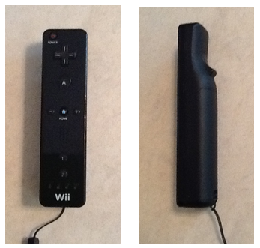
Figure 11: The button layout of the Nintendo Wii Remote
On the front of the Wii remote is an infrared camera sensor from PixArt Imaging. It provides high resolution and a 100 Hz refresh rate. This can be used in a similar way as the Kinect. The sensor requires an infrared sensor bar to enable pointer tracking, which is a bar with two groups of infrared light emitting diodes attached to it. The Wii remote utilizes the infrared camera and the light emitting diodes to calculate an average x-coordinate, y-coordinate, rotation, and distance. If the remote is kept stationary, and the light emitting diodes move; the Wii remote is capable of detecting the moving light emitting diodes and can be used as an unsophisticated motion tracker (Lee). This gives the group another option for control, which is similar to that of the Kinect.
The Wii remote is capable of Bluetooth communication. “The connection uses a Broadcom 2042 chip, which is designed for devices that conform to the Bluetooth Human Interface Device standard.” (Lee) The Wii remote does not comply completely with the Human Interface Device standards, but can connect with most computers (Lee). This might turn out to be a problem when trying to implement the Bluetooth connection with a microcontroller.
The Wii remote sends a relatively small amount of data compared to the Kinect. It sends twenty-two byte packets at a typical rate of one hundred packets per second (Matamoros). At 220 bytes per second, the microcontroller must have enough physical memory space to store all of the data from the remote. This will not be a problem, since the Atmel has 64 kB of SRAM to use. The physical space is not the only concern; the microcontroller must be fast enough to be able to synchronize with the remote and receive all of the information.
In order to utilize the Wii remote, group five will need to add hardware to their original design. However, this will give the group the ability to implement wireless control of the cube. The use of the Bluetooth HID will also increase the complexity and physical size of the code. The additional complexity of the code is not of concern to the group, however it is unsure at this time if there will be enough space on the microcontroller to handle the extra lines of code.
3.2.5.2.1 Nunchuk
The Wii Nunchuk has four lines, which include a supply voltage line, a ground line, a Serial Clock Line, and a Serial Data Line. The lines are all connected with a special female connector and have specific pin locations shown in Figure 12 and the entire Wii Nunchuk is shown in Figure 13. The interfacing protocol is called Two Wire Interface or Inter-Integrated Circuit. The group will need to hardwire all four lines to the microcontroller, which will only require a minimal amount of additional hardware to be able to interface the Wii Nunchuk with the microcontroller.
The Wii Nunchuk is a slave device that is operated from the clock of the microcontroller; it transmits data to the microcontroller on the Serial Data Line at the rising edge of each clock cycle. Inter-Integrated Circuit speeds are standardized around one hundred thousand bits per second. However, communication speeds of up to four hundred thousand bits per second in fast mode, and even speeds as high as 3.4 Mbps in High Speed mode.

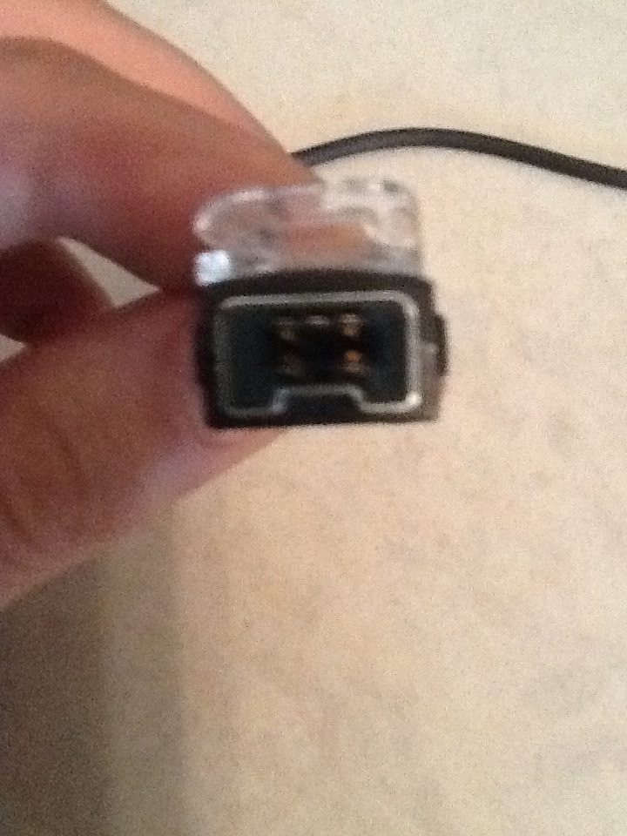
SDA +3.3V N/C
GND SCL

Figure 12: The pin layout of the Nintendo Wii Nunchuk female connections
The Wii Nunchuk uses the LIS3L02AL accelerometer from ST Microelectronics (RobotShop), an analog joystick, and two buttons to send seven different values of information to the host. It sends an average x-coordinate, y-coordinate, and z-coordinate information from the accelerometer that can be used to calculate rotations from the controller. The Wii Nunchuk also sends an x-coordinate and a y-coordinate from the joystick, and two values from the buttons (How). The Wii Nunchuk does not have as many options for control of the cube as the Microsoft Kinect or the Wii remote, but it does have enough different inputs to handle all of the control that is needed for the Rubik’s cube application.
The information is sent six bytes at a time. Due to the limited memory space of the microcontroller, this is the main advantage of using the Wii Nunchuk. This will allow for quicker communications with the microcontroller, and will also not take up a lot of valuable memory space with more data than is needed for the applications.
The Wii Nunchuk will enable control of the animations without adding additional hardware. The simplicity, low cost, and small memory usage of the device make it ideal for controlling the cube.
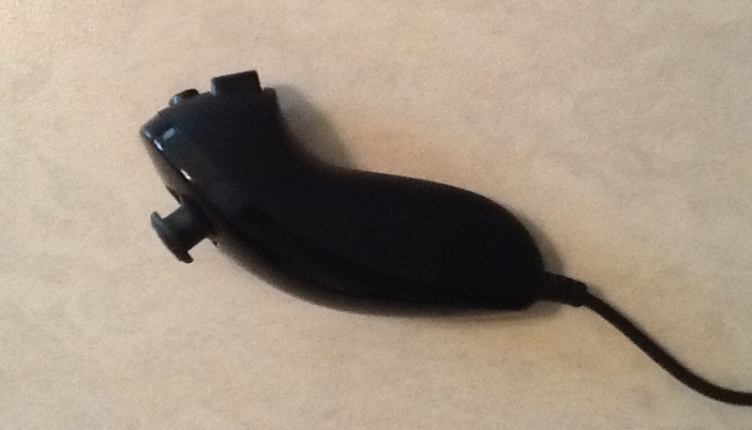
Figure 13: The joystick and button layout of the Wii Nunchuk
3.2.5.3 Controller Decision
The group has carefully researched all three options for control of the Dynamic Animation Cube II. The Microsoft Kinect will offer more interaction capabilities with the cube, and would add an impressive wireless control feature to the project. The Kinect is not a feasible option with the use of the microcontroller, as it sends more data than a microcontroller is capable of handling.
The Nintendo Wii Remote, and the Wii Nunchuk are more viable options for the scope of this project. The Wii Remote sends data packets in the size of twenty-two bytes, and the Wii Nunchuk sends six bytes of data to the microcontroller. The only disadvantage to using the Wii Remote over the Wii Nunchuk, is the additional hardware that will need to be added to incorporate the Bluetooth capabilities. This is the main deciding factor in the group’s decision.
The group has decided to go with the Wii Nunchuk because of its small amount of data transfer, and the relatively simple integration into the hardware design. The Nunchuk will give the group enough control of the cube to implement the applications, without increasing the complexity of the design.
3.2.6 LED Drivers
One of the most important components of the Dynamic Animation Cube II will be the drivers used to control the light emitting diodes. It is therefore necessary to choose a model that will provide the necessary refresh rate, input/output ports, and regulated current supplied that will not over power the light emitting diodes. The following are the main choices that Group 5 will consider to drive the entire cube.
3.2.6.1 TLC Driver (Texas Instruments)
The first choice of drivers that group 5 will look at will be the Texas Instruments TLC5941. The driver includes sixteen channels, twelve bit control, current ratings between zero and eighty milliamps and an output voltage up to seventeen volts. The TLC5941 is capable of operating at speeds up to thirty MHz. It also contains a six bit dot correction, which is used to determine and adjust brightness levels conveyed between the light emitting diodes and the drivers. The maximum current output can be easily set for all channels by using a single external resistor.
Features:
- Constant output of 17V, 80mA
- 30MHz clock frequency
- Flexible serial interface
- Cascading capabilities
- Thermal detection
- LED open detector
- Internal delay of 20ns
When operating in normal air temperature, the TLC5941 is able to run at certain input ranges depending on the pin, while giving a constant output. The voltage of the Vcc pin cannot exceed six volts, and a positive three volts is the maximum input for the remaining input pins. At the maximum input values the TLC5940 is expected to output ninety mA of current and a voltage range up to eighteen volts. Realistically, Group 5 will use a supply voltage ranging from three to five volts, which will give a high input voltage between 0.8 V and Vcc and a low input voltage between ground and 0.2 V. These input specifications will give an output voltage of up to seventeen volts and a current range up to eighty mA, which is an ideal feature for the device. The more current the drivers can supply is directly related to the amount of light emitting diodes the group can turn on simultaneously. This will help increase the refresh rate of the entire cube.
The TLC5941 driver comes with an extremely flexible serial interface, which is controlled through only three pins. The data is then clocked in and a latch is triggered within the device that feeds the inputs into the internal registers. This system allows for reading in of grayscale data and dot correction data, with the process finishing at the end of the grayscale cycle. Multiple drivers can be added in series by attaching the serial output pin of one driver to the serial input pin of the next driver. This is beneficial in that the group will be able to connect multiple drivers together without having to use more than one serial interface pin.
An internal error detection system is also provided on the TLC5941 driver. If an external pull up resistor is connected to the XERR pin, its voltage is set to Vcc. This sets the internal transistor connected to XERR to the off position until it is needed. If either one of two error flags in the driver are tripped, XERR becomes pulled to ground, turning on the transistor. This system reduces the total amount of signals that would be normally necessary to report an error. The two flags that can be tripped are the thermal error flag and the LED open detector. For the thermal flag, if the junction temperature becomes too high, the XERR pin is set to low level, or if the temperature drops too low, the pin is becomes a high impedance node. The other flag checks the connections of the LEDs and reports back if everything is connected correctly. If and LED is broken or disconnected, XERR is pulled to ground.
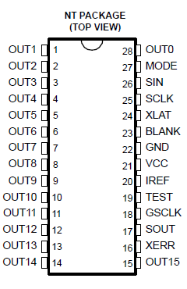
Figure 14: Pin layout for the TLC5941
The switching characteristics of the device are crucial for the desired refresh rate to be achieved. If a positive five volts is applied, the typical rise and fall time for the TLC5941 is ten nanoseconds for each parameter. The propagation delay for the driver is sixty nanoseconds; this is the amount of time it takes for the driver to output current after the data has been shifted into the driver. This is the delay time for one single driver. The TLC5941 is equipped with an internal delay between outputs. This delay feature works whether the device is switched on or off and prevents too much current from flowing through the device. Once data is fed into the chip and the outputs begin to be sent, each output is delayed based on the fixed time. Output0 has no delay, Output1 is delayed by twenty nanoseconds, Output2 is delayed by forty nanoseconds, and up to Output15 which is delayed by 300 nanoseconds. This delay time is added to the already eighty-two nanoseconds of delay for a single driver. This will decrease the refresh rate, which may cause the animations to flicker (TLC5941.)
3.2.6.2 STP24DP05 Driver (STMicroelectronics)
The second choice of LED drivers that group 5 will consider using is the STP24DP05. The driver runs on a low voltage, low current 24-bit shift register specifically intended to implement LED control programs. It implements an 8x3-bit serial-IN, parallel-OUT that feeds code into an 8x3-bit D-type storage register. When the device is running, it provides a constant 5-80mA current to power the LEDs. It also checks what will happen at the output line by looking at three different conditions: whether the circuit is short to Vo, ground, or open line. The results are then placed into the shift registers and then sent to the serial line output.
Features:
- Capability to control 8 LEDs per chip
- Constant output voltage of 20, current of 80mA
- 25MHz clock frequency
- 30ns internal delay
- Error detection mode
- Preset sequences of RGB control
- Temperature detection flag
According to the datasheet, once the registers are loaded, the detection functionality will activate using either a dedicated pin or a logic sequence that will be controlled by the group. In addition to the chip, the group will place three resistors on the board that will change how intensely the LEDs will light up. The device also guarantees a 20 volt output, which will be beneficial for the group to set up several LEDs in series as per the cube specifications. The driver comes with a 25MHz clock frequency, which will provide plenty of room to adjust for the necessary frames per second.
The STP will be able to operate in temperatures from -40°C up to 125°C. The group can power the chip with a supply voltage between 0 and 7 volts, which will give an output of -0.5 to 20 volts and an output current of 80mA. At maximum, the clock frequency can be pushed to 30MHz, but this is ill advised by the chips rating guide, as going over any of the values stated can cause unnecessary stress and damage to the device. If possible, the group would try to run the driver in a range of 3.0 to 5.5 volts input, which would give a constant voltage out of 20, a current between 5 and 80mA, and a clock frequency of 25MHz, as specified by the STP datasheet.
The driver also comes equip with the ability to set a gradual delay between LED output sets. This means that by turning the DG pin, number 9, to a low setting, the outputs will add in a 30ns delay in between each set of R, G, and B pins. The feature is beneficial as it will stop any large rushes of current from passing through as well as reducing the bypass capacitors.
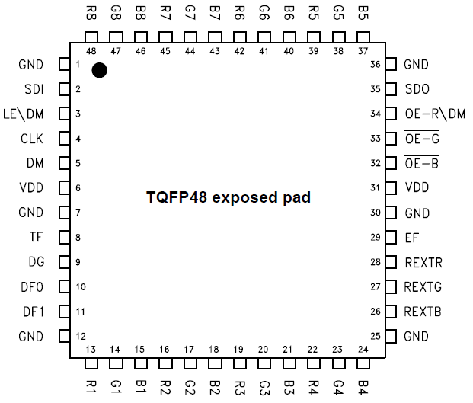
Figure 15: Pin layout for the STP24DP05
The chip also includes an error detection mode that may be switched to at any time during normal mode. When the DM pin, number 5, is set to low, or a command is sent through a logic sequence, the process begins after five clock cycles. While in this mode, the microcontroller switches pin 34 to low and sends a code of all “1”s to the LEDs in order to check for open and short connections with the device and diodes. After 1 microsecond, the pin is set to high and the results are sent through another pin to the microprocessor for analysis. If an error has been detected, the output of the report will be shown as a “0”, while no errors will be a “1”. Once the process is complete, the driver can be set back to normal mode.
The devices shift registers come with preset conditions that can be controlled based on the inputs of the DF0 and DF1 pins, 10 and 11 respectively, as shown by Table 8 below.
Sequence | DF0 | DF1
BGR | 1 | 1
BRG | 0 | 1
RGB | 1 | 0
GRB | 0 | 0
Table 8: How the setting of DF0 and DF1 change the sequence of RGB
The current sequence also changes the order of results after error detection mode has been completed.
Another part of the system belongs to its safety specifications. The STP comes with detection monitors that can turn off the device if certain conditions are met. By using an external resistor, the EFLAG and TFLAG pins will be set to a pulled up mode where the two monitor the device. During error detection mode, the EFLAG becomes shortened to ground to relieve some stress from the chip. On the other hand, if the temperature of the driver’s silicon begins to exceed 180°C, the TFLAG pin shortens to ground and keeps the chip safe from overheating (STP24DP05.)
3.2.6.3 STP1612PW05 Driver (STMicroelectronics)
The third type of driver that group 5 will consider using is the STP1612PW05. This kind of LED driver comes with sixteen output channels, 8 bit gain for adjusting brightness levels, open and short LED detection, thermal detection flags, and 30MHz maximum clock frequency.
Features:
- Constant output voltage of 20, current of 60mA
- Open channel/short circuit detection
- Current output regulation capabilities
- 40ns internal delay
- Thermal flag
- Clock signal detector
As can be seen in the driver's datasheet, the device is able to run at similar maximum settings as the other two drivers. The input voltages can be run with a supply voltage from 0 to 7 volts and an input voltage from -0.4 to Vdd volts. These inputs will give an output voltage from -0.5 to 20 volts, a constant output current of 60mA, and a clock frequency of 50MHz. These values should not be necessary for running the device though; therefore the group will use the more recommended values of 3 to 5.5 volts supply voltage, high input from 0.7Vdd to Vdd, and low input from ground to 0.3Vdd. This will give a constant output voltage of 20 volts and a current of 3 to 60mA.
The STP16 also comes with two error detection methods, either looking for open channels or short circuits in LED connections. The detections happen in a period of about 0.5µs and the device performs both checks simultaneously. This feature can be enabled by setting two channels to on, and then the chip will detect any errors automatically.
The current output can be regulated by the group easily by setting an external resistor. Current values and the resistance necessary to obtain them can be seen in Table 9. This will allow the group to regulate the amount of current that is passing through the system so that the circuit does not overload.

Iout (mA) | Rext (kΩ)
3 | 238.2
5 | 142.2
10 | 69.6
20 | 34.7
30 | 22.94
50 | 13.72
60 | 11.4
80 | 8.63
Table 9: Resistance needed to obtain wanted current
The STP16 driver also comes with a few safety methods that help with the chips performance. The first is a delay that limits the amount of current rushing in. This is done by separating the outputs into four groups and delaying each output set by 40ns. The next is a thermal flag that monitors junction temperature. If the flag detects the chip's temperature to be higher than 150°C, the device turns off all output channels until the temperature drops. Once that happens, the channels will automatically turn back on. The final feature is a clock signal detector. If the PWCLK signal is not connected for around one second, the output channels are set to off. This keeps the driver from providing power forever and protects the LED system from unnecessary damage (STP1612PW05.)
3.2.6.4 LED Driver Decision
With the number of light emitting diode drivers the group will need to purchase, the price is a main deciding factor. As can be seen in Table 10, although the TLC5941 and the STP1612PW05 are cheaper per unit, the group will need to purchase more of the devices to suit their needs. The STP24DP05 comes with eight separate pins for controlling each individual color and can control eight light emitting diodes per chip, while the other two drivers can only control roughly five light emitting diodes per chip. The group will need to purchase forty-eight of the sixteen bit drivers, and only thirty-two of the STP24DP05 drivers.

LED Driver Price Comparison
Driver | Price per unit
TLC5941 | $1.20
STP24DP05 | $2.29
STP1612PW05 | $1.72
Table 10: Price comparison for the LED drivers
The maximum operating frequency of the drivers is another important parameter to consider. The STP24DP05 operates at a maximum frequency of twenty-five MHz, while the TLC5941 and the STP1612PW05 operate at thirty MHz. Even though the two other chips operate at a faster frequency, the group anticipates that the lower operating frequency of the STP24DP05 will be negligible.
When it comes to supply voltages needed, as well as maximum output voltages and currents, each component is similar to how the others run. Each device can run on a maximum of seven volts, and work best from three to six volts. All three drivers are capable of producing an output voltage of up to twenty volts and supply around sixty to eighty mA of current. The drivers also all run between -40 and 170˚C, which is well in the range of expected environmental temperatures that the group can foresee.
Group 5 has decided to use the STP24DP05 light emitting diode driver for the final project. It’s fast operating frequency, and serial peripheral interface capabilities are two of the main features considered when the group decided to go with the STP24DP05 driver. This device has many other features as well that the group expects to assist in the design of the Dynamic Animation Cube II.
3.2.7 Software Architecture
The software that will be loaded onto the microcontroller is crucial to allow the light emitting diode cube to make dynamic animations as well as take user input. Because of this, the specific code that will be put onto the microcontroller is was a very important decision, both in the language chosen, and the library functions to be used. Although most code languages are fairly similar (variables, functions, arithmetic, arrays, loops, etc) the specific languages are better suited to different tasks. The sections below describe the code that will and will not be put onto the microcontroller.
3.2.7.1 Programming Language
The decision of what programming language to use for the microcontroller software design is extremely important and many factors went into the decision to use the C language. Each language in the following sections was seriously considered for the language of the microcontroller. The following sections show the thought process by which C was chosen.
3.2.7.1.1 Java
Java was considered for the project for several reasons, but ultimately was not chosen to be used for the final project. Java would be useful since there are existing libraries for interfacing with the Wiimote as well as the Nunchuk. Java would have also made the actual coding much easier, since there are so many libraries for data structures and serial port interfacing that could have made controlling the actual light emitting diode cube easier. The problem that makes Java unusable for the light emitting diode cube is actually one of the key features of Java: the Java virtual machine. Since no version of the JVM exists for the Atmel microcontroller we chose, it is impossible to use Java. Java is also extremely memory intensive, prohibitively so for a project on an embedded system.
3.2.7.1.2 C
C is a low-level language that is adaptable to many purposes. C has the following features that make it ideal for use in the microcontroller:
- Allows for easy access of serial ports and physical wires on a device
- Easy to switch between assembly code and C code in the same program
- Extremely compact run-time memory usage
- Minimal need for library functions
- Easy access to memory addresses (good for memory mapped devices)
- C can be compiled into assembly code for a huge variety of microcontrollers
- Easy bit-level logic with integers and boolean values
- Transparent array addressing makes changing array addresses simple
The only foreseeable downside to using C is that the language is very unforgiving, coding-wise, and while coding in C it is very easy to make pointer errors that will not be caught by the compiler. Run-time errors are never easy to solve, and on an embedded system with no debugging features and almost no outputs (at least compared to a PC application where one can print data to a screen) pinpointing errors during runtime will be extremely difficult.
3.2.7.1.3 C++
C++ is a procedural and object oriented language. C++ was the second best option for coding the microcontroller, for many of the same reasons as C. C++ is also able to be compiled onto the specific microprocessor that was chosen for the light emitting diode cube, however the memory usage and dependence on exterior libraries would have meant adding an external memory device, which would have slowed down the system considerably. C++ also uses more complex instructions, and would therefore likely have taken more cycle per instruction to run. C++ has many libraries for interfacing with embedded devices; however those functions would also have been prohibitively expensive in time and space on the microcontroller.
3.2.7.1.4 C#
C# is a very robust language, and it would have been very easy to use had the microcontroller been a PC. C# is has many libraries for interfacing with serial ports, which would have helped immensely with controlling the light emitting diode cube. C# was considered mostly because it would have paired excellently with the Kinect, since Microsoft has published code libraries specifically to interface with the Kinect. However, after it was discovered that there was no way to run C# without the Microsoft .Net framework and that the implementing the Kinect on an embedded system of our scale would be impossible due to the amount of data being transferred, the language was immediately dropped.
3.2.7.2 Code Libraries
The extensive Atmel Software Framework (ASF) API as well as the default C <Math.h> library will be included. The functions Math.tan and math.sqrt will be needed will be needed for the ambient animation in order to create a linear path for the wave animation to follow, as well as following the circular path. The ASF library contains 68 code interfaces, however only a small section of them are going to be used in the microcontroller. During compilation, the unused interfaces will be stripped from the compiled machine code, so there will be no loss from simply including the catch-all <asf.h>. The Atmel Software Framework is a very important tool for programming the microcontroller, since it has APIs that will do most of the work in formatting several of the port interfaces that will be used on the microcontroller.
The asynchronous timer (AST) interface will be used to keep track of the timeout counters in all states of the microcontroller. This API will be used to send timeout interrupts that will change the global state-machine variable. Table 11, shown below shows the methods from the AST interface that will be used in the program:
Method Header | Method Description/Use
uint32_t ast_get_counter_value (volatile avr32_ast_t¹ *ast) | This will be used to count the number of cycles before a timeout occurs.
bool ast_init_counter(volatile avr32_ast_t *ast, uint8_t osc_type, uint8_t psel, uint32_t ast_counter) | This function resets the AST. This will be used at microcontroller startup and whenever the microcontroller changes state.
void ast_enable_interrupt (volatile avr32_ast_t *ast, uint32_t interrupt_mask) | This function will set the interrupt timer to go off when the counter matches the given interrupt mast. This will be used to create an interrupt that goes off once every second. This will be called when the microcontroller wakes up from sleep or does a cold boot.
void ast_disable_all_interrupts (volatile avr32_ast_t *ast) | This method will need to be called so that the microcontroller can go to sleep.
Table 11: AST interface
The microcontroller will use the debug macros and functions interface for general memory debugging purposes. This will be particularly helpful to make sure that the dynamic memory allocation is working properly. Any code referencing this interface will not be included in the final firmware on the microcontroller. Below is Table 12 describing the methods that will be called from the interface and each method’s use.

Method header | Method Description/Use
uint_32 get_heap_curr_used_size(void) | Returns the number of bytes currently being used by the heap. Will be compared against the expected values to see if the currently planned methods will not go over the run-time memory limits.
uint_32 get_heap_free_size (void) | This will be used to see where it is possible to use more memory in order to make the program run faster.
uint_32 get_heap_total_used_size(void) | This method returns the total space allocated to the run-time variables. This is different from the heap used size since more memory than is used will be allocated. This can be used to make sure that the size used is as close as possible to the size allocated for maximum efficiency.
Table 12: Debug macros and functions
The dynamic memory allocation interface will be used to instantiate the various arrays that will be used to represent the light emitting diode cube, as well as clearing memory when a particular application has finished. This code will also automatically select memory addresses for variables and arrays so that there are no conflicts in addressing. The Table 13 below describes each of the functions that will be used from the interface:
Method header | Method Description/Use
void* dlmalloc(uint_32 size) | Takes in the number of addresses that will be in the data structure. This automatically handles memory conflicts.
void* dlcalloc(uint_32 size) | Same as dlmalloc, but it automatically sets all elements in the memory array to be zero. Useful for changing cube states, since the cube will have to be initialized to zero anyway.
void free(void*) | Frees up a memory array. Will be useful to make sure that memory is not being wasted on unused variables.
Table 13: Dynamic Memory Allocation
A first-in-first-out buffer will be used along with the AST to hold and output the light emitting diode assignments to the cube as the drivers become ready. The data-structure will be hidden from the runtime code, and can only be interfaced via the included methods. Descriptions of the methods to be called are below in Table 14.

Method header | Method Description/Use
void fifo_flush(fifo_desc_t *fifo_desc) | Clears the FIFO. This will be called when the microcontroller changes state.
void fifo_push_uint32(fifo_desc_t *fifo_desc, uint32 item) | This will be used to queue up commands to light up light emitting diodes. The format of the 32 bit input is as follows (following the format of the example given at the end of section 4.2.1): {10x0, X[1:0], Y[3:0], A,}
uint_32 fifo_pull_uint32(fifo_desc_t *fifo desc) | This method will spit out the light emitting diode description info at the front of the queue. The information will still have to be formatted somewhat in order to output it to the drivers and decoders, but the operations needed to format the data will only take ~4 clock cycles per segment of data sent to a driver, whereas it takes 64 clock cycles to load the data to a driver.
Table 14: First In First Out interface
The general board support interface is a wrapper library that is necessary to access many of the other functionalities. The only method called is the board_init function, which initializes many of the fields of the other ASF APIs and gives different parameters to the APIs based on the board being used, I.E. board_init() sends a value of 17 for the UC3C0 family.
The general purpose input/output (GPIO) interface will be used to control and memory-map the many physical GPIO pins on the microcontroller. GPOI pins will be used to output the 8 select bits going to the drivers’ decoders, as well as the 4 select bits going to the layer decoder. The methods from the interface that will be called in the microcontroller code are described below in Table 15.
Method Header | Method Description/Use
uint_32 gpio_enable_module(constgpio_map pins, unit_32 size) | Enables a gpio pin or set of pins, based on the gpio_map and uint_32 sent in.
void gpio_set_pin_low(uint_32 pin) | Sets the value of a pin low. This will be used for select lines going to the driver decoders.
void gpio_ser_pin_high(uint_32 pin) | Sets the value of a pin high. This will also be used for driving the select lines for the decoder select lines.
void gpio_toggle_pin(uint_32 pin) | Toggles a pin from high to low or low to high. Will be used for alternating the decoder select pins.
Table 15: GPIO Interfaces from the ASF code library
The sleep manager will be used to put the system to sleep after a period of inactivity, and will allow the microcontroller to wake up based on input from the Nunchuk.
Method Header | Method Description/Use
static void sleepmgr_enter_sleep(void) | This method will put the microcontroller into the deepest sleep allowed by the internal sleepmgr_mode enumerated type.
static void slpeepmgr_lock_mode(enumsleepmgr_mode mode) | This method will determine the type of sleep that the sleepmanager can put the microcontroller into, ranging from ACTIVE (not sleeping) to STATIC (cannot process anything but a wake up command).
static void sleepmgr(void) | this function activates the sleepmanager, allowing the microcontroller to go into sleep modes.
Table 16: Sleep Manager Interfaces from the ASF code library
The Serial Peripheral Interface library functions from the ASF code library will be used to write the twenty four bits indicating which light emitting diodes will be lit to the drivers. The library functions will make writing bytes at a time to the serial peripheral interface easy, since it is as simple as one method call to write the data.
Method Header |  | Method Description/Use
spi_status_t spi_initMaster (volatile avr32_spi_t *spi, constspi_options_t *options) |  | This function initializes the SPI with the data needed to function. The function takes in a physical address to a SPI port and an enumerated options type, and outputs an enumerated status type.
int16_t getBaudDiv (const uint32_t baudrate, uint32_t pb_hz) |  | This method will be used for calculating the baud rate expected by the spi_initMaster.
static void spi_put (volatile avr32_spi_t *spi, uint16_t data) |  | This method writes one datum (of predefined size) to the SPI port pointed to by the SPI pointer sent as an argument.
static void spi_enable(volatile avr32_spi_t *spi) |  | Enables SPI port pointed to by the spi pointer argument given.
static void spi_set_delay (volatile avr32_spi_t *spi, uint8_t delay) |  | Sets the number of cycles to hold the chip-select high between writes.
SPI - UC3 implementation |  | This code overloads some of the fields in the above code to better fit the specific microcontroller.
static void spiUC3_init(void) |  | Reinitializes some of the internal addresses and fields of the generic SPI API. This will have to be called after the generic SPI initialization commands.
Table 17: SPI Interfaces from the ASF code library
The Standard Serial I/O interface will also be included into the code. The interface is the code that the serial peripheral interface library functions run off of. The code will be included in the final machine code loaded onto the microcontroller, but no functions will be explicitly called from the C code.
Timer/counter interface will allow easy access of the internal physical timer. The timer/counter will be used to count 1 millisecond and 1 second for the Pong and Game of Life applications respectively. Descriptions of the methods used from the interface are described below:
Method Header | Method Description/Use
int tc_start (volatile avr32_tc_t *tc, unsigned int channel) | Starts a timer of the channel given at the address given. This will be called when the microcontroller enters either the pong or GOL state.
int tc_stop (volatile avr32_tc_t *tc, unsigned int channel) | Stops a timer of the channel given at the address given. This will be called once before the game leaves the either pong or GOL state.
int tc_read_ra (volatile avr32_tc_t *tc, unsigned int channel) | This will be called at the top of the GOL state loop and the pong state loop.
Table 18: Timer/Counter Interfaces from the ASF code library
The two-wire-interface library functions will allow for easy reading from the Nunchuk. The library functions include simple read/write functions that make the access very simple. Descriptions of the roles of the functions are in the table below in Table 19.
Method Header | Method Description/Use
static status_code_t twi_master_read (volatile avr32_twi_t *twim, consttwi_package_t*package) | This method readies bytes to be read from the predefined addresses at which the two wire interface stores data bytes. This will be used to get controller input.
status_code_t twi_master_write (volatile avr32_twi_t *twim, consttwi_package_t *package) | The write method is important for doing basic handshaking with the Nunchuk before data is read.
status_code_t twim_master_init (volatile avr32_twim_t *twim, consttwim_options_t *opt) | This method is used at startup to initialize the two wire interface module internally. This reserves the memory addresses that will be used to store the Nunchuk data.
void twim_disable_interrupt (volatile avr32_twim_t *twim) | This will disable interrupts from the Nunchuk. This will be used after waking up from sleep, since the interrupts are only used when the microcontroller is sleeping.
Table 19: TWI Interfaces from the ASF code library
3.2.8 Decoder/Demultiplexer
In order to receive the desired refresh rate, the group will attempt to multiplex all of the drivers in parallel instead of aligning them sequentially. The previous group from the first Dynamic Animation Cube used the latter method, and was unsuccessful in their implementation.
3.2.8.1 CD74HC4514 (Texas Instruments)
The first decoder that group five will look at is the same one that the previous group decided to use: the CD74HC4514. This device contains a few features that the group finds useful for the overall design of the Dynamic Animation Cube II.
Features:
- Multifunction capabilities
- Balanced propagation delay
- Transition times
- High power reduction
- High noise immunity
First of all, according to the datasheet, the CD74HC4514 can work as both a decoder and a multiplexer. This particular feature is useful in the fact that if group 5 finds the need for a multiplexer during experimentation, they will already have a part that can fill the job. This will save not only space in the design, but will also save money that can be used for other parts.
The propagation delay is another plus for the device in that it controls the transfer speeds between different parts. This makes sure that all components will read in data correctly while limiting error bits and missed latches during testing. The transition times are also good in that they will allow parts to feed in data in the right order without certain areas trying to read something without the information actually having been sent.
The amount of power reduction that the decoder provides is also beneficial in that between the LEDs, the microcontroller, and all of the other parts, it is great to be able to limit power somewhere. This will also work as a safety measure, making sure that not too much power is entering the system that pieces will burn out.
The final feature is the high noise immunity of the component. It will allow the decoder to regulate data being written in, checking for signal distortion, alterations in the data, and false signals that could incorrectly trigger an enable pin. This, in conjunction with the microcontroller, can reduce the amount of errors entering the system, giving the output onto the Dynamic Animation Cube II a clearer and crisper picture (CD54HC4514.)
3.2.8.2 74HC154; 74HCT154 (NXP Semiconductors)
The second decoder that Group 5 will look into is the high speed Si-gate CMOS 74HC154 4-to-16 decoder. This particular decoder takes in four high binary addresses into the inputs and returns sixteen low outputs. There is also a two input enable gate that can be activated to help eliminate bugs that may appear during decoding. By enabling another input pin, the decoder can be changed to a demultiplexer that will read in multiplexed data from one of the input pins, as stated in the datasheet.
Like the CD74HC4514, this decoder comes with an internal propagation delay, transition time, and power dissipation. These features also come with ratings for several different voltage inputs, so if the group decides to change the amount of volts that will be provided to the Dynamic Animation Cube II they will know how the alteration will affect the data speeds through the device. Shown below, in Table 20 is the truth table for the 74HCT154. This table will aid the group in programming the addressing for each of the light emitting diodes that needs to be accessed (74HC154.)
Input |  |  |  |  |  | Output
E0 | E1 | 0 | 1 | 2 | 3 | 0 | 1 | 2 | 3 | 4 | 5 | 6 | 7 | 8 | 9 | 10 | 11 | 12 | 13 | 14 | 15
H | H | X | X | X | X | H | H | H | H | H | H | H | H | H | H | H | H | H | H | H | H
H | L | X | X | X | X | H | H | H | H | H | H | H | H | H | H | H | H | H | H | H | H
L | H | X | X | X | X | H | H | H | H | H | H | H | H | H | H | H | H | H | H | H | H
L | L | L | L | L | L | L | H | H | H | H | H | H | H | H | H | H | H | H | H | H | H
 |  | H | L | L | L | H | L | H | H | H | H | H | H | H | H | H | H | H | H | H | H
 |  | L | H | L | L | H | H | L | H | H | H | H | H | H | H | H | H | H | H | H | H
 |  | H | H | L | L | H | H | H | L | H | H | H | H | H | H | H | H | H | H | H | H
 |  | L | L | H | L | H | H | H | H | L | H | H | H | H | H | H | H | H | H | H | H
 |  | H | L | H | L | H | H | H | H | H | L | H | H | H | H | H | H | H | H | H | H
 |  | L | H | H | L | H | H | H | H | H | H | L | H | H | H | H | H | H | H | H | H
 |  | H | H | H | L | H | H | H | H | H | H | H | L | H | H | H | H | H | H | H | H
 |  | L | L | L | H | H | H | H | H | H | H | H | H | L | H | H | H | H | H | H | H
 |  | H | L | L | H | H | H | H | H | H | H | H | H | H | L | H | H | H | H | H | H
 |  | L | H | L | H | H | H | H | H | H | H | H | H | H | H | L | H | H | H | H | H
 |  | H | H | L | H | H | H | H | H | H | H | H | H | H | H | H | L | H | H | H | H
 |  | L | L | H | H | H | H | H | H | H | H | H | H | H | H | H | H | L | H | H | H
 |  | H | L | H | H | H | H | H | H | H | H | H | H | H | H | H | H | H | L | H | H
 |  | L | H | H | H | H | H | H | H | H | H | H | H | H | H | H | H | H | H | L | H
 |  | H | H | H | H | H | H | H | H | H | H | H | H | H | H | H | H | H | H | H | L
Table 20: Truth table of 4-to-16 decoder illustrating the need for the two latch enable pins to set low before any outputs are shown.
3.2.8.3 Decoder Decision
Group 5 will use the 74HC154; 74HCT154 decoder. There are a few reasons for this. First of all, the price—as seen in Table 21:
Component | Price
CD74HC4514 | $1.76
74HC154 | $2.59
74HCT154 | $1.63
Table 21: Decoder prices
The price of a 74HCT154 decoder is the cheapest to buy and will allow for more to be bought overall. Secondly, the 74HCT154 can be run in a range of 4.5 to 5.5 supply volts, with a recommended setting of five. This coincides with the values that the group will be providing to the system with room to adjust if necessary.
3.2.9 Ribbon Wire Connectors (Pacific Custom Cable)
Another component that the group will have to look at is a connector piece for the ribbon wire that will connect the drivers to the LEDs. The best two choices are an eight pin connector or a twenty-four pin connector. A price comparison between two made by Pacific Custom Cable Inc. can be seen in Table 22.
Component | Price (pack of 10)
8 pin | $14
24 pin | $11
Table 22: Ribbon wire connector prices
A benefit of the 24 pin is that it is cheaper to buy than the 8 pin one. Choosing the 24 pin will also save board space, as three 8 pin connectors would be needed to achieve the same amount of attachments. This will also be cheaper over all because the group will get more connectors for less than they would by choosing to go with the 8 pins.

4. Hardware and Software Design Details
The group has researched many different designs from other similar projects, and reviewed the previous group’s Dynamic Animation Cube. All of the research completed has given the group enough insight on light emitting diode cubes to be capable of designing their own Dynamic Animation Cube II. The group has carefully chosen components that will allow for high throughput of data, and high computational power. The group will keep the existing cube structure that is currently in the Senior Lab, but will have to deconstruct it in order to fix all of the non-working light emitting diodes. The group will also redesign all of the hardware necessary to run the Dynamic Animation Cube II; not keeping any of the previous group’s design.
4.1 Initial Details and Schematics
Having more than four thousand light emitting diodes to control makes this a challenging project. An entire sixteen by sixteen layer contains 256 light emitting diodes. If the entire layer is turned on then the cube will consume roughly five amps of current. This is too much current to have running at any one time. The group will have to use rely on the persistence of vision.
Persistence of vision is a phenomenon of the eye where an image is thought to stay on the retina, even after the image is no longer there, for an extremely small amount of time. This means the group can essentially make it seem like all of the light emitting diodes are turned on simultaneously by switching through a small number of them at a time. As long as the refresh rate of the entire cube is fast enough, the user won’t even notice. This will allow the group to keep the current consumed by the Dynamic Animation Cube II low enough to not destroy any of the hardware of the system.
The design is centered around Atmel’s AT32UC3C2512C microcontroller. It is essentially the “brain” of the entire system. The microcontroller executes all of the code needed to perform the animations, and it also communicates with the Wii Nunchuk and the light emitting diode drivers.
The AT32UC3C2512C will be programmed using Atmel’s AVR Dragon. The AVR dragon is a low cost development tool that can be used with all AVR devices with On Chip Debug capability. The group will hardwire the AVR Dragon to the microcontroller using the Joint Test Action Group (JTAG) interface, and then connect the AVR dragon to a PC using a USB cable. This will allow the group to program and debug the AT32UC3C2512C. Figure 16 shows the block diagram of the entire system.
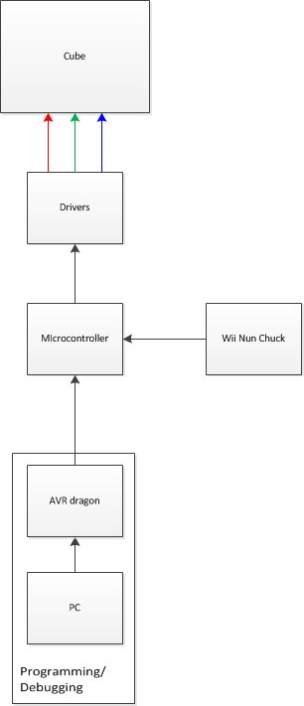
Figure 16: Block Diagram of the Dynamic Animation Cube II system
4.2 Software Design
Since the microcontroller is the only programmable part of the cube assembly, it will have to contain all code for interfacing with the Nunchuk, driver decoders, layer decoder, and the light emitting diode drivers. The microcontroller code will be programmed in C. The main routine will consist of a constantly running loop containing the cube update subroutine and the state update subroutine. The main routine will also contain an initialization subroutine.
The initialization subroutine will call the various library functions in the Atmel Software Framework code repository to initialize the IO ports and memory-mapped interfaces. This code will also be responsible for creating all variables and arrays that will be used for the entire program.
The loop located in the main subroutine will be located procedurally after the initialization subroutine the top-level state machine. The loop will not have an exit condition, as the cube is designed to run until it powers off or goes to sleep. The loop is itself divided into two subroutines: a subroutine to update the state machine and internal fields, and a subroutine to update the physical version of the light emitting diode cube.
The state machine subroutine will update all fields of the various states of the cube. During each iteration the state machine subroutine will also check the Nunchuk and timers to see if the state needs to change. There will be one status bit to determine if the microcontroller changed its state in the last loop iteration which will determine if special initialization operations need to occur in the event of a state change. The state machine subroutine is subdivided into seven subroutines, one for each state (other than bootup). Within those states, the logic for the games will be calculated. While the actual games will vary, the overall time taken for the state machine subroutine can still be estimated based on the state that will take longest to update, the game of life subroutine. The calculation for the state machine timing is shown below:
(((16 high)*(16 wide)*(16 long))*(1 clock cycle to access the position + ((28 neighbors to be checked per light emitting diode)*((1 clock cycle per comparison) + (1 clock cycle per array access)) + 1 cycle to write the new condition of the position))/(66 MHz clock rate on the microcontroller)
= ((16) * (16) * (16) * (1+ (28)*(1+1)+1))/(66 MHz)
= 3.599 Milliseconds
The light emitting diode update subroutine within the main loop will have one instance of the ASF first-in-first-out interface. Whenever the state-machine subroutine calls the setStatus method in the control unit API, the array argument representing the cube will be pushed onto the first-in-first-out structure. The light emitting diode update routine will continue to pull values from the first-in-first-out interface until it is empty. Whenever the first-in-first out interface is empty, it will be filled with the internal array representing the most up-to-date version of the cube and the main loop will return to the state-machine subroutine. The update subroutine will first pull an item from the first-in-first-out structure, format the data pulled into the data that needs to be set for the General purpose input/output pins , and use the spi_put() method from the ASF library to output the data to the Serial Peripheral Interface going to the drivers. Each pull from the first-in-first-out structure will give 16 light emitting diodes worth of data. The calculations below show the timing for the update subroutine:
(((16 light emitting diodes)/(4 light emitting diodes per driver latch))*((3 baud per driver latch)*((8 data bits per baud)*(1 bit per cycle)+(1 cycle to make $\overline{CS}$ low)+(1 cycle to make $\overline{CS}$ high)))*((1 latching to light up the light emitting diodes)+(1 latching to make the light emitting diodes go dark))/(25 Mhz clock for the SPI) + ((1 cycle for memory access) + (4 latches)*((1 cycle for masking the integer value)+(1 cycle for put command))/(66 Mhz clock for the microcontroller)
= (16/4)*(3*(1+1+8)*1)*2))/(25MHz) +((4)*(1+1))/(66 MHz)
= 102.86 KHz = 1/(9.72 microseconds)
The refresh rate for the entire cube (not including the time to update the state machine internal logic) is shown below:
(78.6 microseconds per column of 16 light emitting diodes)*(3 colors)*(16 columns per layer)*(16 layers in the cube)
= (9.72 µs)*(3)*(16)*(16)
= 7.46 milliseconds = 1/(133.94 Hz)
The total time for the state machine subroutine and the update subroutine is 7.46 milliseconds+ 3.599 milliseconds, which gives a total time of 11.05 milliseconds, or 90.5 hertz. This is the boundary case, though, and the actual average will be closer to 100 Hz, since the maximum time was calculated for the state machine subroutine. This refresh rate should theoretically make it appear as though all light emitting diodes that are in the
4.2.1 Control Unit API
The microcontroller code will be designed in such a way that the microcontroller will have a clearly formatted and easy to use API for controlling the cube. The purpose of the API is to make the process of creating new uses for the cube easy. That is to say, creating the API will be difficult, but it will only have to be done once, after which making programs and animations will be as easy as writing a simple C console application on a PC. The microcontroller API will use the Atmel’s memory-mapped interfaces to read and write to and from the peripheral devices. This API will be written in C and will be designed in such a way that all planned applications will easily be able to interface with the cube via the API. The API will interface with both the cube as well as the Nunchuk.
There are two major decisions that affected the API: how the light emitting diodes will be addressed, and which input device will be used. The API will have the methods and fields contained in Table 23.
Method/field & arguments | Return type | Description
Cube methods and fields
Method: getStatus(void) | light emitting diode: int[3][16][16] | Returns the values indicating which light emitting diodes are lit (detailed description below)
Method: setStatus(int[3][16][16]) | valid: boolean | Uploads a new array of index light emitting diodes to be lit. The method will count the lit light emitting diodes and determine if the number of lit light emitting diodes will overload the drivers or not. If the number of light emitting diodes is low enough, the method returns true and updates the cube. Otherwise, the method returns false and does not update the cube.
Nunchuk methods and fields
Method: getJoystick(void) | position: int[2] | Returns the position of the joystick for the Nunchuk. position[0] is the x position and position[1] is the y postion.
Method: getAccel(void) | accel: int[3] | Returns the values for the accelerometer of the Nunchuk. accel[0] accel[1] and accel[2] are the accelerometer values for the x, y, and z levels, respectively.
Method: getButtons(void) | buttons: int | Returns one integer that has the values of the two buttons integrated into the int, where buttons[0] is the C button and buttons[1] is the Z button.
Table 23: Description of API fields
The accelerometer values from the getAccel method range from 0-1023, though the values do not generally exceed 512±250, where 512 is the neutral position. The getJoyStick will return a value between 35 and 228 for the X axis and a value between 27 and 220 for the Y axis.
The two options for internal microcontroller addressing are described and compared in Table 24 below.
Name:
Bitwise addressing | Array-index addressing
This addressing method will have each light emitting diode be accessed by a three-dimensional array of integers. Each bit of the int values stored in the array will correspond to anlight emitting diode. | This addressing method will give each light emitting diode its own address in memory, accessing them through a four-dimensional array of integers where each value of the array is a 1 or 0, representing a lit or dark led, respectively.
Pros:
Takes fewer clock cycles to implement update cube | Takes less time to access individual light emitting diodes
Closer to native input to light emitting diode drivers | Combinatorial game logic of light emitting diodes will be faster
Uses less memory | Easier to code around
Cons:
Will take several clock cycles to access individual light emitting diodes | Memory intensive
Hard to debug code | Takes long time to update cube
Will be time consuming to access the light emitting diodes for the game logic | Needs to be retranslated to bitwise addressing to update cube
Memory usage:
1.5 kb | 24 kb
Est. Time for cube update:
7.37ms (135 Hz) | 9.35 (100.6Hz)
Est. Time for single light emitting diode access:
.455µs | .227 µs
Table 24: Comparison of internal addressing methods
Because of the much faster refresh rate, the 3X16X16 array of integers was chosen for the addressing mode. This addressing mode also has the least amount of waste possible, since each bit in memory is used.
In order to output the cube, the 3X16X16 array needs to be changed into the three outputs required by the drivers and decoders: four bits to the layer decoder, eight bits to the driver decoder, and 24 bits to each driver. Each integer value for the array will be done in four writes. If getStatus[X][Y][Z] = A, then the four bits going to the layer decoder will be Y[3:0]. The bits going to the top and bottom driver decoders will be Z[3:0] and 0x4 respectively for the first and third writes and Z[3:0] and 0x4 respectively for the second and fourth writes. The bits going to the actual drivers will be A[3:0] shifted X*8 bits to the left for the first write,A[11:8] shifted X*8 bits to the left for the second writeA[7:4] shifted X*8 bits to the left for the third write andA[15:12] shifted X*8 bits to the left for the fourth write. The addresses are straddled so that while one driver is getting fresh data, the other is being erased. This is the most efficient use of the microcontroller’s processing time and produces the lowest overall cube refresh time
.4.2.2 Games
The games that will run on the cube will use run in a constant loop on the microcontroller. The microcontroller will be dependent on specific user input commands, to be determined. There will be a top-level state-machine simulation variable to tell what state the cube is in. A visual representation of the state machine is shown below in Figure 17.
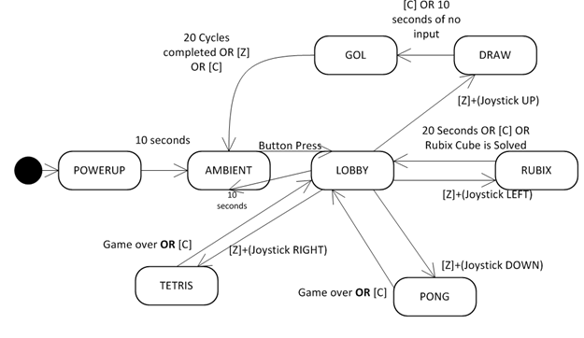
Figure 17: Illustration of microcontroller state machine
Shown below, in Table 25 is a table giving more information about each state.
State | Description | Method of access
DRAW | Allows the player to draw on the cube with the Nunchuk. When the timeout or exit command is detected, the game begins goes to the GOL state. | From LOBBY: [Z+(Joystick Up)] on the Nunchuk
GOL | This state comes from the draw state, and plays Conway’s Game of Life in three dimensions for a set number of iterations. This state takes no user input, and after the iterations are completed, the microcontroller will go back the ambient state. | From DRAW: [C] on the NunchukOR after 10 seconds of no Nunchuk input
PONG | This state is the 1-player pong game. This state is accessed from the lobby. The player’s paddle will be controlled by the joystick. When the score limit is reached, the microcontroller will return to the lobby state. | From LOBBY: [Z+(Joystick down)] on the Nunchuk
RUBIK’S | This state starts with a randomized, but solvable Rubik’s cube represented on the light emitting diode cube. This state will have a high timeout counter. | From LOBBY: [Z+(Joystick Left)]
AMBIENT | The cube will cycle through pre-defined animations that take no user input. This state will continue as long as there is no user input. After 1 hour of no user input, the microcontroller will first write an array of all zeros to the cube (turning all light emitting diodes off) then call the sleepmgr_enter_sleep() function to put the cube to sleep. Upon receiving more input, the cube will return to the ambient state. | From LOBBY: after 5 seconds of no Nunchuk input.
LOBBY | This state occurs when the microcontroller is broken out of the ambient state by user input in the form of a button press. From this state the user will select a game and go to the game state or, if the microcontroller times out without a valid selection, the ambient state. | From PONG:  After game is over OR  after 10 seconds of no user input  OR  [C] on Nunchuk  From RUBIK’S:  After 1 minute of no Nunchuk input  OR  [C] on Nunchuk  From AMBIENT:  [C] OR [Z] on Nunchuk.
TETRIS | This state is a game of Tetris, and will continue until the user loses or breaks out of the game. There will be no score for the game, though the pieces will speed up. | From LOBBY:  [Z+(Joystick Right)]
POWERUP | This state will only occur when the cube is powered on with a cold boot. This state will wait for a specified set-up time, and then go to the ambient state. The microcontroller will not be in this state until it is powered on again. | Start state
Table 25: Detailed description of microcontroller state machine
4.2.3 Controller Integration
The controller will be memory-mapped to one of the Atmel's serial ports. The Nunchuk input will be mostly handled by a separate circuit on the microcontroller, and then memory-mapped to the Atmel processor, making it easy to access the fields of the Nunchuk input. The table below shows the memory locations of the data from the Nunchuk. The Nunchuk will be accessed via the two-wire interface code from the Atmel Software Framework. The format for the data from the Nunchuk is shown below in Table 26.
Joystick X |  |  |  |  |  |  |  | Byte 0
Joystick Y |  |  |  |  |  |  |  | Byte 1
Accelerometer X[9:2] |  |  |  |  |  |  |  | Byte 2
Accelerometer Y[9:2] |  |  |  |  |  |  |  | Byte 3
Accelerometer Z[9:2] |  |  |  |  |  |  |  | Byte 4
Acc. Z[1] | Acc. Z[0] | Acc. Y[1] | Acc. Y[0] | Acc. X[1] | Acc. X[1] | C-butt. | Z-butt. | Byte 5
Table 26: Input format from Nunchuk
This information is all that is needed to get from state to state in the microcontroller, as well as playing the games. The data can be accessed through the API at any time. The Joystick is represented by an X byte and a Y byte, representing the X and Y positions of the Joystick. The bytes will be represent two’s compliment values for the position, since it is possible for them to be negative. The Accelerometer is actually represented by 10 bits for the X, Y and Z accelerations, which can also be zero. The Accelerometer data will be assembled by the API to be in a 16-bit integer format. The C button and Z button are only 1 bit apiece, since they are binary values that can only be one or zero.
4.3 Circuit Board Requirements
The completion of a printed circuit board is essential to any Electrical and Computer Engineering Senior Design Project. There are a large number of considerations that must be taken into account in order to ensure the project be a success. Among these factors are thickness of the traces, the number of layers that will be used, and the overall size of the board.
4.4 System Integration
The system is designed in sections which include the power supply, the Wii Nunchuk, and the light emitting diode drivers. They are all integrated with the micontroller using specific General Purpose Input/Output pins, Figure 18 below illustrates the wiring configuration of all the pins.
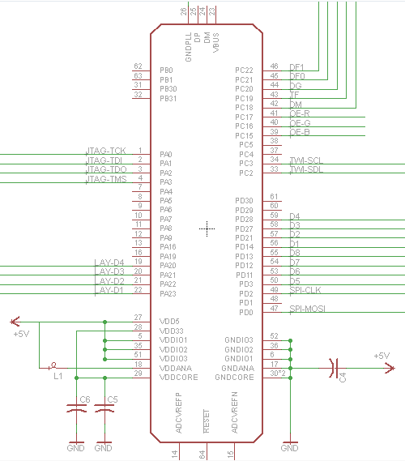
Figure 18: Schematic diagram of the AT32UC3C2512C Microcontroller
The group has carefully gone through the datasheet in order to map each pin correctly. All of the general purpose input/output can be used for general purposes, but they can also be used for additional peripherals on the chip.
The pins associated with the Two Wire Interface are PC3 and PC2. The clock for the Two Wire Interface is connected to PC3 and the data line is attached to PC2. This is where the Wii Nunchuk will be interfaced with the microcontroller.
The drivers are interfaced using the Serial Peripheral Interface. This peripheral is associated with pins PD0 and PD2; with the clock attached to PD2 and the Master Out Slave In line is attached to PD0. With thirty two different drivers the group decided to use two four to sixteen decoders to address all of them. Now instead of using thirty two pins the group can use eight to address all of the drivers. The pins used in the design are PD3, PD11, PD12, PD13, PD14, PD21, PD27, and PD28. The drivers require an additional nine pins for complete control of the drivers. These pins are mapped onto PC5, and PC15 through PC22 (the PC5 pin has not been connected to the driver on the schematic in Figure 19, but it will be added in the final design before being sent to be printed).
The Joint Test Action Group interface is connected to pins PA0, PA1, PA2, and PA3. This will be used to connect the microntoller to the AVR Dragon so the group can write the code onto the Flash memory, and debug anything that goes wrong during testing.
The board will be powered using an on board DC jack which can be plugged into any standard US outlet. The group has decided to use a five volt regulated voltage to power the entire board.
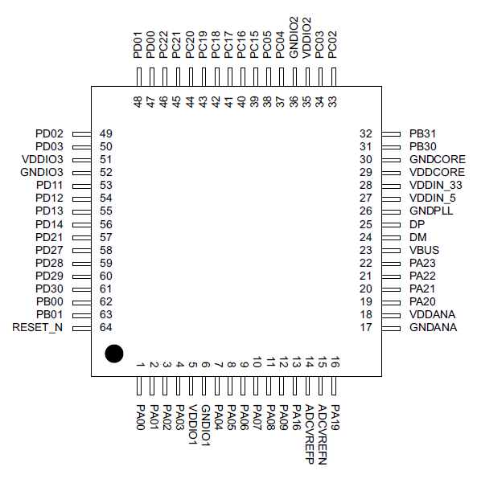
Figure 19: Pin layout of the AT32UC3C2512C
4.4.1 LED Drivers
Multiplexing all of the light emitting diode drivers is the most challenging aspect of the design. There are a few options the group can choose from to multiplex multiple drivers. One method the group can go with is to daisy chain them all, or wire all of the drivers sequentially. In this method the drivers are arranged in an array with the serial data output pin connected to the next drivers serial data input pin. The data is shifted into the first light emitting diode driver from the microcontroller. After twenty four bits have been transmitted, the microcontroller continues to feed in data but the data in the first driver gets shifted into the next driver. This will continue until all of the data is sent to all of the drivers. Figure 20 below shows the previous group’s driver array design utilizing the daisy chain technique.
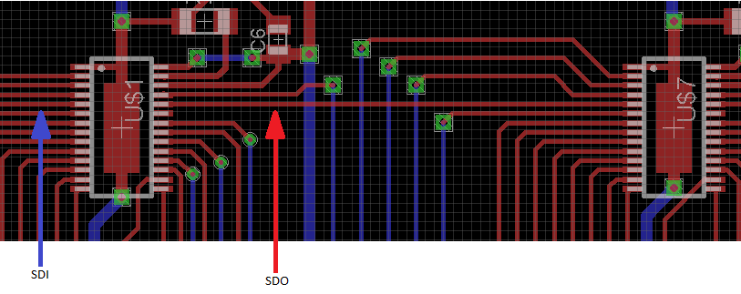
SDI SDO
Figure 20: Previous group’s driver array featuring the daisy chain technique
This method requires the microcontroller to load in the data for all of the drivers before the signals can be sent to the cube. This adds to the overall time it takes to refresh the cube. Also, if one driver fails it will affect other drivers in the array.
The group will use two four to sixteen decoders to address all thirty-two STP24D05 drivers. This will allow the group to choose a specific light emitting diode driver to send information to, as opposed to loading every single driver. Figure 21 shows the layout of all the drivers, and the two decoders.
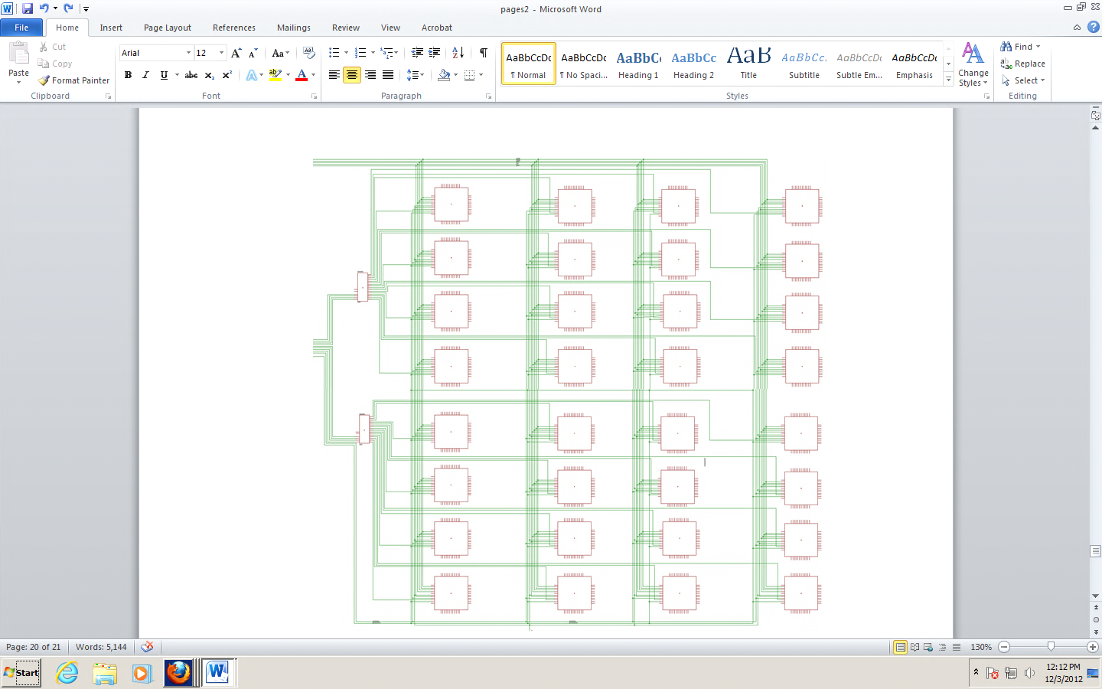
Figure 21: Schematic diagram of all the LED drivers
The Figure 22 below shows a closer look at one at the wiring of the light emitting diode drivers. In order for the Serial Peripheral Interface to work properly, all of the drivers along with the microcontroller must be synchronized. The clock pin for all of the STP24D05 drivers are wired together and driven by the microcontroller on pin PD2. The serial data lines of all the drivers are wired together as well, and attached to pin PD0 of the microcontroller. The latch enable pins of all of the light emitting diodes are each attached to a different output pin on the decoders. This will allow the group to select a particular driver to store the data that is sent from the microcontroller. Once the driver has stored the information, the next step is to send a pulse to the OE-B, OE-G, or OE-R pin on the light emitting diode driver. These pins are attached to pins PC15 through PC17 respectively.
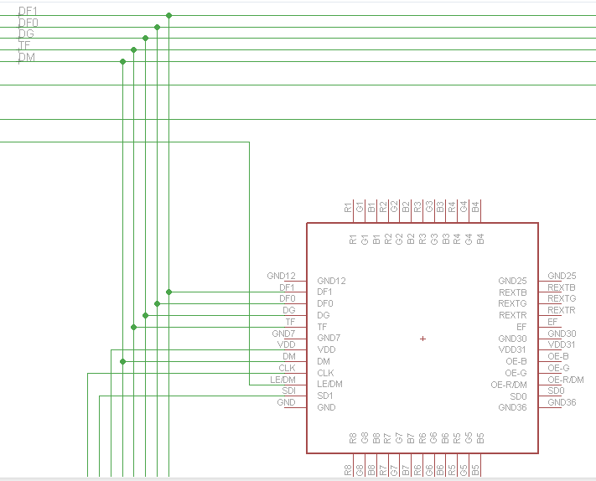
Figure 22: Schematic diagram of a single LED driver
4.4.2 Controller
The Wii Nunchuk communicates with external devices using four lines; a voltage line, a ground line, a line for the serial clock signal, and a serial data line. It takes a positive three volts to power on the Wii Nunchuk. The boards regulated voltage power supply is connected to the input of a three volt voltage regulator. The output of the three volt voltage regulator is then connected to the voltage line of the Wii Nunchuk. A few capacitors are added to both the input and the output of the voltage regulator to eliminate any voltage spikes that may occur.
In order to communicate with the microcontroller, the Wii Nunchuk uses the Two Wire Interface. Pin PC3 on the microcontroller is connected to the clock line of the Wii Nunchuk, and PC2 is connected to the data line. Both pins are also connected to the five volt voltage line to supply a reference for the microcontroller. The full schematic diagram of the wiring is provided below in Figure 23.
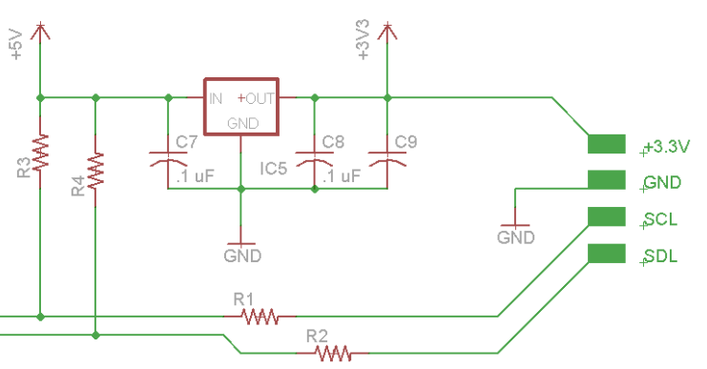
Figure 23: Schematic diagram for interfacing the Wii Nunchuk. Referenced design from Robotshop
4.4.3 Power Supply
The previous Dynamic Animation Cube group used a standard PC power supply to power their boards. Which they had used wires wrapped with electrical to attach it to the board. The group decided that it will be better and more professional if they used a DC jack capable of connecting to a standard wall outlet.
The AT32UC3C2512C requires either a positive three volts, or a positive five volts to power on. The group decided to use five volts to achieve the maximum capabilities of the microcontroller. As you can see from the schematic in Figure 24, there is a five volt voltage regulator to ensure the voltage doesn’t spike up or down which could be detrimental to the equipment. The group has also put in a few capacitors as an added amount of protection.
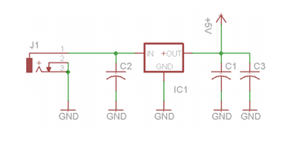
Figure 24: Schematic diagram of the board power supply
4.5 Hardware and Software Design Summary
The group has designed the Dynamic Animation Cube II keeping in mind the needs for a fast refresh rate. The group has also taken into account the amount of current the cube has the potential to consume. The previous group was unsuccessful with their design, and Group Five has taken their results into account while coming up with this design.
Placing the drivers in parallel will allow the group to address specific drivers rather than having to shift data across an array of them. This will give the group more control over the cube, and it will help increase the refresh rate of the entire cube as well. The group has estimated a minimum of eighty-five Hz refresh rate, this is above the required refresh rate of seventy Hz. Figure 25 below, shows the complete schematic of the hardware design.
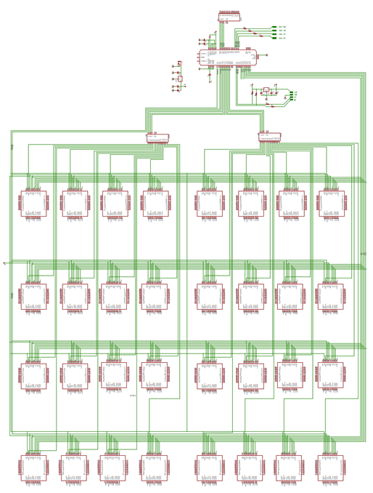
Figure 25: Complete schematic of entire Dynamic Animation Cube II system
There are two types of software that will run on the microcontroller: the simulation of the light emitting diode cube and Nunchuk, and the games and animations that will run on the cube in its final form. The code for these functions will be written in C and compiled for the microcontroller in Atmel Studio 6, the integrated development environment provided by Atmel. The code for the microcontroller will have to be written with both space and timing in mind, i.e. the code will be written as fast and compactly as possible. This is done to ensure that the applications don’t go outside their allocated run-time memory and can update (or simulate) the light emitting diodes as fast as possible to make the cube look as visually appealing as possible.
4.5.1 Simulation
Simulating the light emitting diode cube and the Nunchuk are important steps towards making sure that the microcontroller is functioning properly. The simulations will make it possible to test the microcontroller software thoroughly without it even being connected to peripheral devices. The simulations are going to be as thorough as possible and run extensively since the previous group burned out one of their light emitting diode drivers. If all goes according to plan, there should not be any software-side debugging once the microcontroller is connected to the cube and the Nunchuk.
4.5.1.1 Cube
Simulating the cube will be difficult, since the cube has no input to the microcontroller that can be verified against the input data. There are a few ways we can simulate the cube. First is by connecting connect the microcontroller as it will be in its final configuration, but tying the drivers to ground through a resistor (to prevent sending too much current through them), and measuring the voltage between the pins on the drivers and ground using a potentiometer. Second is using a second, single purpose micro controller. to store the data being sent out through the microcontroller and output it in some readable way (possibly inputting in a serial port into a PC). These two methods are compared below in Table 27.
Method: | Using a potentiometer | Using a microcontroller
Difficulty of setup: | Can be set up in seconds assuming it has been done once before. | Will have to have a boot up for the computer and microcontroller
Difficulty of data collection: | Each simulated light emitting diode will have to be measured separately | The program can run on its own and the data will be analyzed later. The data analysis will be automated as well.
Accuracy of results: | The results reflect, as accurately as possible, response that the light emitting diodes will have to the microcontroller input, since the signal that would go to the light emitting diodes is what is being measured. | The data might not reflect the actual signals going to the light emitting diodes, since the drivers are left out entirely. This shouldn't make a difference since the drivers will be tested separately, but more testing would probably catch more errors.
Test variability: | This method will make it difficult to test the ambient and self-perpetuating tests, since it will be difficult to time the manual measuring of the voltage to the timing of the program. It will be easy to measure the user-input dependent programs, though. | This method would make it easy to test all kinds of inputs. It would be easy since the program would automatically detect what the output of the microcontroller was supposed to be, then check it against the collected data from the microcontroller.
Table 27: Comparison of light emitting diode cube testing options

Because the data will be easier to test, even if not necessarily perfectly accurate, the best method is the separate test-microcontroller connected to a pc. With this method, we can create a variety of test cases to verify the I/O of the microcontroller. We will use the Nunchuk simulation described below along with the Cube simulation to create a completely verifiable simulation of the project.

In order to store the data output by the microcontroller, the computer application Hercules will be used. Hercules is freeware distributed by the HW group that can read in and display serial data in real-time. Hercules is compliant with the universal serial bus format, and which is the format we will use to record the data.

The test cases that will test the light emitting diode Cube are the same as the cases described in the controller section below.
4.5.1.2 Controller
To test the controller, we will hard-code in different types of input from the Nunchuk, and use the method described in 4.5.1.1 to verify the output is what is expected. Unfortunately, this method will be very time consuming, since for each new test case the microcontroller firmware will have to be reloaded with the new test case. Another problem with this method is that it will be very difficult to simulate the accelerometer information, since fluid human motion will involve creating hundreds of data points. Unfortunately, creating manual input data is the only way to easily simulate having the Nunchuk input without actually connecting another input device, which would be just a difficult to verify as the Nunchuk was in the first place.

The Nunchuk simulations will be run at the same time as the light emitting diode cube simulations, since they will have to work in concert in order to accurately depict the entire apparatus. The simulations will test all states of the microcontroller thoroughly.
4.5.2 Applications
The applications that run on the light emitting diode cube are mostly simple games that can be represented by the minimal colors and resolution of the light emitting diode cube. The games will take input from the Nunchuk and output various animations to the light emitting diode cube. There are also ambient animations that take no user input. The ambient animations are able to have more complex formations of light emitting diodes, since without user input they can run smoothly on their own.
4.5.2.1 Rubik’s Cube
Once the user has selected to start the Rubik’s cube game, the microcontroller will load an internal instance of Rubik’s cube. This cube is the state of the Rubik’s cube the last time it was played or by default a solved cube if it is a fresh boot. If the internal cube is solved, the microcontroller will randomly do 10 moves on the internal cube (to ensure the cube is randomized yet solvable). The random internal cube will then be represented on the light emitting diode cube.

The user will then have a cursor, the location of which will be indicated by a light emitting diode flashing on and off every half second. The user will be able to move the cursor with a variable speed; depending on how hard they are holding the analogue stick down, ranging from a minimum of one light emitting diode per second to a maximum of 8 light emitting diodes per second. The cursor will be able to go around corners, although this may make it difficult for the user to see it. After 5 seconds of no user input, the cursor returns to the starting location, the center of one of the faces of the cube.

To rotate one of the 3X3 faces of the cube, the user will hold the [Z] button and press the analogue stick in one direction fully. This will rotate that 3X3 face in the direction of the analogue stick. An example is shown below in Figure 26.

The letters represent the individual small cubes.
The colors are the colors on each side of the small cubes.
Before rotation:
BOTTOM |  |  |  |  |  |  |  |  |  |  | TOP
G | F |  |  | E |  |  |  |  |  |  | Q |  | P |  |  | K
R | Z |  |  | N |  |  |  |  |  |  | V |  | Y |  |  | J
S | T |  |  | M |  |  |  |  |  |  | A |  | B |  |  | C
EAST |  |  |  |  |  |  |  |  |  |  | SOUTH |  |  |  |  |  |  |  |  | WEST |  |  |  |  |  |  |  | NORTH
A | B |  |  | C |  |  |  |  |  |  | C |  | J |  |  | K |  |  |  | K |  | P | Q |  |  |  |  | Q |  |  | V |  |  | A
H | I |  |  | D |  |  |  |  |  |  | D |  | O |  |  | L |  |  |  | L |  | U | R |  |  |  |  | R |  |  | W |  |  | H
G | F |  |  | E |  |  |  |  |  |  | E |  | N |  |  | M |  |  |  | M |  | T | S |  |  |  |  | S |  |  | X |  |  | G
After rotation to the user's LEFT if cursor is on A, B, C, J, K, P, Q or V:
BOTTOM |  |  |  |  |  |  |  |  |  |  |  | TOP
G |  | F |  |  | E |  |  |  |  |  |  | A |  |  | V |  |  | Q
R |  | Z |  |  | N |  |  |  |  |  |  | B |  |  | Y |  |  | P
S |  | T |  |  | M |  |  |  |  |  |  | C |  |  | J |  |  | K
EAST |  |  |  |  |  |  |  |  |  |  |  | SOUTH |  |  |  |  |  |  |  |  |  | WEST |  |  |  |  |  |  |  |  |  | NORTH
C |  | J |  |  | K |  |  |  |  |  |  | K |  |  | P |  |  | Q |  |  |  | Q |  | V |  |  | A |  |  |  |  | A |  |  | B |  |  |  | C
H |  | I |  |  | D |  |  |  |  |  |  | D |  |  | O |  |  | L |  |  |  | L |  | U |  |  | R |  |  |  |  | R |  |  | W |  |  |  | H
G |  | F |  |  | E |  |  |  |  |  |  | E |  |  | N |  |  | M |  |  |  | M |  | T |  |  | S |  |  |  |  | S |  |  | X |  |  |  | G
After rotation to the RIGHT if the cursor is on any face of cubes R, W, H, I, D, O, L, or U
BOTTOM |  |  |  |  |  |  |  |  |  |  |  |  |  | TOP
G |  |  | F |  |  | E |  |  |  |  |  |  |  | A |  |  | V |  |  | Q
R |  |  | Z |  |  | N |  |  |  |  |  |  |  | B |  |  | Y |  |  | P
S |  |  | T |  |  | M |  |  |  |  |  |  |  | C |  |  | J |  |  | K
EAST |  |  |  |  |  |  |  |  |  |  |  |  |  | SOUTH |  |  |  |  |  |  |  |  |  |  | WEST |  |  |  |  |  |  |  |  |  |  |  | NORTH
C |  |  | J |  |  |  | K |  |  |  |  |  |  | K |  |  | P |  |  | Q |  |  |  |  | Q |  |  |  | V |  |  |  | A |  |  |  | A |  |  |  | B |  |  | C
R |  |  | W |  |  |  | H |  |  |  |  |  |  | H |  |  | I |  |  | D |  |  |  |  | D |  |  |  | O |  |  |  | L |  |  |  | L |  |  |  | U |  |  | R
G |  |  | F |  |  |  | E |  |  |  |  |  |  | E |  |  | N |  |  | M |  |  |  |  | M |  |  |  | T |  |  |  | S |  |  |  | S |  |  |  | X |  |  | G
Figure 26: Example of a move in the Rubik’s cube game
The player can rotate the entire cube by holding the [Z] button and jerking the Nunchuk in any direction. The entire cube will rotate in whichever direction the user moved the controller, as interpreted by the accelerometer data. This will only register if the accelerometer data in any direction deviates from the neutral position by more than 200 units.

The software will use a three-dimensional integer array of dimensions [6][3][3] to keep track of the colors of the individual squares. The individual values in the array will hold values [0:5], representing the colors of the squares. The colors used will be red, orange, blue, green, yellow, and purple, since the white and black on an actual Rubik’s cube won’t work with the light emitting diodes.

After each player move, the microcontroller will swap the values of the individual colors involved in the move. This will be a time-consuming process, so some optimizations are in place to minimize the number of instructions. If the move is a rotation of the entire cube, the actual values at the array indexes of four of the faces won’t be changed, only the addresses of the arrays, since four the faces won’t change the configuration of the colors. If the operation is a 3X3 rotation, the same principle will apply: if the addresses of the 3X1 rows of light emitting diodes can be swapped, they will be swapped and minimal instructions will be necessary. The 3X3 optimization will only work on horizontal rotations because the internal addressing method addresses rows and not columns.

After the internal array for the square colors has updated, the microcontroller will translate the [6][3][3] array of integer into the [3][16][16] format expected by microcontroller API to interface with the drivers. This translation will take place row by row, through nested for loops. The calculation for the runtime of the Rubik’s state is shown below:

((9 squares to a side) * (6 sides) * (1 cycle per square to check if it is the same as all others on that side) + (16 clock cycles to load the Nunchuk joystick X and Y positions) + (4 clock cycles to access the Nunchuk joystick data) + (32 cycles to load the accelerometer and button data into memory) + (16 cycles to compile the accelerometer data into 3 integers) + (4 cycles to give the C and Z buttons their own variables) + (2 cycles to change the cursor position) + (12 cycles to determine the move type) + (9 squares to a side) * (6 sides) * ((1 cycle store the value in the alternate Rubik’s cube array) + ((9 light emitting diodes to represent a square) * (2 cycle to update the position in the light emitting diode format)) + (1 cycle to call the updateCube function))/(66 MHz clock rate for the microcontroller)

= ((9) * (6) * (1) + (16) + (4) + (32) + (16) + (4) + (2) + (12) + (9)*(6)*(1+ (9*2)) +1) /(66 MHz)

= 17.86 microseconds = 1/(56 KHz)

If the user solves the cube, the microcontroller will go back to the lobby state. If the user presses the [C] button, the microcontroller will store the state of the cube and go back to the lobby state. If the user does not press a button or move the analogue stick for 1 minute, the microcontroller will store the state of the Rubik’s cube and go back to the lobby state.

4.5.2.2 3D Pong
Pong will be a 1 player game against an AI. When the game starts, the player will have the ball resting at the center of own 3X3X1 paddle. The player can move the paddle at a variable rate ([0:8] light emitting diodes per second) depending on how far the Nunchuk joystick is pressed in any certain direction. The player can move the paddle in any direction on one face of the cube. When the player presses the [Z] button the ball, represented by a 1X1X1 red light emitting diode, will launch forward. The AI will move at a slow rate (3 light emitting diodes per second) always towards the current X and Y position of the ball.

When the software designated position of the ball intersects with the position of either player’s paddle, it will change velocity based on the inertia of the paddle, adding half of the paddle’s X and Y velocities to the ball if the ball connects with the outer layer of the paddle otherwise not altering the X and Y velocities. The ball will also have its Z velocity inverted, although the Z magnitude is constant throughout the game.

Three internal variables, representing the X, Y and Z velocities of the ball, will be used to determine where the ball should move. In order to avoid floating point operations to determine where the ball should move, all the distance values will be multiplied by 1000 and the time will be measured in milliseconds. For example, if the X velocity is 3 and the Y velocity is 5, after 30 updates (at 1 update per millisecond), ΔX=90 and ΔY=150. Only after ΔX, ΔY or ΔZ is >=1000 or <=-1000 will the ball move in that direction and the ΔX, ΔY or ΔZ will be decremented/incremented. This will allow for high precision with low cost in calculation.

When the ball gets to the edge of the cube, the X velocity will be inverted if it is a vertical wall, and the Y velocity will be inverted if it is a horizontal wall. If the ball touches one of the edges that a paddle is on, a point will be awarded and the ball will start on the user’s paddle in the same way as the game start.

This application is the easiest in terms of lighting the light emitting diodes, since it is the application with the least light emitting diodes to be lit, and also it has a constant number of light emitting diodes contained in only 7 columns. The paddles will be stored in a [2][16] array of integers, where the first index is the paddle (0 for player 1 for AI), the second index is the column of the center of the paddle, and the integer value is a power of two, 2^{N} where N is the row value of the center of the paddle. The colors are also all constant, so that data can be hard coded. The timing for the pong state is calculated below.

((1 clock cycle to check timer to see if update is necessary) + (7 clock cycles to increment the X Y and Z positions for the ball and paddles) + (7 clock cycles to compare the X Y and Z positions to 1000) + (7 clock cycles to move the position variables of the lit light emitting diodes) + (16 clock cycles to load the Nunchuk joystick X and Y positions) + (4 clock cycles to access the Nunchuk joystick data) + (2 clock cycles to change the velocity of the user paddle based on the Nunchuk) + (4 clock cycles to compare the AI paddle’s position to the ball and change the velocities accordingly) + (8 clock cycles to change the ball velocity in the case of a wall collision) + (8 clock cycles to detect a collision with a paddle) + (2 clock cycles to detect a score) + (5 clock cycles to change the ball’s velocity in case of a paddle collision) + (1 clock cycle to increment the score) + ((18 positions for a paddles) + (1 position for the ball)+(24 positions for the scores)) * (1 cycle to clear previous position) + (1 cycle to update new position in light emitting diode representation)) + (1 cycle to push updated cube into FIFO))/(66 MHz clock rate on the microcontroller)

= (1+7+7+7+16+4+2+4+8+8+5+1+(18+1+24)*(1+1))/(66 MHz)

= 2.36 microseconds, worst case

The score will be displayed on both vertical outside layers of the cube, in a seven-segment light emitting diode fashion. When the user or the AI has scored ten points, or if the user presses the [C] button, the microcontroller will go back to the lobby state.

4.5.2.3 Tetris
Tetris will start immediately by dropping a piece from the top of the screen. The player can use the left and right and down directions on the joystick to move the pieces. The player can also use the [Z] button to rotate the pieces clockwise. The when the piece hits the bottom of the screen, or hits another piece that has been dropped, the game will check each row that was included in the final position of the piece, and if a row is complete, the game will increment the internal score for the game and remove the row. The internal score is used to determine the speed of the pieces, I.E., the pieces will drop faster the more rows the player has cleared.

The pieces in play will be stored with a [20][16] array of integers, where each integer stores a value [0:7], where 0 is an empty space, and [6:0] is the color of a filled square. There will also be an array of 16 integers that corresponds to the number of filled spaces in each row. The second array will be updated every time a piece is placed, such that it will be easy to determine if a row needs to be deleted. A running tally of filled spaces will make it so that the game won’t have to sum the bits each time a piece is placed, instead just checking to see if the array at the index is equal to 16. The calculation for the timing of the tetris state is shown below:

((4 squares maximum to check below shape) * ((1 clock cycle for memory access) + (1 clock cycle to compare the value to zero)) + (4 clock cycles to store the shape in the array) + (4 vertical rows maximum occupied by placed piece) * ((1 cycle to check the counter for the row) + (1 cycle to increment the row counter) + (16 cycles maximum to shift the rows down if there’s a cleared row) + (16 cycles maximum to update the filled counters in the rows) + (16 cycles to instantiate a new row for the top of the game)) + (256 in the Tetris board array)*((1 cycle to decode the color) + (3 cycles to calculate the position of the block in the light emitting diode cube format)+(1 cycle to write to the light emitting diode cube array))/(66 MHz clock rate for the microcontroller)

= ((4)*(1+1+4)+(4)+(4)*(1+1+16+16+16)+(256)*(1+4+1))/(66 MHz)
=27.7 microseconds, worst case.

The game is over when there is a piece that has been placed at a row above array index 15. When this is the case, the microcontroller will return to the lobby state.
4.5.2.4 Animations
Animations are automated and will always be running in the ambient state. There are two planned animations currently.
The first animation is an animation of a moving wave of light emitting diodes. This animation with start as one vertical layer of lit light emitting diodes, and will rotate about a fixed horizontal axis going through the center of the cube. Each column of the wave will be moved separately, each lagging .2 seconds behind the line in front of it. Each line will follow exactly the pattern of the line in front of it, but slightly after. This will make the wave appear fluid.
The speeds changes will be achieved by have a randomly increasing and decreasing angular acceleration. Since the acceleration is randomly changing, the wave will speed up, slow down and change direction but will not jerk, i.e. the motion of the wave will be smooth. The wave will be drawn by using the Math library tangent function to find a linear equation for the line. Then, starting from the intersection of the line and the center of the cube, the microcontroller will move along the line, one linear light emitting diode worth of distance at a time, and light up the closest light emitting diode to the calculated position. The calculation is shown below:
Known: θ, X₀, Y₀.
ΔX/ΔY = tan(θ)
ΔX = tan(θ)*ΔY
X₁ = (X₀ + ΔX), Y₁ = (Y₀ + ΔY).
(ΔX²+ΔY²)^{.5}=1², because of the Pythagorean theorem and since 1 unit was chosen as the distance.
ΔX²+ΔY²=1
Substituting tan(θ)*ΔY for ΔX yields
(1+tan(θ))²ΔY²=1
ΔY= (1/(1+tan(θ))²)^{.5},and
ΔX= tan(θ)*(1/(1+tan(θ))²)^{.5}

Although the calculation will be intensive, it will only have to be done once per cube update, since once the cube updates, all rows besides the first will simply be assigned to be identical to the one in front of them. Twenty configurations will be stored in memory at a time per line, allowing for each line to be refreshed 20 times in .2 seconds, for a total possible refresh rate of 100Hz at a total memory cost of 30kb. The space calculation for the wave animation is shown below:
(20 vertical layer states stored per actual physical layer) * (16 actual physical layers) * (16 vertical columns per layer) * (1 integer per vertical column) * (2 bytes per integer)
= (20) * (16) * (16) * (1) * (2 bytes)
= 10 kilobytes
The timing calculation for the wave animation is shown below:
((1 clock cycle to check if the time is an even increment of 10 milliseconds) + (1 clock cycle to generate a random angular acceleration value) + (1 clock cycle to normalize the angular acceleration) + (1 clock cycle to increment the angular velocity) + (1 clock cycle to increment the angle) + (10 clock cycles to calculate the tangent of the angle) + (4 clock cycles to normalize the tangent to an integer value) + (13 maximum steps from the center of the cube to a corner) * (2 directions the microcontroller will traverse) * ((60 cycles to calculate the ΔX and ΔY) +(2 cycles to store the new X and Y values)) + (20 stored rows per vertical layer) * (1 cycle to increment each layer’s address)) + (16 vertical layers) * (16 columns per layer) * (16 light emitting diodes per column) * ((1 cycle to access wave-formatted position) + (1 cycle to access API formatted position) + (1 cycle to update API formatted position)) / (66 MHz clock rate for the microcontroller)
= ((1) + (1) + (1) + (1) + (1) + (1) + (10) + (4) + (13) * (2) * (60 + 2) + (16) * (16) * (16) * (1 + 1 + 1))/(66 MHz)
= 210.6 microseconds = 1/(4.741 KHz)
The second animation will be a sort of fireworks display, wherein a series of individual lit light emitting diodes will appear to move from the bottom of the cube to a random height[9:12], then appear to explode like a firework. When a modeled firework explodes, a ring of lit light emitting diodes will expand from the location of the explosion. This will be far simpler than the first animation, since it doesn’t involve nearly as much memory, since all information necessary is in the current configuration of the cube. The colors, heights of explosions, and vertical paths of the fireworks will be random, though the shape of the explosions will always be the same. The circles will be stored as an enumerated type with four integer values: the x, y, and z positions of the explosion, and the current radius of the circle. The circle will be modeled in a similar fashion to the lines of the wave animation, in that starting from (x,y,z+r) the microcontroller will travel along a circular path defined by X²+Z²=R². The microcontroller will traverse the path 1 led-length at a time, checking after each length to light up the nearest light emitting diode. The microcontroller will stop going along the path when it determines that it has traveled a distance of 1.2*(the circumference of the circle). The calculation for traversing the circle is shown below:
Known: X²+Z²=R², X₀and Z₀ are constants
X₁ = (X₀ + ΔX), Z₁ = (Z₀ + ΔZ).
X=(R²+Z²)^{.5}
ΔZ/ΔX =-X/(√((R + X)(R - X))
(ΔX²+ΔZ²)^{.5}=1², because of the Pythagorean theorem and since 1 unit was chosen as the distance.
ΔX²+ΔZ²=1
ΔZ =(-X/(√((R + X)(R - X)))*ΔX
ΔX = √(1/((-X₀/(√((R + X₀)(R – X₀)))²+1)), and
ΔZ=√(1 - ΔX²)

The timing for the fireworks ambient animation is shown below:
((5 maximum fireworks in the air at one time) * ((2 cycles to update and/or check the Y position of the firework) + (3 cycles to get the Z position, X position and current radius) + (1 cycle to update the radius) + (16 max value for the radius) * (2*pi to convert from radius to circumference)*(1.2)*((80 cycles to calculate the ΔX and ΔZ) + (1 cycle to update the position in the firework array)) + (16 vertical layers) * (16 columns per layer) * (16 light emitting diodes per column) * ((1 cycle to access wave-formatted position) + (1 cycle to access API formatted position) + (1 cycle to update API formatted position)) / (66 MHz clock rate for the microcontroller)
= ((5)*(2 + 3 + 1 + 16*2*pi*(80+1)) +(16) * (16) * (16) * (1 + 1 + 1))/(66 MHz)
= ~803 microseconds = 1/(1.244 KHz)
4.5.2.5 The Game of Life
The game of life application will start with the cube entirely blank. The user will have a cursor, same as with the Rubik’s cube. By pressing the [Z] button and any direction on the joystick, the user will toggle the light emitting diode at the cursor to be on or off. The player moves the cursor and can rotate the cube in the same way as the Rubik’s cube. The light emitting diodes on the cube will stay lit as the cube rotates.
When the user presses the [C] button or is idle for 10 seconds, the cube will begin playing Conway’s game of Life in three dimensions. The game of life is based on the following rules:
Any light emitting diode has all light emitting diodes around it as ‘neighbors’, including corners. For example, an light emitting diode not on the surface of the cube has 26 neighbors.
- If a light emitting diode has exactly 5 neighbors that are ‘alive’ (in our case indicated by being lit), it will become alive or stay alive.
- If a light emitting diode has fewer than 3 neighbors, it dies (goes dark) due to starvation.
- If a light emitting diode has more than 9 neighbors, it will die due to overcrowding.
Using these rules, the game will update once every second, until either the entire cube is dead or after 45 iterations or after the user presses the [C] button. At this time, the microcontroller will return to the ambient state.
The updating of the cube will be very intensive, since there is no good way to save on calculations as well as memory. The way it will be done is by going through each light emitting diode, calculating whether or not it should be alive or dead. There will be two [16][16][16] arrays of integers, where each integer is either a 1 or a 0. The waste of space is worth the optimized access time in this case, since each light emitting diode’s state will have to be computed separately. The microcontroller will update one of the internal arrays based on the other. There are two arrays so that the update of the living and dead light emitting diodes doesn’t affect the update as it is being updated. While the internal cube is being updated, the physical cube’s light emitting diodes are being refreshed, based on the older of the two arrays of light emitting diodes. Since the cube doesn’t have to constantly update, there should be plenty of time to update the internal status of the light emitting diodes, as well as translate the [16][16][16] array into a [3][16][16] array. The timing for the game of life is calculated in section 4.2.1.
4.5.3 Test Plan
The group is splitting the project up into three categories; software, hardware, and physical structure. Hardware and software are being designed separately and will be integrated together towards the end of completion. In order to ensure that everything will work well together, the group will have to perform tests throughout all stages of construction of the project. This project is unique in the sense that it is being inherited from a group from previous semesters. The group tested each individual light emitting diode from the previous group’s cube; the results are below in section 4.5.3.2. Since the Dynamic Animation Cube will be on display, the group wants to guarantee that the cube will operate flawlessly. A final test will be taken at the end of completion to make sure the system, as a whole, runs smoothly. This will also, give the group time to fix any bugs in the design before it has to be presented.
4.5.3.1 Test Environment
Most of the testing will be done at the University of Central Florida in the senior design lab. The lab is located in Engineering I, room 456. The lab is equipped with multiple variable voltage sources and multimeters. The group will use the multimeter to monitor the voltages and currents at crucial sections of the system. With a variable voltage source, the group can test the light emitting diodes to ensure that all of the connections are soldered properly without having to connect anything to the PCB board.
The software portion of the project will be written and tested by Adam Heeren. The programming and debugging will be done using Atmel’s AVR Dragon using the Joint Action Test Group interface, and the Atmel Studio software. The software is provided for free from Atmel. It will be tested piece by piece as the code is written. Once the physical structure of the cube is built, the group will be able to connect it to the PCB boards and test how well the code integrates with the physical hardware.
4.5.3.2 Initial Test
The physical structure of the cube was already built, and sitting in the Senior Design lab. The physical appearance of the Dynamic Animation Cube is not very appealing. The light emitting diodes are just strung from the top with very little support. The group went through and individually tested each light emitting diode to ensure that they were all working correctly.
The testing consisted of using one of the power supplies already available in the lab to apply a voltage to all sixteen layers. Then the group grounded each individual column one at a time, and checked to see if any of the light emitting diodes in that column did not turn on. This method was repeated until all three colors of all 256 columns were tested.
The group discovered a lot of problems with the connections of the existing cube. Twenty of the light emitting diodes won’t turn on. Some of the voltage pin connections have been severed; either due to poor soldering techniques or from the lack of support of the existing structure. In some cases the light emitting diodes are burnt out, and will have to be replaced all together. Figure 27 shows one column with twelve blown light emitting diodes.
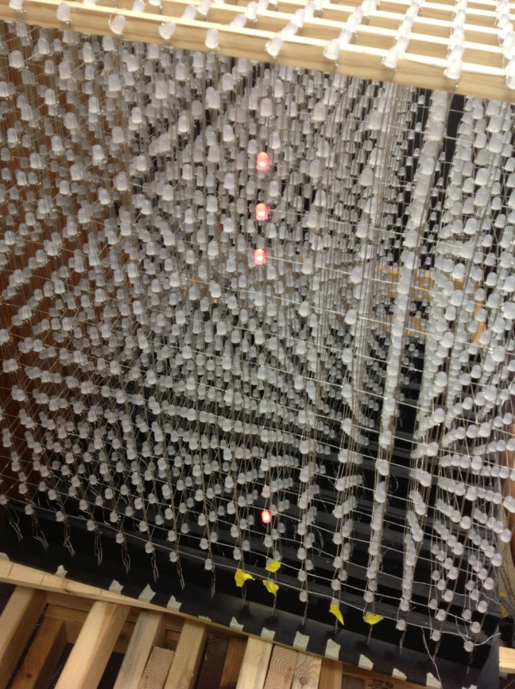
Figure 27: Initial testing of the Dynamic Animation Cube II showing 12 blown LEDs
Another problem that needs to be fixed is the fusing of two colors of some of the light emitting diodes. This means that two or possibly all three ground pins are connected. The group is going to have to remove the existing solder from these pins, and then solder them back correctly.
The results of the initial test are shown in Table 28. As you can see, there are many light emitting diodes in the center of the cube that need to be fixed. The group will have to deconstruct the entire structure in order to be able to get to them. The cube will be taken apart in panels to try and save time. This will also make it easier when trying to reconstruct the cube back. Figure 28 shows the process by which Group 5 tested each column in the Dynamic Animation Cube II.
Initial Testing Data
Top to Bottom | Front to Back | Left to Right | Problem
2 | 2 | 7 | Layer
10 | 2 | 9 | Green
3 | 2 | 9 | Blue
16 | 3 | 13 | Layer
12 | 4 | 3 | Red
10,4 | 4 | 9 | Blown
7 | 4 | 3 | Green
3 | 5 | 9 | Green
14 | 6 | 9 | Green
8 | 7 | 1 | Blue
9 | 7 | 5 | Blown
8 | 7 | 6 | Red
9 | 8 | 5 | Blue
16 | 8 | 15 | Layer
11 | 9 | 7 | Blue
7 | 10 | 13 | Red
2 | 10 | 10 | Green
4 | 13 | 16 | Layer
 | 7 | 11 | Two columns
 | 8 | 11 | Two columns
8 | 16 | 7 | Blown
 | 10 | 7 | Two colors
 | 12 | 15 | Two colors
1,5-12,14-16 | 7 | 1 | Blown
Table 28: LED’s shown to be defective during Initial Testing of the Dynamic Animation Cube II.
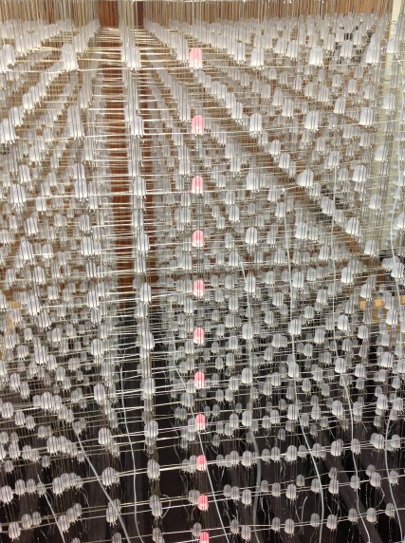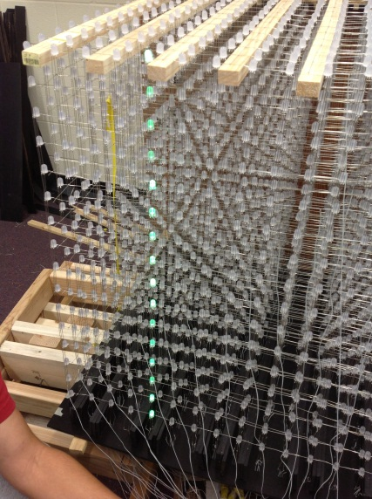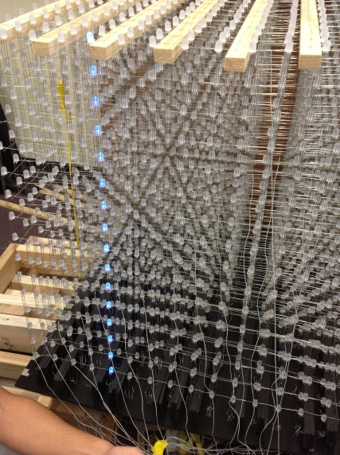Figure 28: The Dynamic Animation Cube II initial testing. Shown is the process by which the group tested each column in the LED array in each of the three colors.
4.5.3.3 Cube
Once the group has finished taking a part the cube, and fixed all of the light emitting diodes; the next phase is to test all of the panels to ensure that everything is soldered correctly. Once all of the light emitting diodes are tested, and work properly, the group will then start reconstructing the cube. Since the light emitting diodes in the center won’t be accessible after the cube is built, the group will start building from the center and test the panels as they are being constructed together. A final test will be taken once the cube is completed to ensure all of the connections remained intact.
4.5.3.3.1 Test Case 1
- Test Objective: Panel Testing

- Test Description: The group will test the panel of light emitting diodes to check if they are all working. All sixteen anode and sixteen cathodes will be hard wired to a breadboard. Using the power supplies available in the lab, a positive voltage will be applied to the anodes and the cathodes will be grounded. The group will check to see if all the light emitting diodes turn on. This will be repeated for all three colors.

- Expected Results: The group expects the panel to not have any blown or disconnected light emitting diodes. Any blown light emitting diodes will be unsoldered and replaced. Any damaged connections will be re-soldered.

4.5.3.3.2 Test Case 2
- Test Objective: Entire Cube Testing

- Test Description: The group will test the entire cube once it is finished to ensure the connections of the light emitting diodes were not damaged. All sixteen layers will be hardwired to a breadboard and applied a positive voltage. Next, the group will ground the cathode of a column and check to see if all sixteen light emitting diodes turn on. This process will be repeated for all three colors on each of the 256 columns

- Expected Results: The group expects all the columns to light up, and for there to be no damaged connections or blown light emitting diodes.

4.5.3.4 Controller
The controller is an important component for the manipulation of the animations. The Wii Nunchuk must be tested to ensure the information being sent to the microcontroller is consistent with all the research the group has collected on it. The group will hardwire the controller to the Atmel evaluation kit. Then read in the data while one of the members push the buttons, maneuver the joystick in different positions, and perform different movements with the Nunchuk itself. The objectives of the tests are to make sure all of the features of the controller work properly, and to interpret how the data and the actual physical movements are correlated.
4.5.3.4.1 Test Case 1
- Test Objective: Ensure all component features work properly

- Test Description: The group will hard wire the Nunchuk to the Atmel evaluation kit. The evaluation kit will be connected to a computer, and one of the group members will first press each button individually. Next, the joystick will be maneuvered in all possible directions. Finally, the controller will be moved left, right, up, down and rotated. All of the data will be analyzed to ensure all of the features are working correctly.

- Expected Results: The group expects all of the features to work properly. If any of the features don’t work, the group will have to replace the controller.

4.5.3.4.1 Test Case 2
- Test Objective: Interpret the correlation between the data and physical movements.

- Test Description: Similar to case two, the Wii Nunchuk will be hard wired to the Atmel evaluation kit, which is connected to a computer. The group will then maneuver the joystick in various positions. Analyze the data and determine the values for each position. Next the group will move the Nunchuk to the left, right, up, down, and perform some rotations. After each maneuver, the group will analyze the data from the computer and attempt to correlate the movements with the values collected.

- Expected Results: The group expects to be able to interpret the relationship between the data and the joystick. However, some complications are to be expected when trying to do the same with the accelerometer values.

4.5.3.5 Drivers
The drivers are the components that are supplying the current to the cube. With so many light emitting diodes in the structure, the group must be careful to not overload the drivers. The group will design a simple printed circuit board with a couple of drivers, and some male header pins to run individual tests on the drivers without sacrificing one of the main circuit boards. The group needs to test the maximum current allowed by the driver, to find out how many light emitting diodes can be on simultaneously.
4.5.3.5.1 Test Case
- Test Objective: Maximum Current Testing

- Test Description: The group will hard wire the driver to a bread board. Then using the variable voltage source in the lab, carefully increasing the current gradually until the chip stops working, or until the current has reached one ampere.

- Expected Results: The group expects the maximum current to be around 300 mA
4.5.3.6 Software
Testing the software will be extremely important for making a fully functional project. The software will have to be tested separately from the hardware, since when the microcontroller is connected to the Nunchuk and the light emitting diode cube it will be impossible to log the input and output. As mentioned previously, it is also important to make sure that the software is operating in a completely safe way before putting any delicate hardware (such as drivers, decoders, the Nunchuk the light emitting diodes) at risk for being overloaded as happened to the previous group.
4.5.3.6.1 Test Case 1
- Test Objective: Testing refresh rate
- Test Description: The Microcontroller will be hard-coded to iterate through the game of life state (the most time-intensive state) as well as one entire-cube update and the Hercules program will be used to time the amount of time it takes to finish.
- Expected Results: The total time will not be more than 11.5 milliseconds.
4.5.3.6.2 Test Case 2
- Test Objective: Changing of states
- Test Description: Once it has been determined that the Nunchuk is working, the Nunchuk will be connected to the microcontroller and various commands ((Z+Jotstick direction) and (C)) will be input via the Nunchuk. The outputs will then be read on the PC via the Hercules program.
- Expected Results: The output to the PC will represent the starting states of four different games: two paddles and a ball, a Rubik’s cube, one blinking cursor, and a Tetris piece falling from the top of the cube.
4.5.3.6.3 Test Case 3
- Test Objective: Sleep mode activation
- Test Description: The sleep timer will be set to a low value (<1 minute) for the purposes of these tests. This test will allow the cube to go to sleep, then be woken up by the Nunchuk input. This will pipe data into a PC like tests 1 and 2.
- Expected Results: The microcontroller will have the ambient animations being output to the PC before the sleep timer goes off. When the sleep timer goes off, the microcontroller should write zeroes to all the virtual drivers then do nothing. When the microcontroller receives more input from the Nunchuk, it will begin displaying ambient animations again.

5. Administrative Content
5.1 Milestones
Throughout the course of the research process the group came across several issues that it rapidly became apparent that the entire project would hinge upon. It is for that reason that the group decided to lay down milestones to aim for during the Senior Design II course that will take place during Spring of 2013. The group has identified the following milestones in Figure 26 that need to take place over the course of the Senior Design II course in order to ensure successful completion of the Dynamic Animation Cube II project.
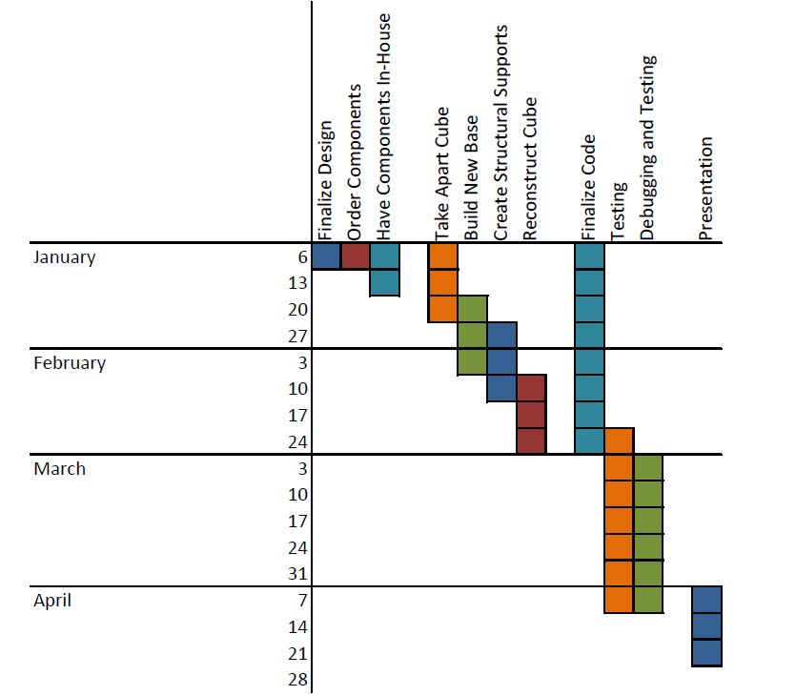
Figure 29: Milestone dates set for the production of the Dynamic Animation Cube II for the Spring 2013 semester

5.2 Budget and Finances
Available Budget: $1500
Table 20 details the spending Group 5 anticipates during the Spring 2013 semester.
Cast Acrylic Sheets for Housing
Price: $79.72 per 36in x 48in sheet
Available from Professional Plastics at a thickness of .22 inches
Description: These cast acrylic sheets will be used to encase the Dynamic Animation Cube II once it is fully operational and ready to be put on display in one of the engineering buildings on the University of Central Florida’s campus. The cast acrylic sheets are durable enough to withstand transportation of the Dynamic Animation Cube II as well as strong enough to provide the necessary protection for the cube.
Cast Acrylic Cylindrical Rods for Structural Support
Price: $17.34 per 6 foot cylindrical rod
Available from US Plastics at a diameter of .5 inches
Description: These cast acrylic rods will be used to create a structural support system for the Dynamic Animation Cube II once it is fully operational and ready to be put on display in one of the engineering buildings on the University of Central Florida’s campus. The cast acrylic rods are durable enough to withstand transportation of the Dynamic Animation Cube II as well as strong enough to provide the necessary structural stability needed for the cube.
Atmel AT32UC32512C
Price: $16.02
Available from DigiKey
Description: Microcontroller
AVR Dragon
Price: $49.00 + shipping
Available from Atmel
Description: Atmel’s low cost development tool. Will be used to program and debug the microcontroller.
Nintendo Wii Nunchuk
Price: $17.99
Available from Gamestop
Description: Contains an accelerometer, and two buttons. That will be interfaced with the cube to control the animations.
LED Drivers ST Microelectronics STP24D05
Price: $109.45
Available from Digikey
Description: A 24 bit LED driver, capable of supplying a constant regulated current.
5V, 2A Adapter
Price: $16.28
Available from DigiKey
Description: 5 volt, 2 amp output wall adapter.
74HCT154 Decoder
Price: $1.63
Available from DigiKey
Description: 4-to-16 decoder/demultiplxer
24 Pin Ribbon Cable Connectors
Price: $11
Available from Pacific Custom Cable Inc.
Description: 24 pin driver to light emitting diode connector.

Item | Quantity | Price/unit | Total Price
Acrylic Casing | 5 sheets | $79.72 | $398.60
Acrylic Rods | 12 rods | $17.34 | $208.08
LED’s | 100 | $0.10 | $10.00
Atmel AT32UC32512C | 2 | $16.02 | $32.04
AVR Dragon | 1 | $49.00 | $49.00
Wii Nunchuk | 2 | $17.99 | $35.98
LED Drivers | 32 | $3.40 | $109.35
DC Power Supply Jack | 1 | $16.28 | $16.28
Decoders | 5 | $1.63 | $8.15
Soldering Supplies | n/a | n/a | $75.00
Ribbon Cable | 100 feet | $0.50 | $50.00
Connectors | 96 | $1.10 | $110.00
AVR Development Board | 1 | $30 | $30
Atmel Studio 6.0 | 1 | $0.00 | $0.00
Hercules Serial Port Software | 1 | $0.00 | $0.00
Table 29: Financing
5.3 Group Member Biographies
The Dynamic Animation Cube II, to be completed by Group 5, will be carried out by a group of four members. The group contains one computer engineer; Adam Heeren who is a senior in Computer Engineering and plans to graduate in May 2013. The remaining three members of the group are electrical engineers; Timothy Foard, Sommer Marsh, and Brian Zei are seniors in Electrical Engineering and plan to graduate in May 2013.
5.3.1 Timothy Foard
Timothy Foard was born in Miami, Florida on March 23, 1989. He was forced to move out of Miami to Pembroke Pines, Florida after his house was destroyed during Hurricane Andrew. Timothy attended Charles W. Flanagan High School from 2003 until graduating in 2007. Academically he always enjoyed mathematics, and performed very well in all of his math classes completing Advanced Placement Calculus by his junior year. He played varsity baseball during all four years of school, where his team won two back to back Florida state championships. In his senior year he was named 2nd team all-county for his position. Baseball has had a major influence in his life. It has taught him the value of teamwork, and hard work. Most of all it has taught how to handle adversity, and to never give up.
Upon graduating high school, Timothy went on to attend Jackson State Community College in Jackson, Tennessee to continue his baseball career. Realizing that baseball was not going to take him anywhere, he decided to move to Orlando, Florida after completing his first year at Jackson State where he would attend Seminole State College. In his first two years of school Timothy never really had any direction, taking three classes a semester with no focus on anything in particular. At the end of his sophomore year he decided to enter the field of engineering, after seeking guidance of two very close friends who were engineering students at the University of Central Florida.
Timothy completed his Associates degree at Seminole State in 2010, and began attending University of Central Florida in the fall of 2010. During his years at the University of Central Florida he has expanded his knowledge in many different aspects of engineering, with a particular interest towards embedded systems. Timothy plans to graduate in May 2013 with a Bachelor’s degree in Electrical Engineering. After being in school for six years, he anticipates to enter the workforce. He would like to attend graduate school to obtain a Masters degree in Computer Engineering. However the cost of continuing his education has to be carefully considered before he can make a decision. He looks forward to completing his undergraduate degree and starting his career as an engineer.
5.3.2 Adam Heeren
Adam Heeren was born in St. Petersburg, Florida in 1991. His father graduated with a master’s degree in electrical engineering from USF and his mother graduated from UCF with a major in math and a minor in computer science. Adam has always had a penchant for technology, and this interest was always supported by his family. Adam attended the Center for Advanced Technologies at Lakewood High School in St. Petersburg, a math, science and technology magnet program, where he discovered his intense interest in programming. At the Center for Advanced Technologies, Adam took advantage of the opportunities available to him, taking several Advanced Placement classes as well as participating in both athletic and academic extracurricular activities, including the wrestling team, academic team, audio-visual club and French club.
At UCF, Adam has been able to learn a great deal about the diverse (albeit a bit sporadic) field of computer engineering. The combination of software and hardware that is offered with the computer engineering degree is perfect for Adam, since he is never satisfied simply to be told that something works; he must know how. The facilities and classes at UCF have allowed Adam to learn both the abstract and concrete aspects of programming, from complex mathematical proofs about the runtimes of algorithms to the configuration of diodes and transistors to make an AND gate. Adam is using this knowledge constantly at the College Work Experience Program at Lockheed Martin, where he works on Verilog firmware. Adam is unsure what exact type of programming he wants to do professionally after graduating from UCF, although he definitely plans to do some form of programming upon graduation.
The light emitting diode cube is an ideal project for Adam to be working on, since it has the software design and algorithm problems to take input from users and animate the cube, and the hardware configuration problems of making refresh rate, current draw, instructions per second, and other hardware-related issues.
Adam is the primary programmer for the cube, since he is the only Computer Engineering major in the group. He is well equipped to create the software for the cube, since he is fluent in C and has programmed on many embedded devices during his college career.
Adam plans to graduate in May 2013 with a Bachelor’s degree in Computer Engineering. He started college at the University of Central Florida in August 2009 and will graduate four years later to obtain his degree. He plans to start working full-time as a software engineer as soon as possible after graduation.
5.3.3 Sommer Marsh
Sommer Marsh was born in Orlando, Florida on June 27, 1991. She has maintained residence in the same area since her birth. She is the youngest of the four children birthed by her parents. She has three older brothers that she will never stop learning from. Sommer attended Colonial High School in Orlando where she participated in several varsity level sports, headed the yearbook department as Editor-in-Chief, and acted as President of the Latin Club. During her high school years, Sommer took Advance Placement classes and participated in the Dual Enrollment program offered by Valencia Community College. Dual Enrollment offered her the opportunity to take college courses free of cost as well as earn the high school credit still needed to graduate.
Throughout her college career Sommer has focused on the hardware aspect of electrical engineering. Outside of hardware, she thoroughly enjoyed her technical electives in power systems engineering. Her biggest challenge thus far at the University of Central Florida has been time management. She picked up an internship her first semester as an engineering student and has worked nearly full-time hours ever since. After obtaining her Bachelor’s degree she plans to remain with her employer and will seek her Professional Engineering license. In addition to seeking her Professional Engineering license, Sommer might also consider continuing her education by seeking her Master’s degree from the University of Central Florida. These plans however, are not concrete and careful thought and consideration will need to be given to this idea.
Sommer is looking forward to upgrading the Dynamic Animation Cube that was created during a previous semester by College of Engineering and Computer Science seniors. She feels that her technical knowledge and mechanical background will aid largely in the retrofit of the Dynamic Animation Cube’s structure. Throughout the course of the research phase of this project Sommer realized that she would need to become more familiar with the workings of a microcontroller and of trouble shooting software problems.
Aside from her focus on academic excellence, Sommer spends her time enjoying the university’s intramural sports, specifically two on two beach volleyball. When un-burdened by school and work, she spends as much time as possible with her family. On the weekend she can be found canoeing, fishing, shooting, reading, or just fixing up the house. Sommer also thoroughly enjoys baking, in whatever form she can get it.
Sommer plans to graduate in May 2013 with a Bachelor’s degree in Electrical Engineering. She started college at the University of Central Florida in August 2009 and will graduate four years later to obtain her degree. She plans to start work shortly after the Dynamic Animation Cube project is finished and final presentations are finished.
5.3.4 Brian Zei
Brian Casey Zei was born on December 6, 1989 in Davie, Florida where he lived for until he left for college. He attended Archbishop McCarthy High School where he took classes mostly in the school’s honors program. He also received excellent grades in upper level classes such as AP Biology, Calculus 1, and English. He graduated in May of 2008.
While in high school, Brian was also part of several after school activities, including marching band, concert band, jazz band, and the chess team. Within the band, Brian played in the percussion section becoming proficient in many instruments, but mostly stuck to the xylophone, marimba, and piano for jazz. During his senior year, he became the captain of the pit section in marching band, leading the group to receive many great and excellent ratings at several competitions. The McCarthy chess team was also very successful, being created during Brian’s freshman year and winning States all four years that he attended the school. The team also competed in the National Scholastic division, bringing home third place his sophomore year and taking first place in his junior year with Brian having one of the team’s top four scores for the tournament.
Brian also logged over 150 hours of community service during his time in high school. Some of this was done at the St. David Summer Camp, where Brian worked as a counselor in training then as a full counselor for the kindergarteners and first graders. Most of the hours though were collected during his time with Boy Scout Troop 317, where Brian was a member from fifth grade until he turned eighteen. Within this period, Brian was able to achieve the lofty rank of Eagle Scout, of which only 2% of boys that start the program finish with, as well as having time enough to receive three Eagle Palms before turning eighteen, at which time the age restriction stopped him from completing a fourth. At this time, Brian signed up as an adult leader and continued to help the troop until he left for college.
Starting in the fall of 2008, Brian began attending the University of Central Florida’s College of Engineering and Computer Science where he started on the road to receiving a degree in Electrical Engineering. He plans to graduate in May 2013, where he hopes to get a job and possibly pursuing a graduate degree in the University of Central Florida’s video game graduate program.
In his off time, Brian enjoys hanging out with friends, playing video and board games, playing chess online against players from around the world, and solving puzzles.
5.4 Division of Labor
The retrofit of the Dynamic Animation Cube that Group 5 has under taken consists largely of three distinct sections; Hardware upgrades, Structural upgrade, and Software upgrades. Hardware upgrades will be headed by Timothy Foard and Brian Zei. Timothy and Brian will collaboratively work out the logistics necessary for implementing the new applications of the Dynamic Animation Cube II. This will include evaluating the current hardware used on the Dynamic Animation Cube and then designing new printed circuit boards for use with the retrofitted cube. The structural upgrades will be headed by Sommer Marsh. She will be responsible for implementing an actual structural support system to help the cube maintain its shape and aid in preventing future wear and tear on the cube while it is on display in the Harris Corporation Building on the university’s campus. The Software aspect of the project will be handled by Adam Heeren. He will work on the code that will ultimately display the applications on the Dynamic Animation Cube II. He will delegate any programming that needs to be done by a different group member.

6. Conclusion
Group 5 will produce the Dynamic Animation Cube II with a specific set of requirements and specifications. In order to ensure the functionality of Group 5’s design, it will be of upmost importance that these specifications be considered when making any altering decisions to the Dynamic Animation Cube II designs. The Dynamic Animation Cube II will need to conform to a physical size of roughly 3.5 feet long, 3.5 feet wide and 4 feet tall (including the housing and base.) The cube will have 5 visible sides, Red, Green, Blue light emitting diodes; a resolution of 16 * 16 * 16, a stable infrastructure that will provide the basic shape of the Dynamic Animation Cube II, and an enclosure that will protect the delicate structure from outside manipulation. The Dynamic Animation Cube II will have a working temperature between 50°F - 100°F and be able to operate anywhere within a 10-80% humidity range. The Dynamic Animation Cube will be able to function from a standard 120 Volt socket. The end result of the Dynamic Animation Cube II will be a solvable Rubik’s Cube puzzle for future engineering students at the University of Central Florida to enjoy.
The base of the Dynamic Animation Cube II will be composed of cast acrylic sheets. The sheets will be machined in a way that will allow the wiring of the light emitting diodes to be concealed beneath the cube. The base will conceal all of the necessary hardware that the Dynamic Animation Cube II needs in order to run. The cast acrylic chosen to be the base of the cube weighs much less than the other materials considered. The base will make use of darkly colored cast acrylic sheets because they are opaque and will add to the aesthetics of the completed Dynamic Animation Cube II project.
The Dynamic Animation Cube II will consist of both a transparent case construction as well as an infrastructure system that will provide the necessary stress relief to the light emitting diode array. In addition to durability, strength and transparency were also considered in order to make a decision about what kind of casing would enclose the finished Dynamic Animation Cube II. With these items in mind, the group decided to use cast acrylic sheets to encase the Dynamic Animation Cube II. In addition to the enclosure that will house the cube, Group 5 will create an infrastructure within the light emitting diode array in order to maintain stability of the entire Dynamic Animation Cube II. For this inner infrastructure system, the group decided to go with cast acrylic rods which will prove to be stronger and less flimsy than extruded acrylic rods.
The hardware for the Dynamic Animation Cube II is designed with considerations for the quickest refresh rate achievable by the group. The AT32UC3C2512C microcontroller was chosen over the Stellaris LM3S8962 for its fast sixty-six MHz operating frequency, and the extra 256 Kbytes of Flash memory space. The group also feels the Atmel environment will be nicer to work with instead of the Stellaris, based on recommendations from previous Senior Design groups. The group has carefully reviewed the previous Dynamic Animation Cube documentation and has completely redesigned the system. Group Five will use a decoder to individual address all of the STP24D05 drivers, rather than daisy chain them in sequence like the previous group did. This will allow the group to select one driver to communicate with instead of having to shift data into all of the drivers. Another feature that will be added to this project that was not in the previous group’s Dynamic Animation Cube is the control of the animations through the use of the Wii Nunchuk. The AT32UC3C2512C will be programmed and debugged utilizing Atmel’s AVR Dragon and a PC.
The software used for the microcontroller will be written in C, and will make heavy use of the Atmel Software Framework. The software will run in a state machine, with one state for each of four games, a lobby, an ambient state, and an instance of Conway’s Game of Life. These states will, based on user input from the Nunchuk, change the configuration of lit light emitting diodes on the cube. The software has been calculated to have a refresh rate of no less than 90 Hz. The information describing the light emitting diodes on the cube will be sent out through a Serial Peripheral Interface, the controls for which are included in the Atmel Software Framework. The planned animations are fairly complex, especially for an embedded system, though according to the timing and memory calculations, the animations should run seamlessly.

7. References
"1/2-Inch Megapixel CMOS Digital Image Sensor." . Micron Technology, 4 Dec 2012. <http://download.micron.com/pdf/datasheets/imaging/mt9m001_1300_mono.pdf>
“74HC154; 74HCT154 4-to-16 line decoder/demultiplexer.” 12 February 2007. NXP Semiconductors. 1 December 2012. <http://www.nxp.com/documents/data_sheet/74HC_HCT154.pdf>.
Artiuch, John. "I2C or SPI Serial Communication, which one to go with?." Your Electronics Open Source. N.p., 11 2010. 30 Nov 2012. <http://dev.emcelettronica.com/i2c-or-spi-serial-communication-which-one-to-go>.
"Atmel 32-bit AVR Microntroller." Atmel.Web. 4 Nov 2012. <http://www.atmel.com/Images/doc32117.pdf>.
Atmel Corporation (2012) Atmel Software Framework (Version 3.5.1) [Code Library]. Available at http://asf.atmel.com/docs/latest/api.html (Accessed 1 December 2012)
“Breadboard Power Supply 5V/3.3V.”Sparkfun Electronics. 1 December 2012. <https://www.sparkfun.com/products/114>.
“CD54HC4514, CD74HC4514, CD74HC4515.” July 2003. Texas Instruments. 20 November 2012. <http://pdf1.alldatasheet.com/datasheet-pdf/view/26940/TI/CD74HC4514.html>.
“Dynamic Animation Cube.” August 2012. UCF Senior Design 2012 Group 1. 15 November 2012. <http://eecs.ucf.edu/seniordesign/sp2012su2012/g01/index.html>.
"How to: Cheap Accelerometer with the Wii Nunchuck." Hack n Mod. HacknMod.com, 21 Nov 2012. <http://hacknmod.com/hack/how-to-cheap-accelerometer-using-wii-nunchuck/>.
“LED Cube 8x8x8.” November 2011. Instructables. 1 December 2012. <http://www.instructables.com/id/Led-Cube-8x8x8/#intro>.
Lee, Johnny. "Hacking the Nintendo Wii Remote." IEEE CS, 15 Nov 2012. http://www.cs.cmu.edu/~15-821/CDROM/PAPERS/lee2008.pdf
Matamoros, Mauricio, Marco Negrete, Yasmine Haddad, and Ron Leder."Nintendo WII remote and Nunchuck as a wireless data subsystem for digital acquisition of analog physiologic data relevant to motor rehabilitation after stroke; part II."IEEE Xplore. IEEE, 19 2010.Web. 1 Nov 2012. <http://ieeexplore.ieee.org/stamp/stamp.jsp?arnumber=05474568&tag=1>.
"The PS1080." PrimeSense Natural Interaction. PrimeSense. 18 Nov 2012. <http://www.primesense.com/en/technology/114-the-ps1080>
Seidle, Nathan. "Wii-mote guts." Sparkfun Electronics. 19 2006.12 Nov 2012. http://www.sparkfun.com/tutorials/43
“STP1612PW05.” December 2009. STMicroelectronics. 15 November 2012. <http://pdf1.alldatasheet.com/datasheet-pdf/view/432726/STMICROELECTRONICS/STP1612PW05.html>.
“STP24DP05.” February 2012. STMicroelectronics. 15 November 2012. <http://www.st.com/internet/com/TECHNICAL_RESOURCES/TECHNICAL_LITERATULI/DATASHEET/CD00197065.pdf>.
“TLC5941: 16-channel LED driver with dot correction and grayscale PWM control.” July 2005. Texas Instruments. 20 November 2012. http://www.ti.com/lit/ds/symlink/tlc5941.pdf.
"Using the I2C Bus."Robot Electronics, Web. 20 Oct 2012. <http://www.robot-electronics.co.uk/acatalog/I2C_Tutorial.html>.
"ZX-Nunchuck Wii-Nunchuck Interface board."Robot Shop.N.p..Web. 21 Nov 2012. <http://www.robotshop.com/ca/content/PDF/inex-zx-nunchuck-datasheet.pdf>

8. Appendix

Figure 30: Sparkfun permission
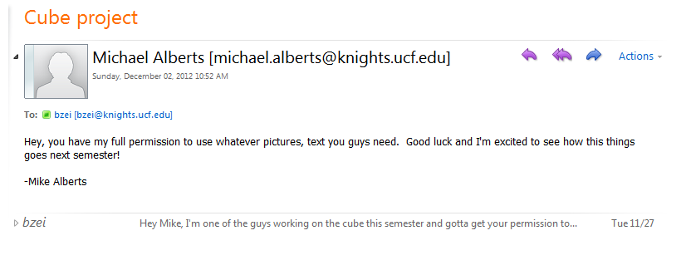
Figure 31: Michael Alberts permission

Figure 32: Atmel Permission

Figure 33: STMicroelectronics Permission

Figure 34: Texas Instruments Permission

