Dynamic Animation Cube II



Group 5
Timothy Foard
Adam Heeren
Sommer Marsh
Brian Zei
Due Date: April 29, 2013
Table of Contents:
- Executive Summary 1
- Project Description 3
  - Motivation and Goals 3
  - Objectives 6
  - Requirements and Specifications 8
- Research Related to Projects and Products 13
  - Existing Project So Far 13
    - Basic LED Cube 14
    - LED Drivers 16
    - Decoders 18
    - Microcontroller 20
    - LED’s 21
    - Structure 24
  - Component Research 29
    - Power Supply Unit (Triad Magnetics) 29
    - Housing 29
      - Extruded Acrylic 30
      - Cast Acrylic 31
      - Glass 33
      - Housing Decision 33
    - Structural Improvements 33
      - Acrylic 34
      - Wood 35
      - Aluminum 35
      - Base 35
      - Structural Decision 36
    - Microcontroller 36
      - Stellaris LM3S8962 (Texas Instruments) 37
      - AVR AT32UC3C2512C (Atmel) 39
      - Microcontroller Decision 41
    - Controllers 43
      - Microsoft Kinect 43
      - Nintendo Wii 44
        - Remote 44
        - Nunchuk 46
      - Controller Decision 47
    - LED Drivers 48
      - TLC Driver (Texas Instruments) 48
      - STP24DP05 Driver (STMicroelectronics) 50
      - STP1612PW05 Driver (STMicroelectronics) 53
      - LED Driver Decision 55
    - Software Architecture 56
      - Programming Language 56
        - Java 56
        - C 56
        - C++ 57
        - C# 57
      - Code Libraries 57
    - Decoder/Demultiplexer 64
      - CD74HC4514 (Texas Instruments) 64
      - 74HC154; 74HCT154 (NXP Semiconductors) 65
      - Decoder Decision 66
    - Ribbon Wire Connectors (Pacific Custom Cable) 67
- Hardware and Software Design Details 68
  - Initial Details and Schematics 68
  - Software Design 73
    - Control Unit API 75
    - Games 78
    - Controller Integration 86
  - Circuit Board Requirements 81
  - System Integration 81
    - LED Drivers 84
    - Controller 86
    - Power Supply 87
  - Hardware and Software Design Summary 88
    - Simulation 90
      - Cube 90
      - Controller 92
    - Applications 92
      - Rubik’s Cube 92
      - 3D Pong 96
      - Tetris 98
      - Animations 98
      - The Game of Life 101
    - Test Plan 102
      - Test Environment 102
      - Initial Test 102
      - Cube 105
        - Test Case 1 105
        - Test Case 2 106
      - Controllers 106
        - Test Case 1 106
        - Test Case 2 107
      - Drivers 107
        - Test Case 107
      - Software 107
- Administrative Content 108
  - Milestones 108
  - Budget and Finances 109
  - Group Member Biographies 111
    - Timothy Foard 111
    - Adam Heeren 112
    - Sommer Marsh 113
    - Brian Zei 114
  - Division of Labor 115
- Conclusion 116
- Manual of Operation 118
  - Normal Operation 118
  - Coding Environment 118
  - Updating Code 120
  - Troubleshooting Guide 122
    - No LEDs Lighting 122
    - No Input from Nunchuk 122
    - Hot Components/Constant Current Mode 122
    - Joint Test Action Group Errors 122
    - Wrong LEDs Lighting 123
- References 124
- Appendix 126

List of Figures:
Figure 1: The Dynamic Animation Cube I 4
Figure 2: Benchmark Dates for Spring 2013 6
Figure 3: 16X16X16 LED Cube 14
Figure 4: Dynamic Animation Cube I LED Driver Schematic 17
Figure 5: Dynamic Animation Cube I Decoder Schematic 19
Figure 6: Lattice of LEDs 22
Figure 7: Dynamic Animation Cube I Supports 25
Figure 8: Dynamic Animation Cube I Structure 26
Figure 9: Dynamic Animation Cube I Base 27
Figure 10: Dynamic Animation Cube I Base 28
Figure 11: Nintendo Wii Remote Button Layout 45
Figure 12: Nintendo Wii Nunchuk Pin Layout 46
Figure 13: Nintendo Wii Nunchuk Button Layout 47
Figure 14: Pin Layout for TLC5941 50
Figure 15: Pin Layout for STP24DP05 52
Figure 16: Dynamic Animation Cube II System Block Diagram 69
Figure 17: Dynamic Animation Cube II Base 70
Figure 18: Wiring of the Dynamic Animation Cube II 71
Figure 19: Internal Frame 72
Figure 20: Rebuild Process of the Dynamic Animation Cube II 73
Figure 21: Microcontroller State Diagram 78
Figure 22: AT32UC3C2512C Microcontroller Schematic 82
Figure 23: Pin Layout for AT32UC3C2512C 83
Figure 24: Dynamic Animation Cube I LED Driver Array 84
Figure 25: LED Drivers Schematic 85
Figure 26: Single LED Driver Schematic 86
Figure 27: Wii Nunchuk Interface Schematic 87
Figure 28: Board Power Supply Schematic 87
Figure 29: Full Schematic of the Dynamic Animation Cube II 89
Figure 30: Example of Move Operation in Rubik’s Cube Game 94
Figure 31: Initial Testing 103
Figure 32: Initial Testing 105
Figure 33: Milestone Dates for the Dynamic Animation Cube II 108
Figure 34: State Machine 118
Figure 35: Compiling Code 120
Figure 38: Accessing the Debug Menu 121
Figure 37: Setting Debug Properties 121
Figure 38: Sparkfun Permission 126
Figure 39: Michael Alberts Permission 126
Figure 40: Atmel Permission 127
Figure 41: STMicroelectronics Permission 127
Figure 42: Texas Instruments Permission 128
List of Tables:
Table 1: Power Supply Pricing 29
Table 2: Physical, Mechanical, and Optical Properties of Acrylic 31
Table 3: Extruded Acrylic Sheets Pricing 31
Table 4: Cast Acrylic Sheets Pricing 33
Table 5: Cast/Extruded Acrylic Rods Pricing 35
Table 6: GPIO Rise and Fall Time 41
Table 7: Microcontroller Parameter Comparison 43
Table 8: DF0/DF1 Settings 53
Table 9: Resistance vs. Current 54
Table 10: LED Driver Pricing 55
Table 11: AST Interface 58
Table 12: Debug Macros and Functions 59
Table 13: Dynamic Memory Allocation 59
Table 14: FIFO Interface 60
Table 15: GPIO Interfaces 60
Table 16: Sleep Manager Interfaces 61
Table 17: SPI Interfaces 62
Table 18: Timer/Counter Interfaces 63
Table 19: TWI Interfaces 63
Table 20: 4-to-16 Decoder Truth Table 66
Table 21: Decoder Pricing 66
Table 22: Ribbon Cable Connector Pricing 67
Table 23: API Field Descriptions 76
Table 24: Internal Addressing Methods 77
Table 25: Microcontroller State Machine Description 80
Table 26: Input Format from Wii Nunchuk 80
Table 27: LED Testing Options 91
Table 28: Initial Testing Data 104
Table 29: Financing 111
Table 30: API Functions 119

1. Executive Summary
In the length of this paper, Group 5 of the University of Central Florida’s Senior Design 2 class for Computer and Electrical Engineers will define specifications, present research related topics, and outline the retrofit of the Dynamic Animation Cube; a three dimensional light emitting diode cube that was constructed as part of a previous senior design course at the University of Central Florida. In order to understand the motivation behind undertaking such a task, Group 5 has provided a brief introduction to the existing Dynamic Animation Cube including its previous functionality, construction, and hardware. Group 5 is made up of four members, three of which are students in the Electrical Engineering program at the University of Central Florida and the remaining member is a Computer Engineering student.
Undertaking an existing project for Senior Design is not the typical protocol in such a course for graduating engineering students. Group 5 members considered their options carefully before they settled on taking over the Dynamic Animation Cube. Due to the construction of the cube already being completed, Group 5 had to brainstorm possibilities for the Dynamic Animation Cube II that would warrant the use of two semesters and the hardware repercussions that would be necessary to redesign for compatibility. Possibilities included full simulated animations and multiplayer interactive games. Ultimately Group 5 decided to implement a design in which future programming would be easily implemented.
The original project was done by a group of four members; Michael Alberts, Joseph Clark, Arnold Li, and Isaiah Walker. Two group members obtained Electrical Engineering degrees while the other two obtained Computer Engineering Degrees. The Dynamic Animation Cube was originally funded by the department of Electrical Engineering and Computer Science with a budget of $800 under the condition that the finished product would remain the property of the University of Central Florida’s department of Electrical Engineering and Computer Science to be put on display as a piece of artwork in one of the engineering buildings on campus.
The Dynamic Animation Cube designed and built by the aforementioned group members during a previous senior design class has a resolution of 16(L) * 16(W) * 16(H). The light emitting diode cube measured roughly three feet long, three feet wide, and four feet tall. The Dynamic Animation cube housed 4,096 light emitting diodes which hang down from eight 2(inch) * 1(inch) wooden rods. Other than these wooden rods, there was no internal structural support for the Dynamic Animation Cube light emitting diode lattice. The light emitting diodes fell upon an acrylic sheet that served as the base of the Dynamic Animation Cube.
The Dynamic Animation cube was previously designed to be only a visually pleasing piece of artwork. Group 5 has retrofitted the cube to include a user functionality that allows the user to complete any number of games that could be implemented for use in an interactive environment.
The objective of Group 5’s retrofit to the Dynamic Animation Cube was to implement a user interface in order to make the cube interactive and not just a stand-alone piece of artwork for viewing pleasure as well as to redesign necessary components to conform to this new design goal. The Dynamic Animation Cube II is capable of displaying 3-dimensional images in a way such that the rapid repeat of a command is not noticeably distracting to the human eye. The Dynamic Animation Cube II, at the discretion of the University of Central Florida’s department of Electrical Engineering and Computer Science, will be put on display in one of the three engineering buildings on campus for the students of the university to enjoy.
The design of the Dynamic Animation Cube II is roughly 33 inches long, 33 inches wide and 52 inches tall (including the housing and base.) The light emitting diodes are constructed in such a manner that a matrix structure with the resolution of 16(L) * 16(W) * 16(H) is utilized and structural supports implemented. The retrofitted Dynamic Animation Cube II retains the use of the 4,096 light emitting diodes that were originally assembled in the senior design lab by the previous group. The design of the cube includes housing all the way around and a base that encloses the entire structure and hardware in such a way to allow easy access in the event that repairs are required. The Dynamic Animation Cube II could be placed anywhere on campus, so all of the hardware needed to be encased within the base of the cube. The cube design includes a structural support system for the light emitting diodes that provides stress relief as well as provides the even spacing to help give the cube its shape.
During the research phase of the design of the Dynamic Animation Cube II, Group 5 came across several methods for implementing the specifications outlined within the contents of this paper. The major design blocks included figuring out multiplexing logistics by using light emitting diode drivers, finding a suitable user controller, structural system implementation, and code writing.
Group 5 compiled a massive amount of research on microcontrollers, user controllers, structural elements, code libraries, and code languages as well as sifted through the large amount of information available on the original Dynamic Animation Cube. From this research and the actual reconstruction of the cube, Group 5 can confidently assert that the Dynamic Animation Cube II conforms to several distinct parameters in its final state. The physical cube will be sized at roughly 33 inches length * 33 inches width * 52 inches height. The cube’s structure comprises of more than 4,000 light emitting diodes.

2. Project Description
Throughout the research phase of the Dynamic Animation Cube II project Group 5 quickly discovered the need to clearly define the end goal of this endeavor. It is only with this definition that the group could collectively and efficiently work toward achieving such a set goal. Through research and intuition Group 5 established this clearly defined end goal that represents the Dynamic Animation Cube II. Contained within this Project Description lies the aforementioned goal along with the motivations behind choosing this project, objectives for the prototyping, and the requirements and specifications of the completed Dynamic Animation Cube II.
2.1 Motivation and Goals
The Dynamic Animation Cube was initially designed as part of the Senior Design I course that took place in Spring 2012 and was then constructed as part of the follow up Senior Design II course that took place in Summer 2012. A senior design project completed at Boston University caught the previous group’s attention and the group sought to design a similar project with enhanced capabilities on a larger scale. The seniors that participated in the Dynamic Animation Cube project all graduated and moved away when the Summer semester ended and the finished product was never functional to its original specifications. In fact, the previous senior design group to work on the Dynamic Animation Cube was not able to get the 16 * 16 * 16 configuration of the cube to function with simulated animations under all circumstances. Instead, the group successfully implemented similar functionality on a much smaller prototype cube which was sufficient to pass the course and go on to graduate from the University of Central Florida. The previous group members to work on the Dynamic Animation Cube secured funding in the form of $800 from the University of Central Florida’s department of Electrical Engineering and Computer Science to construct the cube so long as the cube would remain property of the university and go on display in one of the engineering buildings that are on campus. Shown below in Figure 1 is the Dynamic Animation Cube I as provided by the previous senior design group to complete the project.
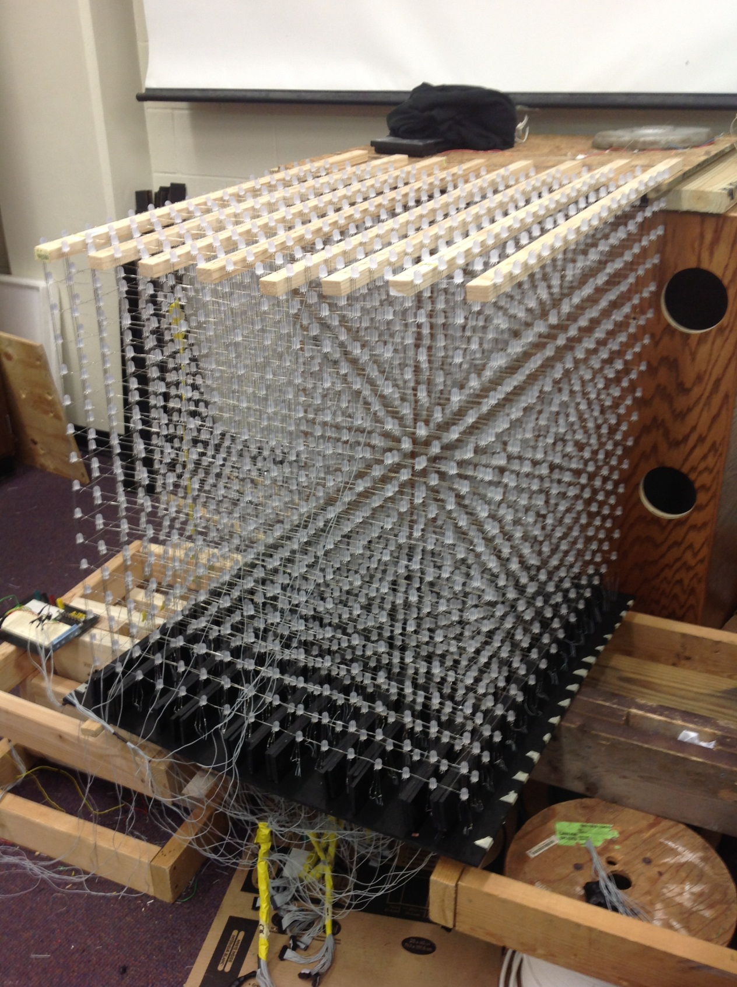
Figure 1: The Dynamic Animation Cube I, as supplied by previous group
During the initial research phase of the Senior Design I course that Group 5 was part of, it came to light that several project ideas would be pitched by local companies throughout the first several weeks of the semester. During this time, Dr. Richie pitched the idea of over taking the Dynamic Animation Cube with the possibility of receiving sponsorship from the University of Central Florida’s department of Electrical Engineering and Computer Science. Over the following couple of weeks several other sponsored projects were pitched by members of several local companies. Group 5 was formed on the day that project ideas were to be finalized and incomplete groups pitched their ideas to all other students without a group or a project idea. Group members Adam Heeren and Brian Zei pitched the idea of taking over the Dynamic Animation Cube and fellow colleagues Timothy Foard and Sommer Marsh decided to rise to the challenge.
Due to the Dynamic Animation Cube already existing, Group 5 had a few initial obstacles to overcome before definitively deciding to proceed. After several discussions that pertained to the future of the Dynamic Animation Cube and Group 5’s involvement in its future, the group came to the conclusion that the Dynamic Animation Cube would become not only a visually pleasing piece of artwork that hangs in one of the universities engineering buildings but also incorporate some sort of user interactive capability.
Due to the capabilities that Group 5 was looking at for the Dynamic Animation Cube II, the idea of seeking out funding from the University of Central Florida’s department of Electrical Engineering and Computer Science was most logical. The project was approved for a $1500 budget from the Electrical Engineering and Computer Science department from the University of Central Florida after direction from Dr. Richie. This funding was a key deciding factor in the continuation of the Dynamic Animation Cube project for Group 5. In addition to the sponsorship, the idea of having the Dynamic Animation Cube on display for future engineering students at the University of Central Florida helped the group decide to retrofit the Dynamic Animation Cube.
The goals of the Dynamic Animation Cube II were based on the physical parameters placed upon the cube’s size, the implementation of a structural support system as well as an encasing for the entire cube, and the functionality of the final product. The physical parameters that guided the retrofit of the Dynamic Animation Cube are a length of 33 inches, a width of 33 inches, and a height of 52 inches. The old configuration of the Dynamic Animation Cube allowed for the light emitting diodes to be arranged in a way such that the cubic form has a pixel pitch of roughly forty centimeters. There was no structural support system within the Dynamic Animation Cube’s structure that provided any form of stress relief. The Dynamic Animation Cube II contains a grid of supports that allow the cube to maintain its cube shape. In addition to the stability additions introduced in the design of the Dynamic Animation Cube II, a base and actual housing were manufactured. The Dynamic Animation Cube could be displayed in any one of the several engineering buildings on the University of Central Florida’s campus and the housing was implemented to prevent wear and tear from deteriorating the integrity of the Cube. The base of the Cube provides the necessary storage to house the hardware that controls the cube and also allows for easy access in the event that maintenance or repairs to the Dynamic Animation Cube II become necessary. The Dynamic Animation Cube in its completed state has the capability of getting input from a Wii Nunchuk..
Since the Dynamic Animation Cube already existed the timeline of completion dates changed a little for Group 5. It was the group’s hope that all stability and structural improvements were to be completed by the end of February 2013 which would have allowed for testing of the Dynamic Animation Cube II’s capabilities, troubleshooting, and redesign throughout the months of March 2013 and April 2013. However, due to the turnaround time while placing orders Group 5’s timeline was dramatically pushed back. The group was able to complete the reconstruction by the end of March which only allowed for about two weeks of testing on the full up configuration.
2.2 Objectives
Senior Design projects in the Department of Electrical Engineering and Computer Engineering require such effort that is it often recommended that only Senior Design II is taken during the last semester of a student’s academic career. This is not the case for any member of Group 5. Due to the time constraints that each member faced while juggling the Dynamic Animation Cube II with other classes, homework, and projects the group decided to try to stick very strictly to an outline of events that would dictate whether the group was on track for successful completion of the Dynamic Animation Cube II. As seen in Figure 2, the group outlined the major benchmarks that were to be completed in the Spring 2013 semester.

Figure 2: Benchmark dates for Spring 2013 Semester
The objectives contained within the remainder of this section reflect a collaborative effort of what Group 5 has researched in order to accomplish the completion of the Dynamic Animation Cube II. Through the completion of the Dynamic Animation Cube II, Group 5 has successfully implemented a proof of concept in order to simulate a user interface controller in order to control the applications the group has researched incorporating into the functionality of the Dynamic Animation Cube II. In order to accomplish this, the light emitting diode driver boards needed to be redesigned to conform to the new design requirements for the Dynamic Animation Cube II. In addition to the new capabilities of the cube, Group 5 has enhanced the overall structural stability of the cube by introducing a grid like system of rods that maintain the Dynamic Animation Cube II’s shape.
Undertaking this project was done so with a learning objective in mind as well. Senior Design courses are meant to push the limits of the student’s current understanding and broaden his or her knowledge base. Group 5 knew that taking over this project would require large amounts of research into unknown topics but also large amounts of research into the existing project. Not being the originators of the project, Group 5 had to rely on the hope that the previous group’s Senior Design documentation was thorough and most important; accurate. The previous group not only had incomplete information on most topics, it also has inaccurate information about their finished product. It was a challenge to get to a comfortable understanding of the existing Dynamic Animation Cube but just this was a very large objective throughout the course of the Senior Design I semester.
As summarized earlier, there are several physical parameters that Group 5 used as guidelines throughout the entirety of the Dynamic Animation Cube II project. First, and foremost, the cube has, a resolution of 16(L) * 16(W) * 16(H). This objective limited the actual dimensions of the cube to a manageable size and ultimately a manageable weight as well. Limiting the resolution of the Dynamic Animation Cube also limited the physical size of the cube. Group 5 was able to keep the size of the cube to roughly 33 inches long, 33 inches wide and 52 inches tall. This objective ensured that the cube could be transported and managed with a considerable amount of ease. The stability additions provide a solid structure to the cube and make managing the cube that much easier.
The undertaking of the Dynamic Animation Cube required that Group 5 become adequately familiar with the operation, control, and function of light emitting diodes. Since this project was inherited, Group 5 did not get to choose the light emitting diode that was used to produce the Dynamic Animation Cube. This required group members to research the existing hardware that was used in the production of the Dynamic Animation Cube. This research included operation and control of specifically the light emitting diodes used in the Dynamic Animation Cube. In addition, Group 5 had to become acquainted with design of a printed circuit board. The only stipulation placed upon a senior design group is the necessity of design of a printed circuit board to go with any proposed project. This stipulation mandates that each and every graduation Electrical or Computer Engineer has experience with printed circuit boards and their applications. The use of a microcontroller is also essential in the final functionality of the Dynamic Animation Cube II. The use of a microcontroller mandates that each member of Group 5 become familiar with the implementation of microcontrollers in a design environment.
The final sets of objectives that Group 5 had to consider were the fiscal and temporal objectives of the Dynamic Animation Cube II. First and foremost, the fiscal objective within the Dynamic Animation Cube was to remain within the budgeted $1500 that was provided in the form of sponsorship from the University of Central Florida’s department of Electrical Engineering and Computer Science. The budgeting of all hardware totaled less than $1300 which gave the group a large amount of budget untouched in case a redesign was needed or supplemental parts were required. Within the constraints of the Spring 2013 school semester there needed to be a necessary amount of time management needed from Group 5. It was expected that each team member spend anywhere between ten and twenty man hours each week on either hardware or software related development of the Dynamic Animation Cube. Group 5 budgeted a total of up to 800 man hours to complete this project.
The fulfillment of the Dynamic Animation Cube II project required that each of the aforementioned objectives was considered throughout the entirety of the project. The project required that decisions were made consciously so that the most effective and efficient decision was made in any matter that concerned the project. Group 5 accomplished this using an open door communication policy so that concerns could be voiced and addressed in a timely manner such that a direction going forward would be determined as soon as possible. The group needed to stay within the constraints of the physical size and the resolution of the Dynamic Animation Cube. The objectives outlined in the previous paragraphs ensured that Group 5 furthered their understanding and knowledge base of light emitting diodes, printed circuit board design and construction, and microcontroller applications throughout the completion of the Dynamic Animation Cube II. In addition, Group 5 outlined and stuck to a monetary budget of $1500 and up to 800 man hours to successfully implement the Dynamic Animation Cube II project.
2.3 Requirements and Specifications
The overpowering force behind the requirements and specifications set forth for the Dynamic Animation Cube II are the aforementioned objectives. It is easily seen that these objectives have guided each decision that Group 5 has encountered throughout the length of the project. The definition of these project requirements and specifications ultimately defined the Dynamic Animation Cube more clearly and dictated how the objectives were met.
- Cube size: 33 inches * 33 inches * 52 inches (L * W * H)
- Visible sides: 5 sides
- Light Emitting Diode type: RGB
- Pixel Resolution: 16 * 16 * 16 = 4,096
- Case Construction: Transparent
- Working Temperature: 50 – 104 ºF
- Working Humidity: 10-80%
- Working Voltage: AC 110V-230V
- Application’s: Animations with user interaction
The first specification that was considered was the physical size and constraints of the cube. The group determined without question that due to the fact that the cube will need to be transported in order to be displayed in one of the engineering buildings on the University of Central Florida’s campus that the cube needed to be limited to certain physical dimensions that will allow for easily manageable transportation. In addition to the transportation, Group 5 also recognized that in order for the user to get the best experience with the Dynamic Animation Cube II, that the size of the cube must be limited. Since the Dynamic Animation Cube already existed, the group used the previous groups sizing dimensions to guide the retrofit of the Dynamic Animation Cube II. The final dimensions of the cube were settled upon to be 33 inches long, 33 inches wide and 52 inches tall. These dimensions confined the size of the Dynamic Animation Cube II to an easily manageable size and weight when it was time to transport the cube to its final display building, as designated by the department of Electrical Engineering and Computer Science at the University of Central Florida. This physical constraint also allows for maintenance or repairs to occur in the event that either is needed. In addition to the height of the actual light emitting diode lattice, the height contribution from the base of the base of the cube was also considered. The group determined that an additional eighteen inches should be given to the height dimension of the cube in order to account for the needed space in cube to house the necessary controlling hardware for the Dynamic Animation Cube II.
In order to ensure an aesthetically pleasing Dynamic Animation Cube II the group had to consider several factors when deciding on the number of visible sides of the cube. It was a unanimous decision to retain the previous group’s idea of only having five visible sides to the cube. This configuration allows the base of the cube to house the hardware necessary for the cube to function. Group 5 decided to also maintain the previous group’s assertion that in order to maintain an aesthetically pleasing final product that it would best serve the cube to have an opaque base which hides the contents of the base to users. This feature adds to the viewing pleasure of users as well as protects the hardware from wear and tear and accidental damage from users. The group also took into consideration whether or not there would be a front side of the cube, which would provide optimum user interaction. Again, Group 5 decided unanimously to create the Dynamic Animation Cube II in a manner such that from any one side of the cube the experience would be equally as great.
Many constraints of Group 5’s Dynamic Animation Cube II were defined by the previous group. The Dynamic Animation Cube that previously existed consisted of more than 4,000 red, green, and blue light emitting diodes. Due to the fact that the Dynamic Animation Cube already existed, Group 5 decided to stick with the current red, green, and blue light emitting diodes that were already procured and soldered together as part of the previous group’s efforts.
“The decision to use light emitting diodes with multiple color capabilities is more difficult to design [with], but would allow for more vibrant and diverse animations. The selection of Red, Green, Blue light emitting diodes will, however, provide its own set of challenges. First, it will extend the complexity of the soldering and coding for the Dynamic Animation Cube. The coding is an issue of particular interest because it is not only the complexity of the code this is amplified by the selection of Red, Green, Blue light emitting diodes but [it] will also increase the size of the code to be implemented, raising concern for memory issues. However, the complexity of the individual light emitting diodes will not be the most hindering aspect of the design, but rather the sheer number of light emitting diodes to be implemented.” (Dynamic)
The Dynamic Animation Cube completed by a previous senior design group had a resolution of 16 * 16 * 16. Because Group 5 simply took over the Dynamic Animation Cube from this previous group, it made more than enough sense to maintain the resolution of the Dynamic Animation Cube II at the same 16 * 16 * 16 resolution. Knowing the resolution of the cube made it possible for the group to get an exact resolution of the resulting Dynamic Animation Cube II that will be displayed in one of the engineering buildings on the University of Central Florida’s campus. It’s easy to obtain the number of light emitting diodes that comprise the Dynamic Animation Cube and the total number of light emitting diodes within the cube’s structure is 4,096. With this amount of light emitting diodes used, the previous group procured at minimum 4,096 light emitting diodes as a base for the structure of the Dynamic Animation Cube. It is unknown how many of the light emitting diodes that were purchased by the previous group were either defective upon arrival or were damaged during the construction process of the Dynamic Animation Cube. The light emitting diodes provide the Dynamic Animation Cube II a lattice structure from which the housing and base are based on.
The Dynamic Animation Cube II comprises of more than 4,000 light emitting diodes. These Red, Blue, Green light emitting diodes are soldered together using solder material to form a delicate lattice structure that is very vulnerable to outside influence as well as every day wear and tear. The delicate structure has a stable framework that provides stress relief to the solder material that holds together each of the light emitting diodes. The Dynamic Animation Cube II could be put on display at the discretion of the University of Central Florida’s department of Electrical Engineering and Computer Science. For this purpose, the group decided that in order to ensure the Dynamic Animation Cube II is available for many future engineering students at the University of Central Florida to enjoy that some sort of housing would be essential to the livelihood of the completed project. The group decided that durability would be most important since the Dynamic Animation Cube will be on display at any one of the engineering buildings on the University of Central Florida’s campus. In addition to durability, strength and transparency were also considered in order to make a decision about what kind of casing would enclose the finished Dynamic Animation Cube II. With these items in mind, the group decided to use cast acrylic sheets to encase the Dynamic Animation Cube II. In addition to the enclosure that houses the cube, Group 5 created an infrastructure within the light emitting diode array in order to maintain stability of the entire Dynamic Animation Cube II. For this inner infrastructure system, the group decided to go with cast acrylic rods which proved to be stronger and less flimsy than extruded acrylic rods. The final housing related issue that the group faced during the research phase of the project was figuring out how to house the necessary hardware within the entire structure of the Dynamic Animation Cube II. Group 5 decided to create an enclosed base to the cube made of wood to house this hardware and any other necessary items.
In order to determine what the feasible working temperature that the Dynamic Animation Cube II would operate in, the group had to define the possible locations that the cube could be placed in by the University of Central Florida’s department of Electrical Engineering and Computer Science. While the exact location that the department could choose is not known, the group can confidently argue that the Dynamic Animation Cube II will be displayed within one of the engineering buildings on the University of Central Florida’s campus. Located within a building on the University of Central Florida’s campus, the Dynamic Animation Cube II will be subjected to normal ambient settings. The buildings on the University campus are all climate controlled at all times. This in itself provides adequate justification that the Dynamic Animation Cube II will be subjected to the typical ambient temperature of anywhere within the seventy degrees Fahrenheit to eighty degrees Fahrenheit marks. Because of these likely conditions the group feels comfortable to set working temperatures to the margin of: 50°F - 100°F which will provide a large margin of error if for an unforeseen reason, the temperature fluctuates in whichever location the department of Electrical Engineering and Computer Science designates the Dynamic Animation Cube II will reside after its completion.
Electronic devices are subject to many factors within the operating environment in which they reside. One of the key factors that contribute to the correct operation of electronics devices is humidity in the surrounding area. Because the functioning humidity level can affect the operating conditions of many electronic devices the group had to consider the environment in which the Dynamic Animation Cube II might be reside after its completed in the Spring of 2013. Located within a building on the University of Central Florida’s campus, the Dynamic Animation Cube II will be subjected to normal ambient settings, which will contribute to a lower humidity level, on average for the typical operating environment. The majority of electronic components are rated on the high end of the humidity spectrum and the group feels confident that the working humidity level of 10-80% will be easily attainable. As stated previously, many electronic devices are rated for similar working humidity levels.
The Dynamic Animation Cube II will be put on display in one of the University of Central Florida’s engineering buildings at the discretion of the department of Electrical Engineering and Computer Science. It relies on this knowledge that the group decided to design the Dynamic Animation Cube II to run through the use of a single standard 120 Volt socket. The group decided to implement a smaller scaled power supply in order to fit the hardware into the designated space in the base of the cube. While picking a power supply from the smaller end of the spectrum, the group also took into account that the power supply will need to be able to power the more than 4,000 light emitting diodes that are part of the Dynamic Animation Cube II. With such a large number of light emitting diodes to power, many considerations need to be given to the selection of the power supply.
The Dynamic Animation Cube II will implement a more complex projection than the Dynamic Animation Cube previously completed by a senior design group at the University of Central Florida. The group has implemented the idea of a user interactive experience into the project through the use of software design.
All of the aforementioned requirements and specifications detail the Dynamic Animation Cube II on the grand scale. In order to ensure the continued functionality of Group 5’s design, it was of upmost importance that these specifications be considered when making any and all altering decisions to the Dynamic Animation Cube II designs. The Dynamic Animation Cube II needed to conform to a physical size of roughly 33 inches long, 33 inches wide and 52 inches tall (including the housing and base.) The cube has 5 visible sides, Red, Green, Blue light emitting diodes, a resolution of 16 * 16 * 16, a stable infrastructure that provides the basic shape of the Dynamic Animation Cube II, and an enclosure that protects the delicate structure from outside manipulation. The Dynamic Animation Cube II has a working temperature between 50°F - 100°F and is able to operate anywhere within a 10-80% humidity range. The Dynamic Animation Cube is able to function from a standard 120 Volt socket. The end result of the Dynamic Animation Cube II is a user interactive game for future engineering students at the University of Central Florida to enjoy.

3. Research Related to Projects and Products
The undertaking of the Dynamic Animation Cube project required the group to do a vast amount of research. The research topics of most interest were the previous Dynamic Animation Cube, existing similar projects and commercially available products, and the areas of improvement that the Dynamic Animation Cube II could potentially improve upon. Through the extensive amount of research that Group 5 conducted, it was discovered that there are quite a few commercially available products that function as the Dynamic Animation Cube was intended to. In addition, this type of cube construction has also been attempted by senior design groups at other universities around the country. However, the scale by which the Dynamic Animation Cube II has be constructed surpasses the scale of many of the commercially available products as well as the other senior design groups that have attempted this sort of project. In addition to the larger scale that the Dynamic Animation Cube II has over the several other designs available, the Dynamic Animation Cube II functions at a higher level than all of these other products. This functionality will include a user interface that allows for the user to complete an interactive game with a controller.
3.1 Existing Project So Far
During the spring and summer semesters of 2012, the University of Central Florida’s Senior Design Group 1 started to build the Dynamic Animation Cube. The purpose of the project was to create a medium that could clearly feature animations and three dimensional images, while also showing how much the members of the group learned throughout their years at the university. This project was more ambitious than most like it in that other people before built cubes that only contained an array of eight by eight by eight light emitting diodes. Group 1 on the other hand, decided to try to create a sixteen by sixteen by sixteen cube that would give better resolution to any pictures they chose to implement. A picture of the completed cube can be seen below in Figure 3.
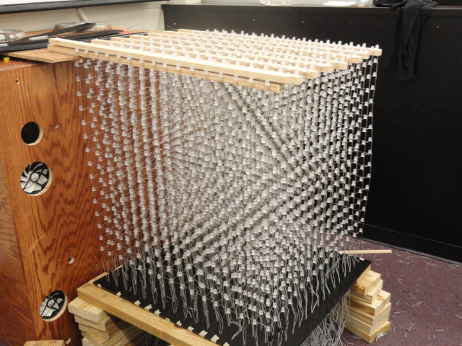
Figure 3: The full 16X16X16 Dynamic Animation Cube (Used with permission from Michael Alberts, see Appendix A)
3.1.1 Basic LED Cube
Group five took over the Dynamic Animation Cube previously started by group one of the spring/summer 2012 semesters of the University of Central Florida’s College of Engineering and Computer Science’s Senior Design program. The cube is a sixteen by sixteen by sixteen cube made of light emitting diodes that is made to show three dimensional images and animations. The previous group got the idea to build this project from similar designs on the internet.
Instructables gives a good example of how to create a light emitting diode cube. The basic light emitting diode cube is an eight by eight by eight cube whose instructions can be found on many different websites. In order to start, it is recommended that the builder have a basic knowledge in electronics, soldering skills, and how to write in C code. The component lists call for 512 light emitting diodes for the structure, several different resistors and capacitors, ribbon cable, a microcontroller, a five volt power supply, a base, and miscellaneous plug, pins, and sockets.
One of the special things about the light emitting diode cube is the addition of the third dimension for picture display. This feature creates an interesting situation in that most two dimensional displays only need to worry about stacking pixels closely in order to create a clearer image. The cube on the other hand needs to be partially see through so that the pixels in the middle can be seen from any side. Therefore when building the cube, it is necessary to keep the light emitting diodes far enough apart so as not to sacrifice voxel fidelity. Unfortunately, most light emitting diode cubes end up showing a display in relatively low resolution than other forms of display.
A normal eight by eight by eight light emitting diode cube will contain a total of 512 LEDs. As such, it is impractical to connect every single on to the microcontroller, as it would be necessary to have a controller with 512 input/output ports with 512 wires between the cube and controller. Therefore, the spectacle known as persistence of vision is depended on in order to fool anyone viewing the cube.
Persistence of vision is an optical property that means when a light emitting diode flashes quickly in front of a person’s eyes, the image stays in the retina for a bit of time after the light turns off. This allows the designer of the cube to flash each layer of the cube one at a time, so that the three dimensional image is really only made up of several two dimensional images being stacked on each other. In electronics, this feature is known as multiplexing. Therefore, the microcontroller only needs to have sixty-four input/output ports, plus eight per layer.
The cube itself is built by setting up several layers and columns of light emitting diodes. Each light comes with a negative and positive leg, also known as a cathode and anode respectively. When building the cube, each light emitting diodes’ cathode leg is soldered to every other cathode leg in the same layer. The same goes for every anode leg, except these are soldered to each other one in the same column. The sixty-four columns are then connected to the microcontroller through a wire. The current through each layer is then regulated by a transistor that turns allows current to flow through and only light the specific layer that it controls.
The next step is setting up a system of multiplexers in order to send all of the information necessary. This will make it so that only eleven input/output lines will be needed to run sixty-four outputs. The other option is to create a serial-in-parallel-out shift register. This works by reading in all data at once, and whenever the clock signal activates from low to high, the data in each bit is shifted to the next position to the right. This is somewhat useful in that it only requires nine input/output lines on the microcontroller.
An important part to consider is the power supply needed. Although each light emitting diode needs very little current in order to run, there will normally be sixty-four of these on at a single time. Therefore, during calculations it is necessary to measure the current passing through with a five volt supply, multiply that number by sixty-four, and add around twenty-five to thirty milliamps for the rest of the system. The electronics should be monitored during this process to make sure none of the parts become too hot and burn out.
Once everything is prepared, the next step is to begin construction. Starting with a flat, sturdy board, drill holes in the correct spacing for the light emitting diodes that will provide the best voxel resolution. Then set up every diode in an eight by eight square, keeping the same spacing used on the board. Solder each cathode leg to the next one in line and add a bracing system when completed. Remove the lights carefully from the board and repeat until every layer is done. Once the layers are completed, begin soldering the anode legs of each light emitting diode to the anode of the diode directly below it.
Once the structure of the cube is built, it is time to connect the base, cathode risers and cables. When done, the hardware pieces can be connected together. Each component that the previous group used is referenced below. After completion, the light emitting diode cube is ready to be programmed with whatever animation or image the creator would like to show (LED.)
3.1.2 LED Drivers
The type of light emitting diode drivers that the previous project owners, according to their documentaion, originally used was the Texas Instruments TLC5941. There were three different methods that they considered implementing, each with a different ratio of frame rate to general purpose input/outputs. Eventually the group decided to go with three sets of sixteen drivers lined up in series, as shown in Figure 4. By using this method, they were able to use the least amount of general purpose input/output pins, but sacrificed clock cycle time. In total, the entire driver system required 256 clock cycles to read the inputted data plus one additional cycle for the latch that transmitted the data to the cube. This method also gave the group the most control of the whole system when implementing commands to the diodes. The types of general purpose input/output pins necessary for the drivers were:
- 3TLC 5941 Serial Data Lines
- 1 TLC 5941 Serial Ground Control Line
- 1 TLC latch Enable Bus
- and 1 TLC Output Enable
giving a total of 6 general purpose input/output pins.
Figure 4: 3 sets of 16 LIGHT EMITTING DIODE Drivers
(used with permission from Michael Alberts, see Appendix A)

Each light emitting diode driver was fed information about certain areas of a layer and which light emitting diodes on the board to power up. Once the signals were put into an array, the different drivers held all of the necessary information in order to power and entire layer. The drivers were divided up into three separate rows that each controlled a single color in the diodes with each driver controlling each layer. The layout of the board made it easy to set up arrays and read the schematic.

The drivers were then connected to a Stellaris microcontroller that could be run in two different modes depending on need. In the first mode, serial communication was used to change the states of the light emitting diodes. By reading in the data from the computer, the Stellaris clocks in each layer on at a time, then multiplexes the data together in order to start showing the 3D images on the Dynamic Animation Cube. With the second mode, the Stellaris communicates with the Cortex M3 processor so read in animations without needing the computer. This method was the more appealing as it allowed the group to create a model that could operate on its own without need of an external processor to provide image and animation data (Dynamic.)
3.1.3 Decoders
The next piece of hardware that the group decided to use was a CD74HC4514 4-to-16 line decoder, shown in 5. With this device, when the enable pin was set to low, the output could be displayed without needing to rely on inputs, thereby keeping it at the previous input entered. Conversely when the enable was set to high, the decoder would read in from the controller General purpose input/output pins and set the cube for the correct output.
Figure 5: 3 4-to-16 decoders (used with permission from Michael Alberts, see Appendix A)
One of the benefits to using this specific device was the option to run it as a decoder or a multiplexer. Although the actual project did not call for use of a multiplexer, the group decided that the need may show up in the future, and by having a part that could play multiple rolls, it would be easy to switch modes without it being necessary to add or change parts. Also, the sixteen outputs of the device synced up with the driver in a desirable way so that the entire cube could be run with only a few decoders.
The device also has a built in balanced propagation delay, allowing for smoother communication and less chances of errors appearing in the system. This made it so that with all of the different means of communication present, there would be a much smaller chance of erroneous bits and latch triggering during transition time.
Another plus to using this device over others was a significant drop in power usage as well as higher immunity to noise. With these features, powering several thousand light emitting diodes, a microcontroller, and all the other parts made any drop in power need acceptable. The noise immunity would allow problems caused by noise to occur much less frequently. This included altering input data, distorting the latch signal or enable pins, or not reading all of the input data and not lighting part of the cube. The microcontroller itself included some noise reduction, but having another component with this capability lessened the stress on the controller (Dynamic.)
3.1.4 Microcontroller
The microcontroller the previous group decided to use was the Texas Instruments Stellaris LM3S8962. This version of controller operates at 50MHz as well as storing up to 256KB of memory. The group could also program the Stellaris with a large choice of programming libraries, allowing for more versatility with code. The core of the processor was a 32-bit ARM Cortex-M3 which could handle interrupts with relative easy. It achieved this through the use of an “Integrated Nested Vectored Interrupt Controller” which responded to interrupts quickly, at about a total of twelve clock cycles. This was good in the fact that the Dynamic Animation Cube’s serial communication system used a high amount of clock cycles and taking up less was a good decision to make. The interrupts could also be controlled one of two ways: through the light emitting diode drivers latch enabler, or the 16-bit system clock included in the system itself.
The fact that the microcontroller could be run at 50MHz was also a good feature to have. Although the light emitting diode drivers were being run with a 14.7456MHz crystal, it was possible that in the future the group would find a way to operate the cube at frequencies that high. Also, having its own built-in memory system would allow the controller to read in and store as much data that was needed to run the states of the light emitting diodes.
The Stellaris also possessed a total of 42 General purpose input/output pins , more than enough to control the entire cube and still have some left over. In addition to this, the controller came with a feature that allowed for quick toggling between IOs in only two clock cycles, again cutting down on the amount necessary for the system to run.
Another method the controller implements to save space is through the use of bit-banding. This method takes a full word in memory and maps it to a single bit, similar to pointers in programming. With this process, animations written in C code could be translated into assembly code and sent to the M3 efficiently. This was also done completely independently by the Stellaris, lightening the load on the programmer from having to make sure the system was in place.
The device also came with two other useful features. The universal asynchronous transmitter/receiver allowed for communication along transmitting and receiving lines from the controller to the cube in a serial manner. The synchronous serial interface on the other hand was used to send information bits to the drivers with a programmable bit rate. This would allow for a variety of frame sizes, from 4 to 16, to be implemented, so instead of using 3 sets of 16 drivers, the group would be able to use 16 sets of 3 drivers. Doing this cut the amount of clock cycles necessary from 256 down to 48. This could also be changed around to take advantage of the extra General purpose input/output pins , meaning the image eventually shown on the cube could be a smooth, flawless image instead of a choppy one (Dynamic.)
3.1.5 LED’s
The previous group decided to use a four pin, five millimeter light emitting diode that had many useful features that the group found appealing, which can be seen in Figure 6. To start, all the light emitting diodes shared a common anode. This meant that when connecting all of the light emitting diodes together in the cube shape, the group only needed one voltage line for each light, which allowed for easy connections between each horizontal layer. This also simplified issue checking, allowing the group to look at multiple diodes without having to moving the voltage line around constantly. This made it so that during testing, if a diode was not lighting, it could be easily checked without disconnecting the entire cube from the power source.
Figure 6: Lattice of LEDs (used with permission from Michael Alberts, see Appendix A)
The second feature of the light emitting diodes is that all of them could emit red, blue, and green. This was perfect in the fact that while most cubes work with only a single color, the Dynamic Animation Cube would be able to shown several kinds of vibrant colors. It also would allow for the images and animations implemented to be displayed in colors that would more easily exhibit the complexity of the cube. The only issue with this design is that the code necessary would have to incorporate one value of each hue, rather than a single one.
The fact that the light emitting diodes were only five millimeters was also a plus. It meant that the lights themselves would take up very little space and allow the group to consolidate the total size of the cube itself. This would eventually bring up another issue with how big to make the cube. If the group made it too large, transportation would be a problem, specifically with trying to move it through doors. On the other hand, if they made it too small, any 3D image the cube would try to display would look more like a conglomeration of lights than an actual picture.
A minor issue that the group noticed with the light emitting diodes was the fact that the casing was water clear. This could cause an issue with multiple colors, because if the light emitting diodes became too bright, the animation might have blurred together instead of being a coherent image. This could be solved in a few different ways though. Either the group could frost the lights by hand, dulling the amount of light being emitted slightly, or lowering the input voltage to a point that the lights would not be so intense.
The light emitting diodes themselves required 20mA of current per bulb. This meant that to power the entire Dynamic Animation Cube at one time, the system needed about 82 amps total. The good thing is that nothing the group was doing required every diode to be lit at the same time. The most they foresaw needed at once was one layer, which only required around five amps, a drastic cut back. This was beneficial in the fact that it made efficient use of the current being fed into the cube, and allowed for the possibility of turning on a few more layers if the image or animation would need it.
Another major plus is the life rating of each bulb. Every light emitting diode has a lifetime of about 100,000 hours, meaning if the cube was left running and never turned off, the light emitting diodes would last for about eleven and a half years. This lifetime also only refers to the amount of time until the diodes lose around 30% luminosity, which means that each light lasts even longer than that. This feature is beneficial in the fact that if the cube is only powered on for a part of the day, it will continue to work for a few decades before any of the light emitting diodes actually need replacing. And even if something happens and a diode burns out earlier than expected, it would be a simple matter to change it out as long as the lights were not space too closely together.
The viewing angle of the light emitting diodes was also rated well for what the group needed. If the degree of the angle was too high, the light would be too spread out, making the image difficult to see. Conversely, if the angle was set too small, the image would suffer in that it could only be perceived from certain places, making any 3D pictures and animations less effective. The viewing angle of the Light emitting diodes chosen was set to 25 to 35 degrees, which was sufficient for the group’s needs.
The internal luminosity rating of 4000 mill candela was also sufficient for what the group had in mind. This would allow the cube to be displayed in normal lighting without taking away from the experience, as well as making display in a dark room even better. The best conditions for viewing though would possibly be in a room that is only dimly lit because 4000 Light emitting diodes in a dark room may become a little too bright.
The final benefit to each light emitting diode was that the only weighed one gram each. Although this is light, the entire cube incorporated 4096 diodes, which makes the weight of the lights alone over four kilograms. This became important in the fact that with soldering and wiring included; the base that was chosen had to be stable and strong enough to hold up the entire weight of the cube (Dynamic.)
3.1.6 Structure
The existing Dynamic Animation Cube I that was completed by a previous senior design group that passed through the University of Central Florida’s Electrical Engineering and Computer Engineering programs was documented to be much more impressive than it really ended up to be. The previous group took on the project and was provided a generous amount of funding to be allocated for the production of the Dynamic Animation Cube. The use of this funding did not however fund any sort of internal structure for the Dynamic Animation Cube I. The entire cube is not encased in any sort of protective cover and there are no internal supports that hold the Dynamic Animation Cube I to its cube shape other than the soldering material that was used to create the Dynamic Animation Cube I. Show below, in Figure 7 is the only form of support that the previous group gave to the Dynamic Animation Cube I. The supports are in the form of eight, two inch by one inch wooden rods that were drilled into a stationary box behind the structure of the cube. These supports are what allowed the light emitting diodes to be soldered together and the rest of the cube shape was then formed downward and using solder material the light emitting diodes were soldered together downward to form the delicate lattice structure that the Dynamic Animation Cube is.
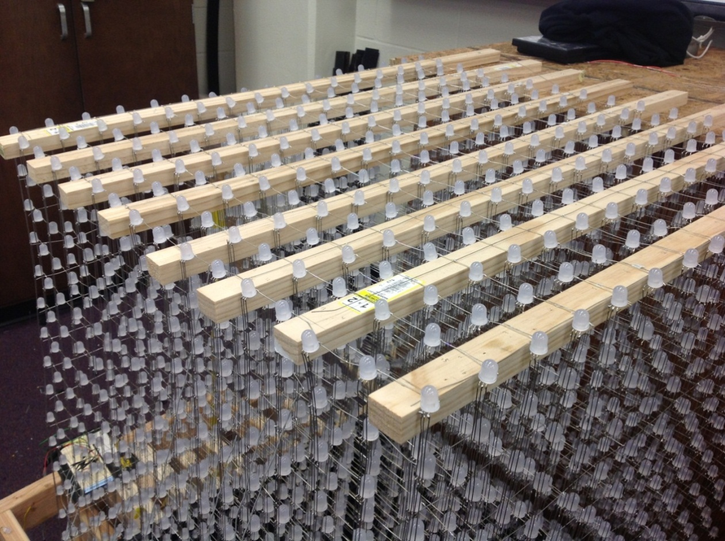
Figure 7: The supports that gave the Dynamic Animation Cube I it’s only form of structural support.
The Dynamic Animation Cube I used a system of eight, two inch by one inch wooden rods. These eight wooden rods were the only form of structural stress relief provided in the design of the Dynamic Animation Cube I.
One oversight that the previous group that completed the Dynamic Animation Cube I project overlooked was the use of an internal structural system to support the delicate lattice structure formed by the arrays of light emitting diodes. The only supports that keep this delicate structure in tact are the eight, two inch by one inch, wooden rods that the entire structure hangs from. These light emitting diodes were held together by the soldering material used to connect each of the individual lights. The lack of structural integrity in the Dynamic Animation Cube I provided a very shaky cube. Shown below, in Figure 8 is a close up view of the lack of structural support in the delicate lattice structure that made up the Dynamic Animation Cube I. Since the Dynamic Animation Cube I was constructed for the purpose of display as a piece of artwork within one of the engineering buildings on the University of Central Florida’s campus, the lack of a structural support system within the delicate array of light emitting diodes would make it very difficult to transport the cube to its final display location somewhere on the University of Central Florida’s campus. In addition to a less than ideal transport situation the Dynamic Animation Cube I would be subjected to any number of unforeseen conditions while being transported to an unknown location. The lack of an internal structure to help the cube retain its shape was the most important improvement that Group 5 decided to give to the Dynamic Animation Cube I.
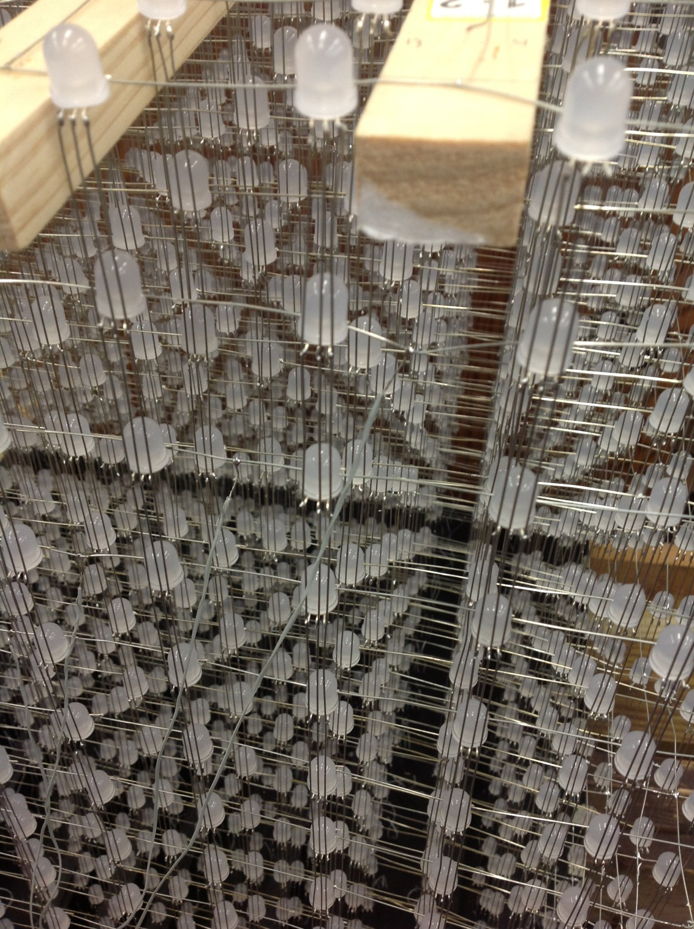
Figure 8: A close-up view of the Dynamic Animation Cube that demonstrates the lack of use of any sort of internal structural system.
The structure of the previously completed Dynamic Animation Cube I project seemed to be a last minute compilation of thoughts from the previous group that worked on the Dynamic Animation Cube. The base of the Dynamic Animation Cube I was a piece of black acrylic. This piece of acrylic had a series of holes drilled in it just large enough to fight the wire for each of the downward streams of bus wire to fit through. The previous grouped outfitted the base of the structure with cut up pieces of acrylic in order to provide some sort of stability within the different downward sections of light emitting diodes. The base of the cube does not have any sort of compartment for the essential hardware for the Dynamic Animation Cube’s operation to be concealed from sight during operation. This configuration is not only aesthetically unattractive but also not practical for the cube’s intended use. The cube is meant to be put on display in one of the engineering buildings on the University of Central Florida’s campus. Shown below, in Figure 9 is the construction of the base of the Dynamic Animation Cube as provided by the previous group that completed the Dynamic Animation Cube project at the University of Central Florida.
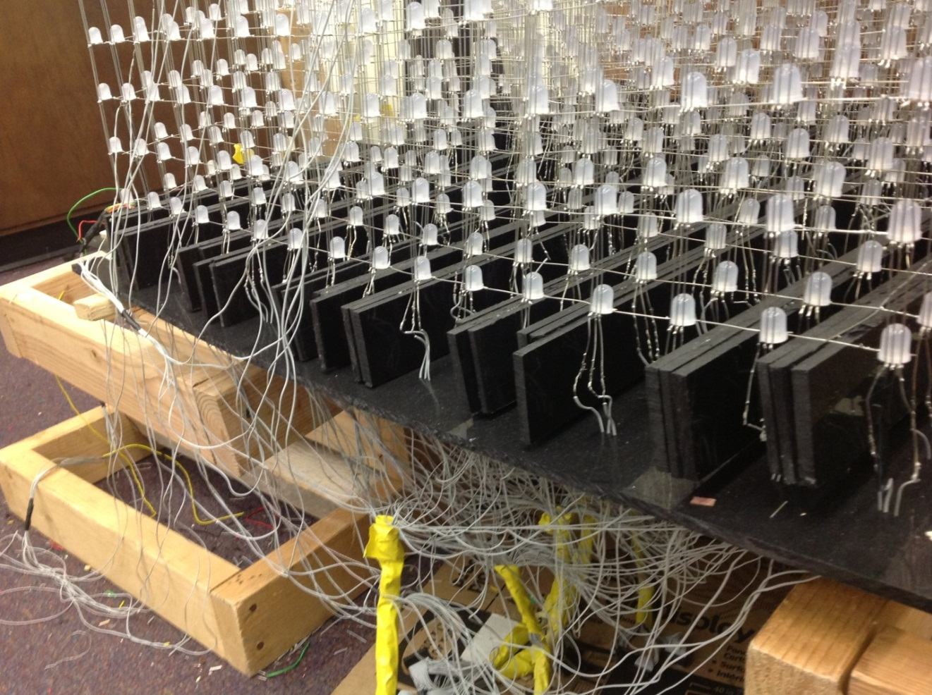
Figure 9: The base of the Dynamic Animation Cube, as provided by the previous group
As shown, the Dynamic Animation Cube does not have a stable base. Due to the construction of the cube and the fact that it’s only stability was provided by eight, two inch by one inch wooden rods nailed into a box at the back of the cube, there is no sort of support at the base of the cube. The base sagged down beneath the two temporary supports provided during the construction of the cube. Due to the haste of the last group to work on the Dynamic Animation Cube, construction of the light emitting diode array was not given the amount of care that it should have been. The haste that the previous group demonstrated during the construction of the Dynamic Animation Cube contributed to the lack of stability in the design. The base of cube, as shown in Figure 10 is supported on both sides by what were supposed to be temporary supports to aid in the construction of the Dynamic Animation Cube. Unfortunately due to poor construction and lack of structural integrity the Dynamic Animation Cube was not capable of standing without the use of these once thought to be temporary supports in addition to the rough looking box structure that stands behind the cube.
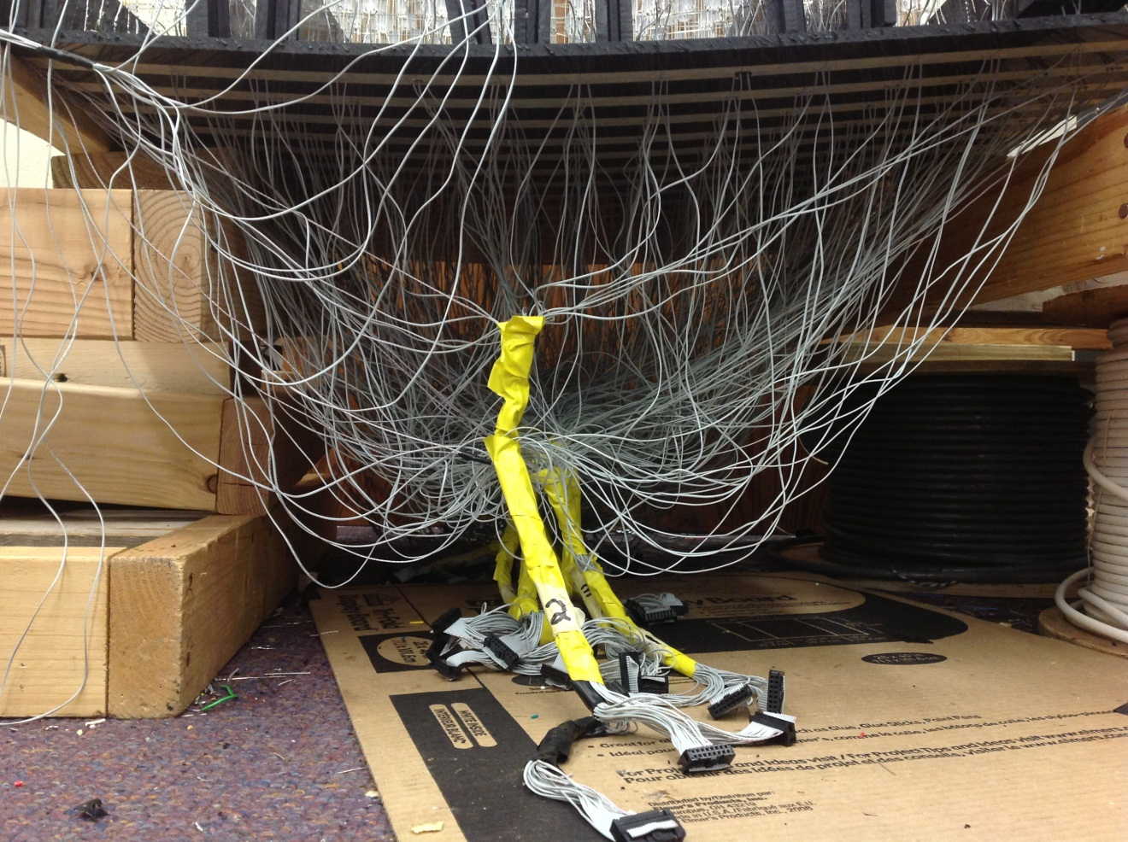
Figure 10: A close up view of the base of the Dynamic Animation Cube I

3.2 Component Research
The following section will describe the types of hardware and software architecture that group five considered using in the Dynamic Animation Cube II. These pieces would be crucial to the success of the project in that each part must work fluidly with each other part so that the cube would work correctly. This would also show the knowledge of the group members by allowing them to choose components that are necessary without wasted space or cost.
3.2.1 Power Supply Unit (Triad Magnetics)
In order to power the Dynamic Animation Cube II, group 5 had many options available to them. The best kind to use was one that plugs into a wall outlet and converts the voltage to 5 volts DC. Luckily, there was no shortage to power supply units that can accomplish this goal. The one the group chose to go with comes from Triad Magnetics. It is a 5 volt DC and 4 amp output. During testing, it was determined that the actual output was approximately 5.1 volts, which was ideal to power the cube. The power supply also has 20 watts of power capabilities and an internal short circuit and over voltage protection that helps protect the system. The entire unit is a wall wart with a six foot cord, which means the cube will be able to be plugged into any wall outlet and still have some room to move away from it.

Component | Price
Breadboard Power Supply | $9.95
5V, 2A adapter | $16.28
4-6V, 1A adapter | $8.66
Table 1: Power supply pricing
3.2.2 Housing
For the Dynamic Animation Cube II the group unanimously decided to take more seriously the idea of protecting our finished product. All of the group’s efforts will be for not if the cube was not properly protected by a strong and durable material as a finished product. It was imperative to the lifetime of the Dynamic Animation Cube II that the cube be protected in a manner that allows for little to no destruction due to the ambient setting that the department of Electrical Engineering and Computer Science ultimately decides to place the cube within. This outer protection encases the entire Dynamic Animation Cube II and provides the necessary protection from the ambient environment to ensure proper functionality of the cube.
The group researched several different materials when considering which material would be best suited for use as the housing for the Dynamic Animation Cube II. During the research phase of the project, the group considered sheets of extruded acrylic, cast acrylic and glass to ultimately encase the Dynamic Animation Cube II. These sheets meet at ninety degree angles to form a cube around the finished Dynamic Animation Cube II. These sheets are beveled at forty five degree angles and then the sheets are bonded together using an industrial grade acrylic bonding agent.
3.2.2.1 Extruded Acrylic
Polymethyl Methacrylate, Extruded or more commonly known as extruded acrylic is a strong and very durable material commercially available. Extruded acrylic is very easy to obtain and is used for a very large number of applications. It is most commonly used when a very high strength to weight ratio is needed. For the purposes of the Dynamic Animation Cube II, the group looked for a strong, durable material that is least susceptible to outside elements while on display at the University of Central Florida. There are several benefits to using an extruded acrylic. These benefits have been outlined to be transparency, strength to weight ratio, and cost.
Most important to the group is that the Dynamic Animation Cube II be encased in an aesthetically pleasing manner that will provide a visually pleasant experience when interacting with the Dynamic Animation Cube II. With this in mind, the group researched using extruded acrylic sheets as a material for the purpose of the housing of the Dynamic Animation Cube II. Extruded acrylic sheets are first and foremost transparent. This feature allows for viewing of the Dynamic Animation Cube II to be unobstructed by opaqueness. It is important to the group that the cube was encased in a very clear and unclouded material that will enhance all of the user’s experiences with the Dynamic Animation Cube II.
Extruded acrylic sheets offer unusually high strength to weight ratios. Shown below, in Table 2 is a table of features of extruded acrylic sheets. Extruded acrylic sheets are manufactured using a process that pushes the liquid form of the plastic through large rollers which are pressed into large sheets as the liquid plastic cools. These features include physical properties of extruded acrylic when tested against the American Society for Testing and Materials standards.
PHYSICAL PROPERTIES | UNITS | ASTM | RESULTS
Density | lb/in³ | D792 | 0.043
Water Absorption (24 hrs) | % | D270 | 0.3
MECHANICAL PROPERTIES | UNITS | ASTM | RESULTS
Tensile Strength @yield | psi | D638 | 8k-11k
Compressive Strength | psi | D695 | 11k-19k
OPTICAL PROPERTIES | UNITS | ASTM | RESULTS
3mm Transparent Clear Transmittance Total | % | D1003 | 92
Table 2: Physical, Mechanical, and Optical properties of interest for extruded acrylic sheets
Extruded acrylic sheets are the most economically priced sheets in the acrylic family. Sheets of extruded acrylic can be procured from a wide range of companies which demands that companies offer competitive prices. The fact that extruded acrylic sheets are offered in such a large number of colors at various thicknesses at competitive prices is what led Group 5 to consider this material for use as the exterior housing for the Dynamic Animation Cube II. Shown below, in Table 3 is a price table that shows a variety of thicknesses of extruded acrylic and the corresponding price with several commercial suppliers of the product.
COMPANY | SIZE (INCHES) | THICKNESS (INCHES) | PRICE
Professional Plastics | 36 x 48 | .22 | $101.94
Professional Plastics | 36 x 48 | .25 | $113.63
Professional Plastics | 36 x 48 | .375 | $175.85
ePlastics | 48 x 48 | .177 | $93.93
ePlastics | 48 x 48 | .236 | $115.50
ePlastics | 48 x 48 | .354 | $207.98
US Plastic Corp | 48 x 48 | .177 | $100.25
US Plastic Corp | 48 x 48 | .220 | $115.88
US Plastic Corp | 48 x 48 | .354 | $209.12
Table 3: Pricing table for several thicknesses of extruded acrylic sheets
3.2.2.2 Cast Acrylic
Polymethyl Methacrylate, or more commonly called cast acrylic is a strong and very durable material commercially available. Cast acrylic is very easy to obtain and is used for a very large number of applications. It is most commonly used when a very high strength to weight ratio is needed. For the purposes of the Dynamic Animation Cube II, the group looked for a strong, durable material that would be least susceptible to outside elements while on display at the University of Central Florida. There are several benefits to using a cast acrylic. These benefits have been outlined to be transparency, strength to weight ratio, and durability.
Most important to the group is that the Dynamic Animation Cube II be encased in an aesthetically pleasing manner that provides a visually pleasant experience for users interacting with the Dynamic Animation Cube II. With this in mind, the group researched using cast acrylic sheets as a material for the purpose of the housing of the Dynamic Animation Cube II. Cast acrylic sheets are first and foremost transparent. This feature allows for viewing of the Dynamic Animation Cube II to be unobstructed by opaqueness. Cast acrylic has a transparency very similar to glass. It was important to the group that the cube be encased in a very clear and unclouded material that will enhance all of the user’s experiences with the Dynamic Animation Cube II.
Cast acrylic is what is used to make the name brand of acrylic known as Plexiglass. Cast acrylic is known to be even stronger than extruded acrylic and this is due to the manufacturing process of each of the types. As stated before, extruded acrylic sheets are manufactured using a process that pushes the liquid form of the plastic through large rollers which are pressed into large sheets as the liquid plastic cools. In comparison, cast acrylic sheets are manufactured by pushing the liquid form of the plastic into molds and then heating the plastic into one solid sheet. This cell cast acrylic has a tendency to be a better, higher quality than extruded acrylic and tends to be stronger. The extruded acrylic is often softer when compared to cast acrylic; it usually contains some sort of impurities, and is more susceptible to scratching.
Cast acrylic sheets are more expensively priced than extruded acrylic sheets. Sheets of cast acrylic can be procured from a wide range of companies which demands that companies offer competitive prices. The fact that cast acrylic sheets are offered in such a large number of sizes at various thicknesses is what led Group 5 to consider this material for use as the exterior housing for the Dynamic Animation Cube II. Shown below, in Table 4 is a price table that shows a variety of thicknesses of cast acrylic sheets and the corresponding price with several commercial suppliers of the product.
COMPANY | SIZE (INCHES) | THICKNESS (INCHES) | PRICE
Professional Plastics | 36 x 48 | .22 | $79.72
Professional Plastics | 36 x 48 | .25 | $114.57
Professional Plastics | 36 x 48 | .375 | $180.06
ePlastics | 48 x 48 | .177 | $119.15
ePlastics | 48 x 48 | .236 | $136.89
Interstate Plastics | 48 x 48 | .236 | $117.72
US Plastic Corp | 48 x 48 | .375 | $171.80
US Plastic Corp | 48 x 48 | .354 | $209.12
Table 4: Pricing table for several thicknesses of cast acrylic sheets
3.2.2.3 Glass
The Dynamic Animation Cube II needed to be housed in a strong and durable material that will be able to be transported and put on display in one of the engineering buildings on the University of Central Florida’s campus. The group unanimously decided that glass would be too delicate a material for the applications that the group was considering. There were a large number of alternatives to glass on the market today and most of them are much more durable and offer many more incentives to use for our purposes. Glass is more expensive, heavier, and more difficult to manipulate for the groups applications.
3.2.2.4 Housing Decision
The group decided to use cast acrylic sheets to encase the Dynamic Animation Cube II. The group unanimously decided that even though cast acrylic sheets are priced higher than extruded acrylic sheets, that the benefits more than outweigh the higher cost of materials. As stated previously, cast acrylic sheets are manufactured by pushing the liquid form of the plastic into molds and then heating the plastic into one solid sheet. This cell cast acrylic has a tendency to be a better, higher quality than extruded acrylic and tends to be stronger than extruded acrylic sheets.
3.2.3 Structural Improvements
The Dynamic Animation Cube II comprises of more than 4,000 light emitting diodes. These Red, Blue, Green light emitting diodes are soldered together using solder material to form a delicate lattice structure that is very vulnerable to outside influence as well as every day wear and tear. Within the delicate structure a stable framework was implemented to provide stress relief to the solder material that holds together each of the light emitting diodes. The Dynamic Animation Cube II will be put on display at the discretion of the University of Central Florida’s department of Electrical Engineering and Computer Science. For this purpose, the group decided that in order to ensure the Dynamic Animation Cube II is available for many future engineering students at the University of Central Florida to enjoy that some sort of housing would be essential to the livelihood of the completed project. The group decided that durability would be most important since the Dynamic Animation Cube will be on display in one of the engineering buildings on the University of Central Florida’s campus. In addition to durability, strength and transparency were also considered in order to make a decision about what kind of casing would enclose the finished Dynamic Animation Cube II. With these items in mind, the group decided to use cast acrylic sheets to encase the Dynamic Animation Cube II. In addition to the enclosure that houses the cube, Group 5 created an infrastructure within the light emitting diode array in order to maintain stability of the entire Dynamic Animation Cube II. For this inner infrastructure system, the group decided to go with extruded acrylic rods which proved to be stronger and less flimsy than other materials. The final housing related issue that the group faced during the research phase of the project was figuring out how to house the necessary hardware within the entire structure of the Dynamic Animation Cube II. Group 5 decided to create an enclosed base to the cube made of wood that would house this hardware and any other necessary items.
3.2.3.1 Acrylic
Extruded acrylic rods are the most economically priced rods in the acrylic family. Rods of extruded acrylic can be procured from a wide range of companies which demands that companies offer competitive prices. The fact that extruded acrylic rods are offered in such a large number of colors at various thicknesses at competitive prices is what led Group 5 to consider this material for use as the internal structural system for the Dynamic Animation Cube II. Extruded acrylic rods are available in both cylindrical rods as well as square rods. Both shapes of extruded acrylic rod are available at several thicknesses as well as lengths.
Cast acrylic is what is used to make the name brand of acrylic known as Plexiglass. Cast acrylic is known to be even stronger than extruded acrylic and this is due to the manufacturing process of each of the types. As stated before, extruded acrylic sheets are manufactured using a process that pushes the liquid form of the plastic through large rollers which are pressed into large sheets as the liquid plastic cools. In comparison, cast acrylic sheets are manufactured by pushing the liquid form of the plastic into molds and then heating the plastic into one solid sheet. This cell cast acrylic has a tendency to be a better, higher quality than extruded acrylic and tends to be stronger. The extruded acrylic is often softer when compared to cast acrylic; it usually contains some sort of impurities, and is more susceptible to scratching. Cast acrylic rods are only available in cylindrical rods. Cylindrical acrylic rods are available at several thicknesses as well as lengths.
Cast acrylic rods are more expensively priced than extruded acrylic rods. Cast acrylic rods can be procured from a wide range of companies which demands that companies offer competitive prices. The fact that cast acrylic rods are offered in such a large number of sizes at various thicknesses is what led Group 5 to consider this material for use as the internal structural system for the Dynamic Animation Cube II. Shown below, in Table 5 is a price table that shows a variety of thicknesses of cast acrylic rods versus extruded acrylic rods and the corresponding price with several commercial suppliers of the products.
COMPANY | TYPE | SHAPE | LENGTH  (FEET) | THICKNESS (INCHES) | PRICE
ePlastics | CAST | CYLINDRICAL | 6 | .312 | $24.90
US Plastics | CAST | CYLINDRICAL | 6 | .375 | $18.90
ePlastics | EXTRUDED | CYLINDRICAL | 6 | .312 | $14.64
US Plastics | EXTRUDED | CYLINDRICAL | 6 | .375 | $2.58
US Plastics | EXTRUDED | SQUARE | 6 | .5 | $5.82
Tap Plastics | EXTRUDED | SQUARE | 6 | .375 | $9.00
Table 5: Pricing table for several thicknesses of cast acrylic and extruded acrylic cylindrical and square rods
3.2.3.2 Wood
Wooden dowels are used for a variety of applications. For the purposes of the Dynamic Animation Cube II applications, the group did minimal research into the use of wooden dowels. The group was limited to the idea of using wooden dowels as a support system for the delicate array of light emitting diodes mainly because wooden dowels are not transparent. Transparency was a major concern for the Dynamic animation Cube II. The Dynamic Animation Cube II will be put on display in one of the engineering buildings at the University of Central Florida. Since it will be on display, the aesthetics of the project are an important guiding factor for each decision that the group has to make. Wooden dowels would dramatically reduce the viewing pleasure of users of the Dynamic Animation Cube II and it is for this reason that the group did not chose to go forward with the design of the Dynamic Animation Cube II with the idea of using wooden dowels as a basis for the structural system that will be implemented
3.2.3.3 Aluminum
Aluminum rods are used for a variety of applications. For the purposes of the Dynamic Animation Cube II applications, the group did minimal research into the use of aluminum rods. The group was limited to the idea of using aluminum rods as a support system for the delicate array of light emitting diodes mainly because aluminum is not transparent. Transparency was a major concern for the Dynamic animation Cube II. The Dynamic Animation Cube II will be put on display in one of the engineering buildings at the University of Central Florida. Since it will be on display, the aesthetics of the project are an important guiding factor for each decision that the group has to make. Aluminum rods would dramatically reduce the viewing pleasure of users of the Dynamic Animation Cube II and it is for this reason that the group did not chose to go forward with the design of the Dynamic Animation Cube II with the idea of using aluminum rods as a basis for the structural system that will be implemented.
3.2.3.4 Base
Extruded acrylic sheets are the most economically priced sheets in the acrylic family. Sheets of extruded acrylic can be procured from a wide range of companies which demands that companies offer competitive prices. The fact that extruded acrylic sheets are offered in such a large number of colors at various thicknesses at competitive prices is what led Group 5 to consider this material for use as the base for the Dynamic Animation Cube II. Extruded acrylic sheets are available in many sizes, thicknesses, and colors.
Cast acrylic is what is used to make the name brand of acrylic known as Plexiglass. Cast acrylic is known to be even stronger than extruded acrylic and this is due to the manufacturing process of each of the types. As stated before, extruded acrylic sheets are manufactured using a process that pushes the liquid form of the plastic through large rollers which are pressed into large sheets as the liquid plastic cools. In comparison, cast acrylic sheets are manufactured by pushing the liquid form of the plastic into molds and then heating the plastic into one solid sheet. This cell cast acrylic has a tendency to be a better, higher quality than extruded acrylic and tends to be stronger. The extruded acrylic is often softer when compared to cast acrylic; it usually contains some sort of impurities, and is more susceptible to scratching. Cast acrylic sheets are available in many sizes, thicknesses, and colors.
Cast acrylic sheets are more expensively priced than extruded acrylic sheets. Sheets of cast acrylic can be procured from a wide range of companies which demands that companies offer competitive prices. The fact that cast acrylic sheets are offered in such a large number of colors, sizes, and at various thicknesses is what led Group 5 to decide to use this material for use as base for the Dynamic Animation Cube II.
3.2.3.5 Structural Decision
The group decided to use extruded acrylic square rods as a basis for the structural support system that was implemented in the retrofit of the Dynamic animation Cube II project. The group unanimously decided that even though acrylic rods were priced higher than other materials, that the benefits more than outweighed the higher cost of materials. Extruded acrylic is less flimsy than other materials which were the structural basis for the Dynamic Animation Cube II needs. In addition the cube base was constructed of wood.
3.2.4 Microcontroller
Choosing the right microcontroller was crucial for our design. The microcontroller must operate at a high frequency in order to be capable of refreshing the cube at a quick enough rate for smooth animations. Memory space is also a very critical factor to consider. The amount of applications the group can implement is affected by the amount of Flash memory the microcontroller has. The input/output pin count has to be considered since the group istrying to multiplex so many light emitting diodes.

3.2.4.1 StellarisLM3S8962 (Texas Instruments)
The group initially considered using the Stellaris LM3S8962 microcontroller because the previous group decided to use it in their design. The entire Stellaris family is designed around the ARM Cortex-M3 controller core, which is capable of operating at speeds up to 50 MHz. The LM3S8962 contains 256 Kbytes of Flash memory, and 64 Kbytes of SRAM. The Stellaris also offers the advantage of ARM’s widely available development tools, and an extensive community of followers. This microcontroller has many features as detailed below:
Features
- 32-bit ARM Cortex-M3 processor
- 256 Kbytes flash
- 64 Kbytes SRAM
- 42 General purpose input/output pins
- Pulse Width Modulation (PWM)
- 50 MHz Processing Speed
- Two Wire Interface (TWI)
- Synchronous Serial Interface (SSI)
The thirty-two bit ARM Cortex-M3 processor is very powerful. It offers high-performance, and low power consumption. Its Thumb-2 instruction allows for increased code density, delivering the computational performance expected from an ARM core without sacrificing memory. The Cortex-M3 also offers a three-stage pipeline Harvard architecture for high throughput during run time.
The Stellaris is equipped with an Integrated Nested Vectored Interrupt Controller, which provides deterministic interrupt handling; always processing in twelve cycles. The Cortex-M3 has thirty-six interrupts with eight different priority levels. This feature can be used when interfacing with slower external devices. The group would have needed to make use of interrupts to achieve the desired refresh rate of the cube.
The fifty MHz processing speed is not the fastest operating frequency out there. Atmel offers their thirty-two bit AVR family capable of operating at speeds of up to sixty-six MHz. It is unsure at this time if fifty MHz was fast enough to perform all of the calculations, and communications the group needed to achieve the desired refresh rate.
The LM3S8962 has 256 Kbytes of Flash and 64 Kbytes of SRAM available. The ARM Cortex-M3 is capable of accessing Flash memory in one clock cycle. The SRAM employs a technology called bit-banding. This allows the processor to use address aliases to access individual bits in a single operation, reducing the amount of time consumed by read-modify-write operations. Both the single-access Flash memory and the bit banding technology will save clock cycles during execution of the program. It was unsure at this time whether this would have been enough memory to handle all of the applications the group would like to implement. If the internal memory space was not enough, the group would have to add an external memory device.
The Stellaris LM3S8963 contains a general purpose input/output module. The general purpose input/output module consists of seven physical blocks corresponding to an individual port. The LM328963 has forty-two programmable general purpose input/output pins. The data control registers are used by the software to drive the data out to the pads. The addressing of all thirty-two LED drivers and all sixteen layers of the cube would have been controlled using the general purpose input/output pins. Failing to account for the correct number of input/output pins would set the group back considerably in production time.
Another important feature is the switching speed of the input/output pins. The general purpose input/output pins on the LM3S8962 are capable of high switching speeds, being able to change every two clock cycles.
Pulse width modulation is an effective technique for digitally encoding analog signal levels. This can be used to select the amount of power that is sent to the LEDs. Varying the amount of current on each pin of the light emitting diodes will fuse multiple colors together, allowing for more possibility of colors other than just red, blue, or green. The microcontroller pulse width modulation module consists of three pulse width modulation blocks, each with a sixteen bit counter. This would have given the group sixteen million (16 x 16 x 16) different color options to be used with the LEDs.
Inter-Integrated Circuit (I2C), also called Two Wire Interface, is capable of communicating with the Wii Nunchuk. The Two Wire Interface allows for bi-directional data transmission through a serial data line and a serial clock line. It is capable of transferring data at either one 100 Kbits per second, or 400 Kbits per second (Robot Electronics). There are four Two Wire Interface modes; master transmit, master receive, slave transmit, and slave receive. For the group’s applications, the microcontroller is the master device, and the Wii Nunchuk is the slave device. After receiving all of the data from the slave device, an interrupt is generated to make the processor aware that the transmission of data has completed.
The LM3S8962 Synchronous Serial Interface is an interface for synchronous serial communication with external devices. It is capable of communicating with serial peripheral interface devices, as well as other Texas Instruments synchronous serial interfaces. The LED drivers the group chose to use going require Serial Peripheral Communication (SPI) in order to be integrated with a master device. The Stellaris synchronous serial interface module has a maximum programmable data size of sixteen bits, which is less than the twenty-four bit size driver. The group will have to send an additional byte after the transmission of the first sixteen bits of data. This is inefficient, and would have decreased the rate at which the cube can be refreshed.

3.2.4.2 AVR UC3C2512C (Atmel)
The Atmel UC3C2512 microcontroller was designed for high performance, and high code density (Atmel). It contains Atmel’s thirty-two bit AVR32UC processor, capable of operating at sixty-six MHz. It utilizes a multi-layered data bus for high data throughput, and contains 64 Kbytes of on-chip SRAM along with 512 Kbytes of internal high-speed Flash memory. The UC3C microcontroller also offers high computing power with a built-in Floating-Point Processing Unit. The ATUC3C2512C has many features listed below:
Features
- 32-bit AVR32UC Processor
- 512 KB Flash
- 64 KB SRAM
- 66 MHz processing speed
- Serial Peripheral Interface (SPI)
- Pulse width modulation (PWM)
- Two Wire Interface (TWI)
- 45 GENERAL PURPOSE INPUT/OUTPUT PINS pins
- Floating point unit
The AVR32UC processor is an implementation of the AVR32 architecture. AVR32 is a high performance 32-bit RISC architecture with a three stage pipeline, and an innovative instruction set. The three-stage pipeline allows the processor to perform one instruction per clock cycle for most instructions. AVR32 has an innovative instruction set which allows for a compact code size, saving memory space. There are some instructions with multiple addressing modes, a compact format and an extended format. The compiler is able to use the format giving the smallest code size. (Atmel)
AVR32UC offers internal High-Speed Flash and SRAM with single-cycle access at full speed. The group is confident the 512 Kbytes of Flash, and 64 Kbytes of SRAM is enough memory to handle the size of the code for all of the applications to be implemented. Keeping the Flash and SRAM on the chip allows for fast and secure access to memory, which is beneficial for achieving the required refresh rate.
The sixty-six MHz processing speed of the UC3C is faster than the Stellaris, which is one of the main reasons the group decided to do more research on Atmel’s UC3C microcontrollers. Being able to perform around sixty-six million instructions per second was fast enough to do all of the calculations, and communications needed for the applications, to produce the desired refresh rate.
The AT32UC3C2512C is compatible with Two-Wire Interface standard communication protocol. The microcontroller behaves as the master device; it uses one clock line to synchronize with a slave device. The slave device then sends, or receives, data to the master over a data line (Artiuch). Two-Wire Interface is capable of transmitting data with speeds of up to four hundred thousand bits per second. The AT32UC3C is capable of transferring a single byte of data or it can transfer a sequence of bytes. The group was able to use this feature to communicate with the Wii Nunchuk.
The AT32UC32512C is capable of Serial Peripheral Interface, which is a synchronous serial data link that provides communication with external devices. The Serial Peripheral Interface behaves like a shift register to serially send data to other Serial Peripheral Interface devices one bit at a time (Artiuch). Data is transmitted by the microcontroller to a slave device by shifting bits into it. The microcontroller and the slave device synchronize together by using the same clock frequency, which is driven by the microcontroller. The STP24D05 drivers use Serial Peripheral Interface to communicate with external devices. This feature allowed the group to send twenty-four bits of data telling the driver which pins to drive.
The microcontroller has a General Purpose Input/Output Controller that controls forty-five input/output pins that were used as general-purpose input/output or assigned to a function of an embedded peripheral. With forty-five general purpose input/output pins, the group had many options for wiring all of the external devices.
In order to save pins, the group decided to use two four to sixteen decoders to address all thirty-two drivers. The drivers need an additional ten lines to interface with the microcontroller. That is eighteen lines needed just to interface the LED drivers. The number of pins was important to consider because if the group ran out of general purpose input/output pins, then the microcontroller would have needed to be replaced. This would have set back production time considerably. The previous group went with the StellarisLM3S8962, which has forty-two general purpose input/output pins. This gave the group confidence that the AT32UC3C2512C has enough general purpose input/output pins to handle the needs of the project.
The number of pins is not the only feature that needed to be taken into consideration. The switching speed of the pins was also very important. Most of the pins are capable of operating at fifty MHz with a ten pF capacitive load; however some are capable of operating at speeds of up to ninety-five MHz. The fall and rise times of all the general purpose input/output pins are shown in Table 6 below.

GPIO Rise and Fall Time
Pin Number | Load  (pF) | Rise Time  (ns) | Fall Time  (ns)
PB00-PB03, PB30-PB31,PC03-PC07 | 10 | 5.3 | 5.2
PB00-PB03, PB30-PB31,PC03-PC07 | 30 | 11.1 | 10.9
PB06,PB21,PB26,PD02,PD06,PD13 | 10 | 1.3 | 1.4
PB06,PB21,PB26,PD02,PD06,PD13 | 30 | 2.7 | 2.7
PA00-PA31,PB04-PB05,PB07-PB20, PB22-PB25,PC00-PC02,PC08-PC31, PD00-PD01,PD03-PD05,PD07-PD12, PD14-PD31 | 10 | 2.4 | 2.4
 | 30 | 5.2 | 5.1
Table 6: General Purpose input/output pin rise and fall times.
The AT32UC has a hardware Floating Point Unit, which performs a multiply and accumulate as a single operation with no intermediate rounding allowing for increased precision (Atmel). This feature allowed the group to program more complicated applications onto the microcontroller.
The AT32UC3C supports two interfaces for programming, JTAG or aWire. Both interfaces offered access to memory, the On-Chip Debug system, and all device peripherals through the Service Access Bus. The Service Access Bus uses a thirty-six bit address space to map the internal address space and other features. The four most significant bits are used to identify multiple slave devices, while the remaining thirty-two bits are decoded within the microcontroller.
The On-Chip Debug system offers an abundance of debugging capabilities. The debug system is based on the Nexus 2.0 standard, which offers basic run-time control, program breakpoints, data breakpoints, program tracing, ownership tracing, and data tracing. This allowed the group to effectively debug any problems that occured while writing the code for the applications.
3.2.4.3 Microcontroller Decision
Choosing the right embedded processor was one of the most crucial decisions for the design. The most important feature of the microcontroller is speed. Choosing an embedded processor with too slow of an operating frequency may cause the animations to flicker due to the slow refresh rate. The AT32UC3C2512C outperforms the Stellaris LM3S8962 in this aspect with its sixty-six MHz operating frequency.
Another key parameter is the amount of internal memory; the microcontroller must contain a lot of Flash memory because the applications the group intends on implementing are complicated and may require a great deal of lines of code. Once again, Atmel’s AT32UC3C2512C surpasses Texas Instruments’ Stellaris, with 512 Kbytes of internal Flash.
Whichever microcontroller the group chose, must also be able to communicate with ST Microelectronics’ STP24DP05 LED driver, and Nintendo Wii’s Nunchuk. Both microcontrollers offer serial peripheral interface, two wire interface, and pulse width modulation interfaces. However, the AT32UC3C2512C offers more channels of each interface.
The AT32UC3C2512C outperforms the Stellaris LM3S8962 in almost every category, as you can see in Table 7 below. The group decided to choose Atmel’s AT32U3C2512C microcontroller. Although the Stellaris is impressive and very similar to the AT32UC3C2512C, the two main deciding factors were the faster processing speed, and the internal memory capacity.

Microcontroller Parameter Comparison
Model | LM3S8962 | AT32UC3C2512C
Processing Speed | 50 MHz | 66 MHz
GENERAL PURPOSE INPUT/OUTPUT PINS | 42 | 45
SPI | 1 | 5
TWI | 1 | 2
PWM | 6 | 14
Flash | 256 KB | 512 KB
SRAM | 64 KB | 64 KB
Table 7: A comparison of relevant microcontroller parameters under consideration for use in the Dynamic Animation Cube II.
3.2.5 Controllers
In order to manipulate the animations of the cube, it was necessary to explore the different options of controllers. The main specification that was of concern was the amount of data that is sent from the controller. The microcontroller has a limited amount of memory space. Another important feature to consider was the communication protocol. There were three controllers that the group decided to consider; a Microsoft Kinect, a Nintendo Wii remote, and a Nintendo Wii Nunchuk. All options have a variety of documentation and examples of third party applications.
3.2.5.1 Microsoft Kinect
The initial choice for a controller was the Microsoft Kinect. The group envisioned being able to manipulate the virtual Rubik’s cube just as if it was a real Rubik’s cube. With the Kinect, it is possible to pick up specific hand gestures and use that to manipulate the animations of the cube. This would have given the Rubik’s cube application a more realistic experience to the user. The user would be able to simulate the motions of solving a real Rubik’s cube with their hands, and the animations will adjust accordingly.
The Kinect uses a pair of cameras, which incorporate CMOS image sensors. The infrared camera uses the MT9M001 sensor from Adina. The relatively large, 5.2µ x 5.2µ (Micron), pixel size performs well regardless of low lighting conditions. This would have allowed the Kinect to pick up user inputs wirelessly and in a wide range of lighting conditions.
The main feature of the Kinect is the on board image processing capabilities. It interfaces two cameras and four microphones with the PrimeSense PS1080. The PS1080 collects the data from all of the sensors and synchronizes them together to be sent to a host (PrimeSense). All of the image processing is being done on the Kinect itself. This feature would have allowed the group to be able to use the Kinect without adding to the complexity of the code.
The amount of data being sent from the Kinect is something that needed to be monitored. The depth camera sends roughly 400 Kbytes of data per frame. The color camera sends a little more than 300 Kbytes bytes of data per frame. At thirty frames per second, this is a lot of data that needs to be collected. The Atmel UC3 series does not have enough memory space to handle all of that information.
The Kinect’s image processing capabilities make it ideal for control of the cube. However, due to the limited memory space on the microcontroller, the group would have had to look into adding an external memory device.
3.2.5.2 Nintendo Wii
Two controllers from Nintendo were worth considering for control of the cube; the Wii remote and the Wii Nunchuk. Both controllers are capable of manipulating the cube using hand motions. Although not as impressive as the Kinect, they both offer a simpler solution which the group was prepared to consider in the event the Kinect could not be integrated with the microcontroller.
3.2.5.2.1 Remote
The Wii remote utilizes the ADXL330, a three axis linear accelerometer capable of sensing motion from the Wii remote. It also has seven buttons on the face of the remote, a four button standard directional-pad, and one trigger on the bottom. All of the button layouts are shown below in Figure 11. This would have allowed the group to preprogram multiple button and gesture combinations onto the microcontroller, designed for the user to control the animations.
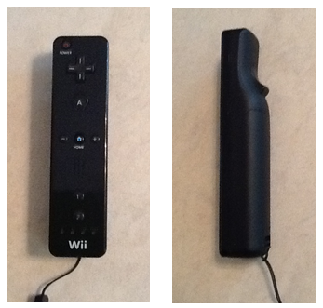
Figure 11: The button layout of the Nintendo Wii Remote
On the front of the Wii remote is an infrared camera sensor from PixArt Imaging. It provides high resolution and a one hundred Hz refresh rate. This can be used in a similar way as the Kinect. The sensor requires an infrared sensor bar to enable pointer tracking, which is a bar with two groups of infrared light emitting diodes attached to it. The Wii remote utilizes the infrared camera and the light emitting diodes to calculate an average x-coordinate, y-coordinate, rotation, and distance. If the remote is kept stationary, and the light emitting diodes move; the Wii remote is capable of detecting the moving light emitting diodes and can be used as an unsophisticated motion tracker (Lee). This would have given the group another option for control, which is similar to that of the Kinect.
The Wii remote is capable of Bluetooth communication. “The connection uses a Broadcom 2042 chip, which is designed for devices that conform to the Bluetooth Human Interface Device standard.” (Lee) The Wii remote does not comply completely with the Human Interface Device standards, but can connect with most computers (Lee). This might have turned out to be a problem when trying to implement the Bluetooth connection with a microcontroller.
The Wii remote sends a relatively small amount of data compared to the Kinect. It sends twenty-two byte packets at a typical rate of one hundred packets per second (Matamoros). At two hundred and twenty-two bytes per second, the microcontroller must have enough physical memory space to store all of the data from the remote. This would not have been a problem, since the Atmel chip has sixty-four kB of SRAM to use. The physical space was not the only concern; the microcontroller must be fast enough to be able to synchronize with the remote and receive all of the information.
In order to utilize the Wii remote, group five would have needed to add hardware to their original design. However, this would have given the group the ability to implement wireless control of the cube. The use of the Bluetooth HID would have also increase the complexity and physical size of the code. The additional complexity of the code was not of concern to the group, however it was unsure if there was enough space on the microcontroller to handle the extra lines of code.
3.2.5.2.1 Nunchuk
The Wii Nunchuk has four lines, which include a supply voltage line, a ground line, a Serial Clock Line, and a Serial Data Line. The lines are all connected with a special female connector and have specific pin locations shown in Figure 12 and the entire Wii Nunchuk is shown in Figure 13. The interfacing protocol is called Two Wire Interface or Inter-Integrated Circuit. The group hardwired all four lines to the microcontroller, which only required a minimal amount of additional hardware to interface the Wii Nunchuk with the microcontroller.
The Wii Nunchuk is a slave device that is operated from the clock of the microcontroller; it transmits data to the microcontroller on the Serial Data Line at the rising edge of each clock cycle. Inter-Integrated Circuit speeds are standardized around one hundred thousand bits per second. However, communication speeds of up to four hundred thousand bits per second in fast mode, and even speeds as high as 3.4 Mbps in High Speed mode.

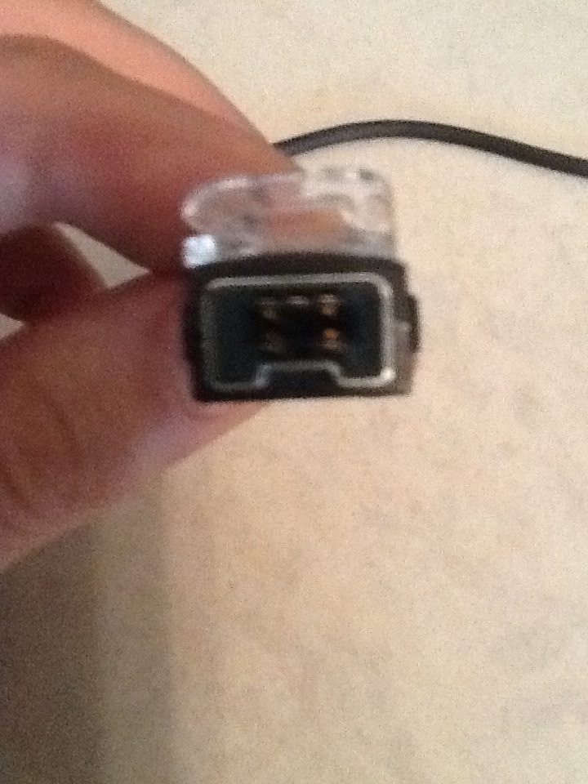
SDA +3.3V N/C
GND SCL

Figure 12: The pin layout of the Nintendo Wii Nunchuk female connections
The Wii Nunchuk uses the LIS3L02AL accelerometer from ST Microelectronics (RobotShop), an analog joystick, and two buttons to send seven different values of information to the host. It sends an average x-coordinate, y-coordinate, and z-coordinate information from the accelerometer that are used to calculate rotations from the controller. The Wii Nunchuk also sends an x-coordinate and a y-coordinate from the joystick, and two values from the buttons (How). The Wii Nunchuk does not have as many options for control of the cube as the Microsoft Kinect or the Wii remote, but it does have enough different inputs to handle all of the control that is needed for the Rubik’s cube application.
The information is sent six bytes at a time. Due to the limited memory space of the microcontroller, this is the main advantage of using the Wii Nunchuk. This allowed for quicker communications with the microcontroller, and does not take up a lot of valuable memory space with more data than was needed for the applications.
The Wii Nunchuk enabled control of the animations without adding additional hardware. The simplicity, low cost, and small memory usage of the device made it ideal for controlling the cube.
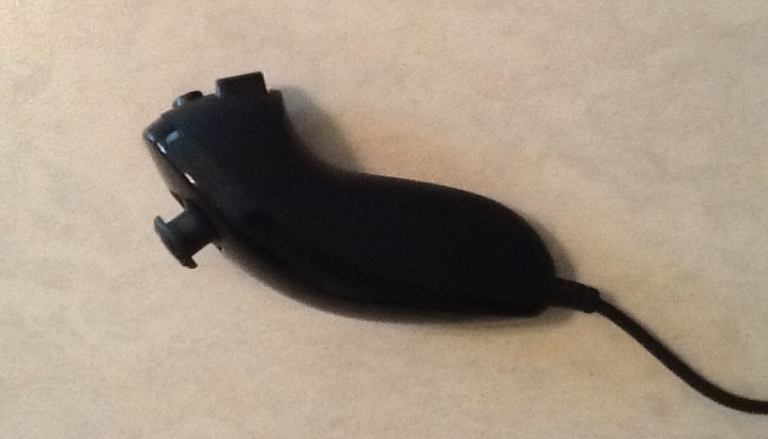
Figure 13: The joystick and button layout of the Wii Nunchuk
3.2.5.3 Controller Decision
The group carefully researched all three options for control of the Dynamic Animation Cube II. The Microsoft Kinect offered more interaction capabilities with the cube, and would have add an impressive wireless control feature to the project. However, the Kinect was not a feasible option with the use of the microcontroller, as it sends more data than a microcontroller is capable of handling.
The Nintendo Wii Remote, and the Wii Nunchuk are more viable options for the scope of this project. The Wii Remote sends data packets in the size of twenty-two bytes, and the Wii Nunchuk sends six bytes of data to the microcontroller. The only disadvantage to using the Wii Remote over the Wii Nunchuk, was the additional hardware that would need to have been added to incorporate the Bluetooth capabilities. This was the main deciding factor in the group’s decision.
The group decided to go with the Wii Nunchuk because of its small amount of data transfer, and the relatively simple integration into the hardware design. The Nunchuk gave the group enough control of the cube to implement the applications, without increasing the complexity of the design.
3.2.6 LED Drivers
One of the most important components of the Dynamic Animation Cube II was the drivers used to control the light emitting diodes. It was therefore necessary to choose a model that would provide the necessary refresh rate, input/output ports, and regulated current supplied that would not over power the light emitting diodes. The following are the main choices that group five considered to drive the entire cube.
3.2.6.1 TLC Driver (Texas Instruments)
The first choice of drivers that group five looked at was Texas Instruments’ TLC5941. The driver includes sixteen channels, twelve bit control, current ratings between zero and eighty milliamps and an output voltage up to seventeen volts. The TLC5941 is capable of operating at speeds up to thirty MHz. It also contains a six bit dot correction, which is used to determine and adjust brightness levels conveyed between the light emitting diodes and the drivers. The maximum current output can be easily set for all channels by using a single external resistor.
Features:
- Constant output of 17V, 80mA
- 30MHz clock frequency
- Flexible serial interface
- Cascading capabilities
- Thermal detection
- LED open detector
- Internal delay of 20ns
When operating in normal air temperature, the TLC5941 is able to run at certain input ranges depending on the pin, while giving a constant output. The voltage of the Vcc pin cannot exceed six volts, and a positive three volts is the maximum input for the remaining input pins. At the maximum input values the TLC5940 is expected to output ninety mA of current and a voltage range up to eighteen volts. Realistically, group five is using a supply voltage ranging from three to five volts, which would give a high input voltage between 0.8 V and Vcc and a low input voltage between ground and 0.2 V. These input specifications would give an output voltage of up to seventeen volts and a current range up to eighty mA, which is an ideal feature for the device. The more current the drivers can supply is directly related to the intensity of light emitted by the diodes and the amount of light emitting diodes the group can turn on simultaneously. This would have helped increase the refresh rate of the entire cube.
The TLC5941 driver comes with an extremely flexible serial interface, which is controlled through only three pins. The data is then clocked in and a latch is triggered within the device that feeds the inputs into the internal registers. This system allows for reading in of grayscale data and dot correction data, with the process finishing at the end of the grayscale cycle. Multiple drivers can be added in series by attaching the serial output pin of one driver to the serial input pin of the next driver. This could have been beneficial in that the group would have been able to connect multiple drivers together without having to use more than one serial interface pin.
An internal error detection system is also provided on the TLC5941 driver. If an external pull up resistor is connected to the XERR pin, its voltage is set to Vcc. This sets the internal transistor connected to XERR to the off position until it is needed. If either one of two error flags in the driver are tripped, XERR becomes pulled to ground, turning on the transistor. This system reduces the total amount of signals that would be normally necessary to report an error. The two flags that can be tripped are the thermal error flag and the LED open detector. For the thermal flag, if the junction temperature becomes too high, the XERR pin is set to low level, or if the temperature drops too low, the pin becomes a high impedance node. The other flag checks the connections of the LEDs and reports back if everything is connected correctly. If and LED is broken or disconnected, XERR is pulled to ground.
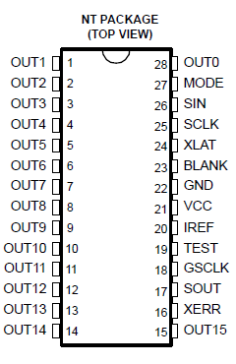
Figure 14: Pin layout for the TLC5941
The switching characteristic of the device is crucial for the desired refresh rate to be achieved. If a positive five volts is applied, the typical rise and fall time for the TLC5941 is ten nanoseconds for each parameter. The propagation delay for the driver is sixty nanoseconds; this is the amount of time it takes for the driver to output current after the data has been shifted into the driver. This is the delay time for one single driver. The TLC5941 is equipped with an internal delay between outputs. This delay feature works whether the device is switched on or off and prevents too much current from flowing through the device. Once data is fed into the chip and the outputs begin to be sent, each output is delayed based on the fixed time. Output0 has no delay, Output1 is delayed by twenty nanoseconds, Output2 is delayed by forty nanoseconds, and up to Output15 which is delayed by 300 nanoseconds. This delay time is added to the already eighty-two nanoseconds of delay for a single driver. This would have decreased the refresh rate, which may have caused the animations to flicker (TLC5941.)
3.2.6.2 STP24DP05 Driver (STMicroelectronics)
The second choice of LED drivers that group five considered using is the STP24DP05 from STMicroelectronics. The driver runs on a low voltage, low current 24-bit shift register specifically intended to implement LED control programs. It implements an 8x3-bit serial-IN, parallel-OUT that feeds code into an 8x3-bit D-type storage register. When the device is running, it provides a constant 5-80mA current to power the LEDs. It also checks what will happen at the output line by looking at three different conditions: whether the circuit is short to Vo, ground, or open line. The results are then placed into the shift registers and then sent to the serial line output.
Features:
- Capability to control 8 LEDs per chip
- Constant output voltage of 20, current of 80mA
- 25MHz clock frequency
- 30ns internal delay
- Error detection mode
- Preset sequences of RGB control
- Temperature detection flag
According to the datasheet, once the registers are loaded, the detection functionality will activate using either a dedicated pin or a logic sequence that was controlled by the group. In addition to the chip, the group placed three resistors on the board that changed the intensity of the light emitted. The device also guarantees a twenty volt output, which was beneficial for the group to set up several LEDs in series as per the cube specifications. The driver comes with a twenty-five MHz clock frequency, which provided plenty of room to adjust for the necessary frames per second.
The STP is able to operate in temperatures from -40°C up to 125°C. The group can power the chip with a supply voltage between zero and seven volts, which would give an output of -0.5 to 20 volts and an output current of eighty mA. At maximum, the clock frequency can be pushed to thirty MHz, but this is ill advised by the chips rating guide, as going over any of the values stated can cause unnecessary stress and damage to the device. The group powered the driver with a regulated five volts.
The driver also comes equip with the ability to set a gradual delay between LED output sets. This means that by turning the DG pin, number nine, to a low setting, the outputs will add in a thirty ns delay in between each set of R, G, and B pins. The feature is beneficial as it can stop any large rushes of current from passing through as well as reducing the bypass capacitors.
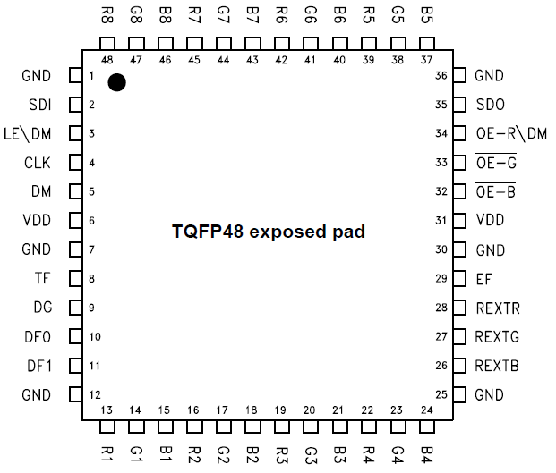
Figure 15: Pin layout for the STP24DP05
The chip also includes an error detection mode that may be switched to at any time during normal mode. When the DM pin, number 5, is set to low, or a command is sent through a logic sequence, the process begins after five clock cycles. While in this mode, the microcontroller switches pin 34 to low and sends a code of all “1”s to the LEDs in order to check for open and short connections with the device and diodes. After 1 microsecond, the pin is set to high and the results are sent through another pin to the microprocessor for analysis. If an error has been detected, the output of the report will be shown as a “0”, while no errors will be a “1”. Once the process is complete, the driver can be set back to normal mode.
The devices shift registers come with preset conditions that can be controlled based on the inputs of the DF0 and DF1 pins, 10 and 11 respectively, as shown by Table 8 below.

Sequence | DF0 | DF1
BGR | 1 | 1
BRG | 0 | 1
RGB | 1 | 0
GRB | 0 | 0
Table 8: How the setting of DF0 and DF1 change the sequence of RGB
The current sequence also changes the order of results after error detection mode has been completed.
Another part of the system belongs to its safety specifications. The STP comes with detection monitors that can turn off the device if certain conditions are met. By using an external resistor, the EFLAG and TFLAG pins will be set to a pulled up mode where the two monitor the device. During error detection mode, the EFLAG becomes shortened to ground to relieve some stress from the chip. On the other hand, if the temperature of the driver’s silicon begins to exceed 180°C, the TFLAG pin shortens to ground and keeps the chip safe from overheating (STP24DP05.)
3.2.6.3 STP1612PW05 Driver (STMicroelectronics)
The third type of driver that group five considered using is the STP1612PW05. This kind of LED driver comes with sixteen output channels, eight bit gain for adjusting brightness levels, open and short LED detection, thermal detection flags, and thirty MHz maximum clock frequency.
Features:
- Constant output voltage of 20, current of 60mA
- Open channel/short circuit detection
- Current output regulation capabilities
- 40ns internal delay
- Thermal flag
- Clock signal detector
As can be seen in the driver's datasheet, the device is able to run at similar maximum settings as the other two drivers. The input voltages can be run with a supply voltage from 0 to 7 volts and an input voltage from -0.4 to Vdd volts. These inputs give an output voltage from -0.5 to 20 volts, a constant output current of 60mA, and a clock frequency of 50MHz. These values are not necessary for running the device though; therefore the group would have used the more recommended values of 3 to 5.5 volts supply voltage, high input from 0.7 Vdd to Vdd, and low input from ground to 0.3Vdd. This would have given a constant output voltage of 20 volts and a current of 3 to 60mA.
The STP16 also comes with two error detection methods, either looking for open channels or short circuits in LED connections. The detections happen in a period of about 0.5µs and the device performs both checks simultaneously. This feature can be enabled by setting two channels to on, and then the chip will detect any errors automatically.
The current output can be regulated by the group easily by setting an external resistor. Current values and the resistance necessary to obtain them can be seen in Table 9. This would have allowed the group to regulate the amount of current that is passing through the system so that the circuit does not overload.
Iout (mA) | Rext (kΩ)
3 | 238.2
5 | 142.2
10 | 69.6
20 | 34.7
30 | 22.94
50 | 13.72
60 | 11.4
80 | 8.63
Table 9: Resistance needed to obtain wanted current
The STP16 driver also comes with a few safety methods that help with the chips performance. The first is a delay that limits the amount of current rushing in. This is done by separating the outputs into four groups and delaying each output set by 40ns. The next is a thermal flag that monitors junction temperature. If the flag detects the chip's temperature to be higher than 150°C, the device turns off all output channels until the temperature drops. Once that happens, the channels will automatically turn back on. The final feature is a clock signal detector. If the PWCLK signal is not connected for around one second, the output channels are set to off. This keeps the driver from providing power forever and protects the LED system from unnecessary damage (STP1612PW05.)
3.2.6.4 LED Driver Decision
With the number of light emitting diode drivers the group needed to purchase, the price was a main deciding factor. As can be seen in Table 10, although the TLC5941 and the STP1612PW05 are cheaper per unit, the group would have needed to purchase more of the devices to suit their needs. The STP24DP05 comes with three separate sets of pins for controlling each individual color and can control eight light emitting diodes per chip, while the other two drivers can only control roughly five light emitting diodes per chip. The group would have needed to purchase forty-eight of the sixteen bit drivers, and only thirty-two of the STP24DP05 drivers.
LED Driver Price Comparison
Driver | Price per unit
TLC5941 | $1.20
STP24DP05 | $2.29
STP1612PW05 | $1.72
Table 10: Price comparison for the LED drivers
The maximum operating frequency of the drivers was another important parameter to consider. The STP24DP05 operates at a maximum frequency of twenty-five MHz, while the TLC5941 and the STP1612PW05 operate at thirty MHz. Even though the two other chips operate at a faster frequency, the lower operating frequency of the STP24DP05 was negligible.
When it comes to supply voltages needed, as well as maximum output voltages and currents, each component is similar to how the others run. Each device can run on a maximum of seven volts, and work best from three to six volts. All three drivers are capable of producing an output voltage of up to twenty volts and supply around sixty to eighty milliamps of current. The drivers also all run between -40 and 170˚C, which was well in the range of expected environmental temperatures that the group can foresee.
Group five decided to use the STP24DP05 light emitting diode driver for the final project. It’s fast operating frequency, and serial peripheral interface capabilities were two of the main features considered when the group decided to go with the STP24DP05 driver. This device has many other features as well that assisted in the design of the Dynamic Animation Cube II.
3.2.7 Software Architecture
The software that is loaded onto the microcontroller is crucial to allow the light emitting diode cube to make dynamic animations as well as take user input. Because of this, the specific code that is put onto the microcontroller is was a very important decision, both in the language chosen, and the library functions to be used. Although most code languages are fairly similar (variables, functions, arithmetic, arrays, loops, etc) the specific languages are better suited to different tasks. The sections below describe the code that is and is not be put onto the microcontroller.
3.2.7.1 Programming Language
The decision of what programming language to use for the microcontroller software design is extremely important and many factors went into the decision to use the C language. Each language in the following sections was seriously considered for the language of the microcontroller. The following sections show the thought process by which C was chosen.
3.2.7.1.1 Java
Java was considered for the project for several reasons, but ultimately was not chosen to be used for the final project. Java would be useful since there are existing libraries for interfacing with the Wiimote as well as the Nunchuk. Java would have also made the actual coding much easier, since there are so many libraries for data structures and serial port interfacing that could have made controlling the actual light emitting diode cube easier. The problem that makes Java unusable for the light emitting diode cube is actually one of the key features of Java: the Java virtual machine. Since no version of the JVM exists for the Atmel microcontroller we chose, it is impossible to use Java. Java is also extremely memory intensive, prohibitively so for a project on an embedded system.
3.2.7.1.2 C
C is a low-level language that is adaptable to many purposes. C has the following features that make it ideal for use in the microcontroller:
- Allows for easy access of serial ports and physical wires on a device
- Easy to switch between assembly code and C code in the same program
- Extremely compact run-time memory usage
- Minimal need for library functions
- Easy access to memory addresses (good for memory mapped devices)
- C can be compiled into assembly code for a huge variety of microcontrollers
- Easy bit-level logic with integers and boolean values
- Transparent array addressing makes changing array addresses simple
The only foreseeable downside to using C is that the language is very unforgiving, coding-wise, and while coding in C it is very easy to make pointer errors that will not be caught by the compiler. Run-time errors are never easy to solve, and on an embedded system with no debugging features and almost no outputs (at least compared to a PC application where one can print data to a screen) pinpointing errors during runtime will be extremely difficult.
3.2.7.1.3 C++
C++ is a procedural and object oriented language. C++ was the second best option for coding the microcontroller, for many of the same reasons as C. C++ is also able to be compiled onto the specific microprocessor that was chosen for the light emitting diode cube, however the memory usage and dependence on exterior libraries would have meant adding an external memory device, which would have slowed down the system considerably. C++ also uses more complex instructions, and would therefore likely have taken more cycle per instruction to run. C++ has many libraries for interfacing with embedded devices; however those functions would also have been prohibitively expensive in time and space on the microcontroller.
3.2.7.1.4 C#
C# is a very robust language, and it would have been very easy to use had the microcontroller been a PC. C# is has many libraries for interfacing with serial ports, which would have helped immensely with controlling the light emitting diode cube. C# was considered mostly because it would have paired excellently with the Kinect, since Microsoft has published code libraries specifically to interface with the Kinect. However, after it was discovered that there was no way to run C# without the Microsoft .Net framework and that the implementing the Kinect on an embedded system of our scale would be impossible due to the amount of data being transferred, the language was immediately dropped.
3.2.7.2 Code Libraries
The extensive Atmel Software Framework (ASF) API as well as the default C <Math.h> library are included. The functions Math.tan and math.sqrt are needed for the ambient animation in order to create a linear path for the wave animation to follow, as well as following the circular path. The ASF library contains 68 code interfaces, however only a small section of them are going to be used in the microcontroller. During compilation, the unused interfaces are stripped from the compiled machine code, so there is no loss from simply including the catch-all <asf.h>. The Atmel Software Framework is a very important tool for programming the microcontroller, since it has APIs that do most of the work in formatting several of the port interfaces that will be used on the microcontroller.
The asynchronous timer (AST) interface is used to keep track of the timeout counters in all states of the microcontroller. This API is used to send timeout interrupts that change the global state-machine variable. Table 11 shown below shows the methods from the AST interface that will be used in the program:
Method Header | Method Description/Use
uint32_t ast_get_counter_value (volatile avr32_ast_t¹ *ast) | This is used to count the number of cycles before a timeout occurs.
bool ast_init_counter(volatile avr32_ast_t *ast, uint8_t osc_type, uint8_t psel, uint32_t ast_counter) | This function resets the AST. This is used at microcontroller startup and whenever the microcontroller changes state.
void ast_enable_interrupt (volatile avr32_ast_t *ast, uint32_t interrupt_mask) | This function sets the interrupt timer to go off when the counter matches the given interrupt mast. This is used to create an interrupt that goes off once every second. This is called when the microcontroller wakes up from sleep or does a cold boot.
void ast_disable_all_interrupts (volatile avr32_ast_t *ast) | This method needs to be called so that the microcontroller can go to sleep.
Table 11: AST interface
The microcontroller uses the debug macros and functions interface for general memory debugging purposes. This is particularly helpful to make sure that the dynamic memory allocation is working properly. Any code referencing this interface is not included in the final firmware on the microcontroller. Below is Table 12 describing the methods that will be called from the interface and each method’s use.

Method header | Method Description/Use
uint_32 get_heap_curr_used_size(void) | Returns the number of bytes currently being used by the heap. Is compared against the expected values to see if the currently planned methods do not go over the run-time memory limits.
uint_32 get_heap_free_size (void) | This is used to see where it is possible to use more memory in order to make the program run faster.
uint_32 get_heap_total_used_size(void) | This method returns the total space allocated to the run-time variables. This is different from the heap used size since more memory than is used will be allocated. This can be used to make sure that the size used is as close as possible to the size allocated for maximum efficiency.
Table 12: Debug macros and functions
The dynamic memory allocation interface is used to instantiate the various arrays that will be used to represent the light emitting diode cube, as well as clearing memory when a particular application has finished. This code also automatically select memory addresses for variables and arrays so that there are no conflicts in addressing. The Table 13 below describes each of the functions that are used from the interface:
Method header | Method Description/Use
void* dlmalloc(uint_32 size) | Takes in the number of addresses that are in the data structure. This automatically handles memory conflicts.
void* dlcalloc(uint_32 size) | Same as dlmalloc, but it automatically sets all elements in the memory array to be zero. Useful for changing cube states, since the cube has to be initialized to zero anyway.
void free(void*) | Frees up a memory array. Is useful to make sure that memory is not being wasted on unused variables.
Table 13: Dynamic Memory Allocation
A first-in-first-out buffer is used along with the AST to hold and output the light emitting diode assignments to the cube as the drivers become ready. The data-structure will be hidden from the runtime code, and can only be interfaced via the included methods. Descriptions of the methods to be called are below in Table 14.

Method header | Method Description/Use
void fifo_flush(fifo_desc_t *fifo_desc) | Clears the FIFO. This is called when the microcontroller changes state.
void fifo_push_uint32(fifo_desc_t *fifo_desc, uint32 item) | This is used to queue up commands to light up light emitting diodes. The format of the 32 bit input is as follows (following the format of the example given at the end of section 4.2.1): {10x0, X[1:0], Y[3:0], A,}
uint_32 fifo_pull_uint32(fifo_desc_t *fifo desc) | This method spits out the light emitting diode description info at the front of the queue. The information will still have to be formatted somewhat in order to output it to the drivers and decoders, but the operations needed to format the data will only take ~4 clock cycles per segment of data sent to a driver, whereas it takes 64 clock cycles to load the data to a driver.
Table 14: First In First Out interface
The general board support interface is a wrapper library that is necessary to access many of the other functionalities. The only method called is the board_init function, which initializes many of the fields of the other ASF APIs and gives different parameters to the APIs based on the board being used, I.E. board_init() sends a value of 17 for the UC3C0 family.
The general purpose input/output (GPIO) interface is used to control and memory-map the many physical GPIO pins on the microcontroller. GPOI pins are used to output the 8 select bits going to the drivers’ decoders, as well as the 4 select bits going to the layer decoder. The methods from the interface that are called in the microcontroller code are described below in Table 15.
Method Header | Method Description/Use
uint_32 gpio_enable_module(constgpio_map pins, unit_32 size) | Enables a gpio pin or set of pins, based on the gpio_map and uint_32 sent in.
void gpio_set_pin_low(uint_32 pin) | Sets the value of a pin low. This is used for select lines going to the driver decoders.
void gpio_ser_pin_high(uint_32 pin) | Sets the value of a pin high. This is also used for driving the select lines for the decoder select lines.
void gpio_toggle_pin(uint_32 pin) | Toggles a pin from high to low or low to high. This is used for alternating the decoder select pins.
Table 15: GPIO Interfaces from the ASF code library
The sleep manager is used to put the system to sleep after a period of inactivity, and will allow the microcontroller to wake up based on input from the Nunchuk.
Method Header | Method Description/Use
static void sleepmgr_enter_sleep(void) | This method puts the microcontroller into the deepest sleep allowed by the internal sleepmgr_mode enumerated type.
static void slpeepmgr_lock_mode(enumsleepmgr_mode mode) | This method determines the type of sleep that the sleepmanager can put the microcontroller into, ranging from ACTIVE (not sleeping) to STATIC (cannot process anything but a wake up command).
static void sleepmgr(void) | This function activates the sleepmanager, allowing the microcontroller to go into sleep modes.
Table 16: Sleep Manager Interfaces from the ASF code library
The Serial Peripheral Interface library functions from the ASF code library is used to write the twenty four bits indicating which light emitting diodes will be lit to the drivers. The library functions make writing bytes at a time to the serial peripheral interface easy, since it is as simple as one method call to write the data.

Method Header |  | Method Description/Use
spi_status_t spi_initMaster (volatile avr32_spi_t *spi, constspi_options_t *options) |  | This function initializes the SPI with the data needed to function. The function takes in a physical address to a SPI port and an enumerated options type, and outputs an enumerated status type.
int16_t getBaudDiv (const uint32_t baudrate, uint32_t pb_hz) |  | This method is used for calculating the baud rate expected by the spi_initMaster.
static void spi_put (volatile avr32_spi_t *spi, uint16_t data) |  | This method writes one datum (of predefined size) to the SPI port pointed to by the SPI pointer sent as an argument.
static void spi_enable(volatile avr32_spi_t *spi) |  | Enables SPI port pointed to by the spi pointer argument given.
static void spi_set_delay (volatile avr32_spi_t *spi, uint8_t delay) |  | Sets the number of cycles to hold the chip-select high between writes.
SPI - UC3 implementation |  | This code overloads some of the fields in the above code to better fit the specific microcontroller.
static void spiUC3_init(void) |  | Reinitializes some of the internal addresses and fields of the generic SPI API. This has to be called after the generic SPI initialization commands.
Table 17: SPI Interfaces from the ASF code library
The Standard Serial I/O interface is also included into the code. The interface is the code that the serial peripheral interface library functions run off of. The code is included in the final machine code loaded onto the microcontroller, but no functions will be explicitly called from the C code.
Timer/counter interface allows easy access of the internal physical timer. The timer/counter are used to count 1 millisecond and 1 second for the Pong and Game of Life applications respectively. Descriptions of the methods used from the interface are described below:

Method Header | Method Description/Use
int tc_start (volatile avr32_tc_t *tc, unsigned int channel) | Starts a timer of the channel given at the address given. This is called when the microcontroller enters either the pong or GOL state.
int tc_stop (volatile avr32_tc_t *tc, unsigned int channel) | Stops a timer of the channel given at the address given. This is called once before the game leaves the either pong or GOL state.
int tc_read_ra (volatile avr32_tc_t *tc, unsigned int channel) | This is called at the top of the GOL state loop and the pong state loop.
Table 18: Timer/Counter Interfaces from the ASF code library
The two-wire-interface library functions allow for easy reading from the Nunchuk. The library functions include simple read/write functions that make the access very simple. Descriptions of the roles of the functions are in the table below in Table 19.
Method Header | Method Description/Use
static status_code_t twi_master_read (volatile avr32_twi_t *twim, consttwi_package_t*package) | This method readies bytes to be read from the predefined addresses at which the two wire interface stores data bytes. This is used to get controller input.
status_code_t twi_master_write (volatile avr32_twi_t *twim, consttwi_package_t *package) | The write method is important for doing basic handshaking with the Nunchuk before data is read.
status_code_t twim_master_init (volatile avr32_twim_t *twim, consttwim_options_t *opt) | This method is used at startup to initialize the two wire interface module internally. This reserves the memory addresses that are used to store the Nunchuk data.
void twim_disable_interrupt (volatile avr32_twim_t *twim) | This disables interrupts from the Nunchuk. This will be used after waking up from sleep, since the interrupts are only used when the microcontroller is sleeping.
Table 19: TWI Interfaces from the ASF code library
3.2.8 Decoder/Demultiplexer
In order to receive the desired refresh rate, the group wanted to multiplex all of the drivers in parallel instead of aligning them sequentially. The previous group from the first Dynamic Animation Cube used the latter method, and was unsuccessful in their implementation.
3.2.8.1 CD74HC4514 (Texas Instruments)
The first decoder that group five looked at is the same one that the previous group decided to use: the CD74HC4514. This device contains a few features that the group found useful for the overall design of the Dynamic Animation Cube II.
Features:
- Multifunction capabilities
- Balanced propagation delay
- Transition times
- High power reduction
- High noise immunity
First of all, according to the datasheet, the CD74HC4514 can work as both a decoder and a multiplexer. This particular feature is useful in the fact that if group 5 found the need for a multiplexer during experimentation, they would already have a part that can fill the job. This would save not only space in the design, but would also save money that can be used for other parts.
The propagation delay was another plus for the device in that it controls the transfer speeds between different parts. This makes sure that all components will read in data correctly while limiting error bits and missed latches during testing. The transition times are also good in that they will allow parts to feed in data in the right order without certain areas trying to read something without the information actually having been sent.
The amount of power reduction that the decoder provides is also beneficial in that between the LEDs, the microcontroller, and all of the other parts, it is great to be able to limit power somewhere. This would also work as a safety measure, making sure that not too much power is entering the system that pieces will burn out.
The final feature is the high noise immunity of the component. It allows the decoder to regulate data being written in, checking for signal distortion, alterations in the data, and false signals that could incorrectly trigger an enable pin. This, in conjunction with the microcontroller, can reduce the amount of errors entering the system, giving the output onto the Dynamic Animation Cube II a clearer and crisper picture (CD54HC4514.)
3.2.8.2 74HC154; 74HCT154 (NXP Semiconductors)
The second decoder that Group 5 looked into was the high speed Si-gate CMOS 74HC154 4-to-16 decoder. This particular decoder takes in four high binary addresses into the inputs and returns sixteen low outputs. There is also a two input enable gate that can be activated to help eliminate bugs that may appear during decoding. By enabling another input pin, the decoder can be changed to a demultiplexer that will read in multiplexed data from one of the input pins, as stated in the datasheet.
Like the CD74HC4514, this decoder comes with an internal propagation delay, transition time, and power dissipation. These features also come with ratings for several different voltage inputs, so if the group decided to change the amount of volts that will be provided to the Dynamic Animation Cube II they will know how the alteration will affect the data speeds through the device. Shown below, in Table 20 is the truth table for the 74HCT154. This table would aid the group in programming the addressing for each of the light emitting diodes that needs to be accessed (74HC154.)
Input |  |  |  |  |  | Output
E0 | E1 | 0 | 1 | 2 | 3 | 0 | 1 | 2 | 3 | 4 | 5 | 6 | 7 | 8 | 9 | 10 | 11 | 12 | 13 | 14 | 15
H | H | X | X | X | X | H | H | H | H | H | H | H | H | H | H | H | H | H | H | H | H
H | L | X | X | X | X | H | H | H | H | H | H | H | H | H | H | H | H | H | H | H | H
L | H | X | X | X | X | H | H | H | H | H | H | H | H | H | H | H | H | H | H | H | H
L | L | L | L | L | L | L | H | H | H | H | H | H | H | H | H | H | H | H | H | H | H
 |  | H | L | L | L | H | L | H | H | H | H | H | H | H | H | H | H | H | H | H | H
 |  | L | H | L | L | H | H | L | H | H | H | H | H | H | H | H | H | H | H | H | H
 |  | H | H | L | L | H | H | H | L | H | H | H | H | H | H | H | H | H | H | H | H
 |  | L | L | H | L | H | H | H | H | L | H | H | H | H | H | H | H | H | H | H | H
 |  | H | L | H | L | H | H | H | H | H | L | H | H | H | H | H | H | H | H | H | H
 |  | L | H | H | L | H | H | H | H | H | H | L | H | H | H | H | H | H | H | H | H
 |  | H | H | H | L | H | H | H | H | H | H | H | L | H | H | H | H | H | H | H | H
 |  | L | L | L | H | H | H | H | H | H | H | H | H | L | H | H | H | H | H | H | H
 |  | H | L | L | H | H | H | H | H | H | H | H | H | H | L | H | H | H | H | H | H
 |  | L | H | L | H | H | H | H | H | H | H | H | H | H | H | L | H | H | H | H | H
 |  | H | H | L | H | H | H | H | H | H | H | H | H | H | H | H | L | H | H | H | H
 |  | L | L | H | H | H | H | H | H | H | H | H | H | H | H | H | H | L | H | H | H
 |  | H | L | H | H | H | H | H | H | H | H | H | H | H | H | H | H | H | L | H | H
 |  | L | H | H | H | H | H | H | H | H | H | H | H | H | H | H | H | H | H | L | H
 |  | H | H | H | H | H | H | H | H | H | H | H | H | H | H | H | H | H | H | H | L
Table 20: Truth table of 4-to-16 decoder illustrating the need for the two latch enable pins to set low before any outputs are shown.
3.2.8.2 CD4514BM (Texas Instruments)
The third decoder that the group considered is TI's CD4514BM. This particular decoder consists of a 4-bit strobed latch and 4-to-16-bit decoder. It is rated for -.5 to 20 volts, 10 milliamps input. It also has 500 milliwatts of power dissipation and a standardized, symmetrical output.
3.2.8.4 Decoder Decision
Group 5 decided to use the CD4514BM decoder. There are a few reasons for this. First of all, the price—as seen in Table 21:
Component | Price
CD74HC4514 | $1.76
74HC154 | $2.59
74HCT154 | $1.63
CD4514BM | $0.98
Table 21: Decoder prices
The price of a CD4514 decoder is the cheapest to buy and allowed for more to be bought overall. Secondly, the CD4514BM can be run in a range of 4.5 to 5.5 supply volts, with a recommended setting of five. This coincides with the values that the group provided to the system with room to adjust if necessary.
3.2.9 Ribbon Wire Connectors (Pacific Custom Cable)
Another component that the group looked at was a connector piece for the ribbon wire that would connect the drivers to the LEDs. The best two choices were an eight pin connector or a twenty-four pin connector. A price comparison between two made by Pacific Custom Cable Inc. can be seen in Table 22.
Component | Price (pack of 10)
8 pin | $14
24 pin | $11
Table 22: Ribbon wire connector prices
A benefit of the 24 pin was that it is cheaper to buy than the 8 pin one. Choosing the 24 pin would also save board space, as three 8 pin connectors would be needed to achieve the same amount of attachments. This would also be cheaper over all because the group would get more connectors for less than they would by choosing to go with the 8 pins.

4. Hardware and Software Design Details
After the group had researched many different designs from other similar projects, and reviewed the previous group’s Dynamic Animation Cube. All of the research completed gave the group enough insight on light emitting diode cubes to be capable of designing their own Dynamic Animation Cube II. The group carefully chose components that allow for high throughput of data, and high computational power. The group kept the existing cube structure that was in the Senior Design Lab, but had to deconstruct it in order to fix all of the non-working light emitting diodes. The group also had to redesign all of the hardware necessary to run the Dynamic Animation Cube II; not keeping any of the previous group’s design.
4.1 Initial Details and Schematics
Having more than four thousand light emitting diodes to control makes this a challenging project. An entire sixteen by sixteen layer contains 256 light emitting diodes. If the entire layer is turned on then the cube will consume roughly five amps of current. This is too much current to have running at any one time. The group had to rely on the persistence of vision.
Persistence of vision is a phenomenon of the eye where an image is thought to stay on the retina, even after the image is no longer there, for an extremely small amount of time. This means the group essentially made it seem like all of the light emitting diodes are turned on simultaneously by switching through a small number of them at a time. As long as the refresh rate of the entire cube was fast enough, the user won’t even notice. This allowed the group to keep the current consumed by the Dynamic Animation Cube II low enough to not destroy any of the hardware of the system.
The design was centered around Atmel’s AT32UC3C2512C microcontroller. It is essentially the “brain” of the entire system. The microcontroller executes all of the code needed to perform the animations, and it also communicates with the Wii Nunchuk and the light emitting diode drivers.
The AT32UC3C2512C was programmed using Atmel’s AVR Dragon. The AVR dragon is a low cost development tool that can be used with all AVR devices with On Chip Debug capability. The group hardwired the AVR Dragon to the microcontroller using the Joint Test Action Group (JTAG) interface, and then connected the AVR dragon to a PC using a USB cable. This allowed the group to program and debug the AT32UC3C2512C. Figure 16 shows the block diagram of the entire system.
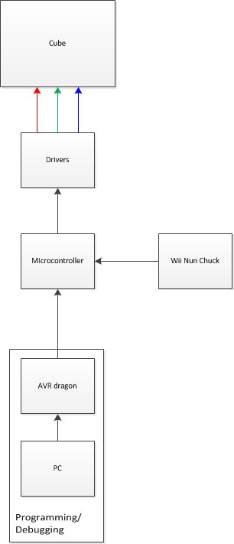
Figure 16: Block Diagram of the Dynamic Animation Cube II system
The task of rebuilding the Dynamic Animation Cube II was completed by group members Sommer Marsh and Brian Zei. The effort began with deconstructing the previous group’s product and then continued with the testing of the massive number of light emitting diodes. In order to accomplish this task effectively and efficiently, the group started by removing the horizontal wires that ran between the sixteen layers of the cube. This allowed for keeping each vertical layer of 16 X 16 resolution connected instead of starting from scratch and disassembling the cube entirely, which made testing of the LEDs more convenient. The method of testing that the group implemented utilized testing each of 256 columns one at a time. Attaching ground wires to each of the colors at the bottom of any one column and then applying a voltage line to each of the rows on the sheet being tested allowed the group to check an entire column for functionality with ease. Testing was completed by connecting any single column of LEDs to ground. The testing process identified which light emitting diodes were no longer functional. A nonfunctional light emitting diode could be caused by several different items; a bad solder connection somewhere, the LED itself being blown, or a different LED in the circuit. As such, when an LED or column of LEDs was deemed to be broken, the group went back to each individual diode, rather than the column, and checked specifically for functionality.
Once the deconstruction and testing effort was completed, the actual build of the Dynamic Animation Cube II could begin. It started with Sommer commissioning a 33 inch (length) x 33 inch (width) x 18 inch (height) base structure. The base was constructed of ¾ inch plywood. A laminate was installed over the outside of the base in order to ensure a professional looking product. Pictured below, in Figure 17, is the completed base for the Dynamic Animation Cube II.
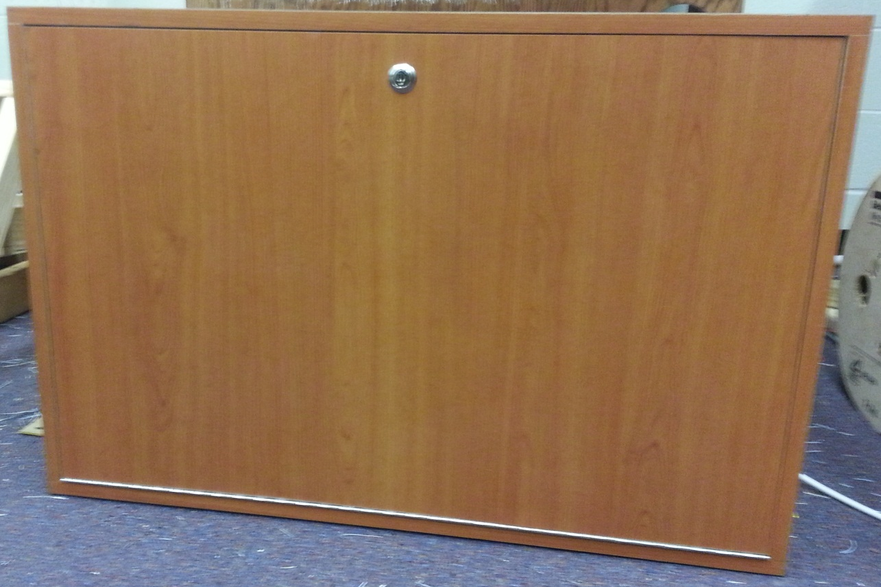
Figure 17: The base utilized by the Dynamic Animation Cube II is constructed of wood. It features a fold down door to ensure that future repairs are easy to make.

The base of the Dynamic Animation Cube II was constructed with very specific purposes in mind. The enclosed design allows for all of the hardware and wiring to be concealed so that damages are minimized to normal wear and tear. The base also features a lockable door to ensure that only authorized people can gain access to the expensive hardware that was designed during the project. After completing the construction of the base, the group had to drill 256 sets of holes in the top for the 28 gauge ground wires to connect to the columns of LEDs. In addition, the group needed to provide a hole for the 16 voltage lines to run from the hardware to the appropriate layers.
Next, the group had to lay the wiring that would eventually power the cube. The wiring effort was tedious and took more than forty man hours. Each set of ground wires for the 256 columns of LEDs had to be wired manually. In an effort to avoid inaccuracies, extreme caution was taken while laying the wiring for this project. Shown below, in Figure 18, is the completed wiring of the Dynamic Animation Cube II base.
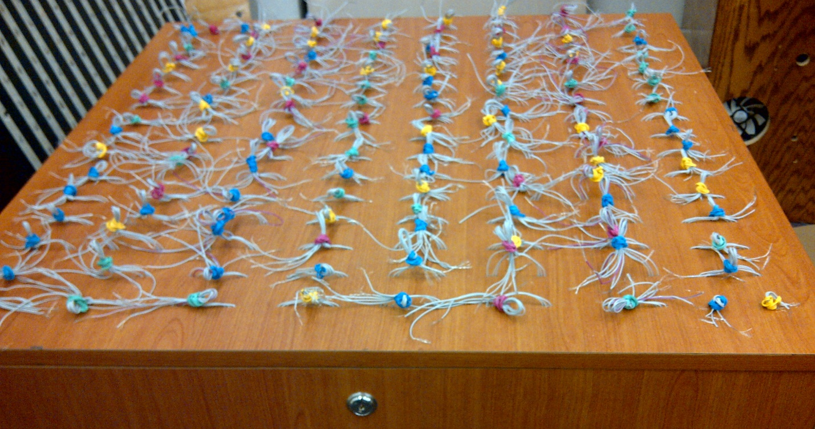
Figure 18: The completed wiring for the Dynamic Animation Cube II. This wiring allowed for the LEDs to be grounded.
One of the many things that the previous group did not implement was the use of an internal structural system to support the delicate lattice structure formed by the arrays of light emitting diodes. The lack of structural integrity in the Dynamic Animation Cube I provided a very shaky cube that could not be moved from the senior design lab. The next structural item that we implemented was an internal support structure to provide stress relief to the delicate LED lattice. The group designed a three dimensional support structure that runs throughout the cube. It utilizes front-to-back, left-to-right, and top-to-bottom lengths of acrylic that intertwine at several points in the array.
Sommer and Brian started the internal support structure by cutting square acrylic rods to several specified lengths. The two used industrial grade acrylic cement, Weld-On #16. This acrylic cement is semi-viscous and develops 75% of the full bond within minutes of setting. Within 24 hours of setting, the cement is at 90% full strength and for the following week, the bond continues until getting to full strength. The group started the internal structure by constructing the three dimensional structure that is illustrated below, in Figure 19. In order for the beginning of the structure to be held up to dry, the group had to create a jig to hold it up. This jig is also pictured in the photo below.
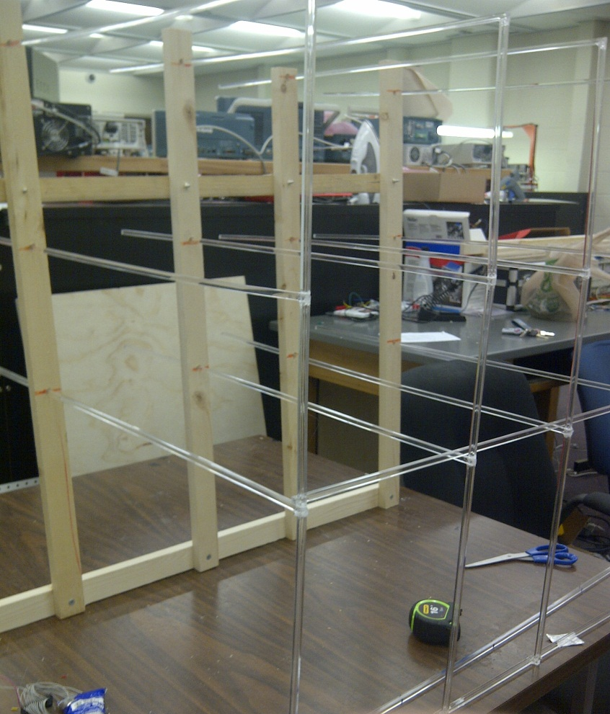
Figure 19: The initial structure for the internal frame.
After completing the initial part of the structure, the group was able to begin piecing together the vertical sheets of the cube. This was done sheet by sheet. The processing is shown below, in Figure 20.
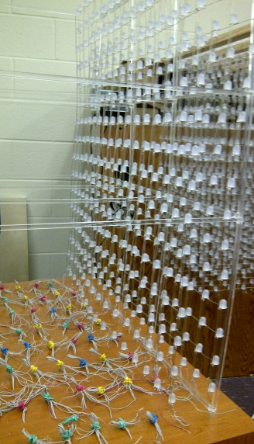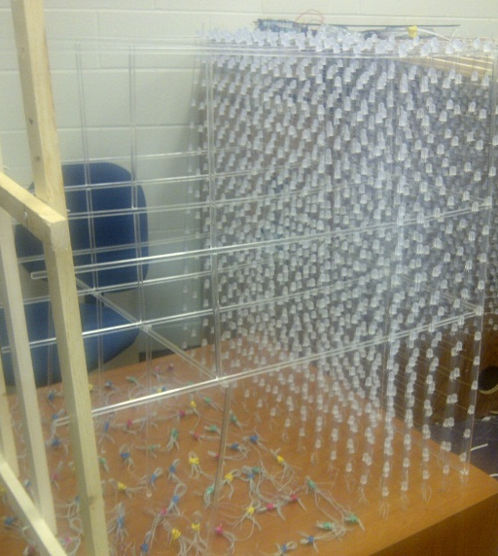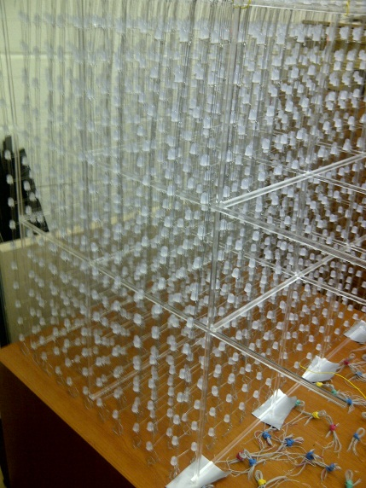
Figure 20: The rebuild process of the Dynamic Animation Cube II.
4.2 Software Design
Since the microcontroller is the only programmable part of the cube assembly, it contained all the code for interfacing with the Nunchuk, driver decoders, layer selection, and the light emitting diode drivers. The microcontroller code was programmed in C. The main routine consisted of a constantly running loop containing the cube update subroutine and the state update subroutine. The main routine also contains an initialization subroutine.
The initialization subroutine called the various library functions in the Atmel Software Framework code repository to initialize the IO ports and memory-mapped interfaces. This code is also responsible for creating all variables and arrays that were used for the entire program.
The loop located in the main subroutine is located procedurally after the initialization subroutine the top-level state machine. The loop does have an exit condition, as the cube is designed to run until it powers off or goes to sleep. The loop is itself divided into two subroutines: a subroutine to update the state machine and internal fields, and a subroutine to update the physical version of the light emitting diode cube.
The state machine subroutine updates all fields of the various states of the cube. During each iteration the state machine subroutine also checks the Nunchuk and timers to see if the state needs to change. There is one status bit to determine if the microcontroller changed its state in the last loop iteration which will determine if special initialization operations need to occur in the event of a state change. The state machine subroutine is subdivided into seven subroutines, one for each state (other than bootup). Within those states, the logic for the games is be calculated. While the actual games vary, the overall time taken for the state machine subroutine can still be estimated based on the state that will take longest to update, the game of life subroutine. The calculation for the state machine timing is shown below:
(((16 high)*(16 wide)*(16 long))*(1 clock cycle to access the position + ((28 neighbors to be checked per light emitting diode)*((1 clock cycle per comparison) + (1 clock cycle per array access)) + 1 cycle to write the new condition of the position))/(66 MHz clock rate on the microcontroller)
= ((16) * (16) * (16) * (1+ (28)*(1+1)+1))/(66 MHz)
= 3.599 Milliseconds
The light emitting diode update subroutine within the main loop has one instance of the ASF first-in-first-out interface. Whenever the state-machine subroutine calls the setStatus method in the control unit API, the array argument representing the cube is pushed onto the first-in-first-out structure. The light emitting diode update routine will continue to pull values from the first-in-first-out interface until it is empty. Whenever the first-in-first out interface is empty, it is filled with the internal array representing the most up-to-date version of the cube and the main loop will return to the state-machine subroutine. The update subroutine first pulls an item from the first-in-first-out structure, formats the data pulled into the data that needs to be set for the General purpose input/output pins, and uses the spi_put() method from the ASF library to output the data to the Serial Peripheral Interface going to the drivers. Each pull from the first-in-first-out structure gives 16 light emitting diodes worth of data. The calculations below show the timing for the update subroutine:
(((16 light emitting diodes)/(4 light emitting diodes per driver latch))*((3 baud per driver latch)*((8 data bits per baud)*(1 bit per cycle)+(1 cycle to make $\overline{CS}$ low)+(1 cycle to make $\overline{CS}$ high)))*((1 latching to light up the light emitting diodes)+(1 latching to make the light emitting diodes go dark))/(25 Mhz clock for the SPI) + ((1 cycle for memory access) + (4 latches)*((1 cycle for masking the integer value)+(1 cycle for put command))/(66 Mhz clock for the microcontroller)
= (16/4)*(3*(1+1+8)*1)*2))/(25MHz) +((4)*(1+1))/(66 MHz)
= 102.86 KHz = 1/(9.72 microseconds)
The refresh rate for the entire cube (not including the time to update the state machine internal logic) is shown below:
(78.6 microseconds per column of 16 light emitting diodes)*(3 colors)*(16 columns per layer)*(16 layers in the cube)
= (9.72 µs)*(3)*(16)*(16)
= 7.46 milliseconds = 1/(133.94 Hz)
The total time for the state machine subroutine and the update subroutine is 7.46 milliseconds+ 3.599 milliseconds, which gives a total time of 11.05 milliseconds, or 90.5 hertz. This is the boundary case, though, and the actual average will be closer to 100 Hz, since the maximum time was calculated for the state machine subroutine. This refresh rate theoretically makes the cube appear as though all light emitting diodes are lit simultaneously.
4.2.1 Control Unit API
The microcontroller code is designed in such a way that the microcontroller will have a clearly formatted and easy to use API for controlling the cube. The purpose of the API is to make the process of creating new uses for the cube easy. That is to say, creating the API was difficult, but it only had to be done once, after which making programs and animations is as easy as writing a simple C console application on a PC. The microcontroller API uses the Atmel’s memory-mapped interfaces to read and write to and from the peripheral devices. This API is written in C and is designed in such a way that all planned applications are easily able to interface with the cube via the API. The API interfaces with both the cube as well as the Nunchuk.
There are two major decisions that affected the API: how the light emitting diodes will be addressed, and which input device will be used. The API has the methods and fields contained in Table 23.

Method/field & arguments | Return type | Description
Cube methods and fields
Method: getStatus(void) | light emitting diode: int[3][16][16] | Returns the values indicating which light emitting diodes are lit (detailed description below)
Method: setStatus(int[3][16][16]) | valid: boolean | Uploads a new array of index light emitting diodes to be lit. The method will count the lit light emitting diodes and determine if the number of lit light emitting diodes will overload the drivers or not. If the number of light emitting diodes is low enough, the method returns true and updates the cube. Otherwise, the method returns false and does not update the cube.
Nunchuk methods and fields
Method: getJoystick(void) | position: int[2] | Returns the position of the joystick for the Nunchuk. position[0] is the x position and position[1] is the y postion.
Method: getAccel(void) | accel: int[3] | Returns the values for the accelerometer of the Nunchuk. accel[0] accel[1] and accel[2] are the accelerometer values for the x, y, and z levels, respectively.
Method: getButtons(void) | buttons: int | Returns one integer that has the values of the two buttons integrated into the int, where buttons[0] is the C button and buttons[1] is the Z button.
Table 23: Description of API fields
The accelerometer values from the getAccel method range from 0-1023, though the values do not generally exceed 512±250, where 512 is the neutral position. The getJoyStick returns a value between 35 and 228 for the X axis and a value between 27 and 220 for the Y axis.
The two options for internal microcontroller addressing are described and compared in Table 24 below.

Name:
Bitwise addressing | Array-index addressing
This addressing method will have each light emitting diode be accessed by a three-dimensional array of integers. Each bit of the int values stored in the array will correspond to a light emitting diode. | This addressing method will give each light emitting diode its own address in memory, accessing them through a four-dimensional array of integers where each value of the array is a 1 or 0, representing a lit or dark led, respectively.
Pros:
Takes fewer clock cycles to implement update cube | Takes less time to access individual light emitting diodes
Closer to native input to light emitting diode drivers | Combinatorial game logic of light emitting diodes will be faster
Uses less memory | Easier to code around
Cons:
Will take several clock cycles to access individual light emitting diodes | Memory intensive
Hard to debug code | Takes long time to update cube
Will be time consuming to access the light emitting diodes for the game logic | Needs to be retranslated to bitwise addressing to update cube
Memory usage:
1.5 kb | 24 kb
Est. Time for cube update:
7.37ms (135 Hz) | 9.35 (100.6Hz)
Est. Time for single light emitting diode access:
.455µs | .227 µs
Table 24: Comparison of internal addressing methods
Because of the much faster refresh rate, the 3X16X16 array of integers was chosen for the addressing mode. This addressing mode also has the least amount of waste possible, since each bit in memory is used.
In order to output the cube, the 3X16X16 array needs to be changed into the three outputs required by the drivers and decoders: four bits to the layer decoder, eight bits to the driver decoder, and 24 bits to each driver. Each integer value for the array will be done in four writes. If getStatus[X][Y][Z] = A, then the four bits going to the layer decoder will be Y[3:0]. The bits going to the top and bottom driver decoders will be Z[3:0] and 0x4 respectively for the first and third writes and Z[3:0] and 0x4 respectively for the second and fourth writes. The bits going to the actual drivers will be A[3:0] shifted X*8 bits to the left for the first write,A[11:8] shifted X*8 bits to the left for the second writeA[7:4] shifted X*8 bits to the left for the third write andA[15:12] shifted X*8 bits to the left for the fourth write. The addresses are straddled so that while one driver is getting fresh data, the other is being erased. This is the most efficient use of the microcontroller’s processing time and produces the lowest overall cube refresh time
.4.2.2 Games
The games that run on the cube run in a constant loop on the microcontroller. The microcontroller is dependent on specific user input commands. There is a top-level state-machine simulation variable to tell what state the cube is in. A visual representation of the state machine is shown below in Figure 17.

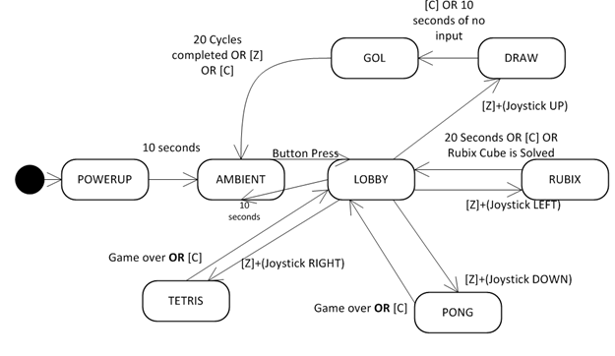
Figure 21: Illustration of microcontroller state machine
Shown below, in Table 25 is a table giving more information about each state.
State | Description | Method of access
DRAW | Allows the player to draw on the cube with the Nunchuk. When the timeout or exit command is detected, the game begins goes to the GOL state. | From LOBBY: [Z+(Joystick Up)] on the Nunchuk
GOL | This state comes from the draw state, and plays Conway’s Game of Life in three dimensions for a set number of iterations. This state takes no user input, and after the iterations are completed, the microcontroller will go back the ambient state. | From DRAW: [C] on the NunchukOR after 10 seconds of no Nunchuk input
PONG | This state is the 1-player pong game. This state is accessed from the lobby. The player’s paddle will be controlled by the joystick. When the score limit is reached, the microcontroller will return to the lobby state. | From LOBBY: [Z+(Joystick down)] on the Nunchuk
RUBIK’S | This state starts with a randomized, but solvable Rubik’s cube represented on the light emitting diode cube. This state will have a high timeout counter. | From LOBBY: [Z+(Joystick Left)]
AMBIENT | The cube will cycle through pre-defined animations that take no user input. This state will continue as long as there is no user input. After 1 hour of no user input, the microcontroller will first write an array of all zeros to the cube (turning all light emitting diodes off) then call the sleepmgr_enter_sleep() function to put the cube to sleep. Upon receiving more input, the cube will return to the ambient state. | From LOBBY: after 5 seconds of no Nunchuk input.
LOBBY | This state occurs when the microcontroller is broken out of the ambient state by user input in the form of a button press. From this state the user will select a game and go to the game state or, if the microcontroller times out without a valid selection, the ambient state. | From PONG:  After game is over OR  after 10 seconds of no user input  OR  [C] on Nunchuk  From RUBIK’S:  After 1 minute of no Nunchuk input  OR  [C] on Nunchuk  From AMBIENT:  [C] OR [Z] on Nunchuk.
TETRIS | This state is a game of Tetris, and will continue until the user loses or breaks out of the game. There will be no score for the game, though the pieces will speed up. | From LOBBY:  [Z+(Joystick Right)]
POWERUP | This state will only occur when the cube is powered on with a cold boot. This state will wait for a specified set-up time, and then go to the ambient state. The microcontroller will not be in this state until it is powered on again. | Start state
Table 25: Detailed description of microcontroller state machine
4.2.3 Controller Integration
The controller is memory-mapped to one of the Atmel's serial ports. The Nunchuk input is mostly handled by a separate circuit on the microcontroller, and then memory-mapped to the Atmel processor, making it easy to access the fields of the Nunchuk input. The table below shows the memory locations of the data from the Nunchuk. The Nunchuk is accessed via the two-wire interface code from the Atmel Software Framework. The format for the data from the Nunchuk is shown below in Table 26.
Joystick X |  |  |  |  |  |  |  | Byte 0
Joystick Y |  |  |  |  |  |  |  | Byte 1
Accelerometer X[9:2] |  |  |  |  |  |  |  | Byte 2
Accelerometer Y[9:2] |  |  |  |  |  |  |  | Byte 3
Accelerometer Z[9:2] |  |  |  |  |  |  |  | Byte 4
Acc. Z[1] | Acc. Z[0] | Acc. Y[1] | Acc. Y[0] | Acc. X[1] | Acc. X[1] | C-butt. | Z-butt. | Byte 5
Table 26: Input format from Nunchuk
This information is all that is needed to get from state to state in the microcontroller, as well as playing the games. The data can be accessed through the API at any time. The Joystick is represented by an X byte and a Y byte, representing the X and Y positions of the Joystick. The bytes will be represent two’s compliment values for the position, since it is possible for them to be negative. The Accelerometer is actually represented by 10 bits for the X, Y and Z accelerations, which can also be zero. The Accelerometer data is assembled by the API to be in a 16-bit integer format. The C button and Z button are only 1 bit apiece, since they are binary values that can only be one or zero.
4.3 Circuit Board Requirements
The completion of a printed circuit board was essential to any Electrical and Computer Engineering Senior Design Project. There are a large number of considerations that must be taken into account in order to ensure the project be a success. Among these factors are thickness of the traces, the number of layers to be used, and the overall size of the board.
The group designed the circuit and laid out all of the devices for the printed circuit board (PCB) using Eagle CAD software. A lot of the components were not in the libraries that came with the software. The group either made the library in Eagle or went onto the internet and downloaded one from a third party site.
Most of the components the group chose were surface mount devices. The decoder has a Small-outline Integrated Circuit (SOIC) package with a .65 mm pitch. Both the driver and the microcontroller have a Quad Flat Package (QFP) with a .5 mm pitch. The driver also has an exposed pad underneath the chip to dissipate heat. The group made sure to not rout any traces underneath the chip to avoid possibly shorting the device to ground.
The group decided to go with a four layer board with a ground plane on the second layer, and a power plane on the third. Since each driver has six ground pins and two power pins, going with a four layer board allowed the group to just drop vias to the power or ground planes saving valuable board space to route all of the traces. Having a large ground plane is also beneficial when dealing with large amounts of current.
Having thirty-two drivers with forty-eight pins made routing the traces very difficult. The width for most of the traces is ten mills, which is capable of handling up to eight hundred milliamps. The group’s final board size ended up being approximately fifteen inches by fifteen inches due to the amount of traces that was required to interface all of the components.
4.4 System Integration
The system was designed in sections which include the power supply, the Wii Nunchuk, and the light emitting diode drivers. They are all integrated with the micontroller using specific General Purpose Input/Output pins, Figure 18 below illustrates the wiring configuration of all the pins.
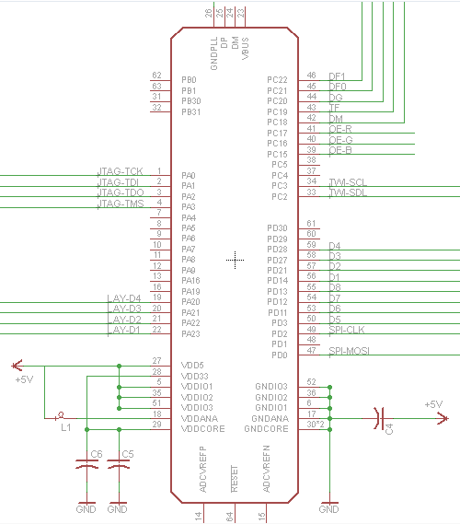
Figure 22: Schematic diagram of the AT32UC3C2512C Microcontroller
The group has carefully gone through the datasheet in order to map each pin correctly. All of the general purpose input/output can be used for general purposes, but they can also be used for additional peripherals on the chip.
The pins associated with the Two Wire Interface are PC3 and PC2. The clock for the Two Wire Interface is connected to PC3 and the data line is attached to PC2. This is where the Wii Nunchuk will be interfaced with the microcontroller.
The drivers are interfaced using the Serial Peripheral Interface. This peripheral is associated with pins PD0 and PD2; with the clock attached to PD2 and the Master Out Slave In line is attached to PD0. With thirty two different drivers the group decided to use two four to sixteen decoders to address all of them. Now instead of using thirty two pins the group can use eight to address all of the drivers. The pins used in the design are PD3, PD11, PD12, PD13, PD14, PD21, PD27, and PD28. The drivers require an additional nine pins for complete control of the drivers. These pins are mapped onto PC5, and PC15 through PC22 (the PC5 pin has not been connected to the driver on the schematic in Figure 19, but it was added in the final design before being sent to be printed).
The Joint Test Action Group interface is connected to pins PA0, PA1, PA2, and PA3. This was used to connect the microntoller to the AVR Dragon so the group could write the code onto the Flash memory, and debug anything that went wrong during testing.
The board is powered using an on board DC jack which can be plugged into any standard US outlet. The group decided to use a five volt regulated voltage to power the entire board.
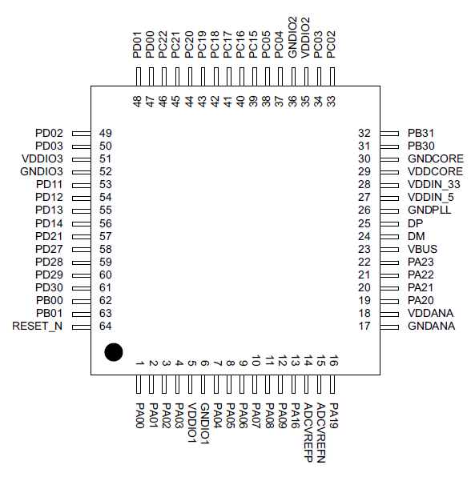
Figure 23: Pin layout of the AT32UC3C2512C

4.4.1 LED Drivers
Multiplexing all of the light emitting diode drivers was the most challenging aspect of the design. There are a few options the group considered to multiplex multiple drivers. One method was to daisy chain them all, or wire all of the drivers sequentially. In this method the drivers are arranged in an array with the serial data output pin connected to the next drivers serial data input pin. The data is shifted into the first light emitting diode driver from the microcontroller. After twenty four bits have been transmitted, the microcontroller continues to feed in data but the data in the first driver gets shifted into the next driver. This will continue until all of the data is sent to all of the drivers. Figure 20 below shows the previous group’s driver array design utilizing the daisy chain technique.
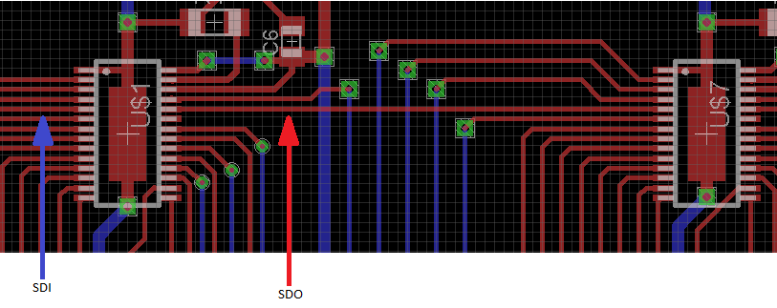
SDI SDO
Figure 24: Previous group’s driver array featuring the daisy chain technique
This method required the microcontroller to load in the data for all of the drivers before the signals could be sent to the cube. This added to the overall time it takes to refresh the cube. Also, if one driver fails it would have affected other drivers in the array.
The group decided to use two four to sixteen decoders to address all thirty-two STP24D05 drivers. This allowed the group to choose a specific light emitting diode driver to send information to, as opposed to loading every single driver. Figure 21 shows the layout of all the drivers, and the two decoders.
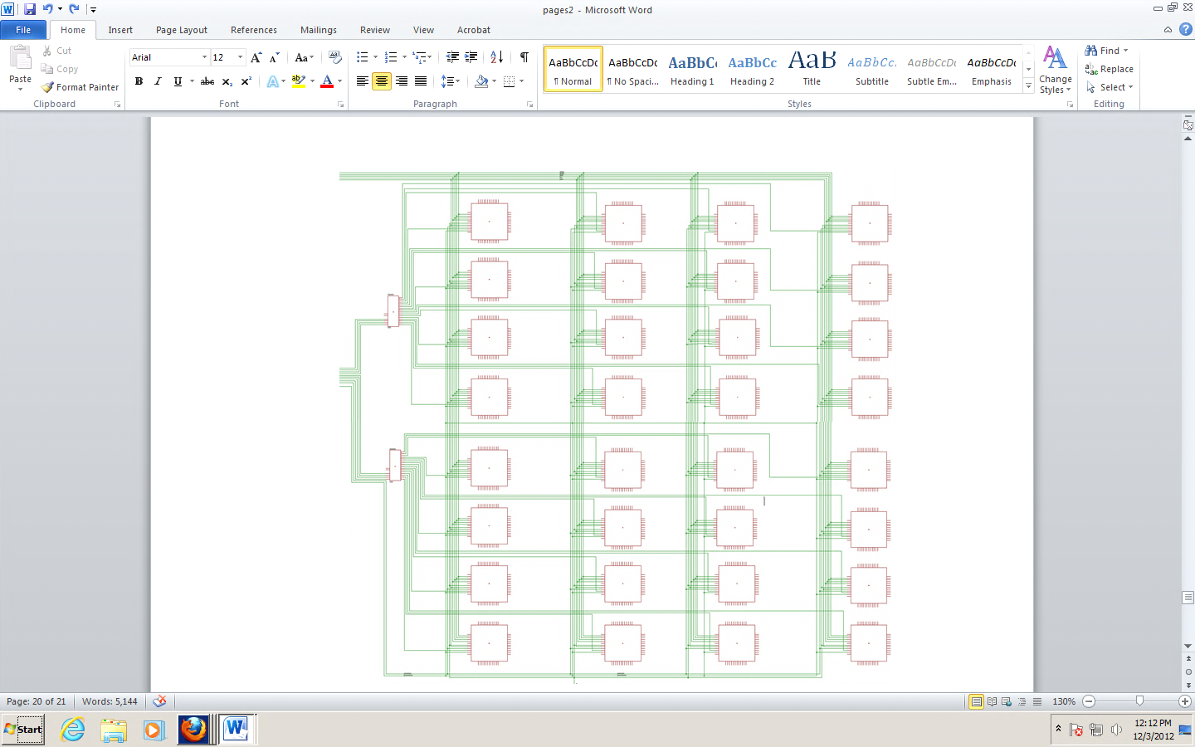
Figure 25: Schematic diagram of all the LED drivers
The Figure 22 below shows a closer look at the wiring of the light emitting diode drivers. In order for the Serial Peripheral Interface to work properly, all of the drivers along with the microcontroller must be synchronized. The clock pin for all of the STP24D05 drivers are wired together and driven by the microcontroller on pin PD2. The serial data lines of all the drivers are wired together as well, and attached to pin PD0 of the microcontroller. The latch enable pins of all of the light emitting diodes are each attached to a different output pin on the decoders. This allowed the group to select a particular driver to store the data that is sent from the microcontroller. Once the driver has stored the information, the next step was to send a pulse to the OE-B, OE-G, or OE-R pin on the light emitting diode driver. These pins are attached to pins PC15 through PC17 respectively.
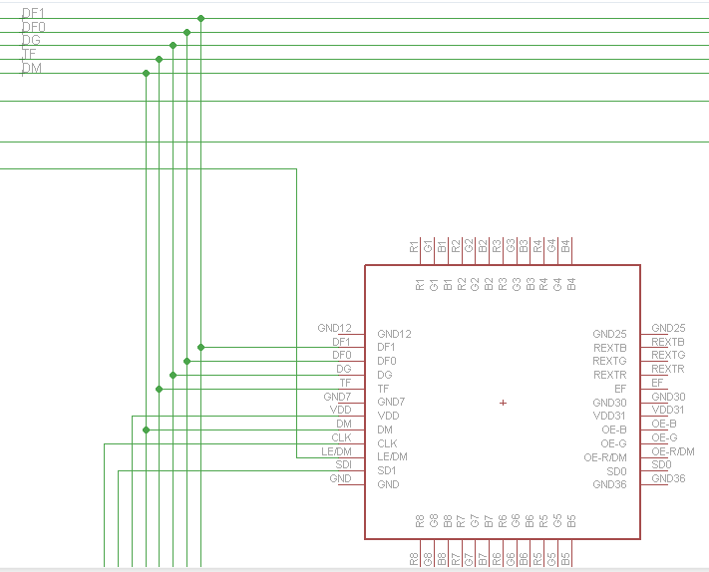
Figure 26: Schematic diagram of a single LED driver
4.4.2 Controller
The Wii Nunchuk communicates with external devices using four lines; a voltage line, a ground line, a line for the serial clock signal, and a serial data line. It takes a positive three volts to power on the Wii Nunchuk. The boards regulated voltage power supply is connected to the input of a three volt voltage regulator. The output of the three volt voltage regulator is then connected to the voltage line of the Wii Nunchuk. A few capacitors are added to both the input and the output of the voltage regulator to eliminate any voltage spikes that may occur.
In order to communicate with the microcontroller, the Wii Nunchuk uses the Two Wire Interface. Pin PC3 on the microcontroller is connected to the clock line of the Wii Nunchuk, and PC2 is connected to the data line. Both pins are also connected to the five volt voltage line to supply a reference for the microcontroller. The full schematic diagram of the wiring is provided below in Figure 23.
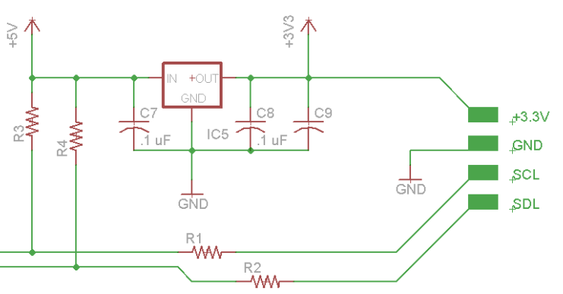
Figure 27: Schematic diagram for interfacing the Wii Nunchuk. Referenced design from Robotshop
4.4.3 Power Supply
The previous Dynamic Animation Cube group used a standard PC power supply to power their boards. Which they had used wires wrapped with electrical tape to attach it to the board. The group decided that it was better and more professional if they used a DC jack capable of connecting to a standard wall outlet.
The AT32UC3C2512C requires either a positive three volts, or a positive five volts to power on. The group decided to use five volts to achieve the maximum capabilities of the microcontroller. As you can see from the schematic in Figure 24, there is a five volt voltage regulator to ensure the voltage doesn’t spike up or down which could be detrimental to the equipment. The group has also put in a few capacitors as an added amount of protection.
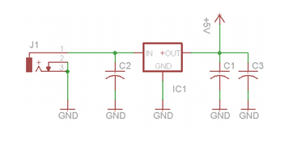
Figure 28: Schematic diagram of the board power supply
4.5 Hardware and Software Design Summary
The group has designed the Dynamic Animation Cube II keeping in mind the needs for a fast refresh rate. The group has also taken into account the amount of current the cube has the potential to consume. The previous group was unsuccessful with their design, and Group Five has taken their results into account while coming up with this design.
Placing the drivers in parallel allowed the group to address specific drivers rather than having to shift data across an array of them. This gave the group more control over the cube, and it helped increase the refresh rate of the entire cube as well. The group has estimated a minimum of eighty-five Hz refresh rate, this is above the required refresh rate of seventy Hz. Figure 25 below, shows the complete schematic of the hardware design.
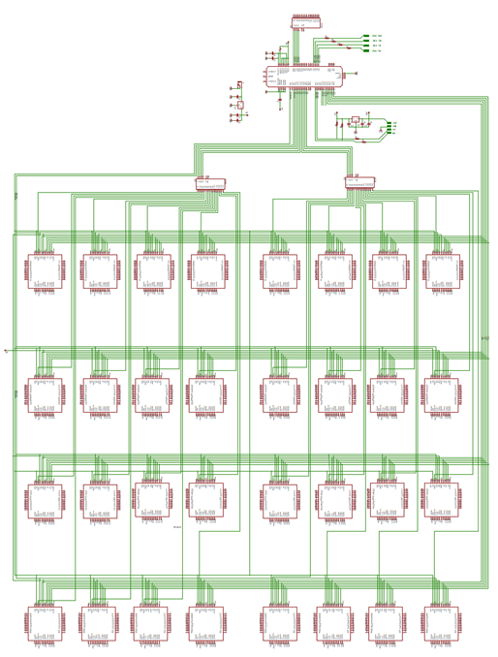
Figure 29: Complete schematic of entire Dynamic Animation Cube II system
There are two types of software that will run on the microcontroller: the simulation of the light emitting diode cube and Nunchuk, and the games and animations that will run on the cube in its final form. The code for these functions will be written in C and compiled for the microcontroller in Atmel Studio 6, the integrated development environment provided by Atmel. The code for the microcontroller will have to be written with both space and timing in mind, i.e. the code will be written as fast and compactly as possible. This is done to ensure that the applications don’t go outside their allocated run-time memory and can update (or simulate) the light emitting diodes as fast as possible to make the cube look as visually appealing as possible.
4.5.1 Simulation
Simulating the light emitting diode cube and the Nunchuk are important steps towards making sure that the microcontroller is functioning properly. The simulations make it possible to test the microcontroller software thoroughly without it even being connected to peripheral devices. The simulations are as thorough as possible and were run extensively since the previous group burned out one of their light emitting diode drivers. There was not any software-side debugging once the microcontroller is connected to the cube and the Nunchuk.
4.5.1.1 Cube
Simulating the cube was difficult, since the cube has no input to the microcontroller that can be verified against the input data. There are a few ways we were able to simulate the cube. First is by connecting connect the microcontroller as it will be in its final configuration, but tying the drivers to ground through a resistor (to prevent sending too much current through them), and measuring the voltage between the pins on the drivers and ground using a potentiometer. Second is using a second, single purpose micro controller. To store the data being sent out through the microcontroller and output it in some readable way (possibly inputting in a serial port into a PC). These two methods are compared below in Table 27.

Method: | Using a potentiometer | Using a microcontroller
Difficulty of setup: | Can be set up in seconds assuming it has been done once before. | Will have to have a boot up for the computer and microcontroller
Difficulty of data collection: | Each simulated light emitting diode will have to be measured separately | The program can run on its own and the data will be analyzed later. The data analysis will be automated as well.
Accuracy of results: | The results reflect, as accurately as possible, response that the light emitting diodes will have to the microcontroller input, since the signal that would go to the light emitting diodes is what is being measured. | The data might not reflect the actual signals going to the light emitting diodes, since the drivers are left out entirely. This shouldn't make a difference since the drivers will be tested separately, but more testing would probably catch more errors.
Test variability: | This method will make it difficult to test the ambient and self-perpetuating tests, since it will be difficult to time the manual measuring of the voltage to the timing of the program. It will be easy to measure the user-input dependent programs, though. | This method would make it easy to test all kinds of inputs. It would be easy since the program would automatically detect what the output of the microcontroller was supposed to be, then check it against the collected data from the microcontroller.
Table 27: Comparison of light emitting diode cube testing options

Because the data was easier to test, even if not necessarily perfectly accurate, the best method is the separate test-microcontroller connected to a pc. With this method, we could create a variety of test cases to verify the I/O of the microcontroller. We used the Nunchuk simulation described below along with the Cube simulation to create a completely verifiable simulation of the project.

In order to store the data output by the microcontroller, the computer application Hercules was used. Hercules is freeware distributed by the HW group that can read in and display serial data in real-time. Hercules is compliant with the universal serial bus format, and which is the format we will use to record the data.

The test cases that tested the light emitting diode Cube are the same as the cases described in the controller section below.
4.5.1.2 Controller
To test the controller, we hard-coded in different types of input from the Nunchuk, and use the method described in 4.5.1.1 to verify the output is what is expected. Unfortunately, this method was very time consuming, since for each new test case the microcontroller firmware will have to be reloaded with the new test case. Another problem with this method is that it was very difficult to simulate the accelerometer information, since fluid human motion will involve creating hundreds of data points. Unfortunately, creating manual input data is the only way to easily simulate having the Nunchuk input without actually connecting another input device, which would be just a difficult to verify as the Nunchuk was in the first place.

The Nunchuk simulations were run at the same time as the light emitting diode cube simulations, since they had to work in concert in order to accurately depict the entire apparatus. The simulations tested all states of the microcontroller thoroughly.
4.5.2 Applications
The applications that run on the light emitting diode cube are mostly simple games that can be represented by the minimal colors and resolution of the light emitting diode cube. The games will take input from the Nunchuk and output various animations to the light emitting diode cube. There are also ambient animations that take no user input. The ambient animations are able to have more complex formations of light emitting diodes, since without user input they can run smoothly on their own.
4.5.2.1 Rubik’s Cube
Once the user has selected to start the Rubik’s cube game, the microcontroller loads an internal instance of Rubik’s cube. This cube is the state of the Rubik’s cube the last time it was played or by default a solved cube if it is a fresh boot. If the internal cube is solved, the microcontroller randomly does 10 moves on the internal cube (to ensure the cube is randomized yet solvable). The random internal cube will then be represented on the light emitting diode cube.

The user has a cursor, the location of which is indicated by a light emitting diode flashing on and off every half second. The user is able to move the cursor with a variable speed; depending on how hard they are holding the analogue stick down, ranging from a minimum of one light emitting diode per second to a maximum of 8 light emitting diodes per second. The cursor is able to go around corners, although this may make it difficult for the user to see it. After 5 seconds of no user input, the cursor returns to the starting location, the center of one of the faces of the cube.

To rotate one of the 3X3 faces of the cube, the user holds the [Z] button and press the analogue stick in one direction fully. This rotates that 3X3 face in the direction of the analogue stick. An example is shown below in Figure 26.

The letters represent the individual small cubes.
The colors are the colors on each side of the small cubes.
Before rotation:
BOTTOM |  |  |  |  |  |  |  |  |  |  | TOP
G | F |  |  | E |  |  |  |  |  |  | Q |  | P |  |  | K
R | Z |  |  | N |  |  |  |  |  |  | V |  | Y |  |  | J
S | T |  |  | M |  |  |  |  |  |  | A |  | B |  |  | C
EAST |  |  |  |  |  |  |  |  |  |  | SOUTH |  |  |  |  |  |  |  |  | WEST |  |  |  |  |  |  |  | NORTH
A | B |  |  | C |  |  |  |  |  |  | C |  | J |  |  | K |  |  |  | K |  | P | Q |  |  |  |  | Q |  |  | V |  |  | A
H | I |  |  | D |  |  |  |  |  |  | D |  | O |  |  | L |  |  |  | L |  | U | R |  |  |  |  | R |  |  | W |  |  | H
G | F |  |  | E |  |  |  |  |  |  | E |  | N |  |  | M |  |  |  | M |  | T | S |  |  |  |  | S |  |  | X |  |  | G
After rotation to the user's LEFT if cursor is on A, B, C, J, K, P, Q or V:
BOTTOM |  |  |  |  |  |  |  |  |  |  |  | TOP
G |  | F |  |  | E |  |  |  |  |  |  | A |  |  | V |  |  | Q
R |  | Z |  |  | N |  |  |  |  |  |  | B |  |  | Y |  |  | P
S |  | T |  |  | M |  |  |  |  |  |  | C |  |  | J |  |  | K
EAST |  |  |  |  |  |  |  |  |  |  |  | SOUTH |  |  |  |  |  |  |  |  |  | WEST |  |  |  |  |  |  |  |  |  | NORTH
C |  | J |  |  | K |  |  |  |  |  |  | K |  |  | P |  |  | Q |  |  |  | Q |  | V |  |  | A |  |  |  |  | A |  |  | B |  |  |  | C
H |  | I |  |  | D |  |  |  |  |  |  | D |  |  | O |  |  | L |  |  |  | L |  | U |  |  | R |  |  |  |  | R |  |  | W |  |  |  | H
G |  | F |  |  | E |  |  |  |  |  |  | E |  |  | N |  |  | M |  |  |  | M |  | T |  |  | S |  |  |  |  | S |  |  | X |  |  |  | G
After rotation to the RIGHT if the cursor is on any face of cubes R, W, H, I, D, O, L, or U
BOTTOM |  |  |  |  |  |  |  |  |  |  |  |  |  | TOP
G |  |  | F |  |  | E |  |  |  |  |  |  |  | A |  |  | V |  |  | Q
R |  |  | Z |  |  | N |  |  |  |  |  |  |  | B |  |  | Y |  |  | P
S |  |  | T |  |  | M |  |  |  |  |  |  |  | C |  |  | J |  |  | K
EAST |  |  |  |  |  |  |  |  |  |  |  |  |  | SOUTH |  |  |  |  |  |  |  |  |  |  | WEST |  |  |  |  |  |  |  |  |  |  |  | NORTH
C |  |  | J |  |  |  | K |  |  |  |  |  |  | K |  |  | P |  |  | Q |  |  |  |  | Q |  |  |  | V |  |  |  | A |  |  |  | A |  |  |  | B |  |  | C
R |  |  | W |  |  |  | H |  |  |  |  |  |  | H |  |  | I |  |  | D |  |  |  |  | D |  |  |  | O |  |  |  | L |  |  |  | L |  |  |  | U |  |  | R
G |  |  | F |  |  |  | E |  |  |  |  |  |  | E |  |  | N |  |  | M |  |  |  |  | M |  |  |  | T |  |  |  | S |  |  |  | S |  |  |  | X |  |  | G
Figure 30: Example of a move in the Rubik’s cube game
The player can rotate the entire cube by holding the [Z] button and jerking the Nunchuk in any direction. The entire cube rotates in whichever direction the user moved the controller, as interpreted by the accelerometer data. This will only register if the accelerometer data in any direction deviates from the neutral position by more than 200 units.

The software uses a three-dimensional integer array of dimensions [6][3][3] to keep track of the colors of the individual squares. The individual values in the array holds values [0:5], representing the colors of the squares. The colors used will be red, orange, blue, green, yellow, and purple, since the white and black on an actual Rubik’s cube won’t work with the light emitting diodes.

After each player move, the microcontroller swaps the values of the individual colors involved in the move. This will be a time-consuming process, so some optimizations are in place to minimize the number of instructions. If the move is a rotation of the entire cube, the actual values at the array indexes of four of the faces won’t be changed, only the addresses of the arrays, since four the faces won’t change the configuration of the colors. If the operation is a 3X3 rotation, the same principle applies: if the addresses of the 3X1 rows of light emitting diodes can be swapped, they are swapped and minimal instructions will be necessary. The 3X3 optimization will only work on horizontal rotations because the internal addressing method addresses rows and not columns.

After the internal array for the square colors has updated, the microcontroller translates the [6][3][3] array of integer into the [3][16][16] format expected by microcontroller API to interface with the drivers. This translation takes place row by row, through nested for loops. The calculation for the runtime of the Rubik’s state is shown below:

((9 squares to a side) * (6 sides) * (1 cycle per square to check if it is the same as all others on that side) + (16 clock cycles to load the Nunchuk joystick X and Y positions) + (4 clock cycles to access the Nunchuk joystick data) + (32 cycles to load the accelerometer and button data into memory) + (16 cycles to compile the accelerometer data into 3 integers) + (4 cycles to give the C and Z buttons their own variables) + (2 cycles to change the cursor position) + (12 cycles to determine the move type) + (9 squares to a side) * (6 sides) * ((1 cycle store the value in the alternate Rubik’s cube array) + ((9 light emitting diodes to represent a square) * (2 cycle to update the position in the light emitting diode format)) + (1 cycle to call the updateCube function))/(66 MHz clock rate for the microcontroller)

= ((9) * (6) * (1) + (16) + (4) + (32) + (16) + (4) + (2) + (12) + (9)*(6)*(1+ (9*2)) +1) /(66 MHz)

= 17.86 microseconds = 1/(56 KHz)

If the user solves the cube, the microcontroller goes back to the lobby state. If the user presses the [C] button, the microcontroller stores the state of the cube and goes back to the lobby state. If the user does not press a button or move the analogue stick for 1 minute, the microcontroller stores the state of the Rubik’s cube and goes back to the lobby state.

4.5.2.2 3D Pong
Pong is a 1 player game against an AI. When the game starts, the player has the ball resting at the center of own 3X3X1 paddle. The player can move the paddle at a variable rate ([0:8] light emitting diodes per second) depending on how far the Nunchuk joystick is pressed in any certain direction. The player can move the paddle in any direction on one face of the cube. When the player presses the [Z] button the ball, represented by a 1X1X1 red light emitting diode, launches forward. The AI moves at a slow rate (3 light emitting diodes per second) always towards the current X and Y position of the ball.

When the software designated position of the ball intersects with the position of either player’s paddle, it changes velocity based on the inertia of the paddle, adding half of the paddle’s X and Y velocities to the ball if the ball connects with the outer layer of the paddle otherwise not altering the X and Y velocities. The ball also has its Z velocity inverted, although the Z magnitude is constant throughout the game.

Three internal variables, representing the X, Y and Z velocities of the ball, are used to determine where the ball should move. In order to avoid floating point operations to determine where the ball should move, all the distance values are multiplied by 1000 and the time will be measured in milliseconds. For example, if the X velocity is 3 and the Y velocity is 5, after 30 updates (at 1 update per millisecond), ΔX=90 and ΔY=150. Only after ΔX, ΔY or ΔZ is >=1000 or <=-1000 will the ball move in that direction and the ΔX, ΔY or ΔZ are decremented/ incremented. This allows for high precision with low cost in calculation.

When the ball gets to the edge of the cube, the X velocity is inverted if it is a vertical wall, and the Y velocity is inverted if it is a horizontal wall. If the ball touches one of the edges that a paddle is on, a point is awarded and the ball starts on the user’s paddle in the same way as the game start.

This application is the easiest in terms of lighting the light emitting diodes, since it is the application with the least light emitting diodes to be lit, and also it has a constant number of light emitting diodes contained in only 7 columns. The paddles are stored in a [2][16] array of integers, where the first index is the paddle (0 for player 1 for AI), the second index is the column of the center of the paddle, and the integer value is a power of two, 2^{N} where N is the row value of the center of the paddle. The colors are also all constant, so that data can be hard coded. The timing for the pong state is calculated below.

((1 clock cycle to check timer to see if update is necessary) + (7 clock cycles to increment the X Y and Z positions for the ball and paddles) + (7 clock cycles to compare the X Y and Z positions to 1000) + (7 clock cycles to move the position variables of the lit light emitting diodes) + (16 clock cycles to load the Nunchuk joystick X and Y positions) + (4 clock cycles to access the Nunchuk joystick data) + (2 clock cycles to change the velocity of the user paddle based on the Nunchuk) + (4 clock cycles to compare the AI paddle’s position to the ball and change the velocities accordingly) + (8 clock cycles to change the ball velocity in the case of a wall collision) + (8 clock cycles to detect a collision with a paddle) + (2 clock cycles to detect a score) + (5 clock cycles to change the ball’s velocity in case of a paddle collision) + (1 clock cycle to increment the score) + ((18 positions for a paddles) + (1 position for the ball)+(24 positions for the scores)) * (1 cycle to clear previous position) + (1 cycle to update new position in light emitting diode representation)) + (1 cycle to push updated cube into FIFO))/(66 MHz clock rate on the microcontroller)

= (1+7+7+7+16+4+2+4+8+8+5+1+(18+1+24)*(1+1))/(66 MHz)

= 2.36 microseconds, worst case

The score is displayed on both vertical outside layers of the cube, in a seven-segment light emitting diode fashion. When the user or the AI has scored ten points, or if the user presses the [C] button, the microcontroller goes back to the lobby state.

4.5.2.3 Tetris
Tetris starts immediately by dropping a piece from the top of the screen. The player can use the left and right and down directions on the joystick to move the pieces. The player can also use the [Z] button to rotate the pieces clockwise. The when the piece hits the bottom of the screen, or hits another piece that has been dropped, the game will check each row that was included in the final position of the piece, and if a row is complete, the game will increment the internal score for the game and remove the row. The internal score is used to determine the speed of the pieces, I.E., the pieces will drop faster the more rows the player has cleared.

The pieces in play are stored with a [20][16] array of integers, where each integer stores a value [0:7], where 0 is an empty space, and [6:0] is the color of a filled square. There is also an array of 16 integers that corresponds to the number of filled spaces in each row. The second array will be updated every time a piece is placed, such that it is easy to determine if a row needs to be deleted. A running tally of filled spaces will make it so that the game won’t have to sum the bits each time a piece is placed, instead just checking to see if the array at the index is equal to 16. The calculation for the timing of the tetris state is shown below:

((4 squares maximum to check below shape) * ((1 clock cycle for memory access) + (1 clock cycle to compare the value to zero)) + (4 clock cycles to store the shape in the array) + (4 vertical rows maximum occupied by placed piece) * ((1 cycle to check the counter for the row) + (1 cycle to increment the row counter) + (16 cycles maximum to shift the rows down if there’s a cleared row) + (16 cycles maximum to update the filled counters in the rows) + (16 cycles to instantiate a new row for the top of the game)) + (256 in the Tetris board array)*((1 cycle to decode the color) + (3 cycles to calculate the position of the block in the light emitting diode cube format)+(1 cycle to write to the light emitting diode cube array))/(66 MHz clock rate for the microcontroller)

= ((4)*(1+1+4)+(4)+(4)*(1+1+16+16+16)+(256)*(1+4+1))/(66 MHz)
=27.7 microseconds, worst case.

The game is over when there is a piece that has been placed at a row above array index 15. When this is the case, the microcontroller returns return to the lobby state.
4.5.2.4 Animations
Animations are automated and are always be running in the ambient state. There are two planned animations currently.
The first animation is an animation of a moving wave of light emitting diodes. This animation starts as one vertical layer of lit light emitting diodes, and rotates about a fixed horizontal axis going through the center of the cube. Each column of the wave is moved separately, each lagging .2 seconds behind the line in front of it. Each line follows exactly the pattern of the line in front of it, but slightly after. This makes the wave appear fluid.
The speeds changes are achieved by have a randomly increasing and decreasing angular acceleration. Since the acceleration is randomly changing, the wave speeds up, slows down and changes direction but does not jerk, i.e. the motion of the wave is smooth. The wave is drawn by using the Math library tangent function to find a linear equation for the line. Then, starting from the intersection of the line and the center of the cube, the microcontroller moves along the line, one linear light emitting diode worth of distance at a time, and light up the closest light emitting diode to the calculated position. The calculation is shown below:
Known: θ, X₀, Y₀.
ΔX/ΔY = tan(θ)
ΔX = tan(θ)*ΔY
X₁ = (X₀ + ΔX), Y₁ = (Y₀ + ΔY).
(ΔX²+ΔY²)^{.5}=1², because of the Pythagorean theorem and since 1 unit was chosen as the distance.
ΔX²+ΔY²=1
Substituting tan(θ)*ΔY for ΔX yields
(1+tan(θ))²ΔY²=1
ΔY= (1/(1+tan(θ))²)^{.5},and
ΔX= tan(θ)*(1/(1+tan(θ))²)^{.5}

Although the calculation will be intensive, it only has to be done once per cube update, since once the cube updates, all rows besides the first are simply assigned to be identical to the one in front of them. Twenty configurations are stored in memory at a time per line, allowing for each line to be refreshed 20 times in .2 seconds, for a total possible refresh rate of 100Hz at a total memory cost of 30kb. The space calculation for the wave animation is shown below:
(20 vertical layer states stored per actual physical layer) * (16 actual physical layers) * (16 vertical columns per layer) * (1 integer per vertical column) * (2 bytes per integer)
= (20) * (16) * (16) * (1) * (2 bytes)
= 10 kilobytes
The timing calculation for the wave animation is shown below:
((1 clock cycle to check if the time is an even increment of 10 milliseconds) + (1 clock cycle to generate a random angular acceleration value) + (1 clock cycle to normalize the angular acceleration) + (1 clock cycle to increment the angular velocity) + (1 clock cycle to increment the angle) + (10 clock cycles to calculate the tangent of the angle) + (4 clock cycles to normalize the tangent to an integer value) + (13 maximum steps from the center of the cube to a corner) * (2 directions the microcontroller will traverse) * ((60 cycles to calculate the ΔX and ΔY) +(2 cycles to store the new X and Y values)) + (20 stored rows per vertical layer) * (1 cycle to increment each layer’s address)) + (16 vertical layers) * (16 columns per layer) * (16 light emitting diodes per column) * ((1 cycle to access wave-formatted position) + (1 cycle to access API formatted position) + (1 cycle to update API formatted position)) / (66 MHz clock rate for the microcontroller)
= ((1) + (1) + (1) + (1) + (1) + (1) + (10) + (4) + (13) * (2) * (60 + 2) + (16) * (16) * (16) * (1 + 1 + 1))/(66 MHz)
= 210.6 microseconds = 1/(4.741 KHz)
The second animation is a sort of fireworks display, wherein a series of individual lit light emitting diodes appear to move from the bottom of the cube to a random height[9:12], then appear to explode like a firework. When a modeled firework explodes, a ring of lit light emitting diodes will expand from the location of the explosion. This is far simpler than the first animation, since it doesn’t involve nearly as much memory, since all information necessary is in the current configuration of the cube. The colors, heights of explosions, and vertical paths of the fireworks are random, though the shape of the explosions is always the same. The circles will be stored as an enumerated type with four integer values: the x, y, and z positions of the explosion, and the current radius of the circle. The circle will be modeled in a similar fashion to the lines of the wave animation, in that starting from (x,y,z+r) the microcontroller travels along a circular path defined by X²+Z²=R². The microcontroller traverses the path 1 led-length at a time, checking after each length to light up the nearest light emitting diode. The microcontroller stops going along the path when it determines that it has traveled a distance of 1.2*(the circumference of the circle). The calculation for traversing the circle is shown below:
Known: X²+Z²=R², X₀and Z₀ are constants
X₁ = (X₀ + ΔX), Z₁ = (Z₀ + ΔZ).
X=(R²+Z²)^{.5}
ΔZ/ΔX =-X/(√((R + X)(R - X))
(ΔX²+ΔZ²)^{.5}=1², because of the Pythagorean theorem and since 1 unit was chosen as the distance.
ΔX²+ΔZ²=1
ΔZ =(-X/(√((R + X)(R - X)))*ΔX
ΔX = √(1/((-X₀/(√((R + X₀)(R – X₀)))²+1)), and
ΔZ=√(1 - ΔX²)

The timing for the fireworks ambient animation is shown below:
((5 maximum fireworks in the air at one time) * ((2 cycles to update and/or check the Y position of the firework) + (3 cycles to get the Z position, X position and current radius) + (1 cycle to update the radius) + (16 max value for the radius) * (2*pi to convert from radius to circumference)*(1.2)*((80 cycles to calculate the ΔX and ΔZ) + (1 cycle to update the position in the firework array)) + (16 vertical layers) * (16 columns per layer) * (16 light emitting diodes per column) * ((1 cycle to access wave-formatted position) + (1 cycle to access API formatted position) + (1 cycle to update API formatted position)) / (66 MHz clock rate for the microcontroller)
= ((5)*(2 + 3 + 1 + 16*2*pi*(80+1)) +(16) * (16) * (16) * (1 + 1 + 1))/(66 MHz)
= ~803 microseconds = 1/(1.244 KHz)
4.5.2.5 The Game of Life
The game of life application starts with the cube entirely blank. The user has a cursor, same as with the Rubik’s cube. By pressing the [Z] button and any direction on the joystick, the user will toggle the light emitting diode at the cursor to be on or off. The player moves the cursor and can rotate the cube in the same way as the Rubik’s cube. The light emitting diodes on the cube will stay lit as the cube rotates.
When the user presses the [C] button or is idle for 10 seconds, the cube begins playing Conway’s game of Life in three dimensions. The game of life is based on the following rules:
Any light emitting diode has all light emitting diodes around it as ‘neighbors’, including corners. For example, an light emitting diode not on the surface of the cube has 26 neighbors.
- If a light emitting diode has exactly 5 neighbors that are ‘alive’ (in our case indicated by being lit), it will become alive or stay alive.
- If a light emitting diode has fewer than 3 neighbors, it dies (goes dark) due to starvation.
- If a light emitting diode has more than 9 neighbors, it will die due to overcrowding.
Using these rules, the game updates once every second, until either the entire cube is dead or after 45 iterations or after the user presses the [C] button. At this time, the microcontroller will return to the ambient state.
The updating of the cube will be very intensive, since there is no good way to save on calculations as well as memory. The way it is done is by going through each light emitting diode, calculating whether or not it should be alive or dead. There are two [16][16][16] arrays of integers, where each integer is either a 1 or a 0. The waste of space is worth the optimized access time in this case, since each light emitting diode’s state have to be computed separately. The microcontroller updates one of the internal arrays based on the other. There are two arrays so that the update of the living and dead light emitting diodes doesn’t affect the update as it is being updated. While the internal cube is being updated, the physical cube’s light emitting diodes are being refreshed, based on the older of the two arrays of light emitting diodes. Since the cube doesn’t have to constantly update, there should be plenty of time to update the internal status of the light emitting diodes, as well as translate the [16][16][16] array into a [3][16][16] array. The timing for the game of life is calculated in section 4.2.1.
4.5.3 Test Plan
The group split the project up into three categories; software, hardware, and physical structure. Hardware and software were designed separately and then was integrated together towards the end of completion. In order to ensure that everything worked well together, the group had to perform tests throughout all stages of construction of the project. This project was unique in the sense that it was being inherited from a group from previous semesters. The group tested each individual light emitting diode from the previous group’s cube; the results are below in section 4.5.3.2. Since the Dynamic Animation Cube will be on display, the group wanted to guarantee that the cube will operate flawlessly. A final test was taken at the end of completion to make sure the system, as a whole, runs smoothly.
4.5.3.1 Test Environment
Most of the testing was done at the University of Central Florida in the senior design lab. The lab is located in Engineering I, room 456. The lab is equipped with multiple variable voltage sources, multimeters, and oscilloscopes. The group used the multimeter to monitor the voltages and currents at crucial sections of the system, and to find any shorted pins after soldering them on. The oscilloscope was very helpful with checking the timings communications between devices.
The software portion of the project was written and tested by Adam Heeren. The programming and debugging was done using Atmel’s AVR Dragon using the Joint Action Test Group interface, and the Atmel Studio software. The software was provided for free from Atmel. It was tested piece by piece as the code is written. Once the physical structure of the cube was built, the group was able to connect it to the PCB and test how well the code integrated with the physical hardware.
4.5.3.2 Initial Test
The physical structure of the cube was already built, and sitting in the Senior Design lab. The physical appearance of the Dynamic Animation Cube is not very appealing. The light emitting diodes are just strung from the top with very little support. The group went through and individually tested each light emitting diode to ensure that they were all working correctly.
The testing consisted of using one of the power supplies already available in the lab to apply a voltage to all sixteen layers. Then the group grounded each individual column one at a time, and checked to see if any of the light emitting diodes in that column did not turn on. This method was repeated until all three colors of all 256 columns were tested.
The group discovered a lot of problems with the connections of the existing cube. Twenty of the light emitting diodes won’t turn on. Some of the voltage pin connections have been severed; either due to poor soldering techniques or from the lack of support of the existing structure. In some cases the light emitting diodes are burnt out, and will have to be replaced all together. Figure 27 shows one column with twelve blown light emitting diodes.
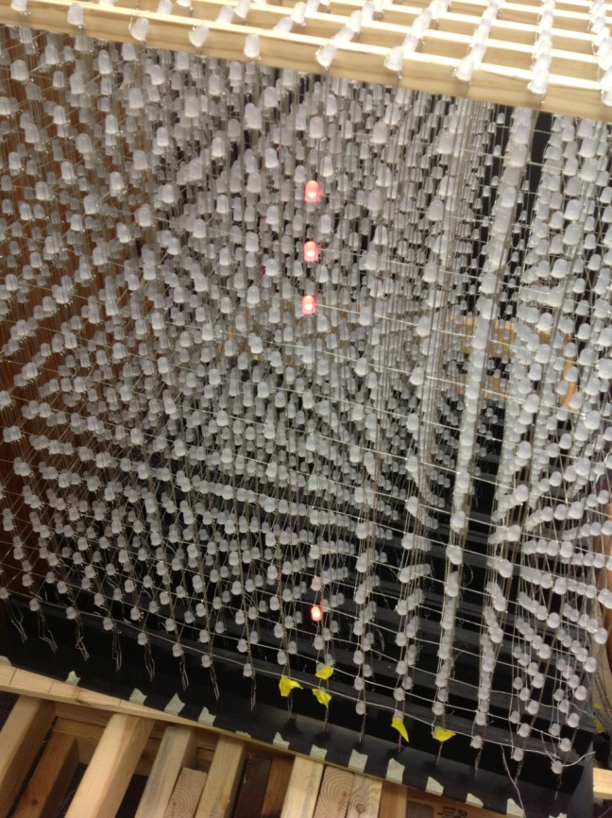
Figure 31: Initial testing of the Dynamic Animation Cube II showing 12 blown LEDs
Another problem that needs to be fixed is the fusing of two colors of some of the light emitting diodes. This means that two or possibly all three ground pins are connected. The group is going to have to remove the existing solder from these pins, and then solder them back correctly.
The results of the initial test are shown in Table 28. As you can see, there are many light emitting diodes in the center of the cube that need to be fixed. The group will have to deconstruct the entire structure in order to be able to get to them. The cube will be taken apart in panels to try and save time. This will also make it easier when trying to reconstruct the cube back. Figure 28 shows the process by which Group 5 tested each column in the Dynamic Animation Cube II.
Initial Testing Data
Top to Bottom | Front to Back | Left to Right | Problem
2 | 2 | 7 | Layer
10 | 2 | 9 | Green
3 | 2 | 9 | Blue
16 | 3 | 13 | Layer
12 | 4 | 3 | Red
10,4 | 4 | 9 | Blown
7 | 4 | 3 | Green
3 | 5 | 9 | Green
14 | 6 | 9 | Green
8 | 7 | 1 | Blue
9 | 7 | 5 | Blown
8 | 7 | 6 | Red
9 | 8 | 5 | Blue
16 | 8 | 15 | Layer
11 | 9 | 7 | Blue
7 | 10 | 13 | Red
2 | 10 | 10 | Green
4 | 13 | 16 | Layer
 | 7 | 11 | Two columns
 | 8 | 11 | Two columns
8 | 16 | 7 | Blown
 | 10 | 7 | Two colors
 | 12 | 15 | Two colors
1,5-12,14-16 | 7 | 1 | Blown
Table 28: LED’s shown to be defective during Initial Testing of the Dynamic Animation Cube II.
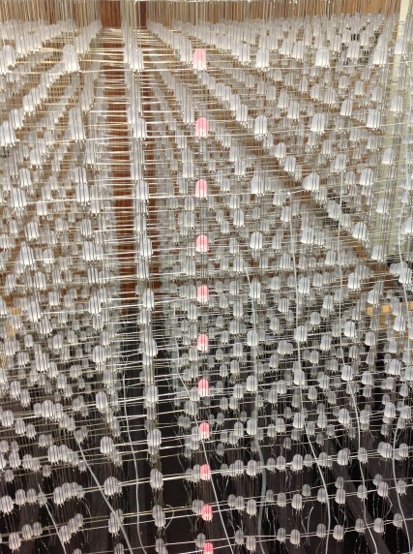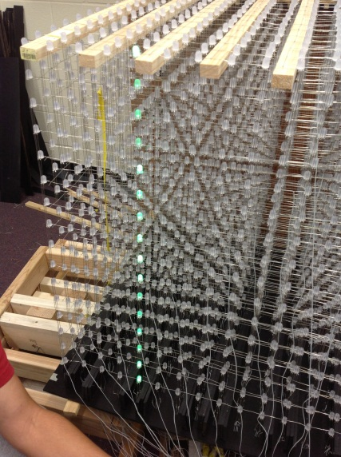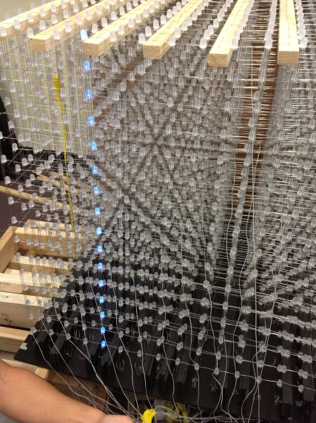Figure 32: The Dynamic Animation Cube II initial testing. Shown is the process by which the group tested each column in the LED array in each of the three colors.
4.5.3.3 Cube
Once the group had finished taking apart the cube, and fixed all of the light emitting diodes the next phase was to test all of the panels to ensure that everything is soldered correctly. Once all of the light emitting diodes were tested, and worked properly, the group then started reconstructing the cube. Since the light emitting diodes in the center weren’t accessible after the cube was built, the group started building from the center and tested the panels as they were being constructed together. A final test was taken once the cube was completed to ensure all of the connections remained intact.
4.5.3.3.1 Test Case 1
- Test Objective: Panel Testing

- Test Description: The group tested the panel of light emitting diodes to check if they were all working. All sixteen anode and sixteen cathodes were hard wired to a breadboard. Using the power supplies available in the lab, a positive voltage was applied to the anodes and the cathodes were attached to ground. The group checked to see if all the light emitting diodes turn on. This was repeated for all three colors.

- Results: There were no blown or disconnected light emitting diodes.

4.5.3.3.2 Test Case 2
- Test Objective: Entire Cube Testing

- Test Description: The group tested the entire cube once it was finished to ensure the connections of the light emitting diodes were not damaged. All sixteen layers were connected to the boards. Next, the group ran a simple program to turn on an entire sixteen by sixteen sheet starting from the bottom layer and work its way up to the top.

- Results: The group discovered inconsistencies between the LEDs intensities. Some were dim, while others were extremely bright. Also, some LEDs had a mixing of colors even when it was only supposed to be red, green, or blue.

4.5.3.4 Controller
The controller was an important component for the manipulation of the animations. The Wii Nunchuk must be tested to ensure the information being sent to the microcontroller was consistent with all the research the group has collected on it. The group hardwired the controller to the Atmel evaluation kit. Then read in the data while one of the members pushed the buttons, maneuvered the joystick in different positions, and performed different movements with the Nunchuk itself. The objectives of the tests were to make sure all of the features of the controller worked properly, and to interpret how the data and the actual physical movements are correlated.
4.5.3.4.1 Test Case 1
- Test Objective: Ensure all component features work properly

- Test Description: The group hard wired the Nunchuk to the Atmel evaluation kit. The evaluation kit was then connected to a computer, and one of the group members first pressed each button individually. Next, the joystick was maneuvered in all possible directions. Finally, the controller was moved left, right, up, down and rotated. All of the data was analyzed with an oscilloscope to ensure all of the features worked correctly.

- Results: Everything worked properly

4.5.3.4.1 Test Case 2
- Test Objective: Interpret the correlation between the data and physical movements.

- Test Description: Similar to case two, the Wii Nunchuk was hard wired to the Atmel evaluation kit, which was connected to a computer. The group then maneuvered the joystick in various positions. Analyzed the data and determined the values for each position. Next the group moved the Nunchuk to the left, right, up, down, and performed some rotations. After each maneuver, the group analyzed the data from the computer and attempted to correlate the movements with the values collected.

- Results: The group was able to recognize the different bit sequences for most of the inputs. However, the last byte of data was not being sent by the slave device
4.5.3.5 Drivers
The drivers are the components that are supplying the current to the cube. With so many light emitting diodes in the structure, the group must be careful to not overload the drivers. The group designed a simple printed circuit board with a couple of drivers, and some male header pins to run individual tests on the drivers without sacrificing one of the main circuit boards.
4.5.3.5.1 Test Case
- Test Objective: Confirm addressing and communication protocol

- Test Description: The group wired the test board with eight drivers to another board with the microcontroller. Then tried to send data to each individual driver. The group analyzed the other drivers to ensure that only the driver they wanted got the desired data.

- Results: The group found out that they could address each individual driver, but since they were using a decoder they could not address more than one driver at a time.
4.5.3.6 Software
Testing the software is very important for making a fully functional project. The software had to be tested separately from the hardware, since when the microcontroller is connected to the Nunchuk and the light emitting diode cube it would have been impossible to log the input and output. As mentioned previously, it is also important to make sure that the software is operating in a completely safe way before putting any delicate hardware (such as drivers, decoders, the Nunchuk the light emitting diodes) at risk for being overloaded as happened to the previous group.
5. Administrative Content
5.1 Milestones
Throughout the course of the research process the group came across several issues that were deemed to be major components and that the entire project would hinge upon. It is for that reason that the group decided to lay down milestones to aim for during the Senior Design II course that took place during Spring of 2013. The group identified the following milestones in Figure 26 that needed to take place over the course of the Senior Design II course in order to ensure successful completion of the Dynamic Animation Cube II project.
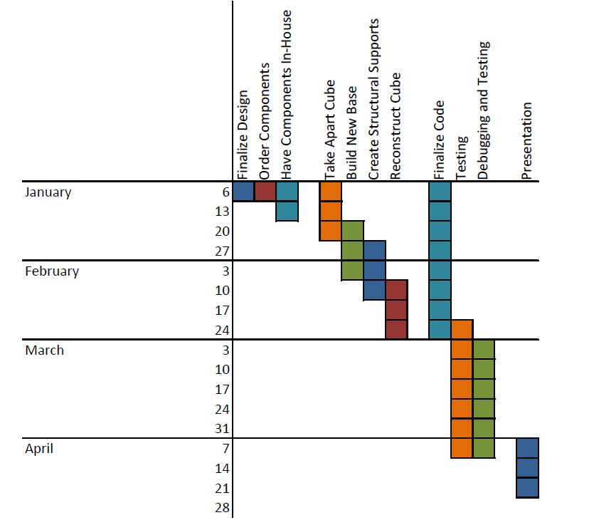
Figure 33: Milestone dates set for the production of the Dynamic Animation Cube II for the Spring 2013 semester
5.2 Budget and Finances
Available Budget: $1500
Table 20 details the spending Group 5 had during the Spring 2013 semester.
Cast Acrylic Sheets for Housing
Price: $79.72 per 36in x 48in sheet
Available from Professional Plastics at a thickness of .22 inches
Description: These cast acrylic sheets will be used to encase the Dynamic Animation Cube II once it is fully operational and ready to be put on display in one of the engineering buildings on the University of Central Florida’s campus. The cast acrylic sheets are durable enough to withstand transportation of the Dynamic Animation Cube II as well as strong enough to provide the necessary protection for the cube.
Extruded Acrylic Cylindrical Rods for Structural Support
Price: $17.34 per 6 foot cylindrical rod
Available from US Plastics at a diameter of .5 inches
Description: These cast acrylic rods will be used to create a structural support system for the Dynamic Animation Cube II once it is fully operational and ready to be put on display in one of the engineering buildings on the University of Central Florida’s campus. The cast acrylic rods are durable enough to withstand transportation of the Dynamic Animation Cube II as well as strong enough to provide the necessary structural stability needed for the cube.
Atmel AT32UC32512C
Price: $16.02
Available from DigiKey
Description: Microcontroller
AVR Dragon
Price: $49.00 + shipping
Available from Atmel
Description: Atmel’s low cost development tool. Will be used to program and debug the microcontroller.
Nintendo Wii Nunchuk
Price: $17.99
Available from Gamestop
Description: Contains an accelerometer, and two buttons. That will be interfaced with the cube to control the animations.
LED Drivers ST Microelectronics STP24D05
Price: $109.45
Available from Digikey
Description: A 24 bit LED driver, capable of supplying a constant regulated current.
5V, 2A Adapter
Price: $16.28
Available from DigiKey
Description: 5 volt, 2 amp output wall adapter.
74HCT154 Decoder
Price: $1.63
Available from DigiKey
Description: 4-to-16 decoder/demultiplxer
24 Pin Ribbon Cable Connectors
Price: $14/40 pack
Available from Futurlec
Description: 24 pin driver to light emitting diode connector.

Item | Quantity | Price/unit | Total Price
Acrylic Casing | 5 sheets | $79.72 | $398.60
Acrylic Rods | 12 rods | $17.34 | $208.08
LED’s | 100 | $0.10 | $10.00
Atmel AT32UC32512C | 2 | $16.02 | $32.04
AVR Dragon | 1 | $49.00 | $49.00
Wii Nunchuk | 2 | $17.99 | $35.98
LED Drivers | 32 | $3.40 | $109.35
DC Power Supply Jack | 1 | $16.28 | $16.28
Decoders | 5 | $1.63 | $8.15
Soldering Supplies | n/a | n/a | $75.00
Ribbon Cable | 50 yards | $1.00 | $50.00
Connectors | 80 | n/a | $28
AVR Development Board | 1 | $30 | $30
Atmel Studio 6.0 | 1 | $0.00 | $0.00
Hercules Serial Port Software | 1 | $0.00 | $0.00
Table 29: Financing
5.3 Group Member Biographies
The Dynamic Animation Cube II, completed by Group 5, was carried out by a group of four members. The group contained one computer engineer; Adam Heeren who is a senior in Computer Engineering and plans to graduate in May 2013. The remaining three members of the group are electrical engineers; Timothy Foard, Sommer Marsh, and Brian Zei are seniors in Electrical Engineering and graduated in May 2013.
5.3.1 Timothy Foard
Timothy Foard was born in Miami, Florida on March 23, 1989. He was forced to move out of Miami to Pembroke Pines, Florida after his house was destroyed during Hurricane Andrew. Timothy attended Charles W. Flanagan High School from 2003 until graduating in 2007. Academically he always enjoyed mathematics, and performed very well in all of his math classes completing Advanced Placement Calculus by his junior year. He played varsity baseball during all four years of school, where his team won two back to back Florida state championships. In his senior year he was named 2nd team all-county for his position. Baseball has had a major influence in his life. It has taught him the value of teamwork, and hard work. Most of all it has taught how to handle adversity, and to never give up.
Upon graduating high school, Timothy went on to attend Jackson State Community College in Jackson, Tennessee to continue his baseball career. Realizing that baseball was not going to take him anywhere, he decided to move to Orlando, Florida after completing his first year at Jackson State where he would attend Seminole State College. In his first two years of school Timothy never really had any direction, taking three classes a semester with no focus on anything in particular. At the end of his sophomore year he decided to enter the field of engineering, after seeking guidance of two very close friends who were engineering students at the University of Central Florida.
Timothy completed his Associates degree at Seminole State in 2010, and began attending University of Central Florida in the fall of 2010. During his years at the University of Central Florida he has expanded his knowledge in many different aspects of engineering, with a particular interest towards embedded systems. Timothy plans to graduate in May 2013 with a Bachelor’s degree in Electrical Engineering. After being in school for six years, he anticipates to enter the workforce. He would like to attend graduate school to obtain a Masters degree in Computer Engineering. However the cost of continuing his education has to be carefully considered before he can make a decision. He looks forward to completing his undergraduate degree and starting his career as an engineer.
5.3.2 Adam Heeren
Adam Heeren was born in St. Petersburg, Florida in 1991. His father graduated with a master’s degree in electrical engineering from USF and his mother graduated from UCF with a major in math and a minor in computer science. Adam has always had a penchant for technology, and this interest was always supported by his family. Adam attended the Center for Advanced Technologies at Lakewood High School in St. Petersburg, a math, science and technology magnet program, where he discovered his intense interest in programming. At the Center for Advanced Technologies, Adam took advantage of the opportunities available to him, taking several Advanced Placement classes as well as participating in both athletic and academic extracurricular activities, including the wrestling team, academic team, audio-visual club and French club.
At UCF, Adam has been able to learn a great deal about the diverse (albeit a bit sporadic) field of computer engineering. The combination of software and hardware that is offered with the computer engineering degree is perfect for Adam, since he is never satisfied simply to be told that something works; he must know how. The facilities and classes at UCF have allowed Adam to learn both the abstract and concrete aspects of programming, from complex mathematical proofs about the runtimes of algorithms to the configuration of diodes and transistors to make an AND gate. Adam is using this knowledge constantly at the College Work Experience Program at Lockheed Martin, where he works on Verilog firmware. Adam is unsure what exact type of programming he wants to do professionally after graduating from UCF, although he definitely plans to do some form of programming upon graduation.
The light emitting diode cube is an ideal project for Adam to be working on, since it has the software design and algorithm problems to take input from users and animate the cube, and the hardware configuration problems of making refresh rate, current draw, instructions per second, and other hardware-related issues.
Adam is the primary programmer for the cube, since he is the only Computer Engineering major in the group. He is well equipped to create the software for the cube, since he is fluent in C and has programmed on many embedded devices during his college career.
Adam plans to graduate in May 2013 with a Bachelor’s degree in Computer Engineering. He started college at the University of Central Florida in August 2009 and will graduate four years later to obtain his degree. He plans to start working full-time as a software engineer as soon as possible after graduation.
5.3.3 Sommer Marsh
Sommer Marsh was born in Orlando, Florida on June 27, 1991. She has maintained residence in the same area since her birth. She is the youngest of the four children birthed by her parents. She has three older brothers that she will never stop learning from. Sommer attended Colonial High School in Orlando where she participated in several varsity level sports, headed the yearbook department as Editor-in-Chief, and acted as President of the Latin Club. During her high school years, Sommer took Advance Placement classes and participated in the Dual Enrollment program offered by Valencia Community College. Dual Enrollment offered her the opportunity to take college courses free of cost as well as earn the high school credit still needed to graduate.
Throughout her college career Sommer has focused on the hardware aspect of electrical engineering. Outside of hardware, she thoroughly enjoyed her technical electives in power systems engineering. Her biggest challenge thus far at the University of Central Florida has been time management. She picked up an internship her first semester as an engineering student and has worked nearly full-time hours ever since. After obtaining her Bachelor’s degree she plans to remain with her employer and will seek her Professional Engineering license. In addition to seeking her Professional Engineering license, Sommer might also consider continuing her education by seeking her Master’s degree from the University of Central Florida. These plans however, are not concrete and careful thought and consideration will need to be given to this idea.
Sommer is looking forward to upgrading the Dynamic Animation Cube that was created during a previous semester by College of Engineering and Computer Science seniors. She feels that her technical knowledge and mechanical background will aid largely in the retrofit of the Dynamic Animation Cube’s structure. Throughout the course of the research phase of this project Sommer realized that she would need to become more familiar with the workings of a microcontroller and of trouble shooting software problems.
Aside from her focus on academic excellence, Sommer spends her time enjoying the university’s intramural sports, specifically two on two beach volleyball. When un-burdened by school and work, she spends as much time as possible with her family. On the weekend she can be found canoeing, fishing, shooting, reading, or just fixing up the house. Sommer also thoroughly enjoys baking, in whatever form she can get it.
Sommer plans to graduate in May 2013 with a Bachelor’s degree in Electrical Engineering. She started college at the University of Central Florida in August 2009 and will graduate four years later to obtain her degree. She plans to start work shortly after the Dynamic Animation Cube project is finished and final presentations are finished.
5.3.4 Brian Zei
Brian Casey Zei was born on December 6, 1989 in Davie, Florida where he lived for until he left for college. He attended Archbishop McCarthy High School where he took classes mostly in the school’s honors program. He also received excellent grades in upper level classes such as AP Biology, Calculus 1, and English. He graduated in May of 2008.
While in high school, Brian was also part of several after school activities, including marching band, concert band, jazz band, and the chess team. Within the band, Brian played in the percussion section becoming proficient in many instruments, but mostly stuck to the xylophone, marimba, and piano for jazz. During his senior year, he became the captain of the pit section in marching band, leading the group to receive many great and excellent ratings at several competitions. The McCarthy chess team was also very successful, being created during Brian’s freshman year and winning States all four years that he attended the school. The team also competed in the National Scholastic division, bringing home third place his sophomore year and taking first place in his junior year with Brian having one of the team’s top four scores for the tournament.
Brian also logged over 150 hours of community service during his time in high school. Some of this was done at the St. David Summer Camp, where Brian worked as a counselor in training then as a full counselor for the kindergarteners and first graders. Most of the hours though were collected during his time with Boy Scout Troop 317, where Brian was a member from fifth grade until he turned eighteen. Within this period, Brian was able to achieve the lofty rank of Eagle Scout, of which only 2% of boys that start the program finish with, as well as having time enough to receive three Eagle Palms before turning eighteen, at which time the age restriction stopped him from completing a fourth. At this time, Brian signed up as an adult leader and continued to help the troop until he left for college.
Starting in the fall of 2008, Brian began attending the University of Central Florida’s College of Engineering and Computer Science where he started on the road to receiving a degree in Electrical Engineering. He plans to graduate in May 2013, where he hopes to get a job and possibly pursuing a graduate degree in the University of Central Florida’s video game graduate program.
In his off time, Brian enjoys hanging out with friends, playing video and board games, playing chess online against players from around the world, and solving puzzles.
5.4 Division of Labor
The retrofit of the Dynamic Animation Cube that Group 5 undertook consisted largely of three distinct sections; Hardware upgrades, Structural upgrade, and Software upgrades. Hardware upgrades were headed by Timothy Foard. Timothy worked day in and day out on the logistics necessary for implementing the new applications of the Dynamic Animation Cube II. This included evaluating the current hardware used on the Dynamic Animation Cube and then designing new printed circuit boards for use with the retrofitted cube. The structural upgrades will be headed by Sommer Marsh. She was responsible for implementing an actual structural support system to help the cube maintain its shape and aid in preventing future wear and tear on the cube while it is on display in the Harris Corporation Building on the university’s campus. The Software aspect of the project was handled by Adam Heeren. He worked on the code that ultimately displays the applications on the Dynamic Animation Cube II. He delegated any programming that needed to be done to a different group member.

6. Conclusion
Group 5 produced the Dynamic Animation Cube II with a specific set of requirements and specifications. In order to ensure the functionality of Group 5’s design, it was of upmost importance that these specifications were considered when making any altering decisions to the Dynamic Animation Cube II designs. The Dynamic Animation Cube II needed to conform to a physical size of roughly 33 inches long, 33 inches wide and 52 inches tall (including the housing and base.) The cube has 5 visible sides, Red, Green, Blue light emitting diodes; a resolution of 16 * 16 * 16, a stable infrastructure that provides the basic shape of the Dynamic Animation Cube II, and an enclosure that protects the delicate structure from outside manipulation. The Dynamic Animation Cube II has a working temperature between 50°F - 100°F and is able to operate anywhere within a 10-80% humidity range. The Dynamic Animation Cube is able to function from a standard 120 Volt socket. The end result of the Dynamic Animation Cube II is an aesthetically pleasing and user interactive project for future engineering students at the University of Central Florida to enjoy.
The base of the Dynamic Animation Cube II is composed of wood. The sheets are machined in a way that allows the wiring of the light emitting diodes to be concealed beneath the cube. The base conceals all of the necessary hardware that the Dynamic Animation Cube II needs in order to run. The wood chosen to be the base of the cube weighs much less than the other materials considered. The base makes use of a laminate since it adds to the aesthetics of the completed Dynamic Animation Cube II project.
The Dynamic Animation Cube II consists of both a transparent case construction as well as an infrastructure system that provides the necessary stress relief to the light emitting diode array. In addition to durability, strength and transparency were also considered in order to make a decision about what kind of casing would enclose the finished Dynamic Animation Cube II. With these items in mind, the group decided to use acrylic sheets to encase the Dynamic Animation Cube II. In addition to the enclosure that will house the cube, Group 5 created an infrastructure within the light emitting diode array in order to maintain stability of the entire Dynamic Animation Cube II. For this inner infrastructure system, the group decided to go with extruded acrylic rods which proved to be stronger and less flimsy than other materials considered.
The hardware for the Dynamic Animation Cube II was designed with considerations for the quickest refresh rate achievable by the group. The AT32UC3C2512C microcontroller was chosen over the Stellaris LM3S8962 for its fast sixty-six MHz operating frequency, and the extra 256 Kbytes of Flash memory space. The group also notes that the Atmel environment was nicer to work with instead of the Stellaris, it also comes with recommendations from previous Senior Design groups. The group carefully reviewed the previous Dynamic Animation Cube documentation and completely redesigned the system. Group Five used a decoder to individually address all of the STP24D05 drivers, rather than daisy chain them in sequence like the previous group did. This allows the group to select one driver to communicate with instead of having to shift data into all of the drivers. Another feature that was added to this project that was not in the previous group’s Dynamic Animation Cube is the control of the animations through the use of the Wii Nunchuk. The AT32UC3C2512C was programmed and debugged utilizing Atmel’s AVR Dragon and a PC.
The software used for the microcontroller was written in C, and will make heavy use of the Atmel Software Framework. The software runs in a state machine, with one state for each of four games, a lobby, an ambient state, and an instance of Conway’s Game of Life. These states, based on user input from the Nunchuk, change the configuration of lit light emitting diodes on the cube. The software has been calculated to have a refresh rate of no less than 90 Hz. The information describing the light emitting diodes on the cube is sent out through a Serial Peripheral Interface, the controls for which are included in the Atmel Software Framework. The animations are fairly complex, especially for an embedded system, though according to the timing and memory calculations, the animations should run seamlessly.

7. Manual of Operation
7.1 Normal Operation
For normal operation of the cube, all the user has to do is plug in the power supply and the cube should automatically re-load the code that was previously loaded into nonvolatile memory. The cube will automatically default to the AMBIENT state and start playing animations. In order to change state, input from the Wii Nunchuck is used as shown in figure fignum below.

Figure 34: Illustration of microcontroller state machine

The cube is designed to run indefinitely, though it is highly recommended to turn the cube off for at least 10 minutes after more than 24 hours of solid operation.
7.2 Coding Environment
In order to write new code for the microcontroller, one must use Atmel Studio version 6 or higher to write and compile the code. The Atmel Software Framework also has to be downloaded; this is usually done at the time of installation of Atmel Studio. The code must be written in C.
In order to write totally new code, the coder has to include the Atmel Software Framework header file (asf.h) which is created by the Atmel Studio when a new project is created. The first thing to be called in the main function must be board_init() In order to access and write to the cube, the coder can use the application programming interface defined in the Table 29 below.

Method/field & arguments |  | Return type | Description
Cube methods and fields
Method: getStatus(void) |  | light emitting diode: int[3][16][16] | Returns the values indicating which light emitting diodes are lit (detailed description below)
Method: setStatus(int[3][16][16]) |  | valid: boolean | Uploads a new array of index light emitting diodes to be lit. The method will count the lit light emitting diodes and determine if the number of lit light emitting diodes will overload the drivers or not. If the number of light emitting diodes is low enough, the method returns true and updates the cube. Otherwise, the method returns false and does not update the cube.
Nunchuk methods and fields
Method: getJoystick(void) |  | position: int[2] | Returns the position of the joystick for the Nunchuk. position[0] is the x position and position[1] is the y postion.
Method: getAccel(void) |  | accel: int[3] | Returns the values for the accelerometer of the Nunchuk. accel[0] accel[1] and accel[2] are the accelerometer values for the x, y, and z levels, respectively.
Method: getButtons(void) |  | buttons: int | Returns one integer that has the values of the two buttons integrated into the int, where buttons[0] is the C button and buttons[1] is the Z button.
Table 29: Detailed descriptions of API functions.

If the coder wants to use their own code to access the Cube, the SPI interface must be initialized by calling the SPI_init function. The general purpose input/output also has to be initialized, as general purpose input/output pins are used to latch the data and select the driver via decoders defined in the PINS.h file available on the group 5 website. In order to initialize the general purpose input/output, GPIO_init() must be called. Each pin must also be enabled by calling GPIO_enable_pin(pin number).
If all the coder wants to do is edit the existing Cube code, he can download the zipped project from the group 5 website and simply re-load the project into Atmel Studio.
7.3 Updating Code
This section will detail the procedure of how to upload compiled code to the microcontroller. These instructions are only applicable if the coder used the procedure detailed in the section above. In order to compile the finished code the coder must use the ‘build solution’ button in Atmel Studio shown in Figure 35. 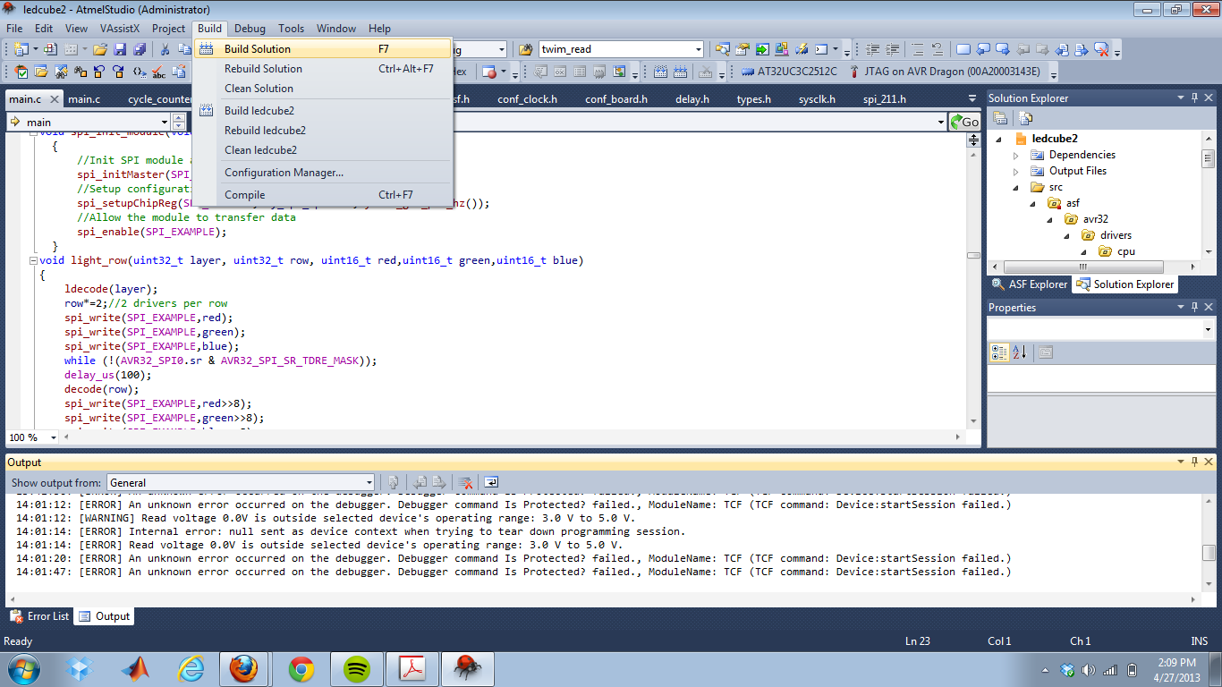Figure 35: Compiling the code
After compilation, the coder must upload the binary code to the microcontroller. This is done using the Joint Test Action Group interface, as that is the only interface accessible on the final printed circuit board. The group used the AVR Dragon to use the Joint Test Action Group interface, but this can be done with other boards as well. The coder must use jumpers to connect the TMS, TDO, TDI, TCK, RST, VCC and GND pins to those on the Main Control Unit printed circuit board. This should not be difficult because those pins have headers and are labeled on the printed circuit board. After the pins have been jumped, the coder must go to tools->device programming in Atmel Studio. From there, the coder must select the debugging device they are using, and select ‘AT32UC3C512C’ under ‘Device’. This is show in if Figures 36 and 37 below.
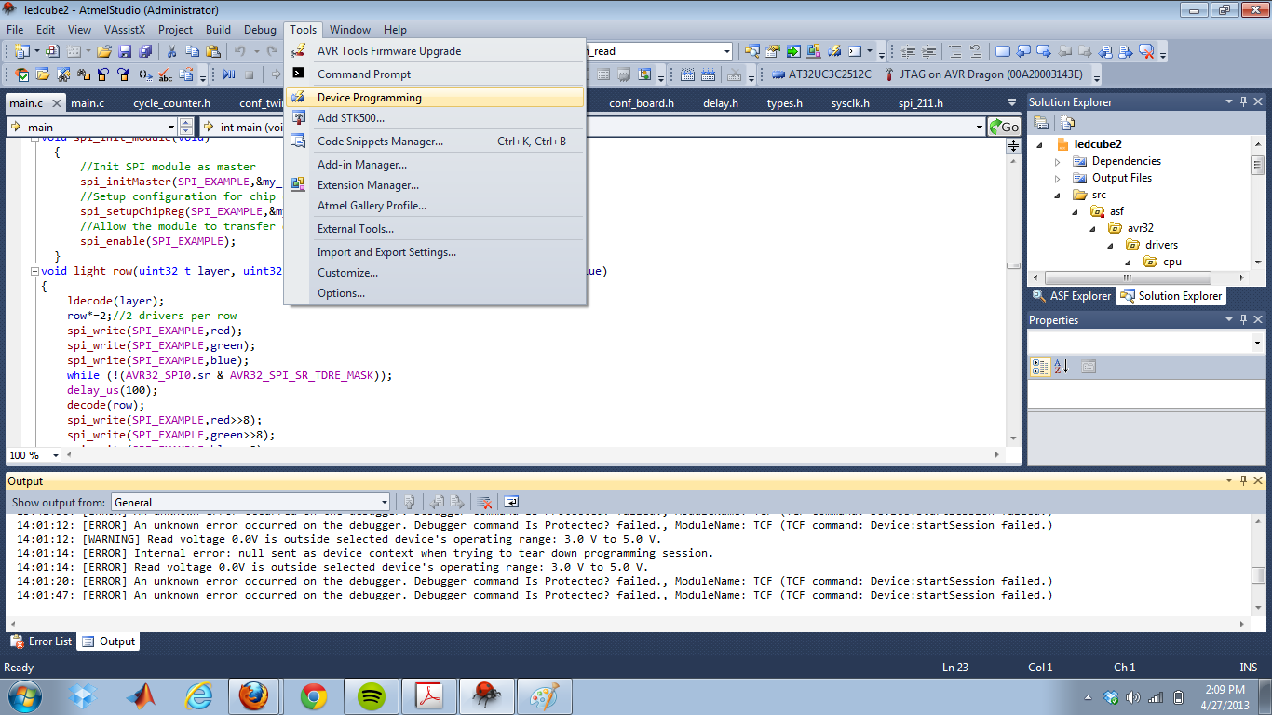Figure 36: Accessing the debug menu.
. 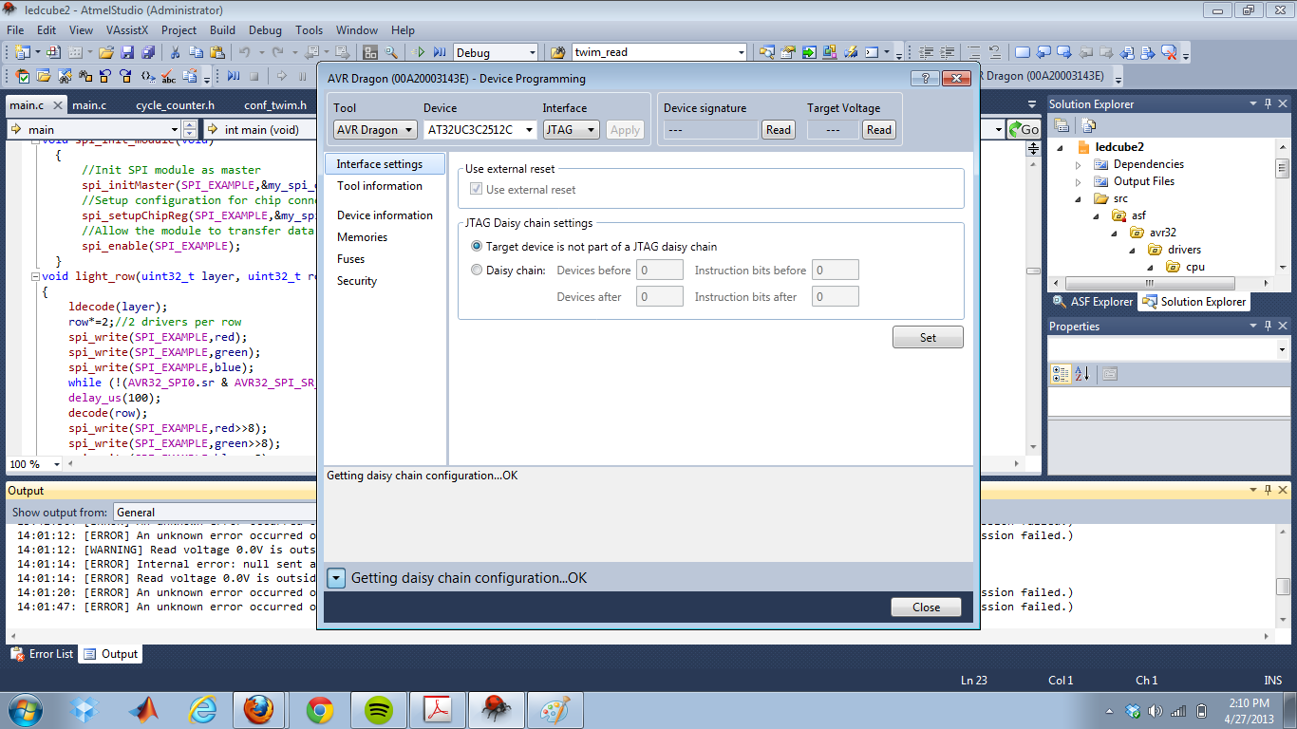Figure 37: Setting debug properties.
After the properties have been properly set, all the coder must do is press the green play button labeled ‘Start Without Debugging’ to upload the code. Once the code is uploaded in this fashion, the microcontroller will automatically start running the code every time it is powered on, i.e. there is no need to re-upload code if no changes are made.

7.4 Troubleshooting Guide
7.4.1 No LEDs Lighting
This is most likely a problem with the code, as the drivers are in a static configuration and are known to be working if the code is properly writing via serial peripheral interface. First, as with all errors, the user should verify that all components are powered and then try unpowering and powering the components back up. Next, using a digital oscilloscope if available, the coder should check the exposed pins for the serial peripheral interface data and clock lines. An error that was commonly encountered was that there would be no output to the data line or both lines, implying that the code does not reach the portion that deals with writing to the serial peripheral interface. Code can hang when errors occur with the handshaking with the two wire interface, as the two wire master holds the program until it receives acknowledgements from the slave.
7.4.2 No Input from Nunchuk
If no input is being received from the Nunchuck, it is possible that there is an error with the code where an initialization statement is not being properly called. This can be fixed by reverting to earlier code and comparing to see where errors may have arisen from. The problem could also be caused by the Nunchuck having bad connections with the jumpers. This is a problem that was common during development, because if the Nunchuck has a bad connection at any point while running, it will not work properly again until the system has been reset. The Nunchuck also causes other errors by making the program hang, so it is a good idea to make sure that the Nunchuck is properly connected.
7.4.3 Hot Components/Constant Current Mode
If components are getting hot or the supply goes into constant current mode, the user must immediately disconnect power, or else serious damage can be done to the board components. The most common reason for this type of problem is debris on the board, so to help debug all one can do is clean off the board. Other than cleaning off the board, there is nothing the user can do.
7.4.4 Joint Test Action Group Errors
If there are problems with the Joint Test Action Group, the user must first verify that the connections from the programming device are connected properly by checking the datasheet for their device. If all connections are correct, the next step is to verify power going to both the main board and the programming device. Finally, Atmel Studio has a tendency to have difficulties with programming devices if it has been running for a long time, so it was discovered that simply restarting the software fixed the problem.
7.4.5 Wrong LEDs Lighting
For this type of error, it is a;most definitely a problem with the code. In order to find the problem with the code, it can be useful to use an oscilloscope on the drivers, the serial peripheral interface data line, and the decoder inputs and outputs. It is possible that the cube was plugged in incorrectly to the main printed circuit board. This can be verified by making sure that the numbers written on the ribbon cables match the numbers on the printed circuit board.

8. References
"1/2-Inch Megapixel CMOS Digital Image Sensor." . Micron Technology, 4 Dec 2012. <http://download.micron.com/pdf/datasheets/imaging/mt9m001_1300_mono.pdf>
“74HC154; 74HCT154 4-to-16 line decoder/demultiplexer.” 12 February 2007. NXP Semiconductors. 1 December 2012. <http://www.nxp.com/documents/data_sheet/74HC_HCT154.pdf>.
Artiuch, John. "I2C or SPI Serial Communication, which one to go with?." Your Electronics Open Source. N.p., 11 2010. 30 Nov 2012. <http://dev.emcelettronica.com/i2c-or-spi-serial-communication-which-one-to-go>.
"Atmel 32-bit AVR Microntroller." Atmel.Web. 4 Nov 2012. <http://www.atmel.com/Images/doc32117.pdf>.
Atmel Corporation (2012) Atmel Software Framework (Version 3.5.1) [Code Library]. Available at http://asf.atmel.com/docs/latest/api.html (Accessed 1 December 2012)
“Breadboard Power Supply 5V/3.3V.”Sparkfun Electronics. 1 December 2012. <https://www.sparkfun.com/products/114>.
“CD54HC4514, CD74HC4514, CD74HC4515.” July 2003. Texas Instruments. 20 November 2012. <http://pdf1.alldatasheet.com/datasheet-pdf/view/26940/TI/CD74HC4514.html>.
“Dynamic Animation Cube.” August 2012. UCF Senior Design 2012 Group 1. 15 November 2012. <http://eecs.ucf.edu/seniordesign/sp2012su2012/g01/index.html>.
"How to: Cheap Accelerometer with the Wii Nunchuck." Hack n Mod. HacknMod.com, 21 Nov 2012. <http://hacknmod.com/hack/how-to-cheap-accelerometer-using-wii-nunchuck/>.
“LED Cube 8x8x8.” November 2011. Instructables. 1 December 2012. <http://www.instructables.com/id/Led-Cube-8x8x8/#intro>.
Lee, Johnny. "Hacking the Nintendo Wii Remote." IEEE CS, 15 Nov 2012. http://www.cs.cmu.edu/~15-821/CDROM/PAPERS/lee2008.pdf
Matamoros, Mauricio, Marco Negrete, Yasmine Haddad, and Ron Leder."Nintendo WII remote and Nunchuck as a wireless data subsystem for digital acquisition of analog physiologic data relevant to motor rehabilitation after stroke; part II."IEEE Xplore. IEEE, 19 2010.Web. 1 Nov 2012. <http://ieeexplore.ieee.org/stamp/stamp.jsp?arnumber=05474568&tag=1>.
"The PS1080." PrimeSense Natural Interaction. PrimeSense. 18 Nov 2012. <http://www.primesense.com/en/technology/114-the-ps1080>
Seidle, Nathan. "Wii-mote guts." Sparkfun Electronics. 19 2006.12 Nov 2012. http://www.sparkfun.com/tutorials/43
“STP1612PW05.” December 2009. STMicroelectronics. 15 November 2012. <http://pdf1.alldatasheet.com/datasheet-pdf/view/432726/STMICROELECTRONICS/STP1612PW05.html>.
“STP24DP05.” February 2012. STMicroelectronics. 15 November 2012. <http://www.st.com/internet/com/TECHNICAL_RESOURCES/TECHNICAL_LITERATULI/DATASHEET/CD00197065.pdf>.
“TLC5941: 16-channel LED driver with dot correction and grayscale PWM control.” July 2005. Texas Instruments. 20 November 2012. http://www.ti.com/lit/ds/symlink/tlc5941.pdf.
"Using the I2C Bus."Robot Electronics, Web. 20 Oct 2012. <http://www.robot-electronics.co.uk/acatalog/I2C_Tutorial.html>.
"ZX-Nunchuck Wii-Nunchuck Interface board."Robot Shop.N.p..Web. 21 Nov 2012. <http://www.robotshop.com/ca/content/PDF/inex-zx-nunchuck-datasheet.pdf>

9. Appendix

Figure 38: Sparkfun permission
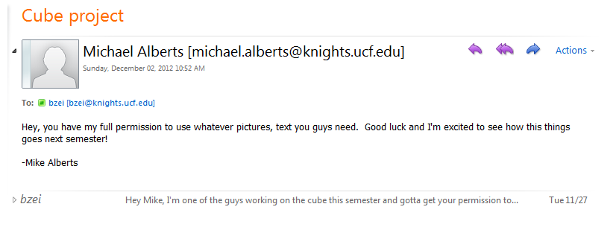
Figure 39: Michael Alberts permission

Figure 40: Atmel Permission

Figure 41: STMicroelectronics Permission

Figure 42: Texas Instruments Permission

