1. EXECUTIVE SUMMARY

Vampire draw, Phantom load, or most commonly know as Standby power accommodates about 10% of the total amount of wasted electricity in the world and in your electricity bill. Devices such as the VCRs, all-in-one printers, and laptops are all examples of the largest culprits. Using 50% of the power as if the device was on while in standby mode. Even though in some cases being necessary such as remote controls, observing temperatures, and digital displays. These devices add up in the modern home and can also add a hefty tax to your electricity bill. The solution to this would be to regulate which devices are left in stand by mode and which devices should be completely unplugged or power cut. Saving energy is important with the depletion of fuels. Alternative sources must be created to be able to sustain our lifestyle and by saving energy this allows us more time to be able to fabricate these sources.

We have aimed to create a device that is low power, user friendly and reduces the amount of power wasted in stand by mode. By cutting all power to a device when not in use this will eliminate standby power. The AUMD or also known as the automated utility management device is similar to a power strip but carries an LCD touch screen display for user interaction. This device will allow the user to regulate devices plugged in to be set on, completely off or depending on surrounding devices. For example say we have the Computer, monitor, and printer plugged in to the AUMD. The device can be set that when the computer enters sleep or standby mode all power will be cut from the surrounding devices therefore eliminating standby power.

This device also carries a Bluetooth technology, which allows a user to link their android device via Bluetooth to the AUMD. This will allow the user to control the device up the 50 feet away. Being able to turn devices on and off from any where in your home making the device easily accessible to the user that is out of reach of the AUMD. It also carries an infrared motion sensor located on the front of the AUMD that will be used to detect primarily if a user has entered or exited the room. This will allows for the AUMD to power down all devices once a user has been gone for a period of time. The AUMD will also display the in the menu of the LCD an average monthly power cost for the devices connected to AUMD and your average electricity bill.

With Similar devices to the AUMD available we noticed that they did not behold many features at all. They were mainly basic power strips with switches to kill power to one of the outlet. The AUMD is design to go above and beyond these designs to create a product with useful features easily accessible and user friendly to people of all ages. With wireless capabilities, infrared motion fail-safe, and monthly power consumption to ensure that the most power is saved even from rooms away.

2. Project Description

2.1 PROJECT MOTIVATION

Most people believe when they turn their device off, it’s not wasting any power. That simply isn’t true because even when a device isn’t being used or in the ‘off’ mode, it’s still draining energy from the outlet. The United States department of energy has defined standby power or phantom load as “The power consumed by a product when in the lowest power consuming mode, which typically occurs when the product is switched to “off” or not preforming it primary function or purpose. An extreme number of electronics on the market today cannot be completely turned off unless being unplugged from the outlet.

According to Forbes “A typical United States home has forty products constantly drawing power, together these amount to almost 10% for residential electricity use”. On average Standby power consumes about five percent to around fifteen percent of electricity used in a modern residential home. This can add up to over five hundred million dollars a year globally. Standby power is turning into a growing epidemic for most households across the globe with the depletion of fuels to produce electricity. Corresponding to the Lawrence Berkley national laboratory (standy.lbl.gov), standby power contributes to one about percent of global carbon dioxide emissions in our earth’s atmosphere, which is about 5 million tonnes of carbon dioxide per year. This is equivalent to impact on the atmosphere of more than 1 million cars.

For some equipment such as fire alarms, security systems or thermostats require the use of stand by power to stay powered throughout the day for daily and emergency purposes. In turn we need to regulate which device should remain in stand by mode and which should be completely turned off. As seen in figure 1.1 on the next page having theses device plugged in when not in use or idle will cost you a considerable amount of money in the long run. Averaging up about five hundred dollars just for the devices listed below in figure 1.1 table.

With the constant rise of cost of electricity we need to be more aware of where our power is going and preserve as much of it as we can for future use. Our group sought out to manufacture a device that eliminates standby power with convenience. With a number of features for accessibility and an energy sufficient design that will not only help with energy sustainability, it will also become beneficiary to the entire planet. Along with saving money and retaining our depleting fuel supply.

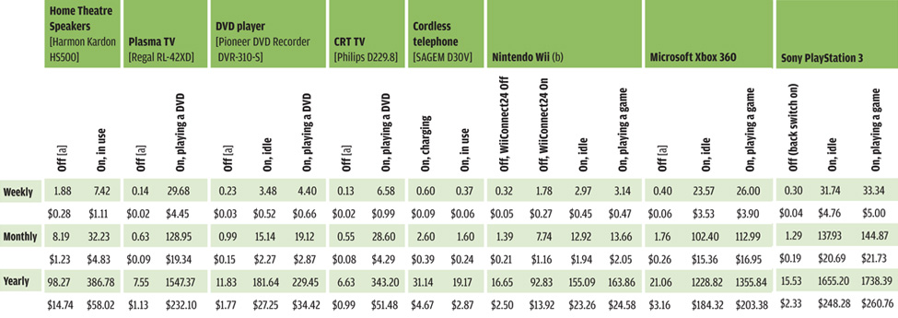
Figure 1.1

2.2 Goals and Objectives

The main goal of our overall project is to create a device that improves energy efficiency, demonstrate energy sustainability and can be completely monitored by the user. We also aspire for the user to have minimal day-to-day interactions with the device. With people always on the go we aimed at having at type of “worry free” device. This design will entail a total of three outlets. The AUMD will look similar to a power strip with an LCD touch screen. The AUMD will also inform you how much energy your appliances are drawing as well as calculate your monthly electric bill.

Cost Efficiency- a major goal of ours is to fabricate a design that is low cost and effective. This plays a huge part in the project when choosing parts and design methodology. We examined our situation and tried to find ways of breaking the cost down little by little. For example with the microcontroller we researched over twenty different kinds and compared specs to be able to choose a microcontroller that was low power, low cost, and able to support all the features that will be present on our device. We also found ways to cut cost by buying in bulk, and shopping around for parts thru different vendors

Energy Saving- Possibly the most important goal of our project is to conserve the use of energy of devices while a device is in stand by mode. Our design will carry three outlets similar to a household power surge and a Liquid Crystal Display (LCD) touch screen interface. The device gives user the capability to set outlets on or completely off (unplugged) preventing standby power. It will up also detect when a master device enters standby mode and kills the power to the surrounding devices that are also plugged into the AUMD. We have also planed to design it to obtain the capability to turn off once a user has left the area for a certain amount of time.

Touch Screen interface- the touch screen interface will be the main brain of the system constantly communicating with the microcontroller to turn devices on and off. The screen will display a menu like screen with toggle switches to enter different modes and apply different features. The first mode that the AUMD will offer is called “Master/Slave mode”. This mode will allow the user to choose one or more devices and set them to either master or slave. When master is selected for a device it will remain on and unaffected by the AUMD. While when the slave is chosen for a device it will set the device to remain on unless the master device enters standby mode or is turned off. Therefore when the master device is not being used all power will be cut to the slave devices saving usually wasted power. Another mode will be “on/off mode”. This will allow the user to set device on or unplugged without actually unplugging the device from the AUMD. The next mode is called “Motion Sense”. This will let the user select if they would like an infrared motion sensor to decide that if no one is present in the room the AUMD will turn off turn off the selected device. This is great when constantly moving from room to room or running out of the house for an emergency. The next and final mode is called “Estimated Power Specifications”. The following mode will allow the user to see how much power the AUMD device is using. It will also allow the user to view how much power is being saved. These figures will also be converted to show the dollar amount versus watts for easy comprehension.

Android Interface- An application will be designed to work on the Android operating system platform. This application will work similarly to the LCD touch screen interface on the AUMD. Which will give the user all the abilities and functions of fully controlling the device without being in the same room. The Android device will connect to the AUMD though Bluetooth technology. Which is a wireless connection and will be able to have a range from zero to fifty feet away. We felt that this would work well with the major increase in popularity of Android devices on the market today. Making the AUMD more versatile and allowing users to power up and off their devices from a fairly far distance.

Motion Sensor- An infrared motion sensor will be placed on the front of the AUMD at an inclined angle. The incline angle will give the motion sensor a better field of view to detect presences. The motion sensor will detect when a user has left the room for a certain amount of time, which can be pre set by the user and will shut down all selected devices for motion control. The motion controller will also helps minimize the day to day interactions with AUMD and be a major contributor of energy and power saving of the AUMD device.

2.3 Scope of work

A Power surge is a device that allows a user to plug multiple devices in order to increase number of outlets available and protects the peripherals plugged in. With the increase in technology today we sought out to magnify its potential to a whole new device. Which will carry more up to date feature such as wireless Bluetooth technology for distance. Motion sensor for when the device is unattended for a certain period of time. It will also display an estimated power consumption and savings in watts versus dollars.

2.3.1 Objectives

The AUMD device was aimed at being a device that would virtually pay for it self over time. Its money saving potential shows it can save some users up to 500$ a year in the average home if we can eliminate standby power. By adding features such as the android application and the motion sensor we felt would give the AUMD an edge on a normal house hold power surge. The motion sensor helps with low maintenance allows the device to shut down if no user is present for a certain amount of time. With the development of the android application we felt would make the device more user friendly and accessible to a broader range of users. According to Theregister.co.uk the android platform controls about seventy five percent of the global smartphone market.

2.3.2 Tasks

Table 1 shown below shows all the hardware components for the AUMD design and the group member responsible for it.

Tasks | Group member
Power | Gardy Lacombe
LCD | Michael Sriprashad
Bluetooth | Benjamin Gruseck
Microcontroller | Benjamin Gruseck
Motion sensor | Michael Sriprashad
Current sensor | Gardy Lacombe
Relay | Gardy Lacombe

TABLE 1 HARDWARE COMPONETS

Table 2 shown below list the software components and the group member responsible for it.

Tasks | Group member
Mobile application | Benjamin Gruseck
Display programming | Michael Sriprashad
Touch interface | Michael Sriprashad
Wireless communication | Benjamin Gruseck

TABLE 2 SOFTWARE COMPONETS

2.3.3 Schedule

To completely finish the AUMD the project will take approximately four months, but we hope to get and early jump on it and have all parts order by the last day of finals in the fall 2012 semester. The project should then be finished and presentation ready in April 2013.

2.4 Significance

The main significance of the AUMD is to promote energy and money saving through out the United States and hopefully the rest of the world. Stand by power uses about ten percent of your monthly electricity consumption adding a nice ten percent increase in your electricity bill. Nothing is permanent and with that said neither is the resources we have obtained on earth. With the depletion of fossil fuel rising every day we need to invest in alternative sources or most modern equipment will not be able to operate any longer. Saving energy helps allow us more time to research and develop alternative fuels for use in the future. The more people that we can get to use the AUMD the better for the planet they will be saving both the earth and on there electricity bill.

We also felt that user accessibility was a huge factor in creating the AUMD in order to reach a more broad variety of users. If users are unable to walk to a certain room in the house or if they are not too technology savvy we wanted to solve this problem. We implemented this by creating an android application that will work with an android platform enabled device though Bluetooth. This application is almost an exact replica of what the LCD display would read. This would as well give the user full access to all capabilities and functions on the AUMD as if you were standing directly in front of the device.

2.5.1 LCD Specification

The LCD touch screen will be based on the top of the AUMD device next to the outlets ports. It is an imperative component of our device and will permit the user the ability to directly interact with the unit. It will allow users to select different features, functions and modes depending on their digression or needs. The touch screen helps eliminate the need for extra-unneeded parts such as buttons, switches, or directional pad.

-Must be able to display current voltage
-Display current power use
-Display Calculated monthly electric cost
-Select functions
-Turn on or off device
-Sleep function to save power
- User friendly

2.5.2 Motion Sensor Specifications

The motion sensor placed on the top front of the AUMD. It needs to be placed so that it covers a wide radius being able to tell weather some one has left or entered the room. The sensor will be set to turn off certain devices selected by the user after a period of time chosen by the user.

-Needs to cover a radius of 20ft
-Needs to sense heat
-Needs to check change in infrared levels constantly
-Needs to communicate with microcontroller

-
3. Research

3.1 Methods

3.1.1 Touch Screen interface

With the growing demand of a user-friendlier interface touch screens became very popular in mid-2005. With the release of all touch screen phones such as the Apple IPhone, HTC HD2, and Motorola droid the demand has grown exponentially. This is why we felt that a touch screen would best suite our project design better than old-fashioned buttons, or switches. Today there are three types of touch screen readily available to the public. Each with their own set of pros and cons and how they can be utilized.

The first to be released is known as the Resistive touch screen, which is a glass panel that has been overlaid with a conductive and a resistive metallic layer. These two layers are placed on top one another and separated by spacers following a top layer which is scratch- resistant. A current is run between the conductive and resistive layers when the screen is touching the two layers make contact in an exact spot. A computer then notes the change in the electric field at the certain coordinates and converts the change into machine language to be processed into a “click” or “enter” type operation. As seen below in figure 873483 is an example of the layer setup of a resistive touch screen

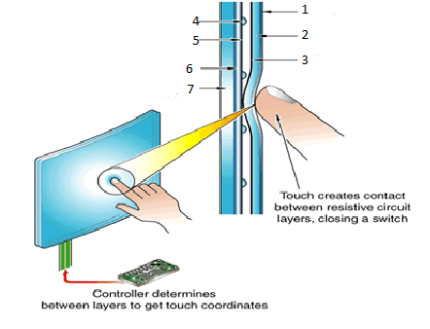Fig 65656
1. PET film
2. Top circuit layer
3. ITO conductive coating
4. Spacer dot
5. ITO conductive coating
6. Bottom Circuit layer
7. Glass or acrylic backing panel

Another type of touch screen is called the capacitive system. Which is a glass panel that has a single overlay that stores electrical charge. When your finger touches the screen electricity is discharged from the overlay and transferred to your finger. Then the decrease in electricity is measured at the exact coordinates where it was touched. In figure 9787 you can see how the touch is processed in a capacitive screen setup. One huge advantage of the capacitive touch screen over the resistive screen would be a clearer picture. A capacitive system transmits about 90 percent of the light from the screen versus the resistive, which only transmits about 75 percent of the light from the screen. But on the other hand the capacitive system is almost twice the price of a resistive touch screen.

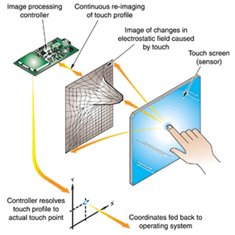
Fig 988

The last touch screen system is known as Surface acoustic wave system. This system works with the use of two transducers, a glass panel, and reflectors. One of the transducers is placed along the x and the other placed along the y-axes of the screen. The reflectors are also placed on the glass. They will reflect the electrical signal produced by the transducers. Now the other transducer will to able to tell if the wave has been distorted by a touch. This set up calls for no metallic layers just the glass panel, which allows 100 percent of light from the screen. Shown below in figure 7878 is a basic representation of the surface acoustic wave touchscreen breakdown. A disadvantage of this system would be the size of the touch. A finger is about the smallest it would be able to read small objects like a pen tip have been proven to not work. Also this system is by far the most expensive out of all the previously mentioned systems by far.

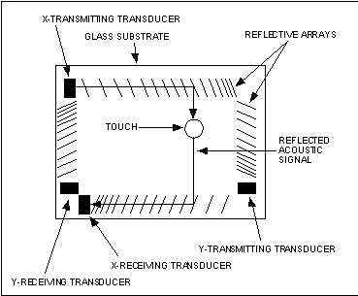
Fig 938983

3.1.2 Motion sensor

In todays market there are multiple types of motions sensors that work in different and similar ways. They are broken down into two categories local and area sensing. Local sensing is the motion sensing referred at a designated location, which includes Visible/infrared light beam, continuous wave, piezoelectric sensors, piezoresistive sensors, piezoelectric sensors. While area sensing is set at a field of view rather than one specific location and includes active/passive infrared, ultrasound motion, footstep detection, microwave Doppler, and video sensing. We researched and narrowed the list of possible useful motion detectors to a few that we felt would work best with our project design.

Active infrared or IR sensors work by producing an invisible light that may contain radar. Then they are able to detect the differences in the radiation within there range. This includes body heat and radar waves. For example this type of motion detector would be perfect for public places controlling the front door movement of opening and closing.

Similarly to active infrared we have Passive Infrared or PIR detectors. Unlike active infrared sensors passive does not emit a beam it works on a combination of heat and infrared sensors. It detects more of a sudden difference in temperature. In figure 2323 it shows the block diagram of the passive infrared sensor. It is definitely the most used detector due to its low power, low cost, and easy maintenance. They are commonly used for burglar alarms and also for detecting if people or animals are in a certain area.

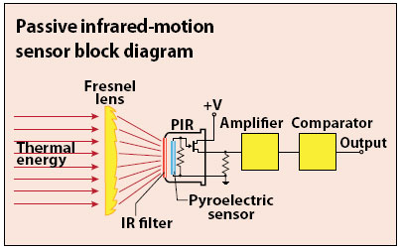
Figure 13232

Next we have Continuous wave radar detector. This type of motion sensor detects motion similarly to a microwave. With the use of electromagnetics waves they transmit frequencies that reflect off the surrounding area. Then it is able to track and report the changes in the frequencies that reflect back. There are also some disadvantages to using the continuous wave radar such as having a reduced range vs. other radars, high chance of interference from other radio signals, and much more expensive. This is most commonly used for tracking speed. In applications such as police traffic radar gun or military radar.

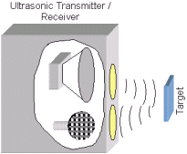
Fig 98

Another type of motion detector is known as ultrasonic. This motion sensor works by gathering sound frequency from surrounding objects. It projects its own sound frequency in an area and detects the disturbances of the frequency that’s produced. As you can see in the figure 98 above the ultra sonic motion sensor produces a sound frequency that bounces off the surrounding area and returns to the sensor. If an object were to come in between this sound frequency it would become disrupted and an alarm would go off. This sensor is great for building and construction applications. Things like checking water levels, detecting leaks, and to tell if sensing parking lots are full are uses of ultrasonic detectors.

The last type of motion detector is a call vibration detector. Created in the 1800s by Jacques and Pierre curie this detector works using piezoelectric, and piezoresistive technology to sense movement. The system relies heavier on piezoelectric technology that creates and electric charge when pressure is applied to a crystal material in the device. This type of motion detecting is extremely useful to engineers it is used on guitars, break in protection, and as a pressure sensor in many touch pads made for mobile phones.

3.2 components

3.2.1 LCD screens

After careful consideration and plenty of LCD research we decided to go with resistive touchscreens. The pros vs. cons ratio definitely out weighed the other choices. We found them to be cheaper then the rest of the competition and also more versatile being able to function using a finger, pen, or any pointed object, which cannot be done with the other choices. It also doesn’t need a specific humidity to operate and can function at any temperature. It can also be used with gloves or any other hand wear. The only disadvantage found was poor visibility in the sunlight but then again we are creating a power strip for indoor use only so it will not cause an issue at all. We have narrowed it down to three different resistive touch screens.

After searching the web for a LCD touchscreen we narrowed it down to three different products. The first is a 3.2-inch ulcd-32pt (GFX) by 4d systems it carries an Active Matrix LCD (TFT) with and embedded PICASO-GFX2 controller, which allows the device to have stood alone function capabilities. The next touchscreen we are considering is the 4.3-inch HDA430-3H by Hantronix. This screen also contains TFT technology, low cost, and high bright optical characteristics to help user use the application in the dark with ease. The last touchscreen is the 3.8-inch DTS408-0380-00, which has analog resistive touch technology and film to glass technology. As seen in Table 343 below it shows the specifications of each individual touch screen.

Touch Screen | DTS408-0380-00 | HAD430-3H | ULCD-32PT
Screen Size | 3.8 inches | 4.2 inches | 3.2 inches
Dimensions | 91 x 72 x 0.95 mm | 105.5 x 67.2 x 3.9 mm | 55.1 × 77.0 × 13.8 mm
View Area | 81 x 63mm | 95.04 x 53.85mm | 47.87 x 63.84mm
Type of resistive screen | 4 wire | 4 wire | 4 wire
Resolution | 280 x 340 TFT screen | 480 x 272 TFT Screen | 240 x 320 QVGA resolution TFT screen
Package mode | Film to glass | Film to glass | Film to glass
Screen treatment | Antiglare | Antiglare | Antiglare
Transparency | 80% | 83% | 82%
Hardness | 3 Mohs | 5 Mohs | 7 Mohs
Connection | FPC | FPC | FPC
Brightness | 500 NIT | 500 NIT |  | 650 NIT

3.2.2 Motion Sensor

The type of motion sensor we decided on was passive infrared sensor. We believed that this one would best fit out design due to its ability to detect infrared light from a distance. The distance is dependent on if the device is properly calibrated or not. This would help because for the AUMD we would like it to have a motion sensor feature that detects if a user is present in the room and have it shut down devices if no user are present for a pre settable amount of time. They are also a lot smaller than the other motion sensors and can pretty much be place anywhere on the device. Another advantage would be that they do not require an external power source due to the fact that they create electricity as they absorb infrared light. One disadvantage that we did find was that passive infrared sensors can only receive infrared light and cannot emit and beams or light. We chose to further research three passive infrared sensors to determine which one would fit out deign perfectly.

We have selected three possible choices for the passive infrared motion sensor for the AUMD. The first is the Panasonic EKMB Standard detection type, which has a range up to five meters and is super low power. The next is the Parallax PIR sensor his has a great feature which allows you to set the sensitivity of the sensor to either short range which is zero to fifth teen feet or long range which is anywhere from fifth teen to about thirty feet. The last motion sensor we research is the Hanse SE-10 after power up its active after 1-2 seconds it takes a picture of the room and senses even the smallest of movements. Taking a look at table 9898 you can see the different specifications of the three passive infrared motion sensors we have considered for our design.

Motion Sensor | Hanse SE-10 | EKMB(standard detection type) | Parallax PIR sensor
Sensor type | Dual Element | Dual Element | Dual Element
Noise | Typ-20uVp-p | N/A | N/A
Operating voltage | 12V | 3.3-5 V | 3.3-5 V
Operating Temperature | -10 - 40 degrees C | -20 – 60 Degrees C | 0 – 50 degrees C
Storage Temperature | -40 – 80 degrees C | -20 – 70 degrees C | -10 – 60 degrees C
Range | 14 mm | 5 meters | 30 ft.
Dimensions | 30.6 x 35.4 x 20.3 mm | .748 x .433 x .374 in | 1.21 x 1.0 x 0.8 in

4 Designs
4.1 Hardware
4.1.1 LCD

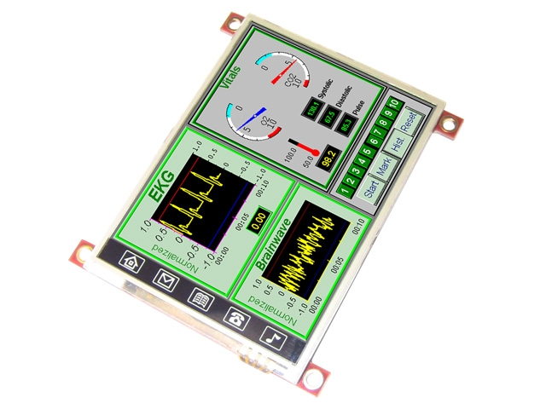
Fig98

For our project we chose to go with the uLCD-32pt (GFX) touch screen. We found that this one would be best for our project. As seen in the figure above this display has high graphic and brightness capabilities a perfect component to be used in the dark if necessary. This screen is a low-cost screen with a diagonal diameter of about 3.2 inches. It boasts a resolution of 240x320 QVGA and RGB 65k true to life colors. It is a 4-wire resistive touch screen.

The 4D-labs PICASO-GFX2 processor also powers this touch panel. Which has a total of 15k bytes of flash memory used for user input and code storage for programming the touch panel. The touch screen also comes with an extensive graphics and system library functions to better help the user program. Another great function of this board is the on-board audio amplifier with a tiny speaker. This can be used to add sounds to further enhance the touch screen user experience.

The screens quick response time and visual display seemed to be perfect for our application. We will be using this screen to change features, view options, and show an estimation of the total power used and the cost in dollars. This screen will also communicate with the microcontroller to activate or deactivate these features such as Master/slave mode, Motion sensing, and or estimated power and cost modes.

4.1.2 Motion sensor
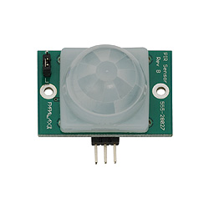
Fig 9898

For the passive infrared motion sensor we decided to select the Parallax PIR Sensor (Rev B). Seen above in the figure is an image of the sensor we felt that because of the low voltage draw and its high range of visibility it would work best with our design. The voltage in take of this device can be any where from three to six VDC. This device also carries a jumper to be set to either standard mode which detects up to thirty feet or in reduced sensitivity mode which changes the range to about fifth teen feet away. The sensor has a sight of about forty-seven degrees from the top to the base.

This sensor also contains an LED light for quick visual response to acknowledge if motion has been detected in its range. Another factor was the size of the device. We sought to minimize the motion sensor to entail more space for other larger components such as the Bluetooth mate, and the LCD screen display. This motion sensor also offers a high range of compatibility being able to interface easily with practically any microcontroller in the world.

The passive infrared motion detector main purpose is to decipher weather a user has entered the room left the room or remains in the room. When the user enters the room the motion controller will send a signal to the microcontroller to wake the touchscreen display. When a user has left the room for a period of time, which can be set by the user the motion controller, will send signals to turn down all devices in use. The passive infrared sensor will constantly search to ensure that when the user is in the room no device are shut down un willingly to prevent error or undesired out come.

4.2 Software
4.2.1 touch screen programming

For our project we will be required to set up a menu type screen to be shown and operated on our touch screen LCD. The menu will consist of a main Home Screen and four feature modes, which will be toggled on the bottom corners of the screen with two arrow keys. The home screen will show the current date, time, and list the four different modes giving the user to go straight to the desired mode without having the toggle thru to the desired mode to save time. The home screen will also allow for the user to input a customized message in there home screen for example a to do list or a reminder to get something done would be great uses for this feature. Shown below in figure 98 is a block diagram of the home screen and its functionality.

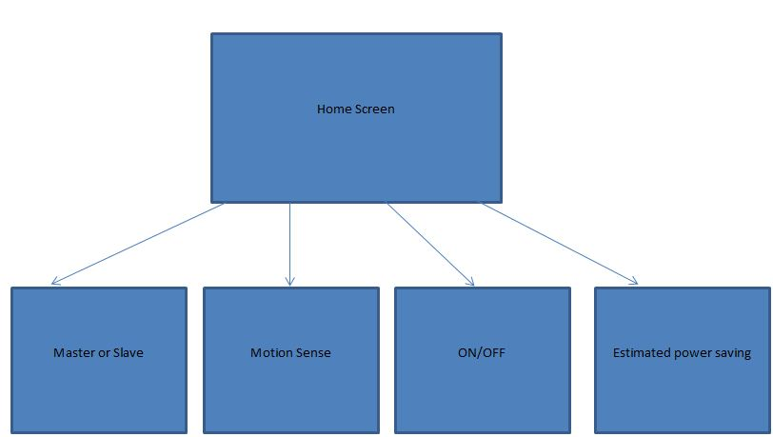
Fig 878

There will be four modes available on this device for user customization. They are Master/Slave mode, Motion Sense, On/off, and Estimated power savings. Each having there own specific function.

The first mode is known as Master/slave. In this mode the user can select out lets to be set as either master or slave. What will happen is when a device is selected as master when it is turned off or in stand by mode it will cut power to all devices selected to be in slave mode. For example say we have a Computer, Monitor, and a printer. We would set the computer to master mode and the other two peripherals to slave mode. When the computer has entered sleep mode or turned off this will cut the power of the other two devices in slave mode practically eliminated the stand by power consumption of the monitor and printer. As seen in the block diagram below is the set up of how the Master/Slave mode will operate. We will first select the mode and one this screen it will shows all three outlets and below the outlets it will display weather the outlet has been set to master slave or off.
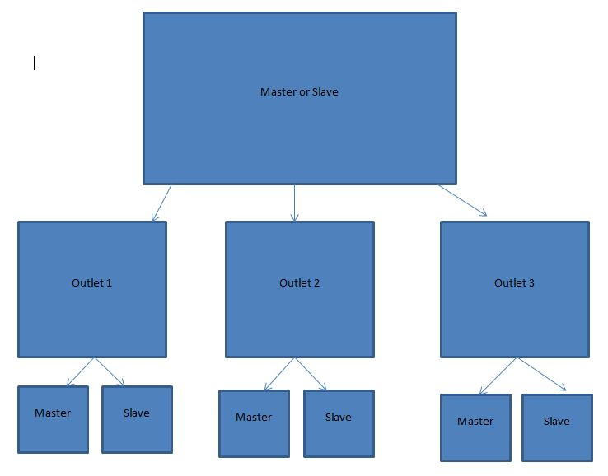
figure 898

The next mode is known as motion sense. We wanted to give the user full capabilities of this mode. This mode will allow user to do a few things first say you walk into the living room and the only reason you go there is to watch television. The AUMD will allow you to select this device to automatically be turned on when a user has entered the room and their presence has been sensed by the passive infrared motion sensor. It will also allow you to do the complete opposite if you left the room for a certain amount of time in which you could set this mode to turn off the device when you leave the room for an extended amount of time. As seen below in figure 98 the Motion sensor menu much like the master/slave will display all three outlets. Below the outlets it will display either on, off, or motion sense off. On will allow device to turn on when motion has been sensed. Off will let the user to set a time when they would like their device to be turned off when no presence has been detected. Lastly motion sense off will do neither unplaying the sensor to the outlet or outlets.

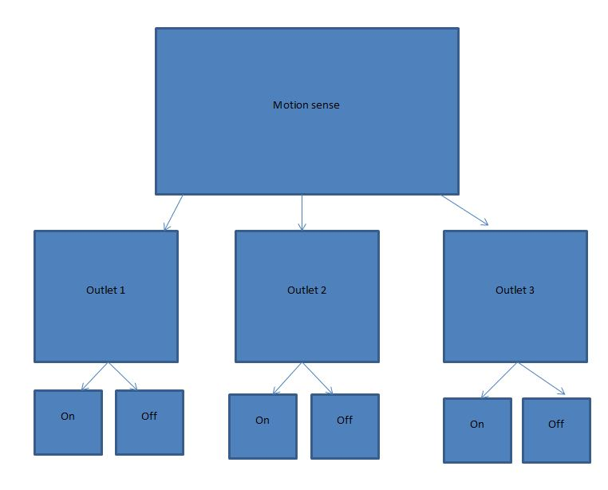
Figure 9898

The following mode is known as ON/OFF mode. This mode probably the simplest out of the others. This mode will allow the users to have a device remain on or in stand by mode. It also will allow the user to select the out let to be off as in completely off (unplugged) allowing for no stand by energy to be used. This is good for some device which it is unsafe and can damage your equipment going from standby mode to completely off such as your desktop or laptop computer
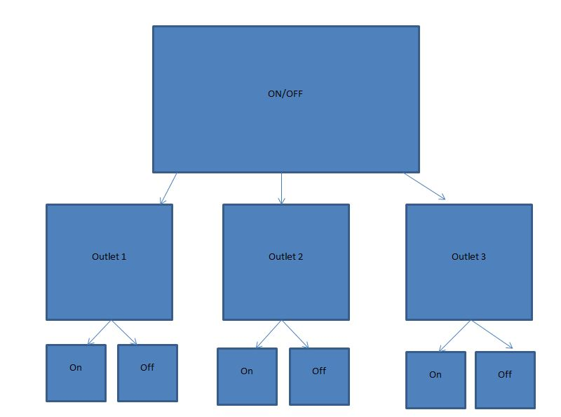
Figure

The last and final mode of our AUMD device is called Estimated cost and power used. In this would it will display to the user the amount of power in volts that each out let has consumed on a monthly basis. This will give the user an Idea of how much money they are saving every month when using the AUMD device in comparison to the standard household outlet or power strip. The amount in volts will then be converted and calculated to a dollar amount showing exactly how much money it will cost to operate certain device on a monthly basis. This is great to give the user the ability to test products both energy efficient and not and see how they can have a serious Impact on your monthly electric bill. We felt that this was considerable the most important mode give the user actual proof that the AUMD will save you money and overall after time be able to compensate for it self.
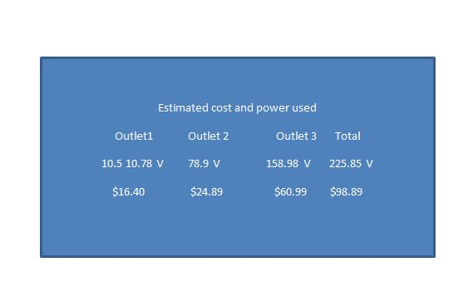
5 testing
5.1 LCD

The main brain to our AUMD is the LCD displaying information and allow the user to input give total control to the touchscreen making it one of the most significant component on our device we will now give a test plan of the Touch screen LCD
-Connect to microcontroller
-Connect to power supply
-Turn on screen
-Program the LCD
-Test touch screen
-Apply
-

5.2 motion sensor

A key component in the AUMD is the passive infrared motion sensor. It will be used to detect weather a user has entered a room, left a room, or remains in the room. We will now show how we will test this device
-Program microcontroller
-Connect to PCB
-Connect to microcontroller
-Power up motion controller
-Calibrate motion sensor
-Place motion sensor properly on AUMD
-Using LED status light determines weather the sensor is working or not.
5.3 menu testing
A menu program will be developed and then programed on the LCD display touchscreen for used on the AUMD. This menu will allow users to select different features and functionality of the AUMD device such as motion sensing, master/slave, or Estimated power savings. This is a test plan for the menu

--Home screen
The home screen give a quick overview showing the user useful information such as the time and date and also allow for a programmable message to be displayed in the home screen

-Check date
-Check time
-Use toggle arrow buttons on bottom corners
-Use home button located between toggle arrows
-Input customize message to be displayed on home screen
-Show that the customized message is been displayed on home menu

--Master/Slave mode
This mode will allow user to select either Master or Slave for each outlet. Then depending on the master device the slave devices will remain on if master is on and turn off when the master device has been powered down.

-Toggle from home menu to master/slave mode
-Set out let one to master
-Set other outlets to slave
-Plug in devices
-Turn on all devices
-Turn off device plugged into outlet one
-Other devices should shortly follow automatically
-Retest using outlet two as master and others as slave
-Retest using outlet three as master and others as slave
-For all test similar results should occur

--Motion sense mode
In this mode it will allow the user to select either on, off, or motion off for each outlet. If an outlet is set to on when motion is detected the device will turn on and remain on unless turned off by the user. When the outlet is set to off a desired off time is entered then after the period of time it turns the device off as long as no motion is detected. Motion off will give the motion sensor no authority over the outlet.
-Toggle from home menu to motion sense mode
-Set outlet one to on
-Plug in device to outlet one
-Exit room for two minutes
-Enter room
-Device one should turn on
-Set outlet one to off
-Set desired time before shut down
-Turn on device on
-Leave for more than desired time
-Upon retiring the device should be shut down
-Retest all steps using outlet two
-Retest all steps using outlet three
- Verify all results are similar

--ON OFF mode
-Toggle from home menu to on off mode
-Set outlet one to off
-Verify device in outlet one cannot turn on
-Set outlet on to on
-Plug device into outlet one
-Verify device in outlet can turn on
-Verify when device in outlet one is turned off it remains in stand by mode
-Retest using only outlet two
-Retest using only outlet three

--Estimated cost and power used
-Toggle from home menu to Estimated cost and power used mode
-Plug in device to outlet one
-Turn on device
-Observe the estimated cost and power used mode
-Outlet one power used should be constantly going up
-With the increase in voltage the dollar amount should rise as well
-Verify result is accurate based on device and amount of time plugged in
-Retest using only outlet two
-Retest using only outlet three

6 relevant technologies (if pages permit)

There are many relevant and similar technologies to our project design some commercial items include products such as the

