The Boy Scouts of America Track Detection System

Mohammad Rehawi, Rodney Brewer, Michael Reyes, Julia Williams

University of Central Florida, Department of Computer Science and Electrical Engineering, Orlando, Florida 32816

ABSTRACT — The Boy Scouts of America Track Detection System is a distributed system of sensing, control, and display. Each subsystem is considered a client, and while its operation is controlled from the host controller they act as an autonomous system entity. The host controller, herein called the host computer, will orchestrate the overall progression and sequencing of a race or user initiated actions such as calibration and system test. The Track Detection System is comprised of five sub-components: the Starting Gate Assembly, the Sensor System, the Communication System, and the Finish Gate Assembly. The host computer along with the main microcontroller will acquire all subsystem handles, configure the messaging communication protocol and coordinate all operations from the beginning to the end of the competition.
Index Terms— Sensor Systems, Wireless Communication, Servo Motors, Displays, Computer Interface, Power Supplies

I. INTRODUCTION

In 1953, Cub Master Don Murphy held the first Pinewood Derby racing event for the Boy Scouts of America. The Pinewood Race is a manually operated race from start to finish. This project integrates key features of a typical pinewood derby race in addition to top and final speed detection, track position, wireless communications, led display, and remote operations. The primary motivation for this project is to design, develop, and implement an automated functional and deliverable track detection system. This system, known as, the Track Detection System 2013 and will be delivered to Cub Scouts Pack 497, and may be duplicated for additional packs. This project should also benefit the Cub Scouts by introducing youngsters to the physical and natural sciences.
Pack 497 own a 50ft long track made out of aluminum. The project’s components will be distributed on the track to make it fully automated. The figures below show the track dimensions and a diagram to show where each component is located.

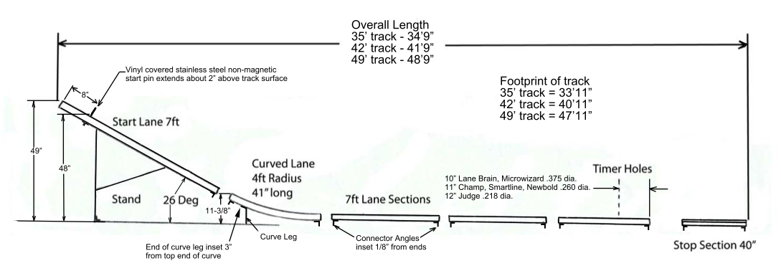
Figure 1 Track Sketch
Figure 2 Detection System Overview

II. design overview

The overall operation of the system is best described sequentially. At the intended beginning of the race, the host computer sends a “start” transmission. The finish gate main microprocessor will respond by clearing all prior race information out of memory, initiating the poll tree lights, resetting the final velocity sensor, sending a “start” message and sending a reset command to the display processor that will set the place standing and velocity displays to a blank state. As the race progresses, the position/speed sensor system will collect its’ data and transmit it to the main microcontroller where it will hold the data until all race data is collected. At this point, the data received from the position/speed system is stored and the final velocity sensor is armed. As soon as the final velocity is calculated and stored, the data is sent out to the display processor. Then all the race data will be routed to the appropriate lane displays by the display processor. The previous discussion is best described pictorially as shown below.

III. Detailed Design
This detail design section of the detection system will follow the order in which each item takes place and will be discussed from the main microcontroller point of view.
Since all operations are originated from the main microcontroller, it should be assumed that this controller permits and regulates all the operations discussed in the following sub-sections.

The starting gate is responsible for the initiation of the race that will be achieved using Servo Motors. The sensors will gather a variety of data that will be used by other components. The finish gate will display most of the data gathered during the race using interactive lighting and display systems. The communication consists of a computer controlled software program that transmits and receives information from and to different points on the track using Bluetooth wireless communication and microcontrollers.

IV. POLL TREE LIGHT

There is more than one design to implement the poll tree light into the track’s system. The concept that is used in this system is by having an LED driver to control the LEDs. Texas Instruments has the TLC59281 that requires SPI bus from a processor. This LED driver doesn’t require any resistors to be connected in series with the LED lights. The only resistor needed if the reference resistor which has its own pin in the LED driver. In addition, unlike some components, i.e CD4049, this LED driver can handle up to 40mA per pin. This means that each pin can handle 2 LEDs without heating up the chip. Since the TLC59281 is SPI enabled, almost every lighting sequence needed can be implemented. The only disadvantage in using the LED driver in the schematic is the LED driver not supporting a chip select, meaning MSSP1 of the main processor will only be connected to the poll tree light.

V. STARTING GATE

The original track utilized mechanical system which begins each race. The mechanical system used a latch, lock, and spring assembly to retract the starting block of each lane simultaneously. This system was replaced by a fully automated system which makes use of a servo controller latch mechanism and is directly connected to the lane starting blocks. Since the starting gate will only include the servomotors, a small footprint processor with an internal oscillator will be used to keep the assembly small. The PIC12F683 is an 8-pin microprocessor with an internal oscillator and has the added capability of generating the required PWM pulse needed to drive the servo. The standard servo PWM signal consists of a 1ms to 2mspulse which will actuate the spindle as needed to open and close the starting blocks of each lane.

The following formula was used to generate the PWM pulse period needed:

$$PWM Period=\left(PR2+1\right)*4*T_{osc}*(TMR2 Prescale Value)$$
(1)

The internal oscillator generates an 8 MHz clock signal, and the register limitations required the internal frequency to be divided down so that the standard PWM period is 20ms or 50 Hz. The selected frequency,
500 KHz, provides a steady and clean PWM signal, while providing an accuracy of 98.2%. This small error will not cause an adverse condition to occur in the starting gate mechanics.

Since the PWM period which is needed for this project is 20ms. The internal oscillator of the microprocessor will be set to 500 KHz, which means that the oscillator period is:

$$T_{osc}=\frac{1}{f}=\frac{1}{500KHz}=2 μs$$
(2)

The pre-scale value for the timer 2 module was set to 16. Solving for equation (1) gives the (PR2+1) equal to 156 clock counts. To be able to calculate the PWM Pulse Width, equation 3 is used, where Register Value, is the value required to obtain the desired active high pulse width times:

$$Pulse Width=T_{osc}*TMR2 Prescale Value*Register Value$$
(3)

The pulse widths needed for the servomotors are 1ms and 2ms. Solving equation 3using the required pulse widths of 1ms and 2ms, the Register Value from equation 3 gives us the minimum Register Values of 32 counts and 63 counts. Using equation 4 and the results from equation 3, the duty cycle can be calculated:

$$Duty Cycle=\frac{Register Value}{4*(PR2+1)}$$
(4)

VI. FINISH GATE

The finish gate main board will include all major components needed for the system. A PIC processor, PIC18F87J11, is designated as the main processor. This MCU was chosen upon the need of an excessive amount of I/O pins. The main MCU is connected to all other processors and components of the system. Features of the PIC18F87J11 are shown in the table below.

Feature | #
SPI | 2
UARTS | 2
I/O Pins | 68
Table 1 MCU Features
A voltage regulator, LT1963ES8, is included in the circuitry of the main board to translate the input voltage from 5 V to 3.3 V, which is the operating voltage of the PIC18F87J11.

The RN-41 was added on the same board of the main finish gate board. This Bluetooth chip dongle required the RS 232 chip to translate the transmitted and received data from low to high to the RN-41 dongle. Both the RN-41 and the RS 232 use the regulated voltage from the LT1963ES8.

To be able to read all sixteen-position sensors data into the main processor, a port expander is used. Speed sensors, display, and position sensors will share the same SPI output, MSSP2, of the main processor. The chip selects are generated using a 4 to 16 selector with inverted logic.

The Finish Gate Housing will be constructed of clear acrylic panels with the dimensions of 12” x 24” x 4½”. It will house the finish gate sensor curtain arrays as well as the main processor and communications board, a SPI interfaced poll tree light assembly, and a SPI interfaced main display board on both sides of the finish gate. The original design called for an elaborate school inspired paint job, but it was decided that making it clear and exposing the circuits and construction would help inspire scouts whom will be receiving the final project.

Figure 3 Finish Gate Housing
VII. FINISH GATE DISPLAY
The display section of the track detection system shows the place standings, the maximum and average speeds (in centimeters per second) and the elapsed time of the race for each lane’s car. It also illuminates a chasing light display in the winner’s lane. This is done by accepting a train of data at the races end from the finish gate processor through the SPI bus. Here, the display processor acts as the slave to this operation. Once the data transmission is complete, this microcontroller’s operation is solely a data router and sends the final display data to the appropriate outputs. Conversely, the processor acts as the master to the display drivers through the second SPI bus on the PIC to route the place and speed data. The design also includes discrete lines that enact the winner’s lane chasing lights.
Microchip’s PIC24F series processor was chosen for this task mainly because it was inexpensive and it has 2 SPI buses. Other good points about this chip are that it is a 16 bit microcontroller, it employs ultra-low power management modes and most instructions are completed in one clock cycle. Additionally, the chip is a good one to get acquainted with since the dsPICs use the same instruction set and it is a relatively new line of cost effective MCU’s.
The display drivers selected are Maxim’s MAX6951 chip. This is an eight-digit common-cathode LED display driver controlled through the aforementioned SPI interface. This device uses a multiplexing technique to reduce connections between an LED driver and the LED. This serves the project’s purpose perfectly since there are 24 seven-segment displays to drive. A reduction from 24 to only three display drivers saved pc board real estate and processor outputs.
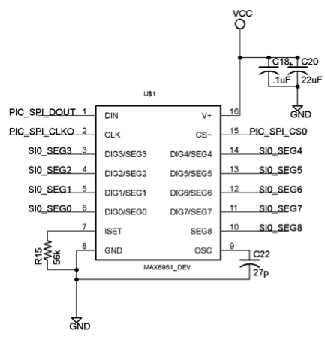
Figure 4 Serially Interfaced LED Driver
The chasing light display is simply a 10 output Johnson counter with the clock input being a 555 timer set to 4Hz. The D0 LED is green and all lanes have this light illuminated after start up and reset, and when the winner is determined, the enable line of that counter is held low and the ten red lights, arranged in a circle highlight the winning lane.
The display processor software is basically an information router. The speed, place and time of the race are calculated in the finish gate processor, however; an overview of how this software is organized is worth mentioning here. Figure 4 shows the block diagram of the data flow, notice that the information gets stored in its’ respective place until all the race information is received and then it is sent to the LED displays.
VIII. SENSORS
A. Track Position Sensors
The Track Position Sensor System uses a reflective paired infrared emitter and detector transistor for determining the racecars relative position along the track. These sensors are small and able to determine with a high degree of accuracy when the racecar is passing by. The position sensors are placed equal distances down each lane and relay the information down the track to the main microcontroller a PIC16F87J11. The output voltages of the photo-detectors are not directly connected to the main microcontroller. Instead, the output voltages are passed through a comparator with a pre-set voltage reference. The output of the comparator is inputted into a flip-flop. A port expander reads the output of each of the sixteen position sensor flip-flops. The main microcontroller then communicates with the port expander using SPI. A reset from the main microcontroller clears all the flip-flops and prepares the position sensors for the next race.
B. Speed Sensors
The Speed Detection System utilizes two infrared emitting diodes along with two infrared detector transistors. Since the direction of travel is defined each speed sensor determines the instantaneous velocity of a passing racer. The two detectors are placed at a predefined distance. The microcontroller responsible for the speed calculations a PIC16F88 takes the time in between the two voltage drops made by the photo-detectors. The speed is transmitted to the main microcontroller using SPI. After the system has completed its velocity calculation it automatically resets itself to the original power up state and waits for the next racer to trigger the process again. The figure below describes the speed sensors pictorially:
Figure 5 Speed Sensors' Block Diagram
The PIC16F88 has an 8 MHz internal oscillator, which is divided down using the internal pre-scalar to approximately 1MHz. This down conversion allows for a resolution of 1µs and a total elapsed time of 65.5ms before a timer 2 overflow interrupt will occur. With a predefined distance of 2cm between the two paired IR emitters and receivers the instantaneous velocity can be calculated by the following equation:
$$Velocity= \frac{∆d}{∆t}=\frac{n}{T_{OSC}∙cnts}∙\frac{cm}{sec}=\frac{f_{OSC}∙n}{cnts}∙\frac{cm}{sec}$$
(5)
$$T_{OSC}=\frac{1}{f_{OSC}}=\frac{1}{1MHz}=1μs$$
(6)
$$0 ≤cnts ≤65,535 (no overflow)$$
The Speed Sensor processor will calculate and store the velocity in RAM until the main processor sends a sequential request to each of the eight speed sensor. The Speed Sensors will respond to the main controller request by activating its SPI communication bus and transmitting the calculated velocity. After the data is transferred the Speed Senor will automatically clear and reset its latches in preparation for the next velocity calculation.
C. Finish Gate Sensors
The Finish Gate Sensor Assembly consists of an infrared emitting diode located above the track in the Finish Gate Assembly housing. Located at the track base are three infrared phototransistors. The three photo-detectors are aligned and spaced evenly. The purpose of using three photo-detectors is to create an infrared curtain at the finish gate this way if any part of the racecar crosses the finish gate it will be detected. Each of the photo-detectors is connected to comparators and then flip-flops. All three flip-flops for each lane are logically OR-ed together so that if any of the three photo-detectors are covered then the car has finished the race. The output of each of the four gates is connected to the main microcontroller. A reset from the microcontroller sets up the next race.
D. Calibration
If the receiver is placed in direct line of sight with ambient light then it may be interfered with by the small amounts of ambient IR waves. For this reason the detectors have calibration circuits installed to account for ambient IR waves and to provide more accurate data acquisition from the sensors. The calibration system is only used on the finish gate sensors since those sensors are the only ones critical for race outcome. Sensor calibration happens at startup and may be manually executed from the host computer. The calibration for the finish gates circuits is achieved by changing the reference voltage to the comparators to either require a greater or smaller voltage drop when the cars cross the finish gate. The calibration system consists of its own main microcontroller part number PIC16F88, a sixteen channel ADC and two eight channel DAC. First the ADC will scan through and transmit to the microcontroller all the voltages received by the photo-detectors with the emitters on. The microcontroller determines a voltage that is 80% less for each of the detectors. The calculated voltage is outputted by the DAC to the comparator as the new voltage reference. All the communication between the microcontroller, DAC, and ADC is done using SPI. If the calibration is manually initiated then a completion signal is sent to the main microcontroller to inform that the next race may begin.
IX. COMMUNICATION

The communication consists of a computer controlled software program that transmits and receives information from and to different points on the track using Bluetooth wireless communication and RS-232 serial port to all microcontrollers. The initial approach was using a system on a chip made by Texas Instruments, the CC2540. Problems arose when then programming stage began due to the code size restriction of the IAR free version IDE. The free version of the programmer would only program 4K words, while the licensed version, that costs $3500, can take up to 265K words. The backup approach was to use the RN-41 Bluetooth chip dongle. The dongle is used to communicate from the computer’s main application to the finish gate main board on the track. This would make the communication between the track and the main application wirelessly.
To be able to communicate with all other components of the track, RS-232 is used. Ribbon connectors will be used to send and receive data from the main processor/board in the finish gate to all components on the track including the starting gate, and all sensors.

X. MAIN APPLICATION

For this project it was decided to use a standard windows based personal computer as the master controller. This was primarily due to the complex nature of Bluetooth and the supporting communication, which would be hard to debug on a standalone master controller. We are using C# and the Microsoft Visual Studios 2012 Ultimate Edition IDE to design and program our application software. The Main controller has four features or functions that will be described in detail. The first of which is the main application software. It is composed of a windows form, which has a graphical depiction of each track/lane. Each of the four lanes has 4 position sensor locations that are shown as simple radio buttons. These indicators will show when a racer passes the specified point along the track. There is also two speed sensors located at the beginning and the end of each track/lane. The speed sensors will determine the racers instantaneous velocity and be reported the main controller. The application will receive this information and display it in the appropriate location on the screen. Below is a visual representation of the Windows based application.
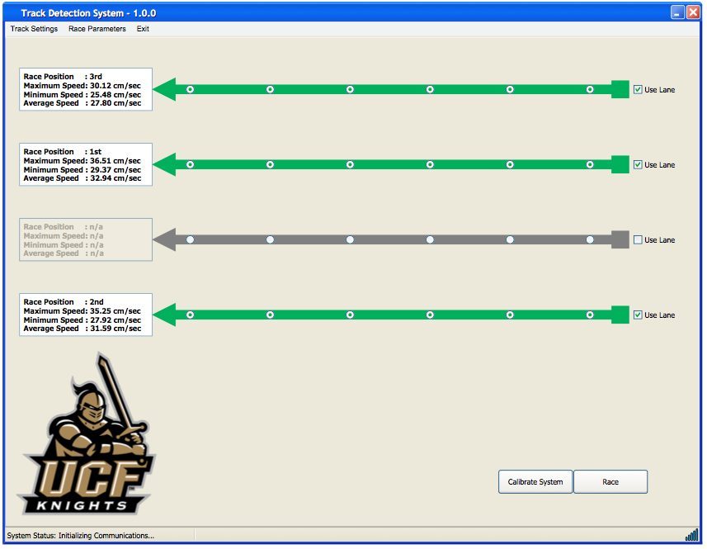
Figure 6 Main Application Screen Shot
XI. SOFTWARE OVERVIEW

- Starting Gate Software
Figure 7 Starting Gate Software Block Diagram
B. Speed Sensor Software
Figure 8 Speed Sensor Software Block Diagram
C. Finish Gate Sensor Software

Figure 9 Finish Gate Sensor Software Block Diagram

D. Display Software

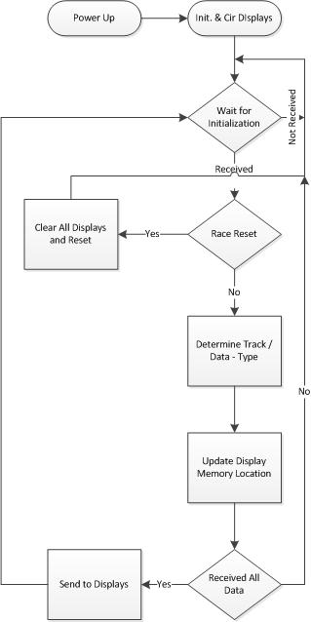
Figure 10 Display Software Block Diagram

XII. CONCLUSION

The Boy Scouts current pinewood derby track system is manually operated and lacks any electronic assistance in determining ranking of each lane. This project added many features that either enhanced or automated the race process. Some of the electronic features included were a lighted display system, sensors, and an automated starting gate. The design challenges inherent to this project were the finish gate assembly and the sensors. Several designs were discussed in to ensure that all assemblies did not violate the project requirements. The final system will be delivered to the Boy Scouts for use in their pack races and events.

The Engineers



Mohammad Rehawi will receive his Bachelors of Science in Electrical Engineering in May of 2013. He is 23 years of age and is a resident in Port Orange Fl, where he received his Associates Degree from Daytona State Collage. Mohammad is originally from Amman, Jordan, he traveled to the United States in 2006.He has been attending UCF since 2010. He participated in a company called Creative Fiber Optics during the summer 2012.



Michael Reyes will receive his Bachelors of Science in Electrical Engineering in May of 2013. He has 22 years of age and is from Miami, Florida. He has been involved in club projects such as AIAA Turbine Engine Project and has participated in internships in companies such as JBT Aerotech.



Rodney Brewer earned his first two Bachelor Degrees in Mathematics and Computer Science in 2006. He is currently working on his third bachelor degree in Electrical Engineering. He is employed by Rockwell Collins as a Design and Test Engineer. Rodney is planning to continue his studies and obtain a Masters degree in RF and Antenna Design. Rodney has been actively employed in the test and engineering field for the past ten years.



Julia Williams will receive her Bachelors of Science in Electrical Engineering in May of 2013. She is from Cape Canaveral Florida and has 18 years of experience in the manufacturing industry, 15 of which she was an Electronics Technician in an avionics design department. Her career interests are the HW/SW design of test systems for performance testing. She is happy to announce that she has accepted a position at Harris Corporation as a Test Engineer beginning in mid-April.

Acknowledgement
The authors wish to acknowledge and thank their respective families for their continuous support.

References
[1] James W. Nilsson, “Electric Circuits”, 7th ed. Pearson Education Incorporated, 2005.
[2] All About Circuits. User-posted content, Creative Commons Public Domain License. Copyright 2000-2012 http://forum.allaboutcircuits.com/showthread.php

