Persistence of Vision Bicycle
Group 29

Nancy Zanaty
Matthew Egan
Gian Thomas
Sean Schindzielorz

Project Narrative:
This project is the designing and building of a persistence-of-vision display on a bicycle. Persistence of vision (POV) describes the human eye’s ability to retain an image for fractions of a second after the image is presented. In the context of this project, POV will be relied on to produce clear LED displays on the wheels of a bicycle.
Over the wheels, the bike will be equipped with a set of spokes/blades. The spokes would effectively be PCBs with embedded LEDs. A motor will be connected to the spoke which will provide rotation. This motor rotation will be superimposed onto that of the wheel’s rotation. The spokes will be connected to a micro controller; the micro controller will provide the right timing of the LEDS to produce the desired image. An RPM sensor on the rim of the bike will detect the bicycle’s speed; this is done to maintain a constant rotational velocity on the POV display. The motor’s applied rotation will be used as a regulator, to maintain a constant rotational velocity to the spokes. This allows the POV display to always have a clear image, even if the wheel is stationary, or if the bicycle is not moving at a sufficient velocity. Additionally if the wheel have reached a RPM which can allow for an active image to be displayed the motor would just shut off saving power.
The use of the POV on the bicycle was geared towards advertisers. The images displayed on the POV could be programmed into the micro controller or be uploaded from anywhere via a GSM card that would also be installed in the bicycle. The main idea behind this was that advertisers could upload any image they wanted to the bicycles in real time.

Project Specifications:
- The finished design should weigh no more than 10 pounds.
- The display should be able to run continuously for at least 4 hours.
- The display should have a refresh rate of at least 30 frames per second.
- The bike should be equipped with GSM modem operating on the following frequencies: EGSM 900 MHz, DCS 1800 MHz and PCS1900 MHz
- The display should be able to display images up to 256 radial pixels.

Hardware Block Diagram:
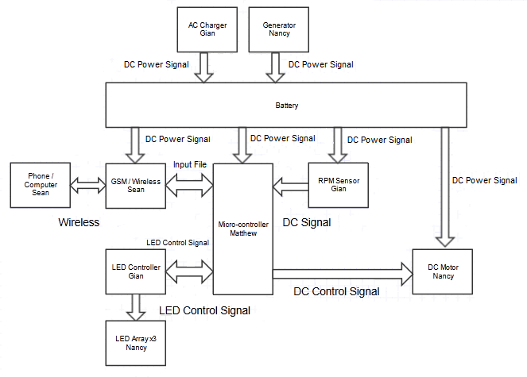

Software Block Diagram:
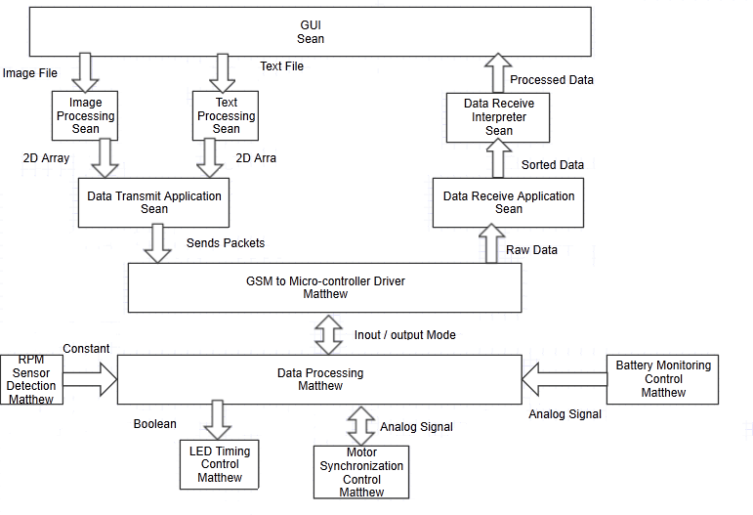

Project Budget:
Our project is expected to cost more than $600 and less than $1000.00. The next paragraph will describe a little bit about each part and how it related to the project. The LED's: This is the core of our project, without the LED's we would have no affordable way to show the effects of persistence of vision.
A small battery will be used to power the LED setup.
To control the LED's we will use LED controllers. A LED controller will abstract some information about the LED as to make programming easier.
The Power Supply is a necessary component for pretty much any project any group may work on. It is possible the power supply could be designed from scratch, but it is listed here in the parts as to get an accurate upper end of our budget.
The bike is project specific, persistence of vision can be done in many ways, and we intend to use a bicycle to show its effects. We intend to use both wheels to enhance the effects of POV.
The PCB boards are where all of our electronics will be, and will provide the appropriate connections to all those electronics.
The motor will be used in conjunction with the RPM sensor to allow the POV display to spin regardless of the bike's speed.
Additionally a GSM module will be used on the bike to allow remote data uploads to the display.

Item | Quantity | Cost (each $) | Cost (total $)
LEDs | x100 | 00.15 | 15
LED Controllers | x5 | 05.00 | 25
Power Supply | x1 | 70.00 | 70
Bike | x1 | 00.00 | 0
Micro-controller | x1 | 50.00 | 50
PCB Board | x1 | 200.00 | 200
Motor | x1 | 100.00 | 100
Bike RPM Sensor | X1 | 40.00 | 40
GSM Module | x1 | 30.00 | 30
Flywheels | x2 | 15.00 | 30
Battery | X1 | 40.00 | 40
 |  | Total: | 600

