5/2/2016
Kyle Ferriss, Daniel Camargo, Benjamin Atsu, Jonathan Obah
University of Central Florida
SPIDRONE
EEL4915 Senior Design II Group 2

Table of Contents
1.0 Executive Summary 1
2.0 Project Description 2
2.1 Project Motivation, Objectives, and Goals 2
2.2 Requirement Specifications 3
2.2.1 Power Specifications 3
3.0 Research Related to Project Definition 5
3.1 Existing similar Projects and Products 5
3.1.1 Existing Auto-Follow Drone projects 5
3.1.2 Existing Wireless Charging Technology 7
3.2 Relevant Technologies 9
3.2.1 Wireless Communication 9
3.2.2 Flight Controller 14
3.2.3 Infrared Distance Sensor 22
3.2.4 Radio Frequency Communications 22
3.2.5 Optical Recognition 24
3.2.6 Wireless Power Transfer (WPT) 27
3.2.7 DC/DC Converters 32
3.2.8 Lithium Polymer Battery Low Voltage Indication 41
3.3 Possible Architectures and Related Diagrams 44
3.3.1 QuadCopter 44
3.3.2 Diagrams 47
4.0 Related Standards 51
4.1 Drone Standards 51
4.2 Global Positioning System (GPS) Standards 52
4.2.1 The GPS Standard Positioning Service (SPS) 52
5.0 Realistic Design Constraints 56
5.1 Economic and Time Constraints 56
5.2 Environmental, Social, and Political Constraints 56
5.2.1 Health Constraints of the WPT 57
5.3 Ethical, Health, and Safety Constraints 58
5.4 Manufacturability and Sustainability Constraints 59
6.0 Project Hardware and Software Design Details 61
6.1 Initial Design Architectures and Related Diagrams 61
6.2. Charging subsystem 63
6.2.1 Design of Wireless charging Station 65
6.2.2 Wireless Transmitter (LTC4125) 66
6.2.3 Wireless Receiver and 400mA Buck Battery Charger (LTC4120) 69
6.2.4 Proposed Wireless charging Application 77
6.3 Auto Landing Subsystem 77
6.4 Tracking Subsystem 78
6.5 Application Program Interface (API) 81
7.0 Project Prototype Construction and Coding 83
7.1 Parts Acquisition and BOM 83
7.1.1 Parts Acquisition for Wireless Transmitter and Receiver 84
7.2 Software 87
7.2.1 Auto Landing Coding Plan 87
7.2.2 Tracking Coding Plan 89
7.3 Hardware 93
7.3.1 Infrared Sensors 93
7.3.2 Global Positioning System (GPS) Sensors 94
7.3.3 SOLAR PANELS 96
7.4 PCB Vendor and Assembly 100
7.4.1 Printed Circuit Board Vendor and Assembly for DC-DC Converter 100
7.5 Final Coding Plan 101
7.5.1 API Coding Plan 102
8.0 Project Prototype Testing 104
8.1 Hardware Testing 104
8.1.1 Wireless Charging Test 107
8.2 Software Testing 108
8.2.1 Precision Landing Testing 109
8.2.2 Tracking Mission Testing 110
9.0 Administrative Content 112
9.1 Milestones Discussion and Project Planning 112
9.2 Budget and Finance Discussion 119
9.2 Sponsors 120
10.0 Conclusion 122
Appendix A - References 123
Appendix B - Copyright Permission 129
Appendix C - List of Tables 134
Appendix D – Figures and Diagrams 136

1.0 Executive Summary

The intent of this design project is to enable us to showcase and expand the skills acquired throughout our academic career. The task is to plan, manage, research, test, design, build, document and report on a University of Central Florida Department of Engineering approved project.

We chose to construct a drone from a mutual interest in drones. We then discussed new upcoming technologies that is getting incorporated in everyday lives such as wireless charging of cell phones, computer vision and augmented reality, and the advances of green energy in the form of solar power. We then evaluated which technologies would be feasible for the purposes of our project, budget, and if it could be applied to a drone as well.

Our initial idea was to build a drone capable of autonomously providing surveillance for an area. We learned that consumer drones typically last for a few minutes in air. In remote areas where the user of the drone is away from their home recharging the drone is a major concern. We realized that we could address this issue by incorporating in the design a portable form of energy capable of providing the power needed to recharge the battery wirelessly. We thus decided to use solar energy to as the source of this power.

The focus of this project is to develop a flying drone and charging dock that supports wireless charging using solar power. The drone will be programmed to have a mission to follow its user. The user will be wearing a transmitter that the drone can track, which will work via tracking technology. The dock will be stationary and the drone will be capable of remembering where the dock is located such that it can return to its dock when its battery is low, or when it has finished its mission (similar to the Roomba robotic vacuum cleaner). When the drone returns to its dock, it will essentially be operating autonomously to properly orient and position itself for the inductive charging to work. If the drone is unable to reach its dock in time, it will land at its current location to prevent a crash.

2.0 Project Description

The SPIDRONE is an environmentally friendly Unmanned Aerial Vehicle (UAV) that provides a tracking mission, uses inductive charging, and solar charging. The name SPIDRONE was created by one of our group members to replace our working title of Inductive Droning. SPIDRONE is an acronym to Solar (S) Power (P) Inductive (I) DRONE, we thought it was creative and the name describes the main assets of our project. In this section, we will describe the key aspects that will be utilized in the making of this project.

The SPIDRONE’s mission will be to track its user by utilizing GPS to follow its user’s path, based on the waypoints created by the user’s movement. The SPIDRONE will not be operated manually, instead its flight patterns will be managed autonomously. To eliminate the need for human interaction, the SPIDRONE will be capable of monitoring its battery and usage conditions to determine when it needs to be charged. When the SPIDRONE does need to be charged it will return to its own charging dock and charge itself. The only human interaction the SPIDRONE will need is to arm, disarm it, or if the SPIDRONE suffers from a failure from an outside source such as foul weather.

Solar energy was our preferred energy source for our charging substation because it is environmentally friendly. This component of our design makes our SPIDRONE very cost effective since the solar radiation are harnessed at no cost. It is very economical in the long run because there are no added costs after installation. The portable station makes it easy for the SPIDRONE to execute mission in very remote areas far from home.

The SPIDRONE will incorporate a magnetic resonance charging technology. Our charging substation will have a wireless power transmitter pad that will deliver power to a receiver via multi coils. The transmitter takes input from the solar portable solar panels. Receiver coil attached to the base of the drone tenable the SPIDRONE to charge it lands on the charging pad. To extend the charging range our wireless transmitter pad will be deployed across a wide area. Precise positioning of the drone is not required for charging. The receiver board on the SPIDRONE automatically stops charging when the battery charges up.

2.1 Project Motivation, Objectives, and Goals

Our project motivation stemmed from a mutual interest in drones, and advances in technology that is becoming available in everyday life. The technological advances that have interested us were the advances in wireless charging in cell phones and televisions and the convenience it provides by not having to plug the phone in. With the advances in solar panels providing an increased efficiency and lower costs, we realized that it would be feasible to apply solar energy to our project, which will ultimately cut down on operating costs of SPIDRONE, and cut down on the emissions that our project may create indirectly from using power provided by utility companies. We also decided to create SPIDRONE to be fully autonomous in order to reduce human interaction.

With our project motivation and objectives, we determined the following goals for SPIDRONE

- Low operating and maintenance costs.
- Environmentally friendly.
- Autonomous user tracking and flight planning.
- Autonomous landing and charging.
- Wireless charging.
- Failsafe for low battery.

2.2 Requirement Specifications

Defining requirement specifications is a very important component in the development of SPIDRONE. Requirements help establish a system design process, where a user should be clarified in the various aspects of the system. In the real world, is very important to discuss with a client the requirements of the system to be built. We as a group decided that the most important specifications are those regarding power as we will go into detail on section 2.2.1 Power Specifications.

2.2.1 Power Specifications

One of the most essential consideration in the design of drones is the power source which provides the needed amount of energy to make the various subsystems work. A low-Watt battery may be used for the flight board, sensors, RF communication and video systems.
The current also plays a key role in calculating the approximate flight time. Most batteries are usually rated by charge and not current. Hence to determine the current and charge relationship of a motor’s flight time, the maximum flight time can be calculated assuming flight time as a linear function of the battery as shown:

Where:
Is the maximum time the motor will operate in minutes.
60 Is the conversion factor from hours to minutes.
Q_{charge} Is the charge held by the battery.
I_{mo} Is the motor’s maximum efficiency operational current.

Regarding the types of batteries for this project, for the motors researched, there existed a trend of a minimal voltage requirement of 11.5V for successful operation. Battery specifications and requirements are thus determined but not limited to:

- High power RC battery with a minimum of 11.5V at operational amperes
- A minimum flight time of 10 minutes.

Many forms of rechargeable batteries are being used for drone applications however dominating the market now as the best choice of rechargeable batteries for consumer drones is the Lithium Polymer otherwise known as LiPo batteries. With a single cell voltage rating range between 3.6V to 4.7V Lithium Polymer Cells allow for the construction of a powerful battery with a minimum number of cells required making it greater choice than its predecessors. Lithium Polymer batteries are however delicate and thus needs careful handling during charging and discharging. Without careful consideration of safety measures Lipo batteries will at best be financially costly, and at worst cause serious harm to the engineers, testers, and the user. Potential hazards could result in overusing the batteries, overcharging batteries and improper or misuse of batteries. Overcharging a battery heats it up and in most cases spark a fire. It is extremely important to double check all device connections and in addition possibly ground oneself as an extra precaution to not incur a shock throughout designing, prototyping, and testing
Outlined below are other precautions for protecting the battery, the designer, and the user.

- The statistical analysis for handling an average time will allow for more accurate testing and flight time thus with every use, the battery's operating time should be recorded.
- Operating at low power or voltage should be avoided. The user should stop operations and begin charging once the battery is low on energy,
- The use of a balancer for charging a multiple- cell battery pack. This is the best choice to allow for maximum charging of each cell. The battery must be observed when charging to make sure it doesn’t become overcharged.
- Dead batteries in the process of testing, must be disposed of properly at the local waste management facility by user.
- It is highly recommended for the user to double and triple check all connections throughout the project.
- Any inconsistencies in temperature, current, or voltage in the circuit should be tested for by both the user and the designer
- The user must always check the temperature of the battery
- The user must make sure the battery stored away in a cool and dry storage container in a dry area.
- Users should properly ground themselves when handling the battery with the copter to avoid shocks.

3.0 Research Related to Project Definition

This section contains the research that was found for this project. Drones are more formally known as unmanned aerial vehicles (UAV); essentially, a flying robot. A drone can have different functionalities and feature. The research consisted of all the technology needed to implement the functionality and features of the SPIDRONE. From this research, the final design decision will be reached.

3.1 Existing similar Projects and Products

There are no existing drone products on the market that have both wireless charging capabilities, and the added mission of tracking and recording the user. However there is currently a drone that is capable of tracking and recording a user but without the wireless charging. There is however a drone product on the market that supports wireless charging technology (WPT). Our senior design is unique from both of the products on the market because it includes designs from the two drones discussed. A brief discussion of both drone products will be discussed in the subsequent sections.

3.1.1 Existing Auto-Follow Drone projects

There are existing auto-follow drone projects with have been developed for filming activities like action sports. One of such product is the AirDog.

AirDog
AirDog is a new drone product from Helico Aerospace Industries. It is a very small and agile quadcopter that is designed for filmmakers and enthusiasts of GoPro cameras. Its mission is to follow and track the user wherever they go. Takeoff and landing is completely autonomous. The drone lands automatically when the battery runs low. It is built to withstand harsh weather conditions like freezing temperatures and rain.

The drone performs inflight calculations to correct its flying pattern, and points the camera at the user wearing a tracking device. This makes it possible for the drone to follow the tracker precisely. The AirDog follows a signal received from a programmable tracker. It sends signals to the AirDog to ensure exact movement trajectory. It uses two axis gyro-stabilized gimbal to ensure that aerial videos are very stable.

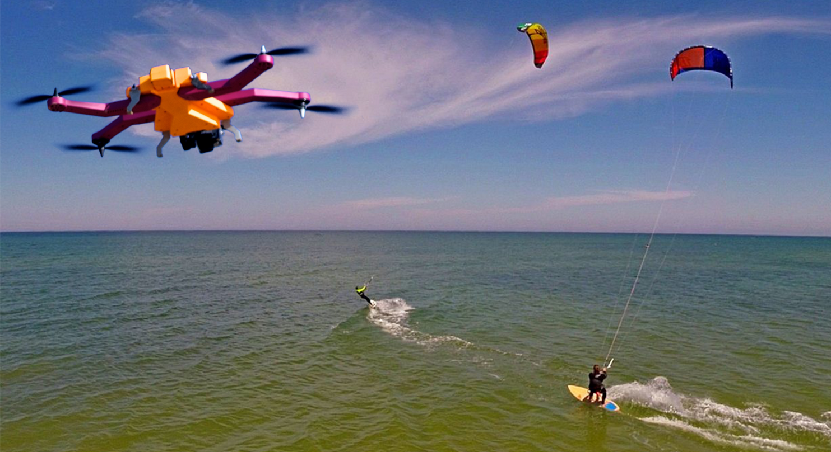
Figure 3.1.1a AirDog Drone Product being used for Action Sports
(Used with permission from AirDog)

AirLeash and AirDog App for Tracking
AirDog has developed its own tracking technology for the drone known as the AirLeash. The AirLeash is a long range bluetooth device capable of tracking altitude as high as 1000 FT. it’s a bullet proof tracker that could be either be strap on the wrist or the helmet. It also has a battery power feedback which alerts the user of when the battery is too low to continue tracking and recording. The product has its own smartphone application that could either be used with the AirLeash to make tracking efficient or as alternative for it.

AirDog for tracking modes
- There is the Auto-follow which allows the AirDog to follow you, precisely repeating your movement trajectory at the same altitude and speed of up to 40mph.
- It is also possible to record your track by adjusting the trajectory on your smartphone app. AirDog will re fly over the trajectory the user has set and the camera will be continually adjusted to aim at the user.
- Another unique way the Airdog can track is by using the Hover as aim setting.
- This setting allows AirDog to stay in one position above the ground while simultaneously directing the camera at the AirLeash.
- The AirDog can make circular rotations on a set radius and altitude while keeping the camera aimed at the AirLeash.

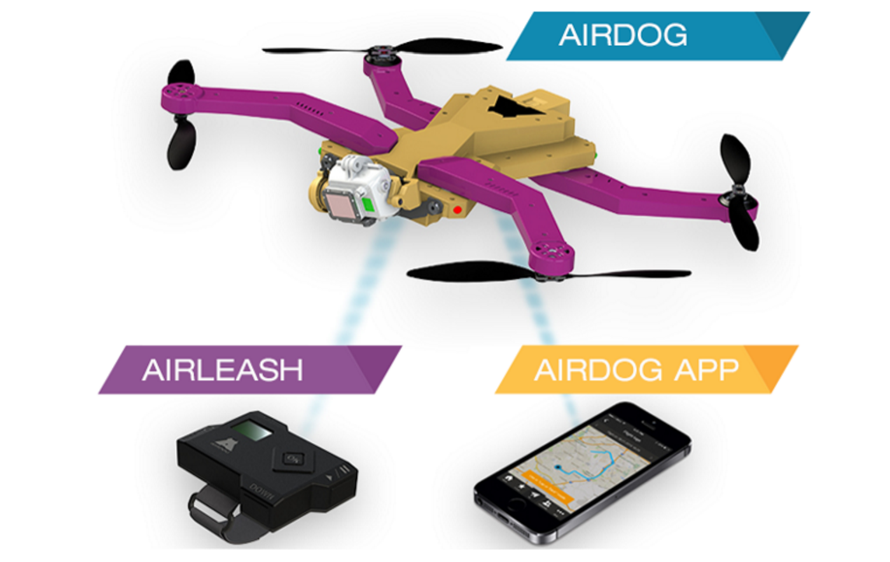
Figure 3.1.1b AirDog Drone Product and Transmitter for tracking user
(Used with permission from AirDog)

3.1.2 Existing Wireless Charging Technology

Current applications in wireless charging are reviewed in this subsection. Non-automotive applications are also discussed.

There are a lot of applications these days where wireless charging is already being implemented. In both automotive and non-automotive applications. Most of the consumer electronics like mobile phones are capable of being charged through inductive charging. Other applications include LED systems medical applications as shown in figure 3.1.2a. In cardiovascular surgery, It is used to assist heart pumps, pacemakers and infusion pumps. The military also have it in some of their defense systems electronics since their electronics need to be reliable at all times. It is also being used in charging electric and hybrid automobiles as shown in figure 3.1.2b.

Currently, Witricity, innovators in the wireless charging applications, have designed a magnetic resonance wireless charging technology that is capable of charging drones. They have designed a charging pad serving as the transmitter. The pad is large enough so that the drone can charge from anywhere on the pad without precise placement. This is possible because magnetic resonance has the ability to charge in situations where there is minimum precision of the receiver on the transmitter pad. They utilize small charging pads to power drones.

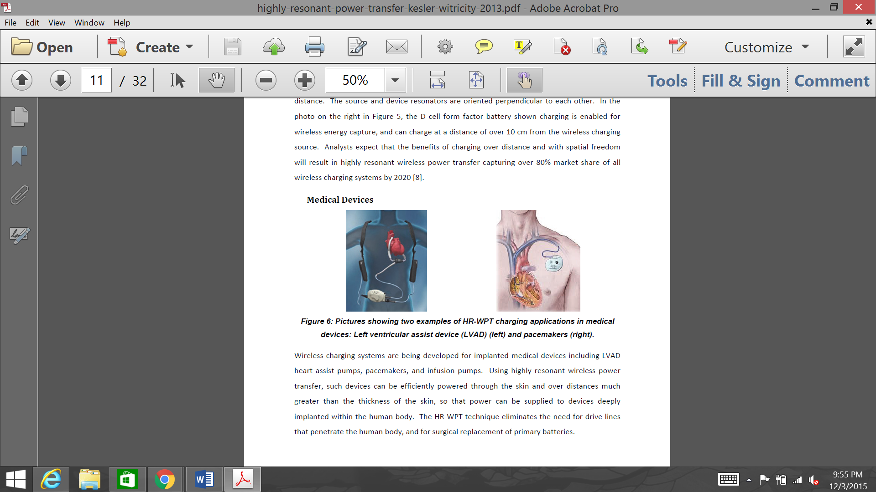

Figure 3.1.2a Examples of WPT charging applications in medical Devices: Left ventricular assist device (LVAD) (left) and pacemakers (right)
(Used with permission from Witricity)


Figure 3.1.2b Application of WPT for charging full electric and hybrid cars
(Used with permission from Witricity)

Witricity Wireless Charging Drones
The leading industry with WPT drone application is Witricity. They use magnetic resonance technology to provide ideal wireless charging solution to drones. The drones land on a wireless charging pad to get charged and continue their mission.
The latter is slightly different from the design we are trying to accomplish.. They are used to deliver power wirelessly to mobile devices.

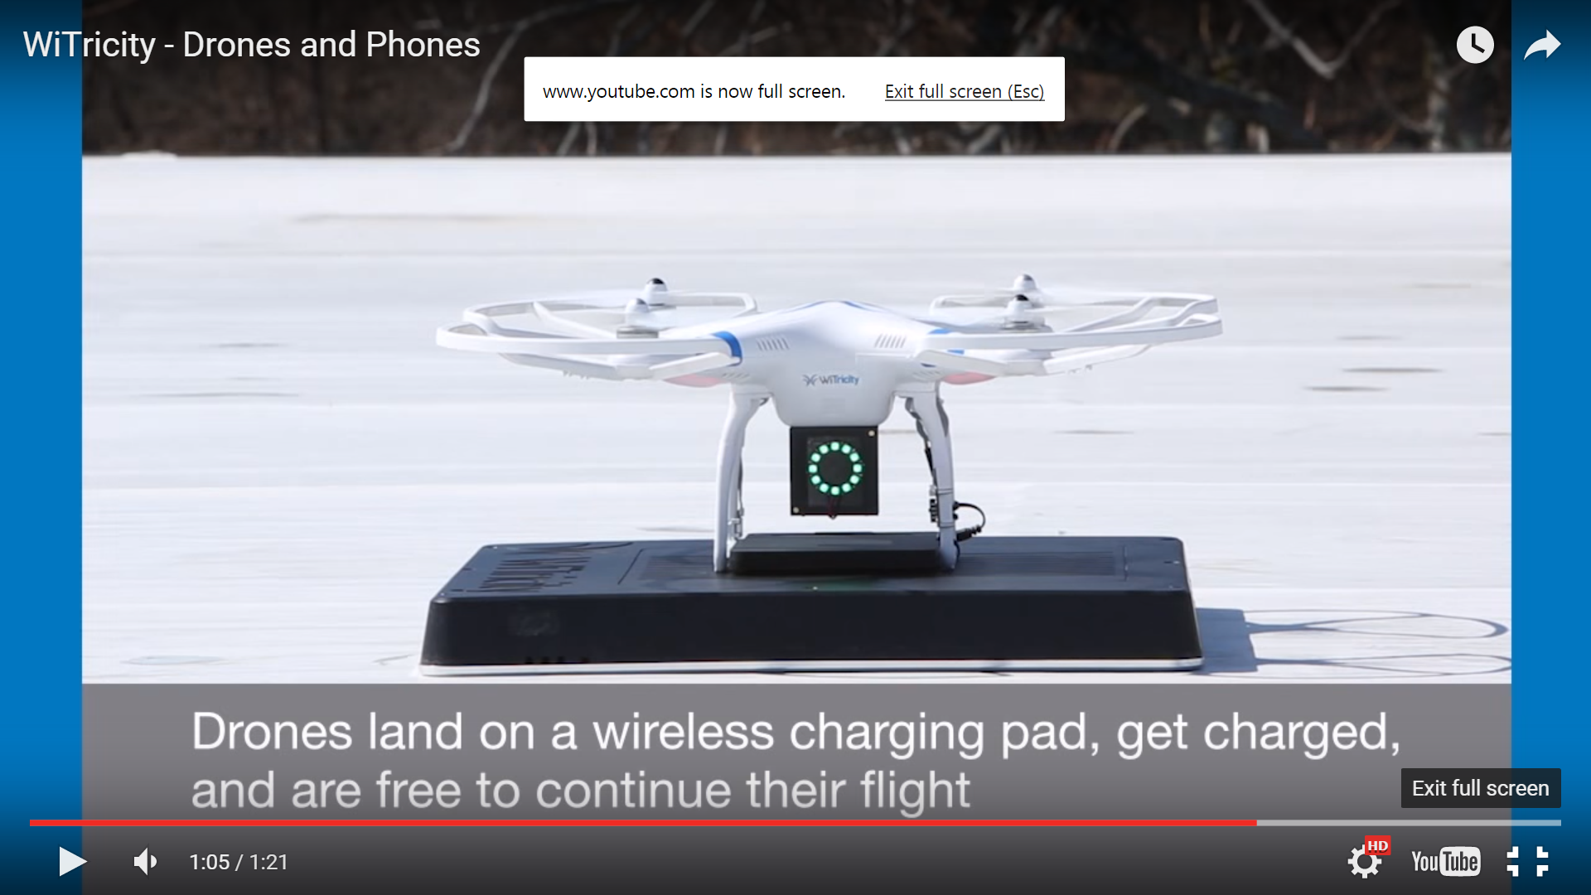

Figure 3.1.1a Witricity Drone charging
(Used with permission from Witricity)

3.2 Relevant Technologies

Throughout the years, technology has played important roles in today’s society. Technology has an impact not only for personal use, but also for working environments. New implementation of technologies arises to take action in meeting human everyday needs. It also can be improved to cut down budges, help the environment, and its surroundings. In this section, we will discuss relevant technologies that were found throughout our research. Although, we are not going to use all of these technologies, we will go in detailed for each technology found. Ultimately, all these technologies could be helpful and used based on projects’ objectives.

3.2.1 Wireless Communication

Wireless communication is a key part of the SPIDRONE project because it gives the drone freedom from being attached to any wire. Wireless connections allowed the drone to increase its mobility, this means it can freely roam without losing its connection. Various types of wireless communications will be discussed based upon their characteristics and specifications. Each wireless communication will be discussed individually to compare each’s weakness and strengths. Once we have compared each different type of wireless communication for the drone, we will be able to decide which wireless communication best fits the purpose of this project.

Bluetooth: Bluetooth technology is practically in almost every electronic device like mobile phone to home entertainment products. Key features of Bluetooth are low power, low cost and its pervasiveness. Using a spread spectrum, frequency hopping, and full-duplex signal at a nominal rate of 1600 hops/sec, Bluetooth operates in the unlicensed industrial, scientific and medical (ISM) band from 2.4 to 2.485 GHz. The adaptive frequency hopping (AFH) capability allows a reduction of interface between wireless technologies sharing the same spectrum. What this means is that the AFH allows for multiple wireless devices to be introduced to the environment simultaneously without collisions. Bluetooth’s range varies depending on the class of radio that is used. There are three classes of radios. Class 3 radios, have a range of up to 1 meter or 3 feet.
Class 2 radios, have range of 10 meters or 33 feet; this is the class that is mostly found in mobile devices. Class 1 radios have a range of 100 meters, 300 feet; this is the class that is primarily used in industrial cases. Bluetooth’s power technology is designed to have low power consumption. The power used for Class 2 is 2.5 mW. In table 3.2.1.1, we will present some advantages and disadvantages for using Bluetooth technology, and whether or not it will be used for the SPIDRONE project.

Advantages | Explanation
Inexpensive | Low cost.
Automatic | When devices are paired, they will automatically begin communication.
Standardized Protocol | Connects devices to each other without being the same model.
Low Interference | Uses techniques like frequency hopping, and also low power wireless signals.
Low Energy Consumption | Because it uses low power signals, Bluetooth requires little energy and will use less battery or electrical power.
Personal Area Network (PAN) | Allows for multiple devices to be connected within its range.

Table 3.2.1.1 Advantages of Bluetooth Technology

Due to the many devices that have this technology and the success that it has, Bluetooth technologies do not have many disadvantages. Unfortunately, these disadvantages could be critical in meeting the desired goals for the project. Table 3.2.1.2 is the short list of disadvantages of Bluetooth technology.

Disadvantages | Explanation
Range | Most of the Bluetooth connections have a range up to 30 feet.
Data Rate | Bluetooth only offers 1 MBps.
Security | Greater range and radio frequency (RF) make it much vulnerable to an interception and attack.
Battery Drain | It slowly drains battery (when not in use)

Table 3.2.1.2 Disadvantages of Bluetooth Technology

When comparing the advantages and disadvantages, Bluetooth technology is much more beneficial when it is used in short range communication. Even though, Bluetooth is a low energy consumption, the battery will slowly be drained. This drain occurs when the Bluetooth is on and it is not being used.

Global Positioning System (GPS): Global Positioning System (GPS) is a satellite based technology. GPS is a navigator system that connects via satellite to 24 satellites placed in space by the U.S Department of defense. The signal is sent to the satellites that circle the earth, and they resend signals back to the device. In other words, the GPS receiver compares the times the signals were transmitted and received to the satellites. Therefore, with this measurements, the receiver can define the position of the user, and display it on a device’s electronic map. The GPS receiver must connect to signals of at least three satellites to calculate a 2-D position that measures as coordinates and track the movement. These coordinates are latitude and longitude. When the GPS receiver connects to four or more satellites, it can calculate the user’s 3-D position. These gives the coordinates of latitude, longitude, and altitude. As the GPS receiver knows the user’s location, it can also calculate other information related to the user’s position, such as distance from location A to location B. The accuracy of this technology today is believed to be very accurate; however, its accuracy depends on the quality of the receiver, atmospheric issues, and the receiver’s position. The GPS satellites signals are transmitted through two low power radio signals. Every day’s GPS uses frequencies of 1575.42 MHz in the UHF band. Ultra-high frequency (UHF) is the range of radio frequencies between 300 MHz and 3 GHz, the wavelengths range from one meter to one decimeter. The GPS signal, transmits three different bits of information to the receiver. On one is the pseudo-random codes which modulates the L1 carrier. The carrier repeats every 1023 bits and modulates at a 1MHz rate. This type of carrier is the most used. Tables 3.2.1.3 and 3.2.1.4 will discuss the advantages and disadvantages similar of how we did the comparison of the Bluetooth communication.

Advantages | Explanation
Easy to Navigate | Tells direction to reach destination.
Climate | Works in all weathers.
Cost | Low compared to other navigation systems.
Coverage | It covers the whole planet.
Easy to integrate | Easier to integrate in other technologies like phones, vehicles.
Updates | System updates regularly

Table 3.2.1.3 Advantages of GPS Technology

GPS has many useful utilities that have help us finding faster routes to destinations and also for tracking purposes. As the technology evolves new features will arise for all GPS technology. As much as they are advantages in GPS technologies, there is a few disadvantages to keep in mind when using this technology. Some of these disadvantages are shown in table 3.2.1.4.

Disadvantages | Explanation
Reliability | Completely relies on satellite signals.
Battery | Loses signal due to battery failure
Accuracy | Loses signal due to obstacles such as buildings, atmospheric conditions, or trees.
Security | Risk of devices being tracked by other devices. (cellular)

Table 3.2.1.4 Disadvantages of GPS Technology

As we can see, GPS technology is very useful for going from destination A to destination B, it works in all weathers, the cost is lower when comparing to other navigation systems, it has a much larger coverage when comparing to Bluetooth Technology, and it’s easier to integrate in other technologies. For the Inductive Droning, using this type of technology would be very beneficial, because we would like the drone to be tracking its mission further unlike Bluetooth technology that has an average of 30 feet. The disadvantages would not affect the Inductive Droning’s mission, it would be used in open space, and with rechargeable batteries to enhance the battery life.

Infrared technology: Infrared wireless technology has been used for short-range & medium-range communications. Infrared technology has been around for a long time. It has been used in intrusion detectors, home-entertainment controls, laser communication, robot control systems, and many other devices used in today’s technology. Infrared wireless, transmits data through infrared radiation, its wavelength is measured from 1,530 to 1,565 micrometers (C-Band). Frequency level of infrared light is approximately 430 THz to 300 GHz. Some of the applications that used infrared are night vision devices and thermal imaging. The line-of-sight mode, is one mode of application of infrared. This mode needs to be a visually unobstructed straight line between the transmitter and the receiver. This means that it cannot have a direct connection through thick obstacles, such as a wall. It can have a connection through glass, but only if the receiver is having a connection directly to the receiver. Another type of mode is the diffuse mode (or scatter mode). This diffuse mode can function when the transmitter and the receiver are not directly visible to each other. Infrared lasers are also used as the light source of optic cables; although, this is not wireless, it shows the versatility of infrared. The Sidewinder seeker is a missile that uses infrared technology to find its target. How this works is that the seeker has an array of sensors that creates an electrical signal when it senses infrared light given by hot objects. Like in the previous wireless communications, tables 3.2.1.5 and 3.2.1.6 will show advantages and disadvantages of using infrared technology.

Advantages | Explanation
Low Power Requirements | Ideal for personal digital assistants (laptops, telephones, etc.)
Low Cost | For entire coding/decoding circuitry
Simple circuitry | Can be incorporated into the integrated circuit of a product.
Security | Bean being directed from transmitter to receiver helps ensure that data isn’t transmitted to nearby devices.
Constraints | There is not many constraints that can affect the project.
High noise immunity | Not likely to have interface from signals from other devices.

Table 3.2.1.5 Advantages of Infrared Technology

From the list above, we can see that infrared technology has a lower cost that other technologies, it also has the simplicity of incorporate this type of technology into an existing circuit. The direct bean that connects the transmitter and receiver, helps for the security of the connection. On table 3.2.1.6, we will see some of the disadvantages that this infrared technology has.

Disadvantages | Explanation
Line of Sight | Transmitters and receivers must be directly aligned to communicate.
Reception | Walls, people, etc. can block transmission if is in the bean’s way.
Range | Short-range. Large areas will require multiple emitter panels.
Sensitivity | Other than obstacles, can affect its performance, like the weather, sunlight, etc.
Speed | Data rate transmission is lower than typical wired transmissions.

Table 3.2.1.6 Disadvantages of Infrared Technology

After analyzing the advantages and disadvantages of infrared technology, we can see that it has plenty of valuable features. The few disadvantages that would affect SPIDRONE will be the range, and sensitivity. For SPIDRONE we will need a wireless communication that allows for a wider range and also be able to accommodate for obstacles in its way. This Infrared technology could be implemented in other part of the SPIDRONE project.

3.2.2 Flight Controller

This section is to outline the research regarding the different flight controllers available and the advantages and disadvantages of each in regards to our project. The flight controller was chosen based on which one best met the objectives and specifications of our project and the budget allotted to the flight controller. The available options are the CC3D, DJI Naza-m Lite, DJI Naza-m V2, KK2, MultiWii, Arduino, and Pixhawk flight controllers.

The first flight controller we looked at was the CC3D board from OpenPilot. The CC3D is inexpensive but lacks functionality. The CC3D board was created with the intent of it being used as a flight stabilization board. The board is a fantastic piece of hardware for manual controls, but in order to utilize the CC3D for the SPIDRONE project, it would need peripherals to be developed which would utilize more time than we could allot for it. Essentially it would turn our project from creating the SPIDRONE into a project that is creating a full autopilot flight controller from a flight stabilization board. Another drawback to using the CC3D flight controller, is the fact that the wiki page that provided information on using the CC3D controller is currently not operational.

The second and third flight controllers are from DJI, which are the Naza-M Lite and Naza-M V2. The lite model is aimed towards entry level pilots of drones, but supports no extensions other than an optional GPS, it is essentially a flight stabilization board much like the CC3D. The V2 model of the board supports extensions created by DJI such as their PMU, and is essentially an autopilot board. However, the flight software that is compatible with these boards is not open source, as DJI is more of a commercial offering, which would make it challenging to use their flight controllers for the SPIDRONE.

The KK2 or newer KK2.1.5 flight controllers is an offering from HobbyKing. The flight controller itself is essentially another offering of the CC3D board for our purposes. It is more of a flight stabilization board instead of a full autopilot, and as such it is disqualified for the same characteristics as the CC3D board.

The MultiWii flight controller was developed around the utilization of motion sensors found in the Nintendo Wii controllers. This offering follows the lines of creating a flight stabilization board such as the CC3D and KK2 boards, as the sensors are paired with an Arduino microcontroller. Sourcing Wii controllers to scavenge for their motion sensors would also take an extensive amount of time, in addition to having to develop the peripherals to turn it into an autopilot flight controller, as we would if we were to choose the CC3D or KK2.

The flight controller used for this project will be a Pixhawk PX4 autopilot flight controller. The Pixhawk flight controller was chosen as its firmware is open source with informative resources available through its community. The Pixhawk flight controller supports multiple types of connectivity options such as I2C, UART, and CAN to ease the development of peripheral sensors and inputs.

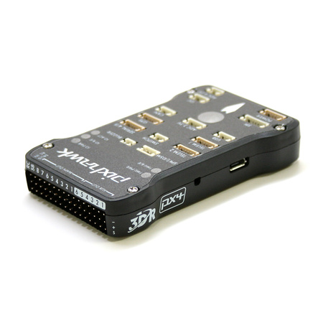
Figure 3.2.2.1 – Pixhawk Flight Controller
(Used with permission from pixhawak.org)

Specifications
(Used with permission from pixhawak.org)

Processor
- 32bit STM32F427 Cortex M4 core with FPU
- 168 MHz
- 256 KB RAM
- 2 MB Flash
- 32 bit STM32F103 failsafe co-processor

Sensors
- ST Micro L3GD20H 16 bit gyroscope
- ST Micro LSM303D 14 bit accelerometer / magnetometer
- Invensense MPU 6000 3-axis accelerometer/gyroscope
- MEAS MS5611 barometer

Interfaces
- 5x UART (serial ports), one high-power capable, 2x with HW flow control
- 2x CAN (one with internal 3.3V transceiver, one on expansion connector)
- Spektrum DSM / DSM2 / DSM-X® Satellite compatible input
- Futaba S.BUS® compatible input and output
- PPM sum signal input
- RSSI (PWM or voltage) input
- I2C
- SPI
- 3.3 and 6.6V ADC inputs
- Internal microUSB port and external microUSB port extension

Power System and Protection
- Ideal diode controller with automatic failover
- Servo rail high-power (max. 10V) and high-current (10A+) ready
- All peripheral outputs over-current protected, all inputs ESD protected

Voltage Ratings

Pixhawk can be triple-redundant on the power supply if three power sources are supplied. The three rails are: Power module input, servo rail input, USB input.
Normal Operation Maximum Ratings

Under these conditions all power sources will be used in this order to power the system
- Power module input (4.1V to 5.7V)
- Servo rail input (4.1V to 5.7V) UP TO 10V FOR MANUAL OVERRIDE, BUT AUTOPILOT PART WILL BE UNPOWERED ABOVE 5.7V IF POWER MODULE INPUT IS NOT PRESENT
- USB power input (4.1V to 5.7V)

Absolute Maximum Ratings

Under these conditions the system will not draw any power (will not be operational), but will remain intact.
- Power module input (0V to 20V)
- Servo rail input (0V to 20V)
- USB power input (0V to 6V)

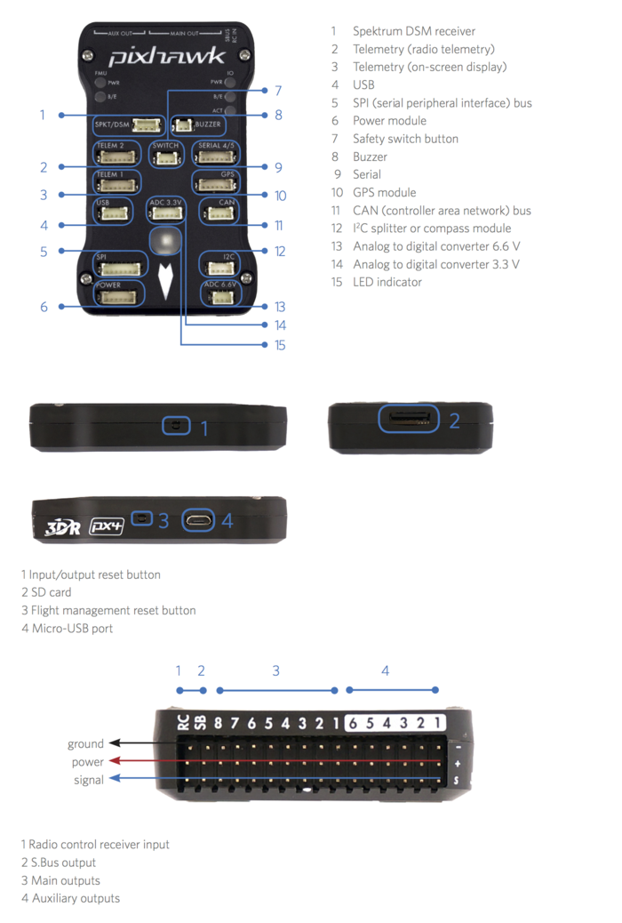

Figure 3.2.2.2 – Pixhawk Connectors
(Used with permission from Pixhawk)

Pixhawk Interface Port Pinouts

Pin | Signal | Volt
1 (red) | VCC | +5V
2 (blk) | TX (OUT) | +3.3V
3 (blk) | RX (IN) | +3.3V
4 (blk) | CTS (IN) | +3.3V
5 (blk) | RTS (OUT) | +3.3V
6 (blk) | GND | GND
Table 3.2.2.1 - Pixhawk TELEM1, TELEM2 ports
(Used with permission from Pixhawk)

Pin | Signal | Volt
1 (red) | VCC | +5V
2 (blk) | TX (OUT) | +3.3V
3 (blk) | RX (IN) | +3.3V
4 (blk) | CAN2 TX | +3.3V
5 (blk) | CAN2 RX | +3.3V
6 (blk) | GND | GND
Table 3.2.2.2 - Pixhawk GPS port
(Used with permission from Pixhawk)

Pin | Signal | Volt
1 (red) | VCC | +5V
2 (blk) | TX (#4) | +3.3V
3 (blk) | RX (#4) | +3.3V
4 (blk) | TX (#5) | +3.3V
5 (blk) | RX (#5) | +3.3V
6 (blk) | GND | GND
Table 3.2.2.3 - Pixhawk SERIAL 4/5 port - due to space constraints two ports are on one connector.
(Used with permission from Pixhawk)

Pin | Signal | Volt
1 (red) | VCC | +5V
2 (blk) | ADC IN | up to +6.6V
3 (blk) | GND | GND
Table 3.2.2.4 - Pixhawk ADC 6.6V
(Used with permission from Pixhawk)

Pin | Signal | Volt
1 (red) | VCC | +5V
2 (blk) | ADC IN | up to +3.3V
3 (blk) | GND | GND
4 (blk) | ADC IN | up to +3.3V
5 (blk) | GND | GND
Table 3.2.2.5 - Pixhawk ADC 3.3V
(Used with permission from Pixhawk)

Pin | Signal | Volt
1 (red) | VCC | +5V
2 (blk) | SCL | +3.3 (pullups)
3 (blk) | SDA | +3.3 (pullups)
4 (blk) | GND | GND
Table 3.2.2.6 - Pixhawk I2C
(Used with permission from Pixhawk)

Pin | Signal | Volt
1 (red) | VCC | +5V
2 (blk) | CAN_H | +12V
3 (blk) | CAN_L | +12V
4 (blk) | GND | GND
Table 3.2.2.7 – Pixhawk CAN
(Used with permission from Pixhawk)

Pin | Signal | Volt
1 (red) | VCC | +5V
2 (blk) | SPI_EXT_SCK | +3.3
3 (blk) | SPI_EXT_MISO | +3.3
4 (blk) | SPI_EXT_MOSI | +3.3
5 (blk) | !SPI_EXT_NSS | +3.3
6 (blk) | GPIO_EXT | +3.3
7 (blk) | GND | GND
Table 3.2.2.8 – Pixhawk SPI
(Used with permission from Pixhawk)

Pin | Signal | Volt
1 (red) | VCC | +5V
2 (blk) | VCC | +5V
3 (blk) | CURRENT | +3.3V
4 (blk) | VOLTAGE | +3.3V
5 (blk) | GND | GND
6 (blk) | GND | GND
Table 3.2.2.9 – Pixhawk POWER
(Used with permission from Pixhawk)

Pin | Signal | Volt
1 (red) | VCC | +3.3V
2 (blk) | !IO_LED_SAFETY | GND
3 (blk) | SAFETY | GND
Table 3.2.2.10 – Pixhawk SWITCH
(Used with permission from Pixhawk)

To program the Pixhawk flight controller, the APM:Copter firmware and Mission Planner software from ArduPilot will be used. The options from ArduPilot were chosen as there is an abundance of information available and the software is open source. As the software is, it supports different command modes and contains different features, with the most noteworthy being:
- Return to Launchpoint – Utilizes the GPS module on board to return the quadcopter to its original launch location.
- Land – Automatic landing sequence.
- Follow Me – Follows the user around by utilizing the telemetry unit mounted to the quadcopter, and computer or tablet equipped with GPS. The computer receives its GPS coordinates and transmits them to the drone.
- Failsafe – Allows for a failsafe to be implemented in the event of a lost control signal or low battery conditions.
- Camera control with live video link capability.
- Data logging to an onboard SD card for debugging.

The different flight modes are similar to what we want to accomplish with our quadcopter’s missions, but we want to execute it in a different manner. Since the source code will contain these different modes of flight, we will be able to modify or completely replace the sections of the source code that contains these functions to meet our requirements.

3.2.3 Infrared Distance Sensor

This section outlines the research regarding the use of an infrared distance sensor and how it may be utilized for our project. An infrared distance sensor was chosen over sonar to determine if the drone has landed as the propellers can interfere with the sonar.

During the auto-landing phase of the quadcopter, there needs to be a way to determine if the quadcopter has actually landed or if it still in the air without human intervention. One method that can solve this is to use an infrared distance sensor or sonar. While sonar is a viable option, the motors from the quadcopter can generate enough noise to interfere with the sonar. Infrared proximity sensors are readily available and inexpensive, for our application there is a short range sensor that is capable of giving an analog readout and is accurate from 4 to 30 cm. This would allow us to adapt the code to the design changes on the drone, rather than physically moving the sensor, which could add weight if a new mount needed to be made. We later determined that this part can potentially be eliminated by using the Pixhawk flight controller as the Pixhawk is able to detect when it has landed and shut itself down.

3.2.4 Radio Frequency Communications

Radio frequency refers to alternating current (AC), if the current is input to an antenna, then an electromagnetic (EM) field is created to be adapted for wireless communications. However, the antenna would pick many radio signals at once, a radio turner is necessary to make tune to the frequency that is desired. Frequencies for the radio frequency communication ranges from 3 kHz to 300 GHz and cover a significant amount of the electromagnetic radiation spectrum. The radio frequency is done when the electronic circuit and antenna responds to a specific frequency emitted by the transmitter antenna. The response from the label is then picked up by an adjacent receiver antenna, then the label response signal and will look for the matching signal based on the desired frequency. Radio Frequency systems use a frequency sweep technique in order to manipulate different label frequencies. The Radio Frequencies communication’s data rates are usually directed by the system. The system determines how much data must be transferred and how often to make this transfer. The lower the data rates are, the better the receiver sensitivity is and this means more range. Tables 3.2.4.1 and 3.2.4.2 are short lists of advantages and disadvantages from Radio Frequency Communications.

Advantages | Explanation
Line of Sight | None
Reception | It can penetrate solids that infrared wasn’t capable of passing through.
Range | Longer Range than Infrared
Sensitivity | Not sensible to the light, weather conditions.

Table 3.2.4.1 Advantages of Radio Frequency Communications

Comparing to the infrared technology that was discussed in section 3.2.1, most of the infrared technology’s disadvantages are advantages in the Radio Frequency Communication. For example, there is not a line of sight for the radio frequency, also the signals can transmit its data through walls. Also, the most important advantage of radio frequency is the range. Radio Frequency can travel at longer distances than the infrared wireless communication. As of the disadvantages for Radio Frequency, table 3.2.4.2 will explain these in detail.

Disadvantages | Explanation
Interference | A lot of communication devices used similar frequencies. (Phones, radios, etc.)
Security | Easier to listen to other transmissions, since signals are spread out.
Cost | It has higher cost than infrared.
FCC Licenses | Some products required a Federal Communications Commission (FCC) licenses.
Speed | Data rate is lower than infrared transmission or directly wired.

Table 3.2.4.2 Disadvantages of Radio Frequency Communications

Looking back at both the advantages and disadvantages of Radio Frequency Communications, we can see that for the SPIDRONE project this type of communication wouldn’t be so efficient as the ones we compared on section 3.2.1. We would like to use something that it has a good reception, able to track an object with longer distances, and and the same time to have the lowest cost possible, as it was the discussed previously in section 2.2 objectives for the SPIDRONE project.

3.2.5 Optical Recognition

This section outlines the potential use of optical recognition with our project. This research was conducted to determine the potential uses, the variations, and how it can be applied to achieve the objectives and specifications of our project.

One option for a precision landing onto the charging dock is to use object recognition. While the Pixhawk supports a return to home functionality, it utilizes GPS which is not accurate enough. By utilizing object recognition and image processing, the quadcopter would be capable of a precision alignment for landing. The charging dock could have a logo, emblem, or target painted on top of it for the drone to target. Limitations of using this option are that image processing requires extensive processing resources. There are some ways around this such as processing a less frames per second than the camera is feeding, or restricting the area of the image that is processed. Both of these options are less than ideal, as a gust of wind can blow the quadcopter far enough off target that the image processor will not notice how much it had moved by the time it loads the current frame. The second option leaves the possibility for the target to be outside of the image processing area. With quadcopters, racing and flying with a first person view (FPV) of the drone being streamed live to the operator has been picking up popularity. The camera feed can be streamed to a computer, which can handle the image processing and issue commands to the quadcopter to guide it to land. By using this option it allows us to not add additional weight by having to fabricate a new mount.

There are a variety of options available for cameras on the SPIDRONE. Action cameras that support an analog video out port can be utilized as FPV cameras. A popular option using this method is the GoPro Hero camera. For our purposes high definition video recording is not necessary, and during the planning phase we accounted for the weight of a GoPro for the construction of the SPIDRONE, the lighter weight of another camera would be ideal. Another option that is better suited for us is to use a FPV charge-coupled device “CCD” camera that is built specifically for operating a drone. When picking a camera an important specification to observe is the TV lines, the higher that number, the high resolution you have, at the cost of a higher expense.

Once a camera has been chosen, the next step in this process will be to transmit the video feed from the SPIDRONE to the computer for image processing. To accomplish this a transmitter will be attached to the drone. It’s important to note that the lower the transmission rate, less power will be required to transmit the same signal than the same transmission of a higher frequency. The lower signal frequency also allows for better range and penetration through objects. The lower frequencies will be used for specifically for transmitting control commands to the SPIDRONE, as that takes priority over the video feed. To avoid interference, it will be pertinent to keep the FPV and control command transmissions on different frequencies. Common transmission frequencies used for FPV cameras are 900 MHz, 1.2 GHz, 1.3 GHz, 2.4 GHz, and 5.8 GHz. Antennas will also be necessary for the transmission of data, one will be needed that will attach to the SPIDRONE, which will need to be a short, lightweight antenna. The second antenna which can be larger in size will be attached to receiver located at the base station, which will receive the video input and feed it into the computer for processing. Pixhawk shows ¼ wavelength and ½ wavelength monopole antennas designed for 433 MHz radios, although may be used elsewhere with adapters. The ¼ wavelength is a good choice for being mounted on the SPIDRONE due to its small size and lightweight, while the ½ wavelength is better suited for being mounted at the base station for receiving data.

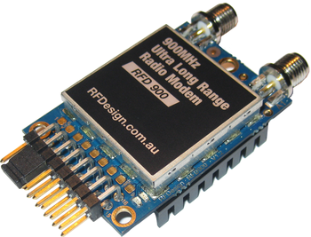

Figure 3.2.5.1 – RFDesign RFD900 Transmitter
(Used with permission from Pixhawk)

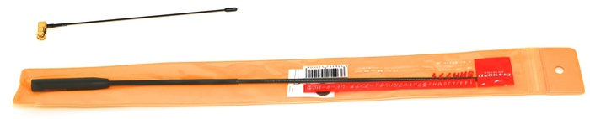

Figure 3.2.5.2 – ¼ Wavelength Monopole and ½ Wavelength Monopole for 433 MHz Radios.
(Used with permission from Pixhawk)

To simplify the image processing, OpenCV (Open Source Computer Vision) will be utilized. OpenCV was designed for computational efficiency with emphasis on real-time applications, making it a perfect fit for the SPIDRONE. OpenCV is written using C and C++, but supports interfaces through C++, C, Python, and Java allowing it to be compatible on multiple platforms. While the primary laptop that will be used for testing the software is powerful enough to provide the necessary resources for image processing, a second backup laptop may be used during the development stages when the first is unavailable. Table 3.2.5.1 contains the specifications of the laptop that will be used.

Make | Hewlett Packard (HP)
Model | Omen
CPU | Intel Core i7-4710HQ @ 2.50GHz – 3.50 GHz
GPU | 4GB NVIDIA GeForce GTX860m
Memory | 512GB PCIe SSD
RAM | 16GB
Operating System | Windows 8.1 Professional Edition
Available Ports | 4 USB 3.0 SS, HDMI, Headphone/Mic Combination Port, and SD Card Reader

Table 3.2.5.1 – Primary Laptop Specifications

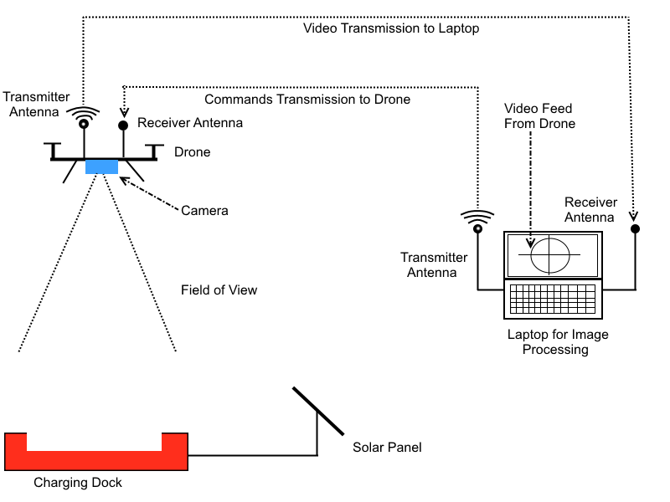
Figure 3.2.5.3 – Diagram of Optical Recognition

3.2.6 Wireless Power Transfer (WPT)

In other to come up with a very realistic wireless charging design for our drone, we will have to understand the science behind the WPT and be able to effectively apply the key principles of the technology into our design.

3.2.6.1 Background on Wireless power Transfer Theory

The theory of wireless power can be obtained from Maxwell’s equations. He proposed in the last two equations below that a time varying electric flux generates a magnetic field. In a similar sense a time varying magnetic flux can generate an electric field.

$$∇.D= ρ$$
$$∇.B= 0$$
$$∇.E= -\frac{∂B}{∂t}$$
$$∇.H= J+\frac{∂D}{∂t}$$

The induced electrical current can also induce a time varying magnetic field somewhere. This time-varying induced magnetic field induces an AC voltage in the receiver.

This theory is what is applied in wireless power transfer technology. There is a resonant circuit known as the wireless transmitter (Tx) which is able to couple a high frequency into another resonant circuit known as the wireless receiver (Rx).

3.2.6.2 Benefits of Wireless Power Transfer Technology (WPT)

There pros and cons to WPT. This section discusses the benefits of the technology and the reason why it was utilized on our senior design.

We utilized this technology because of the following underlined reasons:
- This is a convenient. It eliminates the need of power cords or the need to replace batteries.
- Most components in charging devices are often prone to failures. Especially the power chords. With WPT, that is eliminated.
- It is also a safer alternative to charging because it eliminates the occasional hazards that are resulted from minor explosions caused by conductive interconnections.
- It is very flexible and cost effective because one stationary could power multiple devices with receiving coils at the same time.
- Power delivery is unidirectional.

Figure 3.2.6.2a shows the schematic representation of all the benefits of the wireless power transfer technology.

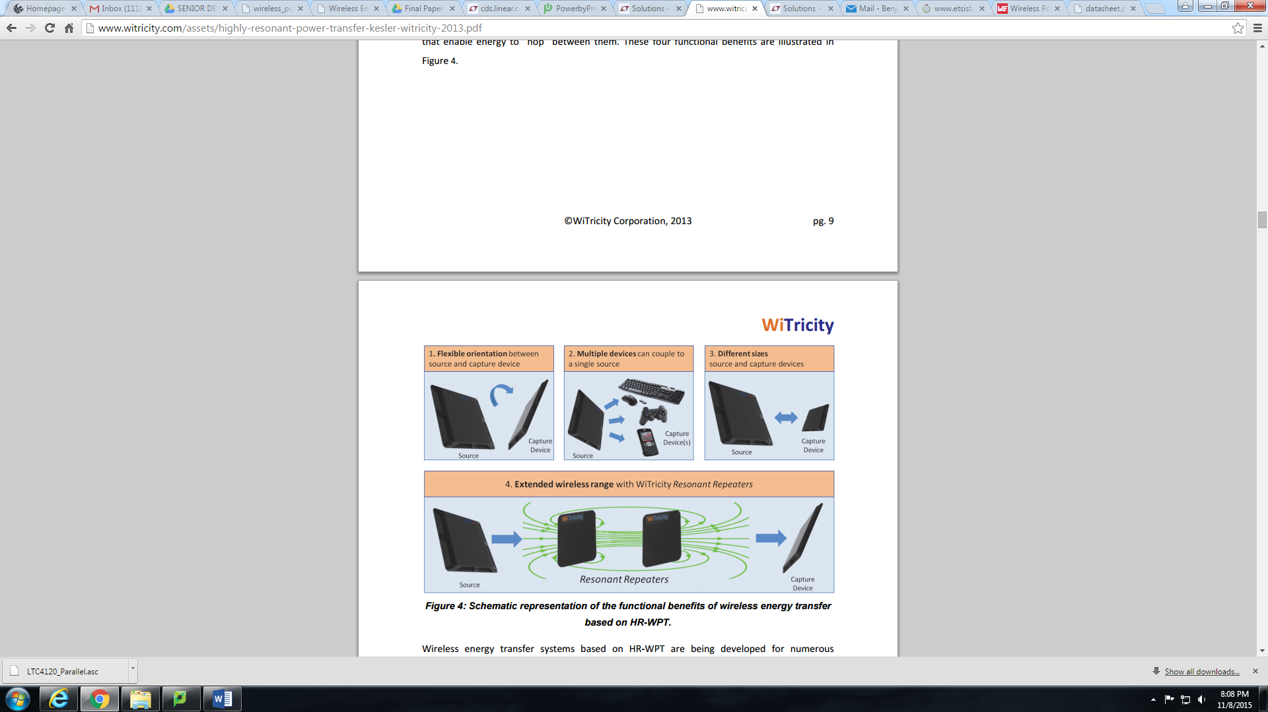

Figure 3.2.6.2a Functional Benefits of WPT
(Used with permission from Witricity)

3.2.6.3 Magnetic Induction Technology

One WPT technology to charge drone wirelessly is magnetic induction. With magnetic induction, a magnetic flux created around a transmitter coil induces an electrical energy in the receiver. The distance between the transmitter and the receiver affects the efficiency of the power since not all the magnetic flux around the transmitter can be converted to electrical energy in the receiver.

Magnetic induction uses a tightly coupled system to improve power transfer efficiency. Tightly coupled are very sensitive to misalignment. This is the reason why we use multiple coils. Multiple coils make positioning of receiver flexible. Additionally, they allow for multiple charging.

3.2.6.4 Magnetic Resonance Technology

The technology preferred for our drone charging system is magnetic resonance. Like magnetic induction, wireless power transmitter and receiver are needed for a complete charging station. The main difference is that it is a loosely coupled system. This means there is a larger distance between the transmitter and receiver. This makes it possible to charge our drone at a distance. The drawback to loosely coupled system is minimum power transfer efficiency and large EM emissions. To ensure flexibility we will use multi coil as opposed to single coil.

The table in figure 3.2.6.4a is the comparison between the different transmitter configurations.



Figure 3.2.6.4a Comparison between the different transmitter configurations
(Used with Permission from Wireless Power Consortium)

Components of Wireless Battery system
- Transmitter Electronics
- Transmitter coil
- Receiver Electronics
- Receiver Coil

The components of the wireless battery system is shown in fig 3.2.6.4b
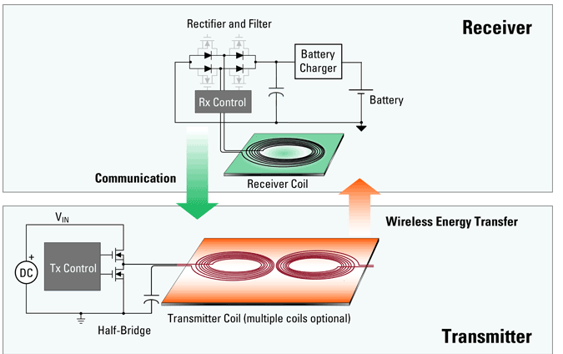

Figure 3.2.6.4b Components of Wireless Charging System
(Pending Permission from IDT)

3.2.6.5 Wireless Power Transmitter

The first component needed in a wireless charging system is a wireless power transmitter.

The transmitter is a DC input wireless charging transmitter with USB port. It transfers power by electromagnetic induction. The design under consideration supports multi-coil arrays driven by separate bridges which are automatically selected to deliver highest coupled power into wireless receiver. It also has an integrated 100mΩ Full Bridge switches which drive the coil and the series capacitance. The series capacitor (Cx) is what is used to determine the resonance frequency in the transmitter. The frequency can be determined by the relation below. Where Lx is the inductance for the transmitter coil and Cx is the capacitance for the transmitter coil.

$$f_{0}=\frac{1}{2π\sqrt{L_{x}C_{x}}}$$

3.2.6.6 Wireless Power Receiver

The second component needed in a wireless charging system is a wireless power receiver. The wireless receiver is an important component in the wireless charging systems. It is used together with the wireless transmitter. The receiver rectifies the power using the diode rectifiers. The diodes are made of FETs to improve its efficiency. It filters the power using ceramic output capacitors. This voltage is applied to the battery using a linear stage or switching regulator. The receiver electronics can alert the transmitter to adjust the charging current and voltage rates. It also can stop complete power transfer when the battery if fully charged.

3.2.7 DC/DC Converters

DC to DC converters are very important in portable electronic devices which are primarily powered with batteries. Due to the presence of several sub-circuits within such portable devices with each sub-circuit having its own voltage level requirement different from that supplied by an external supply or the battery, which may be sometimes higher or lower, a DC-DC converter is needed to implement the conversion to the desired voltage level . In applications where space and weight are critical, switched DC to DC converters offer a method to increase voltage from a partially lowered battery voltage thereby saving space instead of using multiple batteries to accomplish the same thing. For this project the various types and topologies of DC-DC converters were explored so as to determine the appropriate one(s) to be used in the implementation.

LINEAR REGULATORS

A linear regulator is a device used to maintain a steady voltage. The resistance of the regulator varies in accordance with the load resulting in a constant output voltage. The regulating device is made to act like a variable resistor thus making it known otherwise as a variable resistor. The regulator operates within the linear regions of its internal transistors and of active loads being applied. An example of Integrated Linear Regulator is shown in figure 3. 2.7.1a
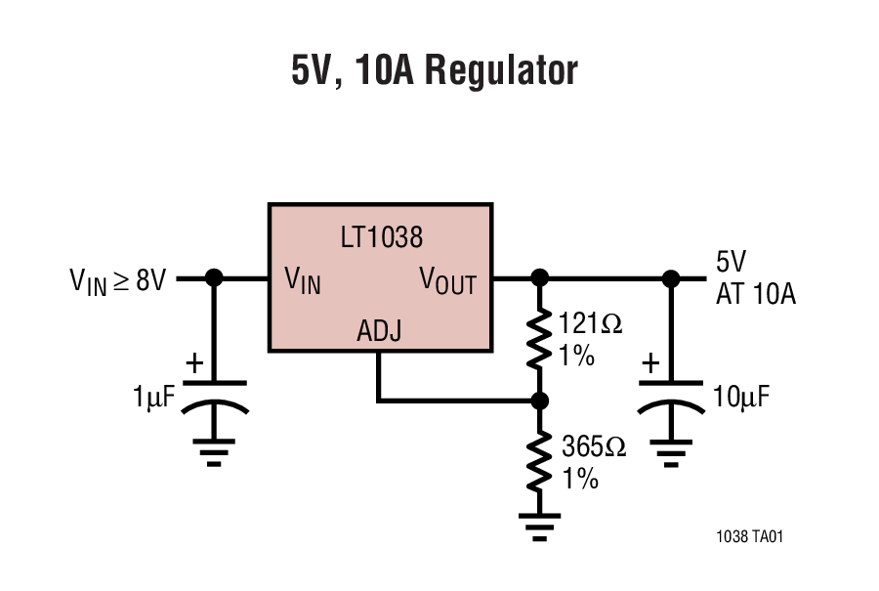
Figure 3. 2.7.1a Linear regulator
(Reprinted with permission from Linear Technology)

For the device to work, it requires the distribution of power to all elements of the system. This requires careful application of voltage and current running through each subsystem and device component. This implementation would be possible by using voltage regulators .Voltage regulators provide two splendid characteristics:

- Maintaining a voltage with a steady-state current.
- Dissipating energy from the system with the use of a heat sink. To summarize, the regulators which would qualify for the quad-copter’s guidelines are the following:

For a voltage regulator to be a suitable consideration for this project the following specifications must apply:

- A ability to take a high input voltage
- Ability to maintain a nominal current in mA range.
- Minimum space usage.
- Temperature must be kept to a minimum.

Table 3.2.7 shows the comparison between linear regulators and switching regulators.

 | Linear Regulator | Switching Regulator
Design Effort | Low | High
Output Power | Low | Low or medium
PCB Layout | Small | Large
High Efficiency Region (V_{out vs} V_{in}) | Narrow | Wide
Design Effort | Low | Moderate
Noise | Low | High
Step down voltage | Yes | yes
Output current | Low to medium | Low to high

Table 3.2.7 Linear and Switching converters comparison.

3.2.7.1 Buck Converter
A buck converter is a converter which steps down voltage and steps up current. It is the most common of all switching regulators. Its principle creates drop in voltage which allows low powered devices in conjunction with a higher powered devices to be controlled without the dangers of overloading the components of the board. DC voltage supplies are easily reduced by using linear regulators which waste energy as they operate by dissipating excess power as heat. With a remarkably ninety-five percent or higher efficiency for integrated circuits Buck converters are useful for tasks such as converting the main voltage supply from 12V down to as low as 0.8-1.8V needed by the processor in computers. The overall efficiency ranges from low to medium, but actual battery life depends on load current and battery voltage over time. Efficiency is high if difference between input and output voltages is small. It’s complex, usually requiring only the regulator and low-value bypass capacitors. Current market models for consideration include but not limited to:
- The LM2575 regulator by National Semiconductor , a buck converter which uses fixed voltages at 3.3V or 5V, depending on the version and an internal clock for its switching frequency at 52 kHz
- The LTC3830 by Linear Technologies which also uses an adjustable voltage. This design uses Zener Diodes and Power MOSFETs to regulate oscillation and is more often used for higher power systems.
Important characteristics of a a typical Buck converter are shown in Table 3.2.7.1

Number of Switches | 1
Range of average output voltage | Input voltage(Vin) ≥ Output voltage(Vout)
Output current | moderate
Footprint | medium
PF Correction | poor
Efficiency | moderate

Table 3.2.7.1 Important characteristics of a Buck converter

3.2.7.2 Boost Converter
Next to the most common buck converter is the boost regulator .A boost converter or step-up converter is a DC-to-DC power converter with an output voltage greater than its input voltage. It is a class of switched-mode power supply containing at least two semiconductors (a diode and a transistor) and at least one energy storage element, a capacitor, inductor, or a combination of both. Filters made of capacitors (sometimes in combination with inductors) are normally added to the output of the converter to reduce output voltage ripple. Since this creates a rise in voltage; a smaller voltage source can be used. This is ideal for instances where a low voltage device is needed to handle more power. Important characteristics of a a typical Boost converter are shown in table 3.2.7.2

Number of Switches | 1
Range of average output voltage | Input voltage(Vin) ≤ Output voltage(Vout)
Output current | moderate
Footprint | medium
PF Correction | high
Efficiency | High
Table 3.2.7.2 Important characteristics of a Boost converter

3.2.7.3 Buck-Boost Converter
Buck boost converter combines the operation of a buck and a boost converter. This is particularly useful in battery powered applications in which the input voltage varies over time. It has the disadvantage of inverting the output voltage. Since the switch has no ground the drive circuit is complicated. Important characteristics of a a typical Buck-Boost converter are shown in table 3.2.7.3

Number of Switches | 2
Range of average output voltage | ‘0--Input voltage(Vin) and Vin – Vmax (∞)
Outputcurrent | High
Footprint | medium
PF Correction | High
Efficiency | Higher

Table 3.2.7.3 Important characteristics of a Buck-Boost converter

3.2.7.4 SEPIC Converter
All dc-dc converters operate by rapidly turning on and off a switch usually a MOSFET, generally with a high frequency pulse. What makes the SEPIC converter superior is what the converter does as a result of this. For the SEPIC, when the MOSFET is on, one inductor is charged by the input voltage and the other inductor is charged by one of the capacitors. The diode is off and the output is maintained by the second capacitor. When the MOSFET is off, the inductor’s output through the diode to the load and the capacitors are charged. The greater the percentage of time (duty cycle) the MOSFET is off, the greater the output will be. This is because the longer the inductors charge, the greater their voltage will be. The SEPIC topology uses capacitors for energy storage in addition to two inductors which can be either separate inductors or a single component in the form of a coupled inductor. This topology is similar to the buck-boost topology in that it can step-up or step-down the input voltage, making them ideal for battery applications. The SEPIC has the additional advantage over the buck-boost in that its output is non-inverting. Another advantage is that the capacitor can offer some limited isolation. Important characteristics of a a typical SEPIC converter are shown in table 3.2.7.4

Number of Switches | 1
Range of average output voltage | ‘0--Input voltage(Vin) and Vin – Vmax (∞)
Outputcurrent | High to medium
Footprint | large
PF Correction | high
Efficiency | Highest

Table 3.2.7.4 Important characteristics of a SEPIC converter

In general switching converters usually have the following characteristics.

 | Switching Converters
Function | Step up (boost), step down (buck), inverts
Efficiency | High, except at very low load currents (μA), where switch-mode quiescent current (I_{Q}) is usually higher
Waste heat | Low, as components usually run cool for power levels below 10 W
Complexity | Medium to high, usually requiring inductor, diode, and filter caps in addition to the IC; for high-power circuits, external FETs are needed
Size | Larger than linear at low power, but smaller at power levels for which linear requires a heat sink
Total cost | Medium to high, largely due to external components
Ripple/Noise | Medium to high, due to ripple at switching rate

Table 3.2.7.4.5 – Switching Converter Characteristics

For the implementation of an efficient DC-DC conversion a careful choice from available converters were made to transmit efficient power and protect the battery. A test was carried out to make a choice from one of the following vendors or design.

TI LM3488 Uncoupled Inductors SEPIC

The input voltage intake required for the wireless transmitter is 5V .Since the power would be supplied by a solar panel whose power level could fluctuate there need to be a dc-dc conversion to ensure that there is constant 5V DC power supply. Two of the DC-DC conversion topologies would be considered and optimized for efficient performance.
The design of the DC-DC converters was executed using TI webench and Simple Switcher. The voltage needed at the receiving end of the wireless station has to be within the range 0f 3.3V to 5.5V. The DC-DC converter is design to take a minimum of 3V input and produce an output 5V at 2 amps. The schematic is shown in figure 3.2.7.4.1.Computer simulation of the output and input current waveforms give an average output voltage of 5.5V for an average voltage of 7.4V as shown in figure 3.2.7.4.

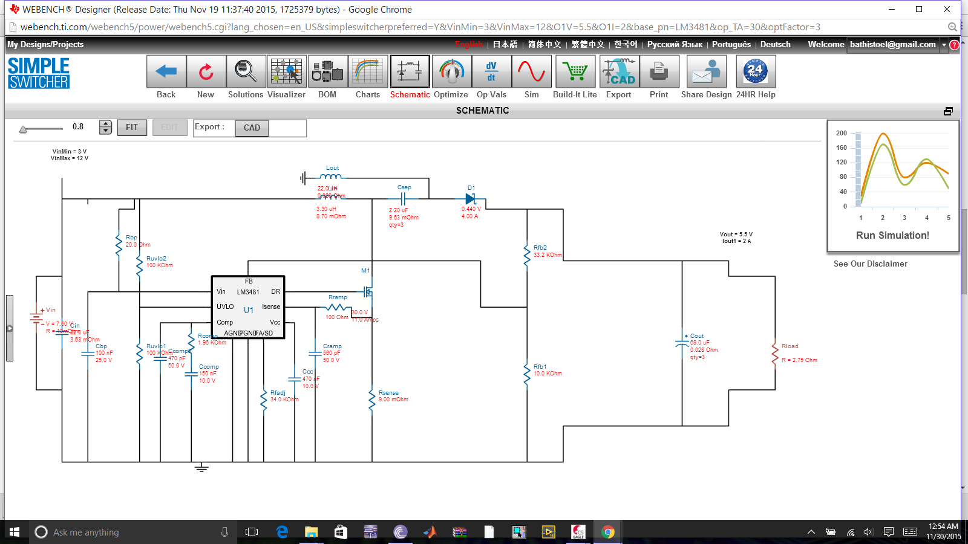
Figure 3.2.7.4.1 Schematic of TI LM3488 Uncoupled Inductors SEPIC.

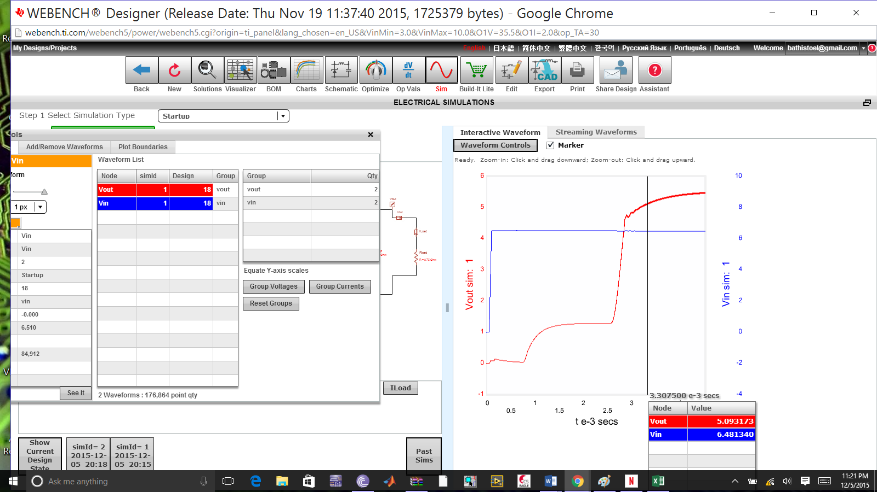
Figure 3.2.7.4.2 Transient Output and input waveform of LM3488

This particular design yielded and efficiency of 84 percent and a total BOM cost of $5.28 The output root mean square current, Foot Print and efficency chart ,and efficiency of the initial design characteristics are shown in figure 3.2.7.3, figure 3.2.7.4 and figure 3.2.7.5 respectively. Looking at the chart closely it can be seen that the efficiency of the input voltage of 3.0V gives an efficiency of about 78% and the input voltage between 6.5 V and 10 V give an efficiency of about 82%.

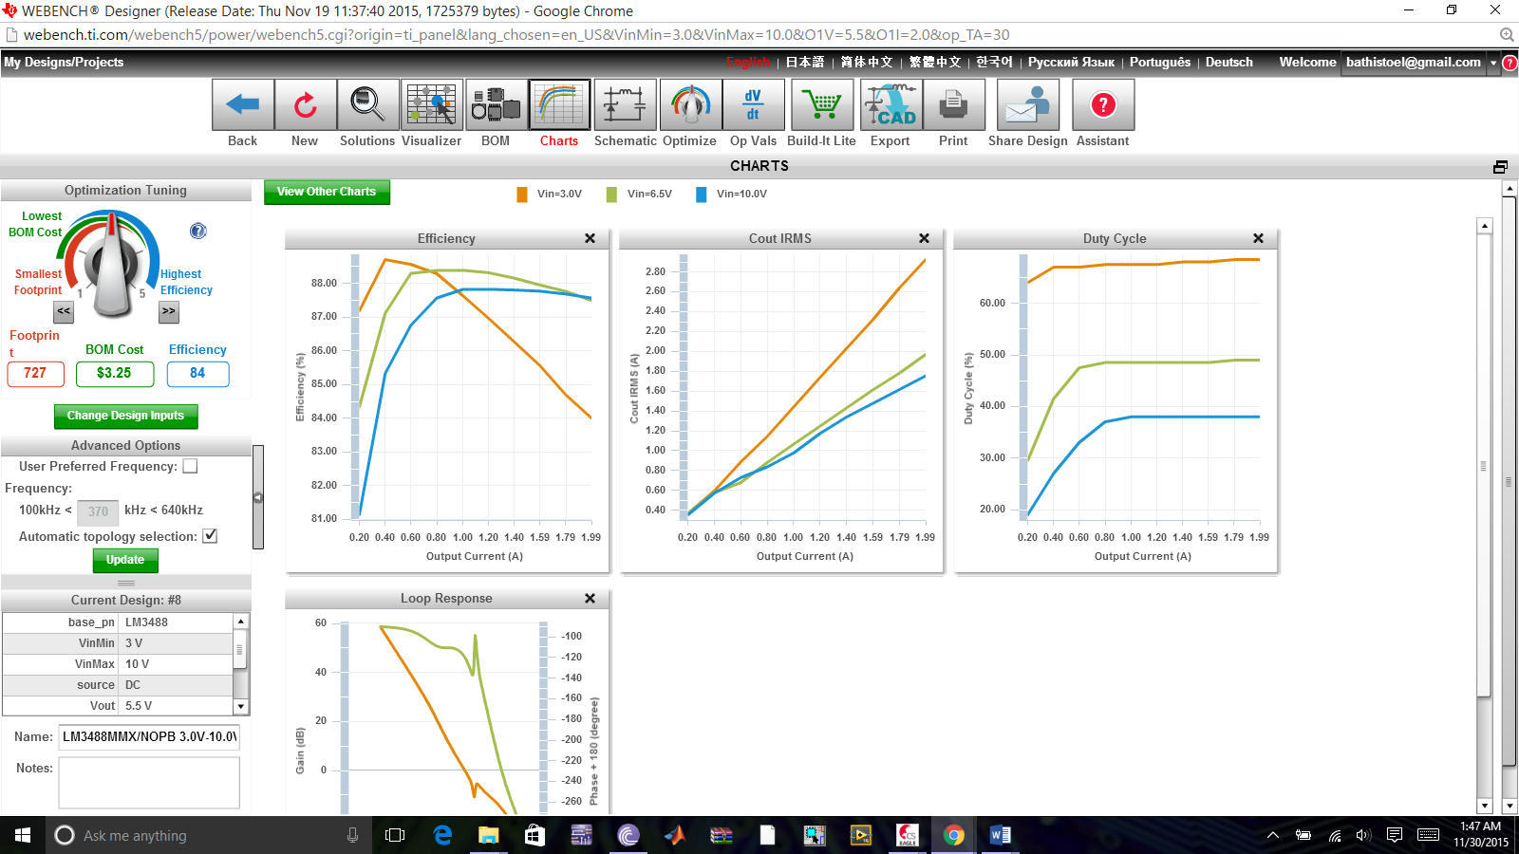
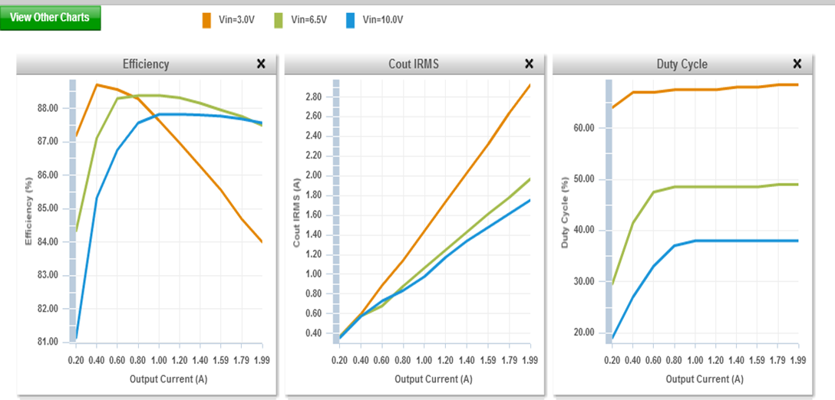
Figure 3.2.7.3 Output Current TI LM3488 Uncoupled Inductors SEPIC
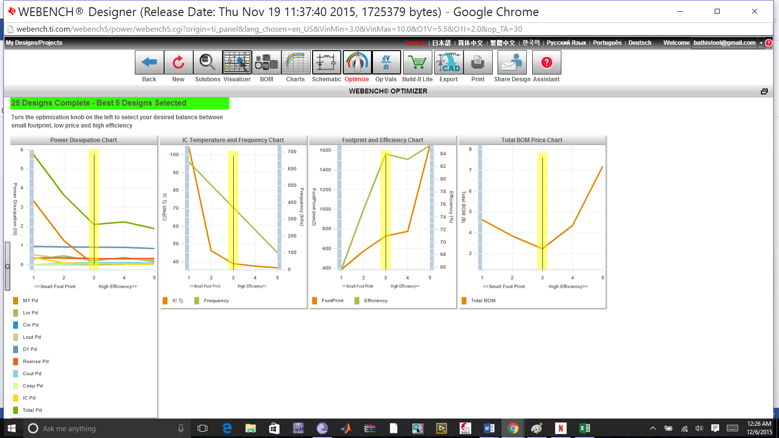
Figure3.2.7.4 Foot Print and efficiency chart for TI LM3488 Uncoupled Inductors SEPIC initial design
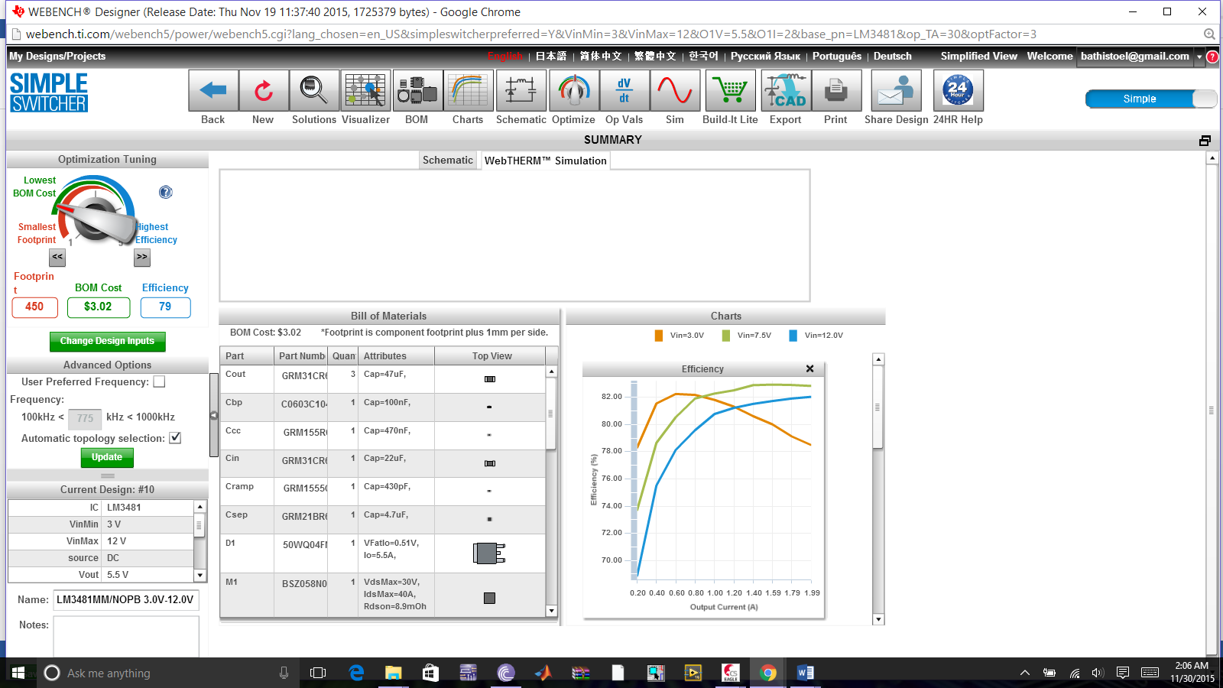
Figure 3.2.7.5 Efficiency of TI LM3488 Uncoupled Inductors SEPIC initial design

The aim of this design is to obtain a highly efficient DC-DC conversion, low cost and the smallest footprint. Changing the design parameters for an efficiency of 86 percent or more however increased the footprint and increased the cost by nearly 50 percent. Again looking at the efficiency chart Figure 3.2.7.4 a closely it can be seen that the efficiency of the input voltage of 3.0V gives an efficiency of about 84% and the input voltage between 6.5 V and 10 V give an efficiency of about 88% which are quite desirable.

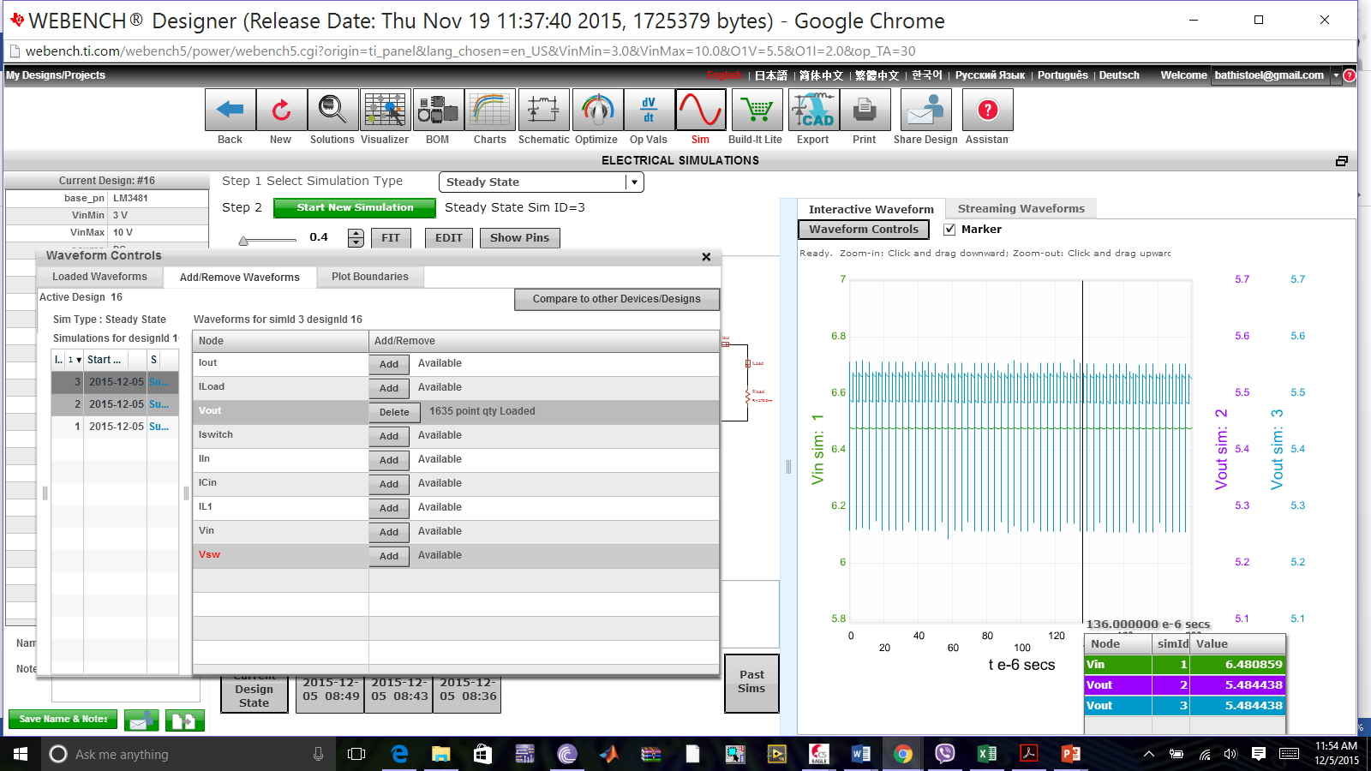

Figure3.2 7.6 Output Current for TI LM3488 Uncoupled Inductors SEPIC final design

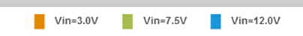
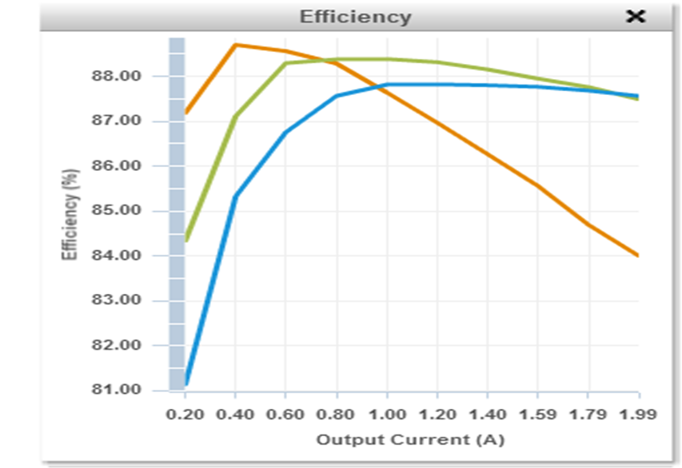

Figure 3.2.7.7Output Current for TI LM3488 Uncoupled Inductors SEPIC final design

The amount that the SEPIC converters step up or down the voltage depends primarily on the Duty Cycle and the parasitic elements in the circuit. The output of an ideal SEPIC converter is given by $Vo=\frac{D×Vin}{1-D}$ where Vo is the output voltage, Vin is the input voltage and D is the duty cycle.The above, however does not account for losses due to parasitic elements such as the diode voltage drop. Taken into account the diode voltage drop ( V_{D} ) the equations becomes $Vo=\frac{D×Vin}{1-D}-$ V_{D.} At the minimum input voltage the maximum Duty Cycle will occur and vice versa

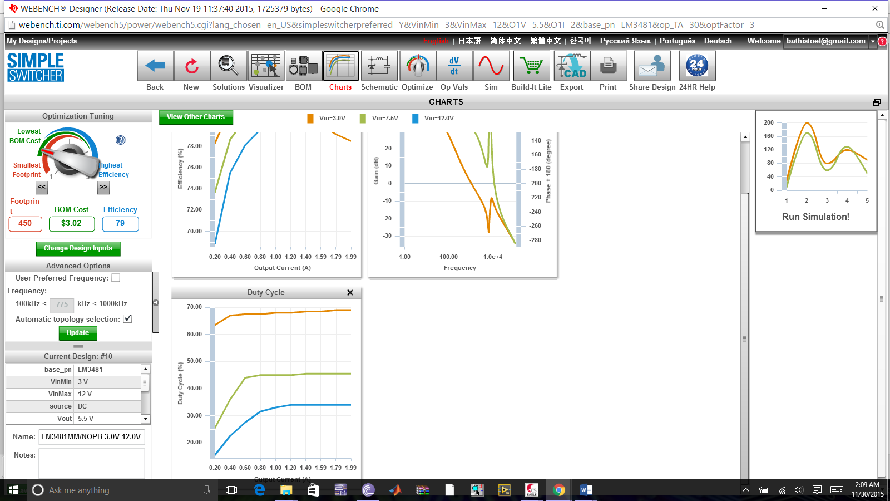
Figure 3.2.7.8 Duty Cycle for TI LM3488 Uncoupled Inductors SEPIC final design

LT1376 switching regulator

Using the LT1376 switching regulator and a reference design, we designed, tested and prototyped a simple but versatile and efficient switching regulator and DC converter capable of taking an input between 7V-25V and outputting a 5V low ripple needed to power the wireless transmitter. The schematic of the design is shown in Figure 3.2.7.4.4

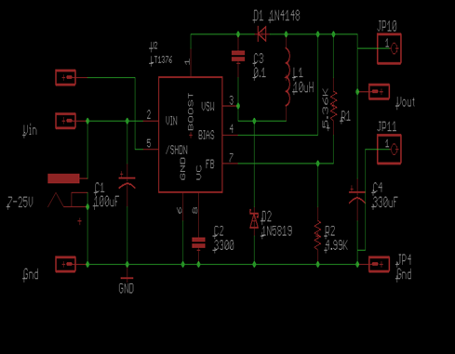

Figure 3.2.7.4.4 LT1376 switching regulator

3.2.8 Lithium Polymer Battery Low Voltage Indication

Since lithium polymer batteries are sensitive to not being operated under a certain threshold, it will be important to operate the SPIDRONE only while the battery is above that voltage. This section looks to outline the different possibilities for determining when the SPIDRONE should land.

One method for determining if the battery is low is to attach a piece of hardware to the SPIDRONE that will monitor the battery voltage. There are different commercial offerings that can accomplish this such, some utilize indicator LEDs to indicate the remaining battery life, while others will have a buzzer attached to signal a warning to the user of the drone. For our application the buzzer would not be feasible as the SPIDRONE will be capable of following its user, but not necessarily controlled by its user. The LED offering can be modified such that the LED is removed and its output is tied to a GPIO pin on the Pixhawk microcontroller to trigger an interrupt.

Another method that can be utilized is a timer. The timer would essentially guarantee that all flight times are the same, however this is a poor method to use for our application. While we can calculate an appropriate general amount of time that the drone can operate, the operating environment can impose the largest influence on our battery life. For instance if we ran some tests inside of a lab to estimate the flight time of the SPIDRONE, that test would be inadequate as the SPIDRONE would not be having to stabilize itself and fly against changing wind conditions. Even if the tests were conducted outside, we could not guarantee a test in the worst flyable conditions as the weather constantly changes. In addition if we were to predict and implement a timer that would account for 95% of the flight conditions, whenever the SPIDRONE operates in conditions that match that other 5%, those specific flights could significantly harm the battery’s longevity.

A third method to monitor the battery life would be to develop an algorithm based on both voltage and current. Given that we know the mAH rating of the battery, and if we monitor the current being used along with the current voltage of the battery, an algorithm can be developed such that the remaining battery life can be estimated. This is much like the distance until empty estimation that many modern automobiles provide.

The Pixhawk flight controller is capable of monitoring its own battery and is capable of predicting the remaining flight time. The Ardupilot software we intend to modify utilizes the Pixhawk’s battery sensing equipment, and implements a battery failsafe that we need to configure. The Ardupilot battery failsafe is tunable and will accomplish the objectives we want to meet in the event of a low battery. The failsafe will trigger if the primary battery’s voltage dips below 10.5 volts for more than 10 seconds, or if the remaining capacity dips below a reserved portion of the battery, in mAH, much like the reserve tank setting of a motorcycle. When the failsafe is triggered the SPIDRONE will either do nothing, if it is already disarmed, disarm the motors if it has landed, return to home if it is enabled and within 2 meters of its home, or land for all other situations. The return to launch feature will be modified such that it lands precisely within its charging dock.

Pixhawk Battery Sensor Configuration (Reprinted with permission):

Parameters
- BAT_V_SCALING - scaling coefficient for voltage sensor
- BAT_C_SCALING - scaling coefficient for current sensor
- BAT_CAPACITY - battery capacity, if < 0 then discharged current will be not used for remaining battery estimation
- BAT_V_EMPTY - empty battery voltage (per 1 cell)
- BAT_V_FULL - full battery voltage (per 1 cell)
- BAT_N_CELLS - number of cells

BAT_V_SCALING and BAT_C_SCALING can be tuned with external multimeter or lab power supply. Note, that current sensor may have some offset, so it's better to use big (near hovering) current for calibration.

BAT_CAPACITY should be set to nominal battery capacity in mAh (e.g. 3300 for 3300mAh) or a bit lower. Actual capacity for new batteries is more then nominal, but for old - it can be less than nominal. Note, that full discharging of LiPo batteries significantly reduces battery life and actual capacity. So it's better (and safer) to land with 20% of charge.

BAT_V_EMPTY should be set to start of fast voltage drop zone (“zone of temptation”, 3.35V on the picture below). You can see it in your logs analyzing BATT.VFilt.

BAT_V_FULL should be set to BAT_V_EMPTY + 0.3 if no current sensor available or BAT_V_EMPTY + 0.2 if it's available. It may look very low, but note that voltage changes not lineary while discharging and it's more important to fit lower part of discharge curve.
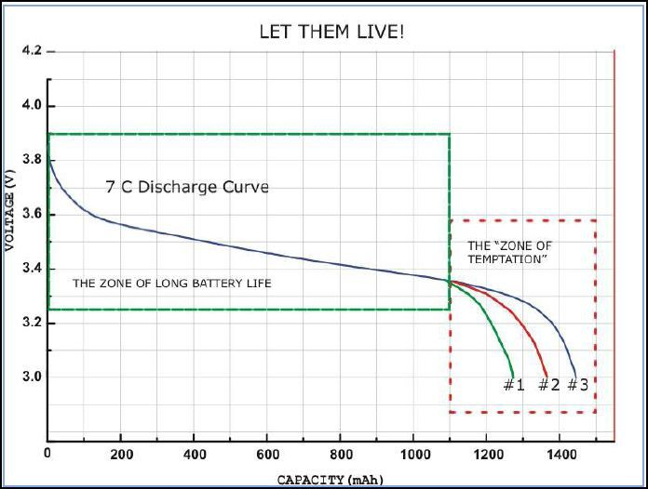

Figure 3.2.8.1 – Battery Discharge Curve
(Reprinted with permission from Pixhawk)

3.3 Possible Architectures and Related Diagrams

For this section, we will be looking at possible architectures and related diagrams that may be useful for the SPIDRONE project. Looking at this architectures and diagrams, we can have a better idea of how we would want to design our project. This section will be divided in three parts, the QuadCoptor, charging station, and diagrams that will give us a better visualization of the intended design.

3.3.1 QuadCopter

This section outlines the research regarding the quadcopter aspect of our project. This research was conducted to determine the components needed to build the quadcopter such that it can meet our objectives and specifications for this project.

The type of drone to be built will be a quadcopter variant as it is a simple design and there is an abundance of information available on quadcopter builds that other enthusiasts have put together.

The frame chosen for this quadcopter is the DJI F450 Flamewheel, where the arms extend out from the hub in an X pattern in relation to the microcontroller. The X pattern will allow for ease of attachment of any forward facing sensors that may need to be mounted. The F450 has been touted as a strong frame that is easy to construct, and inexpensive to purchase and repair. The F450 has been used long enough that there are inexpensive copies of it which will help to keep costs down.

A lithium polymer battery is commonly used for quadcopters over older types of battery technology such as the NiCad battery. Unlike older battery technologies which hold approximately 1.2 or 1.5 volts per cell, lithium polymer batteries hold 3.7 volts per cell. Like other types of batteries, the cells can be chained together in series to increase the voltage. Lithium polymer batteries are specified by 4 different characteristics: the S specification, the P specification, the mAH specification, and the C specification. The S rating specifies how many cells are wired in series to tell what the voltage rating is of the battery. For example, a battery with a 1S rating contains one cell and is rated at 3.7V, while a 2S and 3S will be rated at 7.4V and 11.1V respectively. The P rating is less common, but is used to indicate if a battery pack utilizes 2 or more cells in parallel. For example, a 2S2P battery would contain 4 cells total, it would essentially be 2 2S batteries wired together within the same pack. The mAH rating, or milliamp hour, determines how much of a charge a battery is capable of holding. The higher the rating, the more operating time you can get out of a device. If a constant load of 1000mA were to be drawn from a battery rated at 2000mAH, then it would take the battery 2 hours to be completely depleted. The final rating for batteries is the C rating or the capacity to discharge. If a battery pack is rated at 30C and 3000mAH, the battery maximum amperage that can be drawn from this battery continuously is the C rating multiplied by the capacity in amps, therefore 30 multiplied by 3 would yield a 90 amp continuous draw rate. The battery will be mounted on the hub in the center of the quadcopter.

Unlike the older types of batteries that need to be completely discharged to stay healthy, lithium polymer batteries have a minimum voltage of approximately 3 volts that they should not drop below. If the battery were to drop below this voltage, irreparable damage can be done to the battery pack. To avoid this damage, a general rule of thumb that is followed is to not allow the battery to be discharged below 80% of its total capacity.

Brushless motors are often used for quadcopters, and are the most important piece of the electrical system as the electrical system is essentially built around the motors chosen. Motors are specified by KV, maximum current, thrust, weight, and suggested propeller. The KV specification, not to be confused with kilovolt (kV), is the motor velocity constant. This constant is defined as the RPM of the motor with no load per volt applied to the motor. The maximum current is measured in Amperes, and this value is used to determine the electronic speed controller, and battery that needs to be purchased. The thrust rating is the weight the motor can lift when paired with the recommended propeller. The weight of the motor is important when determining the overall weight of the quadcopter being built, while the weight of the full quadcopter will be split between the 4 motors, it is important to consider the weight of the different motors available. The recommended propeller is typically the propeller found to best work with that particular motor. The motors will be mounted at the end of each arm of the quadcopter.

Electronic speed controllers, commonly referred to as ESC for short, provide a variable amount of power to the motor that it is connected to, in relation to its input signal. The electronic speed controllers are specified by the amperage that they can handle. When choosing an electronic speed controller, the controller should be rated to handle a minimum of 1.2 to 1.5 of the motor’s maximum amperage. One electronic speed controller will be needed per motor on the quadcopter. The electronic speed controllers will be mounted to the middle of each arm.

Propellers are mainly specified by 2 dimensions, the diameter and pitch. These dimensions are typically labeled as being diameter x pitch, both measured in inches. Propellers can be made from different materials, but as the motors typically recommend the diameter and pitch of propeller, it is better to go with the recommended values and pick a propeller that has received good reviews in terms of its build quality and balance. If a propeller is out of balance it will need to be balanced similar to how an automobile tire needs to be balanced, as an unbalanced propeller or tire will cause excessive vibration.

There are many different controllers available, but the controllers can be purchased with a receiver and transmitter already paired to each other that operate on the 2.4GHz or the 5GHz frequency. For our project a controller is not required, but desired for manual inputs during testing and development. Controllers are often advertised as being a mode 1 or mode 2 controller, the difference being that mode 1 has the throttle on the right where mode 2 is on the left.
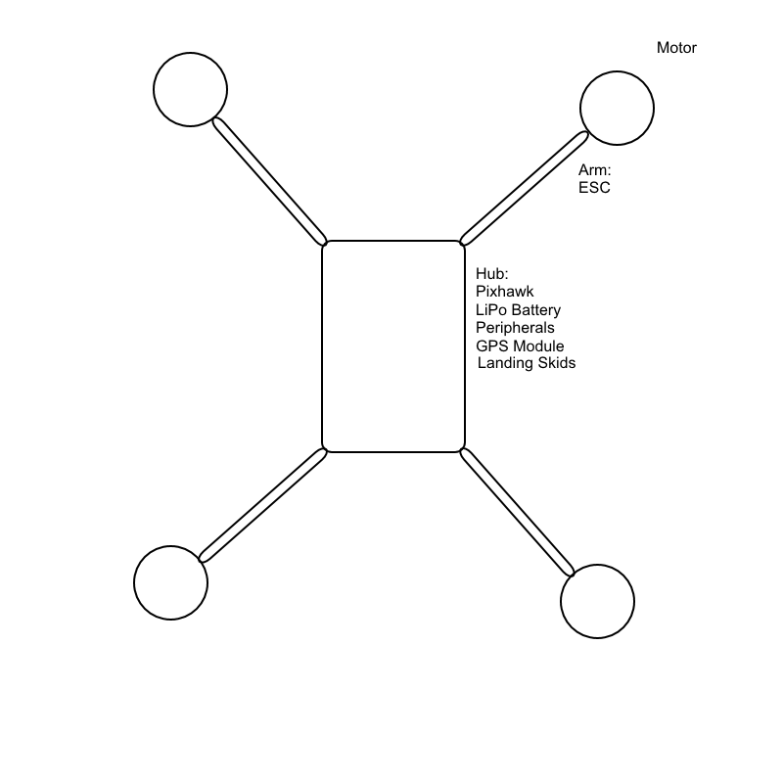
Figure 3.3.1.1 – Quadcopter Layout

3.3.2 Diagrams

This section will have related diagrams for the Inductive Droning. This diagrams can give a visual understanding of how each structure of the project functions and its connectivity to other related parts that ultimately will help in defining the final design for the SPIDRONE project.

Wireless Communication Diagrams: Based on section 3.2.1 Wireless communications, we will show visually how this communications work and how it connects to each of their destinations. For the first wireless communication, we will look at the Bluetooth technology. Then, we will look at the Global Positioning System (GPS) technology and its graphical functionality. Finally, we will look at the infrared technology and how it is implemented.

Bluetooth Diagram:
Transmitter Block Diagram

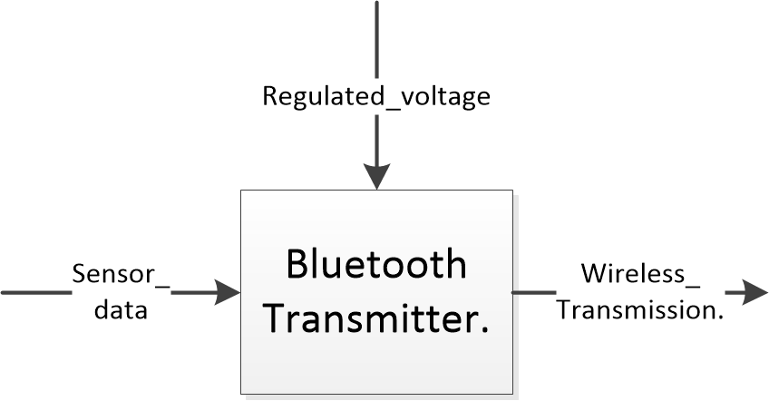

Diagram 3.3.3.1 Bluetooth Transmitter

In diagram 3.3.3.1, we showed how the Bluetooth transmitter works. Regulated voltage for the transmitter is coming in usually about 3.3V. The sensors in the transmitter, sends the data into the transmitter, the transmitter then sends the data through the wireless transmission to the receiver.

Global Positioning System Diagram:

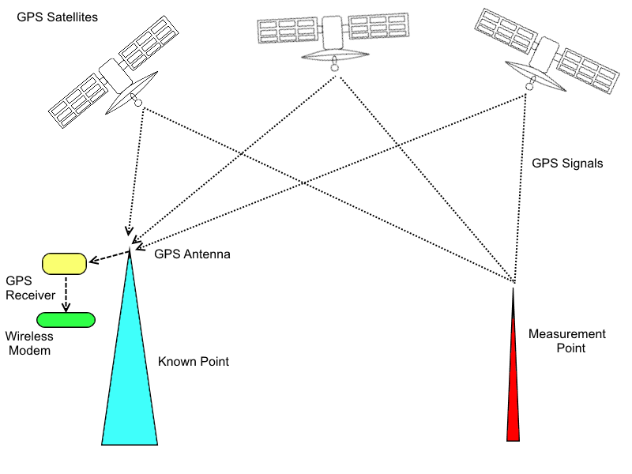

Diagram 3.3.3.2 Global Positioning System (GPS)

A device sends a signal to the satellites about a location, the satellites look for the known points about that location. Once it reaches the location, it sends back the signal to the device with the information requested. For example, a device could request an address, the signal will be send to the satellites, and the satellites will look for this address and return the known location and its information back to the device. Diagram 3.3.3.2 shows the Global Positioning System communications in detail.

Infrared Communication Diagram:

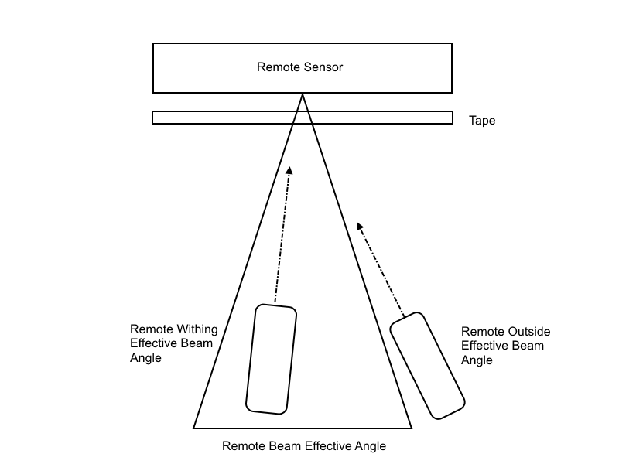
Diagram 3.3.3.3 Infrared Communication

Diagram 3.3.3.3 is an example of how the infrared communication works. There is a remote sensor, two control remotes with different angles, and a scotch tape across the remote sensor to show that the infrared can go through these kinds of obstacles, but not walls as it was previously discussed in section 3.2.1. One remote is within the remote beam effective angle, and the other one is outside the remote beam effective angle.

Radio Frequency Diagrams: The following diagrams are based on section 3.2.4 Radio frequency communications. As we have previously shown for the wireless communication, the radio frequency diagrams will visually describe how this communication works and how successfully connects.

Radio Frequency Diagrams:

Radio Frequency (Transmitter)

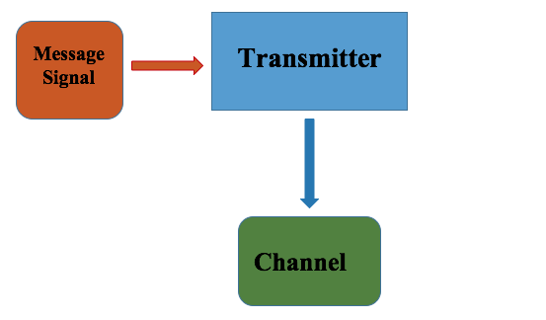
Diagram 3.3.3.3 Radio Frequency Transmitter

Radio Frequency (Receiver)

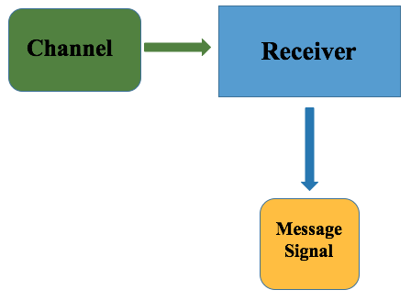

Diagram 3.3.3.4 Radio Frequency Receiver

The radio frequency diagrams are divided in two parts; diagram 3.3.3.2 shows the connections that the transmitter needs in order to send to the receiver. The second diagram, diagram 3.4.3.3 shows the connections for the receiver to complete a successful connection with the transmitter.

In diagram 3.3.3.2, we showed the communication protocols for the radio frequency of the transmitter of the Bluetooth connection. This communication consists of the message sending its signal to the transmitter, the transmitter receives that message signal, and sends it to the channel that connects to the transmitter. Once this is completed, the channel will look for the receiver to connect to.

For the second step on this radio frequency, diagram 3.3.3.3 shows how the channel that has the signal from the transmitter connects to the receiver, the receiver then receives this signal and successfully connects, and the connection is done. The transmitter is connected to the receiver and are now connected to each other.

4.0 Related Standards

Section 4.0 contains the related standards that were found for the SPIDRONE project. Different components that are part of this SPIDRONE project have standards that we have to follow in order to be able to make this a successful and safe project. These standards are published documents that provides procedures and specifications designed to ensure the reliability of materials, methods, and products. Some of these standards addresses a variety of issues, including protocols that help ensure the projects functionality, compatibility, and provide safety and public health. Therefore, it is very important to know the related standards for this project.

4.1 Drone Standards

This section outlines the standards regarding the operation of unmanned aircraft systems (drones), and the impact those standards may have on our project. If a standard creates an obstacle for developing or testing our project, then alternatives will also be outlined within this section.

Unmanned aircraft systems (UAS), as referred to by the Federal Aviation Administration (FAA), do not require authorization from the FAA to operate so long as specific safety guidelines are followed. For recreational purposes, the parameters are outlined in Section 336 of Public Law 112-95 (the FAA Modernization and Reform Act of 2012), the FAA has also partnered with industry associations to form the Know Before You Fly campaign, which is aimed at informing the public about operating UAS. The guidelines are as follows.
Fly below 400 feet and remain clear of surrounding obstacles
- Keep the aircraft within visual line of sight at all times
- Remain well clear of and do not interfere with manned aircraft operations
- Don't fly within 5 miles of an airport unless you contact the airport and control tower before flying
- Don't fly near people or stadiums
- Don't fly an aircraft that weighs more than 55 lbs
- Don't be careless or reckless with your unmanned aircraft – you could be fined for endangering people or other aircraft

The majority of these guidelines can be followed without any additional precautions as the main campus the University of Central Florida is more than 5 miles from the Orlando International Airport (MCO). The guideline about not flying near people or stadiums is of concern though as the University of Central Florida has a stadium, and is a densely populated area which may prevent us from testing flight on campus. However, we do have access to 5 acres in a rural area, allowing us to test the quadcopter while meeting all of the guidelines.

4.2 Global Positioning System (GPS) Standards

Global Positioning System (GPS) is a space-based radio navigation system and it is used for a variety of aspects. GPS standards were found in a published document by the government that provides procedures and specifications of the global positioning system (GPS). There are different types of standards depending on the use of the GPS. We will go over the one that is related to the SPIDRONE project which is the Global Positioning System Standard Positioning Service (SPS) Performance Standard.

4.2.1 The GPS Standard Positioning Service (SPS)

For the purpose of the SPIDRONE project, we need to understand the GPS Standard Positioning Service (SPS) Performance Standard also known as the civilian GPS service. This standard, defines the levels of performance the U.S. government makes available to GPS users for everyday use.

The GPS Standard Positioning Service (SPS) is the positioning and timing service that is provided by signals broadcasted at the GPS L1 frequency. This frequency is transmitted by the satellites, that contain a coarse/acquisition (C/A) code signal, with a navigation data message, that reaches the devices that we use every day. We have discussed the frequency measurements and functionality in detail on section 3.2.1 Wireless Communications.

The GPS baseline is composed of segments owned by the USG: The Control and the Space Segments. The Control and the Space segments provide two types of service, the SPS SIS and the PPS SIS. For the purpose of the Inductive Droning, we will only discuss the SPS SIS. The SPS SIS interface characteristics allocated to two categories:

- Carrier and modulation radio frequency (RF) characteristics.
- Structure, protocols, and contents of the NAV message.

The SPS performance characteristics are availability, health, accuracy, integrity, continuity, and UTC(USNO) accuracy.
For the SPS SIS availability is the probability that the slots in the GPS constellation will be fulfill by the satellites transmitting a traceable and healthy SPS SIS. For this SPS, there are two components. These components are the following:

- Per-Slot Availability – Fraction of time that a slot in the GPS will be occupied with the signal transmitting from the satellite.

- Constellation Availability – Fraction of time that specifies a number of slots that the GPS constellation is being occupied with the satellites that are transmitting a traceable and healthy SPS SIS.

Now we will discuss the SPS SIS health. The SPS SIS heath is status given by real time information that is been broadcasted by each satellite as an integral part of the SPS SIS. The health is also referred to as “satellite health”. There are three possible health conditions: Healthy, marginal, and unhealthy.

- Healthy – the SPS SIS is healthy when all the four condition are present:
  - No alarm indication present.
  - Six-bit health status word of the NAV message is set to all zeroes.
  - User Range Accuracy (URA) alert flag is not raised.
  - Transmitted SPS URA index in sub-frame is less than 8.

- Marginal – if the SPS SIS heath is Marginal, one of these three warning conditions are present:
  - SPS SIS indicates that any one of the satellite’s SIS components may not be fully capable.
  - URA alert flag is raised and SPS URA does not apply.
  - Transmitted SPS URA index sub-frame is greater or equal to 8.

- Unhealthy – SPS SIS is unhealthy if any of these four conditions are present:
  - Alarm indication is present.
  - The MSB Six-bit health status word given a sub-frame 1 of the NAV message is set to 1.
  - The 5 LSBs of the six-bit health status word in sub-frame of the NAV message are set to 0010 (signals are dead) or 11100(SV temporality out).
  - SPS SIS that is being transmitted is untraceable.

The SPS SIS accuracy is described in two statistical ways: the first one being as the 95th percentile SPS SIS user range error (URE) at specified age of data (AOD), and the other way is at 95% SPS SIS URE over all AODs. This accuracy is also known as the pseudo range accuracy.

SPS SIS integrity is determining to be the trust which can be placed in the correctness of the information that is being provided by the SPS SIS. The integrity includes the ability of the SPS SIS to provide time alerts to the receivers when the SPS SIS should not be used for the positioning or timing. The SPS SIS should not be used when it is providing misleading signal-in-space information (MSI). For he SPS PS, the four components of integrity are the probability of a major service failure, the time to alert, the SIS NTE tolerance, and the alerts.

- Probability of a Major Service Failure – this probability of a major service failure is defined to be the probability that the instantaneous URE exceeds the SIS URE NTE tolerance without an alert being delivered. Alerts usually include both warnings and alarms.

- Time to Alert – the time to alert is described as the time from the onset od MSI until an alert indication reaches the receiver’s antenna. This alert could be an alarm or a warning.

- SIS URE NTE Tolerance – Tolerance for a healthy SPS SIS is said to be +- 4.42 times the upper bound on the URA value corresponding to the URA index that is being broadcast by the satellite.

- Alert (Alarm indication) – When the SPS SIS status is healthy or marginal becomes unhealthy when it is the subject of a SPS SIS alarm indication. Presence of any of the nine alarm indicators listed below, indicates the information provided by the SPS SIS may not be correct.

  - SPS becomes untraceable.
    - Ceases transmission
    - Elimination of the standard C/A-code.
    - Substitution of non-standard C/A- code for standard C/A-code.
    - Substitution of PRN C/A-code number 37 for the standard C/A-code.

  - Failure of parity on 5 successive words of NAV data (3 seconds).
  - Broadcast IODE does not match the 8 LSBs of the broadcast Index of Data Clock (IODC).
  - Transmitted bits in sub-frame 1, 2, or 3 are set to 0’s or all set to 1’s.
  - Default NAV data is being transmitted in sub-frames 1,2 or 3.
  - 8-bit preamble does not equal 10001011, decimal 139, or hexadecimal 8B.

Alert (Warning Indications) - When the SPS SIS status is healthy and it becomes marginal or unhealthy when subject of a warming indication is. Warnings are typically contributing in advance of the onset of potential MSI events. Warnings are also common after an alarm and at satellite’s end of life.

Next we will be discussing the SPS SIS continuity. For the continuity, the health is a probability that the SPS SIS continues to be healthy without unscheduled interruptions over a specified time interval. Interruptions that are schedule, are announced at least 48 hours in advance do not contribute to a loss of continuity. Scheduled interruptions are announced by the Control Segment issuing a “Notice Advisory to Navstar Users” (NANU). NANU’s are very similar to the “Notices to Airmen” regarding the scheduled interruptions of the ground-based air navigation aids.

For the final characteristic of the SPS performance, the SPS SIS UTC Accuracy. The accuracy for a healthy or marginal SPS SIS is defined to be the 95% error in the parameters contained in that SPS SIS which relates GPS time to UTC.

The SPS SIS coverage, has two components, the per-satellite coverage, and the baseline/expandable 24-slot constellation coverage. Per-satellite coverage primarily relies on the satellite antenna subsystem design, the on-orbit satellite pointing accuracy, and the satellite altitude. Now for the baseline/expendable 24-slot constellation coverage primarily relies on the per-satellite coverage links up with the baseline/expandable 24-slot constellation architecture. Below we will elaborate more about these components of SPS SIS coverage.

Per-Satellite Coverage- the volume for the per-satellite coverage involves the portion of the near-Earth region in which it extends from the surface of the Earth up to ab altitude of 3,000 km above the surface of the planet which it is visible from the orbital position of the satellite. The per-satellite coverage performance standards apply to the worst case satellite antenna pointing angle relative to the Earth. Table 4.3.1.1 shows the specifications for the coverage.

SIS Per-Satellite Coverage Standard | Conditions and Constraints
Terrestrial Service Volume:  100% Coverage | For any healthy or marginal SPS SIS
Space Service Volume:

No Coverage Performance Specified

Table 4.2.1.1. SPS Per-Satellite Coverage Standards

Baseline/Expandable Constellation Coverage- the service volume for the baseline 24-slot constellation and expandable 24-slot constellation coverage that covers the entire near-Earth region which extends from the surface of the Earth up to an altitude of 3,000 km above the surface of the Earth which is not physically obscured by localizing obstructions. Table 4.3.1.1 refers to the Per-Satellite Coverage, but it can be also be referenced for the Baseline/Expandable Constellation Coverage due to the same result to the standards.

5.0 Realistic Design Constraints

This chapter outlines the different constraints imposed on our project by both internal and external sources of the development group. As the objective of our project is to essentially add new functions to a quadcopter there, there are constraints that come internally from the development team such as scheduling, and external constraints from social and political sources, especially since unmanned aircraft is considered by some to be a controversial topic.

5.1 Economic and Time Constraints

This section outlines the constraints on our project that are influenced by economics and time. The economic constraints imposed on our project stem from the type of project we are creating. Custom built drones or quadcopters have a wide price range for just where the flight controller itself can cause anywhere from $20 to $300. Due to the costs of merely constructing the drone we will be seeking sponsorships to assist in funding the project.

The time constraints on this project are imposed by the University of Central Florida. This project is to be developed over 2 semesters for the Senior Design 1 and 2 courses offered by the university. The first semester is senior design 1 where the course is designed for us to create and research the project that we want to do. Senior design 2 during the second semester places emphasis on developing our project based on our prior research. As such physical development of the project is technically slated for approximately 4 months, although extra time can be had by starting the project earlier during senior design 1. As all members of the group are active students, other courses from the university will impede on development time, along with our occupational responsibilities.

5.2 Environmental, Social, and Political Constraints

This section is to outline the different environmental, social, and political constraints that may influence our project.

The environmental constraints imposed on this project are mostly based on our location. As we are constructing a quadcopter, an ideal environment for testing this project would be a dry spacious outdoor area with good lighting. However, the development of this project will take place in Orlando Florida, which tends to have rainfall on a daily basis. If the project were not utilizing a GPS system we could be able to test the project indoors, such as an empty auditorium or warehouse. The charging system of the quadcopter could be developed and tested indoors or outdoors provided there is an adequate amount of ventilation.

Social constraints imposed on our project can stem from the current controversy regarding the use of drones for unethical reasons. Hobbyists operating drones have reported being confronted by individuals for various reasons such as filming without consent, safety, and noise. One particular hobbyist was confronted by a concerned parent claiming that the person was a sexual predator filming a children’s soccer practice and flying the drone near the soccer practice, despite the operating logs from the GPS system indicating that they were false accusations.

The political constraints imposed on this project come from the FAA regulations established regarding the operation of drones for hobby purposes. The FAA regulations were developed to provide safe operating guidelines for drones such as not to operate near airports, people, or stadiums.

5.2.1 Health Constraints of the WPT

There are a lot of health concern when it comes to delivering power over mid-range distance. The real risk arise when the body is exposed to too much of the electromagnetic waves, hence the need to control the exposure to the body. There are standards which set minimum frequency range the body can be exposed to.
The Institute of Electrical and Electronic Engineers (IEEE) and the International Commission on Non-Ionizing Radiation Protection (ICNIRP) are the international bodies which have guidelines to protect humans against any known adverse effect of exposure to electromagnetic waves. The frequency set is in the range of 3 KHz and 300 GHz.

The IEEE and ICNIRP, there is no established evidence which suggest that human exposure to radio frequency (RF) and electromagnetic fields cause cancer. The only known effect of RF waves is that they cause tissue heating in the human body. The human body increases by 1°C when the whole-body averaged (WBA SAR) levels are less than 4 W/kg. The recommended WBA SAR level for the general public should be 0.08W/kg. Figure 5.2.1a shows the recommended SAR values to the human nervous system.
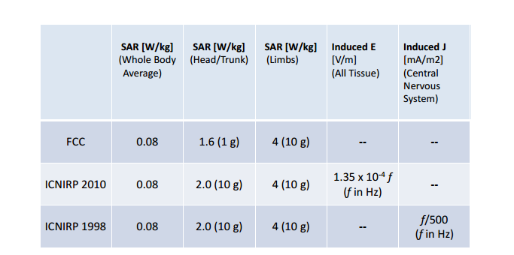
Figure 5.2.1a Recommended SAR, induced Electric field and Current in the nervous system
(Used with permission from Witricity)

5.3 Ethical, Health, and Safety Constraints

There are also ethical, health, and safety constraints imposed on this project, so throughout this section we aim to discuss our predicted constraints, and how we can circumvent these constraints.

While the FAA legislation exists that prevents the operation of drones near people, stadiums, and airports for safety reasons, our group is under an ethical and safety constraint to obey the legislation during the development of the SPIDRONE. To circumvent this constraint, alternative testing locations will be sought such that we can test without endangering the public.

Another safety concern is the chance for injuries while handling the SPIDRONE. During arming and disarming, there may be a chance for the propellers of the drone to spin at high speeds, which are capable of cutting through skin. With this constraint in mind, we have decided that the person directly handing the drone will be required to wear proper safety gear such as eye protection, long sleeved shirt, and pants. It was also decided that a first aid kit will be on hand during testing, and these tests will not be conducted alone.

As we intend to work with lead acid batteries, it is important to know the chemicals involved to makeup the battery and potential side effects from them. Lead acid batteries are used in many motorized applications such as automobiles, motorcycles, boats, and aircraft. They typically consist of a plastic body that contains lead plates immersed in sulfuric acid. Both lead and sulfuric acid are known to potentially hazardous to human health and to the environment. Lead is known to carry cancer risks, while sulfuric acid is corrosive and can cause to irritation or burns to the skin and respiratory system. To circumvent these concerns, proper safety equipment will be worn, such as eye protection, and gloves when handling sulfuric acid. The battery will only be activated by a group member who is familiar with handling lead acid batteries, and will only be charged in a well ventilated area.

The other type of battery that will be used for the SPIDRONE project is a lithium polymer battery, which contain similar health and safety concerns. Energizer’s product safety datasheet contains information about their own lithium polymer batteries, but the data can be applied to lithium polymer batteries in general. Lithium polymer batteries carry health risks which can be caused by ingestion, inhalation, skin contact, and eye contact from the chemicals that makeup the battery. To circumvent this, the batteries chosen for this project will be a sealed type which prevents users from maintaining the batteries. Another concern for lithium polymer batteries is the risk of a fire or explosion. During charging, or rapid discharging, the battery may overheat which can potentially cause a fire. Lithium polymer batteries are also capable of discharging a large amount of energy in a short amount of time, and as such a short circuit is also capable of causing a fire. To circumvent this, cool down times will be implemented between charging and flight times, to prevent the battery from overheating. A fire extinguisher will also be kept within close proximity to testing in the event a fire should break out, the fire department and university officials will be contacted as a burning lithium polymer battery releases toxic fumes.

5.4 Manufacturability and Sustainability Constraints

Due to time constraints, we opted to modify an already made drone system provided by the vendor rather than building our own mechanical parts from scratch. We choose that process due to the simplicity to assemble and to accommodate software configurations.

Because we shall custom build SPIDRONE with different electronics than the pre-built shields, a variety of modification may made to both the software and hardware:

- Radio Integration & Controller Remote PID Tuning
- Motor Control
- GPS integration
- Camera Integration

The design of this the project is approached by the team with sustainability and optimization in mind noted in the environmental and ethical considerations section. Code would be commented and written in a way for easy modifiability in future applications. The hardware is easily modified and replaced. This makes for easy repairs.

The SPIDRONE must be able to last for a minimum of a year under normal operation conditions.

Manufacturability:

Most of the devices used are readily available online at different retailers. Manufacturing of the quadcopter can be constructed from bottom up making it fairly simple however parts of would be obtained and assembled. Manufacturing constraints are mainly involved with environmental issues. For the prototype, a blend of surface mount and through-hole components would use to balance adaptability with PCB size; through hole components are easier to test and diagnose. For final versions, all surface-mount components would be used to increase manufacturability. Most of the devices used are readily available online at different retailers such as linear technology, Texas instruments however soldering needs precautionary steps to avoid hazards to the designer and the board as some components need to be soldered onto the board.

6.0 Project Hardware and Software Design Details

In the following section, we will discuss the project hardware and software design details of the SPIDRONE project. The hardware portion of the project, is the collection of the physical elements that compose the SPIDRONE project. Likewise, for the software details are composed of sets of instructions that directs to the hardware to perform specific operations that are need in order to have a successful SPIDRONE project.

6.1 Initial Design Architectures and Related Diagrams

This section describes the initial design architectures and related diagrams for the SPIDRONE project. These architectures are draft of what we would like to accomplish when the SPIDRONE project is completed. The related diagrams are some examples that we find that could help us on this project. Based on these architectures and these diagrams, our final architecture will be discussed and ultimately chosen.

In order to achieve the task of docking a multirotor for recharging a custom docking station would be designed. Several design architectures are considered against the requirements in order to select the most appropriate. The charging station must be able to fulfill the following charging requirements:

- Shall allow a +- 5cm tolerance on landing
- Should be capable of allowing a +- 15 degrees orientation misalignment
- Should allow a range of multirotor sizes and conﬁgurations
- Shall be able to connect to at least a single lipo(4s) and the corresponding balance connections
Various design alternatives are considered and examined to make the choice the best one for this project. The design types considered are: Mechanical gantry for alignment, cylinder with notches, Guiding cones, Mechanical battery swap, arbitrary contact grid.

Mechanical Battery Swap

For this design the copter lands and a mechanism removes the battery from the copter and then switches in a fresh one from a cartridge. This allows for instant recharge and does not require additional connections. Its limitations are that it is restricted to one drone configuration .It also requires dedicated control of and electronics for the station and is expensive. The benefits are that it requires no connection and has an instant recharge. The hardware for this design is shown in figure 6.1.1

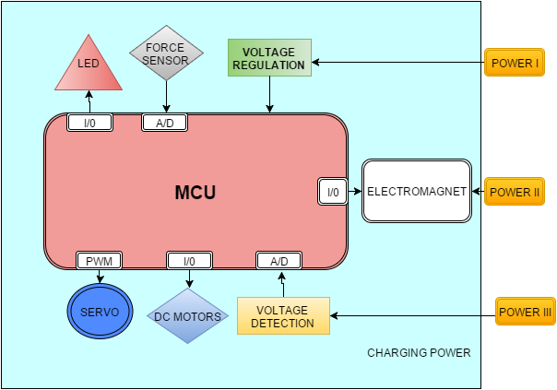
Figure 6.1.1 Prototype hardware for the Mechanical Battery Swap

Mechanical Crane for Alignment
For this design the arm of a mechanical gantry sweeps the drone to an appropriate position when it lands on the target in the approximate area. This is mechanically complicated and requires a lot of dedication for control and electronics. The merits are it could be programmed for multiple drones, can have an arbitrary number of connections and allows greater position and orientation misalignment.

Big Cylinder with Notches
This design would require the drone to have contacts on the arms and land into a cylinder with triangular notches which guide it into a resting position. The coils are housed in the cylinder which provides elevation thus making the transmitting coils closer to the receiving coils. Demerits of this design are that it requires dedicated design per drone. The drone may experience difficulty in taking off due to skids hitting the cylinder and if the cylinder is placed near the blades or underneath the drone they may be turbulence issues. Its advantages lie in its simplicity to build ability to support an arbitrary number of connections and allows greater position and orientation misalignments.

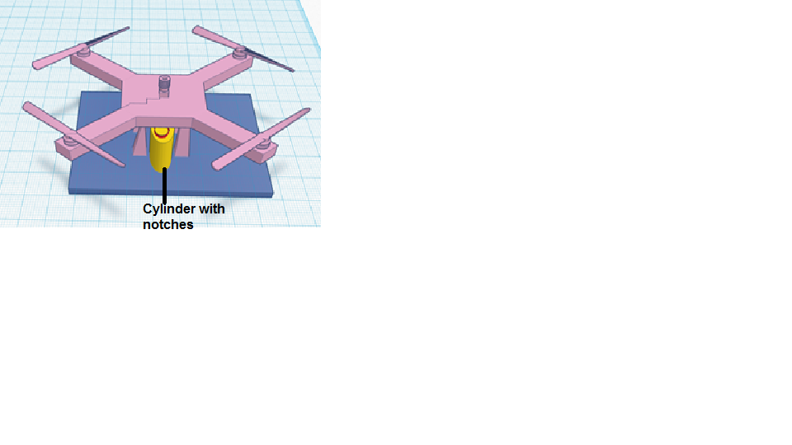
Figure 6.1.2 Prototype design for Big Cylinder with Notches

Guiding Cones
This design is fairly difficult to build and would develop some difficulties in taking off. On the other hand the design can allow greater position and orientation misalignments, support an arbitrary number of connections and can be attached to a wide variety of drones.

The system’s design is based off satellite style docking mechanism with one side active and the other passive. The cone system fits over the camera and sonar assembly at the base of the drone and a cylinder with a raised section and a mating cone placed on the landing target in such a way that the docking is complete when the landing skids barely touch the target.

6.2. Charging subsystem

The design of the charging subsystem comprises of both mechanical and electrical component. The mechanical requirements of the charging station are:
- The charging station shall weigh less than 10lbs.
- The charging station shall be portable. It’s imperative that the station be design to be portable in order for it to be able to carry around
- Be able to house the electrical components.
- Water resistant. Since most electrical components would be housed in the charging station it must be able to resist water to prevent the wireless charging components and the PCB
- The system should require minimum training to use and sustain. Maintenance of the system must be easy. The user
- Conspicuous and unique in its environment to allow for target sensing

The electrical component comprises of the PCB board of the wireless transmitter and that of the DC-DC converter. Both boards would be integrated on a surface mount that allows for stability of the station

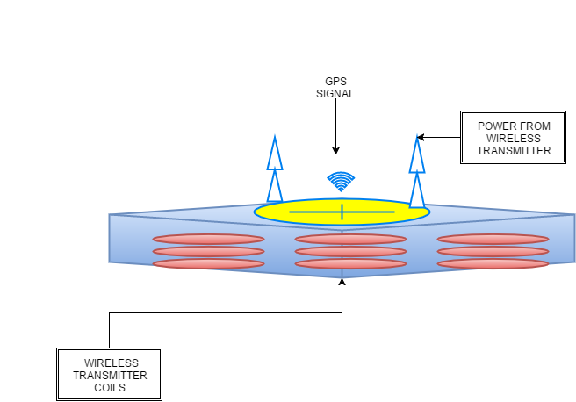

Figure 6.2a Charging station

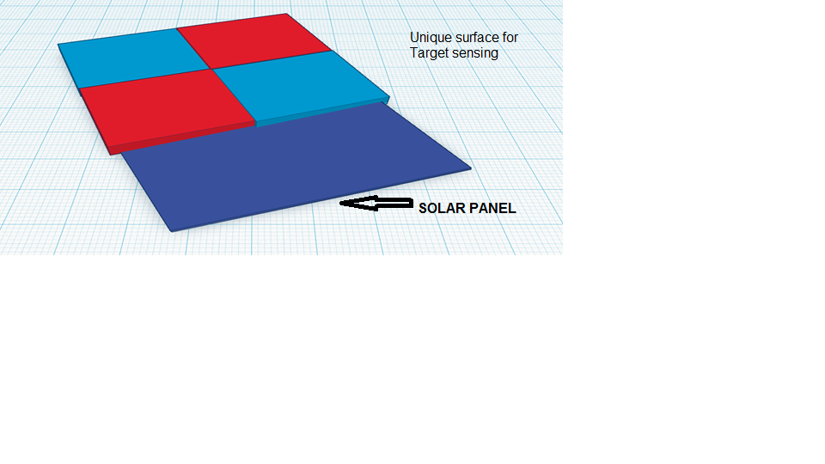
Figure 6.2b Aerial View of Charging station

6.2.1 Design of Wireless charging Station

Based on all the research on WPT, we have come up with our realistic design for the wireless charging station to date. The design is not the final one yet. It will be modified if need be.

Our design takes energy from a power source and transfer it wirelessly. The power that is received is then converted to DC power for charging the battery.
The Block diagram in figure 6.2.1a shows the wireless charging system. The transmitter (Tx) generates a high frequency alternating magnetic field in the transmitter coil, Lx. The receiver consists of a receiving coil Rx. The power output by the receiver depends on the load at receiver. The electrical specifications for our wireless charging station are displayed in table 6.2.1.

Input Voltage | 3.3V – 5.5V
Output Voltage | 11.1V
Output Current | 0.658A
Wireless transfer Frequency | 128.8kHz

Table 6.2.1 Electrical Specification our Wireless Charging System

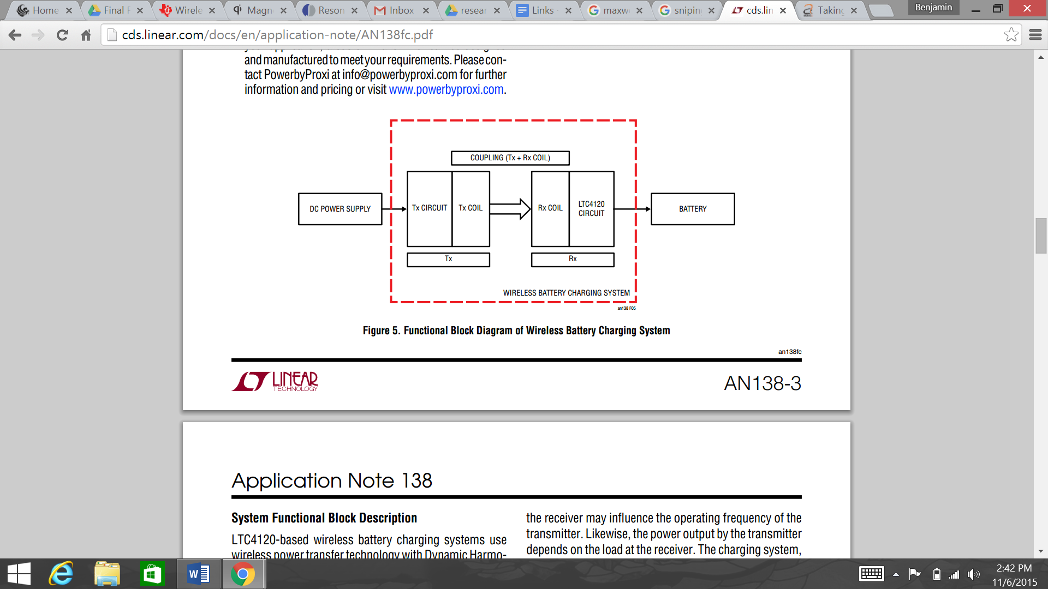

Figure 6.2.1a: Functional Block Diagram of Wireless Battery Charging System
(Used with Permission from Linear Technology)

Arbitrary Contact Grid
This system is based on the idea of having metal contacts placed on the landing skids and a landing on a target with a number of contacts in a pattern that maximize misalignment. The advantages of this design are the ability to allow greater orientation and position misalignment as well as being simple to build. On the other hand a typical disadvantage is that it may require colored contacts and would be only useful for a specific drone design.
This design would be ideal for implementation the project given that it makes the drone to be able to identify it for landing since the colors make it look different from its environment.

6.2.2 Wireless Transmitter (LTC4125)

One wireless transmitter we are considering for our design is linear technology's LTC4125. It is a high performance monolithic full bridge resonant driver capable of delivering over 5W of power. It is a safe and simple transmitter because it controls the current flow in a series connected transmit coil LC network. It automatically adjusts its driving frequency to match the LC network resonant frequency. Its AutoResonant switching allows it to deliver maximum power from a low voltage input supply (3V to 5.5V) to a tuned receiver. The efficiency in the LTC4125 is optimized because it employs a periodic transmit power search and adjusts the transmission power based on receiver load requirements. The only time the device stops delivering power is when there is a fault condition, or if a foreign object is detected. The LTC4125 also includes an NTC input as additional for foreign object detection. It also has a programmable maximum average input current limit. It performs at temperatures between –40°C to 125°C. The schematic for this transmitter is displayed in figure 6.2.2a

The following features are listed below as:
Features
- Monolithic 5W Wireless Power Transmitter
- Input Voltage Range: 3V to 5.5V
- AutoResonantTM Switching Frequency Adjusts to Resonant Capacitance and Transmit Coil Inductance
- Wide Operating Switching Frequency Range: 50kHz to 250kHz
- Transmit Power Automatically Adjusts to Receiver Load*
- Integrated 100Mω Full Bridge Switches
- Multiple Foreign Object Detection Methods
- Programmable Average Input Current Limit and Monitor
- NTC Input for System/Component Temperature Qualified Power Transfer
- Thermally Enhanced 4mm × 5mm QFN 20-Lead Package

The other option is the Proxi-Point 2W transmitter from powerbyproxi. The basic transmitter is 2W compared to the 5W from the LTC 4125. The schematic is shown in figure 6.2.2b. The switch driving circuitry has a diode, gate capacitor, resistor and Zener diode to take care of each switch. As the Zener diodes D1 and D4 in the schematics of the transistor below are used to turn on M1 and M2 with protecting them from overvoltage at the same time. The efficiency of the transmitter relies of the spacing between it and the receiver. Larger distance between the results in a lower power transfer efficiency. These are shown if tables 6.2.2d, 6.2.2e and 6.2.2f. The preferred choice for the design is the option with a 10.5mm gab shown in figure 6.2.2f.

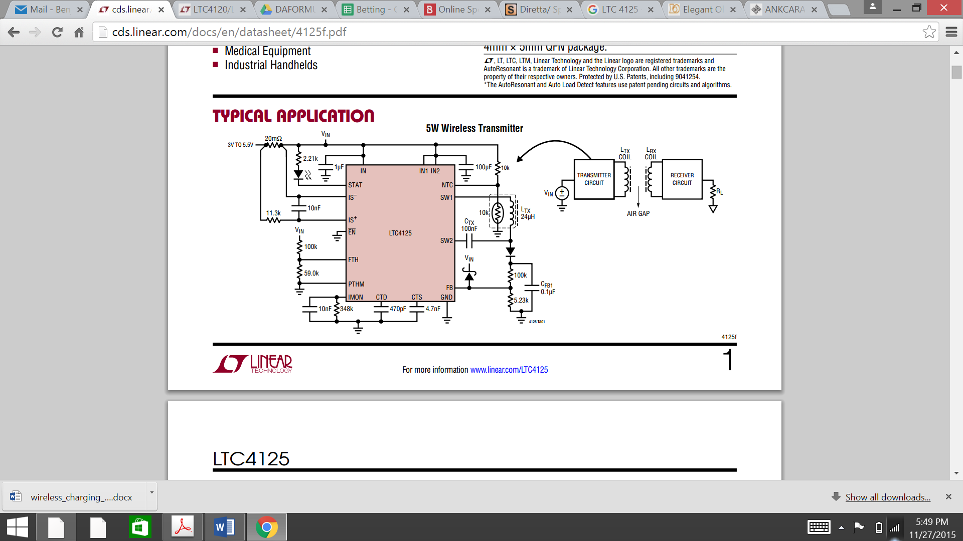

Figure 6.2.2a schematic of Transmitter LTC4125
(Used with Permission from Linear Technology)

The pin configuration for the LTC 4120 receiver are shown in figure 6.2.2b

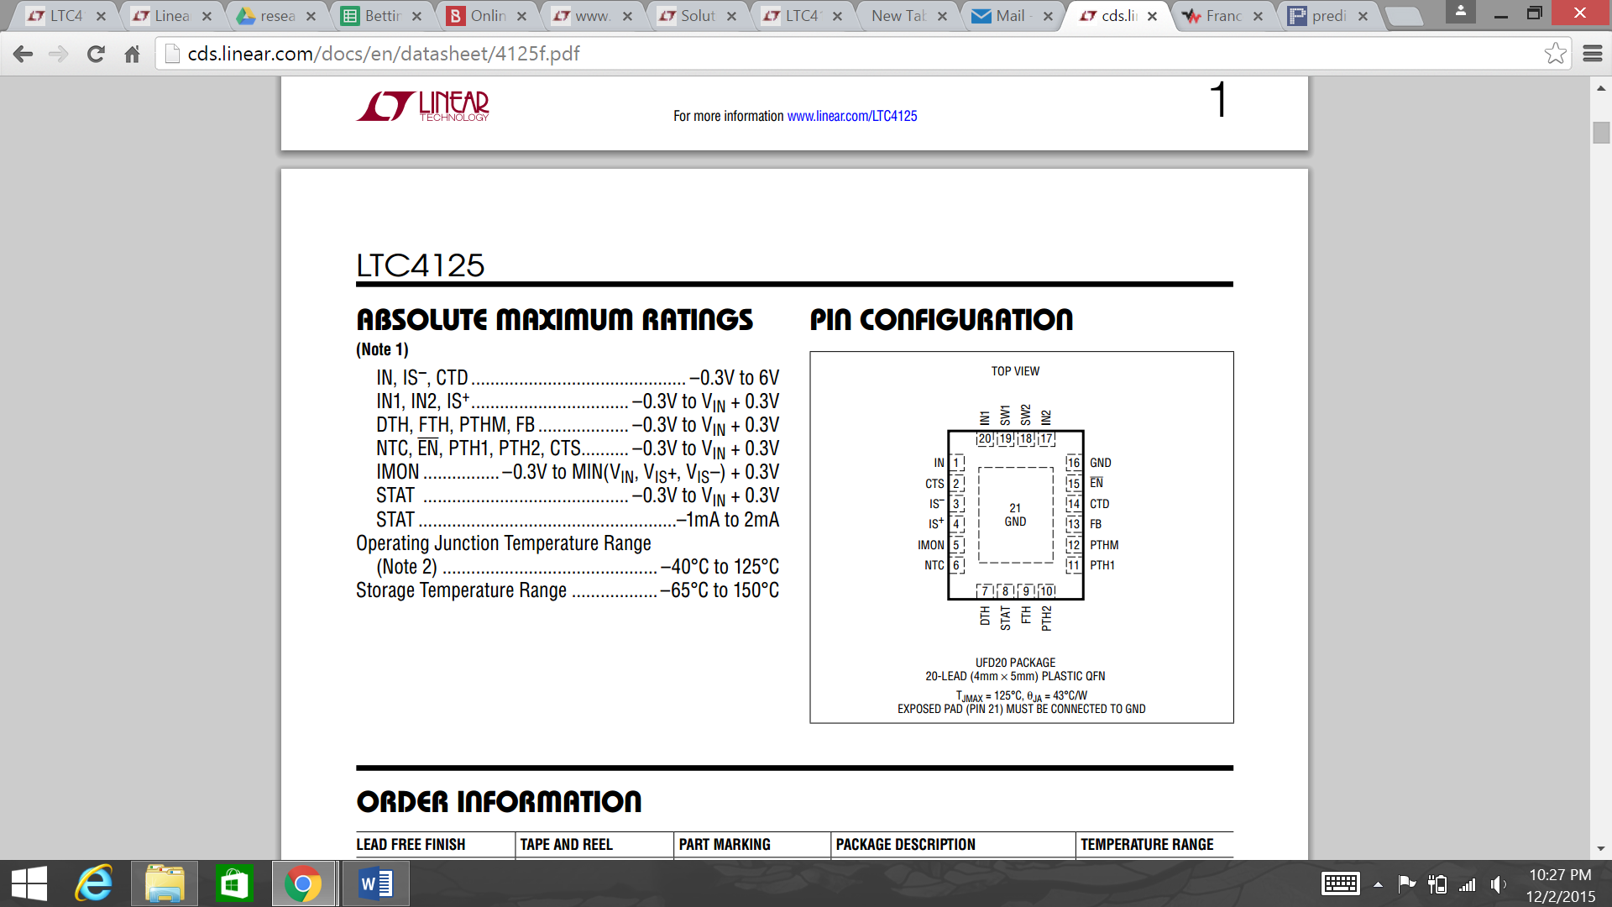

Figure 6.2.2b Pin Configuration for the LTC 4125 Transmitter
(Used with Permission from Linear Technology)


Figure 6.2.2c schematic of Basic Transmitter by Powerbyproxi
(Used with Permission from Linear Technology)

SPECIFICATION | WITH RECEIVER (NO LOAD) | WITH RECEIVER (1.535W LOAD)
Operational Frequency | 129.5kHz | 129.5kHz
Input Voltage | 4.99V | 4.96V
Input Current | 0.154A | 0.602A
RMS Value of Tx Output AC Voltage | 10.9V | 10.5V
Peak Value of Tx Output AC Voltage | 15.2V | 15.2V
Receiver Output DC Voltage | 23.9V | 17.5V
Standby Loss | 0.768W | N/A
Efficiency | N/A | 51.4%

Table 6.2.2d Transmitter circuit parameters 7.55mm Gap

SPECIFICATION | WITHOUT RECEIVER (STANDBY) | WITH RECEIVER (NO LOAD) | WITH RECEIVER (1.58W LOAD)
Operational Frequency | 130.5kHz | 128.7kHz | 128.9kHz
Input Voltage | 4.99V | 4.99V | 4.95V
Input Current | 0.15A | 0.173A | 0.676A
RMS Value of Tx Output AC Voltage | 10.9V | 10.8V | 10.4V
Peak Value of Tx Output AC Voltage | 15.2V | 15.2V | 15.2V
Receiver Output DC Voltage | N/A | 34.9V | 27V
Standby Loss | 0.75W | 0.873W | N/A
Efficiency | N/A | N/A | 47.1%

Table 6.2.2de Transmitter circuit parameters 4.5mm Gap

SPECIFICATION | WITH RECEIVER (NO LOAD) | WITH RECEIVER (1.535W LOAD)
Operational Frequency | 130.2kHz | 128.8kHz
Input Voltage | 4.99V | 4.95V
Input Current | 0.156A | 0.658A
RMS Value of Tx Output AC Voltage | 10.8V | 10.5V
Peak Value of Tx Output AC Voltage | 15.2V | 15.2V
Receiver Output DC Voltage | 17.4V | 13.9V
Standby Loss | 0.777W | N/A
Efficiency | N/A | 46.9%

Table 6.2.2f Transmitter circuit parameters 10.5mm Gap

6.2.3 Wireless Receiver and 400mA Buck Battery Charger (LTC4120)

From our research we have successfully selected our wireless power receiver of choice, the LTC 4120. The LTC4120 accepts a rectified 4.2V to 40V input from the receive coil to power a full-featured constant-current/constant-voltage 400mA battery charger. The receiver coil will be attached to the drone. The receiver coil will be placed directly beneath our drone so it can effectively couple our transmitter coils in our charging station.

The LTC4120 is a constant-current or voltage wireless receiver and battery charger. It has a charge current of 400mA. This LTC4120 is ideal for charging Li-Ion / Polymer batteries. This receiver is capable of charging in harsh environmental conditions and can even charge moving or rotating equipment. It can charge while sealed within an enclosure. The LTC4120 and supporting circuitry has an area of 460 mm2 (single‐sided) in addition to a 25mm diameter receive coil.

The schematic for the LTC4120 is shown in figure 6.2.3a.The components of the LTC120 receive demo board are shown in figure 6.2.3b below.
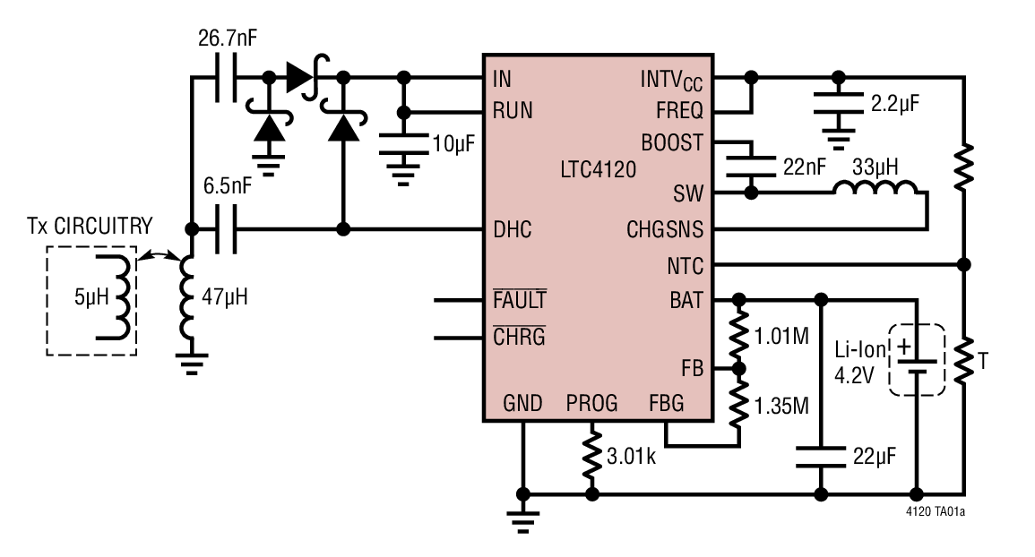

Figure 6.2.3a Schematic of LTC4120
(Used with Permission from Linear Technology)

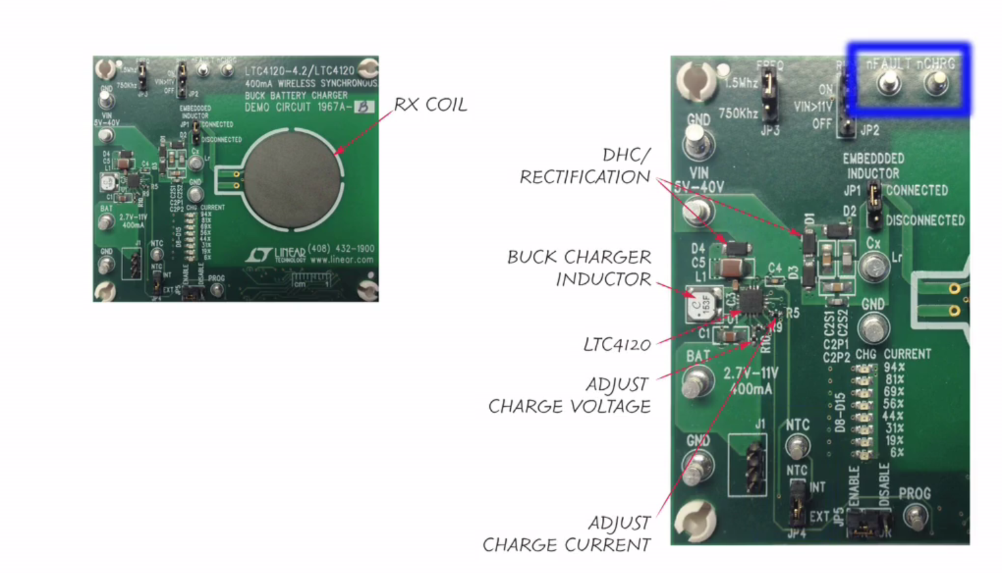

Figure 6.2.3b LTC4120 Receive Demo board Components
(Used with Permission from Linear Technology)

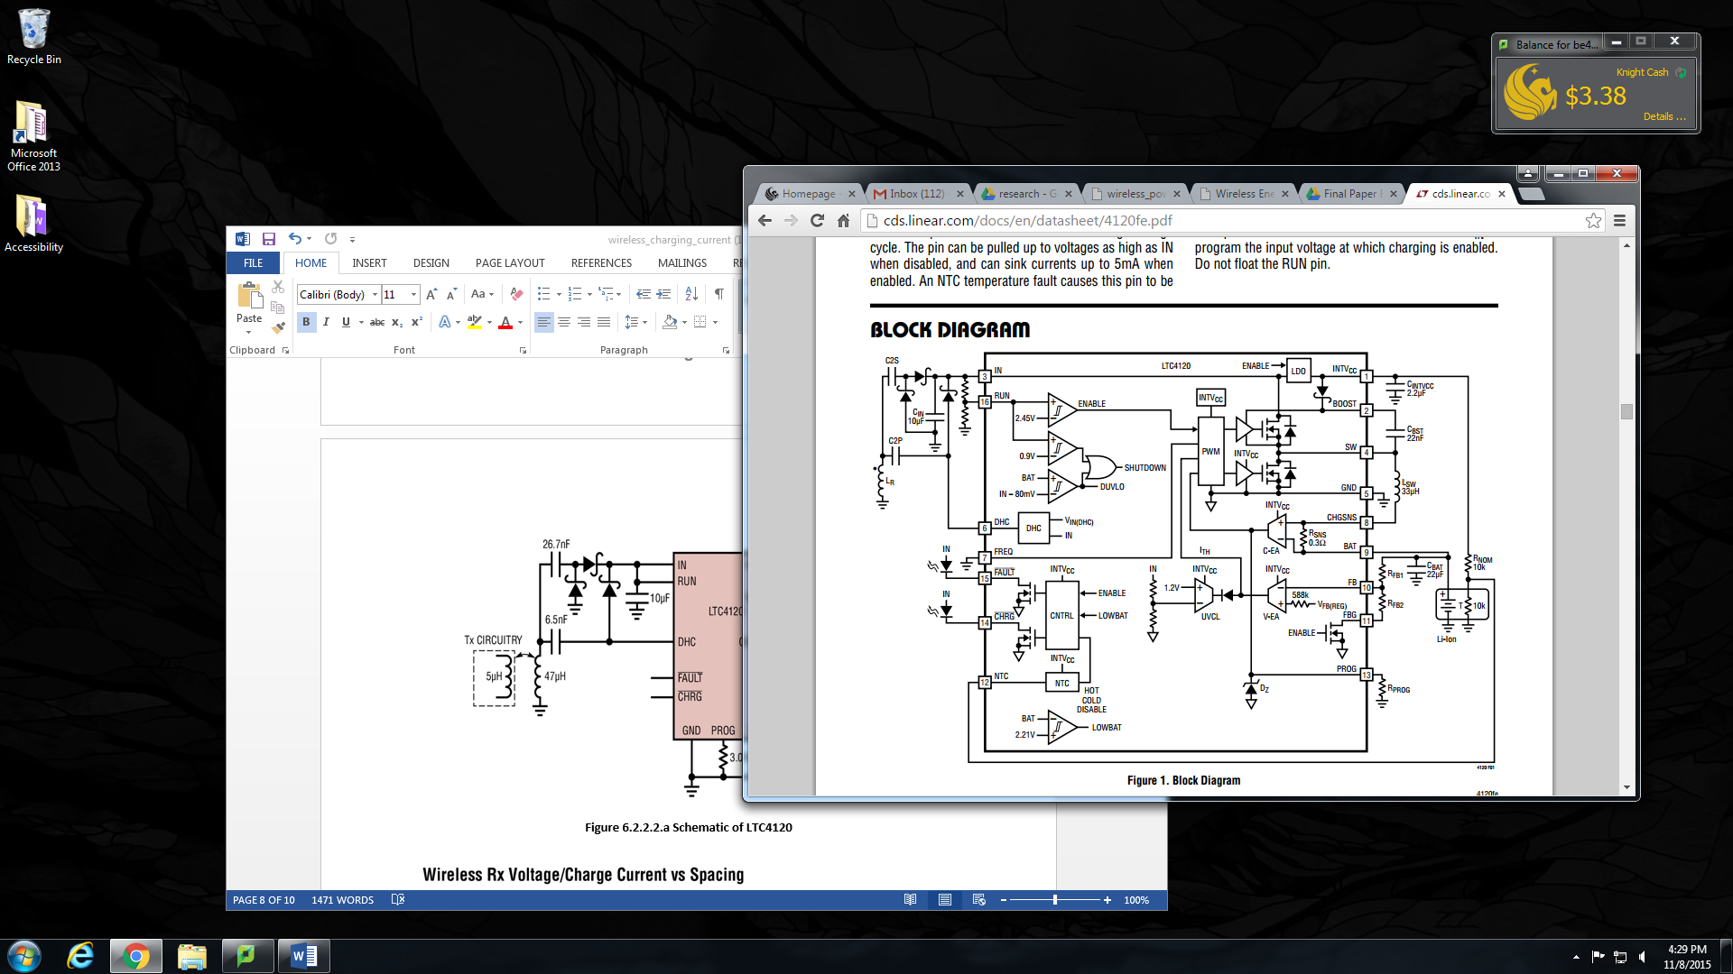

Figure 6.2.3c Block Diagram of LTC4120
(Used with Permission from Linear Technology)

Pin configuration
The pin configurations are detailed below:
- Dynamic Harmonizing Control (DHC) technique: It allows high efficiency charging across an air gap. The same DHC pin regulates the voltage input.
- CHRGPIN: Capable of terminating charging once the battery has reached full capacity via the CHRGPIN. And it can also resume automatic charging whenever the drone battery drops below 2.2%.
- FAULT pin: provides an indication of bad battery or temperature faults.
- NTC pin- : Battery temperature monitoring.
- FAULT pin: Provides an indication of bad battery or temperature faults.
- These other components include RUN pin threshold, low voltage battery preconditioning, bad battery fault detection, timer termination, and auto-recharge.

The pin configuration for the LTC 4120 receiver are shown in figure 6.2.3.d.
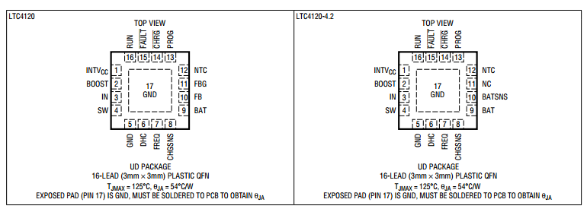

Figure 6.2.3d Pin Configuration for the LTC 4120 Receiver
(Used with Permission from Linear Technology)

Features of the LTC 4120
- Dynamic Harmonization Control (DHC) Optimizes Wireless Charging Over a Wide Coupling Range
- Wide Input Voltage Range: 12.5V to 40V
- Adjustable Float Voltage: 3.5V to 11V
- Fixed 4.2V Float Voltage Option: LTC4120-4.2
- 50Ma to 400Ma Charge Current Programmed with a Single Resistor
- ±1% Feedback Voltage Accuracy
- Programmable 5% Accurate Charge Current
- Thermally Enhanced, Low Profile 16-Lead (3mm × 3mm × 0.75mm) QFN Package

400mA Buck Battery Charger (LTC4120)
The component of the LTC 4120 is responsible for charging the drone battery. It is the 400mA buck charger. The charger will be inbuilt in the PCB of the drone. The schematic for the charger is shown in figure 6.2.3e. The battery is connected to E6 on the schematic .The bar graph in table 6.2.3f show the schematic for the charging percentage for the battery. From the schematic we see that the minimum percentage for the buck charger is 6% and the maximum charging percentage is 94% which is good enough for the drone to execute its mission successfully.

Our design is able to detect when the drone battery is fully charged and signals the LTC 4120 charger to stop charging. Minimum current enters the USB when there is low battery. When the battery level is lower than the desired level, the more current passes through the USB signaling the receiver to begin charging the drone. This added capability is already programmed into the MCU of the LTC4120 board. The flowchart in figure 6.2.3e shows how the MCU executes the instructions. The specification for the battery charger are stated in table 6.2.3f.

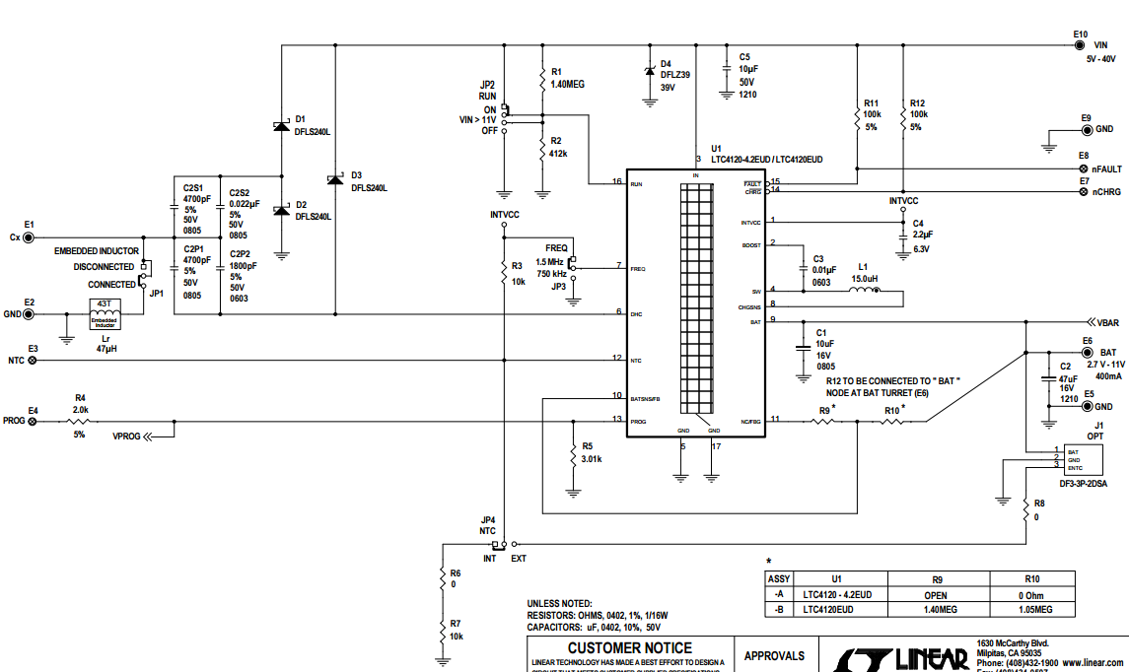

Figure 6.2.3e Schematic for 400mA Wireless Synchronous Buck Battery Charger (Connect Drone Battery to E6)
(Used with Permission from Linear Technology)

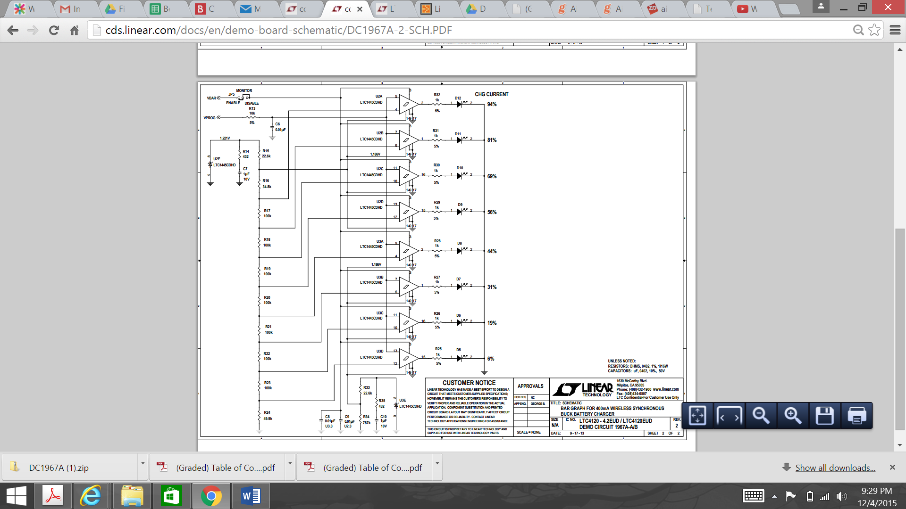

Figure 6.2.3f Bar graph for 400mA Wireless Synchronous Buck Battery Charger
(Used with Permission from Linear Technology)

Power on
Send signal to charge
Read current from Hall Effect sensor
Turn off charging signal
Low current = Full Battery
High current = need charge

Figure 6.2.3e Flow chart for Battery charging

Battery Parameter | Minimum | Typical | Maximum | Units
Charge Current | 383 | 402 | 421 | mA
Standby Current | - | 2.5 | 4.5 | uA
Shutdown Current | - | 1100 | 2000 | nA
Regulation Voltage | 2.370 | 2.400 | 2.407 | V
Recharge Threshold Voltage | –38 | –50 | –62 | mV
Low Battery Linear Charge Current | 6 | 9 | 16 | mA
Low Battery Threshold Voltage | l 2.15 | 2.21 | 2.21 | V

Table 6.2.3f Battery Charger specifications

Figure 6.2.3g shows that for smaller receiver spacing the charge current is smaller and the voltage input of the receiver is also smaller. This suggests that for a more efficient charging we have to tradeoff the maximum distance for charging.

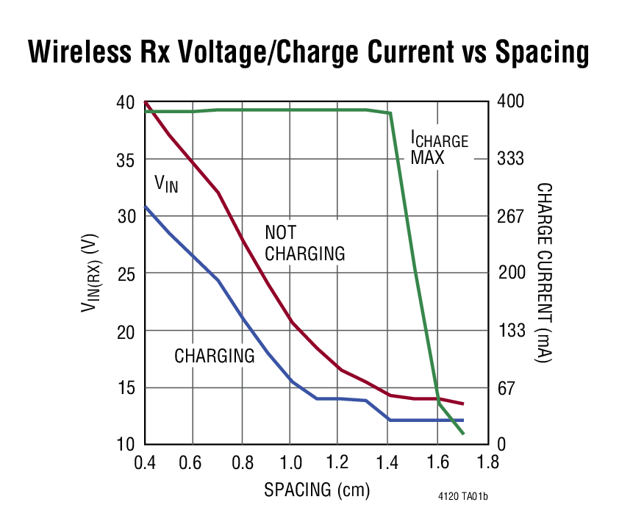

Figure 6.2.3g Wireless Receiver Voltage / Charge current vs Spacing of LTC4120
(Used with Permission from Linear Technology)

The ideal temperature that the LTC4120 has to be to perform at its peak is 25 degrees Celsius. A temperature below this will result in a very small battery charge current. Temperatures above this will also hinder the battery charge current as can be seen figure 6.2.3h

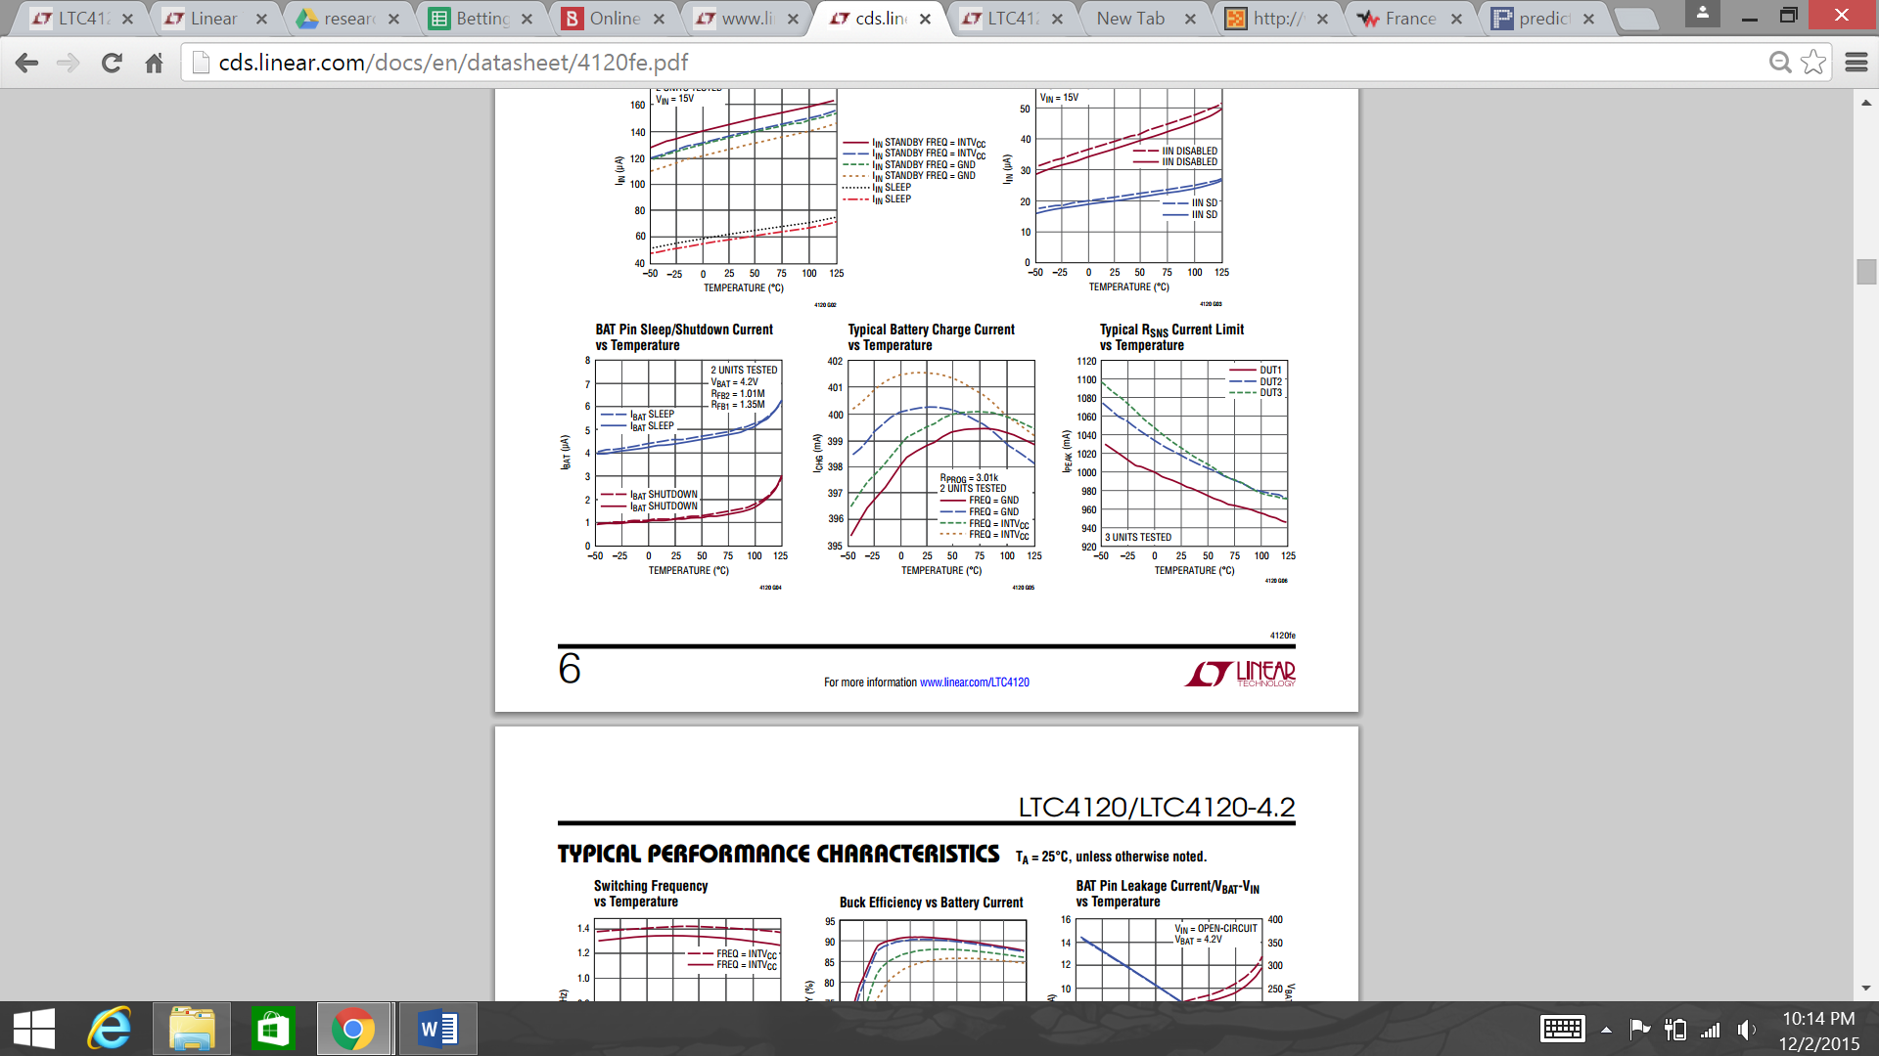

Figure 6.2.3h Typical battery charge current Vs Temperature
(Used with Permission from Linear Technology)

There is an inverse relationship between the battery current and the battery voltage during charging. Less current flows to the battery when the battery is almost charged than at the beginning where there is more current flowing to the battery as can be seen by the blue curve in figure 6.2.3i.

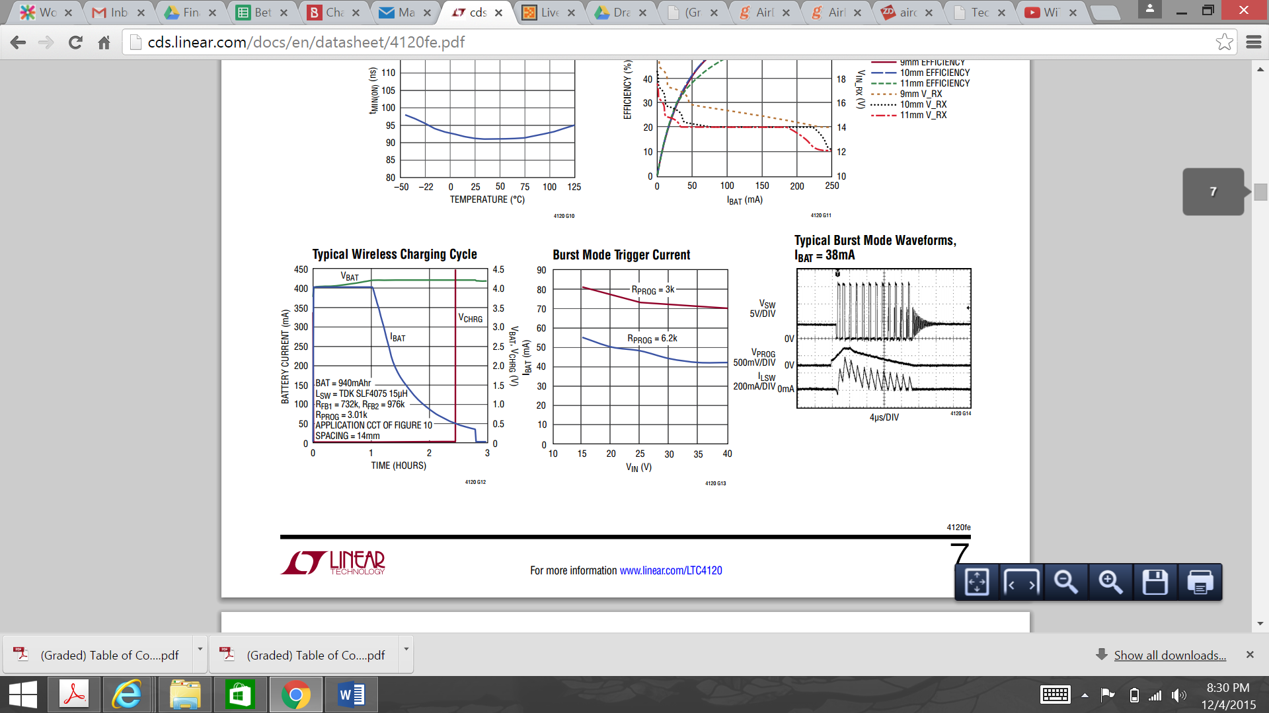

Figure 6.2.3i Typical Wireless Charging Cycle
(Used with Permission from Linear Technology)

6.2.4 Proposed Wireless charging Application

After extensive research into the various wireless transmitter and receiver options, we have finally come up with how to use the aforementioned features into our design. The application of the LTC4125 transmitter and LTC4120 are obtained from the datasheet of the LTC4125 from Linear Technology. This application charges a 200mA single cell LI-Po battery but our drone battery is 3-cell LI-Po. The schematic in figure 6.2.4a is a transmitter driving a 24uH Transmit Coil at 103 kHz, with 530mA Input Current Threshold. The frequency limit is 119 kHz. The surface temperature limit is 41.5 degrees Celsius.
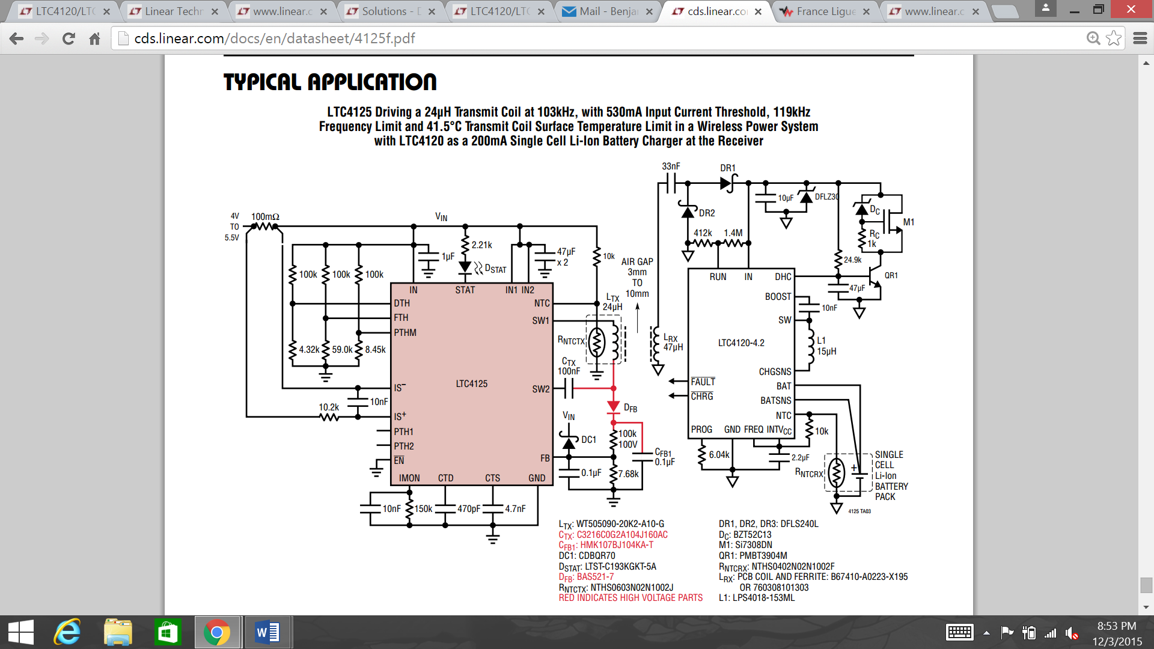

Figure 6.2.4a Typical Wireless Charging Application
(Used with Permission from Linear Technology)

6.3 Auto Landing Subsystem

This section outlines the hardware and software details of the auto landing subsystem for the quadcopter. The hardware and software requirements were chosen to meet the objectives, goals, and budget of our project.

The hardware aspect of the auto-landing subsystem needs to be designed such that it will be lightweight so that the quadcopter will not be burdened by the weight of the hardware, otherwise the quadcopter may have trouble maintaining a stable or any flight whatsoever. Optical recognition was chosen for the precision landing needed by quadcopter to properly align it for charging. However, optical recognition demands a large amount of resources to process any image received. This in turn would require additional specialized equipment, thus adding weight and additional power consumption to the quadcopter. To circumvent this, it was determined that a separate computer or laptop can be utilized to handle the image processing. The quadcopter will have a downward facing camera attached to it, which will stream its video feed to the image processing computer. The Pixhawk flight controller is capable of streaming this video using one of the telemetry ports to allow it to transmit data to and from a computer. The computer will be equipped with the corresponding telemetry unit to receive the video feed from the quadcopter and to transmit instructions to the quadcopter on how to align itself to land.

The software aspect of the auto-landing subsystem needs to be designed such that it can efficiently process the video feed being received from the quadcopter. To accomplish this the software needs to be able to quickly detect an object, specifically a sticker or emblem placed on the charging dock. Then the software needs to determine where the object is located inside of its frame and determine how to move the quadcopter to center the object within its view frame. Once the quadcopter has the object centered within its view frame, the computer needs to issue the command to have the quadcopter start descending, while still issuing commands to maintain its alignment. The need for the computer to still issue commands while the quadcopter is landing is because the quadcopter can lose its alignment because of a gust of wind, or prop wash. Prop wash is the air current created by the propellers spinning, which is how the propellers generate their thrust, but when the quadcopter is within close proximity to an object such as the ground, the prop wash can have adverse effects on the quadcopter which can cause its position to shift during descent.

6.4 Tracking Subsystem

This 6.0 section outlines the hardware and software details of the tracking subsystem for the quadcopter for the SPIDRONE project. This hardware and software subsystems were chosen to meet the objectives, goals, and budget of the project. As discussed in section 3.2.1 Wireless communication, the Global Pointing System we thought was the best fit for our project, due to the range that we wanted.

The hardware that would be incorporated to the tracking subsystem of the SPIDRONE needs to be as efficient as possible within a comfortable distance from its user. Essentially, what we would like to accomplish is for the user to walk a pathway of their choosing. Once the path is done, we then would like the quadcopter to read in this path, and follow that path made by the user. This would be implement as the user finishes is path, the path would be send to the quadcopter via the tracking implementation, once the path has been successfully received by the quadcopter, the quadcopter then should be able to follow the path made by the user, and if the battery allows it, the quadcopter should go back to its charging dock or land safely after its mission is completed. For this tracking subsystem, we have decided to use an implementation of the Global Positioning System (GPS). The reason why we chose to use the GPS as the base of our SPIDRONE project over the other types of wireless communication was because we wanted the best wireless communication for range purposes. GPS is widely known for being equipped with maps and locations from around the world, and its range is appropriate for this SPIDRONE project. We thought GPS would be the wireless communication that our project can benefit from. Since we will be using a Pixhawk controller, we decided to use one of the GPS modules that the Pixhawk offers. Necessarily for the SPIDRONE project, we will like to keep it consistent with its parts and software for the best communication results possible.

In the software implementation, we will be using waypoints GPS navigation. The drone waypoint GPS navigation is an advanced technology. This navigation allows our quadcopter to fly on its own with its flying destination or points pre-planned (in the case of our project, the user’s path) and configured into the drone control navigation software.
The instructions given by the remote control navigation software, will instruct the SPIDRONE where to fly; at what height; the speed and it can also be design to hover at each waypoint. This is the route and destination that the user will record via an android application that will be received by the quadcopter.

The software should be able to support the drone landing in case of a low battery. It has to understand that if the path made by the user is too long or can’t be completed, it needs to track back to the charging dock. If it can reach the charging dock, then along with the auto-landing subsystem discussed in the section 6.3, it should land safely and recharge its battery. In the case that the drone cannot finish the path, and it cannot reach the charging dock, then it would have to land safely. Figure 6.4.1 shows that the user can take any direction when making the path for the drone to follow. The figure 6.4.2, shows that once the path is completed, it will send the path to the drone to follow. Also, figure 6.4.3 shows that the drone will take the path that it received from the user to follow.

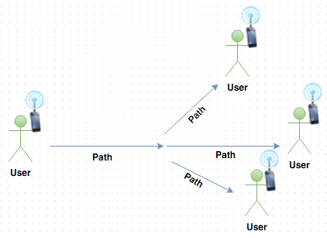

Figure 6.4.1 User’s path

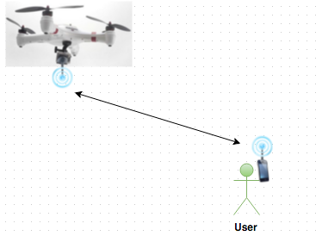

Figure 6.4.2 User and Drone Communication

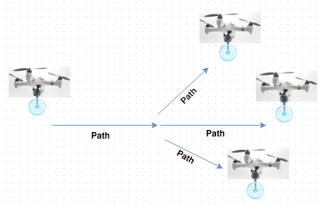

Figure 6.4.3 Drone follows user’s path

After it the drone is done doing the user’s path as shown in figure 6.3.3, it would have to go back to its charging dock or land safely in an open area; finishing its mission and getting charge and ready for the next mission to follow.

6.5 Application Program Interface (API)

This section discusses the Application User Interface (API) that was developed for the SPIDRONE, and why it is necessary. During the precision landing testing phase it was discovered that while the Python script would function when testing through the IDE, it would not function when launched within Mission Planner. The reason for this is because Mission Planner uses its own implementation called Iron Python that works independently of the native Python installation. This meant that when the script was launched through Mission Planner, it would throw an error stating that there were no modules named OpenCV or numpy. The local system path was added into the Python script, but still threw an error with numpy’s MultiArray module. The possible options to circumvent this were to change to a different flight software such as MAVProxy, scrap this portion of the project, or to create an API for an external program to control the drone through Mission Planner.

The key factor for developing the API was to create a reliable method of communicating information between the two programs. One method for this would be reading and writing to text files on the PC, but this solution would be slow and can potentially run into read/write issues with both programs attempting to access the same file. The better solution was to use TCP/IP, which would allow a script inside of Mission Planner to listen and receive commands by listening to a specific TCP/IP port, and interpreting the commands when received. An external program would be able to connect to that port by using the loopback 127.0.0.1, or local host address and the specific port number. Ultimately this does allow for constructing the external program to be written in any language, but we chose to stick with Python as most of the programming was done and just needed to be adapted to the new structure.

7.0 Project Prototype Construction and Coding

This section covers the related work involving the projects prototype construction and the coding that allows the proper functionality of the SPIDROME. All the hardware that will be tested and put together in order, as well as the software plans for SPIDRONE to accomplish its functionality and meet the team’s goals and motivation. We need to keep in mind that for this prototype, we will run into inspected concerns and errors during both phases in the hardware and in the software. We need to be prepare to handle these errors that might come up in the future.

7.1 Parts Acquisition and BOM

Listed in table 7.1.1 is the bill of materials for the TI LM3488 Uncoupled Inductors SEPIC

Part Number | Footprint | Qty Req Per Kit | Order Multiple | Quantity Ordered | Prototype Price | Total
UMK212B7224KG-T | 805 | 1 | 1 | 1 | $0.12 | $0.12
CC0805KRX7R9BB332 | 805 | 1 | 1 | 1 | $0.10 | $0.10
PRL1632-R013-F-T1 | 612 | 1 | 1 | 1 | $0.65 | $0.65
ERJ-6ENF1581V | 805 | 1 | 1 | 1 | $0.10 | $0.10
GRM32ER7YA106KA12L | 1210_280 | 1 | 1 | 1 | $0.99 | $0.99
ERJ-6ENF1002V | 805 | 1 | 1 | 1 | $0.10 | $0.10
ERJ-6ENF2942V | 805 | 1 | 1 | 1 | $0.10 | $0.10
MSS1210-683MEB | MSS1210 | 1 | 1 | 1 | $0.00 | $0.00
CRCW080520R0FKEA | 805 | 1 | 10 | 10 | $0.09 | $0.90
PM2110-220K-RC | PM2110 | 1 | 1 | 1 | $2.37 | $2.37
GRM2195C1H752JA01D | 805 | 1 | 1 | 1 | $0.29 | $0.29
C0603C104K5RACTU | 603 | 1 | 1 | 1 | $0.10 | $0.10
TPSE477M010R0045 | 7343-43 | 3 | 1 | 3 | $8.56 | $25.68
SL44-E3/57T | SMC | 1 | 1 | 1 | $0.78 | $0.78
ERJ-6ENF2263V | 805 | 1 | 1 | 1 | $0.10 | $0.10
CRCW0402100RFKED | 402 | 1 | 10 | 10 | $0.08 | $0.80
CSD18563Q5A | TRANS_NexFET_Q5A | 1 | 1 | 1 | $1.64 | $1.64
LM3488MMX/NOPB | MUA08A | 1 | 1 | 1 | $2.19 | $2.19
35TQC10M | 7343-20 | 2 | 1 | 2 | $2.64 | $5.28

Table 7.1.1 – Bill of Materials

Solar Panels
There are many different types of monocrystalline solar panels produced by many vendors. A careful consideration after research of similar products by different manufacturers led to the selection of the 12V, 5W battery by Allpower. The product comes in the following specifications:
- Solar Panel: Mono-crystalline silicon 18V,5W
- The voltage rating is ideal for this project it would provide
- No-load voltage: 18-23VDC
- Load voltage: 18V
- Output current: 250-280mAh (0.2A-0.28A)
- Size: 320x120x5mm/12.6*4.7*0.19inch
- Weight: 0.323kg/ 11.4oz. The weight is one of the best specification features. This makes it portable and also possible to meet the design specification of the charging station

7.1.1 Parts Acquisition for Wireless Transmitter and Receiver

Most of the wireless charging components will be obtained from Linear Technology. The recommended components for the transmitter and receiver are displayed in figure 7.1.1a and figure 7.1.1c respectively. The components of the high voltage regulator are shown in figure 7.1.1b. The voltage regulator has the following values CX = 300nF with 5µH LX coil, or CX = 233nF with 6.3µH LX coil. The ECHU capacitor can overheat while soldering hence care must be taken. Plastic film capacitors such as Panasonic ECHU series or Metallized Polypropylene capacitors such as WIMA MKPare suitable for the transmitter.

ITEM | DESCRIPTION | MANUFACTURER/PART NUMBER
D2, D3 | DIODE, SCHOTTKY, 40V, 2A | ON SEMI NSR10F40NXT5G
D1, D4 | DIODE, ZENER, 16V, 350mW, SOT23 | DIODES BZX84C16
M1, M2 | MOSFET, SMT, N-CHANNEL, 60V, 11mΩ, S08 | VISHAY Si4470EY-T1GE3
LB1, LB2 | IND, SMT, 68µH, 0.41A, 0.4Ω, ±20% | TDK VLCF5028T-680MR40-2
C4, C5 | CAP, CHIP, X7R, 0.01µF, ±10%, 50V, 0402 | MURATA GRM155R71H103KA88D
R1, R2 | RES, CHIP, 100Ω, ±5%, 1/16W, 0402 | VISHAY CRCW0402100RJNED
CX1, 2 | CAP, CHIP, PPS, 0.15µF, ±2%, 50V | PANASONIC ECHU1H154GX9
CX (Opt) | CAP, PPS, 0.15µF, ±2.5%, 63VAC, MKS02 | WIMA MKS0D031500D00JSSD
LX | 5.0µH TRANSMIT COIL | TDK WT-505060-8K2-LT

Table 7.1.1a Recommended Transmitter Components

Item | DESCRIPTION | Manufacturer/Part Number
U1 | LT3480EDD, PMIC 38V, 2A, 2.4MHz Step-Down Switching Regulator with 70µA Quiescent Current | LINEAR TECH LT3480EDD
M3 | MOSFET, SMT, P-CHANNEL, –12V, 32mΩ, SOT23 | LINEAR TECH LT3480EDD
M4 | MOSFET, SMT, N-CHANNEL, 60V, 7.5Ω, 115mA, SOT23 | VISHAY Si2333DS
D5 | DIODE, SCHOTTKY, 40V, 2A, POWERDI123 | ON SEMI 2N7002L
C6 | IND, SMT, 68µH, 0.41A, 0.4Ω, ±20% TDK VLCF5028T-680MR40-2 C4, C5 C | DIODES DFLS240L
C7 | CAP, CHIP, X5R, 4.7µF, ±10%, 50V, 1206 | COILCRAFT LPS4018-472M
C8 | CAP, CHIP, COG, 330pF, ±5%, 50V, 0402 | MURATA GRM155R71H4755KA12L
C9 | CAP, CHIP, X7R, 0.47µF, ±10%, 25V, 0603 | MURATA GRM188R71H683K
C10 | CAP, CHIP, X5R, 22µF, ±20%, 6.3V, 0805 | TAIYO-YUDEN JMK212BJ226MG
R3,R8 | RES, CHIP, 150k, ±5%, 1/16W, 0402 | VISHAY CRCW0402150JNED
R4,R5,R6,R10,R7 | RES, CHIP, 40.2k, ±1%, 1/16W, 0402 | VISHAY CRCW040240K2FKED

Table 7.1.1b Recommended High Voltage Pre-Regulator Components

Item | DESCRIPTION | Manufacturer/Part Number
D1, D2, D3 | DIODE, SCHOTTKY, 40V, 2A, POWERDI123 | DIODES DFLS240L
D4 (Opt) | DIODE, ZENER, 39V, ±5%, 1W, POWERDI123 | DIODES DFLZ39
LR | IND, EMBEDDED, 47µH, 43 TURNS WITH 25mm FERRITE BEAD | EMBEDDED 4-LAYER PCB (see Figure 12)  ADAMS MAGNETICS B67410-A0223-X195
L1 | IND, SMT, 15µH, 260mΩ, ±20%, 0.86A, 4mm × 4mm | COILCRAFT LPS4018-153ML
C2P1 | CAP, CHIP, COG, 0.0047µF, ±5%, 50V, 0805 | MURATA GRM21B5C1H472JA01L
C2P2 | CAP, CHIP, COG, 0.00018µF, ±5%, 50V, 0603 | KEMET C0603C182J5GAC7533
C2S1 | CAP, CHIP, COG, 0.022µF, ±5%, 50V, 0805 | MURATA GRM21B5C1H223JA01L
C2S2 | CAP, CHIP, COG, 0.0047µF, ±5%, 50V, 0805 | MURATA GRM21B5C1H472JA01L
C1 |  | TDK C2012X5R1C106K
C2 | CAP, CHIP, COG, 0.022µF, ±5%, 50V, 0805 | MURATA GRM21B5C1H223JA01L
C3 | C3 CAP, CHIP, X7R, 0.01µF, ±20%, 6.3V. 0402 | TDK C1608X7R1H103K
C4 | CAP, CHIP, X5R, 10µF, ±20%, 16V, 0805 | TDK C2012X5R1C106K
U1 | 400mA WIRELESS SYNCHRONOUS BUCK BATTERY CHARGER | LINEAR TECH LTC4120

Table 7.1.1c Recommended Receiver Components

7.2 Software

Section 7.2 Software explains the different aspects of the software that we will implement in the SPIDRONE project. Software is often divided into two different categories, application software and System Software. Application software, handles multitudes of common and specializes instructions that a user would like to perform. System Software, controls the basic functionality of the device and comes preinstalled with the machine. For the purpose of SPIDRONE, we will implement these software aspects in the form of the tracking and auto landing of the SPIDRONE as we have previously discussed in sections 6.3 and 6.4.

7.2.1 Auto Landing Coding Plan

This section will outline the coding plan for the auto landing sequence of the quadcopter to demonstrate how the software will be developed through its different stages to meet the details outlined in section 6.3.

The auto landing code will be developed in stages. This will allow us to develop the code for each stage and optimize it before moving onto the next stage. Once the following stage is completed we will be able to go back and check that each stage will be able to proceed through its different test cases before proceeding any further.

The auto landing subsystem can be further split into 2 subsystems that can be developed independently, so long as an integration is created between the 2 subsystems.

The first subsystem is the integration with the quadcopter commands. This subsystem will be responsible for issuing commands to the quadcopter such as strafe left, strafe right, fly forward, fly reverse, stop, rotate clockwise/counterclockwise, and descend. The development of this subsystem will involve creating a command list that can enable the quadcopter to execute every move for unassisted flight. To test this subsystem, a debugging function will be created that will allow us to enter the commands via command prompt or a graphical user interface to test that each command is functional inside of the debugging mode. This debugging mode would also suffice for manual flight controls as well should we implement that feature.

The second subsystem will handle the image processing. This subsystem will receive the video stream from the quadcopter and run its object detection algorithm. The early stages of this subsystem will not be tested on the quadcopter itself but be tested using a combination of static and handheld testing. The first stage of development will be to establish whether or not the image processer will be able to detect its object and report back a simple true or false to indicate if the object is seen. In order to minimize any delays from processing the video feed, the object will be detected by its color. We chose to use a fluorescent orange circle to mark the charging dock as this is a color that is not seen naturally in an open field, and is uncommon when testing on concrete and in labs. The masks used for this will be determined by an interactive calibration tool made solely testing the different mask values in order to fine tune it. Testing this phase will require tests in different lighting conditions, different angles, different positions, and different distances. The testing during this phase will also help us to determine any threshold adjustments that may be required due to variables that are inside or outside of our control such as dust on a lens cover or a glare. The second stage of this development will be to have the image processer computer where the object rests within its frame of view and determine which direction it needs to move itself in order to center the object within the center of its frame of view. To test this phase of the development, the camera will be positioned such that the object is visible to the camera, and is initially centered. The processer will report that it can see the object, followed by the direction(s) the object is in relation to its center, for example: North West, East, South, or centered. This phase will be tested in the same conditions from the prior phase, meaning test it through the different positions, lighting, and etcetera. It can be assumed that if the quadcopter has completed this phase that it is ready to descend, so the final phase will be to test issuing the command to descend once a Boolean flag indicating that the drone is centered is thrown. This phase will be tested by moving the object from center after the descend command has been issued, and checking the results shown by the image processor as the distance between the object and camera decrease. If the camera is unable to see the object anymore, for instance the distance is small that the entire object does not fit into view frame, and the Pixhawk flight controller indicates that the drone has landed, the quadcopter should execute its shutdown sequence.

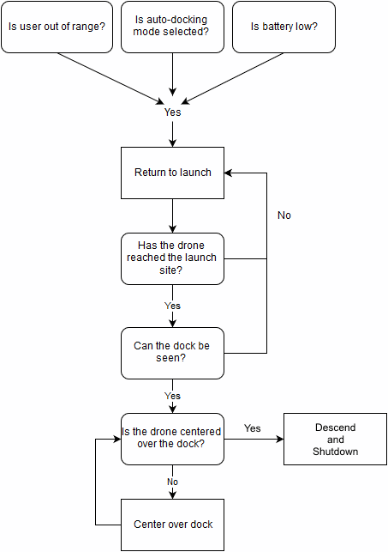

Figure 7.2.1.1 – Auto-Landing Sequence

7.2.2 Tracking Coding Plan

As we have earlier explained on section 6.0 section 6.4, we described how we want the SPIDRONE to respond to the tracking implementation. This section will outline the coding plan for the tracking mission of the SPIDRONE. The coding plan will be developed through a series of stages, where these stages will have a different function that ultimately merges together to accomplish an accurate tracing system.

The stages will allow us to divide the code to obtain an agile environment to be able to perform at the best rate possible. Having an agile environment grants us the ability to check each of the stages individually to make sure that, that part of the code is working properly. To make sure that the code in that stage is working accordingly, we will run different test cases and we will analyze the results of those tests.

One of these stages, it’s for the user to be able to make a path. This stage would be responsible to make sure the user’s path is being sent accordantly. The path needs to be in a safe with the most open space as possible. The path will be using GPS waypoints. The GPS waypoints are programmed into an application, and be stored there until sent to the SPIDRONE.

For the next stage of our tracking coding plan, we will need to have a wireless communication from the user to the SPIDRONE, and from the SPIDRONE to the user. This communication will allow the user’s mission path to be sent and successfully reach the SPIDRONE. Then the SPIDRONE will understand this mission path through the GPS waypoints, and will begin its mission of tracking that path down. For this stage, we have to keep in mind that the drone needs to also be aware of its battery life, and analyze if it can reach the mission’s destination. Once this is completed, we can go the next stage.

The third stage of the tracking code plan, we would like for the SPIDRONE to analyze the mission path sent by the user. The SPIDRONE should be able to see if the battery life is enough for it to reach its destination. For this part of the code, we decided that the SPIDRONE would encountered four different scenarios. These are the four scenarios possible:

Scenario 1) The SPIDRONE recognizes the path, realizes that the battery life is in good shape, proceeds to its mission, and it completes its mission by reaching its destination.

Scenario 2) The SPIDRONE recognizes the path, realizes that battery life is in good shape, proceeds to its mission. While in the mission, the battery life becomes low; then, the SPIDRONE should look for its charging dock. One of these two options should happen:

1) SPIDRONE reaches its charging dock. Mission over.
2) SPIDRONE cannot reach its charging dock, land safely. Mission over

Scenario 3) SPIDRONE recognizes the path, realizes the battery is low, stays put.

Scenario 4) SPIDRONE can’t recognize the path; therefore, stays put.

To be able to complete these stages, like we said before, an agile environment it’s of a great advantage. Having these work environment, allows a better testing and a better way to understand bugs and problems that we might encountered, and be able to overcome those bugs and problems in the tracking code for the SPIDRONE.

Figure 7.2.2.1 shows the tracking plan code, that we have previously explained. This figure shows a graphical view for a better understanding of what we are trying to accomplish with the tracking part of these SPIDRONE project.

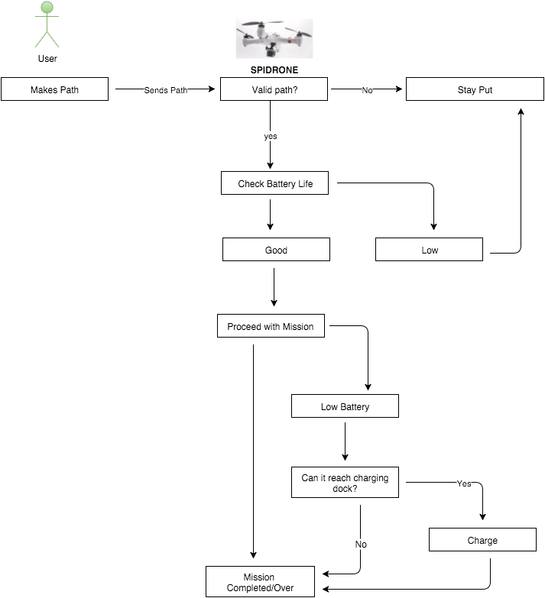

Figure 7.2.2.1 Tracking coding plan for SPIDRONE

7.2.2.1 Android Application for Tracking Mission

This subsection will go in detail of the android application that stores the user’s path GPS coordinates into a mobile device, to then be sent to the SPIDRONE to follow. As we mentioned in section 7.2.2., we need a way to send the user’s GPS coordinates to the SPIDRONE. To accomplish this task, we decided to develop an android application in a mobile device using Android Studio.

Android Studio is the official Integrated Development Environment (IDE) for Android application development. The reason why we chose Android Studio is because it is free to use and it is user friendly. Android Studio offers features that are very useful to the purpose of the SPIDRONE. Some of those features are:

- Flex Gradle-based build system.
- Code templates to help build common app features.
- Layout editor with support for drag and drop theme editing.
- Code shrinking with ProGuard and resource shrinking with Gradle.
- GPS communication directly to the device.
- Free to use.
- Plenty of sources online.

Before developing the “SPIDRONE” application, we wanted to make sure the requirements for the SPIDRONE project application were met. These requirements are:

- Having the least number of buttons possible.
- Record user’s GPS coordinates (Latitude & Longitude).
- Save the GPS coordinates as a .txt file in the device’s SD card.
- Transfer the “Mission.txt” file to the computer from mobile device.
- Send the GPS coordinates to the SPIDRONE.

The first and second requirements were met by having a two button application. These two buttons are “Start/End Mission” and “Upload Mission” buttons. The functionality of the “Start/End Mission” button is that once is clicked, the mobile device is connecting to the GPS satellites. Once the device is connected, the user will be able to see the Latitude and Longitude being recorded. These coordinates will keep recording until the user clicks the “Start/End Mission” button to end the mission. By clicking the button for the second time, the coordinates will be save as a text file.

The third and fourth requirements were met by using the second button in the “SPIDRONE” application; this button is the “Upload Mission” button. The functionality of the “Upload Mission” button is to save the text file in the device’s SD card. The user then can go to the mobile device, open the folder MyAppFile, and view the text file with the latest coordinated that were save from the “SPIDRONE” application. Once the user views the correct coordinates, the mobile device can be then plug in the computer and the text file can be send to the SPIDRONE. The SPIDRONE will arm, throttle, and then it takes off for its mission. Once the mission is completed the SPIDRONE will return to its launching coordinates and land safely. After all of these procedures are executed, the SPIDRONE’s mission is completed successfully. Figure 7.2.2.1 shows the “SPIDRONE” application interface as described.

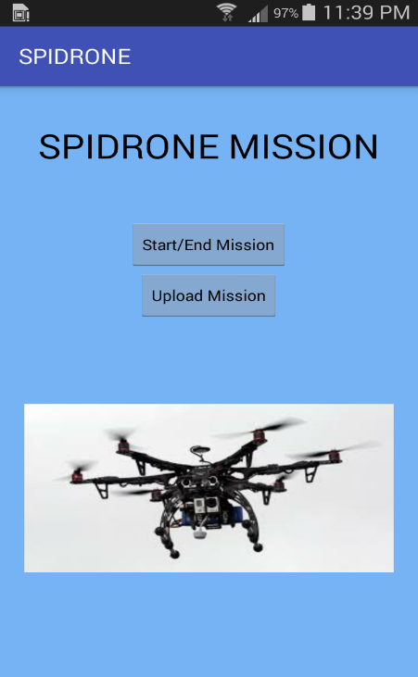

Figure 7.2.2.1 SPIDRONE Application Interface

7.3 Hardware

Section 7.3 Hardware explains the different aspects of the hardware that we will implement in the SPIDRONE project. Hardware is referring to the physical parts that make up this drone and its functionality. The hardware has two different types of hardware, the internal hardware and the external hardware. The internal hardware devices include hard drives, motherboards and memory. Internal hardware parts of a device are often referred as its components, while peripherals are referred to for the hardware devices. For the purpose of SPIDRONE, we will implement these hardware aspects in the form of internal and peripherals hardware components. This includes infrared and GPS sensors, microcontroller, wireless transmitter and the receiver, solar panels, charge controllers, DC/DC converters, and its respective circuit boards.

7.3.1 Infrared Sensors

This section describes the details involved with the infrared sensors with regards to how it will be used to meet the project’s objectives, budget, and specifications.

The infrared sensors will need to be mounted to the bottom of the quadcopter facing downwards in order to detect when it has reached the ground. Since the infrared sensors provide an analog readout to judge the distance, we will need to determine which values are returned by the analog to digital converter (ADC). This value will likely range from 0 – 1023, but ultimately depends on the ADC onboard the controller. We will also need to take into account some variance to allow for interference from different lighting conditions. The best approach will be to have the code trigger a timer, such that when the minimum value is reached it starts the timer. Once an appropriate length of time has passed the timer will be stopped and the command to shut down the quadcopter will be executed.

7.3.2 Global Positioning System (GPS) Sensors

This section of 7.0 hardware, covers the GPS modules that we will use for our project such that it meets the objectives outlined by our project. Since we are using a Pixhawk controller, we want to use sensors that will work alongside the Pixhawk controller and be able to support the waypoints concept for the purposes of the tracking that we have previously discussed in section 6.4. Waypoints are sets of coordinates that recognizes a point in a physical space, in this case a set of coordinates that include longitude, latitude, and altitude. GPS systems are increasingly used to create and use waypoints in all kinds of navigation. We looked at the Pixhawk website and we found the following GPS Modules.

Zubax GNSS – is a high performance, EMI-resistant positioning module with doubly redundant UAVCAN bus interface. This includes three features: a multi-constellation concurrent GPS/GLONASS receiver, a 3-axis compass, and a high precision barometric altimeter. The Zubax GNSS features are the following:

High Performance GPS/GLONASS receiver, with advanced Radio Frequency circuitry and high gain antenna.
High precision digital barometer Measurement Specialties MS5611 (10 cm altitude resolution)
3-axis digital compass Honeywell HMC5883L
Doubly redundant UAVCAN interface.
Auxiliary serial port with direct access to the u-blox module.
Continuous self diagnostics and failure detection.
3D-printable protective case
Low cast
Open Source

Figure 7.3.2.1 Zubax GNSS board
(Used with permission from pixhawk)

Figure 7.3.2.2 Zubax GNSS
(Used with permission from Pixhawk)

Figure 7.3.2.3 Zubax GNSS
(Used with permission from Pixhawk)

3DR uBlox LEA-6H High-Performance Receiver

- uBlox LEA-H module
- 5 Hz update rate
- 25 x 25 x 4 mm ceramic path antenna
- LNA and SAW filter
- Rechargeable 3v lithium backup battery
- Low noise 3.3v regulator
- I2C EEPROM for configuration storage
- Power and fix indicator LEDs
- ArduPilot Mega compatible 6-pin JST connector
- Exposed RX, TX, 5v and GND pad
- 38 x 38 x 8.5 mm total size, 16.8 grams

Figure 7.3.2.4 3DR uBlox LEA-6H High Performance Receiver
(Used with permission from pixhwak.org)

7.3.3 SOLAR PANELS

With growing demand in energy and concerns for environmental protection, the world has turned to renewable energy to meet the demands of the growing populace. With the advent of the Silicon technology solar cells have been one of the most environmentally friendly and renewable source of energy. To eradicate the ethical concerns of this project related to power, solar cells would be used to generate the energy needed to power the device and its components. The benefits of solar energy both economically and environmentally are great. The advantages of using solar energy as a source of energy are listed but not limited to the following:

- The major advantage of solar power is that no pollution is created in the process of generating electricity. Environmentally it is the most Clean and Green energy. Solar Energy is clean, renewable (unlike gas, oil and coal) and sustainable, helping to protect our environment.
- Solar energy does not require any fuel.
- It does not pollute the air by releasing carbon dioxide, nitrogen oxide, sulfur dioxide or mercury into the atmosphere like many traditional forms of electrical generation does therefore Solar Energy does not contribute to global warming, acid rain or smog. It actively contributes to the decrease of harmful greenhouse gas emissions.
- There is no on-going cost for the power it generates – as solar radiation is free everywhere. Once installed, there are no recurring costs.
- It can be flexibly applicable to a variety of stationary or portable applications. Unlike most forms of electrical generation, the panels can be made small enough to fit pocket-size electronic devices, or sufficiently large to charge an automobile battery or supply electricity to entire buildings.
- It offers much more self-reliance than depending upon a power utility for all electricity.
- It is quite economical in long run. After the initial investment has been recovered, the energy from the sun is practically free. Solar Energy systems are virtually maintenance free and will last for decades.
- It’s not affected by the supply and demand of fuel and is therefore not subjected to the ever-increasing price of fossil fuel.
- By not using any fuel, Solar Energy does not contribute to the cost and problems of the recovery and transportation of fuel or the storage of radioactive waste.
- It’s generated where it is needed. Therefore, large scale transmission cost is minimized.
- Solar Energy can be utilized to offset utility-supplied energy consumption. It does not only reduce your electricity bill, but will also continue to supply your home/ business with electricity in the event of a power outage.
- A Solar Energy system can operate entirely independently, not requiring a connection to a power or gas grid at all. Systems can therefore be installed in remote locations, making it more practical and cost-effective than the supply of utility electricity to a new site.
- The use of solar energy indirectly reduces health costs.
- They operate silently, have no moving parts, do not release offensive smells and do not require you to add any fuel.
- More solar panels can easily be added in the future when your family’s needs grow.
- Solar Energy supports local job and wealth creation, fueling local economies.
- Solar energy is useful in remote locations distant from the urban electricity grid

Technology and Operation of solar Cells
While there are dozens of variations of solar cells, the two most common types are those made of crystalline silicon and those made with what is called thin film technology.

Briefly stated a solar or Photovoltaic cell works by allowing particles of light (photons) to knock electrons free from atoms, generating a flow of electricity. Solar panels actually comprise many, smaller units called photovoltaic cells. Solar cells contain materials with semiconducting properties in which their electrons become excited and turned into an electrical current when struck by sunlight. Hundreds of solar cells make up a solar photovoltaic or PV array.

7.3.3.1 Monocrystalline Cell
Monocrystalline, or Single Crystal, is the original and oldest PV technology. It is made of Single crystal modules composed of cells cut from a piece of continuous crystal. The material forms a cylinder which is sliced into thin circular wafers. To minimize waste, the cells may be fully round or they may be trimmed into other shapes, retaining more or less of the original circle. Because each cell is cut from a single crystal, it has a uniform color which is dark blue. Made out of the highest-grade silicon, monocrystalline solar panels have the highest efficiency rates typically from fifteen to twenty percent. They produce up to four times the amount of electricity as thin-film solar panels and are the most durable. The important characteristics taken into account for this project are summarized in Table 7.3.3.1.

COST | Expensive (Higher production price)
EFFICIENCY | Higher (Has an average cell efficiency of 19 percent)
PERFORMANCE AT HIGH TEMPERATURES | Reduced efficiency. ( Dark cells absorb heat causing reduction in efficiency at warmer temperatures)
Table 7.3.3.1 Important characteristics of Monocrystalline Cell

7.3.3.2 Polycrystalline cell
Polycrystalline cells are made from similar silicon material but unlike monocrystalline cells they are melted and poured into a mold which forms a square block that can be cut into square wafers with less waste of space or material than round single-crystal wafers. The material crystallizes in an imperfect manner as it cools forming random crystal boundaries. Efficiency of energy conversion of polycrystalline cells is slightly lower. The important characteristics taken into account for this project are summarized in table Table 7.3.3.2

COST | Less Expensive.(Lower production price)
EFFICIENCY | Lower. (Has an average cell efficiency of 18 percent)
PERFORMANCE AT HIGH TEMPERATURES | Good efficiency. ( Blue cells absorb less heat thus there is no significant reduction in efficiency at high temperatures)

Table 7.3.3.2 Important characteristics of Polycrystalline Cell

7.3.3.3 Thin Film Solar Cells
A thin-film solar cell is a solar cell that is made by depositing one or more thin film of photovoltaic material on a substrate, such as glass, plastic or metal. Film thickness varies from a few nanometers to tens of micrometers thus allows thin film cells to be flexible, light in weight, and have less drag or friction. Thin-film has always been cheaper but less efficient than conventional silicon technology. While there are many variations of thin film technologies module prototypes have an estimated efficiencies between seven and thirteen percent for some specific types of thin film solar cells. The important characteristics taken into account for this project are summarized in table Table 7.3.3.3

COST | Moderately Expensive.(Moderate production price)
EFFICIENCY | Least efficient (Has an average cell efficiency of 10 percent)
PERFORMANCE AT HIGH TEMPERATURES | Great efficiency. (Tolerates extreme heat thus high temperatures have relatively low impact on performance)

Table 7.3.3.3 Important characteristics of Thin Film Solar Cells

To give a complete overview of the discussed solar cells, the three solar cells are compared in table Table 7.3.3.4

 | Monocrystalline | Polycrystalline | Thin Film
COST | Expensive. It has lowest price of about 0.75 $/W | Inexpensive. It has lowest price of about  0.62 $/W | Moderately expensive. It has lowest price of about 0.69 $/W
EFFICIENCY | Best research cell efficiency of 25 percent and a typical module efficiency of 15-20 percent | Best research cell efficiency of 20.4 percent and a typical module efficiency of 13-16 percent | Best research cell efficiency of 17.5 percent and a typical module efficiency of 8.3-10.3 percent
TEMPERATURE RESISTANCE | Performance drops 10-15% at high temperatures | Less temperature resistant than monocrystalline | Tolerates extreme heat thus high temperatures have relatively low impact on performance
FOOTPRINT(AREA PER KW) | Requires least area for a given power usually 6-9 square meters | Requires less area for a given power usually 8-9 square meters | Requires large area for a given power usually 11-15 square meters

Table 7.3.3.3 Solar Cells Comparison

The monocrystalline solar cell would be used as the main power generator for this project. The reasons for the choice are as discussed below:

1. Durability/ Longevity
Monocrystalline solar panels are first generation solar technology with an estimated life span of up to 50 years which provide evidence of their durability and longevity. Modules installed in as late as the 1970's are still producing electricity today. As long as the PV panel is kept clean it will continue to produce electricity.

2. Efficiency
Panels made from monocrystalline solar cells as mentioned earlier are able to convert the highest amount of solar energy into electricity. Monocrystalline panels are a great choice for urban settings or where space is limited.

3. Greater Heat Resistance
Monocrystalline solar modules experience a reduction in output once the temperature from the sunlight reaches around a hundred and fifteen degrees Fahrenheit. This loss of efficiency is lower than what is typically experienced by owners of PV panels made from polycrystalline cells hence making it better choice than polycrystalline overall.

7.4 PCB Vendor and Assembly

Two separate types of PCB boards would be integrated for the design of the charging station. The input of the DC-DC converter directly connected to the output of the solar panel would be would be connected to the wireless transmitter’s PCB board

7.4.1 Printed Circuit Board Vendor and Assembly for DC-DC Converter

The components used in prototyping though difficult to find were not very bad to handle. Designs in school labs are done on breadboards which makes it quite simpler to handle. For this reason, we decided to use bigger discrete components through every time we could. We thus chose the components that would enable us to have some flexibility mounting and soldering them.

To create the PCB we used a free software called Eagle CAD. We first had to find the footprint otherwise called the libraries of each component used on our project. The research into the component libraries and footprints was quite time consuming. Though the main component of this design was the linear technology LT1376, other passive components were from different vendors that needed to be sourced by us. Common libraries where downloaded in order to get the passive components such as resistors, capacitors and inductors and the schematics were done after that. When the libraries were found we made a schematic in eagle and from there exported it to make a board. The board wires were then routed to the desired locations and components were conveniently placed for the task.

As can be seen in Figure 4.7.1 , most of the components of the PCB board of the DC to DC converter that steps down the voltage from the solar panel to the wireless transmitter are all through whole mount. The components are carefully soldered onto the board using soldering iron.

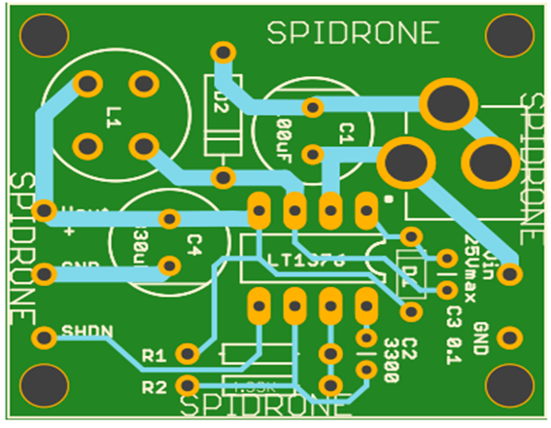
Figure 7.4a PCB layout of DC-DC Converter

7.5 Final Coding Plan

This section is to outline the final coding plan for the individual subsystems and how those subsystems need to be integrated with each other. The final coding plan will be implemented during the final stages of prototype development.

While the user tracking and auto landing subsystems were able to be developed independently as they were developed to be utilized as two different flight modes of the quadcopter. During this phase of prototyping, the different subsystems need to be brought together to ensure that they are both functional on the Pixhawk flight controller and do not interfere with each other. If the 2 subsystems are able to compile and be programmed to the Pixhawk together successfully, test flights will ensue to ensure that the quadcopter is able to meet all of the objectives outlined by our project.

7.5.1 API Coding Plan

The coding plan for the API is to develop two separate programs that will ultimately be capable of operating the drone. Essentially what needs to be accomplished for the API is to take the existing codes developed for the path following and precision landing, and split them into two parts. The first part will be the parts of the code that get transmitted to the drone itself, which will run within the Mission Planner API. The second part will be left to the external program which will issue commands to the API and receive different types of acknowledgements depending on the current status of the drone and API. There will be one main loop that will provide some of the basic functions of the drone such as arm, disarm, takeoff, and receive battery status. The main loop will also provide access to the more complex functions we developed, namely GoTo, and RTL (Return to Launch). The GoTo and RTL functions will operate their own embedded loop, which will communicate with the external program, until the external program determines that it is time to exit out of that function and return to the main loop.

The GoTo function of the project will be utilized for following the user’s path. It will start inside of the external program by opening and parsing the mission.txt file. The text file needs to be parsed because it contains all of the coordinates as comma separated values (CSV), delimited by ^. The parsing will happen by splitting the line into an array, based on the delimiting character, which will make an array of GPS coordinates in a string using the Latitude|Longitude format. The last value of the array will be a null character to denote the end of the mission. The external program will enter into a while loop, that will exit when the current waypoint is null. The external program will open the communication socket to the API and transmit the string “GoTo”, which the API will receive, send an acknowledgement, and start its GoTo subroutine. The API will listen for the external program to transmit its coordinates. Once the API receives the coordinates it will parse the coordinates to an array, based on the | delimiter, and form a waypoint object provided by the Mission Planners libraries. Both the API and external program will enter into a loop. The purpose of this loop is to make the external program wait for the drone to arrive at the waypoint before it transmits the next one. During this loop the API and external program will be constantly exchanging status updates. The possible status updates from the API are OK, lowBatt, and Arrived. OK is used to tell the external that the drone is currently flying to the waypoint, lowBatt tells the program that the battery is low on the drone and needs to be recharged, and Arrived means the drone has arrived at its current waypoint. When the external program receives OK it issues an OK back to the API, but if it receives a lowBatt it will tell the API to halt. The API will stop the drone where it is, and return to its launch point to be charged. When the external program receives Arrived, it tells the API to break. The API will then break out of its wait loop, as will the external program, and proceed back to its main loop. The external program will increment its currentWaypoint counter, but only when it receives the Arrived command. This allows the drone to return, charge, and then attempt to fly out to the waypoint it was trying to reach before it reached low battery state. Then, if the external program has another waypoint it will transmit GoTo again and start that process over. If no more waypoints remain it will break out of this loop and instead transmit the RTL command to the drone.

The Return To Launch (RTL) function of the project will start by the external program issuing the RTL command to the API. The API will start its alignYaw function, which aligns the heading of the drone to the original heading when it launched. This will allow the image processing to use the same coordinate plane and orientation from when it launched. The API will then tell the drone to change its mode to the Mission Planner RTL mode. The reason for this is that the RTL function of Mission Planner allows for user input to control it once it is hovering above its launch point. This will allow the external program to issue commands to the drone to align itself as the RTL function is descending. The API will issue an acknowledgement to the external program which will trigger the external program to start its image processing to search for the charging dock. The API will be listening for directional commands from the external program which will mostly consist of two characters, one indicating the horizontal X status and the other indicating the vertical Y status. The X status can be one of three states: L, indicating that the drone needs to fly left, C indicating that the drone is centered, or R indicating that the drone needs to fly to the right. The Y status is similar, but uses F, indicating that the drone must fly forward, C indicating that the drone is centered, and R indicating the drone must fly in reverse or backwards. Once the external program has issued the directional commands, the API will determine which code was sent and issue the proper commands to set the roll and pitch controls to the appropriate value. If the image processing is unable to detect the charging dock it will issue the command CC so that the drone does not stray off too far, in the event that the camera is on top of the charging dock and can no longer see anything. When the drone disarms, the API will issue the status update of disarmed, which will tell the external program to issue the command EOFunc (End Of Function), and then both programs will break out of the RTL function. If the mission is done the external program will issue the Exit command which causes both programs to close the port they were currently listening to and terminate their execution.

8.0 Project Prototype Testing

Prototype testing refers to the testing of the entire system as one. This means that after running the individual testing for each if the SPIDRONE project, from testing the hardware as well as the software, we need to test the project as a whole with all its functionalities. In this section we will discuss how we plan to test aspects of the system we all of its components integrated.

8.1 Hardware Testing

The environment for testing the hardware aspects of the SPIDRONE project is crucial to determine how the different parts will interact with each other to achieve the ideal outcome for both the drone and its charging dock. The University of Central Florida has several labs available, with the most noteworthy one being the senior design lab. The senior design lab is an indoor lab, open to all students enrolled in the senior design course, and contains specialized tooling such as power supplies, multimeters, oscilloscopes, computers, safety equipment, and lockable storage for our components. The testing performed in this lab will be helpful for simulating the poor to ideal conditions that our components will be subjected to. For instance, on a cloudy day it would be difficult to test the power input from our solar panels. We can circumvent this by using one of the power supplies available inside of the lab, so we can still perform our tests at the ideal voltage the panels would have put out.

Initially, whenever a shipment of components comes in we will perform tests to make sure each component performs its task within its operating specifications. So long as all components are within specification, we can move on to constructing the prototype to ensure that the components interact with each other flawlessly. An important test to be conducted will be to build the quadcopter and do an initial test flight to ensure the quadcopter is capable of flight and get an unladen benchmark for performance, before additional components are added on. After the initial benchmark, another test will be performed with the additional components attached to the quadcopter to ensure that stable flight is still achievable. A lithium polymer battery charger will be purchased in order to continue conducting these test flights while the wireless charging capability is under development. Additional batteries for the quadcopter will also be purchased such that the wireless charging dock construction, and quadcopter test flights do not interfere with each other.

As the SPIDRONE reaches its final phases of prototype development, the hardware tests will move to more test more real world conditions. This will involve actual test flights to ensure the quadcopter is able to land on the charging dock and that the battery is capable of receiving a charge after the coil is installed on the quadcopter.

Testing DC-DC converters is often not simple as adding a load and getting out the scope as the output noise of a converter can be very hard to measure if many ground loops are present throughout the system. A common mode current is developed due to the fast internal switching waveform and the inter-winding capacitance of the transformer when the DC-DC converter switches. The prototype was first made and tested on a breadboard in the lab using a DC power supply and later on the sun using solar panel. The output was then measured with a digital voltmeter. The recorded output in each case is shown in Figure 8.1a. The final product shown in Figure 8.1a c also measured the same output.

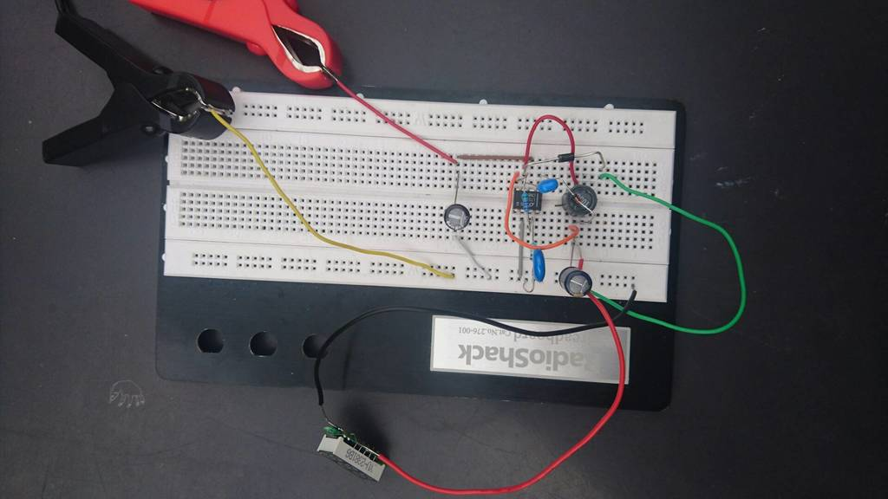
Figure 8.1a Prototype of DC-DC converter

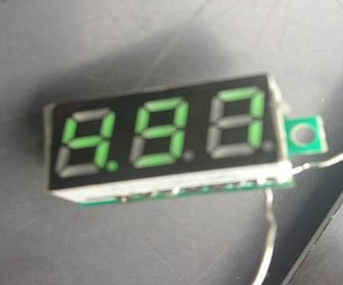
Figure 8.1b. Output of DC_DC Converter
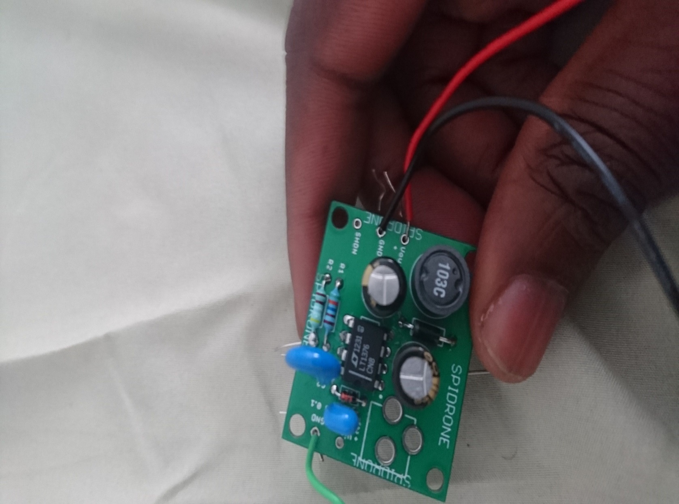
Figure 8.1ac. PCB of DC-DC converter

To test for good operating conditions and the functionality of the solar panel, two tests would be performed on it. An open circuit test (V_{OC}) and Short circuit test(I_{SC})
- The apparatus for the test are
- A good quality Digital Multi-Meter capable of measuring DC Voltage up 20V, and 5 amps DC. A DMM is ideal for this.
- A good Insulated Pair of test leads with Alligator Clips.
- Panel’s Voc and Isc Specifications

Test Conditions:
- Critical for the Isc Measurement, it must be done in bright sunny condition with panel facing directly into the sun to prevent low reading making sure there is no shadow cast on it
- The panel under test should be fully disconnected and completely isolated from electrical gadgets.

Procedure:
Voc measurement:
- DMM is configured to read voltage and connect as shown in figure 8.1a for V measurement.
- DMM is carefully connected to the panel’s positive and negative output. Insulated test leads are used to prevent contact with any exposed wire.
- Refer to panel specifications for the panel Voc voltage.
- For a fully functional panel the measured Voc must meet specifications.
- Meter is disconnected from panel.
- Proceed with Isc measurement when the test has passed

Isc Measurement:
- DMM is configured to read amps and is connected as shown in figure 8.1b.
- DMM is carefully connected to the panel’s positive and negative output. Insulated test leads
- Refer to panel specifications for the panel Isc Current should be within fifteen percent of the specification. The amount of sun light is directly proportional to the current.

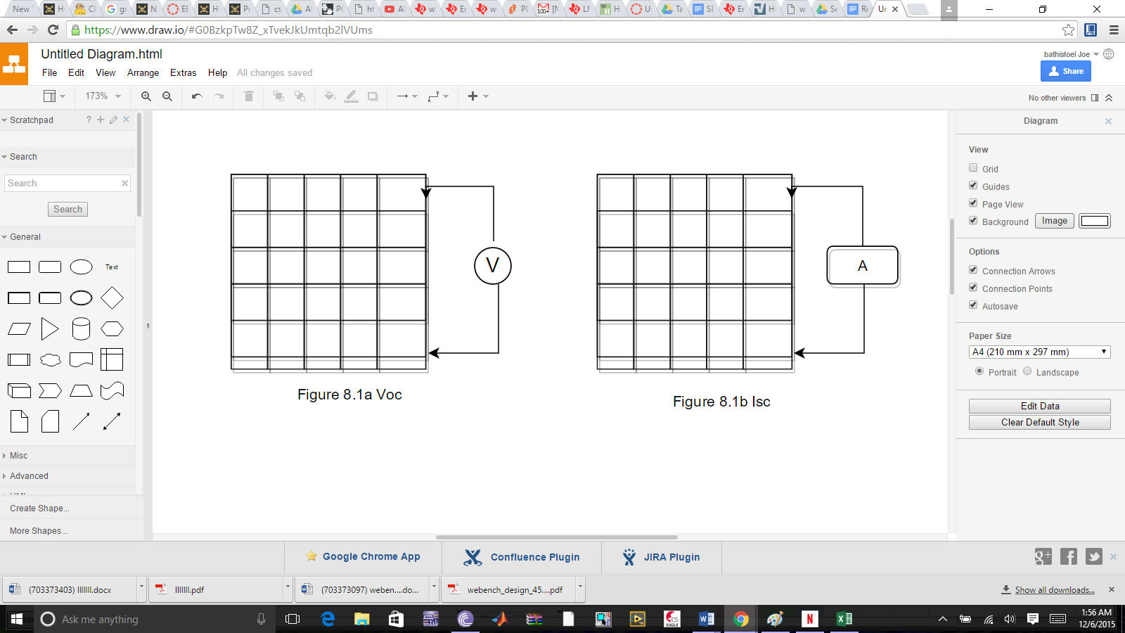

Figure8.1a Open Circuit Test ( Voc) Figure 8.1b Short-Circuit Test (Isc)

8.1.1 Wireless Charging Test

It is very necessary to test our chosen receiver and transmitter to see if it will meet our specification that we started off with. Samples of the LTC 4125 demo board were used to test LTC4120 to ensure our design executes the charging effectively. The following steps were followed to test the wireless charging system
- The first step is to connect a power source to the transmitter.
- Once the power has been plugged in, the transmitter needs to be placed on the LTC receiver and charger. A green LED light on the transmitter turns on. Once the LED turns blinking red we removed the DC2181B and placed it back on the transmitter when the LED turn green again.
- The green bar LEDs on the demo-board should turn green. There is a 10mA which flows from BAT into the LEDs.
- For the basic transmitter. PS1 to 5V, and turned on. PS2 is set to 3.6V, and power supply is turned on. PS2 is the battery emulator battery voltage. The 3.6Ω is to make PS2 into a bipolar supply.
- By placing a 3.6Ω resistor in parallel with a normal supply, the supply can absorb up to 1A at 3.6V.

The LTC4125 transmitter was mounted to a LTC4120 synchronous receiver and charger. There is a 10mm spacing between in the transmitter and receiver configuration. The configuration is shown in figure 8.1.1a

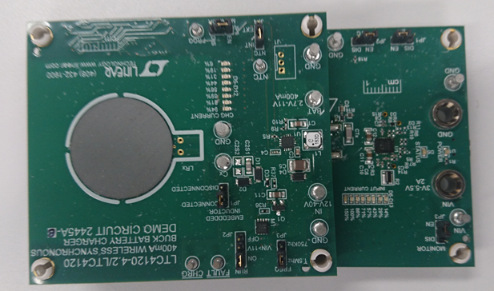
Figure 8.1.1a Wireless Receiver Power Demo Board mounted on Transmitter
(Used with Permission from Linear Technology)

8.2 Software Testing

The approach to testing the software will be similar to the approach used for the hardware testing of the SPIDRONE. Initially, the software testing will be conducted either within the senior design lab, or within the homes of our team. The initial testing will be focused on creating and testing the algorithms that the SPIDRONE needs to carry out its objectives. Once the hardware shipments come in, software testing will move to the senior design lab. The development of the auto landing and user tracking subsystems will be hardware dependent as the firmware created for the SPIDRONE will require input from the hardware components, such as the video feed for image processing.

Once software testing has moved to the senior design lab, the software testing will be performed simulating ideal conditions. For optical recognition the lighting will be optimal without any reflective objects that may create a glare or wash out the camera feed. The development of the user tracking will be tested such that the SPIDRONE is capable of receiving the user’s GPS coordinates as the user’s location changes. For both systems, the lab testing will be performed with the functionality to submit commands to the SPIDRONE fully disabled. This is because we wish to avoid accidentally arming the SPIDRONE, and having it attempt to carry out its mission while we are merely doing a laboratory test.

The final phase of the software testing for the SPIDRONE will consist of live tests conducted in real world conditions. The live tests will consist of test flights with several variations to ensure that the SPIDRONE is still capable of completing its objectives. However, since these are live test flights, the senior design lab will be unavailable as a testing environment and as such testing will be moved to an outdoor location. Due to the large population of students at the University of Central Florida, testing will be moved to either a public park with an open field, or to Kyle Ferriss’ home, which consists of 5 acres of land available for testing.

8.2.1 Precision Landing Testing

In order to test the precision landing, we needed to first make sure that the program would be able to access the wireless video feed and display it. Once that was verified we switched to testing using the webcam on the laptop as it is easier to setup and operate while testing.

The code was then built up in stages, first by converting the video feed into a different color space, for our purposes HSV (hue, saturation, value) was used, as this is able to quickly detect specific colors when used with a mask. After that the mask was added in, which utilizes a lower and upper bound set of values. At first the upper and lower mask values were difficult to fine tune by modifying the source code and running the program, so an interactive calibration tool was created in order to view the results of the mask in real time as the bounds were adjusted. The calibration tool was composed of the video feed and six slider bars, the slider bars controlled the HSV values for both the upper and lower mask, which could then be taken and written into the main program.

The mask was then created and the resulting image was blurred in order to remove any noise. After that, the code had contour detection added in. The largest contour found would be treated as the contour we were interested in, which would be the landing dock. The contour was then drawn on the video feedback screen along with its center point as circles.

With the contour detection working properly, we can move on to determining where its center is in the coordinate plane. The coordinate plane has its origin in the upper left hand corner of the video, and both increase as they move to the lower right hand corner of the screen. With this in mind, a threshold was determined to be used which would indicate what the program would consider as being centered. The program would actively determine which direction in both the x-coordinate plane and the y-coordinate plane that the drone would need to fly in order to center itself over the object. During testing the status of the x and y coordinates would be printed to the command line, which would later be used to control the drone. Figure 8.2.1.1 shows the results of the image processing, when using the cap of the paint to be used on the charging dock.

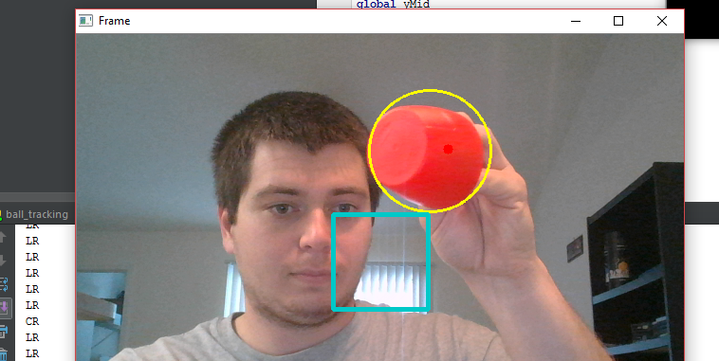
Figure 8.2.1.1

8.2.2 Tracking Mission Testing

As we have discussed previously, in order to test the tracking mission, we needed an open field. This is important due to the fact that we want to make sure users, civilians and the SPIDRONE are as safe as possible. We first have to make sure that the “SPIDRONE” application is working properly. We test this by going outside and recording the coordinates every 5 seconds. Once the coordinates are recorded and saved in the mobile device’s SD card, we can transfer the file to the computer. In the computer, we assure that the coordinates saved are valid coordinates. To valid these coordinates, we use google maps. When this is done, we know that the coordinates recorded by the mobile device are accurate.

Before we can test the coordinates given by the device, we assure that the SPIDRONE is able to read this text file. We made a test text file and test it using Mission Planner. Just in case SPIDRONE goes out of control, we programmed a XBOX ONE controller to be able to control SPIDRONE manually. When sending the test file, we were successful and we were ready to test the file saved in the mobile device’s SD card.

When testing the coordinates received from the mobile device to the SPIDRONE, we noticed that the coordinates were slightly off. Figure 8.2.2. shows in red lines the path that the user made, and the yellow lines show the path that the SPIDRONE did.

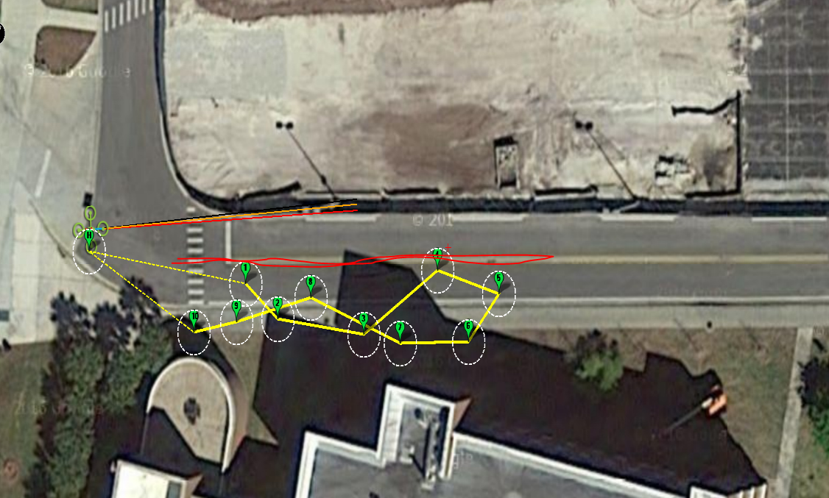

Figure 8.2.2 SPIDRONE & User’s path

As we can see, SPIDRONE did accomplished the mission, not in a straight line, but it did reach the coordinates recorded by the mobile device. The reason why the coordinates are slightly off, is because the coordinates differ from device. For our testing, we used a Samsung Galaxy S3 phone. If the testing is done in a newer mobile device, the coordinates should be closer to the user’s path. For the purpose of our testing, SPIDRONE did what we wanted to accomplished. SPIDRONE armed, throttled, when to its destination, and came back to its launching coordinates; thus, completing its mission and concluding the “Mission” part of the SPIDRONE project.

9.0 Administrative Content

Due to the magnitude of this SPIDRONE project and the many different types of technology that are being implemented, it is very important that we have a clear view of the financial budget and the goals we want to meet, as well as an organized and realistic execution plan for the SPIDRONE project. In this section, we will discuss the various tasks that will need to be completed, project completion time, and each of the individual components budget.

9.1 Milestones Discussion and Project Planning

When we were planning for this project at the beginning of the semester, the group was organized and met weekly to discuss ideas for the project that would allow us to meet all the requirements that were set for the semester. This includes the period of time for planning, research, design, prototype, and testing. However, due to each of the member’s busy class schedule and work schedule, we had to constantly make changes to the project’s initial plan to be able to keep the project going and on schedule. All the work was divided equally amongst the project’s members. We left some room for unexpected issues that might present while being in the process of completing the project. We knew that managing the schedules was going to be essential for this project to be successful and on time. This project will run for a course of approximately 8 months starting on September of 2015, and ending on May of 2016. To show the team’s project planning, we have made a series of tables that will show how the timeline was handled, and the different tasks that we divided for the project. Table 9.1.1 shows the whole outline that was made for the Senior Design I course.

 | September |  |  |  | October |  |  |  |  | November |  |  |  |  | December
 | 1 | 2 | 3 | 4 | 1 | 2 | 3 | 4 | 1 |  | 2 | 3 | 4 | 1 |  | 2 | 3 | 4
Deliverables
Proposal
Funding Proposal
Table of Contents
Draft
Senior Design I Document
Senior Design II Document
Final Product
Demo

Table 9.1.1 Senior Design I Objectives

Tables 9.1.2 – 9.1.7 shows the team’s progress throughout the whole semester in meeting our research and design milestones that were established.

 | September |  |  |  | October |  |  |  |  | November |  |  |  |  | December
 | 1 | 2 | 3 | 4 | 1 | 2 | 3 | 4 | 1 |  | 2 | 3 | 4 | 1 |  | 2 | 3 | 4
Wireless Communication
Research
Design
Prototype
Build
Test
Integration

Table 9.1.2 Wireless Communications Milestone

 | September |  |  |  | October |  |  |  |  | November |  |  |  |  | December
 | 1 | 2 | 3 | 4 | 1 | 2 | 3 | 4 | 1 |  | 2 | 3 | 4 | 1 |  | 2 | 3 | 4
Sensors (Infrared, GPS)
Research
Design
Prototype
Build
Test
Integration

Table 9.1.3 Sensors (infrared, GPS) Milestone

 | September |  |  |  | October |  |  |  |  | November |  |  |  |  | December
 | 1 | 2 | 3 | 4 | 1 | 2 | 3 | 4 | 1 |  | 2 | 3 | 4 | 1 |  | 2 | 3 | 4
Wireless Transmitter & Receiver
Research
Design
Prototype
Build
Test
Integration

Table 9.1.4 Wireless Transmitter & Receiver Milestone

 | September |  |  |  | October |  |  |  |  | November |  |  |  |  | December
 | 1 | 2 | 3 | 4 | 1 | 2 | 3 | 4 | 1 |  | 2 | 3 | 4 | 1 |  | 2 | 3 | 4
Optical Recognition
Research
Design
Prototype
Build
Test
Integration

Table 9.1.5 Optical Recognition Milestone

 | September |  |  |  | October |  |  |  |  | November |  |  |  |  | December
 | 1 | 2 | 3 | 4 | 1 | 2 | 3 | 4 | 1 |  | 2 | 3 | 4 | 1 |  | 2 | 3 | 4
RF Communications
Research
Design
Prototype
Build
Test
Integration

Table 9.1.6 RF Communications Milestone

 | September |  |  |  | October |  |  |  |  | November |  |  |  |  | December
 | 1 | 2 | 3 | 4 | 1 | 2 | 3 | 4 | 1 |  | 2 | 3 | 4 | 1 |  | 2 | 3 | 4
Solar Panels
Research
Design
Prototype
Build
Test
Integration

Table 9.1.7 Solar Panels Milestone

Although the tables we just went over are for the research and design milestones of the project for Senior Design I, we need to start looking ahead to Senior Design II and come up with some milestones, so we can meet the semester’s goals on time. We have created a tentative schedule that we will be using as a reference, but just like Senior Design I, we will encounter issues that we will have to adjust to meet the due dates. The following tables 9.1.8 and 9.1.9 will show that projected schedules that we have set.

 | January |  |  |  | February |  |  |  |  | March |  |  |  |  | April
 | 1 | 2 | 3 | 4 | 1 | 2 | 3 | 4 | 1 |  | 2 | 3 | 4 | 1 |  | 2 | 3 | 4
Design
Prototype Build
Prototype Testing
Final SPIDRONE Build
Integration
Final Testing
Senior Design II Document
Final Product
Demo

Table 9.1.8 Projected Senior Design II Schedule

 | January |  |  |  | February |  |  |  |  | March |  |  |  |  | April
 | 1 | 2 | 3 | 4 | 1 | 2 | 3 | 4 | 1 |  | 2 | 3 | 4 | 1 |  | 2 | 3 | 4
Senior Design II
Research
Design
Prototype
Build
Test
Integration

Table 9.1.9 Projected Senior Design II Milestone Schedule

The following tables 9.1.10 – 9.1.16 show the Senior Design II Milestones.

 | January |  |  |  | February |  |  |  |  | March |  |  |  |  | April
 | 1 | 2 | 3 | 4 | 1 | 2 | 3 | 4 | 1 |  | 2 | 3 | 4 | 1 |  | 2 | 3 | 4
Wireless Communication
Research
Design
Prototype
Build
Test
Integration

Table 9.1.10 Wireless Communication Senior Design II Milestone

 | January |  |  |  | February |  |  |  |  | March |  |  |  |  | April
 | 1 | 2 | 3 | 4 | 1 | 2 | 3 | 4 | 1 |  | 2 | 3 | 4 | 1 |  | 2 | 3 | 4
Sensors (Infrared, GPS)
Research
Design
Prototype
Build
Test
Integration

Table 9.1.11 Sensors (Infrared, GPS) Senior Design II Milestone

 | January |  |  |  | February |  |  |  |  | March |  |  |  |  | April
 | 1 | 2 | 3 | 4 | 1 | 2 | 3 | 4 | 1 |  | 2 | 3 | 4 | 1 |  | 2 | 3 | 4
Wireless Transmitter & Receiver
Research
Design
Prototype
Build
Test
Integration

Table 9.1.12 Wireless Transmitter & Receiver Senior Design II Milestone

 | January |  |  |  | February |  |  |  |  | March |  |  |  |  | April
 | 1 | 2 | 3 | 4 | 1 | 2 | 3 | 4 | 1 |  | 2 | 3 | 4 | 1 |  | 2 | 3 | 4
Optical Recognition
Research
Design
Prototype
Build
Test
Integration

Table 9.1.13 Optical Recognition Senior Design II Milestone

 | January |  |  |  | February |  |  |  |  | March |  |  |  |  | April
 | 1 | 2 | 3 | 4 | 1 | 2 | 3 | 4 | 1 |  | 2 | 3 | 4 | 1 |  | 2 | 3 | 4
Radio Frequency Communication
Research
Design
Prototype
Build
Test
Integration

Table 9.1.14 Radio frequency Communication Senior Design II Milestone

 | January |  |  |  | February |  |  |  |  | March |  |  |  |  | April
 | 1 | 2 | 3 | 4 | 1 | 2 | 3 | 4 | 1 |  | 2 | 3 | 4 | 1 |  | 2 | 3 | 4
Solar Panels
Research
Design
Prototype
Build
Test
Integration

Table 9.1.15 Solar Panels Senior Design II Milestone

9.2 Budget and Finance Discussion

This section outlines the budgetary and financial aspects that will support making this project possible. With Boeing and Leidos sponsoring approximately 90% of our predicted budget, that leaves the other 10% left to be funded. To accommodate the remainder of the budget, and in the event we go over our predicted budget, we intend to fund the remainder of the project evenly amongst ourselves. In order to gain access to the sponsored funds we must order the parts and have it delivered directly to the computer engineering department at the University of Central Florida and within 30 days of purchase, submit a request to be reimbursed. To handle the upfront purchases, Kyle Ferriss will be processing and funding the upfront purchases, while also handling the reimbursements. Kyle Ferriss will also handle the upfront purchases for the remainder of the budget. Refer to Table 9.2.1 for the proposed budget.

Item | Cost
Solar Panel | $20.59
Wireless Video Receiver | $25.99
Flamewheel F450 Frame | $13.31
Flamewheel F450 Spare Arms | $8.69
Turnigy LiPo Charger | $11.45
Turnigy 3000 mAH LiPo Battery (x2) | 27.20
LDPower D310 Power System | $85.80
HKPilot32 Flight Controller with Telemetry and GPS | $177.19
Shipping | $23.23
Eachine FPV200 Kit 5.8GHz | $22.59
XT60 Male/Female Connectors | $8.99
PCB Components | $53.68
Printed Circuit Boards Manufacture | $93.00
Spare Propellers | $18.72
Wireless Power Demonstration Kit | $168.42
EZCap Video Device | $19.57
Printing and Binding | $15.00
Total | $793.42
Sponsorship from Boeing/Leidos | -$745.65
Out of Pocket Expenses | $47.77

Table 9.2.1 SPIDRONE projected budget

9.2 Sponsors

As we have mentioned before, our group was fortunate to be sponsored by The Boeing Company and Leidos for the building of SPIDRONE. We would like to say thank you to these companies for providing us with $745.65 out of the $829.00 that we originally set in our budget for the SPIDRONE. The following thank you letter is from our group member to our sponsors.

Dear Boeing/Leidos,

On behalf of our group here at the University of Central Florida we would like to thank you for your very generous sponsorship for our Senior Design Project “SPIDRONE”. We have received the founding and we will manage it as indicated. Our project currently consists of a Solar Panel, Inductive charging drone that will have auto-landing as well as track a user’s path as a mission. This project will prosper with your generous support of this team. Thank you again for your generosity, and support to all of the Senior Design groups here at the University of Central Florida.

Sincerely,
Daniel Camargo, Benjamin Atsu, Kyle Ferriss, and Johnathan Obah
Senior Design group 2 at the University of Central Florida.

10.0 Conclusion

Even though drones are very common in today’s society and that there is a variety of features for these drones that are similar to our project, we feel that we have created a low cost project that we would enjoy doing. Our team members are enthusiastic for this project for the fact that we all think it’s a cool idea and none of us have actually build a drone and we would like to understand the process to make a successful project.

Our goal for SPIDRONE is to provide a user & environment friendly drone that will support inductive charging, solar panels, and a tracking mission for the user to explore with. The main idea for this project is to provide the user with an entertainment drone that they can fly and also be able to make a path and for the SPIDRONE to follow it using GPS waypoints. SPIDRONE will evaluate the path sent from the user and make its way to the destination or end of the mission. The drone will have available a charging dock, so in case of low battery the drone will look for its charging dock and charge. In the case that SPIDRONE cannot complete its mission and cannot reach its charging dock, the drone will land safety. We as a team wanted to challenge ourselves in designing a drone that was able to use various types of technology currently used. This allowed all our team members to add something to the project that they each wanted to work with, learn from and essentially be able to put it on our resumes. Some of these technologies that are being integrated in our project are wireless communications, microcontrollers, GPS and Infrared sensors, radio frequency communications, Wireless Power transfer, DC/DC Convertors, solar panels, and circuit boards. All of these technologies will be use in the making of the SPIDRONE.

We know that testing the entire system will be challenging, but we believe that we can overcome any challenge that might come in the future. We will provide enough evidence to prove that the drone will be a functional and successful project. Throughout the process of building SPIDRONE, the team will continue to research and gain more knowledge to come up with better and more reliable means of testing the system during the transition from Senior Design I to Senior Design II.

To conclude this document, overall the team is very excited to start working this project and building it. As we are at the end of the semester, we are looking back at some of the lesson that we have learned from this process during Senior Design I. Some of these lessons are the importance of time management. We have to account for unexpected delays that will always arise, but it is our job to be able to manage this circumstances and adjust to them to meet the project goals. Another one of these lessons learned is the communication between team members. Communication is a very important piece to succeed; communicating between members at all times informs the team of each member’s working progress and that makes it easier to reach the member’s goals as well as the team’s goals.

Appendix A - References

- Cisco,. (2015). Five Reasons to Go Wireless. http://www.cisco.com/cisco/web/solutions/small_business/resource_center/articles/work_from_anywhere/why_go_wireless/index.html

DroneZon,. (2014). How Do Drones Work And What Is Drone Technology. http://www.dronezon.com/learn-about-drones-quadcopters/what-is-drone-technology-or-how-does-drone-technology-work/

Design And Reuse,. (2015). Adaptive Frequency Hopping for Reduced Interference between Bluetooth® and Wireless LAN. http://www.design-reuse.com/articles/5715/adaptive-frequency-hopping-for-reduced-interference-between-bluetooth-and-wireless-lan.html

Bluetooth.com,. (2015). Top Things to Know About Bluetooth Technology | Bluetooth Technology Website. Retrieved 8 December 2015, from http://www.bluetooth.com/what-is-bluetooth-technology/bluetooth-technology-basics

Cellware.blogspot.com,. (2015). Cellular Free Software: The Advantages And Disadvantages for Using Bluetooth.http://cellware.blogspot.com/2008/04/advantages-and-disadvantages-for-using.html

Thadani, R. (2015). Advantages and Disadvantages of Bluetooth Technology.Buzzle. http://www.buzzle.com/articles/advantages-and-disadvantages-of-bluetooth-technology.html

Barett, J., & Barett, J. (2015). The Disadvantages of Bluetooth Technology | eHow. eHow. http://www.ehow.com/list_7162156_disadvantages-bluetooth-technology.html

Shure.custhelp.com,. (2015). What is the difference between UHF and VHF frequencies? | Shure Technical FAQ. http://shure.custhelp.com/app/answers/detail/a_id/89/~/what-is-the-difference-between-uhf-and-vhf-frequencies%3F

Lee, D. (2015). Garmin | What is GPS?.Www8.garmin.com. http://www8.garmin.com/aboutGPS/

Pocketgpsworld.com,. (2015). How does the Global Positioning System (GPS) work ?. http://www.pocketgpsworld.com/howgpsworks.php

Trimble.com,. (2015). Trimble - GPS Tutorial - Pseudo Random Code. http://www.trimble.com/gps_tutorial/sub_pseudo.aspx

Roseindia.net,. (2015). Advantages and Disadvantages Global Positioning System. Retrieved http://www.roseindia.net/services/trackingsystem/advantaesanddisadvantagesofgps.shtml

Targetstudy.com,. (2015). Global Positioning System - Advantages and Disadvantages. https://targetstudy.com/articles/global-positioning-system-advantages-and-disadvantages.html

SearchMobileComputing,. (2015). What is IR wireless (infrared wireless)? - Definition from WhatIs.com. http://searchmobilecomputing.techtarget.com/definition/IR-wireless

Study.com,. (2015). Short-Range Wireless Communication: Bluetooth, ZigBee & Infrared Transmission - Video & Lesson Transcript | Study.com. http://study.com/academy/lesson/short-range-wireless-communication-bluetooth-zigbee-infrared-transmission.html

Mitchell, B. (2015). What 'Infared' Networking Is and How it Works.About.com Tech. http://compnetworking.about.com/od/homenetworking/g/bldef_infrared.htm

Trace.wisc.edu,. (2015). An Introduction to Infrared Technology: Applications in the Home, Classroom, Workplace, and Beyond .http://trace.wisc.edu/docs/ir_intro/ir_intro.htm

Teach-ict.com,. (2015). Teach-ICT OCR A2 ICT G063 Syllabus: optical and wireless communication, infrared, laser communication. http://www.teach-ict.com/as_a2_ict_new/ocr/A2_G063/333_networks_coms/optical_wireless/miniweb/pg2.htm

Harris, T. (2002). How Sidewinder Missiles Work. HowStuffWorks. http://science.howstuffworks.com/sidewinder5.htm

Cablewholesale.com,. (2015). Infrared Emitters, Receivers and Repeaters | CableWholesale.com .https://www.cablewholesale.com/support/technical_articles/infrared.php
- Digi.com,. (2015). RF Basics - Digi International .http://www.digi.com/technology/rf-articles/rf-basics

SearchNetworking,. (2015). What is radio frequency (RF, rf, orr.f.)? - Definition from WhatIs.com. http://searchnetworking.techtarget.com/definition/radio-frequency

HowStuffWorks,. (2000). How Anti-shoplifting Devices Work. http://science.howstuffworks.com/anti-shoplifting-device3.htm

Sites.google.com,. (2015). 4.4 Bluetooth Transmitter. - Drum Pants. Retrieved 8 December 2015, from https://sites.google.com/a/onid.oregonstate.edu/ece44x201323/block-diagram/bluetooth-transmitter

Oocities.org,. (2015). http://www.oocities.org/hrsavla/thesis_Savla.pdf

Nishimatsu.co.jp,. (2015). Land Development｜Civil Engineering Technology｜Technology and Solutions｜Nishimatsu Construction Co., Ltd. http://www.nishimatsu.co.jp/eng/solution/tech/doboku/zousei.html

Standardsinsight.com,. (2015). What are Standards? Why are They Important? | . http://standardsinsight.com/ieee_company_detail/what-are-standards-why-are-they-important

Gps.gov,. (2015). http://www.gps.gov/technical/ps/2008-SPS-performance-standard.pdf

DroneZon,. (2014). Drone Waypoint GPS Navigation Technology And Uses Explained. http://www.dronezon.com/learn-about-drones-quadcopters/drone-waypoint-gps-navigation-technology-explained/

Kraft, C. (2012). Extending the range of the AR Drone, 2 ways.. Hackaday. http://hackaday.com/2012/08/23/extending-the-range-of-the-ar-drone-2-ways/

Pixhawk.org,. (2015). GPS Modules - PX4 Autopilot Project. Retrieved 8 December 2015, from https://pixhawk.org/peripherals/sensors/gps
- Amazon.com,. 'Amazon.Com: ALLPOWERS New 18V 5W Portable Solar Car Boat Power Solar Panel Battery Charger Maintainer For Automobile Motorcycle Tractor Boat Batteries: Automotive'. N. p., 2015. Web. 7 Dec. 2015.
- How To Test Solar Panel Voc & Isc - Solar Forum - Solar Energy Discussion Board On Solar Panels And Products '. Solarpaneltalk.com. N. p., 2013. Web. 7 Dec. 2015.
- Linear.com,. 'LDO Linear Regulators - Linear Technology'. N. p., 2015. Web. 3 Dec. 2015.
- Calex.com,. N. p., 2015. Web. 7 Dec. 2015.
- Ti.com,. 'End-To-End Custom Circuit Designs | WEBENCH® Tools | TI.Com'. N. p., 2015. Web. 3 Dec. 2015.

Hackaday.io,. 'Autonomous Recharging And Docking For Multirotors'. N. p., 2015. Web. 7 Dec. 2015.

Wpi.edu,. N. p., 2015. Web. 7 Dec. 2015.

Atmel.com,. (2015). http://www.atmel.com/images/issue4_pg39_43_robotics.pdf

Ardupilot.com,. (2015). ArduPilot | Open source autopilot.http://ardupilot.com/

Openpilot.org,. (2015). OpenPilot.org – The Next Generation Open Source UAV Autopilot. Retrieved 8 December 2015, from https://www.openpilot.org/

Copter.ardupilot.com,. (2015). Build Your Own Multicopter | Copter. http://copter.ardupilot.com/wiki/build-your-own-multicopter/

Copter.ardupilot.com,. (2015). Advanced Pixhawk Quadcopter Wiring Chart | Copter. Retrieved 8 December 2015, from http://copter.ardupilot.com/wiki/advanced-pixhawk-quadcopter-wiring-chart/

Rcgroups.com,. (2015). DJI F450 ARF & Pixhawk Build - Need advice - RC Groups. http://www.rcgroups.com/forums/showthread.php?t=2072672

Quadcopter Garage,. (2014). Pixhawk Quadcopter + Brushless Gimbal - Quadcopter Garage. http://quadcoptergarage.com/pixhawk-quadcopter-brushless-gimbal/

Quadcopter Garage,. (2014). DIY Quadcopter Build | Part One: Planning & Parts List - Quadcopter Garage.http://quadcoptergarage.com/diy-quadcopter-build-part-one-planning-parts-list/

Pixhawk.org,. (2015). Pixhawk Autopilot - PX4 Autopilot Project. https://pixhawk.org/modules/pixhawk

Flyelectric.com,. (2015). Meaning of KV for electric motors. http://www.flyelectric.com/ans.kv.html

AeroQuad Forum,. (2012). Lipo Batteries -- Choosing and Maintaining. http://aeroquad.com/showthread.php?6182-Lipo-Batteries-Choosing-and-Maintaining

DroneTrest,. (2014). How to choose your multi rotor Motors/Props/ESC. http://www.dronetrest.com/t/how-to-choose-your-multi-rotor-motors-props-esc/211

Oddcopter.com,. (1220). Easy DIY Quadcopter Build (Part 1) – The Parts List » Odd Copter. http://oddcopter.com/2012/12/12/easy-diy-quadcopter-build-part-1-the-parts-list/

Parts, C. (2015). The Quad Copter Guy: Choosing Your Parts.Thequadcopterguy.blogspot.com. http://thequadcopterguy.blogspot.com/p/choosing-your-parts_23.html

Faa.gov,. (2015). Model Aircraft Operations. https://www.faa.gov/uas/model_aircraft/

Knowbeforeyoufly.org,. (2015). Know Before You Fly. http://knowbeforeyoufly.org/

GP2Y0A41SK0F, I., v2, L., Sensor, Z., VL6180, S., GP2Y0A21YK, I., GP2Y0A02YK0F, I., & JST, I. (2015).Infrared Proximity Sensor Short Range - Sharp GP2Y0A41SK0F - SEN-12728 - SparkFun Electronics. Sparkfun.com. https://www.sparkfun.com/products/12728

Data.energizer.com,. (2015). Retrieved 8 December 2015, from http://data.energizer.com/PDFs/lithiumpolymer_psds.pdf

PetaPixel,. (2015). Drone Pilot Accused of Being a Pedophile, Handles it Like a Pro. http://petapixel.com/2015/09/03/drone-pilot-accused-of-being-a-pedophile-handles-it-like-a-pro/

Montgomery, C. (2014). Multi-Rotors, First-Person View, And The Hardware You Need - Busting Through The Jargon. Tom's Hardware. http://www.tomshardware.com/reviews/multi-rotor-quadcopter-fpv,3828.html

Copter.ardupilot.com,. (2015). Battery Failsafe | Copter. http://copter.ardupilot.com/wiki/failsafe-battery/

Pixhawk.org,. (2015). Battery Sensor Configuration - PX4 Autopilot Project. https://pixhawk.org/users/battery_config

Pixhawk.org,. (2015). Peripherals - PX4 Autopilot Project. https://pixhawk.org/peripherals/start

CreateDJI,. (2015). NAZA-M V2 - Compact Designed Multirotor Autopilot System | DJI. http://www.dji.com/product/naza-m-v2?www=v1

BB, 2. (2015). 2 - 4S RC Lithium Polymer Battery Low Voltage LED Annunciator Dual Speaker Buzzer BB.http://www.gearbest.com. http://www.gearbest.com/action-toys/pp_139084.html

Helicopter, 2. (2015). 2 - 6S Lithium Polymer Battery Voltage Monitor Indicator Checker Tester for RC Helicopter. http://www.gearbest.com. http://www.gearbest.com/rc-model-accessories/pp_139094.html

HobbyKing Store,. (2015). Hobbyking KK2.1.5 Multi-rotor LCD Flight Control Board With 6050MPU And Atmel 644PA. http://www.hobbyking.com/hobbyking/store/__54299__Hobbyking_KK2_1_5_Multi_rotor_LCD_Flight_Control_Board_With_6050MPU_And_Atmel_644PA.html

MultiWii,. (2015). MultiWii. Retrieved 8 December 2015, from http://www.multiwii.com/

Openpilot.org,. (2015). OpenPilot Ground Control Station (GCS) - OpenPilot.org - The Next Generation Open Source UAV Autopilot. https://www.openpilot.org/product/openpilot-gcs/

Openpilot.org,. (2015). OpenPilot CC3D Board - OpenPilot.org - The Next Generation Open Source UAV Autopilot. https://www.openpilot.org/product/coptercontrol/

Openpilot.org,. (2015). OpenPilot CopterControl Platform - OpenPilot.org - The Next Generation Open Source UAV Autopilot. https://www.openpilot.org/products/openpilot-coptercontrol-platform/

Wirelesspowerconsortium.com,. (2015). Magnetic Resonance and Magnetic Induction - making the right choice for your application. http://www.wirelesspowerconsortium.com/technology/magnetic-resonance-and-magnetic-induction-making-the-right-choice-for-your-application.html

Cds.linear.com,. (2015). http://cds.linear.com/docs/en/application-note/AN138fc.pdf

Digitalcommons.calpoly.edu,. (2015). http://digitalcommons.calpoly.edu/cgi/viewcontent.cgi?article=1136&context=eesp

Cds.linear.com,. (2015). http://cds.linear.com/docs/en/product-info/LTC4120_FAQ_21Nov2013.pdf

Wirelesspowerconsortium.com,. (2015). Magnetic Resonance and Magnetic Induction - making the right choice for your application. http://www.wirelesspowerconsortium.com/technology/magnetic-resonance-and-magnetic-induction-making-the-right-choice-for-your-application.html

Idt.com,. (2015). Introduction to Wireless Battery Charging | IDT. http://www.idt.com/products/power-management/wireless-charging-ics-wireless-power-ics/introduction-to-wireless-battery-charging

Cds.linear.com,. (2015). http://cds.linear.com/docs/en/datasheet/4120fe.pdf

Witricity.com,. (2015). http://www.witricity.com/assets/highly-resonant-power-transfer-kesler-witricity-2013.pdf

Cds.linear.com,. (2015). http://cds.linear.com/docs/en/datasheet/4125f.pdf

Kickstarter,. (2015). AirDog: World's First Auto-follow Drone for GoPro Camera. https://www.kickstarter.com/projects/airdog/airdog-worlds-first-auto-follow-action-sports-dron/description

Appendix B - Copyright Permission

- Permission to use images from Wirelesspowerconsortium



2) Permission to Use images from powerbyproxi




3) Permission to use images from Linear technology



4) Permission for AirDog images



5) Permission from Witricity





6) Permission from Pixhawk.org



7) ICStation

Pending Permissions:

8) Permission from IDT:

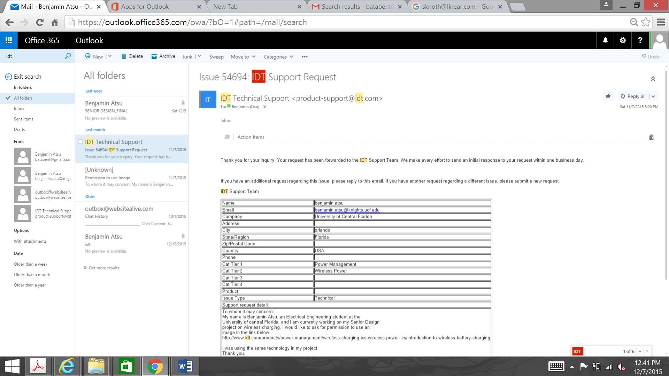

9) Permission from Sparkfun



Appendix C - List of Tables

Table 3.2.1.1 Advantages of Bluetooth Technology
Table 3.2.1.2 Disadvantages of Bluetooth Technology
Table 3.2.1.3 Advantages of GPS Technology
Table 3.2.1.4 Disadvantages of GPS Technology
Table 3.2.1.5 Advantages of Infrared Technology
Table 3.2.1.6 Disadvantages of Infrared Technology
Table 3.2.2.1 - TELEM1, TELEM2 ports
Table 3.2.2.2 - GPS port
Table 3.2.2.3 - SERIAL 4/5 port - due to space constraints two ports are on one connector
Table 3.2.2.4 – Pixhawk ADC 6.6V
Table 3.2.2.5 – Pixhawk ADC 3.3V
Table 3.2.2.6 – Pixhawk I2C
Table 3.2.2.7 – Pixhawk CAN
Table 3.2.2.8 – Pixhawk SPI
Table 3.2.2.9 – Pixhawk POWER
Table 3.2.2.10 – Pixhawk SWITCH
Table 3.2.4.1 Advantages of Radio Frequency Communications
Table 3.2.4.2 Disadvantages of Radio Frequency Communications
Table 3.2.5.1 – Primary Laptop Specifications
Table 3.2.7 Linear and Switching converters comparison.
Table 3.2.7.1 Important characteristics of a Buck converter
Table 3.2.7.2 Important characteristics of a Boost converter
Table 3.2.7.3 Important characteristics of a Buck-Boost converter
Table 3.2.7.4 Important characteristics of a SEPIC converter
Table 3.2.7.5 Switching Converters Characteristics
Table 4.2.1.1. SPS Per-Satellite Coverage Standards
Table 6.2.1 Electrical Specification our Wireless Charging System
Table 6.2.2d Transmitter circuit parameters 7.55mm Gap
Table 6.2.2de Transmitter circuit parameters 4.5mm Gap
Table 6.2.2f Transmitter circuit parameters 10.5mm Gap
Table 6.2.3f Battery Charger specifications
Table 7.1.1 – Bill of Materials
Table 7.1.1a Recommended Transmitter Components
Table 7.1.1b Recommended High Voltage Pre-Regulator Components
Table 7.1.1c Recommended Receiver Components
Table 7.3.3.1 Important characteristics of Monocrystalline Cell
Table 7.3.3.2 Important characteristics of Polycrystalline Cell
Table 7.3.3. Important characteristics of Thin Film Solar Cells
Table 7.3.3.3 Solar Cells Comparison
Table 9.1.1 Senior Design I Objectives
Table 9.1.2 Wireless Communications Milestone
Table 9.1.3 Sensors (infrared, GPS) Milestone
Table 9.1.4 Wireless Transmitter & Receiver Milestone
Table 9.1.5 Optical Recognition Milestone
Table 9.1.6 RF Communications Milestone
Table 9.1.7 Solar Panels Milestone
Table 9.1.8 Projected Senior Design II Schedule
Table 9.1.9 Projected Senior Design II Milestone Schedule
Table 9.1.10 Wireless Communication Senior Design II Milestone
Table 9.1.11 Sensors (Infrared, GPS) Senior Design II Milestone
Table 9.1.12 Wireless Transmitter & Receiver Senior Design II Milestone
Table 9.1.13 Optical Recognition Senior Design II Milestone Table 9.1.14 Radio frequency Communication Senior Design II Milestone
Table 9.1.15 Solar Panels Senior Design II Milestone
Table 9.2.1 SPIDRONE projected budget

Appendix D – Figures and Diagrams

Diagram 3.4.3.1 Bluetooth Transmitter
Diagram 3.4.3.2 Global Positioning System(GPS)
Diagram 3.4.3.3 Infrared Communication
Diagram 3.4.3.3 Radio Frequency Transmitter
Diagram 3.4.3.4 Radio Frequency Receiver
Figure 3.1.1a AirDog Drone Product being used for Action Sports
Figure 3.1.1b AirDog Drone Product and Transmitter for tracking user
Figure 3.1.2a Examples of WPT charging applications in medical Devices
Figure 3.1.2b .Application of WPT for charging full electric and hybrid cars
Figure 3.1.1a Witricity Drone charging
Figure 3.2.2.1 Pixhawk Flight Controller
Figure 3.2.2.2 Pixhawk Connectors
Figure 3.2.5.1 RFDesign RFD900 Transmitter
Figure 3.2.5.2 ¼ Wavelength Monopole and ½ Wavelength Monopole for 433 MHz Radios.
Figure 3.2.5.3 Diagram of Optical Recognition
Figure 3.2.6.2a Functional Benefits of WPT
Figure 3.2.6.4a Comparison between the different transmitter configurations
Figure 3.2.6.4a Comparison between the different transmitter configurations
Figure 3.2.6.4b Components of Wireless Charging System
Figure 3.2.7.1a Linear regulator
Figure 3.2.7.4.1 Schematic of TI LM3488 Uncoupled Inductors SEPIC.
Figure 3.2.7.4.2 Transient Output and input waveform of LM3488
Figure 3.2.7.3 Output Current TI LM3488 Uncoupled Inductors SEPIC
Figure3.2.7.4 Foot Print and efficiency chart for TI LM3488 Uncoupled Inductors SEPIC initial design
Figure 3.2.7.5 Efficiency of TI LM3488 Uncoupled Inductors SEPIC initial design
Figure3.2 7.6 Output Current for TI LM3488 Uncoupled Inductors SEPIC final design
Figure 3.2.7.7Output Current for TI LM3488 Uncoupled Inductors SEPIC final design
Figure 3.2.7.8 Duty Cycle for TI LM3488 Uncoupled Inductors SEPIC final design
Figure 3.2.7.4.9 Lipower -Boost Converter
Figure 3.2.7.4.10 Schematic of Lipower
Figure 3.2.7.4.3 Dimensional Specifications of LM2577 DC-DC Auto Step Up Step Down Power Supply Module (SEPIC)
Figure 3.2.7.4.4 LM2577 DC-DC Auto Step up Step down Power Supply Module(SEPIC)
Figure 3.2.8.1 – Battery Discharge Curve
Figure 3.3.1.1 – Quadcopter Layout
Figure 5.2.1a Recommended SAR, induced Electric field and Current in the nervous system
Figure 6.1.1 Prototype hardware for the Mechanical Battery Swap
Figure 6.1.2 Prototype design for Big Cylinder with Notches
Figure 6.2a Charging station
Figure 6.2b Aerial View of Charging station
Figure 6.2.1a: Functional Block Diagram of Wireless Battery Charging System
Figure 6.2.2a schematic of Transmitter LTC4125
Figure 6.2.2b Pin Configuration for the LTC 4125 Transmitter
Figure 6.2.2c schematic of Basic Transmitter by Powerbyproxi
Figure 6.2.3a Schematic of LTC4120
Figure 6.2.3b LTC4120 Receive Demo board Components
Figure 6.2.3d Pin Configuration for the LTC 4120 Receiver
Figure 6.2.3e Schematic for 400mA Wireless Synchronous Buck Battery Charger
Figure 6.2.3f Bar graph for 400mA Wireless Synchronous Buck Battery Charger
Figure 6.2.3e Flow chart for Battery charging
Figure 6.2.3g Wireless Receiver Voltage / Charge current vs Spacing of LTC4120
Figure 6.2.3h Typical battery charge current Vs Temperature
Figure 6.2.3i Typical Wireless Charging Cycle
Figure 6.2.4a Typical Wireless Charging Application
Figure 6.4.1 User’s path
Figure 6.4.2 User and Drone Communication
Figure 6.4.3 Drone follows user’s path
Figure 7.2.1.1 – Auto-Landing Sequence
Figure 7.1.1c Recommended Receiver Components
Figure 7.2.2.1 Tracking coding plan for SPIDRONE
Figure 7.3.2.1 Zubax GNSS board
Figure 7.3.2.2 Zubax GNSS
Figure 7.3.2.3 Zubax GNSS
Figure 7.3.2.4 3DR uBlox LEA-6H High Performance Receiver
Figure 7.4a Layer PCB layout of Receiver Coil
Figure 8.2d Isolated Load for Testing DC/DC Converters
Figure8.2a Open Circuit Test ( Voc)
Figure8.2b Short Circuit Test (Isc )
Figure 8.2.1a Wireless receiver Power Demo Board mounted on Transmitter
Figure 8.2.1b Proxipoint Transmitter
Figure 8.2.1c Schematic for Basic inductive Transmitter with Pre-Regulator
Figure 8.2.1d DC2181A Wireless Power Demo Board Connection for Proxipro
Figure 8.2.1e DC2181A Wireless Power Demo Board Connection for Basic transmitter

