Summary of Project Head On

In recent years, vehicles have incorporated sophisticated electronic systems in order to improve the safety, comfort, and overall enjoyment of the ride. Notable features seen in newer vehicles include built in navigation, projected speed, directions displayed on the windshield, omni-directional cameras for a 360 view of the vehicle, and proximity sensors to detect nearby obstacles. Meanwhile, the two wheeled counterpart, the motorcycle, continues to lack an implementation of these features that would make riding more comfortable and safer for riders.
Our helmet system hopes to provide a solution to this problem. A screen placed on the helmet displaying data for the rider will increase his or her overall awareness. The main goal is to display a notification indicating the proximity of potentially hazardous objects around the rider. In addition, the current speed of the bike, cardinal direction, and time will also be displayed. The display will be easy to read with a straightforward interface and unobstructive display. The screen will be mounted on the external shell of the helmet in a location that maintains peripheral visibility while providing enough distance to the rider such that the data displayed on the screen is clear and legible.
As previously mentioned, the main goal of this design is to alert the riders of objects in their blind spot. By using multiple sensors our design will cover all blind spots in such a way that the overall awareness of the surroundings is increased. This data will be measured, analyzed, and transmitted to the screen mounted on the rider’s helmet.
Furthermore, the rider assistance system will focus on low power consumption and a renewable power source. We hope to keep the rider connected at all times whether on a short or long trip by incorporating solar power recharging of the system. Additionally, the system will have a built in battery so that the helmet can maintain functionality when away from direct sunlight. This charging versatility will allow the rider to use the system regardless of the existing conditions.
Perhaps the most exciting aspect of this design is the sheer scalability and flexibility of features that can be added. One such feature is conditional adjustment of the proximity sensors based on rider’s speed. For example, at higher speeds the number of car lengths needed to come to a safe stop is greater. Hence, the rider will be notified when the object enters the calculated threshold based on the current speed. Another possible feature is incorporating a GPS tracking and navigation system to be displayed on the screen. Lastly, a crash notification system that alerts emergency contacts if an accident occurs.
In conclusion, there is a lack of available products that improve the overall safety and awareness of motorcycle riders. The features incorporated in our helmet system will help fill this gap by increasing the alertness of the rider in a simple and unobtrusive way. It will open the doors to a plethora of features and enhancements that can be incorporated in the future.

Requirement specifications:
Attribute | Value
Battery Life | Minimum 1 hour
Connectivity distance to onboard transponder | 15 feet
Sensor measurement frequency | 1.5 s
Number of sensors | 4
Forward detection distance | Minimum of 15 feet
Lateral and rear detection distance | Minimum of 3 feet

Block Diagrams:
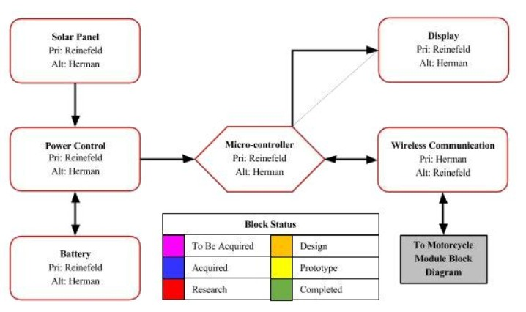
Diagram 1: Helmet Module Hardware
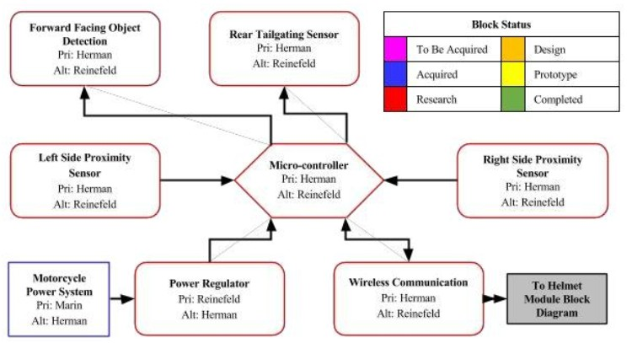
Diagram 2: Motercycle Moule Hardware

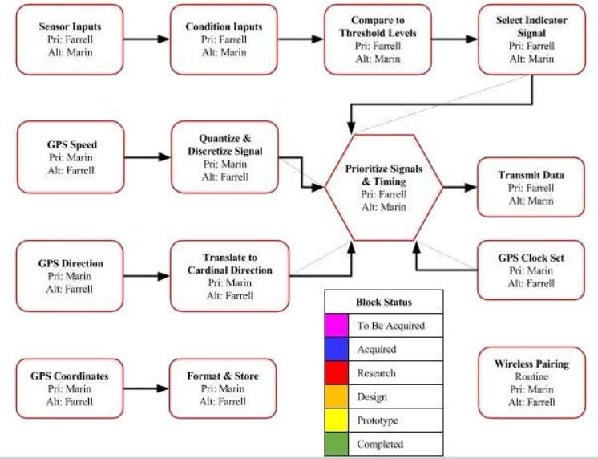
Diagram 3: Motorcycle Module Software
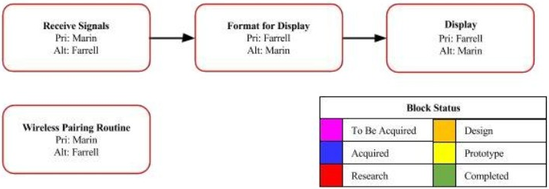
Diagram 4: Helmet Module Software

Budget:
Parts | Quantity | Cost (each)
Motorcycle for testing | 1 | Acquired
Motorcycle helmet | 1 | $50
Printed circuit boards | 10 | $5
Microcontrollers | 2 | $10
GPS module | 1 | $50
LCD display | 1 | $15
Solar panels | 8 | $15
Battery | 1 | $40
Short range sensors | 3 | $10
Long range sensor | 1 | $115
Wireless modules | 4 | $9
Power regulators | 4 | $15
USB TTL board | 1 | $6
Total: |  | $592

