Group 15
Autonomous Firefighting Robot
Bryanna Saavedra-Electrical Engineering
Philip Fritz-Electrical Engineering
Dylan Moro-Electrical Engineering
Dustin James-Electrical Engineering



1) We currently have no sponsors or significant contributors.

2) Even though we live in a world where electronics are taking over, there are still places and fields where they are not quite as prevalent or not present in abundance. One of those fields is firefighting. We always see on the news about houses or businesses catching fire putting human firefighters in dangerous positions to do their job to reduce the damage and also the possibility of saving lives while putting theirs on the line. How could technology help? Autonomous vehicles. Firefighters could be able to use an autonomous vehicle manually or autonomously to go into a building to scan for people, assess damages, and also assist in extinguishing the fire. The Autonomous vehicles would be equipped with sensors and video feedback so firefighters would know exactly what was going and know the severity of the situation, all the while they wouldn’t be in harm’s way.
What could the Autonomous vehicles do?
- Transmit video to allow firefighters to visually see what’s going on inside the building.
- Would have an onboard fire extinguishing system.
- Could be equipped with claw to remove possible dangerous material or even aid in a human exiting the area.
- Would have the ability to be manually driven to the door of the building and switched to an autonomous state where all the fire fighter would have to do is monitor the process or go about another task helping in different aspects.
- Could help smaller/ under-staffed fire departments.

3) List of specifications for the project as a whole:
- Right hand of robot stays within a foot of the wall when no flame is detected
- Robot stops within a foot ± 4 inches
- Robot will be aligned with the most intense source of the fire within 20° centered
- Robot needs to be able to locate and distinguish the fire within a realistic time frame
- Battery life needs to be sustainable for twenty minutes of continuous use
- All sensors must pull a maximum of 20mA from digital pins
- Robot will be no more than twenty pounds for portability
- Robot will use no more than four ultrasonic sensors
- Robot will use no more than five fire sensors
- PCB board will use D-sub connectors to avoid stray wires from coming loose
- Robot will use four brushed motors
- Robot will use two ESCs
- Robot will have four wheels
- Robot will have an aluminum frame
- Robot will not be able to go up stairs
- Robot will be able to go up ramps
- Ultrasonic sensors will ping at least twenty times per second
- When the fire sensor does not detect a flame, the robot will use the right hand rule to guide itself through the maze
- When the sensors pick up a flame, the robot will navigate towards the flame
- Once the flame is extinguished, the robot will take the same path back until it finds the wall and then begin to use the right hand rule again
- Once the job is done, the robot programming will be manually overridden by a wireless user input to stop its current program and be manually driven out of the building.
- No more than $1200
- Memory used will be under 256KB
- Robot will be user friendly
- Robot will be approximately 24in by 12in
- ATMEGA IC chip

Hardware Flow Diagram

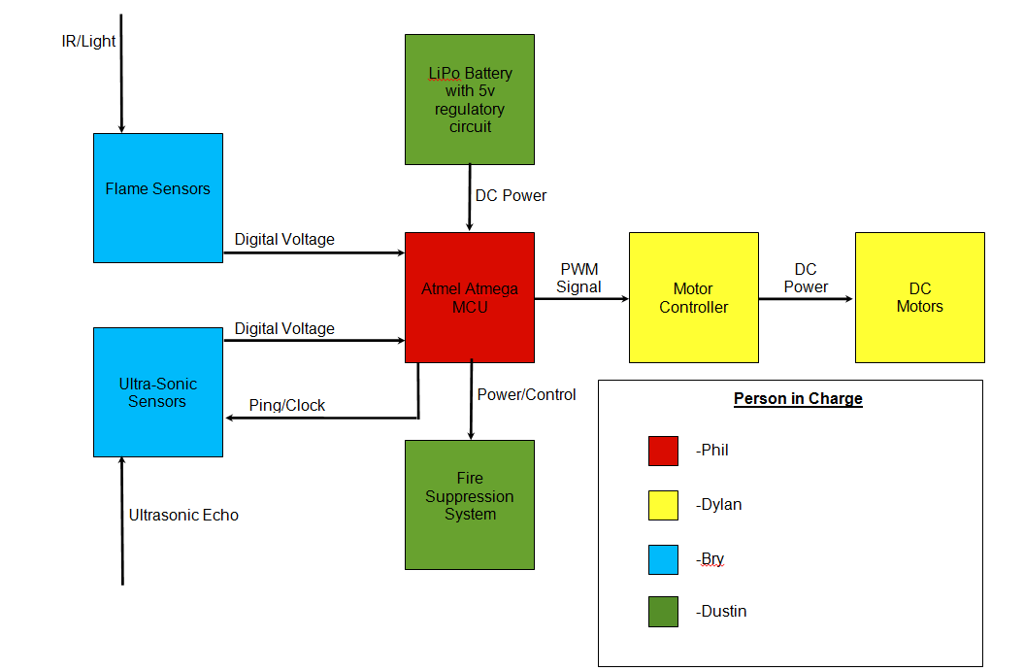

Hardware Legend

Flame Sensors: (To be Acquired) Sensors able to distinguish fire from other light sources.

Ultra-Sonic Sensors: (To be Acquired) Sensors that send an ultrasonic pulse and time the response to determine distance.

Atmel Atmega MCU: (Acquired) Micro-controller by Atmel company.

Fire Suppression System: (To be Acquired) System able to extinguish small flame.

Motor Controller: (To be Acquired) System to regulate/relay power to the DC motors.

DC Motors: (To be Acquired) DC motors to actuate movement.

LiPo battery with 5v regulator: (To be Acquired) Power regulation and supply circuitry.

Software Flow Diagram
Flame Detected
Ping Ultra-Sonic Sensors
Process distance to wall from right side of robot

Read Flame Sensors
Step motor to keep constant distance from wall and right side of robot
Step motor to keep middle flame sensor higher than others

Read Flame Sensors
Process distance to wall from right side of robot
No Flame Detected

5)
 | Company of Product | Quantity | Price (per unit) | Ind part total
Frame/Body
Scout Robot Kit | Servo City | 1 | $169.99 | $169.99
Claw | Servo City | 1 | $9.99 | $9.99
Sensors
Ultrasonic | SainSmart | 4 | $7.20 | $28.80
Fire sensors | SainSmart | 5 | $10.00 | $50.00
MCU
Arduino Mega(testing) | SainSmart | 2 |  | $0.00
Motor Speed Controller | Gearbest | 2 | $19.99 | $39.98
PCB Fab | Oshpark | 2 | $100.00 | $200.00
Wireless communication |  |  |  | $0.00
RC Tx/Rx | Frsky Taranis | 1 | $300.00 | $300.00
Fire Suppression
TBD | TBD | 1 | $100.00 | $100.00
Power Management
5v Regulator |  | 1 | $10.00 | $10.00
LIPO Battery 5000mah | Turnigy | 2 | $35.00 | $70.00
Excess Expenses |  | 1 | $200.00 | $200.00
Grand Total |  |  |  | $1,178.76

6) Milestones:
1st semester
- Effectively research all possible options for the sensors, robot chassis, microcontroller unit and power supply
- Create a rough draft of a functional programming code to perform all necessary applications that the robot needs to accomplish
- Buy all of the essential components
- Begin testing individual blocks of the block diagram i.e. flame sensors and ultrasonic sensors to familiarize ourselves with these components
- Design PCB board
- Design maze
- Build maze

2nd semester
- Assemble all robot hardware
- PCB fabrication
- Wire all electric components of robot
- Solder all necessary components
- Load software onto MCU
- Test all software components to make sure that they are functioning appropriately
- Begin tests for robot
- Correct errors discovered from testing
- Finalize all hardware and software implementations
- Final tests
- Final corrections
- Finished product

