UCF Senior Design I

RF Energy Harvesting for Medical Applications

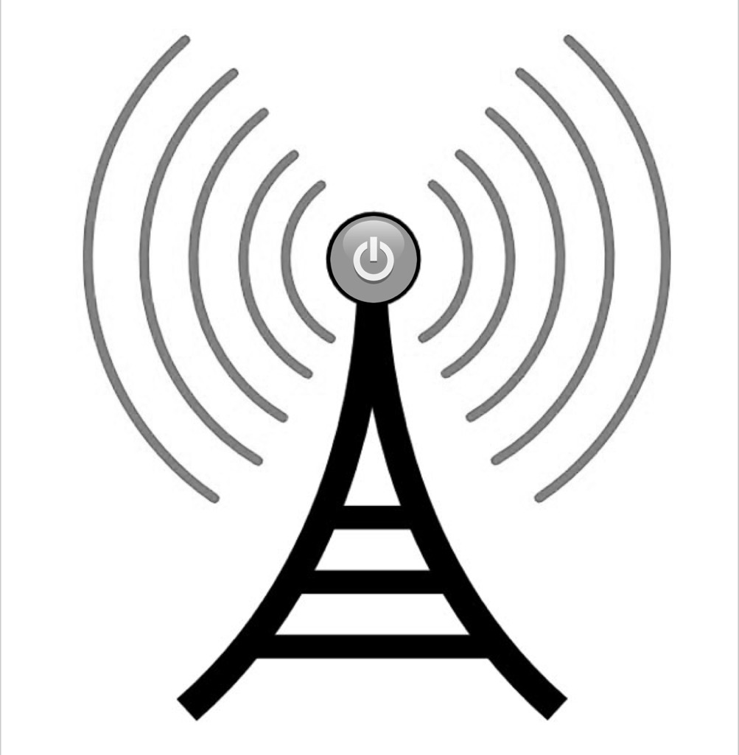

Department of Electrical & Computer Engineering
University of Central Florida
Dr. Lei Wei

Final Document

FALL 2017
Group 18
Joe Sleppy, EE John Foster, EE Ezekiel Rosenbluth, CpE
Table of Contents
Executive Summary 1
Project Description 2
Project Background 2
Objectives 4
Motivation 4
Marketing Requirements & Goals 4
Related Engineering Specifications 5
House of Quality 6
Market Analysis 7
System Design & Implementation 10
Existing Projects and Products 10
RF Energy Density 10
RF Energy Research Paper 13
RF Energy Startup 15
Relevant Technologies 16
Antennas 16
Timing and Controls 19
Energy Storage 20
Monitoring using NFC 21
Bluetooth Low Energy 22
ZigBee 22
Strategic Components Selection 23
Design Ideology 23
RF Signal Sources 23
Antenna 25
Energy Harvesting 28
Thermoelectric Secondary Source 33
Energy Storage 34
DC to DC Converter 39
Power Conditioning 44
Monitoring System 46
Product Enclosure Design 47
Software Design Details 48
External Clocking 48
Measuring Zero Current 49
Sensor Implementation 50
ISO15693 52
UPF Design Environments 53
Taking Readings (Monitoring) 53
Standards and Realistic Design Constraints 54
Related Standards 54
Antennas 54
Unified Power Format 55
Design Structure 55
Power Architecture 56
State Retention 56
Power Distribution 57
Language Basics 59
Lexical Elements 59
Boolean Expressions 61
Power Intent Commands 62
Object Declaration 66
Power-Management Cell Definition Commands 69
Android (Java) Development 69
Source Files 69
File Structure 69
Formatting 70
Operator Precedence 71
Comments 71
Naming 71
Programming Practices 71
Realistic Design Constraints 71
Size & Form Factor 72
Cost 72
Compatibility of Technologies 73
Economic & Time Constraints 73
Environmental, Social, and Political Constraints 73
Ethical Health and Safety Constraints 74
Manufacturability and Sustainability constraints 74
System Prototype, Testing, and Schematic 75
Prototype PCB 75
Full PCB Schematic 77
Bill of Materials 79
Full Circuit Expected Performance 84
Printed Circuit Board Design Requirements 85
PCB Layout Considerations 85
PCB Manufacturing 87
Administrative Content 88
Project Timeline & Milestone Discussion 88
Project Budget 91
Design Problem 92
Roles 93
Future Development 94
Block Diagram and Road Map 99
Final Implementation 99
Conclusion 103
References 104
Appendix A – Purchase Orders 108
Appendix B – Copy Right Request 109

List of Figures
Figure 1 - Energy Harvesting System Overview 1
Figure 2 – RF Signal Sources (a) & Applications (b) 3
Figure 3 - Engineering Specifications 6
Figure 4 – House of Quality 7
Figure 5 – Market Survey Results 8
Figure 6 – IBISWorld Market Analysis & Sizing 9
Figure 7 – Signal Strength at Common Locations 12
Figure 8 – Typical Rectenna Design 14
Figure 9 – Block Diagram of RF Energy Harvesting Systems 15
Figure 10 – Half Wave Dipole Antenna Diagram 16
Figure 11 – Monopole & Dipole Antenna Comparison 17
Figure 12 – Illustration of Antenna Gain 17
Figure 13 – Types of Antennas: PCB(a), Whip (b), and Chip (c) 18
Figure 14 – View of a RF Energy Harvesting Integrated Circuit 19
Figure 15 – High Level Diagram of Circuit Controls 20
Figure 16 – NFC Diagram & Explanation 22
Figure 17 – RF Signal Sources 24
Figure 18 – Bird’s Eye View of Antenna Performance on a Wearable 25
Figure 19 – Antenna Overview 26
Figure 20 – Antenna Options & Selection 27
Figure 21 – W3012 Antenna Performance (Efficiency) 27
Figure 22 – W3012 Antenna Performance (Gain) 28
Figure 23 – RF Energy Harvesting Options & Selection 29
Figure 24 - 2110B Efficiency vs Input Power 29
Figure 25 – Powercast 2110B Performance Metrics 30
Figure 26 – Powercast 2110B Block Diagram 31
Figure 27 – Powercast Timing Diagram 31
Figure 28 – Powercast Capacitor Requirements 32
Figure 29 – Thermoelectric Converter Requirements 33
Figure 30 – Required Charging Circuits 34
Figure 31 – Battery Charging Requirements 35
Figure 32 – Battery Schematic 35
Figure 33 – TI Charging Circuit Parameters 36
Figure 34 – TI Charging Schematic 36
Figure 35 – Traditional Supercapacitor Example 37
Figure 36 – Advanced Super Capacitor Example 38
Figure 37 – Capacitor Discharge Rate 38
Figure 38 – DC to DC Conversion Options from WeBench 39
Figure 39 – Selected DC to DC Converter Design 40
Figure 40 – Simulation of the DC to DC Converter 40
Figure 41 – Waveforms of Selected DC to DC Converter 41
Figure 42 – Waveforms of Common DC to DC Buck Converter 43
Figure 43 – Switching Controls Overview 43
Figure 44 – MOSFET Types 44
Figure 45 – Transistor Switching Guide 44
Figure 46 – Power Management Overview 45
Figure 47 – Microcontroller Block Diagram for Power Management 46
Figure 48 – System Form Factor 47
Figure 49 – OV-0100 Block Diagram 48
Figure 50 – OV-0100 Waveform Timings 48
Figure 51 – Language Visual Guide 58
Figure 52 – Tcl Special Characters 60
Figure 53 – Boolean Operators 61
Figure 54 – UPF Commands 65
Figure 55 – UPF Object Attributes 67
Figure 56 – Value Generation Chart for Proposed System 71
Figure 57 – Breadboard Prototype Circuit 74
Figure 58 – Tested Prototype Circuit 75
Figure 59 – Results of Prototype Circuit 75
Figure 60 - Full prototype circuit in operation 76
Figure 61 – Full Schematic for System 77
Figure 62 – Resistor Equation for Output Voltage Control 77
Figure 63 – Completed Bill of Materials 83
Figure 64 – Full System Performance Estimations 84
Figure 65 – PCB Layout Requirements for Powercast IC 85
Figure 66 – PCB Requirements for Antenna 86
Figure 67 – Project Timeline 90
Figure 68 – Project Budget 90
Figure 69 – Team Members and Roles 93
Figure 70 – Example of an Embedded Medical Device 94
Figure 71 – Inductive Charging Overview 95
Figure 73 – High Level Block Diagram 97
Figure 74 - The back side of the PCB sporting a 50mF capacitor connected by a red wire soldered on to solve a problem 99
Figure 75 - The front side of the PCB while operating as shown by the green LED on the Powercast IC 100

Executive Summary
Every year the number of electronic devices, sensors, and systems increase. This is especially true with the onset of wearable technology for health monitoring. Though tracking heart rate on your smartwatch is plenty cool as is counting your steps, flights of stairs, they are only as useful as long as they remain charged. We identify that these devices, like all consumer electronics, have an alarming dependence on batteries. This project aims to reduce that dependence with a specific focus for users of biomedical sensors and devices such as pacemakers. When such medical devices run out of battery, panic overcomes the user. Our project aims to design a system to power sensors, reduce the dependence on batteries, or reduce the inconvenience for users related to charging these devices (such as an insulin pump) or changing the device’s battery (such as a pacemaker).
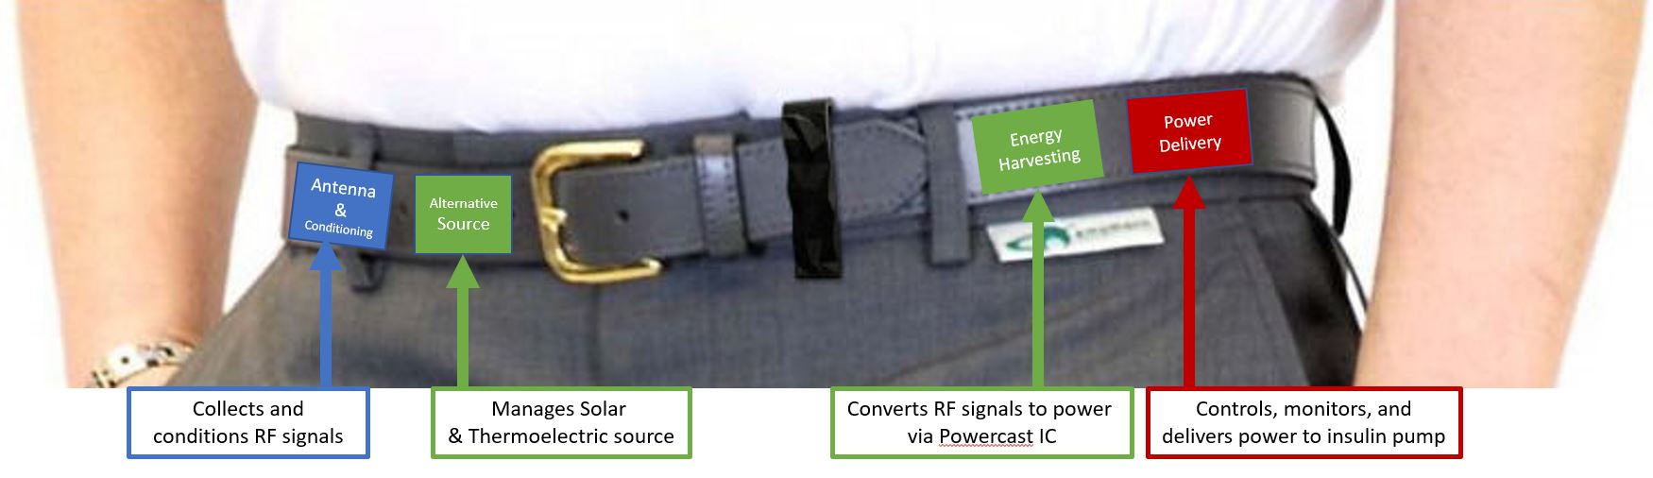
We plan to accomplish this by harvesting radio frequencies (RF) for power. RF signals individually hold very little energy, but collectively these signals can be harvested to deliver an effective amount of power to a load. Furthermore, our system will harvest from sources that are in close in proximity such as a cell phone in a user’s pocket. Our objective is to be the sole power supply to a sensor (or network of sensors), greatly extend the battery to a device such as a pacemaker, or to trickle-charge larger devices such as a diabetic insulin pump. These objectives are feasible given our early stage evaluation of the project. Our goal is to keep the design simple, elegant, lightweight, and as small as possible. Being comfortable, small, and lightweight are key goals as they will not only lead to happier end user’s but also facilitate next-generation applications to our systems that require very small designs. To achieve these goal, the plan is to build the system into a wearable such as a belt. The wearable (as demonstrated in Figure 1) will hold several modules that: collect a range of RF signals (cellular bands and Wi-Fi frequencies), harvest the RF signals for power using a pre-existing integrated circuit (IC) called Powercast, conditioning the all sources of power, and delivering it to the load which will be an network of sensors for our project demonstration. Each module will be its own circuit individually built into the wearable with each module connected by thin, flexible wires. This is a representation of where this project could go. Our project deliverable will be designed in one PCB circuit, power a sensor, and not include a secondary source.
Holds sensors
Sensor
Delivers power to Sensors
Figure 1 - Energy Harvesting System Overview

Project Description

Project Background
Sensors and personal medical devices such as an insulin pump or a pacemaker are battery operated and can best be described as life critical for the user. The battery life of medical devices varies greatly, but they all have one common trait which is they will eventually run out. When this happens, the user goes into panic or might even experience immediate, serious medical issues. For external devices such as insulin pumps, the user charges the battery like they would their phone. Since this is a device that shouldn’t be off the user’s body for more than 15 minutes, it is extremely inconvenient to charge. As for a device internal to the user, batteries often require surgery to change. In addition to this, harmful battery chemistries must be contained within the device, which in the event of failure would cause serious harm.
RF energy harvesting address the core problem described above by supplementing the battery in the device. With RF energy harvesting, the user doesn’t need to find time to charge external devices every day or a few times each week helping them manage their health and reduce their stress as a whole. For internal devices, RF harvesting can add time to the battery’s life helping to delay battery replacing surgeries which reduces the stress of surgery on the body and helps save the user or insurance company money. As for sensors, RF energy harvesting enables smaller designs and reduced cost/inconvenience of replacing batteries. RF energy harvesting is typically done by collecting RF signals, but this generates very little power for the user so it is not popular. Another common option is to use a signal generator which generates a strong and local electromagnetic wave to be harvested wirelessly. This harvests more power than would be for cellular or Wi-Fi signals, but only near the wave generator. These generators are also typically large in size and require a lot of power to generate a signal that is strong enough to harvest.
In this project, a specific focus will be on designing a system that harvests abundant and near-by cellular signals while also designing a circuit that requires little to no input from the user to operate correctly. The circuit must also be passive as it is redundant to design a system with a battery when the entire purpose of the system is to reduce battery dependence. The system must be adaptive, flexible, and completely self-sustaining (no active components) from an electronics point of view.
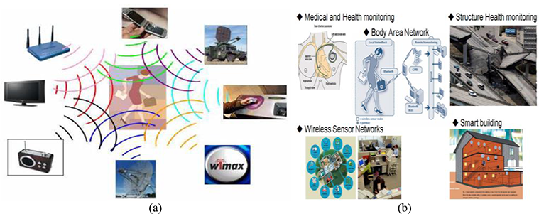

Figure 2 – RF Signal Sources (a) & Applications (b)
Our approach in this project is to leverage the knowledge regarding the topic on how to harvest RF energy, then design a system that will harvest from multiple sources (Cellular Receiving and Cellular Transmitting) all embedded into a wearable device such as a wearable. The bulk of the design work involved in this project is going to be implementation. When working with low power and with RF signals the way an antenna is connected to the board, the internal characteristics of components, the impedance in the traces of a circuit, or even the quality of solder used can change performance. In the end, this system will harvest RF signals to generate >1mW of power for the user. The system will be flexible, light weight, and intuitive so little to no input is required by the user. We plan to implement an app based monitoring systems to keep the user in the loop regarding the energy being generated or the data being read by sensors.

Objectives
Our objective is to design a system that harvests between 1mW and 5mW of energy from a practical source for a user generating value in their life by reducing the stress involved with charging/changing the battery in the device which should result in better overall health for the user. In addition to these power requirements, the upmost care must be taken in the health and safety of the user. Because of this, the device designed will in no way be capable of harming the existing medical device in the event of catastrophic failure. Proper energy storage selection, charge coupling and monitoring all play heavily into this safety. This all must then be implemented into a PCB which is no more than 4in² is size (surface area).

Motivation
The motivation in this project is to demonstrate what we have learned at the University of Central Florida, to challenge ourselves with a difficult project, to put our creativity to good work, and to potentially help someone who has this problem. One of our group members, Joe Sleppy, wears an insulin pump and has had several occasions where his diabetes was affected due to a dead battery and unable to charge his device without interrupting his life. The passion put into this project stems from the fact that this is a very real need. There are also industrial motivations too as the applications for devices that could benefit from RF energy harvesting is valued over $1 Trillion.

Marketing Requirements & Goals
The “system” refers to the circuit that will be delivered involved with harvesting RF energy, the sensors, and the microcontrollers. The term wearable refers to a wearable, patch, or band of some form.
- The system shall fit into a wearable patch to be worn by the user
- The wearable or patch must be mostly flexible and comfortable to wear
- The system shall require little to no maintenance from the user
- The system output will be shown on a mobile application
- The data transfer from the microcontroller to the mobile application must require little to no power
- For sensor readings when appropriate, such as temperature, an average value will be shown on the mobile application
- The system must be able to withstand daily wear and tear such as vibrations from walking or falling down
- The wearable must remain within normal fashion constraints in terms of appearance

Related Engineering Specifications
Fig. 3 below describes all appropriate engineering specifications for the proposed system.
Topic | Specification | Note
Wearable size | 4in² | System will fit within a standard size wearable.
System Output | 1mW to 5mW  Practical Source  30mW to 50mW  Ideal Source | The system output should provide power to a sensor or two.
System Energy  Harvested Tolerance | +/- 20% | Allowable tolerance given the constant changing conditions of RF signals.
Wearable & System Weight | 150% of Original Wearable Weight | The system shall remain relatively lightweight.
System Output Voltage | 3.4V | Natural output of Powercast energy harvesting IC
Project Development Cost | $2,500 | Our budget will not exceed $2,500 through the prototype stage.
System Monitoring | NFC w/ 95% accuracy | We will use NFC to monitor the output of the system which will be 95% accurate.
Data Output | Data transfer user defined | The system will plot the data in a line graph on the mobile application and provide average values if appropriate.
Figure 3 - Engineering Specifications

House of Quality
The following house of quality shown in Fig. 4 combines marketing requirements and engineering specifications into the figure below while describing their relationship. The concepts shown in this house of quality will guide our design decision, help us select components, and will remind us of the user that we are designing this system for. By having a guide such as this, we can ensure a high probability of success for the project and ensure we generate value for the ideal end user.
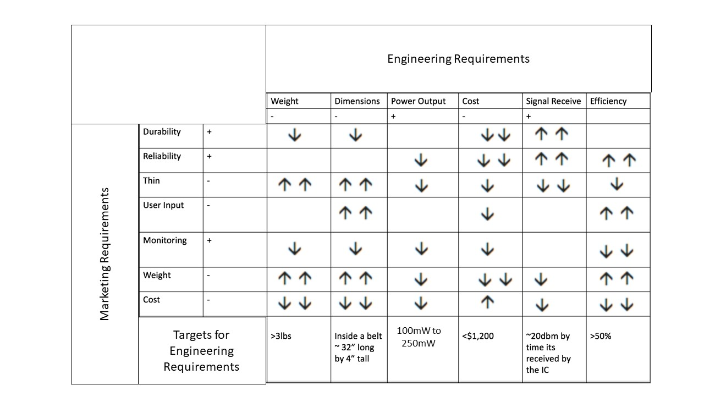
Figure 4 – House of Quality
LEGEND: | + | Positive Polarity
 | 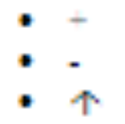 | Positive Correlation
 |  | Additional Arrows represent stronger correlation
 |  | Negative Correlation
 | - | Negative Polarity

Market Analysis
There are about three million types of diabetics in America and three million pacemakers currently being used in the world. Each pump is being recharged about once per week and battery replacement surgeries for pacemakers each decade. That makes a total available market for our energy harvesting system approximately $600M assuming we can sell the energy harvesting wearable for $100. We did a quick run through customer discovery interviewing 10 individuals with insulin pump. We found the following results in Fig. 5:
Figure 5 – Market Survey Results
The results show that the most important value to our potential users is making their pump easier to charge. Most of the users we talked to continue to say that if the battery is easier to charge then the other values follow making it the most valued. They did not seem to resonate with being less likely to have a health issue. Most of the time, when a pump runs out of battery it is a major inconvenience and their blood glucose levels will rise because of the pump being out of battery. However, this is a slight raise in blood glucose and not life threatening, just uncomfortable giving this a less important value proposition.

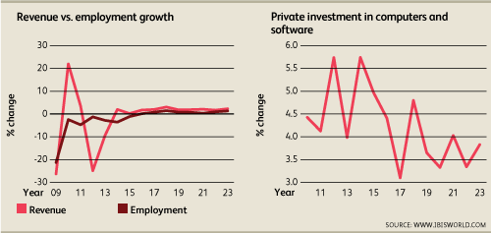
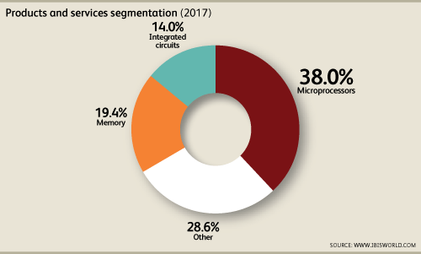
Figure 6 – IBISWorld Market Analysis & Sizing
This data comes from IBISWorld’s Semiconductor Market Analysis which is valued at $50.5B, a portion of which is dedicated to RF Energy Harvesting integrated circuits and Internet of Things. As defined in the report from IBISWorld, RF Energy Harvesting and IoT is expected to be one of the major growth indicators. Furthermore, the IoT industry and RF Energy Harvesting components are poised to heavily differentiate United States based companies from the rest of the world (especially Asia) which follows the common trend of the United States excelling on innovation more so than manufacturing. There are several estimates that shows that the IoT market (one of the broader impact applications of RF energy harvesting) is valued over $1Trillion dollars.

System Design & Implementation

Existing Projects and Products
There are not commercially available products in mass market adoption that utilize RF energy harvesting to power the load, but there have been a number of research papers published on the topic. The research into energy harvesting is a fairly mature technology, but the full implementation has yet to be discovered completely. Just like the advent of CMOS technology, once discovered, the possibilities of implementation and improvement are endless.

RF Energy Density
Crucial to the operation of this device, the density of the signals found in everyday activities decide the effectiveness. Not only are multiple sources present, but multiple environments of signal propagation also exist. The sources include Cellular, Wi-Fi, Television broadcast, Radio Waves, and natural as well as scientific sources. The primary band focus encompassed within the scope of this project is the Cellular band. Due to the exponential increase of mobile device users the 900Mhz band is quite saturated. Because of this the circumstances that a favorable environment for RF harvesting increase drastically. Within the cell band, two favorable conditions occur. In line of sight or near proximity to a cell tower, signals of -17.99dBm may be encountered. This signal will obviously decrease dramatically as the harvester moves indoors or behind an obstruction which isolates the device from the signal. This will undoubtedly hinder the indoor performance of the harvesting, but fortunately other sources may substitute the deficiency. The other favorable condition however is a highly saturated area of cellular users. In this environment abundant amounts of signal will be transmitted.
Before moving into alternative sources, the mode of energy storage should be addressed. The storage is designed in such a way that any amount of charging whether large bursts (mA) or slow trickling (nA) may be stored for later usage. Therefore, even in the absence of high power sources, the device will still capture what is available. The second available source comes from the transmissions back from a cellular device to the tower. Although lower power, these signals will inevitably be closer to the device than a cell tower. The only limiting factor here is the physical density of devices currently in the room with the harvester. This of course will depend on the environment and setting the device is currently in. Large gathering places such as arenas, classrooms, churches, and airports are just a few of the areas in which a high-power density may be expected. Fig. 7 below shows a study done by a research group out of the University of Calgary.
Location |  | Peak Power (dBm) | Input Signal Consistent?
Airport – Arrivals |  | -25.43 | Yes
Airport – Departures |  | -15.82 | Yes
Home 1 |  | N/A | N/A
Home 2 |  | N/A | N/A
Large Park |  | -34.45 | Yes
Mall – Near Entrances |  | -41.47 | Yes
Mall – Near the Middle |  | -22.42 | Yes
Neighborhood 1 – Park |  | -39.95 | Yes
Neighborhood 2 – Park |  | -43.62 | Yes
Neighborhood 1 – Street |  | -40.97 | Yes
Neighborhood 2 – Street |  | -38.92 | Yes
Office 1 |  | -34.5 | No
Office 2 |  | N/A | N/A
Open Field – Cell Tower |  | -17.99 | Yes
Rural |  | -36.95 | Yes
Train Station 1 |  | -28.08 | Yes
Train Station 2 |  | -28.32 | Yes
University – Outdoor 1 |  | -24.24 | Yes
University – Outdoor 2 |  | -38.82 | No
University Cafeteria Off-Peak |  | -42.04 | No
University Cafeteria Peak |  | -42.93 | No
University Lecture Hall – Large |  | -38.03 | No
University Lecture Hall – Small |  | -36.43 | Yes
University Library | -38.41 | Yes
Figure 7 – Signal Strength at Common Locations
One additional factor to consider besides the baseline power available is the peaks generated when cellular devices connect to the tower. This initial connection may again be harvested and provide yet another boost to the power stored in the charging circuit. All of these factors combined provide a vast number of viable options to consistently provide power. Later sections will discuss the actual power seen in varying environments and testing scenarios.
To overcome these peaks and valleys in the available power, the design allows charging when available and store and hold characteristics when no power is available. This allows the power to be stored when available and discharged when needed. I typical flow of the device would be:
- Charging in high density radio frequency areas
- Hold and maintain phase (no charging and no discharging)
- Repeating the following two steps until sufficient power received
- Discharging to the load device until completely drained
- Continue charging when available
Given the amount of power gained is a function of the environment, charging times may not be predicted accurately. Instead, accurate monitoring and switching circuits must control the charging and discharging relying on whether the storage system is fully charged or fully discharged. Future assessments may be done on major cities and areas to allow predictions to be made on charge time in a given area. This will be accomplished with a spectrum analyzer. Much like how Google scans roadways, RF bands may be scanned in the same area to provide estimations of power density. Obviously, every area including the inside of buildings cannot be analyzed, but with enough characterization, predictions can be made based on population density and proximity to cellular towers. With all this data, accurate maps can be made that give approximations of charge cycle times and expected life. This data will provide information crucial to possible users as to whether power harvesting is useful given their area and lifestyle. Although not previously stated, lifestyle does change the effectiveness of the harvesting. For instance, a person who spends lots of time indoors may not receive the same benefit that a person who spends large amounts of time outside.

RF Energy Research Paper
There has been a plethora of research done on RF energy harvesting and even guides created by electronic component wholesale companies such as DigiKey and Mouser. These guides and research papers always cheat by using a dedicated RF signal generator to feed the perfect signal in perfect conditions. Many research papers focus on and discuss at length the concept of a rectenna. This concept is the very thing that this project focuses on with one key difference. A rectenna is an antenna that includes a matching circuit, filter, rectifier, and a DC to DC converter (typically Boost) connected to the output. These same steps, except for the antenna and the matching circuit, are the same as what is in an energy harvesting module such as the one we are planning to use.
Rectennas are not found commercially available. Instead, there are RF energy harvesting modules. The reason for this is purely business purposes. If a company were to make a rectenna commercially available, there would be many products the company would be responsible for the design, manufacturing, and sale of. Each rectenna needs to be tuned to the frequency and the strength of the signal which will determine the input voltage. Instead, component manufacturing companies identified that they could sell the later stages of the system described in the paragraph above. There are less products to manage/sell for the manufacturer by designing generalized rectifiers and boost converters while letting the customer select the antenna. Keep in mind that though this allows a company to sell a product that is more generalized, or one size fits all, these products are still tuned to a rather specific operating point. 900MHz was commonly found as the most efficient frequency to harvest at with these generalized components. Back to the point of a rectenna, (one potential design shown below in figure 8) and its focus in the academic world, rectennas are of much higher performance than these aforementioned generalized solutions.
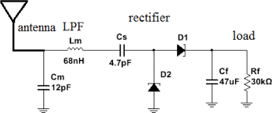
Figure 8 – Typical Rectenna Design
The design engineer can control/expect the conditions their rectenna system will be used in which leads to a more efficient and productive design yielding high performance. We could design a rectenna in the 900MHz frequency for the purposes of this project, however we found that the antenna design in doing so can become quiet complex. Also, because cost is a major consideration, we are using off the shelf components in our design and a rectenna design would require either a large number of individual components or custom fabrication of integrated circuits. In doing this, we may achieve a higher performance, but will fail the marketing requirements.
In general, energy harvesting systems (either ICs or rectennas) will follow the block diagram below in Fig. 9:
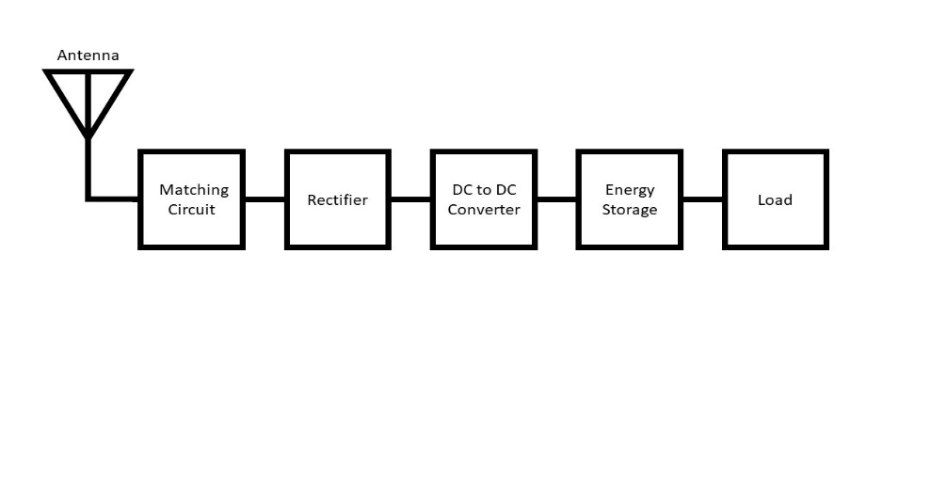
Figure 9 – Block Diagram of RF Energy Harvesting Systems
The most crucial characteristic of any energy harvesting design is the efficiency. Low efficiency energy harvesting modules may still work, however they typically only generate microwatts of power which is essentially useless. Each block in Fig. 9 will be discussed at length in the following sections of this document.

RF Energy Startup
There are other solutions to the problem for external medical device users such as portable chargers, however there have not been any solutions introduced to the market that uses RF energy harvesting to medical devices. Instead, the RF energy market is much more focused on the Internet of Things market by powering small electronic devices and sensors. The leader that we can find in the small business or startup scene is called Freevolt which is focused on RF energy harvesting in the IoT market. They specifically quote:
“In all of these cases the benefit of the Freevolt technology means the sensor is easily deployed, and once set up - you may never need to recharge it with a cable or have to change its batteries.”
-Free Volt
The system we propose will have a very similar end result. Freevolt is focused on being the sole source of power for its sensors. In this project, we will power a network of sensors. This will act as a demonstration to harvesting energy. Later this energy could be used to trickle-charge an insulin pump. Will this system be able to completely power a device like the insulin pump? No, but the goal is supplement the battery. The market is very optimistic of RF energy harvesting technology. For example, Drayson Technologies has raised $9.3M, according to techcrunch.com.

Relevant Technologies

Antennas
This project calls for an antenna to receive random signals in its environment (ambient energy). These antennas also need to fit the marketing requirements by being embedded into the wearable that the user is wearing. To do this, there are several different options to use as antennas.
- Copper Wire: Bare copper wire cut to quarter wavelength, half wavelength, or full wavelength. In this application, the best antenna option is the one that receives the most signal in a specific band or at a specific frequency. Quarter Wavelength and Half Wavelength antennas will be smaller in size which would fit the system (wearable) better, but they are not as efficient. When working with as little power as we are, efficiency is critically important. A Full Wavelength antenna will be more efficient, but larger/longer too.
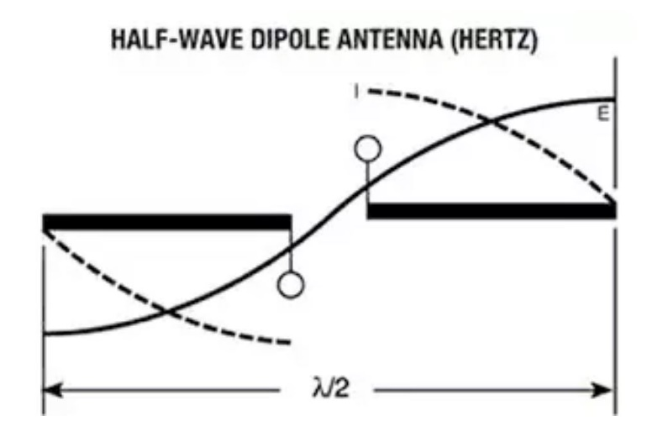
Figure 10 – Half Wave Dipole Antenna Diagram

- Monopole vs Dipole: The key distinction here is that in a monopole the signal radiates on one side of the antenna and a dipole antenna radiates on both sides as show in the image below.
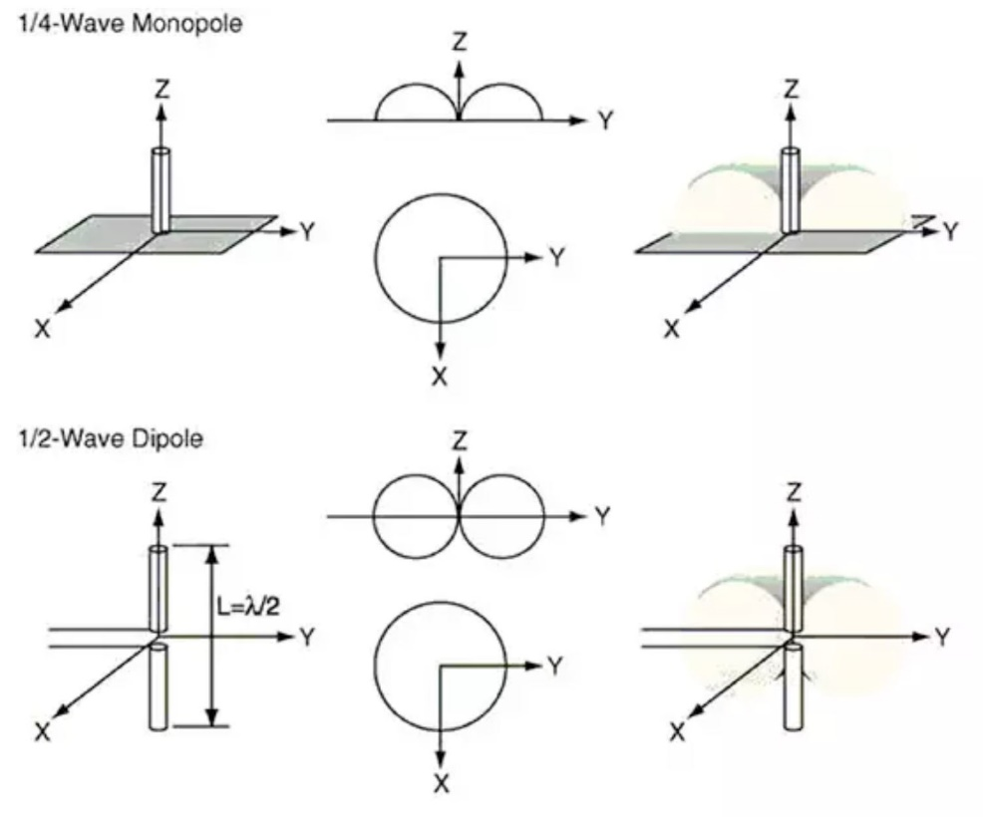
Figure 11 – Monopole & Dipole Antenna Comparison
- Antenna with gain: Gain is a concept often associated with antennas. Simply said, gain in an antenna is a combination of directivity and efficiency. A large gain is not always a good thing as it can mean the antenna is highly directional.
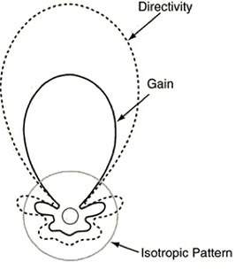
Figure 12 – Illustration of Antenna Gain
- Impedance of Antenna: The impedance of an antenna really refers to the imaginary reactance of the antenna (its inductive and capacitive characteristics) which will change at different frequencies. The Industry standard is 50ohms for antennas.

- Chip Antenna: This is a type of antenna that is built into a chip which would be installed on a PCB. This type of antenna is fair in cost, typically small in size, and has fairly average in performance.

- Whip Antenna: This is the type of antenna people are most familiar with. The whip antenna has the form factor of a whip. It typically has the best performance out of the options, but is expensive and may be hard to fit into the wearable to satisfy marketing requirements.

- PCB Antenna: This is a type of antenna that is built by placing traces in a particular pattern directly on the PCB. This type has low cost, potentially good performance, and can be small in size at high frequencies.

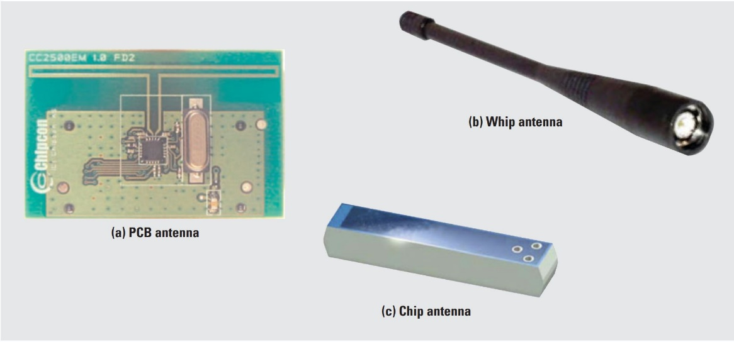
Figure 13 – Types of Antennas: PCB(a), Whip (b), and Chip (c)
RF Energy Harvesting Integrated Circuit
This is the most important technology and component in our system. What this integrated circuit does is essentially rectifies the input signals and then uses a boost DC-DC converter. In theory this is simple, however the speed required by the electronics to be able to rectify high frequencies (which may be subject to noise) and the small size of the boost converter make this component very valuable as we wouldn’t be able to design this ourselves to achieve a similar efficiency.
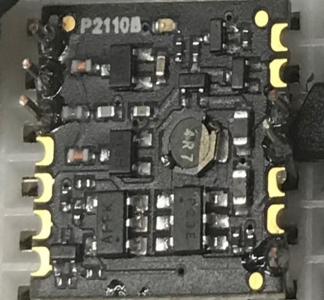
Figure 14 – View of a RF Energy Harvesting Integrated Circuit

Timing and Controls
Due to varying conditions and power received from the harvesting devices in addition to the low current produced, poses a problem for delivering usable power. A proper duty cycle of storage and charging allows the most effective application of the harvested power. In the storage cycle, the Powercast is connected to the supercapacitor and allowed to trickle charge over a few hours. This slow charging allows the Powercast to see limited output resistance and thus run cleanly at high efficiency. Impedance matching ensures that the Powercast and the super capacitor storage system both operate at maximum efficiency. Since the supercapacitor may be slowly charged and also fast discharged, it allows both the trickle charging and fast discharging conditions needed to supply ample current and voltage to turn on the charging circuit. This switching cycle is controlled by a timing circuit that will select the varying stages of either storage or supply depending on the conditions of the device. When in a high-density energy environment, the timing will need to be quicker due to the faster charging of the supercapacitor. Inversely in a low-density environment the circuit will need to stay in storage mode much longer. This parameter will need to be set depending on the area of operation and also the power requirements of the output load as specified in the data sheet. If the load requirements are higher the circuit will need to store longer to achieve effective charging. This ultimately depends on battery chemistry and charging type utilized on the load device.
The switching will be realized by the components that are selected in the design. Given the system will operate in ultra-low power levels, any form of active or advanced switch requires another source of power. This system needs to be stand alone and extremely low power. It is counter intuitive to use energy to harvest additional (but very small) energy. It would be more effective to just use the energy powering the switch to power the load too.
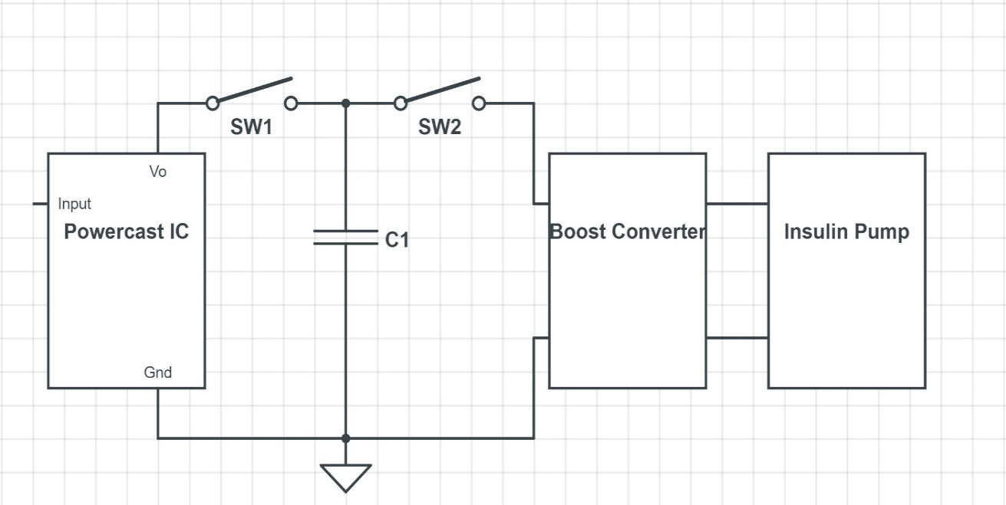
Fig. 15 below shows a simplified view of the control environment. Here, a two-switch control is show whereby the input and output of the supercapacitor is controlled. A typical timing cycle would be as follows. SW1 closed for a charge duration on the order of a few hours. Next SW1 would open as SW2 closes. The circuit is now in discharge mode. The circuit will remain in this mode until the super capacitor is discharged. Now the SW2 opens and the cycle repeats. Again, this ensures optimal conditions for both input and output loads. The control of these switches can be done either with precise timing circuits, or with microprocessor sensing. The discrete timing system relies on much less power, but remains fixed once configured. Microprocessor control allows programming of algorithms to detect and respond to given conditions, and device parameters. Given the programmable nature of microprocessors, this allows future improvements and firmware updates. This increases the potential for operational glitches do to programming bugs, but also increases the robustness of the design due to the future proof design given by the configurability. Both switches will be realized by the Powercast IC and the voltage converter. The Powercast’s output is controlled by discharging cycles from a capacitor connected to the circuit realizing SW1. SW2 is realized by an enable line on the voltage converter which will be controlled by a microcontroller show later on in this document.
Load

Figure 15 – High Level Diagram of Circuit Controls

Energy Storage
This project will include the use of capacitors as an energy storage component. Capacitors are very abundantly used in electronics, however there are many different types, forms, functions, and characteristics of capacitors. The most important characteristics to consider are:
- Capacitance: How well a capacitor can store charge (energy).
  - Larger capacitance stores more charge.
- Voltage Breakdown: The maximum voltage across the capacitor before it shorts.
  - Higher voltage breakdown levels can handle larger input voltages.
- Tolerance: The range of capacitance.
  - Typically a smaller value is desired.
- Equivalent Series Resistance (ESR): Relates mostly to how quickly the capacitor responds to its input.
  - Typically a smaller value is desired. A smaller ESR capacitor will respond to inputs faster.
The Powercast IC is unique because it controls both timing and energy storage for the user. The timing is determined by the size of the capacitor connected. This capacitor should be large (we spec a 50mF capacitor), have a low ESR, and have a very low leakage current (around 5uA). The relationship of the timing controls and this capacitor are discussed further on in this document.

Monitoring using NFC
When designing sensitive and consequential medical devices as proposed, the ability to monitor power in these devices is of utmost importance. Considering numerous options for gathering readings for the monitoring of power in the device, the decision has been made to applying near field communication (NFC). NFC is a form of contactless communication between devices which requires a reader, and a transponder, or tag as it is otherwise referred. The other important principle is that the power for the communication is provided by the host device and as such no internal power is needed for the tag.
NFC systems work by having the reader create a radio frequency current which communicates with the transponder that holds the information that the reader wants. This communication gives enough power to power, read and ultimately resend a transmission to the host. The transponder does not need any power to broadcast because of this.
An NFC tag can be embedded into a PCB and hardwired directly into the board, and is passive, requiring no power. The reader does require power, but can be in the form of a cell phone. As of now, iPhones do not have NFC capabilities, so an Android phone would be required for this functionality. An NFC tag can be embedded into a PCB and hardwired directly into the board, and is passive, requiring no power. The reader does require power, but can be in the form of a cell phone. Most modern Android phones come with NFC capabilities, and as of now iPhones do not, so an Android phone would be required for this functionality should we decide on NFC.
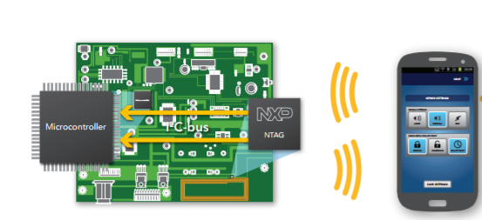
Figure 16 – NFC Diagram & Explanation

Bluetooth Low Energy
Bluetooth LE works just like standard Bluetooth works, enabling short-burst wireless connections and using multiple network topologies including point-to-point and one-to-one communications. It optimizes data transfers and is ideal for connected products, like our transmitter-receiver pair.
As with NFC, Android has built-in Bluetooth LE capabilities, and should be needed for communication between devices. The frequencies operated on are within the ISM 2.4GHz band, and shouldn’t interfere as significant noise with frequencies we are attempting to harvest. BLE is already being used on devices similar to those we wish to power (Blood pressure monitors, fitbits, industrial sensors, etc). The main difference between Bluetooth and BLE is the quantity of data that can be exchanged.

ZigBee
ZigBee is a mesh network protocol designed specifically for the purpose that we are examining – carrying small data packets over short distances while maintaining low power consumption. ZigBee, like Bluetooth, operates in the ISM 2.4GHz band. It uses a version of the IEEE 802.15.4 standard.One major issue with ZigBee comes with interoperability. Two ZigBee profiles can often interfere with one another, so a system where specific readings are vital to operation may not be ideal for this kind of technology. ZigBee is generally used for larger-scale IoT applications like home automation, security systems, and smart lighting, so it will likely not be of much use for this project.

Strategic Components Selection

Design Ideology
We will harvest RF signals coming from cell towers (least powerful), signals leaving your phone (most powerful) and from Wi-Fi signals. These signals were selected because they are the most abundant and strongest in the standard open environment. Our antennas will read the signals in the form of voltage (which will likely be noise) and feed the voltage to the energy harvesting module which rectifies the voltage to be used in the remaining circuitry.

RF Signal Sources
There are many sources to choose from however, our initial research suggested that these three sources would be the most appropriate because of their power and abundance. The user’s cell phone will be the largest source of power for our system.
Source | Common dBm | Common Freq. (Mhz) | Abundance
Cell Tower  (phone receiving signal) | -100dBm to  -85dBm  {Continuous Signal} | 800Mhz, 900Mhz, 1200Mhz, 2400Mhz | Cell towers are very abundant in urban areas. We’ve monitored the dBm on our phones and found a fairly consistent source.
Phone  (transmitting signal) | 27dBm or  34dBm  {Discrete Signal} | 800Mhz, 900Mhz, 1200Mhz | Our phones are always in our pockets and thus are very close to the antenna in the wearable. This is a strong, consistent and reliable source of power for our system.
Wi-Fi | -80dBm to  -50dBm  {Continuous Signal} | 2400Mhz | Every building has Wi-Fi today. Another urban environment source for the user that is fairly consistent.
Figure 17 – RF Signal Sources
It is understood that for testing and demo purposes there are two options:
- We can use an actual cell phone, which would imitate real-world situations using current hardware very accurately

- We can use an RF Transmitter to simulate the cell phone’s emittance, which could provide an ideal setting for power generation and frequency harvesting, and could be a reasonable simulation of the technology with use of future compatible hardware designs which could be implemented into newer (or at least specialized) cell phones.
Generally, a phone uses either a transmitter power output (TPO) of 0.6 watts (W) or 3W, depending on the strength of signal the phone wishes to transmit. Since the 3W transmitters are five times stronger than the 0.6W transmitters, they theoretically broadcast the signal times further, which we can approximate to about twice the distance. Cell phones transmit between the frequencies 824 and 894 megahertz (MHz). As such any simulation of transmission must fall within these boundaries.
For purposes of proof of concept and prototyping, we may use a lab RF signal generator. One simple option would be to design this using an RF transmitter, which can be purchased and programmed to emit either a 315 MHz or 433 MHz. While this does not fall within our ideal range, an RF power amplifier (PA) and modulation can be used to change the frequency to closer, or even right in the 824-894 MHz range as would be the case with Maxim’s MAX2235. The IC accepts many frequencies, but 900-915Mhz is the most efficient.
A microcontroller could be programmed to constantly transmit a signal of a single frequency continuously, or it could be set to vary the frequency to more adequately model the real world, as well as test how it may function through different circumstances. Ideally both models will be tested. Varying the frequency could be done either randomly or by a set pattern. These signals will be collected using very simple 50 Ω antennas designed to the appropriate frequency for each source. In a standard environment, we’ve found that cell towers provide -90dBm on average and Wi-Fi provides -60dBm on average. These signals (when received with a 50 Ω antenna) combine for about a 0.2nW. The transmitting signal will provide an additional 0.6W or 3W though this power is discrete rather than continuous.

Antenna
As mentioned in the Relevant Technologies section, there are a few options for antennas in this project. We will be looking at a full wave monopole antenna. This decision was made because the user’s body could act as an insulator to the signal and the antenna will run parallel to the user’s body rather than orthogonally. For this reason, a dipole antenna would not add value as half the signal would be insulated by the user’s body. This makes the cost advantages of a monopole antenna the core component of the decision.
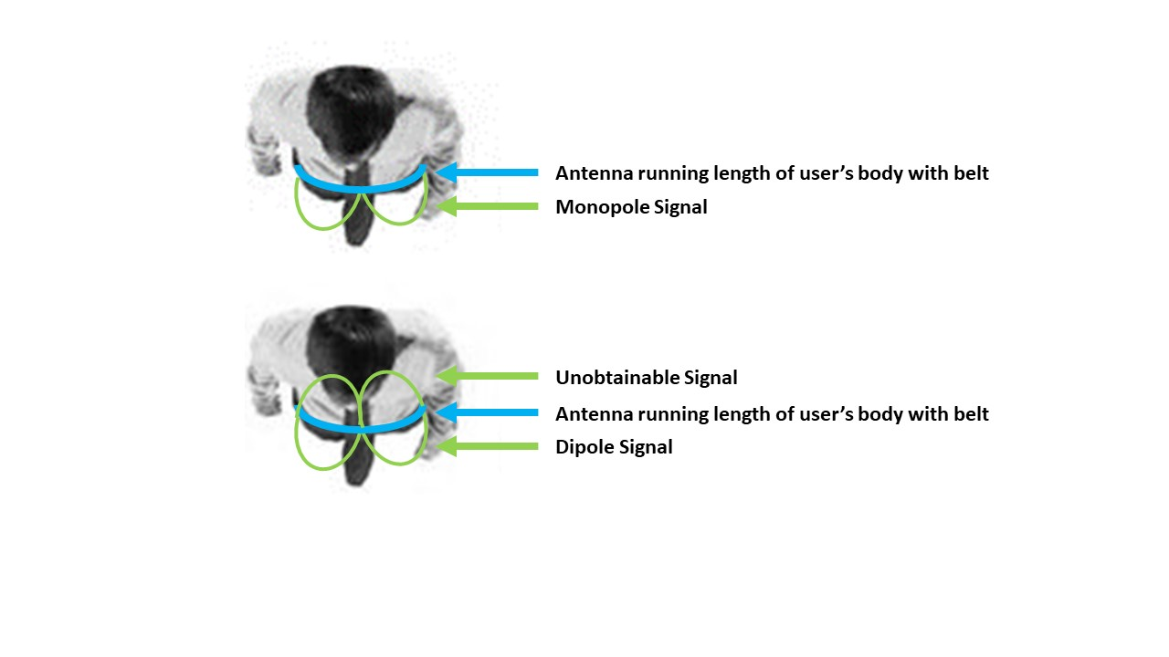
Figure 18 – Bird’s Eye View of Antenna Performance on a Wearable
Monopole versus dipole is not the most critical decision to make regarding this hardware decision. The type (bare wire, chip, whip, or PCB) is a much more critical decision. The bare wire will be the most affordable option but will come at the cost of very low performance and difficulty to implement. The whip antenna will have good performance, but expensive and also hard to implement into a wearable form factor. The PCB and chip antenna option is the best for this project when considering cost and performance, a happy balance. The requirements for this antenna are as follows:
- Must have 50ohm impedance
- Must include matching circuit
- Must focus on 900MHz (cellular band)
- Must be less than $5, though the more affordable the better
- Must fit into a wearable form factor
- Must have a gain between 2dBi and 10dBi

Component | Function | Requirements
Antenna | To receive RF signals which will be more like noise | - 50Ω impedance  - 800Mhz (0.178 Meter wire), 900Mhz (0.158 Meter wire), 1200Mhz (0.119 Meter wire), 2400Mhz (0.059 Meter wire)
Figure 19 – Antenna Overview
We found a few antennas to consider with 50ohm impedance and 900MHz center frequency:
Antenna & Type | Cost per unit | Gain | Size
Yageo ANT1204LL00R0918A  CHIP | $4.66 | 0.5dBi | Good  1.2mm x 12mm x 4mm
Yageo  ANT2112A010B0918A  CHIP | $2.82 | 0.5-1 dBi | Average  0.5mm x 20.5mm x 11.8mm
Pulse  W3012  CHIP | $1.95 | 2 dBi | Good  4mm x 10mm x 3.2mm
Pulse  W1063  WHIP | $7.63 | 3dBi | Bad  168mm long
Figure 20 – Antenna Options & Selection
After reviewing the data listed above in our short list of antenna options, it appears that the Pulse Electronics W3012 Ceramic Chip Antenna is the best option due to its cost, small size, and good performance in terms of efficiency (~70%) at 900MHz. Because this antenna includes all the proper characteristics such as impedance and the matching circuit, this antenna can receive a signal that will be past to the following stage of signal conditioning. As mentioned in several different places in this document, efficiency is key for this RF Energy Harvesting system. We found that this antenna has good efficiency compared to others among the other requirements previously discussed. The efficiency, ~60% is shown in the following figures 21 and 22.

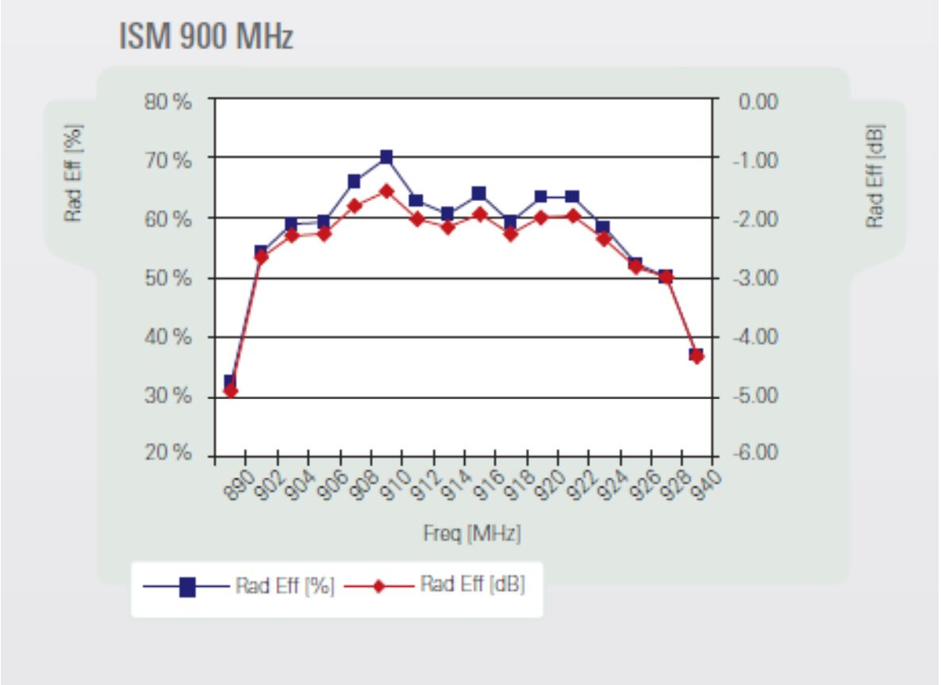
Figure 21 – W3012 Antenna Performance (Efficiency)
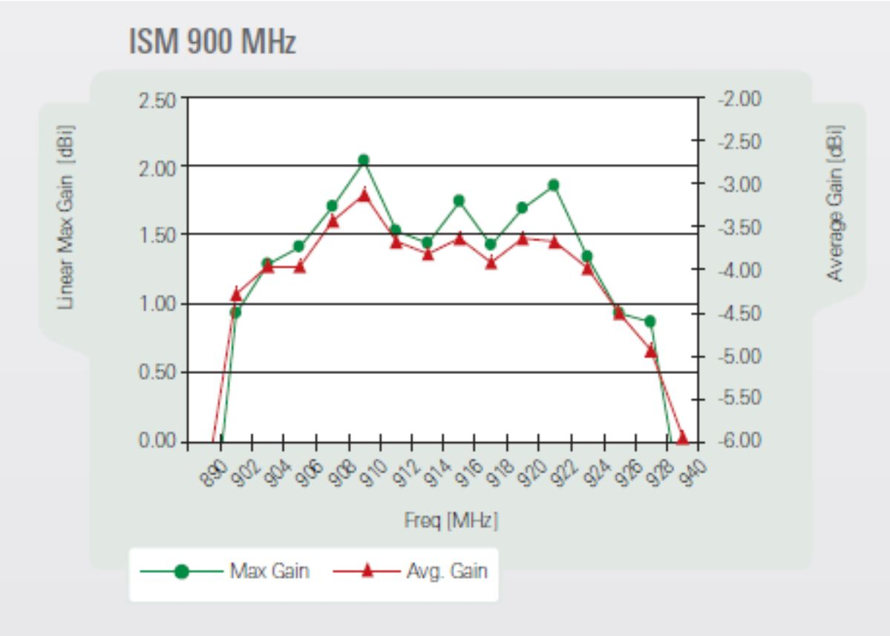
Figure 22 – W3012 Antenna Performance (Gain)
Though the specifications of the W3012 antenna makes it a great option it is not used in our final design. Instead we used a whip antenna. This is because the chip antenna required specific implementation which were out of our manufacturing capabilities. It also features a -6dB return loss which means most of the signal received by the antenna is reflected back to the source. Given we are trying to harvest that signal, we need to receive it and not reflect it back to the source. The whip antenna used in the final design has a 3dB gain, ~12dB return loss (means less than 10% of signal is reflected back), and is far easier to implement on the PCB. We found in prototyping that the performance of this whip antenna to be much better in terms of energy harvested and also range.

Energy Harvesting
Following the antenna is an integrated circuit which will harvest the RF signal for energy. This is the most important component in this project is the energy harvesting integrated circuit. We selected the Powercast 2110B IC Energy Harvesting chip. There are several manufacturing companies making energy harvesting circuits, however we felt the 2110B was the best fit. We judged the components based on size, cost, input power requirement, and efficiency. Fig. 23 belows describes the results from what we found:
Component | Size | Cost | Input Power | Efficiency @ 900MHz
Powercast 2110B | 0.55in by 0.53in | $32.00 | -11 dBm | 30% - 60% (better for weak signal)
Powercast 1110B | 0.55in by 0.43in | $35.95 | -6 dBm | 50% - 70% (better for stronger signal)
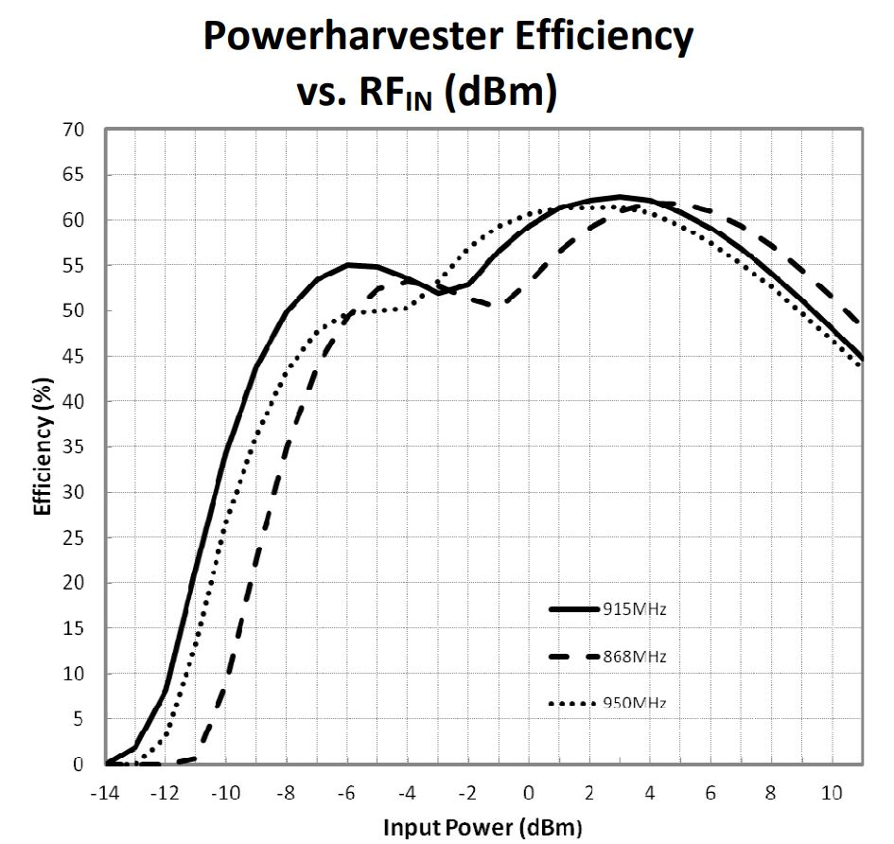
Figure 23 – RF Energy Harvesting Options & Selection
Figure 24 - 2110B Efficiency vs Input Power
We found that being able to harvest energy consistently is more important that harvesting more energy less often. For this reason, we selected the 2110B component for energy harvesting. This component is better with weaker signals and is designed take a weak signal as the input. However, with this component it is absolutely critical that we combine the Wi-Fi and cell receiving signals to generate somewhere near 0 dBm. Without this, the efficiency will be so low it is not worth harvesting. On the flip side of that, for cell transmission signals which are between 30 and 40 dBm in strength, it would be better to use the 1110B component as the 2110B is not efficient over 10 dBm signals. Additional metrics for the 2110B Powercast IC are shown below.
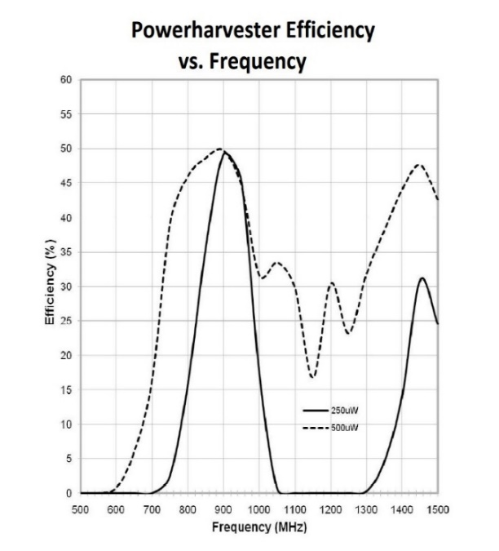
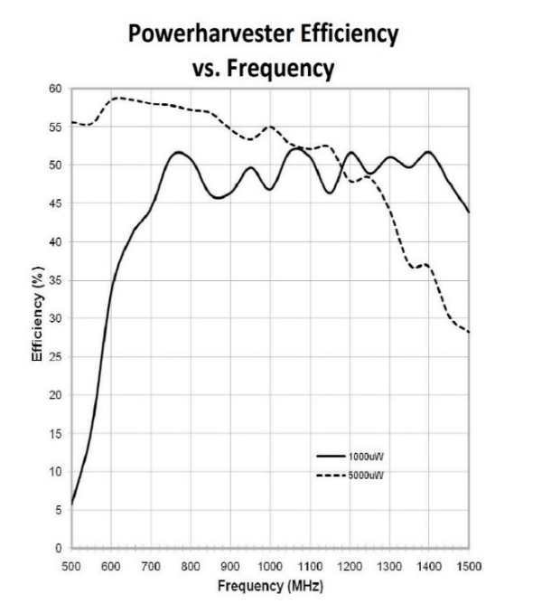
Figure 25 – Powercast 2110B Performance Metrics
This RF energy harvesting module Fig. 26 converts the signal into a DC voltage using full wave rectifiers, then that DC signal is fed to a DC Boost Converter. Such converters typically have a topology such as the one shown below. The Powercast IC requires a capacitor in pin 8 in order to operate. This capacitor needs to be designed and selected based on the rest of our circuit as shown in the timing diagram below in Fig. 27.
Figure 26 – Powercast 2110B Block Diagram
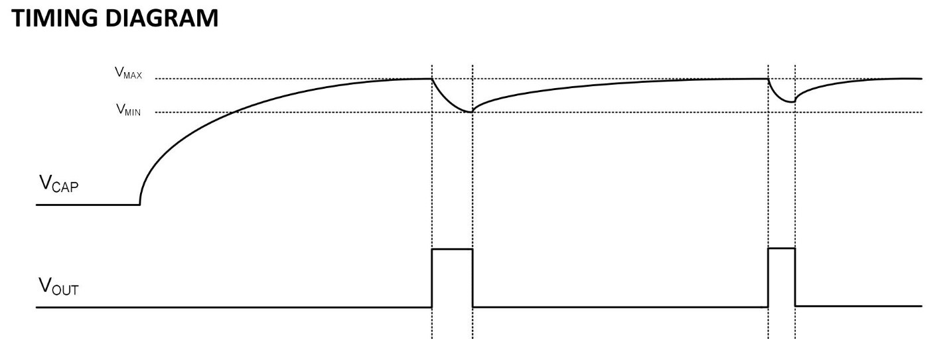
Figure 27 – Powercast Timing Diagram
This diagram shows that the only times the energy harvesting module will deliver an output voltage is while the capacitor discharges from Vmax to Vmin. The controls for this charging and discharging if the capacitor are internal to the IC. There are very specific design parameters for the selection of this capacitor such as Fig. 28
Vmax | 1.25V
Vmin | 1.05V
ESR | <200mΩ
Leakage Current | 1uA at 1.2V
Figure 28 – Powercast Capacitor Requirements
The capacitance of the capacitor used is determined by the designer. There is one main parameter for the designer to consider which is what the required operation time is (t_{on}). In other words, how long does the remaining system/circuit require the output voltage? A larger capacitor will take longer to charge while also providing a longer operating cycle where as a smaller capacitor can charge faster, but will not last as long. This behavior is expected. The capacitance that should be used can be found as:
C= 15*V_{o}*I_{o}*t_{on}
C= 15*P_{on}*t_{on}
The power will be a function of the RF Input and can be predicted based on the data sheet’s information leaving the operating cycle the main parameter to be determined. It makes sense to match the timing cycle of the IC with the timing cycle of the remaining circuit. This way, when the output voltage from the IC is zero, another capacitor source (outside the IC) will discharge and thus powering the load. From lab experimentation with different values of this capacitor, it was found that the overall system works better with a small capacitor value (pF). This is because we are harvesting a very small amount of power. Therefore, a large capacitor would take very long to charge; especially if the user was not in an area with a large number of RF signals to harvest. A small capacitor has a better chance of being charged making it more likely to provide the needed output voltage for operations.

Thermoelectric Secondary Source
In preparation for our future development (see Future Development section for more information), we also started the process of selecting a thermoelectric source. To provide another layer of redundancy with a consistent baseline of power, thermoelectric panels will be used in conjunction with the harvested RF signals. When in contact with a substantial heat source such as the human body, thermoelectric panels will again also provide substantial substitute power. Energy levels from RF signals vary greatly as a user walks indoors, outdoors, and even from one end of a building to another. For this reason, the most consistent alternative source will be selected. Thermoelectric is the best candidate for this kind of function as the user’s body temperature would be fairly consistent regardless of their environment.

Component | Function | Requirements
Thermoelectric Source | A component that will act as a current source when a heat differential is applied. | - High efficiency  - Low power consumption  - Low voltage addition  - High current source
Figure 29 – Thermoelectric Converter Requirements
For purposes of the prototype, we selected TEC1-12706 Thermoelectric Peltier Cooler 12 Volt 92 Watt which is a very standard thermoelectric converter on the market. This thermoelectric converter was selected because it is relatively small, a passive component, and would be easy to integrate into the form of a wearable while remaining connected to the circuit. Other options typically require to be soldered onto the PCB. Given the source of heat for this converter is the user’s body heat, the thermoelectric converter must be detached from the PCB, connecting only by wires.
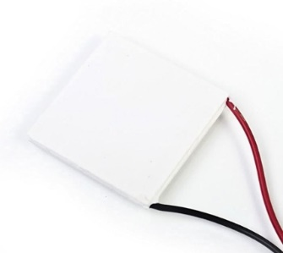
Figure 31 – Thermoelectric Converter

Energy Storage
Following the energy harvesting sections from the Powercast IC and the thermoelectric source, the energy will be stored until used by the load. Options for energy storage include batteries and super capacitors.
Option 1: Lithium Batteries
The potentially low, or varying current output of the power harvesting circuit means that a very efficient and adaptable storage system must be employed. Current may vary from 0-50mA. This causes problems for traditional charging circuits due to minimum input current requirements. Using Texas Instruments WEBENCH utility, the closest lithium polymer charging circuit requires 100mA minimum input current. This amount of current may be achievable using a buffer. The use of a buffer adds another layer of circuit complexity and more conversion inefficiencies. Fig. 30 gives the requirements for a battery charging circuit.

Vin Min | 100mV
Vin Max | 5V
Input Current Max | 50mA
Output Current | 40mA
Vout | 4.2V
Figure 30 – Required Charging Circuits
In addition to an effective battery management circuit, the proper battery must also be selected. A single cell lithium ion battery can provide 3.7 volts nominally to an applied load. Due to high energy density per area, lithium batteries are very attractive in compact environments. A 40 mAh lithium battery fits in a very small package. This is to spec with the size constraints of packaging an entire harvesting system in a wearable. Lithium batteries although compact and powerful, have both chemical and longevity problems. Chemically, lithium cell batteries pose a danger if punctured or shorted. This is of course a concern in applications where the device will be in close proximity or contact to a person. This will require additional certifications and listings to be safe. In addition to this, special care in charging and discharging must be taken. Minimum discharge voltage, maximum charge and maximum discharge or C rating must be observed. Fig. 31 shows the specifications that must be followed.

Charge Voltage | 4.2 volts
V Min | 3V
Charge Current Max | 40mA
Operating Temp | -20˚C – 60˚C
Impedance | ≤250mΩ
Figure 31 – Battery Charging Requirements
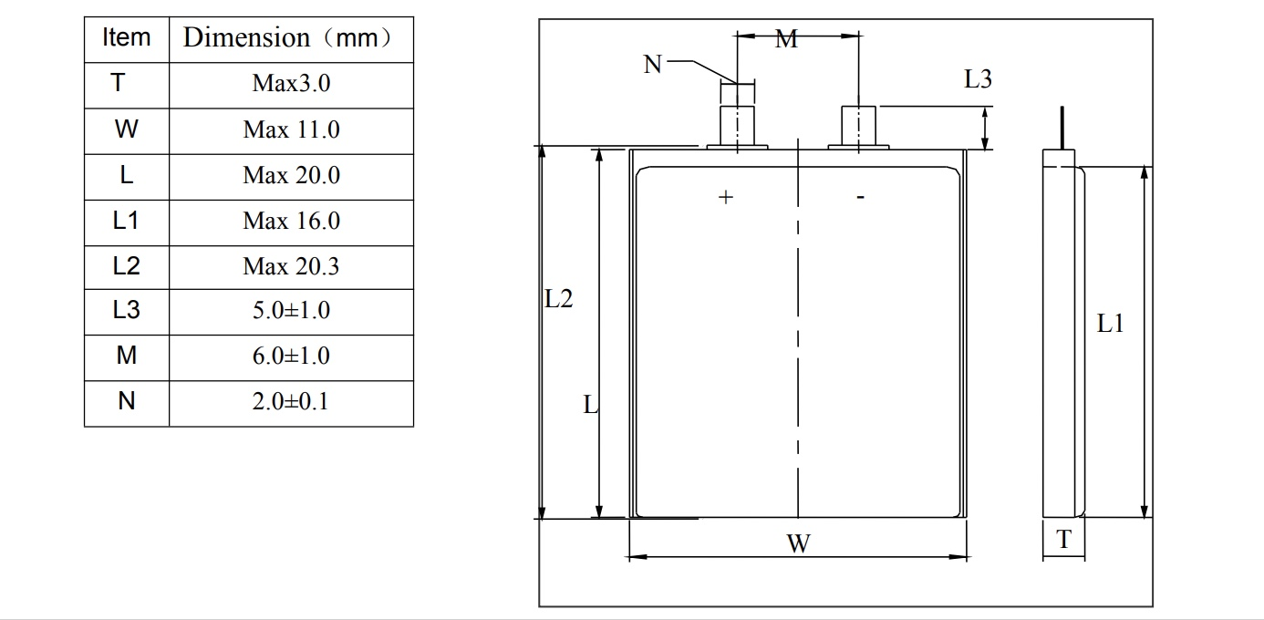
It is very important to consider the battery charging requirements of our load not only to ensure that the user doesn’t assume their medical device is charging when in reality it is not, but also because the user’s battery we are trying to charge can be damaged when given the wrong conditions. Charging batteries with non-idealities are very harmful because they allow the battery to develop a memory to the wrong conditions. There has been research showing that batteries charged with significantly either lower input current, significantly higher current, or significantly higher voltage can damage the battery. Too little voltage won’t activate the power electronics to activate the charging process in the first place. Current is a different story. Too little current can allow the battery to create a memory to the lower input taking longer to charge in the future. A large current can have the opposite effect where the excess current causes the battery to wear down (almost like cycling) faster as it adds additional stress on the battery’s electrodes.
Figure 32 – Battery Schematic
The stringent requirements on input power do not provide many solutions for traditional charging systems. TI’s proposed charging circuit provides the single cell lithium polymer charging at up to 3A. This is overkill for the amount of current that the power harvester can provide. Minimum input voltage is 3.9 volts which is within the requirement. The problem with this circuit is that as stated previously stated, the minimum input current is 100mA. The harvesting system proposed cannot provide this current directly and would require a pre-storage capacitor bank. This will have the effect of reducing the usable current produced by the harvester. Assuming an 80% efficiency, only 40mA of the max 50mA will be delivered. Efficiency in power harvesting decides whether the proposed solution is viable. Fig. 33 shows the range of input and output that the proposed charging circuit can operate. Fig. 34 below also shows the proposed circuit.

Vin Min | 3.9V
Vin Max | 13.5V
Input Current Min | 100mA
Input Current Max | 3.25A
Output Current Max | 3A
Vout | 4.2V
Figure 33 – TI Charging Circuit Parameters
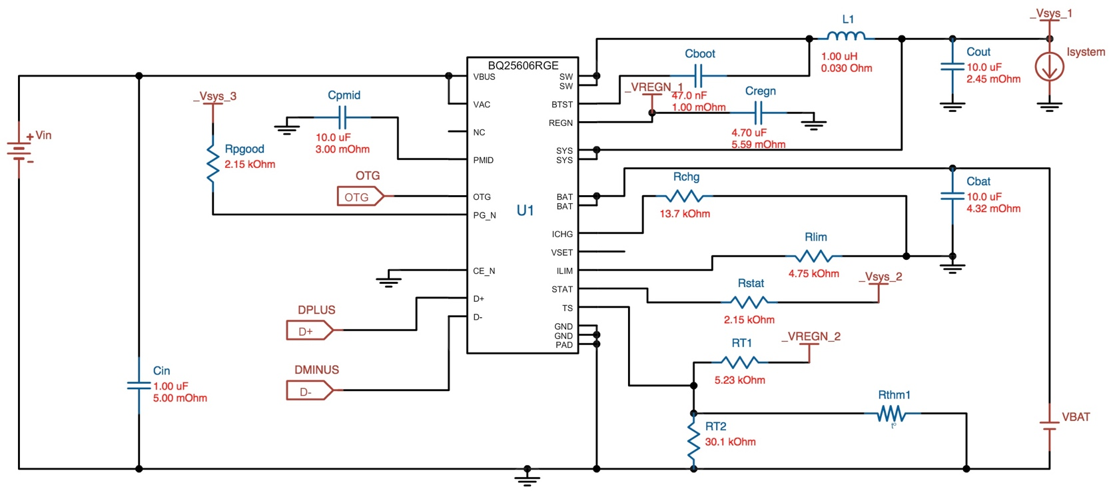
Figure 34 – TI Charging Schematic
In summary, the lithium battery provides ample power in a small package. The problem that must be addressed is whether the lithium battery performance outweighs the added complexities inherited. A charging circuit must be employed that takes the low current output of the harvester and also monitors and controls the charging of the lithium battery. The device must also be rated and listed to reflect the chemical dangers imposed. With all of these restrictions a second option must be considered.

Option 2: Supercapacitor

Supercapacitor storage cells provide a simple yet effective way to store and discharge small amounts of energy repeatedly. The storage capacity of supercapacitors is much less than batteries, but the simplicity of charging and the ability to charge and discharge virtually unlimited times makes it a good option in this package. Duty cycle of the supercapacitors will be much faster than a traditional battery circuit. As such, the supercapacitor will be experimentally sized to charge and discharge within the highest efficiency with little current bleed. This will be characterized based not only on the area that the harvesting is taking place, but the actual output power that can be expected. Currently the design uses 100F single unit capacitors. This will be reduced in future iteration of the design.

The current problem with supercapacitors is that they are bulky and only provide 2.7 volts per unit cell. When combining cells together a larger breakdown voltage can be achieved. AVX Capacitors among other manufactures have several options for 5VDC breakdown rated supercapacitors. Starting with the package size, a traditional supercapacitor comes in cylindrical form much like traditional capacitors Fig. 35. Because of this, packaging in a slim form environment is complicated. Large capacity is easily achievable with these type of capacitors, but again packaging is a serious problem as compared to thin cell lithium. New developments in supercapacitor design have produced thin plate supercapacitors. These capacitors are available up to 35mF and 4.2 volts. This may be low, but put in parallel, larger capacities are easily achievable. As may be seen in Fig. 36, this type of super capacitor is easily stacked and chained within the wearable package to achieve the storage necessary.

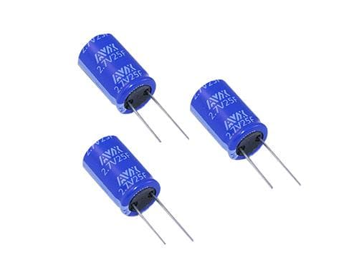
Figure 35 – Traditional Supercapacitor Example

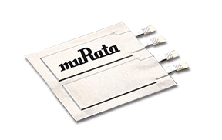
Figure 36 – Advanced Super Capacitor Example
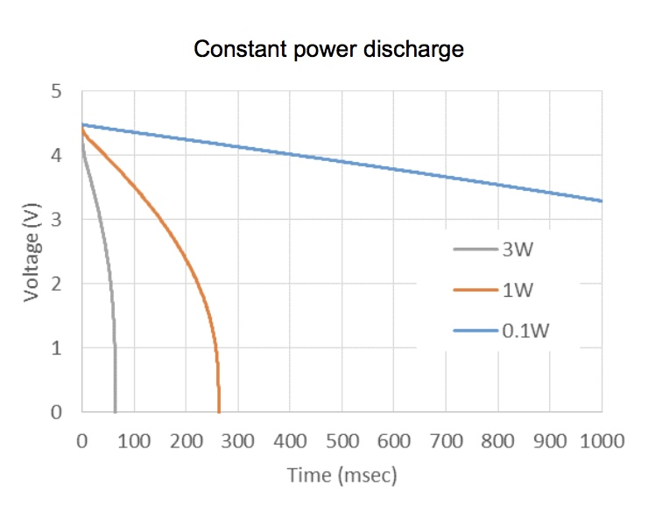
Unlike lithium batteries, supercapacitors are not chemically volatile. This provides more confidence in a product designed for medical use. Supercapacitors do not take the same precautions, liabilities and warnings that lithium batteries require. Because of this, supercapacitors are the clear choice for this application. The same energy stored is not possible in supercapacitors as in lithium ion or lithium polymer alternatives, but in this application large amounts or storage are not needed. The storage cell is only needed as a buffer to the larger storage bank. The timing of this storage discharge cycle will need to be characterized as previously stated. This characterization will allow the selection of the capacity needed to produce the charge and discharge cycle needed. Fig. 37 shows the power discharge curve for the ultra-thin supercapacitors. We selected to use the AVX SCC series Super Capacitor.
Figure 37 – Capacitor Discharge Rate

DC to DC Converter
A DC to DC converter is required to go between the storage element and the load. In other words, a buck converter is required to go from the 3.4V output of the powercast to the 1.5V requirement of the microcontroller load. We used TI’s Webench feature to find designs for a buck converter. Below discusses options for the converter. The most important consideration in this decision is the DC to DC Converter’s efficiency. The second most important consideration in this decision is the size. Lastly, we will consider cost. The cost is not as important in this decision because the components and designs are listed for below $2.
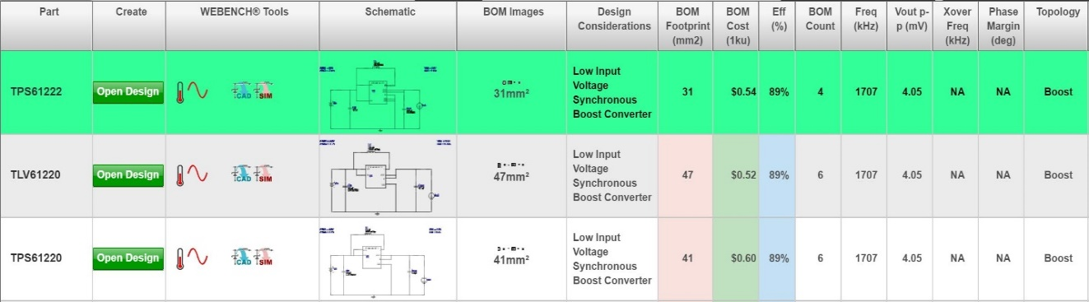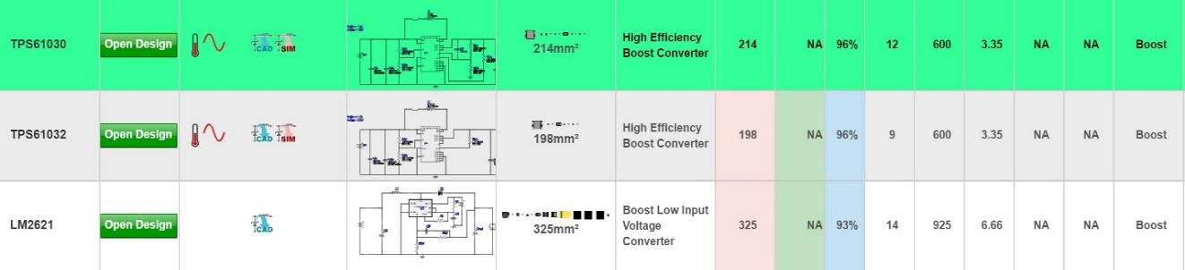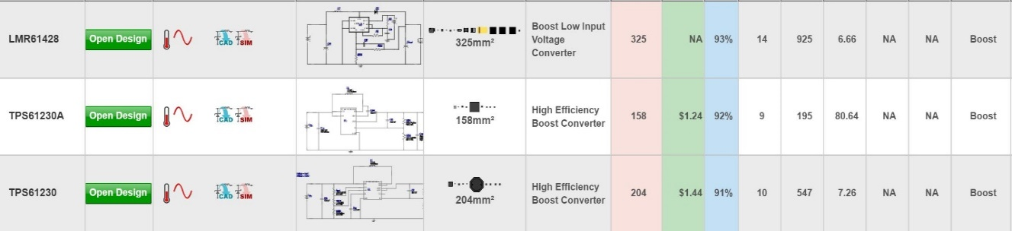
Figure 38 – DC to DC Conversion Options from WeBench
After reviewing the options from Webench by TI and by considering the marketing requirements, it was determined that a difference of 7% in efficiency did not justify the addition of nearly 200mm² in chip size. Going off the goal/objective of harvesting 250mW in total, 7% efficiency difference is only a loss of about 17.5mW. Having said that for 200mm² of PCB space, another source could have been added such as a solar cell, a thermal electric converter, or potentially another Powercast IC to harvest another band. For these reasons, we will use the first option in Fig. 39, design TPS61222. This design schematic is shown below:
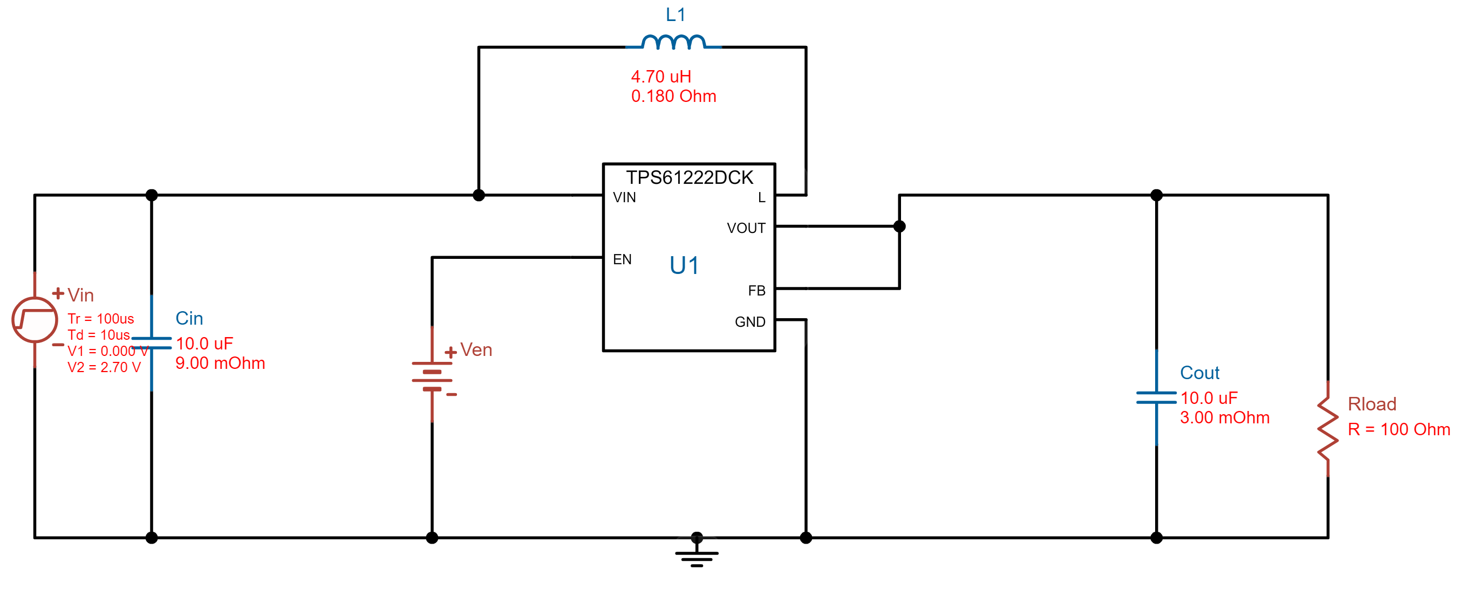
Figure 39 – Selected DC to DC Converter Design
When simulated, this design shows that in steady state the desired results are achieved taking an input voltage of 3.4V and yielding an output voltage of 1.5V with a very small ripple.
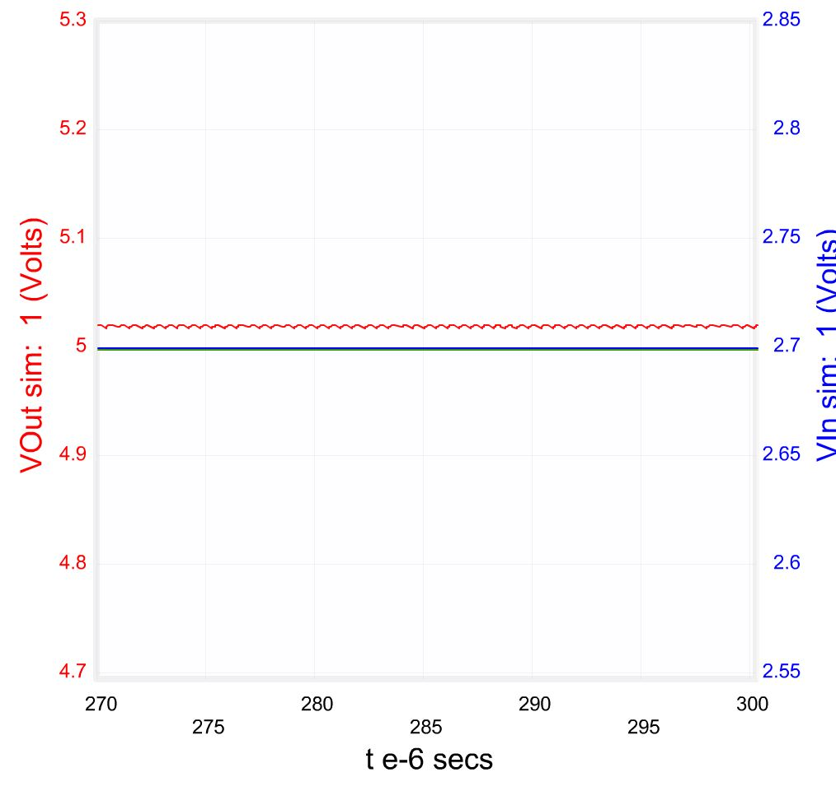
Figure 40 – Simulation of the DC to DC Converter
We can also calculate efficiency from these plots. Efficiency is defined as:
$$\% Efficency=\frac{Pout}{Pin}$$
$$\% Efficency≈ \frac{Vout×Iout}{Vin ×Iin} ≈\frac{1.5V ×0.05A}{3.4 ×Iin}$$
Due to the nature of a buck converter, Iin, is not a constant. It oscillates as shown below.
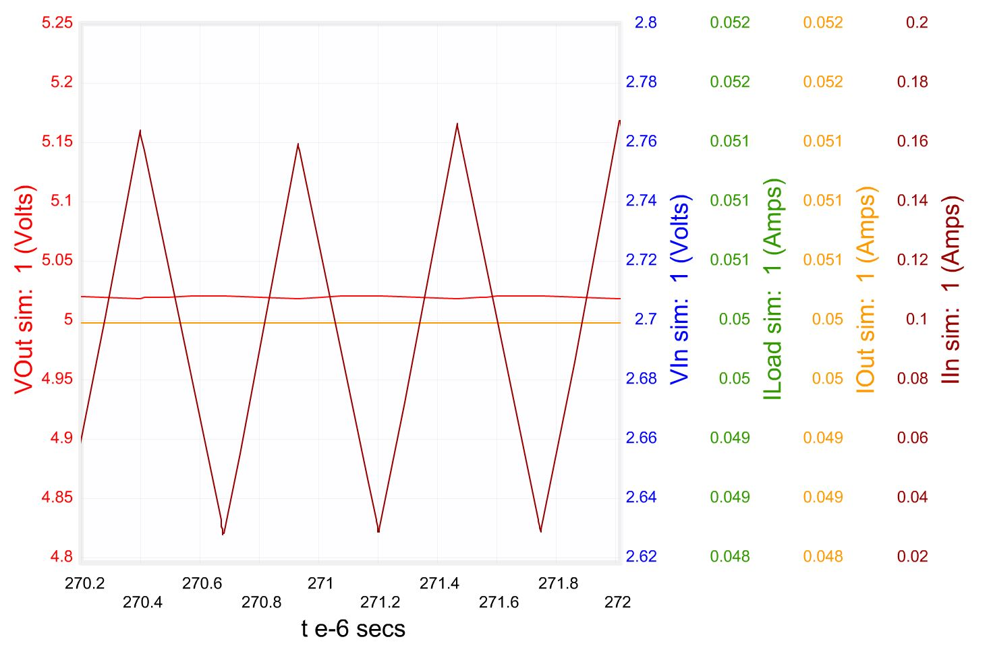
Figure 41 – Waveforms of Selected DC to DC Converter
A DC to DC buck Converter like this can be simplified or modeled with the following waveforms as a result of using an inductor (L), switch (diode), and capacitor (C) in Fig. 42 below:
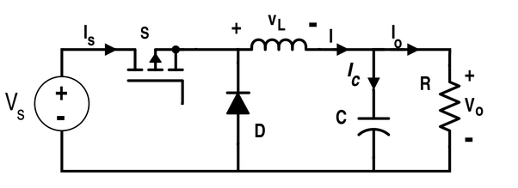
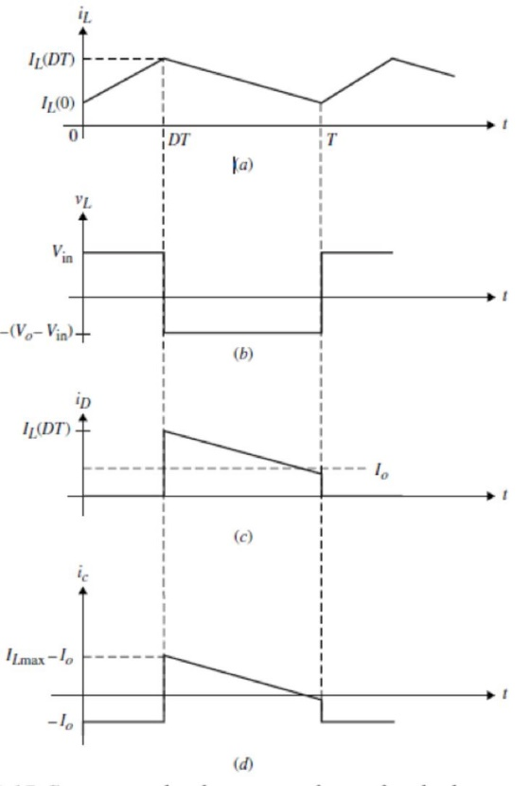
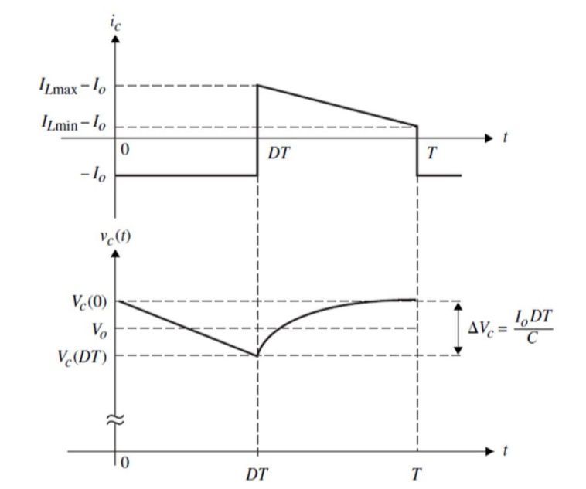
Figure 42 – Waveforms of Common DC to DC Buck Converter

Power Conditioning
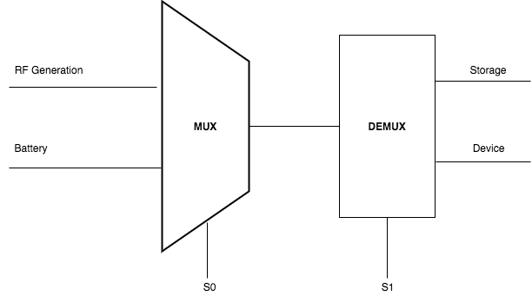
The first step to using power is controlling it. Without controls, the system could burn out, break, be unreliable, etc… As mentioned earlier in the report, there will be a backup energy source for emergencies similar to an Uninterruptible Power Supply for computers/IT equipment. Our core energy source (the phone’s transmitting signals) are sent in discrete time so a backup/switching system is necessary.
Figure 43 – Switching Controls Overview

One way this design might be realized is by using MOSFET transistors to realize the switching.
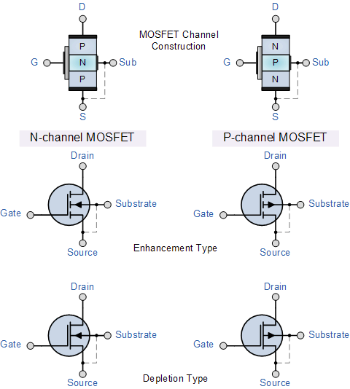
Figure 44 – MOSFET Types
Type | Vgs Positive | Vgs = 0 | Vgs Negative
N Channel Depletion | ON | ON | OFF
N Channel Enhancement | ON | OFF | OFF
P Channel Depletion | OFF | ON | ON
P Channel Enhancement | OFF | OFF | ON
Figure 45 – Transistor Switching Guide
This system must effectively control when power is stored and when it is delivered. A third control case will be in the event of an emergency, backup power will be activated. The decision whether this will be an analog or digital control will be discussed based on ultra-low power. Digital design in the long run will prove more configurable, but possibly at a cost. Every use case will not be the same and as such the device should be adaptable.
For the issue of monitoring the power output of the power source itself, options are more limited. The system must be able to monitor itself using its own power, and considering the signal generated by our source will be very small, it needs to use even less power in order to ensure it can still do its own functions. Options on how frequently the system should check its own power level are under consideration, seeing as continuous checks would be rather draining to the device. Factors such as the urgency of low power must be considered as well – if checks are only done hourly, and the device fails immediately after a check is done which signals a strong power, there would be an entire hour by which the system risks loss of functionality. We are carefully considering options on intervals or lower-power detection methods such as Near Field Communication (NFC) products.
Component | Function | Requirements
Controller | To switch between sources and backups | - Fast switching speeds  - Low power
Monitoring System | To keep the user in the loop about their power levels | - Ultra low power embedded system  - High Accuracy
Figure 46 – Power Management Overview

Monitoring System
Based on how well it applies to our system, and the ease of integrating it into an Android application, we will use NFC to communicate between our device and a reader. Its low power consumption on the tag end, along with its efficiency in transferring small amounts of information make it an excellent choice for the product we are designing. The reading itself, however, must be of some data which was collected previous to the signal request. This current should be measured using a current sensor, and stored in the tag so that at any moment when the reader polls the transponder for data, the data would be up to date, useful, and viable information. A decision must be made regarding the type of sensor used. The options presented are open-loop and closed-loop sensors, which operate in different fashions.

Option: RF430FRL152H
The RF430FRL15xH device is a 13.56 MHz NFC transponder chip. It is equipped with a 14-Bit Sigma-Delta analog-to-digital converter, an internal temperature sensor, a resistive sensor bias interface, and an MSP430 microcontroller. The microcontroller has 2KB FRAM, 4KB SRAM, and 8KB ROM with a supply voltage range of 1.45V to 1.65V, and very low power consumption, with only .14mA in active mode, and .016mA in standby mode. A block diagram for the device is represented in Fig. 47 below. In the diagram, RST/NMI represents the device’s reset/interrupt input, and P1.0-1.7 represent general purpose digital I/O pins. The power supply system is interfaced with the following pins: VDDB represents battery supply voltage, VSS is the ground reference, VDDH is the rectified voltage from RF-AFE, VDDSW is the switched supply voltage, VDD2X is the voltage doubler output, VDDD is the digital supply voltage, while CP1 and CP2 are terminals to the charge pump flying cap. ANT1 and ANT2 are antenna inputs. ADC0 – 2 are analog-digital converter input pins, while TEMP1 and TEMP2 are resistive bias pins. TMS, TCK, TDI, and TDO all interface with the JTAG as mode select, test clock, data input, and data output respectively. CLKIN represents the external clock output pin.
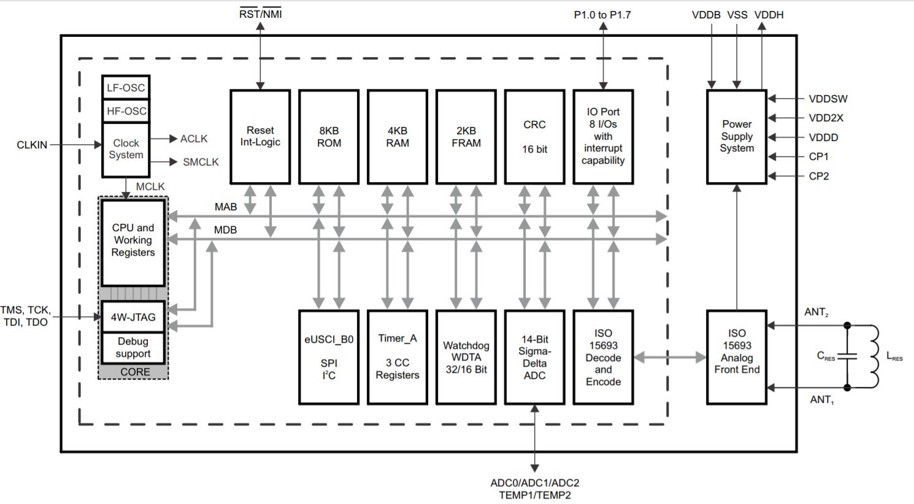
Figure 47 – Microcontroller Block Diagram for Power Management

Product Enclosure Design
This system (all the components described above) will be built into a wearable such as a wearable that is 4” tall and between 32” and 38” long. We will enclose our PCB’s for each stage into a sleeve, likely with some rubber substance to it, and will then sew this into the wearable. The sleeve is intended to help separate the user from the electronics; a safety precaution. We are not the first group to propose the idea of building electronics into a wearable. For example, the wearable below in Fig. 48 is used to enhance night vision for soldiers.
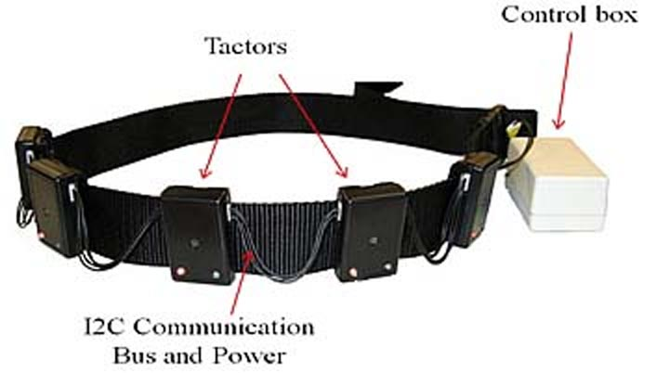
Figure 48 – System Form Factor

Software Design Details

External Clocking
For a low-power, small-package clock oscillator, there are several ideal choices. Two that appear ideal are the Micro Crystal Switzerland oscillators models OV-7600 and OV-0100. Both come in either 3.2mm x 1.5mm with 1.0mm or .7mm height, or 2.0mm x 1.2mm with .85mm or .7mm height. The 3.2 x 1.5 boards in both cases have a lower required supply voltage at 1.2V rather than 1.6V. The main difference between the OV-7600 and OV-0100 is the frequency difference. The OV-7600 runs at 32.768 kHz with a current consumption of only 350nA, while the OV-0100 runs at 100 kHz with a current consumption of 700nA. The block diagram in Fig. 49 below is for the OV-0100, but would only be different for the OV-7600 in the sense that the crystal would have a different frequency. Should we implement a clock device, it may be ideal to use this external clock so as to reduce power consumed by the microcontroller, allowing it to disable its internal clocks, simply requiring that this CLKOUT not only be connected to the INA231, but also the CLKIN pin on the RF430.
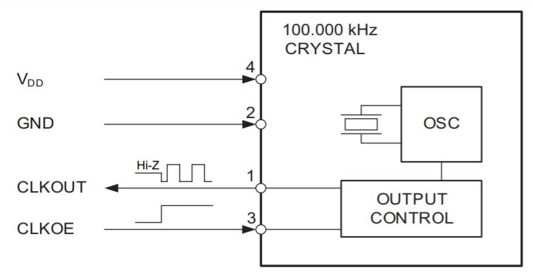
Figure 49 – OV-0100 Block Diagram
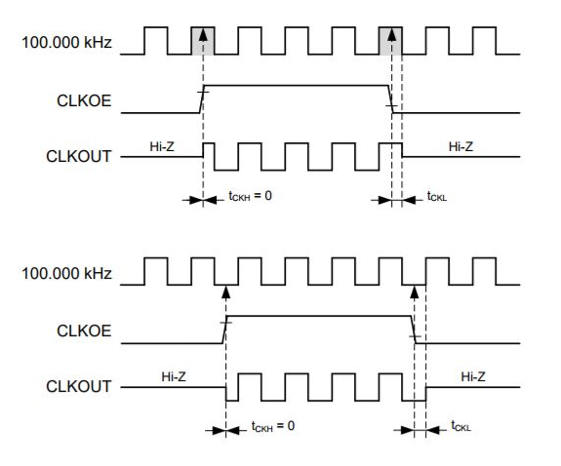
Figure 50a – OV-0100 Waveform Timings

Measuring Zero Current
When polling for current, should a basic “get-set” program be written it would be impossible to obtain a reading of zero from our device. We have several options to consider for this situation. The first option is to sense when power is lower than expected, and broadcast a “low-power” signal to the tag, or simply make the assumption that the system has died and send a “dead” signal. Another option would be to have a small secondary source which would power the sensor’s digital signal, allowing for the system to indeed sense the current at all times.
Implementing a second small source to power this would lead to more accurate readings at all times, and would allow for our system to use more of the generated power towards its intended purpose, however this is still counterproductive, as the purpose of this project is to reduce the need of these small power sources in other embedded systems. Implementing another power source creates a redundancy in terms of the purpose of our design.
The option of broadcasting a preemptive loss-of-power signal is more likely the solution to our problem in this situation. The system can either have a low threshold either pre-programmed, or learnt through machine processes, which would dictate a current value at which the system would report to the NFC tag a signal which triggers a flag that causes the tag, when polled, to return a message stating that the system is low. The flag would get restored once the sensor detects a current stronger than a higher threshold value. This threshold could also be either pre-programmed, or learnt like the low threshold was.
The reason the device may need to teach itself thresholds is the main fact that we are unsure how the device will function in different environments, and while powering different devices. This, while creating a more functional device, will in turn create a less efficient power source, so the decision must be made.
Unfortunately, due to the low amount of power generated by our device, we were unable to reasonably measure current being produced from our device without consuming all of the power generated to do so, thus making our design obsolete.

Sensor Implementation
Despite being unable to measure current with our system we have maintained that taking measurements from various sensors is the best application for our design. We use the RF430FRL152H to take readings from a heartrate monitor and a temperature sensor, the former in order to demonstrate both a realistic use for the device, and the latter a practical implementation for a short demonstration to a committee. The RF430FRL152H has built in firmware for taking sensor readings and storing them in FRAM, which we simply configure using the first several registers of this memory.
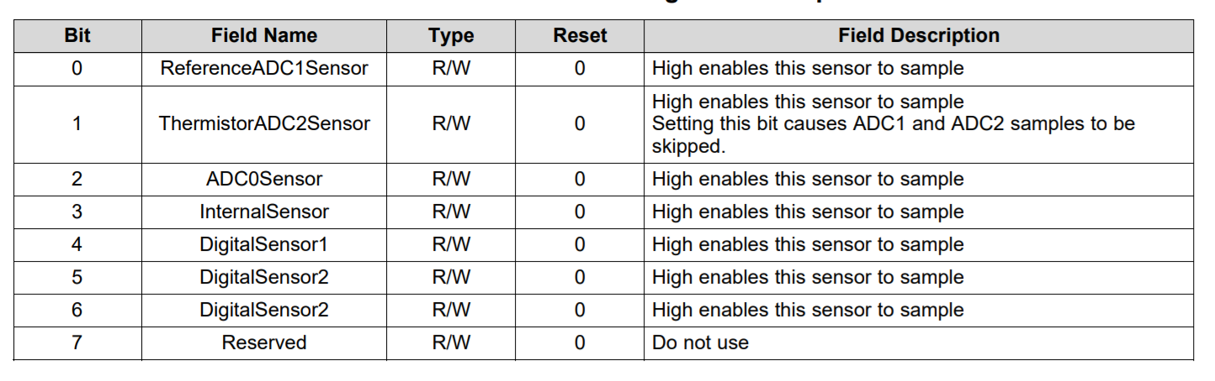
Figure 50b – Sensor Control Register Format
Both sensors are configured to different ADCs on the board. Thus each implementation must configure which ADC to read from using the sensor control register, and each sensor's individual configuration register needs to be set so that we use a gain of 1 and do not use averaging.
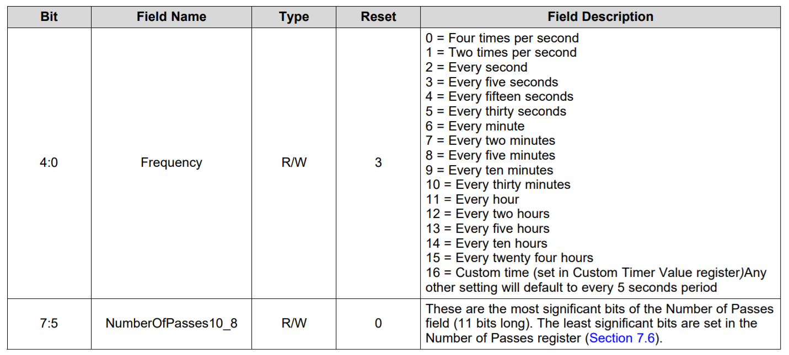
Figure 50c – Frequency Register Format
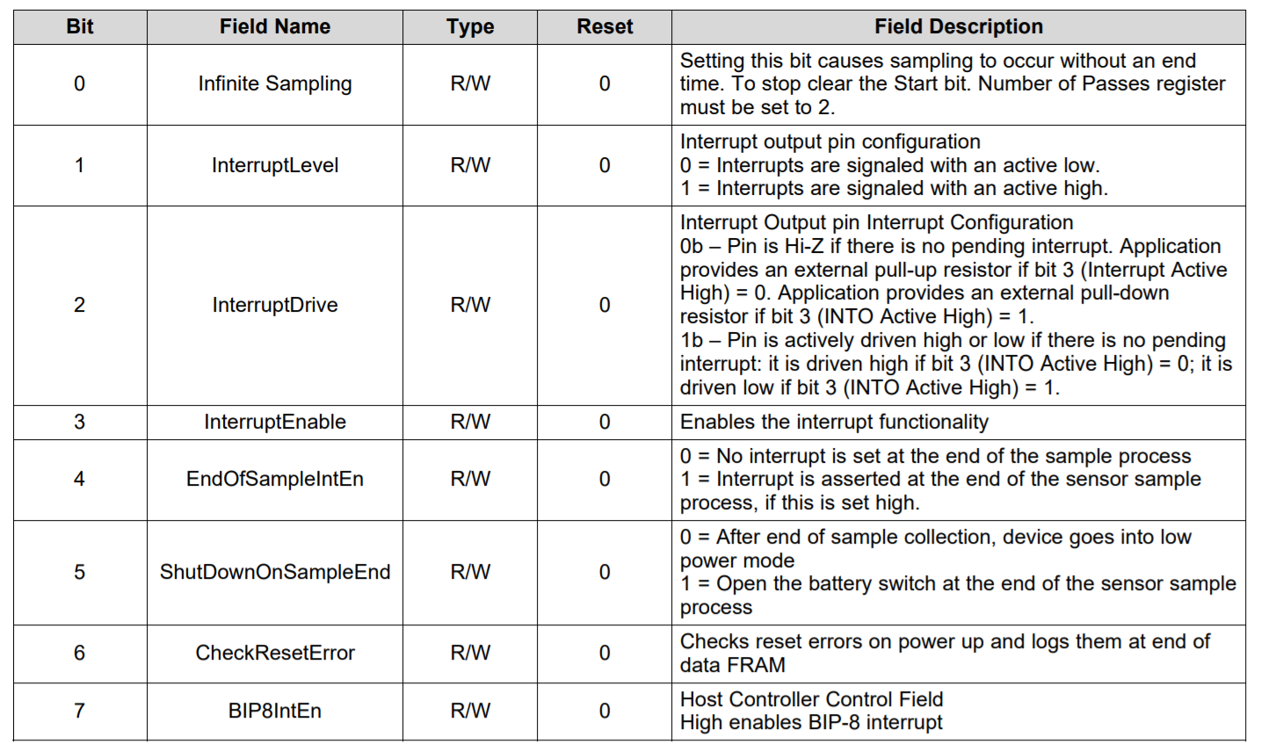
Figure 50d – Infinite Control Register Format
In the case of the heartrate monitor we implement infinite sampling, which is an option controlled by a single bit that allows for continuous samples to be taken which can overwrite previous samples, looping through memory. We must do this in order to constantly maintain the best reading of a sensor with a need to stay updated. In the case of the temperature sensor we program the reading Android application to instruct the device to start sampling, take a finite number of samples, and store only those samples. For this we must disable the infinite sampling bit, and set the number of passes register to the number of samples we wish to take.
The sample rate register differs between the two modes. For the heartrate monitor we need to take as many samples as we can per second, which using our hardware implementation is 40ms per sample. To do this we must set the sampling rate bit in the first control block to allow for a custom rate, and set the custom rate register to 40 (0x28). For the temperature sensor we can be less time sensitive with our samples, and set the sampling rate to a preprogrammed rate of four samples per second, such that we can ignore the custom rate register.

ISO15693
Communication with the Android application is done using ISO15693 protocol, which essentially establishes a set of commands which the Android application can use to get information directly from the FRAM of the RF430FRL152H. To write to configuration blocks we must use the write single block command (0x21), and in order to read each individual block we must use the read single block command (0x23) passed through the Android class NfcV's transceive function.
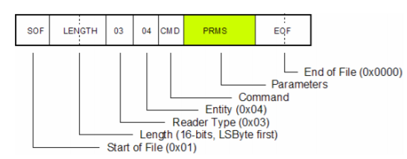
Figure 50e – ISO15693 Command Format

UPF Design Environments
The UPF design is compatible with numerous design tools. For programming in Tcl, several commonly used programming environments for high level languages are compatible. Eclipse, Komodo, and SlickEdit. HDL’s like Verilog are supported by many more environments. Active-HDL/Riviera-PRO is an environment produced by Altera which supports up to SystemVerilog2009. Along with it are MPSim produced by Axiom Design Automation, and Incisive Enterprise Simulator produced by Cadence Design Systems. ModelSim and Questa produced by Mentor Graphics, and VCS produced by Synopsys both support up to SystemVerilog2012. These environments, however, are not free, and would need to be purchased, which may not be ideal for our budgeting purposes. There are several free and open-source simulators which can run HDL programs. Icarus Verilog produced by Stephen Williams can run up to Verilog 2009, and Verilator produced by Veripool can run up to SystemVerilog 2009.
For this project, we will likely end up using Eclipse for Tcl programming due to its ease of use, stability, and relative responsiveness when compared to Komodo and SlickEdit. We will likely use Icarus Verilog for Verilog writing purposes, however if SystemVerilog appears to be more functionally useful for the task we are trying to accomplish, the switch may be made to Veripool. We would choose from one of these due to the preference towards free software.

Taking Readings (Monitoring)
We will be taking readings using a simple Android application, designed such that when a button is pressed, and the phone is in range to communicate with the NFC tag, it will read the values stored in the tag, which at any time should give the last read current value, and a Boolean value of whether or not the system is out of power. Development of the application will be done in Android Studio, as the IDE is free, has built in git implementation for sharing between team members and version control, and also has a virtual emulator for app interface testing purposes. For testing NFC functionality, the emulator won’t be useful, unfortunately.
Android-powered devices support three modes of operation for NFC:
• Reader/writer mode, allowing devices to read and write passive tags.
• Peer-to-peer mode, allowing NFC transponders to communicate with each other.
• Card emulation mode, allowing the device to act as a tag itself.

For purposes of our project, we will use reader/writer mode. We will need to use a minimum SDK API version of 10 in order to have a comprehensive reader/writer support. Accordingly, we will have to ensure that our AndroidManifest.xml file includes the following items.
<uses-permission android:name="android.permission.NFC" />
<uses-sdk android:minSdkVersion="10"/>
<uses-feature android:name="android.hardware.nfc" android:required="true" />
The Android application should be developed with an ability to store data from previous scans and sessions to a database. This will involve SQL implementation, and management of a local database on the device. This feature may be properly simulated within Android Studio.

Standards and Realistic Design Constraints

Related Standards
For design of our system, there are certain standards set in place. As a professional design team we must adhere to these standards. Firstly, we shall observe the standard published by IEEE in regard to Low-Power (IEEE 1801), Energy-Aware Electronic Systems (IEEE 1801). This standard defines syntax and semantics of a format to express this type of system design. It relates to specification, validation, implementation, verification, modeling, and analysis of these systems.

Antennas
There are many standards related to the proper design and use of antennas for a wide range of frequencies. The most commonly referenced is the industry adopted standard of 50Ω impedance in the antenna. This is not a requirement but the generally followed rule in the industry. Other standards that antennas must follow include the quality of electromagnetic field (ANSI C63.5), testing/calibration (ANSI/IEEE 1309), measurement (ANSI/IEEE 291), recommended practices (IEEE 1720), and definition of standard terms related to antennas (IEEE 145).

Unified Power Format
The Unified Power Format allows specification of physical implementation-based power information early in the design process. It allows for specification of power-design information that may not be easily specifiable in hardware description language (HDL) or when using an HDL could tie the logic specified directly to a constrained power implementation. Combined with HDL, UPF files are used to describe the design’s intent. Simulation tools can read the HDL/UPF files and perform simulations on the system. Designs in UPF are meant to be specified using HDLs such as Verilog or System Verilog. Seeing as coursework in Digital Systems has familiarized us in Verilog, it is likely the HDL that we will use for the design of this project. The design may, however, be expressed in multiple HDLs if necessary.

Design Structure
Logic design is important to consider for the purposes of sensing and monitoring power. UPF focuses on controlling power delivered to transistors, assumed to be digital CMOS transistors, but could be implemented in any way. Gate connection is a receiver, and source is a driver. Collections of transistors in the Liberty library format are represented by a standard cell, which has been developed as part of some particular technology library. Libraries also contain hard macros, which provide predefined physical implementations for larger, complex functions. Library elements have corresponding behavioral models for use in simulation. These cell modules are usually written as Verilog modules, and use constructs defined by Verilog or users (user-defined primitives, or UDPs) in order to express the behavior of a standard cell.
Behavioral models are written using the register transfer level (RTL) synthesis subset of Verilog. They are models which can be read by RTL synthesis tools mapped to functionally equivalent netlists. Synthesis involves identifying or inferring the state elements needed to implement the behavior and implementing the combinational logic of the elements and the model’s ports. Many constructs implement this in a way that is ultimately defined in terms of transistors, which in turn define drivers and receivers. An HDL model defines scopes, which are regions of HDL text within which names can be defined. Verilog models generally define single scopes for each model, and thus will likely be unnecessary for us to consider when designing.

Power Architecture
UPF power intent specification defines the power architecture to be used in managing power distribution within a given design. Considering our use of a single power source, we shouldn’t need to focus on standards referring to design partitioning between regions with independent supplies. A power domain is a collection of instances, such as the one which will be implemented in our project, which will be powered in the same way. In physical and logic implementations, the instances of one power domain are generally placed together, so as to ensure navigation to be relatively simple. If they do satisfy this condition, the power domain is considered contiguous. If it does not, it is considered non-contiguous.
A boundary instance of a power domain is in the general case an instance that has no parent. The upper boundary of a power domain consists of the LowConn side of each port on each boundary instance in the domain. The lower boundary of a domain consists of the HighConn side of each port on each child instance that is in some other power domain. After UPF-specified power intent has been completely applied, each instance must be included in a power domain.

State Retention
State retention is the ability to retain the value of a state in a domain while switching off the primary power source, and being able to retain the functional value of it upon power up. Seeing as there is no data which is really vital for a power source, this is not overly relevant, but any data stored in the NFC tag will be accessible even without power being delivered to the system. The value stating that power has been lost should be retrievable with no power in the system, and should be retained. The ideal way of managing retention in this project appears to be the master/slave-alive retention rather than the balloon-style retention.
Balloon-style retention registers have controls to transfer data from a storage element to a balloon latch in what is known as the save step, and does the reverse in the restore step. Retained values are kept in this balloon latch, or in our case the NFC tag, which would be stored externally to the main processor in the PCB. Master/slave-alive retention registers do not have additional controls as the storage element is also the retention element. In this case, the NFC tag would be built directly into the PCB of our main system, which would be ideal considering the majority of write commands in our program would be done with intention of writing to this tag. Placing this part directly into the main storage element would drastically reduce power consumption.

Power Distribution
Electric current transported by a supply net originates as a root supply driver, which will in our case be in the form of an off-chip supply source, or in this case the antenna itself. Each supply subnet should have an associated root supply driver. Because our supply subnet includes one or more resolved supply nets, the root supply driver is the output of the common resolution function shared by those resolved supply nets. This is ideal because it would allow us to simplify our system to a simple power source for future implementations.
Visual cue | Represents
courier | The courier font indicates UPF or HDL code. For example, the following line indicates UPF code:  create_power_domain PD1
bold | The bold font is used to indicate keywords that shall be typed exactly as they appear. For example, in the following command, the keyword create_power_domain shall be typed as it appears:  create_power_domain domain_name
italic | The italic font represents user-defined UPF variables. For example, a supply net shall be specified in the following line (after the connect_supply_net keyword):  create_power_domain net_name
list | list (or xyz_list) indicates a Tcl list, which is denoted with a curly braces {….} or as a double-quoted string of elements “….”. When a list contains only one non-list element (without special characters), the curly braces can be omitted, e.g., {a}, “a”, and a are acceptable values for a signle element.
xyz_ref | xyz_ref can be used when a symbolic name (i.e., using a handle) is allowed as well as a declared name, e.g., supply_set_ref.
time_literal | time_literal indicates a SystemVerilog or VHDL time_literal.
* asterisk | An asterisk (*) signifies that a parameter can be repeated. For example, the following line means multiple acknowledge delays can be specified for this command:  [-ack_delay {port_name delay}]*
[ ] square brackets | Square brackets indicate optional parameters. If an asterisk (*) follows the closing bracket, the bracketed parameter may be repeated. For example, the following parameter is optional:  [-elements element_list]  The following is an example of optional parameter that can be repeated:  [-ack_port {port_name net_name[{logic_value}]}]*
[ ] bold square brackets | Bold square brackets are required. For example, in the following parameter, the bold square brackets (surround the 0) need to be typed as they appear:  domain_name.isolation_name.isolation_supply[0]
{ } curly braces | Curly braces ( { } ) indicate a parameter list that is required. In some (or even many) cases, they have (or are followed by) an asterisk (*), which indicates that they can be repeated. For example, the following shows one or more control ports can be specified for this command:  {-control_port {port_name}}*
{ } bold curly braces | Bold curly braces are required, unless the argument is already a Tcl list. For example, in the following parameter, the bold curly braces need ot be typed as they appear:  [-off_state {state_name {Boolean_expression}}]*
< > angle brackets | Angle brackets (< >) indicate a grouping, usually of alternative parameters. For example, the following line shows the power or ground keywords are possible values for the -type parameter.  -type <power | ground>
| separator bar | The separator bar ( | ) character indicates alternative choices. For example, the following line shows the in or out keywords are possible values for the -direction parameter:  -direction <in | out>
Figure 51 – Language Visual Guide

Language Basics
UPF is based on Tool Command Language (Tcl). As such, Tcl interpreters are used to process the UPF files, using Tcl version 8.4 or above. Libraries used for the project that define additional procs are considered a part of the design file, and need to be visible to any processor trying to interpret it.
The standard uses some coloring for readability purposes. It is not essential, but shows in editors, etc.
- Formal language keywords are shown in boldface red text.
- Command arguments are shown in boldface green text.
- Legacy or deprecated construct keywords are shown in brown text.

Lexical Elements
Identifiers must have an alphabetic first letter, and contain only alphanumeric or underscore characters. They are case sensitive. Identifiers, also known as simple names, can only be defined once, with a unique meaning. Should it be defined twice, an error would be presented. An object name is a category containing both simple names and objects defined in UPF that do not exist in the scope of the project itself. The simple name of an object is defined within a unique global scope.
A UPF power state table is a scope in which simple names of PST states may be defined. A UPF supply set is a scope in which simple names of supply set functions, power states, and state transitions may be defined. A UPF power domain is a scope in which simple names of supply sets, strategies, power states, and state transitions can be defined. A UPF strategy is a scope in which simple names of various supply sets and control signals are predefined.
The following names are predefined in different contexts:
- Power Domain Scope
  - primary
- Power switch scope
  - switch_supply
- Level-shifter strategy scope
  - input_supply
  - output_supply
  - internal_supply
- Isolation strategy scope
  - isolation_supply
  - isolation_signal
- Retention strategy scope
  - retention_supply
  - primary_supply
  - save_signal
  - restore_signal
  - UPF_GENERIC_CLOCK
  - UPF_GENERIC_DATA
  - UPF_GENERIC_ASYNC_LOAD
  - UPF_GENERIC_OUTPUT
- Repeater strategy scope
  - repeater_supply
A dotted name is a compound name designating a UPF object. It is made up of other simple names separated by ‘.’ characters. Some examples are as follows:
- Power-domain strategy names
  - <domain name> . <strategy name>
- Supply set handles
  - <domain name> . <supply set name>
  - <domain name> . <strategy name> . <supply set name>
- Supply net handles
  - <supply set name> . <function name>
  - <domain name> . <supply set name> . <function name>
  - <domain name> . <strategy name> . <supply set name> . <function name>
A dotted name is also an object name.
A hierarchical name is a name that refers to an object outside of the local slope. It often consists of a leading ‘/’ character, then spells out similarly to a directory. If it does not lead with a ‘/’ it is considered a scope-relative hierarchical name, which is then interpreted relative to the current scope. This type of name is also referred to as a rooted name. If it does lead with a ‘/’ it is referred to as a design-relative hierarchical name, which is interpreted relative to the current design top.
Strings can be specified either between quotes or curly braces (“” or {}). Special characters in Tcl are denoted as follows:
Type | Character
Logic hierarchy delimiter | /
Escape character | \ (only escapes the next character)
Bus delimiter, index operator, or within a regex | ||
Range separator (for bus ranges) | :
Record field delimiter | .
Figure 52 – Tcl Special Characters

Boolean Expressions
Boolean expressions can use the following operators in the following languages when attempting to make logical functions and statements:
Operator | SystemVerilog equivalent | VHDL equivalent | Meaning
! | ! | not | Logical negation
~ | ~ | not | Bit-wise negation
< | < | < | Less than
<= | <= | <= | Less than or equal
> | > | > | Greater than
>= | >= | >= | Greater than or equal
== | == | = | Equal
!= | != | /= | Not equal
& | & | and | Bit-wise conjunction
^ | ^ | xor | Bit-wise exclusive disjunction
| | | | or | Bit-wise disjunction
&& | && | and | Logical conjunction
|| | || | or | Logical disjunction
Figure 53 – Boolean Operators

Power Intent Commands
UPF uses a system with its own commands in order to define systems for low-power electronic systems. The commands to be listed will only include current and legacy commands, as current commands are recommended for use, while legacy commands could come up when exploring older files for researching purposes. These commands are as follows:
Command | Function
add_parameter | Defines parameters for use within the system-level IP power model.
add_port_state | Adds states to a port.
add_power_state | Defines power states of an object.
add_pst_state | Defines the states of each of the supply nets for one possible state of the design.
add_state_transition | Defines named transitions among power states of an object.
add_supply_state | Adds states to a supply port, a supply net, or a supply set function.
apply_power_model | Binds system-level IP power models to instances in the design and connects the interface supply set handles of a previously loaded power model.
associate_supply_set | Associates two or more supply sets with one another.
begin_power_model | Defines a power model.
bind_checker | Inserts checker modules and binds them to instances.
connect_logic_net | Connects a logic net to logic ports.
connect_supply_net | Connects a supply net to supply ports.
connect_supply_set | Connects a supply set to particular elements.
create_composite_domain | Defines a composite domain of one or more subdomains.
create_hdl2upf_vct | Define a VCT that can be used in converting HDL logic values into state type values.
create_logic_net | Defines a logic net.
create_logic_port: | Defines a logic port.
create_power_domain | Defines a power domain and its characteristics.
create_power_state_group | Creates a name for a group of related power states.
create_power_switch | Defines a power switch.
create_pst | Creates a power state table (PST).
create_supply_net | Creates a supply net.
create_supply_port | Creates a supply port on an instance.
ceate_supply_set | Creates or updates a supply set, or updates a supply set handle.
create_upf2hdl_vct | Defines VCT that can be used in converting UPF supply_net_type values into HDL logic values.
end_power_model | Terminates the definition of a power model.
find_objets | Finds logic hierarchy objects within a scope.
load_simstate_behavior | Loads the simstate behavior defaults for a library.
load_upf | Executes commands from the specified UPF file in the current scope or in the scope of each specified instance.
map_power_switch | Specifies which power-switch model is to be used for the implementation of the corresponding switch instance.
map_repeater_cell | Specifies a list of implementation targets for repeaters.
map_retention_cell | Constrains implementation alternatives, or specifies a functional model, for retention strategies.
name_format | Defines the format for constructing names of implicitly created objects.
save_upf | Creates a UPF file of the structures relative to the active or specified scope.
set_correlated | Declares that supply nets’ or sets’ voltage variation ranges are to be treated as correlated when being compared; min to min, and max to max.
set_design_attributes | Applies attributes to models or instances.
set_design_top | Specifies the design top module.
set_domain_supply_net | Sets the default power and ground supply nets for a power domain.
set_equivalent | Declares that supply nets or supply sets are electrically or functionally equivalent.
set_isolation | Specifies an isolation strategy.
set_level_shifter | Specifies a level-shifter strategy.
set_partial_on_translation | Defines the translation of PARTIAL_ON.
set_port_attributes | Defines information on ports.
set_repeater | Specifies a repeater (buffer) strategy.
set_retention | Specifies a retention strategy.
set_retention_elements | Creates a named list of elements whose collective state shall be maintained if retention is applied to any of the elements in the list.
set_scope | Specifies the current scope.
set_simstate_behavior | Specifies the simulation simstate behavior for a model or library.
set_variation | Specifies the variation range for a supply source.
upf_version | Retrieves the version of UPF being used to interpret UPF commands and documents the UPF version for which subsequent commands are written.
use_interface_cell | Specifies the functional model and a list of implementation targets for isolation and level-shifting.
Figure 54 – UPF Commands

Object Declaration
UPF commands are executed in the current scope, except as specifically noted. Names of objects shall not conflict with names already declared in the scope. UPF supports specification of attributes of objects. These provide information about related UPF commands. These can be defined with HDL specifications in design code, or with Liberty attribute specifications. The following figure enumerates the attributes predefined in UPF, as well as the UPF commands for each attribute.
UPF predefined attribute name | Attribute value specification | Equivalent UPF command arguments
UPF_clamp_value | <0 | 1 | Z | latch | any | value> | set_port_attributes -clamp_value
UPF_sink_off_clamp_value | <0 | 1 | Z | latch | any | value> | set_port_attributes -sink_off_clamp_value
UPF_source_off_clamp_value | <0 | 1 | Z | latch | any | value> | set_port_attributes -source_off_clamp_value
UPF_pg_type | pg_type_value | set_port_attributes -pg_type
UPF_related_power_port | supply_port_name | set_port_attributes -related_power_port
UPF_related_ground_port | supply_port_name | set_port_attributes -related_ground_port
UPF_related_bias_ports | supply_port_name_list | set_port_attributes -related_bias_ports
UPF_driver_supply | supply_set_ref | set_port_attributes -driver_supply
UPF_receiver_supply | supply_set_ref | set_port_attributes -receiver_supply
UPF_literal_supply | supply_set_ref | set_port_attributes -literal_supply
UPF_feedthrough | <TRUE | FALSE> | set_port_attributes -feedthrough
UPF_unconnected | <TRUE | FALSE> | set_port_attributes -unconnected
UPF_is_isolated | <TRUE | FALSE> | set_port_attributes -is_isolated
UPF_is_analog | <TRUE | FALSE> | set_port_attributes -is_analog
UPF_retention | <required | optional> | set_design_attributes -attribute {UPF_retention required} set_design_attributes -attribute {UPF_retention_optional}
UPF_simstate_behavior | <ENABLE | DISABLE> | set_design_attributes -attribute {UPF_simstate_behavior ENABLE} set_design_attributes -attribute {UPF_simstate_behavior DISABLE}
UPF_is_soft_macro | <TRUE | FALSE> | set_design_attributes -is_soft_macro
UPF_is_hard_macro | <TRUE | FALSE> | Set_design_attributes -is_hard_macro
UPF_switch_cell_type | <fine_grain | coarse_grain> | set_design_attributes -switch_type fine_grain set_design_attributes -switch_type coarse_grain
Figure 55 – UPF Object Attributes

Power-Management Cell Definition Commands
These commands are meant for UPF power-management cells, which include “always-on” cells, diode clamps, isolation cells, level-shifter cells, power-switch cells, and retention cells. They are stored in an external library, and must be imported before the commands can be used.
- define_always_on_cell
- define_diode_clamp
- define_isolation_cell
- define_level_shifter_cell
- define_power_switch_cell
- define_retention_cell
The functionality of these commands is relatively straightforward. An always-on cell is one that is meant to remain functional when the supply pin is switched off. A diode clamp is generally used when pins have antenna protection diodes. An isolation cell identifies a cell as a library piece, allowing it to be used in future works in a design with power gating. A level-shifter cell simply modifies a voltage value/range.

Android (Java) Development
Android applications are programmed in Java, which means they must follow a set of standards for the language. There is no official standard for Android development specifically, but we must still follow the style standards for the language in general. They can be summarized by the following.

Source Files
The source file name should be the name of the highest-level class with the .java extension. It shall be encoded in UTF-8. Special characters should be limited in use. The only space character that should be used is the ASCII horizontal space (0x20), and tab characters should not be used for indentation. Characters with special escape sequences must use that sequence, and non-ASCII characters should use the actual Unicode character, but should be avoided for ease of understanding the code.

File Structure
A source file consists of License and copyright information, if relevant, as well as a package statement, a collection of import statements, and one top-level class. One blank line should separate each section that is present. The package statement should not be line-wrapped, as the column limit discussed later does not apply to package statements. Imports should be ordered properly, in that static imports should be in one block, while the rest should be in another, with no blank lines between import statements, and within each block the names should appear in ASCII sort order. Within the top-level class, there should be some logical order to the order of class contents, but there is no standard defining what this order should be.

Formatting
Braces are always used with if, else, for, do and while statements. They follow the Kernighan and Ritchie style for nonempty blocks and block-like constructs:
- No line break before the opening brace.
- Line break after the opening brace.
- Line break before the closing brace.
- Line break after the closing brace, only if that brace terminates a statement or terminates the body of a method, constructor, or named class. For example, there is no line break after the brace if it is followed by else or a comma.
The exception to the third rule stated above is the case of an empty block. This may be represented by the open brace and close brace one right after the other ({}). When a new block is opened, the following line should be indented 2 lines further than the previous. This applies to both code and comments within the block.
There is a column limit of 100 characters including the indentation spaces. Lines that would exceed this limit must be line-wrapped. The only exceptions to this rule are lines where the column limit is impossible such as a long reference, package and import statements as mentioned before, and command lines in a comment for copy & pasting into a shell. Line-wrapping is when a line of code is spread across two or more lines despite otherwise having the ability to legally occupy one. When a line-wrap is done, it is proper to indent lines past the first at least an extra 4 spaces for readability purposes. The data should be aligned vertically in a way that looks nice in this scenario, but this is not required, nor is there a standard for it.
Class modifiers should appear in the order recommended by the Java Language, which is as follows:
public protected private abstract default static final transient volatile synchronized native strictfp

Operator Precedence
For the purposes of order of operations, it is unreasonable to assume that every reader has the Java operator precedence table memorized, so grouping parentheses, while unnecessary for functional code, is not to be omitted unless there is no reasonable chance that the code would be misinterpreted without them by a reader.

Comments
Any line break may be preceded by arbitrary whitespace followed by an implementation comment. Comments may be left on a single line with a double forward slash (//), or sectioned off in a block surrounded by forward-slashes and asterisks (/*…*/). Should a block comment take up multiple lines, lines beyond the first must start with an asterisk aligned with the one on the previous line.

Naming
Identifiers use only ASCII letters, numbers, and underscores. Package names are all lowercase, with no underscores. Class names are written in UpperCamelCase, which means words are combined with no underscores, but the first letter of each word is capitalized. Test classes are named starting with the name of the class they are testing, and ending with the word Test, with whatever is desired inbetween. Method names are written in lowerCamelCase, which is the same as UpperCamelCase, except the first letter of the first word is lowercased. Constants are named with only capital letters and underscores between each letter. Non-constant fields, parameters, and local variables are alal to be written in lowerCamelCase. One-character parameter names in public methods should be avoided to avoid clashing with other public methods.

Programming Practices
Overrides are to be used before every method when legal. Every caught exception is not to be ignored, it should at the least be logged, or rethrown as an AssertionError, or impossible error. Static class references should be called by referencing the class name, rather than by referencing a specific instance of that class. Finalizers should never be used.

Realistic Design Constraints
Some major design constraints to consider are size, cost, and compatibility of technologies as described in the following sections.

Size & Form Factor
Size is a major constraint for this system. This wearable holds a circuit which includes a module which is responsible for collecting the RF energy, harvesting it, and delivering it to a load. If the system is too large then it cannot fit in the wearable. If this is the case, then the comfort/invisible marketing requirement is not met marking a failure on our end. Thickness is the major size constraint. There is plenty of space on a user’s body height and width wise, but it must be thin. This constraint will be most difficult with the energy storage method (super capacitor). We will need to design this with the intention it will not be soldered to the PCB but connected via hard wire connection to make room.
There is also a difficulty with the form factor. The user’s body can act as an insulator from the RF signals. We plan to address this by strategically placing the antenna, but this revives the problem of not having the wire straight and rigid which may affect the frequencies collected.

Cost
The purpose of this project, at the highest level, is to make our user’s lives better. We ca do this by reducing their pains. The difference between their initial pain and how much pain they have after using our system can be define as value generated. Value is often proportional to the cost the user will pay. Typically, a user will pay a lot of money to reduce their problems by a lot and pay very little for solutions that don’t improve their lives by much. This means that the price this system would be sold at on a commercial scale must be justified by the value we are generating. This provides a constraint in the materials being used to fabricate this system.

Figure 56 – Value Generation Chart for Proposed System
The system must be high enough performing to the point that the system exceeds at its job, creating value, but must do so using designs/components that don’t force the price for the customer so high that the user ends up making a no-buy decision on the system.

Compatibility of Technologies
We are using a few different types of technologies in this project and we are mixing designs/ideology from several different areas in electrical engineering to work toward a common goal. Our sources’ impedances need to match, the output voltage needs to match the load it is charging. The Powercast IC, for example, requires a 50Ω antenna to collect and feed signals to the Powercast IC. If any control of the input signal is required, the same resistance of the input stage must remain at a 50Ω reactance/impedance. This type of load balancing scenario is also true for using thermoelectric energy converters.

Economic & Time Constraints
The system that we proposed exists in a rather gray area. This is because it begs a question of who owns the signals that we plan to harvest. Each stakeholder involved believes they have ownership over these signals. Both Wi-Fi Networks and Cellular Networks provide signals that hold valuable data. These signals and its data is what the end user pays for. So the question is, are you paying for data or the power? Network providers such as Brighthouse, Verizon, etc… argue that they are selling the service to provide the data and that the power used to send the signal carrying the data is a part of their overhead. Therefore the service provider owns the power which means they own the power our system is harvesting.
Consumers argue that they pay for the operations of the company that provides the service. This argument is particularly strong with Wi-Fi networks in homes. The homeowner pays their own power bill which is what provides the energy that would be harvested from the Wi-Fi network. Network providers do not have a strong argument for the homeowner case, but what about somewhere like café, hotel, university, or (now days) any other building. In that case, the user of our system would be harvesting energy from signals they are not paying the power bill for. This argument is not as practical for cellular network providers. The provider actually is selling the data to the user and the user is not exactly paying for the power. We have found that the general consensus for cellular networks is that once the signal leaves the tower, it is for the user/customer to use as they wish. Again, this topic has a gray area and we did not find any laws, standards, rulings, etc…

Environmental, Social, and Political Constraints
No major environmental, social, or political constraints were found related to this project or the topic of RF Energy Harvesting in general.

Ethical Health and Safety Constraints
Due to the complications of the stringent requirements on any medical device, careful attention must be taken in the design, manufacturing and installation. Per FDA requirement section 820.180, all aspects of the procedures, date, manufacturing and design must be well documented. Given this project is still in the design phase, the manufacturing and implementation are not yet under consideration. The purpose then becomes to follow proper design and material constraints to ensure future development and processing may proceed.
The first design aspect to be considered is the longevity the device must adhere to. Like any application of technology, the longevity may be predicted using accelerated testing. This type of testing subjects the device to harsher conditions than it will operate in. This is used to characterize the accelerated conditions. From this data, an expected operating life may be predicted. This is useful in situations where the life of the device is too long to wait before bringing the product to market. Although this is just a prediction, it does give a general idea of the service life and inspection intervals. With these metrics known, a conservative notion of the expected life may be documented. Again, the importance of the expiration is less important than a known, well-documented, characterized expiration. Expiration is important on the extreme edge of the operating range, but more important to life expectancy is reliability. If the device does not operate within set standards it does not matter how long it lasts. For this device output voltage must remain high enough to keep charging reliably and must also not exceed the maximum voltage allowed on the charging input. Keeping this requirement will fall on both monitoring and redundant failsafe conditions. For example, in addition to the converter to set the voltage, additional circuitry will be used as overload protection. Because the harvesting device is not critical to the operation of the medical device, every precaution must be taken to ensure no condition should be allowed to affect the operation of the main medical device.

Manufacturability and Sustainability constraints
Our system is designed with off the shelf and heavily vetted components that satisfy standard regulations such as RoHS and UL. Most of the components are surface mount and our PCB will be very low profile. This low profile (thin) PCB allows the components to avoid unnecessary stress and strain. The PCB will be embedded inside a wearable which is where it will operate. Each module of our system will be its own PCB. The manufacturing of this PCB is more than feasible and will utilize surface mount technology to install each component on the board. The constraint comes from the assembly of the system. An electronics manufacturing group will not want to work with embedding the technology into a wearable. This would be out of their scope and domain expertise. This becomes the constraint because the electronics OEM (original equipment manufacturer) might produce the PCB, but they will not combine the PCB with the wearable which is like an OEM not installing the PCB into an enclosure. Meanwhile, the copper wires (which also need to be embedded inside wearables) end up hanging off the side of the PCB. These wires need to be protected and thus is an implementation challenge for the proposed system.

System Prototype, Testing, and Schematic

Prototype PCB
Before testing the full schematic, the design for the prototype is shown in Fig. 57 below. This helped us measure the expected performance coming out of the Powercast while also troubleshooting issues.
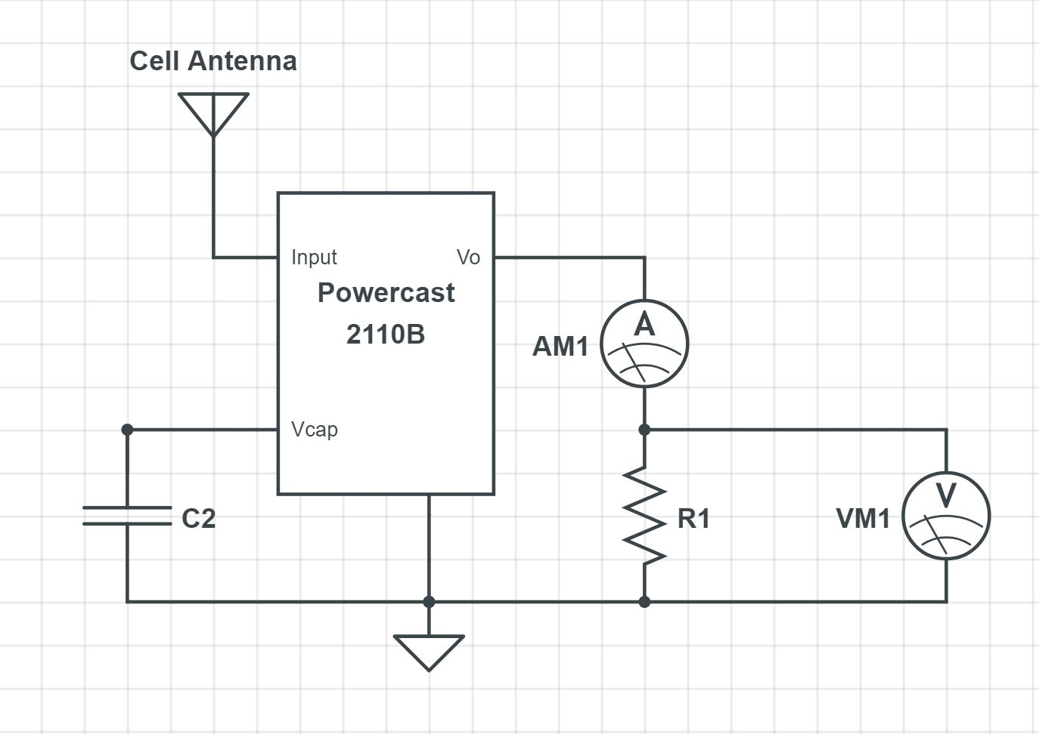
Figure 57 – Breadboard Prototype Circuit
This design uses only crucial components to achieve proper operation. In this prototype, different values of R1 were used to measure the voltage drop. As expected, the equation given in the data sheet was correct. We were also able to observe the switching cycles controlled by the capacitor C2. The following results were achieved from this prototype. The antenna read ~300mV (blue plot on oscilloscope) from cell signals in the lab while the Powercast IC maintained a consistent output of 3.3-3.6V (yellow plot on oscilloscope) shown in Fig. 58 below.
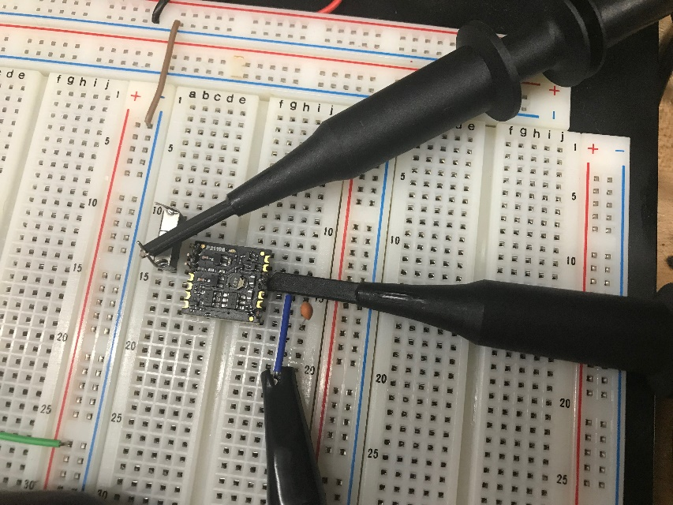
Figure 58 – Tested Prototype Circuit
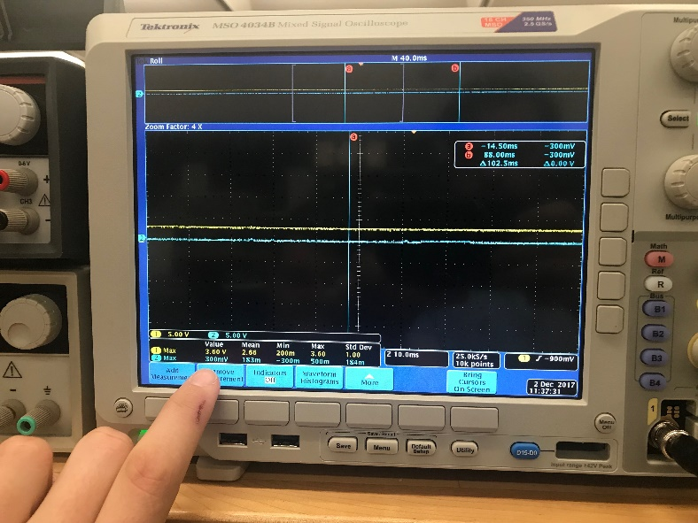
Figure 59 – Results of Prototype Circuit
This design, as shown in Fig. 60 operated properly with an output between 3.3V and 3.6V from the Powercast IC at 0.03mA thus generating about 1mW. The current was measured by reading the voltage drop when additional resistance was added to the output. The input power from the antenna ranged between -10dBm and 10dBm. This is far below our goal of 100mW however this prototype data did not include any use of the secondary thermoelectric source.
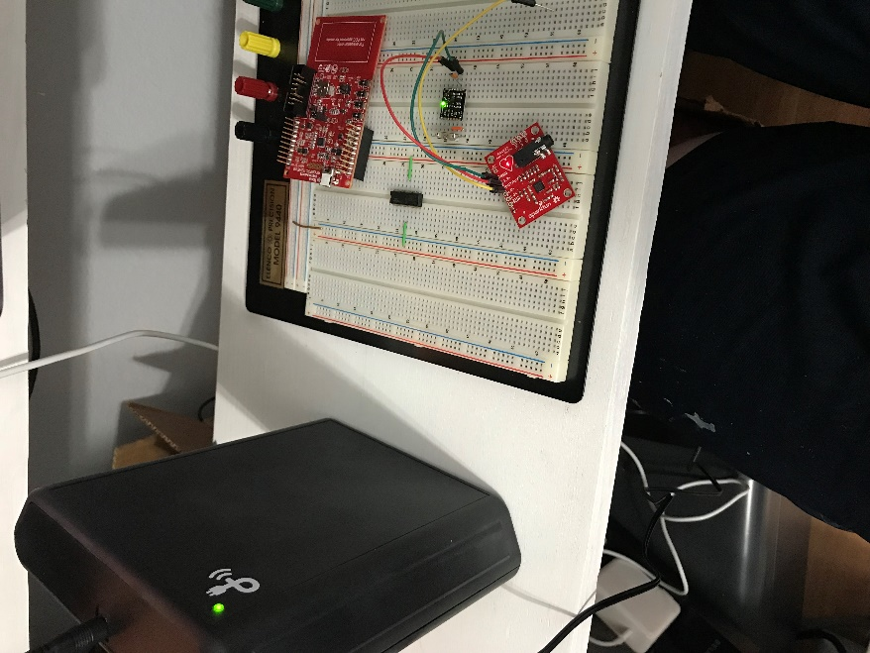
Figure 60 - Full prototype circuit in operation

Full PCB Schematic
On a high level, the circuit below describes the PCB that will be designed for this system.
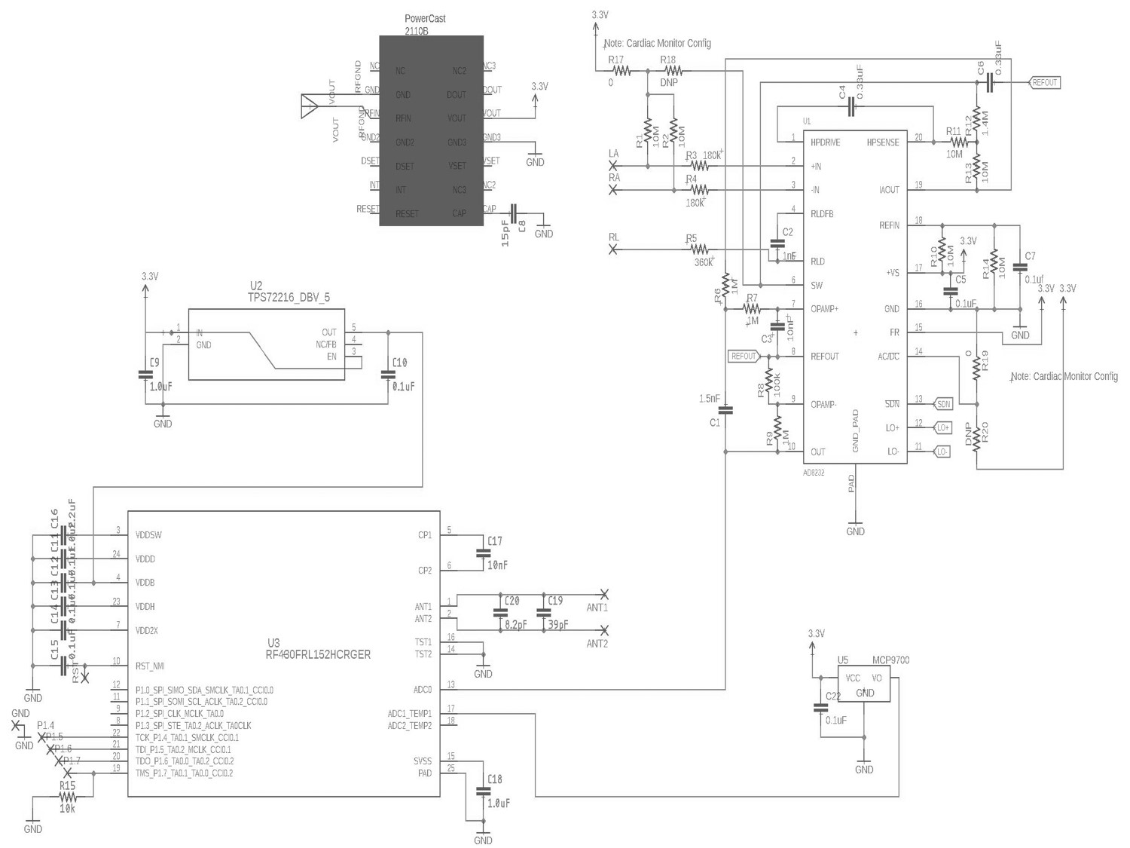
Figure 61 – Full Schematic for System
- The Powercast 2110B is what will convert the RF signals to useable power in the circuit. The output is not continuous however, it is discrete with an operating cycle controlled by C8.

- Not shown in the schematic is an output resistor designed to control the voltage out of Powercast IC. A value of 1.6MΩ will achieve a ~2.5V output from the Powercast IC. This helps protect the microcontroller from seeing too much voltage in the ADC from the sensor outputs. The sensor outputs and the sensor inputs are linearly related/proportional. We selected 2.5V as the output to protect the energy storage super capacitor in the following stage of the circuit.
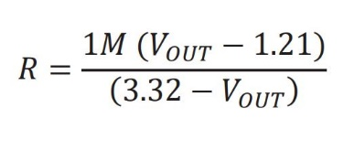
Figure 62 – Resistor Equation for Output Voltage Control
- The small capacitor C8 on the left side of the Powercast is required by the Powercast. The value of this capacitor is left up to the designed to determine the operating cycle or on time for the Powercast. A larger capacitor will require a longer charge time and a smaller capacitor will store less energy yielding a shorter operation cycle. The equation to find the value of this capacitor is shown below. In prototype experiments, we found that a 50mF capacitor with low leakage current yields positive results.
C= 15*P_{on}*t_{on}

- The DC/DC converter uses typical typology to bring the voltage from 2.5V from the Powercast to 1.5V which is required by the microcontroller.
  - This will also require additional testing to confirm the output voltage of the capacitor which will play a critical role in the capacitor.
  - The sensors require at least 2.5V which is why a resistor isn’t calculated to drop the Powercast output voltage to 1.5V.
All other values from the schematic are recommended by data sheet requirements.

Bill of Materials
Component | Manufacturer & P/N | Value
Antenna  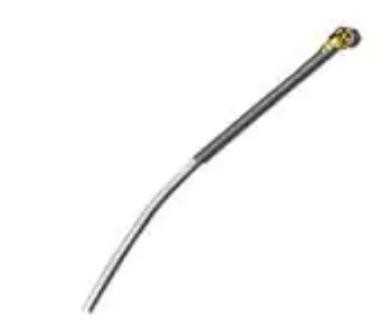 | Anaren  66089-0930 | 915MHz
Powercast  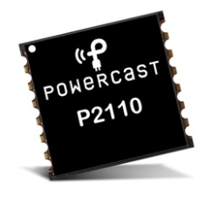 | Powercast  21110B | Depended on Conditions
Antenna  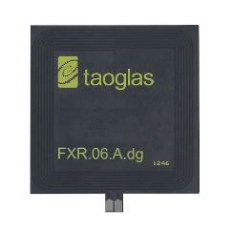 | Taoglas  FXR.06.A | 13.56MHZ
EKG Leads  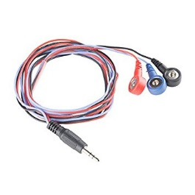 | Sparkfun  CAB-12970 | NA
Capacitor  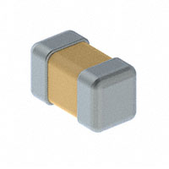 | VJ0603Y104KXJPW1BC | 0.1uF  16V rated
Capacitor | 06035A390JAT4A | 39pF  50V rated
Capacitor | GRT188R61C106KE13D | 10uF  16V rated
Capacitor  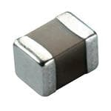 | 06035C152KAT4A | 1500pF  50V rated
Capacitor | 08055C334K4Z2A | 0.33uF  50V rated
Capacitor | C1608X7R1A225K080AE | 2.2uF  10V rated
Capacitor | TMK107AB7105KAHT | 1uF  25V rated
Capacitor | 06035C103K4T2A | 0.01uF
Heartrate Sensor  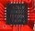 | AD8232ACPZ-R7 | NA
Thermal Sensor  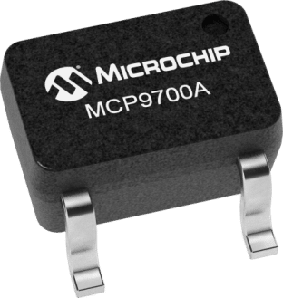 | MCP9700AT-E/LT
Voltage Regulator  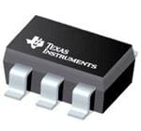 | Texas Instrument  TPS72215DBVT | Output voltage = 1.5V
Microcontroller  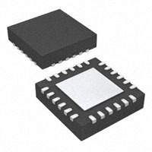 | Texas Instrument  RF430FRL152HCRGER | NA
EKG Pads | Sparkfun  SEN-12969 | NA
Resistor  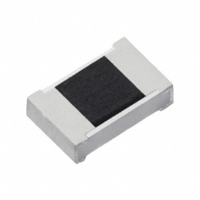 | ERJ-3GEYJ103V | 10kohm
Resistor | ERJ-3GEY0R00V | 0 (zero) ohm
Resistor | CRCW06031M40FKEA | 1.4Mohm
Resistor | ERJ-3EKF1003V | 100kohm
Resistor | CRCW060310M0FKEB | 10Mohm
Resistor | RC0603FR-071ML | 1Mohm
Supercapacitor  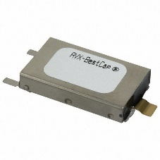 | AVX  BZ015A503ZLB | 50mF  5.5V rated
Figure 63 – Completed Bill of Materials

Full Circuit Expected Performance
Using data from the components selected in this design, we have been able to calculate and predict the circuit performance to be functional, but not revolutionary. On a very high level we are using efficiency of each design stage to determine what the output power of the system will be. An additional and appropriate losses will be added between stages.
Stage | Input Power | Efficiency | Output Power
Antenna | 1W @ 900MHz | 60% | 0.6W @ 900Mhz
Powercast IC | 0.6W | 50% | 0.3W
Figure 64 – Full System Performance Estimations
These approximations suggest that the maximum power to be harvested is about 300mW.

Printed Circuit Board Design Requirements
The nature of this project requires very specific design precautions on the PCB level. Most importantly, we need to be sure that the copper traces inside the PCB will not be interfered causing lower performance from the Powercast RF Energy Harvesting IC. For example, the received RF Signal will be passed through a copper trace to the Powercast IC. If not careful, crosstalk to modify the incoming wave to the Powercast IC causing performance issues.

PCB Layout Considerations
We found that copper traces can provide unwanted capacitance, inductance, resistance, and can interfere with data via EMF interference. The following precautions have been taken in the design stage to minimalize these risks with the help and guidance from Powercast 2110B’s data sheet (direct quote from data sheet):
- The RFIN feed line should be designed as a 50Ω trace and should be as short as possible to minimize feed line losses. Fig. 65 provides recommended dimensions for 50Ω feed lines (CPWG) for different circuit board configurations.
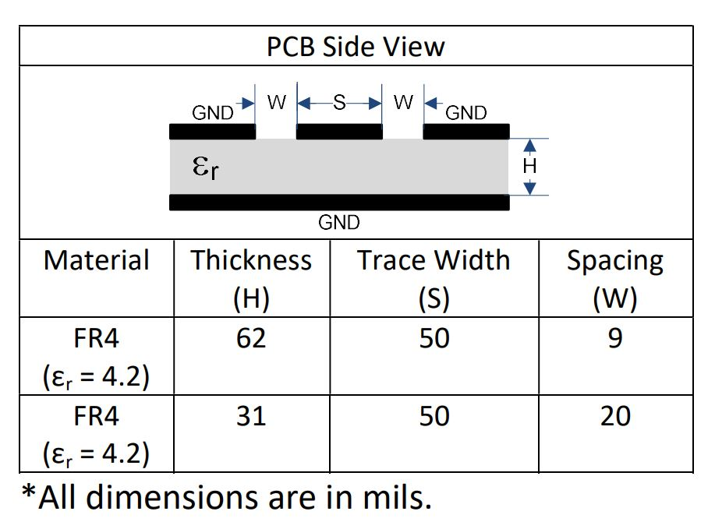
Figure 65 – PCB Layout Requirements for Powercast IC
- The GND pins on each side of the RFIN pin should be connected to the PCB ground plane through a via located next to the pads under the receiver.
- When setting the output voltage, the resistor connected to the VSET pin should be as close as possible to the pin. No external capacitance should be added to this pin.
- The DOUT pin can contain low-level analog voltage signals. If a long trace is connected to this pin, additional filtering capacitance next to the A/D converter may be required. Additional capacitance on this pin will increase the DSET delay time.
- The trace from VCAP to the storage capacitor should be as short as possible and have a width of greater than 20mils to minimize the series resistance of the trace.
The remaining circuitry did not have any specific PCB design/layout requirements.
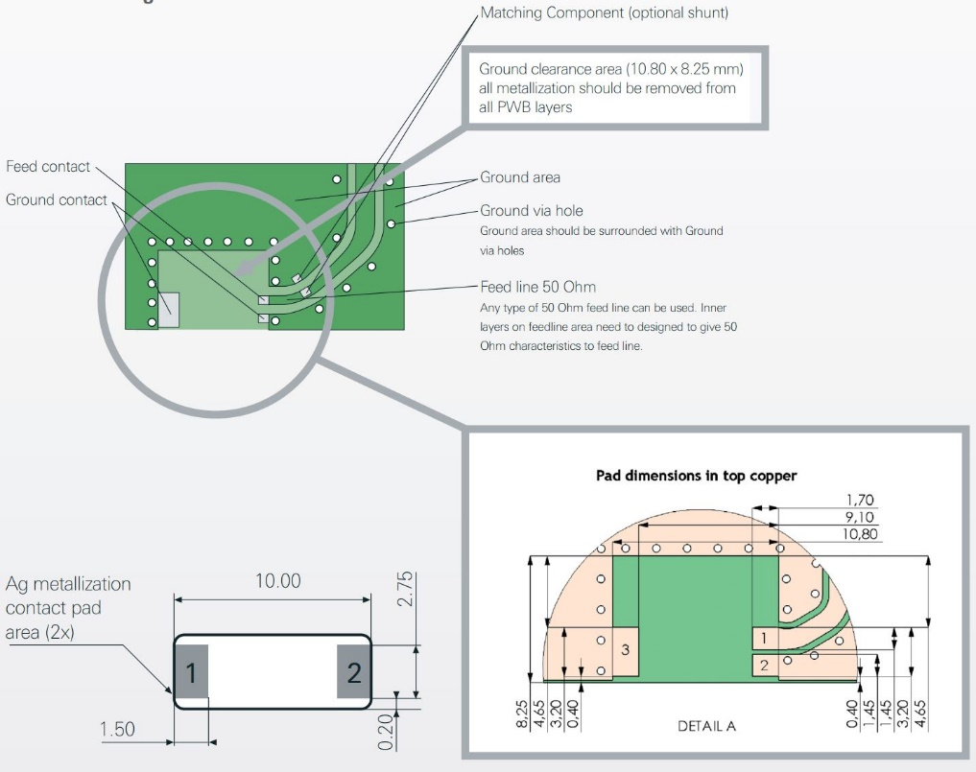
The antenna we selected also has special PCB requirements shown below:
Figure 66 – PCB Requirements for Antenna

PCB Manufacturing
Just as important as designing the PCB, manufacturing the final product from a reliable source with good turnaround is imperative. Several vendors offer 3-5 business day production such as EasyEDA. This company primarily works in circuit simulation and PCB layout, but also processes PCB manufacturing. EasyEDA offers 6 layer PCB designs with a 6mil min line width. Comparatively Advanced Circuits 4PCB service offers 10 layer tracing down to 5mil line width. This is overkill as the final board for this application will require no more than 4 traces. The final selection of PCB manufacture will be based on turnaround time and minimum batch order. These are just a few of the options listed here. Additional options are listed below:
Company | Lead-time | Line width | Layers
EasyEda | 3-5 days | 6mil | 6
Advanced Circuits | Same day | 5mil | 10
Silver Circuits | 1 week | 7mil | 4
Pad2Pad | Next day | 10mil | 2

Administrative Content

Project Timeline & Milestone Discussion
The following timeline will guide this project.
Product Development | 9/17 | 10/17 | 11/17 | 12/17 | 1/18 | 2/18 | 3/18 | 4/19
High Level Research on Feasibility | ---X
Agree on Project Parameters | ----X
10 Page Draft | -----X
RF Signal Receive
Antenna Selection | -----X
RF Sources Research | -----X
RF Signal Standards/Laws | ------- | -------X
RF Signal Conditioning
Block Diagram of Module | -----X
Component Selections | ------- | --X
Requirements Analysis | ------- | --X
Design Combine & Modulation | ------- | -----X
Module Circuit Design | ------- | -------X
RF Energy Harvesting
Order sample Powercast IC |  | -----X
Lab based testing/analysis |  | -------X
Requirements Analysis |  | -------X
Power Delivery
Block Diagram of Module | -----X
Select & Design Software | ------- | --X
Design Control & UPS System | ------- | --X
Module Circuit Design | ------- | -------X
Draft 60 Pages |  | ----X
Full System Design Review |  | ------X
Feasibility/Requirements Review |  | -- | ----X
Draft 90 Pages |  |  | -------X
Customer Review of ~Outcome |  |  |  | ---X
Lab Prototype of modules |  |  |  | -- | --X
PCB Design Draft |  |  |  |  | -----X
OEM PCB Design Review |  |  |  |  | --- | --X
Design Changes |  |  |  |  |  | -----X
Order PCBs & Components |  |  |  |  |  |  | -X
Presentation Draft & Practice |  |  |  |  |  | -- | ---X
Design Assembly & Testing |  |  |  |  |  |  | -----X
Project End |  |  |  |  |  |  |  | ----X
Figure 67 – Project Timeline
We have broken this project into multiple stages/modules. We spent the first few months of the project debating and researching feasibility of our system. This was to identify failures and wrong assumptions early so we can address them.

Project Budget
The following budget was developed to guide this project and accomplishes the requirement of remaining below $1,500.
Component | Cost
Components | $800
PCB Fabrication | $700 (first attempt)  $60 (second attempt)
Equipment | $100
Development Board | $30
Transmitter | $120
Misc. | $300
 | $2,100
Figure 68 – Project Budget

Design Problem
One of the design problems in this system is the antenna. We are using a bare copper wire cut to receive the 900MHz frequency range. This assumes the copper wire is straight but in practice, the wire will follow the circular shape of the user's body creating a problem in the design. Another problem exists with the fact that the body may actually block or insulate the signals in different directions causing the antenna to pick up less signal than we anticipated. A problem exists for the implementation of the antenna on the PCB. The antenna needs to be parallel with the PCB, not orthogonal which wouldn’t fit on the user's wearable. This antenna needs to be parallel to fit through wearable loops and run in contour of the wearable. This poses a manufacturing issue as antennas are typically rigid and easier to place orthogonally to the board.
The implementation of the antennas is also a challenge. The Powercast IC’s first stage (internally) is to rectify the signal. This means that it doesn’t exactly need a perfect, clean signal to work with. This will be however more efficient than feeding the IC noise. We found by inspection that it is possible to filter the noise and feed the Powercast IC a clean signal as well as it being possible to rectify the signal from each frequency band individually then add the DC signals together before modifying the signal to be a perfect signal for the Powercast IC. Though both of these options are possible, we found that there are considerable losses involved with adding these features making the better design decision to be to feed the Powercast IC noise picked up by the antenna.
The antennas for the Wi-Fi band and Cellular band in our PCB design are in series and will likely pick up noise. This is a design problem because of constructive and destructive waves (signals). The very nature of noise means that there is no way for us to predict the signal that will go into the “RF IN” port of the Powercast. There may be cases where the waves are constructive and other cases where the waves are destructive. When the waves are destructive, there may be too little signal (less than -11dBm) to actually harvest the energy. To mitigate this risk, we added the large capacitor C3 in our design. This capacitor will help smooth the output of the Powercast and will continue to keep the system in operation even during destructive waves.
Another major design problem is the entire essence of this project. We know we can harvest signals that are -11 dBm in strength, yet the signals we are looking to work with are all much smaller than this (typically less than –40 dBm). We have designed this system to combine the RF signals where their combined strength is great enough to satisfy the Powercast IC.
On a practicality level and to satisfy marketing requirements, this system is embedded into a wearable that the user would wear each day. At the end of the day, the user may leave the wearable on the floor to potentially step on or another potentially hazardous accident. Having said that, it is a challenge to design an enclosure for our system without making the wearable too large or rigid. On the same note, the system needs to require little to no input from the user. This means the system cannot rely on any external circuitry such as a biasing battery to provide enough power for active components or to provide minimum voltage and current to use advanced components such as diode or transistor. For this reason, the entire circuit was designed passive. We are harvesting very small amount of energy from the thin air to deliver to a battery and not harvesting a small amount of energy to go in series with a battery to charge another battery. This is counter intuitive as these types of systems have such a large impedance that any energy harvested is typically lost. In other words, a major design challenge in this project was finding and selecting high efficiency and passive components at every stage.

Roles
Our team members have the necessary background for this project ranging from software and hardware capabilities. Joe and John came up with this project together by essentially mixing their own individual ideas together. Realizing a monitoring system would be necessary for the project, Zeke became a welcome addition to round out the electrical engineering based team. Joe’s first-hand experience with product development, devices, and system design. John’s background in Biomedical Devices, digital logic, and device fabrication. Lastly, Zeke’s excellence in computer engineering and embedded programming. Together, will drive this project toward success.

Team Member | Role
Joe Sleppy | -Energy Harvesting Stages  -Business/Administration  -Manager
Joe Sleppy’s Career Plan | -Sleppy will continue working on the company he started in college, Capacitech Energy LLC  -Capacitech Energy is commercializing UCF technology known as a cable based capacitor.  -Sleppy is currently the CEO of Capacitech Energy and will continue on with this role after graduation.
John Foster | -Control System  -Medical/Health implications
John Foster’s Career Plan | -Foster has spent his college working in IT, manufacturing, and office computer management.  -Foster will continue on to higher education for a masters and eventual Ph.D in electrical engineering.  -Foster specifically wants to work with medical device engineering and has a passion for wearable medical devices. His dream is to miniaturize this technology into a flexible circuit the size of a Band-Aid for hospitals to easily track vitals of their patients.
Zeke Rosenbluth | -Software  -NFC  -Standards
Zeke Rosenbluth’s Career Plan | -Rosenbluth has a passion for machine learning and artificial intelligence  -Rosenbluth plans to purse these topics further in a masters degree program at UCF.
Figure 69 – Team Members and Roles

Future Development
The system that we are designing has a very bright future in the world of consumer electronics, personal communication devices, and sensors (especially in the world of the Internet of Things). We see this technology being miniaturized into a chip. This would enable it to be embedded into a variety of devices from smart phones to pacemakers and even sensors. The challenge with this concept is the antenna required to collect the signal.
However, that challenge opens an even bigger further development opportunity in the health industry. For something like a pacemaker, this system can be slightly modified to use a different type of signal. Instead of RF signals from the outside world's phones and Wi-Fi modems, what if the system harvested electrical signals that are found in the heart like those measured by an EKG. What if this system can be embedded into cochlear implants to help power electronics that enable people to hear?
The system that we proposed in this paper is a proof of concept that RF signals can be harvested for power. The goal for future developments (focused on medical devices) is to switch from harvesting RF signals to harvesting electrical signals found naturally in our bodies which can enable and power internal medical devices. This would bring value to surgeons and patients by reducing the stress on the body while also helping people live healthier lives.
If we are successful in this design, where a simple circuit can help supplement batteries, then the potential for more internal medical devices improves. It opens the door to make internal medical devices that require additional power as well as additional low power sensors/systems such as a pacemaker. Cochlear implants have the potential to be a completely internal device. This would allow users to hear at night, in the shower, in the pool, and a variety of other places that they cannot currently wear their hearing device in adding major value to their life. The main reason this system is external is because there has not been a feasible design for changing the batteries required. Currently, users of the cochlear implants change their batteries daily.
Because this project has a clear focus on diabetics, this system also has the ability to support the drive toward an artificial pancreas. The artificial pancreas is essentially a closed loop system where an insulin pump and a glucose meter share information back and forth while both system are completely embedded internal to the user. This artificial pancreas would likely be comprised of sensors. Each sensor would be outfitted with our energy harvesting system. Fig. 70 below shows an example of an embedded insulin pump.
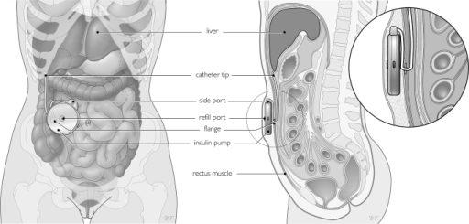
Figure 70 – Example of an Embedded Medical Device
The mass market applications of RF energy harvesting also allows us to apply this system to a variety of other applications outside the intended medical applications. For example, sensors have been added to many bridges, oil rigs, and buildings. These sensors are being used to measure the strain on these structures to potentially deter a catastrophic event like the one that happened in the Gulf of Mexico in 2010. Each of these sensors are outfitted in remote locations and require either frequent battery changes or very expensive long lasting batteries. Our system as it is could help power sensors on buildings and bridges, however underwater for oil rigs, the system needs major upgrades. One upgrade might be changing the system to harvest signals heard underwater rather than RF energy.
Integrated brain sensor applications currently hold huge amounts of market interest. Currently, brain implant devices require physical connection or inductive coil charging. Physical connection is a problem due to body rejection, infection and other complications. Many cases of brain fluid leakage have been seen were a physical socket is implanted in the skull. This is a rather archaic solution to an extremely high-tech emerging technology. Slightly more advanced than physical connection is inductive coil charging and information transmission. Inductive charging works through two coils separated by a small distance. The physical properties of electromagnetic waves come into effect here and enable current to be induced in the second coil. Fig. 71 below shows a simple inductive charging system.
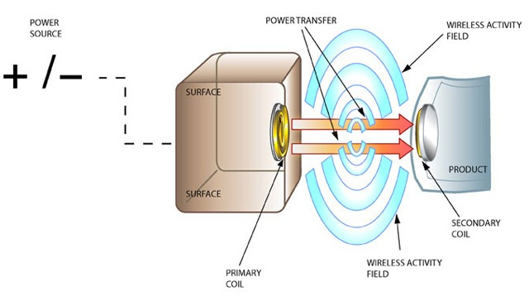
Figure 71 – Inductive Charging Overview
Inductive charging is a true revolution in many industries and is currently used in many medical applications. As such, Inductive charging is a trusted technology that works, but it is not without its flaws. Efficiency and size are two factors that dramatically hinder the efficiency of inductive charging. RF harvesting has the potential to capture enough power to eliminate the need for any form of inductive charging or physical connections. This allows circuits to be directly implanted and left for long periods of time without charging or connection of any kind. This is imperative in situations where deep implantation is needed.
Another way to improve the system for biomedical applications is to use thermoelectric energy. These components thrive on heat difference to generate electrical current using something known as the Seeback Effect. These components have no moving parts and are a solid state device. The best way to think of this device is as a semi-conductor that uses heat as excitation rather than a potential difference. In fact, thermoelectric energy components also have P-N junctions like a diode does. When heat is applied, the P and N cells get excited causing majority and minority carriers to move. This movement can be better described as electrons moving which is the definition of current. Voltage on the other hand would be related more to the physical construction of the device. Because that physical construction is fixed, the voltage remains fixed as well. The power generated by this device is proportional to the heat differential applied to the device while being held at a constant voltage. These devices are notorious for generating very little voltage, but large currents. They are current driven devices, similar to solar cell. It is due to the physical design of the component and laws of physics.
There is also the Internet of Things applications where our system helps supplement the power required for sensors and systems used. The smart home is a popular application for IoT systems. The Nest Thermostat by Google is a great place to start where the Wi-Fi network and cellular networks can be harvested to support the product. This RF energy harvesting system could be very beneficial to IoT applications. Sensors used for IoT are often considered annoying and inconvenient. Often times, these sensors are located in remote locations and require power meaning they are difficult to access to change batteries inside of. Even for non-remote sensors, end users don’t want to think about their sensors in the IoT systems. They want to plug them in and let them run. Changing batteries in the sensors doesn’t let this happen.

Block Diagram and Road Map
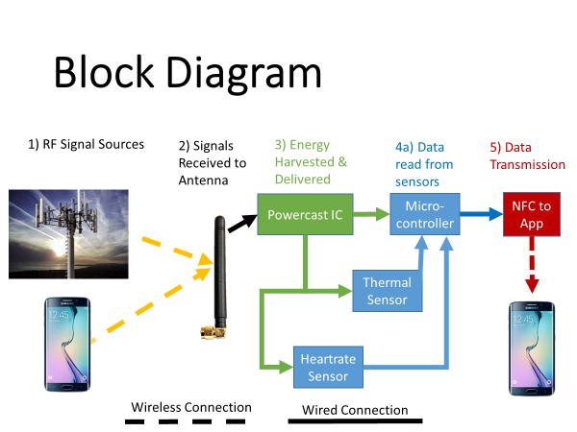
Figure 73 – High Level Block Diagram
1) Joe Sleppy | Design 2) Joe Sleppy | Design 3) Joe Sleppy & John Foster | Design 4) Joe Sleppy | Design 5) John Foster & Zeke Rosenbluth | Design

Final Implementation
There were a few technical hiccups in our project that we dealt with even after a failed initial PCB design attempt. This PCB failed because of oversights. The values were correct for the most part and the connections were correct too however the implementations were very wrong. For one, the Powercast trace widths were not correct causing issues in the traces themselves. There was not a common layer ground plane which caused noise to interfere with performance in a big way. Lastly,
The first major issue was specifying the correct capacitor size in the output of the Powercast. We were using 15pF capacitors in prototyping so that the charge time was very quick allowing us to see if the design was working or not. That value was never updated until after the PCB came in and the circuit was not working. After calling Powercast, we learned a 50mF capacitor was more appropriate (a factor of 3.33 billion). The issue wasn’t so much the mistake but the factor off we were. If it was a different value of picofarad then we could have used a different capacitor in the same package size. Since the factor off was so large, we had to use solder a wire towards the back of the board which is the only area that had enough space for the 50mF capacitor. This capacitor was soldered to the wire that connected it to the correct pin on Powercast and the ground of the capacitor was soldered to the free ground pad that was intended for the antenna bringing us to our second implementation issue. Finally, the PCB fabrication process was incorrect too. The company used, Advanced Circuits, allowed a warning to go un-noticed which resulted in two traces shorting together making the circuit fail all together. Also, the data sheets suggested headers and other support components that were ultimately not needed which added complexities that added no value to the project. We took these mistakes as learning to design and produce another PCB. This PCB was fabricated by PCBWay and had excellent results.
It turns out that the antenna we specified was outside of our capabilities to implement correctly. Couple that with a high return loss and this antenna simply did not work. As a joke during final testing of the PCB, we stuck a random piece of wire on the board in place of the chip antenna that was specified and found performance to be much better in terms of efficiency and range. Going off this observation, we changed the antenna from a chip antenna (which required fancy implementation) to a whip antenna that required nothing more than a pad to be soldered on to.
As a final and rather small error, we had built one of the sensors on our PCB to be a heartrate sensor which takes a EKG reading. This was fine in theory and we could make it work in the lab. We did not have the foresight to realize that in practical demonstration of this sensor, someone would need to take their shirt off to connect the heartrate probes to. This issue could have been mitigated by finding a sensor that would take the readings from someone’s thumb, palm, or neck. Instead, the demonstration of this project’s RF energy harvesting abilities were shown by the thermal sensor alone and by showing proof of the heartrate sensor’s function (just not a live demonstration).
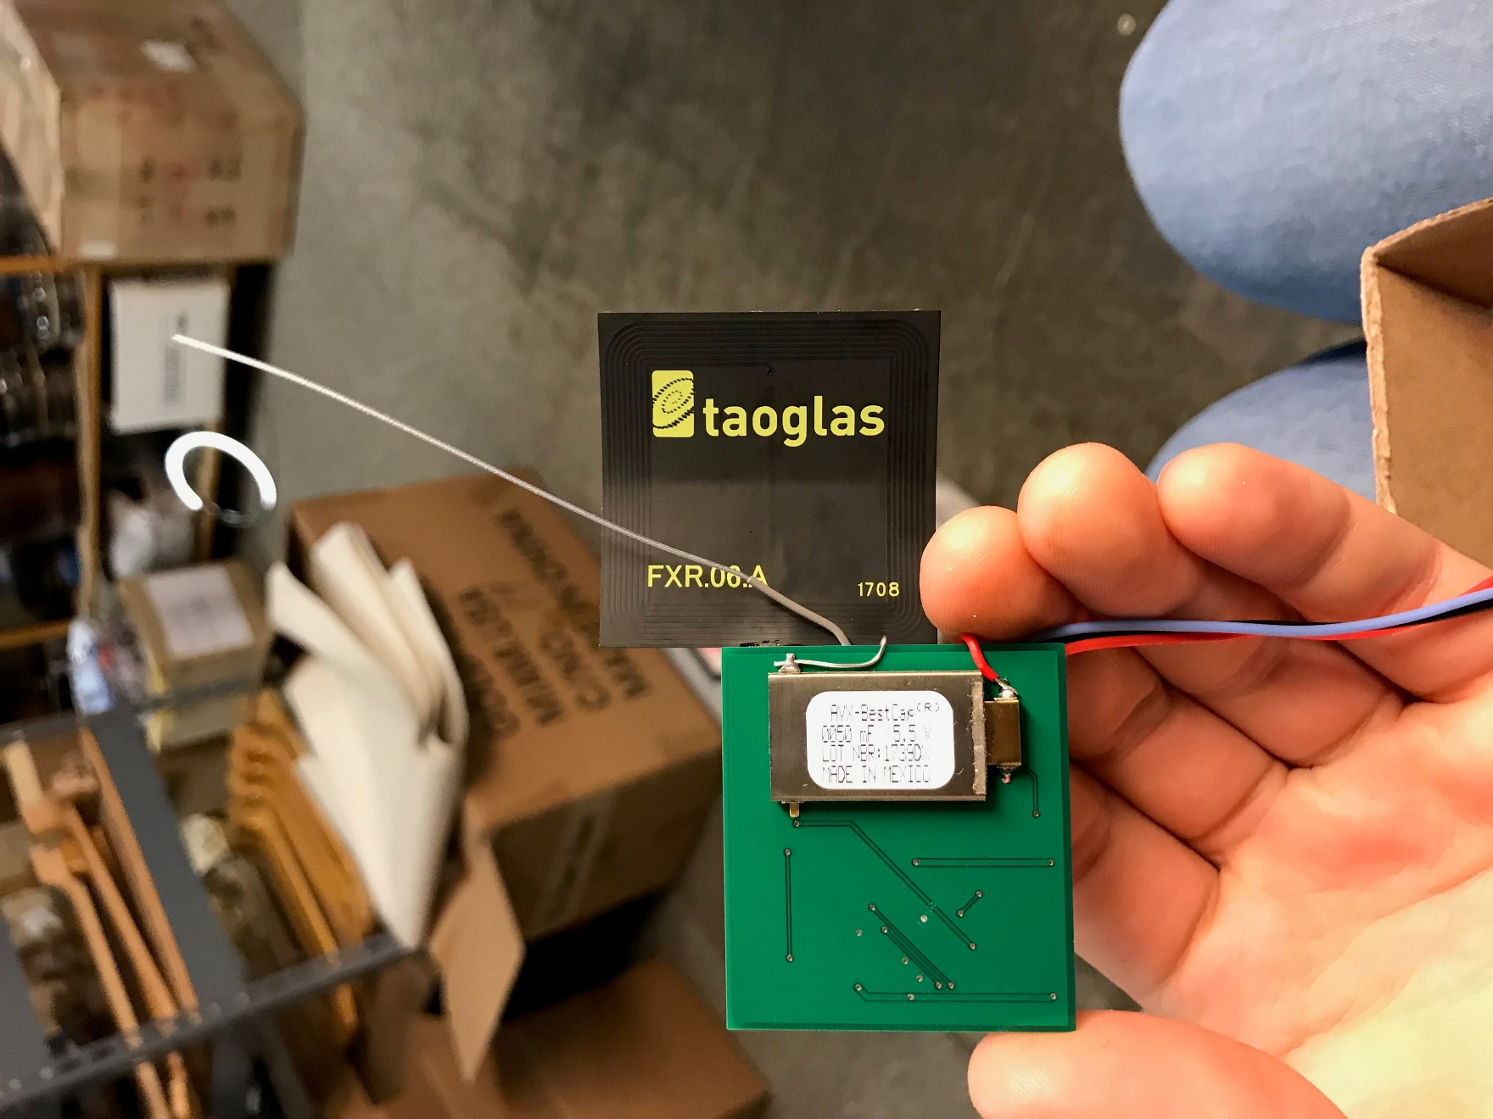
Figure 74 - The back side of the PCB sporting a 50mF capacitor connected by a red wire soldered on to solve a problem
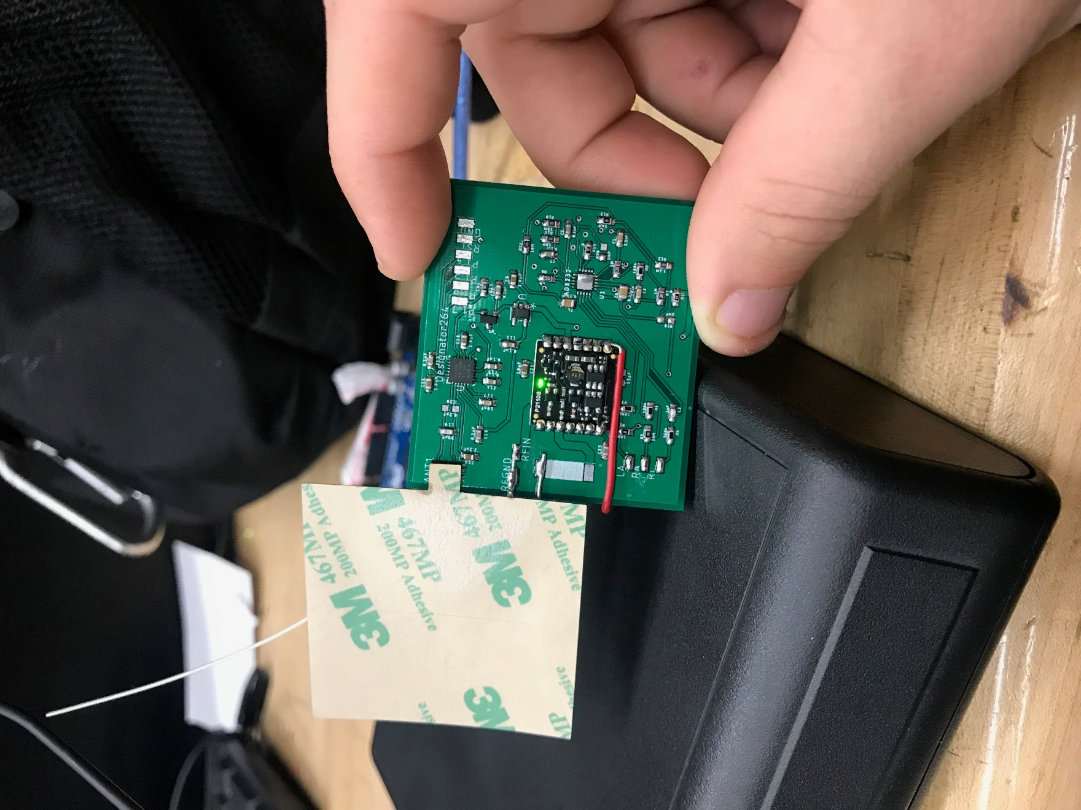
Figure 75 - The front side of the PCB while operating as shown by the green LED on the Powercast IC

Conclusion
In conclusion, this project proposes the development of a free standing RF Energy Harvesting system in the unique form factor of a wearable that will trickle charge medical devices such bio-sensors. The proposed system is expected to work best in metropolitan areas due to the large density of RF signals to be harvested in such locations. The system will require little to no maintenance from the user while also being durable enough to withstand most aspects of daily life such as rain and wear on the system.
From our prototype we found it was feasible to convert RF signals from a cell phone to a 3.4V output at 0.03mA which combines for approximately 1-3mW. These results proves the ideology behind the project and puts the team in a good position to improve the system in the coming months. Immediate next steps for the project will include better antenna selection for improved range, additional antennas at different frequencies for the different cellular bands, a smaller PCB design (better utilizing free real estate on the board), and research into commercialization steps such as a utility patent. Between positive market analysis, prototype results, and the feasibility of the technology we believe the proposed technology can make a positive impact on society.

References
[1] | D. Hudgins, "Precision, Low-Side Current Measurement," Texas Instruments, Dallas, 2016.
[2] | D. Hudgins, "Power and Energy Monitoring with Digital Current Sensors," Texas Instruments, Dallas, 2017.
[3] | C. Mathas, "The Basics of Current Sensors," Digi-Key, 13 September 2012. [Online]. Available: https://www.digikey.com/en/articles/techzone/2012/sep/the-basics-of-current-sensors. [Accessed 20 October 2017].
[4] | NearFieldCommunication.org, "What is NFC? Near Field Communication Explained," NearFieldCommunication.org, [Online]. Available: http://nearfieldcommunication.org/about-nfc.html. [Accessed 25 October 2017].
[5] | NXP Semiconductors N.V., "NFC for embedded applications," August 2014. [Online]. Available: https://www.nxp.com/docs/en/brochure/75017587.pdf. [Accessed 25 October 2017].
[6] | IEEE Design Automation Standards Committee, "IEEE Standard for Design and Verification of Low-Power, Energy-Aware Electronic Systems," IEEE Computer Society, IEEE-SA Standards Board, New York, 2015.
[7] | Android, "Near Field Communication," Android Developers, [Online]. Available: https://developer.android.com/guide/topics/connectivity/nfc/index.html. [Accessed 2 November 2017].
[8] | Bluetooth, "Low Energy: Point-to-Point," Bluetooth, [Online]. Available: https://www.bluetooth.com/what-is-bluetooth-technology/how-it-works/le-p2p. [Accessed 15 November 2017].
[9] | B. Ray, "Bluetooth Vs. Bluetooth Low Energy: What's The Difference?," LinkLabs, 1 November 2015. [Online]. Available: https://www.link-labs.com/blog/bluetooth-vs-bluetooth-low-energy. [Accessed 15 November 2017].
[10] | B. Ray, "ZigBee Vs. Bluetooth: A Use Case With Range Calculations," LinkLabs, 24 August 2015. [Online]. Available: https://www.link-labs.com/blog/zigbee-vs-bluetooth. [Accessed 15 November 2017].
[11] | Google, "Google Java Style Guide," [Online]. Available: https://google.github.io/styleguide/javaguide.html. [Accessed 15 November 2017].
[12] | Electronics Hub, "Arduino and RF Transmitter Receiver Module," Electronics Hub, 29 October 2016. [Online]. Available: https://www.electronicshub.org/arduino-rf-transmitter-receiver-module/.
[13] | D. J. Panagopoulos, O. Johansson and G. L. Carlo, "Real versus Simulated Mobile Phone Exposures in Experimental Studies," US National Library of Medicine National Institutes of Health, 5 August 2015. [Online]. Available: https://www.ncbi.nlm.nih.gov/pmc/articles/PMC4539441/.
[14] | T. Prabhakar, U. Mysore, U. Saini, K. Vinoy and B. Amruthur, "NFC for Pervasive Healthcare Monitoring - IEEE Conference Publication," IEEE Xplore, 5 February 2015. [Online]. Available: http://ieeexplore.ieee.org/document/7031711/?reload=true.
[15] | S. Bhatti and W. Mohiuddin, "Overview of Cell Phone Technology," University of California, Santa Barbara, [Online]. Available: https://www.mat.ucsb.edu/~g.legrady/academic/courses/03w200a/projects/wireless/cell_technology.htm.
[16] | Maxim, "MAX2235 EV Kit," Maxim, [Online]. Available: https://datasheets.maximintegrated.com/en/ds/MAX2235EVKIT.pdf.
[17] | J. Rizzo, "Market for Wearable Sensors Expected to See Sevenfold Increase by 2019," Wearable Tech, 17 October 2014. [Online]. Available: http://www.wearabletechworld.com/topics/wearable-tech/articles/391550-market-wearable-sensors-expected-see-sevenfold-increase-2019.htm.
[18] | H. Ostaffe, "RF-based Wireless Charging and Energy Harvesting," Mouser Electronics, [Online]. Available: http://www.mouser.com/applications/rf_energy_harvesting/.
[19] | Arrow, "The Realities of RF Power Harvesting | Arrow.com," Arrow, 12 October 2015. [Online]. Available: https://www.arrow.com/en/research-and-events/articles/the-realities-of-rf-power-harvesting.
[20] | M. P. Aparicio, A. Bakkali, J. Pelegri-Sebastia, T. Sogorb, V. Llario and A. Bou, "Radio Frequency Energy Harvesting - Sources and Techniques," InTech, 11 May 2016. [Online]. Available: https://www.intechopen.com/books/renewable-energy-utilisation-and-system-integration/radio-frequency-energy-harvesting-sources-and-techniques.
[21] | Powercast Corporation, "P2110B Datasheet - Rev 3," Powercast Corporation, 2016. [Online]. Available: http://www.Powercastco.com/wp-content/uploads/2016/12/P2110B-Datasheet-Rev-3.pdf.
[22] | J. C. Kwan and A. O. Fapojuwo, "Measurement and Analysis of Available Ambient Radio Frequency Energy for Wireless Energy Harvesting - IEEE Conference Publication," IEEE Xplore, 20 March 2017. [Online]. Available: http://ieeexplore.ieee.org.ezproxy.net.ucf.edu/document/7881084/authors.
[23] | Learning About Electronics, "How to Build an Overvoltage Protection Circuit," Learning About Electronics, 2013. [Online]. Available: http://www.learningaboutelectronics.com/Articles/Overvoltage-protection-circuit.php.
[24] | A. Pietrangelo, "Diabetes: Facts, Statistics, and You," Healthline, 6 April 2017. [Online]. Available: https://www.healthline.com/health/diabetes/facts-statistics-infographic .
[25] | A. Norton, "More Americans getting pacemakers," Reuters, 26 September 2012. [Online]. Available: https://www.reuters.com/article/us-more-americans-getting-pacemakers/more-americans-getting-pacemakers-idUSBRE88P1LN20120926 .
[26] | Texas Instruments, "End-to-end Custom Circuit Designs | WEBENCH Tools | TI.com," Texas Instruments, [Online]. Available: http://www.ti.com/design-tools/overview.html?DCMP=sva_web_webdesigncntr_en&HQS=sva-web-webdesigncntr-vanity-lp-en .
[27] | Y. Qin, "Product Specifications," Data Power Technology Limited, 6 November 2015. [Online]. Available: https://cdn.sparkfun.com/datasheets/Prototyping/SPE-00-301120-40mah-en-1.0ver.pdf.
[28] | Battery University, "Supercapacitor Information - Battery University," Battery University, 21 April 2017. [Online]. Available: http://batteryuniversity.com/learn/article/whats_the_role_of_the_supercapacitor.
[29] | K. Kirkpatrick, "World Without Wires," Communications of the ACM, March 2014. [Online]. Available: https://cacm.acm.org/magazines/2014/3/172520-world-without-wires/abstract.
[30] | Texas Instruments, "RF430RL15xH NFC ISO 15693 Sensor Transponder (Rev. C)," Texas Instruments, December 2014. [Online]. Available: http://www.ti.com/lit/ds/symlink/rf430frl152h.pdf.
[31] | Micro Crystal Switzerland, "Low Power Clock Oscillator 32.768 and 100.000 kHz, in Thin and small Package - Micro Crystal," Micro Crystal Switzerland, 2016. [Online]. Available: http://www.microcrystal.com/index.php/news/25-cat-news/cat-articles/207-low-power-clock-oscillator-32-768-and-100-000-khz,-in-thin-and-small-package.

Appendix A – Purchase Orders



Appendix B – Copy Right Request
The following emails were send requesting permission for image use.
