Microgravity Drone Experiment
Group 23 - Blue Team
Adam Brockmeier-EE
Jacob Knepper-CpE
Sponsor: Northrop Grumman (NGC)
Systems Integration Advisor: Eliot Ramey
MAE Systems Project Advisor: Dr. Marino Nader



Table of Contents
1.0 Executive Summary 1
2.0 Project Description 2
2.1 Motivation 2
2.2 Goals/Objectives 2
2.3 Related Work 3
2.4 Engineering Requirements/Specifications 5
2.5 House of Quality 6
2.6 Block Diagram 8
3.0 Research 9
3.0.1 Brief History of Drones 12
3.0.2 Brief History of Microgravity Experiments 13
3.1 Relevant Technologies 14
3.1.1 Flight Controller 14
3.1.2 Global Positioning System 14
3.1.3 Telemetry 14
3.1.4 Microcontroller 14
3.1.5 Camera 15
3.1.6 Inertial Measurement Unit 15
3.1.7 Motors 15
3.1.8 Propellers 15
3.1.9 Electric Speed Controllers 15
3.1.10 Power Distribution Board 15
3.1.11 Battery 16
3.1.12 Switching Voltage Regulator 16
3.2 Part Selection 16
3.2.1 Power System Comparisons 16
3.2.2 Propeller 19
3.2.3 Motor 20
3.2.4 Electric Speed Controller 21
3.2.5 Battery 22
3.2.6 Power Distribution Board 23
3.2.7 Switching Voltage Regulator Components 24
3.2.8 Electronics Comparisons 28
3.2.9 Flight Controller 29
3.2.10 Global Positioning System 31
3.2.11 Telemetry 31
3.2.12 Microcontroller 32
3.2.13 Inertial Measurement Unit 33
3.2.14 Camera 35
4.0 Related Standards and Design Constraints 37
4.1 Related Standards 37
4.1.1 FAA Standards 37
4.1.2 FCC Standards 38
4.1.3 IEEE Standards 38
4.1.4 Testing Standards 39
4.2 Design Constraints 40
4.2.1 Economic and Time Constraints 41
4.2.2 Environmental, Social, and Political Constraints 41
4.2.3 Ethical, Health, and Safety Constraints 42
4.2.4 Manufacturability and Sustainability Constraints 42
5.0 Design Details 44
6.0 Overall Integration 49
6.1 PCB Design 49
6.2 Motor Testing 51
6.3 Autonomy Testing 51
6.4 Integration with Interdisciplinary Teams 52
7.0 Administrative Content 54
7.1 Milestone Discussion 54
7.2 Budget Analysis 55
7.3 Project Roles 57
8.0 Conclusion 59
A1 References 62
A2 Copyright 69

List of Figures
Figure 1: Variable pitch quadrotor concept designed by the Georgia Institute of Technology (image permission requested) 4
Figure 2: The House of Quality 7
Figure 3: Electronics block diagram 8
Figure 4: Parts for the small-scale test drone 44
Figure 5: 5V 3A switching voltage regulator (image permission requested) 45
Figure 6: Components for breadboard testing of a 5V 3A switching regulator 46
Figure 7: Breadboard Test 47
Figure 8: F4 Flight Controller schematic (image permissions requested) 48
Figure 9: Custom printed circuit board schematic detailing the connections between voltage regulator and computers/peripherals. 50
Figure 10: Project Roles and Workload Split 58

List of Tables
Table 1: Propeller Comparisons 19
Table 2: Motor Comparisons 20
Table 3: Electric Speed Controller Comparisons 21
Table 4: Battery Comparisons 23
Table 5: Power Distribution Board Comparisons 24
Table 6: 100uF Capacitor Comparisons 25
Table 7: 100uF Capacitor Comparisons 26
Table 8: 100uH Inductor Comparisons 26
Table 9: Schottky Diode Comparisons 27
Table 10: Switching Regulator IC Comparisons 28
Table 11: Flight Controller Comparisons 30
Table 12: GPS comparisons 31
Table 13: Telemetry Comparisons 32
Table 14: Microcontroller Comparisons 33
Table 15: IMU Comparisons 34
Table 16: IMU Zero Rate Level Comparisons 35
Table 17: Camera Comparisons 36
Table 18: Semester 1 Milestones 54
Table 19: Semester 2 Milestones 55
Table 20: Electronics Bill of Materials/Cost Analysis 56

1.0 Executive Summary

Within the past decade the commercial drone industry has grown exponentially. With this technology now easily accessible to the public, people have been innovating ways to take advantage of it. From aerial surveillance to crop dusting, these unmanned aerial vehicles are revolutionizing a wide range of industries. Our project's goal is to revolutionize microgravity research using a drone.

The current cost for microgravity facilities is very steep, making them almost inaccessible to those below the top echelon of research groups. Parabolic flight, one largely known way to attain microgravity experiments, is largely expensive and requires booking months to even years in advance. Drop towers, which can achieve microgravity through freefall, have large upfront costs to erect such a facility and are sparsely located in the world. We aim to provide researchers with the ability to conduct low cost microgravity research. With a low-cost drone platform that can be operated by pressing simple buttons on a smart device screen, we intend for this drone to be as easy to operate as an elevator. The user will need no prior knowledge of how to fly a drone but merely some simple safety and maintenance knowledge.

The drone used in our project will be used for microgravity experiments like those conducted in drop towers. This is since the drone will accelerate directly downward from a predetermined altitude rather than generate microgravity by utilizing a parabolic path with translational motion in the horizontal plane. The restrictive budget of the project will also prove that this alternative, not replacement for drop tower-style microgravity research, can be affordable for any researcher who wishes to use this method. The microgravity will not be as clean as the conditions seen in a vacuum-chamber drop tower, and will certainly not last as long due to physical restraints. It will, however, achieve a couple of seconds of uninterrupted microgravity conditions that will be suitable for many experiments.

From what we have gathered in research, we believe that the best way to achieve microgravity with a multirotor drone is through assisted free fall in a downward direction. Since this project will use fixed pitch propellers, the drone will be unable to accelerate itself downward with typical propeller rotation that can only provide thrust in an upward direction. To account for this we will reverse the motors’ direction just before freefall, so they will provide thrust in the downward direction. We believe this will enable the drone to achieve sufficient downward acceleration to achieve microgravity. Once the drone falls a certain altitude we will deploy a parachute to slow its downward airspeed and allow it to reach the ground at a safe velocity.

2.0 Project Description

This section demonstrates our reasoning behind choosing this project. It will provide our motivation behind working on this project as well as background knowledge to what microgravity is and why it is important to research. Drones will also be discussed in detail; providing information on how they are able to achieve our goals. The requirements for this project are also listed to show what to expect from the outcome of this project.

2.1 Motivation

There exists a need for a low-cost solution to conduct microgravity experimentation. This need has been expressed by scientists and scholars who seek to perform these experiments but cannot afford existing options. Currently there are four basic methods of creating microgravity conditions. First, heavily-modified commercial airline equipment is necessary to conduct parabolic flight experiments and renting such an aircraft or service is too expensive for the average university faculty, scholar, or researcher. Depending on the payload size, parabolic flight experiments cost approximately $50,000 each flight. Second, vacuum chamber drop towers exist throughout the world that achieve reduced gravity conditions for seven to nine consecutive seconds, but these facilities can be inaccessible for researchers due to travel expenses coupled with the difficulty of securing a reservation of the facility. Third, a payload can be sent up to the International Space Station to conduct the longest duration microgravity experiments. This method comes at a heavy cost and may not be achievable within the timeframe of the researcher. Fourth, ballistic rockets can be used to achieve a few minutes of uninterrupted microgravity conditions. “A period of uninterrupted microgravity longer than about 30 minutes can in practice only be achieved in orbital flight. Shorter periods can be obtained using ballistic rockets (5-15 minutes), aircraft flying parabolic trajectories (tens of seconds) and drop towers (seconds). Although they are limited in scope, many studies can be performed with only tens of seconds of microgravity.” [1]. This article on microgravity research shows promise of a need for an affordable solution, stating that “...the microgravity community is (also) very interested in a flexible, complementary facility that would allow frequent and repetitive exposure to microgravity for a laboratory-type payload.” [1]. The author refers to such an autonomous craft that could possibly be used complementary to researchers’ standard means of perhaps shorter but cleaner microgravity testing.

2.2 Goals/Objectives

Northrop Grumman has proposed the design and construction of a working prototype in the capacity of an unmanned aerial vehicle capable of achieving micro-gravity or reduced-gravity conditions. This UAV must be an affordable alternative to existing microgravity solutions that can provide a repeatable flight pattern where the user can gather recordable data. This drone will carry a payload which will house the user’s experiment. The Requirements/Specifications section lists specific design constraints of the vehicle. The drone will monitor all environmental and experimental conditions during the flight and relay data back to a ground station for observation by the user. All data will also be logged by the craft and/or ground station. The electrical and computer engineers will be responsible for developing the system required for the data capture and logging. Figure 3 outlines the individual team member responsibilities for the craft power distribution system as well as the sensor system, camera, and flight electronics. The mechanical and aerospace engineers will be responsible for the aircraft design including the shape and dimensions. This design will determine the flight characteristics of the drone and will be crucial for the success of this project. The computer science members of our team will be tasked with the development of a graphic user interface through which the user can view flight data and experimental conditions. They will also program the freefall flight pattern for the flight controller to follow to achieve the reduced-gravity conditions.

2.3 Related Work

Research projects have been constructed in the past with the intent of creating reduced gravity conditions via drone technology. Georgia Institute of Technology students Juan-Pablo Afman, John Franklin, Mark Mote, Thomas Gurriet, and Eric Feron, focused on the design and optimization of an autonomous quadrotor drone to achieve microgravity. Their vehicle, while never actually performing the microgravity flights (as of the end of 2016), was simulated to provide proof-of-concept for 4 seconds of microgravity at an accuracy 10⁻³ g's. From their research, they quickly realized that simply letting the craft freefall and attempt to restabilize itself led to catastrophic results. The research led to the development of variable pitch rotors using constant rotor speed, allowing “... a more responsive system capable of fighting drag independent of direction and maintaining attitude control authority independent of the thrust required during a microgravity tracking flight." [2]. These variable pitch motors led the team of students to many unforeseen complications with a high level of complexity, however, leading us to believe an alternative solution may be better suited with our restrictions.

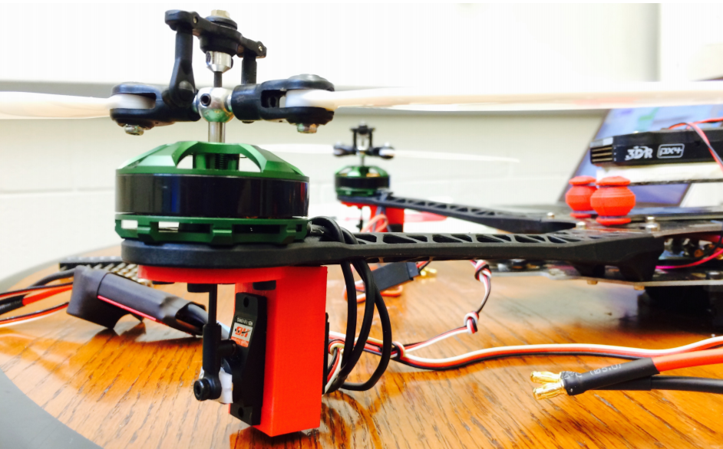
Figure 1: Variable pitch quadrotor concept designed by the Georgia Institute of Technology (image permission requested)
A team of Illinois students conducted an experiment at the Johnson Space Center in 2013 using a drone to autonomously perform a docking maneuver in variable gravity. “The goal was to fly the drone in zero gravity and have it dock on a landing station using magnets to induce eddy currents, causing the drone to brake. [3]” This type of experiment will give our team some insight on how our drone will behave in reduced-gravity conditions. Since some of our instrumentation (i.e. the accelerometer) relies on measurements of acceleration to maintain craft orientation, this could potentially become a problem if we approach zero-G. “The team faced some challenges in accounting for all of the variables. ‘There were certain variables that we couldn’t figure out without actually testing in zero gravity first,’ said ECE senior Sunny Gautam in an interview with CS lecturer Lawrence Angrave, the team’s mentor. The team did what they could to simulate certain effects of the gravity difference on their experiment, such as ‘removing the bearings we use for rotation and just hanging it off a lamp, so we can account for center of gravity,’ but they knew the real test would be the first of their two flights in the plane. [3]” This insinuates that we might encounter some unexpected flight characteristics during our initial low-gravity testing with our scaled-down test craft that our group purchased. The flight controller is programmed to operate around a set of normal conditions it expects to see from its sensors. If these sensors are reading an abnormal range of data, the flight controller may not be optimized to handle these readings and respond appropriately.

The creation of microgravity conditions is not a typically sought-after task while flying aircraft. In most instances reduced gravity conditions are avoided because the recovery from freefall can be dangerous for aircraft and passengers. Therefore, existing flight controllers for RC aircraft do not incorporate a flight mode that supports freefall, parabolic flight paths, or other microgravity-inducing flight patterns. We will need to program a flight mode that intentionally steers the craft into these flight patterns on command. It will manipulate the internal IMU by reversing its virtual orientation via the Pixhawk software. This will in turn make the aircraft think it needs to turn over 180 degrees to right itself, but it will then be facing downward. I will discuss the advantages and disadvantages of this method in our Research section. After freefall has been achieved for a few seconds, the aircraft will slow its descent rate until it is able to right itself and/or land. Various other flight methods have been implemented on experimental aircraft in the past with different levels of success, but we believe this will be the most efficient method.

2.4 Engineering Requirements/Specifications

The project requirements and guidelines are as follows:
- Budget must be constrained as an affordable alternative to other microgravity experimentation methods, as well as constraints set by the sponsor - guidelines from Senior design coordinators fall in the range of $1500-$2000 for the entire multidisciplinary team
- Budget must be divided among MAE, ECE, and CS teams
- Freefall/microgravity conditions must be met for 5-9 seconds per flight
- Drone must be able to achieve starting altitude of ~300 meters
- Required payload size must be roughly 12”x7”x4”, approx. the size of a shoe box
- Drone must be able to recover from freefall and land the payload safely, either via controlled recovery or controlled landing
- Must be a reusable platform with minimal cost to re-deploy the platform for additional tests
- Telemetry must relay relevant information to pilot and customer on the ground, must incorporate a graphic user interface
- Microgravity conditions/sensory data must be logged to record all experimental variables, recording of data can be passive (pulling data log from flight controller after flight testing), or live data stream to the user on the ground
- Flight path must be as uniform as possible for experimental consistency
- Clean microgravity must be in the order of 10^-2 to 10^-6 G
- Flight controller must utilize stabilization hardware and software to compensate for any disturbances in downward flight path to maintain uninterrupted microgravity conditions

2.5 House of Quality
The House of Quality in Figure 2 of the following page illustrates the correlation between all basic requirements and features of our microgravity drone. The upward arrows show positive correlation between the two fields, while the downward arrows show negative correlation. Doubled arrows are the same correlations, but to a higher degree. Each of the fields listed in the house are what we find to be highly related and desirable qualities that we would like our project to have.
From the House of Quality, we can see how each aspect of the project will affect one another. As shown, the efficiency of our drone will be dependent on the amount of time in microgravity conditions we are able to achieve and the gross weight of the drone. We can achieve longer microgravity times and, in turn, have a more efficient drone when the gross weight is at a minimum. The hardware affects the cost of the drone we choose to use and the precision of reaching a near-zero gravity environment. These factors will lower the total cost of the drone for replication and marketing purposes. If we choose to have extremely accurate instrumentation for the drone, the telemetry hardware for the drone will need to be top of the line and this will also result in an increased cost for the drone. Flight stability for the drone will play a role in the amount of time we will be able to sustain microgravity conditions, the degree of microgravity environment we are able to reach, and the flight pattern we choose to use for the experiments. The environment and flight pattern will help us get better stability during our flights and that will lead to increased microgravity times. The weight of the payload will affect our ability to sustain microgravity time, the overall weight of the drone, the type of flight pattern we will be able to work with, and the cost of the project. A smaller payload weight will reduce the need for expensive and powerful motors to lift the drone and will make a drop tower-like free fall much more plausible due to less inertia affecting the drone. Dimensions for the payload will also play an important role in how accurate the microgravity experiment will be. Smaller dimensions will result in less drag, which will result in better times for microgravity and the closeness to zero gravity we can reach. Finally, we will want the drone to have high power, this power will allow it to handle a larger weight and recreate a better microgravity environment. The only downside to increasing the power will be increasing the cost of materials we will need to reach high power levels.
By making this chart we are easily able to visualize the effects that each aspect will have on one another. The foundation of the house shows the quantitative goals we are attempting to reach during the project that have been set by our sponsor. These goals are as follows: the microgravity time achieved will be at least 3 seconds, the weight will need to be under 6kg, telemetry communication should be able to reach at least 1 km, the precision of microgravity will need to replicate 10^-1 G, the drop height we be conducted at 0.5 km, and the cost will be under $1500. During this project we will strive to meet these conditions. One reason the specific budget of $1500 has been defined is the fact that our sponsor has made this project a competition between three teams including ours. The drone must be developed for less than a total of $1500 to define a clear constraint for the competition. Teams will be judged according to their ability to achieve microgravity with this cost constraint. Criterion for successful microgravity include quality, time, and payload weight. This competition is a great example of real-world competition between companies vying for military contracts, employees competing for intra-company projects, etc.

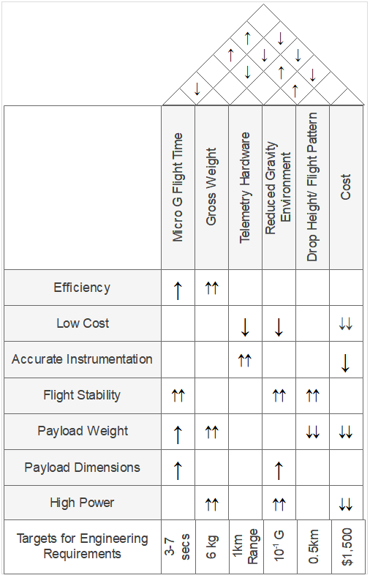
Figure 2: The House of Quality

2.6 Block Diagram

This block diagram below in Figure 3 shows the basic layout of the electronic components for the drone. The computer electronics and sensor hardware will be developed by Jacob, highlighted in green. The power distribution system will be developed by Adam, highlighted in blue.
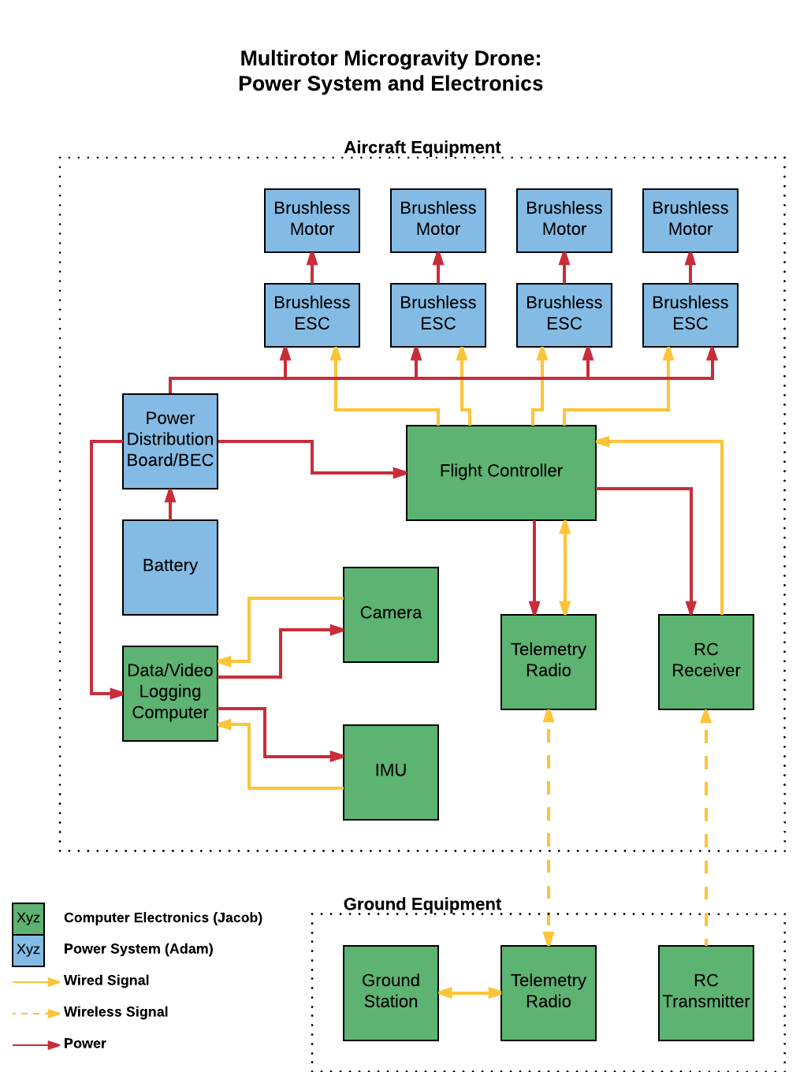
Figure 3: Electronics block diagram

3.0 Research

Microgravity experiments are conducted in a wide range of scientific fields to better understand the impact that gravity, or a lack thereof, has on a system. These fields study systems ranging in complexity from humans to molecules, and the duration of microgravity periods required vary from milliseconds to years. With our drone, we hope to accommodate such experiments that can attain adequate research with only seconds of microgravity and payloads that will keep our drone in compliance with FAA regulations. Since the recent boom in drone technology, extensive microgravity research has yet to be conducted in this scope. Our goal in researching for this project will be focused on taking what we can from current methods of microgravity experimentation as well as the feasibility for a drone to meet the standards for adequate microgravity experiments.

Terrestrial recreation of microgravity is currently limited to either freefall in a drop tower or parabolic flight in ballistic rockets or the 'Vomit Comet'. Drones come in a fixed-wing variety, which could lead to a scaled down replication of the 'Vomit Comet'. However, parabolic flight patterns involving horizontal translation require a large area of real estate, and with telemetry range being a limiting factor in our design this may cause issues in this method. Thanks to a multirotor drone, it will be feasible to create microgravity conditions more akin to drop towers. Achieving microgravity with freefall is much simpler compared to parabolic flight when needing to calculate every force acting upon our craft. Microgravity status (10⁻² to 10⁻⁶ G) is reached when our acceleration downward is equal to the force of gravity. This acceleration downward cancels out the force of gravity, creating a state of (near) weightlessness, or microgravity. True zero gravity is realistically impossible to reach due to non-gravitational forces such as air drag.

Our group has proposed two main options for achieving microgravity using a multirotor drone. We will conduct experiments using an inexpensive aircraft fitted with one flight controller and then with the other, comparing the controllability of each autopilot system. Each one has advantages and disadvantages, and it seems that each is geared toward a single method of freefall. The Pixhawk autopilot seems suitable for freefall where the aircraft ascends to maximum altitude, rotating the aircraft 180 degrees to turn upside down, then accelerating downward. Recovery would involve either flipping right side up and spinning the propellers to slow the aircraft, or deploying a parachute to slow the aircraft to a safe landing speed. Rotating the aircraft upright and attempting to oppose the downward motion of the aircraft could pose a great risk to the stability of the system. Experiments in drone freefall the past have shown drones that lose control of motor functionality when the motors are ‘free-wheeling’, or passively spinning in the wrong direction due to air being forced across the blades in the upwards direction. This prevents the motor from starting to spin in the proper when throttled up, at least to the extent that the motors do not simultaneously spin up to stabilize the aircraft. This further adds to the instability of the system and is typically an irrecoverable situation. Therefore, if we decide to use a Pixhawk flight controller we would need ESCs capable of active braking with the hope that the motors can stay within the control of the computer for the duration of the flight. The active braking mechanism uses electromagnetic force to ‘hold’ the propellers when not spinning, and actively slow them down when throttle is decreased. We would also heavily consider utilizing a parachute deployment system to slow the drone to a safe velocity before landing on the ground, much like skydivers use when they reach their minimum altitude after a jump. After assisted free fall is achieved for a few seconds, the parachute will deploy and slow the aircraft, perhaps still upside down to prevent unnecessary instability caused by rotating the aircraft. The parachute would be mounted inside a tube on the underside of the drone with the open end of the tube facing downwards. This eliminates the risk of the parachute becoming tangled in the propellers and damaged upon deployment, and it allows the deployment while the aircraft is turned upside down. The parachute could possibly be propelled by compressed air to give the push necessary for a full deployment. An actuator would be used to deploy the chute. An advantage of this free fall method is the ability for the aircraft to use asymmetrical propellers that have better lift characteristics than symmetrical propellers since they do not need to spin in both directions. This will make it easier to achieve high downward velocity of the aircraft during the assisted free fall.

We have come up with some creative ideas on how to ‘trick’ the aircraft into turning upside down to accelerate downwards at high speed. The main idea operates on the exploitation of a flight controller parameter during flight. The Pixhawk flight controller is an open-source piece of equipment with the capability to change all aspects of the code, even while the craft is flying. A protocol called Mavlink is used to communicate with the system and parameters can be written ‘on-the-fly’. The rotational orientation of the aircraft is designated in ArduCopter software by a parameter called compass orientation. This parameter was created so Pixhawk users could mount an external compass in any orientation on the aircraft frame and simply compensate for the compass direction in the software. If the aircraft were suddenly tricked into thinking that the compass is mounted upside down on the frame during a flight, the stabilization software would want to turn the craft by 180 degrees to right itself into the upside-down position. If the compass has been rotated properly without reversing any of the new pitch/roll/yaw controls, the craft should then be able to maintain stabilization. For example, if the right-side arms of the quadcopter tilt downwards, the left side motors will momentarily increase throttle to push the left side arms downwards and compensate for the error in orientation. An added effect of this exploitation is inherent in how the autopilot system maintains altitude of the aircraft. Under normal flight conditions with no compass orientation changes, the flight controller uses a barometer to measure the air pressure to maintain altitude in an altitude-hold flight mode. It operates on the concept that relative air pressure corresponds to an altitude. If the aircraft decides that it has dropped in altitude due to a positive change in air pressure, it will ascend until air pressure around the craft returns to its previous value. When we trick the aircraft into accelerating downward in an altitude-hold flight mode, the aircraft will notice a drastic increase of air pressure due to descent and throttle up the motors in attempt to compensate for it. If this throttle can be controlled (which can also be tuned in the parameters) to cause proper downward acceleration, it will assist us in achieving proper microgravity conditions during descent. The final consideration of this approach would be to reset parameters back to default either when recovery phase is initiated without the use of a parachute, or at the end of the flight so the aircraft can begin operating normally for the next flight.

The reversible throttle approach to achieving assisted free fall with our quadcopter involves a flight feature that is not supported by the Pixhawk flight controller. It could ideally be programmed onto the flight controller manually, however for the sake of time our group will simply use an existing flight controller that supports the feature. This method involves the reversal of the motor direction at the apex of the flight to give downward propulsion without needing to rotate the entire craft. This should offer increased stability of the system during the transitional period since rotational motion is not introduced to the aircraft system that must be counteracted to return it to a stable state. The propellers would spin in the reverse direction for the duration of the assisted free fall period, and the recovery would involve either a return of the propellers to the forward direction to slow the aircraft or a parachute-assisted landing. Although not supported by Pixhawk, the reversible motors are supported by another autopilot software called iNav. This allows for the throttle range to span from 100% to -100% rather than 100% to 0%. Through this feature the throttle could be automated to run backwards for downward acceleration of the craft.

If a reverse-throttle method of flight is not able to be automated on the flight controller itself, it could possibly be done by use of a separate microcontroller. A small Arduino-based microcontroller could be used as an intelligent passthrough of the PWM controls from the radio transmitter/receiver. During manual flight mode, the microcontroller would simply pass user controls through to the flight controller. Upon execution of the free fall flight command, the arduino would then use PWM input to force throttle towards 0% and then towards -100% to give downward thrust at a proper rate. This method would preferably need some sensory feedback from a barometer to gauge maximum altitude to begin the drop and minimum altitude to begin recovery phase. There is a high probability of instability in the aircraft during transitional phases between ascent, descent, and recovery, which will need to be minimized to prevent the aircraft from tumbling before it can regain motor speed. We have researched semi-active stabilization methods to keep the aircraft upright when the motors are unable to provide stabilization. It seems that a system of three DC motors fixed to the frame and equipped with massive discs rotating about the X, Y, and Z axes of the aircraft would provide gyroscopic stabilization that would resist any outside forces upon the craft until active stabilization from the propulsion motors is regained. This is referred to as a semi-active stabilization system since it uses power to create inertia, but the gyroscopic motors will not operate independently of one another. The three-axis gyro system will simply be orchestrated to activate when the propulsion motors slow to begin their reversal of direction, and the gyros will stop after the propulsion motors are back up to adequate speed in the opposite direction. This will occur at least twice during the flight, first at the apex before the assisted free fall and again during the recovery phase. The gyroscopic stabilization system will be tested on a small scale with our test craft to prove the viability of this option, and if it works it would be a simple solution to the very real issue of instability in this method of free fall.

An alternative version of the second method of free fall (upright craft with downward propulsion) was also researched but will not likely be implemented due to concerns of craft stability. This version the aircraft design involves the use of coaxial propellers attached to servos that provide variable pitch of the propellers during flight. In theory this would be the best option of flight by allowing the aircraft to maintain upright orientation and forward motor speed for the duration of the transitional phases of the flight. In research it has been found that this variable pitch is difficult to control with accuracy and the use of such a system could cause detrimental effects to overall flight stability. Students from Georgia Institute of Technology attempted this method in 2016 as outlined in Section 3.1. Calibration of the pitch of the propellers would be crucial to the success of this method as well as the use of an intricate control system to dictate propeller pitch throughout the flight. This option could be explored if the previously mentioned methods of flight fail, however we will not otherwise pursue variable pitch propellers.

3.0.1 Brief History of Drones

The advancement of drone technology has skyrocketed within the past decade, even considering this project a few years ago would be nearly impossible. Most drone technology wasn’t readily available to the public and was magnitudes more expensive than it is currently. The very first UAV was launched in 1849 by Austrian forces, the UAV was an unmanned balloon that carried 30 lb bombs over Venice. Nikola Tesla then invented a radio-controlled boat in 1898 which showed the potential drones could possibly have.

The unmanned aerial vehicle started to gain traction in 1918 with the U.S military, which acted as a cruise missile in combat, “Nicknamed the Kettering Bug, it was essentially a flying bomb with 12-foot wings made of cardboard and paper mâché, running off a 40-horsepower Ford engine. [6]” With its beginnings in the military, the drone was developed mainly for government use, out of the hands of the public. The U.S. military lead drone development in the 20th century, adapting their use from being strictly combat oriented, to focusing on surveillance and other operations.

From the use in the military, the drone market began to evolve and now influences nearly every field, from agriculture, to law enforcement, and the sciences. “The number of permits approved by the Federal Aviation Administration (FAA) has skyrocket in just two years, reflecting the increase of drone usage in commercial business. [4]” That increase of permits (from 2 in 2014 to 3100 in 2016) has led to the innovation in every aspect of drone design. Thanks to these innovations our project is much more feasible with a reasonable budget.

The dramatic increase in the drone market has led to a great reduction in cost for the hardware of commercial drones. The hardware now available is also extremely precise and capable of performing many tasks. “Hardware for commercial drones is important, especially in the early stages. However, as we see in other sectors, it will likely be the software that makes the difference in many applications. As it becomes cheaper to customize commercial drones, the door will be opened to allow new functionality in a wide array of niche spaces. [4]” As this quote states, software will play a huge part in whether or not our project will be able to succeed. The drone industry has advanced that the hardware will be able to accommodate what we are trying to achieve, it will be important for our group to program the drone to effectively utilize the hardware available to us.

3.0.2 Brief History of Microgravity Experiments

Interest in how things behave in reduced gravity conditions started during the Cold War space race. Microgravity experiments go back as far as the 1950s with free fall facilities, but once the era for human space travel took place, the considerations for long term effects of microgravity on biological systems was needed. Research is also needed for systems supporting these biological systems, such as environmental control, life support, fire suppression, etc. While the biological systems typically require a more prolonged exposure to microgravity conditions for proper testing, the support systems can be tested in brief scenarios, which is what our drone hopes to accomplish.

Throughout the 20th century microgravity research has been conducted through the means of drop towers, ballistic missiles, aircrafts, and the ISS. The terrestrial microgravity research capabilities flourished in the 1990s across the globe. “Collectively, these made up a broad, integrated architecture of experimental flight opportunities that when combined with ground-based R&D capabilities afforded researchers a variety of cost-to-performance options. [5]” While these research options are far less expensive than actual trips into Earth’s orbit, many researchers are still unable to gain access to these facilities due to cost and scheduling restrictions.

Since financial trouble in the U.S. during the 2000s and NASA’s limited funds, the microgravity R&D had been put to the side as more concerning issues, such as finishing construction of the ISS were deemed imperative. As the U.S. recovers from this financial state, interest in microgravity research funding is on the rise again. This project may serve in a crucial turning point in microgravity research history, “The vision, courage, and capability of the community to adopt new perspectives as the nascent field of microgravity research forms will not only determine the resources available but can clarify the value this work contributes to our society globally. [5]” As the drone market continues to flourish alongside the revitalization of microgravity research, projects such as this will become more prevalent and may become the future for affordable experimentation in this field of science.

3.1 Relevant Technologies

This section will go over all the components that will be used in the electronics system for the drone. Each of these components have a specific purpose and is an essential part to achieve our goals for this project. With each component we will explain its purpose and how it is relevant in helping us achieve our goals.

3.1.1 Flight Controller

The flight controller is the brain of the drone. As a specialized microcontroller, it is tasked with reading all of the sensor data and calculates the best commands to send to the drone in order for it to fly. Equipped with a processor and memory, it runs specialized firmware to control the various devices on the craft and perform calculations.

3.1.2 Global Positioning System

The GPS will measure the drone location by measuring how long a signal takes to travel from a satellite. These devices are only accurate to ±5m, so we will be using a barometer and IMU to calculate the drones position in the air. The GPS’s main function will be used to keep the drone in at a general location while free falling since the drone may drift due to wind or other factors.

3.1.3 Telemetry

Telemetry provides the ability for the operator to communicate with the drone while it is airborne. This is done using RF transceivers and receivers on the drone and at the ground station. Having a telemetry system on the drone will allow us to switch between different autonomous functions at will and stream data collected from our sensors.

3.1.4 Microcontroller

A Microcontroller is a small computer on a single integrated circuit. It includes a processor, memory, and programmable input/output peripherals. They are specialized in being cheap, compact, and are designed for low power consumption.

3.1.5 Camera

This will be the peripheral used by our microcontroller. It will be capable of recording video so that we can capture footage of the payload while in flight.

3.1.6 Inertial Measurement Unit

An IMU is the amalgamation of multiple sensors including an accelerometer, magnetometer, and gyroscope. This allows for 9 Degrees of Freedom (9 DoF) measuring all forces acting on the device in the XYZ axes. This will allow the drone to completely stabilize itself in the air by making any corrections to angular tilt or velocity, exactly what we need to do to achieve microgravity conditions.

3.1.7 Motors

DC brushless motors will power the drone. These motors will spin independently of one another to provide both thrust for and stabilization of the aircraft.

3.1.8 Propellers

Although the propellers could be deemed a mechanical system on the craft, they will be taken into consideration with respect to the power system. The propellers translate rotational motion into downward (and upward) thrust to achieve flight. Characteristics of the propeller such as size and pitch will determine the design of the power system.

3.1.9 Electric Speed Controllers

The electric speed controllers are brushless motor drivers that convert PWM signals from the flight controller into equivalent speeds of the DC motors. They translate a PWM signal with a given duty cycle into a percentage of ‘throttle’ of the motor from 0-100%.

3.1.10 Power Distribution Board

The power distribution board is a printed circuit board that distributes the battery power throughout the aircraft, mainly to the speed controllers. It also allows for the power of the flight controller and other low-voltage accessories through the inclusion of voltage regulator circuitry, described in 3.1.12.

3.1.11 Battery

A battery will be the power source for our aircraft since an electric motor system propels it. The battery has the capacity to power the craft for the duration of the flight, including the recovery and landing period. Using a battery will allow us to fly the aircraft to a sufficient altitude to perform our freefall flight pattern.

3.1.12 Switching Voltage Regulator

Low-voltage electronics are not able to be powered with an unregulated voltage source on our drone. For instance, if a 6-cell battery is plugged in as a voltage source, it is providing the craft approximately 24V DC. This is well outside the operating range of voltage for the microcontroller, the Raspberry Pi computer, and the flight controller. Therefore, some method of voltage step-down must occur to provide a source suitable for these electronics. A switching voltage regulator does just that, providing a constant voltage source whose current provided depends on the circuit components chosen.

3.2 Part Selection

To have an optimal setup that meets our budget requirements, we have made comparisons between various brands and similarly-functioning parts. This section narrates our thought process behind choosing the components that we will order for this project.

3.2.1 Power System Comparisons

The power system of the aircraft is possibly the most difficult system for which to select parts. The autopilot system governs the flight pattern of the craft, but it will work regardless of the overall efficiency of the aircraft - the power system, however, must be picked with careful consideration to optimize efficiency. Aircraft dimensions, mass, cruising airspeed and maximum airspeed must all be taken into consideration. The aircraft dimensions limit the size of the motors and propellers to be used. Mass, however, defines the need for the motor and propeller size. A heavier craft demands more surface area on the propellers to provide the thrust it needs. Propellers can consist of added blades per propeller to achieve more thrust per motor when propeller length is limited. This provides a diminishing return for power and efficiency, so extra blades are not desired. The propeller’s pitch and shape give it certain aerodynamics that determine thrust at various speeds. Pitch is typically selected to achieve maximum efficiency at the speed the propellers will most often be spinning (i.e. hover speed for typical multirotors). We will need to select a propeller that can lift the craft efficiently at low speeds, but still have enough power to accelerate the craft to high velocity.

Once propellers have been selected, motors must be matched to suit the propellers. Brushless DC motors are the most popular type of multirotor motors, due to their high power and efficiency versus outdated brushed motor technology. “Brushless motors offer several advantages over brushed motors thanks to the design. Much of it has to do with the loss of brushes and commutator. Since the brush is required to be in contact with the commutator to deliver a charge, it also causes friction. Friction reduces the speed that can be achieved along with building up heat. ...This means that brushless motors run cooler and more efficiently so they’re able to deliver more power. [6]” Brushless motors are rated most generally by a unit called KV, which translates to the rotations per minute per volt applied to the motor. Higher-KV motors are often used in smaller craft to achieve higher motor speeds with small propellers. They also require lower voltage to achieve sufficient speed, since lower voltage batteries are most commonly used in small craft. Adversely, lower-KV motors are used often with larger craft and batteries with higher voltage. They provide the torque that large propellers need to lift heavy payloads. Besides KV, motors can be further compared by their individual performance through thrust tables. These tables offer the thrust provided and the current drawn for one or a few combinations of propeller and battery. From these thrust charts, the most suitable motor can be chosen.

The electric speed controllers (ESCs) are very simply chosen by finding an ESC rated for 20-30% higher current than the motor will typically draw. This allows enough headroom for the ESC to power the motor in the event of momentary high current draw without destroying the power circuitry. ESCs are additionally considered for extra characteristics such as the following: heat dissipation, firmware/programmability, and the inclusion of a Battery Emulation Circuit (BEC). Heat dissipation is an important factor for consideration in our project. ESCs generate large amounts of heat when pushed to their limits of performance and we intend to run the motors at maximum speed during portions of our flight. We will need to pick ESCs that can dissipate this heat effectively. “ESC firmware is the software running on every ESC, which determines the ESC’s performance, and what configuration interface can be used. The firmware you can use depends on the ESC’s hardware. [7]” ESCs are often programmed via computer software and firmware/hardware determines the features of the ESC such as PWM frequency. This is the frequency at which the flight controller communicates the motor speed to the ESC, and higher frequency is better. Other features of the ESC include active braking and low-voltage cutoff. Active braking is a feature that allows the motor to actively decrease motor speed when throttle is reduced. Low-voltage cutoff protects the craft from draining the LiPo battery down to an unsafe level. The inclusion of a BEC on an ESC is beneficial if some of the electronics on the aircraft require a 5V power source that is not provided by the power distribution board. BECs also provide redundancy if a 5V source is present but not reliable or powerful enough. Aircraft that utilize extra electronics or servos often use one or more spare BECs to provide the current drawn by these items.

The battery is the sole source of power on most multirotor drones. It has the highest demand placed upon it of all the components on the craft. It is therefore extremely important that the right battery is selected for the aircraft for its specific mission. A few factors make up the formula for the right battery - chemistry, voltage, capacity, and discharge rate. Battery technology has improved immensely in the last few decades and the most popular battery chemistry for drones is the Lithium Polymer battery, or LiPo, for short. The LiPo battery boasts an incredibly high discharge rate and the absence of a quirk called ‘battery memory’ that would diminish the capacity of some older batteries. LiPo batteries are perfect for multirotor drones by providing the quick bursts of energy and maintaining a relatively linear voltage drop rate for most of its discharge process. LiPo batteries provide a voltage source of 3.7V per cell nominal, with a maximum voltage of 4.2 volts per cell. These cells can be wired in series to create higher voltage battery packs for use in large aircraft with higher-voltage power systems. Lower-KV motors often require higher voltage to maintain optimal speed, so many multirotors such as ours might require six-cell batteries or greater. Capacity of the battery is determined by calculating the current drawn by the aircraft and the duration of the flight required. For a simple example, an aircraft that draws 20A of current would require a 20,000 milliamp-hour (mAh) battery to fly for one hour. In the case of our project, we will need to decide the time required to perform the flight, and factor in the average current drawn by the craft during the flight. It is always advisable to err on the side of caution when deciding battery capacity if the aircraft draws more current or takes a longer time to land safely. Minor variances in total current draw due to autopilot stabilization, change in takeoff weight, etc. will affect the maximum capacity required. A final consideration when picking a battery is the discharge rate of the battery. It has been stated that LiPo batteries are capable of high discharge rates but not all batteries are created equally. Some manufacturers design batteries more efficiently to withstand higher current draw safely, and it is necessary to find a battery that works well enough for your craft. As an example, if a 3-cell battery has a capacity of 1,000 mAh and a constant discharge rate of 25C and a maximum discharge rate of 50C, this means that said battery should safely be able to provide a constant current of 25 times the theoretical current the battery would deliver per hour, which is 1A, for a result of 25A. The maximum discharge rate is similarly calculated to find that the battery can momentarily provide up to 50A of current.

An often-overlooked portion of the multirotor power system is the power distribution board. Some flight controllers include it on their circuit board, and sometimes ESCs are designed as an all-in-one package with a battery input and motor outputs. For our project, however, we will utilize a discrete power distribution board to support our high-power needs. Like the battery, the power distribution board will need to be able to handle the current of the entire aircraft power system. This is achieved by including terminals/solder pads for the battery as well as all the outputs. The circuit board traces must be robust to handle the high current and trace patterns must be optimized to eliminate excess current through any single trace. The power distribution board may or may not include voltage regulators to provide 5V or 12V to electronics on the aircraft.

3.2.2 Propeller

The propellers of our aircraft must not only be the proper size and pitch to fit our needs, but they will likely need to have semi-symmetrical shape to maintain adequate thrust characteristics whilst spinning forward or backward. They will also bear a higher load than the average drone prop with all the force they will be subjected to recovering from freefall, so the propellers must have excellent strength and minimal flexibility. For these reasons, we have chosen to explore the use of carbon fiber propellers for their high weight-to-strength ratio. The Falcon propeller is intended for gasoline motors, so it is strong enough to withstand high torque and speed. It is also semi-symmetrical meaning it should have at least average lift characteristics when spinning backwards. The propellers are heavier than usual, but the extra mass is used to add strength. The same situation goes for the TCF propellers (having very similar characteristics to the Falcon propeller), however they appear to be a discontinued item. We researched this brand mainly to gather more information on what to expect from the Falcon propeller due to its limited information available on the website. The third propeller is the T-Motor propeller. It does not come in a high-pitch option as do the other propellers, so that may not be suitable for our purposes. It is much lighter than the other two propellers since it is a traditional multirotor propeller, however it does not have symmetrical shape, so it will likely not perform well when spinning backwards. This will only be a suitable option if we decide to explore other flight patterns such as flipping the drone upside down to propel itself downwards rather than reversing motor direction.

Table 1: Propeller Comparisons
Brand | Falcon [8] | T-Motor [9] | TCF [10]
Price (USD) | 40.00 | 31.50 | 22.50
Mass (g) | ~115 | 28 | 115
Size (cm) | 16x8 | 16x5.4 | 16x8
Features | Carbon fiber, heavy duty, semi-symmetrical | Carbon fiber, lightweight, pre-balanced | Carbon fiber, heavy duty, balanced, semi-symmetrical

3.2.3 Motor

Research on the motors initially started with our prior knowledge about DC brushless motors, giving us an idea on where to start looking. It is known that lower KV motors operate at high voltage and provide high torque to push large propellers. We found motors that are recommended for our propeller size and pitch we chose. Several brands have been considered but two brands will be discussed specifically. KDE is a reputable brand that manufactures brushless motors for heavy-lift drone systems, so they are an ideal candidate. They offer a 400KV motor that lists a maximum thrust of up to almost 4 kg per motor with a similar propeller to ours. This would give ample power to our propellers to accelerate and recover our drone. The price is a bit expensive per motor considering our restrictive budget, however it is imperative that the motors perform extremely well, and it is money well-spent. A slightly more expensive option is the Tiger Motor (or T-Motor) U5 400KV option. Tiger Motor is another reputable brand that is considered an industry standard by much of the drone community. They are known for well-engineered and high-performance motors. The maximum thrust for this motor is not listed online, however it is recommended for the size of propeller we will be using. This is a more expensive option compared to the KDE motor, so it is a slightly less favorable option without more details about performance. Therefore, I decided to research a second motor by T-Motor, one of the Navigator Series motors. The KV rating and propeller size are both the same, however there is more information listed about the performance of this motor. Using a six-cell battery and 16” propeller the motor provides just over 3 kg of thrust. This motor is significantly lighter and slightly less expensive than the KDE motor, so it may be considered as a lighter-duty alternative to the KDE motor if the craft has an excess of power or weight.

Table 2: Motor Comparisons
Brand | KDE3520XF-400 [11] | Tiger U5 [12] | T-Motor MN4014 Navigator [13]
Price (USD) | 112.95 | 125.90 | 99.90
Mass (g) | 245 | 156 | 150
Size (cm) | 4.2x4.5 | 4.25x3.75 | 4.47x3.45
KV | 400 | 400 | 400
Max Thrust (kg) | ~3.8 | unspecified | ~3.0

3.2.4 Electric Speed Controller

Electric speed controllers (ESCs) must be selected to provide sufficient power to the motors, govern the motor speed at a high rate, and dissipate heat efficiently. Three ESCs were chosen to be compared by their current rating and features. The T-Motor is the most heavy-duty speed controller of the three, rated for 60 continuous amps of current and 80 amps during momentary bursts of current. It is also equipped with a heatsink for maximum heat dissipation. The downside to this ESC, however, is both the price and the inability to program the ESC for certain features such as active braking and reversible motor direction. This ESC will be suitable in an instance where we will be using large motors and propellers, and the craft will not need to reverse motor direction during flight. The Lumenier ESC has a considerably lower price point for a comparable current rating. It can provide 50 amps continuous current and 60 amps burst current which should be suitable for our application. Another advantage of this ESC is the ability to program the aforementioned features. The ESC is lightweight and seems to be able to deliver the power we need for our drone. Heat dissipation can be assessed upon testing and a heatsink can be added manually if necessary. The DYS ESC is the most light-duty ESC being considered, and our research has led us to believe it will not be suitable for our drone. It is a micro form factor ESC designed for small racing drones, and although it is advertised to provide 40 continuous amps of power for up to a 22.2 V system, this might put too much stress onto the circuitry and cause it to fail during flight.

Table 3: Electric Speed Controller Comparisons
Brand | T-Motor 60A [14] | Lumenier 50A [15] | DYS 40A [16]
Price (USD) | 99.99 | 24.99 | 18.99
Mass (g) | 73.5 | 7.3 | 25.2
Size (cm) | 6.65x3.85x1.87 | 3.5x2.1x0.7 | 6x1.7x0.75
Features | Heatsink, 60/80A current | BLHeli Firmware, active braking, reversible direction | BLHeli Firmware, active braking, reversible direction

3.2.5 Battery

Three similarly-sized batteries were researched to compare the cost versus performance of each battery. The Turnigy battery has a continuous discharge rate of 180A and peak discharge rate of 360A. This seems suitable for our application, since we should be drawing a maximum of approximately 120A of current during flight. A lighter weight alternative to this is the Multistar battery, which boasts a lighter weight at the cost of discharge capability. Its discharge rate of 100A continuous/200A peak does not perform up to our current of ~120A which would very quickly stress the battery and damage/destroy it. We must run under the assumption that we will need to operate at maximum throttle for a moderate amount of time, and the ‘peak’ current range is not intended to be utilized for more than a few seconds. This risk is not worth the savings in cost or weight, since LiPo batteries can become damaged or destroyed very quickly and easily if overworked. We will not consider this battery option unless we scale down the power of the propulsion system. The third battery option comes from a brand called Pulse, who have been a major name in the LiPo battery industry for a long time. They are known for designing incredibly powerful batteries from large to small form factor, and they have a proven track record of quality. Their six-cell 6,000mAh battery boasts a 35C discharge rate, which equates to a 210A discharge rate. This should exceed the needs for our aircraft if we purchase a two-pack of these batteries and strap them on either side of the craft, running them in parallel. The two-pack costs approximately $190, which is significantly more expensive than the Turnigy battery.

Our group initially intended to purchase the Turnigy Graphene battery since it is the best price for the specs and weight. However, it has been brought to our attention that our sponsor is unable to purchase the item from the website where the low price was advertised, HobbyKing. This could be due to reliability issues from this distributor, since HobbyKing has a reputation for failing to deliver products and lacking the customer service to provide refunds for these failed deliveries. It could also be for financial security reasons, since our sponsor is unable to use secure payment portals such as PayPal. This means that purchasing from HobbyKing would require the direct use of a credit card, whose information can be compromised by third-party individuals. This is a perfect example of real world circumstances since many companies strictly use corporate credit accounts to make purchases. The only way we will be able to bypass this situation would be to purchase the battery with our own money and include the cost into our budget. This is because the craft can only be developed with no more than $1500 in parts no matter how they were purchased.

Table 4: Battery Comparisons
Brand | Turnigy Graphene [17] | Multistar [18] | Pulse (x2 batteries) [19]
Price (USD) | 109.04 | 71.74 | 188 (combined)
Mass (g) | 1610 | 1189 | 1768 (combined)
Size (cm) | 18.3x7.7x5.7 | 15.6x6.5x5.3 | 16x4.9x5.1 (each)
Features | Graphene technology, 15C discharge,  12,000 mAh capacity | 10C discharge,  12,000 mAh capacity, lightweight | 35C discharge,  6,000 mAh capacity each, redundant double-battery system

3.2.6 Power Distribution Board

All power distribution boards (PDBs) considered that are capable of high current did not include low voltage regulation systems for the sake of price. The regulators can be purchased separately at a lower cost. The Vulcan board is the most expensive option but can support higher current than the other two. This will be considered as an option only if our system exceeds a 200 A current draw at any point during the flight. The Electriflite PDB is the cheapest option but the large mass is an unnecessary characteristic which will steer us away from it. The most suitable option for price and mass seems to be the Dale PDB, consisting of a very simple plate with battery input pads and 8 large pads for power output. This configuration should suit our application. Since we chose the Dale PDB, the physical specifications and features of the custom printed circuit board have been included in the same column of the table above. The custom circuit board will include a regulator for powering the 5V electronics aboard the craft, and the board will be designed to include the option to add another 5V/3A regulator as well as a 12V/3A regulator. If we choose to add these extra features, this will allow the customer regulated low-voltage supply options to power any electronics they choose to place within their payload for their experiment. The second 5V regulator would be necessary because the single 5V/3A regulator will be loaded down by the flight controller, Arduino microcontroller, and Raspberry Pi during normal craft operation.

We considered integrating the power distribution circuitry directly on our custom printed circuit board, however the high-current output of the battery to the motors would require very large and thick traces on the PCB to operate. If the traces do not have the proper cross-sectional area for the current to be passed through them, they will burn and disconnect very quickly due to their resistance. Circuit board traces are not designed to dissipate heat efficiently, so they are very susceptible to this scenario if designed improperly. This will destroy the circuit board and cause total electrical failure of the craft during flight, ending in a crash. If we intended to integrate the correctly-sized traces of the power distribution system onto our circuit board, the cost of the board would increase significantly. We found that this is due to the nature of the manufacturing process of the PCB. Since the metal trace material is deposited onto the board at uniform thickness, the entire circuit board would need to be made of thick traces. This is both costly and unnecessary. Therefore, we decided to select a discrete power distribution board. The custom printed circuit board will be discussed in Section 6.1.

Table 5: Power Distribution Board Comparisons
Brand | Vulcan [20] | Electriflite [21] | Dale [22] + Custom PCB
Price (USD) | 35.00 | 12.76 | 13.55 + 26.00
Mass (g) | 18 | 101 | 9.7 + 60
Size (cm) | 6.4x6.4x0.2 | 7.4x7.4x2.2 | 6x5x0.2  10x10x1.6
Features | 250 A | 200 A | 200 A, 5V 3A switching regulator

3.2.7 Switching Voltage Regulator Components

Two common types of voltage regulators exist for stepping down DC voltage: the switching voltage regulator and the linear voltage regulator. “Linear regulators are a great choice for powering very low powered devices or applications where the difference between the input and output is small. Even though they are easy to use, simple and cheap, a linear regulator is normally inefficient. The equation for dissipated power in a linear regulator is:
Power dissipation = (input voltage - output voltage) x load current
Switching regulators on the other hand are highly efficient and available as modular chips which are compact and reliable.” (Intersil Power Management, Analog and Mixed Signal Semiconductors). Switching voltage regulators have an added amount of versatility by their ability to step voltage up or down. Their disadvantage is typically cost versus a linear regulator, however efficiency and low heat generation have a higher trade off value for us. “Switching regulators rapidly switches a series element on and off. They can operate with both synchronous and non-synchronous switches (FETs). These devices store the input energy temporarily and then releasing that energy to the output at a different voltage level. The switch’s duty cycle sets the amount of charge transferred to the load. [23]” As this article describes, switching regulators are so efficient because the series element is either fully on and conducting electricity or it is switched off, so there is no part of the cycle where a component is activated and not sending power to the output. If this were the case as in a linear regulator, the energy would be dissipated as heat and the power capacity would be reduced. The tables below will discuss our choices of components for our switching voltage regulator circuit.

Table 6: 100uF Capacitor Comparisons
Brand | Nichicon 50V [24] | Nichicon 35V [25] | Nichicon 63V [26]
Price (USD) | 0.51 | 0.56 | 0.85
Mass (g) | ~1 | ~1.5 | ~2
Size (cm) | 0.8x0.8x11.5 | 1x1x12.5 | 1x1x2
Features | Electrolytic, 50VDC rating, 20% tolerance, RoHS compliant | Electrolytic, 35VDC rating, 10% tolerance, RoHS compliant | Electrolytic, 63VDC rating, 10% tolerance, RoHS compliant

This capacitor will be wired in parallel to the unregulated input of our switching voltage regulator. Therefore, it is important to consider the voltage rating of the electrolytic capacitor to avoid an over-voltage input which would damage the component. We plan to only operate the drone with a 24V battery, so the voltage input of this circuit should not vary from this value by more than one or two volts. The decision of which capacitor to use will come down to the highest voltage seen by the regulator input terminal, as well as the tolerance of the capacitor. The 50V capacitor leaves a large amount of room for the instance where a different battery would be connected to the circuit, however the tolerance of this capacitor is not desirable. The 35V capacitor seems more suitable for our purpose, only marginally more expensive than the 50V option and it has a tighter tolerance. The only stipulation is that the input can at no point meet or exceed 35 volts. The third option, the capacitor rated for 63V, has a low tolerance and high voltage rating. However, it is almost twice as expensive and considerably larger than the other two capacitors. Our group will probably choose the 35V option for this circuit considering we intend to strictly adhere to a 24V input.

Table 7: 100uF Capacitor Comparisons
Brand | United Chemi-Con 10V [27] | Panasonic 25V [28] | Nichicon 6.3V [29]
Price (USD) | 0.72 | 0.91 | 0.76
Mass (g) | ~1 | ~1.5 | ~2
Size (cm) | 0.8x0.8x11.5 | 1x1x12.5 | 1x1x2
Features | 10VDC rating, 20% tolerance, RoHS compliant | 25VDC rating, 20% tolerance, RoHS compliant | 6.3VDC rating, 10% tolerance, RoHS compliant

The capacitor that is wired in parallel with the output of the switching voltage regulator circuit can be rated at a lower voltage since the output is regulated to 5V. This means that the capacitor options we chose ranged from 6.3V to 25V. The first capacitor was rated for 10V and has a 20% tolerance. It is the lowest cost option but has a low tolerance of capacitance. The second capacitor manufactured by Panasonic is rated for 25V, so it is well above the voltage specification, however it is very expensive at $0.19 more per component than the 10V rated capacitor without any lower tolerance. The third option by Nichicon offers a capacitor rated for 6.3V and has a tolerance of 10%. This might be the desirable option if we can be sure the 5V output does not change or spike at any point during operation. Tolerance is a consideration to be taken mainly when planning for mass production, since variances in capacitance can be dealt with for prototypes (components simply replaced if they are unacceptable) but mass production requires high yield of the circuit boards. If a significant number of circuit boards have components that fall outside tolerable specifications, these boards must be reworked or replaced thus resulting in a lower yield of the product.
Table 8: 100uH Inductor Comparisons
Brand | Vacuumschmelze [30] | Pulse Electronics [31] | TinySine [32]
Price (USD) | 4.60 | 3.42 | 1.00
Mass (g) | ~10 | ~10 | ~10
Size (cm) | 2.5x1.4x2.75 | 2.46x1.55x2.8 | 1.3x1.3x0.8
Features | 3A rating, 25% tolerance, RoHS compliant | 3A rating, tray-style package, 20% tolerance, RoHS compliant | 3A rating

The inductor that is wired in series with the IC and the output of the switching regulator circuit is specified to have an inductance of 100uH. Since the regulator will be allowed to provide a current of 3A, the inductor will be rated appropriately. The first inductor from Vacuumschmelze is the most expensive product, which might be an issue considering it does not offer any special advantages over the other options. The second inductor comes from a company called Pulse Electronics. This inductor is set in a (likely ceramic) tray for ease of mounting on a printed circuit board and insulation from surrounding components. It is less expensive than the Vacuumschmelze inductor and has a tighter tolerance. The third option is by far the least expensive component but has little details about the specifications of the inductor itself. This inductor from TinySine is specified for 100uH and 3A, but does not offer a datasheet. We will probably use the Pulse Electronics inductor unless we are very pressed for cost, since we would rather have a full datasheet of information about the component and use a part that is RoHS compliant.

Table 9: Schottky Diode Comparisons
Brand | ON Semiconductor 1N5822 [33] | ON Semiconductor 1N5821 [34] | ON Semiconductor 1N5820 [34]
Price (USD) | 0.23 | 0.19 | 0.20
Mass (g) | 1.1 | 1.1 | 1.1
Size (cm) | ~0.2x0.2x0.5 | ~0.2x0.2x0.5 | ~0.2x0.2x0.5
Features | 3A/40V rating, lead-free | 3A/30V rating, lead-free | 3A/20V rating, lead-free

The Schottky diode used in this circuit is connected in parallel with the output of the regulator. The circuit used online specified the diode to be the 1N5822 model which is rated at 40V. We explored the other variations for this rectifier diode with ratings of 30V and 20V, but the price point was almost identical to that of the listed diode. Therefore, we will likely purchase and use the 1N5822.

Table 10: Switching Regulator IC Comparisons
Brand | ON Semiconductor LM2576-5.0 [35] | Texas Instruments LM2576T-5.0 [36] | ON Semiconductor LM2576-12 [37]
Price (USD) | 1.95 | 3.89 | 1.95
Mass (g) | 2 | 2 | 2
Size (cm) | ~1x1x0.5 | ~1x1x0.5 | ~1x1x0.5
Features | 3A/5V rating, through hole form factor | 3A/5V rating, through hole form factor | 3A/12V rating, through hole form factor

The switching voltage regulator IC is the heart of the regulator circuit. It contains the internal elements to drive the circuit stepping the voltage up or down, depending on the characteristics of the circuit. For our purposes, two brands of 5V regulator and one 12V regulator are being considered. The ON Semiconductor IC rated for 5V and 3A is relatively inexpensive. Alternatively, the TI version is almost twice the price for virtually the same performance. For this reason, our group will go with the ON Semiconductor IC. The 12V IC is being considered in this comparison when contemplating the construction of a 12V switching regulator circuit for our power distribution board. This will offer more power source options for the user when they need to connect the electronics of their payload. The price and current output are both the same for the 12V version of the IC.

3.2.8 Electronics Comparisons

There are three common considerations we had to make when comparing electronic devices for our project. They are price, mass, and size. The budget for this project may be the most limiting factor when deciding which parts we need. Typically, when the price of one of these parts goes up, so does the quality and power. It would be far easier to decide on what to get by picking the latest and highest quality electronics, but with a restricting budget that is shared among three different disciplines, it is crucial that we pick parts that are able to do exactly what we need, at the most reasonable price. Due to this restriction, we are forced to make tradeoffs between different electronics and choose to take less powerful options for our lesser priority goals in the project.

After considering the price, it is very important that we take into consideration of the mass of every part that we are considering. As seen in our House of Quality (Figure 2), a smaller gross weight shows strong correlation with everything that it is involved with. The lesser weight will provide greater efficiency for the craft, allowing it to use less power in lifting itself and giving it more time in the air. A lighter craft will also allow us to carry a heavier payload, again due to less power being used in lifting the craft and more power into carrying the payload.

Finally, the size of the electronics chosen will have to be considered so that everything will be able to fit onto the craft. Most microcontrollers and other electronic equipment we have considered are very compact, omitting unnecessary GPIO ports and unrelated features. For example, if we were to use an Arduino-based board to control a gyroscopic stabilization system, we would pick the Adafruit Trinket to control a single motor driver running three motors in parallel since they do not need to operate independently. This would reduce the footprint of this system to less than a quarter of the size of an Arduino Mega and three motor drivers. This leaves as much room as possible for the payload at the center of mass of the craft, and less equipment at the extremities of the craft is better.

3.2.9 Flight Controller

Since the flight controller will be the brain of our drone, it will be essential to get the highest quality product possible, so everything can run as efficiently as possible. Every other electronic component (aside from the microcontroller) will be connected to the flight controller. It will be loaded with our flight programs and calculate and collect all the data gathered from our sensors. Most flight controllers also have a built-in barometer which will be necessary for giving us accurate altitude measurements.

With this said, the priorities for an optimal flight controller will be the processor, memory, and barometer. The first product in Table 11 is our most ideal flight controller. With its relatively small size and advanced processor paired with a co-processor, it should easily handle anything this project needs it to do. The PixHawk Mini is also optimized for the PX4 flight stack (an open source autopilot software), allowing us to easily jump into programming autonomous missions with plenty of documentation.

The second product on the table, the PixFalcon, is a Chinese clone of the PixHawk Mini. It has been decided that the quality of the components may be compromised due to the large difference in price. Online forums reflect this notion as some users complain of the reliability and compatibility of this flight controller with genuine peripherals for the 3DR version.

The final product we are considering is the F4 Omnibus Pro V2. This controller comes at a fraction of the cost of the other two products. With just enough output pins for four motors, a comparable processor (minus the co-processor and half the memory size), and a slightly more accurate barometer, the controller seems promising enough to fulfill our mission. The F4 is also compatible with a BetaFlight variant called iNav (an open source autopilot software) allowing us to have a similar experience with programming. This software allows for plenty of control customization and incorporates functionality of a GPS/compass combination for holding position in a horizontal plane. This will be vital for our experiment since we will require the craft to stay within a small region of airspace for safety and ease of craft recovery. Wind has a large impact on the horizontal position of a drone in flight, and even a brief flight is enough time for wind to push the craft out of its designated flight zone without position holding assistance.

Further testing with the F4 flight controller option has showed promising results for its use. We have now decided to use the less powerful flight controller in conjunction with a second microcontroller for total flight control. By using SBUS communications between the two, the microcontroller will be able to command the flight controller for throttle power. The flight controller will be solely used to stabilize the craft and GPS positioning. Ideally the SBUS communication could also provide data feedback to the microcontroller to streamline the control process and eliminate the need for redundant sensors onboard the craft. This would in turn create more accurate results and reduce weight on the craft.

Table 11: Flight Controller Comparisons
Brand | Pixhawk Mini Flight Controller [38] | PixFalcon Micro PX4 Autopilot¹ [39] | Flip32 F4 Omnibus V2 Pro [40]
Price (USD) | 229.99 | 131.12 | 24.39
Mass (g) | 15.8 | 15.8 | 5.7
Size (cm) | 3.8 x 4.3 x 1.2 | 3.8 x 4.3 x 1.2 | 3.6 x 3.6
Processor | 32bit STM32F427:  168MHz  256KB RAM  2MB Flash  1.7-3.6V  32bit STM32F130 Co-processor [41] | 32bit STM32F427:  168MHz  256KB RAM  2MB Flash  1.7-3.6V  32bit STM32F130 Co-processor [41] | 32bit STM32F405  168MHz  192+4KB SRAM  64KB CCM  1MB Flash  1.8-3.6V [41]
PWM outputs | 8 | 8 | 6
MicroSD | Yes | Yes | Yes
Barometer | MEAS MS5611  Altitude Resolution: ±10cm [42] | MEAS MS5611  Altitude Resolution: ±10cm [42] | BMP280  Altitude Resolution: <10cm [43]
¹ According to a customer review, PixFalcon telemetry is not compatible with Standard APM/PX4 radios (would need to purchase Micro Telemetry Radio)

3.2.10 Global Positioning System

The Pixhawk and Pixfalcon come packaged with the M8N GPS/Compass module so we would be heavily inclined on using that module instead of purchasing a completely different GPS. If we do decide on the F4 flight controller, however, an alternative would be the SAM-M8Q GPS system. The SAM-M8Q would be a smart alternative due to the drastic difference in weight and size. Purchasing a standalone GPS without a compass could be alleviated by the 9 DoF IMUs, which have integrated compasses.

Since deciding to add a microcontroller to command the flight controller we will need to purchase a GPS and compass module. This gives us the option of purchasing either of the GPS components listed in the table below. Due to our constraints on budget and less important role the GPS will play, the cheapest option is what we have decided on, the M8N. The GPS will not have to be extremely accurate and will only be used during freefall to prevent the drone from drifting out of a designated geofenced area. This designated area will prevent accidental collisions with the environment and help make the drone safer to operate near anyone involved in the experiment.

Table 12: GPS comparisons
Brand | uBlox M8N  GPS [44] | uBlox SAM-M8Q  GPS with SBAS receiver [45]
Price (USD) | 14.13 | 27.99
Mass (g) | 10 | 7.5
Size (cm) | 3.7 x 3.7 x 1.2 | 3.0 x 1.6
GNSS | 3 Concurrent (GPS, Galileo, GLONASS, BeiDou) | 3 Concurrent (GPS, Galileo, GLONASS, BeiDou)
Supply (V) | 2.7-3.6 | 2.7-3.6

3.2.11 Telemetry

With telemetry, other than the common factors stated earlier, there is not much variation when it comes to power or receiving capabilities. The max output power for each of the sets will be 100 mW, to keep within FCC regulations. A full duplex communication is something that each of the sets we look at must have. While the telemetry will be used to send data back to the ground station for live feedback, the ground station will also have to be able to send commands to the drone while it is in the air. The full duplex will allow data to be sent both ways without one party preventing another from trying to communicate.

The second part listed, with a price comparable to either of the previous parts, has a significantly reduced mass. This is made possible with a micro transceiver that has an integrated PCB antenna on the Micro HKPilot Telemetry Radio. The third part, the Hobbypower Radio, is just a ground module. After our research, the microcontroller that we have chosen to command the flight controller will have a built-in telemetry module (outlined in Section 3.2.12). Not only will this allow us save space and weight on the craft, the cost of purchasing an entire telemetry set will be greatly reduced. Its range is sufficient for our purposes, so we will not need to worry about loss of signal during flight. This is because 915MHz transmission, as opposed to 2.4 GHz WiFi transmission, has better range and obstacle penetration with comparable transmitter and receiver power.

Table 13: Telemetry Comparisons
Brand | 3DR Telemetry Radio Set [46] | Micro HKPilot Telemetry Radio Set with Integrated PCB Antenna¹ [47] | Hobbypower Radio Telemetry Ground  Module [48]
Price (USD) | 49.99 | 39.99 | 16.98
Mass (g) | 11.5 | 1.6 | 7.2
Size (cm) | 2.55 x 5.3 x 1.1 | 1.9 x 2.5 x 0.5 | 1.7 x 5.9
Receive Sensitivity (dBm) | -117 | -117 | -121
¹ Would be required to get if also purchasing the PixFalcon

3.2.12 Microcontroller

While microcontroller can power many different components at once and perform a multitude of tasks, the microcontroller for this project will only be used for additional data collection in the form of video recording. The most ideal part for this will be one that is cheap, lightweight, and have enough memory to hold the footage for each flight. The cameras found for recording are only compatible with their respective controllers, so an in-depth comparison will be made with the microcontroller and camera as pairs in the camera section (Section 3.2.14).

With the decision to use a microcontroller to command the flight controller’s use of the motors, further research comparisons will need to be made between microcontrollers. Important specifications to take into further consideration would be the processor speeds, for processing the autonomous flight program efficiently while being able to record data, as well as storage space which will allow us to log a large amount of data during flight. The Feather has been selected as this microcontroller due to these factors. The model we have selected has a built-in radio package, which increases the price here, but we will be saving money overall since a standard radio module would cost more than the extra cost here. While the Zero may appear to have better specifications than the Feather, the Zero is running an operating system and would also be capturing video footage during the flight. To alleviate the amount of work a single controller will be tasked with, we believe that adding a controller will be in our best interest.

Table 14: Microcontroller Comparisons
Brand | Raspberry Pi Zero [49] | Adafruit Trinket [50] | Adafruit Feather [51]
Price (USD) | 5 | 6.95 | 21.73
Mass (g) | 9 | 1.85 | 5.8
Size (cm) | 6.5 x 3.1 x 0.5 | 2.7 x 1.5x 0.4 | 5.1 x 2.3 x 0.8
Operating Voltage (V) | 5 | 3.3¹ | 3.3
Memory | 4GB+² SD card | 8K Flash  512 byte SRAM  512 byte EEPROM | 256K Flash  32K RAM
Processor | 1GHz, Single-core | 8MHz Oscillator | 48MHz
GPIO | 40 | 5 | 20
¹ Trinket comes in 5V version as well (same price)
² Zero needs at least 4GB of storage for OS to allow overhead. More can be used if needed.

3.2.13 Inertial Measurement Unit

Aside from the flight controller, the IMU will be the most crucial part in making sure our drone flies optimally. Data rates and precision are both important characteristics of these IMUs. Both IMUs are capable of freefall detection, which is how we will achieve microgravity, as well as low power modes. The two IMUs currently listed differ in a multitude of ways. The first is that the first IMU houses two separate ICs (FXOS+FXAS) on its board, while the second only has the one(LSM). This is not necessarily good or bad, it just may come to explain the vast difference in precision that is seen. From the table it shows that the 2IC IMU is performs better in every aspect aside from magnetometer precision (which is minimal at that). The FXAS gyroscope that is present on the first IMU is one of the most precise on the market which will be very handy for angular calculations in stabilizing the drone.
Purchasing a separate IMU may not be necessary after adding our additional microcontroller to the craft. The flight controller will have an integrated IMU with an accelerometer and gyroscope. Communication of the IMU data from the flight controller to the microcontroller will be possible and along with the added a compass module we will be replicating the 9-DoF IMUs discussed.

Table 15: IMU Comparisons
Brand | Adafruit Precision NXP 9-DOF Breakout Board - FXOS8700 + FXAS [52] | Adafruit 9DoF+Temp IMU Breakout - LSM9DS0 [53] | Gyro MPU6000 + Digital Compass HMC5883L [54]
Price (USD) | 14.95 | 24.95 | 8.99 (Magnetometer)
Mass (g) | 2.1 | 2.3 | 0.018 (compass)
Size (cm) | 2.83 x 2.05 x 0.3 | 3.3 x 2.0 x 0.2 | 0.3 x 0.3 x 0.09
Accelerometer | Supply: 2-3.6V  ±2g/±4g/±8g acceleration range  ODR: 1.563 Hz to 800 Hz  16-bit data output | Supply: 2.4-3.6V  ±2g/±4g/±6g/±8g/±16g acceleration range  ODR: 95 Hz to 760 Hz  16-bit data output | Supply: 2.4 - 3.5V  ±2g/±4g/±8g/±16g acceleration range  ODR: 4 Hz to 1kHz  16-bit data output
Magnetometer | Supply: 2-3.6V  ±1200 μT magnetic sensor range  ODR: 1.563 Hz to 800 Hz  16-bit data output | Supply: 2.4-3.6V  ±2/±4/±8/±12 gauss magnetic range  ODR: 95 Hz to 760 Hz  16-bit data output | Supply: 2.5-3.6V  ±8 gauss magnetic range  ODR: 75 Hz  12-bit data output
Gyroscope | Supply: 2-3.6V  ±250/500/1000/2000॰/s range  ODR: 12.5 Hz to 800 Hz  16-bit data output | Supply: 2.4-3.6V  ±245/500/2000॰/s range  ODR: 95 Hz to 760 Hz  16-bit data output | Supply: 2.4 - 3.5V  ±250/500/1000/2000॰/s range  ODR: 4 Hz to 8kHz  16-bit data output

One of the most important factors of the IMU to take into consideration is the zero-rate level. This level is, “the deviation of an actual output signal from the ideal output signal if no acceleration is present. [55]” Ideally, the zero-rate level should be 0, which would give a completely accurate reading when the device has no acceleration. The state of no acceleration would be zero gravity and since we are trying to get as close as possible to replicate zero gravity, having our sensors giving us misinformation when we reach the state would be extremely detrimental. To fix this issue with any of the IMUs chosen calibration is required and this calibration would need to be constantly checked so we can be precise as possible during experiments.

Table 16: IMU Zero Rate Level Comparisons
Brand | Adafruit Precision NXP 9-DOF Breakout Board - FXOS8700 + FXAS | Adafruit 9DoF+Temp IMU Breakout - LSM9DS0 | Gyro MPU6000 [56] + Digital Compass HMC5883L [57]
Zero-g level(Accelerometer) | ±30mg | ±60mg | ±50mg (X/Y)  ±80mg (Z)
Zero-gauss level(Magnetometer) | ±10 μT | Dynamically Canceled with Set/Reset Pulse | Dynamically Canceled with Set/Reset Pulse
Zero-rate level(Gyroscope) | @ ±250 dps = 0.3906 dps  @ ±2000 dps = 3.125 dps | @ ±245 dps = 10 dps  @ ±2000 dps = 25 dps | Typical = 20 dps

3.2.14 Camera

The camera used in this project will be strictly used for recording the payload while in flight. The Camera Video Module and Mini Spy Camera would be paired with the Raspberry Pi Zero and Adafruit Trinket, respectively. Since the camera will be used to get visual data on what is happening to the payload during flight, a camera with a high resolution is more desirable for our purposes. This makes our obvious choice the webcam, with its high video resolution and ability to take videos at 1080p30 or 720p60. The Raspberry Pi zero will be tasked with recording video as soon as the drop sequence is initiated, possibly overlaying a timestamp on the video to streamline post-experiment data processing. If the timing is displayed with the video, it will be easy to synchronize the video with its respective data throughout the duration of the experiment. Plenty of post-production video and data manipulation software currently exists so we will not focus on development of these programs. We will simply offer a solution for video and data acquisition.

Table 17: Camera Comparisons
Brand | Camera Video Module Webcam [58] | Mini Spy Camera with Trigger [59]
Price (USD) | 13 | 12.50
Mass (g) | 3 | 2.8
Size (cm) | 0.25 x 0.2 x 0.9 | PCB: 2.85 x 1.7 x 0.42  Camera: 0.62 x 0.62 x 0.44
Video resolution | 2560 x 1920  (5 megapixel) | 640 x 480  (.307 megapixel)
Supply Voltage (V) | ???¹ | 3.7-5
Operating Current (mA) | ???¹ | 110
¹ Information not supplied by manufacturer

Our group knows the cost analysis of our project is subject to change between the early stages of development and the final product. As our project progresses, testing is completed, and we decide what does and does not perform to our requirements, we will update our cost analysis regarding part selection. Compromises will be made as to picking more expensive and better performing parts, as well as cutting costs on over-rated parts where they are observed. Under our time constraint for research, we have picked some components that might not be the best suitable option realistically. For example, motors, propellers, ESCs, and battery have been chosen ensuring that we have plenty of power for the craft. This almost guarantees that the power system will not be pushed to its limits during flight which would result in total failure and heavy damage. Our restrictive budget does not accommodate a partial or full rebuild of the craft if it is heavily damaged, so it was important for us to choose parts that exceed our predictions for power output. Other parts such as the gyroscopic stabilization system and the extra voltage regulators have been omitted for the time being until we see the absolute need for such additions to the system. These options will be considered again after some initial flight testing if we observe any issues arise during flight such as stability or the need for the extra features. Weight is also a large consideration for the omission of excess features, since extra weight will diminish flight time per battery and put extra strain on the power system. Excess strain on the craft during each flight will also generate more heat within the system, increasing the likelihood of heat-related issues and reducing lifespan of the craft. Extra weight also decreases the agility of the craft since it has more inertia. This affects our ability to control the quality of microgravity at short time intervals.

4.0 Related Standards and Design Constraints

This section covers the standards and constraints that will govern the operation and design of our drone. These standards have been defined at national and global levels by professional organizations and administrations to set criteria for safety and quality.

4.1 Related Standards

According to McGraw-Hill Dictionary of Scientific & Technical Terms, design standards are generally accepted procedures, dimensions, materials, or parts that directly affect the design of a product or facility [60]. A wide variety of manufacturers, associations, and organizations establish standards. The purpose of standards is to realize operational and manufacturing economies, to increase the interchangeability of products, and to promote the uniformity of definitions of product characteristics. Thanks to standards, general parts and specifications are easily available and save time on design effort. Regarding a microgravity drone, many standards must be followed and influence our decisions when choosing parts and on implementation. These standards come from a variety of sources, mainly the FAA and FCC for the use of the drone, but also IEEE for the electronics onboard the craft.

4.1.1 FAA Standards

The Federal Aviation Administration is responsible for the safety of civil aviation and is a part of the Department of Transportation. The activities that they control that will affect our project include safety regulation as well as airspace and air traffic Management. All rules that govern our drone are found in Part 107 of the Federal Aviation Regulations [61].

Part 107 “...allows for routine civil operation of small UAS in the NAS and to provide safety rules for those operations. [62]” UAS being an unmanned aircraft system and NAS is the National Airspace System. This part of the FAA regulations states that we can regularly operate our drone weighing less than 55 pounds. This standard will limit our flight time to daylight and civil twilight while being able to maintain visual-line-of-sight (VLOS) operations. Our flight space will also have to be 5 miles away from military or airport space, away from any persons not directly participating in the operation, under 400 ft vertically, and our speed cannot exceed 100 mph. If the operation of our drone will require it, it will be possible to have special permissions for flying above 400 ft, as well as having access to airport or military space. Part 107 also mentions that carrying an external load is allowed if it is securely attached and does not affect the flight characteristics or controllability of the aircraft in a negative way. Again, like most operational restrictions, a waiver can be requested if proof of the proposed operation can be conducted safely under a waiver [63]. These are the most notable regulations, a full list of operational limitations will be included in the appendix.

The FAA standards and regulations impact our design in a multitude of ways. These include the automated flight path and size of our payload. The restriction to our maximum altitude will hinder our ability to achieve an optimal microgravity time. This would be due to the amount of time it would give us to perform the free fall before crashing into the ground. The weight limit of the drone impacts the payload size we would be able to carry, any experiment that requires a payload that would put us near the weight limit could increase the risk in the drone failing to perform its standard automated flight path precisely.

The FAA also requiring a certified remote pilot airman also interferes with our design options. Having a certified pilot necessary to control the drone in the result of a manual override, for whatever reason, limits the availability and convenience that the microgravity drone would hope to alleviate compared to other microgravity options. Due to this an emergency autonomous mode may be considered to abort the operation and preserve the integrity of the drone.

4.1.2 FCC Standards

The Federal Communications Commission regulates interstate and international communications by radio, television, wire, satellite, and cable. The FCC standards, while not directly influencing the design of our drone, are still critically associated to our craft’s operation. FCC Rules part 15 regarding “Unlicensed Spread Spectrum radio systems” will be followed with our telemetry system used to communicate between the drone and ground station.

Since the telemetry set we will be using is within the bands of 902-928 MHz section 15.247 will be relevant to our project. This section limits the frequencies that a frequency hopping system can operate on, using at least 50 hopping frequencies and an average occupancy of them, no greater than 0.4 seconds within a 30 second period. Also, the transceiver shall not exceed a max peak output power of 1 Watt. The manufacturers of the telemetry set will be responsible for adhering to these standards [64].

4.1.3 IEEE Standards

IEEE Standards Association does not currently have any listed standards for rechargeable lithium ion batteries for unmanned aerial vehicles. Standards have been defined for items such as cellular phone batteries, however this is not directly applicable for our project since large, higher-voltage drone batteries pose a higher risk than small low-voltage lithium-ion phone batteries. Safety measures will be taken to handle our drone batteries with care.

4.1.4 Testing Standards

Our drone must be able to perform a repeatable flight pattern so the most appropriate way to do this will be by programming the mission to be flown completely autonomously. The ideal scenario would be for the user to set up the drone and simply ‘press launch’ with no further action needed from the user for the mission to be flown successfully. Once the launch button is pressed, the drone will climb to a designated altitude and begin a controlled descent, slowing itself for a soft landing via propellers or parachute after the specified free fall time. After the flight has been performed, the data logs must be readily accessible to the user in a standard format for analysis. The drone must be easily readied for another flight after landing.

Initial testing with our scaled-down drone will be performed in stages. The first stage will exclude the use of propellers on our craft to avoid injury. The craft will be placed on a level surface with all electronics attached to the flight controller. This includes the installation of the following items: the speed controllers, the motors, the power distribution board, the GPS module, the gyroscopic stabilizer, and the Arduino microcontroller (with its dedicated IMU attached). With all components assembled together, the flight controller and arduino microcontroller will both be connected to a computer. A flight controller software suite will be used to spin up each of the individual motors with the ‘motor test’ function to see that they spin in the proper directions and increase throttle accordingly. After motor functionality is observed, the Arduino will be programmed to feed PWM signals into the PWM input of the flight controller. This will be monitored via the flight controller software suite to check for connectivity between the Arduino and the flight controller. All other peripherals such as GPS will also be checked for functionality through the software suite. The objective of this test is to verify that all electrical components of the craft are functioning properly before any actual flight tests are performed.

The second stage of testing on our test craft will be the programming of a mock-mission on the Arduino, to be tested without propellers. This will involve the microcontroller arming the flight controller, “launching” the drone in ‘GPS-based position and altitude hold mode’, commanding the drone to “ascend” until an altitude is reached, hovering for a moment, changing propeller direction (implementing the gyroscopic stabilizer for this stage), “descending” until a certain altitude, then changing propeller direction back to regain “hovering”. For the sake of this test, the altitudes can be set to 2m (maximum height) and 0.5m (recovery height) so the craft can be picked up by the user rather than flying. This test should adequately lay the basis for the autonomous mission code. Later revisions of the code for proper flight testing would simply change the altitudes sought and tune the descent acceleration to 9.8m/s² with a feedback loop of the velocity/acceleration and throttle as the output. The code will also be edited to implement an emergency stop feature, parachute recovery, and finally WiFi connectivity to the ground station for remote launch control.

The final stage of testing before scaling up to our larger craft will be flight of the drone. This must only be done after mock-flight testing is considered successful. Failure to achieve stable flight can lead to costly and even dangerous results. The initial test flights with the small craft might include simple ascent and descent at moderately low altitudes over soft ground, simply to test the ability of the craft to reverse throttle and recover. After these tests are successful, higher altitudes and longer drop time can be tested. After small-scale testing is successful, we will be ready to move to full-scale design and testing. As a final note on small-scale testing, it is important that the aircraft mass and airspeed are considered with respect to the motor capabilities. The motors and speed controllers for the test craft were purchased with a tight budget in mind so they may be suitable for mild amounts of stress but will likely not handle a full-altitude drop test without the risk of self-destruction from overcurrent/heat.

Once small-scale testing is finished, the full-scale aircraft will be ready for testing. Our Arduino code that handles the free fall sequence will likely need to be modified to account for different aircraft characteristics such as motor thrust, however the basic structure of the code will remain the same. The code will be modified until desired free fall characteristics are achieved. Successful flight testing will involve achieving similar flight results and microgravity conditions during almost every flight. A final facet of our full-scale testing procedure will include the aircraft response to emergency situations. The drone must be able to handle instances where stability or connection is compromised. If stability is lost, the aircraft should stop the motors and deploy its parachute to minimize the risk of high speed ground impact which could cause damage to the craft or surroundings. If connection to the ground station is lost, the craft should engage its failsafe flight mode to descend safely to the ground and land.

For our final product, we will need to design a graphic user interface that incorporates buttons for simple control of the craft via wireless link to the Arduino-based microcontroller. The computer science members intend to develop a mobile application that can be installed to an Android device.

4.2 Design Constraints

Not only will our design be influenced by standards set within the industry, but also by natural factors. These factors constrain our design and must be considered in order to satisfy the public who will be using our product. These constraints include the following: Economic, Time, Environmental, Social, Political, Ethical, Health, Safety, Manufacturability, and Sustainability. Without taking these factors into consideration, our product would be much less appealing for financial, environmental, and general safety reasons. This section will go into detail on how each constraint influenced our design and the choices we made to deal with them.

4.2.1 Economic and Time Constraints

Economic constraints will limit the parts we can choose from and the overall size of the drone. With a budget in the range of $1500-$2000 split between the mechanical, electrical, and computer science groups working on this project, we may have to choose parts that are less than ideal.

Time constraints will limit the amount of collaboration time of the group. Each member has obligations for school and work, and finding times that will work with everyone’s schedule has proven to be difficult. The time also restricts us we have in Senior Design. Over the course of the two semesters we have roughly 8 months to completely research, design, prototype, assemble, and test our craft. As seen in the Milestones section of this paper (Section 7.1), we have a strict schedule to follow and it is essential that we adhere to it to finish this project on time. These constraints may turn us to less complicated design methods to meet the deadline.

4.2.2 Environmental, Social, and Political Constraints

In the pursuit of achieving precise microgravity experimentation one of the most restricting factors for conducting the experiments is the environment. Ideal testing conditions would be for calm, clear days that allow for minimal wind factors affecting the drone’s flight path. Strong enough gusts could affect the amount of power required to reach our desired results and could potentially harm the stability of the craft as well.

Even during calm weather other risks need to be considered when conducting experiments with the drone. Lighting storms are an extreme risk to the drone and would completely prevent experimentation. The risk of completely frying all the electronics is unnecessary to take. Extreme temperatures also pose a risk to damaging or skewing the readings from the electronics. To achieve consistent and accurate data, being within each component’s temperature range is crucial.

Drones also come with a stigma of invading privacy. Due to this social stigma, our options for locations to fly is limited. While our drone will be equipped with a camera, it will be completely focused on the payload of the craft and unable to shift or rotate. Hopefully this will alleviate any poor feelings towards our use of the drone, as people tend to become uncomfortable with the thought of being spied on from up above. With the increase of popularity of drones, this stigma may be lessened as they become more widely known and accepted. The FAA also prohibits the use of drones around anyone not participating in the operation, so this social stigma should not be an issue. The best way to deal with this constraint would to be completely avoid populated areas altogether.

The political constraints are governed by regulations set by the FAA and FCC. We will be restricted to altitudes and frequencies set by these organizations. This will lead to be our current design being viable in the United States, but may have to be modified slightly to coincide with any other countries regulations regarding UAVs and radio frequencies. This would only be applicable if we were to travel out of country, of course.

4.2.3 Ethical, Health, and Safety Constraints

For ethical reasons, our craft will not conduct experiments on animals. The payload that our drone can hold could accommodate for small animals, but that would cause major issues with activists such as PETA and the public.

A high velocity craft autonomously flying always poses a small risk in losing control or crashing. Due to this, safety precautions will be met when using the drone. Preflight checks will need to be made before every takeoff to ensure everything is in working order. Without properly checking the drone beforehand, risks for failure increase. The drone may not be properly set up autonomously and take an unknown flight path, risking the safety of anyone near the craft. To help prevent this, we will need to install a manual override function so that the operator can regain control in the case the drone acts out of the norm. Also, making sure every part of the drone is secured so nothing comes flying off is very important. The propellers of the drone could cause very large vibrations, affecting the quality of our data when testing if everything is not secure as well. The electronic components will also be covered and insulated to prevent electrocution when handling the drone. The risk of shorts in any of the circuitry is also prominent if this is not done. Failure to take these precautions could cause serious injury, or even death.

4.2.4 Manufacturability and Sustainability Constraints

For the sake of our prototyping and testing, availability of parts will restrict the components that we choose to those that are easily available by third party manufacturers. Many complex circuits and electronic devices are needed to operate the drone. Manufacturers already have these parts available, but ordering from them will take time away from our prototyping and assembly since the parts will have to be shipped to us. Having manufactured parts can also be a benefit however, as they are expected to be of high quality and should be reliable.

On a mass-production scale, manufacturability of our drone should not be a large concern. We will consider a design for the frame that is easy to be produced by cutting carbon fiber sheets and tubes. This can be manufactured on a large scale since carbon fiber drone frame production is already a large industry. Our computing systems such as the flight controller, Raspberry Pi, and Arduino are readily available from manufacturers in large quantities. The same applies to the motors, batteries, propellers, and ESCs since they are consumer-grade products. One portion of the system that would not be ready for immediate mass-production is the custom printed circuit board. This board will be prototyped and implemented in our system within a very short time span which does not allow for extensive stress-testing. It has also not yet been considered for quality standard certification such as RoHS which would affect our appeal to some potential customers. Our printed circuit board will, however, be designed to interconnect all our electronics with a minimal amount of wires running around. This means that, with proper headers installed, our flight controller, microcontroller, and Pi computer should all be able to plug directly onto the PCB and be set up for intercommunication. Another portion of our system which might not be readily available to mass produce is our gyroscopic stabilization system. This system will include three DC motors, a motor driver, and some form of balanced metal discs that the motors will spin. For the scope of our project the motor mount will most likely be an FDM style 3D-printed piece with the motors secured with screws or epoxy. Mass-production would require injection molding of the motor mount with screws to secure the motors in place and adequate cooling around the motors.

Sustainability is a topic to be pondered about our product. We imagine that customers will find a wide variety of uses for a microgravity drone. It is possible that humans will soon spend more time in outer space, so the effects of microgravity will need to be studied on anything we plan to bring with us. The introduction of an affordable solution for studying microgravity puts experimentation opportunities in the hands of millions of bright minds. This lowers the bar on what is considered ‘important enough’ to warrant research in this field, and the effects of microgravity can be observed on almost anything small enough to be carried by our drone. These experiments might not need to be limited to outer-space applications - microgravity exists in brief moments of time several times a day right here on earth, any time something falls from the table to the floor. Our group has not been tasked to find potential experiments to conduct with this drone, however an aspiring graduate student or a scientist in the physics field might already know exactly what hypothesis they would test if given the opportunity. This microgravity solution could offer many economic benefits. A company such as Northrop Grumman could further develop and manufacture this product marketed toward the scientific community. This in turn would create jobs for Northrop Grumman, as well as generate research and work opportunities for researchers and scientists.

5.0 Design Details

This section will cover everything related to the electrical design of the drone. A final report will be compiled by all disciplines at the end of the project incorporating the mechanical, software, and electrical aspects of the drone but this document will remain focused on our efforts in designing the electronics hardware of the system. We will discuss our breadboard testing, small-scale flight testing with an inexpensive custom-built drone, and our other hardware incorporated into the design.

The photo below displays the drone parts our group has purchased to conduct small-scale testing of our aircraft design and flight method. The purchase consisted of a 330mm frame, 8045 size propellers, 20A ESCs, an F4 flight controller, 980kv motors, a power distribution board with 5V and 12V regulators, and a radio receiver. Not shown in the photo are the battery and radio transmitter, both of which were owned by a group member prior to the start of the project. This test aircraft is an approximately 50% scale version of our expected actual drone size. It will be sufficient for conducting low-altitude testing of our hardware and software without the risk of damaging the more expensive full-scale aircraft. This will provide proof-of-concept that our flight method will work. The ESCs were chosen for their ability to be bidirectional. The propellers were also chosen for their nearly perfect symmetry which will be suitable for maintaining thrust characteristics when reversing motor direction. The other parts were chosen for their low price and adequate performance specifications.

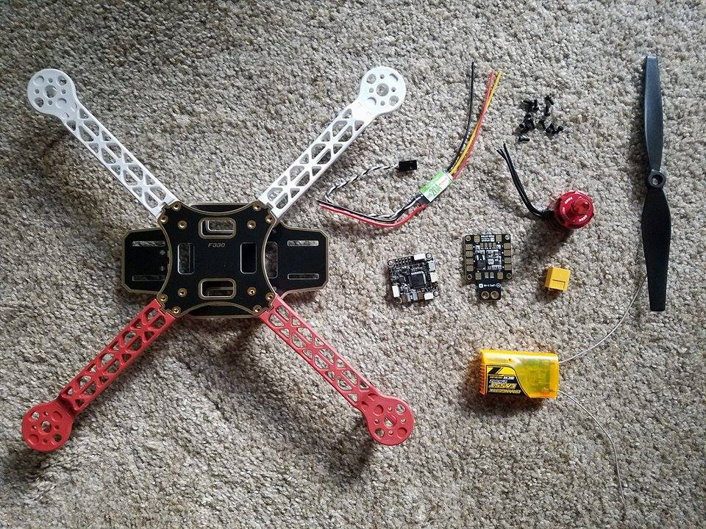
Figure 4: Parts for the small-scale test drone
The schematic below depicts the design for a switching voltage regulator. This circuit is a commonly-used design for the regulation of low-voltage DC power and its schematic appears many places online due to its popularity. This 5V 3A switching voltage regulator will be used on our custom circuit board to provide a constant 5V power supply to the aircraft electronics as well as the payload if the user requires 5V power for their experiment. This circuit is a necessary element in our power distribution system since the power source (the battery) only provides approximately 24V which is out of the operating range of our computing electronics. The capability to provide up to 3A of current is a necessity since multiple electronic devices will be connected to the output of this circuit. A switching voltage regulator is an efficient method of providing constant voltage versus a linear voltage regulator since the voltage applied is not constantly turned ‘on’ and dissipating excess energy as heat with the latter method. The L1 inductor and C2 capacitor act as storage elements, continuing to supply power to the output while the IC switches on and off.

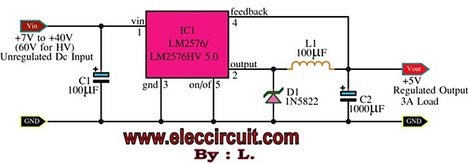
Figure 5: 5V 3A switching voltage regulator (image permission requested)
The photo below is an image of the physical components of the switching voltage regulator. These components allow for the voltage to be stepped down from an input of 7-40V DC to a constant output of 5V DC. All components are rated to handle the maximum voltage seen in the circuit (i.e. 24V in this case), however, further research and breadboard testing will reveal if lower voltage rating for the output capacitor is allowed. This would likely decrease the cost of the component.

We might also include a second switching regulator circuit to provide a 12V power source for our drone electronics. 12 volts is commonly used in low-voltage DC electrical systems. Although we may not need this voltage for our aircraft electronics, the user may benefit from the optional 12V power supply to connect electronics for use in their experiment. An additional 5V switching regulator could also be included for an extra power source to the user, since our first regulator will be dedicated solely to flight-critical electronics.

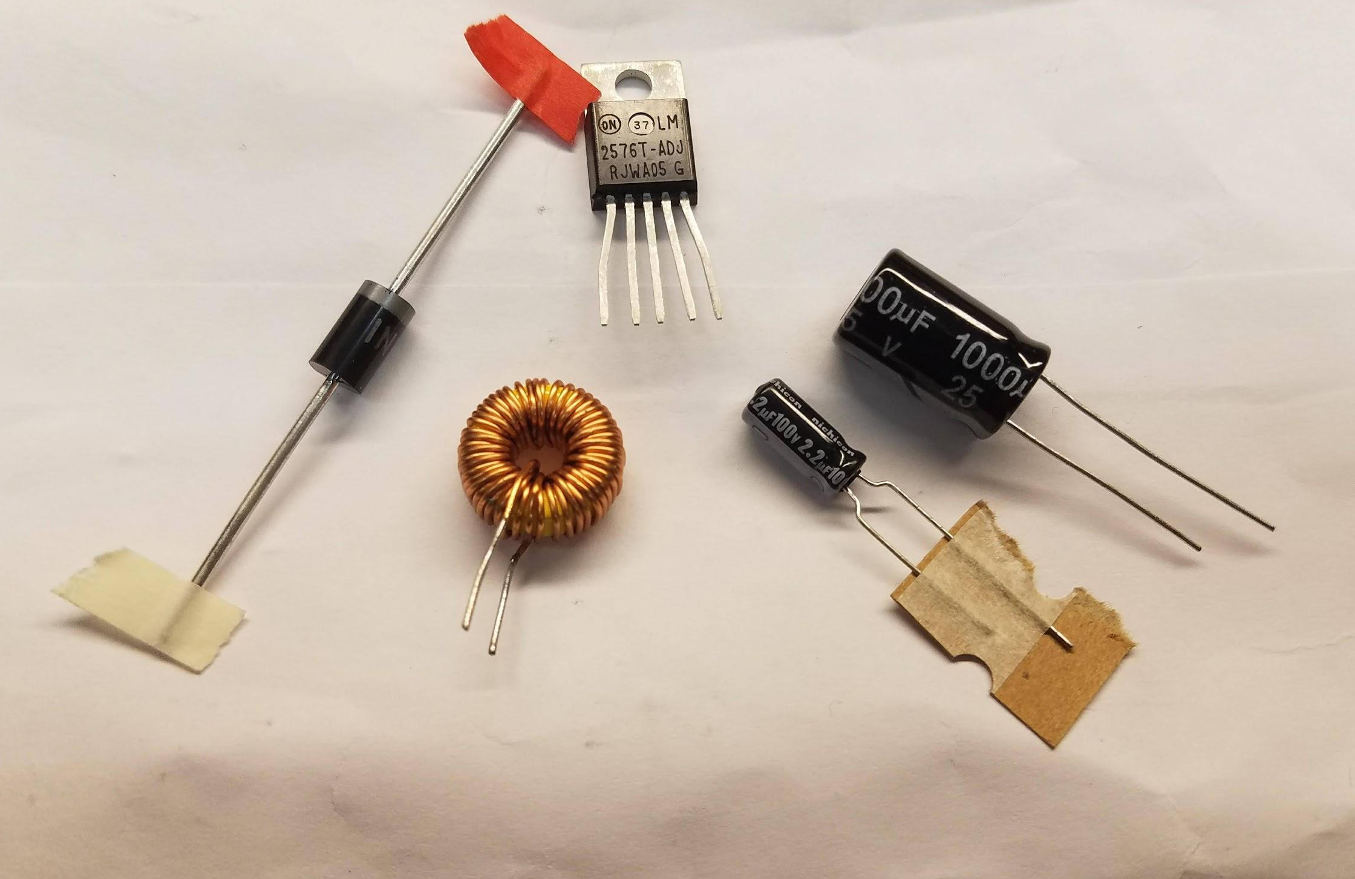
Figure 6: Components for breadboard testing of a 5V 3A switching regulator
The breadboard testing of our voltage regulator circuit was a success. The components shown in Figure 6 above were acquired via Amazon and through fellow classmates while waiting for the components we specified to arrive in shipping. All the components have the proper values, but some are slight variations of the specified parts. The 1000uF capacitor is manufactured by a different brand but has a sufficient voltage rating and the same capacitance. The inductor is 100uH, but the current rating is not specified, so it cannot be determined if it is rated to handle 3A. Additionally, the LM2576 IC shown in the photo is an adjustable output version of the LM2576 series switching voltage regulator IC.

Upon first assembly of the circuit, we did not realize the IC needed the proper output voltage to be defined and briefly powered on the circuit wired as the 5V version would be. Without a voltage divider connected to the feedback pin, we suspect it was wired to run at maximum current and minimum voltage, so it quickly became hot. The output voltage was very low (~0.3V) and not regulated, and the input voltage was loaded down from the 8V that we set on the power supply to 3-4V. We immediately powered down the circuit and double checked our wiring and inspected the components for any signs of short-circuiting. We did not find any issues, but it was then noticed that the LM2576 IC was an adjustable-output flavor. The problem was resolved by removing the feedback from the output node and connecting it between a 3K Ohm and 1K Ohm resistor, connected to the output node and ground, respectively (Digital Lab Adjustable Buck Regulator). Our output voltage was then around 5V DC and the input voltage was no longer loaded down.
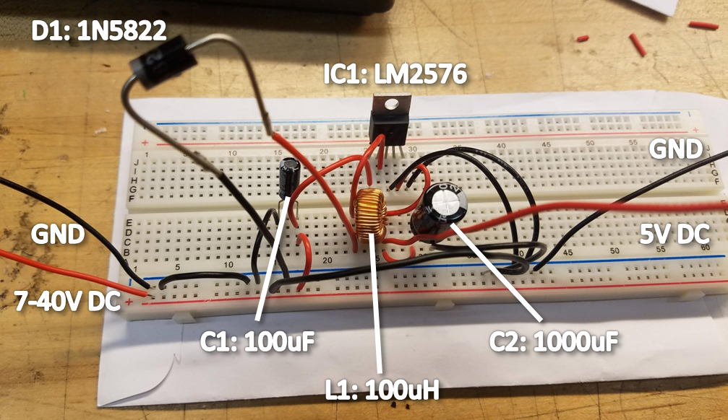
Figure 7: Breadboard Test
The photo above (Figure 7) shows our breadboard testing circuit. As seen in the photo, we wired the circuit to operate properly for the LM2576 regulator designed specifically for 5V output. This variant of the IC is designed to eliminate the need for extra resistors to create a voltage divider if the user intends to only make a 5V regulated circuit. Wired in this configuration we ran into the aforementioned issues with the output and input voltages, however it will work properly when we use the component arriving in the mail. After verifying the functionality of the circuit on breadboard we will move the regulator onto a prototype PC board (also known as solderable PCB or solderable breadboard) for functional testing on our test craft. This should be able to supply our electronics with a steady 5V regardless of the incoming battery voltage. Once we see our desired results with this regulator circuit we will design and print a SMT/through hole hybrid style board. This will allow for the installation of surface-mounted components such as the capacitors and IC, while also incorporating through-hole style components such as the inductor and microcontroller header pins.

Our flight controller schematic is depicted in the figure below. We will communicate with the flight controller and send high-level commands to it via the SBUS port found at J7. The PPM signals for motor controls are available at connections J12-J15 just below the SBUS port. On the underside of the flight controller there is a MicroUSB slot for a memory card to be inserted for data logging. This data log can include all relevant flight information including sensory data, battery voltage, current draw, and GPS position. This will be important for our testing purposes to monitor the performance of the craft, plot the flight data in graphs after each flight, and troubleshooting any issues that might occur resulting in a crash. The flight controller logic operates at 5 volts, which means that the controller will be powered by our switching voltage regulator. It draws a small amount of current, so it will not have a large impact on the battery life of the drone.

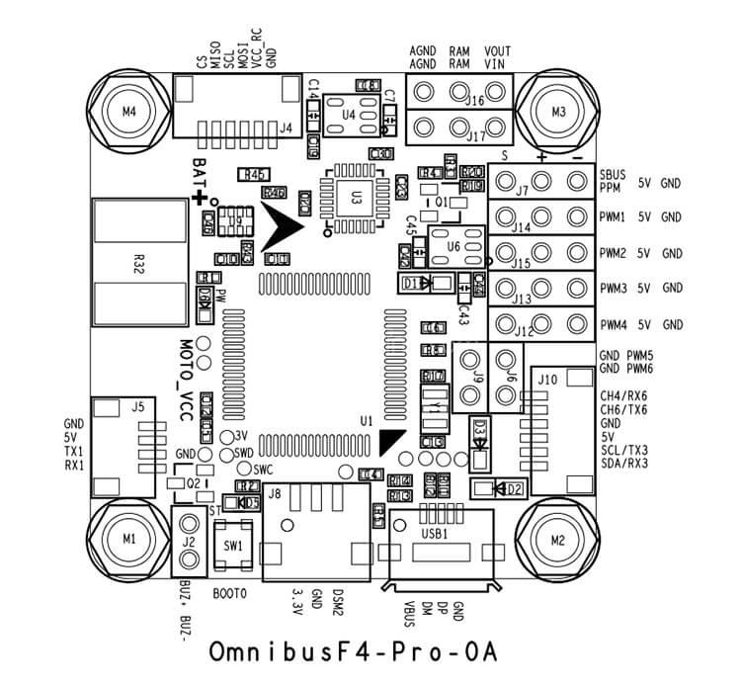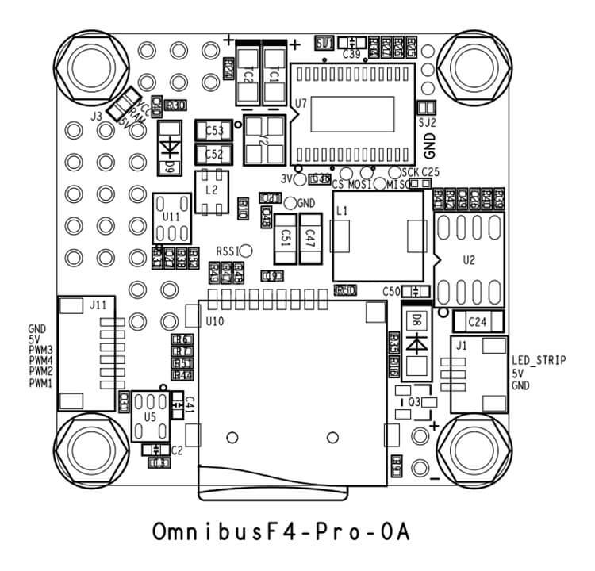

Figure 8: F4 Flight Controller schematic (image permissions requested)
With input from our MAE and CS teams working with us on the drone, we have decided that an additional microcontroller will be used to command the flight controller and log sensory data. This will allow the microcontroller to tell the flight controller how much throttle to give the motors through the SBUS port. The SBUS protocol is a serial protocol often used to communicate between radio transmitters, receivers, and flight controllers. With it, the microcontroller is able have direct control of the flight controller just as a person would using an SBUS-based radio transmitter. The microcontroller will be programmed with our autonomous flight operation using a C program developed by our CS team. With the microcontroller focusing on the flight path and recording data, the flight controller will able to use all its resources keeping the craft stabilized [65].

SBUS protocol allows for faster communication speeds between our components compared to PWM and PPM [66]. SBUS also has a higher resolution compared to PWM or PPM since it is a digital signal which gives us more precise control over the drone. This digital signal is also much less susceptible to communication errors due to electromagnetic interference versus an analog signal. Additionally, error checking is performed using parity bits and can help correct any interference.

6.0 Overall Integration

This chapter will focus on consolidating all our work into a final product. We will discuss our method of finding a PCB manufacturer and the design we have decided to go with for our PCB, testing our product in both the hardware and software aspects, and finally integrating our work on the electronics with the MAE and CS groups.

6.1 PCB Design

We decided to keep our printed circuit board design minimal with respect to complexity and features to keep weight to a minimum. The objective of our custom circuit design is to integrate all computing systems of our craft, as well as provide them with regulated power. This provision of power will be achieved by using a switching voltage regulator to step down the 24V DC from the craft battery to a constant 5V supply capable of delivering up to 3A to the low-voltage electronics. The communication interconnections between the flight controller, Raspberry Pi, and Arduino will be run via traces on the circuit board.

Switching regulator units already exist for a relatively low cost, however a simple switching voltage regulator can be assembled manually by us for cheaper and will be lighter weight and utilize less wires. Our circuit is designed to provide plenty of current to our electronics. The Pi Zero draws between 100-1200mA depending on the peripherals attached and the CPU workload [67]. The Arduino’s current draw is not explicitly listed online but we will dedicate at least 500mA of current headroom for its operation. The F4 variation of flight controller alone draws approximately 90mA of current, however the peripherals such as GPS and compass modules draw extra current [68]. Overall it can be assumed that the electronics of the craft will draw no more than 2A of current, however we would rather provide too much over too little. Therefore, we chose to use a 3A regulator.

We have also considered adding one or two extra voltage regulators to provide accessory power to customer electronics inside the payload. This will give the user the ability to perform computing, data logging, motor/servo movement, etc. within the payload bay if their experiment requires it. This would be achievable without the need for an extra power source which would add more weight to the craft. If we were to add two regulators, they would be designed to provide 5V/3A and 12V/3A since these are two common voltage levels used by most of low-voltage electronics.

The remaining portion of our circuit will involve the communication connections between the computing systems. Sockets for the flight controller, Pi, and Arduino will be added onto the board using female header pins. Each of these boards will be able to be plugged directly into our circuit board eliminating the need to solder connections or use wires. This allows for components to be easily added and removed for programming or replacement. Between the Arduino and flight controller sockets, a connection will be made for SBUS communication. A similar connection will be made between the Arduino and the Pi for the Arduino to command the Pi to begin/end video recording. If necessary, connections will be added for the Arduino to an IMU, Barometer, and SD card reader for the sake of collecting and storing flight data.

The figure below displays our circuit board wiring diagram on a very basic level. It does not detail the number of wires specific to each communication protocol, but merely indicates a communication signal connected by two wires. The wires are color-coded for visibility. The Arduino has connections available to add extra sensors if necessary, which may be included in our circuit later. Some communication methods such as SPI will require multiple wires for signal transmission since they require a clock signal, master signal, slave signal, etc. Other methods such as I2C use less wires since multiple slaves share a single data wire and a total of four wires are used. UART can use only three to four wires (if a VCC is needed) since a clock signal is not needed. Each respective component in our system uses a predetermined type of communication protocol so the full circuit schematic will be designed to reflect these protocols.
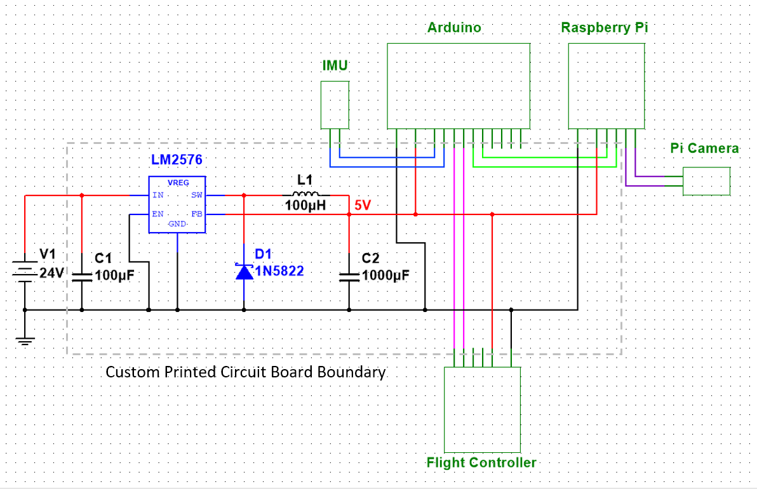
Figure 9: Custom printed circuit board schematic detailing the connections between voltage regulator and computers/peripherals.

6.2 Motor Testing

Testing the motors is difficult to do in a controlled environment due to the nature of flight. The current draw of the motors when the drone is secured to a test bench is different from the current drawn at hover, and it cannot be assumed that bench testing at maximum throttle will reflect power consumed during assisted free fall. This is because throttle will need to be varied with time during assisted free fall, and small motor corrections for stabilization draw varied amounts of current. For this reason, motor testing would be best done through flight tests. We will need to find out how the motors perform when stressed by maximum throttle and how much thrust they can generate to assist with free fall and/or counteract the downward velocity at the end of the free fall.

Motor characteristics to be observed are as follows: heat dissipation, thrust, and control response. Heat dissipation will be a major concern since we are operating the motors at the peak of their capability. This will generate immense amounts of heat which will need to be drawn away by proper airflow. If heat is not dissipated properly it will lead to motor damage and a crash will follow. Thrust will be another main factor since we need adequate thrust to achieve proper acceleration for a respectable amount of time. If the motors provide too little thrust, acceleration will level off to zero soon after descent is started - the motors will not be able to push the craft downward any faster and microgravity ceases to exist. The last consideration of the motors is their response to control input. This is a collective effort of the motor’s response to throttle changes and active braking of the motor. If a throttle input is given to the motor, it must reflect that throttle value as quickly as possible. High control signal frequency will help achieve this. The motors must also all change throttle in sync with one another if applicable, so that there is no instability introduced into the system. When a throttle value is lowered, the active braking feature of the ESC tells the motor to actively slow its speed. This prevents ‘coasting’ of the motor, a scenario which would insinuate that the motor will have an error in its speed for a small moment due to the momentum of the motor spinning. Fast throttle response and active braking will be crucial in our system since we do not want any uncontrolled movement of the motors. Such uncontrolled motor movement can cause anything from the craft tipping over from a variance in motor speeds, to a situation called “freewheeling” - one or more motors unable to counteract the force of wind pushing against the propellers causing them to spin freely in the wrong direction.

6.3 Autonomy Testing

The verification of our autonomous flight software will involve tests in small yet increasing complexity of autonomous flight patterns. We will start by simply testing the aircraft’s ability to arm the motors, idle them, and then disarm. Once this basic objective is accomplished, we can move on to test taking off from the ground, hovering, and landing safely. The next step will be to verify that the aircraft can briefly stop the motors in flight without tipping with the assistance of the gyroscopic stabilizer. Reversing the motors will be tested after this, ensuring through these tests that the craft is able to stabilize itself during downward thrust. Emergency stop, and parachute functionality will be rigorously tested before moving on from low-altitude tests. After these tests are successfully completed, half-altitude and full-altitude free fall flights can be performed. Successful autonomy testing means that the aircraft can perform a full flight and landing without unexpected errors or loss of communication. This testing runs in parallel with stability testing (physical stability of the craft throughout flight) but is its own test strictly based on autonomous software performance.

6.4 Integration with Interdisciplinary Teams

During the design and development of the electrical system of our drone, it will be necessary to collaborate with the computer science members of our group to help them design the software involved in our project. We will inform them of how the electronics will be wired together, and with that information they will be able to establish communication between the electronics. We intend to use an Arduino microcontroller to send high-level commands to the flight controller. This will be accomplished via SBUS protocol, which is natively understood by the flight controller. Since the arduino is fully programmable we will be able to program it to fly the mission without the assistance of the user. This will involve the microcontroller sending the flight controller high-level commands such as the pseudocommands ‘set throttle to 85% to ascend until an altitude of 100m is reached and then set throttle to 75% (hover)’. Once the microcontroller has been programmed with the code to execute the mission, code will be added to incorporate communication with a ground station in the capacity of an Android tablet application. This ground station will offer the user a graphical user interface to interact with the aircraft. Buttons such as ‘launch’, ‘free fall’, ‘land’, and ‘emergency stop’ will be included in the application to offer simple controls for the user to command the craft. It is a possibility that the interface could include options for the user to select free fall time, to offer versatility of the system. This might include the option to free fall for 1, 2, or 3 seconds at a time, which would dictate in the code how high of an elevation to start the craft and how long to accelerate downward. Different functions could be called with these settings predefined.

Once the electrical system of the drone has been fully designed and tested, it will be necessary to meet with the MAE members of our team to completely assemble the drone. This will allow us to see our finished project and make sure everything will assemble and operate as intended. The mechanical and aerospace engineering group members are responsible for the physical design of the aircraft, but the electrical components of the system will need to be accounted for in this mechanical design. Real estate on the fuselage of the quadcopter will be sparse so placement of the gyroscopic stabilizer, flight controller, power distribution board, Raspberry Pi, and microcontroller will be taken into careful consideration. Another topic of consideration between the mechanical and electrical group members will be the weight of the aircraft electronics. It is crucial to keep weight at a minimum, so this will involve the use of lightweight electronics. Fortunately, recent versions of Arduino microcontrollers and the Raspberry Pi feature a small footprint and lightweight design. The switching regulator circuit will also be placed on the power distribution board to avoid the need for a separate PCB and wires to accommodate a store-bought regulator. A parachute will be integrated into the system, activated by a control signal from the flight controller or the Arduino. It will likely involve the use of an actuator and a gas-powered parachute deployment system. This parachute will be housed in a PVC tube with some form of compressed air tank connected to it. A CO2 cartridge or manual-pump air tank could be used to achieve sufficient pressure to eject the parachute. As advised by the mechanical engineering members of the team, the parachute should be mounted in the center of the frame to avoid the drone descending at an angle. This will minimize impact stress on any single portion of the craft, namely the landing gear. Perhaps the gyroscopic stabilization system can be built around the sides of the PVC tube to save on space and maintain optimal center of mass as opposed to the gyroscopes mounted to one side.

Integration with our interdisciplinary team members has been successful and all members have come to agreement on key points leading to our promising design. Specifications were quickly drawn up for which electronics to use, which motors and propellers would be optimal, and how the flight control program should work. Members of each discipline seem to know a little bit about all aspects of the project which streamlines the development process. For example, the ECE team members have experience with programming so they can discuss and assist with the programming process. Additionally, the computer science members have experience with electronics hardware components, so they can voice their needs for hardware in the system. Moving forward with the project all members will be collaborating on the simulation, physical design, and programming. The simulation will be a joint effort of the ECE and MAE members for the physical dimensions and assembly of the 3D model, and the CS members will handle the MATLAB programming of the simulation. Good communication skills among members have kept the team on the same page throughout a rapidly growing and developing plan of action. Open discussions have been had on various topics on a business networking and communication application called Slack. Project success is imminent if this momentum is sustained within our group.

7.0 Administrative Content

This section of the report will demonstrate our ability to manage our time and budget, as well as show our cooperation as a team by assigning specific roles to each member and evenly splitting the workload. Due to the size of our group, we have not been able to have a project manager to oversee everything in the group, as each of us are responsible for half of the system we are working on. The milestones start from the beginning of the Fall 2017 semester and finish at the end of Spring 2018. Our budget will be decided by our sponsor and split among each of the disciplines participating in the project.

7.1 Milestone Discussion

The milestones set throughout the semesters of Senior Design 1 and 2 will keep our team on track and be strictly kept. Our first semester will focus on research. This includes finding the most cost-efficient parts we can afford and the method of flight that is our best option to achieve optimal microgravity conditions.

Table 18: Semester 1 Milestones
Deliverable | Customer | Milestone | Length to complete | Steps to complete
Embedded system+sensors-Ver. 1 | NGC | Oct 30th | 20+ hours | Develop an on -the-ground working prototype
60 pg draft | SD Professor | Nov 3rd | 20 hours | Research, gather sources, collate info  (design specs, etc)
Early flight ready prototype- Ver. 2 | NGC | Nov 15th | 20+ hours | Begin flight testing prototype board and components
100 pg submission | SD Professor | Nov 17th | 5+ hours | Tables, graphics, prototype version comparison, sensor calibration
Ver. 3 prototype | NGC | Nov 28th | 10 hours | Final prototype ready for full flight test
Final Report | SD Professor | Dec 04 | 10 hours | Report revision, editing, corrections

Toward the end of the first semester we were able to design and prototype to prepare for the second semester. Semester 2 will focus on acquiring the parts we have found to be most optimal to reach our goals and assembling our final product in coordination with the other disciplines.

Table 19: Semester 2 Milestones
Deliverable | Customer | Milestone | Length to Complete | Steps to Complete
PCB + components research and comparison | NGC | Jan 30th 2018 | 10+ hours | Gather components, finalize schematics
PCB Ver.0 | NGC | Feb. 14th 2018 | 20+hours | Build to order PCB
Ver.0 ground test | NGC | March 1st 2018 | 10+hours | Conduct ground test with fully functioning board
Ver.0 flight test | NGC | March 15th 2018 | 10+hours | Conduct flight test with fully functional board
Ver.1 and testing if necessary | NGC | March 30th-April 15th 2018 | 30+ hours | Modify PCB or recalibrate if necessary, additional tests
Final product and report | NGC/Professor | April/May 2018 | 20+hours | Submit presentation forms, conduct presentation before panel

7.2 Budget Analysis

Since our project has a total budget of $1500 to $2000 and is split between 3 different teams, this current list of materials will need to be improved. Many of the current items listed could be substituted for a less expensive option. At this time, it is difficult to say how much of the budget will be distributed for the electronics and until that is decided a conclusive bill of materials can’t be made.

Table 20: Electronics Bill of Materials/Cost Analysis
Item(s) | Quantity | Total Price (USD)
F4 Omnibus V2 Pro | 1 | 24.39
Power Distribution Board | 1 | 6.34
uBlox M8N GPS | 1 | 14.13
Brushless Motor Speed Controllers (50A) | 4 | 102.95
Brushless Motors (designed for 6KG takeoff weight) | 4 | 459.80
Propellers (subject to change, MAE must spec) | 4 | 80.00
LiPo Battery (6S, 6000mAh) | 2 | 188.98
Hobbypower Telemetry Ground Module | 1 | 16.98
Raspberry Pi Zero | 1 | 9.05
Pi Zero Camera Video Module | 1 | 13.00
Adafruit Feather (With radio packet) | 1 | 21.73
Digital Compass HMC5883L | 1 | 8.99
Custom PCB + Components | 1 | 33.00
Price Total |  | 972.34

Table 20 above lists our cost analysis for the electronics of our drone, which includes the motors and propellers. It excludes the drone frame and other mechanical systems such as the parachute deployment system and payload container. We have also excluded the cost of the gyroscopic stabilization system since it will not be added at this time. Our budget leaves enough room for the mechanical systems but might not allow for the purchase of a dedicated smart device for the customer to use to operate the drone. The graphical user interface might need to be downloaded to the user’s pre-existing smart device such as their personal tablet or phone.

7.3 Project Roles

Due to our team consisting of one electrical engineer and one computer engineer, the best way to assign the roles for the project was to split the components as best we could into our respective fields. Our electrical engineer would handle anything heavily influenced with our power system (the motors, speed controllers, batteries, and power distribution system) and our computer engineer would handle everything that would be communicating directly with the software (the flight controller, telemetry system, sensors, and microcontroller). With this split of work, we felt that each of us would be most comfortable working with our respective fields and be able to contribute to our fullest potential. This also evenly split the workload for the project since each of these systems is equally important to the successful operation of the drone.

The main task of the electrical engineer will be designing a regulator circuit and power distribution board. This task is best suited for the electrical engineer since it’s dealing with the power system of the craft. The regulator circuit will limit the voltage going to our components from the input source. The power distribution board will be used to distribute power (as needed) from the battery to all the components of the craft.

The computer engineer will mainly be focused on designing the system needed to successfully log the data obtained by the drone, such as sensor reading and the video recording, and the communication between the drone and ground stations. We saw these tasks best suited for a computer engineer due to the data being collected with a microcontroller through digital signals. The communication between the drone and ground will need to be compared between digital options, like WiFi, and analog communications through RF.

Our focus as the ECE team for the project is to focus strictly on the electrical components and power system of the drone. The MAE team will be working on the physical structure and dynamics of the craft. This includes choosing the type of drone, materials it’s made of, and the flight path that will be most optimal to achieve microgravity. While our input is taken into consideration, the MAE students solely make the final decision.

Since creating this figure, the CS team has assumed control over most of the ground station. They will cover the development of the graphical user interface for the program used as well as programming the autonomous flight paths taken by the drone. The ECE members will be aiding in the development of the mission plan to refine the process as much as possible. Our decisions with the electronic components will affect the CS in the programming languages that they will be able to use for programming the autonomous flight, as well as the type of communication signal they will need to be able to receive and process for the user interface at the ground station. We have concluded that the programming of the microcontroller will be based in the C language, with communication to the flight controller via SBUS protocol. The ground station, however, will be programmed as an Android application. Depending on how this program is developed by the computer science team, any number of programming languages could be used for the design. This leaves room for the team to decide which language will be most convenient for them.

Figure 10: Project Roles and Workload Split

8.0 Conclusion

Initial research and testing for this project have lead to a promising design for a drone microgravity platform. We have decided to create a drone with a 500-800mm size frame operating on a 24V brushless electric motor system. The brushless motors have been chosen for their high thrust-to-weight ratio and low friction while spinning. Propellers have been picked to provide sufficient thrust throughout the range of speeds we will be operating the craft, and will be strong enough to withstand the forces placed upon them by the craft in motion. Electric speed controllers have been selected for the system that are rated above the current we intend to draw with each motor. They are also programmable to spin the motors either forward or backward to facilitate our assisted free fall method. The system will be using lithium polymer batteries as a power source due to their high capacity and discharge rate. We have calculated that 12,000mAh in battery capacity should allow us to conduct at least one full flight carrying a customer’s experimental payload. Additional batteries can be purchased by the customer at a later date if they intend to conduct multiple experiments in one session. A flight controller has been specified to operate the craft capable of driving four motors and incorporating onboard sensors to keep the aircraft stable in flight. This flight controller can also accept SBUS input commands from an external microcontroller in order to automate its flight pattern. The flight controller will also use a GPS module and compass to keep the aircraft positioned within a small radius in the horizontal plane to avoid drifting away during flight. A power distribution board was selected to distribute power from the battery to the four speed controllers as well as the regulated voltage system for the onboard electronics of the drone. This board was picked for its ability to distribute up to 200A of current without the risk of overheating and failing, a rating which exceeds our needs. We designed a custom circuit board to incorporate all mission-critical electronics into one package without the need to run wires between computing systems and mount them individually to the craft. A 5V switching regulator circuit is also incorporated into this circuit to provide up to 3A of power to the electronics.

Our microgravity craft will be operational at the hands of any user through our automation software. This software will allow for repeatable free fall mission execution with a few pushes of buttons on a smart device application. It will be as simple as operating an elevator, with buttons for the user to tell the craft what to do and relevant flight data being displayed above. The ground station application will relay simple commands to the microcontroller onboard the craft via a 915MHz radio system, and the microcontroller will perform the mission commands by means of a program written in C. This program will relay high-level control commands to the flight controller such as throttle values, and the flight controller will feed flight data back to the microcontroller. This flight data will be used for control system calculations and it will also be sent down to the ground for display on the GUI. All relevant flight data will be logged onboard the aircraft on a microSD card and can be transferred to a computer for post-experiment data analysis. A Raspberry Pi microcomputer will also record a video of the payload bay for visual analysis.

As an interdisciplinary team there have been many challenges that we have faced regarding communication between all the teams and departments. These issues have led us to be behind on many aspects of the design process for the project such as team organization, budgeting, and design finalization. Most of our semester was spent attempting to get into contact with the other departments and choose which teams from the other disciplines we would be working with. This ultimately led to the splitting of our initial group of 4 into 2 groups of 2, since we were already behind and did not want to waste more time trying to accommodate for miscommunications between departments. From this we have learned to be ahead of schedule so issues like this will not waste crucial time in research and development of the project. These sorts of issues arise in real-world companies frequently, since members of management responsible for organizing teams are not always efficient with communication and defining the roles and responsibilities of their team.

After teams had been decided upon the next issue that we faced was scheduling meetings. This issue has made it difficult to meet as an entire group to discuss our project since each department has different schedules and finding a time where everyone can meet has also proven to be difficult. Each member of the team is a full-time student and many members have jobs outside of school that occupy a portion of their time. Class deadlines outside of this project were prevalent so extra effort was needed to allow all deadlines to be met. The most reliable way we have been able to communicate as a team is through apps such as Slack. This allows asynchronous communication between us and we can provide feedback whenever it is convenient. This is relatable in real-world applications of engineering since many companies operate using satellite locations. It is imperative that the workers at these remote locations be kept current on projects, so methods of communication such as teleconference and collaborative applications have become a necessity.

Budgeting has also proven to be an issue that we face. Since the electronics of the drone require the largest portion of the budget, we have the responsibility of managing most of the expenses while leaving enough room in the budget for the mechanical and programming aspects. This limits the choices we can make when it comes to the design of the drone. For example, the power system will need to be optimized to provide enough power for the craft while remaining affordable with respect to part cost. Having to work based on specifications and decisions made by the other departments require compromise of some of our own solutions to the design problems that this project faces. Once these problems have been resolved, an alternative solution for improving upon these issues can be found.

This project has taught us a lot about working with a group and with members of many different engineering disciplines. Group collaboration is vital for the success of engineering projects since nearly all feats of modern engineering are accomplished by the sum of many facets of engineering. With these challenges that we must overcome to be successful in this project, we are able to gain invaluable experiences that are more than likely to arise in our future endeavors as engineers.

A1 References
[1] D. Mesland et al., “Ballistocraft: A Novel Facility for Microgravity Research,” European Space Agency, ESA Bulletin, May 1995. [Online] Available: http://www.esa.int/esapub/bulletin/bullet82/mes82.htm. [Accessed: 11-Oct-2017].

[2] J. Afman, J. Franklin, M. Mote, T. Gurriet and E. Feron, On the Design and Optimization of an Autonomous Microgravity Enabling Aerial Robot. Atlanta, GA, 2016, pp. 1-8.

[3] M. Pajor, “Students Conduct Zero Gravity Experiment via NASA Program,” ECE Department of the University of Illinois, News Story, July 1, 2013. [Online] Available: https://ece.illinois.edu/newsroom/article/2543. [Accessed: 11-Oct-2017].

[4] J. Desjardins, "Here's how commercial drones grew out of the battlefield," Business Insider, 2016. [Online]. Available: http://www.businessinsider.com/a-history-of-commercial-drones-2016-12. [Accessed: 03- Dec- 2017].

[5] DiFrancesco, J. M., & Olson, J. M. (2015). The economics of microgravity research. NPJ Microgravity, 1, 15001–.[Online] Available: http://doi.org/10.1038/npjmgrav.2015.1 [Accessed: 03- Dec- 2017]

[6] K. Koehler, “Brushed vs. Brushless Motors: What’s the Difference?” Pro Tool Reviews, 2015. [Online] Available: https://www.protoolreviews.com/news/brushed-vs-brushless-motors/18990/. [Accessed: 11-Oct-2017].

[7] O. Liang, “ESC Firmware and Protocols Overview,” July 10, 2017. [Online] Available: https://oscarliang.com/esc-firmware-protocols/. [Accessed: 12-Oct-2017].

[8] “16x8 Carbon Gas (Propeller),” Falcon, Product Page. [Online] Available: http://www.falconpropellers.com/products-page/falcon-2-blade-tractor-carbon-fiber/16-x-08-carbon-gas/. [Accessed: 12-Oct-2017].

[9] “P16x5.4 Prop-2Pcs/Pair,” T-Motor, Product Page. [Online] Available: http://store-en.tmotor.com/goods.php?id=382. [Accessed: 12-Oct-2017].

[10] “TCF Precision Carbon Fiber Propeller 16x8 (1pc),” HobbyKing, Product Page. [Online] Available: https://hobbyking.com/en_us/tcf-precision-carbon-fiber-propeller-16x8-1pc.html. [Accessed: 12- Oct- 2017].

[11] “KDE3520XF-400 Brushless Motor for Heavy-Lift Electric Multi-Rotor (sUAS) Series,” KDE Direct, Product Page. [Online]. Available: https://www.kdedirect.com/collections/uas-multi-rotor-brushless-motors/products/kde3520xf-400. [Accessed: 12-Oct-2017].

[12] “Tiger U5 Motor 400KV,” Quadrocopter, Product Page. [Online]. Available: http://www.quadrocopter.com/Tiger-U5-Motor-400KV_p_1217.html. [Accessed: 12-Oct-2017].

[13] “T-Motor MN4014 Navigator Brushless Motor (400kv),” Helipal.com, Product Page. [Online]. Available: http://www.helipal.com/t-motor-mn4014-high-power-brushless-motor-400kv.html. [Accessed: 12-Oct-2017].

[14] “Flame 60A HV,” T-Motor, Product Page. [Online]. Available: http://store-en.tmotor.com/goods.php?id=370. [Accessed: 12-Oct-2017].

[15] “Lumenier BLHeli_32 50A 3-6S DSHOT 1200 ESC w/ LED,” GetFPV, Product Page. [Online]. Available: https://www.getfpv.com/lumenier-blheli-32-50a-3-6s-dshot-1200-esc-w-led.html. [Accessed: 12-Oct-2017].

[16] “DYS 40A ESC,” ReadyMadeRC, Product Page. [Online]. Available: https://www.readymaderc.com/store/index.php?main_page=product_info&products_id=4124. [Accessed: 12-Oct-2017].

[17] “Turnigy Graphene Professional 12000mAh 6S15C LiPo Pack w/ XT90,” Hobbyking, Product Page. [Online]. Available: https://hobbyking.com/en_us/turnigy-graphene-professional-12000mah-6s-15c-lipo-pack-w-xt90.html. [Accessed: 13-Oct-2017].

[18] “Multistar High Capacity 10000mAh 6S 10C Multi-Rotor Lipo Pack XT90,” Hobbyking, Product Page. [Online]. Available: https://hobbyking.com/en_us/multistar-high-capacity-6s-10000mah-multi-rotor-lipo-pack.html. [Accessed: 13-Oct-2017].

[19] “PULSE 6000mAh 6S 22.2V 35C - LiPo Battery - 2 Packs,” Pulse, Product Page. [Online]. Available:https://www.pulsebattery.com/pulse-6000mah-6s-22-2v-35c-lipo-battery.html. [Accessed: 13-Oct-2017].

[20] “Vulcan 250A Power Distribution Board,” Rc-Drones.com, Product Page. [Online]. Available: http://www.rc-drones.com/Vulcan-250A-Power-Distribution-Board_p_736.html. [Accessed: 13-Oct-2017].

[21] “200A Multirotor Power Distribution Board,” Electriflite, Product Page. [Online]. Available: http://www.electriflite.co.uk/store17/index.php/multicopters/flight-controllers/commercial-professional-flight-controllers/pdb-300.html. [Accessed: 13-Oct-2017].

[22] “Super High Current 200A PDB PCB Power Hub Power Distribution Board,” Aliexpress.com, Product Page. [Online]. Available: https://www.aliexpress.com/store/product/Super-High-Current-200A-PDB-PCB-Power-Hub-Power-Distribution-Board-for-Agricultural-Plant-Protection-Multicopter/613616_32709736914.html. [Accessed: 13-Oct-2017].

[23] “Switching Vs. Linear Voltage Regulator,” Intersil. [Online]. Available: https://www.intersil.com/en/products/power-management/linear-vs-switching-regulators.html. [Accessed: 13-Oct-2017].

[24] “UHE1H101MPD1TD Nichicon,” Mouser Electronics, Product Page. [Online]. Available: https://www.mouser.com/search/ProductDetail.aspx?R=0virtualkey0virtualkeyUHE1H101MPD1TD. [Accessed: 13-Oct-2017].

[25] “UKL1V101KPDANA Nichicon,” Mouser Electronics, Product Page. [Online]. Available: https://www.mouser.com/search/ProductDetail.aspx?R=0virtualkey0virtualkeyUKL1V101KPDANA. [Accessed: 13-Oct-2017].

[26] “UKL1J101KPD Nichicon,” Mouser Electronics, Product Page. [Online]. Available: https://www.mouser.com/search/ProductDetail.aspx?R=0virtualkey0virtualkeyUKL1J101KPD. [Accessed: 13-Oct-2017].

[27] “EKZE100ELL102MJ16S United Chemi-Con,” Mouser Electronics, Product Page. [Online]. Available: https://www.mouser.com/ProductDetail/United-Chemi-Con/EKZE100ELL102MJ16S/. [Accessed: 13-Oct-2017].

[28] “EEU-FR1E102 Panasonic,” Mouser Electronics, Product Page. [Online]. Available: https://www.mouser.com/search/ProductDetail.aspx?R=0virtualkey0virtualkeyEEU-FR1E102. [Accessed: 13-Oct-2017].

[29] “UKL0J102KPD Nichicon,” Mouser Electronics, Product Page. [Online]. Available: https://www.mouser.com/ProductDetail/Nichicon/UKL0J102KPD/. [Accessed: 13-Oct-2017].

[30] “T60405-A6161-X003 Vacuumschmelze,” Mouser Electronics, Product Page. [Online]. Available: https://www.mouser.com/ProductDetail/Vacuumschmelze/T60405-A6161-X003/. [Accessed: 13-Oct-2017].

[31] “PE-92108KNL Pulse Electronics,” Mouser Electronics, Product Page. [Online]. Available: https://www.mouser.com/ProductDetail/Pulse/PE-92108KNL/. [Accessed: 13-Oct-2017].

[32] “Inductor 100uH 3A,” TinySine, Product Page. [Online]. Available: http://www.tinyosshop.com/index.php?route=product%2Fproduct&product_id=584. [Accessed: 13-Oct-2017].

[33] “1N5822: Schottky Barrier Rectifier, 3.0 A, 40 V,” ON-Semiconductor, Product Page. [Online]. Available: http://www.onsemi.com/PowerSolutions/product.do?id=1N5822. [Accessed: 13-Oct-2017].

[34] “1N5820-1N5822,” ON-Semiconductor, Product Datasheet. [Online]. Available: http://www.mouser.com/ds/2/149/1N5822-888313.pdf. [Accessed: 13-Oct-2017].

[35] “LM2576 3.0 A, 15 V, Step-Down Switching Regulator,” ON-Semiconductor, Product Datasheet. [Online]. Available: http://www.onsemi.com/pub/Collateral/LM2576-D.PDF. [Accessed: 13-Oct-2017].

[36] “LM2576T-5.0 Texas Instruments,” Mouser Electronics, Product Page. [Online]. Available: https://www.mouser.com/ProductDetail/Texas-Instruments/LM2576T-50/?qs=sGAEpiMZZMtitjHzVIkrqaeIqJaO9bXJBlZ4%2FFyg6JA%3D. [Accessed: 13-Oct-2017].

[37] “5V 3A Switching Regulator circuit by LM2576,” ElecCircuit, 28-Nov-2016. [Online]. Available: https://www.eleccircuit.com/5v-3a-switching-power-supply-by-lm2576/. [Accessed: 13-Oct-2017].

[38] "3DR Pixhawk Mini - 3DR", Store.3dr.com. [Online]. Available: https://store.3dr.com/products/3dr-pixhawk. [Accessed: 13- Oct- 2017].

[39] "PixFalcon Micro PX4 Autopilot plus Micro M8N GPS and Mega PBD Power Module," Hobbyking, 2017. [Online]. Available: https://hobbyking.com/en_us/pixfalcon-micro-px4-autopilot-plus-micro-m8n-gps-and-mega-pbd-power-module.html?countrycode=US&gclid=EAIaIQobChMI-NHZl6Gc1wIVyx-GCh2dgAMfEAQYASABEgL2y_D_BwE&gclsrc=aw.ds. [Accessed: 13- Oct- 2017].

[40] "FLIP32 F4 OMNIBUS V2 PRO Flight Controller Board For FPV w/ Baro built-in OSD," eBay, 2017. [Online]. Available: https://www.ebay.com/itm/FLIP32-F4-OMNIBUS-V2-PRO-Flight-Controller-Board-For-FPV-w-Baro-built-in-OSD-US/192234198274?ssPageName=STRK%3AMEBIDX%3AIT&_trksid=p2057872.m2749.l2649. [Accessed: 10- Nov- 2017].

[41] "STM32F4 - ARM Cortex-M4 High-Performance MCUs - STMicroelectronics," St.com, 2017. [Online]. Available: http://www.st.com/en/microcontrollers/stm32f4-series.html?querycriteria=productId=SS1577\. [Accessed: 03- Dec- 2017].

[42] R. Fischer, "High Precision Micro Barometer Module MS5611 | AMSYS," Amsys.info, 2017. [Online]. Available: http://www.amsys.info/products/ms5611.htm. [Accessed: 13- Oct- 2017].

[43] "BMP280," Bosch-sensortec.com, 2017. [Online]. Available: https://www.bosch-sensortec.com/bst/products/all_products/bmp280. [Accessed: 15- Oct- 2017].

[44] "7M/8M Ublox M8N GPS Module for APM Pixhawk CC3D Naze32 F3 Flight Control for RC Drone," www.banggood.com, 2017. [Online]. Available: https://www.banggood.com/7M8M-Ublox-M8N-GPS-Module-for-APM-Pixhawk-CC3D-Naze32-F3-Flight-Control-p-1078657.html?rmmds=search&ID=522794&cur_warehouse=USA. [Accessed: 30- Nov- 2017].

[45] "Ublox SAM-M8Q GPS, GLONASS, Galileo, QZSS and SBAS receiver", Csgshop.com, 2017. [Online]. Available: http://www.csgshop.com/product.php?id_product=250. [Accessed: 13- Oct- 2017].

[46] "915 MHz (American) Telemetry Radio Set - 3DR," Store.3dr.com, 2017. [Online]. Available: https://store.3dr.com/products/915-mhz-telemetry-radio. [Accessed: 13- Oct- 2017].

[47] "Micro HKPilot Telemetry radio Set With Integrated PCB Antenna 915Mhz," Hobbyking, 2017. [Online]. Available: https://hobbyking.com/en_us/micro-hkpilot-telemetry-radio-set-with-integrated-pcb-antenna-915mhz.html. [Accessed: 15- Oct- 2017].

[48] "Hobbypower Radio Wireless Telemetry Ground 915mhz Module for MWC Multiwii Apm2.6 Apm2.5.2," Amazon, 2017. [Online]. Available: http://a.co/fbcINN3. [Accessed: 30- Nov- 2017].

[49] A. Industries, "Raspberry Pi Zero - Version 1.3," Adafruit.com, 2017. [Online]. Available: https://www.adafruit.com/product/2885. [Accessed: 14- Oct- 2017].

[50] A. Industries, "Adafruit Trinket - Mini Microcontroller - 3.3V Logic [MicroUSB]," Adafruit.com, 2017. [Online]. Available: https://www.adafruit.com/product/1500?gclid=EAIaIQobChMI0Kno9Oed1wIVjB6GCh2xyAh_EAQYAyABEgJis_D_BwE. [Accessed: 14- Oct- 2017].

[51] "Adafruit (PID 3176) Feather M0 RFM69HCW Packet Radio - 868 or 915 MHz," Amazon, 2017. [Online]. Available: http://a.co/dTfHaOw. [Accessed: 30- Nov- 2017].

[52] A. Industries, "Adafruit Precision NXP 9-DOF Breakout Board [FXOS8700 + FXAS21002]," Adafruit.com, 2017. [Online]. Available: https://www.adafruit.com/product/3463. [Accessed: 15- Oct- 2017].

[53] A. Industries, "Adafruit 9-DOF Accel/Mag/Gyro+Temp Breakout Board - LSM9DS0," Adafruit.com, 2017. [Online]. Available: https://www.adafruit.com/product/2021. [Accessed: 15- Oct- 2017].

[54] "SunFounder Digital Compass HMC5883L Module for Arduino and Raspberry Pi," Amazon, 2017. [Online]. Available: http://a.co/97Plbll. [Accessed: 30- Nov- 2017].

[55] "Overview | Comparing Gyroscope Datasheets | Adafruit Learning System," Learn.adafruit.com, 2017. [Online]. Available: https://learn.adafruit.com/comparing-gyroscope-datasheets/overview. [Accessed: 15- Oct- 2017].

[56] MPU-6000 and MPU-6050 Product Specification Revision 3.4. Sunnyvale, CA: InvenSense Inc., 2013, pp. 10-20.

[57] 3-Axis Digital Compass IC HMC5883L. Plymouth, MN: Honeywell, 2013, pp. 2-3.

[58] "Camera Video Module 5MP Webcam 1080p 720p for Raspberry Pi 3 Model B Pi 2 and Pi ZERO," Amazon, 2017. [Online]. Available: http://a.co/aCYLsa0. [Accessed: 30- Nov- 2017].

[59] A. Industries, "Mini Spy Camera with Trigger for Photo or Video," Adafruit.com, 2017. [Online]. Available: https://www.adafruit.com/product/3202. [Accessed: 14- Oct- 2017].

[60] "design standards," TheFreeDictionary.com, 2017. [Online]. Available: https://encyclopedia2.thefreedictionary.com/design+standards. [Accessed: 10- Nov- 2017].

[61] "What we do," Faa.gov, 2016. [Online]. Available: https://www.faa.gov/about/mission/activities/. [Accessed: 10- Nov- 2017].

[62] Operation and Certification of Small Unmanned Aircraft Systems. Department of Transportation, 2016, pp. 10-13.

[63] "Fact Sheet – Small Unmanned Aircraft Regulations (Part 107)," Faa.gov, 2016. [Online]. Available: https://www.faa.gov/news/fact_sheets/news_story.cfm?newsId=20516. [Accessed: 10- Nov- 2017].

[64] "FCC Rules Part 15.247 - Spread Spectrum radio systems," Iprocessmart.com, 2017. [Online]. Available: http://www.iprocessmart.com/techsmart/Spread%20Spectrum%20FCC%20Regulations.htm. [Accessed: 10- Nov- 2017].

[65] "Arduino S-Bus," Ernstc.dk. [Online]. Available: http://www.ernstc.dk/arduino/sbus.html. [Accessed: 10- Nov- 2017].

[66] "SBUS or PPM, which is better?," DroneTrest, 2015. [Online]. Available: http://www.dronetrest.com/t/sbus-or-ppm-which-is-better/1356. [Accessed: 10- Nov- 2017].

[67] "Raspberry Pi FAQs - Frequently Asked Questions," Raspberry Pi. [Online]. Available: https://www.raspberrypi.org/help/faqs/. [Accessed: 02- Dec- 2017].

[68] "How much power flight controller consumes?," Quad Me Up, 2016. [Online]. Available: https://quadmeup.com/how-much-power-flight-controller-consumes/. [Accessed: 02- Dec- 2017].

A2 Copyright
from: Jacob Knepper <jacobknepper@yahoo.com>
to: Airbot
date: Sun, Dec 03, 2017 at 1:14 AM
subject: Permission for Use - F4 Omnibus Pro V2 schematic

Hello,

My name is Jacob Knepper, I'm a senior computer engineering student at the University of Central Florida. I am currently working on a project for school building a drone and I would like to use the F4 Omnibus Pro V2 schematic you have listed on the link below to use on my drone. I would also like to include your schematic photo in my documentation, using proper citation for your website. Please let me know if this is a possibility or if you have any issue with me using your design. Thank you for your time!

Link to your F4 Omnibus Pro V2:
https://www.ebay.com/itm/FLIP32-F4-OMNIBUS-V2-PRO-Flight-Controller-Board-For-FPV-w-Baro-built-in-OSD-US/192234198274?ssPageName=STRK%3AMEBIDX%3AIT&_trksid=p2057872.m2749.l2649.

-Jacob K.

from: Adam Brockmeier <brockmeier.adam@gmail.com>
to: mome.name@yahoo.com
date: Thu, Nov 16, 2017 at 8:04 PM
subject: Permission for Use - 5V 3A Switching Regulator Circuit

Hello,

My name is Adam Brockmeier, I'm a senior electrical engineering student at the University of Central Florida. I am currently working on a project for school building a drone and I would like to use the schematic you have listed on the link below to build a 5V 3A switching regulator to use on my drone. I would also like to include your schematic photo in my documentation, using proper citation for your website. Please let me know if this is a possibility or if you have any issue with me using your design. Thank you for your time!

Link to your switching regulator schematic: https://www.eleccircuit.com/5v-3a-switching-power-supply-by-lm2576/

-Adam B.

from: Adam Brockmeier <brockmeier.adam@gmail.com>
to: jfranklin36@gatech.edu, afman@aerospace.gatech.edu, tgurriet3@gatech.edu, mmote3@gatech.edu, feron@gatech.edu
date: Tue, Nov 28, 2017 at 10:25 PM
subject: Permission for Use - Variable-Pitch Propeller Quadcopter Photo

Hello Mr. Afman and Mr. Franklin,

My name is Adam Brockmeier, I'm a senior electrical engineering student at the University of Central Florida. I am currently working on a project for school building a drone and I would like to use the photo you have in your research paper of your quadcopter, shown below. I would use proper citation for your paper, whose PDF link is also provided below. Please let me know if this is a possibility or if you have any issue with me using your photo. Thank you for your time!

-Adam B.

Link to your paper:

https://arxiv.org/pdf/1611.07650.pdf

Photo:
[redacted]
--------------------------------------------
from: Feron, Eric M <eric.feron@aerospace.gatech.edu>
to: Adam Brockmeier <brockmeier.adam@gmail.com>
cc: "tgurriet3@gatech.edu" <tgurriet3@gatech.edu>,
"Mote, Mark L" <mmote3@gatech.edu>,
"Feron, Eric M" <eric.feron@aerospace.gatech.edu>
date: Tue, Nov 28, 2017 at 10:37 PM
subject: Re: Permission for Use - Variable-Pitch Propeller Quadcopter Photo

You bet! Please go ahead. Your asking for permission is greatly appreciated.
There is a much better setup now (that works for real). I have attached the paper, feel free to use any part of it.

Eric Feron

