Senior Design

Arcadia Spider Robotic Hub



Department of Electrical Engineering and Computer Science

University of Central Florida

Dr. Lei Wei and Dr. Samuel Richie

Initial Project Document and Group Identification

Senior Design 1 – Fall 2017

Group 24

Dries Kassabi Electrical Engineering
Steven Solis Photonic Science and Engineering
Angel Mandujano Electrical Engineering
Said Mourfik Electrical Engineering
Consultant Arcadia Spectacular

Table of Contents
Table of Contents i
List of Figures iv
List of Tables vii
1 Initial Proposal 1
1.1 Project Narrative 1
1.2 Goals and Objectives 2
1.3 Block Diagrams 3
1.4 Specifications 4
1.5 Project Timeline 5
1.6 Engineering-Marketing Tradeoff Table 6
1.7 Budget 7
2 Structural and Mechanical Considerations 9
2.1 Structure and Mechanics 9
2.2 ASRH Structure: Platform and Shroud 10
2.3 Camera, Gun, and Pitch Motor Gimbal 12
3 Microcontrollers and Peripherals 13
3.1 Function of Microcontrollers 13
3.2 Raspberry Pi 3 Model B and Peripherals 14
3.2.1 Raspberry Pi 3 14
3.2.2 Peripherals 16
3.3 MSP430FR5994 and Peripherals 18
3.3.1 MSP430FR5994 18
3.3.2 Peripherals 20
4 Servo Motors 23
4.1 Servo Motors on the ASRH 23
4.2 Parallax Continuous Rotation Servos 23
4.3 VS-19 Pico Linear Servo 27
5 Lasers and LEDs 30
5.1 Laser and Light Show on the ASRH 30
5.2 LEDs 30
5.3 LASERs 38
5.4 Safety 39
5.5 Syncing Lights and Audio 40
5.6 LED Drivers 42
5.7 Physical Design Planning 51
6 Computer Vision Research and Implementation 54
6.1 Computer Vision on the ASRH 54
6.2 Visual Servoing Theory 54
6.2.1 Proportional Control 54
6.2.2 Derivative Control 55
6.2.3 Integral Control 56
6.2.4 PID Control 56
6.3 Computer Vision and Image Processing Methods 56
6.3.1 Template Matching 56
6.3.2 Color Detection 58
6.3.3 Edge Detection 62
6.3.4 Feature Detection and Keypoint Matching 68
6.4 Applying Visual Servoing 72
7 Initial Power Supply Research 76
7.1 The Need for Power Regulation 76
7.2 Voltage Regulators 76
7.3 Zener Diode as Voltage Regulator 76
7.4 Linear Voltage Regulator 77
7.5 Switching Voltage Regulator 79
7.6 Comparison, Analysis, and Decision 81
8 Power Supply 82
8.1 Powering the ASRH 82
8.2 AC to DC Converter 82
8.2.1 RD-50 Series, 50W Dual Output Switching Power Supply 82
8.2.2 RD-65 Series, 65W Dual Output Switching Power Supply 83
8.2.3 125W Triple Output Switching Power Supply, RT-125 series 86
8.3 Voltage Regulation Circuit 88
8.3.1 Voltage Regulation on the ASRH 88
8.3.2 Powering the Raspberry Pi and Parallax Motors with the TPS63070 88
8.3.3 Powering the Pico Servo with the TPS63070 95
8.3.4 Powering the MSP430 with the TPS54424 98
8.4 Higher Efficiency Regulators 101
8.4.1 LM 5175 101
8.4.2 LM 5176 104
8.4.3 TPS 54824 107
8.4.4 TPS 561208 109
9 Testing Plan 115
10 Verification 120
10.1 Overview 120
10.2 Verifying Ease of Use 120
10.3 Verifying Robust Response 120
10.4 Verifying Audio and Visual Synchronization 121
10.5 Verifying Optical Output 121
10.6 Verifying Reliability 122
10.7 Verifying Power Consumption 122
10.8 Verifying Autonomy 123
10.9 Verifying Cost 123
10.10 Verifying Weight 124
References 125
3 – Microcontrollers and Peripherals 125
4 – Servo Motors Research 125
5 – Lasers and LEDs 126
6 – Computer Vision Research 126
7 – Initial Power Supply Research 127
8 – Power Supply 127
9 – Testing Plan 128

List of Figures
Figure 1-1 - Mock Representation of Planned Structure Design 2
Figure 1-2 - Project Block Diagram 3
Figure 1-3 - Software Block Diagram 4
Figure 1-4 - Hardware Block Diagram 4
Figure 1-5 - Project Timeline 5
Figure 2-1 - 12x1 Inch Styrofoam Disk 10
Figure 2-2 - 12-Inch Smoothfoam Half Ball (Outside) 11
Figure 2-3 - 12-Inch Smoothfoam Half Ball (Inside) 11
Figure 2-4 - 8-Inch Styrofoam Cube 12
Figure 3-1 - Raspberry Pi 3 Model B + Raspberry Pi Camera Module V2 + 12-Inch Ribbon Cord Extension 16
Figure 3-2 - Xbox 360 Controller 17
Figure 3-3 - Diagram of Transducer Microphone 20
Figure 3-4 - Example Pre-Amplification Circuit for Microphone 21
Figure 3-5 - MSP430FR5994 + BOOSTXL-AUDIO + 430BOOST-SHARP96 22
Figure 4-1 - Timing Diagram for No Rotation 24
Figure 4-2 - Timing Diagram for Clockwise Rotation 24
Figure 4-3 - Timing Diagram for Counter Clockwise Location 25
Figure 4-4 - Parallax Continuous Rotation Servo 26
Figure 4-5 - Nerf SecretStrike 27
Figure 4-6 - VS-19 Pico Linear Servo 28
Figure 5-1 - Shows Current Where Red LED's Power Output is Most Sensitive 31
Figure 5-2 - Shows Current Where Green LED's Power Output is Most Sensitive 31
Figure 5-3- Schematic of 5mm two lead LED 32
Figure 5-4 - Schematic of 5mm Three Lead LED 33
Figure 5-5 - Physical Specs of RGB 3W LED 35
Figure 5-6 - Luminosity Functions Relative Intensity Vs. Wavelength(nm) (Pokorny, Jin and Smith, 1993) 36
Figure 5-7 - Lab Test of Red Diode in LED Mode 37
Figure 5-8 - Lab Test of Green Diode in LED Mode 37
Figure 5-9 - 5mW 650nm LASER Diode (ChanSmart) 38
Figure 5-10 - Hi-Fi Speaker Design 42
Figure 5-11 - Schematic of LM8502 by TI 44
Figure 5-12 - Typical LED Circuit with TI LM3549 45
Figure 5-13 - LED Circuit with TI LP55281 46
Figure 5-14 - LED Circuit with TI LP5569 47
Figure 5-15 - Block Diagram of LP55281 [TI.com, 2017] 50
Figure 5-16 - Rough Schematic of the external peripheral placement 52
Figure 5-17 - Rectangular Shell Rough Schematic 53
Figure 6-1: Example of Large Error 55
Figure 6-2 - Example of Small Error 55
Figure 6-3: A 'Waldo' Template 57
Figure 6-4: Template Found in a “Where’s Waldo’ Puzzle 57
Figure 6-5: Successful Match Without Identical Template 57
Figure 6-6 - Raw Images of a Pink Soccer Ball 59
Figure 6-7: Images After Color Detection Through Thresholding 59
Figure 6-8 - Hue Saturation Value (Intensity) Color Space 60
Figure 6-9 - Filtering a Color Mask 61
Figure 6-10 - Derivatives and Edges 62
Figure 6-11 - An Image Intensity Function and its Derivative 63
Figure 6-12 - Smoothing with a Gaussian 63
Figure 6-13 - Gaussian Filter for Edge Detection 64
Figure 6-14 - Raw Image with Corresponding Gradient Image 64
Figure 6-15 - Non-Maximum Suppression 65
Figure 6-16 - Hysteresis Thresholding 65
Figure 6-17 - Hough Transform, Analyzing a Single point 66
Figure 6-18 - Hough Transform, Finding Edge Lines 66
Figure 6-19 - Finding Circles of Unknown Radii, Parameter Space for One Point 67
Figure 6-20 - Result of Hough Transform for Circles 67
Figure 6-21 - Keypoint Matching Example 68
Figure 6-22 - Flat, Edge, and Corner Regions 69
Figure 6-23 - Harris Corners and Second Moment Matrix 69
Figure 6-24 - Harris Corners Step 1: Compute Corner Response Function 70
Figure 6-25 - Harris Corners Step 2: Find Points with Strong Corner Response Scores 70
Figure 6-26 - Harris Corners Step 3: Non-Maximum Suppression 71
Figure 6-27 - Detected red shirt, with mask, drawn contours in blue, centering point in green, and center-bounding-box in green 73
Figure 6-28 - Captured frame with corresponding directions to center the bounding box on the red object's center point 74
Figure 7-1 - TPS549B22 Inner and Outer Look 78
Figure 7-2 - LM 7805 Circuit Diagram 78
Figure 7-3 - Efficiency Characteristics 79
Figure 7-4 - Efficiency Characteristics 81
Figure 8-1 - RD-50 Series, 50W Dual Output Switching Power Supply 82
Figure 8-2 - RD-65 Series, 65W Dual Output Switching Power Supply 83
Figure 8-3 - 125W Triple Output Switching Power Supply, RT-125 series 86
Figure 8-4 - Efficiency vs. Output Current 89
Figure 8-5: Circuit Diagram of TPS63070 90
Figure 8-6 - Dynamic Voltage Positioning 91
Figure 8-7: WEBENCH® schematic for the TPS63070 92
Figure 8-8 - TPS63070 Duty Cycle Chart 93
Figure 8-9 - TPS63070 Pout Chart 93
Figure 8-10: TPS63070 Efficiency Chart 94
Figure 8-11: TPS63070 Efficiency Log Scale Chart 94
Figure 8-12: TPS62175 efficiency vs. output current 95
Figure 8-13 - Circuit Diagram for adjustable TPS62175 97
Figure 8-14 - Efficiency vs. output current for 5V output 98
Figure 8-15: Circuit diagram for TPS54424 adjustable voltage regulator 100
Figure 8-16 - WEBENCH® schematic of the LM5175 102
Figure 8-17 - LM5175 Duty Cycle Chart 103
Figure 8-18 - LM5175 Pout Chart 103
Figure 8-19: LM5175 Efficiency Chart 104
Figure 8-20 - WEBENCH® schematic of the LM5176 with a filter 105
Figure 8-21 - LM5176 Duty Cycle Chart 106
Figure 8-22 - LM5176 Pout Chart 106
Figure 8-23: LM5176 Efficiency Chart 107
Figure 8-24: WEBENCH® schematic of the TPS54824 108
Figure 8-25 - TPS54824 Duty Cycle Chart 108
Figure 8-26 - TPS54824 Pout Chart 109
Figure 8-27 - TPS54824 Efficiency Chart 109
Figure 8-28: WEBENCH® schematic for the TPS561208 110
Figure 8-29 - TPS561208 Duty Cycle Chart 111
Figure 8-30 - TPS561208 Efficiency Chart 111
Figure 8-31: TPS561208 Efficiency Chart 112
Figure 8-32: TPS561208 Efficiency Log Scale Chart 112
Figure 9-1 - A Methodology for Testing Complex Professional Electronics Systems 116
Figure 9-2 - Voltage regulator using LM2575 118

List of Tables
Table 1-1 - ASRH Specifications 5
Table 1-2 - ASRH Market Requirements 6
Table 1-3 - ASRH Engineering Requirements 6
Table 1-4 - Tradeoff Table 7
Table 1-5 - Budget for Project Parts 8
Table 3-1 - Raspberry Pi 3 Model B Functionalities on ASRH 13
Table 3-2 - MSP430FR5994 Functionalities on ASRH 13
Table 3-3 - Raspberry Pi 3 Model B Technical Specifications 15
Table 3-4 - Control Scheme for ASRH + Xbox 360 17
Table 3-5 - MSP430FR5994 Technical Specifications 19
Table 4-1 - Parallax Continuous Rotation Servo: Speeds and Directions 25
Table 4-2 - Parallax Continuous Rotation Servo Technical Specifications 26
Table 4-3 - VS-19 Pico Linear Servo: PWM Signal Width and Nub Position 28
Table 4-4 - VS-19 Pico Linear Servo Technical Specifications 29
Table 5-1 - Turn On Voltages and Threshold Currents of Two LED diodes 32
Table 5-2 - Datasheet for two/three lead LEDs from Chanzon 32
Table 5-3 - Specification Sheet RGB 3W LED 34
Table 5-4 - OSHA Laser Classifications - Summary of Hazards [Osha.gov, 2017] 39
Table 5-5 Audio Frequency Spectrum 40
Table 5-6 - Arcadia Spider Robotic Hub Frequency Channels 41
Table 5-7 - Major Properties of Two Interface Systems 48
Table 5-8 - SPI Interface Timing Values [TI.com, 2017] 48
Table 5-9 - I2C Interface Timing Values [TI.com, 2017] 49
Table 5-10 - LP55281 Maximum Ratings [TI.com, 2017] 50
Table 7-1 - Linear Voltage Regulators Operation Conditions 77
Table 7-2 - Buck Converters Operation Conditions 80
Table 7-3 - Summary of Voltage Regulator Selection 81
Table 8-1 - Manufacture's Testing on RD-65 85
Table 8-2 - Comparison Data Sheets 87
Table 8-3 - Component with its Corresponding Regulator 88
Table 8-4 - Description of the features of TPS63070 89
Table 8-5: Summary of the purposes of each external component 91
Table 8-6 - Description of each feature of the TPS62175 96
Table 8-7: Recommended LC combination 97
Table 8-8: Summary of the purpose of each external component 98
Table 8-9 - Summary of the features of TPS 54424 99
Table 8-10: Summary of the operation of each external component 101
Table 8-11 - Comparison Table of the higher-efficient regulators 114
Table 10-1 - Verifying Ease of Use 120
Table 10-2 - Verifying Robust Response 121
Table 10-3 - Verifying Audio and Visual Synchronization 121
Table 10-4 - Verifying Optical Output 122
Table 10-5 - Verifying Reliability 122
Table 10-6 - Verifying Power Consumption 123
Table 10-7 - Verifying Autonomy 123
Table 10-8 - Verifying Cost 124
Table 10-9 - Verifying Weight 124

Initial Proposal

Project Narrative

Electronic Dance Music (EDM) has gained popularity in recent years, not only in the United States, but all over the world. What started as an underground scene in the 1980s, has evolved into a $6.2 billion global industry. Most of that money isn’t coming from record sales, but live music events where DJs/Producers play music in front of a live audience. Every March since 1999, the city of Miami hosts what is known globally as “the world’s biggest festival”, Ultra Music Festival. Annually capping off Miami Music Week, Ultra boasts lineups that put all other festivals to shame and attracts over 150,000 people over the span of the 3-day event.

One aspect of the festival that has grown dramatically over time is the quality of stage production. For many festival-goers, stage production can make or break an event. Indeed, the demand for production quality has gotten so great, Ultra has looked to outside independent companies to do it for them. One of these companies is Arcadia Spectacular, and they host their own exclusive stage called the “Arcadia Spider”. It is the only 360-degree stage at Ultra and hosts the lesser popular “underground” DJs that are part of Ultra’s “Resistance” brand. On top of that, the stage also has its own half-hour mini show called “The Arcadia Landing Show” that is exclusive to the Arcadia Spider and adds even more distinctiveness to their setup.

It was while witnessing this unique show that the idea came to mind to work with them for a Senior Design Project. We reached out to them through their website and sure enough, they were more than happy to have a group of eager engineering students work on designing an addition to their stage. After a lot of brainstorming and input from Arcadia, particularly their founder and director Pip Rush, we decided that our project would be a half-sphere shaped robotic hub that would fit under the DJ booth located in the center of the stage.

When talking to Pip, he mentioned that he wanted something to go under the DJ booth to interact with the crowd in that area of the stage more. A robotic hub seemed to be a perfect option as it could house any special effects that we wanted and could easily fit under the DJ booth, accomplishing Pip’s desire for more crowd interaction. Furthermore, a robotic hub could be easily scaled for the constraints we would face in Senior Design. Although what we produce won’t be a full-scale product, our project would serve as a proof-of-concept prototype and prove the viability of the design for full-scale implementation.

Goals and Objectives

For our goals and objectives for this project, we will first outline what we envision for the full-scale version of the product, and then talk about how we will scale it down for our Senior Design project. First, the structure of the Arcadia Spider Robotic Hub (ASRH), can be envisioned as a half-sphere, where the flat part of the structure is attached to the bottom of the DJ booth. An extremely crude depiction of how our setup would like is shown in Figure 1-1. This is only intended to give an early visual conception of our idea.

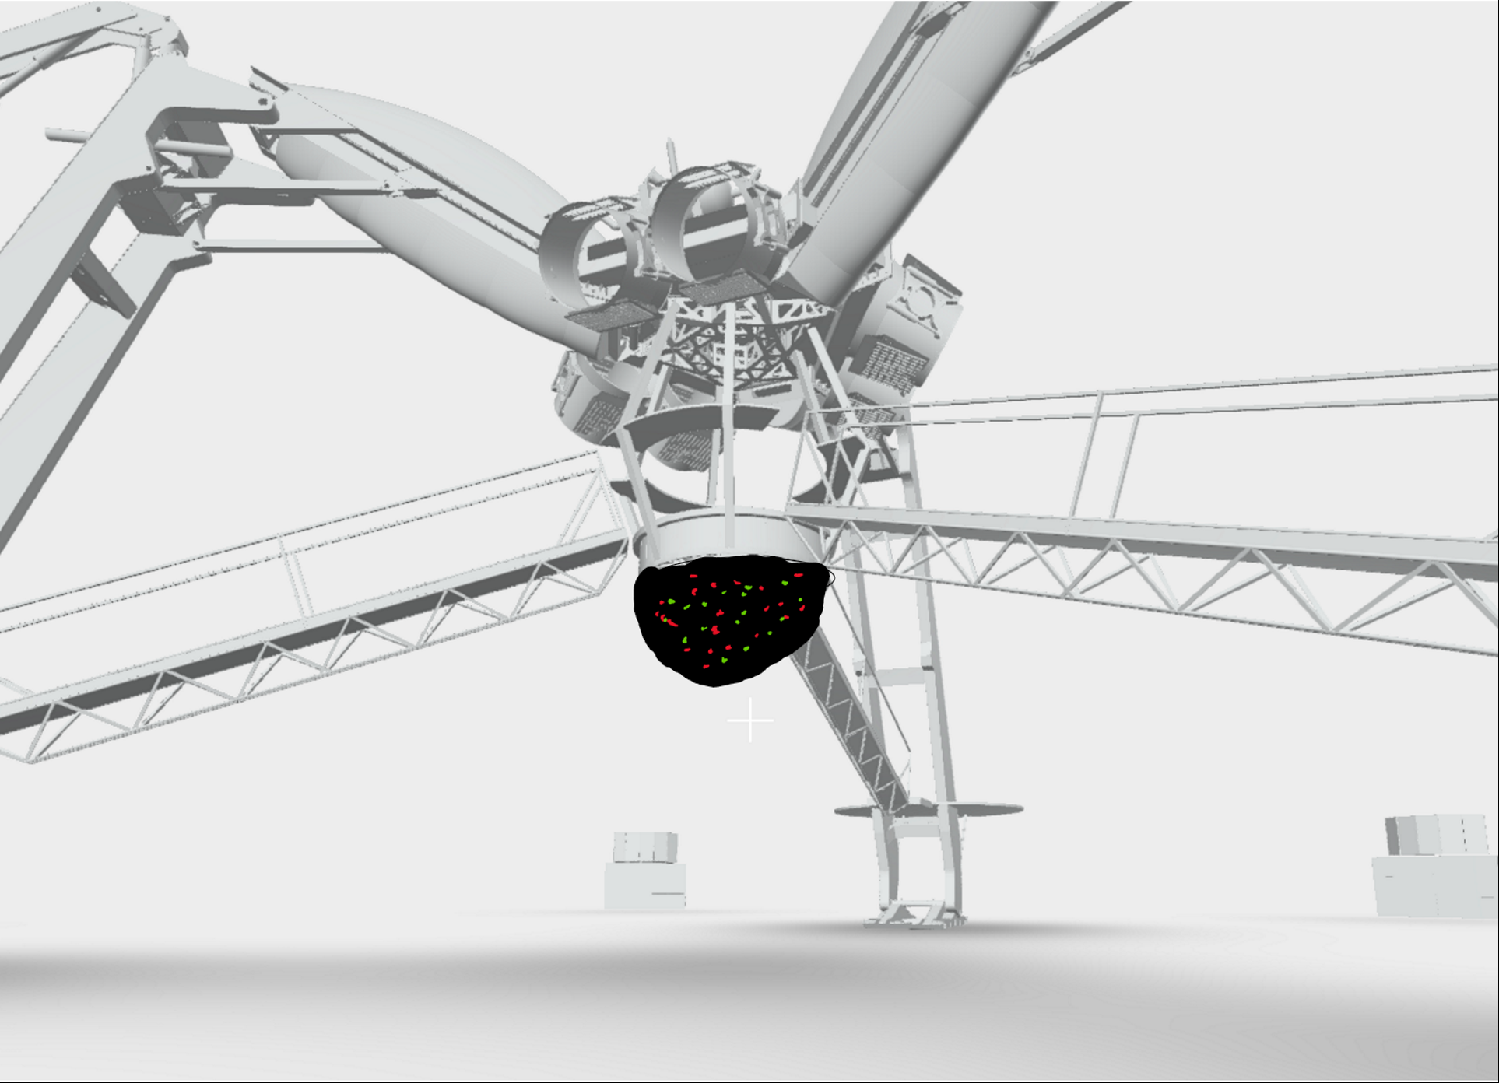
Figure 1-1 - Mock Representation of Planned Structure Design
In the full-scale version, we envision the hub to have lasers, LEDs, and C02 blasters as its special effects, and have the capability to rotate 360° on the Yaw axis. The ASRH will also include a camera that can rotate 90° on the Pitch axis. Both the Pitch and Yaw motors of the ASRH can be either manually controlled, or put on an automated procedure. The laser/light show will react to music that is being played, giving the audience a synchronous experience between what they see and what they hear. The camera on the ASRH will serve two purposes: to capture footage, and be used for the robot vision aspect of the device. While the device is in operation, the user can command the ASRH to be in “lock-on” mode. In “lock-on” mode, the ASRH will look for an object of interest in the crowd, and follow that object in the crowd so that it stays relatively close to the center of the camera image. While in lock-on mode, the user can manually fire the C02 blasters, or activate “auto-fire” which would fire the C02 blasters.

For senior design, we will build a scaled-down prototype of the product. The size of the device will not exceed a diameter of 2 feet, a height of 1 foot, and a weight of 15 pounds. We will use a limited number of LEDs and lasers, and will substitute a small nerf gun or small C02 blaster in for a full-scale C02 blaster.

Essentially, our project will possess all the functionalities of the full-scale version, with scaled down hardware. Our goal is to create a working proof-of-concept prototype that demonstrates the viability of our design to be re-created as a full-scale product, given the proper resources.

Block Diagrams

Figures 1-2, 1-3, and 1-4 are a series of block diagrams for our project. Figure 1-2 outlines the main components of our project, and is color-coded to reflect which group member(s) are responsible for each particular component. Figure 1-3 outlines a sketch of the software flow of the ASRH. Figure 1-4 outlines a sketch of how all the different hardware components are connected to each other.

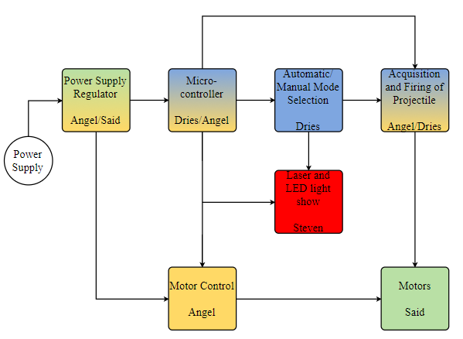
Figure 1-2 - Project Block Diagram

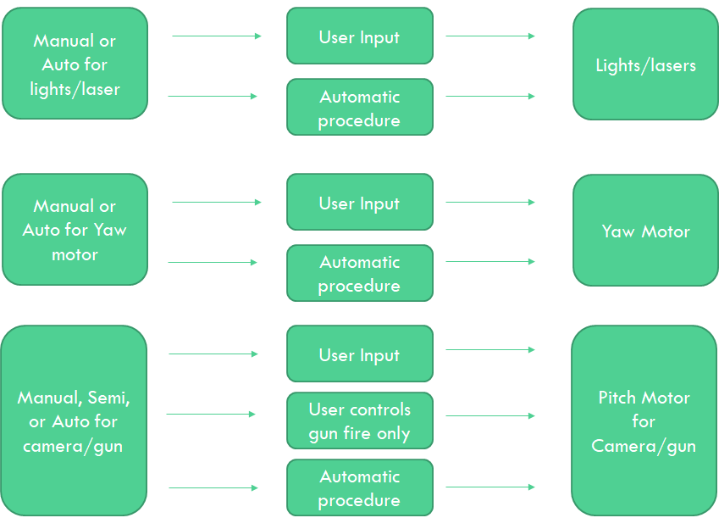
Figure 1-3 - Software Block Diagram

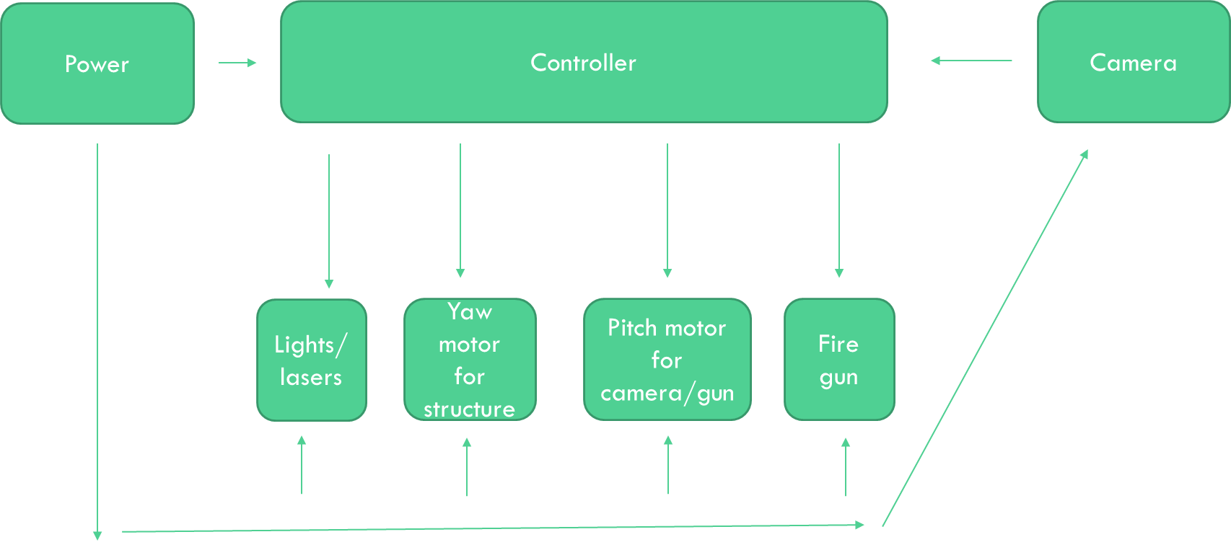
Figure 1-4 - Hardware Block Diagram

Specifications

Like any design, our project has certain specifications we plan to meet. Table 1-1 outlines the specifications we have come up with for the ASRH.
Table 1-1 - ASRH Specifications
Specification No. | Function
1 | The ASRH structure shall be able to rotate 360° on the Yaw axis
2 | The ASRH camera/gun shall be able to rotate 75° on the Pitch axis
3 | The ASRH laser/light show will react to audio input (audio/visual sync)
4 | The ASRH shall be able to locate, track, and follow an object of interest
5 | The ASRH shall allow the user to select automatic or manual control for the following capabilities  - Yaw motor rotation  - Pitch motor rotation  - Laser/Light show  - Target Acquisition and Gun Firing

These specifications represent the core functionalities of our project, and will serve as a checklist of items for our team to complete.

Project Timeline

Figure 1-5 outlines a rough timeline of objectives for our project. It outlines planned start and end dates for various parts of our project and is subject to change.

Figure 1-5 - Project Timeline

Engineering-Marketing Tradeoff Table

We have come up with a list of market and engineering requirements for our project. They are outlined in Tables 1-2 and 1-3.

Requirement No. | Description
1 | Easy to Use
2 | Robust Response
3 | Aesthetic
4 | Captivating Light Show
5 | Low Power Consumption
6 | Automatic and Manual Control Options
7 | Low Cost
8 | Reliable
Table 1-2 - ASRH Market Requirements

Requirement No. | Description
1 | Simple User Interface (< 5 input selections for user)
2 | Low Latency (< 1 second)
3 | Lasers and LEDs are synced with audio input
4 | > 330 milliwatts of optical output
5 | > 100 cycles before failure
6 | < 50 watts power consumption
7 | > 1 automated systems
8 | < 15 pounds weight
9 | < $1000 to build
Table 1-3 - ASRH Engineering Requirements

Table 1-4 is our tradeoff table corresponding to our market and engineering requirements.

Positive Correlation: ↑
Strong Positive Correlation: ↑↑
Negative Correlation: ↓
Strong Negative Correlation: ↓↓
Positive Polarity: +
Negative Polarity: -

Table 1-4 - Tradeoff Table
 |  | Simple UI | Latency | Audio visualizer | Optical Output | Reliability | Power Consumption | Autonomy | Cost | Weight
 |  | + | - | + | + | + | - | + | - | -
Easy to use | + | ↑↑ | ↓↓ | ↑ | ↑ | ↑ | ↓ | ↑↑ | ↓
Robust Response | + | ↑ |  | ↑ | ↑ | ↑↑ | ↓ | ↑↑ | ↓
Aesthetic | + | ↑ |  | ↑↑ | ↑↑ | ↑ |  |  | ↓ | ↓
Captivating Light Show | + | ↓ | ↓↓ | ↑↑ | ↑↑ | ↓ | ↓↓ | ↑ | ↓ | ↓
Power | - | ↑ |  | ↓ | ↓ | ↑ |  | ↓↓ | ↑↑ | ↓↓
Runtime | + | ↓ |  | ↑ | ↓ | ↓↓ | ↓↓ |  | ↓↓
Targets for Engineering Requirements |  | < 5 input selections | < 1 seconds | Laser and LEDs portray audio input | >300 mW | > 100 cycles before failure | < 50 Watts | > 1 automatic systems | <$1000 | < 15 lbs.

Budget

Table 1-5 outlines the budget that has been spent so far. Not included in the budget as of now are basic circuit components like resistors and capacitors. Major components that will be used will be added after further research is done for design constraints, as well as how many basic components will be needed. The miscellaneous section in Table 1-5 is a catch-all for any parts that might be damaged and need to be replaced, as well as any shipping costs. For most of the parts we will be using, free shipping is offered and therefore won’t add any additional costs.

Table 1-5 - Budget for Project Parts
Item | Quantity | Cost Per Item ($) | Total Cost ($)
VS-19 Pico Linear Servo | 1 | 9.85 | 9.85
9g Micro servo | 1 | 3.56 | 3.56
RD-65A Power Supply | 1 | 15.95 | 15.95
Parallax Continuous Rotation Servo | 2 | 13.99 | Free
Raspberry Pi 3 Model B | 1 | 35 | 35
Raspberry Pi Camera Module V2 | 1 | 23.99 | 23.99
MSP430FR5994 | 1 | 16.99 | 16.99
XBOX 360 Controller | 1 | 26.99 | Free
Mini LEDs | 100 | .09 | 8.99
LASER Diode | 10 | .60 | 5.99
Styrofoam Disk | 2 | 5.99 | 11.98
Smoothfoam Half Ball | 1 | 11.99 | 11.99
Styrofoam Cube | 1 | 11.99 | 11.99
BOOSTXL-AUDIO:  Audio Signal Processing BoosterPack Plug-In Module | 1 | 29.99 | 29.99
Voltage Regulator: LM 5175 | 1 | 6.64 | Sampled
Voltage Regulator: LM 5176 | 1 | 10.48 | Sampled
Voltage Regulator: TPS 54824 | 1 | 4.65 | Sampled
Voltage Regulator: TPS 63070 | 1 | 2.59 | Sampled
Voltage Regulator: TPS 561208 | 1 | 0.83 | Sampled
TFT LCD Color Monitor | 1 | 32.99 | 32.99
Multicolored Breadboard Jumper Wires 120CT:  Male to Male, Male to Female, Female to Female | 120 | 0.08 | 9.99
TOTAL COST | 229.25 + tax

Structural and Mechanical Considerations

Structure and Mechanics

As stated in chapter 1, the vision for the ASRH is to be a half-sphere shaped robotic structure that will hang on the underside of the Arcadia Spider. For this proof-of-concept prototype our team is building for senior design, we need to find a feasible and effective way to build the structure for the ASRH. This includes the base of the ASRH which all of the electrical components will rest on, and the outer structure that will cover the ASRH and house all of the electrical components within it. In addition, will also need to use a couple gimbals to attach to our Pitch and Yaw motors to rotate the ASRH in each respective direction. When coming up with a way of going about this part of the design, there are a few things to keep in mind.

First and foremost, no one in our group is a mechanical engineer and none of us really have any type of background in that area of engineering. Therefore, it is important that we keep the structural and mechanical part of the ASRH as simple as possible and easy enough for a non-mechanically inclined team to put together.

Second, one of our market requirements is ‘aesthetic’ meaning it should be pleasing to the eye when one looks at it. For this requirement, all that really matters is the outer structure. Since all the electronics and other mechanical components will be housed inside the structure, they are invisible to people looking at the ASRH on the outside and have no effect on its visual appearance. This means that using a material for the outer structure that can be easily modified in terms of appearance would be extremely favorable and will allow us to ensure that the ASRH itself is visually appealing.

Third, another one of our market requirements is “low cost”. In other words, we do not want to break the bank in terms of selecting our structure. The cheaper the material the better. This means that if we can avoid it, we will probably stay away from 3D printing the structure for the ASRH as it is a relatively expensive process and also requires some mechanical designing with a CAD program, something which we mentioned earlier as something we wanted to avoid. We also will look for the cheapest and most effective gimbals that we can find.

Fourth, we have an engineering requirement that states the ASRH shall weigh no more than 15 pounds. The weights of the electrical components are what they are and aren’t really able to be changed. However, we have complete control over the mechanical and structural components we will use on the ASRH. Therefore, it is favorable to find and use the most lightweight products and materials available for our gimbals and structure.

Lastly, we need to build the structure of the ASRH in a way that is easy to hook up the electronics. The inside of the ASRH will house our PCB, MCUs, wires, gimbals, and camera, while the lights and lasers will be on the outside of the structure. We need a material that will allow easy connection of the lights and lasers on the outside of the ASRH to the power and control circuitry on the inside of the ASRH.

ASRH Structure: Platform and Shroud

In terms of outward appearance of the ASRH structure, there two main parts: the flat Platform that the components on the inside of the ASRH will rest on, and the outer dome shaped Shroud that will sit on top of the platform and cover up all the components sitting on the inside. There are three main traits/characteristics we are looking for: we need a structure that is sturdy enough to house electronics and gimbals, lightweight enough to help us meet our engineering requirement of having the ASRH weigh less than 15 pounds, made of a material that will allow easy connections between the components outside the ASRH and the components inside the ASRH, and the structure needs to visually modifiable to meet our market requirement for the ASRH to be aesthetic.

For the ASRH, we are planning to use Styrofoam or a similar material for both the Platform and Shroud. These types of material are both lightweight and sturdy, lending itself as perfectly for use on the ASRH structure. For the Platform, we plan to use a 12x1 inch Styrofoam Disc from Hobby Lobby. 12 inches is a good size for this proof-of-concept prototype version of the ASRH and is more than sturdy enough to support a few circuit cards. At a price point of $5.99, we can achieve both of our requirements of being lightweight and inexpensive. On top of that, the Platform will be extremely easy to attach to the servos as it is just a matter of a few screws. For the ASRH, we will implement two of these disks in the design. One to serve as the platform for the on-board electronics, and another to serve as a steady, non-moving base. A small hole will be cut into the base to house the Yaw motor. This helps with the overall aestheticism of the ASRH as the motor will be obscured from view, and will help keep the ASRH stable with a solid base. Figure 2-1 shows the Styrofoam disc we plan to use for both the platform and base.

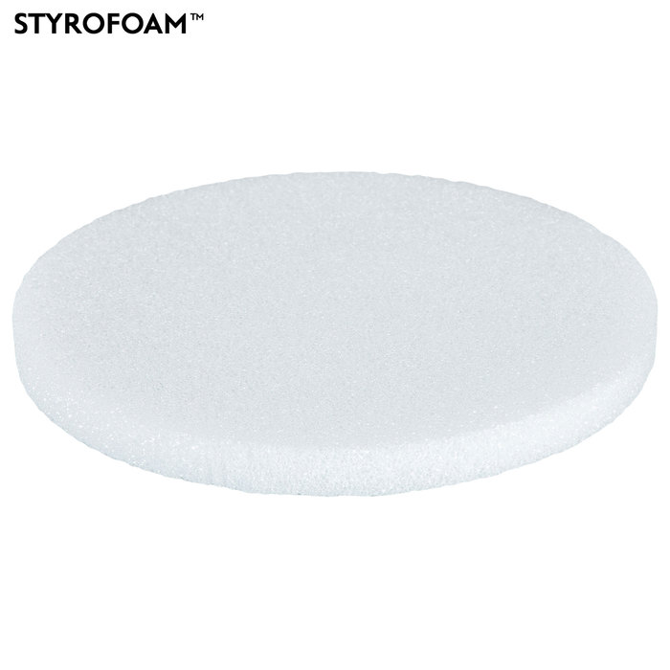
Figure 2-1 - 12x1 Inch Styrofoam Disk

For the Shroud, we plan to use a 12x7/8-inch Smoothfoam Half Ball that we found on Hobby Lobby. A 12-inch is perfect size to fit on our Platform and it is already hollowed out, giving space for the inside components. The most useful trait of a shroud like this is how easy it makes connecting the LEDs and lasers to the electronics on the inside. The LED leads can poke right through the Shroud and for the lasers, a small hole is easy to make with a drill. In addition, it will be a simple process to attach and remove the Shroud to and from the Platform with something as simple as sticky tabs. At $11.99, it is not as cheap as the Platform, but is still a good deal, especially considering the Smoothfoam is already cut and hollowed out exactly the way we need it. The only extra work we need to do is create an opening in the dome for the camera and gun. Figure 2-2 shows the outside of the half ball and Figure 2-3 shows an inside look.

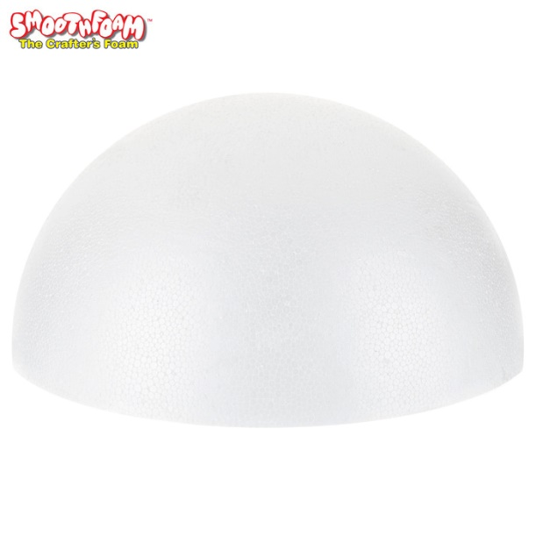
Figure 2-2 - 12-Inch Smoothfoam Half Ball (Outside)
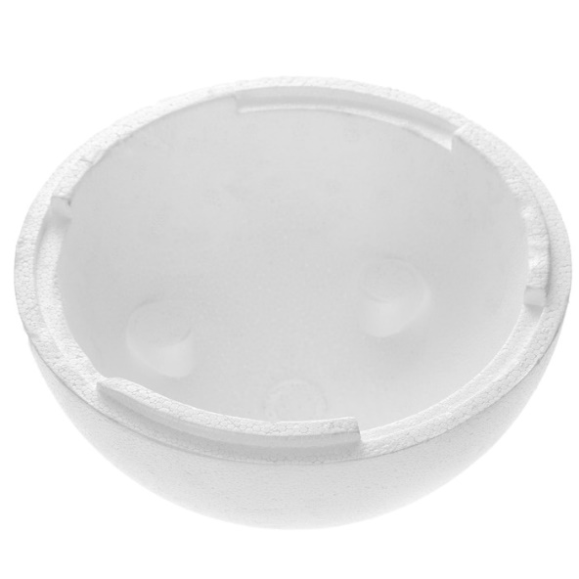
Figure 2-3 - 12-Inch Smoothfoam Half Ball (Inside)
Both the Platform and the Shroud are both blank canvases, giving us what we need to ensure we meet our market requirement for an aesthetic looking product. In addition, all of the components of the structure are made of a sturdy foam material, keeping the weight of the ASRH down, which helps us meet our engineering requirement to keep the total weight below 15 pounds. On top of all that, the total cost of all the components of the structure come out to less than $25, making it an extremely economical approach. It really helps to keep the cost down and stay true to our ‘low-cost’ market requirement.

Camera, Gun, and Pitch Motor Gimbal

The final mechanical consideration we need to account for is how to move the camera and gun in the Pitch axis direction. After some searching online, all we could really find were expensive camera gimbals that are more for stabilization rather than actuation. We realized that since our use of a Pitch gimbal is so specialized, we need to build it ourselves. Although none of the group has a background in mechanical engineering, we can easily build the type of gimbal structure we are looking for with some more Styrofoam.

Really, all we want to do is place the camera and gun somewhere on the platform where it can look outside of the dome where the opening was made. In addition, it needs to be able to have a range of motion and vision from straight ahead, to 70 degrees above that. We’ve already discussed in an earlier section of this chapter how attaching our servos to the Styrofoam only takes a few screws. To achieve our design goal, we can simply attach the camera and gun to a block of Styrofoam through means such as sticky pads and electrical tape. Once that is done, we can simply attach both the Pitch and Gun motors to the Styrofoam. If need be, we can even use some Styrofoam to elevate the pitch motor, so the camera and gun sit higher within the ASRH Shroud. To do all of this, we need to buy one more piece of Styrofoam. We decided to buy an 8-inch cube. The reasoning behind this decision was that it’s enough Styrofoam to cover our needs, and its cubic shape gives us virtually unlimited flexibility in how we want to cut the Styrofoam. At a price point of $11.99, it is a solid deal. Figure 2-4 shows the Styrofoam cube we plan to use.

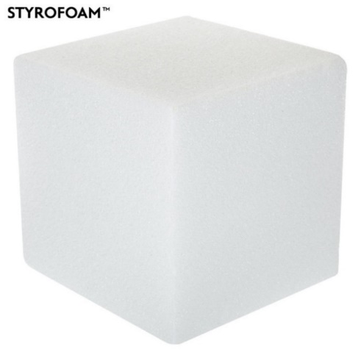
Figure 2-4 - 8-Inch Styrofoam Cube

Microcontrollers and Peripherals

Function of Microcontrollers

The ASRH will employ the use of two microcontroller units (MCUs) to execute the functionalities specified in chapter 1. The two MCUs that will be used are the Raspberry Pi 3 Model B and the MSP430FR5994. Both MCUs will use peripherals to perform their functions and more details will be discussed on the role each MCU will play in this chapter. Tables 3-1 and 3-2 below summarizing the functionalities that each MCU will perform.

Table 3-1 - Raspberry Pi 3 Model B Functionalities on ASRH
Raspberry Pi 3 Model B
Functions
- Accept raw video input from external peripheral camera
- Perform a variety of image processing methods using Python and OpenCV
  - Template Matching for object tracking
  - Color detection and thresholding for object tracking
  - Edge detection and Hough Transform for object tracking
  - Feature detection and matching for object tracking
- Accept input from peripheral controller for manual control of the ASRH
- Communicate with MSP430 for motor control and visual servoing

Table 3-2 - MSP430FR5994 Functionalities on ASRH
MSP430FR5994
Functions
- Accept raw audio input from external microphone
- Perform audio signal processing
  - FFT to obtain frequency spectrum of audio input
  - Filters for splitting audio into different frequency channels (bass, mid, treble)
- Control LASER diodes and LEDs
- Communicate with Raspberry Pi for motor control and visual servoing

Raspberry Pi 3 Model B and Peripherals

Raspberry Pi 3

The Raspberry Pi 3 Model B is a standalone single board computer developed in the United Kingdom by the Raspberry Pi Foundation. The Pi is referred to as an MCU in this paper for simplicity, it really is a misnomer. Unlike other MCUs where code is developed on a separate PC and then loaded in, the Pi compiles and executes code written on the device itself. As mentioned, the Pi is a standalone computer with its own operating system (OS) that boots from an SD card inserted into the device. To use it, one must connect it to a monitor via HDMI and control it using USB peripherals such as a keyboard and mouse.

While researching to find the best MCU for our computer vision functionalities, the Pi came out on top for several reasons. First and foremost, there is a plethora of online resources and tutorials concerning the use of the Pi for almost every computer vision application one can imagine. If we ever hit a roadblock and can’t seem to figure a way around it, chances are someone has run into the same problem and proceeded to post a solution on the web. In addition, most, if not all, of these examples utilize the open-source software OpenCV along with Python to implement these computer vision techniques. This is beneficial as some group members are already familiar with using Python and OpenCV.

Second, the fact that the Pi is a standalone computer with an OS greatly simplifies the process of implementing computer vision functionalities on the ASRH. Computer vision is already complex enough on its own; having to implement as an embedded system on an MCU without an OS would increase the complexity by a significant amount. Considering the fact that none of the group members specialize in software, it makes sense to select an MCU that’s easy to use for those that are relatively new to computer vision which we are. After all, the initial impetus behind developing the Raspberry Pi was to promote the teaching of computer science in schools and in developing countries. Ease of use is one of the strongest reasons the Pi was selected.

Lastly, the value that we would get with the purchase of a Raspberry Pi 3 Model B is virtually unmatched. For a mere $35, we get an easy-to-use, single board computer that has been proven to be extremely effective in implementing computer vision processes similar to what we need for the ASRH. On top of that, the specs on the Raspberry Pi 3 Model B are quite impressive and exceed that of similar yet more expensive boards. For example, the BeagleBone Black is a comparable board to the Raspberry Pi 3 Model B, but is twice the price and its performance is still inferior to the Raspberry Pi 3 Model B. Overall, the Raspberry Pi 3 Model B looks to be the perfect choice for computer vision on the ASRH. Table 3-3 outlines the technical specifications of the Raspberry Pi 3 Model B.

Table 3-3 - Raspberry Pi 3 Model B Technical Specifications
Raspberry Pi 3 Model B Specifications
Type | Specification
Target Price (USD) | $35
Architecture | ARMv8-A (64/32-bit)
System on a Chip (SoC) | Broadcom BCM2837
CPU | 1.2 GHz 64-vit quad-core ARM Cortex A53
GPU | 3D processing @ 300 MHz  Video processing @ 400 MHz  OpenGL ES 2.0  1080p60 H.264/MPEG-4 AVC high-profile decoder and encoder
Memory (SDRAM) | 1 GB (shared with GPU)
USB 2.0 Ports | 4 (via the on-board 5-port USB hub)
Video Input | 15-pin MIPI camera interface (CSI) connector
Video Output | HDMI, composite video, MIPI display interface (DSI) for raw LCD panels
Audio Output | Analog via 3.5 mm phone jack  Digital via HDMI
On-Board Storage | MicroSDHC slot, USB Boot Mode
On-Board Network | 10/100 Mbit/s Ethernet  802.11n wireless  Bluetooth 4.1
Low-Level Peripherals | 40 GPIO pins (includes I²C, UART, SPI)  HAT ID bus
Power Ratings | 1.5 W average when idle  6.7 W under stress
Power Source | 5 V via Micro USB or GPIO header
Dimensions | 85.60 mm x 56.5 mm x 17 mm (3.370 in x 2.224 in x 0.669 in)
Weight | 45 g (1.6 oz.)

Peripherals

The Raspberry Pi 3 Model B on the ASRH will use two different peripherals to perform its specified functions: a camera to capture live raw video and feed to the Pi for image processing, and an input controller to allow the user manual control over the ASRH.

When it came to camera selection, we really had two main options: use an external USB camera, or use the Raspberry Pi Camera Module V2 that connects to the specialized CSI present on the Raspberry Pi 3 Model B. Both options fall in the $20-$30 range so in terms of economics, they are about the same. One particular USB camera that we looked at was the ELP Megapixel Super Mini 720p USB Camera Module with 45 Degree Lens. It is a 7-megapixel camera with maximum video resolution of 720P (1280x720) at 30 frames per second (FPS). It connects via a 1-meter long USB 2.0 cable and has a small size of 32x32/26x26mm, allowing plenty of flexibility and adaptability for mounting the camera on a gimbal. The Raspberry Pi Camera Module V2 on the other hand is an 8-megapixel camera capable of 4K resolution at 30 FPS, 1080P resolution at 60 FPS, and 720P resolution at 180 FPS. Clearly, when it comes to image quality, the edge definitely goes to the Raspberry Pi Camera Module V2. On top of that, it is actually even a few dollars cheaper than the ELP Megapixel Super Mini 720p USB Camera Module with 45 Degree Lens ($23.99 versus $25.99).

Because the Raspberry Pi camera is built specifically for the Raspberry Pi 3 Model B itself, using that camera seems to be a better option. It allows for much more control options, and it seems that our greatest resource for figuring out how to implement our desired functions, the internet, has more demos and tutorials utilizing the Raspberry Pi Camera Module V2 than a more traditional USB camera. The one drawback of the Raspberry Pi camera however is how it connects to the Raspberry Pi 3 Model B itself. It utilizes a 6-inch ribbon cord, which greatly restricts how the camera can be used. Since our application on the ASRH requires the mounting of the camera onto a gimbal to be controlled by the Pitch motor, this small detail is a potential deal breaker. Thankfully though, we can order a longer ribbon cable to work around this problem. With both camera being comparable in cost and adaptability to the ASRH, the Raspberry Pi camera V2 is clearly the optimal choice due to its superior image quality and specialized compatibility with the Raspberry Pi 3 Model B. Figure 3-1 shows the Raspberry Pi 3 Model B with the Raspberry Pi Camera Module V2 and its 12-inch ribbon cable extension.
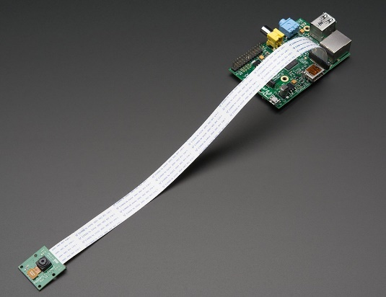
Figure 3-1 - Raspberry Pi 3 Model B + Raspberry Pi Camera Module V2 + 12-Inch Ribbon Cord Extension

The reason we need an input controller on the ASRH is because one of our market requirements “Automatic and Manual Control Options”. Our goal is for the ASRH to be a completely autonomous system on its own. This corresponds to our engineering requirement of ‘> 1 automated system’. However, if the user wishes to control the functions of the ASRH manually, our goal is to accommodate that option. When it comes to selection, the number of options available to us is virtually limitless. For the ASRH, one of our engineering requirements is to have a simple user interface (no more than 5 input selections). This corresponds with our market requirement of the ASRH being “easy to use”. Basically, the goal is for the user to have easy and intuitive manual control over the ASRH when desired.

One thing that is immediately apparent is the fact that since we are using the Pi, we have USB ports available. Therefore, a USB controller could be a great option. With a little searching on the web, we found that with the correct drivers installed, the Pi can read input from a USB Xbox 360 controller. This is a major plus as the group already has access to these controllers which means no extra economic resources would be required to implement it. Our idea is that when the ASRH turns on, its automated procedure begins. Once the ASRH detects user input, the automated procedure will stop and will only perform functions that the user instructs it to. If the ASRH receives no input commands for a certain amount of time, it will revert to its autonomous procedure. Figure 3-2 shows an Xbox 360 controller and Table 3-4 outlines the control scheme for the ASRH.
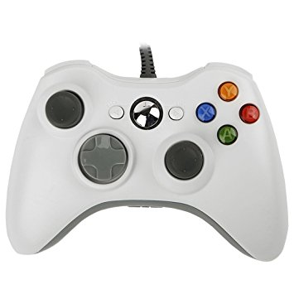
Figure 3-2 - Xbox 360 Controller

Table 3-4 - Control Scheme for ASRH + Xbox 360
Xbox 360 Controls for ASRH
Left Analog Stick | Yaw Motor
Right Analog Stick | Pitch Motor
Left Trigger | Initiate “Lock-On” Mode
Right Trigger | Fire Gun

MSP430FR5994 and Peripherals

MSP430FR5994

The MSP430FR5994 is a member of Texas Instrument’s (TI) MSP430 line of low power MCUs. The reason that this specific model of the MSP430 was chosen is because this device is a part of TI’s new ULP FRAM technology platform. Ferroelectric Random-Access Memory (FRAM) is a new cutting-edge memory technology that combines the best features of flash memory and RAM into one nonvolatile memory. One of the main features that FRAM technology brings to the MSP430 is the new low energy accelerator (LEA). The LEA is a new math hardware model that is designed for fast, efficient, and low-power vector math and its processes are completely independent of the CPU.

The reason that this is important is because this MCU is what will control the lights and lasers on the ASRH. One of our specifications is to have a laser/light show that is in sync with audio that is being played. It corresponds two of our marketing requirements: ‘aesthetic’ and ‘captivating light show’ Further details on the laser/light show will be discussed in a different chapter. For now, the only thing important to know is that to meet these requirements and specifications, real-time audio signal processing will be necessary. That is why the LEA is so important; it provides a boost of 13.8x over a traditional C implementation for a 256-point complex Fast Fourier Transform (FFT), and provides real-time filtering performance at a high audio sampling rate of 20 kHz. In addition, TI already provides a free optimized Digital Signal Processing (DSP) library, greatly simplifying the software design process we will need to implement to meet our requirements. The MSP430FR5994 was made for DSP applications and is therefore a perfect fit for the ASRH

In addition to controlling the laser/light show, this MCU will also play a role in controlling the Pitch, Yaw, and Gun servo motors on the ASRH. The MSP430FR5994 will receive commands from the Raspberry Pi 3 Model B to actuate the servos. There are a couple main reasons for implementing this type of design. First, since the Raspberry Pi 3 Model B will be occupied with computer vision processing, it may be best not to burden it any more than that. Sure, the Raspberry Pi 3 Model B is powerful, especially compared to other MCUs, but there is no reason to burden it any further than it needs to be as it is still a limited platform. On top of that, mixing our computer vision code with our servo code may complicate things and cause our servos to malfunction. By using the MSP430FR5994 as a buffer between the Raspberry Pi 3 Model B and our servo motors, it keeps them safe and makes sure that nothing causes them to malfunction. The second main reason is the fact that the MSP430FR5994 has dedicated timers for precise timing applications. Servo motors are controlled by Pulse Width Modulation (PWM), and servos usually differ in what kind of PWM signals it accepts for control. There is no ‘one size fits all approach’. The timers available on the MSP430FR5994 are perfect for creating our own custom PWM signal, allowing us to send precise signals to the motors. Without that, there will be no way of actuating the servos at all.

One thing to note is that for development and for use with our peripherals, we are purchasing the development kit for the MSP430FR5994 and not just the chip itself. This way, we can code and debug the MCU from our own PC, and can also add TI BoosterPacks onto our development kit. These BoosterPacks are peripheral devices especially made for MSP430 and MSP432 Launchpad Development Kits and are designed to add functionality to them. The peripherals we are using on our board will be discussed later in this chapter.

For $17, the MSP430FR5994 Launchpad Development Kit a great choice for our applications on the ASRH. It’s specialty in signal processing makes it the perfect candidate for controlling the laser/light show, and the on-board precision timers are perfect for creating custom PWM signals to control the motors on-board the ASRH. Table 3-5 outlines the technical specifications for the device.

Table 3-5 - MSP430FR5994 Technical Specifications
MSP430 Specifications
CPU | 16 MHz MSP430
Non-volatile Memory | 256 KB
RAM | 8 KB
GPIO Pins (#) | 68
I²C | 4
SPI | 8
UART | 4
DMA | 6
ADC | ADC12 – 20ch
Comparators (#) | 16
Timers – 16-bit | 6
Multiplier | 32x32
AES | AES256
BSL | UART
Operating Voltage | 1.8-3.6
Active Power | 120 uA/MHz
Standby Power (LPM3) | 0.7 uA
Features | LEA  Real-Time Clock  Watchdog  Temp Sensor  Brown Out Reset  IrDA

Peripherals

For our MSP430FR5994 to be able to carry out all of its intended functions, it’s going to need some help from peripheral devices. Actuating the servo motors doesn’t need anything besides connections from the Raspberry Pi 3 Model B and the servos themselves. However, interpreting audio signals to control the laser/light show is going to require some external hardware.

We need to convert pure audio into an electrical signal to be further processed by the MSP430FR5994. This process is called transducing, and is done using an electrical device known as a transducer. A microphone is a type of transducer that uses the principle of Faraday’s Law of Electromagnetic Induction to transform sound waves into electrical output. The way it works is that the microphone is built with a flexible diaphragm that vibrates back and forth when it is hit by sound waves. This diaphragm is attached to a coil of wire that is wound around a magnet. When sound waves hit the microphone and move the diaphragm, the coil moves in a magnetic field, inducing a current in the wire. The bigger the amplitude of the sound wave (louder sound), the more the coil will move in the magnetic field, inducing a larger current output. Figure 3-3 illustrates this idea.

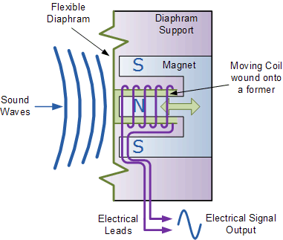
Figure 3-3 - Diagram of Transducer Microphone
This process successfully transforms raw audio output into an electrical signal but there is one problem: the electrical output is extremely small and at its current amplitude is practically useless for audio processing. All microphones require a pre-amplification circuit to increase the amplitude of the audio signal to a value high enough to be processed by the MSP430FR5994. The process of pre-amplification is relatively simple as it only requires a single op-amp circuit to perform. Usually, a bias voltage is added to the microphone input at the positive terminal of the op-amp by using a resistor divider to add bias from the positive power supply of the op-amp. Other than that, it is a normal non-inverting op amp configuration that we can use with some added capacitors for op-amp stability and noise reduction. Figure 3-4 shows an example of a microphone pre-amplification circuit with a gain $A_{v}$ of 23.

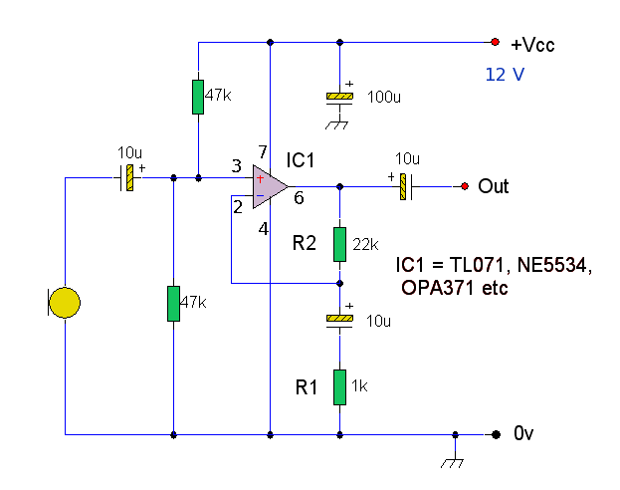
Figure 3-4 - Example Pre-Amplification Circuit for Microphone
So, buying a small microphone and building a pre-amplification circuit is a viable way of getting an acceptable digital version of an audio signal to our MSP430FR5994, however we investigated further to see if there may be a better way to go about it. Earlier, we mentioned the modularity of the MSP430 Launchpad Development Kits and their ability to connect to specially designed BoosterPacks to increase their functionality. It turns out that there is indeed a BoosterPack available that is perfect for our application and it is called BOOSTXL-AUDIO.

BOOSTXL-AUDIO is an Audio Signal Processing BoosterPack Plug-In Module that can be directly connected to the MSP430FR5994 Launchpad Development Kit. It includes a TI DAC8311 14-bit digital-to-analog converter for high-quality audio output, an onboard low-profile speaker, a volume control slider, a TI TS3A225E for autonomous headset type detection which supports both 4-pin and 3-pin 3.5-mm audio jacks, and an onboard microphone with a front-end amplifier (same as a pre-amplification circuit). Not only does this peripheral device have both the microphone and pre-amplification circuit we need, but also allows us to feed audio directly to the MSP430FR5994 via audio jack from an MP3 player or other similar device. For $30, this ‘all in one’ package is ideal for our application on the ASRH and is well worth its price. In addition to this, we will also purchase a 430BOOST-SHARP96 Launchpad BoosterPack to help us during development. It is a small LCD screen that will allow us to graphically see the output of the FFT of the incoming audio signals as well as the filtered output. For only $7 extra, it is a worthwhile investment as we begin to experiment with real-life digital signal processing for the first time. Figure 3-5 shows the setup of using an MSP430FR5994 in conjunction with the BOOSTXL_AUDIO and 430BOOST-SHARP96 BoosterPacks.
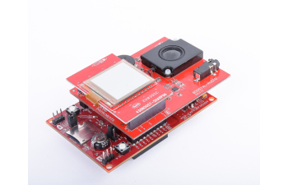
Figure 3-5 - MSP430FR5994 + BOOSTXL-AUDIO + 430BOOST-SHARP96

Servo Motors

Servo Motors on the ASRH

One of the main features of the ASRH is that the device is not static, but dynamic; it features movement in multiple directions and is not meant to simply be an immobile hunk of electronics. There are three main movements that the ASRH needs to be capable of the meet our requirements.
- 360°- degree rotation of the ASRH structure on the Yaw axis (in both clockwise and counter clockwise directions)
- 75° - degree rotation of the ASRH camera and gun on the Pitch axis (in both ascending and descending directions)
- Actuation of the ASRH gun when commanded by the user or automatic procedure

We plan to use two different types of servo motors to complete these three movements: two Parallax Continuous Rotation Servos, and one VS-19 Pico Linear Servo. The Parallax servos will control the 360-degree rotation of the ASRH structure on the Yaw axis and the 75-degree rotation of the camera and gun on the Pitch axis. The following sections will go more in depth on each servo and how exactly they will be used.

Parallax Continuous Rotation Servos

Unlike most conventional servos that have a limited range of motion, continuous rotation servos allow for full 360-degree rotation in either direction. To meet our ASRH functionality specification for full rotation in the Yaw axis, a continuous rotation servo is the only servo that can help us achieve this goal. Before we even started searching for them on the internet, we realized we already had them. During freshman year, all of us took the class EGN 1006, Introduction to Engineering. In that class we played around with the Parallax Boe-Bot. The kit included not one, but two Parallax Continuous Rotation Servos. Although most of the group had discarded or sold their Boe-Bot, one of the group members still had theirs making them available for use on the ASRH. Although they are relatively cheap servos at around $13 each, having them on hand is extremely beneficial as we don’t have to wait for them to come in to start testing them. In addition, the extra money we save on not having to purchase these servos can be used elsewhere in the project.

Like most servo motors, the Parallax servo has three different leads: a red lead, a black lead, and a white lead. The red lead connects to the power supply for the servo itself. The Parallax servo operates anywhere between 4 and 6 volts. The higher the supply voltage, the faster its maximum rotation speed becomes. At a typical power supply voltage of 5 volts, the maximum rotation speed is 50 revolutions per minute (RPM). The black lead on the Parallax servo simply connects to ground.

The white lead on the Parallax servo is the most important lead and is what we will use to control the servo. Like all other servos, the Parallax servo interprets a pulse width modulation (PWM) signal to actuate the motor. The amplitude of this signal should be no less than 3.3 volts, but no greater than 0.2 volts higher than what is supplying power to the servo. Both rotational speed and direction are determined by the duration of the high pulse that is in between 1.3 and 1.7-msec. To ensure smooth rotation, a 20-msec pause between pulses is required. Pulses of 1.5-msec will cause the servo to stay completely still; any pulses greater than this value will cause the servo to rotate in the counter-clockwise direction, and any pulses less than this value will cause the servo to rotate in the clockwise direction. Figures 4-1, 4-2, and 4-3 illustrate this idea with timing diagrams.

Figure 4-1 - Timing Diagram for No Rotation

Figure 4-2 - Timing Diagram for Clockwise Rotation

Figure 4-3 - Timing Diagram for Counter Clockwise Location
As mentioned earlier, 1.3 and 1.7-msec pulses will command the Parallax servo to rotate at its maximum speed. Values in between those and 1.5-msec can be used for fine tuning and small servo movements. Table 4-1 will be used as reference to fine tune the Parallax servos.

Table 4-1 - Parallax Continuous Rotation Servo: Speeds and Directions
Parallax Continuous Rotation Servo: Speeds and Directions
Signal Width (ms) | Rotation Speed (%) | Direction
1.30 | 100 | Clockwise
1.34 | 80 | Clockwise
1.38 | 60 | Clockwise
1.42 | 40 | Clockwise
1.46 | 20 | Clockwise
1.50 | 0 | None
1.54 | 20 | Counter-Clockwise
1.58 | 40 | Counter-Clockwise
1.62 | 60 | Counter-Clockwise
1.66 | 80 | Counter-Clockwise
1.70 | 100 | Counter-Clockwise

This servo is perfect for use on the ASRH as it is exactly what we need to rotate the structure 360 degrees on the Yaw axis. And since we have two, we can easily use the other to control the camera and gun in the Pitch direction. Although we won’t use the full continuous rotation functionality of this servo for that task, it still will help us achieve our specification of 75-degree rotation on the Pitch axis. Overall, the Parallax Continuous Rotation Servo is a perfect fit for the ASRH and is a free part for our group as we already own two. Figure 4-4 shows a picture of the Parallax servo and Table 4-2 outlines its technical specifications.

Figure 4-4 - Parallax Continuous Rotation Servo

Table 4-2 - Parallax Continuous Rotation Servo Technical Specifications
Parallax Continuous Rotation Servo Technical Specifications
Servo Type | Analog Servo
Operating Voltage (Volts) | 4 to 6
Maximum Current Draw (mA) | 140 +/- 50
Signal Voltage (Volts) | 3.3 to 0.2 + Operating Voltage
Signal Width (ms) | 1.3 to 1.7 (pause of 20 in between)
Range of Motion | Bidirectional Continuous Rotation
Maximum Rotation Speed (RPM) | 50
Torque | 38 oz.-in torque @ 6 V
Dimensions | 2.2 x 0.8 x 1.6 in (5.58 x 1.90 x 4.06 cm)
Weight | 1.50 oz. (42.5 g)
Operating Temperature | 14 to 122 °F (-10 to +50 °C)
Price (USD) | $13

VS-19 Pico Linear Servo

To activate the gun on the ASRH, we will utilize a linear servo. Unlike most other servos that rotate, linear servos can only move back and forth in one direction. The gun that we are using to represent a C02 blaster on a full-scale version of the ASRH is the Nerf SecretStrike, which is shown in Figure 4-5. This toy gun is activated by pressing a small button on the top of it.

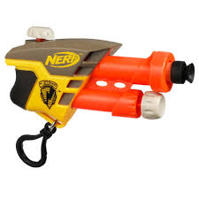
Figure 4-5 - Nerf SecretStrike
As you can see, the small button on the top of the gun does not take a large or powerful servo to press it down. We selected the VS-19 Pico Linear Servo as the servo to actuate the firing of the gun. One of the biggest perks of using this servo is its extremely compact size. With dimensions of 29 x 7.3 x 15.7 mm (1.14 x 0.29 x0.62 in), this servo will be extremely easy to work with when it comes to mounting the servo onto the ASRH. Like our Parallax servo, the VS-19 has three leads: one for the power supply, one for ground, and one for the PWM signal. This servo operates anywhere from 2.5 to 3.7 volts. The traveling nub on the servo (this is what will fire the gun) takes about one second to move from one side of its channel to the other (about 2 cm) at 3.7 volts. Using power supplies lower than 3.7 volts will greatly slow down the movement of the nub.

As far as sending signals to the VS-19 goes, it accepts servo pulses from 800 to 2200 microseconds (µs) with a neutral position of 1500 µs. This is all the information given by the datasheet on signaling the servo. It can be implied that for this servo, the width of the PWM signal determines the position of the traveling nub on its channel. Pulses of 800 and 2200 µs will send the nubs to each end of channel while PWM pulses of 1500 µs will send the nub to the middle of the channel. Unlike the Parallax motor datasheet, the VS-19 datasheet gives no information on how long the pauses between pulses should be. Therefore, it will take some experimentation and trial and error to find the right PWM we need to fit this servo to our needs. Table 4-3 will be used as reference to configure the VS-19 Pico Linear Servo.

Table 4-3 - VS-19 Pico Linear Servo: PWM Signal Width and Nub Position
VS-19 Pico Linear Servo: PWM Signal Width and Nub Position
PWM Signal Width (µs) | Nub Position (cm)
800 | 0 (beginning of channel)
975 | 0.25
1150 | 0.5
1325 | 0.75
1500 | 1 (center of channel)
1675 | 1.25
1850 | 1.5
2025 | 1.75
2200 | 2 (end of channel)

Overall, the VS-19 Pico Linear Servo shown in Figure 4-6 is the perfect component to fire the Gun on the ASRH. Its compact size allows for easy mounting, and its simple design makes it easy to program the servo to fire the gun. Its technical specifications are outlined in Table 4-4.

Figure 4-6 - VS-19 Pico Linear Servo

Table 4-4 - VS-19 Pico Linear Servo Technical Specifications
VS-19 Pico Linear Servo Technical Specifications
Servo Type | Linear Actuator
Operating Voltage (Volts) | 2.5 to 3.7
Maximum Current Draw (mA) | 450
Signal Voltage (Volts) | Unspecified
Signal Width (µs) | 800 to 2200 (1500 is neutral)
Range of Motion | Bidirectional Linear Channel (2 cm)
Maximum Speed | 12 mm/sec (0.47 in/sec) at 3.7 V (No load)
Torque | 0.83 oz.-in torque @ 3.7 V
Dimensions | 1.14 x 0.29 x0.62 in (29 x 7.3 x 15.7 mm)
Weight | 0.13 oz. (3.7 g)
Operating Temperature | Unspecified
Price (USD) | $9.85

Lasers and LEDs

Laser and Light Show on the ASRH

As discussed in the previous section, the ASRH will be an addition to the Arcadia Spider stage that is featured perennially at Ultra Music Festival, arguably the biggest dance music event in the world. One of main staples of dance music culture is the use of visual effects during a show. Considering that the ASRH is a specialized device for a dance music festival, and that our main consultant, Pip, is looking for something to engage the crown standing under the spider more, implementing visual effects is imperative our project.

On top of that, the visual aspect of the ASRH is part of both our market and engineering requirements. Our market requirement is ‘captivating light show’ and our engineering requirement is ‘> 300 mW of optical output’. With recent advancements in technology, there are multiple low-cost options available to us that we can use to meet our requirements. The following sections outline these methods and the theory behind them.

LEDs
The device will have an abundance of LEDs of multiple colors. The color of an LED plays a key role in how the device functions. Each will have a certain turn on voltage and saturation current depending on how the device was constructed. Device with a larger bandgap will emit a light with a shorter wavelength. To excite the atoms enough so that an electron will jump across the bandgap and excite a photon a voltage must be applied. In most cases, large bandgaps coincide with a larger turn on voltage for the device. There is also the issue of applying too large of a voltage across the LED. While the LED may function for a certain amount of time at a higher voltage, the current will reach a saturation point and the diode will begin to breakdown.
As the diodes get pushed closer to their breakdown voltage the responsivity of the device begins to decrease meaning that any additional electrical power applied to the diode is not as efficiently converted to optical power as seen in Figures 5-1 and 5-2. For our device to operate at its maximum potential the response of the diodes will be tested to determine the current at which they emit the highest optical power without the current being predominantly wasted as heat.

Figure 5-1 - Shows Current Where Red LED's Power Output is Most Sensitive

Figure 5-2 - Shows Current Where Green LED's Power Output is Most Sensitive
We intend our device to have a variety of LED colors which means that multiple turn on voltages and breakdown voltages of the LED’s must be taken into consideration when programing the microcontrollers. We also do not want to overload our system so a limit to the number of diodes that can be on at one time must be determined to operate our system safely.

Table 5-1 showcases the turn on voltages of two diodes previously tested in a lab from previous classes. In this case, each diode has a corresponding turn on voltage and threshold current making it more difficult in wiring individual diodes with unique properties. To streamline the design process, we selected diodes from a seller that groups their colors into two voltage categories as shown in table 5-2. These diodes are small on the order of a few millimeters as demonstrated in figure 5-3 and 5-4 so they can be easily mounted to the surface of our project. The company also claims that all their diodes have the same threshold current which will help us predict how much current the diodes will be drawing. One concern that we have is that the diodes will not perfectly match the spec sheet since they are a budget product.

Table 5-1 - Turn On Voltages and Threshold Currents of Two LED diodes
Diode Color | Turn on Voltage (V) | Threshold Current (A) | Saturation Current (I)
Red | 1.7 | .17 | .25
Green | 2.137 | .035 | .05

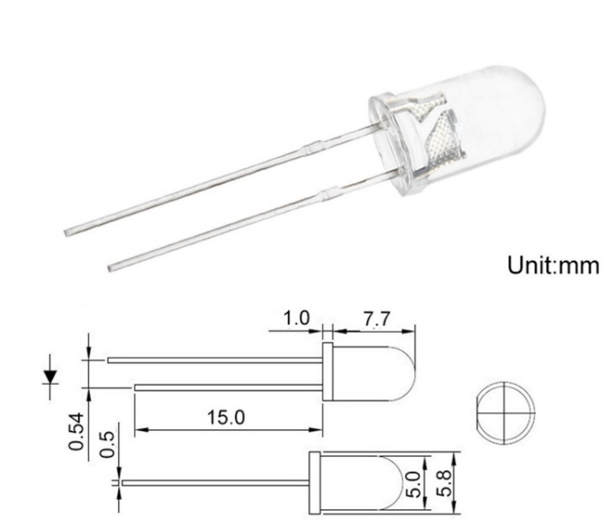
Figure 5-3- Schematic of 5mm two lead LED

Table 5-2 - Datasheet for two/three lead LEDs from Chanzon
5mm Clear Lens (IF=20mA) | Wavelength | Luminous Intensity | Forward Voltage | Viewing Angle
White | 6000-9000K | 12000-14000mcd | 3.0-3.2 V | 30º
Red | 620-625nm | 2000-3000mcd | 2.0-2.2 V | 30º
Green | 515-525nm | 15000-18000mcd | 3.0-3.2 V | 30º
Blue | 450-455nm | 7000-8000mcd | 3.0-3.2 V | 30º
Yellow | 588-592nm | 1500-2000mcd | 2.0-2.2 V | 30º
Warm White | 2800-3000K | 14000-16000mcd | 3.0-3.2 V | 30º
Yellow-green | 570-575nm | 500-700mcd | 2.0-2.2 V | 30º
Orange | 602-610nm | 1500-2000mcd | 2.0-2.2 V | 30º
Purple (UV) | 395-400nm | 300-400mcd | 3.0-3.4 V | 30º
Pink | / | 7000-8000mcd | 3.0-3.2 V | 30º

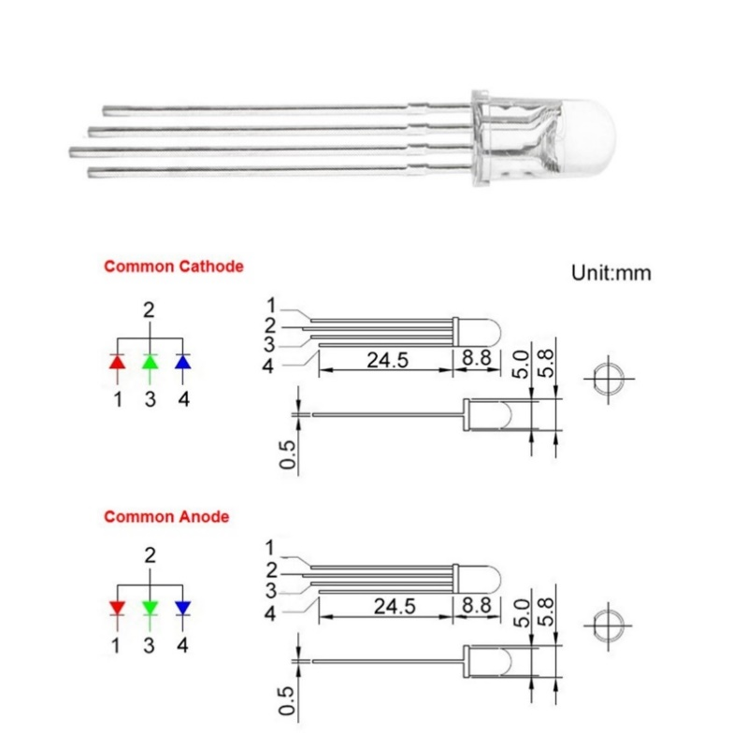
Figure 5-4 - Schematic of 5mm Three Lead LED
To ensure that the voltages and currents of the diodes are as labeled, each color diode will be tested to ensure that the data sheet on the packaging is correct. Also, the threshold current of each diode is said to be 20mA which is unusual for diodes, but would simplify the design process. While each diode may turn on at the same current their relative brightness may differ, to get a uniform illumination the currents passing through will have altered.

Then there is the issue of using the three lead diodes versus the two lead diodes. While the properties of the diodes are the same, there may be some difficulty implementing them into our microcontrollers. The benefits of the two lead diodes include that the voltage will either be above or below threshold to determine whether it is on or off. The downside is that each color will have to be wired individually to a pin meaning more connections and not all the lights will be used if only one color is showing at a time. For the three lead diodes all the diodes will be able to be on at the same time since each diode can be any color. The difficulty may arise in getting the proper signal to create the colors and patterns we want but this also means when can create more complex visuals compared to a double lead set up.

A third option that may be the most feasible are RGB LEDs. These LEDs package all the colors into one unit while simultaneously allowing us to control the color and refresh rate. Another benefit that can be derived from the RGB device is that the optical power output is much higher per unit meaning less devices that we must connect to our controllers as shown below in Table 5-3. A downfall of the RGB units is that they boast a larger footprint as well as requiring an abundance of pin connections as seen in Figure 5-5. The RGB does allow us the ability to create multiple colors from three base colors but this requires programming to pump each color to the correct level to create the appearance of another color.

Table 5-3 - Specification Sheet RGB 3W LED
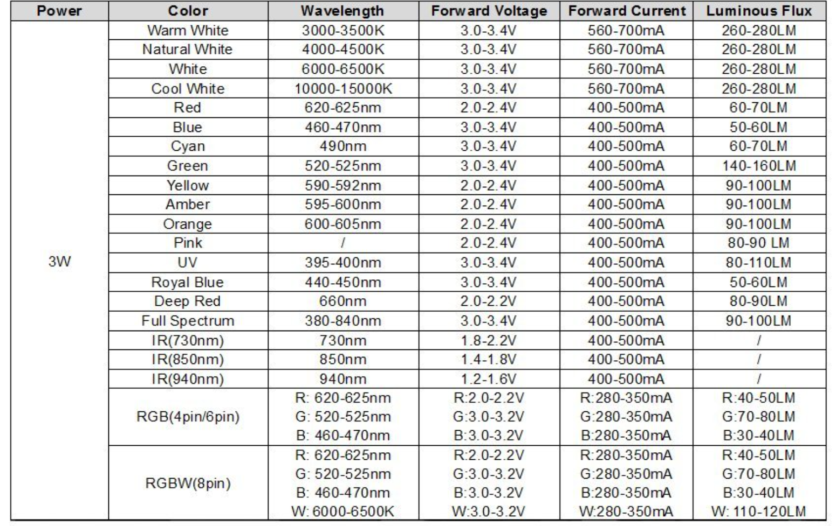

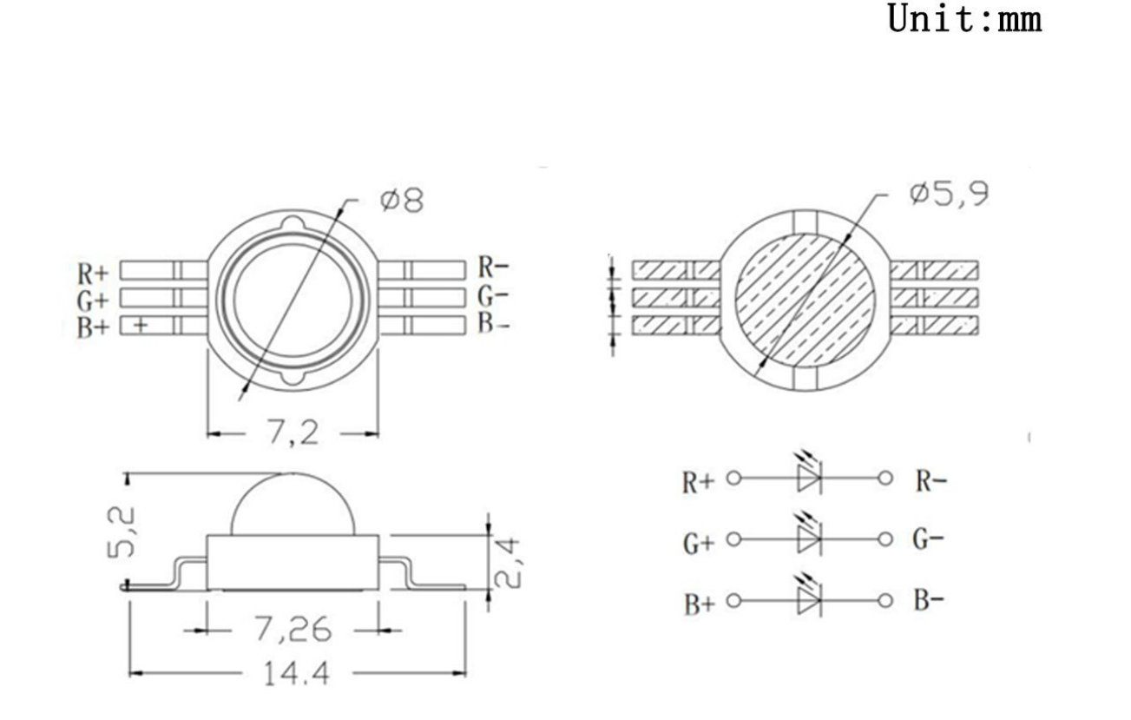
Figure 5-5 - Physical Specs of RGB 3W LED
To provide ample amount of light we want to get a fraction of the brightness of a standard light bulb. A standard lightbulb is approximately 800 lumens and the average luminosity of an LED diode is 5 lumens so with 20 of these diodes we can get around a tenth of the luminosity of a lightbulb. The issue for using lumens as a benchmark for brightness is that it is dependent on the wavelength of the source. The lumen is an angle dependent function of the candela which is the unit for the apparent brightness of a single candle. These units are great when determine of light sources with a wide spectrum of light but fail to properly represent how much energy is being released from light sources that are monochromatic.

The determination of a light source’s luminosity considers its emitted spectrum of light. There is one benchmark that awards more weight to light with a frequency centered on what we perceived as green, as shown by the curve in Figure 5-6. This curve is based on the sensitivity of the human eye to distinct colors of the spectrum. For example, using the green scotopic curve, a light source with a central wavelength of 450nm would need approximately double the optical power as a 550nm light source to appear just as bright to the human eye. The consideration to how the human eye perceives colors makes lumens and candela a great metric of measuring how well a light source fills a room, so we can see. What a candela does not do is provide us with an accurate intensity of light sources that are on or off the edge of the visible spectral range.

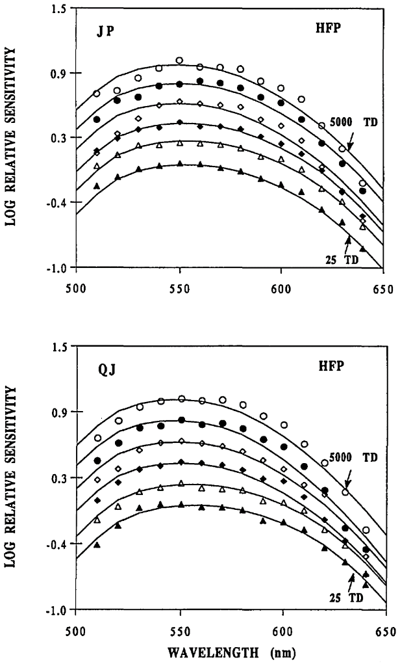
Figure 5-6 - Luminosity Functions Relative Intensity Vs. Wavelength(nm) (Pokorny, Jin and Smith, 1993)
To properly determine the optical power output of our system and determine the power efficiency of the lighting setup we will have to directly measure the energy released by each color of diodes. An optical power meter will be used and will look for the wavelength that the company provided on the data sheet shown in Table 5-3. Once the average optical power output of every diode color is determined, then the number of components needed to reach our goal optical power output of 300mW can be calculated.

Every LED has its unique characteristics, but these physical properties of the diode usually do not differ much from diodes with the same spectral output. Figures 5-7 and 5-8 were compiled using data from two diodes that were capable of functioning as a LED or an LD (Laser Diode). The data was taken from the diodes in their LED modes and relates the optical power output of each diode relative to the current passing through them. As seen in Figures 5-7 and 5-8, the power output of the green diode is about 60mW greater than that of the red diode, all while drawing less than a quarter of the current of the red diode.

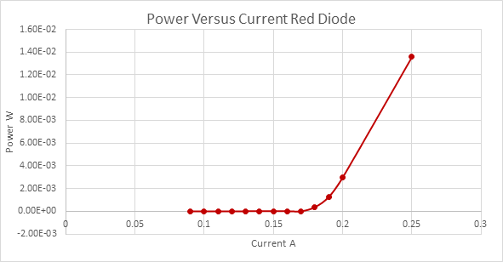
Figure 5-7 - Lab Test of Red Diode in LED Mode
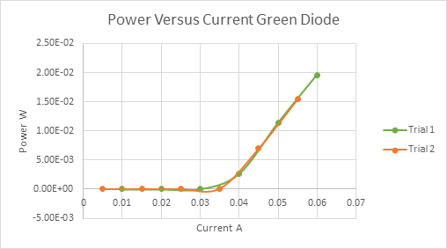
Figure 5-8 - Lab Test of Green Diode in LED Mode
The significant differences in output powers can be attributed to many factors, including internal reflection in the diode, the quantum efficiencies of the semiconductor material, and other physical factors such as diode temperature. Smaller contributors to the power output difference has to do with the wavelength of light each diode is creating. Every electron that passes through the green diode has the potential to release a photon with a higher energy than a photon that is excited from the red diode. The emission of light is quantized into packets known as photons and are proportional to their wavelength the speed of light and Planck's constant. The energy of a single photon can be given by $E_{photon}=\frac{hc}{λ}$. This means that in a perfect scenario of two diodes had the same current passing through them and had the same internal efficiencies then the diode with the shorter wavelength would produce the highest optical power.

LASERs

The LASERs will be used to produce precise long-distance effects. To keep the weight, cost and power consumption down, LASER diodes will be implemented into our projects. They benefit our design with their compact design and low power consumption as well as their ease of implementation. The main diodes we will be using have a red 650nm wavelength and a 5mw power output, shown in Figure 5-9. For now, these are the only LASER diodes we will be using since they have the lowest cost since the color variety found in LED diodes is not currently present at the same low prices when it comes to LASER diode devices. A ten-pack of red diodes with a unit cost of less than one dollar per diode cost less than a single green laser diode and approximately the same as a single blue diode. The price difference come in the cost of the lasing crystal, and is significantly higher in the green diode due to the use of a secondary crystal to convert the output of an LED diode with light outside of the visible range to a laser with a green wavelength.

The LASER diode we will be using has a maximum current of 20mA which is the threshold current of the LED diodes. The operating voltage is 5V which is significantly higher than the LEDs, so we need to make sure our microcontroller will be able to produces enough voltage to power the diodes. The packaging for these diodes does not include the threshold hold current of the device so this will need to be tested to ensure that enough current can be supplied to the diodes. Based off the maximum current and operating voltage, each diode will consume approximately 100mW of power which is greater than highest power consuming LED diode at 80mW.
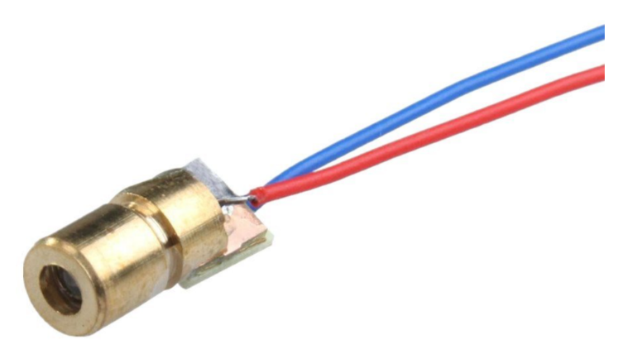
Figure 5-9 - 5mW 650nm LASER Diode (ChanSmart)
One of the goals for our project is make it as visually appealing as possible, one criteria for this would be a multitude of colors for our device to project onto the crowd. Unfortunately, when it comes to low powered consumer LASER diodes there are not many options that are affordable and serve our purpose. The blue and green diodes found online are either too expensive or too powerful to implement into our design. These reduces our options to just the red diodes unless a cheaper alternative for different color diode appears.

Safety

A major concern for the lighting design is the optical safety of the device. Since this product will be used for entertainment purposes, many individuals will be viewing the device for extended periods of time. For the LED diodes there is no risk of eye damage to the lower optical power output of each diode as well as the wide viewing angle of the diffuse light. There is a larger chance of damaging eyesight from a standard lightbulb than one of our low powered LED lights. The OSHA Laser Classifications are outlined in Table 5-4.

Table 5-4 - OSHA Laser Classifications - Summary of Hazards [Osha.gov, 2017]
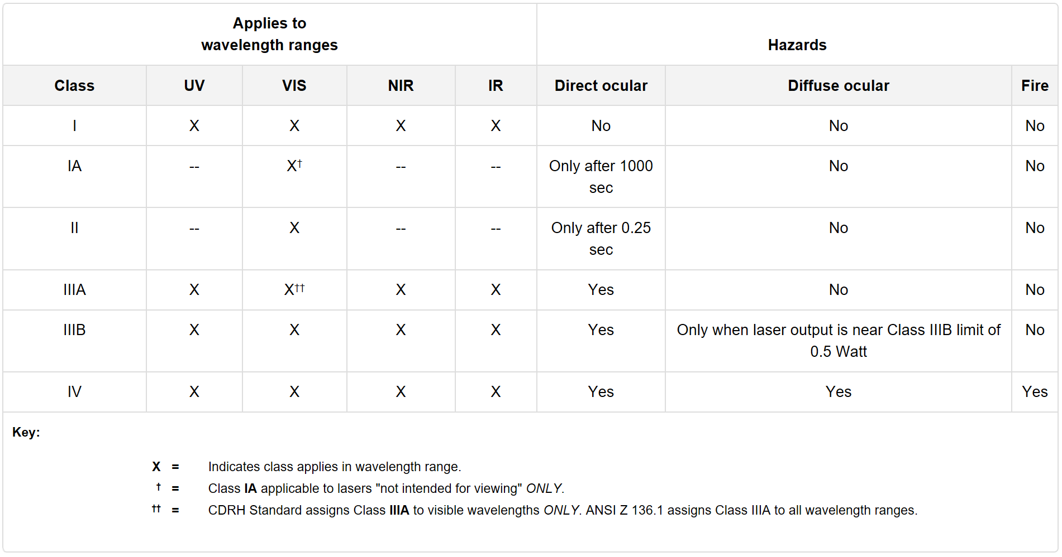
LASER diodes carry a larger risk, the optical path of the beam does not diverge as much as an LED which leads to higher intensities hitting the eye which is what damages retinas. Based off the IEC 60825-1 standard, the diodes we are using fall into the class 2 range which means that the laser is blink safe. A blink safe laser is one that is not powerful enough to damage the eye in the time it takes for a person to look away or blink. The structure is designed to be far away enough from the audience so that the LASER beams will have diverged enough to ensure that the light is sufficiently eye safe. The diodes also come with a lens that allows us to focus or defocus the beam to our ideal spot size.

The concern for eye safety would be amplified if the project was scaled up to full size. For the current design the laser will not have to be seen from more than a few meters, but a large-scale version would have LASERs visible from more than 50 meters away. These commercial lasers would have a stronger potential for eye damage at a faster rate due to higher power output and ability to be tightly focused. To prevent eye damage the LASER's would be programed so that they do not appear in one spot with enough time for a person to look at the beam and damage their retina. So even if someone was actively trying to look directly as the beam they would unable to do so.

Syncing Lights and Audio

One of the main functionalities of the ASRH is to have a laser/light show that is synced with incoming audio signals. The idea is to have certain LEDs and lasers turn on when the amplitude of the audio signal reaches a certain threshold. To make the laser/light show more captivating, the plan is to link different lasers and LEDs to different frequency ranges from the audio. For example, one group of lasers and LEDs would be configured to only turn on when the amplitude of the bass of the incoming audio signal reaches a certain threshold – audio input outside of the selected frequency range would not activate these lasers or LEDs.

The first item that requires investigation to bring this idea to fruition is defining the frequency spectrum for audio signals. This is shown in Table 5-5.

Table 5-5 Audio Frequency Spectrum
Frequency Band Name | Frequency Values | Description
Sub-bass | 20 to 60 Hz | Usually felt more than heard. Many instruments struggle to reach this range
Bass | 60 to 250 Hz | Fundamental notes of rhythm are centered in this range, mostly in the 90-200 Hz area
Low Midrange | 250 to 500 Hz | Contains lower order harmonics of most instruments
Midrange | 500 Hz to 2 kHz | Contains medium and higher order harmonics of most instruments
Upper Midrange | 2 to 4 kHz | Human hearing is most sensitive in this range. Contains many percussive and rhythm instruments
Presence | 4 to 6 kHz | This range is responsible for clarity and definition of sound
Brilliance | 6 to 20 kHz | This range is composed entirely of harmonics and is responsible for sparkle and air of a sound

To keep things simple, we will divide the audio spectrum into three different frequency bands for the ASRH. The more bands we have, the more complicated our lighting scheme will be, and the more filtering we will have to ask out of our MSP430FR5994. Three is a good place to start as it is simple enough to execute, but complex enough that we can create a ‘captivating light show’ to meet our market requirement. If we get three frequency channels working perfectly with ample time left, we may investigate adding more but for now, we will start with three.

The first frequency band will go from 0 Hz to 250 Hz. This will be our ‘Bass’ channel and will pick up the lowest frequencies of the incoming audio signal. The second frequency band will range from 250 Hz to 2 kHz. This will be our ‘Mid’ channel and will pick up frequencies that are in the middle of the park on the audio frequency spectrum. The last frequency band will range from 2 kHz to 20kHz. This will be our ‘Treble’ channel and will pick up frequencies that are on the upper end of the audio frequency spectrum. Table 5-6 shows the different frequency channels for the ASRH.

Table 5-6 - Arcadia Spider Robotic Hub Frequency Channels
Arcadia Spider Robotic Hub Frequency Channels
Channel Name | Frequency Values
Bass | 0 Hz – 250 Hz
Mid | 250 Hz – 2 kHz
Treble | 2 kHz – 20 kHz

The idea here is to treat our laser/light show design the same way a Hi-Fi stereo is designed. In a Hi-Fi stereo the incoming audio input is filtered into different bands to send to different speakers. Some speakers are designed to output low frequency audio while others are designed to output higher frequency audio. We want to apply the same concept to the ASRH but instead of audio output from speakers, we want optical output from our lights and lasers. We’d separate our visual components into three groups: Bass, Mid, and Treble. The amplitude of the audio in each of these frequency bands will determine whether a certain group of lasers and LEDs will activate.

For the ASRH, we will employ a design using digital filters as opposed to analog. The main reason for this is that it allows for flexibility in our design. If we use analog filters, once they are put on our PCB, we are essentially stuck with those values. The only way to change them is to build brand new filters and solder those onto the PCB. Using digital filters allows us to change our design at any point we feel the need to. If we decided to build analog filters and found out during testing that our pre-selected frequency values did not give us good results, we would have to completely redesign our filters. This means doing another analysis, finding the right components we need, and then breadboard testing the circuit all over again. With digital filters, we can change not only the cutoff frequency values for our filters, but also the number of channels we use with just a few keystrokes. This is the reason we selected the MSP430FR5994 as our MCU in control of the laser and light show. With the BOOST-XL-AUDIO Launchpad BoosterPack, we get the microphone and audio amplifier all in one, which means we can use the filtering capabilities of our MCU to realize our design. In fact, the LEA on the MSP430FR5994 was specifically designed for vector math operations and allows the CPU to process other things beside the math. This type of design allows high performance real time audio signal processing, which is exactly what we need on the ASRH. Figure 5-10 illustrates this idea with Hi-Fi speaker design. For the ASRH, these output speakers are simply replaced with lasers and LEDs.

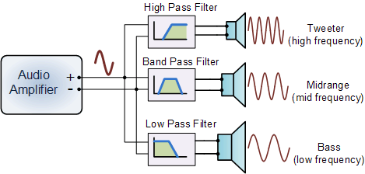
Figure 5-10 - Hi-Fi Speaker Design

LED Drivers

Our project intends to utilize many LEDs to create a vibrant light show. While the power consumption of each LED is low in the milliwatt range, when multiple devices need to be turned on at once the power consumption will jump up significantly. If each two lead LED uses around 60mW of power and over twenty of those would have to be used means a power consumption of 1.2 Watts at a minimum. For the RGB LEDs each one has a power consumption of 3 Watts if ran continuously. To the reduce the load on our controllers we will want to use LED drivers that can flash the LEDs at a rate that makes them appear to be continuously on while reducing the power consumption of each device. For example, if we had the RGB LED flash for 10 milliseconds 30 times a second the device would be on for 300 milliseconds, 30% of the time it would be on if it was run continuously, this means a power consumption of 900 milliwatts, less than half of our original power consumption.

The length and duration of the flashes can be optimized to get the most apparent brightness while reducing the power consumption of the system. The drivers will also have to be able to communicate with the audio processing unit to react the beat and frequency of the audio the device is subjected to. We will want the driver to have at least three channels to control the three audio bandwidths that we want the device to respond to. There are the high frequency, mid-range and the low frequency bands that the device should be able to respond to. If the device were to have a more complicated response to stimulus then each range of sound would have multiple channels. Of course, as more channels are added the complexity of the system increases and creates more possibilities for error.

Focusing on the bare minimum goal of having three channels, one for each rage of audio that the system will be subjected to. An LED driver that is capable of power multiple lights at once as well as alter their color and intensity is needed. For example, when audio processing unit detects a beat in the low end 100Hz range we will want it to flash when the beat hits by pulsing several lights at the same repetition rate as the beat. This function will work well with the low-end portion of the sound spectrum since it usually consists of drum beats and other periodic sounds found in music that are usually very well defined and easy to distinguish.

For the midrange portion of the sound a different approach for the systems response would benefit us the most. Usually the midrange of music consists of vocals and most instruments. Therefore, it would be difficult for the system to pick out just an individual instrument or voice and follow its pattern. Following just one portion of the densest portion of the audio spectrum would not represent the music properly and we would like some variety in how our lights respond to the audio stimulus. To capture the midrange, we would have the brightness of the lights that are connected to that range alter according to the amplitude of the music that is playing. For example, during the quiet portions the lights would dim and when the music builds up to a crescendo there would be an intense amount of light produced.

Finally, for the upper end of the spectrum, which usually consists of cymbals, hi hats, and electronically produced noises we will have a third channel. This channel, so that it differs from the previous two, will have its lights react to either the frequency within the predetermined range or the speed of the beat at the upper range. To elaborate more on this feature, when the high-pitched portions of the song get even higher, the brightness of the LEDs will also increase. As a second option, when the beat of the hi hats or cymbals are increased then the brightness of the high-end lights will increase. This second option may pose a problem because there may be multiple upper end instruments, or their beat may remain constant, so we will not be able to show off the abilities of our optical processing unit.

Now that we have outlined how we want our LED drivers to control the lights and how the system will respond to each band of audio input it receives we can look as a few of the driver options available to us. Looking at our parts list we create the criteria for our search for the driver that best suits the project requirements. Each channel must be able to drive enough current and voltage so that it crosses the threshold. Looking at the smaller, low power diodes as our baseline, we need to draw at least 20 mA per channel to turn on the diodes. To increase the intensity of the light the current would have to be above that threshold, so we are looking for a driver than can produce over 25mA of current. The output at each channel must be able to produce a voltage anywhere from 2.0V up to 3.4V so that all the colors can be utilized in the design. If a driver was unable to supply a different voltage to each diode then multiple drivers would have to be using within each audio band so that multiple colors can be represented. Another option would be to use just one driver so that each audio band uses a unique set of colors and would require less programming and wiring as well as reducing the electrical load placed on the system.

The first driver that we looked at is TI’s LM8502 which has a footprint as shown in Figure 5-11. This driver advertises 12 channels with 10 of them being current sink LED outputs. The other 2 channels have a flash function which is able of pushing 600mA per channel or 1.2A through one channel. This driver interests us because it may be able to power the 3W RGB LEDs that we had in mind for our design as well as the smaller diodes. The problem that stands out the most is that the documentation suggests that the flash channels cannot be on concurrently with the 10 lower current channels. Making this driver a viable but not necessarily the best option.

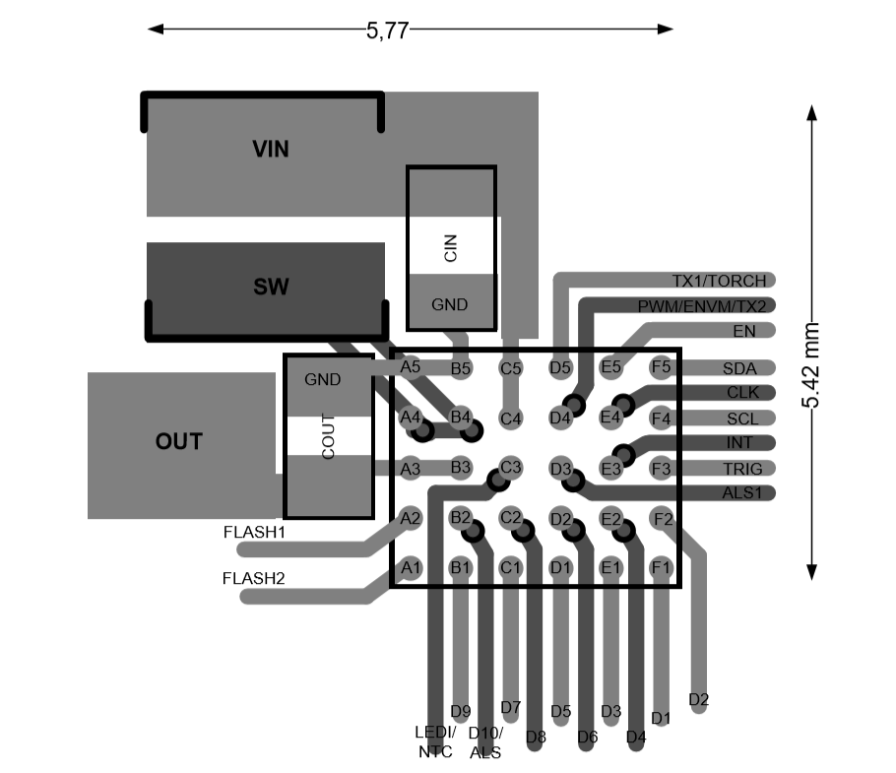
Figure 5-11 - Schematic of LM8502 by TI
A second driver that we looked at was TI’s LM3549 as pictured in Figure 5-12. The benefits that this driver boasted was that it was programmable, had good current accuracy, and a 700mA maximum current drive. The 700mA max current drive was characteristic that really peaked our interest due to its ability to easily drive the 3W RGB LEDs that we are considering using that demand a minimum of 300mA each. With three channels, this driver appeared as our best option for driving the more power demanding lights in the design. The downside this device is that it is sequential and only channel can be utilized at a time so to have multiple 3W RGB LEDs on at the same time each would need their own driver. Even though multiple lights cannot be powered at once with this driver, one can connect three LEDs to each driver and have them turn on sequentially to get an interesting visual effect, so this device is not completely off the table when it comes to making an appearance in the final product design.

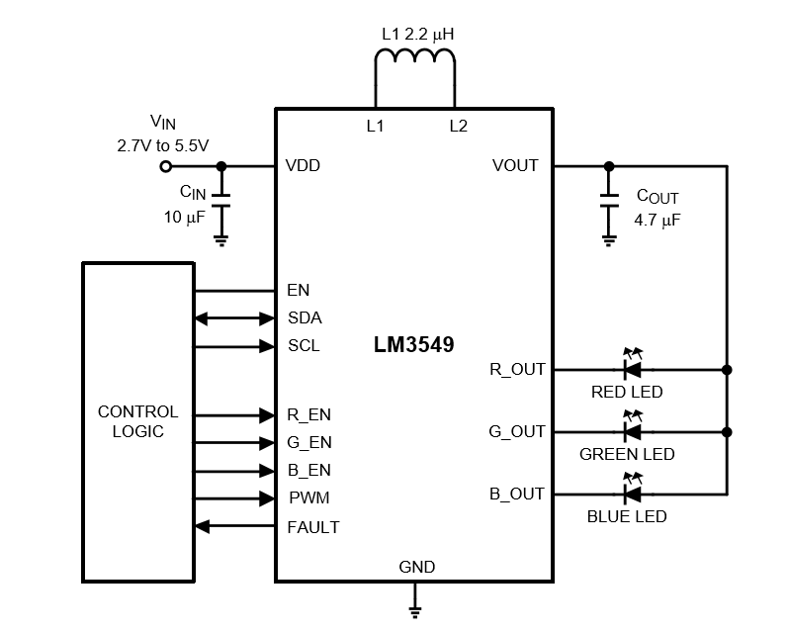
Figure 5-12 - Typical LED Circuit with TI LM3549
The third option that we have, the TI LP55281, appears to have the most promise for being implemented into our design. The driver as shown in Figure 5-13 even includes the schematic for how to connect an MCU unit to the driver which makes us believe it is designed to work well MCUs. Since an MCU will be recording an analyzing the audio data to create a signal for the optical drivers to follow communicating that data between MCUs would make the process streamlined and this driver will be able to process the data using a program we code into the MCU it is connected to. Another standout function of this device is its ability to power up to four RGB LED sets or 12 single LED’s. While the power output of each channel is limited to 30mA making the high power RGBs impossible to power, the driver would do an excellent job of powering the less energy intensive three lead RGB diodes or the two lead single color diodes. With this device capable of driving up to 13 LEDs at once it will be able to handle most of the work load using the lowest number of drivers.

Furthermore, as we continue to look at abilities of the device we see that one pin referred to as the fun light pin can synchronize itself with an audio input. This feature is promising in that we may be able to utilize the audio processing power of the driver to create patterns for some of our lights. Also, referencing to above where we stated the driver’s inability to push enough current to drive the larger 3W RGB LEDs, the product description claims that the device can work with LEDs powered from a boost output or external power supply. This can make the driver just a signaling system while we have the lights hooked up to a system that can produce enough power for all the light to run concurrently, independent of their power consumption.

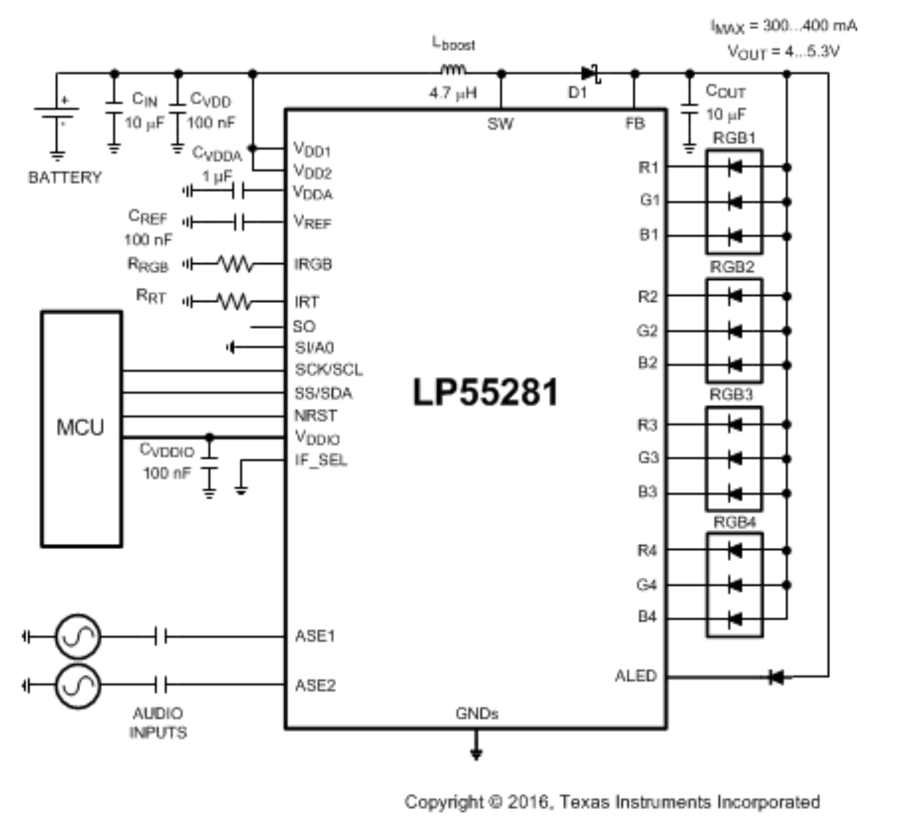
Figure 5-13 - LED Circuit with TI LP55281
The fourth driver that we are considering for driving the diodes in our system is the LP5569 from TI and is shown in Figure 5-14. Like the previous driver it boasts a larger number of current drivers with nine channels, each capable of pushing 25.5mA. Each channel is controlled by an 8-bit input like the LP55281 providing an ample amount of control in the brightness of the LEDs and ensuring that they do not get pushed pass their saturation current. The driver claims to have PWM dimming and an input frequency ranging from 100Hz to 20kHz which coincidentally matches with the average range that the human ear can detect. The ability to modulate the light is important because it will allow to reduce the power consumption of the device if a lot of lights are being operated simultaneously. There is also a master fader ability that can dim al the LEDs at the same time which would be a beneficial tool in for the midrange band of lights that will be reacting to the intensity of the audio in their range.

While this driver has an abundance of positives it falls short in one crucial detail. The maximum driving current is shown as 25.5mA which is above the threshold current that the manufacturer claims on its two lead diodes. Even though it is over threshold it may not be enough to drive the lights to the brightness we desire. Also, the smaller range of current that we have to play with means that any dimming or fading functions that we apply will be unnoticeable unless one were paying special attention to look for it.

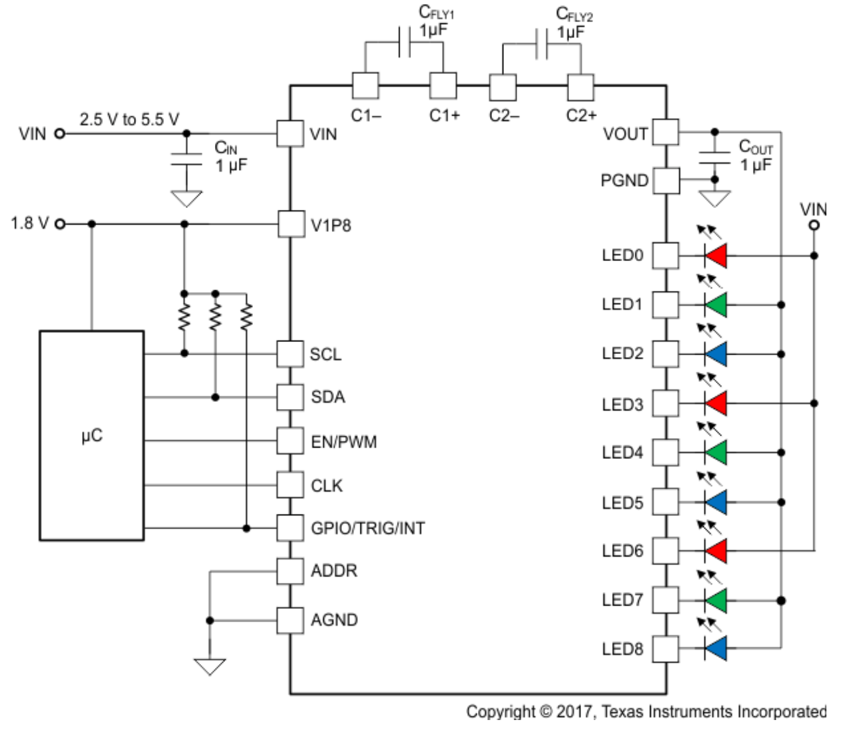
Figure 5-14 - LED Circuit with TI LP5569
After looking at the different options for the drivers and discussing the key features each one possesses we now need to look at how these drivers will communicate with the rest of our system. The two interfaces that most of the drivers have in common are Inter-Integrated Circuit (I²C) and Serial Peripheral Interface (SPI). These interfaces are used in the communication of peripheral devices, in this case the LEDs and laser diodes we will be installing onto our project. A key feature of I²C is that it can support multiple masters and slaves on the same bus. This feature allows the device to require fewer pins to communicate with multiple peripherals. Where SPI differs in that it only has one master that may have multiple slaves attached to it, but each slave requires its own pin. If a large number of devices were to be connected using SPI, then the number of pins would increase linearly. With I2C, only two pins are needed connect the slaves the master and since the data the transferred from the master to the slave with using an address specific to each slave. A comparison of these two options is outlined in Table 5-7.

Table 5-7 - Major Properties of Two Interface Systems
Interfaces | SPI | I²C
Pins Per Slave | 3 + N slaves, N being the number of peripherals attached | 2 pins up to 128 slaves
Bandwidth | Limited by Attached Electronics > 50 MHz | 400-800 kHz usually, can be 1.2 MHz occasionally
Stacking | Can be stacked | No
Pin Purposes | Clock, Master Output, Master Input, Slave Select | Clock, Data

As an example, we can look the SPI and I2C specifications for the LP55281 driver to see how the previous section applies to the drivers. The quick response time of the SPI interface is shown off in table 5-8 which highlights the minimum speeds at which the different processes occur. The cycle time can be a minimum of 70 nanoseconds which means the device can cycle at a maximum rate of about 14 Mb/s. As noted in Table 5-7, the SPI can achieve speeds as high as the electrical components will allow.

Table 5-8 - SPI Interface Timing Values [TI.com, 2017]
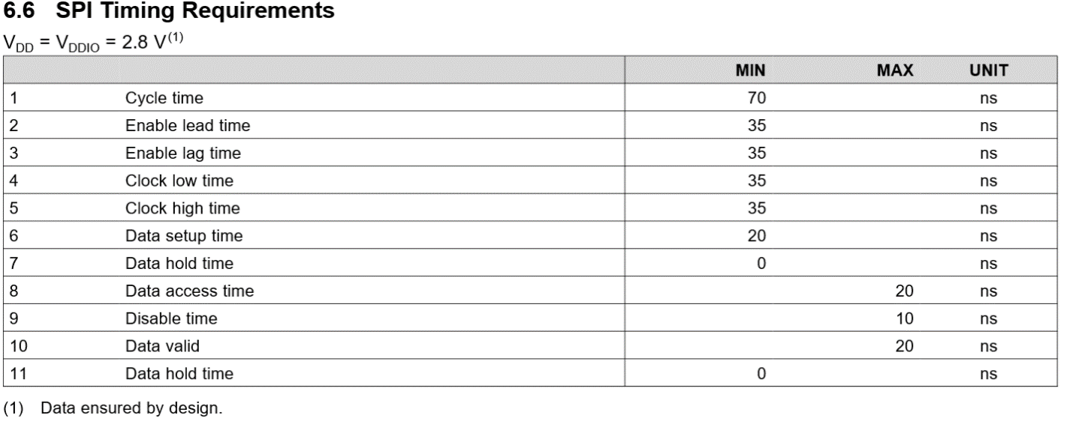

In the case of an I2C system, we can look at Table 5-9 and see that the speed of the system is much slower with the clock speed minimum of 1.9 microseconds which gives a frequency of about 500kHz which falls into the middle of the typical 400-800kHz range that we saw in table 5-7. Even though the SPI interface has a faster data rate there is still more data to be sent since there are four outputs sent out compared to I2C's two pin output.

Table 5-9 - I2C Interface Timing Values [TI.com, 2017]
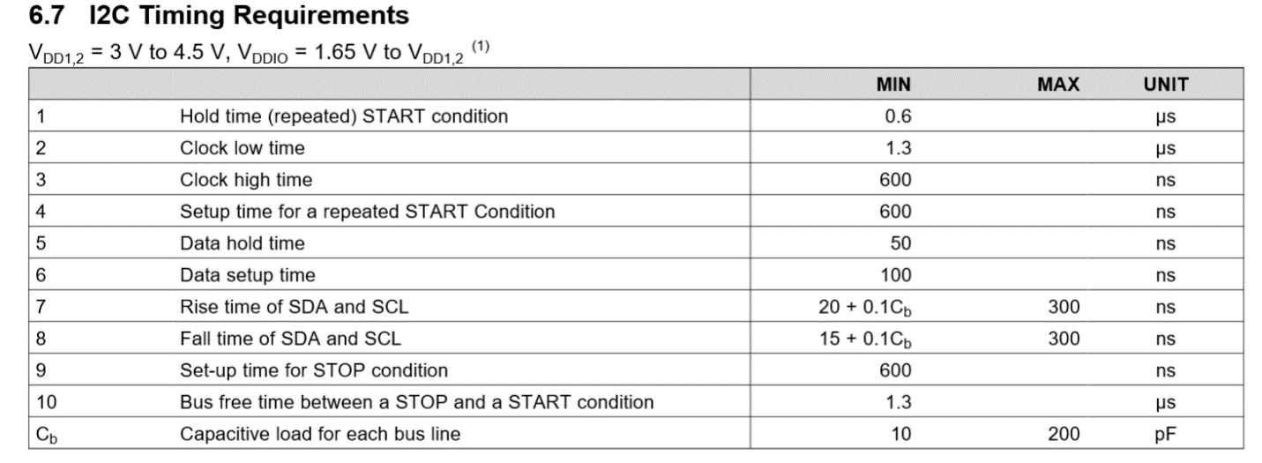

To suit our design parameters, we must see what each interface has to offer that will benefit out project. The table below summarizes a few of the key features that each interface boasts. For out purposes we will only have few drivers devoted to lighting up our device. This means that even though an SPI interface would be using a few extra pins over I2C the difference would be 3 pins. In turn, if there are enough pins open on the microcontroller then there will be no issue using SPI over I2C. For the bandwidth portion, the data rate going to the drivers will be significantly lower than the data rate sent to the drivers. The I2C interface is more than capable of running our drivers and the SPI interface is more speed than we need since it is used in highspeed read/write systems such as memory cards for digital cameras. The only reasons why we would choose one interface over the other would be ease of programming and if the other peripherals that the MCU is controlling could only communicate with a specific interface.

After looking at the all the options that we have for LED drivers we can narrow down the options to one that appears to work the best for most situations. This would be the LP55281. This driver has an abundance of channels with the current output we need and is intended to work with lighting systems. It is flexible in that it will work with SPI and I2C, so it does not matter if any other peripherals attached to the same MCU need to use a specific interface.

The minimums of the system fall within our power inputs, so the device will have enough power to turn on. The maximum voltage of 6V in Table 5-10 is greater than the output of the MCU at 5V, so there is little concern of burning out the driver unless it is powered with its own source.

The block diagram schematic shown in Figure 5-15 is the schematic we will use to connect the LEDs to the driver as well as the MCU to control the driver. As seen in the bottom right of the block diagram there is an audio synchronized LED connection, but the maximum current output is 15mA. This goes against our first intuitions in the previous sections that it would be possible to have a separate LED running off that pin using the drivers programming. Instead we will have to consider whether the driver has audio processing capabilities that can take some of the computing load from the MCU that we choose to power the drivers.

Table 5-10 - LP55281 Maximum Ratings [TI.com, 2017]
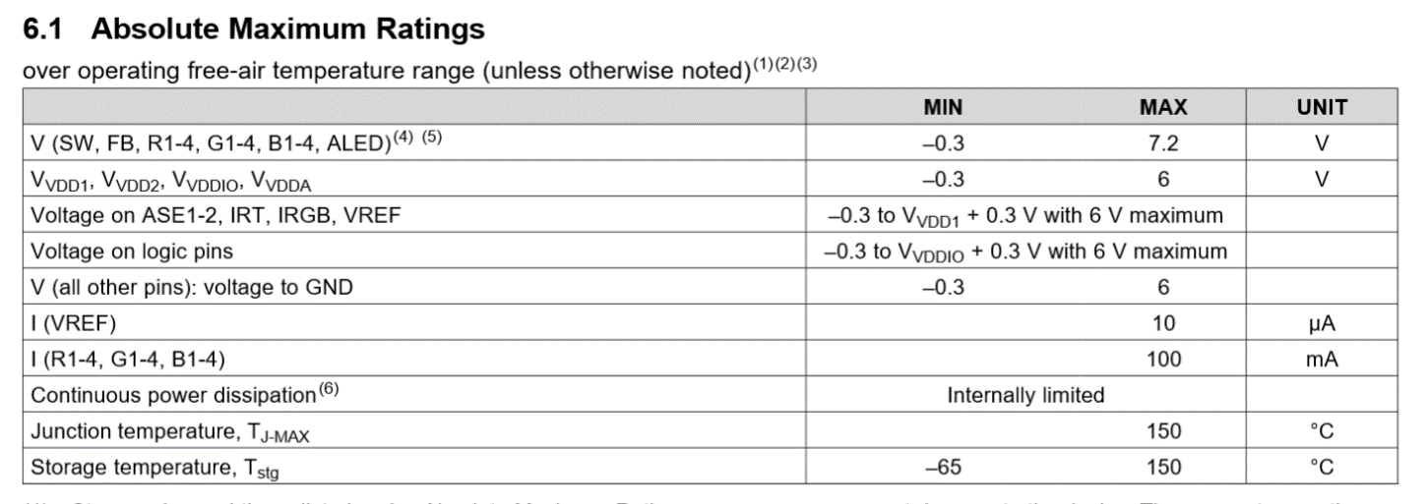
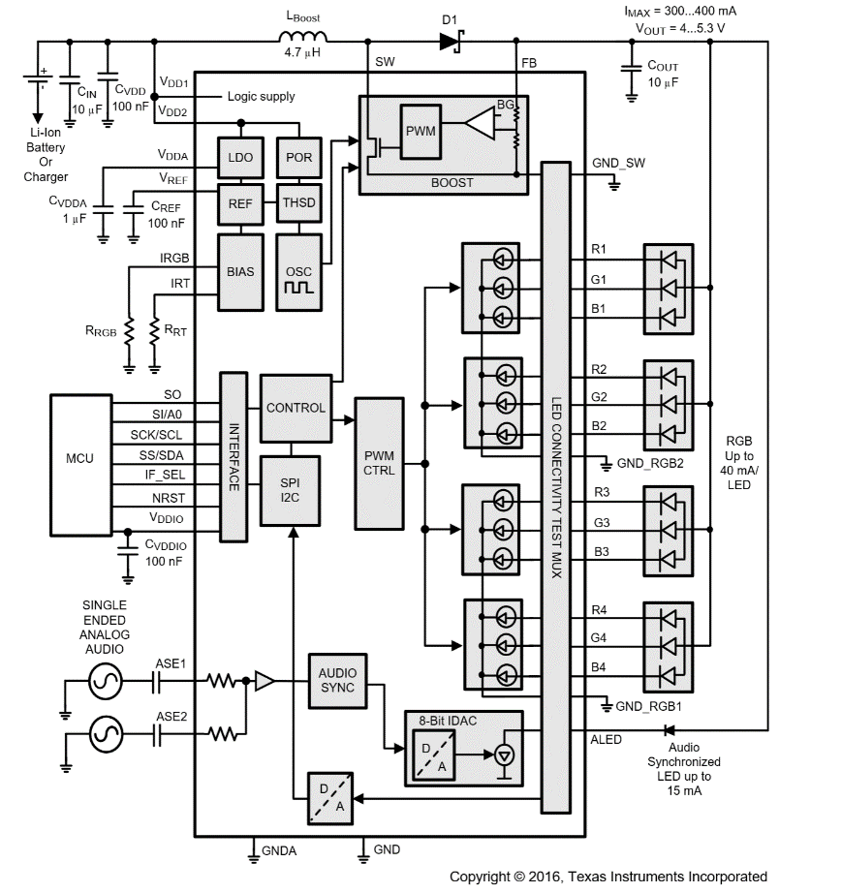
Figure 5-15 - Block Diagram of LP55281 [TI.com, 2017]

Physical Design Planning

Now that we have looked at all the components that will be generating the light show we will need to begin drafting a design as to where we will place all the lights. We drafted up two low detail models that have the general shape and placement of external components on the device. The first design is a hemisphere that looks good to its radial symmetry, which is an excellent quality to have in a design that rotates along a fixed axis. The second design that we have in mind is a cube structure. While this design may not have perfect rotational symmetry, there are more options with the geometry and the difficulty of construction is lowered.

In both versions of the design we look to utilize the full surface area of the device to produce an appealing light show. There must be a balance of colors around the surface so that every section of the device can display a similar pattern. Also, the size of the LEDs and lasers is not proportional to the rest of the structure. The exaggerated features are just eye catchers that draw attention to the key features of the design. It may be a possibility that bundles of similar color lights could be placed to create the appearance of a larger light source.

Another possibility is that we mix single red green and blue diodes to create our own colors. This is not something we have tested now, but creating our own color blends could be a goal we could achieve with some driver programming. Of course, this color blending is speculative, we know this is how colors are created on displays such as cellphones but since the diodes are not as close as in a display the optical illusion may not work on a large scale.

The first housing design we selected prioritizes the 360º stage design the device is being built for. The LEDs and Laser would be scattered across the entire surface of the shell illustrated in Figure 5-16 which shows the rough schematic for the dome. At the bottom of the dome the imaging detection system will be placed so that it can easily tilt downwards towards the crowd. This placement would reduce the surface area of the dome that the camera would be blocking. The servos that rotate the entire platform would be located within the dome-shaped shell. We aim to keep this project as aesthetic as possible by hiding any components that do not contribute to the lighting or tracking aspects of the project.

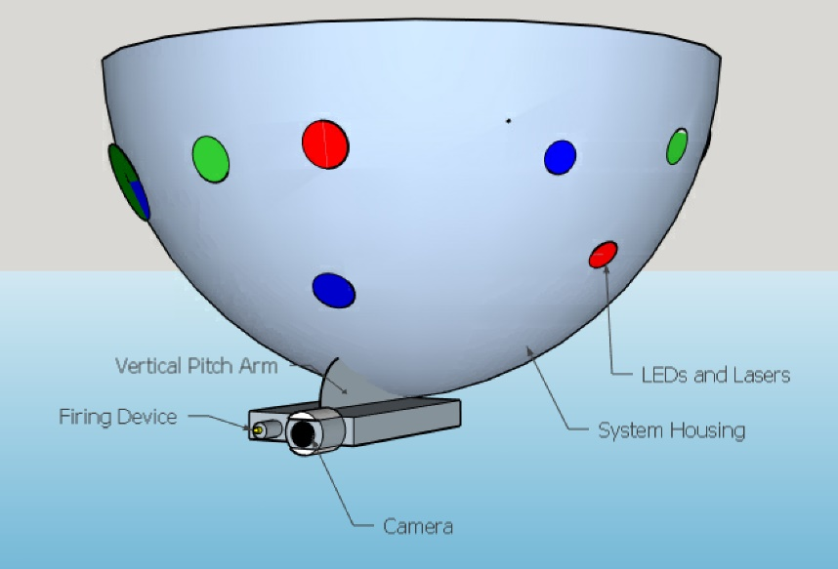
Figure 5-16 - Rough Schematic of the external peripheral placement
The second design option that is being looked at is a cube shaped shell that would house all our components, illustrated in Figure 5-17. The one benefit that stands out right away for using a cube design is the larger volume that can be used to store more components internal and allow for easier cable management. The downside is that, in our opinion, having the rounded housing of the dome would make the project stand out as well as contribute to our engineering goal of making the device visually appealing to the consumer. Also, since the surface is not curved the LEDs and more importantly the laser diodes will all be point out at 90º intervals from each other. This lack of range is really a non-issue for the LEDs since they have a wide angle of emission and couple be positioned inside of the shell so that they are at different angle relative to the surface of the shell. For the laser diodes, since there are fewer of them as well as their small angles of emission the range of coverage in the box design is very limited. The laser beams will also shoot out parallel to the ground if they are placed perpendicular to the side surface of the of the housing.

While having the laser fire parallel to the ground instead of onto the crowd may not look as nice, there is an opportunity to create new and captivating features in a future build. In the future the lasers should be able to pivot inside the housing as well as be directed toward the air or down onto the crowd. Another option would be lateral positioning, so they can intersect beam paths with their neighbors. The box design also has the capability for the laser to be down-firing. This angle would allow for the possibility of overlaying patterns onto the crowd and dancefloor.

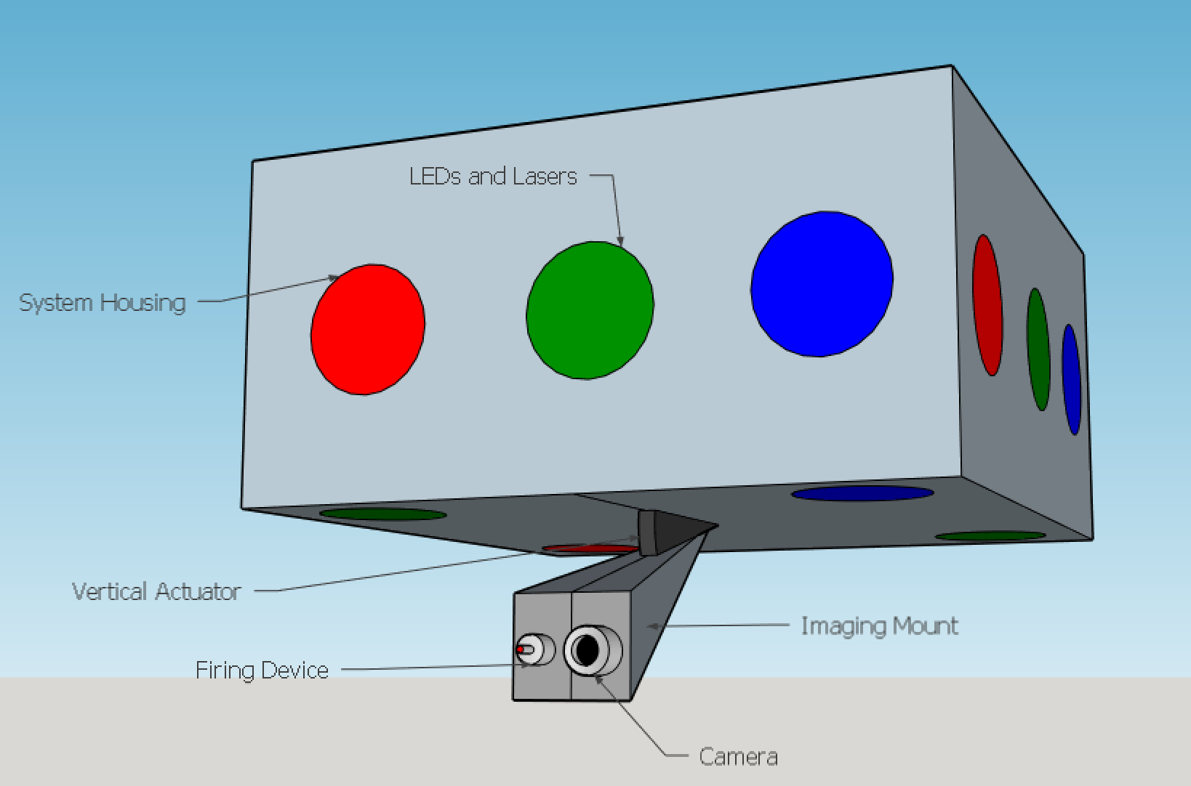
Figure 5-17 - Rectangular Shell Rough Schematic

Computer Vision Research and Implementation

Computer Vision on the ASRH

One of the main features of the ASRH is to be able to locate, track and follow objects of interest. In order to accomplish this, we need to implement some sort of computer vision algorithm on the ASRH. Thankfully, there is a free online library of computer vision tools known as OpenCV, which is short for open computer vision. It is essentially an open source software library that contains a variety of computer vision tools to assist users in implementing their own computer vision application. Two of our group members, Dries and Angel, are currently taking EEL 4660 – Robotic Systems, and have learned about a variety of computer vision techniques and have experience coding computer vision algorithms using the programming language Python along with OpenCV.

For our project, the idea is that when in automatic mode, the camera mounted on the ASRH shall be able to detect the object of interest once it is in its field of view, and then command the Pitch and Yaw servo motors accordingly so that the ASRH always attempts to center the object into its field of view. And since the gun and camera will be mounted together pointing in the same direction, this function will also aim the gun at the target. This method of using video imagery as a means of controlling servo motors is known as concept called Visual Servoing. This is the main functionality that needs to be implemented on the ASRH.

Visual Servoing Theory

Visual Servoing, also known as vision-based robot control, is a technique which uses feedback information extracted from a vision sensor to control the motion or pose of a robot. In this application, we want the ASRH to follow an object of interest. In other words, we want our robot to keep the object of interest as close to the center of our camera image as possible. This translates to having both our camera and gun directed at the object at all times while in automatic mode. The process of Visual Servoing really comes down to correcting an ‘error’ by reducing it as much as possible, ideally to zero. For the ASRH, the ‘error’ is simply how far away our object of interest is from the center of the camera image. There are three types of control that we can use: proportional control, integral control, and derivative control. Each of these techniques bring something different to the table and when used together, form quite a powerful combination. The following sections outline these different types of control and how they work together.

Proportional Control

Proportional control is really the main source of reducing error. This type of control is what will prompt our camera to continually adjust its pose to center the object of interest in its field of view. The reason this method is called proportional control is because it will actuate the robot in proportion to the size of our error. The two figures below will be used to help illustrate this concept. Figures 6-1 and 6-2 illustrate exactly what we are trying to do with the ASRH. The pink ball in the figures represent our object of interest. The errors in these figures are $∆x$ which denotes the horizontal distance from the center, and $∆y$ which denotes the vertical distance from the center. As the name suggests, proportional control would command the ASRH to look left or right at a velocity proportional to $∆x$, and up or down at a velocity proportional to $∆y$. Relating this back to our figures, the ASRH would move much quicker to reduce the error in Figure 6-1 than it would in Figure 6-2.

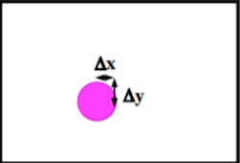
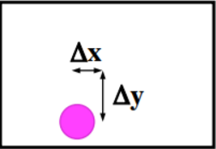
Figure 6-1: Example of Large Error

Figure 6-2 - Example of Small Error

The proportional controller has an output proportional to its input (the error), and can be represented by the equation $O_{output}=K_{p}∙\left(V_{d}-v\right)=K_{p}∙i_{input}=K_{p}∙error\left(t\right)$.$K_{p}$ is a proportionality constant, or gain. The gain used in proportional control is really the main driving factor behind how fast the ARSH will move to reduce the error. For example, even if we have a huge error, a very small gain will still cause the robot to adjust slowly.

When choosing the gain, there are a few important things to consider. First, real systems have momentum and will take some time to respond to commands. Second, having a large gain $K_{p}$ can lead to oscillations where the system will overshoot, recover, and then over shoot again (similar to an under-damped system). And lastly, if the gain $K_{p}$ is excessively large, the oscillations may become divergent as the overshoot gets larger over time. Thankfully, there is a way to help dampen these oscillations, and it will be discussed in the next section.

Derivative Control

With derivative control, a system can be tuned to act in proportion to the rate of change of the input (error) and can be characterized by the equation $O_{output}= K_{d}∙\frac{di_{input}}{dt}=K_{d}∙\frac{d_{error\left(t\right)}}{dt}$. $K_{d}$ is a proportionality constant for the derivative control system. The main feature that derivative control brings to the table is that it provides damping. This property of derivative control can prove extremely useful when combined with proportional control to reduce the overshoot/oscillation that the proportional gain $K_{p}$ can cause.

Integral Control

With integral control, a system can be tuned to act in proportion to the integral of its input (error), and is characterized by the equation $O_{output}=K_{i}∙\int{i_{input}\left(t\right)dt}=K_{i}∙\int{error\left(t\right)dt}$. $K_{i}$ is a proportionality constant for the integral control system. The main feature that integral control brings to the table is that it can help eliminate steady state errors. If a system is run over a long period of time, small errors that aren’t caught by proportional or derivative control can add up, causing the control system to degrade in performance as time passes. Integral control helps solve this problem by eliminating these accumulated errors.

PID Control

A PID control system combines all three of the control methods mentioned in the earlier sections and can be easily expressed by the equation $O_{output}=K_{p}∙i_{input}+K_{i}∙\int{i_{input}\left(t\right)dt}+K_{d}∙\frac{di_{input}}{dt}$. By using PID control, we can reap the benefits of all three different control methods in one control system: The proportional control component minimizes instantaneous error, the integral control component minimized cumulative error, and the derivative control component provides damping to the system. When using PID control, all three gains: $K_{p}, K_{i},$and $K_{d}$ must be tuned together. This means we can’t find an appropriate gain for only proportional control, and expect that gain to work the same in PID control. Finding the correct gain is a difficult process, but it can be done by numerous methods through analytical means, empirical means, a search strategy, or learning/evolutionary methods. In all likelihood, we will end up using mostly an empirical approach; nothing is more tried and true than trial and error.

Computer Vision and Image Processing Methods

Now that the method for actually configuring the ASRH to follow an object of interest through visual servoing, the question now becomes “how will the ASRH find the object of interest”? This is where we need to implement some kind of computer vision algorithm that the ASRH can use to find, track, and follow an object of interest. Computer vision deals with acquiring, processing, analyzing and understanding input from digital images or videos. The purpose of computer vision is to take in real world information and convert it into numerical or symbolic data that can then be further processed to give usable information. There are various forms of computer vision techniques and algorithms available to us; we just need to figure out which method will be the most useful in our specific application. The following sections will outline some different image processing techniques and will compare how useful each one can be for use on the ASRH.

Template Matching

Template matching is a simple method that takes a static image template and runs it through another image in which we want to find the corresponding template. This method can work alright for simple applications but has difficulty with images that don’t correspond exactly to the template image. Lighting, position, scale, and image variability can cause this method to fail, leading to a lack of matches or false matches appearing. Figures 6-3 and 6-4 illustrate the idea of template matching in action. Figure 6-3 is the template and Figure 6-4 is the search image. Template matching will run the template across the search image and find the best match. The template in Figure 6-3 is boxed in blue on the search image in Figure 6-4


Figure 6-3: A 'Waldo' Template

Figure 6-4: Template Found in a “Where’s Waldo’ Puzzle

Now this doesn’t mean that template matching is utterly useless if the template is not identical to some sub image in our scene; a match can be meaningful if scale, orientation and general appearance are right. Otherwise, a more complex approach is needed. Figure 6-5 illustrates an example where template matching works for non-identical cases. The template car is completely different than the detected match, but since the scale and orientation of both cars are similar, it still finds a match.

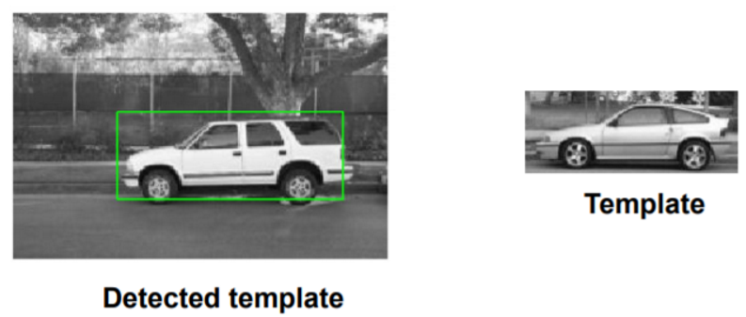
Figure 6-5: Successful Match Without Identical Template
To implement this type of algorithm in Python using OpenCV on the ASRH, we need two things: a template image and a search image. The template image will be a picture of our selected object of interest, and the search image will be the view of our camera. We can receive input from our camera in two ways. One way is to use the cv2.VideoCapture() command to obtain a live raw video feed from our camera. It does this by reading in the images frame by frame. If this method is used, our search image will be the frames that are read in by the camera. The other way we can obtain a search image is to use the cv2.imread() command. We can use this command to configure the ASRH camera to take a certain number of pictures per unit of time, and use those images as our search images.

Once we’ve obtained the search image, we can now run template matching. There are three different template matching methods available to us in OpenCV and they either use cross-correlation or sum squared difference algorithms. For each method, there is a normalized version, giving us a grand total of six different methods. We can test out each of these methods to see what works best. In past projects, it was found that the normalized methods usually yield better results. Once a match is found, we can draw a rectangle around the match using the command cv2.rectangle(). We can use the location of this rectangle to determine whether we need to instruct the ASRH to move up, down, left, or right to center the object on the camera image.

Now although template matching is in theory doable, it could be problematic in practice for several reasons. First, as mentioned earlier, template matching is not invariant to scale, position, and lighting. This means that to get a good match, we may need to use multiple different template images taken with varying distances, angles, and lighting environments. Having to use multiple templates will cause an increase in computational cost, increasing the overall time it will take for the ASRH to process incoming images using template matching. With a market requirement of ‘robust response’ and a corresponding engineering requirement of ‘less than one second of latency’, this method may cause impediments in meeting these requirements. Still, it is hard to say for sure until it is actually tested.

Color Detection

Another imaging process method is called color detection. As the name implies, its main tool is the use of color in an image for processing. Images are made up of pixels, and each pixel is described by Red, Green, and Blue values (RGB) that usually range from 0 to 255. Different combinations of these three colors in varying intensity give way to all the colors we can see on a digital image.

Through the use of a technique called ‘thresholding’, we can find areas of high color intensity. The way it works is by first setting a threshold value $μ$. Then, you scan every pixel in the image; if the value for the image is above the threshold, set the pixel to binary 1, if it is below the threshold, set the pixel to binary 0. This is extremely useful if we are trying to isolate a certain colored object from the rest of an image.

Using this method of thresholding RGB values definitely holds merit and can be extremely effective in certain situations. However, it is not without its limitations. Illuminations in an environment may vary, causing the same object to have different RGB values based on the ambient illumination. You can actually see this phenomenon in action in Figures 6-6 and 6-7. Pay close attention to the images in the top left corner of the grid. In the raw image, it is clear there is a pink ball there. However, in the processed binary image, you can see that the thresholding algorithm misses the bottom left of the ball because the lighting is not as strong, changing the RGB values of that part of the ball below the threshold.

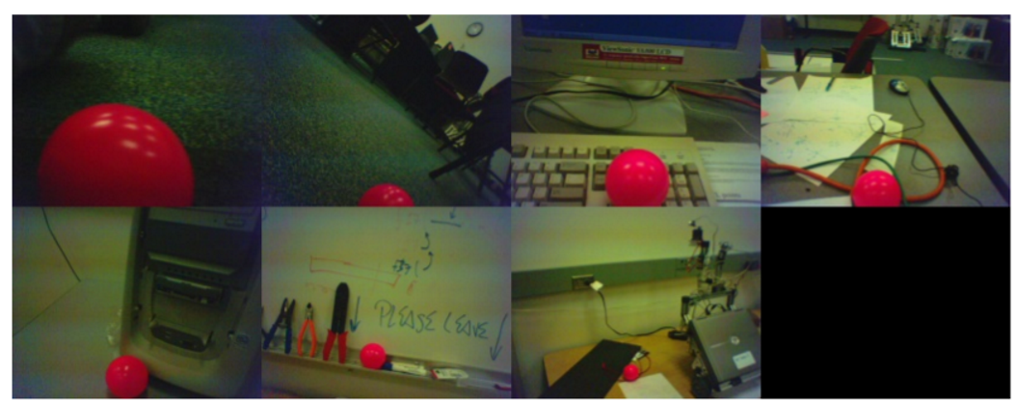
Figure 6-6 - Raw Images of a Pink Soccer Ball
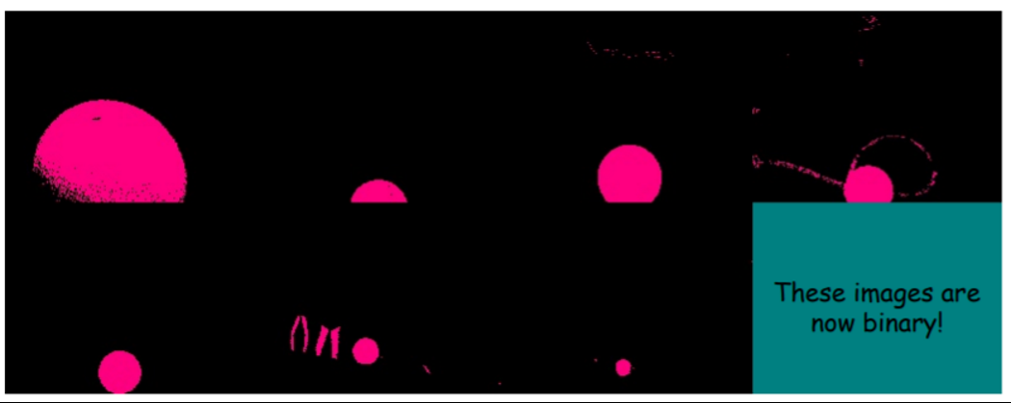
Figure 6-7: Images After Color Detection Through Thresholding

We can get around this problem by changing the color space to something other than RGB. The alternative is a color space called Hue Saturation Value (Intensity) or HSV/HIS for short. This color space is essentially an RGB cube on its vertex. Figure 6-8 illustrates the HSV color space.

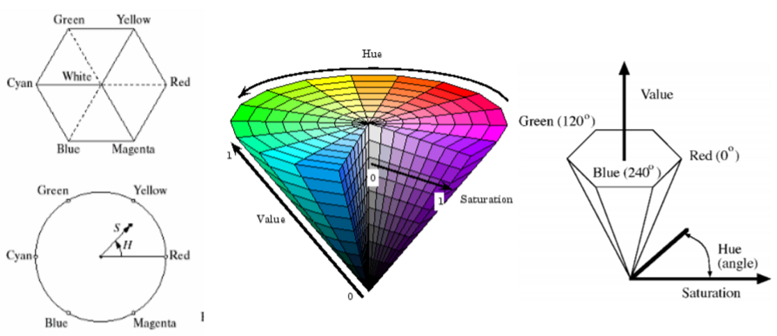
Figure 6-8 - Hue Saturation Value (Intensity) Color Space
To use color effectively for tracking objects, there are some cases where thresholding in HSV space may be a better fit than using RGB space. In other cases, RGB works better and sometimes, it is optimal to combine all 6 values in RGB and HSV together. Another thing to think about is the context of the pixel being analyzed by considering the neighboring pixels or overall pixel count.

To implement this type of algorithm using Python and OpenCV on the ASRH, we first need to obtain the incoming raw video feed from our camera. As discussed earlier, this can be done using the cv2.VideoCapture() command. Once the video feed is obtained, we can create a binary image using color thresholding. To do this, we first need to change the color space from BGR to HSV (in OpenCV, colors and images are initially recorded in reverse order of RGB) using the command cv2.cvtColor([video frame], cv2.COLOR_BGR2HSV).

Next, we create our thresholds using the command numpy.array([Hue], [Saturation], [Value]). Two thresholds will be created: an upper threshold and a lower threshold; the target color values will fall in between these two thresholds. We can then extract this target color using the command cv2.inRange([color space], [lower threshold], [upper threshold]). After obtaining a raw mask, we need to filter the image to get rid of noise and fill in white spaces in the image that the mask may have missed.

To do this we need to perform morphological operations called ‘opening’ and ‘closing’. ‘Opening” helps to remove random noise dots that appear in the mask image, and ‘closing’ works to fill in the small holes that are present in the actual object in the mask image. We start off by defining two kernels using the command numpy.ones([matrix length], [matrix width]). These kernels are 2d matrices that control the effects of ‘opening’ and ‘closing’. We then perform the opening by using the command cv2.morphologyEx([raw mask], cv2.MORPH_OPEN, [‘opening’ kernel]), and obtain the final mask by ‘closing’ the ‘opened’ mask using the command cv2.MorphologyEx([‘opened’ mask], cv2.MORPH_CLOSE, [‘closing’ kernel]). Figure 6-9 shows 4 different images. The first labeled ‘cam’ is raw video image, the second labeled ‘mask’ shows the raw mask, the third labeled ‘maskClose’ shows the final mask after ‘opening’ and ‘closing’, and the fourth labeled ‘maskOpen’ shows the mask after ‘opening’ but before ‘closing’.

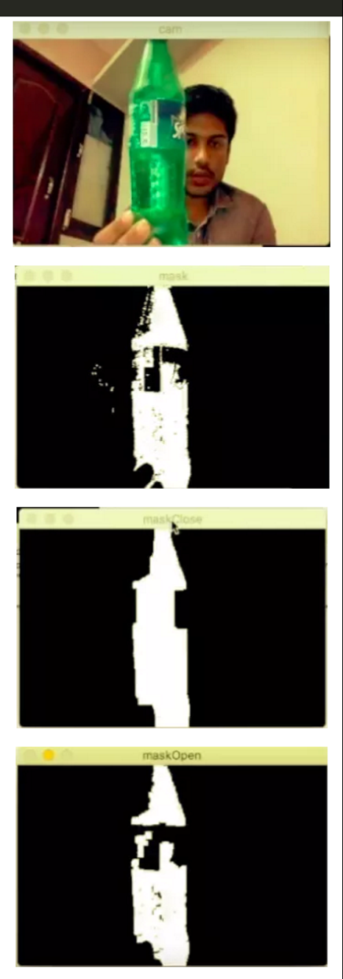
Figure 6-9 - Filtering a Color Mask
With a clean masked binary output, we can now draw contours around our object using the command cv2.findCountours([final mask name].copy(), cv2.RETR_EXTERNAL, cv2.CHAIN_APPROX_SIMPLE). With these contours, we can now find the center of the object using the command cv2.moments(c). Depending on the location of the center on the camera image, we can instruct the ASRH to move up, down, left, or right in order to center the object on the camera image.

Edge Detection

Another potentially useful image processing method is edge detection. As the name suggests, this method helps us find edges in an image. Finding edges in an image can be extremely useful; edges are where the (visual) action is! There are four main underlying causes that can cause edges:
- Reflectance change: surface texture
- Depth discontinuity: object boundary
- Change in surface orientation: shape
- Cast shadows

The point here is that edges alone can tell us a lot of information about in image. When comes to computer vision, an edge is a place of rapid change in the image intensity function. In other words, edges are places in an image where the magnitude of the slope or derivative of the image intensity is a large value. Figure 6-10 illustrates the derivatives and edges relation.

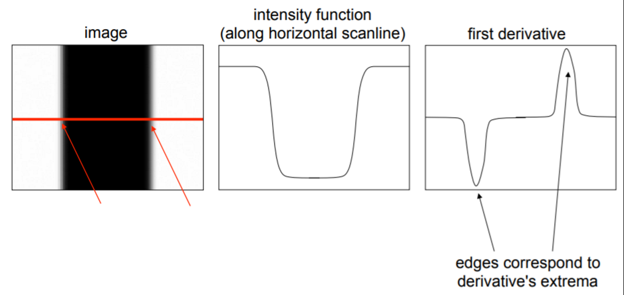
Figure 6-10 - Derivatives and Edges
Before we just start calculating derivatives on an image to find edges, we first have to take care of the problem noise causes when it comes to edge detection. By looking at the image intensity function in Figure 6-11, it is reasonable to assume that the edge takes place at point 1000. However, because of the noise in the image, the derivative of the intensity function is not so clear and according to that graph, there are edges all over the place! To combat this, we can use a technique called filtering to smooth out the image intensity function and reduce the impact of the image noise. The main type of filter used in these situations to smooth images is called a Gaussian filter. The effect of a Gaussian filter is primarily determined by the parameter $σ$. The larger $σ$ is, the more the image is blurred or smoothed. Figure 6-12 illustrates this idea.

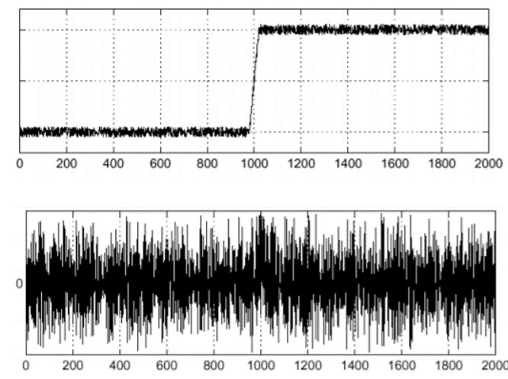
Figure 6-11 - An Image Intensity Function and its Derivative

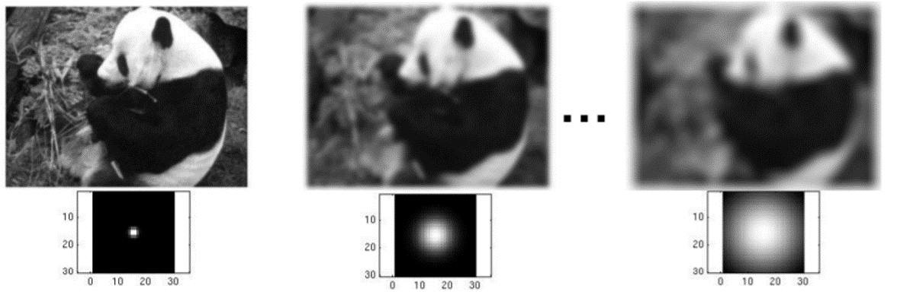
Figure 6-12 - Smoothing with a Gaussian
With this smoothing, we can minimize noise in the image intensity function helping us find the true edge. Figure 6-13 shows how smoothing helps detect an edge.
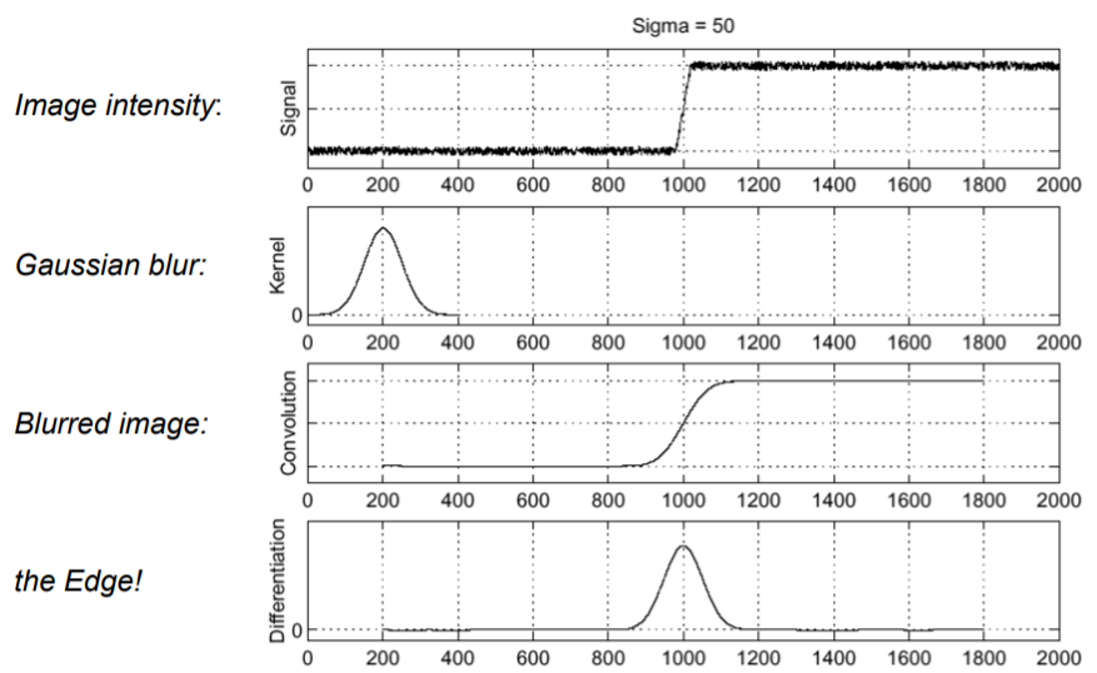
Figure 6-13 - Gaussian Filter for Edge Detection
Now that we’ve filtered the image, we can continue with edge detection. An optimal edge detector that can be used is the Canny edge detector. The Canny edge detector works by first filtering an image with the derivative of a Gaussian (as discussed above) and then finding the magnitude and orientation of the gradient for each group of pixels. To obtain the gradient of an image window the equation $Δf=\left[\frac{∂f}{∂x},\frac{∂f}{∂y}\right]$ is used, where $x$ is the $x$-direction value (horizontal) of the image and $y$ is the $y$-direction value (vertical) of the image. Every point has an edge strength and an edge orientation; the orientation is given by the angle of the gradient $θ=\tan^{-1}\left({\frac{∂f}{∂x}}/{\frac{∂f}{∂y}}\right)$ and the edge strength is given by the magnitude of the gradient $\left\|∇f\right\|=\sqrt{{\left(\frac{∂f}{∂x}\right)}^{2}+{\left(\frac{∂f}{∂y}\right)}^{2}}$. Figure 6-14 shows a raw image along with its gradient image.

Figure 6-14 - Raw Image with Corresponding Gradient Image

Non-maximum suppression checks if a pixel is a local maximum along a gradient direction and selects a single maximum across the width of the edge. This helps avoid over-redundancy when getting edges. If two points are extremely close and their gradient directions and magnitude are similar, we really only need one of those points to know where the edge is. In Figure 6-15, the white curve is part of the gradient image. However, since it is so thick, we want to narrow it down to one pixel instead of several. The image on the right shows the gradient of pixel $q$. Non-maximum suppression would check the gradients of pixels $p$ and $q$, check which of the three pixels has the strongest gradient in that direction, and finally eliminate the two lowest leaving only the local maximum; hence the name, non-maximum suppression.

Figure 6-15 - Non-Maximum Suppression
Once we’ve found our edges and eliminated any points that aren’t a local maximum, we can move on to thresholding the edges. This means that only gradients of a certain strength will be counted as an edge. However, this can be problematic as certain parts of edges can be lost; an image edge could have a strong gradient in one area but as you follow the edge, the gradient may not stay strong enough to remain above the threshold, causing it not to count as an edge even though it is. To combat this, we can employ a technique called hysteresis thresholding. With hysteresis thresholding, two thresholds are defined: low and high. The high threshold is used to start image curves where the gradient is strongest. The low threshold is used to continue these edges, so they do not get lost in the image processing. This idea is illustrated with the three images in Figure 6-16.

Figure 6-16 - Hysteresis Thresholding
Taking it a step further, one technique that may be useful for our application is using edge detection in conjunction with the Hough transform. The Hough transform is used to find parameterized shapes in images, specifically, lines and circles. Although finding lines would not be all that helpful, if we use something circular such as a ball or plate as our object of interest, using the Hough Transform could be perfect for our application. First, Hough transform for finding lines will be explained to help further understanding of how it works, and then the method will be related to finding circles.

Hough transform works by taking an edge image and transforming it to parameter space. Next, each individual pixel is analyzed and then ‘votes’ for all the possible models where a line could be. In Figure 6-17 below we are looking at only one edge pixel in the image to the left. With only this to work with, the edge in the image that forms a line could be in any direction! The Hough transform takes these possible lines as ‘votes’ and puts them in a 2-D parametrized space as shown in the image on the right. The idea is to do this for all pixels in an image.

Figure 6-17 - Hough Transform, Analyzing a Single point
Wherever there is a maximum or peak in votes, that is where the true edge line is, as shown in Figure 6-18.

Figure 6-18 - Hough Transform, Finding Edge Lines
To find circles in an image, the same general method is used, but with a slightly different approach. There are two main cases for circles: when the radius is known and when the radius is unknown. In our application, the distance of the object of interest from the camera can cause the perceived radius to vary, leaving us with the second case.

In this case, we need to employ a 3-D parametrization for each edge point. Each point on the perimeter of a circle will produce a cone surface in the parameter space and that cone counts as its ‘vote’, illustrated in Figure 6-19. The reason the vote is a cone is because it votes for all possible models, and so it will vote for circles with different possible radii. This process is repeated for each edge and the ‘winner’ is where the largest number of cone surfaces intersect.

Figure 6-19 - Finding Circles of Unknown Radii, Parameter Space for One Point
The crosshairs in the image in Figure 6-20 represent the results of the Hough Transform. As you can see, this method could potentially be extremely powerful on the ASRH if we choose circular objects of interest.

Figure 6-20 - Result of Hough Transform for Circles

Feature Detection and Keypoint Matching

The final possible computer vision method we could use on the ASRH to lock on and track an object of interest is a technique known as Keypoint Matching. There are five main steps when it comes to performing Keypoint Matching:
- Find a set of distinctive ‘features’ or ‘keypoints’
- Define a region around each keypoint
- Extract and normalize the region content
- Compute a Local descriptor from the normalized region
- Match local descriptors

Unlike template matching, keypoint matching is invariant to scale and orientation making it much more effective at finding matches in a random environment. With template matching, we may need to use multiple templates with different scales and orientations to find a correct match. With keypoint matching, we would only need one template image. Once keypoints and descriptors are found, matches are determined by finding the difference between keypoint descriptors. If the difference is below the threshold, we have a match. Figure 6-21 below illustrates this process of finding keypoints, normalizing the surrounding region, computing descriptors, and then finding the difference between them. Keypoints A₂ and B₂ are normalized their descriptors are denoted by $f_{A}$ and $f_{B}$. Since the difference between them is below the threshold $T$, these two keypoints constitute a match.

Figure 6-21 - Keypoint Matching Example
When it comes to finding keypoints, we are looking for areas in an image where there is a large change of intensity in any direction. ‘Flat’ parts of an image have no intensity change in any direction. Edges only have sharp intensity changes at the edge and not along the edge direction. Corners have a significant intensity change along all directions, making them ideal as keypoints. Figure 6-22 illustrates this idea showing ‘flat’, ‘edge’, and corner areas on the same image.

Figure 6-22 - Flat, Edge, and Corner Regions

A well-defined and proven way to find corners in an image is to us the Harris corner detector. The Harris corner detector begins by finding the second moment matrix $M$ of a particular image window and is defined by $M=\sum_{x,y}{w\left(x,y\right)\left[\begin{matrix}I_{x}^{2} & I_{x}I_{y} \\ I_{x}I_{y} & I_{y}^{2}\end{matrix}\right]}$ where $I_{x}$ is the derivative of the image window in the $x$ direction and $I_{y}$ is the derivative of the image window in the $y$ direction. Figure 6-23 illustrates this idea.

Figure 6-23 - Harris Corners and Second Moment Matrix

Once the second moment matrix $M$ is calculated we can use the corner response function to determine whether a window contains a corner or not. This corner response function is defined as $R=\det\left(M\right)-α*trace{\left(M\right)}^{2}=λ_{1}λ_{2}-α*{\left(λ_{1}+λ_{2}\right)}^{2}$ where $α$ is a constant between 0.04 and 0.06 and $λ_{1}$ and $λ_{2}$ are the eigenvalues of the second moment matrix $M$. Basically, the larger the eigenvalues are, the stronger the corner response will be. To find the corners, all we need to do is set a threshold and any corner responses larger than that threshold will be considered true corners. The final step is to employ non-maximum suppression to find local maxima for corners, eliminating any redundancy. Figures 6-24, 6-25, and 6-26 illustrate this idea.

Figure 6-24 - Harris Corners Step 1: Compute Corner Response Function
Figure 6-25 - Harris Corners Step 2: Find Points with Strong Corner Response Scores

Figure 6-26 - Harris Corners Step 3: Non-Maximum Suppression

As helpful as the Harris operator is, it is not invariant to scale and orientation on its own. For a better image matching algorithm that is invariant to scale and orientation, as well as using descriptors that are robust to variations typical of viewing conditions, SIFT was made. SIFT stands for Scale-Invariant Feature Transform and features edge-oriented histograms around Harris corners. SIFT finds a set of key points, creates a descriptor that describes the key points by analyzing the surrounding image patch, matches the image patches using a distance function, reduces false matches by outlier elimination, and then computes the image transformation between the two images using a homography.

There is another keypoint matching algorithm called SURF which stands for Speeded-Up Robust Features and is comparable to an accelerated version of SIFT. SIFT approximated Laplacian of Gaussian with Difference of Gaussian for finding scale-space, but SURF approximates the Laplacian of Gaussian with Box Filter. For orientation assignment, SURF uses wavelet responses in vertical and horizontal directions for a neighborhood size of 6s, where s is the size around the key point, with gaussian weights added to the assignments. They are plotted in a unit-circle-like space, and the dominant orientation is calculated by summing all responses within a sliding orientation window of 60º.

For feature description, SURF utilizes Wavelet responses in horizontal and vertical direction. A neighborhood size of 20s by 20s is taken around the key point, the divided into 4 by 4 sub-regions. For each sub-region, the horizontal and vertical wavelet responses are taken, and a vector v is formed, with $v=\left(∑d_{x}, ∑d_{y},∑\left|d_{x}\right|,∑{|d}_{y}|\right)$. This gives the SURF feature descriptor a total of 64 dimensions. Lower dimensions offer higher speeds of computation and matching and provide better distinctiveness of features. If more distinctiveness is needed, SURF feature descriptor can be extended to a 128-dimension version.

The use of sign of Laplacian for underlying interest points is another added improvement over SIFT. It adds no computational cost since it was already computed during detection, and the sign of the Laplacian distinguishes bright blobs on dark backgrounds and vice versa. In the matching stage, features are compared only if they have the same type of contrast, allowing for faster matching without reducing the descriptor’s performance. In short, SURF is roughly 3 times faster than SIFT with performance being comparable to SIFT’s. SURF works well at handling images with blurring and rotation but doesn’t work well at handling viewpoint changes and illumination changes.

The only issue with these two algorithms is that both SIFT, and SURF are patented. However, since we are not making any money off of this senior design project, we can use SIFT and SURF to see how well keypoint matching would work to lock on and follow an object of interest on the ASRH. Worst case, we can use an OpenCV method called ORB that is similar to SIFT and SURF in that it is a keypoint matcher, but is completely open source and not patented.

Applying Visual Servoing

We have several options we can choose from when applying our visual servoing theories and algorithms. We have the simple color detection and tracking, face detection, object tracking, template matching, and feature detection at our disposal. Each option adds versatility and additional options that we can work with depending on the environment or the situation at hand. The simplest and easiest to implement would be the color detection and tracking method. We will start with this method and eventually we can work our way up to include several more tracking methods into our software design.

Color detection and tracking works simply by finding a specified color, at almost any intensity that is above a certain threshold, in the environment. The color we choose will be in the HSV color space, which should not be affected by change in color intensity. Some difficulties that can arise with this format are reflectivity, ambient light color, and thresholding. If an object is too reflective there is a chance that it will not be detected, since other colors can be seen instead or if not enough of the color is showing up from the object. Ambient light color is also an issue. If white light is used in the environment, no issues should occur. If any other light color is used then the objects we want to detect can show up with a tint of the light’s color, causing it to not be registered by the color detection algorithm we will be using. Thresholding is the final cause for misdetection. If an object is simply too dark, even though it is the color we want to detect, there is a chance it will not be detected since it is below our chosen thresholds. In an optimum environment, with all precautions taken to make sure these issues are minimized, then we should have no problems detecting an object of a desired color.

Now, once the color is detected and a filtering mask is made to filter out noise in the captured frame, contours are drawn up indicating what colored object has been found and a center-point that we can use for the tracking is made. Figure 6-27 shows the detected object in the top section, the mask in the second section, and the final detected image with drawn contours in the bottom section of the image.

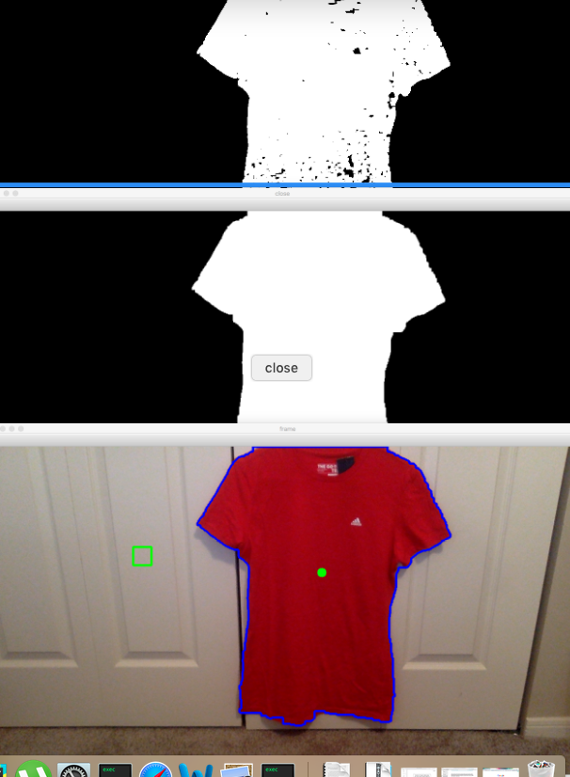
Figure 6-27 - Detected red shirt, with mask, drawn contours in blue, centering point in green, and center-bounding-box in green
To apply the actual servoing part in our visual servoing, we need a reference frame to work with. The camera we are using is able to capture video up to 4k resolution, but for simplification purposes we will limit our resolution to 640 by 480, and work with a frame rate between 30 and 45. The frame rate range is because we want to find the best frame rate that will give us the best detection but will not cause too much latency that will exceed our latency requirement restriction. For testing and initial debugging, we will choose a framerate of 30 but this is subject to change as we optimize our code and camera. Now that we have our reference frame set up, we will choose our camera’s default center-point to be in the middle of our capture frame at: 320 pixels in the horizontal direction and 240 pixels in the vertical direction. If nothing is detected, we want our default center-point to be in the middle of the frame to avoid causing our servos to move when they aren’t supposed to. Figure 6-28 shows how the output capture looks like when an object is detected, and the center-point is outside of the bounding box.

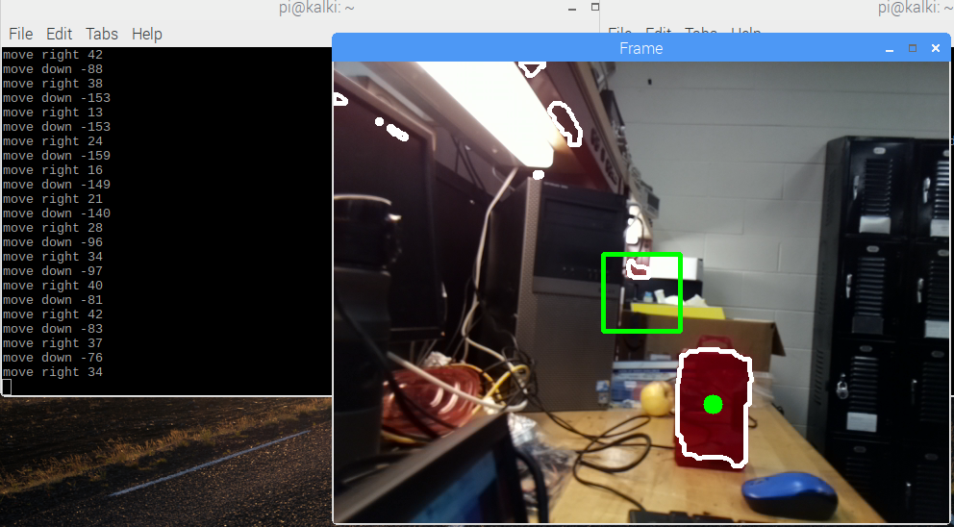
Figure 6-28 - Captured frame with corresponding directions to center the bounding box on the red object's center point
With our center-point set we will be using positive and negative numbers to indicate displacement from the center-point. The positive direction we will use is the up and right directions, about the frame’s center-point. The negative direction will be the left and down directions, also about the frame’s center-point. With these positive and negative directions, we can explicitly choose what direction our servos will rotate at and when they need to rotate if a desired object is detected. For simplification purposes, left and down will always be our counter-clockwise rotation directions. The up and right will always be our clockwise rotation directions, and this will be true for both continuous rotation servos.

This set up will be used as much as possible for the other mentioned methods as well, depending on whether it is functionally practical to do so. This covers the color detection method and how the servos will be used for this method. We have several other options for other methods we can implement, but due to time constraints we will be focusing more on color detection and tracking now. As this method is further polished up and the camera we are using is optimized, we will be able to implement other methods and still meet our project specification requirements.

Once the detection and tracking method is set up and finished, PID control will be implemented to keep the servos from oscillating and overshooting as they try to center on the center-point. If PID control is not used, oscillations or jagged movement will occur and cause our camera to lose track of the object. If multiple objects are detected and the one we want loses detection area, the servos will start to spasm as they may switch back and forth between the detected object’s center-points.

From Figure 6-28, we had directions we had directions specifying what directions we had to move our bounding box. These directions are only necessary for testing and visualization purposes for the user and programmer. The numbers are useful as they specify exactly the calculated pixel displacement from the centering-point and can be used for the PID control.

Initial Power Supply Research

The Need for Power Regulation

Once we decide on the components list, it was clearly that our design has multiple components that operate at different input voltages. Our main power supply will operate at a maximum output voltage of 12 volts. Some of our main components are lasers, Microcontrollers, servos, etcetera and each require its own operating input voltage. Since our team decided to use one 12 Volts AC/DC power supply, it was necessary to use voltage regulators to fulfill each component’s operating voltage.

Voltage Regulators

Voltage regulators are some of the most important components that are used in almost every electronic device. They are the target components for when steady reliably-regulated voltage is needed, by regulating an input voltage of some magnitude and adjusting it to a desired output voltage that can either be fixed or adjusted by using the right external components. Providing a smooth input voltage to a microcontroller, for example, will guarantee that the microcontroller will function with a smooth operation. Voltage regulators can be classified as followed: Zener or integrated circuits with three terminals or multi terminal voltage regulators, linear voltage regulators, or switching voltage regulators that can be grouped as fixed or adjustable.

The question we need to answer is what type of voltage regulator would suit the need of our design. Our power supply with output voltage of 12 V would need to provide power to our main components such as servos, microcontrollers, and LEDs.

There are few voltage regulators that are in use today by electronic companies, and since we will pay for the expenses related to our design, we will try to save as much money as we can and minimize cost. Therefore, the cheapest voltage regulator option that we can build is a Zener Diode.

Zener Diode as Voltage Regulator

The simplest way to regulate voltage is to use a Zener Diode as voltage regulator. Since Zener Diodes can provide satisfactory voltage regulation and sometimes limited to only a single component, it can shunt voltages above its breakdown voltage threshold. It is easy to use Zener Diodes as voltage regulators by pulling the output voltage across the Zener Diode's leads.

Yet, the more current is drawn by the load the less current passes through the Zener Diode. Therefore, the regulated voltage is unstable especially with applications that require high load current. In addition, Zener Diodes have poor temperature response which make them unsuitable for high current load applications. Another issue with Zener Diodes as voltage regulators is that they are limited on how to handle power. They are suitable for applications that use very low power. Therefore, we cannot use Zener Diodes as voltage regulators in our design due to power limitation. The second option that we have is using integrated circuits as voltage regulators. Knowing that using an integrated circuit as a voltage regulator will fix some issues that we encountered when using Zener Diodes. When integrated circuits are used as voltage regulators they draw current from a power source which gives a bias current that is generally independent from the load and input voltage. In addition, integrated circuit voltage regulators are temperature compensated.

Linear Voltage Regulator

A linear voltage regulator is a device that maintain stable and steady output voltage regardless of changing the input voltage. It is derived from sample electronic theory that the resistance changes with respect to load resulting in constant output voltage. The concept behind the regulation is changing a voltage divider network to get a stable output voltage and filtering the difference between the input voltage and the regulated output voltage in the form of heat. Some of the most common ones are LM317 and LM78XX. A table of common regulators and their operating conditions are shown in Table 7-1.

Table 7-1 - Linear Voltage Regulators Operation Conditions
Voltage Regulator Number | LM 317 | LM 318 | LM 7805(fix) | TPS549B22
Vin(Min) (v) | 3 | 3 | 1 | 1.5
Vin(Max) (v) | 40 | 40 | 7.5 | 18
Vout(Min) (v) | 1.25 | 1.2 | 4.8 | 0.6
Vout(Max) (v) | 37 | 32 | 5.2 | 5.5
Iout(Max) (A) | 1.5 | 5 | 1.5 | 25
Duty Cycle(Max) (%) | 99 | 99 | 98 | 80
Operating Temperature Rating (c°) | 0 to 125 | 0 to 125 | 0 to 125 | -40 to 125

After analyzing the specifications from the data sheets and from the data in Table 7-1, since most of our components operate at 5 volts or less, we will choose to use TPS549B22 as an option because it has better range for output voltage, and most important for our design in that TPS549B22 has more output current than other linear voltage regulators. Figure 7-1 shows circuit diagram of TPS549B22.

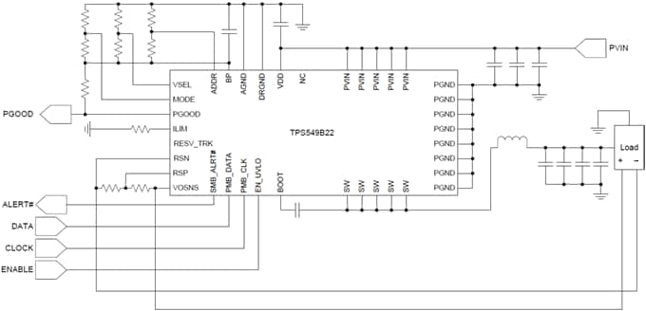
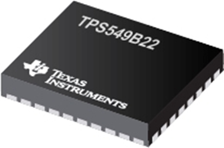

Figure 7-1 - TPS549B22 Inner and Outer Look

Knowing that our design involved many components, it is always necessary to operate on the safe side. We need voltage regulators that can handle more current to guarantee smooth operations of each component in our design. Working with linear voltage regulators is easy to design and implement. However, they have some disadvantages that would create problems for our design. One of these problems is that linear voltage regulators consume a lot of energy and they are only 50% power efficient. In addition, they produce lot of heat that will interfere with the operations of other components in our design knowing that the entire design will be enclosed in a dome-shaped Styrofoam cover.

The consumption of energy and the large amount of heat produced by the linear voltage regulators comes from the fact that they are designed with a couple of transistors diodes and resistors. The inside of the linear regulator LM7805 is shown in Figure 7-2.

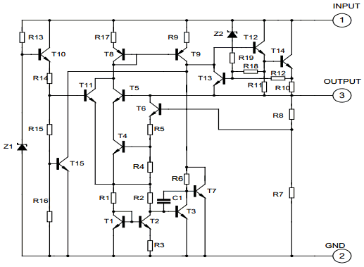
Figure 7-2 - LM 7805 Circuit Diagram
Since the power elements (transistors) operate in the active, or linear mode, and cannot switch on and off the current will keep flowing constantly. Therefore, generating heat that will require a heat sink to prevent malfunction of the device and the other components in the circuit. This will affect the overall power efficiency of our design. The Efficiency characters are shown in Figure 7-3.

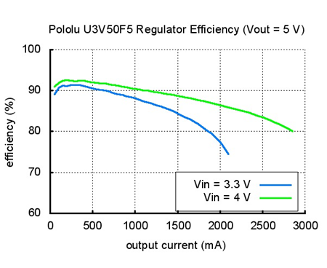
Figure 7-3 - Efficiency Characteristics
One of the greatest barriers in engineering designs are tradeoffs. They are always an issue for design limitation. Saving money and thinking with simple design configurations might not provide the desired results. Therefore, we must consider using switching voltage regulators as a better alternative.

Switching Voltage Regulator

Switching voltage regulators are very efficient once built correctly. The complexity of switching voltage regulators comes from the use of inductors, capacitors, diodes, and transistors (MOSFET or BJT) as switches. There are 3 types of switching voltage regulators: Step Down (Buck Converter), Step Up (Boost Converter) and a combination of Step Down and Step Up (Buck/Boost Converter).

The step down, or buck converter, produces an output voltage lower than the input voltage similar to a linear voltage regulator but more efficient. The step up, or boost converter, on the other hand can produce an output voltage regulator higher that the input voltage. They use the same components as the buck converter but are configured differently. A Buck/Boost converter is a combination of both step down and step up. There are many types of Buck/Boost like Inverting Buck/Boost, Single-ended primary-inductor converter SEPIC, and Cuk, just to name few, and most of the voltage regulators are used on battery circuits. Table 7-2 outlines the operating conditions of some commonly used buck converters.

Table 7-2 - Buck Converters Operation Conditions
Voltage Regulator Number | LM 3670 | LM 3671 | LM 2575 | LM 2576 | LM 2595
Vin(Min) (v) | 2.5 | 2.7 | 4 | 4 | 4
Vin(Max) (v) | 5.5 | 5.5 | 45 | 45 | 45
Vout(Min) (v) | 0.7 | 1.1 | 1.23 | 1.23 | 1.2
Vout(Max) (v) | 3.3 | 3.3 | 37 | 37 | 37
Iout(Max) (A) | 0.35 | 0.6 | 1 | 1 | 1
Duty Cycle(Max) (%) | 99 | 99 | 98 | 98 | 98
Operating Temperature Rating (c°) | -40 to 85 | -40 to 85 | -40 to 125 | -40 to 125 | -40 to 125

The use of inductors causes many problems in designing electronic circuits. Caution must be taken when deciding which inductor to select. The magnetic components are the cornerstone of all voltage regulator designs because choosing the right core and winding techniques will guarantee great outcomes and for reliability of the regulator. On the other hand, if the inductor is not carefully designed there is a possibility of high voltage spikes that can be generated by current in the power supply and possible core saturation can result in abnormal operations. Another issue caused by the voltage spikes is the breakdown of semiconductors, due to entering the avalanche region. Furthermore, interference of Electro-Magnetics are possible problems as well. Though this can be fixed by selecting proper shielding.

Switching voltage regulators are the best option because they have power efficiencies of 85%, which is 35% greater than linear voltage regulators. This is the result of transistors switching on and off, which allow them to consume little power. Figure 7-4 shows power efficiency and as we can see the efficiency is maximum for the minimum input voltage. In addition, they can provide wide range of output voltages, and they operate at low temperature compared to linear voltage regulators that require heat sinks. The good properties of switching voltage regulators comes at a price: they are more expensive and complicated to design, and sometimes they require compromising the performance or behavior of the rest of the circuit due to the electronic noise that the regulator can generate. However, for our design we need a high-efficiency voltage regulator.

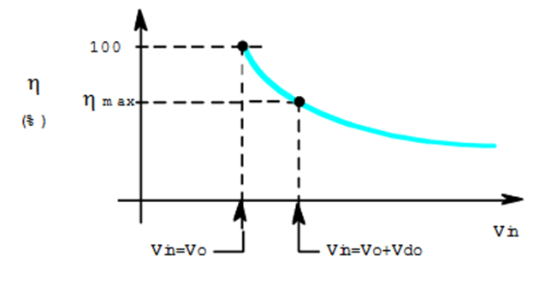
Figure 7-4 - Efficiency Characteristics

Comparison, Analysis, and Decision

After demonstrating the advantages and disadvantages of all types of voltage regulators, now it is time to choose and decide which one would serve our design better. Table 7-3 shows a summary of the three types of voltage regulator options available to use.
(-) Poor outcome
(+) excellent outcome

Table 7-3 - Summary of Voltage Regulator Selection
Type of Regulator | Power Efficiency | Design | reliability | Operating Temperature | Cost
Zener Diode | - | + | - | - | +
Linear Regulator(fix/Adjs) | - | + | - | - | +
Switching Regulator(Fix/Adjs) | + | - | + | + | -

In conclusion, the voltage regulator is the core for any circuit to work properly by providing the correct voltage along with the needed flow of current and power dissipation that won't result in the production of a lot of heat and interference. Therefore, we will decide to go with switching voltage regulators like the LM 2576 because they are reliable and have higher power efficiency ratings.

Power Supply

Powering the ASRH

The ASRH will have an on-board power supply to provide functionality to the hardware. For our demo, we will power the ASRH by plugging it into a standard wall plug that yields 120 volts at 60 Hz. Our power supply will consistent of two parts: an AC to DC converter, and a voltage regulation circuit. The following sections will describe the components we are using and the details of our design.

AC to DC Converter

For our project, we will not be designing our own power supply. Instead we will be buy a pre-made power supply, which will provide us with enough voltage and current to meet our specifications. The main specification we chose for the power supply requirement is to be able to provide 6 volts and 2.5 amps. As requirements may increase our voltage or current needs, we will choose the appropriate power supply that meets all our specification needs. The Raspberry Pi will need 5 V and 2.5 A, the MSP430 will need 3.3 V and 2 A, the two continuous rotation servos will need 5.5 V and 0.19 A each, the linear actuator will need 3.7 V and 0.45 A, and the LED driver requirements may vary depending on functionality and usability. As of now, these are the main components that need to be powered by the power supply. We will have the appropriate voltage regulators handling each components requirement feeding off the power supply.

RD-50 Series, 50W Dual Output Switching Power Supply

One AC to DC power supply we can use is a 50W dual output switching power supply, an RD-50 series manufactured by Mean Well, shown in Figure 8-1.
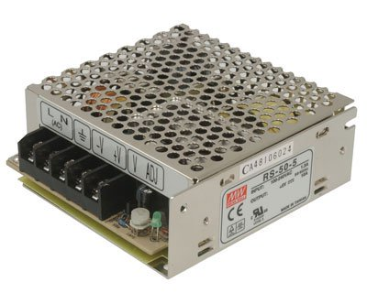
Figure 8-1 - RD-50 Series, 50W Dual Output Switching Power Supply
It has two channels for output, with CH1 supplying 5V at 6A and CH2 supplying 12V at 2A. Its input has a voltage range of 88 to 264 VAC and 125 to 373 VDC, with a frequency range of 47 to 63 Hz. Its efficiency is 73%, with a setup time of 500ms and a rise time of 20ms/230VAC. It offers short circuit protection, overload protection, and over voltage protection. It is cooled by free air convection and offers an LED indicator for power on notification. This power supply was initially chosen before we realized the camera onboard the Raspberry Pi made the current requirement 2.5 A instead of 2 A. Due to this realization, we chose not to use this power supply any more, and instead choose one that can deliver the necessary current we need at the correct voltage level. And as we increase our requirements, we also increase the power we need. Since our design is meant to be low power, we will be trying to select power supplies that are necessary and not too heavy on power consumption. Table 8-2 shows the comparison of each power supply that will be mentioned, and their specifications.

RD-65 Series, 65W Dual Output Switching Power Supply

The second AC to DC power supply we can use is a 65W dual output switching power supply, RD-65 series manufactured by Mean Well, shown in Figure 8-2.

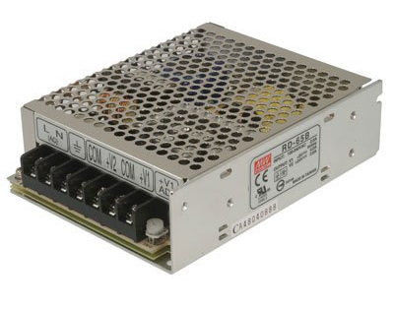
Figure 8-2 - RD-65 Series, 65W Dual Output Switching Power Supply
It has two channels for output, with CH1 supplying 5V at 6A and CH2 supplying 12V at 3A. Its input has a voltage range of 88 to 264 VAC and 125 to 373 VDC, with a frequency range of 47 to 63 Hz. Its efficiency is 79%, with a setup time of 500ms and a rise time of 20ms/230VAC. It offers short circuit protection, overload protection, and over voltage protection. It is cooled by free air convection and offers an LED indicator for power on notification. This power supply was chosen as the best power supply that meets our voltage and current needs without going too far over our power consumption limit. Since the RD-65 series power supply has two outputs, we can power components that require low voltage but high current requirements easily as well as components that require high voltage but low current needs. These options give us more freedom with powering our components without overloading a single output with too many components.

As of now, we have only accounted for the servos and the development boards in our power requirement design. We still need to account for the LEDs and lasers, but with this power supply we should be able to cover these extra components without needing to look for another power supply. Channel 1, the low voltage but high current output, can be used exclusively to power the LED drivers if they require high current at lower voltages. If the LED drivers need higher voltage and lower current then channel 2 can be used for them and the continuous rotation servos, and the linear actuator and the MSP430 can use channel 1 exclusively since they require less than 5 volts and less than 6 amps to operate. These setup combinations will be used only to lessen the load on the outputs, which will lessen the power dissipated and will use both outputs instead of wasting the opportunity to use both by only using one channel for all the components. If more current is needed, the RT-125 series power supply has also been considered to meet the increase in power requirements. For more specifications regarding the RD-65 series power supply, refer to Table 8-1 and the comparison for all the power supplies mentioned.

RD-65 power supply was tested by the manufacture to grantee proper operations and customer satisfaction when using this type of power supply. Table 8-1 is a summary of some of the tests done on RD 65 such as the input requirement test, output function test, and protection and safety function tests. This test serves as a proof of why we are choosing this type of power supply. It provides more detailed about input current, input voltage range, and output current and voltage range along with safety and protection in case of mal function of the device. This is what interest us the most for our design. However, more tests are done on this power supply such as: environment test and components stress test. Although, all these tests pass the manufactory requirement we will still test our power supply before connecting it to our circuit just to make sure that the right output voltage and the right current is delivered by the output. Because of the presence of many components in our design that gets its power from the voltage regulators; Which get their power from the power supply. All of these tests passed.

Table 8-1 - Manufacture's Testing on RD-65
Test Type | Test Item | Specification | Test Condition | Result
Output  Function  Test | RIPPLE& NOISE | V1:80 mVp-p(max)  V2:120 mVp-p(max) | I/P: 230 VAC  O/P: Full Load | V1: 16 mVp-p(max)  V2: 18 mVp-p(max)
Output  Function  Test | OUTPUT VOLTAGE  ADJUST RANGE | CH1: 4.75 V~-5.5 V | I/P: 115 or 230 VAC  O/P: MIN LOAD | 4.51V ~ 5.82V/230 VAC  4.51V ~ 5.82V/115 VAC
Output  Function  Test | LINE REGULATION | V1: -0.5 %~ 0.5 % (Max)  V2: -1.5 %~ 1.5 % (Max) | I/P:115 VAC ~ 264 VAC  O/P: FULL LOAD | V1: 0 %~ 0 %  V2: 0.3 %~ -0.3 %
Output  Function  Test | LOAD REGULATION | V1: -0.5 %~ 0.5 % (Max)  V2: -3 %~ 3 % (Max) | I/P: 230 VAC  O/P: FULL ~MIN LOAD | V1: 0.2 %~ -0.2 %  V2: 0.6 %~ -0.6 %
Output  Function  Test | OVER/UNDERSHOOT TEST | < +5% | I/P: 230 VAC  O/P: FULL LOAD | TEST: <5 %
input  Function  Test | INPUT VOLTAGE RANGE | 88VAC~264 VAC | I/P: TESTING  O/P: FULL LOAD | 59 V~ 264 V
input  Function  Test | EFFICIENCY | 79 % (TYP) | I/P: 230 VAC  O/P: FULL LOAD | 79.5 %
input  Function  Test | INPUT CURRENT | 230 V/ 1.2 A (TYP)  115 V/ 2 A (TYP | I/P: 230 VAC  I/P: 115 VAC  O/P: FULL LOAD | I = 0.8 A/ 230 VAC  I = 1.3 A/ 115 VAC
input  Function  Test | LEAKAGE CURRENT | < 2 mA / 240 VAC | I/P: 254 VAC  O/P: Min LOAD | L-FG: 0.3 mA  N-FG: 0.3 mA
Protection  Function  Test | OVER LOAD PROTECTION | 110 %~ 150 % | I/P: 230 VAC  I/P: 115 VAC  O/P: TESTING | 142 %/230VAC  142 %/115 VAC
Protection  Function  Test | OVER VOLTAGE PROTECTION | CH1: 5.75 V~ 6.75 V | I/P: 230 VAC  I/P: 115 VAC  O/P: MIN LOAD | 6.31V/ 230 VAC  6.31V/ 115 VAC
Protection  Function  Test | SHORT PROTECTION | SHORT EVERY OUTPUT  1 HOUR NO DAMAGE | I/P: 264 VAC  O/P: FULL LOAD | NO DAMAGE  Hiccup Mode
Safety  Test | WITHSTAND VOLTAGE | I/P-O/P: 3.0 KVAC/min  I/P-FG: 1.5 KVAC/min  O/P-FG: 0.5 KVAC/min | I/P-O/P: 3.6 KVAC/min  I/P-FG: 1.8 KVAC/min  O/P-FG: 0.6 KVAC/min | I/P-O/P: 3.21 mA  I/P-FG: 2.98 mA  O/P-FG: 1.49 mA  NO DAMAGE
Safety  Test | GROUNDING CONTINUITY | FG(PE) TO CHASSIS  OR TRACE < 100 mΩ | 40 A / 2min | 8 mΩ
Safety  Test | ISOLATION RESISTANCE | I/P-O/P:500VDC>100MΩ  I/P-FG: 500VDC>100MΩ  O/P-FG:500VDC>100MΩ | I/P-O/P: 500 VDC  I/P-FG: 500 VDC  O/P-FG: 500 VDC | I/P-O/P: 9 G Ω  I/P-FG: 6 G Ω  O/P-FG: 12 GΩ  NO DAMAGE

125W Triple Output Switching Power Supply, RT-125 series

The third AC to DC power supply we can use is a 132W triple output switching power supply, RT-125 series manufactured by Mean Well, shown in Figure 8-3.
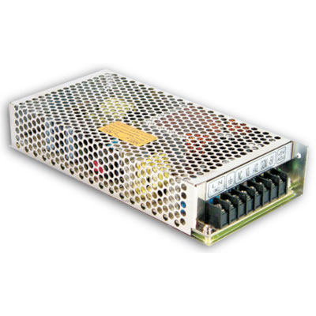
Figure 8-3 - 125W Triple Output Switching Power Supply, RT-125 series

It has three channels for output, with CH1 supplying 5V at 12A, CH2 supplying 12V at 5A, and CH3 supplying -12V at 1A. Its input has a voltage range of 88 to 264 VAC and 248 to 373 VDC, with a frequency range of 47 to 63 Hz. Its efficiency is 80%, with a setup time of 500ms and a rise time of 20ms/230VAC. It offers short circuit protection, overload protection, and over voltage protection. It is cooled by free air convection and offers an LED indicator for power on notification. This power supply will only be used if the RD-65 series power supply is not sufficient enough to power our components.

If this power supply is deemed necessary, we will likely use only channels 1 and 2, unless we need use of a strictly negative output voltage will we use channel 3. For the Raspberry Pi and the MSP430 we would use channel 1 to power them, since both development boards use less than 5 volts but require the most current to power. The servos and the linear actuator can use channel 2, since they require the most voltage, though the actuator only requires 3.3 V, but use the least amount of current. As for the LEDs, and the drivers they need to power them, they would also be connected to channel 2. This is because channel 2 offers the most voltage and enough current to power most drivers. Channel 3 will not be used since it only offers negative voltage and low current to use. If, however, a component needs a negative voltage supply we will be using this channel.
Table 8-2 - Comparison Data Sheets
Specification | RD-50 | RD-65 | RT-125
Primary Output Voltage (VDC) | 5 | 5 | 5
Output Current (A) | 6 | 6 | 12
Maximum Output Power (W) | 54 | 66 | 132
Family | RD-50 | RD-65 | RT-125
Additional Output Voltages (VDC) | 12 | 12 | 12, -12
Input Voltage (VAC) | 88 to 264 | 88 to 264 | 88 to 264
Input Frequency (Hz) | 47 to 63 | 47 to 63 | 47 to 63
Maximum Input Current (A) | 1.3 | 2 | 3
Output Connector Type | Screw Terminal Block | Screw Terminal Block | Screw Terminal Block
Number of Outputs | 2 | 2 | 3
Product Type | AC to DC Power Supply | AC to DC Power Supply | AC to DC Power Supply
Efficiency (%) | 79 | 79 | 80
Minimum Isolation Voltage | 3000 V | 3000 V | 3000
Operating Temperature-Min (Cel) | -25 | -25 | -25
Operating Temperature-Max (Cel) | 70 | 70 | 70
Length (inch) | 3.9 | 5.1 | 7.8
Width (inch) | 3.8 | 3.9 | 3.9
Height (inch) | 1.4 | 1.5 | 1.5
Agency Approvals | UL/CUL/TUV/CE/CB | UL/CUL/TUV/CE/CB | UL/CUL/TUV/CE/CB
Type | Auto Switching | Auto Switching | Switch Selectable
Style | Multiple Output | Multiple Output | Multiple Output
Weight | 0.41 kg (0.904 lbs.) | 0.44 kg (0.97 lbs.) | 0.67 kg (1.543 lbs.)
Cost ($) | 14.49 | 15.95 | 26.49

Voltage Regulation Circuit

Voltage Regulation on the ASRH

Up to this point we have decided to use LM 2576 as a viable switching adjustable-voltage regulator for the reasons mentioned before and from the data on table 7-2. So, the next step is to get to know LM 2576 more and figure out how this chip can be configured and used to provide us with the desired output voltage to power every component in our design. However, after building the first voltage regulator and test the voltage and the current, we did not get the right results the voltage reading was okay, but the output current was lower than expected. After modifying and testing the circuit, we could not get the right results. However, thanks to Dr. Samuel Richie's advice we used Texas Instrument’s WEBENCH® design tool to get the right voltage regulator based on our need for output voltages, output currents, output power, and power efficiency.

The initial power layout would be implemented using Texas instruments Buck-Boost voltage regulators as follow: Raspberry Pi (5v,2.5A), and two Parallax (5.5v,0.19A) will be powered by TPS 63070, the MSP 430 (5.5v,2A) will be powered by TPS 54424, and the Pico Servo (3.7v, 0.45A) will be powered by TPS 62175. Table 8-3 summarizes the regulator module with the component that will be used with. These regulators were selected for a balance between footprint size, cost, and efficiency. After we talk about these components we will talk about another set of components that are more efficient but have a larger footprint and may cost more than the balanced set.

Table 8-3 - Component with its Corresponding Regulator
Component | Vout(V) | Iout(A) | Regulator Model
Raspberry Pi | 5 | 2.5 | TPS63070
MSP 430 | 3.3 | 2 | TPS 54424
Parallax 1 | 5.5 | 0.19 | TPS63070
Parallax 2 | 5.5 | 0.19 | TPS63070
Pico Servo | 3.7 | 0.45 | TPS62175

Powering the Raspberry Pi and Parallax Motors with the TPS63070

TPS 63070 is a buck-boost voltage regulator that provide an output voltage between 2.5 volts and 9 volts, and can deliver a maximum output current of 2 Amperes for buck and boost configuration. The buck-boost converter is based on a fixed frequency, pulse-width-modulation (PWM) controller using synchronous rectification for maximum efficiency. Figure 8-4 shows the diagram of efficiency Vs output current and output voltage.
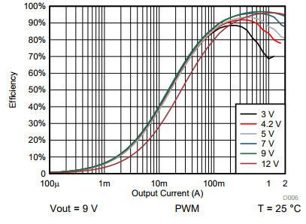
Figure 8-4 - Efficiency vs. Output Current
TPS 63070 has many features that make the devices a good candidate for smooth regulated output voltage with high efficiency and low power consumption. Table 8-4 summarizes some of these futures.
Table 8-4 - Description of the features of TPS63070
Feature | Description
Control Loop | The average inductor current is regulated by a fast-current regulator loop which is controlled by a voltage control loop.
Enable | Compares the voltage applied to a fixed threshold of 0.8024V for a rising voltage.
Power Good | The device has a built-in power good output that indicates whether the output voltage has reached its nominal value.
Soft Start | To minimize inrush current during start up. Soft-start cycle is started, and the input current is ramped until the output voltage reaches regulation.
PS/SYNC | Switching between forced PWM mode and power save mode, and synchronizing to an external clock applied at pin PS/SYNC
Short Circuit Protection | To protect the regulator and the application
VSEL and FB2 pins | To select between two different output voltages on the adjustable version
Overvoltage Protection | A built-in over-voltage protection which limits the output voltage
Under voltage Lockout | The under-voltage lockout prevents maloperation by switching off the device in case of input voltage drop.
Over temperature Protection | When the junction temperature, the device goes into thermal shutdown

TPS 63070 requires the use of some components that will be connected to the regulator pins, but this depends on a fixed or adjustable voltage regulator configuration. Figure 8-5 shows the diagram of one of the possibilities that TPS 63070 can be configured to provide the desired voltage and current outputs.
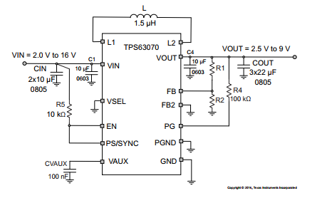
Figure 8-5: Circuit Diagram of TPS63070
As we can see from Figure 8-5, it is required to have input capacitors (CIN), which are recommended to be as close as possible from Vin to GND to filter out high frequency noise, and for better transient behavior of the regulator. In addition, they are required to reduce the source impedance. Input capacitors need to be large enough because the under-voltage lockout circuitry needs time to operate properly. The output capacitor (COUT) is a combination of capacitors for suppressing high frequency noise. The use of large capacitors will help lower output voltage ripple and stabilize the operation, as well as lower output voltage drop during load transients. Inductor (L) to charge during on position of the MOSFET and discharged when MOSFET is in off position and provide current for the output. The core material has great impact on overall efficiency. The smaller the inductor value the higher the conduction and the lower the ripple current as well as helping with slower load transient response, loss and the higher the ripple current. On the other hand, the higher the inductor's value, the lower the conduction loss.

Another reason why it is important to use the right inductor value is that the stability of the feedback loop is affected by the value of the inductor. The phase margin of feedback loop is lower when right half plane zero is moved to lower frequency because of higher values of the inductor. R1 and R2 form voltage divider that will be used to provide the desired output voltage using the equation shown below. To provide high accuracy and best robust design it is always preferable to use low resistor values.
$$R_{1}=R_{2}\left(\frac{V_{out}}{V_{ref}}-1\right), V_{ref}=0.80247 V$$

The summary of the purpose of each external component is summarized in Table 8-5.

Table 8-5: Summary of the purposes of each external component
Component | Operation
Input capacitor(Cin) | to reduce the source impedance
Output capacitor(Cout) | to stabilize the output voltage and reduce the ripple
Inductor | Charged when MOSFET (on) discharged when MOSFET (off)
R1, R2 | form voltage divider to provide the desired output voltage

The Device functional mode:
TPS 63070 has the capability to work in the Power Save Mode to provide the best efficiency over complete load range. TPS 63070 uses Pulse Width Modulation, and at low load the device switches to power save mode to minimize power consumption and external battery use. When the device is in this mode the converter stops regulating and the output voltage goes low, depending on the value of the output capacitor and the nature of the load. Since the output voltage is monitored by the comparator, the output voltage is always compared to the comparator's threshold. If the output voltage reached the "comp low" and the output current is lower than the inductors current of 650mA the device keeps switching and the operation keeps repeating. However, when the "comp High" threshold is reached, and the inductor's current is above 650mA, the device switches to PWM mode at the next Pulse Frequency Modulation (PFM). Therefore, to eliminate a critical voltage drop when switching from Zero Ampere to full load, the output voltage is usually higher than the nominal value of 1%. This will permit the device to regulate at small output capacitance and still provide absolute voltage drop during heavy load transients. Figure 8-6 illustrates the dynamic voltage positioning.

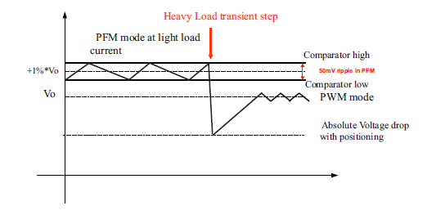
Figure 8-6 - Dynamic Voltage Positioning
Figure 8-7 shows the proposed circuit schematic that will feed our continuous rotation servos and LED drivers. The project requirements for our design have been ran multiple times in TI’s WEBENCH® design tool and this schematic has been choses each time as the best optimized for efficiency, cost, and footprint size.

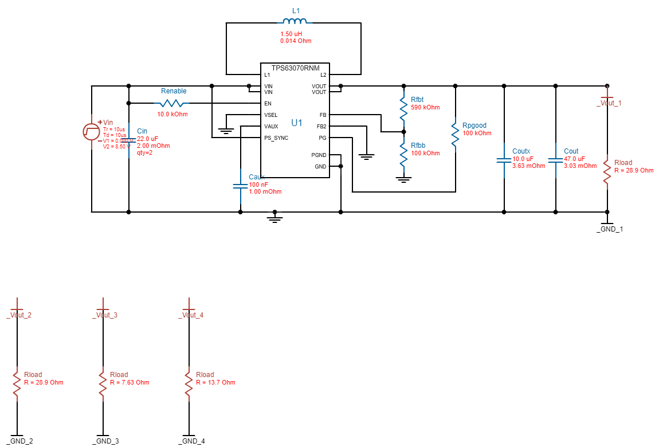
Figure 8-7: WEBENCH® schematic for the TPS63070

We are using the TPS63070 to regulate an input voltage to 5.5 volts and 1.6 amps that will feed both of our continuous rotation servos, and our LED drivers LM3549 and LP55281. This chip was chosen because we are using the WEBENCH® Design Center from TI to design our power supply regulator, and was the optimized choice for footprint, BOM cost, and efficiency. The schematic that was drawn up by the WEBENCH® gives the best optimization to feed our servos, with an estimated total cost of $2.36, a footprint size of 112 mm², and an efficiency of 95%.

For this voltage regulator, we have an interesting duty cycle graph shown in Figure 8-8. As output current increases up to 0.6A it is a linear slope for varying levels of input voltage, but once that point is passed it decreases drastically and then settles out. Output power, shown in Figure 8-9, is a linear graph as output current increases. Efficiency for this component is shown in Figure 8-10, with an average of 94% at varying levels of input voltage at its maximum current draw. Another efficiency graph in log scale form is shown in Figure 8-11, which shows how quickly efficiency drops after 1A current consumption.

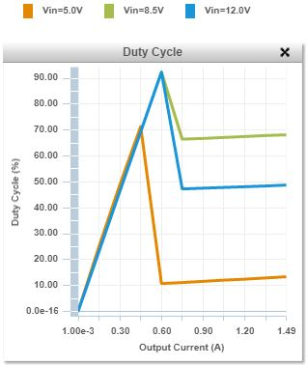
Figure 8-8 - TPS63070 Duty Cycle Chart

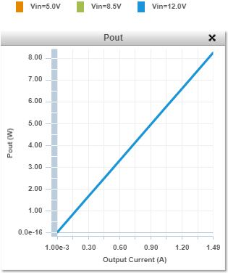
Figure 8-9 - TPS63070 Pout Chart

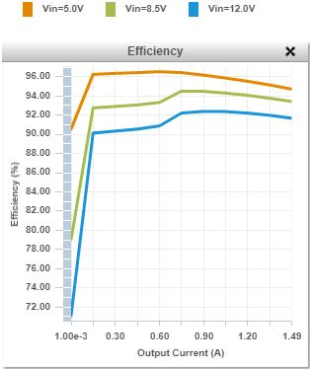
Figure 8-10: TPS63070 Efficiency Chart

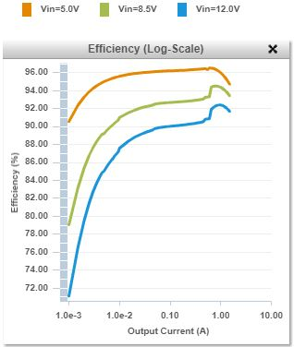
Figure 8-11: TPS63070 Efficiency Log Scale Chart

Powering the Pico Servo with the TPS63070

TPS62175 is synchronous switch mode power converter that can provide seamless transition to power save mode. The voltage regulator is a combination of hysteretic, voltage mode, and current control loop. It can set switching frequency and has quick response to dynamic load changes. In addition, TPS 62175 works better with small external components as well when it is in power saver mode, when load current decreases which lead to high efficiency. Furthermore, it has seamless transition from pulse width modulation (PWM) to power saver mode with no effect on output voltage.

TPS62175 has different functional modes: soft start that controls the output voltage slope to filter out the extra rushing current and maintain the output voltage's rise time, and Pulse Width Modulation (PWM) that provides continuous conduction mode since the frequency variation depends on the input voltage and the output voltage. It stays in this mode until the output current is equal to or less than half of the inductor's ripple current. Power save mode operation starts when the load current is decreasing. Which guarantees the high efficiency for light load operation. Figure 8-12 shows the graph of efficiency versus output current when the device is in sleep mode.

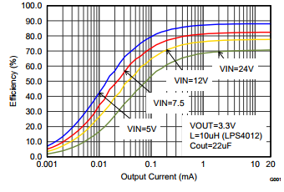
Figure 8-12: TPS62175 efficiency vs. output current

TPS 62175 has many features that makes the device regulate the output voltage with high efficiency and low power consumption. Table 8-6 summarize some of these futures.

Table 8-6 - Description of each feature of the TPS62175
Feature | Description
Enable/Shutdown (EN) | The device can be switched ON/OFF by pulling the EN pin to High (operation) or Low (shutdown).
Output Discharge | When the device is turned off by EN, UVLO or thermal shutdown.
Current Limit and Short Circuit Protection | Devices are protected against heavy load and short circuit events.
Power Good (PG) | Power good (PG) function to indicate that the output reached regulation.
Under voltage Lockout (UVLO) | The under-voltage lockout function prevents miss operation by turning the device off.
Thermal Shutdown | The junction temperature (TJ) of the device is monitored by an internal temperature sensor.

Modes of Operation:
- Soft Start
To avoid inrush current and to control output voltage drop, the soft start circuitry monitors the output voltage drop. During start-up, the EN is set to high and output voltage rises, and the internal current limit sets to 525mA. The startup sequence ends, and the device reaches regulation at the full output current.

- Pulse Width Modulation (PWM) Operation
TPS 62175 runs at PWM in continuous mode (CCM). The frequency variation depends on Vin and Vout. When the output current is more than half of the inductor's ripple current, the device is in PWM. However, to achieve high efficiency when load is low the device enters power save mode at the discontinuous conduction mode (DCM).
- Power Save Mode Operation.
This mode is achieved by the device when the load current decreases, which allows the device to function with high efficiency when load is very low.

- Sleep Mode Operation
In this mode, the quiescent current is drooped from 22µA to 4.8 µA to increase efficiency. Sleep mode operation is enabled or disabled with the condition of the SLEEP pin (High or Low). However, a pull-down resistor connected to the sleep signal pin is needed in case the sleep input signal goes to high impedance. Likewise, an external pull-down resistor on the sleep pin is needed in case the sleep signal goes from logic high to high impedance.

Like TPS63070, TPS 62175 requires the use of some external component but not as much as TPS 63070. These components will contribute to regulating voltage based on the whether it is used for fix regulation or adjustable regulation. Figure 8-13 shows the circuit diagram for TPS 62175 configured as an adjustable voltage regulator.
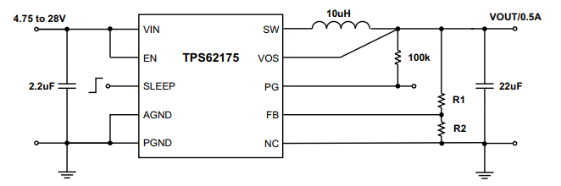
Figure 8-13 - Circuit Diagram for adjustable TPS62175

TPS 62175 is different than TPS 63070 not because of the use of fewer external components but also the use of an LC filter at the output that is responsible for the corner frequency of the converter. The capacitor and the inductor must be carefully chosen to provide the correct filtering operation, Table 8-7 shows Texas Instruments’ recommended output filter component's values.

Table 8-7: Recommended LC combination
 | 22uF | 47uF | 100uF | 200uF
10uH
22UH

The inductor selection is critical because besides the filtering purpose, the value of the inductor is responsible for lowering the level of ripple current and ripple voltage. Also, it is responsible for safe mode efficiency. The output capacitor is recommended by Texas Instruments to be 22 (µF) because during large load the output ripple voltage is controlled, and to keep the DC output accuracy and small output voltage ripple, the capacitor need to have a larger capacitance. The input capacitor, on the other hand, is recommended to keep as low as 2.2 (µF) and needs to be placed as close as possible to Vin and PGND. R1and R2 form a voltage divider that will be used to provide the desired output voltage using the equation shown below, and to provide high accuracy and better voltage regulation under all operation modes of the TPS62175. Table 8-8 presents a summary of the reasons of choosing external components.

$$R_{1}=R_{2}\left(\frac{V_{out}}{V_{ref}}-1\right), V_{ref}=0.80247 V$$

Table 8-8: Summary of the purpose of each external component
Component | Operation
Input capacitor(Cin) | to reduce the source impedance
Output capacitor(Cout) | to stabilize the output voltage and reduce the ripple
Inductor | responsible for the safe mode efficiency, provide the correct filtering
R1, R2 | form voltage divider to provide the desired output voltage

Powering the MSP430 with the TPS54424

The TPS 54424 is a 17 Volt, 4 Ampere synchronous step down (buck) converter that utilize two n-channel MOSFETs, which is the reason why the device is suitable for applications that requires high efficiency power supply with continuous 4 Amperes current. Figure 8-14 shows the efficiency versus output current for 5 volts output voltage regulation. In addition, it has phase lock loop (PLL) connected to the RT/CLK pin that provides synchronization between the switching cycle and to the falling edge of the external system clock. TPS 54424 is protected against output overvoltage as well as the thermal fault conditions; this feature is taken care of by the power good comparator. Furthermore, it can shut down if the junction temperature is higher than thermal shutdown trip point.
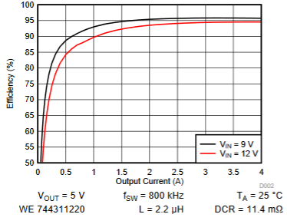
Figure 8-14 - Efficiency vs. output current for 5V output
TPS 54424 has many features that collaborate to an excellent synchronous voltage regulator with higher efficiency, output overvoltage protection, and power good output monitor for under-voltage and overvoltage. Table 8-9 summarize the features of TPS 54424.

Table 8-9 - Summary of the features of TPS 54424
Feature | Description
Fixed Frequency PWM Control | The device uses an adjustable fixed frequency, peak current mode control.
Continuous Conduction Mode Operation (CCM) | As a synchronous buck converter, the device works in CCM  (Continuous Conduction Mode) under all load conditions.
VIN Pins and VIN UVLO | The device is disabled when the VIN pin voltage falls below the internal VIN UVLO threshold. The internal VIN UVLO threshold  has a hysteresis of 200 mV.
Voltage Reference and Adjusting the Output Voltage | The voltage reference system produces a precise ±0.85%, 0.6 V voltage reference over temperature by scaling the output of a temperature stable band gap circuit.
Error Amplifier | The device uses a transconductance error amplifier to compares the FB pin voltage to the lower of the SS/TRK pin voltage or the internal 0.6-V voltage reference.
Enable and Adjustable UVLO | The EN pin provides on/off control of the device. Once exceeds its threshold voltage, the device starts operation. when is pulled below the threshold voltage, the regulator stops switching and enters low operating current state.
Soft Start and Tracking | the SS/TRK pin while its voltage is lower than the internal reference to implement soft start. A capacitor on the SS/TRK  pin to ground sets the soft start time. it has an internal pull- up current source of 5 µA that charges the external soft start capacitor.
Safe Start-up into Pre-Biased Outputs | The device has been designed to prevent the low-side MOSFET  from discharging a pre-biased output during monotonic pre-biased startup.
Power Good | The PGOOD pin is an open-drain output requiring an external  pull-up resistor to output a high signal. PGOOD is immediately pulled low if VIN falls below its UVLO, or the TPS54424 enters thermal shutdown.
Sequencing (SS/TRK) | The common power supply sequencing methods can be implemented using the SS/TRK, EN and PGOOD pins. can be implemented by sequential method, or ratiometric Sequencing method.
Adjustable Switching Frequency (RT Mode) | The switching frequency of the device is adjustable from 200 kHz to 1600 kHz by placing a maximum of 250 k Ω and minimum of 30.1 kΩ respectively.
Synchronization (CLK Mode) | An internal Phase Locked Loop (PLL) has been implemented to allow synchronization from 200 kHz to 1600 kHz, and to easily switch from RT mode to CLK mode.
Bootstrap Voltage and 100% Duty Cycle Operation (BOOT) | Uses small capacitor between the BOOT and SW pins as a gate drive. The capacitor is refreshed when low side of the MOSFET is on.
Output Overvoltage Protection (OVP) | The OVP feature minimizes the overshoot by comparing the FB pin voltage to the OVP threshold.
Over current Protection | The device is protected from over current conditions by cycle-by-cycle current limiting  on both the high-side MOSFET and the low-side MOSFET.
High/Low -side MOSFET Over current Protection | The maximum peak switch current through the high-side MOSFET for over current protection is done by limiting the current reference internally, the low-side sourcing current limit prevents current runaway and may also sink current from the load.

TPS 54424 requires the use of some external components to provide the desired regulated voltage. The components chosen will vary from one design to another, but for our project and as recommended by Texas Instruments WEBENCH® we will choose the following design topology shown in Figure 8-15.
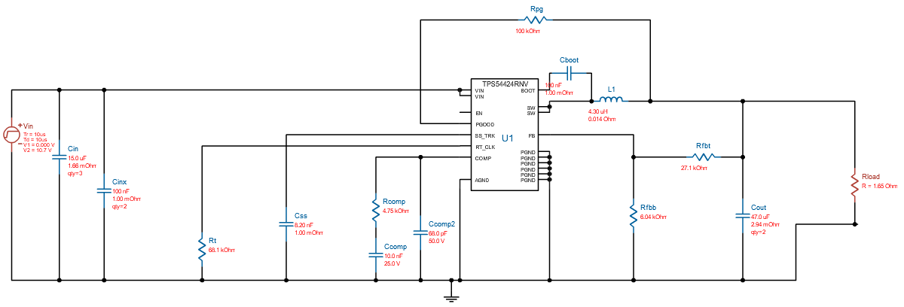
Figure 8-15: Circuit diagram for TPS54424 adjustable voltage regulator
The design shown in Figure 8-15 will be the best for our project. This device will provide power to our MSP430. The circuit has external components that will contribute to providing the right output voltage, power, and efficiency.

The idea of having an output capacitor is to filter the output ripple generated by the inductor. However, choosing a high ripple inductor will affect the output capacitor selection, which must have a ripple current rating equal or greater than the inductor's ripple current. It is not necessary to exceed the RMS and peak inductor current and saturation current ratings. For the output capacitor, it is very important to consider the output voltage ripple and the way the regulator responds to a large change in the load current. Another reason why we need the output capacitor is to absorb charge until the regulator responds to the load step. TPS 54424 requires an input decoupling capacitor that need to be as close as possible to the integrated circuit. The capacitor must be placed by the VIN pins 2 and 11 for high frequency bypass to reduce the high frequency overshoot and ringing on VIN and SW. In addition, the capacitor's voltage rating must be greater than the maximum input voltage. RFBB and RFBT form a voltage divider that will be used to provide the desired output voltage using the equation shown below, and provide high accuracy and better voltage regulation under all the operation modes of TPS54424.

$R_{FBT}=R_{FBB}\left(\frac{V_{out}}{V_{ref}}-1\right), V_{ref}=0.6 V$

The soft-start Capacitor is added to determine how much time is needed for the output voltage to reach its nominal value when powered up. This would be helpful when the load requires a controlled voltage slew rate, or when the output capacitance is so large and needs high current to charge the capacitor to the required output voltage level. The external voltage divider RENT and RENB are used to adjust the under-voltage lockout which is consisted of two thresholds: one when input voltage is rising and the other one when the input voltage is falling. The bootstrap capacitor is connected between BOOST and SW with the addition of a small resistor that will slow down the turn-on of the high-side MOSFET. This would help reduce voltage spikes on SW. This operation must be carefully monitored because it may cause power loss which might reduce efficiency. The PGOOD Pull-up resistor is necessary to pull-up power good signal when FB conditions are met. Table 8-10 summarize the purpose of each external component that TPS 54424 requires.
Table 8-10: Summary of the operation of each external component
Component | Operation
Output inductor | Charge and discharge depending on MSFET condition (On or Off).
Output Capacitor | To filter the output ripple generated by the inductor.
Input Capacitor | To reduce the high frequency overshoot.
RFBB and RFBT | They form voltage divider that will be used to provide the desired output voltage.
Soft-start Capacitor | Helpful when the load requires a controlled voltage slew rate, or when the output capacitance is so large and needs high current to charge the capacitor required output voltage level.
RENT and RENB | To adjust the under-voltage lockout which is consisted of two thresholds.
Bootstrap Capacitor | Will slow down the turn on of the high-side MOSFET.
GOOD Pull-up Resistor | To pull-up power good signal when FB conditions are met.

Higher Efficiency Regulators

The following regulators described in this section are optimized for maximum efficiency. They come at a more expensive cost and larger footprint, but may be worth the investment. The following sub-sections describe some of these regulators and how they would fit into our design

LM 5175

The LM5175 is a synchronous four-switch buck-boost DC/DC controller capable of regulating an output voltage above or below the input voltage. It operates over a range of 3.5V to 42V, and employs current-mode control both in buck and boost modes of operation for load and line regulation. The switching frequency is programmed by an external resistor and can be synchronized to an external clock signal. Figure 8-16 shows the proposed circuit schematic that would be used. The schematic was optimized to deliver the necessary voltage and current for our Raspberry Pi. The LM5175 offers an adjustable current limit, which is helpful for us if the camera onboard the Raspberry Pi peaks the current intake above the expected 2.5 A max value. The chip can handle the peak without suffering any serious damage. Table 8-11 shows the specifications of the LM 5175 along with the other higher-efficient regulators.
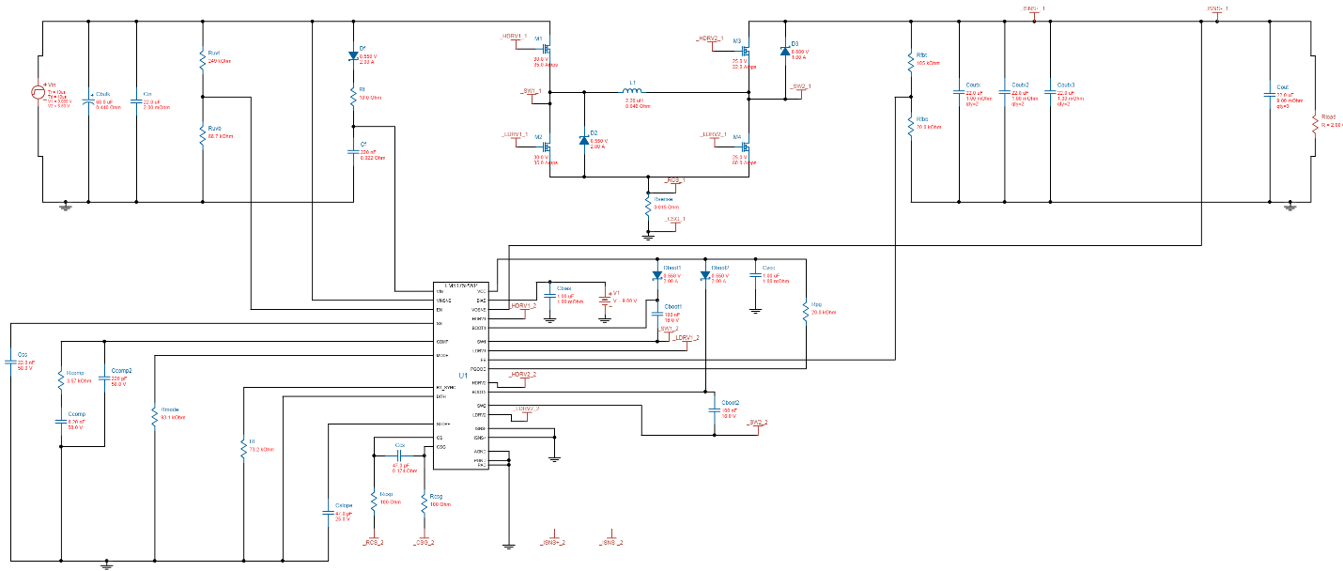
Figure 8-16 - WEBENCH® schematic of the LM5175
Figure 8-19 shows how efficient this circuit arrangement is at varying output currents, with decreasing efficiency as output increases as well as at what input voltage the efficiency is. Since the LM5175 is meant to feed our Raspberry Pi, which will be used the most of any major component of our project, we must make sure it is properly supplied the voltage and current it needs without any problems occurring. Due to the camera boarded onto the Raspberry Pi, this regulator was chosen as the best optimized chip for our design. The LM5176 however, is an even more efficient optimization but at a higher BOM cost and bigger footprint.

Depending on possible requirements that might arise for the Raspberry Pi, this regulator may or may not be used. Previously the Raspberry Pi was only going to need 2 A, but due to the camera we now needed 2.5 A. If more major components are necessary and must be connected to the Raspberry Pi we will have to change our design further to account for any increase in voltage or current requirements. The LM 5175 and LM 5176 are both usable regulators, but emphasis is given to the LM 5176 due to it being the more efficient choice.

We will be using this regulator to regulate an input voltage to output 5 volts and 2.5 amps that will feed our Raspberry Pi 3 Model B. This chip was chosen because we are using the WEBENCH® Design Center from TI to design our power supply regulator, and this chip was the optimized choice for footprint, BOM cost, and efficiency. The schematic that was drawn up by the WEBENCH® gives the best optimization to feed our Raspberry Pi, with an estimated total cost of $6.33, a footprint size of 558 mm², and an efficiency of 94%.

Looking at Figure 8-17, we can see that the duty cycle does not change as output current increases. This is true for all voltage levels shown as well. From Figure 8-19, we notice that our efficiency seriously drops as we increase our current consumption at varying levels of input voltage. For this voltage regulator, we will be using the 5V input and may be consuming an average of 2 amps or more, which will put us around an estimated 95.5%. If we have to switch over to the 12V input due to any reasons our efficiency will drop to around 95%, which is still relatively efficient. And for our output power it looks like it will be a linear slope depending on the current, as shown in Figure 8-18. We are checking the output power to also make sure we don’t heat up our component too much and affect efficiency of this component and others in our design.

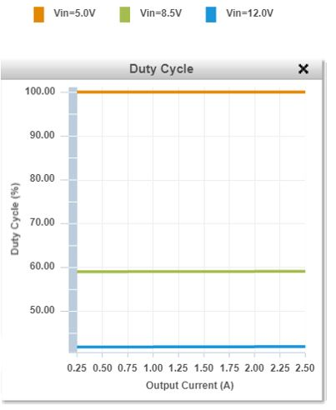
Figure 8-17 - LM5175 Duty Cycle Chart

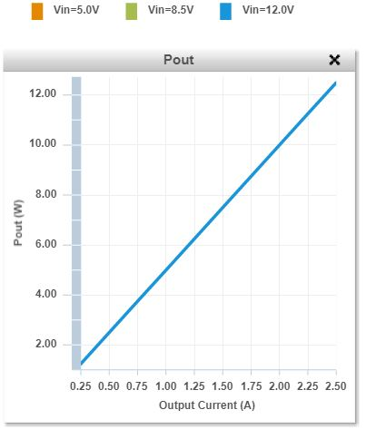
Figure 8-18 - LM5175 Pout Chart
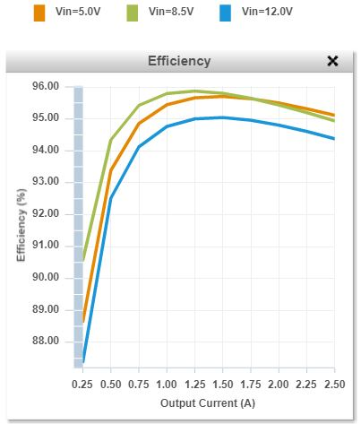
Figure 8-19: LM5175 Efficiency Chart

LM 5176

The LM5176 is a synchronous four-switch buck-boost DC/DC controller capable of regulating an output voltage above or below the input voltage. It operates over a range of 4.2V to 55V, and employs current-mode control both in buck and boost modes of operation for load and line regulation. The switching frequency is programmed by an external resistor and can be synchronized to an external clock signal. Figure 8-20 shows the proposed circuit schematic we intend to use for our project, with an LC filter for higher efficiency. The schematic was optimized to deliver the necessary voltage and current for our Raspberry Pi. The LM5176 offers an adjustable current limit, which is helpful for us if the camera onboard the Raspberry Pi peaks the current intake above the expected 2.5 A max value. The chip can handle the peak without suffering any serious damage. Table 8-11 shows the specifications of the LM 5176 along with the other higher-efficient regulators, like the LM 5175. The only precaution we must take is that the maximum current allottable for the LM 5176 was not given, but assuming the LM 5175 has a maximum of 20 A allottable we believe the LM 5176 may have a similarly high max current.

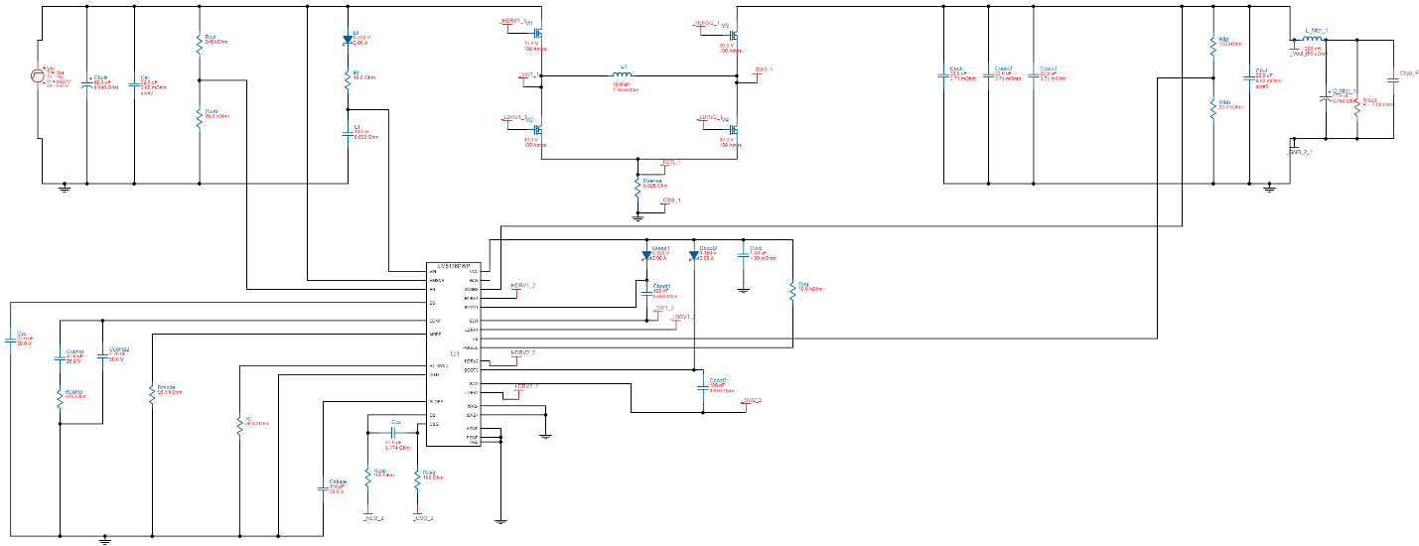
Figure 8-20 - WEBENCH® schematic of the LM5176 with a filter
We will be using this regulator to regulate an input voltage to output 5 volts and 2.5 amps that will feed our Raspberry Pi 3 Model B. This regulator was chosen because we are using the WEBENCH® Design Center from TI to design our power supply regulator, and this chip was the optimized choice for footprint, BOM cost, and efficiency. The schematic that was drawn up by the WEBENCH® gives the best optimization to feed our Raspberry Pi, with an estimated total cost of $11.77, a footprint size of 1449 mm², and an efficiency of 98%. This regulator can be used to replace the LM5175 option, where this regulator is more efficient with a filter to supply our Raspberry Pi with the voltage and current it needs. Figure 8-23 shows the efficiency of this chip in the designed schematic at varying output currents and at given input voltages. This increase in efficiency comes at a cost of a higher footprint size and a higher BOM cost, compared to the LM5175. If more components need to be connected to the Raspberry Pi and a different voltage or current requirement is needed, we will have to change this design for one that can meet the new requirements. If that change is needed, we will still choose the most optimized form possible. It is favorable not change this design much at this point, but the better option will be chosen regardless.

Referring to Figure 8-21, we can see that our duty cycle for this component is constant for varying levels of input voltage and not dependent on output current. Interestingly, our efficiency improves as output current consumption increases, as shown in Figure 8-23, reaching around 98% efficiency at 5V input and 97.5% efficiency at 12V input. This is good for us since this voltage regulator will be the one that will most likely be the most used and cause the most power consumption, which will relate to how hot our component will get and affect efficiency of this component and surrounding components. The output power is shown in Figure 8-22 and gives a visual of how much expected power we can assume will be consumed as output current requirement rises.

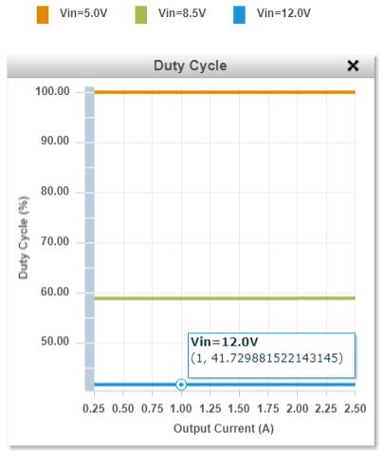
Figure 8-21 - LM5176 Duty Cycle Chart

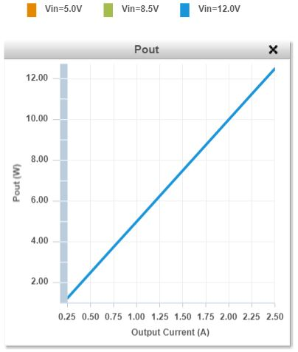
Figure 8-22 - LM5176 Pout Chart

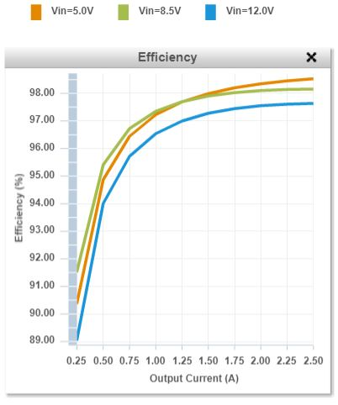
Figure 8-23: LM5176 Efficiency Chart

TPS 54824

The TPS54824 is a full featured 17-V, 8-A synchronous step-down converter in a 3.5mm x 3.5mm HotRodTM QFN package. The device is optimized for small solution size through high efficiency and integrating the high- and low-side MOSFETs. It offers peak current mode control for space saving, and using a high switching frequency to reduce the inductor footprint. The peak current mode control simplifies the loop compensation and provides fast transient response. A dedicated EN pin can be used to control the regulator on or off and adjust the input under voltage lockout. Figure 8-24 shows our proposed circuit schematic using the TPS 54824, drawn up by the WEBENCH® design tool. This design is optimized for high efficiency to supply the necessary voltage and current needed for our MSP430. If the voltage or current requirements change for any reason, we can still use this chip since several optimizations were done for the MSP430 and this chip was selected for each one. Therefore, we believe this chip offers the best efficiency and versatility for this project.
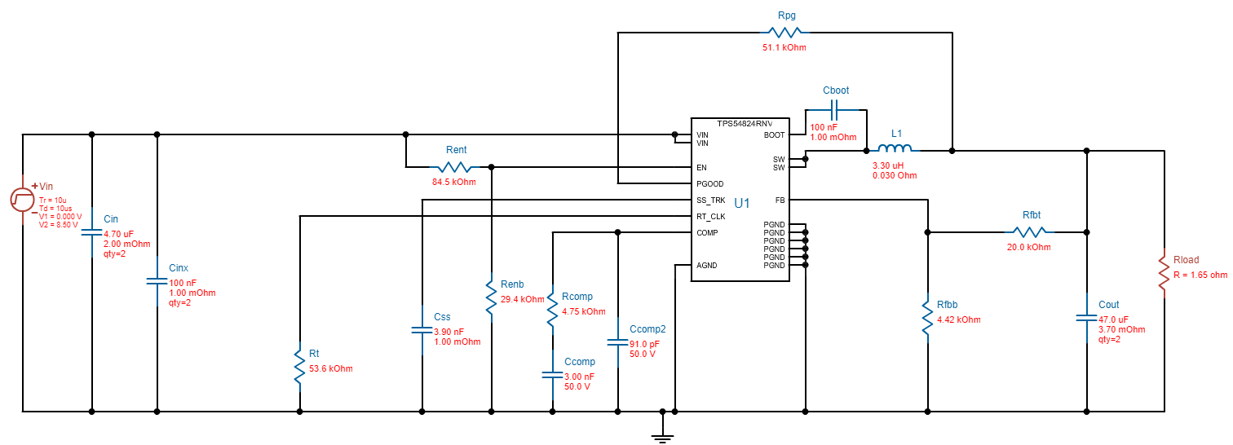
Figure 8-24: WEBENCH® schematic of the TPS54824
We are using the TPS54824 to regulate an input voltage to 3.3 volts and 2 amps that will feed our MSP430. This chip was chosen because we are using the WEBENCH® Design Center from TI to design our power supply regulator, and was the optimized choice for footprint, BOM cost, and efficiency. The schematic that was drawn up by the WEBENCH® gives the best optimization to feed our MSP430, with an estimated total cost of $2.82, a footprint size of 173 mm², and an efficiency of 93%. Figure 8-27 shows the efficiency of the proposed circuit design at varying levels of output current, and at given input voltages. This efficiency is the optimal setting we want to achieve but will vary on the conditions we find for the MSP430 and any peripherals that might be attached to it.

From Figure 8-25, we can see that the duty cycle for this component slightly increases as output current rises at varying levels of input voltage, but not by much. The efficiency for this voltage regulator design is around 98% at varying levels of input voltage, shown in Figure 8-27. And the output power, shown in Figure 8-26, increases linearly as output current increases. Thanks to the high efficiency and lower power consumption, heat shouldn’t be much of an issue for this component and surrounding component’s efficiencies.
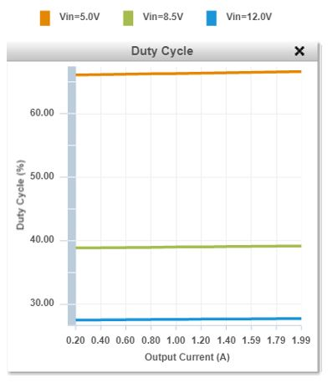
Figure 8-25 - TPS54824 Duty Cycle Chart
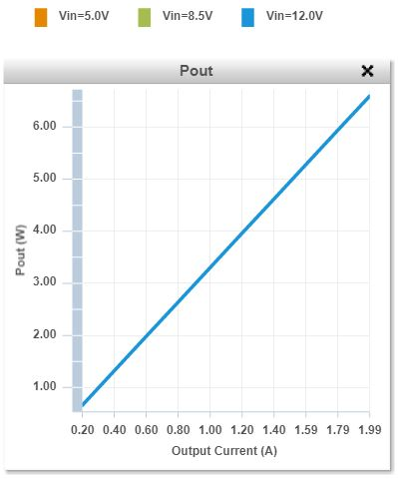
Figure 8-26 - TPS54824 Pout Chart

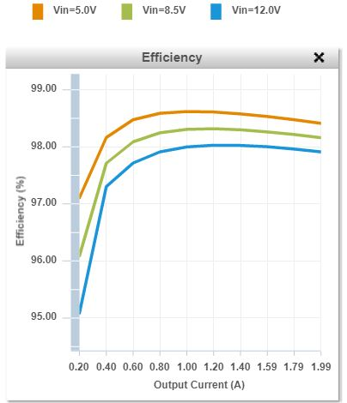
Figure 8-27 - TPS54824 Efficiency Chart

TPS 561208

The TPS561208 is a 1-A synchronous step-down converter in SOT-23 package. The device is optimized to operate with minimum external component counts as well as optimized to achieve low standby current. This switch mode power supply (SMPS) device employs D-CAP2 mode control providing a fast-transient response and supporting both low equivalent series resistance (ESR) output capacitors such as specialty polymer and ultra-low ESR ceramic capacitors with no external compensation components. Figure 8-28 shows the proposed circuit schematic using the TPS561208 drawn up using TI’s WEBENCH® design tool.
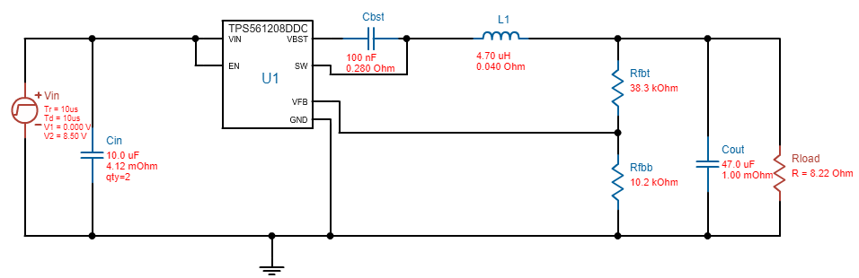
Figure 8-28: WEBENCH® schematic for the TPS561208

We are using the TPS561208 to regulate an input voltage to 3.7 volts and 0.450 amps that will feed our linear actuator. This chip was chosen because we are using the WEBENCH® Design Center from TI to design our power supply regulator, and was the optimized choice for footprint, BOM cost, and efficiency. The schematic that was drawn up by the WEBENCH® gives the best optimization to feed our actuator, with an estimated total cost of $1.19, a footprint size of 68 mm², and an efficiency of 95%. Figure 8-31 shows the efficiency of the proposed schematic at varying output currents and at given input voltages. Figure 8-32 shows the efficiency of the schematic in log-scale for a clearer view as to how the efficiency changes as output current increases. The TPS561208 was choses multiple times as we ran optimizations for efficiency in the WEBENCH® design tool. Because of the multiple appearances of this chip in those optimizations, we believe this chip is the best suited for our applications and requirements for feeding our linear actuator.

Referring to Figure 8-29, the duty cycle of this voltage regulator slightly increases at output current increases, but is almost constant at varying levels of input voltage. As output current increases, efficiency also settles out to around 94%, shown in Figure 8-31. Since this voltage regulator is mainly for the linear actuator only, which will not be on often, the efficiency of this component should be closer to 96% at 5V input voltage. Another view of the efficiency graph shown in log scale is visualized in Figure 8-32. And power output also increases regularly as output current increases, which is shown in Figure 8-30. This component is probably the most efficient and consumes the least amount of power due it only feeding the linear actuator.

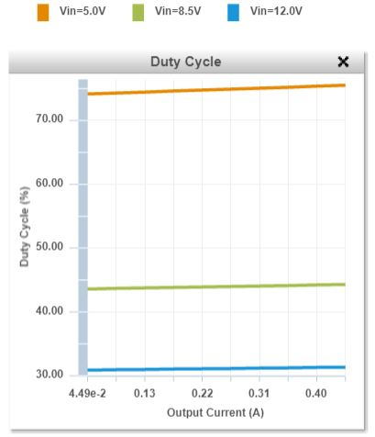
Figure 8-29 - TPS561208 Duty Cycle Chart

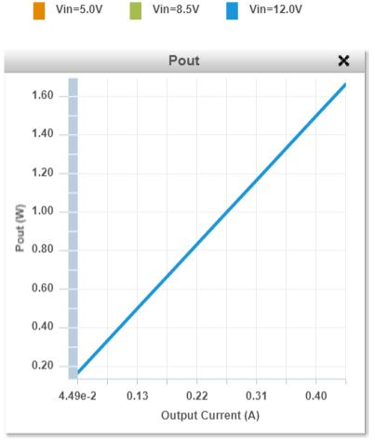
Figure 8-30 - TPS561208 Efficiency Chart

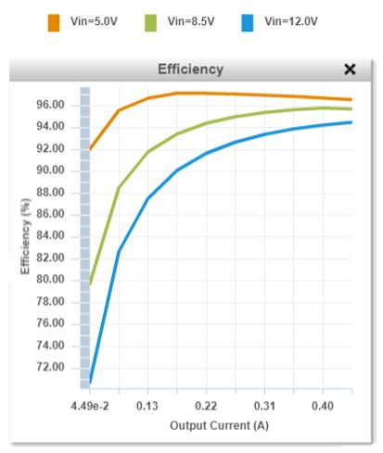
Figure 8-31: TPS561208 Efficiency Chart
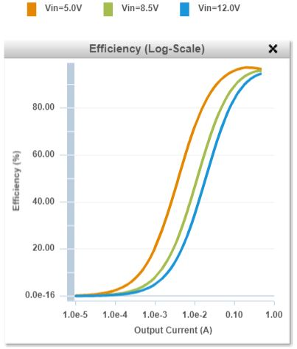
Figure 8-32: TPS561208 Efficiency Log Scale Chart
If more components are added to our design, we will use WEBENCH® and run the power architect design tool to account for these new components. We will choose chips for a balanced set for cost, efficiency, and footprint size as well as components with high efficiency prioritization.

Table 8-11 compares the higher-efficient prioritized regulators only. This table is for quick look-up and comparison if higher-efficient regulators are found, then we can compare to see if the new regulators truly are better than the ones we have selected so far.

Table 8-11 - Comparison Table of the higher-efficient regulators
 | LM5175 | TPS54824 | TPS63070 | TPS561208 | LM5176
Topology | Buck/Boost |  | Buck/Boost |  | Buck/Boost
Vin (Min) (V) | 3.5 | 4.5 | 2 | 4.5 | 4
Vin (Max) (V) | 42 | 17 | 16 | 17 | 55
Vout (Min) (V) | 0.8 | 0.6 | 2.5 | 0.76 | 0.8
Vout (Max) (V) | 55 | 12 | 9 | 7 | 55
Switch Current Limit (Min) (A) | 20 |  | 3.6 |  | 20
Duty Cycle (Max) (%) | 100 | 98 | 100 | 80 | 100
Switching Frequency (Min) (kHz) | 100 | 200 | 2100 | 580 | 100
Switching Frequency (Max) (kHz) | 600 | 1600 | 2800 | 580 | 600
Iq (Typ) (mA) | 1.65 | 0.58 | 0.05 | 0.4 | 1.65
Features | Adjustable Current Limit Enable  Frequency Synchronization  Power Good  Pre-Bias Start-Up  Synchronous Rectification  UVLO Adjustable | Enable  Frequency Synchronization  Power Good  Pre-Bias Start-Up  Synchronous Rectification  Tracking | Dynamic Voltage Scaling Enable  Frequency Synchronization  Light Load Efficiency  Load Disconnect  Output Discharge  Power Good  Synchronous Rectification  UVLO Fixed  Voltage Margining | Enable  Forced Pulse Width Modulation (FPWM) Mode  Synchronous Rectification | Adjustable Current Limit Enable  Frequency Synchronization  Power Good  Pre-Bias Start-Up  Synchronous Rectification  UVLO Adjustable
Control Mode |  | Current Mode |  | D-CAP2
Iout (Max) (A) | 20 | 8 | 2 | 1
Operating Temperature Range (C) | -40 to 125 | -40 to 150 | -40 to 125 | -40 to 85 | -40 to 125
Rating | Catalog | Catalog | Catalog | Catalog | Catalog
Package Group | HTSSOP  VQFN | VQFN-HR | VQFN-HR | SOT-23-THIN | HTSSOP

Testing Plan

Designing and implementing electrical circuits is expending, which result in an increase of competition between manufacturing companies. Part of the competition is to increase the production volume and decrease production time. Unfortunately, short production time affect the quality and reliability of products. As technology expends and improves, the complexity of electrical circuits gets more complex such as increase circuits functionality, and combining multiple interfaces into single device. As result, engineers have several problems on how to examine and test such complex circuits in very short time. During the design process, about 40% of the time is spent in testing and verifying the functionality of the device. However, due to time limitation sometimes testing and verification process is not done properly; which affect quality and reliability of the device. The question that always rise is: what is a good testing strategy that engineers can use? To answer this question, one should have good understanding of what the device should do and what are the specifications, so they can be compared to test results. In addition, testing engineers should have better understanding of the current error spectrum and error level, because it changes over time due to changing technology. To illustrate, faulty Electronic components are much lower than before “Component quality levels within the semiconductor industry have improved significantly over the last 2 decades. As we approach silicon defect rates in the magnitude of parts per billion, we believe there is a reduced need for electrical verification of components when performing structural test” [*]. Today’s technology produced fine- pitch components and double side SMT boards that eliminate faulty components, and most of the time errors in Printed Circuit Boards is soldering joint defect which sometimes hard to detect with manual and visual inspection, but can be easily checked using X-ray testing techniques. Figure 9-1 presents methodology for testing complex professional electronics systems.

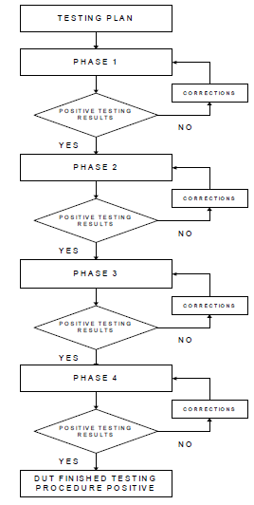
Figure 9-1 - A Methodology for Testing Complex Professional Electronics Systems

Most manufactures perform two different types of tests:
- PTP (product test plan) testing the device in the production process.
- QTP (qualification test procedure) to test the correctness of the design and software protocol.
Product test plan (PTP) can be done using four stages that are completed sequentially, and in order to move to the next stage the previous stage must be completed with positive result. Otherwise, the test process must stop until the error is fixed, and the same stage is repeated for confirmation that the errors have been fixed. The four stages of Product Test Plan are as follow:

- Hardware Testing:
The very first step in this stage is to test the hardware. For the purpose of our design, we will perform this step twice one for breadboard and the second one for the Printed Circuit Board. During this test we will examine (In addition to manual and visual inspection of bread board and PCB) the connection between nodes, and the impedance of the lines. The resistance should be zero with equal potential points and infinite resistance with installed electronic equipment. Other hardware test that will be done is to check for the components values that should be within the required tolerance, the components are in the right orientation and in the right place. After soldering components in PCB, the board will be examined to check if there are bad solder or shorts.
- Functionality testing:
Once the hardware testing is completed and all errors are fixed, then functionality test will be performed to verify the device’s software and make sure that it functions as described and meet all the specifications. This test could be difficult depends on the complexity of the design. For example, if the design has couple of subsystems within a single board, the functionality test might be complicated and identifying the errors will be difficult. The nature of complexity of functional test comes from the fact that it has different interfaces along with different ways of connections, and it is main reason is to examine the communication between the hardware and software of the device. However, before conducting this test a list of what the device should and should not do must be specified along with range of tolerance. Therefore, the decision of whether the device pass or fail will be easy to make. For our design it is necessary to check the interface and connection between our main components (Raspberry Pi and MSP 430) and to make sure other components such as the lasers, Camera, and Gun are responding to the controllers correctly and within the response time specified.
- Stress testing:
The next step after hardware and functionality tests would be the stress test. This test would focus on what would happened when the normal or the nominal environmental conditions of the device changes. In other words, the test will inspect the stability of the device and how accurate to compensate for unexpected environmental changes. To illustrate, our first attempt to design voltage regulator shown in Figure 9-1. This has input voltage range between 4 volts and 37 volts using LM2575 was successfully done. However, when the circuit was tested for an input voltage of 25 volts the input capacitor blowout causing an open circuit. Also, all resistors shown in the bottom of figure were heated and smoked while we tried to adjust the output current to the desired value required by our design. Therefore, this scenario could happen to our design due to failure of power supply not supplying the required input voltage. Therefore, stress test would be defined and setup by the designer to provide a list of environmental changes to be tested which is dependent on the purpose of the design and the expected results.

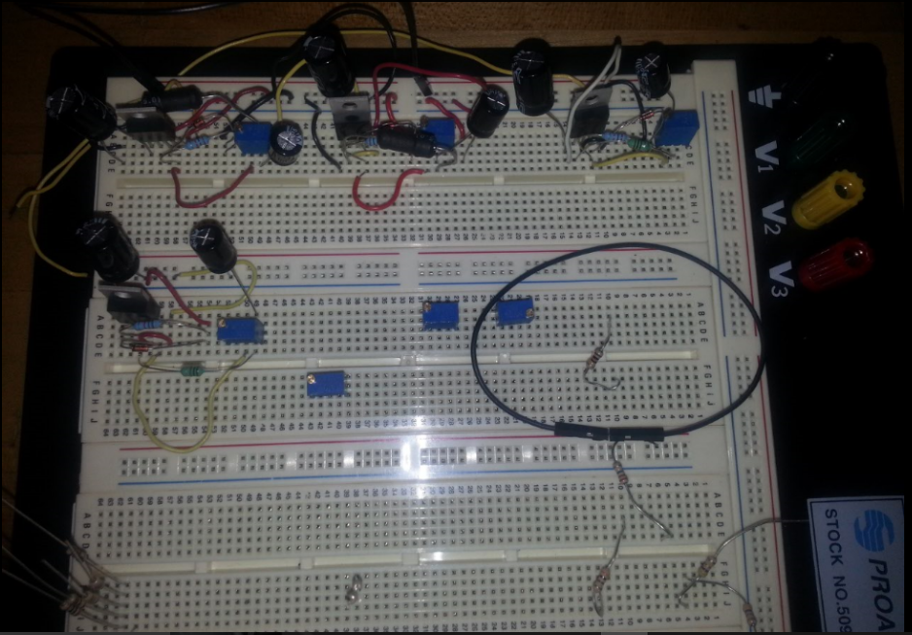
Figure 9-2 - Voltage regulator using LM2575

- Robustness testing:
The final stage of the testing process using product test plan strategy is the robustness testing. This test would focus on the functionality of the device when up normal condition occurs by improper use of the device, and the result when such situation occur. Therefore, this testing stage is the answer of “what if this happened….?” It is the inspection of functionality of the design and or a component when extreme conditions occur. Robustness is analysis of a situation in which an extreme condition or the risk and consequences beyond the normal happen. Examples of such conditions would be sudden temperature change (cold, hot), liquid damage, and dropping down the device. For our design the rapid change of temperature (heat) would be a good condition to check the robustness of our device since it is will be enclosed in dome shaped structure which is a subject to sudden temperature change; which requires adding holes for air to circulate or adding a fan.

Qualification test procedure (QTP) is final testing stage in the design and prototyping devices; Which focus on the operation of the design and software of the device. In addition, it presents information about whether the device meets the requirements and standards of the manufactures. It is also dealing with specific markets certification, and standard.

Verification

Overview

To ensure that the ASRH meets all of its specifications, market requirements, and engineering requirements, a series of tests will be conducted. This section outlines the details of these test, and what results constitute a pass or a fail for each test.

Verifying Ease of Use

One of our market requirements is for the ASRH to be easy to use. We envision the user interface having two main components: a small monitor showing the video feed from the ASRH camera, and an Xbox 360 controller that will allow the user manual control of the ASRH. Currently, our corresponding engineering requirement is to have less than 5 input selections, but this is subject to change. At this point in time, we don’t know exactly how much functionality we will be able to implement on the ASRH and how much of that functionality we will allow the user to control. Therefore, we will verify this requirement in more of an open-ended way rather than a concrete metric. We will simply allow our faculty committee to demo the ASRH, and then ask them if they felt the user interface was simple enough in their opinion. If the majority of the committee members feel the user interface is sufficiently simple, we will interpret that as verification of this requirement. If the majority of the committee feel the user interface was not sufficiently simple, we will consider this requirement to be unverified. This is illustrated in Table 10-1.

Table 10-1 - Verifying Ease of Use
Verification Metric: Opinion of Faculty Committee
> 50% Approval | Verified
< 50% Approval | Unverified

Verifying Robust Response

One of our market requirements is for the ASRH to have a robust response. This corresponds to an engineering requirement of less than 1 second of latency. There are three aspects of the ASRH that we want to have as close to a real-time response as possible: the synchronization between the laser/light show and the audio, the raw video feed from the ASRH camera, and the user input to control the ASRH. Although one second of latency may seem like a lot, we wanted to give us more than enough room to work with. In addition, the numerical value of this metric may change as the project further develops.

One potential problem of verifying this method with the use of the metric of ‘latency time’ is that the exact latency may be difficult to obtain. Therefore, we plan to use an open-ended approach to verify this requirement, similar to verifying the simplicity of the user interface. We will simply allow our committee to demo the ASRH, and ask them if they felt the device had a robust response in terms of the audio/visual synchronization, the raw video feed, and the manual control features. If the majority of the committee say the ASRH has a sufficiently robust response, we will interpret that as verification of this requirement. If the majority of the committee feel the response on the ASRH is not sufficiently robust, we will consider this requirement to be unverified. This is illustrated in Table 10-2.

Table 10-2 - Verifying Robust Response
Verification Metric: Opinion of Faculty Committee
> 50% Approval | Verified
< 50% Approval | Unverified

Verifying Audio and Visual Synchronization

Two of our market requirements is for the ASRH to have a “captivating light show” and to be “aesthetic”. This corresponds to our engineering requirement of having our LEDs and lasers portray the incoming audio signals. Like the past two requirements mentioned in this section, we will take an open-ended approach to verifying this requirement. The fact is, there isn’t really a defined metric we can use to verify this requirement. We will simply have our committee watch the ASRH laser/light show, and ask if they though the music and visuals were sufficiently synchronized. If the majority of the committee felt that there was good synchronization between the music and the laser/light show, we will consider this requirement verified. If the majority of the committee feels the music and laser/light show was not properly synchronized, we will consider this requirement unverified. This is illustrated in Table 10-3.

Table 10-3 - Verifying Audio and Visual Synchronization
Verification Metric: Opinion of Faculty Committee
> 50% Approval | Verified
< 50% Approval | Unverified

Verifying Optical Output

Verifying this requirement also corresponds with our market requirements of the ASRH having a “captivating light show” and being “aesthetic”. Our corresponding engineering requirement is to have at least 300 mW of optical output. This is the first requirement for which we will use a concrete metric to verify it. It is as easy making sure that the sum of all LEDs and lasers on the ASRH exceed optical output of 300 mW. This metric subject to change. This is illustrated in Table 10-4.

Table 10-4 - Verifying Optical Output
Verification Metric: Optical Power Output
> 300 mW | Verified
< 300 mW | Unverified

Verifying Reliability

One of our market requirements is for the ASRH to be a reliable system. This is the hardest requirement to verify as the term ‘reliability’ on its own is extremely vague. Currently, we have our corresponding engineering requirement listed as ‘more than 100 cycles before failure’ which doesn’t make verifying this requirement any less vague. The fact is figuring out how to verify this requirement won’t become clear as development of the ASRH progresses. To pass senior design, the ASRH only needs to work for the demo, which is less than half an hour usually. However, this only verifies that the ASRH can work one time, not that it is a reliably functional device. Another thing we could try to test its reliability is to allow the ASRH to run an extended period of time (several hours). The full-scale version of the ASRH would have to work for about 12 hours straight if used on the Arcadia Spider at Ultra Music Festival, so that may be the best method to verify our reliability requirement. This is illustrated in Table 10-5.

Table 10-5 - Verifying Reliability
Verification Metric: Continuous Operation Without Failure
> 12 Hours | Verified
< 12 Hours | Unverified

Verifying Power Consumption

One of our market requirements is for the ASRH to have a low power consumption. The corresponding engineering requirement is for the device to consume less than 50 watts of power. Verifying this requirement is simple; all we need to do is use a power meter. A power meter is a device that plugs into a wall outlet and also has an outlet of its own. Plugging a device into this outlet allows the user to see the power consumption of that device. The value selected of 50 watts is subject to change. When we plug the ASRH into the power meter, a power consumption of less than our selected value will verify this requirement. A power consumption over our selected value will result in this requirement being unverified. This is illustrated in Table 10-6.

Table 10-6 - Verifying Power Consumption
Verification Metric: Power Consumption
> 50 W | Verified
< 50 W | Unverified

Verifying Autonomy

One of our market requirements is for the ASRH to have automatic and manual control options. The method of manual control has already been discussed, but when it comes to automatic operation of the ASRH, the corresponding engineering requirement is to have more than one automated system. Currently there are two planned automatic procedures that the ASRH will be capable of: automatic synchronization of the LEDs and lasers to audio input, and automatic lock-on and tracking of an object of interest. If we are able to successfully implement both of these procedures on the ASRH, this requirement will be considered verified. If we can only get one of these automatic systems functional, this requirement will be considered unverified. This is illustrated in Table 10-7.

Table 10-7 - Verifying Autonomy
Verification Metric: # of Automatic Systems
> 1 Automatic System | Verified
< 1 Automatic System | Unverified

Verifying Cost

One of our market requirement is for the ASRH to have a low cost. This corresponds to an engineering requirement of the device costing less than $1000. This seems like a high amount, and we made it that way on purpose as when we began, we had no clue about how much our required materials would cost. At this moment in time, it looks like the total cost for the ASRH will be well under $1000, so the metric is subject to change. If the total cost of the ASRH falls below our selected value, we will consider this requirement verified. If the cost of the ASRH exceeds our selected value, then this requirement will be considered unverified. This is illustrated in Table 10-8.

Table 10-8 - Verifying Cost
Verification Metric: Cost of Materials
< $1000 | Verified
> $1000 | Unverified

Verifying Weight

One of our market requirement is for the ASRH to be easy to use. This not only includes a simple user interface, but also the ability to handle the structure of the ASRH without much difficulty. Our corresponding engineering requirement for this is to keep the weight of the ASRH under 15 pounds. Currently, it seems as though this will be an easy requirement to verify, as the main structural material of the ASRH will be Styrofoam, an extremely lightweight material. However, the exact metric for the weight of the ASRH is still subject to change. To verify this requirement, we will simply place the ASRH on a scale. If the scale reads less than our selected value, then we will consider this requirement verified. If the scale reads more than our selected value, then we will consider this requirement unverified. This is illustrated in Table 10-9.

Table 10-9 - Verifying Weight
Verification Metric: Weight on a Scale
< 15 Pounds | Verified
> 15 Pounds | Unverified

References

3 – Microcontrollers and Peripherals

[1] "Arduino Mega 2560 Rev3", Store.arduino.cc, 2017. [Online]. Available: https://store.arduino.cc/usa/arduino-mega-2560-rev3. [Accessed: 09- Oct- 2017].

[2] "Raspberry Pi 3 Model B - Raspberry Pi", Raspberry Pi, 2017. [Online]. Available: https://www.raspberrypi.org/products/raspberry-pi-3-model-b/#buy-now-modal. [Accessed: 09- Oct- 2017].

[3] "Beagleboard:BeagleBoneBlack - eLinux.org", Elinux.org, 2017. [Online]. Available: https://elinux.org/Beagleboard:BeagleBoneBlack. [Accessed: 09- Oct- 2017].

[4] “Filtering and Signal Processing Reference Design using MSP430 FRAM Microcontroller,” TIDM-FILTERING-SIGNALPROCESSING Filtering and Signal Processing Reference Design using MSP430 FRAM Microcontroller | TI.com. [Online]. Available: http://www.ti.com/tool/TIDM-FILTERING-SIGNALPROCESSING. [Accessed: 23-Oct-2017].

[5] “Audio Signal Processing BoosterPack Plug-In Module,” BOOSTXL-AUDIO Audio Signal Processing BoosterPack Plug-In Module | TI.com. [Online]. Available: http://www.ti.com/tool/BOOSTXL-AUDIO. [Accessed: 23-Oct-2017].

[6] “MSP430FR5994 (ACTIVE),” MSP430FR5994 16 MHz Ultra-Low-Power MCU With 256 KB FRAM, 8 KB SRAM, Low-Energy Vector Math Accelerator | TI.com. [Online]. Available: http://www.ti.com/product/MSP430FR5994. [Accessed: 23-Oct-2017].

4 – Servo Motors Research

[1] "What is a Servo?", Servocity.com, 2017. [Online]. Available: https://www.servocity.com/what-is-a-servo. [Accessed: 13- Oct- 2017].

[2] M. Rouse and M. Haughn, "What is servo (servomechanism)? - Definition from WhatIs.com", WhatIs.com, 2015. [Online]. Available: http://whatis.techtarget.com/definition/servo-servomechanism. [Accessed: 13- Oct- 2017].

[3] "Understanding RC Servos", RCHelicopterFun.com, 2017. [Online]. Available: https://www.rchelicopterfun.com/rc-servos.html. [Accessed: 13- Oct- 2017].

[4] "FS90--Micro 9g servo for Air plane", Mantech.co.za, 2017. [Online]. Available: http://www.mantech.co.za/Datasheets/Products/FITEC_FS90.pdf. [Accessed: 13- Oct- 2017].

[5] "ANNOUNCED SPECIFICATION OF HS-805BB+ MEGA 1/4 SCALE SERVO", https://www.sparkfun.com/products/11881, 2017. [Online]. Available: https://cdn.sparkfun.com/datasheets/Robotics/hs805.pdf. [Accessed: 13- Oct- 2017].

[6] "RB-Sbo-109 VS-19 Pico Linear Servo", http://www.robotshop.com/en/vs-19-pico-linear-servo.html, 2017. [Online]. Available: http://www.robotshop.com/media/files/pdf/datasheet-22090.pdf. [Accessed: 13- Oct- 2017].

5 – Lasers and LEDs

[1] Okorny, J., Jin, Q. and Smith, V. (1993). Spectral-luminosity functions, scalar linearity, and chromatic adaptation. Journal of the Optical Society of America A, [online] 10(6), p.1304. Available at: https://doi-org.ezproxy.net.ucf.edu/10.1364/JOSAA.10.001304 [Accessed 3 Nov. 2017].

[2] Osha.gov. (2017). OSHA Technical Manual (OTM) | Section III: Chapter 6 - Laser Hazards | Occupational Safety and Health Administration. [online] Available at: https://www.osha.gov/dts/osta/otm/otm_iii/otm_iii_6.html#4 [Accessed 2 Nov. 2017].

6 – Computer Vision Research

[1] "Computer vision", En.wikipedia.org, 2017. [Online]. Available: https://en.wikipedia.org/wiki/Computer_vision. [Accessed: 29- Oct- 2017].

[2] "OpenCV: Canny Edge Detection", Docs.opencv.org, 2017. [Online]. Available: https://docs.opencv.org/trunk/da/d22/tutorial_py_canny.html. [Accessed: 30- Oct- 2017].

[3] G. Sukthankar, "Lecture 5: Computer Vision: Linear Filters & Template Matching Edge Detection", Nicholson School of Communication, UCF, 2017.

[4] "Introduction to SURF (Speeded-Up Robust Features) — OpenCV 3.0.0-dev documentation", Docs.opencv.org, 2017. [Online]. Available: https://docs.opencv.org/3.0-beta/doc/py_tutorials/py_feature2d/py_surf_intro/py_surf_intro.html. [Accessed: 30- Oct- 2017].

[5] G. Sukthankar, "Lecture 12 Visual Servoing; Robot Architecture", Nicholson School of Communication, UCF, 2017.

[6] G. Sukthankar, "Lecture 4: Image Processing: Color", Nicholson School of Communication, UCF, 2017.

[7] G. Sukthankar, "Lecture 6: Computer Vision: Edge Detection", Nicholson School of Communication, UCF, 2017.

7 – Initial Power Supply Research

[1] "LM 317 Voltage Regulator", diyaudioprojects.com, 2017. [Online]. Available:
http://diyaudioprojects.com/Technical/Voltage-Regulator/

[2] "Linear Voltage Regulator",lifewire.com , 2017. [Online]. Available:
https://www.lifewire.com/types-of-voltage-regulators-818851

[3] "Switching Voltage Regulator", www.baldengineer.com , 2017. [Online]. Available:
https://www.baldengineer.com/switching-voltage-regulator-tutorial-addohms.html

[4] "Zener Diode as Voltage Regulator", www.electronics-tutorials.ws , 2017. [Online]. Available:
http://www.electronics-tutorials.ws/diode/diode_7.html
l

8 – Power Supply

[1] "RD-50A: MEAN WELL: AC to DC Power Supply Dual Output 5 Volt 12 Volt 6 Amp 3 Amp 54 Watt : Power Supplies & Wall Adapters", Jameco.com, 2017. [Online]. Available: https://www.jameco.com/z/RD-50A-MEAN-WELL-AC-to-DC-Power-Supply-Dual-Output-5-Volt-12-Volt-6-Amp-3-Amp-54-Watt_323425.html. [Accessed: 14- Nov- 2017].

[2] "50W Dual Output Switching Power Supply RD-50 Series", Jameco.com, 2015. [Online]. Available: https://www.jameco.com/Jameco/Products/ProdDS/323425.pdf. [Accessed: 14- Nov- 2017].

[3] "RD-65A: MEAN WELL: AC to DC Power Supply Dual Output 5 Volt 12 Volt 8 Amp 4 Amp 66 Watt : Power Supplies & Wall Adapters", Jameco.com, 2017. [Online]. Available: https://www.jameco.com/z/RD-65A-MEAN-WELL-AC-to-DC-Power-Supply-Dual-Output-5-Volt-12-Volt-8-Amp-4-Amp-66-Watt_323505.html. [Accessed: 14- Nov- 2017].
[4] "65W Dual Output Switching Power Supply RD-65 Series", Mean Well USA, 2017. [Online]. Available: http://meanwellusa.com/productPdf.aspx?i=166#1. [Accessed: 14- Nov- 2017].

[5] M. WELL, "RT-125B MEAN WELL", Mouser Electronics, 2017. [Online]. Available: https://www.mouser.com/ProductDetail/MEAN-WELL/RT-125B/?qs=sGAEpiMZZMsPs3th5F8koJemULuvcPkzkgG1Ui06wQU%3d. [Accessed: 15- Nov- 2017].

[6] "125W Triple Output Switching Power Supply", Mouser.com, 2017. [Online]. Available: http://www.mouser.com/ds/2/260/RT-125-SPEC-806385.pdf. [Accessed: 15- Nov- 2017].

[7]"TPS63070 2-V to 16-V Buck-Boost Converter With 3.6-A Switch Current", Ti.com, 2017. [Online]. Available: http://www.ti.com/lit/ds/symlink/tps63070.pdf. [Accessed: 10- Nov- 2017]

[8]"TPS6217x 28-V, 0.5-A Step-Down Converter With Sleep Mode", Ti.com, 2017. [Online]. Available: http://www.ti.com/lit/ds/symlink/tps62175.pdf. [Accessed: 10- Nov- 2017]

[9]"TPS54424 4.5-V to 17-V Input, 4-A Synchronous SWIFT™ Step-Down Converter with Current Mode Control", Ti.com, 2017. [Online]. Available: http://www.ti.com/lit/ds/symlink/tps54424.pdf. [Accessed: 10- Nov- 2017]

[10]"LM5175 42V Wide Vin 4-Switch Synchronous Buck-Boost Controller | TI.com", Ti.com, 2017. [Online]. Available: http://www.ti.com/product/LM5175/description. [Accessed: 14- Nov- 2017].

[11]"TPS54824 4.5V to 17V Input, Current Mode, 8A Synchronous SWIFTTM Step-Down Converter | TI.com", Ti.com, 2017. [Online]. Available: http://www.ti.com/product/TPS54824/description. [Accessed: 14- Nov- 2017].

[12]"TPS63070 Wide Input Voltage (2V-16V) Buck-Boost Converter | TI.com", Ti.com, 2017. [Online]. Available: http://www.ti.com/product/TPS63070/description. [Accessed: 14- Nov- 2017].

[13]"TPS561208 4.5V to 17V Input, 1A Output, Synchronous Step-Down Converter | TI.com", Ti.com, 2017. [Online]. Available: http://www.ti.com/product/TPS561208/description. [Accessed: 14- Nov- 2017].

[14] WEBENCH® Design Center. Dallas, Texas: Texas Instruments, 2017.

[15 ]"LM5176 55V Wide VIN Synchronous 4-Switch Buck-Boost Controller | TI.com", Ti.com, 2017. [Online]. Available: http://www.ti.com/product/LM5176/description. [Accessed: 15- Nov- 2017].

9 – Testing Plan

[1] Journal.ftn.kg.ac.rs. (2017). Cite a Website - Cite This For Me. [online] Available at: http://www.journal.ftn.kg.ac.rs/Vol_9-1/08-Paunovic-Kovacevic-Resetar.pdf [Accessed 15 Nov. 2017].

[2] www. meanwell.com. (2017). 65W Dual Output Switching Power Supply. [online] Available at: http://www.meanwell.com/productPdf.aspx?i=166&pdf=UkQtNjVBLVJQVC5QREY=&a=2 [Accessed 29 Nov. 2017].

[*] Effective Structural Test Strategies for High Complexity Boards, Amit Verma, The Test ’98 Conference

