University of Central Florida
Department of Electrical Engineering and Computer Science
University of Central Florida
Dr. Samuel Richie
Dr. Lei Wei
Senior Design I



Smart Security Dashboard Camera

Matthew White - Electrical Engineering
Timothy Deligero - Computer Engineering
Austin Sturm - Computer Engineering
Scott Levine - Electrical Engineering
Joseph LaBauve - Electrical Engineering

Group Number: 25

Table of Contents

1.0 Executive Summary 1
2.0 Project Description 3
2.1 Project Motivation 3
2.2 Goals 3
2.3 Function 4
2.4 Related Works 5
2.5 Requirements Specifications 6
2.6 House of Quality 8
Figure 1: House of Quality 9
2.7 Hardware Diagram 10
Figure 2: Hardware roles given to team members 10
2.8 Software Diagram 11
Figure 3: Software roles given to team members 11
2.9 Brief Operation Manual 12
3.0 Design Constraints and Standards 12
3.1 Device Dimensions 13
3.2 Cameras 14
Figure 4: Camera view radius 14
3.3 Telemetry 15
3.4 Storage 15
3.5 Communication 15
3.6 Safety Devices 16
3.7 General Data Protection Regulation (GDPR) 17
3.8 Timing and Economic constraints 17
3.9 Legal constraints 19
3.10 Environmental constraints 19
3.11 Social constraints 20
3.12 Ethical 20
3.13 Quality and safety 20
3.14 Power supply constraints 21
3.15 PCB Design Constraints 21
3.15.1 Thermal control 21
Figure 5: Thermal heat dissipation 22
3.15.2 Tracing Inductance and Board Layout 22
Figure 6: Partitioning of analog and digital 23

Equation: Crosstalk 24
3.15.3 Grounding 24
Figure 7: Ground Noise 24
3.15.4 Star Ground 25
Figure 8: Star Grounding Example 25
3.15.5 Partitioning of the Analog and Digital 25
3.15.6 Designing a Ground Isolation Amplifier 25
4.0 Research 27
4.1 Accelerometer Sensor Research 27
4.1.1 Accelerometer Connection 27
4.1.2 Accelerometer MEMS 28
Figure 9: 2-Axis Accelerometer 29
4.1.3 Accelerometer Sensitivity 31
4.1.4 Accelerometer Vibration Detection 32
Figure 10: Example of a piezoelectric accelerometer 34
Figure 11: IEPE accelerometers output voltage signals
proportional to the force of the vibration
on the piezoelectric crystal. 34
4.1.5 Accelerometer X, Y, and Z Axis 35
Figure 12: Example of axes of measurement for a triple axis accelerometer 35
4.1.6 Accelerometer Sensor Selection 36
Figure 13: Accelerometers had a wide usable frequency
range where sensitivity was relatively flat. 37
Table 1: Frequency Limits for Mounting a 100 mv/G Accelerometer. 38
Table 2: Accelerometer Sensor Comparison 40
4.2 Gyrometer Sensor Research 40
4.2.1 Gyrometer Connection 41
4.2.2 Gyrometer MEMS 41
Figure 14: Internal operational view of a MEMS gyro sensor 42
4.2.3 Gyrometer Rotation Detection 42
4.2.4 Gyrometer X, Y, and Z Axis 42
Figure 15: Example of axes of measurement for a triple axis gyrometer 43
4.2.5 Gyrometer Sensor Selection 43
Table 3: Gyrometer Sensor Comparison 44

4.3 Magnetometer Sensor Research 44
4.3.1 Magnetometer Sensitivity 44
4.3.2 Magnetometer MEMS 45
4.3.3 Magnetometer Sensor Selection 45
Table 4: Magnetometer Sensor Comparison 46
4.4 Global Positioning System (GPS) Research 47
Figure 16: Global positioning system 47
4.4.1 GPS Specifications and Selection 48
4.5 Wireless-Fidelity (Wi-Fi) Communication Research 49
4.5.1 Wireless-Fidelity Communication Selection 50
Table 5: Wireless Chip Comparisons 51
4.6 Cellular Research 51
4.6.1 CDMA Module Selection 52
4.6.2 GSM Module Selection 52
Table 6: Cellular Chip Comparison 54
4.7 Camera Research 54
4.7.1 Camera Sensor Research 55
4.7.2 Camera Lens Research 56
4.7.3 Camera Sensor Selection 56
Table 7: TVL to NTSC Pixel Conversion Chart 57
Table 8: Camera Lens Comparison 58
4.8 Storage 58
4.9 Power Management Research 59
4.9.1 Methodologies of Power Supply 59
4.9.2 Power Supply Part Selection 59
4.10 Microcontroller 60
4.10.1 Microcontroller Components 62
Figure 17: Microcontroller Structure and Components 63
4.10.2 Microcontroller Advantages and Disadvantages 67
4.10.3 Atmel Microcontrollers 68
4.10.4 Microcontroller Selection 71
Table 9: Microcontroller Comparison 71
4.11 Mobile Platforms 71
4.12 Languages 72
4.13 Hardware Suppliers 73
4.14 Online Data Storage 74
4.14.1 AWS 74

Figure 18: AWS Storage Costs 74
4.14.2 Dropbox 74
4.14.3 Google 75
Figure 19: Google Cloud Storage Costs 75
4.14.4 Local Storage 75
4.15 PCB design research 76
4.15.1 PCB Base Material 76
Figure 20: PCB internal view 76
4.15.2 PCB 77
4.15.3 Vias 77
4.15.4 Silkscreen 78
4.15.5 PCB surface finish 78
4.15.6 PCB Pads 78
5.0 Design 79
5.1 Hardware 79
Figure 21: Block diagram 79
5.1.1 Design 79
Figure 22: Driver view SSDC 81
Figure 23: Side view SSDC 81
Table 10: Possible PCB Dev Programs Cost Analysis 82
5.1.3 Altium 82
5.1.4 EAGLE 82
5.1.5 Printed circuit board 83
5.1.6 PCB Design 83
5.1.7 PCB manufacturers 84
Figure 24: Comparison of multiple PCB manufacturers 85
5.1.8 PCB housing 86
5.1.9 Reasoning for wireless/4G 86
5.2 Software 87
5.2.1 Android Application UI Design 87
Figure 25: Design Interface Mock-up. 88
5.2.2 Development Tools 89
5.2.3 Development Lifecycle 90
Figure 26: Development Lifecycle 90
5.2.4 Data Flow Charts and Diagrams 92
Figure 27: Flowchart depicting software communication 93
Figure 28: Data Flowchart depicting the SSDC Software Design 98

Figure 29: Use Case Diagram for the SSDC’s mobile application 100
Figure 30: Use Case Diagram for the SSDC Device 101
Figure 31: User Interface Diagram of the Mobile Application 102
Figure 32: ERD of the SSDC Database 104
Figure 33: Class Diagram of SSDC Device and Mobile Application 107
5.2.5 Mobile Application Features 108
Figure 34: Alert Data Format 109
Figure 35: Live Video Recording and Tracking application UI 113
5.3 Security 115
5.3.1 Attack Surface 115
Figure 36: Attack Surface 115
5.3.2 Risks and Concerns 116
5.3.3 Wi-Fi 116
5.3.4 WPA2-PSK Cracking 117
5.3.5 KRACK 117
5.3.6 SSL 118
5.3.7 GPS Security 118
5.3.8 Mobile Application Security 118
5.3.9 Physical Device Security 119
6.0 Project Prototype Construction 120
6.1 Hardware Overview 120
Figure 37: SSDC Device Components and Parts 122
Figure 38: Breadboard Prototype Testing 123
Figure 39: Prototype Testing 123
6.2 PCB and Integrated Schematic 124
Figure 40: Schematic Design 124
Figure 41: Final Board Design 126
7.0 Project Prototype Testing Plan 126
7.1 Hardware Testing Environment 126
7.2 Hardware Testing Scenarios 127
7.2.1 Accelerometer Readings Test 127
7.2.2 Gyrometer Readings Test 128
7.2.3 Magnetometer Readings Test 129
7.2.4 Camera Recording Footage Test 130
7.2.5 GPS Chip Testing 131
7.2.6 Carbon monoxide Monitoring Chip Testing 132
Table 11: CO Alarm Response Time Levels 132

7.2.7 Temperature Tolerance Testing 132
7.3 Software Testing Environment 133
7.4 Software Testing Scenarios 134
7.4.1 Data Readings of Accelerometer, Gyrometer, and Magnetometer Testing 134
7.4.2 Received Recording of Live Footage Testing 136
7.4.3 Storage of Recorded Footage and Images Testing 137
7.4.4 Communication Connection Testing 139
7.4.5 GPS Tracker Testing 140
7.4.6 Security Testing 141
8.0 Project Operation 143
9.0 Administration 145
9.1 Project Budgeting and Financing 145
Table 12: Costs and profits of data as a service ($) 146
9.2 Project Milestones 148
Table 13: Project Milestones 148
9.3 Team Roles 149
8.4 Parts Selection and Parts Cost 150
10.0 Conclusion 152
Appendix A References 155
Appendix B Permissions 161
Appendix C Data Sheets 167

1.0 Executive Summary

With the recent automotive break-ins on the UCF campus over the span of one night in spring 2017. The need for the 360 automotive security was evident. This was a very recent noteworthy event, but there were many less known incidents. Prior to this epidemic the focus was around wheel theft which happened at the beginning and ending of every semester. There was no other real way to protect the cars owned by students and faculty other than a beeping horn. The Smart Dashboard camera was more relative today with the growing use of Wi-Fi and CDMA technology. With the technology readily available to make this product, the cost to produce this device for most young professionals and working individuals was aimed to be affordable. Most college students were able to afford a variant of the camera. Rearview cameras were mandated in all vehicles manufactured in the US by January 2018. This brings the cost of cameras and lens way down. Therefore making the cameras cheaper for the group to purchase. This brings down the overall cost of the product to the end consumer.

The project goal was to create a product that could be bought and used as theft deterrent device. This product was aimed be able to detect a disruption due to motion that was unwarranted to the vehicle. Video starts recording when an instance occurs. The video had stop 1-2 mins after the motion stops. Interviews had been conducted at numerous conferences and trade shows. One of the shows was SEMA (Specialty Equipment Manufacturers Association) in Las Vegas, Nevada. SEMA mention, “The Specialty-Equipment Industry Reaches Record $39.18 Billion in Sales for 2016—Up 8% From Previous Year.” [56] A small portion of these sales were in security at roughly $2-$3 Billion. Another show that was attended and customers were interviewed was CES (Consumer Electronic Show). Interviews at both of these shows proved that potential customers and businesses were interested in this type of technology. Data shows the consumer market was ready for the connected car. The future cars had been more connected to the house and the individuals that drive them. Lots of development had been done in this field and had continue to be done.

When interviewing multiple customers and businesses we found out that they wanted security for their vehicles. They wanted GPS tracking, video, and notifications when something happens. Some were skeptical about paying a subscription fee for the service but others had no problem. Although individuals that were previous victims of car or house theft were much more interested. The idea for creating the SSDC was to sell to those who had been victims in the past, and now want security. Also to raise awareness to car security to hopefully get deals with dealerships to make car security mandatory acquiring future profit with companies such as a Honda.

The device had to be light weight, in a discrete location, and had few to no false positives. This means the camera only records in parking mode when absolutely needed. The Smart Security Dashboard Camera had both hardware and software involved. There were 1 or 2 main PCBs. There was a mobile android phone application to control the camera features, and receive live video feed from remote locations. There were two software projects on this product, they included the software to run the device, and the software to run the application on the smartphone. The Smart Dashboard Camera had two 170 degree cameras. The option to add another camera to see out the rear window in full view is available for an extra cost, but this is not implemented in the course of the senior design. The Smart camera works during a hit and run, vehicle theft, smash and grab, wheel theft, and other noticeable vandalism to be considered successful. The group preferred it to be sensitive to triggers, but not so sensitive that minor disturbances such as cat walking on the car had set it off. The camera is supposed to be inside the car protected from the elements. The camera also sends data to the cloud from the camera. That way if the thief takes the camera the video had still be captured. This data transfer can be done over Wi-Fi to save valuable data to the cloud or it can be done via 4G cell phone connection. Where the 4G service is active in the event of no Wi-Fi if the service was activated. If the service was not activated then the vehicle had to be in Wi-Fi range for the data transfer to occur, so if theft occurs in an area outside Wi-Fi the only info that can be gained was off the MICROSD card.

This report discusses the design and thought process of the smart dash cam. It first covers what was the inspiration for the dash cam as well as the goals of implementing this project. This paper had then discuss the required design specifications that need to be met for the device to be able to be in vehicles. In the R&D section of this paper it had discuss the comparison between potential parts and modules, and why they were chosen over competitors. After this we had discuss what constraints that were experienced in the designing as well as the implementation. Some of these constraints were things such as including things such as bulkiness incorporating a separate battery to power the dashboard camera during idle durations. Other constraints involve industry standards that had to be met in order for the device to both be able to survive in a harsh car environment as well as be allowed to be sold at market. The following section had involve the hardware and software of the device this includes the block diagrams, flow chart, and applicable schematic designs. The hardware design of the device had included the dashboard camera PCBs as well as the interconnection power design. The software had discuss the application for operating the dashboard camera, code to run the PCBs, and why we chose both Wi-Fi and 4G. Next the paper had explain the reasoning behind the aesthetic design of the dashboard camera, and why this design was optimal for a car security dash cam. Afterwards, this paper had given a thorough explanation of how the device was tested in order to ascertain if it met a desired level of competence. The paper had to go over what overall budget for the project was as well as the development cycle that was undertaken to achieve the creation of the device. Then the paper had reviewed the administration of work for the project. This had covered each member's personal responsibility in the project as well as the areas that they had been assisting with. Some areas were slight grey areas that all of the group had been expected to assist with if the area was not well known to anyone in the group.

2.0 Project Description

This chapter outlines the Smart Security Dashboard Camera (SSDC) project as determined by the group. The chapter illustrates in simple terminology and through the utilization of pictorial documents the design of both the hardware and application aspects of the project; block diagrams were provided to illustrate both the hardware and software components as well as the interaction between all of the components. As well as providing documents in relation to the overall project's goals and achievements, especially those that may be prudent to showcasing the product at a high level. The goal of the chapter was to provide insight on both the product and intended design criteria to be identified and prioritized in later sections. The below table illustrates at a high level components utilized in the project as well as the goal and minor specifications of each component in the overall design.

2.1 Project Motivation

On UCF Campus alone there had been 30 plus vehicles that had had their windows smashed, items stolen, and privacy disrupted according to UCF police reports. There had been suspected hundreds of unreported other accidents that had affected the lives of many students. The reason that many of these accidents and thefts were either not reported or do not get solved due to an obvious lack of evidence. According to the Department of Motor vehicles there were 721,053 successful attacks on cars in the US in 2012 alone. Of these thefts and attacks on vehicles a majority of them were on unattended vehicles making the identification of the thief as well as arresting of them very difficult. The Dash cam had not only identify that a vehicle was in distress, but functions as a form of tracking your vehicle and giving video feed of who the assailant is. This had drastically increase the probability of arresting the potential thief, and gaining compensation for damages. If this project can reduce the estimated, “4.3 billion dollars” of lost money due to car related damages and thefts; the project had to be considered successful in terms of our original desire.

2.2 Goals

- The dash camera had had a clamping function to allow for easy portability between vehicles, and give some level of discreteness

- The dash camera had contain a low power picture mode to allow for lower energy costs to the power system during inactive times.

- The dash camera had been calibrated to be able to tell the difference between a true crisis compared to a truck passing by. This was due to the need to reduce unnecessary alerts, and to inform the user of when the vehicle was under real distress.

- The dash camera had need to be able to have an almost 360 degree view to give a clear line of sight to most possible points of impact/concern. This had been addressed by implementing two cameras with wide angle lenses for 180° viewing.

- The device was designed to be not too bulky so to not distract a user during driving, and not impede crucial lines of sight. This had been achieved by using a locking mechanism to secure the camera to the rear view mirror minimizing the obstruction of view.

- A few possible objectives were to implemented thermal heat conversion pads to convert thermal energy to electricity, including a portable separate battery, and a system for facial recognition was being considered.

2.3 Function

The purpose of this project was to provide detection and accountability 24/7 for a vehicle. During a vehicular accident the chances of getting compensated for an accident where the user were not present in the vehicle were all dependent on whether the individual who injured the vehicle left a note or not. Without any evidence other than paint left from a dent or a streak mark on a vehicle there was very little that can be done to achieve due process for the one responsible. The desired function of the dash cam stated before was to give digital evidence of what had occurred during an accident to an unattended vehicle. However, this does not stop at just stationary parking surveillance, but this device had also allow for constant surveillance during driving. According to esurance during a car accident the user should follow a few basic steps which summed up were if able to move your vehicle to a safe area, check on those affected, and then gather information as well as call the police. These steps were the typical steps many insurance companies tell their customers, but another key step that cannot be overlooked was that they also suggest customers do not admit their faults. Many people unknowingly follow this step even if they had never been told to do so. In the court of law according to john helms a dallas criminal defense lawyer a case where both sides claims no fault turns into a he said she said style of case. This means that the only thing that a judge or jury could use to determine the case was any recovered evidence which could be scarce, and the involved parties testimonies which under oath were considered evidence. The dash cam’s function removes the possibility of he said she said by giving a direct view of what happened at the scene of the crime.

Other than security and documentation of surroundings a vehicle the dash cam also offered a secondary function of ease of mind. There were two forms of stress eustress and distress. Eustress was health and allows for though contemplation of issues. Distress was unhealthy and caused by issues of life that were typically unplanned. The dash cam removes the distress of both worrying about your vehicle while unattended, but also allows the user to know that the user had had documentation should any problems arise on the road.

2.4 Related Works

Currently there many other market dashboard cameras, but the one that was the most similar the Smart Security Dashboard Camera (SSDC) was the Waylens 360 security camera. The difference between the products was easily described with their designs. The SSDC was designed to be more discreet, compared to the Waylens flying saucer design. The SSDC also uses two cameras compared to the Waylens one HD 360 degree camera design. Also it was desired that by the time the dash camera goes to market it had contain 5G compared to the current generation 4G camera designs. This had been a key differentiator for the product compared to the others on the market. The Waylens security camera had the ability to support up to 256GB of memory to the microSD card. They had also send this data to the cloud as a service for customers so that in the instance that something happens to their camera or memory card the footage was still safe.

The Blackvue dash camera records in 60 fps and had Full HD 1080p, and the camera was a top contender in the price level of the SSDC. The Blackvue company offered the option of two cameras or one camera. They sell this set up as one channel or two channels. They also offered up support up to 128 GB microSD memory card. The Sony Starvis camera sensors offered supreme night recording and day recording. The Dash camera offered one 139 degree camera. Another 139 degree camera was available for the rear windshield at an additional cost. The dash camera also comes with an infrared light used in conjunction with Sony Starvis sensors that help to capture video in all light settings. This was especially useful at night or dark parking garages. The camera includes GPS so that speed and location can be recorded as well. This was useful to post speed on the video output. It was also useful if the user forgets where they parked their car.

The Thinkware Dash Camera had the ability to record in Full 1080p HD 140 degree video at 30fps. The camera quality was 2.19MP Sony Exmor CMOS technology. This camera also had parking mode, lane departure detection and red light camera alert. Thinkware also had the option of 2 channels. This includes 2 cameras with the Full 1080p HD 140 degree video technology. They were not as well known as Blackvue in the United States. They were known in Canada better than the US. Thinkware was a direct competitor to Blackvue and the SSDC. They had a two channel output as an option for customers. The SSDC had had two channels as a standard for customers. This had put it one step above the traditional Dash camera companies. Thinkware had the parking mode continuous recording option just like BlackVue.

Some more highly regarded dash cameras were the Cobra CDR 900 for $299.99 or the Garmin Dash Cam 65W for $249.00. The Cobra CDR 900 uses a 1080P HD video camera and an Ambarella™ A7LA chipset to ensure high-quality imaging, even during nighttime. The Cobra Dash Cam had a frame rate of 30 fps. It was Wi-Fi enabled and had a 160 degree viewing angle. The Garmin Dash Cam 65W was a 1080p with 180-degree field of view. It had a framerate of 30 fps. These two cameras a very comparable but they were lacking the ability to send video in a live stream. The user had to wait until they get back to the vehicle.

2.5 Requirements Specifications

The requirements for the Smart Security Dash Camera (SSDC) were components that had detect cases for car theft and car damage, a mobile application to notify the user of the scenario when the device triggers, a GPS tracker to detect the car’s position for the user, and a source to charge the device. Multiple components, such as an accelerometer, a gyrometer, and a magnetometer, had been used to detect the car thefts and car damages while also be coded to filter any false positives. The mobile application had been used on an Android device and a GPS chip had been used to track the car’s position from the user’s device to the user’s Android application. The device had been powered by a hardwired that had been connected to the car.

- Accelerometer

- Must be built in to measure and detect acceleration forces when the vehicle was stationary

- Must be able to detect any unusual acceleration forces or vibrations when the user was inactive of his/her vehicle which had send a signal for the camera to record the instance

- Gyrometer

- Must be built in to measure and detect angular momentum when the vehicle was stationary

- Must be able to detect any unusual angular momentum when the user was inactive of his/her vehicle which had send a signal for the camera to record the instance

- Magnetometer

- Must be built in to measure the direction of the vehicle when it was stationary

- Must be able to detect the change in direction of the user’s vehicle from the measurement of magnetic fields and had send a signal for the camera to record the instance

- Cameras

- Must be high resolution cameras with at most 170 degree FOV

- Must be able to record consistent footage whenever the camera was active

- Must be a 16 megAPIxel digital camera

- Must had a battery saver mode to use less voltage from the user’s vehicle when it was inactive

- Must be able to save recording footage if the camera gets damaged

- The camera must be connected to the rear view mirror of the user’s vehicle

- One camera must face the inside of the vehicle as well as being positioned to view the side windows and back window to had a view of any car theft and car damage that occurs on the sides of the car

- Another camera must face the front window of the vehicle to view the car theft and car damage in front of the car and record footage of user’s vehicle when it was driven on the road

- The camera must be positioned and mounted on the rear view mirror in a way that it had view and able to record footage of the car theft and car damage taking place and be kept stable during driving or scenarios of vibrations or extreme forces

- Android Application

- Sends a notification to the user, even when the smartphone was silent, if the recording camera detects any car theft or damage

- Must be easy to use and understand for the user

- Must use Bluetooth, Cellular, or Wi-Fi to interact with the recording camera and for the user to see the recording footage

- Must be able to store recording footage to the application

- The recording footage and user’s data must be protected and encrypted

- GPS Tracker

- Must be built in to detect if the user’s vehicle was moving out of place when the vehicle was inactive, either from car theft, or the vehicle was being towed

- Can be used to help the user find their vehicle when they don’t remember where it is

- Hardwire Charger

- Must be built to charge the recording camera through the vehicle’s battery

2.6 House of Quality

The house of quality shown below gives a visual representation of the marketing requirements compared to the actual engineering requirements for the dash cam to be successful.

The engineering requirements were the things that need to be focused on in order for the device to function at peak functionality. An example of this was megapixels need to be at a certain levels for the dash cam to be recording at 1080p HD compared to a low resolution 480p. The engineering requirements were typically separate from cost consideration, and the reason for the house of quality to exist was to make a general comparison between the engineering requirements compared to the marketing requirements. In the dash cam the install ease was lower due to the expectation to make the dash cam need professional installation, and this was due to the engineering design requiring the power to come from the car battery instead of a portable battery.

The marketing requirements were essentially the design variables that make the dash cam desirable to the potential consumer, and the purpose of identifying these elements was to balance them with the engineering requirements. The consumer of this product ideally would want the device to be low cost, had a high resolution, and be very easy to install. The problem with this was that many of these things would require higher prices due to the increases in the engineering requirements. An example of this was to make the resolution 4K, however this increases the needed memory for data storage, a more powerful camera that would require a larger power supply, and would require a completely different PCB design. Another major market requirement that needs to be thoroughly addressed was the reliability because if the device does not function as expected then the product had become undesirable. Also the dash cam needs to not be activated while the car was sitting idle unless there was a true accident as a result the reliability of the device needed to be calibrated to be high, and as a result the failure rate had to be properly addressing creating a larger engineering requirement. Focusing to much on any one section can result in time wasted, and a loss of profit. Ideally the engineering requirements need to be balanced with the market requirements enough so that the product was quality and cost efficient trying.

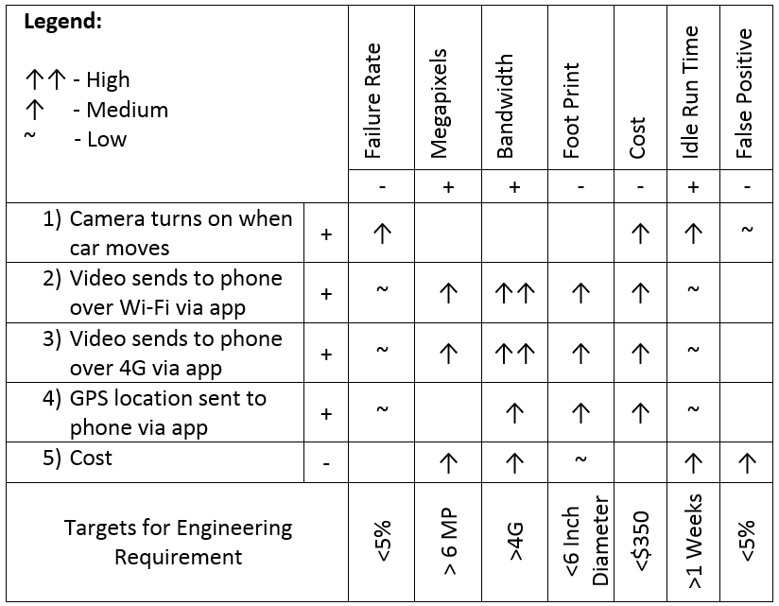

Figure 1: House of Quality

Failure rate: hardware failures such as shutdown, battery failure
False positive: percentage of false positive and negatives.
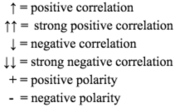

2.7 Hardware Diagram

Hardware diagram illustrating the numerous components of the physical device as well as potential add ons that may be added to the final product in numerous versions when going to market, such as a Bluetooth module over wireless for enhanced power saving. The diagram also illustrates the communication routes between each of the components, and arrow indicating the flow of traffic to a device as a receiver.

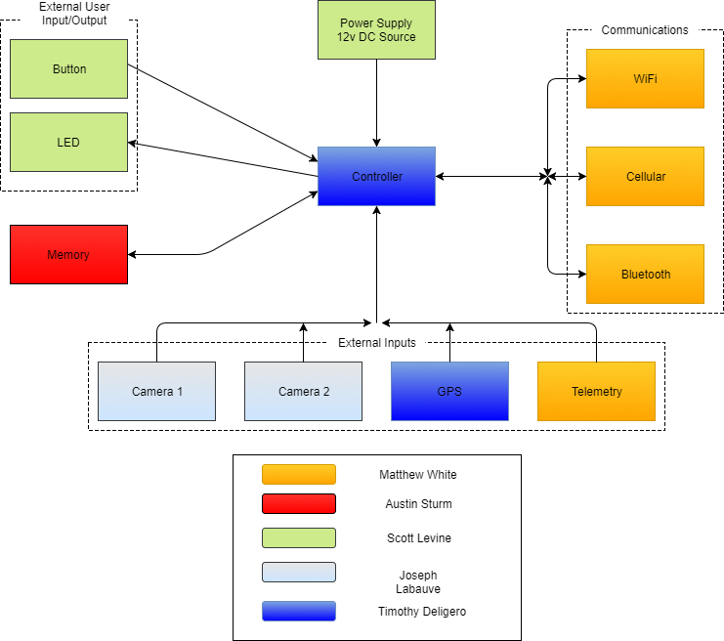

Figure 2: Hardware roles given to team members

2.8 Software Diagram

The software diagram provides insight into the applications features as well as tracks the basic flow of communication between the two mobile application and the physical device. Lower level flow charts for application design and information tracking had been provided later as well as any necessary external documentation. The diagram below shows that board software had control the different components of the Future PCB. The analog features on the board had been the push button and the LED light, and the rest of the components had been digitally controlled. The app had communicate with board through the use of the cloud, and had provide basic features once the connection was established.

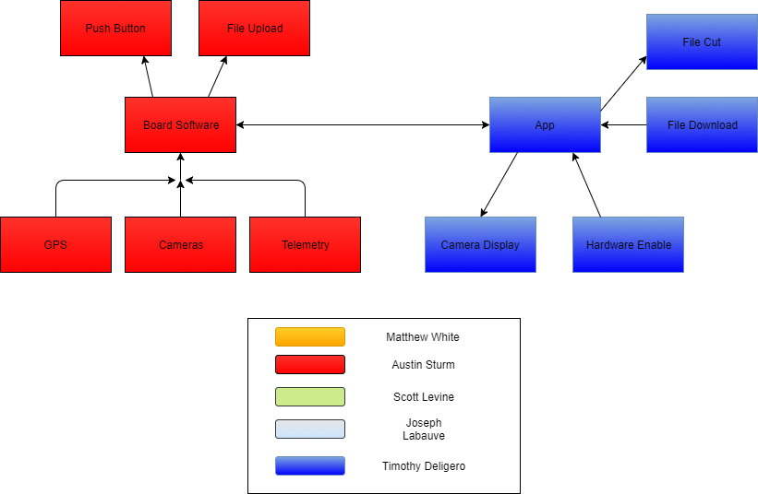

Figure 3: Software roles given to team members

2.9 Brief Operation Manual

The SSDC was a stationary security camera for vehicles to protect and secure vehicles from aggression. The SSDC had a simplistic setup listed below, but connecting the device to the car battery does require professional assistance or automotive knowledge. This decision was made to protect the user from either electrocuting themselves, or compromising the protective firewall while trying to install the device. Once the device was connected to the battery the SSDC was simply attached to the back of the rear view mirror through the use of a rubber tipped clamp. The choice to put the device on the back of the mirror was an aesthetic, legal, and discretion choice. The aesthetic reason for this was to not add too much to what drivers already see when driving allowing for a feeling of security with large changes. Along with trying to not obstruct the view of driver this was a legal matter due to some states and countries not allowing large obstructions located on the front windshield. This location also happens to be the easiest choice for discretion allowing the device to function as intended without drawing attention to itself from a passersby. Once the device was secure it must be turned on as it had to be connected to your phone.

Once the device was securely latched down the next part of the setup was to setup the Mobile application. To do this the application had first be downloaded then an account must be setup to link the camera data to the account. Once this was setup the connection between the device and the application had been established allowing for data to be transferred when in Wi-Fi range or through the use of cellular data transmission. The settings for the device can be setup through the application though these had been limited for senior design.

Steps to setup the SSDC

- Have the device wiring physically installed by a mechanic or professional installer capable of wiring the device through the firewall of the vehicle and into the fuse box.

- Clamp the SSDC to the back of the rearview mirror where it sees both the front windshield and back window.

- Setup the mobile application following the instruction provided with device, and sync the device with the mobile application.

3.0 Design Constraints and Standards

The following chapter outlines design parameters and specifications related to the project. These requirements were designed based on the project objectives, industry standards such as a temperature range of -40°C to 85°C, a humidity range from 0% to 100%, and a target field failure rate of less than 1% [57], as well as following security best practices. The device was intended to be a secure product line, keeping the consumer in mind by ensuring new attack surfaces were not introduced by the product.

3.1 Device Dimensions

Device dimensions severely impact the marketability of the product; users typically would not purchase a product which takes large areas of window space. This was not only a marketing concern but as well as a safety concern; a product which envelops a large amount of windows space may disrupt the driver’s vision leading to potential accidents. The design choice of putting the SSDC behind the rear view window was also a legal protection choice due to some states in the US as well as other countries prohibiting a certain amount of the windshield from being blocked. Securing the SSDC to the back of the window had results in a less distracting front view while being more aesthetically pleasing. The device had been designed to fit neatly behind the driver’s rearview mirror to maximize driver visibility, while still maintain full camera view of both the interior and exterior of the vehicle. Max dimensions would be below 20.32cm x 7.62cm x 5.08cm (L x W x H) app as this was the typical size of rear viewing mirrors. Also if the choice was made to install an extra camera in the back of the vehicle when the SSDC was brought to market the camera had discreetly fit in the top middle of the rear windshield. It was believed that this location with optimally not cause distraction or be easily noticed. The dimensions of the rear camera would be minor as the device would be connected through a long ribbon cable going through the ceiling of the car. This additional camera would had to be professionally installed to reduce damage to the vehicle.

Summary:

  - The device fits behind rear view mirror
  - The cameras were back to back and capture near a 360 degree video
  - No larger than 20.32cm x 7.62cm x 5.08cm (L x W x H)

3.2 Cameras
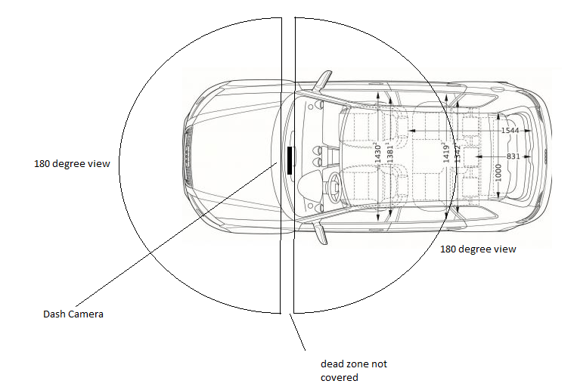

Figure 4: Camera view radius

The essential features to this product was to provide valuable video evidence during critical moments. This requires two cameras to provide full comprehensive evidence of occurring incidents; they need to provide clear view of both the interior and exterior of the vehicle. Optional attachments may be provided to ensure that the product had maximum visibility, ensuring any incidents may be accurately recorded. This had require two cameras of approximately 170 degree view, one facing out the front window and the second facing towards the interior of the vehicle. Both cameras of a high enough resolution to provide clear imagery of any potential incidents.

Summary:
  - Two cameras had been placed on the dash camera unit
  - One camera facing towards front window
  - One camera facing interior
  - Dash cam while driving
  - Security camera while parked
  - 1080p resolution camera

3.3 Telemetry

Telemetry was responsible for the most crucial aspect of the product, incident detection, the sensors were responsible for determining if an incident occurs. The mixture of sensors had been programmatically designed to detect jumps in telemetric data; the design minimizes false incident rate and efficiently detects when incidents were truly occurring. Accelerometers utilized to determine if the vehicle experiences a strong force, it must be able to detect spikes of motion. Gyrometer to detect if the vehicle had been flipped or was in the process of being lifted, this can be utilized to detect towing. GPS tracking enabled to determine vehicle longitude and latitude for the vehicle position monitoring in the event of theft.

Summary:
  - Accelerometer which had identify if the vehicle had moved in any direction, and the magnitude of the change in movement.
  - Gyrometer to detect changes in pitch, yaw, and roll.
  - Magnetometer to determine direction
  - Global positioning system (GPS)

3.4 Storage

All monitored statistics and recordings had been stored for up to approximately 256 GB’s of data. The storage device had been a micro-sd that may be replaced by the user to allow for easy storage. Upon reaching 75% of the theoretical limit the device had begun to rewrite over old files to ensure all recordings were saved. The data had been offloaded automatically when connected to a known wireless network, upon complete upload the data had been wiped. The remainder of the 25% storage space was preserved for any crucial recording when the car was parked or moving, and any action activates the accelerometer, gyrometer, or any other component. When and if the device was connected to the cloud via CDMA technology the data had flown directly to the cloud and minimal space had been used on the microSD card.

Summary:
  - Micro-SD support up to 512gb SDXC
  - 256 GB card provided
  - 75% data limit

3.5 Communication

A security product would provide little benefit to the user without the ability to offload evidence to a remote device; Utilizing local storage the device could be destroyed by the offender, rendering the device’s objective failed. The device had implemented a remote communication method to allow for the transfer of sensitive files. In order to provide this functionality implementation of both Wi-Fi for local transfers near known networks, as well as cellular for areas without known wireless networks. Both chips had exist on the same board, and the cellular chip had activatable at a later date if desired through a monthly rate that had been decided upon after senior design.

Summary
  - Code Division Multiple Access (CDMA), or Global Systems for Mobiles (GSM) communication devices to allow 4G mobile internet access to communicate with the user’s mobile phone and upload video to an online database cloud service.
  - Wi-Fi connection access device to allow non-mobile internet connection to upload videos from home, office, or hotspot location.

3.6 Safety Devices

Certain safety functions had been included with the SSDC. The SSDC had been attached to the rear view mirror which was the ideal position to included safety devices within it. Considering the possibility of people sleeping in a running vehicle the device had reduce the chances of certain unintentional injuries due to dangerous gases, or loss of person’s with the vehicle in the case of children or the elderly. This had been achieved through the use of gas monitoring sensors to alert of excessive harmful vapors through noises, and phones alerts. Also this had been done through the use of GPS tracking to keep track of vehicle location.

Summary:

  - Carbon Monoxide detector to ensure any occupant in the vehicle was not inhaling an unsafe level of carbon monoxide. The detector had create a push notification to the user’s phone as well as an audible sound to warn occupants of the vehicles who might not had access to the user’s phone.

  - GPS tracking for children or elderly parents. The GPS coordinates had been displayed on a mobile map within the application so the users were able to see the location interactively. The GPS tracking can be used to find elderly family members that were lost or disoriented. Also, it can be used to monitor young drivers as they first start out. The technology had also be used to track the car's location in the event it was stolen or if the user had forgot where they parked. This had insure the location was known at all times. Increasing the overall safety for families.

  - With the added benefits of these safety features other technologies can also be combined to help make sure the driver and other drivers around were safe at all times. This could be as simple as checking in with a new driver or keeping up with current traffic to help redirect your spouse on their way home. There uses that may had not been discovered yet but the hardware and software updates to make the technology more viable had been there for the future.

3.7 General Data Protection Regulation (GDPR)

An important piece of legislation was passed in the EU on April 14, 2016 that had affect any business that had any form of control over an EU citizen’s data. This legislation was called the EU General Data Protection Regulation or GDPR, and its function was to protect the information of EU citizens. This legislation simplified requires that the same level of security be given to people's general information as was given to say Social Security number or bank passwords. A key change compared to prior information protection laws set by the EU was that any information processing company found to be not properly securing people’s information had been fined regardless of where a breach occurs at. This point was key due to the complex way people’s data can be stored anywhere in the world, but can be accessed in the EU almost instantly. This However means that if an American company that does small amounts of business in the EU and gets breached the EU had now had the authority to fine them up to 4% of annual global turnover or 20 million euro whichever was higher. This legislation becomes active May 25, 2018 [58]. Another key component of this legislation was that should an EU citizen request to know if their data was being processed they must be informed if it is, and if that data was requested an electronic version of it must be provided free of charge. Also this data must be erased if it was requested to be by the citizen.

For the SSDC this means that performing business comes with an additional risk should there be a breach in EU citizen’s information of any kind. Business with European countries had come at the cost and risk of increasing the security measures of the SSDC, so that cyber threats to the system. This was primarily done through by encrypting the data to stop the ability to decipher the information. Also the ability to track specific user’s data must be possible so that the data can be removed if requested to do so, and the need to more thoroughly monitor the data of people can raise further issues regarding privacy. This means that a support service had to be created if it was desired to do business in the EU resulting in a higher cost and the need for more resources.

3.8 Timing and Economic constraints

Economic constraints were constraints due to monetary or financial means. This project had a high economic constraints due to this entire project being funded by Matthew white. The costs were discussed later near the end of this this paper lists the necessary components as well as their necessary costs per part. This does not factor in labor costs due to this being a project for senior design. However, due to the project being funded by a current student the economic constraints must be addressed, and this project was projected to go to market increasing the initial economic constraints much broader amounts in the future due to mass production.

The timing and economic burden of the SSDC were limiting constraints. This device had to be fully designed and implemented during the next 5 months. This produces tight time constraints for the project to be completed. Monetarily the device can be created as a prototype but at a high volume. In a high volume arena the capital needed to make 2,000 - 3,000 units would need to exceed $350,000. The $350,000 had provide enough capital to make the first initial batch of PCBs and the plastic injection mold for the outer shell. For senior design class the cost of this unit prototype should not exceed $2,000. This had included the plastic shell, electrical components, printed circuit board and two cameras. For senior design the team looks to create an MVP but also an off-tool product that looks similar to a plastic injection molded part. The MVP had come first and be rather larger and bulky but the smaller finished product had been the off tool part. This outer shell of the SSDC had been smooth, sleek, and close to production ready. The goal within our given constraints had been to produce a close to production ready model. This had taken lots of time and resources. The Kickstarter had also be launched right after senior design. This had ensure that the funds could be raised before talking to investors.

Due to the monetary constraints of having a student sponsor the research and design of the project had to be carefully designed and purchased. This means that multiple possible components cannot be purchased for testing. This was due to the high cost of either creating a PCB with the new components or even testing the components on a breadboard with development boards. Development boards for many of the components being considered for the PCB such as Wi-Fi, CDMA, and camera sensor modules cost in the range of 100 to 1000 dollars. If any of the components selected were found to not be compatible with other components they had been changed in the selection part of this paper, and if any components were found to be needed they had been added to the cost analysis/budget section of the paper.

Timing constraints for this project were constraints caused by required project achievement dates and goals. This means that certain parts of this project need to be completed by certain dates. This was an important consideration especially during the research phase of the project, and the testing phase of the project. Certain amounts of this senior design paper had to be completed these were listed in the Time table near the end of the paper, and these essentially rush the project which cause the researching of parts and contacting of companies need to be done in a short amount of time. This dialogue with companies to get testing parts can take an extended amount of time, and certain parts had not be able to be acquired in the time tables listed even if this dialogue was started at the start of senior design 1. Also the time tables for senior design 2 were not yet known, but it was known that most of the software design had been done during this semester. This software for the SSDC needs a thorough amount of time to properly code the base functions of the device. The senior design 2 semester was only 16 weeks, so this was the maximum amount of time for coding and testing of the SSDC. The base code for functionality requires a lot of time, but afterwards it had require fine tuning to stop false positives from arising. This fine tuning had require a lot of extra time in testing the product in multiple environments requiring extended periods of testing that need to be done. There was also the timing constraints of organizing meeting times between the five group members in the group.

3.9 Legal constraints

With the use of the SSDC there were specific laws that must be abided by when considering if it was okay to record another party in a state. To help understand the law two terms must be properly defined which were single party and all parties. Single party refers to one person who was part of a conversation or discussion, and all party refers to everyone that was part of a conversation or discussion. Many states allow for the recording of individuals and conversations only requiring only that the single party recording be part of that conversation or dialogue in some form or fashion. However, there were select states that require all parties to agree consent for the recording process before recording can happen. Often these laws refer to audio recording not video recording, but there were also grey areas in these laws such as if the incident in question was a private discussion or under the expectation of being public. Some states in the US that do not allow for recording without consent of all party members were Washington, Illinois, and Pennsylvania. Now these recording laws had exceptions and stipulations that can allow for recording, but to simplify the legal process a section had been created in the User agreement documentation that had require the user to look up recording laws in their particular state before using the device.

In many European countries there were legal grey areas revolving around dashboard cameras due to European data protection laws. In some countries such as Austria there were fines given if a dashboard camera was found in the vehicle. In recent years many laws were changing or being updated. The recent GDPR discussed earlier had impact a lot of data and surveillance devices in the current years. Currently this had highly affect CCTVs, but dashboard cameras were not considered CCTVs. However, this puts dashboard cameras in a grey area that had likely be defined through precedent court cases, and further legislation as well as amendments to laws. However, in some countries dash cams were altogether forbidden from being used such as Switzerland.

While the dimensions of the SSDC were stated before there were certain legal restrictions regarding the mounting of devices on windshields for both size and location. Many states allow dash cams, but do not permit them to be mounted to the windshield. Also the area which the device was allowed to obstructed changes widely from state to state. These constraints had affected the design, and mounting choice greatly during the design phase of the device. As a result of the existing laws the choice was made to attach the camera to the back of the rear view mirror as to circumvent the issue of window mounting laws and reduce area of obstruction.

3.10 Environmental constraints

The environmental constraints to overcome in this project were the harmful effects that the environment of being mounted in a car creates for the SSDC. These were very important to address during the design phase of the SSDC since this project was projected to go to market eventually. These environmental constraints were mainly concerns with regards to trauma due to acceleration changes as well as thermal changes. These factors can be overcome through proper component selection by analyzing the datasheet to determine compatibility with the environmental standards.

3.11 Social constraints

When designing the SSDC both functionality as well as human psychology were taken into consideration, and measures were taken to try to provide a level of appropriate social acceptability for consumers. It was not uncommon for people to become agitated or angered when they find out they were being recorded without knowing beforehand. These situations can cause tension, and uneasiness in pedestrians as well as other drivers. To try to circumvent anger as a result of being record the SSDC was designed to be discrete as mentioned in the Design dimensions. This removes a significant amount of attention from being drawn to the SSDC, and as mentioned in a later section the SSDC had had customizable colors in the future allowing for the camera to match most mirror colors to blend in even more. However, this had play a lower factor when it comes to the functionality of the system.

3.12 Ethical

The ethical constraints of this project fall within the material choices of the project to guarantee an easily disposable and/or recyclable product, and to meet the specification standards we set for ourselves. To do this the materials chosen for the SSDC had been environmentally friendly meaning they can be salvaged or recycled. Since this project was a designed to be a pseudo security system. Considering that this system needs to be very accurate. We had an ethical responsibility to not choose shoddy components that had not function optimally. Thus we had not cut corners on components for the SSDC based on price to turn a larger profit. Also there was the ethical concerns regarding public filming of individuals. However, the first amendment protects public speech which involves recording individuals as long as the recording was done in a public space, and was done without the intent to gain private information.

3.13 Quality and safety

The quality and safety constraints for this project were the constraints concerning the health and safety of the consumer. To achieve these goals the SSDC had not be produced using toxic materials dangerous the health of those that interact with the device, and the device had been given proper time and consideration for its design before it was brought to market. All parts that had go into the PCB had been tested to show that proper function was achieved. The design of the PCB for the SSDC had been created using optimal setup by separating the analog and digital components, using minimal tracing width, and not use dysfunctional or untested components. Through carefully component selection and testing of the device the possibility of the device malfunctioning or even worse causing damage to the vehicle or surrounding area cause can be avoided. This device needs to go directly to the car battery, so it had had to go through the firewall of the car to reach it. To protect people from either electrocution or damaging the very important firewall of the vehicle the device had very clearly declare in the instructions and on the packaging the need for professional installation. Finally the product had not contain toxic materials, and had been light enough that in the event of the product becoming dislodged due to extreme trauma it had not cause major injury.

3.14 Power supply constraints

In the SSDC there were multiple issues surrounding the power supply going to the SSDC. The SSDC does not had any relevant power constraints while the vehicle was on due to the constant flow of power, but once the power was switched off the device had to continue to function in low power settings. This means if the SSDC was connected directly to the battery of the vehicle the battery had slowly be drained, and while this had not pose a threat should the vehicle be driven occasionally extended absence of not driving can cause the battery to reach critically low levels. To remedy this it was believed that low power settings as well as a cutoff point should be created to preserve the vehicle battery.

The SSDC while on was a dashboard camera, but during vehicle shut down it acts as a security system that needs to be able to react fast. An issue with using the car battery for this power supply was that should the car battery run to low and the shut off was activated the device had not function as desired, so an option that was being considered was the installation of an exterior battery that was used to keep the device primed for should any issues arise.

3.15 PCB Design Constraints

3.15.1 Thermal control

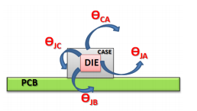

Figure 5: Thermal heat dissipation (Permission Pending)

Control of thermal elements was an important process in modern circuitry due to the desire to make PCBs as small as possible, and the effects that overheating can cause. This was even more crucial in the SSDC since it had been located in a highly variable environment. According to a study performed by Jan Null recorded car temperatures can reach temperatures of 132 when ambient temperatures outdoors were only 82 degrees Fahrenheit. It also had to address how fast temperatures can fall resulting in a dangerous thermal shock for sensitive electronics not prepared for drastic changes. This shock however can be reduced in a variety of ways by the use of external heat sinks like those found in computers, but for small devices like the SSDC a method of thermal dissipation was using copper tracing due to it having a better power efficiency value than other materials used for tracings combined with minimal heatsinks.

Power dissipation was typically given in the form of 𝜽 and having the units Celsius/Watt. 10C/W power dissipation would mean that there was 10C created for the dissipation of 1 watt. The temperature itself for each component was broken down between the case and the junction, case and ambient, and junction and ambient from notes of Arthur weeks. [66] Each of these can be calculated to find the heat created by each component. The total temperature differential was calculated by the T=#watt*𝜽 canceling out the watts in the units and leaving the temperature in C [66]. For the device to be considered reliable the total heat created by the component would had to be less than T_{j}max or the max allowable junction temperature.

3.15.2 Tracing Inductance and Board Layout

The layout of the PCB for the SSDC was very important due to the use of copper tace mixed with the CDMA and GSM high frequencies. Typically the impedance of the copper was negligible, but these high frequencies can affect the copper enough to cause high impedances. The impedance of a copper tracing was given in the first calculating the inductance of a tracing using the equation below. Then calculate the resistance of the component using the inductance and frequency.

Lower frequencies cause the impedance caused by this inductance to be so low that the value was negligible, but when the values of frequency reach into the gigahertz or high Megahertz this value becomes large enough to cause issues. There was a technique to lower this however by placing the output and return paths close to each other.

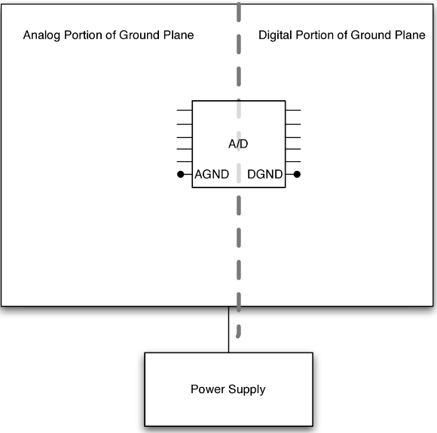

Figure 6: Partitioning of analog and digital (Permission Pending)

Placement of components on the board was a crucial part of good PCB design. Correct setup of a PCB should put as much space between analog and digital components as possible to prevent crosstalk from arising. Separation was typically done through planar partitioning of the PCB, and crosstalk was the electric or magnetic disturbance of a circuit due to a signal leakage. Crosstalk can also be reduced through a number of measures including: grouping logic families according to function, placing components close to each other, place components away from the I/O connector, isolate high noise emitters on their own layers, route adjacent layers orthogonally, and avoid traces parallel to each other [49]. By carefully setting up the PCB many problems caused by distortion can be solved before issues ever arise. The equation for determining crosstalk strength was listed below. “The constant K had to be less than 1 and depends upon the rise time of the circuit and length of the traces, $H^{2}$is the product of the two heights of parallel traces, and D was the direct distance between the center line and traces” [49].

Equation: Crosstalk

3.15.3 Grounding

Grounding a circuit was a basic concept that every electric engineer learns in their first circuitry class however this concept becomes more complex when there had to be proper grounding for both analog and digital components in the same PCB. Issues arise when the complex impedance between two ground points had a current run through them. This current can travel across the ground impedance, and corrupt the signal at another point connected to a different ground shown in the figure below. This signal corruption was the result of ground noise partially or completely jamming the signal. This threat of a ground current was increased when a ground network contains loops or circular patterns. Thankfully there were a number of ways to reduce this issue, and one was already built into the PCB through the use of ground planes. These planes had a very low impedance reducing the noise inherently. Below were a few ways to reduce the noise and corruption caused by ground noise.

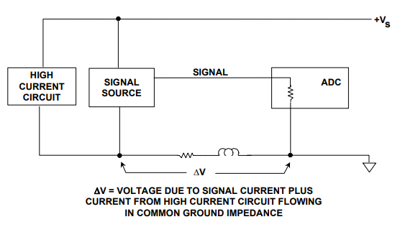

Figure 7: Ground Noise (Permission Pending) [55]

3.15.4 Star Ground

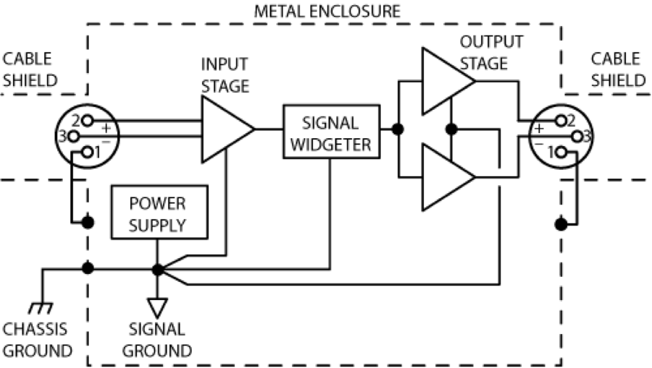

Figure 8: Star Grounding Example (Permission Pending)

The star ground concept basically means that all points on a circuit were referenced back to a single ground point removing the possibility of a current to travel across the ground plane because there was no other ground point [55]. While this sounds like an easy solution to a complex problem it can be an extremely complicated concept to be implemented in complex circuits. The benefit of a star ground was typically overwritten by the problems caused by the extra tracing and extreme amount of vias to reach the star ground. This means that star grounding while being a good way to reduce ground current was ultimately not a feasible. A simple example of star grounding was shown above where all necessary ground points were connected to one ground

3.15.5 Partitioning of the Analog and Digital

An effective way to reduce ground noise was to partition the analog and digital components to their own ground plane and areas of the board as well as had their own power source. Doing this reduces the corrupt of the signals due to the ground noise, and also was a smart design choice because analog and digital components can interact negatively when placed close to each other on a board. Also when doing this the two sides of the board had to be connected by an electro bead which was the only connection between the two boards. The planes that power the partitioned sections had been physically separated as well making one plane 3.3v and the other plane had been a pure 3 volts. These were the only two voltage planes that were needed for the circuit as any other necessary voltage can be achieve using these planes with dividers or other circuits.

3.15.6 Designing a Ground Isolation Amplifier

Another way to reduce ground noise was to add a ground isolating amplifier to the circuit. The amplifier’s purpose was to reduce the error voltages by measuring the signal in a, “differential fashion” [55]. The use of these amplifiers essentially reject the CM voltages that were causing issue for the circuit. By using an amplifier the user get a high impedance which results in a relatively low voltage drop reducing noise, and the differential fashion in which the signal was measured reduces the circuit’s sensitivity to ground noise.

4.0 Research

4.1 Accelerometer Sensor Research

Accelerometers were devices that measure acceleration, which was the rate of change of the velocity of an object. They measure in meters per second squared (m/s^2) or in G-forces (g). A single G-force for us here on planet Earth was equivalent to 9.8 m/s^2, but this does vary slightly with elevation (and had been a different value on different planets due to variations in gravitational pull). Accelerometers were useful for sensing vibrations in systems or for orientation applications. Accelerometers were electromechanical devices that sense either static or dynamic forces of acceleration. Static forces included gravity, while dynamic forces can included vibrations and movement. [31] The accelerometer had been used to sense car theft and car damage from the vibrations and movements of acceleration forces. These acceleration forces had been tested and recorded in the accelerometer to distinguish scenarios of car theft and car damage from other scenarios of vibration and movement, such as when a car passes by, the car was being touched or bumped by bystanders, etc. and even false positives that can potentially trigger the device with the accelerometer. Gravity must also be taken into account when recording the results as it was an active acceleration force that had always affect the device and the accelerometer itself.

4.1.1 Accelerometer Connection

The accelerometer sensing was a fusing of electrical and mechanical components which allow machines to perceive movement by means of detecting acceleration. They do this most commonly by means of measuring the change in the position of mass. An analog signal was created by an interface module which was run through an analog-to-digital converter (ADC) to allow the signal to be utilized by a digital processor. The accelerometer works primarily by means of Newton’s Second Law of Motion, which states that acceleration was equal to the sum of the forces on an object divided by the object’s mass. [5] As such, the accelerometer sensor measures acceleration indirectly through force and knowing the precise mass of the moving portion of the sensor.

The communication interface of the accelerometer had three ways of communication: 1) Analog, 2) Digital, and 3) Pulse Width. Accelerometers with an analog interface show accelerations through varying voltage levels. These values generally fluctuate between ground and the supply voltage level. An ADC on a microcontroller can then be used to read this value. These were generally less expensive than digital accelerometers. Accelerometers with a digital interface can either communicate over SPI or I2C communication protocols. These tend to had more functionality and be less susceptible to noise than analog accelerometers. Accelerometers that output data over pulse-width modulation (PWM) output square waves with a known period, but a duty cycle that varies with changes in acceleration. [31] The analog interface must be looked into for issues in buffering and impedance. This was by far the single most common source of problems in projects involving analog accelerometers, because so few people thoroughly read the required documentation. Both PIC and AVR datasheets specify that for A-D conversion to work properly, the connected device must had an output impedance under 10 kΩ. [34] The input impedance must also be kept high while the output impedance needs to be kept low, so the output impedance must had been under 10 kΩ, while the input impedance must be significantly higher than that. This helps preserve the signal levels and frequency responses, but if the input impedance doesn’t become significantly higher than the output impedance, than the signal-to-noise ratio and frequency responses suffers as a result. A higher input impedance also ensures that circuits had interface with the accelerometer correctly that may not supply enough power and voltage and a low output impedance helps the accelerometer interface with circuits that require high input power and voltage.

Accelerometers were generally low-power devices. The required current typically falls in the micro (µ) or mA range, with a supply voltage of 5V or less. The current consumption can vary depending on the settings (e.g., power saving mode versus standard operating mode). These different modes can make accelerometers well suited for battery powered applications. [31] This was beneficial to the SSDC device as the voltage required to operate the accelerometer was low which creates more room to power other components of the device as well. Tests had need to be done to tested the voltage requirement that the accelerometer had operate in, especially during standard operating mode and power saving mode as they had implemented into the SSDC.

4.1.2 Accelerometer MEMS

What had been used was called a microelectromechanical systems (MEMS) accelerometer. Most typically, the structure of the MEMS accelerometer sensor was constructed as a variable capacitor. There were two common arrangements to create this variable capacitance. One form was called single-sided, the other was known as a differential pair. The single-sided was to have a fixed electrode and a moveable mass. The other arrangement, called a differential pair, was constructed such that there were two fixed plates with a defined area and specific distance between the two. A moveable mass was then placed between the two plates. Thus, the sensor actually works by detecting the displacement of the moveable mass. The mass was displaced by micrometers, caused by the acceleration of the sensor, which creates an extremely small change in capacitance.

For both arrangements, the orientation of the set of plates were as such as the plates were perpendicular to the motion that was being measured. Both of these sensors were designed such that there was a spring between the plates which centers the moveable mass after movement was detected. The plates, or electrodes, were created from silicon substrates. These variable capacitor-type sensors were known for being highly accurate, having good stability, dissipating low power, were not susceptible to noise and variations in temperatures, and were simple to construct. They had a limiting bandwidth of only a few hundred Hertz due to the construction utilizing springs and trapped air within the IC which acts as a damper.

Because the sensor’s change in capacitance was so small, it was suggested to use multiple movable and fixed plates connected in parallel with one another. This typically results in a large structure of fixed electrodes and moving plates in a large parallel array for the most accuracy. Many manufactured accelerometers had at least 8 moving electrodes that move in relation to fixed plates which were connected to sense the change in capacitance. For multi-axis sensors, these arrayed sensors can be mounted orthogonally to one another in a single unit such that one sensor array senses acceleration in the X-direction, one in the Y-direction, and the final one senses acceleration in the Z-direction. Another option for the construction of multi-axis accelerometers was to use one moveable mass with fixed plates in an arrangement such that the mass can move in two axis.

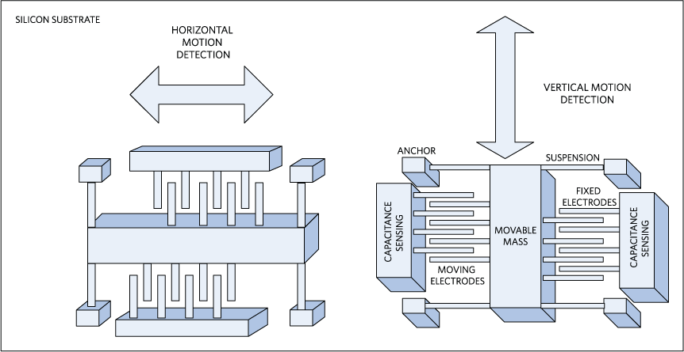

Figure 9: 2-Axis Accelerometer (Permission Pending) [65]

One aspect of MEMS accelerometers that had been beneficial to the SSDC was condition monitoring. Condition monitoring was the process of monitoring the state of the machine or device while it was in operation. This type of monitoring observes machine condition such as vibration, temperature, etc. This benefits the use of the SSDC for future maintenance but also to prevent failures and avoid consequences. For accelerometers and the purpose of this device, detecting vibrations was essential for detect car theft and car damage.

Solid-state electronics can impact the size of the transducer. A smaller form factor triaxial mounted on a printed circuit board (PCB) and inserted into a hermetic housing suitable for mounting and cabling on a machine, can help enable a smaller overall package, offering more mounting and placement flexibility on the platform. In addition, today’s MEMS devices can included significant amounts of integrated, single voltage supply signal conditioning electronics, providing analog or digital interfaces with very low power to help enable battery-powered wireless products. For example, the ADXL355, a high resolution, high stability triaxial accelerometer had an integrated Σ-Δ analog-to-digital converter (ADC), with an effective resolution of 18 bits and an output data rate of 4 kSPS, and consumes less than 65 µA per axis. [36] Having signal conditioning supports ADC as the signal can be manipulated in a way that prepares an analog signal to be processed and converted into a digital signal. This type of conditioning was also used for conditions in vibration, temperature, etc., which had been useful when using the accelerometer for vibration detection and having the analog voltage signals be converted into digital value signals for acceleration forces. The use of low power for the accelerometer had also support the SSDC to be able to operate and function with the accelerometer at low voltage requirements.

The topology of a MEMS signal conditioning circuit with both analog and digital output variations was common and opens up options for the transducer designer to adapt the sensor to a wider variety of situations, enabling a transition to digital interfaces commonly available in industrial settings. For example, RS-485 transceiver chips were widely available and open market protocols, such as Modbus RTU, were available to load into an adjacent microcontroller. A complete transmitter solution can be designed and laid out with small footprint surface-mount chips that can fit within relatively small PCB areas, which can then be inserted into packages that can support environmental robustness certifications requiring hermetic or intrinsically safe characteristics. [36] This had support the PCB design of the SSDC device as it needs to be relatively small enough to fit behind the rear view mirror and meet the requirement specifications of the device’s dimensions.

A MEMS had demonstrated to be very robust to changes in the environment, as well. The shock specifications of today’s generation of devices were stated to 10,000 g, but in reality can tolerate much higher levels with no impact on sensitivity specifications. Sensitivity can be trimmed on automatic testing equipment (ATE) and designed and constructed to be stable over time and temperature to 0.01°C for a high resolution sensor. Overall operation, including offset shift specifications, can be guaranteed for wide temperatures ranges, such as −40°C to +125°C. For a monolithic triaxial sensor with all channels on the same substrate, cross axis sensitivity of 1% was commonly specified. Finally, as a device designed to measure the gravity vector, a MEMS accelerometer had a dc response, maintaining the output noise density to near dc, limited only by the 1/f corner of the electronic signal conditioning and, with careful design, can be minimized to 0.01 Hz. [37] The environmental robustness had support the testing scenarios and the purpose of the SSDC device when undergoing cases of car theft and car damage, especially in extreme cases of car damage where the acceleration forces can be very high. Being temperature tolerant had also benefit the use of the SSDC device when functioning inside a car as it can reach high temperatures. A wide range of temperature tolerance for the accelerometer was needed to be able to operate and function under high and low temperatures. Sensitivity stability and output noise density kept at DC levels supports more accurate readings of large changes in signal.

Perhaps one of the biggest advantages of MEMS-based sensors was the capability to scale up manufacturing. MEMS vendors had been shipping high volumes for mobiles, tablets, and automotive applications since 1990. This manufacturing capability residing in semiconductor fabrication facilities for both the MEMS sensor and the signal conditioning circuit chip was available to industrial and aviation applications as well, helping to lower the overall cost. Moreover, with more than a billion sensors shipped for automotive applications over the last 25 years, the reliability and quality of MEMS inertial sensors had been demonstrated to be very high. MEMS sensors had enabled complex crash safety systems that can detect crashes from any direction and appropriately activate seat belt tensioners and airbags to protect occupants. Gyroscopes and high stability accelerometers were also key sensors in vehicle safety controls. Today’s automotive systems make extensive use of MEMS inertial sensors to enable safer, better handling cars at low cost and excellent reliability. [36] Since MEMS technology had been tested in crash safety systems and crash detections, this had been reliable when using the MEMS technology for the accelerometer in the SSDC device when testing for car crash scenarios. This also supports the function of the SSDC device as it was made to detect instances of car theft and car damage and notify the user of such.

4.1.3 Accelerometer Sensitivity

An accelerometer can be distinguished by a few features, these features had determine what the proper sensor for the application is. One of the key features was that of sensitivity. This sensitivity was rated in millivolts per gram (mV/g), and was a metric of the minimum change or movement of the physical mass that had produce a detectable signal. The sensitivity was only valid for one frequency, and not a range of frequencies. The range of frequencies an accelerometer functions within was considered the Bandwidth, which was measured in Hertz (Hz). The bandwidth was a realistic range of vibration frequencies in which the accelerometer had produce reliable signals. The bandwidth can also be the frequency in which the user can take a reliable reading from the sensor. The bandwidth was also associated with the frequency response which was measured in Hertz (Hz). This, like bandwidth, was a frequency range which the sensor had given a true signal that signifies the proper detection of motion. The frequency response typically had a tolerance range. In a similar vein, the dynamic range of the sensor was the range between the smallest possible motions that had incur a true detection signal to the largest possible movement that had taken place right before saturating the output signal which would result in clipping and distortion of the detection signal.

An important characteristic of accelerometer sensors was what’s called the voltage noise density, which was a function of the voltage from noise and the inverse-square root of the bandwidth. This states that the faster an accelerometer was read, the lower the accuracy for the sensor becomes. The more often the changes of an accelerometer were read, the larger the effects of noise become. This was exacerbated in lower-gravity situations. Such as zero-g situations. The zero-g voltage was a phrase that makes the voltage output under 0g acceleration, or no acceleration in the X and Y directions. [8]

4.1.4 Accelerometer Vibration Detection

Vibration was the movement or mechanical oscillation about an equilibrium position of a machine or component. It can be periodic, such as the motion of a pendulum, or random, such as the movement of a tire on a gravel road. Vibration can be expressed in metric units (m/s2) or units of gravitational constant “g,” where 1 g = 9.81 m/s^2. [35] The accelerometer had been used to detect vibrations during cases of car passing by on the road or parking areas or cases of vibrations caused by car theft. These vibrations must be distinguished from one another in order for the accelerometer to trigger the SSDC device during cases of car theft and car damage and ignore cases of vibrations that can potentially cause false positives such as movement in the tires of a car. There were two types of vibration: free vibration and forced vibration.

Free vibration occurs when an object or structure was displaced or impacted and then allowed to oscillate naturally. For example, when the user strike a tuning fork, it rings and eventually dies down. Natural frequency often refers to the frequency at which a structure “wants” to oscillate after an impact or displacement. Resonance was the tendency for a system to oscillate more violently at some frequencies than others. [35] These type of vibrations can be caused by minor bumps or hits to the car, or even vibrations to the tires of the car from cars passing by or the ground moving slightly and eventually die down. These type of vibrations should be ignored as they were not proper scenarios to trigger the SSDC device. However, if constant free vibrations occur during cases of car theft where the amplitude of the vibration stays the same over time then dies down, then this must be tested and recorded as the SSDC device had need to be triggered during these types of cases of free vibrations. Other cases of free vibrations must also be filtered out if the change in vibration was minor or if the scenario causing a free vibration does not qualify as an event that should cause the accelerometer to trigger the SSDC device.

Forced vibration at or near an object’s natural frequency causes energy inside the structure to build. Over time the vibration can become quite large even though the input forced vibration was very small. If a structure had natural frequencies that match normal environmental vibration, then the structure vibrates more violently and prematurely fails. Forced vibration occurs when a structure vibrates because an altering force was applied. Rotating or alternating motion can force an object to vibrate at unnatural frequencies. An example of this was imbalance in a washing machine, where the machine shakes at a frequency equal to the rotation of the turnstile. In condition monitoring, vibration measurements were used to indicate the health of rotating machinery such as compressors, turbines, or pumps. These machines had a variety of parts, and each part contributes a unique vibration pattern or signature. By trending different vibration signatures over time, the user can predict when a machine had fail and properly schedule maintenance for improved safety and reduced cost. [35] Sudden acceleration forces of car theft and car damage can cause a forced vibration to occur, and the accelerometer would need to detect these type of vibration and trigger the SSDC device. Further testing and recording of these type of vibrations were needed during these scenarios to have the accelerometer trigger the device during these cases. However, these types of vibrations can also occur when the vehicle was active and when the user was driving their vehicle. Forced vibrations can occur when sharp turns or sudden motions of the car were made by the user that would not be considered as events to trigger the device. Different parts of the car at different frequencies and vibrations can also cause forced vibrations if there was an imbalance in the vehicle. These types of scenarios in forced vibrations must be tested and recorded to filter them out in the accelerometer to prevent false positives to trigger the device.

Most accelerometers rely on the use of the piezoelectric effect, which occurs when a voltage was generated across certain types of crystals as they were stressed. The acceleration of the tested structure was transmitted to a seismic mass inside the accelerometer that generates a proportional force on the piezoelectric crystal. This external stress on the crystal then generates a high-impedance, electrical charge proportional to the applied force and, thus, proportional to the acceleration. Piezoelectric or charge mode accelerometers require an external amplifier or inline charge converter to amplify the generated charge, lower the output impedance for compatibility with measurement devices, and minimize susceptibility to external noise sources and crosstalk. Other accelerometers had a charge-sensitive amplifier built inside them. This amplifier accepts a constant current source and varies its impedance with respect to a varying charge on the piezoelectric crystal. These sensors were referred to as Integrated Electronic Piezoelectric (IEPE) sensors. Measurement hardware made for these types of accelerometers provide built in current excitation for the amplifier. [35] The use of the piezoelectric crystals applies to the use of the accelerometer and the SSDC device as they had undergo mechanical stress during scenarios of car theft and car damage and other scenarios that had cause vibrations on the vehicle and the device. Another alternative in measuring the acceleration forces in an accelerometer was the use of internal capacitive plates. In this case, the plates can either be fixed or be attached to miniscule springs that had move internally when acceleration forces were acted upon the sensor. The movement of these plates cause a change in capacitance, and from this change the acceleration forces can be determined in the accelerometer.

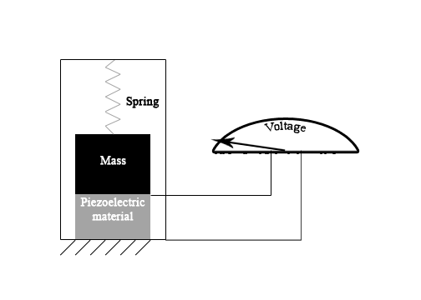

Figure 10: Example of a piezoelectric accelerometer [31]

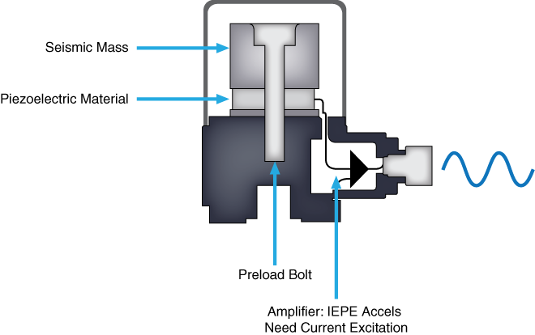

Figure 11: IEPE accelerometers output voltage signals proportional to the force of the vibration on the piezoelectric crystal. (Permission Pending) [35]

4.1.5 Accelerometer X, Y, and Z Axis

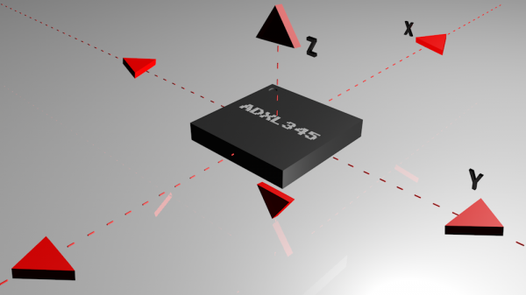

Figure 12: Example of axes of measurement for a triple axis accelerometer (Permission Granted by SparkFun) [31]

The accelerometer can support up to a 3D axis plane to detect acceleration forces. For the SSDC device, three axes must be used in order to detect acceleration forces on the car from all sides. The position of the 3D plane of axes must be checked as to better record values that were positive or negative to know the direction of where the acceleration force was coming from. The X- or Y- axes can be considered to be front or sides of the car and acceleration forces from either left or right or forward and backward can be distinguished with positive and negative value. Gravity must also be taken into account as it had most likely affect the Z-axis of the accelerometer, most likely causing a negative acceleration force downwards on to the vehicle. If the vehicle were lifted slightly or driving or parked uphill, the change in the acceleration forces in the Z-axis can occur. These acceleration forces in the 3D axis plane must had been recorded when the user was driving their vehicle and when the vehicle was parked and the vehicle was inactive. The changes in acceleration forces can occur when the vehicle was driving either in a straight motion, during turns, or when a car crash occurs. The vehicle when parked and inactive must be currently in a constant state and the sudden changes in acceleration forces can be recorded.

Most accelerometers had had a selectable range of forces they can measure. These ranges can vary from ±1g up to ±250g. Typically, the smaller the range, the more sensitive the readings had been from the accelerometer. For example, to measure small vibrations on a tabletop, using a small-range accelerometer had provide more detailed data than using a 250g range (which was more suited for rockets). [31] The ranges selected for the accelerometer must be good enough to detect vibrations or sudden changes in acceleration from other acceleration forces that count as car theft and car damage.

4.1.6 Accelerometer Sensor Selection

There were multiple characteristics when selecting an accelerometer, as they were versatile with varying sizes, designs, and ranges. The requirement specifications must be considered when selecting the accelerometer. Characteristics that need to be considered were vibration amplitude, sensitivity, and number of axes, weight, mounting options, environmental constraints, and cost.

The maximum amplitude or range of the vibration the user were measuring determines the sensor range that the user can use. If the user attempt to measure vibration outside a sensor’s range, it distorts or clips the response. Typically, accelerometers used to monitor high vibration levels had a lower sensitivity and lower mass. [35] The range of detecting the vibrations must meet the requirements of detecting car theft and car damage. This range can be determined by the amount of acceleration force that car theft and car damage caused to the vehicle.

Sensitivity was one of the most important parameters for accelerometers. It describes the conversion between vibration and voltage at a reference frequency, such as 160 Hz. Sensitivity was specified in mV per G. If typical accelerometer sensitivity was 100 mV/G and the user measure a 10 G signal, the user expect a 1000 mV or 1 V output. The exact sensitivity was determined from calibration and usually listed in the calibration certificate shipped with the sensor. Sensitivity was also frequency dependent. A full calibration across the usable frequency range was required to determine how sensitivity varies with frequency. In general, use a low sensitivity accelerometer to measure high amplitude signals and a high sensitivity accelerometer to measure low amplitude signals. [35] Small and high vibrations levels need to be detected as scenarios of car theft and car damage must be detected to trigger the device and the accelerometer must also be able to filter out any scenarios that can cause false positives or were not valid triggers for the SSDC device. A middle ground must be made in order to detect high and low amplitude signals.

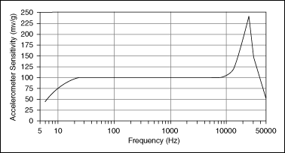

Figure 13: Accelerometers had a wide usable frequency range where sensitivity was relatively flat. (Permission Pending) [35]

The user can choose from two axial types of accelerometers. The most common accelerometer measures acceleration along only a single axis. This type was often used to measure mechanical vibration levels. The second type was a triaxial accelerometer. This accelerometer can create a 3D vector of acceleration in the form of orthogonal components. Use this type when the user need to determine the type of vibration, such as lateral, transverse, or rotational. [35] The accelerometer used should be 3D axis as the SSDC had need to measure the acceleration forces from all sides of the vehicle. The triaxial accelerometer can be beneficial for the SSDC device as it helps detect specific scenarios such as car theft and car damage to properly trigger the SSDC device and filter out any occurrences that may cause false positives or aren’t a valid trigger to the device.

Accelerometers should weigh significantly less than the structure the user were monitoring. Adding mass to the structure can alter its vibrational characteristics and potentially lead to inaccurate data and analysis. The weight of the accelerometer should generally be no greater than 10 percent of the weight of the tested structure. [35] The accelerometer that had been used for the SSDC device had generally weigh less and must be of minimal mass in comparison to device to had accurate recording of acceleration forces. This should not be a major issue as the accelerometer chips available for use in the SSDC device were generally small and weigh very little in comparison to the whole device that had been used.

Another consideration for your vibration measurement system was how to mount the accelerometer to the target surface. The user can choose from four typical mounting methods: 1) Handheld or probe tips, 2) Magnetic, 3) Adhesive, and 4) Stud mount. Stud mounting was by far the best mounting technique, but it requires the user to drill into the target material and was generally reserved for permanent sensor installation. The other methods were meant for temporary attachment. The various attachment methods all affect the measurable frequency of the accelerometer. Generally speaking, the looser the connection, the lower the measurable frequency limit. The addition of any mass to the accelerometer, such as an adhesive or magnetic mounting base, lowers the resonant frequency, which may affect the accuracy and limits of the accelerometer’s usable frequency range. Consult accelerometer specifications to determine how different mounting methods affect the frequency measurement limits. [35] The SSDC device should had the accelerometer be stud mounted onto the device to provide a secure connection and had a high frequency limit. The accelerometer should also be permanently attached inside of the hardware of the device, as the typical user had not be concerned with removing the accelerometer from the device, nor had they be concerned with the inside of the hardware. Only the requirements specification must be met in order for the accelerometer to operate and function within the device. Other methods of mounting had not be used for the final SSDC device creation.

Method | Frequency Limit
Handheld | 500 Hz
Magnetic | 2,000 Hz
Adhesive | 2,500 to 5,000 Hz
Stud | > 6,000 Hz

Table 1: Frequency Limits for Mounting a 100 mv/G Accelerometer. (Permission Pending) [35]

When choosing an accelerometer, pay attention to critical environmental parameters such as maximum operating temperature, exposure to harmful chemicals, and humidity. Most accelerometers can be used in hazardous environments because of their rugged and reliable construction. For additional protection, industrial accelerometers built from stainless steel can protect the sensors from corrosion and chemicals. A charge mode accelerometer can be used if the system must operate in extreme temperatures. Since these accelerometers do not contain built-in electronics, the operating temperature was limited only by the sensing element and materials used in the construction. However, since they do not had built-in conditioning and charge amplification, charge mode accelerometers were sensitive to environmental interference and require low-noise cabling. If the environment was noisy, the accelerometer should use an inline charge converter or IEPE sensor with a built-in charge amplifier. Humidity specifications were defined by the type of seal an accelerometer had. Common seals included hermetic, epoxy, or environmental. Most of these seals can withstand high levels of moisture, but a hermetic seal was recommended for fluid immersion and long exposure to excessive humidity. [35] The environment of the accelerometer in the SSDC device had been on the back of a rear-view mirror inside the user’s vehicle. The vehicle had been exposed to high temperatures as cars can generally become hotter when placed under sunlight over time. This mean that the accelerometer needs to had a wide range for temperature tolerance to operate and function in the device. Since the environment had potentially be noisy as the accelerometer had also detect vibrations caused by car theft and car damage, including vibrations caused by bumping or hits and shaking in the ground to the tires by cars passing by, the noise should be handled to prevent inaccurate readings of acceleration forces. Fortunately, the MEMS technology provides sensitivity stability and keeps the output noise density at DC levels to allow accurate readings and prevent constant changes in the measurement of the vibrations and acceleration forces.

Although charge mode and IEPE accelerometers had similar costs, IEPE accelerometers had a significantly lower cost for larger, multichannel systems because they do not require special low-noise cables and charge amplifiers. In addition, IEPE accelerometers were easier to use because they require less care, attention, and effort to operate and maintain. [35] A low cost accelerometer was needed as the SSDC device had been composed of multiple devices necessary to detect car theft and car damage and filter out any false positives or instances of vibrations that should not trigger the device. There were accelerometers with a lot of features and had parameters that meet the requirements specifications of the project, but were costly. The accelerometer should be good enough to reach the requirements specifications and had low cost when selected for the device. The features in the accelerometer selected should only support the function and purpose of the device.

The project had only require the sensing of acceleration in the horizontal plane direction as well as the vertical plane, so an X, Y, and Z axis accelerometer had been utilized. The two main characteristics were its sensitivity, and its operating temperature. As it had been in a vehicle, the interior had get increasingly hot the longer it was outside, especially in Florida. Temperatures can range up to 172°F (77.78°C) [7], as such ideally the sensor should be able to handle temperature ranges in excess of 81°C for a 5% margin for error. The sensitivity of the sensor had to be sufficient enough such that it had been able to accurately detect when the vehicle was moved while parked. These sensors can be either analog, meaning it outputs a specific voltage given a sensed acceleration, or digital meaning the sensor had a subsystem which involves feeding the analog output of the sensor into an on-board analog-to-digital (ADC) circuit, a filter, and a serial input/output unit. These types of sensors were handy for use with things such as microcontrollers and other digital processing systems. The sensitivity of these type of sensors were given in terms of units per least significant bits (LSB) such as mg/LSB, or milli-gravity per LSB.

Part Number | Axis | Temperature Range | Maximum Temperature Range | Resolution | Sensitivity
ADXL345 | 3-Axis | -40°C - +85°C | 105°C | ±2g | 3.9 mb/LSB
 |  |  |  | ±4g | 7.8 mg/LSB
 |  |  |  | ±8g | 15.6 mg/LSB
 |  |  |  | ±16g | 31.2 mg/LSB
LSM9DS0 | 3-Axis | -40°C - +85°C | 105°C | ±2g | 0.061 mb/LSB
 |  |  |  | ±4g | 0.122 mg/LSB
 |  |  |  | ±6g | 0.183 mg/LSB
 |  |  |  | ±8g | 0.244 mg/LSB
 |  |  |  | ±16g | 0.732 mg/LSB

Table 2: Accelerometer Sensor Comparison

4.2 Gyrometer Sensor Research

Gyrometers function in a very similar way to accelerometers. However, while accelerometers detect in a linear motion, gyrometers detect movement in a rotational way, around a specified axis. These axis were typically named the yaw, roll, and pitch axis. The axis’ name depends on how the gyrometer sensor was mounted, and not defined by a universal spatial standard, such as the X, Y, and Z axis. Most typically, the roll axis was the axis that goes in the center of the object in the direction of motion. The yaw was perpendicular to the roll axis and describes twisting motion on the horizontal plane, meaning rotational motion left or right of the direction of motion. The pitch axis was again perpendicular to both of the previous axes and typically describes the motion of the body up and down, in reference to the horizontal plane of motion.

4.2.1 Gyrometer Connection

Gyros can had either a digital or analog communication interface. Gyros with a digital interface usually use either the SPI or I2C communication protocols. Using these interfaces allow for an easy connection to a host microcontroller. One limitation of a digital interface was max sample rate. I2C had a max sample rate of 400Hz. SPI, on the other hand, can had a much higher sample rate. Gyros with an analog interface represent rotational velocity by a varying voltage, usually between ground and the supply voltage. An ADC on a microcontroller can be used to read the signal. Analog gyros can be less expensive and sometimes more accurate, depending on how the user were reading the analog signal. [12] The digital and analog communication interface had been used for the SSDC as samples of angular speeds need to be taken to filter out false positives and trigger properly during scenarios of car theft and car damage to the device. For this, the ADC had been used on the microcontroller to simulate the measurements of the angular speed of the vehicle from the device to make measurements of reads of the car’s current and changing angular velocity.

4.2.2 Gyrometer MEMS

Much like the accelerometer, the gyrometer that had been used was a MEMS gyrometer. The MEMS gyrometer was constructed differently than the MEMS accelerometer, but uses the same effect of sensing the change in capacitance by having fixed plate electrodes and moving electrodes that move with a mass. However, gyrometers were constructed of three sub frames. The outermost frame was constructed with fixed plate electrodes on two opposite sides. Within the frame was an inner frame which had moving electrodes on its perimeter that interact with the outside frame’s fixed electrodes, thus these electrodes were nested in between the fixed plates of the outside frame. The inner frame was connected to the outside frame by springs which center it in the middle. These springs were connected to the two sides that had no electrodes, such that there was no axial motion of the plates. Nested within the inner frame was a specific mass which acts as the catalyst for motion. This mass was connected to the inner frame by two springs, which were orthogonal to the springs which connect the inner frame to the other frame. Thus, as the mass resonates, the energy was transferred to the inner frame which then changes the capacitance in the sensing electrode plates on the outer frame which was thus read as a signal.

MEMS gyros were generally low power devices. Operating currents were in the mA and sometimes a microA range. The supply voltage for gyros was usually 5V or less. Digital gyros can had selectable logic voltages or operate at the supply voltage. For any digital interface, remember to connect 5V to 5V lines and 3.3V to 3.3V lines. Also, gyros with digital interfaces can had low power and sleep modes that allow them to be used in battery powered applications. Sometimes this was an advantage over an analog gyro. [12] These low power devices had been beneficial in supply voltage to gyrometer along with many other components on the SSDC. A low power and sleep mode had been used as the vehicle had been active when the user was driving their vehicle and be inactive when the vehicle was parked by the user.
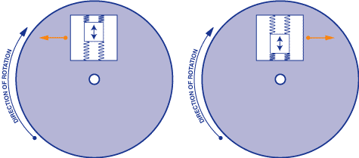

Figure 14: Internal operational view of a MEMS gyro sensor (Permission Granted by SparkFun) [12]

4.2.3 Gyrometer Rotation Detection

The functionality of the gyrometer, much like the accelerometer, detects rotational motion by means through measure of an acceleration. The acceleration that was measured was called the Coriolis acceleration. The Coriolis acceleration was the acceleration due to a spinning and translating reference frame, which the inner-frame of the MEMS gyrometer acts as. The necessary variables to find the Coriolis acceleration was the rotational velocity of a rotating body and the velocity of the object within the rotating body. Thus, by measuring the Coriolis acceleration, we can find the rotational velocity. This means of measurement was the same effect as Foucalt’s pendulum, in which a swinging or vibrating mass was displaced axially due to rotation of the connecting body. [10]

4.2.4 Gyrometer X, Y, and Z Axis

A triple axis MEMS gyroscope can measure rotation around three axes: x, y, and z. Some gyros come in single and dual axis varieties, but the triple axis gyro in a single chip was becoming smaller, less expensive, and more popular. [12] A triple axis gyroscope had been need as the vehicle’s angular velocities need to be measured on all sides, which requires a 3D plane measurement. The direction, or in the case of measuring the angular velocities either positive or negative measurements, must be considered when recording the data from the hardware and software code as well as the range of values that can be measured as well.

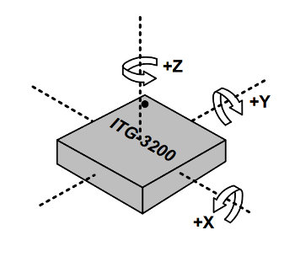

Figure 15: Example of axes of measurement for a triple axis gyrometer (Permission Granted by SparkFun) [12]

4.2.5 Gyrometer Sensor Selection

Selecting a gyrometer that was correct for the application was important, and as such metrics should be defined to better understand and had the ability to compare the sensors. Some basic characteristics that should be taken under consideration. One of these characteristics was what should be called the range of the sensor. That is, the angular velocity range in which the sensor can accurately detect. As such, ideally this would be the minimum angular velocity which should be detected and act as a true trigger, as well as the maximum range in which would be just outside the possibility of this application. Another such characteristic to be considered was that of the error that’s inherent in the sensor. The aim for this should be zero, however for real applications this was not so. Some causes of bias errors would include bias drift, which was the tendency of a gyrometer to in accurately detect change in angular velocity [11], as well as changes due to temperature. These errors were typically well documented, and when integrated with other sensors, these errors can be reduced. The final characteristic to take into account was the sensitivity of the sensor. The sensitivity was given as millivolts per degree per second (mV/°/s), and thus was the amount the voltage the sensor produces given the angular velocity. This had to be sufficiently large such that the controller that’s used can detect the changes accurately enough to make accurate and precise reactions. [12]

Part Number | Axis | Temperature Range | Maximum Temperature Range | Resolution | Sensitivity
BMG160 | 3-Axis | -40°C - +85°C |  | ±125°/s | 16.4 LSB/°/s
 |  |  |  | ±250°/s | 32.8 LSB/°/s
 |  |  |  | ±500°/s | 65.6 LSB/°/s
 |  |  |  | ±1000°/s | 131.2 LSB/°/s
 |  |  |  | ±2000°/s | 262.4 LSB/°/s
LSM9DS0 | 3-Axis | -40°C - +85°C | 105°C | ±245°/s | 8.75 LSB/°/s
 |  |  |  | ±500°/s | 17.5 LSB/°/s
 |  |  |  | ±2000°/s | 70 LSB/°/s

Table 3: Gyrometer Sensor Comparison

4.3 Magnetometer Sensor Research

Magnetic fields were an accumulation of varying magnetic forces. These magnetic forces were created by things such as magnetic elements and electrical currents. Magnetic forces interact, and were affected by everyday items. The magnetic field passes through materials and was altered by what’s called the material’s relative permeability. The magnetic field strength (H) was given by the equation: H = μ_{m}B Where B was the magnetic field, and $μ_{m}$is the material’s relative permeability. As such, when the field passes through different materials, the strength of the magnetic field changes. The magnetic field was also affected by other magnetic fields, which can be caused by electrical currents. This includes the human body, which produces its own magnetic field. The magnetic field that passes through a given point in space and time was called the flux. The flux was a vector, insomuch that there was a magnitude, or strength, of the magnetic field, and the direction of that field. [13]

4.3.1 Magnetometer Sensitivity

The magnetometer sensor detects the magnetic field in its surrounding area. There were two basic forms of magnetometers. The first was known as a scalar sensor. These sensors only detect the strength of the flux which passes through the sensor. The other type of sensor was a vector sensor. These types of sensors detect not only the magnitude of the magnetic field, but also the direction of the flux. [14] A simple example of a sensor was a simple coil wire, which, in the presence of a magnetic field, would create an electric current. This would not be able to detect the direction of the magnetic field, but would be able to determine the strength of the magnetic field. A popular construction methodology was to use what’s called Hall Effect sensors. These sensors pass a continuous current through a silicon semiconductor. In the presence of a magnetic field, some of the charge was deflected to the sides of the semiconductor which was then detected as voltage. [15]

4.3.2 Magnetometer MEMS

A more complex construction example was that of MEMs-based designs. MEMs-based magnetometer sensors use Lorentz-Forces. A Lorentz force was a force caused by an electrical charge and a magnetic field. The equation that describes this, F = qE + qv × B, where ‘q’ was a charged particle, ‘E’ was the electric field, ‘v’ was the velocity of the charged particle ‘q’, and ‘B’ was the magnetic field. [17] As such, the force the MEMs-based magnetometer detects was a function of both the electric charge received and the magnetic field it’s undergoing. Thus, the sensor finds the magnetic field through indirect means by the forces applied to the internals of the sensor. These MEMs-based magnetometers send an AC signal to its components, thus all of the variables within the Lorentz-Force equation was known except for ‘B’. Once force was sensed, B can then be solved by computation. MEMs-based magnetometers also sense the magnetic field by means of capacitance. This was done by sensing the differentiating capacitance in a linear array of capacitor elements within the sensor. As the magnetic field passes through these capacitors, the capacitors slightly charge or discharge based on the field. As such, a further layer of detection was added. These sensors can be put in an orthogonal configuration to get a 2-dimensional mapping, or a 3-dimensional mapping of the magnetic field. Thus the sensor was able to give a vector read out of the field. [18]

4.3.3 Magnetometer Sensor Selection

Similar to all sensors, choosing the correct sensor for the application was important. As such, metrics were put in place to help determine which the best choice was given the environment it had been subject under, and the necessity of the sensor. Some of these characteristics included the sensitivity to the magnetic field, the hysteresis or range in which no discernable difference in the field was detected, how linear the response to the change in the magnetic field the sensor is. Another important measurement to take into account was the noise of a sensor. This had the capability of giving a false-positive report, or even a false negative if the amount of noise the sensor was subject of was large enough such that the threshold was too large and masks an actual change that would be necessary. The dynamic range of the sensor was also an important unit to keep in mind, as this had determine the distance at which the sensor can accurately detect changes in the field. If this range was too large, there’s a risk that changes that were not associated with what should be monitored. If the range was too small, then it might not react strongly to an event that should be watched. These values had to be optimized to receive the best results while taking the magnetic field into account.

Within the LSM9DS0 was a magnetometer which, along the lines of the digital accelerometer and digital gyrometer had measurement ranges. The ranges associated with the magnetometer within the LSM9DS0 was ±2, ±4, ±8, ±12 gauss. Within these ranges, the sensitivity were as followed: For ±2 gauss, the sensitivity was 0.08 mgauss/LSB, for ±4 range its 0.16 mgauss/LSB, for the ±8 range its 0.32 mgauss/LSB, and for the ±12 gauss range its 0.45 mgauss/LSB.

Whichever sensor was used must be put into various environments inside of a vehicle to be tested to find the appropriate range, such that the sensitivity had still be beneficial to sensing.

Part Number | Temperature Range | Maximum Temperature Range | Resolution | Sensitivity
LSM9DS0 | -40°C - +85°C | 105°C | ±2 gauss | 0.08 mgauss/LSB
LSM9DS0 | -40°C - +85°C | 105°C | ±4 gauss | 0.16 mgauss/LSB
LSM9DS0 | -40°C - +85°C | 105°C | ±8 gauss | 0.32 mgauss/LSB
LSM9DS0 | -40°C - +85°C | 105°C | ±12 gauss | 0.48 mgauss/LSB
LSM303DLHCTR | -40°C - +85°C | 125°C | ±1.9 gauss | 0.91 mgauss/LSB
LSM303DLHCTR | -40°C - +85°C | 125°C | ±2.5 gauss | 1.17 mgauss/LSB
LSM303DLHCTR | -40°C - +85°C | 125°C | ±4.0 gauss | 1.49 mgauss/LSB
LSM303DLHCTR | -40°C - +85°C | 125°C | ±4.7 gauss | 2.22 mgauss/LSB
LSM303DLHCTR | -40°C - +85°C | 125°C | ±5.6 gauss | 3.03 mgauss/LSB
LSM303DLHCTR | -40°C - +85°C | 125°C | ±8.1 gauss | 4.35 mgauss/LSB

Table 4: Magnetometer Sensor Comparison

4.4 Global Positioning System (GPS) Research

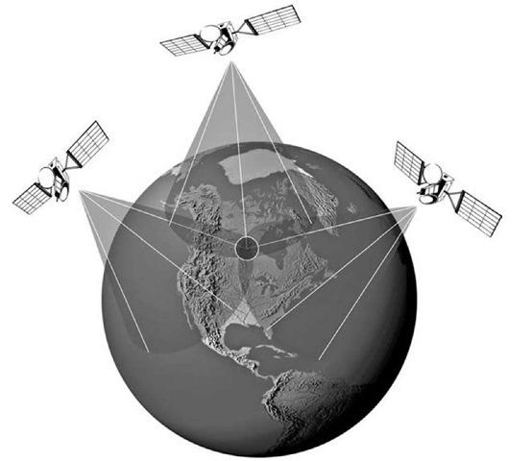

Figure 16: Global positioning system (Permission Pending) [64]

Global Positioning Systems was a United States government-based system that was originally created for military use by the Department for Defense (DoD) for satellite navigation. The modern system became fully operational in 1993 [19]. The system was constructed with at least 24 satellites at Medium Earth Orbit (MEO) at about 20,200 km (12,550 mi) above the Earth. The satellites were put in a total of 6 orbital planes, each were inclined 55° above the equator, with each satellite exactly 60° from the satellite in front of it and behind it on its orbital plane. Each of the satellites orbit the Earth once every 24 hours. The system was setup such that there were always satellites above every position on the globe in a way that the position can be determined from the satellites. [20] For proper communication a minimum of three satellites were needed for GPS triangulation shown above however it had been found that a fourth was typically needed for minor correction and accuracy.

The satellites were controlled by multiple land-based centers which ensure the satellites were in the right orbit, and functioning properly. Onboard the satellite, there were precise time circuits, called atomic clocks, which were necessary to determining the positioning of the user. This was necessary because there was actually a time differentiation between the clocks on the satellites and the time on Earth. This was because of the General and Special Theory of Relativity. These theories dictate since the gravity exerted on the satellites was less than that on the surface, the circuitry had appear to run faster than the same circuitry on the surface. The satellites send their position and time to the receiver on the ground. The signals were sent at the speed of light. Thus, when it gets to the receiver, the timestamp sent by the satellite and the actual time had been different. From this, the distance to the satellite can be determined. There needs to be three satellites to triangulate the position of the receiver in a two dimensional way, such as latitude and longitude. However, the satellite systems were set up such that there were always 4 satellites in line of sight of every position on the planet, this was called trilateration. With these four satellites, the receiver can determine the latitude, longitude, and altitude. [21]

Each satellite emits three basic types of data. They were constantly transmitting at least 2 low-power signals which included pseudorandom code, or the satellite’s identification. It also transmits what’s called ephemeris data which had the satellite’s position as well as the time and date that’s onboard the satellite. To help the receiver, the satellite also transmits almanac data which contains where each satellite’s orbital location at any time. GPS receivers were constructed of an antenna, and a chipset-based interface. The interface receives transmission signals from the GPS satellites through the antenna. These signals were then interpreted to determine the time it took to transmit the signal to receive the receiver. With this data, after a few iterations of the data being transmitted, the interface was able to determine the velocity and heading. [22]

4.4.1 GPS Specifications and Selection

Important characteristics for GPS modules for this application was acquisition sensitivity, or the strength level of the signal from the GPS satellites necessary in order to locate the module. Since the GPS module had to work in all areas a vehicle might be parked, the sensitivity had to be such that it can find the position of the vehicle inside of a parking garage, as well as in areas with tall buildings or trees that would affect the signal’s strength. In the same area, the module’s time to get its first fix was also important, a reasonable metric for comparing this was by means of comparing the number of channels on the module. The more channels, the possibility of lower fix times increases. The absolute minimum applicable number of channels was 12 to 14 channels [21, which would allow tracking but would take a relatively long time to lock.

With these comparisons in mind, a possible GPS module was the Maestro A2200-A, who had 48 channels, a time to first fix in a cold start being 35 seconds. Its acquisition sensitivity was on the higher spectrum of the modules that showed up during the search, with -163 dBm for tracking. Some other modules had as low as -143 dBm sensitivity for tracking. For cold start acquisition, the signal sensitivity was reduced to -148 dBm. Meaning the signal had to be stronger for it to be considered an acceptable level to track accurately. The warm start and cold start time to first fix was specified as being less than 35 seconds for each, with a hot start being less than one second. This module also passes the operating temperature test, with its operating range being between -40°C to 85°C, which, again, was higher than the maximum temperature with a 5% error margin. The physical size of the module was 14 mm x 10.2 mm x 2.5 mm.

An alternative option was the Antenova M2M RF module, which had a smaller footprint of 9mm x 9mm x 1.8 mm. The cold acquisition sensitivity was -148 dBm. After the first fix, when its “hot”, the sensitivity for acquisition was -163 dBm, with a tracking sensitivity of -165 dBm. This was directly comparable to the Maestro A2200-A, except the Antenova M2M actually outperforms in the sensitivity department on hot acquisition and tracking. As well, the Antenova M2M had a decisively faster hot time to first fix, with the cold start being similar with less than 35 seconds, but the warm start was less than 25 seconds, and the hot start was less than 1 second, same as the Maestro A2200-A. As such, the channel structure of the Antenova M2M was different than the Maestro A2200-A in that it isn’t one set number of channels, rather the Antenova M2M had 66 acquisition channels, and 22 tracking channels, versus the 48 channels of the A2200-A.

4.5 Wireless-Fidelity (Wi-Fi) Communication Research

As there had been a cloud-storage component of this system where the storage was located at a remote location to the vehicle or the owner’s home, thus internet access was necessary. Wi-Fi communication was one part of this connection, as the base option. The concept being that when the vehicle was parked at your home, it had connect to the internet and upload all of the data that needs to be put on the cloud. The standard for Wi-Fi communication was noted as 802.11, which was a reference to the Institute of Electrical and Electronics Engineers (IEEE) standard 802.11, which refers to a set of media access control (MAC) and physical layer (PHY) specifications which allows the implementation of wireless local area networks. [20] There were multiple different sub-standards such as 802.11 a, b, g, etc. which refer to different modulation standards. The wireless module must be capable of communicating utilizing the IEEE standard as well as being capable to host the wireless network hotspot. The wireless hotspot had produce a network capable of communication between multiple devices while implementing standard WPA2 security as discussed in the security section of this paper. The network needs to be capable of supporting and routing traffic between a minimum of two devices, preferably more to allow for numerous users per device at a singular point in time. Due to the high power consumption utilized by wireless devices, it had been required for the wireless chip to had power consumption minimized as best as possible; this was critical as the device needs to be powered on for long periods of time to be efficiently utilized as a security device.

Wi-Fi communication works by means of transmitting data over one of two specific frequencies. Those frequencies were 2.4 gigahertz (GHz), and 5 GHz. The specific frequency ranges for the 2.4 GHz bracket that were utilized were 2.412 GHz to 2.472 GHz. Wi-Fi routers had specific channels which allow higher transfer rates due to low air traffic, since all of the data was ideally being transmitted over the range of channels. The less data per channel, the more efficient the data transmission is. Wi-Fi routers that were in the 2.4 GHz range had 12 different channels, while the 5 GHz routers had about 30 channels. However, the amount of channels varies by country. [53]
There were numerous methods for access point integration amongst wireless module chips. One such methodology enables non routing devices into virtual routers through the use of software, this method was named software enabled access point. This requires implementation at the software level and thus was requires high level abstraction for utilization. Most devices implementing Soft AP were incapable of being a client as well as producing a WLAN, they require the device to receive their internet communications through other means. In this case that may be achieved through the cellular communications module. Soft Access point remains the most widely used integration for ad-hoc integration in non-routing devices, utilized in popular embedded controllers such as the ESP82666.
Another method for performing wireless communication between devices was the implementation of Wi-Fi direct. Wi-Fi direct enables devices to connect easily with each other through a singular channel without the implementation of a wireless access point; this was described as a single radio hop communication. The methodology can be equated to Bluetooth communications where a system for pairing must be implemented.

4.5.1 Wireless-Fidelity Communication Selection

As such, standards implementations do not need to be taken into consideration. Multiple companies produce system on chips (SoC) which require minimal external components to function and provide internet connection. Some of these modules even had an integrated antenna built in. For instance, the Microchip ATWINC15x0-MR210xB was an IEEE 802.11 b/g/n module. This unit was an all-in-one unit with an integrated antenna, crystal, and chipset. Its maximum data rate was 72.2 Mb/s. For communication, the receiving signal strength sensitivity was important, especially in the environment of a car, and at potential distances from the router source that would be subject to. As such, the maximum signal sensitivity was -95 dBm, this was for 802.11b modulation at 1 Mbps (megabits per second). To achieve the maximum data transfer rate, the signal’s strength must be -70.5 dBm or greater, this was under the 802.11n modulation range. Device size remains approximately 15 mm x 22 mm rounded up to provide minor padding for the device. The operating temperature range of this chip was within the necessary range, with the range being -40°C to 85°C. The interface for this unit involves serial peripheral interface (SPI) and universal asynchronous receiver-transmitter (UART). Support for Wi-Fi direct and Soft access point were both available with implementation of all IEEE security standards such as WPA2. As well as fast boot features to enable to the device to reduce the time to live, which provides huge benefits for potential power saving by allowing the network to go done during non-crucial periods.

An alternative choice was the Silicon Labs WGM110 Wizard Gecko, which also had a built in integrated antenna. Much like the ATWINC150x-MR210xB, it was set up to modulate by means of IEEE 802.11 b/g/n. The maximum data transfer was also 72.2 Mb/s. However, the Wizard Gecko had a maximum sensitivity rating of -98 dBm, which means it’s more capable of transmitting at farther ranges, or under more harsh circumstances, when in comparison to the ATWINC150x-MR210xB. The interface capability of the Wizard Gecko includes SPI, UART, in addition to USB, and Inter-Integrated Circuit (I2C). Thus, the Wizard Gecko was capable of a more varied interfacing environment. Wireless for the device implements all required features for the product such as Soft AP as well as station mode (STA). Wireless security features were already implemented on the communication methods allowing for communication over WPA2 as required by our security guidelines. Device size similar to the ATWINC15x0-MR210xB, at 14.4 x 21.00 mm thus it was a slightly smaller profile than the ATWIN module. The operating temperature range was also from 40°C to 85°C.

Product Name | IEEE 802.11 Modulation Channels | Maximum Transfer Speed | Maximum Sensitivity | Interface Communication Protocol
Microchip ATWINC15x0-MR210xB | b/g/n | 72.2 Mbps | -95 dBm | SPI & UART
Silicon Labs WGM110 Wizard Gecko | b/g/n | 72.2 Mbps | -98 dBm | SPI, UART, & I2C
Texas Instruments CC3120MODRNMMOBR | b/g/n | 72.2 Mbps | -95 dBm | SPI, UART, & I2C

Table 5: Wireless Chip Comparisons

4.6 Cellular Research

Code Division Multiple Access (CDMA) was a way of multiplexing numerous signals within a single transmission channel. This process of delving up the channel allows maximum use of the available bandwidth within the communication frequency. This was mainly used in cellular phone communication. By multiplexing the signals this allows the signals to not distort or cause interference for other signals in the channel. This process takes more processing power than GSM, and focuses on the use of what’s called pseudo-noise (pn) codes to decode a combined message into its individual message. The pn code used to decode the signal was hardwired into the device. By using these pn codes many messages can be retrieved out of one massive message. The frequency used was in the ultra-high-frequency (UHF) range, which consists of frequencies from 800 MHz up to 1.9 GHz. Nominally, CDMA was 1.23 MHz wide, in which all mobile data transmission occurs in. Currently, the most commonly used CDMA protocol was the third generation, or 3G, and fourth generation, or 4G. [40] However, there was currently a fifth generation (5G) under works. This generation might be implemented in this system, if possible. A slight disadvantage of using CDMA was channel pollution or simply put to many users trying to access the the communication network. However, it was believed that this problem was highly unlikely unless due to an urgent widespread crisis arising. Another problem with CDMA was the lack of internationality. This means that international support of CDMA had been lacking, but was currently being phased out of countries outside the United States. Sprint stopped covering roaming CDMA users in countries outside the US in 2016. Understanding these key facts CDMA had been chosen for boards that function within the United States only.

Global System for Mobile (GSM) communication was another mobile telephone communication protocol, which was more common in Europe but was supported through a global marketplace unlike CDMA. It’s a variation of Time Division Multiple Access (TDMA). GSM converts all data into digital format, then sends it down a channel alongside two other data streams. The purpose of sending the data through time division was that all the data gets sent essentially in a line, but each receiver knows what time to take each message from the line allowing multiple inputs to be sent as long as the time was known. The frequency that GSM operates in was very similar to the Ultra-High Frequency (UHF) range that CDMA utilizes, however GSM’s operates typically within two specific frequency bands: Either 900 MHz, or 1800 MHz. [41] GSM requires a SIM card in order to connect to the correct network, they were utilized as an onboard memory device to provide the data plan, contact information and subscriber identity. This of course becomes an added cost to the production of a device implementing GSM based technology, but was essentially the only realizable choice for the SSDC use outside the United States.
Long Term Evolution (LTE) bases itself off of GSM. The protocol was a data only protocol, not allowing for voice; which in the case of this application was appropriate. The utilization of a SIM card was required in order for the device to know which networks it may communicate with. The protocol differs in implementation from GSM as opposed to time division multiple access the protocol utilizes frequency switching or orthogonal frequency division multiplexing (OFDM).

4.6.1 CDMA Module Selection

Sierra Wireless offered a product called MC7455, which was a Long-Term Evolution (LTE) module that supports the latest generations of CDMA communication, those generations being third generation (3G) and fourth generation (4G). The rated maximum uplink speed was 50 Mbps, and a rated maximum downlink speed of 300 Mbps. The MC7455 was certified with multiple carriers, such as AT&T, Verizon, Sprint, Vodafone and others that could be utilized in North America. There was driver support for Android and Linux, thus could be run off of any processor that would be utilized for this project. Since temperature range was important for this application, it’s important to note that the extended operating temperature range of the MC7455 was from -40°C to +85°C, which was finely suited to the environments in a vehicle. An added bonus to this module was that there was a GPS module located on the chipset. The CDMA chip had had the most reliable coverage throughout the United States but it had had no coverage anywhere else in the world. However, these features come at a price which exceeds that of other GSM options.

4.6.2 GSM Module Selection

The company Adafruit offered a breakout board with all of the modules necessary for GSM cellular connection. This board, known as the Adafruit FONA (product ID 1946) had quad-band connection capabilities with the ranges 850, 900, 1800, and 1900 MHz which can connect to any global GSM network with any second generation (2G) SIM card. Onboard the breakout board was a uFL connector to attach an external antenna. The interface utilizes auto baud detection, to ensure the proper baud rate was used when attempting to transmit data, voice, or text. However, the application would only utilize the data connection. Onboard this breakout board was a LiPoly battery charger circuit. There were also voltage level shifting elements that allow the board to run with any voltage from 2.8v to 5V logic levels. Then, of course, was a standard SIM card slot on the reverse of the board to allow the system to have all of the connection information and data plan necessary. The processing necessary just requires any processor that utilizes 3 to 5 volts and can communicate via universal asynchronous receiver-transmitter (UART) protocols. The subsystem on this breakout board also contains a GPS module, which had a -165 dBm tracking sensitivity.

Adafruit also offered a product called SIM808, which was nearly identical to the FONA in that its an all-in-one unit that had quad-band connection capability. The same 850, 900, 1800, and 1900 MHz range as the FONA. The SIM808 similarly works with any 2G SIM card, and had a fully integrated MT3336 GPS chipset with -165 dBm tracking sensitivity, much like the FONA. In many ways, it was identical to the FONA except in its form. The FONA had a SIM808 at its core, with different connections and auxiliary circuitry to allow it to be a breakout board. The SIM808 was bare-bones and requires any external circuitry to be added, such as an antenna connection, SIM card holder, battery charger and battery port, headphone connection, and other circuitry that might be superfluous to the application.

The development boards available for use were mostly 2G models. The cell chipset needs to had the capability of 4G using the CDMA technology for video data transfer. The GSM technology had been used for international purposes. The CDMA technology was usually cheaper. The GSM technology was more expensive but can adapt globally to all cell carriers with the correct frequency tuning. The device had need to compress and send video data to the cloud and to the user's phone. The device had use a 4G chip. The 4G chip had been selected based on how readily available the chips are, the chip samples, and datasheets provided. A development board for the 4G cellular chip may had to be constructed using Eagle in order to complete the breadboard prototype design of the PCB. The development board may also be purchased from the chip manufacturer. These development boards range from $200-$600 depending on brand and capability.

Product Name | Communication Standard | Generation Support | Frequency Range | Interface Communication Protocol | GPS
Adafruit FONA | GSM | 2G | 850, 900, 1800, 1900 MHz | UART | Yes
Adafruit SIM808 | GSM | 2G | 850, 900, 1800, 1900 MHz | UART | Yes
Sierra Wireless MC7455 | CDMA | 3G & 4G | LTE | Linux & Android | Yes

Table 6: Cellular Chip Comparison

4.7 Camera Research

Digital video and photography was done in a novel way, in comparison to film video and photography. In digital photography, rather than a strip of light-sensitive film, a solid-state module was used to capture the light required for a digital image. The most basic form of digital photography was a light sensor, which had change the signal based on the intensity of light. High resolution digital photography was very similar to that process. However, for high resolution photography, there were a large array of various light sensors arranged onto a wafer. This was called an image sensor. During the manufacturing process of the sensor, wells were created in a silicon wafer which house light sensitive elements, these wells with light sensitive parts were called pixels. Image sensors can range in having only a few pixels on the sensor, such as a 400 pixel by 400 pixel low-resolution image sensor, upwards to 16 or more megapixels (16,000,000 or more).

The output of this sensor was continuous, as the image sensor was an analog device. As such, in order for the sensor to act properly with a digital processor and digital circuits, it must be converted and handled in such a way to convert the continuous analog output to a form that can be understood by the processor. This was done by dedicating each pixel to a unique number so the processor can articulate the image in a meaningful way. Since each pixel can only determine the brightness of a color, filters were placed over each pixel so that it only reacts to a specific range of colors. These colors were red, green, and blue. A colorless sensor can also exist without these filters, however. However, for this application a color sensor was to be used. Because there were now three colored pixels, the processor needs to assemble the pixels in a way that would be actually representative of the real-world view. This was done by a process known as demosaicing, where the processor combines the three pixels for a given area, and collects all of the different pixels into a single image, where a pixel in the final image was actually an amalgam of the results from the red pixel, the green pixel, and the blue pixel of a given area. [42] Thus, an image was made by the reflection of light off of an object or person with unique light wells that produces a pixel representation of that image. The most basic image was the output of a simple light sensor, which could be representative of a single grayscale pixel of the image. The more pixels that were able to acquire reflected light, the better the representation of the image is. This was called resolution. Resolution was most commonly given in the form of width of pixels then the height of pixels. Such as, “1920x1080” refers to a resolution that was 1,920 pixels wide, and 1080 pixels high.

The light that interacts with the camera sensor can be focused using a lens. Without a lens, the light that’s incident with the visual sensor was too plentiful for the sensor to work properly. As such, a photograph or video taken without a lens was out of focus and otherwise unusable. This was because what’s known as the focal length was set at infinity. This causes the pictures to be unfocused. Also, the aperture was set to infinity, causing too much light to hit the sensor. This causes the image to lose the contrast in the image, leading it to become washed out. Thus, a lens must be fitted to the digital image sensor to allow the sensor to function as necessary. [43]

In regards to still images, the digital image sensor typically reacts with the incident light over a period of time. This period of time was called shutter speed. Some digital image sensors were able to achieve speeds up to 1/8000th of a second and faster in high-end digital single-lens reflex cameras (DSLR). This effective shutter speed had determine how blurry a moving object or person was when taking both a picture and a video. However, a higher shutter speed was also associated with having better low-light sensitivity. This was because the light well that’s associated with collecting photons for each pixel was able to collect more light for each image. This means that the light reflecting off a moving object or person might interact with the specific light sensor more than once for a given image, or frame. [50]

Video, for all intents and purposes, was a stream of contiguous images that were shown in such a way that there was a representation of what was in front of the image sensor. The number of images that can be used can vary greatly. It can be as extreme as one image every 5 seconds or more, down to over 120 pictures every second. In video, the name of each image was known as a frame. So, the frame rate was typically in the form of frames per second (fps). The higher the frames per second, the smoother the video appears. [51] The average human mainly perceives movement in the range of 7 and 13 fps. However, higher frame rates increase the sensitivity to movement, but at an exponentially lower rate. [52] It appears that 30 frames per second was a good baseline for clear videos. However, 60 frames per second were objectively better, and would result in a smoother perceived image.

4.7.1 Camera Sensor Research

A proper camera sensor must be adequately chosen such that there’s a maximization and balance between performance and resource allocation. However, resolution was necessary to properly identify people, things, or vehicles that would be of importance. There were two main forms of camera sensors. One was named charged couple device (CCD), and the other was called complementary metal oxide semiconductor (CMOS). Both types of sensors work the same way, by converting light energy to a signal. For CCD, the voltage created by the light incident with the sensor was channeled out through a small number of output channels, and sent to an external controller or processing circuit as an analog signal. Since this system was basically a uniform input-output system, the entire area can be devoted for the light hitting the pixel causing a general uniformity to the image, increasing the image’s quality. The analog output acts as a bandwidth bottleneck so processing speed was limited.

The CMOS sensors work in a different way in that they don’t output an analog signal. In fact, the CMOS sensors function by means of processing at a pixel level. Each pixel had integrated components such as charge-to-voltage converters, amplifiers, noise correction circuitry, and digitizing circuitry. Thus, the sensor had a digital output, versus the CCD’s analog output. The benefit of this was that it allows for a massively parallel system, which utilizes a large amount of bandwidth. However, the disadvantage of this CMOS system was that a much smaller area of each pixel can be dedicated to light capture. Since there was less physical area where light can interact with the sensor, the uniformity of the image, in terms of quality, was reduced somewhat greatly. [44]

4.7.2 Camera Lens Research

The lens can set the focal length, aperture, and effectively the range of view. The shorter the focal length, the wider the view is. This would be beneficial to the application at hand as with the increase in number of cameras would increase the burden on not only the visual subsystem, but all other supporting subsystems. Since the goal was to use 2 cameras, a wide angle lens must be used to get the most range of view as possible. The ideal field of view (FOV) was 180°. However, a true 180° lens was technically impossible. There were quite a few CMOS cameras that were fitted with wide angle lenses, such as 160°, and 170°. However, some lenses were rated for an angle that the lens cannot reasonable produce. [45]

4.7.3 Camera Sensor Selection

The goal of camera selection should be a resolution of no less than 786 pixels by 494 pixels. Many CMOS camera sensors were labeled using security camera nomenclature. The security cameras were described by something called TV lines (TVL). TVL naming methods equate to half of the number of black vertical lines, and half white vertical lines. An example of this was an instance of 400 TVL, this equates to 200 alternating dark vertical lines and 200 light vertical lines. The following table, which was extracted from a website, shows the comparison between TVL and NTSC resolutions. [46]

Device | TVL/Pixel | Effective Pixel NTSC | Effective Pixel PAL | Total NTSC | Total PAL
Analog SONYCCD | 480TVL | 510H*492V | 500H*582V | ~0.25 megAPIxel | ~0.29 megAPIxel
Analog SONYCCD | 600TVL | 786H*494V | 752H*582V | ~0.38 megAPIxel | ~0.43 megAPIxel
Analog SONYCCD | 700TVL | 976H*494V | 967H*582V | ~0.48 megAPIxel | ~0.56 megAPIxel
Analog SONY CMOS | 1000TVL | 1280H*720V |  | ~0.92 megAPIxel

Table 7: TVL to NTSC Pixel Conversion Chart (Permission Pending) [46]

From the above table, it was clear the TVL-minimum for this application was the 600TVL. Due to it meeting the numerous restraints and concerns required for the quality of our device. The issue being the production value of the device and closed source mindset behind the suppliers technologies.

Product Name | Resolution | Lens | Operating Temperature Range
Wide Angle Mini FPV - HobbyKing SKU: 640000002-0 | 700TVL | 160° Horizontal, 127° Diagonal,  2.6 mm | -20°C - +70°C
KrazePony Wide Angle FPV for QAV240-Multicopter (AZ) | 1000TVL | 120°  3.6 mm | -20°C - +60°C
VIDEOTORG Mini FPV for Quadcopter QAV250 (AZ) | 1000TVL | 120°  2.8 mm | -10°C - +50°C
CrazePony FPV Camera 1.2G (AZ) | 1000TVL | 170°  2.8 mm | -10°C - +50°C
OmniVision OVP0921-B44G (Digikey) | 1280x720 NTSC | N/A | +10°C - +70°C

Table 8: Camera Lens Comparison

4.8 Storage

The storage of the device had been in the form of a micro SD card. Connected to the PCBs via a micro SD push port. Considering that the SSDC had been recording at a constant 1080p there had to be enough space to hold enough footage until the SSDC re-enters either Wi-Fi or Cellular range. With this in consideration an SD storage card of 256GB was chosen to meet the storage needs of the SSDC. The size of 256GB for the SD card was chosen because this value equates to around 53 hours of 1080p recording time for a single camera. With two cameras this SD card had last for approximately one full day of recording, and the average user was not expected to drive continuously to fill up these hours. Also in correspondence with the law an individual was not allowed to drive more than 10 hours in a single instance. Also this amount of time for recording was chosen so that the user would not had to worry about running out of recording space on the device.

The connection of the micro SD card to board had been established through the use of a micro SD card connector. To connect these two to allow for communication the connector datasheet had to be pulled up then the data pins on the layout had to be connected to the Microcontroller. For the voltage inputs SD cards and ports require a very precise voltage current, so a voltage divider was not a recommended choice or the user could corrupt the data or even damage the card. To achieve a very stable input voltage a level shifter for a stable input vcc. Following the other pins of the sd connector of ground and clk the SD card had been connected to the microcontroller. Also it was recommended to check the sizes of allowance for both the SD card connector and the actual SD card so that it was guaranteed that the two were compatible.

4.9 Power Management Research

The main power source for the components was going to be the car’s battery, which was nominally 12 volts. However, as the car sits, starts, and runs, the voltage on the battery had change. The principle issue was that there had been a few different voltages that need to be held constant in order for all of the various components to work harmoniously. A car’s battery must be above 12.4 voltage to be able to operate the car and turn the engine on. While the vehicle was operating, the charging voltage, or the voltage that’s present on the connection posts of the battery was nominally in the range of 14.2 volts to 14.5 volts [23]. Voltage ranges applicable for this system includes 5 volts, 3.6 volts, and 3.3 volts. There were various ways in which these voltages can be achieved.

4.9.1 Methodologies of Power Supply

One way to reach these voltages were by using basic voltage regulators, such as the Thomson Microelectronics TEA7605, which was a 5 volt regulator. The benefits of this method were that it’s simple to produce, and the output was within a range of ±4%, which means it had a drift range of 0.4 volts from the median. This would put the output voltage within the range of acceptable levels for almost every module that would be used. However, the method in which this regulator works was by turning the excess voltage into heat energy. Which would heat up the entire system that would be inside of the case with this regulator. Further, this method was very wasteful, and thus would lower the max idle time the unit could run with the vehicle off.

An alternative method to this was a step-down converter, or a buck converter. Buck converters were DC-to-DC power converters which step down a higher voltage to a lower one. One side effect of this was to increase the total current of the system. Buck converters work by means of switching a circuit that includes an inductor, capacitor, and diodes, on and off. The interaction with these components creates a voltage step-down and current step-up based on the various values of each component. The downside of this was the possibility that the energy which was stored in the inductor could affect the communications of other on-board modules with its expanding and contracting magnetic field. [24]

4.9.2 Power Supply Part Selection

The SSDC had been supplied power from the battery of the vehicle in which it resides. This had require having someone properly install the SSDC or having the proper knowledge to do it alone. Since the power comes from the car battery voltage regulator had been used to adjust the voltage to a usable level.

4.10 Microcontroller

Microcontroller was a single chip microcomputer made through VLSI fabrication. A microcontroller also called an embedded controller because the microcontroller and its support circuits were often built into, or embedded in, the devices they control. A microcontroller was available in different word lengths like microprocessors (4 bit, 8 bit, 16 bit, 32 bit, 64 bit and 128 bit microcontrollers were available today). [61] A microcontroller functions as a computer as it had several things in common:

- All computers had a CPU (central processing unit) that executes programs. If a user was sitting at a desktop computer right now, the CPU in that machine was executing a program that implements the Web browser that was displaying this page. [59]

- The CPU loads the program from somewhere. On a user’s desktop machine, the browser program was loaded from the hard disk. [59]

- The computer had some RAM (random-access memory) where it can store "variables." [59]

- And the computer had some input and output devices so it can talk to users. On a user’s desktop machine, the keyboard and mouse were input devices and the monitor and printer were output devices. A hard disk was an I/O device -- it handles both input and output. [59]

Microcontrollers were embedded into devices to control the features and functions of products. Most of these products were consumer products, which was why microcontrollers they were popular in usage for electronic devices in modern society. Devices that were used to measure, store, control, calculate, or display any information usually contain a microcontroller. The largest single use for microcontrollers was in automobile industry (microcontrollers widely used for controlling engines and power controls in automobiles). Consumers can also find microcontrollers inside keyboards, mice, modems, printers, and other peripherals. In tested equipment, microcontrollers make it easy to add features such as the ability to store measurements, to create and store user routines, and to display messages and waveforms. Consumer products that use microcontrollers included digital camcorders, optical players, LCD/LED display units, etc. [61]

In comparison to a desktop computer, which was a “general purpose computer” that can run thousands of programs, the microcontrollers were “special purpose computers.” [59] These characteristics define a microcontroller and even a computer as a “special purpose computer”:
- Microcontrollers were "embedded" inside some other device (often a consumer product) so that they can control the features or actions of the product. Another name for a microcontroller, therefore, was "embedded controller." [59] For the case of this project, the microcontroller had been used in an embedded device as a part of the team’s SSDC, a security camera that had been used to detect and record car theft and car damage. This product also acts as a consumer product as appropriate for this project.

- Microcontrollers were dedicated to one task and run one specific program. The program was stored in ROM (read-only memory) and generally does not change. [59] ROM was generally nonvolatile memory, which means that the data was retained and be retrieved in the storage when there was a break in the voltage supply or the power was turned off compared to RAM, which was generally volatile memory, which requires voltage and a power supply to store and retain data.

When designing the SSDC device around the microcontroller’s ROM, it should only contain programs and data that do not generally change. However, while the SSDC design does contain a lot of components, the ROM should be kept at a minimum as some ROM had not be needed unless using a thousand parts for the design, and can be potentially useless. A good amount of RAM would be needed for the SSDC device had a lot of data from multiple “variables” had been collected and recorded from the SSDC device to detect car theft and car damage.

- Microcontrollers were often low-power devices. A desktop computer was almost always plugged into a wall socket and might consume 50 watts of electricity. A battery-operated microcontroller might consume 50 mW. [59]

This was essential as the SSDC device had require multiple components with a minimum amount of power used as possible as the device had been powered by the car’s power supply. It would be inconvenient for the user to had the device use the car’s power while the device was active and the car was not and waste the car’s power, so the power consumption for the device should be kept at a minimum.

- A microcontroller had a dedicated input device and often (but not always) had a small LED or LCD display for output. A microcontroller also takes input from the device it was controlling and controls the device by sending signals to different components in the device.

For example, the microcontroller inside a TV takes input from the remote control and displays output on the TV screen. The controller controls the channel selector, the speaker system and certain adjustments on the picture tube electronics such as tint and brightness. The engine controller in a car takes input from sensors such as the oxygen and knock sensors and controls things like fuel mix and spark plug timing. A microwave oven controller takes input from a keypad, displays output on an LCD display and controls a relay that turns the microwave generator on and off. [59]

The SSDC device had taken inputs from the mobile application by the user to the user’s device and accelerometer, gyrometer, and magnetometer data to detect car theft and car damage, while the device had output notifications, recorded footage, and images, of the instance of car theft and car damage.

- A microcontroller was often small and low cost. The components were chosen to minimize size and to be as inexpensive as possible. [59] The design of the SSDC device had generally choose the essential components that had meet the requirement specifications while also being at a minimum low cost.

This was to prevent the device from being too costly as there were multiple components needed for the SSDC device. Using a microcontroller was also beneficial for its size as the SSDC device had had to be small enough to meet the project’s standards and requirements as the device had been place behind a rear-view mirror.

- A microcontroller was often, but not always, ruggedized in some way. The microcontroller controlling a car's engine, for example, had to work in temperature extremes that a normal computer generally cannot handle. A car's microcontroller in Alaska had to work fine in -30 degrees Fahrenheit (-34 degrees Celsius) weather, while the same microcontroller in Nevada might be operating at 120 degrees Fahrenheit (49 degrees Celsius). When the user add the heat naturally generated by the engine, the temperature can go as high as 150 or 180 degrees Fahrenheit (65-80 degrees Celsius) in the engine compartment. On the other hand, a microcontroller embedded inside a VCR hadn't been ruggedized at all. [59]

This was relevant to the SSDC device as the microcontroller had need to be functional and operate to meet the requirements and be able to record data during extreme temperatures. There had need to be selection of a proper microcontroller to meet the expected temperatures inside a car in order to be functional.

4.10.1 Microcontroller Components

The microcontroller contains multiple components within its structure: Central processing unit (CPU), Random Access Memory (RAM), Read Only Memory (ROM), Input/output ports, timers and counters, interrupts controls, etc. The microcontroller consists of features that were required for a computing system and functions just similarly to a computer, excluding any external digital parts inside it. A user was able to program the pins on the microcontroller chip, which had been used in the SSDC device’s design as inputs and outputs to collect data and create responses. The microcontroller had many bit handling instructions that can be easily understood by programmers, was capable of handling Boolean functions, had high speed and performance, had an on-chip ROM structure inside of it to provide better firmware security, and was easy to design at a low price and small size. [61]

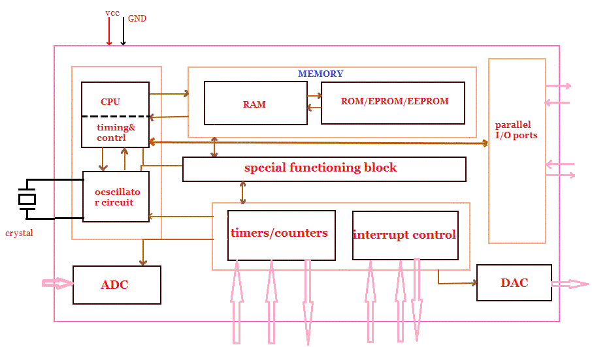

Figure 17: Microcontroller Structure and Components (Permission Pending) [61]

The figure above shows the structure and a diagram of the microcontroller that includes these components:

- CPU (Central Processing Unit) - was the brain of a microcontroller. CPU was responsible for fetching the instruction, decodes it, and then finally executed. This component was also known as the processor, hence why it was where the calculations and instructions take place. CPU connects every part of a microcontroller into a single system. The primary function of CPU was fetching and decoding instructions. Instruction fetched from program memory must be decoded by the CPU. [61]

CPUs were included as an internal component in all computers, as well as microcontrollers, and microprocessors. There were two components of the CPU itself, which was the ALU (Arithmetic Logic Unit) and the CU (Control Unit). The ALU was responsible for performing any arithmetic and logical operations, while the CU extracts instructions from the memory and decodes and executes them, and also calls the ALU if necessary.

- Memory - The function of memory in a microcontroller was same as microprocessor. It was used to store data and program. A microcontroller usually had a certain amount of RAM and ROM (EEPROM, EPROM, etc.) or flash memories for storing program source codes. [61] There were different types of memory when using microcontrollers and in embedded systems:

- RAM (Random Access Memory) - RAM was a type of computer memory that was accessed randomly, which means the memory was accessed without interacting with preceding bytes. RAM memory was volatile, which means that it was dependent on the power supply of the device to retain data and memory.

The RAM family includes two important memory devices: static RAM (SRAM) and dynamic RAM (DRAM). The primary difference between them was the lifetime of the data they store. SRAM retains its contents as long as electrical power was applied to the chip. If the power was turned off or lost temporarily, its contents had been lost forever. DRAM, on the other hand, had an extremely short data lifetime-typically about four milliseconds. This was true even when power was applied constantly. Many embedded systems included both types: a small block of SRAM (a few kilobytes) along a critical data path and a much larger block of DRAM (perhaps even Megabytes) for everything else.[63]

SRAM was used for the device’s system cache and does not need its memory to be refreshed as it retains the data depending on the device’s power supply and loses its data once the power supply was turned off or experience a break in power. SRAM devices offered extremely fast access times (approximately four times faster than DRAM) but were much more expensive to produce. Generally, SRAM was used only where access speed was extremely important.

DRAM was used for main memory in computing devices, such as PCs and smartphones, and this memory needs to be constantly refreshed in order to retain data, hence why the data had an extremely short lifespan. The job of the DRAM controller was to periodically refresh the data stored in the DRAM. By refreshing the data before it expires, the contents of memory can be kept alive for as long as they were needed. A lower cost-per-byte makes DRAM attractive whenever large amounts of RAM were required. [63]

- ROM (Read Only Memory) - ROM was a type of computer memory that cannot be removed or changed from the device it was placed in and can only be read. Unlike RAM, ROM was nonvolatile, which means the data and memory was retained even when the power supply was turned off. Most PCs and personal mobile devices contain only a small amount of ROM to execute essential programs for booting the system and was common in calculators and peripheral devices. There were two types of ROM available: PROM and EPROM.

One step up from the masked ROM was the PROM (programmable ROM), which was purchased in an unprogrammed state. If the user were to look at the contents of an unprogrammed PROM, the user would see that the data was made up entirely of 1's. The process of writing your data to the PROM involves a special piece of equipment called a device programmer. The device programmer writes data to the device one word at a time by applying an electrical charge to the input pins of the chip. Once a PROM had been programmed in this way, its contents can never be changed. If the code or data stored in the PROM must be changed, the current device must be discarded. As a result, PROMs were also known as one-time programmable (OTP) devices. [63]

An EPROM (erasable-and-programmable ROM) was programmed in exactly the same manner as a PROM. However, EPROMs can be erased and reprogrammed repeatedly. To erase an EPROM, the user simply expose the device to a strong source of ultraviolet light. (A window in the top of the device allows the light to reach the silicon.) By doing this, the user essentially reset the entire chip to its initial--unprogrammed--state. Though more expensive than PROMs, their ability to be reprogrammed makes EPROMs an essential part of the software development and testing process. [63]

- Hybrid Memory - As memory technology had matured in recent years, the line between RAM and ROM had blurred. Now, several types of memory combine features of both. These devices do not belong to either group and can be collectively referred to as hybrid memory devices. Hybrid memories can be read and written as desired, like RAM, but maintain their contents without electrical power, just like ROM. Two of the hybrid devices, EEPROM and flash, were descendants of ROM devices. These were typically used to store code. The third hybrid, NVRAM, was a modified version of SRAM. NVRAM usually holds persistent data. [63]

EEPROMs were electrically-erasable-and-programmable. Internally, they were similar to EPROMs, but the erase operation was accomplished electrically, rather than by exposure to ultraviolet light. Any byte within an EEPROM may be erased and rewritten. Once written, the new data had remain in the device forever--or at least until it was electrically erased. The primary tradeoff for this improved functionality was higher cost, though write cycles were also significantly longer than writes to a RAM. So the user wouldn't want to use an EEPROM for your main system memory. [63]

Flash memory combines the best features of the memory devices described thus far. Flash memory devices were high density, low cost, nonvolatile, fast (to read, but not to write), and were electrically reprogrammable. These advantages were overwhelming and, as a direct result, the use of flash memory had increased dramatically in embedded systems. From a software viewpoint, flash and EEPROM technologies were very similar. The major difference was that flash devices can only be erased one sector at a time, not byte-by-byte. Typical sector sizes were in the range 256 bytes to 16KB. Despite this disadvantage, flash was much more popular than EEPROM and was rapidly displacing many of the ROM devices as well. [63]

The third member of the hybrid memory class was NVRAM (non-volatile RAM). Non-volatile memory was also a characteristic of the ROM and hybrid memories discussed previously. However, an NVRAM was physically very different from those devices. An NVRAM was usually just an SRAM with a battery backup. When the power was turned on, the NVRAM operates just like any other SRAM. When the power was turned off, the NVRAM draws just enough power from the battery to retain its data. NVRAM was fairly common in embedded systems. However, it was expensive--even more expensive than SRAM, because of the battery--so its applications were typically limited to the storage of a few hundred bytes of system-critical information that can't be stored in any better way. [63]

- Parallel input/output ports - Parallel input/output ports were mainly used to drive/interface various devices such as LCD’S, LED’S, printers, memories, etc. to a microcontroller. [61]

- Serial ports - Serial ports provide various serial interfaces between microcontroller and other peripherals like parallel ports. [61]

- Timers/counters - This was the one of the useful function of a microcontroller. A microcontroller may had more than one timer and counters. The timers and counters provide all timing and counting functions inside the microcontroller. The major operations of this section were perform clock functions, modulations, pulse generations, frequency measuring, making oscillations, etc. This also can be used for counting external pulses. [61] Timers and counters had been used during recording and taking images during car theft and car damage during the instance. It could be used to record the time of the incident and take a number images in time intervals.

- Analog to Digital Converter (ADC) - ADC converters were used for converting the analog signal to digital form. The input signal in this converter should be in analog form (e.g. sensor output) and the output from this unit was in digital form. The digital output can be use for various digital applications (e.g. measurement devices). [61]

- Digital to Analog Converter (DAC) - DAC perform reversal operation of ADC conversion. DAC convert the digital signal into analog format. It usually used for controlling analog devices like DC motors, various drives, etc. [61]

- Interrupt control - The interrupt control used for providing interrupt (delay) for a working program .The interrupt may be external (activated by using interrupt pin) or internal (by using interrupt instruction during programming). [61]

The SSDC device had constant detect the user’s vehicle’s motion from the accelerometer, gyrometer, and magnetometer. The data received from these components had constantly be monitored, until an instance of car theft or car damage was detected, which had trigger the device. Multiple interrupts and if conditions had been made to filter out any false positives and only detect a proper instance of car theft and car damage. These interrupts had also be used to send notifications, recorded footage, and images to the user’s mobile application. However, the interrupts must be coded correctly to prevent polling in the case of nested interrupts or repeated execution of instructions in the interrupts with no breaks from the interrupts.

- Special functioning block - Some microcontrollers used only for some special applications (e.g. space systems and robotics) these controllers containing additional ports to perform such special operations. This considered as special functioning block. [61]

4.10.2 Microcontroller Advantages and Disadvantages

Advantages of Microcontrollers

- Flexibility - Microcontrollers were special types of processor chips that were very small and somewhat flexible, due to their programmable nature. [62] The microcontroller acts as a microcomputer without any of a computer’s digital parts [61]

- Faster Speed of Execution - Since microcontrollers were fully integrated inside the processor, i.e., a “computer on a chip,” these devices operate at faster speeds to execute instructions compared to general purpose microprocessors. [62] Low time was required for performing operations. [61]

- Inexpensive - As microcontrollers were fully integrated onto one chip, these devices were cheap to manufacture. Usually, microcontrollers had much lower specifications than lower specifications than low-power consumer-grade general-purpose microprocessors, making them even easier to mass produce. [62] As the higher integration inside microcontroller reduce cost and size of the system. [61]

- Rigid - Once microcontrollers were programmed, typically they cannot be reprogrammed, if microcontrollers were controlled by Read-Only Memory (ROM) only rather than Random Access Memory (RAM). [62] ROM had the data retained even without the power supply as it was nonvolatile memory, but contains programs that cannot be changed.The additional RAM, ROM, and I/O ports can be easily interfaced [61]

- Labor Saving - Many tasks can be performed by microcontrollers repetitively and human efforts can be saved. The programmable nature of these devices also allows manufacturing robots to reproduce these motions very quickly and consistently, increasing productivity. [62] The usage of the microcontroller was simple and it was easy for troubleshooting and system maintaining. [61]

- Applications - Microcontrollers were widely used in modern electronics equipment, such as industrial and household applications which includes measuring physical quantities in pressure, force, velocity, acceleration, etc., measure metrics of circuits in voltage, current, phase angle, power factor, frequency, resistance power, energy, etc., robotics, biomedical instruments, peripheral controller in a PC, automobile applications, motor controls, household applications such as washing machines, light controls, cameras, TV, etc., and office equipment such as photocopying machines, telephones, fax machines, printers, security system, etc. [61]

Disadvantages of Microcontrollers

- Complex Architecture - Microcontrollers had more complex architecture than microprocessors. Therefore, understanding their functionality was quite difficult. [62]

- Development Time - Due to complexity to the circuit board, the development time of a microcontroller increases and cost increases. [62]

- Limitations - Microcontrollers can only perform limited number executed instructions simultaneously. Microcontrollers were also used mostly in small devices and cannot interface high power devices directly. [61]

4.10.3 Atmel Microcontrollers

Atmel microcontrollers was an example of a leading corporation and manufacturer in the development of microcontrollers. The microcontrollers provided features that were useful for the SSDC device’s design and meet the purpose of the device. (Note: The use Atmel microcontrollers was not final, but had been used as a reference to meet the specification requirements for the microcontroller inside the SSDC device).

Today's mobile products continue to change the way people consume information, socialize, conduct business, and buy products. Meeting the needs of increasingly mobile consumers now requires solutions that offer:

- Support for intuitive touchscreen interfaces [60]

- Efficient power management [60]

- Fast response time for nimble operation [60]

- Highly integrated designs for small footprints and minimal bill-of-materials (BOM) costs [60]

- Secure hardware-based authentication of accessories [60]

Atmel microcontrollers provide extensive mobility with touch, power, and security. The microcontroller electronics that the SSDC device was considered with Atmel were its cameras and GPS tracking.

- Cameras - Combine the best picture taking with exceptional speed and minimal power consumption. The broad family of Atmel ARM®-based microcontrollers integrate all the functions required to implement digital cameras on a single-chip.

This includes capturing, processing, compressing, displaying, and storing images in Flash memory cards, as well as controlling camera functionality through the use of an integrated processor. In addition, the Atmel ATSHA204 CryptoAuthentication IC authentication chip family was the only battery authentication IC that uses a SHA-256 cryptographic engine and a 256-bit key to protect cameras from counterfeit accessories, such as battery packs. [60] The cameras were necessary as they were essential to recording the car theft and car damage. They also need to have clear images with minimal power consumption in the device to meet the requirements.

- GPS for Fleet Management, Asset-, Vehicle-, and Personal-Tracking - GPS-enabled tracking devices were gaining popularity for fleet management, vehicle-, and asset-tracking and as a security feature for the elderly and children.

Vehicle trackers not only ensure productivity and visibility of a fleet of delivery vehicles, they can help mold a teen driver into being a responsible motorist. They can also assist in locating your car if it was stolen or the user simply do not remember where the user parked at the mall. For the elderly or people with special needs, a GPS-enabled tracking device can be the difference between life and death. A GPS tracker can alert a caregiver the instant a special needs patient wanders outside of their home, or help relatives locate someone who was lost. [60] The GPS tracker was used in cases of when the user cannot find their vehicle or in the case of car theft can track their stolen vehicle once they were notified of the incident. GPD for vehicle tracking had been beneficial for the user during the case of car theft.

The Atmel microcontrollers provides advantages of low power consumption, better signal;-to-noise ratio, single-chip touch solutions, rigorous security, etc.

- Lower Power Consumption - maXTouch devices feature extremely low current consumption, less than 1.8 mW in "touch-ready" state with startup time below 10 ms from idle. Atmel picoPower® technology provides power-saving modes to conserve power while offering abundant performance. [60] The power consumption from the microcontroller must be low as well as the other components in order to prevent excessive power consumption to the vehicle’s power supply.

- High-Security Hardware Authentication - Software-only security solutions were notoriously weak. Atmel provides low-cost, high-security hardware authentication solutions, including the ability to integrate security with Atmel AVR microcontrollers and ARM-based microcontrollers. Atmel CryptoAuthentication was the first authentication chip family using the SHA-256 hadh algorithm, the latest U.S. government-recommended algorithm for superior algorithm security, to authenticate accessories, battery packs, or any replaceable item that contains a power source. [60] There needs to be security provided within the SSDC device to prevent harmful effects from other users onto the user’s vehicle and the SSDC device.

- Responsiveness - Response time was a critical success factor in the user experience. maXTouch touchscreen controllers were designed to support the most response-sensitive applications, including video games and handwriting recognition. With the ability to scan the touchscreen sensor every 4/1000 ^{th} of a second, your application can sustain a data report rate greater than 250 Hz. [60] The response from the SSDC device must be efficient and fast enough to let the user be notified of the incidents of any car theft and car damage occurring to their vehicle.

- Robustness - maXTouch devices were environmentally robust, so the user can confidently design cameras and cell phones for harsh weather conditions. [60] The device had need to be robust in certain temperature and even during car crashes as the car can be subjected to high temperatures and harsh damage in the case of car damage.

- Range of Atmel AVR and ARM microcontrollers - Atmel provides 8-, 8-/16-, and 32-bit AVR and 32-bit ARM-based microcontrollers optimized for low power and 1.8V operation. Save time and money by taking advantage of the Atmel QTouch® Library for standard microcontrollers as well as easy-to-use, low-cost tools. [60]

- Highly Integrated Power Management - Atmel provides optimized solutions for Atmel AT91SAM ARM-based devices, including integrated DC/DC converters, low dropout regulators, real-time clock, and audio CODEC (compressor-decompressor), all controlled through industry-standard serial interfaces. [60]

4.10.4 Microcontroller Selection

The microcontroller that was to be selected had to be chosen such that it was able to function as necessary without being way past what was necessary. Thus, the microcontroller must be chosen based on clock speed, memory and the type of interfaces in which the microcontrollers can communicate with sensors, and other modules. Included in that was their ability to be programmed.

Part Number | Clock Speed | Memory | Communication Interfaces
TMS5703137DPGEQQ1 | 180 MHz | - 3 MB Program  - 256 KB RAM  - 64 KB Flash | - 10/100 Mbps Ethernet Mac  - FlexRay  - CAN controller  - SCI  - I2C  - LIN  - MibSPIs  - SPIs

Table 9: Microcontroller Comparison

4.11 Mobile Platforms

Mobile applications were platform specific as each phone implements their own operating system, the most common of the two being Android and iOS; there was also a separate platform for windows based phones but due to its low market penetration had not be considered for this product. In 2016, the market share for android held 84.3%, iOS held 13.4% and the remaining 1.8% to windows mobile [27].

Android

As the most widely used mobile platform in order to achieve the highest accessibility the mobile application must be available on Android. The open source nature of the platform allows for easier development and documentation and promotes increased resources. Development for applications on this platform require no separate purchases and remains completely free to develop for. The platform was a Linux based distribution which allows for higher accessibility and utilization of underlying features of the device without advanced programming knowledge. Development for the platform lies mainly in Java, an easy to understand language that had been discussed later in this paper. The tool utilized to develop had been the android studio or Android developer tools, both which were free integrated development environments (IDE). Applications were published to the Google Play store to be available for download, in order to be able to publish applications to the store the developer must pay a one-time $25 fee. At which point publishing of any application had incur no additional costs.

iOS

The iOS platform for Apple devices maintains a high enough market share to require consideration for development. The platform utilizes a singular programming language, Swift, for all development. The language was based off of objective C (C#), and development requires the use of their proprietary IDE Xcode. The IDE requires the mac OSx operating system to run, thus reducing the ease of access for development. In order to publish to the Apple store the developer was required to pay a recurring $99 fee annually to maintain developer publishing access. Due to these restrictions the project had not implemented an iOS version of the mobile application.

4.12 Languages

Numerous languages had been utilized in order to properly implement all required aspects of the product. The device had two critical software components, the embedded device and the mobile application. Due to the nature of these components, different languages had been required to be implemented. Choosing the best language for either component remains critical for usability and ease of development. Support and compatibility play vital roles when considering a language due to the restraints imposed by any microcontroller.

Python Programming Language

Python remains one of the easiest and streamline languages to utilize in development. The language lies at an extremely high and abstract level thus shielding the developer from low level interfacing that would be experience in languages such as C. This abstraction comes at the cost of increasing code runtime and thus reducing performance; the benefit being a reduction in development time. Another potential issue with python’s high level was implementation with low level devices such as our embedded systems. Utilization of a form of python named “Embedded Python” or “C-Python” had been required to bridge the gap of compatibility; running this platform had require running a lightweight distribution of Linux. This had require more memory than may be available on the device and thus had require significant testing, if this appears to be the case utilization of other python implementations with a lower memory footprint such as PyMite or Zerynth may be required.

C Programming Language

Traditional embedded devices utilize the C language for the code base due to the low level nature of the language. This allows for large compatibility as most high level languages were ported off of C. The language had a higher development time but had allow for increased runtime efficiency as well as a lower memory footprint. This language also had not require the use of an interpreter such as was the case with python, as C was a compiled not an interpreted language.

Java Programming Language

Android development revolves around the Java programming language, nearly all android applications were developed in this language. Java was a high level object-oriented programming language that had allow for streamlined development of the android application. The language itself runs in a virtualized container environment named the java virtual machine (JVM) and relies on the Java Runtime environment (JRE). Due to the courses provided at UCF this language was known and familiar to our team members and had reduce research time in the development lifecycle of the mobile application.

4.13 Hardware Suppliers

This section had review the utilization and comparison of numerous suppliers when considering both purchasing and sampling of numerous major components for the final product. Decisions regarding component manufacturers were based off numerous criteria prioritizing the ease of access of the component, the ability to receive the component, the simplicity for the design and utilization of the component as well as of course the price point for the component. A major concern for the development team was to keep cost low to make the product as appealable and marketable as possible for mass market. The simplicity and ease of access as well as documentation accessibility were critical when considering the development stage of the design.

The major providers the team utilized for this project were chosen due to that ease of accessibility. Such as Texas Instruments who graciously provides an easy method for receiving samples of their components. As well as the ease to accessibility of their products they had an easy to contact support as well various well documented sources for their components. These factors had been discussed in the following paragraphs.
Texas Instruments provides reliable hardware at competitive prices. The team had work with TI for Wi-Fi chips, accelerometers, and MCU’s. TI had some of the lowest power chip sets around. This project requires low power consumption chips because they had been running on the car battery. Another chip supplier of the team had been Ambarella or Novatek for their video processors. These chips make it easy to process images and video from a recorder. This had save the team development time but increase the chip price. Intel had also be a supplier because of their large chip sets of FPGA chips. These chips were a low cost way to design a video processor instead of buying a preprogramed one.

4.14 Online Data Storage
The device had need to speak with a cloud server for the data storage aspect for both videos and logging of certain information related to the devices. Cloud storage was provided as a service to the user and was abstracted from them through the use of a yearly/monthly service fee. This section was the research related to choosing a cloud storage provider based off factors such as cost, scalability and ease of use. The following sections had make assumptions based off setting a standard of 1TB of cloud storage per user. All analyzed costs must be achievable and marketable to a user as part of a monthly fee, without online storage the device had been limited to local storage.

4.14.1 AWS

Amazon web services remains the most widely utilized cloud provider for both data storage as well as utilization of cloud servers. The data server for communication would be able to be implemented in this platform along with the cloud data storage. Due to the large usability of the platform the ease of utilization and accessibility had outperform most other providers. The documentation and automated tools revolving around AWS also was of the highest quality due to their wide spread. The platform itself can be easily scaled as they were capable of hosting full enterprise environments with ease, many companies such as Disney were porting entire environments to the AWS infrastructure.

The most critical aspect of all factors lies in the cost of storage per user. For amazon standard storage costs the AWS S3 storage can be seen in the below screenshot.

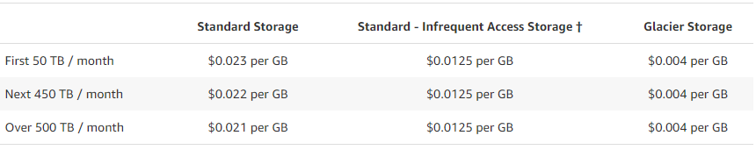

Figure 18: AWS Storage Costs

Utilizing the assumed data storage of 1 TB per user the cost per month for each user in storage cost would be $23.552 or $282.624 per year. The costs may be able to be reduced utilizing regional servers. During product testing phase they provide one free year of cloud storage suitable for the testing phase.

4.14.2 Dropbox

Dropbox had the strangest pricing and storage requirements of all of the listed companies. They don’t deal with conventional cloud environments and charge for a per user storage basis. In our case only a maximum of three user accounts would be required at a cost of 25 per user per month. The issue resulting in the requirement of requesting more storage when the data per user goes over 1 TB. While the state unlimited data testing would need to be performed utilizing the 30 day free trial provided, in order to determine if the statement was completely valid. If it was possible, beyond the low bandwidth of the storage the cost per data would be astronomically inexpensive.
They also had a hurdle when it comes to ease of accessibility, as they do not support the utilization of file syncing with a server. In order to accomplish this development would need to be performed for implementation.

4.14.3 Google

Another well-known and utilized company, but not in the cloud storage space. They utilize a different format for their cloud storage pricing scheme. Unlike amazon they do not charge for network usage or file access, their pricing depends solely on storage usage and thus had a slightly higher price per GB of storage. Through this process no unaccountable data costs had been reached with over access of the network.

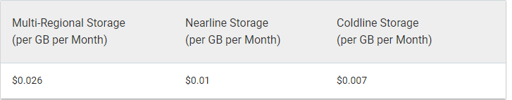

Figure 19: Google Cloud Storage Costs

Utilizing the assumed data storage of 1 TB per user the cost per month for each user in storage cost would be $26.624 or $319.488 per year. The costs may be able to be reduced utilizing regional servers. During product testing phase they provide 5 GB free storage for a year.

4.14.4 Local Storage

The option most likely to be utilized in the project for low user base remains local storage. While this forces a higher burden on the development team for setting up access to storage the cost was tremendously decreased. The cost would be outweighed if the hardware was not already accessible to the team, a usable server from a previous employer of one of the team members provides access to an older but functional server. The storage space of the device accounting for approximately up to 3 TB. The only true cost to the team would be development time to ensure setup was completed alongside the cost of electricity, a minor cost in comparison to other providers.
While this option was both affordable and sustainable for the development phase the product would be forced to migrate to cloud providers for a higher user base as the cost of acquiring new hardware outweighs potential profit margins.

4.15 PCB design research

The following section of the report discusses the reasoning behind the internal design and material choices for the SSDC PCB while addressing solutions to issues that arise during PCB creation. Proper setup for a PCB increases its life expectancy and overall performance. When considering materials for the SSDC PCB it was important to address certain aspects of the environment in which the SSDC had been located, or issues such as thermal shock could potentially damage the device. Selecting the correct materials and proper placement of components for the PCB can increase life expectancy of the product as well as negate certain issues before they ever arise.

4.15.1 PCB Base Material

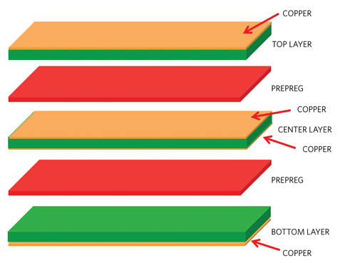

Figure 20: PCB internal view (Permission pending) [54]

Substrate Materials:

- FR-4 - The material FR-4 was a reinforced laminate sheets used to produce the cores in PCBs illustrated by the green substrates in Figure#. The FR in the title refers to Fire retardant, and was typically followed by TG###. The TG### refers to the transition glass temperature of the material, and the ### was a number that represents the temperature where the reinforced glass temperature becomes deformed or softened. FR-4 was the standard in the PCB manufacturing industry for material design in the sheets. It wide use also makes it one of the cheaper options for material in boards. The FR-4 material was used to create the isolation of the copper sheets.

- G10 - G10 was another core material that was used to separate the copper layers in a PCB similar to FR-4. G10 was a high pressure fiberglass laminate material created by binding multiple layers of glass cloth and soaking them in epoxy resin. G10 had essentially been replaced by FR-4 due to FR-4 being safer, and this was because G10 was not flame resistant. G10 was now typically a special case use of material in PCB, and in general was being phased out for FR-4. G10 was considered as a possible material to use in prototyping due to its lower cost.

- FR-2 - FR-2 was a core PCB material that was an outdated version of FR-4. However, even though FR-2 was an outdated form of FR-4 it was still used for low cost production when high quality was not needed, or when large environmental changes were negligible. Of all the material on this list FR-2 was the cheapest material option on the market at the cost of being less reliable.

- Aluminum - Aluminum was a higher class more costly PCB design material. Using aluminum for PCBs requires a copper layer being placed then a dielectric then the aforementioned aluminum layer. Aluminum was a more costly design choice, but provided some benefits other materials do not benefit from. The Heat dissipation in an aluminum board was dramatically superior to the previously mentioned FR-4. The dielectric used were five to ten times as thermally conductive compared to G10 or FR-4 at only a fraction of the thickness. Thermal transfer was more efficient, and lower amounts of copper can be used compared to other insulating material. Aluminum was being considered for when the SSDC goes to market, but the hindrance was the increase in price.

4.15.2 PCB

The SSDC was expected to have 2 to 4 double sided copper foil layers illustrated by the copper foil in the figure above. For the copper layers of the SSDC PCB design the choice had been 1 ounce per square foot. The amount of copper on PCBs was measure in ounces per square foot, and the more copper on the board the better the power dissipation becomes. However since the board had not be high powered 1 ounce per square foot should suffice. The spacing for the board had been 6/6 mil. The board itself was expected to be 1.6 mm thick, and the vias connecting the different layers of the board had been tented so they were not improperly soldered.

4.15.3 Vias
When constructing a board in Eagle there was typically a need to drill holes in boards that were more complex. These holes were called vias and connect different layers of a PCB together through copper tracing. In more complex PCB design it was sometimes extremely difficult or altogether impossible to have all the necessary traces on a board without crossover or shorting something. To simplify the tracing of a PCB holes can be created to jump around the different layers, but had many vias in a design was typically frowned upon.

4.15.4 Silkscreen

When the board was designed it was typically marked on the surface with a silk screen which was essentially a substance acting as ink to add markers to a board. These marks on the board can indicate placement of components warnings or manufacturer logo and labels. Typically a manufacturer had typically provide a manufacturer’s mark unless told not to by altering the files in the gerber file.

4.15.5 PCB surface finish

The surface finish of the SSDC PCB had likely be HASL which was popular coating for PCBs which goes on the top and bottom of the PCB. The surface finish was typically not given as much attention as other parts of the PCB however improper selection of surface coating can cause thermal shock or cause other issues to the PCBs if not accounted for. The HASL was a low cost choice for surface coating due to its popularity, and its ability to be repaired. This was likely to be what was used for the senior design prototype, but in future marketed designs of the SSDC a tin immersion coating would be more optimal for the environment in which the device had been located.

4.15.6 PCB Pads

The PCB pads were the areas on the PCB not covered by the silkscreen. These were where the components had been soldered to the board. These were very important because if they were covered up it had been very difficult to solder properly. For the project the standard pad size had been used; however this sometimes needs to be shrunk or increased depending on components and applications. Pads can come in different versions as well with through pads as well as the more common surface mounted pads.

5.0 Design

5.1 Hardware

The following chapter discusses the design choices and reasoning beyond isolating the component choices while including all necessary tools involved with the development. Development choices had also be considered such as the UI design and the reasoning behind these choices. This section had also detail the full project in hardware design and construction as well as any pitfalls that may need to be discussed through our decisions and physical mistakes. Identifying these pitfalls allow for the product to evolve and improve the product, ignoring these mistakes would lead to potential repetition in other aspects of development.

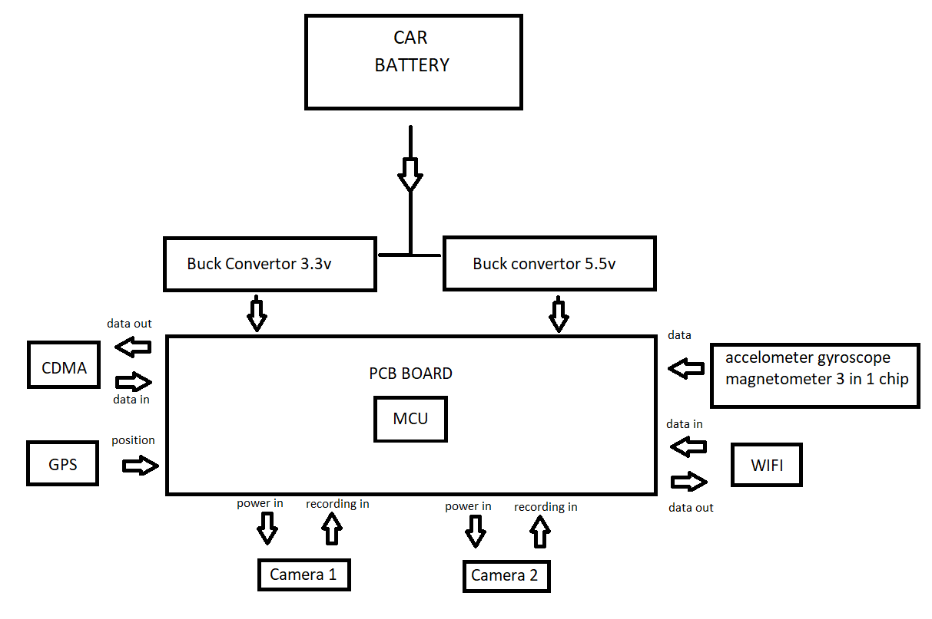

Figure 21: Block diagram

5.1.1 Design
Consumers who had purchase the SSDC had not typically be engineers or skilled mechanics. Keeping this in mind the device had been made with simplicity and safety in mind. This had been done primarily through two methods; having the device initially professionally installed, and also making the application simple/easy to use.

The purpose of having the device need professional installation was for safety, simplicity, and liability. The SSDC had need to be attached to the car battery directly meaning that the device had had to go through the interior of the car, and the firewall separating the interior from the engine. Having a professional install the device prevents the consumer from unintentionally damaging their vehicle’s crucial firewall, and as a result possibly saving their life in future accidents. Professional installation also removes some liability from DEUCE because the installation had typically be done by a mechanic of the consumer’s choice, and any installation issues had been the result of their professional ability. The device had also be professionally installed to simplify the process. Having to professionally install can seem counterproductive to simplicity. However, keeping in mind most people were not auto mechanics, and there were safety constraints that need to be kept in mind. The simplest choice for the average consumer was to allow a professional to install the device.
The physical design of the product was intended to achieve a minimal impact on the driver's view while still maximizing the camera’s view and angle. The design should be both minimalistic as well as small as possible. The company logo should be visible from the exterior of the car when looking into the windshield to serve as both an indicator of added security and provide marketing to a passersby. The final design may be larger than the intended project due to design inexperience but was hoped to be improved after the first revision of the product. Utilizing the experience gained from the first development as well as integrating smaller and more compact components to the device. The product had been design to fit on the rear-view mirror of the vehicle without the assistance of an external mount or provided mount. Two clamps on both sides of the device positioned in a similar method as a bracelet or watch, had wrap around the rear view mirror in order to provide a comfortable and secure fit. The device had under this design experience as much distortion and shake as created by mirror itself. One camera had been facing towards the interior of the vehicle right above the top of the rear view mirror in order to provide view as well as avoiding compromising much of the physical mirror as possible. The second camera had been placed facing the exterior of the car out through the windshield, this had been located on the rear of the rear-view mirror in order to provide the view of the vehicle surroundings and road. The design should impact a very minimal portion of the driver's view as well as not create any unsightly device. We determined that most care users would prefer their vehicle to be uncluttered with bulky devices such as a dashboard camera, and thus minimizing the user's view of the device maximizes the product’s appeal to customers. A rough sketch of the potential design before 3-d modeling can be found below.

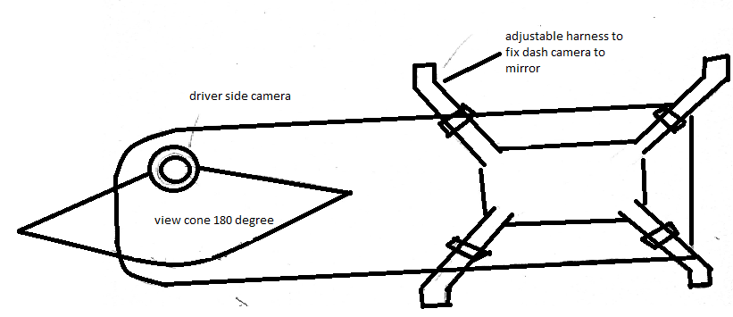

Figure 22: Driver view SSDC

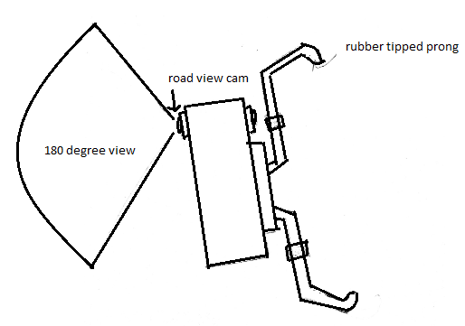

Figure 23: Side view SSDC

5.1.2 Development Tools

Software | Specs | Price
Eagle Premium | 99 Sheets, 16 Signal Layers | $100 per year
Altium Premium | 99 Layers, Unlimited | $7245 per year
Orcad Free | 2 Layer, 500 pins | Free
Eagle Free | 99 Sheets, 16 Signal Layers | Free
Altium Trial | Unlimited | Free for 15 days

Table 10: Possible PCB Dev Programs Cost Analysis

5.1.3 Altium

Altium 14 was a PCB design software created by The Company Protel. It was a comprehensive software for both the design and creation of PCBs. The software first allows the generation of a schematic for the potential circuit board, and once the schematic was completed the circuit board can be accessed and the components loaded. Before the components and board were laid out for placing the program shows a list of all modifications done to the schematic design giving the user full authority over what was designed. The program also gives the ability to bring full designs from other CAD tools by following their program guide wizard. The Altium designer was a versatile well supported program with many features that was highly supported, but the program costs a staggering $7,245 as posted on their site. A free trial version of the software was available, but the program was very limited in the amount of time that it can be used before the program was locked.

5.1.4 EAGLE

PCB design programs can had both a high cost and high difficulty. The program that was chosen for the design of the PCB in the SSDC was Eagle. Eagle was a PCB design software that allows for the creation of multi-layer PCB designs. The program also offered auto routing of the created board using advanced mathematical equations to try to find the optimal etchings for the placed components. The choice to go with Eagle was both an economic choice see that Eagle offered a free version of their software for students with an active school email, and also because eagle was well supported by many companies meaning that many components on the market already had eagle compatible designs. This was very important because the creation of components in software such as Eagle can be a very tedious project especially if it needs to be done for more than one component.

Eagle Operation: The operation of the eagle program had done in two parts first the PCB had been designed in a schematic format on the eagle program then the components had been placed on a board in a .br file. The schematic and the components in the .br were intertwined; meaning that if the user create a component in the schematic portion of the program that component had appear for placing in the .br file on the simulated PCB.

The first part of the creation of a PCB in eagle the user had to create a schematic. This can be done by opening eagle, right clicking the project manager and selecting new project. Then select the location for the new project. This location had hold both the schematic file and the board design folder as well as a file that connects them. Once this was done the schematic of the board can be designed, and when components were added to the schematic they immediately showed up on the board design for placement and wiring. Since the added component shows up instantly the wiring/placing of the board components can be done all at the end throughout the duration of the schematic design. To add components to the board select the add button located on the left side of the program or under the edit menu. From here components can be selected. When searching for components entire families can be searched by using a * on a search query. The next thing the user need to do was to create a frame which isn't mandatory to had, but looks more professional. Adding the desired components was simple enough select the component click once and it appears. Now once all the components were place put any power supplies needed by the design. Once all the components that had been used were on the board they had to be wired together. This can be done via the wire tab located on the left side of the program. This was typically a straightforward process, but caution must be taken when wiring. This was because while the eagle software does report issues in a design if the user incorrectly wire over something such as a mosfet the program had not considered this an error, but instead it had considered this a chosen design. Since this had not be reported as an error this may be overlooked, and as a result the board may be fabricated as was resulting in problems later on.

5.1.5 Printed circuit board

The schematic of the layout PCB for the SSDC had been finished early at the start of the second phase of senior design, and had been created early afterwards so that testing can begin. For the PCB that had been in the SSDC the board had been designed then professionally manufactured. The choice to have the board be professionally manufactured was to reduce risk of creation errors of the board. Also there were some relatively cheap options offered to students for the soldering of components and board manufacturing. Time had also been considered when designing the PCB, and considering that there was a large amount of work that can only be done once the board had been designed it was decided that there was no reason to risk any errors hand soldering components. Thus the PCB had been designed, sent out to be fabricated, and then brought to a local company to have the components soldered.

5.1.6 PCB Design

As stated earlier the chosen design software for the layout of the PCB had been Eagle. Once the board was designed completely, and no error had been reported the board had been saved and exported. Eagle had an export file called Gerber that allows for many PCB manufacturers to see the specifications of what the board needs. These files were accepted at most PCB manufacturers, and simply layout the board for the manufacturing process. Many PCB manufacturers even had an upload section on their sites for gerber files to provide an accurate estimate of the cost to manufacture. However if there were any errors in the board that show up before manufacturing takes place the board had been declined. Also if a wire was misplaced in the design of the board but no error was detected the PCB had been manufactured and had been assumed to be an expected feature resulting in a possible short. This means the design of the PCB had to be essentially perfect before exporting the gerber files to a manufacturer, or the user had pay for and receive a very costly worthless piece of silicon and copper. Also seeing that many manufacturers require a minimum of 5 PCBS be made to create a design the economic burden had been even furthered if the design was off.

5.1.7 PCB manufacturers

When selecting a manufacturer for PCB manufacturing a few key things were taken into consideration as the main considerations when choosing a manufacturer. These key considerations were allowable board thickness, maximum allowed sized allowable size for all desired components, tracing options because the width of the traces had been important with the high frequencies in the system, allowable number of layers, price estimate through online quotes, creation time since time was need to tested the device, and customer review quality of manufacturers. When considering these points custom setting for order were not considered, and the estimates provided were based on the standard creation options. This means that many of these manufacturers offered more advanced options such as number of layers or tracing, but the tradeoff was a much higher cost due to the need to change the mainstream process. Certain qualities were considered from the custom setting for this project, but it was determined that the SSDC had not need extreme customizations to perform at the desired quality level. Also another very important thing to make a special note of was that increasing past certain sizes as well as jumping to 4 layers increases the price of a PCB radically.

PCB manufacturer | 4PCB | PCBway | PCBcart | SEEEDStudio
Board thickness | .031 to .125 | .4 to 2.4 mm | 1.6 to 3.2 | .6 to 3mm
Allowed board size | 1200 | 1200 | 1200 | 1200
Tracing option | 4/4 to 6/6 mil | 5/5 mills | 3/3 to 6/6 mils | 4/4 to 6/6 mils
Minimum quantity | 1 | 5 | 1 | 5
Max layers | 10 | Unlimited | Unlimited | Unlimited
Price estimate | $80 | $60 | $100 | $65
Deals | none | 5 dollars off | none | none
Creation time | Same day to 7 days | Same to 5 days | 7 to 18 days | 5 to 6 work days

Figure 24: Comparison of multiple PCB manufacturers

4PCB

4PCB was a manufacturer based out of the US that manufactures PCBs on all levels supplying orders of singular PCBs to tens of thousands of PCBs. 4PCB offered standard specifications for boards up to 10 layers, FR-4 material, 5/5 mill tracings, and .031 to .125” board thickness. 4PCB also offered a 50% discount for first time customers making smaller PCB quantity cheaper than typical.

PCBcart

PCBcart was company based out of China that had been providing PCBs for 14 years. PCBcart offered specifications up to 3.2mm thickness, FR-4 material, single or dual panel board, and up to 1200mm squared board size. PCBcart also offered an online projected quote for their boards, and early estimation of our boards specifications puts their quote around 90 to 100 dollars for the board.

PCBway

PCB way was a PCB manufacturing company based out of china. PCB way offered a variety of manufacturing specification options. PCBway offered multiple board materials including aluminum, FR-4, and rigid flex. They allow up to 12 layers, and a thickness of up to 2.4mm. There was also an option for tenting or plugged vias. PCBway’s online projected quote estimates our board to be around 58 dollars. PCBway also offered a 5 dollar coupon to first time buyers which reduces the price some. However, they had a minimum requirement of 5 boards be ordered.

SEEEDSTUDIO

SEEESDSTUDIO which had been referred to as SS was a PCB manufacturer that offered PCB development as well as assembly. SS offered typical options for PCB manufacturing with standard FR-4 material, up to 3 mm thickness, up to 6 layers, copper up to 3 oz a square foot, and track spacing down to 2/2mil. Their estimated quote for the SSDC PCB was around 90 dollars USD for a minimum quantity of 5 boards without assembly.

5.1.8 PCB housing

The housing for the electrical components located on the PCB need important consideration due to the environmental issues based on where the device was located. These issues were a result of heat, and the forces exerted by the acceleration and deceleration of the vehicle in which the SSDC was located. The case for the SSDC had to be able to withstand a variety of temperatures as well as fast changes in temperature caused by the air conditioning changing the internal of the vehicle rapidly. Not properly selecting a material capable of withstanding these temperature can cause cracking of the housing, and exposing the internal sensitive electrical components. Also the casing for the SSDC had to be durable able to ideally withstand a car minor to medium car accident or else the product had not be able to function as it was intended to. A possible solution to these design issues was to make the casing of the SSDC out of fiberglass which can handle radical temperature based on material chosen as well as handle physical abuse of a minor car accident. The downside of this was the look of fiberglass was not an exceptionally attract look for the product. Regardless of what material was selected the PCB along with the camera components had been secured to the external frame through indicated points on the PCBs by the use of screws.

5.1.9 Reasoning for wireless/4G

When considering whether to use wireless or data it was decided that both systems had been used on the PCB. The system had been sold as wireless with the ability to activate the 4G if the consumer wants the ability to access the cloud anywhere. When trying to choose if only one or the other should be implemented the wireless had the lower cost to the customer, but the 4G had most versatility.

The 4G was feature originally designed for the device, and can be used to send footage to the cloud in most locations. The idea behind the 4G design was that in the event of an accident should the device become damaged the footage had still be available in the cloud for review and access. In addition, having the 4G activated would allow the system to notify the owner in real-time if there was an accident involving their vehicle, or provide real-time position tracking if the vehicle was stolen. This data could be relayed to law enforcement to greatly reduce the time it takes for the police to intercept the vehicle, reducing the potential damage the thief could do to the vehicle. By including 4G in vehicle it also allows for the tracking of the aforementioned vehicle via GPS tracking resulting in the recovery of any stolen vehicles.

The initial use of Wi-Fi on the board was chosen for both economic reasons as well as a local use. Many people who would use the Wi-Fi only version of the dash cam would ideally be parking the vehicle somewhere within range of their work or home Wi-Fi. The dash cam still operates as a deterrent to theft because the Wi-Fi model was the exact same as the 4G version of the SSDC, so a knowledgeable thief had considered it on the same level protection. During driving the data had been stored on the devices’ ssd card until it comes into range of Wi-Fi, and transfer the data to the cloud. This was also less of a concern due to many devices being able to become hotspots allowing the SSDC to function similarly to a 4G model when utilized external devices such as a cell-phone.

5.2 Software

The following chapter discusses the design choices and reasoning beyond isolating the component choices while including all necessary tools involved with the development. Development choices had also be considered such as the UI design and the reasoning behind these choices. This section had also detail the full project in hardware design and construction as well as any pitfalls that may need to be discussed through our decisions and physical mistakes. Identifying these pitfalls allow for the product to evolve and improve the product, ignoring these mistakes would lead to potential repetition in other aspects of development.

5.2.1 Android Application UI Design
The simplicity of the device had also be extended to the software. To simplify the software for the device the application controlling the camera had included only necessary software that was believed to be necessary, and functionally optimal. Crucial elements included features such as alerting and video recordings of potential intruders or damage to the vehicle. As well as giving the option to live stream the video camera output to the mobile application with no quality degradation and minimized latency. The simplicity of the application keeps the SSDC functional while not becoming cluttered with unneeded additions that already exist in pre-existing applications.
As stated previously the application design needs to remain simple and elegant as users prefer simplistic designs with low learning curves. All crucial features need to be quickly accessible from the main menu through a singular touch such as the live feed, settings and relevant statistics. All submenus such as the wireless settings under the settings menu should be no farther than two touches away from the home UI. The design mentality throughout development had been that no one feature should be more than two touches away from the home screen, minor exceptions had been made for some sub-features such as video editing. The first phase of development had provide a lackluster design but the barebones UI had exist under a minimized design lacking graphical dressing. A sketch of the potential main UI can be seen below, from this menu the user should be able to access all required applications from a singular point.

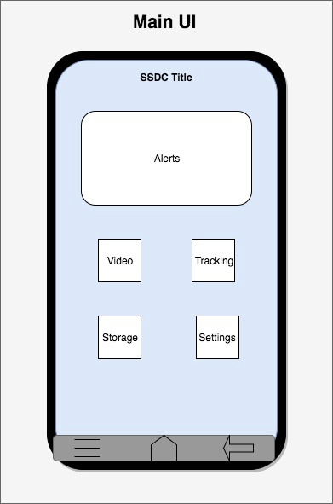

Figure 25: Design Interface Mock-up.

5.2.2 Development Tools

Android Development Platform

The android platform provides a simpler means of production for newly started products due to the availability and accessibility. Android utilizes the Android Package Kit (APK) format to allow for easy installation of applications on Linux based devices. Development of the android application had been wrote in Java just as most android applications were developed in this language. Android Studio had been utilized in order to create the application, utilizing the provided android emulator to perform quality assurance testing of the application during the development lifecycle. The virtualization of the android device through the use of the integrated development environment increased productivity and efficiency as well as accessibility during the testing and debugging phases, potentially saving tens of hours. As well as allowing for the application to be tested against a variety of android operating system versions and flavors beyond a singular distribution that may be available amongst the team members.

Operation of Android Development Platform

The development of the application through the utilization of Android Development Studios remains straightforward. The application had been designed incorporating the design constraints such as the two click design as well as simplicity paired with runtime restraints. With those restraints in mind the application had been developed through standard means through the use of the IDE. Once a runnable application was produced the application had then be tested utilizing the simulation service provided by the integrated development environment for the first few tests. After a more acceptable product was developed the application had been tested utilizing physical Android cellular devices owned by the team.

Python

When considering what program to use to program the PCB for the SSDC a few key points were addressed. These included simplicity to increase productivity, familiarity to prevent a needing to learning a new language, and cost to prevent a large of an entrance fee, and support so that the program was up to date and compatible with most software platforms. Python was a high level language programing software that was chosen for for the programming of the SSDC board. Python was an easy to use object oriented software that supported across Windows, Linux, Unix, and MAC OS X. Python program was copyrighted, but the program was currently free under open source. Currently python was known to some members of this group and well as other languages, if python was not known directly it was an easy transition from C programming. Python had a vast amount of programs that currently exist from many uses which reduced the amount of smaller programs that need to be created from scratch. Python also had fewer complicated steps to programming than other languages, and had a very interactive error system that allows for testing smaller code segments. The derivation of python that had been utilized in this project had been a form of embedded python called micro-python, C-Python or Zyneth. All were different ports of embedded platform that were intended to be ran on supported microcontrollers, the choice on which port of the language utilized had been determined after testing the platform on the microcontroller.

5.2.3 Development Lifecycle

In order to ensure an appropriate product lifecycle as well as standardize the development process for future use the team had follow a standardized software development lifecycle. This had ensure congruity amongst the team when developing the initial prototype as well as the finalized product. The lifecycle aspect comes into play when considering both new products as well as the addition of new features; that along with the integration of version control create for a streamlined and modular design methodology to maximize the team’s efficiency.
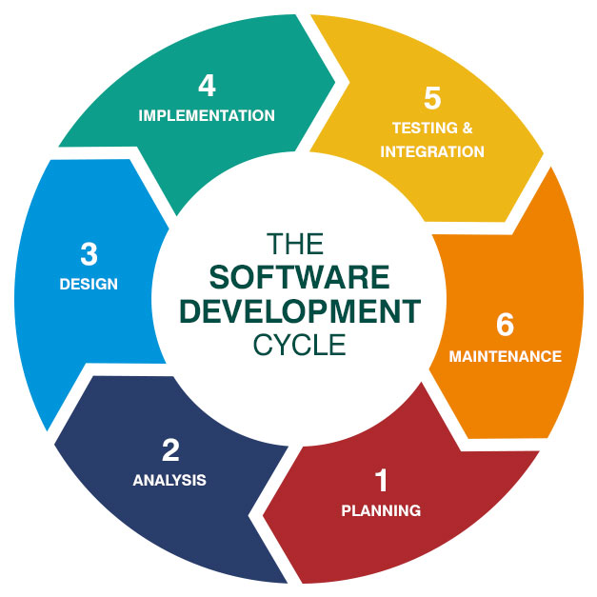

Figure 26: Development Lifecycle (Permission Pending)[47]

Most developers in both enterprise and startup scenarios define and utilize the development life cycle to ensure products were appropriately developed in a timely and monitored matter. There were typically six stages to the software development life-cycle as can be seen in the above figure. The four important aspects of which for us had revolve around: Planning, Design, Implementation and Testing; these were the most critical components to ensure a working product had been released. The planning stage was covered through our research section of the paper, ensuring that all possible critical components and technologies as well as potential suppliers were understood and noted.

The design stage involves the utilization of any applicable SRS or design restraints to ensure the product meets a baseline qualification as well as provide high level documentation. It creates the outline for the actual implementation of the application, high level documents such as data flow diagrams, PEP diagrams as well as process diagrams. The implementation stage was when the design takes the physical form and where the bulk of work was completed. The actual application design begins implementing the high level diagrams into a lower level form of actual physical code. The design section was what was covered in this chapter involving the implementation of our planning and highlighting major features that need to be implemented; within this same chapter we cover the implementation as well, major features had been discussed at an implementation level as well below.

Stages one, three and four had ensure the user had a product or prototype built but to complete and ensure a working product the user must implemented testing and integration, stage five. After implementation there had potentially be pit-falls or bugs that may be hard to detect in development, thus testing must be completed to discover, observe and resolve these hidden issues. Not only was it critical to the functionality of the device, the testing stage provides valuable insight in any missing features as well as any potential integration issues that may arise. During this stage it was potentially beneficial to receive outsider insight into the product, possibly perform a case study and get the device in the hands of beta-testers. For the project at hand this stage may be considered our submission and demoing the device at the end of Senior Design II.

Following the life-cycle in the manner discussed above with the correct team produces the product efficiently. The following sections had keep this development life cycle in perspective and the team followed this methodology throughout the development stage of the product.

Version Control

An important aspect of the development lifecycle was reliable and appropriate version control. Version control was the mechanism utilized to ensure that the software may be operated in both a communal manner as well as ensure that the software was safely stored outside of a local drive. This also allows for the forking of new versions and if an issue occurs in one version then the code base may be reverted back to a known working version of the code.

The most popular framework for version control and the one utilized in this project was GitHub. The framework was widely used in both enterprise as well as personal projects due to the simplicity and ease of accessibility of the framework. Most engineers, especially those team members in this project were familiar with the platform thus allowing for an easier development phase in the product lifecycle. The project’s code base was stored in a private repository, a repository being the master codebase of a singular application, on GitHub that may be forked by each individual team member.

5.2.4 Data Flow Charts and Diagrams

This section depicts numerous pictorial representations of key parts of the application and the interactions on the software portion of the product. These diagrams were representative of the planning and design stage of the software development lifecycle. They represent the functioning of the application as a whole, and should provide insight on the high level workings of the application at an easy to understand level. The diagrams themselves for the most part were created utilizing the draw.io software and do not follow one set diagramming methodology.

The flowcharts and diagrams were meant to represent the coding structure of the SSDC device, and give insight on what needs to be put into the code. These flowcharts and diagrams were meant to be general and not specific as to only show the basic structure and design of code, such as representing what objects and functions need to be provided, and what she be stored in the database provided for the device. An example of this would the use case diagram, which was meant to show the basic functions between the user and the database, and between the database and device. This includes sending and receiving notifications with recorded footage and images and sending them through the database from the device through means of triggering the device. This also includes the user’s basic functions on the mobile application such as viewing the live recorded footage and GPS locator. Another example was the class diagram which includes a view of the objects and its functions that were used to interact with each object. Each object had its own attributes and types, as well as its functions. There would be different types of arrows to represent the types of relationships between objects. The attributes had been used to describe the characteristics and data retained in that object, while the functions had been used to interact with different objects as well as retrieve or send the data from the attributes. Hence why the attributes were also viewed as variables as they included data types as well.

Software Communication

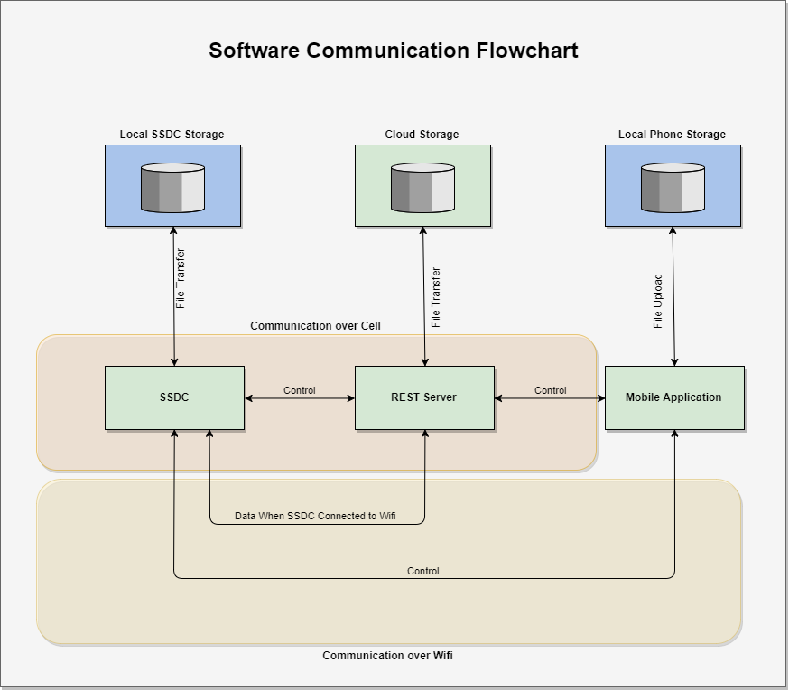

Figure 27: Flowchart depicting software communication

The above diagram illustrates the communication between all four separate hosts: the smart security dashboard camera, the REST server, Mobile application and the cloud storage server. Green boxes represent separate hosts, host’s that were not connected by a physical device, and the blue box represent local internal objects to the device. In the case above only the local storage was represented for the mobile device. The numerous lower opacity boxes behind the diagram illustrate the means of communication for the devices, a yellow tinted box as stated represents communication of wireless; this wireless communication may be over the SSDC local hotspot or for the case of the SSDC over a connected wireless network to the device. A light red tint represents the device communication over the cellular service of either the mobile device or the cellular chip on board of the SSDC device. No tinting represents that the means of communication was either local or general communication methods specific to the host, in this case most likely general Ethernet.

When the mobile application needs to speak to the device and was not connected over wireless directly to the device, the application must send the request to the server over its data communication method; from there the central server forwards the request over to the SSDC through its direct communication channel, assuming the SSDC device had network connectivity. If the connection fails the server had return connection error to the application and had not retry to send the request more than three times before returning the error. The reason we don’t continuously attempt to send the request as we would potentially encounter conflicting requests that may lead to internal errors; it may be possible that a few crucial requests such as commands issues to upload the stored files to the cloud had been logged and sent once connectivity was reestablished.
The SSDC utilizes the Soft AP technology in order to create a virtualized wireless hotspot for the cellular device to connect to and allow for the mobile application to directly communicate with the device. During this process the mobile application had receive an ip address dynamically while the device itself acting as the gateway had had the static internet protocol address, meaning the IP address had remain the same whenever the hotspot was enabled, the addresses utilized had been 192.168.1.1 or 10.0.0.1 as was standard. When the mobile application was directly connected to the devices wireless hotspot, direct communication through the hotspot had been established. A communication channel for the data transfer had been created and utilized to communicate between the two devices. All possible functions such as live stream had been handled directly through LAN communication, such as the live camera feed and any control interactions. This had allow for the application to receive the data and vice versa with the least latency between the communications amongst all the other communication methods. The downside of this was that it requires the user to be within a small range of the vehicle.

The device may be connected to an external network through the utilization of either cellular or wireless. When the device maintains connectivity through wireless the device was capable of sending all of its requests directly through a traditional network setup; meaning that the device may utilize traditional protocols for communication such as TCP/IP and built on top of that the HTTP protocol. The hypertext transfer protocol (HTTP) allows for a streamlined and easy to use communication protocol to a REST API server. The data just needs to be formatted and authenticated to JSON then sent to the servers load balancer or directly to the server. The server then can process that data and then any required information through to the mobile device requesting the information.
If the device does not had accessibility to a wireless network such as the case in remote areas, the device had automatically default to cellular data as possible. This situation provides the most difficult communication challenge as the device must be able to receive data and commands from devices that do not know the devices location as cellular had no IP address associated with the device. This challenge enforced the need for a remote server to act as the communication liaison between the mobile application and the SSDC device. The device had open up a communication channel in order to avoid polling if possible, with the remote server. The server had associate the connection with the correct mobile user and forward all control commands to the device and any data to the associated mobile application.

The final communication occurs when the device was unable to establish a communication channel via either wireless or cellular data. This had force the device to utilize the base interactions and store any data to the local device storage. All interactions and decisions for the device were then handled by the underlying programming of the device.

Data Flowchart

The data flowchart shown below was a representation of how the code had implemented to control its flow while it was running. Since the SSDC device requires specific triggers from the sensors and the SSDC device to respond to user inputs, controlling the data flow was essential in order to meet the requirement specifications for the device and had it function the way the developers had intended.

For this data flowchart, there had been conditions for each object and function before having the data processed. These can be if, if-else, and else statements or interrupts within the SSDC device. These conditions had been met with either a true or false value (yes or no). These conditions do not necessarily mean that the given data were only true or false as for example, the sensor data, from either the accelerometer, gyrometer, and magnetometer, had only allow certain numbers that were taken as scenarios of car theft and car damage while ignoring minor instances or false positives. If the data given to these conditions were either following the given circumstances or do not, the different pathways had been given to the data being processed, hence why this data flowchart represents how the data flow was controlled.

Sensor Conditions:

The sensors of the SSDC device includes the accelerometer, gyrometer, magnetometer, and CO monitor chips. The accelerometer, gyrometer, and magnetometer had detect motions occurring on the vehicle and process if the data evaluated counts as a car theft and car damage, while the CO monitor had detect levels of CO gases accumulating within the vehicle.

The accelerometer, gyrometer, and magnetometer process the motion of the user’s vehicle with the SSDC device differently. The accelerometer detects acceleration forces, the gyrometer, detects angular velocities, and the magnetometer detects the direction of the vehicle. The code had constantly read the measurements from these sensors and process if a car theft and car damage had occurred or to ignore the motion detection. The data that does count as car theft and car damage had been sent to the user through the server and to the user to alert the user that their vehicle had either been damaged or stolen from. The conditions had most likely be complex as the there were a lot of scenarios that need to be accounted for as it requires three sensors and the data required for the conditions to be viable for car theft and car damage can either be one individual sensor or a combination of sensors. The conditions must also take into account the data from the three axes, the X-, Y-, and Z-axis, as well.

The CO monitor detects CO gas levels inside the vehicle from the SSDC device. If the gas levels measured from the CO monitor were excessive, then an alert had been sent through the server to the user. This had notify the user that their vehicle had accumulated excessive amounts of CO that were considered toxic.

(Note: The CO monitor might not be included for the final design of the SSDC device as it was bulky and expensive, which had impede on the requirement specifications and create more constraints when designing the device in further development. This portion of the data flowchart might be removed as well as not provided or ignored when implemented into the code.)

Wi-Fi Conditions:

In order for the SSDC device to connect to the user’s mobile application, it requires Wi-Fi connection. The code had check if Wi-Fi connection was provided for the SSDC device can connect to the server. If the Wi-Fi connection was not available, the cellular data had been used to connect to server, which was another way to connect the SSDC device to the user’s mobile application, either with LTE, 4G, and 3G. This had require a Wi-Fi chip with the SSDC device to connect to the user’s mobile application. The Wi-Fi connection had been used to transmit any recorded live footage, images, and alerts and notifications from the device to the user as well as connect to a server.

Alert Conditions:

The server had send alerts and notifications included with recorded footage and images to the user once the SSDC device was triggered. There had been a condition that processes if the server was transmitting and alerts that car theft and car damage had occurred to the user’s vehicle. If this occurs, then the data being transmitted had been processed to the user's mobile application. If not, then the server had been ongoing until an alert had been sent to it. These conditions had also require the type of alert that was occurring and any recorded footage and images to be transmitted to the user’s mobile application to reach the requirement specifications and intended functions of the SSDC device to had evidence of the car theft and car damage occurring to the user’s vehicle.

Once the mobile application receives the notifications, then it had proceed had storing the recorded footage and images transmitted to the user’s cloud storage in their mobile device Just like the conditions for transmitting the alerts from the server, this requires that recorded footage and images were received by the user. This had allow the user to respond to this output when their vehicle was being stolen from or being damaged. This also stored previously recorded footage into the SSDC device once the footage was received.

Storage Conditions:

The storage of the recorded footage and images requires that a mobile device was available from the user. This condition was made in order to ensure that a Cloud storage was provided that was included with the mobile device. If a mobile device was not provided by the user when storing the recorded footage and images, then a error had occur. This error does not necessarily mean that the user’s mobile application had stop functioning but had rather let the user know that either a proper mobile device was not available or storage was not possible as Cloud was not provided for storage. This condition was required as to ensure that the recorded footage and images was actually stored somewhere for the user.

User Input Conditions:

The user input conditions were basically the basic functions that the user had on the mobile application and check if the user was trying to access this certain function. This was better explained with the Use Cases Diagram and UI Diagram. The user can view live footage or view the GPS location of the SSDC device and their vehicle. The live footage requires the SSDC device to be active and grant the user access to the cameras to view the inside and outside of the user’s vehicle. The GPS locator allows the user to view the location of the vehicle through means of data sending the latitude and longitude of the SSDC device. This chip had been provided in the SSDC device and the user from the mobile application can access the GPS locator to the SSDC device.

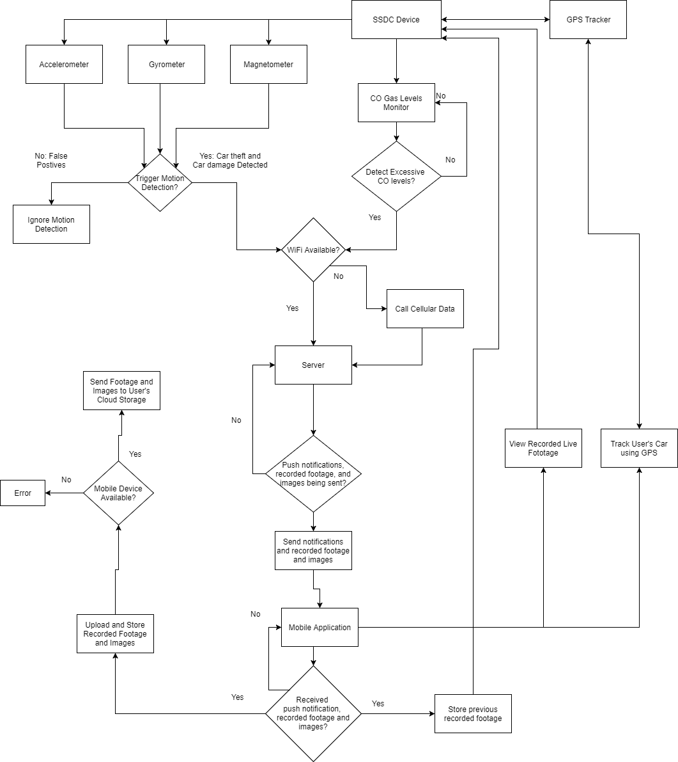

Figure 28: Data Flowchart depicting the SSDC Software Design

Use Cases Diagram

The use cases diagrams shown below was to show the interactions between the user and the server and the server and the SSDC device as well as representing basic functions. The uses cases shown below were to identify, clarify, and organize the basic requirements in the SSDC device. The first use case diagram represents the interactions in the mobile application and the second first use case diagram represents the interactions in the SSDC device.

Mobile Application:

This use case diagram shows the interaction between the user, server, and the cloud storage. The user had basic functions of logging in, viewing the main menu, receiving and viewing notifications, viewing the live footage, and viewing the GPS Locator. Logging and viewing the main menu was a basic function and essential for the user to input their login information for security and the main menu to gain access to the other functions as well. Receiving notification and viewing the live footage, images, and GPS location of the user’s device and vehicle requires the server transmit the data to the user.

The server was responsible for transmitting the notifications with the recorded footage and images of the car theft and car damage, the live recording footage, and the GPS location to the user. The server was also responsible for storing the recorded footage and images to the user’s cloud storage as well, depending if the mobile device along with cloud storage was provided by the user while using the mobile application.

SSDC Device:

This use diagram shows the interaction between the server and the SSDC device. The SSDC device had been responsible for detecting the scenarios of car theft and car damage as well as providing the live footage, images, and GPS location to the server. The motion detection by the SSDC device had been done with the accelerometer, gyrometer, and magnetometer sensor within the hardware, while the software had filter out any false positives and had it clarify the data if it counts as scenarios of car theft and car damage. The processed data had been used to trigger the device to send the recorded footage and images of the car theft and car damage to the server. The GPS locator had been used to get the location of the device alongside the vehicle it was in. The location had been sent to the server as well when the user requests it.

The server had received the GPS location and the recorded footage and images to send to the user. The server acts as a transmitter between the user and the device to send the requested GPS footage and live footage as well as send alerts as well.

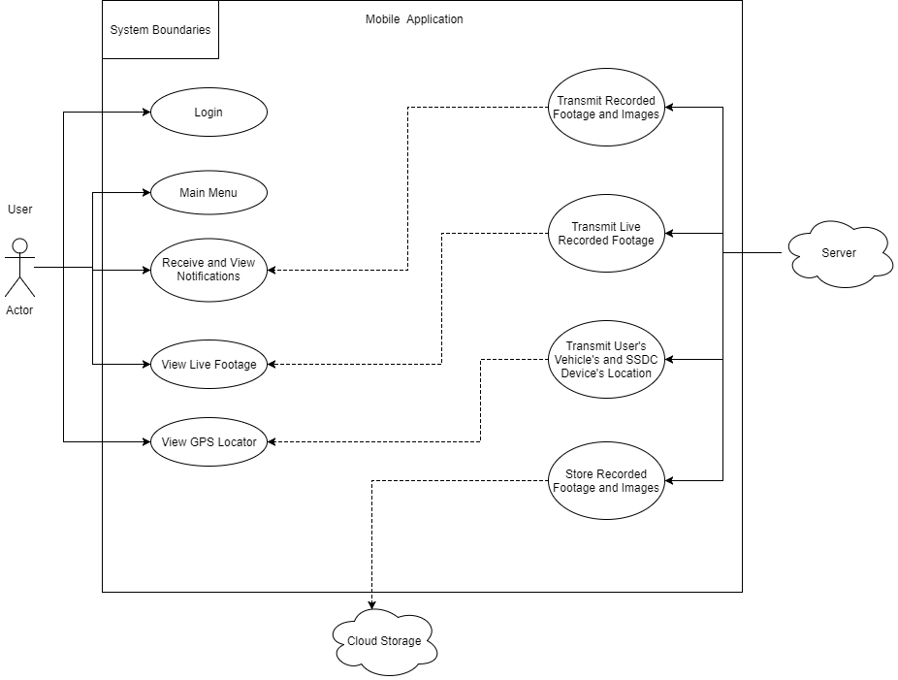

Figure 29: Use Case Diagram for the SSDC’s mobile application

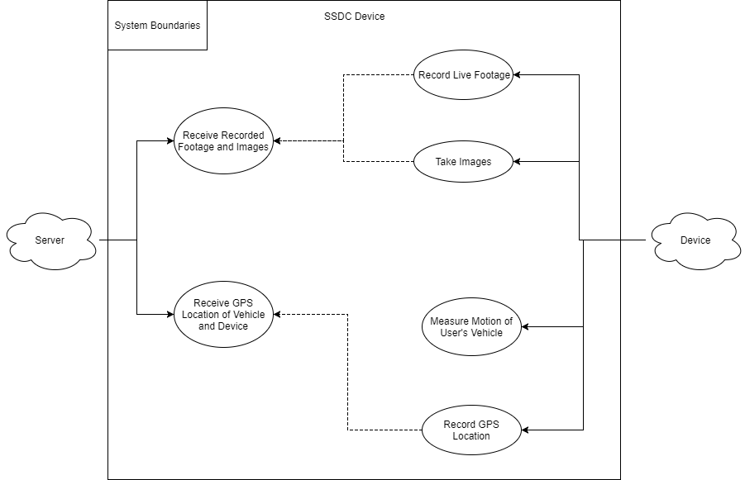

Figure 30: Use Case Diagram for the SSDC Device

UI Diagram

The user interface diagram was used to model the interactions between the user and the interface of the mobile application. Much of the interactions in the mobile application were represented by the use cases diagram where it shows the basic functions of the user, but the UI diagram classifies the inputs and outputs from the user and other objects that were interacting with each other in the mobile application.

User Inputs and Outputs:

The user commands represents the inputs that the user makes on the mobile application or its UI. One input command was to login using the UI with their login information. The login information was stored into the server, so once the user enters the login information it was processed in the server for clarity and security. If the login information was valid, the user had access to the rest of the functions of the mobile application. If the login information was invalid, the UI responds that the login information was invalid and ask the user to input their login information again.

The other inputs commands was for viewing the live footage and GPS location of the device. The user when interacting with UI to view the footage and location was inputted to the server to gain access. The server then outputs to the user the live footage and the GPS location as well as a response to the user’s commands.

Server Inputs and Outputs:

The server in response to the user’s inputs to view the live recording footage and GPS location by providing access to the data. It had also respond to the SSDC device’s inputs as well. When the SSDC device was triggered and sends the recorded footage and images of the car theft and car damage to the server, it responds by outputting the given data to the user interface and the user was able to view the information. The server had also respond by storing the recorded footage and images to the Cloud storage of the user’s mobile device, granted it was provided. Live footage and GPS location had been outputted by the user once the user had inputted that they want to view the data as well.

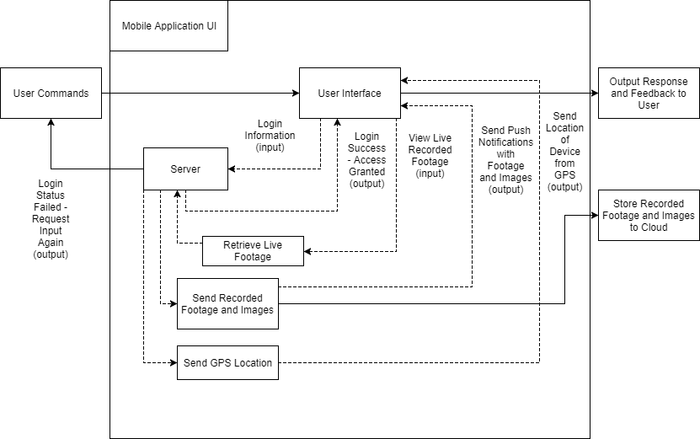

Figure 31: User Interface Diagram of the Mobile Application

ERD Database Design

The entity-relationship diagram represents the entities and their relationships in the database, showing how data was stored, shared, and related to each entity. The entities represented here included the account, device, alerts, sensors, and sessions. For the SSDC device not all data needs to be stored, but there were essential data that had need to be stored such as the accelerometer data and GPS location and the user login information as well. Primary keys of unique identification were provided for each entity were stored to prevent redundant data from occurring and allow the entities to be unique and be distinguished from each other.

Account Entity:

The account entity acts as a storage for the user’s login information as well as personal information, such as their name, and, optionally, their address and preferred language. The login information was mandatory to provide security for the user’s account as well as provide the user to gain access to their own SSDC device. Their full name had also be filled out as well to identify the user outside of their login information. The address and language had been optional for the user, but the language had automatically be English when viewing the UI.

Device Entity:

Since multiple devices can be used for the same application and user account information as well, the information used to distinguish the device and the user must be stored to create unique connections between the user’s device and their mobile application’s account information. The device had store info such as its name and the functions as well provided in the UI and software itself. It was also in relation to its alerts, sensors, and sessions, all of which were information that were shared with the user in their account.

Alert Entity:

The alert entity had store the time, title, and type of alert to be sent to the device and as a results had been viewed by the user. These need to be stored as to keep a history of past alert signals of either car theft or car damage to the user. This was also necessary to provide evidence of submission of recorded footage and images given to the user when these alerts were sent.

Sensor Entity:

The sensor entity includes information about the GPS location and accelerometer data
that had been provided to the device and stored. It was not necessary to store the gyrometer and magnetometer data as it was not required by the SSDC device’s requirement specifications. Also, the information about the accelerometer data and GPS location was more important than the other components for storage. With the GPS location, it not only locates the user’s vehicle with the device but also where the occurrences of car theft and car damage occur. Recording of the acceleration forces were also needed to identify car damage or minor instances as well as important to record the amount of damage caused due to a certain amount of acceleration force.

Session Entity:

The session entity was used to store the user interaction with the device and its interaction with the server as either active or inactive. This was used to keep track of when the user was interacting or using the device. This was also needed for the user to be granted access to the functions of the mobile application as well as be notified and view the live footage, images, and GPS location of their vehicle.

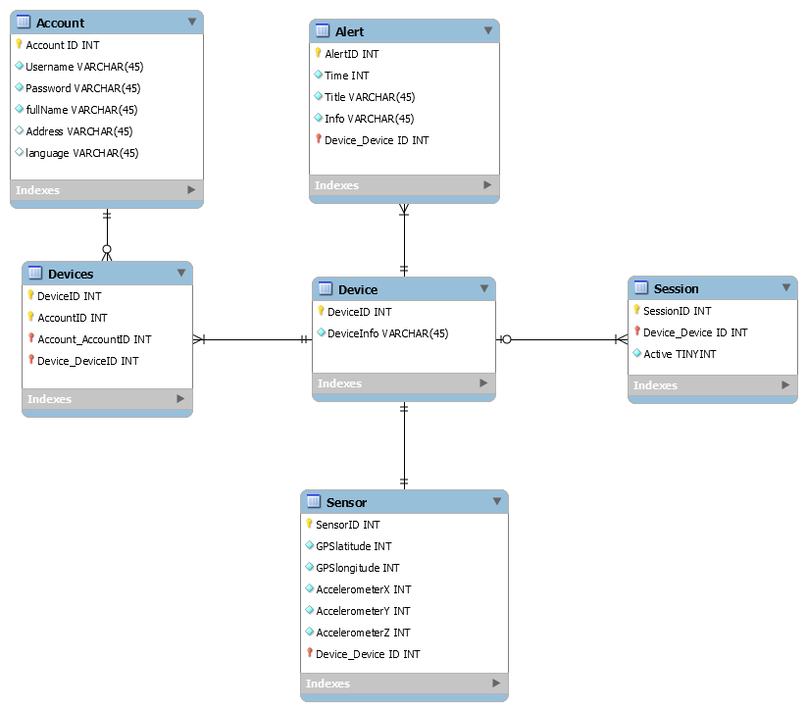

Figure 32: ERD of the SSDC Database

Class Diagram

The class diagram shown below was to represent the objects and their attributes and methods. The class diagram was used to show the data that was stored for each object and the functions that they need to produce. The class diagram takes functions from the data flowchart, use cases diagram, and ERD, but also further shows the data and their data types and the names of the methods that had been used to perform the functions for the SSDC device and mobile application. Just like the ERD, the IDs given for each object had prevent redundant data and provide uniqueness for the objects.

User Class:

The user class, as mentioned in the ERD, contains the user’s login information in the form of a username and password, which was used for security and gives the user access to the mobile application by using this information. The methods were to allow the user to login to their account as well as change their account information if they want to change it for security purposes or personal preferences.

Main Menu Class:

The Main Menu was the object used to represent the UI of the mobile application and gives the user access to the mobile application’s functions once they were logged in. The user had been able to configure settings, setup Wi-Fi connection, activate the device, and view the recorded live footage and GPS location. Viewing the recorded live footage and GPS location had require the user to interact with the main menu and send an input to the server to gain access to the live footage and GPS location, which was stored in the SSDC device. From the Main Menu, the user had receive notifications and be able to view the recorded footage and images of instances of car theft and car damage occurring on their vehicle.

Server Class:

The server class act as the receiving end of the SSDC device where it had retrieve the device’s data and any notifications that had been sent to the user. Before these methods can become active, a connection between the mobile application and the SSDC device must be made so that responses can be made between the two objects. The server had contain a name to identify it outside of its ID. The server had only retrieve the device’s data and notification once the device had been triggered and they had been transmitted.

SSDC Device:

The SSDC device had contain all the sensor data, recorded live footage, and GPS Location within the object. With this, the object was responsible of retrieving data from the sensor, live footage, and GPS to be sent to the server so that the user can retrieve the data. This was also where the device had been triggered by the sensor to send alerts along with the footage and images of the instance of any car theft and car damage. The device had also respond to user inputs sent from the server to view any live footage or the GPS location from the device.

- Sensor Class: Includes data from the accelerometer, gyrometer, and magnetometer. Responsible for triggering under certain conditions that count as a scenario of car theft or car damage, and as a result had retrieve the data from each sensor and send it to the device to start sending alerts to the mobile application.

  - Accelerometer: Contains data of acceleration forces in the X-, Y-, and Z- axis and sends them to the Sensor class to clarify if the scenario was a case of car theft or car damage or ignore it as it was a false positive.

  - Gyrometer: Contains data of angular velocities in the X-, Y-, and Z- axis and sends them to the Sensor class to clarify if the scenario was a case of car theft or car damage or ignore it as it was a false positive.

  - Magnetometer: Contains data of direction in the X-, Y-, and Z- axis and sends them to the Sensor class to clarify if the scenario was a case of car theft or car damage or ignore it as it was a false positive.

- Live Video Class: Contains the recorded live footage from the SSDC device. Once the device sends a response that trigger had occurred then it had transmit the recent recorded footage and take images to be sent to the user through the device and server. It had also respond to any user inputs from the server and device class if they need to view the live footage.

- GPS Locator Class: Contains the GPS location in terms of latitude and longitude. The class had respond to any user inputs if they need to view the current GPS location of the device and their vehicle. This had then transmit the GPS location to the user through the device and server for the user to retrieve the information.

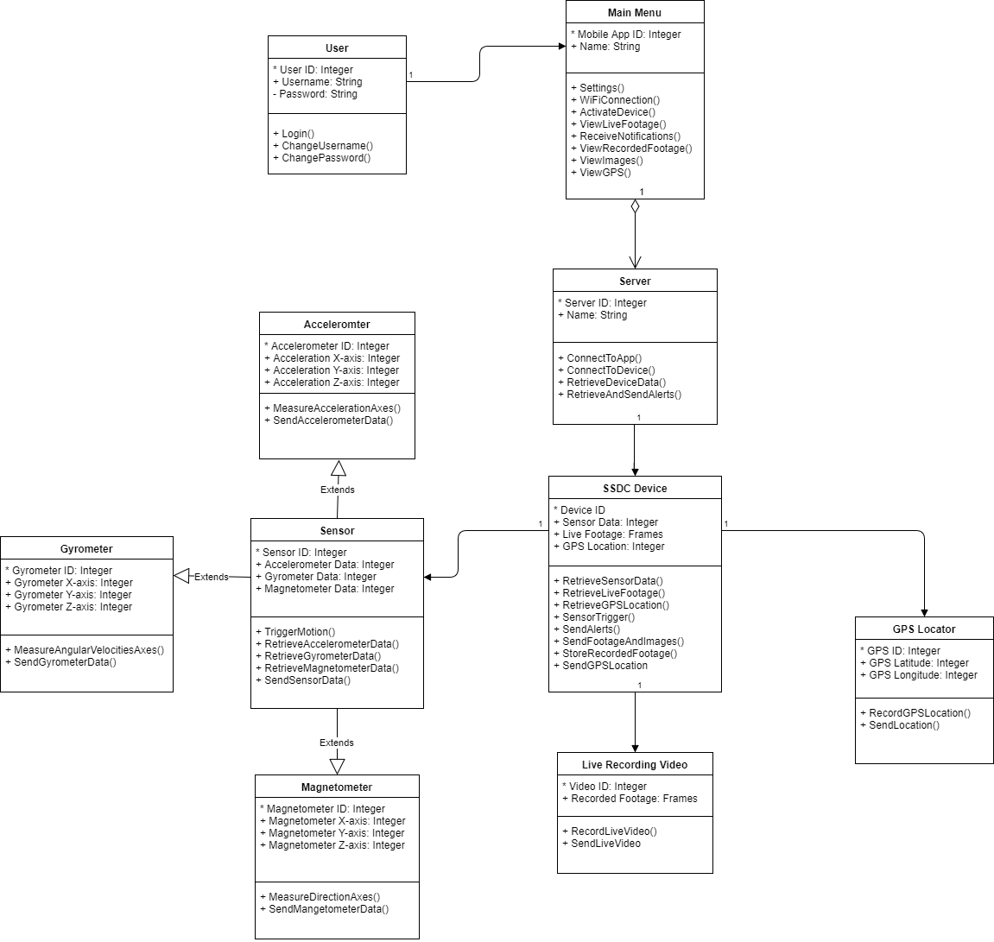

Figure 33: Class Diagram of SSDC Device and Mobile Application

5.2.5 Mobile Application Features

The following sections discuss the numerous critical features and components of the mobile application, this includes detailed technical information, design choices as well as general utilization of the application. All related specifics and challenges had also be discussed in the following sections, little to no specific code had been detailed. The application can be broken into multiple different features that make up the bulk of the application, features such as the live video camera feed, the GPS location as well as the cloud interfacing for long-term accessible storage and synchronization.

Any feature listed below were deemed as necessary features to the critical utilization of the product and were thus prioritized in the development phase. The list below was not representative of all possible features for the product nor was it comprehensive. Any new features or minor additions had been documented at a later date.

Authentication

The mobile application had need a form of authentication and device registration in order to ensure only the correct users utilize the mobile application. It would be a large issue to allow for any user to be able to access the user’s data, control the device or view the live stream. There were numerous safe methods to implemented such a feature, many devices had do one time-registrations where the user need the device’s serial number or another long hardware unique number associated with the device. It was also possible to force an initial registration that associates the client’s device when the physical device was booted up for the first time, this would make it difficult to utilize other devices to view the feed. Whichever method utilized had require the device to associate itself with a unique identifier or physical interaction with the device to ensure device registration associates the correct device and prevents unwarranted users from registering devices to their phones.

Our device had require a one-time setup on device boot-up that had allow the user to connect to the device through the mobile application by simply joining the devices network. Once connected it had pull that unique identifier information and the mobile application had remember and pull the devices connection information, this had included a unique number associated with the device, the wireless password utilized to connect to the device as well as any information related to the settings of the device. The application takes all this data as for the one time registration it had utilize all the information pulled and any data inputted to automatically create a user registration. The mobile application had then utilize the cellular device to send the registration information directly to the registration server.

Once the mobile application had performed the initial registration the user had been prompted to login in order to access the data from the communication server. Registration had only be prompted when requested else a login prompt appears on the mobile application home screen unless already authenticated. Authentication was required in order to ensure that the device was communicating to the correct host.

When a new mobile device wants to connect to the device it logs in with the account credentials created during the initial registration. Upon successful authentication verification with the registration server the device receives a unique identifier for the dashboard camera device as well as a session token and all subsequent requests to the control server had contain the unique identifier and the session token for that device. In this setup it would be possible to implemented device login auditing as well as device history. The session tokens provided had expire after a set period of time or on logout, when a user logs out the application tells the server to kill the related session. When a sessions was expired or invalid the user had been prompted to login once again to obtain a new session token. The session token was entirely responsible for validating and authenticating the requests to the SSDC device, as had been discussed in the security section if the sensitive information such as passwords or session tokens were hijacked then an attacker may mimic and control the device themselves.

Notifications/Alerting

A crucial aspect of a security device was the timely notification and alerting of critical security events such as break-ins or physical damage. The device must be capable of sending the device alerts and the mobile application must be able to either convey these alerts through SMS or through the mobile application. The prioritized method had been to send an SMS method directly to the primary registered mobile device associated with the unique device, this information would be stored directly on the device. The SMS message would alert the user that the device had an alert, the alert would contain the following information:

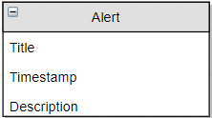

Figure 34: Alert Data Format

This provides sufficient information to the user to alert them to any possible issue, that may had occurred; the user then may check their device remotely utilizing the video feed and determine if an issue was truly occurring. The method at which alerts were determined were discussed later in the paper as the system was critical to the major function of the device. When an alert occurs the device had attempt to send the alert to the server and associate it with the unique device number. Through this method the mobile application had been capable of rendering the alert through the application and even provide a log for all the alerts on a device up to a certain timestamp. With logging a system may be implemented in the long term to allow for the integration of an AI alongside with user feedback on alerts to determine an improved algorithm for determining alert sensitivity.

Video Feed

The video feed involves the live video feed from either of the two onboard cameras of the device. This feature as stated before, had require the mobile application to request the live feed to be transmitted in order to avoid higher than normal data usage. The data when requested had been automatically transferred immediately to the REST server assuming the communication service on the device end was available. If the communication strength was weak and incapable of supporting the full quality of the stream at the preferred 1080p, the device had degrade the service to the maximum possible stream quality available. This may lead to the device only being capable of sending a lower frame rate as well as a lower pixel resolution, the lowest pixel resolution that had been supported being 240p; Incapability to support a 240p pixel resolution had result in the device providing an error stating the lack of service available to the device. Upon error the live stream control had automatically disable the feature to avoid the live stream continuously streaming without the user’s knowledge. The device had of course still saved the data to the local storage for later uploading and ensuring critical information was not lost.

The above figure illustrate the intended UI to be utilized on the live video interface. The “Live Camera Toggle” button was the control for which camera the user were viewing, the button had three states: live feed disabled, camera one feed enabled and camera two feed enabled. Interaction was as simple as toggling through each but may be changed a different UI design, potentially one which had not enable camera one in order to see camera two’s live feed; a potential solution to this problem would be implementation of more buttons, a drop down list design or some other possible more elegant gesture detection control. When the live feed was disabled the live feed had just display a blank error page. The interior enable and exterior enable were also buttons, these buttons provide the ability to disable to the devices cameras during recording. For example during dashboard camera mode most users may not want their device to record the interior of the vehicle, this had allow for the user to temporarily disable that camera from recording during dashboard camera mode. The preference had been ignored when the device records due to alerts or live feed.

There would be two ways of getting the video feed from the cameras of the device. Either through remote feed or local feed. Local live feed is used with the SSDC device and mobile application when the user is connected to the device’s router network. This allows lower latency and buffering and clearer view from the cameras. However, this means that the mobile application will not have internet connection with the use of the device’s network, unless they have another network connected with internet connection, such as using cellular. Remote feed is used when the user is away from the device and vehicle from farther distances. The local feed is received using an RTMP protocol to receive the live feed from the cameras. Both live feeds have the option of toggling the cameras ON or OFF at any time.

Video Recording and Storage

The device must be aware of the moments to differentiate between full recording or just taking photos. In order to save power, the SSDC device had only do full video recording when the car was in operation as a Dash Cam and after an alert was triggered or live stream was enabled. The device determines if the vehicle was currently in operation by monitoring the vehicle's battery level, if the car was in operation the vehicle battery should register a higher voltage than under other circumstances. Under these circumstances the device had been constantly recording full video feed to the devices local storage (an SD Card). The device had record all the data that it can until local storage reaches capacity, at which point the device had attempt to upload the data before that point. If the data cannot be offloaded by the time which the device reaches a max storage space it had begun to overwrite the oldest data.

If the device experiences an alert the device had also begin to record for a duration of 8 minutes after an alert was triggered. The device had not extend this duration based off any alerts experienced during that time lapse; For example if the device first sees an alert at 10:00 the device had begun recording, the device then experiences another alert at 10:05 before the device had completed the initial trigger recording, at this point the device had end recording at 10:08 as initially determined. If another event was triggered after the recording was finished it had then begin recording for another 8 minutes. This was to prevent excessive battery drainage from consecutive alerting and to be sure to only record critical events.
If the camera was being operated in the live feed mode the device had begun to record all actively view cameras. As indicated in the above section, the live mode had not activate all cameras only the camera currently being viewed by the user. Whichever camera being activated through this feature had write the device data to storage as possible.

All features may be customizable at some point allowing for the user to customize their recording experiences. Such as in the case if a user would like to downgrade the video quality to reduce bandwidth costs they may be able to adjust the resolution at which the devices record or upload. Another potential setting had been the ability to force the live feed to enable both cameras when live feed was active thus recording through both cameras and allowing for a quicker swap between the live feeds. During the live mode the cameras had power down after a brief period of time of inactivity.

Unfortunately, this was simplified with the final prototype as research and implementing the code for the parts that were being plan to use took too much time and had too many issues of getting it to work as there was no available code to support its usage for this device. However, what the prototype has now compensates for this and can receive and store media from the device.

Tracking

The GPS location feature provides the necessary access to track the vehicle through the GPS module onboard the device. The purpose of this feature was to provide a means for finding and tracking the vehicle for purposes of potential theft as well as if the user just mistakenly forgot their vehicle’s location. Which can be a handy utility for the user to be able to find their car in massive parking locations such as Walt Disney World. The SSDC device transmits the GPS longitude and latitude of the device periodically along with other sensor information such as the accelerometer and gyrometer to the data server, assuming it had connection and correlates it with the time sent.
The mobile application when swapped to the “Tracking” module of the application had request the last known GPS location of the device from the data server; a button had been available to manually request a sensor refresh to have the device grab more recent information regarding the sensors. Utilizing the grasped information the application had then process the data and formulate it on top of an open source module with an extensive API, most likely google maps as it comes standard on most android devices and was familiar with an extensive open source API for utilization. The user then may double click the location to be provided with navigational options to the coordinates through the use of an external application such as Waze or Google maps.

Along with the GPS numerous other sensors were available such as the accelerometer and gyrometer. The data associated with these devices were being sent along with the GPS data periodically to the data server. This information while utilized in alerts may not be available to the customer directly. Future utilization may be discovered in repurposing the data for applications beyond alerting such as implementation into a sort of game tracking or statistic analyzer of vehicle speed over time and location. The data may also be utilized after being sent to the server for insurance purposes as well as in a corporate environment driver safe driving checking. The device information had a wide variety of potential uses in the marketing and insurance industries.

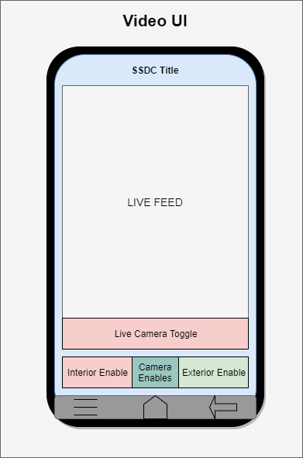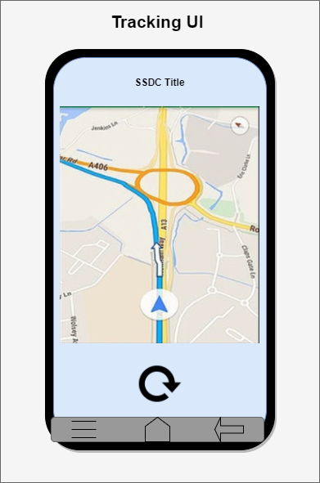

Figure 35: Live Video Recording and Tracking application UI

Settings

The settings menu was valuable to any application to allow for user customization as well account or device changes that were created during the initial device registration. The settings menu had also provide information regarding the device such as that device's serial number, which was a uniquely identifiable number that should be impossible to enumerate. The settings menu had been where the user may customize all the settings regarding the wireless hotspot, the devices known networks, camera and upload settings and other miscellaneous features.
The wireless hotspot settings had provide a diverse group of customizable features. The most important being the configuration of the actual hotspot the user must be able to change the wireless WPA2 key passphrase for the hotspot. Of course the device may had the wireless hotspot renamed beyond the standard default channel of SSDC_{Random Number}. The user from the settings menu may also be able to change security features regarding the device as well as completely enable or disable the hotspot; if the user was connected to the hotspot and then disables the hotspot their communication channel had been ended and the mobile application and device had been forced to swap communication channels.

The wireless connection settings were crucial for the product’s operation as the device preferably would desire to be connected to a wireless hotspot over utilization of cellular data, for both bandwidth as well and energy concerns. The device needed to have the feature enabled first and foremost, the user may optionally disable this portion if it may provide battery savings or if was not optimal for their location. User’s utilizing the feature must be able to create known trusted networks for the device to connect to as the device had not attempt to connect to random unsecured open wireless networks without the network being added to the configuration. The user from the settings menu may add known networks of either open or secured networks that utilize WEP/WPA/WPA2 to their configuration; a dialog box had appear on the screen when adding new trusted networks that had ask for network configuration such as network SSID, identity, passphrase and connection type. If the user prefers to select the wireless SSID from a menu a Dropbox had been available that had force the device to search for visible wireless networks on the 2.4 GHz bandwidth, selection had auto-fill the wireless SSID in the menu. From the known networks the user may rank network priority so that the device had communicate with the highest listed priority network over a lower priority network.

The camera upload settings as mentioned in above sections had allow the user to control the program flow of the application and quality of the data and cameras. The user had had the capability to customize the data usage and overall quality of the device. Camera settings may be adjusted to default different features to be enabled beyond the traditional configuration. Settings such as the video quality of the device during recording, live stream and alerting may be changed from up to 1080p the max quality down to 240p; the user had been warned if adjusting the device beyond 720p indicating that the quality had been extremely degraded at that resolution. The camera’s may be configured to enable at different times such as implementing the ability to disable the front facing camera while in dashboard camera mode or enabling the cameras to both record when in live stream mode until the mode is exited by the user. Along with other smaller but enjoyable features that the team deems necessary or marketable.

In order to manage the bandwidth of the device the user may adjust when the device had attempt to offload the videos to the cloud storage. Some users may find they prefer for the device to only upload the video data when the device was connected to wireless over cellular to same data bandwidth costs or that they would like to upload the data at a lower quality than the regular 1080p. While others may find they prioritize the data to be available to the cloud as soon as possible and had had all new recordings be sent to the cloud storage immediately with no care for the communication channel utilized. Other settings may be implemented at a later date for production utilization as well.

5.3 Security

Historically, security had not been a prime issue for new technologies; the coming of internet of things (IoT) devices, smart products that were connected via a form of networking, had brought upon a new dawn of technological issues and risks. Interconnectivity of smart devices and the connection of these devices to the public internet had greatly increased the public attack surface. Security researchers had stated the security risks of IoT devices to be of the highest risk and can be seen by the increase in security research for these devices. According to Gartner Inc., “Worldwide spending on Internet of Things (IoT) security had reach $348 million in 2016, a 23.7 percent increase from 2015 spending of $281.5 million”. The long list of IoT devices increases greatly with every coming year, the issue does not lie solely on the customer but on the poor security implementations of the product designer. These products were being created quickly and mass quantity in order to be the first to market or reduce costs to allow for a higher market penetration. A standard customer may not be aware of the risks of these devices and it may not even be a high priority; although for devices connected to sensitive infrastructure such as a vehicle, security plays a vital role compared to a smart light bulb. Depending on the interconnectivity of the device to other infrastructure, the smart device may provide a tunnel to attack devices non-smart devices that were connected to the product. A security product should not introduce security flaws, with this mindset the device had been designed with a complete security mindset.

5.3.1 Attack Surface

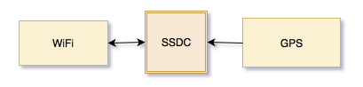

Figure 36: Attack Surface

Attack surface of a device was the possible penetration points for an attacker; minimizing the attack surface greatly reduces risk and potential access points. In the case of the Smart Security Dash Camera, the device only had three physical potential penetration points: Wi-Fi, the physical device and GPS. The most critical of the three attack points being Wi-Fi, this was due to the remote nature of the technology. Ensuring the security of that attack point had been the most critical to ensure the device and data were not tampered with remotely. The physical device’s security becomes crucial for a physical security mindset. The attack surface of GPS remains only the jamming of the signal preventing tracking. The device as well may be attacked from an application level such as the mobile application and on a network level.

5.3.2 Risks and Concerns

Smart products run the risk of being exploited remotely by attackers due to their level of interconnectivity. The wireless hotspot created by the Smart Security Dashboard Camera provides the ability for an attacker to attempt to perform malicious activities against the device. In the case of a thief attempting to steal the vehicle after noticing the camera, assuming the security of the device was poor, the attacker could simply connect to the wireless access point and disable the device. As well as in the case of remote spying, the attacker upon connecting to the wireless access point would also be able to download all of the data on the device; personal data such as video recordings of the owner in their private property. This had been a concern for numerous smart home devices such as smart security cameras. The SSDC must be designed to ensure the security and safety of the user’s personal data and vehicle.

5.3.3 Wi-Fi

Due to the nature of wireless transmissions the data being sent over wireless networks remains completely visible to any receiver decoding the signals. Without encrypting the data any arbitrary individual may receive the transmitted signals travelling the open air and decode the data to understand the transmission. In the case of a standard wireless network not utilizing encryption, an attacker was able to receive all the data packets, including data such as account login information or browsing history. Jamming was another issue with wireless devices, blocking communication from one device to another as was the case with all devices reliant on wireless transmissions.
Encryption for wireless networks (WEP) was first introduced in 1990 and had since been declared insecure, with the introduction of new encryption methods with WPA2 as the current standard. Even utilizing WPA2 a network may still become compromised due to certain attack vectors or weak/insecure encryption keys. The SSDC had require WPA2-PSK implementing a secure password policy.
A secure password policy had been indicated as a key with at minimum eight characters, one symbol, and one integer. Although in order to have a stronger security policy users would be encouraged to implemented higher entropy keys. Higher entropy can be achieved through a passphrase consisting of two or more unrelated words, this also allows for an easier to remember passphrase.

The device had only connect to wireless networks indicated as trusted by the user, this was to ensure arbitrary unsecured networks were not joined providing an access point for an attacker to communicate with the device. As an attacker may only see the device on a network level by being on the same network as the device. Trusting only residential, work and school networks were recommended to ensure the device was segmented from potentially malicious users.

5.3.4 WPA2-PSK Cracking

Potential for vulnerability lies in the methodology for sharing the the public key in the four way handshake. When the client attempts to authenticated to the wireless access point the client and server utilize this handshake to authenticate the user the access point (AP). The wireless access points security-phrase, more commonly known as the wireless password had to be shared. The client does not send this phrase in plaintext but it was possible to still decrypt the security phrase sent to the access point..

Methodology

In order to capture the handshake packets being sent to the access point we must first had the ability to the run a wireless network card in promiscuous mode to receive all packets that were being sent over the air, even ones not directed to our host. The utilization of a networking security tool, “airmon-ng” and “airodump-ng” were necessary to streamline the process. Utilizing this tool the user may monitor all the frames being sent to all SSIDs and narrow down to a specific network. In order to capture the four way handshake a valid connection to the access point had to be made by a client with the correct password this may be achieved with time or by forcing a user to reconnect; to force a user to reconnect may be possible through the utilization of network death. This requires sending de-authentication frames to the network to de-authenticate a client. Once the handshake was captured the user may utilize a program to such as WPA crack to run an attack against the WPA2 password in attempt to crack the hadh to the plaintext password.

Risks

The average computer may be capable of testing 3 million passwords a day, thus taking a long time to break the security key. Assuming strong password requirements the feasibility of said attack was low in the volatility of the network and the value of performing an attack. Brute Forcing attacks in known good encryption schemes were typically extremely slow and unutilized in security attacks.

5.3.5 KRACK

The key reinstallation attacks (KRACKS) vulnerability was released to the public October 2017, demonstrating a security flow in the widely utilized WPA2 wireless network encryption standard. The attack tricks the victim into reinstalling the key utilized for network transmission in message three of the four part handshake; accomplished by manipulating and replaying cryptographic handshake messages. The access point had retransmit message three if it detects there was an error with the receival of data, in order to force the client to reset their encryption key the attack just had to replay message three of the handshake. Due to the resets the encryption protocol can be attacked, packets had been able to be forged and replayed.

Risks

Due to the recent release and easy of exploitation the vulnerability risk was higher than would be typically warranted. Release patches had not been provided for all devices, the client side requires the patch instead of the access point. Assuming devices were patched to not reuse the encryption key then there was no risk to exploitation. The SSDC device may not be configured to assist in the prevention of this attack.

5.3.6 SSL

All of the devices data (recordings, statistics and alerts) had been sent over wireless networks. Network protocols by default do not enforce encryption and thus were capable of being decoded by any application with access to the packets. In order to ensure the security of the data being sent to and from the SSDC encryption on the transport layer must be enforced. This may be accomplished by the implementation of Secure Socket Layer (SSL) on the Hypertext Transfer Protocol (HTTP) packets being sent over the network. SSL was a protocol built on top of HTTP to allow for secure communications over computer networks.

SSL provides this security through the utilization of a private key and a public key. The public key being the SSL certificate and the private key being stored on the web server. The device communicating to the server may not send and receive data from the web server encrypted by utilizing the keys to encrypt and decrypt messages. There were cryptographically weak algorithms that must be avoided to ensure the messages may not still be decrypted through methods of Brute Force or handling collisions.

SSDC had implemented SSL on all networks utilizing the OWASP best practices for Transport Layer Security (TLS). This had ensure that the data being sent over the networks may not be received and decoded by arbitrary users.

5.3.7 GPS Security

Global positioning system had very little security concerns when regarding the SSDC; as GPS cannot be considering a critical system for this product. The utilization of GPS in the system was to confirm your vehicle’s position, this may be useful for situations such as towed vehicle or vehicle theft. In the case of vehicle theft, the thief may dispose of the device or if that was not possible jam the device. Jamming the device while uncommon must still be considered as a potential attack method. As such the SSDC had not protect against GPS jamming due to the minimal risk.

5.3.8 Mobile Application Security

A standard attack vector lies in the mobile application. The SSDC had require the utilization of the mobile application to communicate with the device over a secure channel. In order to ensure the correct user was accessing the device the product had also require a secret key; A secret key was a pre-shared key known by the device to be utilized as a form of basic authentication. This key had been provided by the device during product registration and must be entered into the mobile application to ensure only valid users may access the mobile application. The key had follow be randomly generated of twenty-four characters in length, consisting of both numbers and characters.

5.3.9 Physical Device Security

A crucial aspect of the device in order to prevent tampering and theft was the physical security of the device. The device needs to be constructed securely enough to prevent an attacker from removing the device with extreme ease. This can be accomplished by designing all components to be securely built and enforce a locking mechanism to remove devices such as the SD card. This can be achieved by placing the relevant slots near such as the SD card facing a non-accessible surface such as the mirror or mount point. Then force a lock on the mount point to ensure the device can only be removed by extreme force or the appropriate user. This had been crucial in ensuring the integrity of the media and device, which had been important in commercial sales of the device. The device may not be completely secured from an attacker as brute force had always provide a means for the removal of the device. The purpose of these counter measures to attack were merely preventive. During the potential attack on the vehicle the camera should be secure enough to cause the attacker to have to stay a prolonged amount of time to allow for both the user to get a notification of the attack as well as bring attention to the attack due to extended duration of brute force.

While the desire of the device’s construction was to create a secure device that was hard to tamper with the future desire of the product was to included customizability. This customizable nature had been in the form of color changes. While this had drawn attention to the SSDC it had ultimately serve as a double edged sword. Possible thieves had seen the device if it was colored pink or a bright color, but as a result the thief had known the danger of trying to assault a car armed with a security system. It was also expected that the ability to choose colors for the SSDC had increase sales in market by appealing to a vaster amount of users desires.

6.0 Project Prototype Construction

6.1 Hardware Overview

The following section cover the parts chosen to be in the SSDC. The individual parts were explained in prior sections, so this section had list the parts we had use but not all of their specifications. The parts mentioned here had been the parts in the figures and blocks below.

3 in 1 accelerometer, gyroscope, and magnetometer LSM9DS0 - The LSM9DS0 was chosen for the accelerometer, gyroscope, and magnetometer due to its ability to function as all three at the same time as well as having a reasonable price point. The LSM9DS0 boasts testing ranges from ±2 to ±16 g linear acceleration detection for the accelerometer. Its readings range for flux range from ±2 to ±12, and also had a ±245 to ±2000 dps angular rate. The use of the LSM9DS0 removes the need for extra components as well as saves space on the PCB saving money. The system required input voltage of 2.4v to 3.6v falls within ideal ranges to be able to utilize the 3.3v voltage plane that had been implemented in the PCB. The device had been fully utilized due to the need for every part of the component in the SSDC.

Switching Regulator LM2592HV - The SSDC had run off of a car battery, so the input voltage had to be reduced to a usable level. Fortunately the voltages for the component of the SSDC were for the most part either 3v or 5v dependent. To reduce the voltage to a safe the LM2592HV was chosen to reduce the high input voltage to a stable 5V DC voltage input into a lower DC voltage with a 2ma stable current. A second LM2592HV 3.3V switching regulator had been used to run a physically separated part of the layer to allow the components above to had their voltage supplied from the plane rather than having a vast number of traces. To do this on the PCB it was a simple process of adding a separation in the plane during the eagle creation, and had been translated to the PCB manufacturer through the gerber files.

WI-FI Chip CC3120MOD - The Wi-Fi component selected for the SSDC was the CC3120MOD. Similar to the other components the input voltage was allowable for between 2.7v to 3.7v which falls in the range of the 3.3v. The Wi-Fi chip was also low power which was ideal for the low power setting when vehicle was idle. The chip also integrates many of the necessary functions and protocols reducing the need for extra of software programing. The chip also comes with an accompanying arm processor to assist in data transfer and receiving. This reduces the strain the chip had put on the MCU which had to already handle two HD cameras. Also the chip comes with 256 bit encryption which was covered in depth in the security section of the paper.

MCU TMS570LS3137 - The TMS570LS3137 was chosen for the processor in the SSDC due its high performance, already being automotive grade, and falling into other necessary requirements. The MCU requires an input voltage of 3.3v similar to the other components to simplify PCB design. The MCU was also chosen for its dual core running CPUs, memory storage/processing with 3MB of program flash and 256KB of RAM, and an acceptable input bandwidth of up to 186MHz. These were important considerations when choosing this MCU due to the need to run multiple HD cameras. A downside of the MCU was that it cannot run Linux, but it was thought that including a processor that could would result in over engineering. Also already being automotive grade the MCU was thermally acceptable at -40C to 125C operating temperature. This MCU was chosen for the processing due to its affordable nature, and tremendous power for its size, and not knowing 100% a less tested component would fail.

GPS FGPMMOPA6H - The GPS chip selected for the device was the FGPMMOPA6H. This chip was a high precision GPS chip that was both low power as well as high velocity compatible. The sensitivity of the device was up to -165 DBm, and utilizes automatic antenna switching functionality. The chip also comes with a 1- PPS timing accuracy allowing for extremely accurate location readings.

CDMA AirPrime HL7588 - The HL7588 was chosen for the CDMA chip chosen for SSDC due to performance and price. The HL7588 was a 4G CDMA chip that had access 3G if 4G was not able to connect. This chip had the most reasonable price for 4G performance. The thermal ranges of the chip were between -40 to 85C, so the device meets the desired thermal standards for the interior of a vehicle. Had a 3 volt input which can be easily obtained with the use of buck regulators or voltage dividers. The development board for the chip was also very cheap compared to other CDMA chips.

Surface Mounted Switching Regulator LM5165-Q1 - The synchronous buck Converter with ultra-low IQ allows the circuit to conveniently connect to low current devices such as video processors, MCU, GPS, and any other lower power device. This had allow all chips to receive the same voltage and current constantly. Obtaining low current for the circuit leads to low power consumption. This method can produce less heat and provide more power savings to the device in a time of low power need. The camera needs to record while the vehicle was off. This allows for the user to gain important photographic evidence of any situation outside the norm. The output voltages of the regulator were conveniently 3.3V and 5V. The lead on the high-side P-channel MOSFET can operate at 100% duty cycle for lowest dropout voltage and does not require a super capacitor or battery for gate drive.

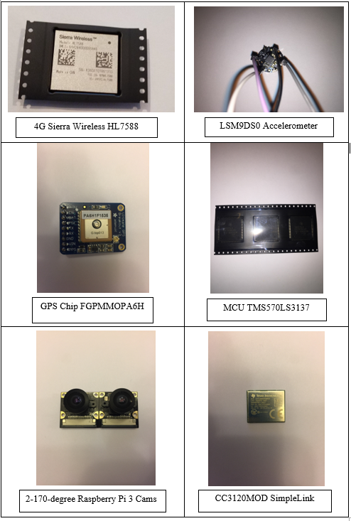

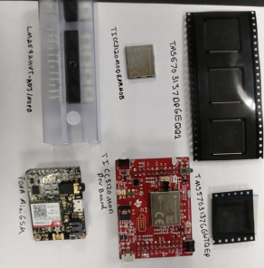

Figure 37: SSDC Device Components and Parts
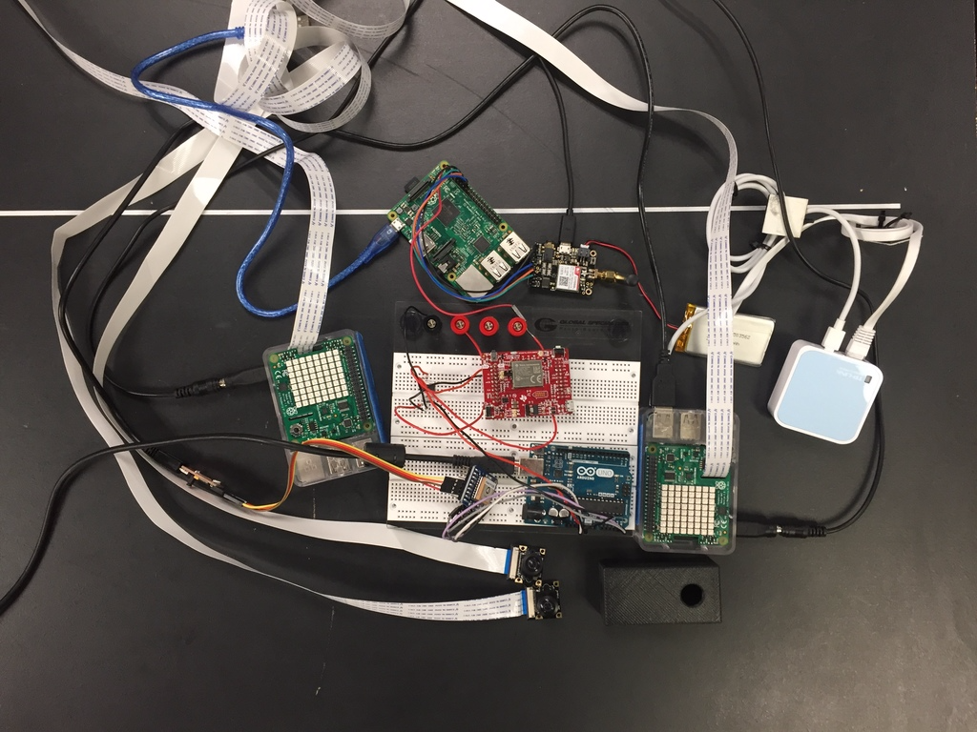

Figure 38: Breadboard Prototype Testing

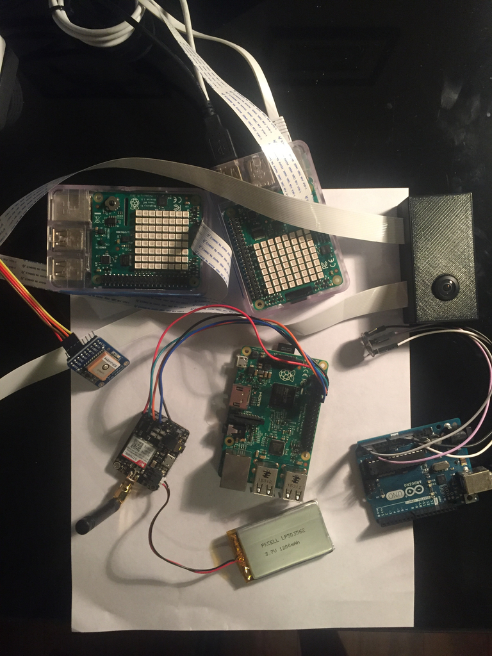

Figure 39: Prototype Testing

6.2 PCB and Integrated Schematic

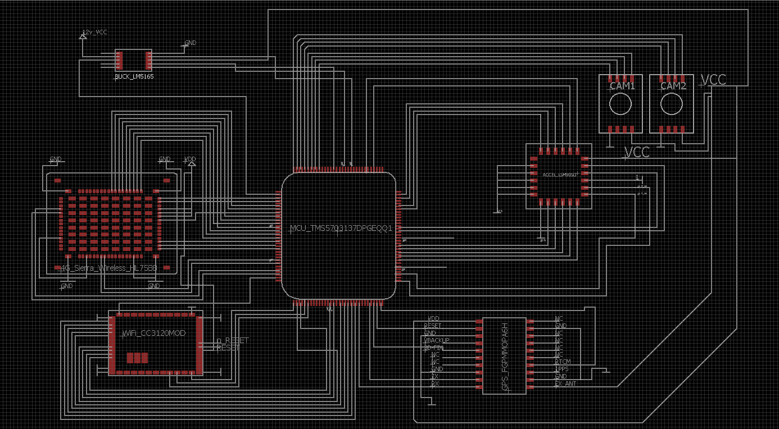

Figure 40: Schematic Design

The above diagram was a draft representation of the schematic design for our PCB and project. All major components were shown above connected through pinouts determined by the data sheets provided by the manufacturer. This schematic does not demonstrate the final build for the device as it was missing smaller connections such as required resistors, LEDs and other smaller electronic components required to get the device in a functioning state. Instead the diagram was representative on a higher functioning level than the final schematic.
As can be seen the device stems from the main microcontroller, to all other components. Two cameras lead from the microcontroller to the device connected through 3 singular wires to SPI pins. In the final design these cameras may instead lead to a video processor that then sends the final processed data to either storage or the microcontroller.

From the microcontroller the sierra wireless package as well as the CC3120MOD can be seen connected to the device on the left hand side. These had numerous required connections and had been sent directly to the microcontroller, due to their ability to already process the data on their own chips. In the final PCB design these chips had been positioned on the outside wall of the PCB, obtaining a position as close to the exterior as possible. This was due to the requirement for the devices, they need to be near the external wall separate from parts that may cause interference in order to obtain the best possible signal through their antennas.

On the left hand side of the schematic the power supply conversion for the device may also be seen connected to the MCU. The buck converter provides the power stepping from the received voltage down to a usable 3.3v or 5v power VCC.

On the right side again the user can see two more devices the GPS and accelerometer. Both devices which provide analog signals can be seen connected to the device utilizing the onboard analog to digital converter pins in order to read those analog voltages and decode the data. They also fit all of their other required pinouts to the device such as VCC.

The diagram provides a valid representation of the product in the design stage, while some parts were missing such as the low level parts and the SD slot mapping. The final representation had included all such components and be a functioning design of our product that had been sent to the PCB manufacturer of our choosing.

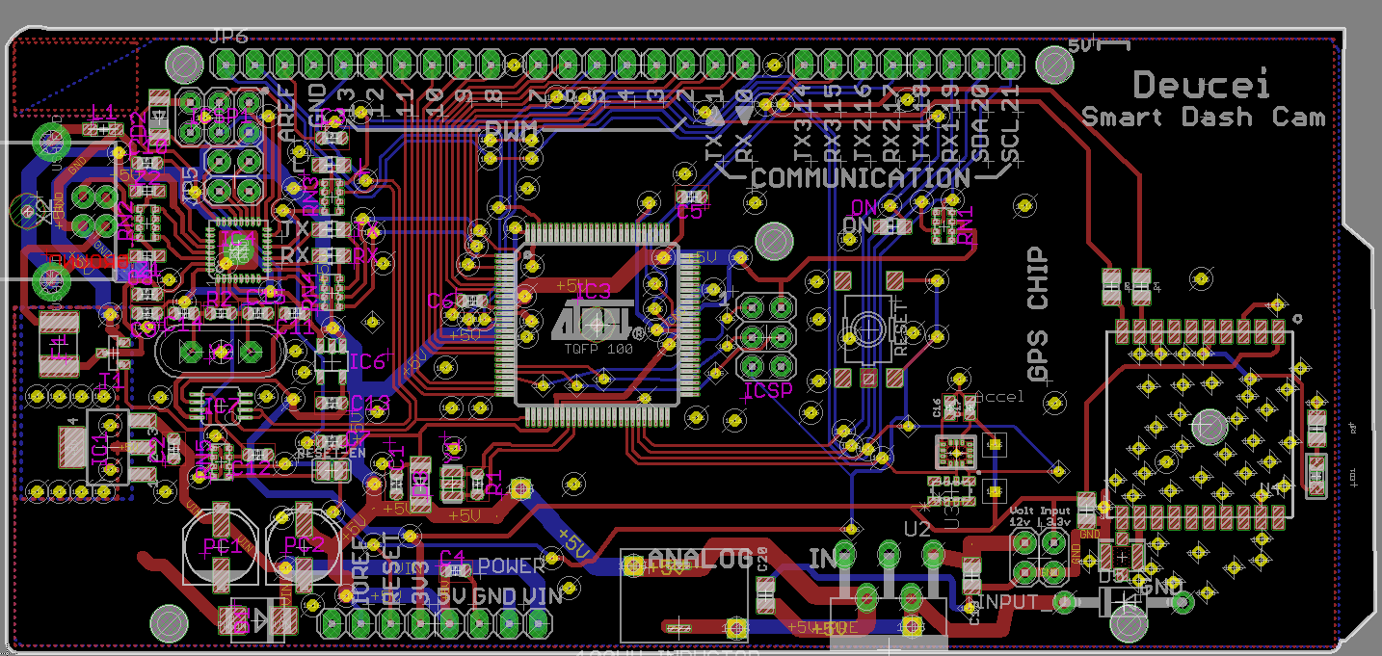

Figure 41: Final Board Design

The diagram above is the final board design used for the SSDC device. It includes the parts selected for this project, including the accelerometer, GPS chip, Wi-Fi chip, MCU, etc. However, the DM388 development board was not used in the final design of this board as it took too much time and design constraints for coding and having it function along with the board. It was abandoned during creating the design and soon compensated in coding. This is the third board created by the group that functions with the specification requirements and is used for the prototype demo.

7.0 Project Prototype Testing Plan

The project prototype had needed to go through many testing scenarios in order to be validated as functioning properly. Since the project had undergo many possible scenarios that had possibly trigger hardware and software, there were many ways for there to be errors in the design or false positives to be present. Since this was a prototype, the device had not been able to undergo all the possible scenarios if it were placed inside a car and detect car theft and car damage. The prototype device had needed to be tested in parking garages, near train stations, and other high vibration environments. This had been done using an arduino with an Adafruit accelerometer, gyrometer, and magnetometer chip. The device had recorded the different scenarios and use code to make sure to filter them out. This was to ensure that a customer does not receive a false communication error that their car was being broken into. This would make the product nonproductive as it was only suppose notify the user in parking mode via a smartphone app if an unexpected theft or crash happens. The other testing had been ensued during normal driving conditions. The camera system should clearly record all of the environment during normal driving conditions during the day or at night. The prototype had also need to be able to upload this video directly to the Cloud storage in real time. This had been done using Wi-Fi and Code Division Multiple Access (CDMA) or Global System for Mobile (GSM) to deliver the data to the cloud in real time. The smartphone app had needed to send push notifications to the users and notify them of an event even though their smartphone, even if it was on silent.

7.1 Hardware Testing Environment

In this project, the dashboard camera had been attached behind the rearview mirror where most of the hardware had been attached onto the back of the mirror, while the camera portion had been right below the mirror to record footage in front and back of instances that were occurring inside and on the sides of the car and in the front of the car as well. The camera must be able to record clear, live footage in the front and back and had instances where it takes and stores pictures and footage of instances of car theft and car damage. The accelerometer, gyrometer, and magnetometer must trigger properly in order to catch these instances without creating a false positive. The camera had also had to be temperature tolerant, as the car had become extremely hot under harsh sunlight, which can potentially cause the device to malfunction. The camera had also detect excessive emissions of carbon monoxide inside the car as to prevent carbon monoxide poisoning from fumes coming into the car, especially when passengers stay inside the car. The GPS chip was included in case of car theft to detect where the car was currently located.

7.2 Hardware Testing Scenarios

These testing scenarios had mostly tested the accelerometer, gyrometer, and magnetometer as they had detect instances of car theft and car damage. The accelerometer had detect instances of acceleration forces, the gyrometer had detect rotation or angular speed, and the magnetometer had detect movement of nearby objects. The camera had been tested in its ability to record clear, continuous footage and be able to record and take images of instances of car theft and car damage. The carbon monoxide chip had been tested in detecting excessive emissions of carbon monoxide present in the car. The GPS chip had been tested in detecting where the car was located when attached.

7.2.1 Accelerometer Readings Test

The accelerometer chip had been wired to the breadboard and connected to a breakout board. The testing had had the accelerometer chip be placed on a dynamic surface, a surface that can move, but also imitate the scenario of being inside a vehicle. Multiple tests of movement and acceleration forces had been enacted upon the accelerometer chip to be tested on its sensitivity and detection of vibrations and acceleration forces.

During and after testing, the accelerometer chip had been recorded on being able to detect vibrations and acceleration forces in the X-, Y-, and Z-axis. The positioning of the 3D plane of the accelerometer chip should be established to distinguish between positive and negative measurements in the acceleration forces. It should be kept in mind that the testing must exclude gravity as an acceleration force during recording as it was constant force that was enacted on the Z-axis of the accelerometer chip. It should also be kept in mind that the detection values had been different when the vehicle was running and when user was driving the vehicle. This type of testing had been done and verified when the design was more compatible when placed inside the user’s vehicle.

This testing was done to observe the behavior of the accelerometer chip when vibrations and acceleration forces were enacted upon it and its surrounding environment and also ensure that the accelerometer functions properly, which was to detect acceleration forces. One example of testing the accelerometer on the breadboard and breakout board was to had it wired to its x, y, and z axes and connected to LEDs for each axis to detect any instance of vibration or acceleration force. Tested cases had simulate scenarios of car theft and car damage and false positives, such as minor vibrations in the environment or minor acceleration forces that should not be registered as damage to the user’s vehicle. These results had been recorded to filter out any instances of false positives and be implemented to the accelerometer chip to trigger the device of actual tested cases of car theft and car damage.

The accelerometer chip should be aimed to these objectives at the end of testing:

- The accelerometer should detect vibrations and sudden acceleration forces occurring on the dynamic surface.

- The observed tested results should be recorded and used to filter out any false positives.

- The accelerometer chip must be implemented to better detect tested case scenarios of car theft and car damage.

- The accelerometer must be able to properly record driving acceleration data for indexing purposes, and drawing correlations.

7.2.2 Gyrometer Readings Test

The gyrometer chip had been wired to the breadboard and connected to a breakout board. The testing had gyrometer chip be placed on a rotating surface to be tested on its sensitivity and detection of rotations and angular velocities. These rotations and angular velocities should be simulated to represent a user’s vehicle.

The gyrometer chip had been recorded on the breadboard and breakout board on the instances that it detects any rotation on the X-, Y-, and Z-axis. An example of this type of testing had involve LEDs being connected to each axis to observe the detections of angular velocities on the rotation surface. These rotation should be simulated to represent pitches, rolls, and yaws. These types of rotations occur on different axes of the gyrometer chip. These rotations should be tested independently and should be distinguished on what type of rotation was enacted on the surface where the gyrometer chip was connected to. It should be established the positioning of the gyrometer’s 3D plane to distinguish between the positive and negative angular velocities occurring on the rotating surface. These recorded results had been used to distinguish between instances of car theft and car damage and false positives.

These results had been implemented to the gyrometer chip to filter out false positives so the gyrometer chip had trigger the device properly. These types of rotation measurements had been different when the user was driving their vehicle as the vehicle had constant turn and rotate. This type of testing had been done when the SSDC device was more compatible with being placed inside of a vehicle.

The gyrometer chip should be aimed to these objectives at the end of testing:

- The gyrometer should detect sudden rotations or angular speeds occurring on the rotating surface.

- The results should identify the different types of rotations occurring on the rotation surface.

- The recorded results during testing should be used to filter out any false positives.

- The gyrometer chip should be implemented to trigger properly during tested cases of car theft and car damage.

- The gyrometer chip must accurately record the angular velocities of the device.

7.2.3 Magnetometer Readings Test

The magnetometer chip had been wired to the breadboard and connected to a breakout board. The testing had had the magnetometer chip be placed on a dynamic and rotating surface. The testing done with the chip had been to observe how the magnetometer chip had detect the direction of the user’s vehicle as it moves and rotates. This type of movement of the user’s vehicle had been simulated on the magnetometer chip to observe its behavior.

The magnetometer chip had had different tests on its position and location by having it turn at different angle, at different heights, and move as well to determine the direction the surface of the device it was attached to and simulated the car being moved in a certain direction. The different type of positioning, location, and directions should be recorded. It should also be recorded on which the 3D plane axes were pointing when the surface was moving in a certain direction to observe the behavior of the magnetometer chip. This had been done by having LEDs connect to the axes to record the direction the surface was going during testing. Verify that the result match the direction of the surface. Then, tested case scenarios had been enacted upon the magnetometer chip of car theft and car damage and false positives.

This testing had been done to distinguish the type of recorded directions of the magnetometer chip during these tested cases. The recorded results of these tested cases had been used to implement the magnetometer chip to filter out false positives and trigger the device during scenarios of car theft and car damage. More testing had been done in the future as these results had been different when the user was driving the vehicle from the simulations made during prototype testing.

The magnetometer chip should be aimed to these objectives at the end of testing:

- The magnetometer should detect the direction the surface was going in during testing simulation.

- The results should identify the different types positioning, locations, and directions.

- The recorded results during testing should be used to filter out any false positives.

- The magnetometer chip should be implemented to trigger properly during tested cases of car theft and car damage.

7.2.4 Camera Recording Footage Test

Two cameras with at most 170 degree view (or at least 160 degree view depending on the type of camera lens used) had been used to record instances of car theft and car damage. These cameras had been tested if they can record live footage at 1080p and 60fps. For the sake of prototype testing, the camera footage recorded might be 720p and 30fps depending on the cameras used for the prototype testing, and the team had most likely used different set of cameras if the recorded footage was not clear or efficient enough for recording the footage intended for the SSDC device. These cameras had also be tested on how clear the images it can take when the SSDC was triggered during instances of car theft and car damage. For this type of testing, either the accelerometer, gyrometer, or magnetometer must trigger the device properly for the camera to take footage and images of the instance or simulate the scenario to had the device be triggered.

The two cameras should be place in a position where one covers the back, while the covers the front field of view. This was to simulate how the cameras had been mounted onto the car’s rear view mirror in further testing when the SSDC device’s design was more compatible for such tested case scenarios. This helps get a view of the inside of the user’s vehicle and the side mirrors and a view of the front of the car viewing past the front mirror. This had help capture any instances of car theft and car damage in almost full view when the device was triggered. These cameras had been put into different angles and positions to observe the footage and its efficiency.

The cameras had then be tested during triggers in the SSDC device by either the accelerometer, gyrometer, and magnetometer chips or simulated scenarios by having the SSDC device trigger or had the cameras trigger to record the footage and take images. If the accelerometer, magnetometer, and gyrometer chips were used to trigger the cameras and they don’t properly trigger the cameras or trigger during false positives, then testing needs to be revisited on those chips and these results need to be recorded if they were successful or not.

The footage and images recorded must be clear enough to view the incident happening in real time. The footage must also be consistent with no drops in quality or frames depending on the camera’s parameters and the images taken must had the instances be visible to the user from the camera. The stability of the cameras must be tested as the cameras needed to have minimal vibrations in order to record clear footage. The cameras must be tested in different types of brightness as the recorded footage and images must be clear during bright daylight and night time, especially when the device and cameras were triggered. The recorded tested results had been recorded to be either a success or failure in the different tested cases. The tested cases must be distinguished from one another to identify the purpose of the tested and for the testers to know if the tested was a success or failure for the type of test.

By the end of testing the cameras, it should reach these objectives:

- The two 170 degree cameras should record clear, live footage at all times.

- The footage and images must only be stored when these instances of car theft and car damage occur as storing continuous footage had use too much data.

- The footage and images stored should had a clear visual of the car theft and car damage occurring.

- The cameras must be kept stable, or be able to not shake when the car was being driven or when the car shakes from its surroundings.

- The cameras must be able to have a good angled view of inside and outside of the car.

- The camera must be able to have a view in different types of brightness, either during bright daylight or nighttime.

7.2.5 GPS Chip Testing

The GPS chip had been connected to a breadboard and breakout boards to test. The GPS chip had need to be powered to be tested. The GPS chip had been tested to observe how reliable it was in transmitting the location of the SSDC device with the GPS chip.

Test cases had involve testing the GPS signal strength in various locations that a car would be, such as a house’s garage, surface streets, and multiple parking garages. The signal strength should be a reasonable level such that it would give the location of the module within 2.5 meters. This type of testing had not be accomplished with the prototype as the device had need to be more developed before moving the SSDC device with the chip in multiple locations.

For the prototype testing, the GPS chip had been moved to more reasonable distances where the testers can be able to observe the distance and connectivity immediately. At most, the GPS chip should at least transmit its current location in order for it to function for the prototype. Multiple tested cases had been recorded along with the distance from the users and the GPS chip itself, and its signal strength and reliability.

By the end of testing the GPS chip, these objectives should be reached:

- The GPS component should reliably communicate with GPS satellites and transmit location in various scenarios.

- The GPS should have accurate values in both latitude and longitude.

7.2.6 Carbon monoxide Monitoring Chip Testing

The carbon monoxide monitoring chip had been connected to the breadboard and breakout board and be powered by a battery or a voltage source. The carbon monoxide chip had been used and tested to detect CO gases that can accumulate in the inside of vehicles.

The device had been placed inside of a sealed container with another carbon monoxide detector with a digital read-out of the PPM of carbon monoxide. Using an aerosol carbon monoxide bottle, spray carbon monoxide inside of the container. The device should alert based on the following table below of PPM of carbon monoxide and the amount of time at that level.

Each threshold should be tested independently and reset between each tested to ensure no false positives were produced. If any of these thresholds were passed, the device should throw a flag which would allow the controller to notify the user as well as create an audible sound to alert occupants of the vehicle. These tested results should be recorded independently as well with the recorded amounts of PPM that had accumulated, the alarm expected and actual response time, and if the results succeeded or failed in alarming the user of the CO levels.

Carbon Monoxide Levels | Alarm Response Time
40 PPM | 10 Hours
50 PPM | 8 Hours
70 PPM | 1 Hour
150 PPM | 10 Minutes
400 PPM | 4 Minutes

Table 11: CO Alarm Response Time Levels (Permission Pending) [25]

Unfortunately this idea and testing was abandoned as there was not enough time to implement this to the project’s design.

7.2.7 Temperature Tolerance Testing

The temperature tolerance had been tested to observe if the components can operate and function in the SSDC device at low and high temperatures. Since these components were going to be used inside the user’s vehicle, they can potentially can get extremely hot during high temperatures of the day. Each component had parameters and a temperature tolerance range when buying the product. These parameters had been testing within and outside its range to be tested on the components functionality in these temperatures.

Each component listed above had been tested for humidity, heat, cold, and spontaneous temperature change tolerance. These factors had been tested through the use of environmental testing chambers. Testing chambers provide a very high level of control for certain aspects of the testing zone such as humidity. These chambers had been rented for the testing of the product. However, this testing was not a possibility in the time span of senior design, but since the focus of this project was for the creation of a full-fledged marketable product which had require thorough testing of the specified conditions. This was due to the environment which the camera had been located had typically be subjected to great fluctuations of heat, cold, and humidity.

For the prototype testing, the components had been tested differently. The components had been placed inside an environmental tested chamber capable of reaching low temperatures of -40°C (-40°F) and then they’ll be placed inside an environmental tested chamber that can reach high temperatures of 85°C (185°F). Once the components reach their targeted equilibrium temperatures, they had been tested to observe if they still function properly for the SSDC device. If it does reach its intended functions, such as recording video footage and sending the video footage to the user’s mobile device, as well as the SSDC’s GPS location, then it had been considered acceptable to meet the requirement specifications of the SSDC device. These recorded results need to identify the temperature that the component was in and state if the component still functions with this temperature applied. The components had had multiple tested cases that were within the range of its parameters to tested if its given parameters were accurate and some tested cases outside of its intended temperature range to tested its limits.

By the end of the temperature tolerance testing, these objectives should be reached:

- The components should work in ranges from -40°C to 85°C (-40°F to 185°F).

- The circuits should be able to be functional on all temperatures in these ranges, as the temperature in vehicles can vary widely.

The temperature tolerance was not specifically tested but relied on the specifications given by the product’s description of its temperature tolerance. During testing, the device worked fine in the ranges given in the parts.

7.3 Software Testing Environment

The software of the project prototype had been done using Python programming language and be used in an Android mobile application. The interface had been simple and accessible to the user with little learning and effort on how to use the application. The user had been able to view the recording footage live inside the car using the application at all times. The interface had had an internal storage for recorded camera footage and images of instances of car theft and car damage. These instances had been notified to the user’s mobile application using push notifications, even though the mobile device was silent. The recorded footage and images had been stored through Cloud storage using Wi-Fi and Code Division Multiple Access (CDMA) or Global System For Mobile (GSM). The interface had provide an instruction manual to provide assistance to the user on how to use the application. The user had had a GPS tracker in their car connected to the mobile application to know the location of the user’s car. The mobile application had been connected to the Smart Security Dash Camera (SDCC) through Wi-Fi. The software had been used to filter out instances of false positives to had the controller trigger properly during instances of car theft and car damage.

7.4 Software Testing Scenarios

The software of the project prototype had been tested with multiple triggers from the accelerometer, gyrometer, and magnetometer to distinguish real instances of car theft and car damage and instances of false positives. Observing these instances that trigger the controller had present scenarios that need to be filtered out to have the controller only trigger during real instances. The coding should allow live recording footage at all times and be consistent to be 1080p and 60fps. The mobile application should be coded to allow storage of recorded footage and images during valid triggered instances of the controller. This should be stored exclusively to the user’s Cloud storage through Wi-Fi and CDMA or GSM. The coding of the connection between the Android application and the device through Wi-Fi should be tested to observe if there was a strong and efficient connection. The GPS tracker should be tested in the code to observe if the connection functions properly through software.

7.4.1 Data Readings of Accelerometer, Gyrometer, and Magnetometer Testing

Code must be first prepared and implemented for the accelerometer, gyrometer, and magnetometer testing. This code must be designed to trigger the device once the components detect any instances of car theft and car damage. It was also suggested that the code should output any response when the device was triggered for the person on the other end of the code to detect when the code had activated the one of the triggers. Comments and the names of the functions should clearly identify its purpose in the code and which component it was associated to.

Before enacting the tested cases, the positioning of the components must be predetermined before determining what the positive and negative values for each component mean. This was for the testers to make sure that the results were accurately measured and the intended scenario matches the results in the right directions and axes. Once the 3D plane position for each position was established, each component should be labeled where the axis was and be recorded during each tested case.

When the code was running, it should output the current measurements of each component of the SSDC device. The accelerometer should be measuring acceleration forces, the gyrometer should measure angular velocities, and the magnetometer should the direction of the device in the form of magnetic fields. It should be realized that gravity had affect these components all together. So the code should either ignore the gravitational forces (this might be already done within the components depending on the product), or the gravitational forces should be removed from the recorded results to had more accurate measurements. This had help record the results of the tested case scenario as well as see the change in the measurements as well.

Multiple tested case scenarios for the prototype had been done to simulate the inside of a car vehicle that was parked. These scenarios had vary from minor vibrations, rotations, positioning and movement for a sense of direction to observe the behavior to extreme cases that can count as car theft and car damage. It should be documented from these scenarios if they’re false positives or not. It should also be documented of what type of scenario was trying to trigger which components. For accelerometers, the direction and the probably acceleration force must be identified, for gyrometers, the of rotation, such as a pitch, roll, or yaw to the different axes at either clockwise or counterclockwise must be identified, and for magnetometers, the direction the chip or device itself was moving must be identified. This was to predetermine what the results should look like in order to verify that the code was take the measurements accurately. If the results do not match the tested case scenario, the the test should be redone in order to get more accurate results.

After collecting enough results from the tested cases, the gathered information had been used to add any implementations to the code for it to trigger properly during tested cases of car theft and car damage while also filtering out any false positives. The tested cases should be repeated while also recording the type of tested case and the results for further implementation. Each time the developers change the code, it must be documented that the new tested cases were done after these changes in order to record the version history and check if the implementations improved the results, introduce more faults, or barely change the results to become more functional and efficient for the design. Enough tests should be done until the developers had decided that they had an idea overall on how the major hardware components had work with the software to develop the device more.

These tested cases had not been completely accurate to real life scenarios as these had been simulations during prototype testing and the components might change for more suitable ones for the SSDC device.

At the end of the data readings testing, these objectives should be reached:

- The code should trigger instances through the accelerometer of car theft and car damage in the controller and filter out any false positives.

- The code should trigger instances through the gyrometer of car theft and car damage in the controller and filter out any false positives.

- The code should trigger instances through the magnetometer of car theft and car damage in the controller and filter out any false positives.

- The code should identify and notify the user of either car theft or car damage occurring.

- Data readings should be recorded before, during, and after testing.

- Any changes or implementations to the code must be recorded along with the data results that come with each implementation of the code.

- Code must still function the same and work more efficient as previous versions and identify and remove any errors and faults that may lead to failures.

Not all of these objectives had been reached as there had been time and effort constraints with implementing and recording the results in the tested cases planned for prototype testing. However, this type of testing can be considered in future testing of the SSDC device when it becomes more developed.

7.4.2 Received Recording of Live Footage Testing

The code for the recorded live footage should be implemented to observe the behavior of the code running when the live footage was being recorded. It should had an output that tells the tester that the footage was being received on the other end and at any point when the recorded footage goes through any errors, that the tester receives the note that a major error or fault had occurred when the code and tested was running.

This testing was done along with the recording footage of the two cameras in the hardware testing as the recorded live footage was dependent on the cameras. but the tested results should differentiate which results were measuring the hardware and the software during the tested cases. When testing both the cameras for recording footage for both the hardware and software, the hardware tests should had the cameras be positioned on different angles and locations when the software was running to observe how the code was receiving the recorded live footage when the hardware was changing viewpoints. If any errors or faults occur in the testing, then both hardware and software was looked into.

The footage should pass the black and white vertical line test, and be able to differentiate between different colors placed next to each other. This had been to test how the recorded footage had handle different types of brightness when exposed to daylight and nighttime. The camera had then be tested to ensure an almost 360 degree view around the vehicle. This type of testing had been dependent on the cameras as the degree turn was dependent on their parameters. It should be recorded on the maximum angle viewpoint that the recorded footage can achieves when running the code and if the footage was being processed efficiently through the code as the cameras were turning for a new viewpoint.

The camera had record until the storage space was filled to test the consistency of the recording at 1080p and 60fps while it was active in recording footage. The SSDC device or the cameras had been placed in random locations and tested to see if the device can send images to the phone application. Should the area tested not be in range of any cellular towers then the device should start to send data when it becomes in range. The SSDC had been tested to ensure that a remote view of the SSDC can be achieved when the vehicle was within range of Wi-Fi.

The different tested cases must be documented on where the recorded footage was taking place, the conditions it was in, such as the brightness or maximum degree turn, and if it had succeeded or failed any of the tests given to it. The code should be examined as well during these tested cases to observe any errors or faults that may occur that can cause failure.

The camera and data had been considered successful if the application can view the camera remotely at 1080p and 60fps. Should the frames be lacking or the view not be in 1080p the camera had need to be analyzed to find the errors in the device causing such abnormalities, and then be fixed/replaced. If the device cannot be accessed both the connection quality as well as the device had need checking for errors. The tested cases should be done again to observe if the implementations improved the results or had not changed the overall results at all.

At the end of the testing for the received recorded footage, these objectives should be reached:

- Live footage should be available at all times to the user on 4G.

- The user should be able to view the live footage in real time using the mobile application.

- The live footage should stay consistent in 1080p and 60ps with no drops in the quality of the footage and frames.

Unfortunately, the cameras couldn’t receive the full 1080p and 60fps for this project, but still was functional enough to serve the purpose for this project.

7.4.3 Storage of Recorded Footage and Images Testing

Just like the recorded live footage testing, testing should be done along with the recording footage of the two cameras in the hardware testing as the recorded live footage was dependent on the cameras. but the tested results should differentiate which results were measuring the hardware and the software during the tested cases.

For this testing, the software must be investigated extensively as the storage of the recorded footage and images must be done properly in the code. The live recorded footage from the cameras can be changed for a better viewpoint by changing the positioning and angle of the cameras to view the target in the recorded footage and images. Any abnormalities or errors for the hardware or software of the recorded live footage or cameras themselves must already be investigated and fixed with implementations during the hardware camera testing and the software live recorded footage testing.

The code had been implemented to trigger the camera to record footage and take images of simulations of car theft and car damage when it occurs. This should be triggered by the device’s accelerometer, gyrometer, and magnetometer data readings, which should already be verified during its testing for both its hardware and software. If the major components in detecting the acceleration forces, angular velocities, and direction were functioning properly for the SSDC device, then testing for those components in both hardware and software must be investigated again to have the device trigger properly for these tests.

(Note: It was possible to do these tests without having the accelerometer, gyrometer, and magnetometer trigger the cameras to record the footage and take images. Simulated triggers were possible in order to test if the device can be triggered during valid cases.)

The SSDC should be placed behind the rear-view mirror inside the car and be position in angled in a way that can capture the footage and take images of the car theft or car damage occurring. Since this was prototype testing, this can be done by having the cameras face the front and back to have an almost 360-degree viewpoint. Check if the camera was currently recording footage and can still be seen live on the mobile application. These tests should’ve been verified in the received live recording test.

Enact scenarios that would trigger device of car theft and car damage or cause false positives. If the device was not triggered by a scenario of car theft and car damage or a false positive occurs, then the data readings for the accelerometer, gyrometer, and magnetometer should be looked into again, or if it was a simulated trigger, check the code of where and why the error had occurred. There should be further coding implementation and testing for the cameras to be properly triggered and to filter out any false positives.

When the device was triggered, the user’s mobile application should receive a push notification of car theft and car damage occurring in real time and had the recorded live footage and images stored into Cloud. The user should be able to view the recorded footage and images from their Cloud. The user should also have clear view in the footage and images of the car theft and car damage occurring. If the user cannot view the instance happening in the recordings and images, then the camera should be properly positioned and angles again. If the user was not able to view the instance occurring clearly then the device needs to be analyzed for any abnormalities in the recording and be fixed.

The transfer data of the recorded footage and images to the user’s mobile application must be recorded. These recorded footages and images must be send to the right account and only be received by the user. Since a server was not established yet for the device to communicate with the mobile application, then the recorded footage and images can be sent to an email or similar type of storage to have the testers receive and observe the output result of the code sending footage and images.

If the device triggered during a scenario where car theft and car damage occurred and notifies and sends clear, visible recorded footage to the user’s mobile application and Cloud storage, then the tested was considered successful. Else, if the device isn’t triggered during these scenarios or triggers during cases of false positives, then the data readings and the code that triggers the device through the accelerometer, gyrometer, and magnetometer should be looked into and done further testing to improve the device’s functionality. Else, if the recorded footage and images taken aren’t clear and visible enough to the user, then the camera must be checked for abnormalities and be fixed and be tested again. If the camera still doesn’t provide clear recording footage and images, then alternatives need to be considered to meet the requirements. In this case, the type of cameras used might change in further testing or when the device was more developed.

At the end of the storage of recorded footage and images testing, these objectives should be reached:

- When the device was triggered by instances of car theft and car damage, recorded footage and images should be stored in the web application into Cloud.

- Push notification should be activated to notify the user of car theft and car damage even though their mobile device was silent.

- The recorded footage and images should capture the instance of car theft and car damage and be viewed properly and clearly by the user and anyone else.

- The time that the recorded footage and images were sent to the Cloud storage must be in real time.

7.4.4 Communication Connection Testing

The development team had implemented the code that had connect the SSDC to the user’s mobile application through Wi-Fi or 4G. For this testing, the SSDC device had been observed on its connection to the user’s mobile application through means of Wi-Fi connection or cellular connection. The code implemented should output results that state if the connection was successful and when the connection was receiving buffering or errors.

The user’s mobile application must first be connected to the SSDC device. This can be done by having the mobile application already using a local Wi-Fi router or enable 4G and cellular data. The tested cases had had the developers observe if the mobile application was connected to the SSDC and had a strong, efficient signal. This can be observed through the recorded footage live and received recorded footage and images in real time and the time it takes to get push notifications when the device was triggered. (Given that testing of the accelerometer, gyrometer, and magnetometer data readings tests and received recorded footage and images tests were successful) The results had been recorded to have the signal strength measured and it the time it takes to receive the recorded footage and images and if they were clear and efficient for the purpose of the SSDC device, which was to detect car theft and car damage.

Repeat the above testing, but at lower levels of Wi-Fi or 4G to observe the results at weaker signals. The recorded results should be documented to state that the tested cases here had lower levels of Wi-Fi or 4G. These results should be made in comparison with the above testing. If the results were inefficient where recording live footage was slow, the time it takes to receive push notification, recorded footage, and images takes too long, etc., then the code should be looked into again to fix connection issues.

If the connection through Wi-Fi or 4G was sufficient enough for the user to get recorded footage with no lag and receive push notification, recorded footage, and images in real time, then the testing was successful. If not, then the code should be re-implemented to improve the Wi-Fi connections and to fix any errors or abnormalities. For every implementation it must be documented on the changes that were made and if the errors and faults had been fixed after retesting the Wi-Fi connection. It should also be documented on the version of the code that was used for the tested cases to observe its progression as the SSDC device was being developed.

By the end of the Wi-Fi Connection testing, these objectives should be reached.

- The code should allow the mobile application and the device be connected through Wi-Fi.

- The Wi-Fi connection should be strong and efficient given that Wi-Fi was available to the user.

- The Wi-Fi should connect to detectable Wi-Fi signals within range automatically.

Due to time and effort constraints, some of these objectives were not reached during prototype testing.

7.4.5 GPS Tracker Testing

The development team had first implemented the code that had use the GPS to track the user’s device’s position. The code should output if the connection of the GPS was successful or if an error occurs when it was running. The code should also output the location of the SSDC device when using the GPS using latitude and longitude as its measurements.

The device or the GPS chip had been enabled once it was powered by a voltage source and connect to the user’s mobile application. These had been used to track the user’s device. We observed and record the listed device coordinates and verify the device was correctly outputting the devices accurate latitude and longitude.

If the GPS was able to track the user’s device’s position in terms of latitude and longitude accurately, given some rough estimations, then the testing was successful and the GPS tracker functions properly with the device and mobile application. If not, check the coding on the GPS for any errors or abnormalities that create inaccurate values in the latitude and longitude. Each tested case scenarios must be documented with the current version and new implementations of the code for the GPS tracker to keep track of the progression of the tested results if they fix any errors and faults and if the testing was becoming more successful to reach the requirement specifications.

By the end of the GPS tracker testing, these objectives should be reached:

- The code should allow the mobile application to detect the device’s location through GPS.

- The GPS signal strength should be strong and efficient for the user to identify where the vehicle was located.

7.4.6 Security Testing

This testing had involve observing the security of the mobile application and its connection to the SSDC device. This was needed to ensure that the user’s mobile device and SSDC device had been protected by harmful attacks from outer sources. An example of this was protecting the user’s information and connection between the mobile application and the SSDC device by encrypting the data.

The testers attempted to connect to the wireless network without previous knowledge of the password through the use of WPA2 cracking and brute forcing. This was assuming the network was not able to be breached. The testers had then login as a valid user to the network. The code implemented must output that if a user was currently logged in to the mobile application to observe if the access to the mobile application was a success or failure.

The connection had been monitored between the device and the mobile application through the utilization of Wireshark. Examinations and observations of the Wireshark pcap file had been made to ensure that no unencrypted data had been sent over the network. If unencrypted data appears in the file, reexamine the SSL configuration. These tested results must be documented on whether the data had been properly encrypted or unencrypted data had been leaked in each tested cases. The SSL configurations must also be documented for each test case to observe the progress of improving the security,

Assuming network connection was secure, and SSL was appropriately working, the testers had then determined the pairing between the mobile application and the device. This requires downloading the application. Upon downloading the application, the testers had observed the availability to connect to the device and observe a password prompt upon pair attempt. If no prompt was provided, then recheck the authentication portion of the program. The tested results should record the inputted login information and the output response by the mobile application. It should be observed in the code if the login information stored was a success and if the authentication process had properly processed the login information and outputs the right response whether to let the user be allowed to access the mobile application with the right login information or prevent access if the login information was invalid.

The device was correctly implemented in numerous forms of encryption and authentication to ensure the device and the data were maintained securely. Best practices should be implemented and working correctly at a minimum of basic levels of security. Advanced security features such as two factor authentications were not necessary due to the level of data criticality. Each implementation should be recorded and what changes were made and who made them and an explanation on why and how it had improved the security and fix any errors or faults. Each tested case should record the changes and implementations made before so to observe the progress of the security testing.

By the security testing, these objectives should be reached:

- The wireless access point should not be accessible or readable by users without the secure password

- The communication between the device and mobile application should be communicated over SSL

- The mobile application was implemented for best security practices with authentication carefully considered.

8.0 Project Operation

This section explains how the SSDC device operates and how it should be used by the user. This includes how to use the SSDC device itself and the mobile application that comes along with the device.

SSDC Device

The SSDC Device must be turned on and be powered on in order for the user to communicate with it using the mobile application. The device should be placed on the dashboard with the cameras placed on the rear-view mirror, one facing the front of the vehicle, and the other facing the inside of the vehicle. This allows the user to have a nearly 360-degree view of the vehicle at all times. The user can also change the positions of the cameras in a way that they would prefer.

Mobile Application

The mobile application has multiple features that the user can view and use to interact with the SSDC device.

Login/Register: The user must either login to a previously made account or register a new account on the mobile application. Logging in requires valid user information in the form of a username and password. Registering a new account requires a unique email, username, and password to create a new account and user information.

Manage Devices/Networks: The first thing that the user should do to interact with their SSDC device is to manage their list of devices. First, they would add the device to their list with the device ID provided. Afterwards, the user can view a list of devices the user has added to their account. The user can connect, clear alerts, delete, and view the networks of the selected device. Connecting a device is important in order to user the other major features. Clearing alerts deletes any recorded alerts with the associated device and deleting the device from the list removes the device to no longer be viewed or selected by the user. The user can add and delete networks that the device can connect to with a provided SSID, PSK, and network type (WEP, WPA, or WPA2).

Alerts: On default, the user views all alerts from all devices the user has in their account. If connected to a selected device, the user will only view alerts from that specific device. The user will receive push notifications of a new alert recorded by the device. This occurs even if the user is switching between apps. Logging out of the user’s account notifies the user that they will not receive any push notification of alerts recorded by the device.

Live Feed: The user has the option to view the live feed remotely or locally. Remote live feed is used when the user is far from the vehicle/device. The user can view the live feed if they are connected to a Wi-Fi network that provides Internet connection. Local live feed is used when the user is connected directly to the device’s network close by. This receives less buffering and clearer live feed, but no Internet connection. The user has the ability to toggle the cameras ON or OFF by their choice when the device is running.

GPS Location: The user can view the location of their vehicle/device using the GPS in the device to view using a Google Maps view. The user can be able to see a marker of where the vehicle/device is located at on the Google Maps display. This location will also update periodically to get the current recorded location of the device.

Media Storage: The user can view any recorded and stored media by the device during occurrences of car theft or car damage. The user can view these in a list and delete them from the storage as well.

Edit User Information: The user can change their user information, namely their username or email. This is to give user the choice to change their username or email to something that they prefer.

9.0 Administration

This chapter illustrates a few of the requirements placed out by the original ten page document request related to the senior design project as well as a few administrative details deemed prudent to the final project as determined by the senior design group. These included planning related information such as project milestones as well as the information related to finances and budgeting for the product as well as long term marketing information for the final product.

9.1 Project Budgeting and Financing

The project budget was $1,500 for development of the 3 PCBs with components, 3D printed cases, 3 power cords, product box for one complete looking market ready product and assisting components. The sponsor was the company Deucei. The project funds had been supplied by the owner of Deucei. Each unit had cost $100 to make and sell for $300 retail at low quantity (under 100 units). At higher quantities (over 1,000) the price per unit goes down to $65 for the Wi-Fi only unit. Each unit had sell for $250 retail. The 4G enabled unit had cost $95 to make each unit and the unit had sell for the $350 retail. The year 1 projection was selling both Wi-Fi and Cellular units combined to make a total of 2,500 units for a total revenue of $575,000. The cost of goods had been $175,000 with a gross margin of $400,000.

The mass production of the product had included a roll out of 5,000 - 10,000 devices being produced. This had driven production costs down to $30-$40 per unit. The unit price could continue to decrease as more units were ordered. Bulk orders were known to save lots of money down the line. The product could become more of an expensive device if customers ask for it. The device could also include 1080p and 120fps camera or a 4k 60fps camera. Neither one was out of the question.

A kickstarter campaign will be held in the future. This will help to ensure that the team was able to raise enough money to make a large bulk order of electrical components, plastic injection molds, and the money for making it through FCC testing, RoHS, Wi-Fi Alliance, and other various testing. The Kickstarter will need to reach $200,000 or above to get the first initial orders.

If the kickstarter does not quantify the needed capital investment the company needs to look for venture capital. The design and utility patents that the company will hold, will provide value for potential investors. The company will ask for between $200,000 - $500,000 from their investors. This will help secure the needed funds to hit production. The design will be completed by the in-house engineering team to help mitigate costs but the manufacturing will be taken place at multiple locations overseas. This will cut down the manufacturing budget enormously. The savings from using overseas manufacturers had ensure that the company can spend more money on development of new products and design.

With the device the company will also be able to collect road conditions, traffic information, and notify other cars of incidents or slowdowns ahead. The app had allow users to stay connected and work together to improve drivers’ safety. This information had been sold to companies that need such data. This data had to be kept secure and users of the product had been aware that their data was being sold. This had make another argument that the company can produce revenue even after the sale of the device. This was a continually revenuing product after it is sold. It will be a service and a hardware purchase.

The SSDC had produce income from its hardware cost, data collection, and the ability to collect a cloud/data usage fee. There had been two versions of the camera. One version had been able to connect and send video over Wi-Fi only. The second camera had been able to send video over Wi-Fi and Cellular 4G transmission on an LTE network. The user had had to pay Deucei a data fee to provide cloud service and data service to them. Thus ensuring that all theft and vandalism was caught on camera. With users having the ability to check in on their car and receive instant video there had been a price associated with that service. This had help both the users and the company mutually. Cellular data plans had start at $19.95. This price had increase with the need of cloud space storage and the amount of storage and individual wants. The user had not been required to have cloud space storage but in order to had the full functionality of the camera it had been a good idea. This fact had also allow the company to generate financing and revenue long after the sale of the product. Below were some numbers based on a data price point of $19.95.

Data as a service table

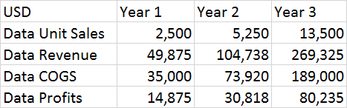

Table 12: Costs and profits of data as a service ($)

There had been two final versions of the SSDC. A Wi-Fi version only and a Wi-Fi and cell phone chip version. One device had been able to send live video while on cell connection to the user’s cell phone. This table represents costs and profits for cell phone service. The costs associated with the cell service should run about $19.95 a month or $199 a year. As the years increase the team plans to me more of the devices for the demanding customers.
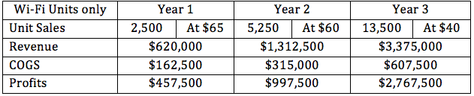
Table 3: Unit sales for Wi-Fi units retail $250, costs of goods sold, revenue, and profits

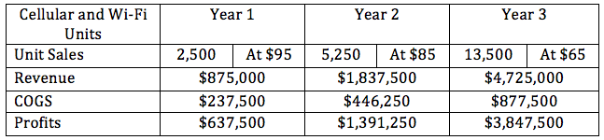
Table 4:Unit sales for Cell and Wi-Fi units retail $350, costs of goods sold, revenue, and profits

9.2 Project Milestones

Task | Start | End | Status | Responsibility
150 page project report
Divide and conquer document | 22-Aug | 9-Sep | Complete | Group 25
Table of Contents | 4-Sep | 10-Sep | Complete | Group 25
Updated Divide and Conquer | 11-Sep | 22-Sep | Complete | Group 25
75 Page Draft | 23-Oct | 1-Nov | Complete | Group 25
125 page draft | 6-Nov | 12-Nov | Complete | Group 25
Final Documentation | 20-Nov | 26-Nov | Complete | Group 25
Research, Cost Analysis, Design, Documentation
Analysis/choosing of parts | 4-Sep | 18-Oct | Complete | Group 25
Controller Software | 1-Oct | 22-Mar | Complete | Group 25
Financial Part Analysis | 18-Oct | 25-Oct | Complete | Group 25
PCB Design | 15-Sep | 15-Jan | Complete | Group 25
Power Supply Design | 15-Sep | 10-Nov | Complete | Group 25
Camera Choice | 15-Sep | 1-Nov | Complete | Group 25
Product Layout | 18-Oct | 25-Nov | Complete | Group 25
Development Plan | 10-Dec | 22-Mar | Complete | Group 25
Senior Design II
Order and tested parts | 10-Feb | 1-Mar | Complete | Group 25
Construct prototype | 3-Mar | 27-Mar | Complete | Group 25
Debugging and Adjusting | 10-Mar | 27-Mar | Complete | Group 25
Final testing | 20-Mar | 27-Apr | Complete | Group 25
Peer Presentation | 16-Feb | 16-Mar | Complete | Group 25
Final Report | 27-Apr | 27-Apr | Complete | Group 25
Final Project Presentation | 16-Apr | 16-Apr | Complete | Group 25

Table 13: Project Milestones

9.3 Team Roles

Matthew White at a high level was responsible for hardware design, exterior design and implementation of the hardware. This entails the design of both the schematic as well as the eventual creation of the model for the physical device. As acting company sponsor he also was in charge of determining the financial purchasing and final decision on product selection. Alongside these tasks, he was also charged with managing all administrative content such as determining group meeting times and delivering and binding of the final paper submission.

The software aspect of this project relies heavily on the contribution of two key members: Austin Sturm and Timothy Deligero. These two members were solely responsible for the software design for both the physical SSDC device, the development of the middle server, communication protocol as well as the mobile application. Austin acts as design and engineering lead for the software aspect of the project, as well as lead developer for the physical device as well as the communication protocol and middle API server. Timothy provides support for those projects while taking on the challenge and acting as lead developer for the mobile application. Together the two contribute a large portion of the project after the hardware design and played a vital role in determining project requirements and constraints. Scott Levine assists as well in the development phases for all aspects of the software engineering, providing assistance where needed while maintaining his other duties.

Scott Levine was in charge of LED, button, and assisting with programming and software protocols. He was responsible for a portion of the PCB design for LED and button or buttons that had been implemented onto the board. Among these roles, hardware had been a primary focus. However, he had been assisting with programming the development boards further and he had also been help with programming and flashing the chips that were placed on the final PCB. Amongst these responsibilities Scott was able to assist other team members with any issues they had and act in a supporting role.

The physical layout and design of the SSDC was done in three sections of development. These sections were component selection schematic creation, and PCB design/manufacturing. Joseph Labauve, Matthew White and Scott Levine were responsible for the hardware development of the SSDC. Joseph Labauve was responsible for the cameras of the SSDC and assisting with the creation of the PCB design in Eagle. This includes the design choices for the camera components, PCB design choices such as materials, and development of PCB placement.

8.4 Parts Selection and Parts Cost

The parts were very carefully selected and may continue to change as time goes on. The TMS570LS3137 16-Bit and 32-Bit RISC Flash Microcontroller (MCU) was originally considered for the project, but the ATMEGA 2560 MCU was chosen to replace it. This MCU can handle the processes that needed to run such as the processor to run the cameras, Wi-Fi module, the GPS chip, the cellular chip, the accelerometer, magnetometer, and gyrometer data. The 8 band CC3120MODRNMMOBR Wi-Fi chip was also ordered from Texas Instruments as well as the LM2592HVT-ADJ/NOPB 12v to 5.5v switching regulator. Many components from suppliers were proprietary. This makes obtaining them a slightly longer process. The FGPMMOPA6H GPS chip had been used in order to gain vehicle position and location. This had help ensured that the user can find the car if it was lost or stolen. This particular GPS chip was selected because it came with a nice development board to work with and it had 66 acquisition channels. The accuracy was less than 50 meters but during development that had do.

The cameras for development purposes were raspberry pi cameras. The imaging sensors had 170 degree lenses on them. These lens provided close to a 360 degree field of view for the user. This ensures that theft was caught on camera. With two 170 degree cameras the user had been able to turn off the camera recording them. This was to ensure privacy and rights to the driver of the vehicle. With full 360 degree video the driver would always be recorded. This had not been acceptable to all users. Although it had been beneficial to insurance companies not all drivers had like to had 360 degree while driving video. Although 360 degrees was great while the car was parked, it was not such a great feature while the car was driving. The cameras on the finished product had been a volume manufactured part. The team was currently in contact with suppliers like FRAMOS Technologies that supply imaging sensors. The imaging sensor that was of interest was the Sony IMX 327. The camera records in 1080p with a framerate of 60fps. The product had required two of these cameras. This image sensor was highly capable of low light conditions. So that makes it perfect for our surveillance applications.

The team was also looking into the video processor from Ambarella. Ambarella sells processors that can process the video with ease. If the team does not program a FPGA then an off the shelf video processor may need to be used such as Ambarella. Ambarella provided high quality with single or multi-channel recorders. The device was a multi-channel recorder. The processor can pass automotive testing. The processor was loaded with HDR, 3D noise filtering, smart auto-exposure, and full-resolution sampling. The higher resolution during wider video captured allows for a higher level of detail over all. The cost of this part was still unknown but it had been somewhere between $20-$40 in low quantity. There were cheaper video processors in the market such as Novatek. These processors were cheaper but also harder to obtain in the United States. There were many other video processors on the market as well. More research had been completed to really solidify the decision of the processor the company chooses. The processor chosen should be able to process two cameras at the same time making it multi-channel.

Unfortunately, a few parts were not used for the final prototype. The Sony optical sensors were going to be used as a way of detecting any intruders to the user’s vehicles, which could had improved the functionality and purpose of the SSDC device. The DM388 Development board would had been used to store the media recorded by the SSDC device, which would have fit with our specification requirements. Unfortunately, these parts took too much time to research and program in order to fit and use for the SSDC device. The Sony optical sensors where just too big and did not fit with the size requirements for our cameras to be functional and efficient for the purpose of the device. The DM388 took too much time to research and code to create libraries, with too many obstacles to get it too work in time for finishing the project. These parts were abandoned in the end, but overall device built would compensate for the specification requirements and goals needed to be reached by the end of process.

10.0 Conclusion

The documentation done for this senior design project was extensive due to the fact that this was a five person group, which under the conditions of the senior design course requires 30 pages per person, which for the team was a challenge as the resulting documentation was required at least 150 pages, not counting the title page, table of contents, and appendices, as most of the research and documentation was done in the body of the senior design paper. Also, while the team does had the majors required for the senior design project, the team still lacked in experience about documentation and building a design during the first couple days, which resulted in an arduous process of research for relevant data to be documented with the team’s design for the SSDC device. Throughout the semesters, the team members had learned a lot of the planning and requirements needed to make and implemented a prototype design in the senior design project during the first semester.

The project idea of a security device for user vehicles for the senior design project was created and suggested by the head of the group Matthew White, which was to create a device to track and record instances of car theft and car damage as a means of security provided for the user’s vehicle. This was an interesting and useful project idea that was very relevant to modern society and even the students on UCF campus as the security of users’ vehicles was valuable and many students on the campus use the parking lot garages on UCF to be able to attend classes and had their vehicles parked as well. Afterwards a description of the project was made to create an end goal of the project as well as organize the roles of the team members in the group. The project was given goals, requirements specifications, house of quality, and hardware and software diagrams, in order to organize what was needed to be in the design of the SSDC device and what group members were comfortable in doing a portion of either the hardware or software of the senior design project. However, the roles and requirements were not final as further implementation and development in the design of the SSDC device. Also, it was possible that the group member roles can extend into each to help support the team members as a whole. This was also because some of the team members were inexperienced during the first couple days of the semester and further implementation design might take more experience. The team members still learned a lot on the need for a description and goals as a means to organize the documentation and future implementation of the SSDC device.

Researching design standards and constraints was not too difficult as the dimensions, components, communication, data protection, etc. were already studied and given a lot of documentation on what would be needed for security devices as well as meeting the functions and plans of the SSDC device when being placed inside the user’s vehicle in order to meet the project idea, which was to detect and record instances of car theft and car damage. There were many constraints to be found when using security devices inside vehicles such as law regulations, social issues, data protection and security, safety for the user, etc. The constraints and standards needed to be considered when further implementing and building the design of the project as they were essential to the requirements specifications.

A lot of research was made for the SSDC device as the device requires multiple components, such as the accelerometer, gyrometer, magnetometer, GPS, tracker, cellular chips, Wi-Fi chips, etc. Some of these components were needed to detect the motions of the user’s vehicle and any instances of car theft and car damage, some were used to connect the device to the user’s application, etc. The team members tried to find any research relevant to the design of the SSDC device and anything related to security devices and car theft and car damage. The team members were able to learn a lot about the components of the SSDC device and how they work and technologies provided for those components as well the design for the mobile application and PCB for the SSDC device. One example was discovery of the MEMS technology for the accelerometer and gyrometer as they provide a lot of features that support the SSDC device and its purpose. Another example was learning that the accelerometer, gyrometer, and magnetometer had functions on how it should operate in the detection of car theft and car damage to the user’s vehicle. Learning the measurements in the X-, Y-, and Z- axis for these components was essential as detection of motion was needed in a 3D plane axes and the type of measurements as well as the direction in either positive or negative values was needed to distinguish each component from one another and be able to identify how it had to be used in the SSDC device.

Planning and building the design was difficult as the team members were still inexperienced at the time of how the hardware, software, and security should be made. Fortunately, the research made before so makes up for that as the team was able to figure what would be needed in the design. The parts and components selected needed to have an idea of the PCB design to have a representation of how the hardware had look inside the SSDC device. The software was represented by multiple flowcharts and diagrams to represent the objects, functions, and relationships and interactions between the objects. This had been used to had an idea what objects and functions needed to be and where the data must be processed and used to interact with each object as the software was designed for the device. The security was important as a means of protecting the data and user’s information within the device. There were many methodologies found for the security and many things had to be considered such as the physical device itself and the user’s mobile application connect to the device as well.

The prototype construction was an arduous process as being inexperienced with EAGLE for PCB design, it was difficult to build the schematic given the datasheets and pin layout of the chips to connect to the MCU. The group also had to find the appropriate chips and their datasheets to have proper connection in the EAGLE program for the PCB design. The team also managed to get most of the parts essential for the SSDC device and descriptions were made for each component used.

The prototype testing plan was made for the hardware and software sections of the SSDC device as well as having tested cases relevant to the function and purpose of the device which was to detect and record instances of car theft and car damage occurring on a user's vehicle as well as sending notifications to the user’s mobile application to notify the user of the vent occurring at the time. A lot of prototype testing would be needed for the accelerometer, gyrometer, and magnetometer as they were major components for the detecting the car’s motion as well needed to filter out any false positives to properly trigger the device. This also included security testing, GPS tracker testing, sent and received recorded footage and images to the mobile application, etc. There were many tests needed for this device as it had a lot of components and there were tested cases that can find any potential errors or improper functioning of the SSDC device.

The project operation section was created to show an owner’s manual on how to use the device. This gives instructions on how both the SSDC device should be used and placed within the user’s vehicle and how the mobile application interacts with the device. Each feature of the mobile application is briefly explained to give the user an idea of how each feature functions and should be used. Most importantly, the instructions for the mobile application shows what the user should do first, such as logging or registering into an account and first connecting to a device before using any other feature.

The administration section was made to keep track of the project’s budgeting, milestones, and parts selected, and even the team’s roles in the project. The project milestones state what needs to be accomplished in Senior Design I as well as Senior Design II, but the dates for the second semester had not been decided yet, but also had been fully realized when entered into Senior Design II. The team roles were meant to give each member a part in the project according to what they’re comfortable with, but were prone to change in the future along with any project milestones as the design becomes more implemented and built.

Ultimately the group had learned a lot about what was needed for the SSDC device and planned out how to build the design, tested it, and what the requirements specifications are. The group still would had liked to do further testing and probably change parts for the SSDC device to better suit the requirements as the device was still in a prototype stage. Overall, the group gained valuable experience from building this project.

Appendix A References

[1] Bosch, R. (2006). Design Requirements for Automotive Reality. [pdf] Montreux,
Switzerland: ESSDERC, pp.1-45. Available at: http://www-g.eng.cam.ac.uk/robuspic/pub_present/ESSDERC06/6-ROBUSPIC-Workshop-ESSDERC06-VVonTils.pdf [Accessed 2 Nov. 2017]

[2] "Car Theft Prevention | DMV.org", DMV.org, 2017. [Online]. Available:
https://www.dmv.org/insurance/car-theft-prevention.php. [Accessed: 02- Nov- 2017].

[3] "Esurance | Auto Insurance Quotes - How to handle a car accident in 7 easy steps",
Esurance.com, 2017. [Online]. Available: https://www.esurance.com/info/car/how-to-handle-a-car-accident. [Accessed: 02- Nov- 2017].

[4] "John Helms, A Dallas Criminal Defense Lawyer Discusses “He Said, She Said”
Cases - John Helms Dallas Criminal Defense Attorney | All rights reserved", John Helms Dallas Criminal Defense Attorney | All rights reserved, 2017. [Online]. Available: http://johnhelms.attorney/john-helms-dallas-criminal-defense-lawyer-discusses-said-said-cases/. [Accessed: 02- Nov- 2017].

[5] “What is Newton's second law?,” Khan Academy. [Online]. Available:
https://www.khanacademy.org/science/physics/forces-newtons-laws/newtons-laws-of
-motion/a/what-is-newtons-second-law.

[6] “Accelerometer and Gyroscopes Sensors: Operation, Sensing, and Applications.”
Accelerometer and Gyroscopes Sensors: Operation, Sensing, and Applications - Application Note - Maxim, www.maximintegrated.com/en/app-notes/index.mvp/id/5830.

[7] “How hot can the interior of a car get – and how quickly?,” HeatKills. [Online].
Available: http://heatkills.org/how-hot/.

[8] "Gyrometer - Colibrys – MEMS Accelerometers", Colibrys – MEMS Accelerometers,
2017. [Online]. Available: http://www.aoengr.com/Dynamics/CoriolisAcceleration.pdf. [Accessed: 02- Nov- 2017].

[9] F. Owen, Coriolois Acceleration. San Luis Obispo, CA: Alpha Omega Engineering,
Inc., 2017, pp. 1-6. Available: http://www.colibrys.com/c/technology/memsgyro/.
[Accessed: 02- Nov- 2017].

[10] Foucault Pendulum. [Online]. Available:
http://farside.ph.utexas.edu/teaching/336k/Newtonhtml/node59.html. [Accessed: 02- Nov- 2017].

[11] “Understanding Sensor Bias (offset),” Knowledge Base. [Online]. Available:
https://base.xsens.com/hc/en-us/articles/209611089-Understanding-Sensor-Bias-offset-. [Accessed: 02- Nov- 2017].

[12] Gyroscope. [Online]. Available: https://learn.sparkfun.com/tutorials/gyroscope/all.
[Accessed: 02- Nov- 2017].

[13] “Magnetic Field Strength H,” Magnetic Field Strength. [Online]. Available:
http://hyperphysics.phy-astr.gsu.edu/hbase/magnetic/magfield.html#c1. [Accessed:
02- Nov- 2017].

[14] EngineersGarage, “Magnetometers,” EngineersGarage, 21-Mar-2017. [Online].
Available: https://www.engineersgarage.com/articles/magnetometer. [Accessed: 02-
Nov- 2017].

[15] Pardon Our Interruption. [Online]. Available:
http://www.electronics-tutorials.ws/electromagnetism/hall-effect.html. [Accessed: 02-
Nov- 2017].

[16] “Magnetic Sensors: Growing in Use, Shrinking in Size,” Magnetic Sensors: Growing
in Use Shrinking in Size | DigiKey. [Online]. Available:
https://www.digikey.com/en/articles/techzone/2015/sep/magnetic-sensors-growing-in
-use-shrinking-in-size. [Accessed: 02- Nov- 2017].

[17] The Editors of Encyclopædia Britannica, “Lorentz force,” Encyclopædia Britannica,
08-Jun-2017. [Online]. Available: https://www.britannica.com/science/Lorentz-force.
[Accessed: 02- Nov- 2017].

[18] “Lorentz-Force Magnetometers,” Coventor. [Online]. Available:
http://www.coventor.com/mems-solutions/magnetometers/. [Accessed: 02- Nov-
2017].

[19] B. Dunbar, “Global Positioning System History,” NASA, 05-May-2015. [Online].
Available: https://www.nasa.gov/directorates/heo/scan/communications/policy/GPS_History.html. [Accessed: 02- Nov- 2017].

[20] Browse Standards. [Online]. Available:
http://ieeexplore.ieee.org/browse/standards/get-program/page/series?id=68.
[Accessed: 02- Nov- 2017].

[21] How does GPS work?| Explore. [Online]. Available:
http://www.physics.org/article-questions.asp?id=55. [Accessed: 02- Nov- 2017].

[22] D. Lee, "Garmin | What is GPS?", Www8.garmin.com, 2017. [Online]. Available:
http://www8.garmin.com/aboutGPS/. [Accessed: 02- Nov- 2017].

[23] Testing battery and charging system. [Online]. Available:
https://www.w8ji.com/battery_and_charging_system.htm. [Accessed: 02- Nov-
2017].

[24] H. Gonçalves, “Buck (step down) converter/regulator,” Buck converter (Step down
regulator). [Online]. Available: http://www.onmyphd.com/?p=voltage.regulators.buck.step.down.converter#h2_how [Accessed: 02- Nov- 2017].

[25] "What are the carbon monoxide levels that will sound the alarm?",
http://www.kidde.com/home-safety/en/us/, 2011. [Online]. Available: http://www.kidde.com/home-safety/en/us/support/help-center/browse-articles/articles/what_are_the_carbon_monoxide_levels_that_will_sound_the_alarm_.aspx. [Accessed: 02- Nov- 2017].

[26] A. Sivakumar, “NXP Home >” NXP Blog, 30-Sep-2015. [Online]. Available:
https://blog.nxp.com/connected-car/howto-detect-vehicle-presence-or-movements-with-magnetometers. [Accessed: 02- Nov- 2017].

[27] “DR750S-2CH - Dual Full HD Cloud Dashboard camera by BlackVue™,” BlackVue. [Online].
Available: https://www.blackvue.com/dr750s-2ch. [Accessed: 02- Nov- 2017].

[28] “Gartner Says Worldwide IoT Security Spending to Reach $348 Million in 2016,”
Gartner. [Online]. Available: https://www.gartner.com/newsroom/id/3291817
[Accessed: 02- Nov- 2017].

[29] M. Vanhoef and F. Piessens, Key Reinstallation Attacks: Forcing Nonce Reuse in
WPA2. Blogger, 2017, pp. 1-16.

[30] “Aircrack-ng,” cracking_wpa [Aircrack-ng]. [Online]. Available:
https://www.aircrack-ng.org/doku.php?id=cracking_wpa. [Accessed: 02- Nov- 2017].

[31] “SparkFun Triple Axis Accelerometer Breakout - ADXL335,” Learn at SparkFun
Electronics. [Online]. Available:
https://learn.sparkfun.com/tutorials/accelerometer-basics. [Accessed: 02- Nov- 2017].

[32] Garmin and G. L. or its subsidiaries, “Dash Cam 65W | Cameras,” Garmin. [Online].
Available: https://buy.garmin.com/en-US/US/p/587334/pn/010-01750-05#.
[Accessed: 02- Nov- 2017].

[33] “CDR 900,” Cobra Electronics: CDR 900 Drive HD Dash Cam & Dash Cam
Reviews. [Online]. Available: http://www.cobra.com/products/dash-cams/cdr-900.
[Accessed: 02- Nov- 2017].

[34] “A beginner's guide to accelerometers,” Dimension Engineering. [Online]. Available:
https://www.dimensionengineering.com/info/accelerometers. [Accessed: 02- Nov-
2017].

[35] “Measuring Vibration with Accelerometers,” Measuring Vibration with
Accelerometers - National Instruments. [Online]. Available: http://www.ni.com/white-paper/3807/en/#toc5. [Accessed: 02- Nov- 2017].

[36] Ed Spence Download PDF, “What the user Need to Know About MEMS Accelerometers
for Condition Monitoring,” What the user Need to Know About MEMS Accelerometers for Condition Monitoring | Analog Devices. [Online]. Available: http://www.analog.com/en/technical-articles/mems-accelerometers-for-condition-monitoring.html. [Accessed: 02- Nov- 2017].

[37] “Designing Cellular Technology into Embedded Systems,” Arrow.com,
13-Nov-2015. [Online]. Available: https://www.arrow.com/en/research-and-events/articles/designing-cellular-technology-into-embedded-systems. [Accessed: 02- Nov- 2017].

[38] “IDC: Smartphone OS Market Share,” www.idc.com. [Online]. Available:
http://www.idc.com/prodserv/smartphone-os-market-share.jsp. [Accessed: 02- Nov-
2017].

[39] G. Gangster, "Accelerometer & Gyro Tutorial", Instructables.com, 2017. [Online].
Available: http://www.instructables.com/id/Accelerometer-Gyro-Tutorial/. [Accessed: 02- Nov- 2017].

[40] “What is CDMA (Code-Division Multiple Access) ? - Definition from WhatIs.com,”
SearchTelecom. [Online]. Available: http://searchtelecom.techtarget.com/definition/CDMA. [Accessed: 02- Nov- 2017].

[41] “What is GSM (Global System for Mobile communication)? - Definition from
WhatIs.com,” SearchMobileComputing. [Online]. Available: http://searchmobilecomputing.techtarget.com/definition/GSM. [Accessed: 02- Nov- 2017].

[42] “Digital Camera Sensor Explained” WhatDigitalCamera [Online]. Available:
http://www.whatdigitalcamera.com/technical-guides/technology-guides/sensors-1147 [Accessed: 12- Nov- 2017].

[43] “Understanding Camera Lenses” CambridgeInColour [Online]. Available:
http://www.cambridgeincolour.com/tutorials/camera-lenses.htm [Accessed: 12- Nov- 2017].

[44] “CCD vs. CMOS” Teledynedalsa [Online]. Available:
http://www.teledynedalsa.com/imaging/knowledge-center/appnotes/ccd-vs-cmos/ [Accessed: 12- Nov- 2017].

[45] “Field of View Comparison” [Online]. Available:
https://hobbyking.com/media/file/870109005X376443X27.png [Accessed: 12- Nov- 2017].

[46] “Security Cameras - Megapixels vs TV Lines” Unifore [Online]. Available:
https://www.unifore.net/analog-surveillance/security-cameras-megAPIxel-vs-tv-lines.html [Accessed: 12- Nov- 2017].

[47] “Software Development Cycle” Tricia Hussung [Online]. Available:
https://online.husson.edu/software-development-cycle/ [Accessed: 12- Nov- 2017].

[48] “Study of Excessive Temperatures in Enclosed Vehicles” Jan Null [online]. Available:
http://ggweather.com/heat/heat%20study.pdf [Accessed: 15-November-2017]

[49] “Minimization of
http://www.wseas.us/e-library/conferences/2010/Cambridge/ICNVS/ICNVS-18.pdf
[50] “Understanding Shutter Speed” PhotographyLife [Online]. Available:
https://photographylife.com/what-is-shutter-speed-in-photography [Accessed: 15- Nov- 2017].

[51] “Why Frame Speed Matters” Gizmodo [Online]. Available:
https://gizmodo.com/why-frame-rate-matters-1675153198 [Accessed: 15- Nov- 2017].

[52] “How Many Frames Per Second Can The Human Eye Really See” PCGamer
[Online]. Available:
http://www.pcgamer.com/how-many-frames-per-second-can-the-human-eye-really-see/ [Accessed: 15- Nov- 2017].

[53] “How Does Wi-Fi Work?” QuickAndDirtyTips [Online]. Available:
http://www.quickanddirtytips.com/tech/mobile/how-does-Wi-Fi-work?page=1
[Accessed: 15- Nov- 2017].

[54] ”Printed Circuit Boards” [online].
available: https://www.maximintegrated.com/en/app-notes/index.mvp/id/5800
[Accessed: 15-November-2017]

[55] “PRINTED CIRCUIT BOARD (PCB) DESIGN ISSUES” [online].
Available:http://www.analog.com/media/en/training-seminars/design-handbooks/Basi
c-Linear-Design/Chapter12.pdf [Accessed: 15-November-2017].

[56] Simon, C. (2017). “2016 SEMA Market Report” | SEMA. [online] Sema.org.
Available at: https://www.sema.org/sema-news/2016/10/2016-sema-market-report [Accessed 20 Nov. 2017].

[57] Aecouncil.com. (2017). Cite a Website - Cite This For Me. [online] Available at:
http://www.aecouncil.com/Documents/AEC_Q100_Rev_G_Base_Document.pdf
[Accessed 20 Nov. 2017].

[58] EU GDPR Portal. (2017). Key Changes with the General Data Protection Regulation.
[online] Available at: https://www.eugdpr.org/key-changes.html [Accessed 20 Nov.
2017].

[59] Brain, M. (2017). How Microcontrollers Work. [online] HowStuffWorks. Available at:
https://electronics.howstuffworks.com/microcontroller1.htm [Accessed 2 Dec. 2017].

[60] Atmel.com. (2017). Microcontrollers (MCUs). [online] Available at:
http://www.atmel.com/products/microcontrollers/default.aspx [Accessed 2 Dec.
2017].

[61] Circuits Today. (2011). Basics of Microcontrollers - Electronic Circuits and
Diagram-Electronics Projects and Design. [online] Available at:
http://www.circuitstoday.com/basics-of-microcontrollers [Accessed 2 Dec. 2017].

[62] GradeStack. (2017). Advantages And Disadvantages Of Microcontrollers -
Introduction to Microprocessors and Microcontrollers - MHE - Microprocessors and
Microcontrollers. [online] Available at:
https://gradestack.com/Microprocessors-and/Introduction-to/Advantages-And/19309-
3912-37481-study-wtw [Accessed 2 Dec. 2017].

[63] Barr, M. (2001). Types of Memory in Embedded Systems. [online] Barr Group.
Available at: https://barrgroup.com/Embedded-Systems/
How-To/Memory-Types-RAM-ROM-Flash [Accessed 2 Dec. 2017].

[64] What-when-how.com. (2017). Positioning through Satellites (GPS). [online]
Available at: http://what-when-how.com/GPS-galileo-dual-rf-front-end-
receiver-and-design-fabrication-and-test/positioning-through-satellites-GPS/
[Accessed 3 Dec. 2017].

[65] Silicon Substrate MEMs diagram [online] MaximIntegrated. Available at:
https://www.maximintegrated.com/en/images/appnotes/5830/5830Fig07.png
[Accessed 2 Dec. 2017].

[66] Neamen, D. (2006). Electronic circuit analysis and design. London: McGraw-Hill.

Appendix B Permissions

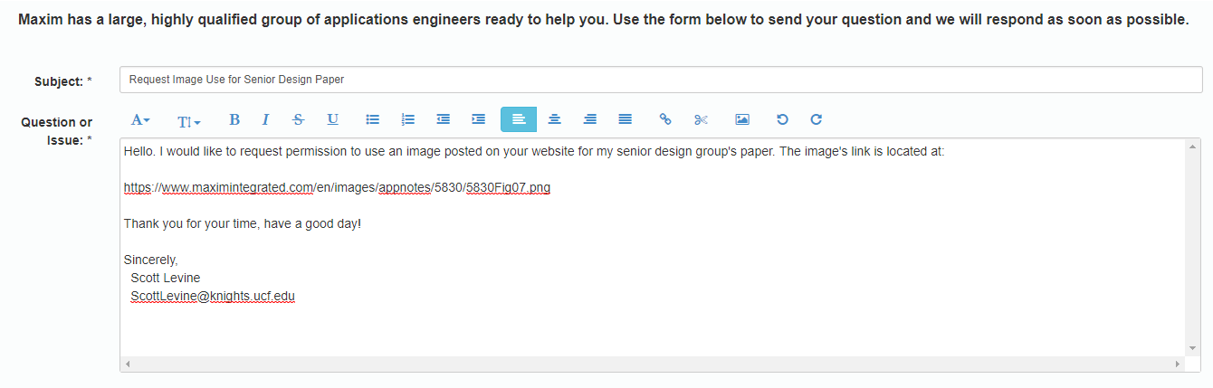

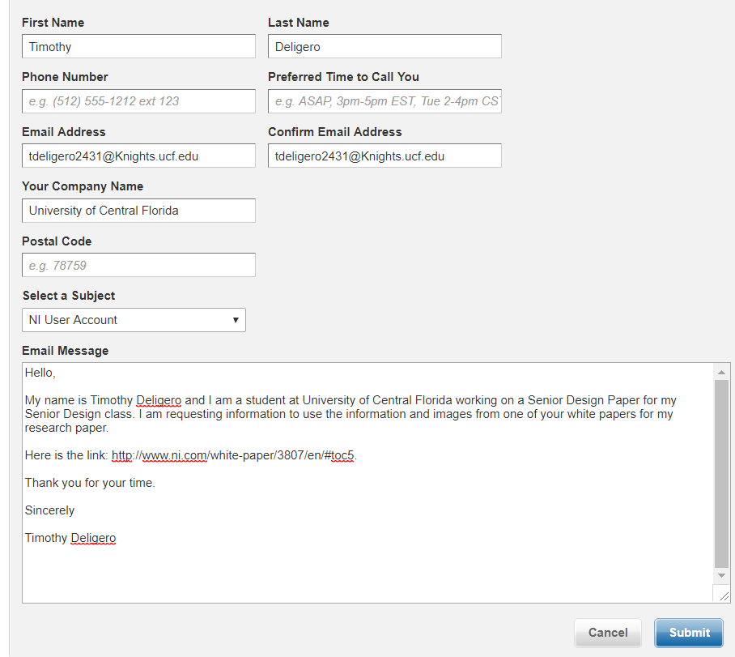



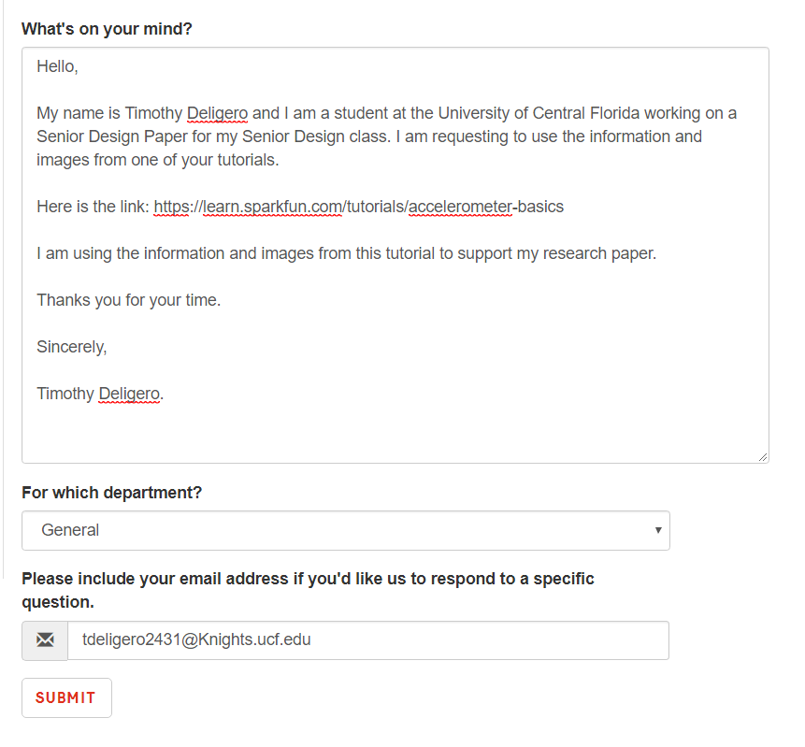

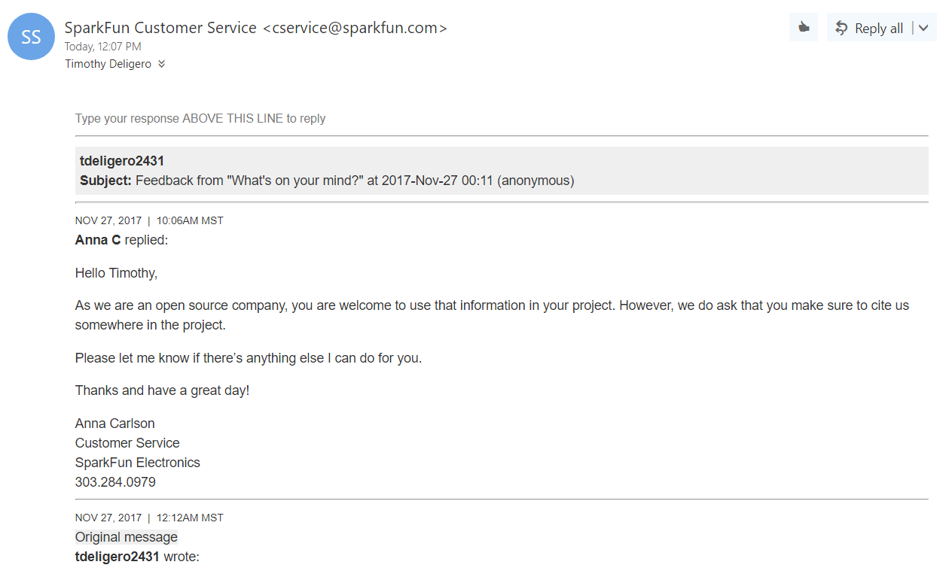
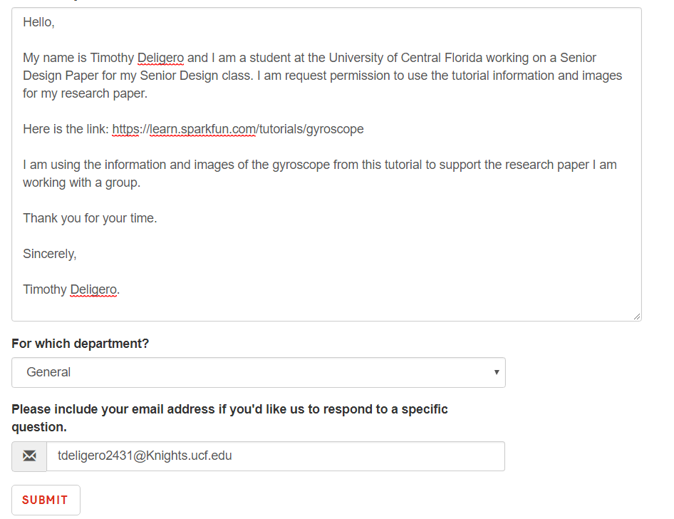

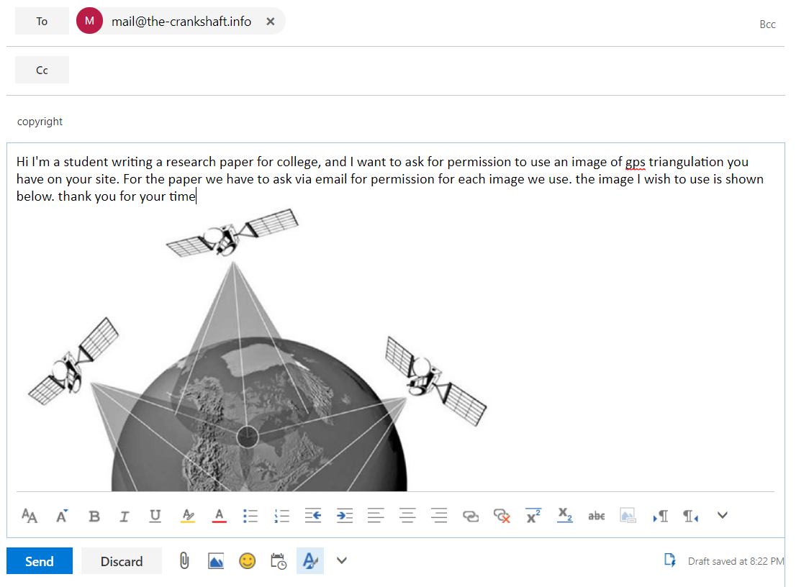

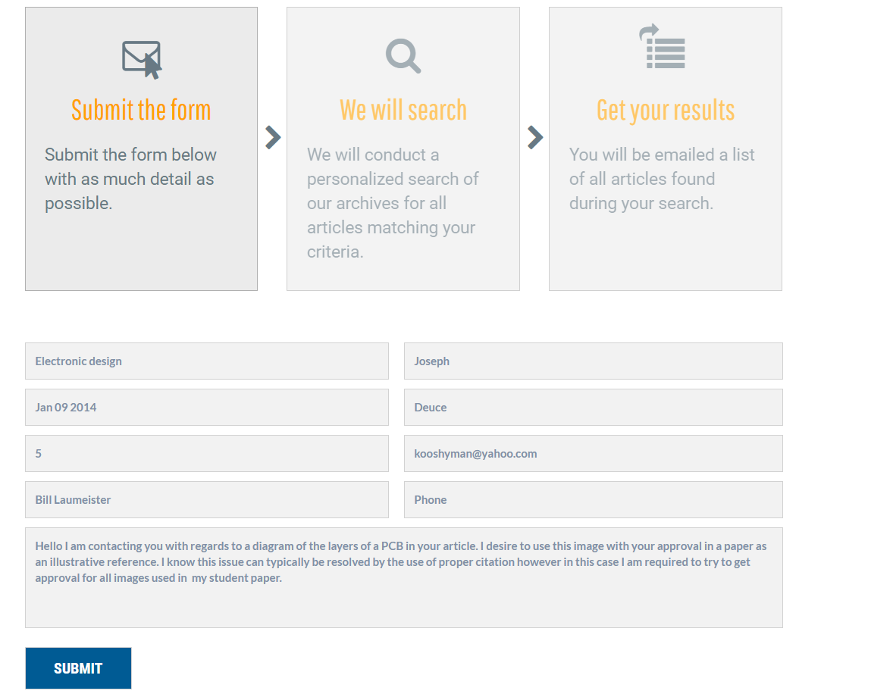
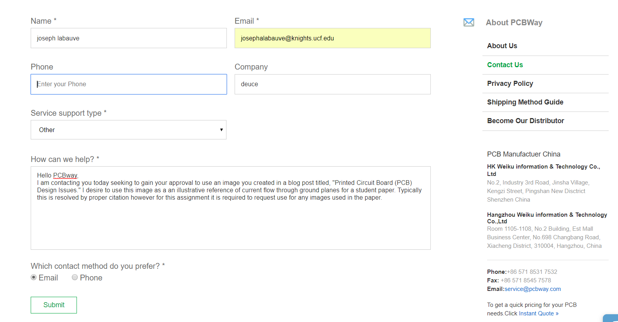

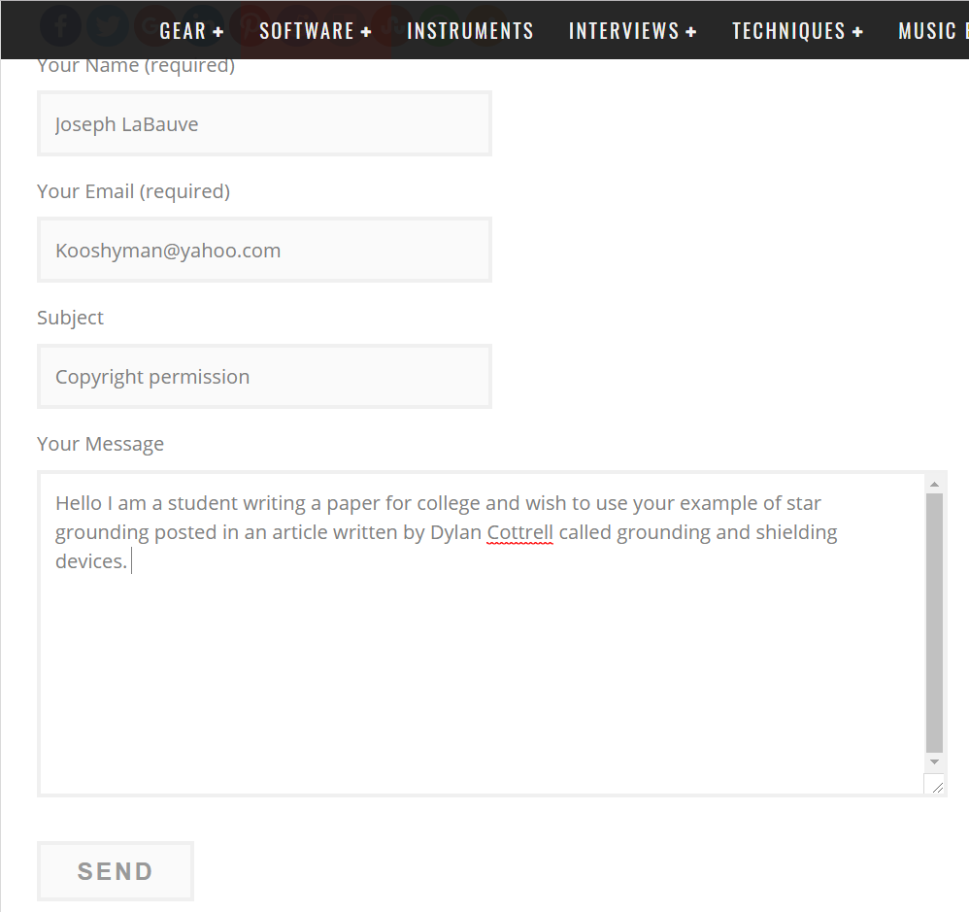

Appendix C Data Sheets

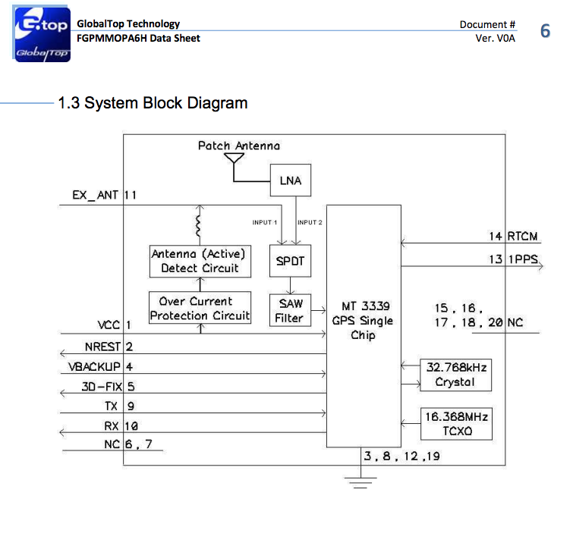
GPS FGPMMOPA6H system block diagram PCB layout for 2G Simcom chip
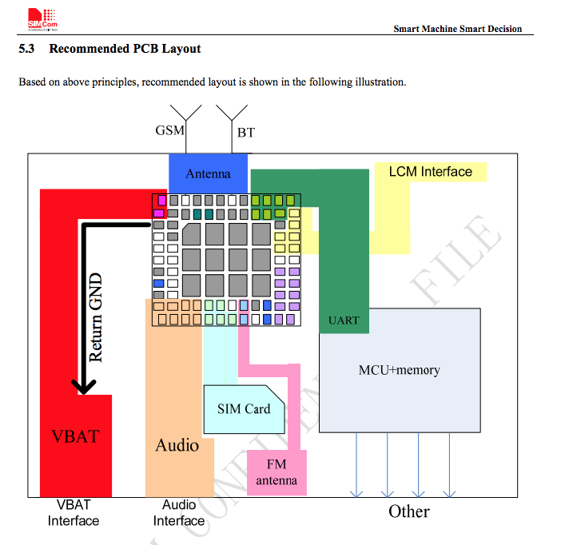
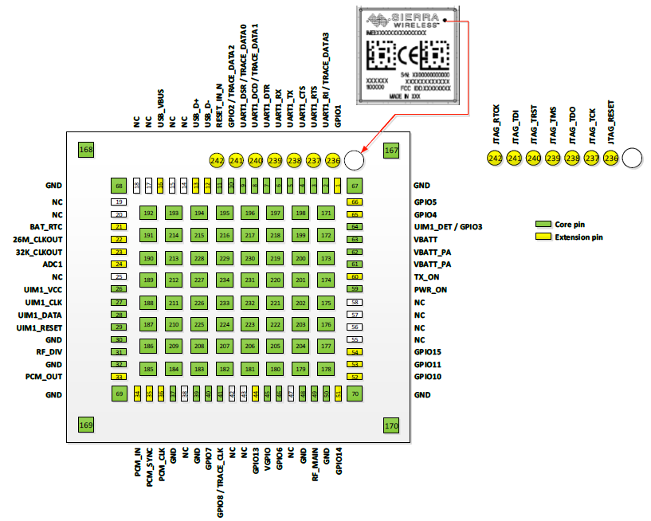
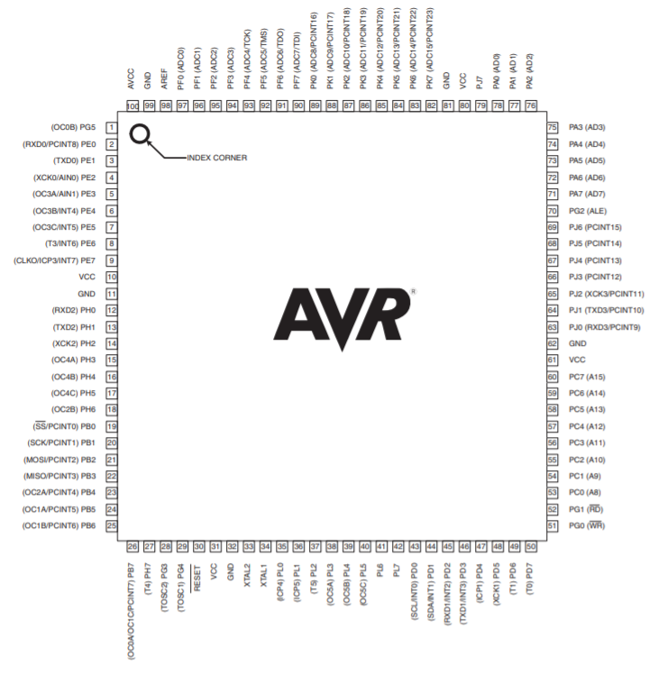

TI TMS570LS3137 MCU Sierra Wireless HL7588

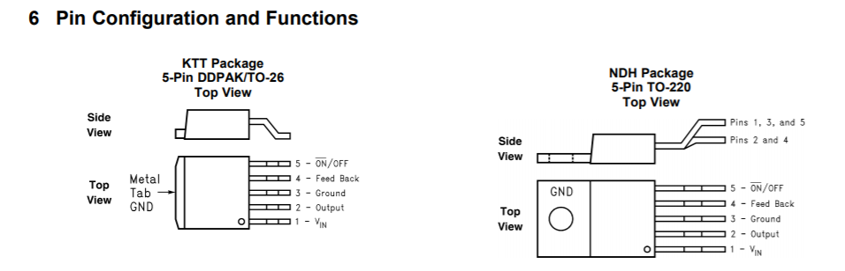
Pin Configuration Layout of DDPAK/TO-26 Pin Configuration Layout of TO-220

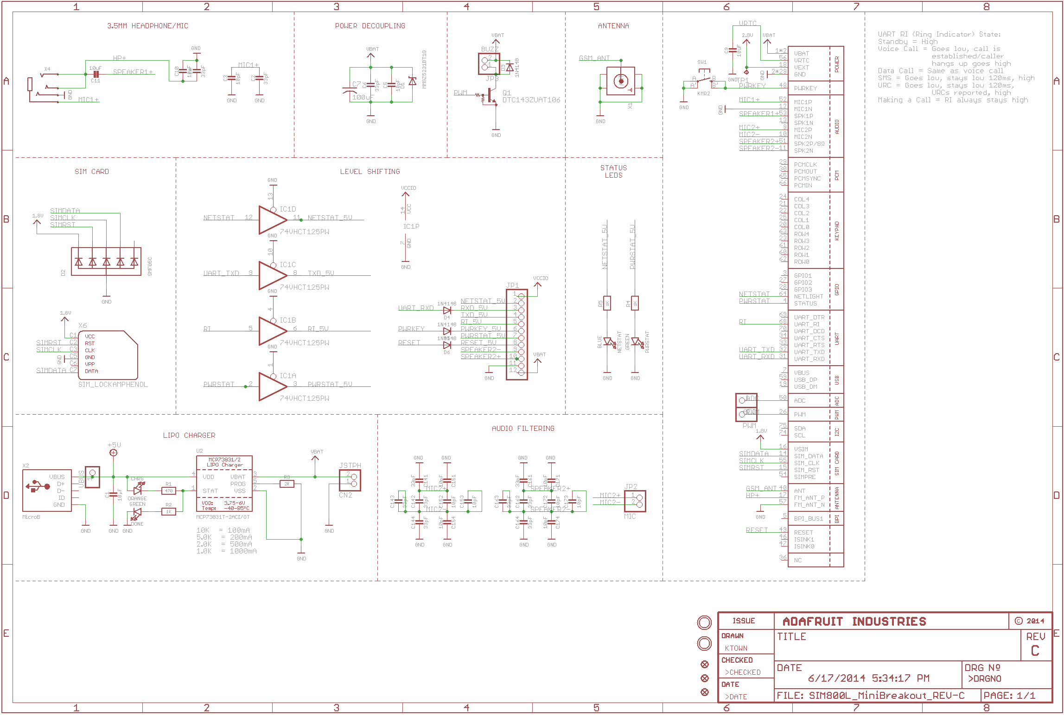

Adafruit Cell Product Schematic

