Solar-powered Path-finding Carrier (S.P.C) Robot

University of Central Florida
College of Optics and Photonics (CREOL) and Department of Electrical and Computer Engineering

Dr. Samuel Richie
Senior Design 2
Senior Design 2 Final Project Document

Group 8

Deborah Campbell - Computer Engineering
Brianna Chavira - Optics and Photonics Engineering
Ularislao Cordova - Electrical Engineering
Tommy Rodriguez - Electrical Engineering

Table of Content
Table of Content 1
1. Executive Summary 7
2. Project Description 9
2.1 Project Motivation and Goals 10
2.2 Objectives 10
2.3 Requirements Specifications 11
2.3.1 Software Specifications 11
2.3.2 Software Constraints 12
2.3.3 Hardware Specifications 12
2.3.4 Optical Specifications 13
2.4 House of Quality Diagram 14
Cost 14
Dependability vs. Durability 15
Dependability vs. Sensor 15
Size vs. Weight 15
Solar vs. Efficiency 15
Battery life vs. Durability 16
Battery life Vs. Accuracy 16
2.5 Block Diagrams 16
Summary of Design 19
3. Research Related to Product Definition 20
3.1 Existing Similar Projects and Products 21
The Gita 21
Follow Me Cooler 22
3.2 Relevant Technologies 23
3.2.1 Relevant Sensing Technologies 23
3.2.2 Relevant Power Delivery Technology 26
3.2.3 Optical Components 29
3.2.4 Electro-Mechanical 44
3.2.5 PCB Software 45
3.2.6 Microcontroller Selection 48
3.2.6 Serial Communication 53
3.3 Strategic Components and Part Selections 61
3.3.1 Ultrasonic Sensors 62
3.3.2 Parts Selection Summary 64
4. Standards and Design Constraints 64
4.1 Standards 65
4.2 PCB Standards 65
4.3 Legal Standards 66
4.4 Data Format Standards 66
4.4.1 JSON 67
4.4.2 BSON 67
4.4.3 YMAL 68
4.4.4 MessagePack 68
4.4.5 XML 69
4.5 Application Program Interfaces 70
4.6 Realistic Design Constraints 71
4.6.1 Time Constraints 72
4.6.2 Environmental Constraints 73
4.6.3 Social Constraints 73
4.6.4 Financial Constraints 73
4.6.5 Ethical Constraints 74
4.6.6 Safety Constraints 74
4.6.7 Laser Safety Standards 74
4.6.8 Manufacturability Constraints 75
4.6.9 Sustainability Constraints 76
5. Project Hardware and Software Design Details 76
5.1 Hardware Design Details 77
5.2 Initial Design Architectures and Related Diagrams 78
5.2.1 First Subsystem design 83
5.2.2 Second Subsystem design 83
5.2.3 Third Subsystem design 83
5.3 Optical Design 83
5.3.1 Laser Modulation 85
5.4 Software Design Details and Implementation 87
5.4.1 Mobile Application 87
5.4.2 Mobile Application Development 88
5.4.3 Swift 90
5.4.4 Android Studio 91
5.4.5 React Native 92
5.4.6 Java Virtual Machine 94
5.4.7 Java 95
5.4.8 JDK 95
5.4.9 J2SE 96
5.4.10 Java SE 6 96
5.4.11 Java SE 7 96
5.4.12 Java SE 8 97
5.4.13 Java SE 9 97
5.4.14 Java SE 10 97
5.4.15 Java SE 11 97
5.4.16 Java SE 12 98
5.4.17 JavaScript 98
5.4.18 API 99
5.4.19 API Design 100
5.4.20 REST API 100
5.4.21 Backend Development 102
5.5 Project Source Control 110
5.5.1 Client-Server Source Control 110
5.5.2 Distributed Source Control 111
5.5.3 Apache Subversion (SVN) 113
5.5.4 Git 114
5.5.5 Centralized Workflow using Git 114
5.5.6 Feature Branch Workflow 114
5.5.7 Higher Level Workflow Designs 115
5.5.8 Source Control Selection 117
5.6 Final Coding Plan 117
6. Project Prototype Construction and Coding 118
6.1 Integrated Schematics 119
6.2 PCB Vendor and Assembly 121
7. Project Prototype Testing Plan 122
7.1 Hardware Test Environment 123
7.2 Hardware Specific Testing 123
7.3 Software Test Environment 123
7.4 Optical Testing 124
8. Owner’s Manual 127
8.1 To Power on The Robot 127
8.2 Using GPS Streaming Module (Follow me) 127
8.3 Using GPS Waypoint 127
9. Administrative Content 128
9.1 Milestone Discussion 128
9.2 Budget and Finance Discussion 129
Appendices 130
Appendix A – Copyright Permissions 131
Appendix B – Datasheets 131

Table of Figures
Figure 1: House of Quality Diagram 7
Figure 2: Block Diagram 10
Figure 3: Optical Layout of LiDAR Sensor 11
Figure 4: Motor Controller 12
Figure 5: Complete Electrical and Communication System 13
Figure 6: The Gita Robot 14
Figure 7: Follow Me Cooler 15
Figure 8 : Overall GPS Network 17
Figure 9: Force Satellite Control Network remote tracking stations (AFSCN) 18
Figure 10: NEO-M8 19
Figure 11: Solar Panel 20
Figure 12: Battery Diagram 21
Figure 13: Oregon 72-106 Universal Wheel 22
Figure14: Gearbox for 12V Motor 22
Figure 15: 12V Motor 23
Figure 16: Model of Time-of-Flight Principle 23
Figure 17: Social Spectral Irradiance vs. Wavelength 25
Figure 18: SPL PL90_3 Pulsed Laser Diode 27
Figure 19: Relative spectral emission of the SPL PL90_3, where Irel = f (λ); IF = 30 A; Popt = 75 W; tp = 100 ns 28
Figure 20: RLD90QZW3 Pulsed Laser Diode 28
Figure 21: SPL S1L90A_3 Channel SMT Laser 29
Figure 22: AD500-8 Photodiode 30
Figure 23: MTAPD-07 Photodiode 31
Figure 24: AD500-9 Photodiode 32
Figure 25: Spectral response of AD500-9 32
Figure 26: MAX3658AETA+ 33
Figure 27: ADCMP600 34
Figure 28: TDC-GP21 35
Figure 29: Collimating light from a Laser diode 36
Figure 30: Ray diagram of Bi-Convex lens 37
Figure 31A: Forward Motor Figure 31B: Reverses Motor Figure 31C: Braking 39
Figure 32: Qunqi L298N Motor Drive Controller Board Module Dual H Bridge DC Stepper for Arduino 39
Figure 33: Different PCB Programs 40
Figure 34: Flow of multiplication in software 44
Figure 35: MSP430FR6989 46
Figure 36: I²C Bus 49
Figure 37: I²C Data Signal Diagram 50
Figure 38: SPI Configuration 51
Figure 39: SPI Timing Diagram 52
Figure 40: SPI Regular/Independent Slave Mode. Permission by GFDL 53
Figure 41: SPI Daisy-Chain, Permission by GFDL 53
Figure 42: UARTS line of communication 54
Figure 43: Summary of protocols on considered MCU 55
Figure 44: HC-SR04 Ultrasonic Module 56
Figure 45: Ping Ultrasonic Sensor 57
Figure 46: MB1030 LV-EX3 57
Figure 47: Prototype Design of Robot 71
Figure 48: Prototype Design of Robot, back view 72
Figure 49: Solar Panel Charge Time Estimator Calculator 73
Figure 50: Summary of protocols on considered MCU 74
Figure51 : Solar Angle Calculator for Solar Panel 75
Figure 52: Electrical Components Overview 76
Figure 53: Model of Pulse Detection Process 78
Figure 54: TDC data processing of distance measurements 78
Figure 55: schematic of a pulsed laser driver 80
Figure 56: Distributed Version Control 107
Figure 57: Flow Control Using Subversion 108
Figure 58: Example of Gitflow Workflow 110
Figure 59: Example of Forking Workflow 111
Figure 60: Solar Charger Design Block Diagram 113
Figure 61: INA240A2PWR Functional Block Diagram 114
Figure 62: Power Stage Schematic with 2 LM5109BMA switching both N-Channel transistors 114
Figure 63: Ambient Light Sensor and chip 115
Figure 64: DFRobot Bluno PCB board 116
Figure 65: Qunqi L298N Motor Drive Controller Board Module Dual H Bridge DC Stepper for Arduino 116
Figure 66: Software Flow 118

1. Executive Summary
In today’s hyperactive and busy world, carrying items is something everyone is constantly and actively doing. The issue that then rises is the number of things we are readily able to carry with our hands. When we get our groceries either from the car into the house or vice-versa, having the option of a one-time trip is always satisfying. However, like many things there will always be obstacles that we just can’t overcome on our own, which makes a one-time trip nearly impossible due to an item being too big/heavy to carry.
Perhaps, you may know someone or be in the specific situation yourself, where you’re having issues carrying items from point A to point B. This could be due to age or health related issues and unfortunately, we cannot always have someone to be there to help/assist at that point in time. These concerns are what led our team to consider making our “Solar-Powered Path-Finding Carrier Robot” project.
Our project is to design and build a path-finding carrier robot that is completely solar powered. This robot will assist the user with carry up to 25 pounds of cargo, while either following behind the user or autonomously navigating to GPS coordinates. Our carrier robot will be equipped with Bluetooth so that it can follow the user effectively. In addition, a GPS module and compass will be used to navigate the robot to specific coordinates given by the user. The motivation behind this project was the desire to improve our daily lives while assisting an individual to carry an extra load with the carrier robot. Our robot can be used by the everyday consumer to carry their groceries to their house or textbooks around campus, as well as assisting disabled individuals with everyday tasks.
For our robot to safely move around autonomously, we used multiple sensors. The main sensor and primary optical component of this project is the LIDAR sensor, used for obstacle avoidance and autonomous navigation. This sensor will be designed and built tailored for our carrier robot needs. This sensor will be using the time-of-flight principle to measure the distances of surrounding objects. The TOF principle is a method of measuring the distance between a target and the sensor, based on the time taken for the emitted signal to return to the sensor after being reflected off the target. This while create a 2D map of the robot’s surrounding area with every potential obstacle in its way. Our LIDAR sensor will have a range of 20-25. This will give the robot amble time to detect an obstacle in it's way and find an alternative path. The LIDAR sensor will be placed on the top-front side of the robot to give it the best view of its surroundings. Two ultrasonic sensors will be placed on the sides of the robot for a double layer of detection on the sides of the robot.
Finally, the robot will contain PV solar panels which will allow for the recharge of the batteries. Solar panels are useful because they convert the particles of sunlight into energy or electricity. This will help with not having to charge the robot directly to an outlet, over time occurring at a higher and higher cost. In addition, this will make the robot truly autonomous as it will be able to charge on its own, versus having someone plug it in or change its batteries.
This paper will discuss the many choices we made in the design process of our robot. This paper discuss the requirements and specifications, the constraints and all the goals we aim to achieve with our project. In addition, each part we selected and the research and comparison behind our selections is discussed. Finally, we describe the design or each of our systems, broken down into; hardware, software and optical design and make a plan for testing our components.

2. Project Description
In this chapter we discuss how the project has undergo different phases. The first phase was to come together and realize how the group would like to make the robot come to life and what it will assist us with in our daily lives. The second phase will be research based, where we saw what building material, sensors, components, and panels are most efficient while also being cost effective. During this phase we also discuss the terms of creating the application to command the robot. We then go into our next phase and that is testing our researched materials. During this phase we see what may or may not work together more effectively. This requires us to do a bit more research when one part does not go as anticipated. Finally, we start making a prototype where we discover further errors until we have our final working prototype to present.

2.1 Project Motivation and Goals
The motivation behind this project was the desire to improve our daily lives while assisting an individual to carry extra load with a human-following robot. This can enable the user to carry up to 25 pounds extra which can be used in different ways. Some examples for the use can be to assist with bringing grocery shopping from the car to the house. Also, a second cart can be hooked to the robot to increase the number of things that can be carried.
The goal of the design will be durable, efficient, and low cost. There are many materials that can be used to make this robot. Our goal is to research the most durable recycled material when building this robot. This is to help the robot to carry the items and not break mid-transition. To keep it low cost we made sure that this material is highly recyclable and there is a surplus of flow in the market of this material to use to build. Finally, to make sure that the robot is efficient we made sure that all components of the robot are compatible with each other to fully function.

2.2 Objectives
The objective for this design will be ensure that the carrier robot follow the user and stay behind within a reasonable distance. The carrier robot will be able to avoid obstacles and navigate a clear path for the user while containing PV Solar cells for running and charging of batteries. The carrier will communicate via GPS/Bluetooth to the mobile application that would be built for this project. One of the main objectives for the carrier robot will be to ensure its able to carry a significant amount of weight and is able to move at a preferrable distance in between 2 to 5 mph.
- Tell user via phone app or display message that batteries are running low and need charge. The carrier robot must be able to follow behind the user when needed
- Follow GPS coordinates given via the application and move between them until stopped. Using the mobile app, the user will be able to control what mode the carrier robot is in
- The robot will use a LIDAR sensor and ultrasonic sensors to detect obstacles ahead of time and avoid them
- With the use of the solar panels the carrier robot should be able to be powered autonomously
- The carrier robot will use GPS to navigate to and from desired locations. It will also use Bluetooth to keep track of the user and follow behind them

2.3 Requirements Specifications
The requirements and specifications needed to implement our project and ensure it operates as intended is as follows:

Specifications | Target
The carrier robot should be able to detect and avoid obstacles within 1m | 1m
The carrier robot should be able to run autonomously for up to 2 hours | 2 hours
The solar panels should be able to charge the carrier robot’s battery to 100% | 100%
The carrier robot must follow the user within 3m behind them | 3m
The carrier robot should be able to travel between 1-5 miles an hour autonomously | 2-5 miles/hr
The carrier robot must be able to keep up with the user up to 5 miles/hour | 5 miles/hr
The carrier robot should be able to carry up to 25lbs | 25 lbs
Total system and assembly cost must be under $800 | $800
Table 1: Requirement specifications

2.3.1 Software Specifications
The software that will be controlling the carrier robot will be event state driven which will remain in low power with the sensors that will be reading the state the carrier robot should be in. The sensor detects its threshold for given values prompted by the user that will trigger an event to switch into navigation mode to inform the system users of it connection.
- The software will assist the carrier robot with navigation
- The software will enable carrier robot to monitor the battery level
- The software will monitor the communication between user and the carrier robot

2.3.2 Software Constraints
An app must be developed to successfully communicate and control the carrier robot. The app depends on operating systems. Therefore, a smart phone is required to communicate and use carrier robot

The carrier robot must be able to detect the mobile application
The carrier robot should be able to detect when connection is lost
The carrier robot should be able to change directions and move when prompted
The carrier robot should have a sensor that can detect collisions
The carrier robot should be rechargeable
The carrier robot should be able to measure the weight of the object placed on it
The carrier robot should be able to connect to the application with an Android device.
Table 2: Software specifications

2.3.3 Hardware Specifications
The team designed a constructed hardware specification plan for this project. One of the first specification that will be apparent will be the actual enclosure of the robot which has to be able to serve as object carrier for the user. The robot will be powered by two 12 V batteries which then are going to be recharged when robot is not use. The batteries will be charged by a combination of a solar panel with a charge controller which will be designed by the team using the MSP430F5132IDA as MCU. It is estimated that the robot will have the ability to carry things for the user up to approximately 25 pounds. The robot will have sensors which will be able to detect obstacles and avoid them accordingly. Below is a list with the main hardware in the PCB boards that will be implemented on this design.

PART NAME | MANUFACTURER | DESCRIPTION
MSP430F5132IDA | Texas Instruments | 25 MHz Mixed Signal Microcontroller with 8 KB Flash, 1024 B SRAM and 29 GPIOs
CC2540 | Texas Instrument | Wireless MCU
ATmega328P | MICROCHIP | 8-bit AVR® RISC-based MCU, 32 KB ISP Flash memory with read-while-write capabilities, 1024B EEPROM, 2 KB SRAM
L298N | STM Microelectronics | high voltage, high current dual full-bridge driver designed to drive inductive loads such as relays, solenoids, DC and stepping motors.
Table 3: Hardware specifications in the PCB Board

2.3.4 Optical Specifications

The main component of the optical system is the LIDAR sensor. This LIDAR sensor will be designed and built customized for the needs of our robot and its functions. The sensor will be used as the primary tool in obstacle avoidance when the robot is autonomously navigating, therefore it needs to meet the following design specifications:
- Utilize the TOF method
- 360-degree scan of the environment
- Range up to 20m
- Operate at wavelength of 905nm
- Cost under $130

2.4 House of Quality Diagram
A project needs the marketing and engineering requirements to help in identifying the necessary tradeoffs, which would help the team from a conceptualized state to an actual state of the project. Below is the tradeoff matrix for the project “Solar-Powered Path-Finding Carrier Robot”:
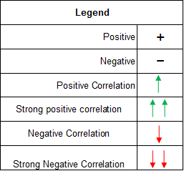
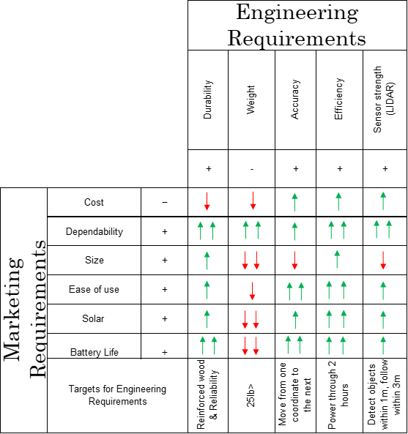
Figure 1: House of Quality Diagram

Below we discuss the strongest hitters on our project when comparing Marketing against Engineering Requirements.

Cost
First, we would like to discuss cost. Cost will not be compared to just one thing; it will be compared to all things. The reason behind that is because the price of all materials that is purchased will vary. As a whole, we cannot only look at how much something cost but also the specs and reliability of such item. You may find something cheaper that is more durable, weighing less, efficient, and accurate or you can find the complete opposite. Usually, the price goes up with the premium items that checks off more engineering specs. The saying “You get what you pay for” applies for this and almost any project an Engineer will work on. Making the cost of items the highest influence on whether we should pick one part over the other.

Dependability vs. Durability
Dependability is a characteristic that goes hand in hand with durability. If something is dependable then the person knows it will be there for them. For something to be durable and withstand strong outside forces and stand against time then we can conclude that the items durability it dependable on.

Dependability vs. Sensor
The sensors are important factors on this robot. Without the sensors the robot will not be able to acknowledge that there are obstacles in its paths. The sensors will help the robot avoid the obstacles and reach the given destination given by the customer. The sensors will also help the robot choose the best path to reach its destination.

Size vs. Weight
When a customer is shopping around for a robot that will carry items for them, they would like it to be bigger in size. The bigger the size the more possible items they can have carried. However, the tradeoff comes with engineering. With bigger robot comes bigger mechanical parts like wheels, and with bigger wheels comes with bigger DC motors. The list goes onto the power supply needing to increase to give stronger torques and PWM. All of this will evidently bring up the cost.

Solar vs. Efficiency
In a world where we are constantly trying to save on energy to let off less pollution, we look to use solar to power up our robot. Since solar is supplied for only certain times of the day we must find parts that will help robot perform its duties efficiently. This means whenever there is a time that the robot will be able to use less power, then it should go into a power saving mode to have higher efficiency in power and last longer during times of less solar supply. Which means having components that can enter a low power or power efficiency mode will be a plus for our robot.

Battery life vs. Durability
As a customer you would like your robot to last long. Over time we know that battery wares out. This means that as an engineer we must find the capable battery to last long enough for the customers satisfaction. This also means that the batteries reliability must be high. To do this, our battery has to be able to take a certain number of solar charges before beginning to ware down over time.

Battery life Vs. Accuracy
When purchasing a machine with a promised range of battery life, this can influence marketing highly. We are currently aiming to have the robot to run autonomously for 2 hours. This means that when testing we must make sure the accuracy of it lasting about 2 hours is high priority as this is the length of time someone is expected to be using the robot. Not only that but we must also know the number of expected charges the battery is able to take in before the battery starts to be considered as degraded. This information can be found usually by the vendor of the battery.

2.5 Block Diagrams
The figure 2, our main block diagram, we display a general overview of our system. Our project’s power source will come from a solar energy. We have used a solar panel and charge controller to convert the solar energy to power for the rechargeable battery that will power the rest of the system. The voltage regulator maintains the voltage to a constant output so that the rest of the system can run properly. The microcontroller works as the brain of the system and controls all the other subsystems.

The microcontroller will receive inputs and output directions to the rest of the system, including the sensors, motor driver and the Bluetooth module. We are using two ultrasonic sensors and a LIDAR sensor, both of these devices will be used to measure distances to surrounding objects so the robot can properly ovoid these objects. The motor driver will be used to control the motors and run the robot. The Bluetooth module will be used to send information from the robot to the mobile app and vice versa. Each of the subsystems are labeled by what stage of development they are in, such as research, in development or to be acquired. They are all also color coded by which team member is responsible for that subsystem, so that way we can each other accountable and stay on track.

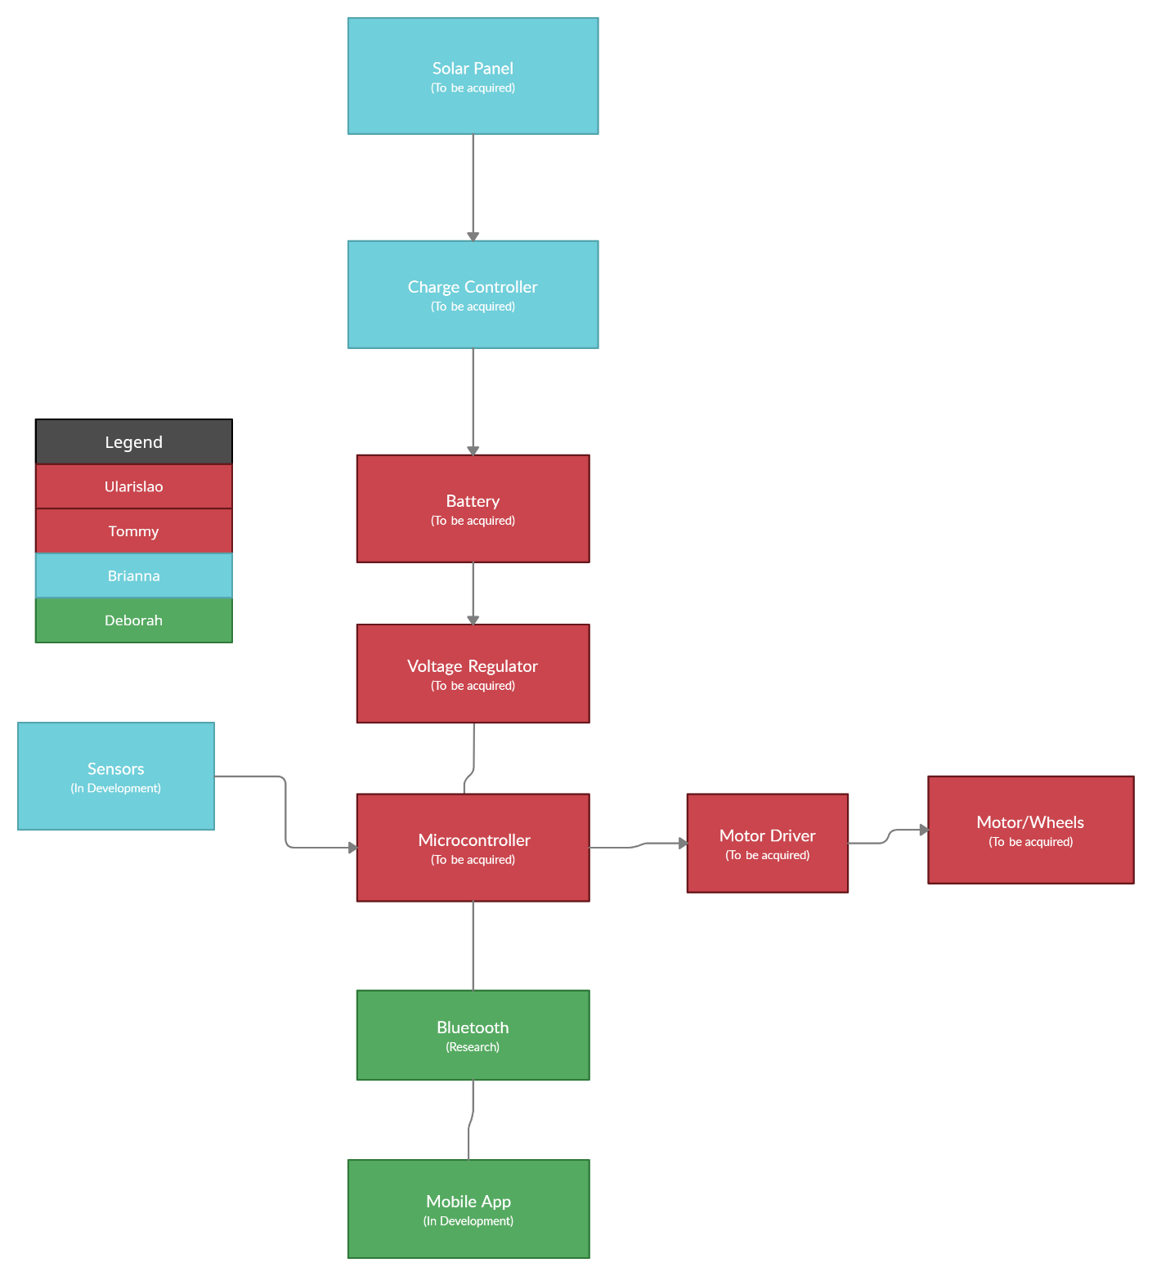
Figure 2: Block Diagram
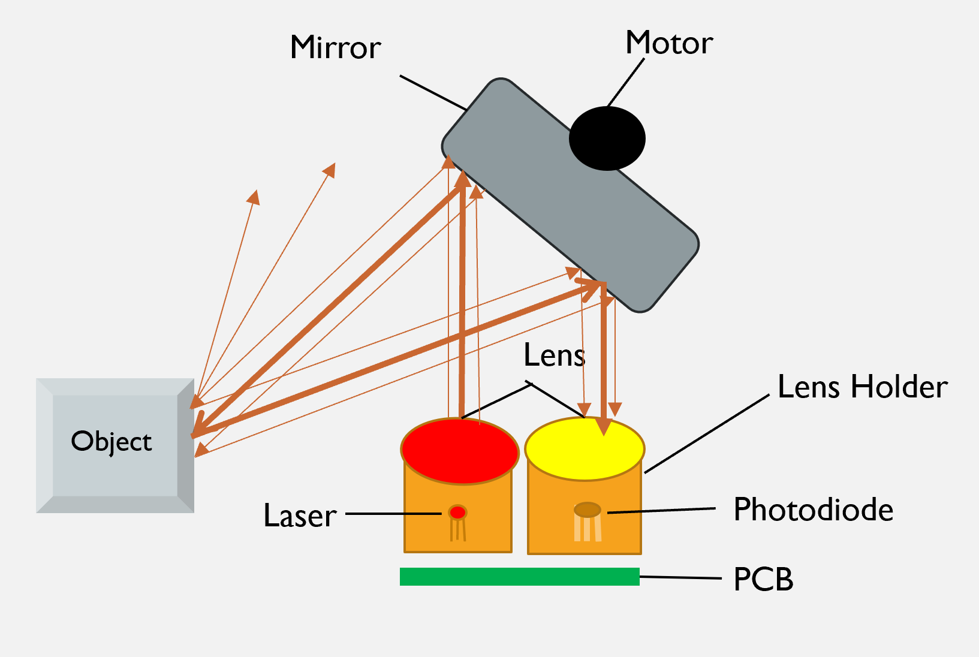
Figure 3: Optical Layout of LiDAR Sensor

In Figure 3 we show the block diagram of the LIDAR sensor. This sensor will be using the time-of-flight principle to measure the distances of surrounding objects. The TOF principle is a method of measuring the distance between a target and the sensor, based on the time taken for the emitted signal to return to the sensor after being reflected off the target. In this case, the laser will emit very short pulses of light aimed at the mirror, because the mirror will be at a 45-degree angle, these pulses will then travel into the surrounding area.

When one of these pulses hits an object, it will reflect into the mirror and then into the photodiode. The photodiode is the receiver in this system, and it will collect all the reflected light pulses from the laser. With the help of an amplifier, comparator, and time-to-digital converter, the photodiode will be able to measure the exact time it took for that pulse to leave the laser and then return to the sensor. Using this time measurement and the velocity of light, the sensor will be able to measure the distance to that object. That is how one measurement is taken in one direction, by using a motor attached to the back of the mirror so that it rotates 360 degrees. The sensor will be able to repeat that process repeatedly until it has a 2D map of its surrounding area with every potential obstacle in its way.

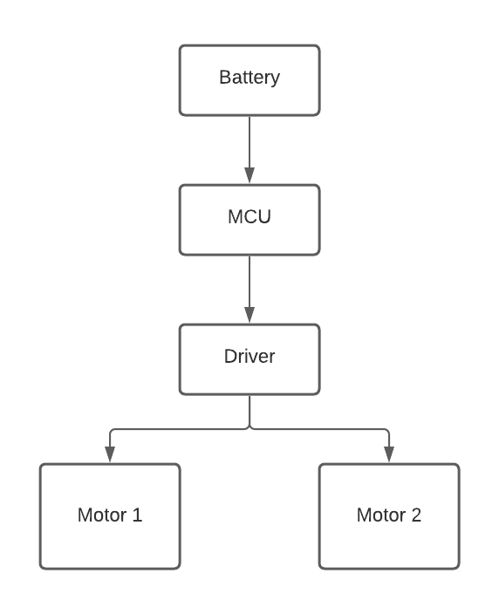
Figure 4: Motor Controller

Summary of Design
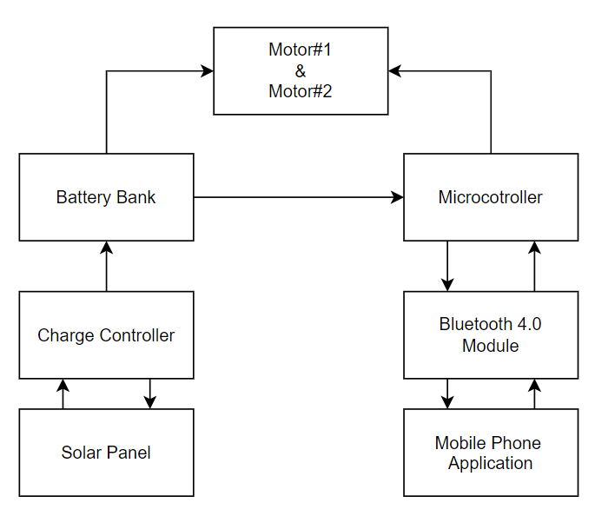
Figure 5: Complete Electrical and Communication System

3. Research Related to Product Definition
With this chapter we aim to explore the various technologies with close and similar relations with the carrier robot. This section will dive into existing projects that are simultaneous to our proposed project. In addition to this, our team wanted to explore and gain a thorough understanding of autonomous devices to be more educated and certain of the decisions we’ve made while working on this project. The following sections of this chapter will center around the various functions of similar projects before comparing with our project and choosing one for reference on this project.

3.1 Existing Similar Projects and Products
Regarding existing marketed products on autonomous devices, there were quite a few already out there in the market.

The Gita
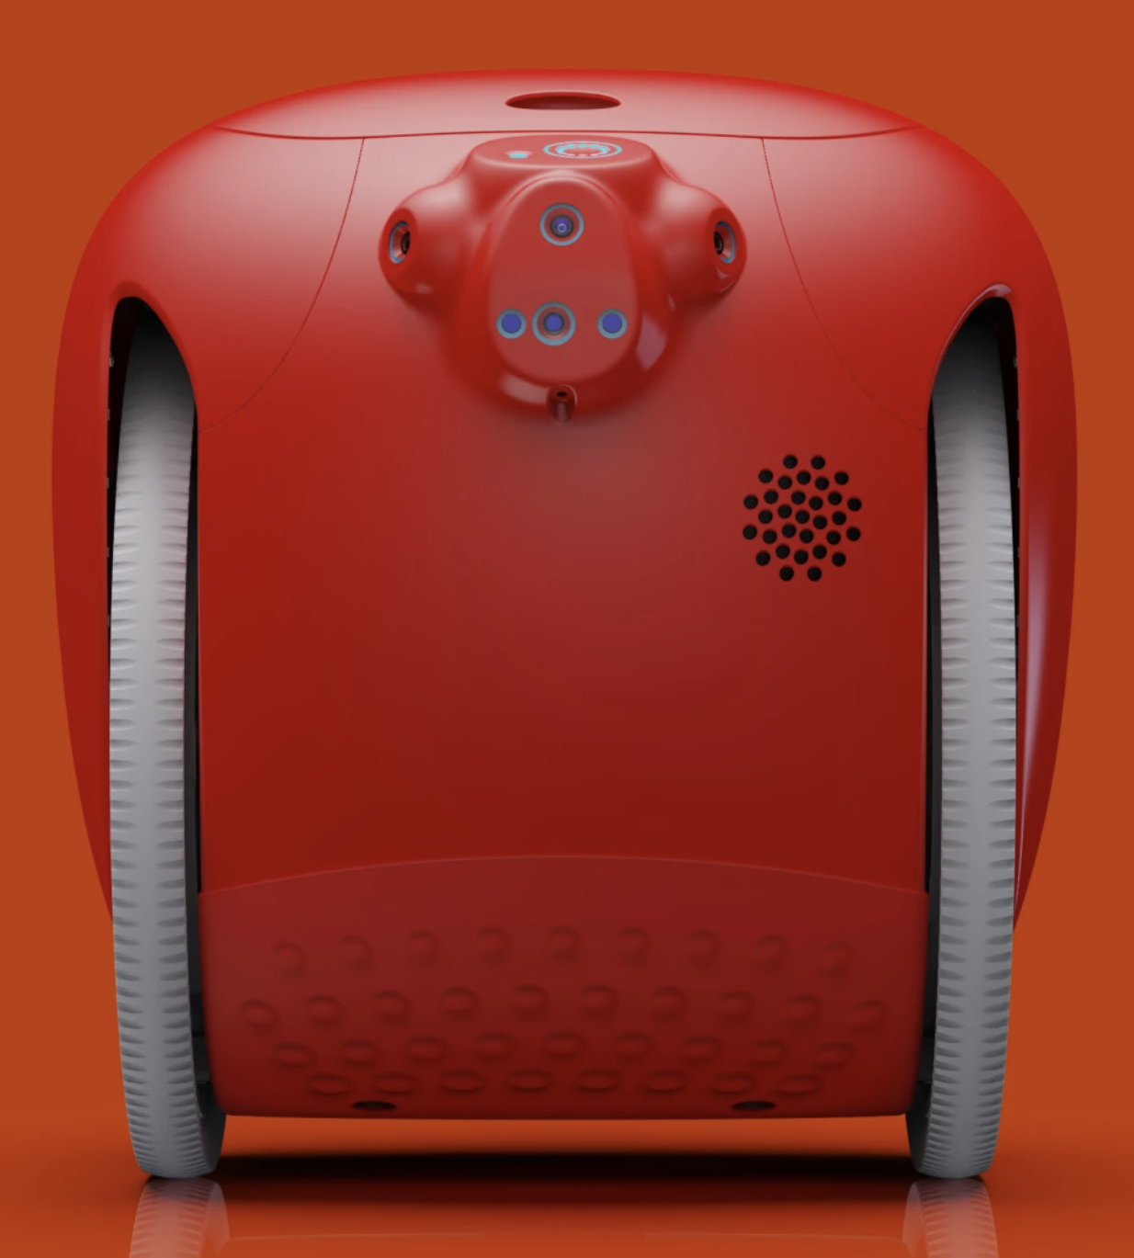
Figure 6: The Gita Robot
The most commercially available similar project on the market right now is the Gita robot developed by Piaggio Fast Forward. It is a two-wheeled, cargo-carrying robotic vehicle. The Gita is a highly intuitive and user-friendly robot, its main function is to follow the user around using computer sensor vision. PPF claims that the Gita’s following technology is “the first and only of its kind”. Similar to our robot the Gita uses a variety of sensors that allow it to see, understand, and react to its surroundings in the following ways. The Gita uses depth-sensing technology to gain a three-dimensional understanding of obstacles, people, speeds, and trajectories so that it can mirror your speed as it follows behind you and therefor adapt its distance accordingly. It also uses color-sensing technology to differentiate between different obstacles, such as people and objects. The main navigation system used by the Gita is a pair of stereoscopic cameras mounted on the front and back of the robot. These cameras are constantly performing visual simultaneous localization and mapping or SLAM. The first version of the Gita also came with a belt for the user that had a built-in stereoscopic camera in it as well, the robot then used the SLAM from the belt to compare to the SLAM picture from its own cameras. In the second version they have since done away with the belt as well as the previously used LIDAR sensor they had in the first model. The first version has an autonomous mode and was able to park itself, but they changed their direction in version 2 to making the sole purpose of the robot to follow the user. The Gita 2 can hold a total of 44 pounds, while traveling up to 6 miles per hour, for 12 miles. It also has several advanced features such as the “mygita” app that can be used to lock the cargo bin as well as play music through the speakers and check the battery status of the device. This device was launched in 2019 and cost $2,950. While this device has the same primary goal as our robot the methods used are very different.

Follow Me Cooler

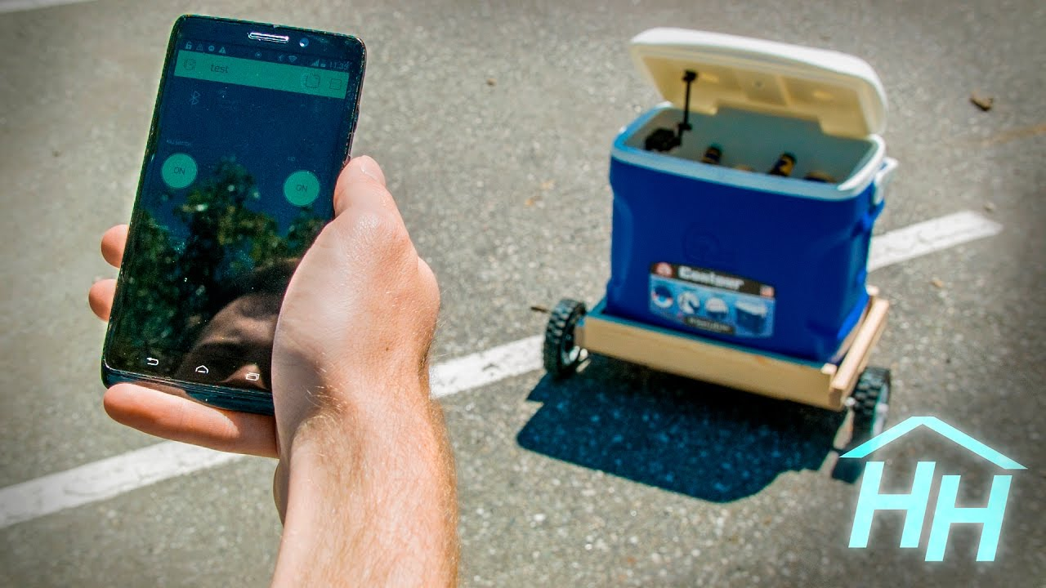
Figure 7: Follow Me Cooler
The Follow Me Cooler from Hack Shack is an autonomous following robot that carries your cooler for you. This robot connects to your smartphone via Bluetooth and uses GPS to navigate. The robot is powered by an Arduino uno and they use a Bluetooth module, a GPS module, and a compass to send to directions to the robot. Using a IOT mobile app they are able to give GPS coordinates to the robot and send it to that location. They use a wooden base with a 3-wheel design.
The main differences between the follow me cooler and our robot is the power source and sensors. In their design they don’t use any kind of sensor to avoid obstacles, in fact the robot is shown running into a fence. One way we improved the design is by using two different types of sensors to ensure that our robot can run autonomously and safely. Also, our robot is completely powered by a solar energy and a rechargeable battery, allowing the robot to be truly autonomous.

3.2 Relevant Technologies

3.2.1 Relevant Sensing Technologies

3.2.1.1 GPS
We all use GPS to get around. GPS has evolved over time and has become widely used technology to help navigate around the world. How does GPS work? What is a GPS? And how can a GPS help an autonomous robot go from one point to another to carry items? These are the questions that are discussed and answered in this section.

First off, the word GPS is an acronym for Global Positioning System. It is defined as a positioning system based on a network of satellites that continuously transmit coded information. This information is interpreted by receivers to identify locations on earth by measures distances from satellites. [1] Since GPS was first developed for military use it is mostly controlled by the U.S. Department of Defense. The GPS is comprised of three components, the space segment, often referred to as the satellites orbiting around the earth, the control segment, referred to as the satellite here on earth, and the user segment, which is the receiver the user has on their device.
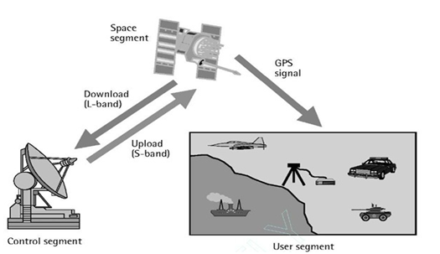
Figure 8 : Overall GPS Network

The Space Segment consist of 24 GPS satellites. The satellites are arranged in a constellation arrangement with six equally spaced orbital planes around Earth. Each plane has four slots occupied by baseline satellites. “This 24-slot arrangement ensures user can view at least four satellites from virtually any point on the planet.” [8] The United States is committed to having these satellites operational 95% of the time. Each satellite transmits a signal, which are broken down into two sinewaves, two digital codes, and a navigation system.

The control segment consists of global network of ground facilities that track the GPS satellites, monitors their transmissions, perform analyses and second commands and data to the space segment constellation. The control segment has three elements, the monitor stations, master control station, and ground antennas. Monitor Stations track GPS satellites as they pass overhead, collect signal data, and feeds observation to master control station. Monitor station provides global coverage with the help of 6 air force monitor stations and 10 from National Geospatial-Intelligence Agency (NGA). Mission Control Station provides command and control of the GPS constellation. It does this by performing satellite maintenance and anomaly resolution, including repositioning satellites to maintain optimal constellation. It is location in Colorado and is backed by fully operational alternate master control system in case of down time. Lastly there is the Ground Antennas that send commands, navigation data uploads and processor program load to the satellites. There are 4 dedicated GPS ground antennas plus 7 Air Force Satellite Control Network remote tracking stations (AFSCN). [8]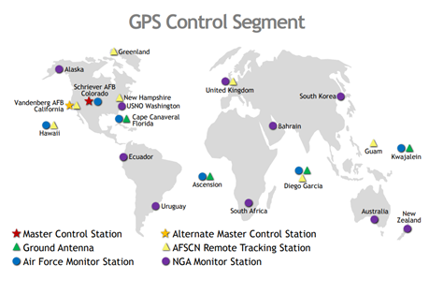
Figure 9: Force Satellite Control Network remote tracking stations (AFSCN)

If the distance from a point on the Earth, to three GPS satellites are known along with the satellite locations, then the location of the receiver can be determined by applying a concept called resection. The carriers and the codes are used to determine the distance from the user’s receiver to the satellite. “When a GPS receiver is switched on, it will pick up the GPS signal through the receiver antenna. Once the receiver acquires the GPS signal, it will process it using its built-in software. The partial outcome of the signal processing consists of the distances to the GPS satellites through the digital code and the satellite coordinates through the navigation message.” [6] Three tracked satellites are needed to track a receiver because it would be located on the intersection of the three spheres, each having their own radius from the receiver. However, the fourth satellite is needed to account for the receiver clock offset.

In this project the autonomous robot takes the input from the GPS receiver and using those inputs it will be able to navigate through a set of points. These points are given to the GPS receiver via the phone app, which is discussed on the application section. To start the GPS receiver tries to get a fix on visible GPS satellites and computes the current latitude and longitude. It then looks at the direction it is pointing with the help of the compass and computes the direction of the next destination point specified. The robot will then move in the direction of the next specified point using the GPS component and compass help. The GPS will determine its location via geographical coordinates given to the bot. Once it reaches the next geographical coordinate the GPS will pass on the message to the robot and the robot will come to a halt.

The GPS component we decided to use alongside the Atmega328P Arduino microcontroller for our project is the NEO-M6, the 50-channel receiver. This GPS recognizes multiple constellations simultaneously and provides positioning accuracy in scenarios where urban canyon or weak signal are involved. It supports message integrity protection, geofencing, and spoofing detection. This helps the device to fighting against anyone that may attempt to hijack and give false geographical location to the GPS. The exact version of the NEO-M8 will be the NEO-M8N since it is their best performance version. It is also future proof which helps for customers who would like to keep their bot for a long period of time. The future proof is made easy with the internal flash that allows future firmware updates. Within the first 27 second it will try determining its position, this is considered the cold start, however if you tell the GPS the date, time, and position ahead of time this will drastically cut down start time to 3 seconds or less, this is considered an aided start. The accuracy of the location is about 2.5 meters and receives a signal for update between 30-60ns with signals to receive and track being the L1C/A at 1575.42 MHz.. The NEO-M6 uses a power supply voltage of 3.6V to 5V. The NEO-M6 offers a power-optimized architecture with build-in autonomous power saving function to minimize power consumption at any given time. [9]

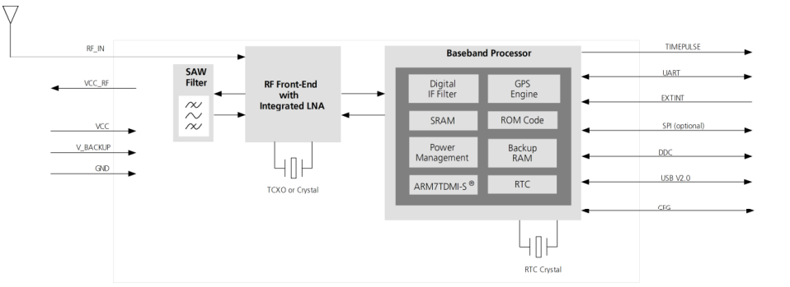
Figure 10: NEO-M6 Block Diagram

3.2.2 Relevant Power Delivery Technology

3.2.2.1 Solar Panel

The Solar Panel in consideration is by an 12V/50W SUNSUL Monocrystalline Solar Panel which has a Max Power Voltage (Vpm) of 18.2V. The Solar Panel will be bought from SUNSUL which has free shipping inside of the United States with and estimated shipping between 1 to 3 days. Since the popularity of Solar Panels is growing it, sellers seem to have enough products in hand. Most of the supplier of Solar Panels have multiple units in stock. This Solar panel weighs approximately 9 pounds which makes it ideal for our design. This solar panel provides a decent charging time considering the price. Some other characteristics of this solar panel are:

Dimensions: 21 in x 21 in x 0.9 in
Open Circuit Voltage (Voc): 22.4V
Max Power Voltage (Vpm): 18.2V
Short Circuit Current (Isc): 2.9A
Working Current (Imp): 2.75A
Output Tolerance: ±3%
Charge Voltage: 12V
Temperature Range：-40°F to +176°F

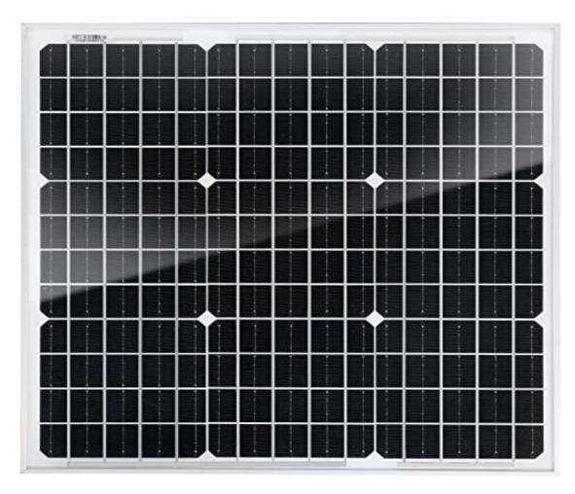
Figure 11: Solar Panel

3.2.2.2 Batteries

For this design it was decided to have (2) ML9-12 - 12 V 9 Ah Rechargeable SLA Battery connected in parallel to maintain control over the speed of the robot. Both batteries will be obtained from the same seller, MIGHTYMAX BATTERY. This seller is one of the most popular sellers of smaller batteries such as the 12V battery. The usual shipping wait time is between 3 to 5 days inside of the Unites States. The seller is also available on Amazon Primer which makes the shipping free and faster. These batteries weigh 5 lbs. allowing us to minimize the weight of
the robot as much as possible. In, addition if user wanted to make it faster then the batteries could be connected in series to increase the velocity of robot.

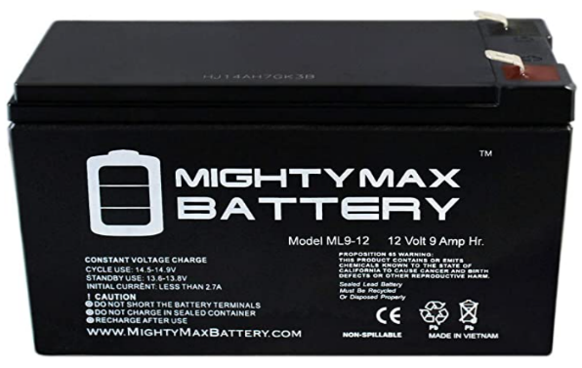
Figure 12: Battery Diagram

3.2.2.3 Wheels, Motor and Gearbox

The design will be supported by (4) Oregon 72-106 Universal Wheel 6X150 Diamond Plastic which weight approximately 0.7 Pounds each with a diameter of 7 Inches and a capable load of approximately 60 lbs. each wheel. These wheels are commonly used in lawnmowers now a days making availability almost guaranteed regardless of time of year. The wheels will be bought from Amazon with an estimated shipping waiting time between 1 to 3 days. The size and requirements of the wheels are a standard multiple industry insuring availability regardless of seller.

Finally, the gearboxes will each house a RS 550 12V Motor with and estimated of weight 0.9 lbs. Approximately. Similarly, to the wheels, the motors selected for this project are commonly used in Toy Cars now a days making availability almost guaranteed with any seller. The motors selected for this design will be bought from Amazon with the seller being SHENGEL. The estimated shipping waiting time for this item is between 2 to 5 days. These motors used typically draw around 2.5 Amps each at No Load making them a good option for this project since its considered to be a low current consumption motor.

The methodology of the selection process of the mechanical components was determined by mainly two factors, availability, and affordability. Since one of the main goals of this project is to develop and implement the designed product with a limited budget affordability was a significant factor in the selection process. On the other hand, availability is equally as important when taking in consideration the selection of the components. That’s why it was ultimately decided to select industry most commonly bought component increasing the chances of availability since this increases the number of sellers available. Therefore, after careful consideration the components illustrated below comprise the mechanical system of the design

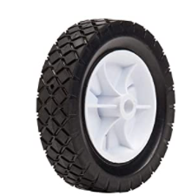
Figure 13: Oregon 72-106 Universal Wheel

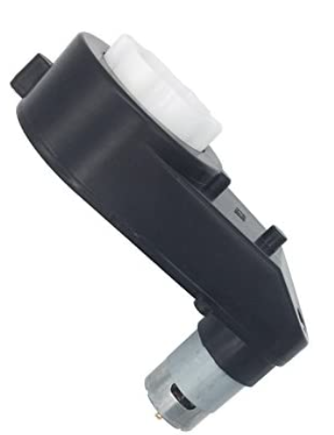
Figure14: Gearbox for 12V Motor

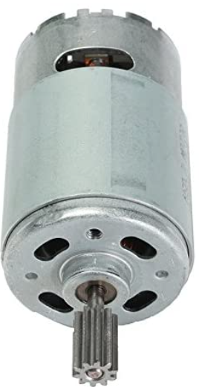
Figure 15: 12V Motor

3.2.3 Optical Components

The main optical component of this project is the Lidar sensor used for obstacle avoidance and autonomous navigation. Lidar is short for light detection and ranging, this sensor will allow the robot to create a 360-degree scan of its environment and map out where the obstacles are using the time-of-flight principle (TOF), so that it can avoid them ahead of time. The lidar sensor does this by emitting pulsed light waves into the environment that bounce off surrounding objects and return back to the sensor. The sensor then uses the time it took for each pulse to return to calculate the distance it traveled

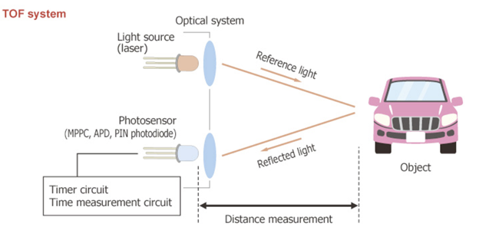
Figure 16: Model of Time-of-Flight Principle

3.2.3.1 Lasers

The most significant component of the LIDAR system is the laser or transmitter. Almost every LIDAR system today uses either a diode-pumped solid-state laser or a diode laser for the source. While diode lasers are cost effective and very efficient, they don’t have the ability to store energy and therefore they cannot be Q-switched. They also have a broader beam and broader laser line width than a solid-state laser. Solid state lasers have a beam divergence closer to the diffraction limit. The laser has the biggest effect on the overall system performance. Therefore, when determining the data acquisition requirements for the LIDAR system, the laser specifications usually determine the system’s performance, cost and feasibility of an application. Therefore, it’s very important to choose the right laser that meets the desired parameters as discussed down below.

3.2.3.1.1 Wavelength

When choosing a wavelength for the LIDAR system there are several factors to consider. Lidar sensors emit electromagnetic waves in the optical and infrared wavelengths and receive the reflected signals back. Lidar is similar to radar except at a much shorter wavelength meaning that it will have a much better angular resolution. A typical Lidar will use a wavelength between 850nm to 1600nm, this falls within the eye safety constraint governed by the International Electrotechnical Commission(“IEC”) 60825 standard. This system will utilize a wavelength of 905nm at Class 1 level, which is the safest level of operation. One of the main factors in the decision of the wavelength is the water absorption level. Our carrier robot will run outdoor and indoor, therefore all-weather conditions need to be taken into account. Water from fog or rain can affect the signal integrity of the lidar, high wavelengths can suffer from significant signal degradation. Comparatively, 1550nm light experiences 4-5 times higher levels of degradation then 905nm light when transmitted through adverse weather conditions. This is caused by the relatively high attenuation coefficient in 1550nm light, leading to strong absorption when passing through water and loss of signal strength with distance. This feature can significantly impact the quality of perception that the lidar sensor produces in rainy, snowy or foggy environments.

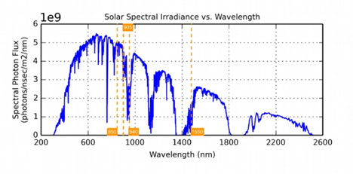
Figure 17: Social Spectral Irradiance vs. Wavelength
Another important factor is the power consumption levels of each wavelength. The 1550nm system consume 10x more power than the 905nm system. High power consumption leads to excess heat generation, requiring the need for larger systems with cooling components and additional power. Additionally, the availably of tech components for 905 nm systems is much greater because of their popularity, this will keep the cost of the project low.

3.2.3.1.2 Pulse Repetition Rate and Pulse Width
The pulse energy and pulse repetition rate determine the sampling rate of the LIDAR system. Which means the density of the network of geo-referenced points produced by the system is dependent on the pulse rate. The higher the pulse repletion rate the higher point cloud density and the faster acquisition of data. Also with higher repetition rates, the achievable resolution of the system is increased. With advances in LIDAR systems, newer systems can process multiple laser pulse returns, allowing the pulse rate to be greater than 1Mhz.

Multiple pulse returns is when a pulse strikes an object but only part of it is reflected while the other part continues until it reaches a further object and then returns. Multiple return systems increase the amount of collected data and create a more precise 3D mapping of the environment. The laser pulse width determines the vertical target resolution or range of the system. This resolution is determined by dR = cτ/2, where c is the speed of light and T is the pulse width or pulse duration. As an example, if the pulse width was 1ns then the resolution (dR) would be 15cm, meaning that two objects would have to be at least 15cm away from each other to be accurately distinguished from each other. Conventional LIDAR systems on the market today use pulse widths in the 5ns range.

3.2.3.1.3 Spectral Width

The spectral width is the range of wavelengths emitted by the laser source and surrounding the center wavelength at a power level equal to half the max power. It is essential for the spectral width of the laser to be sufficiently narrow, around 0.1 nm, this improves the signal-to-noise-ratio (SNR). In order to meet these requirements many LIDAR receivers employ a narrow-bandpass filter to their system. Bandpass filters only allow wavelengths or frequencies within a certain range to propagate through. The central wavelength of the system is determined by thermal conditions of the diode and is subject to wavelength shifts. This means that the bandpass filter must be designed with a uniform and broad transmission spectrum. This requirement is usually met by using multilayer thin film coating techniques to achieve optimal system performance. Typically, the laser is required to emit 90% of its pulse energy within a bandwidth of less than 2 nm.

3.2.3.1.4 Laser Power and Beam Divergence

One of the main factors determining the maximum range of the LIDAR system is the laser’s peak power. The peak power has to be high enough that the reflected beam is strong enough to overcome the sensor’s SNR and trigger the pulse sensor. Sensors are designed to block out the noise from ambient light and therefore they typically have a limiting threshold that the pulse must surpass to be detected. The minimum spot size of the LIDAR system is directly related to the laser beam divergence. While laser divergence will have almost no effect on our system because it will be on the ground, it has a significant impact on airborne LIDAR systems.

3.2.3.1.5 Types of Laser Diodes

SPL PL90_3
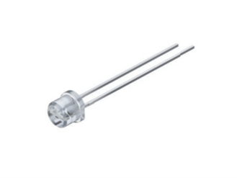
Figure 18: SPL PL90_3 Pulsed Laser Diode

The SPL PL90_3 is a pulsed laser diode from OSRAM Opto Semiconductors. This diode operates at a laser wavelength of 905nm with a peak power of 75 W. The laser’s aperture size is 200 µm x 10 µm. It utilizes nanostack technology including 3 epitaxially stacked emitters. The max pulse width at FWHM is 100ns and the spectral bandwidth at 50% of max intensity is 7nm. The relative spectral emission of the system is shown in the figure down below, where wavelength (nm) is plotted as a function of the relative intensity.

The plot shows that the wavelengths range from roughly 898nm to 912 nm, with the peak intensity at 905 nm. The beam divergence is 9 degrees in the direction parallel to the pn-junction and 25 degrees in the direction perpendicular to the pn-junction. This type of diode is typically used for equipment illumination and industrial automation.

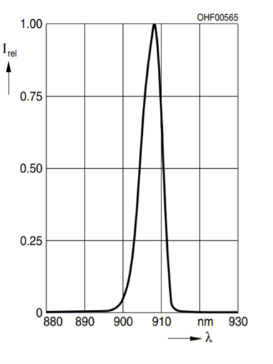
Figure 19: Relative spectral emission of the SPL PL90_3, where Irel = f (λ); IF = 30 A; Popt = 75 W; tp = 100 ns
RLD90QZW3

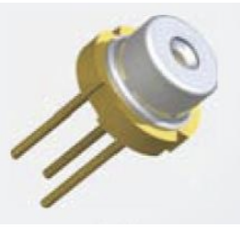
Figure 20: RLD90QZW3 Pulsed Laser Diode

The RLD90QZW3 is an invisible pulsed laser diode from ROHM Semiconductors. This diode operates at a laser wavelength of 905nm with a peak power of 75 W. The operating voltage is 16 V and the threshold current is 0.9 A. The laser has pulse width of 50ns at FWHM and a beam divergence 10 degrees in the parallel direction and 25 degrees in the perpendicular direction. The laser’s aperture size is 225 µm x 10 µm. This diode is typically used as a TOF sensor. Due to its narrow emission width, it is able to have a longer detection distance and improved sensing accuracy.

SPL S1L90A_3
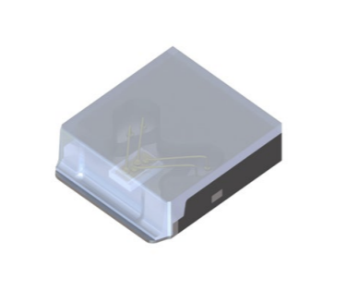
Figure 21: SPL S1L90A_3 Channel SMT Laser

The SPL S1L90A_3 is a channel SMT laser by OSRAM Opto Semiconductors. This laser diode operates at a laser wavelength of 908nm with a peak power of 120 W. The pulse width at FWHM is 100ns. The operating voltage is 11 V and the threshold current is 0.6A. This laser has an aperture size of 220 µm x 10 µm. The beam divergence is 25 degrees in the perpendicular direction and 10 degrees in the parallel direction. This diode is typically used for 3D sensing, CCTV surveillance, LIDAR and Measurement Leveling.

3.2.3.1.6 Laser diode selection
The main factors when it comes to deciding the best fit for a laser diode is the pulse width, pulse repetition frequency, peak power, and wavelength. As discussed in the laser modulation section, we need a pulse width of less than 5ns and a pulse repetition frequency of 6MHZ to achieve our design constraints of a range of 25m and a resolution of 0.75 m. Each of these laser diodes can meet these specifications as they can all be modulated from 1 to 100 ns. Therefore, the next most important factor is the peak power. The SPL S1L90A_3 has the highest peak power at 120 W, however it doesn’t have the same packaging type as the other PCB components, so therefore the robot will come equipped with the SPL PL90_3.

Model | Wavelength (nm) | Peak Power (W) | Aperture Size (µm) | Pulse width (ns) | Cost
SPL PL90_3 | 905 nm | 75 | 220 x 10 | 1-100 | $19.92
RLD90QZW3 | 905nm | 75 | 225 x 10 | 1-50. | $77.91
SPL S1L90A_3 | 908 nm | 120 | 220 x 10 | 1-100 | $28.08

Table 4: Laser Diode Selection

3.2.3.2 Receivers

As the photons reflects off the object and returns to the system, they are captured and converted into an electrical signal and current. This is done through a photodiode sensor; the most common types of photodiode sensors are silicon avalanche photodiodes (APD) and positive-intrinsic-negative (PIN) photodiodes. PIN diodes use the photoelectric effect to create electron-hole pairs called charge carriers, which are used to deliver the photocurrent. PIN diodes have a low conversion ratio of photons to electrons which means a lower sensitivity and more photons are needed for current to be measured. APDs accelerate the charge carriers in the electric field, expanding the photoelectric principle. With the use of the electric field they are able to produce more electron-hole pairs through impact ionization. When compared to PIN photodiodes, APDs have a greater sensitivity which is why for this project we have compared several APDs for the lidar receiver.

3.2.3.2.1 Types of Receivers
AD500-8
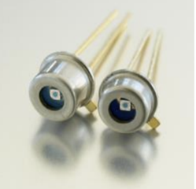
Figure 22: AD500-8 Photodiode
The AD500-8 is an APD from First Sensor, this photodiode has a 0.2mm^2 circular active area with 500 µm diameter active area. It has a fast rise time and low capacitance with an optimum gain of 50-60. The spectral response ranges from 400 nm to 1100 nm with the peak at about 800 nm. This photodiode is commonly used for laser range finders, high speed optical communications and high speed photometry.

MTAPD-07

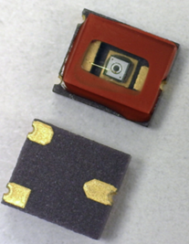
Figure 23: MTAPD-07 Photodiode
The MTAPD-07 is an APD from Marktech Optoelectronics, this photodiode has a 0.2mm^2 circular active area with 500 µm diameter active area. It has a fast rise time, low noise, and low capacitance with an optimum gain of 100. The spectral response ranges from 400nm to 1100nm with a peak at 905nm. This photodiode is commonly used for optical range finders, high speed optical communications and bar code readers. While this photodiode would have been a great option for our receiver, it was on backorder at every distributor.

AD500-9

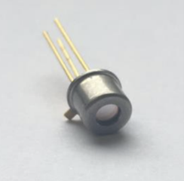
Figure 24: AD500-9 Photodiode
The AD500-9 is an APD from First Sensor, this photodiode also has a 0.2mm^2 circular active area with NIR enhanced sensitivity. It has a fast rise time and low noise with an optimum gain of 50-60. The spectral response ranges from 400 nm to 1100 nm with the peak at about 905 nm. Unlike the AD500-8 the AD500-9 comes with a built in 905nm BP filter, making the spectral response with the filter from 860-940 nm. The quantum efficiency is greater than 80% at 750nm-910nm. This makes the AD500-9 photodiode the perfect receiver for our laser diode of 905 nm. This photodiode is commonly used for laser range finders, high speed optical communications and high-speed photometry.

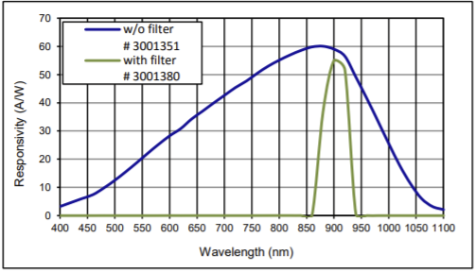
Figure 25: Spectral response of AD500-9

3.2.3.2.2 Receiver Selection

The most important factors when choosing the receiver are the responsivity measured in A/W, the peak sensitivity wavelength, the spectral range and the cost of the device. The responsivity of a photodiode is the ratio of generated photocurrent and incident optical power. The higher the responsivity of the photodiode the lower the signal to noise ratio, meaning the better the efficiency of the detector. While the MTAPD0-07 has a slightly better responsivity, than the other two devices, it didn’t match the packaging type of the components we are using on the PCB. In addition, the AD500-9 has a built-in interference filter at 905 nm, making it the all-around best photodiode with a small spectral range exactly where needed.

Model | Peak Sensitivity Wavelength | Dark Current (nA) | Responsivity (A/W) | Rise-Fall Time(ns)
AD500-8 | 800 | 0a.5 | 48 | 0.35
MTAPD-07 | 905 | 0.4 | 55 | 0.6
AD500-9 | 905 | 0.8 | 49 | 0.55
Table 5: Receiver Selection

3.2.3.3 Transimpedance Amplifier

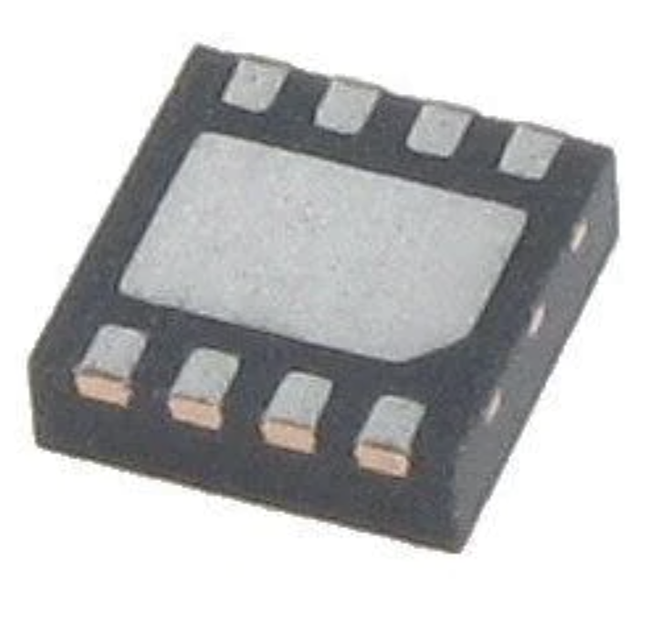
Figure 26: MAX3658AETA+
A transimpedance amplifier is a current to voltage converter almost always used with one or more amplifiers. The TIA can be used to amplify the current from photodetectors, photodiodes, and other types of sensors to a usable voltage. In our sensor, the TIA will do just that it will take the current from the photodiode and transmit it into a usable voltage for the comparator. We used the MAX3658AETA+ from Maxim. It has low noise, high gain, and low power dissipation, making it ideal for small form-factor transceivers. The MAX3658 has 18kΩ transimpedance gain, 580MHz bandwidth and consumes only 66mW of power. These characteristics along with a small die size allow for an easy assembly with a photodiode.

3.2.3.4 Comparator
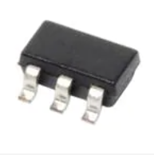
Figure 27: ADCMP600

A comparator is a device that compares two voltages or two currents and outputs a digital signal indicating which is larger. In our TOF system the comparator will capture the data from the amplifier and send their data to an FPGA for calculation of the TOF method. The way the comparator works, is one of the inputs is tied to a reference voltage, and then the incoming light pulse from the reflected object is measured and compared to this reference voltage. If the measured pulse is higher than the reference threshold then the distance to that object will be measured. A comparator is a far better choice than an ADC is this system because we only need the distance to be measured. Using a comparator simplifies the system and saves money by lowering the cost of the receiver chip and the lowering the cost of the external components and downstream processing devices. In our sensor we used two of the ADCMP600 by Analog devices. This device offers 5ns propagation delay with 10mV overdrive on 3mA typical supply current.

3.2.3.5 Time to Digital Converter
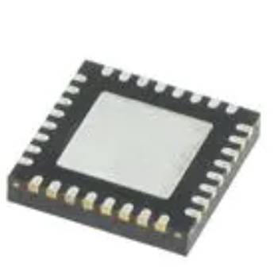
Figure 28: TDC-GP21
A time-to-digital converter is a device commonly used to measure a time interval and convert into a binary output for digital processing. In our sensor the TDC with take time intervals that surpass the threshold of the comparator and convert them into a binary output. They are used to determine the time interval between the start and stop pulse. The start pulse is when the light pulse leaves the laser diode, and the stop pulse is when the reflected pulse reaches the photodiode. Then a calculation can be done to find the distance to that object. In our sensor we use the TDC-GP21 by ScioSense. This sensor has a measurement range from 700ns to 4ms, and a 90 ps resolution. It operates at an average ultra-low current of 0.08 µA when measuring every 30 seconds.

3.2.3.6 Lenses

The optics is the powerhouse any lidar system. Simply put the bigger the optical components the better the performance of the LIDAR system. But it many cases, such as ours, we have to find a balance between the performance and size of the optics so that our device can remain compact. The two main goals of the lens system is to project the laser beam as far as possible, and to collect as many photons as possible into the receiver. In order to accomplish the first goal you’ll want to create the most uniform, outgoing beam with no optical distortion as possible. To achieve this you will need to collimate the laser beam, meaning the beam will have parallel rays that spread minimally as it propagates. Most systems, including ours, use a semiconductor laser that produces a distorted ellipse pattern. That pattern will need to be transformed into a perfectly uniform parallel beam. An example of light being collimated from a laser diode can be shown in the figure below. The light emits from the laser diode, unequal and diverging and the lens converges the light into parallel rays to make it a perfectly collimated beam. In more complex systems, multiple optical elements will be used to get the collimation ideal and efficient. Cylindrical lenses can also be configured so that the focal length of one side addresses the fast axis, while the other focal length addressed the slow axis. This method achieves the best collimated beam.

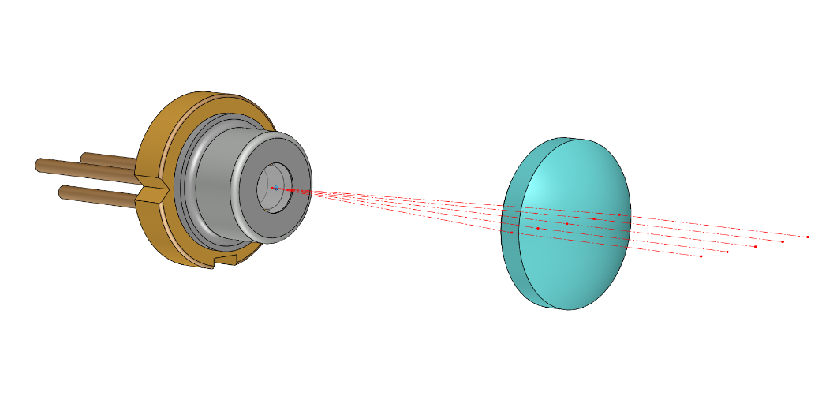
Figure 29: Collimating light from a Laser diode
For the receiver the primary objective is to collect as many photons as possible. Therefore, it is all about getting the photons down to the detector and focusing those photons to an exact spot that is the size of the detector. In this system the optical system can be treated as an energy gathering device rather than an imaging device. You need to find a balance between ensuring your lenses are optimally sized to guarantee clear imaging as well as efficiently collecting photons. While a larger lens on the receiver captures more photons, larger systems are more unstable. Therefore, the efficiency of the lens will need to be improved instead. This can be achieved by minimizing spherical aberration by using doublets. Doublets are sets of lenses with different radius of curvature, refractive indexes and/or amounts of dispersion. This method allows more degrees of freedom to correct the aberrations and achieve the sharpest focal point.

When choosing the material of your lens, there are several factors to consider. While glass is generally seen as the best choice, it tends to fracture and scatter into small pieces on impact. Since our LIDAR sensor will be going on the front of our robot, glass isn’t the safest choice to make our lens out of. In contrast, acrylic is more ductile and less likely to fracture. In addition, acrylic lenses are more cost effective and the discrepancies between the two materials are minimal. Coatings can be added to lenses to improve scratch resistance as well as avoid backscatter.

3.2.3.7 Bi-Convex Lens
The primary lens used for the laser will be a Bi-convex lens. These lenses are made of two convex surfaces in spherical form, generally with the same radius of curvature. They work similar to plano-convex lenses by focusing parallel rays of light to a single point. A collimated beam of light enters the lens and converges at a spot behind the lens, as shown in the figure below. The distance from the lens to the spot it converges is called the focal point. The focal point of a Bi-Convex lens can be calculated using the lens makers equation and simplifying for equal radii of curvature as shown below. Where f is the focal point, n is the refractive index of the lens, d is the thickness of the lens and R is the radius of curvature, assuming the lens is in air.
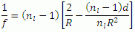
These lenses minimize spherical aberration, distortion, and chromatic aberration due to their symmetry. Bi-convex lens have a wide range of applications, including control and focusing of laser beams and quality imaging. An example of a Bi-convex in everyday life is the eye, light rays coming from objects and converge onto the retina. The closer the object the more sharply the light rays have to bend to focus on the retina, while light rays coming from distant objects require less diffraction. In our system a Bi-Convex lens will be used in front of the laser diode to focus the laser beam onto the mirror.
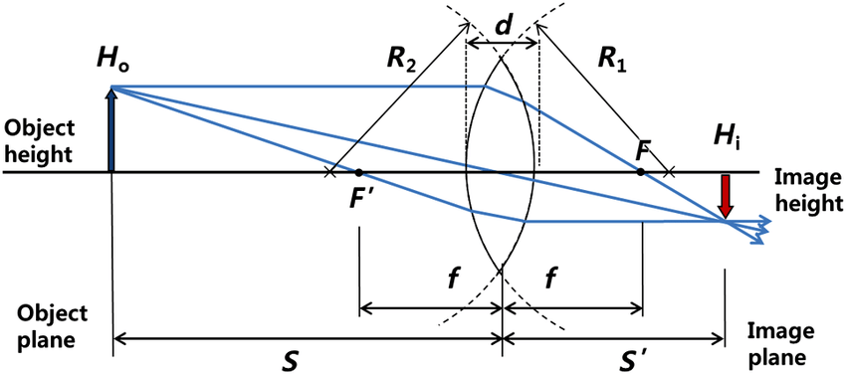
Figure 30: Ray diagram of Bi-Convex lens

Product Number | Focal Length (mm) | Diameter (inches) | Radius of Curvature (mm) | Cost
LB1092 | 15 | 0.5 | 14.6 | $26.18
LB1761 | 25.4 | 1 | 24.5 | $27.48
LB1811 | 35 | 1 | 34.9 | $26.00
Table 6: Bi-Convex Lens Cost

3.2.4 Electro-Mechanical
DC (Direct Current) Motors are two wire (power & ground), continuous rotation motors. When supplying a DC motor, it will continue to spin until its power supply is removed. To spin the motor backwards the polarity must be flipped. DC motors run at high RPM (revolutions per minute). The speeds are controlled using PWM (pulse width modulation). With this we pulse the power on and off rapidly and the speed of the rotation is determined by the percentage of time spent cycling the power supply on and off. The pulses during PWM are so rapid that the motor appears to be continuously spinning. For this project we chose to use DC motors over Servo Motors because servo motors have a limitation of 180 degrees in rotation. Although DC motors are missing that “control” feature that servo motors have we can manipulate the DC motors using PWM effectively enough to slow down its RPM.

To operate the DC motor, we cannot connect it directly to the board. This is because it will just continuously keep rotating and we cannot give it a PWM. For this project we implemented a Motor Drive Controller. Connecting the DC motor to the Motor Controller allows us to give a PWM signal. The Motor controller allows us to communicate with the Direct Current as much as protocol allows. Motor Driver Controllers use discrete MOSFETS which are able to handle large amounts of currents and higher voltages than the standard 3.3V or 5V. In order to control the DC motors to slow them down, halt them, or change the directions of them we pulse the MOSFETS. In other words, the MOSFETS are acting like switches on the Motor Drive Controller. To turn the motor in one direction, two of the MOSFETS need to be turned on in a certain direction, which will allow current to flow. An example of this is below in figure 18A. To turn the motor in the opposite direction then the opposite pair of MOSFETs must turn on while the previous MOSFETS turn off. This will reverse the direction of the current flow as seen in figure 18B. If you would like the motor to come to a stop then turning off all the MOSFETS will completely power off the motor. However, keep in mind that more than likely the motor has enough momentum that its inertia keeps it spinning for just a little longer than expected before it actually comes to a complete stop due to laws of physics. To avoid this, we can apply an equal voltage to both sides which makes a braking reaction. The braking reaction is seen in figure 18C.

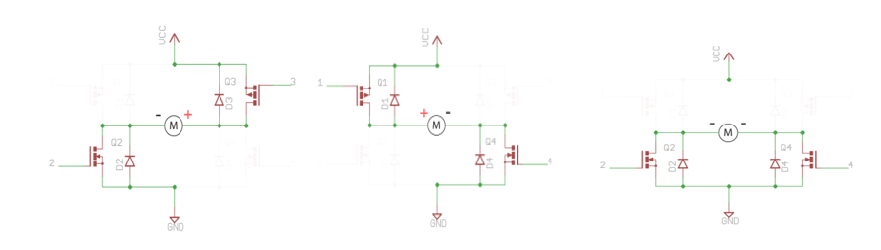
Figure 31A: Forward Motor Figure 31B: Reverses Motor Figure 31C: Braking
The Motor Driver Controller selected for this project was the BTS7960 Half bridge Motor Driver. These motor drivers are commonly used for systems with higher currents up to 43A. This Half bridge allows to control only one motor two directions, clockwise and counterclockwise. It contains one P-Channel MOSFET and one N-Channel MOSFET in addition to an Integrated Chip to control the logic input received from the microcontroller. The IC allows the user for easier connection with a microcontroller such as the ATmega328P chip used for this project. It also has an overtemperature protection circuit which shuts down both the output stages, which protects the system in higher temperatures.

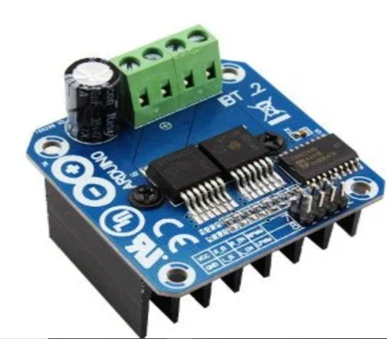

Figure 32: BTS7960 Motor Drive Controller Board Module Single H Bridge DC Stepper for Arduino

3.2.5 PCB Software
Electronic Design Automation (EDA) is software that is used to develop PCBs when the projects designing and prototyping of the circuit is done. This kind of software contains a schematic editor for designing circuits. Parts are placed on sheets and connected through ports. These kinds of software allow back annotation to schematics and auto-routing to automatically connect traces based on the connections done back on the schematic. Using functions like these helps with making it easier to make PCBs. Common Electronic Design Automation Software that are used are Altium, Eagle, DipTrace Starter, and ORCAD. Most of these programs usually do require a pretty penny for commercial usage, however a few of them do offer a free version for non-commercial usage like ORCAD, Eagle, KiCAD and DipTrace. Altium does also offer a 6-month free trial. Usually, the once that offer a free version of their software do give us limitations like the number of allowed layers. When choosing which program to use for PCB building, we looked at the community support, Ease of use, capability, and portability. Eagle being the program that most of us were introduced to in a previous class and having a pretty large community of users made it one of the most appealing of them all to use. All the programs do have many online tutorials and libraries available to them. However, since Eagle is one software we are most comfortable with, it is the program we have decided to use when designing PCBs. Below are a few comparisons of different programs. Ultimately, they all look relatively similar and perform the same task at hand, at the end it came down to preference for us.

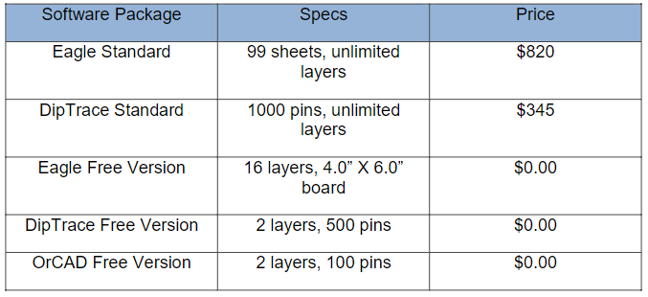
Figure 33: Different PCB Programs

3.2.5.1 Increasing PCB Reliability
PCB is a crucial component to any electronic. Having a reliable design means that it is important to have a long-lasting PCB. Most PCB are different and need their unique approaches for designing, this section will discuss some of the basic precautions that can be taken to improve the reliability of a system. Most of these techniques have been used for over 20 years and are still in use today. These techniques not only increase reliability, but they also reduce the dimensions of the PCB making the overall electronic more compact, helping to save on the cost of manufacturing PCBs. The following are the recommended techniques to produce long lasting PCBs.

#1: Keep the traces short and direct as possible
With longer traces the system can experience higher resistance and inductance on the power lines. Keeping the traces short can import the performance of the PCB. This would apply in analog and high-speed digital circuity where impedance and parasitic effects play a part on limiting system performance.

#2: Group related components and test points together
Keeping all related components together is useful because chances are they are most likely connected to each other. Grouping these components will help develop shorter paths between components, thus keeping the traces together. This helps in case troubleshooting must be performed during testing. This mostly applies to Integrated Circuits on the PCB because Integrated Circuits require bypass capacitors and resistors. Grouping these together helps with the noise cancellation properties of the bypass capacitors.

#3: Manage the power lines and ground with a power plane
This ensures that power flows with minimal impedance or voltage drop, and ground return paths are adequate. With this, it is recommended that multiple supply lines are ran on the same area of the board. For multilayer boards, it is recommended to use a whole layer as the ground plane. There should not be any overlap between analog and digital power planes.

#4: Picking the correct grid
This one may not be entirely major however, following all these do help with the PCB reliability and ease of creating. Find the correct grid spacing that fits as many of the components as possible and use it all throughout. Multiple grids may sound nice at the beginning but avoiding this may help with spacing down the line, so avoiding these difficulties at the beginning is important as it will help with maximizing board use.
#5: Use decoupling capacitors
Decoupling capacitors help shield Integrated Capacitors on board from high frequency noises. Capacitors are generally a cheap component yet robust enough that is should always be used whenever possible. Keeping all of the decoupling capacitors in a standard range helps keep inventory simple.

#6: Use heat sinks to lower thermal resistance of the circuit
Heat sinks are external, low thermal resistance devices that are connected to Integrated Circuits to help with heat removal. It is recommended to attach a heat sink that is larger in area and weight to help with heat dissipation. If in a confined space, natural air ventilation should be provided with forced air in case of several watts being dissipated in that confined area.

#7: Panelize PCB on larger boards
Replicating your PCB on a larger board can help to do this. Using a size that best suits the equipment and is used by the manufacturer will improve the cost of prototypes and manufacturing. This can be done by laying out the board as one panel and repeating the design multiple times within the panel.

#8: Proceed with caution on automatic signal routing CAD software
This is not to say that this automatic feature is not reliable on most CAD software, as it is available because it works at times. However, critical signal paths it highly recommended to be routed by hand to avoid undesired coupling and emissions. Designing multilayer PCBs properly can reduce EMI emission and increase immunity to RF fields by a factor of at least 10. Most PCB software have a Design Rule Check function that checks the design for lots of different validations. This can be useful and should be used frequently during design.

#9: Use the Silkscreen
Silkscreen is used to help people identify components, part numbers, and wiring symbols on a PCB. This is an important part for understanding the circuit being viewed, so proper fonts and orientation should be used. The use of Silkscreen on the PCB can help reduce re-works down the line.

#10 Verify the generated PCB
When the PCB is generated, verify it before sending it out to be manufactured. This way any error missed can be caught before it basically cannot be undone without having to send to create a new one, which raises the cost on the team and waiting time period for correct manufactured part.

#11: Place mounting holes strategically
The mounting holes for the PCB is better planned in advance and should be clear of tracks and components. The holes are to be coated with dielectric material if metal screws or connectors are being used. Something to keep in mind as well is that manufactures typically charge more for different sized mounting holes on a PCB, therefore make sure to keep the holes similar to each other.

3.2.6 Microcontroller Selection
This section will go into details of the microcontrollers that were considered during the selection phase of the project. Different controllers were considered during the initial phase of our project due to capabilities that each MCU can offer. The MCU was that will be chosen has to be able to have multiple communication protocols, adjustable in terms of programs available to the group, available for purchase and priced well.

3.2.6.1 MSP430FR6989

The first microcontroller that was considered is the MSP430FR6989. This was because it was a microcontroller that most of us already had on hand from a previous class. This MCU is part of the FRAM line of microcontrollers that TI offers. FRAM (Ferroelectric Random-Access Memory) is a low power non-volatile memory with fast random access This is a MSP430 based microcontroller. Some key points on this microcontroller are that it has low power, and quick response times. The fast response time is something that also had us of high interest for our robot due to the sensors we have on board. With the sensors we need to have an MCU that will allow fast response time. The MCU allows 64KB of write data in 4ms while having 128KB nonvolatile storage. The 128KB nonvolatile storage can be helpful on storing a few coordinates for the robot, this allows it to return to various locations without having to always give it the same recent coordinates. The microcontroller also offers 32-bit hardware multiplier, three-channel internal direct memory access, a total of five timer modules with multiple capture/compare registers, 128-bit AES security encryption and decryption processor which can help with random procedural, and enhanced serial communication interface module (eUSCI).

FRAM is a non-volatile memory that can hold data even after it is powered off. This was one of the biggest points as well for this MCU because it would be able to hold coordinates even after the system shut down. This will also help it with going straight to work because the sensors would not have to take in as much data as soon as it starts if the robot is in the same exact location it was shut down on. That idea may not be something we may continue with due to the fact that we would have to write a code that would detect if it was in the same spot, therefore having the robot always checking its surroundings via the sensors would be better and safer to avoid collision. However, the fact that it can hold locations after shutting down would be beneficial if the robot is used constantly for just going to the same areas.

With the data reliability, low power, speed, unified memory, being part of the MSP430 line, and TI’s support, would all make it easy to port over to new setups with minor efforts. Data is almost completely unaffected by the stray electric fields and radiation. On top of that, the cells have greater read-write endurance than flash or EEPROM. Write speed has been improved on this MCU so that it is faster than flash and EEPROM, with an additional compressed write and read verifiability. This MCU also has a unified memory interface. Which means that both the standard nonvolatile and volatile memory are one. This would help to make an easier time when designing the code because the programmer only has to keep in mind the overall memory usage instead of two different sections, nonvolatile and volatile, and their usage. Another advantage of using a device such as this one from TI that has FRAM is that it gives ease of integration into existing project. This has to due with the C code being completely portable from one MSP device to another. Even though the different memory structure would be there, the programmer can easily still implement their existing code. The only trade off here is the lower memory density compared to others. The direct memory access module also comes integrated on this MSP430 package. It provides a high speed to low-cost ratio method for moving predefined data with various methods. The most common reason this module is used for is the automatic pulling and moving data between peripherals at a low cost against CPU. This module does not pull any of the limited cycles for processing since it is usually in parallel with the CPU. This is where the programmer must give the device a standard condition in which concurrent access to set resources happens in the wrong order. The hardware multiplier included already helps the programmer as well because multiplication is not a low-level operation in many microcontrollers. Usually, multiplication is a costly operation. The hardware implementation offered by the MPY allows for hardware offloading which leads to increasing speeds of up to 17 times when put against software implementation. We can see from figure# that software has to go through a whole process to do this which is not ideal if you would like the system to run with higher speeds.
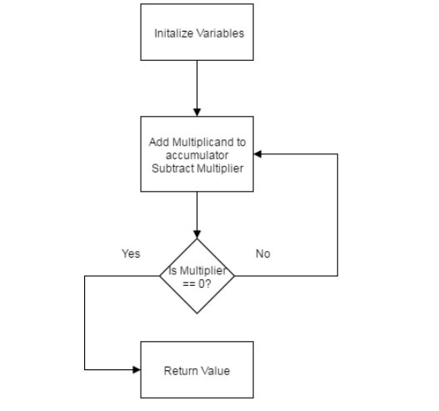
Figure 34: Flow of multiplication in software
The clock system for the MSP430 line in general is pretty robust. The clock system allows for multiple sources to be used and configured in the instances that a clock is used as an input. A main system clock is used to generate the clock signals that is used throughout the device. The clock speed of this device is configurable using presets with the speed of up to 16Mhz. This device comes with a 32kHz crystal, which is the long-standing standard used across devices due to its ease of production, stability, and being divisible by 2. The crystal is the core of the low power mode if the peripherals are running without a main clock. Additionally, to the clock system, it can use external clocks for clocking its system. This is beneficial if a specific speed, precision, or power draw was needed to be met, then an external hardware could be used to provide this. This gives more freedom of customization for the needs of the customer using the device.

The timer module built into the MSP430 family are useful for multiple tasks. They can be used for implementing PWM without the direct processor to intervene. The timer includes five modules with multiple registers for each. This allows multiple parallel lines being driven with proper hardware generated PWM. The security for this is also helpful because it keeps all information like code or incoming and outgoing information that may be sensitive encrypted with the ability of decryption with the decryption coprocessor.
One of the major things looked at for all MCU when determining which once to consider are also their communication protocols. We are looking for an MCU that can offer multiple protocols due to the flexibility it has for all the other parts of the robot. For this MSP430 it has an eUSCI module provided. This is a much more enhanced version of their counter parts that may just include USCI. This communication module includes the protocols I2C and SPI, that are synchronous, and UART that is asynchronous. It also includes enhanced UART with automatic baud-rate detection, which helps with error detection.

To conclude this MCU we would like to say that this device provides a multitude of reasons why this proves to be a pretty good candidate. With the hardware that was offered for the significant clock optimization and customization that may be needed for driving. However, one reason we may not end up using this MCU is because of the lack of max speed on the memory controller being at 8MHz. This MCU may be considered to be “fast” being that its low power but may not be fast enough to do all the read and writes required all at the same time as processing data and accessing its peripherals or other attached parts that need data transferred.

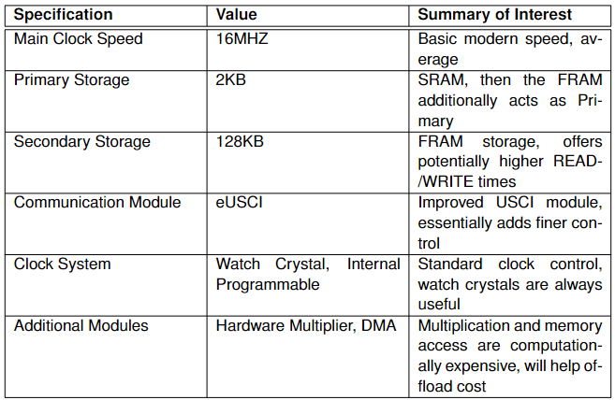
Figure 35: MSP430FR6989

3.2.6.2 ATmega328P (Arduino Uno)
Arduino Uno is a microcontroller board based on the ATmega328P. It has 14 digital input/output pins, 6 of which we can use as PWM outputs. It also has 6 analog inputs, a 16MHz ceramic resonator, a USB connection, a power jack, an ICSP header and a reset button. It has two 8-bit Timers with compare modes, and one 16-bit Timer with compare mode and capture mode. The timer on this board is also programmable like the previous board discussed. The timer also has a separate oscillator. The most special features to point out are the power-on reset, internal calibrated oscillator, external and internal interrupt sources, and the six sleep modes that are IDLE, ADC noise reduction, power-save, power-down, standby, and extended standby. This board has high endurance non-volatile memory segments. This board has 32K bytes of in-system self-programmable flash program memory, 1K bytes EEPROM, and 2K bytes internal SRAM. It also has the option to boot code section with independent lock bits. This means it has in-system programming and read-while-write operation. The memory also has programming lock for software security. Arduino software is its own IDE, which makes it easier to use and program for different levels of programmers. It is an open-source software that can be expanded onto C++ libraries. We do expect to use the Arduino Uno board as it brings simplicity for use. It also brings many different ports that are of benefit to us. Lastly, it provides all the communication protocols we would need to connect most parts.

3.2.6 Serial Communication
Serial communication is a communication method that uses one or two transmission lines and receive data. That data is continuously sent and received one bit a time through a single bit of data through a channel sequentially, opposed to a parallel communication, which sends multiple bits of data over a number of channels simultaneously. It is widely used to transfer information between equipment and peripherals.
There are a few standardized serial communication methods that exist for sending and receiving data synchronously and asynchronously that will benefit this project. Synchronous serial communications such as I²C (Inter-integrated Circuit), and SPI (Serial Peripheral Interface) could be used for interfacing the microcontroller with other subsystems such as Bluetooth. Asynchronous serial communications such as UART (Universal Asynchronous Receiver Transmitter) are useful for transmitting and receiving data between the device and the external device without having to wait for the other electronic. This would benefit something like the GPS when it just sends the coordinates information when it needs to across the microcontroller. When connecting the other subsystems to the microcontroller we must make sure we use the correct communication protocol. This is because in order for a subsystem to communicate with the entire system it needs to be able to route its information through the correct buses.

3.2.6.1 I²C
I²C, is the acronym of Inter-Integrated Circuit. It is a communication protocol originally designed by Philips Semiconductor, now known as NXP Semiconductors, in 1982. There have been 6 different revisions for I²C. These revisions have been mainly concerning the increase of speed in signal transmission with the offering of high frequency modes for the data and clock signals. Since 2006, the protocol is available for use by the public, royalty-free unless you are trying to obtain slave addresses, which in that case NXP does charge. I²C is supported by a large number of devices and is used at low speeds for communication between integrated circuits.
A serial bus is used to facilitate communication between devices. This allows multiple masters to communicate with multiple slaves. This type of communication protocol is primarily used for short distances. Conventional I²C has both 10Kbps slow mode, a 100 Kbps standard mode, a 400 Kbps fast mode, a 3.4 Mbps high speed mode, and a 5Mbps ultra-fast speed. The I²C bus uses 7-bit addresses and is comprised of two signals. This is known as Two-Wire Interface.
- Serial Data (SDA): This is the data signal. This is the transmission line that data is transmitted between masters and slaves.
- Serial Clock (SCL): This is the clock signal. The clock signal is created by the master bus. Slaves have the ability to command those clock signals to a lower frequency for some extra processing time in case they are receiving too much data from the master all at once.

Seral Data and Serial Clock lines use pull-up resistors usually at around 4700ohms. This protocol is able to identify connected devices and classify them as either a master or slave. Once the roles are defined the devices are limited to do certain task at certain times depending on which role they were permitted. The masters and slaves are distinguished by nodes.
- Master node: This node sets the clock signal and begins transmitting data to the slaves.
- Slave node: This node acknowledges the clock and receives the data that was transmitted from the master.

The two-wire bus supports unlimited masters and can support a maximum of 1008 slaves. The master and slave have the ability to swap roles between signal transmission, but multi-master bus does not allow for masters to communicate with other masters simultaneously. There are four modes of transmission that characterize the master-slave nodal behavior:
- Master transmission: The master transmits data to a slave.
- Slave transmission: The slave transmits data to the master.
- Master Reception: The master receives data from the slave.
- Slave reception: The slave receives data from the master.

I²C signal messages are denoted in all capital letters. The signals are recognized as START, STOP, and ACK (acknowledge). When the master begins transmitting it uses a START bit along with the desired slave’s 7-bit address, which means data is sent in one-byte. The last bit will determine if the data is being read or written. When the slave receives this message, it transmits an ACK bit. The master then continues to operate in either the transmission or reception mode depending on if the last bit of the first message was a 0 for write, or a 1 for read. When either the master or the slave is receiving data, they send an ACK bit after each byte is received. When the signal transmission is completed, the master sends a STOP bit to end the transmission or sends another START bit to begin a new transmission. In other words, all transmissions are initiated and terminated by a master.
As seen in Figure 1, only two signals, clock, and data, are used regardless of how many devices are on the bus. Both signals pull up to the power supply voltage through appropriate resistors. Every device interface to the clock and data signal through open-drain or open-collector output drivers. The open-drain for the SDA and SCA is what distinguishes the I²C from the SPI and UART. This means that an I²C can only assert a low signal, making it an active-low.
As seen in Figure 2, the green line shows that by default, the signal wires are set high using the pull-up resistors. Data signal is updated on falling edge of the clock signal and sampled on the rising edges. This hardware configuration allows all devices to safely read or write to the SDA and SCL lines at their appropriate time. Master devices wait until a STOP has been declared before trying to write over the bus lines, and the slave devices reads the bus lines to check whether the address following the START bit matches. Non-matching slaves will wait until another STOP is declared before reading again. Due to the active low utilization the masters can use the feature called stretching in the event a slave is unable to keep up with the master speed. This brings an advantage because now the chances of signal conflict happening is very unlikely, which helps with corruption of signals and damage hardware.

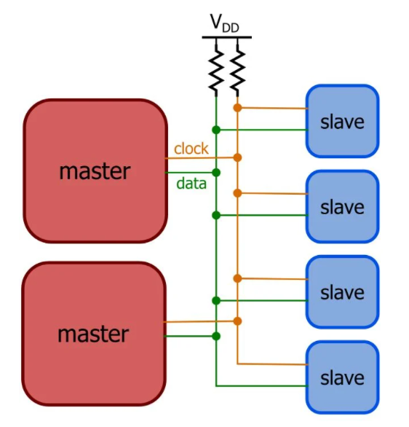
Figure 36: I²C Bus

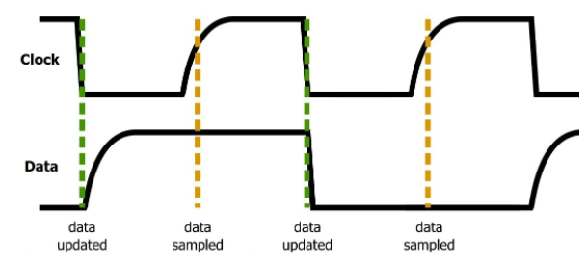
Figure 37: I²C Data Signal Diagram

The I²C is a communication protocol that could be used for the carrier robot. The I²C would be on the microcontroller, for example an Arduino, and this microcontroller would act as the master. The I²C allows us to connect up to 128 devices to the board like the sensors. The devices like the sensors would act as “slaves” in this system. Since I²C uses an address and a shared bus, many devices can be connected to the exact same wire. This means that fewer wires would be used which give us fewer pins on the microcontroller if we wanted to manage it easier. Each slave would be assigned specific software function since they have their individual address.

3.2.6.2 SPI
The serial Peripheral Interface Bus, also known as SPI, is a serial communication created by Motorola. It was made to use over small distances and has been considered a standard embedded system communication method for some time due to its simplicity and versatility. The SPI is also synchronous just like the I²C protocol. This means that the clock signal will also be used to synchronize data and transmission. Devices that use SPI transmit and receive data at the same time. This is referred to as full-duplex mode. Like the I²C, SPI uses the master and slave method as well. The SPI protocol can also be called the four-wire interface (FWI). This is higher than our previously discussed protocol, the I²C, who has only a two-wire interface. The four SPI bus wires that are important are:
- Slave Select (SS): This is the signal that the master uses to choose which slave it will communicate with.
- Serial Clock (SCLK): This signal is generated by the master, and it synchronizes all SPI signals.
- Master In Slave Out (MISO): This is a unidirectional data signal that travels from the slave output pin to the master input pin.
- Master Out Slave In (MOSI): This is a unidirectional data signal that travels from the master output pin to the slave input pin.

The SPI protocol uses a single master but supports multiple slaves. At the start of the transmission, the master generates a SCLK signal at a mutual frequency. The frequency usually caters to the selected slaves the master would like to communicate with. From here, the master will pull the selected slave’s line down and then wait if a response is expected. This will activate the transmission into full-duplex mode. During this time the master sends data over the MOSI line, and the slave can send data over the MISO line. If the master is communicating with multiple slaves, then each slave will require its own SS in order to be addressed. Figure 22 shows how the SPI will configure with the master and slave.
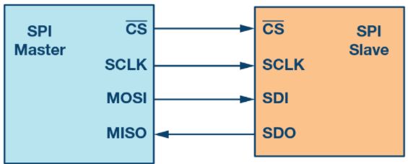
Figure 38: SPI Configuration
During signal transmission, 8-bits of data from a shift register in the master is swapped with data from a shift register in the slave. During this swap, the most significant bit from the master or the slave is replaced with the least significant bit from its counterpart. The process is continued through many clock cycles until the shift registers has completely swapped values. Once this is done, the shift registers are reset to prepare for the transmission. When the transmission is finally complete, the slave is released from the SS line. Figure # shows a timing diagram for an SPI signal transmission. Signal transmission is done with respect to Serial Clock (SCLK). The timing of the SCLK signal is characterized by two options, the Clock Polarity(CPOL), and the Clock phase (CPHA). The clock polarity is responsible for the clock signal inversion or noninversion at 0 for active high or 1 for active low. The Clock Phase is responsible for shifting the sampling edge clock signal at 0 for rising edges or 1 for falling edges. This means the SCLK has four potential modes that communication can occur within a microcontroller:
- Mode 0: CPOL = 0, CPHA = 0. The SCLK is active high, and the data is captured on the rising edge.
- Mode 1: CPOL = 1, CPHA = 0. The SCLK is active high, and the data is captured on the falling edge.
- Mode 2: CPOL = 0, CPHA = 1. The SCLK is active low, and the data is captured on the rising edge.
- Mode 3: CPOL = 1, CPHA = 1. The SCLK is active low, and the data is captured on the falling edge.
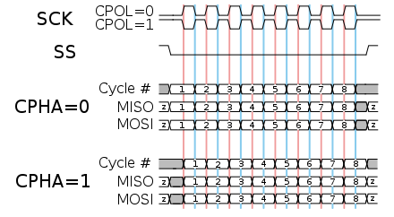
Figure 39: SPI Timing Diagram

The SPI can use has two different modes when it’s doing the combination of 1 master to multiple slaves. The two modes are called regular mode, sometimes referred to as independent slave, and daisy-chain mode.
- Regular/Independent Slave Mode: Each Slave has its own select line leading from the master.
- Daisy-Chain Mode: There is a single select line that branches to each slave.

In regular mode the chip select signal is enabled (pulled low) by the master. The clock and data on the MOSI/MISO lines are available for the selected slave. This is the most common method for SPI communication. If multiple line select signals are enabled, the data on the MISO line is corrupted, since there is no way for the master to identify which slave is transmitting the data. As the number of slaves increases, the number of select lines from the master increases as seen in Figure 23. This can quickly add to the number of inputs and outputs needed from the master and limit the slaves that can be used. To increase the number of slaves in regular mode using a multiplexer to generate can help to generate more select line signals. However, using the regular mode comes with the disadvantage of utilizing many more pins on the microcontroller because of the many select lines.
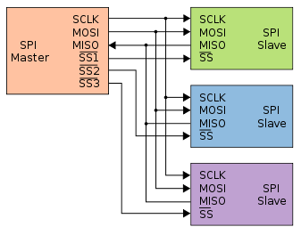
Figure 40: SPI Regular/Independent Slave Mode. Permission by GFDL
Figure 24 shows the daisy-chain configuration. This involves each slave sharing a single line that branch off from the master. In this method, all the slaves are connected and receive the same SPI clock at the same time. The data from the master is directly connected to the first slave and that slave provides data to the next slave and so on. Which means that the MISO line from the first slave is directly connected to the MOSI line of the next slave, until the MISO of the last slave is connected to the MISO of the master. As the data is passed on from one slave to the next, the number of clock cycles required to transmit data is proportional to the slave position in the daisy chain. This makes this configuration act like a buffer naturally since the same data transferred from the shift register of one device to the next on each clock cycle. This method uses fewer pins than the regular mode because of the utilization of a single slave select line.

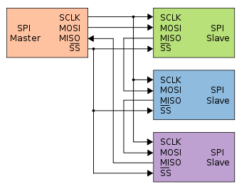
Figure 41: SPI Daisy-Chain, Permission by GFDL
SPI is faster than I²C with speeds that exceed 10 Mbps due to its full duplex design, and not being limited to its 8-bit words. It requires more signal wires than most protocols. Due to its much higher speed and simplicity, it is a better candidate for connecting the sensors for the Robot since the robot is constantly relaying information or obstacles it needs to avoid much faster. The disadvantage of using SPI comes with the fact that slaves cannot explicitly communicate to each other, and that only one master is supported using this protocol. This does not allow slave acknowledgment or error checking. However, one idea for the robot is that the microcontroller would be the only master that is needed, and all peripherals are connected as slaves to the microcontroller. One aspect that may hinder the use of using SPI for the robot is the issue with error checking, at least in I²C the slaves have the ability to do so. SPI may have the upper hand in speed but I²C may have the more robust protocol for most peripherals.

3.2.6.3 UART
The UART (Universal Asynchronous Receiver Transmitter) is something that enables serial communications. This is another interface that is commonly used by microcontrollers between parallel and serial connections. One side of the UART has a parallel bus with multiple data lines, and the other side has two serial lines: the receiver (RX) and the transmitter (TX). In two-way communication, we use two wires for successful serial data transfer. This can help with the need of less circuitry and wires, thus reducing the cost of this implementation. UART is used by various communication standards such as RS-232. The UART is responsible for:
• Converting the data from the microcontroller received through the parallel bus into serial data sent through the TX serial line.
• Converting data received through the RX serial line into data sent over the parallel bus lines that were received by the microcontroller.
• Checks the parity of transmission by inserting a parity on output signals and removing the party bit on input signals.
• It also helps with handling interruptions from peripheral devices.
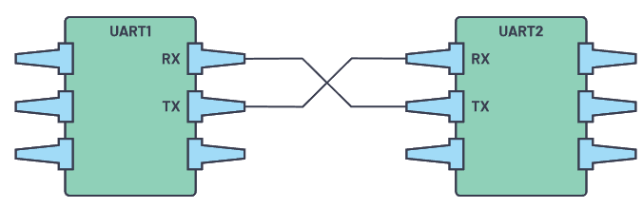
Figure 42: UARTS line of communication

When the microcontroller begins sending data through a shift register, a start bit, parity bit, and stop bit are created by the UART and the data is sent through the serial TX line. The UART also sets flag that lets the microcontroller know that it is busy. This also indicates to the microcontroller that the shift register and buffer contains data.
The UART interface does not use a clock signal to synchronize the transmitter and receiver devices. This means it transmits data asynchronously. The transmitter generates a bitstream based on its clock signal while the receiver is using the internal clock signal to sample the incoming data. Synchronization is managed by having the same baud rate on both devices. The baud rate is the rate at which information is transferred to a communication channel. If this does not happen it may affect the timing of sending and receiving data, which can cause discrepancies during data handling.

3.2.6.4 Arduino Microcontroller using I2C, SPI, and UART
The Arduino can connect to other MCUs through the three different protocols I2C, SPI, and UART. These protocols are implemented as libraries to handle the details of the individual protocols. Each protocol libraries use similar schemes: opening a connection, then begins its transmission, and closing the connection. The Arduino Microcontroller having the ability to use all three protocols gives the advantage of choosing different devices that require different protocols, and different transmission speeds. The chart below is a simple guide throughout the project to quickly decide what devices should connect to the protocols, and the limitations we encounted using each protocol during the building process of the robot.
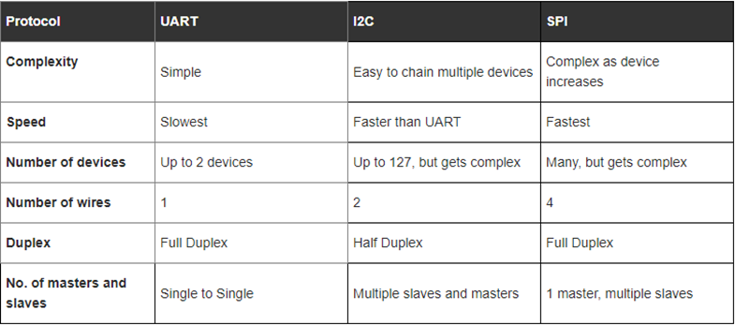
Figure 43: Summary of protocols on considered MCU

3.3 Strategic Components and Part Selections

3.3.1 Ultrasonic Sensors
Ultrasonic sensors are instruments that measure the distance to an object using ultrasonic sound waves. One of the benefits of ultrasonic sensors is the because it uses sound waves, unlike LIDAR sensors that uses light waves, it won’t be affected by the ambient light outside. These sensors use a transducer to send ultrasonic pulses into the surrounding area. These pulses then bounce off of objects and return to the transducer, allowing it to relay back information about the object’s proximity.

HC-SR04
0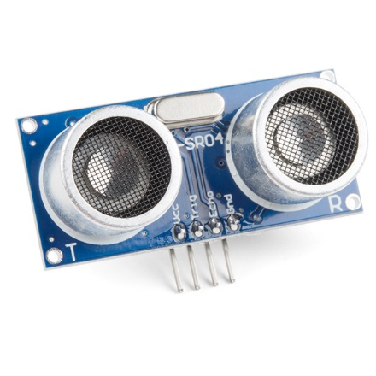
Figure 44: HC-SR04 Ultrasonic Module
The HC-SR04 is an ultrasonic ranging module, this unit measures distances within its range. It has a range from 2cm – 400 cm, with a ranging accuracy of 3mm. This module comes with the ultrasonic transmitter, receiver, and control circuit. The way it works is the transmitter will emit eight 40 kHz and the receiver will detect whether this a pulse signal coming back from a nearby object. Then it will calculate how the distance to the object using the equation below, where speed is the is velocity of sound (340 M/S), time is the how long it takes one pulse to leave the transmitter bounce off an object and return to the receiver, and D is distance.

$$D=\frac{Speed ×Time}{2}$$

This unit needs a 5V power supply and operates at a working current of 15mA. It is a compact device with dimensions of 45mm*20mm*15mm, making it the perfect size to fit on the sides of our robot.

Ping Ultrasonic Distance Sensor

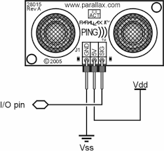
Figure 45: Ping Ultrasonic Sensor
This ultrasonic sensor is designed by Parallax and an excellent option for distance measuring. This sensor is compatible with Arduino, Propeller, and micro:bit, making it user friendly. This unit has a range from 3cm to 300cm with an unknown ranging accuracy. This unit uses a 3-pin male header, making the connection easy with no soldering. It needs a 5V power source and operates at a working current 35mA. It is a compact device with dimensions of 22mm * 46mm * 16mm. The Parallax Ping is ideal for parking assistant systems, security systems and autonomous robot applications.

MB1030 LV-EX3

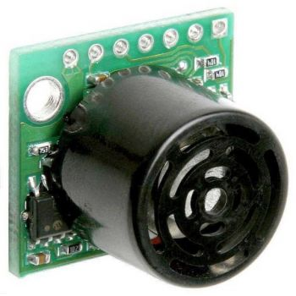
Figure 46: MB1030 LV-EX3
The MB1030 LV-EX3 is an ultrasonic rangefinder made by Maxbotix. It is a narrow beam sensor with a good side object rejection and is RoHS compliant. This sensor has a range from 6 inches to 256 inches, with a resolution of 1 inch. It has 3 output sensors that read the analog voltage, serial and pulse width. The sensor operates at any voltage between 2.5V-5.5V with a low operating current of 2mA. It is a small light weight module that is best for security applications.

Sensor | Model | Range (cm) | Operating Current (mA) | Cost
Ultrasonic | HC-SR04 | 2 – 400 | 15 | $2.80
Maxbotix | LV-EZ3 | 0 – 645 | 2 | $24.95
Parallax | PING | 2.5 – 304 | 35 | $29.99
Table 7: MB1030 LV-EX3 Cost Diagram

3.3.2 Parts Selection Summary
The parts selected for this project kept in consideration two things in the process, availability regardless of time of year and affordability. Most parts of this project are general parts which are commonly used in their respective area making availability through number of sellers. At the same time affordability was an important aspect since this project is designed and sponsored by the students names above.

4. Standards and Design Constraints
An important factor that determines the success of a project in its goals and eventually in the market and/or industry is to analyze and implement solutions based on relevant standards that pertains to their specific project. The importance of standards is evident in the display of guidelines and deliverables provided that the project and team should aim towards. To ensure that the product created has a well-defined background for usage to enable users will be adequately informed about the limits that could be encountered, standards must be properly observed and implemented.

4.1 Standards
To protect the PCB and other implemented electronic devices, it is advisable to consult and/or request the guidance and expertise of professional engineers and scientist who have performed numerous experiments to achieve a standard that is acceptable. The International Electrotechnical Commission (IEC) creates and publish standards for electricity related technologies to assist in synchronizing, protecting, and globalization of current and future electro-technologies.

4.2 PCB Standards

The Institute of Printed Circuits (IPC) are the industry adopted standards for design, manufacturing, and electronic assembly of all PCBs. Every step of the design, production and assembly is associated with an IPC standard. For our project we closely follow these standards in order for our PCB to be connected to a battery for power distribution. By following the standards correctly, we eliminated the risk of electrostatic discharge which can completely destroy the circuit and components. The IPC-221 is a generic standard for circuit board design and will be the one we followed for our project. This standard sets the rules for clearance, creepage, thickness and insulation.

The clearance distance is the distance between two conductors or nodes. The IPC-2221 refers to many different clearances related to different aspects of the circuit board, in the figure below some of these distances are displayed.

Feature | Clearance
Component leads | 0.13mm (up to a voltage of 50V)
Uncoated conducting areas (washers or similar mechanical hardware) | 0.75mm
Test probe sites | 80% of the component height (0.6mm minimum and 5mm maximum)
Mounting hardware | Should not protrude more than 6.4mm below PCB surface
PTH relief in the heat sink | 2.5mm larger than the hole (includes electrical clearance and misregistration tolerance)
Table 8: Clearance Distances

The creepage of a PCB refers to the distance between conductors or nodes along the surface of an insulator. This space should always be maximized as much as possible. The conductor spacing should be allotted in such a way that the etch compensation of the other physical features should be twice the etched copper thickness.

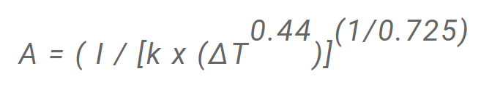

The thickness of the traces is also set by the IPC-2221 standard and it’s dependent on the amount of current it’s meant to carry. If the trace is thinner than the required thickness, it will burn as the current propagates through it. Also, characteristics that factor in on the thickness of the trace are the signal characteristics and maximum allowable temperature. The trace width and cross-sectional area can be calculated using the formulas below. Where I is the maximum current in Amps, k is the Boltzmann constant and delta T is the temperature rise in above ambient in Celsius.

4.3 Legal Standards
An engineer developing a new system always must have the legal standards enforced to limit accidents. The carrier robot will be noted to be operated by someone of a certain age due to its weight and size.

4.4 Data Format Standards
To solve the data transmission issues from one platform to another while maintaining the data integrity, the transmission of data objects has several common formats for the serialization of data. The most popular standards for serialization of data languages and how they differ from each other will be further compared are as follows.

4.4.1 JSON
JSON (JavaScript Object Notation) is a popular choice for a vast majority of applications and its lightweight format designed for data interchanging, more specifically in the case of asynchronous browser-server communication. While the JSON could be said to have been originally designed for JavaScript, many languages, and platforms include/require support for both the generation and parsing of JSON object.
JSON is designed based on transmitting data objects consisting of attribute-value pairs and array (or other serialized values) data types consisting of the atomic types of numbers (which should be noted that JSON doesn’t differentiate between integer or floating point), string, Boolean, array (an ordered list of values), object (an unordered collection of name-value pairs typically represented via strings), and null. One of the largest draws of JSON is the code/text used is considered human-readable which enables everyone regardless of technical background to understand, making it is easy to be taught and thus it highly modular. In addition to this fact due to the popularity of JSON many IDEs and web service API’s offer preset configuration for working with JSON format

4.4.2 BSON
Very similar to JSON is BSON (Binary JSON) which is based on the term JSON. BSON was designed to counter the issue of file size storage that differ in comparison to JSON. The values stored in a BSON document are in binary format which helps reduce data storage size and a faster memory manipulation of data for operations such as traversal and/or insertion. The binary storage format also proves useful for exchanging of more complex data types such as images or attachments. BSON is the primary form of data representation for MongoDB which is claimed to provide MongoDB’s speed and ease of traversal.

Finally, BSON supports more data types that are not available to JSON and its core JSON types. The following additional types, double (64-bit defined by the IEE754), date w/o time zone (long integer count of milliseconds since the Unix era), byte arrays, BSON objects and arrays, JavaScript code, MD5 binary data, and Regular expressions (which are a sequence of characters that defines a search pattern which is typically used by string-searching algorithms to locate or find and replace operations on strings or for input validation).

4.4.3 YMAL
The next language is YAML (YAML Ain’t markup language undoubtedly a homage to GNU’s recursive naming convention and an alternative to JSON) which was designed to be a language with truly human-readable data-serialization language code creating a convention that requires little to no technical familiarity to understand how to read it. Its structure is denoted/organized via Whitespace indentation removing the need for both quotes and brackets. Additionally, YMAL contains a syntax for relational data with & representing internal references with anchors & and * representing aliases. YAML is especially suited for files such as configuration, log, document headers, or debug dumps files due to the ease of viewing and editing of the files data structures.

YAML’s data types include a very comprehensive set of independent types with two major classifications:
- The first main classification is called collections, which include
  - unordered set of key (!!map)
  - ordered sequence of key (!!omap)
  - ordered sequence of key (!!pairs)
  - unordered set of non-equal values (!!set)
  - sequence of arbitrary values (!!seq).

- The second main classification is called scalar types which include
  - Null values
  - decimal integers (1234), hexadecimal integers (0x4D2), octal integers (02333)
  - fixed (1_230. 15) and exponential (12.3015e+02) floating points,
  - infinity, NaN (not a number)
  - Boolean
  - Timestamps (!!timestamp)
  - binary (!!binary) base64 encoding.

- Much like JSON, YAML has a large breadth of support for reading and writing in many programming languages for example in both languages and environments such as Emacs. Language supports ranges from older imperative paradigms like C to object oriented paradigms like java and is still being integrated and supported by new languages such as Crystal, Dart, and Rust.

4.4.4 MessagePack
MessagePack (also known as msgpack) is another binary format serialization designed with the intent of replacing JSON though it is still being highly influenced by it. MessagePack offers more compatibility with JSON as compared to BSON. Some of the features of MessagePack is that has a smaller overhead than BSON with the ability to serialize smaller objects in most cases. MessagePack as a wide range of supported types and format such as:
- nil
- boolean
- Integer (up to 64-bit signed or unsigned)
- floating point numbers (IEE754 single and double precision supported)
- UTF-8 strings
- binary data (up to 2³²-1 bytes)
- arrays,
- associative arrays (maps)
- ext which is an arbitrary data segment of an application-defined format with the limitation of 2³²-1 bytes.

MessagePack imposes limitations on the size of arrays and integers which comes at the benefit that it becomes more compact and therefore more concise in access times and operation times such as traversals or insertions. As with the previous ones for language support, MessagePack offers a wide range of implementations including C, C#, C++, D, Erlang, Go, Haskell, Java, JavaScript (NodeJS), Lua, OCaml, Perl, PHP, Python, Ruby, Scala, Smalltalk, and Swift which makes it almost as versatile as JSON.

4.4.5 XML
The markup language that originally inspired/defined all these data serialization languages and is arguably the oldest markup language still used today is known as XML (Extensible Markup Language). XML is a markup language that defines a set of encoding rules and restrictions for documents in a human-readable and machine-readable format that aims to be legible to both humans and machines with its main design objective/goal to emphasize simplicity, generality, and usability across the internet. XML is a textual data format with strong Unicode support for multiple human language interpretations along with its other features which enables it to be used for the representation of arbitrary data structures typically found in web and application services. Before further explanation on the XML, it should be noted what the markup language is in comparison to the previous language that dealt with data serialization. A markup is a system for annotating documents in a way that is syntactically distinguishable by the application of syntactic rules provided in the specification from text typically via some notation like tags. Markups lack traditional atomic data types that are present in the other standards explained above.

In this section, the XML’s key terminologies will be further discussed and how they are used to construct the XML document.

- First is Character, which expresses that everything in an XML document is a string of Unicode characters with very limited restrictions on what characters may appear. Some XML documents may include a declaration which describes some information about the XML document pertaining to version or encoding.

- In XML the keyword Processor, often referred to as the XML parser, is used to analyze the markup and passes structured information onto another keyword, the application. The specification places requirements on what an XML processor must and must not do, but since the application is external it is outside of the scope.

- String characters that make up an XML document are divided into Markup and Content which use syntactic rules to differentiate between the two applications. Markups are encapsulated with characters that begin & end with < >, or they begin with the character & and terminate with ; , additionally whitespace before and after the outermost elements is classed as markup. Otherwise, anything inside of these markup notations would be considered content.

- Tags are a markup construct that denote when an element starts and stops or if the element in question is empty. The three types of tag:

  - start-tag, such as <section>;
  - end-tag, such as </section>;
  - empty-element tag, such as <line-break />.

- Elements are logical document components that are encapsulated with either a start-tag or ends with the matching characters in-between comprising the elements content.

- Finally, the Attribute is a markup construct consisting of name-value pairs that exist within start-tag or empty-element tag that describe the content of the data itself. Due to the long life of XML in the field there exists support for XML in almost any API or IDE along with it being able to integrate with nearly any language due to the fact it is a way of annotating and processing a raw text file.

4.5 Application Program Interfaces
Often inexplicably entwined with the issue of data serialization languages is the calls needed to access and utilize them these routines, tools, and protocols used to construct, and access software are packaged together in what is referred to as application program interfaces also known as APIs. These APIs help offer a standardized platform of communication for web and mobile services that might be in different environments, but still need to be classed as cross platform communicable.

The most common of these APIs for general purpose and data transmission via web or mobile application is the Restful API colloquially known as REST API. The general overview of the REST API is that it uses existing HTTP protocols of GET, PUT, POST, and DELETE to manipulate data. In REST API a request will be made to the resources URI (uniform resource identifier) which then elicits a response payload in a format such as HTML, XML, JSON, or other various formats. The response can then confirm that alteration to the data has been made in the stored resource and then the response can provide hypertext links to other related resources or collections of resources.

REST makes leverage of both stateless protocols and standard operations in order to aim for fast performance, steady reliability, and the ability to scale by re-using components that can be managed as well as updated without affecting the system as whole even during operation. REST API follows the following architectural design properties: performance is component interactions can be a dominant factor in user-perceived performance and network efficiency, scalability allowing to support large component numbers and interactions amongst said components, simplicity via a uniform interface, visibility of communications via service agents of the components, modifiability of components to change and adapt as needs change and arise even during the applications execution, reliability in the resistance to failure at system level at the exchange of failures within components, connectors, or data, and finally portability of components allowing movement of program code along with the data.

4.6 Realistic Design Constraints

Understanding the limitations of our project is crucial to the safety and function of our robot. The primary function of the solar-powered path-finding robot is to lessen the burden on those who use the robot. This can be done be allowing the robot to carrying heavy cargo or by navigating a clear obstacle free path for the user. Therefore, one of the one of the main design constraints is how much weight the robot can carry while still maintaining its other functions. The minimum weight goal we have set for our robot is 25 extra pounds. Thus, if the robot is asked to carry more than 25 pounds, the robot’s ability to perform its other functions are compromised.

Another design constraint for the solar-powered path finding carrier robot is performance of its sensors. Our robot will be using two different types of sensor to optimize its obstacles avoidance abilities. The main sensor, placed at the front of the robot will be a lidar sensor. This sensor will have a max range of 25m, meaning that any obstacle outside of the range will not be picked up by the sensor and the robot will not account for it. The ultrasonics sensors will be places on the sides of the robot with a max range of 4m, anything outside of this range will not be interpreted by the robot.

The maximum speed of the robot is another design constraint. In order for the robot to follow behind the user it needs to be able to maintain a walking speed. If the robot isn’t fast enough it will lag behind the user and eventually loose connection. If the robot is too fast it could be safety hazard as stopping it before it hits obstacles could be a challenge. Therefor it is important that the robot can change its speed, dependent on the pace of the user to be able to safely follow behind them. We decided that the robot should be able to operate between 1-5 mph in order to achieve the limitation set by this design constraint.

The solar-powered path-finding carrier robot can prove to be extremely helpful in many workplaces, such as the medical field, military applications and industrial applications. Each of these industries have design constraints of their own that have to be followed by any product they use.

In the medical field the robot can carry the many tools needed for doctors from place to place or even bring supplies to patients who are at high risk for infection and have shouldn’t interact with other people as much as possible. However medical devices are very sensitive and susceptible to interference from other machines. Therefore, any equipment used will need to follow the EMI and EMC standards set by the medical facilities.

Another major industry the robot would be helpful in is the military. The military has its own set of standards, completely different from any other industry. The devices they use have to be able to withstand high shock, vibration, pressure and heat. Each component of the robot would need to operate at higher temperatures without burning out. The robot would have to go through rigorous testing before being able to enter the military industry.

All of these design constraints are very important to us and have been taken in account in the requirement specifications of out robot.

4.6.1 Time Constraints

This project is projected to be developed and completed in approximately 8 months. These 8 months were divided into two phases. The first phase is the planning phase which consist of the first four months of the total project time. In this phase the group gather information for recent technologies and social problems, develop possible solution for such problem and to conceptualize the solution into a final design. The following four months are for development of final design, testing, troubleshooting, and presenting. This time constrain allow between four to six months of actual building and troubleshooting which if components begin to arrive faulty or get faulty will delay the schedule of the project. With this in mind the group decided to begin development and building of such project as soon as it was possible allowing for more time in case component reordering is needed.

4.6.2 Environmental Constraints

This project contains many components that can be used for other future project. Once the project is finalized the robot will be disassembled and divided accordingly to the group members. Once the batteries are no longer usable they will be disposed following the Florida Homeowner’s Guide to Battery Recycling and Disposal [45] .

4.6.3 Social Constraints

Our autonomous robot is designed to function alongside humans and is bound to have some social impacts. One of the biggest impacts our robot will have on society is the enhancing the quality of life of those who choose to use it. There are many everyday tasks that can be replaced by the robot, such as bringing in groceries from the store and carrying tools to the office or workplace. Using the robot for these tasks will lighten the load of the user and allow them more time and energy to do other productive things.

While the main goal of any invention is to make the lives of those who use it easier, there are also negative concerns along with those goals. One of the growing concerns these days when it comes to automating tasks, is the loss of jobs. Many fear that as more jobs become automated by robots, there will be less jobs on the market for them and the unemployment rate will increase. However, history has proven this theory to be wrong. In the past when advances in technology have led to automation in different industries, new jobs were created that never existed before. Therefore, one could argue that with the employment of more robots, more jobs will be created not less.

4.6.4 Financial Constraints

It is important to remember that this project is completely sponsored by the author of the project. The budget of this project will be kept to a minimum with availability and affordability as main guidelines. This does not mean that the team selected the most affordable items available, but availability of the product was a more impactful driving factor when selecting the product. The initial estimated budget goal was set to $1000.00, although recent estimates suggest that the final price will be around $500.00.

4.6.5 Ethical Constraints

The purpose of this project is to help a person in need of assistance with carrying an item from point A to point B. Therefore, no corners will be cut during the making of this project, especially one that may affect the safety of the user of the product. No feature will be cut due to only financial reasoning.

As for patents, comprehensive research will be concluded on existing patents to make sure the Path Finding Robot does not infringe on an existing patent. Any protected design or concept will not be copies or used without the correct given consent and credit where it is applicable.

4.6.6 Safety Constraints

This project involves the live use of low voltage which can cause burns if not managed properly. Therefore, when handling the electrical components of this project the team will take the precautions needed to safely handle the electrical components. It is important to remember that it is possible that a point in time the maximum the voltage in the system be as high as 24V. The electrical equipment will be handled in spaces prepared to handle such components with the necessary precautions established as needed.

4.6.7 Laser Safety Standards

As a part of our carrier robot, the lidar sensor includes dangerous equipment such as a laser. Lasers can cause permanent damage to the eyes or skin if they’re not handled properly. The laser we used is an infrared laser, which poses further dangers because this wavelength is invisible to the human eye, which means working with the laser is much more difficult because we cannot detect the path of the beam.

An operator should always be aware of the different types of mediums and how they affect their laser. A laser can be amplified through a semiconductor, gas, dyes, and excimer. Semiconductor lasers are highly dependent on the material they are made with, they typically emit a specific wavelength in a broad range. Gas lasers typically have a wavelength ranging from the visible red to the far infrared. They are usually used for high powered lasers for cutting materials. Dye lasers emit a wide range of wavelengths and are usually tunable. An Excimer laser uses reactive gases to amplify the laser and produce a wavelength in the ultraviolet range.

The laser used in the lidar device is a semiconductor laser or also known as a pulsed laser diode. The laser will operate at 905nm, which falls within the infrared range and is not visible to the human eye. This poses a threat to the operator because they will not be able to locate the beam path and if it points to the eye, it can cause permanent damage to the eye. If skin is exposed to the beam for long periods of time, it can cause burns, increased pigmentation, and cancer. It is very important for the operator to take precautions, such as wearing safety glasses when working with the laser diode.

There are two main standards when it comes to the regulation of lasers handled by the public. The first of these is American National Standards Institute (ANSI) Z136.1. It categorizes lasers into four classes based on the safety risk associated with the wavelength, output power, pulse duration and other factors. With this standard, our laser diode would be classified as a class 1 laser product because it has a relatively low power, and it cannot emit accessible laser radiation in excess. The second standard is regulated by the International Electrotechnical Commission (IEC). This standard is classified a bit different and under this standard our laser falls into the class 1M. This class is defined as lasers that have a wavelength between 400 nm – 700nm and are safe except when used with optical aids. This means that these lasers are generally low risk unless an optical aid is used to amplify them, such as binoculars.

4.6.8 Manufacturability Constraints

During the time of making this robot we are in an unprecedented time. This is because in the past two years we have been in a pandemic. This pandemic has brought a shortage of many things to be manufactured. This means that gathering all materials that we need may be in back order, specifically chips. For this reason, the team will take into consideration how long a particular item or part would take to ship out to us. We also would take into consideration how long this piece of technology has been available to consumers and how long it is expected to be available. Along with how long it will take to ship, we would also checked if the manufacture even has it in stock. Our hope is that the manufacture will have thousands available for purchase. This is because if this item was to become a mass manufactured item, then it would become an issue if there are only a few remaining parts for this robot.

One manufacturing constraint that rised up as well is during prototyping. This was for various reasons but specifically due to lack of equipment from the very beginning due to the shipping constraints. To help ease this part of the constraint, we used what we were able to find in the Senior Design Lab at the University of Central Florida. This helped create at least a protype for the team while fulfilling the manufacture constraint of waiting for equipment during the pandemic.

4.6.9 Sustainability Constraints

The robot will be running into many obstacles, different weather, and debris. With this in mind we need to be able to make sure that the robot will be able to withstand these natural occurring issues. The robot needs to be able to withstand hot temperatures that are experienced in the south and freezing temperatures are on the north. When deciding what kind of materials will be used to create the robot the team needs to keep into account and consideration of these constraints. The sensors on board of the robot need to be able to withstand some wind before it starts to become affected. All these natural elements that come from just being on Earth are factors we must take when choosing what kind of material the robot will be made out of. With proper material it should also be able to overcome survivability, a constraint that is pretty much attached to the sustainability constraint.

5. Project Hardware and Software Design Details
This section of the documentation addresses the specific details in relation to the hardware and software capacity of the project. For any project, it is imperative to consider the design aspect of things from a wide view before the beginning of a project development cycle. The cycle could be pre-production, prototyping, fabrication, or deployment. We overview the design details of our autonomous carrier robot in both hardware and software details.

5.1 Hardware Design Details
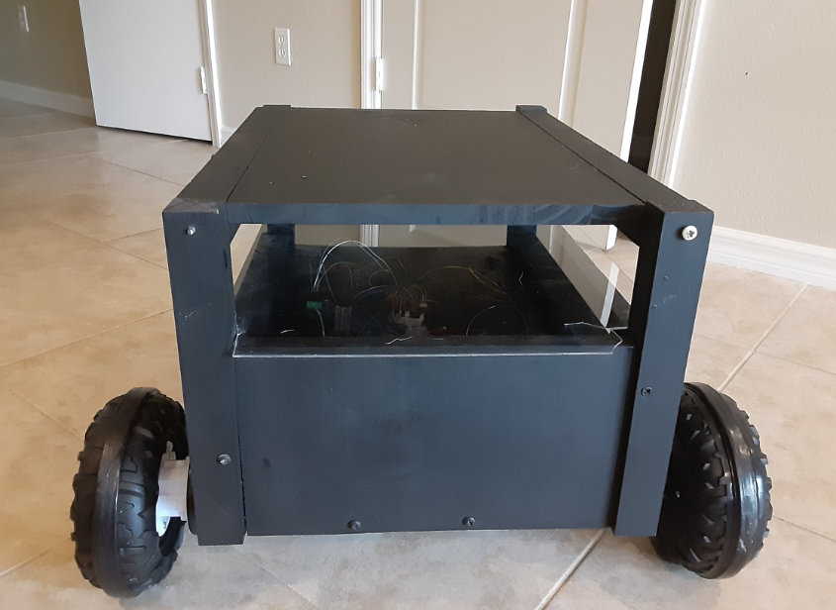
Figure 47: Structure Side #1

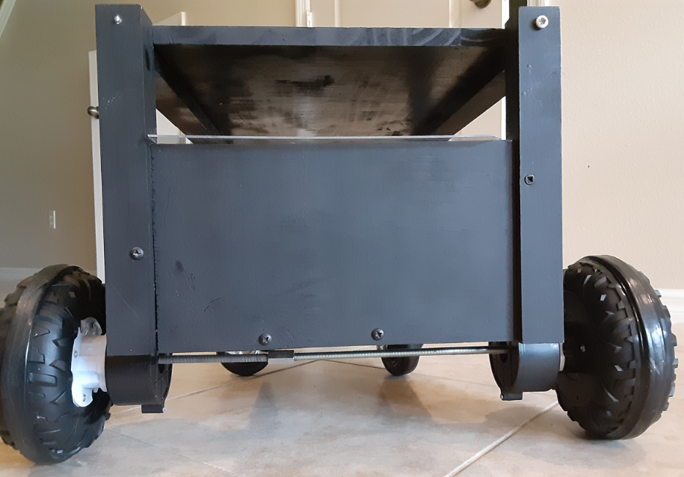
Figure 48: Prototype Design of Robot, axle view

The figures shown in figure 47 and figure 48 shows how the robot physical appearance will look. The structure was completely built by the team. It consists of some wood panels 13” inches wide by 22’ inches long. It uses two 2 35000 RPM (Revolutions Per Minute) Gearboxes for 12V motors and 2 5” inch Caster wheels on the back for better mobility. The wood was treated with a waterproof sealant to protect it from water as much as possible. The body is reinforced with 4-inch screws for better sturdiness. All the bolts and nuts were secured in place with glue as well, to prevent disassembly due to vibrations as it is moving through tougher terrain. The Plexi-glass allows for a good airflow to maintain the components as cool as possible while preventing water from coming in and allowing the user to see the inside with ease. The frame was able to withstand 35-lbs and move without any problem.

5.2 Initial Design Architectures and Related Diagrams

Electrical Specifications
The main components of the electrical systems for the carrier robot are: Solar Panel, Charge controller, batteries, and motors. For the Solar Panels we used (1) 50W 12V Monocrystalline Solar panel which provides a perfect charging capability in enough amount of time in between use while improving its efficiency in sunny days and increasing the battery life per cycle. Panels of this capacity usually weigh between 8 to 12 pounds allowing us to maintain the total weight as low as possible. Using a Solar Pane Charge Calculator, it was possible to estimate that the total charge time using an MPPT Solar Charge Controller in a sunny day is around 4.3 hours for the solar panels and batteries that were selected for this design. [Figure 21].

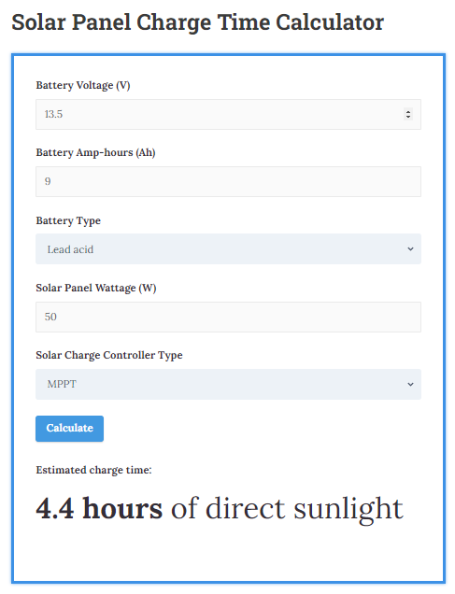
Figure 49: Solar Panel Charge Time Estimator Calculator
For the design the batteries that are going to be used are (2) 12V 9.5h Amp battery which provides a good and cost-effective solution while providing up an estimated 2 hours of use with a full charge. The two batteries will be connected in parallel with the solar panel to provide a longer life per cycle while maintain a voltage that does not affect the motors. Since the motors selected are rated for 12V it is important to maintain the voltage at that level to protect the integrity of the gears and maintain a low and safe speed. This design also provides an easy modification option by selecting a pair of higher rated motors while connecting the batteries in series to increase the voltage to 24V increasing the speed while reducing the life per cycle.
The diagram below illustrates the overview connection of the electrical components of the design

The solar panel supports will be built in such way that allows the solar panel to become detachable from the robot to reduce the overall weight when in operation and to preserve the solar panel from fall if robot tilts and falls. By removing the solar panel when in operation allows for an increase in possible load and keeping the stress on the motors to a minimum. Therefore, the solar panel will be used only when the robot is not in operation for faster charging.

Maximum Power Point Tracking (MPPT)

The responsibility of the Charge Controller is to maintain the Maximum Power Point Tracking which is dependent on the irradiation received by the solar panel voltage. This is basically a DC-DC converter or a step-down conversion that allows for optimal exchanged between the Solar panel and the batteries. If a solar panel is connected directly to the batteries, it will simply over-charged and damage the battery, therefore a charge controller is needed to protect the battery.

Maximum Power Point Tracking measure the difference between the input from the solar panel then compares it with the voltage in the battery banks to calculate the optimal power level that the solar panel must maintain to charge the battery bank. This helps to maximize the power generated from the solar panel while protecting the battery [50].

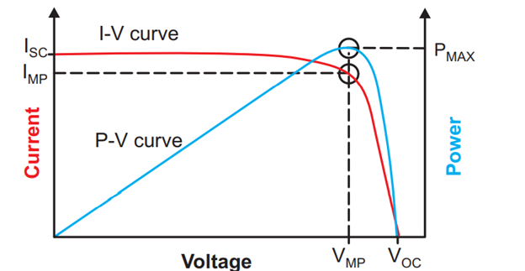
Figure 50: Summary of protocols on considered MCU

From the figure above it is possible to see the relationship between the output current and the output voltage in the panel. The maximum power output can be obtained by multiplying the maximum panel current and maximum
Solar Panel Angle

The solar panel will be set to the optimum angle depending on the time of the year. For this design the presentation date is estimated to be around April 2022 which is considered to be Spring. Therefore, the sun is still settling slightly lower than the summer sun and because of that the solar panel must be set at the optimum angle for spring sun. The panel will be place at an angle of approximately 70 degrees from the vertical axis. This allows for maximum performance of the photovoltaic panel located on the top of the robot. The list below takes in consideration the specific location of the solar panel and suggest the optimum angle bases on the different months of the year.

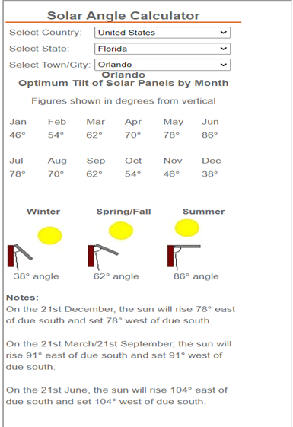
Figure51 : Solar Angle Calculator for Solar Panel

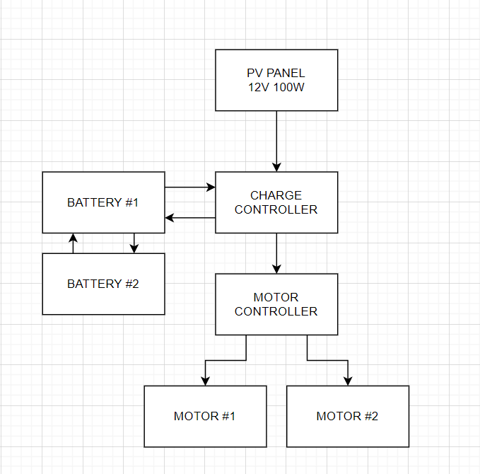

Figure 52: Electrical Components Overview

The motors that were selected are the standard (2) RS550 12V Motor which are usually used for children’s toy car for up to 75 pounds. For Arduino which will be powered from the charge controller . Finally, the charge controller for the circuit will be designed by members of the group following schematics provided for TIDA-010042 MPPT charge controller reference design for 12-V, 24-V and 48-V solar panels by Texas Instrument. In addition, an LDO Charge Controller will also be designed to compare and contrast between the controller to see which perform betters for this system.

Low Dropout (LDO) Charge Controller

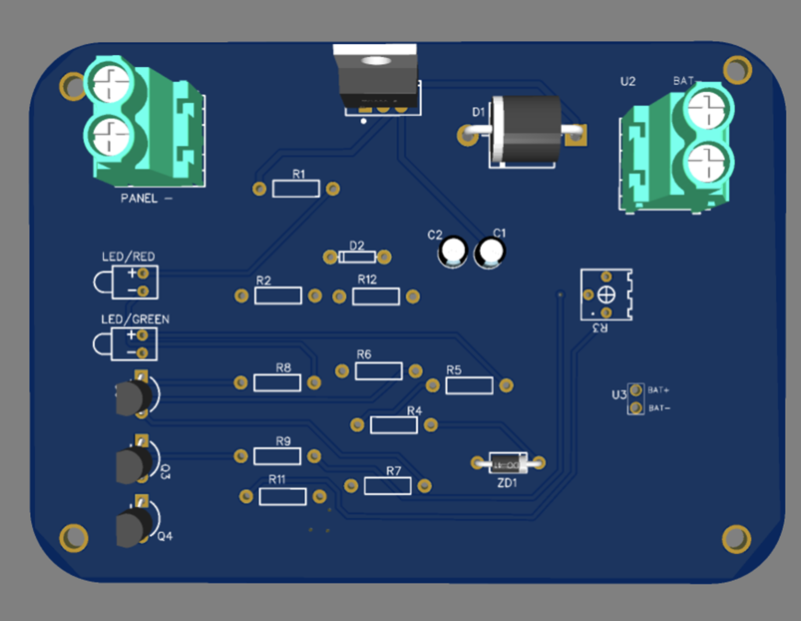
Figure 52: LDO Charge Controller

The LDO Controller allows to maintain and higher voltage on the Panel side by regulating the battery voltage and allowing current to flow from the Panel into the Battery. In any case that the Panel’s voltage decreases enough that the battery voltage is higher, then the charger will not allow the flow of current effectively turning off the charger. The Controller also possesses a reverse battery protection circuit in case the user connects the battery in reverse. Figure X. Illustrates the charging response of the battery connected to a 50W 12V Monocrystalline Solar Panel.

5.2.1 First Subsystem design
This project can be divided into three separated subsystems: Power system, Software system, Aesthetic system and lastly the Optical system. The first subsystem is composed of the detachable solar panel, batteries, motors, and solar charge controller and motor controller. This system is responsible for discharging and charging of the batteries and the solar panels while controlling the motors independently.

5.2.2 Second Subsystem design
The second subsystem consist mainly of the software component of the project. This system consists of Mobile Phone Application, Communication Protocol Module, Microcontroller and Motors.

5.2.3 Third Subsystem design
The next subsystem of the project consists of body and aesthetic look of the robot. The body of the robot will be separated into 3 parts. This 3 parts are the following: wheels, hardware housing and utility space.

5.3 Optical Design

Our lidar sensor is made up of 4 main components with several additional parts to assist them. The first main component is the transmitter. We are using a pulsed laser diode to emit short pulses of light into the surrounding environment that will reflect off the objects around it and return to the sensor. A pulsed laser driver including; a MOSFET and driver, current sensing resistor and a comparator is used to run the pulsed laser diode.

The second is the receiver, the receiver’s job is to transmit the pulses of light that come back from the object into electrical data so that the time-of-flight measurement can be done. We used an avalanche photodiode as our receiver. With the help of a transimpedance amplifier the current output from the photodiode can be amplified to a usable voltage. From there, a high-speed comparator captures the data and sends it to a time-to-digital converter (TDC) for calculation of the ToF measurement as shown in Figure. The comparator works by tying one of the inputs to a reference voltage and comparing the reflected pulse to this voltage. If the reflected light pulse from the object is above the reference threshold, the distance to that object will be sent to the TDC and measured. The TDC measures the start and stop time from when the pulse left the laser diode to when it was picked up by the receiver and converts this time interval into a digital (binary) output. Using the equation:
$$D=\frac{c ×t}{2}$$
where d is the distance, c is the speed of light, and t is the time interval from start to stop, the distance from the sensor to the object can be calculated.

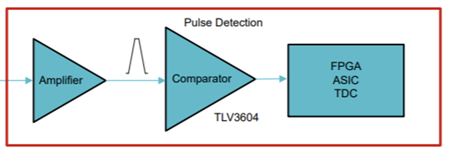
Figure 53: Model of Pulse Detection Process

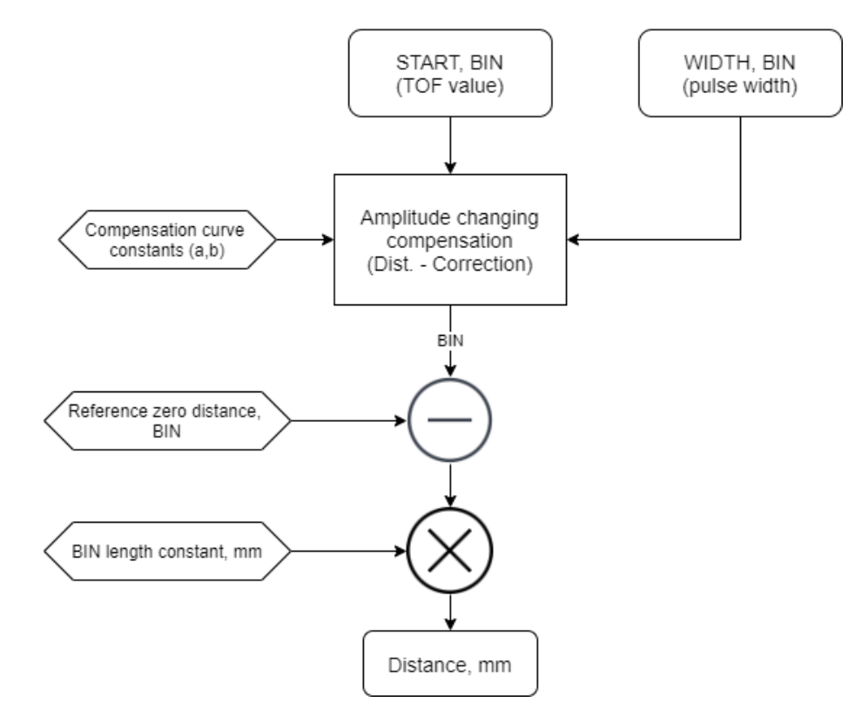
Figure 54: TDC data processing of distance measurements
The third main component of the LIDAR sensor is the Lens and filters. A laser lens and M12 mount and holder are used to focus the collimated light from the laser diode onto the mirror. A photodiode lens with a CS mount and CS lens holder are placed on top of the photodiode to capture the signal of the incoming pulse from the object. Also, the photodiode has a built-in bandpass filter from 870nm- 940nm, with the peak at 905nm. This means that any light picked up by the receiver that has a lower wavelength than 870nm or a higher wavelength than 940nm will not pass through the filter. This is extremely helpful for blocking out the noise of background light from the environment when the senor is operating outdoors.

The last main component is the rotating mirror. This mirror will reflect the pulses coming from the laser diode out into the environment and pulses coming from the environment into the photodiode. The mirror will be kept at a fixed 45 degree angle and placed in a holder so that it can be rotated. Using a BLDC motor driver and motor attached to the back of the mirror, the mirror will rotate 360 degrees. By rotating 360 degrees, the sensor will be able to send and retrieve pulses from every surrounding object, creating a 2D scan of the robot’s environment.

5.3.1 Laser Modulation
In Time-of-flight LIDAR systems short, strong pulses of light are needed. The resolution value of the sensor is determined by the ratio between noise value and the rate of the measurement signal. The resolution can be improved by shortening the rise and fall times or by increasing the output power of the transmitted pulse. The total noise value of the pulse and receiver can also have a negative effect on the resolution of the system.
Laser diodes emit short pulses of light. The length and frequency of these pulses are controlled through the modulation of the laser. There are two ways to modulate the output pulse of a laser diode; by changing the input/ driving current or by alternating the continuous wave output after the light is generated. We used a pulsed laser diode, therefore we also used a laser driver to control the modulation of our laser diode. A pulsed laser driver consists of a capacitor with capacitance C and a switch which discharges the capacitor’s charge to the laser. The capacitor is charged between the laser pulses, to achieve short laser pulses the gate switch must be charged very quickly. A MOSFET, an avalanche transistor or GaN FET can be used as a switch. Shown in the figure below is the schematic of a pulsed laser driver with a MOSFET for a switch and capacitor C1 for storing energy.
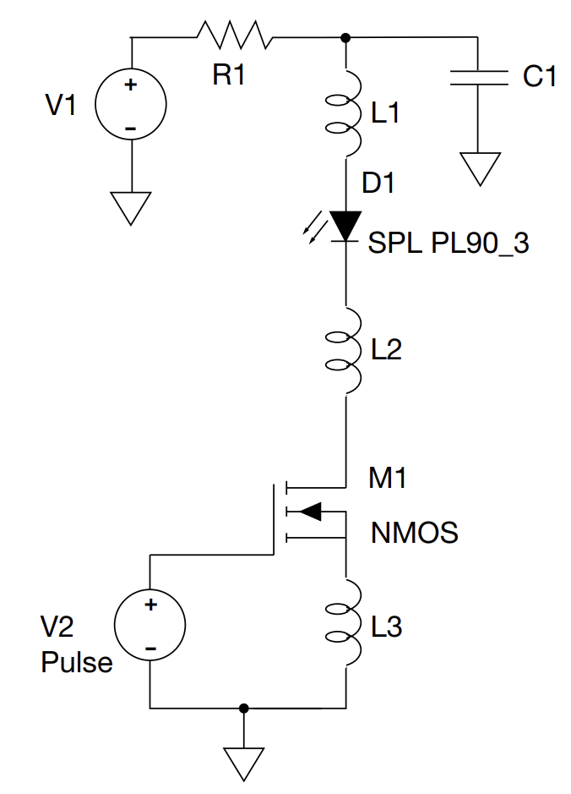
Figure 55: schematic of a pulsed laser driver
The GaN FET has a lower gate capacitance compared to the MOSFET, meaning it enables faster switching and can achieve shorter pulses of light. Short pulses of light are desired because they increase the resolution of the system. As shown in the equation below, where delta t is the pulse width, R is the resolution and c is the speed of light.
$$R=\frac{c *∆t}{2}$$

Shorter pulses of light lead to a smaller resolution, meaning that the sensor is more effective at determining the distances of surrounding objects. A suitable pulse width for LIDAR sensor is in the range of 5-10ns. This is important because the primary use of our LIDAR sensor will be for obstacle avoidance. To achieve a resolution of .75m we needed a pulse width of 5ns or less.
To reach a certain optical peak power within a very short time, a current slope minimum is required. The current slope is dependent on the parasitic inductances in the circuit and the supply voltage. The current slope can be decreased by increasing the supply voltage and/ or decreasing the parasitic inductances as shown in the formula below. GaN FETS are able to handle higher voltages than other components. In addition, the leads of the laser diode must be cut as short as possible to avoid parasitic inductances. Each inch of length increases the inductance by approximately 20 nH.
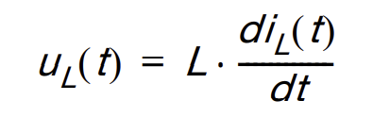
The range of a TOF system is determined by many factors, but one of the most important factors is the pulse repetition frequency of the laser diode. The pulse repetition frequency of the radar system is the number of pulses that are transmitted per second. The higher the PRF the longer the max range of the sensor, as shown in the equation below. Meaning that the LIDAR sensor will be able to determine obstacles from further away. To achieve a range of 25m will need a pulse repetition frequency of 6MHZ.
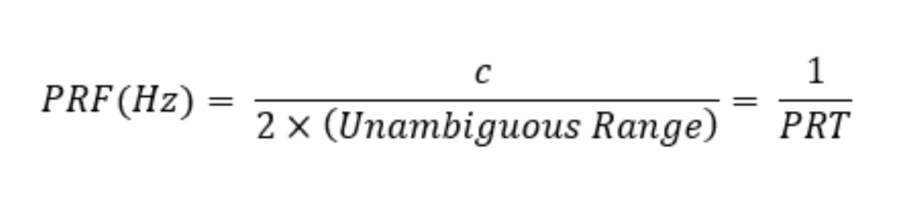

5.4 Software Design Details and Implementation
The following sections discusses the implementation details for the software design of the autonomous carrier. Throughout each section the research conducted pertaining the implementation strategy would be included.

5.4.1 Mobile Application
Despite having an interface that the user can use to interact with on the carrier robot, we felt it pressing to explore a mobile application platform as a supplementary platform of support for the carrier robot given the fact that today’s market is making a large divergence towards mass integration with different mobile platforms such as android or iOS. While some control aspect might be put into consideration for the carrier robot, this would be a secondary goal as the system will have all the controls on it easily accessible to the user.

Although, the more substantial issue we could overcome with a mobile application would be the issue of parsing and indexing the data given from the serialized outputs. A solution to this issue would to be to create an app that acts as a data logger/acquisition platform. A data logger is traditionally an electronic device, but more recently can be web or mobile application platforms whose goal is to record a stream of data over time in relation to a location via sensors or external instruments. It is the job of these data loggers to continually parse the data stream from the sensors or instruments and store them in a manner that the user would later be able to access them later.

Typically, this data is accessed via a database, either local or service-based, and stored in such a manner that it can be transmitted across various platforms such as a desktop or mobile application at a later point in time. The reason this would be a good solution for the carrier robot is the fact that with the on-system screen we are limited with the amount of data we can display at any given time due to size constraints of the screen. Additionally, we could run into issues with storing large tracks of continuous readings to the MCU due to the data being stored being much larger by comparison than the available memory of the chip. Therefore, the proposed mobile software application would negate these two issues and allow the carrier robot to meet more of its intended project scope. The general design of the application would be as follows: a routine in the MCU would poll the data from the sensors like normal and store it for a predetermined amount of time which would be over multiple sampling periods, after this time passes the MCU would transmit the data via some connection model (Bluetooth, wi-fi, radio, etc.) to a database (either local or service-based). The data would be transmitted in some form of standardized format such as XML, JSON, or YAML in order simplify the relaying process to the database.

Once in the database the user can call the data using a mobile application to present the data in an orderly tabular matter using a GUI programming with different options to chunk and sort the data (possibly by minute, hour, day, week, and month). The next portion of the application development cycle discussion will be split into two major sections the back-end development and front-end development.

5.4.2 Mobile Application Development
Mobile application development is the process of creating software applications which runs on mobile devices. It is also helps utilize a network connection to work with remote computing resources. Hence, the mobile development process involves the creation of installable bundles (code, binaries, assets, etc.), and implementing backend services such as data access with an API and testing the application on targeted devices.
When we discuss about mobile applications, we cannot go without elaborating on the different device platforms, especially the two dominant platforms which is iOS platform from Apple Inc and the second which is Android from Google. The iOS platform is the operating system that powers the popular iPhone smartphone line from Apple. While the Android operating system is used to build smartphones and other smart devices by Google devices and many other OEMs.

While there are similarities between the two platforms when building applications, developing for iOS vs developing for Android involves using different software development kits (SDKs) and different development toolchain. The iOS is used exclusively by Apple for its own devices while Google makes Android available to other companies that meet the specific requirements. When building mobile applications, there are four major developments approached, namely:
- Native Mobile Applications
- Cross-Platform Native Mobile Applications
- Hybrid Mobile Applications
- Progressive Web Applications
Each of the approaches for developing mobile applications has its advantages and disadvantages. To choose the right development approach for their individual projects, developers must consider the desired user experience, the computing resources and native features required by the app, the development budget, time budget, and resources available to the user to maintain the app.

5.4.2.1 Native Applications
Native mobile applications are written in programming language and frameworks that are provided by the platform owner and runs directly on the devices operating system such as iOS and Android. This indicates that native applications framework meant for one platform such as iOS cannot be used for Android devices and vice versa. Its advantage is that it has the best runtime performance, good user experience, and has direct access to device APIs. Due to the exclusivity of the native application, the robot will more than likely not require this approach since we would like to use different platforms.

5.4.2.2 Cross-Platform Applications
Cross-platform native mobile applications can be written in variety of different programming languages and frameworks, but they are compiled into a native application running directly on the operating system of the device. Its advantage is that it is easy to build and maintain the app, it also requires single code base for multiple platforms.

5.4.2.3 Hybrid-Web Applications
Hybrid mobile applications are built with standard web technologies such as JavaScript, CSS, and HTML5, which are bundled as app installation packages. Contrary to the native apps, hybrid apps work on a ‘web container’ which then provides a browser runtime and a bridge for native device APIs via Apache Cordova. Its advantage is in using web development skillset for building mobile apps, and shared code base between web and mobile apps. While its disadvantage lies in its lower performance as compared to native apps and limited support for native device features, they are easier to use since it only requires a single code and would operate on different platforms such as Apple or Android. This application will most likely be used for this project since it isn’t exclusive to one mobile platform and could be coded in JavaScript.

5.4.2.4 Progressive Web Applications
The PWAs offer an alternative approach to traditional mobile app development by skipping the app store and app installations. PWAs are web applications that utilize a set of browser capabilities such as working offline, running a background process, and adding a link to the device home screen to provide an ‘app like’ user experience. Its advantage is that it requires no installation and is accessible through a URL, and it has the same app available for both web and mobile. The robot will most likely no require the use of this application because it will not require internet access to function.

5.4.3 Swift
Swift is a mobile development language which allows the user to write/implement code to help produce the Apple iOS mobile applications. To create more comprehensive and updated versions of objective-c, the Swift is used. While some of the creators tried to implement embedded c in specific ways, the code has little to do with objective-c. Apple introduced Swift in 2014 to the World-Wide Developers Conference and upon its releases, Apple explained the combability of Swift, which is that it would be compatible with its own IDE. To develop mobile applications for iOS, Apple proprietary IDE known as XCode would be needed. Hence why it comes as no surprise that the XCode is only available for download and installation on the iOS operating systems, which would be a major form of concern for developers. Without a Mac, it is impossible to utilize Swift in the development which makes this this language one whose path the project will not be exploring. Below is the XCode Hardware Requirements

Required Operating System | Mac OS X 10.3 or later
Language Available | Swift, Objective-c
Recommended CPU | i5 or better
Minimum RAM | 4GB
Minimum Required Disk Space | 128GB
Table 9: XCode Hardware Requirements

5.4.4 Android Studio


In the development of mobile application that are not required to run on iOS mobile devices, the developer will be having to look at other available options. One of the largest competitors for mobile devices in the US are devices that run on Android. A native application that run on Android can be developed by using Google Android Software called the Android Studio. The applications written using the Android Studio IDE are mostly written in Java, though it is possible to write the source code in different object-oriented languages such as C++.

One of the benefits of using Android Studio are it accessible features and the flexibility in the requirements for the operating system used to run the Android Studio. This means that the host machine can run on Mac OS, Windows, or Linux. The downside to using the Android Studio is that the developer will run into complications if the application is to be run on an iOS mobile device, which then makes the Android Studio not a viable option for mobile development. Swift would be a better application for the developer. Below is the illustrated specification needed for the host machine to run Android Studio efficiently:

Operating System | Mac OS | Windows | Linux
Languages Allowed | Java, C++ | Java, C++ | Java, C++
Minimum RAM | 2GB | 2GB | 2GB
Minimum Disk Storage | 2GB | 2GB | 2GB
Java Development Kit (JDK) | JDK 6 | JDK 8 | JDK 8
Table 10: Specification for Android Studio

The Android studio is the official integrated development environment for Google’s Android operating system and is designed for Android mobile application development. It creates only Native applications for Android devices, and it replaces the Eclipse Android Development Tools as the primary integrated development environment. Android Studio first announced back on May 16, 2013, at the Google I/O conference and was only in early access until June 2014 when it entered beta. Version 1.0 came out in December of 2014 and the preferred language for Android mobile application development was Java, C++ was also a very popular language that was used for mobile application development.

Newer versions of Android Studio have been released and other programming languages have been supported such as intelliJ, CLion, Kotlin, and Go. Kotlin has become Google’s preferred language for mobile application development since the update that came out in May 7,2019. Not all the language features of Java 12 are supported in Android Studio but all of Java 7 is supported, and a subset of Java 8 is supported, and some Java 9 features are supported. One of the features of Android Studio is that it offers template-based wizards to create Android designs and components to make it easier for mobile application developers to get started on an application.

Another feature of Android Studio is that it has an advanced layout editor that allows its developers to drag and drop user interface components and it has the option to preview different types of layouts on different screen configurations. The robot most likely uses Android Studio because it only creates Native apps for Androids, and we are not interested in creating an exclusive mobile application for Android. We want our mobile application to be available on all mobile devices. The system requirements for Android Studio are not high, all it requires is a 64-bit processor, CPU with unrestricted guest support, SDK Tools 26.1.1 or higher, and HAXM 6.2.1 or later. The robot will decide which type of coding language it wants to use for its mobile application development, one of the options it has is Java.

5.4.5 React Native

Upon researching into the most common mobile development platforms, the biggest issue discovered between platforms is the compatibility of the devices and the application. In the case of Mac and iOS devices, Swift is the only option and although there are other options than Android Studio there is still the issue of not being able to deploy the app onto IOS native devices. To ensure the developer can deploy the exact same application across different platforms, one of the best options is React Native.

React is a JavaScript library created specifically for developing user interfaces. React was developed by Facebook in 2013 to provide developers with a way to create web applications. Later in 2015, at a Facebook conference they announced the release of React Native. React Native uses the React architecture used to create web applications and overlays them onto IOS and Android applications. In comparison to the other development platforms, React Native has various advantages that our team could benefit from. The first benefit is that React Native is a child of JavaScript language so writing the code for React Native applications is written in JavaScript. This includes all the fundamental UI that is capable in objective-c or Java.

One feature of React Native that no other development platform utilizes is called Hot Reloading. The Hot Reloading allows the user to load libraries into the applications at execution without affecting the state of the application. This means that as a developer, the application can still be running while we inject new files that have been edited at run time. This could be a substantial debugging tool while we develop the application. As stated previously, both the Apple and Android applications can be written using React Native and it gives options for optimization on different devices.

The last feature of React Native that provides a huge advantage is the debugging and testing application called Expo. If the development computer and device both run Expo, the developer can run the application onto the phone through the Expo client app. The only caveat is that the host machine and device must be connected to the same wi-fi network.

There are many ways to develop React Native code, and the most commonplace way is using a text editor that acts as the IDE. There have been many reviews on which text editor is most useful to develop using React Native. The most commonplace is Atom.io as the IDE/text editor. The following table shows a few different options that we could use when developing with React Native.

IDE/Text Editor | Atom | Deco IDE | Sublime  Text 2(or 3) | Visual  Studio Code
Operating System | Mac OS  Windows,  Linux | Mac OS | Mac OS  Windows,  Linux | Mac OS  Windows,  Linux
License Required | Open Source | Open Source | Free Download, Pay for License | Free  To Download
Table 11: Development Environment Comparisons

5.4.6 Java Virtual Machine
The Java Virtual Machine is a virtual machine that enables a computer to run Java programs as well as programs written in other languages that are compiled to Java bytecode. The organization of the Java Virtual Machine is handled by a specification, which is a set of documented requirements to be satisfied by a material or service that shows what its implementation is. The Java Virtual Machine’s implementation is developed by the OpenJDK project as open-source code. The Java Virtual machine has an algorithm called the garbage collection which is the mechanism used in Java to deallocate unused memory and is essentially tracking down all the objects that are still used and marks the rest as garbage to deallocated.

The Java Virtual Machine is essentially a 32-bit machine that operates on primitive values because it uses long and double types, which are 64-bits, but they consume two units of storage in a frame’s local variables and each unit is 32 bits. When it comes to objects and arrays the Java Virtual Machine has a garbage collected heap that stores them in the method area. The method area is treated differently by the implementation because it might not garbage collect it like it does with the heap. With each call of the method a frame is created and is added to a stack that each Java Virtual Machine thread has. Whenever the method exits the frame is destroyed and whenever the method is called a new frame is created. Inside of each frame is an array of local variables that are inside of an operand stack that is used for operands to compute things and it is used for receiving a return value from the method. The Java Virtual Machine is implemented in each new version of Java that has been released over the years.

5.4.7 Java
Java is an object-oriented general-purpose programming language and is designed to have as few implementation dependencies as possible. It first appeared on May 23, 1995 and has since released many different versions of itself that have many different language features. The syntax of Java is very inspired by C and C++, but it does not have as many low-level facilities as them. The original developer of Java is James Gosling from Sun Microsystems and was released as a core component of Sun Microsystems’ Java platform. Since its release it has become one of the most popular programming languages for client server web applications. One of the key features that Java has is that when Java code is compiled it can run on all platforms without the need for recompilation. Also, Java does not need its developer to handle memory allocation instead it uses its Java virtual machine which handles all bytecode.

5.4.8 JDK
The first stable version of Java that was ever released was back on January 23, 1996, and many versions of 1.0 were released with it as well, they went up to J2SE 1.4. Version 1.0 was also called Java 1 and had the very basic object-oriented features nothing advanced came with Version 1.0. It wasn’t until February 19, 1997, that JDK 1.1 was released, and it included a pretty important feature called JDBC, which stands for Java Database Connectivity and is an application programming interface which defines how a user connects to a database.
JDBC was Java’s first API that they released and quickly became very popular and has since become a part of the Java Platform, Standard Edition. Other features of JDK 1.1 are JavaBeans, RMI, and reflection. After JDK 1.1 there was J2SE 1.2 that came out in December 8,1998 and it also had the nickname Java 2. This replaced JDK to distinguish the platform from J2EE and J2ME. With this release the Java platform was significantly increased to 1520 classes in 59 packages. It also included API Swing which was Java’s graphical user interface widget toolkit, Java plug in, Java IDL, and Collections framework. On May 8,200 J2SE 1.3 was released and its release included Java Platform Debugger Architecture, Java Naming and Directory Interface, and it had HotSpot. HotSpot is a Java Virtual machine for desktop and server computers. The release of J2SE 1.4 on February 6, 2002 was the first release that was developed by the Java Community Process. This release came with many library improvements some of which included Non-blocking I/O, Regular expressions that are modeled after Perl, Integrated XML parser and XSLT processor, and Logging API.

5.4.9 J2SE
This was released on September 30, 2004 and was originally called J2SE 1.5 but the community felt that this version increased the level of stability and scalability enough that it should be 5.0. One of the major changes that came with this release was Metadata, which was also called annotations, this allowed language constructs such as classes to be tagged with additional data. Metadata by definition is data that provides information about other data, so this allows those constructs to be tagged with more detailed data. Another update that came with this release was improved semantics of execution for multiple threaded Java programs. The improved semantics addressed issues of complexity, effectiveness, and performance. There were also various improvements to the standard libraries like Swing, the concurrency utilities, and also the scanner class for parsing data.

5.4.10 Java SE 6
This was released on December 11, 2006 and replaced the name J2SE with SE and was developed under JSR 270. Some of the major changes in this update was the support of Scripting languages. An API was released for integration with scripting languages, and it had built-in Mozilla JavaScript Rhino integration. Another API was released called the Java Compiler and allowed the Java programs to select and invoke a Java Compiler programmatically. Major updates and performance improvements for Java Swing and the platform itself came with the update. Some upgrades to the garbage collection algorithms in the Java Virtual Machine was released and the application start-up performance was improved.

5.4.11 Java SE 7
One of the biggest updates for Java was released on July 7, 2011, and this update was so major that its development was organized into thirteen different milestones. The Java Virtual Machine was changed dramatically because it now allowed support for dynamic languages with the new invoke dynamic bytecode. Another major change was the addition of the I/O library that created support for multiple file systems, file metadata, symbolic links, and multiple file programs. More APIs were released for the graphics features and improvements for Java Swing was also released. The codename for this update was Dolphin and this update became the default download on the website for Java.

5.4.12 Java SE 8
This update came out on March 18, 2014 and had some leftover features from Java 7 that couldn’t make it due to development issues. The biggest feature in this update was the addition of language-level support for lambda expressions. A lambda expression is a function definition that is not bound to an identifier and these expressions are often arguments being passed to higher-order functions. The addition of lambda expressions enables functional-style operations on streams of elements. It also allowed users of an API to add new methods to the program without causing errors in the old code while using it. Other features of this update include unsigned integer arithmetic, date and time API, statically linked JNI libraries, and launch JavaFx applications. Java 8 was also supported on Windows XP.

5.4.13 Java SE 9
Java SE 9 was released on September 21, 2017 but was released with some controversy because other projects were still being accepted at the time and that caused some open issues and concerns. Some of the features in this update are Modularization of the JDK, variable handles that define a standard means to call the equivalents of various operations, compact strings, and the milling project coin. Java SE 9 was delayed multiple times because there were some security issues and critical bug fixes to do. Also, Oracle wanted Java SE 9 to include a different default garbage collector, self-tuning Java Virtual Machine, and native code integration. All of this caused Java SE 9 to be delayed for months, it was originally supposed to be released back in early 2016 but was delayed until September 2017.

5.4.14 Java SE 10
Java SE 10 was released on March 20, 2018 and had 12 features included in its update. Some of these features were root certificates, garbage-collector interface, thread-local handshakes, time-based release versioning, and heap allocation on alternative memory devices. One of its bigger features on this update is application class-data sharing which allows a program’s classes to be placed in a shared archive to reduce the startup of other Java applications.

5.4.15 Java SE 11
This update was released on September 25, 2018, and it offers Long Term Support and LTS. Some of the features on this update include Dynamic class-file constants, Low-overhead heap profiling, HTTP client, Flight recorder, and Epsilon which is a no-op garbage collector. Some overlapping features from other versions were released on this update as well. This was a relatively small update compared to other major ones like Java SE 7 or Java SE 8.

5.4.16 Java SE 12
This update was released on March 19, 2019 and has a total of eight new features on this update. Some of those features include Default CDS Archives, Microbenchmark Suite, Abortable Mixed Collections for G1, and JVM Constant API. This was probably one of the smallest updates for Java to be released but it did come with some important Java Virtual Machine changes regarding the garbage collector. The robot will most likely only have to use the version Java 7 at least to be able to make its mobile application that will allow the user to switch between the modes of the ACA like follow or lead.

5.4.17 JavaScript

Another very likely coding language that the robot will have to use to create its mobile application is JavaScript. JavaScript first appeared on December 4, 1995 and is a programming language that conforms to the ECMAScript specification and is a high-level multi-paradigm. JavaScript is as popular as HTML and CSS when it comes to web applications because it enables interactive web pages. It is a lead developer when it comes to client-side page behavior and many companies use it for developing their web applications. The JavaScript engines are also embedded into server-side website deployments like Node.js and are also embedded in a variety of other applications. The only similarities between Java and JavaScript are syntax and some respective libraries but other than that they are completely different.

JavaScript was not very popular at release because scripting languages were stagnant in the late 90s and early 2000s. But this changed in 2004 when Mozilla released the Firefox browser which was run by EMCAScript. In 1996, Netscape which is the company that owned JavaScript submitted it to EMCA International, which is a standards organization for information and communication systems, to make it the standard specification for all browser vendors to conform to. They accepted it and it became the first EMCAScript language specification as of June 1997. Microsoft's Internet Explorer dominated the browser market in the early 2000s and that meant that JavaScript became the standard for client-side scripting on the Web. But when Firefox was released, the EMCAScript had to start work for the XML standard. And then in 2008, Google released their browser Google Chrome which had a JavaScript engine that was the first to use just-in-time compilation which significantly improved execution times. So as of 2008 the three biggest web browsers, Google Chrome, Firefox, and Internet Explorer, all used JavaScript as their back engine.
Almost 95% of today's websites use JavaScript for its client-side scripting of the Web. All the major web browsers of today use a built in JavaScript engine that executes the code for its devices. They also use third-party JavaScript libraries for their client-side page scripting. Many development stacks use JavaScript as one of their main languages like MERN or MEAN almost entirely use JavaScript as its language. Some of the scripted behavior JavaScript has inspired is loading new page content without refreshing the page like if you need to post a new message on Facebook or Twitter. Another example of scripted behavior is sending data information about a user’s behavior for personal user or analytics, this is also known as a cookie and is used by companies to keep track of what a user does on their website. This leads to some security issues that JavaScript must pay attention to because it leaves a risk for their users and also it causes problems with privacy of a user.

5.4.18 API

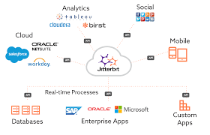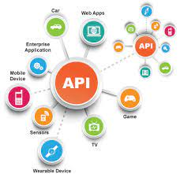
An application programming interface or an API is a computing interface to a software component or a system, that defines how other components or systems can use it. An API basically defines how multiple software components including mobile devices, computers, tablets, databases, front-end, back-end, and many other things communicate with each other. An API is a very flexible development tool because it can be entirely custom to a specific component, or it can be designed to become an industry standard for commercial use. It simplifies programming by abstracting the underlying implementation and only showing the actions that the developer needs to accomplish. It’s kind of like a software library because it describes the behavior while a library is the actual implementation of a set of rules. An API depends on what programming language it is being used for. For example, if it is being used for an object-oriented language then it would provide a specification of classes and its class methods but if it's for a procedural language then it would consist primarily of basic routines to execute code.

The robot could use an API to communicate between the mobile application and the Bluetooth module that will be attached on the ACA. Another name for an API could be software framework because framework is based on several libraries implementing several APIs, but the behavior is different because the framework is mediated by extending its content with new classes plugged into the framework itself. APIs are also used to specify the interface between an application and an operating system. An example of this is Microsoft, they are very committed to using a backwards compatible API so older applications can run on newer versions of Windows. There are many different types of APIs that are available and each one is designed for different devices.

5.4.19 API Design
A good design of an API provides the user with only the tools that the user expects to find. The design affects the usage of it because if it is not correctly designed then it will be very confusing for the user to accomplish their goal. The principle of information hiding is when you enable modular programming by hiding the implementation details of the modules so that users of modules only see the simple side of the program and not the hidden complex details. It also affects the software architecture of the application because the application is depending on the API to complete tasks with it and another software.
Software architecture is fundamental structures of a software system and the discipline of creating such structures and systems. The robot will not require us to design an original API for it because there are plenty of available APIs to use to create the mobile application and implement the Bluetooth module with it. They are one of the most common ways technology companies integrate with each other and when someone provides one they are considered members of a business ecosystem. A very common API is known as the RESTful API Modeling Language and it provides all the information necessary to describe RESTful APIs.

5.4.20 REST API
REST is short for Representational state transfer is a software architectural style that defines a set of constraints to be used for creating Web services. These services that use REST architectural style provide interoperability between computer systems on the Internet. Web resources are any identifiable thing, whether digital, physical, or abstract and the use of these resources is very important for a Web application. In a RESTAPI, requests made to a resource's URI gives a response that has a payload formatted in the standard formats like HTML, XML, or JSON. The robot will not have to use a RESTAPI because it will not require a Web application integrated with its mobile application. Because it will not require users to create accounts with it so there will be no need for any database or Web service.
There are some constraints that hold back a RESTful system because they restrict the ways that the server can process requests so that the system gains the needed nonfunctional properties, for example simplicity, performance, portability, and modifiability.
- One of the constraints is Client-server architecture and the constraint is the separation of concerns. The separation of the front-end user interface concerns and the back-end data storage concerns is very important to improve the portability across many platforms. Also another very big benefit is that it allows the components to evolve independently and this supports the scale of the Internet across multiple organizational domains.

- Another constraint is Statelessness which is when the communication between the client and the server is constrained by no client context being stored on the server between requests. There is a state called the session state which tells the status of what is being transferred to a from the client and the server. This back-and-forth exchange starts with the client sending a request and when it is ready to transition to a new state and one or more requests are outstanding the client is in transition.

- Another constraint is the Layered system, which is a system in which components are grouped, layered, in a hierarchical arrangement, such that lower layers provide functions and services that support the functions and services of higher layers. This hierarchy does have an advantage because it can add a security level to the web services to separate business logic from security logic.

- One of the biggest constraints of a RESTful system is uniform interface which is imperative towards the design because it simplifies and decouples the architecture which enables each part to become independent. There are four parts to this constraint, and they are:

- Resource identification in requests: Which is when resources are identified in requests. These resources are conceptually separate from the presentations that are returned to the client.
- Self-descriptive messages: Which is when each message in the client-server communication contains information to describe how to process each message.
- Resource manipulation through representations: This is when the client side is representing a resource and has enough information to delete or change the resource’s state.
- Hypermedia as the engine of the application state: The final part is when the client has accessed an initial URI for the REST application and then the REST client should then be able to use server-provided links that change to find all available resources that it needs.

These are all the constraints of a RESTAPI application and another very important concept is the relationship between URI and HTTP methods which is how Web services APIs adhere to the REST architectural constraints. The three things that are essential for Web services are: a base URI, standard HTTP methods, and a media type which defines state transition data elements. The media type also shows what the representation of the client is and how it composes requests for the transitions of all the next available application states. There is a list of commands that the HTTP can use to manipulate the RESTApi.
These are some of the most common HTTP methods that are still used today to command Web services. These services can be called upon any Web API and are essential to any developer that wishes to use APIs that are using the client-server type of communication.

5.4.21 Backend Development
The often-unnoticeable portion of application development, Backend Development is a crucial part to the functionality and performance of any application. The backend performs multiple integral roles such as where the storage of data transmitting to a from the application will take place. Backend also often acts as a computation offset to the entire framework as typically the user wants as little load calculation placed on their end as possible. An application’s backend remedies this by using its frontend interface to make calls to the backend so that it may perform the more intensive computations. These results are then either stored in the backends database aspect for later access and usage or the results are transmitted once again to the front through the use of the backend API in order to give the seamless appearance that whatever operation that appears on the user’s end has been completed on the user’s environment entirely while the resultant operation took far less of the user’s local resources than it would if the task had been performed on the host machine itself.

5.4.21.1 Database
One of the first things to consider in our applications development cycle is where the data will be stored for the user to access it and analyze if the robot has been operating under proper conditions. In a way this is the crux of most of the application as if the data is unreachable or presented in a way that obfuscates its nature from the user then it is largely worthless. When databasing, it is essential to consider whether a local database, or a service-based database will be used. A Service-based database is one that can only be accessed via a server using an MDF (Media Descriptor File) and must have constant server-service/daemon running for it to be accessed to ensure the process of all requests and accesses. Though it is noted that none of the data will be accessible if access to the server is not granted. In comparison a Local database is a database which stores all its data to a local medium such as a hard disk drive, compact disc, or magnetic tape.

Furthermore, it should be noted that the nomenclature of local has some mixed meaning. A local database can be hosted and accessed online via internet and any other connections such as LAN. The term local refers to the locality of the data stored and not the method of contacted the database itself, meaning that while a local database can be hosted to a server change to it can be reflected without having to call access to the server via an MDF file. By comparing the two types for the purpose of carrier robot we decided that it would be best to go with a local database since it will be simpler and faster to reflect the changes locally and then have them stored to an online host rather than to parse everything through a server.

Next, we had to decide would we host the database on our own hardware or rent out space from a database storage. While hosting on our own hardware certainly gives us the most control it also puts addition expensive on us to assemble our own host and the cost, we would incur for the uptime for said host in addition to any troubleshooting of the hardware setup or integration with the application were among the reasons we decided to inquire about paying for a database hosting service. However, we have a lot to consider in this choice which will be broken down and analyzed in the subsequent part addressing our different options for hosting.

Before exploring the various options, we needed to understand the difference between relational and non-relational databases and the impact this difference could have on our selection and ultimately performance of the application. Of the major ways to structure a database, a relational database or relational database management system (RDMS) is the oldest technology available. The most common way of interacting or core idea behind relational is to provide an expressive query language to manipulate the data in highly sophisticated way such that they can provide use to both operational and analytical applications. In addition to this, relational is often tightly coupled with the first functionality is the idea to access data via an index to work alongside the query language to perform operations. It should be noted that the indexing should take place entirely on the databases side and not on the side of the application. A unique byproduct of these requirements is that it produced a largely universal language known as the SQL (Structured Query Language) which is based off the mathematical fields of set theory and relational theory (largely universal refers to the fact that it is an approved standard by the ANSI and ISO with the core language structure remaining the same but can often include minor tweaks varying from provider to another). One of the biggest benefits of SQL is the speed which it can carry out complex queries to be built into large databases that help build, search, and filter specific data across multiple tables. A downside to the SQL/relational database paradigm is that interfacing and parsing the data for applications remains a non-trivial task despite the plethora of resources for the topic.

The other database solution is the non-relational database (sometimes called NoSQL) which by the nature of its design remains unstandardized and comes in a variety of flavors such as wide-column databases, graph databases, key-value databases, and document databases. The capacity of non-relational, henceforth referred to as NoSQL, databases is that they can excel in fitting non-standardized or unconventional data formats such as chat messages, user logs and session data, large data designed from streaming such as video or images, and data from devices or items in the IoT (internet of things). Theoretically, NoSQL’s greatest weakness is also its greatest strength, while the lack of standardization can often make interfacing and initializing a daunting task, the open-endedness of its design paradigm is what allows it to fit so many data structures and types which might not work well or at all under a conventional schema table from SQL. Flexible data models aren’t the only benefit of NoSQL databases, they also possess the ability to be highly scalable. This means that the database can scale out on any platform be it a locally deployed service or a cloud-based solution this enables nearly unlimited growth of a database while still maintain higher throughput and lower latency than their relational counterparts.

Having established some foundational concepts between the two databases, we now compare the strengths and weakness of relational and non-relational databases to fully understand them. Starting with SQL based databases, they possess a powerful and fully featured language that allows for rapid performances of simple query commands such as insert, update, delete, or retrieve. The SQL databases have well defined structures and schemas which can help to sanitize the stream of data input for devices such as carrier robot. Additionally, these schemas can be made to include date and times of the data's arrival and perform various sorting operations based off this. However, the weakness of SQL databases is the storage of the data which might prove difficult depending on the type of file formatting chosen to transmit the data. Overcoming such weakness might prove difficult when it needs to transmit data to an application interface. Also, we would be remiss to not discover the possibility of SQL injections possible with the relational databases. While commonly an attack vector traditionally targeting websites a SQL injection is possible on any platform utilizing SQL for its database.

A SQL injection is one in which attackers exploit a security vulnerability, typically in application software’s user’s input field’s embedding SQL statements in them which causes unexpected execution of the command. This can cause the command to execute allowing an unauthorized change to the database or in a worst-case scenario, throws a handling error allowing the attacker to access to the entire database’s schema meaning that data in the system has been completely disclosed to an unauthorized source. Now to consider the strengths and weaknesses of non-relational databases, first and foremost the biggest strength of NoSQL databases is that it allows the storage of any data type primitive or complex and relational chaining of data can still be achieved to some degree in NoSQL by embedding documents inside other documents or by using multi-dimensional data types such as arrays.

NoSQL also makes the storage type interfacing of data much easier for transmission to the application since the formatting of the document is typically kept in the JSON file format. While it isn’t largely relevant for this singular project in particular, the scalability of NoSQL databases would be greatly beneficial in the event of the carrier robot being produced in a massive quantity the scaling up of the database would become a non-issue. The next benefit is cost which is much cheaper for NoSQL than its relational counterpart in fact it’s only around 10% of the cost as a relational database.

Finally, their design details ensure they are very resourceful lax, which means they will not have an issue to continuously run on lower powered devices. Tradeoffs remain for these benefits, first tying back into security matters some NoSQL databases do not consider the atomicity of directions nor the trustworthiness of the information, they transmit this can make proactively defending them substantially more difficult even without the threat of an SQL injection. Another issue is due to the newer nature of its market presence there isn’t as extensive as support from the community or as many comprehensive literatures on the topic yet as it remains a relatively young technology. Having a full range of knowledge of the general market solutions available for databasing we now dive into several specific considerations and decide which would fit the carrier robot the best.

5.4.21.2 Google Firebase
One of the first considerations is Google's Firebase which is not just a database, but an entirely mobile and web application development platform which commonly used to solve complex challenges and optimize app experience. From the database perspective the service provides a NoSQL cloud database with real time syncing across multiple clients in real-time. The data is all stored as JSON documents which allows us for easy communication across multiple platforms. Additionally, the provided detailed documentation and client libraries are able integrate with a variety of platforms including Android, iOS, JavaScript, Java, Objective-C, Swift, and Node.js applications including these the database is also compatible with the REST API and includes bindings for several JavaScript frameworks including AngularJS, React, Backbone.js, and Ember.js.

A unique benefit to firebase is it offers a service known as Firebase Cloud Messaging which is a cross-platform solution for messages campaigns and notifications on Android, iOS, and web applications. Regarding storage security firebase provides secure file uploads and downloads for firebase-based apps independent of the app’s connected network quality. The hosting policies of firebase deliver files over a CDN (content delivery network) which is secured through HTTP Secure and Secure Sockets Layer (SSL) which provides additional secure transferring of files. Finally, in terms of pricing Firebase offers three plans Spark, Flame, and Blaze however for the scope of the carrier robot we only looked into the spark plan. First the plan is provided free with some limitations on its capabilities. It allows for 100 simultaneous connections with up to 1GB of storage for the real-time database with a 10GB/month bandwidth. The storage allowed in the firebase storage system overall is 5GB and there are the following limits on upload operations 20K/day writes and deletes and download 50k/day reads.

5.4.21.3 Amazon DynamoDB
Another consideration is the Amazon DynamoDB, a key-value and document-oriented database. One of the major attractive things about DynamoDB is it has a large library of language bindings supporting Java, Node.js, Golang, C#, .NET, Perl, PHP, Ruby, Haskell, and Erlang as well as offering Hadoop integration. These factors make up for a highly versatile platform of support selection. An additional unique factor to DynamoDB is that purchasing a service is based on throughput rather than on storage which is a dynamic take on service provision that can allow for reduced pricing in cases of smaller storage databases. Scaling of the database is done for the user via an auto scaling setting that will adaptatively allocate more cloud resources to users as their usage grows, it should be noted however that should the user choose, this feature can be disabled, and the user left in charge of all scaling of the system.

The users and administrators of the database may also request the throughput to be changed and DynamoDB will spread the traffic load over a number of solid-state drive severs which can shape the performance down to a predictable level. As of 2013 Amazon also made a kit available to users for development in local environments while still being able to leverage a large portion of the Dynamo toolkit. One of the main selling points of DynamoDB is its claimed ability to reduce latency time for mobile applications due to the serverless system. Regarding the pricing, Amazon provides the free tier of DynamoDB to any users and begins to charge once these limits have been exceeded. The free plan includes 25GB of storage per month, 200 million read/write requests per month divided by 25 write capacity units and read capacity units (1 write capacity unit providing up to 3600 writes per hour and 1 read capacity unit providing up to 7200 reads per hour) with the ability to deploy globally in up to two Amazon webservice regions. Finally, on demand backup is offered at a rate of $.10 per GB a month which only includes the active amount of GB at the end of the period not targeting data removed or deleted.

5.4.21.4 Oracle
A more traditional platform is Oracle Database (commonly referred to as Oracle DBMS) or as it is colloquially known as Oracle DB. Oracle DB is the longest existing commercial relational database using SQL in the market today. In addition to the standard features common to SQL databases the Oracle DB hosts a rich and versatile body or tools and support to complement the database. The first of these is Oracle’s active data guard which limits access to data in physical standby databases to a read only state so that more intensive tasks, such as reporting, data extraction, and backups have a minimal intrusion on the response times to their commits. Regarding scalability, oracle offers scalability plans based on real application clusters which is Oracle’s database repeated redundantly over a computer clusters architecture to ensure high availability while still being able to offer large enough room to expand for customers.

Oracle offers an array of analytical tools for the database including a partitioning tool which stores large objects in a collection of secular small pieces that appear seamlessly in the real time application as a uniform object. Oracle also leverages enterprise R language environments to allow in-database data mining algorithms and online analytical processing models and queries while also supporting specific pre-constructed data models based off an industry specific dataset including models for retail, communication, airline, and utilities. For the performance aspect Oracle offers several features like advanced compressing which features informational lifecycle management capabilities, In-Memory which is a column oriented in memory store which is integrated with the aim to improve the performance of analytical workloads while attempting to work around oracles traditional row memory format and mitigate performance loss that can come with this, and finally a caching system known as TimesTen Cache which allows the caching of a database’s subset in the application level in order to improve response time.

Oracle DB also boasts a wide range of security features such as transportation data encryption, data redaction, enforced segregation of duties, principles of least privileges, and fine-grained label-based access control. Finally, regarding the pricing, Oracle offers two primary models for payment pay as you go option and monthly flex rate both of which break down pricing costs by OCPU (Oracle Computing Unit) per hour with the two options going for $.1254 and $.0064 respectively for standard edition oracle database.

5.4.21.5 Microsoft Azure
A cloud platform that has been growing in popularity over the past few years is Microsoft’s Azure which is a comprehensive cloud computing platform created for the building, testing, deploying, and managing of applications and application services via Microsoft owned data centers over a globalized network Azure’s scale allow it to provide solutions via SaaS (software as a service), PaaS (Platform as a service), and IaaS (Infrastructure as a Service) while supporting a wide range of programming languages, tools, and frameworks , including both Microsoft-specific and third party software and systems. Azure offers mobile services such as mobile engagement collection which uses real-time analytics that highlight’s user behavior and provide push notifications to mobile devices. Additionally, Azure’s HockeyApp is a tool that can be used for development, distribution, and beta-testing of mobile applications.

For its storage services, Azure provides support for both REST and SDK APIs for storage and access of data in cloud environments. It also provides support for alternative storage modes such Azure Table Service, which is a NoSQL non-relational database, and lets programs store structured text in partitioned collections of entities that are then accessed via a partition key like a lookup table. A Blob Service, which allows programs to store unstructured text and binary data as blobs that can then be accessed via an HTTP(S) path which additionally provides security mechanisms to control access to data. Next is Queue Service, which allows for communication between programs asynchronously by using queue structures.

With regards to data management Azure provides several solutions, the first being Cosmos DB, a NoSQL database service implemented as a subset of the SQL SELECT statement on JSON documents. A unique feature about Cosmos DB is the feature that makes it dynamically tunable along three dimensions the throughput, storage space size, or consistency with each of these featuring multiple levels of tuning to narrow down the exact performance cost tradeoff desired for a service. Cosmos DB is supported by the following environments .NET, .NET Core, Node.js, Java, and Python and may also be accessed via the REST API (minus direct mode access). In addition to this support Cosmo DB offers several different querying mechanisms such as SQL-like language adjusted to match JSON data types, Microsoft’s LINQ (language integrated queries) library, JavaScript language integrated queries for the server-side SDK modeled after Underscore.js API, and finally support for the MongoDB query language via MongoDB driver level protocol support.

Azure offers a more traditional database approach with the Azure SQL Database option (formerly and henceforth referred to as SQL Azure). Features of SQL Azure include a wide range such as continuous dynamic scaling to minimize application downtime. Additionally, it offers extension into Microsoft’s cloud environment using Microsoft SQL Server. SQL Azure targets both business and consumer applications both web and mobile environments and includes multiple database management for multi-tenant applications. SQL Azure is known for its ability to create development and test databases to speed up the overall development cycle.

An important factor about Azure service is that it has predefined classifications in order to help the user decide what pricing range they wish to invest starting with basic target at small databases supporting a single active operation best in mind for development or testing databases and small scale applications, standard is the traditional cloud service package providing multiple concurrent queries includes use cases such as a workgroups or web applications, and finally followed by premium which is designed for high transactional volume with the ability to support many concurrent users typically selected for databases supporting mission critical application. Looking at the basic package and breaking down the cost into a rate comparison of DTUs (Database transaction units) per month Microsoft’s Azure tends to be a more pricey solution with the basic package offering 5 DTUs a month and a max storage size of 2GB at the price of $4.8971 per month; a DTU is based on a bundle measure of computes, storage and IO resources typically measure for single databases and customers who wish to have simple preconfigured resources compared to the vCore based model.

5.4.21.6 MongoDB
A new and popular choice for the non-relational databases is MongoDB. MongoDB was built around applications that have databases that use both structured and unstructured data. The general overview is the database engine works to connect the databases to MongoDB applications using their database drives which include support for the following languages C, C#, C++, Java, Node.js, Perl, PHP, Python, Motor (Python Asynchronous), Ruby, Mongoid (Ruby Object Documented Mapper), and Scala. MongoDB supports field and range queries as well as regular expression searches and searches can return specific fields of a document also including user defined JavaScript functions. Despite the fact MongoDB wasn't constructed to handle relational data models it can process these however often at the cost of some performance issues and even supports indexing fields in a document with a primary and secondary index.

MongoDB supports horizontally using sharding in which the user chooses a shard key, which determines how the data in the collection will be distributed. The data is then split into ranges based on said shard key and distributed across multiple shards (a shard being defined as a master with one or more slave nodes or replicas). Alternatively, the shard key can also be hashed to map to a shard – enabling an even data distribution. MongoDB can then be distributed across multiple servers to achieve load balance or to duplicate the data to keep the system up and running in case of hardware failure.

A unique feature of MongoDB is that it can be used as a file storage system called GridFS, with load balancing and data replication features over multiple machines for storing files, which MongoDB provides the functions for file manipulation and content for developers. GridFS divides a file into parts, also called chunks, and stores each of these chunks as a separate document.

MongoDB provides three separate solutions for aggregation of data:
- aggregation pipeline,
- map-reduce function, and
- single-purpose aggregation methods.

Map-Reduce can be used in cases that require batch processing of data and aggregation options, though according to MongoDB’s documentation, the Aggregation pipeline provides better performance for most aggregation operations. While stringing together, aggregation framework can form a pipeline like the Unix pipeline to streamline the process and enables results comparable to the results for SQL GROUP BY. When it comes to pricing MongoDB provides a community server edition free to any developer which however lacks some configuration to security of the server and a lower throughput and less predictable memory latency than its enterprise counterpart with a storage capacity of 512MB and shared RAM per application non-scalable.

5.5 Project Source Control

The software to make the robot system function completely requires us to use some form of source control or version control to prevent the us, the developers, from breaking the entire application when changes are made. Before discussing the different source control tools, the different ways in which version control is handled on the server end are discussed along with their similarities/differences as they are examined. After the discussion of the different types of servers that use source control the different options available for us to use for the robot version control will be discussed and then selected.

5.5.1 Client-Server Source Control

The first type of version control software to be discussed is the client-server model of source control. This form of source control takes a similar approach as a webserver does for the clients that it is serving. There is only a single source that each of the clients are accessing at any given time. In client-server source control model, there is only a single repository that contains all the code for a given project. All the developers will then share that one repository. There are a couple of benefits to using this form of version control. One of which is that all the developers will be working on the same code, which makes it easier to communicate about different problems or debugging of code. Another benefit is that whenever changes are made to the repository, all the other users will see the updates in real time when looking at the repository. One of the downfalls of this control scheme is that when users make changes to the repository, any of the code that other developers are using that gets changed could break the application build on the next compilation. Another obstacle one might face has to do with web connectivity while working on the project. If work is done offline from the server and the code on the server changes before being reconnected, then the work being done offline could be behind the new code in the repository on the server.

5.5.2 Distributed Source Control

The next type of version control to be discussed is the distributed source control approach. Distributed revision control systems do not adopt the same single shared repository structure that client-server model uses. Instead, the approach is to use a peer-to-peer approach to source control. Rather than a single, centralized repository that all developers synchronize to, each developer has their own working copy of the codebase that is separate from the centralized database containing the code. This immediately results in some differences compared to client-server approach. There is no single reference copy of the codebase, there are only working copies. The operations like commits, viewing the history of the repository, and reverting changes become very fast because there is no need to communicate with a central server.

Communication time is necessary is when changes are being pushed or pulled from or to other peers. Which means that each working copy functions as a remote backup of the codebase and its change-history giving a much better way of protecting from data loss in the codebase or across peers. After researching the advantages and disadvantages of the different source control schemes, it becomes hard to determine the significant disadvantages of using a distributed model compared to the centralized model. Using a distributed version control system only provides more options and control in comparison to the centralized control system. If we wanted to implement a centralized control system on a distributed model, we could. Due to the popularity of distributed version control in the industry, we have decided that there are many advantages to using this model over the centralized approach.
The table below shows the advantages and disadvantages of using the two different types of source control methods.

 | Centralized Source Control | Distributed Source Control
Advantages | - All developers work on the same single repository, so discussion of defects and debugging is much easier  - Final release version resides on the top of the source control line | - Allows users to work productively without being connected to a network  - Common operations are faster (no need to communicate with central server)  - Allows private work, so user drafts don’t affect other users  - Working copies function as remote backups which removes the single point of failure of centralization  - Various development models can be applied to the maintenance of codebase  - Centralized control of “release version” of code
Disadvantages | - The central repository holding the codebase becomes a single point of failure if the machine holding the codebase is lost or corrupted  - Everyone must know the changes made in a recent change before applying their own
Table 12: Comparison of Version-Control Models
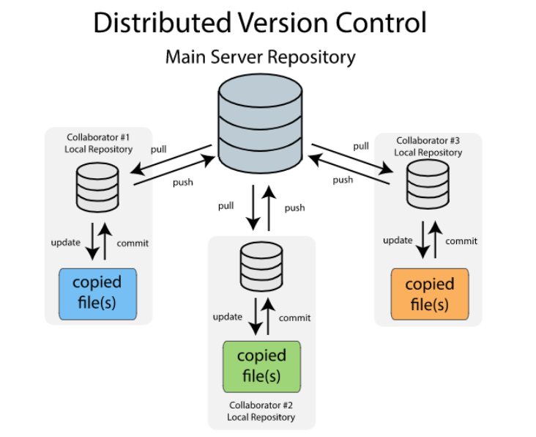
Figure 56: Distributed Version Control

5.5.3 Apache Subversion (SVN)

Apache Subversion, also known as SVN, is centralized software versioning and revision control system that is open source under the Apache License. It was created in 2000 by CollabNet Inc. was an attempt to write an open-source version-control system that operated much like its predecessor Concurrent Versions System (CVS) that fixed a lot of the bugs seen in CVS while adding new features. Subversion uses an inter-file branching model from Perforce to implement branching and tagging. A branch is a separate line of development whereas tagging refers to the labeling of a repository at a certain point in time used to locate a certain point in time of development. In Subversion the only difference between branches and tags are the way in which they are used. All the versions in the branch maintain the history of the file up to the point in which it was copy including any of the changes made since the copy. The use of merge commands can be used to move the changes from one branch to another branch. The figure below shows a potential workflow of a Subversion project.
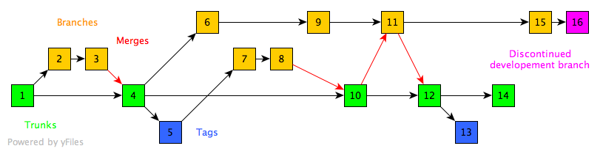
Figure 57: Flow Control Using Subversion

5.5.4 Git
Another highly used version-control system in the software engineering industry is Git. Unlike Subversion, Git uses a Distributed revision-control system to manage and track changes in a codebase. It is aimed at speed, data-integrity, and support for distributed, non-linear workflows.
Linus Torvalds, the same creator of the Linux operating system, began development of Git in 2005 with several other kernel developers. Since then, the current maintainer is Junio Hamano. Due to the nature of distributed version-control systems, each of the developers on PQUADs team would have a full-fledged repository on their own personal computers to develop software. Git is free and open-source software that is under the terms of the GNU Pubic License version 2.
Git also has a variety of different workflow models to help organize the control over a codebase of a project. In the next few sections we discuss the details and implementation of the different workflow models.

5.5.5 Centralized Workflow using Git
This workflow is the most like a Centralized Version Control System such as Subversion. It utilizes a central repository to serve as a single point of entry for all the changes to a project. The main development branch is called the “master” branch and is the only branch used in the project (this is called the “trunk” branch in other centralized systems). Using this workflow in combination with Git provides a few advantages. The first is that every developer will have their own local copy of the master branch. This means everyone will be isolated from one another and let each developer work independently from all the changes to a project. A single developer can forget about the upstream developments until it is convenient with them

5.5.6 Feature Branch Workflow
The core idea behind the Feature Branch Workflow is that all the development of new features being added to the system should take place in their own dedicated branch that is not the master branch. This encapsulation makes it easier for multiple developers to work on a particular feature without tainting the master branch. This means that the master branch will never be broken, which is a huge advantage for continuous integration environments. Another additional bonus that our team could leverage when using the feature branch workflow is the use of pull requests. Pull requests are a way to initialize the discussion around the code involved in a feature branch. The provide the developers the opportunity to “validate” a branch before it gets integrated into the official project. This makes it much easier for others to collaborate on different developers work.

5.5.7 Higher Level Workflow Designs
The Gitflow was first published and designed by a man named Vincent Driessen at nvie. This workflow uses a much stricter branching model that is focused on different project releases. This provides a robust framework for managing larger projects. This doesn’t add any commands or concepts behind the Feature Branch Workflow however, it does assign specific roles to different branches and defines exactly how and when these branches should interact with one another. In addition to the different feature branches that are used in the Feature Branch Workflow, there are different branches for preparing, maintaining, and recording releases. The figure below shows a possible flow of a project that is utilizing the Gitflow model.
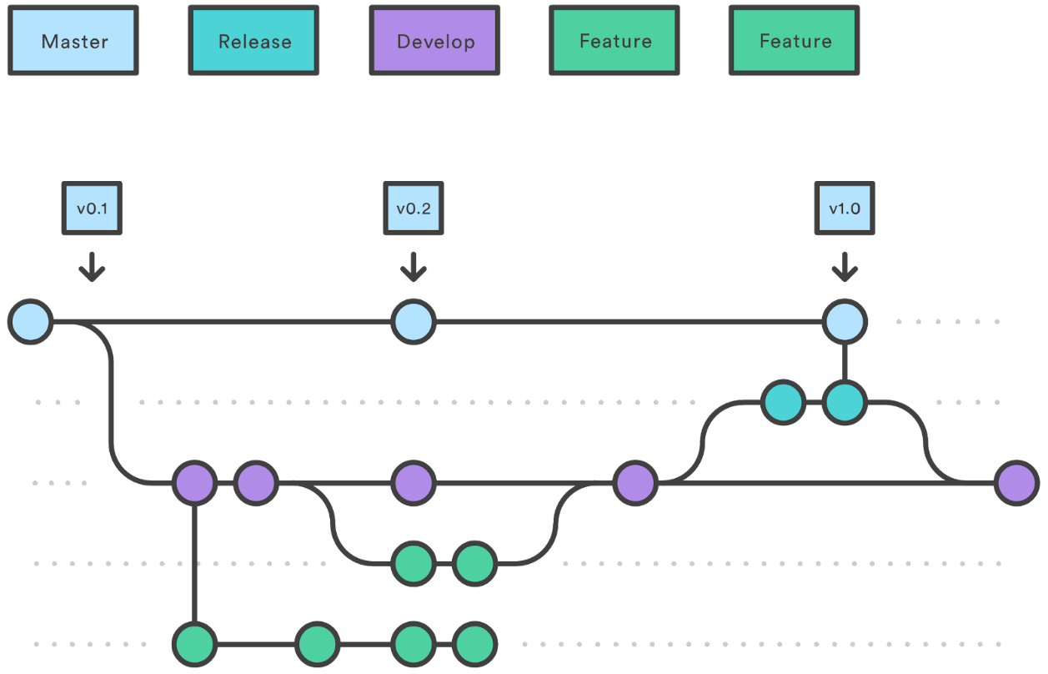
Figure 58: Example of Gitflow Workflow

Forking Workflow
The Forking Workflow is fundamentally different than all of the different workflows that has been discussed so far. Instead of using a single server-side repository to act as the “central” codebase, each developer gets their own server-side repository. This means that each developer has two total Git repositories: a private local one and public server-side one. This workflow is often used in public open-source projects. The main advantage of the Forking Workflow is that contributions can be integrated with needing everyone to push to a single central repository. The developers push to their own server-side repository and then the project maintainer can push the official changes to the official repository. This means that any developer can commit to the official repository but only if the maintainers give them write access to the official repository.
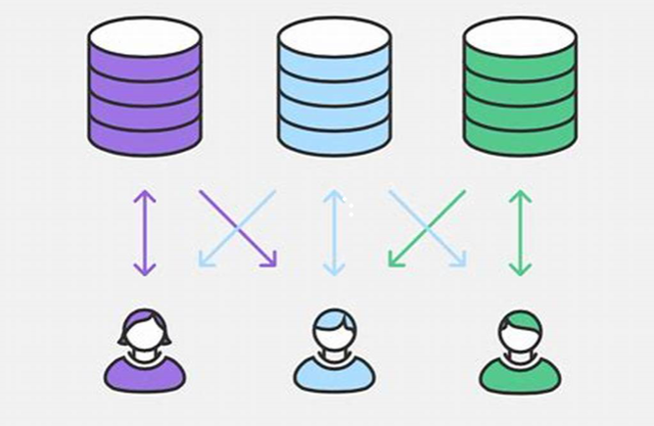
Figure 59: Example of Forking Workflow

5.5.8 Source Control Selection
For the robot specific implementation, the decided control to be used is the Git as our system of version-control. This was the preferred idea of using a distributed version-control system as compared to a centralized system. It is also a toll that is widely used in the industry and getting comfortable using Git in a smaller project setting. Another reason the Git was chosen is that there are several workflow models that we can follow that help to make version-control much easier to use. Using these workflow templates can also make it easier to develop a coding plan for the project. The template used is the feature workflow branch. This template makes the most sense for us because of the simplicity and organization. Each developer will be able to work on their own copy of the project and before the changes are merged into the master branch, we can do a pull request to manage the code being added. Now that we must organize our project into features for the corresponding branches, we can assign features to developers and then the developers can work on their own branch in parallel with one another. The higher-level workflow models are overly complex for the project scope of robot.

5.6 Final Coding Plan
For the actual implementation of robot’s software system and the development of the features, the following table describes the sprints, their tasks, the start date, and whether a feature branch will be created. The use of agile as well as Feature Branch Workflow, made it possible to come out with a final coding plan for the project. Each sprint will last a single week and the tasks involved may or may not be finished by the end of the sprint. If we don’t meet the criteria for the task to be finished by the start of the next sprint, the team will collaborate to finish the unfinished tasks before moving on to the next task.

Sprint | Tasks to be Completed | Start Date | Feature-Branch Created
1 | Initialize Git repository with empty main | 12/20/2021 | N/A
 | Set up database structure | 12/20/2021 | N/A
 | Begin mobile application development | 12/20/2021 | N/A
 | Set up hardware timers for polling sensors | 12/20/2021 | N/A
 | Write I2C driver (generic read/write) | 12/21/2021 | N/A
 | Set up external interrupts for environment variables | 12/21/2021 | N/A
 | End Sprint 1 | 12/27/2021 | N/A
2 | Program LCD Display Interface | 12/28/2021 | N/A
 | Write SPI driver for Wi-Fi Module | 12/28/2021 | N/A
 | Write message API for Temp/Humidity Sensor | 12/28/2021 | No  (I2C driver branch)
 | Get mobile application and database in communication | 12/28/2021 | N/A
 | End Sprint 2 | 12/30/2021 | N/A
3 | Get database and Wi-Fi module in communication | 01/02/2022 | N/A
 | Clean up Mobile application GUI | 01/07/2022 | N/A
 | Write API calls for accessing sensor | 01/18/2022 | N/A
 | End Sprint 3 | 01/22/2022 | N/A
4 | Testing | 01/26/2022 | N/A
Table 13: Software Sprints and Tasks

6. Project Prototype Construction and Coding

6.1 Integrated Schematics

This project contains four Printed Circuit Boards with two of them designed by members of this group. The two PCB boards designed for this project are the Solar Charge Controller and the LiDar Sensor. This PCB board consist of multiple of Integrated Circuits which by working together with the help of the software can fulfill their task. Below are two lists with the Integrated Circuits of each board designed by the team.

Solar Charger Design.

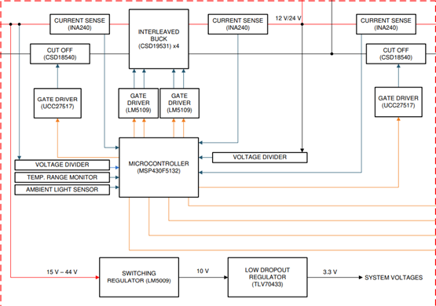
Figure 60: Solar Charger Design Block Diagram

The design is based on the MSP430F5132IDA Microcontroller which is a low power consumption board that will gather the data from the battery, solar panel, current sense amplifiers in order to be available to calculate and maintain the Maximum Power Point for the Solar Panel attached.

From the block diagram it is possible to see that the input from the solar panel will pass through two different Integrated Circuits withing the solar charge controller. The INA240A2PWR is a Voltage out, current sense amplifier which can sense a common node voltage between -4V and 80V, allowing our solar panel which is rated for 12V we are within the acceptable range for the current sense amplifier. For the solar charge controller, three Current sense amplifiers INA240A2PWR will be used, one for the receiving input, one between the buck converter and the battery bank and between the solar panel input and the Low Dropout Regulator. They will be connected to the MCU for status and alarms.

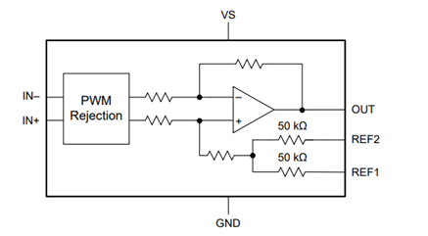
Figure 61: INA240A2PWR Functional Block Diagram

Another important set of Integrated Circuits are the Gate Driver LM5109 and the Switching Regulator LM5009 LM5109BMA which are commonly used for DC-DC converters due to their high-speed switching while consuming low power.

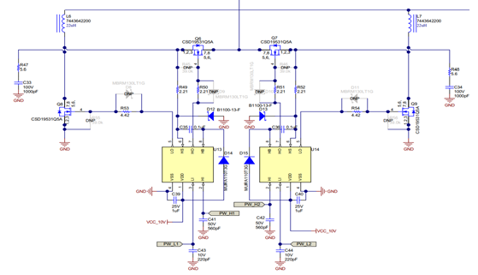
Figure 62: Power Stage Schematic with 2 LM5109BMA switching both N-Channel transistors

OPT3001 which is a digital ambient light sensor (ALS) will be used to detect and measure the visible light available. The single-chip lux meter measures the light intensity as seen by the human eye. Lux is the unit of Illuminance which is the total luminous flux per unit area
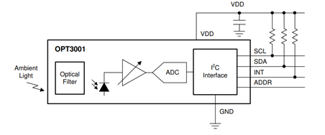
Figure 63: Ambient Light Sensor and chip

6.2 PCB Vendor and Assembly

This project contains mainly three PCB boards. The first board is the charge controller which will be designed by the team. A rough estimate was done with dimension gathered from the design dimensions using and online estimator.

Estimated PCB Layout Dimensions: 130 mm x 82mm x 38 mm
Estimated price per board ~ $38.00 per board.

The second PCB board used for this project will be the DFRobot Bluno which is an Arduino compatible Board that includes the Bluetooth 4.0 module allowing for communication with a mobile device. This PCB is becoming increasingly popular for professionals and hobbyist alike making its availability almost guaranteed at an affordable price. Th estimated price of this board is $25.00 per board

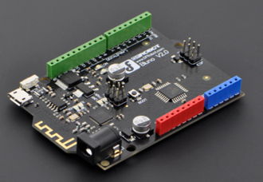
Figure 64: DFRobot Bluno PCB board

The third PCB board used will be the BTS7960 Motor Drive Controller Board Module Single H Bridge which will work in conjunction with DFRobot Bluno to control and drive both 12V motor. Since the Motor driver can only control one motor at a certain time, two of these will be used for this project. This board is extremely popular and affordable with each board costing between $5 to $10.

Figure 65: BTS7960 Motor Drive Controller Board Module Single H Bridge DC Stepper for Arduino
.

7. Project Prototype Testing Plan

7.1 Hardware Test Environment
An important component that needs to be thoroughly tested once designed and received is the Solar Charge Controller which will be designed by the team. This controller will follow the TI Instrument MPPT Solar Charge Controller TIDA-00120 / PMP7605. To test this equipment, it is necessary the Digital Oscilloscope, DC source for simulating the solar panel, Multimeters, and an electronic load. This testing will be performed that Engineering building 2 in the University of Central Florida.

7.2 Hardware Specific Testing
A simple test that can be perform is to check for the efficiency as a function of the output current this behavior is expected to look like a logarithmic function increasing rapidly and the slowly plateauing around the 98% area.

Another board that will need to be tested once received is the Arduino uno and BTS7960 Motor driver. The Arduino Uno board will be tested by setting each channel to ground and connect a voltage source to produce a specific voltage to read the output in the Serial Monitor. This value should match the input value [27]. The BTS7960 will be tested in similar fashion except the output expected will be the rotation of the motor. All this testing will be performed at the University of Central Florida

7.3 Software Test Environment

Software flow developed around the TI MSP430F5132 MCU [1 Reference]
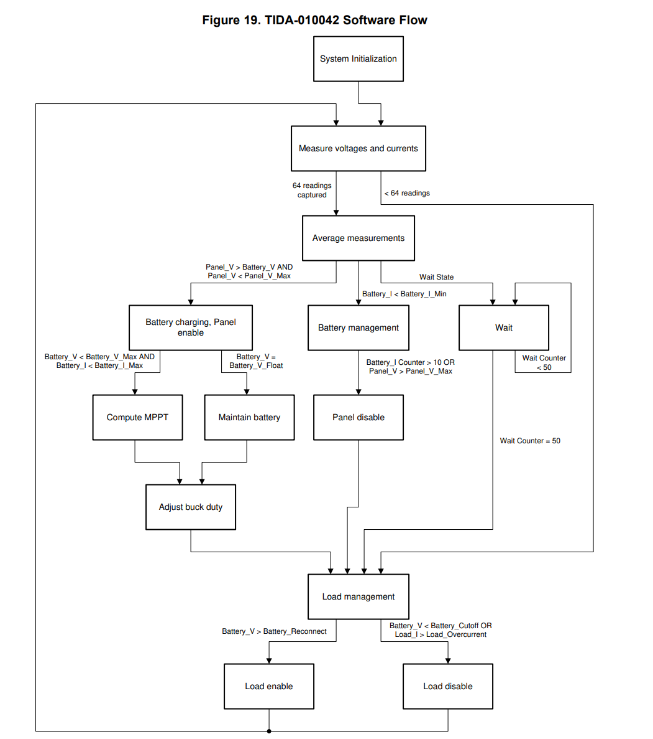
Figure 66: Software Flow

7.4 Optical Testing
For our optical design of the LIDAR sensor, before building we made sure that each of the components are working properly. The main components we tested are the photodiode, lens, laser diode and the motor with mount. All of our testing was done inside of senior design lab for safety concerns, in case anything goes wrong.

The first component we tested is the photodiode. In order to test the photodiode, we constructed a simple circuit on a breadboard. We connected the cathode of the photodiode to the positive terminal of a power supply and then we connected the anode of the photodiode to a 100-ohm resistor and the resistor to the negative terminal of a power supply. Next, placed the probes of a digital multimeter across the cathode and anode of the of the photodiode and measure the current across. When we placed a light source above the photodiode, we read a higher A/W reading.

Next, we tested the laser diode. The main characteristic of the laser diode that we tested is the frequency and width of the pulses. Once we received the PCB, we were able to solder the laser diode on and make sure that the laser driver and laser diode was working properly. We tested this by aligning the photodiode directly in front of the laser diode and turning the laser diode on. We tested the output of the laser diode by measuring the output with the photodiode and connecting it to an oscilloscope to display the results.

On the oscilloscope were able to see the waveform of the laser pulses and by freezing the screen we were able to see rise and fall times of a single pulse. By counting the number of horizontal division of one period and observing the setting of the SEC/DIV knob to see the timing its positioned at, we can find the time of a period by multiplying these two values and the frequency of the pulses by taking the inverse of the time. To find the pulse width of the waveform we need to measure the elapsed time between the rising and falling edges. The measured pulse width needed to be 5ns or less in order to get our desired resolution. We can also measure the peak value by looking at the voltage at the peak of the waveform on the oscilloscope.

The lens will need to be tested to ensure that they have no aberrations and are working properly. To do this we checked each lens in the laboratory and verify that their focal length is accurate. To test the focal length, we placed an object at a distance equal to the desired focal length on an optical rail in front of the lens and a CCD at a distance equal to the back focal length behind the lens. We then checked to make sure the CCD is picking up a clear image. We also tested the bi-convex to make sure that it is converging. We did this by placing the lens along the optical rail and a non-collimated light source behind the lens, such as an LED, at the focal point. Then we placed a screen on the other side of the lens which gave us a small circle. When we move the screen further away, we should see that the size of the beam does not change shape or size and is therefore collimated.

The mirror and mount also needed to be tested before attaching it to the sensor. The plan was to have the mount for the mirror 3D printed so that it can perfectly fit around the mirror, keeping it at a 45-degree angle, and attach to the motor. This will allow the mirror to rotate 360 degrees as fast as possible without fear of the mirror falling out and shattering. We completed this test by placing the mirror inside of the mount as well as gluing it down, and then attaching the motor to the top of the mount. Then we connect the motor to the motor driver and turn it on, the mirror rotated a full 360 degree without moving in the mount.
Once we know all the components of the system are working, we then put them together and start testing the LIDAR sensor. This was a series of test to make sure the laser diode, photodiode and mirror are perfectly aligned so that the light pulses travel from the laser diode into the photodiode. In addition, the range and resolution of the system was put to the test.

8. Owner’s Manual

8.1 To Power on The Robot
This will power on the robot to prepare it for proper use.

Below are the steps to power on the robot:
- Power on robot properly with power switch.
- Open Blynk app on android device.
- Connect robot to Blynk app via Bluetooth.

8.2 Using GPS Streaming Module (Follow me)
GPS streaming allows the robot to follow the user via their phone GPS coordinates.

Below are the steps for using the GPS streaming module:
- On android device, turn on location services in settings.
- Press Play on the Blynk App, which would have the robot come online.
- Step away from the robot.
- Toggle the motor kill switch to off.
- The robot will follow behind the user. Stay within the distance of 0-1 meter from the robot.

8.3 Using GPS Waypoint
This mode will allow the user to send a coordinate to the robot to reach a designated waypoint.

Below are the steps for using the GPS Waypoint:
- Make sure to have Blynk app offline.
- Press on the GPS Streaming module.
- Switch the virtual node from V0 to V4 (or any unused virtual node)
- Press Play on the Blynk App, which would have the robot come online.
- Type coordinates (Latitude, Longitude) on the terminal widget on the Blynk application.
- Toggle the motor kill switch to off.
- Press enter on the terminal widget.

9. Administrative Content

9.1 Milestone Discussion
To ensure our project is successful and done within our time constraint, it is important we divided our tasks into smaller segments. This will allow us to stay on track while focusing on smaller achievable goals and working towards the end goal of the project. Tracking our milestones also allowed our professors to see how we be divided up the two semesters of work. In addition to the hard deadlines set by the customers for the first semester, we also broke down how we spent our time in the second semester to ensure a working prototype. Our milestones are outlined in Table 14, showing when we plan to start and finish each task and the status of that task currently. In the first semester we primarily focused on the research aspect of our project, while in the second semester focused on building our robot and testing its performance.

Task | Semester | Start | End | Status
Senior Design Ideas | Fall | 8/24/2021 | 8/27/2021 | Complete
Confirm Project Ideas | Fall | 8/27/2021 | 9/5/2021 | Complete
Initial Project Documentation | Fall | 9/10/2021 | 9/16/2021 | Complete
Divide and Conquer 2 | Fall | 9/22/2021 | 10/1/2021 | Complete
Meeting with Professor | Fall | 9/22/2021 | 9/22/2021 | Complete
Research Sensor Technology | Fall | 9/12/2021 | 12/1/2021 | Complete
Research Sensor Communication | Fall | 9/12/2021 | 12/1/2021 | Complete
60 Page Draft | Fall | 9/16/2021 | 11/5/2021 | Complete
100 Page Draft | Fall | TBD | 11/19/2021 | Complete
Final Documentation | Fall | TBD | 12/7/2021 | Complete
PCB Layouts | Spring | 10/12/2021 | 1/16/2022 | Complete
Research Coding Languages | Spring | 9/16/2021 | 1/16/2022 | Complete
Assign Tasks | Spring | 11/12/2021 | 1/12/2022 | Complete
Order Components | Spring | 1/20/2022 | 3/21/2022 | Complete
Initial Testing | Spring | 3/25/2022 | 4/5/2022 | Complete
Build Prototype | Spring | 2/21/2022 | 4/10/2022 | Complete
Test & Debug Prototype | Spring | 2/21/2022 | 4/15/2022 | Complete
Final Documentation | Spring | 1/10/2022 | 4/23/2022 | Complete
Finalize Project | Spring | 4/4/2022 | 4/15/2022 | Complete
Table 14: Project Milestone

9.2 Budget and Finance Discussion
This project is not sponsored by anyone. We divided the cost amongst the four of us in the group. Our goal is to keep the cost under $1000. We made the estimated cost to be about $800 in senior design 1 but, instead it came out to be about $549.17. We were pleased with this since it was well below our expected price and below the inital budget we gave ourselves. Also included in this portion is shipping cost, which was higher because of our time constraint. The higher cost were the PCBs. We negotiated as much as we possibly can until we found the cheapest website. These were all the possible cheapest prices we can find with generally good quality parts for the robot.

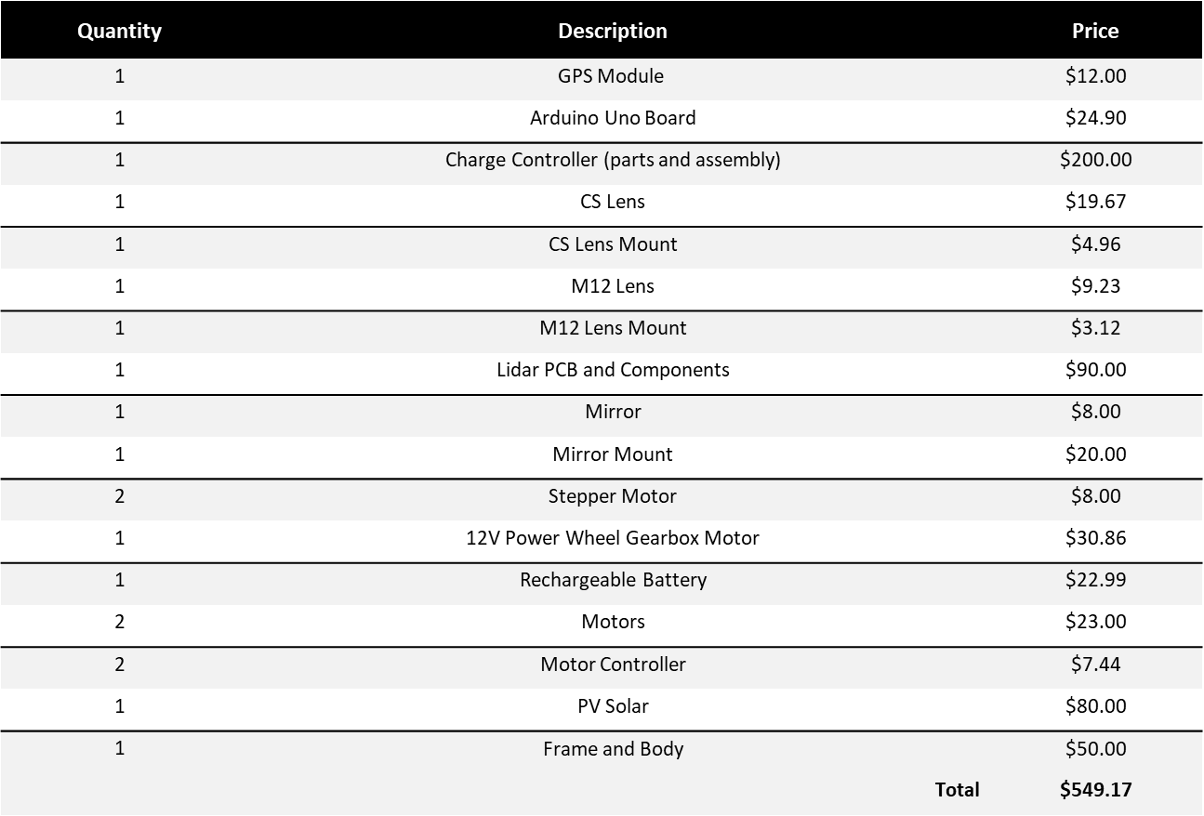
Table 15: Estimated Budget

Appendices

Appendix A – Copyright Permissions

Appendix B – Datasheets
[1] Tida-010042.” TIDA-010042 Reference Design | TI.com, https://www.ti.com/tool/TIDA-010042.
[2] https://en.wikipedia.org/wiki/Data_logger
[3] https://www.mccdaq.com/appnotes/android-data-acquisition-apps.aspx
[4] http://www.vbforums.com/showthread.php?530655-What-is-the-Different-between-Service-Base-database-and-a-local-database
[5] https://www.codeproject.com/Questions/312261/Confused-in-Local-Database-and-Service-Based-Datab
[6] https://www.mongodb.com/scale/relational-vs-non-relational-database
[7] https://hackernoon.com/relational-versus-non-relational-database-d5d1c439fb86
[8] https://acodez.in/sql-and-nosql-an-overview/
[9] https://en.wikipedia.org/wiki/SQL_injection
[10] https://firebase.google.com
[11] https://aws.amazon.com/dynamodb/
[12] https://en.wikipedia.org/wiki/Oracle_Database
[13] https://cloud.oracle.com/iaas/database/pricing
[14] https://www.sitepoint.com/data-serialization-comparison-json-yaml-bson-messagepack/
[15] https://en.wikipedia.org/wiki/JSON
[16] https://en.wikipedia.org/wiki/Regular_expression
[17] https://en.wikipedia.org/wiki/BSON
[18] http://yaml.org
[19] https://en.wikipedia.org/wiki/YAML
[20] https://en.wikipedia.org/wiki/MessagePack
[21] https://en.wikipedia.org/wiki/XML
[22] https://en.wikipedia.org/wiki/MongoDB
[23] https://azure.microsoft.com/en-us/product-categories/databases/
[24] https://azure.microsoft.com/en-us/services/cosmos-db/
[25] https://en.wikipedia.org/wiki/Microsoft_Azure
[26] https://www.microcontrollertips.com/lidar-and-time-of-flight-part-2-operation/
[27] Software start up and test of Arduino Uno | NAROM
[28] https://ieeexplore.ieee.org/document/7087165
[29] https://ieeexplore.ieee.org/document/736342
[30] https://ieeexplore.ieee.org/document/5991833
[31] https://www.nrcs.usda.gov/Internet/FSE_DOCUMENTS/nrcs144p2_024990.pdf
[32] https://ieeexplore.ieee.org/document/6566533
[33] http://w3.uch.edu.tw/ccchang50/ebook_introduction%20to%20gps.pdf
[34] https://spaceplace.nasa.gov/gps/en/
[35] https://www.gps.gov/systems/gps/
[36] https://www.u-blox.com/sites/default/files/NEO-M8-FW3_DataSheet_UBX-15031086.pdf
[37] http://what-when-how.com/gps/introduction-to-gps
[38] https://core-electronics.com.au/tutorials/motor-drivers-vs-motor-controllers.html
[39] https://www.allaboutcircuits.com/technical-articles/introduction-to-the-i2c-bus/
[40] https://maker.pro/arduino/tutorial/common-communication-peripherals-on-the-arduino-uart-i2c-and-spi
[41] https://www.circuitbasics.com/basics-of-the-i2c-communication-protocol/
[42] https://www.analog.com/en/analog-dialogue/articles/uart-a-hardware-communication-protocol.html
[43] https://www.seeedstudio.com/blog/2019/09/25/uart-vs-i2c-vs-spi-communication-protocols-and-uses/
[44] Flutter SDK releases | Flutter
[45]FLORIDA HOMEOWNER’S GUIDE TO BATTERY RECYCLING AND DISPOSAL (floridadep.gov)

https://en.wikipedia.org/wiki/Serial_Peripheral_Interface

[46]https://aws.amazon.com/mobile/mobile-application-development/
[47] https://sdk.finance/how-to-spot-a-good-api/
[48] https://www.jitterbit.com/blog/10-reasons-you-need-an-api-integration-platform/
[49] Mobile game developer survey leans heavily toward iOS, Unity
[50]What is Maximum Power Point Tracking (MPPT) | Northern Arizona Wind & Sun (solar-electric.com)
[51] unity.com Competitive Analysis, Marketing Mix and Traffic - Alexa
[52] Unity dropping major updates in favour of date-based model | GamesIndustry.biz
[53] Programming and Scripting with Unity | Unity
[54] Oracle | Integrated Cloud Applications and Platform Services
[55] Unity Technologies - Wikipedia
[56] React Native on the Universal Windows Platform - Windows Developer Blog
[57] https://www.ti.com/lit/wp/slat151/slat151.pdf?ts=1637265182931&ref_url=https%253A%252F%252Fwww.google.com%252F#:~:text=The%20FRAM%20memory%20cell%20operates,1V%20across%20the%20ferroelectric%20film.
[58] https://www.ti.com/product/MSP430FR6989#design-development
[59] http://ww1.microchip.com/downloads/en/DeviceDoc/Atmel-7810-Automotive-Microcontrollers-ATmega328P_Datasheet.pdf
[60] https://www.mouser.com/ProductDetail/Maxim-Integrated/MAX3658AETA%2B?qs=dExMeKSma84h8bh3Yf5aFA%3D%3D
[61] https://www.mouser.com/ProductDetail/Maxim-Integrated/MAX3658AETA%2B?qs=dExMeKSma84h8bh3Yf5aFA%3D%3D
[62] https://www.mouser.com/ProductDetail/ScioSense/TDC-GP21-3K?qs=DPoM0jnrROXIn1bltLXtZg%3D%3D
[63] https://www.java.com/en/
[64] https://www.oracle.com/java/technologies/downloads/
[65] https://jdk.java.net/
[66] https://en.wikipedia.org/wiki/Java_Development_Kit
[67] https://www.javascript.com/
[68] https://www.w3schools.com/js/DEFAULT.asp
[69] https://en.wikipedia.org/wiki/JavaScript
[70] https://www.mulesoft.com/resources/api/what-is-an-api#:~:text=API%20is%20the%20acronym%20for,you're%20using%20an%20API.
[71] https://en.wikipedia.org/wiki/API
[72] https://www.api.org/
[73] https://www.apple.com/swift/
[74] https://developer.apple.com/swift/
[75] https://www.interviewbit.com/blog/backend-developer-skills/
[76] https://www.autodesk.com/products/eagle/blog/library-basics-part-1-creating-first-package-autodesk-eagle/
[77] https://www.rfwireless-world.com/Terminology/NFC-vs-RFID-vs-Bluetooth-vs-wifi.html
[78] https://electronics.stackexchange.com/questions/102158/what-are-the-most-common-data-storage-devices-in-small-consumer-electronics
[79] https://reactnative.dev/blog/2016/03/24/introducing-hot-reloading
[80] https://www.atlassian.com/blog/software-teams/version-control-centralized-dvcs
[81] https://www.atlassian.com/git/tutorials/comparing-workflows
[82] http://www.wi2wi.com/wireless-connectivity/embedded-series/wi-fi

