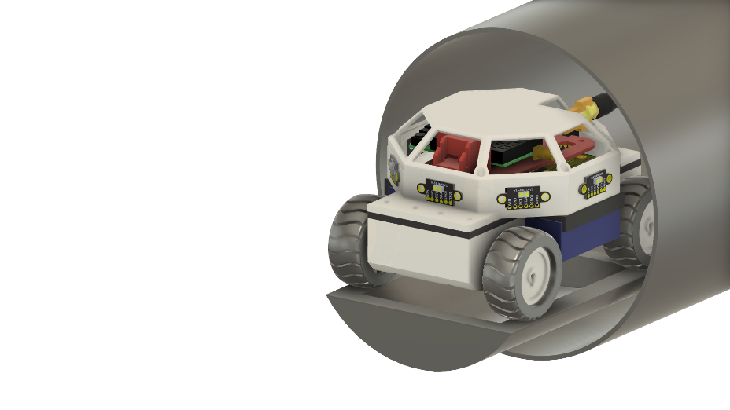
Arcturus Payload Grey Team: Autonomous Rover – Processor on Wheels
Michael Schumacher, Brett Parker, and Adriano Gussoni
Department of Electrical and Computer Engineering, University of Central Florida, Orlando, Florida, 32816-2450

Abstract—The Arcturus rocket is UCF Engineering Senior Design entry in the 51025 FAR Competition and requires an independent on-board payload. Group 35 has made an autonomous rover, to function as the payload for the Arcturus rocket, with the support and backing of Aerojet Rocketdyne Coleman Aerospace. This is an overview of the design methodology and prototyping of this autonomous rover.
Keywords—Autonomous, Object avoidance algorithm, Video transmission

Introduction
The payload that is being produced by the gray team is an autonomous rover that is mean to fit into the payload bay built into the Arcturus rocket for payload deployment. The rover’s design was constrained by the space allowed within the payload capsule of the Arcturus rocket. We were given an internal capsule diameter of 15.2 cm (6 in), and a length of 40.6 cm (16 in) to fit our design within the payload bay. The weight of the rover was to be made around 1 kg (2.2 lb.) as the payload being overweight or underweight could cause problems for the rocket’s expected flight path and trajectory.

The rover has three main goals. The rover must:
- Be able to guide itself to the area of the launch pad with no human intervention or control after deployment.
- Be able to transmit a video feed of its mission that can be received on a home device, at least 400 ft away from the launch pad.
- Be able to control the motors individually to ensure proper turning angles as well as having a secondary tracking method.

Attempting to complete all these goals while staying with our spatial, time, and financial constraints were the biggest challenges to the design of our autonomous rover. All our design choices were made to ensure that at least one of these goals were met. We chose to design our own motherboard that implemented all our systems so that we could reduce the size of the rover.

Rover Systems

Power Regulation System
The power delivery is the most vital system of the rover and covers the battery and voltage regulators. There are multiple systems within the rover that all require different voltage levels, and we need a regulation system that can supply enough amperage for all the systems at the right voltage.
The list of requirements from the power delivery system is the following:

- The rover should be able to supply enough current to the motors during its operation.
- The power system should be responsive enough to change directions or brake before the rover contacts any obstacles (as determined by the control logic).
- The power system should deliver power to all the main drive motor controllers simultaneously and equally or as needed to ensure proper operation
- The power system should consume as little energy as possible while the rover is idle (in flight) as to extend the battery life and duration of the rovers’ travel back to the launchpad.
- The power system should be able to supply enough power for the live video transmission subsystem.
- Main power wires must be held firmly in place at all times including take-off.

We started with 3.3V regulation as that is the simplest portion of the power delivery system. The sensors, the MCU and the inertial measurement unit (IMU) all function off 3.3V so we had to ensure that our chosen regulator could provide enough current. Our chosen voltage regulator, the LM1085IS could supply up to 3A of current and was our preferred choice. We instead had to implement 2 LP38690DT-3.3 voltage regulators which only have 1A of maximum current draw []. This was due to supply and availability changing during the time between Senior Design 1 and 2. This would cover the current draw needed for 8 IR sensors, the MCU, the GPS and the IMU with enough head room on each regulator to make sure they aren’t running hot.
We had to trade space on the board to make sure that two regulators would fit but we managed to save money as the regulator with the higher current limit cost more than two lower limit regulators. Each 3.3V regulator handles half of the IR sensor bank as well as either the IMU and GPS or the MCU. These regulators are fixed at 3.3V and the chips that are dependent on them have some level of accepted variance.
The 5V regulators are needed to run the most power-hungry components of the rover: the motors and their drivers. We decided that we would implement the DRV8833 motor drivers from Texas Instruments. These motor drivers use H-bridges to control the motors and each chip has 2 H-bridges (2 channels). Each channel can output up to 1.5 A which is plenty to cover the current draw from the motors, even when they are stalling.
Table 1- Voltage Regulator Specs.
Part Name | LD29150DT50R | LP38690DT-3.3
Max Output Current (A) | 1.5 | 1
Input Volt. (V) | 3 – 14 | 2.7 – 10
Output Volt. (V) | 5 | 3.3
Operating Temp. (°C) | -40 – 125 | -40 – 125
Price ($) | 1.45 | 1.89

Each motor driver has two channels so they can run one motor per channel. The way we chose to turn our rover was by having the wheels on a given side turn forward while the other side spins in reverse. This explained in greater detail in the movement program design section.

IMU and Sensory Systems
The rover’s sensory systems are how we connect the rover’s logic to the outside world. These systems include an IMU (consisting of a magnetometer, an accelerometer, and a gyroscope), a GPS, several infrared range finders.
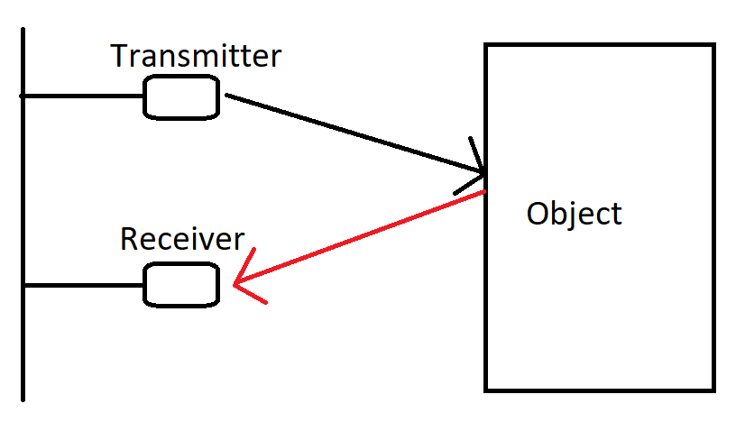
Magnetometers measure electric field or magnetic dipole moments. They are commonly used to measure the earth’s magnetic field in the applications of a digital compass. This allows us to tell the rover which direction it is travelling and whether it is moving towards the designated goal point.
GPS is a satellite-based radionavigation system owned by the United States. Applications of GPS include determining location, navigation, tracking, and mapping. Applications vary from avionics systems to consumer based mobile products. The GPS is used to determine the goal point for the rover as well as track the rover when while it’s completing its mission.
Accelerometers are electromechanical devices that measure proper acceleration. Proper acceleration is the acceleration on an object from a rest frame of reference that does not have to include earth’s gravity. In simpler terms, accelerometers measure forces acting on an object.
The main technology that is used for object sensing is IR or infrared light sensing. The IR sensor technology sends out a very specific light wave frequency and has a receiver that retrieves the reflection of that light wave from whatever object was hit As shown in Figure 2.
From the time taken for the light to reach the receiver, the sensor can give an accurate distance reading of the object that reflected the light wave. This data will be able to tell us if any sides of the rover are close to an object. If the rover senses an object in front of it, it will turn to follow the object until it is no longer in front of the rover. The rover detaches from the object and continues to moving towards the goal point.

Microcontroller
The MCU is the component that controls all the other components on the rover and processes the data that the sensors gather. These controls will range from turning subsystems on and off, gathering data, and sending data throughout the rover. For this reason, it’s important we find a MCU that has a fast enough processor speed to keep up with these tasks, but not be overkill and waste battery power.
An important factor when picking our MCU was to make sure that they must had a development board option with some way to program the chip. Since we planned to do a significant amount of breadboard testing when building the rover, having a development was invaluable. We initially planned on using a Raspberry Pi but decided that we would have to create our own mother board design to reduce the footprint of the rover.
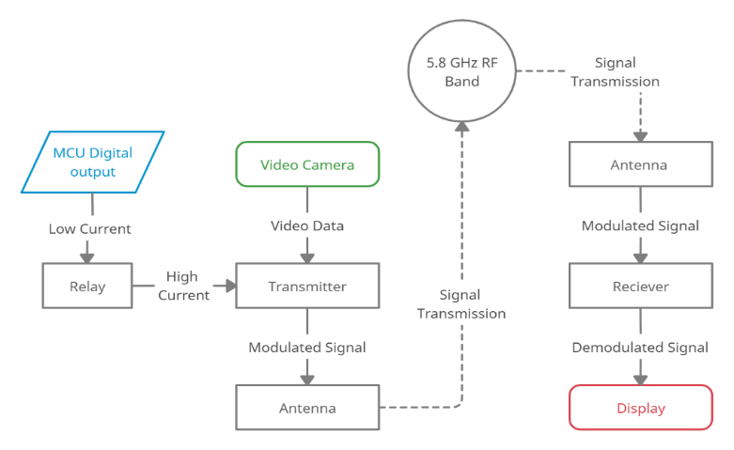
In the research to decide on an MCU, we encountered the STM32L053R8. This is an ARM based MCU which is interesting to us since we would like to work with an ARM based processor in our project for future job applications. The ARM processor is partially known for its use in the Raspberry Pi models as a very fast processor. In that vein, this MCU has a 32-bit architecture with a 32MHz clock frequency. In its active mode the chip uses 88 µA while it uses .27 µA in standby mode [2]. We chose this chip out of the extensive STM32 collection mainly by development board availability and relative size compared to the other chips we are using. As a side note this chip also has compatibility with Arduino like the ATmega chip.
We would have implemented the STM32L053R8 but we encountered supply shortages when we decided to purchase the MCU. As a result, we had to find a chip that was similar to the one we had previously chosen and within the same ecosystem. The chip we chose was the STM32L4S9ZIT6 which is much larger and has far more resources than the previously chosen chip [3]. This was the cheapest alternative MCU we could find that had enough timers for our applications and was within the same ecosystem that was feasibly hand solderable. It has a total of 144 pins, but we could save time in soldering by limiting the connectivity of the chip on the motherboard. The only pins that were routed were the necessary connections and some choice pins that were potentially usefulness if the design had to drastically change.
Table 2 - MCU Specs
Part Name | STM32L0 | STM32F3xZ | STM32L4S9ZIT6
Price Board ($) | 13 | 20 | 30
Price Chip ($) | 5 | 14 | 20
Clock Frequency (MHz) | 32 | 72 | 120
GPIO count | 51 | 115 | 112
Power Consumption (µA / MHz) (max/min) | 88 – active  0.27 – standby | 1033 – active  1.03 – standby | 110 – active  0.91 - standby
Operating Voltage (V) | 1.65 to 3.6 | 1.65 to 3.6 | 1.65 to 3.6
Memory | 8 KB RAM  64 KB flash | 64 KB RAM  64 KB flash | 640 KB RAM  2 MB flash

Video Transmission System
The video transmission design we decided to go with is a WolfWhoop C5 micro camera with a transmitter that sends its information straight to a 5.8 GHz RF receiver. The transmitter is turned on or off based on our PCB logic. When on the transmitter sends out 5.8 GHz RF waves via the antenna connected to it. We will then have a receiver, separate from the rover, on a matching frequency and channel to receive the video.
The purpose of the PCB in this system is simply to supply power. When the MCU that is controlling our rover wants to start the live video transmission, it will supply power to the transmitter and camera to turn them on. The transmitter will be hard set to the frequency and channel of our choosing so there is no need for the PCB / MCU to do anything more.
The transmitter ended up being the deciding factor for most of our design. We looked at many different RF ranges for price, quality, and simplicity. We ended up choosing a 5.8 GHz FPV (First Person View) video transmitter for not only its range (in distance) but also its bandwidth. The transmitter comes with an antenna that should exceed our range requirements and a matching receiver.
When choosing which frequency we would use, the limiting factor seemed to be bandwidth. For our initial design that used the Raspberry Pi, we were finding transmitters that couldn’t even transmit 420p at 1 frame a second, or about 300kbps. Around the 1 GHz range we found some transmitters that would be able to send 1 or 2 frames a second at 420p, but this is the range our GPS will be working in. Finally, we found these 5.8 GHz transmitters which have the bandwidth able to match our cameras output.

Hardware Design

Motor Driver Implementation and Design
The DRV8833 motor driver can be used in a direct fashion with only forward, reverse, and brake control or using a PWM signal to control the speed of the motor. Given that we will be using encoders with the motors to allow for control, we will be using the PWM signal method. This lets us choose different speeds for the motor depending on the PWM duty cycle from the MCU. Using PWM inputs also lets chose whether we let the motor slow decay (brake) or fast decay (coast) while going forward or backward.
The logic for the PWM inputs can be seen in Figure 4. The basic idea for controlling the motors is that when holding one of the input pins low and having the other be our PWM input, we can turn the motor forward or back, depending on which pin is constant, and have it fast decay [4]. If we hold the constant pin high and control the other with PWM, we can have the motor turn with slow decay.
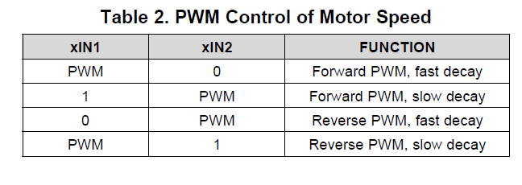
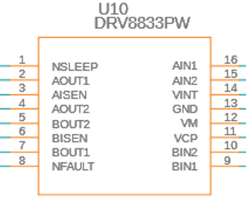
The chip has a built-in current regulation feature for each motor. These current sensing pins are denoted as the xISEN (A or B) pins as seen in Figure 5. We use these xISEN pins to control the current draw limit of each motor. Since the motors we are using are identical, we use resistors of the same value each of the 4 motors. The datasheet for our motor shows us that our current for the stall torque is 1.5A but we can limit that further with the current control [5]. The reference voltage is set to 200 mV, so we calculated our resistor value by deciding on a current limit. We limit the current to 1A to keep the start-up time of the motor low but still able to draw enough current in the case we need to run the motor at max power (~0.81A) [5]. The current being limited at 1A ensures that the motor drivers are never draw more current than the voltage regulators can supply as well. With a current limit of 1A, our current sense resistors would be around 0.2 Ω (or 200 mΩ).

IR Sensor Implementaion and Design
We decided to implement an eight-direction detection algorithm which means there will be eight IR sensors 45° apart from one another. This setup will allow us to detect objects a full 360° around the rover. A key design feature here is that each “corner” sensor is at 45° angle from the face of the rover instead of being at the actual corners of the rover. Since our rover is a rectangle, this keeps the sensors equally spaced on the collision circle. This means whichever way the rover turns we will be able to line up a sensor in that direction.
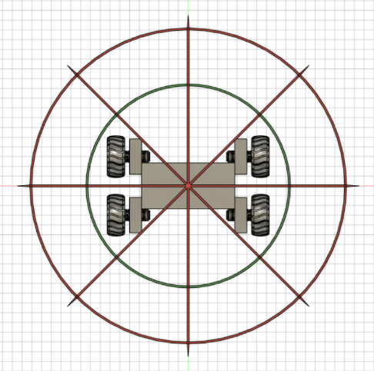
In Figure 6, the rover is depicted gray, the green circles are the inner and outer collision boundaries, the red lines are where the sensors will be pointed, and the red circle is the max distance of the sensor. For mounting the sensors, we will put them in the eight locations where the redlines meet the blue box and then point them at the correct angle away from the center of the rover. As for the collision boundaries, we will have to calculate the distances at which each red line crosses a green circle and those will be the two distances we will be checking for when we read from the sensors.
As for the wiring of each IR sensor, they will be connected to an I2C line as a slave while the MCU will be the master. The sensors will be read one after another to have a valid sense of the distances from objects in each of the directions.

IMU Implementation and Design
To keep track of our local position, we use all the IMUs sensors. The IMU’s purpose is to tell us how fast the rover is moving and help us relate where we are to where we were. The accelerometer will give us the change in 3d space. The gyroscope tells us the angle change in 3d space. The magnetometer will be compared to the accelerometer data to relate it to the earth’s magnetic field which will provide the yaw measurement which is another type of rotation in 3d space.
The IMU sensors will be connected to the same I2C lines as the distance sensors above. This means they will also be slaves while the MCU is the master so it can control when the data is read from the IMU. It is important that the MCU reads the data from all three sensors at the same time, much like the group of distance sensors, since the calculations need to all be made in the same location at roughly the same time for the data to be significant.
For the IMU system we had the option between an off the shelf unit or building it into our PCB. We chose to build it into the motherboard so that we could reduce the size of the rover, but this had some drawbacks. The off-the-shelf units tended to have their own MCU to gather and produce the roll, pitch, and yaw data through I2C. This meant that instead of getting understandable data straight from the sensors, we had to process it in our rovers MCU to produce our usable values. This meant more work for our MCU to process; however, we had enough processing power to make it work.
It is important where we put these sensors as well since the magnetometer uses the hall effect which might be interfered with by the motor encoders and the GPS. Our solution to this problem is to build the sensors into the PCB which is located towards the center of the rover. The motor encoders are at the bottom while the GPS is at the top, so the center of the rover is our best bet for the electronics not to interfere with each other. As added insurance, we made sure to only use one of the three electronics at a time to minimize the interference with each other. We placed the IMU system close to the center of the rover as this is beneficial for the calculations of the roll, pitch, and yaw since the values are approximating a point and not the whole rover itself.

Software Design

Movement Program Design
After researching multiple methods we could implement to move and turn the rover, we decided on a 4-wheel drive system that will be able to turn our rover without use of any steering devices in the frame. This is relevant to the software design as our software will instruct each motor which way to move and how fast. In this case, each wheel will have a motor attached to which means our software will drive four motors.
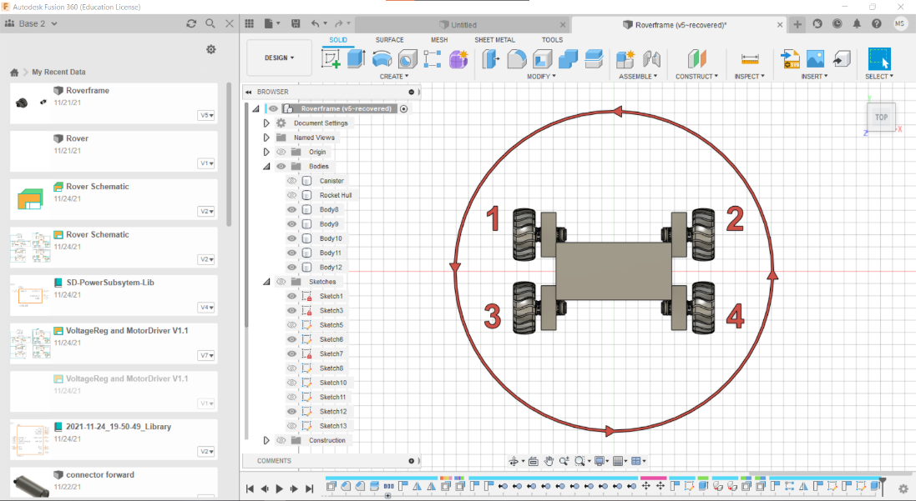
For the example seen in Figure 7, our program will tell motor 1 and 3 to move back while motor 2 and 4 move forward. This will result in a counterclockwise motion and will act as our rover’s ability to turn left.
Since our rover is longer than it is wide, we expect there to be a little deviation to the circular path because of some wheels getting dragged. We should be able to account for this with either with information gained from the encoders on the motors or from trial and error. In the best-case scenario, the wheels will turn together without dragging, but if they do, we will be able to vary the speed of the rotating motors, via motor feedback to the software, to make up the difference between expected and actual results.
With the turning of the rover covered, the movement of the rover will be significantly simpler. The speed of the rover is decided by the software depending on factors outside of the motor control. While moving, the rover may be stopped by the software at any time if it senses that the rover may collide with an object or if it’s calculated the rover will be unable to turn without collision

Sensor Software Design
The software oversees collecting sensor data and processing and/or executing on that data if needed. The sensors will be in the same three groups: distance, inertial measurement, and GPS.

Distance
For distance data, our software collects these data points multiple times a second. This is done using I2C and collects the distance of any object in eight specific directions with respect to the rover. This data is converted to an integer for our program and used, not only in respect to their value, but by what sensor it came from as this will dictate the direction of the object in respect to our rover.

Inertial Measurement
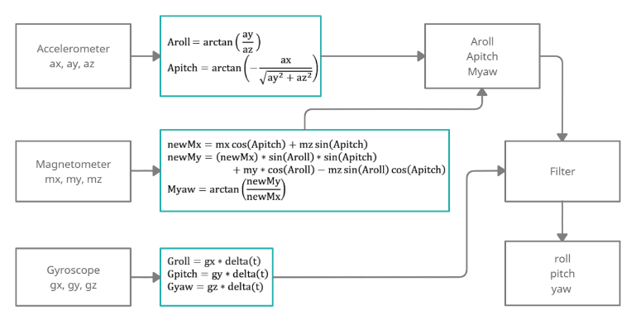
The sensors used for inertial measurement are not used as often as the distance sensors. We only need to know the rover’s position when we make decisions on where to move next. The three IMU sensors are also connected though I2C to the MCU which means our code fetches these measurement values. The accelerometer, gyroscope, and magnetometer each give the program three float values through I2C which will be in respect to the three axes of a graph, that is XYZ.
This data alone will not be very valuable to us, so the goal is to convert the data into values such as roll, pitch, and yaw. The way we will do this in code is by following the steps laid out in Figure 8. The formulas shown in Figure 8 used to convert the data are shown as Formulas 1-8
$Aroll=\arctan\left({ay}/{az}\right)$ (1)
$Apitch=\arctan\left({-ax}/{\sqrt{ay^{2}+z^{2}}}\right)$ (2)

$newMx=mx*cos\left(Apitch\right)+mz*\sin\left(Apitch\right)$ (3)
$newMy=newMx\sin\left(Aroll\right)\sin\left(Apitch\right)+my\cos\left(Aroll\right)- mzsin\left(Aroll\right)cos⁡(Apitch)$ (4)
$Myaw=\arctan\left({newMy}/{newMx}\right)$ (5)

$Groll=gx*delta(t)$ (6)
$Gpitch=gy*delta(t)$ (7)
$Gyaw=gz*delta(t)$ (8)

After these calculations are completed, we will then finally be able to use the roll, pitch, and yaw values as integers in our code. These values will help us figure out where we are compared to where we were in a local sense.

GPS
The GPS system is connected to the I2C line as well. The data that collected from the GPS chip is the latitude and longitude of our rover. This data is converted to integers for the program. The purpose of this data is to figure out our location in a global sense while the IMU system is gaining the local location. We use this data mainly to compare where we are currently to the destination of our rover.
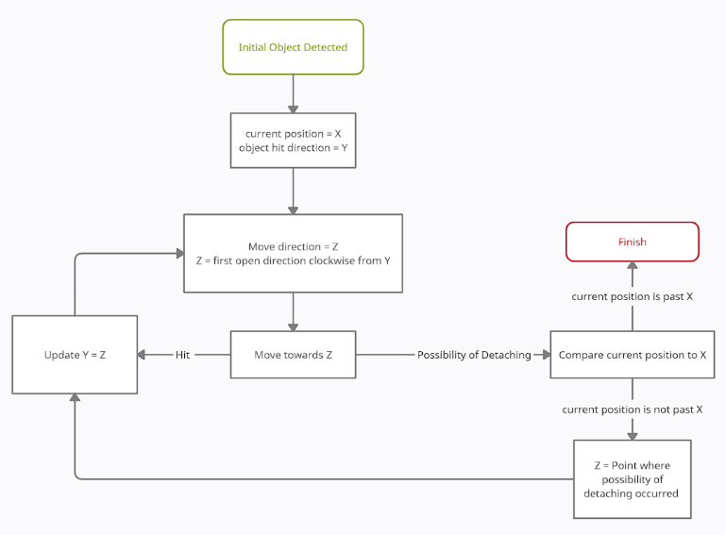
There are a few electronics that our software controls through either turning them on or off. Most of this work will be done during start up or during shut down. The biggest thing our software controls is the live video transmission subsystem. When the rover exits sleep mode after deployment, our code sends a signal to turn on the power line to the live video. In this section of code, it also extends the transmitter antenna which is done by the powering on of a servo. Once power is driven to the live video subsystem it will power the camera by itself and send video without our program’s interference.

Object Avoidance Program Design
For the object avoidance software, we have two main algorithms, one for functionally working our rover around the object and another for close range actions that requires immediate attention. These two algorithms will also use two different distance ranges from the eight directional sensors.

Outer Ring
The outer ring algorithm is based on the same idea as following a wall inside a maze to find the exit. If we sense an object in front of us, we can follow the edge of the object and go around it to get back on track to our destination. A good example of this is if we hit a circular rock on our straight path then we can go to the left or right of the rock and follow its edge until we eventually end up back on the same line but on the other side of the rock.
The start of the outer ring algorithm is whenever we are moving in a direction and hit an object for the first time. Detecting an object will move us from the general control loop that is going straight to the destination and place us in the outer ring algorithm until the algorithm is finished.
The first thing we do when we enter the algorithm in code is save our current position and save the direction that we initially sensed the object. The direction we initially sensed the object in will be the start of our looping algorithm to move to the first sensor that does not have an object sensed in the outer ring region. This direction is noted in the code as one of the eight directions we have sensors pointing. The position data that is saved is in terms of some vector <x, y> and is orientated in the direction of the object. This position data will be used to tell if our rover has gone past the initial point of contact, which would mean we are ready to detach from the object and start going towards our destination again. This idea can be seen in Figure 10.
The first encounter is shown with the red circle, encountering the object; this is the initial location data (position) we save. It is clearly seen that when the final rover position goes to detach from the object it is farther ahead of the initial rover position. After the initial data is captured, the program picks a direction clockwise from the initial point of contact. Always choosing a clockwise position from the point of contact will insure we are hugging the object as closely to the left of our rover as possible. We then move forward until we receive one of two interrupts. The first option is that we sense an object in the direction we are moving. The second option is we are going to detach our last contact point on the left side of our current direction.

Exit Condition
If the first option occurs, then we update the direction of the object hit and again pick another direction with no objects in the way currently and clockwise from the direction we just hit the object at.
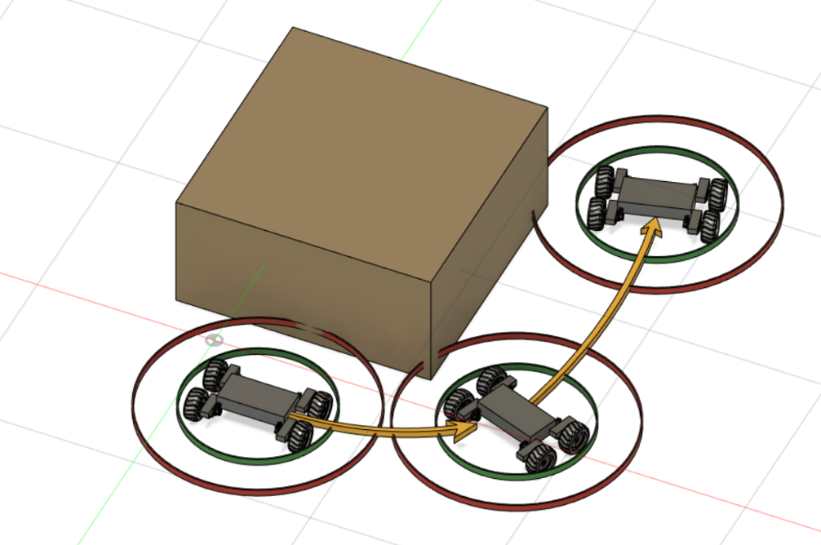
When the second option occurs, we know we are about to become detached from the object on the left side of the rover. Left, in this sense, will be defined as the first three directions counterclockwise from the direction we were moving.
When this happens, we compare our current position to the initial position recorded. From this comparison, there is again two situations that can occur, either we are past the initial position, or we are not past the initial position.
If we are past the initial position, then this is where the algorithm stops, we return to the main control loop. However, if we see that we are not past the initial point of contact then stop moving in the direction we current are and recalculate where to go. To do this, we update the value of last direction hit to the last point of contact on the left side of the rover and pick a new direction clockwise and open from that point.
This situation can be imagined from Figure 10, at the bottom right corner of the object. The rover will be traveling east then notice the northwest point is about to detach from the object. It will then turn north to continue following the object.
This point where the object is about to detach from the object will be calculated and captured by the clock cycle that we use to check all eight sensors. So, when we are checking the sensors in the software we will see if there is an object that is X distance away, which may be right on the outer ring what we are sensing, so in that case it would be expected that X+1 would be outside of the outer ring since we are traveling in a direction that affects these three sensors.

Software and program Development
For software development, we mainly used C++. We used an IDE specific to the STM32 chipset called the STM32cubeIDE, to be able to connect and run the program directly from our computer to the chip [6]. Programming the chip like this initially provided an easy way to program and change the program whenever we want. This method also provided us with any specific MCU information that the IDE can show us. This meant we had the ability to see the information stored in the MCU’s specific registers. Beyond this, we were able to step through the code since our computers were in control of the MCU. Being able to step through the code, line by line, was an important feature when trying to debug problems that occurred throughout development.
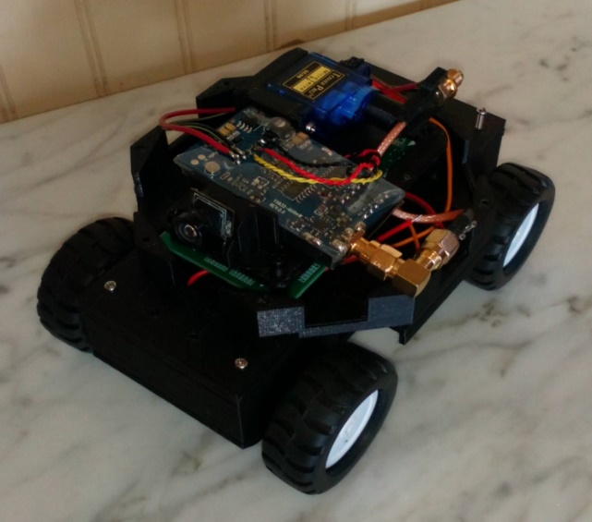
The development board for our MCU was another important part of software testing and development environment. The development board allowed for quick programing of the board via the ST-Link the board provides. This also provided the debugging, step through, as mentioned above. The development board also has all the pins to the MCU easily accessible which was important for software development when we wanted to test a specific piece of equipment and how it interacted with the program. The board also has many input connections such as different types of USB connections as well as a 32.768 kHz crystal if we needed an extra clock to help test the software. The inbuilt LEDs provided an easy way to make sure certain parts of the code were functioning as we expected flashing LEDs after certain steps [3].
After we finished testing the software using the board, we programmed the separate MCU chip using a stand-alone ST-Link device and copy the code to the new board. Using this multi-chip process allowed us to make tweaks to the code using the development board. When we were satisfied with the changes, we migrated the program to the MCU on our custom PCB using the ST-Link device. Software wise this was helpful as we won’t have to unsolder the chip every time we want to test or slightly change something in the code. We planned to do as much testing with the development board in a breadboard like environment before working with the stand-alone chip on the custom PCB.

Hardware and PCB Development
The PCB that was designed for the rover needed to be compact. To achieve this goal, a 4-layer PCB was designed using primarily 0402 resistor and capacitor sizes. The integrated circuits that were chosen, needed to be Surface Mount Technology (SMT) instead of through hole components. SMT was used so that we could use all the available board area as possible while still making the PCB small enough to be integrated into the rover payload without increasing the size of the end project.

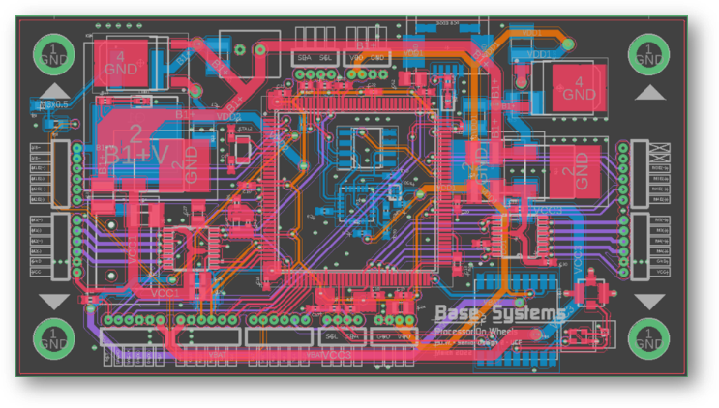
Figure 12: Board Layout of the main control board
To prepare the board for reflow, a solder stencil was used to apply the solder paste evenly across the PCB. Next, steady hand and digital surface microscope was used to populate the main boards.

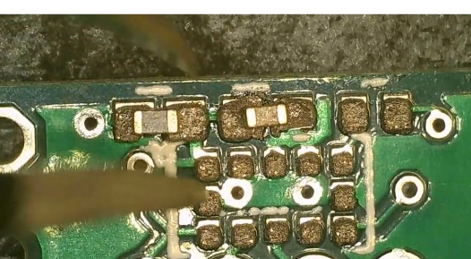
Figure 13: Placement of 0402 components under a digital microscope.

A combination of the heat plate, and hot air tool were used to reflow the main PCB. While our team did not have direct access to the reflow oven, the temperature profile of reflow on the paste packaging was imitated using the solder tools. The solder stencil and digital microscope made the board population and reflow less complex and with patience, the resulting PCB emerged completed.
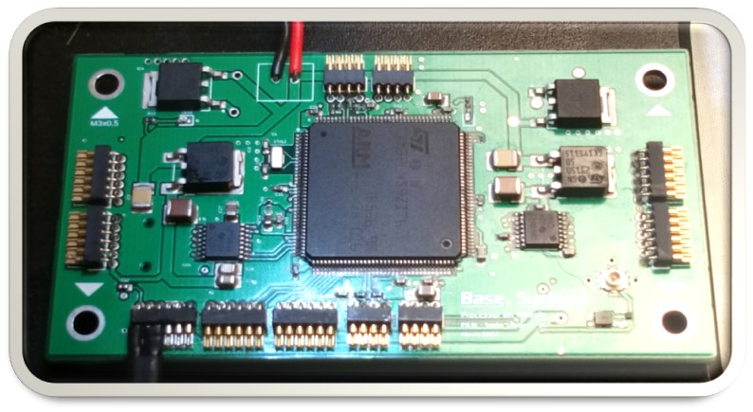
Figure 4: Main PCB, top layer, completed reflow.
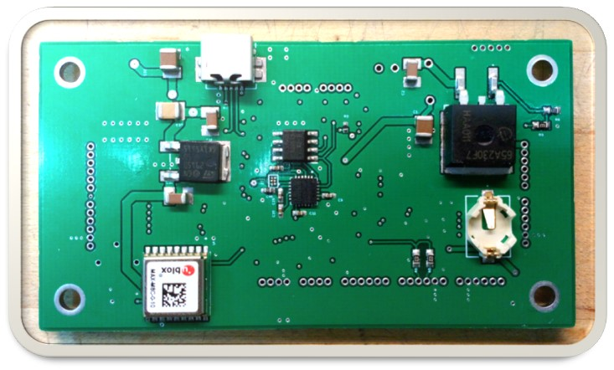
Figure 5: Main PCB bottom layer completed reflow.

Acknowledgment
This project would not have been possible without a sponsorship from Aerojet Rocketdyne Coleman Aerospace. We want to thank our faculty advisor, Dr. Felix Soto Toro for his weekly guidance with the project and Dr. Kurt Stresau for organizing UCF’s entry in the FAR 51025 competition. We would also like to thank the Pathfinder and Continuity Rocket teams for working with us this past year to help us integrate our payload with their platform. We wish good luck to the other payload teams that worked alongside us on similar projects this past year and best of luck to the Red Team and their rover design that will be implemented for the competition.

References
- Texas Instruments, “LP38690, LP38692 1-A Low Dropout CMOS Linear Regulators”, SNVS322M Datasheet, Dec. 2004 [Revised Dec. 2015]
- ST Electronics, “Ultra-low-power 32-bit MCU Arm®-based Cortex®-M0+, up to 64KB Flash, 8KB SRAM, 2KB EEPROM, LCD, USB, ADC, DAC”, STM32L053R8, DS10152 datasheet Rev. 9, Feb. 2014 [Revised Jun. 2019].
- ST Electronics, “Ultra-low-power Arm® Cortex®-M4 32-bit MCU+FPU 150DMIPS, up to 2MB Flash, 640KB SRAM, LCD-TFT & MIPI DSI, AES+HASH”, STM32L4S9ZIT6, DS12024 datasheet Rev. 4, Oct. 2017 [Revised Mar. 2020].
- Texas Instruments, “DRV8833 Dual H-Bridge Motor Driver,” SLVSAR1E Datasheet, Jan. 2011[Revised Jul. 2015]
- Pololu, “Micro Metal Gearmotors,” Micro Metal Gearmotors datasheet, Revised Sept. 2021 [5th Revision].
- ST Electronics, “Integrated development environment for STM32 products, STM32CubeIDE,” DB3871, Revised Nov. 2021 [6th Revision].

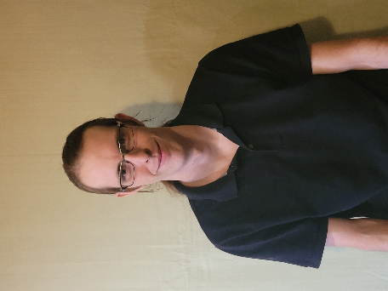
Michael Schumacher, A first-generation senior student of the computer engineering department at University of Central Florida. Michael will be striving to pursue a career in the field of embedded, real-time, control systems for the defense industry after graduation with plans of attending the Guidance and Control EECE Master’s Program at UCF.


Brett Parker, A senior student of the computer engineering department at University of Central Florida. Joined UCF’s College of Electrical and Computer Engineering in 2016 with plans to graduate in Fall 2022 with a Computer Engineering Bachelor and Math Minor. Interested in a career mostly focused on low level software development after graduation


Adriano Gussoni, A senior student of the computer engineering department at University of Central Florida. Joined UCF’s College of Electrical and Computer Engineering in 2018 in the Power and Renewable Track and graduates in 2022. Will pursue a career in renewable energy technologies after graduation.

