Arcturus’ Aerojet Payload
Group 35
Divide and Conquer (Ver. 2.42)


Team Members
Brett Parker |  |  |  | Computer Engineering
Adriano Gussoni |  |  |  | Electrical Engineering
Michael Schumacher |  |  |  | Computer Engineering
Senior Design - Advisors
Dr. Lei Wei | Primary Advisor |  |  | Ph.D. M.E., B.E.
Dr. Samuel Richie | Secondary Advisor |  |  | Ph.D. E.E.
Dr. Kurt Stresau | Interdisciplinary Advisor |  |  | Ph.D. M.E., MS A.E

Executive Summary

In a race to explore and collect data from distant planets, a vast array of aerospace agencies have been working on projects that involve sending automated and / or man-controlled robotics into the depths of space to ultimately land on and explore our neighboring planets. All the while, communicating data and media back to mission control on Earth. One example of such a robot is the Mars 2020 Perseverance rover, which has scientific equipment to test for microbial life on Mars. Another example of one of the more recent Mars robotics projects is NASA’s project Ingenuity. Opposed to Perseverance 2020, which is used for ground-based studies, Ingenuity is the first aerial robot (drone) to have successfully arrive, land, and test powered and controlled flight on another planet. Surely, interplanetary exploration is still a young but quickly growing study.

Asking graduating, senior level UCF students to build a robotic rover; fully integrated, with the top-of-the-line components and technologies; within a two-semester period would be a heavy and costly task to burden. Thus, we are thankful that our sponsor, Coleman Aerospace, will provide funding for a scale Aerojet featuring an integrated, robotic payload. The general ideas that govern full scale rocket launch compared to amateur scale rocket launch, scale by cost, size, and complexity. These first principles include (but are not limited to): propulsions, control & navigation, and data/media transmission. Successful launching systems, recovery systems (parachutes), and payload operation are also (usually) crucial for any full-scale mission to be considered a success.

As graduating students studying engineering, the scope of the payload team is to elevate the idea of “build-it yourself robotic kits” that are sold by various online vendors; by creating a custom payload design which will excel in performance compared to the afore mentioned kits. Our team intends on creating a one-of-a kind robotic payload which would meet or excel current technology in amateur robotic rocket payloads by attempting to condense the theories and ideas that we have been studying throughout our educational career until graduating in 2022. For inspiration in our payload design, we will explore the newest technologies in:

- Data acquisition (sensing)
- Data transmission (media or parametric)
- Drive systems via control theory
- Our team will strive to make the robot fully autonomous
- Reliable, live video data transmission
- Low power electronics

A current problem in planetary robotics is guidance and control. If the ideal control system existed and could be implemented to full extent, studies in autonomous transport would be solved. As autonomous systems become more control savvy, emerging problems such as power supply systems, real-time scheduling focusing on deadline success deadline success (“hard real-time system”). Thus, these two problems in current robotics will heavily considered throughout the design of the robotic payload.

It has not been confirmed if the Mechanical and Aerospace engineering majors will need EECE skills with launching systems and any other scope of the Arcturus Aerojet project that does not cover the robotic payload. Therefore, this document will only cover the scope of the payload system (Figure 1) and is intended to be a subdocument to be appended to the main Arcturus Aerojet design document either by section or reference.

This payload project will be designed, built, and tested in Orlando, Florida. While the actual project deployment will occur in the Mohave Desert, California.
Project Description
The basis of our team project is to make a payload that can be placed within a scale Aerojet rocket (Arcturus) to compete in an amateur rocket launch and rover competition. This payload will be a robotic rover. Given that the dimensions of the rockets hull diameter must be at least 3” from the project proposal documents; there is some flexibility in the size that the payload can have. Though, the size of the payload will affect the performance of the Aerojet. Because of this, our team strives to produce a compact payload.

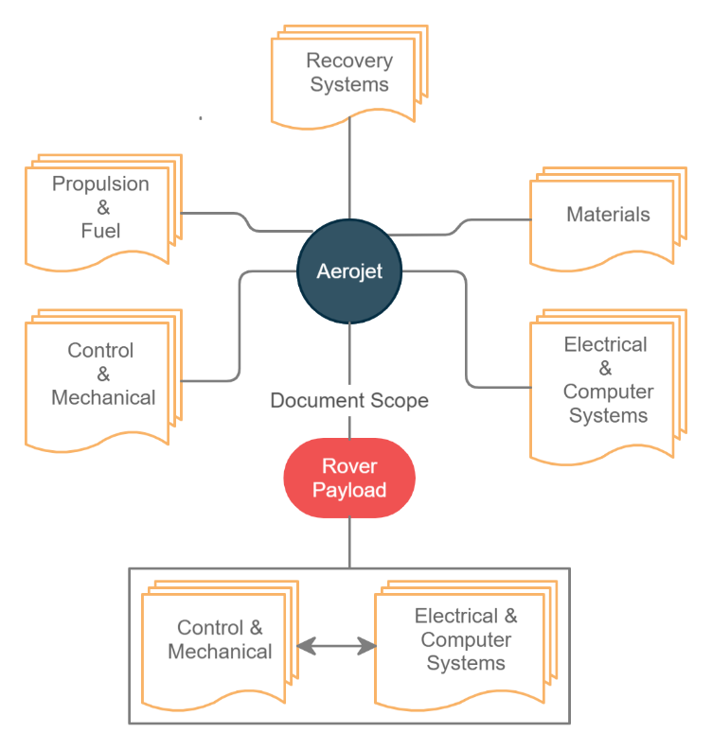
The payload must be remote-controlled or autonomous to meet competition requirements. Thus, we have chosen the more challenging option; fully autonomous. Upon successful rocket ejection and after safely landing, this rover should be able to leave the payload sled and travel a minimum distance per minimum competition rules. The rover should be able to return to the origin of launch for maximum competition points.

Finally, the payload should also have a live video transmission beginning from successful payload ground deployment to the end of its journey. For more competition points, the video may be stored on a memory device. The camera that this video is taken from must rotate 360°. The team assumes that although the rover is fully autonomous, it makes the most sense that the camera rotation control be from the team. The implementation of artificial intelligence will not take place in this project making camera prediction movements for auto camera rotation unachievable. If the design has room for general purpose sensors (which are unrelated to control sensors), they will be implemented.
Figure 1: Project Aerojet overview.

Figure 2: Project Aerojet overview.

Objectives & Goals

Our main goal is to successfully implement as many components relevant to the FAR-1030 competition, listed in the given project proposal documents, as our part of the project allows. One of these project features is remote controlled (RC) versus autonomous rover which awards 1000 or 3000 points respectively with successful implementation. A 500-point award is given if live video data be stored on a memory card. The team hopes to incorporate all these potential aspects described in the competition document, into our design with the hopes of maximum achievement in competitive points and ultimately claiming first place.

Another problem that robotics face is power consumption. Therefore, it is a goal of the team that this payload be equipped with the sufficient power for its mission. The scale distance of this mission is minor, with the main dependent variable being ground distance traveled from the launch site, as the rover will have to self-return to the launchpad. Given that the rocket will not go perfectly straight up and will have some horizontal velocity component; this distance can vary dramatically. Therefore, low power consumption would be ideal to achieve maximum operation time as possible.

Besides successful completion of competition requirements, it would be fulfilling that the payload encompasses the minimal sensing technologies (temperature, time of day, humidity). These standard technologies should be incorporated into the final design. It should also be noted that special attention will be given to the transmission of the video that is captured to hopefully achieve uninterrupted video streaming of the rovers’ journey.

Engineering Requirements

Fully autonomous

The rover should carry out its tasks without or any human guidance. To further define “Fully autonomous” for this project: The rover shall be required to:

- Self-wake from sleep period. (Sleep period defined as: time from location parameter value acquisition and finish storing GPS location to memory on the launch pad → until ejection from rocket (ground 0’).
- Boot microprocessor on descent, in effort to gather video data as soon as possible.
- Sense when on ground level, and that it is no longer descending. (Full wake of MCU and safe to leave deployment sled)
- Guide its way from the landing location to the launching location.
- Periodically gather general, non-control related sensor data at a rate of one sample per minute until completion of the journey, stored to memory.
- Have the ability and agility to avoid obstacles of a certain size (definition of “obstacles” and requirements below).
- Acknowledge successful return to home within 15 ft of launch pad.
It should be specified now, that A “backdoor” (user operated override) will be installed as this method should be highly considered and practiced; considering results of the Pathfinder mission; which almost resulted in mission failure, due to a conflict in scheduling hard real-time task sets (priority inversion). While our project will remain on earth, if at any point the rover shows sign of preventable harm to property or people, it would be wise to have a method to prevent damage.

Power Supply &

Some of the rover’s functions will be operational for the entire descent and not just after making contact. We need to ensure a base level of power delivery for live video transmission and GPS tracking.

- The power system should be able to supply enough power for the live video transmission as well as the camera motor function during the descent.
- The rover should be able to supply enough current to the motors during its operation.
- The power system should be responsive enough to change directions or brake before the rover contacts any obstacles (as determined by the control logic).
- The power system should deliver power to all the main drive motors simultaneously and equally as to ensure proper operation
- The power system should consume as little energy as possible while idle as to extend the battery life and duration of the rover.
- Main power wires must be held firmly in place at all times including take-off.

Live video transmission and video storage

- The rover should be able to send live video transmission. Minimum resolution of 720i and a maximum resolution of 1080p.
- The data transmission from the microprocessor should be able to work on RF bands: _ and _, and achieve a data transmission rate of ____.

Maximum mass | - Total weight of our deployment mechanism (combined ejection sled, attachment system, and rover) may not exceed 9.5 lbs. (4.31 kg). While the rover itself must weigh less than (997.9 g).
Maximum size | - The maximum size of our payload comes from the design of the Arcturus team (Appendix A.X): (including sled and canister) is 40.64 cm length, _ inner diameter and _ outer diameter; and should be smaller than the above values.
Heat | - The payload will be subject to exhaust gases which will be given as heat parameter by the Arcturus team (____ ° C sustained for ___ seconds) based on the types of charges used to eject the payload.
Power consumption | - Depends on what size drive motors are used with respect to the size of the rover. The goal is to be as energy efficient as possible, so the current predicted requirement is no more than 20 W/hrs.
Obstacle avoidance | - The definition of “obstacle” in terms of this project: We want the rover to be able to avoid collisions with obstacles in the direct 120° field of view in the forward direction of the rover. The size of the obstacles must be at least.2 feet across and 6 feet away. We want our rover to be able to avoid this object no later than 2 feet away from said obstacle.
Body / frame materials | - The frame of the rover should be rigid, and able to withstand the forces experienced during launch, apogee deployment, payload deployment, landing, as well as terrain traversal.

Specifications Table

Rover Specifications Table Green Font = Goal featured parameter
Parameter | Value
- Power consumption under:  - steady state conditions:  - Transient turning and acceleration change | - < 12 W/hr.  - ≤ 20 W/hr.
- Autonomous | Yes ☑ No ❑  - Self-maneuvering  - Self-return to home
- Obstacle avoidance  - Object detection size  - Detection radius  - Detection range  - Detection radius  - Detection range  - Avoidance range | Yes ☑ No ❑  - 2’ diameter  - 210°  - 6’  - 2’
- Maximum mass  - Combined sled and rover  - Rover | - 2.2-lb (1 kg)
- Maximum size  - Length  - Inner canister diameter  - Outer canister diameter | - < Depends on airframe radius  - <  - <
- Frame / body  - Max lateral accel.  - Max vertical accel.  - Max rocket recovery deceleration.  - Max play recovery deceleration: | Rigid, durable to withstand subjected forces
- Video capturing and transmission
  - Resolution
  - Data Rate
Table 1: List of organized specifications.
House of Quality

 |  |  | Power Consumption | Total Payload Weight | Total Payload Size | Project Cost | Max EGT | Obs. Avoidance | Deploy Force
 |  |  | - | - | - | - | + | + | +
1. Low Power |  | + | ↑↑ | ↑ | ↑ | ↓ |  | ↓
2. Size |  | - | ↑ | ↑ | ↑↑ | ↑ |  | ↑ | ↑↑
3. Cost |  | - | ↓ |  | ↑ | ↑↑ | ↑ | ↑ | ↑
4. Reliability |  | + | ↓ |  | ↓ | ↓ | ↓↓ | ↓↓ | ↑↑
5. Autonomous |  | + | ↑ | ↑ | ↑ | ↓ |  | ↑
6. Durability |  | + |  |  |  | ↓↓ | ↑ |  | ↑↑
7. Video Quality |  | + | ↓ |  |  | ↓
8. Agility |  | + | ↓ | ↑ | ↑ | ↓ |  | ↑↑
Engineering Requirement Targets: |  |  | ≤ 19 W/hr | ≤ 4.3 kg | ≤ 40.64 cm | ≤ $2,000 | TBA | ≤ 2 feet away | ≥ 8G force

The below House of Quality. Table , shows the specification trade offs and their impact towards each other upon changes in the design. If at any point during the design a component is needed to be changed, this table will show the overall impact to the project and the various trade-offs encoutered.

 |  | Power Consumption | Total Payload Weight | Total Payload Size | Project Cost | Max EGT | Obs. Avoidance | Deploy Force
 |  | Engineering Requirements
 |  | - | - | - | - | + | + | +
1. Low Power | + | ↑↑ | ↑ | ↑ | ↓ |  | ↓
2. Size | - | ↑ | ↑ | ↑↑ | ↑ |  | ↑ | ↑↑
3. Cost | - | ↓ |  | ↑ | ↑↑ | ↑ | ↑ | ↑
4. Reliability | + | ↓ |  | ↓ | ↓ | ↓↓ | ↓↓ | ↑↑
5 Autonomous | + | ↑ | ↑ | ↑ | ↓ |  | ↑
6. Durability | + |  |  |  | ↓↓ | ↑ |  | ↑↑
7. Video Quality | + | ↓ |  |  | ↓
8. Agility | + | ↓ | ↑ | ↑ | ↓ |  | ↑↑
Engineering Requirement Targets: |  | ≤ 19 W/hr | ≤ 4.3 kg | ≤ 40.64 cm | ≤ $2,000 | TBA | ≤ 2 feet away | ≥ 8G force
Table 2: House of Quality

Correlation Matrix Key
↑ | Strong positive
↑↑ | Positive
↓ | Negative
↓↓ | Strong Negative
 | Not Correlated

Payload - Rover Hardware / Electrical / Software Flow Overview
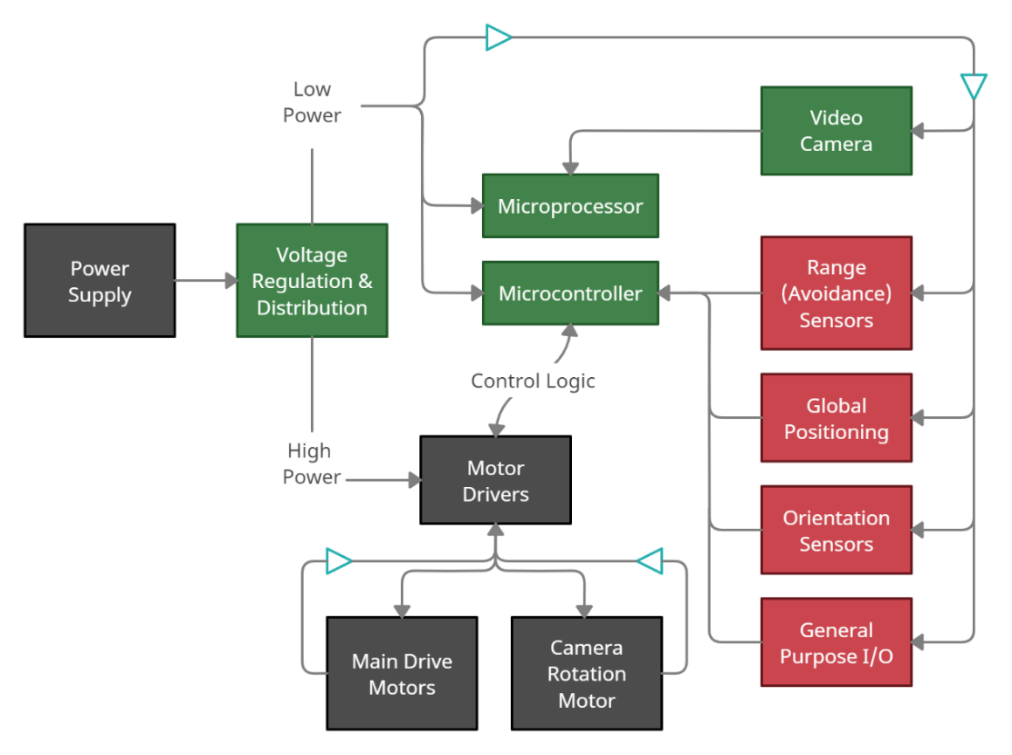
Figure 3: Payload – Rover Electrical & Hardware Overview
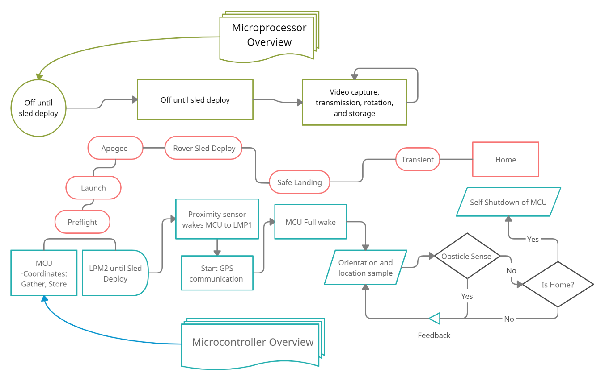
Figure 4: Payload – Rover Software/Control Overview

Project Motivation

“My motivation to join the team, stems from my past; having interest in topics such as aviation, electronics, and guidance systems. This project “hits home” and is well aligned with my studies as a graduating computer engineer with electives geared toward embedded, real-time control systems. I did intend on starting amateur rocketry as a hobby after graduation with the intent of making scale self-landing rockets; which made me favor this project more! Although I will not be working on Arcturus directly; I feel that this [autonomous rover] project is an excellent test of creativity and engineering. Born competitive, once I understood there was a challenge attached to this project, I have an internal urge to succeed, and intend on working with ample focus to insure the first-place win for team Arcturus.”

- Michael Schumacher

“Working in such a large project with multiple disciplines involved will be a great starting experience for working in the industry. We will rarely be working within a single team that doesn’t rely on another discipline. As a Power Track EE, being able to expand my knowledge with electronics and mechanical components will be very interesting. Learning more about the software side of the operation from my teammates will be great experience as well. Since we will be going for the autonomous rover route, this means I will have to practice my control systems and get more experience apply linear controls to real world applications which is something I wouldn’t get normally in a lecture.”
- Adriano Gussoni
“I think this project will be a great opportunity to learn about not only embedded systems but also how those systems are worked into an overall project. I’m excited to work with a diverse group of all types of engineering majors and hope to learn a lot about the hardware and software that goes into building a rover.”
- Brett Parker

Project Milestones
Activity | Date
- Project introduction and group formation | Aug. 2021
- 10-page design draft | Sep. 2021
- Consult with ME / AE for hull dimensions for sizing of payload. | Oct. 2021
- Create initial brainstorm prototype designs for the payload. | Oct. 2021
- Research parts for the design. | Oct. 2021
- Create a prototype of block level system. | Dec, 2021
- 60-page draft
- Build, test, and debug prototype(s). | Dec-Jan, 2021-2022
- Finalize design. | TBD, 2021
- Submit final design draft 100 page. | TBD, 2022
- Complete final design. | TBD, 2022
- Test, debug, fix final issues. | TBD, 2022
- Project deployment and council review (Final Project). | TBD, 2022
- Win 1st in the FAR-1030 competition. | TBD, 2022
Table 3 Project Milestones

Budget Overview

$ 2,000 will be provided by our sponsor, Coleman Aerospace, to incorporate into the payload section of the project finances. Project budget can be divided into two categories: Structural and Component level systems. Table 4 shows an overall aspect of the distribution of funds. For a detailed list of prices per system, see: Bill off Materials _______.

Electronics, Drive, & Power Systems
- MCU PCB (Fab./Populated) | Up to $ 325
- Microprocessor (E.g., Raspberry Pi, FPGA) | ~$ 100 (may have on-hand)
- Video camera | $ 50-100
- Main power supply | ~$ 80
- Various sensors | Included in MCU PCB
- Voltage regulation | Included in Main power supply
- Electromechanical Motors | ~$ 25
- EM Motor Drivers | TBD
Structural
- Rover frame | Up to $ 50
- Rover body (Optional) | Up to $ 125
- Rover heat shielding (Optional)
- Payload canister | $ 300
- Supports to sled | Up to $ 50
To date total (Maximum): | $ 1,155
Table 4: Rover budget overview
*Table is subject to change as the project comes to a midpoint.
Perseverance 2020 Rover
https://mars.nasa.gov/mars2020/mission/overview/
Accessed September 23, 2021

Ingenuity NASA Drone
https://mars.nasa.gov/technology/helicopter/#Overview
Accessed September 23, 2021

Current Challenges and Opportunities for Space Technologies
https://support.microsoft.com/en-us/office/add-footnotes-and-endnotes-bff71b0c-3ec5-4c37-abc1-7c8e7d6f2d78
Accessed October 1, 2021

http://www.cs.cornell.edu/courses/cs614/1999sp/papers/pathfinder.html

Documentation from FAR-1030 June 2021 amateur rocket competition (link below)
https://secureservercdn.net/198.71.233.138/2af.f63.myftpupload.com/wp-content/uploads/2021/03/FAR-1030-Competition-2021-June-5-edited-v5-FINAL.pdf

Appendix A

The term autonomous, being very broad nowadays, is defined in “Requirements & Specifications”, Table _.

