

Senior Design 1

Project Title: Myriapod Robot: Modular Robot Platform with Exotic Locomotion

Group number: 25

Project Members & Authors:
Ethan Thomas - Computer Engineering
Juan Torres Camacho - Computer Engineering
Axel Maysonet - Computer Engineering

Review Committee Members:
Aman Behal (abehal@ucf.edu)
Ronald DeMara (ronald.demara@ucf.edu)
Suboh Suboh (suboh.suboh@ucf.edu)

Acknowledgements:
Diego Santiago - Computer Engineering
Paulo Camasmie - Symbol Robotics

Table of Contents
Figures 4
Tables 5
Chapter 1: Executive Summary 5
Chapter 2: Project Description 7
Section 2.1: Narrative 7
Section 2.2: Table of Specifications 9
Section 2.4.1: Software Requirements 10
Section 2.4.1.1: Segment Software Requirements 10
Section 2.4.1.2: Teleoperation Software Requirements 10
Section 2.4.2: Hardware Requirements 11
Section 2.4.3: PCB Requirements 12
Section 2.4.4: Anticipated Standards 13
Section 2.5: Block Diagrams 15
Section 2.5.1: Hardware 15
Section 2.5.2: Segment Software 15
Chapter 3: Technology Investigation and Part Selection 16
Section 3.1: Hardware Technology Selection 16
Section 3.1.1: Battery Technology 16
Section 3.1.2: Distance Sensor Technology 17
Section 3.1.3: Optical Flow Sensor Technology 19
Section 3.1.4: Leg Motor Assembly Technology 21
Section 3.1.5: Wireless Communication Technology 25
Section 3.2: Part Selection 27
Section 3.2.1: Segment Microcontroller Unit 27
Section 3.2.2: Turning Servo Unit 30
Section 3.2.3: Battery 33
Section 3.2.4: Time-of-Flight Sensors 35
Section 3.2.5: Battery Management System 37
Section 3.2.6: Leg Servos 40
Section 3.2.7: Power Distribution System [Docs AI] 42
Chapter 4: Standards and Design Constraints 46
Section 4.1: ASTM F45 - F3218-19 Standard for Documenting Environmental Conditions [GPTA] 47
Section 4.2: IEC 62133 - Safety testing for Lithium batteries [GPTB] 48
Section 4.3: Design Constraints [GPTC] 49
Section 4.4: Cost of Components [GPTD] 50
Section 4.5: Size [GPTE] 51
Chapter 5: Impact of ChatGPT/LLMs on Learning 53
Chapter 6: Hardware Design 57
Section 6.1: Overall Design 57
Chapter 7: Software Design 60
Section 7.1: Software Overview 60
Section 7.2: Segment Communication Protocol 61
Section 7.3: Servo Control 63
Section 7.4: Metachronal Wave Locomotion 64
Section 7.5: Time-of-flight Sensor Control 68
Section 7.6: Obstacle Avoidance 68
Section 7.7: Startup and Synchronization Sequence 68
Section 7.8: Remote Control Interface 70
Chapter 8: System Fabrication [Docs AI] 71
Section 8.1: PCB Electronic Schematic 71
Section 8.2: Current PCB Layout Progress 76
Chapter 9: System Testing 79
Section 9.1: Hardware Testing 79
Section 9.2: Hardware Change 83
Section 9.3: Integration Plan 83
Section 9.4: Plan for Senior Design 2 85
Chapter 10: Administrative Content 88
Section 10.1: Estimated Project Budget 88
Section 10.2: Bill of Materials 89
Section 10.3: Work Distribution Table 90
Section 10.4: Project Milestones 91
Section 10.4.1: Semester 1 Milestones 91
Section 10.4.2: Semester 2 Milestones 92
Chapter 11: Conclusion [GPTH] 93
Appendix 96
Appendix A: References 96
Appendix B: ChatGPT (Or Other LLM) Conversations 102
Appendix C: Acronyms and Definitions 102
Appendix D: External Contributors 103
Appendix E: Copyright 103

Figures
Figure 1: House of quality
Figure 2: House of quality
Figure 3: Hardware block diagram
Figure 4: Software block diagram
Figure 5: General open loop control system
Figure 6: General closed loop control system
Figure 7: STM32CubeMX pin configuration example
Figure 8: CAN-Bus Topology (Electronic Two Wire Communication)
Figure 9: Overall schematic
Figure 10: CAD assembly prototype
Figure 11: CAD assembly prototype (no cover)
Figure 12: Displacement analysis
Figure 13: Stress analysis
Figure 14: A complete CAN bus frame, including stuff bits, a correct CRC, and inter-frame spacing
Figure 15: Sequence diagram for CAN communication software
Figure 16: Relationship between pulse duration and servo angle
Figure 17: Quadrature sine waves
Figure 18: Centipede forward propagation
Figure 19: Simplified force vector for naive metachronal wave
Figure 20: Mechanical synchronization and homing sequence
Figure 21: Mock user interface
Figure 22: STM32G431RBT6 Power
Figure 23: STM32G4 Nucleo-64 boards
Figure 24: Voltage Regulation
Figure 25: Servo Headers
Figure 26: STM32G431RBT6 Pin Connections
Figure 27: STM32F446RET6 Pin Connections
Figure 28: PCB layout progress
Figure 29: 3D model of PCB layout

Tables
Table 1: Myriapod specifications
Table 2: Battery technology comparison
Table 3: Distance sensor technology comparison
Table 4: Leg motor assembly technology comparison
Table 5: Wireless communication technology comparison
Table 6: MCU comparison
Table 7: Turning servo comparison
Table 8: Battery comparison
Table 9: Time-of-flight sensor comparison
Table 10: High level BMS comparison
Table 11: BMS specification comparison
Table 12: High level leg servo comparison
Table 13: Leg servo specification comparison
Table 14: Power distribution system comparison
Table 15: Hardware troubleshooting steps generated by ChatGPT
Table 16: Output of ChatGPT for simple JSON filtering task
Table 17: CAN message language
Table 18: Estimated project budget
Table 19: Bill of materials
Table 20: Work distribution
Table 21: Semester 1 milestones
Table 22: Semester 2 milestones

Chapter 1: Executive Summary
As technology rapidly advances, the world is constantly looking for ways to improve efficiency in our lives. This means finding faster ways to communicate with one another, more cost-effective ways to transport goods and services, or more environmentally friendly sources of energy. This project aims to add to this list by designing and constructing a prototype that showcases the viability of a myriapod robot platform in mobile robotics.
A myriapod robot is a type of robot that is inspired by the centipede. It has multiple segments, each of which has its own set of legs. This design allows the robot to navigate uneven terrain more effectively than a traditional wheeled or tracked robot. The myriapod robot in this project is expected to be able to navigate flat and uneven terrain under its own strength. It will have multiple segments with the intention of demonstrating the modular capability of the myriapod robot platform. Each segment will be able to have its own dedicated sensor or device, and segments can be continually added to the design. Given the time and resources, the segments will utilize quick-disconnects for ease of use. The robot will also have the ability to be teleoperated wirelessly by a given smartphone or remote controller.
All of the segments of the centipede robot will have the ability to communicate with one another and synchronize its legs to one another using a metachronal wave. This is a wave-like motion that is used by centipedes to move their legs in a coordinated fashion. The robot will be able to go in the forward, backward, turn left, and turn right directions. All of this will be implemented between the head segment and its body segments using a custom-designed PCB and 3D printed body for each segment.
This project has the potential to make a significant contribution to the field of mobile robotics. The myriapod robot platform is a versatile and adaptable design that could be used for a variety of applications, such as search and rescue, inspection, or manufacturing. The ability to add new sensors or devices to the robot as needed makes it a very flexible platform. The wireless teleoperation capability also makes it easy to use in a variety of environments. This project is still in the early stages of prototyping, but it has the potential to be a noteworthy contribution in the field of mobile robotics.

Chapter 2: Project Description

Section 2.1: Narrative

For as long as it has been feasible, humans have always been fascinated with replicating nature’s creatures. From building robot mice that solve mazes, to building robot dogs that can walk up and down stairs, we’ve always been captivated with the idea of recreating an animal’s ability to traverse the world. Alternative mobility robots provide features and capabilities that traditional mobile robots are not able to achieve. This can range from navigating difficult terrain, to climbing walls, to swimming in the ocean. The applications for these innovative technologies are only limited by one’s imagination.

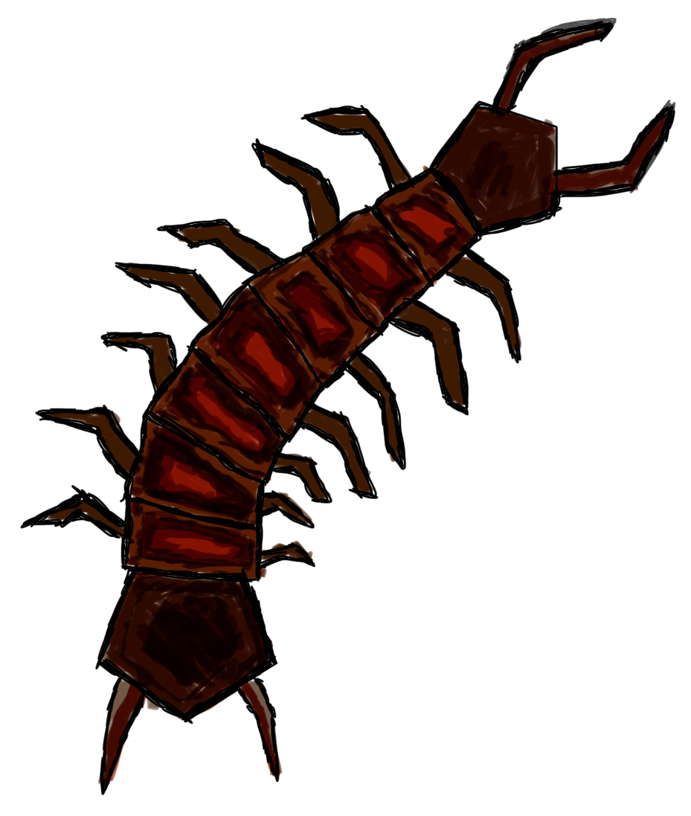
Myriapods are of particular interest thanks to their unique ability to maneuver through almost any obstacle on land, thanks in large part to their robust walking mechanism. Myriapods are known for their abundant number of legs, and these legs give them better traction control of their own bodies. Centipedes, being a part of the myriapod family, take advantage of these characteristics as well. They rely on a large quantity of legs to maintain stability and control as opposed to the two or four legs you might find on other animals. The issue with developing a bipedal or quadrupedal robot is that achieving ideal stability while also moving relatively quickly proves to be a very complicated task. Existing solutions have to consistently make adjustments and calculations to make sure they can remain upright and such calculations require a lot of computing power. Instead, we focus on a centipede robot which is able to balance, move, and traverse obstacles mechanically by design, without having to make as many computations. [2]

Fundamentally, centipedes have a head, where they control all of their actions and movements, and a trunk, which consists of numerous segmented body parts. Each segment of the trunk contains two legs, which allows it to move efficiently. Many centipedes are born with only 4 pairs of legs, but they grow one more pair each time they sprout a new segment on their body. The layout of our robot will mirror this closely: One head that controls all/most of the logic, and a trunk that contains modular, segmented body parts that each accommodate a pair of legs. In its modularity, the user would be able to add more segments and legs for additional walking capabilities. Furthermore, each new segment would have the potential and ability to add new functionalities such as sensors or logic units.

Our robotic centipede’s goal is to establish a mobile robot platform that intends to address the need for an affordable, durable, expandable robot. The robotic centipede will be able to serve various different applications as needed, offering its ability to be modular and reliable. Its reliability is due to the fact that it relies on less computational power, for example: incase of an electrical failure the robot will have no trouble maintaining its position. Its modularity is due to the fact that we intend to embed technology that allows additional segments to be added to its body. These segments are what will allow it to accomplish different tasks like search and rescue, industrial surveying and being a potential space rover.

With that being said it's important to address how our solution compares to the other current market solutions that are in a similar ‘alternative mobility robot’ sphere. Number one is cost, one quick look at quadrupedal and bipedal robots and you will notice the high price tag. One of our objectives for our robot is to present a more affordable option. This will be accomplished by using inexpensive computer components since the need for “top of the line” computer hardware isn't really apparent. Number two is expandability, although robots like Spot from Boston Dynamics offer a peripheral mounting system [1], they can often be very restricting in terms of how many tasks it can perform simultaneously. Once you add one component to Spot, it becomes increasingly difficult to add any more. With a robotic centipede, the possibilities truly become limitless. Any functionality one would want to add to the robot, you can essentially join another segment and you're good to go. Need more battery? Add a battery segment. Need a LiDAR sensor? Add a LiDAR segment. This is indeed a remarkable advantage the robotic centipede aims to achieve. Number three is functionality and capability: potential solutions like aerial drones or treaded robots are very good at their jobs but they are just that, ‘only good at that one job. Drones over the years have become more affordable, however their functionality is limited due to the fact that any sensors or computer you want to add to it will weigh it down. This then forces the user to construct a larger, more expensive drone to produce more lift. This is without mentioning that many drones are decently fragile in large part due to the fact they have to use lightweight materials. Moreover, a treaded robot is unable to make as many maneuvers or navigate as complicated terrains that a robotic centipede could. With our first iteration of the centipede robot, we hope to prove its advantages over other alternative mobility robots, and continue making it even more robust.

Section 2.2: Table of Specifications

Specifications
Maximum Speed | 0.5 m/s
Acceleration to Maximum Speed | 0.1 m/s^2
Turning Radius | 0.5 m
Supported Terrain | Flat ground, sand, rocks
Connected segments | ≥ 4 segments connected to head
Segment add/remove/swap time | ≤ 5 minutes
Obstacle detection range | 0.5 m
Maximum payload per segment | 10 lbs on flat ground
Battery Life | 3 hours
Table 1: Myriapod specifications

Section 2.3: Goals
The primary objective for this project is to develop a prototype that demonstrates the potential for myriapod robots as a viable mobile robotics platform. We wish to specifically highlight the affordability, robustness, and expandability of a myriapod robot design.

- Main goals - These are goals that make up the minimum acceptable progress for the completion of our project.
  - Design and integrate a myriapod robot that, under its own power, can locomote around a human-navigable environment (such as a room), as well as over uneven terrain (such as sand or debris).
  - Design at least one segment that performs a specialized function to demonstrate modularity (such as an atmosphere sensor module)

- Advanced goals - These are goals that our group is confident within reason that we can implement, but are not critical to the demonstration, and can be sacrificed if necessary.
  - Integrate quick connectors for swapping modular body segments
  - Implement wireless control of the robot; i.e. controlling locomotion from a computer, connected via wireless signal

- Stretch goals - These are goals that our group will attempt to implement if we have time and resources remaining after completing the above.
  - Implement active motor drive of segment linkages (other than the neck joint) for shape control
  - Implement model predictive control for leg and body pose adjustment

Section 2.4: Requirements

Section 2.4.1: Software Requirements

Section 2.4.1.1: Segment Software Requirements
- The user shall be able to teleoperate the robot’s movement.
- The robot shall have at least the following movement operations: Forward, backward, turn left, and turn right.
  - The robot is not required to be able to turn in place.
- The head segment shall receive commands from an external control source and send the necessary commands to each body segment of the myriapod to realize that action.
- The head segment shall support all commands in Requirement 2 of Section 2.4.1.2.
- When the robot is powered on, the head segment shall query all body segments to ensure they comprise a valid myriapod (e.g., no gaps in segment IDs).
  - The robot shall home all segments on startup after Requirement 4 has been satisfied.
  - Each segment shall know its position in the myriapod (i.e., whether it is the head segment, first body segment, etc.)
    - There could be a mechanism for each segment to automatically find its position in the myriapod.
- Each body segment shall be able to individually control each servo connected to the segment’s MCU.
  - The head segment shall be able to command a segment to move an individual servo on that segment to the angle specified in the command.
- The head segment shall be able to detect obstacles in front of it and issue the appropriate command(s) for the robot to continue moving and avoid the obstacle.
  - Obstacle avoidance commands shall take precedence over user movement commands.

Section 2.4.1.2: Teleoperation Software Requirements
- The external software shall communicate with the myriapod using a common communication standard. Each message sent by the software to the myriapod shall correspond to one or more commands on the myriapod’s internal communication bus.
- The following commands shall be able to be sent by the external software and executed by the myriapod.
  - Move
    - Parameters: Velocity, turn angle
    - This command shall command the myriapod to move with the provided parameters until it is commanded to stop or if the velocity parameter in this command is equal to zero.
  - Stop
    - This command shall interrupt any movement commands currently being executed by the myriapod.
  - Query segment status
    - Parameter: Segment number or all segments
    - Return value: Status of a single segment or the status of all segments sequentially
      - The status information shall include the operational status of the segment (OK or error).
      - Querying the status of all segments shall return the overall operational status of the robot in addition to the individual status of each segment.
      - This information could include the operational status of the segment’s peripheral, including the absence of such a peripheral.
- The external software could be able to send the following commands.
  - Query segment peripheral
    - Parameter: Segment number
    - Return value: Segment peripheral data
      - The segment peripheral data shall be, within reason, whatever length and structure that best fits the peripheral of the segment specified by the parameter.
- The myriapod shall respond to each command from the external software with a status message (e.g., OK, failed, not supported) and the return value of the command, if applicable.
- The external software shall log all responses from the myriapod for the current session (i.e., until the software is terminated).
  - The log shall be visible in the user interface.
  - The log shall maintain at least the past 10 responses from the myriapod.
- The external software shall monitor the status of the connection to the myriapod
- The external software shall include a graphical user interface (GUI) with any elements and/or controls necessary to realize the following
  - View the status of the connection with the myriapod
  - View available commands
  - Choose a command
  - Enter parameters for the chosen command
  - Send the command with the specified parameters to the myriapod

Section 2.4.2: Hardware Requirements
- The robot shall have the following hardware:
  - Leg servos
  - Distance sensors
  - External communication interface
  - Internal communication bus
  - Battery
  - Power distribution system
  - Hardware not mentioned in this list, but necessary to satisfy another requirement.
- Each leg of the robot shall have two axes of motion.
- Each body segment shall have two legs.
- The robot shall implement metachronal wave locomotion.
- The battery must be able to supply sufficient current to all motors, electronics, and other hardware for at least 5 segments (1 head segment and 4 body segments) while under load.
- The body segments of the robot should be able to be added, removed, or reordered.
- All segments shall communicate with each other using a single communication bus.
- Each body segment shall support communication with at least one peripheral device unrelated to the segment’s movement functions.

Section 2.4.3: PCB Requirements
- PCB and circuit design shall be done using reference designs from part manufacturers and design tools.
- There shall be at least test pads for each connection between ICs on the PCB.
- The PCBs mounted to each body segment shall have the following
  - Hardware and any electrical components needed to support such hardware
    - One STM32G431RB MCU
      - There shall be a MIPI10 connector for connection to an external SWD/JTAG programmer
    - CAN transceiver
      - SN65HVD230 is suggested
    - At least 2 LEDs for debugging
    - Reset button
    - 3.3V power supply
  - Ports and headers
    - One 4-pin header for servo PWM signals
    - One 2-pin header for serial communication over UART (peripheral pins may be labeled LPUART or USART depending on MCU)
    - Power in (+V and GND)
      - There shall be a second port passively connected to the input to pass power to adjacent segments.
        - This second port can be omitted on the head segment PCB
    - CAN (CANH and CANL)
      - There shall be a second port passively connected to the input to pass CAN signals to adjacent segments
      - There shall be a 120 Ω resistor across the CANH and CANL lines
        - There shall be a 2-pin jumper in series with the resistor.
    - One 2-pin header for the I2C interface
    - One 3-pin header for the SPI interface
- The head segment PCB shall have the following
  - Hardware and any electrical components needed to support such hardware
    - STM32F446RE MCU
      - There shall be a 6-pin header for connection to an external SWD/JTAG programmer.
    - CAN transceiver
      - SN65HVD230 is suggested
    - At least 2 LEDs for debugging
    - Reset button
    - 3.3V power supply
  - Ports and headers
    - Headers for at least two VL53L7CX ToF sensors
    - 1-pin header for turning servo PWM signal
    - Power in (+V and GND)
      - There shall be a second port passively connected to the input to pass power to adjacent segments.
        - This second port can be omitted on the head segment PCB
    - CAN (CANH and CANL)
      - There shall be a second port passively connected to the input to pass CAN signals to adjacent segments
      - There shall be a 120 Ω resistor across the CANH and CANL lines
        - There shall be a 2-pin jumper in series with the resistor.
- Each segment PCB must fit entirely inside the 2D footprint of that segment.

Section 2.4.4: Anticipated Standards
- ASTM F45 - Committee F45 on Robotics, Automation, and Autonomous Systems
  - This project falls within the committee’s scope, as our group aims to design and integrate an autonomous vehicle
  - This committee and its various subcommittees detail various methods and standards for the design and testing of autonomous vehicles.
- ISO 13482 - Safety requirements for personal care robots
  - Though the myriapod robot is not inherently being developed with personal care as a use case, proximity to humans is anticipated.
- ISO 10218 - Safety requirements for industrial robots
  - Though our prototype is not intended to be suitable for industrial applications, it is intended to demonstrate the potential for a myriapod robot design to be viable in such applications
- IEC 62133 - Safety testing for Lithium batteries
  - Our robot will have onboard batteries to provide power
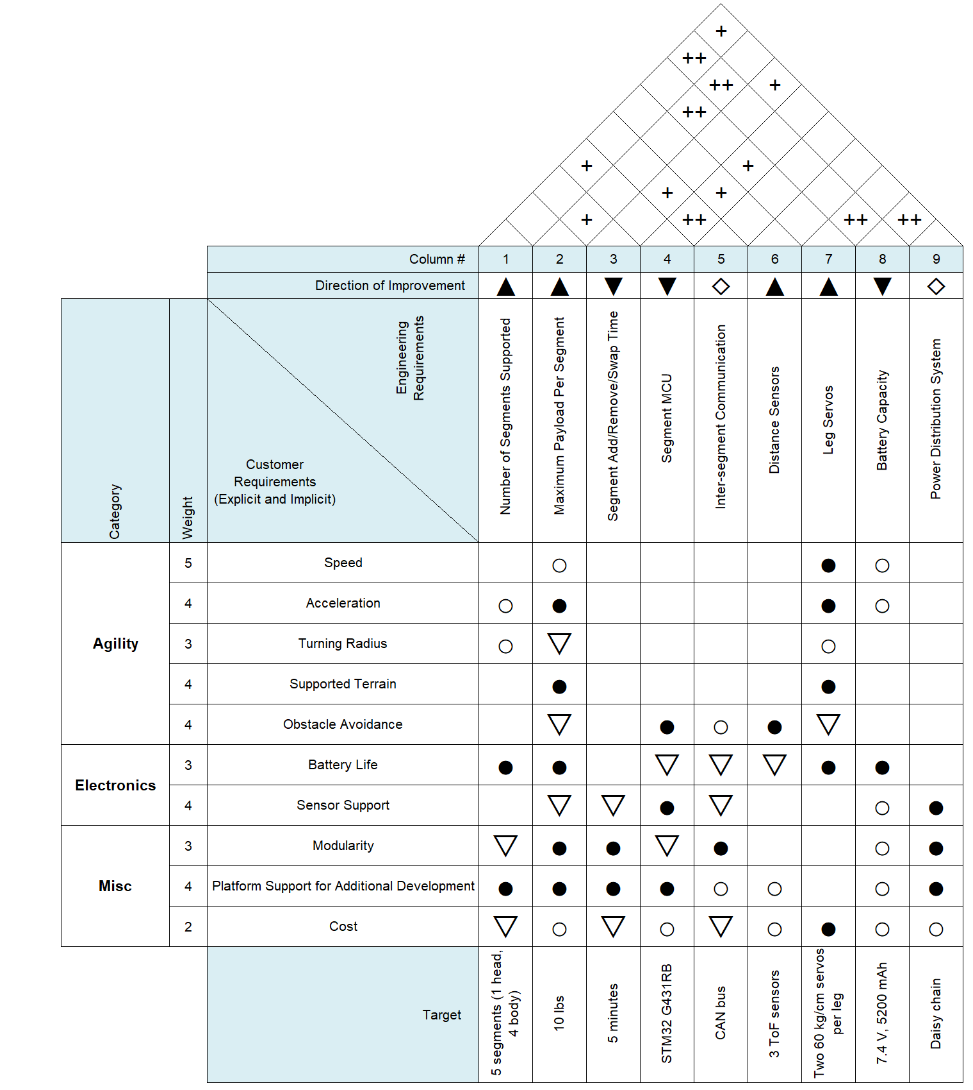
Figure 1: House of quality
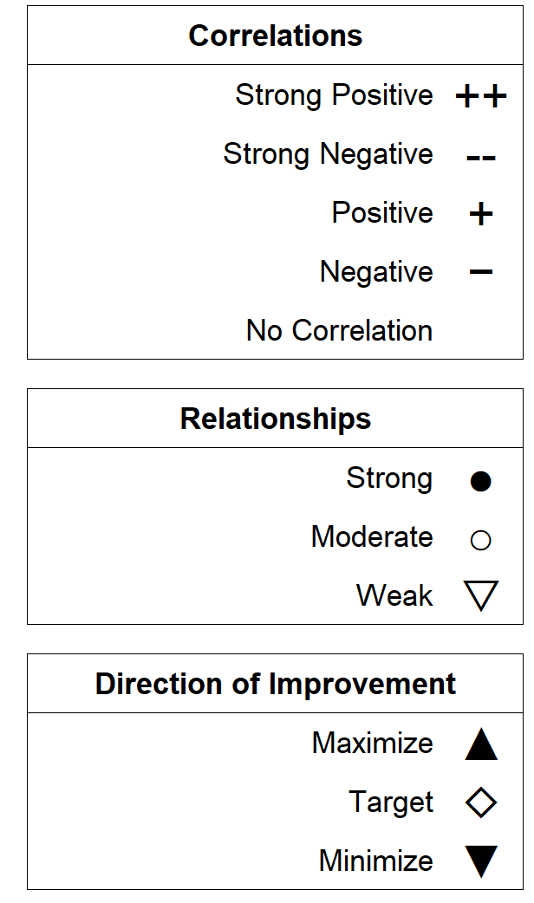
Figure 2: House of quality legend

Section 2.5: Block Diagrams

The diagrams shown in Figures 3 and 4 give a high-level understanding of the hardware and software on the myriapod robot and how these components interact with one another. Since the myriapod robot is a distributed system, each MCU only has to calculate the commanded angles for the servos in its segment, reducing the load on the head MCU and potential latency as more segments are added.

Section 2.5.1: Hardware

All blocks have been purchased.
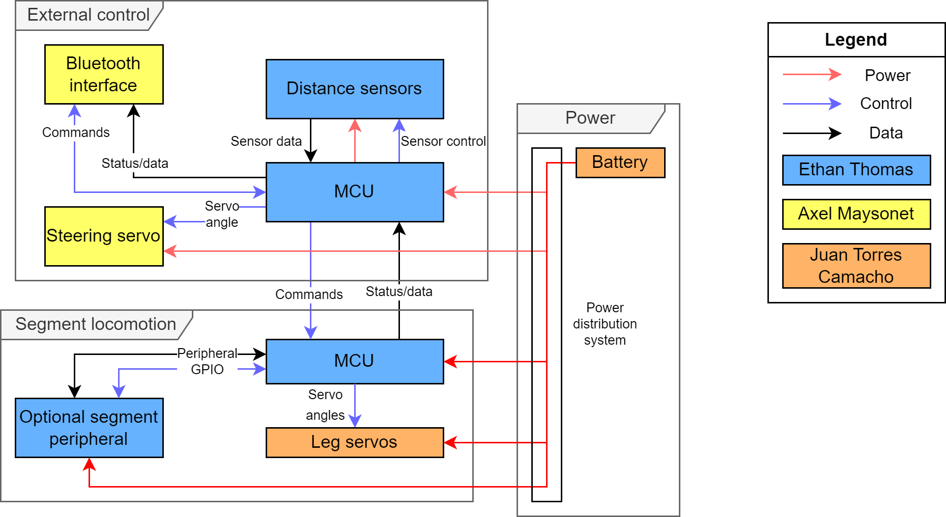
Figure 3: Hardware block diagram

Section 2.5.2: Segment Software

All blocks have been implemented.
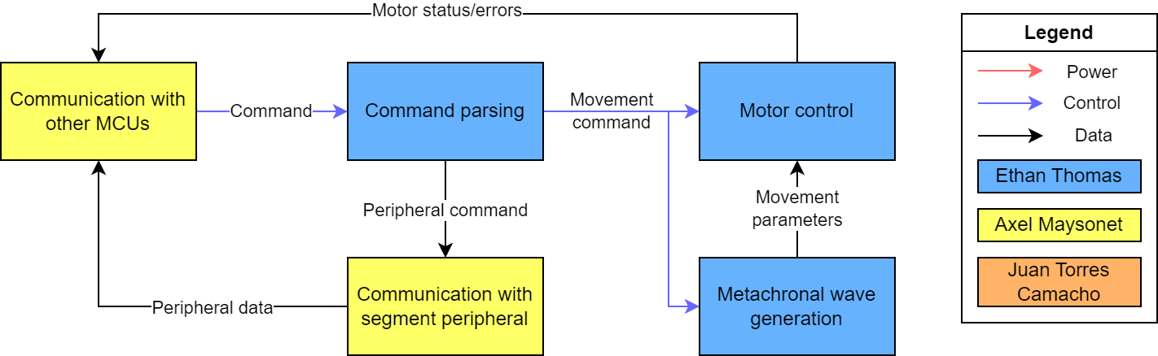
Figure 4: Software block diagram

Chapter 3: Technology Investigation and Part Selection

Section 3.1: Hardware Technology Selection

Section 3.1.1: Battery Technology
Choosing the correct battery for a robot is important if we want reliable and efficient operations. The battery serves as the robot's primary power source, influencing its runtime, mobility, and overall performance. The right battery selection ensures that the robot can operate for extended periods, meet its voltage and current requirements, and remain within size and weight constraints for optimal mobility and maneuverability. Battery safety features and compatibility with the operating environment are also crucial factors to prevent hazards and maintain reliability. Cost-efficiency and scalability considerations also play a role in selecting a battery that aligns with the robot's requirements while balancing budget constraints. Ultimately, the choice of battery directly impacts the robot's functionality, capabilities, and its ability to fulfill its intended tasks effectively and safely.
We have several battery options at our disposal, each with distinct advantages and disadvantages. Among the battery compositions under consideration are Lead Acid, NiMH (Nickel Metal Hydride), Lithium-ion (Li-ion), and Lithium Polymer (LiPo). Table 2 provides an overview of the pros and cons associated with each battery composition, offering valuable insights into the decision-making process.
Battery Comp. | Self-discharge  (per month) | Cycle Times | Temperature | Specific Energy Density(Wh/kg)
Lead Acid | 3% – 5% | 500 - 1200 | -20C to 50C | 30-50
NiMH | 30% | Up to 500 | -20C to 70C | 60-120
LiPo | 5% - 10% | 500 - 1000 | -20C to 60C | 140-200
Li-ion | 5% - 10% | 500 - 1000 | -20C to 60C | 90-190
Table 2: Battery technology comparison
After thorough research on the batteries types compared in Table 2, it became clear that either lithium-ion or lithium polymer could suffice for our project's needs. However, the lithium polymer battery emerges as the preferred choice. While a side-by-side comparison of their specifications reveals minimal differences, the lithium polymer battery offers a distinct advantage in terms of safety. This heightened safety aspect is of great importance, particularly when considering potential damage during handling. It gives confidence that the battery will not pose a risk of explosion in the event of an unexpected accident. Additionally, we must consider the future applications of our centipede, which may involve navigating through areas where the battery could be vulnerable to external factors that might puncture it. In such scenarios, the assurance of a non-explosive battery significantly reduces the risk of damage to the entire system.

Section 3.1.2: Distance Sensor Technology
In order to pick the best technology for the distance sensors on the myriapod robot, we must first consider why they are necessary in the first place. It is necessary to integrate such sensors in the robot to realize obstacle avoidance, one of the software requirements of the robot.
While some cameras have integrated depth/distance sensors, having one or more dedicated distance sensors would enable the robot to more quickly react to changes in its environment and adjust its path accordingly. This is due to the fact that most distance sensors measure the distance relative to a single point or a small grid of distances instead of a high resolution depth image or point cloud, such as those produced by an RGBD camera. Normally, a higher resolution “image” would be preferred over a single value because the increased precision would enable the robot to better see its environment and detect objects. However, the lower point count of most distance sensors is actually advantageous in this case. It greatly reduces the amount of data that needs to be processed by the device reading the data from the sensor. Less data requires less time to analyze and less computing power to process. As a result, data from a distance sensor could be parsed by a less powerful device like one of the microcontrollers on each segment instead of the main SBC. In addition to offloading a task from the main SBC, the smaller data size enables the MCU reading the sensor data to parse the data much more frequently, reducing the robot’s reaction time to obstacles.
Given the purpose of the distance sensors on the myriapod robot, the attributes of interest for the distance sensors are field of view, update rate, and measurable range. The main types of distance sensors are ultrasonic, infrared, and time-of-flight (ToF) sensors and their typical values are compared in Table 3 below.

Technology | Measurable Range | Field of View | Update Rate
Ultrasonic | 4 m - 6.5 m | 15° - 50° | 10 Hz - 40 Hz
LiDAR | 10 m - 180 m | 0.5° - 3.6° | 1 Hz - 1 kHz
Time-of-flight | 0.1 m - 4 m | 15° - 90° | 10 Hz - 50 Hz
Table 3: Distance sensor technology comparison [11][12][13]

The field of view of a distance sensor measures the angle of the cone of perception in front of the sensor. Larger angles result in wider cones of perception. Wider cones enable the sensor to detect objects more off center from it. This is advantageous because fewer sensors can be used to cover the same volume in front of the robot. Update rate is the maximum frequency at which the sensor can take measurements. Higher update rates decrease the sensor’s reaction time to obstacles, giving the robot more time to take the appropriate action and avoid the obstacle. Measurable range represents the shortest and longest distances the sensor is rated to measure. Similar to update rate, a higher maximum range enables the robot to detect objects from further away which could give the robot more advanced warning than a sensor with a shorter maximum distance. Conversely, a lower minimum range increases the chance that the robot will successfully detect obstacles close to it and report the correct distance from the robot to the object.
Ultrasonic distance sensors can be a good option for prototyping due to their ease of setup and low cost. While the other two technology options use an established communication protocol (e.g., UART or I2C) [12], ultrasonic sensors typically use two digital signals: one to trigger the sensor to take a measurement and one to signal when the sound is reflected back to the sensor[13]. Given the time between these two signals, it is trivial to calculate the distance measured by the sensor using the distance formula (distance = rate * time) and the speed of sound (343.14 m/s at 20°C)[14].
However, these sensors are difficult to integrate and protect in a final product. Unlike the other options in Table 3, the space between the ultrasonic sensor and its target must be completely unobstructed, meaning that the sensor must either be completely exposed or have a specially designed shield to allow sound to pass through while still protecting the sensor. As a result, this sensor technology is not suitable for the intended applications of the myriapod robot, which might place these sensors in harm’s way.
LiDAR distance sensors are exceptionally good at measuring long distances and reporting said distances an order of magnitude more frequently than the other technologies. As shown in Table 3, these sensors can report at up to 1 kHz which is an order of magnitude greater than the other options. Additionally, these sensors can be easily protected in a chassis through the use of window lenses, or exposed if robustly designed, making them a good option for the myriapod robot.
This sensor technology could be useful in an application-specific add-on segment for the myriapod, but are unsuitable for obstacle avoidance due to their extremely narrow field of view. While the other options have a field of view in the range of 15° to 90°, the field of view of most LiDAR sensors is typically less than 10°.
The best distance sensor technology for obstacle avoidance is time-of-flight (ToF) because it is easy to integrate and protect in a chassis, is more cost effective than LiDAR for this role, and can detect a grid of distances in front of it instead of a single point. As mentioned in the analysis of ultrasonic distance sensor technology, it is important to protect the sensor from damage by shielding it behind the robot’s chassis. However, unlike LiDAR sensors, ToF sensors are frequently sold as bare sensor chips [12] or development boards [11]. This is a double edged sword because on one hand, the sensors are physically smaller, reducing the design impact from integrating them. On the other hand, care must be taken when designing the frame around the sensor to reduce the chance of foreign object debris (FOD) coming in contact with it. That being said, a simple enclosure and lens should provide sufficient protection for most applications.
The last feature, multi-zone distance measurement, is of particular interest due to the extra information it provides and the features it could support down the line. While choosing the sensor technology that provides the most data points out of the other technologies might seem contradictory to the discussion at the beginning of this section, the amount of distance points these sensors produce is still orders of magnitude smaller than full-resolution depth images from an RGBD camera [15]. Additionally, some sensors support programmable grid sizes, meaning that the number of distances the sensor measures and reports can be tailored to its application [15]. In the case of obstacle detection for the myriapod robot, a grid resolution of 2 by 2 distances, reporting a single average value, or using a single zone ToF sensor will likely be enough to satisfy the basic obstacle avoidance requirement. If more complex obstacle avoidance is required, the single zone ToF sensors should be replaced with multi zone ToF sensors.

Section 3.1.3: Optical Flow Sensor Technology
The robotic centipede needs to know where it's going if it's going to be able to traverse any type of terrain. One of the primary ways it will do this is by using an optical flow sensor. This sensor will have the ability to inform the robot of the space in front of it. In essence, like many animals, it will be able to make sense of how objects move in real time merely by observation. This is optical flow, the way an observer may perceive the movement around them as they travel in space.[43]185
An optical flow sensor’s responsibilities are to not only contextualize when the objects around them move, but also to acknowledge one's own movement as well in an environment. Its intention is to send information of distances and velocities to an MCU to then be interpreted. The sensor’s job is not to tell you how to move. Instead it's to tell you how far away objects are and the speed at which they are coming towards you. In a person or animal, the brain will immediately understand subconsciously that the environment moving backward, is the act of moving forward. This assessment is not thought about at all, since instead it happens naturally and automatically. However for a camera sensor receiving image data, it will only see a splotch of blurred pixels and not be able to interpret the significance of the lack of detail in the image. Furthermore, this is not an impossible problem to solve. Computer scientists and mathematicians over the years came to realize that all of these blurring effects have a pattern that can be traced. If one has a camera actively recording video data, 30 frames a second, and all of the sudden for 60 frames pixel gradients appear to be consistently shifting in a direction, one may be able to concur that the subject holding the camera is moving. In fact if you take the frames and compare them to one another, the software may be able to notice how a certain segment of pixels seems to repeat on each frame but appear in a different location. This shifting of segments of pixels, if interpreted correctly, can allow a sensor to decipher this phenomena as movement. [44]457
There are a multitude of competing and complementing methods to interpret image data through camera or sensor data, and as such there is an entire field within computer vision dedicated to this conundrum. Nevertheless, when it comes to an optical flow sensor for the robot centipede, we are only concerned about one thing: the getting from point A to point B. That is, a sensor that allows the robot to have an understanding of its obstacles and provide data that informs the MCU or servos when and where to move. The optical flow of any object can be interpreted as a function of space over time, and attempting to process image data in motion, means taking the derivative of the new/next image. In other words, deriving where pixels came from and how they shifted causes patterns to emerge that can be interpreted as data to be collected and analyzed. [44]435
Optical flow sensor technology and mathematics have a long and well documented history as scientists and engineers kept striving to improve their algorithms and ability to read apparent flow. Refined techniques can amass a massive amount of computation in the pursuit of more detailed information about object motion and their environments. This is without mentioning the considerable role that artificial intelligence and machine learning has taken on in this space, allowing for even more modern, complex optical flow tech. For decades, scientists have been trying to get around the glaring complications like smoothness and brightness. For context, in the computer vision field, preceding tools relied on detecting pronounced features on surfaces to then store that information. [45]53 These pronounced features could then be utilized in optical flow problems to be able to correlate the translation of the objects. The issue that arises from this is if that surface did not have any pronounced features or if the lighting was too dark to distinguish details, the sensor wouldn't be able to detect anything. [43]188 This is why AI or various new solutions have been introduced to circumnavigate these obstacles of optical flow computing.
When it comes to distinguishing between the types of optical flow sensor technology, it can be readily split into two sub categories, sparse optical flow and dense optical flow. [44]438 Choosing the most suitable version for any application of this technology greatly varies by circumstance as both have their own strengths and weaknesses. In a sparse optical flow system, or low frequency, one will notice that the information it stores can be far in-between. This can be attributed to the fact that when the optical flow is sparse, the sensor will actually observe and store less points of interest or detail. With the idea of conserving computational power, it will limit itself to tracking a small amount of points. Conserving computational power can lower costs, increase battery life and overall be more efficient. This is in considerable contrast to the dense optical flow sensor, or high frequency. Here, thanks to its inherent density of points and pixels, it will track all of the possible points of interest within a given field of view of the sensor. What this results in is a more complete map of the environment it is tracking. A dense flow sensor will be able to recognize almost any movement thanks to its redundancies. This ability, however, comes with its own negatives. Having a sensor compute all of this information immediately proves to be vastly more expensive than choosing a few key points. Depending on the application at hand it may or may not be beneficial to satisfy its expensive computational power
After obtaining a solid foundation of understanding for what optical flow is and what it means for us as humans or a sensor, one should delve into the calculations. As one may be able to deduct, calculating an environment's optical flow or image displacement can get complicated exponentially depending on circumstance. Despite that, it all begins with one decently simple function, $I(x +dx, y +dy, t +dt)$. This equation represents the displacement of an image region and can also be rewritten as $I(x, t) = I(x +dx,t +dt)$. The function I is equal to the image intensity and can be used to equate the movement of a pixel or segment. A sensor's ability to detect motion is thanks to the items in its ability to also detect objects with its environment. [44]435

When a sensor is trying to compute its optical flow there are several issues that may arise that will hinder its effectiveness. When referring to optical flow in nature, it is unaffected by the lighting conditions. In contrast, algorithms need as much illumination as possible to effectively detect edges and features as mentioned previously. If the sensor tries to estimate its motion from a limited dataset, this will hinder its ability to inform any mcu or chip of movement. Similarly, if the scene contains transparent or translucent surfaces it adds another layer of complexity for the sensor to deal with. Additionally, sensors will read translational motion, with rotational motional potential influencing that movement’s ability to be detected. Optical flow sensors relate to objects with translational movement and rotations can be attributed to some of that optical flow as well. However if the rotational proves to be too substantial, it will inhibit the translational movement data, and thus should be avoided if at all possible. [45]45
In situations like these, it is worth exploring all of the possible alternative solutions to the optical flow problem. Possible ways of solving for optical flow may include intensity-based differential methods, multiconstraint methods, frequency-based methods, correlation-based methods, multiple motion methods, and temporal refinement methods. [44]440 Delving into these various methods is out of the scope of this report however, all of the options should be carefully reviewed when eventually applying the sensor to the robotic centipede.

Section 3.1.4: Leg Motor Assembly Technology
The main requirement of the myriapod robot is that it is a mobile platform, so choosing the right motors for the job is critical for the project’s success. Given the scope of the project and limited time to build it, complete motor assemblies will likely be used instead of sourcing the individual mechanical components. Opting for a premade assembly eliminates the need to design, assemble, and debug a custom assembly. While a custom assembly could be better in theory since it could be tailored to the exact mechanical specifications needed, the benefits from doing so do not outweigh the aforementioned time cost of doing so. As a result, the mechanical design of the robot will be designed around the selected premade motor assembly type, not the other way around. As shown in Table 4, motor assembly types will be compared based on their rotation range, need for external supporting components, and control system. Each evaluation criterion is explained below.

Assembly Type | Rotation Range | Required External Support Components | Control System
Direct Drive | Continuous | Motor driver, encoder | None
Geared Stepper | Continuous | Motor driver, encoder | Open-loop
Geared Servo | Limited or continuous | None | Closed-loop
Table 4: Leg motor assembly technology comparison

Rotation range can either be limited or continuous. Limited rotation implies that the motor assembly cannot turn more than 360°, while continuous rotation implies that it can. Given that the myriapod legs will likely not be capable of rotating more than 360°, an absolute rotary encoder will almost certainly be necessary to allow the robot to “home” each leg motor and prevent them from crashing into each other during operation or if they become desynchronized (e.g., if the legs moved when the robot was off).
A rotary encoder is a type of sensor that determines the angular displacement of the object it is measuring. There are two main types of encoders: absolute and incremental. An absolute encoder always knows the exact angular displacement of the object, even after power-cycling, because the value it measures is encoded in the measurement ring attached to the object. However, this type of encoder can only measure one complete rotation. As a result, special considerations will need to be made if an absolute encoder is used to measure the angular displacement of an object designed to rotate continuously. Incremental encoders measure relative angular displacement and pair well with continuous rotation applications. If an absolute angular displacement is desired from an incremental encoder, the object will need to be moved to a “home” position. After the object is homed, the incremental encoder measures an absolute angular displacement from the home position.
The need for external supporting components is defined as the electrical and mechanical components needed for the motor to function both electrically and mechanically such as motor drivers, closed-loop control hardware, rotary encoders, and gearboxes. Supporting components add cost and complexity to both the mechanical and electrical design. Ideally, supporting components would either not be required by the selected motor technology or integrated into the assembly to reduce their impact on the design of the robot. Additionally, components like custom motor drivers and closed-loop control hardware require tuning to be effective, increasing the integration time and difficulty. Control system refers to the type of control, if present, used in the motor assembly. These are usually categorized as either open-loop or closed-loop systems as shown in Figures 5 and 6, below.
Figure 5: General open loop control system

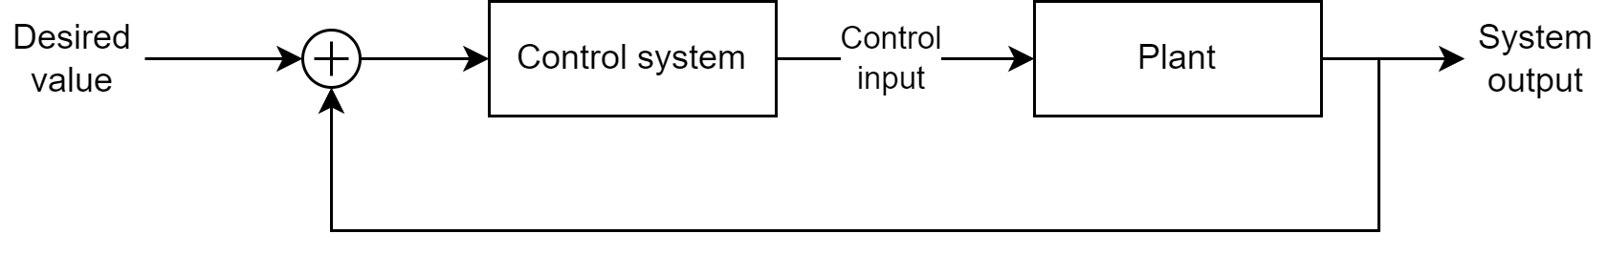
Figure 6: General closed loop control system

Given the significant number of moving parts in both a single myriapod leg and the robot as a whole, a control system of some kind will almost certainly be necessary. Open-loop control systems convert a command from an external source (e.g., an MCU) to the electrical signals necessary to drive the motor to that position. However, the control system itself has no information about the actual state of the motor it is controlling. As a result, it cannot account for external torques applied to the motor shaft and take corrective action to ensure the motor maintains the correct speed or torque. Something to note is that if the control system is external to the MCU, the entire control system will be open-loop with respect to the MCU commanding it. An additional feedback path from the control system to the MCU could be added if necessary, but this adds cost and complexity to the electrical and software design.
Direct drive is another way of specifying that the motor output shaft is directly connected to the mechanical load that it is supposed to turn. There are no gears, belts, or other mechanisms in the path between the motor and the mechanical load. This greatly simplifies the mechanical design and removes many wear parts that turn into points of failure down the line. This means that the motor needs to have enough torque to drive the mechanical load by itself, without the torque gained from connecting it to a gearbox. While this does usually equate to needing a more expensive motor, the cost from omitting the gearbox reduces the impact of this cost increase. However, some of the parts absent in direct drive assemblies such as motor drivers and rotary encoders are necessary for the leg motors in the myriapod robot. If this assembly type is selected, these parts would have to be externally sourced and tested, adding to design cost and complexity. Finally, an external closed-loop controller would need to be implemented for each motor to control their motion and prevent the legs from crashing into each other. As a result, direct drive is not the right assembly type for the myriapod’s legs, at least for the scope of this project.
As the name suggests, a geared stepper motor assembly combines the torque from a gearbox with a precision of a stepper motor. This assembly type could work for the leg motors due to the exceptional precision and torque it provides. Additionally, the open-loop control system used to drive the incremental rotation of a stepper motor provides some level of confidence that the motor rotated to the angular position to which it was commanded. However, this open-loop control system is also one of the main reasons why this assembly type is not the right choice for this project. As mentioned in the rotary encoder discussion above, the angular displacement of a load must be interpreted relative to the starting position until the load is moved to a known home position. Normally, this is not an issue as the system can home each motor on bootup and move on. However, given the complexity of the myriapod design, the homing problem becomes much more complex due to the possibility of legs colliding with one another and the sheer number of motors in the robot. While the issue of legs colliding with one another could be resolved by providing sufficient space between each segment and shortening the legs, such modifications add complexity to the design that could be avoided by choosing a different control scheme. While most stepper motors are run open-loop, it is possible to run a stepper motor with a closed-loop control system. However, this presents another issue: buying geared stepper motors and encoders (integrated or external) significantly increases the cost of each assembly. As a result, this assembly type is not the right choice for this project.
A servo motor is any motor assembly that has a built-in closed-loop controller [41]. As a result, any motor technology could be converted to a servo mechanism if controlled with a closed-loop controller. With that in mind, the reason they occupy a separate category compared to the other assembly types is that all parts of a servo motor (motor, driver, closed-loop controller, gearbox, etc.) are physically integrated into one unit. This feature is of particular interest because such assemblies are usually smaller than creating a servo mechanism from external components, which means they fit better into the limited space available on the myriapod platform. This integration also simplifies the electrical design as most hobby-grade servos only require three wires (power, ground, and position) [41]. In addition to requiring the fewest wires, the position control scheme for servos is also the simplest of the three candidate assembly types. Most hobby-grade servos use pulse-width modulation to encode a position command for a servo, which is trivial to implement using a timer on an MCU. Additionally, a single MCU timer usually has multiple channels, meaning that a single MCU timer can be used to drive multiple servos. This greatly simplifies the design as each segment would only require a single MCU to handle all servos instead of one MCU for each servo.
The main benefit of this assembly type and why this assembly type was selected is the integrated closed-loop controller. Not only does this free up the myriapod segment’s MCU for other duties, but it also provides much more reliability than open-loop control (or no control at all). For all intents and purposes, when the segment’s MCU sends a position command to the servo, it can be assumed that the servo will make it to that position and stay there until a new command is received. That being said, the servo is technically open-loop with respect to the MCU, so a servo with a feedback output would need to be purchased if the MCU needed the actual position of the servo shaft.
That being said, servo motors (especially the hobby-grade ones used for this project) are not perfect. Many closed-loop controllers used in these servos use potentiometers with a limited rotation range. As a result, servos with these controllers have a limited rotation range. While continuous rotation servos exist both in the concept of a servo mechanism made from discrete components as described above and as actual products [42], most hobby-grade servos are non-continuous. The limited range of this assembly type is actually an advantage because the myriapod’s legs should not be able to rotate more than 360°, so having a motor assembly incapable of doing so should reduce the risk of the legs crashing into other legs or the myriapod’s body.

Section 3.1.5: Wireless Communication Technology
Given that teleoperation by the user is a main hardware requirement for the robot, it is necessary to determine an adequate method for the user’s device to communicate with the robot. While a wired communication method like serial or directly attaching to the robot’s internal CAN bus would work, limiting the robot to wired-only teleoperation significantly reduces its flexibility and viability as a robotic platform. As a result, there needs to be a wireless communication interface of some kind implemented on the robot. Given that the robot has a CAN bus for internal communication, only one interface to this technology will be necessary.
The following technologies will be evaluated by their nominal range, data rate, power consumption, network topology, device compatibility, and implementation complexity. Range is defined as the maximum distance a stable connection can be established and maintained between a client device and the interface to the given technology. Both open-air and inside environments are considered to provide a more complete picture. Data rate is defined as the rate at which data can be transferred from one point to another using the given technology. Power consumption is defined as the maximum power consumed by the interface during transmission or reception. Note that average power consumption of the interface depends on the duty cycle of time spent in transmission/reception to idle time in addition to this value. Network topology is defined as the typical structure for a communication network using the given technology. This also includes the requirement for any additional hardware necessary for the network to function. Device compatibility is defined as the typical class of device that incorporates a given technology. The more classes of devices that support this technology as well as the width of those classes, the better the technology is for both the project and the viability of this robot as a foundational platform. Implementation complexity is defined as the software complexity required to implement basic communication between a single MCU on the myriapod and an external device using a given technology.
The wireless communication technologies of interest are WiFi, Bluetooth, and Long Range (LoRa), and their typical values for the main evaluation criteria are summarized in Table 5 above. Note that the values listed in Table 5 are based on hardware that can be readily embedded on a PCB and are practical to install on the robot, rather than the actual best value supported by the technology.

Technology | Range | Date Rate | Power Consumption | Network Topology
WiFi | 50 - 200 m | 20 - 30 Mbps | ≤ 792 mW | Infrastructure, ad-hoc, mesh
Bluetooth | 25 - 125 m | 125 Kbps - 3Mbps | ≤ 165 mW | Point-to-point, broadcast, mesh
LoRa | > 15 km | 0.3 Kbps - 50 Kbps | ≤ 400 mW | Star-of-stars
Table 5: Wireless communication technology comparison [69][70][74][75][76][77][78][79]
WiFi is a strong candidate due to its long range, high data rate, and near-universal adoption on modern devices. The range would allow the user to pilot the robot almost anywhere in a reasonably large room, even with obstructions such as walls. While longer range WiFi interfaces with higher transmission power exist, such interfaces are either too large or too power hungry for the myriapod robot. Being the fastest option out of the candidate technologies, it could be the ideal choice if multiple high-bandwidth sensors and cameras are connected to the myriapod. However, the current scope of the robot does not require such high bandwidth, so the main advantage of picking this technology would be wasted. WiFi’s near universal adoption on modern devices would significantly open up the myriapod robot as a platform for external development as software could be written for any WiFi-capable device to interface with and control the robot. That being said, WiFi is more complex to implement, requiring most of the OSI Network Stack to design even a simple application. While this would leave much more room for high-level features to be implemented down the line, it is overkill for the current scope of the project and the software controlling the robot. That being said, a WiFi interface could be connected to the expansion headers on one of the segments, so WiFi functionality could be added without redesigning the PCB. Additionally, while WiFi can be used for point-to-point communication using an ad-hoc network, connecting to the robot would tie up the single WiFi interface on most devices, possibly preventing them from connecting to the internet. This could be mitigated with an external access point to which both the robot and the controlling device connect, but requiring such a device would make it more difficult to use the robot without an access point.
Bluetooth is the best communication for the myriapod robot due to its support point-to-point communication, sufficient data rate, low power consumption, and low implementation complexity. Instead of needing an entire HTTP or websocket application to communicate with the robot, Bluetooth acts as a wireless serial terminal to the robot, meaning that the communication protocol could be reduced to simple text strings. This greatly simplifies the implementation and should reduce the time needed to integrate this technology into the software stack. As a side effect, this would also enable the robot to be controlled via a wired serial terminal commonly used for debugging. This almost gives us a “free” command line application for teleoperating the robot or when debugging wireless communication. Given that the current requirements only require that simple commands and responses be supported by the robot, even the slowest 125 Kbps Bluetooth PHY should be fast enough to satisfy the requirements.
Long Range Wide Area Network (LoRaWAN) or simply LoRa has the longest range out of the candidate technologies by several orders of magnitude and is optimized for low-power extended run applications. As a result, it also has the slowest maximum data rate of the three candidates, because such applications (e.g., geolocation tracking and IoT devices) [79] typically require minimal bandwidth. While this data rate might be sufficient for the robot’s current goals, it limits future expansion more than the Bluetooth’s low speed. Additionally, while this technology supports exceptionally long communication ranges, most of this range will be wasted for the current goals of the robot, most of which involve tele-operating the robot either in the same room or line-of-sight of the user. If the intended application for the myriapod requires long distance communication or needs to connect to LoRa devices, a LoRa interface could be connected to the expansion header on a segment. However, the main reason why LoRa was not chosen for the myriapod was that it is not commonly supported by phones and laptop computers. This is a major concern because it severely limits the devices that can control or interface with the myriapod and is contradictory to the project’s purpose as a general foundation on which to build.

Section 3.2: Part Selection

Section 3.2.1: Segment Microcontroller Unit
The modularity requirement defined in Chapter 2 is satisfied relatively easily by making the myriapod robot a partially distributed computing system. The system is partially distributed in the sense that computation is not centralized to one component, but all components do report to and receive commands from a central computer. In the myriapod robot, each segment will have its own microcontroller to communicate with and execute commands from the single board computer in the head segment. Such commands could be for movement, segment status, or to execute a segment-specific function (e.g., read the sensor on one of the segments). The last item is of particular importance because one MCU should be able to interface with most peripherals, eliminating the need to source a different MCU for each unique peripheral to be supported.
In general, the microcontroller on each segment will need to have several communications interfaces, sufficient GPIO pins, timers for generating control signals and triggering events, and a math coprocessor. The communications interfaces are for communicating with the main computer, other segments, the segment’s peripherals, and for interfacing with external debuggers and programmers. Common communication interfaces found on microcontrollers include Inter-Integrated Circuit (I2C), Serial Peripheral Interface (SPI), Universal Asynchronous Receiver Transmitter (UART), and Controller Area Network (CAN). Most peripherals support either I2C or SPI, so requiring the chosen MCU to both interfaces enables support for the majority of the peripherals and sensors we would connect. UART is commonly used for serial communication, usually to print information to a terminal or communicate with other peripherals. CAN, albeit designed for automotive applications [7], is frequently supported by MCUs for many different applications and can enable communication between components of a larger system. In the case of the myriapod robot, CAN will be used to transmit data to and from the single board computer and the segment MCUs.
The chosen MCU should have enough GPIO pins to communicate with the leg servos and interface with the segment’s peripherals. While communication pins are sufficient for most peripherals, limiting connection options to only communication pins limits functionality on peripherals that have more pins and significantly increases the difficulty interfacing with peripherals without a communication interface.
The timers will mainly be used for controlling the servo motors in the myriapod’s legs. The rotational position of a common hobby servo, like the ones selected for the legs, is controlled by sending a pulse width modulation (PWM) signal, and timers excel at generating these signals. Additionally, many timers in STM32 microcontrollers, like the ones mentioned below, often include special modes designed for generating these signals, further reducing development complexity.
The math coprocessor will likely be necessary for generating the metachronal wave used to control the myriapod’s legs. While software support for advanced math functions exists, an MCU with a dedicated math coprocessor could free up the MCU for other tasks, increasing reliability.
Even if a given MCU were to have all the features described above, it would only be a candidate if it could use all of them at once. The features in many MCUs, including the ones mentioned below, are frequently dependent on which other features are currently enabled. It is not uncommon for an MCU to have an abundance of peripherals, only for many of them to become unavailable as more are activated and configured.
Finally, the chosen MCU should have a development board available from the manufacturer. While this limits the total pool of MCUs to consider, being able to develop on one MCU during prototyping and put that same MCU on the final circuit boards would reduce any MCU-specific issues not encountered during prototyping.
All of the candidate MCUs shown in Table 6 below were chosen from STMicroelectronics due to their exceptional software support and the group’s past experience working with them. This software support comes in the form of STM32CubeMX, which provides a GUI for easy configuration of chip pins and peripherals. It also automatically generates the majority of the setup code needed to run software on these microcontrollers. For example, instead of having to hunt for the specific registers and hardware abstraction library (HAL) functions for changing the mode of a pin, each pin can be selected graphically in STM32CubeMX and its desired role chosen from a simple drop down menu as shown in Figure 7. When the project is generated, STM32CubeMX creates the initialization routines for these pins, greatly reducing development time. Pins used by activated peripherals are also displayed on the chip to make it clear which pins are in use and which are free for other tasks.

MCU | I2C | SPI | CAN | Timers | Math | Speed | Pins | Unit Cost for 10+ Units
STM32F446RE | 3 | 3 | 2 (std) | 14 | No | 180 MHz | 64 | $11.24
STM32G431RB | 3 | 3 | 1 (FD) | 12 | CORDIC FMAC | 170 MHz | 64 | $6.15
STM32H563ZI | 4 | 6 | 2 (FD) | 20 | CORDIC FMAC | 250 MHz | 144 | $10.87
Table 6: MCU comparison [8, 9, 10]
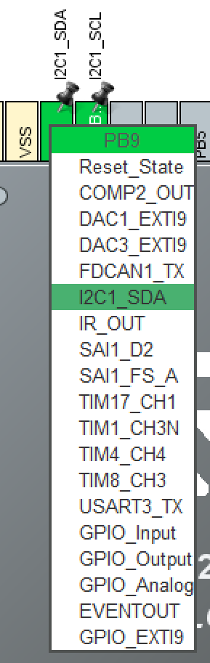
Figure 7: STM32CubeMX pin configuration example

While the team is most familiar with the F446RE, its lack of a math coprocessor, combined with its higher price prevent it from being selected. However, if it is discovered that the math coprocessor is not required and/or additional CAN interfaces are required, it could work in place of the G431RB. Additionally, both the F446RE and G431RB share the same LQFP64 package [8][9]. This simplifies the process of switching them in the event the former is selected.
The G431RB is the best chip for the job compared to the other two because it meets all the requirements listed above for the lowest price per unit, and it has CORDIC and FMAC math coprocessors, which can be used to accelerate trigonometric functions and DSP/filter math, respectively [8]. Unlike the F446RE, its CAN interface is a flexible data rate CAN (FD-CAN) interface which, among other things, supports higher data rates and variable frame sizes [7]. Such features could be useful when designing the communication between the single board computer and the segments as it would allow more data to be transferred on the same bus, reducing the need for a second CAN interface, and make the communication protocol specific to the robot easier to design and implement. That being said, whether the CAN peripheral can actually be used in FD-CAN mode will depend on whether that mode is supported by the SBC and the transceivers used to connect CAN devices.
The H563ZI is the fastest MCU in the lineup and the most feature-rich, but this comes at the price of a significantly larger footprint. Unlike the other chips, it comes in an LQFP144 package instead of a LQFP64 package [10]. These pins could be used to accommodate more complex peripherals and more of them. However, given both the anticipated physical scale of the robot and this project in general, it would be overkill to dedicate one of these to each segment. Most of the advanced features that this chip supports [10] would go unused, meaning that both the money and space needed to select this chip would be wasted. Finally, unlike the other two chips, this chip is not available to buy directly from STMicroelectronics [10]. This makes it substantially more difficult to source and purchase than the other two chips. This could cause problems when we need to buy more chips, especially during the prototyping stage or if we need to make a last minute repair.

Section 3.2.2: Turning Servo Unit
When deciding on what servo to select, it can be a challenge to know which one exactly is right for the job. Servo motors are essentially precise, rotating motors that allow you control the angle of the rotation shaft. Furthermore, it can be difficult to choose the best servo motor for the task when essentially, they all serve the same or similar purpose. Even after extensive research of different servo motors, it was observed that each of the brands only had slight differences in specifications. Regardless, it was important that we chose the right servo that best meets our requirements. The servo, chosen for the robotic centipede turning servo task, was the MG996R 55g servo motor, due to its overall advantage over other similar servo motors. However, it’s important to discuss the two other servo motors that were considered; the Smraza 20KG Digital Servo Motor and the BETU 25KG High Torque RC Servo. When choosing the most suitable turning servo for our centipede project, we have to consider all of the characteristics that will affect how the robot performs. This includes but is not limited to dimensions, weight, operating speed, torque materials used, turning angles, operation voltage and price.
The dimensions of an object are the measures that define its volume or spatial magnitude in 3D space. For a servo motor, putting its proportions into consideration is crucial in design creation. We need to be able to produce a design that incorporates the motor sizes perfectly, with little room for error if the DC motor or servo is too large for the design. For our robotic centipede, component size is a big consideration due to the fact it is still supposed to resemble a centipede when finished. The Smarza servo motor and the BETU servo motor have similar dimensions as listed in Table 7. Although these two sizes are unproblematic, we leaned towards the MG996R’s dimensions since saving on the width size will help in the final design of the robotic centipede. Despite this, it's worth noting when it comes to dimensions most likely any of these servos could have worked given that we modify the robots design proportions. The operating speed, or turning speed, of a servo motor is the speed at which the rotating shaft is able to turn at a given range of angles. When utilizing servos, knowing its operating speed can be essential to understanding its limits. Depending on the application, you may want a faster or slower operating speed. For the purposes of the robot centipede, a servo motor that was balanced in its speed performance, was preferred. Since the servo motor will be used as a turning servo, speed may not necessarily be a priority. Instead, a servo’s torque is much more important of a consideration. The BETU servo has a speed of 0.15 seconds at 60 degrees, using 5V, while the MG996R has a speed of 0.17 seconds at 60 degrees using 4.8V. The difference is not major but the BETU motor does have a faster turning speed. Compared to the Smraza which has a 0.18 second/60° turn, the MG996R falls in between the two and inhibits a favorable balance.
The “weight” as listed by the manufacturer could be interpreted as the mass of the object, and is relevant when considering how much the robot is able to lift. It's worth noting that weight is usually attributed to force exerted by gravity, but in this scenario the manufacturer may have meant to list it as mass. The weight is usually only a major consideration for the other components of a design after choosing a motor. However, the weight of the servo does contribute to the total mass, and it is beneficial to minimize this value. As shown in Table 7, the chosen MG996R is lighter than these two alternatives, falling at a weight of 56g. This small amount of weight conservation may assist our robot design process further down the line by making the centipede lighter and more agile. The stall torque of a motor is the point at which the rotational speed becomes zero while under load. This is one of the most important features to consider when choosing any DC or servo motor. Choosing the servo with the correct stall torque will determine the applications that your robot or prototype will be able to accomplish. Out of all of our options for servo motors, our leading candidate for turning servo was the one that had the least amount of stall torque. The BETU servo has a stall torque of 21kg*cm at 5V and the Smraza motor has a stall torque of 20.5kg*cm at 4.8V, whereas the MG996R has a stall torque of 9.4kg*cm. The reasoning behind this is that the turning servo doesn't necessarily need to be the strongest and capable model. Instead, this type of servo is one where we are able to save on cost by selecting one that has lower stall torque.
Operating voltage is the range of voltage that the device is able to function at, or in this case the voltages the servo motor supports. The operating voltages of our servos will play a significant role in the power system used within the robot centipede, so choosing properly is vital for an efficient robotic system. Ideally, we choose a servo motor that has a great enough range to be able to support different power systems while also being cost efficient. The BETU servo fails to meet our expectations when it comes to flexibility since it only officially supports an operating voltage of 5V to 6.8V. Although this range is not entirely inadequate, the idea is that we should choose a motor that exceeds that by at least a slight amount. The MG996R boasts a range of 4.8V to 7.2V, which succeeds in covering a larger range of voltages. Additionally, the Smraza has an operating range of 4.8V to 7.4V, which is moderately more extensive albeit not cost efficient when compared to the MG996R. The control system of the servo is how the motor is electronically controlled to be able to perform its rotational work. Choosing the correct control system will play a major role in getting our robot to work correctly. With this being said, Pulse Width Modulation or PWM is utilized in all of the aforementioned servo motor options. As one browses options for motors, one will quickly observe how widely adopted the PWM control system is. This is thanks to its ability to generate maximum torque even at lower speeds.[49] Deciding between control systems did not play a role in selecting the most applicable turning servo. All three servo alternatives, the MG996R, the BETU, and the Smraza are valid choices for PWM.
The materials of the servo motor in broad scope, can be anything that was used in the construction of servo. This information is relevant since we desire the servo to be reliable and durable enough to not fail while it's being tested. Our application does not require waterproofing certification but it's worth noting that some of our motor options had claims of being resistant to water. Both the BETU and Smraza servos had waterproof statements within their specifications. This water resistance could be useful in future iterations of the centipede robot, but as it stands, our robot will not be waterproof so this is not necessary. Otherwise, metal gears are vital to ensure reliability, and it's safe to say that all of our options had some form of metal gears. The shell of the motor is a factor in its durability, however we decided it was not a priority since the motor will be housed within the robot and expenses could be saved by choosing against CNC aluminum shells. With all of this being said, the MG996R was deemed the most appropriate option since it saved costs presumably by not waterproofing its chassis. The temperature range of any device plays a role in its expected durability and expected lifespan. Oftentimes components are not made for all temperatures and conditions, instead they will operate within an optimal range, typically near room temperature. It's important to take note of the temperature range nonetheless when dealing with stressful conditions. One’s design should take into consideration the climates that it will operate in and ensure that its components will be able to manage such temperatures. Our robotic centipede has the stretch goal of navigating dangerous terrain, so it's worth choosing a motor that is able handle a reasonable range. Discounting this stretch goal for the first prototype, the MG996R’s temperature range of 0°~55°C is more than sufficient for our purposes. However, it's worth considering that the Smraza servo and its operating temperature range is -25°~70°C and the BETU servo’s temperature range is -15°~70°C. These larger ranges could both be useful in future iterations, but not a necessary expense at this time.
Overall, the MG996R servo motor proved to be the most cost-efficient out of the options, for the included features whilst having a lower price than both of our other alternatives. This choice of motor has a unit price of $7.50 per servo. Consequently, one can begin to appreciate the affordable pricing of the MG996R model, when the BETU servo is $16.50 per unit and the Smraza servo is $13.99 unit price.

Characteristic | MG996R 55g Metal Gear Torque Digital Servo [50] | BETU 2 Pack 25KG High Torque RC Servo  [51] | Smraza 20KG Digital Servo Motor Full Metal Gear [52]
Dimensions | 40*33*43mm | 40*20*40.5mm | 40*20*40.5mm
Operating Speed | 0.17sec/ 60°  (4.8V no load, 0.13sec/ 60°) | at no load, 0.15sec/60° 5V  (0.13sec/60° 6.8V) | no load, 0.18sec/60° 4.8V  (0.15sec/60° -7.4V)
Weight | 56g | 60g | 60g±5%
Stall Torque | 9.4 kg-cm 4.8V,  (12 kg-cm 6V) | at locked, 21 kg-cm 5V,  (24.5 kg-cm 6.8V) | 20.5 kg.cm -4.8V,  (23.8 kg.cm -7.4V)
Operating Voltage | 4.8V - 7.2V | 5V - 6.8V | 4.8 - 7.4V
Materials | All Metal Gears | Full Metal Gear, iron core motor, CNC aluminum middle shell | CNC Full metal gear, aluminum case
Temperature range | 0℃ - 55℃ | -15℃ - 70℃ | -25℃ - 70℃
Price | $7.50 ($14.99 Two-Pack) | $16 ($31.99 Two-Pack) | $13.99
Table 7: Turning servo comparison

Section 3.2.3: Battery
Based on our specifications, our best options are going to be either a lithium-ion battery or a lithium polymer battery. Both options stand out as excellent candidates due to their remarkable specific and volumetric energy densities when compared to the other options. This means that these batteries are smaller and lighter but can still give out great levels of voltage and current. These batteries make it ideal for portable electronic devices as they offer extended usage without adding excessive weight. Lithium batteries currently are considered the best options for what they offer.
Two possible batteries were identified for this project. The first one is from a brand called Zeee and is a lithium polymer battery. The other one is from a brand called URGENIX and is a lithium-ion battery. In Table 8, we can see the specification for each.
Battery Brand | Voltage | Type | Capacity | Dimensions | Weight
Zeee | 7.4V | LiPo | 5200mAh | 138*47*25mm/5.43*1.85*0.98 inch | 250g/8.82oz
FLYLINKTECH | 7.2V | NiMH | 6200mAh | 134x46x23 mm/5.3*2.5*0.9 inch | 980g /2.1lb
URGENIX | 7.4V | Li-ion | 2200mAh | 70*34*17mm/2.75*1.34*0.66in | 88.3g /3.11oz
Table 8: Battery comparison
From Table 2 and Table 8, we can see that both batteries have similar qualities which would make either one a great choice. While we have not yet determined the precise voltage and current requirements for our project, going for either of these batteries would serve as a solid starting point. Considering the demands of our centipede, we might have to use a whole module for the batteries themselves because they are going to have to use two to three of these batteries for it to be able to run for 3 hours as described in the robot’s specifications. The batteries being lightweight and small but still able to give us all we need is ideal.
When we closely compare these two types of batteries, we notice some significant differences. First, lithium polymer batteries (LiPo) are known for being lightweight and flexible, making them a great choice when you have limited space or need a customized power source. On the other hand, Lithium-ion batteries (Li-ion) have a more rigid and cylindrical shape, which works better for typical electronic devices. Lithium polymer batteries have the advantage of storing more energy in a smaller space, which is ideal for projects with limited room. In contrast, Lithium-ion batteries are well-known for lasting a long time and providing a steady stream of power as they discharge, ensuring consistent performance.
The battery that we are going to use is the LiPo battery from the company Zeee. This battery brand offers good quality batteries for a cheap price, making it a cost-effective choice. The reviews and feed-back from users are also really good which is important when buying a product because we know that further down the line we are not going to have any problem with it. This LiPo battery meets the criteria for size, weight, cost-effectiveness, and its ability to deliver the required voltage and current. This ticks all the boxes we consider essential for a great integration into our project.

Section 3.2.4: Time-of-Flight Sensors
An ideal time of flight sensor for obstacle avoidance should be able to detect objects at a wide range of distances and angles and be able to check for obstacles frequently. Table 9 showcases three candidate ToF sensors of various capabilities. All sensors in Table 9 are small surface mount components designed to be soldered directly to a circuit board that utilize vertical cavity surface emitting laser (VCSEL) technology for ranging and inter-integrated circuit (I2C) interfaces for communication [15][21]. In addition to the data shown in the table, the sensors will be evaluated by the quality of the manufacturer-provided documentation, software development kits (SDKs), development hardware, and any stand-out features.
ToF Sensor | Measurable Range | Field of View | Update Rate | Zones | Unit Cost
ST  VL53L0X | 4 cm - 200 cm | 25° | 50 Hz | 1 | $5.05
ST VL53L7CX | 2 cm - 350 cm | 60° | 15 Hz or 60 Hz | 16 or 64 | $8.91
AMS TMF8801 | 2 cm - 250 cm | 21° or 37° | 30 Hz | 1 | $7.00
ST VL53L1CB | 4 cm - 400 cm | 27° | 60 Hz | 4, 9, 16, or user defined | $6.68
Table 9: Time-of-flight sensor comparison [15][20][21][22][59][60]
The STMicroelectronics VL53L0X ToF sensor is a good candidate due to it being the most cost-efficient option in terms of the limited scope of both the complexity of the desired obstacle avoidance functionality and the project as a whole. Despite having the lowest maximum measurable range, two meters is likely enough range to perform meaningful obstacle avoidance. STMicroelectronics also provides outstanding development resources and support for this sensor, including entire development kits with embedded software examples [23], integration-ready boards [24], and documented software libraries [25][35] to assist in the development process.
Given the narrow field of view of this type of sensor, the myriapod robot will likely use multiple ToF sensors for obstacle avoidance to cover the widest field of view. The documentation for this sensor includes an application note for using more than one of this specific sensor in the same device [31], which will likely help during development and integration.
The STMicroelectronics VL53L7CX is the best sensor for obstacle avoidance on the myriapod robot solely due to the cost effectiveness and extremely wide field of view. As shown in Table 9, a single VL53L7CX has almost three times the field of view of the competing sensors, meaning that fewer sensors can be used to cover the same area. Additionally, using fewer sensors reduces the design complexity of the PCB and the number of connections to MCU.
Despite having the lowest field of view and update rate out of the three sensors, the AMS TMF8801 ToF sensor is a strong candidate solely due to its inclusion of a short-range mode that significantly increases its field of view from the lowest to the second highest of the three candidate sensors [30]. Such a mode could be extremely beneficial for obstacle avoidance because a wider field of view covers a wider volume of space, increasing the probability that any obstacles in the robot’s vicinity are detected. Additionally, fewer sensors with a wider field of view could be used to cover the same volume, meaning that this could be the most cost effective option, despite being the most expensive candidate. Finally, this sensor also has the lowest minimum measurable range, meaning that it is more likely to accurately measure the distance between the robot and extremely close obstacles. While the robot should avoid an obstacle before it gets closer than the 4 cm minimum of the ST ToF sensors, the 2 cm minimum of the AMS sensor shown in Table 9 could enable the robot to navigate tighter spaces than the other sensors.
Unlike the other candidate ToF sensors, the TMF8801 is made by AMS-OSRAM, not STMicroelectronics. This is significant because more time and effort will need to be spent porting their API and other code to work with the chosen MCU. Given the complexity, scope, and limited available time for the project, it does not make sense to choose this sensor, despite its advantages. Finally, the evaluation kits for this sensor are twice as expensive as those for the ST’s ToF sensors [26][28][29].
The STMicroelectronics VL53L1CB is a good runner-up choice for the obstacle avoidance ToF sensor due to its outstanding specifications, multi-zone functionality, and asynchronous ranging mode. As shown in Table 9, the VL53L1CB has the greatest measurable range, nominal field of view, and update rate out of the three candidate sensors. The most notable specification out of those is the measurable range, which supports a max distance twice that of the chosen ToF sensor and 1.6 times greater than the AMS sensor. If the lighting conditions are right and the correct configuration tradeoffs are made, this sensor can measure distances further than 4 meters, which could allow the ToF sensors to work as more than just obstacle avoidance sensors [39]. As discussed earlier, the longer the maximum range, the farther away the robot is able to detect an obstacle and plan for it. However, given the anticipated speed of the robot in Table 1, being able to detect obstacles further than 2 or 3 meters away is likely unnecessary to successfully avoid them.
The VL53L1CB’s first standout feature is multi-zone ranging, which allows it to capture more depth information in one measurement than the other sensors. Such information could be used to augment the depth images from the RGBD camera, detect gestures, or simultaneously perform the work of multiple ToF sensors. While the first two are more advanced features, the last possibility is of particular interest for this project because it could reduce the number of sensors needed for obstacle detection. However, the field of view of this sensor is too limited for this to make a meaningful impact on this project at its current scope.
The VL53L1CB’s other standout feature is the asynchronous ranging mode supported by its API. Unlike the other sensors, the VL53L1CB can be set to “autonomous mode” which allows the sensor to continuously take measurements in the background and report to the host using either polling or interrupts [37]. This feature is of particular interest because asynchronous processing frees the host MCU to process other tasks (e.g., leg motor control, communication, etc.) while the ToF sensor is performing a measurement. The choice between polling or interrupts grants additional flexibility in the software implementation and integration with the MCU’s other tasks and peripherals.
Similar to the VL53L0X, STMicroelectronics offers development boards [27] supported by a well-written data sheet [36], user manual [37], and SDK [38] for the VL53L1CB and VL53L7CX [59][61], so either one should be relatively easy to use and integrate with the chosen MCU. Finally, each sensor’s ranging performance in various conditions is described in both the datasheet [36] and a dedicated document [39]. This could be helpful in debugging to determine whether the sensor hardware is at fault, especially since both documents indicate that the maximum measurable range is significantly affected by object reflectiveness and sunlight [36][39].

Section 3.2.5: Battery Management System
When selecting a battery management system (BMS), several important considerations come into play to ensure the best performance and safety for the application. It's essential to first evaluate the compatibility of the BMS with the specific battery chemistry you intend to use, as different chemistries have distinct voltage and current requirements, in our case it is lithium polymer. The BMS should operate within the voltage range of the battery pack, and its capacity to handle current demands without overheating is a key factor. Cell balancing capabilities are important for extending battery life, as they prevent overcharging or over-discharging of individual cells. Other characteristics worth noting are protection features, including safeguards against overcharge, over-discharge, overcurrent, and short-circuits, all of which are important for the safety of the whole system. Temperature monitoring and control, a suitable communication interface, accurate measurement capabilities, and energy efficiency should also be factored in. Finally, the scalability, cost, reliability, and support from the BMS manufacturer play an essential role in the decision-making process. All this must also fit in with the specifications that we have for the project.
A battery management system (BMS) assumes a huge role in the operational integrity of a robotic centipede, serving as a guardian of its power source. A centipede robot relies on stored energy within its battery to facilitate its movements and tasks. The BMS is going to oversee the battery's well-being to ensure seamless and secure operation.
One primary responsibility of the BMS is to regulate the battery's state. It monitors the battery's charge level, ensuring it neither becomes excessively charged nor excessively depleted. This vigilant oversight extends the battery's longevity, enhancing the robot's overall operational efficiency.
In addition, the BMS assumes a role of big importance in ensuring the safety of the centipede and its surroundings. By preemptively detecting and mitigating potential risks such as short-circuits and excessive heat, it contributes to a secure operational environment, whether the robot is deployed indoors or in dynamic outdoor settings.
The battery that we decided to use is a Lithium Polymer battery from the company Zeee. This battery delivers 7.4 volts and has a capacity of 5200mAh. This is only one battery pack and we might have to use two to four of them making our voltage range from 7.4V – 29.6V and the capacity from 5200mAh – 20800mAh. Given this voltage and capacity range, it is important that the selected battery management system (BMS) is fully equipped to manage this dynamic power spectrum. The BMS must possess the necessary capability to handle the diverse voltage levels and current demands coming from multiple battery packs. Compatibility with the lithium polymer battery chemistry is a prerequisite, ensuring an optimized and sustainable power management solution for our project.
After conducting thorough research, our attention has been drawn to the components listed in Table 10. These components are compatible with both Lithium Ion and Lithium Polymer batteries, precisely the types we intend to integrate into our project.
BMS Name | Supported Battery Chemistry | Size | Cost
Texas Instruments  BQ76952 | Li-Ion  LiPo  LiFePO4 | 7 x 7mm | $3.48
Renesas  ISL94203 | Li-Ion  LiPo | 6 x 6mm | $11.37
Texas Instrument  BQ40Z80 | Li-Ion  LiPo | 4 x 4mm | $6.09
Table 10: High level BMS comparison
The BMS options from Texas Instruments (BQ76952, BQ76942) present an array of reliable features aimed for safeguarding our battery and associated components. These include essential functionalities such as multi-cell support, programmable memory, comprehensive protection against overcurrent during charging and discharging, as well as safeguarding measures against overtemperature, overvoltage, and under voltage scenarios. The incorporation of additional safety measures such as scratchpad memory, short-current detection, and temperature sensing support the protective capabilities of the BMS. By implementing these advanced features, we ensure the prevention of potential harm to our battery and the other components connected to it, safeguarding them against voltage or current fluctuations. This approach is important if we consider the value and sensitivity of certain devices that form the other parts of our system. This is going to protect these devices which will ensure the integrity of our project.
The second BMS from the company Renesas (ISL94203) is designed with a range of protective features, including Over Current, Over/Under Voltage, and Short Circuit protection, ensuring the utmost safety and security during the charging process. One of the standout features of the ISL94203 is its automatic shutdown and recovery capability in response to out-of-bounds conditions, adding an extra layer of protection against potential damage to the battery. The ISL94203 presents an automatic pack cell balancing control, a valuable attribute that ensures each cell within the battery pack is charged and discharged uniformly. By maintaining a balanced charge across all cells, the BMS optimizes the overall performance and longevity of the battery, thereby enhancing its efficiency and extending its operational life.
For the other BMS from Texas Instruments (BQ40Z80), the features that that one offers are Over Current, Over Temperature, Over/Under Voltage, Short Circuit protection. The difference with this one is that it offers an LCD display and that this device measures and maintains an accurate record of the available capacity, voltage, current, temperature and reports the information to the system host controller to a compatible interface. It effectively communicates this vital information to the system host controller via a compatible interface, enabling integration within our framework. This data reporting mechanism contributes to a better understanding of the battery's performance metrics and facilitates informed decision-making during the centipede's operation.
When we examine these devices more in depth we have to pay attention to a range of significant aspects. We need to carefully check the capacity of these devices to handle a specific number of cells, this makes sure that the BMS and the battery we have in mind align perfectly. Understanding the minimum voltage requirement for these devices to function properly, as well as the maximum voltage limit they can handle without issues is crucial. Equally important is to understand the various operating conditions under which these devices can work optimally such as the temperature range where the BMS can work optimally. Ensuring this compatibility is essential for the smooth functioning of the entire setup, enabling us to make the most of the capabilities offered by the Battery Management System (BMS) and facilitating an efficient and effective operation overall.
In Table 11, we present a comprehensive list of the factors discussed earlier, aiming to enhance visual clarity and understanding.
BMS | Num. Max Cells | Num. Min Cells | Max Voltage | Recommended Operational Conditions
BQ76952 | 16 | 3 | 80V | 59.2V
ISL94203 | 8 | 3 | 45V | 36V
BQ40Z80 | 7 | 2 | 35V | 32V
Table 11: BMS specification comparison
Based on the information presented in both Table 10 and Table 11, it appears that the Texas Instruments BQ40Z80 emerges as the most promising. Our current plan involves the utilization of 2–3 battery packs (each composed of 2 cells) because each battery pack will give us an approximation of 40 min to 1hr of use each and on our specification document we specified a 3hr run time without charging, this will result in a combined total of up to 6 cells and a maximum voltage of 29.6 volts. Unless we change to a battery configuration with a greater number of cells or encounter any unexpected power demands from other components within the system, the Texas Instruments BQ40Z80 is anticipated to fulfill our requirements.
An advantage of this BMS lies in its compatibility with both Lithium Ion and Lithium Polymer batteries. This versatility ensures that in the event of a potential switch between battery types, the BMS can still work without compromising its functionality. With its protective features, the BQ40Z80 offers a reliable shield against potential risks, ensuring a secure and stable operational environment for our project. Finally, its compact size translates to a more efficient utilization of space on the breadboard, allowing for potential flexibility in accommodating additional components within the system.

Section 3.2.6: Leg Servos
Servos are going to play a really important role in this project because it’s the component that is going to give the movement to our robotic centipede. With their ability to deliver precise position and controlled motion, servos are crucial to achieving precise and fluid movements, ensuring the centipede navigates its environment with agility. This introduction explores the essential features and considerations in selecting the ideal servo for our robotic centipede, aiming to optimize its performance and maneuverability in diverse operational scenarios.
This component is going to be the most expensive part of our whole project because we are going to need 20 of them in total and the price for one ranges from $30 – $100 plus dollars each. The robotic centipede is not going to be a small robot, so the servos that we are going to need are going to be bigger so that they could produce more torque to be able to move the centipede. We are making it so that it can go through different types of terrain, so it would be ideal for the servo to be waterproof just in case one of the terrain conditions involves water. Having that extra layer of protection ensures the safety and longevity of our components. Additionally, waterproofing can also mitigate the risk of foreign object debris entering the servo mechanism.
When evaluating the selection of a servo, there are several characteristics that we must consider like checking the necessary voltage specification for good functionality, the servo's physical dimensions, torque output, rotational capacity in degrees, and the cost. These factors contribute to ensuring a smooth integration and effective operation of the servo within our robotic centipede. Aligning the chosen battery's voltage output with the servo's requirements is an important consideration because it will guarantee the precise power input necessary for the servo's best performance. By carefully evaluating and addressing these key aspects, we aim to facilitate the smooth and efficient functioning of our robotic centipede. This will end up delivering a reliable system customized to meet our intended operational objectives.
The servos that we are going to be looking at all have similar attributes, including metal gears, high torque output, and they are all digital servos. These shared qualities represent ensuring a high standard of quality and durability for the servos. This is also going to minimize the amount of plastic that the servo could have for its inner components. These are the most basic features that we wanted them to have so that the servos could be of good quality which will enhance the extended use and the resilience of the servos, protecting their performance and reliability over extended periods of use. The table below shows a high level comparison of all the servos of interest.
Leg Servo | Max Rotation | Weight | Size | Price
ReadyToSky | 180° or 270° | 174g | 65*30*48mm | $35.89
SAVOX  SW0231MG | 165° | 66g | 42*30.6*43.8mm | $39.99
SAVOX  SC0252MG | 165° | 49g | 40.7*28.6*41.2mm | $36.99
Table 12: High level leg servo comparison
The ReadyToSky servo distinguishes itself by its larger build in comparison to the other two options, delivering a commendable increase in torque capacity. This significant size and increased torque potential are particularly advantageous, given the expected dimensions of the entire centipede. The centipede is expected to carry another 10lbs on top of its own weight, so this enhanced torque will ensure a better integration of additional weighty components without compromising the centipede's overall performance. The servo's operating voltage ranges from 6 to 8.4V and aligns with our intended use of a lithium polymer battery. This alleviates concerns about compatibility and power management. It is essential to highlight that the servo's operating temperature range is the same as the batteries, simplifying the monitoring and maintenance process for the entire system. This servo comes with water protection that scales to IP67, this reflects a high degree of protection. The IP67 rating implies that the servo can be submerged in water of up to one meter for 30 minutes without taking any damage. The servo should be fully safeguarded against water and dust, ensuring strong performance even in challenging and potentially hazardous environmental conditions.
The SAVOX (SW0231MG) servo offers a combination of compact size, reduced weight, and good torque capabilities. This servo would not only ensure efficient performance but also contribute to the overall agility of the centipede, allowing for swift movements and enhanced maneuverability. The operating voltage range is from 4.8 - 6V and the current needed with no load is 120mA, both of these requirements are met with the current battery we chose which will guarantee a stable and reliable operation. The operating temperature range for this servo is -10°C to 50°C, this shows us its versatility, enabling us to use the centipede in various climates and environments with the exception of extreme environments but nevertheless its adaptability makes it a great option for most practical scenarios. This servo also offers a waterproof integration which will help keep this whole component safer.
The SAVOX (SC0252MG) servo stands out as the most lightweight option among the other two, presenting a good choice for optimizing the centipede's overall weight distribution and maneuverability. Its minimal current requirements also set it apart from the other servos, making it a promising contender, particularly if we decide to streamline the power source to a single battery. Simplifying the system to only one battery could contribute to a more efficient setup and easier maintenance. The pricing of this component falls within a similar price range as the other two servos, this would aid in the maintenance of a reasonable overall project cost. However, it's important to note that its potential limitation lies in its torque output, which may raise concerns regarding the centipede's smooth movement. This servo lacks the waterproof capabilities which calls for increased caution during outdoor usage. This indicates a need for careful handling and protection against moisture to ensure the longevity and optimal performance of the servo in different environmental conditions.
Table 13 is going to show some of the specifications that we just talked about.
Leg Servo | Voltage Range | Current | Torque | Temperature Range
ReadyToSky | 6V ~ 8.4V | 6.2A | 60kg*cm | -15℃～70℃
SAVOX (SW0231MG) | 4.8V ~ 6.0V | 4.8A | 15kg*cm | -10°C to 50°C
SAVOX  (SC0252MG) | 4.8V ~ 6.0V | 1.7A | 10.5kg*cm | -10°C to 50°C
Table 13: Leg servo specification comparison

Based on the information provided, the ReadyToSky servo stands out as the ideal option for the centipede based on several crucial factors. First, its substantial size and impressive torque capacity render it well-suited for the demands of a larger and heavier centipede design, enabling seamless handling of increased load and potential supplementary components while maintaining top-notch performance. The servo's 6 - 8.4V operating voltage range would work perfectly with the planned lithium polymer battery, guaranteeing a smooth integration process and consistent power supply. The ReadyToSky servo possesses an exceptional IP67 water protection rating, ensuring almost complete resilience against water and dust. This defense mechanism equips the centipede to operate with confidence in challenging outdoor settings, solidifying the ReadyToSky servo as a reliable and enduring choice for the project's effective implementation and continued operation. This is why we selected this servo to use in the centipede’s legs.

Section 3.2.7: Power Distribution System [Docs AI]
When creating any type of robot, there are a variety of components that all need to be powered. This robotic centipede and all of its segments are no exception. Because of the centipede's nature, it will have a large number of moving components, a significant portion of which are the servos that either act as the centipede's legs or body turning points. This necessitates a power distribution system that can handle a large number of servo motors. The power distribution system must be able to provide enough power to all of the servo motors simultaneously without causing any voltage drops or fluctuations. It must also be able to distribute the power evenly so that no one motor is overloaded.
A servo power distribution system is a network of components that deliver power to servo motors. The reason we aim for a distribution system that is servo focused is that it will make managing 8-10 servos an easier task. A component that is designed with servos in mind will be able to tailor to a servo’s 3 pin I/O and withstand the stress servos can cause. The system includes a power supply, a controller, and a distribution network. The power supply provides the electrical power to the system, the controller manages the power flow, and the distribution network delivers the power to the servo motors.
The power supply is typically a DC power supply that provides a regulated voltage to the system. The controller is a microprocessor-based device that manages the power flow to the servo motors. The controller receives signals from the user interface/MCU and sends commands to the power distribution network. The distribution network is a network of cables and connectors that deliver the power to the servo motors. The servo power distribution system is a critical component of many industrial and commercial applications and the system ensures that the servo motors have the power they need to operate reliably and efficiently.
There are benefits to using a servo power distribution system like increased dependability, the system provides a reliable source of power to the servo motors, which can help to improve the overall reliability and stability of the system. Or reduced downtime, the system can help to reduce downtime by providing a reliable source of power to the servo motors. Increased efficiency, The system can help to improve the efficiency of the system by providing a regulated voltage to the servo motors. Reduced costs, the system can help to reduce costs by providing a solution that is more cost effective than connecting up servos individually.
Choosing the correct servo distribution board for the circumstance is crucial for a system to efficiently distribute and manage power to multiple servos. Each situation and application is different and selecting the most relevant option will be beneficial. To choose the most appropriate servo power distribution board for the robot centipede, we will need to compare three different boards from GoBilda, HappyModel, and HobbyKing. By exploring their specifications and features in detail, the aim is to provide a comprehensive understanding of how these components differ and their potential applications.
The GoBilda Servo Power Distribution Board, characterized by its lightweight design of 23 grams, offers 8 channels and supports daisy-chaining of boards for expanded capabilities. It can handle a maximum continuous current of 15A, with a peak current of 30A, making it suitable for applications with moderate power demands. Notably, this board operates within a voltage range of 3.3-24V, delivering this power through XT30 connectors. Its lightweight nature and moderate current handling capacity make it an ideal choice for projects with limited space and power requirements.
The HappyModel Servo Power Distribution Board distinguishes itself with an 8-channel input and 17-channel output configuration. It can accommodate input voltages of 3S or 15V and provides a range of output voltage options, including 5V, 12V, 6V, and 7.4V for servo ends. Moreover, it can manage servo terminal currents of up to 20A, offering a versatile solution for a wide range of applications. Operating efficiently within a temperature range of -20°C to 85°C, this board caters to projects in varying environmental conditions. However, it is relatively heavy, weighing 162 grams, which could be a consideration down the line.
HobbyKing's Servo Power Distribution Board stands out with a substantial channel count, offering 12 input channels and 34 output channels. Its working voltage range spans from 4.8V to 12.6V, allowing compatibility with various battery configurations. In terms of servo current, it provides a wide range, from 0A to 30A, making it suitable for different types of servos and power demands. The board operates efficiently within a temperature range of -20°C to 85°C. With dimensions of 150x80x20mm and a weight of 150 grams, it is a more substantial option, which may be a determining factor for users with specific space requirements.
Specification | GoBilda [53] | HappyModel [54] | HobbyKing [55]
Weight | 23g | 162g | 150g
Input Voltage | 3.3-24V nominal voltage | 3S or 15V | 4.8~12.6V
Channels (Input/Output) | 8 channels, daisy-chain | 8-channel input, 17-channel | 12 input channels, 34
Max Current (Continuous) | 15A (30A Peak) | 20A | 30A
Output Voltage Options | 15V | 5V, 12V, 6V, 7.4V | N/A
Working Temperature | N/A | -20℃ to 85℃ | -20°C to 85°C
Dimensions | 40x40x18mm | 137x74x18mm | 150x80x20mm
Table 14: Power distribution system comparison
When comparing the three servo power distribution boards from GoBilda, HappyModel, and HobbyKing, several key specifications set them apart and influence a robot's performance. GoBilda is the lightest at 23 grams, while HappyModel is relatively heavier at 162 grams, and HobbyKing falls in between at 150 grams. Current handling capacity is a crucial factor. GoBilda, with a maximum continuous current of 15A, is suitable for applications with moderate power requirements. However, if a robot's servos demand more power, it may lead to limitations or reduced performance. HappyModel's capacity to handle servo terminal currents of up to 20A offers more flexibility, allowing the robot to operate a broader range of servos and power-hungry mechanisms without straining the distribution board. Furthermore, the channel count plays a pivotal role in controlling multiple servos and mechanisms within a robot. GoBilda and HappyModel both offer 8 channels, sufficient for many applications. However, HobbyKing's 12 input channels and 34 output channels stand out as a considerable advantage for complex robots that require precise control of numerous servos and mechanisms. This extensive channel count can enable more intricate and sophisticated movements, potentially enhancing a robot's overall performance. In summary, the choice among these three boards is critical, as it can significantly impact a robot's performance, particularly regarding power distribution and the management of multiple servos and mechanisms.
The final decision on what servo power distribution board to select for our application, should be driven by the unique requirements of the intended application. GoBilda, with its lightweight design and moderate current handling, is suitable for projects where space is at a premium. HappyModel, with its varied output voltage options and versatile current management, is ideal for a wide range of applications. HobbyKing, with its high channel count, broad current range, and temperature resilience, is the go-to choice for complex and demanding projects. However, ultimately it comes down to cost and GoBilda’s option stands above the rest when it comes to affordability.

Chapter 4: Standards and Design Constraints
In the realm of robotics, developing a functional and efficient robotic centipede necessitates a nuanced understanding of various design constraints that significantly influence the project's trajectory. Addressing crucial factors such as time limitations, cost of components, the physical size of the centipede, and the impact of having one less member are imperative to the successful development of a robust and agile robotic centipede system.
One of the primary challenges in the development process is the constraint imposed by time. Given the project's strict timeline, ensuring the timely completion of each phase, from design to testing, becomes a critical priority. Meeting strict deadlines requires careful planning and effective use of resources to keep the work on track and prevent delays. By using flexible methods and smart project management, we aim to make the best use of time and improve how we develop the project. Another potential constraint arises from potential delays in the supply chain, which may impact the timely delivery of essential components.
Another significant constraint involves the budgetary considerations associated with sourcing and integrating the necessary components. With the project's financial limitations and total number of some of these components, the buying of high-quality, durable components at a reasonable cost poses an important challenge. Implementing a cost-benefit analysis and exploring viable alternatives for essential components emerges as a critical strategy for managing budget constraints. By balancing cost considerations with quality requirements, we aim to secure cost-effective yet reliable components to optimize the centipede's functionality without compromising its overall performance.
Determining the physical dimensions of the robotic centipede presents a key design challenge, demanding careful consideration during both the initial planning and the consecutive manufacturing phases. Achieving the optimal size and proportion for the centipede is essential to ensure smooth movement across various terrains and environmental conditions. Balancing the need for a compact design to enhance maneuverability with the necessity for a strong and durable structure to maintain stability becomes a key goal. Attaining an ideal size that complements the centipede's designated operational capabilities remains an essential focus, with an emphasis on creating a design that enables the centipede to navigate with agility and stability across diverse landscapes and challenging conditions.
Recently, a new constraint has surfaced in our project: we are now operating with one fewer team member. Fortunately, the specific task originally assigned to the absent member does not significantly impact the overall design of the centipede. We have already explored alternative, simpler solutions that can effectively substitute for the originally assigned task. Nevertheless, the departure of this team member has resulted in the loss of valuable knowledge in this type of robotic project, creating a void that necessitates an adjustment in our approach and increased collaboration among the remaining team members.
In navigating the complex landscape of designing a robotic centipede, acknowledging and effectively addressing key design constraints, including time limitations, cost considerations, and size requirements, play an important role in steering the project towards success. By adopting a strategic and adaptive approach to problem-solving and design optimization, we aim to overcome these constraints and develop a strong and agile robotic centipede that excels in performance and functionality, while adhering to the project's specific design parameters and operational objectives.

Section 4.1: ASTM F45 - F3218-19 Standard for Documenting Environmental Conditions [GPTA]

Standards are crucial to ensure any product or service is not only consistent amongst one another but also safe to be used around people. For the robotic centipede, there is no exception and there are few standards that we are expecting to follow. Firstly, is the ASTM F45, which constitutes a committee on robotics and autonomous systems. As this committee actually oversees a collection of standards, it's important to highlight the standard we are referring to. This standard is the F3218-19 Standard Practice for Documenting Environmental Conditions [56]. As the robot centipede is intended to be able to navigate terrain, we follow the standards put in place by this committee.

This standard lists various criteria that are considered to be crucial and vital to producing reliable testing conditions and methods. This information is used to be able to accurately document a robot's performance in a given environmental condition. It’s presented as a structured approach to testing, and allows the person or peers to replicate and compare results with other robotic systems. It addresses both stationary and in-motion Automatic through Autonomous Unmanned Ground Vehicles (A-UGVs) and classifies environmental conditions into three categories: static, dynamic, and transitional. It outlines the procedures for documenting and considering environmental conditions when testing A-UGVs.

The significance and use of this standard lie in the recognition of the pivotal role that environmental conditions play in the performance of A-UGVs. A-UGVs are designed to operate in diverse environments, and these conditions can have a substantial impact on their functionality. Our robotic centipede is no exception and as such, this practice offers a structured framework for documenting environmental conditions during testing, ensuring that tests are conducted under conditions that are relevant to real-world scenarios. It emphasizes the importance of considering environmental factors when conducting tests for A-UGVs and provides a foundation for comparing test results under varying conditions, both when the robot is stationary and in motion.

ASTM F3218-19 addresses several key elements related to environmental conditions during A-UGV testing. It divides these conditions into three primary categories: static, dynamic, and transitional. Static conditions are situations where the environment remains consistent throughout the A-UGV test apparatus. This might involve minor fluctuations in temperature or other factors. In contrast, dynamic conditions describe those in which the environment significantly differs within the test apparatus, which could involve changing temperature levels between test repetitions. Transitional conditions signify instances where the environment significantly differs in different areas within the test apparatus, and this may include changes from colder to warmer conditions, for example. [56]

The standard further details specific environmental conditions, including lighting, external sensor emissions, temperature, humidity, electrical interference, air quality, ground surface, and boundaries. For each of these conditions, the standard provides guidelines on how to document various aspects and parameters. For instance, under lighting conditions, it addresses various lighting sources, including ambient and direct lighting, and outlines different light intensity levels and spectrum considerations. [56] The standard also covers external emitter configuration, spectrum, and location, for instances of external emissions. Similarly, it addresses temperature levels and humidity conditions that may affect A-UGV performance, discussing specific categories and their impacts.

In summary, ASTM F3218-19 offers a comprehensive framework for considering and documenting environmental conditions when conducting A-UGV tests. By providing guidance on documenting various environmental factors and classifying them as static, dynamic, or transitional, this standard ensures that A-UGV testing is conducted under conditions that mirror real-world scenarios. [56]

Section 4.2: IEC 62133 - Safety testing for Lithium batteries [GPTB]

Secondly, the other main standard we plan on following is IEC 62133, the safety testing for lithium batteries. IEC 62133 is an international standard for the safety of rechargeable lithium-ion batteries. It plays a crucial role in ensuring the safety and reliability of these batteries across a wide range of applications. These batteries are ubiquitous in modern electronics, powering devices such as cell phones, laptops, and in our case robots. The standard encompasses various aspects of battery safety, addressing electrical, mechanical, and chemical concerns. By providing a comprehensive framework for safety and performance, IEC 62133 has become a benchmark in the lithium ion battery industry, guiding manufacturers, regulators, and engineers.

The standard addresses critical issues such as overcharging, over-discharging, short-circuiting, and thermal runaway, all of which can pose significant safety risks if not properly addressed. It also mandates labeling and documentation requirements and prescribes testing procedures to verify compliance. Complying with IEC 62133 is of paramount importance for lithium ion battery manufacturers as it not only safeguards consumers but also helps in meeting regulatory requirements in various countries. [57]

IEC 62133 safety testing offers several benefits, making it a valuable process for manufacturers. Firstly, it ensures the safety of products, which is essential for consumer trust and satisfaction. By identifying potential safety hazards and reducing the risk of accidents, the standard helps manufacturers build credibility and differentiate their products in a competitive market. Additionally, it assists in improving product quality by identifying and rectifying potential issues in battery design, manufacturing, and performance.

There is a noteworthy distinction between the IEC 62133 2nd Edition and IEC 62133-2 1st Edition, and understanding these differences is crucial when entering different markets. The newer version, IEC 62133-2 1st Edition, includes separate requirements for nickel and lithium chemistries, introduces changes in cell level requirements, modifies testing conditions, and aligns with regulatory changes in regions like the European Union and North America. [57]

The adoption of IEC 62133-2 1st Edition by the EU and similar actions by other regions demonstrate the evolving landscape of battery safety regulations. These standards are continually updated to address emerging safety concerns and ensure that lithium ion batteries remain safe for use in various applications. Manufacturers seeking to enter global markets with lithium ion battery products must stay updated with the latest standards and partner with experts to navigate the complexities of compliance.

Section 4.3: Design Constraints [GPTC]
In the domain of robotics, the journey toward creating a functional and efficient robotic centipede involves navigating a complex web of design constraints that wield a profound impact on the project's overall direction and success. Successfully addressing and managing critical factors such as time limitations, the cost implications of various components, the physical dimensions of the centipede, and the intricate challenges posed by operating with a reduced team are imperative in the quest to craft a resilient, adaptable, and high-performance robotic centipede system.
Efficient time management stands as a cornerstone in the intricate development process. With the project's strict timeline looming overhead, the success of the main objective revolves around ensuring the smooth execution and timely completion of every pivotal phase from the initial design conceptualization to testing. Meeting these strict deadlines demands more than mere adherence; it necessitates a careful arrangement of resources, strategic planning, and a vigilant eye to prevent any potential setbacks that might impede the project's progress. As we delve deeper into the labyrinth of these time constraints, our approach is marked by the implementation of adaptive strategies and the incorporation of innovative project management techniques such as tracking individual tasks on a Kanban board and using the Scrum methodology to determine which tasks should be worked next. These techniques are aimed at not just optimizing our workflow but also augmenting the overall efficiency of the project.
In addition to engaging with the challenge of time, another challenge that demands our attention is the persistent threat of potential supply chain delays. The possibility of interruptions or extended delays in the sourcing and delivery of essential components casts a significant shadow, presenting a substantial threat to the project's continuous advancement and overall schedule. In anticipation of these potential supply chain challenges, we have taken proactive measures by ordering the essential components well in advance, safeguarding against any potential disruptions that could impede the project's progress. This preemptive step ensures that we have all necessary components on hand, allowing us to maintain a seamless workflow and adhere to the planned project timeline. By adopting this forward-thinking approach, we aim to fortify the project's resilience to unanticipated roadblocks and sustain an uninterrupted momentum toward the successful and timely completion of the robotic centipede.
Our focus remains centered on ensuring the smooth coordination of our operational efforts, the seamless improvement of communication channels among team members, and the cultivation of a collaborative environment that fosters proactive problem-solving. By emphasizing effective time management practices and constructing a strong foundation of supply chain management protocols, we remain determined in our commitment to overcome any challenges and guide the project toward a successful and timely conclusion.

Section 4.4: Cost of Components [GPTD]
In the pursuit of developing an advanced robotic centipede, our primary objective revolves around maintaining a low budget without compromising the quality and efficiency of the project. This report aims to delve into the key reasons why the cost of specific components acts as a significant design constraint and how we intend to address this challenge effectively.
With the aim of keeping the project's budget as economical as possible, our foremost concern lies in strategically managing the financial aspect without compromising the operational integrity and overall performance of the robotic centipede. Maximizing the value derived from every investment remains at the forefront of our approach, ensuring that the integration of high-quality components aligns with our goal of minimizing costs without sacrificing performance.
A substantial portion of the project's overall cost is attributed to the leg motors, constituting a significant proportion of the estimated total cost of $889, which amounts to approximately $720. In light of this substantial investment, we recognize the critical importance of conducting thorough research to explore potential alternatives that offer cost savings without compromising the essential attributes required for the leg motors' performance. This comprehensive research initiative aims to ascertain whether there exist more economical options that align with our project requirements or if the initial leg motors remain the most suitable choice.
Furthermore, recognizing the significance of every individual component, our approach entails conducting detailed research for each component, enabling us to develop a comprehensive understanding of the overall cost implications and the specific attributes offered by each component. This research methodology aims to provide us with a comprehensive overview of the price points for each component and will serve as a guiding factor in determining their feasibility and compatibility with the project's budgetary constraints.
Beyond the immediate cost considerations, our focus also extends to ensuring the sustainable cost efficiency and long-term viability of the robotic centipede. Striking the right balance between cost-effectiveness and the integration of reliable, high-quality components remains important in our endeavor to create a robust and efficient robotic centipede that operates seamlessly within the designated budget.
In conclusion, the pursuit of cost-effective components serves as a critical aspect in our project development, emphasizing our commitment to maintaining a low budget while ensuring the integration of high-quality parts. Through our proactive approach to value assessment, cost-effective alternatives, and sustainable cost efficiency, we are dedicated to creating a resilient and high-performance robotic centipede that embodies an optimal balance between affordability and operational excellence.

Section 4.5: Size [GPTE]
Size plays a critical role in the development of our robotic centipede. The sheer scale of the centipede project introduces both challenges and opportunities, requiring careful deliberation and strategic planning to ensure that its dimensions align smoothly with the envisioned functionalities and operational requirements.
Given the substantial size of the robotic centipede, ensuring its mobility and agility across diverse terrains emerges as a key focal point. In the process of designing our robotic centipede, a key focus revolves around delicately balancing the demands of accommodating its robust and substantial build while ensuring its smooth mobility across various terrains. This balance is not merely a matter of physical construction but a careful consideration of the internal framework's strength and resilience to support the centipede's weight and structure effectively.
The consideration of the centipede's considerable size involves the management of its weight distribution and overall balance. Achieving an optimal design that can effectively support the weight of the centipede, while also facilitating controlled movements, presents a significant challenge. As such, careful attention to structural integrity and material selection becomes critical in ensuring that the centipede maintains its stability and maneuverability without compromising its size.
Moreover, the design process emphasizes the need to incorporate adequate space for essential components and intricate mechanisms within the centipede's considerable framework. Managing the internal space constraints while accommodating key operational elements such as the motor, power supply, and control systems poses a critical consideration. Efficiently organizing these components within the centipede's expansive structure without impacting its overall size is imperative to optimize its functionality and ensure seamless operational performance. The main component of interest for maneuverability is the servo motors in the centipede’s legs. While more powerful servos can enable the centipede to move faster and support heavier payloads, they are also usually physically larger and require more power. The latter issue is of particular interest because choosing larger servo motors for the legs would likely require a larger battery for the robot.
Given the complex nature of these challenges, we are committed to tackling the size-related design constraints with a careful approach that prioritizes the integration of a stable structure, ease of movement, and effective utilization of space.

Chapter 5: Impact of ChatGPT/LLMs on Learning

Like many things, large language models (LLMs) like ChatGPT are tools. Whether they have a good or bad impact on a student and their education depends on how they use them.

The main benefits of LLMs to a student’s learning experience are that they can be used as a 1-on-1 tutor, to help the student get a high-level understanding of a concept, and help the user refine the requirements for what they want. The use of LLMs can be likened to using a graphing calculator or computer algebra system when doing math homework. A student can either put the math problem into the calculator and get the answer for their homework without a second thought, or they can use the answer the calculator gives them to understand the concept they’re trying to learn. However, unlike a calculator, LLMs can be prompted to explain their output, helping the user understand the LLM’s “thought process” and how they should approach the problem in the future. Additionally, ChatGPT and other LLMs are usually context-aware, meaning a user can reference previous prompts or outputs without explicitly including it in the prompt. This allows the user to use more natural language and chat with the LLM as if it were a person. This feature positions ChatGPT as a potential tutor for many topics, because the user can focus on discussing their problems with the “tutor” instead of figuring out how to phrase their question so the model understands them. While not a replacement for a human tutor, LLMs have the advantage of being available to help 24/7 and at a moment’s notice, further improving their utility as tutors.

On the topic of teaching, ChatGPT can help a student quickly gain a high-level understanding of a concept by asking it to create a short reference guide with examples. Unlike quick-start guides for software and other tasks, guides created by an LLM can provide more immediate value to a user because they are tailored to the user’s prompt. Furthermore, instead of directly solving the problem, a user can prompt the LLM to help them understand how to approach the problem. This also expands the possible use cases for LLMs helping users with tasks beyond generating text. For example, ChatGPT was able to help debug an issue with CRC error checking in a communication protocol between an embedded system and a peripheral by prompting the model with the system, problem, and attempted solutions. While unable to directly provide the solution, it generated the detailed list of troubleshooting steps shown in Table 15 to try with explanations as to why they would work and why they’re important to the system. Note that the explanations for Steps 2-6 were omitted from Table 15 for brevity.

1. Verify the CRC algorithm: Double-check that you have correctly implemented the CRC algorithm according to the BiSS-C protocol specifications. Ensure that you are using the correct generator polynomial, bit ordering (MSB or LSB), initial value, and final XOR value. Any discrepancies in these parameters can result in incorrect CRC calculations.
2. Test with known data: …
3. Check bit ordering: …
4. Validate data parsing: …
5. Verify message length: …
6. Consider byte ordering: …

Table 15: Hardware troubleshooting steps generated by ChatGPT [GPTF]

As mentioned before, ChatGPT and other LLMs can be used to quickly draft an idea with little effort from the user. Combined with the model’s context awareness, a user can work with the model to quickly create and iterate on a solution to their problem. This is very similar to working in a Scrum team for rapid iterative development of individual components where the work produced by each team member is reviewed by the other members before it is accepted. With an LLM, the user becomes the team leader and peer reviewer while the LLM assumes the role of developer. Unlike working with a human team or pair programming, the near instantaneous response of an LLM significantly speeds up development, greatly decreasing the time needed to refine the actual requirements for the task into a final product.

Going back to the comparison of using a calculator to solve math problems, it takes some level of understanding to evaluate the answer from a calculator or LLM. Without it, a student could make a mistake that could have been easily caught by considering the answer in the context of the problem. The same is true for LLMs. A lack of understanding could cause someone to take the output from an LLM at face value without taking the time to analyze every point it makes. ChatGPT and other LLMs usually design their output around what it should “look” like, not whether it’s correct. For example, when asked to write an expression to filter a simple JSON array in an Ansible playbook by a specific value, ChatGPT struggled not only to use the correct language for the query, but it also failed to form a valid query that performed the specified task.

"{ {% for item in dictionary_list %}'{{ item.key }}': '{{ item.value.subkey1 }}'{% if not loop.last %}, {% endif %}{% endfor %} }"
"{ {% for key, value in my_dictionary.items() %}'{{ key }}': '{{ value.subkey1 }}'{% if not loop.last %}, {% endif %}{% endfor %} }"
"{ {% for key in my_dictionary.keys() %}'{{ key }}': {{ my_dictionary[key].subkey1 }}{% if not loop.last %}, {% endif %}{% endfor %} }"
"{*: {subkey1: @.subkey1}}"
Table 16: Output of ChatGPT for simple JSON filtering task [GPTG]

As shown in Table 16, ChatGPT knows what the query should look like, but none of the examples it provided were valid solutions. Additionally, a lack of understanding can cause a student to become an intermediary between the LLM and the system, hoping for the former to find the solution for the latter without thinking critically about the solutions it presents, why they’re not working, or the root cause of the problem. This is a double-edged sword as on one hand, the user is indirectly forced to learn about the concept needed for the solution to reach it. On the other hand, it can slow the user’s progress or trap them in an infinite loop of close, but not correct solutions to their problem. Going back to the example in Table 16, a lack of understanding of Ansible, the Ansible version being used, and the system on which it was running prevented both ChatGPT and the user from reaching the desired solution.

While the previous paragraphs primarily focused on the potential benefits of LLMs to a student’s learning experience, it could not be done without at least touching on the potential harm that could come from using these tools. The two main risks associated with using LLMs are that LLMs can hallucinate and that there is little direct incentive for a student to proofread the output of the model. In the context of LLMs, “hallucination” means generating false information and presenting it as fact. This is especially problematic when using LLMs for research as it is supposed to be based on existing knowledge from previous and related work. Basing one’s research on false information cracks the foundation that said work was supposed to provide. At best, this leads the researcher to a dead end and wastes their time. At worst, they present a study based on false information and hurt their credibility. Going back to students using these tools, one could ask an LLM for information or sources on a topic and be presented with a mixture of true and false information, complete with realistic looking citations. While some hallucinations can be caught by a simple fact check, others can be more difficult to catch based on the application of the LLM’s solution and more importantly, the confidence in the natural language used by these models.

This ties into the other risk with using LLMs: the lack of a direct incentive to proofread the output of the tool. While other tools tend to provide the answers for steps along the way, ChatGPT and other LLMs can provide near-complete solutions to problems. All a student has to do to take advantage of it is copy and paste it into the submission box or wherever they need it. Chances are that the model’s output is correct or that it looks good enough for most people. As a result, there is little incentive for a student to comb through the output with a fine-tooth comb or otherwise check the work done by the LLM. As mentioned before, in most cases, there is much more to be learned by deeply analyzing and understanding the output of an LLM rather than taking its output at face value. That being said, the risk itself is nothing new. There is a similar risk to taking the output of a calculator or using the first answer to a question on the internet without checking to see if it makes sense in the context of the problem or if it’s supported by other sources.

Chapter 6: Hardware Design

Section 6.1: Overall Design
The overall design of the myriapod robot is a distributed system using discrete microcontrollers and a single Controller Area Network (CAN) bus for communication and is depicted in Figure 9. Each segment of the robot contains a power distribution board (PDB), G431RB microcontroller, VD230 CAN transceiver, and four leg servo motors. The PDB provides power to the servo motors and the microcontroller and facilitates easy connection of the MCU to each of the servo motors. Additionally, the chosen PDB has both a power input and power output available on XT30 connectors, so segments can easily be daisy chained by connecting the power input of the last segment to the power output of the previous segment.
The main benefit of using a distributed system is the flexibility it brings to the myriapod as a robotic platform. The robot could theoretically function with just the head segment, but would need at least one body segment in addition to the head to move. This also greatly simplifies the connections between segments, reducing the complexity of the mechanical design. If all of the robot’s logic was centered in the head segment, the signals for all following servo motors and the peripherals on each segment would have to be routed through the mechanical connection between each segment. In the case of the segment immediately following the head, it would have to carry twenty 3-pin connections for the servos, plus whatever communication is used by each of the segment peripherals. While centering the robot’s computer in one segment would simplify the programming process, it would fix the number of segments supported by the robot, limiting its flexibility and potential for future expansion and make it much more difficult to modify and repair the robot. The multiple programming problem could be mitigated in the future by implementing a firmware update command in CAN bus or adding an additional shared communication bus between the segments.
The VD230 CAN transceiver provides an interface to the common CAN bus used by all segments of the robot. This bus allows the head segment to send movement commands to the segments and for the segments to send data back to the head segment (e.g., sensor data) for further processing. While the VD230 transceivers do not support the faster FD-CAN standard used by the CAN interface on the G431RB MCU, the 1 Mbps bandwidth of classic CAN should be more than enough for the purposes of this project. Additionally, the other MCU in the head segment, F446RE, only supports classic CAN, so that standard needs to be used either way. As shown in Figure 8, CAN networks are typically connected using a bus topology terminated with 120 Ω resistors at either end and the network used in the myriapod robot is no exception. The development boards for the VD230 CAN transceivers include a 120 Ω resistor across the CANH and CANL lines controlled by a jumper for easy configuration. The segment PCB design also includes this jumper so segments can easily be reordered in the network topology as needed.
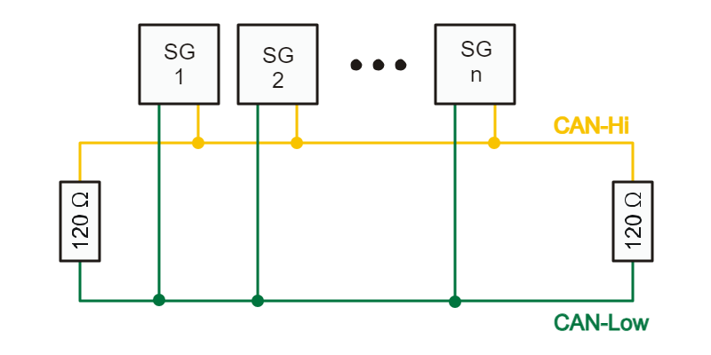
Figure 8: CAN-Bus Topology (Electronic Two Wire Communication) [63]
Reproduction permitted by attribution and license terms in Appendix E
In addition to the aforementioned components, the head segment also houses the battery, F446RE MCU, two time-of-flight sensors, and the turning servo unit. As shown in Figure 9, the F446RE is responsible for controlling these components and sending CAN messages as the head segment. The G431RB in that segment was originally responsible for this functionality, but it was discovered that the libraries and 84 KB firmware used by the ToF sensors almost completely filled the 128 KB flash memory of the MCU, leaving little room for other software. Unfortunately, this firmware must be loaded to each ToF sensor every time the robot is powered on, so it wasn’t as simple as loading the firmware once and removing it afterwards. As a result, a second MCU, the F446RE, was added to the head segment to control these sensors and interpret the data. The F446RE MCU has 512 KB of flash memory instead of the G431RB’s 128 KB, so it has no problem holding this data. While the F446RE and its supporting components are on the same segment as the G431RB, they will be on separate PCBs to make the design process easier. That being said, the PDB has more than enough headers to accommodate both PCBs, so only one PDB should be needed for the head segment.
While the two VL53L7CX ToF sensors can theoretically be run using only power and the two connections for I2C, the LPn and INT connections shown in the head segment in Figure 9 need to be made to enable multiple ToF sensors to be connected to the same MCU and for the sensors to be able to interrupt the MCU when new data is available. The LPn pin is used to set the sensor’s I2C interface to low-power mode so it does not receive any messages on the I2C bus. This is used to communicate with one sensor at a time on bootup because both sensors have the same I2C address by default.
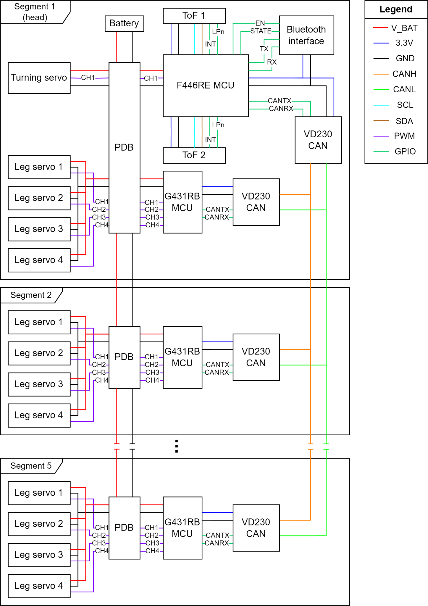
Figure 9: Overall schematic

Section 6.2: Mechanical Design

Section 6.2.1: Overall Mechanical Design
The distributed nature of the segment electronics require that the mechanical design of the robot take a similar approach. As shown in Figure 10, all body segments are identical in both form and function. While the head and tail segments have a slightly different footprint to accommodate their additional functions, both use the same leg mechanism as the body segments to simplify the design.
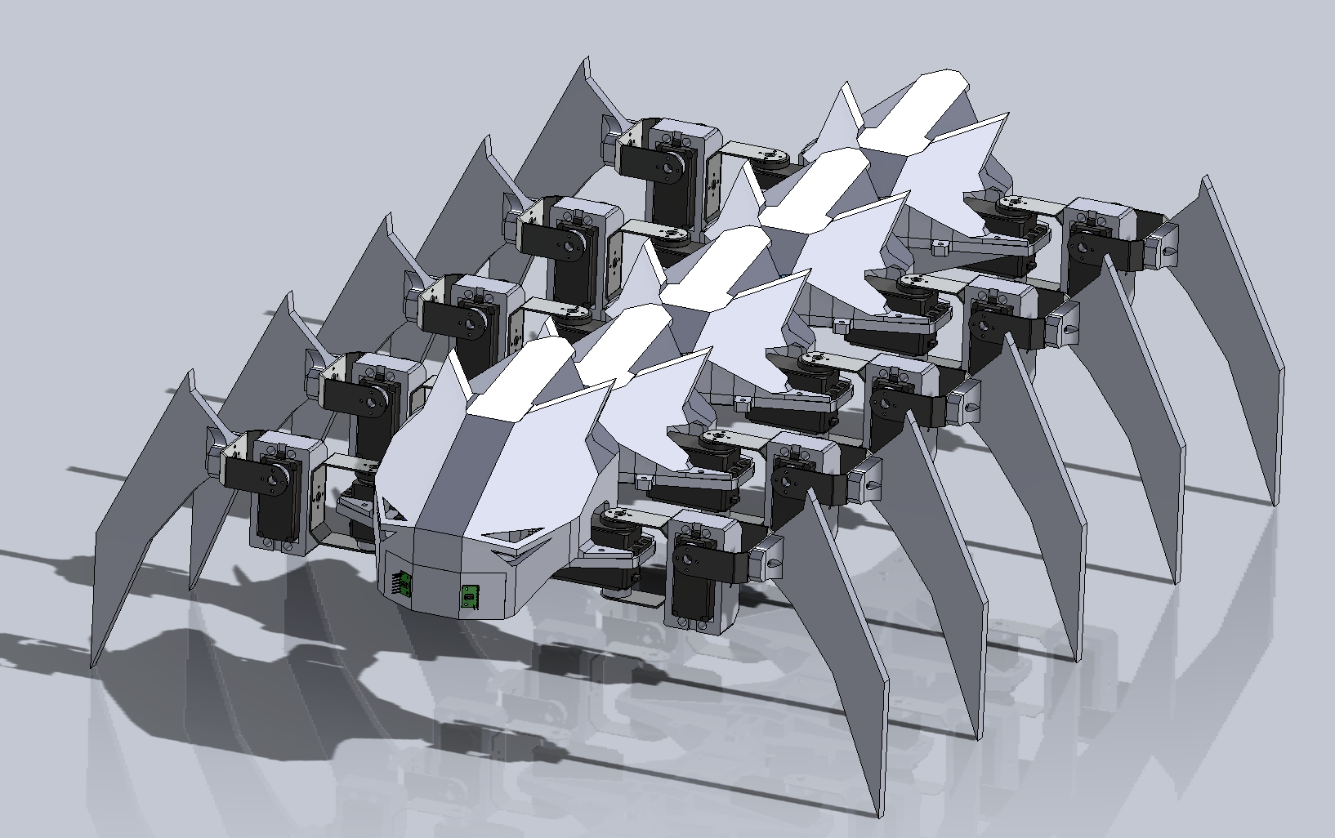
Figure 10: CAD assembly prototype

Section 6.2.2: Head and Tail Segments
Removing the top covers on the centipede shows the hardware mounted to each segment as it relates to the major components in Figure 9. Note that while the version of the robot in Figure 11 uses the ST Nucleo development boards to control each segment, the PCBs designed for this project will replace them for the final robot. The secondary MCU (F446RE) for the head segment is vertically mounted above the primary MCU (G431RB) and is primarily used to interface with the time-of-flight sensors at the front of the robot and the Bluetooth interface. While Figure 9 shows the battery mounted in the head segment, the design of the power distribution system allows power to be connected at either end. The mechanical designer determined that it was better to mount the battery at the back than to mount everything at the front. As shown in Figure 11, the rear segment has an additional tray to accommodate the battery.
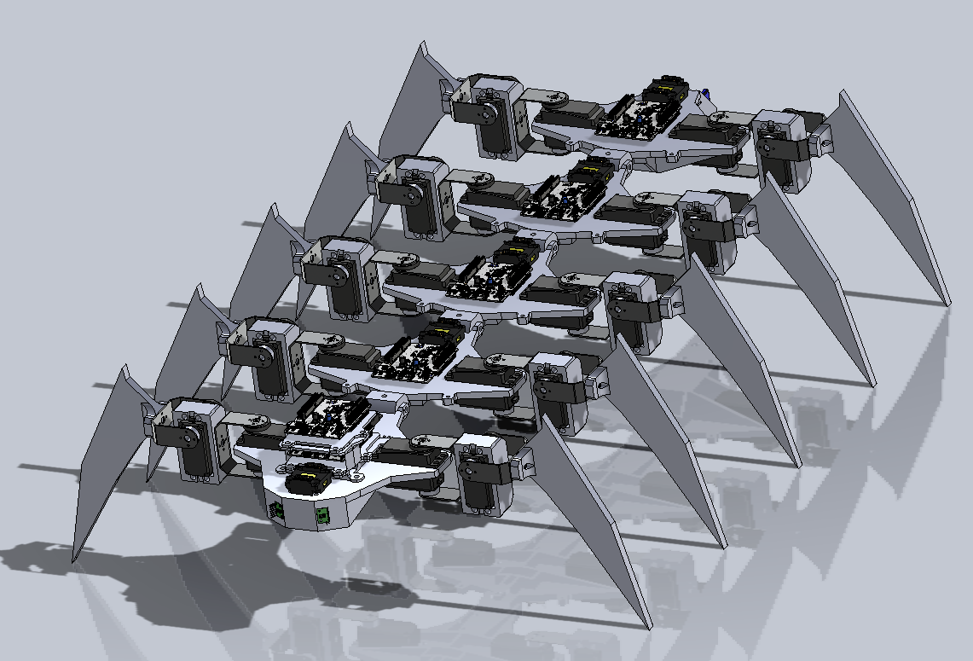
Figure 11: CAD assembly prototype (no cover)

Section 6.2.3: Simulation
During the design process, the mechanical designer conducted a static analysis to identify and reinforce any weak points on each of the parts of the myriapod frame. Figures Z and W show the results of the displacement and stress simulations of the static analysis of a body segment while the robot is at rest. While Figure 12 appears to show significant displacement, the largest displacement found during simulation was less than 4% of 1 mm, well within the elastic range of ABS plastic used for the body. As shown by the near solid blue color of the stress analysis in Figure 13, the sternites (underside support plate structures) adequately distribute the internal forces caused by the mass of each segment, as well as the force exerted on the segments by the servos and legs in a stationary pose.
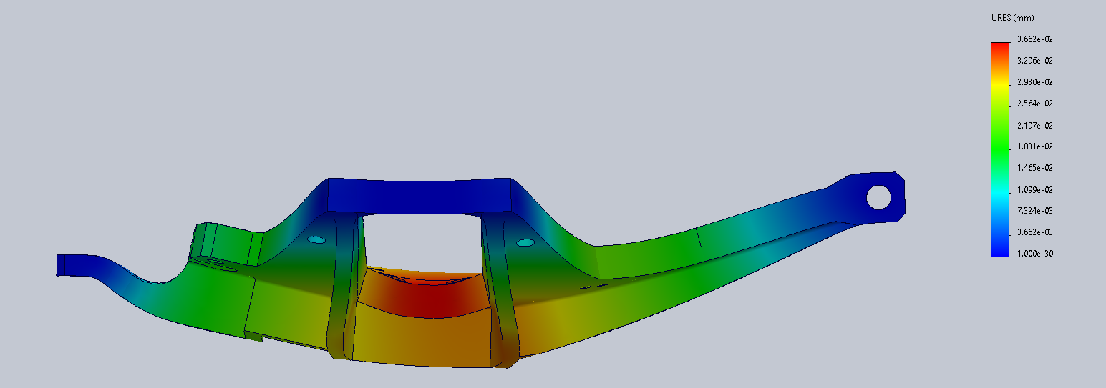
Figure 12: Displacement analysis
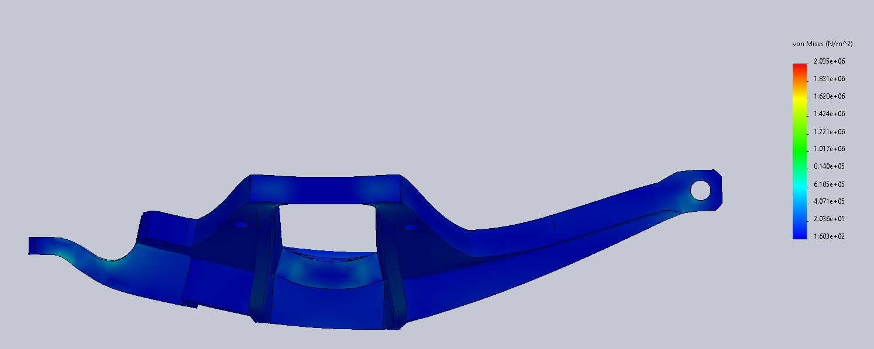
Figure 13: Stress analysis

Chapter 7: Software Design

Section 7.1: Software Overview
The main purpose of the software in the head and body segments is to realize the overall requirements of the myriapod robot. As a result, the software requirements were designed around this principle and kept as short as possible to minimize overhead. The general capabilities of the software are inter-segment communication via CAN bus, control over all four leg servos, and communication with the segment peripheral using I2C or SPI. In addition to these capabilities, the head segment also communicates with ToF sensors, interprets the data from these sensors for obstacle avoidance, and controls the turning servo.
The approach to satisfying these requirements was to write the shortest and simplest code that would satisfy all requirements. Wherever possible, existing software libraries and board support packages were used, including those generated or included by STM32CubeMX, instead of manually implementing low-level functionality. This is important as such libraries have been extensively tested and can usually be eliminated as the cause of any issues during troubleshooting. In addition to reducing development time, using these libraries greatly improves the reliability of the robot and simplifies the debugging process as these libraries were designed by the same company that designed the MCU and they have likely been tested much more extensively than could reasonably accomplished by our group in the limited time provided for this project.
The code is interrupt-based, hardware focused, and written on bare metal. Basing the code on interrupts allows the MCU to respond near instantaneously to an action and reduces the need for any scheduling or priority logic. Additionally, the Cortex M4 CPU used by both the G431RB and F446RE MCUs incorporate a nested vector interrupt controller (NVIC) which allows for convenient prioritization and control over interrupts [62]. The prioritization granted by the hardware grants a form of proto-scheduler as, by definition, it supports multiple interrupts occurring at once (i.e., nesting) and interrupts pre-empting other interrupts. As a result, the issue of interrupts colliding with one another is not a serious concern. As a result, there is currently no need for an RTOS like FreeRTOS to run the segment software. Running the software on bare metal completely eliminates any overhead from running an RTOS and simplifies debugging as there is no RTOS or scheduler to interfere with how tasks are run.
These interrupts are primarily triggered by hardware events such as a timer completing a period or the CAN interface receiving a new message. As a result, the CPU usage is kept to a minimum to maximize the time computationally intensive tasks have to complete and to reduce unnecessary operations like polling or manually calling functions. The specifics for these interrupts will be described in the following sections as each of them are used to realize a specific subsystem of software functionality.

Section 7.2: Segment Communication Protocol
While the CAN communication protocol has been standardized, the significance of the values sent is not. As a result, it is necessary to define a common “language” understandable by all devices on the CAN bus. Each command or “word” of this language directly corresponds to one or more of the software requirements described in Section 2.4.1. The hardware abstraction layers (HALs) for the CAN interfaces on the G431RB and F446RE handle the formation and transmission of CAN packets, so the programmer only needs to determine the values of the fields in the packet. The main fields of interest are the arbitration header, DLC, and data. The first field is also known as the identifier and is traditionally used to identify the priority of the packet during the arbitration phase with lower numbers indicating a higher priority. For the myriapod robot, it will be used to identify the segment and individual servo number to save a data byte. As a side effect, this also gives data for the head segment the highest priority. 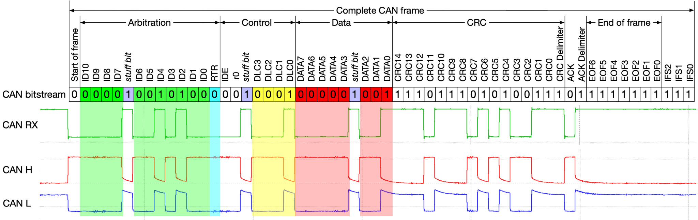
Figure 14: A complete CAN bus frame, including stuff bits, a correct CRC, and inter-frame spacing [64]
Reproduction permitted by attribution and license terms in Appendix E
The other two fields, DLC and data, represent the length in bytes of the data and the data itself, respectively. The classic CAN protocol used in the robot is limited to data lengths of 8 bytes or less, so the language must be designed to fit within this limitation. As shown in Table 17, the main optimization used to fit messages in the limit is to use the data length itself to identify the command.

Command | DLC | Byte 0 | Byte 1 | Byte 2 | Byte 3
Move forward or backward | 1 | Velocity
Turn left or right | 2 | Turning angle in degrees (MSB first)
Move individual servo motor to set position | 3 | Servo angle in degrees (MSB first) |  | Hold flag
Transmit sensor data | 4 | Sensor data  (meaning depends on sensor type)
Table 17: CAN message language
Designing the language in this way makes parsing the CAN messages trivial. The sequence for parsing a message and determining which action to take is shown in Figure 15 below. The CAN interfaces on both the G431RB and F446RE incorporate sending and receiving queues to buffer outgoing and incoming messages, respectively. This prevents collisions on the bus and eliminates the need for the CPU to wait for the bus to be available before sending the message. On the receiving side, the CAN interface uses filters configured during initialization to determine whether the message should be accepted. This happens at the hardware level, so CPU cycles are not wasted on parsing messages not for this segment.
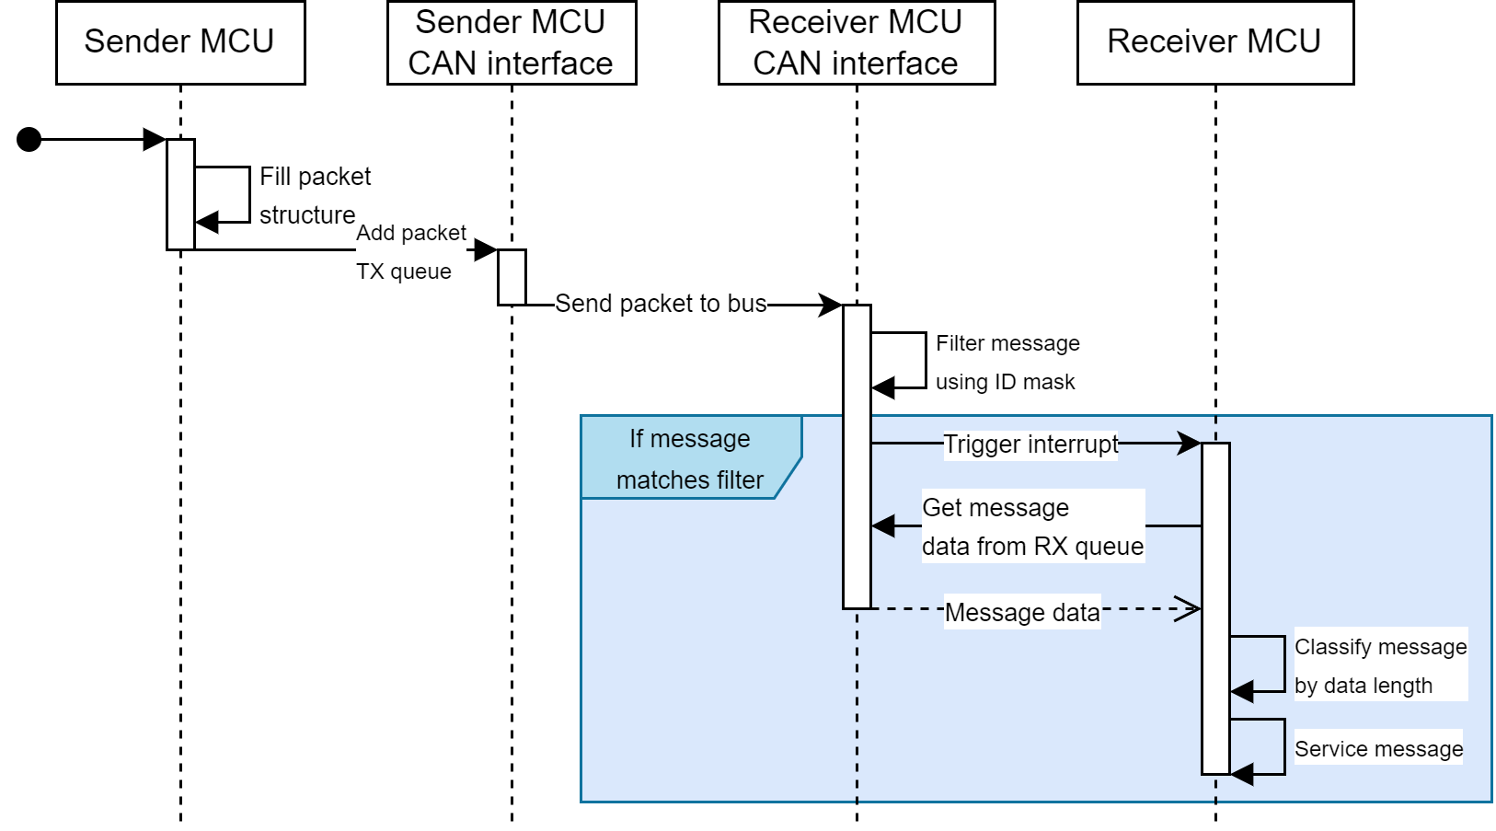
Figure 15: Sequence diagram for CAN communication software
If more than 8 commands are implemented in future updates, the data length could be used to identify the type of command (e.g., movement, configuration, etc) rather than the command itself. For example, the sequence length and phase offset described in Section 7.4 as well as the direction of the sequence could be made configurable via a single CAN command for easy experimentation. However, configuration commands that impact the movement of the entire robot should be passed using a single ID received by all segments or sent individually by the head to each segment.
The CAN interfaces on both the G431RB and F446RE feature several filters, each of which can be set to look for a list of specific CAN IDs or to compare it with a provided ID and a bitmask. The latter method is used for the myriapod robot as the CAN ID can be split into individual hexadecimal digits with each digit identifying a different part of the robot. More specifically, the least significant digit identifies the servo that should receive the command. The next least significant digits identify the segment that should receive the command. For example, Segment 1 can be addressed using any CAN ID from 0x10 to 0x1F whereas Segment 1 Servo 3 can only be addressed using CAN ID 0x13. Using this method and the length of the ID field shown in Figure 14, the myriapod can theoretically support up to 2⁷ or 128 segments with 2⁴ or 16 servos (or other addressable components) per segment using this communication protocol.

Section 7.3: Servo Control
The servo control software subsystem realizes low-level control of the myriapod’s servo motors by providing a software interface from the segment MCUs to each of the servo motors. Like most hobby-grade servo motors, the leg and turning servos respond to pulse-width modulation signals to determine the angle to which they should move. It should be noted that the servos respond to the length of this pulse, not the duty cycle of the PWM signal, so the frequency of the PWM signal can be almost any frequency that allows the full range of pulse lengths to be intelligible by the servo (i.e., no extremely low or high relative duty cycles).
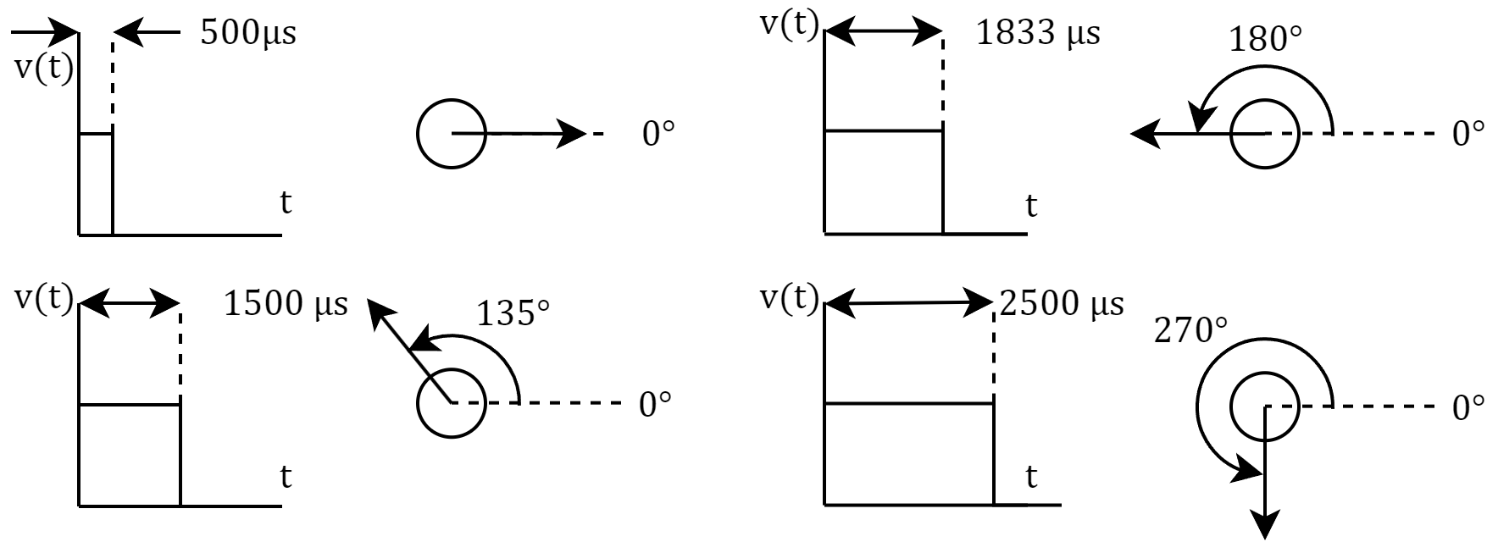
Figure 16: Relationship between pulse duration and servo angle
As shown in Figure 16, the servo angle has a linear relationship to the pulse duration, so the angle can be set by simply mapping the desired unit to the movement range of the servo. For example, the leg servo has a 270° range and supports pulse widths between 500 µs and 2500 µs, so the [0°, 270°] input interval is mapped to [500 µs, 2500 µs] using simple scale and offset operations.
One of the microcontroller’s timers is used to generate these signals. Many MCU timers, including many of those on both the G431RB and F446RE, have multiple channels, meaning that a single timer can be used to control multiple devices. In fact, TIM1, one of the advanced control timers on the G431RB, has 6 channels, 4 of which can be output on the MCU’s pins. According to the reference manual for the G431RB[65] TIM1 is connected to APB2, so the 170 MHz clock frequency of that bus is used for the timer’s clock. Setting TIM1’s prescaler to 170 brings this down to 1 MHz, increasing the maximum period of the timer and simplifying the calculations for pulse duration. With a frequency of 1 MHz, the timer’s counter register will be incremented every 1 µs. As a result, the capture compare register can hold the raw pulse duration value in microseconds without any transformation. The timer is set to count up to 5000, so the signal will have between a 10% and 50% duty cycle if the [500 µs, 2500 µs] range is used. This provides an ample range of pulse widths for the servo to process without generating exceptionally short or long pulses that could be misinterpreted by the MCUs in the servos themselves.
During initial testing, it was observed the current draw of a servo would rapidly spike when commanded to move to a new position. This makes sense as the internal servo controller wants to move the shaft to the new position as fast as possible. However, this presents a new challenge as these spikes have been observed to be 2A or greater. In the worst case, if all 20 servo motors on the myriapod suddenly jerked to a new position, the battery would be hit with a 40 A load. While not necessarily an issue for the servos, such a current spike and accompanying voltage drop could cause errors in the MCUs or other hardware faults. As a result, the logic for setting the angular position of a specific servo has been modified to limit the maximum speed the pulse width sent to the servo can change. Instead of immediately assigning the received value to the appropriate channel’s capture-compare register, the received value is set as the target and the actual value of the register is slowly updated to reflect the new value. These changes are triggered using a separate timer, and both the frequency at which these updates occur and the size of the update steps can be configured to control the time it takes for the new value to take full effect.
Both the leg and turning servo motors lack feedback signals, so the segment MCU has no way of reading the current angle from them. As a result, special precautions must be taken to prevent legs from crashing into each other and minimize current spikes caused by sudden movement. The former issue could be mitigated by mechanically spacing the segments in such a way that the legs have either little or no overlap in their range of motion. Given that the most likely time the latter issue would occur is on startup, the startup sequence should be designed in such a way that concurrent motor movement is avoided until all motors have been individually commanded to move to a known “home” position.

Section 7.4: Metachronal Wave Locomotion
The locomotion technique used by the myriapod robot utilizes metachronal waves, or identical waves with a phase relationship between them. The term “metachronal” describes the fact that the waves experience time in the same way, but are sequentially shifted in time relative to each other. This time shift is what creates the phase shift in the waves. While metachronal waves can be generated from any periodic function, the simplest choice is to use a sine wave as the common function.
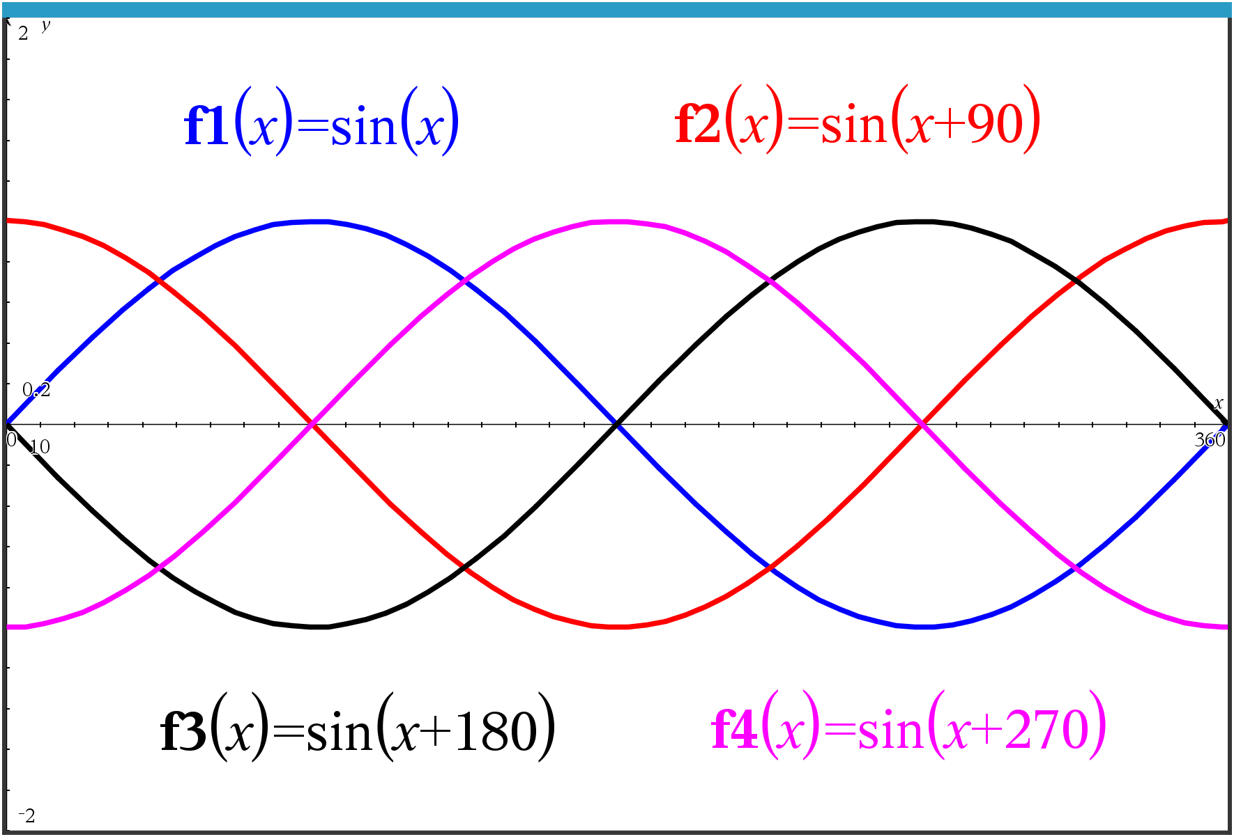
Figure 17: Quadrature sine waves
Quadrature sine waves, as shown in Figure 17, depict a simple case of metachronal waves. All four functions use a common function, but shift the parameter, $x$, by a fixed amount in time. They also show how any set of waves can be evenly spread across a single period of the common function. This concept can be generalized to any number of waves depending on the intended application. For example, a three wave metachronal sine wave is used in three-phase electricity. Similar to the quadrature sine waves, three-phase electricity uses evenly spaced waves. In this case, a sequential shift of 120° per wave is needed to cover the 360° range of the sine function.
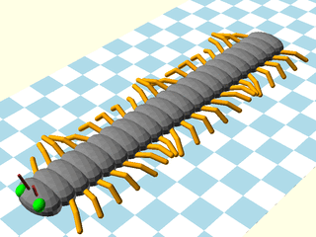
Figure 18: Centipede forward propagation [66]
Reproduction permitted by attribution and license terms in Appendix E
This technique can be applied to centipede locomotion by considering each leg’s motion as a single wave in a metachronal set with known sequential phase shift. Metachronal waves for locomotion must also provide enough points of contact for the centipede to be mechanically stable. Simply dispersing all legs on one side across the entire phase space is not enough for locomotion. Consider one side of the 3D model of a centipede shown in Figure 18. The model uses an 8 wave metachronal sequence, so leg $i$ has the same position as leg $i+8n$, where $n$ is the period number. This centipede also has 21 legs on each side, so $n$ can be any non-negative integer such that $i+8n<21$, assuming legs are indexed from 0.
$$\frac{2N}{L}≥3$$
Equation 1: Stable centipede condition
In general, the centipede and the metachronal sequence it uses satisfy Equation 1 where $L$ is the length of the metachronal sequence and $N$ is the number of legs on one side of the centipede. This guarantees that the robot has at least three points of contact with the ground at all times, with three being the minimum number of points necessary to define a plane. In order to maximize stability, these points should be spread as evenly as possible across the length of the centipede and have approximately half of the total number of points on each side. For example, the centipede in Figure 18 is mechanically stable because it has $L=8$ and $N=21$, giving it approximately 5 points of contact with the ground, all of which are visible in the figure (3 on the left, 2 on the right).
These points of contact are not discrete as the legs immediately before and after a leg in contact with the ground are inherently close to the grounded leg’s position. The benefit of this is magnified by increasing the length of the metachronal sequence and number of legs to support this new length. Increasing the length decreases the phase difference between each segment, and positioning more legs on or close to the ground at any given time. The main benefit of this type of locomotion is that if a leg were to suddenly fail mechanically (e.g., break off), the legs immediately before or after it would still provide a relatively parallel plane. Increasing this length only improves the magnitude of this benefit.
The time complexity of implementing metachronal waves significantly depends on how the common function is implemented. If it is implemented using trigonometric or other math functions, it might be too slow to compute on some microcontrollers. On the other hand, implementing the function with a lookup table provides O(1) computation at the cost of space in MCU’s flash memory to store the table. Fortunately, some MCUs, including the G431RB, implement a Coordinate Rotation Digital Computer (CORDIC) that can quickly approximate trigonometric and hyperbolic functions. For the sine function used for the majority of this section, the math.h single precision sine function takes roughly 15x as many CPU cycles to compute the sine as the CORDIC [67]. Furthermore, the CPU is idle while the CORDIC computes these values, so it is free to perform other tasks. This also leaves more CPU headroom for additional features that might be implemented down the line.
Composing the common function for the metachronal wave using functions from the CORDIC almost negates the aforementioned concern while retaining human readability and the low space requirements of simple function calls and operations. The human readability aspect is paramount in a project like this as it greatly decreases the time required to iterate on the metachronal wave for the leg motion, decreases debugging complexity, and makes it easier to understand. The actual function used for locomotion has yet to be finalized, but all the prerequisite tools have been designed and implemented to create and test this function.
Given that there are two motors per leg, each segment will need to run two multiple metachronal waves in parallel. Fortunately, the right and left sides of the robot will be exactly 180° out of phase with one another, so only the software only needs to handle two concurrent metachronal waves. These waves could be manually designed, determined experimentally through a training process led by an evolutionary algorithm or other machine learning approach. While the former approach covers the main goal of the project, there is nothing preventing the latter or a combination of the two from being implemented on a future version of the robot’s software. Returning to the former approach, the waves should be designed to work together such that the robot moves in the most efficient way possible. Additionally, the wave should be continuous and start and end in the same position to avoid sudden movements that could cause current spikes and mechanical wear on the motors and myriapod chassis. In addition to the aforementioned constraints, the precision at which the metachronal wave is calculated (or stored if a lookup table is used) should be kept within the mechanical precision of the servo motors and the resolution at which they can measure pulse duration.
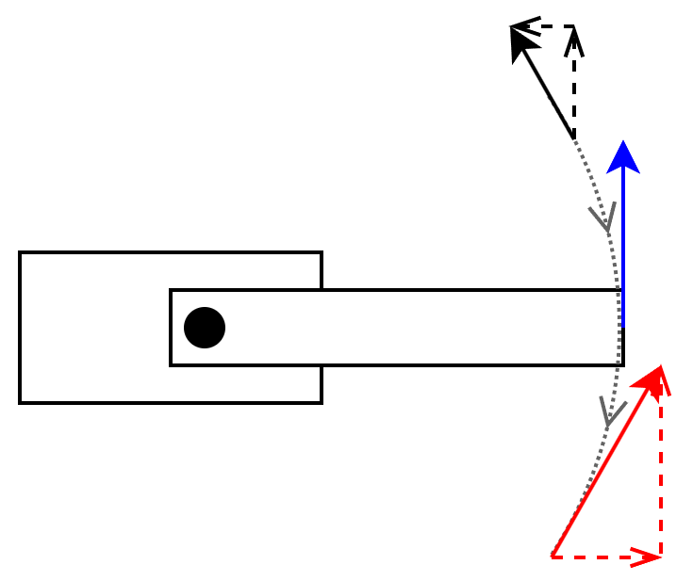
Figure 19: Simplified force vector for naive metachronal wave
A good first approach to making a pair of metachronal waves for locomotion using legs with two joints would be to maximize the range of motion in the horizontal (hip) joint and only use the knee (vertical) joint to pick the leg off the ground for the wave to reset. While this would likely work, it would be inefficient. Consider the reactive forces from the ground to a single leg as it follows this path as shown as the dotted gray arc in Figure 19. The main issue is that the reactive force from the leg’s contact with the ground would only be parallel to the body of the centipede when the horizontal joint is perpendicular to the body (blue vector). If the force vector is not parallel to the body (such as the black or red vectors in Figure 19), there is a component of that vector pushing the centipede off the intended path. Considering that the leg on the other side of that segment is following an equal, but opposite motion, the two legs of the myriapod perpetually fight each other and waste energy in the process.
This motion can be improved by using the vertical (knee) joint to keep the reactive force vector parallel to the myriapod’s body by counteracting the perpendicular component created by the hip joint, depicted as the dotted horizontal arrows in Figure 19. In addition to increasing efficiency, this improvement allows the torque from both the hip and knee joints to be used to propel the robot forward instead of just the hip joint. This can be observed in the knee joints in the centipede in Figure 18 as the knee’s angle differs based on the phase of the leg to which it is attached.
The process for turning the robot follows a similar approach to the efficiency improvement from using the knee joint. Consider a centipede turning in one direction such that the turn angle is the same for all segments. The parallel movement lines discussed in the previous paragraphs become concentric arcs as does the body of the centipede. Given two arcs with the same angle, but different radii, the arc with the smaller radius is shorter than the one with the larger radius. As a result, the legs on the inside of the arc need to travel a shorter distance than those on the outside. This can be implemented by individually scaling the movement angles for each side based on the commanded turn angle. However, the number of contact points the robot has with the ground limits its ability to turn its entire body at once. As a result, the turn command needs to be gradually propagated through the body of the centipede to allow the straight-moving segments to complete their cycle before shifting towards a left or right-biased movement. The time required for the turn command to take full effect as well as the factor used to scale the left and right ranges of motion during a turn will be determined experimentally during prototyping.

Section 7.7: Startup and Synchronization Sequence
Synchronizing the movement between segments is also an important consideration as the metachronal wave used to move the robot is distributed among several MCUs. Not synchronizing the segments could prevent the robot from moving efficiently or at worst, cause the legs to crash into each other and cause damage to the robot. Each segment is programmed to know its position in the myriapod, so there is no reason for a segment to start desynchronized on the software side. It should be noted that the problem is with the robot not knowing the position of the legs, not that the motor controllers built into the servo motors do not know the position. These internal controllers are based on a potentiometer which acts as an absolute encoder. As a result, there is no need to mechanically home the legs. However, there are two cases in which the positions of the legs could be mechanically ambiguous or become desynchronized: power on and during operation.
The first case is the most likely as there is nothing to prevent the motors in the myriapod from turning when power is removed. While the high-torque gearbox inside the servos provides considerable mechanical resistance to rotation when powered off, it is still a risk that must be mitigated. It is likely to occur if the robot is reconfigured, packed for shipping, or repaired. The problem can be mitigated by sequentially commanding all segments to move to a known home position during power on in such a way that guarantees no leg will enter the range of motion of an uninitialized leg. Given that each leg has two joints, this will need to be done for each joint. This process should also put the centipede in a standing “ready” position to indicate that it is functioning correctly.
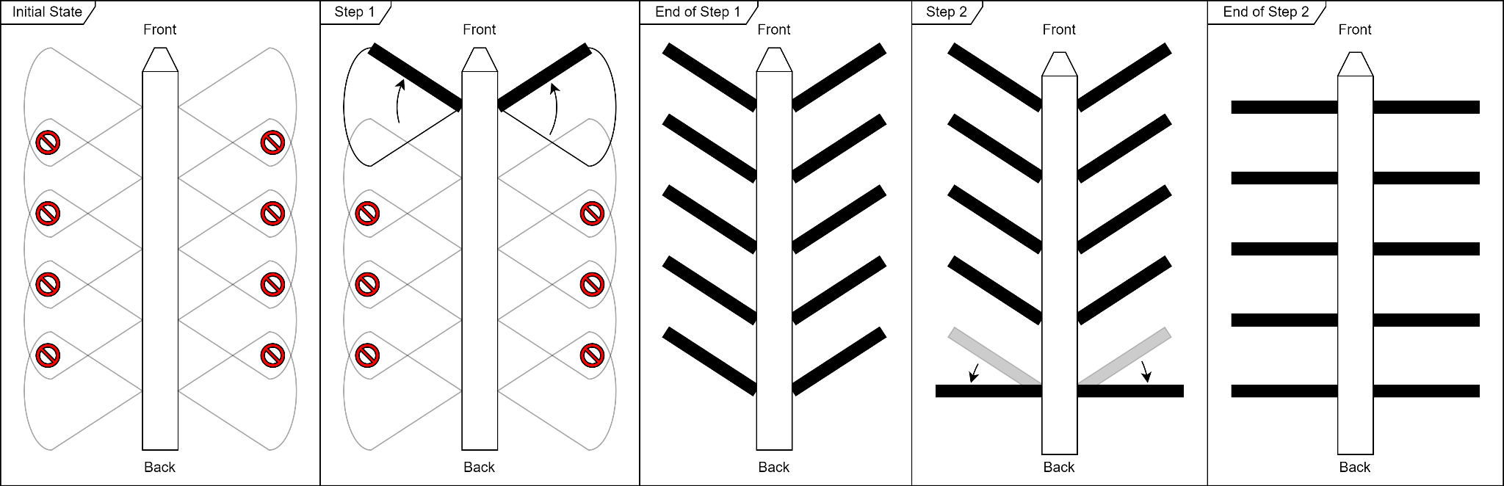
Figure 20: Mechanical synchronization and homing sequence
As shown in Figure 20, the homing sequence requires two steps to safely move all legs from an unknown position in their range of motion to the home position. Initially, all legs could be anywhere in their range of motion as indicated by the gray cones in the figure and could collide with one another if commanded to move without homing. Step 1 of the homing process resolves this by moving all legs towards the front of the myriapod. In order to ensure the homing process goes smoothly and to minimize current spikes from sudden movements, the segments are individually homed instead of moving them all at once. Given that the rotation is towards the front of the myriapod and the front legs will always be unobstructed during power on, the legs of the head segment must be first in sequence. Step 2 completes the homing sequence by moving all legs backwards to a neutral position. Similar to Step 1, the direction of the sequence depends on the direction of the turn. In this case, the legs turn towards the back of the robot, so the last segment is the first in the sequence for Step 2. The successful completion of both steps indicates that the robot has successfully homed all segments and is ready for operation.
This could be improved by upgrading the leg motors to servos with a feedback signal or by adding rotary encoders to the legs, enabling the robot to store the last position of all the servos in non-volatile memory. These values would be read on startup and compared with values measured by each motor. This comparison would enable a shorter and more intelligent homing process as only the motors that need to be homed would undergo that process. This upgrade could be used to skip the homing process entirely by waiting to move the segment for the first time during this power cycle until the commanded angle is equal to the measured angle of the servo. That being said, a version of this could be implemented with the current servo motors by periodically storing the last angle commanded for each servo instead of measuring it. However, this has limited accuracy and could worsen the servo current spikes it is designed to prevent if all servos are commanded to move to their stored positions at the same time.
The second case could happen if a software bug or power issue occurs during operation and requires regular checks. The first method that could be used to check synchronization is by periodically sending a “heartbeat” command to each segment to make sure they are functioning correctly and expecting a response in a specified time frame. This could be expanded by adding information such as the current phase in the metachronal wave and any errors (e.g., motor jammed) to the heartbeat response. Such information could be sent to the user for diagnosing issues with the robot and would be provided in addition to any error codes communicated by the debugging LEDs on each segment’s PCB. This information could also be tailored by the end user for their intended application and by the peripherals and sensors installed on the robot. In addition to the software-oriented homing process, the mechanical design of the centipede can be adapted in such a way that the legs are either incapable of entering each others’ range of motion or have minimal overlap.

Section 7.8: Remote Control Interface
The graphical user interface for teleoperating the robot as well as the application that it controls were added late in the development process and, as a result, have yet to be designed and prototyped beyond the mock interface shown in Figure 21 below. Given that teleoperated movement is a core requirement of both the application and the robot itself, the mock user interface has directional pad and speed controls front and center on the main screen. While these two elements could be combined into a single analog joystick on the screen, separating them allows more consistent control over the robot’s speed. Instead of needing to hold their finger in the exact position on the joystick that corresponds to the designed speed and direction, they can simply set the speed once using the slider on the right and hold anywhere on the button for the desired direction. The menu bar in the top right of the interface will be used to switch to a menu for configuring the application, changing robot settings, and viewing information about the robot such as the operational status of each segment.
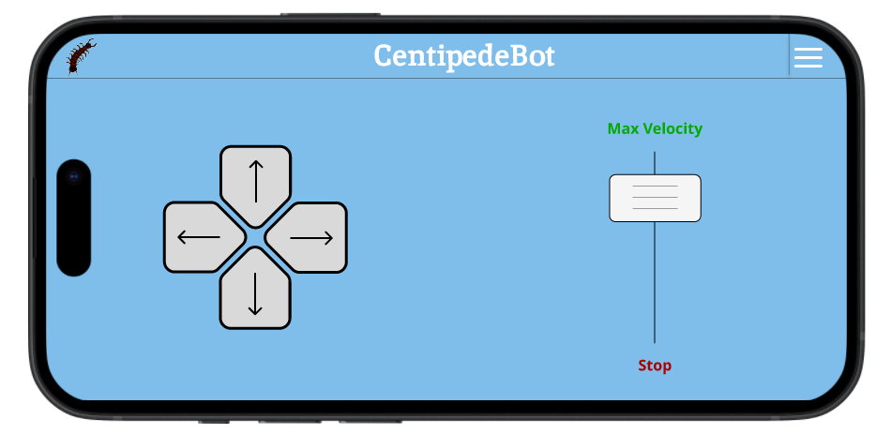
Figure 21: Mock user interface

Chapter 8: System Fabrication [Docs AI]

Section 8.1: PCB Electronic Schematic
The design of the electronic Printed Circuit Board (PCB) for the robotic centipede involves careful consideration of each component to ensure seamless functionality and robust performance. This section delves into the schematic design of the PCB, focusing on the selected microcontroller unit (MCU), power distribution, and key connections for both the primary (STM32G431RBT6) and secondary (STM32F446RET6) MCUs. The choice of the STM32G431RBT6 MCU is driven by the exceptional software support and resources provided by STMicroelectronics. Detailed datasheets for each processor played a pivotal role in the schematic design, ensuring precise placement of components. Each major component of the schematic will be shown, and the reasoning behind their inclusion will be explained. The MCU is the central processing unit of the board, and it is responsible for controlling all of the other components. The MCU is connected to the rest of the board via a variety of buses, including the I2C bus, the SPI bus, and the USART bus.

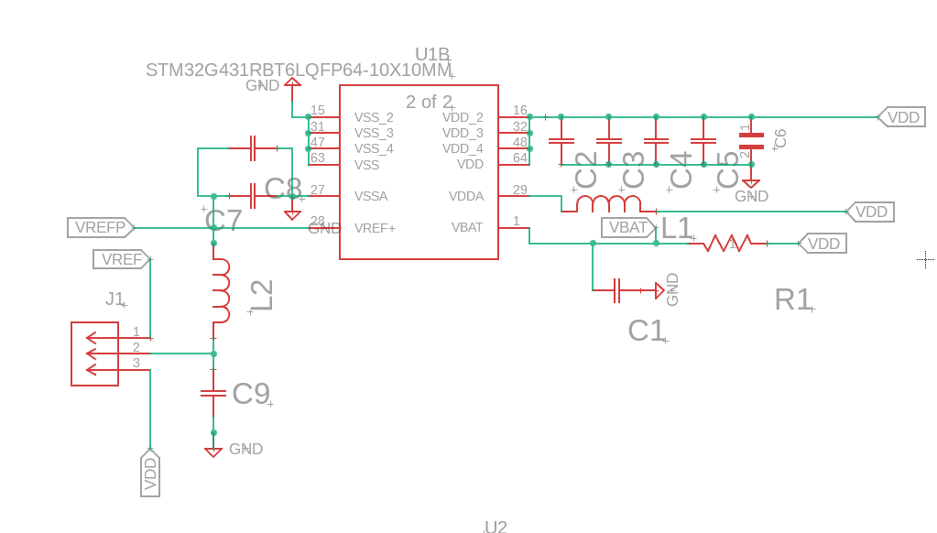
Figure 22: STM32G431RBT6 Power
An integral aspect of the PCB schematic is the power distribution for the STM32G431RBT6 MCU. Here displayed are the power pins of the STM32 MCU and how they are connected. Most notable are the capacitors in parallel to one another, serving as decoupling capacitors. As emphasized in the datasheet, the decoupling capacitors have to be as close to the pins as possible, and these will help stabilize voltages and decrease noise. The VDD connections are then relayed to the voltage regulator outputs the 3.3V needed by the MCU. ST has a development board that uses this MCU, and its manual contains helpful diagrams that showcase how power is distributed to its controller.

Referencing the high-level diagram from the STM32G431RBT6 datasheet, the implementation of an LD39050 voltage regulator is consistent for maintaining a stable 3.3V output and is the one ST chose to use on their development board. This choice ensures compatibility and minimizes potential variables that could affect the overall system performance. ST has a development board that uses this G431RB, and its manual contains helpful diagrams that show how power is distributed to its controller. However, it is worth noting that some changes had to be made in order to accommodate the centipede robot. For example, the centipede robot has a higher current draw than the development board, so a larger capacitor might be needed to provide enough capacity. Overall, the power system for the centipede robot is a complex and carefully designed system ensuring that all of the components are properly powered and that noise is minimized.
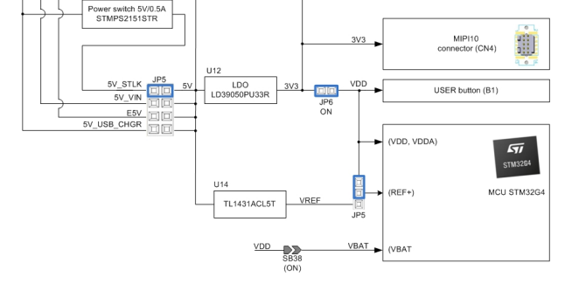
Figure 23: STM32G4 Nucleo-64 boards [72]
The diagram above depicts the high-level architecture of how ST intends for its microcontroller to be powered. It utilizes an LD39050 voltage regulator, and we intend to choose the same one for our application for consistency and to minimize variables that could go wrong. Below this will be shown to demonstrate how we implemented it. Furthermore, this development board by ST has the option to use micro USB for power, but this was believed to be unnecessary to realize in our design. The same 8-pin jumper is included in our design, but it is more of a formality. Most likely, only the 5V power pin will be used. Additionally, the programmable voltage reference TL1431A (U5 in our schematic) is also included in our schematic design as VREF.

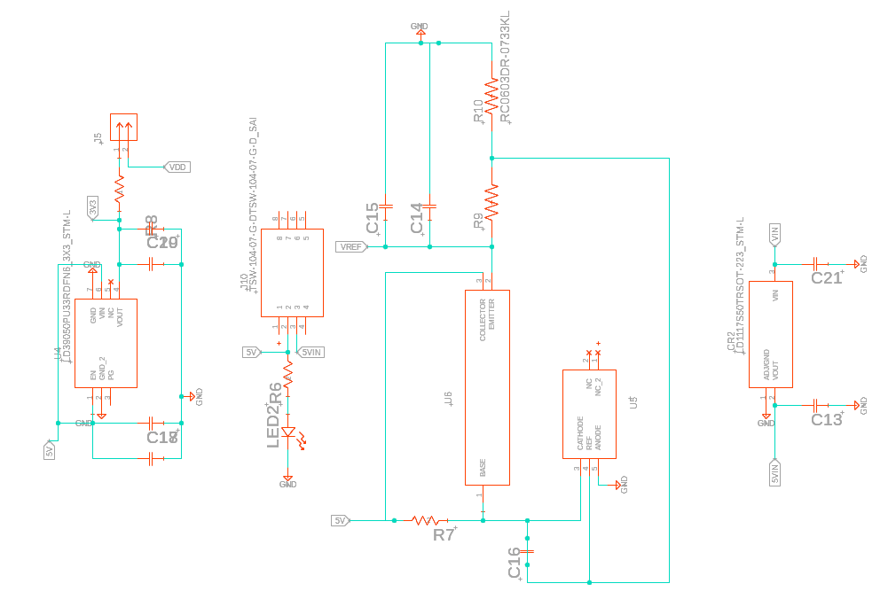
Figure 24: Voltage Regulation
The voltage reference will be used as the voltage reference point for the STM32’s built-in analog to digital converter, and having that available is especially useful for any analog input devices we might end up using, most notably due to the fact the segments are modular. The voltage reference provides a stable voltage that the ADC can use to compare the analog signals to. From here, how the STM32 board will be powered has been discussed. In addition to the G431RB, the head segment in the centipede robot also has a secondary MCU. This MCU is responsible for communicating between the time of flight sensors, the turning servo motor, and the external communication interface. This MCU is the STM32F446RET6, also provided by STMicroelectronics (same brand for compatibility). To power this processor, it was fairly straightforward since it required the same 3.3V input as the other processor. One just needed to make sure the one regulator and battery can handle both. Further testing will be conducted on this to ensure this is the case.

Moving on from powering microcontrollers, we need a way to power all of the servo motors. Now, compared to the MCU’s this process was fairly straightforward. However, it's a crucial consideration due to the fact we have to consider how all of the segments will be powered by one battery. Our overall design of the robot does not include storing a battery in each segment instead they will be powered by the same external battery. This means considering running ports and connections that can be detached and attached, but also be able to withstand the current draw of the servos. Below you will see not only the servo connections themselves, but also the XT30 that will be used to power segments behind this segment.

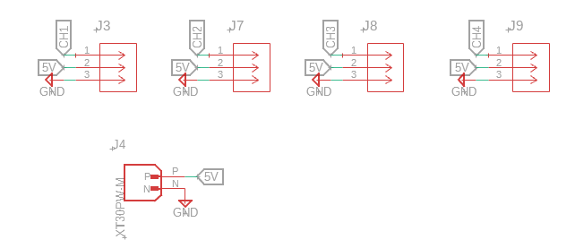
Figure 25: Servo Headers
It is now an opportune time to delve into the many connections that the G431RB and the F446RE utilize to carry out all of their functions. Firstly, as shown in the figure above, each segment with its four servo motors will communicate to the MCU using the CH1. CH2, CH3, CH4 channels respectively. These channels lead to pins on the processor that ST’s datasheet describes as being capable of communication. As expected, these servos communicate commands with Pulse Width Modulated signals, and we can confidently use these pins on the MCU for this purpose. Furthermore, the STM32 board has several more notable pins that are used for communication and programming. This can include but is not limited to the I2C connections, SPI, and TXD/RXD wires. The TXD and RXD wires communicate with the SN65HVD23HVD230 CAN transceiver that's able to transceive those signals to the physical high and low wires on the CAN bus. This bus is further transported to other segments on the robot by using a pair of headers. Similarly the SPI, and I2C buses have their own headers on the PCB schematic since they are not currently being used but the option should be available for any segments that might use them.
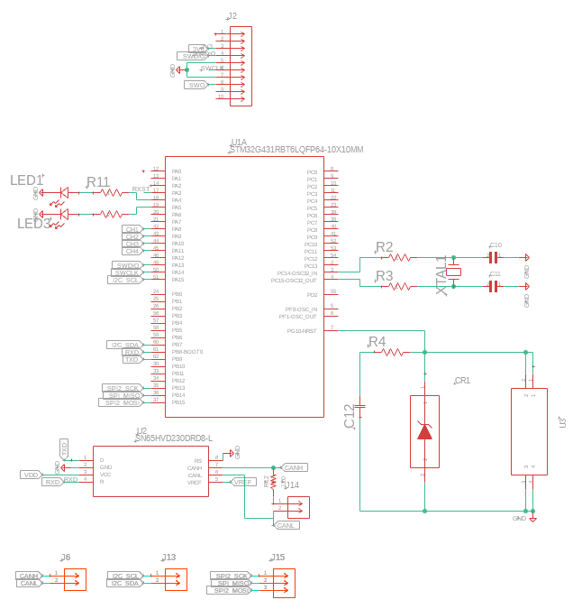
Figure 26: STM32G431RBT6 Pin Connections
The following are the final G431RB board connections, not including power, that will be implemented in each segment of the centipede robot. The jumper with ten pins, the MIPI10, is what will serve as the “STLINK” used for programming and debugging ST products. In this connector, the SWCLK and SWDIO pin connections are used but the SWO is not, but is left there as a precaution. In a similar way, there is an external clock XTAL1 that is implemented, but is not necessary due to the fact there is a clock built into the MCU package. However, the redundancy could help troubleshoot any issues or debugging down the line. On the subject of debugging, LED 1 and 3 are able to be programmed to diagnose any issues and the button U3 is a reset button to reset any programming. Simultaneously, in the head segment exclusively, the F446RE has its own individual pin connections that are worth discussing.

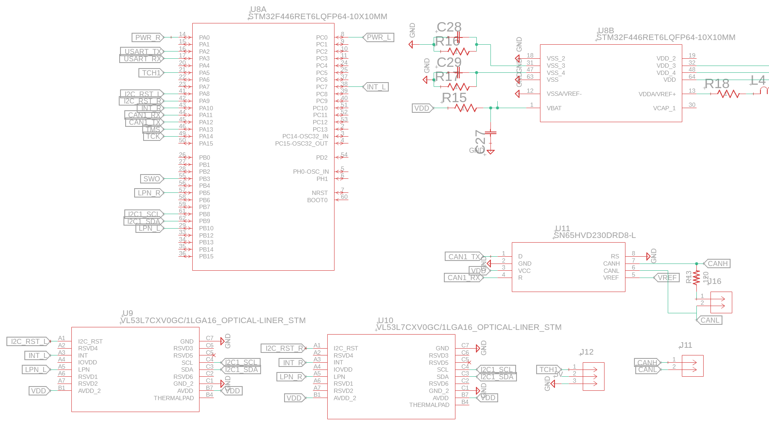
Figure 27: STM32F446RET6 Pin Connections
As previously mentioned, the same transceiver is used in this application, but in this case it is used on the F446RE while using the same CAN bus lines. Additionally, the CH1 pin is used for the 3-pin header, which in this case is used for the turning servo. All of the other connections that are unique to this processor are the ones that are used to control the left/right time-of-flight sensors.

The transceiver is a device that enables a device to interface with the physical layer of the network. In this application, the transceiver is used to communicate with the CAN bus, which is a network protocol that allows multiple devices to communicate with each other. The CAN bus lines are used to transmit data between the transceiver and the other devices on the network. The CH1 pin is used to control the turning servo. The turning servo is a motor that will be used to rotate the robot. The CH1 pin is connected to the servo's control input, which allows the microcontroller to control the servo's speed and direction. The left/right time-of-flight sensors are used to measure the distance to objects in front of the robot. The microcontroller uses this information to know the distance to the object. The connections that are unique to this processor are the ones that are used to control the left/right time-of-flight sensors. These connections include the TOF_L and TOF_R pins, which are used to connect these sensors to the microcontroller. The microcontroller uses these pins to read the data from the sensors and to control the sensors' operation.

Section 8.2: Current PCB Layout Progress
The process of designing a PCB layout from a schematic is a complex and iterative one. There are many factors to consider, including the number of layers, the type of routing, and the placement of components. In the early stages of development, it is important to keep an open mind and be willing to experiment with different layouts. This will help to ensure that the final design is optimal for this specific robotic application.
One of the first decisions that needs to be made is the number of layers in the PCB. A two-layer PCB is the simplest and least expensive option, but it may not be sufficient for complex designs. A four-layer PCB provides more routing space and better signal integrity, but it is also more expensive. In some cases, a six-layer or eight-layer PCB may be necessary.
Once the number of layers has been determined, the next step is to choose a routing method. There are two main types of routing: manual and automatic. Manual routing is more time-consuming, but it gives the designer more control over the final layout. Automatic routing is faster, but it may not produce the best results.
The placement of components is also an important factor. Components should be placed in a way that minimizes the amount of routing required and maximizes the signal integrity. It is also important to consider the physical size of the components and the clearances required between them.
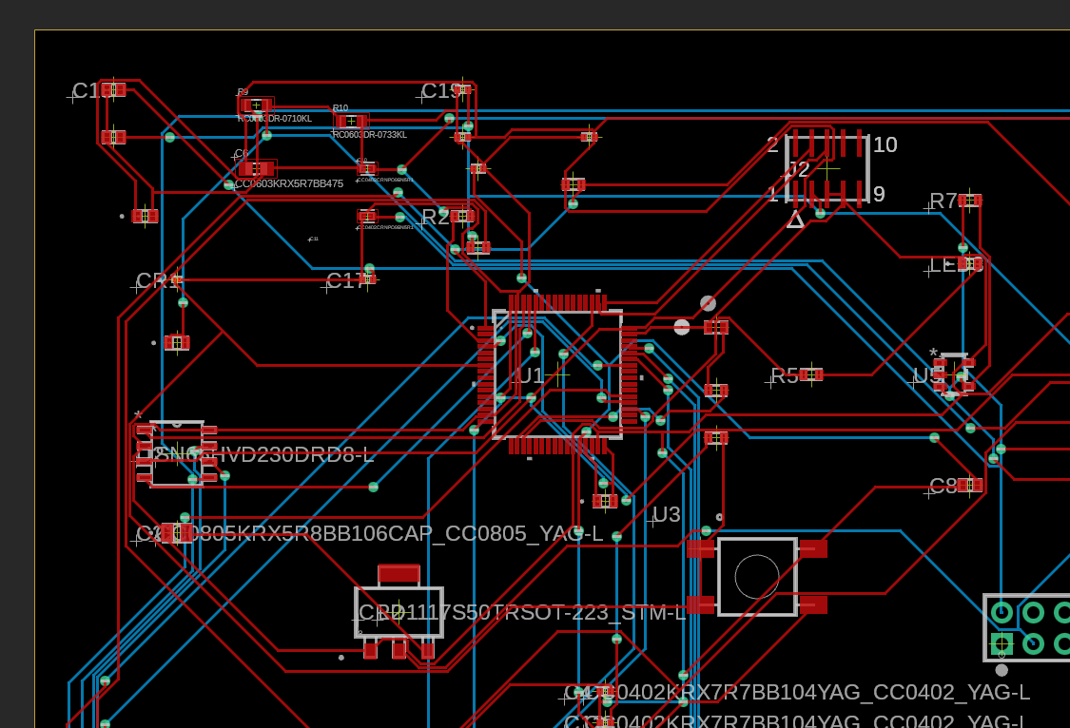
Figure 28: PCB layout progress
The design process is often iterative, with us having to make changes to the layout as needed. This is especially true in the prototyping phases, when the designer is still learning about the application and the requirements of the PCB. By keeping an open mind and being willing to learn, we can create a PCB layout that is optimal for the robotic centipede.
It is worth noting that our chosen electrical schematic design software, Fusion 360, allows us to create a 3D rendering of our PCB. This is a very useful feature, as it allows us to place the PCB on the CAD model of our completed centipede robot. This ensures that when we finalize our PCB, we can guarantee that it will fit perfectly in our robot.
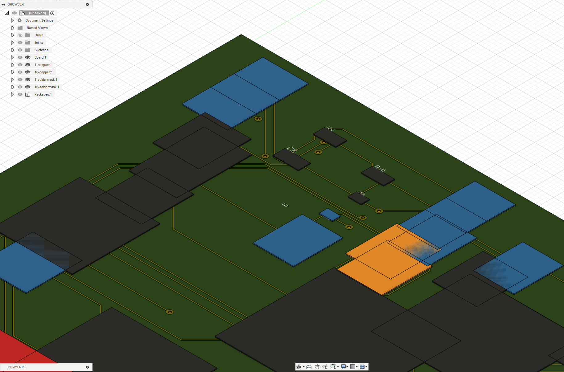
Figure 29: 3D model of PCB layout
Currently, pushing a 3D model of the PCB into Fusion 360 gives us errors. However, we are currently working to insert the correct 3D models. Once this issue is resolved, we will be able to use Fusion 360 to create a complete digital model of our centipede robot, including the PCB. Allowing us to see the robot in its completed form.

Chapter 9: System Testing

Section 9.1: Hardware Testing

I. Test Overview
1. Objective:
Evaluate the functionality, reliability, and performance of key hardware components in the robotic centipede.
2. Scope:
Test the following components:
- Leg Servos
- Distance Sensor
- Turning Servo
- Microcontroller Unit (MCU)
- Power Distribution System
- Battery

II. Test Preparations
3. Documentation Review:
Verify that all hardware documentation, including datasheets and assembly instructions for each component, is up to date.
4. Component Inspection:
Inspect each component for physical damage, loose connections, or any signs of wear.
5. Firmware/Software Configuration:
Confirm that the robotic centipede's firmware or software is correctly configured for testing each component.

III. Leg Servos Tests
6. Individual Leg Movement:
a. Objective:
- Verify the range of motion and precision of each leg servo.
b. Procedure:
- Command each leg servo to move through its full range of motion.
- Observe and record any irregularities or limitations in movement.
c. Expected Results
- Smooth and precise movement without noticeable hesitations or limitations.
7. Coordination Test:
a. Objective:
- Ensure synchronized movement of multiple leg servos.
b. Procedure:
- Command coordinated movements involving multiple leg servos.
- Check for smooth and synchronized motion.
c. Expected Results
- Legs move in a coordinated and synchronized manner.

IV. Distance Sensor Test
8. Accuracy Test:
a. Objective:
- Assess the accuracy of distance measurements.
b. Procedure:
- Place objects at different distances from the sensor.
- Record and compare measured distances with actual distances.
c. Expected Results
- Distance measurements closely match the actual distances.

V. Turning Servo Test
9. Turning Precision:
a. Objective:
- Verify the accuracy and precision of the turning servo.
b. Procedure:
- Command the turning servo to turn at various angles with the max turning angle of 180 degrees.
- Confirm the alignment accuracy.
c. Expected Results
- The turning servo accurately aligns with the specified angles.

VI. MCU Tests
10. Communication with Components:
a. Objective:
- Ensure the MCU communicates effectively with all hardware components.
b. Procedure:
- Test the communication interfaces between the MCU and each component.
- Confirm data transmission and reception.
c. Expected Results
- Reliable and consistent communication between the MCU and components.

VII. Power Distribution System Test
11. Voltage Stability:
a. Objective:
- Confirm stable power distribution to all components.
b. Procedure:
- Measure voltage levels at key points in the power distribution system during normal operation when all motors are moving.
- Verify that voltages are within acceptable ranges.
- Verify that no connections are overheating
c. Expected Results
- Voltage levels remain within acceptable ranges without significant fluctuations.

VIII. Battery Test
12. Battery Life:
a. Objective:
- Assess the operational time of the robotic centipede on a full battery charge.
b. Procedure:
- Run the centipede through typical operations until battery depletion.
- Record the time of operation.
c. Expected Results
- Operational time aligns with expectations based on battery capacity.

IX. Subsystem Integration Tests
13. Legs and Turning Integration:
a. Objective:
- Verify seamless integration of leg servos and turning servo.
b. Procedure:
- Execute coordinated movements involving both leg servos and the turning servo.
- Confirm synchronized operation.
c. Expected Results
- Smooth integration with synchronized operation.
14. Sensor and MCU Integration:
a. Objective:
- Ensure accurate communication between the distance sensor and the MCU.
b. Procedure:
- Test the sensor's ability to transmit data to the MCU.
- Confirm proper interpretation of sensor data.
c. Expected Results
- MCU receives and interprets sensor data accurately.
15. Subsystem Communication:
a. Objective:
- Verify communication between different subsystems.
b. Procedure:
- Test the interaction between the leg subsystem, turning subsystem, and sensor subsystem.
- Confirm data exchange and synchronization.
c. Expected Results
- Data exchange and synchronization between subsystems occur as intended.

X. Complete System Integration Test
16. Functional Test:
a. Objective:
- Validate the overall functionality of the complete robotic centipede system.
b. Procedure:
- Execute a series of predefined operations covering all subsystems.
- Verify that the system behaves as expected in a comprehensive environment.
c. Expected Results
- The system performs all operations as intended without errors.
17. Performance Test:
a. Objective:
- Assess the performance of the complete system under various conditions.
b. Procedure:
- Test the centipede's mobility, sensor accuracy, and responsiveness in a range of scenarios.
c. Expected Results
- Stable performance across diverse scenarios.
18. Endurance Test:
a. Objective:
- Evaluate the system's endurance and reliability over an extended period.
b. Procedure:
- Run the robotic centipede through a prolonged series of operations.
- Monitor for any signs of fatigue, overheating, or performance degradation.
c. Expected Results
- The system remains operational without signs of fatigue or performance degradation.

XI. Test Execution
19. Testing Procedures:
a. Sequential Tests:
- Execute tests in a predefined sequence.
- Verify that the system behaves as expected under various scenarios.
20. Issue Reporting:
a. Documentation:
- Record test results, including any anomalies or failures.
b. Bug Tracking:
- Use a bug tracking system to log and prioritize hardware-related issues.

XII. Test Completion
21. Test Summary:
a. Results Analysis:
- Analyze test results and compare them against expected outcomes.
b. Documentation Updates:
- Revise documentation based on any changes or discoveries during testing.
22. Recommendations:
- Provide recommendations for improvements, modifications, or further testing.
23. Approval:
- Seek approval from relevant stakeholders based on the test results.

XIII. Test Sign-off
24. Sign-off:
- Confirm that the hardware testing phase is complete and meets the specified criteria.

XIV. Additional Considerations
25. Safety Measures:
- Ensure that appropriate safety measures are in place during testing, especially when dealing with moving parts or electrical components.

Section 9.2: Software Test Plan
The purpose of this section is to define how the software on the myriapod robot should be tested to ensure that all hard requirements (i.e., requirements using the word “shall”) outlined in Section 2.4.1.1 have been satisfied. Each test will reference one or more requirements in that section by number to ensure that all tests are directly linked to the requirement specification. These tests are designed to test integration or system-level functions, so individual unit tests or tests for singular requirements are omitted.

Section 9.2.1: Initialization (Requirement 5)
- Program each segment with a valid segment ID (e.g., 1, 2, 3, 4, 5)
- Power on and observe robot
  - Expected results
    - Robot successfully homes all segments
    - LEDs indicate system operational after short delay
- Power off the robot
- Change the ID of one or more segments to an invalid value (e.g., 1, 2, 4, 3, 5) by reprogramming the software on the modified segments
  - Power on and observe the robot
    - Expected results
      - Robot does not perform homing sequence
      - LEDs indicate there is an error
- Power off the robot
- Reprogram the segments modified in Step 4 to fix the error
- Power on the robot
- Repeat Step 2

Section 9.2.2: Teleoperation (Requirements 1, 2, 3, 5)
- Wirelessly connect the external software to the myriapod
  - Expected result
    - Successful connection to the robot
- Use the external software to command the robot to move forward, backward, then stop.
  - Expected results
    - Robot movement is consistent with user input.
- Use the external software to command the robot to turn at different angles in either direction.
  - Expected results
    - Robot movement is consistent with user input
- Repeat Step 3 while the robot is moving straight.

Section 9.2.3: Individual Servo Movement (Requirement 6)
- Connect an external CAN device to the robot’s CAN network
- Power on the robot
- Use the CAN device to send an individual servo movement command to a specific segment
  - Expected results
    - The specified servo on that segment moves to the specified position.
    - No other servos move on the robot.
- Power off the robot
- Disconnect the external CAN device

Section 9.2.4: Obstacle Avoidance (Requirement 7)
- Repeat Test 2 with an obstacle near the robot. Steer the robot towards the obstacle and observe its behavior.
  - Expected results
    - Robot moves as normal, but changes course to avoid the obstacle when it is detected.
    - The user should not be able to steer the robot into the obstacle.

Section 9.2.5: Query Robot State (Requirement 4)
- Wirelessly connect the external software to the myriapod
  - Expected result
    - Successful connection to the robot
- Use the external software to query the state of the entire robot
  - Expected results
    - Robot response contains overall operational status as well as the individual status of all segments connected to the robot.
      - The “status” information the robot sends to the external software should be consistent with the definition in Requirement 2 Section 2.4.1.2.
- Use the external software to query the state of a single segment
  - Expected results
    - Robot returns operational status of specified segment
      - The “status” information the robot sends to the external software should be consistent with the definition in Requirement 2 Section 2.4.1.2.

Section 9.3: Removal of Battery Management System
In our ongoing efforts to enhance the efficiency and reliability of our robotic centipede, we have re-assessed the inclusion of a battery management system (BMS) in our design and have decided to shift towards a more effective approach. Recognizing the potential complexities with implementation and the amount of time we have, we are now focusing on the integration of a low voltage alarm system. This new system is designed to alert us when the battery voltage dips below a predetermined threshold, offering a straightforward and timely notification mechanism. The alarm includes a display, buzzer, and red light indicator that ensures that our team can quickly address any emerging issues, providing a proactive means of protecting the battery and preventing potential disruptions in the robot's operation.
The reason behind this shift comes from the acknowledgment of the drawbacks associated with a rapidly discharging battery within our system. The detrimental effects of accelerated discharge extend beyond mere battery health, impacting the overall functionality and longevity of interconnected electronic components. Excessive discharge not only compromises the performance and lifespan of the battery but can also lead to a domino effect, negatively influencing the health of other critical elements in the system. By choosing a low voltage alarm, we aim to lower the risks associated with rapid battery discharge and safeguard the integrity of the entire robotic centipede system.
This strategic decision aligns with our commitment to designing a strong and resilient robotic platform that prioritizes simplicity and reliability. The low voltage alarm not only shows our approach to battery management but also encourages a more efficient and sustainable solution, mitigating potential challenges before they escalate.

Section 9.4: Integration Plan

Section 9.4.1: Comprehensive Overview
- Objective: Establish a comprehensive integration plan to seamlessly merge and validate both hardware and software components within the Centipede robotic system, ensuring a cohesive and high-performance robotic platform.
- Scope: The integration plan encompasses the following key components:
  - Hardware Components:
    - Leg Servos
    - Distance Sensor
    - Turning Servo
    - Microcontroller Unit (MCU)
    - Power Distribution System
    - Battery
    - Wireless Communication Interface
  - Software Components:
    - Control Software
    - Sensor Algorithms
    - Motor Control Algorithms
  - Frame Manufacturing:
    - 3D printing of the robotic frame

Section 9.4.2: Integration Plan Preparations
- Documentation Review:
  - Objective: Ensure alignment with the latest hardware and software documentation for accurate integration.
  - Tasks:
    - Review and update datasheets for each hardware component, noting any recent changes or updates.
    - Validate assembly instructions for hardware and ensure that software documentation reflects the latest features and functionalities.
    - Review and finalize 3D printing specifications for the robotic frame.
    - Review documentation for the wireless communication component.
- Component Inspection:
  - Objective: Assess the physical readiness and integrity of each hardware component.
  - Tasks:
    - Inspect for physical damage, wear, or deformities in Leg Servos, Distance Sensor, Turning Servo, MCU, Power Distribution System, Battery, Wireless Communication Component.
    - Verify secure connections and tighten any loose components.
    - Evaluate the integrity of software code, ensuring that it is error-free and follows coding standards.
- Firmware/Software Configuration:
  - Objective: Confirm that firmware and software are configured for effective hardware and software integration.
  - Tasks:
    - Validate the compatibility of firmware with the MCU and other hardware components.
    - Ensure software configurations align with the desired functionality of each hardware element.
    - Confirm that software dependencies are properly managed and up to date.

Section 9.4.3: Frame Manufacturing: 3D Printing
- Frame Design and Printing Setup:
  - Objective: Design and prepare the robotic frame for 3D printing.
  - Tasks:
    - Finalize the 3D model of the robotic frame, ensuring it meets structural requirements.
    - Configure the 3D printer with the appropriate material and settings for optimal frame production.
- Printing and Quality Assurance:
  - Objective: Ensure the successful 3D printing of the robotic frame with high quality and precision.
  - Tasks:
    - Initiate the 3D printing process and monitor for any deviations or issues.
    - Conduct quality assurance checks during and after printing to verify structural integrity.

Section 9.4.4: Wireless Communication Integration
- Wireless Module Setup:
  - Objective: Integrate the wireless communication component for remote control capabilities.
  - Tasks:
    - Configure the wireless module with the appropriate protocols and settings.
    - Establish communication protocols between the wireless module and the head segment MCU.
    - Verify basic communication between an external device and the head segment.

Section 9.4.5: Integration Steps
- Sequential Integration:
  - Objective: Integrate each hardware and software component, including the 3D-printed frame and wireless communication, to ensure a step-by-step validation process.
  - Tasks:
    - Begin with Leg Servos, performing a series of controlled movements while assessing the responsiveness of control software.
    - Integrate the Distance Sensor, validating accurate data acquisition and the synchronization of sensor fusion algorithms.
    - Incorporate the Turning Servo, ensuring precision in navigation and responsiveness to control software commands.
    - Connect the MCU, validating proper communication with both hardware and software components.
    - Integrate the Power Distribution System and Battery, conducting tests to evaluate sustained power distribution and battery efficiency.
    - Integrate the 3D-printed frame, ensuring secure attachment of all components.
    - Integrate the wireless communication component, testing remote control capabilities.
- System-wide Validation:
  - Objective: Validate the interaction and collaboration of all integrated hardware and software components, including wireless communication, within the Centipede robotic system.
  - Tasks:
    - Conduct comprehensive system-wide tests, including scenarios that stress both hardware and software components.
    - Identify and address any integration issues that may arise during system-wide testing, implementing necessary adjustments in both hardware and software.
- Performance Optimization:
  - Objective: Optimize the performance of the integrated hardware and software components, including the 3D-printed frame and wireless communication, for efficiency and reliability.
  - Tasks:
    - Fine-tune parameters and configurations based on the results of integration testing, ensuring optimal functionality in both hardware and software.
    - Implement any necessary adjustments to enhance overall system performance.

Section 9.5: Plan for Senior Design 2

Time Schedule and Planning
Reviewing objectives and goals (Week 1):
- Make sure we all have set meeting times during the week.
- Identify the best way to work on the project regarding our work and school schedule.
- Get familiar with deadlines for each goal that we set.

Mechanical
Segments Modified for PCBs (Week 2):
- Evaluate the initial mechanical design and modify segments to accommodate the integration of PCBs.
- Ensure proper spacing and attachment points for PCBs within each segment.

Modular Segment Connections Finished (Week 3):
- Finalize the design of modular connections between segments, allowing for easy assembly and disassembly.
- Test the connections to ensure stability and flexibility in different configurations.

First Full Prototype Complete (Week 5):
- Assemble the first full prototype of the robotic centipede, incorporating the modified segments and modular connections.
- Verify that all mechanical components fit together smoothly.

Mechanical Design Finalized (Week 7):
- After testing and refining the full prototype, finalize the mechanical design.
- Confirm that the design meets structural requirements and is ready for the integration of electronic components.

Hardware
PCB Design(s) Complete (Week 3):
- Develop and finalize the design of the PCB(s) based on the electronic components needed for each segment.
- Ensure compatibility with the overall mechanical design.

PCB Assembly (Week 4):
- Begin the assembly of the PCBs, integrating them into the designated segments.
- Verify that the assembly process aligns with the mechanical design and allows for efficient wiring.

All Segments Working in Parallel (Week 4):
- Integrate the fully assembled segments to ensure they work in parallel.
- Verify that the communication between segments is smooth and that all electronic components function together.

PCB Testing Complete (Week 5):
- Test each PCB to ensure proper functionality and communication with other components.
- Address any issues identified during testing before proceeding to the next steps.

Software
Segments Controlled by Commands from SBC (Week 6):
- Develop the software to enable communication between the Single Board Computer (SBC) and individual segments.
- Implement basic commands to control the movement of each segment.

Basic Obstacle Avoidance (Week 7):
- Integrate obstacle avoidance algorithms into the software.
- Test the basic obstacle avoidance capabilities of the centipede using simulated or controlled obstacles.

Robot Logic Finalized (Week 12):
- Refine and finalize the overall robot logic in the software.
- Ensure that the centipede responds appropriately to various commands and environmental stimuli.

Testing
Test Terrain Constructed (Week 11):
- Create a test terrain that simulates the intended operating environment.
- Include various surfaces, obstacles, and challenges to thoroughly test the centipede's capabilities.

Full System Testing Complete (Week 13):
- Conduct comprehensive testing of the fully integrated system in the constructed test terrain.
- Evaluate the centipede's performance in terms of movement, obstacle avoidance, and overall responsiveness.
- Make sure all three specifications we chose pass.

Chapter 10: Administrative Content

Section 10.1: Estimated Project Budget

Item Description | Quantity | Total Cost
Distance Sensor | 2 | $15
Leg Servo | 20 | $700
Turning Servo | 1 | $20
MCU | 5 | $50
Battery | 1 | $40
Power Distribution System | 5 | $50
Total |  | $880.00
Table 18: Estimated project budget

Section 10.2: Bill of Materials

Item Description | Quantity | Total Cost | Link
Time-Of-Flight  VL53L7CXV0 | 2 | $18 | [60]
Leg Servo | 20 | $720 | [48]
Turning Servo | 1 | $16 | [50]
MCU  STM32G431RBT6 | 5 | $34 | [58]
Battery | 1 | $36 | [17]
MCU  STM32F446RET6 | 1 | $7.94
Power Distribution System | 5 | $65 | [53]
Transceiver  SN65HVD230DR | 6 | $8.46
Voltage Regulator  LD39050PU33RD | 5 | $5.05
Voltage Regulator  LD1117S50TR | 5 | $1.38
Adjustable Voltage Reference  TL1431CL5TS | 5 | $2.44
Bluetooth MCU  CC2540F128R | 1 | $2.57
Total |  | $930.70
Table 19: Bill of materials

Section 10.3: Work Distribution Table

Group Member | Primary Responsibility | Secondary Responsibility
Ethan Thomas | MCU programming | Mechanism design and modeling
Axel Maysonet | Electrical and PCB design | MCU programming
Juan Torres Camacho | System integration and test engineering | Mechanism design and modeling
Table 20: Work distribution

Section 10.4: Project Milestones

Section 10.4.1: Semester 1 Milestones
Category | Milestone | Expected Completion
Report | Divide and Conquer document completed | Week 4
Report | 45 page document completed | Week 11
Report | First draft of 90 page document completed | Week 13
Report | 90 page document completed | Week 15
Mechanical | Mechanical design for single segment complete | Week 9
Mechanical | Mechanical design for head segment complete | Week 10
Hardware | Hardware selection complete | Week 11
Hardware | Unit tests complete for single segment | Week 13
Hardware | Multiple legs working in parallel | Week 14
Software | Communication with leg servos | Week 12
Software | Basic robot movement functions | Week 15
Table 21: Semester 1 milestones

Section 10.4.2: Semester 2 Milestones
Category | Milestone | Expected Completion
Report | Final report | Week 15
Report | Team website finalized | Week 15
Mechanical | Segments modified to accommodate PCB(s) | Week 2
Mechanical | Modular segment connections finished | Week 3
Mechanical | First full prototype complete | Week 5
Mechanical | Mechanical design finalized | Week 7
Hardware | All segments working in parallel | Week 4
Hardware | PCB design(s) complete | Week 3
Hardware | PCB assembly | Week 4
Hardware | PCB testing complete | Week 6
Software | Segments controlled by commands from SBC | Week 6
Software | Basic obstacle avoidance | Week 7
Software | Robot logic finalized | Week 12
Testing | Test terrain constructed | Week 11
Testing | Full system testing complete | Week 13
Table 22: Semester 2 milestones

Chapter 11: Conclusion [GPTH]
In the rapidly advancing landscape of technology, the relentless pursuit of efficiency has become a driving force behind innovation. Whether it's facilitating communication, optimizing transportation, or seeking eco-friendly energy sources, the world continually seeks novel solutions to enhance various aspects of our lives. With further development on the goals set out in this document and beyond, this project has the potential to become a significant contribution to the field of robotics by introducing a myriapod robot platform with the potential to revolutionize how a general robot design can be tailored for specific tasks and its functionality scaled as task complexity increases.
The myriapod robot, drawing inspiration from the centipede, offers a revolutionary design with multiple segments, each equipped with its own set of legs. This innovative structure allows the robot to navigate diverse terrains more effectively than conventional wheeled or tracked counterparts. The primary objective of this project was to demonstrate the myriapod robot's ability to autonomously traverse flat and uneven terrain, showcasing its modular capability. Each segment boasts the potential for dedicated sensors or devices, facilitating adaptability, and scalability. The envisioned quick-disconnect mechanism aims to enhance the ease of use, offering a practical solution for adding or modifying segments over time. The wireless teleoperation feature, controlled via a smartphone or remote controller, adds a layer of versatility, making the robot suitable for a myriad of applications.
Essential to the success of this project is the coordination among the centipede robot's segments, achieved through a metachronal wave, a synchronized, wave-like motion utilized by centipedes. The implementation of a custom-designed PCB and 3D printed bodies for each segment, orchestrated by the head segment, enables the robot to execute forward, backward, left, and right movements. This not only showcases the technical capabilities of the project but also emphasizes the potential for its practical application in real-world scenarios.
The project commenced by extensively researching individual components, exploring the details of various technologies, materials, and functionalities. This foundational phase laid the groundwork for informed decision-making, ensuring that each component selected aligned smoothly with the overall objectives of the myriapod robot platform. We didn't just want to know how things work; we also looked at how long they last, how adaptable they are, and if they fit well together. This shows how carefully we approached the project from the start.
Design constraints emerged as a crucial consideration, challenging the team to think critically about the limitations and possibilities in creating a myriapod robot with our limited time and resources. Ensuring that the technical aspects work well in practical situations, the design constraints guided the project which influenced our decisions at every stage. This phase emphasized the importance of thoughtful planning and foresight, bringing a sense of discipline in the decision-making process.
The integration of hardware and software design marked an important part in the project, requiring a smooth operation between the physical and virtual realms. The myriapod robot's unique metachronal wave locomotion and the coordination among its segments demanded a unique hardware design. The software architecture will be crafted to translate conceptual ideas into executable commands, ensuring the smooth synchronization of the robot's movements. This dual-layered approach highlighted the symbiotic relationship between hardware and software components in the robotic system.
The development of the myriapod robot platform shows the importance of teamwork in transforming a concept into a tangible and innovative prototype. From the initial idea generation to the final stages of prototyping, the diverse skills of each team member proved crucial in overcoming challenges and making informed decisions. Effective communication channels, regular team meetings, and collaborative brainstorming sessions facilitated the exchange of ideas, ensuring that individual insights were integrated into the decision-making process. The myriapod robot's complex design demanded constant collaboration, particularly when navigating unforeseen challenges and making critical decisions that could influence the project's outcome. Its ability to easily add new segments and functions stressed the need for coordination among team members. Our approach and significant progress thus far demonstrates that in the ever-changing field of robotics, teamwork is the key factor driving success and providing the team with valuable experiences for future projects.
As we reflect on the current state of the project, it is evident that this myriapod robot platform will give us a great insight into the big world of robotics. Beyond its capabilities in traversing challenging terrains, the adaptability of the design opens doors for diverse applications, including search and rescue missions, inspection tasks, and manufacturing environments. The ability to smoothly integrate new sensors or devices enhances its flexibility, positioning it as a dynamic solution for evolving needs in various industries.
While the project is still in its early stages, this has shown us the challenge that we signed up for by making us take everything step by step. The collaboration between innovative design elements, technological ingenuity, and a commitment to addressing real-world challenges establishes a foundation for future advancements. As we move forward to the next phase of development, the myriapod robot platform reflects our dedication to explore new frontiers, striving for increased efficiency, adaptability, and versatility.
In conclusion, the myriapod robot project has not only showcased the technical innovation of a flexible and adaptable robotic platform but has also highlighted the significant impact of collaborative teamwork. The smooth integration of new segments, each contributing unique sensors or devices, exemplifies the modular capability and scalability of the myriapod robot. This addition not only enhances its functionality but also underscores the foresight and adaptability embedded in the project's design philosophy. As we reflect on the journey from individual component research to design constraints, and from hardware and software design to the collaborative efforts that will bring the myriapod robot to life, it is evident that the success of this project lies not just in the technical achievements but in the shared commitment and collective ingenuity of the team.

Appendix

Appendix A: References

- Boston Dynamics, “Equip the right payload for the job”, BostonDynamics.com, https://bostondynamics.com/products/spot/payload/ (accessed September 10, 2023)
- “Centipede” portrayed by Axel Maysonet
- ASTM F45: https://www.astm.org/get-involved/technical-committees/committee-f45
- ISO 13482: https://www.iso.org/obp/ui/en/#iso:std:iso:13482:ed-1:v1:en
- ISO 10218: https://www.iso.org/obp/ui/en/#iso:std:iso:10218:-1:ed-2:v1:en
- IEC 62133: https://webstore.iec.ch/preview/info_iec62133-2%7Bed1.0%7Db.pdf
- Influx Technology India, “CAN VS CAN FD - Know The Difference | Simple Explanation”, https://www.influxbigdata.in/post/can-vs-can-fd-know-the-difference-simple-explanation (accessed September 25, 2023)
- STMicroelectronics, “STM32F446RE - High-performance foundation line, Arm Cortex-M4 core with DSP and FPU, 512 Kbytes of Flash memory, 180 MHz CPU, ART Accelerator, Dual QSPI”, https://www.st.com/en/microcontrollers-microprocessors/stm32f446re.html (accessed September 26, 2023)
- STMicroelectronics, “STM32G431RB - Mainstream Arm Cortex-M4 MCU 170 MHz with 128 Kbytes of Flash memory, Math Accelerator, Medium Analog level integration”, https://www.st.com/en/microcontrollers-microprocessors/stm32g431rb.html (accessed September 26, 2023)
- STMicroelectronics, “STM32H563ZI - High-performance, Arm Cortex-M33 with TrustZone, MCU with 2-MByte Flash, 640-Kbyte RAM, 250 MHz CPU”, https://www.st.com/en/microcontrollers-microprocessors/stm32h563zi.html (accessed September 26, 2023)
- Sparkfun, “Distance Sensor Comparison Guide”, https://www.sparkfun.com/distance_sensor_comparison_guide (accessed October 5, 2023)
- STMicroelectronics, “Time of flight (ToF) Sensors - FlightSense”, https://www.st.com/en/imaging-and-photonics-solutions/time-of-flight-sensors.html (accessed October 6, 2023)
- Last Minute Engineer, “How HC-SR04 Ultrasonic Sensor Works & Interface It With Arduino”, https://lastminuteengineers.com/arduino-sr04-ultrasonic-sensor-tutorial/ (Accessed October 6, 2023)
- National Weather Service, “Speed of Sound Calculator”, https://www.weather.gov/epz/wxcalc_speedofsound (Accessed October 6, 2023)
- STMicroelectronics, “VL53L1 - Time-of-Flight (ToF) ranging sensor with advanced multi-zone and multi-object detection”, https://www.st.com/en/imaging-and-photonics-solutions/vl53l1.html (Accessed October 8, 2023)
- MakerPro, “Lithium-Ion vs Lithium Polymer Battery”,
https://maker.pro/custom/tutorial/battery-systems-for-robots (Accessed October 2, 2023)
- Zeee, “Zeee 2S Lipo Battery 5200mAh 7.4V 50C Hard Case”,
https://zeeebattery.com/products/zeee-2s-lipo-battery-5200mah-7-4v-50c-ec3-plug?_pos=2&_sid=cbe06fd2c&_ss=r&variant=43953776951603 (Accessed October 4, 2023)
- Best Products Reviews, “10 Best Rc car battery in the US”,
https://www.bestproductsreviews.com/rc-car-battery (Accessed October 3, 2023)
- Amazon, “7.2V 6200mAh NIMH Battery for RC Cars, 6-Cell Flat Rechargeable Battery Pack, Replacement Hobby Battery with Tamiya Connector for Car Truck Truggy Buggy Tank Airplane Helicopter Boat Racing (2 Pack)”, https://www.amazon.com/dp/B08P35DRNP (Accessed October 11, 2023)
- STMicroelectronics, “VL53L0X - Time-of-Flight (ToF) ranging sensor”, https://www.st.com/en/imaging-and-photonics-solutions/vl53l0x.html (Accessed October 11, 2023)
- AMS, “TMF8801 1D Time-of-Flight Sensor”, https://ams.com/en/tmf8801 (Accessed October 11, 2023)
- Digikey, “TMF8801-1BM”, https://www.digikey.com/en/products/detail/ams-osram-usa-inc/TMF8801-1BM/11477793 (Accessed October 11, 2023)
- STMicroelectronics, “P-NUCLEO-53L0A1 - VL53L0X Nucleo Pack - Includes VL53L0X Expansion board and STM32F401RE Nucleo”, https://www.st.com/en/evaluation-tools/p-nucleo-53l0a1.html (Accessed October 13, 2023)
- STMicroelectronics, “53L0-SATEL-I1 - Satellite: mini-PCB with VL53L0X for easy integration into customers devices”, https://www.st.com/en/evaluation-tools/53l0-satel-i1.html (Accessed October 13, 2023)
- STMicroelectronics, “X-CUBE-53L0A1 - Ranging sensor software expansion for STM32Cube”, https://www.st.com/en/ecosystems/x-cube-53l0a1.html (Accessed October 13, 2023)
- Mouser, “TMF8801-EVM Evaluation Kit”, https://www.mouser.com/c/?marcom=139591343 (Accessed October 14, 2023)
- STMicroelectronics, “VL53L1-SATEL - Breakout boards based on the VL53L1CB Time-of-Flight ranging sensor with multi-object detection and FoV programming”, https://www.st.com/en/evaluation-tools/vl53l1-satel.html (Accessed October 14, 2023)
- STMicroelectronics eStore, “Imaging Evaluation Boards: 53L0-SATEL-I1”, https://estore.st.com/en/products/evaluation-tools/product-evaluation-tools/imaging-evaluation-boards/53l0-satel-i1.html (Accessed October 14, 2023)
- STMicroelectronics eStore, “Imaging Evaluation boards: VL53L1-SATEL”, https://estore.st.com/en/products/evaluation-tools/product-evaluation-tools/imaging-evaluation-boards/vl53l1-satel.html (Accessed October 14, 2023)
- AMS, “TMF8801: Datasheet (English)”, https://ams.com/documents/20143/4409395/TMF8801_DS000648_10-00.pdf (Accessed October 14, 2023)
- STMicroelectronics, “Using multiple VL53L0X in a single design”, https://www.st.com/resource/en/application_note/an4846-using-multiple-vl53l0x-in-a-single-design-stmicroelectronics.pdf (Accessed October 14, 2023)
- DigiKeyBMS: https://www.digikey.com/en/products/detail/texas-instruments/BQ40Z80RSMT/10434704 (Accessed October 9, 2023)
- Texas Instruments BMS: https://www.ti.com/product/BQ76952#tech-docs (Accessed October 9, 2023)
- Texas Instruments BMS: https://www.ti.com/product/BQ76942 (Accessed October 9, 2023)
- STMicroelectronics, “World smallest Time-of-Flight ranging and gesture detection sensor Application Programming Interface”, https://www.st.com/resource/en/user_manual/um2039-world-smallest-timeofflight-ranging-and-gesture-detection-sensor-application-programming-interface-stmicroelectronics.pdf (Accessed October 18, 2023)
- STMicroelectronics, “New generation Time-of-Flight ranging sensor with advanced multi-zone and multi-object detection”, https://www.st.com/resource/en/datasheet/vl53l1.pdf (Accessed October 19, 2023)
- STMicroelectronics, “Time-of-Flight long-distance ranging sensor with advanced multi-zone and multi‑object detection”, https://www.st.com/resource/en/user_manual/um2133-timeofflight-longdistance-ranging-sensor-with-advanced-multizone-and-multiobject-detection-stmicroelectronics.pdf (Accessed October 19, 2023)
- STMicroelectronics, “X-CUBE-TOF1 - Time-of-Flight sensors software expansion for STM32Cube”, https://www.st.com/en/ecosystems/x-cube-tof1.html (Accessed October 19, 2023)
- STMicroelectronics, “Ranging performances of the VL53L1”, https://www.st.com/resource/en/application_note/an5573-ranging-performances-of-the-vl53l1-stmicroelectronics.pdf (Accessed October 19, 2023)
- Motion Solutions, “Servo Motor vs Stepper Motor: Which is right for your application?”, https://www.motionsolutions.com/servo-motor-vs-stepper-motor-right-application/ (Accessed October 22, 2023)
- Sparkfun, “Servos Explained”, https://www.sparkfun.com/servos (Accessed October 22, 2023)
- Pololu, “Continuous Rotation Servos”, https://www.pololu.com/category/143/continuous-rotation-servos (Accessed October 22, 2023)
- B. K. Horn and B. G. Schunck, "Determining optical flow," *Artificial Intelligence*, vol. 17, no. 1-3, pp. 185-203, 1981. [Online]. Available: https://doi.org/10.1016/0004-3702(81)90024-2.
- S. S. Beauchemin and J. L. Barron, "The Computation of Optical Flow," *ACM Computing Surveys*, vol. 27, no. 3, pp. 433–466, Sep. 1995. [Online]. Available: https://doi.org/10.1145/212094.212141.
- J. L. Barron, D. J. Fleet, and S. S. Beauchemin, "Performance of optical flow techniques," *International Journal of Computer Vision*, vol. 12, no. 1, pp. 43–77, Feb. 1994. [Online]. Available: https://doi.org/10.1007/BF01420984.
- SERVOCITY,“SW0231MG”, https://www.servocity.com/sw0231mg-waterproof-standard-digital-servo/ (Accessed October 16, 2023)
- SERVOCITY,”SC0252MG”, https://www.servocity.com/sc0252mg-standard-digital-servo/
(Accessed October 16, 2023)
- Amazon, “Waterproof 60kg Servo Metal Gear High Torque Digital Servo Motor for RC Car Robot (Control Angle 270°)”, https://www.amazon.com/Waterproof-Servo-Torque-Digital-Control/dp/B098WQW43J?th=1 (Accessed November 10, 2023)
- B. Fortman, “A faster current loop pays off in servo motor control,” Texas Instruments, SWPY031, July 2017. [Online]. Available: https://www.ti.com/lit/SWPY031. [Accessed: 25-Oct-2023].
- Beffkkip, “MG996R”
MG996R 55g Metal Gear Torque Digital Servo Motor
(Accessed September 26, 2023)
- BETU, “YLK2020414”
BETU 2Pack 25KG High Torque RC Servo
(Accessed September 26, 2023)
- Beffkkip, “FT5330M 35kg”
35KG Digital Servo Waterproof Full Metal Gear High Torque
(Accessed September 26, 2023)
- GoBilda “Servo Power Distribution Board”
Servo Power Distribution Board (8 Channel) - goBILDA
(Accessed October 25, 2023)
- Happymodel, “Servo Power Distribution”
Happymodel Servo Power Distribution Board Servo Section Board
(Accessed October 25, 2023)
- HobbyKing, “Servo Power Distribution”
https://hobbyking.com/en_us/power-dp-30a-servo-power-distribution-board
(Accessed October 25, 2023)
- "ASTM F3218-19 - Standard Practice for Documenting Environmental Conditions for Utilization with A-UGV Test Methods," ASTM International, [Online]. Available: https://www.astm.org/f3218-19.html. [Accessed: October 30, 2023].
- "IEC 62133: Safety Testing for Lithium Ion Batteries," Intertek, [Online]. Available: https://www.intertek.com/energy-storage/battery-safety/iec-62133/. [Accessed: October 30, 2023].
- STMicroelectronics eStore, “STM32G431RBT6”, https://estore.st.com/en/stm32g431rbt6-cpn.html (Accessed November 10, 2023)
- STMicroelectronics, “VL53L7CX - Time-of-Flight 8x8 multizone ranging sensor with 90 degrees FoV (ToF)”, https://www.st.com/en/imaging-and-photonics-solutions/vl53l7cx.html#documentation (Accessed November 19, 2023)
- STMicroelectronics eStore, “VL53L7CXV0GC/1”, https://estore.st.com/en/vl53l7cxv0gc-1-cpn.html (Accessed November 19, 2023)
- STMicroelectronics, “SATEL-VL53L7CX”, https://www.st.com/en/ecosystems/satel-vl53l7cx.html#documentation (Accessed November 19, 2023)
- STMicroelectronics, “STM32 CortexⓇ-M4 MCUs and MPUs Programming Manual”, https://www.st.com/resource/en/programming_manual/pm0214-stm32-cortexm4-mcus-and-mpus-programming-manual-stmicroelectronics.pdf (Accessed November 30, 2023)
- Wikimedia Commons, “File: CAN-bus Elektrische Zweidrahtleitung.svg”, https://commons.wikimedia.org/wiki/File:CAN-Bus_Elektrische_Zweidrahtleitung.svg (Accessed December 1, 2023)
- Wikimedia Commons, “File:CAN-bus-frame-with-stuff-bit-and-correct-CRC.png”, https://commons.wikimedia.org/wiki/File:CAN-bus-frame-with-stuff-bit-and-correct-CRC.png (Accessed December 1, 2023)
- STMicroelectronics, “STM32G4 Series advanced Arm-based 32-bit MCUs”, https://www.st.com/resource/en/reference_manual/rm0440-stm32g4-series-advanced-armbased-32bit-mcus-stmicroelectronics.pdf (Accessed December 1, 2023)
- Wikimedia Commons, “File:Centipede forward propagation.gif”, https://commons.wikimedia.org/wiki/File:Centipede_forward_propagation.gif (Accessed December 1, 2023)
- STMicroelectronics, “How to use the CORDIC to perform mathematical functions on STM32 MCUs”, https://www.st.com/resource/en/application_note/an5325-how-to-use-the-cordic-to-perform-mathematical-functions-on-stm32-mcus-stmicroelectronics.pdf (Accessed December 1, 2023)
- Numerical Analysis Better Left Unsaid, “Metachronal waves of legs”, https://www.nablu.com/2022/12/metachronal-waves-of-legs.html (Accessed December 2, 2023)
- Ardupilot, “ESP32 WiFi telemetry”, https://ardupilot.org/blimp/docs/common-esp32-telemetry.html (Accessed December 3, 2023)
- Espressif, “WiFi Driver - ESP32” https://docs.espressif.com/projects/esp-idf/en/latest/esp32/api-guides/wifi.html#esp32-wi-fi-throughput, (Accessed December 3, 2023)
- Microchip, “RNBD451 Add On Board”, https://www.microchip.com/en-us/development-tool/EV25F14A (Accessed December 3, 2023)
- STMicroelectronics,”STM32G4 Nucleo-64 boards (MB1367)”, https://www.st.com/resource/en/user_manual/um2505-stm32g4-nucleo64-boards-mb1367-stmicroelectronics.pdf (Accessed December 3, 2023)
- Espressif, “ESP32 Series Datasheet”, https://www.espressif.com/sites/default/files/documentation/esp32_datasheet_en.pdf (Accessed December 4, 2023)
- Bluetooth Technology Website, “The Bluetooth Range Estimator”, https://www.bluetooth.com/learn-about-bluetooth/key-attributes/range/ (Accessed December 4, 2023)
- Components101, “HM10 Bluetooth Module Datasheet.pdf”, https://components101.com/sites/default/files/component_datasheet/HM10%20Bluetooth%20Module%20Datasheet.pdf (Accessed December 4, 2023)
- Cisco Press, “Wireless Concepts”, https://www.ciscopress.com/articles/article.asp?p=2999384&seqNum=4 (Accessed December 4, 2023)
- LoRa Alliance, “What is LoRaWAN® Specification”, https://lora-alliance.org/about-lorawan/ (Accessed December 4, 2023)
- Casals Ibáñez, Lluis & Mir Masnou, Bernat & Vidal Ferré, Rafael & Gomez, Carles. (2017). Modeling the energy performance of LoRaWAN. Sensors. 17. 2364. 10.3390/s17102364.
- STMicroelectronics, “LoRa”, https://www.st.com/en/applications/connectivity/lora.html (Accessed December 4, 2023)

Appendix B: ChatGPT (Or Other LLM) Conversations

Format: [GPTx] - “Conversation Name”

[GPTA] - “ASTM F45 Robotics Standards”
[GPTB] - “IEC 62133 Battery Safety”
[Docs AI] - Portions of this text were edited and written by Google Workspace Labs
[GPTC] - “Time Design Constraint”
[GPTD] - “Cost Design Constraint”
[GPTE] - “Size Design Constraint”
[GPTF] - “CRC Basics”
[GPTG] - “Filter & Convert YAML to JSON”
[GPTH] - “Conclusion”

Appendix C: Acronyms and Definitions

Acronym | Definition
MCU | Microcontroller unit
IMU | Inertial measurement unit
BMS | Battery management system
RGBD | Red-green-blue-depth
SBC | Single board computer
PWM | Pulse width modulation
GPIO | General Purpose Input/Output
FOD | Foreign object debris
VCSEL | Vertical cavity surface emitting laser
SDK | Software development kit
API | Application programming interface
HAL | Hardware abstraction library
A-UGV | Automatic through autonomous unmanned ground vehicle
PDB | Power distribution board

Appendix D: External Contributors
- Diego Santiago (CpE)
  - Original project idea and consulting
  - Purchased servo motors and PDBs for project
  - Mechanical Design
  - Robot CAD model and static analysis in Chapter 6
- Paulo Camasmie
  - Advising
  - Provided some development hardware

Appendix E: Copyright

Figure 8: Stefan-Xp, CC BY-SA 3.0 <http://creativecommons.org/licenses/by-sa/3.0/>, via Wikimedia Commons

Figure 14: Ken Tindell, Canis Automotive Labs Ltd, CC BY-SA 4.0 <https://creativecommons.org/licenses/by-sa/4.0>, via Wikimedia Commons
Figure 18: Anachronist, CC BY-SA 4.0 <https://creativecommons.org/licenses/by-sa/4.0>, via Wikimedia Commons

LLM Declaration: We hereby declare that we have used a Large Language Model (LLM) for the creation of some parts of this document. Parts drafted, edited, or modified with an LLM are marked with citations as described in the “ChatGPT (Or Other LLM) Conversations” section of the appendix.

Obtained by multiplying WiFi radio max current draw by 3.3 V supply voltage, both values from [74]
Dependent on PHY used [74]
See Section 3.2.1 for more information about the F446RE and G431RB.

