30 Page Project Report
Self-Driving Robotic Platform


University Of Central Florida
Department of Electrical Engineering and Computer Science

Dr. Lei Wei
Senior Design 1

Group 33
Kei Long – Computer Engineering
Logan Wilson – Computer Engineering

Reviewer Info
Sean Mondesire – PhD in Simulation/ML
Yicong He – NEED TO GET CONFIRMATION AGAIN, I ASKED IN CLASS A WHILE AGO BUT WANT TO MAKE SURE
Table Of Contents

1. Executive Summary 3
2. Project Description 5
2.1 Goals And Motivations 5
2.2 Function Of The Platform 5
2.3 Requirements Specifications 7
2.4 Block Diagram 7
2.5 Progression Flow Chart 9
2.6 House Of Quality 10
3. Project Research And Part Selection 11
3.1 Technology Comparison 11
3.1.A MCU 11
3.2 Parts Selection 13
3.2.A Battery 13
3.2.B Relays 15
3.2.C Steering Mechanism 18
4. Design Constraints And Standards 23
4.1 IEEE/ISO Standards 23
4.2 Design Constraints 27
4.3 Impact of Standards On Design Constraints 31
5. ChatGPT 33
5.1 Brainstorming And Problem Solving 33
5.2 Communicating With Bystanders 34
8. Administrative Information 35
8.1 Project Budget 35
8.2 Milestone 36

1. Executive Summary
As humans, we only have a limited amount of time to learn as much as we can. Many of us spend all our time learning, or maybe honing down on a specific skill. Our brains can only process this information so fast. Computers on the other hand, don’t have the same limitations as we do. They can process information faster than we can even comprehend. We can use this to our advantage and get results that would take humans years to even come close to. This is the main goal of machine learning. If we can give a computer data that we want to analyze, the computer, compared to humans, can instantly give us results. The only problem is providing data. We need a reliable way (and in a sense an automated way) to collect data. Since it would be impracticable to collect a good amount of data by hand, we need to build some type of platform that can move on its own and be able to recognize its surroundings. That is where the platform comes in.
If we can design some type of platform that: have autonomous mobility, can detect everyday objects outside with the use of pattern recognition, implement of type of hardware that makes the platform able to interact with the environment, and lastly implement a personal GPS, we would have a perfect robotic platform.
Autonomous mobility is a key feature of this platform. Currently we are working with a skateboard. One of the reasons we chose a skateboard for the platform is how flexible it is, especially an electric skateboard. We can change out any part that doesn’t work, and has a lot of space to add anything, for example cameras. Our current plan to implement some type of autonomous mobility is with the motor on the electric skateboard. Based on our research, the way an electric skateboard can move is with the use of special wheels on the back trunk, which has a belt inside of the wheels. This belt is being moved by a motor, which we can control. Currently, we want to implement either a physical controller or some type of phone app that can control the platform, making it easier to use. We can control motors with the use of some type of PCB. We can make use of relays on our PCB, sending signals for stop and go, as well as implement steering. On its own, a skateboard is unable to steer on its own, relying on a user’s weight to shift to steer. We also need to implement its own steering maneuvers as well. This can be done with the use of a third wheel and will be manipulated by our steering algorithm. However, if we are to install a third wheel, it will kill the traditional use of a skateboard. This platform will be modular in the sense that you can switch between autonomous and manual.
Object detection is based on the types of classes that the model can detect. For now, we are planning to use a broad model, with over 50 classes, MS COCO dataset, and can detect a large range of objects. However, with time and training, we can finetune the model to detect we need it to fit our needs. For example, in the future we can implement facial detection, and find patterns in stranger’s walking habits, and use that to find the most densely populated parts of UCF. Object detection is also important in the autonomous mobility part too. The platform needs to plan its path and move accordingly. Based on its use, we can finetune the model and implement a better algorithm. One example of this is with a crosswalk detector, and the platform will be able to recognize the correct side to walk on, as well as avoid as many people as possible.
Interaction is also a key feature in the robotic platform. It is needed because interactions allow the platform to be self-sufficient. Our current plan of action is to install two-degree motion arms that can rotate and touch objects. Although the programming of the arm won’t be too complex, it will still be able to perform some basic tasks. This can include moving small objects out of its path, as well as invoking traffic signals, so it doesn’t stall on one side of the world. In the future, we can implement more complex features but for now this is all we have got.

2. Project Description
In this section, we go over the overall main plans and ideas for the function of the platform, the goals and motivations for this project and why we chose them, the requirement specifications we need and which ones we will prioritize for demonstration, the block diagram for the platform and how it will be divided, the progression flow chart and how it will be used to measure our progress, and finally our house of quality and its implications.

2.1 Goals And Motivations
The goal of this project is to build some type of autonomous device, that is able to navigate and detect objects. Another key feature of this project is to make sure that the “platform” will be able to interact with the environment. We want to take advantage of all of the recent developments that has been achieved with computer vision, such as ChatGPT. The platform that we will be going with is a skateboard with a motor attached to it, an electric skateboard. Since this is a sponsored project, our sponsor gave us a list of other platforms to choose from, such as a wheelchair. That will be talked about in more detail later. In order to detect objects, we need to set up a processing unit, a single board computer (a microprocessor would not be enough for this case), that will detect objects and handle them according, with the help of additional sensors, such as cameras. Finally, one of the last goals is to make sure that we can control the platform ourselves, with the help of a remote or phone app.
The main motivation behind this platform is for a bigger computer. We want to use the data that we collect from our platform, such as the objects, or patterns, and feed it into a bigger computer. This computer can use its data for a variety of purposes, such as input data for a LLM. As of now, the details of this computer is still being worked out, however, that will probably be its main goal.

2.2 Function Of The Platform
The function of this platform is of course autonomous driving. The reason we went with the skateboard is because the skateboard has everything built in it already, making it the easiest to modify. For example, most electric skateboards have motors built in them, which means that we can utilize them for our case. Although the skateboard that we received was broken, it doesn’t matter since all we need is its framework. The body of the skateboard makes it really easy to implement motor control, because the original use of the skateboard is to move on its own, similar to what we want to do; only difference is that we want it to move on its own. It doesn’t matter that the PCB is broken, or the battery doesn’t work, since we can just replace those parts and use them. If we went with, for example, a wheelchair, we needed to come up with new original ideas with where to put everything, such as a battery and our processing units. Also, the skateboard comes with a housing unit, and we can just use that for our processing unit and new PCB. Also, it takes less power to spin a wheel on a skateboard compared to something bigger, such as a wheelchair.
When we first got our skateboard, we wanted to test it and see what worked. The first thing that I did was I wanted to the remote that it came with, and see if the skateboard would move on its own. Of course, it didn’t. The first thing I wanted to do was to test the battery. I did that by plugging the entire device into an outlet. The LED turned on, which is a good sign. However, I tried to use the remote that it came with, and there was no response. We tried to look up the reason for that, maybe the board doesn’t work when its charging, but we couldn’t find any information of it. The next step was to make sure that all the other parts are working. From plugging it into an outlet, and using a multimeter, we concluded that the battery was dead, as it only returned 5V instead of the 15V it was rated for. The next thing we wanted to test was the PCB. The first thing that we noticed when we took apart the housing unit was that it was covered in this weird black liquid, which the developers put on to hide all the important parts of the PCB. However, we analyzed the PCB and we figured out what terminals did what. We sent power to the LED, it turned on. When we sent power to the motor, it worked, sometimes. The motor only works for 14V, and the maximum voltage we can fix from the power supplies in the lab is 12V, therefore, it only worked (rotated) sometimes, not a 100%.
The next thing we tested was the remote. We gave the PCB a 12V signal, which should power everything. We didn’t give the motor 12V, as it would spin and that is the PCB’s job. We replaced the battery inside the remote and tried to turn it on; the light inside the remote turned on, however, the motor did not want to spin. We took it apart and found that the reason that it didn’t work was because the PCB on the board did not have a radio receiver, also, we tested if any signals were being sent using a spectrometer, and that device found nothing was being sent. The only thing that really worked from the broken skateboard was the motor, which is fine.
With that being said, we must use the motor as the steppingstone for our project. Our current plan is to build a new PCB, which does everything the old one did, with more features. The remote that we were given (the one that came with the board) is uni directional. That means that it only moves in one direction, and nothing more. Our new PCB is now bi-directional, which is great for the CV (computer vision) part of our project, as it gives us more tools to move the platform. We will use all our motor controls with the ESP32. Next, we must implement steering, which we will do with the help of extra wheels. After that, we will insert the nano into the housing unit and start to build our computer vision algorithms.

2.3 Requirements Specifications
Below is our requirements specifications. It features a list of goals and features that we want to implement in this project. The colored parts of the requirement specifications is the parts we will demo.
Requirement Specifications
Max Total Power Needed | <= 100 W
Minimum Motor Strength | 150 J
Front Wheel Turning Angle | >= 180 Degrees
Weight | >= 6 lbs
Computer Vision Capabities | Travel On Sidewalk Without Deviating For 5 Yards
Camera Quality | ~2 MP
Number Of Robotic Arms | 1
GPS Capabities | Yes
Wireless Protocol | Wi-Fi And Bluetooth
Table 2.3: Requirements For Hardware

2.4 Block Diagram
For our proposed self-driving robotic platform to be a success, we had to come up with a block diagram as a general overall schematic early on to get a proper visual representation of the device. In figure 2.4 shown below, we built our block diagram as well as divided it up into the individual sections that represented what each team member would be responsible. Due to our unusually small team though, this is more of a formality and we both will be handling essentially every part as needed.
The figure below explains the basic layout of the self-driving robotic platform, starting with the power supply at the top. This power supply will need to directly power four different components: the Jetson Nano, the ESP32, the motor, controller PCB and the robotic arm. The ESP32 from there will send and receive data from the robotic arm as needed in order to control its movement, send data to the microcontroller PCB in order to run, reverse, or shut off the motor, send and receive data from the steering servo as well as deliver power to it in order to control the steering of the device, and finally send and receive data to the Jetson Nano. This brings us to the Jetson Nano, which both powers and receives data from the camera. All of these functions combine to allow the powerful Jetson Nano to compute information from the world through the camera and send its movement directions to the ESP32 which will actually control the movement of the device.
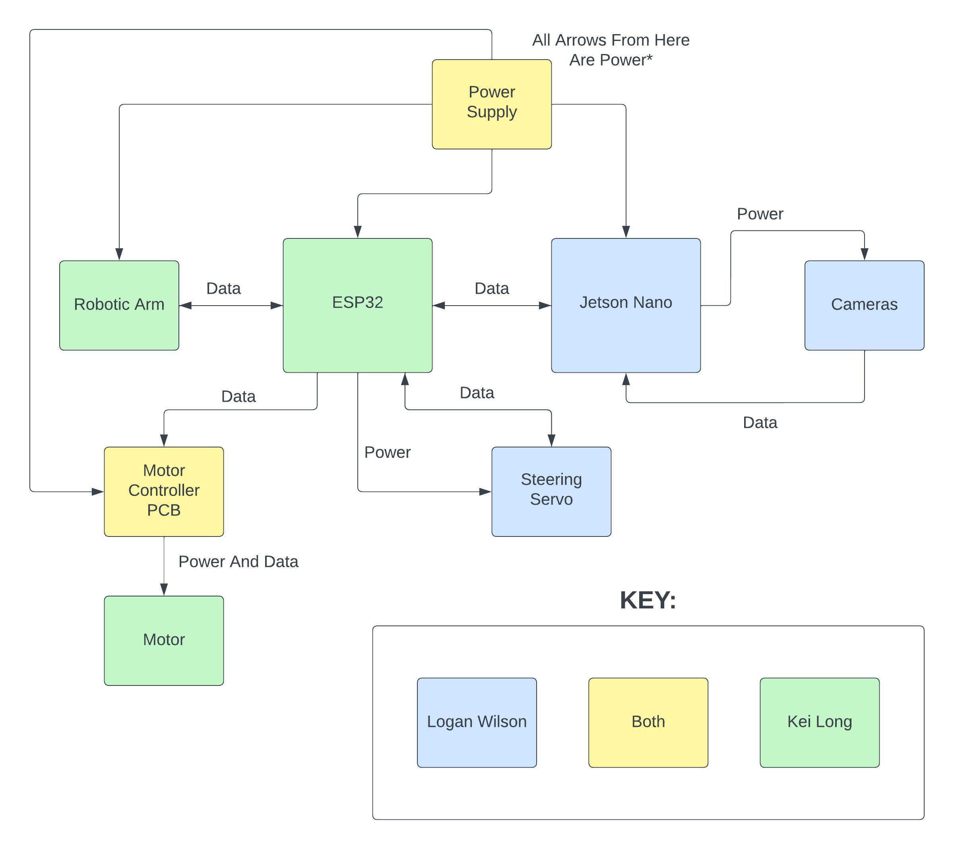
Figure 2.4: Block Diagram

2.5 Progression Flow Chart
To accompany our block diagram and further visually express how we would accomplish our task of designing and building this device, we decided from the beginning that it would be useful to create a progression flow chart that describes the path we will take to accomplish our goals, which won’t be a straight line. As shown below in figure 2.5, we divided all of our tasks for progression into three categories, research, prototype, and design. This allowed us to further organize our plan of action, but in order to make sure we were meeting the timeline well, we also specified what was completed, in progress, not yet touched (when left undescribed). Finally, to make sure we were fully organized, we divided it up (once again as a formality) into our individual processes, leaving the more software and ML processes to Logan Wilson and the more hardware-based ones to Kei Long, sharing anything that includes both as this is where our strengths lie. As mentioned earlier though, we will mostly share responsibility for all tasks/processes as needed.
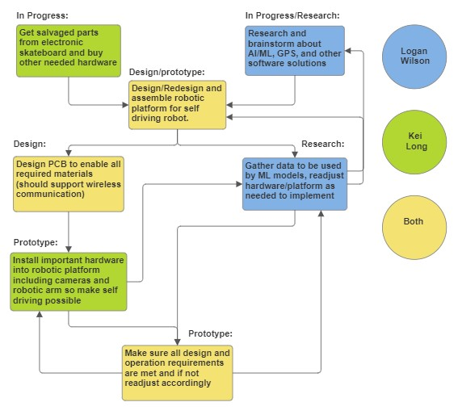
Figure 2.5: Progression Flow Chart

2.6 House Of Quality
The House of Quality is a tool used in quality management. The primary purpose of the House of Quality is to facilitate the systematic process of translating marketing requirements into engineering characteristics and specifications for a product or service.
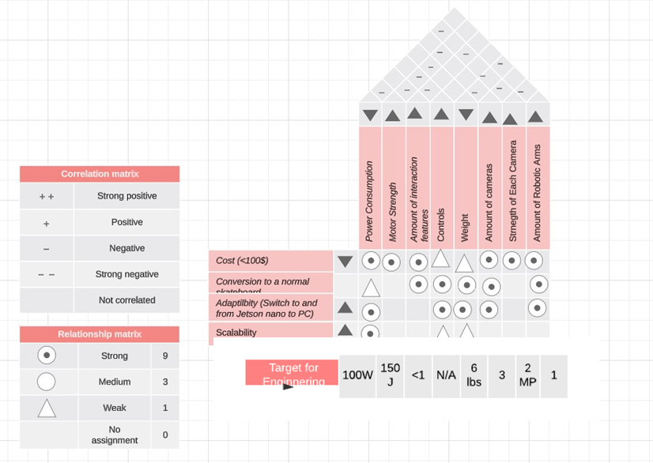
Figure 2.6: House Of Quality

3. Project Research And Part Selection
In this section we will talk about the research done on the project as a whole in addition to each part individually. With every part/technology we used, we would first research what was needed in order to meet our engineering requirements, marketing requirements, and standards. We then would compare and contrast the different part/technology options that met our specifications in order to find the best fit given our budget, time constraints, functionality needs, and room for error/expansion.

3.1 Technology Comparison
As of now, the main two technologies that I will be focusing on is our MCU for motor control and the computer that we will be using for processing the data in real time. For the MCU, we had 3 major choices, the ESP32, Arduino, and MCP432. For the processing unit, we need a GPU, there are 3 choices that we considered. ROCK Pi N10, BeagleBone, and the Jetson Nano.
There are many factors that I need to consider when we choosing a MCU. One important one is processing power. I really don’t need to handle anything, since our processing unit will handle everything complicated. Another key aspect is the connectivity. For our project, I need to consider which wireless communication protocol I am going to use. I/O pins are also important, however, most of the boards will come with good amount anyway. Power consumption is another key aspect to consider.

3.1.A MCU
The first MCU I am going to compare is the ESP32. he ESP32 is a powerful and versatile microcontroller that has gained popularity for a wide range of IoT and embedded systems projects. Another key reason for its rise of popularity is the integration it has with many wireless communication modules. One key feature of the ESP32 is its dual-core processor. The ESP32 features a dual-core Tensilica LX6 processor, which can run at up to 240 MHz. This dual-core architecture allows you to handle multiple tasks simultaneously. We can write code to take advantage of it’s dual core, by using a RTOS, real time operation system. This will allow us to write concurrent code, which will give us an increase in speed.
Wi-Fi and Bluetooth Connectivity is also another highlight of the ESP32. It comes with integrated Wi-Fi (802.11 b/g/n) and Bluetooth (Bluetooth 4.2 and BLE) capabilities. Also, based on my research, it comes with a code generator for its Wi-Fi and its Bluetooth modules. This makes it really easy for us to write code and take advantage of these features. We can use Wi-Fi in our project to give us real time feedback on the platform. Another feature of the ESP32 is it’s rich set of GPIO pins. It provides a large number of GPIO pins, which are flexible and can be used for various purposes, including digital input/output and analog input. However, we this isn’t really that big of a deal, since our processing unit will also have GPIO pins, and we will have more than enough. The ESP32 also has extensive library support for pretty much anything, including libraries for web servers, WebSocket communication, MQTT, and more. Like I mentioned previously, Bluetooth and Wi-Fi can be included in these libraries, making integration simple. On other MCUs we might need to solder or use GPIO pins to use Wi-Fi. Camera support is also built in the ESP32. This will make it simple to make use of cameras. Although our processing unit will have a camera, we can always use additional cameras for other purposes. For example, we can handle the distance off the ground with a separate camera from our processing unit, and decrease the load on our processing unit. Also, another neat feature of the ESP32 is that it can secure boot, as well as has flash encryption. Secure Boot is a security feature implemented in many modern computer systems, including most PCs and servers. Its primary purpose is to ensure that only trusted and authorized software is allowed to run during the boot-up process of a computer. Secure Boot helps protect the system against various types of malwares, rootkits, and unauthorized operating systems. Flash encryption is a security mechanism designed to protect data stored on flash memory devices. It involves encrypting the data on the flash storage to prevent unauthorized access to the information, even if the physical storage medium is compromised or stolen. If needed, we always have the capabilities to secure our data. We can also take advantage of the LPMs on the ESP32, which is another feature of the ESP32. Like I mentioned earlier, we can install RTOS, such as freeRTOS, which is used in many applications, most notably embedded systems. This will allow us to run two things at the same time, concurrently. For example, we can use one process solely to collect data, then the other process can be the process that will process the data and maybe output it to our processing unit.
Another popular MCU is using Arduino, specifically the ATmega328P. The ATmega328P is a common microcontroller found on Arduino boards like the Arduino Uno. It operates at up to 16 MHz and has 32 KB of flash memory for program storage, 2 KB of RAM, and 1 KB of EEPROM. The key benefit of using arduino is its ease of use. Arduino is known for its beginner-friendly development environment, which includes an integrated development environment (IDE) and a simple, easy-to-learn programming language based on C/C++. Another feature of using the Atmega328P is its expandability with shields. Arduino can be easily expanded using pre-made shields that stack on top of the base board to add features such as GPS, Ethernet, and Wi-Fi. Also, they are the cheapest option. However, the difference of price is about 20$-30$, which isn’t much.
The one key feature that sets the MSP432 is its power consumption. The MSP432 microcontrollers are designed with an emphasis on ultra-low power consumption, making them ideal for battery-powered and energy-efficient applications. This is probably the most important feature that sets its apart from other MCUs. Another feature of the MSP432 is its peripherals. MSP432 microcontrollers offer a range of integrated peripherals, including GPIO pins, analog-to-digital converters (ADCs), timers, UART, SPI, I2C, and more. Going back to its power consumption, one key way that the MSP432 is able to operate on such low power levels is with its LPMs. MSP432 microcontrollers support various low-power modes, allowing you to reduce power consumption during periods of inactivity. The MSP432 has 4 LPMs, depending on what we want it to do. Since it is going to be battery powered, we should take this into consideration. Another feature of the integrated sensors. Some MSP432 microcontrollers include built-in sensors, such as temperature sensors, which can be useful in temperature-sensitive applications. Another thing that makes the code simple is that the MSP432 comes with a real time clock. Many MSP432 devices include a real-time clock, which can be essential for applications that require accurate timekeeping. Similar to the ESP32, the MSP432 comes with RTOS support, however, its not the one that everyone uses, its its own software called TI-RTOS. It is beneficial for projects that require multitasking and precise timing.
Based on all these facts, we are going to choose the esp32. It has the best processing power out of all of the parts I listed, which is important. For anything computer vision, processing power is important. Also, its connectivity is the best. For the aurdino and MSP432, the only connectivity modules installed is serial/wired connections, such as UART, which we can not implement for our project. If we want to use Wi-Fi, we will need to part in extra effort to make it work.

3.2 Parts Selection
In this section we will discuss the process with which we selected each of our parts. This includes the comparison of all candidate parts and the analysis of factors that led us to deciding on individual parts.

3.2.A Battery
When deciding on a power source for the robotic platform, our initial thought was to go for something similar to the battery used in the existing skateboard that we were building off of. This gave us a starting point to research what type of battery would suffice for a device of this size, as we had the foundational understanding that the majority of our power consumption would still be from the movement of the actual platform. Below shown in figure 3.2.A1 you can see the original battery along with it’s written specifications, though somewhat obscured.
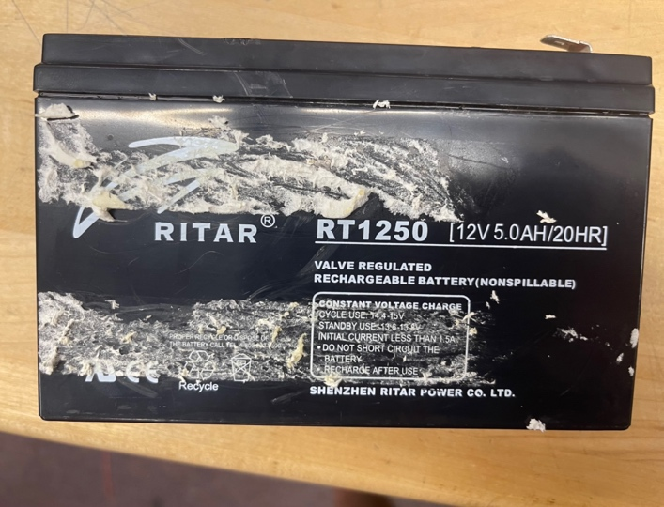
Figure 3.2.A1: Original Battery
Due to a lack of documentation for the parts in the salvaged skateboard, this was our best initial understanding of the power consumption requirements for moving a device such as this. This allowed us to learn that 12V 5.0AH batteries with large capacities such as this would be best for our completed platform.
From this point on, we began researching parts online to find the best match, recording all of the possible candidates as we went. There were many factors that we cared about, but the most important were:
- The voltage and amperage matched the original battery or exceeded it, hence also leaving us with the same or higher wattage/power delivery.
- Rechargeability as this is a necessity for our project.
- Weight as this affects the movement of the platform.
- Size as this affects the housing we will put this in and what else we can fit.
- Price as we need this to fit out budget.
- Time to ship as we needed to start testing this battery as soon as possible.
Below shown in table 3.2.A1 is the comparison of different batteries we found and their properties.
Table 3.2.A1: Battery Comparison
Battery | RT1250 (Original Broken Battery) | ML5-12 SLA (Our Choice) | SP12-5.5HR (Bad Reviews For Reliability) | EXP-1250
Manufacturer | Ritar | Mighty Max | SigmasTek | Expert Power
Voltage | 12 V | 12 V | 12 V | 14 V
Amperage | 5 AH | 5 AH | 5.5 AH | 5AH
Is Rechargeable | Yes | Yes | No | Yes
Weight | 3 lbs | 3.5 lbs | 4.2 lbs | 3.2 lbs
Dimensions | 3.54in x 2.76in x 4.21in | 3.58in x 2.76in x 4.21in | 3.54in x 2.76in x 3.98in | 3.5in x 2.8in x 3.9in
Price | N/A | $16.99 | $13.59 | $19.79
Shipping Time | N/A | 3 Days | 12 Days | 8 Days

After careful deliberation of our candidate options from the table, we decided to go with the Mighty Max ML5-12 SLA as this meets all of our power consumption needs, was average in dimensions, weight, and price, but most importantly it shipped the fastest, allowing us to get a jump start testing with this new battery.

3.2.B Relays
Once decided that we were going to need the ability for our self-driving platform to go both forwards and backwards, we began brainstorming ways to redo the PCB to control the motor bidirectionally. With the help of Dr. Arthur Weeks, we were able to work through a few designs and settled on the following circuit that would allow for our microcontroller to switch the motor from forwards to reverse and vice versa.
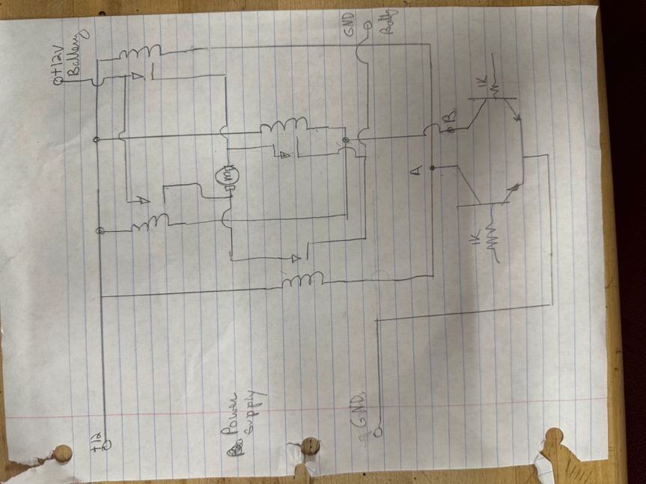
Figure 3.2.B1: Circuit diagram for motor controller
Since this circuit contains relays, we were sure that we would need to pick relays that would work best for this type of job. Since we had already chosen a battery with similar specs to the included one and were still using the motor that the skateboard came with, we decided to look at the existing PCB to see what types of relays would be a best fit. Upon inspection of this PCB (shown in figure 3.2.B2) we found that the relays used were 40A/12VDC, which would be important for us to match given the constraints of the battery we have and the requirements of the motor.
Upon looking at the soldering on the bottom of the PCB (shown in figure 3.2.B3), we were also able to determine that the relays used are 4 pin, which makes sense given the application. This gave us a starting point to research relays that would meet these requirements in addition to a few other determining factors.
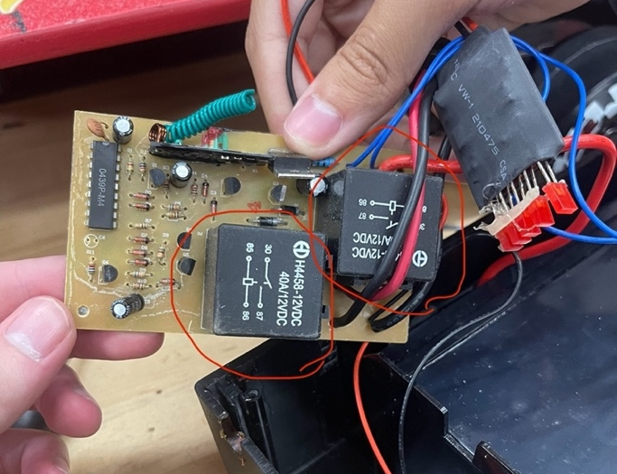
Figure 3.2.B2: Original relays on the included skateboard PCB
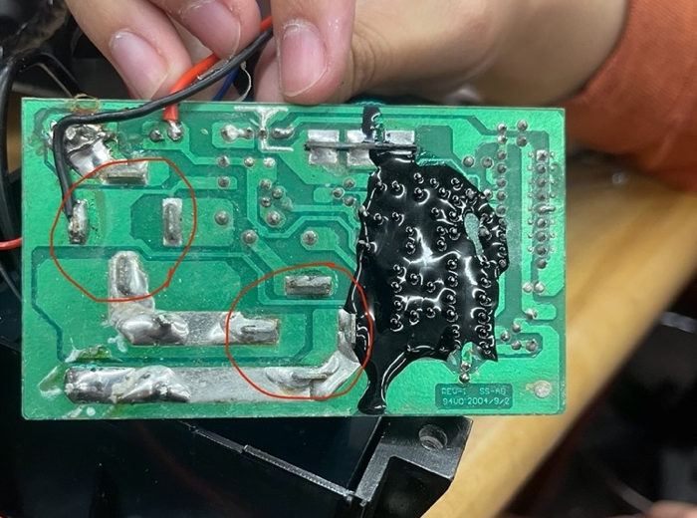
Figure 3.2.B3: Original relays on the included skateboard PCB
Since we also had a lack of documentation for the PCB in the salvaged skateboard, the inspections described above led to our only initial understanding of what type of relays would work best for this application, so we decided to base our research points around the voltage and current ratings as well as the number of pins and decide among the choices we then find.
Once we’d established what we would look for this, we started researching parts online to find the best matches, recording all of the possible candidates as we went. There were many factors that we cared about, but the most important were:
- The voltage and amperage (amperage has a lot more leeway as 40 is unnecessary) matched the relays from the original PCB, hence also leaving us with the same power rating.
- The number of pins matched the original relays, as we only needed a switch from open circuit to a wire, not from one wire to another (hence 4 makes the most sense but using 5 is still possible).
- Size as this affects how big the PCB will be and subsequently how much room in the housing we will need to allocate for the PCB.
- Minimum purchase quantity as this affects what we will have to pay in total and how many unnecessary extras we will have.
- Price per unit as we want this affect our budget as little as possible.
- Time to ship as we needed to start testing these on a breadboard as soon as possible.
Below shown in table 3.2.B1 is the comparison of different relays we found and their properties.
Table 3.2.B1: Relay Comparison
Relay | RT1250 (Original Relays) | JD-1912 12V30A (Our Choice) | AE-001-1 | JD-1912 12V40A
Manufacturer | Si Tai&SH | Magic Mask | EPAuto | Gebildet
Voltage | 12 V | 12 V | 14 V | 14 V
Amperage | 40 A | 30 A | 30 A | 40 A
Pin Count | 4 | 4 | 5 | 4
Minimum Quantity | 1 | 4 | 5 | 2
Dimensions | 1.98in x 3.71in x 2.61in | 1.4in x 0.94in x 0.63in | 5.63in x 1.78in x 3.61in (Includes Cable) | 8.98in x 2.24in x 1.3in (Includes Cable)
Price Per Unit | $1.74 | $1.50 | $3.18 | $3.98
Shipping Time | 28 Days | 3 Days | 5 Days | 6 Days

After careful deliberation of our candidate options from the table, we decided to go with the Magic Mask JD-1912 12V30A as this matches our voltage requirement, still gives plenty of extra room for the amperage at 30 A, had 4 pins, was the smallest option, came with the exact number of pieces we needed, was the cheapest option, and shipped the fastest. Also, only buying 4 (leaving us with no spares) works well as we could always take one from the old PCB as a replacement if needed.

3.2.C Steering Mechanism
At this point we had completed the design for the platform’s movement based on the skateboard, even incorporating the ability to change the direction of the motor, but this left us with one main problem relating to mobility, the ability to turn. Since the salvaged skateboard this platform was built around wasn’t designed to be electronically steered and had no mechanisms for such movements, we had to get creative with how we would implement this.
Now that we had realized the challenges of implementing this type of movement, we began researching ways this has been implemented in similar devices. One such possible solution we found, as shown below, is called a Mecanum wheel.
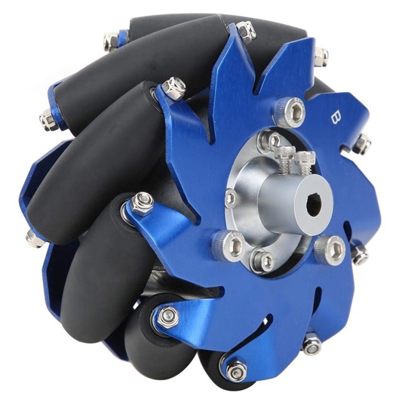
Figure 3.2.C1: Image of a Mecanum wheel, credit to this Mecanum wheel for sale at https://www.amazon.com/Mecanum-Aluminum-Industrial-Accessories-Coupling/dp/B08H2F29CJ for the picture.
Incorporating this type of wheel on our platform would eliminate the need to change the trucks of the skateboard to somehow be able to rotate, as Mecanum wheels allow a vehicle to turn simple by applying different directional (either forward or backward) force to each wheel the combination of which, making use of the 45-degree rollers lining the wheels, causes the entire vehicle to turn. This can be seen in the diagram in figure 3.2.C2 below.
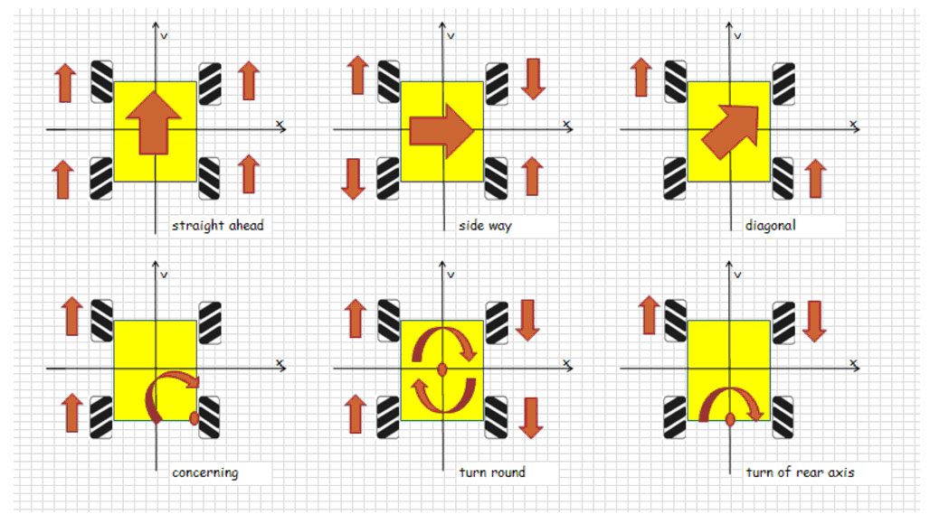
Figure 3.2.C2: Diagram of Mecanum wheel function, credit to https://www.roboteq.com/applications/all-blogs/5-driving-mecanum-wheels-omnidirectional-robots for the picture.
Upon researching further, though, it became apparent that there were downsides to using this approach. The main issue with switching directly to Mecanum wheels would be that this would require not only 4WD but also a designated motor per wheel, and we only currently have the 1 motor that came with the RWD skateboard. In the end, this ended up deterring us from this solution, as implementing this would not only mean practically a complete redesign but also a large increase in expenses, but this led us back to one of our original ideas, implementing a steering servo.
For this to work, we would need to disconnect the front truck (the piece containing both front wheels) from the skateboard, cut a hole in the skateboard to place the servo in, screw the servo into the skateboard, and connect the truck to the rotational head on the servo. While this may sound like a decent amount of augmentation, this was certainly more manageable than adding 4 more motors and redesigning our motor-controller to support all of them.
Based on this, we began looking at similar projects such as 1:8 model RC cars and observed that many of our DIY engineering peers also used this solution, though there were clearly some specifications that needed to be met for this solution to be properly implemented. One such design that operates similar to how ours is intended to is shown below in figure 3.2.C3.
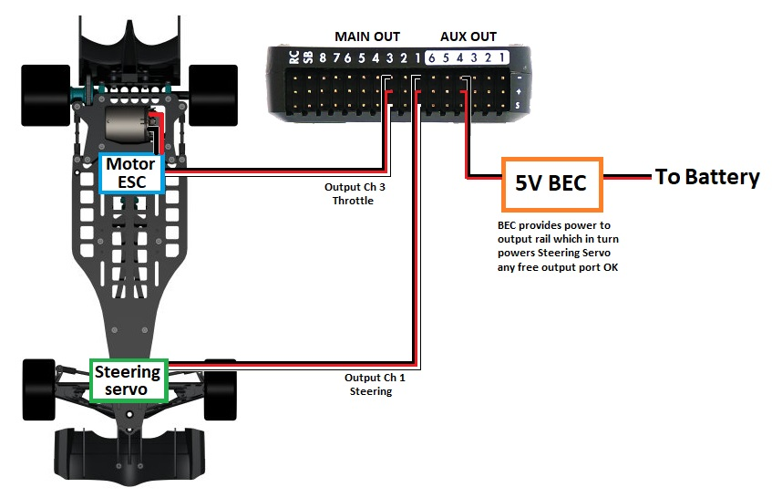
Figure 3.2.C3: Design for RC car with single RWD motor and steering servo guiding front wheels, credit to https://discuss.ardupilot.org/t/doubt-in-servo-connection/30509 for the image.
The main difference between the design shown above and what we are implementing is that the RC care pictured in figure 3.2.C3 has a stationary truck with two front wheels on it that pivot according to force from the servo. In our case, the entire truck will be connected to the servo in order to avoid redesigning the trucks and all of the mechanical engineering that would be involved with that (this should be fine assuming we cushion properly and meet the specifications described later).
Now that we knew what we were looking for, we began researching possible parts that would work for our intended design, prioritizing the following features:
- The voltage needs of the servo.
- The rotational angle of the servo as this determines how far we can turn the wheels in a given direction.
- Size as this affects how it will need to connect to the truck.
- Weight as this will add to the pressure of the truck-servo connection point.
- Torque as we will need to not only move the individual wheels but also the entire truck, though for our purposes it doesn’t need to be super-fast.
- Minimum purchase quantity as this affects what we will have to pay in total and how many unnecessary extras we will have.
- Price per unit as we want this affect our budget as little as possible.
- Time to ship as we needed to start testing these on a breadboard as soon as possible.
Below shown in table 3.2.C1 is the comparison of different relays we found and their properties.
Table 3.2.C1: Relay Comparison
Relay | MS24 | MS62 (Our Choice) | MG995 | DS35MG
Manufacturer | Miuzei | Miuzei | TIANKONGRC | 9imod
Voltage | 6.8 V | 8.4 V | 6 V | 7.4 V
Weight | 2.89 Ounces | 0.32 Ounces (this is listed on the product page, not sure if it’s a mistake) | 4.6 Ounces | 3.31 ounces
Rotational Angle | 270 Degrees | 270 Degrees | 180 Degrees | 180 Degrees
Torque | 20 kg/cm | 25 kg/cm | 13 kg/cm | 35 kg/cm
Minimum Quantity | 1 | 1 | 2 | 1
Dimensions | 3.82in x 2.64in x 1.22in | 4.61in x 3.62in x 0.94in | 5.12in x 3.86in x 1.46in | 3.7in x 3.54in x 1.02in
Price Per Unit | $12.59 | $16.44 | $7.49 | $33.49
Shipping Time | 5 Days | 13 Days | 5 Days | 11 Days

After carefully going over our candidate options from the table, we decided to go with the Miuzei MS62 as it didn’t draw too much voltage, had one of the largest rotational angles, had the second highest torque (not unnecessarily high but still enough for our needs), allowed us to get only 1 servo, was a good size, and was the second cheapest option. This is all despite it having the longest shipping time, but in this case we feel it is necessary for the greater torque it will provide.

4. Design Constraints And Standards
Design constraints and standards are crucial in any engineering project, including the development of the platform. Standards often include safety guidelines and regulations that must be followed to ensure the safe operation of a device. Adhering to these standards can help prevent accidents and ensure the well-being of users and bystanders. Many industries and applications have specific regulations and standards that products must comply with to be legally used. Adhering to these standards ensures that your rover platform meets regulatory requirements, avoiding legal issues and facilitating market acceptance. Below are some of the standards that we are adhering to for the project.

4.1 IEEE/ISO Standards
When building our platform, there are many standards that we have to comply to. Major standards include IEEE, ISO, and ACM. One of the most prevalent standard is the WiFi standard, or IEEE 802.11.
IEEE 802.11 plays a vital role in enabling wireless communication and data transfer for our platform. It facilitates remote control, real-time feedback, data transmission, and connectivity, making it a fundamental component for the operation of similar platforms, particularly in scenarios where wired connections are impractical or infeasible. We considered using IEEE 802.3 or ethernet for our platform. Although the nano comes with a ethernet module in our platform, we might use it to directly communicate with the central computer (something we need to discuss more with Group 31). However, for the remote control aspect, such as controlling the platform through a phone or computer, other than the nano, IEEE 802.11 plays a vital role in the success of the platform.
IEEE 802.11 provides the framework for establishing wireless communication between devices. For our platform, this means that it can use Wi-Fi to connect to and communicate with other devices, such as a remote-control station, other computers/platforms, or sensor nodes. This wireless communication is essential for remote control, data exchange, and real-time monitoring of the platform activities. Although we didn’t really plan this part out yet, if we decide to transmit our data from the nano to, lets say a KVM (Keyboard Video Mouse) or the main pc, we need to account for data transmission.
Similar platforms often generate a significant amount of data through their cameras and sensors. IEEE 802.11 allows the platform to transmit this data wirelessly, which is especially important if the platform needs to send images or sensor data back to a control center, the main PC.
Another thing to consider is the real time operation of the platform. For example, if we need to change the parameters mid operation, or just see something in real time, we need to use IEEE 802.11. The low-latency capabilities of IEEE 802.11 can enable real-time feedback from the platform to the operator. This is essential in situations where immediate decisions or adjustments are required, such as during autonomous navigation or when dealing with dynamic environments. It’s difficult to see this far in the future, but it might come useful. Although during the run, the platform might stay offline, this is important to keep in mind. But we might need to implement some type of real time interpretation of its environment. By using IEEE 802.11, we can improve its mapping features.
IEEE 802.11 can be used in combination with Wi-Fi access points to aid in indoor or outdoor localization and mapping for the platform. By triangulating the platform’s position relative to known access points, it can improve its navigation and mapping capabilities.
Lastly, IEEE 802.11 has security features, which is one less thing to think about. IEEE 802.11 standards also include provisions for wireless network security, which is critical for safeguarding the platform’s communication and data transmission. Security measures like WPA3 encryption can help protect against unauthorized access and data breaches. However, UCF’s protocol for encryption is WPA2, which is still great.
Another standard to be aware of is ISO 13482. Since we are planning to install the arm on the platform, I am going to classify it as a robot. This standard technically only applies to robots, but being able to carry out tasks without any human intervention makes it a “robot”. (I need to cite this later, https://robotsguide.com/learn/what-is-a-robot, or maybe find a better link) Its principles and safety guidelines can impact the design, development, and use of such robots, including our platform, in various ways. One way is with safety compliance.
ISO 13482 provides a framework for ensuring the safety of personal care robots. When designing and building our platform, we need to adhere to the safety requirements outlined in this standard to mitigate risks associated with robot operation. The first way is with our design and development. When designing our platform, we need to consider safety from the initial concept phase. This includes identifying potential risks, hazards, and failure modes associated with the platform’s operation. For a platform, this involves assessing the safety of the robot's mobility system, sensors, and computer vision algorithms. Safety considerations may also extend to the design of any moving parts, such as the arm.
ISO 13482 requires developers to perform a comprehensive risk assessment, which involves identifying potential hazards and assessing the severity of these hazards. For our platform, potential hazards might include collisions with objects, entanglement of wires or cables, or unsafe interactions with humans. We must then implement safety measures and design features to mitigate these risks. We also need to calculate every edge case and implement those in our computer vision algorithms. Although our platform isn’t dangerous in any way, its just a skateboard with a arm and a computer attached to it, we still don’t want anyone to get hurt from it.
The platform’s control system and programming play a crucial role in ensuring safe operation. This involves developing algorithms that enable the platform to detect and respond to safety-critical situations. For example, the platform might need to detect obstacles in its path and take appropriate actions to avoid collisions or stop if necessary.
Another thing that we need to take in consideration is emergency stop and safe modes. ISO 13482 mandates the inclusion of emergency stop mechanisms and safe modes of operation. In the context of our platform, these features could be designed to allow immediate cessation of any hazardous actions or the robot's movement in emergency situations. Safe modes may limit the robot's actions to reduce the potential for harm. We are planning to implement this in our remote. In order to make a remote, we needed a new MCU/new logic. The one that came stock with the platform was awful. It had only two features, run and stop. Our new logic that we build is bi-directional and also we can implement a hard stop feature in order to stay compliant to the standard.
We also need to document everything about the usage of the platform. The standard requires clear and comprehensive documentation related to safety measures and risks. This documentation should be made available to operators, and anyone involved with the robot's operation. For our platform, this means providing detailed information on safe operation, emergency procedures, and any specific precautions related to the platform's vision system. In order to stay compliant, we can include a tutorial on how to use it and safe practices on the usage of the platform.
Lastly, the standard requires us to perform major testing and validation. ISO 13482 stipulates the need for rigorous testing and validation of the platform’s safety features and functionality. For a platform, this could involve testing its ability to recognize and respond to safety-critical situations accurately and in a timely manner. I feel like this will come naturally, as we tinker with the platform more.
Another standard that we should consider is ISO 9241. ISO 9241 is a series of international standards that pertain to the ergonomics of human-system interaction. While these standards are primarily focused on the design of systems, including software and hardware interfaces, rather than physical devices like our platform, they can still have an impact on the design and usability of the platform in terms of its user interfaces and human-robot interaction. (I feel like this applies more to Group 31, but we will still have some type of UI, therefore, I am including it. This is a topic we need to discuss with them.)
The key takeaway from this standard is the User Interface Design. ISO 9241 provides comprehensive guidelines for designing user interfaces that are both ergonomic and user-friendly. When applied to our platform, these guidelines can impact the design of the rover's control interface in many ways. One way is with Task analysis.
ISO 9241 recommends conducting a thorough task analysis to understand the tasks that users will perform with the platform. This involves identifying the specific tasks related to controlling the platform and its vision systems, such as navigation, image capture, data analysis, and communication. Task analysis helps in tailoring the user interface to support these tasks efficiently.
The standards also promote user-centered design, emphasizing the importance of designing the interface with the needs, abilities, and expectations of the users in mind. In the case of our platform, this means considering the requirements and preferences of the operators who will control the platform’s actions and vision systems.
ISO 9241 provides guidance on how information should be presented on the interface. For the platform, this includes how real-time camera feeds, sensor data, and navigation information should be displayed. The standard encourages clear and intuitive presentation to help operators quickly interpret the data. I feel like a standard terminal (stdout) is fine, but we can maybe organize our data in maybe a JSON, or maybe just a log file, which allows us to quickly find certain parts that went wrong. One example of this is if we know there is a problem with a specific task, then we can run it through edge cases. Then, if we efficiently organize our log files, we know exactly which cases broke our platform.
The standard addresses interaction design, which involves defining how users will interact with the system. In the context of our platform, this means specifying how operators will input commands and receive feedback, whether through touchscreens, physical controls, or other input devices.
ISO 9241 underscores the importance of providing feedback to users regarding the state of the system and the outcome of their actions. For our platform, this means ensuring that the interface gives clear feedback on the platform’s movement, camera orientation, and any errors or obstacles encountered.
The standard encourages usability testing to evaluate the effectiveness of the user interface. Usability testing involves observing how users interact with the interface and making iterative improvements based on their feedback. For our platform, this process can help refine the interface to enhance operator performance.
ISO 9241 includes considerations for accessibility, ensuring that the user interface is usable by individuals with disabilities. When designing the interface for our platform, it's important to adhere to accessibility guidelines to accommodate users with varying needs, such as screen readers for visually impaired operators.
The standards advocate for interface consistency, promoting a uniform look and feel throughout the system. In the context of our platform, this ensures that controls and interactions are consistent, making it easier for operators to switch between different functions and reduce cognitive load.
ISO 9241 emphasizes the importance of designing interfaces for efficiency, minimizing the number of steps required to complete tasks. It also covers effective error handling, ensuring that the interface helps users identify and recover from errors or issues efficiently.
The standards in ISO 9241 aim to create a positive user experience by addressing factors like ease of use, efficiency, and user satisfaction. This is relevant when designing the human-robot interaction aspects of the platform, as a well-designed and intuitive interface can enhance the operator's experience.
ISO 9241 encourages usability testing, which involves observing users interacting with a system to identify areas for improvement. For our platform, usability testing can be essential to refine the control interface and ensure that operators can effectively control the rover and its vision systems. We have many people working on this project, and this is a very important element to focus on. Since we (Logan and I) are developing it, maybe of the things might seem natural to us. However, many people, such as people that never used anything like this before, might have difficultly reading data or seeing how it works. Going through vigorous testing will allow it to be as efficient as possible.
ISO 9241 emphasizes the importance of efficiency in human-system interaction. When applied to our platform, this standard encourages the development of interfaces that allow operators to control the rover and its vision systems with minimal effort, reducing the potential for errors and improving efficiency.
ISO 9241 places a strong emphasis on human-centered design, which involves considering the needs, abilities, and limitations of users when designing systems. This approach is crucial for developing our platform’s interface that is user-centric and tailored to the specific needs of the operators.

4.2 Design Constraints
Since our platform is going to be based off a skateboard, rather than something like a wheelchair or a base off-the-shelf robotic kit, there are many design constraints that we have to consider. For example, the robotic kits have everything considered, things like power, and expansion of extra modules. However, since we are building everything from scratch, this gives us a lot of freedom to do whatever we want, however, we have to be careful with how we implement it. I think the most obvious thing that we have to consider is the mechanical constraints.
The mechanical constraints play a key role in the success of the project. The first is stability and safety. Ensuring the mechanical stability of your robot is paramount. If our platform is not mechanically sound, it could be prone to tipping over, especially when you add a robotic arm, which can significantly shift the center of gravity. A stable platform is safer to operate, reducing the risk of accidents or damage to the platform itself or its surroundings. Another thing to consider is mobility. The mechanical design directly impacts the platform’s mobility. The platform should be able to navigate various terrains and handle obstacles. Adequate ground clearance, the right choice of wheels and tires, and an appropriate suspension system are all critical for maintaining mobility. Mechanical constraints also play a vital role in the functionality. Mechanical constraints influence the platform’s ability to perform its intended tasks effectively. The design should support the installation of cameras, sensors, and the robotic arm in a way that optimizes their functionality. For instance, if the cameras are not properly positioned or stabilized, it can negatively impact the quality of data for computer vision tasks. Also, since we are always coming up with new ideas, we need to make it as modular as possible. A carefully designed mechanical system allows for customization and adaptability. A well-designed housing unit and mounting system make it easier to incorporate new sensors, cameras, or tools and adapt to changing project requirements. Mechanical constraints also allow us to get performance optimization and a minimization of interference. Mechanical design can impact the platform’s energy efficiency, speed, and payload capacity. Optimized mechanical systems can help maximize the platform’s performance and range of possible tasks as well as ensuring that the components do not interfere with each other.
That being said, some of the mechanical constraints that we have to take into account include weight balance and distribution. The addition of computer vision equipment, sensors, and a robotic arm can significantly alter the weight distribution of the skateboard. We need to ensure that the weight is balanced to prevent tipping or instability. One way to overcome this is by using counterweights or redistributing components as needed. This is why our housing unit is so important. If pieces shift around as the platform is moving, this can mess with the weight and our vision algorithms might fail because of that. Another thing that we need to consider is as a mechanical constraint is our housing unit modifications. One way to counteract this is by reinforcing the frame, add mounting points for cameras and sensors, and create space for the robotic arm's base. Another mechanical constraint that we have to take into account is suspension and mobility. The skateboard is not really meant to used offroad. One way might be to use different type of wheels as stated in section 3. Another mechanical constraint that we have to consider is the payload. Although, once the arm is installed, it’ll be very hard for a human to ride the board, I think this will be a great feature to somehow implement, as it will give the platform another use. Another mechanical constraint to consider is viberation damping. To be honest, I don’t know how to really solve this, since the back trunks can’t change. One thing that we can try is to install some springs in the housing unit, allowing the platform to take some of the shock away from the wheels and damp it out. One of the most mechanical constraints to consider is the center of gravity. The center of gravity is so important because that is the core of maintaining stability. This is probably one of the most important things to keep track of. The last mechanical constraint that I can think of is access for maintenance. I think the most naïve solution for the housing unit is just to take wood and put everything inside, then just screw it on. However, if something fails, or we want to install another module, it will be a hassle to get the unit open. Even the housing unit the board came with was pretty bad, everything was glued together and impossible to separate.
Another design constraint that we have to take into consideration is the battery/power supply. As explained in 3.2, we have a 12V battery, that runs on 5Ah. The running life of this battery is sometime around 20H. However, if we install more things, and once we get the nano running, the battery life will shrink. Another thing that we had to do, as mentioned in 3.2, is that we replaced the battery. The way the manufacturers installed the battery is that they glued it onto the housing unit. However, to charge the battery, they took wire soldered on the battery, and used some type of AC to DC converter and had that charge the battery. This can lead to failure and overall not safe, also had no documentation. Therefore, we also need to install a battery charger, so we don’t have to replace the battery every week.
Of course, another design constraint we have with this setup is the computer vision. However, it is not all software focused. We need to choose the right type of cameras for the platform, as well as the other sensors. Some of the key factors that we need to consider are the field of view, which is dependent on the location of the cameras relative to the ground, and the spacing between them, as well as resolution. However, this is all dependent on the processing capabilities of the board. In order to combat this, we choose with the Jetson Nano, which comes with a Nvidia GPU, with CUDA cores, which handles all of the vision capabilities. This allows us to do real time data processing, and get a better platform. There is no point of the best model in the world without the processing power of the input data.
Another design constraint that we have to consider is the mobility of the platform. We already made modifications to it’s interface in order to support our protocols. At first, the skateboard was uni-directional, which is useless for our case. In order to make the skateboard better, we are working on a new PCB that will go bi-directional. Also, we need to implement some type of suspension system so our platform doesn’t break then it falls 5 feet. (pothole, steep sidewalk, etc).
Of course, another design constraint we have to consider is the robotic arm and all of the implications that it brings. The first major thing is the kinematics of the arm. The arm that we have is a 6 DoF, which is a large range of motion compared to other arms ( the human arm has 7). Also, none of us ever did robotic programming. We also have to take that into consideration. This might limit what we can make the arm do. However, I think we will both love to take that challenge and see what we can do.
Another design constraint is the communication constraints of the platform. In a perfect world, we will have many sensors and cameras all interacting at once. We need to get all of that input data into the nano so the nano can do all of its processing. How will all of the input communicate with the final destination? That is the communication constraints come in. We first need to consider what type of connectivity that we will use. Common options include Wi-Fi, Bluetooth, Zigbee, LoRa, or cellular networks. We will try all of these can come up with a solution. However, Wi-Fi looks like the most promising, as we will go into more detail later. Another thing that we need to consider is the range and coverage. Since we will be operating on UCF campus, we should have full connectivity throughout the entire campus. Another thing to consider is the data transfer rate. IEEE 802.3 will be the fastest, however, maybe of the sensors won’t include this, therefore, we have to settle with the slower, less reliable IEEE 802.11 standard.
Another design constraint that we must consider is the safety of the platform. This ties into all of the standards mentioned in 4.1. As mentioned in the previous section, according to those standards, we need to implement a failsafe, such as an emergency stop. I will go in more detail on this in a later section.
The last design constraint that we have to consider is the legal and ethical constraints. Although it seems silly, we have to consider what happens if we accidently don’t consider certain things. For example, if we were to collect PII (Personally Identifiable Information) with our platform, even if its an accident, we can get in a lot of trouble. We have to put in a lot of effort in compliance with the law. Violating laws and regulations can result in penalties, fines, lawsuits, and legal consequences that can harm our future. Another reason on why these legal constraints are important is because it involves the protection of privacy and rights. Ethical considerations and legal requirements related to privacy and data protection are fundamental for respecting individuals' rights. Ignoring privacy and data protection can lead to invasions of privacy and damage to individuals' dignity and rights. Ignoring legal considerations can lead to legal battles, intellectual property disputes, and contract violations, which can be financially and operationally burdensome.
Some of the legal and ethical constraints that we have to consider include privacy regulations. We will mostly operate in UCF campus, as mentioned before. In Florida, if it is public property, as such as public college campus, we are free to record without any problems. Although people might not consent, there is no need to collect consent, therefore we should be able to record no problem. The next one is more of a ethical constraint, and it is data security. We are planning to solely use the input data for training, and nothing more. Companies that do something similar to what we are doing also claim to do the same thing, but their privacy policy says that they can freely share their data to stakeholders, such as Tencent. We will try to either delete the data once used in a training cycle, or if applicable, transfer the data collected from the Jetson nano, over to the main bigger computer and have it hosted on their until trained on. Then, maybe we can process the data and use it as part of a test set. Another ethical constraint is that it will be roaming on public spaces. UCF doesn’t have their own rules about this, so I will be referencing Auburn’s robotic rules (https://webhome.auburn.edu/~vestmon/robotics.html ) (need to cite this better) . As long as our platform doesn’t injure anybody, we are in the clear. Another ethical constraint is intellectual property. This goes for any project, not just ours. Another ethical constraint is safety and liability. Of course, if our platform damages property or injures anybody, it is our responsibility, since it is our platform. We need to come up with the algorithms in order to prevent that from happening. It is never over goal to let that happen. Lastly, another ethical regulation that we have to consider is the environment. Thankfully, our platform only runs of a 12V battery, which isn’t harmful to the environment. If we were running an engine, that used oil as its source, then we should be careful with how we operate. However, since its only a 12V DC battery, we don’t really have to consider this. The only thing we have to consider for the environment is how we are going to dispose of the platform, however, I don’t see us doing that for a long time.

4.3 Impact of Standards On Design Constraints
As I mentioned above, the standards play a massive role on how we can implement many features. I will start with the mechanical constraints. The mechanical constraints are impacted by all three of the standards that I included in 4.1. If we decide to go with 802.3 in our final implementation rather than 802.11, this will cause our platform to have a lot more components, which in turn forces us to come up with a more clever solution on how to overcome our constraints, such as the center of gravity problem.
For the battery constraint, ISO 9241 plays a major role in choosing our battery. We had to choose a battery that was convenient for us to install in type of housing unit that we can install onto the board. If we chose a bigger battery, it might of caused the housing unit to be more troublesome, and made the platform both look out of shape and less ergonomic.
For the computer vision constraint, we have to take a look at ISO 13482. ISO 13482 mentions thing about human-robot interaction. If our computer vision is awful, it might misclassify humans as objects, and treat humans as objects, which in turn can harm the human. Same with our mobility constraint. We already installed features that were not meant for the original board, which in turn can lead into problems with our implementation. In order to overcome this, we need to do extensive testing, which ISO 13482 calls for. Same with the robotic arm and safety. Safety is one of the most important things to consider when doing anything robotics. If something fails, even if it is something small, it can lead into disasters. If we follow the ISO 13482 protocol correctly, we should avoid all of the problems with regards to safety.
For ethical and legal constraints, both IEEE 802.11 and ISO 13482 can be followed here. Legally, we if cause damage to property, or do invasion of privacy, this can lead into disasters. ISO 13482 tries to avoid every types of these problems with a list of procedures in order to avoid things like that from happening. A foreign agent can get into our Wi-Fi systems, and harvest all of our data. When something like this happens, it is the fault of the operators and developers, which is us. IEEE 802.11 has data security measures that tries to make sure that doesn’t happen.
These standards are in place in order for us to get the most out of our work. These standards are extensively tested and proven to work. If we implement them in our project, all of the constraints will be solved.
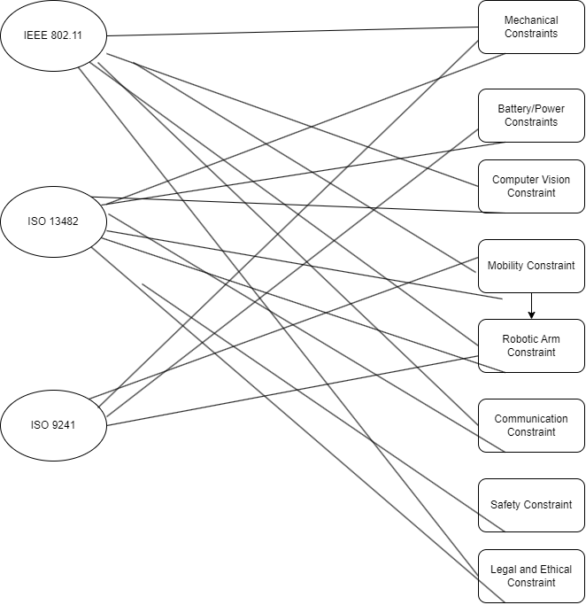
Figure 4.1: Plot of how all relevant standards and design constraints interact with each other

5. ChatGPT
In this section we will discuss the ways that ChatGPT can help us with our project, as since AI technology is getting increasingly better we might soon be in a world where those who use it well succeed while those who don’t fail. In the context of our project, it might seem like a large language model like ChatGPT can’t help us accomplish our goals in creating a self-driving robotic platform, but in reality, there is a ton you can achieve by being creative with these powerful AI’s.
The first way in which we have already began to realize the potential of ChatGPT is in brainstorming new ideas and potential solutions to engineering problems. While most versions of ChatGPT cannot utilize the internet and won’t be able to help us with things like product research and picking, ChatGPT is able to help us come up with new ideas when stuck on design issues, solve problems for us related to circuitry, compatibility, etc., and help us conform to engineering standards or with good documentation practice.
The other main way that we can incorporate ChatGPT into our project is by actually making it a part of the self-driving platform’s features. In our case, we have spoken with our sponsor about the stretch goal of possibly having the robotic platform speak to nearby civilians when it experiences an issue such as being unable to find the correct path or being unable to locate the crosswalk button and ask for help. This would allow us to troubleshoot any possible unforeseeable issues in addition to just being a great failsafe for the platform. It also could make the cyber-punk looking device somewhat more personable, as this could be an important step to avoiding conflicts or fear of the device from bystanders.

5.1 Brainstorming And Problem Solving
One of ChatGPT’s main features is to come up with ideas. As a LLM, trained from internet sources, if we have an idea, ChatGPT will find other similar ideas, one way is by semantics. ChatGPT can help me generate innovative ideas for my project. I can describe my goals, challenges, and constraints, and it can provide me with suggestions and concepts to consider, and maybe implement. I can also perform a feasibility analysis with ChatGPT. Since many of the things I am doing in this problem is new to me, it can help me evaluate the potential challenges and provide insights on how to address them. Another thing ChatGPT can help me solve problems is with component selection. If I am ever unsure about which components or sensors to use for computer vision, ChatGPT can provide recommendations based on the project requirements and budget. Also, coming up with algorithms for my projects can be a difficult task. I can ask for suggestions on image processing algorithms, object detection methods, and machine learning approaches that might be suitable for my project, as well tweak exist algorithms and make it fit for my project. Also, ChatGPT can help with troubleshooting my project. I can describe the problem, and ChatGPT can help me troubleshoot and suggest potential solutions. However, based on my previous experiences, I hadn’t had the best experience with this. However, if the time is right I have no problem with trying again. Lastly, ChatGPT can help me safety considerations. Personally, I don’t too much about the law and other types of regulations in my area. ChatGPT can assist in discussing safety protocols and guidelines for the platform, which is crucial for any project involving robotics and computer vision.

5.2 Communicating With Bystanders
One way we make our rover extremely “high-tech” is by integrating ChatGPT’s api in our platform. There is many things that we can do once we get the API on our platform. One of them is Natural Language Interaction. I can enable your rover to understand and respond to natural language commands from users. This allows for more intuitive and user-friendly control, making it accessible to a wider range of users. This would defeat the purpose of building our own model, but if all else fails, this is something that we can do. Another thing that I can do is voice control. I can integrate a speech recognition system with ChatGPT to enable voice-controlled interactions. Users can speak commands to the rover, which will process the speech and respond accordingly. Another thing we can do once we implement the API is transfer the platform into a remote assistant. ChatGPT can provide remote assistance by helping users troubleshoot issues, answer questions, or provide guidance on how to operate the platform and its robotic arm effectively. ChatGPT can also do route planning, acting similarly to a GPS. Another thing that it can do is provide multilingual support, act as a translator for the platform. Therefore, the platform will interact with everyone, no matter one’s background. Another thing that ChatGPT can do is Data Analysis. ChatGPT can assist in data analysis, helping the platform make sense of data collected through its sensors and cameras. However, this will again defeat the purpose of the entire project. The only reason we collect data is just to train the model, nothing more. We don’t need to use statistical models on the data for a greater output. Lastly, it can generate emotional responses. I can program the rover to exhibit emotional responses by using ChatGPT to generate text or speech with appropriate emotional tone, making interactions more engaging and relatable.

8. Administrative Information
In this section, we will cover all administrative, financial, and time obligations we have for this project, including the project budget, our timeline requirements and milestones, and our bill of materials. The contents of this section are primarily not by our design, but rather is due to the constraints or requirements from either our sponsor, the university, or our environment, though we able to make choices on certain aspects.

8.1 Project Budget
For this project, we were sponsored by Dr. Lei Wei, and were given $500 and several parts in order to build our self-driving robotic platform. We budgeted in such a way that we were able to leave a considerable amount of room for error, and ensure we have more than enough to complete the engineering requirements. Also, using the parts that Dr. Lei Wei has given to us, we were able to cut the budget further allowing for higher expenses on things where money = performance. Below is our drafted budget and should cover everything we need to build the self-driving robotic platform.
Table 8.1: Project Budget
Item | Quantity | Cost Per Unit |  | Total |  | Notes
Microcontroller | 1 | $0 |  | $0 |  | We were given this
Camera | 2 | $0 |  | $0 |  | We were given this
Motor | 1 | $0-40 |  | $0-40 |  | Given but might replace
Truck With Wheels | 2 | $0-40 |  | $0-80 |  | Given but might replace
Platform Base | 1 | $0-40 |  | $0-40 |  | Given but might replace
Secondary Microcontroller | 1 | $30 |  | $30
WWAN  Network  Interface Card And | 1 | $50 |  | $50
Accompanying Equipment | - | - |  | -
PCB | 1 | $50 |  | $50
Tools | 3 | $10 |  | $30 |  | As needed
Online Resources | 2 | $15 |  | $30
Steering Device | 1 | $25 |  | $25
Total Cost | $215-375 |  | Money For MISC And Replacements |  | $125-285

8.2 Milestone
During this project, we will come by very important milestones on our short 30-week rush to meet the engineering and marketing requirements. Initially, this essentially consists of documentation for our project, but in the later weeks we will come to prototyping and testing until, finally, presenting. The latter half of these will take place mostly in Senior Design 2 while the former half will take place this semester in Senior Design 1. For the purpose of efficiency and speed, we will do our best to work on starting the latter half in this semester, hence the starting dates.
Table 8.2: Project Milestones
Requirement | Start Date | Due Date
 | Senior Design I
Divide And Conquer/Initial Design Document | 08/20/2023 | 09/15/2023
60 Page Draft Document | 08/20/2023 | 11/03/2023
120 Page Final Document | 08/20/2023 | 12/05/2023
 | Senior Design II
Component Selection | 08/20/2023 | TBD
System Design | 08/20/2023 | TBD
System Testing | 08/20/2023 | TBD
System Interface | 08/20/2023 | TBD
Prototype Demo/Completion | 08/20/2023 | TBD

