Pool Boy

Automated pool water purification system

Group 3

Paul Setlak

Ivan Latorre

Mitchell Lienau

Robert Sers

EEL 4914

May 3rd, 2010

Executive Summary
In the name of conservation and safety, we as a society should aim to reduce the number of harmful chemicals in our homes. Our product aims to greatly reduce the need for harsh chemicals. With intelligent monitoring, the Pool Boy system is able to reduce the usage of chlorine in a pool by 80%. This drastic reduction in chlorine results in a more pleasant swimming experience for users as chlorine attacks not only bacteria. Human hair, skin and lungs are targeted because they are organic as well. Chlorine can leave your hair dry and brittle, while also leaving your skin flaky. it can also trigger a negative reaction in the elderly and children as they can be extra sensitive to chlorine. Furthermore, the production of chlorine is extremely energy intensive. With this being said, it is time to confront the caustic chlorine solutions and bring consumers a product that can keep their pools clean while greatly reducing the needs for hazardous chemicals.

Improper pool maintenance will shorten the life of pool components and damage the surface on your pool. This increases the overall cost of ownership. The challenges presented to owners are the various environmental factors that cause chemicals levels to become inadequate in a short period of time. This brings a burden on owners to continuously test and tweak the levels to ensure proper component longevity and water safety. Our device attempts to tackle these problems by continuously monitoring and adjusting chemical levels that ensure all aspects of a pool do not succumb to premature failure and relieve pool owners of the constant maintenance.
Pool maintenance can be broken down into two major subgroups, first is ensuring component longevity by establishing a suitable Langelier Saturation Index (LSI). Second, is to purify the water of bacteria and viruses.

System will have three main modes; unit self-check, water Validation (for maintaining our saturation index), water purification (killing off bacteria). First, system self-checks will be made to ensure that the chemical adjustment levels are appropriate and the system is running correctly. Second, the system will check the water levels to ensure that the water is safe for purification. Finally, the system will ionize the pool to purify the water of bacteria and algae. Figure 1.1, listed below, summarizes the three phase system discussed in this paper.

Finally, the system will interact with a wireless unit stationed inside the house where the user will set the pool settings and scheduler. This wireless unit will be referred to as the “receiver unit” for the duration of this document. In general, the receiver unit will be the slave and the pool unit will be the master. This means that the pool unit will be doing the calculations, making decisions and sending commands to the receiver unit. The receiver unit will be continually listening for commands from the pool unit.

Chapter 1

Pool Boy Automated System Overview

1.1 System Overview

Figure 1 is a three tier system that uses modular design techniques wherever applicable to made the debugging process as transparent as possible. Now we will go into greater detail for each of the three systems; Unit self-check, water validation, water purification.

Figure 1.1: System overview

1.2 Unit self-check Mode 1

Figure 1.2 is the unit self-check which will be used to monitor system levels and notify the owner when chemicals are getting low and need to be added to the reservoir. There are three potential outcomes once the unit checks the system levels. Either the levels are adequate, low, or inadequate. If the levels are adequate we jump straight to mode 2, water validation. If the chemical levels are low then we need to notify that owner that levels need to be adjusted, but then proceed to mode 2. Finally, if the adjustor chemicals are too low to adequately adjust the pool, we notify the user and then sleep until we can check the levels again. If the levels are too low to make adjustments then we cannot leave mode 1 and must sit in this loop until fluids are added.

Figure 1.2: Unit Self Check

1.2.1 Mode 1 In-Depth

Figure 1.2.1 contains information regarding the check system levels module, the receiver unit will first send a command to the pool unit to check the chemical adjustment levels. The pool unit will read in the pressure values from each reservoir and send those values back to the receiver unit. The receiver unit will then calculate the levels in each reservoir and establish one of three cases: pass, low, fail. If there is a pass scenario we move to mode 2. If there are low or fail levels of fluid then we will notify the user that they need to refill the reservoirs. After the reorder notification if we are low but can still continue operation then we go to mode 2. Finally, after we have done the reorder notification with the fail case then we notify the user that they much refill the chemicals and go into a timed sleep. After the sleep we return to start.

Figure 1.2.1: Unit Self Check In-Depth Look

1.3 Water Validation Mode 2

In Figure 4, the water validation module will first test the water to ensure that it is ready for ionization. If the pool has passed the safe ionizer status then the test water module will pass on to module 3 for ionization. If the test waiter fails then adjustments need to be made to the pool water. These calculations will be described in greater detail below. Finally we have our chemical dispersion sleep which is a timeout period which waits for the adjustments to settle into the pool system so an accurate retest can be made

Figure 1.3: water validation

1.3.1 Mode 2 In-Depth

Water sanitation is necessary to ensure pump hardware longevity as well as prevent pool surface deterioration. There are a few main factors that can be monitored to ensure proper pool performance; namely pH, total alkalinity, and calcium hardness. Once you have measured these various elements, you can calculate whether your water is corrosive, scale forming or well balanced. If the water is corrosive, under-saturation, the water will try to saturate itself by dissolving the surface of your pool. If the water is scale forming, over-saturation, it will try to correct it’s over saturation by precipitating the hard water salts causing cloudy water and eventually deposit scale on pool components. The formula for establishing this index is:

Saturation Index = pH + calchd + totak + temp - 12.1

Where Ph is Ph, calchd is calcium hardness, totak is total alkalinity, and temp is the temperature of our pool water. If the result of this calculation is zero then we have reached our target. If the saturation index is below zero, then the water leans toward being corrosive and if the index is above zero then the water is scale forming. Neither of which are acceptable for quality pool maintenance. An acceptable value for this range is +.5 or -.5, any variance greater than that needs to be addressed as soon as possible to ensure proper component longevity. If the index is out of this range, tweaks will need to be made to the calcium hardness, alkalinity and pH to bring it as close to zero as possible. Below will be a brief outline of each of the three chemicals.

 | To Lower | To Raise
Ph | Muriatic acid | Soda ash
TA | Hydrochloric acid | Sodium bicarbonate
Calcium hardness | Replace water (backwash) | Calcium Chloride

Table 1.3.1: How to manipulate levels for Saturation Index

1.3.2 pH

First is the water’s pH. Ph is the most important element to balance in the pool because if affects the chemical balance of every other chemical. pH is defines as a measure of hydrogen ion concentration in pool water. This indicates the relative basicity or acidity of pool water. pH is measured from zero (a strong acid) to 14 (a strong base) with 7 being the neutral pH. In pools the ideal level is a slight alkaline pH from 7.4 to 7.6. This is the best range because it is the most comfortable on the human eye and is the optimum levels for chlorine. If the Ph is too low (below 7) then the water becomes acidic and chlorine dissipates from the water quickly, eye irritation begins and plaster surfaces are etched. If the pH is too high then chlorine becomes less effective, discoloring of pool walls, water becomes scale forming and cloudy.

If pH is under 7.4 then we add the amount of soda ash indicated by Table 2; wait for the chemical dispersion timer to time out and retest the water until desired level is reached.

 | GALLONS IN POOL
pH | 1,000 | 5,000 | 10,000 | 15,000 | 20,000 | 25,000 | 50,000
7.2-7.4 | 2/3 oz. | 3 oz. | 6 oz. | 9 oz. | 12 oz. | 1 lb. | 2 lbs.
7.0-7.2 | 3/4 oz. | 4 oz. | 8 oz. | 12 oz. | 1 lb. | 1 1/4 lbs. | 2 1/2 lbs.
6.6-7.0 | 1 1/4 oz. | 6 oz. | 12 oz. | 1 lb. | 1 1/2 lbs. | 2 lbs. | 4 lbs.
Under 6.7 | 1 1/2 oz. | 8 oz. | 1 lb. | 1 1/2 lbs. | 2 lbs. | 2 1/2 lbs | 5 lbs

Table 1.3.2.1: Raising pH with Soda Ash

If pH is over 7.6 then we add the amount of acid indicated by Table 3; wait for the chemical dispersion timer to time out and retest the water until desired level is reached.

 | GALLONS IN POOL
pH | 1,000 | 5,000 | 10,000 | 15,000 | 20,000 | 25,000 | 50,000
7.6-7.8 | 1 1/4 oz. | 6 oz. | 12 oz. | 18 oz. | 24 oz. | 1 qt. | 2 qts.
7.8-8.0 | 1 1/2 oz. | 8 oz. | 16 oz. | 24 oz. | 1 qt. | 1 1/4 qts. | 2 1/2 qts.
8.0-8.4 | 2 1/2 oz. | 12 oz. | 24 oz. | 1 1/4 qts. | 1 1/2 qts. | 2 qts. | 1 gal.
Over 8.4 | 3 oz. | 16 oz. | 1 qt. | 1 1/4 qts. | 2 qts. | 2 1/2 qts. | 1 1/4 gal.

Table 1.2.2.2: lowering pH with Muriatic Acid

1.3.3 Total Alkalinity

Next chemical for discussion is the Total Alkalinity (TA). TA is the measure of water’s resistance to change in pH. TA is closely related to pH but rather than a measure of hydrogen it is a measure of the solutions ability to neutralize hydrogen ions. TA is a result of alkaline materials like bicarbonates, carbonates and hydroxides. The acid neutralizing capacity is desired in pool water because it prevents wide variations in the pH whenever small amounts of alkali and acid are added to the pool. TA should be maintained between a range of 80 to 150 ppm.

If TA becomes too low, the pH will drop rapidly along the pH scale when other chemicals or impurities enter the pool. The pH could then etch the pool walls and destroy components. The TA could also become too high, causing cloudy water and filter problems. Raising and lowering alkalinity is seen below is tables 1.3.3.1 and 1.3.3.2 respectively.

Increase | GALLONS IN POOL
(ppm) | 1,000 | 5,000 | 10,000 | 15,000 | 20,000 | 25,000 | 50,000
10 | 0.14 lbs | 0.7 lbs. | 1.4 lbs. | 2.1 lbs. | 2.8 lbs. | 3.5 lbs. | 7 lbs.
20 | 0.28 lbs. | 1.4 lbs. | 2.8 lbs. | 4.2 lbs. | 5.6 lbs. | 7.0 lbs. | 14 lbs.
30 | 0.42 lbs. | 2.1 lbs. | 4.2 lbs. | 6.3 lbs. | 8.4 lbs. | 10.5 lbs. | 21 lbs.
40 | 0.56 lbs. | 2.8 lbs. | 5.6 lbs. | 8.4 lbs. | 11.2 lbs. | 14.0 lbs. | 28 lbs.
50 | 0.70 lbs. | 3.5 lbs. | 7 lbs. | 10.5 lbs | 14.0 lbs. | 17.5 lbs. | 35 lbs.

Table 1.3.3.1: Raising Alkalinity Using Sodium Bicarbonate

Decrease | GALLONS IN POOL
(ppm) | 1,000 | 5,000 | 10,000 | 15,000 | 20,000 | 25,000 | 50,000
10 | 2.56 oz. | 0.8 pts. | 0.8 qts. | 1.2 qts. | 1.6 qts. | 2.0 qts. | 1 gal.
20 | 5.12 oz. | 1.60 pts. | 1.6 qts. | 2.4 qts. | 3.2 qts. | 1.0 gal. | 2 gal.
30 | 7.68 oz. | 1.2 qts. | 2.4 qts. | 3.6 qts. | 1.2 gal. | 1.5 gal. | 3 gal.
40 | 10.24 oz. | 1.6 qts. | 3.2 qts. | 1.2 gal. | 1.6 gal. | 2.0 gal. | 4 gal.
50 | 12.80 oz. | 2.0 qts. | 1.0 gal. | 1.5 gal. | 2.0 gal. | 2.5 gal. | 5 gal.

Table 1.3.3.2: Lowering Alkalinity Using Muriatic Acid

1.3.5 Calcium Hardness

The third and final variable in our saturation index is the Calcium Hardness which is a measure of bicarbonates that accumulate in a pool after it has been in use for a time. These solids are unfilterable and include body wastes, sun screen, algaecide, dirt, pollen, ect. Traditionally this is more of a problem for indoor pools because they get used year round. Pools do not want to contain more than 450 ppm TDS.

1.3.6 In-Depth Look At Mode 2

Now we will take an in-depth look at each module for mode 2 in Figure 1.3.6. First, we enter our test water module so the receiver unit sends a command out to the pool unit to check the water chemical levels. The pool unit reads the values of each chemical sensor and returns that data to the receiver unit. The receiver unit now can generate two cases: pass or fail. If all of the levels pass then a pass case is generated and we move on to mode 3. If one of any of the chemical results fails then we need to adjust the levels in the pool.

The adjust levels module begins with the receiver unit sending the adjustments to be made to the pool unit. The pool unit then makes adjustments by telling which valves for each reservoir to open and for how long. After the adjustments the system enters a chemical dispersion sleep. Many adjustments take time to disperse around the pool before an accurate retest can be taken. Once the sleep timer has expired we return to start.

This is where the bulk of the work will be done and system effort spent. Mode 1 and 3 don’t require much processing power but reading in these sensors and calculating the amount to add of which chemical is the bulk of the design.

Figure 1.3.6: in-depth for module 2

1.4 Water Validation Mode 3

Our third and final module is the water purification phase in Figure 1.4. It is necessary to disinfect pool water to prevent the spread of disease and organisms from person to person and prevent unwanted growth of bacteria and algae in the pool. Traditionally, this is accomplished by adding chlorine somewhere between 2.0 and 2.5 ppm to your pool. This is where the ionizer system is able to shine. With an ionizer you are only required to keep your pool chlorine levels at 0.2 ppm which is substantially lower.

The system utilizes water ionization techniques to supplement chlorine chemicals to keep a pool bacteria and algae free. This will result in a reduction of pool chlorine by 80 to 90 per cent. Ionizers use a very low voltage to releases millions of negatively charged silver and copper ions into the water. The copper (and actually all heavy metals) is an algaecide. It interrupts the plants ability to photosynthesize, thereby killing it. All these charged particles floc together and then they are pulled out by the filter. This is potentially more sustainable then chlorine since copper and /or silver are not subject to deterioration from the sun's ultraviolet rays, as is chlorine. The metal that is not consumed by the algae, bacteria and viruses remain in the pool as residual purifying agents. This gives you a very economical and low maintenance method to keep your pool clean.
The small amounts of ions that do the job of sanitizing a pool are completely safe for humans and are within the Environmental Protection Agency’s drinking water standards. These ions are also present in the human body in small amounts. In fact, the EPA standard for our drinking water is 1.3 ppm of copper which is four times more than the amount that is needed to purify your pool; a meager 0.3 ppm. Supposedly, the ancient Romans also relied on this principle to keep their water fresh by dropping metal coins into it.

One further element does need to be considered. If your water contains iron, it must be removed before you start your Ionizer. This can be accomplished by adding a metal remover, which will be available from any local pool store. It should be circulated in the water for approximately 48 hours and then the system will then need to be cleaned or backwashed.

Figure 1.4: water purification

1.4.1 Mode 3 In-Depth

Now we will take an in-depth look at each module for Mode 3 in Figure 1.4.1. The size of the pool determines how often the ionizer will need to be run. First the receiver unit checks the ionization schedule and returns two cases, yes or no. if it is not time to run the ionizer then we return to the start. On a yes case the receiver has established that it is time to run the ionizer and a command is sent to the pool unit. The pool unit continues to run the ionizer and listens for a command from the receiver to halt ionization. Once the ionization period has completed then we return to start.

Figure 1.4.1: In-Depth Water Purification

1.5 Prototype

Below, in Figure 1.5, is an example of what the system might look like and how it would fit in and existing pool system.

Figure 1.5: Design Prototype

Pool Unit: The water will flow in from left to right, over the ionizer system and then across each sensor, then be circulated back into the pool. There will be electronic valves and sensors for each chemical.

1.6 Design Concerns

1.6.1 Materials

The materials used to construct this final prototype must be non-corrosive. Metal bushings should be avoided as those can fail prematurely due to the corrosive properties of the water and the chemicals. Nylon or some other type of polymer will have to be the medium for our design. PVC is actually the industry standard when it comes to pool piping and equipment for solar panels.

1.6.2 Chemicals

Another implementation concern revolves around the system going off line for a while when it does not have the chemicals it needs to run properly. In this scenario the user will have to readjust the levels in the pool manually so that they are in a range that the Pool Boy can be turned back on and run properly. It is important to note that the Pool Boy has its limitations and should ideally be used to maintain a working pool than recover one that has it’s levels far out of whack. Hooking up the Pool Boy system to a pool that is extremely off on its levels can result in damage to the sensors and other components. This is why when the Pool Boy runs out of adjustor chemicals it stops running to prevent itself from being damaged by the improperly balanced water. At this point the user will need to readjust the levels to where they need to be and only after the levels are correct can he reattach his Pool Boy. This shines light on the importance of the user being aware that their chemical levels are low. It also shows how imperative it is that users refill the levels when they plan on leaving the pool unattended for a while.

Thinking forward, true automation could be achieved by offered a refill service to the user. The device could connect to the web, notify the local pool store when the unit’s levels are low, and they send a tech to refill you. This would mesh well with the existing market because it would allow pool stores to continue to sell products and offer services. This is all, however, a bit of a pipe dream as the infrastructure needed to implement a system like that is massive. However, it is still amusing to consider all of the options.

Another implementation concern is the problem with trying to add soda ash (which is a powder) using liquid valves. One suggestion was to mix water with the soda ash and add it this way. This would indeed work and if the team can find soda ash in liquid form then perhaps that should be the way to go. One company is now marketing a TA increaser which combines the benefits of sodium bicarbonate and soda ash. This product, known as sodium sesquicarbonate affects TA more than sodium bicarbonate and also does not cause as much increase in pH as soda ash. Below, in Figure 1.6.2, is the formula for adding the sodium sesquicarbonate to a pool:

Increase | GALLONS IN POOL
(ppm) | 1,000 | 5,000 | 10,000 | 15,000 | 20,000 | 25,000 | 50,000
10 | 0.13 lbs. | 0.63 lbs. | 1.25 lbs. | 1.88 lbs. | 2.50 lbs. | 3.13 lbs. | 6.25 lbs.
20 | 0.25 lbs. | 1.25 lbs. | 2.50 lbs. | 3.75 lbs. | 5.00 lbs. | 6.25 lbs. | 12.50 lbs.
30 | 0.38 lbs. | 1.88 lbs. | 3.75 lbs. | 5.63 lbs. | 7.50 lbs. | 9.38 lbs. | 18.75 lbs.
40 | 0.50 lbs. | 2.50 lbs. | 5.00 lbs. | 7.50 lbs. | 10.00 lbs. | 12.50 lbs. | 25.00 lbs.
50 | 0.63 lbs. | 3.13 lbs. | 6.25 lbs. | 9.38 lbs. | 12.50 lbs. | 15.63 lbs. | 31.25 lbs.

Figure 1.6.2: Raising Alkalinity Using Sodium Sesquicarbonate

1.7 Basic Filters

There are three basic pool filter types, sand, cartridge, and Diatomaceous Earth (DE). Sand is generally considered to be fail proof as it is the most reliable system. Cartridge tends to be very low maintenance. The cleanest purifier is the DE because of its effectiveness at filtering out small particles. Debris as small at 5-8 microns can be filtered out because DE is much finer than sand which makes it more able to filter than a sand filter. A tip for cartridge users is to add a small dose of diatomite to the filter to help the filter with smaller particles that the cartridge can miss.

DE filters work by adding Diatomite to the system through the skimmer with the pump running. Each filter has a different amount of DE that is required to be added before it can be run. When the filter pulls in the DE the filter fabric gets coated and the filter turns into an effective microscopic remover. When the pressure of the system runs up 8-10 PSI then it is time to backwash the system or clean the filter. After the filter is cleaned the user will need to add more diatomite.

All three filter styles have their advantage and all three will be compatible with the Pool Boy. For the team’s demo a cartridge type filter will be used because of its simplicity. When working with filters it is always important to consider how easy the filter is to access as you will need to get at it to keep it clean.

There are a few steps that can be taken to decide on a good filter for your system. The first step is to decide the minimum flow rate. Use the following equations, in table 1.7.1, when determining flow rate.

Pool Size  (US Gallons) | divided by | Turnover  Time | divided by | 60 | equals | Minimum  Flow Rate
35,000 | divided by | 8 hours | divided by | 60 | equals | 73 GPM
35,000 | divided by | 10 hours | divided by | 60 | equals | 58 GPM
24,000 | divided by | 8 hours | divided by | 60 | equals | 50 GPM
24,000 | divided by | 10 hours | divided by | 60 | equals | 40 GPM
18,000 | divided by | 8 hours | divided by | 60 | equals | 38 GPM
18,000 | divided by | 10 hours | divided by | 60 | equals | 30 GPM

Table 1.7.1: minimum flow rate. reprinted with pending permission from www.poolplaza.com

To use this chart, you will first locate the size of your pool in gallons, then determine the amount of turnover time you would like the pool to run for, 8 or 10 hours. Finally divide this by 60 (because there are 60 minutes in an hour) to achieve our minimum flow rate. We will not want to fall beneath this minimum flow rate.

The second factor is to determine the maximum flow rate. The flow rate of any plumbing system is limited by the size of the piping and the equipment that maximum flow rate of a 1.5 inch PVC pipe is 42 GPM. So even if you are moving 200 gallons per minute, it will not matter because the PVC is going to limit you to 42 GPM. So for each 1.5 inch we have intake line we’re limited to a maximum flow of 42 GPM and with a 2 inch intake line we’re limited to 73 GPM. It is also important to note that the user should also verify that the lines going back to the pool are also going to support the flow calculated.

The next step to determine the correct filter is to determine which type of filter you would like. The flow rate for these varies from company to company but datasheets will always be available to inform the user of the max and min flow rates, an example is provided in table 7.

Recommended flow rates for different sizes of SAND FILTERS
Tank Diameter | 19" | 21" | 24" | 30" | 36"
Surface Area | 1.8 sq. ft. | 2.3 sq. ft. | 3.1 sq. ft. | 4.9 sq. ft. | 6.9 sq. ft.
Max Flow Rate | 40 GPM | 50 GPM | 60 GPM | 100 GPM | 140 GPM

Recommended flow rates for different sizes of D.E. FILTERS
Surface Area | 24 sq. ft. | 36 sq. ft. | 48 sq. ft. | 60 sq. ft. | 72 sq. ft.
Max Flow Rate | 48 GPM | 72 GPM | 96 GPM | 120 GPM | 144 GPM
Best Flow Rate | 36 GPM | 54 GPM | 72 GPM | 90 GPM | 108 GPM
While the manufacturers will specify the Max flow rate, we strongly recommend staying with the Best flow rate to avoid crushing grids due to high pressure.

Recommended flow rates for different sizes of CARTRIDGE FILTERS
Surface Area | 100 sq. ft. | 200 sq. ft. | 300 sq. ft. | 400 sq. ft. | 500 sq. ft.
Max Flow Rate | 38 GPM | 75 GPM | 112 GPM | 150 GPM | 150 GPM
Best Flow Rate | 30 GPM | 50 GPM | 75 GPM | 100 GPM | 125 GPM
While the manufacturers will specify the Max flow rate, we recommend choosing one within the Best flow rate for best filtration and better dirt loading capacity.

Table 1.7.2 : min and max flow rates. Reprinted with pending permission by poolplaza.com

The team has decided to go with the SwimClear filter from haywardnet.com because they offer competitive prices and a good product. This cartridge filter is designed for simplicity so that we do not need to dabble in sand or diatomite while we are trying to demo the solution.

1.8 Pool Pumps

Pool pumps are a bit more complicated than the pool filters. Some pool pumps are made for certain types of pools as there are in-ground pools and above-ground pools which require different systems. Some pool pumps are variable-speed. These variable speed pumps have the advantage of being able to throttle the horsepower of the motors to lower overall power consumption and help encourage pump longevity.

Generally, pools will need one or two filter cycles per day for about 4 to 6 hours a day. There are many factors to consider when purchasing a pump so these factors will be outlined below.

Everything that water passes through within a circulation system creates resistance or friction loss. This friction loss for standard plumbing supplied such as pipes, elbows and fittings. Friction loss for equipment such as filters and heaters can be found in the units documentation. The sum of the total resistance is called the Total Dynamic Head (TDH) and is traditionally measured in Feet of Head. For new installs it is possible to calculate the THD by using reference tables to determine the friction loss. Once TDH is determined you can then use Table 1.8.1 as a reference for deciding what size pump you will need.

A typical performance chart
Pump Size | Pump Output (GPM) versus Total Resistance to Flow (feet of Head)

 | 20 ft | 30 ft | 40 ft | 50 ft | 60 ft | 70 ft
1/2 | 55 | 45 | 29 |  |  | -
3/4 | 67 | 58 | 47 | 31
1 | 85 | 76 | 65 | 50 | 27
1-1/2 | 97 | 90 | 80 | 67 | 50 | 10
2 | 116 | 111 | 99 | 85 | 70 | 51

Table 1.3.1: reprinted with pending permission from mypool.com

There are different pumps for different applications so it is important to consider these designs; above ground pools, in ground pools, spas, and waterfalls. Each of these unique systems has different calculations of head pressure, as indicated in Table 1.8.2 below.

  Above Ground Pool
  Skimmer/Drain | 0.2
  Intake Line | 2.0
  Intake Manifold | 2.0
  Backwash Valve | 12.0
  Filter | 10.0
  No Heater | 0.0
  Return Plumbing | 2.0
  Return Fittings (inlets) | 1.0
  Total | 29.2
  In Ground Pool
  Skimmer/Drain | 0.2
  Intake Line | 3.0
  Intake Manifold | 1.0
  Backwash Valve | 15.0
  Filter | 10.0
  Heater | 10.0
  Return Plumbing | 3.0
  Return Fittings (inlets) | 3.4
  Total | 45.6
  Spa
  Skimmer/Drain | 0.2
  Intake Line | 3.0
  Intake Manifold | 1.0
  Backwash Valve | 15.0
  Filter | 10.0
  Heater | 10.0
  Return Plumbing | 3.0
  Return Fittings (inlets) | 10.0
  Total | 52.2
  Waterfall
  Skimmer/Drain | 0.2
  Intake Line | 3.0
  Intake Manifold | 1.0
  Return Plumbing | 3.0
  Return Manifold | 2.0
  Rise to Outlet | 10.0
  -- | --
  -- | --
  Total | 19.2

Table 1.8.2: head pressure. reprinted with permission from poolplaza.com

It is important to notice that even minimalistic components like skimmers can add to the head pressure. Above ground pools generally require a lower head pump because there is less equipment in above ground pools than underground pools so less pressure is needed to push the water around the system. In ground pools generally have more equipment than above ground pools and because of this larger amount of piping and heater the in ground pool will need a medium to high head pump. Spas require high pressure pumps to run the comfort jets. For spas, a high head pump is required. Finally, waterfall systems generally require very little equipment but a lot of water flow and as such waterfall pumps are usually low head pumps.

Users may be tempted to run a slightly larger pump than the one that is needed. After all, customers always believe that bigger is better. But the truth of the matter is that with today’s technologies, increase in efficiency and performance, the user may actually be able to accomplish the same task with a smaller pump. However, choosing a pump that is too small can result in improper filtration and surface skimming and long filter cycles. Also, like vacuums, as dirt builds up in the filter, the pressure goes up, increasing the dynamic head and slowing flow rate. So the user must take this into account and choose a pump. Conversely, choosing a pump that is too large will almost certainly result in damage to the equipment and can cause pump cavitation, which can destroy a pump.

Cavitation is the forming of bubbles in the water, near the impeller, which occurs when the water is vigorously vibrated. As the bubbles pop, shock waves are crated within the pump that burst with so much force that it will actually damage the impeller and other pump parts. Pressures created by the cavitation have been measured at reaching 30,000 PSI.

Cavitation occurs when the output capacity of the pump exceeds the supply of water available. The vacuumed created within the pump is literally enough to suck the oxygen out of the water which is what causes the bubbles to form. An oversized pump can also create excessive flow which causes erosion of the system’s piping. According to NSF standards, the flow rate of a 1 ½-inch pipe should never exceed 10 feet per second for PVC. In summary, when it comes to choosing the correct pump for you.

For the demoing purposes of our project, the team has decided to go with a ½ HP pump because our system will only be pushing through and maintaining a ten gallon reservoir. This would be a small pool even by above ground pool standards.

1.9 Pool size

We can see from the below table, Figure 1.9, that calculating pool size is no trivial task if your pool happens to be a bizarre shape. If the user of the Pool Boy does not know the size of their pool then they will need to refer to this document to calculate the size. This sizing chart will simply have to be included with the product so that an uneducated pool owner can understand how to input the correct pool size for the calculations

An important thing to note is that the average depth of a pool is determined by summing the depth of the shallow end and the depth of the deep end and dividing by two. This is a very rough estimate of the actual average depth in a pool but will be accurate enough for the Pool Boy system.
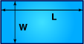 | Area = L x W  Gallons = area x average depth x 7.48  Liters = Gallons x 3.785
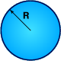 | Area = R x R x 3.14  Gallons = area x average depth x 7.48  Liters = Gallons x 3.785
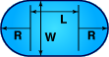 | Area = (L x W) (R x R x 3.14)  Gallons = area x average depth x 7.48  Liters = Gallons x 3.785
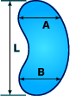 | Area = (A + B) x L x 0.45 (approx.)  Gallons = area x average depth x 7.48  Liters = Gallons x 3.785
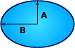 | Area = A x B x 3.14  Gallons = area x average depth x 7.48  Liters = Gallons x 3.785
Figure 1.9: all pool size images have been reprinted with pending permission from conelyco.com

Chapter 2

Chemical monitoring

Before deciding on how to measure the chemicals in pool water first it was necessary to decide what water sanitization method should be used to treat the water. After doing research online there were three main water sanitation methods being used in swimming pools each with benefits and draw backs. The first of the methods was the most common method of using a large amount of chlorine to sanitize the water by killing bacteria and other microbes. The second was salt sanitizing systems which still uses chlorine but instead of buying and adding chlorine the system turns the salt into chlorine. The third is the least common of the methods and is called Ionization which places Ions in the pool killing bacteria and algae.

To supplement the online research of pool water sanitation it was decided to use a professional consultation. The consultant was Dan Griffith, Manager of the Pinch-A-Penny store in Oviedo Fl on Mitchell Hammock rd. He said in his experience that the traditional method of using large amounts of chlorine is a very effective way of keeping a pool clean, as long regular testing of the water and chemical adjustments are made to the alkalinity (PH) and chlorine. He also said that saltwater systems are steadily becoming more popular. By using salt there is no chlorine to directly add to the pool. This means there are no harsh chemicals to handle and less harsh chemicals in the water to irritate skin and evaporate into the air. The salt system can also save money because the salt will not evaporate out of the water the owner only has to add salt about once a year instead of weekly. The downsides of saltwater systems he explained to be the initial cost of the unit $1000 at his store and the expensive metal element that allows the salt to turn into chlorine which needs to be replaced every two to three years and costs $400. He said this is his preferred method and the one he had on his own pool. He did not know a lot about the pool ionizer. He had heard of them but did not sell any at his store and did not know anyone that uses them. When questioned about the use of electric sensors to measure the chemical levels in the pool He said that the salt in the water has a scale build up effect on metals and may make the sensors inaccurate and/or non-functional at the very least lowering the life expectancy of the sensors. He suggested using the traditional chlorine method in a pool that would have metal and sensors in it. He commented on our project saying that he has seen similar commercial automatic chemical monitoring and adjusting products but they are normally ineffective due to human error in not monitoring the system and high cost. He also expressed interest in the final product if we could design it as effective as current products with a lower cost.

2.1 Pool Water Sanitation Methods

2.1.1 Traditional Water Sanitation System

In order to decide on the water sanitation method for the project more research needed to be done on each of the different systems to find the one that is cost efficient and easy to maintain with an automated system as well as be economical for our budget and long term use. Using just a chlorine system is reliable system that most people choose to use. It breaks down to two main chemicals involved in keeping pools clean Hypochlorus acid (HOCI) and Hypochlorite ion (OCI-). These particles attack the cell walls of bacteria and other micro-organisms by breaking down the enzymes inside of the organism. This is a very effective method of cleaning your pool however there are some undesired properties of chlorine. The Chlorine has a strong smell and if over chlorinated the chlorine gas just above the water can be harmful to you if you breath it in. Chlorine can also cause skin and eyes to become itchy and irritated. It also fades colors which over time can fade the color of your clothes or even your hair if it is exposed to the chemical for long periods of time. Another downside to chlorine is that it breaks down quicker when it is heated and exposed to UV light. This leads to spending more money on chlorine that needs to be constantly added as it evaporates to be maintained at a safe level which increases the overall human interaction with the pool. The most hazardous form of the chlorine is when it is in its purest form before it is combined with the water. If the chlorine gets on your hands or in your eyes and is not immediately washed off it can cause major skin irritation as well as giving of toxic fumes that could cause fluid to fill your lungs if you breath too much in. Storage of chlorine is also extremely important. By itself in a closed container Chlorine is relatively safe however if it gets mixed with other chemicals such as algaecide that people often store in the same place the mixture could give off toxic gas, catch fire, or even explode.

 | Minimum | Ideal | Maximum
Free Chlorine, ppm | 1.0 | 1.0-3.0 | 3.0
pH | 7.2 | 7.4-7.6 | 7.8
Total Alkalinity, ppm | 60 | 80-100 | 180
Total Dissolved Solids, ppm | 300 | 1000-2000 | 3000
Calcium Hardness, ppm | 150 | 200-400 | 500-1000+

Table 2.1.1: The table above shows the parameters required to keep a traditional chlorinated pool system working properly.

2.1.2 Salt Water Sanitation System

The saltwater method of sanitizing in many ways is similar to the chlorinating method. In this type of system salt is added to dispenser and is slowly mixed with the water. Then it is put through a chlorine generator which uses titanium electrodes to turn the salt into chlorine that gets disbursed in the water. The amount of salt in the water for this process to occur is between 3,000 and 5,000 part per million (ppm). This amount of salt is one tenth of the ppm of salt in most ocean water and is barely enough for someone to taste the salt in the water if they got it in their mouth. It is enough salt to make the water soft-water which gives the water a "silky" feel that cancels out the dry irritation skin can get from chlorine. The cost to maintain this type of system is lower than the traditional chlorine method because salt is cheaper then chlorine. A common misconception about saltwater systems is that because salt does not evaporate so the owner does not need to constantly add salt to the system. This is not true as the salt is constantly being broken down into chlorine which is then being broken down and still evaporate. In many cases people using this kind of system have to use a stabilizer (cyanuric acid) which slows the effects of the UV rays on the chlorine so the level of chlorine doesn't drop too low. If the chlorine level does drop too low the chlorine generator will not be able to produce the chlorine faster than its oxidized and broken down to kill the bacteria and algae. Then to bring the levels of chlorine back up to an operational level you will have to physically add more chlorine as in the first method. Another problem with the saltwater method is that calcium and mineral deposits will form on the titanium plates of the chlorine generator. Some high end salt systems claim use a reverse current on the titanium plates before shutting off which they claim will stop these deposits from forming. Once formed it they will decrease the effectiveness of the chlorine generator and cause the system to fail. The plates are another piece of equipment that will need to be monitored and eventually be cleaned to keep the system working properly. The chlorine generator cells need to be replaced every 3-5 years and costs $350 to replace. Another problem with having salt in the water is that everywhere water is allowed to sit and dry it will leave salt deposits. Some owners find these salt deposits to be an eye sore all around the walls of the pool as well as larger deposits forming in waterfalls or any other water display features.
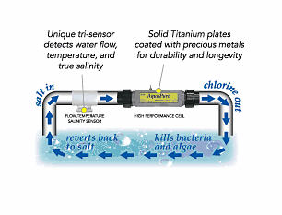
Figure 2.1.2: This picture show how a salt water pool system works. (pending permission of south shore gunite pools and spas)

 | Minimum | Ideal | Maximum
Free Chlorine, ppm | 1.0 | 2.0-4.0 | 3.0
pH | 7.2 | 7.2-7.6 | 7.8
Total Alkalinity, ppm | 60 | 80-100 | 120
Total Dissolved Solids, ppm | 300 | 1000-2000 | 3000
Calcium Hardness, ppm | 150 | 200-400 | 500-600
Cyanuric Acid, ppm | 50 | 60-80 | 120
Salinity, ppm | 2000 | 2500-4000 | 6000

Table 2.1.3: The table above shows the parameters required to keep a salt water pool system working properly.

2.1.3 Copper Ionization System

The third method is using copper ionization. The ionization method works by placing two copper electrodes in the filters exhaust pipe and applying low dc voltage to it. The dc current applied makes the copper ions attempt to jump to the other electrode but are then caught in the moving water and dispersed in the pool. Once in the pool the ions are small enough to stay suspended in the water.

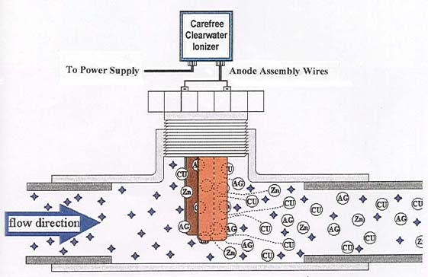

Figure 2.1.4: The Figure above shows how Ionizer works by adding the ions to the water (pending permission from care free clear water ionizer)

These copper ions then work similarly to the ions made from the chlorine penetrating the cell walls of bacteria and algae and destroying the enzymes in them. The levels of copper ions in ppm required to kill the bacteria and algae is smaller than the amount of copper in most drinking water. The lifetime of the copper electrodes is every 2-3 years which is the same life span of the chlorine generator but costs much less to replace at $70. The main down side of the ionization system is that by itself it can't oxidize the dead bacteria and algae to remove it from the pool. This can build up and cause the pool to become cloudy or slightly discolored. I fix this small amounts of chlorine can added to supplement the ionizer in cleaning the pool by oxidizing the waste material that it can't . This is the method that is going to be implemented in our project. It greatly reduces the amount of chlorine that needs to be handled by the user as well as saves them money by buying much less chlorine. They will also save money since the only thing that needs to be replaced cost much less than that of other systems and is simple to install so the owner can change it themselves.

Since the main aspect of this system is small amounts of copper particles the water is completely safe giving the them no itchy skin or eyes and even safe to get in your mouth.

 | Minimum | ideal | Maximum
Free Chlorine, ppm | 0 | .4-.8 | 2
pH | 7.2 | 7.2-7.6 | 7.8
Total Alkalinity, ppm | 60 | 80-120 | 180
Total Dissolved Solids, ppm | 300 | 750-1500 | 3000
Calcium Hardness, ppm | 150 | 225-375 | 500-1000+
Copper Ions, ppm | .2 | .3-.4 | .6

Table 2.1.5: The table above shows the parameters required to keep a copper ionizer pool system working properly

2.2 Chemical Sensors

2.2.1 Chlorine sensors

The most important aspects for monitoring the chemical levels in the pool was cost effectiveness, reliability, and accuracy of the system measuring the chemicals. The systems also had to be long lasting with minimum human interaction to make the system as automated as possible. Research was first done to find a way to monitor chlorine levels in the water. To directly measure the amount of chlorine in water there are two different measurements that can be made total chlorine and free chlorine. Total chlorine is the sum of free chlorine and chloramines which is "combined chlorine" or the product of chlorine after it combines with organic material such as bacteria and algae. Free chlorine is hypochlorous acid (HOCL) and hypochlorite (OCL-) ion which is chlorine before it combines to become chloramines. Free chlorine is what we want to measure as it is the chlorine still in the water that is able to sanitize the water. Free chlorine sensors work by allowing a small flow of water over the sensor passing over a silver anode and a gold cathode. The HOCL is then broken down into chloride ion at the gold cathode and the silver anode is oxidized which forms silver chloride (AgCl). The release of electrons at the cathode and acceptance at the anode creates the current flow which is proportional to the free chlorine concentration in ppm. (Omega) This process is directly affected by PH levels and temperature so it is important the parameters of the sensor match the all possible characteristics of the pool. These are the sensors that fit our system parameters.

Item # | Range of ppm | Ph range | Output | Additional Features | Price
56-595 | .02-2.0 | 5.5-9.5 | 4-20 mA | Assembly included | $1,525
R-99672-06 | 0-2.0 | 4-11 | 4-20 mA | N/A | $950
ECL1/x | 0-10 | 4-11 | 4-20 mA | N/A | $2,125
FCLTX-100 | 0-2 | 5.5-5.9 | 4-20 mA | N/A | $1,100
498CL-01 | 0-20 | N/A | 4-20 mA | PH-independent | $3,000
CLT 1 | 0-2 | 5.5-5.9 | 4-20 mA | N/A | $900

Table 2.2.1: Compares available chlorine sensors

Do to the precious metal involved in making a accurate electronic free chlorine sensors the overall price of these sensors did not fit in the project budget. In researching alternative methods of electronically measuring chlorine levels it was found that the amount of free chlorine could be measured using an oxidization reduction method. Free chlorine is considered an oxidizer because of the way it removes electrons from other substances. Oxidation is the name of the process chlorine uses when it enters bacteria and algae. The process of oxidation reduces the chlorine meaning the ion charge from the chlorine has been used and can no longer combine with other When free oxidizing agents are measured in a solution it is called the ORP (oxidation reduction potential). An ORP sensor uses a silver electrode and a platinum electrode with the sample water flowing between them. The silver electrode is called the reference electrode, it is used to find a stable and constant voltage in the water. The platinum electrode is called the measuring electrode it generates a changing voltage. The difference between these two voltages gives us the ratio of oxidizers to reductants in the water. An ORP sensor cannot measure the amount of free chlorine in the water as ppm however it does allow us to know if there is an effective amount of oxidizers in the water. If the PH, alkalinity, and calcium hardness are at the correct levels a low oxidation reduction ratio will mean that more chlorine is needed to be added to the water

2.2.2 Oxidation Reduction Potential sensors

so accurate monitoring of those level will also be very important. These are the ORP sensors we researched

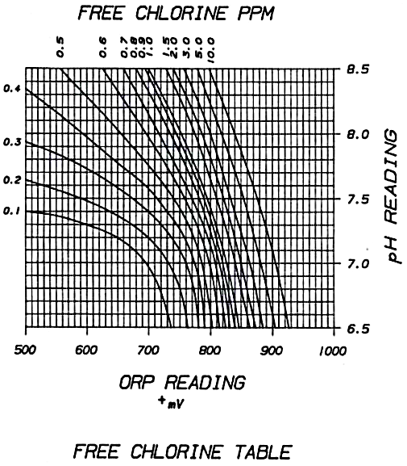

Figure 2.2.1: The graph above shows how to calculate the amount of free chlorine in the water using the reading of the ORP sensor and the reading from the PH sensor (pending permissions from sensys ltd)

Item # | Output | Output type | Price
WQ600 | 4-20 mA | Wire | $624
WQ-ORP | -1250-1250 mV | USB | $299
AM1419 |  | USB | $80
ORP-BTA | -450-1100 mV | USB/Wire | $80
B001EU9OBG | 0-1999 mV | Wire | $138
Aquaclip100 |  |  | Pending quote

Table 2.2.2: Various possible sensor choices.

The ORP sensor that will be implemented in the project is the Vernier ORP sensor Item ORP-BTA. This sensor will be implemented because it fits in the budget for the project and it has changeable output hardware.

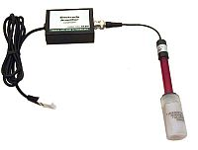

Figure 2.2.2: The picture above is of the Vernier ORP sensor (pending permission from Vernier)

2.2.3 Ph Sensors

The most important element to monitor in pool water is its phi The pH affects every other chemical level in the water. pH is equivalent to the hydrogen ion (H+) concentration in the water which is generally displayed as numbers between 0-14, 0 being the most acidic and 14 being a strong base.

When the pH is too low, all metals that the water touches may begin to erode, chlorine will evaporate and break down faster, and the water becomes an irritant to eyes. If the pH gets too high chlorine will become less effective, the water can become cloudy, and the pool walls and molding can become discolored. The pH sensor is similar to the ORP sensor as it has a reference electrode as a positive pole and a measuring electrode as a negative pole the voltage created is directly proportional to the hydrogen Ion concentration in the water. In order to accurately measure the PH there must also be a temperature sensor either build into the pH sensor or added in addition the PH sensor. These are pH sensors we researched. For several of the sensors we are still waiting for specs and quotes from international companies.

Item # | Ph range | Output | Accuracy | Price
PH-BTA | 0-14 | 59.2 mV/pH | N/A | $80
PHE- 45P | 2-10 | -178-296 mV | +-2% | Pending quote
WQ201 | 0-14 | 4-20 mA | +-2% | Pending quote
6015WC | 0-14 | -999-999mV | +-1% | $45

Table 2.2.3: Various possible sensor choices.

The pH sensor that will be used in the project will be item 6015WC the extech instruments waterproof pH electrode. This sensor is very accurate and much cheaper than the other sensors researched.
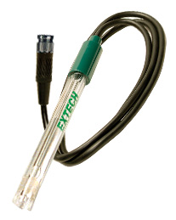

Figure 2.2.3: The picture above is of the Extech Instruments pH sensor (pending permission from Extech Instruments)

2.2.4 Calcium hardness sensors

Calcium hardness is the how much dissolved calcium salts are in the water. Calcium hardness in pool water needs to be maintained between 200-400 ppm in pool to keep the water from becoming corrosive or scale forming. If the calcium hardness in the pool gets too low it can be raised using "hardness increaser" which is calcium chloride. If the hardness is too high the owner will have add anhydrous trisodium phosphate or partially drain their pool and refill it with fresh water to lower the calcium hardness. If the calcium hardness is too low the water can become corrosive water, etching of plaster, staining , skin and eye irritation, foaming, and reduction in chlorine effectiveness. However if Calcium hardness becomes too high the pool could develop scale formations, calcium build up in the filter, decrease in pool water circulation, and reduction in chlorine effectiveness.

Item # | Range ppm | Range pH | Price
m1-pm-51340610 | .2-40000 | 3-12 | $540
ISE-8740 | .02-40100 | 2.5-11 | $227
LIS-146CAC | .2-40000 | 3-10 | $450
ISE-8740 | .2-40000 | 3-10 | $180

Table 2.2.4: Various possible sensor choices.

The electrode that will be used in the project is the Vernier calcium Ion-selective electrode. All of the researched electrodes are similar in the range of measurement and fit in the ideal pH range that the pool will have. The most important aspect of the Vernier calcium ion selective electrode is that it is lowest in cost and fits in our budget better than the other electrodes.

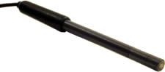

Figure 2.2.4: The picture above is of the Vernier Instruments Calcium Ion-Selective Electrode (pending permission from Vernier Instruments)

2.2.5 TDS/Conductivity sensors

Total dissolved solids or TDS is everything added to water that is not water. Some dissolved solids are required to stabilize the pool such as the chlorine, pH leveling chemicals, and the copper from the ionizer. However there are other total dissolved solids that are too small to be filtered out such as body waste, suntan lotion, stabilizer, dirt, pollen, hair products, and anything esle that can dissolve in water. The three most common reasons for the total dissolved solids level to get too high is when a lot of people go in the water in a short period of time, when large amounts of chemicals have been added in a short period of time and from evaporation, since when the water evaporates it leaves all the dissolved solids in the water. When the total dissolved solids in the water reach higher than recommended levels metal equipment can begin to corrode, skin and eye irritation can occur, and algae can begin to bloom even with pH and chlorine levels are correct. To lower the level of total dissolved solids the easiest way to partially drain the water and refill it with fresh water.

Item # | Output | Accuracy | Price
WU-99243-36 | 4-20mA | +-1% | $680
Ps-2116A | 4-20mA | +-10% | $108
GTS-WA300 | 4-20mA | +-4% | $118
SKU 669170 | 4-20mA | N/A | $340

Table 2.2.5: Various possible sensor choices.

The conductivity sensor that will be used in the project is the Pasport Conductivity Sensor. TDS only needs to be monitored to make sure it does not get too high so extremely accurate expensive TDS sensors are not needed. The Pasport Conductivity Sensor fits in the project budget and can be calibrated via computer. The Pasport Conductivity Sensor measures conductivity in µS/cm that will need to be converted to TDS in ppm. these conversions are in Figure 1.2.6.

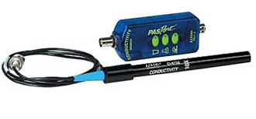
Figure 2.2.5: The picture above is of Pasport Conductivity Sensor (pending permission from Pasco)

TDS(ppm) | Conductivity(uS/cm)
0-70 | 0-140
70-150 | 140-300
150-250 | 300-500
250-320 | 500-640
320-420 | 640-840
Above 420 | Above 840

Table 2.2.6: The table above shows the conversions from conductivity to Total Dissolved Solids (pending permission from Global water Instrumentation)

2.2.6 Copper Ion Selective Electrode Sensors

Copper Ions are the main particles that will be released from the ionizer. The amount of copper released into the water must be checked regularly to maintain a higher than .2 ppm to be at a level high enough to kill the bacteria and algae and keep the system working properly. The levels also have to remain lower than .6 ppm. When there are more than .6 ppm of copper in the water the ions can begin to settle at the bottom of the pool and cause staining or discoloration. Finding a method of measuring the copper ions was difficult because there were few products designed to measure it and even fewer electronic sensors. There were only two copper ion selective electrode sensors that were found that fit our requirements.

Item # | Range ppm | Output | Price
WD-35802-14 | 6350-.13 | 4-20 mA | $333.40
Cuo1502 | 6350-.00064 | 4-20 mA | $334

Table 2.2.7: Various possible sensor choices.

The copper ion selective electrode sensor that will be used in our project will be the Oakton copper single junction ion-selective electrode because it fits the parameter of the system. It is a single junction ion selective electrode because that is what was recommended for clean water. Double junction electrodes were recommended for waste water and water with high volumes of metals.

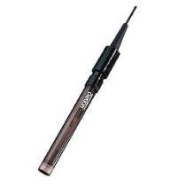

Figure 1.2.7: The Figure above shows the copper ion selective electrode sensor (pending permission from Oakton)

2.2.7 Pressure Sensors

The pressure sensor will be used to replace the mechanical pressure gauge that is attached to most pool filters. The gauge can be used to determine things about the filter and filter housing. As the pump runs water through the filter the particles that it removes from the water gets clogged in the filter which increases the pressure in the filter housing. Since the pressure increases with the more the filter is clogged it is possible to estimate how clogged it is and when to clean it based on the water pressure in the filter housing. This will allow the system to have a warning setting for the when the pressure reaches a certain level making the user aware that it needs to be cleaned. Another warning sensor can be used to protect the filter housing and pump.

In researching water pressure sensors it was first considered to use pressure transducers. This type of pressure sensor allows the user to know the exact pressure being measured as a ratio of the output. The pressure conducers that were researched are in the table below.

Item # | Pressure Range | Output | Additional Specifications | Price
AST 4000 | 0 - 100 PSI | 4 - 20 mA |  | $150
Gp 50 1002 | 0 - 50 PSI | 0 - 5 V | Choice of male Connector | Pending Quote
Model Ds | 0 - 100 PSI | 0 - 5 V |  | Pending Quote
FP 2000 | 0 – 1000 | 0 - 5 mV  0 - 5 V  0 - 10 V  4 - 20 mA | Selectable Output | Pending Quote

Table 2.2.8: Various possible pressure transducers choices.

Although the not all the price quotes have been received the over the phone estimates have been between $100 -$300. Although these sensor would work well in the system they are expensive for a component that just needs to give an output when the pressure is high.

Another solution that was found is to use a water pressure switch. The way a water pressure switch would be implemented in our system is a normally open pressure switch would be set to close when a certain range of pressure is applied to it. If 1 V was applied on that circuit to a I/O pin on the microcontroller the microcontroller can set a desired output.

Item # | Operating Pressure | Factory On/Off | Contact Arrangement | Price
LF10-W | 15 - 80 PSI | 20 - 40 PSI | Normally Open | Pending Quote
0110 | 0 - 4350 PSI | 14.5 - 145 PSI | Normally Open | Pending Quote
9013FSG2J20 | 10 - 65 PSI | 20 - 40 | Pending Quote | $20

Table 2.2.9. Various pressure switch choices.

The pressure switch that will most likely be used for the project is the Mamco LF10-W. This switch is in the normal off position which is required as well as a pressure rating of 20 - 40 PSI which is in the range of when most filters housings need to be opened up and the filter cleaned.

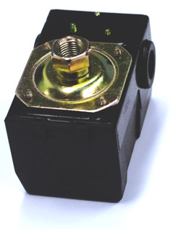

Figure 2.2.8 Water pressure switch (pending permission from Mamco)

2.2.8 Temperature Sensors

The temperature sensor will measure the water temperature so it can be displayed on the control panel. The temperature sensor works by changing in resistivity as the water temperature changes.

Item # | Temperature Range | Price
WQ101 | -50-50C | $150
107-L | -35-50C | $85
“Aquasense”  Water thermistor | -20-100C | Pending Price Quote
R0011800 | -50-50C | $85.98
T7022A1010 | 60-90F | $90.57
520272 | -35-50C | $42.48
Ts5L | -35-50C | $46.88

Table 2.2.10: Various possible sensor choices.

The temperature sensor that will be used in the project is the Pentair temperature sensor Item 520272. This sensor fits the project budget the best while having the temperature range of the more expensive sensors. The sensor is shown below.

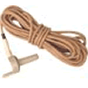

Figure 2.2.9 Temperature sensor (pending permission from Pentair)

2.3 Sensors Testing/Calibration

Testing each of the sensor is important to make the rest of the system reliable. The output of each of the sensors will be converted into digital inputs and compared to the parameters obtained in table 1.1.5 which will be converted to binary equivalent of their voltage equivalents. Then equations will be used to find the correct adjustments that need to be made in the chemical levels.

2.3.1 ORP Sensor Testing

To test the ORP sensor there will be a set of ten water samples at a constant pH of 7.5. Each of the water samples will have a different chlorine levels from .1 to 1 ppm of chlorine. The chlorine levels will be measured by using a Aqua check silver test strips (Figure 1.3) to ensure their values as well as checking the pH of each sample to ensure the pH level of each is the same. Then an input voltage will be applied using a DC power source and the output of the sensor will be connected to a voltmeter. Next the sensor will be applied to each of the water sample solutions to check that the output voltage is changing for each sample and the output voltages will then be recorded. The output voltages recorded will be used to set the reference voltages of the Analog to Digital converter.

2.3.2 pH Sensor Testing

To test the pH sensor another ten water samples will be set with different pH values ranging from 7- 8. These levels will be reached by adding pH up or pH down to obtain the correct values. The values will then be checked by the Aqua check silver test strips (Figure 1.3). Then an input voltage will be applied using a DC power source and the output of the sensor will be connected to a voltmeter. Next the sensor will be applied to each of the water sample solutions to check that the output voltage is changing for each sample and the output voltages will then be recorded. The output voltages recorded will be used to set the reference voltages of the Analog to Digital converter.

2.3.3 Calcium Hardness Sensor Testing
For the calcium hardness sensor testing there will five water samples ranging from 100 - 500 ppm. The sample will be increased with a calcium chloride a common calcium increaser purchased from a pool store. Each sample will be tested to with Aqua check silver test strips (Figure 1.3) Then an input voltage will be applied using a DC power source and the output of the sensor will be connected to a voltmeter. Next the sensor will be applied to each of the water sample solutions to check that the output voltage is changing for each sample and the output voltages will then be recorded. The output voltages recorded will be used to set the reference voltages of the Analog to Digital converter.

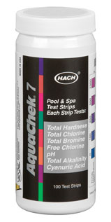

Figure 2.3.1: Test strips that will be used to test chlorine, pH and calcium hardness (pending permission from poolcenter.com)

2.3.4 Total Dissolved Solids Sensor Testing

In testing the total dissolved solids sensor five water samples will be used ranging from 500 to 3000 ppm. The range of this test is from the ideal parameters of the system to the higher limits of the parameters. This is because there is no concern for not having enough dissolved solids in the water but too many becomes a problem. In the five water samples salt will be used as the dissolved solids. Each sample will be tested using Aquatic pro lid test strips (Figure 1.4) to test their levels in ppm. Then an input voltage will be applied using a DC power source and the output of the sensor will be connected to a voltmeter. Next the sensor will be applied to each of the water sample solutions to check that the output voltage is changing for each sample and the output voltages will then be recorded. The output voltages recorded will be used to set the reference voltages of the Analog to Digital converter.

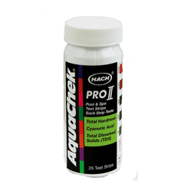

Figure 2.3.2: Test strips that will be used to test total dissolved solids (pending permission from poolcenter.com)

2.3.5 Total Dissolved Solids Sensor Testing

The copper ion selective electrode sensor will be tested using six water samples. Each sample will have a different level of copper ions ranging from .1-.6 ppm. The copper ions will be added to each sample by placing the ionizer in the water and applying the DC voltage while the water is moving. Over time the amount of ions will go up, this will be tested using the Aquatic Copper Test Strips (Figure 1.3.3). This will test that the ionizer is working properly. Each time the copper ppm in the water increases by .1 the water will be used to check the copper ion selective electrode sensor. An input voltage will be applied using a DC power source and the output of the sensor will be connected to a voltmeter. Next the sensor will be applied to each of the water sample solutions to check that the output voltage is changing for each sample and the output voltages will then be recorded. The output voltages recorded will be used to set the reference voltages of the Analog to Digital converter.

Figure 2.3.3: Test strips that will be used to test copper ions in the water (pending permission from poolcenter.com)

2.3.6 Pressure Sensors Testing

To test the pressure switch first a multi-meter must be connected to the wires from each side of the switch. Initially there should be no continuity through the switch because it is a normal open switch. Then 20 PSI of pressure should be applied to the switch and continuity should be checked again. If there is continuity while the pressure is being applied then the switch is working.

2.4 Sensor Amplifiers

Each of the sensors will have their own output voltage source. The voltage will be in mille-volts which is easily influenced by noise. This can cause the voltage going to the analog to digital converter to vary and cause the system to fail. Two major steps will be taken to ensure that the correct values will be entering the input analog channels. First any wires with low voltages will have a grounded metal shield around it to prevent the wires acting like transmission wires and adding noise. Secondly operational amplifiers will be used to increase the voltage to the range allowed on the analog input channels.

2.4.1 ORP Sensor Amplifier

The output of the ORP sensor is between -.45-1.1 V. Research is being conducted to find the maximum range of analog input voltage the analog to digital converter can use but it is believed that it can handle 0-3.6 V. For this situation the ORP sensors output voltage must first go through a summing amplifier adding .45 V with a gain of about 2.4. Then it will go through a unity gain inverting amplifier to obtain a positive voltage.

These values and outputs were obtained using the summing amplifier equation and the inverting amplifier equation which are as follows.
$$vo=-(\frac{rf}{r1}*v1+\frac{rf}{r2}*v2)$$

$$vo=-vin*(rf/r1)$$

Equations 2.4.1: Equations for a summing amplifier and inverting amplifier

Figure 2.4.2: The Figure above shows the op amp that will be used to attenuate the sensor signal

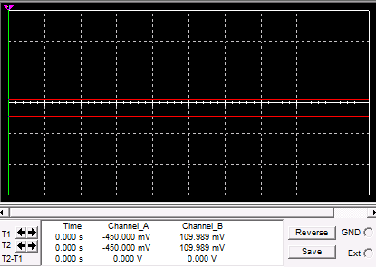

Figure 2.4.3: The Figure above shows the output of the op amp circuit with the smallest possible output value

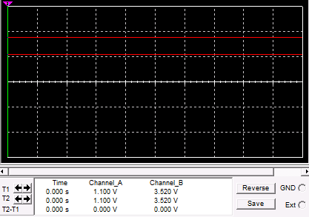

Figure 2.4.4: The Figure above shows the output of the op amp circuit with the highest possible output value

The output of the sensor will now range from .10 V to 3.52 which is within the analog to digital converts analog range of 0-3.6 V.

2.4.2 pH Sensor Amplifier

The output voltage of the pH sensor is initially -.999 to .999 mV. The voltage needs to be attenuated so that it is in the range of 0-3.6 V. To do this again the summing amplifier and inverter equations will need to be used. The circuit and outputs of the minimum and maximum voltages are as follows.

Figure 2.4.5: The Figure above shows the op amp that will be used to attenuate the sensor signal

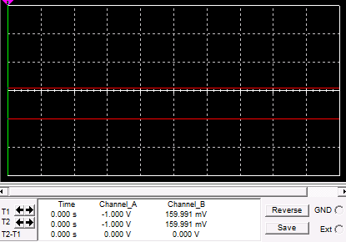

Figure 2.4.6: The Figure above shows the output of the op amp circuit with the smallest possible output value

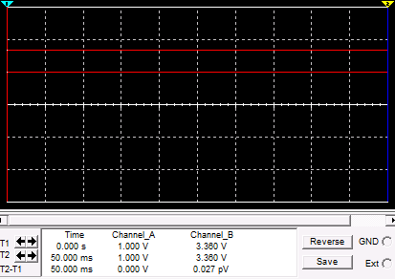

Figure 2.4.7: The Figure above shows the output of the op amp circuit with the highest possible output value

The output of the sensor will now range from .16 V to 3.6 which is within the analog to digital converts analog range of 0-3.6 V.

2.4.3 Calcium Sensor Amplifier

The output voltage range for the calcium sensor range from 1.5 - 1.9 V. For this sensor the output voltage range needs to be brought down to 0 then attenuated so that it fits in the analog range of 0-3.6 V. To do this again the summing amplifier and inverter equations will need to be used. The circuit and outputs of the minimum and maximum voltages are as follows.

Figure 2.4.8: The Figure above shows the op amp that will be used to attenuate the sensor signal

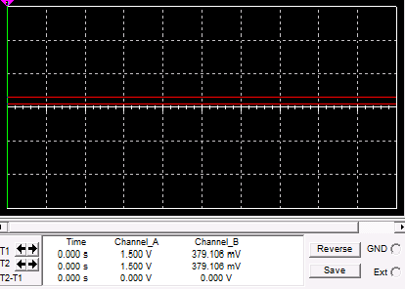

Figure 2.4.9: The Figure above shows the output of the op amp circuit with the smallest possible output value
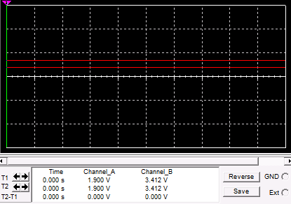

Figure 2.4.10: The Figure above shows the output of the op amp circuit with the highest possible output value

The output of the sensor will now range from .38 V to 3.41 which is within the analog to digital converts analog range of 0-3.6 V.

2.4.4 TDS/Conductivity Sensors

The particular conductivity sensor that will be implemented in the project was designed to be used with computer instead of an analog system and comes with its own analog to digital converter. The sensor spec sheets did not state a specific output voltage range. The voltage range that will be used will be found from section 1.3.4 in when doing the calibration and testing of the sensor.

2.4.5 Copper Ion Selective Electrode Sensors

The copper ion selective electrode sensor has a output voltage from 0-.3 V. Again the desired output of the sensor is between 0-3.6 V. The voltage range of this sensor does not need to be shifted toward 0 so the output only needs to be attenuated. To do this a non-inverting operational amplifier. The equation, circuit and output are as follows.

$$vo=(\frac{rf}{r1}+1)Vin$$

Figure 2.4.11: The Figure above shows the op amp that will be used to attenuate the sensor signal

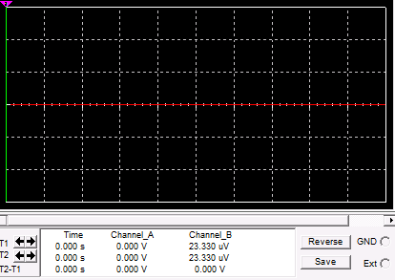

Figure 2.4.12: The Figure above shows the output of the op amp circuit with the smallest possible output value

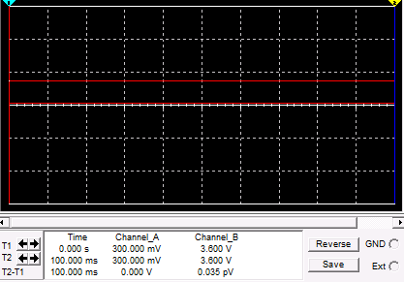

Figure 2.4.13: The Figure above shows the output of the op amp circuit with the smallest possible output value

The output of the sensor will now range approximately from 0 V to 3.6 which is the analog to digital converts analog range of 0-3.6 V.

Chapter 3

Solenoid Valves

The Pool Boy will automatically adjust chemicals. Therefore there must be a system to regulate the flow of these chemicals. In order to get chemicals from the reservoirs to the pool without manual action there shall be electric valves between the reservoirs and the main flow of the pool. These valves will be electronically controlled by the microprocessor discussed in detail in Chapter 5. These valves open when a voltage potential is placed across them. Electronically controlling the valves is critical to the operation if the system is to be truly independent from user interaction.

3.1 Valve Specifications

Internet searches revealed that there are numerous types of electronic valves available. Further searches implied that not all electronic valves will meet the specifications of Pool Boy. Therefore three different types of valves were considered for this implementation and they are as follows: Model 54049 from Lawn Genie, Model 57210 from Orbit, and the 220 series from TORO. Specifications of these valves are listed below in Table 3.1.1.

Model | Cost | Voltage | Inrush Current | Sustained Current | Flow Rate | Valve Size
LG 54049 | $11.97 | 19-24 V | 9.6 VA | .2 Amps | 5-25 GPM | ¾ inch
Orbit 57210 | $11.95 | 24 V | 8.4 VA | .23 Amps | 5-40 GPM | ¾ inch
TORO 200 series | $52.99 | 24 V | 11.5 VA | .2 Amps | 5-40 GPM | 1 inch

Table 3.1.1: Table of different valve specifications [1][2][3]

One specification not listed in Figure 6.1 is the material that the valve is made of. Both the Lawn Genie and Orbit models are made of plastic while the TORO 200 series is made from brass. Further research into the subject revealed that brass is corroded by chlorine. Therefore the valve from TORO is not applicable in the implementation of the Pool Boy. Of the two remaining valves in consideration another factor in determining which valve will best suit the needs of the Pool Boy is a “Flow Control Knob.” The “Flow Control Knob” is located on top of the valve and it allows the user to change the rate of flow through the valve. This knob is best illustrated below in Figure 3.2. This is an essential component to the system because it will allow for more accurate dispersion of chemicals. By slowing the rate at which the chemicals flow through the valve makes measuring that amount much easier and will make for a more comfortable pool environment. Both of the models left in contention have a “Flow Control Knob” so further narrowing down is required. Both valves are the same size at ¾ of an inch, but the Orbit model has a higher flow rate. However after much consideration on the topic it was decided that the valve from Lawn Genie would best suit the needs of Pool Boy. The higher flow rate of the Orbit model does not outweigh the fact that Lawn Genie is a trusted and well respected company and the valve is readily available at any Home Depot. Also there is more documentation on the Lawn Genie model than the others and that was also a major deciding factor.

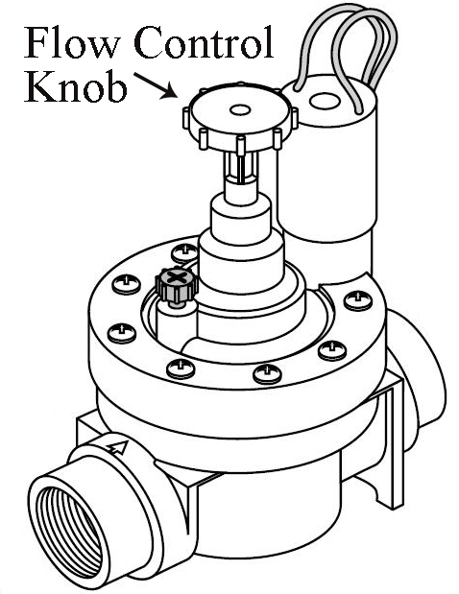

Figure 3.1.2: Flow Control Know illustration [pending permission from Lawn Genie][1]

3.2 Valve Testing

Testing the valves will prove to be a difficult task. Initial observations suggest that the flow through the valve will roughly follow a logarithmic curve that approaches the maximum flow rate. That is when the valve is first opening there is little room for chemicals to flow, but the rate will increase as the valve opens wider. When the valve is fully open the slope of the curve will be zero as the chemicals will be flowing through the valve at a constant rate. When closing the valve, the flow rate through the valve will decrease at roughly an exponential rate. While the valve is closing there is a continuous decrease in space for flow of chemicals. This entire description is illustrated below in Figure 3.2.1. The graph suggests taking the integral of the curve to get the total volume of chemicals dispersed.

The graph below assumes ideal flow through the valve. There will most likely be a “2 liter effect” when dispensing chemicals. Because the valves are sealed there will be a vacuum effect when the chemicals are trying to flow out. This effect may be equivalent to when a 2 liter bottle that is filled with liquid is turned upside down without the cap on. The liquid exits the container very sporadically and at a much slower rate than if there was a hole at the bottom of the bottle allowing are pressure to aid in the dispersal. The Flow Control Knob should prevent this condition from occurring, but if it does not an alternative solution must be devised. The alternative solution is described in greater detail in the next section.
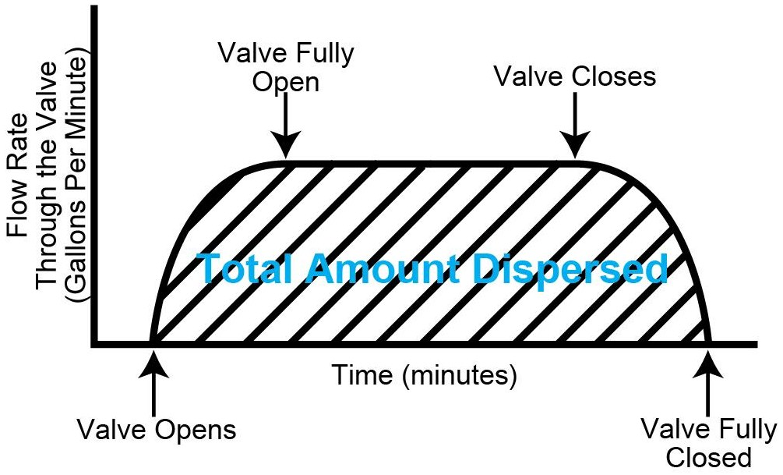

Figure 3.2.1: Valve Flow Illustration

While this method will give the exact amount of chemical dispersed it is very difficult to derive the exact equation. Therefore a more straightforward and easier method will be employed. The first step is to measure the amount of time it takes for the valve to fully open with no chemicals flowing through. Next the microcontroller will be programmed to open the valve for that exact amount of time and then close when that exact amount of time has expired. By measuring the amount of chemical dispersed during this time interval, one can deduce the amount of chemical dispersed during the curved sections of the graph above. By knowing this amount the rest of the volume to be dispersed becomes easy to compute because the slope of the curve during this portion is zero implying a linear relationship between volume of chemical dispersed and time. By subtracting the amount dispersed during opening and closing from the total volume to be dispensed and dividing this quantity by the maximum flow rate with gravity as the driving force, an equation for the amount of time the valve should be open is derived. It is shown below in Figure 3.2.2 to help illustrate the equation.

$${\text{Time}}_{\text{Open}}\text{= }\frac{\text{Vol. to be dispensed - Vol. dispensed during opening \& closing}}{\text{Maximum Flow Rate}}$$

Figure 3.2.2: Equation for Open Time of Valve

As one can conclude from examining the equation above the numerator gives a term in volume (most likely gallons). The denominator is in the form of gallons per minute. Therefore the gallons term from the numerator cancels with the volume term from the denominator. The “per minute” term in the denominator is equivalent to a single minute term in the numerator leaving the total time to be open in minutes. The final term can be multiplied by sixty to obtain an answer in seconds if desired.

In order to correctly dispense the correct amount of chemical in every single instance of valve openings another case must be taken into consideration. The case is when the volume to be dispensed is less than the volume that is dispensed while opening and closing. This situation is best depicted below in Figure 3.2.3.
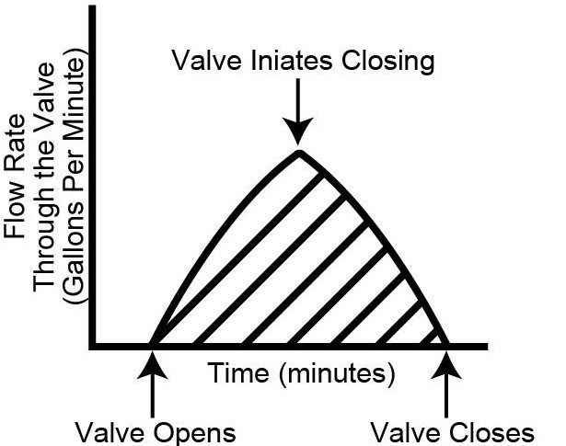

Figure 3.2.3: Graphical Representation of a Small Amount of Chemical Dispersion.

One can conclude that the slope of the function above is only equal to zero at one point. The time needed to dispense this amount of liquid cannot be derived from the equation in Figure 3.2.2 because the valve never fully opens. The tolerances and flow control knob should prevent this situation from occurring, but it still must be considered. If this situation is encountered the time open shall be approximated by a linear relationship.

3.3 Alternative Solution

As stated in the previous section the flow rate through the valve may not be as smooth as indicated in Figure 3.2.1. This section is aimed at offering an alternative solution to the sporadic dispersion problem. Initial ideas suggested tilting the reservoir at roughly a forty five degree similar to how liquid from a two liter bottle is poured into a cup. In order to implement this method the type of sensor used to measure chemical levels would need to be changed, because of the different pressures that are associated with the new angled orientation. The optical sensor method would then be the best method to implement. This method would offer a more consistent flow, but it would still cause sporadic dispersion. Therefore yet another scheme must be agreed upon as the alternative solution.

The next technique is taken from present required building codes, and is known as “putting air behind water.” This is the same idea as poking a hole in the bottom of a 2 liter bottle then turning the bottle upside down. The first thought was to implement a “hole” at the top of the reservoir. This idea was quickly disregarded, as a “hole” would allow for the evaporation of chemicals and contamination. It was decided that the best way to implement “putting air behind water” is to build a custom cap for each reservoir. Part of the cap will be hinged and can be lifted. A simple servo motor will raise the hinged part of the cap during chemical dispersion to allow for smooth flow out of the reservoir. This idea is illustrated below in Figure 3.3.1.

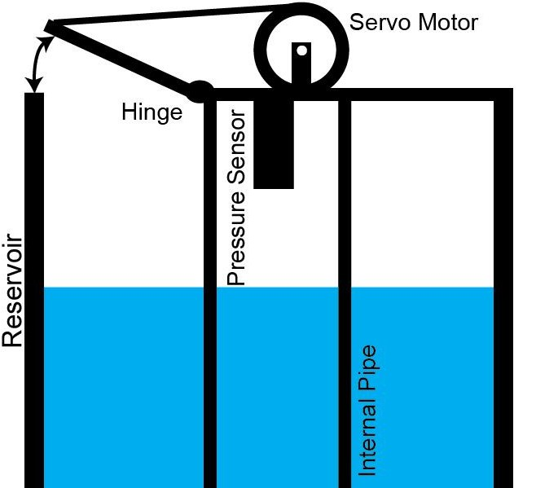

Figure 3.3.1: Illustration of proposed solution to the sporadic flow problem.

As illustrated in Figure 3.3.1 the proposed solution to the sporadic flow problem may be solved by incorporating a hinged component into the top of the reservoirs. While this offers a valid solution the weakness associated with this method need to be addressed. Adding a servo motor to the top of the reservoir will complicate the wiring and circuitry. In a casual conversation with a group member from the Senior Design group ParkBot there was a discussion on how on numerous occasions sensors were fried by their servo motors. This leads to a conclusion that the servos should be on a different circuit than the sensors. This idea is discussed in greater detail in the next chapter.

Possibly the biggest question mark using this method is cap security. The cap needs to be air tight for the pressure sensor to function properly. It this cannot be implemented properly the optical sensor shall be used in its place.

Chapter 4

System Implementation

As discussed in chapter 2, Pool Boy may need to add the following chemicals to the water of the pool in order to meet the suggested National Spa and Pool Institute standards: Chlorine, Muriatic acid, Soda ash, Hydrochloric acid, and Sodium bicarbonate. The motivation for this chapter is explaining how these chemicals will be stored. Pool Boy needs a viable storage unit in order to easily access the chemicals listed above. The term for this unit shall hereby be referred to as a reservoir.

4.1 System Design

As an entire entity Pool Boy will interact directly with the pool water. This shall be done by placing Pool Boy in line with the main flow pipe of the pool, in between the filter and the actual pool itself. This ensures that all chemicals that pool boy will add to the pool are not diluted or intercepted by the filter. It also reduces the load that the filter will have to handle. This introduction includes how all of the components are related to one another. The brain of the system (the microprocessor) will continuously collect information and issue concurrent instructions to specific components. By integrating reservoirs into the design the system becomes a complete design. Reservoirs can be thought of as passive objects in an object oriented design. They have no direct impact on the system yet every component relies on the chemicals that they hold.

What may be the easiest components to build will prove to be one of the most important to the entire system design. The reservoirs will hold the chemicals that will be directly injected into the pool and will also relay information to the microprocessor that includes the volume of chemicals left in the reservoir.

Figure 4.1.1 offers a graphical representation of the form that Pool Boy is expected to take next semester. Three reservoirs in the picture have been left out to avoid redundancy. The three missing reservoirs are accounted for by the 5 LED’s on the wireless control panel.

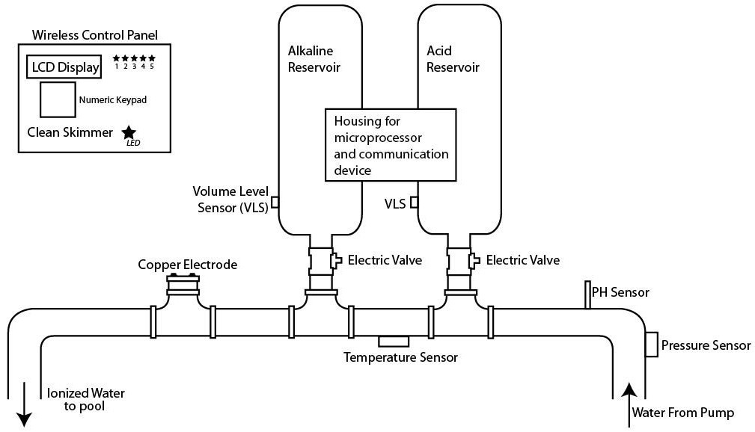

Figure 4.1.1 Graphical Depiction of Pool Boy

4.2 Reservoir Specifications

After much research into the topic it was decided that the reservoirs used in the system would have to be made from scratch. No premade reservoirs were available online that would meet the requirements for the Pool Boy. These reservoirs will be constructed from standard PVC pipe available in most hardware stores. PVC was chosen to be the material used in the construction of the reservoirs because of its resistance to the chemicals it will hold. A standard 4 inch PVC pipe with capped ends will serve as the reservoir. The final capacity for the reservoirs has yet to be determined, but a length of 18 inches will yield a volume of approximately 226 cubic inches, approximately 3.7 liters, or approximately 1 gallon. Most chlorine controlled pools will use more than this amount, However as mentioned in Chapter 2 the water that Pool Boy will analyze will need 85% less chlorine because of the added copper electrode. Therefore this volume should be sufficient for Pool Boy’s specifications.

Four inches was chosen to be the diameter of the reservoir, because that is the largest diameter of PVC pipe that is readily available at most hardware stores with extending accessories. The top to the reservoirs must be removable in order add chemicals when the volume of chemicals reaches a low reading. Therefore a threaded cap will be incorporated into the design at the top of the reservoir in order to add chemicals easily. The bottom of the reservoir must be scaled down to ¾ of an inch; reason discussed in greater detail in the next chapter. This will be achieved through a series of reduction pieces, which are also readily available at most hardware stores. The entire reservoir will be held together with standard PVC cement also available at any hardware store. The PVC cement will also prevent any leaks from occurring. A table of materials needed to construct the reservoirs is listed below in 4.2.1. All pieces listed in the table will be purchased from Home Depot.

Piece | Price
4 in. x 10 ft. sch40 PVC pipe | $13.46
4 in. PVC Cap (x5) | $9.25
Oatey 8 oz. PVC Cement | $3.76
1 in x 10 ft. sch40 PVP pipe | $2.67
Total | $25.44

Table 4.2.1: Materials Needed for Reservoir and Corresponding Prices

As noted from Figure 4.2.1 the cost of building all five reservoirs will be $29.14. In terms of the overall cost this number is less than one percent of the total budget. Now that the materials of the reservoirs have been discussed the orientation of the reservoirs must be discussed. That is should the reservoirs be oriented in parallel or perpendicular to the main flow pipe. The solution becomes obvious after minimal thought. The reservoirs will be oriented perpendicular to the main flow pipe so that gravity can be used as the driving force for expelling the chemicals. Utilizing gravity in the design is crucial, because it eliminates the need for an external pump. For purposes of demonstration and portability the size of the reservoir shall stay at 226 cubic inches. Changes to the volume of the reservoir can be made by simply using a wider diameter pipe or extending the length of the current reservoir.

4.3 Reservoir Testing

There seems to be only one viable way of testing the effectiveness of the reservoirs, and that is to simply build one and observe the results. The reservoirs contain no moving parts, so In order to prove that this method is applicable to Pool Boy, it must be able to hold the certain chemicals without leaking for an acceptable period of time.

4.3.1 Chemical Level Monitoring (Sonix-40)

One feature that will be included in pool boy is chemical level monitoring. The system will continuously measure the amount of chemicals left in the reservoirs. The volume of chemicals is decreased as they are added to the closed loop system of the pool. When the volume reaches a low level the system will notify the user to add more chemicals to the reservoir.

In researching the topic several methods of accomplishing this task became apparent. A Google search of “volume level sensor” produced numerous links, and the first was for Automated Sonix Corporation. The Sonix-40 from Automated Sonix Corporation seemed to offer the best solution. The sensor works by sending an ultrasonic signal into the reservoir. The signal then hits the chemical and is reflected back towards the source. The time it takes for the echo to return determines the distance the sensor is from the level of the chemical. An onboard microprocessor computes this calculation. An illustration of how the sensor works is located below in Figure 4.3.1. The black lines represent the initial signal while the red lines represent the echo. The large block represents the reservoir and the specific chemical is represented by the blue shading. The Figure is also drawn approximately to scale.

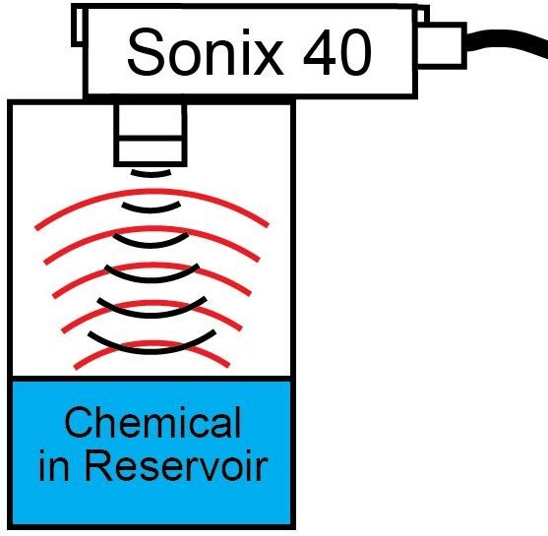

Figure 4.3.1: Ultrasonic Wave Reflection Illustration [4]

After seeing how the sensor works it becomes apparent that the Sonix-40 is a very capable solution for the problem. It is extremely accurate with an approximate error of +/- .3%. The sensor could be mounted at the top of the reservoir where no major modifications would be needed. It also should be noted that the sensor continuously checks the distance between the sensor and chemical at a rate of seven measurements per second. The fast rate has no apparent advantage over any other method other than that the user will be notified of significant leaks very quickly.

Unfortunately all of the advantages that the Sonix-40 offers are vastly outweighed by its one disadvantage: price. In an email exchange one sensor was quoted at $780. With an entire budget of $3,000 the five sensors that would be needed (one for each reservoir) would indebt the group an extra $900. Therefore another solution had to be developed.

4.3.2 Optical Sensor

In a casual conversation a fellow peer suggested using an optical sensor. Research into the sensor proved to be quite helpful as this suggestion seems to provide a very suitable solution to the problem. Another Google search for “optical sensor liquid” produced some valuable links with some important information. The sensor operates on 10-28 Volt DC input. The main component of the sensor is an infrared LED that is housed in a prism. While the LED is on the light waves from the LED reflect off of the prism then are reflected back up to a receiver. The genius in the design comes from the physics. If the sensor is in the presence of liquid then the infrared rays are refracted out into the liquid, leaving little or no light to reach the receiver. This process is best illustrated below in Figure 4.4.1

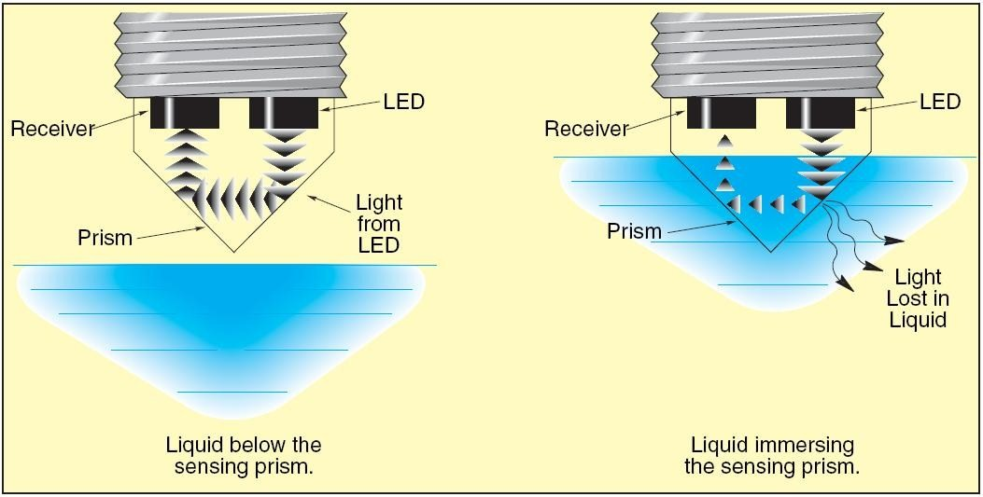

Figure 4.3.2a: Optical Sensor illustration [pending permission from Omega.com][5]

In order to implement the optical sensor method a way of mounting the part had to be devised. An initial suggestion implied that the sensor should be free floating near the bottom of the reservoir with power wires run up through the top of the reservoir. Running the power wires through the actual chemicals obviously is not a practical design therefore another method needed to be considered. The next idea was to drill a hole into the side of the reservoir where the sensor could be mounted near the bottom. This idea implies mounting the flat sensor on the round surface of the reservoir; therefore yet another method had to be devised to mount the sensor. The final design as it stands is to use a T joint made of PVC. One end of the joint will be attached to the bottom of the reservoir. The bottom of the T joint will be reduced down to three quarters of an inch which is the width of the valve that was decided upon. A four inch cap will be placed on the side of the T joint which will provide a flat surface on which to mount the sensor. A picture of this design is located below in Figure 4.4.2. This method of implementation has some advantages such as the simplicity of the design. The T joint will offer stability to the reservoirs without making any major modifications. While the T joint offers a flat surface on which to mount the sensor the possibility of leaks occurring must still be considered.

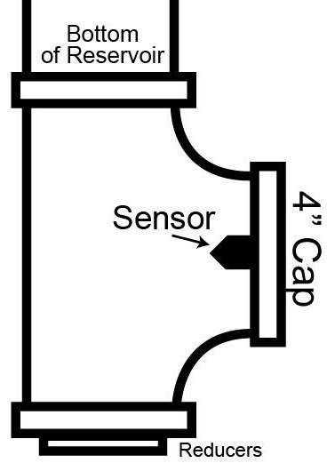

Figure 4.3.2b Mounting Illustration for Optical Sensor

While the price of each optical sensor is very favorable compared to Sonix-40 at $65 per sensor, the price is high enough to consider alternative options. At this point in the design the optical sensor seems to offer the best solution for the price. This method will simplify the code needed to implement it because its state will only change when chemical level falls below the sensor.

4.3.3 Float Gauge

Internet searches still offered little help in a way to solve the problem at hand however a simple changing in the wording of the search yielded better results. A comparison between the task at hand and a gas tank gauge offered similar situations. A float floats on top of the gas where it is connected to a rod. The rod is connected to a variable resistor or potentiometer and when the level of the gas changes so does the value of the resistor. It can be oriented such that the resistor either increases or decreases as the amount of gas decreases. By wiring another resistor in series with the variable resistor the voltage across either resistor can be measured and the level of gas can be determined.

In order to implement this design into the project some remodeling of the gas gauge had to be done. Typically gas tanks are wider than they are taller therefore the range of the rod used can be as wide as needed to cover the entire height of the tank. The reservoir in Pool Buddy is only four inches wide so range that a rod can cover is only four inches. This range does not offer any relevant information, so that is why the design needs to be slightly modified. By replacing the rod with heavy duty string and orienting the variable resistor parallel to the surface of the chemicals the range of detection will approach the limit of the reservoir. The float will be connected to a track mounted to the side of the reservoir, so that the most accurate reading can be made. The string will be connected to the float at one end and the variable resistor at the other. As chemicals flow out of the reservoirs the float will go down and pull the string therefore turning the variable resistor. This process is best illustrated below in Figure 4.5.1. The resistor can turn either way as long as it is done consistently across the three reservoirs. By reading the voltage across the potentiometer, the level of chemicals in the reservoir can be accurately computed.

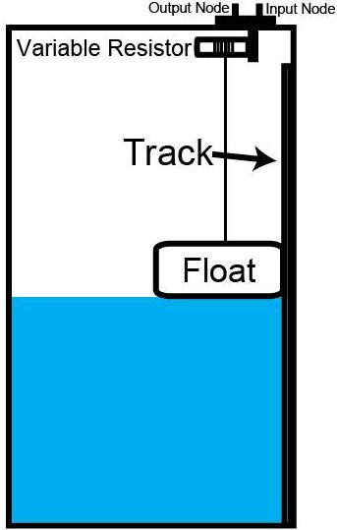

Figure 4.3.3: Gauge Illustration

If price were the only factor in deciding which method to use, the gauge model offers the best solution. Potentiometers are available at RadioShack for $3 and volt meters are readily available for under $15. The gauge method might offer a valid solution, but the disadvantages are glaring. For instance after each refill the string will need to be wound up again manually and the potentiometer will have to be set to the original position. If it is not set to the exact same value the readings will change and the level reading will not be accurate. If given a choice between a mechanical device and a solid state device to accomplish the same task the group decided that a solid state device would most likely work longer and more accurately.

4.3.4 Pressure Sensor

The initial idea of implementing level monitoring was to use a pressure sensor, but the idea was scrapped due to uncertainty of how to mount and power the sensor. An appropriately titled article “Liquid Level Monitoring Using a Pressure Sensor” from National Semiconductor, offered a distinct solution to the problem at hand. While the initial idea suggested mounting the sensor near the bottom of the reservoir the article contends the opposite. The author of the article, Amy Le, articulates how to implement the sensor best; “The height of liquid in a container can be measured using a pressure sensor. Placed at the top of the container, the pressure sensor is connected to an open-ended tube that is submerged in the container. The amount of water in the container exerts a proportional amount of pressure on the sensor via the trapped air in the tube. At its output, the sensor produces a pressure equivalent voltage.” [88] This description is best illustrated below in Figure 4.6.1.

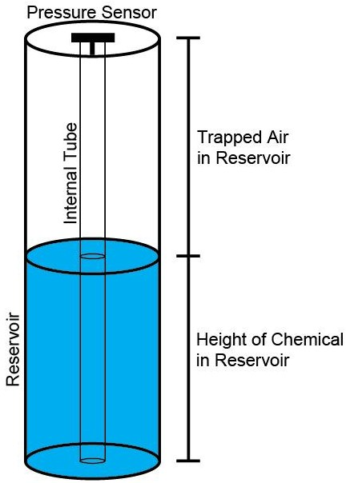

Figure 4.3.4: Pressure Sensor Illustration [88]

The model sensor that is used in the article is the GE NovaSensor’s NPC-1210 series. GE is an extremely well known company and offers an enormous variety of quality products. It was decided that if the pressure sensor method was to be used to implement chemical level monitoring the group would use the same model sensors. By following the procedures explained in the article it seems very difficult to fail in implementation. This method quickly became the most favorable method among the group members.

The article is extremely descriptive and also describes how to convert the analog voltage at the output of the sensor into a digital reading that can be used for autonomous monitoring. It also suggests the models for operational amplifiers and analog-to-digital converters to use. With so much documentation and trust in the National Semiconductor name this method became even more favorable to the design process. The main factor that has this method in the lead is price. The total price for the sensor, operational amplifiers, and analog-to-digital converters appears to be under $35 which is the second cheapest method.

4.4 Chemical Level Monitoring Solution

Of all the methods described in this chapter only one must be decided upon to implement. Before the method of implementation is decided a summary of each method is listed below in Figure 6.5.1 in order to clearly see the differences between each method of implementation.

Method | Price | Advantages | Disadvantages
Sonix-40  [40] | $780 | -No moving Parts  -Extremely accurate | -Price
Optical Sensor  [41] | $65 | -Easy to implement  -Accurate | -Potential for leaks  -Price
Level Gauge | $15-20 | -Price | -Hard to build  -May be inaccurate
Pressure Sensor  [88] | $25-35 | -Good documentation  -No moving parts  -Price | -May be hard to build  -May be inaccurate

Table 4.4.1: Table of Level Monitoring Methods

After much deliberation it was decided that the pressure sensor would best solve the issue at hand. The price and extensive documentation backing the method proved to be the major deciding factors in choosing this method. The group felt the risks involved with the pressure sensor were vastly outweighed its advantages. It was decided that this method offered the best potential for success. The document from National Semiconductor will prove to be an invaluable resource when building the component. A block diagram from the article from National Semiconductor best illustrates how to implement the sensor. The diagram is shown below in Figure 4.4.2. This Figure will be valuable in assisting the building and implementation process.

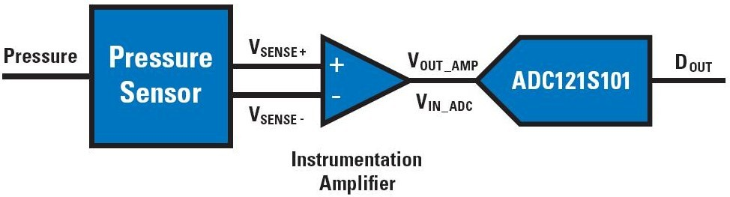
Figure 4.4.2: Pressure Sensor Block Diagram [pending permission from National Semiconductor][88]

4.5 Chemical Monitoring Design and Implementation

The article from National Semiconductor contains a circuit diagram that is perfect for implementing the pressure sensor. This article was a late find in the research process so conformation of use of the circuit and diagram has not yet been received. All credit for the design goes to National Semiconductor. That being said, the design calls for three operational amplifiers in order to compute the gain of the instrumentation amplifier. The design is illustrated below in Figure 4.8.1. Using common operational amplifier characteristic learned in classes such as Linear Control Systems and Networks and Systems equations for voltages at each node can be derived. The equations are listed are listed below the diagram and are referenced (65a) through (5e).
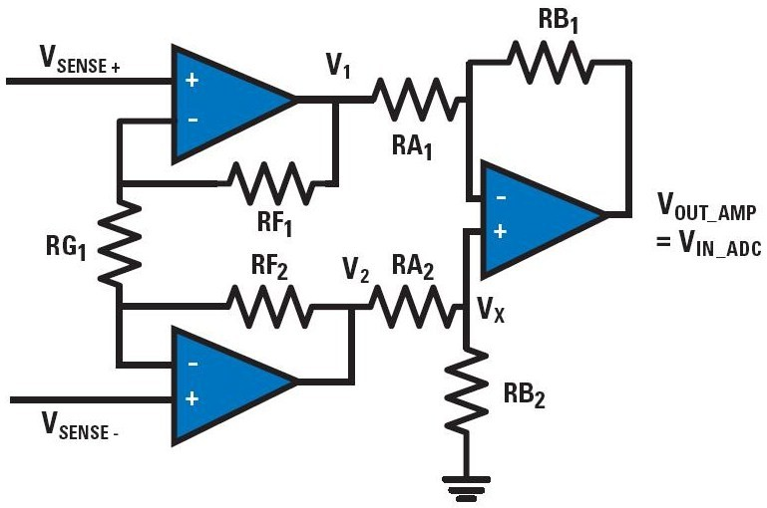
Figure 4.5.1: Instrumentation Amplifier Circuit Diagram [pending permission from National Semiconductor] [88]. The following equations are derived from this circuit diagram.

${\text{V}}_{\text{1}}\text{=}\left({\text{V}}_{{\text{SENSE}}_{\text{+}}}\right)\left(\text{1+ }\frac{{\text{RF}}_{\text{1}}}{{\text{RG}}_{\text{1}}}\right)\text{+ }\left({\text{V}}_{{\text{SENSE}}_{\text{-}}}\right)\left(\frac{{\text{-RF}}_{\text{1}}}{{\text{RG}}_{\text{1}}}\right)$ (5a)

${\text{V}}_{\text{2}}\text{=}\left({\text{V}}_{{\text{SENSE}}_{\text{+}}}\right)\left(\frac{{\text{-RF}}_{\text{2}}}{{\text{RG}}_{\text{1}}}\right)\text{+ }\left({\text{V}}_{{\text{SENSE}}_{\text{-}}}\right)\left(\text{1+ }\frac{{\text{RF}}_{\text{2}}}{{\text{RG}}_{\text{1}}}\right)$ (5b)

${\text{V}}_{\text{X}}\text{=} \left(\frac{{\text{RB}}_{\text{2}}}{{\text{RB}}_{\text{2}}\text{+} {\text{RA}}_{\text{2}}}\right)\left({\text{V}}_{\text{2}}\right)$ (5c)

${\text{V}}_{\text{OUT_AMP}}\text{= }{\text{V}}_{\text{X}}\left(\frac{{\text{RB}}_{\text{1}}\text{+ }{\text{RA}}_{\text{1}}}{{\text{RA}}_{\text{1}}}\right)\text{ - }{\text{V}}_{\text{1}}\left(\frac{{\text{RB}}_{\text{1}}}{{\text{RA}}_{\text{1}}}\right)$ (5d)

$\text{Gain= }\frac{{\text{V}}_{\text{IN_ADC}}}{{\text{∆V}}_{\text{SENSOR_OUT}}}$ (5e)

The gain of the operational amplifier becomes important to compute because different gains will produce different voltages. By correctly computing the gain of the operational amplifier the output to the analog to digital converter a more precise value for the height of the chemicals can be computed. The output from the circuit has a direct correlation to the level of chemical in the reservoir. The mounting of the sensor and corresponding internal pipe will prove to be critical in calculating the correct height. This idea is discussed in greater detail in section 6.10.

4.6 Chemical Monitoring Parts Acquisition

It has conveniently become commonplace to order parts online, so the group will use this method. The three pressure sensors shall be purchased from Allied Electronic at a price of $27.80 per sensor. The three analog to digital converters will be purchased from National Semiconductor for $1.60 per converter. RadioShack offers numerous models of operational amplifiers all of which are under two dollars. Resistors are widely available at most electronics stores at very low prices. There are also resistors available for use in the Senior Design Lab. The total price for chemical level monitoring in all of the reservoirs will be approximately ninety dollars.

4.7 Testing the Pressure Sensor Method

The article provides detailed information in how to calibrate the sensor that is independent from different resistor values and different operational amplifiers. The first step in ensuring that the most accurate reading can be made from information learned in previous classes such as Linear Control Systems and Networks and Systems. In order to ensure a good common-mode rejection, RF₁ should be equal to RF₂. RA₁ should be equal to RA₂, and RB₁ should be equal to RB₂. This idea is also suggested in the article from National Semiconductor. Once the pressure sensor is connected to the correct power supply the sensor can be calibrated. The article suggests that for every 10 inches of liquid in the reservoir the output shall increase by 50 mV. In order to correctly calibrate the sensor a reading shall first be taken place with exactly 10 inches of chemical in the reservoir. After the reading has been recorded a different amount of liquid shall be poured into the reservoir and the corresponding output can be used to calibrate the sensor. It is best articulated by the author; “By pouring in the container ‘x’ inches of liquid and then measuring the sensor’s differential output voltage ‘Δy’, where Δy is [(V_{SENSE+}) - (V_{SENSE-})], the sensor can be calibrated. (Le, 2)” By using the following equations the relationship can be calculated and the sensor will be correctly calibrated.

$$\text{∆}{\text{V}}_{\text{SENSOR_OUT}}\text{= }\left({\text{V}}_{{\text{SENSE}}_{\text{+}}}\right)\text{- }\left({\text{V}}_{{\text{SENSE}}_{\text{-}}}\right)$$

$${\text{∆V}}_{\text{SENSOR_OUT}}\text{=} \left(\frac{\text{∆y}}{\text{x}}\right)\text{×(Height)}$$

Having a correctly calibrated sensor will give the most accurate reading. For the scope of the problem, the reading that Pool Boy obtains from the sensor will not have to be incredibly accurate. This is because Pool Boy will only notify the user to add more chemicals when the sensor reads a low reading. Therefore the exact amount of liquid doesn’t play an important part in the problem as long the sensor can return true when the level is low.

4.8 Backflow Prevention

Another feature that will be added to Pool Boy is backflow prevention. This feature will prevent water from the main pipe from flowing into the reservoirs when the valves open to disperse chemicals. This is done by allowing the flow of liquid in only one direction comparable to how a diode only allows current flow one way. Backflow preventers are mainly used in residential water supply systems. The device prevents sewage from rising into the home level when the water demand is very high. There are over ten thousand reported cases of backflow contamination each year, and in some incidents have proved fatal. Implementing the feature in Pool Boy will be fairly easy as the device is a single piece that will be fitted in between the bottom of the reservoir and the valve. Ensuring that the reservoirs will not be contaminated shall be the main focus of implementing this feature.

The backflow prevention device can be found at any Home Depot and costs $4.27 compared to $5 online not including shipping. The hose fitting size is half an inch therefore a few more adaptive PVC pieces will be needed in order to implement this feature. Initial estimates suggest that the total cost for implementing this feature on all of the reservoirs will be less than twenty dollars.

In order to test the feature’s functionality a prototype must be built. Using methods described section 6.2 the backflow device shall be incorporated into the reservoir. In order to pass inspection the device will be subjected to a water test. A typical garden hose shall serve as the intrusion supply. If the device functions properly no water should enter the reservoir. If water manages to reach the reservoir another technique must be devised.

Chapter 5

Microcontroller

The microcontroller chosen for the project is the brain of our entire system, as it will interact with all the other devices used. Before deciding on a device, a number of issues need to be addressed in order to make sure there are enough I/O pins and the ability to interface correctly to the devices being used. Memory and speed do not play a big factor as our system only runs periodically throughout the day. Therefore an 8-bit MCU should provide enough processing power for our system. However, although processing power is not a big issue having a low powered microcontroller would be essential.

5.1 Research

The microcontroller will be used to interpret the information given from the sensors and perform task set by our specifications to keep the chemical levels of the pool at a safe and clean level. In order to deposit these chemicals into the pool filtering system we will be using electric valves which must be controlled when the need arises, based on the sensor values and specifications stated. The MCU must also interface with the LCD on board with the control panel. When dealing with the LCD we must make sure we have enough I/O pins that can handle the LCD display along with the buttons used to interact with the LCD. In addition to the interpretation and control of the valves, the microcontroller must also interface with the wireless communication chosen to be used, which will require either UART or SPI interface to the microcontroller.

With the multiple interactions required it would be essential to use more than one microcontroller in order to avoid complicating the system and possibly putting the microcontroller into overload. Cost is another factor to consider as we do not wish to go over budget in purchasing microcontrollers and other related products, such as development kits for programming the microcontroller’s firmware. Today in the market there are several different manufacturers with all sorts of variety of microcontroller options. Researching the microcontrollers is a very hard task as every company is designing general purpose chips for all kinds of applications. The manufactures most represented in the microchip industry were considered and researched were the following:

5.1.1 Microchip Technology

Microchip is a well known company in the industry and among hobbyist, with great customer support and resources. One of the most popular products is the PIC series of microcontrollers, which come in a large variety of hundreds of different configurations, using a family of Harvard architecture. One particular aspect which is really appealing is the new nanoWatt eXtreme Low Power (XLP) series of microcontrollers which are very battery friendly with low power sleep mode. The XLP series of microcontrollers are available in the 8-bit series, which is what the device is aimed to use. Some typical applications of the 8-bit series of microcontrollers include motor control solutions, wireless connectivity, and segmented LCD solutions all with a large variety of pin counts, UART, and SPI interface; all of which are necessary in the design.

PIC microcontrollers are programmable in assembly language, Basic, or C language, with the compilers provided along with Microchips MPLAB IDE software. Prices for the PIC family of microcontrollers are competitive with the other manufacturers in the industry with the prices ranging from $1 to up to $10 for a single MCU. The cost that comes into play with the Microchip family of microcontrollers is the cost of the programmer and possibly a development kit. While at first this cost seems like an issue, if the Pool Boy, automated pool maintenance system, is mass produced the cost of the programmer becomes almost negligible. Making the creation of the design available at low cost the onetime cost of a programmer is not a big issue. Microchip does provide a large variety of development kits, the two most prominent for this design include the PICkit3 starter kit, which includes lessons and a small protoboard to assist in simple design, and the ICD3, which can be purchased with a development board containing an LCD, push buttons, and LEDs.

5.1.2 Atmel Corporation

Atmel is another large manufacturer in the microcontroller industry, running right along with the PIC series of microcontrollers available at Microchip at similar prices. The Atmel families of microcontrollers are known as AVR’s which is comparable to the PIC series as they both use the Harvard architecture and also offer a large variety of different configurations with different pin counts and memory. Atmel has aimed to provide the same type of application of solutions as Microchip but at a higher speed of efficiency. Atmel also poses a larger advantage in terms of robotics. Atmel does not, however, provide a clear cut option for a low power microcontroller that would fit our needs which could be a deciding factor.

AVR microcontrollers are programmable using assembly language or C language. Like Microchip, Atmel provides its own IDE software AVR Studio IDE, with one advantage of providing a more versatile programming in providing Mac OS and Linux users to program the chips using a command line assembler. Prices for the AVR microcontrollers are competitive with other manufacturers ranging from $1 to $10 per unit, where the development boards become the large cost factor. One of the companies commonly used development boards is the STK500 starter kit which can be used to program the microcontrollers and comes with an LCD display and LCD controller MCU. The board fairs quite similarly to that of the Microchip family.

5.1.3 Texas Instruments

Texas Instruments has long been one of the leaders in microchips with a large variety of different products, providing great documentation and support on their products. Leading in digital signal processors and analog semiconductors they provide a large range of products. One microcontroller that looked very appealing for the application of the system design is the MSP430 series of microcontrollers; a 16-bit series of MCU’s providing low cost and low power consumption. The prices for this series of MCU’s are competitive within the industry but cost a bit more than that of Microchip and Atmel. Another appealing aspect is the low cost development tools provided. Although the cost of development tools is not necessarily a factor, as many times they pay for themselves, it is an appealing option. TI, just like most other companies in the industry, provides many different RF solutions and interfacing that becomes appealing.

5.2 Microcontroller Selection

A summary of the research about suitable microcontrollers are presented in the table below, including important characteristics and advantages of each microcontroller series.

Manufacturer | Product Series | Architecture | Advantages | Disadvantages
Microchip | PIC (8-bit) | Harvard Architecture | nanoWatt eXtreme Low Power (XLP), IDE environment, widely used in industry for years | Slower compared to others, limited memory for program/data.
Atmel | AVR (8-bit) | Harvard Architecture | IDE environment, cross platform support | RF integration not supported on smaller chips
Texas Instruments | MSP430 (16-bit) | von Neumann architecture | Low power Consumption, great documentation | Learning curve with particular processor, not as much work done with particular processor.

Table 5.2.1: Comparison of microcontrollers

With cost, power consumption, and interfacing being the most important aspects in the design, Microchip seems to provide the system with the best solution. Offering hundreds of different chips to choose from and plenty of support the PIC series will interface well with the system.

Upon choosing the PIC series, the next step was to Figure out which series of PIC 8-bit microcontrollers would fit well with the system. The system will require 4 main tasks that need to be controlled. The first being the Sensors, the sensors are analog and will require A/D convertors to interpret the information and Figure out how much chemicals must be added. After the microcontroller analyzes the data from the sensors it will need to actually perform the task of dispensing the chemicals based upon predefined specifications. This dispensing will be utilized by using solenoid electric valves. In addition to dispensing the chemicals upon analysis of the sensors, the information must be transmitted to the control panel. This will be achieved interfacing the microcontroller with the wireless communications. Lastly the microcontroller needs to control the LCD.

5.3 Design

As the system requires all these small task it was important to avoid overloading the microcontrollers with a bundle of task. Instead using 3 different microcontrollers would divide the tasks and help in the overall organization of the system. To begin the solenoid valves require a microcontroller which would be able to turn the solenoid on and off. A PIC16F84 will be used to perform this task. The wireless transceivers will require SPI and UART interfaces on the microcontrollers. The PIC18 series is powerful and can uphold this task and be able to perform additional task as well. The PIC18F43k20 contains both SPI and UART capabilities along with 13 A/D channels and has the capability to run the LCD on the control panel. Using these three microcontrollers the master microcontroller will be the one located directly to the sensors, which are the heart of the whole system. The master will then transmit commands to the two slave microcontrollers. The first being to the valves to dispense the chemicals, the other will be transmitted wirelessly to the control panel to display the information.

Master PIC18F43k20
Sensors
Slave – PIC18F43k20
Control Panel
Slave – PIC16f84
Valve Control

Figure 5.3.1: Design Implementation

5.3.1 Programming

To program the MCU, we will be suing MPLAB IDE software along with the MPLAB 18 compiler created specifically to run on the PIC18 series of microcontrollers using the C language. The compiler is compatible with the IDE software and allows source and hardware level debugging tools.

Subroutines

In order to implement all the tasks the system will be using small subroutines which will bring up other small subroutines. To begin the first subroutine implemented will be on the Master MCU reading information from the sensors. This subroutine will utilize the A/D convertor channels to read in the information from each of the sensors. Following the reading of the sensors brings about the need for two new subroutines. The first subroutine wirelessly transmits the information of the sensors to the MCU on the control panel and the second being the transmission to the MCU controlling the valves.

The MCU on the control panel will display this information through the LCD. This MCU will also have the ability to change set information coded into the microcontroller. This will be done through the user interface of the control panel, where the user can input specifications of their particular pool size and things like the frequency of use and time of the year. This will be done on command using interrupts and the user interface. Once specifications are set in the MCU will transmit the information wirelessly back to the Master MCU where the MCU will be able to change values of dispersion that is implemented within the MCU controlling the valves. The system will run in a continuous loop with sensors and valves unless the control panel interrupts with new information.

Schedule

A typical pool filter system runs off of a pool timer, where throughout the day the filter will kick on and the water will flow through extracting the leaves and minerals contained in the water. It is possible to take advantage of this timer as the pool monitoring will be taken periodically throughout the day as well. As the pool filtering system turns on our power supply will turn on the sensors and the microcontrollers will begin to process the information.

5.3.2 Analog To Digital Converter

The analog to digital converter is the portion of the microcontroller that takes analog voltages and turns them into binary numbers that can be used by the micro-controller. The analog inputs are multiplexed into a single sample and hold circuit. The sample then begins to be converted using many comparators to compare reference voltages to the analog voltage. The final output of the converter is a 10-bit binary number. The micro controller stores the binary numbers in the analog to digital result registers ADRESL and ADRESH. The block diagram of for the A/D converter is below.
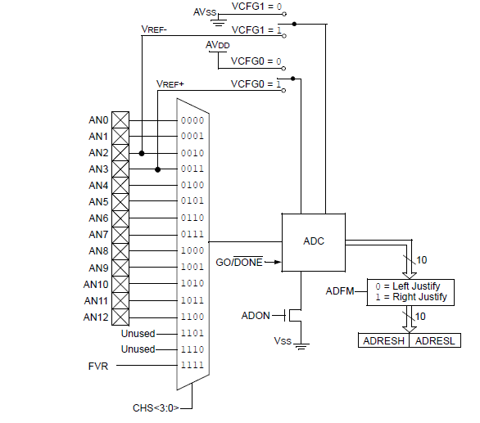
Figure 5.3.1: A/D converter block diagram shows many of the pins and registers involved in the conversion process. (pending permission of microchip)

There are four registers involved in the analog to digital conversion ADRESH (A/D high result register), ADRESL (A/D Low result register), ADCON0 (A/D control register 0), ADCON1 (A/D control register 1) and ADCON2(A/D control register). ADRESH and ADRESL registers are both used to store the 10 bit output from the A/D converter. Each of the two register is 8 bits so together there is actually a 16 bit output stored. The 10 bit conversion result comes from either left justifying or right justifying the 16 bits. The justification depends on the ADFM bit of the ADCON2 register which controls the format as show below.
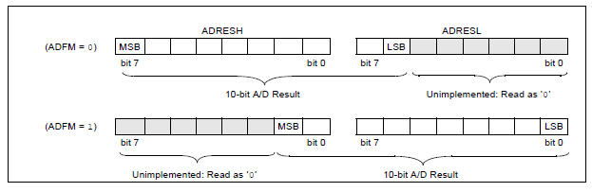
Figure 5.3.2: shows when the left of right justification of the result registers occurs. (pending permission from microchip)

ADCON0 A/D control register 0
The ADCON0 is an 8 bit register where the bits are broken down into the bits in the table below. The A/D control register0 controls the analog channel bits that are selected, gives the status of the converter as converting or done converting and turns on the A/D.

Bit # | Bit definition | Bit Values
7 | Unused | considered 0
6 | Unused | considered 0
5 | Analog Channel Selected (CHS0) | 000-111
4 | Analog Channel Selected (CHS1) | 000-111
3 | Analog Channel Selected (CHS2) | 000-111
2 | Analog Channel Selected (CHS3) | 000-111
1 | Conversion Progress (GO/DONE) | 0-1
0 | Turns A/D on or off (ADON) | 0-1

Table 5.3.3 shows bits of the ADCON0

The tables below show the possible values for the CHS bits, GO/DONE bit, and ADON bit and what the values represent.
CHS<3:0>

0000 = AN0 | 1000 = AN8
0001 = AN1 | 1001 = AN9
0010 = AN2 | 1010 = AN10
0011 = AN3 | 1011 = AN11
0100 = AN4 | 1100 = AN12
0101 = AN5 | 1101 = Reserved
0110 = AN6 | 1110 = Reserved
0111 = AN7 | 1111 = 1.2 V (Fixed Voltage Reference)

GO/DONE ADON
0 = conversion not in progress | 0 = disables operating current
1 = conversion in progress/start conversion | 1 = enables operating current

Table 5.3.4 shows the represented values of bits.

ADCON1 A/D control register 1
The ADCON1 is an 8 bit register where the bits are broken down into the bits in the table below. The ADON1 register controls the reference voltages. Theses bits are shown in the table below.

Bit # | Bit Definition | Bit Values
7 | Unused | Considered 0
6 | Unused | Considered 0
5 | Negative Voltage Reference (VCFG1) | 0-1
4 | Positive Voltage Reference (VCFG0) | 0-1
3 | Unused | Considered 0
2 | Unused | Considered 0
1 | Unused | Considered 0
0 | Unused | Considered 0

Table 5.3.5 shows bits of the ADCON1

The table below shows values of VCFG0 and VCFG1 and what they represent.
VCFG1 VCFG0
0 = voltage supplied internally from Vss | 0 = voltage supplied internally from Vdd
1 = voltage supplied externally from Vref- pin | 1 = voltage supplied externally from Vref+ pin

Table 5.3.6 shows the represented values of bits.

ADCON2 A/D control register 2
The ADCON2 is an 8 bit register where the bits are broken down into the bits in the table below. The ADON2 register controls the right or left justified format, acquisition time the amount of time the holding capacitor remains connected to the A/D, and A/D conversion clock source. Theses bits are shown in the table below.

Bit # | Bit Definition | Bit Values
7 | Conversion Format (ADFM) | 0-1
6 | Unused | Considered 0
5 | Acquisition Time (ACQT2) | 000-111
4 | Acquisition Time (ACQT1) | 000-111
3 | Acquisition Time (ACQT0) | 000-111
2 | Conversion Clock Source (ADCS2) | 000-111
1 | Conversion Clock Source (ADCS1) | 000-111
0 | Conversion Clock Source (ADCS0) | 000-111

Table 5.3.7 shows bits of the ADCON2

The table below shows values of ACQT and ADCS and what they represent.
ACQT ADCS
000 = 0 | 000 = FOSC/2
001 = 2 TAD | 001 = FOSC/8
010 = 4 TAD | 010 = FOSC/32
011 = 6 TAD | 011 = 600 KHz nominal
100 = 8 TAD | 100 = FOSC/4
101 = 12 TAD | 101 = FOSC/16
110 = 16 TAD | 110 = FOSC/64
111 = 20 TAD | 111 = 600 KHz nominal
Table 5.3.8 shows the represented values of bits.

TAD and FOSC are from the following table from the data sheet.

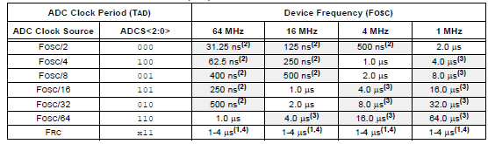

Figure 5.3.9 ADC clock period (TAD) vs. device operating frequencies (pending permission from Microchip)
Comparator

The comparator works by comparing the Vin+ and the Vin- voltages. When the Vin+ voltage is greater than the Vin- the output of the comparator is a digital high output. If Vin+ is less than the Vin- than the output of the comparator is a digital low. This relationship is shown in the figure below.

Figure 5.3.10 Input vs. output of a comparator relationship (Pending permission of microchip)

5.3.3 Solenoid Valves

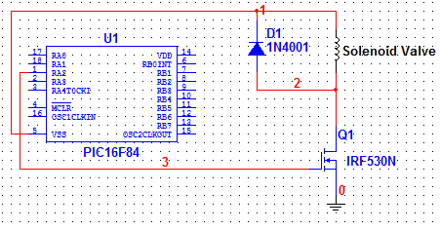
A typical solenoid consists of a steel plunger inside an electric coil. As the coil is energized a magnetic field s induced causing the plunger to push into the tube. As the coil is de-energized a spring pushes the plunger back out of the tube. This can be controlled using a standard MOSFET circuit, where on the microcontroller setting the pin to a high value ‘1’ will switch the solenoid on and a low value ‘0’ will turn the solenoid off. Depending on previous specifications the microcontroller will be programmed based on the amount of fluid to be dispersed. The PIC16F84 has 13 I/O pins in which will be used specifically for all the valves in the pool system.

Figure 5.3.11 Solenoid Valve Circuit
5.4 Testing the Microcontrollers

Testing of the microcontrollers is vital to the entire system design. With malfunctioning microcontrollers the entire system would completely fail. Numerous number of testing will be done to ensure that the microcontrollers are properly programmed and have the ability to outlast the design specifications.

Phase 1

Testing of all the microcontrollers will start out with simple programming and task to ensure that the device works properly by using a breadboard and applying a simple flashing led circuit program to the microcontroller.

Phase 2

After the first phase of testing more complicated task will be tested for each microcontroller based on their specific task the microcontrollers are set out to achieve. Fortunately the manufacture Microchip provides numerous development kits. These development kits include the PICkit3 debugger which includes a development board along with Microchips MPLAB IDE software which provides many debugging and simulator solutions. Using simulators available in MPLAB we intend to test run each program for each individual microcontroller. This will save time and ensure that our coding works well and completes the task we wish to achieve.

Phase 3

Once the simulations meet the specifications required we will move to the breadboard stage of testing. Once the microcontrollers are tested and able to physically handle all specifications they can be interfaced with the other components.

Phase 4

Once the interfacing between all the different components of the system design meet our standards, testing will move on to the PCB stage of testing. Once soldering and surface mounting the parts are done and the PCB has been tested to work properly, the microcontrollers will undergo the same testing as set in the breadboard stage. Ensuring the microcontrollers work under all the conditions specified in the specifications.

Chapter 6

Wireless Communication

The general objective for the Pool Boy, automated pool maintenance system, wireless communication is to provide communication between the pool system’s sensors and the monitoring control panel. The need for a RF solution is practical as there might not be a line of site between the pool system and the monitoring control panel. In a practical situation, the control panel will be set either on a computer, iphone, or as a device located inside the home, receiving and displaying data periodically throughout the day. Due to the use of Radio Frequencies (RF) many regulations must be considered, as we cannot violate any of the FCC standards. This does not prove to be a big problem as the system will not need any high frequencies and is not going to interfere with many objects around the area; however, it is something that has to be considered especially when dealing with self designed circuitry.

The goal of the wireless communication is to transmit data received from the sensors implemented on the system through free-space and receive the signal at the control panel, in which the users will be able to see the information. A two-way communication system would be ideal so that the system could be set up to optimal conditions, as many different factors, such as the pool size and weather conditions, can affect the pool’s cleaning conditions. With the use of microcontrollers or computers, the information can be processed and used to graphically display on the LCD of the control panel, along with displaying any warnings when the system must be checked. Upon deciding to use the PIC series of microcontrollers from Microchip the wireless solution must be able to interface with the microcontroller. This can easily be achieved through the use of the UART and SPI interface available on most microcontrollers.

6.1 Research

Through many hours of research it became apparent that the designing of RF circuits could become very complex and that it would be more efficient to purchase an IC that would meet our needs. This option would save a lot of time and add little cost of the project. There are many different transceiver IC’s available in the market as well as many protocol solutions. Through research four protocol solutions, Bluetooth, Wi-Fi, ZigBee, and MiWi, were found along with many other IC’s from different manufacturers. All of these products would be able to establish a connection from the system to the control panel. Bluetooth or Wi-Fi would best be used when integrating the system to a computer or cell phone. Today most computers and cell phones have Bluetooth or Wi-Fi, making it an easy solution to integrate the control panel as a program on a computer or cell phone. ZigBee/MiWi and other Radio Frequency IC’s would provide the same solution, without the ease of computer integration. Looking at each of these wireless solutions, the selection of these technologies will be based on different aspects such as size, price, development cost, industry support, availability and power consumption.

6.1.1 RF

Radio Frequency (RF) modules do not contain pre-installed software stack and can become very complicated when integrating into the system. One important aspect is the range of the device, although many RF IC’s are capable of providing a good range an antenna still might have to be considered possibly adding cost and more complications when creating the circuit. Federal Communications Commission (FCC) standards must also be taken into consideration when creating this communication link.

6.1.2 Bluetooth (802.15.1)

Bluetooth is a short range unlicensed RF technology that operates at 2.4 GHz used for personal area networks and is directed towards connecting and exchanging information between two devices. Bluetooth operates in the ISM (3.4 GHz) band at different speeds depending on the different versions and range classified by the device. Today Bluetooth connectivity is very common. One issue considered, however, is the efficiency of Bluetooth use for the device purposes. Computers and cell phones today have the ability to connect via Bluetooth but the option is almost always turned off as the use does have an impact of power consumption. In order for the pool to be monitored directly the option would have to be turned on in order to be read on the device. This power consumption cost as well as the cost of the module itself needs to be considered. Through the use of the UART integrated on many PIC microcontrollers, connectivity through Bluetooth can be easily achieved. The ease of computer usage and integration with the microcontroller makes Bluetooth a feasible option.

Class | Maximum permitted Power mW (dBW) | Range
Class 1 | 100 mW (20 dBW) | 100 meters
Class 2 | 2.5 mW (4 dBW) | 10 meters
Class 3 | 1 mW (0dBW) | 1 meter

Table 6.1.1 Bluetooth Specifications

6.1.3 Wi-Fi (802.11)

Wireless Local Area Networks, known as Wi-Fi, is used for high data exchange between devices using high data rates, commonly seen today in computers and cell phones. For the communication that we are looking for Wi-Fi provides extra power and extra speed of up to 54Mbps which is not necessary. IC’s for Wi-Fi are the expensive side, as they are made for high data transfer and reliability. Integration with a computer makes Wi-Fi an option to consider, however, Bluetooth can achieve this same result at a fraction of the cost.

6.1.4 ZigBee/ MiWi (802.15.4)

ZigBee is a specification of protocols utilizing low power Radio frequencies based on the IEEE 802.15.4 standard for wireless personal area networks (WPANs). ZigBee is a relatively new technology aimed towards applications involving low power consumption that do not need high data rates, intended as a simpler and less expensive alternative to Bluetooth. ZigBee uses unlicensed ISM bands including 2.4 GHz, 900 MHz, and 868 MHz at a data rate of up to 250Kbps. Although this does not provide easy integration to a home computer, this alternative provides a low power and cost effective method to integrate with microcontrollers.

MiWi is also a proprietary wireless protocol designed by Microchip Technology utilizing low power Radio frequencies based on the IEEE 802.15.4 standard for wireless personal area networks (WPANs). Due to the fact that the device will be using the PIC series from Microchip Technology, MiWi seemed to be an alternative protocol to use in place of ZigBee. Both are essential one in the same, with the differences being in the procedure in which the protocols are written. MiWi offers more of a variety in their protocols as they can be modified based on the users preference. Depending on the integration between the control panel and system we wish to achieve the determination between MiWi and ZigBee protocols would have to be decided upon.

6.2 Component Selection

Seeking to make the Pool Boy cost effective, the best solution appears to be to utilize the IEEE 802.15.4 standard using ZigBee/MiWi. Wi-Fi is a more expensive solution that is not cost effective for the device we wish to create. Bluetooth provides an efficient connectivity but is still pricey and still requires more power consumption. RF circuits would bring complexity into the design. A comparison chart of the 3 different wireless communications is displayed below showing the advantages between each other

ZigBee and MiWi were essentially created for this type of design, and is being accepted in the industry today being widely deployed in wireless control and monitoring applications providing the system with cost efficient, high reliability, long range, and low energy consumption. It is a much cheaper and just as effective alternative as Bluetooth.

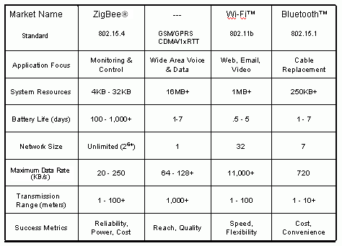

Table 6.2.1: Chart Comparing wireless standards (pending permission from ZigBee Alliance)

Searching for a ZigBee/MiWi compliant module that would integrate well with the PIC series proved to be simple based on Microchip’s support. Microchip offers the MRF24J40MA and the MRF24J40MB module which is a 2.4 GHz IEEE 802.15.4 power radio transceiver intended for long range applications. With an integrated PCB antenna this module provides the range necessary for wherever the control panel is set into place. The module connects to the PIC microcontroller using a simple four-wire SPI interface and is surface mountable; being a perfect fit for use with the PIC microcontroller’s that will be used. Both modules work in the same way the difference is in the transmission capabilities between the two devices. Below is a table displaying the important characteristics between the two devices, where transmission is the key element.

Module | MRF24J40MA | MRF24J40MB
Range – Indoor | 100 ft (30m) | 300 ft (100m)
Range – Outdoor | 300 ft (100m) | 1 Mile (1500m)
Operating Voltage | 2.4-3.6V (3.3V typical) | 2.4-3.6V (3.3V typical)
Operating Temperature | -40°C to +85°C | -40C to +85C
Dimensions | 0.7” x 1.1” (17.8 mm x 27.9 mm | 0.9" x 1.3" (22.9 mm x 33.0 mm)
Transmit Power | +0 dBm | +20 dBm
Receiver Sensitivity | -94 dBm | -102 dBm
TX Current | 23 mA | 130 mA
RX Current | 19 mA | 25 mA
Sleep Current | 2 μA | 5 µA
Table 6.2.2 ZigBee Module Comparison chart

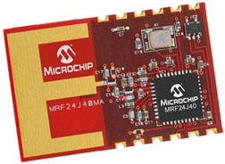

Figure 6.2.3 MRF24J40MA Module (pending permission from Microchip)

6.3 ZigBee Network Configuration

Ideally the ZigBee transceiver MRF24J40MA has a range of approximately 100 ft (30m) indoor and 300 ft (100m) outdoor. This proves to be efficient has the two devices in communication will be in a household setting within a decent range of each other. Requiring only two transceivers for this design one of the transceivers will act as the ZigBee Coordinator and the other as the ZigBee End Device. The ZigBee Coordinator essentially forms the network and bridges to other networks. The ZigBee End Device can pass receive the data and pass data on to other devices. The main benefit of the ZigBee End device is that it can be used as a Reduced Function Device (RFD) where the receiver is off when idle. This configuration can save power and is more prominent when used with battery power sources. Since the two modules are transceivers this set up can essentially go both ways, but it is important to set a standard for which one will initially from the network. With only two simple transceivers a star network configuration would work well with one coordinator node transmitting to an end device.
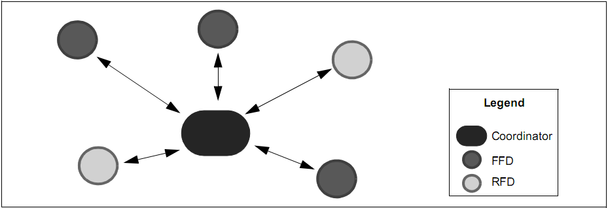

Figure 6.3.1 Star Network Configuration (pending permission from Microchip)

The pool system will be home to one of the transceivers and the control panel will be integrated with the other. The pool system transceiver will be integrated with the PIC 18F43k20 via a simple four-wire SPI interface, receiving the data of all the sensors and additionally will be used to receive data from the control panel to set specific levels based on the initial pool system specification. The control panel transceiver will mainly be receiving the transmitted sensor values and displaying them to the user and displaying any warnings which might arise. As the pool system will be transmitting constant information the pool system transceiver will be set as the ZigBee Coordinator and the control panel as the ZigBee End Device. As our initial design specification, the pool system will be connected to a power supply and the control panel will be battery powered. Having the control panel transceiver used as an RFD can help save more power and help make the battery powered control panel.

Control
Panel

Pool Filter System

Signal

PIC 18F43k20 Microcontroller

ZigBee
Transceiver
Coordinator

PIC 18F43k20 Microcontroller

ZigBee
Transceiver
End Device

DI (Data in) DI (Data in)

CTS CTS

DO (Data Out) DO (Data Out)

RTS RTS

Figure 6.2.2 Transmission and Connection Diagram of ZigBee wireless Communication

6.3.2 Coordinator and End Device Configuration

A beacon-enabled network proves useful when dealing with multiple transceivers where it is important not to mix data types. The system only requires 2 transceivers both operating on the same channel, therefore it is not necessary to worry about multiple different transmissions at once. To enable the coordinator in a nonbeacon-enabled network the PANCOORD (RXMCR 0x00<3>) bit is set to ‘1’ to conFigure as the PAN coordinator. The SLOTTED (TXMCR 0x11<5>) bit is set to ‘0’ to conFigure Unslotted Carrier Sense Multiple Access-Collision Avoidance (CSNA-CA) mode. Then Beacon Order (BO) (ORDER 0x10<7:4>) and Superframe Order (SO) (ORDER 0x10<3:0>) is set to a value of ‘0xF’. In order to conFigure the end device as a nonbeacon-enabled network the PANCOORD (RXMCR 0x00<3>) and SLOTTED (TXMCR 0x11<5>) are both set to ‘0’ in order to use the module as device and to use Unslotted CSMA-CA mode. The CSM-CA algorithm is defined by the IEEE 802.15.4 Standard, with the intention to avoid any collisions between devices.
6.3.3 Sleep Configuration

Because the system does not have to be real time, but rather at set intervals throughout the day, an ideal way to greatly reduce power consumption is by taking advantage of the MRF24J40 low current sleep mode. Due to the fact that the system will be taking data at set times during the day using the Immediate Sleep and Wake Mode of the module will greatly take advantage of less power consumption. In this mode the host microcontroller places the transceiver to sleep and wakes it up. This is done by simple programming enabling the IMMWAKE (0x22<7>) bit to ‘1’. To sleep immediately two steps need to be performed. First the Power Management Reset RSTPWR (0x2A<2>) bit is set to ‘1’. And by setting the SLPACK (0x35<7>) bit to ‘1’, where both bits will be automatically cleared to ‘0’ by the hardware. Similarly the module can wake-up immediately via the SPI port by setting the REGWAKE (0x22<6>) bit to ‘1’ and then clearing it to ‘0’. Upon wake a delay of 2ms is required to allow the main oscillator time to stabilize, where it will be ready to transmit and receive.

6.3.4 Wireless Transmission

The data from the sensors will be read in from the A/D convertors on the microcontroller. After the microcontroller has obtained the values they will be transmitted over to the microcontroller on the control panel. The connection takes place through the SPI port where the data is transmitted through the Serial Interface Data Input and Output. Once both transceivers are set to receive and transmit the data will be sent, the data will then be stored to the other microcontroller. Using the different addresses available on the microcontroller, there will be set addresses for each of the different sensor values. Having these addresses set the microcontroller will be able to utilize the information when needed to display to the LCD.
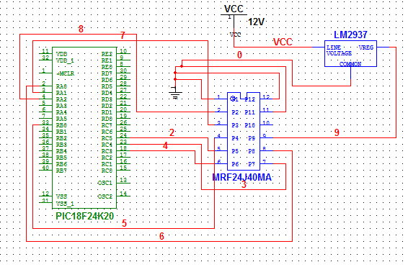

Figure 4.3.4.1: Connection diagram of Microcontroller to transceiver

Along with the sensor values being stored in the addresses the pool specifications data needed for chemical dispersion will be able to be transmitted from the control panel to the system to disperse the correct amount of liquid. The IEEE 802.15.4 standard details the Physical Layer (PHY) and Medium Access Control (MAC) specifications. The MAC specifies automatic packet acknowledgment and provides options for transmission at specified intervals and provides security encryption. The packets sent out are between 5 and 127 bytes long. These packets are made of several different fields including destination address information, source address information, a length field, and data payload. A 4-byte preamble field and start-of-frame delimiter (SFD) byte are added upon transmission and removed when received.

6.4 Testing the RF transceivers

The two ZigBee transceivers will first be connected to the circuit board. Once all necessary pins are connected and the modules are set in place pins 17-20 on the pool system will be conFigured to transmit to the receiving module on the control panel verifying a simple value is transmitted and that the range of the device is sufficient to transmit and receive data between both devices. First a manual signal will be supplied to the device before interfacing to the microcontroller ensuring that the device meets its specification. The next phase involves interfacing with the microcontroller and writing a simple program to ensure that both modules are transmitting and receiving correctly in the range specified. Once the transceivers have passed these test the device should be ready to be integrated into the system.

Chapter 7

Control Panel

The control panel is designed to be an elegant, clean solution that users can use to interface with the Pool Boy from within the comforts of their own home. Users could access the control panel to view information about the status of their pool, temperature, and overall swimming experience of their personal oasis. There will be an LCD display for viewing information and a numerical pad for entering in information about the pool, for example size of the pool and chemical readouts. First to be detailed about the control panel will be an inquiry into the functions of a good interface. Then lead into hardware solutions for these interface challenges. Finally, end with a detailed outline of how the receiver might be built.

7.1 Research

A good interface must be user friendly when considering design. This is why the unit will implement a simple touch pad with a few scroll buttons and nothing else. This should allow for the user to scroll through the few options that will be available to them. In reality, the user will not need to input information into the receiver unit very often. This is why we have taken a minimalistic approach and not spring for some expensive capacitive touch screen. As engineers, it is important to ensure that designs do not become redundant or gaudy for the sake of flare. This is why it was decided to strayed away from an expensive i-pad solution and go with a simple, cost effective 4x20 pixel LCD display, driven by a microprocessor, for user feedback. There is no doubt that the development tools for capacitive touch screens are powerful and with limited effort one could be implemented for this solution. However, cost is a variable in creating the Pool Boy and it could not be justified to spend lavishly on an interface that will only rarely be used. There is no doubt that a well designed capacitive touch screen would be more user friendly but at a cost that was deemed too steep.

Other ways to ensure a user friendly design is to have the layout of the options clear and easy to read, with only a limited amount of access given to the user. There will only be two options that the user will be able to go through and change on the unit. These options are pool size and the chemical level readout screen.

7.2 Display

7.2.1 Pool Size Screen

First, the pool size option screen, seen in Figure 7.2.1. Pools range in a variety of sizes and need to have different levels of adjustments made depending on the size of the pool. Users will be able to enter a range of 1,000 gallons to 50,000 gallons depending on the size of their pools. This screen will prompt the user to input the size of their pool in gallons and then store that information in the variable which will calculate how much of each chemical to add.

Figure 7.2.1: pool size option screen

7.2.2 Chemical Level Readout Screen

The next screen is the chemical level readout screen, seen in Figure 2.2.2. This screen will be the home screen for the system and will have readouts of all the chemical levels that the user can check by traversing the menu. The user will also be able to check how much of the adjustment chemicals are remaining. The receiver unit will also use this screen to notify the user when levels are low. When levels are low status LED’s will turn on and indicate to the user that these chemicals need to be replaced. Because the system cannot run when the chemical adjustors are empty, a courtesy chime will go off from the receiver every 30 minutes to notify the user that the Pool Boy needs is dangerously low on chemicals. It is important that the Pool Boy does not run out of adjustor chemicals because the amount of work to recover a bad pool is much more than it is to recover a slightly out of balance pool. If the Pool Boy is not allowed to maintain the levels of the pool, the water can get so out of whack that the user will need to step in and once again manually adjust the levels before reconnecting the Pool Boy.

Figure 7.2.2: Chemical level readout screen

7.2.3 Software GUI summary

In summary, usability will be encouraged by intelligent use of minimalistic hardware design as well as clear and easy to understand menu options in the software. Next, will be the discussion of hardware solutions for the user input and output.

7.3 Modularity

In the name of modularity, it would be best if the analytical knife of thought could separate our systems into secular entities. As seen in Figure 2.3, with this layout we have four main entities in the hardware of the receiver unit; they are the Input module, readout module, communications module, and logic module. Input module, readout module, communications module will be driven by the logic module. These four modules are explained in detail below.

Figure 7.33: 4 main modules for Receiver

7.4 Input and Display

First, is to address input and display modules at the same time because they are similar. For simplicity, a third party compiler will be used to program the PIC18f chip called Swordfish. Swordfish is a PIC BASIC complier that generates optimized, stand alone code that is programmed straight to the PIC. Extensive library support which includes LCD, USB and software UART make this one of the most powerful compilers available. Swordfish allows for modularity which allows the grouping of subroutines and functions into a single entity called a module. With this methodology, functions can be reusable and robust.
As discussed previously, a simple number pad and LCD display will be used to retrieve and display info. Below, in Figure 7.4, is a detailed schematic of how the LCD can be driven by a PIC 18f:
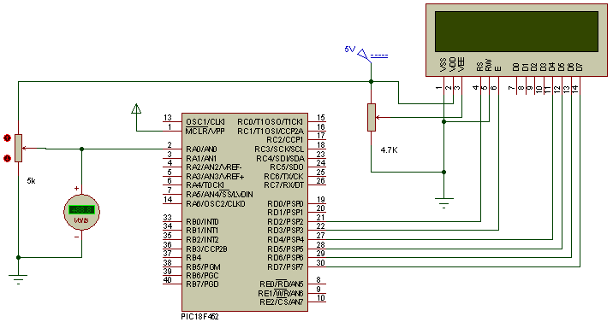

Figure 7.4: reprinted with permission by Graham @ edaboard.com

7.5: Swordfish Compiler

First, the brains of the operation; the PIC 18fxxxx. A true industry standard as it has replaced the 16fxxxx chip due to superior reliability. Both the Microprocessor and LCD display run off of 5v power. Pins 12-14 on the LCD are the data lines that hook to the PIC from RD3-RD7. Then all we have to worry about is powering the PIC, LCD, and adjusting the potentiometer for the contrast on the display. To outline how simple it is to use the Swordfish compiler a small bit of code has been included below:

Device = 18F4520
Clock = 20
// some LCD options...
#option LCD_DATA = PORTD.4 // Assign the LCD connections
#option LCD_EN = PORTD.3 //
#option LCD_RS = PORTD.2 //
// Start Of Program...
DelayMS(150) // Let the LCD warm up
LCD.Cls // Clear the LCD screen
LCD.WriteAt(1,1,"Hello World") // Send some text to the LCD
Wend

The function LCD.WriteAt(1,1,”hello world”) will be all that needs to be updated to display new information to the LCD. This example shows the glory and simplicity of the LCD and Swordfish as we do not have to dabble in I-Squired-C trying to bit-bang the message across. Many LCDs adhere to the HD44780 LCD standard and it is commonly used with embedded systems. There are obviously a variety of sizes for the LCD but our system will implement the 40x4 character display. Character LCDs use a standard 14-pin interface and those with backlights have 16 pins. The pinouts are as follows:

Ground
VCC (+5V)
Contrast adjustment
Register Select (R/S)
Read/Write (R/W)
Clock (Enable)
Bit 0
Bit 1
Bit 2
Bit 3
Bit 4
Bit 5
Bit 6
Bit 7
Backlight Anode (+)
Backlight Cathode (-)

7.6 Status LEDs

Next up is the ability to drive status LEDs for notifying when the chemical levels are low. This should be a simple circuit with the Swordfish compiler. Below in Figure 7.6 is a circuit to drive an LED. The status LEDs will also be able to be implemented as a warning indicator.

The first implementation being a warning indicator stating that the filter needs to be cleaned out.This is achieved through the use of a pressure sensor that will give an indicator when the leaves collected through the pool system are clogging the filter, increasing the pressure. Another indicator to be implemented is a power indicator as the control panel device will be using battery power. Giving an indication of battery levels will help to ensure that the whole pool boy system is in constant use.
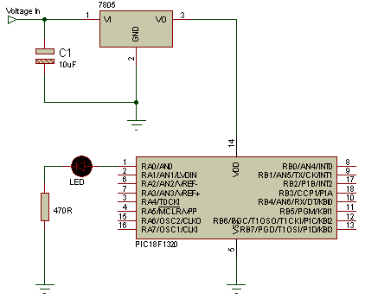

Figure 7.6: reprinted with permission by Graham @ edaboard.com

7.7 Illustration of Simplicity of Swordfish Compiler

Below is the Swordfish code to toggle the port RA0

Device = 18F2620 // Declare the device
Clock = 8 // Declare the Clock speed
Config OSC = INTIO67 // Setup the PIC for internal OSC use
// Start of program...
OSCCON = %01111111 // Sets up the internal oscillator clock
While True // Create an infinite loop
Toggle(PORTB.0) // Toggle PORTB.0
DelayMS(1000) // Delay for 1 second
Wend

The code is quite straight forward and toggles on or off the LED every 1000ms. Again, this shows how easy it will be to drive the LCD and some status LEDs with only 1 PIC18f and using Swordfish.

7.8 Power Supply Schematic With PIC and LCD

In Figure 7.8 below, notice that the power supply will be from a 9v DC wall wart fully rectified to 5v for both the LCD and the PIC. Below is a schematic of what the power supply might look like when hooked up to the output LCD system.

The power supply is providing 5v to the Primary LCD display, PIC18f and status LEDs. For the user input there will be a secondary LCD display that shows them what they have entered. Below is a schematic diagram of a 16-key input pad and an echo display so that the user can see what they are inputting. This is the input module which is driven by our PIC microprocessor. It is important to note that each module will have its own microprocessor so that each module can be tested and verified before being plugged into the system. This is in general considered to be good problem solving techniques because it allows you to systematically locate the problem.

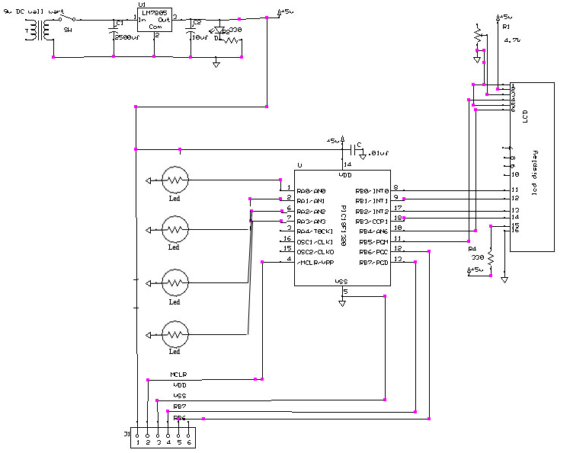

Figure 4: full circuit with power supply reprinted with pending permission by graham @ edaboard.com

7.9 User Input Schematic

Figure 7.9 is the number pad and echo display for user input. 5v will come in from our power supply to drive the LCD and Microprocessor. This input schematic is very similar to our output schematic but with the only difference being the 12 keypad that users will use to check different menu options and input their pool size.1

7.9.1 Communications Module

The communications module will largely be covered in another part of the documentation, namely, in the discussion of the pool unit. To do communications the Zigbee RF solution was selected because of its simplicity and lack of security, which is a selling point because it generally makes the communications much similar when you do not need to concern yourself with security.

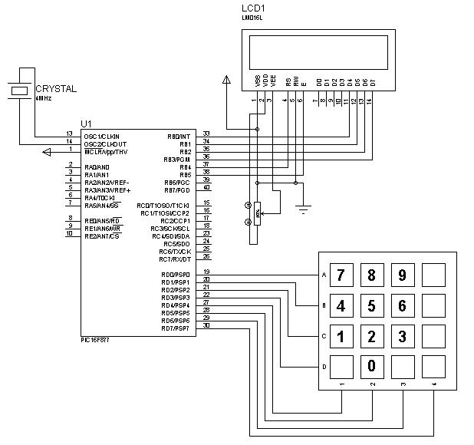

Figure 7.95: Reprinted with permission by Tahmid @ edaboard.com

7.9.2 Logic Module

Finally, the logic module. This module will largely be used for linking the outputs from modules and feeding new data to other modules. The logic layer is to be as clutter free as possible to ensure good, clean transfers between modules. Then, for debugging purposes, we can simply look to see that the logic module microprocessor is receiving the correct data and if one of the modules is returning incorrect data we will know exactly where to look. This is the beauty of modular design.

7.10 Low-Battery Led Indicator

A major goal of the project is to make the system user friendly. As stated by Dan Griffith " he has seen similar commercial automatic chemical monitoring and adjusting products but they are normally ineffective due to human error in not monitoring the system...". If the battery in the LCD monitor dies the user would not be able to monitor the system which would cause the system to fail.

To implement this it was decided to implement a red LED that turns on when the battery output is low. In researching low-battery indicators a circuit was found on the Maxim Innovation Delivered website (see Figure2.1) that would fit the design needs of the project.

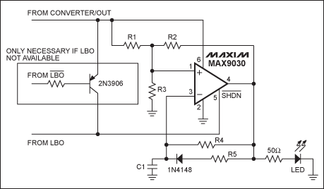

Figure 2.1The Figure above shows the circuit that will be implemented for the low battery led indicator (pending permission from Maxim Innovation Delivered)

The equations for the circuit were also on the website. They are as listed in table 2.2..

Duty Cycle | DC = t_{ON}/(t_{ON} + t_{OFF})
 | V(t)=V(1-e^{-t/RC})
Time On | t_{ON} = -R₅Cln(1 - V_{TRIPHI}/V_{OUT)}
 | V(t)=Ve^{-t/RC}
Time Off | t_{OFF} = -R₄Cln(V_{TRIPLO}/V_{OUT})
Vout High | V_{TRIPHI} =V_{OUT}[R₃(R₁ +R₂)]/[R₃(R₁ +R₂)+R₁R₂]
Vout Low | V_{TRIPLO} = V_{OUT}[R₃R₂]/[R₃(R₁ + R₂) + R₁R₂]

Table 7.10: The table above shows the equations for the low battery led indicator (pending permission from Maxim Innovation Delivered)

As suggested by the website the duty cycle will be set to be about 2.5% to lower the amount of power used by the LED. Values will be calculated for all variables however research is still being done to find the voltage source value that will be used to power the LCD screen and monitor.

7.11 Test Plan

A test plan for the receiver unit will include two primary types of testing, quality assurance and a setup test to check the wireless connection. Taking a look at these tests deeper, quality assurance will be set up to check that the computer can handle the values for the varying pool sizes. For example, it will be important to check that the pool is calculating the correct amount of chemical adjustment levels for the ranges of 1,000 gallons all the way up to 50,000 gallons. Also, will want to verify that the sizes inputted by the user are indeed the values that are being received by the pool unit. The Second primary type of testing is to check that the receiver is within range of the pool unit. It is understood that users will want to bring this wireless unit inside the house with them. If the unit is out of range then obviously this will not work. We will have to a check between the remote and the pool unit to verify that these are close enough.

7.12 Development Boards

Prototyping the receiver unit will be done to Verilog (VHDL) to simulate the hardware. PIC microcontrollers will be plugged into bread boards, downloaded on to, and then used to drive physical circuits. The team has at this point constructed a working prototype of a LCD display being driven by a PIC 18f microchip. The team also has gotten the ZigBee RF solution to talk back and forth using this PICDEM Z development board, purchased by Dr Ford at CEI. The team has also successfully implemented LEDs on the microcontroller.

7.13 Custom Enclosure

Another type of prototyping that could be considered would be trying to fabricate a custom enclosure to hold the inner workings of this receiver unit. In the first demo an old modem was gutted to use the house the microprocessor. A solution, yes, but not the most elegant. The UCF ME/IE students have access to a fabrication machine which takes in a .CAD file and they can fabricate anything. Apparently this only costs a few hundred dollars for materials and they are more than willing to do it. This could lead to a sleek handheld device with ergonomics implemented into the design. Certainly, this would not be first on the order of business as learning Pro-E would be a challenge for any team member. However, if we have the finances we could potentially contract out the work to another student or company. This leads nicely into the next point, subcontractors.

Chapter 8

Electronics Enclosure Design

Our goal is to design the enclosure so that it can fit in with an already existing pool filtration system. For the electronics on the pool system with sensors and valves this means the device will be outside in the same vicinity of the pool. The control panel will be portable and intended for household use. Being outside it is important to ensure that the device can go through rigorous testing and conditions to ensure that none of the electronics will be prone to failure.

8.1 Printed Circuit Board

The Pool Boy Automated Pool Maintenance system will require 2 different printed circuit boards in which the microprocessor, power supply, voltage regulators, wireless communication hardware, control circuitry, and user interface circuitry will be connected into the final design. One of the circuit boards for the pool system and another for the control panel. Initial all of the different sections of the design will be tested and implemented on breadboards. Solder less breadboards are a convenient method for prototyping and saves time and energy. Printed Circuit Boards (PCBs) are used in the industry and will be a valuable learning experience throughout the design. Upon a complete and stable system two printed circuit board designs will be created. There are a few options for creating the final circuit boards:

- Use Solder Point-to-Point Boards
- Mill PCB machine in the Senior Design Lab at UCF
- Create schematics using PCB layout software and have them professionally manufactured

Although the first two options are less expensive they require much work and a large learning experience with the different machines. We decided to go through a manufacturer to create our PCB design, using ExpressPCB as our manufacturer of our PCB board as we have had some experience with the company. The software is very functional and user friendly and provides plenty of help and general computer testing for first time PCB developers.

Once the design circuitry is proven to work functionally and meet our design specifications in the breadboard stage the schematic diagrams will be complete. The development software used by ExpressPCB is ExpressPCB which is the board layout tool and ExpressSCH which is the schematic development tool. schematic will then be implemented where we will be able to acquire quotes for the manufacturing cost. The ordering process is estimated to take a week to come in where the final design and assembly phase will be to implement the PCB.

8.2 Board Design and Layout

Some simple design guidelines to insure proper manufacturing and easy implementation, are to place all components on one side of the board leaving .5” between IC’s to assist in assembling phase. The use of a standard configuration for the direction of IC’s is another layout guideline keeping pin one in the same place for each IC. Once the standard guidelines are established and fit we will print out the circuit board and layout components to ensure accuracy with component fitting. The trace sizes compared to the current ratings recommended by ExoressPCB are listed in the table below. The currents measured from the breadboard stage will be used to determine which widths would be optimal and work best for our design.

Width  (in) | Current (A)
0.010 | 0.30
0.015 | 0.40
0.020 | 0.70
0.025 | 1.00
0.050 | 2.00
.100 | 4.00
.150 | 6.0

Table 8.2.1: Current Ratings for trace widths

The wireless module chosen will have to be surface mounted. The module is .032” thick with castellated mounting points on the edge. The module should be mounted on the edge of the host OCB, and an area of 1.2” clear of metal objects around the antenna to avoid interference. It is also recommended to extend the gorund plane around the module to around .4”. The mounting of this device will be important as it can cause great interference.

Other devices on the PCB board will be using the PDIP socket package, as this package type is easier to be implemented in the breadboard stage. The PDIP is also easier to program using the PICKIT3 we have chosen to use as our programmer. However, upon final design other packaging types may be taken into consideration as packages such as the QFN are much smaller than the PDIP counterpart and could help in reducing the size of the PCB which in turn reduces the overall cost of manufacturing.

We will have a ground plane on the backside of the board ensuring that there is proper grounding. The power traces will be directly from the source to the part, with signal traces determined based on the current needed.

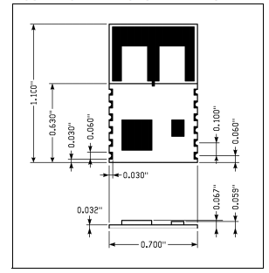

Figure 8.2.2: Recommended PCB footprint (pending permission from Microchip)

As all the individual circuitry is assembled in the breadboard stage the final schematic will be finalized. Where we will aim to have an efficient overall design to be able to be easily assembled and be easily removed, for any modification or any troubleshooting problems which may arise. Below is a Figure of the general layout of the system circuit board.

AC Power Connection

PIC18 40-pin Socket
And Circuitry

MRF24J40
Wireless Module

Power Supply

PIC16 18-pin Socket
And Circuitry

Valve Circuitry

Sensor Connection

Valve Connection

Figure 8.2.3: System Circuit Board Layout
The circuit board for the control panel will be smaller than the system counterpart as less components and connections required. Below is a Figure of the general layout of the circuit board.

Power Supply

PIC18 40-pin Socket
And Circuitry

MRF24J40
Wireless Module

Keypad
Connection

LCD Connection

Figure 8.2.4 Control Panel Circuit Board Layout

The layout is a simple layout illustrating the general idea behind the interaction of each part. The PIC 18 processor is the main device behind all the circuitry around it, all traces will be centered on the device. The wireless module will have to be surfaced mounted and is a very important piece of the PCB as small interactions between the components could cause the wireless to malfunction. Our budget allows for a board of around the size of 6” by 6”, upon completion of the final design reductions will be made to accommodate a good cost effective ratio for the final design.
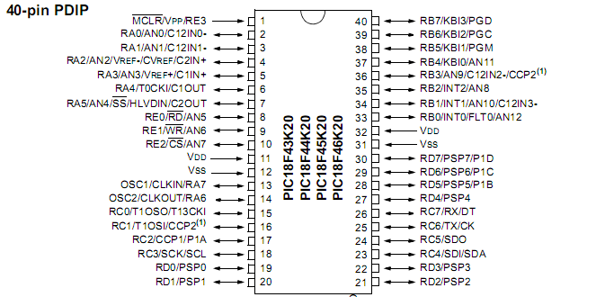

Figure 8.2.3: PDIP Package – Size .600 inches, Mass: 6.5 g
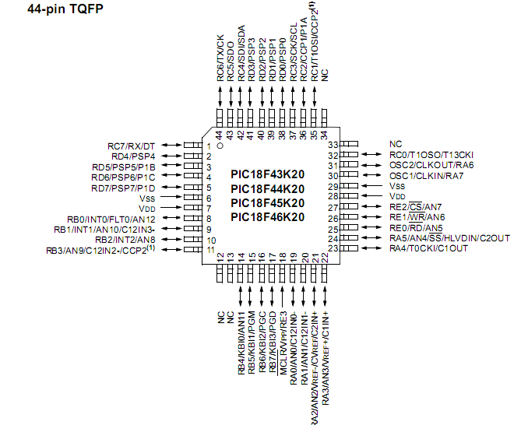

Figure 8.2.4: TQFP Package – Size 10x10x1mm, Mass: 0.2733

8.3 System Electronic Enclosure

Some of the weather conditions this system must be able to sustain are water from the pool, rain, thunderstorm and temperature conditions. As heat and water are the main destruction of electronics, it is very important to create a waterproof casing to prevent the electronics from getting wet. Searching online for a good manufacturing site we came across Automation Direct which produces NEMA 4 Industrial Enclosures. NEMA 4 rating is specified for outdoor use, primarily to protect against rain and to be undamaged by dripping water and can serve in applications where pressurized water can be sprayed directly onto the enclosure as the enclosures are gasketed and the door is clamped for maximum sealing. The Company sells a lift cover wall mount which is specifically used for electrical control enclosures providing protection against The size of the enclosure would probably be a 6” x 4” x 3” at this stage of the design. This will most likely change as we finalize the circuitry of the system.

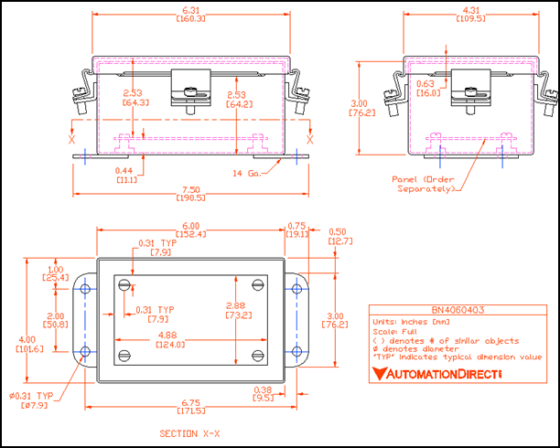

Figure 8.3.1: AutoCAD drawings of N4 LIFT OFF COVER WALL 6X4X3 (Pending permission from AutomationDirect)
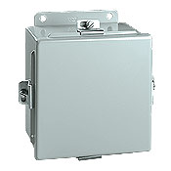

Figure 8.3.1: N4 LIFT OFF COVER WALL 6X4X3 (pending permission from AutomationDirect)

The cost of this enclosure is approximately $41.50 with a 10 day lead time. As we will aim to decrease the size of the design as much as conveniently and effective as possible, the price of this enclosure could very well decrease.

8.4 Control Panel Enclosure

Having a good looking control panel design is very important from a marketing and business standpoint. Due to the fact that the control panel will be set up inside of the home, a clean design that is appealing to the user is essential. A simple way to accommodate the control panel PCB along with the LCD and keypad would be to use a type of picture frame design. As a popular feature used in today's homes are digital photo frames, our idea is to house the PCB, LCD, and keypad into a decent size picture frame that can be hung up on a wall.

8.5 Temperature

The enclosure would also require a good ventilation system as heat can become a factor as the device is outside and the device will be running frequently. Using a simple DC Brushless fan will be able to keep the electronics cool. Using 2 simple DC brushless fans with the dimension of 50x50x10mm will provide a cooler system. The motor operates at 5V and is rated at 190 mA.

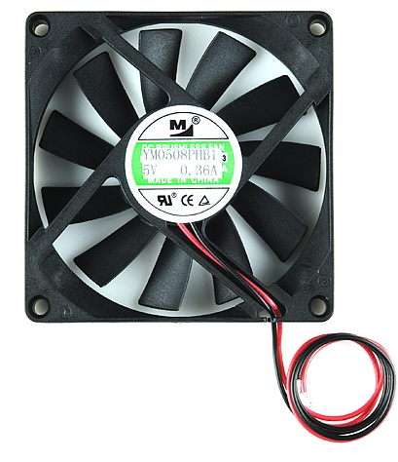

Figure 8.4.1 DC Brushless fan (Pending permission from SparkFun Electronics)

Lastly living in Florida, the lightning capital of the world, and we are dealing with a commonly used outdoor device it is important to have protection against any kind of storm surge that could affect the system. This protection can be implemented in a large variety of ways. The system will use fuses to protect against over current from short circuit or overloading of the device. Diodes will be implemented on the power supply and added to additional circuitry to ensure the system remains intact during the proper use.

8.6 Testing

Testing of the PCB is very important, where prospering testing will help save large amounts of cost and time. After receiving our PCB board from the manufacturer the traces will be checked with a multimeter to verify the continuity and make sure no traces have crossed. Once the individual components are tested and work in the breadboard stage they will be soldered one by one with their connections being tested with a multimeter. After the microcontroller is programmed the pins will be checked to ensure proper voltages and current is being sent through the PCB, checking the integrity of all the traces.

Chapter 9

Power

What has become commonplace in technology in today’s society is the need for separate power supplies for circuits that contain logical computational units. A different power supply is needed for the components that operate on voltages much higher than the microcontroller. This is because of the inrush currents that the bigger components draw. These currents create spikes in the circuit that can easily fry the microcontroller and other sensitive components. Therefore another power supply will be needed for the microcontroller and sensitive sensors. This is the method that will be implemented in Pool Boy.

9.1 Main System Power

Now that the main system components have been discussed, it now must be discussed how the main system components will be powered. These are the components that can draw more than .1 Amps at any time. Without any research one could contend that there is only one viable way to power a system with the given components. That solution would be to use standard wall power (120 V, 60 Hz). From there the choice splits into two categories: an internal power supply or a wall mounted external power supply. In terms of pros and cons the choice from the beginning is not entirely obvious. The first thought was to use an external wall-mounted power supply because of its simplicity and relatively low cost. The first step in determining if this is a viable option is to first measure the voltages and currents that each component will need. From Figure 3.1 one can deduce that the valves need a holding voltage of 24 volts to operate. This voltage is also the largest voltage that any single component will need. Therefore a 24 volt direct current (VDC) power supply will be able to provide power for all of the components in Pool Buddy. The final step in choosing a power supply is in determining the maximum currents that each component will draw. The maximum currents must be considered because there is a possibility that every component can be on at a given time. If maximum currents were not considered there could be a condition where the power the system needs is greater than the power available. To prevent this situation from occurring the maximum output current of the power supply must be greater than or equal to the sum of the maximum currents of each component. A table of each component and its maximum current is listed below in Figure 9.1.1.

Component | Operation Voltage | Max. Current (Amps)
Valve (x5) | 24 V | 2
Copper Electrode | 12 V | .5
 | Total | 2.5

Table 9.1.1: Maximum currents for each component

As one can concur from Figure 9.1 at any time when the system is on it may draw 2.5 Amps. Therefore the system must contain a power supply that can supply at least that amount of current. This specification greatly narrows the search for a sufficient power supply and makes the selection easier. A power supply that can supply more current than 2.5 Amps could be used with no negative effects, and infers that more features could be added to Pool Boy in the future and there would be no need to change the power supply.

Three different power supplies were considered for powering Pool Boy and they are as follows: Model# PS-65-24, Model# REL-70-1006, and Model# PSAA60W-240. All three power supplies are from TRC Electronics. The first model features an open frame design at a great price. The second model also features an open frame design with low leakage currents. The third and final model is an external adapter that resembles a laptop power adaptor. More features and specifications of each power supply are listed below in Figure 9.1.2.

Model | Price | Max Current | Advantages | Disadvantages
PS-65-24  (open frame) | $18.03 | 2.7 Amps | -A little current output to spare | -
REL-70-1006  (open frame) | $77.46 | 2.9 Amps | -Small size  -Low leakage currents | -Price
PSAA60W-240  (external adapter) | $39.00 | 2.5 Amps | -Easy implementation | -Low current output

Table 9.1.2: Power Supply Specifications Table used to determine the best option of given power supplies [5]

The power supply that was chosen for Pool Boy is Model# PS-65-24 and it is pictured below in Figure 9.1.3 to help illustrate the open frame design. The overall design of the project implies that the housing that will contain the power supply, microprocessor, and other components will have to be water proof as leaks that penetrate the housing can cause shorts and ruin some components. This model was chosen mainly because of its price and the little extra current the supply offers. The extra power is not needed at the moment, but it suggests that some power friendly features could be added to Pool Boy in the future and the power supply would not have to be changed. The open frame leaves only one way to mount the supply, but makes for easy diagnosis of potential problems and easy access for repairs.

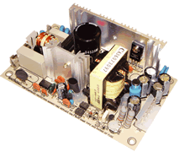
Figure 9.1.3: Model PS-65-24 Power Supply. Picture shown to depict open frame design [Pending permission from TRC Electronics]

Now that a power supply has been picked the paper will now discuss how the components will be wired. As mentioned earlier the highest voltage that any single component needs is twenty four volts. This suggests that the components should be wired in parallel such that each branch of the circuit will provided with sufficient voltage. A potential circuit diagram can be viewed below in Figure 9.1.4. Components that need 24 volts to operate will be given their own branch in the circuit as each branch will receive that amount. The copper electrode needs twelve volts to operate therefore a resistor with the approximate resistance of the electrode is wired in series with the electrode. This creates a voltage drop of twelve volts across the resistor and the electrode.

Pool Boy shall only dispense chemicals and ionize the water when the water is flowing. Therefore there must be a way to turn on the circuit when water is flowing. This is indicated by the switch FS or Flow Sensor. The microcontroller shall turn on the relay when the Flow Sensor returns a true value. This enables the circuit for use and immediately starts ionizing the water. Because the microcontroller will be on a different circuit from the valves it becomes critical that there still be a way to control them. The mechanisms used to accomplish this task are indicated by the relays S1 through S5. These relays will turn on when instructed by the microcontroller completing the loop for each specific valve and opening it. The microcontroller shall turn the relay off when the correct amount of chemicals has been dispensed. The diagram’s main purpose is to show that chemical dispersion and water ionization is dependent on the flow of water through the main pipe. While there is no flow of water through the main pipe the power supply, valves, and copper electrode will sit idly by.

From the diagram above one can conclude that none of the sensitive components or the microcontroller will be damaged by spikes in current from the valves or copper electrode, because they are not on the same circuit. This is a fairly simple circuit and there seem to be no glaring weaknesses in the design of the circuit.

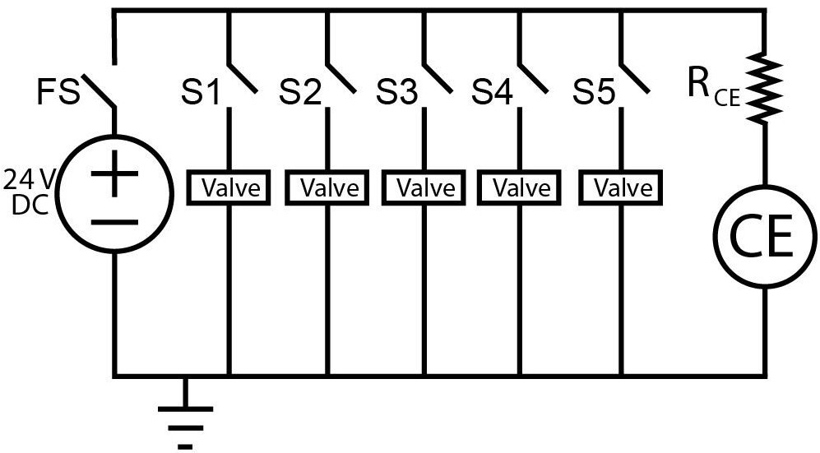

Figure 9.1.4: Circuit Diagram for the Main Components of Pool Boy

9.2 Microcontroller and Sensor Power

Now that it has been determined how the large components will be powered it is now time to discuss how to power the microprocessor and the concurrent sensors. A table of components and their corresponding voltages and maximum currents is listed below in Figure 9.2.1 in order to clearly see the needs for powering the microcontroller and the other sensitive components. The article from National Semiconductor suggests that the input voltage to the pressure sensor should be 5 volts. This suggestion is taken and is also indicated in the Figure below.

Component | Operating Voltage | Max Current
Microcontroller | 5 VDC | < 7 mA
ORP Sensor | 5 VDC | < 15 mA
Calcium Ion Selective Electrode | 12 VDC | < 20 mA
Copper Ion Selective Electrode | 12 VDC | < 20 mA
Pressure Sensor | 5 VDC | < 11 mA
Flow Sensor | 12 VDC | < 15 mA
 | Total | < .1 A

Table 9.2.1: Table of small component voltages and currents used in determining characteristics that the power supply must have.

From the Figure above one can tell that the highest voltage that will be needed for any component is twelve volts. Therefore a twelve volt direct current power supply will be needed to power the components listed above. Because the sum of each component’s maximum current is less than .1 Amps the power supply chosen must be able to supply at least that amount of current. A quick reference back to TRC Electronics’ home page produced numerous power supplies able to meet the specifications given in Figure 9.2.2, however only four were considered in the actual implementation. They are as follows: Model# NFM-05-12, Model# PS-05-12, Model# PBA10F-12-N, and Model# PSA-05R-120. The first model has an open frame design and is also Medical Safety Approved. This simply means that the model has low leakage currents. The second model is also an open frame design and it is a little cheaper, but it is not Medical Safety Approved. The third model features a closed frame and compact design. The fourth and final model is a external wall mounted supply. A summary of specifications and advantages and disadvantages of each model is listed below in Figure 9.2.2.

Model # | Price | Max Current | Advantages | Disadvantages
NFM-05-12  (Open Frame) | $13.11 | .42 | -Low leakage current
PS-05-12  (Open Frame) | $9.51 | .45 | -Price  -Compact Size
PBA10F-12-N  (Closed Frame) | $32.75 | .9 | -Extra Power to spare | -Price
PSA-05R-120  (External) | $13.72 | .42 | -Easy implementation | -Less customization

Table 9.2.2: Table of 12 VDC power supply specifications. This was used to determine the power supply that offered the best solution.

From the Figure above it was decided that Model# NFM-05-12 offered the best solution for the problem at hand. It is pictured below in Figure 9.2.3 to show the open frame design the power supply utilizes. Price and the low leakage currents proved to be the major deciding factors for choosing this model. The low leakage currents are attractive because it offers some protection to the microcontroller and sensitive components.
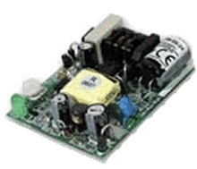
Figure 9.2.3: Model# NFM-05-12 Power Supply. Shown here to depict the open frame design [pending permission from TRC Electronics]

Now that a power supply has been chosen it must now be discussed how the components will be wired. A basic potential circuit diagram is shown below in Figure 9.2.4. It suggests a solution similar to the circuit diagram in the previous section. Components will be wired in parallel such that each component will receive sufficient voltage. There will need to be a voltage regulator wired in series with the microcontroller and pressure sensors because they both operate on five volts. This ensures that they both will only receive five volts therefore protecting them from surges and voltage spikes. As noted in Chapter 2 the system Pool Boy shall only take readings and add chemicals when the water is flowing. Therefore there must be a switch incorporated into the design. While water is flowing the system shall take measurements of the water. In the Figure below VR is an acronym for Voltage Regulator. FS stands for Flow Sensor. The pressure sensors are referred to by PS and a corresponding number. The abbreviation ORP signifies the Oxidation Reduction Potential Sensor. The transistors needed to implement the switches are shown as S_{S} and S_{ORP}. The Calcium Ion Selective Electrode and Copper Ion Selective Electrode are indicated by CA and CU respectively. The slightly thicker lines indicate wires that carry twelve volt potential.

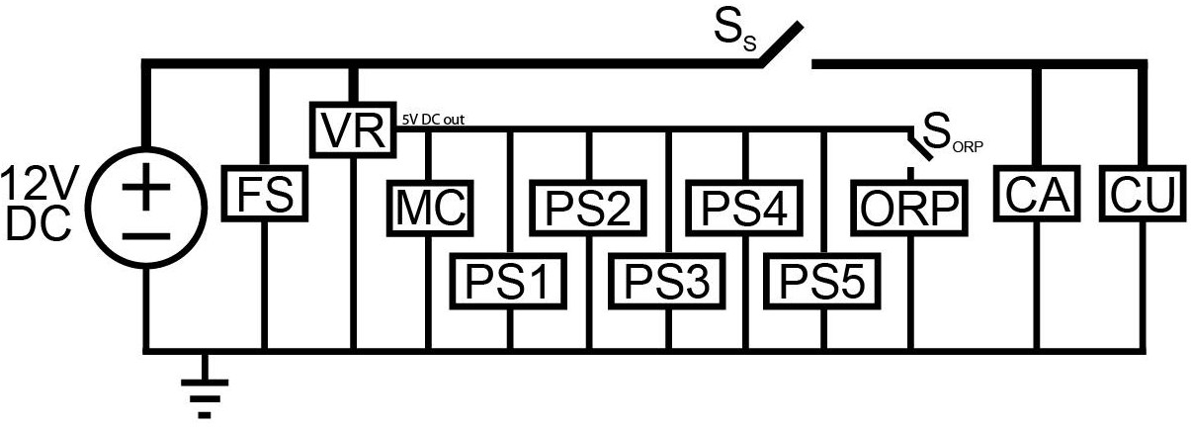

Figure 9.2.4: Potential circuit diagram of sensitive components

Again it is important to place emphasis on the fact that some components’ operation depend entirely on flowing water. The transistors needed in order to implement the switches in the diagram above will be described in greater detail in the next section.

9.3 Control Panel Power

The control panel will serve as the interface device between the user and the microprocessor on Pool Boy. As mentioned in chapter 7 the control panel will offer the following features to the user: An LCD display to relay information, a numeric keypad for pool size adjustments, four LED’s indicating potential low levels in each respective reservoir, a battery low LED indicator, a transceiver to send and receive data from Pool Boy, and a final LED to inform the user to back wash the pool.

All of the components listed above are extremely low power consumers leading to the idea that a battery should be a suitable power source for the control panel. Initial estimates put the total current needed to run all of the components significantly under 565 mAh, which is the approximate capacity of a common Alkaline 9V battery. A rechargeable 9V battery with the option of plugging in the control panel to charge appears to be an attractive option, because the user would not have to power off the control panel in order to change the battery.

Alkaline 9V batteries can be purchase at any hardware store as well as every major grocery store for approximately $4-5 for a two pack. Rechargeable 9V batteries however are more difficult to locate. Ace Hardware offers an Energizer rechargeable 9V battery for $13.49. Therefore it would take six recharges of the rechargeable battery to justify the purchase. It is not clear yet the length of life the battery will give to the control panel. For the scope of testing and presentation the alkaline batteries offer the better solution in the short term, but because the battery life is uncertain in the control panel’s circuitry it was decided to use a rechargeable 9V battery.

9.4 Transistor Switches

Two transistors will be used in the circuit depicted in Figure 9.2.3 in order switch power on and off for the ORP sensor and both the Calcium Ion Selective Electrode and the Copper Ion Selective Electrode. There are many ways to implement the switch. The implementation strategy that was decided upon suggests that the collector be connected to 12 V output from the Model# NFM-05-12 power source. The emitter shall be connected to the sensor which is connected to ground. The gate shall be connected to a pin on the microcontroller that when output goes high on the pin the transistor shall move to active mode and provide voltage for the ORP sensor, the Calcium Ion Selective Electrode, and the Copper Ion Selective Electrode.

Transistors are readily available at most hobby shops and every RadioShack. At a cost of less than two dollars for every type of transistor it becomes apparent that transistors are very cost efficient switches. The group plans on obtaining the transistor from a local RadioShack.

9.5 Relays vs. Solid State Relays

Relays are typically used in place of transistors when a transistor cannot provide enough current to the component. In effect relays are just bigger switches than transistors. Where transistor are solid state devices, relays work with an electromagnetic field and a coil that forces two contacts together when supplied with the correct voltage. This acts as a sort of a mechanical switch. Because Pool Boy is designed to be outdoors it would be preferable to have a way of switching power without mechanical movement as corrosion can expedite the failure time of the device. This however, is a viable option to switch power for a basic demonstration.

A solid state relay implies the same idea as a regular relay however it is a solid state device meaning it has no moving parts. As mentioned in section 9.5 solid state devices are preferable to mechanical devices because there is less chance for error and failure. This characteristic instantly makes a solid state relay a more attractive option than a regular relay. However it is still necessary to compare the two and determine the best option to implement in Pool Buddy. The comparisons are done below in Figure 9.4.1.

 | Relay | Solid State Relay
Model | SPDT Micro Relay | ODCM-5
Price | $4.69 | $12.53
Max Current | 1 Amp | 1 Amp
Input Voltage | 5 VDC | 5 VDC
Part Supplier | RadioShack | Tyco Electronics
Advantages | -Ease of availability  -Price | -No moving parts  -Large input range
Disadvantages | -Moving Parts  -Potential for Corrosion | -Shipping  -Price

Table 9.5.1: Table Comparing Relays

After deliberating on the pros and cons of each relay it was decided that a solid state relay would best suit the specifications for Pool Boy. The solid state relay was chosen primarily because of the advantages that it offers. The fact that it is a solid state device and has no moving parts proved to be the most influential characteristic in choosing the relay. The design as it stands calls for six solid state relays. The relays are depicted in Figure 9.1.4. One is needed to switch power on for the entire circuit and the other five are needed for each individual valve. Solid state relays will be incorporated into the design, because of the larger currents that the valves and copper electrode will draw compared to the other sensitive components.

The relays used in Pool Boy will be purchased online from Tyco Electronics. The relays Tyco offered seemed to be the only relays online that offered DC output for a reasonable price. The limited resources that are seen online seem to suggest that there is another option that may provide better functionality to the circuit, but has not been discovered or discussed yet. More research must be done next semester to ensure the best choice was made for Pool Boy’s functionality.

9.6 Voltage Regulators

A voltage regulator is a device designed to automatically maintain a constant voltage no matter what the input voltage is. Voltage regulators are needed in the design for multiple components. The microcontroller, pressure sensors, ORP sensor, and flow sensor will all be operating on five volts in a twelve volt circuit. A five volt regulator will ensure that those components will only receive five volts.

A voltage regulator is needed to implement the logic circuit indicated in Figure in 9.2.4. In a twelve volt circuit there are numerous components that require only five volts to operate. A voltage regulator will provide all of the components with the required voltage. The exact model needed will be determined in this section.

LM7805

The LM7805 from Fairchild Semiconductor offers a variety of fixed output voltages which make it desirable in a wide range of applications. This model is probably the most common linear voltage regulator. It employs internal current limiting and thermal shut down to ensure safe operating area protection. A disadvantage in the LM7805 is that linear voltage regulators are notoriously inefficient creating excess heat and power dissipation. It offers up to 1 amp at the output which is more than enough for the logical units and sensors. The heat should not present any problem as Pool Boy has been designed to operate flawlessly in the hot Florida sun. The power dissipation is a potential problem, because of the sensitivity of the components at the output. The LM7805 is the leading candidate for the voltage regulator that will be used in the implementation at the moment.

LM2937-3.3

Because the microcontroller can be implemented with low power mode 3.3 volt input, it seems logical to consider a 3.3 volt regulator. The LM2937 from National Semiconductor offers a potential solution for the low power mode. While the output current is half of what the LM7805 offers it is still more than enough current for all of the components. The LM2937 requires an output capacitor for stability as most voltage regulators do. This component is critical in the design parameters.

LM317

The LM317 from National Semiconductor appears to be the Mercedes of the voltage regulator world. It offers adjustable output all the way down to 1.2 volts and all the way up to 37 volts. With a guaranteed output of 1.5 Amps it offers approximately ten times more current that needed. The feature that makes the LM317 an attractive option is the adjustable outputs making it desirable for many applications. It requires only two external resistors to set the output voltage. This has quickly become the new leader in voltage regulators

Voltage Regulator Selection

Before the voltage regulator is decided upon it has become standard practice to include a table of each components and specifications that directly affect the choice. This table is located below in table 9.6.1.

 | LM7805 | LM2937-3.3 | LM317
Price | $.60 | $.88 | $.72
Manufacturer | Fairchild Semiconductor | National Semiconductor | National Semiconductor
Output Voltage | 5, 6, 8, 9, 10, 12, 15, 18, 24 VDC | 3.3 VDC | 1.2 – 37 VDC
Output Current | 1 A | .5 A | 1.5 A
Advantages | -Adjustable Output  -Sufficient Current | -Can enable low power mode | -Can enable low power mode
Disadvantages | -Power dissipation  -Extra heat | -Only one application | -Requires input ≥ 28 V

Tbale 9.6.1: Table Comparing Common Voltage Regulators

After examining the table it was first decided that the LM317 offered the best solution, however upon further inspection it was noted that the LM317 requires an input voltage of at least 28 V. Because the input to the regulator would be twelve volts it makes the regulator unusable in the circuit’s applications. The final decision was to integrate the LM7805 into the circuit, because of its ability to supply voltage to all of the components on the branch instead of just the microcontroller.

The datasheet that accompanies the regulator suggests a circuit in which to implement a fixed output regulator. This circuit is depicted below in Figure 9.5.2. The capacitors in the circuit in effect cut out any noise that may enter the regulator therefore making the circuit fixed output.
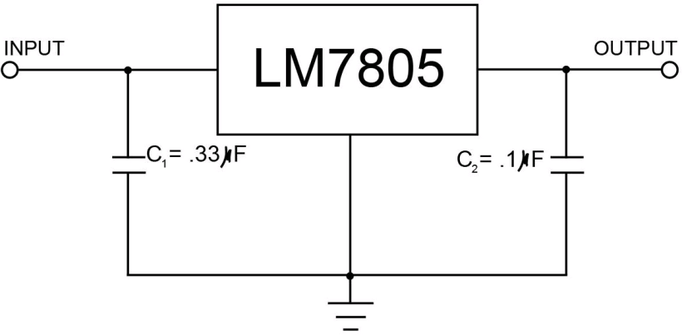
Figure 9.5.2 Fixed Current Output Circuit

9.7 Power Supply Testing

Preliminary tests for the power supplies will be done in Multisim. Connecting the circuits indicated in Figures 9.1.4 and 9.2.4 and running simulations shall be the first step in testing the power supplies. If simulation results show correct or optimistic results the circuits will be hardwired and the testing will go to phase two.

An oscilloscope and multi-meter will prove to be two devices used extensively in the actual testing of the power supplies during phase two. Testing the power supplies also implies testing the circuits themselves, and this will be the last step in the entire design process. Once the two power supplies have been obtained the first step will to be to test each component separately with each specific power supply. Taking voltage readings and current readings across the components will be the first step in determining if each specific component will work in the circuit. If a component does not function properly in the circuit then changes must be made. If it is determined that new components need to be ordered then testing the circuits shall still be the last step in determining Pool Boy’s overall system functionality.

A positive test with all of the components in each circuit will prove to be the highlight of the entire year. Ensuring the system’s functionality is the main goal of Senior Design II and no doubts have been made as to the extent of time it will take in order to make Pool Boy a legitimate competitor in the pool and spa market. As mentioned in chapter 1 a system like Pool Boy has never successfully been marketed to the pool and spa industry. Research shows that consumers would most likely purchase a product that lived up to Pool Boy’s specifications. A successful test in Senior Design II should be motivation to take Pool Boy to the public and observe the actual interest in the product. Profit from the idea will be available if the market dictates the research.

Chapter 10

Administrative Content

10.1 Cost Plan

The main focus of the pool boy is the consumer friendly price point. Fully automated systems like the Pool Boy already exist but because of the tremendous overhead in engineering and development costs, these companies are forced to charge four to five thousand dollars per unit. The nature of Senior Design is that students receive zero pay and so the Pool Boy does not need to recover engineering costs. As such, the price point will be somewhere near $1,500 which is nearly 1/3 the cost of existing systems.

The majority of the cost goes into the purchase of chemical sensors. These can cost anywhere from one to two hundred dollars each. Electronic valves may also be expensive as they will need to be made of a non-corrosive material which may lead to an expensive, niche product. Even with a few unknown variables it is speculated that the cost of the Pool Boy will be near 1,200 dollars.

10.2 Center for Entrepreneurship and Innovation

The Pool Boy was entered in the UCF Inventing Entrepreneurs competition hosted by CEI@UCF. One of the judges at this competition, Erik Weaver CEO of Digital Ribbon Inc., said this to the Pool Boy Team afterwards; If the Pool Boy could tag on the heel of the green movement and convince people that this reduction in chlorine was going to make the world a better place, then everything else will fall into place. If there were ever a marketing plan for the Pool Boy this would be it. The eco movement is huge and there is no reason why the Pool Boy can’t get a small slice of that big pie. Perceived value of the Pool Boy would be huge if consumers could see that they would be saving money, saving time, and reducing interaction with harmful chemicals.

Eco investors on the west coast are becoming a viable option. It would not be unrealistic to think that there would be one who would be willing to pick up our goal to change the world by reducing the amount of chlorine we contact in our lives. In fact it’s this ethos, this emotional appeal, which can start a movement and get people excited about changing the way they live. This is the type of enthusiasm that the Pool Boy can incite in people.

Many handicapped and elderly people enjoy immersing themselves in water because it gives them the sensation of weightlessness. This weightlessness can be an excellent way for disabled or weak persons to get exercise because they can move more freely when they are floating than when standing on solid ground. However, many of these people are also unable to have a pool at their homes because of the constant maintenance required. This is another great use for the Pool Boy system. The elderly and the weak will now be able to enjoy the luxuries of a pool because the Pool Boy system will give them an affordable, cost effective solution that doesn’t require them to do any actual labor on the pool.

A prototype was constructed, seen in Figure 15, for the competition and while the Pool Boy did not place in the top three; it was a very solid presentation.

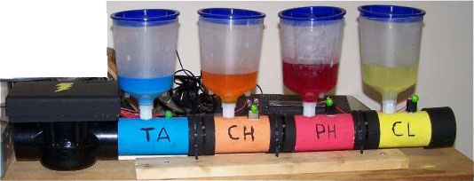

Figure 10.2: Pool Boy prototype

One major cost for the presentation side of things will be the eventual design and building of the pool demo prototype with included pump and pool filter. Only once we have a full, complete working prototype will the team be satisfied with the demo. The impact on the audience and professors who see our project will be much more profound if we can show the system working entirely.

10.3 Demoing

There was a nice egg of knowledge gained from the CEI competition that the team hopes to improve on. The team had one general complaint from everyone that saw our project and that was that no one could empirically see how the product worked. Because of the size restrictions a 20,000 gallon pool cannot be brought inside to show a demo. To alleviate this problem a pump and filter system will be purchased and set up in line with system and the Pool Boy will monitor a small water reservoir that is to represent a pool. This way, people will get to see the entire system in motion and watch water flow across the sensors.

10.4 Consultants

Consultants include the fine people over at edaboard.com. These are not hired consultants, simply hobbyists who happen to be willing to answer questions about electronics. Generally they are willing to reply to a question within a matter of hours which is better than can be said about most consultants. User groups are a fantastic forum for individuals to come together and share knowledge on a centralized topic. It’s important for the modern engineer to be able to identify the value and harness the power of these user groups.

10.5 Suppliers

A few suppliers will be Digikey, northwestwholesale.com, and harbor freight tools. DigiKey has already provided the team with LCDs, dev kits, key pads, cable ties, solder iron, generic hardware and breadboards. These things all proved to be useful during the development of the prototype model. Harbor freight tools provided the team with some spray gun paint reservoirs which worked perfectly for holding the chemicals needed to adjust the levels in the pool. The reason why these paint reservoirs were so ideal is because they were made from plastic, even had nylon threads on the bottom. So the chemicals, no matter how corrosive, could not damage the surface for the reservoir. Finally, North West Wholesale will be providing us with a pool pump and filter so that we may properly demo this device in action. This flows nicely into the next segment which will touch on proper demoing.
10.6 Facilities and Equipment

This section describes the facilities and equipment that will be used by our senior design group throughout the semester.

10.6.1 Senior Design Lab

As senior design students at UCF, we have access to a full design lab located on the fourth floor of the Engineering I building on the UCF main campus. This lab includes plenty of equipment that will prove useful throughout the whole entire design process. The lab is equipped with function generators, oscilloscopes, multimeters, and power supplies. Along with the standard equipment in the lab there is a PCB milling machine which can be used to create our own PCB design. The senior design lab will be used mostly for the building and testing of the electronic equipment of the system.

10.6.2 Pool Test Facilities

In addition to the senior design lab we have access to a current, in place, underground pool at our senior design group member Robert Sers House. This facility is very important as we will need a pool to test how the whole design is going to work. This facility is located near UCF and will be available to us throughout the whole design phase. We will be using the pool for the final testing and the initial testing of all of the sensors to be used in the design to be sure that we are obtaining accurate readings.

10.7 Financing

The Pool Boy team has been given an opportunity to receive $3,000 in funding for the project. Dr. Cameron Ford at UCF was the coordinator of the funding and event. The team’s experience with CEI could not have been better. It was great business experience for an engineering team that otherwise would have not gotten any business experience before graduating. The competition also lit a fire under the team and required that hard work be put into the project early on. Even now, a head of the curve, our team found itself struggling to complete the paperwork on time so without this budgeting to get us going we would have had a hard time.

10.8 Budget

Below is table listing all components and the corresponding prices

Components | Price | Manufacturing Equipment | Price
ORP Sensor | $80 | AquaCheck Silver | $24.61
pH Sensor | $45 | AquaCheck Pro li | $10.45
Calcium Hardness Sensor | $180 | AquaCheck Copper | $10.62
Total Dissolved Solids Sensor | $108 | 2 X Pickit3 | $45
Copper Ion Sensor | $333.40 | Solder Station | $124.95
Pressure Switch | $20 | 2XBreadboard | $74.90
Temperature Sensor | $42.48 | M Series Toggle Kit | $35.00
PCB | $80 | 2XLCD Module 16x2 Char | $11.76
LCD Mod Char 4x20 | $17.70 | LCD Mod Char 2x20 | $24.00
Keypad 12 Key | $12.26 | Keypad 4 Key | $18.90
5X Valve | $59.85 | Chemicals | $60
Outdoor Enclosure | $45.00
Indoor enclosure | $15.00
Ionizer | $55.00
PVC Pipe | $10
PVC Acceseries | $20
Microcontrollers | $10
Small Electronic Components | $20
2X Power Supply | $40
Production Price Of Individual Product | $1253.69 | Price To Build Prototype | $1693.88

Table 10.8 Budget Table

If Pool Boy was successfully implemented and the market demands more Pool Boys the group shall give the masses what they desire. Masses of people will flock to pool stores around the country demanding pool boy. There is an associated overhead with the development boards that will not be there if Pool Boy is mass produced. There will only need to be one development board to implement multiple Pool Boys. The development board overhead will asymptotically approach zero as more and more Pool Boys are produced.

Most manufatuers offer reduced prices for products purchased in bulk. This will dramatically reduce the cost of each individual system and increase profits. An initial visit to Pinch-A-Penny proved to be a potential leak into the pool and spa market. The owner of the store expressed explicitly his interest in the product and was willing to sell it in his store if Pool Boy proved to be a viable option in automated pool maintenance. The only concern found with a product of such magnitude is reliability. With a reliable product that would be susceptible to more specific options, the Pool Boy could have the potential to be a large market product.

10.9 Monthly Milestones

January:
It was decided that the group would do a pool water maintenance device so we began assigning research portions to each group member. Ivan took micro processor research. Mitch took valves and reservoirs. Paul researched the remote device. Lastly, Robert took sensors.
Applied for funding opportunities with CEI group. Contacted Dr. Ford at CEI.

February:
Given a three thousand dollar grant from CEI@ UCF.
Began truly understanding the magnitude of the work load. Decided on the Zigbee RF solution. Ordered PIC chips for development and learning. Still uncertain about sensors. Investigated custom build sensor solutions but that turned out to be too expensive.

March:
Built prototype demo which included Valves, sensors, reservoirs, ionizer, pool unit, and receiver unit.

April:
Completed 40 pages of documentation in early April for class. Approximately seventy-five percent of paper done

May:
Compile a comprehensive list of things that need to be ordered. Decide on which sensors and valves. Order pool pump and filter system for comprehensive demo.

June:

Begin construction of working prototype.

July:
Early July our CEI funding ends and we are no longer able to order parts. Should be nearing completion of functioning prototype.

August:
Pool Boy will be completed!

Chapter 11
Design Summary

The preliminary design of the system consists of the monitoring and dispersion of chemicals into the pool in order to maintain a clean pool. Several different approaches were taken into consideration to find the most cost efficient and effective method to implement our initial design idea. From research it was found that using a pool ionizer along with standard pool chemicals would be the best solution to achieve our goal. The first step in developing the design is how to monitor the chemical levels in the pool which needed to be checked and adjusted constantly throughout the day.

With the use of a variety of sensors the system will be able to read chemical values. The sensors to be used are analog and require A/D convertors to be able to convert the voltages read by the sensor to digital form where they will be able to be interpreted. Microcontrollers prove to be a great solution as they provide a wide variety of features on a single chip with large processing power, including multiple channels for A/D conversion. Upon reception of the sensor values through the A/D convertor provided on the chip, the microcontroller will dispense the chemicals based on the specifications and equations programmed onto the microcontroller. In-depth information of each of the sensors used can be found in Chapter 2: Chemical Monitoring.

As the chemicals are liquids solenoid valves are used to control the amount of volume being dispersed at one moment. The microcontroller will control these valves using a simple MOSFET switching circuit. Once dispensed the system will work in its continuous loop as the chemicals will be checked periodically throughout the day to ensure proper maintenance.

With a wide variety of different pools and changing climates it is important to be able to initialize the system properly. This is done through the use of a control panel. The control panel is wireless with an LCD and keypad, through the use of microcontrollers and transceivers. The control panel has the capability of changing predefined values of chemical dispersion equations on the microcontroller on the system along with being able to display the status of the system and all the chemicals being monitored. Detailed information on the control panel can be found in Chapter 7: Control Panel. Through this constant control system in place the system will maintain chemical levels. See Figure 11.1 for a visualization of the process.

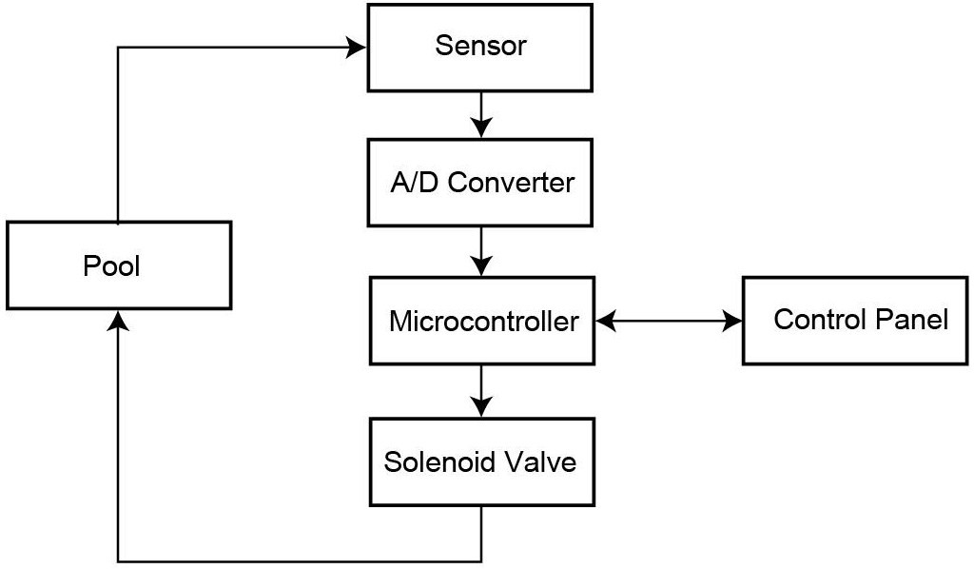

Figure 11.1: Overall System Design Overview

Appendix A

Bibliography

- ExpressPCB, (2008). Tips for Designing PCBs. Retrieved April 24, 2009, from ExpressPCB. Web site: http://www.expresspcb.com/ExpressPCBHtm/Tips.htm
- Microchip Website: http://www.microchips.com/
- Atmel Website: http://www.atmel.com/
- Texas Instruments. Web site: http://www.ti.com/
- TRC Electronics Web Site: http://www.trcelectronics.com/
- National Semiconductors. Liquid-Level Monitoring Using a Pressure Sensor. Amy Le. National Semiconductors Web Site: http://www.national.com/
- [1]https://www.lawngeniestore.com/Comergent/en/US/StaticContent/LawnGenie/product_manuals/Valve%20Manuals/54048_49.pdf
- [2] http://www.orbitonline.com/lib/media/94080-24%20rB.pdf
- [3]http://www.toro.com/irrigation/com/downloads/com_valves/P-220_series/p220%20sell%20sheet.pdf
- [40] http://www.automatedsonix.com/son40.htm
- [41]http://www.fluidswitch.com/pages/OpticalLiquidLevelSensorOS-900.htm

