Initial Project and Group Identification Document

Interactive LED Gaming System



Group 1

Members:
Robin Adams
Nathan Duran
Tyler Hansen
Shaun Sontos

As our senior design project the group has chosen to develop an interactive LED gaming system. The primary motivation behind this project is to develop a fun and easy to use tabletop gaming system. By doing this the group also hopes to develop a prototype that takes the typical hobbyist LED cube to a new interactive level showing the functional capabilities of a basic three dimensional user interface system.
Along with this primary motivation, the group hopes to display a solid understanding of the fundamental principles which have been studied by all of its members in the past several years. This will be done by drawing on the strengths of each of the group members and offering a collaborative and cooperative learning experience. The project will also serve as an opportunity, within reason of the overall design specification, to introduce or expand on exposure to unfamiliar materials which any of the group members seeks.
The general functionality of the gaming system is an interactive one player versus computer gaming experience. The experience will begin with a main menu which will offer multiple selections of game mode to the player. This will be achieved by a two dimensional scrolling text. Possible game modes discussed are a ‘Battleship’ style game, ‘Reversi’ style game, ‘Connect 4’ style game, ‘Missile Command’ style game, a general paint pallet, as well as many others. Based on the memory and I/O limitations of the system the group has also considered a simple game mode expansion feature which would allow the ‘purchase’ of new games as they are developed.
Due to the financial and special limitations of the project the group will have to develop an addressing scheme to allow selection of any of the available coordinates (addresses) within the cube. It may also become necessary to allow selection and display of multiple colors which the system will have to recognize and process. This will involve the use of encoding and decoding between the user interface and the processor. This will also depend on the development and use of pulse width modulation to extract an array of colors from basic RGB (red, green, blue) LEDs.
Once the game is selected the user will interact with the system by means of strategically located touch sensors which will allow the selection of particular coordinates within the game board. A single game will be playable from beginning to end with text displaying the winner and any notable game statistics at the end of each round of game play.
Additional features have also been taken under consideration. They include a rechargeable lithium ion battery power distribution system. The group has discussed a single system with two player capabilities. Finally, it has been recommended to limit the player interface to a two dimensional game system and focus on communication and wireless data transfer. This would be accomplished by developing two separate two dimensional user interfaces, each with the ability to act independently, but also with the feature of linking the units into a two player game mode.

Specifications:

PROJECT ASSEMBLY
1) Total parts required
- MCU -- BASIC Stamp 2sx module (x1)
- MCU -- DV164120 (PICkit 2 Starter) (x1)
- MCU -- PIC24FJ128GA310 (x1)
- RGB LED -- Lumex SML-LXR851SIUPGUBC (x234) minimum
- Photoelectric Sensor -- Honeywell HLC1395-001 (x84) minimum
- PSU --5V 12A 60W Switching120/240VAC (x1)
- DC-DC Converter -- PT6601D 3.3 V, 9 A (x1)
- LED Driver -- 16-bit, STMICROELECTRONICS (x24)

2) RGB LED Test Prototype
2.1. MCU -- BASIC Stamp 2sx module (x1)
2.2. RGB LED -- Lumex SML-LXR851SIUPGUBC (x1)
2.3. Photoelectric Sensor -- Honeywell HLC1395-001 (x1)

3) 2x2x2 LED RGB Cube (Generation 1)
3.1. MCU -- DV164120 (PICkit 2 Starter) (x1)
3.2. RGB LED -- Lumex SML-LXR851SIUPGUBC (x8)
3.3. Photoelectric Sensor -- Honeywell HLC1395-001 (x8)
4) 10x10 LED Array (2D) + 5x5x5 LED Cube (3D) (Generation 2)
4.1. MCU -- PIC24FJ128GA310 (x1)
4.2. RGB LED -- Lumex SML-LXR851SIUPGUBC (x225)
4.3. Photoelectric Sensor -- Honeywell HLC1395-001 (x20 + 55)
4.4. PSU --5V 12A 60W Switching120/240VAC (x1)
4.5. DC-DC Converter -- PT6601D 3.3 V, 9 A (x1)
4.6. LED Driver -- 16-bit, STMICROELECTRONICS (x24)

PART DESCRIPTION AND TECHNICAL SPECIFICATIONS

2.1: BASIC Stamp 2sx module
- 8-bit Architecture
- Processor Speed: 50 MHz
- PBASIC Programming language enabled
- Program Execution Speed: ~ 10,000 PBASIC instructions/sec.
- RAM Size: 32 Bytes (6 I/0, 26 Variable) + 64 Bytes (Scratch Pad RAM)
- EEPROM Size: 8 x 2 kB
- Number of I/O Pins: 16 + 2 dedicated serial
- Current Draw @ 5 VDC: 60mA (Running), 500 µA (Sleep)
- Package: 24-pin DIP
- Power Requirements: 5.5 to 12 VDC (Vin), or 5 VDC (Vdd)
- Communication: Serial (9600 baud for programming)
- Dimensions: 1.20 x 0.63 x 0.15 in (30.0 x 16.0 x 3.81 mm)
- Operating Temperature: -40 to +185 °F (-40 to +85 °C

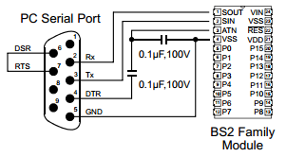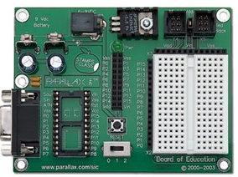

3.1: Microchip Technology Inc. DV164120 (PICkit 2 Starter)
- MPLAB IDE
- USB Port
- PIC16F690 (MCU)
  - 8-bit Architecture
  - Operating speed: 20 MHz oscillator/clock input
  - Wide operating voltage range (2.0V-5.5V)
  - Industrial and Extended Temperature range
  - Multiplexed Master Clear/Input pin
  - Supports RS-485, RS-232 and LIN 2.0
  - Standby Current: 50 nA @ 2.0V, typical
  - Operating Current: 11 uA @ 32 kHz, 2.0V, typical
  - 17 I/O pins and 1 input only pin
  - High current source/sink for direct LED drive
  - 10-bit PWM with 1, 2 or 4 output channels,
  - programmable “dead time”, max frequency 20 kHz

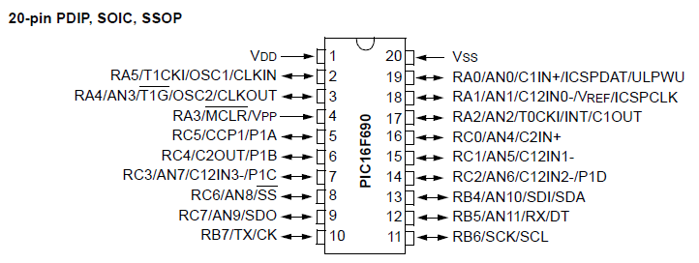

4.1: PIC24FJ128GA310
- 16- bit Architecture
- CPU Speed: 16 MIPS
- Program Memory(Flash): 128 kB
- RAM: 8 kB
- Temperature Range: -40 - +85 C
- Operating Voltage Range: 2 - 3.6 V
- I/O Pins: 85
- Pin Count :100
- Internal Oscillator: 8 MHz, 32 kHz
- Capture/Compare/PWM Peripherals: 7/7
- PWM Resolution: 16 bits
- Timers: 5 x 16-bit
- Current: 150 uA Run mode, 330 nA Sleep mode (RAM retention)
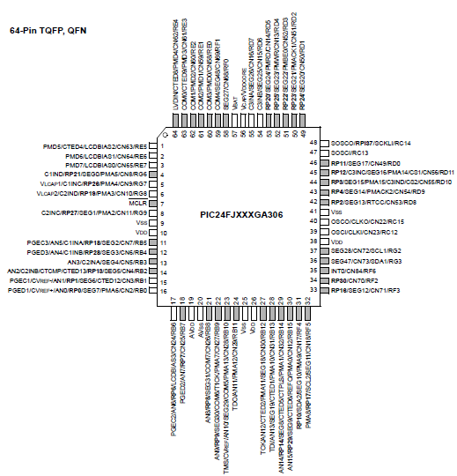
2.2, 3.2, 4.2: RGB LED -- Lumex SML-LXR851SIUPGUBC
- RGB wavelengths: 636/525/470 nm
- Operationg Voltage: 2/3.5/3.5 Volts (R/G/B)
- Maximum Voltage: 2.6/4/4 Volts (R/G/B)
- Steady current: 25 mA
- Peak forward current: 60/100/100 mA (R/G/B)
- Power dissipated: 105 mW
- Operating temp: -40 to +85 C

2.3, 3.3, 4.3: Photoelectric Sensor -- Honeywell HLC1395-001
- Brand/Series: HLC 1395
- Current, Forward:10 mA; 50 mA continuous
- Function: Proximity
- Material: Opaque Polysulfone (Housing-Outer Shell)
- Power Dissipation: 100 mW
- Type: Photoelectric, Infrared
- Range, Measurement: 1.02 mm
- Temperature, Operating: –40 to +85 °C
- Voltage, Supply: 1.6 V

4.4: 60 W Switching Power Supply Unit

Input: 100-120 VAC

Output: +5 Volt(DC), 12 A(max)

4.5: PT6601D Voltage Regulator 3.3 V, 9 A, DC-DC Converter
- Input: 4.5-6 Volt(DC)
- Output: 3.3 Volt(DC), 9 A
- 14-pin

4.6: STMICROELECTRONICS - STP16CP05MTR - IC, SM DRIVER, LED SINK 16-BIT
- Output pins: 16
- Output Current: 100mA
- Output Voltage: 20V
- Input Voltage: 3V to 5.5V
- Dimming Control Type: Analog
- Switching Frequency: 30 MHz
- Operating Temperature Range: -40°C to +125°C

Block Diagrams:

Hardware development: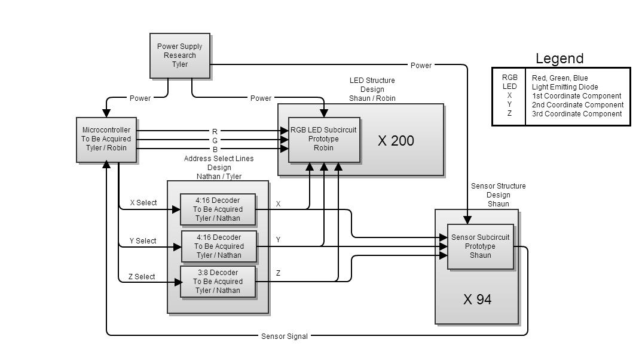

Software Development:
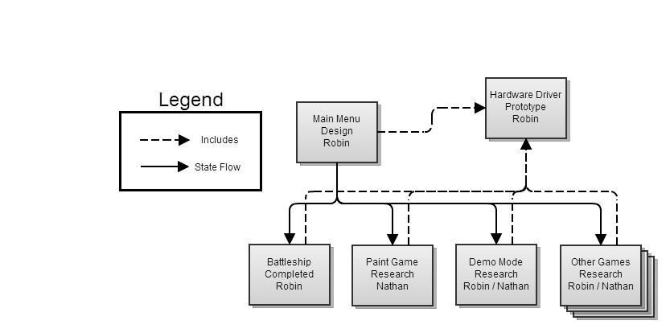

Budget and Financing:

Projected Financing:
As far as we know this project is going to be completely self-financed. Therefore, we plan on minimizing the budget for this project. The most expensive component of this project is the LEDs and sensors depending on how big we want to make the cube. Because of the added touch input and cost of these components, we are minimizing the size of the cube.

Budget: $800

We will evenly split the cost of all parts required. In the event that someone takes a personal interest in a specific part, they are free to buy the part themselves and take it when the project is over.

$800/4 = 200/group member

Projected Expenses:
- MCU -- BASIC Stamp 2sx module (8-bit): $63.95
- MCU -- DV164120 (PICkit 2 Starter) (8-bit): $53.95
- MCU -- PIC24FJ128GA310 (16-bit): $28.95
- RGB LED -- Lumex SML-LXR851SIUPGUBC (234*0.78): $186.47
- Photoelectric Sensor -- Honeywell HLC1395-001(84*1.75): $150.95
- PSU --5V 12A 60W Switching120/240VAC: $23.9
- DC-DC Converter -- PT6601D 3.3 V, 9 A: $7.45
- LED Driver -- 16-bit, STMICROELECTRONICS (24*3.5):$ 87.95
- Acrylic (base, mount, case): ~$0.35 per sq in: $60
- Wires: $20
- Solder: $20
- PCB : $50
- Multiplexers: $20

Total: $ 773.57

Milestones:

Two groups of milestones have been constructed based on the information contained in this project document. The first is a set of milestones is for Senor Design One, to be completed in the spring of 2013. This set focuses on the processes of definition, research, design, and experimentation. The second set of defined milestones is to be completed during Senior Design Two in the summer of 2013. This group deals with the processes of prototype and test. While the milestones are presented in linear order it may be possible for progress to be made on multiple points at one time.

Senior Design One:
- Definition
  - Develop a clear design specification
  - Draft a final design
- Research
  - Create a library of reference document , data sheets, and past examples
  - Generate a complete parts list and preliminary cost analysis
  - Generate a final cost analysis based on the final design
- Experimentation
  - Create test bench models of each individual feature to determine if selected parts are appropriate for design
    - Sensor circuit (HW)
    - Indicator circuit (HW)
    - Pulse width modulation for color variance (SW)
    - Individual game modes (SW)
    - Power distribution (HW)
    - Addressing scheme (HW/SW)
- Other
  - Acquire funding for anticipated costs plus twenty percent for additional unanticipated expenses

Senior Design Two:
- Prototype
  - Order and receive all parts needed for full scale prototype
  - Develop full scale prototypes of test bench model
  - Integrate each feature individually and test
  - Develop fully functioning prototype
- Testing
  - Generate a comprehensive test program to individually check each full scale prototype
  - All features/aspects of final design are functioning
  - Generate a comprehensive test program to check functionality of final completed prototype

