Knight Bright — an interactive LED array gaming platform
Robin Adams, Nathan Doran , Tyler Hemp-Hansen, and Shaun Sontos
Dept. of Electrical Engineering and Computer Science, University of Central Florida, Orlando, Florida, 32816
Abstract — Over the last 20 years, electronic gaming platforms have become increasingly complex and sophisticated. Video game consoles, which started out as mostly self-contained interactive systems in the 1980s and 1990s, are now capable of networking with multiple telecommunication protocols, as well as interfacing with many different device platforms. This paper describes the implementation, and capabilities of one such modern electronic gaming platform.

I. Introduction
Knight Bright is an interactive LED gaming and display board. The device will have three primary modes of operation: gaming mode, display mode, and programming mode. The gaming mode will allow the user to select from 1 of 3 games stored on the device. Display mode grants the user a text-display capability output. Lastly, the programming mode allows the user to program the device themselves through the use of a simple, programming environment. This programming environment will be stored on the Program PC (host). The device hardware will consist of 3 layers: the pixel circuit cell array, the communication layer, and the central control system. To allow input from the user, each pixel circuit cell consists of an IR emitter and IR collector component. These components will act as a proximity sensor to detect the user’s hand or any other object placed atop each pixel circuit cell. Knight Bright also has a Bluetooth module, which allows for interfacing with an Android OS enabled mobile device. The communication layer receives the user input from all 100 pixel circuit cells, and forwards the data to the central control system. This communication interface is organized into 100 distinct address locations, 1 for each pixel circuit cell. All 100 addresses are continuously called by a dedicated communication microcontroller, which forwards the user data to the central control system. The 100 RGB LEDs are controlled by dedicated IC LED drivers, which are used in conjunction with the communication microcontroller. The LED drivers will control the LEDs with onboard PWM.
II. Specifications
Knight Bright is designed to function within certain specification parameters defined by the group. These parameters are:
- Display size is ~ (20” x 20” x 2”)
- User interaction with Knight Bright occurs through either IR touch sensors, or an Android mobile app
- Display resolution is ~ (10x10) pixels
- Color Depth is greater than or equal to 8-bits
- Able to wirelessly communicate with an Android OS enabled device. Wireless communication range must be greater than or equal to 33 feet
- Must be able to store at least 3 on-board games
- Power consumption must be less than or equal to 200 W
III. Essential System components
Knight Bright is comprised of 3 microcontroller units, an LED driver array system, an IR sensor array system, a swappable memory SD card, and a Bluetooth module. Each subsystem and essential component will be described in greater detail in the following paragraphs. The group believes in 3 basic design philosophies for project design: ease-of-use, minimalism, and modularity. All essential components were selected with those 3 tenants in mind.
A. Microcontrollers
All 3 MCUs and their system roles will be executed using Atmel’s ATmega328. The ATmega328 has an 8-bit architecture, 20 MHz operating frequency, and comes equipped with 32 kB of onboard Flash memory. The ATmega328 was selected because of it’s minimal architecture, low power consumption, and proliferated software support on the Arduino development platform. Also, the ATmega328 comes available in a standard 28-DIP package, which allows all of it’s hardware features to be easily accessed.
B. Touch sensors (IR-emitter and IR-collector)
The touch sensor circuit is comprised of 2 components: an IR emitter, and an IR collector. The IR-emitter is realized with the QED123 IR LED. The QED123 operates at +1.7 V(forward biased), emits an 880 nm wavelength signal, and operates at a maximum current rating of 100 mA (forward biased). The total power dissipation of the QED123 is 200 mW. The IR-collector is realized with the QSD123 IR phototransistor. The QSD123 can be best described as a BJT, with a Collector, Emitter, and Base nodes. The QSD123 operates at +5 V_{CE} (forward biased), and when the device receives an 880 nm wavelength signal, the Base node sends the QSD123 into a forward-biased On-state. The QSD123 can operate at a maximum current rating of 16 mA(forward biased, On-state), and has a total power dissipation of 100 mW.
C. LED
The group had an extensive selection of RGB LED manufacturers to choose from. For the most part, there is little discrepancy between different company designs of LEDs. There are only 2 major types of LED designs that were considered; common anode, or common cathode. In the common anode design, an RGB LED comes with 4 a total of 4 pins; 3 cathode pins, 1 for each color, and 1 cathode pin. The common anode design is the inverse, 1 common cathode with 3 anode pins. The group chose the M500RGB4D, which is a common cathode design.
D. LED Drivers
There are 100 RGB LEDs on Knight Bright’s array platform. Each RGB LED is a superposition of 3 LED bulbs (red, green, and blue). This translates into 300 individual LED channels that must be controlled. Furthermore, each channel utilizes PWM to allow control of a complete color wheel. To fulfill both hardware requirements, Knight Bright’s LED array will be controlled by the Texas Instrument’s TLC5941. The TLC5941 can control up to 16-channels per IC, and each channel comes equipped with a 12-bit PWM Grayscale, which stores the PWM setting on an internal register. The PWM Grayscale is transmitted serially as one 192-bit word from the LED Driver MCU to the TLC5941. Further details on how the TLC5941 is operated can be reviewed in Section V.
E. 4:16 Decoder
The interconnection and addressing scheme of the IR Sensor Array and LED Array both depend heavily on the use of demultiplexing. The HEF4514B is a 4:16 Decoder that significantly reduces the pin interconnection between the MCUs and the Arrays. The HEF4514B has 2 pins (“EN” and “EL”) that are required to be controlled in order to access the 4 input addresses. Pin “EN” is the “Enable” pin for the HEF4514B. “EN” is active low, so the HEF4514B can only access it’s output pins when “EN” is set low. If “EN” is set high, then all output pins are disabled, and all address inputs become irrelevant. Pin “EL” is the latch pin for the input addresses. Once “EL” is set high, then whatever values that happen to be on inputs A0-A3 will be latched onto the HEF4514B’s internal registers, and the outputs can be accessed (again, assuming that the enable pin is set low.)

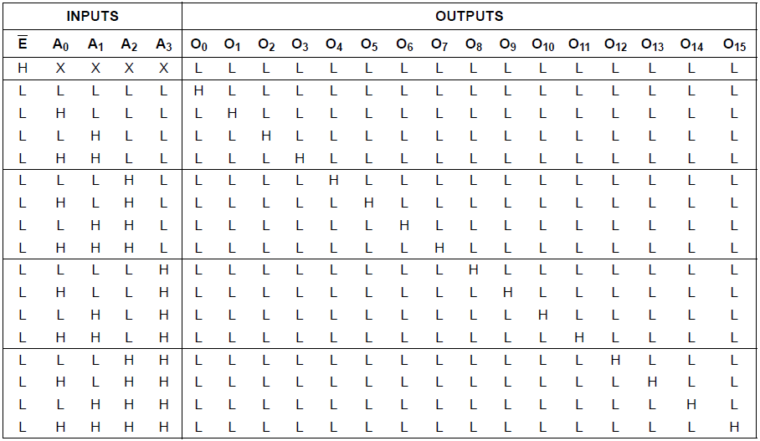

Fig 1. The truth table for the HEF4514 IC. This table assumes that the latch pin(“EL”) is set high. Note that when the enable pin(“EN”) is set high, then all outputs are set low.
F. Bluetooth Module
Knight Bright’s Bluetooth capabilities will be realized using the RN-42 Class 2 Bluetooth Module. The RN-42 supports Bluetooth 2.0+, which allows baud rates of up to
921 Kbps. The RN-42 comes equipped with an onboard antenna, which operates at 2.4 GHz, and can communicate with BT-enabled devices at distances up to 60 ft. The RN-42 also comes equipped with a UART interface, which allows TTL serial communication with microcontrollers. The BT module comes preloaded with the Serial Port Profile (SPP). The SPP is a port emulation protocol which emulates the RS-232 serial communication protocol. When the GPIO7 pin line remains in a high state, this sets the module to transmit at a 9600 baud rate(wireless and UART), which is the default setting. The module also comes preset to automatically accept wireless connections from android device. The RN-42 has an operating voltage of +3.3 V.
G. SD Memory Card
All of Knight Bright’s gaming/visual program applications will be stored onto a SanDisk 8 GB, 30 MB/s SDHC memory card. The SD card will be accessed by the Primary MCU.
IV. SYSTEM CONCEPT AND DESIGN
This section describes how Knight Bright’s main subsystem assemblies will be interconnected, and realized. The Knight Bright can be broken down into 3 essential subassemblies; The LED Array System, the IR Sensor Array System, and the Primary MCU interconnect. Figure 2 gives a basic overview of Knight Bright’s system and subsystem integration.
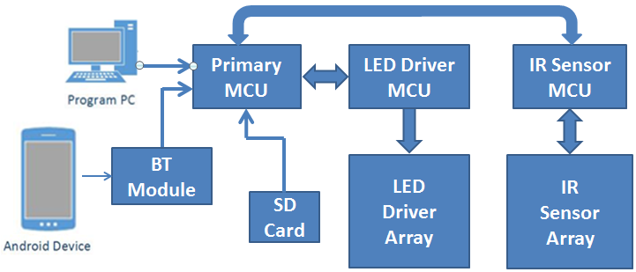

Fig 2. Knight Bright’s overall system design.

A. Microcontroller unit interconnections
The primary MCU acts as the main interface between the Host PC (and the Android device) with the LED array and IR array. It also controls the 2 secondary MCUs (the LED Driver MCU, and the IR Sensor MCU). The Primary MCU communicates with the host PC through the Arduino Uno development board (the Primary MCU is NOT soldered directly to the main PCB board). When a new procedural program is required to be downloaded onto the Primary MCU, the Primary MCU will simply be swapped off the main PCB board, and mounted onto the Arduino Uno board. This interconnection can be realized because all MCU ICs have a DIP package (as opposed to a QFP package), allowing the Primary MCU to be easily removed from the main board. The ATmega328 comes equipped with only 1 UART port per IC. UART communication between both secondary MCUs, to the Primary MCU, are realized using software serial communication through each MCU’s general purpose digital I/O pins (and not the dedicated Rx and Tx pins).

B. IR Sensor Array System Concept
The IR sensor array consists of 100 individual sensor circuit pixels, and all 100 circuit pixels are organized into a (10x10) pixel circuit array. Each pixel circuit is comprised of 1 RGB LED, 1 IR emitter diode, 1 IR collector diode, and a 74HC08 AND-gate IC. A 3-input AND-gate provides an active-high positive logic to control the user input. The 3 inputs are:
1) The IR sensor output
2) The row number of the IR sensor
3) The column number of the IR sensor
The row and column number of the pixel circuit will be used to address all 100 pixel circuits. This row/column addressing scheme is depicted in Table I. The IR Sensor MCU will constantly cycle through all 10 rows and 10
Table I
Example of pixel circuit addressing (4x4 Array)
Row/Column | 00 | 01 | 10 | 11
00 | 00 00 | 00 01 | 00 10 | 00 11
01 | 01 00 | 01 01 | 01 10 | 01 11
10 | 10 00 | 10 01 | 10 10 | 10 11
11 | 11 00 | 11 01 | 11 10 | 11 11

columns of the pixel array. Once a specific pixel circuit’s row, column, and IR sensor output are all active high, the 3-input AND gate will send a return signal back to the IR Sensor MCU. This reduces the total number of required digital pins on the IR Sensor MCU to 20 (10 row pins + 10 column pins). Two 4:16 demultiplexers are used to further reduce the interconnection pins between the IR Sensor MCU and Array. These demultiplexers are realized using the HEF4514B IC. 10 row pins are the outputs of one 4:16 demultiplexer, and 10 column pins are the outputs of the other 4:16 demultplexer. The IR Sensor MCU only needs 8 general purpose digital pins to access all 100 pixel circuits in the IR Sensor Array.

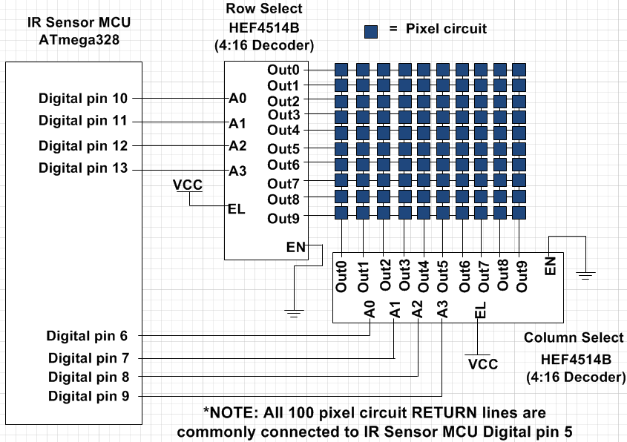
Fig 3. IR Sensor Array.
C. LED Driver Array System Concept
The group has arrayed 100 RGB LEDs into a (10x10) pixel circuit matrix. Each RGB LED anode will be terminated to a +5 V voltage supply, and every LED cathode will be terminated to a channel pin on the TLC5941. Every RGB LED consists of 4 pins (3 cathodes and an anode). This means that an LED driver channel will be needed for every LED cathode to be terminated. A total of 20 LED drivers will be used to control the grayscale fading of every LED. The Grayscale fading of all 16 LED channels on the driver will be controlled by the LED Driver MCU. There are 5 pins on each TLC5941 that must be terminated to the LED Driver MCU in order to operate the Grayscale feature. Because the group used 20 driver ICs, those translates into a total of 100 pin interconnections that must be accounted for. Fortunately, out of the 5 Grayscale driver IC pins, 4 pins can be commonly connected together to the LED Driver MCU’s general purpose digital I/O pins. This leaves a total of 20 unaccounted pins (XLAT). All 20 XLAT pins will be connected to a 5:32 demultiplexer circuit. 6 general purpose digital I/O pins on the LED Driver MCU will be used to control the 20 address lines of the 5:32 demultiplexer. Since no 5:32 demultiplexer IC exists on the market, the group has again utilized the HEF4514B. Two HEF4514B decoders will be used in conjunction to form an equivalent 5:32 demultiplexer. The details of how this XLAT addressing paradigm is implemented, and a description of TLC5941 Grayscale feature are both in Section V.
V. HARDWARE DETAIL
This section will focus on the design, description, and implementation of Knight Bright’s remaining low-level system and component-level hardware. This section will also serve to elaborate on some of Knight Bright’s higher order system design. Redundant hardware components, such as the MCU description and the touch sensor description, will be left omitted.

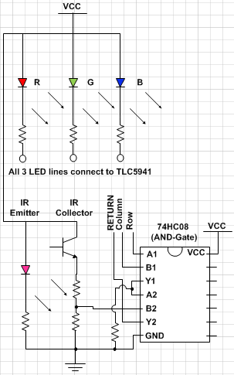
Fig 4. Unit Pixel Circuit diagram.

A. Pixel circuit
Each pixel circuit is comprised of a QSC123 phototransistor(IR-collector), a QED123 IR LED (IR-emitter), an RGB LED, a 74HC08 AND-gate IC, and 7
resistors. The pixel circuit components were mounted and soldered on Perfboard (DOT PCB). The circuit diagram in Figure 4 best depicts the design layout of the pixel circuit. The red, green, and blue LED bulbs shall each be terminated to a channel of the TLC5941 LED driver. The group was able to realize a 3-input AND gate by connecting two 2-input AND gates in conjunction with each other. The circuit diagram in Figure 5 best depicts this equivalent digital logic design.
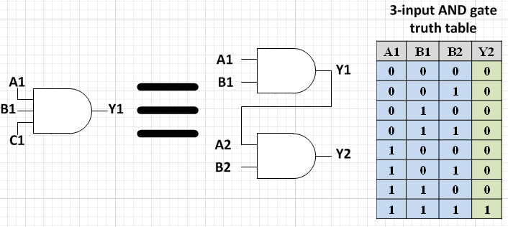

Fig 5. Equivalent 3-input AND gate, and truth table.
B. LED Driver Addressing
A 5:32 demultiplexer is used to address the twenty TLC5941 LED drivers. Since no 5:32 decoder IC exists on the market, two 4:16 decoders are used to create an equivalent 5:32 demultiplexer. The outputs “O1” through “O10” on the first 4:16 decoder connect to the XLAT pin of the first set of ten LED drivers(1-10). Outputs “O1” through “O10” of the second 4:16 decoder will connect to the XLAT pin of the second set of ten LED drivers(11-20). Digital pins 5-8 on the LED Driver MCU are address pins A0-A3, respectively. Digital pin 14 on the LED driver MCU is the equivalent 5th input address pin to access LED drivers 17-20. Digital pin 14 is commonly tied to the “EN” enable pin on both HEF4514B decoder ICs. Because the HEF4514B only outputs when “EN” is set low, the LED Driver MCU can toggle between the 2 decoders. Digital pin 14 is tied directly to the “EN” pin on the first decoder(the device that outputs to LED drivers 1-10). Digital pin 14 is also tied to an inverter logic gate IC (in this case, the CD4049UB hex inverter) and the output of the inverter is tied to the decoder that outputs to LED drivers 11-20.

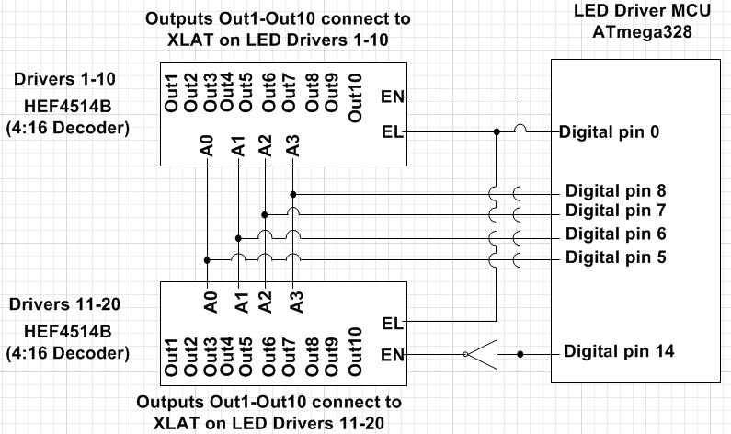

Fig 6. This diagram depicts how the LED Driver XLAT addressing will be implemented. Both HEF4514B decoders, when used in conjunction, becomes equivalent to a 5:32 demultiplexer.
C. TLC5941 Grayscaling
Grayscaling is a method of controlling the color brightness of a signal or image. In the TLC5941, Grayscaling occurs through 12-bit PWM, which allows the group to control 4096 distinct levels of color brightness. The TLC5941 has 16 distinct channels, each with 12-bits of PWM. The grayscale of all 16 channels is transmitted as one 192-bit long word serial data transmission between the LED Driver MCU and all 20 drivers. This means that, if one channel requires it’s PWM level to be adjusted, then all 16 channels must be accessed in order to make the change.
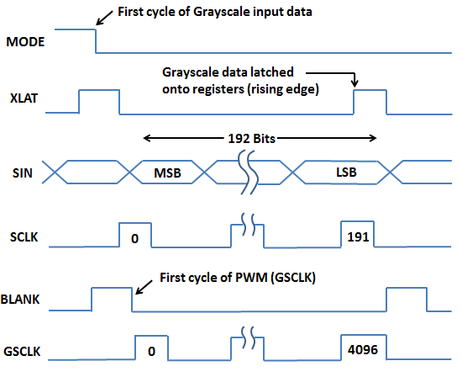

Fig 7. TLC5941 Grayscale Event Cycle.
The following 6 pins are required to operate the TLC5941’s Grayscale feature: Mode, XLAT, SIN, SCLK, BLANK, and GSCLK. The Mode pin is a switch that toggles the TLC5941 between Grayscale mode, and DOT Correction mode. When the Mode pin is low, the TLC5941 enters Grayscale mode. DOT Correction is not used in Knight Bright, so the Mode pin is simply grounded. XLAT is the latch pin for the 192-bit Grayscale word. Once XLAT goes high, then 16 x 12-bits of PWM serial data is stored onto all 16 channel’s internal registers. The XLAT pin is one of the most critical hardware features of the TLC5941. The existence of the XLAT hardware pin allows all 20 LED drivers to have all their serial data PWM pins connected in common with the LED Driver MCU. All 20 drivers will receive the same PWM serial data, but because only 1 XLAT can be triggered at a time, the remaining 19 drivers will be unaffected by the change. The SIN pin is the 192-bit serial data transmission line itself. The SCLK pin is the clock pin that distinguishes between all 192 individual serial pulses. The BLANK pin is a reset pin. Once BLANK transitions from high-to-low, then all 16 channels begin a PWM iteration. The GSCLK pin is a counter for all 16 channels’ PWM. GSCLK initiates at “0” decimal, and begins comparing it’s value with all 16 channel’s internal registers (where the serial data is stored). If the value stored in GSCLK is equivalent to any of the internal register values, that channel ceases PWM. Once all 16 channels have been checked, the GSCLK counts up, and checks all 16 channels again. This continues until GSCLK reaches “4095” decimal. Once this value has been reached, all 16 channels cease PWM. PWM for all 16 channels begins again when BLANK has been reset.
VI. BOARD DESIGN
There are 2 main layers in the final system design. The top layer consists of the wooden frame and pixel circuits, and the bottom layer consists of 4 corner Perfboards, the main PCB, and a PSU. The top layer consists of all 100 pixel circuit boards mounted onto a wooden frame. All pixel circuit wiring is ran through-hole under the wooden frame to the bottom layer. Each pixel circuit has a total of 8 copper wire lines; 3 RGB LED lines that run to the TLC5941, 1 VCC line, 1 GND line, 2 address lines(Row and Column) that run to the IR Sensor Array decoders, and 1 line(RETURN) that runs to the IR Sensor MCU. In total, there are 800 copper wire lines that must be soldered and terminated. To greatly simplify the final wiring termination, 25 pixel circuits will have 5 of their 8 distinct lines(VCC, GND, RETURN, Row and Column) terminated together onto a corner Perfboard. A total of four (5x5) pixel circuit corner boards will be used to partition the wiring. The remaining 3 lines(LED Red, Blue, and Green) on all 100 pixel circuits will be terminated directly to the main PCB board. In order to reduce cost, the group decided that Advanced Circuits would be the manufacturer of Knight Bright’s Main PCB. In order to qualify for the $33 board special on www.4pcb.com, the Main PCB must be designed with the following specifications:
- 2-Layers Copper plate
- Max. size 60 sq. inches
- Min. 0.006" line/space
- Min. 0.015" hole size
- Maximum 35 drilled holes Per Sq. Inch

Initially, the group developed the schematic and PCB design layouts of the Main PCB using CadSoft’s EAGLE Light Edition. This version of EAGLE CAD comes with a free license for university students. However, the dimension limitations of EAGLE Light (4 x 3.2 inches) were much too restrictive to develop the Main PCB on. Instead, the KiCad EDA Software Suite was used to develop the schematic and PCB layout of the Main PCB board. KiCad is released under the GNU GPL v2 public license, and comes with no development restrictions.
The Main PCB has the following ICs mounted on it: all 20 TLC5941 LED Driver ICs, all 4 HEF4514B decoders, all 3 ATmega328 MCUs, and the CD4049UB hex inverter IC. None of the ICs components are actually soldered to the board itself. Instead, DIP sockets are soldered to all through-hole copper leads. All IC components will be mounted onto these DIP sockets. This allows for simple hardware debugging, and reusability of the main PCB.
During the testing phase of the project prototype, there were many system failures due to faulty interconnection wiring between the system components. The fundamental purpose of the Main PCB, is to significantly reduce
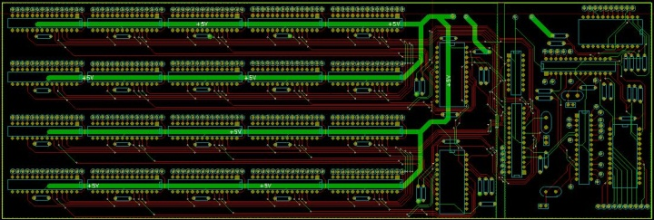

Fig 9. Main PCB board design

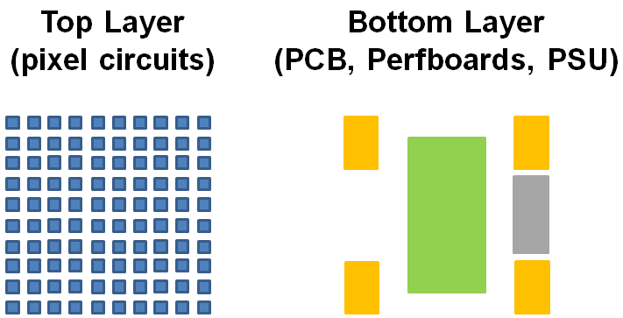

Fig 8. A depiction of the Top and Bottom Layers. On the Top Layer, the pixel circuits are mounted on the top side of the wooden frame. On the bottom layer, the Main PCB is centered, the 4 Corner Perfboards take up the corners, and the PSU is mounted between 2 corner sides flushed to one side of the frame.

these system failures by eliminating these connection faults. The group also noticed significant UART communication errors and power failures between the 3 MCUs. These system faults started occurring after the UART baud rate on all 3 MCUs was increased to 115 kbps. Sometimes the LEDs would display whenever Knight Bright was reset, but most of the time the LEDs and IR sensors would not output properly. It was determined that these system faults occurred because of power disruptions to the MCUs, due to the increased baud rates. To resolve this, the group used 2 power supply unit output terminals; 1 to power only the 3 MCUS, and 1 to power all other system components. Immediately, this solution resolved the system faults, and Knight Bright operated predictably once again. Therefore, a secondary purpose of the Main PCB is to isolate the 3 MCU’s VCC trace, and GND plate from the VCC trace and GND plate of the 20 LED Drivers.

VII. SOFTWARE DETAIL
Because Knight Bright is controlled using Atmel microcontrollers, all software support for Knight Bright was developed using the Arduino IDE. Arduino was also selected because of the group’s previous experience with the platform. Lastly, the Arduino development board comes with a boot-loader pre-installed. This allowed for a seamless transition from the prototype phase to the final design of Knight Bright. In the prototype, all 3 MCUs were each programmed on the Arduino board. In the final design, all 3 MCUs execute in standalone on the Main PCB board.
A. Board Programming
The user will have the capability of programming Knight Bright through the KB Board Programmer. The KB Board Programmer is a GUI application developed by the group using National Instruments’ LabWindows/CVI, and tested on a Windows 7 64-bit OS. The GUI acts as both a software development environment, and a board simulator. The SDE comes equipped with an onboard code editor and compiler. All source gaming files for Knight Bright were developed with the Knight Bright C (KBC) programming language, which was also developed by the group based on the C programming language syntax and grammar. KBC includes all fundamental reserved and control functions from C (main, for, while, if, function calls, etc.) The GUI compiler then compiles the KBC source program into Knight Bright Executable (KBE) machine code. KBE is equivalent to a (.exe) file for the Knight Bright board. The KBE machine code is then stored onto the SD memory card, where it can be accessed by the Primary MCU.

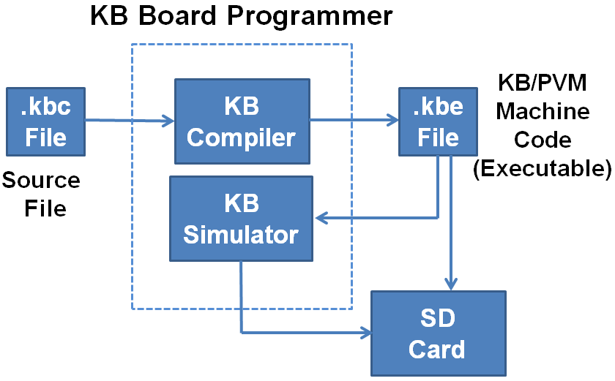

Fig 10. Knight Bright System Software design.

Once the (.kbe) file has been compiled and produced, the GUI simulator can then execute and simulate KBE code the same way it will run on the actual board. Some slight discrepancies are to be expected between the GUI simulator and Knight Bright final design, since the simulator executes instantaneously, and the Knight Bright board will have intrinsic timing delays.
B. Microcontrollers’ Software Detail
The Primary MCU was programmed with an onboard virtual machine (PVM). The Primary MCU receives (.kbe) machine code files from the SD flash memory card. The machine code is then read to the PVM, 1 byte at a time. A single instruction in (.kbe) is 3 bytes long, with the first byte correlating to a unique assembly instruction, and the following two characters correlated to modifiers and values of those assembly instructions, respectively. The JVM can jump to any point in the SD card to run loops, jumps, and subroutine calls.
The following protocol will describe the serial communication between the IR Sensor MCU and the Primary MCU. The IR Sensor MCU will receive an (x,y) coordinate from the touch sensor array, which the Primary MCU will initiate a status call of. The IR Sensor MCU will then return an appropriate value for the status of the touch sensor coordinate. The following protocol will describe the serial communication between the LED Driver MCU and the Primary MCU. The LED Driver MCU will receive an (x,y) coordinate from Primary MCU, and an 18-bit color value (6 bits for red, green, and blue, respectively). The LED Driver MCU will then set the RGB LED to the specified value.
Communication between all 3 MCUs will occur using the SoftwareSerial Library developed by Arduino. SoftwareSerial allows all 3 MCUs to use their digital general-purpose I/O pins as UART communication lines. Both the IR Sensor-Primary MCU, and the LED Driver-Primary MCU communication protocols are set at a baud rate of 115.2 kbps. They involve checksums to avoid errors.
C. Android Application
An Android OS-enable mobile device will be used as a wireless peripheral control to the Knight Bright board. The Android application for the wireless peripheral control was coded in Java, and developed on the Eclipse IDE using the Android SDK Plugin. There are 3 modes of peripheral control for the Android Application:
- Text input
- Remote controller with directional arrows and select buttons
- Grid mode for 1 to 1 touch control with the (10x10) pixel array
The grid and remote control modes will send specific predetermined characters to the Primary MCU for interpretation. Not to confuse the grid and remote controller characters with the input from the text window, the grid and remote control modes will send commands with a reserved character that will concatenate with the grid and remote control characters themselves. For instance, in the remote control mode, if the "up" arrow key is pressed then the character 'u' will be sent with a ‘#’ character to distinguish it from the 'u' character in text input mode.

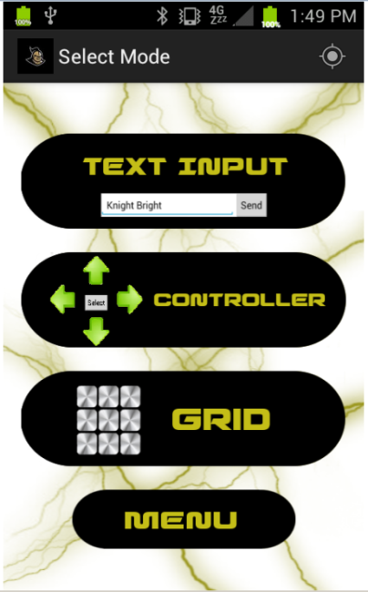

Fig 11. Knight Bright Android Application menu screen. All 3 peripheral control modes(Text Input, Remote Controller, and Grid) are available.
VIII. Power Supply
To power Knight Bright, the group had to find a PSU that came with 2 isolated terminals; 1 for the MCUs, and 1 for the rest of the board. Power ratings for all essential components were gathered from all relevant data sheets, and an absolute maximum power rating estimate was calculated. It was determined that the absolute maximum power rating for Knight Bright would run at ~147 W. All components, with the exception of the BT Module, operates at +5 VDC. Ultimately, the group settled on the TDK-Lambda LS200-5 PSU. The TDK-Lambda LS200-5 is a 2 terminal PSU that draws on 120 VAC, and converts it into +5 VDC.
Acknowledgements
Group 1 of the Spring-Summer 2013 section of Senior Design would like to acknowledge and thank the Department of Electrical Engineering and Computer Science at the University of Central Florida.
THE GROUP

Robin Adams is a double-major in Computer Engineering and Computer Science. She aspires to work as a Software Engineer after graduation. She has worked at Lockheed Martin through the CWEP program for the past two years, gaining experience with software communication protocols and discrete I/O.

Nathan Doran is a Computer Engineering major at the University of Central Florida. He hopes to become a Network Administrator for a major company. In his free time he enjoys gaming and learning Korean.


Tyler Hemp-Hansen is an Electrical Engineering major at the University of Central Florida. He worked for 1 year as an intern at Lockheed Martin. He enjoys learning about software and German in his free time.


Shaun Sontos is an Electrical Engineering major at the University of Central Florida. He currently works as an intern at Mitsubishi Power Systems. He is expecting his first child in September of 2013 with his wife of 3 years.

References
[1] ATmega328. Atmel Corporation, 2009. April 2013. <http://www.atmel.com/Images/doc8161.pdf>

[2] HEF4514B. NXP Semiconductor, 1995. April 2013.
<http://www.nxp.com/documents/data_sheet/HEF4514B_CNV.pdf>

[3] QED123. Fairchild Semiconductor, 2001. April 2013.
<http://www.farnell.com/datasheets/1533419.pdf>

[4] QSD123. Fairchild Semiconductor, 2001. April 2013.
<http://www.fairchildsemi.com/ds/QS/QSD123.pdf>

[5] TLC5941. Texas Instruments, 2008. March 2013.
<http://www.ti.com/lit/ds/slvs589d/slvs589d.pdf>

