S.S. Entertainment
Mark Boutwell, Daniel Graves, Hugh Hackler, Devin Hobby
Dept. of Electrical Engineering and Computer Science, University of Central Florida, Orlando, Florida, 32816-2450

Abstract --- This paper presents the design methodology used in order to implement a solar powered cooler for consumer use. Included features are battery protection, filter and amplifier network, LED display, and mobile phone application control. Also included in this paper is the design methodology for the software encompassing the mobile phone application.
Index Terms --- Analog Circuits, Active Filters, Audio Amplifiers, Battery Operated, Bluetooth, Mobile Communication, Low Power Electronics, Solar Powered, Peltier, DC-DC converters.

I. INTRODUCTION
Designed to include many features consumers look for when spending a day outdoors; a cooler to keep food and drinks, Bluetooth connectivity to steam audio wirelessly from a mobile phone, and ambient lighting. In addition, this project employs solar power and a battery operated circuit with battery protection in order to prevent overcharging. This project was self-funded and designed with input from each team member. Implementing a class AB amplifier with a three channel active crossover to drive a low frequency bass driver, mid-range driver, and two high frequency tweeters. Using solar power to charge a bank of batteries will provide ample power for the consumer during the day with the ability to plug into any US wall outlet to charge during the evenings when solar is not available.
II. SYSTEM COMPONENTS
This system is presented below in terms of system components; individual modules that are designed and interfaced to create the final product. Below is a semi technical introduction to each of these system components.
A. Solar and Battery Power
Our system is run off of a battery bank consisting of 10 D-cell NiMH batteries in series. These batteries are rechargeable but can be damaged by overcharging. We have implemented a charge controlled to monitor the battery voltage and to protect it from over-voltage. Another aspect of this sub system is the constant changing input power from the solar panel. We are using a 50-watt solar panel that has a short circuit current of 2 amps and an open circuit voltage of 25 volts. We implemented a buck DC-DC converter to convert power from the panel to be usable by the battery. The DC-DC converter limits the current to a maximum of 1 amp and is designed to match the voltage of the battery.
B. Power System
Our system requires regulated voltages at many different levels. The MCU requires a voltage of 5V for power, the Bluetooth module requires 3.3V, the audio system requires positive and negative 12V, and the cooling and charging stations require 12V. We decided to use linear voltage regulators to regulate the various voltages. We also needed a voltage converter to convert a positive 12V to a negative 12V.
C. Audio Filter and Amplification Network
The audio system consists of a three channel class AB audio amplifier with an active filter network implemented before amplification. A low pass, band-pass, and high pass filter separate the frequency spectrum and feed into an audio driver designed for each specific frequency band. Using only resistors and capacitors in the feedback loop of the active filters made this product cost effective and highly accurate at reproducing an input signal. Our audio system is fed an input from the main MCU and Bluetooth chip for streaming from a mobile device.
D. Cooling Station
The cooling station is primarily driven by two Peltier plates. These plates act as heat pumps that transfer the heat from one wide to the other. The cooling station will have slots the size of a typical aluminum can, which sits in fitted strip of fitted aluminum. The Peltier extracts the heat from the aluminum casing and into a heat sink. The heat sink will sit in an air channel which will transfer heat to the passing air and out of the system. A simple 12 V DC fan will push the air through the channels across the heat sinks. Since the Peltier plates are limited by a difference in temperature from one side to the other, it is absolutely crucial that the air dissipate the heat, to allow for cooling to take place. The temperature will be measure by a TMP36 which is read by the main microcontroller. This will allow the user to see through the mobile app the temperature at which the drink is cooling. The microcontroller also is connected to a relay which is used to turn on or off the stations.
E. LED display
The system includes an array of LED strips laid around the cooler. The user will be able to select one of four patterns to display on the LED strips or have the LEDs act as an audio visualizer that beats along with the music being played through the speakers.
F. Mobile Communication and Interface
The user can control the cooler via a mobile application developed for Android Devices. The application’s role is to provide a user interface to control the LEDs on the system as well as provide sensor readings from the device including the temperature in the cooler, the power output of the solar panel, and the current battery level. The application also sets up a connection for audio from the phone to be sent to the cooler’s onboard speaker system.
III. SYSTEM CONCEPT
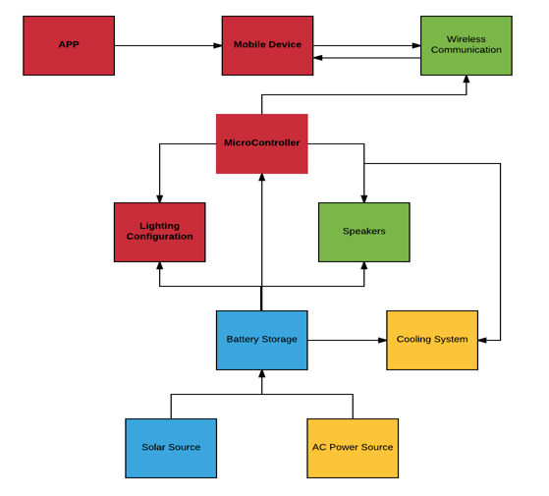
To understand the system completely, the following block diagrams have been included.
Fig 1. System Block diagram
Our system is controlled by an app that can be easily downloaded on any android device. The app communicates with a microcontroller via Bluetooth. This allows the app to receive feedback from system performance and control power to the system. We are making use of two Arduino microcontrollers. Firstly, we are using the Arduino Nano with an ATMEGA 328and is used to receive feedback from the solar panel and battery. Also it is used to control a PWM signal sent to the charge controller circuitry. The other controller makes use of the ATMEGA 328 chip, this controller communicates the feedback from the charge controller to the app while also controls and powers the LED strip. The MCU will also receiving feedback from the cooling station. After the data is received then it will make a decision whether it needs to cut or supply power to the Peltier plates. The MCU also communicates with the audio signal sent from a mobile device and will receive the signal via Bluetooth, sample it and recreate a signal to send to the filter and amplifier network. Next the power system will be shown and explained with a more in depth block diagram.
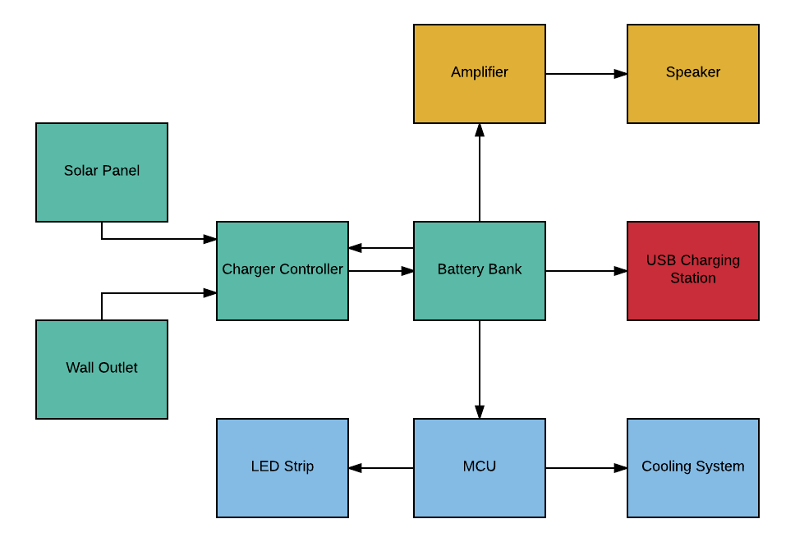
Fig 2. Power System block diagram
The power system begins with two sources. The first source being a solar panel and the second being an AC wall outlet. The system will take whatever input is available at the time of charging. The sources are then run into a charge controller. The duty of the charge controller is to monitor the battery level in the charging process. The controller will allow the source to charge that battery until a certain point. When the battery is fully charged the controller will cut the power sources off. We are using a 12V solar panel and also approximately a 12V battery bank. This battery bank will supply power to the various portions of the system. The power system will require multiple DC-DC converters. This is due to various components in the system running at lower voltages than our battery bank supplies.
Now that we have taken a look at the flow of this system, we can give a more detailed description of the hardware sub systems that were put together to accomplish this product. In order to simplify the task of testing each subsystem, we found it easier to keep everything somewhat separate. When we discuss the design and layout of the PCB an additional explanation can be found to shed light on our thought process.
IV. HARDWARE DETAIL
In the following section each feature will be explained in technical details unlike section II where just a simple introduction to each feature was presented.
A. Charge Controller
The charge controller consists two sub circuits interfaced together. The first is a hysteresis window that switches between states of charging and dumping energy flowing to the battery. The second is a DC-DC buck converter that converts the power from the solar panel to match that of the battery. The following circuit diagrams show these configurations.
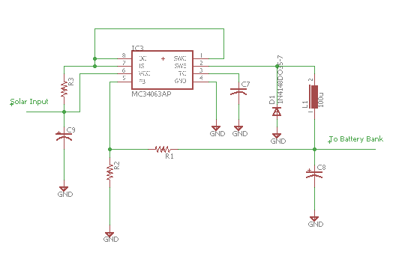
Fig.2: Buck Converter Circuit
This circuit takes input from the solar panel or AC power sources and regulates the output voltage and current. Resistors R1 and R2 can be chosen to output a specific voltage. Using the equation given in the datasheet of the MC34063
V₀ = 1.25(1+R₂/R₁) (1)
We selected our output voltage to be 15V therefore resistor R₁ = 1.2k and R₂ = 13k. Once this was set up we wanted to check our maximum current output. The MC34063 is rated for 1.5A and we measured a short circuit current of around 1.1A.
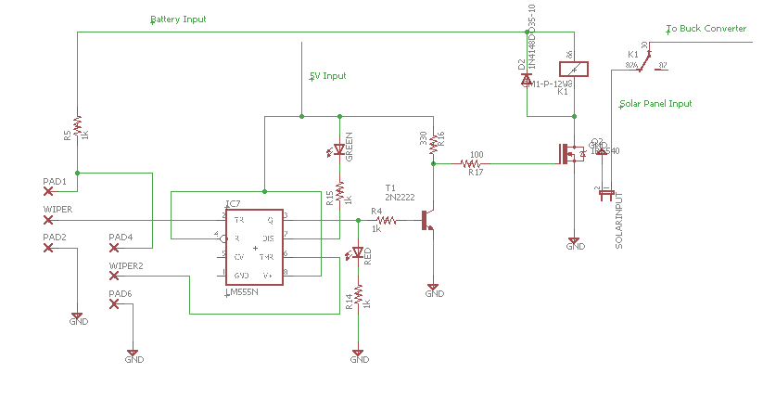
Fig. 3: Switching Network
This circuit uses the battery voltage read across two potentiometers to decide which state the battery bank is in. Depending on what the battery voltage is the internal flip-flop in the 555 timer will set or reset. Then the 555 timer either sends an output on pin 3 or it discharges on pin 7. There are two LED’s to correspond to either dumping energy or charging the battery. Once the timer outputs which state the charger needs to be in it runs through a BJT amplifier. This brings the voltage up enough to drive the MOSFET gate. Finally, the drain of the MOSFET gate is connected to one of the ends of the coil of a relay. The relay is set up to disconnect the battery from the source when charging has reach its maximum. This circuit is pretty versatile for different battery bank voltages. The window for protection can be changed very easily. There are two test points in the circuit, one is on pin 2 and the other is pin 6. We set our window using a DC power source. We set the DC power source to 12.2V then checked the voltage at test point 1 (pin2). Then you trim the potentiometer until the voltage at pin 2 is 1.67V. Next we set the supply voltage to 15.4V and measured test point 2 (pin6). We trimmed the potentiometer until the voltage on pin 6 was 3.33V.

B. Power System
- LM7805, 5V regulator
- LM7812, 12V regulator
- LTC1144, -12V regulator
- TI UA78M33CKCS, 3.3V regulator
Each of the linear regulator circuits uses a smoothing capacitor at the input and output to ground. The following schematics show our power system.
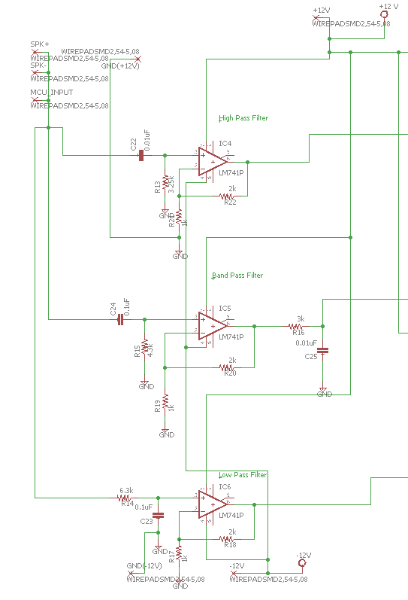
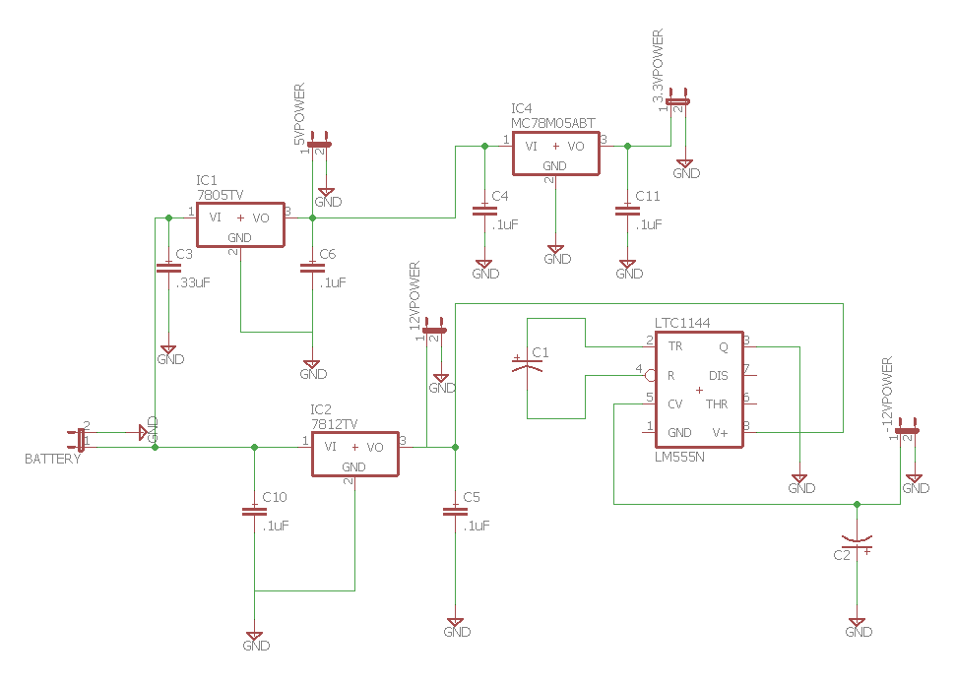
Fig 4. Power System
The battery is connected directly to the positive 12V and the 5V regulators. We tested the method of having the battery only connected to the 12V regulator then periodically dropping the voltage down from there. We ran into an issue of adding interference into our amplifier circuit. Then cascaded off of the 12V and 5V regulators we have the LTC1144 and the 3.3V regulator respectively.

C. Audio Filter and Amplifier Network
In order to produce high fidelity audio a homemade audio system was built. Designing an audio system can be quite challenging when trying to reduce noise while still delivering suitable gain and quality sound. An input from the MCU and Bluetooth is sent into a three-way active crossover to separate the input signal into three distinct frequency bands (lows, mids, and highs). Implementing active low, band, and high pass filters is done using the LF351 operational amplifier. An improvement over the LM741 it provides much higher input impedance and improved slew rate. Using resistors and capacitors each channel can be used to drive a specific audio driver and a DC gain of approximately 2 provides a slight pre-amplification.
Fig 5. Audio Crossover
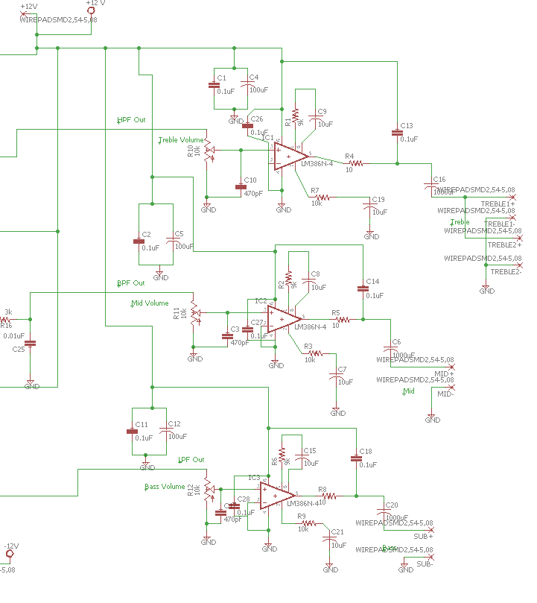
At the heart of the audio amplifier is the Texas Instruments LM386N-4 class AB operational amplifier. Class AB amplifiers are preferred for audio designs as they are efficient but provide superior sound quality. The design of the amplifier is fairly simple and is constructed from three single channel 1-W mono operational amplifiers. Two pins (1 and 8) are provided for gain control, if a resistor is placed in series with a capacitor the gain can be set between 20 and 200 (26 dB & 46 dB respectively). Gain was set to approximately 200 and tested at full volume in order to prevent clipping distortion to the signal. Decoupling capacitors were used to isolate any noise introduced by the power supply in each channel.
Fig 6. Audio Amplifier network
Audio drivers include a subwoofer, mid-range, and two tweeters. Volume controls for each audio channel (low, mid, treble) are provided to the consumer to tune the frequency band to the audio being streamed. Volume potentiometers are accessible for the consumer on the outer casing and speakers are mounted into the product to provide adequate stereophonic audio coverage.

D. LED System
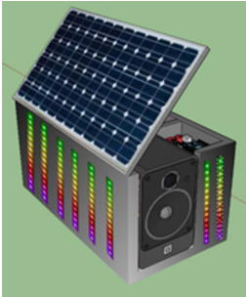
Fig 7. LED display
To get a nice look without using an impractical amount of LEDs, we decided to have 6 LED strips each on the long sides and 2 to 4 LED strips on the other two sides for a total of 300 LEDs. The LEDs will be individually addressable RGB LEDs, giving us full control over their color and intensity. Because controlling these many LEDs will require a rather large amount of processing power, they will be controlled by a separate microcontroller so that the main microcontroller can focus on the Bluetooth communication and audio processing. The user will be able to select from several different color schemes or create their own. The microcontroller will also be capable of taking the audio signal and control the LEDs to create an audio visualizer, changing the LEDs to match the audio.
For the LED display on the cooler, we went a strip of SMD5050 RGB LEDs with WS2811 controllers, The WS2811 controllers are widely used with the microcontroller we chose and already has great libraries for interfacing with the controller. For the microcontroller, we went with the same microcontroller IC as the main microcontroller, a single ATmega 328P. This allows us to simplify development by only requiring one development environment and programming board and also reduce costs by buying the microcontroller IC in bulk.
The hardware for the LED system is rather simple thanks to the WS2811 controller. The ATmega 328p only needs to use one digital pin to send data to the LEDs. Both the LEDs and the microcontroller require 5V, so they will be sharing the same +5V power rail. The LED microcontroller then connects to the main system microcontroller through the two pins for the I2C bus and one analog pin to receive the audio output of the main system microcontroller. The LEDs require 3-6 volts to operate with the optimal voltage at 5V and each LED consumes around 60 mA for a total power draw of 90 W for the entire roll.
E. Main Microcontroller
The microcontroller is the interface between the mobile application and the rest of the system, communicating with or controlling all of the other components and has many roles to play. The first job of the microcontroller is to communicate with the mobile application through the Bluetooth module. It will then have to convert the digital audio from the application to an analog audio signal that the audio amplifier will be able to use. The microcontroller will also have to receive commands from the mobile application to update the LED controller settings. Lastly, the microcontroller will have to read data from various sensors including: a temperature sensor found in the cooler, a power sensor attached to the Solar panel to aid the user in finding the best angle and position of the panel, and a sensor for reading the battery level.
To satisfy our requirements, we have chosen to use the AVR ATMEGA 328P microcontroller. Although there were cheaper options that satisfy our needs, we decided to go with the 328P for several reasons. The most significant reason was that the 328P is the same microcontroller used in the popular Arduino prototype development boards that has widespread support and documentation. Because this is the same microcontroller, we can flash the Arduino bootloader onto it and make it compatible with the Arduino IDE simplifying the programming process significantly. This made the ATMEGA 328P the best choice due to our familiarity with the Arduino development boards.

E. Cooling System
The Peltier plate is considered an inefficient device due to the large amount of power consumed during operation. This portion of the project is designed to be used sporadically as up to 60 W can be dissipated in the device. The benefit of these plate is their small compact design, easy DC configuration, and their solid state operation. These plates can reach up to a 57 ∘C difference between the hot and cold side. This means the cooling temperature is relative to the ambient temperature. The cooler the temperature on the hot side, the colder the cold side will be. Due to the simplicity the Peltier plates provide an easy to control 5 V relay is all that is necessary to operate the whole circuit. The on off state is controlled by the app which can display the temperature at which the drink is cooling. The TMP36 sensor communicates with the microcontroller through 10 mV steps, that correspond to a 0.1 change in the temperature.
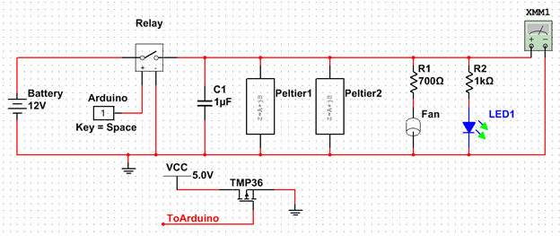
Fig 8. Cooling Station Schematic
Powering the circuit at 12 V, the connection will be made directly to the battery instead of through the 12 V regulator. This circuit is insensitive to voltage changes that fall in the batteries range of operation, so no damage is done in the fluctuation made by a fully or almost empty battery. Also, where the circuit to be powered through the regulator a large amount of current would be drawn and potentially damage the unit.
When tested in a room with a temperature of 23 ∘C, 6 ∘C was measured internally on the contact to the drink. In warmer ambient temperature, lower temperatures are more difficult to achieve but due to the concealed nature will still chill drinks placed in the station.

V. SOFTWARE DETAIL
The software for this product is used to program the microcontroller and serves as the main user interface for the consumer via the smart phone application. Through the software we are able to determine the cooler temperature, battery charge left, and solar power, while also enabling the consumer to control the LEDs and stream audio.

A. Mobile Application
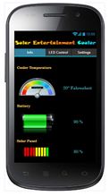
Fig 9. Mobile Application
The mobile application has been developed solely for Android™ devices due to an unavailability of testing devices for other operating systems. We are using the Android SDK in conjunction with the Android Studio™ development environment that was developed by Google specifically for developing applications for the Android operating system.
The graphical user interface of the application consists of three different pages. An info page displaying all of the sensor data from the cooler such as the cooler temperature and battery level. There is an LED Control page that lets users set the Mode and Color scheme. The final page allows the user to change settings for the application such as whether or not to intercept the audio from the phone and play it back on the cooler, the temperature unit to display on the Info page, and which notifications you want to receive.
B. LED Controller Program
While the hardware for the LED display and controller are simple, the program for the controller is much more complex. Once every loop, which will be in 33 ms intervals since we will be running at a refresh rate of 30 times per second, the controller will check the I²C bus for any incoming requests from the main system microcontroller. These requests will be contained in 80 bit packets. Three colors of 24 bits each, 8 bits per RGB channel, and 8 bits for the mode select. If one of these packets is received, it is processed and saved as settings in the program. One of these settings is the mode, of which there are currently four planned.
For the Audio Visualizer mode, it will need to convert the analog audio signal to multiple frequency levels and then to pixel data that it can send to the LEDs. Thankfully, there is a great Arduino library for using Fast-Fourier Transform on analog signals like this that is compatible with our microcontroller. Using the standard analogRead() in the main loop and analyzing the signal myself would be far too slow to provide useful data. The FFT library from Adafruit taps into a special mode of the Analog-to-Digital converter called free mode, automatically collecting analog samples at a specified sample rate and converting the samples into frequency spectrum using a Fast-Fourier Transform. The microcontroller then has to convert the complex frequency spectrum data into a graph representation and its color values and send them off to the LED controllers.
For the other modes, the microcontroller will be generating random patterns based on the time and mode. For instance, when the system is in Blink mode, the microcontroller will need to create a random alternating color pattern using the time as the seed. If the system is in mixed mode, it will randomly select from the other modes and set it as the current mode temporarily.
C. Main Microcontroller Program
The program for the microcontroller has three main jobs. It needs to process the Bluetooth packets for both receiving and sending. It needs to send commands to the LED controller. And finally, it needs to receive data from 3 external sensors.
The received packets from the phone will contain setting changes for the LED controller such as the mode and up to three different RGB color values for the color combination and theme. The LED settings component of the packet will be set at 80 bits, 8 bits for the mode and 24 for each of the three different colors. These 80 bits will be processed and forwarded to the LED microcontroller
The three external sensors are a temperature sensor from inside the cooler, a battery level sensor on the battery, and a power sensor on the solar panel output. All three of these sensors will have an analog output, so they will be connected to three analog input pins on the microcontroller. The built-in Analog-Digital converter has an output of 10-bit values, giving us a range of 1,024 possible values, which is more than enough for these sensor readings. These sensor readings will then be packaged into a response Bluetooth packet and sent to the phone through the Bluetooth module.

VI. BOARD DESIGN
We decided that it was best for our system to create two PCBs, one for the audio amplifier and MCUs and the other for the power and charge controller. This was done to minimize any external noise introduced into the audio signals. We choose the manufacturer PCBWAY as we found that their prices and turnaround time was our best option and there really weren’t any other competitors. At a price of around $56 dollars, we were able to order our two boards in quantities of five and we received them in exactly a week.

A. Power and Charge Controller
We designed this board using Eagle Cad software. We designed an initial trial board to test and prototype with. Once we had all the bugs worked out of the prototype we were able to redesign a more efficient optimized board.

B. Amplifier and MCUs
Using Eagle Cad software this board was designed to be separate from the power board in order to minimize any external noise introduced into the audio system. Our first board design was a success and was implemented in this product.

The Engineers

Daniel Graves is a 28-year-old electrical engineering major. Graduating in the fall of 2016 with a goal of working in the power industry. Working for a company such as Next Era or Duke Energy.


Mark Boutwell is a senior at the University of Central Florida studying Computer Engineering. He is currently a software developer at the Institute for Simulation and Training as an Army Contractor.


Devin Hobby is an EE major at UCF and a Simulation Systems Intern with MITRE Corporation. He currently is involved with Army research in the Human Dimension Domain.


Hugh Grant Hackler is a 27-year-old Electrical Engineering major at UCF. Graduating in Fall of 2016 with a goal of working in the specialized area of audio engineering and/or signal processing.

Acknowledgements
This team wishes to acknowledge the assistance and support of Dr. Lei Wei, Dr. Parveen Wahid, Dr. Qun Zhou, and Dr. Nazanin Rahnavard; University of Central Florida.

References
[1] T. I. Incorporated, January 2015. [Online]. Available:
http://www.ti.com/lit/ds/symlink/lm555.pdf.

[2] M. Davis, "A New and Improved Solar/Wind Charge
Controller," 2011.
[Online]. Available: http://mdpub.com/555Controller/.

[3] J. Eargle, Handbook of Recording Engineering, 2003: Springer.

[4] J.E.A.C, Foreman, Audio Engineering for sound reinforcement, Hal Leonard Corporation, 2002.

[5] JBL Professional, Sound System Design Reference Manual, JBL, 1999.

[6] Analog Devices “Low Temperature Sensors TMP35/37”, Datasheet, 2008, D00337-08/08(E).

[7] CUI, Inc, “Peltier Application Note,” 12 July 2016.
[Online].Available: http://www.cui.com/catalog/resource/peltier-app-note.pdf.

