Diabetic Ketone Breathalyzer
Jonathan Brown, Edert Geffrard, Christine Sleppy, Noah Spenser
Dept. of Electrical Engineering and Computer Science, University of Central Florida, Orlando, Florida, 32816

Abstract — The objective of this project is to create a non-invasive and simple way for a person to monitor ketone levels, which acts as a key indicator of an unhealthy glucose level. Through this relationship, persons with diabetes or restrictive diets can make sure ketone levels, and therefore glucose levels, are within a healthy range. Since ketones in the body break down into volatile acetone, the device itself measures the concentration of acetone particles in the user’s breath in order to give a ketone value. This direct relationship between body ketone levels and the levels of acetone found in breath, is the foundation of the project.
Index terms — Biomedical monitoring, biomedical microelectromechanical systems, biosensors, diabetes, gas detectors
I. INTRODUCTION
Diabetes is a disease that causes elevated glucose levels due to the inability of the body to produce a hormone called insulin. Insulin regulates the amount of glucose in the blood. When diagnosed with Type 1 Diabetes, the pancreas can’t automatically work to supply insulin throughout the body and diabetics have to take care of this burdensome process themselves. The first step in properly carrying out this task is for patients to know their blood glucose levels throughout the day. Everyone has their own healthcare plan that works for their body, but the most important part of that plan is proper management.
Currently the only accurate method for blood glucose testing is by pricking the finger. The finger prick draws a drop of blood that is placed on a test strip and read by a meter. This process must be done before every meal or snack as well as any other time when the diabetic is feeling like they’re experiencing symptoms of high or low blood sugar levels, both of which can be very dangerous to the body. In addition, keeping a log of results is vital to be sure that the body is agreeing with its current healthcare plan. This is very demanding, invasive, and painful resulting in the lack of proper management by the diabetic. It is unhealthy for them to be unaware of their blood glucose levels throughout the day. Our project proposes a possible solution to these daily difficulties. The Diabetic Breathalyzer is to create a device that can detect a range for one’s blood glucose level by breath. This is noninvasive and less painful to do multiple times throughout the day.
The Diabetic Breathalyzer will have many features that are attractive to those who suffer from diabetes. This device will be small and compact for easy portability and allows for a glucose-monitoring device to be on their person at all times. It will send data directly to the user’s smartphone via wireless communication. This will provide the diabetic with an easy way to see trends in their data and help promote them to act accordingly and live a healthier lifestyle. Our non-invasive feature will help encourage the user to be aware of their blood glucose levels more often.

II. BIOCHEMICAL RELATIONSHIP

The entire basis of this project hinges on our ability to create a distinct relationship between certain chemicals found and measured inside the body. Through understanding why and how certain measurable chemicals are present in the body, we can make assumptions about the health of the individual.

A. Diabetes Biochemical Impact

The idea can be implemented by the relationship between acetone levels in the breath and ketone levels in the body. Ketones are a class of chemical produced in the body when there is a shortage of insulin causing the body to use fat for energy instead of glucose. The acetone levels in one’s breath can be used as an indicator for presence of these ketones. A paper published by the American Journal of Clinical Nutrition states that, “Breath acetone is as good a predictor of ketosis as is urinary acetoacetate.” [1] Diabetics with very high levels of glucose see these ketones in their urine. Ketosis is the condition in which ketones are being created in the body as a result of lack of insulin. By showing that there is a clear correlation between measured acetone levels in breath and measured acetoacetate in urine, we can conclude that a device, in which spikes in breath acetone are found, will be able to accurately show dangerous spikes in ketones. The connection between our design and methods, already confirmed to be reliable, will allow us to confidently create a necessary correlation.
This idea of a diabetic breathalyzer would be able to determine the levels of acetone in the breath and directly connect it with the presence of ketones in the body, which leads to the indication of high blood glucose level without a single prick of the finger.

B. Sensor Functionality

The two volatile organic compound sensors used in the breathalyzer work by a simple voltage divider circuit to monitor the change in resistance in the sensing unit. By heating up a small piece of metal oxide within the sensing unit, resistance then becomes directly related to the concentration of volatile organic compounds in the air. In order to monitor the change in this resistance, the MCU tracks the measured voltage in between the sensor and a specified load resistance, R, as seen in the circuit in Fig 1.
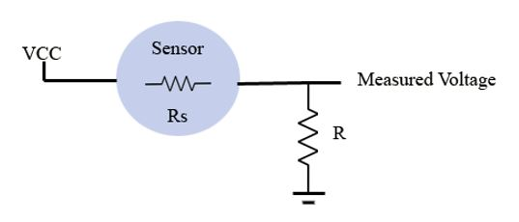
Fig 1. Circuit representation of voltage divider circuit used to monitor the change in resistance in Rs.

The measured voltage is taken in by the MCU using an analog pin and that is converted to a resistance value using equation (1) where R is the load resistor, VCC is the standard 5V input, MV is the measured analog voltage, and Rs is the measured resistance of the sensor.

$Rs=R(\frac{VCC}{MV}-1)$ (1)
For our device, VCC will always be 5V and R will always be 4.7 KΩ. Having these constants known, the MCU can take in the analog voltage reading (MV) and compute what the current resistance is. It is this resistance value that gives us our ratio that can be directly related to gas concentration.

III. DATA RELATIONSHIP

In order for the device to function as intended, a mathematical model is needed to relate the measured resistance of the sensors and a real concentration value in parts per million. The only resource available to make these relationships are the charts provided in the sensor datasheets. It is from these charts that equations were found using linear line regression to make the necessary relationship.

A. Datasheet Figures

The device uses two different volatile organic compound sensors in order to get an accurate reading of the concentration of acetone in the user’s breath. The first sensor, the TGS822 from Figaro, has a concentration range of 50 PPM to 5000 PPM which can be seen in Fig 2. The TGS is used to measure potential large quantities of acetone that would be found in the breath of an unhealthy individual. As Fig. 2 shows, there is a logarithmic, inverse relationship between measured resistance level of the sensor and concentration of volatile gasses.

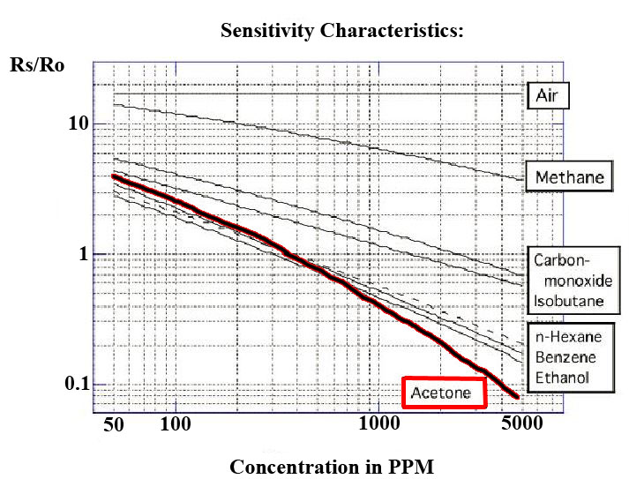
Fig 2. Relationship between the measured sensor resistance, as compared to a base value, and the apparent gas concentration in parts per million for the TGS822. [2]
We can see in Fig 3 that the temperature and humidity experienced by the sensing unit can have measurable effects on the perceived resistance of the sensor. This must be taken into consideration when trying to get a real PPM value and is the reason for creating a scaling factor based on the information in Fig 3. Once temperature and humidity are known, the measured resistance is scaled by a value that typically falls between 0.7 and 2.

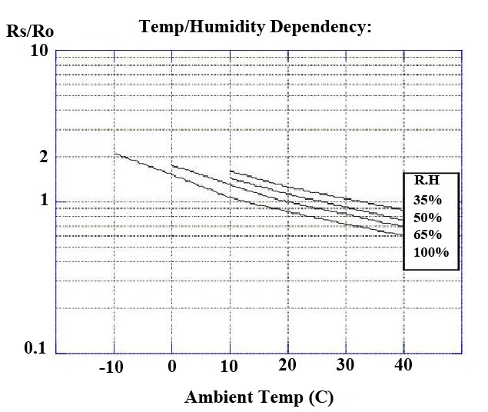
Fig 3. Dependency that the TGS822 has on temperature and humidity as stated by the datasheet. [2]
Fig 4 and Fig 5 show similar plots and relations for the second sensor used, the Grove WSP2110 from SeeedStudio. This sensor has a sensitivity range from 1 to 50 parts per million. Using the TGS in combination with the WSP gives a sensitivity range of 1 to 5000 PPM which covers every possibly scenario a ketone breathalyzer would be concerned with. The relationships for the WSP are similar to those of the TGS with an inverse logarithmic one between sensor resistance and gas concentration. The temperature and humidity scaling factors are also similar in look to the TGS.

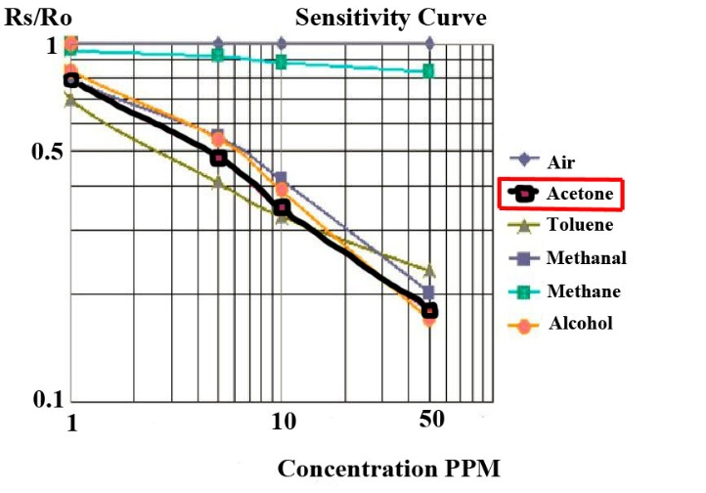
Fig 4. Relationship between the measured sensor resistance, as compared to a base value, and the apparent gas concentration in parts per million for the WSP2110. [3]
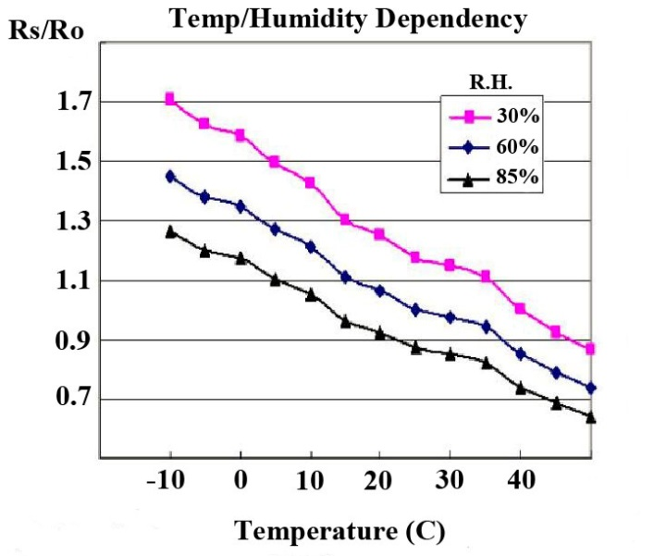
Fig 5. Dependency that the WSP2110 has on temperature and humidity as stated by the datasheet. [3]
B. Linear Line Regression

Using figures 2-5, a mathematical model can be created to explain the relationships of interest. By simply logging each data point into Microsoft Excel for each graph, the linear line regression tool was used to create a useable equation to describe the relationship between sensor resistance and gas concentration, along with dependencies on temperature and humidity.
It can be seen, when visually studying Fig 2 for the TGS, that the relationship is not exactly linear for the entire range of resistance ratios. The same fact can be seen in Fig 4 for the WSP. Being able to use a straight line for computing gas concentration is very helpful and straightforward, so each plot for the TGS and WSP were broken into two parts to get equations that best fit the original line.
First we look at the TGS822 sensor and by studying Fig 2 we can see the line begins to diverge from linearity around when the resistance ratio is equal to 0.6. This value was used as the breaking point between equations for the TGS. Readings that get a resistance ratio above or equal to 0.6 will use Equation (2) and readings that get a ratio value below 0.6 will use Equation (3).

$\log\left(\frac{R_{s}}{R_{o}}\right)=1.897973-0.742212*\log\left(PPM\right)$ (2)

$\log\left(\frac{R_{s}}{R_{o}}\right)=2.725923-1.037742*\log\left(PPM\right)$ (3)

Using these two separate equations instead of a single equation brings the R squared value from about 0.92 up to 0.99 which shows us that the relationship created is one that provides sufficient confidence.
The next step in creating a proper mathematical model for the TGS822 sensor is to relate the temperature and humidity to a particular scaling factor. Fortunately, the relationship is fairly predictable and from Fig 3 a multivariable equation can be created that accurately relates temperature and humidity to its impact on resistance. We can see that this relationship is

$\log\left(SF\right)=0.4454-0.01045*T-0.00295*H$ (4).

Here, SF stands for Scaling Factor, which is what we divide the initial resistance value obtained by. T is the measured temperature in Celsius and H is the relative humidity in %.
The exact same process can be used to create necessary mathematical models for the WSP2110 sensor. By studying Fig 4 we again broke up the resistance and PPM relationship into two better fitting lines. For the WSP, we consider all ratio values greater than or equal to 0.45 for our first equation (5), and then ratio values less than 0.45 for equation (6).

$\log\left(\frac{R_{s}}{R_{o}}\right)=-0.9754-0.3203*\log\left(PPM\right)$ (5)

$\log\left(\frac{R_{s}}{R_{o}}\right)=-0.0837-0.3781*\log\left(PPM\right)$ (6)

Again, by splitting up the line into two different equations, we are able to get and R squared value over 0.99 which confirms our use of the equations obtained. And finally the scaling factor is represented the same way as the TGS but by studying Fig 5 now. Equation (7) shows this relationship with SF, T, and H, all representing the same values as before.

$\log\left(SF\right)=0.28299-0.0049*T-0.00249*H$ (7)

Using these found equations makes working with the sensors possible. They are easily implemented into the hardware code on the ATMega328p MCU which can handle any mathematical computation we may need.

IV. HARDWARE CONFIGURATION

While the hardware for the Breathalyzer device is simple, proper management of the sensors and the incoming data is critical to an accurate device. Precision mathematics and quick, accurate delivery of data are important factors to proper functionality.

A. Power System

The main concerns with power come from the fact that our device must remain lightweight, comparable to a cell phone or similar device, and it must be portable. These requirements create a specific need for the type of power system our device has. Since the device is portable, the battery we use has to be rechargeable with the ability to last an entire day, or 12-14 hours. This again goes along the lines of standard use for a cell phone type device that many people are already accustomed to using.
To meet these needs, the power source selected was a lithium ion polymer battery. These batteries boast high capacity and small size. Since lithium ion batteries come in increments of 3.7 V for each cell, our input voltage would be around 7.4V if we decided to use two single cell batteries to suffice the 5V the two sensor heaters run on and therefore there would be a rather large drop-off that could prove costly with respect to energy if used frequently, which it will be with our device. This would call for the need of a step-down (Buck) regulator.
We found it more space and cost efficient to implement a step up regulator with the use of only one single cell battery without trading in efficiency.
The regulator we use to get the necessary steady 5V is a compact (0.32″×0.515″) U3V12F5 switching step-up (or boost) voltage regulator from Pololu. Using this instead of a linear regulator allows us to achieve optimal efficiencies and save on energy consumption which will be very critical in the functionality of the device. [4]
The use of basic linear regulators can, however, be used when 3.3V is required. Since the current draw on those 3.3V components is low compared to the current draw by the heaters running in the sensors; the concern for energy loss is minimal.
The Lithium Ion and Lithium Polymer battery charger we use to recharge the power source is based on the MCP73833. It uses a USB mini-B for connection to any computer or 'USB wall adapter'. Charging is performed in three stages: first a preconditioning charge, then a constant-current fast charge and finally a constant-voltage trickle charge to keep the battery topped-up. The fast-charge current is 500mA by default, but is easily adjustable from 100mA up to 1000mA by soldering a through-hole resistor on-board. [5]
In order to determine what capacity our battery will require, we must consider the current draw of the device. Since the majority of the time the device will be in sleep mode only powering the sensor heaters, we can look at just the current draw of those. All other components will be used sparingly and have a much smaller impact on power consumption than the sensor heaters. Both sensors will combine to draw about 180 mA of current during down time. If we are to maintain our initial requirements of a device that will hold a charge for 12-14 hours, ideally our battery would have a capacity of (180mA)*(12-14 hours) = 2160-2520 mAh. This would be the required capacity needed if our conditions were ideal. Unfortunately, many other factors can play a role in the lifetime of a battery including but not limited to temperature, current draw rate, and charging tendencies. Because of this it is recommended to apply an allowance for these unknown factors. We will use the assumption that 80% of the capacity will be used for our purposes as a way to assure the necessary leeway to achieve our requirements. This factor is chosen simply as precaution for this specific project and does not hold a particular value. Our value of 80% is to assure that our needs are more than met. This can be seen in equation (8).
$\left[Draw\left(mA\right)*Duration\left(hr\right)\right]÷Allowance$ (8)

With the consumption figured to be about 180 mA and the desired duration of 12-14 hours along with an allowance factor of 80%, our new desired range of battery capacity is 2700 – 3150 mAh. So our needs require a power source with at least a capacity of 3100 mAh, which is the capacity of the battery we selected.
B. MCU Control

This device requires a control unit which can quickly do floating point math while also controlling peripheral modules. This needs to be done with as little energy as possible as well. Because of these reasons and the familiarity, our Ketone Breathalyzer utilizes the ATMega328p which is the standard control unit in the popular Arduino microcontroller devices. By having the capacity to remain in an Arduino C based programming environment, we can have a less demanding time getting the right functionality our goals requires. Our device requires that there be enough general purpose input output (GPIO) pins so as to keep up control over the different sensors and the Bluetooth module. The sensors likewise require a devoted analog pin keeping in mind the end goal to peruse the resistance of the sensors, which is the pertinent data needed from them. The ATMega328p can handle all of these requirements effectively.

C. Sensing Hardware

The most integral part of the Breathalyzer unit is the Volatile Organic Compound sensor. These sensors fuse the utilization of a warmed metal-oxide component that has a variable resistance. The resistance is reliant on the grouping of certain carbon based chemicals called Volatile Organic Compounds. The most striking of these are methane, ethanol, carbon monoxide, and the compound this project is worried with, CH32CO (acetone). The changing resistance brought about by the presence of these compounds is directly correlated to its concentration. It is from the CH32CO data information that the ketone estimation will originate from.
The two sensors we chose to use, as previously stated, are the TGS822 and the WSP2110. These sensors offer a small package size which is crucial to our finished product, as every needed to fit with our specific enclosure. Along with this they are easily read using nothing more than an analog pin which works very well with the microcontroller chosen to run the breathalyzer.
Current research is inconsistent in saying what a typical acetone concentration could be in the breath, since it can vary from person to person. An expected range would be from 1ppm to over 1000ppm. This would require the use of both sensors as the WSP2110 would be used to detect levels in perfectly healthy individuals, and the TGS822 would be used to detect levels in individuals
A combination between the two sensors, WSP2110 and TGS22 covers a very large range allowing us to get as exact levels when detecting acetone as possible.
The other sensor involved in figuring out acetone gas concentration is the temperature and humidity sensor. We used the DHT22 module which provides accurate readings at a low voltage and current draw. It is important to have accurate readings for both temperature and humidity since the VOC sensors have dependencies on those values. Without adjusting our readings for the change in temperature and humidity the concentration values received would be skewed in a higher direction.

D. Wireless Communication

The breathalyzer device utilizes a low power Bluetooth module to communicate with a designated Android phone. The module used is the HC-05 which runs off of 3.3V and uses serial communication to transport data. While the range of the device is up to 30 meters, at no time during typical use should the distance apart ever be more than a few feet. Using Bluetooth was the easiest option for data delivery since most handheld devices have Bluetooth capability already built in.

E. Physical Description

The most important factor with this project when considering the physical design is transportability. Since the device will be used repeatedly throughout the day, and should be able to be carried with little inconvenience. One factor in transportability is the weight of the unit. To achieve this, the casing is made of a lightweight ABS plastic to ensure durability while still conforming to the lightweight requirement.
The mouthpiece in which the user breathes into is a durable plastic tubing that will be detachable. By allowing the user to remove the mouthpiece, the device will be easier to transport. Due to the fact that germs from the users mouth could build up on the mouthpiece with repeated use, implementing the use of antimicrobial plastic for the mouthpiece was necessary. Being able to remove it from the unit will allow the user to clean it as well.
Since the device relies on the analysis of exhaled breath, it was important that once the inner chamber fills, it remains as stable as possible, for as long as possible. This will assure that the data received form the VOC sensors is reliable. Air is able to enter the chamber from a specific point, but be prevented to exit once the exhaled breath is complete. This is achieved by sealing all points where air could escape except for a single air vent hole that will allow the user to cover it up after exhalation to assure an accurate reading. As long as the device is able to pick up the maximum resistance change, the length of time that the air inside is stagnant is not too much of a factor. Finding this max value typically takes only 5 to 10 seconds after the user finishes breathing which allows for quick and efficient use.

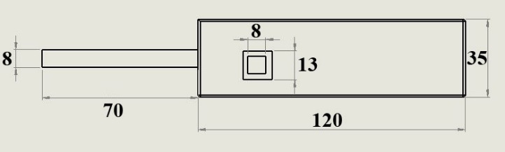


Fig 6. Measurements of the breathalyzer unit in millimeters.

Figure 6 shows the final dimensions of the breathalyzer device. The size of the main body is similar to that of a standard smartphone but with added depth in order to contain the necessary sensors. By trying to mimic the typical size of a phone, usability is made easier since readings can be achieved with a single hand working the read button.

F. Device Functionality

Using the breathalyzer is very straightforward. The main device power will be controlled by a switch on the bottom of the unit. Typical use would have this left on at all times in order for the sensors to retain stability at all times. This is necessary in order to take readings whenever the user desires. All other operations within the unit, MCU and Bluetooth module, will be in a low power or off state. Only when the read push button is pressed on the side will the hardware code begin to run.
Each time the read button is pressed, the breathalyzer will go through a 10 second warmup loop that assures the sensors are at a stable state. During this time, a status LED located opposite of the read button will be lit blue. Blue is representative of an unstable or warming up state. Once it is confirmed that the sensors are where they need to be, the LED will turn green indicating that it is time for the user to begin breathing into the mouthpiece. The user then exhales an entire breath into the device while holding down the read button. During this time the status LED will return to blue as the sensors are no longer at their stable state. Within 10 or 15 seconds from when the read button is released, at the end of the breath, the Bluetooth connect Android application with present the current value of acetone in the breath in PPM and what that relation is to typical ketones levels found using urinalysis strips. When all is finished the user will be able to see a healthy range and where their values fall in that range.

V. DEVICE AND APP SOFTWARE

A. Arduino Hardware Code

In order to process the data coming in from our various sensors, the MCU must be able to take in an analog value, compute the correlating equations, (equations 2-6), then send that value over a Bluetooth channel. This can be easily achieved within the Arduino IDE with the use of a few standard libraries and custom functions to do the computations.
Once a Bluetooth connection is made, the hardware code will begin reading once the signal from the push button goes from low to high. This initiates the computational analysis of the analog read on the two VOC sensors. That data along with the readings of temperature and humidity are then placed within the proper equation and a final value is sent via serial communications over the Bluetooth module.

B. Application Code

The application is the main user interface of the whole device. Therefore, the user needs an easy intuitive way to access the data stored inside it from previous readings as well as a meaningful and helpful way of interpreting the data from each reading. In addition, once an initial pairing is made, the device should automatically connect and function without much user effort for the foreseeable future.
Upon receiving the data from the device, the application must first display this information to the user when they prompt the device to connect and send data. Then, it must save each stored value to the phone’s memory in a permanent file. Upon every launch it must repopulate the contents of the file to the code and update the file as the user supplies new readings. Proper communication and reception of values as well as reliable storage with adequate information is important.

VI. EXPERIMENTAL RESULTS

This project required a certain level of experimentation, once the device was built. Through prototype testing, we needed a confirmation that the assumption we made about acetone being related to ketone levels was accurate. While there is biological and chemical evidence to support this claim, we needed to confirm that our device would further support it as well.
To achieve this confirmation, ketone test strips were used to get a urine ketone level. The strips use a color coded gradient to show where the user’s ketone levels fall. With these, we were able to compare computed values from our ketone breathalyzer to the test strips. What we found was that low levels of acetone registered in the breath did relate to low levels of ketones in the user’s urine.
This is where we ran into a problem of biological experimentation. In order to confirm that high readings from our breathalyzer correlate to high levels of ketones in urine, we would need an individual that is very unhealthy. Since this is not a proper medical experiment, this was not attainable.
Though this proved a problem, we were able to show an increase in measured acetone levels in the breath to a ketogenic change in diet. This change requires an increased consumption of fat and a decreased consumption of carbohydrates, forcing the body to burn fat as fuel as opposed to glucose. This is the process that increases the amount of ketones in the body. Though the evidence is anecdotal, we can say that our device can and will measure a change in acetone levels in a person’s breath. We can say that this acetone level is directly related to ketone levels since ketones break down into an acetone gas inside the body.
Table 1 shows results from two group members. The first two rows indicate initial uses before any diet changes were done. The first column the results from the ketone strips which use a numbered scale to represent ketone concentration in urine. The scale is 5-160 and is representative of the ketone level in the user’s urine in mg/dL. Once this value approaches 80, the levels are said to be high. The next column has the readings from our breathalyzer in parts per million. These values are general averages over a few breaths done in succession over the course of a few hours. We can see that with a change in diet to increase ketone levels, there was a small measurable change.
TABLE 1
EXPERIMENTAL RESULTS
 | Urine Ketone Level | Breathalyzer acetone PPM | Notes
User 1 | 5-Trace | 1.75 | No diet changes
User 2 | 5-Trace | 1
User 1 | 15-Small | 8.7 | After a week of low carb dieting
User 2 | 10-Trace | 6.2

This change is extremely small and further testing would be required to confirm bodily changes continue to match the breathalyzer changes. So while our experimental confirmation is light, we are confident in saying our device will measure acetone levels in the breath, achieving our goal.
One thing that should be noted about the use of our breathalyzer device is that the sensors used are not specifically tuned to just detect acetone. There are many other volatile organic compounds that can cause the sensors to react. None of these compounds are naturally present inside the breath of a healthy individual in any measurable amounts. However, any consumption of alcohol leading up to a reading will cause the device to see a huge spike. This spike is a reaction to the ethanol and not acetone within the breath. While this could cause great problems with frequent drinkers, our assumption is that a typical diabetic would not be too heavy a drinker due to the complications that it can cause with the disease. We have also found some anecdotal evidence that residue from inhaled smoke can cause minor spikes in the acetone readings. So the conclusion from these observations is that alcohol and tobacco should not be consumed around testing times.

VII CONCLUSION

This project allowed us to take a look at a very serious issue, diabetes, and work on trying to help those afflicted by the disease. We all know someone impacted by diabetes, so being able to explore technological options for making living with diabetes easier was greatly rewarding. However, this project presented us with many problems along the way, mainly the fact that the technology we used is simply not sophisticated enough to be considered a true solution to the issue of glucose and ketone monitoring.
This project started with the hope that we could use breath analysis and metal-oxide sensors to detect glucose levels in the body. This proved to be an unachievable feat considering the resources available to us. Due to the fact that acetone levels in the breath are not immediately impacted by a user’s glucose level, the scope of the project had to change. Instead we had to look at what the acetone was directly related to, ketones.
By transitioning our goals into ketone monitoring we were able to build a breathalyzer that can give a user an indication on whether or not their ketone levels are dangerously high. Previously this was done with urinalysis test strips. While the test strips may provide a more precise understanding of one’s ketone levels, the breathalyzer is much quicker and easier to use, which was one of the main goals from the start. We wanted to create a product that would make the lives of those dealing with diabetes easier. Our project proves that there is reason to look into this acetone and ketone association with further research.
Research is currently being done to help fix this problem. With proper sensor technology, a greater level of accuracy can be achieved which would provide more worthwhile data. Currently new types of metal-oxides are being looked into as a way to garner this greater accuracy. While the sensors our device use are based on tin and aluminum oxides, current research is being done on a titanium based metal-oxide sensor. [6]
The future for biotechnology is a very exciting one. As biological and technological understanding advances further, the limits at which we push will also advance further.

REFERENCES

[1] Kathy Musa-Veloso, Sergei S Likhodii, and Stephen C Cunnane. Breath acetone is a reliable indicator of ketosis in adults consuming ketogenic meals. American Journal of Clinical Nutrition 76.1, U.S. 2002
[2] Figaro, “TGS 822-for the detection of Organic Solvent Vapors,” TGS822 datasheet, Revised Feb. 2009. www.figarosensor.com/products/822pdf.pdf
[3] Winsen, “VOC Gas Sensor Manual,” WSP2110 datasheet, May, 2013. http://www.winsen-sensor.com/d/files/flat-surfaced/wsp2110.pdf
[4] RobotShop, “5V Step-Up Voltage Regulator U3V12F5”, Regulator datasheet, www.robotshop.com/media/files/PDF/datasheet-2115.pdf
[5] Microchip, “Stand-Alone Linear Li-Ion / Li-Polymer Charge Management Controller,” MCP73833/4 Datasheet, https://www.adafruit.com/datasheets/MCP73833.pdf
[6] T. Itoh, I. Matsubara, M. Kadosaki, Y. Sakai, W. Shin, N. Izu, and M. Nishibori, "Gas-Sensing Properties of Tin Oxide-Based Volatile Organic Compound Sensors for Total Volatile Organic Compound Gases," Sensors and Materials, vol. 21, no. 5, May 2009. Available: myukk.org/sm_pdf/SM0765.pdf

