Initial Project Document- Divide and Conquer

Diabetic Breathalyzer
New and Noninvasive

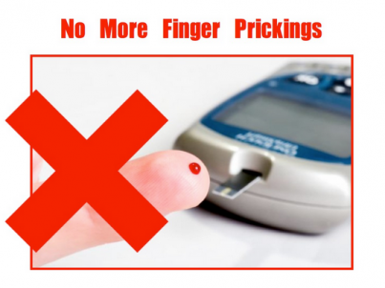

Department of Electrical Engineering and Computer Science
University of Central Florida

Group 13

Jonathan Brown Electrical Engineer
Christine Sleppy Electrical Engineer
Noah Spenser Electrical Engineer
Edert Geffrard Electrical Engineer
Project Narrative
Diabetes is a disease that causes elevated glucose levels due to the inability of producing a hormone called insulin. This disease affects millions of people every day who have to constantly monitor themselves and their food intake. Insulin regulates the amount of glucose in the blood. When diagnosed with Type 1 Diabetes, this process is not so simple. Without the pancreas automatically working to supply insulin throughout the body, diabetics have to take care of this burdensome process themselves. The first step to properly carrying out this task is to know their blood glucose level.
Traditionally, monitoring ones blood glucose level is through a prick of the finger. In fact, this is currently the only way to accurately determine ones blood glucose level. Pricking the finger draws a drop of blood that is placed on a test strip and read by a meter. This process must be done before every meal or snack as well as any other time when the diabetic is feeling like they’re experiencing symptoms of high or low blood sugar levels, both of which can be very dangerous to the body. In addition, keeping a log of results is vital to be sure that the body is agreeing with its current healthcare plan. This is very demanding, invasive, and painful causing the diabetics to carry out proper testing less often. It is unhealthy for them to be unaware of their blood glucose levels throughout the day. Our project proposes a possible solution to these daily difficulties. The goal of our Diabetic Breathalyzer is to create a device that can measure one’s blood glucose level by breath instead of by pricking the finger. This is noninvasive and less painful to do multiple times throughout the day.

The idea can be implemented by the relationship between acetone levels in the breath and ketone levels in the body. Ketones are a chemical produced in the body when there is a shortage of insulin causing the body to use fat for energy instead of glucose. The acetone levels in one’s breath can be used as an indicator for presence of these ketones. Diabetics with very high levels of glucose see these ketones in their urine. However, they will usually check their blood glucose number by pricking their finger and then doing a urine test to check for ketones. Our breathalyzer would skip this extra step and create a direct relationship between them. This idea of a diabetic breathalyzer would be able to determine the levels of acetone in the breath and directly connect it with the presence of ketones in the body, which leads to the indication of high blood glucose level without a single prick of the finger.

There has been research conducted in recent years to try and find a proper correlation between levels of acetone in the breath and the level of ketones in one’s system. A paper published by the American Journal of Clinical Nutrition states that, “Breath acetone is as good a predictor of ketosis as is urinary acetoacetate.” Ketosis is the condition in which ketones are being created in the body as a result of lack of insulin. By showing there is a clear correlation between measured acetone levels in breath and measured acetoacetate in urine, we can conclude that a device in which spikes in breath acetone are found, will be able to accurately show dangerous spikes in ketones. The connection between our design and methods already confirmed to be reliable will allow us to confidently create a necessary correlation.

Ultimately, diabetics do not want any signs of ketones in their body. They typically only check their level of ketones when their blood glucose number rises above a 300. The breathalyzer will be able to pick up these kinds of spikes in the glucose level and provide a time period of when it tends to happen. This is valuable to the user so they can easily see trends in their data.

One objective for this project will be to make the design small enough to easily fit inside a pocket or a purse. This characteristic is attractive to diabetics who are used to carrying around larger packs that contain their meter as well as test strips. The smaller size will help the user to be more inclined to bring the breathalyzer around with them, as they should.

Another objective is to feature a sensor that will have to be sensitive enough to give out accurate readings of the acetone level found. By using the previously stated research as a reference and also with the help of persons already suffering from diabetes, tests can be performed to assure that the data we receive is reliable and accurate. In order to be sure that the information we get is truly indicative of high ketones we will compare those values with other proven methods of analysis. (ie urinalysis ect…) This will provide confirmation that our sensor is sensitive enough to make the accurate readings.We will need to compute the corresponding ketone level from the breath, and convert the final reading to a number diabetics are used to seeing. This is normally a range between 70 and 200.

We also need a system to make sure that the threshold for breath has been reached for accurate readings. The next objective is to implement a blinking LED that will easily inform the user when they can stop blowing. This can be done with a simple code that will blink one color to indicate that the user needs to keep blowing and blink another color to indicate that the sensor has gathered enough information for an accurate reading and the user can stop blowing. In order to keep this from being a safety hazard, we will also implement a counter during this process to make sure that the user is not blowing for an unhealthy amount of time.

When using a glucose meter, there is a long process of downloading all the information from days, months, or years onto a computer. The final objective of this project is to provide a user friendly way to track the glucose levels for the day. Once the data for the day has been obtained, our device will use wireless communication to send the data directly to the smartphone for immediate and easy-to-use tracking and logging. This will display a trend in high glucose levels and provide a visual aid for personal spikes.

The overall goal of this project is to make a low cost, low power, user friendly breathalyzer that is sensitive enough to give out accurate readings at any time and allow diabetics another resource
Overall Objectives:
- Hand-held design that can fit into a pocket or small purse allowing for easy, daily transportation.
- Sensor that can make accurate readings of acetone level in the breath and converting these readings into familiar diabetic numbers.
- Implement blinking LED to provide an easy way for the user to know how long to blow in order to receive proper readings.
- Use wireless communication to send real time data to your smartphone for easy tracking and logging allowing a visual aid for personal spikes.
- Have the device be powered by a lightweight battery that will hold a charge for a day of use.

Specifications:
- Unit Size:
- Will fit in a single hand.
- No heavier than a typical cell phone.
- Made of lightweight material
- Power
- Rechargeable battery.
- Should last entire day.
- Connectivity
- Wireless connectivity.
- Android application interface
- Connection up to 25 feet away.
- Sensors
- Use a volatile organic compound sensor
- Temperature and humidity sensors to properly adjust output

Design Requirements
The entire unit will be able to fit easily in the hand. A box will contain two chambers, one for the microcontroller PCB control unit and another will house the air chamber. This air chamber will hold the breath, utilizing a one way vent, and contains all the necessary sensors. The air chamber will comprise of the majority of the size of the design. Connected to the box will be a mouthpiece for the user to breathe into.

The bottom of the unit will have a PCB mounted to it that contains the MCU and all required circuitry. There will be connector headers to connect the necessary sensors. This allows for some freedom of the sensor configuration. From here, there will be a micro USB plug in that will be able to charge the lithium ion battery. The battery can easily be mounted on the side. The bottom part, or Control Unit, will be only as large as necessary to house the PCB.

There will be overall power control which, when turned on, will supply the heaters with power and have the MCU on standby. This should be left on since the heaters must be very hot to stabilize the resistance. This stability can then be conveyed by an LED indicator. Once this occurs, the user would then press the read button and after holding for 5-10 seconds, would then breathe into the air chamber via the mouth piece. Once the sensor stabilizes long enough with the new resistance level, the data will be outputted. Software flow will be important to assure the data received is accurate.
The expectations of this device are simple. The breathalyzer should be able to give the user a general estimate to large blood sugar spikes, through ketone levels. There should be a clear range or level of acetone that shows a potential health concern. A single breath and minutes of analysis should be all that is needed to get usable data on your mobile device.

Constraints and Concerns
The current sensors available are typically based off a metal oxide design to detect the presence of volatile organic compounds, of which acetone is. These sensors are inexpensive, but not always sensitive and reliable enough for continued use. Research is being done on a metal oxide sensor comprised of titanium oxide as opposed to the typical tin oxide. These have shown great promise for precise detection, but are still in the research stages. For today, the current available sensors should be up to the task for general spike detection in VOC’s in a person’s breath.
These VOC sensors require a strong internal heater to function. The heat up time in some cases can take up to 120 hours. This means they need to be continuously provided with 5 volts to maintain the temperature. This raises a concern for power consumption. One solution could be to provide the sensor with power periodically to maintain the temperature without continuously being on. This could be accomplished in the software. Another option would be to get a rechargeable lithium ion battery for the power supply. A rechargeable lithium ion battery of 7.4V and about 2600mAh would be able to run the heaters for ~14 hours, which would allow the user a full day of use before a recharge was necessary.
These sensors rely on the fact that level of organic compounds react with the metal oxide in a way that changes its resistance. Correlating this resistance to a near precise acetone level and therefore ketone level could prove difficult. The conversion from resistance to acetone concentration requires linear line regression of a provided graph that may cause minor discrepancies in the data. I believe by using two sensors that each cover a different range of concentrations will allow us better certainty in the data acquired.
One final issue could be verifying the assumption we are making, that measureable ketone levels in the breath are directly related to a person’s blood sugar level. There is research being done to verify this claim, but it can be seen as preliminary. It should be safe to make this assumption, however, for the sake of this project since the device should still be able to measure acetone regardless of the science that relates it to blood sugar.

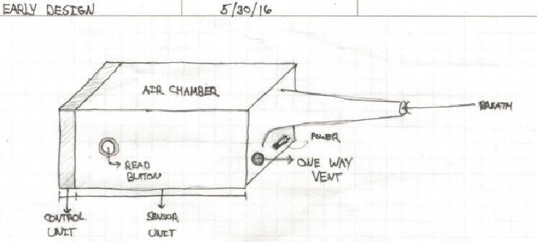

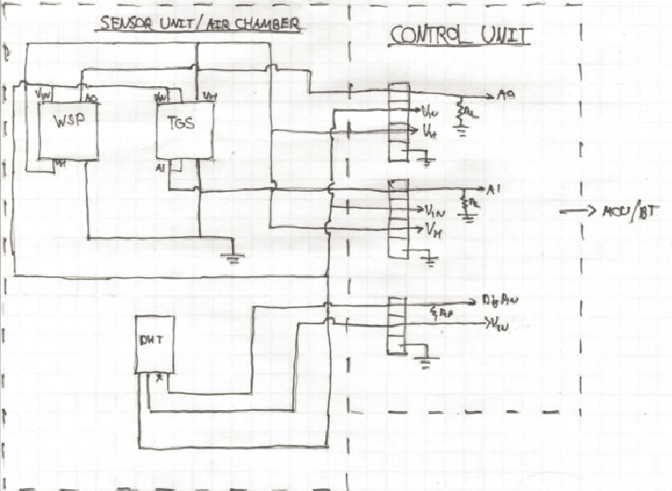
Possible external design and internal layout
Software and Hardware Block Diagrams
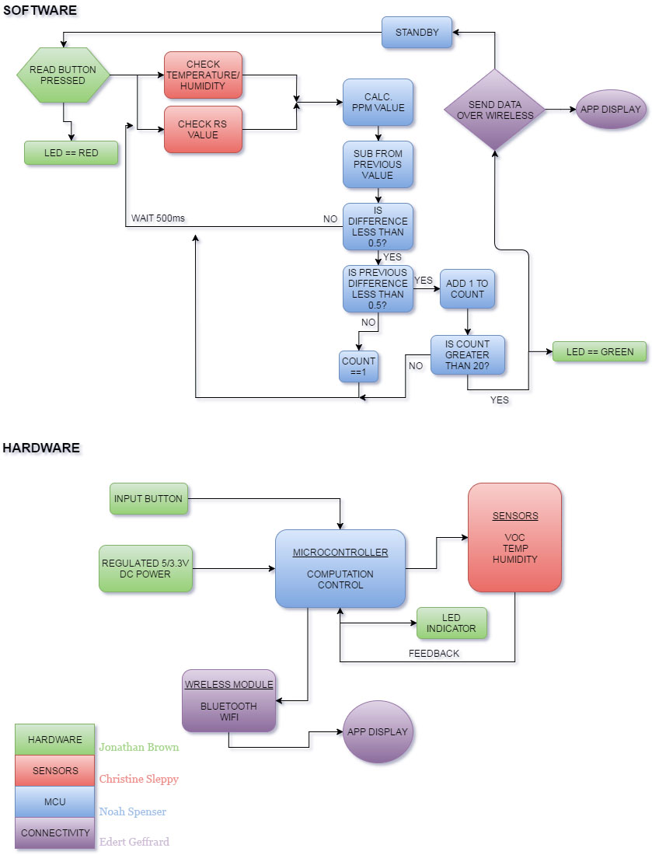
Project Budget

Part | Prices
Volatile Organic Compound (VOC) Sensors (Count: 1) | <$8
Volatile Organic Compound (VOC) Sensors (Count: 1) | <$8
Temperature and Humidity Sensor (Count: 1) (DHT11 or 22) | <$6
Microcontroller (Count: (ATMEGA32) | <$7
Power Supply (250 mA lipo Charger) | <$6
Bluetooth Module (Count: 1) (HC06) | <$7
Aluminum Cashing | <$30
PCB Fabrication | $200, roughly
Android Application | <$25
Total: <$297.00
Note
The parts tabled above may subject to change upon completing this project. Some parts might not be suitable to make this project work to the projected requirements.

Project Milestone
Summer Semester Time Line:
Week 1 (5/16-5/20)
- Group selection
- Brainstorm and examine project ideas
- Begin to think about finalizing the project choice
- Learn more about the specifics and the goals of each project
Week 2 (5/23-5/27)
- Finalize project choice
- Begin work on Divide + Conquer Initial Document Assignment
- Discuss roles and each person’s focus
- More specifics about what is needed for the final project
- Begin more intensive research about the details of the project
Week 3 (5/30-6/3)
- Finish Divide + Conquer assignment
- Discuss the project more in depth
- Assign roles and focuses for each member
- Have a good set of research and requirements for what will make the project work
Week 4 (6/6-6/10)
- 30 minute meeting regarding Divide + Conquer Initial Document assignment
- Update submission with regard to what had been discussed in the meeting
- Begin a more detailed research for preparation into specifics of the final design
Week 5 (6/13-6/17)
- Work on more detailed constraints and standards from lecture
- Begin design with more in depth exploration of the specifics of the project
- Expand the document with findings
Week 6 (6/20-6/24)
- Continue work on the standards assignment
- Work towards a more specific and more finalized designs and part selection
- Work towards the specifics of the pieces of the final document
- Start to break up the final document to each group member
Week 7 (6/27-7/1)
- Work on Table of Contents submission
- Have a specific plan for how the full document will be completed
- Have at least 60 pages completed
Week 8 (7/4-7/8)
- Put together a reasonable draft of the final document
- Continue editing with table of contents
- Finalize parts research/selection
- Work on eagle design
- Create more detailed plans for each group member
Week 9 (7/11-7/15)
- Complete the eagle design for the project
- Continue to work on the final document
Week 10 (7/18-7/22)
- Compile all updates and changes into final form of the Final Documentation
- Check for reliability, feasibility, and any mistakes/oversights.
Weeks 11 and 12 (7/25-8/2)
- Last minute checks/updates
- Be sure that the format is correct and page count is exact
- Final Document is due

Fall Semester Time Line:
Week 1 (8/22-8/26)
- Prepare for semester
- Begin gathering parts
- Make sure everything is in order to begin working
Week 2 (8/29-9/2)
- Gather initial and baseline parts and materials
- Go over designs again with group and ensure their quality and feasibility
Week 3 (9/5-9/9)
- Ensure that we have all of the necessary parts and materials needed to make our device
- Work on any necessary conversions needed for acetone to ketone analysis
- Work on circuitry and putting together functional breadboard
Week 4 (9/12-9/16)
- Work on code for phone application
- Work on communication between the device and the phone
- Write any other needed code for computations and conversions from the sensor output
Week 5 (9/19-9/23)
- Continue to work on circuitry and breadboard
- Work on code for phone application and its wireless connectivity
- Be sure that sensors are working and output is accurate
- Begin troubleshooting on completed parts

Week 6 (9/26-9/30)
- Have meaningful progress and the beginning of a functional prototype for both code and circuitry for whole device
- Achieve effective demonstrable use of sensors and parts
Week 7 (10/3-10/7)
- Begin working towards completed printed circuit board design(s)
- Continue troubleshooting on circuits and code
- Focus on power consumption and make adjustments accordingly
Week 8 (10/10-10/14)
- Put in the order our final printed circuit board design
- Put together initial iterations of full device with reasonably completed code
Week 9 (10/17-10/21)
- Give the printed circuit board a week to come in
- Test and troubleshoot printed circuit board(s) with the rest of the device (including size, sensors, code, power, wireless connectivity)
Week 10 (10/24-10/28)
- Continue testing and make necessary changes needed to make the device work
- Check for any power consumption issues
Week 11 (10/31-11/4)
- Major data collection from testing and optimizing device for effective detection and algorithms for the code
Week 12 (11/7-11/11)
- Continue data collection and algorithm generation
- Major testing/troubleshooting/error correction of the device
Week 13 (11/14-11/18)
- Finish final work on project
- Close all tasks that are still on-going
- Make sure that all group members are done with their tasks and help each other if needed
- Begin putting together final presentation
Week 14 (11/21-11/25)
- Continue to work on putting together the final presentation
- Have a plan to show that our device works
- Prepare demonstration of working device
Week 15 (11/28-12/2)
- Final preparation for final presentation and demonstration
- Be sure that each member has completed all their assigned tasks and are ready to present on them
Week 16 (12/5-12/12)
- Final presentations and demonstrations

Decision Matrix
Due to the fact that everyone on the group had very interesting ideas, it was quite a challenge to come a unanimous project to design. We contemplated on designing a hydroponics system. Basically, hydroponics is growing plants without the use of a traditional dirt medium by using a nutrient rich water solution. Those mediums used to "plant" in range from fiberglass to sand and from fired clay balls to nothing at all. Several branches of hydroponics include aeroponics, aquaponics, etc. But why would I want to take all this extra time and effort to grow my plants in this "special water"? Hydroponically grown foods not only taste better and are more nutritional, you can change the properties of your food, monitor what goes into your food and pollute less. You can also grow more in less space. This is especially great for those people that that have limited areas in their backyard to grow in. With the right plant selection, you can also keep pests away; a citronella plant has oils that keep away mosquitoes and other pests. Hydroponics uses 70 to 90 percent LESS water than conventional growing does. However, after extensive communication amongst the group, it was realized that several others proposed the similar ideas, so we all agreed to pursue the breathalyzer. The breathalyzer is a different kind of idea than most and incorporates some biomedical engineering skills, which two of our group members are interested in. The breathalyzer offers a much more stimulating semester of research and design with a good purpose of helping others who don’t have life as easy as we do. It also gives us a good open ended project for further extension of research if desired to make it even better and more accurate. Overall, our group is more interested in the breathalyzer and is excited to begin working on this project.

Kathy Musa-Veloso, Sergei S Likhodii, and Stephen C Cunnane. Breath acetone is a reliable indicator of ketosis in adults consuming ketogenic meals. U.S. 2002

