Zip line Inspection Tool

Group 9
Friedrich Schulte (CpE)
Ellis Curry (EE)
Paul Jenny (CpE)

Sponsor: United Launch Alliance

Table of Contents
1.0 Executive Summary 1
2.0 Project Description 1
2.1 Motivation 2
2.2 Objectives 3
2.3 Requirements Specifications 3
2.3.1 Scope 4
2.3.2 Operation requirements 4
2.3.3 Device Requirements 4
2.3.4 Additional Requirements 5
2.3.5 Marketing and Engineering Requirements 6
3.0 Research Related to Project Definition 7
3.1 Existing Steel Rope Inspection Technologies and Products: 7
3.1.1 Magnetic Flux Leakage 8
3.1.2 Variation of sensors: 8
3.2 Relevant Technologies 9
3.2.1 Hall Effect Sensors 9
3.2.1.1 Magnets 10
3.2.2 Voltage regulators: 11
3.2.2.1 Linear Voltage Regulators: 11
3.2.2.2 Switching Voltage Regulators: 12
3.2.3 Rechargeable Batteries 12
3.2.3.1 Battery Configurations 13
3.2.4 Data Storage 14
3.2.4.1 Video compression 14
3.2.4.2 Solid State Removable Storage 15
3.2.5 Motor 16
3.2.5.1 Brushless DC 16
3.2.5.2 Stepper Motor 17
3.2.5.3 H-Bridge 18
3.2.5.4 Pulse Width Modulation 19
3.2.5.5 Digital Motor Drivers 19
3.2.5.6 Motor-less Design using Eddy Current Brake 20
3.2.6 Controls 20
3.2.6.1 Radio Frequency 21
3.2.6.3 Automated Run 21
3.2.7 Frames Per Second vs. Shutter Speed 21
3.3 Strategic Components and Part Selections 22
3.3.1 Motor 22
3.3.1.1 H-Bridge Motor Driver 24
3.3.1.1 Digital Motor Driver 26
3.3.2 Microcontroller 28
3.3.3 Hall Effect Sensor 29
3.3.3.1 Permanent Magnet Selection 32
3.3.4 Visual Sensor 33
3.3.4 Visual Sensor Updates 35
3.3.4 Visual System Controller 36
3.3.5 Battery Selection 37
3.3.5.1 Motor Battery 37
3.3.5.2 Sensor Battery 39
3.3.6 Voltage Regulator 39
3.3.6.1 Linear Voltage Regulator 39
3.3.6.2 Switching Voltage Regulator: 41
3.3.7 Data Storage 42
3.4 Parts Selection Overview 44
4.0 Related Standards 45
4.1 Zip line Standards 45
4.1.1 OSHA Requirements 45
4.2 Battery Standards 46
4.3 Software and Systems Engineering- Software Testing Standard 46
5.0 Design Constraints 48
5.1.1 Monetary Constraints 48
5.1.2 Time Constraints 48
5.2 Environmental, Social, and Political Constraints 49
5.3 Ethical, Health, and Safety Constraints 49
5.4 Manufacturability Constraints 50
6.0 Inspection Tool Hardware and Software Design Details 51
6.1 Visual Inspection and Data Storage 51
6.1.1 Visual Sensor Hardware 51
6.1.2 Data Storage Hardware 53
6.1.3 Visual Sensor Hardware Complete 53
6.2 Hall Sensor Design 54
6.2.1 Sensor Design 54
6.2.2 Data Acquisition 55
6.3 Motor Design 56
6.3.1 Initial Design and Related Diagrams 56
6.3.2 Motor Controller Hardware 58
6.3.3 Motor Controller Software 58
6.4 Microcontroller Design 60
6.5 Additional Hardware Design Features 63
6.6 Software Design Details 63
6.6.1 Distance Traveled Calculated 63
6.6.2 Motor Control 64
6.6.3 Monitoring Hall Sensors 66
6.6.4 Camera/Video Handling 67
7.0 Project Prototype Construction and Coding 67
7.1 Parts Acquisition and BOM 68
7.2 PCB Vendor and Assembly 69
7.3 Prototype and Construction Plan 70
7.3.1 Motor Sub-System Prototyping 70
7.3.2 Hall Effect Sensor Sub-System Prototyping 71
7.3.3 Video Sensor Sub-System Prototyping 73
8.0 Project Prototype Testing 75
8.1 Hardware Test Environment 75
8.2 Hardware Specific Testing 75
8.2.1 Hall Sensor Output Voltage Testing 76
8.2.2 SD Card Module Testing 77
8.2.3 Hall sensor Testing 78
8.2.4 DC-to-DC Testing 78
8.2.5 Motor Testing 78
8.2.6 Motor Control Hardware Testing 79
8.2.7 Enclosure Testing 79
8.3 Software Test Environment 80
8.4 Software Specific Testing 80
8.4.1 Video 80
8.4.2 Hall Sensor 81
8.4.3 Motor Control 81
8.4.4 Distance Calculation 82
8.4.5 Data Storage 82
9.0 Administrative Content 83
9.1 Milestone Discussion 83
9.2 Budget and Finance Discussion 84
9.3 Project Roles 86
Appendices 86
Acknowledgement 86

1.0 Executive Summary
The scope of the project is to design a tool that can efficiently and effectively inspect the cables to the Emergency Egress Zip Line System that is used at the Crew Access tower. The device shall be used to perform a visual scan of each of the 4 emergency egress system cables to detect possible damage to the cables. Currently the visual safety checks are conducted through a tedious in person inspection and with the need to inspect the cables visually following any severe weather event or launch the need for a more efficient less tedious solution arose.

2.0 Project Description
United Launch Alliance (ULA) has installed a 1,350-foot-long (410m)-zip line on its Atlas V Launchpad in Cape Canaveral, Florida. The zip line is intended to give astronauts a quick and safe way to escape during a Launchpad emergency, and hopefully will never have to be used. The system was installed in April of 2017 and has been subject to the coastal Florida environment as well as the powerful forceful rocket launching events. Intense heat in the summer, high volumes of rain and wind from storms, and possibly even some lightning will have no doubt caused strain and potential damages to the zip line system. Currently the most common inspection method of steel cables used in zip lines is just a visual check for frays and corrosion. The current method presents an array of problems to the United Launch Alliance. The first being that the steel rope system is so long and so high up that the procedure to visually check the entire length of the rope is cumbersome and time-consuming. Secondly that the visual inspection will fail to identify any possible damage that has occurred on the inside of the steel zip line rope, underneath the several outer windings. United Launch Alliance has therefore commissioned the design of a tool that can inspect the cables to the Emergency Egress System zip lines at the Crew Access Tower.
By creating a controllable inspection tool that can traverse along the zip line cable recording valuable data we can hope to save the ULA time and money. The inspection tool can obviously have no lasting impacts or cause any damage during the inspection process. This steel rope inspection tool should make the job of evaluating the condition of the zip line faster while also being easy to use and portable due to the relatively hard to access nature of the zip line. The data obtained from the inspection tool should be accurate while also remaining reasonably easy to interpret and follow by the inspection team. The ultimate goal is to create a unique, effective, and low-cost inspection tool, that can be applied to not only the emergency egress system of the Atlas V Launchpad but other zip lines as well. While similar products have been in development they mostly occur overseas and deal with high voltage power lines, suspension bridges, cranes, ski lifts and other products that incorporate steel suspended wires. The scope of the project is to design a tool that can inspect the cables to the Emergency Egress System zip lines at the Crew Access Tower and flag likely spots for damage requiring further inspection.
This project is a multi-disciplinary project where we are working in conjunction with three separate mechanical engineering senior design teams. A hall-effect sensor will be designed to detect flux leakage in the metal wire; additionally, cameras will be incorporated to provide a visual inspection of the cable as the unit traverses the wire. The mechanical engineering teams are working separately and will design three various chassis to which the sensor will be attachable. Our scope in the project is to provide a sensor to the mechanical teams as well as programming modular controls for the motors and sensors in addition to handling battery and power requirements as well as data storage and interpretation. Because we are one group and there are three separate mechanical groups working on three various chassis, the sensors and controls will be modular and contained in a transferable control and sensor box that is to be under 15lbs.

2.1 Motivation
United Launch Alliance (ULA) requires a fast, reliable, and safe emergency egress system to evacuate personnel from the Crew Access Tower in the case of an emergency event. The system developed was a Zip Line with 4 parallel cables, that support 20 personnel escape harnesses, and allows the personnel to descent the 185ft from the Crew Access Tower at speeds of up to 50mph whisking them away to a safe landing zone approximately a quarter mile away. The Crew Access Tower (CAT) Emergency Egress System (EES) zip line cables must undergo periodic inspection to ensure no damage to the cable has occurred due to any potentially damaging events (launch, hurricane, lightning strike, etc.). The current method of inspection requires personnel to do a visual inspection of the entire length of the cable, while riding the cable. This requires multiple personnel, inspecting and setting up equipment, and can amount to significant man hours and costs for the United Launch Alliance.
The fixed wire rope that serves a crucial role in the egress system is exposed to the natural weather conditions of the Florida Coastline as well as intense launch conditions that could cause damage or degradation of the wire rope. As a result, following every weather event or launch the cable must be visually inspected for foreign objects on the cables broken strands that are a protrusion to the cable, breaks in the cable strands, signs of electrical damage, or excessive corrosion. The current process of inspection requires an individual to traverse the full length of every cable and visually inspect it, this process proves to be cumbersome and expensive. Due to the cumbersome nature of the current inspection ULA has sought alternative inspection methods such as a Zip Line inspection tool. The motivation for this project is to demonstrate our knowledge of Electrical and Computer Engineering while working in conjunction with multiple Mechanical Engineering teams and apply what we have learned in the classroom to present a solution to ULA’s need for an inspection tool and become familiar with the industry side of Engineering. Working not only in a group of our own but on a multi-group interdisciplinary project allows us to gain valuable experience working in both a small individual team and as a part of a larger interdisciplinary team. This senior design project will provide beneficial and crucial insight into the differences in industry vs. school and how to apply what we have learned in school to industry. The challenges and lessons that we will learn regarding product research, development, and design, as well as developing a product to meet the needs of the customer are valuable and necessary experiences that will solidify the topics we have learned throughout our studies and allow us to apply the knowledge and skills we have gained as students at the University of Central Florida.

2.2 Objectives
The main objective of this project is to design a wire cable inspection tool for the United Launch Alliance for the Crew Access Tower at Kennedy Space Center. The Statement of Objective is to Design and implement a device that can be installed on the cable and controlled across the length of the cable while inspecting for broken wires or other deformities. The inspection tool will be used to check for any potential problem spots on the cables that arise from recent launches or severe weather occurrences such as a frequent Summer Thunderstorm. The inspection tool shall traverse all four of the emergency egress system cables to inspect for possible damages. It shall provide a recorded video feed of the entire diameter and length of each of the cables. While taking video of the cables the inspection tool shall also use a hall sensor to pinpoint any possible problem areas so that they may later be more closely assessed with the video footage. The objective of this is to make sure that there are no signs of damage that would jeopardize the safety of a person using the cable during a training exercise or prior to a mission. This would include making sure there is no foreign debris on the cables, broken strands that are protruding out from the cable, broken strands in general, signs of electrical damage (i.e. lightning strike), or excessive corrosion.
For the inspection tool to effectively meet our main objective it needs to make the process of inspecting the wire cables much less time consuming and simpler than the current process is. The goal is to provide a satisfactory safety check of the cable after any severe weather or launch without needing to contract a third-party to come do a rigorous inspection after every possibly damaging event. This will not replace the more rigorous third-party testing but instead will supplement it in between the more thorough routine inspections.
The inspection tool should be able to be used and implemented using only a single person. This person should be able to install and remove the inspection tool from the cable and should be able to complete an inspection of all four cables at one time without having to make multiple trips other than to reset the inspection tool on the next cable. A full inspection includes traversing all 4 cables while having an acceptable quality video of the full length and diameter of each cable while being able to store and upload this data so it can be reviewed and used for comparison purposes in the future.

2.3 Requirements Specifications
The zip-line inspection tool will have several requirements to meet to certify the tool’s precision, battery life, data acquisition and storage capabilities as well as additional requirements to ensure the overall performance of the device. The main functional requirement of the zip-line inspection tool given by the sponsor ULA is that the device shall be able to accurately identify the locations of possible damage to the steel wire rope. Damage that the steel wire rope may have could include local faults/crack in individual strands, corrosion due to weather, or other types of damage that may occur during a launch. Once the device has flagged a location for possible damage it is desired that the user of the device to be able to visually inspect the location to ascertain a better understanding of the possible damage to the steel wire rope. This visual follow-up shall be capable with the use of on board cameras that have taken and stored photos of the entire length of the steel wire rope allowing a 360-degree perspective with adequate resolution for proper visual inspection. The requirement specifications can be broken down into the following categories and will be in conjunction with the Mechanical senior design teams’ requirement specifications: functional, user interface, economic, power consumption, accuracy, dimensions, modularity, and inspection time. The Scope, operation, and device requirements derive from our meeting with the customer (United Launch Alliance) and were provided following the discussion. The requirements provided by ULA must be strictly adhered to and met and may be subject to a Customer Design Review at the end of summer.

2.3.1 Scope
The Zip Line Inspection Tool (Device) shall be used to perform a visual scan of each of 4 emergency egress system cables to detect possible damage to cables.
1) Device should at a minimum provide video recorded feed of entire cable diameter and length.
2) Device can provide additional sensor scan data (i.e. Hall Sensor) to provide greater fidelity data.
3) The objective of the inspection is to look for signs of damage that would jeopardize the safety of a person transition the cable during a training exercise or prior to a mission. This would include:
a. Foreign objects on the cables (FOD)
b. Broken strands that are a protrusion to the cable – trolley path of transition.
c. Broken strands of the cable in general.
d. Signs of electrical damage from arc (i.e. lightning strike)
e. Excessive corrosion

2.3.2 Operation requirements
1) Device will only be required to descend the length of each cable, no ascent required.
2) Maximum desired window of time to complete all scans (all cables) is 4 hours.
3) Required to be able to upload and store the data for each cable individually for future comparison purposes. Upload of data to be done after all four cables inspected per session.

2.3.3 Device Requirements
1) Device should be less than or equal to 45 pounds.
2) Device must be easy to install and remove from cable while working overhead and in less than 5 minutes labor by one person.
3) It shall remain secure on the cable during descent and not be able to fall from the cable or get stuck half way down.
4) Device should operate under its own power (remotely). There is not a power source on the tower that can be used.
5) Device will be stored when not in use in a climate controlled store room.
6) Device will need to operate in wind conditions up to and including wind gusts of 20 knots.
7) Device will not be operated when lighting is occurring or expected to occur within 5 nm.
The Specifications of the Egress System to be inspected are depicted in Table 1 below.
Length (Horizontal Span) | 1319ft
Average Grade | 14%
Cable | IWRC 6X19 Wire Rope
Cable Diameter | 3/4’’
Cable Weight per ft. | 1.04lb/ft.
Max Rider Weight | 1000lb
Total Equipment Weight | 1100lb
Cable Tension (Static Pre-Tension | 15,000lb
Table 1: Cable Specifications provided by United Launch Alliance

2.3.4 Additional Requirements
- The weight of the sensors, microcontrollers, cameras, storage devices, etc. shall be no more than 15 lbs.
- The Device should be capable of being installed, operated, and removed by a single person.
- The zip-line inspection tool will be able to be mounted on other zip-line crawlers from different mechanical teams.
- The battery will be capable of providing power to the cameras, sensors, microcontroller, motor, etc. for the entire time taken to inspect the rope
- The crawler will be able to traverse the entire length of the zip-line (410 m) on one battery charge and it shall take no more than 4 hours
- The total cost of the inspection tool shall not exceed more (ULA Budget?)
- The Hall sensors will be provided with a constant current source.
- The device will be capable of tracking the position where signals are measured and pictures are taken
- Storage of the sensor data and pictures will be stored on a SD card with adequate room
- The microcontroller must have enough analog input channels to read and store signal information from sensors
- Components shall be chosen such that they are compatible with one another and do not interfere with other parts of the device
- The system shall have weather proof protection on all electrical components

2.3.5 Marketing and Engineering Requirements
 |  | Dimensions | Cost | Weight | Power Consumption | Accuracy
 |  | - | - | - | - | +
Install Ease | + | ↓ | ↓ | ↑
Cost | - | ↓ |  | ↓ | ↓↓ | ↓↓
Ease of Use | + |  | ↓ |  |  | ↑
Accuracy | + |  | ↓↓ |  | ↓
Portability | + | ↑↑ | ↓ | ↑↑
Targets for Engineering Requirements |  | < 15"x8"x8" | < $1000 | < 15lbs | <50Wh | >75% detection

 |  | Modularity | Inspection Time | Control | Implementation Time
 |  | + | - | + | +
Install Ease | + | ↑ | ↑ |  | ↑↑
Cost | - | ↓ | ↓ | ↓ | ↓
Ease of Use | + | ↓ | ↑ | ↑ | ↑
Accuracy | + |  | ↓
Portability | + | ↑ | ↑ |  | ↑
Targets for Engineering Requirements |  | ≤ 3 Configurations | < 3 hours | Directional Movement Control | >15min
Table 2: Marketing and Engineering Requirements
Marketing: Engineering:
↑: Positive correlation
↑↑: Strong positive correlation
↓ : Negative correlation
↓↓: Strong negative correlation
+: Increase the requirements
- : Decrease the requirement

3.0 Research Related to Project Definition
This section is dedicated to the discussion of research regarding existing nondestructive testing techniques of steel wire rope. The research that will be discussed below will focus on the types of instruments used, types of damage along the rope length assessed and various applications of currently available products and services. The sources for this research will be from various higher education institutions, published research articles, and other supporting materials on the subjects. The research presented is an important introduction to understanding each part of the design of the zip-line inspection tool.

3.1 Existing Steel Rope Inspection Technologies and Products:
The more common methods which have been studied before and implemented by various companies include acoustic emission, electromagnetic method, and X-ray. Companies use these techniques to evaluate the conditions of wire ropes used in applications for mining, suspension bridges, ports, ski-lifts, sky trams, steel, petroleum, cableway, elevator and other industries. After some deliberation it was clear that the choice of technique for this project aimed at pinpointing areas of possible damage on the length of the zip-line would be the electromagnetic method. The electromagnetic method seems to be the most common technique currently employed in the industry of non-destructive testing due to its simplicity, mobility, effectiveness, and cost. And because it is the most widely used technique there are many examples and an abundance of written material to work with. The other two methods were deemed too complicated and required the removal of the zip-line from its support structure. The core working principle of the electromagnetic method is that of sensing magnetic flux leakage from the ferromagnetic material being tested and will be explained further in the following section.
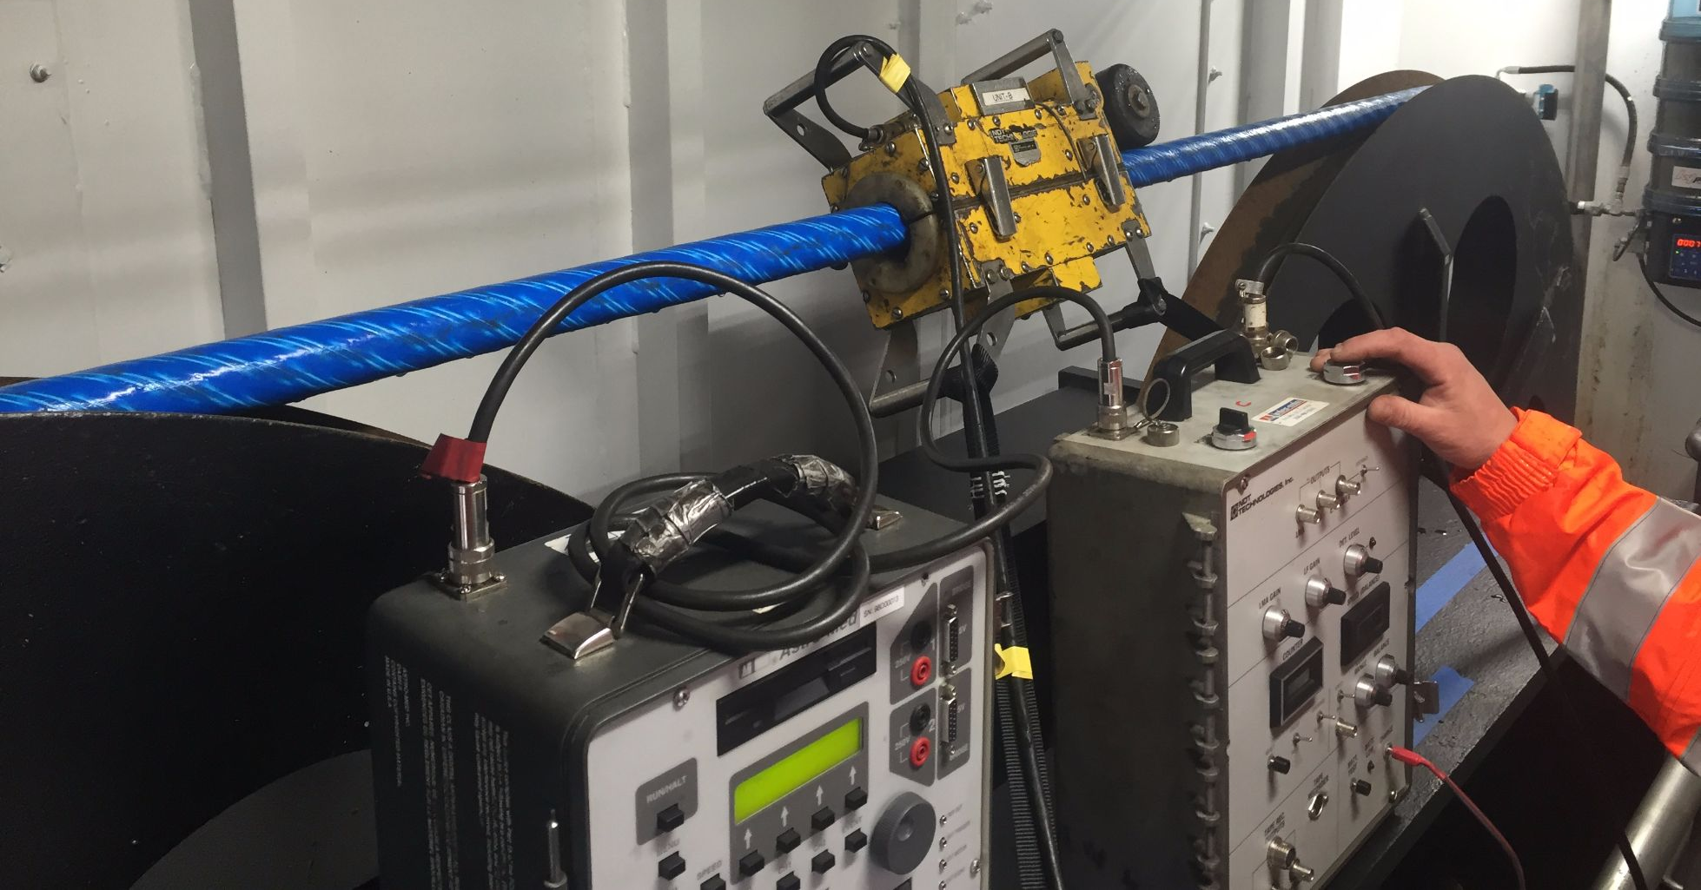
Figure 1: Worker pulling a steel wire rope through a magnetic flux leakage testing device.

3.1.1 Magnetic Flux Leakage
The ferromagnetic material is first magnetized past the saturation point of the material with an applied strong magnetic field. As seen in Figure 2 below.
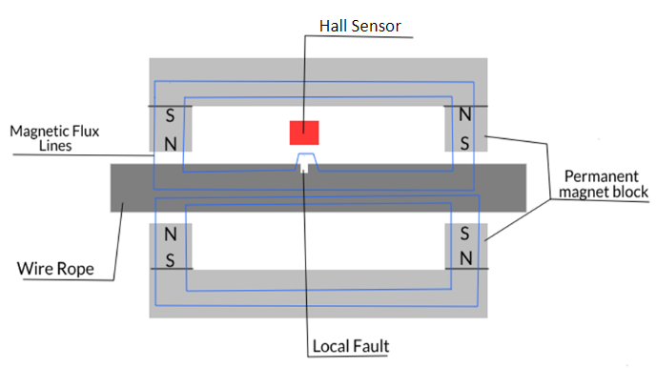
Figure 2: Working principle of magnetic flux leakage detection.
The magnet and sensor will be moving relative to the wire rope longitudinally and in the case where there is no fault in the wire rope the magnetic flux lines will pass through the inside of the ferromagnetic strands composing the wire rope and the sensor will have low input. If there is a fault, however, then the magnetic flux lines will be distorted due to the fact that the magnetic permeability of the fault is much smaller than that of the wire rope material therefore the magnetic resistivity will increase in the fault area. Since the wire rope is saturated the flux lines will have to expand into the more magnetically resistive air. When the sensor is passing over the location of the damage an electrical signal will be produced due to the received magnetic flux. This electrical signal will be largest when the sensor is closest to the area of the fault. The corresponding electrical signals can be stored for further evaluation by trained expert wire rope inspectors to determine the severity of the damage and if the wire rope should be retired. One of the notable things about magnetic flux leakage is that it can catch several types of damage such as broken wires, abrasion, and corrosion on the surface as well as on the interior of the rope.

3.1.2 Variation of sensors:
The measurement of the magnetic flux leakage at the damage site is usually obtained by either coils or Hall Effect sensors. Coils are very sensitive to local flux variation produced by defects but its signal amplitude would be related to the change in magnetic flux through the area encircled by the coils according to Ampere’s law which means the signal strength would be related to the speed at which the coils passed over the damaged area. Because of this and the complex nature of attaching many coils around the wire rope Hall effect sensors were chosen to be the magnetic flux leakage sensors. Hall Effect sensors come in a wide variety and allow the measurement of the absolute value of the magnetic flux density. Hall Effect sensors are also very small and many can be used together to encapsulate the circumference of the wire rope, providing a higher degree of flaw determination.
An important part of the principle of magnetic flux leakage detection is that the steel wire rope must be magnetized until it is saturated with magnetic flux lines. This effect can be accomplished by three main ways in the industry; AC magnetization, DC magnetization, and permanent magnet magnetization. AC magnetization produces skin effects and eddy currents, and the depth of magnetization decreases with the increase in current frequency so it is only practical to be used for detection of defects near the surface of the wire rope. DC magnetization can detect deeper than surface defects and magnetization can be controlled by adjusting the size of the current, however, it is difficult to achieve larger magnetizations, and demagnetization is needed after every use. Permanent magnet magnetization uses strong rare earth permanent magnets due to their exceptionally high energy to volume ratio. This type of magnetization is similar to DC magnetization except for the ability for adjustment. Rare earth magnets also require no electricity. For these reasons it was the choice of this project to choose permanent magnet magnetization as the method for achieving magnetic saturation in the wire rope.

3.2 Relevant Technologies
This section will focus on what existing relevant technology is already present in our world and how we can use existing technologies and incorporate them into our system to achieve our desired goals and meet the requirements of the United Launch Alliance.

3.2.1 Hall Effect Sensors
It is well known that electric current generates a magnetic field and magnetic fields can induce an electric current in a nearby conductor. If the conductor or semiconductor has a constant current established across on of its axis, the presence of a magnetic field will can cause a deflection of said current. If the magnetic field is of the correct orientation such that the Lorentz force moves the electrical charge perpendicular to the original direction of current flow it will induce a voltage potential across the conductor. The simple Hall Effect sensor is made up of two separate circuits called the bias circuit and the measurement circuit. The bias circuit applies a fixed voltage from the “north” and “south” terminals of the semiconductor material. The measurement circuit senses an induced voltage across the “east” and “west” side of the semiconductor. In the absence of a magnetic field the measured voltage is negligible, but when a magnetic field is present and oriented in accordance with the right-hand rule, a voltage can be measured across the breadth of the semiconductor. This can be seen in below as the Hall voltage: V_{H}, the Hall voltage is directly proportional to the strength of the magnetic field. It is important to remember that magnetic field strength, and thus the Hall voltage on the sensor, is inversely proportionate to the square of the distance of the sensor to the source.
There are two main categories of Hall Effect sensors currently available on the market; fixed threshold Hall switches and linear Hall sensors. Threshold Hall switches will produce a constant Hall voltage when the magnetic field strength reaches a certain amplitude and/or polarity. Latching threshold devices turn on when a positive field strength reaches the threshold but only off under a negative field of the same strength. These devices are configured with an amplifier and Schmitt trigger before a typically digital output. Linear Hall sensors will produce a Hall voltage proportional to the strength of the magnetic field around it and the orientation of the surrounding magnetic field can determine the polarity of the voltage swing if the device is bipolar. Hall Effect sensors come in a wide range of packages, sensitivity, operating temperature, polarity, operating supply voltages and maximum output currents making them available for many different type of applications.

3.2.1.1 Magnets
The working principle of the magnetic flux leakage technique using hall sensors requires that the steel wire rope be saturated with magnetic field lines. That is to say that attempting to apply more externally applied magnetic field (H) to the steel wire rope will give rise to no additional magnetic induction (B) in the steel wire rope. To estimate the amount of externally applied magnetic field required for this operating condition in the steel wire rope one must look at an induced magnetism and permeability plot for the material of which the steel wire rope is made. See Figure 3 for this plot and notice that the mild steel achieves the saturation condition when the strength of the applied external field is approximately 1500 Oersted. Now the steel wire rope may not be the exact same type of mild steel used for this data, but it is assumed that this induced magnetism plot is a good estimate for our zip line inspection tool. Shown below in Figure 3 is a plot of induced magnetism and permeability in mild steel vs. applied magnetic field strength.
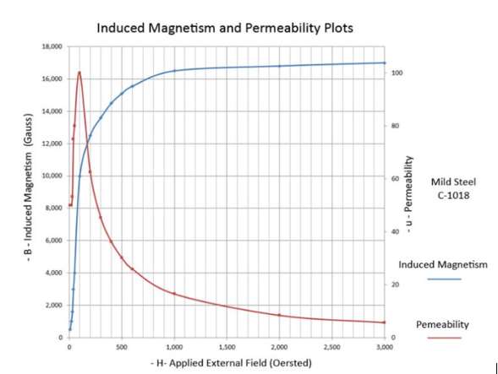
Figure 3 (permission to use image granted by Duramag)

3.2.2 Voltage regulators:
Voltage regulators are designed to maintain and stabilize voltage levels and are commonly used for DC-to-DC voltage step down conversion and can be found in most electronic devices. This voltage step down is necessary because if one were to connect components to voltages out of the range of the recommended operating values there would be risk of damaging the components. It is important when choosing voltage regulators to make sure that the output voltage is suitable and that the voltage regulator can provide the necessary amperage required of the output components.
The way voltage regulators work is dissipating the excess energy provided to the output from the input voltage as mainly heat. Therefore, when selecting voltage regulators, it is also important to keep the efficiency of the device high so that the amount of excess energy dissipated as heat is kept to a minimum. If substantial amounts of heat are being given off by the regulator it may be necessary to attach a heat sink to ensure there is no damage to the component or further efficiency degradation. Voltage regulators come in many varieties with the two main categories being linear voltage regulators and switching voltage regulators.

3.2.2.1 Linear Voltage Regulators:
A linear voltage regulator operates by using a voltage-controlled current source to force a fixed voltage to appear at the regulator output terminal. There is then a sense/control circuitry that senses the output voltage of the regulator and controls the current source to hold the output voltage to the desired value usually found on the datasheet of the device. The design limit of the current source defines the maximum load current the regulator can source and still maintain regulation therefore it is important that the battery (being stepped down) be capable of delivering the required current continuously needed to maintain voltage regulation at the output.
The feedback loop that controls the output voltage of the voltage regulator requires some type of compensation to assure the loop is stable. This compensation is usually built in to the device however some regulators may require external capacitance from the output lead to ground to guarantee the stability of the regulator. Any linear regulator used will require a finite amount of time to adjust the output voltage to the desired value if there is an increase or decrease in the load current demand. Therefore, if changes in the load current demand are to be expected then it is important to review the datasheet of the device to ensure that the transient response to steady state response time is within reason for operating the load. The three basic types of linear voltage regulator are the standard npn regulator, the LDO (low dropout) regulator, and the quasi LDO regulator. The largest difference between these three types of regulators is their dropout voltage. Dropout voltage is the minimum voltage drop required across the regulator to maintain output voltage regulation. As the name suggests the LDO regulator requires the least voltage across it while the standard regulator requires the most, this voltage difference is directly related to efficiency and amount of heat dissipated. The second biggest difference between the types of linear voltage regulators is the ground pin current required for driving the rated load current. The LDO normally requires the largest ground current and the standard regulator has the lowest required ground current. It is desirable to incorporate a regulator with a small ground current because ground current is essentially unused current which is drawn from the power supply but does not power any load.

3.2.2.2 Switching Voltage Regulators:
Switching regulators operate by taking small chunks of energy from the input voltage source and moving them to the output load. This is accomplished through the use of an electrical switch and a controller which determines the rate at which the switch is on or off and therefore how much energy is passed through the device to the output load. Because of this operation, switching regulators are known for their high efficiency rates which normally can approach values as large as 85%. Most switching regulators are more flexible when it comes to powering loads from larger voltage sources than their linear voltage regulator counterpart because they are so much more efficient. However, the drawbacks to their efficiency is that they are typically more expensive can be complex to design as they typically require more components for optimal voltage performance at the output.
The most commonly used switching regulator is the Buck regulator which is used for DC-to-DC conversion from a higher voltage input to a lower voltage input of the same polarity. The Buck regulator uses a transistor as a switch that alternates between connecting and disconnecting the input voltage to an inductor and diode preceding a capacitor connected in parallel to the load.
When the switch is in the on position the voltage that appears across the inductor is the voltage difference between the supply voltage and the load voltage. The current in the inductor will increase at a rate proportional to this difference in voltage and inversely proportional to the inductance. The diode will be reverse biased at this time. Since current through an inductor cannot change instantaneously current will still flow through the load when the switch is opened. At this time the capacitor discharges into the load and the diode will be forward biased and forms the return path to the inductor with the return current equal to that of the load current. The voltage polarity on the inductor has switched as well and therefore the current through it is decreasing in proportion to the output voltage and inversely proportional to its inductance. The current flowing through the inductor is not constant and is said to “ripple” or oscillate around an average value. The DC load current from the regulated output is the average value of the inductor current. Ripple currents are typically less than 25% of the rated DC current and can be found on the datasheet of the device provided by the manufacturer.

3.2.3 Rechargeable Batteries
Battery selection is very important for the success of this project. The battery must be capable of powering the motor of the crawler for the entire length of the zip line to be inspected. It is required to be rechargeable and small enough as to not exceed the dimensions allowed for its placement on the tool while also not being too heavy as to put excessive strain on the motor. The two main types of batteries that were considered for this project are Lithium Ion and Lithium Polymer batteries due to their recharge ability and high energy density to weight and dimension ratio. Lithium Ion and Lithium Polymer batteries have large depths of discharge while maintaining nominal voltage across the terminals, which is important for the motor. Most Lithium Ion and Lithium Polymer batteries also can be charged back up to their same capacity hundreds of times while maintaining most of their original Amp Hour capacity.

3.2.3.1 Battery Configurations
The motor to be used is the 23L204S-LW8 manufactured by Anaheim Automation and is a high torque stepper motor designed to offer the highest possible torque while minimizing vibration and audible noise. Powering such a motor requires a large voltage to maintain the torque and large start amperage to start the motor rotation. This initial start amperage is large but it is only required to be supplied by the battery briefly and is only going to become a factor in the battery selection if the motor is starting and stopping many times while on the zip line which will try to be avoided as much as possible. The torque vs. RPS (Speed) curves that the mechanical team has provided for this particular motor is seen in the figure below.
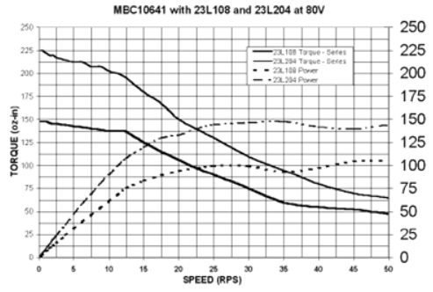
Figure 4: Torque vs. Rps Curve for 23L204S-LW8 Motor
To maintain the torque line and speed of the motor the motor will require being supplied with an 80-volt power supply.
When considering batteries, it is noteworthy that one can increase the Amp hour capacity of the power supply or the voltage depending on the configuration of connection of multiple batteries. If batteries with the same nominal voltage are connected in parallel with on another then the amp hour capacity of the power supply will be equal to that of the sum of the amp hour capacity of each of the batteries while the voltage of power supply remains equal to that of one battery. If the batteries are connected in series then the nominal voltage of the power supply will be equal to the sum of each of the batteries voltages while the amp hour capacity of the power supply remains equal to that of one battery. This flexibility in battery configuration may come to play apart in the battery selection when considering the dimensions and weight of the selection.
For this project separate batteries for the electric stepper motor that will drive the crawler and the sensors, cameras, microcontroller, etc. will be considered. This separation of power supplies is considered because the battery required by the motor is so large and the operating voltages of the electrical components will not be nearly as high. Without this separation additional design and complexity will be introduced to step down the motor battery to be compatible and whichever method this is done by (voltage regulator, transformer, etc.) will also present efficiency issues causing the motor battery to be depleted quicker. Since it is the desire that the zip-line inspection tool not get stuck half way down the line and the motor voltage remain as close to 100% as possible to maintain speed and torque a second battery for the electrical components is viewed as a solution.

3.2.4 Data Storage
This section will go into detail about the different technologies that are available and generally used for data storage, specifically more focused on the storage of visual data. The first section will be more focused on the different video compression formats that exist and are commonly used while the second will discuss flash storage and types of memory used for that data.

3.2.4.1 Video compression
This section will discuss common video compression standards, commonly used techniques used to achieve video compression and the importance of video compression on data storage especially when taking long sections of video.
Video compression is used mainly for the storage and transmission of visual data. The compressed video will have a much smaller size compared to the uncompressed video this allows for a smaller file and quicker transfer of data. The two different main types of video compression are lossy and lossless compression which is more a description of the level of video compression. Even though it may be described as lossless compression there will always be a loss of data due to the compression algorithms. With a lossless compression the data will not be compressed nearly as much but the loss in visual quality is usually imperceptible to the human eye which is why it is considered lossless.
To understand how video compression works you first have to understand that video data can be represented as a series of still frames. The rate of these frames and the number of pixels per frame determine the amount of data being collected by the camera or visual sensor. The more frames per second and the greater resolution or number of pixels the greater the data rate will be for the video, for example an uncompressed 1080p 10-bit RBG video will take up around 13 Gigabytes for a sixty second video. Using the H.264 standard which a commonly used standard takes the sixty second video down to closer to 740 Megabytes. There are many different video compression standards commonly in use today with their own advantages, disadvantages, and specific data type focuses. Below shown in table 3 you can see compression standards commonly used in the past and today.

Standard | Publisher | Year
H.120 | ITU-T | 1984
H.261 | ITU-T | 1988
MPEG-1 Part 2 | ISO,IEC | 1993
MPEG-2 Part 2, H.262 | ISO,IEC,ITU-T | 1995
H.263 | ITU-T | 1996
MPEG-4 Part-2 | ISO,IEC | 1999
H.264/AVC, MPEG-4 Part 10 | Sony, Panasonic, Samsung, ISO, IEC, ITU-T | 2003
VC-2 | SMPTE | 2009
H.265 | ISO,IEC,ITU-T | 2013
VP7 | On2, Google | 2005
VP8 | Google | 2008
VP9 | Google | 2012
Table 3: Common Video Compression Standards
The two main methods that most video compressions use is spatial compression and temporal compression. Spatial compression uses still image compression techniques on the individual frames of the video the image is split into blocks and then a transform technique is applied to them and they are quantized the most popularly used transform technique is the Discrete Cosine Transform or its modifications. Temporal compression uses comparisons between video frames in order to save space. If the video has parts of it that do not move and are the same between multiple frames it can literally copy the exact bits that make up that section of the frame and will copy it for the future frames. This saves space as it is not repeatedly saving the same bits for each frame and instead saves it once and then tells it to look at the original set of bits for the future frames. If pixels are moved or rotated the compression software can use algorithms to predict the movement of the pixels. Those are the two main methods that are used in many of the popular compression standards used today.

3.2.4.2 Solid State Removable Storage
This section will discuss solid state storage drives and the specific advantages that they have in comparison to more common hard disk drives that are much more prevalent and widely used in data storage applications.
Solid state hard drives store information electronically rather than magnetically as is used with traditional hard disk drives. Because of this and the fact that solid state drives have no moving parts, most solid-state drives have advantages across the board compared to hard disk drives in respect to read/write times, power consumption, heat produced, size, and weight. The main downside to a solid-state drive is the extra cost, though depending on the application it is worth the extra price. All the advantages the solid-state drive has makes it an obvious better choice, however the feature this project is most concerned with is the fact that solid-state drives have no moving parts. This is an important factor because of the requirement that the inspection tool still be functional even after a twelve-foot drop. A standard hard disk drive works by reading and writing data to spinning disks that are stacked inside the hard drive using a reader arm similar in function to an old vinyl record player. Because of the way the moving parts function it makes them extremely vulnerable to and drops, vibrations, or sudden movements especially when the drive is actually running. Because the reader arms do not actually touch the disks and if they were to contact the disks they could corrupt data or even completely destroy the disk in the hard disk drive if the contact is severe enough. Solid-state drives however use electrical signals to read/write the data stored in the hard drive this makes them much more resistant to any drops, vibrations, or sudden movements which are very likely issue when connected to a motorized device traveling down a wire cable that can be met with strong gusts of wind while in action. These reasons factor into why we chose a solid-state drive over a more standard hard disk drive.

3.2.5 Motor
An electric motor will be used to power the wire rope inspection tool, electric motors convert electrical energy to mechanical energy. Electric motors are made up of a rotor, bearings, stator, air gap, windings, and a commutator. The rotor is the moving part of the motor which turns the shaft to deliver mechanical power, the bearings support the rotor allowing the rotor to turn on its axis, the stator is the stationary part of the motors electromagnetic circuit typically consisting of windings or permanent magnets, the air gap is the distance between the rotor and the shaft and should be minimal, the windings are wires laid in coils that are wrapped in such a way that magnetic poles are formed when energized with current, the commutator switches the direction of flow of electric current. Electric motors come in many forms for our needs we primarily be focused on Brushless DC motors that will be most suitable to meet our needs. The particular Motor of choice due to its precision and high level of control will be a Stepper Motor. While other motor types were considered due to Size, Torque needs, and control a Stepper Motor was selected as the Motor. Due to the nature of a Stepper Motor and how it operates in steps or turns each turn is able to be precisely programmed and set to allow for exact measurements and steps as the zip line inspection tool traverses the length of the steel wire rope.

3.2.5.1 Brushless DC
In a brushed motor, fixed conductive brushes make contact with a rotating commutator causing reversal of the current through the coils, which allows the coil polarities to continually flip to maintain rotation. Brushless DC motors on the other hand do not use brushes, rather than having the coils located on the rotor, a brushless motor has fixed coils located on the stator and the rotor is a permanent magnet. Due to the stationary nature of the coils in a brushless motor, brushes and commutators are no longer necessary. In a typical brushed motor controlling the magnetic fields generated by coils on the rotor and leaving the magnetic field generated by stationary magnets fixed achieves rotation, rotation speed is then dependent on coil voltage. Alternatively, in a brushless DC motor the permanent magnet (rotor) rotates and rotation is accomplished by changing direction of the magnetic fields surrounding the fixed (stationary) coils, rotation speed is now dependent on magnitude and direction of the current into the coils. Brushless DC motors offer many advantages by being controllable continuously at maximum rotational force (torque) they are much more efficient than a brushed motor and can deliver much more power. Because brushless DC motors are controllable they can deliver precise amounts of desired torque and rotation speed. By being accurate and controllable energy consumption and heat generation can be reduced, two important factors that must be considered in this project. This in turn can extend battery life, which is critical because extended battery life would require a smaller battery and in turn less weight on the system. Additional advantages of Brushless DC Motors include, better speed vs. torque characteristics, high efficiency, long operating life, noiseless operation, and higher speed ranges, smooth operating motion.

3.2.5.2 Stepper Motor
While the Stepper Motor and the Brushless DC motor rely on the same fundamental principles and the Stepper motor is a form of a Brushless DC motor they differ in the sense that a Brushless DC motor is intended for smooth motion in operation and a stepper motor operates in steps. Because a stepper motor operates by turning in well-defined angles referred to as steps they offer a high level of control and precision. Typically, a Stepper motor converts input pulses, most often square waves, into a defined exact increment in the shaft position. Each input pulse moves the shaft through the defined fixed angle. The rotation angle of the motor is proportional to the input pulse. Stepper Motors offer many advantages including low cost vs. control, high torque at startup and low speeds, high reliability, and a wide range of rotational speeds.
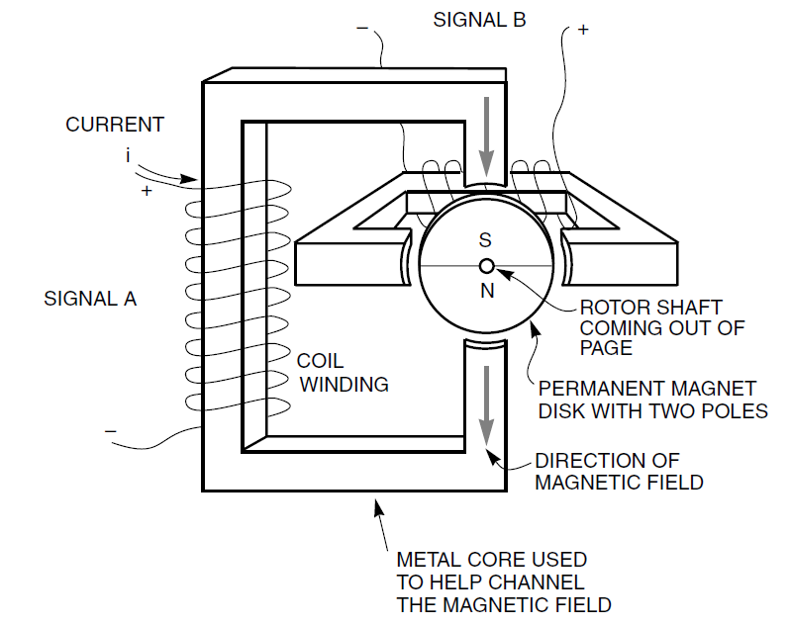
Figure 5: Permanent Magnet Stepper Motor

Stepper Motors convert electrical pulses into mechanical movements and the shaft of the stepper motor rotates in discrete step increments when these electrical pulses that control the motor are applied in proper sequence. The speed of a stepper Motor is directly related to the frequency of input pulses and the length of rotation is directly related to the number of pulses applied. This affords Stepper Motors many advantages and of course disadvantages in comparison to your typical DC or Servo Motor. Some of the advantages of using a Stepper Motor include: rotation angle of the motor is proportional to the input pulse allowing an elevated level of control and modularity. A stepper motor maintains full torque at standstill as long as the windings are energized. Stepper motors have excellent response to starting and stopping and reversing. Due to the lack of contact brushes in a motor they are very reliable and don’t involve a lot of peripheral mechanical aspects that can fail over time. Because of open-loop control in the digital impulse signals the motor can be simpler and less costly to control. And lastly a wide range of rotational speeds can be achieved due to the nature of speed being proportional to frequency of input pulses. As seen Stepper Motor advantages primarily focus on control and precision as well as modularity, three of the main key factors when considering parts and methods of operation in this project. There are few disadvantages for our scenario in regard to stepper motors, the overall disadvantages of stepper motors are that they are difficult to operate at extremely high speeds and resonances can occur if they are not properly controlled. However due to the nature of our task there is absolutely no operation need for extremely high speeds eliminating the disadvantages of using a stepper motor and leaving us with the easy choice of using a Stepper Motor for the Steel-Wire Rope inspection tool. Stepper Motors often go hand in hand with a motor controller which can then be used to control the input pulses and steps of the motor. Our original plan was to use a H-Bridge to control the stepper motor however as development continued we realized a digital stepper motor would be best suited for our needs and the needs of the mechanical teams.

3.2.5.3 H-Bridge
Due to the nature of DC motors, to move both forwards and backwards the polarity (direction) of the motor must be modified in some way. A common method of reversing polarity in DC motors is to incorporate a H-bridge. An H-bridge is an electronic circuit that allows voltage to be applied across a load in the opposite direction, allowing forwards and backwards rotation of the motor. An H-bridge is built using four switches, that typically form an H shape, hence the name H-bridge.

S1 | S2 | S3 | S4 | Motor State
1 | 0 | 0 | 1 | Moves Left
0 | 1 | 1 | 0 | Moves Right
0 | 0 | 0 | 0 | Coasts
1 | 0 | 0 | 0 | Coasts
0 | 1 | 0 | 0 | Coasts
0 | 0 | 1 | 0 | Coasts
0 | 0 | 0 | 1 | Coasts
0 | 1 | 0 | 1 | Brakes
1 | 0 | 1 | 0 | Brakes
1 | 1 | 0 | 0 | Short Circuit
0 | 0 | 1 | 1 | Short Circuit
0 | 1 | 1 | 1 | Short Circuit
1 | 0 | 1 | 1 | Short Circuit
1 | 1 | 0 | 1 | Short Circuit
1 | 1 | 1 | 0 | Short Circuit
1 | 1 | 1 | 1 | Short Circuit
Table 4: Motor State based on H-bridge Switch Position

3.2.5.4 Pulse Width Modulation
Pulse Width Modulation is a method of using digital signals, typically in waves, to control power applications. One of these power applications that can be controlled using PWM is motor speed control. By controlling the input voltage to the motor using a PWM signal speed can be controlled. PWM gives us the ability to adjust the average value of voltage going to the motor by toggling the power on and off at a high rate. Average Voltage then depends on the amount of time the signal is on vs. the amount of time the signal is off, in a given period of time, this is known as the duty cycle. We must keep in mind that PWM can only be used to control Motor Speed, not direction, in order to have full control over the Motor PWM (speed control) was originally planned to be used in conjunction with an H-bridge (Rotational Direction Control), however as the development process was ongoing it was decided that using a Digital Stepper Motor Driver would be best. As stated Pulse Width Modulation is simply controlling the speed of a motor by regulating the amount of voltage across its terminals. By driving the Motor with a series of “On-Off” pulses, applied by a digital stepper driver, and varying the duty cycle motor speed is controlled. The duty cycle in regards to Pulse Width Modulation is the fraction of time that the output voltage is ”ON” compared to the time when it is “OFF”. The longer the pulse is “ON” the faster the motor will rotate, the shorter the pulse is “ON” the slower the motor will rotate. Wider pulse width leads to more average voltage being applied to the motor terminals which leads to faster rotation in the motor.

3.2.5.5 Digital Motor Drivers
The original design plan was to use an analog L298 H-Bridge as the motor driver. However, as development was ongoing we opted to change that to a Digital Stepper Motor Driver. Due to the higher torque needs and the lower electrical knowledge of the Mechanical teams it was decided that since the entire system would be passed off to the mechanical teams in Fall that a Digital Stepper Motor Driver would be easier for the Mechanical teams to set up and learn to use. Digital Stepper Drivers drive at a much lower noise, lower heating, and involve smoother movements than traditional analog stepper motors. The Digital Drivers are typically easier to set up and can be incorporated into a microcontroller which will control the pulse signals and handle the PWM. By using a Digital Stepper Motor and the Arduino Stepper Motor Library easy to understand code that the mechanical teams can understand and modify can be written for controlling the motor. A digital Motor driver would additionally provide optimal torque and nullify mid-range instability.

3.2.5.6 Motor-less Design using Eddy Current Brake
An alternative design being implemented by the Black Team involves no motor. Due to the elevated starting point and only one-directional movement being required by United Launch Alliance, the Black Team has explored the option of letting gravity do all the work and simply incorporating a braking method to control the speed of the Zip Line inspection tool as it moves down the zip line. By releasing the inspection tool from the top of the Launchpad gravity will take over and the zip line will accelerate down.

An Eddy is the circular movement of water causing a whirlpool, similarly an Eddy current is a swirling current in a conductor because of a changing magnetic field. The current swirls in a way that creates a magnetic field opposing the change (in magnetic field). An Eddy Current Brake works much like a traditional friction brake, in a traditional friction brake an object slows down through the dissipation of kinetic energy as heat. In a traditional friction brake the drag force, the force that allows the object to slow down, is generated through friction by pressing two surfaces together. In an Eddy Current Brake, the drag force is an electromagnetic force due to eddy currents induced in a conductive object due to electromagnetic induction between a magnet and a nearby conductive object in relative motion.

Benefits to using an Eddy Current Braking method as opposed to a DC motor to power the zip line inspection tool include no need for complicated motor setup because gravity is doing all of the work, minimal maintenance, low noise, and a simpler design. Disadvantages to using an Eddy brake include the need for electric power for braking, less effective under low velocities, and the lack of ability to hold the system in a stand still position due to braking force diminishing as speed is reduced, as well as one-directional movement only. By releasing the Zip Line Inspection tool at the peak height where the potential energy is highest gravity will do the work and speed will simply have to be capped at a pre-determined threshold. Once that speed is met the Eddy Current Brake goes into effect insuring that the Inspection Tool operates at a controlled manageable speed that allows for both the video and hall sensors to operate successfully, when determining the speed threshold, it must be kept in mind that the run time must fall within the desired window of 4 hours to complete all scans.

3.2.6 Controls
Controlling the System and Sensor packages will involve a microcontroller and a board for all of the electrical components to communicate through. Driving a stepper motor requires the use of a motor card, video sensors require data inputs and outputs, and the inspection tool must be controlled in some way. When it comes to controlling the inspection tool there are two options, Radio Frequency controls, or automated controls with a preprogrammed run cycle.

3.2.6.1 Radio Frequency
Radio Frequency is a wireless electromagnetic signal used as a form of communication. A Radio frequency module is an electronic device used to send radio signals between two devices, allowing these devices to communicate wirelessly. A typical Radio Frequency module consists of a transmitter and a receiver. A RF Transmitter transmits a radio wave and modulates the wave to carry data, turning electrical signals into radio waves. Similarly, the RF receiver receives the modulated RF signal and extracts (demodulates) the information-bearing signal from a carrier wave. Radio Frequency would give the operator full control of the Steel-Wire Rope Inspection Tool as it traverses the wire and was the original planned method of controlling the steel-wire rope inspection tool. However, following our first meeting with our Sponsor they informed us that due to security reasons and the location of the Atlas V Launchpad and Emergency Egress System being on an Air Force BASE RF signals are restricted in the airspace. Due to this RF controls are not suited for our project or customer. We therefore began exploring Automated Run times by preprogramming the Stepper Motor to run a certain distance based on clicks in addition to other methods of stopping the motor such as a force sensitive resistor.

3.2.6.3 Automated Run
Due to the lack of RF frequencies an ulterior and perhaps necessary method of running the inspection tool is a pre-determined automated run sequence. With fixed cable lengths provided and with the use of a stepper motor a run sequence is determined and pre-programmed into the motor and the inspection tool must then be started and will run the duration of the cable before stopping. However, with automated run time you lose control and should any snags or issues arise as the zip line inspection tool traverses the wire rope potential problems could arise. Additionally, the sensor, both visual and hall, would have to be started at the start of the run and stopped at the end. The sensors will run continuously as the inspection tool traverses the full length of each cable. By having a known step angle on the motor of choice and knowing the set cable distance length and desired run speed the rotational velocity can be calculated and the corresponding amount of input steps can be determined to have the motor run the exact 1320 feet of cable length. The exact number of steps is programmed in however this is not the only method of stopping the motor. It was decided that incorporating a force sensitive resistor to stop the motor at the end of the wire would be prudent. The force sensitive resistor is a resistor that acts as a switch upon feeling a touch or resistance. By placing a force sensitive resistor on the end of the Steel-Wire Rope inspection tool the motor will be stopped once the tool reaches the end and pushes against the stop barrier triggering the force sensitive resistor switch. A third method of starting and stopping the motor was additionally incorporated in the form of a traditional toggle switch that turns the motor on and off.

3.2.7 Frames Per Second vs. Shutter Speed
This section looks at the importance of frames per second vs shutter speed in capturing quality video and images. This is important to understand for this project as we are trying to take quality video of the wire cable while moving at a relatively quick speed for how close the visual sensors are to the cable.
The more key factor for making sure that the video comes out in a clear quality is actually the shutter speed and this has to do with how a CMOS camera works by capturing light at a specific moment and then converting that into quantifiable bits that make up the image. If the shutter speed is longer it allows more light but the sensor will also have moved incrementally from the point it begins to capture the image to when it finishes even if it is only lasting fractions of a second and this creates motion blur. A quicker shutter speed reduces the motion blur but also lessens the amount of light let in which can darken the image so you must adjust the aperture which controls the amount of light let in and make sure that there is adequate lighting of the cable to account for this.
The frame rate actually has more to do with how much of the cable will be captured and how smooth the video will be. The higher the frame rate the smoother the video will be while an extremely low frame rate can make the video choppy and look more like a slideshow than a video. Also, if the frame rate is to low the video can miss parts of the cable as the visual sensor will have moved farther than is in the field of view of the camera and will have sections of cable in between frames that will not be seen. For example, if the sensor can only cover only 2 inches on either side of the sensor but the sensor moves six inches before the next frame there will be two inches between the two frames that is not seen on the video.

3.3 Strategic Components and Part Selections
When it comes to picking components and parts to be implemented in our system the design parameters and requirements must be carefully considered. In this section various components are analyzed for selection and ultimately chosen based on the needs of our system.

3.3.1 Motor
When selecting a Motor, a variety of parameters must be kept in mind. The main parameters we had to keep in mind when selecting a motor included modularity, power output, power consumption, torque requirements to climb, size, and weight. Due to the interdisciplinary nature of this project where 3 separate mechanical engineering teams will develop systems, the motor(s) selected may vary. As a result, the Motor and its controls must be modular in nature. The Sensor Package and Controls developed must work with all three designs and the need for modularity must be kept in mind when selecting components and parts. For reference sake the Mechanical Engineering teams and their respective motors will be Blue Team, Gold Team, Black Team.
When considering a motor size and weight had to be kept at the forefronts of our minds. However, because the project is interdisciplinary in nature the Motors were researched and chosen by the Mechanical Teams and passed along to our Electrical/CpE team. In order to meet the needs of the requirements the Mechanical Engineers had to keep a few things in mind when determining the best motor for their needs. The United Launch Alliance requires that the full Zip Line Inspection tool weighs less than 45lbs, the system has many parts including but not limited to, Wheels, Gears, Motor, Sensor Packages, and batteries. As a result, a lightweight high torque motor powered by a battery supply was ideal. An additional high priority parameter is the need for modularity and programmable controls, as such a DC Stepper motor presented itself as the best option. In Table 5 shown below are the specifications listed by the manufacturer Anaheim Automation for the 23L204S-L8 Stepper Motor. The NEMA size refers to the National Electrical Manufacturers Association standard for electrical products, including Stepper Motors. The given NEMA Size of 23 simply means that the mounting size of the 23L204S-L8 Stepper Motor is 2.3 square inches (56.4mm).
NEMA Size | 23
Bipolar Torque (oz.-in) | 226
Series Current (A) | 1.414
Unipolar Current (A) | 2
Parallel Current (A) | 2.828
Series Inductance (mH) | 14.4
Rotor Inertia(oz-in-sec2) | 0.006734
Step Angle (Degrees) | 1.8
Series RMS Voltage (V) | 6.4
Weight (lbs.) | 2.2
Length (in) | 3.1
Table 5 outlines the 23L204S-L8 Stepper Motor Specs.
The Blue Team and the Gold team have both opted to use a high torque stepper motor manufactured by Anaheim Automation. The 23L204S-L8-stepper motor offers a high torque while minimizing vibration and audible noise. The standard 8 lead wires on the motor offers modularity and application flexibility; ideal due to the modular needs of the various groups. The motor features modular windings, which can be customized, to match desired voltage, current, or max operating speed, along with the ability to be connected in all possible configurations (series, unipolar or parallel). The Blue Team requires a Torque of 384 oz./in in order to meet their desired run speed of 0.868 ft./s. To meet the high torque needs which, exceed the Bipolar Torque generated by the 23L2304S-L8 motor (226 oz.-in) the Blue Team will be designing and incorporating a gear box to their system. Due to the high torque ratings with minimal vibration and the modular features the Anaheim 23L204S-LW8 motor fits the needs of the Blue and Gold Teams. With a weight of 2.2 lbs., length of 3.1in, mounting size of 56.4mm and Bipolar Torque of 226 oz.-in (or 1.6N/m), which can be increased through a gear box, the 23L204S-L8 stepper motor met the needs of the Blue and Gold teams.
Due to the higher costs of the chosen motor and battery supply for the summer prototyping phase an alternative stepper motor of the same NEMA Size (23) and very similar specifications was used. The Motor that was selected for the Steel Wire-Rope Inspection tool prototyping is the 23HS45-4204S Stepper motor, a High Torque Nema 23 100mm Stepper Motor with a step angle or 1.8° and a Holding Torque of 3.0Nm(425oz.in). Weighing 1.8kg with a recommended operating voltage of 24-48V and a current rating of 4.2A this powerful motor will be used to turn a gearbox developed by the mechanical teams to achieve our necessary torque requirements to traverse along the steel wire. The motor will be driven by a DM542 digital stepper driver. The motor driver consists of two connectors, P1 for control signal connections and P2 for power and motor connections. P1 configurations are made up of 6 pins in total.
Two Pulse signal pins (PUL+ and PUL-) used to represent the pulse signal used to drive the motor. Two direction signal pins (DIR+ and DIR-), a signal with low and high voltage levels representing the two directions of motor rotation. Note that rotation direction is also related to motor-driver wiring, exchanging the connection of two wires for a coil will reverse motor direction. The last 2 pins on the P1 configuration are used to enable and disable the driver (ENA+ and ENA-). The P2 configuration is made up of 4 pins in total. The first pin +V is connected to the Power Supply (20-50VDC), the second GND is used for Power Ground, the A+ and A- pin is used for motor phase A, and similarly the B+ and B- pin is used for motor phase B.
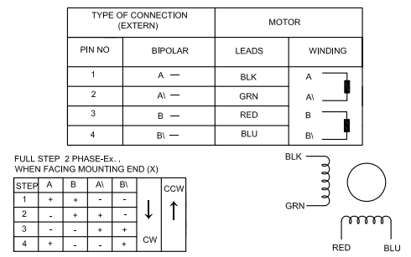
The Black Team has opted for a Motor-less System that use the Potential Energy at the peak of the Zip Line and features a Eddy-Current Braking System to control the Speed of the Zip Line Inspection tool. The innovative and unique approach requires no involvement from our EE/CpE team in terms of motor control because there is no motor. However, a control system may need to be implemented to monitor speed. The Black team is still conducting research on their braking method and if a supply current will be needed to apply a magnetic field. Ideally, they would like to incorporate a control system with a form of speed monitoring, one possible implementation would be to use a Digital Tachometer to measure the number of revolutions in a given interval of time to control the speed of the motor.

3.3.1.1 H-Bridge Motor Driver
In order to drive the motor an H-Bridge Motor Driver will be needed to control the motor and additionally act as a motor shield for the microcontroller to handle the higher torque needs of the System. The primary purpose of the H bridge is to control high current motors, the H bridge configuration is commonly used to provide on/off as well as directional controls of motors. When selecting an H-Bridge to use we had to keep the torque needs as well as modularity with the Microcontroller and PCB in mind. Other factors to consider include maximum Power Supply Voltage, Power rating, and maximum DC Operation output Current. Additionally, because the system will be running in Cape Canaveral on the coast of Florida in the heat of summer operating temperature must be considered. The H-Bridge Motor Driver that best suited our needs and requirements and will be used is the L298 Dual Full-Bridge Driver. The Modular nature and powerful motor driver module that the L298 H bridge offer made it an attractive choice.
Manufactured by STMicroelectronics the L298 is an integrated monolithic circuit that is a high voltage, high current, dual full-bridge driver designed to accept standard TTL (Transistor-transistor logic) logic levels and drive loads. The L298 operates at a supply voltage of up to 46V, with Total DC current up to 4A, additionally the L298 offers a low saturation voltage and overtemperature protection. Shown in Table 6 are the absolute maximum operating thresholds for the L298 according to the datasheet provided by the manufacturer STMicroelectronics.
Absolute Maximum Ratings for the L298 H Bridge
Power Supply | 50V
Logic Supply Voltage | 7V
Input and Enable Voltage | -0.3 to 7V
DC Operation Peak Output Current, each channel. | 2A
Sensing Voltage | -1 to 2.3V
Total Power Dissipation | 25W
Junction Operating Temperature | -25 to 130℃
Storage and Junction Temperature | -40 to 150℃
Table 6
The L298 comes in a MultiWatt 15 package meaning it is a configuration of 15 offset pins. The Pin Connections are shown in Figure 6 below provided by the manufacturer STMicroelectronics. As seen in the figure the L298 features 4 Output Pins and 4 Input Pins, along with 2 Enable Pins, 2 Current Sensing pins, 1 logic supply voltage pin, 1 supply voltage pin, and lastly 1 ground pin. The L298 H Bridge uses two different supply voltages a Logic Supply Voltage and a Supply Voltage. Pin 9 labeled as the Logic Supply Voltage powers the Chip and should be set to 5V. While pin 4 labeled as the Supply Voltage powers the motors and can handle up to 46V. The Enable pin must be set to HIGH in order to activate a motor. By applying a LOW or HIGH signal to Input1 and Input2 the motor and its direction can be controlled.

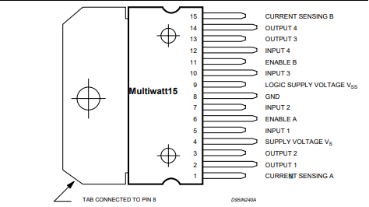

Figure 6: Pin Layout of L298 H Bridge
In order to ensure that a circuit is protected from reverse voltage and current, a protection or safety diode is often built into an H Bridge. However, the L298 does not have a built-in protection diode so protection diodes will have to be added in, the datasheet suggests four fast 1-amp recovery elements. The 1N4933 Diode manufactured by Diodes Incorporated is a Fast Switching High Current Capable and Low Voltage drop 1.0A Fast recovery rectifier that meets the needs of the L298 H-bridge. With a DC Blocking voltage of 50V and reverse Recovery time of 200ns the 1N4933 Diode made a great fit for our needs, additional specs provided by the manufacturer Diodes Incorporated.
Lastly, due to the Mutliwatt15 pin layout, in order for the L298 H bridge to function with the PCB properly a breakout board needed and designed. A breakout board "breaks out" pins onto a printed circuit board that has its own pins. The breakout board takes a single electrical component, in this case the L298 H Bridge motor driver, and makes it easy to integrate and use on other electrical components. The breakout board will be used to accept the L298 motor bridge chip and then the breakout board will be wired to the PCB. Details on the construction and materials to be used for the breakout board can be seen in section 6.3.1.2.

3.3.1.1 Digital Motor Driver
As development progressed we quickly realized a Digital Stepper Motor Driver would be a better choice for controlling our motor rather than the traditional analog L298 H Bridge. To drive the Motor and act as a bridge between the Motor and the Microcontroller the 23HS45-420S will be paired with a DM542 digital stepper driver. The advantage of using a digital stepper driver versus a traditional analog stepper driver is that the DM542 can drive a stepper motor at much lower noise, lower heating, and smoother movement. This makes it the ideal choice for high requirement applications such as our own. The DM542 motor driver is suitable for stepping motors in the range of 17 to 34 NEMA size. It features Anti-resonance to provide optimal torque and nullify mid-range instability, it is suitable for 2-phase and 4-phase motors, additionally it features Over-voltage and over-current protections. A typical stepping system configuration including a stepper motor, stepping driver, power supply, and microcontroller used for pulse generation is shown in Fig. 8 below. The Specifications for the DM542T Digital Stepping Motor Driver are detailed below in Table 7.
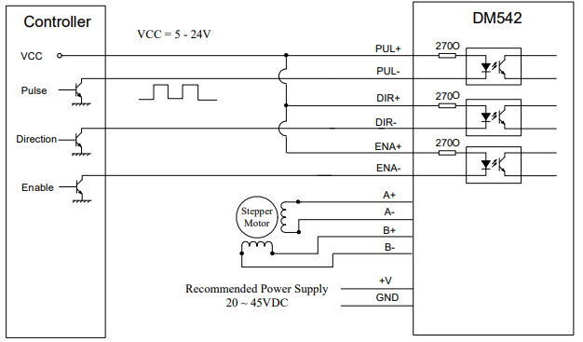
Fig. 7 Typical stepping system configuration using DM542 Motor driver. [2]
Stepper Driver Specifications
Input Voltage (V) | 20-50
Output Current | 1-4.2A
Microstep(Steps/rev.) | 400-25600
Max Pulse Input (kHz) | 200
Pulse Width (us) | 2.5
Weight (kg) | 0.21
Table 7. DM542T Specifications

3.3.2 Microcontroller
A microcontroller is a single chip Integrated Circuit that contains a Central Processing Unit, memory, Input and Output buses to connect components, and RAM to store the variables used when the program executes. While initially it may seem that the main task of the microcontroller is to control the motor directly, because a microcontroller has a low output current and a motor draws a high current connecting the microcontroller directly to the motor will destroy the microcontroller due to the high currents. As such the H bridge and breakout board are incorporated onto the microcontroller to act as a motor shield. The main functions of the microcontroller will be to process input data recorded by the Visual and Hall sensor packages, along with storing program memory and controlling Pulse Width Modulation to drive the stepper motor which will then be incorporated with the H-bridge to control motor run time and automation. While examining Microcontrollers for use, these functions and tasks required of the Microcontroller must be kept in mind. Additional things to consider when selecting a microcontroller include core size, peripherals required, speed, power consumption, flash memory, cost, available libraries, modularity, processing power, and program language. Two microcontrollers were considered due to prior experience and exposure as well as fitting other parameters well. We will examine in further detail the advantages and disadvantages of the Atmel ATmega328p-PU microcontroller and the Texas Instruments MSP430G2553.
The MSP430G2553 is a member of the Texas Instruments MSP430 family of ultra-low-power microcontrollers. It is designed with five combined low-power modes to optimize battery life and features a 16-bit RISC CPU, 16-bit registers, a Low Supply Voltage Range (1.8V-3.6V), Ultra-low power Consumption (Active mode: 230uA at 1MHz, 2.2V), and is programmed in the familiar C language. However, the libraries are not as extensive, nor catered towards PCB design, and incorporating analog inputs and the initial setup requires much more coding in comparison to the ATmega328P.
The ATmega2560 is a robust microcontroller suited for complex products. It features 54 digital I/O pins including 15 for PWM outputs, 16 analog inputs, 4 hardware serial ports, and a 16MHz crystal oscillator. Due to its high number of I/O pins it was considered for running all of the subsystems involved in the Steel Wire-Rope Inspection Tool. However, it was determined that the clock would not be able to handle all of the various processing needs of the sub systems and that a better method would be to have each sub system controlled by its own separate microcontroller.
The ATmega328P- PU produced by Atmel is an 8-bit low-power CMOS microcontroller that combines an instruction set with 32 general-purpose working registers directly connected to the Arithmetic Logic Unit. This allows two independent registers to be accessed in a single instruction executed in one clock cycle. The ATmega328P is one of the most versatile and popular choice in microcontroller projects and as a result has extensive libraries and documentation allowing for user-friendliness. The 8bit AVR RISC-based microcontroller combines 32KB ISP flash memory with read-write capabilities and additional features include 2KB SRAM, 23 general purpose I/O lines three flexible timers/counters, internal and external interrupts, and is programmed using the C language. A comparison between features of the various microcontrollers can be seen below in Table 8. Ultimately, it was decided that benefits of extensive libraries, higher Flash and RAM, ease of testing, and versatility of the ATmega328P provided optimal function for our needs in comparison to the MSP430 and the ATmega2560 and the microcontroller we will be using is the ATmega328P- PU produced by Atmel.
Features | ATmega328/P | MSP430G2553 | ATmega2560
Pin Count | 32 | 20 | 100
Flash Memory (KB) | 32 | 16 | 256
CPU Speed (MHz) | 8 | 16 | 16
Supply (Operating) Voltage | 1.8-3.6V | 1.8-5.5V | 1.8-5.5V
Analog, I/O Pins | 6in/0out | 8in/0out | 16/0
Digital I/O Pins | 9 | 8 | 54
Cost (USD per unit) | $2.01 | $2.41 | $12.35
Table 8: Comparison of features in the ATmega328P-PU vs. ATMEGA2560 vs. MSP430G2553 Microcontrollers

3.3.3 Hall Effect Sensor
When considering Hall effect sensors for the application of detecting flux leakage due to material loss the main factors to consider are the Hall effect sensor’s magnetic sensitivity, output characteristics and operational range. It is the desire for the Hall effect sensor’s magnetic sensitivity to be as large as possible due to the fact that the potential cracks in the wire rope may not be very large and therefore only allow minimal flux leakage. It is also the desire for the Hall effect sensor to have easy to connect and interpret output which could be directly connected to a microcontroller for voltage data acquisition and storage. Therefore, an analog output Hall effect sensor which varies its output to a ratio of its supply voltage should work well in this capacity. Also, it is important that the operational range of the Hall effect sensor be wide such that the zip line inspection tool can distinguish between detections of a large amount of flux leakage from the wire rope, which would suggest more serious fault, and detections of smaller amounts of flux leakage which would suggest a less serious fault. Other features of the device are important as well, such as operating temperatures, quotient voltage, and polarity, but these are the features that will be the main decision-making points on which Hall effect sensor is chosen.
After much searching the TI DRV5056-Q1 Automotive unipolar ratiometric Linear Hall effect sensor was chosen based on its high sensitivity, low quiescent offset voltage, and uni-polarity. The DRV5056-Q1 is a 3-pin linear Hall Effect sensor with fully integrated signal conditioning, temperature compensation circuits, mechanical stress cancellation, and amplifiers. The device operates from 3.3-V and 5-V (±10%) power supplies, measures magnetic flux density, and outputs a proportional analog voltage that is referenced as VCC. A functional block diagram of the device can be seen in Figure 8.
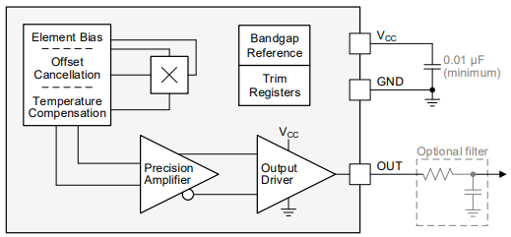
Figure 8 Functional block diagram of the DRV5056-Q1
The device produces a linear response when the output voltage is within the specified V_{L} range. Outside the range the sensitivity of the device is reduced and becomes nonlinear. See Figure 9 for the output voltage to magnetic field strength response.
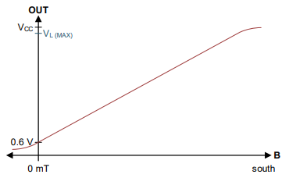
Figure 9 Magnetic response of the DRV5056-Q1
This Hall effect sensor uses a ratiometric architecture that can minimize error from VCC tolerance when the external analog-to-digital converter uses the same VCC for its reference. The TI Hall effect sensor has a couple different packages and several different magnetic sensitivity options. The sensitivity options go from 200mV/mT at a ±20-mT range to 25mV/mT at a ±158-mT range. The DRV5056-Q1 is designed to have a low-noise output with a ±1-mA drive while also boasting a fast 10-kHz sensing bandwidth. For a complete list of the specifications of the DRV5056-Q1 please reference table 8 below.
 | Value | Unit
Vcc Power Supply Voltage | 4.5 - 5.5 | V
IO Output continuous current | -2 | mA
TA Operating Ambient Temperature | -40 – 150 | °C
ICC Operating supply current | 10-Jun | mA
td Propagation delay time | 10 | µs
VQ Quiescent voltage | 0.55 – 0.65 | V
VL Linear range of output voltage | VQ to (VCC – 0.2) | V
Table 9 – operating specifications of the DRV5056-Q1
For a complete list of the magnetic sensitivity options provided by the TI DRV5056-Q1 Hall effect sensor please reference Table 9.
Option | Linear magnetic sensing range (mT) | Sensitivity (mV/mT) | Output-referred noise (mVPP)
A1 | ±20 | 190 - 210 | 24
A2 | ±39 | 95 - 105 | 12
A3 | ±79 | 47.5 - 52.5 | 6
A4 | ±158 | 23.8 - 26.2 | 3
Table 10– Sensitivity options for the DRV5056-Q1 at Vcc = 5V, 25°C
When deciding the option for the Hall effect sensor it is unlikely that the magnetic flux leakage will be larger than 39mT and the highest sensitive option (A1) will be required to measure it accurately. This option does however possess the largest output-referred noise but this drawback should not affect the desired outcome of meeting the requirement specifications of the zip-line inspection tool.
Of the two package options the DBZ package was decided to be the best for measuring the theoretical direction of magnetic flux leakage while being mounted onto a PCB and can be seen in Figure 10 below.
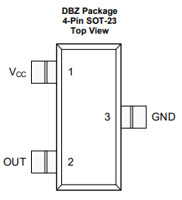 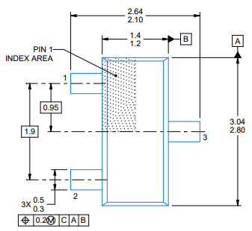Figure 10 – package of the DRV5056-Q1 with dimensions given in mm

3.3.3.1 Permanent Magnet Selection
When researching various custom strength and dimensions rare earth magnet vendors it was important that the magnets used have a surface field strength of at least the 1500 Oersted mentioned earlier. It is also important that the dimensions of the magnet be similar in size to the 0.75-inch diameter steel wire rope to be inspected.
The SBCC6-OUT is a Nickel-Plated Neodymium magnet with a surface field of 4260 Gauss and due to its dimensions and price it was chosen for the application of saturating the steel wire rope. See Figure 11 for a complete listing of this rare earth magnet’s specifications.
Weight | 0.965 oz.
Dimensions | 3/4" length x 3/4" width x 3/8" thick, with step OUT
Material | NdFeB, Grade N42
Magnetization direction | Thru Thickness
Surface Field | 4260 Oersted
Max operating Temperature | 176°
Figure 11 – specification of the SBCC6 - OUT

3.3.4 Visual Sensor
This section discusses the visual sensors considered for the inspection tool and looks at what specifications are most important for our device and why they are important.
A visual sensor is a type of sensor that takes in light and converts it to electrons and then converts those values into bits which are then processed and stored. There are actually many types of visual sensors with the most commonly thought of ones being those used in modern digital cameras and cell phones. Those are only one type however as there are many other types ranging from something as simple as a basic light sensor to something as complex as modern day lidar sensors. For the purposes of the inspection tool the type of sensor used in a common digital camera is what is necessary for our purposes. With the full video of the entire length and diameter of the cable being the most important aspect of the inspection having a good visual sensor is extremely important.
Important points to consider for our visual sensor is that the video must be detailed enough that any potential damages or imperfections to the wire cable will be visible when looking at the video footage. Also, the video quality must also be able to stay consistent as the inspection tool moves down the cable so it is important to pick a sensor that can keep optimal quality and resolution at the speed the tool is moving down the cable. Below in Table 12 you can see the comparison of the specifications for the two sensors considered.
 | CMOS OV5640 Camera Module | CMOS OV5642 Camera Module
Active Array Size | 2592 x 1944 | 2592 x 1944
Power Supply | core: 1.5V +- 5%  (with embedded 1.5V regulator)  analog: 2.6 ~ 3.0V  I/O: 1.8V / 2.8V | core: 1.5VDC +- 5% (internal regulator)  analog: 2.6 ~ 3.0V  I/O: 1.7 ~ 3.0V
Output Formats | (8-bit): YUV(422/420) / YCbCr422,  RGB565/555/444, CCIR656,  8-bit compression data,  8/10-bit raw RGB data | (8-bit): YUV(422/420) / YCbCr422,  RGB565/555/444, CCIR656,  8-bit compression data,  8/10-bit raw RGB data
Lens size | ¼” | ¼”
Input clock Frequency | 6 – 27 MHz | 6 – 27 MHz
Shutter Style | Rolling shutter / frame exposure | Rolling shutter
Max Image Transfer Rate | QSXGA (2592×1944):  15 fps  (and any size scaling down from 5 megapixel) | 5 megapixels (2592×1944): 15 fps  (and any size scaling down from 5 megapixel)
Pixel Size | 1.4 um x 1.4 um | 1.4 um x 1.4 um
Table 12 Visual Sensor Comparison
Active Array Size: This is how many pixels are in the active image array for the CMOS cameras, this determines the max resolution that can be achieved by the visual sensor.
Power Supply: The amount of power the sensor draws while it is running and the voltages for the input/output are important for knowing the battery size required to run the sensors as well as properly connecting the input/output to pins that will handle the voltage used.
Output Formats: The distinct types of output determine the quality and size of the data to be output by the sensors which is then processed by the microcontroller and then stored on the storage device.
Lens Size: Influences the amount of magnification available as well as the angle of view at different focuses.
Input Clock Frequency: Generally, a higher clock rate means more instructions can be executed in the same time but it depends on the way the instructions are written for the specific sensor and how the processor handles them.
Shutter Style: This aspect can be very important as the type of shutter used by a visual sensor can influence the image produce by the camera. With a rolling shutter the pixels are processed either one row or column at a time all the way across the image array. A global shutter however captures every pixel at the same instant for the whole array.
Max Image Transfer Rate: This is an extremely important aspect as it determines how much data can be transferred and processed at a time. At higher resolutions there will be fewer frames per second as each frame is much larger while at lower resolutions there can be much higher frames per second at each frame is much smaller. Whether frames per second or resolution is more important depends on the application the visual sensor is being used for.
Pixel Size: Pixel size can influence the quality of the image as larger pixels are able to capture light and shadows better but smaller pixels can give more points of data to collect.
Comparing the specifications of the two visual sensors they are both very similar to each almost the same. The OV 5642 however had better support with a wider range of development boards and is used in the ArduCAM Mini 5MP Plus Camera Module which is discussed more in section 6.1.1. It also had the advantage at having more readily available solutions for connecting multiple visual sensors in parallel as the inspection tool will have three sensors running at the same time.

3.3.4 Visual Sensor Updates
This section discusses the changes and updates made with respect to the visual sensors after early testing and development had been done and the capabilities of earlier choices were more well known. These later choices were more focused on the compatibility and ease-of-use than the pure comparison of which visual sensor had the more powerful specifications as they were all able to achieve above what we deemed the minimum visual quality necessary. In Table 13 below are the three sensors considered.
As seen in the figure above the three cameras considered are the CMOS OV5642 Module that was originally used and then the Logitech C920 and the Raspberry Pi Camera Module V2. The OV5642 module was originally chosen as it allows the use of multiple cameras with the Arduino Uno or the ATmega328P microcontroller. During early development and testing it became quickly clear that the combination of the ATmega328P and the OV5642 module would not be able to achieve the video quality needed for the project. The OV5642 module did function well and could achieve high quality images, the ATmega328P however was not strong enough to process the amount of data. It would take almost five seconds or more to load a single 1080p image from a single camera much less be able to handle the data throughput for three cameras outputting video. To correct the issue of not enough processing power the Beaglebone Black board was chosen to run the cameras using the same system as with the Arduino. Due to outdated open-source libraries and multiple changes with the handling of the GPIO interface of the Beaglebone Black we were unable to get the cameras to interface with the Beaglebone Black.
The failure of the Beaglebone Black then led to the attempt with a Raspberry Pi to interface with the OV5642 modules and the consideration of the Logitech C920 and the Raspberry Pi camera module V2. Time constraints were becoming an issue which led to the consideration of multiple alternatives at the same time. With the large price on the Logitech C920 weaker USB cameras were used for development tests alongside the Raspberry Pi Camera module V2. The OV5642 also failed to interface with the Raspberry Pi correctly which led to the side by side development with the USB cameras and the Raspberry Pi Camera module V2.
While working with the Raspberry Pi it became quickly evident that even though the Raspberry Pi Camera module V2 could not achieve the same maximum quality that the Logitech C920 would be able to, the ease-of-use and compatibility with the Raspberry Pi made it the much more effective camera as the existing code libraries allowed a large amount of control over the functions of the camera while still being more than capable of achieving a sufficiently good video quality of 1080p at 30 frames per second.

 | CMOS OV5642 Camera Module | Logitech C920 | Raspberry Pi Camera Module V2
Output Formats | 8-bit compression data, | JPEG, YUV | JPEG , GIF, BMP, PNG, YUV420
 | 8/10-bit raw RGB data | h.264 | h.264
Shutter Style | Rolling shutter | Rolling shutter | Rolling shutter
Max Image Transfer Rate | 5 megapixel (2592×1944): 15 fps | 15 megapixel | 8 megapixel
 | (and any size scaling down from 5 megapixel) | 1080p30 | 1080p30
 |  | 720p60 | 720p60
 |  |  | 640 × 480p60/90
Price | $40 | $50 | $25
Table 13: Second Visual Sensor Comparison

3.3.4 Visual System Controller
This section discusses the microcontroller and microprocessors considered for the Visual System. Originally the initial Microcontroller comparisons covered the microcontroller considerations for all the major systems, visual, motor, and hall sensor, however after early testing and development it became apparent that a much more powerful system would be required in order to handle the requirements for the visual system as compared to the other systems.
The three systems considered were the Arduino Uno which uses an ATmega328P, the BeagleBone Black which uses an AM335x 1GHz ARM Cortex A-8, and lastly the Raspberry Pi which uses a Broadcom BCM2837B0 Cortex-A53. Basic specifications for the three can be seen below in Figure XX.
Features | ATmega328P | Sitara AM3358 | Broadcom BCM2837B0
Core Size | 8-bit AVR | 32-bit RISC | 64-bit ARM v8
Max clock Frequency | 20 MHz | 1 GHz | 1.4 GHz
Supply Voltage | 1.8-3.6 | 1.8-3.3 | 5V DC
General Purpose I/O Pins | 21 | 4 x 32 | 40
Table 14: Visual System Controller Comparison
The ATmega328P was the initial choice as it is cheap and easy-to-use with extensive existing libraries and would keep development and coding consistent across the multiple systems that made up the final device. A method was found to run up to four cameras simultaneously with the ATmega328P which helped to push development in that direction however quickly after initial testing it was found that the microcontroller could not consistently output more than 3 frames per second at 360p and only when using a single camera. The system was able to run multiple video streams simultaneously but it did so by going to each camera and pulling a single frame in a loop. The system proved it could work but would need more processing power to work effectively. This led to the addition of the comparisons including the Beaglebone Black and the Raspberry Pi, the Beaglebone Black was chosen as it had the strongest pure overall processing power and was capable of integrating with the OV5642 camera module. Issues arose however with outdated code libraries and changes with the Beaglebone Black OS and how it handled controlling GPIO settings led to development difficulties and ultimately was unable to interface the board and camera properly.
Development then shifted to using a Raspberry Pi which was a much more well-documented system as compared to the Beaglebone Black, though even with those advantages problems still arose with the OV5642 camera module. With time constraints becoming an issue development then started with using USB and the Raspberry Pi Camera module V2 side-by-side. It was quickly evident however that the compatibility and ease-of-use of the Raspberry Pi system with the Raspberry Pi Camera was more than powerful enough to ensure quality 1080p video at 30 frames per second. The extensive existing libraries also allow for control over many aspects of the camera such as frame rate, shutter speed, and exposure settings to help improve the video quality. The one downside to the Raspberry Pi system however was that it only allows the connection of one Raspberry Pi Camera at a time which means that the device requires three separate Raspberry Pi’s to control each camera, though this does guarantee that it is able to run the cameras at the high quality needed.

3.3.5 Battery Selection
Our system will incorporate two separate batteries, one to power the Motor and its components, and another to power the Video and Hall Sensor packages. Included in this section is analysis and justification for selection of the two motors.

3.3.5.1 Motor Battery
After researching these three types of batteries and comparing the voltages, capacities, weight and dimensions to the specific needs of the motor it was concluded that LIPo batteries were the best selection. Limiting the search to be able to handle the motor for more than a couple hours at the required voltage while also staying within the space and weight allocation led to a few choices which were then narrowed down to just the Powerizer LiFePO4 battery with a nominal voltage of 24V and capacity of 10Ah. This particular battery comes equipped with a PCB installed which protects the battery from over charge and over discharge, over current and short circuit. The Powerizer battery specifications and dimensions are represented below.

Powerizer LiFePO4 Battery 24V 10Ah (240Wh, 20A rate)

Voltage | Nominal: 24V  Charge Cut off: 29.2±0.05V  Discharge Cut off: 19.2V
Capacity | 10Ah±5%
Cycle Life | >1000 cycles (80% of initial capacity @ 0.2C rate, IEC Standard)
Operation Temperature Range | Charge: 32F (0°C) - 113F (45°C)  Discharge: 14 F (-10°C) -140F (60°C)
Storage Temperature Range | Less than 1 month: 14F (-10°C) -104F (40°C)  Less than 3 months: 32F (0°C) - 86F (30°C)  Less than 1 Year: 59F (15°C) - 77F (25°C)
Charge Rate | Standard: 0.2C (2A)  Maximum: 0.5C (5A)
Discharge Rate | Standard: 0.5C (5.0A)  Maximum Continuous: 2C (20A)
Impedance | ≤40mΩ (50%SOC at 25°C)
Terminal | B1 Terminal
Weight | 5.0 lbs. 11.4Oz (2.59 kg)
Dimensions | (LxWxH) 181 mm (7.1") x76mm (3.0") x 166mm (6.5")
Table 15 – Battery specifications
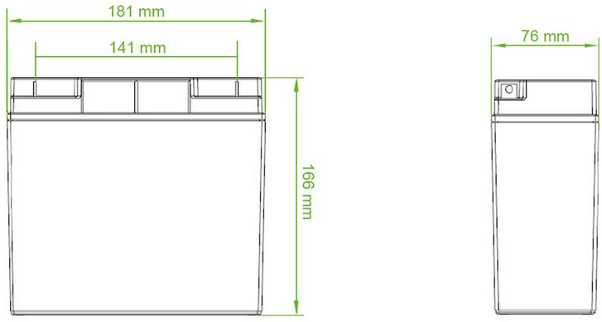
Figure 9 – Battery Dimensions

3.3.5.2 Sensor Battery
The goal for the portable power supply for the zip line inspection tool was to have separate batteries for motor power and electronic peripheral and sensor power. Given that there is limited space and weight available for the crawler to carry these were the most important attributes of the batteries considered when searching for them. In the case of the smaller sensor, microcontroller, and camera battery it was determined that there was only a need to be able to supply about 0.15 Amps of current to power all of these electronics. This will also be useful for testing the electronic sensors and controller subsystem of the zip-line inspection tool without the need to be mounted with the mechanical subsystem. After some searching it was determined that a rechargeable Lithium Ion battery with ample voltage and capacity would be ideal for quick recharging. Using the same supplier of the motor power supply a simple search led to the decision of selecting a custom LI-Ion 18500 battery pack capable of 7.4 Volt and 2.8 Amp Hours. The battery pack is made of four pieces of high quality cylindrical 18500 rechargeable cells wrapped in poly vinyl chloride shrink.
The dimensions of this battery are 4.2 inches long by 1.5 inches wide by 0.9 inches high and weighs just 4.4 ounces. This battery pack comes with three wires making it easy to connect to the stepdown DC-to-DC converters. The Li-Ion battery pack also comes with a PCB installed that is limited to three Amps and a two Amp poly-switch for full protection. This PCB is located at the end of the battery pack. As stated earlier, Lithium Ion batteries need to be charged correctly so to avoid any damage to the cells or surrounding equipment or personnel therefore a smart charger will also be considered for purchase

3.3.6 Voltage Regulator
This section is dedicated to comparing the two different types of voltage regulators picked for the applications of this project. The TPS7B6950 linear voltage regulator with low dropout voltage and the switching voltage regulator LMR14010A which is also produced by Texas instruments. This section lays out the main features with brief descriptions as well as some typical design schematics for regulating voltage.

3.3.6.1 Linear Voltage Regulator
After some searching and deliberation for a linear voltage regulator that met the requirements of the microcontroller selection as well as the cameras and Hall effect sensors it was determined that the Texas Instruments TPS7B6950 possessed the necessary features. The TPS7B6950 has a wide range of unregulated input voltage and capable of providing a max output current of 150 mA. Depending on the part number selection one can get a fixed output voltage of either 3.3 V or 5.0 V plus or minus three percent. This regulator has only a 15 micro Amp typical quiescent current at light load which makes it applicable for standby micro control-unit systems such as always on applications like e-meters fire alarms, and other appliances. Texas Instruments also builds these linear voltage regulators with built in integrated fault protection which will protect the circuit in cases of thermal shutdown or short-circuit. Please see table adsf below containing a more detailed list of all the important features provided by the TPS7B6950 linear voltage regulator

Specification | Value
Input Voltage | 5.5 – 40 V
Quiescent current | 15 – 25 μA
Regulated output | 5 V ± 3%
Line Regulation | 10 mV
Load Regulation | 20 mV
Output Current | 0 – 150 mA
Junction Shutdown Temperature | 175 °C
Dropout Voltage | 450 – 800 mV
Table 16 – Electrical characteristics and specifications of the TPS7B6950
The TPS7B6950 comes in two different packages, the DCY SOT-223 package which has 4 pins and the DBV SOT-23 package which has 5 pins. The extra pin on the SOT-23 package has no internal connection however and therefore the main difference between the two different packages is their size. The SOT-23 has a slightly smaller body size of 2.90 mm by 1.60 mm and the SOT-223 has a body size of 6.50 mm by 3.50 mm.
Texas Instruments provides a typical application circuit for the TPSB69xx family of devices which the schematic of can be seen in Figure below. Texas Instruments recommends a low equivalent series resistance ceramic capacitor with a dielectric of type X5R or X7R for better load transient response.
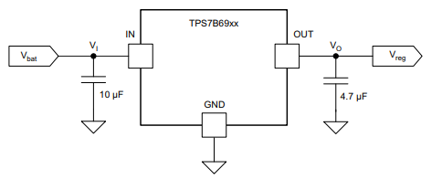
Figure 10 – Typical application schematic for TPS7B6950

3.3.6.2 Switching Voltage Regulator:
After some time spent looking through some manufacturers catalogs of switching voltage regulators considerations it was determined that Texas Instruments LMR14010A step-down converter would satisfy the design of the zip line inspection tool. The LMR1410A is a pulse width modulated DC-to-DC step-down regulator with a wide input range making it suitable for many applications including cameras. The shutdown current for this buck regulator is extremely low making it ideal for extending the life of the battery it is connected to. The operating frequency is around 700 kHz which allows the attachment of small external components while keeping the output ripple voltage to a minimum. One of the main reasons switching voltage regulators are not used in an application is that they require extra components however the LMR104010A has built in internal soft-start and compensation circuits which limit the need of external components. The Texas Instrument step-down converter also comes with some other features such as pulse-by-pulse current limit, thermal sensing, and shutdown due to excessive power dissipation. The LMR14010A has a very high efficiency vs output current at above 80 percent for anything above one milli-Amp making this device very desirable for battery life conservation. Please review Table 123 for further details on the features of the LMR1410A.
Specification | Value
Input voltage | 4 – 40 V
Switching frequency | 550 - 850 kHz
Quiescent current | 30 μA
Regulated output | 5 V ± 3%
Output voltage ripple | 1%
Maximum duty cycle | 96%
Output current | 0.1 – 1 A
Junction shutdown temperature | 170 °C
Feedback voltage | 0.74 – 0.79 V
Table 17 – Features and specification of the LMR14010A
The LMR1410A has six pins and a small package size of just three-square millimeters making it easy to incorporate onto the printed circuit board with the rest of the components. Texas Instruments also provides an example design procedure and sample schematic for the purpose stepping down a 12 V input to 5 V capable of a one Amp output current. This sample schematic can be viewed in Figure 11 below.
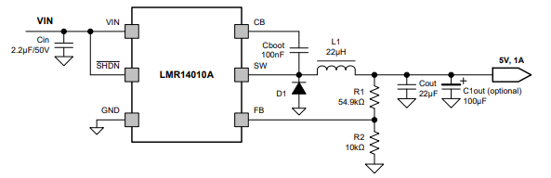
Figure 11 – Sample design circuit using the LMR14010A

3.3.7 Data Storage
This section will look at the different types of data storage we compared for storing the output from the visual sensors, hall sensors, and other data output streams we have associated with the inspection tool. Below in Table 18 are the specifications for the three drives we considered.
We did not want to rule a traditional hard disk drive out immediately as they would be the easiest and cheapest drive to replace in most cases. For that reason, we looked at the LaCie Rugged Mini which is a traditional hard disk drive. It is made to be shock, drop, and pressure resistant which will keep the drive safe from most possibly damaging situations along with its smaller size saving space in the inspection tool.
The ioSafe Rugged Portable SSD was the next option considered with it being an extremely durable solid-state drive. It already began with the advantages that solid-state drives have over hard disk drives as discussed in section 3.2.3.2. however, it was also specifically made to be resistant to a large number of conditions which pass multiple Department of Defense military standards for equipment durability.
The StarTech Rugged Hard Drive is actually an enclosure that can be used with any traditional 2.5-inch hard disk or solid-state drive. This option was focused on trying to find an option that had the advantages of a solid-state drive but not the price tag associated with the ioSafe drive. The StarTech also possessed many of the Department of Defense military standards for equipment durability but did so at a much cheaper price point while allowing flexibility on the drive used in the enclosure.

 | LaCie Rugged Mini | ioSafe Rugged Portable SSD | StarTech Rugged Hard Drive Enclosure
Capacity | 1/2/4 TB | 500 GB/ 1TB | Variable
Storage Type | HDD | SSD | HDD or SSD
Interface | USB 3.0 | USB 3.0 | USB 3.0
 |  |  | SATA for drive
Drop Height | 4ft | 20ft | 13ft
Other Resistances | Rain/Pressure | Crush/Water/Chemical | Vibration/Humidity
 |  | Environmental/Altitude | Salt Spray/Dust
Price | 1TB - $100 | 500 GB - $650 | $50*
Table 18: Storage Drive Comparison Table, *Plus cost of SSD in enclosure
Capacity: This factor was important as the storage device will need to store the video output from three visual sensors, which will take up a large amount of memory even with video compression, along with measurements from the hall sensors and distances traveled on the wire cable for four cables in a single trip. This made it necessary to be able to have a drive with significant storage.
Storage Type: This denoted whether the drive was a solid-state or hard disk drive as there are advantages and disadvantages to both types.
Interface: The interface determines the ports and connections necessary to connect the sensors and microcontrollers to the storage device as well as the data transfer rate. The other importance to the interface is for the end user as the goal is to make is as easy as possible for them to disconnect the drive and be able to connect it to their computer and be able to store and backup the data.
Drop height: This is one of the most important determining factors for which data storage we could use as the inspection tool has a requirement of being able to survive a 12ft drop and still be functional.
Other Resistances: These items are not the main priority but help with the overall durability and longevity of the storage drive as it will possibly be exposed to the natural elements associated with the Florida coast while it is in use.
Price: The cost of the storage drive could be almost be ignored for the final product as the end user would be able to upgrade the storage as they felt the need to. However, for development purposes we wanted to have an option that satisfied all of our requirements while as being as low cost as possible. Keeping the price down also improves the upkeep and maintenance costs for the device over its lifespan.
After looking at all the factors the LaCie hard drive does not come close to the 12ft drop requirement for the inspection tool and to try and build extra cushioning into the inspection tool to compensate for the extra 8ft would be more work and effort then spending the extra money for a more durable hard drive. The ioSafe solid-state hard drive is more than capable of surviving the 12ft drop requirement however and comes with many other resistances and advantages that make the drive much more durable. With the added capabilities though also comes a much higher price tag that is almost doubled if you expand the storage to 1 terabyte. The price would make the storage the most expensive component of the inspection tool and would cost almost more than all the other sensors and electrical components combined.
The Startech enclosure clears the 12ft drop requirement and passes a good handful of durability standards that will help the longevity of the drive while also coming in at only fifty dollars. The downside however is needing to purchase a solid-state drive to go in the enclosure, though looking at prices of 2.5-inch solid-state drives shows that you can purchase two or three terabyte solid-state drives before you would equal the cost of the ioSafe drive. With the combination of cost and durability the Startech enclosure is the best option as it satisfies the durability requirements while also not being the largest portion of budget for the inspection tool.

3.4 Parts Selection Overview
Table shown below offers an overview of the part selections for the major components making up our system.

 | Part Number | Manufacturer | Cost (USD per unit)
Motor | 23L204S-L8 | Anaheim Automation | $175
Motor Driver | DM542T | Amazon | $39.99
Microcontroller | ATMega328P-PU | Atmel | $2.01 x2
Hall Effect Sensor | DRV5056-Q1 | Texas Instruments | $1.83
Visual Sensor | ArduCAM-Mini-5MP-Plus OV5642 Camera Module | ArduCAM | $39.99
Battery A | Li-Ion 18500 Battery pack: 7.4V 2.8Ah | AA Portable Power Corp | $40.00
Battery B | Powerizer LiFePO4 Battery 24V 10Ah | Powerizer | $299.00
Storage Enclosure | Rugged Hard Drive Enclosure (S251BRU33) | StarTech | $49.99
Storage Device | 850 EVO 500GB 2.5-Inch SATA III Internal SSD | Samsung | $154.00
Video Microcontroller | Raspberry PI | Amazon | $39.00x3

Table 19: Major Parts Selection Overview

4.0 Related Standards
Standards are a crucial aspect of any design, in this section standards applicable to our Zip Line Inspection Tool will be discussed. The related standards that will be discussed include Zip Line, Battery, and Software Testing Standards.

4.1 Zip line Standards
In this section the Zip Line standards will be outlined per OSHA standards. Zip Line standards insure safety however they can be tedious to monitor. We need to ensure that as the wire rope of the Zip Line is being examined it meets all of the OSHA standard requirements.

4.1.1 OSHA Requirements
According to OSHA standards the basic requirements for a wire rope inspection are a diameter check and a visual inspection.
From OSHA Standard 1926.1413 Wire rope inspection:

- Significant distortion of the wire rope structure such as kinking, crushing, un-stranding, bird caging, signs of core failure or steel core protrusion between the outer strands.
- Significant corrosion.
- Electric arc damage (from a source other than power lines) or heat damage.
- Visible broken wires, as follows:
- In running wire ropes: Six randomly distributed broken wires in one rope lay or three broken wires in one strand in one rope lay, where a rope lay is the length along the rope in which one strand makes a complete revolution around the rope.
- In rotation resistant ropes: Two randomly distributed broken wires in six rope diameters or four randomly distributed broken wires in 30 rope diameters.
- In pendants or standing wire ropes: More than two broken wires in one rope lay located in rope beyond end connections and/or more than one broken wire in a rope lay located at an end connection.
- A diameter reduction of more than 5% from nominal diameter.
- In rotation resistant wire rope, core protrusion or other distortion indicating core failure.
- A broken strand.

4.2 Battery Standards
This project requires the use of portable batteries to power its motors and other electronic peripherals. Lithium polymer batteries were chosen to be this source of this power. This decision makes a significant difference in the end product of the zip-line inspection tool and the standards in relation to these batteries are very important to the overall design. The safety of the operators of the zip-line inspection tool as well as the longevity of the battery and durability of the final product are the main concerns. There are many standards that are applied to Lithium Polymer batteries which come from the Institute of Electrical and Electronics Engineers (IEEE), Underwriters Laboratories (UL), the National Electrical Manufacturers Association, the United Nations (UN), the International Electrotechnical Commission (IEC), the Battery Safety Organization (BSO) as well as some others. Some of the Lithium polymer standards are listed below.
- IEC 61960 : Using Lithium battery cells for portable applications
- UL Subject 2271: Batteries for Use in Light Electric Vehicle Applications
- UL 2575: Lithium-Ion Battery Systems for Use in Electric Power Tool and Motor Operated, Heating and Lighting Appliances
- BATSO 01: (Proposed) Manual for Evaluation of Energy Systems for Light Electric Vehicle (LEV) — Secondary Lithium Batteries
- JIS C8714: Safety Tests for Portable Lithium-Ion Secondary Cells and Batteries for Use in Portable Electronic Applications
- Recommendations on the Transport of Dangerous Goods, Manual of Tests and Criteria, Part III, Section 38.3
- IEC 62281: Safety of Primary and Secondary Lithium Cells and Batteries During Transportation
- C18.2M: Part 2, Portable Rechargeable Cells and Batteries — Safety Standard
- IEEE 1625: Rechargeable Batteries for Multi-Cell Mobile Computing Devices
- UL 1642: Lithium Batteries
- UL Subject 2271: Batteries for Use in Light Electric Vehicle Applications
These listed standards should cover all the storage, charging, discharging, casing, temperature, transportation, etc. safety concerns when handling Lithium polymer batteries. Adhering to these standards while constructing and operating the zip-line inspection tool will ensure the safety of all individuals and provide the project with the best results

4.3 Software and Systems Engineering- Software Testing Standard
The ISO/IEC/IEEE 29119 Software Testing Standard “is an internationally agreed set of standards for software testing that can be used within any software development life cycle or organization.” By implementing these standards, it shows that our group uses internationally recognized and agreed upon standards for software testing. There are currently five parts to the standard: Concepts and Definitions, Test Processes, Test Documentation, Test Techniques, and Keyword Driven Testing. For our purposes the first, second and fourth portions will be explained and discussed as they relate to this project.

Part 1: Concepts and Definitions
ISO/IEC/IEEE 29119-1 exists to facilitate understanding and the use of all the other standards within ISO/IEC/IEEE 29119. The first section of the standard introduces vocabulary that all the other standards are built upon and gives examples of each concept introduced. While not something that can necessarily be directly applied itself, it is informative and provides definitions of the different software testing concepts that will later be used and applied in the other sections of the standard.
Part 2: Test Processes
ISO/IEC/IEEE 29119-2 is used to define a general process model relating to software testing that can be applied within any software’s development lifecycle. The general model specifies test processes that can be used to manage software testing in a broad range of professional or simple project to ensure quality software testing. The process is based on a three-level approach that includes organizational specifications, test management, and dynamic testing. The standard focuses on a risk-based approach so that the testing can prioritize and focus on the most key features and attributes of each component under the test. Below in Figure 12 you can see a basic outline of the relationship between the different parts of the test process.

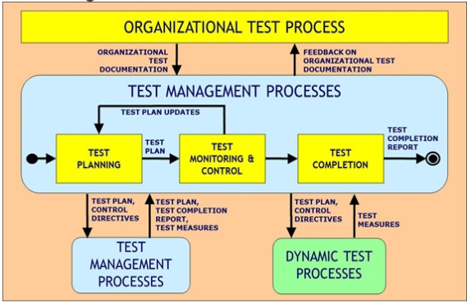
Figure 12: Process Relationship Overview; Figure provided by IEEE
Part 4: Test Techniques
ISO/IEC/IEEE 29119-4 focuses on defining one international standard covering software test design methods or test case design methods that are able to be used with any range of companies or software development lifecycles. Test design methods in this standard can be used to design test cases that can be used to provide evidence that the requirements of each component in the system have been met or that defects have been found. Going back to ISO/IEC/IEEE 29119-2 a risk-based approach is used to determine which specific methods and procedures are applicable to specific situations and which test procedures and test cases should be prioritized. This helps these techniques to then be tailored to the specific needs of each project and component in the system.

5.0 Design Constraints
In this section various Design Constraints will be addressed, when developing a product there are many numerous factors and constraints that must be considered in the development process including but not limited too Monetary constraints, Time Constraints, Environmental Constraints, Ethical and Safety Constraints and Manufacturability constraints.

5.1.1 Monetary Constraints
The cost of the entire zip-inspection tool is a major constraint due to the fact that the components, especially the battery, can be quite expensive. Also, it is desirable to keep the cost low to remain competitive with technologies and services which are currently available on the market. A higher cost of the system will make this zip-line inspection tool less desirable. However, the burden of cost should be greatly reduced by general funding and sponsorships, namely from ULA (United Launch Alliance) and TNZ (Terra-Nova Zipline). ULA and TNZ are the companies that designed and built the emergency egress system located at Cape Canaveral Air Force Station which will be the main test for this zip line inspection tool. This monetary boost may welcome some trial and error for determination of which components and configurations derive the best results of the zip-line inspection tool. Since there are many aspects which are capable of influencing the sensor resolution and reliability such as magnetic saturation level of the steel wire rope under test, sensor technologies, position and dimensions of the defects the ability to tweak and test these different aspects should be a beneficial boost to the robustness of the zip line inspection tool. Also, it is noteworthy that there are currently three different mechanical engineering teams building three different chassis for the zip-line inspection tool. This will mean that whatever funding received will have to be spread around fairly but the aim of the electrical and computer science end of the zip-line inspection tool is to create a tool which is as modular and compatible as possible to the mechanical side of the project. That way the same tool can be attached to the three-different chassis without much of a headache or need for different parts.

5.1.2 Time Constraints
The time constraints on this project maybe some of the more complicated constraints to evaluate and meet. The reason is because the mechanical teams are graduating in the fall while the electrical and computer science teams are graduating in the summer. This will require extra coordination such that each team knows how to incorporate the zip-line inspection tool with their chassis during the functional testing and presentation in the fall with limited assistance from the electrical and computer science team. However, this may prove to be a blessing in disguise since one half of the project should be built, tested, and completed in the summer then awaiting attachment in the fall.
The time schedule for the project concerning the electrical and computer science parts begins in the Senior Design I course and ends near the last week of the Senior Design 2 course in the summer of 2018; the zip-line inspection tool must be completed by August 3, 2018. This is a total of about seven months. During this time the designing, ordering of components, building and testing of this project must be completed and the zip-line inspection tool must be fully functional as to fulfill the engineering requirements. To safeguard that these goals are met an agenda of the project is outlined in the Milestones section and the table lists each task and the time required to complete the task in chronological order all the way through to August 3.

5.2 Environmental, Social, and Political Constraints
This tool was designed to eliminate the need of inspecting the entire length of a very long steel wire rope directly by human eye. Doing so should save lots of time for the individuals whose job it is to complete this inspection by enabling them to inspect the wire rope without climbing down the zip line themselves. Therefore, the only social constraint the zip line inspection tool could face is that if it is deemed to be more of a burden than the original inspection method of manually.
Since this is a portable device and is intended to be used outdoors the main environmental constraints are from the weather of the coastal Florida location. The location has high humidity, heat, and salt levels in the air from the nearby Ocean. It is not advised that the zip-line inspection tool be operated in rainy, stormy, or very windy conditions due to the hazard that these conditions would present the individuals using the tool and to the tool’s operating conditions. If the tool were to be used in rainy or wet conditions the device may be prone to slippage due to not being able to grip the slick surface of the wire rope appropriately. Not to mention that the zip line inspection tool may incur water damage to its electronic components if there is no perfect seal. Windy conditions which are strong enough to sway the zip-line may also cause the zip-line inspection tool to rock on the line distorting any images captured by the on-board cameras and thus wasting time. Lighting strikes would also be very damaging to electronics and the zip line inspection tool should not be operated in a lightning storm.
Storage of the Zip line inspection tool is important to maintaining the condition of the batteries as well as moving parts. The zip line inspection tool should not be stored in a damp or overly warm environment. Doing so may incur rust to the moving parts such as the motors or the PCB. Storing of the batteries which power the zip line inspection tool in environments of temperatures more than 30 degrees Celsius will cause the battery to not be capable of charging to 100 percent of its original capacity after several months.
Given the nature of the location and working environment this device is intended to be used in it is important the all OSHA regulations be followed in the operation of the zip line inspection tool. This is to ensure the safety of the inspection team. It is also important that the OSHA regulations on the integrity of steel wire rope be tracked to coincide with the inspection tool.

5.3 Ethical, Health, and Safety Constraints
This section discusses the possible ethical, health and safety constraints that may affect the design and building of the zip line inspection tool. With the device being used to inspect the wire cables for an emergency egress system health and safety is a crucial factor.
The inspection tool will be attached to the overhead cable by a single worker once the device is finished, with this in mind we need to consider any factors that could endanger the person operating the tool. Items such as the weight and size of the device are a factor as we need to make sure that the device can be safely lifted overhead by a single person without needing extra assistance. Also, any moving parts that a person could possibly get caught in or injure themselves with. With these factors considered our goal is to make the device as light as we can while keeping it small and contained in a convenient casing.
With the health and safety of the operator considered we then want to look at anything the device may be coming into contact with or affecting any changes on. In this case the focus would be on the wire cable and making sure nothing on the device could cause damage or harm to the cable. This means making sure that none of our inspection methods would affect the structure of the cable. As well as anything that may be touching the cable such as any wheels or part of the casing that may come in to contact with the cable at some point.

5.4 Manufacturability Constraints
This section looks at the manufacturability constraints that have an effect on building and producing the inspection tool. Looking at production issues that may exist now or may come along later in the devices lifecycle.
Manufacturability is the measure of how easily and effectively a product or technology can be produced while still being able to achieve certain standards of quality. The important points that overall combine to determine the manufacturability of an item are cost of parts and components, ease of access and supply of those parts and components, time and effort needed to assemble all parts, testing of the device, portability of the device and then later repair or replacement of the device. Our goal with the inspection tool is to design a device that is as simplistic to use as possible and can be assembled using parts from third-party manufacturers without too much complexity.
With the possibility of multiple types of mechanical systems used to allow the inspection tool to descend the wire cables our goal was to make all of the visual, electromagnetic, and physical sensors along with the data storage and power supply for the electronic systems to be its own contained system as much as is possible. The system of sensors can then be attached to whatever mechanical system is being used to traverse the wire cable and should take accurate measurements and readings with possibly only minor calibration changes depending on the movement system being used.
For sustainability purposes we will have an enclosure for the PCB board and the data storage components. The cameras will be in another enclosure mainly for the purpose of providing a consistent video quality of the wire cable as it moves along the cable. This will serve a secondary purpose of also protecting the cameras from the elements while they are up on the wire. Even with the protections from the enclosure the electrical components will still possibly break down or have issues from normal wear and tear. With this in mind we want all the components to be easily acquired from third-party manufacturers and easily replaceable with the components already on the inspection tool.

6.0 Inspection Tool Hardware and Software Design Details
This section will go over the various Hardware and Software Design details for the components of the Zip Line Inspection Tool. The software design details for various sub systems will be examined.

6.1 Visual Inspection and Data Storage
This section will go into detail about the specific hardware components chosen relating to the visual inspection of the cable and the storage of the data from the Hall sensor, the reading of the distance traveled and the visual data from the camera modules. The last part will also discuss the software used to manipulate the visual data.

6.1.1 Visual Sensor Hardware
This section will discuss the specific visual sensor hardware that will be used for the visual inspection. These components are important as the main goal our sponsors want to achieve is a quality video of the entire length of the cable. Also, all of the video hardware will be controlled by a microcontroller though it will be its own standalone controller for the video system but it will be the ATmega328/P which is discussed further in section 6.4.

For camera hardware we are using three ArduCAM-Mini-5MP-Plus OV5642 Camera Modules. The ArduCAM-Mini-5MP-Plus OV5642 is a general purpose high definition 5MP SPI camera. This camera modules integrates the 5MP OV5642 CMOS image sensor discussed in section 3.3.4, along with adding some more hardware to assist with the image processing and handling and reducing the complexity of the camera control interface. It also gives it the advantage of being able to be easily interfaced with many different development platforms and hardware while having an existing open source library for the software to operate the camera module. The large advantage we were interested in though is that it allows for multiple cameras to be connected to a single microcontroller since all of the image processing is not being handled by only microcontroller. Below is the pin assignments along with the block diagram for the camera module hardware in figure 17 below as well.
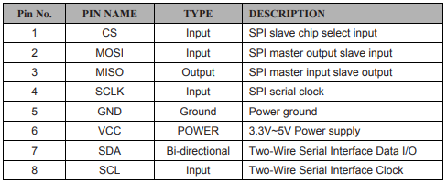

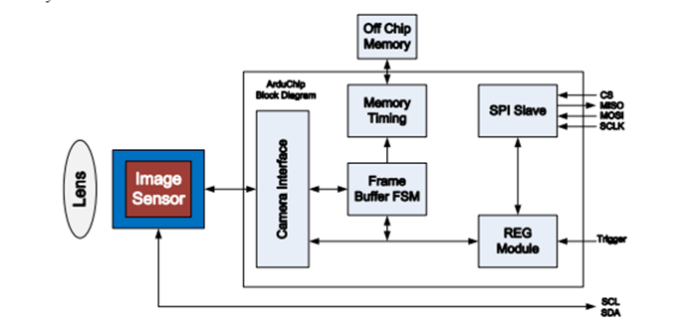
Figure 13: ArduCAM-Mini-5MP-Plus Diagram
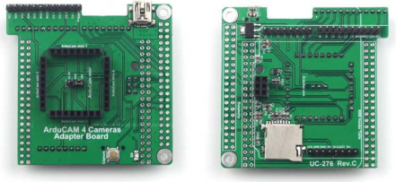
Along with the microcontroller and multiple camera modules we also used a specific hardware interface to be able to connect the multiple cameras simultaneously. It is the ArduCAM 4 Cameras Adapter Board that you can see below in figure 14. The board is used for ease in development and design testing. Then below the image of the board is the wiring schematic in order to connect multiple cameras at the same time in figure 15.
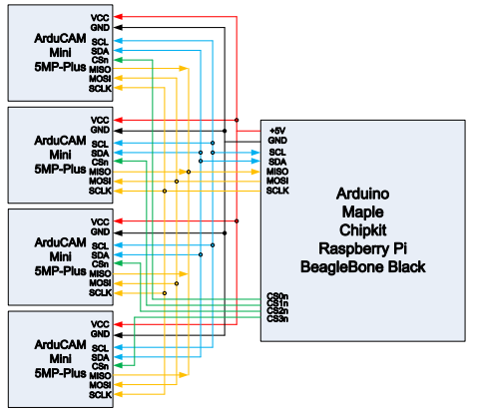
Figure 14: 4 Camera Adapter

Figure 15: Multi-cam Wiring Schematic

6.1.2 Data Storage Hardware
This section discusses the hardware used to store the data output from the multiple visual sensors, hall sensors and the distance reading from the inspection tool.

The decision was made to use the StarTech Rugged Hard Drive Enclosure based on comparisons looked at in section 3.3.6. This option gave us the most flexibility for what storage drive we wanted to use while also staying low on cost and passing the durability and survival requirements imposed by the project sponsors. However, with this option we then needed to select a basic 2.5-inch solid-state drive to put in the enclosure. The only major requirements for it being that it is a 2.5-inch drive that is SATA compatible. With this in mind and wanting to keep budget low we decided on the Samsung 850 EVO 500GB 2.5-inch SSD. This allows us to keep the cost down while still being able to effectively develop and test the zip line inspection tool and later on the sponsor with more budget can simply upgrade the storage drive to a larger drive as it is not necessary for us to spend the large amount of extra funds to get a one or two terabyte drive just for development and testing purposes.

6.1.3 Visual Sensor Hardware Complete
This section will discuss the final selection of components for the Visual Sensor Hardware. These selections are the choices made after significant development and testing and are what we determined were the best choices to accomplish the goals of this project while staying within any constraints and requirements imposed upon us.
The final hardware selection is comprised of three Raspberry Pi’s connected to three separate Raspberry Pi Camera module V2. All three systems have three simple LED’s connected to each system separately to convey the current state of the system to the user while all systems are connected to a simple button as well. The Raspberry Pi and camera module can be seen below in Figure 16.
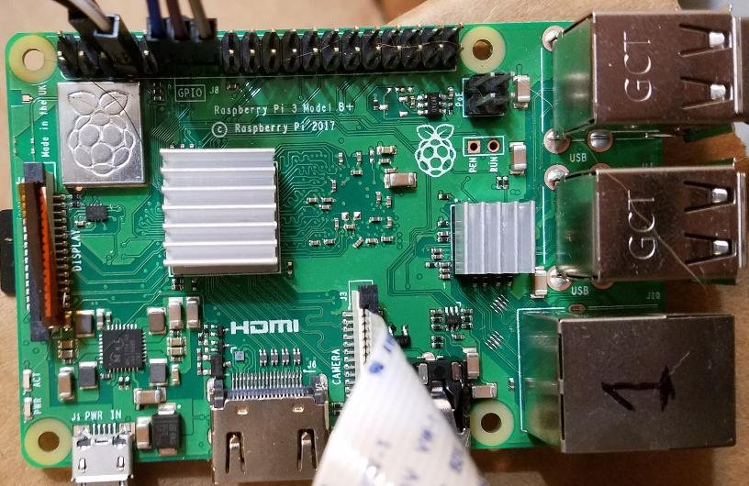
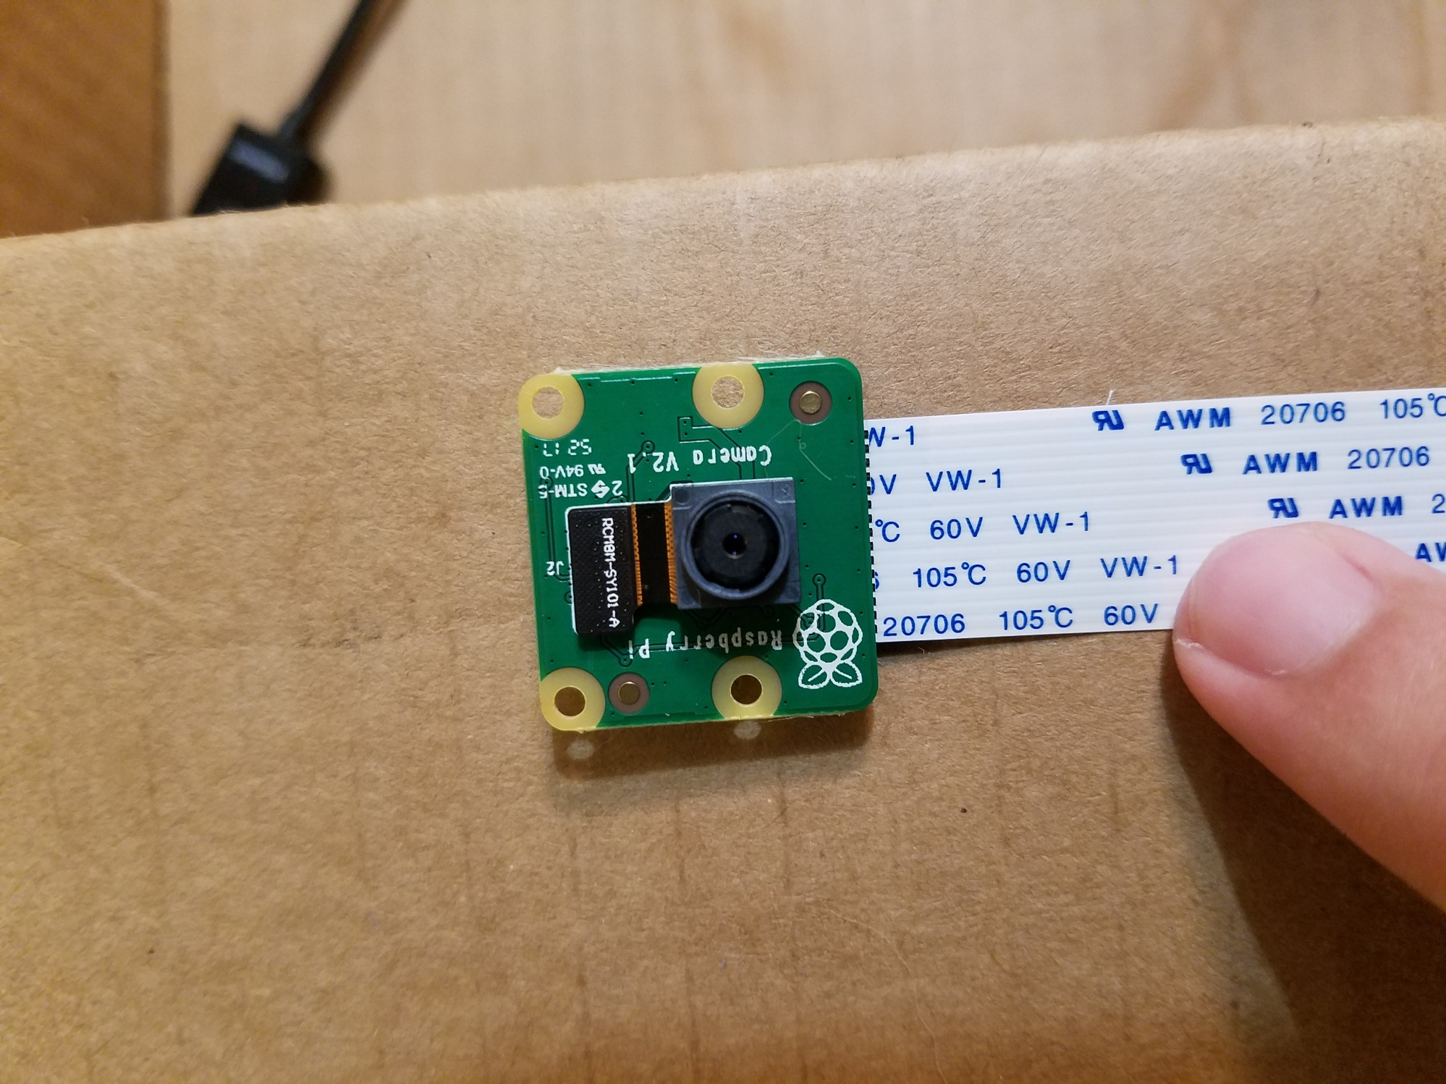
Figure 16: Raspberry Pi and Camera Module

Using the three Raspberry Pi’s increased total costs but allowed assurance that the cameras would be able to output at a consistent 1080p at 30 frames per second. The advantage of three separate systems also allowed for the simplification and modularity of the system allowing for more failure tolerance and easier replacement if there are issues with the system. By splitting the system, it allows for the replacement of only an individual system if there is an issue and simplifies the cost and effort associated with it.

The system uses a simple button to start and stop each of the three cameras while using three very simple LED’s to inform the user whether the system is ready to begin recording, in the process of recording, or ready to be turned off. Using one button allows for synchronization across the cameras while the separated LED’s allow for he state of each individual component to be known.

6.2 Hall Sensor Design
The goal of this section is to discuss the schematic designed in Eagle of the Hall effect sensors selected for detection of the magnetic flux leakage. This section will also briefly describe the data acquisition of the analog output of the Hall effect sensors as well as possible PCB layout of the sensors.

6.2.1 Sensor Design
The design of the Hall sensor elements consists of the attachment of the input voltage to a regulated 5 Volt power supply. Then the connection of a .01 μF capacitor between the ground and input voltage pins. Next for lower noise on the analog output pin an additional RC filtering circuit was elected for addition to further reduce the bandwidth and lower the noise seen by the microcontroller analog input pin. In figure 17 below is a schematic of a connection of one of the Hall effect sensors done in EAGLE schematic design software.
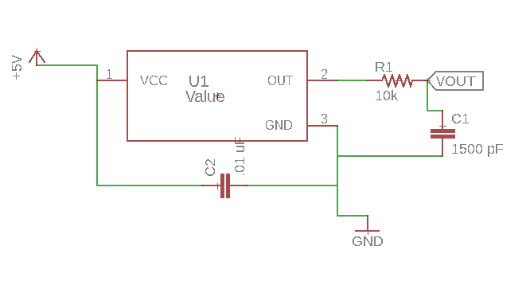
Figure 17 – Schematic of the Hall effect sensor connected to 5V supply and microcontroller
The wire rope is to be surrounded by an array of these sensors and printing a PCB board to match this configuration will be a major challenge. Ultimately, we require that there be two Printed Circuit Boards, each with their own set of Hall effect sensors and connections for input voltage, ground, and wire connection placements for VOUT to the microcontroller analog input reading. See Figure 123 for a rough sketch of the desired PCB.

Figure 18 – Draft design of PCB layout for hall sensor placement

6.2.2 Data Acquisition
The DRV5056-Q1’s to be used in the Zip line inspection tool are continuous-time, ratiometric, linear Hall-effect sensors. They receive a five Volt input from the voltage regulator and accurately produce a ratio of the five Volt input based on an applied magnetic field to the sensor. If there is no magnetic field applied to the sensor then the analog voltage output from the sensor will be the quiescent voltage which is 0.6 Volts for the DRV5056-Q1. The output pin of the DRV5056-Q1 will be directly connected to the analog input pin of the microcontroller for reading at the optimal clock rate. This value will then be converted to a digital value for storage in a variable. Please refer to Figure 19 for a simplified block diagram of the process of how the Hall sensors will be interfaced with the microcontroller.
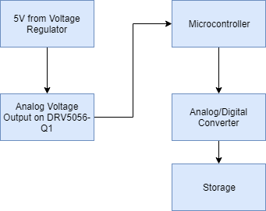
Figure 19 – block diagram of the Hall effect analog voltage detection and storage
How the data is stored from the hall sensor is important because when there is a fault and ideally the hall sensor reads this as a high voltage there needs to be a correlation with the video input from the cameras to the location of the high voltage from the Hall effect sensor. When storing each value from each hall sensor the time at which the reading was taken will be stored alongside it in an array format such that the values can be downloaded for further analysis. Ideally it is desired that the sensor voltage data to be graphed versus time and to be viewed in conjunction with the camera footage to make the identification of faults on the zip-line easier to locate.

6.3 Motor Design
The Motor Design section will examine the hardware and software design details of the Motor subsystem. The motor subsystem consists of a battery to power the motor and related components, the 23L204S-L8 Stepper Motor, L298 H-Bridge Motor Driver, and ATMega 328P Microprocessor.

6.3.1 Initial Design and Related Diagrams
The Initial Design and proposed sub-system was developed in the early stages of the semester through the divide and conquer document. The initial design is shown below in Figure 20. Following our meeting with the United Launch Alliance representative we were informed that RF frequency controls were not an option and had to shift to an automated preprogrammed run.
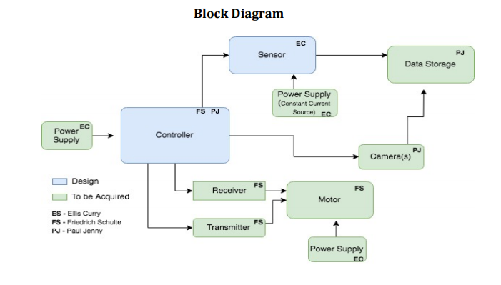Figure 20 depicting Initial Block Diagram design.
While we found that changes had to be made to our initial Block Diagram the fundamental blocks remained, an updated Block Diagram is shown in the figure below.
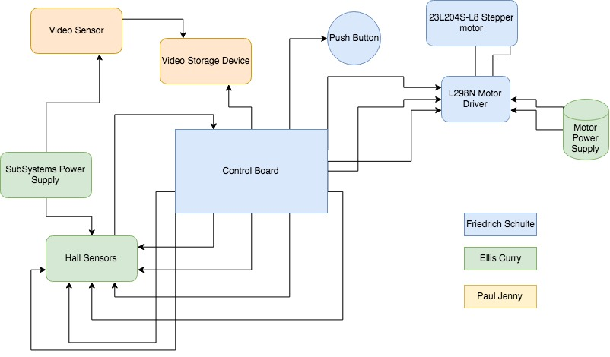
Figure 21 depicting update Block Diagram Design
As development continued in Senior Design 2 we once again had to revise our block diagram to reflect changes to our design. Below in Figure 22 we see the final updated Overall block diagram for the Steel Wire-Rope Inspection Tool.
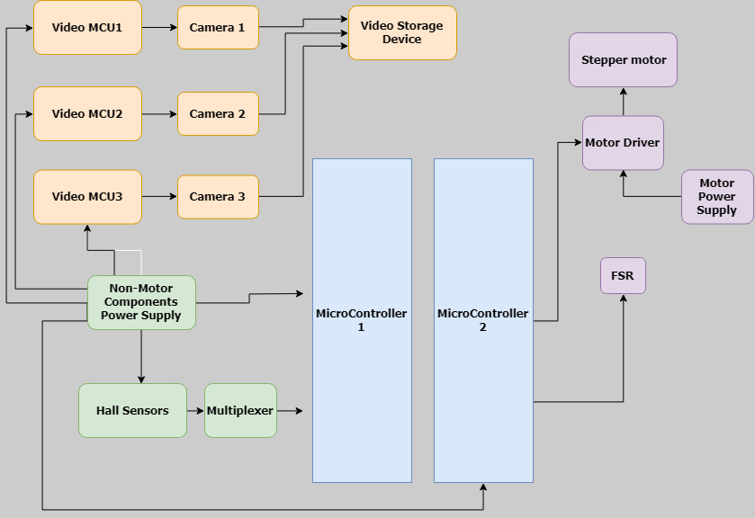
Figure 22: Final Block Diagram

6.3.2 Motor Controller Hardware
The hardware involved in controlling the motor consists of the Motor Controller, and Microprocessor. The Motor Controller that will be used is the L298 H-Bridge and the ATMega328P microprocessor will be integrated and used. Additional Hardware for the Motor Control will include a heatsink to achieve maximum current output from the L298 H-Bridge, Protection Diodes
Design changed to switch the Motor Controller from the L298 H-Bridge to the DM542T Digital Stepping Driver. The motor driver consists of two connectors, P1 for control signal connections and P2 for power and motor connections. P1 configurations are made up of 6 pins in total. Two Pulse signal pins (PUL+ and PUL-) used to represent the pulse signal used to drive the motor. Two direction signal pins (DIR+ and DIR-), a signal with low and high voltage levels representing the two directions of motor rotation. Note that rotation direction is also related to motor-driver wiring, exchanging the connection of two wires for a coil will reverse motor direction. The last 2 pins on the P1 configuration are used to enable and disable the driver (ENA+ and ENA-). The P2 configuration is made up of 4 pins in total. The first pin +V is connected to the Power Supply (20-50VDC), the second GND is used for Power Ground, the A+ and A- pin is used for motor phase A, and similarly the B+ and B- pin is used for motor phase B.

6.3.3 Motor Controller Software
The L298 H Bridge motor controller will be used to control the rotational direction of the motor as well as communicating to the Motor when to start and stop based on pin configurations. Table below shows how by applying a LOW or HIGH signal to the Input 1 and 2 lines the motor and its direction can be controlled.
Input 1 | Input 2 | Action
LOW | HIGH | Motor breaks and comes to a stop
HIGH | LOW | Motor turns forward
LOW | HIGH | Motor turns backward
HIGH | HIGH | Motor breaks and stops
Table 20: Signal inputs to control stepper motor using L298.

A simple code block of
DigitalWrite (6, LOW);
DigitalWrite (7, LOW);
Will bring the motor to a stop, likewise
DigitalWrite (6, HIGH);
DigitalWrite (7, LOW);
Will cause the motor to turn forward if the HIGH and LOW variables are switched then the polarity of the motor would flip and it would turn backwards.
Ex)
DigitalWrite (6, LOW)
DigitalWrite (7, HIGH)
By integrating our L298 Motor controller with our ATMega328P-PU we are able to store run time instructions and controls and interface them with the Motor. By appropriately coding the necessary amount of turns based on turn distance we can pre- determine the number of steps needed by the stepper motor to achieve the desired run distance of 1319 feet. By incorporating a simple push button, the Zip Line inspection tool will simply have to be mounted on the wire and the push button engaged for the motor to begin turning and the wire inspection to begin.
The software design details for the original configuration of the L298 Motor Controller are detailed above however for the updated prototype featuring the DM542T Digital Stepper Motor Driver a variety of code control blocks were written to control the motor. Shown below is the stepper motor control code with the Force Sensitive resistor incorporated to stop the motor.


Figure 23: Motor Control Code with FSR to stop

6.4 Microcontroller Design
The ATMega328P Microcontroller offers
• 32kb of FLASH memory for program storage.
• 2kb of RAM memory.
• 1kb of EEPROM memory
• Two 8-bit and one 16-bit timer/counters.
• 6 channels of 10-bit analog-to-digital converter (ADC).
• Serial communications port. This can be used to communicate to the COM port of a computer.
• 21 lines of general purpose I/O
For both the Hall Sensor sub-system and the Motor Control sub-system the ATMega328p was used as our microcontroller of choice. Two separate ATmega328p microcontrollers were used, one for the Hall Sensor sub-system and one for Motor Control. Shown below are the relevant schematic and board layouts for each system.
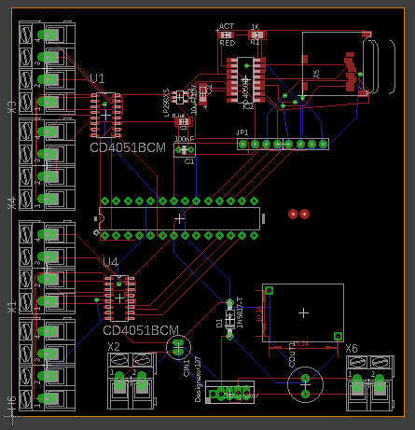
Figure 24: Eagle CAD schematic of Hall Sensor Control Board

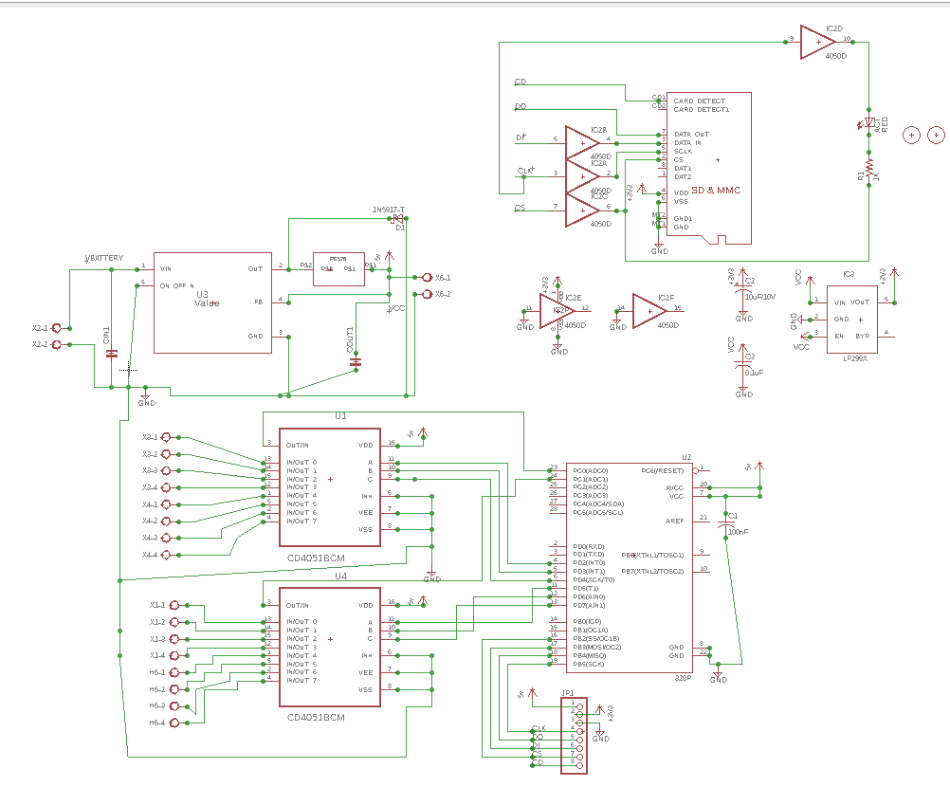
Figure 25: EagleCAD Schematic of Hall Sensor Control Board
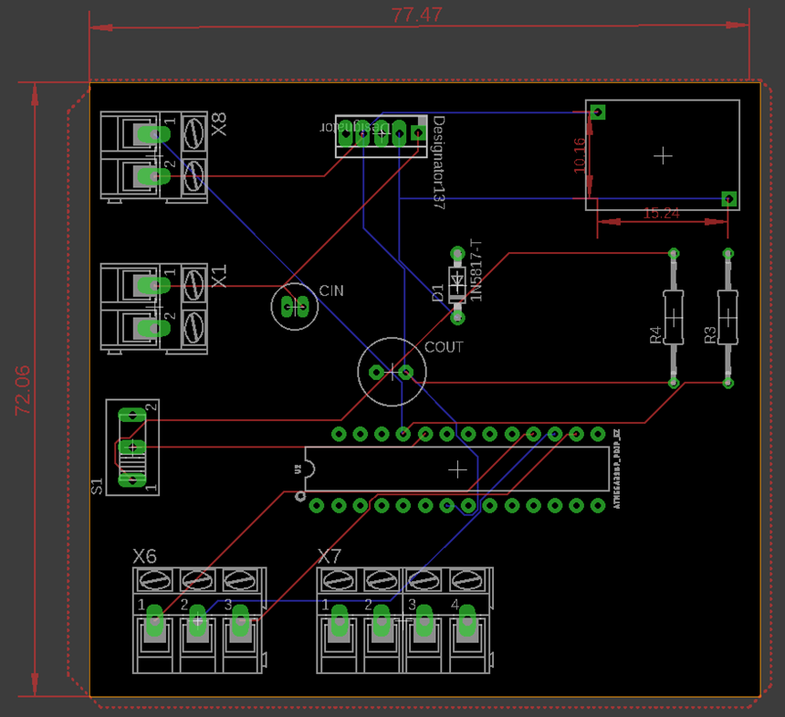
Figure 26: EagleCAD Board for Motor Control
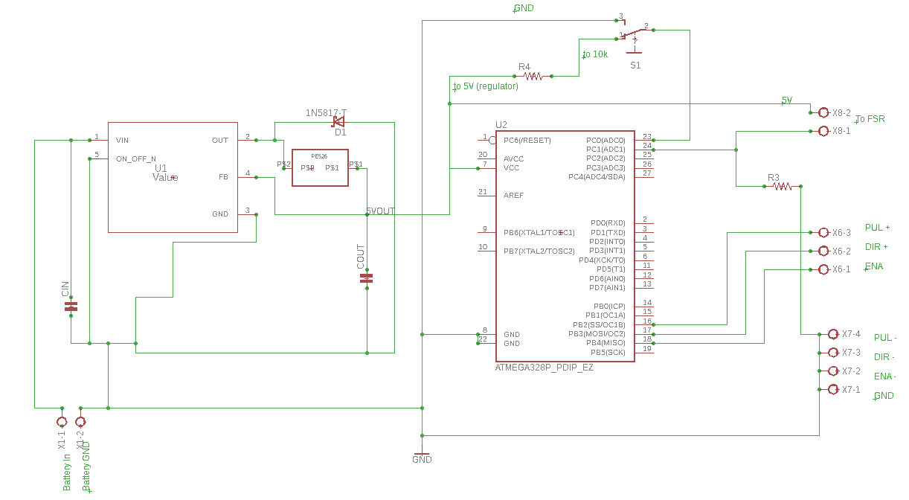
Figure 27: EagleCAD schematic for Motor Control

6.5 Additional Hardware Design Features
Additional Hardware Design Features include the housing box where the PCB and all of the Electrical components will reside. The housing box will be 8x8x10 inches and will connect to the various mechanical designs implemented by the mechanical engineering teams. By utilizing a housing box the electrical components are protected from the elements and it allows us to keep all of our components in one removable element that can be used among the three mechanical teams.

6.6 Software Design Details
This section will specifically discuss the different distinct portions of the software design for the inspection tool. The software for the inspection tool will have four primary areas of focus: calculating distance traveled on the cable, movement control, monitoring hall sensors, and handling the cameras and video software. Distance traveled will be calculated using a rotary encoder on a wheel on the cable to measure distance, movement control will be more varied as the forms of movement may differ depending on the other mechanical groups. Output from the Hall sensors will be monitored and converted into a graph like display showing outputs at certain distances and then the three cameras will need to be processed and the video stored for later use.

6.6.1 Distance Traveled Calculated
This section will discuss how the distance traveled on the wire cable will be calculated. Knowing the exact distance traveled on the cable will be important for syncing the hall sensor readings along with the video. They will also be useful if any major issues are discovered so that the person physically inspecting the cable will know the exact section where to inspect.
Using the input from the rotary encoder connected to the wheel riding on the wire cable, then using some calculations based on the circumference of the wheel the microcontroller will keep a calculation of the exact distance traveled so far. The distance will be primarily to mark where the hall sensors spikes happen on the cable so the important points can be marked on the video footage and output graph from the hall sensor. By using a rotary encoder and a software program to calculate the distance the program can be calibrated to make adjustments to the distance moved for each rotation of the rotary encoder based on the type of propulsion being used for each specific mechanical groups chassis.

6.6.2 Motor Control
There are a few methods for the programming of the ATMega328p for motor control. Using the Arduino development environment, the Microcontroller can be used with an Arduino board and Programmed on the Arduino board, then the Microcontroller can be removed and integrated into the circuit. Alternatively, Atmel has created a standard IDE for AVR’s called AVR studio, however this is limited to Windows Operating System only. Additionally, a USBasp programmer can be used. The method of programming the Microcontroller will most likely be to program the Arduino with the Microcontroller on it using an ISP programmer such as ArduinoISP or AVRISP to flash the Arduino and install an Arduino bootloader. By using a working Arduino connected to our computer where the code will be written the microcontroller can be programmed as shown below in Figure 25. The simplest method of uploading the bootloader is through the Arduino IDE, in the Arduino IDE the board will be selected and the BurnBootloader tool will allow us to find the associated bootloader in the board.txt file and install it. Below Figure 25, Table 20 outlines the necessary connections for programming the ATMega328p using an Arduino.
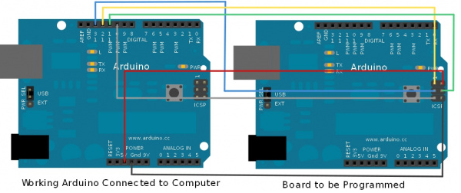
Figure 25
ISP Header | ATmega328
Pin 2 | Vcc
Pin 6 | GND
Pin 4 | D11
Pin 1 | D12
Pin 3 | D13
Pin 5 | Reset
Table 20 Connections for using Arduino as Programmer

The ATMega328p microcontroller will be used for programming the motor controls. The ATMega328p consists of 20 input and output pins, 14 digital and 6 analog. It features 32kb of Flash memory for program storage and 2kb of RAM memory. The ATMega328p was selected due to the affordability and familiarity as well as ample documentation existing reducing the difficulty in integrating hardware components and troubleshooting. By integrating our Motor controller with the Microcontroller unit run time instructions and controls are stored and interfaced with the Motor. By determining the amount of necessary turns based on step angle we can appropriately program the motor to turn precisely as far as we need to meet the run distance of approximately 1320 feet. By sending HIGH and LOW pulses to a digital I/O pin selected to be the pulse pin on the microcontroller the stepper motor will turn.
The motor can be started and stopped with a simple switch incorporated into the system. In addition to stopping the motor by coding in a set run time, or by turning off the switch, an alternative method of stopping the motor was developed through the use of a Force Sensitive Resistor. When the inspection tool reaches the end of the wire and hits a stopping point the force sensitive resistor will be touched and acts as a switch to turn the motor off.
Below we calculate desired Speed and Runtime Values for our Stepper Motor given: Step Angle of 1.8°, Shaft radius of 5mm, desired Linear velocity of 0.868 ft./s.

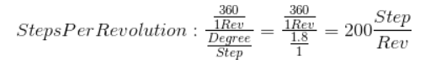

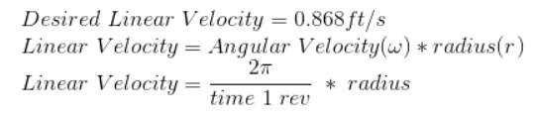
Using our desired Linear Velocity, we can calculate the necessary time for 1 revolution to occur and subsequently determine the necessary Revolutions Per Minute (RPM) to meet our desired run time. First, we determined that the time for 1 Revolution to occur t= 0.03619 seconds. Then we multiply this value by 60 seconds to determine that a run speed of 2.1714 RPM is necessary to achieve our desired Linear velocity of 0.868 ft./s.
Knowing that our Stepper Motor speed is controlled through the microcontroller via steps per second and having calculated the RPM necessary to achieve our desired Linear Velocity we can use the RPM value to determine precisely how many steps per second the motor needs to turn in order to achieve a Linear Velocity of 0.868ft/s
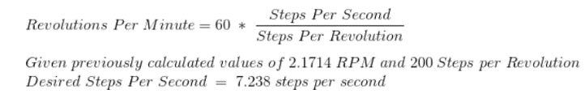

6.6.3 Monitoring Hall Sensors
This section is focused on the monitoring and handling of the hall sensor output and then the storage of the data acquired from the hall sensors. This process will also interact with the distance traveled software at specific times.
While the inspection tool is traversing the wire cable the hall sensors will be monitoring the magnetic flux through the cable and then outputting a voltage within a range dependent on how high or low the flux is at that moment. The microcontroller will be continually polling the sensors on the way down the cable and will store the output of each sensor. If any particular sensor spikes too high or the sensors as a whole rise higher than the normal reading the software will pull the distance traveled and store it alongside the sensor reading at that time. If there is no higher than normal reading however the software will take the distance traveled at regular intervals and store it alongside the reading at the time so when observing the data at a later time it will serve as a reference for where certain readings were located on the cable. The biggest factor however is that the average output reading will have to first be measured for the cables initially and then the software will have to be calibrated to that average reading to ensure a quality reading.

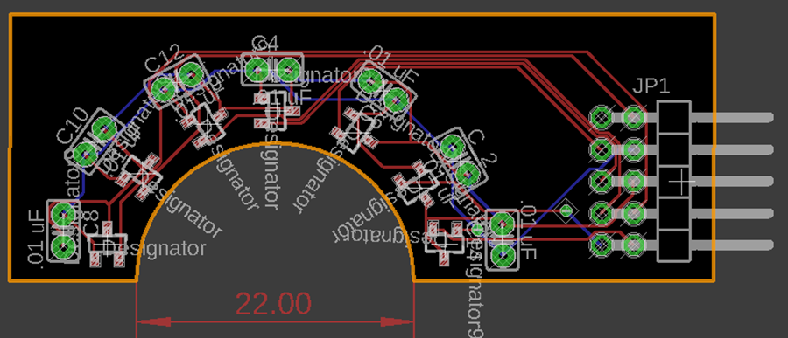
Figure 28: EagleCAD schematic of Hall Sensor Array

6.6.4 Camera/Video Handling
This section will look at how the software will handle the output from the visual sensors. The sensors need to be started at the same time and have the videos synced with each other so that the full circumference of the cable will be visible when watching the videos later.
The microcontroller will initially send the begin recording command to the three visual sensors once it has received the main start command for the entire device. It will then handle the input from the three 5MP-Mini-Plus CMOS OV5642 Camera Modules. These three camera modules will be run simultaneously and spaced equidistant around the wire cable so that all points of the wire cable will have uniform quality video coverage. The three cameras will need to be outputting at a resolution, frame rate, and shutter speed high enough to ensure good video quality, these three video streams will then be output to a data storage device from which the video data can be transferred and stored for later use and comparisons. When output to the storage device the three videos will be timestamped, and have each individual video stream differentiated so that which videos belong to which cable will be easily identifiable as all four cables will be in a session each time the device is used.

7.0 Project Prototype Construction and Coding
This section will give insight to the parts that are required and the construction plans for our system, the Printed Circuit Board. The development life cycle begins with developing a schematic layout and modelling and testing our PCB design using modelling software, followed by sending our PCB schematic to our PCB Vendor where it will be Printed onto a Circuit board and returned. Once the board is delivered we will begin prototyping and debugging on both the hardware and software portions of the system.

7.1 Parts Acquisition and BOM
Subsystem | Item | Quantity | Vendor | Estimated Cost
Motor | 23HS45-4204S NEMA23 Stepper Motor | 1 | Amazon | $39.00
Motor | DM542T Digital Stepper Driver | 1 | Amazon | $39.00
Motor | Mounting Brackets | 1 | Home Depot | $3.99
Motor | ATMega328P-PU Microcontroller | 1 | Atmel | $2.01
Motor | Motor Battery  Powerizer LiFePO4 (24V 10Ah) | 1 | Powerizer | $299.0
Motor | Switch/FSR | 1 | Amazon | $8.50
Motor | Miscellaneous electrical components (resistors, chips, capacitors, wires, etc.) | - |  | $15
Hall Effect Sensor | Hall Effect Sensor | 6 | Texas Instruments | $1.83 x 6  =$10.98
Hall Effect Sensor | Video/Hall Sensor  Li-Ion 18500 Battery Pack | 1 | AA Portable Power Corp | $40.00
Visual Sensor | ArduCAM OV5642 Camera Module | 3 | RobotShop.com | $29.99x3  =$90.00
 | Raspberry PI MCU | 3 | Amazon | $39.99x3  =$120.00
Additional Costs | PCB(s) (Estimate) | 4 | OSH Park | $15x4  =$40.00
Additional Costs | Shipping, Taxes, and other miscellaneous fees. | - | - | $20
Total Estimated Cost |  |  |  | $727.48

7.2 PCB Vendor and Assembly
The first step in PCB Assembly is modelling our PCB using Eagle AutoCAD software. The PCB will be modelled and simulations will run to ensure that all values are correct and all of the components are integrated properly. Once the PCB has been successfully modeled prototyping can begin. By sending our schematic of the designed PCB to our chosen PCB vendor the board will be developed and sent to us. When we have received our board, prototyping can begin and we can start to test the functionality of the hardware and software components.
The PCB is the vital component of the system that allows all of the various sub systems and modules to interact and work together to meet the requirements and deliver a successful product, as such determining which PCB vendor best suits are needs is critical. Reliability, cost, turnaround time, and quality of the board must be considered when weighing our options. With a variety of services, reasonable costs, good turnaround time, stellar reviews claiming excellent customer service and quality deliverables OSH Park was our PCB Vendor of choice. OSH Park takes a PCB order and offers high quality, lead-free boards, manufactured in the United States.
The standard Two Layer Boards ship with FR4 substrate, purple mask over bare copper, and ENIG finish. The minimum design rules for Two Layer Boards provided by OSH Park are as follows
- 6 mil (0.1524mm) trace clearance
- 6 mil (0.1524mm) trace width
- 10 mil (0.254mm) drill size
- 5 mil (0.127mm) annular ring
OSH Park offers a variety of Services that are cost-dependent on the service requested. These services are outlined in Table 21 below. Note that while the table shown below depicts Services for Two Layer boards, one-sided one-layer boards can be ordered on any of the two-layer services provided by OSH Park.
Service | Cost | Time to Ship | Board Thickness | Copper Weight
Prototype | $5 per square inch, per set of 3 | 12 Calendar Days | 63mil (1.6mm) | 1oz
Super Swift | $10 per square inch, per set of 3 | 5 Business Days | 63mil (1.6mm) | 1oz
2oz 8mm | $5 per square inch, per set of 3 | 2-3 weeks | 32mil (0.8mm) | 2oz
Medium Run | $1 per square inch, 100 square inch minimum. Must be in multiple of 10 | 15 Calendar Days | 63mil (1.6mm) | 1oz
Table 21 Services offered for Two Layer boards

Additionally, Four Layer Boards are offered featuring FR408 substrate, purple mask over bare copper, and ENIG finish. The minimum design rules for Four Layer Boards provided by OSH Park are as follows:
- 5mil (0.127mm) trace clearance
- 5mil (0.127mm) trace width
- 10mil (0.254mm) drill size
- 4mil (0.1016mm) annular ring
- Note: Blind or Buried vias are not supported
The services offered for Four Layer boards are outlined in the table below.
Service | Cost | Time to Ship | Board Thickness | Copper Weight
Prototype | $5 per square inch, per set of 3 | 9-12 Calendar Days | 63mil (1.6mm) | 1oz outer  0.5oz inner
Medium Run | $2 per square inch, 100 square inch minimum. Must be in multiple of 3 | 2-4 weeks | 63mil (1.6mm) | 1oz outer  0.5oz inner
Table 22 Services offered for Four Layer boards

7.3 Prototype and Construction Plan
The first step in Prototyping and construction is to create a schematic by laying the PCB out in modelling software such as Eagle CAD. Once the model has been constructed testing will begin through simulations. By running simulations, we can easily make adjustments that are necessary to our schematic using software rather than having to wire or order a new PCB when something goes wrong. Once all necessary adjustments have been made the next phase of Prototyping can begin.
The PCB Schematic will be sent off to OSH Park where they will then develop the board and send it back to us. When the board is received we can begin integrating all of the subsystems and components. With minimal soldering experience in our group this could prove to be a great learning experience but patience will be required. The finished Sensor Package Prototype will be constructed and developed to a working state by the end of summer. Following Summer, the mechanical engineering teams will once again begin working on their designs and chassis and have the finished prototype of the Motor/Motor controls, Visual Sensor, and Hall sensor ready for use.

7.3.1 Motor Sub-System Prototyping
This section will look at a few images and their descriptions from the prototyping phase of the Motor Sub-system. Initial prototyping took place on a breadboard to prove functionality of all of the working parts of the Motor Sub-System.
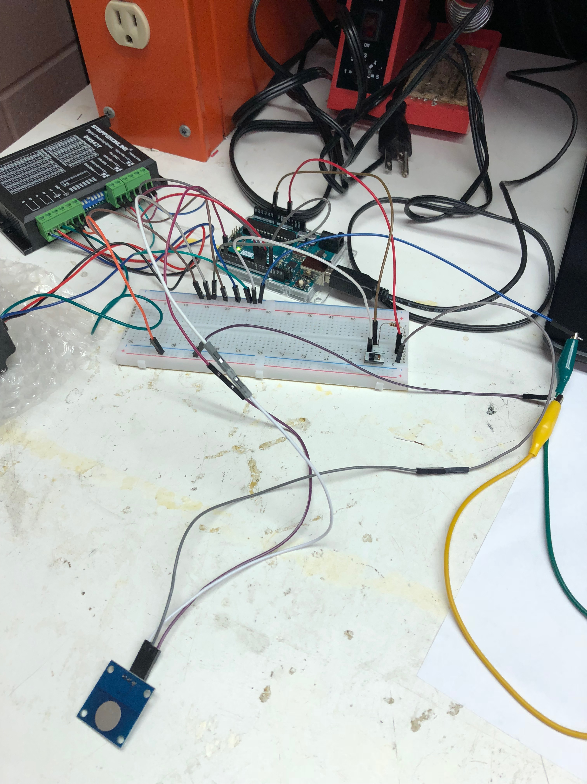
Figure 29: Force Sensitive Resistor Prototyping

7.3.2 Hall Effect Sensor Sub-System Prototyping
This section will look at a few images and their descriptions from the prototyping phase of the Hall Effect Sensor Sub-system. Initial prototyping took place on a breadboard to prove functionality of all of the working parts of the Hall Effect Sensor Sub-System.
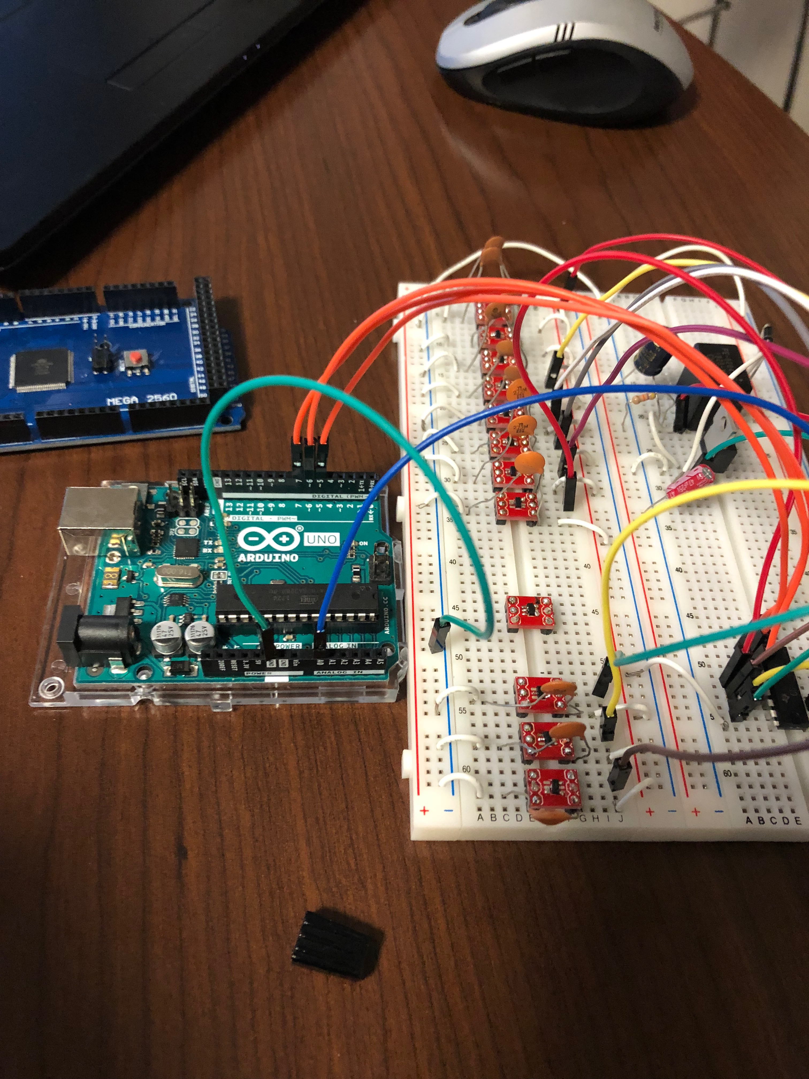
Figure 30: Hall Effect Sensor Prototyping
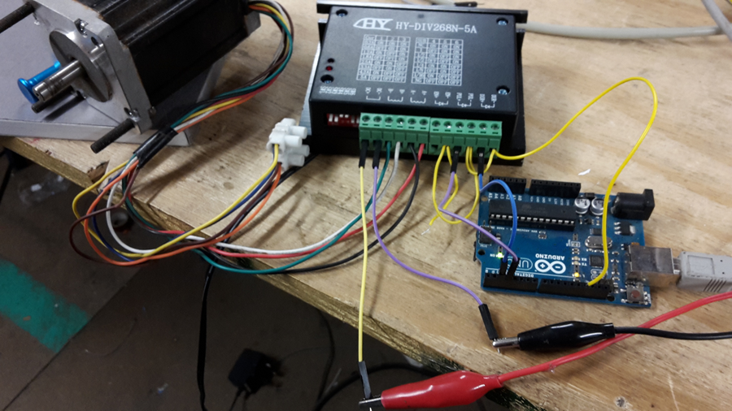
Figure 31: DM542T Stepper Motor Driver Prototyping
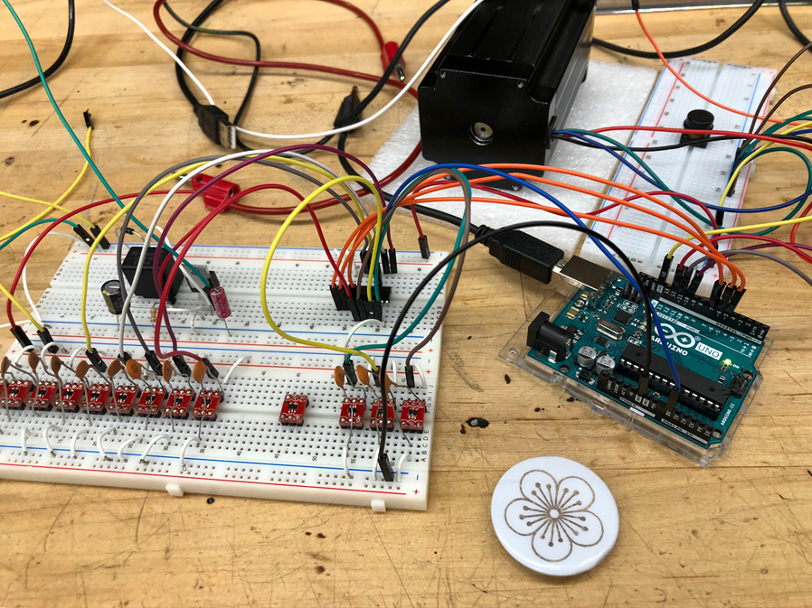
Figure 32: Hall Sensor and Motor prototyping

7.3.3 Video Sensor Sub-System Prototyping
This section will look at a few images and their descriptions from the prototyping phase of the Video Sensor Sub-system. Initial prototyping took place on a breadboard to prove functionality of all of the working parts of the Video Sensor Sub-System.
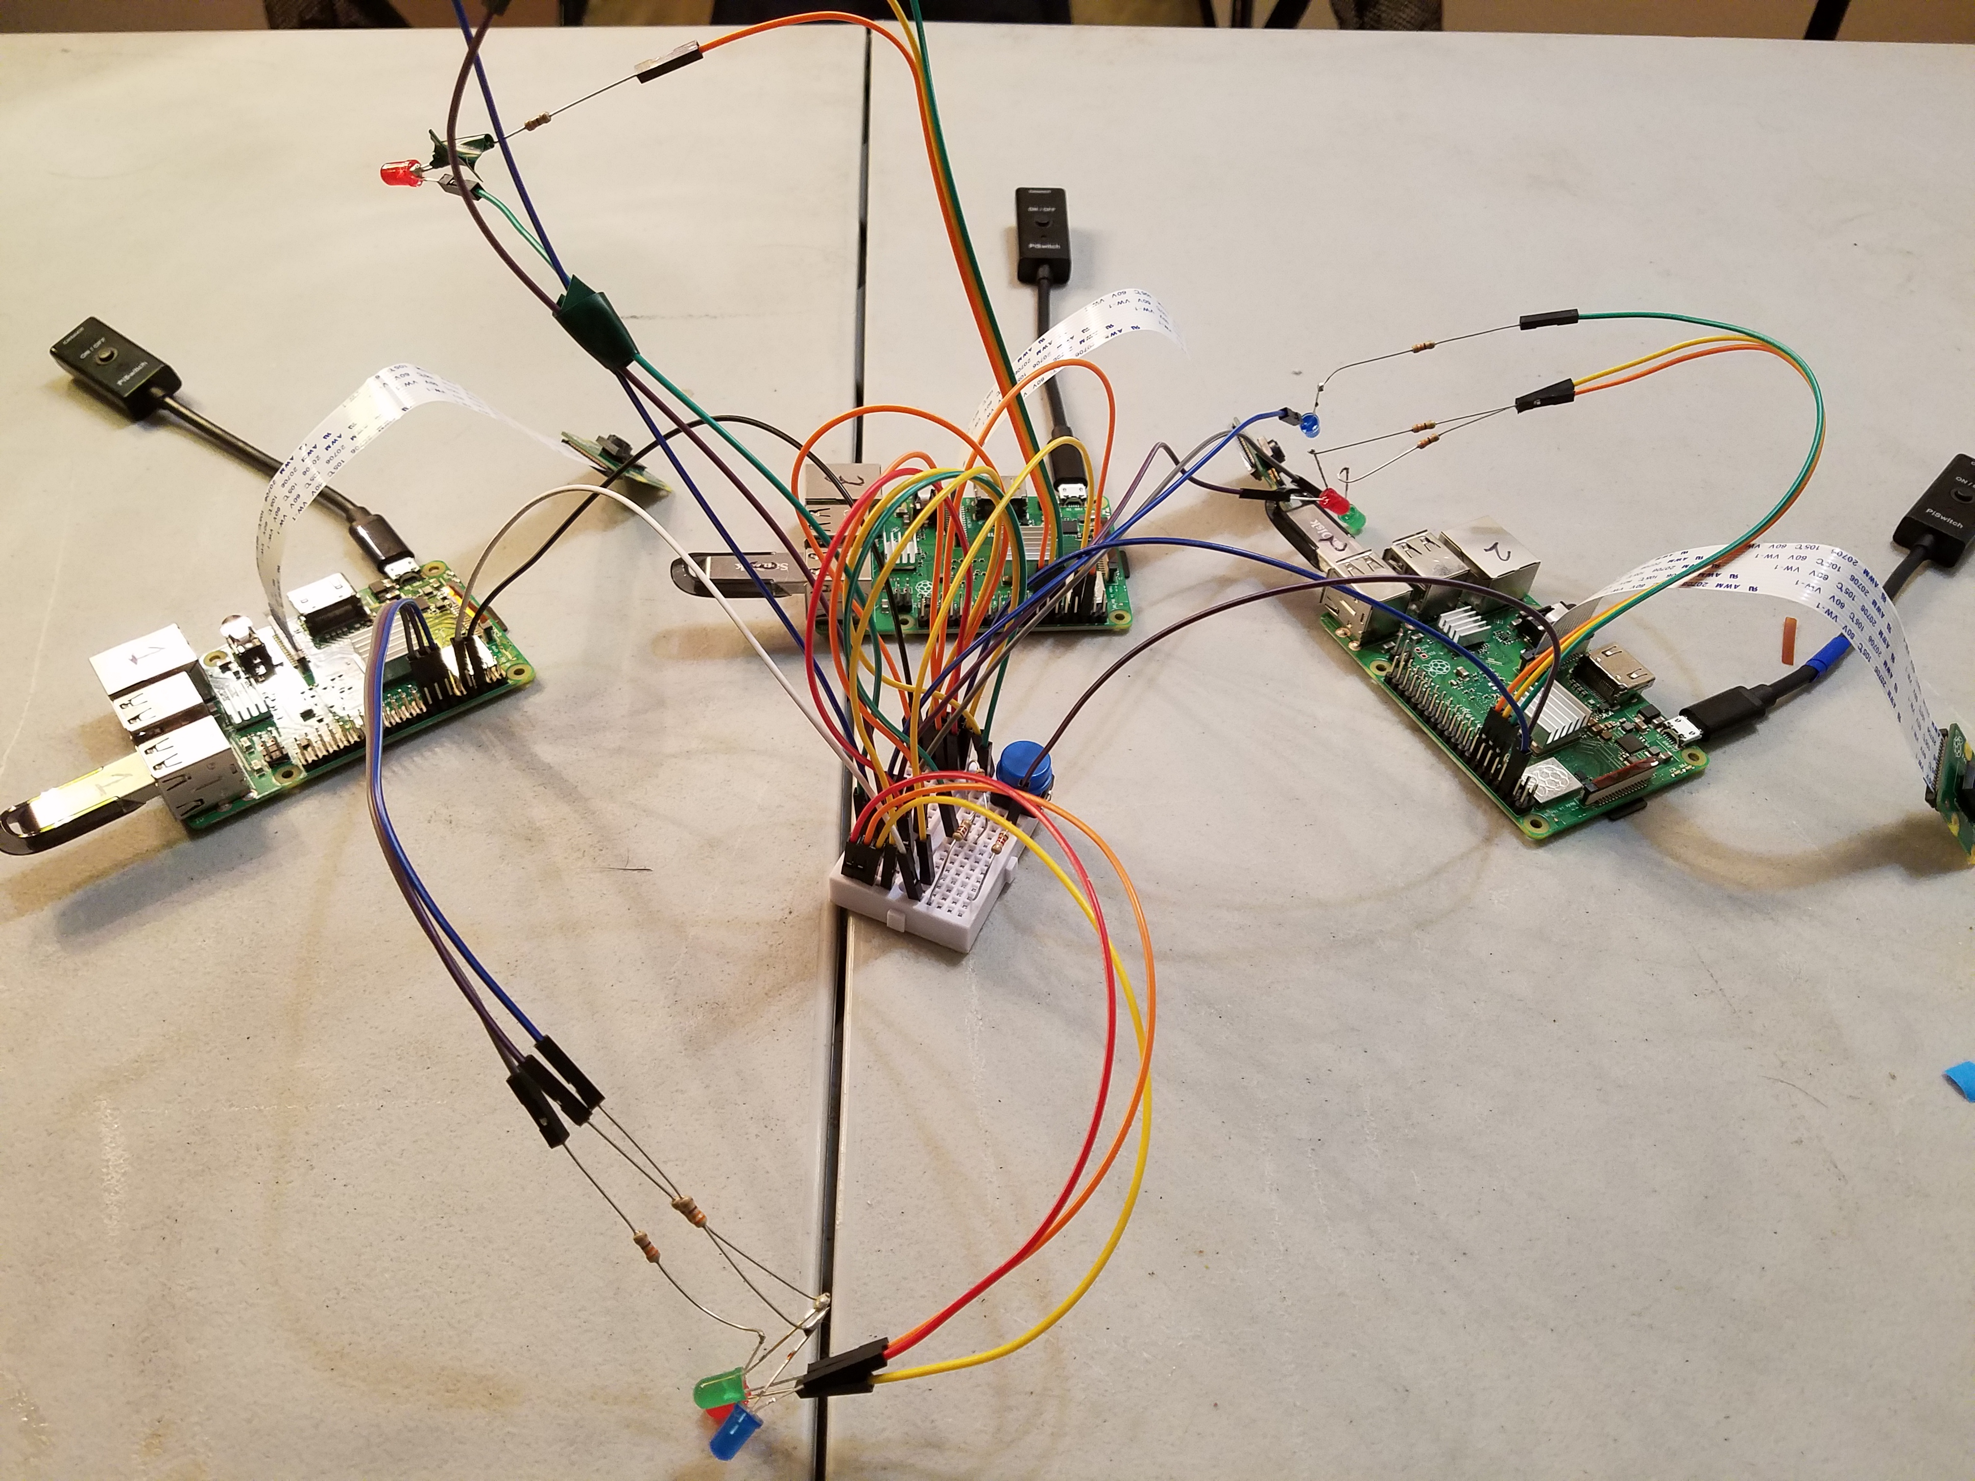
Figure 33: Video Prototyping
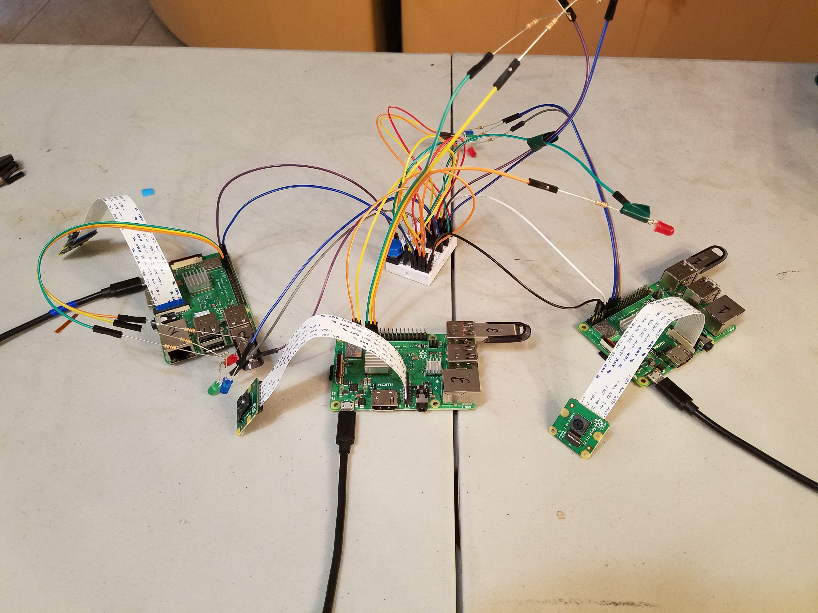
Figure 34: Video Prototyping

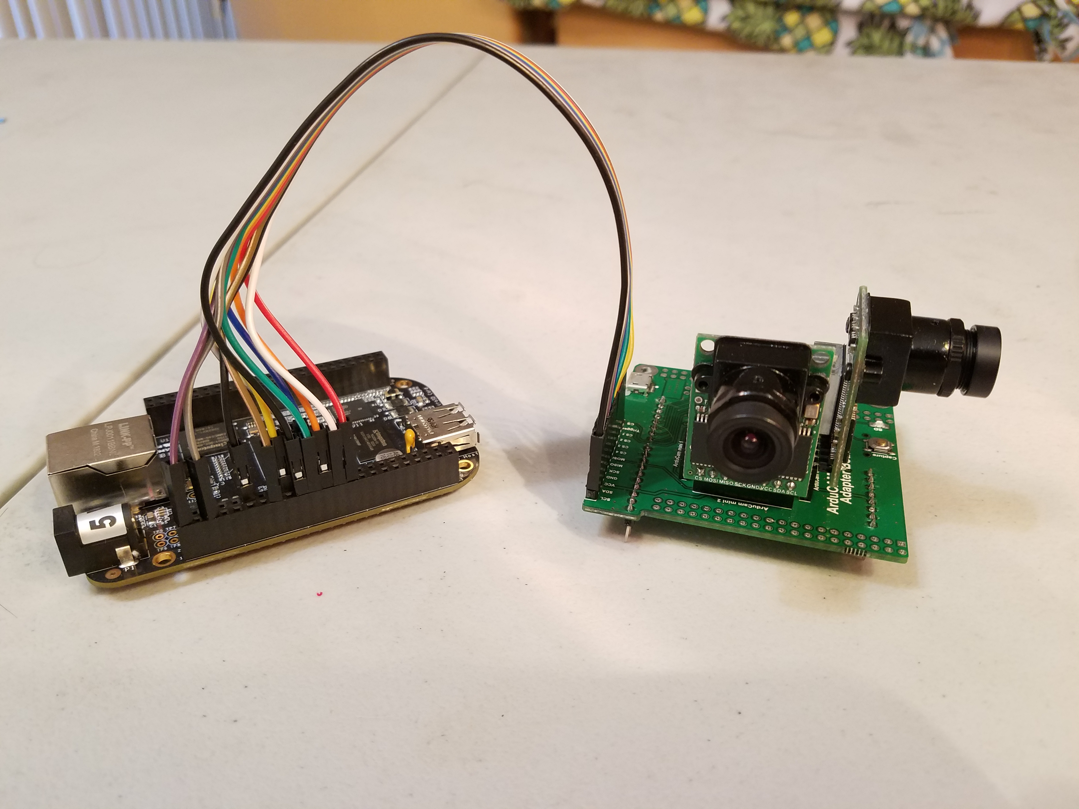
Figure 35: Video Prototyping
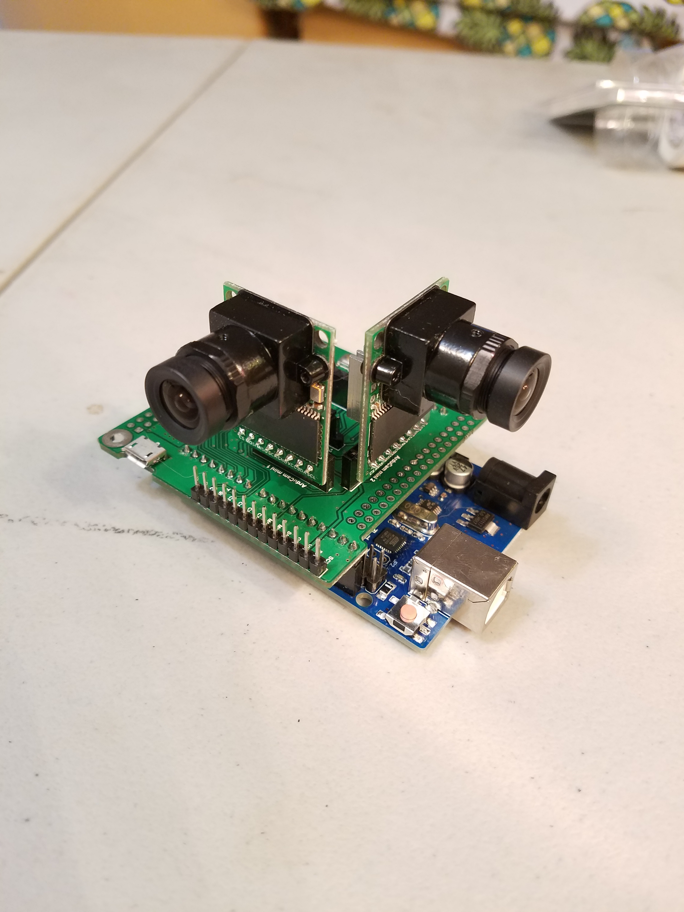
Figure 36: Video Prototyping

8.0 Project Prototype Testing
Prototype testing and implementation will begin following the conclusion of this report and Senior Design I. With a reduced summer semester testing will have to be methodical and efficient. However, testing must remain thorough in order to make the transition to the implementation phase of physical hardware components a smooth one.

8.1 Hardware Test Environment
The intention of building a prototype is to build a realistic model of the system to be tested for functionality and performance. The tests will be performed on the software and hardware subsystems of the zip-line inspection tool prototype. The testing is done in this individual subsystem fashion to aide in troubleshooting the design of the Zip-Line Inspection tool by localizing the issue. Testing will mostly take place in the senior design lab located at UCF’s main campus in Engineering 1, Room 456. The senior design lab is equipped with all the necessary equipment for testing all of the hardware components of our prototype. This equipment includes a Tektronix MSO 4034B Digital Mixed Signal Oscilloscope, a Tektronix AFG 3022 Dual Channel Arbitrary Function Generator, a Tektronix DMM 4050 Precision Multi-meter, and an Agilent E3630A Triple Output DC Power Supply. Testing of each module will require at least one member from the group to be present.

8.2 Hardware Specific Testing
Each subsystem and the relevant hardware will have to be tested prior to implementation to avoid potential damage to hardware components. By designing and simulating each subsystem and its relevant components and creating a model of the system it can be tested for functionality and adjustments can be made prior to implementation of physical hardware components. Once each individual subsystem is found to be operating as desired the overall System will have to be modelled and tested as well to insure all subsystems are operating concurrently without any issues.
The rechargeable lithium ion battery was tested with a digital multimeter in the senior design lab to ensure that the battery maintained and outputted proper voltage. This Battery will be used to power all the Hall effect sensors, microcontrollers, cameras, etc. After determining if the power supply was maintaining a proper voltage the leads of the battery were then connected to the breadboarded components and then functionality of the components was then checked. This voltage and current check was done on the switching voltage regulator, the multiplexors, the Hall sensors, the microcontrollers, and the cameras. Table 7.324.2. ad shows the results from these tests.

Component | Expected Voltage | Measured Voltage
Lectron Pro LiPo Battery | >22.5 V | 24.5 V
Input of Voltage Regulator | 24.5 V | 24.5 V
Output of Voltage Regulator | 5.0 V | 5.0 V
Vcc of Hall Sensors | 5.0 V | 4.97 V
Output of Hall Sensors | 2.5 V | 2.47 - 2.51 V
Vcc of Multiplexor | 5.0 V | 4.98 V
Input of Cameras | 5.0 V | 4.97 V
Input of Microcontrollers | 5.0 V | 4.97 V
Table 23 Power Supply Test
After the test was conducted it was determined that the power supply was capable of providing power to all of the components and that all of the components were receiving the desired input voltage.

8.2.1 Hall Sensor Output Voltage Testing
After soldering an array of seven hall sensors to surface mount adapter boards and supplying them with five Volts of input it was desired to show that the output of the sensors responded to magnetic fields as shown in their technical documents. This was now done by connecting the output of each hall sensor to the analog input pins of the Arduino microcontroller. Then writing a simple code to print the value of the voltage at the analog input pin to the serial monitor. Next a magnet would then be placed over the hall sensor and the output voltage will be easily observed on the serial monitor. The output of the hall sensors will then be observed and recorded when the proximity of the magnet is adjusted from far to near the sensor. Table 324.2. displays the results of this functionality test of the hall sensors.
 | Expected Voltage | Measured Voltage
Vcc of Hall Sensors | 5.0 V | 4.97 V
Output when no magnet present | 2.5 V | 2.47 - 2.51 V
Output when magnet 5 cm away | 2.6 - 2.8 V | 2.5 V
Output when magnet is 2.5 cm away | 3.0 – 3.5 V | 2.76 V
Output when magnet 1 cm away | 3.8 – 4.3 V | 3.7 V
Output when magnet 0 cm away | 4.9 - 5.0 V | 4.93 V
Output when magnet is flipped and 0 cm away | 0 - 0.2 V | 0.06 V
Table 24 Hall Sensor Functionality Test
After the Test was conducted it was observed that the Hall sensors behaved as expected in the sense the output voltage responded appropriately to magnetic interference. It was noted that the sensors were not as responsive than what was expected to the magnet when it further away.

8.2.2 SD Card Module Testing
One of the main advantages of choosing an Atmega microcontroller and breakout board is that there is a built in Arduino library as well as a plethora of online tutorials and documents for implementation and adaptation. A micro SD card breakout board was acquired for breadboard testing of the saving of the sensor data. The Micro SD card breakout board is manufactured by adafruit and the schematic and other necessary documentation of the device is provided on their website. For the purposes of saving the hall sensor data the SD card will be interfaced to the microcontrollers through SPI mode. This mode requires four pins from the microcontroller; SCK, MISO, MOSI, and SS pin. For testing this with the hall sensors the tutorial the sensors will be powered on and connected as they were for the hall sensor voltage where the voltage was printed to the serial output, however now the voltages shall be printed to a created text file on the SD card for storage. Seen in Figure 123 is an example of the block of code that will be used to implement the save data functionality of the wire rope inspection tool. First the text file is opened or created with the command SD.open. The hall sensor voltage is then read by the analogRead command from pin A0. Next the value from the pin must be converted from the 10-bit analog to digital converter to a value in-between zero and five volts. Once this is done the float voltage is stored to the text file with the command println. And lastly the file HallData is closed. To verify that the data is stored on the SD card the SD card is then plugged into a laptop and the text file HallData is viewed. After conducting this test, the text file was indeed populated with Hall sensor data that was easily readable and ready for further analysis.
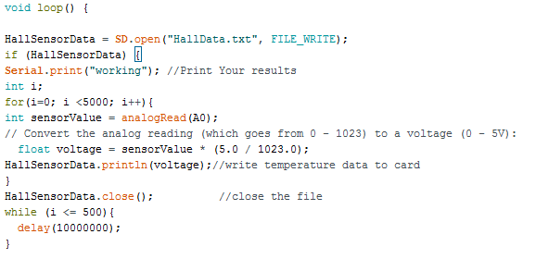
Code to initialize and write to SD card

8.2.3 Hall sensor Testing
The Hall effect sensors will be tested using the in-house Tektronix DMM 4050 Precision Multi-meter and checked for proper wiring and connection. The analog voltage output and regulated five Volt inputs will also be measured along with their accompanying currents to ensure that the devices are behaving as expected with reference to their datasheets.
Another test for the sensor design will use an actual sample steel wire rope provided either by ULA or obtained through a vendor. This sample steel wire rope will be incurred with various measured flaws to test the effectiveness and sensitivity of the Hall effect sensors. This will be done by inducing a magnetic field in the sample steel wire rope with the permanent rare earth magnets and then moving the Hall effect sensor array over the spots where the flaws are located and measuring the voltage output.

8.2.4 DC-to-DC Testing
For the DC-to-DC conversions, the voltages should all be within three percent of the anticipated output and the currents should remain constant within their rated values. If there is an issue the first step will be to measure the voltage using the Tektronix DMM 4050 Precision Multi-meter at the points where the supply enters the circuit board. If this is determined to not be the cause of the issue, then testing points on the PCB are the next step. This will be possible by placing open connector holes in the design process of the PCB. These test points on the circuit board will greatly reduce the time spent trouble shooting any issues with DC-to-DC conversions in the step-down voltage regulators. These DC checks will be performed on all the output pins of the microcontroller as well.

8.2.5 Motor Testing
The objective of testing the motor is to ensure that the shaft is rotating at the proper speed and is in control. Since the motors used for the zip line inspection tool are stepper motors the software downloaded to the microcontroller will be tested on its capability of individual steps and the number of steps required to traverse the entire length of a zip line. This test will require the use of a digital multimeter with a 20 Volt setting because we want to operate the motor at 24 Volts and 1 Amp. It will also be necessary to test the operation of the motor for a prolonged period and observe that the microcontroller and battery for the motor can maintain the motor’s speed and torque.

8.2.6 Motor Control Hardware Testing
Control of the Motor will be tested to ensure that all hardware components of the motor control system are operating correctly and all components are integrated correctly. The Motor Control subsystem is made up of the L298N motor driver, Stepper Motor, Microcontroller, and power Supply. Each component will have to be implemented in a modelling software piece by piece and simulated and tested. The motor subsystem will first be modeled and designed in a circuit simulation software to determine unforeseen errors in circuit design and allow rectification of any errors prior to physical testing of hardware components. By conducting tests using simulation software we can insure that everything is operating smoothly and correctly by measuring relevant input and output values so that when it is time to prototype and test the actual hardware we reduce the risks of damaging hardware components which would then have to be replaced. The UCF Senior Design Laboratory located in ENG1 RM456 is equipped with all the testing equipment and licensed software we will need to conduct testing including the following:

- Tektronix MSO 4034B Digital Mixed Signal Oscilloscope, 350 MHz, 4 Channel
- Tektronix AFG 3022 Dual Channel Arbitrary Function Generator, 25 MHz
- Tektronix DMM 4050 6 ½ Digit Precision Multi-meter
- Agilent E3630A Triple Output DC Power Supply
- Breadboards and misc. electrical components.

8.2.7 Enclosure Testing
The enclosure for the zip line inspection tool will be tested for by measuring the weight of everything contained within plus the enclosure itself to make sure that the design requirements are met. The dimensions of the zip-line inspection tool enclosure will also be measured to ensure that it is capable of fitting onto the mechanical crawler. The PCB and electronics must also be checked such that they fit well into the enclosure without interference to one another. One of the design requirements is that the zip-line inspection tool must be able to withstand a drop from twelve feet and therefore this will be a major concern when designing the enclosure in terms of the security and ability of the zip line inspection tool to absorb the impact with the ground. The Mechanical engineering teams are tasked with handling all mechanical aspects of the project including the enclosure housing. Shown below is a mockup provided by the mechanical engineering teams of the enclosure.
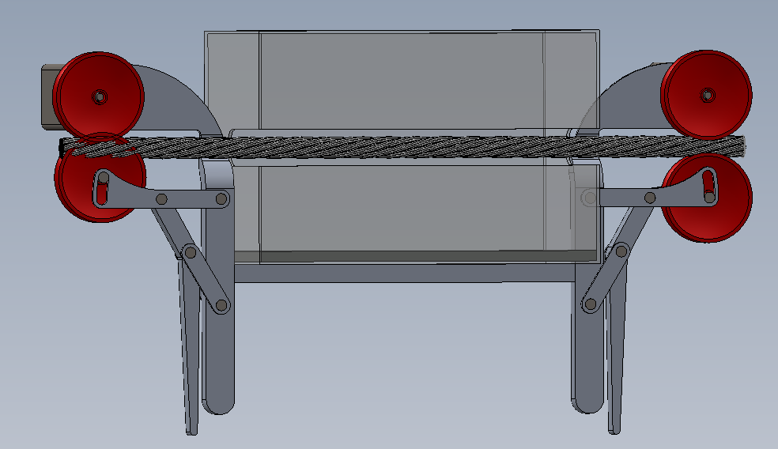
Figure 37: Enclosure

8.3 Software Test Environment
This section will define the specific test environment used for software testing on the components and the inspection tool as a whole. The majority of the testing for the software components will take place in the Senior Design Laboratory at UCF. Personal computers using the Arduino IDE will be used to monitor the data output and edit the program code that is implemented on the Arduino microcontroller.

8.4 Software Specific Testing
This section goes into detail about all the testing done on each specific part of the software to make sure that it is operating correctly and is reading the inputs from all sensors correctly while also outputting the correct data or commands to specific components. This testing is extremely crucial as some of the components will be communicating with each other at certain times where the software needs to handle these communications and signals between each other and respond appropriately. Also, many critical components such as the motor driver will rely on commands from the software which without the inspection tool will not move down the line. Pieces will be tested separately to make sure each component individually works but they must all be tested together at the end, as there will be one main start command which will initialize all the data collecting components as well the movement system for the device at the same time.

8.4.1 Video
This section will discuss the specific software control for the video system and the steps taken during testing to ensure that the video software is performing as necessary. Some of the tests discussed seems hardware related but control of many of the aspects of the images from the visual sensors is done through the software and not actual physical manipulation of the devices except in extreme cases.
The video system will be run initially for a short time with a section of wire cable, matching the size of the cable used by the United Launch Alliance, placed in the appropriate position between the cameras. The video will be output to a computer at this time in order to check that the cameras are all focused correctly, have consistent lighting of the cable and are outputting consistent quality video. This section will then be repeated with the storage device to ensure that the video is outputting to the storage correctly.
The next step will be to run the test portion of the cable through the cameras at close to the speed that the device will be moving down the cable while actually doing the inspection. This video will then be used to ensure that the frame rate and shutter speed of the cameras is correct. Checking the shutter speed to make sure there is no excess motion blur due to the exposure being too long. Then also the frame rate to make sure all sections of the cable are seen as to low of a frame rate would cause the video to skip over sections of the cable.
The last portion of video testing will be to test that the system will run for the appropriate amount of time without any problems. For this test the video system will be left running for the full amount of time calculated to fully traverse the cable. The time used will be dependent on the slowest movement device supplied by the mechanical groups with extra time added on to account for error. The cable will be adjusted every few minutes to ensure the video is still consistent quality footage for the full length of time. If all these tests can be passed then the video software can be assumed to be functioning correctly.

8.4.2 Hall Sensor
This section will discuss the software for controlling and monitoring the hall sensors and the tests taken to make sure the sensors are performing correctly and that they are taking accurate measurements. The tests for the hall sensors will take place from two directions, first the microcontroller side to make sure the software reacts correctly and then from the hall sensor side to make sure they are working correctly themselves with the software.
The initial testing will be using a variable voltage supply with only one input to test that the software is reading the input correctly and storing the values to the data storage correctly. The voltage will be varied in order to test that the software measures the different values and stores them correctly and also makes note of when the values spike outside of the average range set from calibration. This process will then be repeated with multiple inputs and then be tested to make sure all input values are accurately read and stored.
The next step is to fully connect the hall sensors and check that they are supplying input to the board, we want to make sure there is no issue with the input from the sensors as it will not be as steady or consistent as with a voltage generator. A wire cable will then be placed in the appropriate location inside the hall sensors and a reading will be taken and then used for calibration. Once we confirm we have a consistent reading from the sensors we will then test moving a wire cable through the sensors at the appropriate speed and checking to make sure readings are consistent. The initial test will be with a good condition wire cable while the second test will be with a wire cable with different sources of damage to check that the sensors will spike correctly when there is a damaged point on the cable. If all these tests are passed it can be assumed that the software for the sensors is functioning correctly.

8.4.3 Motor Control
The controls for the motor will be written and stored on the ATMega328P microprocessor, prior to integrating our system the developed Code will have to be tested and debugged. By using an IDE, we can simply debug our code. By incorporating a basic setup of a Stepper motor and Arduino we can verify that the developed code will successfully control our motor.

8.4.4 Distance Calculation
This section focuses on the software for the distance calculations. The distance calculation is an important part for syncing the multiple data streams when looking at them later and pinpointing the exact location for any potential issues with the wire cable. The distance calculation is interesting as it can be calculated using the stepper motor that will drive the device but one group will not be using the stepper motor so we need the rotary encoder to measure the distance when not using the stepper motor.

Since we will be using an incremental rotary encoder there will be two outputs from the encoder to the microcontroller, the outputs look like two square waves 90 degrees out of phase from each other. Depending on which order the outputs arrive determines what direction the encoder is moving. The first test will be to input two square waves 90 degrees out of phase to check that the software interprets the inputs correctly. The order of the inputs will then be reversed to make sure direction can be measured.
The next step once making sure the inputs are being interpreted correctly will be calibrating the distance calculation. To make sure the readings are accurate we will rotate the wheel connected to the encoder a known distance and then compare that to the number of cycles counted from the encoder output. Using some calculations, we will be able to find the exact distance traveled per rotation of the encoder. The next step will be to measure larger distances to make sure the calculation holds up over large distances and that a very small calculation offset does not become a large measurement error over larger distances

8.4.5 Data Storage
This section focuses on the methods taken to ensure that the data storage system is tested thoroughly and that it is performing as expected when interacting with the software.
The main test for the data storage will happen after all the other individual components have been tested. They will all have some amount of interaction with the data storage at certain points in time when the device is in use. Since it will be tested with all the separate components any major issues should appear early within testing but if all components pass with no problems then the next step is to check all components working in tandem and outputting all of their data to the storage drive.
The first trial will be a basic full start of the system and run for a short time to ensure that everything is outputting to storage and that all data files can be found and accessed from the storage device. Once it has been shown that the data is outputting to storage correctly then will be a full runtime test where the system will be left running for the expected length of time to traverse the cable plus extra to account for any issues. During this time necessary adjustments will be made to the different components gradually to ensure that all different readings should be picked up by the sensors and output correctly to storage.

9.0 Administrative Content
This section will give an overview of the administrative workflow used in the development of this paper and the Zip Line Inspection tool. Milestones, PCB Vendors, Budget and Finance needs, Project Design Problems that arose, and Project roles will be addressed.

9.1 Milestone Discussion
This section looks at the major milestones and goals set for the two semesters of senior design with the first semester being more focused on design and research of the project and technologies relating to it. The second semester focuses more on the prototyping, building, and testing of the components, followed then by full-scale tests.
Spring 2018 Semester (Senior Design I):
- Project Proposal (3-4wks)
- Idea (1/12/18)
- Interdisciplinary Request (1/18/18)
- Initial Divide and Conquer (1/28/18)
- Research and Documentation (9wks)
  - Updated Divide and Conquer (3/11/18)
- Complete Design of Project (14wks, end of Semester)
  - Documentation Rough Draft (4/9/18)
  - Final Documentation (4/27/18)
Summer 2018 Semester (Senior Design II)
- Begin Prototype (3-4wks)
- Acquire Parts
- Begin initial testing/assembly of individual system components
- Complete V1 Prototype
- Test, Debug, Improve
- Redesign if necessary
- Complete fully functional working V2 Prototype (9wks, end of Semester)
- Finalize Prototype
- Final documentation and Presentation

9.2 Budget and Finance Discussion
United Launch Alliance (ULA) is the sponsor/customer for this project. Shown in Table 23 below is our preliminary budget developed at the preliminary stages of research and development. The preliminary budget includes mechanical components however because we were able to expand this project into an interdisciplinary project the second updated Table only includes the components needed for the Motor and Sensors. The second table depicts a more accurate and updated Estimated Cost table.
Item | Cost
Controller components | $50
Motor | $50
Magnets (flux production system) | $25
Hall sensors | $25
Data storage | $30
Circuit board and components | $150
Battery and power system | $300
Component housing | $50
Cable gripping mechanism | $150
RC Transmitter/Receiver | $40
Cameras | $40
Additional Expenses | $90
Estimated Total | $1000
Table 23: Initial Estimated Project Budge
The costs were able to be reduced from initial estimates, the RC Transmitter/Receiver that were previously going to be used for controlling the Zip Line Inspection Tool will no longer be incorporated due to RF frequencies being restricted at the Site as it is an Active Military Base, the removal of those components along with our preliminary budget being a high estimate have allowed us to reduce costs by nearly $300.

Subsystem | Item | Quantity | Vendor | Estimated Cost
Motor | 23HS45-4204S NEMA23 Stepper Motor | 1 | Amazon | $39.00
Motor | DM542T Digital Stepper Driver | 1 | Amazon | $39.00
Motor | Mounting Brackets | 1 | Home Depot | $3.99
Motor | ATMega328P-PU Microcontroller | 1 | Atmel | $2.01
Motor | Motor Battery  Powerizer LiFePO4 (24V 10Ah) | 1 | Powerizer | $299.0
Motor | Switch/FSR | 1 | Amazon | $8.50
Motor | Miscellaneous electrical components (resistors, chips, capacitors, wires, etc.) | - |  | $15
Hall Effect Sensor | Hall Effect Sensor | 6 | Texas Instruments | $1.83 x 6  =$10.98
Hall Effect Sensor | Video/Hall Sensor  Li-Ion 18500 Battery Pack | 1 | AA Portable Power Corp | $40.00
Visual Sensor | ArduCAM OV5642 Camera Module | 3 | RobotShop.com | $29.99x3  =$90.00
 | Raspberry PI MCU | 3 | Amazon | $39.99x3  =$120.00
Additional Costs | PCB(s) (Estimate) | 4 | OSH Park | $15x4  =$40.00
Additional Costs | Shipping, Taxes, and other miscellaneous fees. | - | - | $20
Total Estimated Cost |  |  |  | $727.48
Updated BOM and Cost Estimate

9.3 Project Roles
This section identifies the specific components of the design that each group partner is specifically in charge of. Collaboration was key and each member supported the other when needed despite whether or not the portion being worked on fell within their work distribution. Teamwork was a key focus in this project and being able to gain valuable team experience is something that each member of the team will be able to take with them into the work force.
Group Member | Motor/Controls | Power | Visual Sensor | Hall Sensor
Friedrich S. | P | S
Paul J. |  |  | P
Ellis C. |  | P |  | P
Table 24: P indicates Primary, S indicates Secondary

Appendices

Acknowledgement
The authors wish to acknowledge the assistance and support of the ECE Department at the University of Central Florida. A special thank you is directed towards Professors Lei Wei and Samuel Richie for their guidance and support during the duration of this project. Thanks, and gratitude are offered to the professors who have so kindly agreed to review the Steel Wire-Rope inspection tool project. Additionally, we would like to thank the Mechanical Engineering teams for their collaboration and work on all mechanical aspects of the tool and wish them luck as they continue and finish final development in the Fall 2018 semester. The Steel wire-rope inspection tool may not have been possible without the funding and support received from its sponsor, United Launch Alliance.

References:
Spec Sheets:
CD4051: http://www.ti.com/lit/pdf/schs047
DM542T: https://www.omc-stepperonline.com/download/DM542T.pdf
23HS45-4204S: https://www.omc-stepperonline.com/download/23HS45-4204S.pdf
DRV5056-Q1: http://www.ti.com/lit/ds/symlink/drv5056-q1.pdf
TPS7B69-Q1: http://www.ti.com/lit/ds/symlink/tps7b69-q1.pdf
ATMega328P: http://ww1.microchip.com/downloads/en/DeviceDoc/Atmel-42735-8-bit-AVR-Microcontroller-ATmega328-328P_Summary.pdf
OV5642: https://www.uctronics.com/download/cam_module/1Inch4_5_Megapixel_OV5642_CMOS_Camera_Module_DS_V1.1.pdf
TTP223: https://infusionsystems.com/support/TTP223.pdf

