EEL 4914 Senior Design II

Project Documentation

Automated Safety Spotter

Department of Electrical Engineering & Computer Science

University of Central Florida

Dr. Lei Wei

Group 15
Yanlin Ye, E.E
Chris Weech, E.E
Aaron Larson, E.E
Angel Morfa, Cp.E

Table of Contents
- Executive Summary 1
- Project Description 2
  - Project Background 2
  - Motivation 3
  - Objectives 3
  - Requirement Specifications 3
- Research Related to Project 5
  - Existing Projects and Products 5
    - Fitvisor 5
    - Juggernaut: Automatic Bench Press Spotter 5
    - Tripwire 6
    - ABPS (Automatic Bench Press Spotter) 6
    - Maxx Bench 7
    - Schween Machine 8
  - Relevant Technologies 9
    - Material Research 9
    - Linear Actuators 10
    - Photodetectors 12
    - Transimpedance Amplifier 14
    - Microcontroller 14
    - Power Supply 14
    - Microwave Sensor 15
    - Acoustic Sensors 15
    - Optical Sensor 15
    - Video Camera 15
    - Cell Phone Camera 16
    - Speech Recognition 16
    - OpenCV 17
    - Conventional Neural Networks 18
    - Voltage Regulator 20
    - Switching Regulator 20
    - Linear Regulator 21
    - Interface Configurations 22
    - Display 24
    - Touch Screen 28
    - Step Motor Driver 32
  - Strategic Components and Part Selection 32
    - Linear Actuator 32
    - Laser 34
    - Photodiode 35
    - Transimpedance Amplifier 37
    - Microcontroller 37
    - Wi-Fi Module 40
    - Microwave Sensor 46
    - Acoustic Sensor 47
    - Optical Sensor 48
    - Camera 50
    - Audio Sensor 55
    - GPU 56
    - Display Screen 57
    - Power Supply 63
    - Computer 71
    - Step Motor Driver 78
    - Transimpedance Amplifier 79
- Related Standards and Realistic Design Constraints 80
  - Standards 80
    - Power Supply Standard 80
    - Wi-Fi Standard 81
    - PCB Standard 83
    - Plug and Socket Standards 84
    - Electrical Safety Standard 85
    - Software Testing Standard 86
    - Language Standard 86
    - Camera Serial Interface 88
    - Design Impacts of Chosen Technologies and Standards 88
  - Realistic Design Constraints 89
    - Economic and Time constraints 89
    - Environmental, Social, and Political constraints 90
    - Ethical, Health, and Safety constraints 91
    - Manufacturability and Sustainability constraints 92
- Project Design Details 93
  - Initial Design Architectures and Related Diagrams 93
    - Laser Break System 94
    - Computer 95
  - Programming Languages 96
  - Software Design 101
- Project Prototype Testing and Construction 104
  - Integrated Schematics 104
    - Step Motor Driver 104
    - Photodiode 105
    - Camera 106
    - Touch Display 107
    - Full Schematic 108
  - PCB Vendor and Assembly 108
  - Physical Part Assembly and Construction 111
    - Arms 111
    - Barbell 112
    - Linear Actuator Housing 112
    - Computer Housing/Camera Stand 113
  - Testing Plan 114
    - Laser Break System 114
    - Software Tests 115
    - Raspberry Pi Testing 117
    - Power Supply Testing 118
- Administrative Content 119
  - Milestone Discussion 120
  - Budget and Finance Discussion 120
  - Project Design Problems 124
  - Looking Back 125
  - Project Roles 126
Appendix A – Part Orders 128
Appendix B – Parts Received and Built 131
Appendix C – Bibliography 135

Table 1: Sensor Selection 17
Table 2: Convolutional Neural Networks performance at ILSVRC 19
Table 3: Parallel vs Serial Interface 23
Table 4: LCD vs LED Displays 25
Table 5: LED vs OLED Displays 26
Table 6: LED vs QLED Displays 27
Table 7: LED vs µLED Displays 28
Table 8: Capacitive Configuration Advantages and Disadvantages 29
Table 9: Resistive Configuration Advantages and Disadvantages 30
Table 10: Extra Display Features 31
Table 11: Linear Actuator Information 33
Table 12: Laser Information 34
Table 13: Photodiode Information 35
Table 14: Arduino Comparison 40
Table 15: CC3200MOD Wi-Fi Module 42
Table 16: ESP8266EX Wi-fi Module 44
Table 17: ESP32-S Wi-Fi Module 45
Table 18: Wi-Fi Module Comparison 46
Table 19: RCWL-0516 Attributes 47
Table 20: Microwave Comparison 47
Table 21: HC-SR04 48
Table 22: Acoustic Sensor Comparison 48
Table 23: TF Mini LiDAR specifications 49
Table 24: LiDAR Comparison 49
Table 25: Raspberry Pi Camera Module 50
Table 26: Pixy 2 Specifications 51
Table 27: Husky Lens 52
Table 28: Open MV Camera 54
Table 29: Camera Comparison 55
Table 30: Audio Sensor 56
Table 31: Cloud Computing Comparison 57
Table 32: PCAP Touch Module 58
Table 33: TFT Display 59
Table 34: TM2800 Specs 60
Table 35: Raspberry Pi 7" 61
Table 36: Raspberry Pi 5" Display 62
Table 37: Display Spec Comparison 63
Table 38: RS-15-12 Features Expanded 64
Table 39: RS-15-5 Features Expanded 66
Table 40: RS-35-12 Features Expanded 67
Table 41: LS-25-12 Features Expanded 68
Table 42: RD-50A Features Expanded 69
Table 43: Power Source Features Compared 70
Table 44: Raspberry Pi 4 Features Expanded 72
Table 45: Rock Pi 4 Model B Features Expanded 74
Table 46: Banana Pi Features Expanded 75
Table 47: Raspberry Pi 3 Model B 77
Table 48: Single Board Computer Feature Comparison 78
Table 49: Step Motor Comparison 79
Table 50: Power Supply Standard 81
Table 51: Wi-Fi Standard 82
Table 52: PCB Standard 84
Table 53: Plug and Socket Standard 85
Table 54: Programming languages trade-offs 100
Table 55: Step Motor Driver 105
Table 56: Camera Pinout 107
Table 57: Touch Display Pinout 108
Table 58: Milestones 120
Table 59: Budget Table 122

Figure 1: Ronfic Fitvisor 5
Figure 2: Juggernaut: Automatic Bench Press Spotter 6
Figure 3: ABPS Project 7
Figure 4: Maxx Bench 8
Figure 5: Schween Machine 8
Figure 6: Hydraulic linear actuator 10
Figure 7: Screw driven linear actuator 11
Figure 8: Belt driven linear actuator 11
Figure 9: Pneumatic linear actuator 12
Figure 10: Photodetectors 13
Figure 11: Linear Regulator 22
Figure 12: Parallel vs Serial Interface Configurations 23
Figure 13: Power Consumption/Efficiency 25
Figure 14: Capacitive Configuration 29
Figure 15: Resistive Configuration 30
Figure 16: Huskey Lens 32
Figure 17: Photodiode Sensitivity 36
Figure 18: RCWL-0516 47
Figure 19: HC-SR04 48
Figure 20: LiDAR Sensor 49
Figure 21: Raspberry Pi Camera 50
Figure 22: Pixy 2 Camera 52
Figure 23: Huskey Lens Sensor 53
Figure 24: OpenCV Camera 54
Figure 25: Google AIY Voice Kit box 55
Figure 26: Grove Speech recognition module 56
Figure 27: PACP Touch Module 58
Figure 28: TFT Display 59
Figure 29: TM2800 Display 60
Figure 30: Raspberry Pi 7" Display 61
Figure 31: 5” Raspberry Pi Display 62
Figure 32: RS-15-12 Power Supply 65
Figure 33: RS-15-5 Power Source 66
Figure 34: RS-35-12 Power Source 67
Figure 35: LS-25-12 Power Source 68
Figure 36: EAG-24-12 Power Supply 69
Figure 37: Raspberry Pi 4 Single Board Computer 73
Figure 38: Rock Pi 4 Model B 74
Figure 39: Banana Pi Single Board Computer 75
Figure 40: Raspberry Pi 3 Model B 76
Figure 41: PCB Standards 83
Figure 42: Project Design 94
Figure 43: Laser Break System Flowchart 95
Figure 44: Raspberry Pi with Signals in and out 96
Figure 45: Paradigms 97
Figure 46: OpenCV Flowchart 101
Figure 47: Theoretical GPU vs. CPU Comparison 103
Figure 48: Step Motor Driver 104
Figure 49: Photodiode 106
Figure 50: Camera 106
Figure 51: Touch Display 107
Figure 52: Full Schematic 108
Figure 53: PCB Schematic 109
Figure 54: PCB Layout 110
Figure 55: Built PCB 110
Figure 56: Laser mounted in arm 111
Figure 57: PCB Mounted in support arm 112
Figure 58: Actuator Housing 113
Figure 59: Brain Box 114
Figure 60: Testing pyramid. From simplest & fastest 117
Figure 61: House of Quality 121

- Executive Summary
Exercise has seen a tremendous increase in popularity over the last 5 to 10 years. Weather this gain in popularity is because the increase in public knowledge around diet and health, or because body image has become a major source of insecurity in the rising generations due to the growth of social media brands; either way there’s no disputing that the number of first time gym goers is at an all-time high. As these numbers continue to grow with no signs of stopping or even slowing down, we are seeing a lot of people, at all ages, come out of their sessions in the gym with injuries from a lack of knowledge on form, how to preform exercises, as well as how to properly increase weight when doing those exercises.
The Automated Safety Spotter is an add-on tool used to help weightlifters in barbell exercises. With this tool we have tackled the task of replacing a spotter with what is essentially a robot. By replacing a human with a computer, we have increased the safety for solo-gym goers; eliminating the risk of possible human error (distraction, reaction time, lack of judgement, etc.) while spotting. The product consists of a camera, a display/controller, and two linear actuators with arms that have an embedded laser-break system. The two liner actuators sit on either side of the lifter behind the barbell’s path of travel. As the lifter is ready to begin the lift the actuators lower to the height of the user’s chest and allow him or her to perform the exercise. The camera is placed directly behind the weightlifter to track the barbell’s movement in real time with the utilization of computer vision software. The camera detects the bar’s movement and can determine if it has stopped during the lift, indicating the lifters fatigue. If the bar’s motion stops in a determined area during the lift, the actuators rise and assist the lifter in completing the lift. Our goal was to build a highly accurate system to assist weightlifters in the barbell bench press, given that not reacting on time could lead to injury or even be fatal.

2. Project Description
In this section we discuss our reasoning in why we have chosen to create this prototype for our project. We dive into what caused us to implement the safety features we are, as well as what we’ve seen and researched that will allow us to ensure our ability to implement these features properly, functionally, and accurately. We also explicitly lay out our primary goals of this project in addition to the list requirements that we have put into place as a determining factor in the level of our project’s success.
2.1 Project Background
While in the gym there is no disputing that barbell training is one of the most effective ways of building strength, gaining muscle mass, loosing body fat, and stay active in an increasingly sedentary world. With the barbell being one of the most popular pieces of equipment in the weight room, and in a way the universal symbol of fitness centers. We can say with confidence that one of the most popular barbell exercises around the globe is the barbell bench press. Though the bench press is one of the most popular movements in the gym as well as one of the most effective, it is also perhaps one of the most dangerous exercise to perform in the weight room. The barbell bench press consists of the lifter laying his or her back down on a bench parallel to the ground and then grabbing onto a bar resting above their head, they then hold the barbell up at arm’s length, right above the face, neck and chest area. If the bar happens to slip out of the lifers the hands it will fall down landing directly on the lifter’s body, neck, and face, causing bodily damage to the lifter is the best-case scenario if this happens and death is not an outlandish possibility. Even if this doesn’t happen, and during the exercise the lifter becomes fatigued enough to where they are not able to continue pushing the bar up and place it on the rack, he or she will still get stuck under the bar, needing assistance from others or rolling the bar down their body to stand up and vacate the underside of the bar. Another possibility with using this exercise if you are using to heavy of weight you injure yourself causing a delayed return to the gym leaving you with no ability to work out. With heavy weights it makes seemingly simple tasks very difficult, such as un-racking the weight into the starting position and then even racking it back. The heavier the weight gets in these situations the more dangerous and uncomfortable they can become
To avoid this, weight machines called smith machines were created. These machines were created as a safer alternative to barbell exercises by taking a barbell and attaching it to two very strong pipes on either side of the bench. This creates a fixed two-dimensional plane for the bar to travel along and prohibits any horizontal movement within the bar’s path. Further increasing the safety, these machines have many slots along the vertical plane of the bar’s path; allowing it to be racked very easily in multiple positions along the bar path with a slight rotation of the wrist. However, this is not as safe a solution as it appears. If the lifter is so fatigued that they are unable to rotate their wrists and ultimately rack the bar, he or she will be trapped under the bar with no escape. Though this is a safer piece of equipment in regard to dropping the bar on yourself the guided nature of this machine can cause the user to adopt an unnatural positions and movement that could induce an injury and be avoided on a standard piece of equipment.
Other bench press apparatus incorporate safety stands parallel to the lifter and the bench. This is the most common type of safety feature found on bench presses. Nearly every free weight bench press has these stands on either side of the user. These stands are to be set as close to the user’s chest height as possible to provide support to the bar if the user drops it. The issue with these stands is that they are not able to make fine adjustments. Utilizing a pin and place type of adjustment so if you aren’t lucky enough to be the perfect size for one of the positions than you will be forced to have a limited range of motion or be in an unsafe position with the stands below your chest.
An alternative to these options is to simply have a person stand behind the lifter, known as a spotter, to rack/un-rack the bar. The spotter can also help to assist the lifter if they get stuck and alleviate some of the weight allowing the user to push the bar up. This is not only inconvenient for the solo gym goer but also still not very safe. The human reaction time is not fast enough to catch a bar with such high potential energy if the user’s muscles hit a wall and they end up dropping the bar.
When looking at these options and seeing that there was no truly safe way of bench pressing with little to no risk of the barbell dropping on your head; our team decided that our idea certainly had a place in the gym and was not an impractical task to undertake.
2.1 Motivation
The motivation for this project comes from the recognition of weightlifters' desire to lift increasingly heavier weights and/or go to failure yet are unable to do so because of the potential risks of training without a spotter or with an unreliable one. Our goal is to create a solution that will allow the solo gym goer to accomplish his or her goal and attempt the milestones they placed ahead of themselves while maintaining their own safety and the safety of the people around them.
2.3 Objectives
Our goals for this project were to create a machine that can increase the safety of gym occupants, specifically those using the barbell bench press without sacrificing the experience of working out. We wanted to make our project able to fit virtually all bench presses and have the ability to create a unique and customized safety setup for every user that lays on our bench. This safety setup should allow the user to achieve their personal strength milestones no differently than they would with a traditional barbell bench press. This system also tracks the path of the bar as it raises and lowers through the users range of motion and has the ability to acknowledge when the user is struggling and assist them in completing that final repetition. The project also includes an interactive screen that allows the user to perform calibration reps and to also track the workout.
2.4 Requirements Specifications
- The calibration sequence determines the low point of user’s reps by utilizing a laser-break system located on the inside of the motorized arms to locate the high point of the user’s chest. The arms stop lowering within 0.5 seconds of the laser being broken.
- After the calibration rep, the exercise is initiated with the user pressing a “GO” button on the display which initializes the camera within 5 seconds, in order to track the barbell.
- The actuator arms assist the user within 2.5 seconds if movement of the bar is halted.
- The display has a “DONE” button that disables the system until the next user completes the calibration process.
- The system consists of 2 support arms that sit 96.5 cm (38 in) apart.
- The support arms are powered by 2 linear actuators.
- The linear actuators have an attachment to the rack.
- The system has 1 laser-break system.
- The system has 1 display with 800x480 resolution and 14 cm (5.5 in) in size. The display allows initiation of calibration sequence and the tracking of the barbell.
- The system has 1 camera that monitors the bar path
- The system is controlled via a Raspberry Pi 3B.

3. Research Related to Project
In this section we discuss some projects that exemplify premises we plan to incorporate into our project. We have found examples ranging from project that do exactly what we plan to do in a less accessible form, all the way to circuitry designs that are implement a functionality similar to one we will need to have in our project in order for it to be successful.
3.1 Existing Projects and Products
3.1.1 Fitvisor
There is one product in the market, called Fitvisor, from a Korean company called Ronfic, that addresses all the issues with current weight machines that were mentioned in the executive summary. It is a robotic rack with safety arms that help lift the bar if necessary but otherwise stay out of the way so that the lifter can perform the full range of motion. The company offers various models and they claim that more than twenty exercises can be performed in them. It has an algorithm that tracks the workout, the workout style of the lifter, the condition of the lifter, and provides assistance accordingly. It has a high definition display that shows current workout activities and gives statistics real time. Until 2018, the company had delivered 18 units and had 120 orders total. Fitvisor is a full rack, however, while our project aims to be more portable, an add-on. The price could not be found, as it not shown on their website and it appears they sell only through contracts, but it appears to be an expensive product.
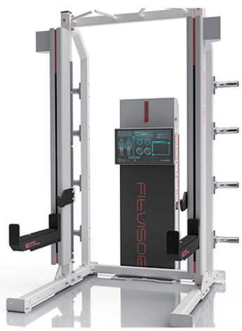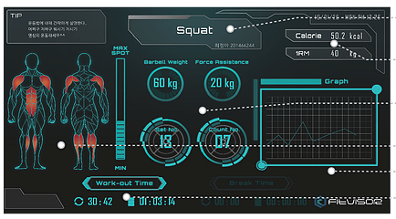
Figure 1: Ronfic Fitvisor
3.1.2 Juggernaut: Automatic Bench Press Spotter
The second similar product was found on YouTube, although their products were made seven years ago and limited information is available, their design is still worthy of our attention. Their design structure is essentially the same as ours, but most the electronics parts we use were different. According to the Juggernaut design, they set one Kinect feedback sensor on the top, one piezo stomp pad sensor, on the front for manual override if the sensor is detected and two AC servo actuator to drive the support arms. The piezo stomp pad sensor is an interesting feature that we may add to our project. Because any electronic product has a certain chance of malfunctioning, if our two ultrasonic sensors and top camera fail, even though the chances are very low. The piezo stomp pad sensor can drive two supports arms to lift the bar with highest privileges when the sensor is activated, which can provide extra safety measure for those who use our products. Overall, their products provided a reference for our design.
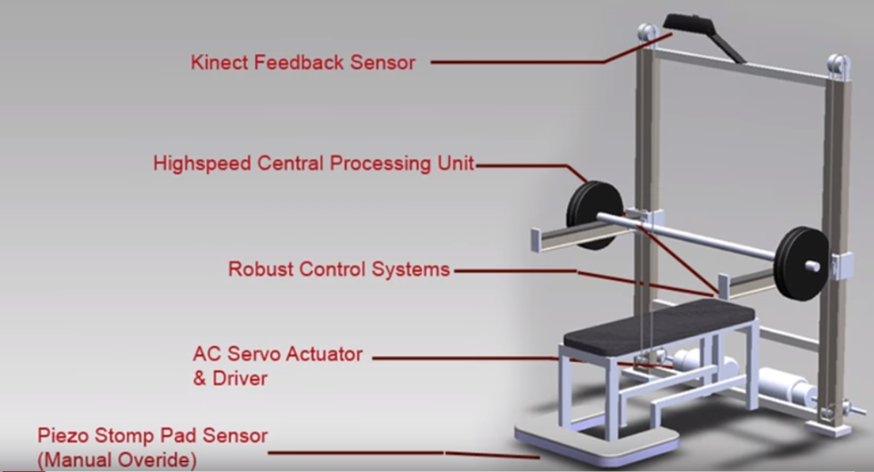
Figure 2: Juggernaut: Automatic Bench Press Spotter
3.1.3 Tripwire
When researching projects that were similar to our laser break system, we found that there is a type of simple home security system. You may have seen it make a couple of cameos in a Hollywood movie or two. This home security system is called a tripwire. In Hollywood this translates to a room with a ton of lasers that shoot in every direction across the room and when one is interrupted an alarm will sound. Our system was not this complex; it simply had one laser that shoots from one arm to the next, the wire part of tripwire, and instead of an alarm sounding when the beam is broken, it stops the linear actuators from lowering the arms any further.
This circuit includes a few simple components that together create an operational alarm. Those systems include: a voltage divider, where the photoresistor is in the R2 position, along with a 555 timer and another resistor to provide the desired voltage to the trigger pin of the 555 timer. The only thing not included in the schematic shown in figure one is a laser. We knew this circuit would work for our application, but we found that the alarm tripwire application and circuit provided many more features and abilities that were unneeded in our application. We only needed a voltage divider that would provide a change in voltage to a pin on our PCB. Having these extra parts and components that allowed for more functionality only opened the door for potential complications and part failures, something that on our restricted timeline we could not afford to spend time troubleshooting if not absolutely necessary. We also wanted to keep the budget of our project to a minimum so the less parts we needed, the better.
3.1.4 ABPS (Automatic Bench Press Spotter)
This project is created by students from Mississippi State University, they created a similar product to ours, but used different electronic components to achieve the same goal. The first main difference is their project was using the electric hoists instead of linear actuator to lift the bar. Also, they were concerned about not producing too many decibels when the engine was running to avoid noise interference. On the other hand, they were using motion detectors, occupancy detectors, and rotary encoder. Overall, their design was worthy of reference.
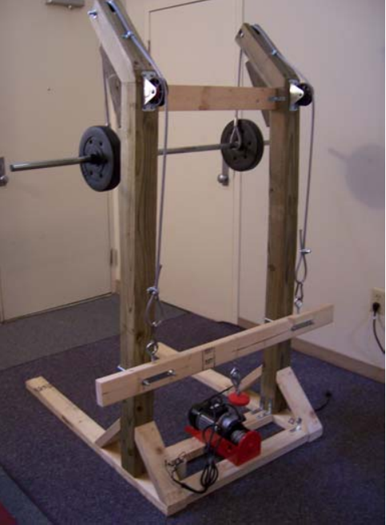
Figure 3: ABPS Project
3.1.5 Maxx Bench
Another product called Maxx Bench was successfully funded in 2017 on a Kickstarter campaign, and its simplicity makes it very compelling. Instead of having motors lift the heavy bar, the bench itself is lowered with the help of hydraulics when a foot pedal is pressed, thus lowering the body below the safety arms and exposing them to the bar.
As the campaign advertised: this solution does not compromise the integrity of the exercise, which is one of our main objectives. This implementation would not have let us play with computer vision software.
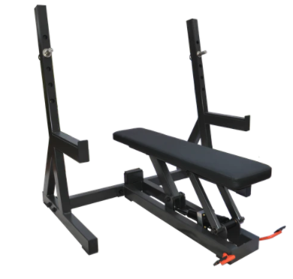
Figure 4: Maxx Bench
3.1.6 Schween Machine
The Schween Machine is another company that offers a similar line of products. Their automated weight machines provide a 360-degree omni-directional self-locking bar with self-locking plates. With this product not only the safety arms move up and down as needed, but the vertical posts to which the arms are attached move forward and backward to get out of the lifter’s way. The system helps assist the lifter when he or she starts to fail repetitions, which was a key functionality of our project.
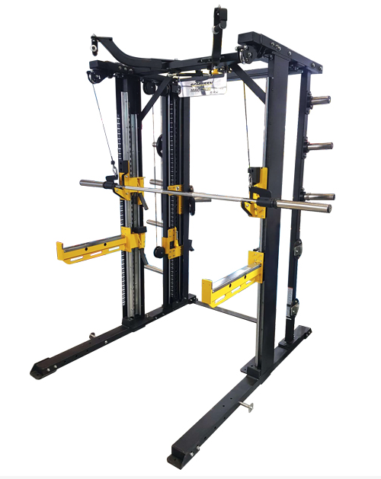
Figure 5: Schween Machine
3.2 Relevant Technologies
3.2.1 Material Research
When designing our project and considering the specifications for the actuators at our price point we decided that most important feature we needed to acknowledge is weight. We looked at aluminum, titanium and many alloys in between. We realized these options would be very difficult to implement given their basic features and how they would have to be mounted onto the actuators. The mount we would have to create to attach to the actuator would have to be of fairly substantial in size and therefore, substantial in weight. Though these alloys and metals are some of the lightest and strongest on the market, they relatively heavy when applied to our application. Another reason these alloys will not work is that there is limited ability to limit the material at the end of the arm. With a consistent amount of material across the full length of the arm there will be a large moment of force at the end of the arm. This will end up putting additional torque on the linear actuator that could be avoided with another, more thoughtful solution with a more customizable mount and dynamic material. We decided the solution would have a larger potential for success with a material resembling a fiber of sorts.
The two fibers we considered were carbon fiber and fiberglass. The strength for both of these fibers derives from their crosshatched pattern. Fiberglass is most commonly seen in auto body parts and repair. Fiberglass works tremendously under an environment that induces very high stress patterns, where as carbon can flex some but not to the extent of fiberglass. Because carbon has such limited flex it is found that this is actually a limiting factor, it will snap sooner than fiberglass while increasing weight. The flexible capabilities of fiberglass allow it to maintain a load while bending. Carbon fiber is 70% lighter than steel and 40% lighter than aluminum; this is why it is very commonly used in applications such as race cars, bicycles, and even in airplanes. Carbon fiber is most notable for its strength to wait ratio, hence why it is used in all applications that demand the need for minimal wait. The difference in price point in the two materials is also something worth noting; fiberglass is much cheaper than carbon because the process in which it is created in much easier.
As we begin to compare the specific strength of fiberglass and carbon, we have found that the societal notion of carbon being much stronger actually comes from a misunderstanding of the word “stronger”. Materials have basic properties that allows for easy comparisons. Strength and stiffness are two of these characteristics that are commonly brought up in the conversation. Another thing we found that added to the confusion between which would be more successful in our application is that there are actually many types of fiberglass. The one we have found to be most successful, is also the most comparable to those basic properties of carbon fiber is S-glass fiberglass.
When comparing S-glass and carbon fiber it was clear that carbon fiber was definitely stiffer, but it is not stronger. The breaking point of the s-glass fiberglass is actually higher than that of carbon fiber, also, the strength to weight ratio of this is higher as well. When considering these attributes alongside the fact that s-glass is cheaper than carbon fiber, we elected to make our arms out of s-glass fiberglass.

3.2.2 Linear Actuators
The primary source of movement in our project is done by actuators. Actuators are essentially ‘movers’ and can come in many forms, but all of them are consistent in that they need a signal for when to actuate and an energy source for power the movement. A few options we found for the actuators were hydraulic actuators that utilize hydraulic fluid, linear actuators that use an electric motor and a gearing system for movement, and pneumatic actuators that utilize the compression of air to initiate movement.
Hydraulic actuators utilize a physical substance called hydraulic fluid to move and hold statically. One of the natural and most notable characteristics or features of hydraulic fluid is that it is incompressible. The hydraulic actuator, also called a hydraulic ram, operates by loading this liquid into and draining it out of a cylinder with what is essentially a piston separating two chambers. By adding and draining liquid from these chambers in the cylinder on either side of the piston, the actuating arm extends and retracts. The extension process is displayed below in figure 3. This type of actuator is commonly used in very large machinery such as construction equipment, and robotic arms in factories. In many situations hydraulic rams are utilized in situations where they are needed to withstand extremely heavy loads. One of the downfalls of these actuators is that they themselves are very heavy, but this is partially due to the hydraulic fluid being very dense. The high density of the hydraulic fluid may be a downfall because of its weight but that is also the property that allows it to be incompressible.
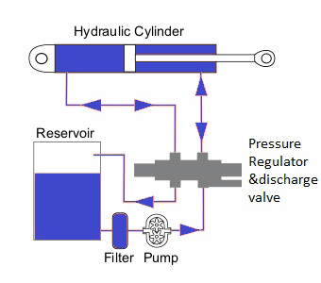
Figure 6: Hydraulic linear actuator
Linear actuators operate through the utilization of an electric motor, specifically a type of motor called a stepper motor. The way this motor works is by breaking down a full 360-degree rotation into a thousand of incremental rotations or steps. As the motor steps around the circle at a very high rate of speed the motors axle makes a smooth rotation with the overall rotational speed being determined by the number of steps it takes the motor to make a full rotation. This axle is typically attached to some sort of gear system to accomplish a more complex task resulting in the lifting or lowering of an object. Beyond the classification of linear actuator, they are generally broken down into two more categories, screw driven, and belt driven. Below is an illustration of each in figures 4 and 5. The stepper motor is geared to rotate a screw that is attached to a cylinder that does not rotate. With the action of the screw rotating it causes the cylinder to lift and lower. The belt driven actuator has the stepper motor attached to what is essentially a conveyer belt. The action of the motor rotating causes a platform attached to the belt to move.
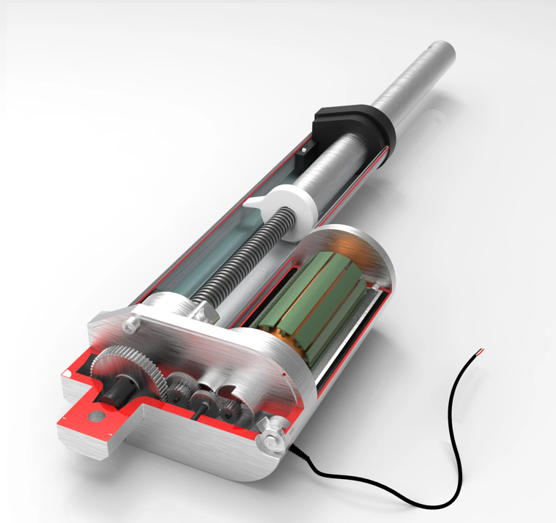
Figure 7: Skew driven linear actuator
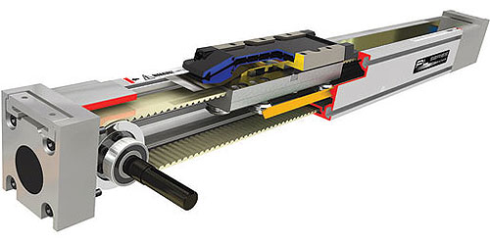
Figure 8: Belt driven linear actuator

Pneumatic actuators operate through the use of pressurized air interacting with a diaphragm. The is a diaphragm at the bottom of the top chamber of the actuator that moves up and down with a change in pressure. The underside of the diaphragm has a rod connected to it and with the change pressure and movement of the diaphragm the rod actuates to a very accurate degree. The rod is commonly connected to something in the bottom portion of the actuator that utilizes this movement. This sort of actuator is commonly used in valves that need an extremely high level of precision. An image of a pneumatic actuator is displayed below in figure 6.
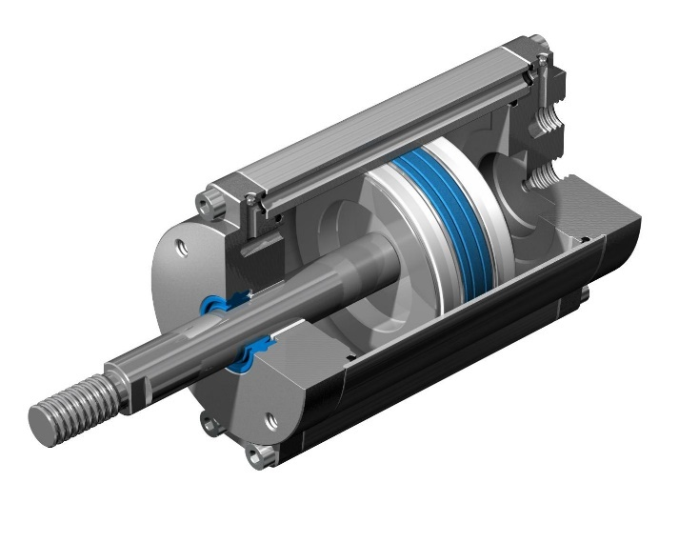
Figure 9: Pneumatic linear actuator
3.2.3 Photodetector
There are a few different types of photo detectors that we felt would potentially create a successful reaction for use in our laser’s receiver. The three options we considered were a photoresistor, photodiode, and phototransistor. All of these options function slightly differently internally yet are similar in the sense that an electrical property is altered inside of the part as it is illuminated by a light source; this altered electrical property alters the will alter the voltage that is seen at the output pin of the circuit and this change indicates that the light’s state at the detector has changed. We ended up using a photodiode, primarily for its response time.

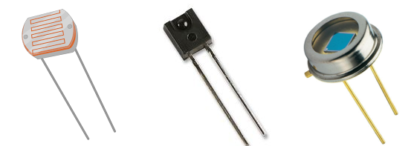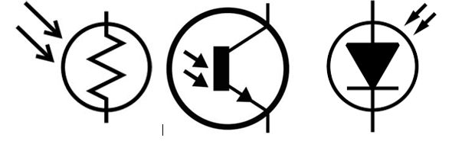
Figure 10: Photoresistor, Phototransistor, Photodiode (left to right); physical part (top), schematic symbol (bottom)
The first option we looked into was the photoresistor. This option seemed to provide all of the capabilities that we were seeking and would perform the task at hand, electrically it is also the simplest. One of the first leaps in our research was the finding of the tripwire system and we noticed that a lot of people were utilizing photoresistors in those circuits, so we naturally followed that path of thinking based on the parallelism in the two systems. Upon more research into the electrical properties of the photoresistor we found that the rise and fall time of the impedance as the part interacted with light source was relatively long when compared to the other potential components. In the instance of the lengthy rise and fall time we would in return have a lengthened change in voltage. The rise and fall times being longer than potentially possible with the photoresistor raised some red flags for us. Seeing that this system is one of the key safety features of our project, and it is a time dependent measurement, it is imperative that we utilize the most effective, fast, and accurate parts that are available to us while maintaining our position within the time and budget constraints.
As we eliminated the possibility of the photoresistors, we began to dive deeper into research on the phototransistors and photodiodes, we found that though they were much more complex devices, they had the ability to have the same functionality as the photoresistor but with a much simpler external circuit and did not need the extra components such as the 555 timer and extra resistors. With these simpler circuits we found that they could be tailored toward our specific application while maintaining a limited number of parts, as well as a limiting opportunity for errors, resulting in driving the overall price of the project lower and lower to maintain the sensitive budget we’ve put into place.
The phototransistor is a Bipolar Junction Transistor, or BJT, and operates with the base pin activated when it is illuminated. A BJT utilizes the base pin as sort of a valve, as the base sees a voltage it allows for a current to flow through the device from the collector pin to the emitter pin. The way this part works in a phototransistor package is very similar. When the photons from the light source, in our case a laser diode, come in contact with the p-n-p junction it excites the electrons and allows for more free carriers in the depletion region of the junction to form. The more light the freer carriers. The greater number of free carriers that are created, the more the current flow is amplified.
Similar to phototransistors, when photodiodes are exposed to light, they gain an excess electron hole pair. This process that generates the excess electron hole pairs is called photoconductivity. Instead of a p-n-p junction like the phototransistor has the diodes are a simpler p-n junction. With this simpler construction containing fewer junctions it allows the diodes to be even faster than the phototransistors which by nature are already much faster than the previously analyzed photoresistors. The diode is placed in reverse bias, with the n type material attached to the source, this is how the free pairs that the photons create can cross the junction and create a small current. This small photocurrent created by the light is known as a reverse saturation current. With this current present we can set a pull-up or pull-down resistor and alter the voltage at out Vout pin.
3.2.4 Transimpedance Amplifier
A transimpedance amplifiers is a type of amplifier circuit that utilizes an op-amp to amplify the input signal. Specifically, the transimpedance amplifier can take a small current input and turn it into a much larger voltage. The size of this voltage compared to the size of the input current is called the gain of the amplifier. This gain is determined by the feedback resistor. The size of resistance in the feedback wire is the determining factor of the gain.
3.2.5 Microcontroller
Microcontroller is an integrated circuit, is the use of ultra-large-scale integrated circuit technology with data processing capabilities of the central processor CPU, the random memory RAM, red-only memory ROM, a variety of I/O ports and interrupt system, timer/counter and other functions integrated into a piece of silicon to form a small and complete microcomputer system, widely used in the industrial control field. The microcontroller can be compiled in multiple languages, and if the program is written and the circuit is designed, the microcontroller will run as required.
3.2.6 Power Supply
It is well known that the main power supply to a home or building in the United States is AC 120V. However, most electrical appliances usually operate on 5V and 3.3 V DC voltage. The primary reason every country uses AC power instead of DC power as the transmitted energy is that AC power can maintain high voltage/low current when transmitting power, reducing voltage drop (I2R loss). Also, the AC power can be easily converted to DC power by using a transformer which is easy to supply electric DC drive equipment.
The automated safety spotter uses the wall outlet AC 120V and 60 Hz for the power source. However, most of the electronic parts of our project used DC power to work, and direct use of AC power can cause damage to the equipment and the human body. In order to prevent accidents and damage to parts due to voltage instability, we need DC power supply to provide voltage for all the electronic equipment, because most of the electronics of our project will use 5V or less than 5 V DC for operation, except the linear actuator need 24V DC.
3.2.7 Microwave Sensors
A microwave sensor can monitor the speed and the direction the bar is moving in by measuring the change in frequency of the electromagnetic radiation that the sensor emits. The faster the bar moves, the higher are the frequencies picked up by the receiver if the bar is moving up (towards the sensor) and the lower they are if the bar is moving down (away from the receiver). This is simply the Doppler effect. The Doppler effect is given by the equation $f = c/(c + Vs)*f'$, where f is the observed frequency, c the speed of sound, Vs the velocity of source (negative if it is moving toward the observer, and f’ is the emitted frequency of the source.
This change or shift in frequency can be interpreted by the computer which then sends a signal to the actuator arms when the bar has stopped moving. Microwave sensors that connect to microcontrollers and small computers such as Arduinos Raspberry Pies are cheap and easy to use.
3.2.8 Acoustic Sensor
The use of an ultrasonic sensor was another potential solution to track the movement of the barbell. These sensors work in a similar fashion to microwave sensors and make use of the Doppler effect as well, the only difference being the use of mechanical waves instead of electromagnetic ones. They too are cheap and easy to use.
3.2.9 Optical Sensor
The optical sensor equivalent to the ultrasonic sensor is LIDAR (Light detection and ranging or light imaging, detection and ranging). This type of sensor can detect or even map an object or terrain by sending pulses of (usually infrared) light and calculating the return time of the reflected light. LIDAR technology is in high demand, especially in the field of self-driving cars as many companies use it along with other sensors and cameras to precisely map the car surroundings and detect traffic. Although demand has brought prices down, from around $75,000 before 2017 to less than $7000 in today’s market for a high-quality sensor, LIDAR is still an expensive technology compared to the rest.
3.2.10 Video Camera
A video camera was the preferred choice for this project. This option was quite compelling for a couple of reasons. First, it provided an opportunity to learn and implement a set of computer vision and machine learning tools, libraries and algorithms that are in high demand in the industry, such as face detection, object tracking, OpenCV, Tensorflow, Keras, Pytorch, among others. This option of hardware combined with these advanced tools facilitated an open-ended design, since many additional features could be added on the software side, allowing the system not only to detect the movement of the bar but if desired, to also to track and verify whether the exercise was being performed correctly, respond to human voice commands and even facial expressions, this way acting as a more natural spotter, but with the speed of a computer.
A second function of the video camera that could be implemented if time allowed was to record the lift so that the user could later watch him or herself performing the exercise and catch errors that are to be avoided or nuances to be remembered the next time the exercise is performed.
3.2.11 Cell Phone Camera
Perhaps the first camera option that came to mind was the one we have in our cell phones. Cell phones in 2020 are ubiquitous and the quality of the videos they record vary from good to excellent. Besides from video quality, an advantage to this solution was that the user would have the video on his or her phone instantly, without the need to transfer files. The application could provide feedback in the form of text or even annotations right on the video. However, a moment of thought revealed this solution to be too complex for our project, with the disadvantages outweighing the conveniences of privacy, quality and having the videos permanently on their devices.
The first challenge had to do with the different operating systems (OS) available and their many versions. At least two different applications would need to be developed for the two most popular operating systems (iOS and Android), and approval from the respective companies would be needed to have them available for download. Extra effort and time would be needed to guarantee that these applications work on outdated versions of the OS, to provide a good experience to as many users as possible. Other challenges came up when we took into account that the phone could crash in the middle of the recording, or the battery could die, or the user simply would not bring his or her phone to the gym.
This lack of control over the software and hardware of cellphones made this option inadequate for this project.
3.2.12 Speech Recognition
Another technology that we thought of implementing was voice command-driven actions. The idea was to provide the user with a safe, fast way of indicating if he or she needed help, even if the camera system had not recognized it. This way, the user could say Help! or I’m done! and the computer would send a signal to the motors to have the actuator arms pick up the bar. This would result in a more natural way of interacting with the barbell spotter system.
One of the ways we could have achieved this was using the Google AIY Voice Kit. It would allow us to add voice recognition and natural language processing to the Raspberry Pi, using the Google Assistant API. This sensor costs around $25.00.
Criteria for selecting a (tracking) sensor
Although the type of sensor we wanted to use from the beginning was clear (a video camera), we still did research and compared different types of sensors to make sure that our final choice was a sensible one.
Using a sensor with an onboard processor that comes with many computer vision algorithms already installed and only needs a relatively small amount of code seemed like an easier solution, but it would have come at the cost of flexibility and not learning the extensive library of OpenCV functions that are used by companies like Google, Microsoft, Intel, IBM, Honda and many others, or important frameworks such as TensorFlow if we had decided to use it later in the development process. Ultimately, our criteria were bounded by price, accuracy and precision, open-ended design, learning potential, and use of in-demand technologies. The table below summarizes this.
 | Accuracy & Precision | Open-ended design | Price | Learning potential | In-demand technology
Microwave | high | no | < $2.00 | low | no
Ultrasonic | high | no | < $3.00 | low | no
LIDAR | high | no | < $40.00 | low | yes
Camera / Machine learning | high | yes | < $65.00 | high | yes
Table 1: Sensor Selection
    - OpenCV
OpenCV (Open source computer vision) is one of the most popular computer vision and machine learning software libraries in the world of Artificial Intelligence. Originally developed by Intel around 1999, it is now supported by the non-profit foundation OpenCV and it is free to use under the 3-clause BSD license, which allows “unlimited redistribution for any purpose as long as its copyright notices and the license's disclaimers of warranty are maintained.”[1]
According to its website (opencv.org), the libraries have more than 2500 algorithms that can be used for face tracking and face detection, classify human actions in videos, extract 3D models of objects, track moving objects, and many more use cases. Although the libraries are written and developed in C++, they also have Python, Java and MATLAB interfaces.
Some of many functions available to analyze or alter video feeds are:
- calcMotionGradient: it calculates a gradient orientation of a motion history image.
- calcGlobalOrientation: it calculates the average motion direction in the selected region of the image.
- segmentMotion: it finds all the motion segments (separate independent motions, such as barbell and arms) and marks them with individual values for further analysis.
- meanShift: it finds an object in an image by implementing an iterative object search algorithm.
- CamShift: it stands for Continuously Adaptive Meanshift. It finds the object center, size and orientation.
- findContours: it finds the contours in a binary image. This is useful to get the shape of the barbell for tracking.
- CascadeClassifier: it detects objects of different sizes in an image. This algorithm became popular after Paul Viola and Michael Jones published their research paper Rapid Object Detection using a Boosted Cascade of Simple Features in 2001.
OpenCV can be used on Windows, Mac OS, Android, and Linux. The latter is the operating systems of Raspberry Pi computers. The combinations of operating systems and programming languages that OpenCV offers plus the substantial online documentation and support made it the choice for this project.
This was our choice of computer vision library. In later sections we explain how it was implemented.
3.2.14 Convolutional Neural Networks
Simply explained, neural networks are a group of multilayer perceptrons that are fully connected. A perceptron can be thought of as a function that takes an input, performs some computations, and outputs a result, usually used as a binary classifier to determine if the input or inputs belong to a specific set. Neural networks combine many of these perceptrons and connect every single input to every single perceptron. If the network is multi-layer, then it has many of these perceptrons whose outputs feed more perceptrons until the final output layer that gives the result.
Convolutional Neural Networks have many layers that perform convolution on images to extract simpler and simpler patterns the deeper the image is “passed” through the network.
The main layers are:
- Convolution: it is simply a weighted sum. The weights are given by the chosen matrix or kernel and will be modified by the network using backpropagation on each iteration.
- Non-Linearity: Since convolution operations are nothing but a weighted sum, the amount of learning or complexity that networks would be able to handle would be limited if all operations performed on images were linear. To give networks more flexibility, a non-linear operation must be introduced. It turns out that such operations need not be complex to dramatically widen the spectrum of problems networks can tackle. One example is the Rectified Linear Unit (ReLU), where the output is given by the maximum value between zero and the input; that is, it is practically linear. There are many others, such as Leaky ReLU, tanh, sigmoid and SoftMax.
- Pooling: This layer takes care of compressing the input images (matrices) while only retaining the most useful or important information. Thus, it makes the images smaller and easier to perform computations on them, while avoiding the problem of overfitting.
- Classification (Fully Connected Layer): This layer uses all the features extracted from previous layers to classify them into categories that vary depending on the task at hand.
Below is a summary of many successful networks and their performance in a popular annual software contest, ImageNet Large Scale Visual Recognition Challenge (ILSVRC). It is remarkable how the error rate of these networks is reduced by a half or more with each passing year.
Year | CNN | Place | Top-5 error rate | No. of parameters
1998 | LeNet(8) | - | - | 60,000
2012 | AlexNet(7) | 1st | 15.3% | 60 million
2013 | ZFNet() | 1st | 14.8% | -
2014 | GoogLeNet(19) | 1st | 6.67% | 4 million
2014 | VGG Net(16) | 2nd | 7.3% | 138 million
2015 | ResNet(152) | 1st | 3.6% | -
Table 2: Convolutional Neural Networks performance at ILSVRC
An architecture can have multiple combinations of all of these layers. To build or improve on already existing networks for use in our project, there exist frameworks mentioned above, such as Pytorch, Tensorflow, Keras and Scikit-Learn.
A potential add-on or improvement to the project would have been the implementation of such convolutional neural networks to have the software “learn” what the correct posture was when the user was performing the exercise, to “see” if the user needs help by watching facial expressions or body reactions (like arms shaking). This is so intuitive to a human that we do not stop to think how we know it. However, for a computer to accurately predict or identify any of these details, it needs to process hundreds, maybe tens of thousands of similar videos of people performing the exercise it’s supposed to get good at. This is why data gathering and data cleaning is so important before training a program or a network to perform certain tasks.
Many image databases such as MNIST, NOAA images, CIFAR-10, CIFAR-100, CALTECH101, IMAGENET, COIL-100 and more already are available to train networks. Video datasets also exist, many with audiovisual annotations (for supervised learning) such as AVA and J-HMDB which are focused on human motion. Although these datasets could have been used to train a network from scratch, or we could have implemented an already trained algorithm to increase the accuracy and speed of our code, we would have ultimately needed to create our own database based on videos collected from online sources such as YouTube, edit them to make them reasonably short, and annotate them one by one if we decided to use a supervised learning algorithm, so that it could compare its predictions with the video labels and that way improve future predictions. This would have taken significantly amount of time, a limited resource, so we decided to go with the OpenCV solution.
3.2.15 Voltage Regulator
A voltage regulator is a device that stabilizes the output voltage. The regulator consists of a regulating circuit, a control circuit, and a servo motor. When the input voltage or load changes, the control circuit samples, compares, amplifies, and then drives the servo motor to rotate, so that the position of the carbon brush of the regulator changes, by automatically adjusting the coil turns ratio, so as to keep the output voltage stable. The voltage regulator automatically adjusts the output voltage of the generator by controlling the AC excitation current of the generator. Generator voltage regulator can meet the common 60/50Hz and intermediate frequency 400Hz single or parallel operation of the generator. Any electronic device that requires voltage fluctuations requires a voltage regulator, because voltage fluctuations can damage electronic components and pose a risk of injury to the user. The regulator protects the electronic circuitry from accidental damage that could cause the microcontroller to blow up due to severe voltage fluctuations. According to the different output characteristics of voltage regulators, voltage regulators are generally divided into two categories: AC regulators (AC stabilized power supplies) and DC regulators (DC stabilized power supplies). The regulator is often divided into two types of power (linear regulator and switching regulator) depending on the operating state of the adjustment tube. There is also a small power supply that uses a regulator tube.
3.2.16 Switching Regulator
Switching regulators use an output stage to repeatedly switch between “on” and “off” states to produce an output voltage with energy storage components (capacitors and inductors). Its adjustment is realized by adjusting the switching timing according to the feedback sample of the output voltage. In a fixed frequency regulator, the switching timing is adjusted by adjusting the pulse width of the switching voltage, which is called PWM control. In a gated oscillator or pulse mode regulator, the width and frequency of the switching pulses remain constant, however, the "on" or "off" of the output switch is controlled by feedback. According to the arrangement of switches and energy storage components, the generated output voltage can be greater than or less than the input voltage, and multiple output voltages can be generated with one regulator. In most cases, pulse (buck) switching regulators are more efficient than linear regulators in switching power supplies with the same input and output voltage requirements.
Pros of Switching Voltage Regulator:
Transistors can work in (on-off) and (off-on) switching states alternately. The transistor can alternately work in the (on-off) and (off-on) switching states. The switching speed is fast, the frequency is generally 60Khz, and the highest can reach hundreds to 1000KHz.
The switching regulator does not use bulky industrial frequency transformers, and due to the low power consumption and high efficiency, eliminates the need for larger heat sinks.
The output voltage from the switching power supply is regulated by the space-occupancy ratio of the input signal, which can be compensated by frequency or width adjustment, so that it can effectively stabilize the output voltage in case of large changes in the operating grid voltage.
The working frequency of the switching regulator is about 1000 times that of a linear regulated power supply, which also improves the filtering efficiency after rectification by almost 1000 times.
The circuit form of the switching stabilized power supply is flexible and diverse. Designers can take advantage of various types of circuit features to design a switching stabilized power supply that can meet different applications.
Cons of Switching Voltage Regulator:
The circuit structure is complicated, the failure rate is high, and maintenance is troublesome.
Another disadvantage of switching regulators is the presence of serious switching interference. In a switching regulator, the transistor V operates in a switched state and the AC voltage and current it generates is passed through other components in the circuit to generate spikes and resonance interference. If no measures are taken to suppress this, the operation of the machine can be seriously affected. In addition, because the switching regulator power supply oscillator is not isolated from the RF transformer, these disturbances will be strung into the RF power grid, causing serious interference to other nearby electronic instruments, equipment.
3.2.17 Linear Regulator
A linear regulator uses a transistor or FET operating in its linear region to produce a regulated output voltage by subtracting the excess voltage from the applied input voltage. The voltage drop is the minimum difference between the input voltage and the output voltage required by the voltage regulator to maintain the output voltage within 100mV of its rated value. Positive output voltage LDO (low voltage drops) regulators usually use power transistors as PNP. This transistor allows saturation, so the regulator can have a very low voltage drop, usually around 200mV; On the other hand, the voltage drop of a conventional linear regulator using an NPN composite power transistor is about 2V. The negative output LDO uses NPN as its delivery device and operates in a similar mode to the PNP device of the positive output LDO. A linear regulator may not be able to achieve the overall efficiency of a switching converter or regulator, but it still has its own advantages. When the input and output voltage difference decreases, the regulator's energy efficiency will increase. When the input voltage is just above the output voltage, the energy efficiency of the linear regulator is close to 95% to 99%.
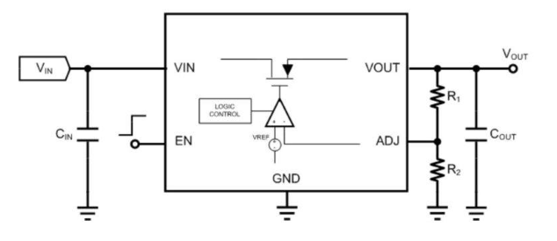
Figure 11: Linear Regulator
Pros of linear voltage regulator:
- Low output ripple and noise
- Fast transient response on VOUT in the face of large load changes
- Low cost (at least due to low power consumption)
- Very few external components make linear regulators easy to design
- No EMI concerns because the linear regulator does not draw current into the inductor
- Easy to implement short circuit protection

Cons of linear voltage regulator:
- Low efficiency at VIN>VOUT, which requires a larger power supply
- Power generation with voltage regulator (VIN - VOUT)
- IOUT is dissipated by a regulator, usually requiring a heat sink
- VOUT will always be lower than VIN
Overall, the linear output of the linear regulator produces very little noise and the output is very smooth, but the energy efficiency is much lower than the switching voltage regulator, and not able to achieve a boost output higher than the input voltage.
3.2.18 Interface Configuration
A reoccurring trend that can be seen in every display that has been chosen for consideration, is the fact that each of the interfaces have been of a parallel configuration. Something to note is that seeing that there are only two ways to transmit bits of data between two digital devices, with a Serial interface or a Parallel interface. The reason that parallel configuration was chosen as the desired type of configuration is because with parallel configuration it is possible for there to be greater flexibility that its counterpart, serial configuration, just simply is unable to provide. The following figure below shows on a very basic scale the difference in how each of the configurations are implemented from the perspective of the schematic.
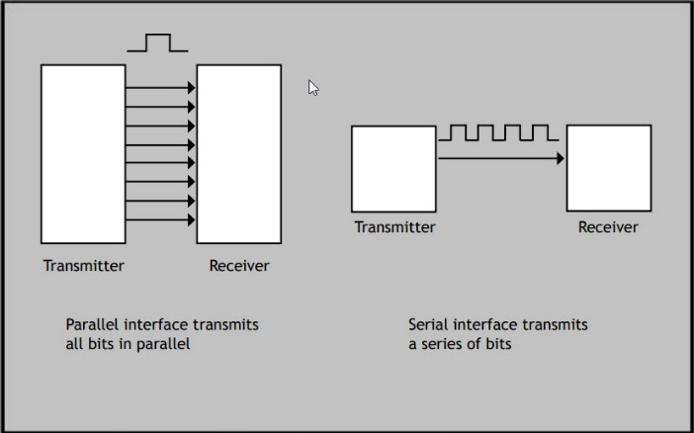
Figure 12: Parallel vs Serial Interface Configurations
Notice in the figure above, there are more wires making a connection between the transmitter and the receiver in the parallel interface configuration. Referencing the picture, the parallel interface configuration has multiple connections from transmitter to receiver, meaning that it would have a large throughput since multiple bits would be travelling to the transmitter simultaneously. This would also mean that there would be greater speed in which the data can be processed relative to the serial interface configuration. There are many different reasons why one would choose one over the other, the following chart aims to highlight some of the key points in which one would base their decision. This chart shows how the parallel and serial interfaces compare to each other, highlighting some of the key advantages that a serial interface would have over a parallel interface and vice-versa.
Which is Better for this Implementation?
Serial Interface Configuration | Parallel Interface Configuration
Low transmission speed as compared to parallel interface configuration | Great transmission speed compared to the serial interface configuration
Less space occupied due to a lesser amount of wires being utilized, since only one bit is needed to be transmitted per clock pulse | More space is occupied seeing that there are multiple data bits being transmitted simultaneously, hence more wires
Capable of delivering a single stream of data per clock pulse | Capable of delivering multiple streams of data per clock pulse
Can traverse over longer distances without data being corrupted or altered, making it reliable | Used only in short distances since the wires tend to interfere, corrupting data over long distances (>25 meters)
Table 3: Parallel vs Serial Interface
In conclusion, we saw that there is a valid argument for both serial and parallel interface configurations. However, when deciding on which, we must look at the context in which the device will be used for the project. A parallel configuration would be most advantageous based solely on the speed it transmits data. Although there can be distortions in the data when there is a long distance to be travelled between transmitter and receiver, this isn’t a problem in our implementation since the system is relatively self-contained and doesn’t need a lead distance of more than a few inches. Seeing that there is reason to believe that we are sending a relatively large amount of data to the display, a parallel interface would be ideal rather than the serial interface configuration.
The serial interface configuration is unable to work in this instance simply due to its limitations in terms of data transmission capabilities. Although there are ways to increase the throughput of a device that utilizes a serial interface configuration, it would only increase the power consumption, which is not a compromise that we could afford to make. This is because we have built a system of where power consumption was always a consideration in an effort to maximize energy efficiency. Having an energy efficient system is a very attractive attribute to both the general public and commercial consumers. A low power consuming product gives the commercial customer the incentive of implementing this device in their respective establishments due to the low expenses that can be associated with the electricity cost of the machine.
3.2.19 Display
LCD vs LED Display
Our chosen display was one of the LED (light-emitting diode) variety, which begs the question, why choose one of that variety and not one of the LCD (liquid crystal display) or OLED (organic light-emitting diode). Firstly, we looked at the comparative differences between LEDs and LCDs, and why one is generally considered to be superior to the other.
Usually the LED is considered to be the superior display variation compared to the LCD seeing how the LED is only a more technologically advanced version of the LCD. This statement was reason enough to vouch for the choosing of the LED over the LCD display archetype, however we went even deeper into what exactly made the LED to be considered a more “technologically advanced version of the LCD”.
The differences in the technology of the LED is mainly warranted by the fact that the fluorescent tube that was previously present in the LCD is now replaced with new backlight technology of smaller more energy efficient light-emitting diodes, therefore producing a crisper, cleaner picture relative to that produced by the LCD. The LED also boasts a much wider viewing angle than that of the LCD. The viewing angle is the greatest angle in which a display can be viewed with acceptable visual performance. The LED also is equipped with a better black level, contrast, and delivery in regard to color accuracy. The following table shows a comprehensive comparison of the advantages and disadvantages of the LED and LCD display archetypes:

Which is Better for this Implementation?
LCD Display | LED Display
Shorter life-span | Extremely long-life span
More maintenance is required | Low maintenance device
Produces significantly more heat when operating | Produces little to no heat when operating
Not a very efficient device | Highly efficient device
Slower response time | Fast response time
Lower picture quality | Crisp, clean picture quality
Smaller viewing angle in relation | Great viewing angle
Lower color accuracy | Greater color accuracy
Less costly | Costlier than LCD
Lighter in terms of weight | Heavier device
Includes millions of color options | Limited color options compared to LCD
Relatively subpar black level and contrast | Exceptional black level relative to LCD
Table 4: LCD vs LED Displays
As a more visual representation of the power consumption differences between the LED and LCD, the below graph shows an example of the brightness (lumens) as it relates to the amount of power consumed (watts).

Figure 13: Power Consumption/Efficiency
OLED vs LED
There is another type of display that could’ve also been considered when looking into the options available for the display we are seeking. The OLED (Organic light-emitting diode) is another type of display that is fairly new technology which only began shipping in 2013, and are only produced by LG display, so it is difficult to find smaller displays that offer this option. However, it is possible to find the display, but what makes it different from the regular LED?
The OLED differs in the fact that it can produce both the light and color from a single diode, when the electricity is fed into the diode. This is interesting since every pixel is a singular self-contained diode because there is no reason for a backlight to be present in the OLED configuration. This completely removes the LCD portion of the LED hence the organic in the name of OLED reinforcing the fact that the display is completely self-contained. This fact that each pixel can produce its own light and color when being powered by electricity is very important in the black level capabilities of the display. Since the LCD relies on an exterior backlight source to produce its light rather than doing so itself, it suffers from an effect called “light-bleed”, which simply means light from another area disrupts the black level of another area of the display. Since the OLED produces both its own light and color with every pixel being its own diode, if no electricity being supplied to a diode, it is completely and utterly black with no bloom or haze to be heard of.
That is just one of the many differences between the OLED and LED display types, there are many different arguments that can be made in defense for either party. A more comprehensive comparison is shown in the following figure, which highlighted some of the features of the display that we were interested in when we making our decision.
Which is Better for this Implementation?
LED Display | OLED Display
Greater brightness capabilities | Not as bright as its LED counterpart
Relatively less costly | Much more costly than
Larger in size | Smaller in size relative to LED
Long life span | Shorter life span
Very rigid in its design | Can be contorted in different shapes more easily
Thin screen size | Much thinner screen size relative to LED
Heavy relative to OLED | Light weight
Slower response time | Extremely fast response time
Smaller viewing angle | Larger viewing angle
Low power consumption | Greater power consumption
Table 5: LED vs OLED Displays
Although there are many different arguments that can be made in the favor of the Organic Light-Emitting Diode as a more attractive option for the display. However, there are some factors that eliminated the OLED as the best option for the display to be implemented in our design. The fact that it was relatively new in terms of a technological advancement, so it would be extremely costly and hard to find for the purpose of our project. Also, the power consumption and fact that it had a shorter life span than the LED makes it a less attractive option, even with all of the other positive qualities that it has.
LED vs QLED Display
We also looked at another type of display which is called the Quantum Light-Emitting Diode or QLED for short, which is essentially a form of LED which instead utilizes nanoparticles called quantum dots to supercharge its brightness and color. It is also a fairly new category of display relative to the likes of LEDs and LCDs, beginning distribution in 2013 to 2014. These QLED displays lights up using the backlight of a great number of LEDs, which is essentially how the LED attains its light. However there is one difference in that the quantum dots are used as a sort of optimizing agent, in which it takes the light that it receives from the LEDs and then maximizes the use of said light by producing brighter hues in the color spectrum all while not losing any saturation, which makes it differ from regular LED displays in that regard. This combination will achieve some of the brightest pictures while maintaining laudable definition as well. The comparison chart showed some of the key advantages and disadvantages between QLEDs and LEDs that we looked at when making our decision.
Which is Better for this Implementation?
LED Display | QLED Display
Not as bright as its QLED counterpart | Some of the brightest colors to date
Relatively less costly | Much more costly than LED
Larger in size | Smaller in size relative to LED
Relatively same lifespan | Relatively same lifespan
Thinner screen size | Thicker screen size relative to LED
Heavy relative to QLED | Light weight
Similar response time | Similar response time
Similar viewing angle | Similar viewing angle
Similar power consumption | Similar power consumption
Table 6: LED vs QLED Displays
While the two technologies are fairly similar due to the fact that it only differs in adding the nanoparticles as a means of optimizing the backlight that it receives and produce brighter colors than normally achievable. This is essentially the only difference between the two display types and seeing how the QLED being one of latest technologies makes it very costly and somewhat difficult to acquire in the capacity that we would like to implement it in.
LED vs µLED Display
The µLED display is also a relatively new technology but it is something that warranted attention and comparison in how it stacks up to the regular LED display. This is also a type of display that was considered as a potential display that could’ve been used for our implementation of a display as the interaction point for the user and the system. The µLED configuration consists of multiple arrays of microscopic LEDs which form the individual pixel elements, giving it some of the same properties of the previously mentioned OLED, this allows for it to have superior contrast and black level capabilities. In the following comparison chart, we looked at how the µLED compares to the LED which we chose as the configuration for the display we implemented.
Which is Better for this Implementation?
LED Display | µLED Display
Good brightness | Not as bright as its LED counterpart
Relatively less costly | Much more costly than LED
Larger in size | Smaller in size relative to LED
Relatively same lifespan | Relatively same lifespan
Thin screen size | Thicker screen size relative to LED
Heavy relative to µLED | Light weight
Slower response time | Faster response time
Smaller viewing angle | Greater viewing angle
Similar power consumption | Similar power consumption
Table 7: LED vs µLED Displays
Similar to most of the other new technologies the µLED was relatively difficult to find in the capacity by which we wanted to use it. Although both the OLED and µLED are usually created for smaller applications due to the how many individual units must be put together to have each one to be associated with a singular pixel. The fact that it is such an intimate design makes it costly for larger display units and relative to every other application that it is generally used for such as Apple watches, and the like. This immediately eliminated it from being implemented in our design. Since the majority of our funds were spent towards the linear actuators, we needed to make more economical decisions in other areas such as this, while still choosing quality components.
3.2.20 Touch Screen
In the comparison of the different displays, a note is made showing the type of touch screen configuration that is utilized by the different touch-screen capable displays. This can be very important depending on the implementation and what a user is looking for in regard to how he or she wants their display to function within the entire system. The following tables highlights the advantages and disadvantages of the two types of touch screens, resistive and capacitive.
Capacitive Configuration
Advantages | Disadvantages
Higher touch sensitivity | More expensive to produce
Supports multi-touch | Cannot be used with most gloves
Good visibility even in sunlight | Does not work well with pointed objects (stylus, etc.)
Table 8: Capacitive Configuration Advantages and Disadvantages
As we can see, it supports multi touch, which is similar to most touch screen devices in today’s society, but with extra sensitivity comes a greater price and the lack of functionality when the user is utilizing gloves. This will be very pivotal when it comes to some members of the exercise facility who, when working out, use gloves as a means of personal preference. The figure below shows the way in which a capacitive configuration looks on a lesser scale, showing how the capacitive configuration operates and is able to produce a touch screen by using taking advantage of basic physical science and electrical engineering concepts.
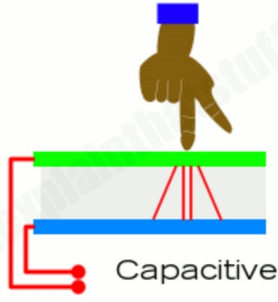
Figure 14: Capacitive Configuration
With this configuration, the reason it is called a capacitive configuration is because the screen itself acts as a capacitor, When the finger makes contact with the screen then it disrupts the electrical field of the inner (blue) and outer (green) glass thus creating the current in that area. This is why a capacitive configuration is able to be able to function and respond when being touched in multiple areas, unlike the resistive configuration.

Resistive Configuration
Advantages | Disadvantages
Very inexpensive to produce | Not very sensitive to touch
Better resistance to dust and water | Multi-touch is not supported
Can be used with gloves | Poor visibility in sunlight
Table 9: Resistive Configuration Advantages and Disadvantages
As with the resistive configuration there were some advantages that made for some interesting dilemmas while choosing a type of configuration. For some applications, the resistive configuration can be prioritized because of the fact that it can be used with gloves and is less susceptible to failure due water and dust. However, the lack of multi-touch support can make it less versatile in terms of when more complex applications are needed. Another thing we thought of is the fact that it is less susceptible to water or dust failure, since sweat is something that is common in weight rooms and gyms, however the fact that it is not as sensitive to touch gave us cause to lean towards the capacitive configuration in relation to the touch screen. As with the capacitive configuration the figure below shows how the resistive configuration works to provide feedback to the user upon interaction.
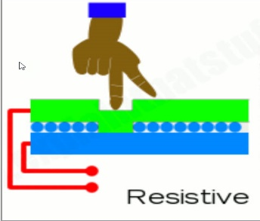
Figure 15: Resistive Configuration
In the resistive configuration there are two conducting layers and pushing the screen as shown in the previous Figure 6 completes the circuit therefore sending the signal, making it react in the associated way. As mentioned in the previous tables, there are some merits to having this configuration, however, there is one major drawback. The fact that it does not support multi-touch functionality is due to the fact that it only completes one circuit at a time since it is all connected to one circuit unlike the capacitive configuration which has multiple smaller circuits. It is similar to how a keyboard, when holding down two individual keys at the same time, only one of the keys will continue to produce a result rather that both. In theory if the keyboard was capacitive in its configuration then both of the keys should print concurrently when holding down both keys since both electrical fields can be disrupted simultaneously.
In regard to the display there was also a potential for it to need to display the repetitions of the user’s exercise when using the bench press. Though we did not implement this feature we felt that if time allotted this would be a feature we could append to our project, therefore we planned accordingly. With the Raspberry Pi 5” Display it would be able to easily display the repetition captured from the camera for the user to view and allow them improve upon his/her form.
With this display there was no need for another external device to be used as the input device such as a keyboard, etc. The display screen only requires two connection ports to fully implement into the Raspberry Pi computer, HDMI and microUSB. Being that this display is easily implemented into different types of computers it allowed us to modify the coding to do exactly what we wanted it to do. By using this display, we created an all-in-one user interface which the user can interact with and easily and intuitively. Some more general information about the display screen can be found below.
ELEMENT | VALUE
Color Pixel Arrangement | RGB Vertical Stripe
Viewing Direction | 12 o’clock
Operating Temperature | -20 ~ +70 C°
Storage Temperature | -30 ~ +80 C°
Weight | 8.8 oz
Table 10: Extra Display Features
The low-power and low weight attributes of the display screen were very desirable for our project. The fact that it can also be stored in such a wide variety of temperature conditions was also something that led us to making the decision that this was the best display screen available for the application of our project.
Since the display can be utilized by using a raspberry pi computer board, we were able to easily use principles that we were familiar with along with the data sheet in order to implement the functions that we needed in the display.
Another display that should be mentioned is the HUSKYLENS which is a display that has no touch screen however it does have the ability to capture motion and could have been used in place of a camera. This would allow us to implement the OpenCV code directly to the display since this display also has a camera and can track the movement of the bar.
However, something that the HUSKYLENS does have above all other displays is the fact that it has a camera acting as the input directly to the display. This could be extremely advantageous depending on the way it was being implemented. For example, if the HUSKYLENS was being used as the center hub for which the user interacts with the system itself there would not be a lot that you can do with the HUSKYLENS. Conversely, if you were to use the HUSKYLENS as the camera to which we control the linear actuators, that will provide movement to our support arms, then it could be integral to the entire system. With the ability to convert visual stimulus directly into a signal, using OpenCV we could use this piece of equipment to directly send signals to our linear actuators, informing that part of the entire system when to provide support to the exercising party. The HUSKYLENS display can be seen in the following figure below:
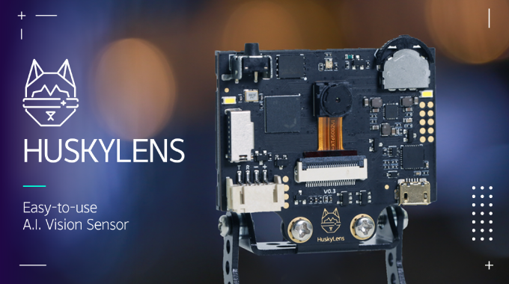
Figure 16: Huskey Lens
While the HUSKYLENS did boast about a lot of novel features, as far as being the display that we were looking for it was lacking in one of the most vital attributes we needed and that was being able to interact with the user. We wanted it to be a very intuitive way of communicating to the system that you are ready to begin calibration as an example.
3.2.21 Step Motor Driver
Step motors operate on a rising or falling edge of a Pulse Width Modulation function as the input signal. Understanding how the stepper motor operates is crucial in realizing the purpose of the step motor driver. Different motors react differently to the rising and falling edges by taking them as the signal to make their step in the incremental rotation. Because the motor relies on the rising and falling edge it will not work without the specified driver.
3.3 Strategic Components and Part Selection
3.3.1 Linear Actuator
In our initial research on linear actuators we were shocked to find out how expensive they are. This caused a bit of concern while searching for viable options after we had already created a full plan. Our initial specification was to have the system equipped to assist with over 200 pounds of weight, yet as we found out how expensive the actuators were we decided the best course of action was to reduce the amount of weight that we would be required to lift and this would allow for a savings in money. With this new approach and amended requirement we certainly will not be looking to implement this exact prototype into a real gym. This prototype however, allowed us to showcase the electronic and software abilities of our system while proving the concept that we had originally set out to display.

Feature | LIN-ACHD-25-R1 | FLS40L50005C7 | FA-BH36-224-12
Manufacture | Windy Nation | FUYU | Frigelli
Travel Distance | 24in | 19.685in | 24in
Top Speed | 0.2in/sec | 3.46in/sec | 0.157 in/sec
Supply Voltage | 12V | 1.7V | 12V
Load Capacity | 750lbs. | 33.06lbs. | 224lbs.
Max Current Draw | -- | 2.0A | 1A
Price | $169.99 | $163.00 | $185.00
Table 11: Linear Actuator Information
From observations based on information shown in table 3 above we deduced that the Frigelli actuator was not going to be the one we used because it is both the slowest moving and the most expensive. Even though it does move a substantial amount of weight, it is shown that the Windy Nation actuator can lift over two and a half times that of the Frigelli actuator while having the ability to move faster and maintain a lower cost to the consumer. Seeing that this was going to be the most expensive piece of our project and, as previously mentioned in the paper, the budget was closely being monitored, a part that did not fall into the budget constraints with no positively outstanding performance benefits that the competitors could compare to with a significantly lower cost, was not a justifiable part for our selection process. As we looked on to the FUYU actuator in comparison to the Windy Nation actuator we can see that they are very similar in price, yet the FLS40L50005C7 has a slightly shorter stroke by about four and a half inches, but it is offset by its speed. The LIN-ACHD-25-R1 can lift a tremendous amount of weight, but because it is an internal screw driven driver it is extremely limited on its actuating speed at only a fifth of an inch per second. When analyzing this and figuring a full stroke we found that it would take 120 seconds, 2 full minutes, to fully extend from a complete contraction to a complete extension. In this application that would be to long when comparing against something that is almost twenty times faster that is essentially the same price (as seen in table 3 it is actually 6 dollars cheaper). The four inches we give up on the stroke length is justified for the ability to make a full actuation in just over five and a half seconds. The availability of speed with a reduction of weight required was crucial to the ability of showing our concept to its fullest extent and displaying the safety features properly(We have also spoken with our professor and were told that because this projects scope lies within an electrical engineering practice it is understood that mechanical attributes such as weight lifted was not a feature we needed to concern greatly; as long as we could show the proof of our concept and design we will have created an acceptable project.). After consideration, we decided to go with the FUYU FLS40L50005C7 actuator in our design.
3.3.2 Laser
The features we were looking for in a laser were not incredibly strenuous. We simply needed a beam of light from a source at reasonable price that does not draw an incredible amount of power. Given that these features are pretty common among laser diodes we believed that cost would probably be the deciding factor.
We found three Adafruit lasers that were very similar in their abilities and all could work in our project. The three lasers were the Adafruit laser series including 1054, 1057, 1058. As these all are same laser based on the specs, we found that to an extent they were the same but had slight variations. The difference between the 1054, 1057, and 1058 was the lens. There is a varying lens shape at the end of the part that alters the shape of the beam. The 1054 has a single point that made a traditional laser pointer type beam. The 1057 laser is a line for applications such as 3-dimensional scanners, and the 1058 laser is a cross, noted to be good for tasks such as targeting or guiding. Since neither of these tasks or shapes are conducive to our goals, we are going to use the 1054 Adafruit laser to allow for a single dot pointed toward our photodetector.
As we dug further into the datasheets of these two lasers diodes, we have been able to find that they are slightly different lasers inside of the same package, and both would work for our application. The VLM-650 laser has a wavelength of 650nm, while the VLM-635 has a wavelength of 635nm. They both have a dot size between 5mm and 7mm at 5 meters away proving that they are accurate enough for our application requiring no more than 2 meters of accurate distance. The other differentiating factor between these two lasers is the LPT vs. LPA. This signifies the different output power options. The LPT in the part number signifies the output power is less than 1mW whereas the LPA part number signifies an output of less than or equal to 2.5mW.
Features | Adafruit 1054 | VLM-650-03 LPA | VLM-635-03
Manufacture | Adafruit | Quarton | Quarton
Supply Voltage | 2.8V~5.2V | 2.6V~5V | 2.6V~5V
Wavelength | 650nm | 650nm | 630nm
Max Current | 25mW | 35mW | 50mW
Size | 10.11mm | 7mm | 7mm
Weight | 11.85g | -- | --
Price | $8.95 | $18.31 | $20.68
Table 12: Laser Information
Based on the data in table 1 we went with the Adafruit 1054 laser. This laser has the highest wavelength and because most photodiodes are the more sensitive to infrared light which is in the 800-900nm range with a pseudo bell curve in sensitivity on either side. The Adafruit 1054 has a wavelength of 650nm and is 20nm higher than the VLM-635-03LPT. We believed the photodiode would be slightly more sensitive to its light compared to the Quarton lasers. Even though the VLM-650-03 LPT is slightly smaller and uses less current we found the losses in those categories justifiable when put up against a savings in cost of over 50%.
3.3.3 Photodiode
For our part we were only concerned with the bandwidth that our laser was producing. The wavelength of our laser was fixed at 650nm. There are photo detectors made for many different wavelengths ranging from ultraviolet light, visible light, and infrared light. A lot of photodiodes and photodetectors are more sensitive to IR light. Seeing that we had no desire to detect this light and would prefer if we didn’t detect it, we were able to narrow our part selection down by simply limiting our target wavelength.
Feature | SFH 2201 | ADPD2140 | PDB-C160SM
Manufacture | Osram | Analog Devices | Luna
Photo Sensitive Area | 8.12mm² | 0.31mm² | 7.02mm²
Dark Current | 1nA | 1.74pA | 2nA
Photocurrent | 13uA |  | 80uA
Reverse Voltage | 16V | 8V | 32V
Peak Wavelength | 950nm | 850nm | 850nm
Response Time | 40nS | 227nS | 20nS
Price | $1.38 | $4.85 | $4.71
Table 13: Photodiode information
Table 2 above highlights the key values of the photodiodes we are analyzing and selecting from. We were able to quickly deduce that the Analog Devices diode was not the one that would fit best in our project. We discovered in the datasheet that this diode had four different outputs, this finding made it apparent why it was the most expensive option. Another thing that was discovered in our delve into the data sheets was that the sensitivity for the ADPD2140 was much different than the other two. Though it is clear that the other two options are not the most sensitive at our desired wavelength they do however have a sensitivity to our 650nm wavelength because of a bell curve type roll off in sensitivity. This dissimilarity in sensitivity of the parts is displayed in figure 7 below. Paired with the fact that it had the longest response time we deduced that the Analog Devices photodiode was not the part we were going to use in our project.
Comparing SFH 2201 and PDB-C160SM we can see that Luna’s photodiode has the fastest response time yet less surface area and is more expensive. Another thing that is slightly misleading is Osram’s peak sensitivity wavelength. Referring back to Figure 7 below we can see that at 650nm the Osram’s sensitivity is still above 80% where Luna’s is down at about 40%. We realized that the response time of the Luna diode is half that of the Osram diode but when analyzing 20ns we found that this amount of elapsed time breaks down to two one hundred millionths of the time it takes to blink an eye. When taking this into consideration these features, we decided that the larger surface area, lower reverse voltage, and lower price was more important than the fraction of an eye blink; therefore, we implemented the Osram SFH2201 photodiode in the laser system of our project.
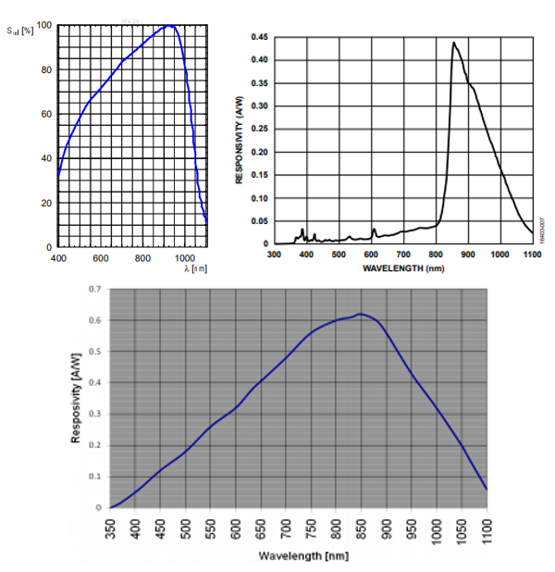
Figure 17: Photodiode sensitivity response for SFH2201(left), ADPD2140(right), PDB-C160SM(bottom)
3.3.4 Transimpedance Amplifier (Op-Amp)
In our design we are utilizing the AD8675 made by Analog Designs. This Op-Amp required a -5V for the negative power rail but allowed us to set the positive rail to 3.3V allowing our maximum output to go no higher than that of the pin threshold of the Raspberry Pi. Given that we were able to do this as well as this being a transimpedance amplifier we found that it worked well for our application.
3.3.5 Microcontroller
The Microcontroller is a very important element in our hardware’s design. It controls the camera, and the laser-break system while allowing the camera and laser-break system to send and exchange information to the computer. Choosing this item right was critical to the success of the project. The Arduino runs the Arduino firmware program, a set of core base software that allows the Adruino to communicate with the computer via USB and to use all the features of the computer. The Arduino will only do what it has been programmed to do and will do it immediately.
TI Msp430x series
The MSP430 controller series is a family of microcontrollers made by Texas instruments. It is easy to use and most of our team members have experimented with MSP430 before. Also, it is one of the most popular and common uses for general purpose. The MSP430 is bit 16 low power mixed signal processor. And the MSP430 is low power consumption, low cost, convenient for applications that run on small batteries. Additionally, one of the characteristics of MSP430 series is measuring and sensing, this microcontroller can perfectly fit with any kind of detectors we use for this design such as laser brake system, ultrasonic sensor and infrared detector. Moreover, the MSP430 series is a very common chip that can be bought anywhere on the internet. Also, there are many supported forums and detailed information on the internet that the programmer can easily access to the tutorial information.
MSP430FR6989
MSP430FR6989 is one of the chips that UCF Electrical Engineering and Computer Engineering students have experience within the Embedded systems class. MSP430FR6989 is a embedded microcontroller that with 16 MHz clock speed, 83 GPIO pins, Wide supply Voltage range from 1.8V to 3.6V, and Contains a non-volatile memory of 128KB build inside the chip and 2KB RAM. Some of the important features that are included Optimized Ultra Low Power Modes, 32 Bit hardware Multiplier, Three-Channel Internal Direct Memory Access(DMA), Five 16-Bit Timers with up to 7 Capture/Compare Registers Each, Extended scan interface(ESI) for Background, water, heat and Gas measurement. Also, this chip has many serial communications which include 2 I²C with Multiple-Slave Address, 4SPI and 2 UART with Automatic Baud-Rate Detection. There are also many options for low power modes integrated in this MCU and are optimized. However, MSP430FR6989 has limited memory size which is not friendly for the programmer if the product contains multiple sensors and features. The Automated Safety Spotter used multiple sensors and camera to improve accuracy and provide more safety for the user, so the MSP430 was not be the first choice for our design.
MSP430G2553
MSP430G2553 is also one of the MSP430 family with low power consumption and consists of different features and five power saving modes. It includes 16 MHz clock speed, 16KB of flash memory, 512 of RAM and 20 GPIO pins. This chip also includes many serial communications which include 1 I2C with Multiple-Slave Address, 2SPI and 1 UART with Automatic Baud-Rate Detection. Compared to MSP430FR6989 they almost have the same features, except MSP430G2553 contains bigger flash memory and RAM but less GPIO pins. However, there are only 20 GPIO pins on MSP430G2553 which could cause issues in future implementations.
CC3220x Series
The CC3220x series microcontroller is created by Dual-Core Architecture which includes a User-Dedicated application MCU subsystem and highly integrated Wi-Fi network process. Moreover, regarding internet security features the CC3220x series microcontroller include asymmetric keys, unique device identity, software IP protection and secure storage. The IOT network has been highly secured by all those features that the user doesn’t need to worry about privacy exposure. Furthermore, this chip has advanced low power modes for battery powered applications and built in power management subsystem which can provide a better energy consumption for battery usage. CC3220x series is part of the SimpleLink MCU platform it supports Bluetooth and WI-FI modules which is a big advantage that MSP430x series don’t have. Regarding the performance CC3220x series has a maximum of 80 MHz clock speed, 1MB memory size and 256kb RAM. The clock speed is way faster than the MSP430x series which could allow the automated spotter to respond in a short time and improve the safety factor. Memory size is large, programmers don’t need to worry about no size to implement complex code. Additionally, built in Camera sensor, built DC/DC converters and built in Wi-Fi processor could provide more convenience for the constructor to build products and add more features.
Additionally, there are three different variants of CC3220x series: CC3220R, CC3220S, and CC3220SF. Each version has different features, the CC3220R: contain kilobytes of RAM, and it includes IoT networking security with device identifiers/keys. The CC3220S is built upon the MCU level by including file system encryption, user IP (MCU image) encryption, secure boot and debug security and uses the same features as the CC3220R version. After all, CC3220SF is the advanced version of CC3220S and integrates a user dedicated 1 MB of executable Flash. The CC3220SF version combines all the features of CC3220S, CC3220R, and has extra memory coming from the executable flash. Therefore, the CC3220SF was considered because it contains better performance and memory size than the other two.
ATMega2560
The ATMega 2560 microcontroller could be looked as a multifunctional chip for our senior design project. The ATMega 256 includes many low power modes of the microprocessor that can allow the microprocessor only to consume little power while standby and quick start up when the user needs it. Furthermore, there are also many sleep modes in this chip to minimize the power consumption which allows the user to shut down unnecessary modules. There are also two ultra-low power modes in ATMega 2560, active mode: 1.8V:500 microamps @ 1MHz, and power -down mode: 0.1 microamps @1.8V.
This microcontroller provides more memory size than the MSP430FR6989 but less than the MSP430G2553 and CC3220SF. Moreover, ATMega 256 is popular to use, many people use ATMega 256 chips in many different projects which can prove that ATMega 256 is user friendly for execution. Furthermore, from the table below we see the ATMega 256 can run with a 16 MHz maximum clock speed which is relatively fast, and the speed is similar with MSP430FR6989 and MSP430G2553 but slower than the CC3220SF. Higher clock speed can allow the chip to have a quick response and rapidly computing power when multiple peripherals are being used at the same time. The memory size of ATMega 256 is ok which is larger than MSP430FR6989 but smaller than MSP430G2553 and CC3220SF. Even the memory size is not the biggest one of the lists but still relatively large for the programmer to write code. The RAM of this chip is about 8KB which is bigger than MSP430FR6989 but smaller than MSP430G2553 and CC3220SF. The ram size was not ok, because the camera needed a lot of ram storage and this chip is was not multiple-sensors friendly due to its RAM size. As a result, ATMega 2560 was discarded as a choice.
Microchip Technology SAMA5D21
The SAMA5D21 series is a ultra-lower power ARM cortex-A5 processor based MPU, the cortex A5 processor can perform high performance that can runs up to 500 MHz and has ARNM NEON SIMD engineer contain with a 128KB L2 cache and a floating point unit which can perform high speed and be efficiency at the same time. The SAMA5D21 has 160 KB program memory and 128KB data memory which is a good size for the programmer to write complicated code and have enough ram size to add multiple sensors and cameras to the design. Also, SAMA5D12 series come with seven different types of RAM controller and one 10/100 ethernet MAC. The bus width of SAMA5D21 is 32 bit which will cause some issues if the sensor is 16 bits. The MPU is low energy consumption and high integration with 4-layer PCB. The ultra-low power consumption activation allows the MPU to use less than 200uA to active retention mode with fast wake-up and 5uA in backup mode. The operating voltage range of SAMA5D21 series is 1.1-1.32V and the MCU only includes 2 communication lines for I2C which is kind of a challenge for the product with multiple sensors that need to communicate repeatedly with the MCU.
SAMA5D21 also provides a lot of security functions to protect the confidentiality of source code such as: ARM TrustZone, tamper detection, secure data storage, hardware encryption engine, on-the-fly DDR encryption and secure the boot loader. If we wanted to introduce and sell our product to the market, this feature could have prevented malicious entities from stealing our technology and provided a lot of benefit for the producer to protect their rights and interests. This chip could have also improved the security of our product because the external data transfers are highly secure, which can decrease the chance of people stealing or modifying information from the bench press machine and send malicious code or interrupt the movement of the hydraulic arm. SAMA5D2 comes with support for touchscreens, LCDs, keyboards built in.

MCU | MSP430G2553 | CC3220SF | MSP430FR6989 | SAMA5D21
Manufacturer | Texas Instruments | Texas Instrument | Texas Instruments | Microchip Technology
Program Memory Size | 512 kb | 1 MB | 128 KB | 160KB
Maximum Clock Frequency | 16 MHz | 80 MHz | 16 MHz | 16 MHz
SRAM Bytes | 16 KB | 256 KB | 2 KB | 8 KB
Communication Peripherals | 1-I²C s, 2-SPI, 1-UART | 2-I2C, 4-UART, 2-SPI | 2-I²C s, 4-SPI, 1-UART | 6-I2C, 9- UART, 6-SPI
Timers | 2x16 Bit | 5x16 Bit | 5x16 Bit | 4x16 Bit or 5x32 Bit
Temperature Range (degree) | -40-85 | -40-85 | -40-85 | -40-85
Operating Voltage Range (V) | 1.8-3.6 | 2.1-3.6 | 1.8-3.6 | 1.1 -1.32
Total Pin | 24 | 40 | 83 | 196
Price (USD) | $0.91 | $7.99 | $3.49 | $6.38
Table 14: Arduino Comparison
Arduino is a single-chip microcomputer, and it made programming difficult because it does not run the existing general-purpose OS in the machine. Arduino is more like a specific machine that executes through the setup and loop interfaces and its memory is also very small. However, OpenCV require large amount of image processing and high level of computation, the calculation processing speed and storage capacity of Arduino are far lower than a real computer, it will be very difficult to run open CV with Arduino. Therefore, we may need a real computer to handle all the operations.
3.3.6 Wi-Fi Module
A Wi-Fi module is a self-contained SoC device that has integrated TCP/IP protocol stack to allow any traditional serial devices and microcontroller that lack WIFI capabilities access to the WIFI network. In a WIFI module every data is transmitted by certain kinds of communication technologies for example, RF, MAC, baseband, and microcontrollers. Those technologies allow the user to send and receive information through radio frequency. Moreover, IEEE 802.11 is the most popular used wireless computer networking standards, and every WIFI module needs to implement the IEEE 802.11 standard protocols to send or receive packets, and request or receive permission access to the networks. The WIFI module is crucial to the automated bench press spotter design because it will allow the camera to upload the recorded video to the internet and the user can access it anytime they want.
CC3200MOD (Price: Chip-$17)
The CC3200MOD Wi-Fi module is created by Texas instruments, it contains maximum of 256 KB RAM size, peripheral diver stored in ROM, configured with ARM Cortex-M4 core processor and the maximum clock speed can run up to 80 MHz, only one single device need to be used to develop an application. Moreover, the developer can easily develop faster even if they don’t have Wi-Fi development experience due to CC3200MOD having on-chip Wi-Fi, strong internet capabilities, and strong security protocols. The CC3200MOD module is easy assembly and low-cost PCB design because all the required system-level hardware components are merged into an LGA package. Furthermore, every Texas instrument product has plenty of resources online such as, user guides, sample code, and support forum. Rich online resources save developers a lot of time to develop new features which can provide a better product experiment for the customer.
According to the data sheet the CC3200MOD Wi-Fi module contains 25 programmable GPIO Pins, some of the pins are for general use and some are used for specific functions. Embedded processors based on ARM core generally provide Pin multiplexing function in the chip. when the pins are limited, the Pin multiplexing can allow the developer to reuse some pins. For example, 126th GPIO can be used as an ordinary GPIO control LED, can also be configured as I2C clock signal or UART clock sign, or can be configured as SPI data out signal. However, there is only one hardware signal; thus, these functions cannot exist at the same time.
The subsystem of CC3200MOD include an 802.11 b/g/n radio, baseband, and MAC with a strong crypto engine. The powerful crypto engine can enable a fast and secure internet connection that supports 256-bit encryption. Additionally, the CC3200MOD and ESP8266EX Wi-Fi module have function in common such as, they both support station and access point mode. The only difference is the CC3200MOD have a third extra mode call Wi-Fi Direct Modes. Wi-Fi Direct Modes provides the ability to connect wirelessly to compatible devices without the need for a Wi-Fi hotspot. For example, two Wi-Fi direct compatible device such as TV can connect to each other directly to transfer photo, music, and movie.
The CC3200MOD Wi-Fi module has four different power modes to optimize the use of current. These power management options listed below can reduce the current drawn which allow the developer to have more options to save energy and keep the battery last longer period.

Mode | Characteristic | Current Drawn
MCU Active Mode | The MCU is implementing code at 80-MHz state rate | 15.3mA-278 mA
MCU Sleep Mode | MCU clock---OFF  Entire state of the device----Reserved  The MCU can be woken up immediately by interrupts. | 12.2-275 mA
MCU Lower-Power Deep Sleep Mode (LPDS) | State information---LOST  Some MCU-specific register configuration and some specific memory---Reserved  The MCU can be woken up by interrupts. | 0.875-272 mA
MCU Hibernate Mode | Real-Time Clock (RTC)---ON  All digital logic is power-gated and the MCU can be woken up by interrupts. | 7 uA
Table 15: CC3200MOD Wi-Fi Module
ESP8266EX (Price: Chip-$1.6, Development board-$9)
The ESP8266EX has 50 KB RAM size and configured with Tensilica L106 32-bit RISC processor and the maximum clock speed can run up to 160MHz. Unfortunately, the ESP8266EX has no programmable ROM in this chip, user program must be stored in an external SPI flash and the maximum capacity of SPI flash is 16 MB. Regarding the data sheet ESP8266EX chip includes 17 GPIO pins but some of the pins are not recommended to use and some have specific functions. In order to use the three common serial communication peripherals during the design process we need to figure out the pin location of SPI, UART and I2C.
• I2C--- located at Pins 9 and pins 14
• General SPI(Master/Slave) --- located at Pins18-23
• HSPI (slave)--- located at Pins 9-10 and Pins 12-13
• UART0(used for communication) --- located at Pins 12-13 and Pins25-26
• UART1(usually used for printing log) --- located at Pins 14 and Pins23
The ESP8266EX has a high performance wireless SoC, it provides maximum performance at the lowest cost and offers opportunities for any no Wi-Fi module system access to the Wi-Fi network. This Wi-Fi module is popular to use all over the world and suitable for microcontrollers without a Wi-Fi module. Moreover, the benefit of its popularity is that many tutorials and tons of online support can be found on the internet, which make it more user-friendly and easier to troubleshoot. Also, the Software Development kit comes with the device providing sample codes for different kinds of applications which can help the newcomer easier to learn how to use it. Furthermore, the ESP8266EX can be used as a slave to run on other master MCU or operate as a complete self-contained Wi-Fi network application. In our senior design project, the ESP8266Ex will be used as a slave to integrate with the MCU by using UART or SPI communication pin. The ESP8266Ex follows the IEEE802.11 standard and it includes 802.11b/g/n support(2.4GHz), the processing speed of 802.11 n support can up to 72.2Mbps. There are also many features included in this module such as, Defragmentation, 2 x virtual Wi-Fi interface, Automatic beacon monitoring, antenna diversity and Wi-Fi support infrastructure. Additionally, there are three powerful modes of Wi-Fi support infrastructure that should be introduced.
• Station Mode
• Soft Access Point Mode
• Promiscuous mode (Station Mode+ Soft Access Point Mode)
Station mode is connected to one specific network, in this mode the ESP module is connected to a Wi-Fi network established by an access point. There are many features that can be used to simply and manage the Wi-Fi connection. For example, If the Wi-Fi connection is lost, the ESP8266EX module will automatically reconnect to the last available access point. The same thing will happen again even when module reboot, the previous authorization will be saved to the last used access point in flash memory.
In the software part there are several versions of begin function used to change the module to station mode. When a restricted network needs to be visited the ssid(service set identifier) and passwords are needed to be filled out correctly in order to gain permission to access a specific access point. Two useful command for station mode is list below
• WiFi.begin(ssid,password)- Set Wi-Fi with two parameter(ssid, password) only
• Wi-Fi.begin(ssid,password,channel,bssid,connect)- Set Wi-Fi with all five parameter (ssid,password,channel,bssid,connect)
The second mode is soft access point mode, in this mode other Wi-Fi devices can connect to the ESP module and become part of the local network. The ESP module can configure as an access point that other devices such as laptops, smartphones, tablets will gain permission to connect to it. Overall, the soft access point of ESP module acts as an access point, it helps certain devices gain access to Wi-Fi network except the access point can connect those devices to wired network, soft access point only has interface to wireless network and only 5 stations can connect to the soft access point at the same time.
In the software part, the soft access point can be set up as an open Wi-Fi network, which means only one parameter is needed to set up a network. On the other hand, password, channel, and hidden can become optional. The user can set up these features later if they want and SSID is the only necessary parameter to make this soft access point function work. Two useful command for soft access point mode is list below
• WiFi.softAP(ssid)- Set Wi-Fi with one parameter(ssid) only
• Wifi.softAP(ssid,password,channel,hidden)- Set Wi-Fi with all four parameter (ssid,password,channel,hidden)
The Third mode is Promiscuous mode (Station Mode+ Soft Access Point Mode). This mode is the combination of station mode and soft access point mode. The ESP module can access to the Wi-Fi network and help other devices access to the virtual Wi-Fi network at the same time.
The ESP8266EX Wi-Fi module also has several Power managements options to reduce the current drawn which is a beneficial way to extend longer battery life and reduce energy consumption. Four low power modes will be listed below and introduced.

Mode | Characteristic | Current Drawn
Active Mode | The module is fully functioning. Chip can receive, transmit, or listen  Chip radio---ON | 56mA-170 mA
Modern-Sleep Mode | Wi-Fi and Radio---OFF  CPU---ON | 15 mA
Light-Sleep Mode | CPU and all peripherals---PAUSED  Wake up events (MAC, external interrupts, host, RTC timer,) will wake up the chip | 0.9 mA
Deep-sleep Mode | Only RTC---ON  Remaining parts of the chip---OFF | 20 µA
Table 16: ESP8266EX Wi-fi Module
The low power modes of ESP8266EX are extremely powerful, the performance of the chip will not be greatly affected by the reduced power consumption.
ESP32-S (Price: Chip-$10.99)
The ESP32-S is created by a Chinese company named Espressif Systems and manufactured by TSMC. The chip is running with Tensilica Xtensa 32-bit LX6 processor and the maximum clock speed can run up to 240MHz. Also, it has 520 KB RAM size, 448KB ROM, and supports 4X16 Mbytes of external QSPI flash and SPRAM.
The ESP32-S is the successor of ESP8266EX, they have similar features, and both can run on low power mode as well. On the other hand, ESP-32 is the upgraded version of ESP8266EX, it gains an extra CPU core, more GPIO pins, more capable SoC, faster Wi-Fi speed, and supports Bluetooth 4.2 module as well. Furthermore, the ESP32-S module contains plenty of peripherals such as, built-in hall effect sensor and built-in temperature sensor, touch sensors, and low noise sense amplifiers. The ESP32-S Wi-Fi module has four different power modes, the same as the CC3220MOD Wi-Fi module. The chart below shows these power management options.
Mode | Characteristic | Current Drawn
Active Mode | Chip radio---ON  The MCU can receive, transmit, listen | 80mA-260 mA
Modern-Sleep Mode | WI-FI, Bluetooth baseband and radio---OFF  CPU---ON  Clock---able to do configuration | 3 mA-20 mA
Light-Sleep Mode | CPU---PAUSED  RTC&ULP-coprocessor---ON  The chip will be woken up if any wake-up events is operated | 0.8 mA
Deep-sleep Mode | Only RTC---ON  All the connection information of Wi-Fi and Bluetooth are stored in RTC  ULP-coprocessor---standby | 20 µA-0.15mA
Hibernation Mode | ULP-coprocessor---OFF  Internal 8MHz oscillator---OFF  RTC recovery memory---Clock frozen  One RTC timer on slow clock and some RTC GPIOs---ON  The MCU can be woken up by RTC GPIOs and RTC timer | 2.5 µA
Table 17: ESP32-S Wi-Fi Module
Regarding the data sheet ESP32 chip includes 36 GPIO pins which is the highest on the list, these extra GPIO pins allow the programmer to work more flexibly and no need to worry about running out of pins.
Overall, the ESP32-S has the same wireless capabilities as the ESP8266EX module but adds a balance and dual-use switch. Compared with the ESP8266 chip, another improvement is that the ESP32-S embeds an RTC clock, which implements TCP/IP and the full 802.11 b/g/n Wi-Fi MAC protocol, and the data rate is up to 150 Mbps. Also, it supports old Bluetooth protocol and Bluetooth low energy protocol. Additionally, ESP-32S contain 1 DAC, 8 ADC, 10 pulse counters, and the developer allows use of 8 different pins to wake the MCU up from any state transitions.
The chart below shows all detail information for CC3200MOD, ESP8266EX, and ESP32-S Wi-Fi module. Each of them could have fulfilled the requirement for the automated Safety Spotter.
Wi-Fi Module | CC3200MOD | ESP8266EX | ESP32-S
Frequency | 2.4GHz | 2.4GHz | 2.4GHz
Protocol | 802.11 b/g/n | 802.11 b/g/n | 802.11 b/g/n/d/e/i/k/r
Serial Interface | UART, I2SC. SPI | UART, I2SC. SPI, I2S | 3-UART, 2-I2S. 4-SPI, 2-I2S
Maximum Data Rate | 54 Mbps | 54 Mbps | 150Mbps
Current Drawn range | 7µA-278mA | 20µA-170mA | 5µA-260mA
Voltage Range | 2.3 V-3.6 V | 2.5 V-3.6 V | 1.8 V-3.3 V
Price | $17 | $1.6 | $4.99
Table 18: Wi-Fi Module Comparison
Wi-Fi Module Final Decision
If we needed it, we decided we would choose the ESP8266EX Wi-Fi module. There are several reasons that support our decision.
First, the price of ESP8266EX is way cheaper than the other two, we can order couples of them to use for backup in a very low price. However, if we choosed either CC3200MOD or ESP32-S the price will be way more expensive. On the other hand, from the chart above we can see the ESP8266EX and CC3200MOD Wi-Fi module have similar performance and characteristics of serial interface. The other difference is CC3200MOD include more extra features that we don’t need and spend more current drawn during the operation. Since we didn’t want to spend extra money on unwanted features, ESP8266EX became a better option than CC3200MOD. Moreover, ESP32-S is an upgraded version of ESP8266EX, they have similar features but different performance. ESP32-S is obviously more power than ESP8266EX, it contains a faster data rate but more expensive as well. The performance of ESP8266EX already can do all we needed, the exceeded power of ESP32-S will become overflow and useless.
The last reason is, we believed ESP8266EX could do a better job of power consumption due to it low current drawn range. CC3200MOD would not be considered due to it price and choosing ESP32-S would not be wise because being a Chinese microcontroller, it could be difficult fining tutorials or technical support online. ESP8266EX is cheap and it is a popular product, so we could easily find technical support, tutorials and datasheets on the internet.
3.3.7 Microwave Sensor
RCWL-0516 microwave motion sensor
The RCWL-0516 microwave motion sensor can be found at around $1.60 and works with both Arduino and Raspberry Pie. Given its sensitivity, it must be carefully positioned to avoid detecting motion outside of the user-barbell system (e.g. people walking nearby).
Operating Voltage | 4V – 28V
Operating Current | 2.8 mA – 3 mA
Detection Range | 5m – 9m
Board Size | 35.9mm x 17.3mm
Price | < $2.00
Table 19: RCWL-0516 Attributes
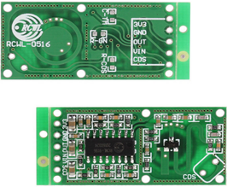
Figure 18: RCWL-0516
The table below compares different available microwave sensors including the RCWL-0516 based on price, detection range and operating voltage.
 | Operating Voltage | Detection Range | Price
RCWL-0516 | 4V – 28V | 5m – 9m | < $2.00
SEN0192 (Gravity) | 5V | 2m – 16m | $9.00
24GHz Microwave Radar | 4V – 8V | 0.5m – 20m | $80.00
HB100 | 4.5V – 5.2V | 20m | $5.00
Table 20: Microwave Comparison

3.3.8 Acoustic Sensor
HC-SR04 Ultrasonic Module Distance Sensor
A popular, inexpensive option is the HC-SR04 Ultrasonic Module Distance Sensor for Arduino and Raspberry Pie and can be purchased at about $2.20.
Operating Voltage | 5V
Operating Current | 15 mA
Detection Range | 0.02m - 4m
Board Size | 45mm x 20mm x 15mm
Price | < $3.00
Table 21: HC-SR04
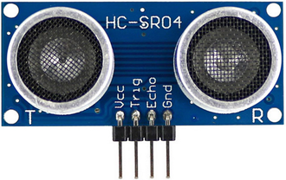
Figure 19: HC-SR04
Tests would have been needed to determine whether the vibrations on the floor of the facility (caused by other people dropping heavy weights) affected the accuracy of this kind of sensor. The table below compares different available acoustic sensors including the HC-SR04 based on price, detection range and operating voltage.
 | Operating Voltage | Detection Range | Price
HC-SR04 | 5V | 0.02m – 4m | < $3.00
URM37 V5.0 | 3.3V – 5.5V | 0.02m – 8m | $14.00
URM04 | +5V | 0.04m – 5m | $28.00
Gravity URM09 | 3.3V – 5.5V | 0.02m – 5m | $12.90
Table 22: Acoustic Sensor Comparison
3.3.9 Optical Sensor
TF Mini LiDAR (ToF) Laser Range Sensor
The TF Mini LiDAR is an affordable option at $39.00 that has excellent precision and is compatible with Arduino and Raspberry Pi. It is unidirectional and has a working range from 0.3m to 12m. For distances shorter than 6m, the accuracy is 99%.
Operating Voltage | 4.5V - 6V
Operating Current | 24 mA
Detection Range | 0.3m - 12m
Board Size | 42mm x 15mm x 16mm
Price | $39.00
Table 23: TF Mini LiDAR specifications
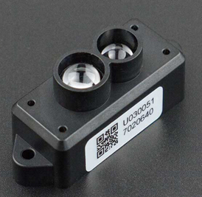
Figure 20: LiDAR Sensor
Using LIDAR would have provided us with the most accurate measurement of the position of the bar during the exercise, but a cost-benefit analysis showed that it is not worth purchasing over the previous ones. The distance from the sensor to the bar is so small that differences in accuracies would not have been noticeable to justify the high price.
The table below compares different available LIDAR sensors including the TF Mini based on price, detection range and operating voltage.
 | Operating Voltage | Detection Range | Price
TF Mini | 4.5V – 6V | 0.3m – 12m | $39.00
DE-LIDAR TF02 | 5V | 0.3m – 10m | $99.00
Gravity: VL53L0X | 3.3V – 5V | 0.03m – 2m | $12.90
TF-Luna | 5V | 0.2m – 8m | $19.90
Table 24: LiDAR Comparison
3.3.10 Camera
Raspberry Pi Camera Module v2
The main alternative to all the previous sensors was to use a camera, specially a less powerful camera that is compatible with single board computers such as Raspberry Pi and Arduino. Many of these cameras had an adequate video quality for our project, were not expensive, and provided us with a consistent, stable environment for testing and debugging. Some of them even had an onboard processor that allows them to track and recognize objects without the need of a computer.
The Raspberry Pi Camera Module v2 (our final choice) records video at 1080p resolution at 30 frames per second, 720p at 60 frames per second, and 480p at 60 or 90 frames per second, more than ideal for tracking a barbell. It has a Sony IMX219 sensor with 3280 x 2464 resolution and 8 megapixels still resolution. It connects to the controller using a ribbon cable and uses the Camera Serial Interface Type 2 (CSI-2). If used with an open source Linux distribution called MotionEyeOS, the videos can even be uploaded to cloud storage services such as Google Drive and Dropbox.
Operating Voltage | -
Resolution | 8-megapixel
Video mode | 1080p30, 720p60, 480p90
Price | < $30.00
Board size | 25mm x 23mm x 9mm
Onboard processor | No
Table 25: Raspberry Pi Camera Module
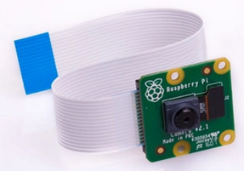
Figure 21: Raspberry Pi Camera
Pixy 2 CMUcam5 Image Sensor
Another good option was the Pixy2, which has an onboard processor (NXP LPC4330) that allows it to perform object recognition and tracking without connecting it to a computer. This camera can record at 60 frames per second and has a variety of connections, USB and UART among them. The operating voltage is 5V, but it has an onboard voltage regulator and it can be powered by an unregulated voltage source of 6V to 10V. Operating current is 140mA.
The PixyMon software allows easy setup, training and debugging of the Pixy2. It has four program modes. The first one is Color Connected Components, where it can detect objects based on its color codes, using a color-based filtering algorithm. This is fast and robust, and uses the same principles used in OpenCV for tracking objects based on the hue and saturation of pixels. The algorithm can remember up to 7 different color signatures, and training it can be as simple as placing the object in front of the camera and pressing the push-button on the top of the device, while the onboard RGB LED gives appropriate feedback by turning the same color as the object is being trained on. Once the object has been “learned”, the processor saves the color signature to a tracking index, so that it can track it afterwards in every frame.
The second mode is Line tracking, where the Pixy2 can detect lines and intersections (and also barcodes) and follow them, guided by the vector directions it analyses at every frame. The third mode is Pan-Tilt, a program and a mechanical unit the Pixy2 can be mounted on so that it can rotate when tracking objects. The fourth mode is Video mode, where Pixy2 just functions as a standard video camera.
Operating Voltage | 5V
Resolution | 1296 x 976
Video mode | 60 frames/sec
Price | $60.00
Board size | 53mm x 50.8mm x 35.6mm
Onboard processor | Yes
Table 26: Pixy 2 Specifications
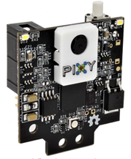
Figure 22: Pixy 2 Camera
HuskyLens
The HuskyLens sensor is a similar sensor to Pixy2 in that it has many of the same capabilities, such as Line Tracking, Color Recognition and Object Recognition and Tracking, thanks to the onboard Kendryte K210 processor. It can also be trained to learn specific gestures. Training it to recognize an object is also as easy as the push of a button. This module also comes with an onboard screen that shows all these features live. It connects via UART or I2C.

Operating Voltage | 3.3V - 5V
Resolution | 2-Megapixel
Video mode | 30 frames/sec
Price | < $45.00
Board Size | 52mm x 44.5mm
Onboard processor | Yes
Table 27: Husky Lens
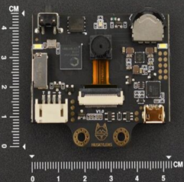
Figure 23: Huskey Lens Sensor
OpenMV Cam H7
The OpenMV is a small microcontroller with an ARM Cortex H7 processor and with a built-in camera designed for machine vision applications. This option was compelling, because programs could be coded in Python with total control of the I/O pins, using the OpenMV IDE and thanks to MicroPython, an implementation of Python 3 that is optimized to run on microcontrollers. It is also expandable, with “shields” ranging from an LCD module, to a motor module, to a Wi-Fi module and many more. The lenses are swappable, with an IR, Telephoto, Super Telephoto and Ultra-Wide Lens available. Applications with this microcontroller include Face Detection, Optical Flow, Line Detection, Rectangle Detection and more.

Operating Voltage | 3.6V - 5.5V
Resolution | * Grayscale: 640x480 & under  * RGB565: 320x240 & under  * Grayscale JPEG: 640x480 & under  * RGB565 JPEG: 640x480 & under
Video mode | * 16-bit RGB565 images @ 60 FPS with resolution above 320x240  * 30 frames/sec average
Price | $65.00
Board Size | 45mm x 36mm x 30mm
Onboard processor | Yes
Table 28: Open MV Camera
The table below compares these camera sensors based on price, operating voltage and whether or not they have computer vision (CV) or machine learning (ML) capabilities.
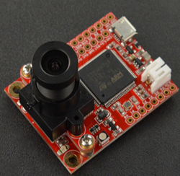
Figure 24: OpenMV Camera

 | Operating Voltage | CV/ML Capabilities | Price
Camera Module v2 | - | No | < $30
Pixy2 | 5V | Yes | $60
HuskyLens | 3.3V – 5V | Yes | < $45
OpenMV Cam H7 | 3.6V – 5.5V | Yes | $65.00
Table 29: Camera Comparison
There are many other state-of-the-art microcontrollers with a camera that focus on these machine learning and deep learning algorithms, but the majority were outside our price range. Some of these are: the Firefly DL, that records at 60 frames per second and trained neural networks (later discussed) can be deployed right on the module so that no computer is needed to help it do the job. This module costs $299.00. The Datalogic P-series Color smart camera records at 1280 x 1024 px, 60 fps, has many machine learning functionalities too but cost around $3000.00
3.3.11 Audio Sensors
The Google Assistant SDK is not available for commercial use, only for experimental and non-commercial uses only. What is great about this product is that a constant internet connection is not needed to be able to use the API.
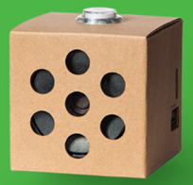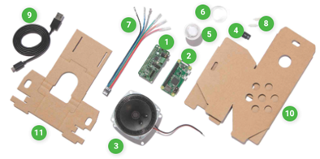
Figure 25:Google AIY Voice Kit box
Another option was to purchase the Grove Speech Recognition Module, which sales for about $20.00. This module can recognize up to twenty-two pieces of commands such as start, stop, play music, etc. We could have just programed the voice commands we needed so that when spoken, the module would send the appropriate signal to the actuators.
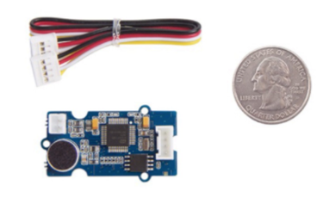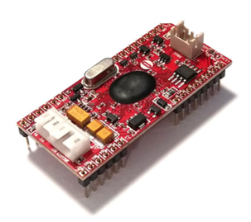
Figure 26: Grove Speech recognition module(left) and EasyVR Speech Recognition(right)
Yet another option was the EasyVR Speech Recognition Module 3 Plus, available for $33.00, which offers similar technologies to the Grove Module.
The top choice among these would have been the Google Voice Kit, because of the powerful API that comes with offering Natural Language Processing (NLP) capabilities, plus the speaker is already present.
 | Price | NLP Capabilities
Google AIY Voice Kit | $25 | High
Grove Speech Recognition Module | $20 | low
EasyVR Recognition Module 3 Plus | $33 | low
Table 30: Audio Sensor
The alternative to using the capabilities of these sensors would have been to utilize just their microphone to record the voice commands given by the lifter, or buy a cheaper microphone to do the same, and then analyze the text using one of the many NLP libraries available for Python, such as Natural Language Toolkit (NLT), Spacy, Scikit-learn, Genism, Polyglot, and others. This of course would have required significant research and time to familiarize ourselves with the frameworks.
3.3.12 GPU
The process of data gathering and labeling is time consuming, so implementing any of the initial features described might have not been feasible given our time constraints. Another constraint was computer power, given that this kind of training requires powerful GPUs as mentioned before. If a GPU was not available locally, we could have gone with many companies such as Google Could, Google Colab (GCP), Nvidia, Paperspace, Amazon (AWS) and Microsoft (Azure) that offer online services where GPUs “times” can be bought, with the user being able pick from many different alternatives based on performance and price. The table below offers a comparison of the price some of these companies’ charge based on GPU model, GPU RAM, CPU and CPU Ram.
Cloud Services | NVIDIA GPU | CPU | GPU RAM | CPU RAM | Cost Per Hour | Wall Time | Cost to Train
Google Collab | K80 | 1 | 12 | 13 | 0 | 31.17 | 0
Google Cloud Compute Engine | P100 | 6 | 16 | 20 | 0.5 | 5.32 | 0.04
Google Cloud Compute Engine | P4 | 4 | 8 | 26 | 0.33 | 10.28 | 0.06
Google Cloud Compute Engine | V100 x4 | 8 | 64 | 30 | 3.05 | 3.38 | 0.17
AWS EC2 | K80 (P2.xlarge) | 4 | 12 | 61 | 0.28 | 20.9 | 0.1
Table 31: Cloud Computing Comparison
3.3.13 Display Screen
In order to display information for the safety spotter we are looking to implement a compact, LCD screen with a touch screen interface. As per our design specifications we were looking for a screen that had a 800x480 resolution and approximately 14 centimeters. Also, we needed there to be a low power output and have the ability to run with the use of the Raspberry Pi computer configuration.
The display needed to support multi-color graphics including red, green, and blue (RGB) with a power control over an I2C protocol. The display is used as a medium to initiate the calibration sequence for the system as well as the interface for the user to interact with the system itself and other features within it. The touch screen is tantamount to the design simply because it is an easier interaction for the user and allows them to easily interact with the system.
The display needed to be a low-cost, low-power device with a significant backlight life span and one that would provide information to the user as he/she used the machine. If appropriate, the display should have been able to provide things such as amount of reps done, countdown to begin calibration sequence, and an option to reset the calibration settings.
Looking at options available online, we compared and contrasted some of the features of the different choices that are available in terms of the LCD screen displays.

PCAP Touch Module TM3500
Screen Size | 3.5” (88.90mm)
Pixel Resolution | 320 x 480
Touch Screen | Yes, Capacitive
Interface | Parallel, 18-Bit (RGB)
Viewing Area | 48.96mm (W) x 73.44mm (H)
Display Type | TFT - Color
Dot Size | 0.15mm (W) x 0.15mm (H)
Nominal Voltage | 3.3V
Cost | $30
Table 32: PCAP Touch Module
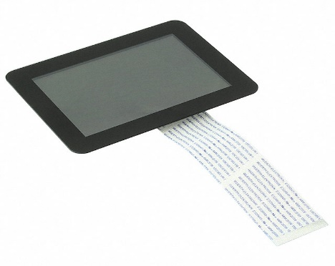
Figure 27: PACP Touch Module
Although this display has many of the features that were good for us to utilize in our project—especially when taking the cost into consideration, plus the fact that the touch screen was of capacitive nature—we thought that the size of this display could represent a problem. The display was perhaps a decent size to experiment in home projects, but for our purposes we needed a larger screen area that would allow the user to easily see the buttons.

TFT Display
Screen Size | 5” (127 mm)
Pixel Resolution | 800 x 480
Touch Screen | No
Interface | Parallel, 18-Bit (RGB)
Viewing Area | 110.3mm (W) x 66.9mm (H)
Display Type | TFT - Color
Dot Size | 0.135mm (W) x 0.135mm (H)
Nominal Voltage | 3.3 V
Cost | $30.78
Table 33: TFT Display

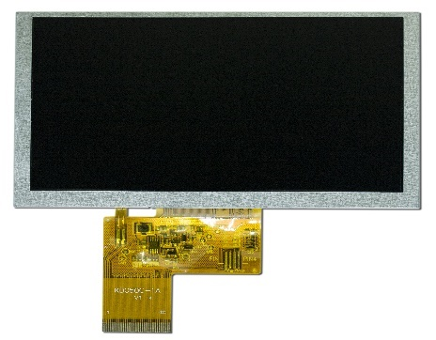
Figure 28: TFT Display

With the TFT display there were many good features to be had, one of which was the increased size. This would allow for a greater viewing area, and an improved pixel resolution. Although the nominal voltage and cost was relatively the same as the previous display module, the lack of touch screen is something that we could not ignore, as we wanted to have something that was intuitive to the user, and touch screens are so much more prevalent in today’s electronics, that the user’s first impulse would be to try interacting with it by touching it.

TM2800 (90-00001-A0)
Screen Size | 3” (76.2 mm)
Pixel Resolution | 320 x 480
Touch Screen | Yes, Capacitive
Interface | Parallel, 8-Bit (RGB)
Viewing Area | 73.44 mm (W) x 48.96 mm (H)
Display Type | TFT - Color
Dot Size | 0.153 mm (W) x 0.153 mm (H)
Nominal Voltage | 3.3 V
Cost | $25
Table 34: TM2800 Specs

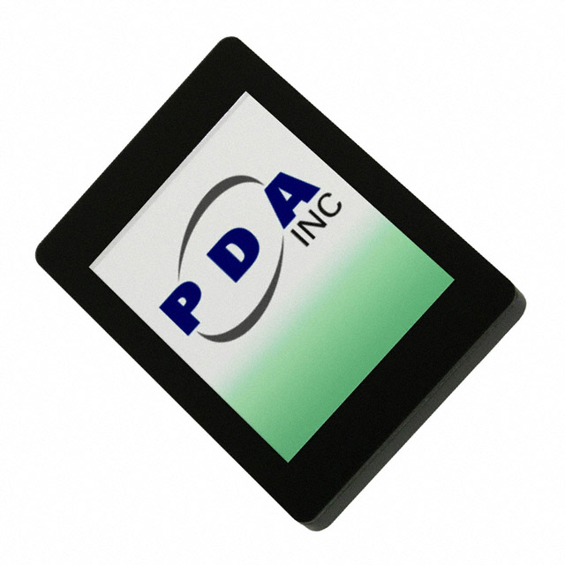
Figure 29: TM2800 Display
This display screen also had almost all the features that we are searching for in regard to our application. The touch screen was of a capacitive nature and the display does support RGB and it had a low power consumption rate, along with a low cost. However, the viewing area and overall size of the display was still too small for our application. The fact that the interface only supports 9-bit is also something that could not have been overlooked.

Raspberry Pi 7” Display
Screen Size | 7” (177.8 mm)
Pixel Resolution | 800 x 480
Touch Screen | Yes, Capacitive
Interface | Parallel, 24-Bit (RGB)
Viewing Area | 154.08mm (W) x 85.92 mm (H)
Display Type | TFT - Color
Dot Size | 0.1926 mm (W) x 0.1790 mm (H)
Nominal Voltage | 3.3 V
Cost | $45
Table 35: Raspberry Pi 7"
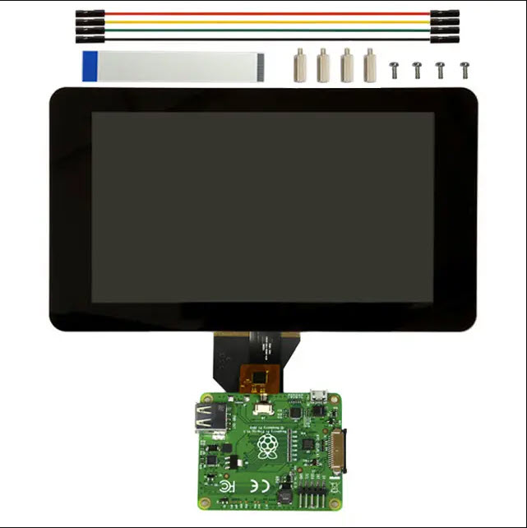
Figure 30: Raspberry Pi 7" Display
This touchscreen introduced a lot of positives in this model, an increased screen size as well as a good pixel resolution. The 24-bit RGB interface is also something that was very advantageous in the implementation we were going for. It is a capacitive touchscreen, which we needed. This display screen fitted all the specifications that we required and even though the cost was a little bit more than the previous models, the benefits outweighed the difference in price. Below in the following Table 5 is a comprehensive comparison chart of the different types of displays, highlighting some of the more important features and how the differ, the column in yellow indicates the superior specifications.
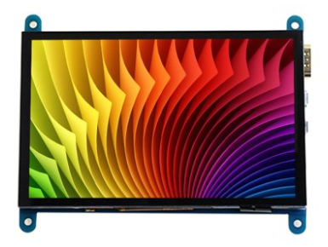
Figure 31: 5" Raspberry Display

5” Raspberry Pi Display
Screen Size | 5” (76.2 mm)
Pixel Resolution | 320 x 480
Touch Screen | Yes, Capacitive
Interface | Parallel, 8-Bit (RGB)
Viewing Area | 73.44 mm (W) x 48.96 mm (H)
Display Type | TFT - Color
Dot Size | 0.153 mm (W) x 0.153 mm (H)
Nominal Voltage | 3.3 V
Cost | $40
Table 36: Raspberry Pi 5" Display
This display screen had similar features comparable to the 7-inch display that was previously shown in the document. It had similar size; however, this LED display utilizes the HDMI port as a means of connection for video, which allowed us to use one cable to provide both video and audio. This provided much more convenience over the other displays. Although it had a smaller size in terms of viewing area (5 inches vs 7 inches) it more than made up for that deficiency in the fact that it was compatible with multiple different computer types, some of which we considered before deciding to use the pi. Good online documentation was also a positive factor here.
With all of the previous statements in mind, this was be the display that we used. Although it did give up ground in terms of the viewing area, it more than made up with ease of setup, price, online documentation and easy installation. The display was more the enough when it comes to what we are trying to use it for, acting as just a central hub in which the user can interact with the system from an input standpoint. It had the capacitive touch screen, which we desired. The main function that we wanted the display to have is the ability to act as an input for the user to begin the calibration sequence in order to detect the user-specific threshold in which help may or may not be needed when the user is in the midst of a workout.
Display | PCAP | TFT | TM2800 | Raspberry Pi 7” | Raspberry Pi 5”
Screen Size | 88.9mm | 127mm | 76.2mm | 177.8mm | 127mm
Pixel Resolution | 320 x 480 | 800 x 480 | 320 x 480 | 800 x480 | 800 x 480
Screen Configuration | Capacitive | N/A | Capacitive | Capacitive | Capactive
Interface | Parallel 18-bit | Parallel 18-bit | Parallel 18-bit | Parallel 24-bit | Parallel 24-bit
Viewing Area | 48.96 x 73.44mm | 110.3x 66.9mm | 73.44 x 48.96mm | 154.08 x 85.92mm | 110.3 x 66.9mm
Display Type | Color | Color | Color | Color | Color
Dot Size | 0.15 x 0.15mm | 0.135 x 0.135mm | 0.153 x 0.153mm | 0.1926 x 0.1926mm | 0.135 x 0.135mm
Voltage | 3.3V | 3.3V | 3.3V | 3.3V | 3.3V
Price | $30 | $31 | $25 | $45 | $40
Table 37: Display Spec Comparison
By referencing Table 38 you can see that the Raspberry Pi 7” and Raspberry Pi 5” have a lot of features that are favorable in relation to the other display options. One thing that is very important to note is the fact that all of the displays that are touch screen compatible have a configuration that is of a capacitive nature. Another feature that is particularly good for our cause is the greater viewing area, dot size and pixel resolution. While the pixel resolution is the same in the TFT display, the viewing area is outmatched in favor of the Raspberry Pi 7”, which along with its 24-bit interface, would allow for us to have much greater toolbox at our disposable. However, the price in the Raspberry Pi 5” made up for the minute differences between it and the Raspberry Pi 7” display which made it favorable for our purposes.
3.3.14 Power Supply
Now, we will take a look back on our decision of which power supply was the most suitable for our what our application was requiring. We knew that we wanted a power supply that was able last for a long time as well as have a continuous output of at least 5V and 24V in our estimation when we looked at what exactly needs to be powered and for how long they need to be powered for, as well as multiple output for the different functions that we needed. We also needed to have a high operating temperature due to the nature of our project. Being inside a gymnasium with a substantial amount of people exerting energy through sweat and heat can increase the temperature of the operating room, being the gym or weight room.
RS-15-12 from MEAN WELL
Features
- Universal AC input / Full range
- Protection devices for Short Circuit / Overload/ Over voltage/ Over Temperature
- Cooling by free air convection
- LED indicator for power on
- Standard input voltage range 80-265 V_{ac}
- 100% burn-in test
- Withstand 300VAC surge input for 5 seconds
- High operating temperature up to 70°C (-20°C ~ 70°C)
- Withstand 5G vibration test
- High efficiency (81%) and high reliability
- Long lifespan
- Dimensions of 62.5mm x 51mm x 28mm (LWH)
- Low no load power consumption <.5W
- Single output switching power supply (G3 Series) – 12VDC 1.3A ≈ 15W
- Enclosed supply type
- Cost of $7.8
Table 38: RS-15-12 Features Expanded
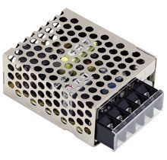
Figure 32: RS-15-12 Power Source
When we decided on some of the basic criteria for what we would wanted to have in a power supply we went and did research in order to compare and contrast the different power supplies that were on the market. This gave us an idea of which power supplies were affordable as well as fitting of the criteria that we were hoping for them to fulfill. The following tables will show us the different types of power sources and the features that they presented, which ultimately led us to our decision after determining the different capabilities of each.
With this table all the features that we were interested in, one thing in particular the power consumption when the supply is at no load. For it to only be consuming less that .5W when it is no load made it quite desirable, however the fact that it only has a single output can prove to provide some difficulties in our applications. The size of the power supply was also something that was desirable since we wanted it to be on the smaller side and not too large. Another great thing about the RS-15-5 is how low the cost is which can allow for us to spend more in another more costly department.
The following table shows another power supply that was of a different model and has different features but was also something that we considered for our design.

Mean Well USA RS-15-5
Features
- Enclosed Configuration
- Dimensions of 62.48mm x 50.8mm x 27.94mm (LWH)
- Standard input voltage range 100-264 V_{ac}
- Single output switching power supply – 5V 3A ≈ 15W
- Low no-load power consumption, <.5W
- Withstand 5G Vibration test
- Long Lifespan ≈ 108.8K hours
- Short Circuit, Overload, and Over voltage protection
- High operating temperature (≈70°C)
- DC Adjustment Range of ±10% by potentiometer for single output
- Small Footprint with High power density
- Cost of $8.97
Table 39: RS-15-5 Features Expanded
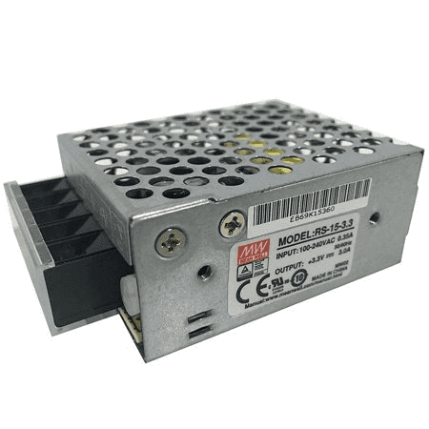
Figure 33: RS-15-5 Power Source
This power supply also provided some great features such as a higher range for the voltage input as well as the DC adjustment range via the potentiometer. The cost of $8.97 is also something that was very desirable to our cause, there is still only one output in this power supply, but it did have switching capability.
Looking at a different power source we can see some of the features it offered and how our project could’ve benefitted from said features.
Mean Well USA RS-35-12
Features
- Enclosed Configuration
- Dimensions of 99.06mm x 81.79mm x 35.05mm (LWH)
- Standard input voltage range 88-264 V_{ac}
- Panel Mount
- Single output switching power supply – 12V 3A ≈ 36W
- Low no-load power consumption, <.5W
- Withstand 5G Vibration test
- Withstand 300 V_{ac} surge input for up to 5 secs
- Long Lifespan ≈ 249K hours
- Short Circuit, Overload, and Over voltage protection
- High operating temperature (≈70°C)
- DC Adjustment Range of ±10% by potentiometer for single output
- Small Footprint with High power density
- Cost of $14.79
Table 40: RS-35-12 Features Expanded
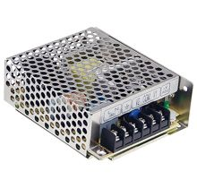
Figure 34: RS-35-12 Power Source
This was a very good power supply when you put into account the fact that it has such a long lifespan and a great no-load power consumption along with the same as previous models of power supplies. This one differed however in its maximum power output, which is a whopping 36W which was a good sign for the applications that we were hoping to provide to the user. With this amount of power available we would’ve been able to. The overload protection percentage was also greater than the previous models, which clocked in at 110%-180%. This can prove to be very useful, along with its over voltage protection of 115% - 135% of its rated voltage that it can withstand.
Looking at another type of power supply we considered, even though multiple outputs were quite desirable, there was still a possibility where we were able to use single output since the cost for multiple output was exponentially greater. The cost was ultimately one of the bigger constraints that we have in regard to the project.
LS-25-12
Features
- Enclosed Configuration
- Dimensions of 99.06mm x 81.79mm x 35.05mm (LWH)
- Standard input voltage range 88-264 V_{ac}
- Panel Mount
- Single output switching power supply – 12V 2.1A ≈ 25W
- Low no-load power consumption, <.5W
- Withstand 5G Vibration test
- Withstand 300 V_{ac} surge input for up to 5 secs
- Long Lifespan
- Short Circuit, Overload, and Over voltage protection
- High operating temperature (≈-25°C to 70°C)
- Highly efficient in operations
- Small Footprint with High power density
- Cost of $16.50
Table 41: LS-25-12 Features Expanded
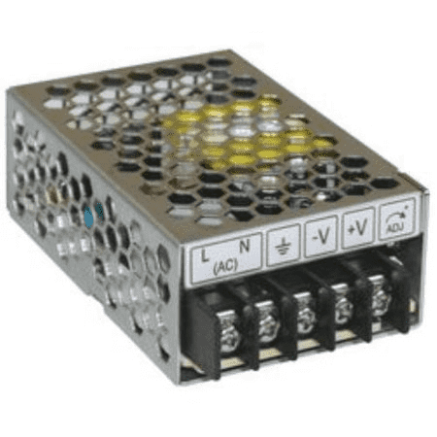
Figure 35: LS-25-12 Power Source
Also, the case with this power supply it had a good operating temperature as well as being very efficient when operating. The cost was also something that was very desirable coming in at less than $20 which could’ve also opened up the door to allocate funds to different areas of the projects such as the linear actuators. It also had a great range in voltages that it was able to operate under, and the fact that it has low power consumption under a no- load condition. This series also had an adjustable output range (10V = 13.2V)
We will now look back on the last power supply that we were considering in this portion of the paper, in which we compared and contrasted how it contended with the existing power supplies that we had already observed.
Eagwell EAG-24-15
Features
- Enclosed Configuration
- Dimensions of 200mm x 99.06mm x 50.8mm (LWH)
- Standard input voltage range 88-264 V_{ac}
- Panel Mount
- Single output switching power supply – 24V 15A ≈ 360W
- Low no-load power consumption, <.5W
- Withstand 5G Vibration test
- Withstand 300 V_{ac} surge input for up to 5 secs
- Long Lifespan ≈ 249K hours
- Short Circuit, Overload, and Over voltage protection
- High operating temperature (≈70°C)
- DC Adjustment Range of ±10% by potentiometer for single output
- Small Footprint with High power density
- Cost of $25.96
Table 42: EAG-24-12 Features Expanded
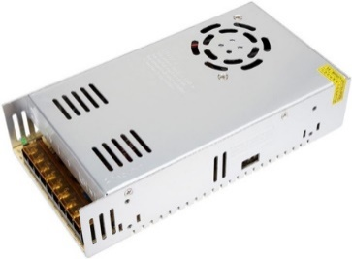
Figure 36: EAG-24-12 Power Source
Looking at this power supply we can see that via the spec sheet we can understand that it is similar to all of the previous power supplies, however there is a key difference in the fact that it provides a much greater output which would prove very beneficial when using the linear actuators. The cost of the item is also something to behold in the fact that even though there is multiple inputs as the cost is as low as $25.96
Now that we have a general understanding of the battery sources that are available to us at reasonable prices, we will highlight some of the features between all of them and look at which power source has the most positive characteristics. We will look at six main characteristics of the different power sources and highlight which power source provides the best feature in that category, which will be identified with bold highlighted characters.
Power Supply | Dimensions | Efficiency | Protection | Cost | Input Voltage Range | Output Power
RS-15-12 | 62.5 x 51 x 28 mm | 81% | Short Circuit, Overload, Over Voltage, Over Temperature | $7.80 | 80-265 V_{ac} | 15 W  12V_{DC}  1.3A
RS-15-5 | 62.48 x 50.8 x 27.94 mm | 81% | Short Circuit, Overload, Over Voltage | $8.97 | 100-264 V_{ac} | 15 W  5V_{DC}  3A
RS-35-12 | 99.06 x 81.79 x 35.05 mm | 84.5% | Short Circuit, Overload, Over Voltage | $14.79 | 88-264 V_{ac} | 36 W  12V_{DC}  3A
LS25-12 | 99.06 x 81.79 x 35.05 mm | 83% | Short Circuit, Overload, Over Voltage | $16.50 | 88-264 V_{ac} | 25 W  12V_{DC}  2.1A
EAG-24-15 | 200 x 99.06 x 50.8 mm | 84% | Short Circuit, Overload, Over Voltage | $24.96 | 88-264 V_{ac} | 360 W  24V_{DC}  15A
Table 43: Power Source Features Compared
Looking at the comparisons between all of the different power supplies we can clearly see some of the key features that would be important when considering a design. While RS-15-12 has a lower efficiency than that of the EAG-24-15, it does have a smaller size and another layer of protection in the overheating protection. However, in order to prevent any of the issues that may arise with power quality when using the linear actuators, our most expensive piece of equipment, we decided to be cautious and use the EAGWELL supply.
The RS-15-5 does boast the smallest volume when it comes to space that would require on the circuit board however, there is the fact that it has a higher amperage rating and the same power output as the RS-15-12 which can be a good or bad thing. The higher amperage will be needed for certain equipment such as the Raspberry Pi which led us to choosing this power supply seeing that the Pi only operates on 5V and 2.5A+. The laser would need a separate 5V power supply due it’s unique need of -5V which is why we opted for two of these power supplies.
The RS-35-12 boasts one the greatest output in terms of power, while also having the highest efficiency rating out the ensemble of power supplies chosen as candidates for the project. While the aforementioned specifications and features does make it an attractive candidate for our project, the fact that it is the second-largest power supply on the list and it also has a relatively high amperage which can, as previously stated, lead to problems relating to overtemperature. It also is very costly relative to the other power sources listed, which is one of the constraints we placed on the power source.
The cost is one of the bigger constraints when it comes to the power supply simply because it should be one of the easier items to find at a reasonable price while still have a high value in terms of quality performance. Knowing these things about the power source using one the least costly one in this instance because not only because it is less costly, but it also has other redeeming qualities as shown in the previous tables going into further detail about the features. One of the more attractive things about the RS-15-5 and EAG-24-15 is the voltage range in which it can operate as well with its long lifespan and even some such smaller qualities such as the LED indicator allowing us to know the status of the power supply.
3.3.15 Computer
We will now shift gears to looking at the type of computer that will be used and the different features that they present. The computer was instrumental in the functionality of the system as a whole, so it was tantamount to pick a computer that provided a level of comfortability for us.
The following tables show some of the advantages and disadvantages of the following single board computers. Although we created a printed circuit board, the computer acted as the device to relay information to the different parts of our systems.
Raspberry Pi Series
The Raspberry Pi was developed by the British-based charity organization “Raspberry Pi Foundation”. It is an ARM-based microcomputer motherboard with SD/MicroSD card as the memory hard disk. The motherboard has 1/2/4 USB ports and a 10/100 Ethernet interface which can be connected to a keyboard, mouse, and network cable. All of the above components are integrated on a motherboard that is only slightly larger than a credit card. Raspberry Pi has the size of a cred card but contain all the basic functions of computer, it is the smallest desktop computer in the world, also known as a card computer. It is very different than Arduino because the Raspberry Pi can run a complete operating system which means the designer can use a specific language and libraries for development. Also, it can easily run multiple tasks in the background at the same time. Arduino on the other hand, is a traditional single-chip microcomputer system, it can only run one assigned program at a time.
Raspberry Pi 4
The Raspberry Pi 4 is the fourth-generation Raspberry Pi computer. The fourth generation has a quad- core Broadcom BCM2711 64 bits ARMv8 processor it can perform high performance that can runs up to 1.5 GHz it is the fastest one of the lists. The Raspberry 3B has 2 USB 2.0 ports, 2 USB 3.0 ports, 40 GPIO Pins, Micro USB 5V port, gigabit ethernet, 2.4GHz and 5.0 GHz 802.11n Wi-Fi, Bluetooth 5.0, 1G RAM and an external micro SD card slot. The Raspberry Pi 4 basically do the same thing as Raspberry Pi 3B except it has better performance and contain more features such as support run two monitors at once in 4K resolution.
Overall, Raspberry Pi 4 and 3 both include the same range of connectivity option such as wireless LAN, ethernet, Bluetooth, and 40 pins extended GPIO. However, Raspberry Pi 4 has better performance than Raspberry Pi 3B, it provides a faster Wireless LAN, USB ports and Bluetooth technology. Additionally, the display connectivity of Raspberry Pi 4 is dominant due to it allow two 4K display monitors run at the same time, Raspberry Pi 3B only allow one 1080P resolution monitor run at a time.
Raspberry Pi 4
Features
- Broadcom BCM2711, quad-core Cortex-A72 (ARM v8) 64-bit Soc @ 1.5GHz
- Includes GPU to handle all graphical input and output
- Ability to handle 4K and other HD inputs
- Relatively simple and easiest for beginners to begin working with
- Cost of $35 – 1GB RAM
- Cost of $45 – 2GB RAM
- Cost of $55 - 4GB RAM
- Not the most powerful but has the ability to program robotic arms
- Good machine learning ability
- Very versatile in terms of coding languages
- Documentation for debugging is readily available seeing as community is large
Table 44: Raspberry Pi 4 Features Expanded
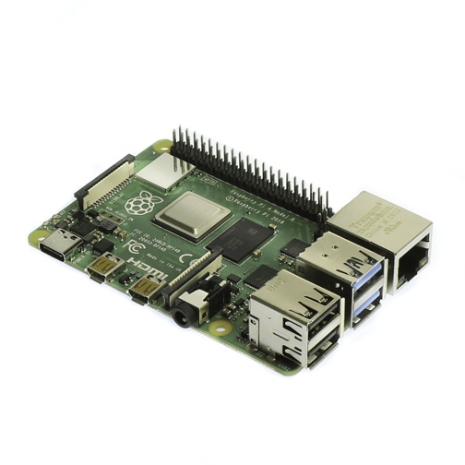
Figure 37: Raspberry Pi 4 Single Board Computer
With these different features in mind we can see how the Raspberry Pi 4 could have been a great candidate for the computer in our project. It is versatile, has a good machine learning system and it relatively cheap. With the Raspberry Pi 4 computer, not only would we be getting a very flexible and versatile component, but computing power was something we wouldn’t have worried about. Along with any Pi product there are many different reference documents as well as reference projects which proved to be very useful in our debugging process. This single-board computer also came with a decent amount of RAM, even on the cheapest version of it, and the HD and 4K capability was an added bonus, seeing how we would want our display to have quality video output in future implementations. The Pi 4 was also compatible with our display which would allow for us to implement it into our project easily.
We will now look at another type of single board computer that was under consideration as the main computer in project. This computer is also considered an alternative to the Raspberry Pi, interestingly enough.
Rock Pi 4 Model B
Looking at this single-board computer, its specs are better than the previous Raspberry Pi 4, with better performing CPUs and GPUs which makes it better for machine learning. It also boasts the ability to run Android OS and supports mainstream AI stack with GPU acceleration which is ideal for computer vision. There are also multiple storage options and it features a better read and write performance on external storage drives. The only drawback with this model, was the fact that it is not as beginner friendly as the previous model due to the lack of an online community, so troubleshooting would have been more difficult as there wouldn’t be a lot of references and documentation as readily available for it.
We will continue to look at different single board computers, keeping in mind some of the basic criteria which we were trying to meet, such as beginner friendliness, documentation, and computer power.
Rock Pi 4 Model B
Features
- Dual Cortex-A72, frequency 1.8Ghz with quad Cortex-A53, frequency 1.4Ghz
- Mali T860MP4 GPU, supports OpenGL ES 1.1 /2.0 /3.0 /3.1 /3.2, Vulkan 1.0, Open CL 1.1 1.2, DX11
- Ability to handle 4K and other HD inputs
- Relatively simple and easiest for beginners to begin working with
- Cost of $49 – 1GB RAM
- Cost of $59 – 2GB RAM
- Cost of $75 - 4GB RAM
- RAM 64bit dual channel LPDDR4@3200Mb/s, 4GB, 2GB or 1GB depending on model
- Good machine learning ability
- Very versatile in terms of coding languages
- Documentation for this particular SBC is very scarce seeing how the community is not as grand as that of the Raspberry Pu
Table 45: Rock Pi 4 Model B Features Expanded
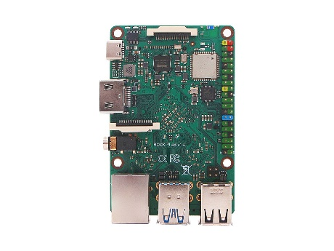
Figure 38: Rock Pi 4 Model B

Banana Pi M64
This is also a very good SBC with great processing power and speed along with a good GPU, however it also faces the same problem that many of the previous models in the fact that it has very little tutorial materials and documentation. There is also the fact that unlike the other computers this one does not have different options regarding the RAM, only offering 2GB at a $60 price point.
Banana Pi M64
Features
- CPU – Allwinner 64 Bit Quad Core ARM Cortex A53 1.2 GH
- GPU – Dual-core Mali 400 MP2
- 8 GB of eMMC which is the main feature that differentiates it from the Raspberry Pi 4
- Relatively simple and easiest for beginners to begin working with
- Cost of $60 – 2GB RAM
- RAM 2 GB DDR
- Good machine learning ability
- Very versatile in terms of coding languages
Table 46: Banana Pi Features Expanded
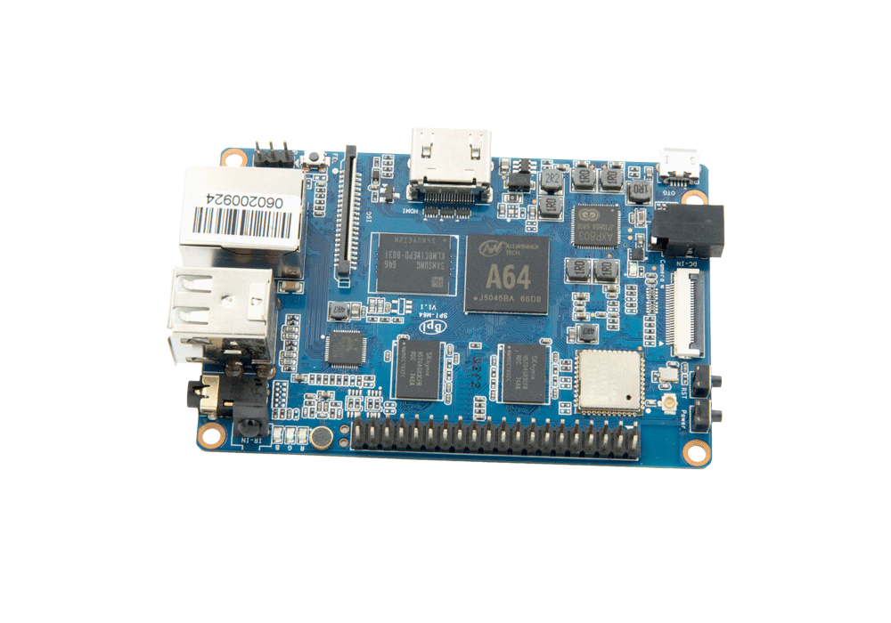
Figure 39: Banana Pi Single Board Computer

Raspberry Pi 3B
The Raspberry Pi 3B is a credit card size minicomputer with wireless LAN and Bluetooth connectivity that can be used for many purposes, such as gaming, task processing, or play high resolution video. It includes a quad- core Broadcom BCM2837 64 bits ARMv8 processor can perform high performance that can runs up to 1.2 GHz which is faster than most of the Arduino microcontroller. The Raspberry 3B has 4 USB 2.0 ports, 40 GPIO Pins, Micro USB 5V port, 100 base ethernet, 802.11n Wi-Fi, Bluetooth 4.1, 1G RAM and a external micro SD card to store the operating system and programming code which is flexible for the programmer to write and store their complicated code and the massive RAM size can allow designer to add any features or peripheral devices they want into the product. Also, the Raspberry Pi 3B has a BCM43438 wireless LAN and Bluetooth 4.1 on board as well which can ensure the stability of wireless network and provides various option for the user to choose.
The power supply interface of the Raspberry Pi 3B is ordinary micro USB, which is the interface used by many Android phones, but one thing need to pay attention is avoid to use a computer USB to power the Raspberry Pi because the current is too small and the Raspberry Pi may encounter unknow problems. An independent power supply with a voltage of 5V and current of 1A or more is recommended to use. Furthermore, the LCD display can be powered by Raspberry Pi’s GPIO, which is very convenient to use.
Overall, Raspberry Pi 3B is more powerful than most of the microcontroller, it is more convenient to use and very friendly for new beginner as well.

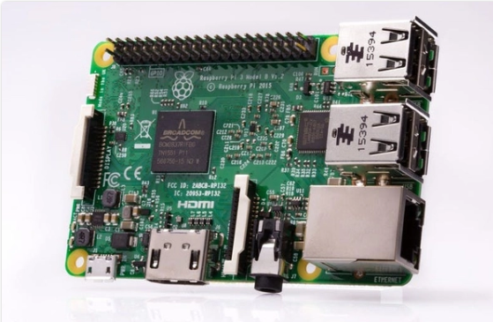
Figure 40:Raspberry Pi 3 Model B

Raspberry Pi 3 Model B
Features
- Broadcom BCM2711, Quad core Cortex-A72 (ARM v8) 64-bit SoC @ 1.5GHz
- Mali T860MP4 GPU, supports OpenGL ES 3.0, Vulkan 1.0, Open CL 1.1 1.2, DX11
- Dual monitor support up to 4K outputs
- Relatively simple and easiest for beginners to begin working with
- Cost of $35 – 1GB RAM
- Cost of $45 – 2GB RAM
- Cost of $55 - 4GB RAM
- RAM 64bit dual channel LPDDR4@3200Mb/s, 4GB, 2GB or 1GB depending on model
- 2.4 GHz and 5.0 GHz IEEE 802.11ac wireless, Bluetooth 5.0, BLE
- Very versatile in terms of coding languages
- Documentation for this particular is readily available seeing how it is an earlier model with a lot of reference projects that has been implemented on it
Table 47: Raspberry Pi 3 Model B
From inspection we can see that this version of the Raspberry Pi is slightly older that the model 4, however, it does have a lot of the same qualities with only slight variations, which made it a viable option in terms of usability for the scope of this project. With the ability to implement high resolution images and while boasting a substantial amount of RAM storage, this computer was a prime candidate. It was user friendly towards beginners and it had ample amounts of documentation that was readily available as a means of troubleshooting. This version of the Raspberry Pi has also been implemented in many other projects all over the world, which allowed us to find solutions to our own set of problems.
With all of the features of some of the single board computers we were interested in, we can now compare some of the more key features that were vital in choosing the single board computer for the project. The following table shows the four key attributes of each of the last three candidates we considered

Single Board Computer | Central Processing Unit (CPU) | Graphical Processing Unit (GPU) | RAM Capabilities (Descending Order) | Cost According to RAM Variationd | Documents
Raspberry Pi 4 | Broadcom BCM2711, quad-core Cortex-A72 (ARM v8) 64-bit Soc @ 1.5GHz | Broadcom VideoCore VI | 1 GB RAM  2GB RAM  4GB RAM | $45  $55  $65 | Somewhat Available
Rock Pi 4 Model B | Dual Cortex-A72, frequency 1.8Ghz with quad Cortex-A53, frequency 1.4Ghz | Mali T860MP4 | 1 GB RAM  2GB RAM  4GB RAM | $49  $59  $75 | Relatively Scarce
Banana Pi M64 | Allwinner 64 Bit Quad Core ARM Cortex A53 1.2 GHZ | Dual-core Mali 400 MP2 | 2GB RAM | $60 | Scarce
Raspberry Pi 3B | Broadcom BCM2711, Quad core Cortex-A72 (ARM v8) 64-bit SoC @ 1.5GHz | Mali T860MP4 GPU | 1 GB RAM  2GB RAM  4GB RAM | $35  $45  $55 | Readily Available
Table 48: Single Board Computer Feature Comparison
With the above table we can see that each of the three single board computer units are relatively close to each other in terms of performance qualities, with some obvious improvements in terms of processing speed and graphical improvements in the newer models. However, for our implementation, such improvements were not of great consequence. In the Raspberry Pi 3B, you can see that since it has been in the consumer world for a lengthier period of time it has gained a community of programmers that together have solved practically all the issues that one could encounter when playing with the PI. This made the Raspberry Pi 3B the best choice
3.3.16 Step Motor Driver
The feature of highest importance in ours and any situation when using a stepper motor is that the motor and driver are compatible. One of the determining factors for the driver and motor connection largely depends on the rising and falling edge of the motor and how it responds. We found three different drivers that we believed would work with the actuators we had selected, more over the actuator’s stepper motors. Below we have displayed a table below giving the attributes that were investigated in the selection process.
Features | Liukouuav7rf915pu | R60 Driver | TB6600
Manufacture | Liukouu | RTELLIGENT | Twotrees
Voltage Input | 24 - 50V | 20 - 50V | 9 - 42V
Current | 2.0 - 6.0A | 1.4 - 5.6A | > 4A
Adjustability | 16 Levels | 16 Levels | 32 Subdivisions
Highest Resolution | 51200 steps/rev | 25600 steps/rev
Max Pulse Frequency | 250Kpps | --
Price | $83.99 | $31.99 | $11.99
Table 49: Step Motor Comparison
The table above displays our options for step motor drivers. Something that the table does not show but is worth taking into consideration is the customer reviews on the given product. In this instance the Liukouu driver has no customer ratings or reviews, this doesn’t mean that this is a bad product yet to the same token it is not ensured with real accounts that it will operate as we hope and expect it to. The lack of reviews in conjunction with it being significantly more expensive than any of the other drivers, we couldn’t justify buying this driver when the other two had similar specs and are significantly cheaper. The driver we decided to select for our project is the Twotrees driver; it was the cheapest while maintaining similar attributes as the other. This driver also had reassuring customer reviews, so we trusted its performance.
3.3.17 Transimpedance Amplifier(Op-Amp)
For our project we utilized analog devices’ AD8675. The selection of this part was made seamless by the utilization of analog devices circuit and amplifier design tools on their website. They AD8675 is intended to be used as a transimpedance amplifier and after some testing we were able to get the output we desired. This amplifier needed -5V for the negative power rail to operate correctly. This was a slight cause for concern seeing that our output could go negative and the raspberry pi would be damaged if feed a negative voltage. We found that by grounding the inputs we were able to get and maintain a low voltage(low not zero due to some noise acquired in our wires, less than 0.3V so still read as low by the pi) when the diode was dark. We set the positive rail to 3.3V and that was our illuminated output with a gain resistor of 68.7K.
4. Related Standards and Realistic Design Constraints
This section will discuss the standards that pertain to our project and how we will be implementing and following them. The second part of this section discusses some of the real-life constraints that we will be facing in the implantation of our design. These constraints are all listed and have an effect on how we can and will build our prototype. We discuss the constraint why it’s of concern and also or planning on how we intend to work around this problem.
4.1 Standards
Establish standard is very important because standard refer to uniform provisions for repetitive technical matters within a certain range. Standards can become the technical basis for independent innovation, because standard makers have the technical elements, indicators and their derived intellectual property rights in the standards. It is based on original patented technology and is usually supported by a patent group. Through the control of core technologies, an exclusive technological monopoly is quickly formed. Especially in terms of market access, it can adopt a licensing method to exclude competitors from entering to achieve the purpose of market monopoly. On the other hand, under the standards peoples must follow a certain kind of regulations to make thing, which can help people comply with rules and reduce accidents. Also, improve the efficiency of work, help the sustainable development of society.
4.1.1 Power Supply Standard
Power Supply is very important in senior design because every election product need to run with power and there is a power supply standard “POWER SUPPLY SAFETY STANDARD, AGENCIES, AND MARKS” to create and regulate the electrical safety standards. Every country establishes different safety standard to prevent incident happen such as: electric shock, body injury, explosions and fire caused by electricity. There is a table below to describe the safety standard for power supply equipment, such as batteries.

IEC | Function area | Information
IEC 60950-1 | Safety of Information Technology Equipment. | Proposed to prevent injury and harm, for example, electric shock, fire, dangerous temperature
IEC 60065 | Safety of video, Audio, and similar electronic apparatus. | Proposed to prevent fire, electric shock and injury, electronic equipment and communication
IEC 62368-1 | Audio, Video, Information and communication technology equipment | Standards that use to manage companies marketing audio-visual products, computing and communications equipment in North America and the EU
IEC 60601-1 | Safety of Medical electrical equipment. | Standard that use for governing basic safety and essential performance applicable to medical electric equipment including surgical, monitoring, hospital devices
IEC-61010-1 | Safety of measurement, Control and Laboratory equipment. | Standard that use for measurement, control and laboratory equipment. Such as meter and oscilloscope, X-ray equipment.  Use to protects electrical shock, fire, mechanical and burns injury
UL 1310 | Safety, Standards requirements for class 2 power units | Standard that for indoors and outdoors environment that use Class 2 power supplies and batteries chargers in applications such as lighting systems and machinery that installed in residential and industrial environments.
UL 600799 | Standard for explosive atmospheres | Standard that for electrical equipment that use for explosive atmosphere such as construction, gas, combustible dust.
Table 50: Power Supply Standard
4.1.2 Wi-Fi Standards
In today society Wi-Fi is the most commonly used wireless communication technology, people can easily set up a Wi-Fi in everywhere at any time. However, many peoples may not understand what Wi-Fi standard is or don’t realize the importance of Wi-Fi standard. Wi-Fi standards are set of services and protocols that determine the operating of your Wi-Fi network. IEEE 802.11 is a standard comply used in wireless local area networks today. It is a standard for wireless network communication defined by the institute of Electrical and Electronics Engineers. The IEEE 802.11 is developed by IEEE in 1997, it is the first version of the standard for wireless LAN. It defines the media access control layer (MAC layer) and the physical layer. The physical layer defines two spread-spectrum modulation methods and an infrared transmission method that work in the 2.4GHz ISM band. The total data transmission rate is designed to be 2Mbit / s. The two devices can build a temporary network by themselves, or they can communicate under the coordination of an access point or a base station. In order to obtain good communication quality in different communication environments, CSMA / CA (Carrier Sense Multiple Access / Collision Avoidance) hardware communication method is adopted.
In Today, there are five popular Wi-Fi standards is popular to use. For examples, the 802.11a is extends the standard physical layer and specifies that the layer uses a 5GHz band. The standard uses orthogonal frequency division modulation data, and the transmission rate ranges from 6 to 54 Mb / s. This rate can meet both indoor and outdoor applications. The 802.11b is a standard for wireless LAN and established in 1999. The carrier frequency can go up to 2.4GHz and it also can provide multiple transmission speeds of 1,2.,5.5 and 11Mbit/s. The 802.11g have the same carrier frequency as 802.11b and provides speed specifications above 20 Mbps in the 2.4GHz band. Also, if 802.11g and 802.11b works in the same frequency band, g can be compatible with b. Which mean the network card supporting g can support b as well. The 802.11n protocol is a dual frequency working mode (including 2.4GHz and 5GHz operating frequency bands). In this way, 802.11n guarantees compatibility with the previous 802.11a b, g standards. The 802.11 ac is developed from 802.11 n and has a higher speed than 802.11 n. The table below show more detail information regarding to those five Wireless standards.
Protocol | Frequency | Max Data Rate | Signal | Transmission Range
802.11 | 2.4 Ghz | 2 Mps | FHSS or DSSS | 20 feet indoors
802.11a | 5 Ghz | 54 Mps | OFDM | 20-75 feet indoors
802.11b | 2.4 Ghz | 11 Mps | HR-DSSS | Up to 150 feet in doors
802.11g | 2.4 Ghz | 54 Mps | OFDM | Up to 150 feet in doors
802.11n | 2.4Ghz/5Ghz | 540 Mps | OFDM | At least 175 feet in doors
802.11ac | 2.4Ghz/5Ghz | 400M-2.4Ghz,  900M- 5Ghz | OFDM/MIMO | Similar range with 802.11 n
Table 51: Wi-Fi Standard

4.1.3 PCB Standards
Paul Eisler is the founder of printed circuit board; he installed the first printed circuit boards into a radio in 1936. The main benefits of using circuit boards are that it greatly reduces wiring and assembly errors and improves automation and production labor rates. After that the United States officially recognized the reaction for commercial use in 1948 and the IPC (Association Connecting Electronics industries) is an organization that setting standards for the assembly and specification of electronic products. Printed circuit board is popular to use because we can see so many advantages such as, simplify the electrical connection between various components in the circuit, instead of complicated wiring, reduce the wiring workload under the traditional method, and simplify the assembly, welding, and debugging of electronic products. Also, help save plenty of space, reduced the cost of the product, and improved the quality and reliability of the electronic equipment.
Printed circuit board is an important electronic part that support the electronic component. It is unnecessary to establish a standard to regulate the quality of their production and use.
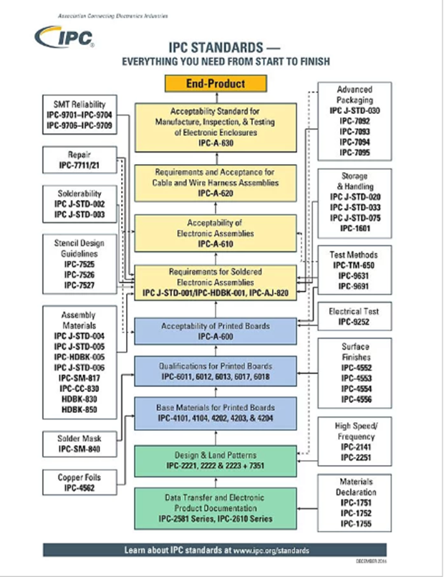
Figure 41: PCB Standards
Moreover, we should follow the IPC standard to design and create the PCB board if we assume the automated safety spotter will be promoted to the market in the future. Because every product whether it is in the international market or the domestic needs to meet a specific standard to be sold in the market; thus, making a strict standard for our design can further improve the quality and safety of our products, increase the credibility of automated safety spotter can make every customer more confident to use our products. Furthermore, according to the IPC-221B Printed Board standards, electronic products are divided into Level 1, Level 2, and Level 3. The higher the level, the stricter the quality inspection conditions.
 | IPC Class 1 | IPC Class 2 | IPC Class 3
Product types | General Electronics Products | Dedicated Service Electronics Products | High-Reliability Electronics Products
Service life | Short | Long | Longest
Quality | Poor | Good | Excellent
Example s | Flashlights, Toys, Headphones | Complex industrial and commercial equipment, Refrigerators, Washing machines. | Military and Medical equipment
Table 52: PCB Standard
From the table above we decided to pick class 2 as our PCB standard, because automated safety spotter is committed to working for a long time with low power consumption and should not malfunction under normal usage conditions, even the breakdown occur it can be repair by human and use again.
4.1.4 Standard for plugs and sockets
In today, every electronic product need electricity to work, and every electronic must have a jack-plug to connect with the outlet to gain electrical power. In the world, there are generally two types of voltages used in indoor electricity in countries around the world, which are AC 100V-130V and AC 220-240V. 100V, 110-130V are classified as low voltage, Some countries use low voltage due to safety purposes such as the United States, and Japan. ; 220-240V is called high voltage, Some countries use high voltage because they focus on energy conversion efficiency which includes China's 220V and Britain's 230V. In countries with 220-230V voltage, there are also cases where 110-130V voltage is used, such as Sweden and Russia. The table below illustrate the detail of American wall outlets standard

 | Wall Type A | Type B
Zone of application | North America, Central America and Japan | North America, Middle America, Japan
Plug Rate | 15 amps | 15 amps
Voltage range | Around 100V-127V | Around 100V-127V
Notes | No grounded pin  Only compatible with plug A (Two flat parallel prongs) | With grounded pin suitable for high power appliances  Compatible with plug A and B
Table 53: Plug and Socket Standard
4.1.5 Electrical Safety Standard
Electricity can make our lives more convenient, but it would be dangerous if there are no regulations to regulate the use of electronic products. Moreover, our products are designed in accordance with all safety standards, because people’s safety is our primary concern of this product. However, any electronic product has a certain chance of malfunction and causing accidents such as short circuit or electric shock. We must set up good safety mechanisms so that designers and users can be protected to the greatest extent. The OHSA (Occupational Safety & Health Administration) set up a series of standard to introduce such as self-protection and standardize the safe use of electronic appliances.
Wiring design and protection: This standard explains the equipment wiring labels and protection aspects of the Automated safety spotted design. This also allows the correct ground terminal connection to be properly marked during the produce.
Hazardous locations: This standard explain the requirement for electric equipment and wiring in hazardous locations. Moreover, every occupancy that contain one of the following flammable material; flammable vapors, liquids, gasses, combustible dusts and fibers, can classified as hazardous location. For examples, aircraft hangars and gas stations.
Electrical Protective Equipment: This standard introduces a list of Insulator products can be used to prevent electric shock such as rubber insulating matting, rubber insulating covers, rubber insulating gloves, and rubber insulating sleeves, rubber insulating line hose, rubber insulating blankets.
Personal Protection: Everyone should be equipped and should use electrical protection equipment suitable for the specific part of the body being protected and the work being performed, to prevent fire or parts from being damaged due to a short circuit.
Electrical Power Generation, Distribution: Only qualified peoples can do installations and maintenance of electric power generation, control, transformation, transmission and distribution lines.
Use of Equipment: Introduce the standard of use of cord and plug-connected equipment. For example, we should observe the condition of portable cord, plug connected equipment and flexible cord set before the we use, a new one should be replaced if damaged or missing parts. Also, outer jacket and insulation of the flexible cords need to be well protected.
Overall, safety was our primary concern, because the purpose of all those standards had been created were for human’s safety. Improper use of electricity or certain professional equipment may destroy a part, cause fire or electric shock. Furthermore, any kind of accident can cause physical or monetary trauma, physical trauma may prevent academics from continuing, and severely cause disability. Also, as a student financially there may be no more money to buy additional parts, so we treated every piece of equipment seriously and connect every wire carefully in the course of the experiment and follow every regulation and standard.
4.1.6 Software Testing Standard
The ISO/IEC/IEEE 29119 Software and systems engineering – Software testing was created with the purpose of defining “an internationally-agreed set of standards for software testing that can be used by any organization when managing or performing any form of software testing.”[4] It defines processes, documentation, vocabulary, etc. It consists of five international standards regarding software testing:
- Part 1: Concepts and definitions: Defined in ISO/IEC/IEEE 29119-1:2013. It introduced the vocabulary necessary to talk about the standards.
- Part 2: Test processes: Defined in ISO/IEC/IEEE 29119-2:2013. It defined a generic test process model for organizations to use when performing software testing at different levels: organizational, test management and dynamic test process.
- Part 3: Test documentation: Defined in ISO/IEC/IEEE 29119-3:2013. It provided templates and examples of what test processing may look like while supporting the process levels mentioned above.
- Part 4: Test techniques: Defined in ISO/IEC/IEEE 29119-4:2015. It provided standards for test design techniques and divided them into categories: Specification, Structure, and Experience-Based Test Design.
- Part 5: Keyword-Driven Testing: Defined in ISO/IEC/IEEE 29119-5:2016.
4.1.7 Language Standards
The International Organization for Standardization (ISO) and the International Electrotechnical Commission (IEC) promote, prepare, oversee and publish international standards in the areas of electrical engineering, electronics and similar or related technologies. These standards ensure that those that abide by them create a product with a level of quality and safety that could not be guaranteed otherwise. By following best practices, software developers around the world can cooperate and use scripts, libraries and frameworks with the peace of mind that transparency and regulation provide.
ISO/IEC 14482:2017 “specifies requirements for implementations of the C++ programming language”[2], replacing the last standard from 2014. Java also uses ISO/IEC standards, but are focused on data management and interchange (database languages such as SQL) like the ISO/IEC 9075-13:2016 standard. MATLAB and OCTAVE do not have ISO/IEC standards.
Similar to these last two, and unlike C++ and Java, Python is not ISO/IEC standardized. It has what is colloquially called a “de-facto” standard, which means that the community that works with the language has agreed on a series of guidelines and standards resulted from years of cooperation and use of the language (i.e. from practice). These guidelines are known as Python Enhancement Proposal (PEP), where minor and major features and new standards are proposed and agreed upon if there is a consensus within the community. PEP is divided into three kinds:
- Standards track PEP where such new features are proposed.
- Informational PEP used to describe design issues or provide general information.
- Process PEP used to describe processes related to the language (but not the language itself) and propose changes.
All these proposals have a short number of editors that are responsible for administrating them. When a new idea or improvement surfaces, a discussion is had in the community and, if there is consensus, a new PEP is proposed and drafted, and the editors then must approve it or reject it. In the case of the former, a PEP number is assigned, labeled according to the type it corresponds to (standards track, informational, process) and after all revisions necessary, is approved by the final authority, akin to the “editor in chief.” There are hundreds of PEPs in the Python Developer’s Guide. One of the most popular PEP is PEP 8: Style Guide for Python Code. It provides coding conventions and best practices to facilitate readability.
Popular tools called linters check Python code against guidelines such as PEP8 and report all the instances that are not in line with them: mistakes, style mismatch, etc. Some of these tools are Pylint, Flake8, mypy, pyflakes and others.
There were significant changes from versions of Python 2.x (2.5, 2.6, …) and Python 3.x (3.1,3.2, …). Python 3.0 was released in December 2008 with the aim of delivering a simpler syntax, removing redundancies and fixing many flaws that the previous versions had. Some of the changes made were: the print statement, which was treated as such, became a proper function; Python 2 used the ASCII standard by default, and Python 3 switched to Unicode for better compatibility and support; integer division now returned a float and not an integer; the raw_input() function became input(). Python 2 was discontinued as of January 2020, so it will not receive further updates, bug fixes or support of any kind; it is now considered legacy language. Also, Python 3 is not backward compatible with Python 2.
Although the older version is still being used, partly because of the extended number of libraries that Python 2 supported and partly because companies that built huge software platforms on it do not take risks with newer technologies and transitions so substantial cost large amounts of money, more and more companies and projects are transitioning and have transitioned, benefiting from the many new libraries that are only compatible with newer versions and from the enhancements and bug fixes that will arrive in the future. Examples of frameworks and libraries that have switched are TensorFlow, Scikit-learn, PyTorch, pandas, Apache Spark, IPython, NumPy, Matplotlib, SciPy, and many others. The latest stable version of Python is version 3.8 and 3.9 is in development.
Before, it was mentioned that Python is not compiled but interpreted. Technically, this is not a feature of the language but of the implementation, and Python has many different implementations to choose from depending on the platform the programs are going to run and the goal of the programmer. The default implementation of Python is CPython, called that way because it is written in the C language. It compiles the source code to bytecode, which is then interpreted by a visual machine, as described before. But there is also PyPy, a just-in-time (JIT) compiler written in a subset of Python called Restricted Python (RPython) that offers faster run times. A JIT compiler compiles the code at run time, instead of before execution. There is also Jython, which is written in Java and the bytecode that it generates can be used by the Java Virtual Machine. Other examples are MicroPython, IronPython, Brython, Cython, etc. There are releases for both CPython and PyPy for Raspberry Pi, and since our project is not sensitive to these kinds of decision, the default implementation will be used.
4.1.8 Camera Serial Interface Standard
As mentioned before, the chosen sensor to track the barbell, the Raspberry Pi Camera v2 Module, uses the Camera Serial Interface Type 2 (CSI-2) to connect to the Pi, a “specification intended for point-to-point image and video transmission between cameras and host devices” [3]. This specification was released in April 2017 by the Mobile Industry Processor Interface (MIPI) Alliance, a non-profit corporation composed of more than 250 member companies worldwide that develops interface specification for mobile ecosystems (and electronics in general). It is backward compatible with previous CSI-2 specifications and it supports RAW-16 and RAW-24 color spaces.
The main features of this protocol are high performance, low power consumption and low electromagnetic interference. The CSI-2 protocol has 5 layers:
- Physical Layer
- Lane Merger Layer
- Low Level Protocol Layer
- Pixel to Byte Conversion Layer
- Application Layer
4.1.9 Design Impact of Chosen Technologies and Standards
Naturally, the decisions made on the type of sensor and the type of software influenced the design of the project. Because the Raspberry Pi Camera is connected via de ribbon to the computer, and the camera must be placed up from the floor at a certain height so that the barbell and the lifter’s chest are on its field of vision, the computer itself needed to be located near the camera, resting on the “brain box” that we created. Cable management was also treated seriously during the building process and during testing, since all the components except the actuators are relatively small and delicate; tripping over a cable could have easily damaged any of these.
Because the programming language of choice was Python and it does not have any standards (not the ones set by major industries or organizations), we technically did not need to comply with any. However, not adhering by PEP guidelines is bad practice and does not make the code “Pythonic”, a term used to describe code that is clear and maintainable using all of Python’s capabilities and guidelines. Given the lack of standards, PEPs became those standards. Our goal in programming this project was achieved: to create simple, understandable but powerful code that exploits the OpenCV capabilities and delivers excellent results.
4.2 Realistic Design Constraints
Engineering is an application of science and mathematics, throughout this application, the materials and energy in nature can be used to make efficient, reliable and useful things to human beings in the shortest time and with less manpower.
Every engineering design product will have a limitation refers to requirements. Constraints may affect the quality, stability, and performance of the final product. Moreover, the existence of standards will limit the engineer to follow a certain regulation to build the product. The list below shows all the constraints we may encounter during this design project.
4.2.1 Economic and Time Constraints
In this senior design project, we have around $600 for our budget. The economic constraints are one of the problems we have encountered for the automated safety spotter. The automated safety spotter needed two high-powered actuators to use as movement in the system; therefore, this a non-negotiable piece of the project we could not get rid of or go to the bottom budget parts for. Because this is one of the most import parts of this project and has some very strict requirements, we were prepared to accept that this would be the most expensive part of our project. However, the budget is still in place and after finding that our ideal actuator was about two to three times more expensive than our full budget we knew that the financial aspect of this part was going to be one of the largest constraints that we would need to be take into consideration when picking this part. The first thing we found was that the slower moving actuators gave us some room with the budget but as we began to do the calculations, we realized that with these slower it would cause a full gate of the arms would take two minutes or even more. We decided that there was no way that this would be a viable option and definitely would not prove the concept of our design as we are expected to do. We knew we couldn’t consider any actuators with a shorter gate because we had to show the application of them of a full-size bench and six inches would not be a reasonable gate for this project. This left one final compromise to investigate. Load capacity. We began to see some actuators that had a reasonable cost as well as a respectable speed with a full arm’s length of gate (or close to it). The sacrifice we would end up having to make was going to have to be the amount of weight our system could lift. Seeing that this would not change any of the electrical requirements of the project we spoke with our advisor and this alteration was approved.
The time constraint was another serious situation we would be dueling with in senior design. We only had one sixteen-week spring semester and one twelve-week summer semester to finish this project with a one-week gap in-between. This is significantly less time than most senior design students are allotted since the course is more commonly taken over two sixteen-week semesters, fall and spring, or spring and fall. The students with a fall spring course take have a full month break between the two semesters that allows them to work on the project and the spring fall students have almost three months over summer to continue the progress on their designs. Because of this sever lack of time, time management was a crucial strategy that we needed to exercise in conjunction with organization as a team in order to successfully complete the course and more importantly complete our design project. As a group, we needed to make a consciences effort to meet and communicate effectively with each other to clearly discuss our ideas in a timely manner. The act of relaying our points accurately to discuss the tasks at hand was imperative to making sure everyone understood the requirements for this project and our goals moving forward with it. Another key to optimizing our time on this project was strategically distributing the workload among all four team members. A key tactic to increasing or productivity on this project was playing towards the strengths team members. This is an important balance because as we needed to optimize our time with playing to our strengths, we also needed to ensure that everyone was not only doing the same quantity of work but also the same quality of work. All of these skills that we had to hone in the adventure of this capstone style project gave us students an opportunity to work in a pseudo work environment, being on a team with a distributed workload, milestones, and problems that require real world thinking and solutions. These were exactly the types of experiences that we needed to fully prepare us for our future careers in the industry. Additionally, working on this senior design project gave us experience on, not only how to do academic research, but also how to apply the useful information on cutting edge research to our project. Group meetings were a good method to alleviate this time constraint, because it allowed us to share information and discuses everything, we have gathered from our independent research pertaining to our individual topics. Also, everyone could raise any issues they have encountered on their own and we could put all of our heads together and solve them as a team. High quality of work efficiency allowed us to reduce everyone’s workload and stress. This was a good way to maximize time and minimize the amount of pressure we are dueling with throughout the entire capstone project.
4.2.2 Environmental, Social, and Political Constraints
In today's world electronics are more integrated into society than we have ever seen before. However, all of these electronic devices have a limited lifespan, and once their service life is reached, they get thrown away creating large amounts of e-waste. The generation of this waste is a great burden on the environment and there is no efficient method to eliminate e-waste in today’s world. The good thing about our automated safety spotter is that it used AC and DC power instead of batteries. Not using batteries was a sacrifice we made to take our part in limiting the amount of e-waste we are producing. We felt like this was a responsible tradeoff because the automated safety spotter is more about the versatility of being able to set up on any bench press with the mobility of the system designed as an additional feature. With the system not indispensable with limited movability we decided to use a chorded power system. The e-waste that we are limiting with the lack of batteries in our design consists heavily of highly toxic heavy metal ions such as mercury, cadmium, and lead, which will cause serious pollution to the environment.
Socially, under the protection of automated safety spotter, people may go beyond and overestimate their limits when they do the bench press exercise. For example, an average 150lb adult male can usually lift 120lb of weight 3 to 4 times in each reps. However, with the help of automated safety spotter, people may overestimate their ability and lift way higher than 120lb. If people do it at home or in other gyms without the protection of automated safety spotter and lift higher than 120lb, they may injure themselves. In order to solve this concern, we decided to provide an interface platform and program a feedback system to help people calculate and design a safe and effective range of weightlifting base on their bodyweight, ages, gender, etc.
Politically, the actuators for this project may produce noises while in operation. OSHA regulation states that the safe range for noise a level in an enclosed environment is under 85 decibels(dB). In order to abide by this regulation, we ensured our parts were low audible noise parts but tried to maintain a high efficiency throughout the project.
4.2.3 Ethical, Health, and Safety Constraints
Science and technology play a major role in promoting social development. It is also an important factor of building a material civilization. Observing ethical norms in scientific and technological activities is imperative in social development; without it we would not have a civil civilization. Not all scientific and technological activities conform to everyone’s ethical and moral codes. These morals and ethics that are challenged by people can be sent to moral courts or even punished by law. Under this capstone project, we prepared to solve any ethical issues, even if we were not facing direct ethical constraints.
Our product needed be safe and suitable for most people, because the reason we wanted to make it in the first place was to ensure the safety of everyone who worked out alone. Although we could not build a state-of-the-art equipment, given that this would necessitate a much larger budget and much more time, with the right materials our solution would have been nothing but safer in a gym environment.
Additionally, all electronic components and electrical were properly grounded, and all contacts were insulated to prevent potential electrical shock hazards.
With the recent outbreak of the COVID-19 pandemic we have faced tremendous hardships as a society on many different levels. Ranging from our entire country, all the way down to the community of our school we have been faced with extreme adversity and alterations to what used to be a normal day. This transition has put many constraints on what used to be our daily lives such as going to class, meeting with professors, or even buying groceries. The adjustments we made within the scope of this project had to address issues like not having the ability to hold a simple meeting or even discussion after class. Because of the quarantine that was put into place, the ability to meet up in person and have group meetings was non-existent for a few weeks. This caused a bit of confusion not only as to how we would move forward with solving issues within the project but also as to how the communication would be held, maintained, and if not increased through the time of isolation. A few things we found and treated as a grail to success was the use of group chats, emails, and video conference meetings. At the end, we understood that these modes of communication were crucial to our success. We held off face-to-face meetings as much as possible, and only did so during the final 3 weeks of the semester.
These unprecedented times have created hurdles that forced us to solve and overcome more problems than just technical electrical and software engineering problems that arised in the design of our project. We had to tackle real world problems that any other adult also had to face in a time of hardship such as the one we still find ourselves in today at the time of this writing.
4.2.4 Manufacturability and Sustainability constraints
In engineering, the conceptual design of product is largely determining manufacturability characteristics. Also, industrial design in conceptual design largely determines the manufacturability of product conceptual design. In the words, designers need to consider not only the primary goal of function realization but also manufacturing issues. Because even if the product is designed to be perfect and advanced, but it cannot be manufactured rapidly or requires huge manufacturing costs to produce, which will cause a series of problems. Such as, cost over profit, difficult to sale and market lost. On the hand, Manufacturability design facilitates standardization and automation of the production process, and ultimately achieves the goal of improving production efficiency. Also, the universality of manufacturability design facilitates the global production of products and simplifies the process of technology transfer and product transfer. Therefore, our goals for this product were low cost and high productivity, because reduced costs could improve product competitiveness and sales. If the automated safety spotter could be sold in the market, our products would be manufactured by the principles of manufacturability design.
Sustainability is a design based on comprehensive standards of economy, ecology and society. The focus of sustainable design is to minimize those negative impacts when meeting the needs of society, and Sustainable design is not to reduce the negative impact on the environment, but to make everyone feel more connected to nature. In this capstone design project, we considered sustainability as one of the potential constraints. For example, most of the material we used to build the bench was wood, and we tried minimizing the generation of e-waste as much as possible with longer lifetime electronic components and using parts we already own instead of buying everything.

5. Project Design Details
In this section we give all design plans and testing procedures for both hardware designs and software designs. We also break down the project into all of its subsystems and explain each one; it is this section that you will find flow charts, schematics and complete designs of our project.
5.1 Initial Design Architectures and Related Diagrams
For our project we used two linear actuators that worked in conjunction with a laser break system and an open cv loop. These three major portions of our project were in a closed loop to the computer providing constant feedback. With this feedback the computer can make quick clear decisions based on the software we have created. This primary loop would be utilized for the main functionality of our project, the safety spotter. If the barbell stopped moving at any point or the lifter was stuck at the bottom for more than 2.5 seconds the arms will rise and assist the lifter in completing the rep our arms will rise and assist the lifter in completing the lift. The other large portion of our system is the calibration rep, this process does not use the camera but utilizes a constant feedback loop with the laser and the laser detector. This signal is fed through the computer and out to the actuators as they are lowered. As the laser is broken the computer sends a stop signal to the actuators and saves the position. With this saved position it allows for the actuators to stay at that point while the user is performing the lift. These arms sitting at this point allows the user to have a safety net when pushing to failure on their workout. If the lifter experiences a catastrophic failure and their muscles experience such fatigue, they will essentially collapse. What the arms sitting at the chest height do is allows the user to reach their limit with the knowledge that they are doing so safely. With the ability to reach these limits safely the goal of the safety spotter is to allow users to experience tremendous growth towards their goals and do so even faster than before and limit or diminish the danger that is expected with free weight exercises.
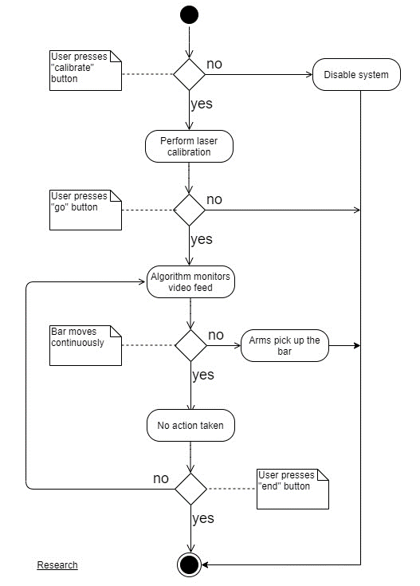
Figure 42: Project Design
5.1.1 Laser Break System
Below you can see a top-level block diagram for the actuators and laser break system. Inside of each actuator arm you can find the laser embedded in one and the photodetector on the PCB in the other. The laser’s signal interacts with the photodiode which sends the signal to the CPU or to an analog to digital converter. The use of an analog converter initially seemed to be an optimizing idea that would allow for some ease in the future for the software but as we found in our research the photodiode is just as fast as the ADC if not maybe faster. In this situation we elected to remove the ADC in an effort to remove the potential error and complications.
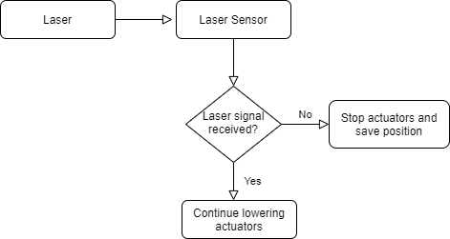
Figure 43: Laser Break System Flowchart
Photodiode and ADC
In our situation the photodiode was the most fitting. After researching our options, we found that the circuits for each component would operate the same with the same layout. Each component allowed for a simple voltage divider and with the photodetectors in the R1 position. Due to the similarity in the circuits which affirms the lack of complexity with each option the final considerations came to speed and cost. Knowing that these three components’ prices are in the same ballpark we concluded that speed would be the deciding factor. Because the photodiode has a single junction it is the fastest of the three options, we are implemented the photodiode into our project.
With the utilization of a photodiode we felt that we could get this task done without the use of an analog to digital converter. The photodiode was fast enough that it made a clear transition for the CPU, as we primarily seeked a binary response, meaning high or low. Analog to digital converters are used to give a range of different values based on the input, for example as the analog input goes from 0 volts to 9 volts an analog to digital converter would step in 1 volt increments for 0 to 9 volts. We felt that these extra values would only further complicate the output from the photodiode and would potentially create more complications looking ahead to the software and reading these values coming into the CPU. Another act of precaution we planned to take was to add an infrared filter over our photodetector to further limit the unwanted light and narrow our detecting bandwidth, but this was not necessary.
5.1.2 Computer
The Raspberry Pi is the “brain” of the Automated Safety Spotter, as it is the computer that processes the video feed and all other input and output signals. The actuators, camera, display and laser-break system connect to it.
When the ‘calibrate’ button is pressed on the display, after a small delay to give the lifter time lay down on the bench, the Pi sends a signal to the actuators to move up until the photodiode—located on the inside of the arms—starts detecting the signal from the laser, indicating that the arms are slightly above the lifter’s torso, exactly where they should stay (the safest for the lifter) unless help is needed lifting the bar mid-session. The Pi receives the signal from the photodiode and sends another one to the actuators to stop moving, and the software records that height for future sets, so that only one calibration needs to be done per lifter at the beginning of the workout.
When the ‘go’ buttons is pressed on the display the Pi sends a signal to initiate the camera recording so that the barbell can be tracked. As the software analyzes the video feed, it constantly checks whether the bar stops moving. If it does stop, then it sends a signal to the actuators, so the arms go up and lift the bar from the lifter’s hands.

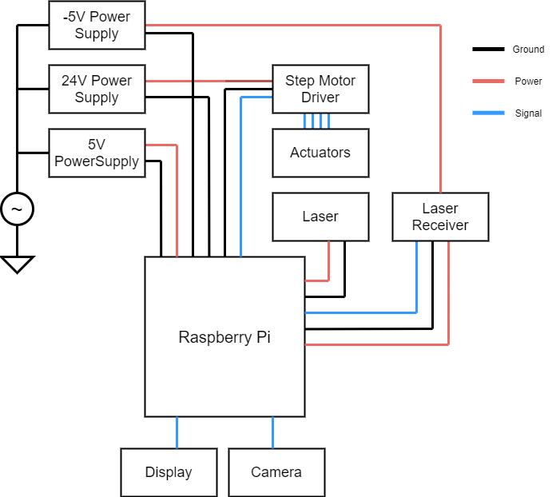
Figure 44: Raspberry Pi with Signals in and out
5.2 Programming Languages
Paradigms
Programming languages divide into different paradigms according to their features. Imperative languages, like C or Fortran, consist of a series of commands or statements that are (mainly) executed in the order that they are written, with the help of variables, loops, conditional statements, functions, etc. This makes the code easy to write and to follow, since its structure focuses on “how” to solve a problem. These programming languages are usually more efficient in terms of memory and speed because the level of abstraction is relatively low, which means that the conversion of the code to machine language can be done faster. The imperative paradigm can be subdivided into other categories, procedural and object-oriented languages among them.
Procedural languages focus on functions or subroutines that are executed one by one, typically in a top-down approach. Object-oriented languages, like C++, Java or Python, model the world as a collection of classes and objects that contain data and methods that modify such data. This approach has many advantages: objects can be reused without the need of rewriting them, classes can copy properties of another class while adding its own (inheritance), many programmers can work on the code at the same time, etc. This paradigm offers a higher level of abstraction at the cost of speed, although modern day optimizations do allow for decent run times. A higher level of abstraction also allows us to tackle more complex problems, focusing on the many parts that comprise the problem and their relationship rather than on the difficulties and nuances of the language itself.
Another paradigm is called declarative programming. Here, the focus is on what the program should do (the logic) rather than on how it should do it (the structure). An example of this is SQL. Therefore, these languages have a higher level of abstraction than imperative languages. Declarative languages can be subdivided into other categories such as functional and logic.
Functional languages such as Haskell, a pure functional language, or Java and C++ which also support the functional paradigm, focus on functions and expressions instead of on data and statements. This makes the code shorter, easy to follow and easy to test. On the other hand, its high-level abstraction makes this paradigm not suitable for programming microcontrollers.
The Logic programming paradigm use in languages such as Prolog follows a structure that resembles mathematical logic: a series of definitions and relationships are established, and the computer uses them to arrive at logical conclusions. Many programming languages used today support many paradigms, and this flexibility makes the language richer and more useful to a wider audience, which in turn makes the language and its capabilities grow.

Figure 45: Paradigms
C++
To use the OpenCV library to track the barbell via a camera, a choice of programming language had to be made. As mentioned earlier, OpenCV can be used with C++, Python, Java, MATLAB and Octave. The following observations helped us decide which language to use.
The libraries in OpenCV are written in C++, so programming with this language could be seen as the most logical option. Although technically C++ is a high-level language, it is sometimes considered low-level when compared to other languages such as Java or Python, because the level of abstraction can be and often is lower than those two. It is a compiled language, which means that the source code passes through a program called a compiler that translates the code into assembly language which is then translated into binary code. A compiled program or code generally has fewer errors than an interpreted one (discussed next) and runs faster too because it only needs to be compiled once (assuming no changes are made). These last two observations translate into faster execution times.
C++ is a statically typed language, which means that the type of each variable must be specified. Statically typed languages have the advantage that many errors can be caught early during compilation, facilitating debugging later on if something does not work as it is supposed to. It supports procedural, object oriented and functional paradigms, and it supports dynamic memory allocation, which is essential for critical applications that must have control of every single aspect of the program, allowing it to allocate and deallocate memory when needed, instead of relying on automatic memory management such as the Garbage Collection in Java or Python. This control over the memory is ideal for applications that involve small computers or microcontrollers that usually have just a few gigabytes available. This was important in our project given that the Raspberry Pi only has 1GB of RAM and 16GB of flash storage.
None of the members of this group were comfortable writing in C++, so we decided it would not be used unless strictly necessary. It is also harder to follow and understand (at first glance) than languages like Python.
Python
According to the 2019 Stack Overflow developer survey where 87,354 developers participated, Python was the 4th most popular language with 41.7% of the votes, surpassing Java with 41.1% and C++ with 23.5%.
Python is a high-level language with a greater level of abstraction when compared to C++, one of the reasons being that its syntax is more human friendly. It is a dynamically typed language, so the type of variables does not need to be specified. Although this makes the code more readable, it can cause unwanted results or bugs at runtime or later in the development process that can be hard to track. Python also supports procedural, object oriented and functional paradigms. The memory management is done automatically using a garbage collector, which works well the majority of the time but can pose potential problems for critical applications as mentioned before, especially when dealing with live simulations, because the user or programmer does not have fine control over all the resources and their status on memory. However, the software side of our project was simple enough that this would not (and did not) represent an issue.
Python is an interpreted language; thus, it typically does not need a compiler the way C++ needs one. Instead, the source code is compiled to bytecode first (instructions closer to machine language) and then a virtual machine, which is a program written specifically for each of the operating systems supported, executes those bytecodes. This is why a Python script can run in any machine (as long as Python is installed) while C++ programs must be compiled every time it is placed on a new processor architecture. These scripts are generally shorter in length than C++, and this makes prototyping solutions much simpler and faster in Python. Combined with tools such as Jupyter notebooks (an open-source web application that make the code “live” by letting the user interact with the output and visualize data, do statistical modeling, numerical simulation and much more) and the extensive documentation, tutorials and support available makes coding in Python not only practical but even fun.
Python comes with many libraries installed, but many more are available online thanks to collective effort and interest of many individuals that use the language in many domain areas such as web development, GUI applications, computer vision and machine learning, statistics, business analysis and more. Some of the machine learning and data science libraries are: NumPy, Pandas, Matplotlib, Seaborn, Plotly, Cufflinks and Scikit-learn. Although Python is the leader in the fields of machine learning and computer vision, academics doing state-of-the-art research are starting to turn away from it, because on those situations it turns out to be too slow a programming language. (Researches are starting to turn to languages that support differentiable programming paradigms like Swift, not covered here).
Because of its simplicity and because one of the members is familiar with OpenCV using Python, this language was our candidate for our project. Python is also the number one language used in the field of computer vision, machine learning and data science, so it helped in adding relevant experience that is in demand in the industry.
Java
Java is another high-level language. It is statically typed, and similarly to Python, the source code is compiled to bytecode and then interpreted by the Java Virtual Machine (JVM). It supports object oriented and functional paradigms. Memory is managed via the Garbage Collection process as in Python. The resources available to code in Java are extensive, with plenty of tutorials and libraries to work with. Java is also one of the two languages used to create applications on Android (along with Kotlin). It is typically considered faster than Python. Java is a verbose language, and slightly harder to read and understand than Python.
MATLAB
MATLAB is the oldest programming language among the ones being compared here. Its focus in on numerical computing, but it has packages or libraries that enable graphical simulations, symbolic computing and much more. It is dynamically typed and interpreted (it is a high-level language), not compiled. MATLAB is very powerful; it offers optimized matrix calculations (essential for images and video manipulations), excellent visualizations and a great documentation and support. It is used in many universities and academia in general. However, it is an expensive product, and extra packages or toolboxes cost extra money, and UCF does not provide it for free for students; instructors must reach out to the IT department and request a license for the students and wait for approval. Also, although it has a support package for Raspberry Pi, to develop applications for the latter the programs must be coded on a separate computer and then sent via a remote connection to the Pi. MATLAB has a steep learning curve, and our project was time sensitive.
GNU OCTAVE
An alternative to MATLAB is GNU OCTAVE, another high-level, interpreted programming language. Its syntax is similar to MATLAB and it has many of the same functionalities, but it is free under the GNU Public License, which allows all users to run, modify and share the software. Even though OCTAVE is compatible with Raspberry Pi, documentation to use OpenCV libraries with it is poor.
Below is a summary of the comparisons between these languages and their usefulness and practicality for our project. Python is the simplest, syntactically friendlier language, with extensive documentation and tutorials and fast enough for our use case. Compilation or execution speed differences would not be noticeable. Simplicity is rated from 1 to 3, with 3 being the simplest.
 | Simplicity (1-3) | Demand (Comp. Vision field) | Documentation
C++ | 1 | High | Good
Python | 3 | High | Good
Java | 2 | Medium | Good
MATLAB | 2 | Medium | Good
OCTAVE | 2 | Low | Poor
Table 54: Programming languages trade-offs. The higher the simplicity number the easier the language.

5.3 Software Design
Tracking the barbell
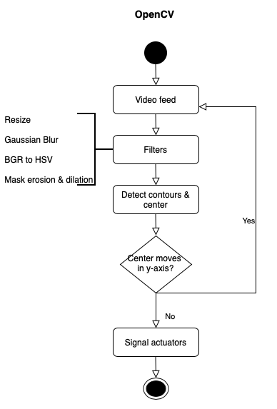
Figure 46: Open CV flowchart
An essential part of the project consisted of the system being able to track the bar and detect if the user needed assistance in lifting the bar. A human spotter would recognize this need for help by watching the user’s face showing signs of struggle, his or her arms or legs shaking, and whether the barbell is moving as it is supposed to (that is, the exercise is being performed correctly) meaning the correct bar path, stopping half way up or even falling back down toward the lifter. While performing the exercise if the bar comes to a prolonged stop, indicating that the user cannot lift it, or if the user loses control of the bar and begins to lower or even worse it accelerates downwards, the spotter must react instantly and provide help. Human reaction times are simply not fast or reliable enough to maintain the consistency required to maintain high levels of safety while performing dangerous exercises such as the barbell bench press. Countless accidents have been known to occur around the world because of human reactions, actions, and lack thereof.
While the system as a whole is composed of the user plus the barbell, the system must monitor the user and the bar’s movement to effectively spot a lift. We took a much simpler approach by monitoring only the bar movement (the computer also recognizes upward and downward direction). Seeing that monitoring this variable alone was sufficient to prevent an accident (more complex solution would involve the user’s body reactions and perhaps voice commands) we felt that it was an adequate—perhaps initial—solution. There were a few ways to monitor bar movement. As mentioned in previous sections, optical, microwave, and acoustic sensors were an option. Eventually we decided to go with the Raspberry Pi camera and use OpenCV.
To do this, we monitored the barbell via its color. This proved to be very accurate and did not overclock the Raspberry pi, which occurred with other methods such as background subtraction. After the camera was initialized in software, a for loop was used to check each frame and do the following operations to each one of them. The frame was blurred and converted to the HSV color model, and a mask was created with a color of the barbell (this color mask was easily modified with a small program that takes a picture of the object to be tracked to determine the ideal HSV values. In the context of a gym environment, barbells are predominantly gray and lighting condition is stable). Then contours were found around the mask, and its center (x,y coordinates) was calculated. This center was being tracked to detect movement. On each new frame, the center coordinates were compared to the coordinates a few frames back (comparing it to the previous frame can cause noise, as a small change in lighting could make two consecutive frames different) and the difference of y coordinates was calculated. If this difference was greater than 60 pixels (approximately 15 cm), then it was considered movement. If after approximately 2 seconds the bar had not moved more than that, then the actuators are triggered. This timing could be reduced to 1 second or less, but it would interfere with the exercise, as the bench press requires a momentary stop at the top and bottom of the rep when changing directions, and if the user were to drop the bar, the actuators sitting at the appropriate height would catch it, preventing injuries.
The Computer Vision field
The importance of Computer Vision software and techniques have dramatically increased in the last 20 years, and the technological advances like Graphical Processing Units (GPU) and the newer Tensor processing units (TPUs) have provided an ideal platform for these algorithms to run ten or twenty times faster than a powerful, state of the art CPU, thanks to speed that multiple parallel instructions provide. Part of the motivation for these technologies come from wanting computers and robots to model the world as humans do, through vision, and not through ultrasonic, LIDAR or RADAR sensors alone. Below is a graph that shows theoretical speeds of GPUs vs (the most powerful) CPUs until 2016, created by Karl Rupp at karlrupp.net.
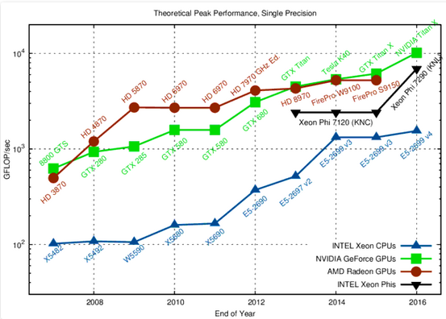
Figure 47: Theoretical GPU vs CPU comparison
Computer vision algorithms are increasingly being implemented in the automotive industry, making autonomous, self-driving cars a reality. Software already available in 2020 can keep a car on its lane, perform lane changes, enter and exit highways, recognize traffic signs and pedestrians as well as perform self-parking routines. The technology is also positively impacting healthcare, as highly trained algorithms can “scan” MRIs or simply pictures of the skin or eyes and predict conditions or diseases with higher accuracy than doctors in many cases. It is also being used to identify fungal diseases in crops, to help navigate robots around public areas, to help fly and land drones, to help choose clothing at retail stores, and many other applications. The potential is limitless, and by using some of the many algorithms available we could have created a solid, safe implementation of the barbell spotter.

6. Project Prototype Testing and Construction
This section will display the construction of our project along with all electrical schematics. This is where we will explain how we will physically combine all of the technology that we have discussed in the earlier sections of this document. For the mechanical parts of our project, we will include those designs and build details in this section as well. The final thing we will discuss in this section is the testing plans for each part, subsystem, and eventually a successful project.
6.1 Integrated Schematics
6.1.1 Step Motor Driver
The step motor that is the driving force behind the linear actuator is unable to accept a pure DC voltage for operation. The nature of the step motor requires individual pulses of electricity to make its steps. The step motor driver creates these steps from a DC voltage input. The output it creates is a pulse width modulation function with the motor taking action on the rising or falling edge. The width of this function is determined and altered with a variation of a series of switches on the driver.
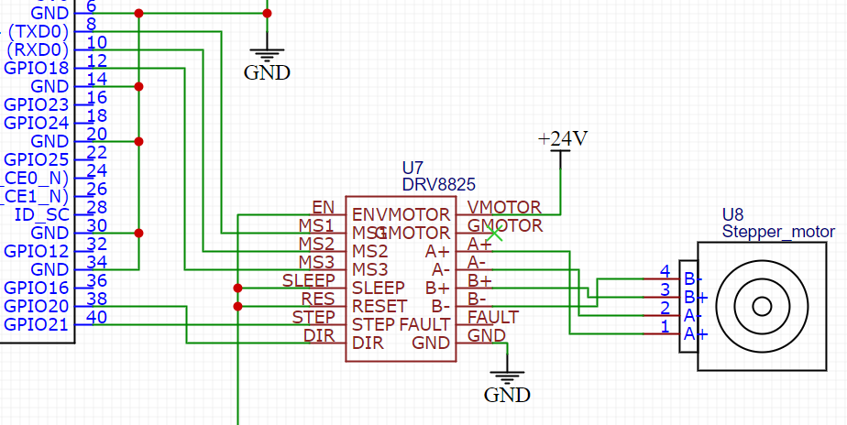
Figure 48: Step Motor Driver

Stepper motor | DRV8825 | Raspberry Pi 3B
A+ | A+
A- | A-
B+ | B+
B- | B-
 | VMOTOR-VCC
 | GMOTOR-VEE
 | FAULT
 | EN
 | MS1 | PIN 8
 | MS2 | PIN 10
 | MS3 | PIN 12
 | SLEEP | PIN 1
 | RES | PIN 1
 | STEP | PIN 40
 | DIR | PIN 38
 | GND | PIN 39
Table 55: Step Motor Driver
6.1.2 Photodiode
The photodiode is used to receive and feedback the laser diode's emitted laser and acquire the height of the user’s chest. If the laser is not blocked, the signal is sent to the raspberry pi is high, in the software this means keep lowering. On the other hand, if the laser is blocked, the raspberry pi receives a low signal and tells the linear actuators to stop and hold their position. This position will be the failsafe for the circumstance of the user’s muscles giving out.
In our application the photodiode works as a current source in a transimpedance amplifier. When the light hits the photosensitive are of the photodiode, the junction gains an excess of electron hole pairs. The diode then provides a current that is amplified to our positive power rail and we send a 3.3V output to the pi. With no light on the diode there is no current flowing and because both inputs of the amplifier are connected to ground our output to the pi is ~0V.
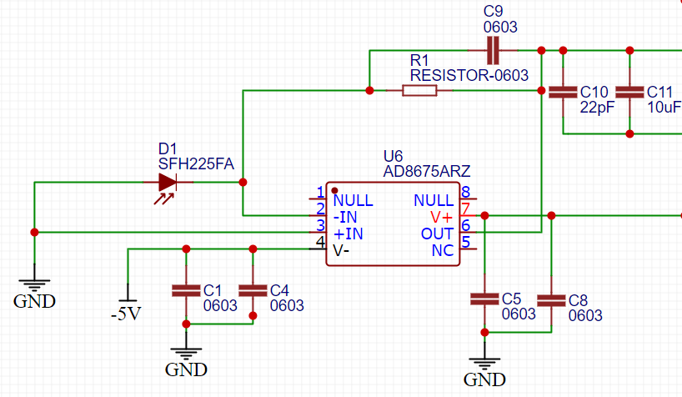
Figure 49: Photodiode
6.1.3 Camera
The Raspberry Pi camera V2 only has one plug, so we didn’t need to concern about the pin out number it can be directly connect to the Raspberry Pi 3 board. The schematic shows the detail of each pin within the Raspberry Pi camera V2 socket.
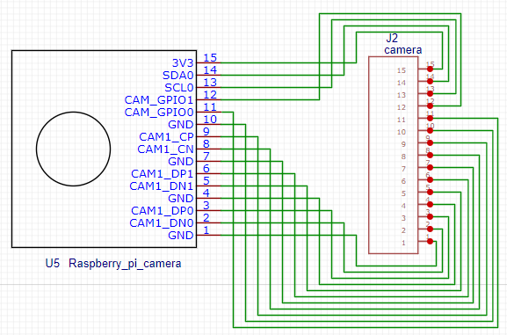
Figure 50: Camera
Raspberry pi camera V2 | Raspberry Camera module
GND | PIN 1
CAM1-DN0 | PIN 2
CAM1-DP0 | PIN 3
GND | PIN 4
CAM1-DN1 | PIN 5
CAM1-DP1 | PIN 6
GND | PIN 7
CAM1_CN | PIN 8
CAM1_CP | PIN 9
GND | PIN 10
CAM_GPIO0 | PIN 11
CAM_GPIO1 | PIN 12
SCL0 | PIN 13
SDA0 | PIN 14
3V3 | PIN 15
Table 56: Camera Pinout
6.1.4 Touch Display
The touch display we used comes with a HDMI cable, along with a micro USB for touch feedback and power. Thus, the monitor can be connected directly to Raspberry Pie's HDMI module.
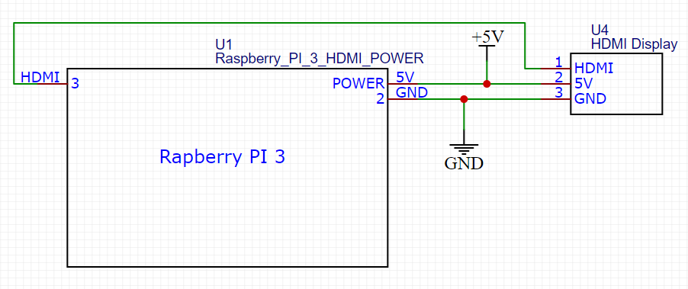
Figure 51: Touch Display Schematic
Raspberry PI HDMI Module | Touch Display
HDMI | HDMI
5V | 5V
GND | GND
Table 57: Touch Display Pinout
6.1.5 Full Schematic
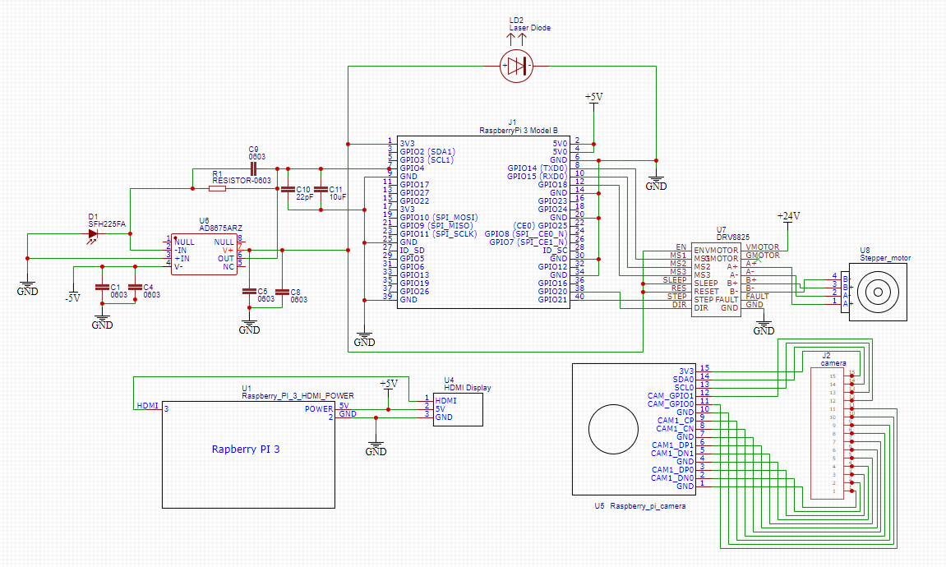
Figure 52: Full Schematic
List for parts in this schematic
- Raspberry Pi 3B MCU
- Raspberry camera V2
- Touchscreen
- Laser diode and driver
- Photodiode
- Step motor and driver
6.2 PCB Vendor and Assembly
For our PCB we utilized a company called EasyEDA. This was a company that had reliable reviews with a fast spin time and a good deal of 10 boards for the of one. This allowed us to run some tests on different boards as well as have two fully functioning boards to manipulate and tweak to work on our exact system. We were able to receive these boards within about two weeks and begin our tests.
Our board went through a few different versions due to a mistake on layout design as well as some inconsistencies in the output. We eventually grounded both inputs of the amplifier to ensure our output at no light was low. By lowering our positive power rail to 3.3V we ensured our illuminated output would give no more than 3.3V which is the threshold of the pi.
We also had a noise issue in the length of wire from the actuator arm where the PCB was housed back to the ‘Brain Box’ where the pi was housed. To clean out this noise we place two capacitors, 10uF and 22pF, as close to the input pin on the pi. This reduced the noise from over a volt to about 10mV. (Below is our schematic and layout for the PCB respectively)
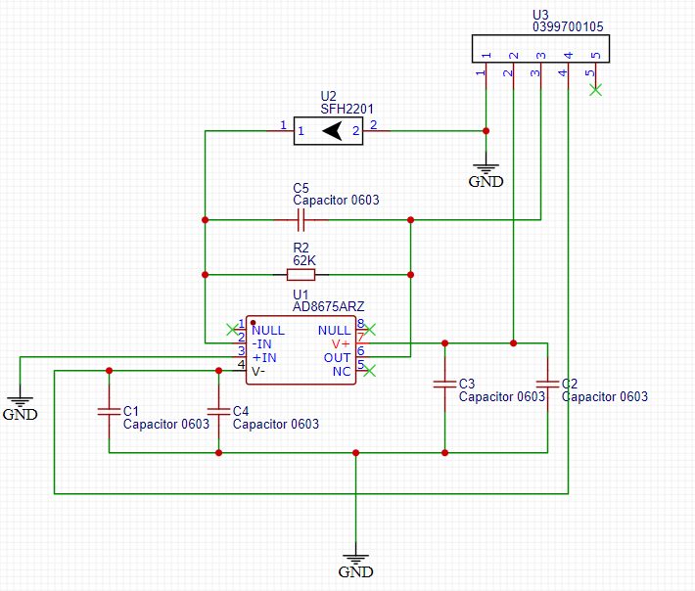
Figure 53: PCB Schematic
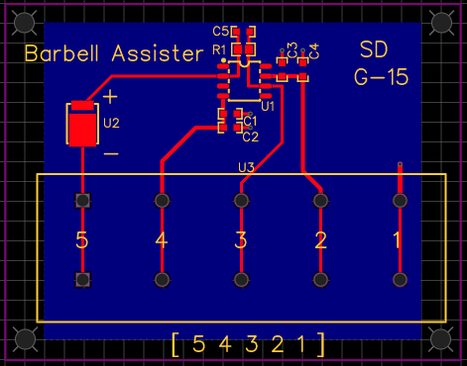
Figure 54: PCB Layout
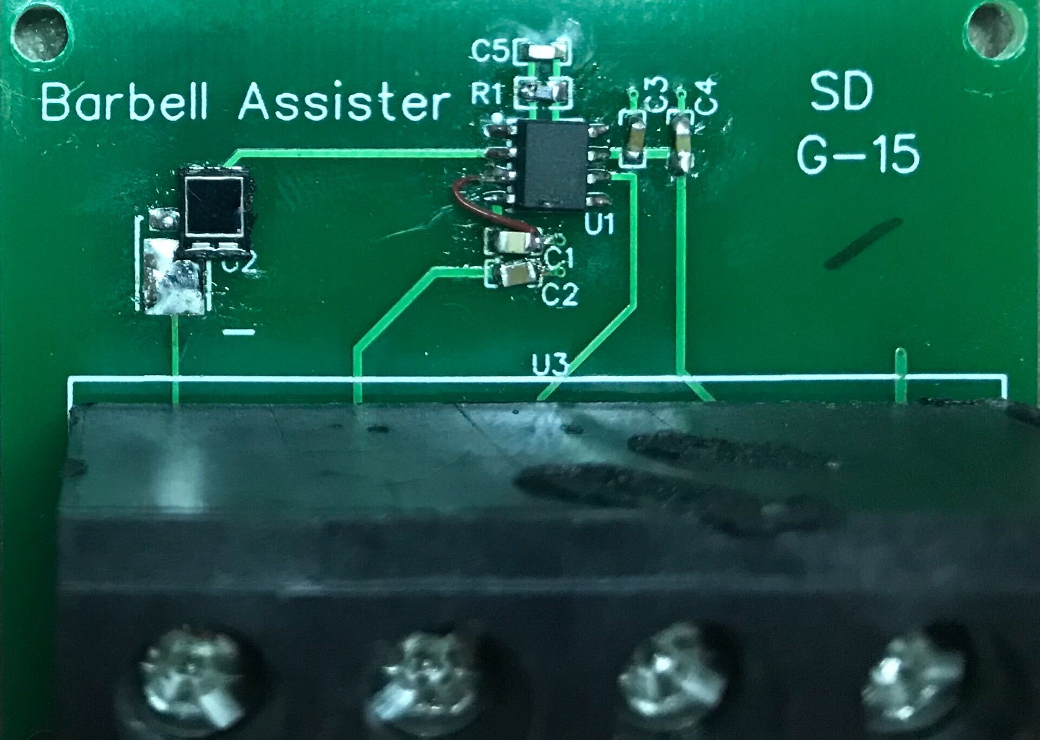
Figure 55: Built PCB
6.3 Physical Part Assembly and Construction
6.3.1 Arms
Fiberglass is a very simple material to turn from cloth to rigid structure, in its underlying process. Fiberglass cloth comes off the shelf is in what looks to be a blanket or cloth, hence the name. the other two key ingredients in the making of fiberglass is the resin which is a liquid with a consistency of syrup and the other component is a liquid known as the curing agent. The curing agent induces a chemical reaction in the resin to occur and harden, this reaction and hardening gives the final material its strength and rigidity. After the curing agent is mixed into the resin the chemical reaction is underway and there is a limited amount of time until the mixture is unworkable, so it is crucial to work quickly once the process is initiated. To create a full fiberglass structure the resin mixture is applied thoroughly applied to the fiberglass cloth to an extent that it looks like it was dropped in a bucket of the resin. If the cloth is not fully saturated, then the expected strength will be compromised. As the hardening process becomes apparent the substance will begin to turn to a substance that resembles a consistency similar to chunky jelly and as sticky as pine tar. At this point the substance is too difficult to work with and you are better off making another batch of the resin mixture after your current work has dried and adding more layers of cloth if the desired shaped or strength has not been met.
To build our arms we needed to create a couple of layers of fiber glass cloth in conjunction with a piece of aluminum to create a strong attachment to the actuator. With the signal layer of the cloth hardened we cut them into triangles and strips for the top and sides of each arm. After the shapes were cut, we then glued the pieces together to create a general form for our arms. Once the glue was cured, we began to layer fiberglass onto the existing structure. With each layer we added strength to the arm. We have elected to leave the bottom of the actuator arms open because the laser and PCB are mounted on the inside of the arm. Due to the bottoms being open there is a significant lose in strength. To reinstate this strength, we cut a wooden dowel and placed it perpendicular to the walls and along the bottom of the arm. We added 5 – 6 on each side and this was a perfect solution to our problem, and we had a solid stiff arm. These dowels also made mounting the parts to the inside of the arms a breeze. The laser was glued right to the top of the dowels and pointed across to the other arm that housed the PCB which was bolted to the wall of the arm.
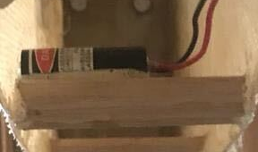
Figure 56: Laser Mounted in arm
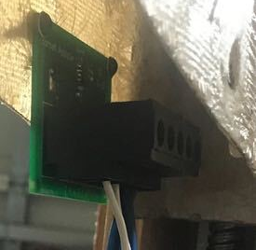
Figure 57: PCB mounted in support arm
6.3.2 Barbell
Our replacement for a real barbell was a long piece of wood. Wood is an easy material to work with and allowed us to fine tune the weight of the bar easily. This allowed us to tape the part that is visible to the camera and which made the computer vision software work at a higher consistency given the greater differentiation.
6.3.3 Linear Actuator Housing
The housing our linear actuator live are built on a stand as well. Unlike standard screw driven actuators that have a length at the bottom ours utilize their full length for actuation. This means we needed a stand to raise the bottom of the actuator off the ground and allow the actuation range to be in a useful range.
Building the stands maintained a simple construction of wood, glue, and some screws. After we built the base and framing of the stand, we then attached the housing of the actuator to our desired height. The key traits of our stand are sturdiness, and accessibility. If our casing for actuator lacks accessibility, we would not be able to work on the part if something went wrong or we need to apply any modifications. Because the base has connected both sides and arms we have ensured strength and reduced undesired mobility in the actuator arms.
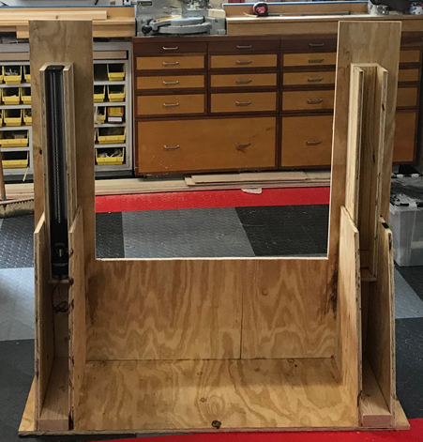
Figure 58: Actuator Housing
6.3.4 Computer Housing/Camera Stand
The box that our camera is mounted to is essentially the control center of the project. This is where we are housing the computer and our screen is mounted. This box is made of wood and is be mounted on a stand that is elevated 3 to 4 feet off the ground. We determined that for the open cv software to work optimally, and as we expect it to, this is the ideal height. This height will provide a perpendicular view to the path of the barbell, giving the camera a view of the most physical movement possible.
The reason we made the box from wood is because it is the easiest and most accessible to work with. Our control center needed to be easy to mount to and maintain a low profile. This low profile provided an aesthetic completeness to our project, but also an increase on the emphasis of reduction in weight. A reduced weight was crucial in limiting and lowering the center of gravity of the control center. The housing’s stand needed to be sturdy and have a strong, wide base so if it is bumped, we can be confident in its stability. To ensure a strong base we utilized a platform of wood held up with three 2X4’s all interconnected for increased strength.
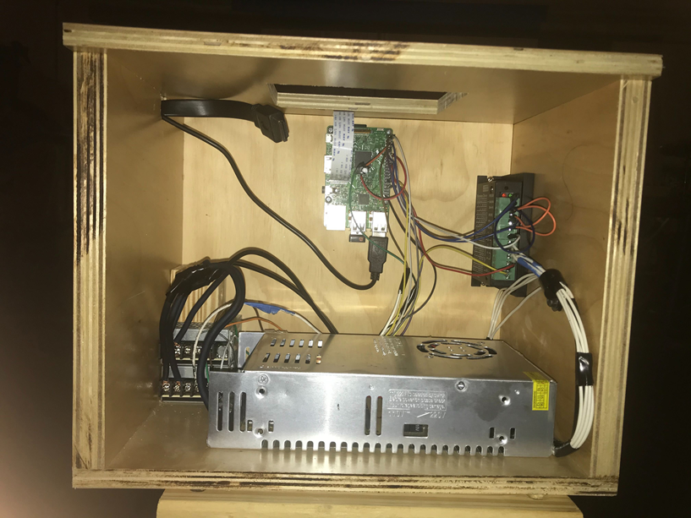
Figure 59: Brain Box
6.4 Testing Plans
6.4.1 Laser Break System
The most efficient way to go about testing our system was test each part individually as we removed it from the package. As each part passed its individual test, we slowly built up and integrated each part into the system in its designated spot, eventually ending up with a fully operational project with all parts working seamlessly and cohesively.
Laser
The testing our laser was a fairly simple process; the difficulties with this part were going to arise when implementing the project into a light filled environment where the laser’s light would be less defined. The initial testing was successful as long as the laser received the correct amount of power. It would respond by turning on when it receives or “sees” three volts and off when it didn’t. The laser did not demand rigorous testing until it interacted with the power supplies that we are utilizing unless it would have failed to work on a steady 3V. If the laser was not successful with three volts and we would make sure that there is nothing wrong with the DC power supply and following we could attempt to provide the laser with more power; given the result of this we could either try a second laser if this doesn’t work or we could try to add a fairly large capacitor to the power line providing the laser with power. This would act as a decoupling capacitor and clean out any noise from the signal.
If the laser worked at a voltage higher than three volts can assume that the line is either very long and creating a lot of inductance between the power supply and laser, or we have a ‘noisy’ signal coming from the power supply which isn’t providing the laser with a constant three volts. Adding the capacitor will help fill and clean these gaps in the power along with assist in removing some inductance.
*Upon more consideration we believed that it would be a good idea to add large capacitors in parallel to all the power supply lines near the components that have any substantial length to them. This is in an effort to reduce inductance and maintain a clean and consistent power supply voltage.
Photodiode
One of my largest concerns for the photodiode was that if the ambient light in the room was enough for the photodiode to detect. This problem would arise as the laser beam is broken by the user’s chest, if the ambient light was too strong then the system would fail to realize the user’s chest and in return the arms would not stop at the proper height and the safety of our system would be compromised. The system knowing the height of the user’s chest was one of the key safety features of our project, and if the photodiode did not react as anticipated and activate the system as we expect, our project would fail at one of its key safety attributes.
We are unsure of the end environment that the system could end up in and because of this we needed to devise a solution that would be applicable in very bright and dark environments. A solution we created was a tunnel or tube feature to house the photodiode in. This would block a lot of the ambient light in the room or environment that the photodiode would potentially pick up as the laser’s signal. An added benefit of this tunnel design is that it creates a higher level of consistency among light level received in different environments.
To ensure accuracy of our laser receiving the signal from our laser we thought we might include a light concentration lens over our laser receiver. The concentration lens would act as a magnifying glass would on a hot summer day, concentrating all of the sun’s light to one small point. The use of this lens is to ensure that the system does not induce any action based on a false negative and would only react to a true laser trip. Another action we thought of adding if it was needed to ensure accurate reading of the laser was to include an inferred light filter.
Linear Actuator
The testing of the linear actuator would be slightly more involved compared to the individual electrical components. Beyond testing the actual movement of the actuator, we needed to test the mechanical portion of the project as well. Testing electronically would be giving a few different voltages and ensuring that it moves. The mechanical design is where things became a little hairy. None of us are mechanical engineers by any means and we would need to utilize a light material for the arms that can also be sturdy enough to hold the weight at an extension in the case of a needed assistance.
6.4.2 Software Tests
There are many different types of testing that software developers make on a daily basis to test out new features, correct bugs and make sure that their application or platform is running as expected. Testing can be done manually or automated. Manual testing is done by a person as the name implies. The same developer or someone in charge of quality control goes over every detail of the application, testing each button, each menu, each feature, etc. At an organizational level, this kind of testing becomes expensive pretty fast, given that many people are needed to check all aspect of a project and still, it does not guarantee that it will be bug free.
Automated tests then, are the logical next step. Many of these tests can run multiple times without extra cost to the developer. The more thorough the test is however, the more complex it becomes.
Some of the many different types of testing are:
Unit test: Individual functions, methods and logic are tested. These are easy to automate and run quickly. In our project, examples of unit tests were: testing that the camera recorded video when the VideoCapture function is called, testing that the frames were being filtered correctly (they are converted to HSV, then smoothed, etc), that the camera detected the barbell moving up and down every time, that the computer sent the appropriate signal to the actuators, that every interaction with the display resulted in the expected output, etc. When the ‘calibrate’ button is pressed on the display, a function would print to the terminal different parameters, like the 5 seconds that the computer would wait before starting the calibration sequence. If the ‘go’ button was pressed and the calibration sequence was never performed, a message appeared on the display explaining that the former was necessary before pressing ‘go.’
Integration tests: Groups of functions, methods, modules and logic are tested. These are one step more complex that Unit testing, since it combines two or more of those to test integration. Examples of integration tests in our project were: testing that when the camera detected that the bar has stopped moving, the computer would send a signal to the actuators and they moved, regardless of whether they moved in the right direction and the right distance (at this stage). Also, that when the ‘calibrate’ button was pressed on the display and after the timer finished, the actuator arms would move.
Functional tests: This is similar to the previous type of test, but it is stricter. So not only each one of the modules work, but they work together producing the expected output: if the bar stopped moving, the actuators would move in the right direction, picking up the bar this time.
End-to-end tests: This test checks that all the modules and logic work as expected. They are more expensive to run in organizations and take longer time. In our project, an example of an end-to-end test translated to a simulation of a lifter who approaches the bench press to start the exercise: he or she interacts with the touchscreen, presses the ‘calibrate’ button and lays down on the bench for calibration, whereupon the actuator arms move up and down calculating the correct height for the resting position with the use of the laser-break system. Then the lifter presses the ‘go’ button and a signal is sent to the computer letting it know that the exercise is about to start. If while performing the exercise the bar stopped moving, the camera would notice and send the appropriate signal to the actuators so that the arms rise and relieve the lifter from the weights. This test was performed multiple times and with different lifters, to make sure that the laser-break system and the tracking software worked as.
Acceptance tests: these test not only verify whether the system as a whole works, but it checks that it works within the requirement specifications. We executed this kind of test at the end of the Senior Design class, since the criteria for a successful project was that we demonstrated at least three of the specifications as stated on the Senior Design document. We would check that the laser-break system works consistently and at many different heights, and that the actuators would start moving within 2 seconds of the bar being at rest.
Performance tests: This test examines the system and its response during stress. In our case, this would mean trying the exercise with the maximum specified weight multiple times and see if the system held, verifying that the arms were strong enough and that the actuators supported the weight. We decided not to perform this kind of test, because time would not be on our side if a major component broke and we needed to buy a new one.

Figure 60 - Testing pyramid. From simplest & fastest (Unit Test) to more complex and slowest (Performance test)
Initially, we thought that continuous and thorough testing would be challenged because of the current health crisis, and that the team would not be able to meet in person, which meant that End-to-End testing would not be feasible. Luckily, we were able to perform these tests, enough times to record our demonstration video and present a fully functional project.
6.4.3 Raspberry Pi Testing
In order to run the Raspberry Pi on Windows we need to Install the raspberry pie system image file on the SD card. A tool for installing images is needed to install the operating system image file such as win32diskimager.
1. Unzip the downloaded operating system image compression file to get the img image file (the filename suffix is img).
2. Connect the SD to the computer after using the cassette or card reader.
3. Unzip and run the win32diskimager tool.
4. Select the system image (img file) in the win32diskimager software, select the SD drive character under "Device", and then select "Write", during which the dialog box appears to select Yes.
5. Wait for the dialog box to appear. Write successful means it worked.
We insert the SD card into the Raspberry Pi after the system is installed on the SD card. Connect the USB keyboard, mouse, and display to the Raspberry Pi. In our case, no VGA and HDMI interface are included so one would need to connect the specific pin out from the display to the raspberry Pi (5V-pin2, SDA-pin3, SCL-pin5, GND-pin6). Next, connect the raspberry pie to the router with a net cable if applicable. After everything is set up the raspberry pi should be able to power up. The red power indicator on the Raspberry Pie motherboard is lit, and the green indicator lights between or blinking indicates that the system has started, and the raspberry pie logo will appear at this point. After logging into the system, one would automatically enter the Initialization Setup Wizard. Since our team was planning to use the ssh function from the beginning, we needed to create an empty file named ssh in the root directory of the SD card with no file suffix.
The computer and display were tested in tandem. The way in which we tested these two components was to first complete the configuration tutorial provided in the user manual of the display, which allowed us to complete the connection of the Raspberry Pi 3 Model B and then allowed us to further customize the capabilities of the display after configuring it. Next, we tested the capability of the display’s input, by creating a simple code in which by touching the display screen there would be some sort of notification by way of the computer, such as printing something to the terminal window. After multiple simple testing scenarios, we continued on to more complex testing situations such as providing signals from the Raspberry Pi 3 Model B to create movements in the linear actuator.
6.4.4 Power Supply Testing
The power supplies were a simple thing to test with the help of a multimeter. Since they have an LED built into the power supply indicating whether it is receiving power, all that was left for us was to measure the output voltage and regulated it to our specific needs.

7. Administrative Content
This section of the document will show how our group will manage their time and budget for our project. The time frame in which we plan to complete tasks as well and budget layout and group distribution.
7.1 Milestone Discussion
The first milestone the team reached was choosing a project idea. This might seem obvious or trivial, but it was not. An acceptable project in Senior Design must be complex enough so that more than two students are needed to develop it and complete it, but time constraints, budget and experience prevent it from being too complex. Because we completed Senior Design I and Senior Design II in the Spring and Summer semesters respectively, we only had approximately seven months to complete the project. Also, because we were not being sponsored and paid all expenses ourselves, we had to choose appropriate parts that fitted our budget. This was the first time we formed part of a group project this significant and had much to learn as we went along. Thus, our choice for the project idea had to be valuable and pragmatic. We spent about four weeks deciding on it: from a smart traffic light, to a drone equipped with camera and laser sensors, to a smart lock, to finally an automatic bench press spotter.
The second milestone was coming up with design choices. We discussed building a whole rack, not feasible given that we would have to spend many hours just trying to solve a mechanical problem just to then get to the computer and electrical parts; having one hydraulic motor behind the bench with two arms on the side parallel to it (also too challenging because of the momentum the bar and weight would create on the arms) to finally two actuators, one each side of the bench to drive two independent arms that lift the bar, and a laser-break system that’s located on the inside of the arms to find the lowest point the arms should go while keeping the lifter safe. We also discussed using a variety of sensors to track the barbell, microwave, ultrasonic, laser, until finally decided to use a camera for video recording and post analysis with OpenCV. We decided to add a display for easy user interaction.
The third milestone was Divide and Conquer. We talked about what each member of the group wanted to contribute to the project and split those tasks accordingly.
The fourth milestone was deciding which parts to use. This took several weeks, partly because of the many options available and their multiple combinations, and also because our inexperience induces uncertainty and makes choosing components harder. Although we already had the computer (the Raspberry Pi) we purchased all other components online.
The fifth milestone was to complete and submit the Senior Design I document.
The sixth milestone was to build a prototype or a proof of concept, and make sure the basic functionalities worked.
The seventh milestone was building the system (not just a proof of concept), building the arms, setting the actuators, the enclosure to the computer, camera and display, and making all the connections between all of the components.
After this step was done, there came a long process of testing. We tested individual components, the integration between them, and the system as a whole. We had to write the code and run through multiple iterations until we confirmed it worked as intended and looked for edge cases where the system could fail and manage those. This took the majority of our time during the semester.
The eighth milestone was to have a product that had a minimum of three features or specifications which we had to demonstrate at the end of Senior Design II. Eventually we ended up with 3 main specifications and 3 secondary ones.
The ninth milestone was project presentation and the submission of the Senior Design II documentation.
Number | Milestone | Planned Completion
1 | Brainstorming | January 1 - January 30
2 | Research & Design | January 30 - March 30
3 | Divide & Conquer | January 30 – February 7
4 | Part selection | March 30 - April 16
5 | Senior Design I Final Report | February 1 - April 20
6 | Build prototype | April 21 - May 30
7 | Troubleshooting / Testing | May 30 – July 16
8 | Final prototype | July 16 - July 20
9 | Presentation & final report | July 22
Table 58: Milestones

7.2 Budget and Finances Discussion
Budget was a crucial part of not only the planning of a project but also the outcome. When analyzing and creating a budget, it is key to account for the accuracy needed in certain portions of the project. In many cases, the thing that will drive the cost of a product higher is its accuracy and its weight/mobility. When minimizing a budget one needs to make sure they are allocating money responsibly. For example, if NASA bought a cheap radar system for the shuttle yet bought the highest technologically advanced desks on the market there would be a bit of a question as to whether they could make it to space with a lousy radar. This is a bit of a dramatic and excessive analogy, but the principle is there. It is important to put the money towards the areas that need it the most. Our goal limit was 500 dollars, below we discuss what this money was put towards and explain why we spent the money where we did.
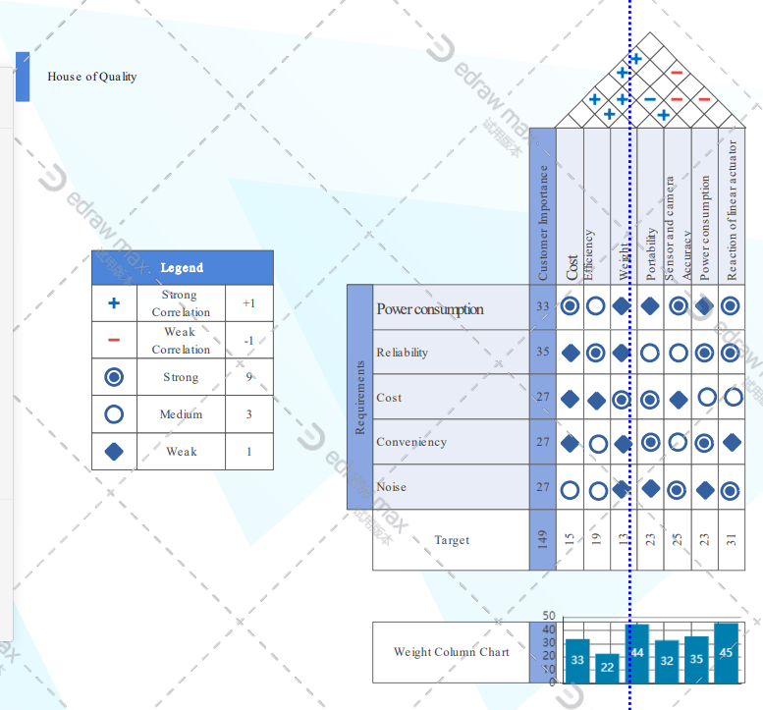
Figure 61: House of Quality

Component | Price
Display | $39.99
Laser | $5.90
Photodiode | $1.38
Power Supply | $10
Computer (Raspberry Pi 3 Model B) | $0
Linear Actuators | $163 x2
Stepper Motor Driver | $11.99
Barbell | $5.00
Wood for Actuators and Control Center Housing | $30.00
Fiberglass | $40.00
Hardware | $10.00
Camera | $21.38
Misc | $10.00
Total | $511.64
Table 59: Budget Table
The above table shows components that were used in order to build the components along with the prices of them on the time of ordering them. Going through each of them one by one we can see the complete breakdown in the allocation of funds. Firstly, we will look at the cost of the display which came out to $39.99 which is a reasonable price for the display and it has the ability to implement many different functions giving us some flexibility in the different features that is possible from the standpoint of the display itself. With features such as an initiation for the calibration as well as a possible counter feature for the reps of the user, when doing a specific workout, and a beeper to inform the user the desired amount of reps is complete.
The laser and photodiode were two part that had to be selected together. We needed to make sure that the photodiode would accept the wavelength of the lasers output. The budget was not a major concern in this regard due to our general knowledge of the parts. We knew that the laser would be less than $10 and that we would be able to find a photodiode for around a couple dollars. We were successful in doing this and able to follow our budget.
The power supply is where a lot of the cost is made up in the fact that it only costs so little. This allowed us to allocate more funds towards the components that supported the arms themselves (linear actuators), allowing for greater quality in that area which is where we decided that the most funds should be allocated to since those are what actually comes in contact with the bar and is what actually does most of the labor in terms of our project scope. The power supplies used would supply all of the proper amounts of power we needed for our design. Given that the power supplies we used had the ideal power ratings for our parts we felt like this was the best choice for our parts. This would ensure that there were no discrepancies in the amount of power needed with accordance to the amount of power actually supplied which resulted in our system functioning as planned and continuing to do so for the length of the workout. We confirmed this through a variety of different testing procedures when building the device and had success in all areas of power distribution.
The computer that we used was the Raspberry Pi 3 Model B, which is an older version of the computer series, but it provided the features that we needed in order to implement our project from the standpoint of communication between devices. Not to mention that what ground it gives up in the way of power and feature capability it more than makes up in the way of the vast amount of documentation that it has available for it. Since it is a relatively older model, there is quite a lot of documentation that is available for it as well as the amount of references from the community which, served as an invaluable source of information when we were troubleshooting and debugging in the latter stages of the project.
Next, we will observe the linear actuators which would serve as the tools to provide the movement of the arms as well as determining the strength of the arms themselves. We agreed that most of our funds would be allocated to this area of the project simply because of the importance of this area. The success of the project hinges mostly on the ability of the arms themselves to support the amount of weight that we are promising we will be able to lift, as the support for the user on the bench press.
The stepper motor driver is needed for the linear actuators as a means of filtering the noise that may be produced when transferring power from the power source to the linear actuators themselves, allowing for proper functionality of the actuators themselves which, as mentioned before, is quite pivotal in the functioning the project in its entirety.
The Barbell was be made up of a wooden 2X4 that can be purchased at any hardware store or even some craft stores. The utilization of the 2X4 allowed us to precisely track the bar with the OpenCV. By utilizing a 2X4 and some tape we were able to increase contrast on the and improve the performance of the openCV.
The housing for both the actuators and control center were made of wood. This seemed to be the most efficient material to use given it ease of construction coupled with its accessibility and affordability.
When it came to the arms, we knew that something light would be required but it needed to be able to maintain its strength. Fiberglass is something that is very accessible and easy to work with, so we decided, given its strength that it is a reasonable choice.
Hardware consisted of random supplies needed to build the project such as screws, tape, glue, etc. We were not limited to any specific brands when it comes to products such as this yet they are some of the most crucial elements of our project.
The camera which acts as the main tracking device for the computer to know when or when not to activate the linear actuators. The camera in tandem with the OpenCV software were what tracked the movement of the bar and detected when the user needs help based on the criteria that we provide. The camera specifications are mostly determined by the specifications of the OpenCV software which is very strict in terms of framerate. Luckily camera technology that is sufficient to utilize the OpenCV software is not very expensive to come by, which allowed us to save funds on that front.
Miscellaneous expenses would consist of anything that we needed not included in the above paragraphs. The individual items that fall in miscellaneous expenses will be less than a dollar and more likely around 10 to 50 cents. These parts will be things like passives such as resistors and capacitor. Though these are not major components when it comes to cost, they are extremely important in providing the proper voltages and cleaning the signals. We found that throughout our design build and test these little parts were really what allowed us to turn this idea to reality.
We had originally planned to spend around $500 and as the previous table shows we were very close in doing this.
7.3 Project Design Problems
As of the end of Senior Design I (SDI), no major problems or setbacks were encountered in terms of brainstorming, research and part selection. The current health crisis and the quarantine it has forced, however, added a level of difficulty to the completion of the project. With classes canceled and no access to campus, building a printed circuit board turned almost impractical, and physical meetings with the whole were avoided up the second half of the Senior Design II (SDII) semester.
Other complications, delays and obstacles came from the inexperience of working in a group towards a big project and also applying what until now had been theory in a classroom. Even though each component is understood by itself, in isolation, it is the interconnection of all of them what made this task challenging.
One of the first design issues that we encountered had to do with the linear actuators. When brainstorming at the beginning of SDI, we pictured our final project being able to lift hundreds of pounds. We came to realize that in order to create a system that would assist a lifter that was benching 300 pounds would have cost us close to $5,000, so having weight as one of the specifications became impractical. After finding that this would be the case, our team quickly decided to approach the professor for an acceptable solution. Given that this was an electrical and computer engineering project, and making the system lift significant amounts of weight would become a serious mechanical problem to solve, we decided to drop this specification. The team agreed that this was a reasonable solution due to the ideal that the electronics and software of the project would not change in the event that more capable actuators were installed later on, if desired.
Another design problem came up much later, this time during the laser-break system testing. The test, which consisted on having the actuators move down and stop as soon as the photodiode stopped receiving light from the laser, was very inconsistent. Most of the time the actuators would barely move, which seemed to indicate that either the code was faulty, or the voltage output of the amplifier was off. A few false positive tests also delayed finding the problem, which turned out to be noise at the Raspberry Pi pins connection. The input signal from the amplifier was too close to the connections for the actuators on the Pi, and this cause around 1.5 V of noise. The problem was solved using a 10 uF and 22 pF decoupling capacitors closed to the GPIO pin.
7.4 Looking Back
This section aims to provide insight on the process of brainstorming, researching, testing and teamwork that we have experienced during this project
The first thing that proved to be difficult was the step of establishing an idea for the project we wanted to create. Brainstorming was not as easy as it sounded, and we struggled for quite some time deciding on a project that we wanted to pursue. We decided to write down ideas on things that interested us and then try to find a common ground. This proved the turning point in this particular hardship, which let us to the idea of the Automated Safety Spotter, which aimed to incorporate something of interest for all parties involved.
After the research duties were allocated to the specific team members, we all took to recording our findings in pursuit of the initial 60-page paper. We quickly came to realize that it was much more difficult than we were anticipating. This lack of preparedness lead to us being unable to completely finish the 60 pages and this was another pivotal moment for our team, a situation we vowed to never find ourselves in again. In order to avoid being in said situation, we began to meet more frequently as a means of providing updates on our progress of our portion of the 100-page document that was to be written next. This led to everyone being held more accountable and a sense of urgency now existing within our team environment. We were able to complete the 100-page assignment but there were still some bumps in the road along the way to this milestone as well.
Perhaps the greatest obstacle that we all agreed to have faced is the fact that most of us had little to no experience in undertaking a project of this magnitude. This showed in the initial research stages where we were unaware of how to undergo the research procedure and how we were going to set out implementing the project we had envisioned together. Overcoming this provided us the greatest leap in momentum for our team, and we began to understand how we should work together and build on each other’s findings. By being in constant communication we were able to find a common ground on what our expectations were of each and we were able to meet those expectations.
During Senior Design II and the health crisis, our meetings face to face came to a stop, but communication did not, as we turned to Zoom and met online multiple times before having to meet face to face again, towards the final face of the project. This is perhaps, the greatest take away of Senior Design: lack of communication and clarity can easily impede progress. Luckily, we learned this lesson at the beginning of the journey. Our individual hard work paid off, but this task would not have been possible to complete alone.
7.4 Project Role
Aaron Larson
Aaron’s portion of the project was to design, build, and document, the creation of the laser break system and the integration of the linear actuators. He found himself doing research on a range of technologies throughout his journey. From learning about circuits for running lasers in conjunction with different types and applications of photodetectors, all the way across the board to comparing different types of fiberglass and carbon fiber composites he gained knowledge on not only electronics but also in material sciences and more efficient research techniques. In addition to his research he took the responsibility of being the parent of the document. This role put him in a position that was responsible for collecting and formatting all of the information within the document. He enjoyed working with the team and is excited to move along the path toward a comprehensive and completed report and eventually a successful design and prototype in Senior Design II.
Angel Morfa
Angel’s personal role in the project was software and the integration of all the components with the computer. He worked with the input from the display, with the video feed from the camera and used OpenCV software to filter the video frames to track the barbell and send the signal to the actuators to move and meet the bar when necessary. He also worked with the input signal from the photodiode to code the calibration section of the project.
Christopher Weech
In the scope of the project Christopher was responsible for researching the capabilities of the different viable computer options and ultimately, with the final input of the team, choose the computer that would be best for the completion of the project. This research included if the computer will be able to implement the OpenCV software and the capability of it to both receive input and provide signals based on that input to incite the initiation of other functions within the system. Making sure that there is a substantial amount of machine learning capabilities in the computer was also something that was considered in his research seeing how there is the movement of the arms of the automated spotter.
Christopher was also in charge of the research and selection of the display that would be utilized in the project. Working alongside Angel specifically who had prior knowledge in this area, he ultimately came to the conclusion that the best decision for display was the 5” display shown in the display portion of the paper.
Yanlin Ye
In this senior design project, Yanlin was responsible for research information for the Raspberry Pi and microcontroller, we finally decided to pick the Raspberry Pi 3B because Raspberry Pi can work as a computer, less constraint than a microcontroller. Also, our team member Angel has experience with Raspberry Pi before, so we decided to pick things we familiar with. Moreover, Yanlin was also responsible for gathering information about the process of producing PCB and talk about the standard for each electronic part, distinguish all the constraints we are facing during this project and find a solution to solve all the problems. Furthermore, Yanlin uses EasyEDA to draw and design the schematic. Senior design is a great learning process that I can get in touch with different techniques such as PCB design, schematic draw, wire up all the electronic parts, etc. Also, understand the importance of standard.

Appendix A– Part Orders


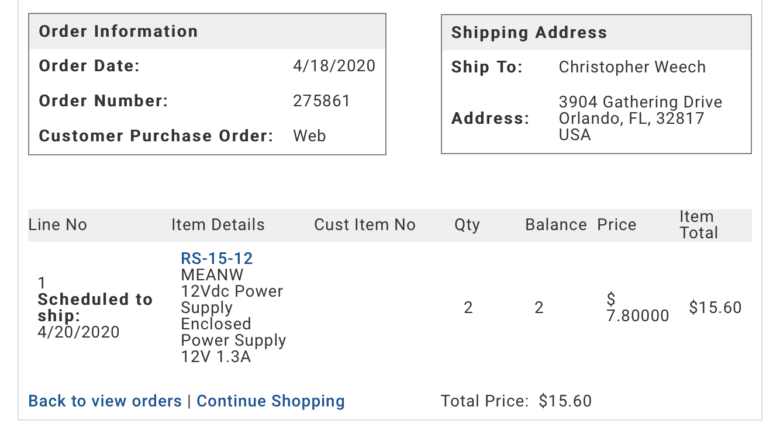
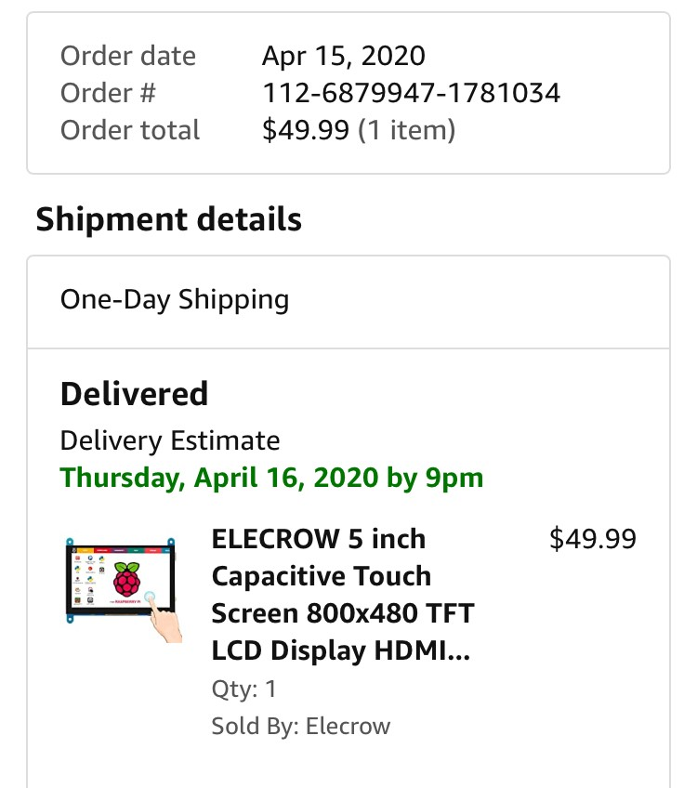
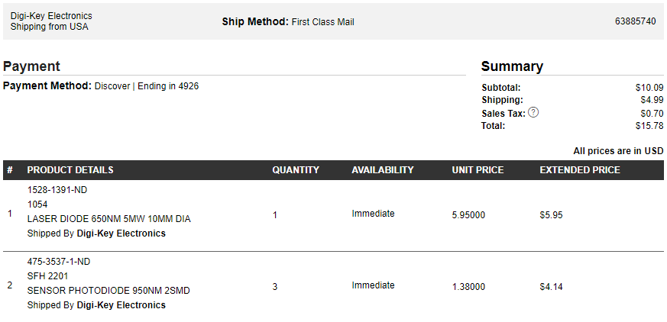

Appendix B – Parts Received and Built
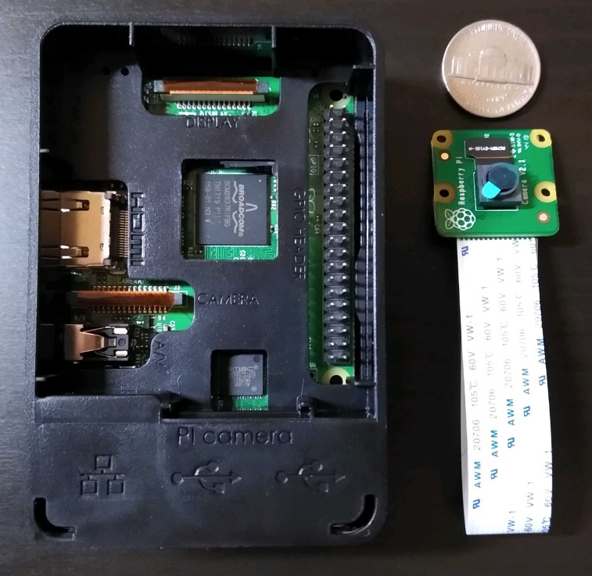
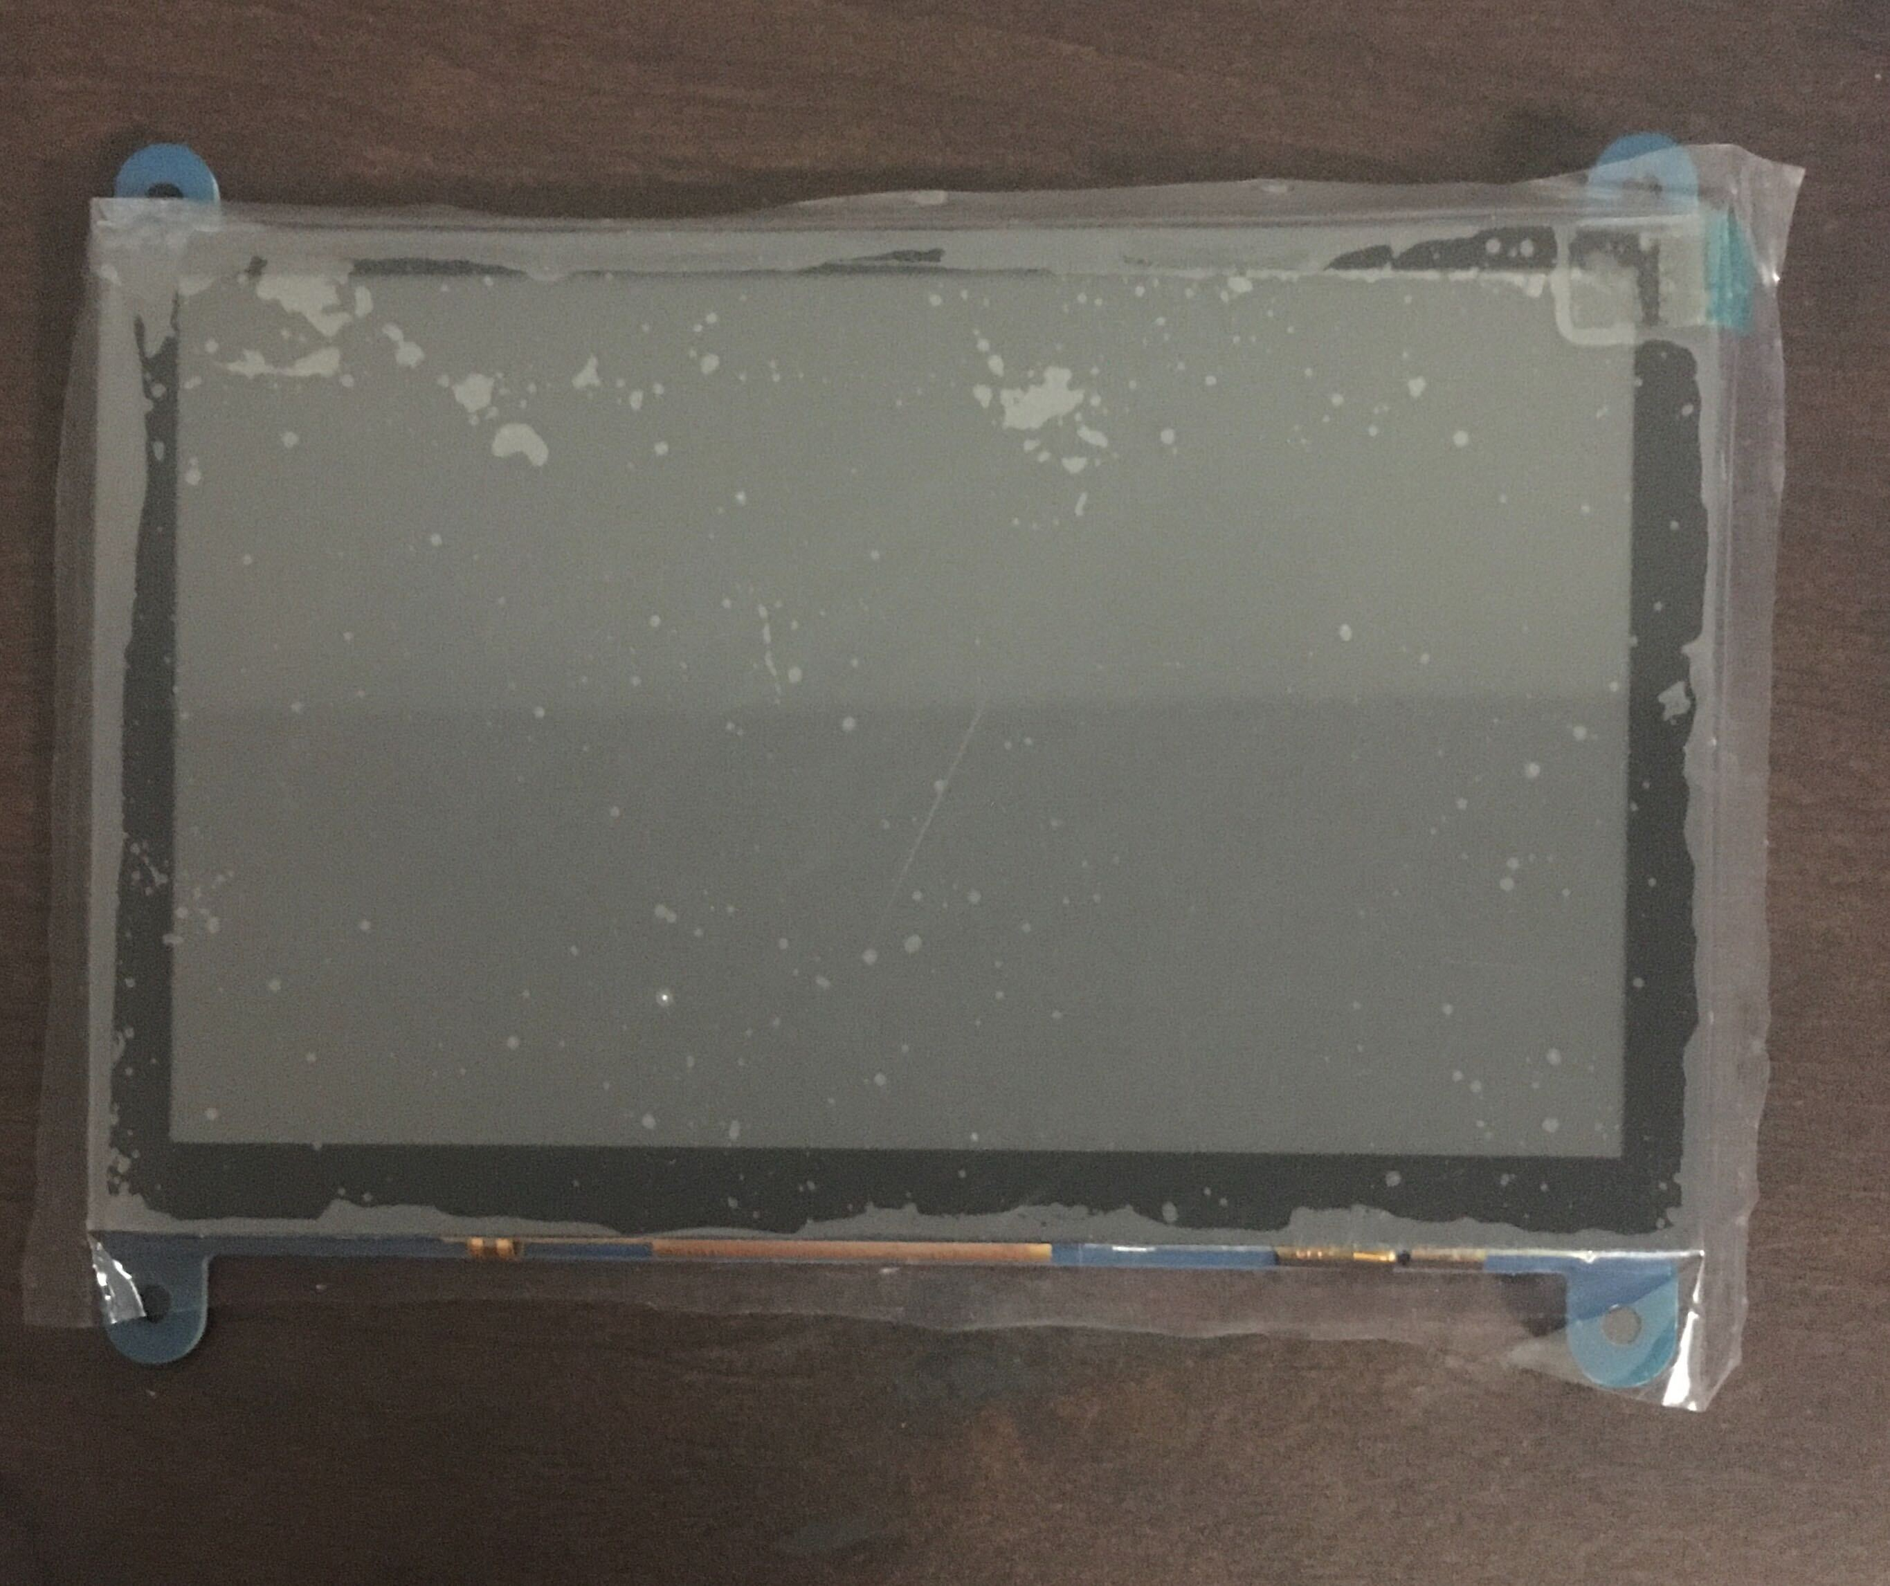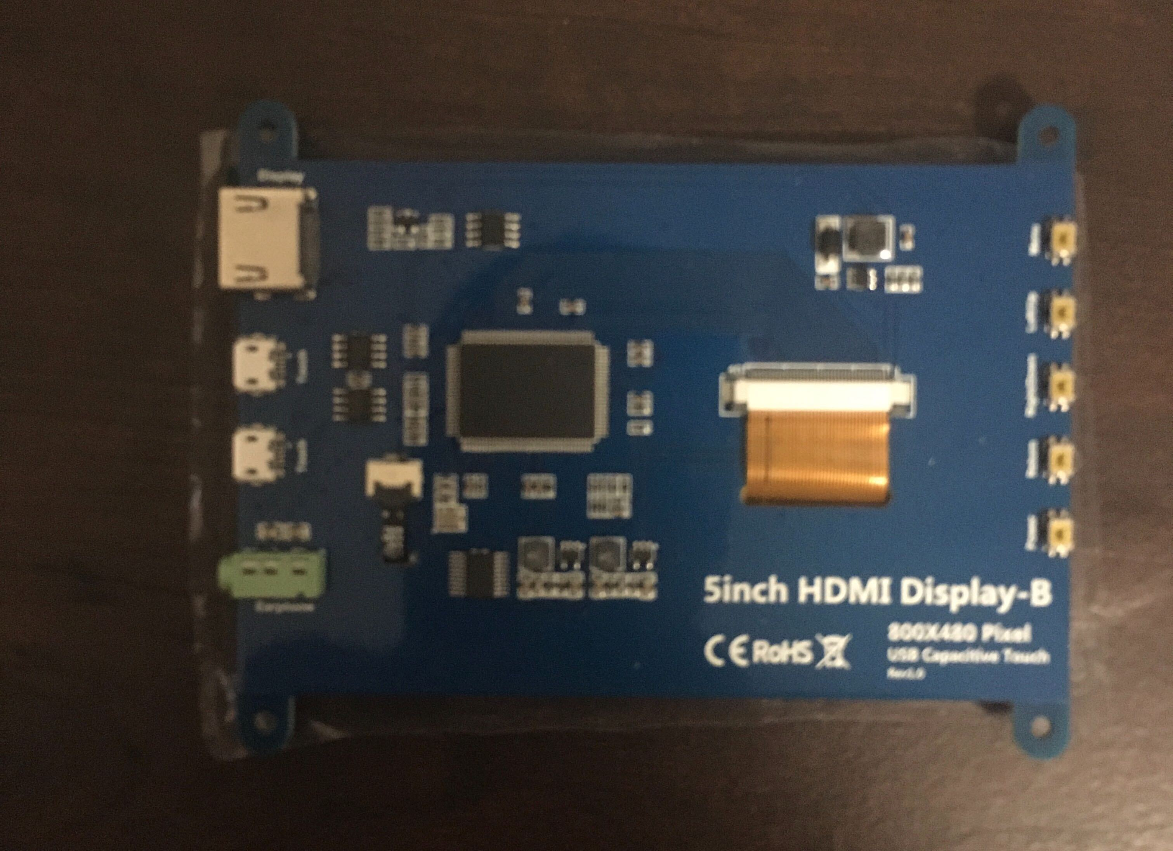

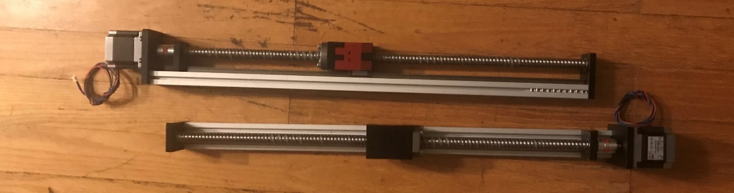
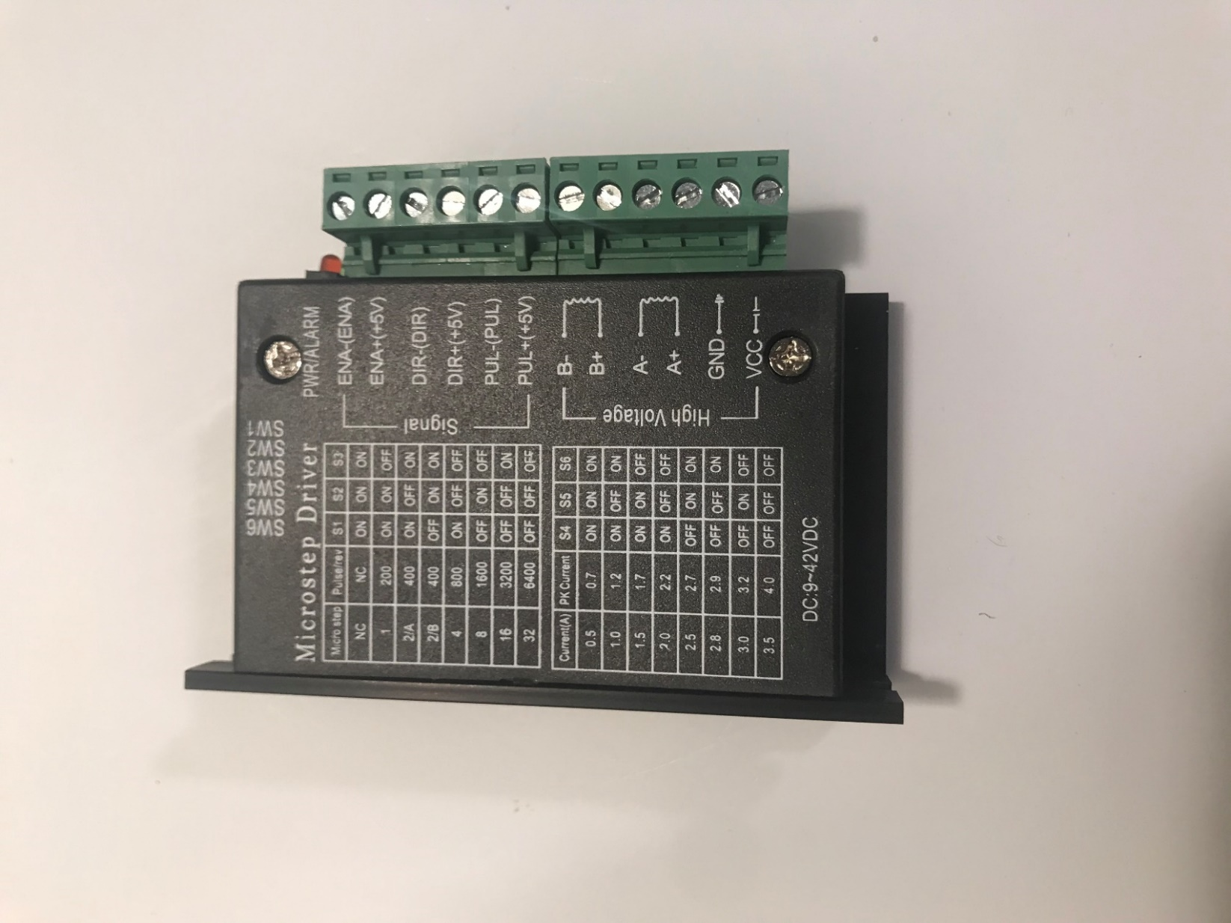
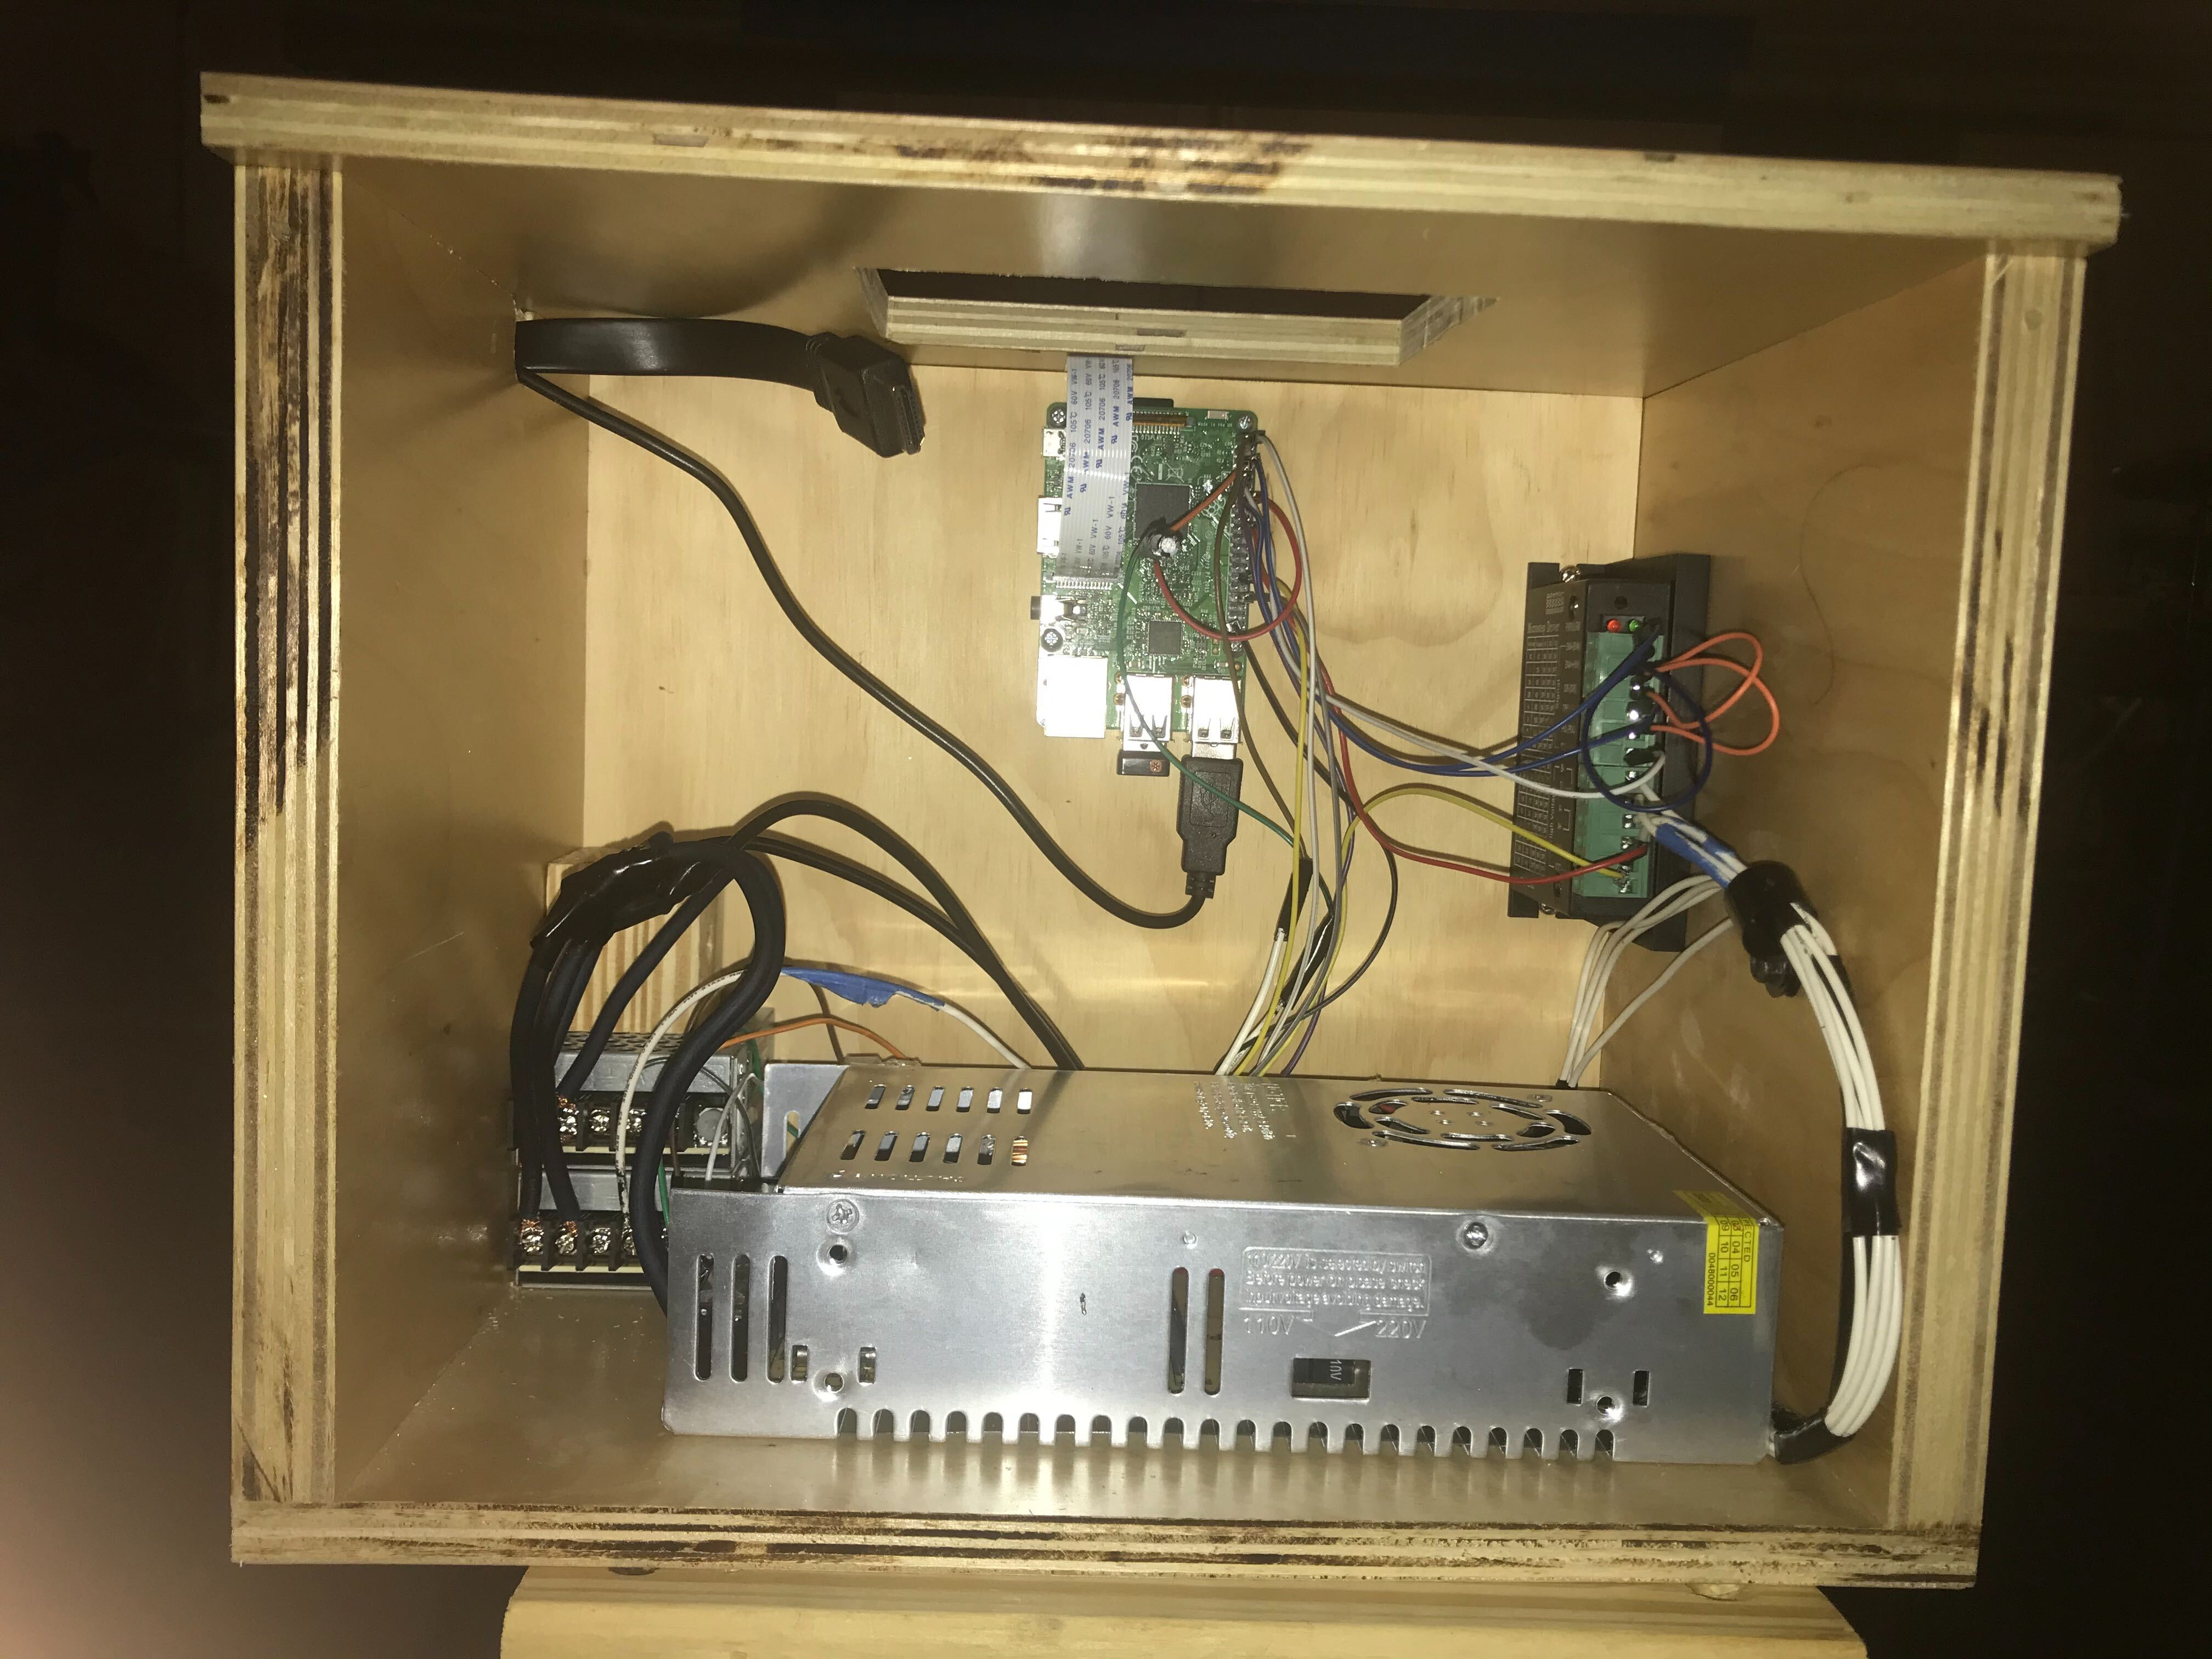

Appendix C – Works Cited
PCB standard. (n.d.). From IPC: https://www.ipc.org/
SpecTree Juggernaut. (n.d.). From Youtube: https://www.youtube.com/watch?v=sU9-0jq1jEI
ABPS: Automatic Bench Press Spotter. (n.d.). From citeseerx: http://citeseerx.ist.psu.edu/viewdoc/download?doi=10.1.1.621.6945&rep=rep1&type=pdf
Power Supply Standard. (n.d.). From CUI inc: https://www.cui.com/catalog/resource/power-supply-safety-standards-agencies-and-marks.pdf
Laser Driver. (n.d.). From Homemade-circuits: https://www.homemade-circuits.com/simple-laser-pointer-dc-current/
12V to 5V Converter. (n.d.). From Youtube: https://www.youtube.com/watch?v=8jzOirylcKg&t=202s MSP430. (n.d.). From Texas Instruments: http://www.ti.com/microcontrollers/msp430-ultra-low-power-mcus/overview.html
Linear Vs Switching Regulators. (n.d.). From Renesas: https://www.renesas.com/sg/en/products/power-management/linear-vs-switching-regulators.html
EasyEDA. (n.d.). From EasyEDA: https://easyeda.com/
Photodiode vs. Phototransister vs. Photoresistor: https://www.youtube.com/watch?v=DNAgJrnj4EM&t=385s
Serial vs Parallel Interface: https://www.newhavendisplay.com/app_notes/parallel-serial.pdf
Touchscreens: https://www.explainthatstuff.com/touchscreens.html
HUSKYLENS Specifications: https://www.kickstarter.com/projects/1371216747/huskylens-an-ai-camera-click-learn-and-play
DigiKey Display Specifications: https://www.digikey.com/products/en?mpart=8997466&v=1690
CrystalFontz Display Specification: https://www.crystalfontz.com/product/cfaf800480e0050sn-5-800x480-tft-display?kw=&origin=pla&gclid=EAIaIQobChMIgtiWjoul6AIVCIeGCh3KuQDnEAQYASABEgIGI_D_BwE
LCD vs LED Display Specifications: https://www.digikey.com/catalog/en/partgroup/tm3500/54675
OpenCV: https://en.wikipedia.org/wiki/BSD_licenses
Software Testing: https://www.iso.org/obp/ui/#iso:std:iso-iec-ieee:29119:-5:ed-1:v1:en
Language Standard: https://www.iso.org/standard/68564.html
Camera Connection Standard: https://mipi.org/specifications/csi-2

