Senior Design Group 4
Daniel Sypioe - CPE
Manuel Correa - PSE
Andrea Styles - CPE
Tim Walsh - EE

Photonic EWI Saxophone
Last Edit: 29th January 2021

STATEMENT OF MOTIVATION
The purpose of this project is to utilize our skills in Photonics, Computer, and Electrical Engineering to create an alternative to the electronic wind instrument using an input system of optics and photonics as the primary mechanism for sound as opposed to the standard electronic input.

GOALS
- Midi
  - Interface via MIDI (Musical Instrument Digital Interface: industry standard of circuitry for electronic musical instruments established between companies or manufacturers. Midi devices, regardless of brand, allow a user to communicate multiple signals to exchange information. The data transferred through midi signals include notes/pitches, voice program changes, volume control, and other data related to the device being used.)
  - Junction between two or more different signals. The common connection used today is between midi in/out and usb.
  - Midi Filters - Function with the continuous controller that enables or disables control change, program change and aftertouch
  - Midi In/Out/Thru - Connections used between devices via a 5 pin din cable and/or MIDI USB interface that allow for proper communication if using multiple units at once
  - Continuous Controllers/Control Change (CC) - General midi function that allows a user to connect devices to a specific channel. Used prominently between the EWI, MIDI USB foot controller, and volume expression pedal.
    - Breath controller
    - Foot Controller
    - Expression
    - Volume
    - Total of 95 CC channels to select based on what is being used within the specific sound hardware or software
- Key Sensitivity is operated by contacts on the instrument (unlike a traditional woodwind instrument that operates on an open/close tone.
- Mouthpiece allows user to utilize the vibrato, pitch bend, and modulation technique
- Additional functions
  - Hold Key - function on the ewi that allows a user to sustain a selected pitch while playing other notes above or below it. Also known as a sustain key
  - Voice Program Changes
    - Performance combination - Most commonly a custom voice patch (sound patch) that is programmed using multiple instruments and/or voices at once
    - Program Change - to switch to another voice within a sound bank currently programmed into a tone generator. This operation can either be executed using the program change key and/or the physical tone generator itself
  - Lip Controls
    - Lip Data - function to allow users to choose between vibrato or modulation in response to action of the mouthpiece
    - Lip Data Range - toggle switch used to set limits to the overall range of the pitch bends or modulations from narrow to wide
    - Lip Gain - setting that configures sensitivity to the players lip based on its response to the embouchure
    - Lip Pressure - overall range which a pitch can be bent up or down with use of the embouchure
    - Lip Zero - Used to adjust and center the pitch based on the natural embouchure position
  - Transposition
    - Transposition - Setting used on tone generators and certain EWI models that allows a player to set a device to a specific key: either C, Bb, Eb, F, or other transposing instruments
    - Range of 8 octaves
    - Setup button - Speed function that permits the arrangements of octave key transposition, sustained pitches, pitch bend/modulation, and wind gain sensitivity. This key is held while pressing the proper octave keys to compute any of the specific functions.

  - Pitch Bend/modulation keys
    - Modulation - alteration of the MIDI sound by its frequency in response to the action performed with the embouchure or the pitch bend/modulation wheel. When modulation is used, vibrato and other sonorities will vary based on the sound patch parameters.
    - Pitch Bend/Modulation Wheel - Spring loaded key that allows users to alter a pitch up and down depending on the selected sound patch or settings configured on the device.
- Tone generator/computer to receive the signals and produce the desired sounds
  - Tone Generator- Synthesizer that receives the signals from a EWI or other compatible instruments. Communication between devices is enabled through MIDI. A tone generator contains storage for a variety of voice/instrumental sounds, performance sound. Additional features include transposition, volume, acoustics, and master tuning. Some devices allow a user to create custom voice/instrumental and performance combinations. Tone generators can come in hardware/software versions.
  - Reverb - sound simulating the acoustics of a specific room or space through electronic settings. Many tone generators contain configurations that allow a specific sound patch to simulate performance in, for instance, a cathedral or small closet.
  - Semitone trill key - aux key for the purpose of trilling to pitch a half step higher when the key is pressed
  - Sound Bank - refers to the accompanying list of sounds that are located within one section of a tone generator
- Casing to hold internal components
- Desktop application to handle file upload
  - Application will be installed locally
  - Device can be connected to a computer via cable
  - Application will import recording files and save them to the computer’s memory
  - Additional goal (time permitting): Web based interface to upload and store recordings
    - Same function as desktop application, but with the option to store recordings in the cloud
    - Recordings will be saved under a user account

FUNCTIONS
The “system” refers to the entire instrument, including casing and internal components.
- The system will convert an optical input to produce a sound.
- The system will read user input to start and stop notes.
- The system can be played portably.
- The system can be charged.
- The system output can be transmitted through to earphones or through a handheld device.
- The system can generate a recording that can be uploaded to a computer.
- The system’s volume can be altered either with user input or a control knob.
- The system will implement a control setting to change the timbre of a pitch.

SPECIFICATIONS
- The system must weigh no more than 10 lbs.
- The system must perform for a period of 1 at least one hour.
- The system should be able to output at a volume of at least 30 db.
- The system must have a response time of no more than 1 second.
- The combined system must not exceed a cost of $750.

CONSTRAINTS
- Time: Project is limited to 2 semesters
- Budget
Battery | $30
Microphone/Audio Sensor | $5
Controller | $30
Laser Diode | $400 ($20 each, 20 total)
Speaker | $30
Various Circuit Components (BJTs, OP amps, Buck Converter, ect) | $40
Instrument Casing | $100
Total Cost | $665

STANDARDS
- MIDI
- AUX
- Bluetooth
- USB

MILESTONES

Finalize General Design | Group 4 | 2/5/2021 - 4/1/2021 | In Progress
Part Selection | Group 4 | 2/12/2021 - 4/1/2021 | In Progress
Input Design | Tim, Manuel | 2/12/2021 - 4/1/2021 | Researching
Power Delivery Design | Tim, Manuel | 2/12/2021 - 4/1/2021 | Researching
Laser Switch Input Design | Manuel | 2/12/2021 - 4/1/2021 | Researching
Microcontroller Programming | Daniel, Andrea | 2/12/2021 - 4/1/2021 | Researching
Speaker/Preamp Design | Tim | 2/12/2021 - 4/1/2021 | Researching
PCB Design | Tim | TBD
Order Parts | Group 4 | TBD | N/A
Assembly and Testing | Group 4 | TBD | Implementation
Finalization | Group 4 | TBD | Implementation
Project Presentation | Group 4 | TBD

Work Distribution Block Diagram

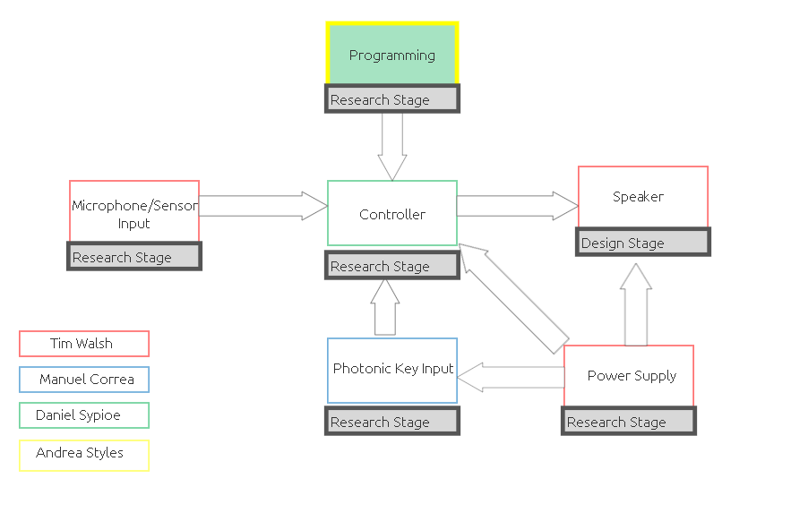

PHOTONIC KEY INPUT SUBSYSTEM
The design for the photonic input subsystem will depend on the playing mechanism of the desired design. So far there are three variations of the mechanism: a valve input, a hole input, and a slide input.

Valve Input
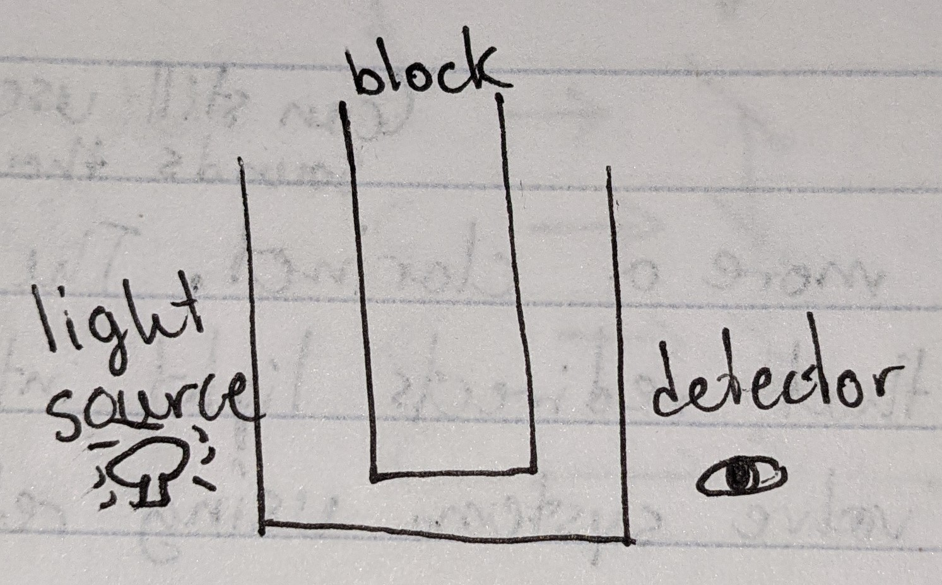
Hole Input
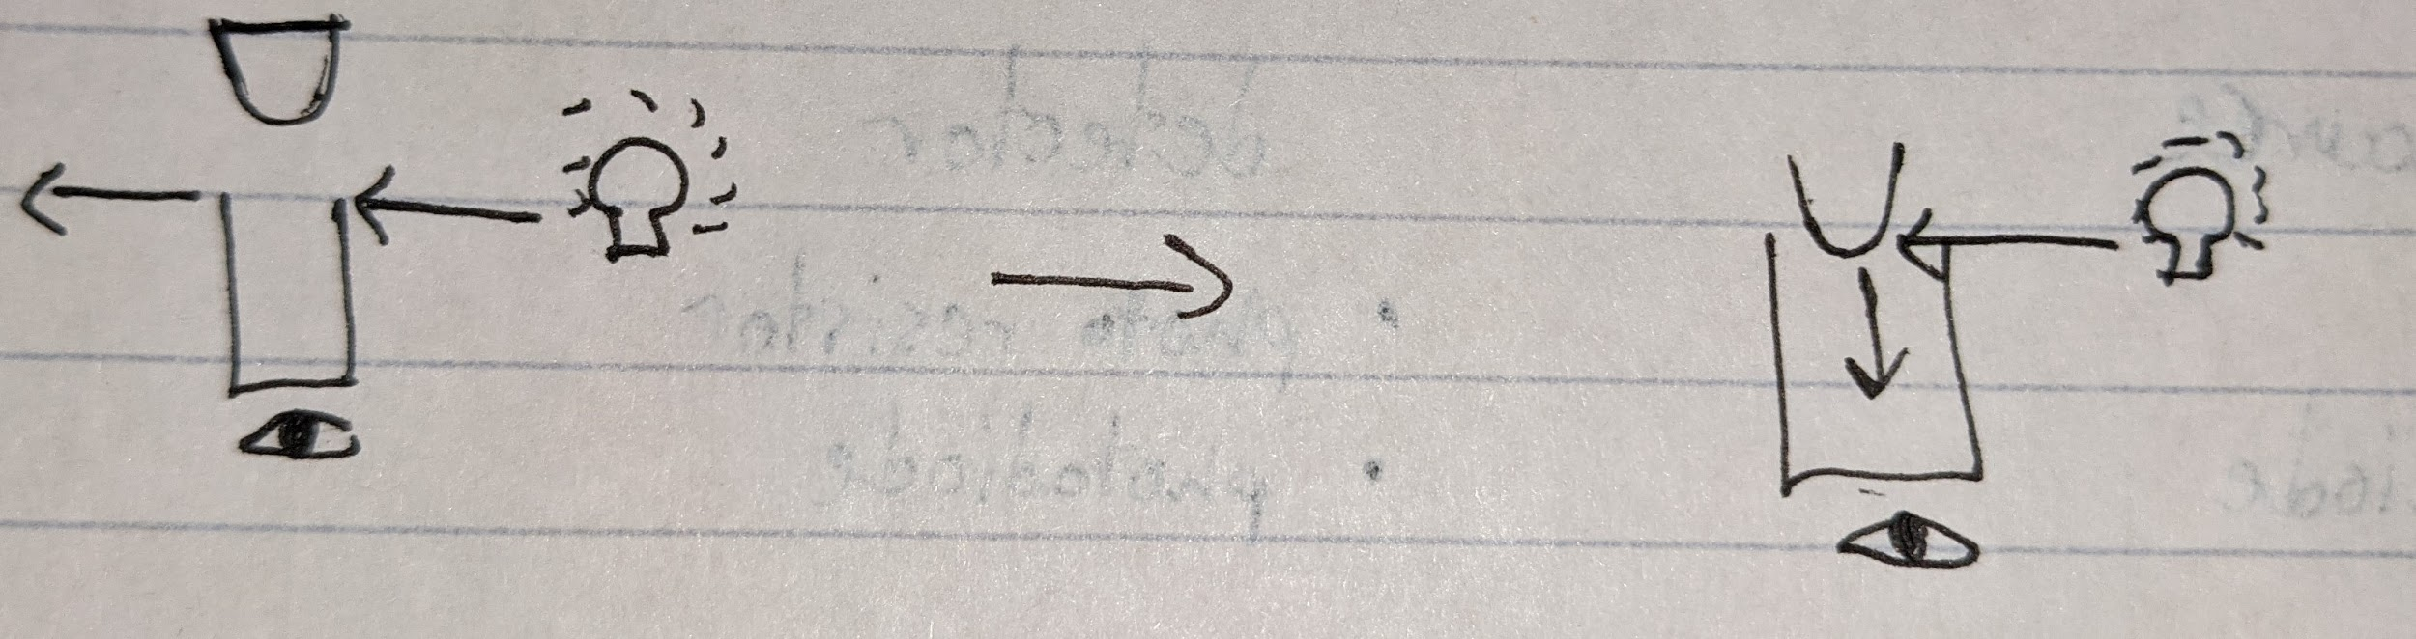
Slide Input
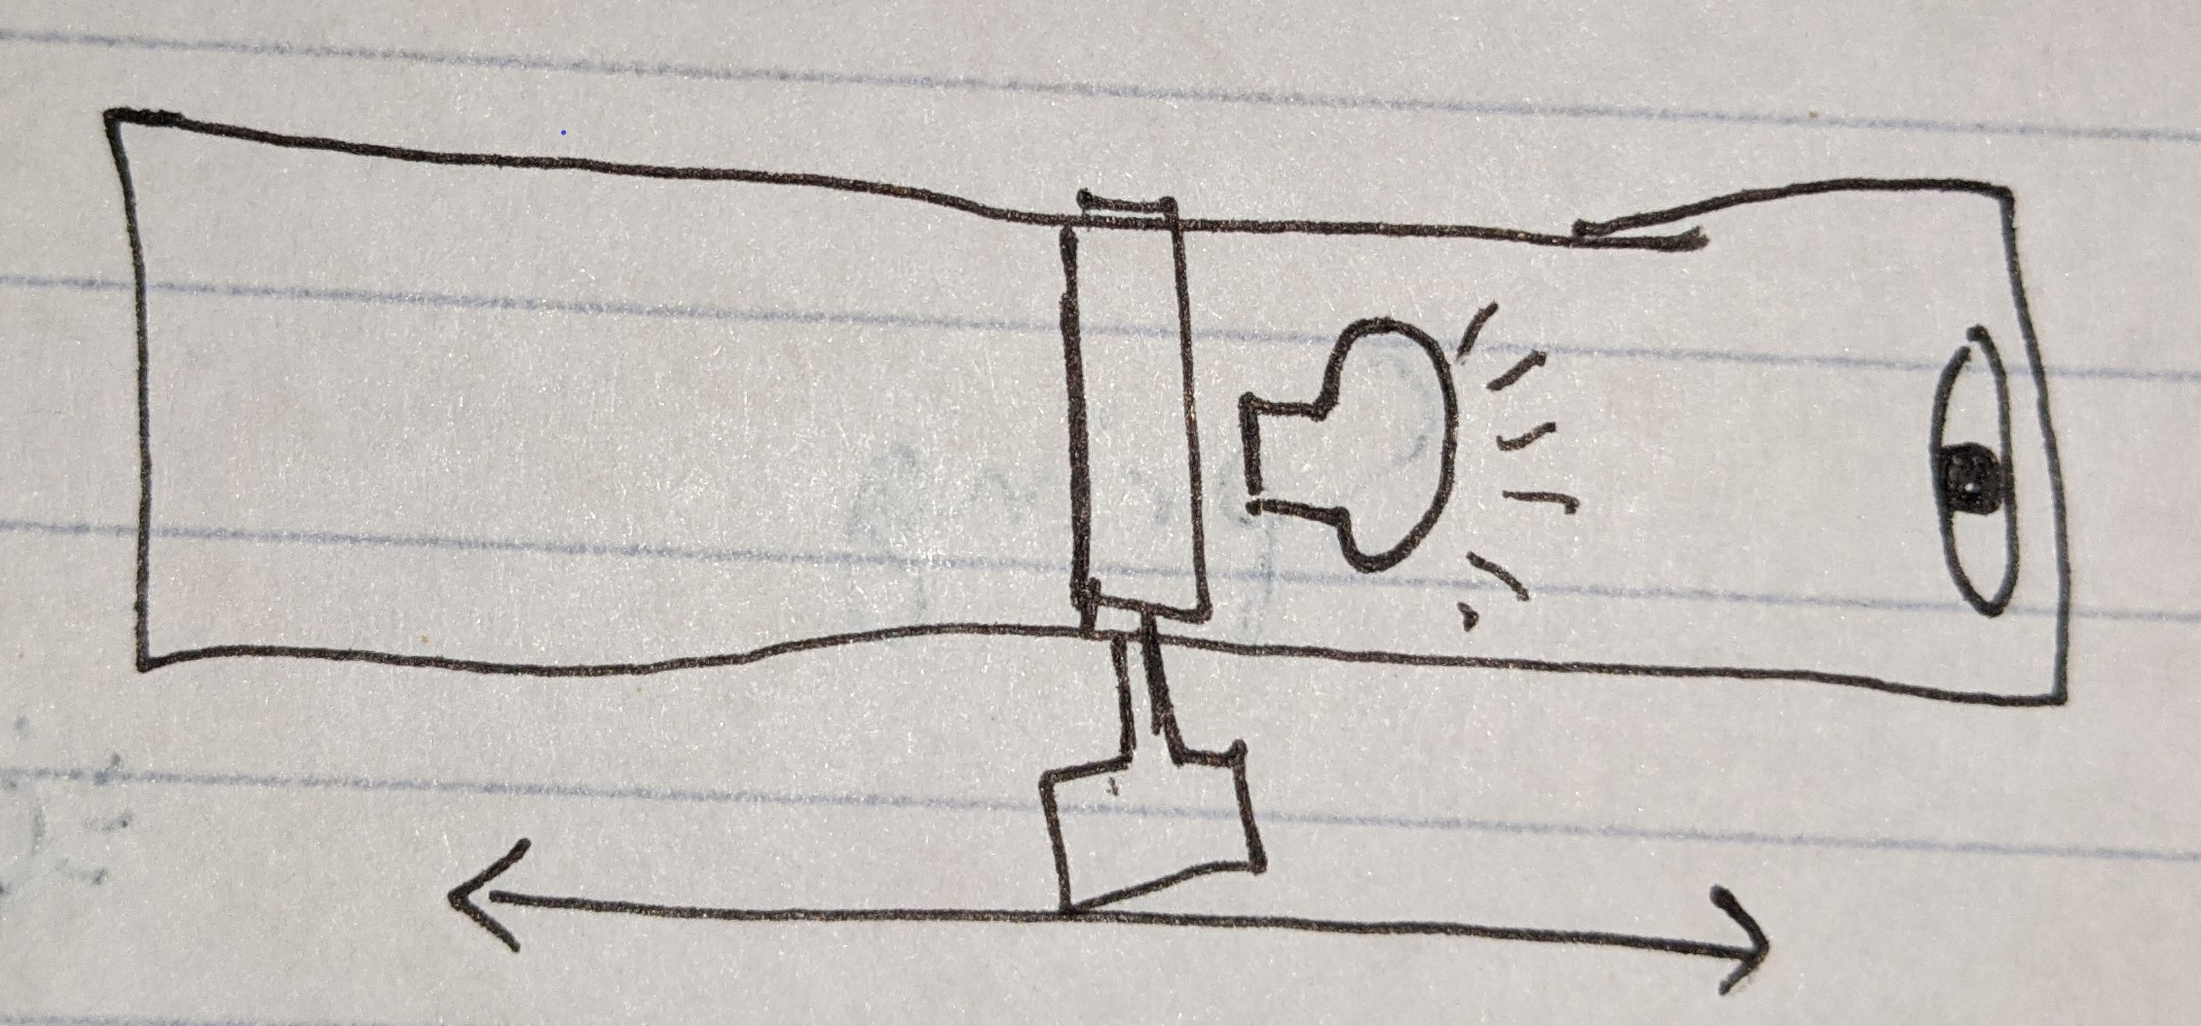

Device Local App - Software UML Diagram
The device is projected to save up to 20 three minute recording sessions. As the recordings are saved locally to the device in the midi and .wav formats, metadata about the recording will be saved alongside the sound input. Once the device is connected to a PC, a program with a GUI that is locally installed will be able to perform various functions related to music editing. The option to save the edited recording locally to the PC will be presented and the user will then have the ability to perform actions on other recordings saved to the device. If time permits more functions will be added to the local program as well as a web based interface.
