Optoelectronic Saxophone
Manuel Correa
Andrea Styles
Tim Walsh
University of Central Florida

Table of Contents
Table of Contents 2
Abstract 1
Photonic Subsystem for an Electronic Wind Instrument (EWI) 2
Executive Summary 2
Statement of Motivation 2
Sound Bank 4
Octave Key 4
Tone Generator 4
Proximity Sensor Mouthpiece 4
Volume Knob 5
Resemble an Alto Saxophone’s Playing Capabilities 5
Standards 7
General MIDI 7
TRRS Auxiliary Connector 10
Constraints 11
Project Milestones 12
Bill of Materials 13
Equipment Used 14
Siglent SDS 1104X-E 100MHz Digital Storage Oscilloscope 14
LG Function Generator FG -8002 15
Alto Saxophone 16
TackLife MDC01 DC Power Supply 17
Hardware Used 18
Arduino Mega 2560 Microcontroller 18
Samsung 2500mAh 18560 Lithium - Ion Batteries (Single Cell) 25
TDA7052 25
Power Delivery PCB 27
Photodetectors 29
Laser Diodes 31
LM317 Voltage Regulator 34
UA741 Operational Amplifier 35
Audio Signal Conditioning 37
Electronic Wind Instrument Body and Control Box 40
Input System 40
Mouthpiece 40
Proximity Sensor - CNY70 40
Control Box 41
Software Used 44
Arduino Integrated Development Environment (IDE) 44
MultiSim Live 44
House of Quality Diagram 56
Figure 28: House of Quality 56
Functional Block Diagram 57
Method 58
Participants 58
Assessments and Measures 58
Alto Saxophone Emulation 60
Photonic Key Input Subsystem 63
Control Box Concept 73
Stage 1 - Laser Diode Driver Circuit 73
Stage 2 - Photodiode Detector Circuit 76
Full Photonic Subsystem (Stages 1+2) 78
Figure 49: Photonic subsystem demonstration from SD1 78
Stage 3 - Upper/Lower PVC Input Mechanism Assembly 79
Stage 4 - Mouthpiece Assembly 81
Stage 5 - Volume Knob Assembly 82
Stage 6 - Arduino Decoding and Encoding 83
Stage 7 - Speaker Assembly 84
Stage 8 - Samsung 18650 Portable Battery Integration 84
Stage 9 - Control Box Assembly 84
Discussion 89
Licensure and Copyright 97
GPIO Zero: Copyright 97
Audio-To-Midi: MIT License 99
SoundFile Library: BSD 3 Clause 100
Mido MIDI Library: MIT License 102
Arduino: General Public License 104
References 105

Abstract
Practicing and playing a traditional wind instrument is quite noisy, so it is very difficult for players to practice their craft when they live in close proximity to others. With this in mind, there is an obvious demand for a quieter approach to practicing wind instruments while still maintaining the same feel and technique. A good solution to this problem is an electronic wind instrument, which would let you play the instrument you love to play, but with full control of the volume. Electronic Wind Instruments are a niche subset of musical instruments, developed by only a few companies such as YAMAHA and AKAI. With this project we hope to create a blocking based photonic subsystem that can be utilized within a wind instrument’s main chamber. Our approach is to create a 3D-printed based electronic wind instrument with a center control box that houses the necessary electronics of the circuit. This includes the microcontroller unit for registering photonic inputs and an embedded system to detect state changes in the microcontroller and play the triggered notes and recreated mechanisms of the saxophone.The spring enabled valve system will feature a small printed housing with a straight optical axis and has the laser diode driver circuit affixed to one end of the main system and the photodiode detector circuit affixed to the other end. A key cap with a spring is inserted atop the small housing to act as a stopper for the light.
Keywords: Electronic Wind Instrument, Photonic Engineering, Electrical Engineering, Computer Engineering

Executive Summary

Statement of Motivation
The purpose of this project is motivated by the desire to express oneself without imposing themselves onto others. Oftentimes new players become discouraged to continue to press on with music as people around them simply refer to their practice as “noise”. This feeling is exacerbated even more with the current pandemic of COVID-19, as most people are confined indoors with restrictions on leaving their houses. Most have come to rely on the tranquility the home brings to cope with these uncertain times, and experiencing any external “noise” threatens the safety they have created. This design aims to create a compromise between the musician and the surrounding public, allowing one to learn and play with no restraint while maintaining the sanctity of a peaceful living situation. The function of the saxophone will remain the same (as it is a musical instrument), but it will build upon the existing technology of the electronic wind instrument as well as incorporate a photonic input system as opposed to the current electrical standards.

Functional Goals and Specifications
The “system” refers to the entire electronic wind instrument, including the casing and housing of the instrument as well as its internal components.
- The system will convert an optical input to a readable signal that when passed through a microcontroller and embedded system will produce a desired sound effect.
- The system will be able to read user input via the spring based blocking system in order to start and stop playing a desired note.
- The system will be able to be played portably within two hands of the user and weigh no more than 10 pounds.
- The system will be able to transmit sound through the onboard speakers of the device or via an audio system that utilizes the 3.5mm male audio terminal.
- The system’s volume can be altered via user input on a control knob.
- The system must be able to perform for a period of at least one hour
- The system must have a response time of no more than 0.5 seconds.
- The system must not exceed 6 inches in width.
- The system must not exceed 2 feet in length.
- The combined system must not exceed a cost of $750.
In order to be considered an electronic wind instrument certain aspects of the instrument must be functionally similar to the actual instrument. Listed below are functions within the electronic wind instrument that we hope to achieve and accomplish throughout the entirety of this project.

Sound Bank
Within the sound bank will be a set of songs that the user will be able to play along to. The main song that we hope to be achieved is Hot Cross Buns on the spring loaded blocking system. Other songs of similar difficulty will be preloaded into the embedded system so then the user is able to practice and get accustomed to the fingering of the spring loaded blocking system.

Octave Key
On the back side of the electronic wind instrument will have an additional octave key using the same mechanisms as the other keys. It will be able to perform the same function as the octave key on a saxophone which enables the same note to be played at a whole musical scale higher.

Tone Generator
Synthesizer that receives the signals from an EWI or other compatible instruments. The selectable tones will be recordings of the alto saxophone and of the LG Function Generator FG-8002.

Proximity Sensor Mouthpiece
The pressure sensor attached to the mouthpiece of the alto saxophone will be able to be mounted and registered when a user's embouchure has been placed on the mouthpiece and signal for sound to come out of the instrument's speaker system as the user plays the instrument with their fingers.
One aspect of the pressure sensor mouthpiece is that the actual electronic component must be waterproof. This is because while the user plays a horn instrument, saliva from the mouth builds up and then enters the instrument. With a waterproof resistive pressure sensor as well as a physical internal design to block incoming liquids, the internal electronics will not be compromised.
Another subtle difficulty to this system is that having no keys pressed is equivalent to another note on the saxophone. This means that if the system was solely reliant on whether the keys were pressed or not, it would lack the completeness of the range of the instrument. This pressure sensor will act as a primary trigger that decides when a note shall be sustained, whereas the key system will decide which note will be played.

Volume Knob
In order to change the volume of the instrument, a volume knob will be added to the control box. The volume knob will consist of a potentiometer voltage divider circuit that is connected to one of the Arduino’s analog pins which will read and write via serial communications to the Raspberry Pi embedded system.

Resemble an Alto Saxophone’s Playing Capabilities
The common alto saxophone is able to play notes C#3 to F5 on the musical scale and with some specialty made alto saxophones, it is able to play up to the note A5. For this project we will be selecting the notes on the G major, C major, A major, and D major as well as achieve the goal of playing the beginner’s song “Hot Cross Buns” to show that the device can be played as a musical instrument, as this will cover the control both tonality and rhythm .In order to play these 4 scales, the electronic wind instrument must be capable of playing the notes: G, G# A, B, high C, low C, D, E, and F#, and C# (open note). Table 1 below shows the notes of the Western scale and the frequencies that need to be generated in order to produce each note.

Note | Frequency (Hz) | Wavelength (cm) | Note | Frequency (Hz) | Wavelength (cm)
C#₃/D^{b}₃ | 138.59 | 248.93 | F#₄/G^{b}₄ | 369.99 | 93.24
D₃ | 146.83 | 234.96 | G₄ | 392.00 | 88.01
D#₃/E^{b}₃ | 155.56 | 221.77 | G#₄/A^{b}₄ | 415.30 | 83.07
E₃ | 164.81 | 209.33 | A₄ | 440.00 | 78.41
F₃ | 174.61 | 197.58 | A#₄/B^{b}₄ | 466.16 | 74.01
F#₃/G^{b}₃ | 185.00 | 186.49 | B₄ | 493.88 | 69.85
G₃ | 196.00 | 176.02 | C₅ | 523.25 | 65.93
G#₃/A^{b}₃ | 207.65 | 166.14 | C#₅/D^{b}₅ | 554.37 | 62.23
A₃ | 220.00 | 156.82 | D₅ | 587.33 | 58.74
A#₃/B^{b}₃ | 233.08 | 148.02 | D#₅/E^{b}₅ | 622.25 | 55.44
B₃ | 246.94 | 139.71 | E₅ | 659.25 | 52.33
C₄ | 261.63 | 131.87 | F₅ | 698.46 | 49.39
C#₄/D^{b}₄ | 277.18 | 124.47 | F#₅/G^{b}₅ | 739.99 | 46.62
D₄ | 293.66 | 117.48 | G₅ | 783.99 | 44.01
D#₄/E^{b}₄ | 311.13 | 110.89 | G#₅/A^{b}₅ | 830.61 | 41.54
E₄ | 329.63 | 104.66 | A₅ | 880.00 | 39.20
F₄ | 349.23 | 98.79
Table 1: Notes of the Western scale and their frequencies.

Standards

General MIDI
As the components we are using utilize MIDI to generate instrument sounds, the MIDI standard dictates how those components work. The Musical Instrument Digital Interface (MIDI) standard, created in 1983 and maintained by the MIDI Manufacturers Association (MMA), defines the hardware and communication protocols used by sound-based devices to interact with each other. MIDI devices generally have 16 channels, each with the ability to support an instrument sound and manage factors such as pitch and velocity independently of each other. MIDI connectors can transmit to all 16 channels using one cable by selecting the channel to receive an instruction within the instruction’s data. Devices communicate asynchronously using a common set of MIDI messages, each carrying the type of message and instruction values within byte-formatted data. The standard baud rate for MIDI communication is 31250 baud.
The General MIDI standard specifies additional features that a MIDI-compatible device should have. These requirements include being able to support polyphony of up to 24 sounds simultaneously, polyphony on each channel, and control for a set of controllers that includes channel pressure and pitch bend. General MIDI also ensures that programs - which decide the instrument to be played - of the same number produce the same instrument sound across devices. A standard list of 128 melodic tones and 47 percussion tones is the baseline for what a device’s tone bank must include. Table 2 below lists the instruments in the standard melodic tone bank and the program numbers to which they correspond.
1 | Acoustic Grand Piano | 33 | Acoustic Bass | 65 | Soprano Sax | 97 | FX 1 (rain)
2 | Bright Acoustic Piano | 34 | Electric Bass (finger) | 66 | Alto Sax | 98 | FX 2 (soundtrack)
3 | Electric Grand Piano | 35 | Electric Bass (pick) | 67 | Tenor Sax | 99 | FX 3 (crystal)
4 | Honky-tonk Piano | 36 | Fretless Bass | 68 | Baritone Sax | 100 | FX 4 (atmosphere)
5 | Electric Piano 1 | 37 | Slap Bass 1 | 69 | Oboe | 101 | FX 5 (brightness)
6 | Electric Piano 2 | 38 | Slap Bass 2 | 70 | English Horn | 102 | FX 6 (goblins)
7 | Harpsichord | 39 | Synth Bass 1 | 71 | Bassoon | 103 | FX 7 (echoes)
8 | Clavi | 40 | Synth Bass 2 | 72 | Clarinet | 104 | FX 8 (sci-fi)
9 | Celesta | 41 | Violin | 73 | Piccolo | 105 | Sitar
10 | Glockenspiel | 42 | Viola | 74 | Flute | 106 | Banjo
11 | Music Box | 43 | Cello | 75 | Recorder | 107 | Shamisen
12 | Vibraphone | 44 | Contrabass | 76 | Pan Flute | 108 | Koto
13 | Marimba | 45 | Tremolo Strings | 77 | Blown Bottle | 109 | Kalimba
14 | Xylophone | 46 | Pizzicato Strings | 78 | Shakuhachi | 110 | Bagpipe
15 | Tubular Bells | 47 | Orchestral Harp | 79 | Whistle | 111 | Fiddle
16 | Dulcimer | 48 | Timpani | 80 | Ocarina | 112 | Shanai
17 | Drawbar Organ | 49 | String Ensemble 1 | 81 | Lead 1 (square) | 113 | Tinkle Bell
18 | Percussive Organ | 50 | String Ensemble 2 | 82 | Lead 2 (sawtooth) | 114 | Agogo
19 | Rock Organ | 51 | SynthStrings 1 | 83 | Lead 3 (calliope) | 115 | Steel Drums
20 | Church Organ | 52 | SynthStrings 2 | 84 | Lead 4 (chiff) | 116 | Woodblock
21 | Reed Organ | 53 | Choir Aahs | 85 | Lead 5 (charang) | 117 | Taiko Drum
22 | Accordion | 54 | Voice Oohs | 86 | Lead 6 (voice) | 118 | Melodic Tom
23 | Harmonica | 55 | Synth Voice | 87 | Lead 7 (fifths) | 119 | Synth Drum
24 | Tango Accordion | 56 | Orchestra Hit | 88 | Lead 8 (bass + lead) | 120 | Reverse Cymbal
25 | Acoustic Guitar (nylon) | 57 | Trumpet | 89 | Pad 1 (new age) | 121 | Guitar Fret Noise
26 | Acoustic Guitar (steel) | 58 | Trombone | 90 | Pad 2 (warm) | 122 | Breath Noise
27 | Electric Guitar (jazz) | 59 | Tuba | 91 | Pad 3 (polysynth) | 123 | Seashore
28 | Electric Guitar (clean) | 60 | Muted Trumpet | 92 | Pad 4 (choir) | 124 | Bird Tweet
29 | Electric Guitar (muted) | 61 | French Horn | 93 | Pad 5 (bowed) | 125 | Telephone Ring
30 | Overdriven Guitar | 62 | Brass Section | 94 | Pad 6 (metallic) | 126 | Helicopter
31 | Distortion Guitar | 63 | SynthBrass 1 | 95 | Pad 7 (halo) | 127 | Applause
32 | Guitar harmonics | 64 | SynthBrass 2 | 96 | Pad 8 (sweep) | 128 | Gunshot
Table 2: Programs 1 - 128 of the General MIDI 1 melodic tone bank
The MIDI standard also defines how the traditional note scale corresponds to data values. Because the data message used to send note values is 1 byte, or 8 bits, the value of a note can range from 0 to 127. The Western chromatic scale is used, and middle C corresponds to the value 60. Increasing the note value by 1 corresponds to moving up a half-step in the scale, and decreasing the note value by 1 corresponds to moving down a half-step. Adding 12 to the note value corresponds to moving up an octave, and subtracting 12 from the note value corresponds to moving down an octave. Figure 1 below shows the full scale of notes and the values to which they correspond.
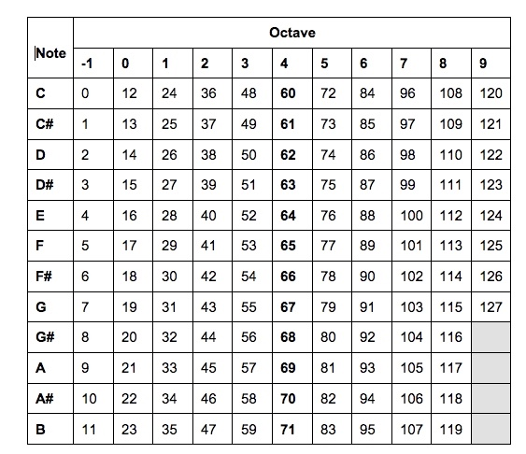
Figure 1: Western chromatic scale mapped to values 0 through 127

TRRS Auxiliary Connector
The auxiliary (AUX) connector used in this project is a 3.5 mm TRRS jack and port that is used commonly throughout the technology industry. TRRS stands for Tip-Ring-Ring-Sleeve, and describes the layout of the jack. The standard for the connector is defined by the CTIA to ensure compatibility between audio devices. As shown in Figure 2 below, the tip of the jack carries the left audio data, the first ring carries the right audio data, the second ring carries the ground voltage, and the sleeve carries the microphone data.
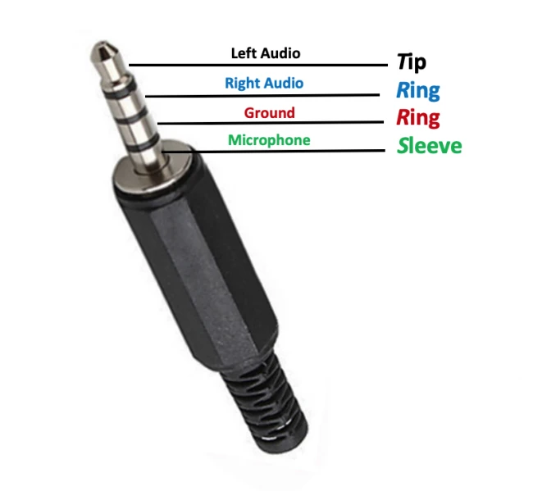
Figure 2: TRRS Auxiliary Jack diagram
The CTIA TRRS standard is used by most smartphone, speaker, and headphone manufacturers, so using this standard ensures that our project will be compatible with the widest possible array of audio devices.

Constraints
- Time: Our design must be feasibly manufacturable within the time frame that we have been allotted. The duration of the Senior Design II course during which we will be building our prototype is 12 weeks. We will have this time to gather our parts, schedule potential meeting times to work on hardware, develop code, and perform testing. It is important that the team organizes effectively to finish on time.
- Durability: The finished product must be able to withstand multiple uses without any failures or breakages. This includes potential stressors such as impacts from drops or movement, moisture from saliva entering the mouthpiece, and wear on the finger keys. The casing should be able to protect its contents from damage, and pieces that the user will interact with should be able to stand up to repetitive motions.
- Ease of use: The finished product should not be difficult to handle or interact with. It should not be too large or heavy to avoid being cumbersome, and the interface should be intuitive enough that a user can learn to use it without trouble.
- Safety: Our finished product will consist of electrical components that may pose a risk to the user if not properly implemented and integrated. All circuitry that the user does not need to interact with should be covered in order to protect the user. The product should also not be too heavy to avoid risk of injury.
- Cost: As budget is one of the most imminent constraints, it is important that the required parts cost as little as possible while still maintaining quality. The bill of materials shown below lists the components that we will need along with the price that the group has determined to be suitable.

Project Milestones
Finalize General Design | Group 4 | 2/5/2021 - 4/1/2021 | Finalizing
Part Selection | Group 4 | 2/12/2021 - 4/1/2021 | Finalizing
Input Design | Tim, Manuel | 2/12/2021 - 4/1/2021 | Finalizing
Power Delivery Design | Tim, Manuel | 2/12/2021 - 4/1/2021 | Finalizing
Laser Switch Input Proof of Concept | Manuel | 2/12/2021 - 4/1/2021 | Finalizing
Photoresistor Detector Proof of Concept | Manuel | 4/12/2021 - 4/19/2021 | Finalizing
Speaker/Preamp Design | Tim | 2/12/2021 - 4/1/2021 | Finalizing
Final Draft Due | Group 4 | 4/26/2021 | Finalizing
PCB Design | Tim | 5/01/2021 - 7/01/2021 | Finalizing
Order Parts | Group 4 | 4/26/2021 - 6/1/2021 | Finalizing
Microcontroller Programming | Andrea | 5/20/2021 - 7/26/2021 | Finalizing
Assembly and Testing | Group 4 | 7/1/2021 - 7/26/2021 | Finalizing
Final Testing | Group 4 | 7/26/2021 | Finalizing
Project Presentation | Group 4 | 7/28/2021 | Finalizing

Bill of Materials
Component Type | Projected Component | Budget | Unit Price
Battery | Samsung 2500mAh 18650 Lithium Ion battery x2 (wired in parallel for a nominal voltage of 3.3-4.2V and a maximum current of 40A) | $30 | $4.99/ea. - Amazon  $9.98 total
Microcontrollers and Embedded Systems | Arduino Mega  SparkFun Musical Instrument Shield  Arduino Stackable Header Kit | $60 | Arduino Mega- $40.30 - Arduino  Instrument Shield- $34.95 - SparkFun  Header kit- $1.50 - SparkFun  $76.75 total
Laser Diodes | OP310 850 nm laser diodes | $150 | $15.56/ea. - Mouser  $155.60 total
Speaker | Jameco Valuepro TQ-100F-R Speaker Square Ferrite 4" 8 Ohm 5W 800Hz-10kHz Paper 97 dB | $30 | $11.99 - Amazon
Proximity Sensor | CNY70 | $15 | $6.99 - Arrow
Photodiode (Photonics Demo) | Inolux INL-5APD80 | $10 | $0.78/ea - Mouser  $7.80 total
PCBs | Manufactured by JLCPCB | $100 | $5/ea - JLCPCB  $25 total
Instrument Casing | Screws and bonding | $20 | Free
Total Cost |  | $415 | $294.11

Equipment Used

Siglent SDS 1104X-E 100MHz Digital Storage Oscilloscope
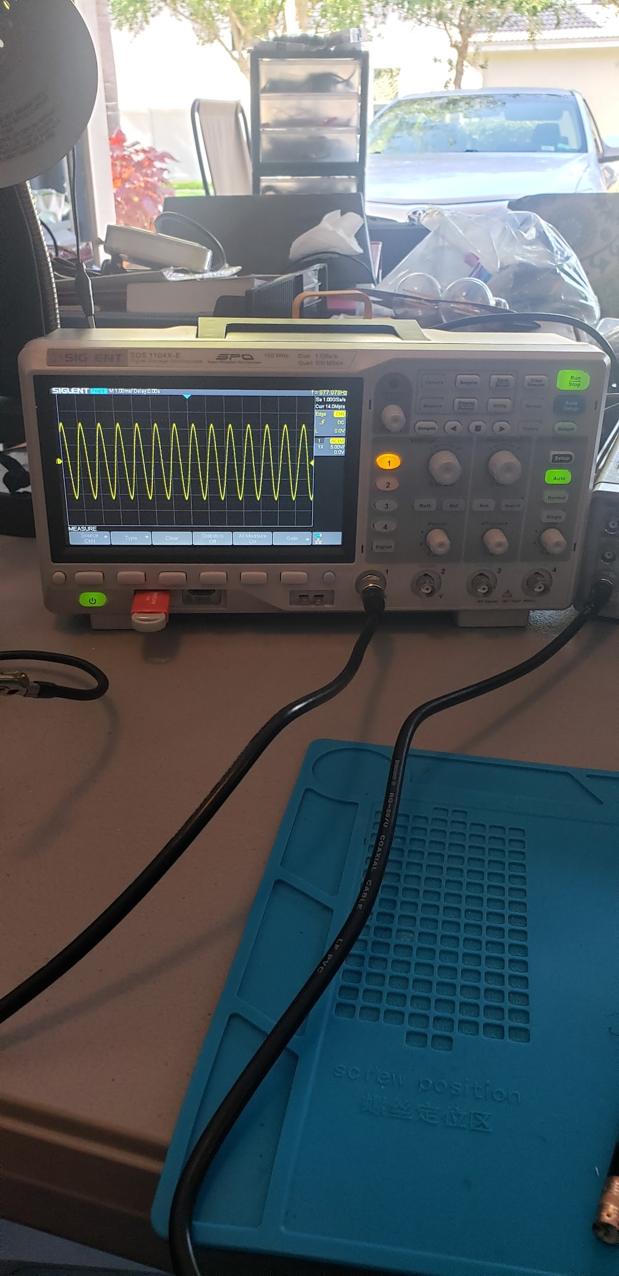

LG Function Generator FG -8002
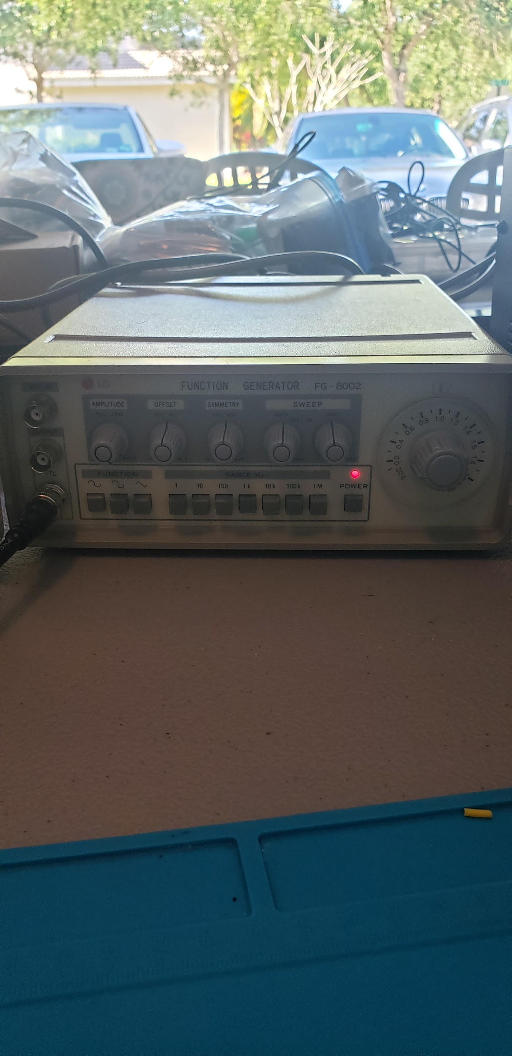

Alto Saxophone
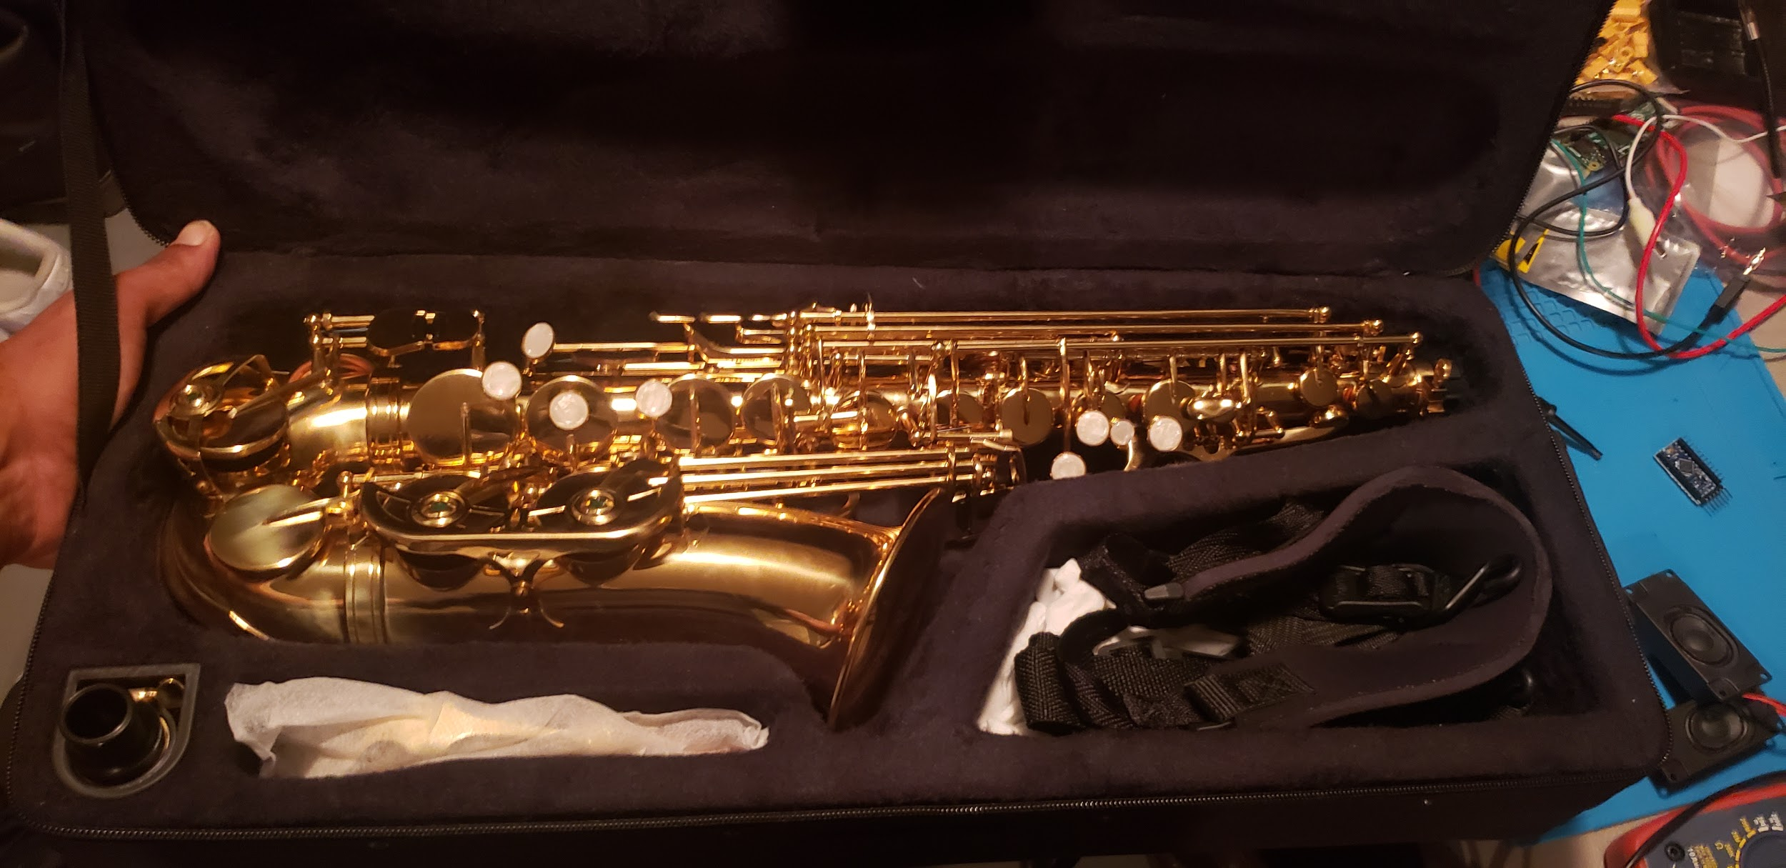

TackLife MDC01 DC Power Supply
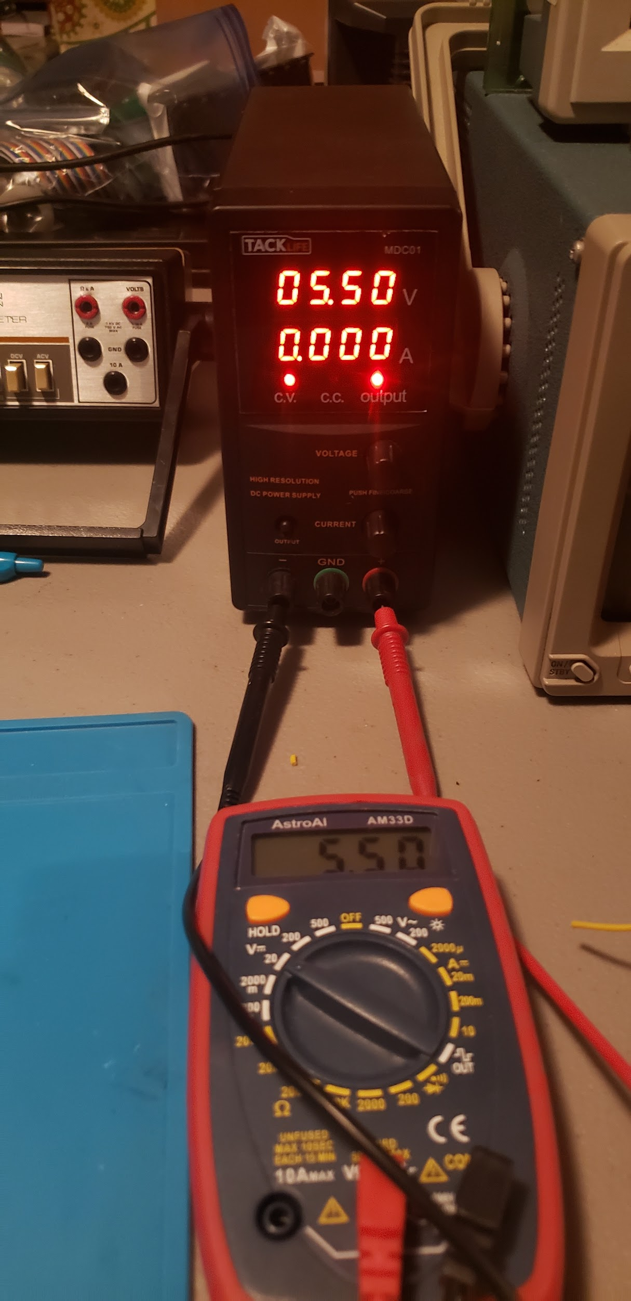
Output Voltage: 0-30V DC
Output Current: 0-5A DC

Hardware Used
Custom PCB Manufacturing
Our project will require a fair amount of circuitry and we are confined to the small cylindrical space inside of a saxophone. With this in mind, we chose to divide our needed circuitry into smaller separate PCBs to allow more freedom in terms of placement of the PCBs within the device. The simpler circuit design’s PCBs were etched by ourselves using copper plates on laminate substrates using Ferric Chloride and laser printing transfer for the traces. The more complex circuitry was produced for us by JLCPCB. JLCPCB is a Chinese based manufacturer that offers some of the cheapest rates on the market; however, the turnaround on these boards was around one month which was a bit of an issue. In retrospect, we should have utilized a domestic manufacturer with a higher cost but faster turnaround to allow us more time for testing.

Arduino Mega 2560 Microcontroller
Because of its high number of available pins and high clock rate, the central processor of the system was chosen to be the Arduino Mega 2560. The board runs on an Atmega 2560 single-chip microprocessor, which is based on the AVR RISC architecture. The 8-bit processor runs on an internal 16 MHz clock and features 256 KB of flash memory, 8 KB of static RAM, and 4 KB of EEPROM. The board has 54 digital input/output pins, 16 analog input pins, and 4 serial ports, as shown in Figure 3 below.
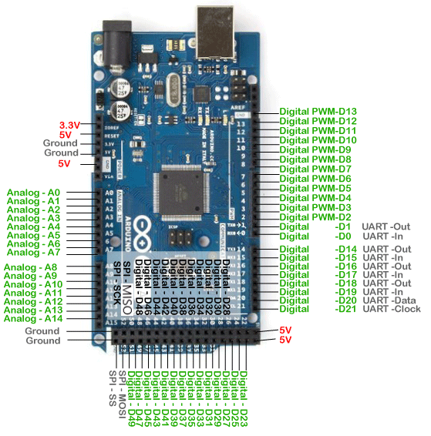
Figure 3: Arduino Mega 2560 pin layout
The chip has an operating voltage of 5 V. Power can be supplied either through the Vin pin or through the USB B port used to program the chip. When using the USB B port, power can be drawn either from a computer or from a battery supply through a USB B to USB A cable. The board also has the capability to use its internal voltage to supply power to the rest of the system. The pin layout includes five ground pins, three 5 V supply pins, and one 3.3 V supply pin. The system’s PCBs and auxiliary components are all powered using these pins. For the purposes of processing the input from the system’s sensors, the board’s UART and ADC units are used.

Universal Synchronous and Asynchronous Receiver/Transmitter
Onboard the Arduino are 4 Universal Synchronous/Asynchronous Receiver/Transmitter (USART) units. Each unit can run in normal asynchronous, double speed asynchronous, master synchronous, or slave synchronous clock mode, allowing operation with or without a clock, as well as in SPI mode if needed. In asynchronous mode, the clock is used to generate the baud rate by clocking a down-counter. The counter starts at a specified value, based on the desired baud rate and the clock frequency, and each time the counter reaches 0, a clock output is generated. The USART provides built-in support for a serial connection on digital pins 0 (RX) and 1 (TX) on the Arduino Mega board. The unit sends data as frames consisting of a start bit, between 5 and 9 data bits, either 1 or no parity bits, and 1 or 2 stop bits. Figure 4 below shows the format of a USART frame, with bits in brackets being optional.
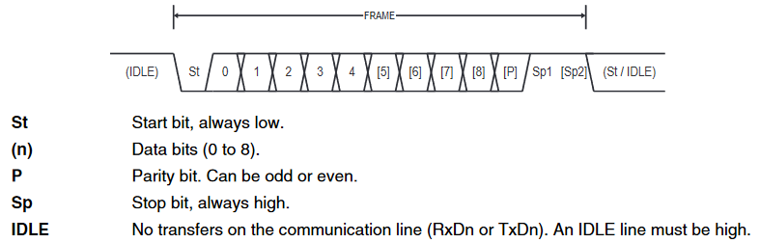
Figure 4: USART data frame format
Frames are loaded into the transmit buffer either when the register is detected as being empty, or when a transmission is completed. The frame is then transmitted one bit at a time, beginning with the start bit, then proceeding from the least significant bit of the data to the most significant bit. Any included parity bits are sent next, followed by the stop bits. The data is also received at the other end one bit at a time. When a start bit is detected, the receiver samples each subsequent data bit at the specified baud rate and stores them in the receive shift register. When the first stop bit is detected, the contents of the shift register are moved into the receive buffer, where they can be read and utilized. For the purposes of this project, a software library is used to replicate the function of the USART in normal asynchronous mode, allowing a serial connection to be established over digital pins 2 and 3, instead of pins 0 and 1.
Analog-to-Digital Converter
The Arduino Mega 2560 comes with a 16-channel, 10-bit precision Analog-to-Digital (ADC) unit. This unit reads an input voltage value from each of the 16 analog input pins (A0:15) as well as the AREF pin. The analog inputs are converted to 10-bit digital values by the process of successive approximation, giving results between 0 and 1023. A sample-and-hold circuit ensures that the input to the ADC is constant during the conversion.
The conversion begins with the most significant bit in the 10-bit approximation register being set and the rest being cleared. The digital value of the entire register is then sent to a digital-to-analog converter (DAC) in order to obtain the analog voltage corresponding to that value. The voltage on the AREF pin is used as a reference voltage along with ground to convert the digital values to a voltage between 0 and the voltage of AREF. After the voltage is obtained, it is compared to the analog input. If the input is greater than the generated voltage, the current bit remains set. Otherwise, it is cleared. The value of the previous bit is left unchanged when the approximation proceeds to the next bit, resulting in a series of levels to which the input voltage is compared. Figure 5 below shows a simple example of the conversion process.
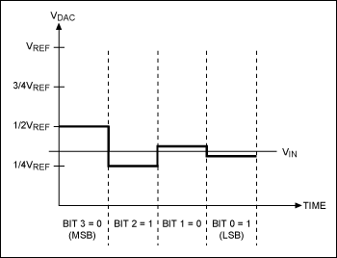
Figure 5: Simple example of successive approximation
A typical conversion takes between 13 and 14 clock cycles, and the typical sample-and-hold time for a conversion is between 1.5 and 2.5 clock cycles. Using the Atmega 2560’s 16 MHz clock and a prescaler of 128, the ADC operates at a generated clock rate of 125 KHz, within the required range of 50 to 200 KHz. This results in a conversion taking between 116 and 132 microseconds.

SparkFun Musical Instrument Shield
The SparkFun Musical Instrument shield acts as the system’s MIDI synthesizer and tone storage device. The board runs on a VLSI VS1053b Ogg Vorbis/MP3/AAC/WMA/MIDI decoder, which contains a digital signal processor core, VS_DSP, and 16 KB of instruction memory. Header pins are soldered into the pin holes of the shield and used to connect it to the header pins of the Arduino. The shield’s power is drawn from one of the Arduino’s 5 V pins. There are 2 reset pins, one for the reset button located on the board, which connects to the Arduino’s power reset pin and performs a hardware reset when pressed, and one for MIDI reset, which connects to digital pin 4 on the Arduino. Before the shield can operate as a MIDI device, the latter reset pin must be written digital low then high to perform a software reset. Though serial communication is supported through digital pins 0 (RX) and 1 (TX) on the Arduino, the instrument shield receives MIDI signals through digital pin 3, requiring the use of the SoftwareSerial library to simulate the function of the USART through pins 2 (TX) and 3 (RX). Because the shield does not transmit data, pin 2 is used as a dummy pin. Figure 6 below shows the layout of the shield and its pins.
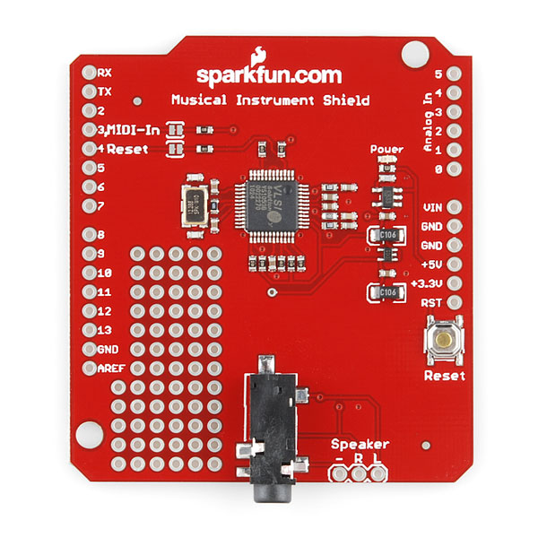
Figure 6: SparkFun Musical Instrument Shield layout
The board also features a 3.5 mm AUX port, into which any compatible speaker or headphone set can be connected, and pins for directly connecting the left and right channel cables of a speaker. This is what gives the system its ability to use either a built-in speaker or allow the user to connect an audio output device of their choosing. Instead of having to store the desired MIDI tones on a separate device, the instrument shield comes with a built-in melodic tone bank that complies with the General MIDI 1 standard and a percussion tone bank that complies with the General MIDI 2 standard. The maximum MIDI polyphony that the shield can maintain is 64, which also complies with the General MIDI standard.

Samsung 2500mAh 18560 Lithium - Ion Batteries (Single Cell)
The device battery system will be powered by two Samsung 2500mAh 18650 batteries due to the high power delivery capabilities, small cylindrical form factor, widespread availability and use within common hobbyist/professional settings. Samsung 2500mAh 18650’s are the primary battery type when powering laptops as the cells are wired in 4s2p which means 4 in series and 2 in parallel. This boosts the nominal voltage to about 12v and maximum current to 40A, which the laptop then converts to standard computing voltages. Alongside consumer products such as laptops and portable devices, their robust lithium ion chemistry also makes them the ideal power source for production electric vehicles such as the Nissan Leaf and all Models of Tesla (prior to their release of the newest cylindrical lithium ion battery). In our design, we will use 218650s in parallel to increase the operational discharge current and increase the battery life. Since these batteries operate at a voltage of approximately 3.7-4.2V, we will need to step up the voltage for use in both the Arduino and the laser diodes.

TDA7052
For the audio output, the TDA7052 was used which is an low power audio amplifier integrated circuit with fixed gain. The TDA7052 operates on a 5V supply signal and can drive an 8 ohm speaker at 1 Watt completely on its own with no need for any other components (although capacitors to filter any noise from the power supply and audio signal lines were used as shown in Figure 7). To adjust the volume of the output, a potentiometer was placed between the audio signal input on the board to the input pin on the TDA7052 which will adjust the amplitude of the audio signal going into the TDA7052. Therefore, adjusting the knob on the potentiometer will lower or raise the audio level. The finalized PCB design can be seen in Figure 8.
The speaker chosen was an 8 ohm magnetic speaker that is fairly sensitive to best match the signal from the TDA7052 since the gain isn't necessarily very high compared to other audio amplifier configurations.
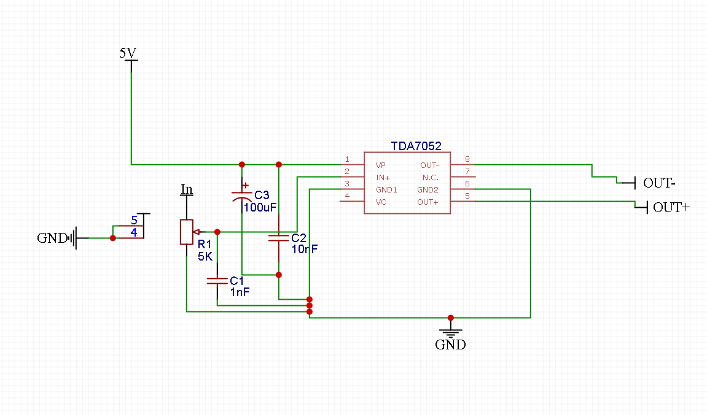
Figure 7: TDA7052 Circuit
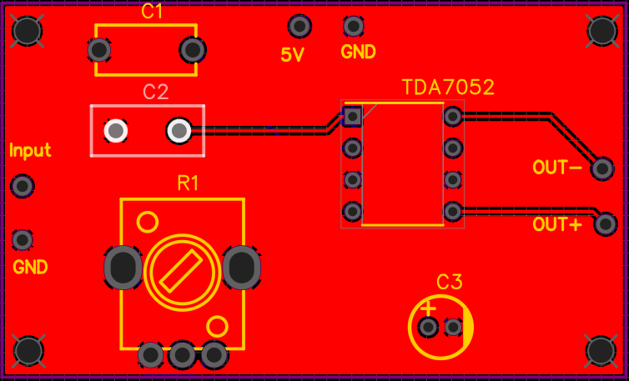
Figure 8: TDA7052 PCB Layout

Power Delivery PCB
The Arduino Mega which is powering our device and majority of our components requires a 5V input. To achieve this we will power the device with 18650s using a board with a TPS6109 and a MCP73871. The TPS is a 5V boost regulator used to boost the 3.7V of the batteries to 5V with 92% efficiency. The MCP is an IC that allows for passthrough charging of the batteries, which means the device can be used and powered via microUSB while the batteries are charging. Both of these ICs do not have much freedom in terms of how they are implemented; therefore, we simply used the configurations (which can be seen in Figure 9) given to us in each of their respective data sheets.
This approach was chosen since using 9V batteries aren’t as common anymore in devices to the end-user but would have worked just as well as the 18650’s with the same device usage. The 18650s chosen are rated at 3500mAH and the device draws between 500mA-900mA depending on usage (500mA idle not in sleep mode and 900mA at peak current draw); therefore, the device has about a 3-5 hour battery life at max charge. The finalized PCB design for this component can be seen in Figure 10.
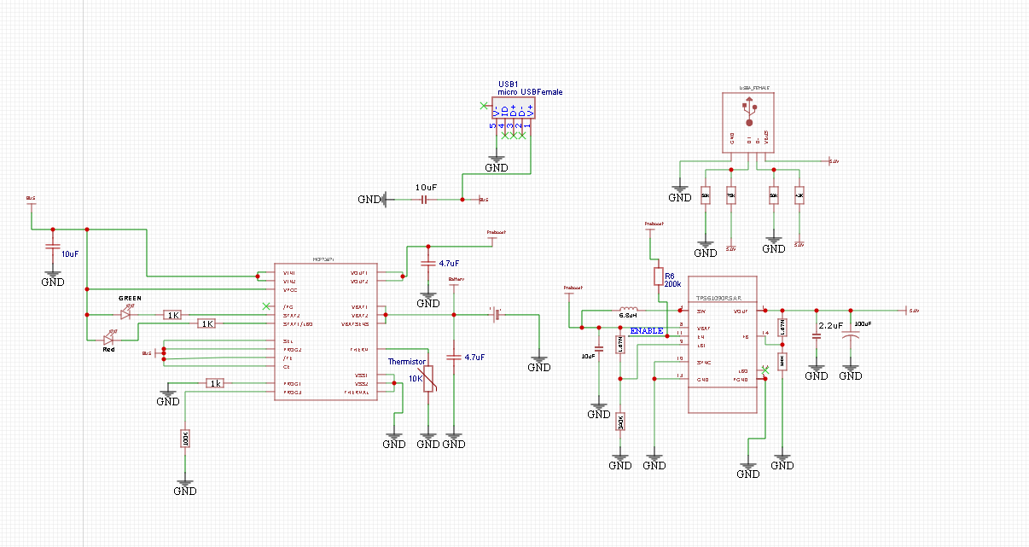
Figure 9: Boost and Charging Circuit
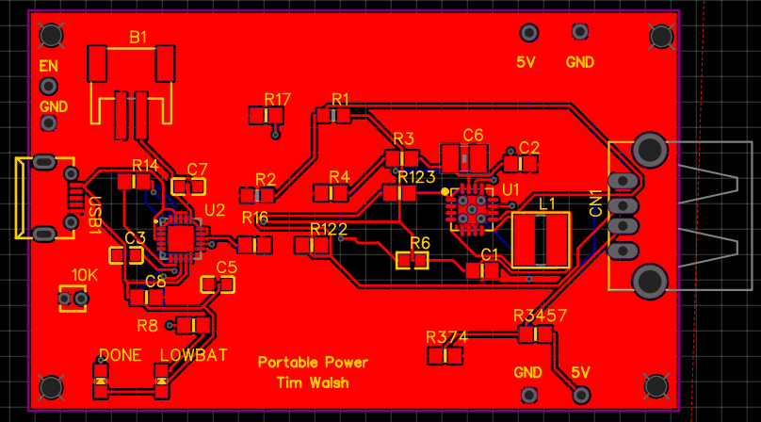
Figure 10: Boost and Charging PCB layout

Photodetectors
Initially the detectors used were the GL5539 light-dependent resistors. These components change resistance depending on the amount of light shone on its surface. They were used in the photonics demonstration along with the WOWOONE red dot laser diodes, which will be covered in the next section.
Photoresistors can either be intrinsic or extrinsic. For intrinsic devices, photons may fall on it to excite electrons from the valence band to the conduction band, creating more free electrons that are able to carry current, inherently lowering its resistance. These are undoped substances - pure compounds without any externally added impurities - such as silicon or germanium. Extrinsic photoresistors, however, contain dopants that create a new energy band above the existing valence band. This allows the electrons to require less energy to make the transition into the conduction band thanks to the smaller energy gap. This makes the device have different sensitivity levels depending on the wavelength of the light. Cadmium sulfide falls under the category of extrinsic devices. Regardless, both types of photoresistors will decrease in resistance with higher illumination.
Light-dependent resistors lack a P-N junction like true semiconductor devices despite being nonlinear. Thus if the light intensity remains constant, there may still be variations in the resistance due to thermal effects, making them sensitive to both light and heat. There is also a time latency between changes in the light intensity and the subsequent changes in resistance. This is known as the resistance recovery rate. It takes a few to a few tens of milliseconds for the resistance to drop when light is applied in complete darkness as well as for the resistance to rise after the removal of said light. Due to this, they are not entirely optimal for high amounts of back and forth fluctuations of light. However, these numbers are still considerably below the average response time for humans, which is about 250 milliseconds.
The benefits to using them were mainly centered around cost. In fact, one of our members had around 30 GL5539s at his disposal, along with the multiple others of the same GL55 line; therefore, all the hassle in ordering and waiting for components was skipped over. However, these photoresistors posed some problems that did not become apparent until later.
The first was that these resistors contained Cadmium Sulfide, a toxic and even carcinogenic substance. There are certain restrictions for objects containing this and other harmful substances. We are more specifically referring to the European Union Directive RoHS, which stands for Restriction of Hazardous Substances. The original directive was implemented in 2002 and has since had addendums in 2011 and 2015, expanding the list of restricted compounds. The very first material is, in fact, Cadmium.
The second issue was that for the sake of a more responsive system, we felt some concern over the resistance recovery rate property of the photoresistors. Having any substantial delay between inputs, especially for more rapid and technical pieces may instead deny the user from playing to their full potential, thus hindering the overall intended performance of the system.
For these reasons we have chosen photodiodes for the instrument - the INL-5APD80 by Inolux. These have a much faster response time than the photoresistors as well as more control over the current passing through the device. Most importantly though, their composition has zero connection to any of the harmful substances stated in the RoHS directive. An image of the photodiode with a size reference can be seen below in Figure 11.
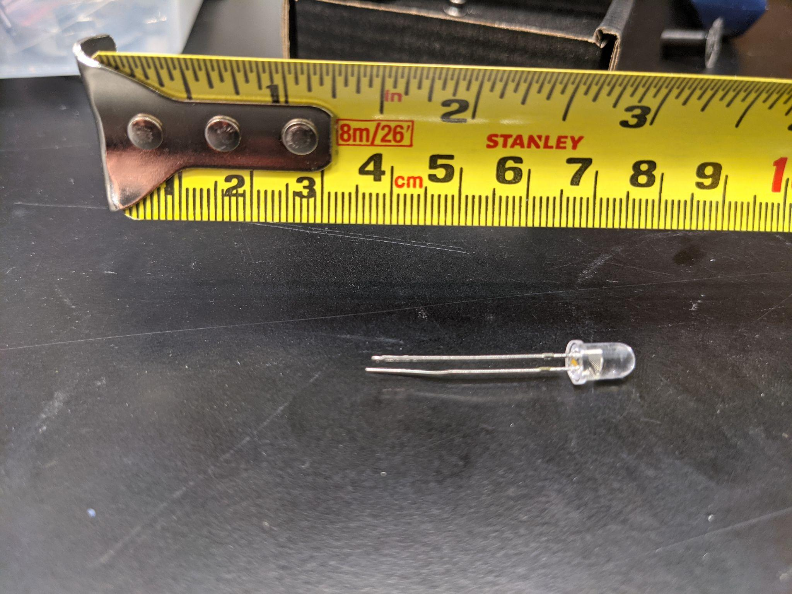
Figure 11 . Image of one of the purchased photodiodes with a measuring tape above to give reference to its size.

Laser Diodes
In order to design and build the proof of concept for the photonic subsystem demo, WOWOONE 5mW 650nm red dot laser diodes are to be used. Typical applications of this type of laser diode include laser pointers and hobbyist projects that are compatible with controllers such as the Arduino and Raspberry Pi. More sophisticated and robust semiconductor laser diodes have the capability to function within spectroscopes, laser monitoring systems, and other high power applications; however, the 5mW laser will be used as it is within allowable safety levels for commercial use and therefore not harmful to the end user. The operating voltage of the laser diode is 5V and the operating current must remain under 20mA in order to remain operational without the diodes burning. However, as they are laser diodes, they must not fall below their threshold current as they will not lase and behave closer to an LED. An example of a current diagram of a laser diode is shown in Figure 12. Unfortunately the threshold current was not defined in the specifications of our laser diode, so we will take special care to keep the current at or near, but not above, the maximum operating current of 20mA.

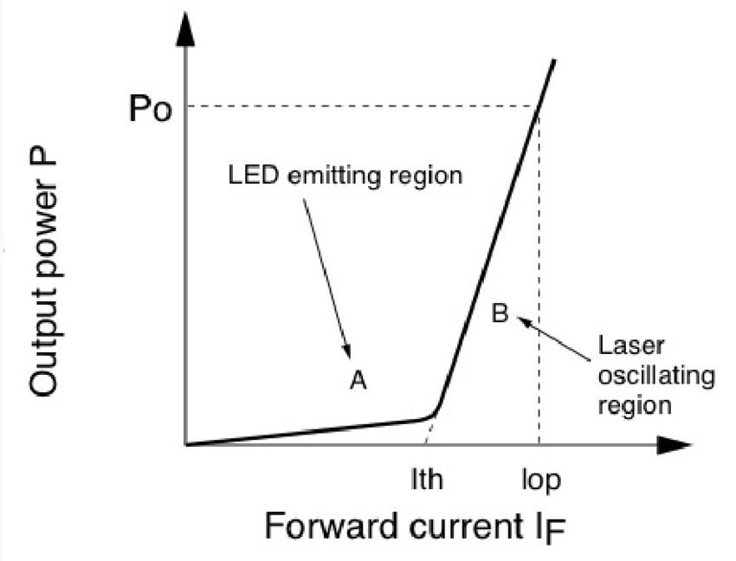
Figure 12: Diagram demonstrating the optical properties of a laser diode. I_th functions as the threshold current that allows the diode to lase, whereas I_op and P_op are the respective operating current and power that is allowed before the device is damaged.

Due to the need to implement more optical design into our product, the laser diodes that were finally integrated into the system were the OPV310 vertical cavity surface emitting lasers. One can be seen below in Figure 13.

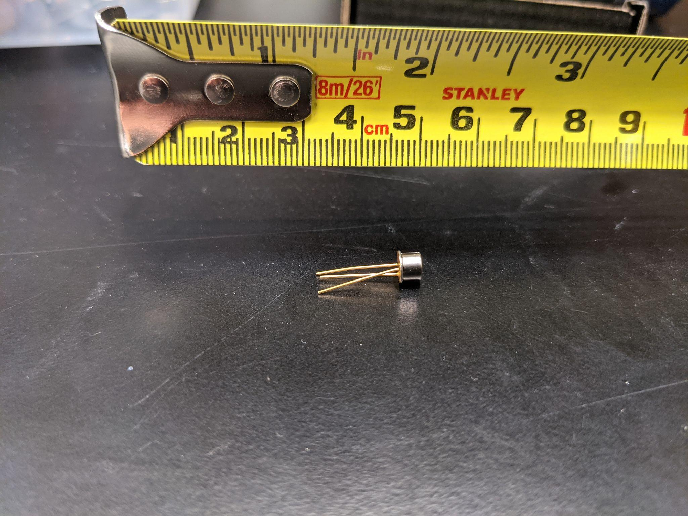
Figure 13. Image of one of the purchased laser diodes with a measuring tape above to give reference to its size.

LM317 Voltage Regulator
In order to regulate the amount of current able to pass through the laser diode, we have chosen the LM317 Adjustable Voltage Regulator IC. Depicted below the typical application circuit we will use as reference when designing our photonic key input subsystem. The capacitors filter unnecessary feedback frequencies from the input and output. When a single resistor (R1) is connected from the output of LM317 to ground, it will output a constant voltage of about 1.2-1.3V, which will act as a reference voltage. When another resistance is applied at the adjustment pin (R2), the total output will be a function of the reference voltage and two resistances, given by $V_{out}=V_{ref}*(1+\frac{R2}{R1})$. When working on the photonics demo we achieved our desired 5V output for the lasers by using R1 = 220Ω and R2 = 660Ω. One important thing to note is that the input must be at least 1V or 2V higher than the desired output or else our output will clip down, hence our chosen input voltage of 7V. Figure 14 below depicts one possible application of the LM317.
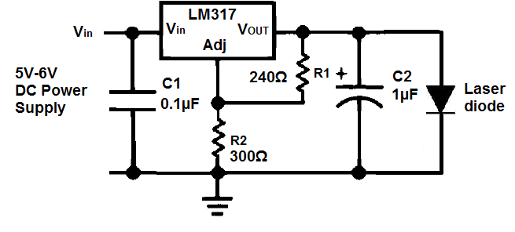
Figure 14 : LM317 Typical Application Circuit

UA741 Operational Amplifier
The signal from our photodiode configuration may be weak and noise due to heat or other external elements may interfere with operation. To overcome this, we will use the UA741 Operational Amplifier IC to boost this signal from the photoresistors for easier interpretation of the signals by the Arduino. As we can see in Figure 15, this device is a very straightforward Op Amp and Figure 16 shows us a maximum gain of 300 which should be more than sufficient to boost our signal.

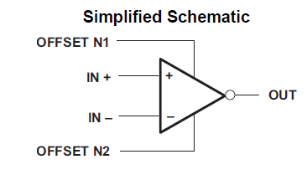
Figure 15: Schematic of the UA741

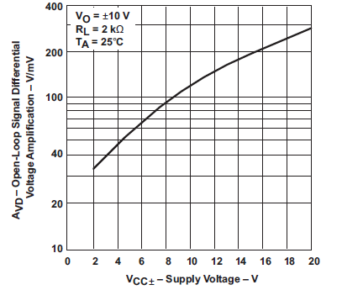
Figure 16: Open Loop Signal Differential Amplification vs Supply Voltage

Audio Signal Conditioning
After learning about the common bandpass (BP) filters we have decided to use one BP filter as a pre-amplification filter to gain maximum sound fidelity. In order to choose the right filter, the Axtron Blog’s Tool for Designing Butterworth and Chebyshev filters will be used after we complete a simple BP filter and find parameters that will work with the EWI. Small signal amplification/analysis is one of the most essential parts of audio circuit analysis because high quality sound fidelity requires a system to be designed with electronic audio components, the sound environment, the sound supply, and many more factors. The foundation of sound quality processing is choosing the right filter that matches the instrument and environment; that being said a common BP filter only took us so far in the prototyping stages.
The following four filters are more robust filters capable of being meticulously attenuated in order to get the sound samples we strive for. Given that the alto saxophone is at a range of 138 Hz and 880 Hz we will limit the sound to be within this range. In order to do so it might be beneficial to use a bandpass, butterworth cascade filter in order to neglect the frequencies below 138 Hz and above 880 Hz so we know that the output will mimic the minimum and maximum frequency ranges of the alto saxophone.
In order to filter out the sound of each of the notes on a saxophone we will be using a Butterworth filter since as a musician blows into the mouthpiece of an instrument there is a sharp burst of air in order to get sound out the device and as the note is finished being played, there is a pianissimo effect as the lungs are losing air capacity. To counteract this, we will use the Elliptic LC filter in tandem with the Butterworth filter due to the sharp increase in the signal and a faster taper time than the Chebyshev Type 2 LC filter, as shown in Figure 17.
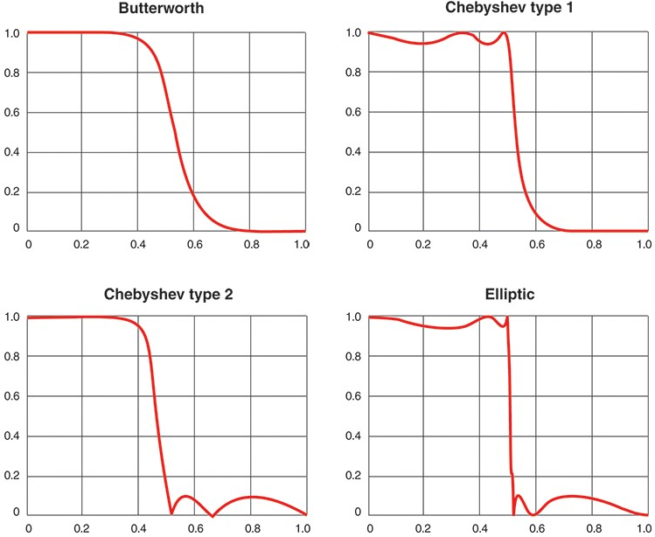
Figure 17: Intermediary LC Low Pass Filters for more controlled signal attenuation

Electronic Wind Instrument Body and Control Box

Input System
The lower and upper input system of the electronic wind instrument will be a 3D-printed case with a smaller subsystem of keys to resemble a valve system. The keys will be a smaller housing consisting of a pair of a laser diode and a photodiode along a straight axis. Each key will match to a corresponding key of a saxophone.

Mouthpiece
The mouthpiece of the device will be a standard alto saxophone mouthpiece, except without the ligature and the reed installed. This will allow the user to have the same feel as an actual alto saxophone without needing to blow any air through the instrument.

Proximity Sensor - CNY70
In order to best simulate the effect of a traditional wind instrument where the velocity of air being blown into the mouthpiece will produce a louder sound, a microphone was used initially and the amplitude of the signal from the microphone scales the output volume. The issue with this approach was when the microphone was being blown into, the signal from the microphone would be clipped. Our next approach was taking a CNY70 proximity sensor and placing it under a membrane such as a piece of latex. The CNY70 is a relatively simple device that consists of an infrared (IR) beam and a phototransistor. The circuitry, which can be seen in Figure 18, is quite simple and requires only the device itself and two resistors. As a reflective surface approaches the CNY70, the IR beam will reflect off of the surface and back into the phototransistor which will result in different output voltages.
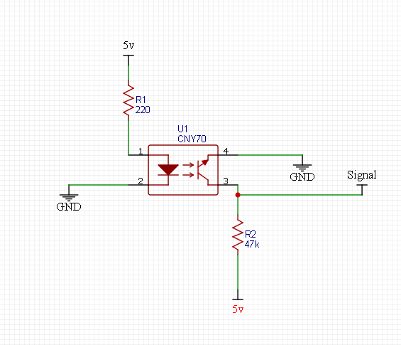
Figure 18: CNY70 Circuit

Control Box
The control box of the unit will be 3D Printed to allow a custom size and shape to fit our needs. We initially planned for the device to be made of wood in our original design in SD1; however we soon realized 3D printing the housing out of plastic would not only be easier to do, but would be cheaper and would reduce the weight of the device which would improve the end-user’s ease of use. We think the 3D printed housing is also much more visually appealing and professional than the original wood design.

PCB Etching
As mentioned before a few of our PCBs seemed too simple to warrant sending to have professionally manufactured. With this in mind, we decided to make these PCBs ourselves at home. The most straightforward and cheapest way to do this was using Ferric Chloride etching of copper. Other etching methods either require very expensive equipment such as custom drills for etching or chemicals much harsher and hazardous compared to Ferric Chloride such as Hydrogen Fluoride or Cupric Chloride. Cupric Chloride is much cheaper than Ferric Chloride and is reusable; however, as someone with a limited background in chemistry, I chose to not pursue this chemical because it must be mixed yourself and there is a risk of it letting off chlorine gas if done incorrectly.
After choosing the ideal chemical to use for our etching process and buying a premixed solution on Amazon, the next step was choosing a substrate. We chose to use copper plates with a laminate substrate because they are easy to etch, very cheap and can be ordered in bulk supply. As you can see in Figure 19, the plates come in a very ideal size for use as a PCB which means it requires no extra cutting or prepping. After acquiring the plates, we cleaned them with acetone to remove any impurities and they were almost ready for etching.
The next step was to print the circuit traces and pads on the plates. Since the Ferric Chloride is extremely corrosive, it will destroy all the uncovered copper on the plates leaving only the laminate substrate. To ensure the desired traces stay on the plates, we use a laserjet printer to print the traces onto transfer paper, and transfer the ink onto the plates. Since the Ferric Chloride cannot permeate the ink, it will only remove the unwanted copper from the plate, leaving only the desired traces and pads we put on the plate with the transfer paper.
The final product is a laminate board with copper traces and pads which represents our desired circuit. The next and final step is to cover the board with a solder mask to protect the copper traces from corrosion and other wear and tear. We ran into issues with this step because out of the four hobbyist brands of solder mask we tried using, none of them would evenly coat and dry the plate which would cause more issues than it solved. We soon scrapped the idea of using a solder mask on the custom PCBs because for this specific project, longevity of these PCBs was not paramount. However, if we were given more time or were concerned about the device lasting a few years, we would have sourced a brand of professional grade solder mask. Overall we are quite happy with how these boards turned out for our first time using this process of etching.
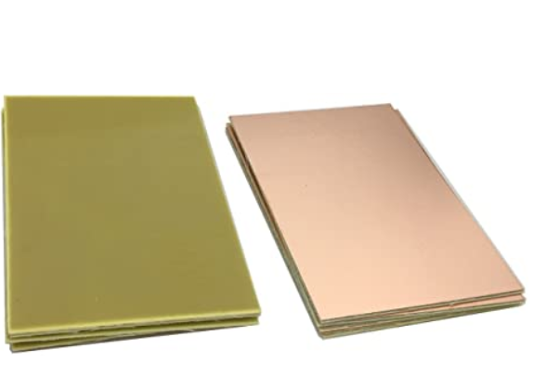
Figure 19: Copper plates with laminate substrate. The left is the laminate side and the right side is the copper side

Software Used

Arduino Integrated Development Environment (IDE)
In order to program the Arduino, we need to use the IDE provided by Arduino. The software and code are compatible with every Arduino model and necessary to flash the microcontroller in order for it to start executing the programmed commands. The IDE comes preinstalled with several libraries to simplify the process of coding with added hardware. Code can be written in C/C++ as well as Java.

MultiSim Live
MultiSim Live is an online circuit simulation software that will be used intermittently while designing and prototyping. It features a circuit building tool as well as a graphing tool that logs voltage and current over time and can be used to find the correct component values that we may need throughout the duration of the project.
EveryCircuit
EveryCircuit is a circuit simulation software that is completely hosted online. It is accessible by any web browser with Flash support and on almost any smartphone device as it is in both Android and Apple app stores. This software is ideal for quickly sharing simulations for simple circuitry with people who may not have access to MultiSim. We plan on using this for simpler circuit designs where we don’t need the robust features offered by MultiSim.
EasyEDA
To generate the required Gerber files for our PCB manufacturer to make our PCBs, we used EasyEDA. EasyEDA is a PCB development and design tool made by JLCPCB, who is also the manufacturer of our PCBs, so we assumed this would be the best suite to use to design our PCBs since it is the manufacturer’s proprietary program. However, this program was very frustrating to use and lacked many tools and options offered by competitor programs such as EAGLE or KiCAD.
TinkerCAD
TinkerCAD is a free and online software used to produce designs that will be used for 3D printing. Its ease of use allowed complete beginners such as ourselves to quickly gain a grasp of the interface, granting us the power to create extremely efficient parts for our saxophone.
PrusaSlicer
Provided by the university, this program by the company Prusa “slices” the design files from the creation software and converts it into a new generated gcode file that can be read by their Prusa 3D printers. This program was necessary for realizing our designs into physical components that can be tested and assembled.

Arduino Code
At the core of the device is the Arduino Mega 2560 and the program written to power its operation. The code is written in C and is 117 lines long. Included in the program is the SoftwareSerial library, which comes with the Arduino IDE. The library’s functions allow for a serial connection to be established over digital pins other than those supported directly by the USART by using software to replicate the USART’s functionality. The code has the Arduino take input from the photodiodes and proximity sensor, which are all connected to analog pins, processes the value of each input, then decides whether the instrument is being played and what note should be played. The Arduino then passes instructions to the instrument shield, which generates the desired MIDI tones.
MIDI Messages
In order to communicate with the instrument shield, standard MIDI messages are used. These messages are sent through an asynchronous serial connection as packages of 1 data byte (8 bits), 1 start bit, and 1 stop bit. Between 1 and 3 of these packages are sent per message. The first byte sent through the connection is always the status byte, which tells the receiver what type of message is being transmitted. Status bytes can be broken up into 2 sets of 4 bits, referred to as nibbles. The most significant bit of a status byte is always set, so it is differentiated from other messages. This results in the first nibble of a status byte having a hexadecimal value of 8 or greater. The remaining bits in the first nibble identify the message type.
If the first nibble’s value is between 8 and E, then the message is a voice message. These messages are sent to only one of the MIDI device’s 16 channels at a time, and the second nibble of the status byte is used to specify the channel.
A first nibble value of 8 indicates that the message is a Note Off message. This message lets a specified channel know that a given note should be released. This message type always comes with 2 data bytes following the status byte; 1 for the value of the note to be released, and 1 for the velocity with which the note is to be released. A higher velocity value indicates that the note should be released quickly, resulting in a more abrupt stop. Figure 20 below shows the format of a Note Off message.
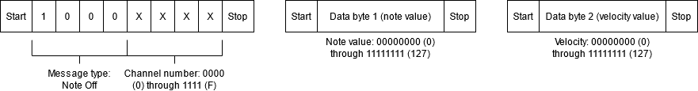
Figure 20: Note Off message format
A first nibble value of 9 indicates that the message is a Note On message. This message lets a specified channel know that a given note should begin sounding. The format of the Note On message is the same as the Note Off message, with the first data byte indicating the note value to be played and the second data byte indicating the velocity with which the note should be played. The Note On message can also function in the same way as the Note Off message by sending a velocity value of 0. Figure 21 below shows the format of a Note On message.
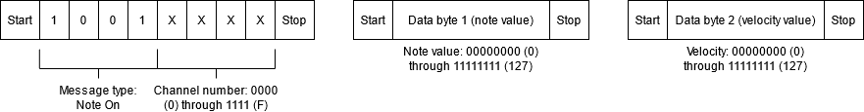
Figure 21: Note On message format
A first nibble value of A indicates that the message is an Aftertouch message. Aftertouch is used for pianos, percussive instruments, or string instruments, and can be determined from the pressure with which a user is holding down a key. As aftertouch is not used for reed instruments, the message will not be detailed here.
A first nibble value of B indicates that the message is a Control Change message. This message is used to modify the value of a selected controller on a given channel. There are 127 controllers, including volume, balance, and tremolo. A controller of importance is number 0, or bank select. On a device with more than one tone bank, this controller allows for the selection of a tone bank to use before selecting an instrument within the bank. This message type comes with 2 data bytes after the status byte; 1 for the number of the controller to be changed, and 1 for the value to be assigned to the controller. Figure 22 below shows the format of a Control Change message.
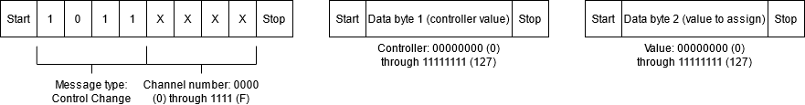
Figure 22: Control Change message format
A first nibble value of C indicates that the message is a Program Change message. This message type is used to assign a program, or instrument, to a given channel. Once a channel has been assigned a program, any note it produces will use the sound of the assigned instrument. Since each of the device’s 16 channels can each be assigned a unique program, up to 16 instruments can be played at once. This message comes with only one data byte after the status byte, indicating the program number. On devices with more than one tone bank, a Control Change message must be used to select a tone bank before a program can be assigned for the first time. Figure 23 below shows the format of a Program Change message.
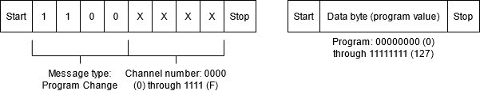
Figure 23: Program Change message format
A first nibble value of D indicates that the message is a Channel Pressure message. This message functions very similarly to Aftertouch, being determined by the pressure with which a user is holding down a key, but applies to the entire channel and affects the pressure applied to every key. This message type comes with one data byte after the status byte, indicating the pressure value. Figure 24 below shows the format of a Channel Pressure message.

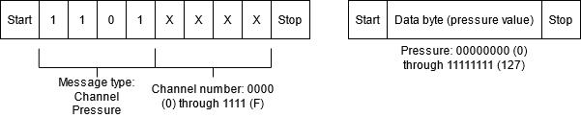
Figure 24: Channel Pressure message format
A first nibble value of E indicates that the message is a Pitch Wheel message, which is used to adjust the pitch of a note. A first nibble value of F indicates that the message is not a voice message, but a system message. These messages are used to control sequencing, start and stop playback of files, and reset the system. Again, as these message types are not used, they will not be detailed here.
Processing Algorithm
The code begins by instantiating a SoftwareSerial connection over digital pins 2 and 3, then declaring variables to be used in the program. For ease of access, the mouthpiece’s proximity sensor and each of the keys’ photodiodes are assigned variables containing the number of the pin that they are assigned to, with keys 1 through 8 being assigned to analog pins 8 through 15 (A8 - A15) and the mouthpiece being assigned to analog pin 7 (A7). A variable for the instrument shield’s software reset pin is also declared. Then, variables note, newNote, and playing are declared. The variable playing is initialized to false to have the instrument not play upon startup. Container variables for each of the sensors’ input values are declared and initialized to 0.
In the setup function, the Arduino is prepared in order to execute the code properly. The SoftwareSerial connection is opened at 31250 baud, as specified by the MIDI standard, then a software reset is performed on the instrument shield by writing its reset pin low, then high. 3 MIDI messages are sent before the main loop of the program begins. The first is a Control Change message to set the master volume to its maximum value, the second is another Control Change message to select the melodic tone bank, then the third is a Program Change message to select program 65, which is the alto saxophone, and assign it to channel 0.
The main loop begins by reading the input from the mouthpiece proximity sensor into its container variable. Since the supplied reference voltage is the same 5 V input used for all of the sensors, the digital values provided by the ADC will be at the maximum value of 1023 when there is no voltage drop across the sensor. The voltage output from the proximity sensor decreases as the distance read in front of it decreases, so if the read value is below a given threshold (unfortunately, due to complications with the sensor’s operation, no formal tests could be run to determine the ideal threshold), the membrane in front of the sensor is being blown inward, meaning the instrument is being played. In this case, the value of the variable playing is set to true. Otherwise, it is set to false.
Next, the value of newNote is set to 0 to prepare it for manipulation during the note selection process. The input voltage from each photodiode is then read into its respective container variable. Then, starting with key 1, each input value is compared to a threshold of ½ of the reference voltage to see if the key is pressed. Since the voltage output from a photodiode drops from 5 V to near 0 V when its laser is blocked, the threshold only needs to detect maximum and minimum values. For each bit N, if the input value is below the threshold, bit N-1 in newNote is set. This bit manipulation creates a unique decimal value for each key configuration, allowing them to easily be mapped to note values. This is preferable to mapping a configuration directly to a value, since that would require nested if-else statements to find the configuration and would take much longer to iterate through. Figure 25 below shows an example of the value-mapping process.
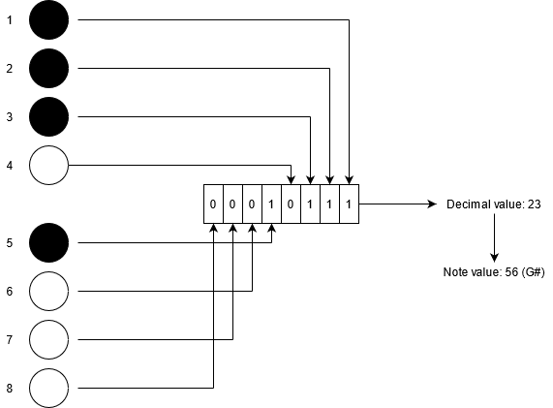
Figure 25: Fingering configuration for G sharp used to generate corresponding note value. Black keys are pressed, white keys are not pressed. Key 1 controls the least significant bit, key 8 controls the most significant bit. Decimal value of newNote is used to determine note value
After each key is checked and newNote has been modified, the code iterates through an if-elseif-else statement to map the value to the appropriate note. If the value does not directly correspond to a note, then it is considered to be the open note E (C in alto scale), note value 64, equivalent to not having any keys pressed. Figure 26 and Table 3 below show the valid fingering configurations for each note, and the binary, decimal, and note values generated by each configuration. Below them, Figure 27 shows the entirety of the note decision process.
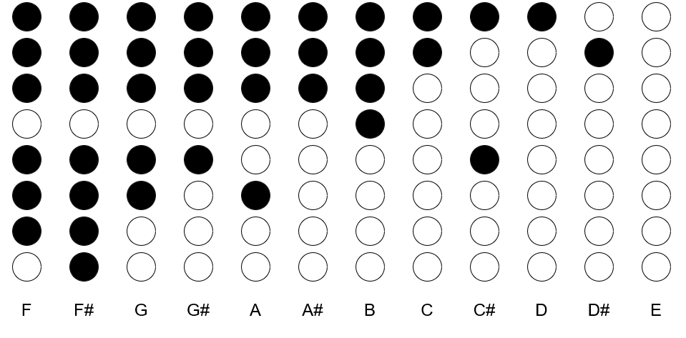
Figure 26: Valid fingering configurations for notes. Black keys are pressed, white keys are not pressed. Keys number 1 - 8 top to bottom

Note | Binary value of newNote | Decimal value of newNote | Final note value
F | 01110111 | 119 | 53
F# | 11110111 | 247 | 54
G | 00110111 | 55 | 55
G# | 00010111 | 23 | 56
A | 00100111 | 39 | 57
A# | 00000111 | 7 | 58
B | 00001111 | 15 | 59
C | 00000011 | 3 | 60
C# | 00010001 | 17 | 61
D | 00000001 | 1 | 62
D# | 00000010 | 2 | 63
E | 00000000 | 0 | 64
Table 3: Mapping of note fingerings to binary, decimal, then note values
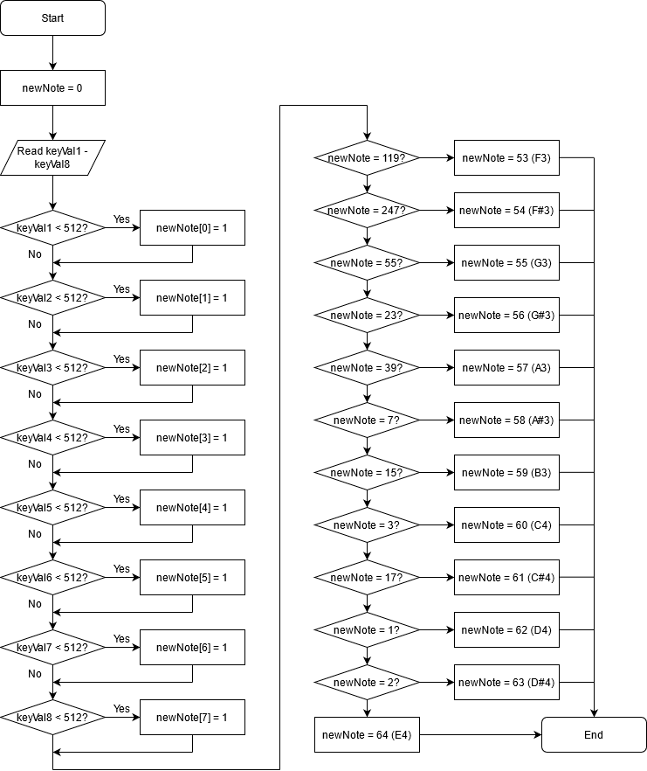
Figure 27: Note decision algorithm performed during each iteration of the program’s main loop

After the correct note has been determined, its value is assigned to newNote. The note that was turned on in the previous iteration of the main loop, whose value is stored in the variable note, is turned on with a velocity of 0, effectively turning the note off. This is to prevent notes from overlapping, as this can occur due to MIDI’s polyphony capabilities. If the variable playing is set to true, then a note with the value of newNote is turned on with a velocity of 60. Otherwise, the instrument remains silent. The value of newNote is then assigned to note to preserve it, then the loop begins again.
Given more time, this code would have made use of the Arduino’s Analog Comparator and its corresponding interrupts. The comparator works by reading two analog pins, AIN0 and AIN1, and comparing their values. If the voltage on AIN0 is greater than the voltage on AIN1, a bit in the comparator’s control and status register is set. This bit can be used to trigger an interrupt when its value is toggled, which would have allowed for the use of the Arduino’s low-power modes. When the bit was toggled low, the currently playing note would have been turned off, then the Arduino would have been put into idle mode. When the bit was toggled high, operation would resume as described above, minus the utilization of the playing variable. Below in Figure 28 is a flowchart representing a full overview of the device components and how they interact.

Functional Block Diagram
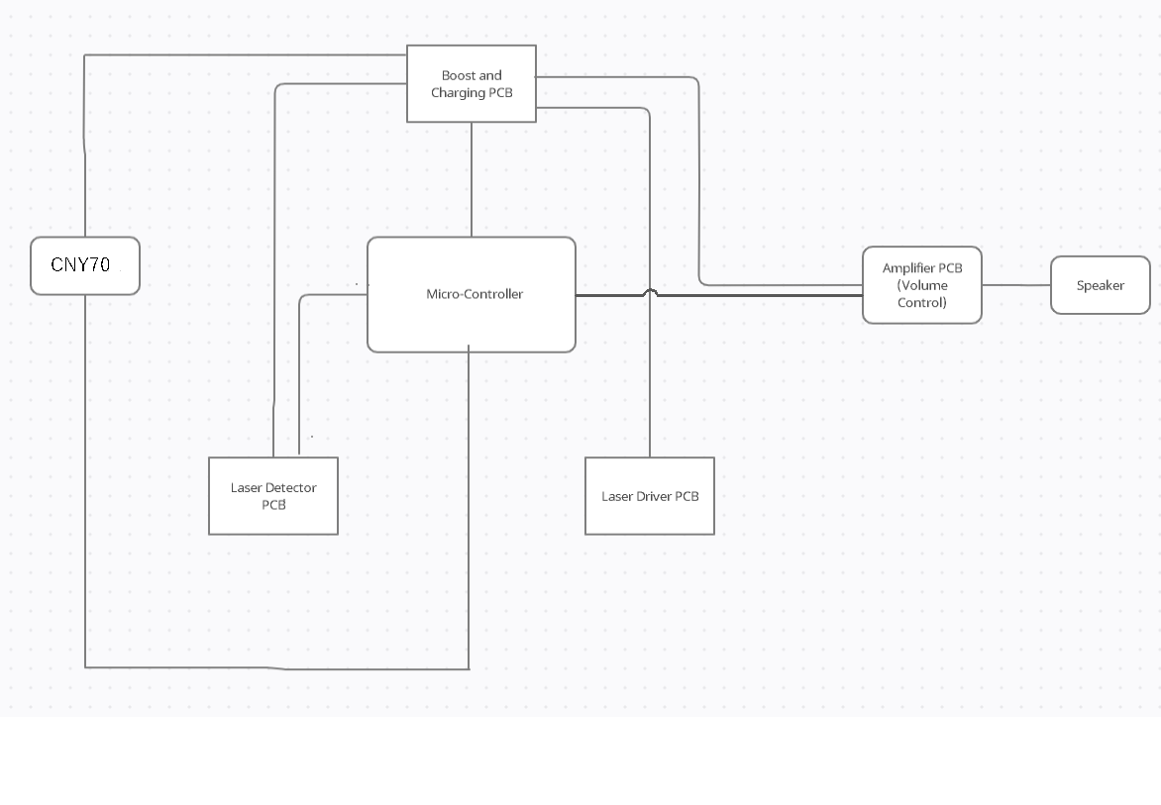
Figure 28: Communication inside the system, from input to output.

House of Quality Diagram

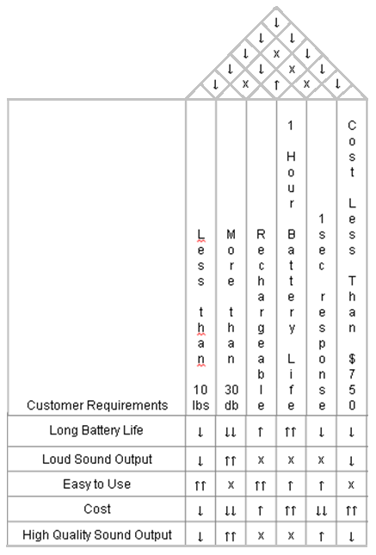

Figure 29: House of Quality

Method

Participants
For this project, the photonic subsystem and the casing as a whole was created and developed by Manuel. The portable power system based on the Samsung 18560 cylindrical non-button top batteries was developed by Tim. Andrea created the software necessary for the project and integrated the necessary components. All other auxiliary designs were developed as a collective.

Assessments and Measures
Before starting the design of the project, an alto saxophone was inspected to see if we could implement a version of the blocking system that we had envisioned. While assessing if the blocking system could be placed within the alto saxophone, many obstacles presented themselves that would not allow us to implement the photonic subsystem for an electronic wind instrument within the actual saxophone.
Firstly, the rod mechanisms of the alto saxophone would have to be removed in order for us to access all of the valve systems of the saxophone, which would then have to be replaced perfectly with the blocking system attached to the pads of each of the keys. As a group we decided that this aspect was far too mechanical for us to undertake within the 12 weeks we would have allotted for designing the electronic wind instrument since alongside this we would have a far greater challenge of debugging the system after it is reassembled.

Another challenge redesigning the alto saxophone was how complex the open and close mechanisms actually are. When you press a note on the saxophone, more often than not three or more valves on the saxophone open and close with the exception of the octave key which opens a single mechanism on the neck of the instrument or the key bindings that are played by a player's palm instead of fingers. This proved an issue as the scale of the microcontrollers we would need to map out the twenty valves of the alto saxophone would add an additional expense to the budget for microcontrollers/embedded systems as well as take up physical space inside the saxophone.
The most crucial aspect of our assessments was that the laser diode blocking system would be too bulky to fit within the alto saxophone. The laser diodes that we had selected for the proof of concept are 6 millimeters in diameter and the top portion of the alto saxophone would become too cluttered and would not have enough space for the blocking mechanisms. On top of that, creating a housing for both the laser diode and photoresistor using pre-existing components used up even more space.
Therefore, we have instead chosen to create our own electronic wind instrument casing from pvc and project panels from the Home Depot Hardware Store. This provides us the ability to choose parts to resemble the valve system that fit the size constraints of our laser diode and photoresistor detector subsystem.

Alto Saxophone Emulation
The alto saxophone is a very complex instrument at its core and requires many years of practice to become a professional player. Some common issues new players face are: needing to perfect the embouchure on the mouthpiece in order for sound to come out of the instrument, learning the key and button finger placements for the various notes, as well as having the right tongue/breathing techniques in order to get the desired note to be played. With our electronic wind instrument we hope to alleviate most of the common problems that beginners face while starting to learn a new instrument. Although our design is limited to only playing four concert scales, the alto saxophone is tuned in the key of Eb concert, which means many of the songs a beginner will try to play will be on the G major scale. By adding the notes G#, C# (alto saxophone open note), we can broaden the scope for more intermediate pieces.
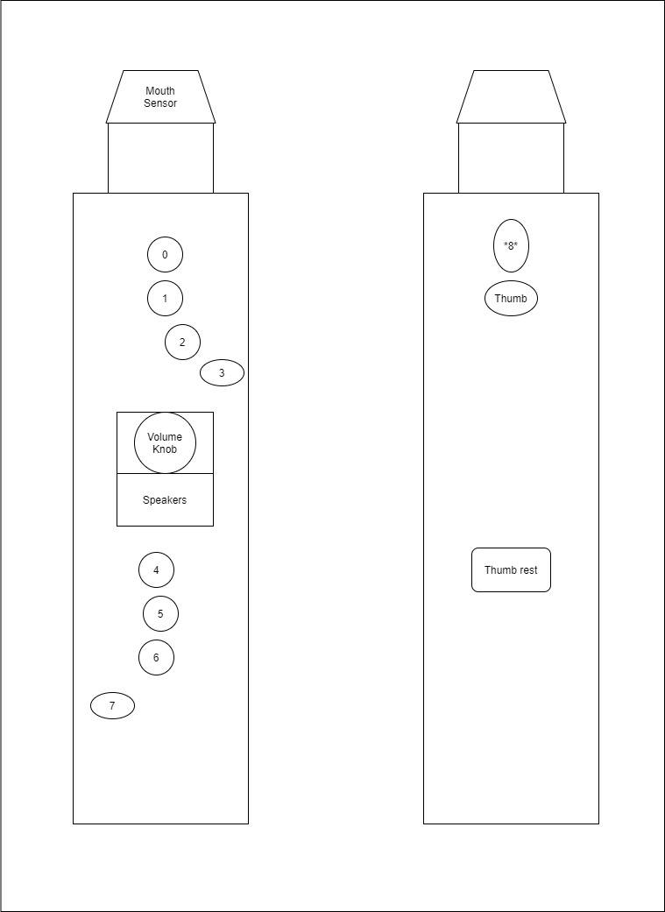
Figure 30: Early Concept Diagram of the Instrument

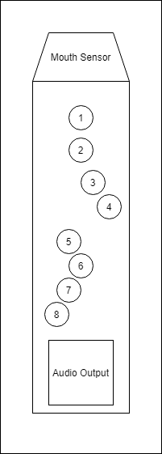
Figure 31. Finalized Concept of the Instrument

Photonic Key Input Subsystem
The design for the photonic input subsystem will depend on the playing mechanism of the desired design. So far there are three variations of the mechanism: a valve input, shown in Figure 32, a hole input, shown in Figure 33, and a slide input, shown in Figure 34.
The valve input is the simplest of the three mechanisms. The light shines straight to the detector, though a stopper in between determines whether the detector receives said light or not. The block acts depending on the user’s input - that is, if the key is pressed or not, the block will move accordingly.
The hole input is similar to the valve input, but the acting mechanism is the user themselves. This concept revolves around the law of reflection. The light beams through, but not in the path of the detector. What makes the light shine through to the detector is the user’s fingers. They will obstruct the path of the source and reflect the light onto the receiver, which is inside a small cavity that attempts to collect as much of the reflected light as possible.
The final mechanism is entirely different from the other two. This idea revolves around a slide. The source “slides” back and forth, much like a trombone, depending on an external appendage that the user controls. Depending on the position of the slide, an affixed detector will collect varying light intensities that will then translate into a range of voltages. Then a unique pitch will be mapped to each of the voltage intervals. The advantage in this configuration as opposed to the valve or hole ideas was the ability in adding tones not conforming to the Western 12-note system, allowing for a more “analog” or “free-range” flexibility.
While realizing the slide input design was more rewarding in terms of both a musician and an engineer, it ultimately imitates more a trombone than a saxophone and thus was reserved in case the idea for a saxophone could not be realized. The hole input idea was scrapped almost immediately as it allowed for a lot of leakage in light, and there was a possibility it may become a disturbance if the user is sensitive to changes in light. There was also the chance that it may interfere with external devices that use light as sensors. Therefore, our chosen solution became the valve input.

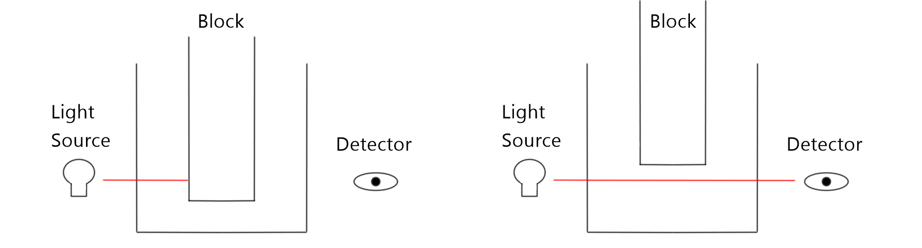
Figure 32: Valve Input Drawing

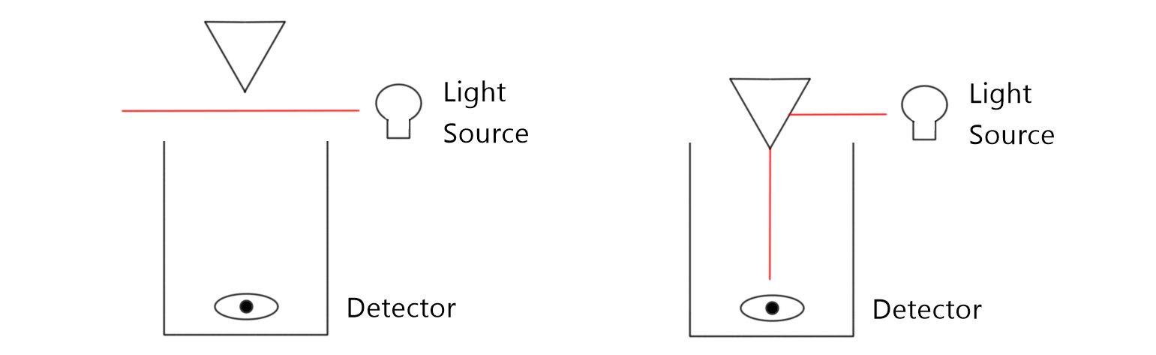
Figure 33: Hole Input Drawing

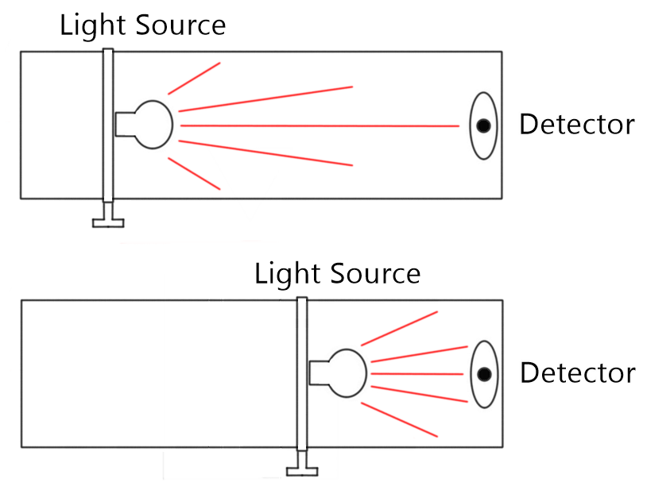
Figure 34: Slide Input Drawing

The initial idea for the valve input was to have a mechanism similar to a saxophone, where when a key is pressed the block comes up, allowing for the light to hit the detector. However, when we began to construct the physical mechanism for the input system, it became apparent that while having a lever-like system was certainly possible, its large volume would have restrained the positioning of the keys on the total system. This contradicted our specification for ease of use, and thus we brainstormed to find a different approach. Finally we came up with a more compact design, illustrated in Figure 35. This mechanism features the block on a spring instead of a lever. The key at rest is positioned such that the light stops at the side of the block. When pressed, the holes created on the block will align themselves to create a path for the light to reach the detector. The advantages here are three-fold:
- The system consists of only the pit and block without a need to create a larger mechanism outside of it.
- Once the block is fully pressed the light is totally confined inside the pit with no leakage to endanger the user.
- The springs offer a natural resistance that is similar to that on an actual saxophone. If we were to use a lever mechanism, we would have to modify the design to allow for needle springs to achieve the same effect, which are much more uncommon and expensive as the regular compression springs used.
Figures 35-39 show the construction and completion of a key while Figures 40 and 41 show the key being connected to the laser driver circuit and receiver circuit, respectively.

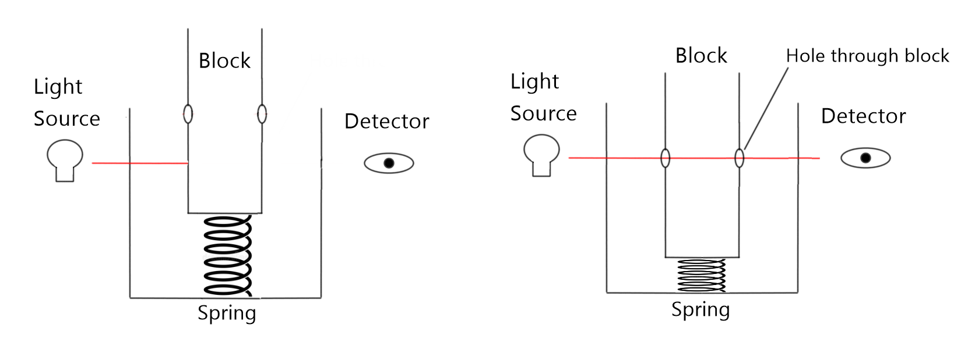
Figure 35: Valve Input Design from the Photonics Demo

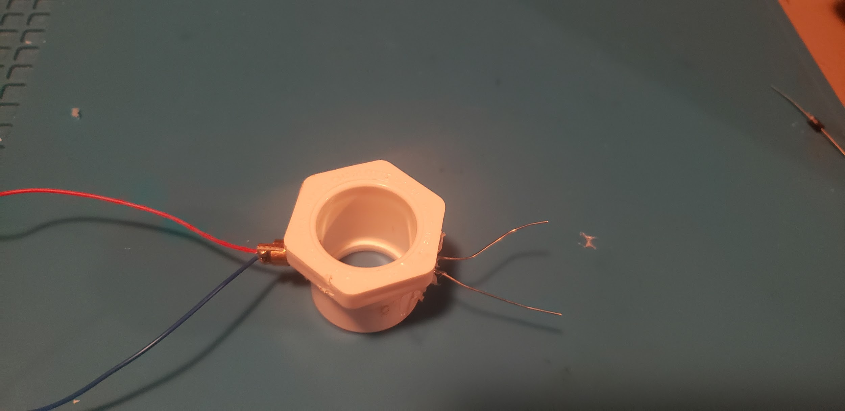
Figure 36: Completed pit. Laser diode and photoresistor are connected on the sides

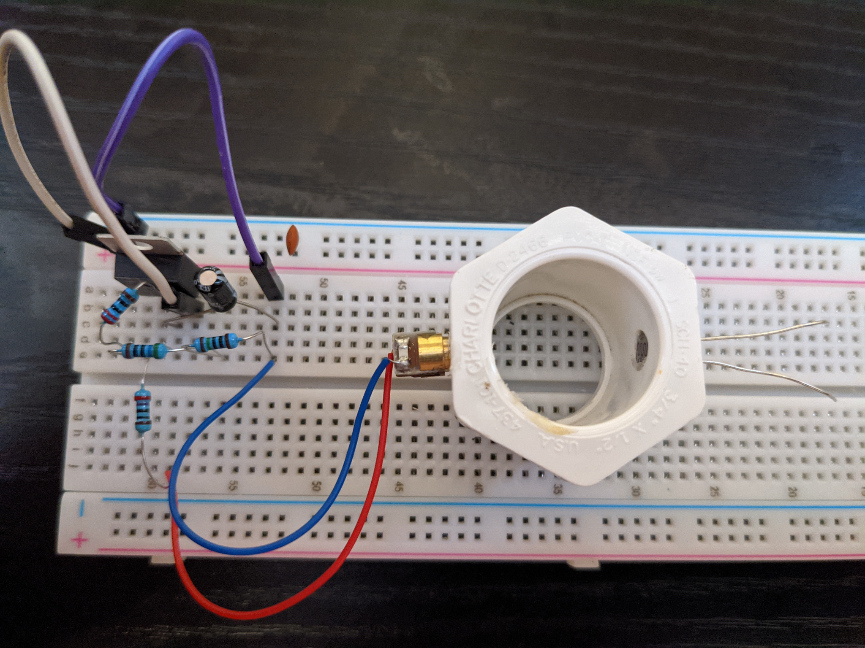
Figure 37: Pit connected to laser driver circuit.
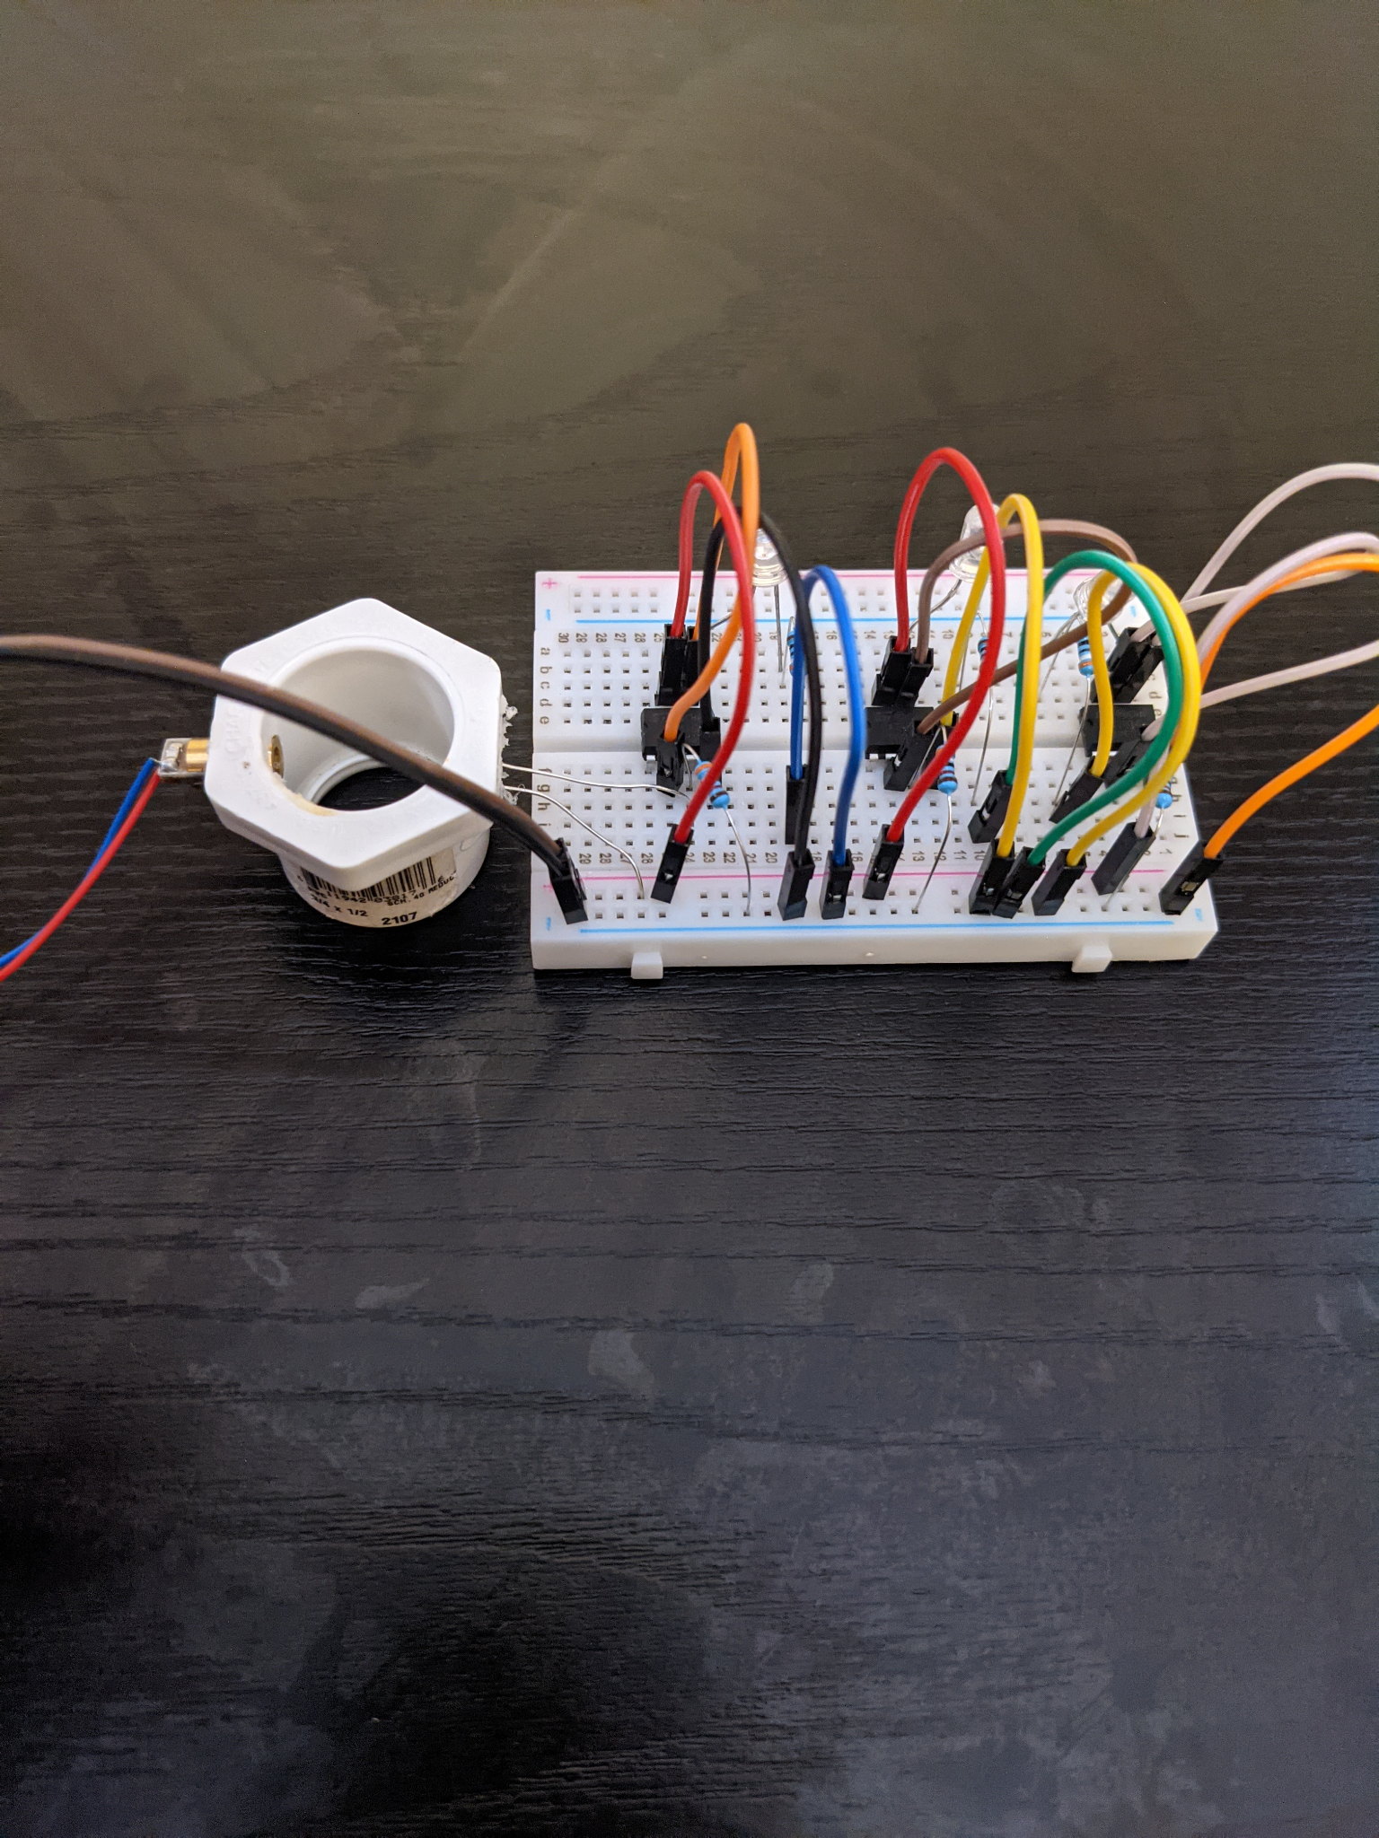
Figure 38: Pit connected to receiver circuit.

After the photonics demo at the end of the first semester of Senior Design 1, we optimized the key mechanism to be even more compact, while also providing additional shielding for the user against the output light. This can be seen in Figures ?, ? and ? below.
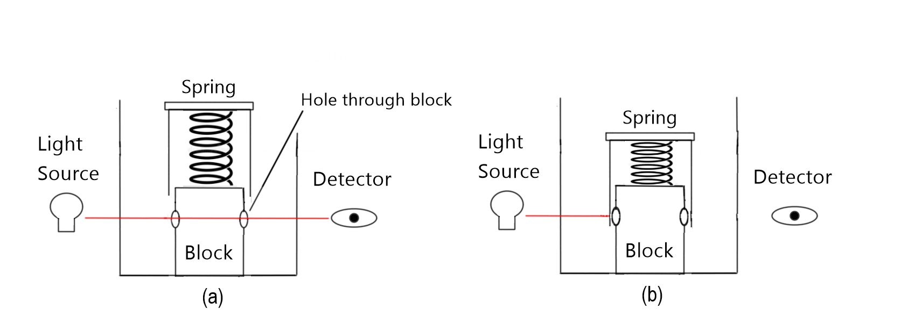
Figure 39: Final Concept for the Key Mechanism
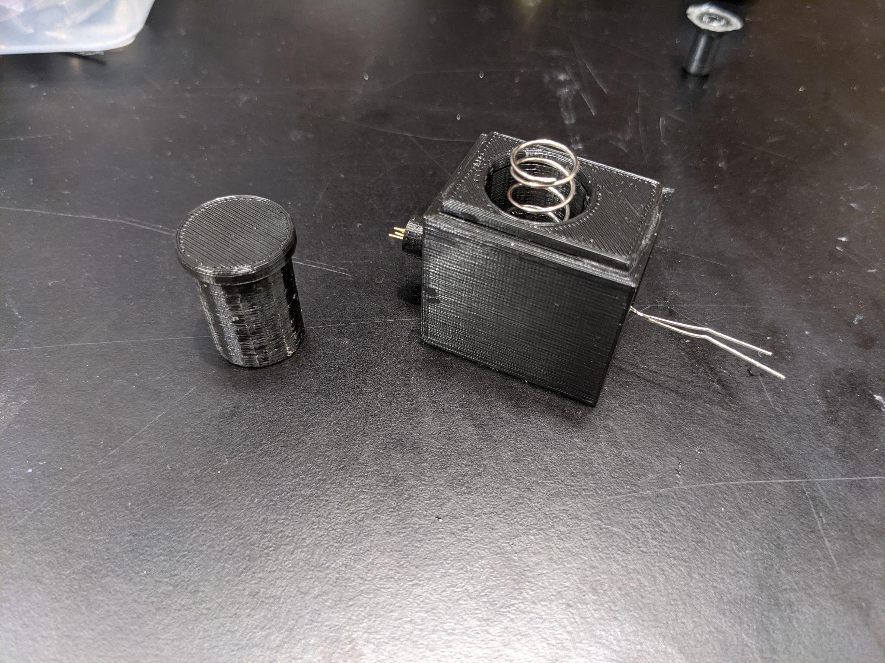
Figure 40: Single Key with stopper off
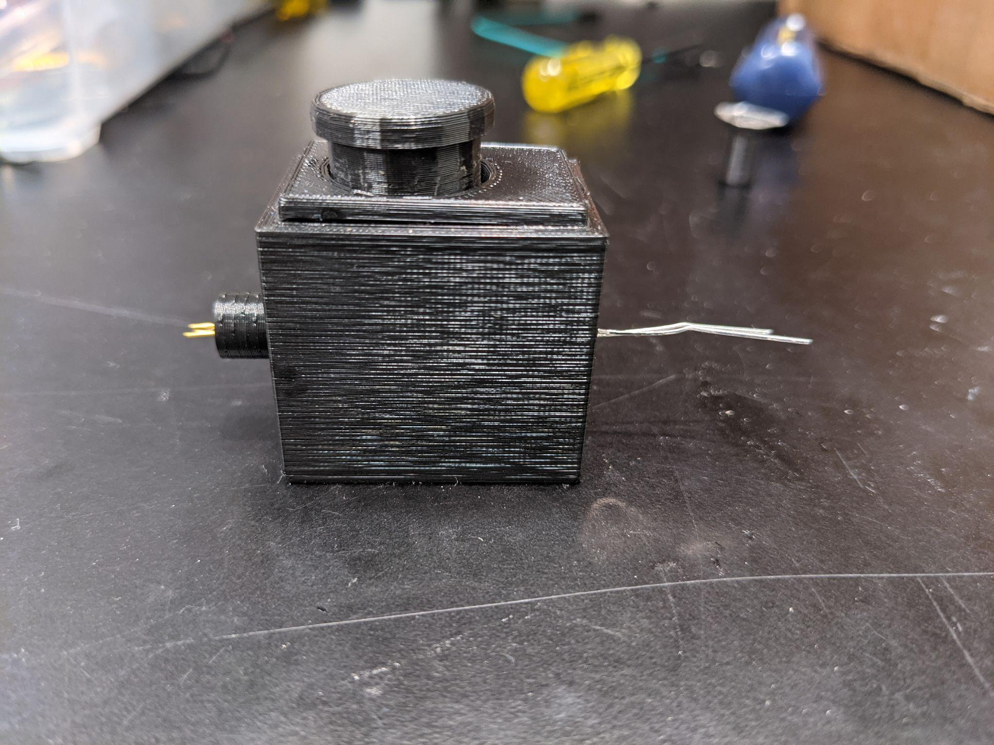
Figure 41: Single Key with stopper on
There were a few major changes. The first is that instead of using PVC we elected to use the 3D-filament PLA as our material of choice. PVC, while lightweight, was extremely difficult to work around. It was only available in tubular forms, and if we wanted to manipulate the pieces in such a way that they resemble a saxophone, we would have required a wide variety of tools normally used in woodworking or machining, as well as an extraordinary amount of expertise and experience in using those tools to achieve our desired effect. The difficulty required to 3D print parts was inversely proportional to how well we were able to make designs for those parts. Considering that the most important condition was satisfied with the latter - having physical access to a machine (in our case a 3D printer) as well as an extensive amount of plastic that allows us to experiment with our designs - the decision was evident. Being able to have such strong control over the shape of the parts was an overwhelming advantage, as we could design parts that would conform to the other system components that were less malleable such as the printed circuit boards, the microprocessor, and any additional peripherals that extend the capabilities of the saxophone. Additionally, having a design be printed allowed for reproducible parts, as letting the printer do its job without any human intervention would allow for more consistency in creating more of the same components. This was especially useful with the keys in particular.
Another main advantage with the black PLA is that it is near impervious to some ranges of wavelengths. This meant that we would not have to be concerned that the light will pass through the material and into the system’s surroundings, and most importantly into the user’s eyes. PVC had a much more limited range, so the risk was indeed greater.
The next significant alteration was that a pressed key would no longer allow light to pass through, and instead it would simply block the light when down. This removed the complexity of introducing additional holes to the sides of the stopper, which would have increased the production time of the keys. This now meant that the keys at rest would report full brightness and when pressed they would measure little to no light intensity, opposite to the previous iteration. This had little impact on the overall design, as it only affected the coding aspect of the note recognition. What needed to change now was the assigning of values to notes based on an inverted input, which could be remedied by switching the threshold values - which is less than one line of code - and applying the same change to the other keys, which is as trivial a matter as just copying and pasting the same line to the others.

Control Box Concept
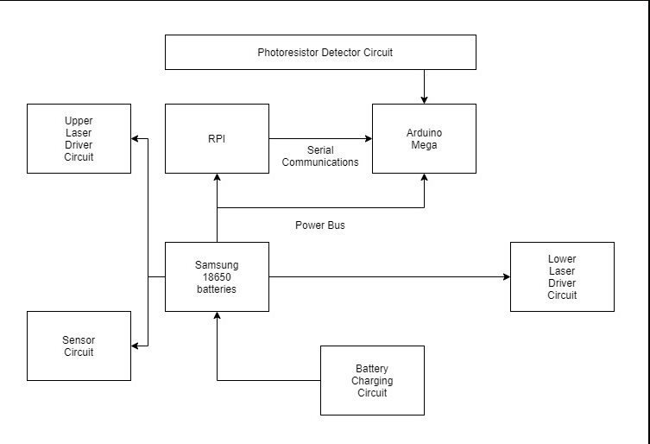
Figure 42: Control Box Functional Diagram

Stage 1 - Laser Diode Driver Circuit
Supplying power to our laser diodes is quite simple and can be seen below in Figure 43. Since this device requires a bit more power than the other circuits, we wire it directly to the power circuitry since it requires too much power to piggyback off the Arduino’s internal 5V regulator. The circuitry for the laser diodes is quite simple. Each laser is hooked up in series to a current conditioning resistor and each of these branches is connected in parallel to the 5V and GND headers of our power circuit. The final PCB design can be seen below in Figure 44.
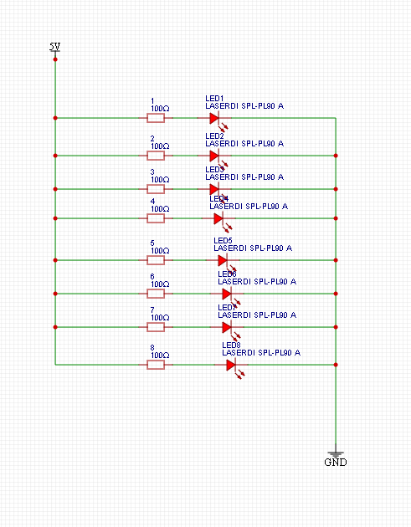
Figure 43: Laser Driver Circuit

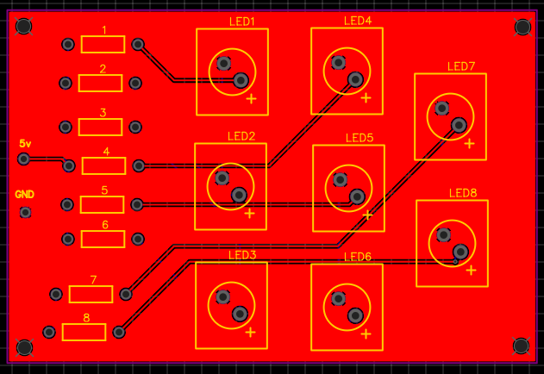
Figure 44: Laser Driver PCB

Stage 2 - Photodiode Detector Circuit
The circuitry for our photodiode detectors is quite simple and is shown below in Figure 45. We have our photodiodes in series with an output pin which will allow us to check the voltage level after the photodiode which will tell us whether the light is blocked or not. After that is just a current conditioning resistor. All of these individual branches are wired in parallel and hooked up to our Arduino’s 5V and GND pins. The final PCB design can be seen below in Figure 46.

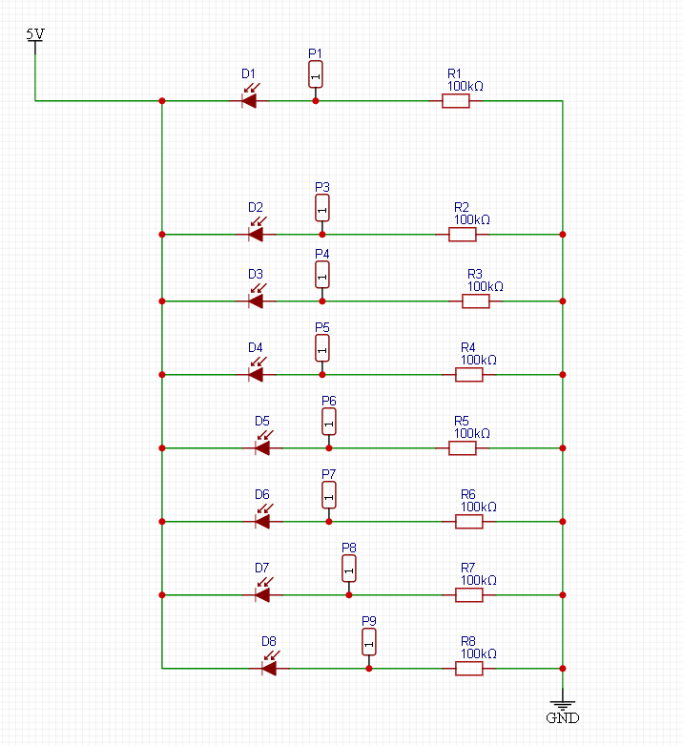
Figure 45: Laser Detector Circuit
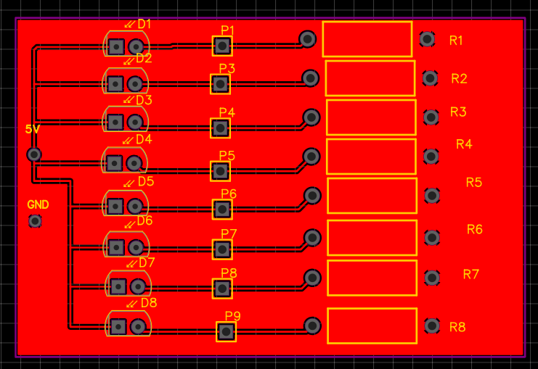
Figure 46: Laser Detector PCB

Full Photonic Subsystem (Stages 1+2)
Figure 47 is the proof of concept of Stages 1 and 2, physically recreated with three keys. The laser driver circuit sits at the top of the image. The two wires sticking out to the left are to connect the test input source that will be later connected to the battery. At the very bottom of the driver circuit the outputs are spaced out for a more presentable view, although they may be put more closely together. The pits are connected to the driver circuit with the block on top. Here the blocks are not attached to the bottom so that they can be pulled out and shown to the audience at the demonstration, but they will later be attached to the bottom of the pit during further development. Finally the photoresistor from the pit is connected to individual receiver circuits. The output is visually expressed with an LED at each receiver circuit here for the purpose of the demonstration. That same output will later be input into the processing unit.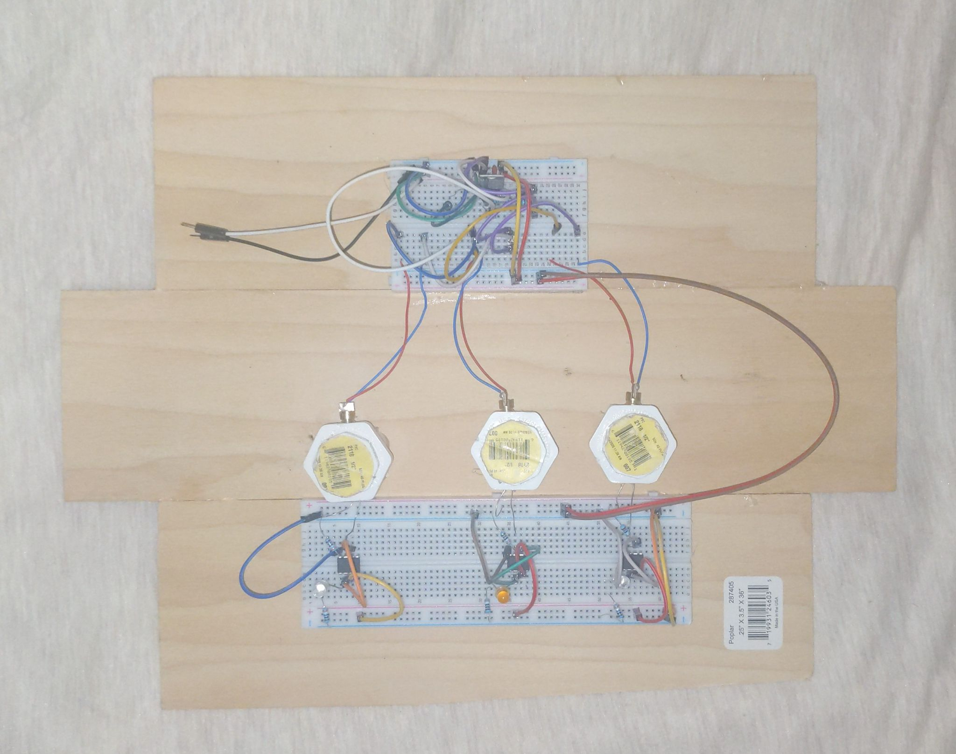

Figure 47: Photonic subsystem demonstration from SD1

Stage 3 - Upper/Lower PVC Input Mechanism Assembly
The upper and lower input mechanisms of the electronic wind instrument will feature the photonic spring blocking subsystems. In order to create the blocking mechanisms first we will have to source PVC T-joints and joint end caps from Home Depot. We will recreate the Laser Diode Driver circuit as necessary in order to have enough current to drive each of the laser subsystems in parallel. Currently the design splits the photonic subsystem into two, having one driver at the upper joint for the left and another driver for the right hand at the lower joint. Table 4 will be used to reference the keys by associating them with a number 0-7, with a special 8th key representing the octave key. Keys 0 to 3 as well as Key 8 will be assigned to the upper driver circuit whereas keys 4 through 7 will be configured to the lower driver circuit. Table 4 shows a list of photoresistors being triggered and the note it will play as a result.

Mechanisms Triggered | Note played
Mouthpiece only (alto saxophone open note) | C#
1 | High C
0 | B
0, 1 | A
0,1,2 | G
0,1,2,3 | G#
0,1,2,4 | F
0,1,2,5 | F#
0,1,2,4,5 | E
0,1,2,4,5,6 | D
0,1,2,4,5,6,7 | Low C
8 | Octave Key
Table 4: Key Bindings in Accordance to Conceptual Diagram of the Instrument

Stage 4 - Mouthpiece Assembly
In order to detect whether or not the user is trying to play a note on the instrument or not, we used a setup involving a CNY70 proximity sensor and a latex membrane. As the user blows into the mouthpiece, the membrane will expand and increase in proximity to the CNY70. As this membrane approaches the CNY70, the voltage signal from the CNY70 will decrease linearly, allowing us to program this voltage drop to correlate with the amplitude of the output volume which can be seen in Figure 48.

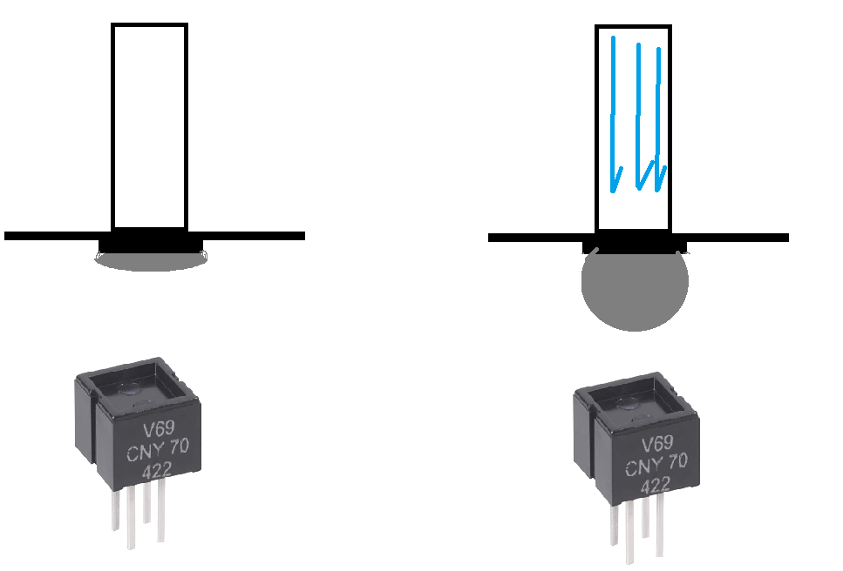
Figure 48: CNY70 configured as breath sensor

Stage 5 - Volume Knob Assembly
We initially opted to use Op-amps to boost our output signal, but after swapping to the TDA7052, we could not have complete control of the signal gain since the TDA7052 has a fixed gain of about 30. So instead of adjusting the output gain, we used a potentiometer to adjust the amplitude of the input signal to the TDA7052 as seen in Figure 49. This seemed to be a fairly common solution to having adjustable audio output from the TDA7052 when looking at other configurations of this device in audio applications similar to ours.
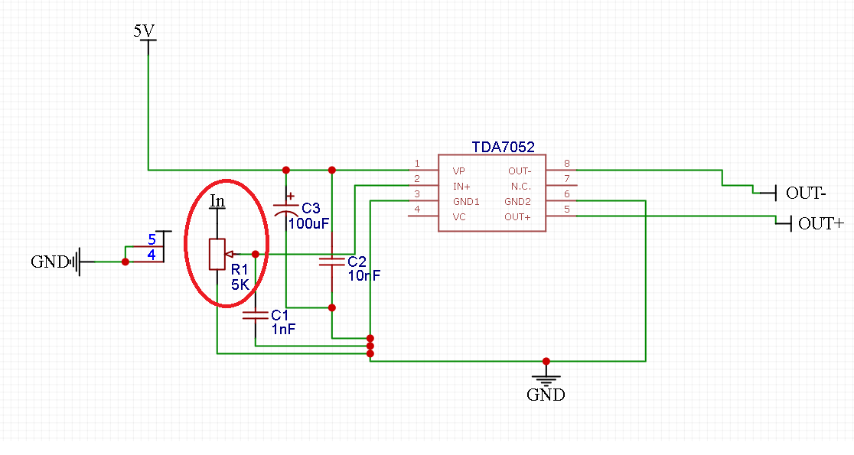
Figure 49: Volume control of TDA7052 circuit

Stage 6 - Arduino Decoding and Encoding
Figure 50 shows the photoresistor driver array’s connection to the Arduino’s IO pins. When the signal to the photoresistor detector circuit is passed to an Arduino, it will then be decoded as to what input mechanism from the EWI was triggered and what voltage level the signal is at. If in the event the signal from the laser driver circuit and photoresistor detector circuit is strong enough (between 3.3V and 5V), the code within the Arduino will encode the pin for serial communications to the MIDI shield. The message that will be sent to the MIDI shield will include: which pin was triggered, the voltage level that the pin is currently at, and what note the wind instrument is trying to recreate.
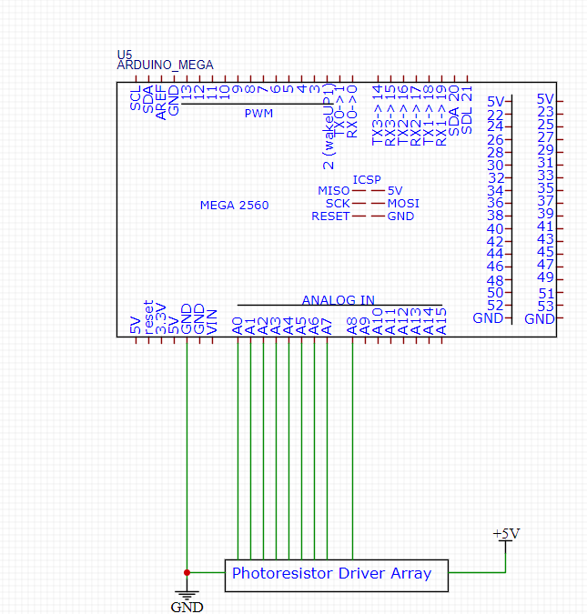
Figure 50: Photoresistor Driver Array to Arduino Pins

Stage 7 - Speaker Assembly
Our speakers were installed at the lower end of the saxophone and were connected to the Arduino through our TDA7052. Using the standard output end of a saxophone is a pretty intuitive solution for the placement of the speakers because it is the largest free space within the device and we can hopefully use some of the acoustic properties of this opening to further amplify our volume output.

Stage 8 - Samsung 18650 Portable Battery Integration
Our charging circuit is complete with both the passthrough charging capability we need and a 5V boost converter we need to power our Arduino. We used the pins on the Arduino, which itself is powered by our boost circuit, to power most of our low current devices since the Arduino itself has an onboard 5V regulator. The batteries which are powering all of this are attached to the inside wall of the device housing and plugged into the boost circuit via a JST connector.

Stage 9 - Control Box Assembly
The device housing and the buttons which control the device were all 3D printed by Manuel. The housing was designed to hold each of the individual PCBs and components in place. A full rotation of the case can be viewed below in Figures 51, 52, 53 and 54 .
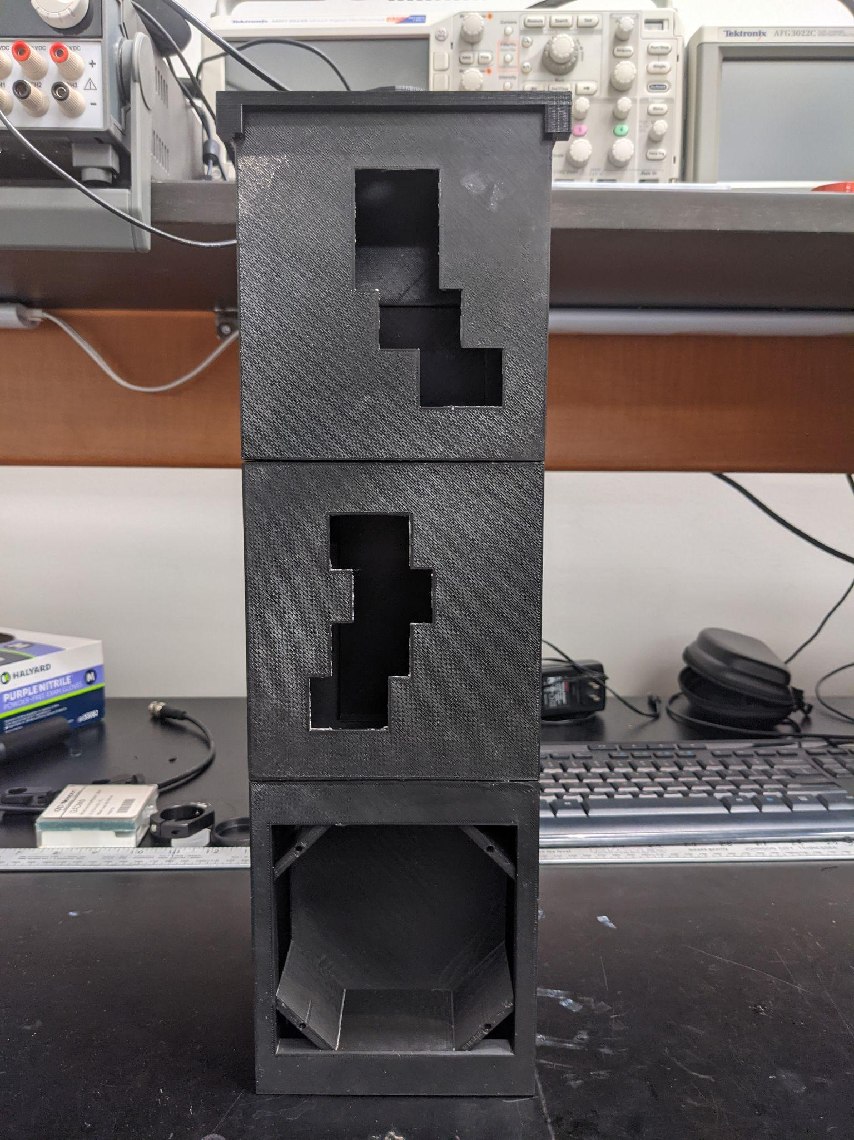
Figure 51: Top view of the device housing

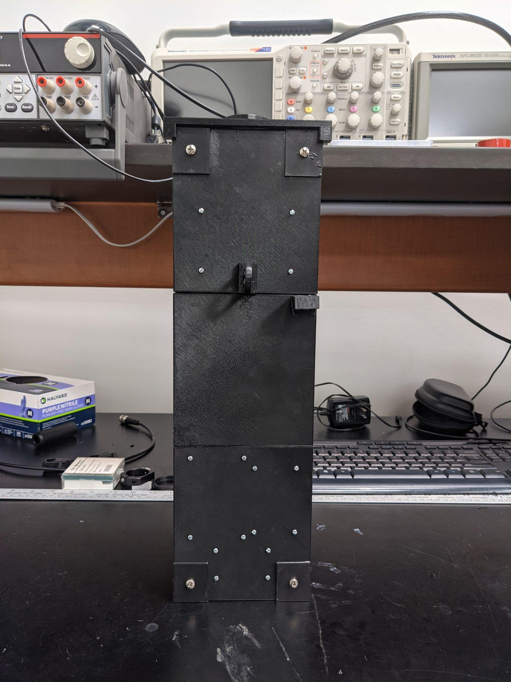
Figure 52: Bottom view of the device housing
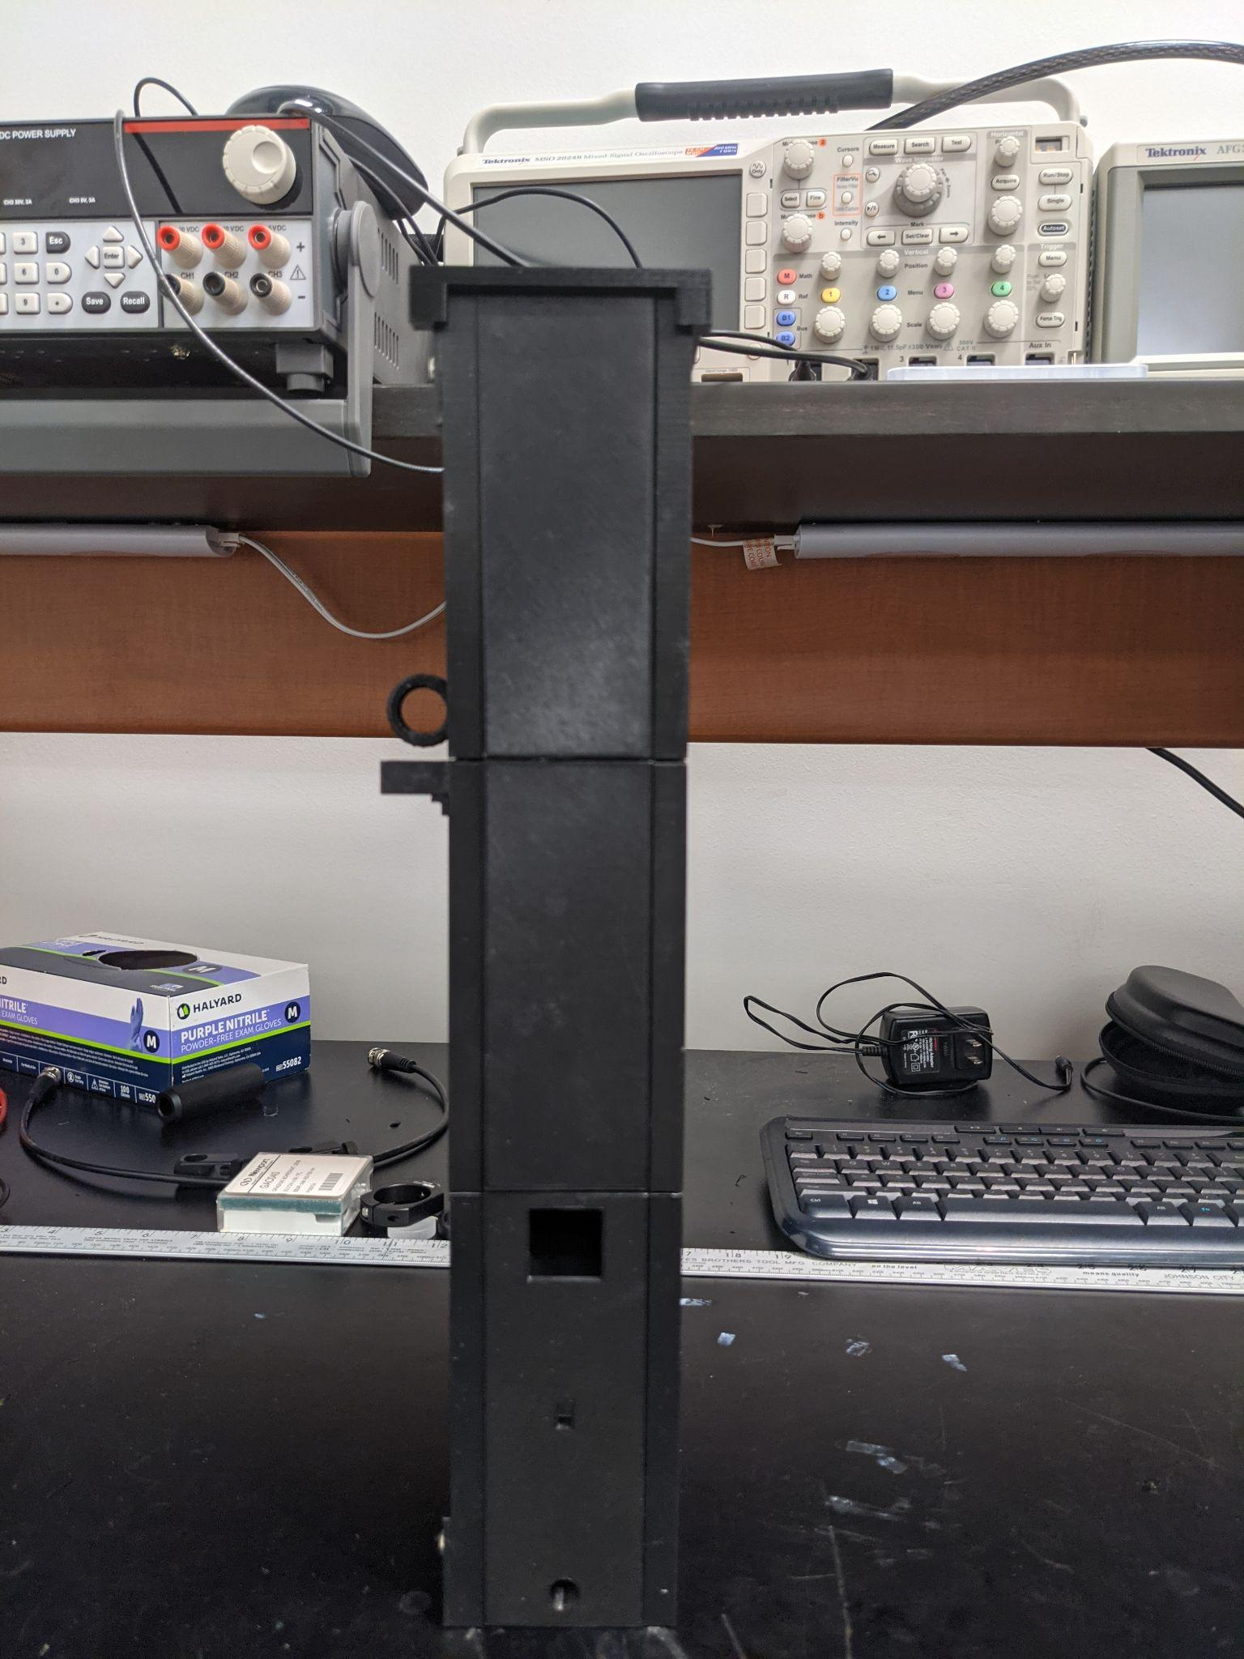
Figure 53: Side view of the device housing
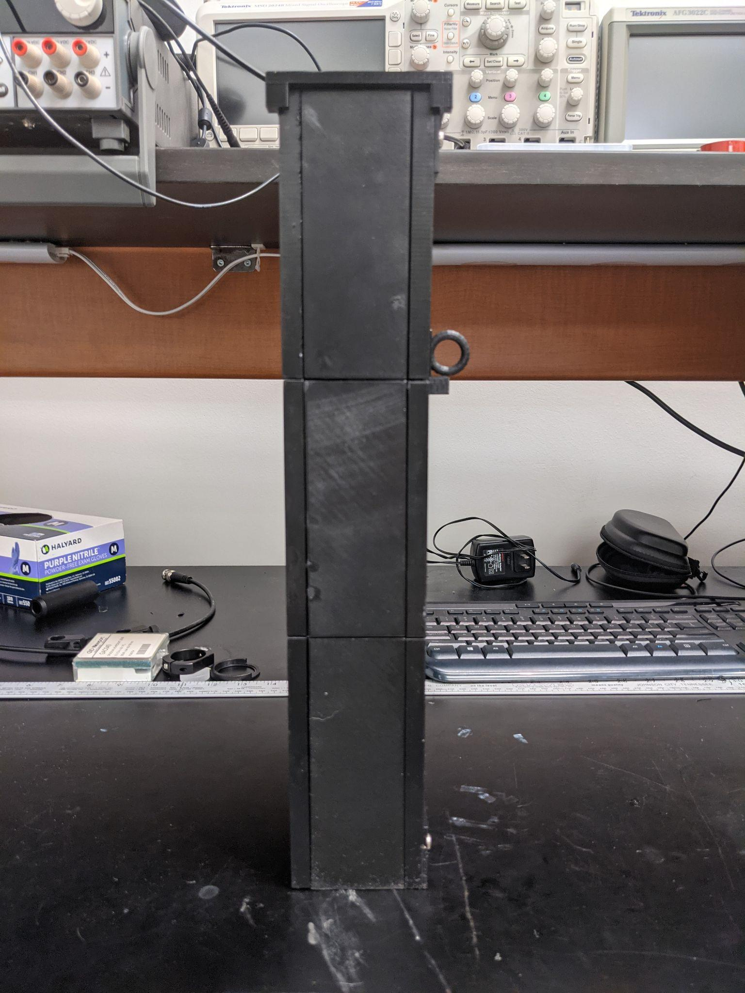
Figure 54: Alternative side view of the device housing

Discussion
We believe this design for an PWI, or photonic wind instrument, satisfies all of our needs as both musicians and engineers. It has a rechargeable battery with a very sufficient operation time per battery charge, a robust library of sounds to ensure it sounds realistic, full volume control and an extremely fast response time to register a key press. With help from the charging/boost circuit, this device offers fast 1.5A passthrough charging via microUSB which is a very popular and common format for charging and almost all users should be familiar with how to use it. This is in contrast to the alternative method of charging 18650 batteries which has the user remove them from the device and charge them in an external charger.
All this is packaged inside of a compact frame to ensure the device is both easily portable and durable. This device is meant to serve the purpose of allowing saxophone players, who otherwise wouldn’t be able to practice due to noise constraints, the ability to freely play and practice their craft. While other designs from large companies are more focused on a compact design, we focused on ensuring our product felt and operated almost identically to a traditional saxophone. This was mainly done through the key mechanisms applied to the design. Our overall goal was to ensure that a player can practice with our product, and then switch to a traditional saxophone and notice little to no difference and no compromise.
During our time developing this device, we ran into many challenges. Firstly, one of our team members had to withdraw from the course due to medical reasons. This caused us to have to redesign our project and lower the scope of what we can accomplish within our established time frame. Since he was in charge of the MIDI processing and generation, we were required to find an existing product on the market that could fulfill his duties in the project since other non-MIDI approaches we tried made the device seem very gimmicky and sound quite poor. We also ran into the issue of PCB acquisition. Initially, we wanted to use domestic manufacturers to allow for quicker turnaround time for ordering our PCBs; however, the rates offered by manufacturers in China were much lower and helped with budget concerns greatly. The issue with this was that turnaround times increased to about 4-5 weeks for our PCBs which was longer than what was advertised and was pretty detrimental to our timeframe of two months. To remedy this, many of the simpler circuit boards were made by ourselves at home using Ferric Chloride etching on copper plates. This solution seemed inevitable, as the increased turnaround to receive the printed circuit boards meant that we could not test or troubleshoot as desired. In our final few days, we realized that our design of one of our circuit boards was incorrect. Instead of the intended detector and resistor pairs running parallel to one another, it would appear that the photodiodes were in series with one another, also known as “daisy-chained.” We realized this mistake too late, and we were forced to delay our assembly and testing to a later date to acquire new blank boards and the PCB etchant. Additionally, it rendered nearly all of the designed saxophone case unusable, as the new boards that were created manually were relatively enormous compared to the imported counterparts and would not fit the slots that were inserted into the case. The size of the blank boards was 4 inches by 2.7 inches, which by themselves is already occupying two-thirds of the width constraint of 6 inches that we implemented for the ease of use for the end user. If we were to redesign the housing to incorporate the larger boards, we would have to edit the files of 14 surfaces, each taking anywhere from one hour to 5 hours to print - not counting the amount of reprints due to trial and error necessary in order to obtain the final satisfactory piece. This was a physical impossibility, as the error came to light two to three days before the final submission date for the documents, whereas it took nearly three entire weeks to get the final housing to its most modern state. This also excludes the extra time needed to design and print the mouthpiece attachment that would make the instrument easier to play - as this was not realized at the end of the first design either, also due to lack of sufficient time. Needless to say, this was a catastrophic oversight for all parties involved.
We also ran into the issue of the mouthpiece assembly working by itself, but when integrated into the completed device would cause nothing but issues. We couldn’t completely isolate the main cause of this issue but it was most likely either due to poor connections to the Arduino, the membrane material used not being reflective enough in the absence of light or the membrane not expanding as much as we expected it to. Additionally, due to time constraints a proper mouthpiece was not printed to accommodate the saxophone. While attempting to test the CNY70 with the latex, we found that most of the air that we blew was scattering outwards and not focused onto the instrument. We worked around the issue by using a much less durable material, paper. We cut strips of paper and taped them to either side of the front side of the casing. The paper behaved as desired; it expanded outward towards the proximity sensor with little effort. However, it seemed as if the frailty of the paper would act against us, as the sensor was not about to detect the movements of the strips. Thus, for the final demonstration, we elected to omit any functionality of the mouthpiece sensor. Neither the latex nor the paper had reached our expectations, and while the paper provided some progress towards our goal, it overall seemed like a “cheap fix” that temporarily solved our foremost issue at the time, and showing or discussing this aspect felt unprofessional. If we had more time to work on this configuration, we would have had great success with it, more so than what we were able to accomplish at the time, because it worked flawlessly outside of the device and was a much better design than the original microphone setup. However, the CNY70 configuration was developed within the last three weeks of our allotted project time and in retrospect, we should have dropped the microphone idea much sooner rather than trying to force it to work.
Despite our few failures, we had mostly successes and improvements along the way. For example, we initially were planning on making the device housing out of wood, which would have worked but would have felt quite ‘tacky’ and hobbyist. We switched to using a plastic 3D printed housing rather than wood which turned out to be very clean and professional in appearance and on top of that, lowered the total weight of the device significantly. We also ended up 3D printing the keys rather than using cuts of PVC pipe. This approach has multiple benefits, listed below:
- PVC piping leads to increased scattering and loss of light, which would provide an improper and inconsistent reading that would considerably complicate the data collection process. Switching to a 3D-printed material provided consistency in our data as we could produce near-identical models throughout the entirety of the saxophone. These models were also fully enclosed and had a tight fit, denying any possibility of light escaping by an extraordinary amount in comparison to PVC.
- While PVC is light and affordable, their structures are rigid and would require extensive knowledge and care in using tools to manipulate the pipes in a suitable fashion. Unfortunately, none of us have the required expertise to handle PVC in such a manner. Additionally, even if we were to attempt the feat, the amount of losses involving materials and time due to trial and error and experimenting would be incalculable, severely impeding our progress in assembling and testing other subsystems. Using the plastic filament allows us a much more intricate level of control in creating housings for each individual piece as well as crafting specific designs for asymmetrical systems - mainly the keys and PCB slots.
The laser diodes that were intended to be used initially also faced some pushback. The WOWOONE 650 nm red dot laser diodes were indeed cheap, costing around $7 for a pack of 20. This was extremely cost effective as it meant we could focus our financial focus on other aspects of the project such as the electrical subsystem and peripherals. However, the main drawback to using this is that this forewent the idea of Senior Design. We essentially chose the component solely out of cost with no regard to its other properties. This was noticed by our Optics and Photonics advisor, Dr. Aravinda Kar, and addressed to us, stating that there is “no optics and photonics design being implemented into the system”. This was a matter of fact. So to address this, we had to take a step back and look at the photonic components individually and assess how our project allowed for adequate design. The first to be inspected were the laser diodes, since there was much to be improved upon there. Since laser modification through lens design was not possible due to the limited amount of time, funds, and resources, we elected to redefine what we wanted out of our saxophone. Since we wanted to pursue a focus on user comfort, we thought that the best solution was to limit the discomfort provided by the use of lasers. This involved lowering the output optical power of the lasers as well as the wavelength of radiation that was being emitted. For this reason we chose the OPV310 diodes. Its 1.5 mW output is a nice lowered value compared to the 5 mW from the WOWOONE lasers, which are just at the power cusp of becoming a laser with regulation needed for use. This was obviously not ideal for our intention of incorporating it into a product that is meant to be for commercial use. Additionally, its 850 nm wavelength is within the range of wavelengths that the black PLA used for 3D printing the case will not allow to transmit, meaning that the infrared radiation of the lasers will not leak past the system itself. There may be inconsistencies around the casing due to the bonding used - in this case we are referring to the epoxy resin. The reason being is that some parts when made to be a “perfect fit” for the joints were for some reason not in fact perfect fits. There must have been some margin of error for 3D printing that we did not take into account. Apart from loosening the joints to fit for an extra millimeter or half of a millimeter, we used the epoxy as a secondary measure for fitting the surfaces together. This also meant that due to the nature of epoxy expanding as the resin dried out, we would then begin to have cracks across the saxophone. This would inevitably lead to some amounts of radiation leaking throughout the instrument. To further combat the effects of discomfort from the radiation of the laser diodes, the fact that we chose 850 nm wavelength radiation would mean that it would be undetectable to the human eye. That coupled with its lowered power output would mean that whatever light did escape through the saxophone it would not inconvenience the player by not distracting them or causing harm. Apart from that the OPV310 was the cheaper option out of all other low-powered 850 nanometer laser diodes available. There was another diode in the same line, the OPV300, which was almost half the price while providing the similar specifications as the OPV310; however, the product was on backorder and was not readily available at our supplier’s warehouses. It was a real shame that we could not get our hands on the OPV300 since we would have had a larger room for error when it came to soldering, as it only had two pins - representing the anode and the cathode - as opposed to the three pins from the OPV310, which featured an internal photodiode as well as its lasing capabilities. The extreme amount of difficulty in soldering wires was already exacerbated by the component’s miniscule structure, but to have three separate pins - as well as the need to avoid coming into contact with one of said pins - instead of just two connectors only meant that we had an inconceivably daunting task that we had to overcome. And while we were partly successful in that we got four of the eight keys working in proper condition, we failed in achieving our desired goal of eight total keys. Those that were working properly had to be positioned carefully, as one minute change could have shorted the connection, shifting the numbers in favor of the failed keys - and ultimately becoming unfavorable for us as a whole.
Apart from the laser diodes, we also switched from using photoresistors, which we initially planned on using in Senior Design 1, to using photodiodes. This was also in response to Dr. Kar’s statement on the need for more optical design work being implemented. Thus, for our new receiver we mainly wanted to upgrade to either a photodiode or a phototransistor. Both have fast response times, though the photodiode edges out the phototransistor in speed whereas the latter excels in sensitivity. Seeing as we needed a simple on-and-off state - whether the receiver was accepting light or not - and not careful and intricate manipulation of current and voltage values, we opted for the photodiode for its remarkable response time. All that was left in choosing the ideal photodiode was for it to match the laser diode we chose - that is, we required its peak wavelength sensitivity to match that of the OPV310 and have similar, if not exact, diameters such that it maintains uniformity with the axis of the laser diode and it won’t further complicate the reception for the detector. The second self-imposed requirement, although seemingly arbitrary, was just as important as the other constraint because: (1) this would reduce the amount of optics necessary for the detector to collect light, and this was extremely important with the severe lack of time necessary to make a complete overhaul of the project, and (2) the uniformity of laser diode and photodiode reduced the complexity of the key casing such that our resources - namely time and effort - could be wisely distributed among the remaining stages of the project, which for us was the entire design and assembly of the outer saxophone casing, the convergence of the electrical and optical subsystems, troubleshooting of both hardware and software, and final assembly towards a completed product. For these reasons, Inolux’s INL-5APD80 was our best option. Also, after having to spend $150 for the laser diodes within the last few weeks of the semester, it was very refreshing to see we found a great product that sold for only a fraction of a dollar each.
Although we failed in producing a complete product, we are satisfied with our results. Firstly, the amount of detail and care necessary to obtain our final rendition was like no other project we have faced, and we can only thank our advisors as well as those prior in establishing such an arduous feat in our final year of our undergraduate career. In doing so we were able to experience an introductory taste of the engineering field in the form of preparation and planning, communicating with a team, and coming together to achieve one desired result. With this failure we are able to look within ourselves and recall the last two semesters of our bachelor’s degree, analyze our shortcomings and mistakes and revise our strategies for undergoing certain procedures, and create a plan of action should the circumstance arise once again.

Licensure and Copyright
The following is a list of Licenses and Copyright of the software and materials used in the project.

Adafruit Creative Commons License
Subject to the terms and conditions of this License,
Licensor hereby grants You a worldwide, royalty-free, non-exclusive,
perpetual (for the duration of the applicable copyright) license to
exercise the rights in the Work as stated below:

a. to Reproduce the Work, to incorporate the Work into one or more
Collections, and to Reproduce the Work as incorporated in the
Collections;
b. to create and Reproduce Adaptations provided that any such Adaptation,
including any translation in any medium, takes reasonable steps to
clearly label, demarcate or otherwise identify that changes were made
to the original Work. For example, a translation could be marked "The
original work was translated from English to Spanish," or a
modification could indicate "The original work has been modified.";
c. to Distribute and Publicly Perform the Work including as incorporated
in Collections; and,
d. to Distribute and Publicly Perform Adaptations.

Arduino: General Public License
Official Arduino libraries are protected by the LGPL and therefore we can use the bootloader and libraries for our prototype of the Electronic wind instrument. Therefore we are not required to release sketches.

References
Wikipedia. “Serial Communication.” Wikipedia, Wikimedia Foundation, 1 Mar. 2021, en.wikipedia.org/wiki/Serial_communication.
Pandit, Abhiemanyu. “Serial Communication Protocols.” Circuit Digest, 29 Apr. 2019, circuitdigest.com/tutorial/serial-communication-protocols.
Charles, Roger. Ultimate Songwriting, 4 Jan. 2017, www.ultimatesongwriting.com/alto-saxophone-fingering-chart/.
Suits, BH. “Tuning.” Frequencies of Musical Notes, Michigan Technological University, pages.mtu.edu/~suits/notefreqs.html.
“Arduino Mega 2560 Rev3.” Arduino Mega 2560 Rev3 | Arduino Official Store, store.arduino.cc/usa/mega-2560-r3.
Ada, Lady. “Adafruit Powerboost 1000C.” Adafruit Learning System, learn.adafruit.com/adafruit-powerboost-1000c-load-share-usb-charge-boost.
How to Build a Laser Diode Circuit, www.learningaboutelectronics.com/Articles/Laser-diode-circuit.php.
Ada, Lady. “Force Sensitive Resistor (FSR).” Adafruit Learning System, learn.adafruit.com/force-sensitive-resistor-fsr/using-an-fsr.
“1. Installing GPIO Zero.” 1. Installing GPIO Zero - GPIO Zero 1.6.2 Documentation, gpiozero.readthedocs.io/en/stable/installing.html.
“RPi.GPIO.” PyPI, pypi.org/project/RPi.GPIO/.
Jones, Neil F. “Audio-to-Midi.” PyPI, 23 Nov. 2020, pypi.org/project/audio-to-midi/#description.
Bechtold, Bastian. “SoundFile.” PyPI, 25 Nov. 2019, pypi.org/project/SoundFile/.
“MIDI Files.” MIDI Files - Mido 1.2.9 Documentation, mido.readthedocs.io/en/latest/midi_files.html.
Ada, Lady. “Force Sensitive Resistor (FSR).” Adafruit Learning System, learn.adafruit.com/force-sensitive-resistor-fsr/using-an-fsr.
“1.0 DC to DC Buck Converter.” DC to DC Buck Converter Circuit Homemade Arduino, electronoobs.com/eng_circuitos_tut10.php.
Laser Diode. (n.d.). OdicForce. Retrieved April 27, 2021, from https://odicforce.com/Background-and-Projects/Laser-Diodes
Ada, Lady (2018), “Photocells” https://www.mouser.com/datasheet/2/737/photocells-932884.pdf
Laser Safety Information. (2019, June 24). Retrieved from https://www.lia.org/resources/laser-safety-information
Panchal, Kamal, Cox, Garfield (2021); “The Implications of COVID-19 for Mental Health and Substance Use”; https://www.kff.org/coronavirus covid-19/issue-brief/the-implications-of-covid-19-for mental-health-and-substance-use/
TTElectronics (2018), OPV310 Datasheet, https://www.ttelectronics.com/TTElectronics/media/Pr oductFiles/Optoelectronics/Datasheets/OPV300- 310Y-314Y.pdf
Inolux (2019), INL-5APD80 Datasheet, http://www.inolux corp.com/datasheet/IR/Sensor/3mm_5mm_PD/INL 5APD80_V1.0.pdf
European Parliament, Council of the European Union (2015); Directive 2015/863 “amending Annex II to Directive 2011/65/EU of the European Parliament and of the Council as regards the list of restricted substances” Accessed from https://eur-lex.europa.eu/legal-content/EN/TXT/PDF/?uri=CELEX:32015L0863&from=EN
CircuitGlobe (2021), circuitglobe.com “Difference Between Photodiode & Phototransistor” Accessed from https://circuitglobe.com/difference-between-photodiode-and-phototransistor.html
Keim, Robert, Elinoff, Gary; eepower.com “Photoresistor | Resistor Types | Resistor Guide”; Accessed from https://eepower.com/resistor-guide/resistor-types/photo-resistor/#

