Project 1: QuikCam
Project 2: 3D Environment Reconstruction Drone

Group 26
Chisom Ikejiani – Computer Engineering
Andre Samaroo – Computer Engineering
Michael Serignese – Computer Engineering

Project 1 Sponsor: QuikCut

Project 1 Divide and Conquer:
Narrative Overview
The tall tripod-mounted action camera is meant to act as a sports camera that can rapidly pan, tilt, and zoom (also called a PTZ camera), rapidly responding via the user interface in order to capture fast-paced events from a vantage point that allows effective coverage of a large sports arena. The previous implementation designed by Qwikcut is rather pricey for a system that does not quite meet a desirable maintenance schedule, where three cables for power, audio, and video appear to be grafted onto the camera system in such a way that they often fail. Additionally, the waterproofing for the system is lackluster and may cause failure on an incident of rain, a detrimental feature for a camera system that is meant to capture events often held outdoors. Therefore, the goal of this project is to offer a new design and implementation of the product that is lower cost, more tightly integrated, has superior waterproofing, and requires less maintenance than the initial design.

The camera will output audio and video data to a workstation computer that will be responsible for recording to disk, livestreaming the audio-video media content in real time, and issuing commands to the camera via the user interface of a game controller. The inputs of power and commands to the camera as well as the media output from it will flow over an ethernet cable capable of conducting the signal and wattage necessary for the device.

The camera will be controlled via a game controller, using two joysticks and at least four buttons to control pan, tilt, and zoom, starting and stopping the recording or livestream, increasing or decreasing the brightness of the video stream, and finally powering on and off the device. If there are additional interfaces on the controller that remain unused, the goal for these features is to reserve them to attain maximum control over the camera through the controller, and only deferring to the workstation computer as a secondary control mechanism.

Since this is an action camera, the responsiveness of the device both in terms of software control features and also in mechanical agility are paramount. The controller-camera logical connection, in tandem with the pan-tilt motor agility, must be bridged in such a way that commands transmitted via the user interface of the controller reach the camera

Requirements Specifications

Tripod-1
The tripod must be sturdy enough to provide mechanically stable video.

Housing-1
The device housing must be waterproof in moderate rain.

Video-1
The camera system must be capable of sampling 1080p at 30 frames per second.

Audio-1
The audio system must be able to sample audio in the following formats, or an equivalent format that offers comparable quality parameters: WAV (44.1kHz, 16 bit), MP3 (320Kbps), or OPUS (128 Kbps).
Mount-1
The mounting connectors between the tripod, motor mounts, and camera system must be able to withstand minor force without being damaged.

Controller-1
The controller must be able to connect to a workstation computer via USB2 or newer, and control the camera via the joysticks and buttons on the device.( a feature more than a requirement)

Controller-2
The controller must be able to pan, tilt, zoom, and otherwise control the camera on the full range of the device’s capabilities.

Block Diagram

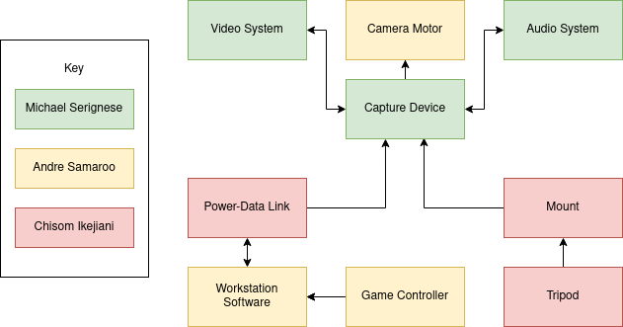

Diagram 1: Block Diagram 1

Budget

Item | Quantity | Price
Camera | 1 | TBD
Microphone | 1 | TBD
Power-data link | 1 | $30
Game controller | 1 | $50
Capture device | 1 | TBD
Mount | 1 | TBD
Motor | 1 | TBD
Total | -- | TBD
Table 1: Budget 1

Initial Project Milestones

Senior Design 1
Week | Milestone
1 | Form teams
2 | Brainstorm ideas
3 | DC1
4 | Investigate project idea
5 | DC2
6 | Investigate weather-proofing
7 | Draft parts requirements
8 | Finalize parts requirements
9 | Assignment on standards
10 | Order parts and set up development software
11 | Begin assembly and experiment with control software
12 | 60 page draft
13 | Test camera motor and implement mount
14 | 100 page draft
15 | Final draft
16 | Final submission
Senior Design 2
1 | Software plan
2 | Implement workstation software
3 | Implement controller software and data exchange protocol
4 | Implement video subsystem
5 | Implement audio subsystem
6 | Final revision, assembly, and testing of prototype 1
7 | Revise software for workstation, controller, and data link
8 | Revise mechanical stability, weatherproofing, and software for audio-video
9 | Final comments and accessory ideas
10 | Final revision, assembly, and testing of prototype 2
11 | Assess and Report
12 | Final draft
Table 2: Milestones 1

Project 2 Divide and Conquer:
Project Narrative
Many people long to visit the pyramids of Giza or walk the halls of the Louvre, but often never get the chance. And in the covid-19 era, visiting monuments and museums is near impossible. Sure, we can look at pictures and imagine what it’s like to be there but wouldn’t it be great to experience a virtual replica.

Virtual reconstruction of various cultural heritage sites has been an ongoing project of archeologists and scientists alike. The desire to create the digital equivalent of what plaster cast replicas were to the 19th century has driven museum curators and cultural sites preservationists to digital reconstruction techniques such as photogrammetry using Lidar scanning or computer vision. Environment reconstruction has been an important area for roboticists too because the accurate mapping of an unfamiliar environment allows robots to have even greater autonomy. A combination of machine learning and computer vision allows robots to build maps of new environments to easily navigate and understand the world in which they interact with. Coincidentally, detailed 3D maps of unfamiliar or hard to reach environments can be useful to historical researchers too.

This project aims to create a drone robot that will map a closed environment and produce an accurate 3D model of the space for future use and research use. While a simple car-based robot would be easy to build, it is limited to only large flat areas devoid of bumps or low-lying obstructions. A flying drone need only be small enough to maneuver through difficult terrain. Some may criticize drones for being too slow, but for the purposes of 3D scanning, slow and steady movement is an asset.

The goal of this project is to use a Lidar sensor to take depth data and reconstruct an indoors environment, but Lidar has some issues. The first is the expense. Full Lidar systems or kits can be expensive, so a goal of the reconstruction drone would be to use a low cost Lidar system. Another issue is that Lidar can be unreliable under dark lighting conditions or when mapping shiny or transparent objects. So, another goal of the project is to use sonar sensor data to help compensate. Sonar uses sound waves which don’t rely on light, so they can map shiny and transparent surfaces more accurately.

Since a drone can only carry a limited payload, the sensors and processors need to be light weight. To reduce the weight capacity, the major processing unit where the map will be built will be in a separate control device. The drone will transmit the data to the off-board control unit which will process the data and create the 3D map from both Lidar and sonar sensors.

Long lasting power remains an issue with drones, so the scanning process would need to be quick. A possible stretch goal to reduce power consumption is to use a GPU based machine to reduce calculations since GPUs are SIMD architecture that can do parallel processing very well. This can speed up the machine learning algorithm creating the model because the process is so hardware intensive.

A stretch goal for the software is that the drone will be able to sense when it has done a complete scan of a room and report to its original position by determining if the map is continuous. It may be more feasible to have the drone base completeness based on input parameters from the control module but we hope to make the drone as autonomous as possible.

Requirements and Constraints
Constraints:
Lidar and photogrammetry are sensitive to lighting conditions
Drones have limited power supply, so limited flight time
Drones can move slowly (but slow and steady is good for scanning)
Drones need to be light weight or motors need sufficient power to carry all components
Sonar can only be used in short range mapping (for sake of stability)
Lidar can be expensive (computer vision option is cheaper but less stable without complex machine learning algorithm or high-definition camera)

Requirement Specifications:
- Have drone stay in flight for at least 10 minutes
- Keep sensor system, including main controller and transmitter, under 0.5Kg
- Keep the whole project under $200
- Maximum range should be 1-meter radius
- Reconstruction algorithm should produce a model in about 10 minutes
- Sensors should be able to perform in low light conditions, at minimum they should perform in indoor artificial lighting
- Drone should be able to move semi-autonomously, needing only to be placed in the correct position and given a defined space to map
- The map should be accurate to the room (still researching a benchmark)

Block Diagram

Software:
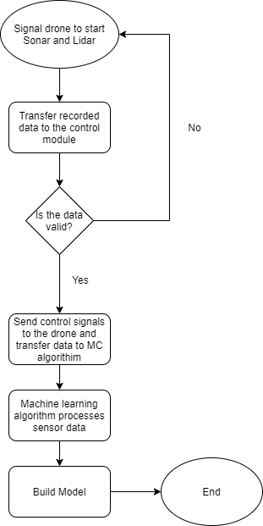
Diagram 2: Software Flowchart

Hardware:

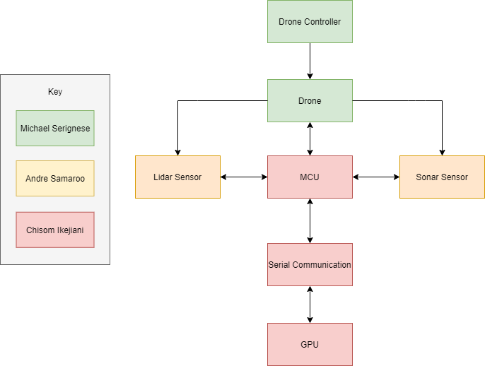
Diagram 3: Block Diagram 2
Budget
Item | Quantity | Price
Arduino ultrasonic sensor HC-SR04 | 2 | $8.00
Raspberry pi 4 | 1 | acquired
Lidar range finder | 1 | $40.00
range finder sensor | 1 | $9.00
microcontroller (if pi not allowed) with transmission capability | 1 | TBD
propellor motors | 4 | TBD
propellors | 4 | TBD
battery (for drone) | 1 | TBD
drone frame (if we don’t build/print it) |  | TBD
Total | -- | $57.00  (incomplete estimate)
Table 3: Budget 2

Initial Project Milestones
Senior Design 1
Week | Milestone
1 | form teams
2 | brainstorm ideas
3 | Divide and Conquer 1
4 | research sensors and drone parts
5 | Divide and Conquer 2
6 | start looking into software
 | --machine learning software to build model
 | --software to communicate between drone and control module
7 | finalize prototype plans
 | --PCB board designs
 | --drone schematics
 | --sensor arrays
 | --control module
8 | order parts
9 | Assignment on Standards
10 | test software
 | --communication between drone and control module
11 | build prototype
12 | 60-page draft
13 | assess results
14 | 100-page draft
15 | Final draft
16 | Final submission
Senior Design 2
1 | research solutions to problems with prototype
2
3
4
5
6
7
8
9 | test prototype 2
10 | report and assess
11 | final product
12 | final report

Table 4: Milestones 2

Decision Matrix

Table 5: Decision Matrix

 | project 1: QuikCam | project 2: drone
cost | < $490 | < $200
sponsorship | yes | no
tech interest
- hardware | PTZ cam, ethernet communication, remote control | drone, transmitters and receivers,  Lidar, sonar
- software | audio/video streaming, remote control functions | machine learning, autonomy, robotic vision, visual servoing
technology familiarity | High | Medium
Table 5: Decision matrix

Sources:
Project 1:
Documentation from Qwikcut about requirements:
https://webcourses.ucf.edu/courses/1370771/files/folder/potentialprojects?preview=84393337

Project 2:

Project Narrative:
3D scanning heritage sites
https://blog.trimech.com/using-3d-scanning-for-heritage-preservation
https://www.emerald.com/insight/content/doi/10.1108/IR-08-2019-0164/full/html?skipTracking=true
3D scanning with laser
https://ieeexplore.ieee.org/document/1240274
3D scanning processing using GPU
https://hal.archives-ouvertes.fr/hal-01762188/document

Examples:
Prices of 3D scanners
https://all3dp.com/1/best-3d-scanner-diy-handheld-app-software/
https://www.3dnatives.com/en/top-10-low-cost-3d-scanners280320174/#!
example of lidar drone
https://www.autonomousrobotslab.com/localization-and-3d-reconstruction.html

Items:
Ultrasonic sensor
https://www.sparkfun.com/products/15569
Lidar range finder
https://www.robotshop.com/en/benewake-tfmini-s-micro-lidar-module-i2c-12m.html
range finder sensor
https://www.robotshop.com/en/tof-range-finder-sensor-breakout-board-voltage-regulator-vl6180.html
wifi transmitter
https://www.robotshop.com/en/esp8266-wifi-shield.html
cheap 3D scanner
https://www.ebay.com/itm/Bevel-3D-scanner/224328259493?hash=item343b0197a5:g:7EUAAOSw4wdgDw-o
Mid-range Lidar 360 scanner
https://www.amazon.com/MakerFocus-Rangefinder-Ultra-Small-Navigation-Avoidance/dp/B07YC78WDK/ref=sr_1_4?dchild=1&keywords=360+degree+lidar&qid=1611892980&sr=8-4

