Project: Pan-Tilt-Zoom Camera

Group 26
Chisom Ikejiani - Computer Engineering
Andre Samaroo - Computer Engineering
Michael Serignese - Computer Engineering

Table of Contents
Title Page................................................................................................................ i
Table of Contents.................................................................................................... ii
Executive Summary................................................................................................ 1
Project Description................................................................................................. 1
-Motivation............................................................................................................. 2
-Objectives.............................................................................................................. 2
-Requirement Specifications................................................................................... 3
-Standards and Constraints...................................................................................... 4
-Marketing requirements......................................................................................... 5
Research.................................................................................................................. 7
-Existing Products................................................................................................... 7
-Camera................................................................................................................... 8
-Audio Systems....................................................................................................... 14
-Motors.................................................................................................................... 16
-Electronic Speed Control....................................................................................... 21
-Mount/Frame.......................................................................................................... 24
-Main control board................................................................................................. 27
-Power/Data Link.................................................................................................... 30
-Remote Control...................................................................................................... 34
Design...................................................................................................................... 37
-Prototype................................................................................................................ 37
-Hardware................................................................................................................ 38
Software................................................................................................................... 41
-Testing.................................................................................................................... 45
Administration......................................................................................................... 46
-Budget..................................................................................................................... 46
-Milestones............................................................................................................... 47

Executive Summary:

Motion control rigs are basically robotic cameramen. They control the camera’s movements and even the camera settings. These systems allow you to execute difficult camera shots with the ease of programming the movements. This also allows us to take camera shots from difficult places and remotely.

The tall tripod-mounted action camera is meant to act as a sports camera that can rapidly pan, tilt, and zoom (also called a PTZ camera), rapidly responding via the user interface in order to capture fast-paced events from a vantage point that allows effective coverage of a large sports arena. The implementation we looked at was designed by Qwikcut. It is rather pricey for a system that does not quite meet a desirable maintenance schedule, where three cables for power, audio, and video appear to be grafted onto the camera system in such a way that they often fail. Additionally, the waterproofing for the system is lackluster and may cause failure on an incident of rain, a detrimental feature for a camera system that is meant to capture events often held outdoors. Therefore, the goal of this project is to offer a new design and implementation of the product that is lower cost, more tightly integrated, has superior waterproofing, and requires less maintenance than the initial design.

The camera will output audio and video data to a workstation computer that will be responsible for recording to disk, livestreaming the audio-video media content in real time, and issuing commands to the camera via the user interface of a game controller. The inputs of power and commands to the camera as well as the media output from it will flow over a USB cable capable of conducting the signal and wattage necessary for the device.

The camera will be controlled via a game controller, using two joysticks and at least four buttons to control pan, tilt, and zoom, starting and stopping the recording or livestream, increasing or decreasing the brightness of the video stream, and finally powering on and off the device. If there are additional interfaces on the controller that remain unused, the goal for these features is to reserve them to attain maximum control over the camera through the controller, and only deferring to the workstation computer as a secondary control mechanism.

Since this is an action camera, the responsiveness of the device both in terms of software control features and also in mechanical agility are paramount. The controller-camera logical connection, in tandem with the pan-tilt motor agility, must be bridged in such a way that commands transmitted via the user interface of the controller reach the camera.
As a stretch goal, we would like to automate the control rig in some way. We thought that a computer vision based tracker would be best. The camera will lock onto a subject in frame and then basically follow that person until the feature is turned off. This leads to another stretch goal of making the game controller communicate with the workstation wirelessly to allow for the person to control the camera remotely.

Project Description

Motivation:
In the PTZ camera world there exists many high-end cameras that can capture and stream high-quality sports action video phenomenally. Today’s cameras can smoothly and safely capture under the roughest of conditions from the strongest of winds to the fiercest of rainstorms. Inside tight weather-proofed housing there are no worries or risk of damage to the investment. During sporting events, the cameras can track real-time movements like baseballs after being hit by a bat through the sky or a football player charging down a field at a high speed. Everything related to these PTZ cameras seems almost perfect except their ultimate costs, they can cost anywhere from $1500 to $10k+. For big sports organizations that price point may be miniscule but for the local high school or small youth teams it can be near impossible.

Our implementation of the PTZ camera seeks to solve the issue of price by combining and assembling a PTZ camera that preserves many of the qualities the high-end cameras have such as weather-resistance, real-time tracking, and remote controlling. The proposed camera will achieve its low price point by sourcing budget products such as Arduino and standard consumer cameras while using cheaper 3d printed materials for the housing and design. Our design will also cut out expensive controlling software used today by using a standard gaming controller as the remote and simple custom video software to both control and display video from the camera. It will be cheaper, more portable, and practical than any of the other PTZ cameras available today.

Our PTZ camera will be easy to use and setup, remote controlled camera that only needs a single laptop to work with. The light weightiness of design makes it perfect for the traveling camera man or local sport institutions. The targeted customer would be those without the financial means or incentive to invest in a high-end expensive PTZ camera, such as youth sports teams, local high schools, and general action sport hobbyists. The target group would find that the camera assists with not having to lug around heavy equipment and can be used without having to go through a steep learning curve since the remote control and software are simple to use.

Additionally, alternative PTZ cameras today are also equipped with complex and expensive control and streaming software that our project eliminates all together by using a simple to use and easily available gaming controller combined with custom computer software that will display video and push commands to the systems motors. Another problem our project indirectly solves as a byproduct of our minimalist approach is the cluster and entanglement of wires that occurs when using the bigger more expensive cameras and systems.

Objectives:
A key to having a successful project is to maintain clear objectives and goals that guide the mission, design, and implantation of the project at hand. After a few goals are established, the project will have enough direction and purpose to continue successfully.

Some of the objectives of this project are to assemble a PTZ camera that can shoot high quality video, withstand harsh weather, track real time tracking, maintaining a low price point, and portability. However, the three of them are essential to the success of fulfilling the purpose of this project are listed below.

  - To shoot High quality video
  - Have suitable weather resistance
  - Be Cost-effectiveness

The first objective of the PTZ camera is the ability to shoot high quality video comparable to the standard set by alternative PTZ cameras today. The lowest quality considered high definition would be 720P @ 30fps. This quality is achievable in a wide selection of cameras and is within the budget of the project. The camera selected will also have to consider our minor objective such as portability, so the light-weight options will be preferred.

The second objective of the PTZ camera is to achieve a weatherproof design, able to capture and withstand winds 10mph or less and heavy rain. This is one of the most essential objectives as some PTZ cameras used in sports must capture steadily no matter the weather without damaging equipment. Without proper weatherproofing device damage is inevitable, so achieving dependable weatherproofing is a must.

The third objective of the PTZ camera is to remain cheap and cost-effective when compared to other PTZ cameras on the market. The low price point is achievable by first purchasing the desired quality of camera and focusing on using 3d printed parts for the housing, low-cost microcontrollers, and low-cost motors. The camera should also be able to maintain its quality without opting for cheapness where it is unnecessary.

Altogether the desired objectives work in tandem to fulfill a design that works to keep the cost cheap while providing, high quality video, harsh weather resistance, and portability. These goals and objectives serve as a guideline which will help keep the team directed and in agreement in order to ensure the success of this project.

Requirement Specifications:
Tripod-1
The tripod must be sturdy enough to provide mechanically stable video in wind gusts of 10 miles per hour.

Housing-1
The device housing must be waterproof in moderate rain, at 0.10 inches of rain per hour.

Video-1
The camera system must be capable of sampling 1080p at 30 frames per second, with a delay of less than one second for the samples to arrive.

Video-2
The camera subsystem must be under 1 pound.

Audio-1
The audio system must be able to sample audio in the following formats, or an equivalent format that offers comparable quality parameters: WAV (44.1kHz, 16 bit), MP3 (320Kbps), or OPUS (128 Kbps). The samples must not be delayed longer than 1 second to arrive.

Mount-1
The mounting connectors between the tripod, motor mounts, and camera system must be able to withstand minor force of 5 ft-lbs without being damaged.

Motor-1
The motor must be able to pan and tilt with an attached mass of at least 1 pound.

Controller-1
The controller must be able to connect to a workstation computer via USB2 or newer, and control the camera via the joysticks and buttons on the device.

Controller-2
The controller must be able to pan, tilt, zoom, and otherwise control the camera on the full range of the device’s capabilities, initiating the commands from the controller in under 1 second.

Workstation-1
The workstation software must transmit the commands received from the controller in less than 0.5 seconds.

Workstation-2
The workstation software must process packets received from the camera system to prevent a packet backlog of over 1000 packets from forming.

Standards and Constraints:
We will be using multiple control boards to perform different functions. These boards will communicate through pin connections from the general-purpose input/output (GPIO) ports. Most devices have a standard layout for these pins. On Raspberry Pi devices, the pin layout uses a 2 by 20 design located to one side of the board. On Arduino, the pins are split into 1 by 20 blocks, one on each side of the board. There may also be additional pins such as RVR pins for I2C connections. Pin block designs can be found documented in the control board’s specification sheet.

We will be using soldering to attach pin connectors to the GPIO ports to allow the PWM board and main control board to connect easily. We will follow IPC soldering standards to make sure that our pin connections are secure and that we remain safe while soldering. IPC-J-STD-001 defines standard soldering practice for PCB’s. To properly solder the pin connections, we must hold the pin headers to the ports and heat the pin heads. The best practice for applying solder is to melt it on the soldering iron and then apply the small drop to the area around the pin head. Just enough solder should be applied to cover the GPIO pad around the port to avoid creating bridges and shorts between the ports.

We are transmitting data over wi-fi and USB. Each of these transmission methods has standards with regards to how to encode data and how to interface the devices at each end of the transmission. For wi-fi, it is IEEE 802.11. This is a standard defined by IEEE that defines how a wi-fi signal should transmit, collision control, and what channels the device can use in the radio wave spectrum. All purchasable products are IEEE 802.11 compliant. The release of USB 2.0 in the year 2000 signified the increase of the data rate to 53 Mbyte/sec, allowing a current of 1.5 A while performing high-bandwidth, high-speed communication, or a more power-heavy load of 5 A while sacrificing data transfer speed. The USB 2.0 Micro connector supports a similar pin-out scaled down to fit a smaller, differently shaped port. Power always flows from the host to the secondary device.
https://www.usb.org/document-library/usb-20-specification

There are constraints with regard to power and current that applies to the technologies that we have bought for the project. Each motor has an operating voltage that determines the minimum required voltage for a motor to achieve full speed, so the power supply for the control board needs to be able to power the motors as well as the boards.

We also have a constraint on how the power supply should be connected. The main power is routed through the PWM board and then driven to the main controller through the 5-volt and ground GPIO pins. We need to make sure that the amount of voltage through the port does not go too high to prevent overloading and damaging the board. 5-volt compliance is a standard that says that a higher voltage power supply will be regulated down to 5 volts. Most of the control boards available are designed either this standard in mind through the main power supply port but driving power through the GPIO port will bypass this regulator and present the possibility of burning the board. We should either make a regulator or keep the voltage in mind when connecting to the 5-volt rail.

Marketing Requirements:
The client’s assumed intent is to use the device to perform videography on high-speed sports events that require a bird’s eye view of a wide area that can be covered quickly by the action camera system. We intend to deliver this product as an easily controllable bundled package that relies on commonly available computer hardware. Including prebuilt options like cameras and controllers defers the research costs to other companies, ensures ease of part replacement in the case of failure, and reinforces the likelihood that users will be familiar with the parts and operation of the device.

Impacts
The impact of cost will filter the users of the device to include those willing to invest more than those satisfied with taking snapshots from the ground. The benefits of the elevated device must outweigh the extra cost of developing the tripod-based system. This is the basis for competition with those ground-based video capture products. Alternatively, there are other tripod-type camera systems available on the market, but they are often homebrew-style devices without tight integration of the parts. Ideally, this device’s quality choice of parts with pre-planned integration will increase the competitiveness, product viability, and competitiveness of our project.

This will make such a camera model available as a bundled package without the need to implement it from scratch. As such, communities, schools, sporting venues, or otherwise bird’s eye videography will become more available to the public if drone video shooting is undesirable but shooting from the ground is not sufficient to cover the area being filmed.

Safety
The tripod camera system, when used as intended, does not cause harm to the user or to individuals nearby during operation. The electronic interference is negligible and does not take advantage of large-scale radio transmission technology. Only the proper physical handling of the device is required in order to establish safe conduct.

Steps should be taken to ensure that in high wind conditions, the tripod is fixed securely enough that it does not topple over, which could prove an impact hazard to people or property.
A brief safety pamphlet noting the potential dangers of handling electricity would cover the bases for any power sources involved in setting up the device.

Manufacturability and Sustainability
The camera, the tripod, the controller, the workstation, and the connecting hardware are all standardized and widely available. The software written for the project can naturally be duplicated freely by the manufacturer. Therefore, the project ecosystem as a whole is supported by a highly manufacturable industry and faces no general threat of shortage.

There is a chip shortage as of 2021, but this is less likely to threaten access to embedded parts. It is likely that after this shortage passes, parts for regular maintenance or repairs will continue to be available to the general public.

Given that there are not many moving parts beyond the pan and tilt motors, the product should overall not need replacements until the lifetime of the individual components passes. If necessary, new motors could be sold as separate parts for the user to perform maintenance. Alternatively, a system where damaged parts are shipped back to the producer, repaired, and returned to the customer could also be implemented, allowing the manufacturer to determine the cause of the defect in order to provide insights into improvements on the device.

If there are updates to the software or otherwise security vulnerabilities discovered in the product after publication and distribution, the software maintained by our team runs on a typical desktop-style workstation, so updates could be pushed over the internet if necessary.

Requirements to Use
Users will be familiar with the technology involved if they have general experience with cameras, ordinary computer use, and possibly a background in using video game console controllers. The most important background is in the use of the controller device as this is the most specialized. In order to capture video with an action camera on a fast-paced sports game, a certain minimum level of fast reflexes are required. Therefore, the operator should be alert and dexterous enough in order to capture these events as they occur.

For those users that have prior experience with video game console controllers, they are likely to be familiar with the PS4 controller that is used to operate the camera controls; this will ease the learning process for the device.

House of Quality
The house of quality, in Table 1, illustrates the tradeoffs between the marketing and engineering requirements. By comparing the tradeoffs between the two requirements we are able find what can be accomplished conceptually before actually physically building the project.
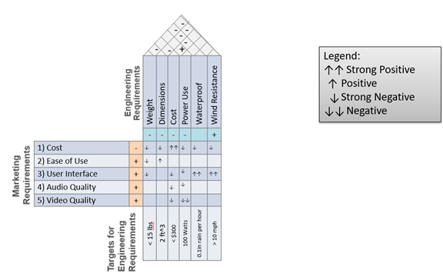
Table1: House of Quality Diagram

Research
Existing Products:
During initial product and project research we were able to find a few PTZ cameras like our own in the sports and security industries and one hobbyist project open sourced to the internet. In sports PTZ cameras usually consist of a 4k camera inside weather-proofed housing that is attached to the top of a tripod mount. The security industry takes a slightly different approach as most of their cameras are powered using PoE and don’t move nearly as fast as a sports PTZ if they can move at all. The hobbyist was able to mount a DSLR Canon EOS 250D to a self-designed and 3D printed mount controlled by a controller and moved by stepper motors. Our camera’s design takes advantage of 3D printing and available electronic gadgets while also implementing a solution that can keep up with the panning and tilting speed of a sports camera.

Cameras:
Sports PTZ
Panasonic’s Professional PTZ Cameras are a line of PTZ camera that are remotely used to handle the quick and rugged sports filming job. The AW-UE150 4k 60p Professional PTZ Camera is one of Panasonics top high-end cameras. Shown in Figure 1 in white and black variants this camera comes in supporting SRT Protocol for 4k 60p video streaming, up to 20x optical zoom and image stabilization. The Panasonic PTZ camera also supports simultaneous video output with various 4k interfaces as output such as 12G-SDI, HDMI, Optical Fiber, and IP. The biggest drawback for this camera is the hefty MSRP at $11,400. Our goal is to source our own project parts while also costing less than 5% of the price while still being able to stream high-quality video.

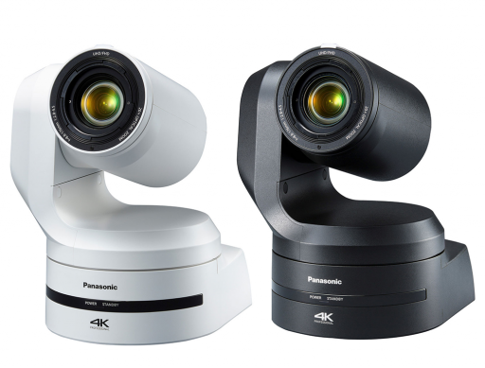

Figure 1: AW-UE150 4k 60p Professional PTZ Camera

Security PTZ
Security PTZ are security cameras mounted to houses, businesses, and anywhere that requires monitoring that can Pan, Tilt, and Zoom usually at a slow pace. These types of cameras are made to keep reliable non-stop surveillance, have human motion detection abilities, and night vision. They can interact with applications to remotely notify the user when motion is detected or alert of noise if applicable. Security PTZ differ from other PTZ as they are almost always connected to a closed network or CCTV by power over ethernet and aren’t made to track fast moving objects or shoot very high-quality video depending on their price.

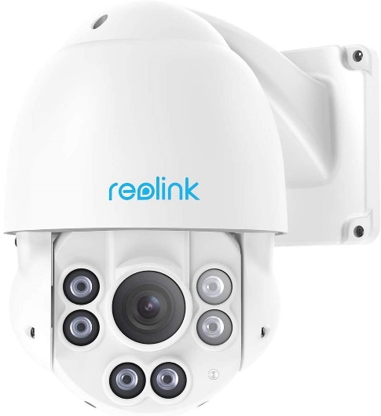

Figure 2: Reolink PTZ Camera

The Reolink PTZ Outdoor camera is a cheaper security camera that can shoot and record surveillance footage at 5 mega pixels in 2560x1920 Super HD. The camera features a 360-degree pan, 90-degree tilt, and 4x optical zoom. It has complete weatherproofing and since it will be mounted to a wall using one wire cabling. The PTZ camera is also able to alert the user as soon as any motion is detected and has the ability for the user to set the range, they want the camera to detect. The biggest drawback of this type of camera is its inability to work with non-native software and its original design not being geared to catch action sports.

Open-Source PTZ
During our research we found an open-sourced pan-tilt-zoom mount on YouTube that utilized 3D printing, printed circuit boards, a microcontroller, and gaming controller to assemble a self-made PTZ camera. The microcontroller used was an Arduino Nano which handled the control of everything and the monitoring of inputs. For panning and tilting two Nima 17 stepper motors were used which were controlled by the A4988 stepper driver board. Another insightful function of the camera was the edition of embedded sensors that reside in the pan and tilt axis that would reset the stepper motors to its original position when the device was powered on. This project provided a lot of insight but differs from the two of our main objectives as it isn’t as cost-effective, and it doesn’t have any type of weather resistance.

PTZ Camera | Price | Type | PoE Enabled | Weather Resistant
AW-UE150 4k 60p Professional | $11,400 | Sport | Yes | Yes
Reolink PTZ Camera | $229 | Security | Yes | Yes
Open-Sourced PTZ | $350+ | General Purpose | No | No
Our PTZ | >$300 | Sport / General Purpose | No | Yes
Table 2: A comparison of similar products to our project

PTZ PoE Security Cameras:
The first consideration for the camera we analyzed is a straightforward power over Ethernet pan-tilt-zoom (PoE, PTZ) camera, typically used in settings for security. These devices typically feature remote controls over TCP/IP on the HTTP protocol. A web interface is offered pre-built by connecting over HTTP on port 80.

The motor is also included in the system, meaning that the system is capable of covering the full range of motion for capturing action events. With respect to the power-over- Ethernet power supply, the IEEE802.3af Ethernet standard can support powered devices that do not draw more than 15.4 watts.

One consideration on the motor is that these cameras are primarily designed to be used as wall-mounted security cameras. This is a hint at the fact that they often do not provide audio out of the box, and if they do, it is often not high fidelity enough to qualify it for selection. These cameras also may not pan rapidly enough to qualify as an action camera. Therefore, if this is meant to be a viable option, our own audio subsystem would have to be implemented on top of this.

Finally, since the prebuilt turret-style security camera almost universally supports features that are not relevant to our project, such as wireless imaging, remote monitoring over a web interface, SD cards that are built into the camera, noise-emitting self- contained alarm systems, and so forth, we pay extra for features in a product that we will simply not be using. The prices for example security cameras running over PoE, with the required features, but also with the consequential defects listed above are compiled in a table below.
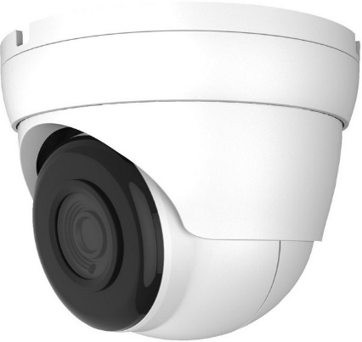
Figure 3: Simple turret-style PoE security camera.

Camera | Resolution | Framerate | Price | Weight
Amcrest | 3 Mpixel | 30fps | $109.99 | 1.4 lb
Montavue | 4k | 30fps | $219.95 | 2.0 lb
Hikvision | 3 Mpixel | 30fps | $191.15 | 1.5 lb
Table 3: PTZ camera comparison
https://www.electronics-notes.com/articles/connectivity/ethernet-ieee-802-3/ standards.php

DSLR:
DSLR cameras have a high-quality lens and an enhanced capability for digital zoom that allows for a clear picture out of the box. Supporting advanced features correcting for brightness in overcast weather and image auto-stabilization in windy conditions, there are clear benefits for the DSLR camera.

One particular advantage of the DSLR camera is the support for many types of electronic and mounting accessories. Most relevant to our use case is accessory audio systems. Although DSLR cameras typically contain a small pinhole port for audio sampling, these assume the sample is close-by and that the source has limited noise interfering with the signal. There are many consumer attachments for DSLRs that allow for superior audio sampling over the stock pinhole models that help in canceling interference from wind.
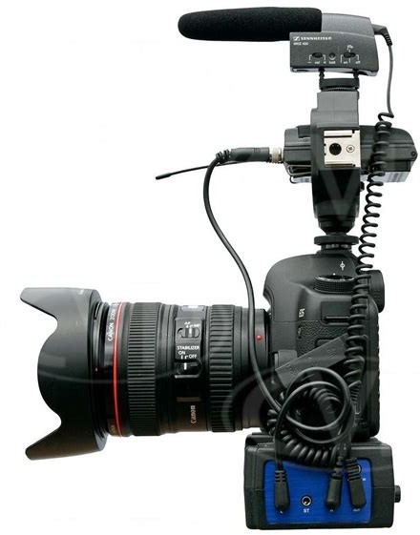
Figure 4: DSLR-style camera with attached microphone.

The ideal DSLR camera for taking video is the mirrorless camera. These are more expensive than the DSLR camera, but the advantage in the auto-focusing system is clear. In DSLR cameras with a mirror, the mirror has to be shifted away in order to unblock the auto-focusing element.

However, DSLR cameras that are waterproof are less common than in action cameras. A DSLR camera meeting the waterproofing requirements, that is mirrorless, and that falls within the constraints of the project budget narrows the range of choice in cameras significantly.

The ultimate problem of the DSLR mirrorless camera is the cost. Taking the example of the Canon EOS M2, this is a camera at the low end of the price spectrum. An older camera from the year 2013, we find a reasonable price at about $200 used. The requirements for quality are satisfied, and we are able to take audio and video at 30 frames per second on 1080p; however, the camera itself is very heavy due to the size of the frame and battery, and most importantly the requirements for remote control are not satisfied. The part’s availability is low because they can only be bought used; furthermore, they are no longer in production and have been superceded by more expensive, newer models.

On the other end of the spectrum, we examine the second element of the case study: the Fujifilm X-T30. This camera does tick all the boxes for the engineering requirements. With 4k video at 30 frames per second, a lightweight frame and battery clocking in at under one pound, and high-quality digital zoom, the point of failure is the mirror image of the Canon EOS. This greatly exceeds the budget to satisfy the marketing requirements, costing over $800.

The obvious solution might be to find a middle of the road camera that lies just above the lower cost mirrorless DSLR but has the features required by the project. However, I could not find many like this that were not used goods in the same manner as the lower bounds camera.

In conclusion, the DSLR camera suffers from lack of parts availability or extreme price when considering the overall budget of the project.

Sports Action Cameras:
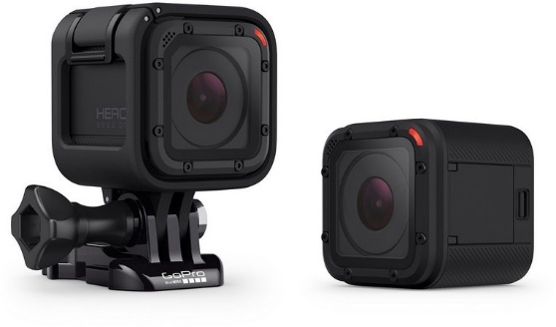
Figure 4: Gopro HERO Action Camera.

The advantages of the premade action camera are clear. The device is waterproof out of the box, the video capabilities support 60 frames per second or 30 frames per second in regard to the framerate requirements, and 1080p or 720p resolution is standard. This is the most popular consumer-grade action camera, so the support for attachments, mounting setups, and documentation is widely available. The downside to using a flagship camera in the center of the action camera spotlight is the price.

The action camera family also supports external microphones over 3.5mm jacks. This would increase the sound quality and reduce interference in audio sampling, but cursory research indicates attaching an external microphone requires removing or altering the waterproof housing of the device. If the waterproofing is compromised, one of the major benefits of the action camera would be liquidated.
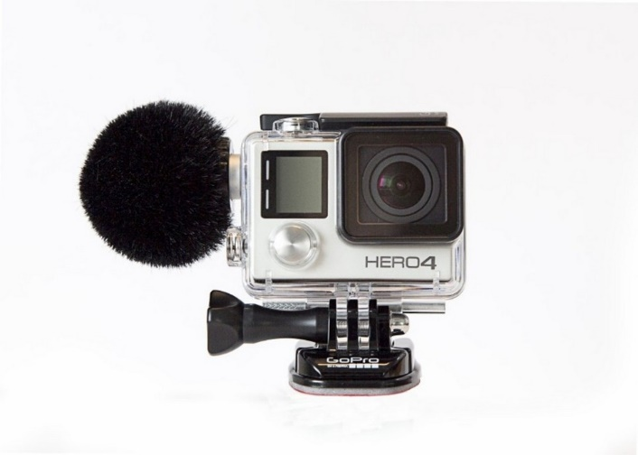
Figure 5: GoPro with external microphone and wind muff.

The Sony FDR X3000R is an alternative action camera to the Gopro with comparable features. Water resistance and video modes are directly comparable at a reduced price. The battery life on the Sony FDR is not as high-powered as on the Gopro or some of its competing alternatives, but this is mitigated by the attached charging cable in our configuration.

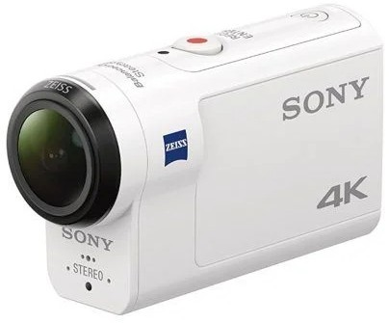
Figure 6: Sony FDR X3000R Action Camera.

Camera | Housing | Resolution | Framerate (frames/sec)
Sony FDR X3000R: | Plastic | 4k | 30
Garmin VIRB Ultra | Plastic | 4k | 30
AKASO V50 Pro  Action Camera | Plastic | 1080p | 60fps
Yi 4k + | Plastic | 4k | 30

Table 4: Comparison of camera housing, resolution, and frame-rate Source: amazon.com

Audio Systems:
Many premade consumer microphones are available with a variety of connectors to support our application: from the camera’s fixed location, record sound at the target location of the video recording. This has two immediate implications: first; the microphone would be a cardioid-style microphone, that is, it will pick up sound in a monodirectional fashion. Second, the microphone mount will most likely be mounted on or nearby the camera in order to passively take advantage of the panning and tilting to determine the direction that sound is read from.

Microphones have many different connection standards. For commercial applications and high-fidelity audio, the professional XLR connector is used. The XLR connector is popular because it is capable of providing current approximately up to 10 amps at 24 volts; at over 200 Watts, this more than doubles our requirements for the ceiling on our power system design. This is because the XLR connector can double for stage lighting and other cinematography applications that exceed the needs of our camera system.

On the other hand, the connector is not used routinely on single-board computers or embedded devices like the Arduino. Cursory research shows little results for XLR connectors on embedded devices including the Arduino platform, the TI MSP systems, the Adafruit platform, and the Beaglebone platform. Additionally, requiring that an XLR device be used would require additional hardware, either XLR to USB or XLR to 3.5mm barrel jack in order to attach them.
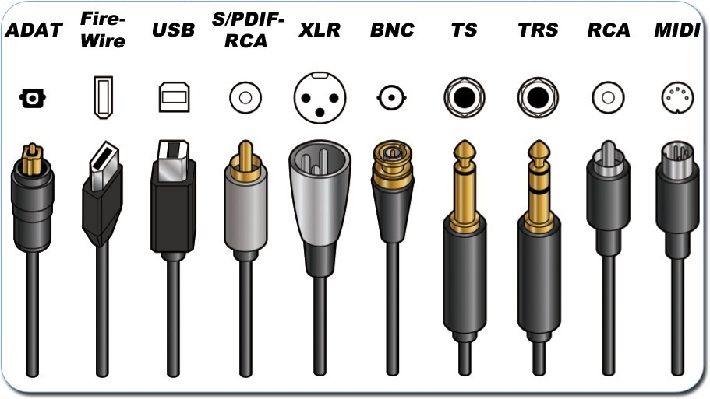
Figure 7: Many type of audio connectors.

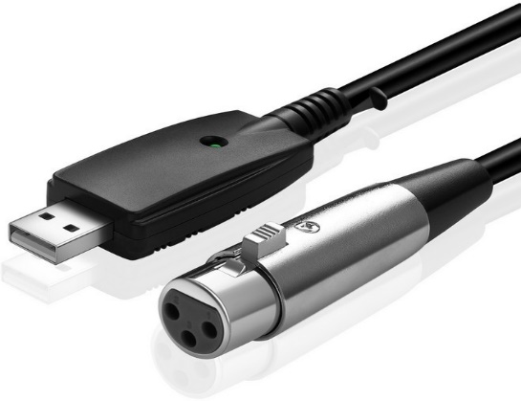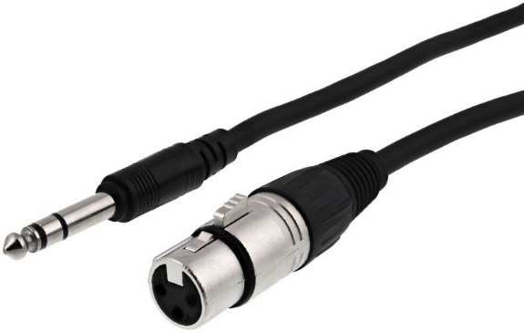
Figure 8: Microphone XLR connector to (a) USB; (b) 3.5mm jack.

One solution to the problem of connectors is to link an XLR microphone directly to the workstation hardware. This would open possibilities regarding types of using higher fidelity microphones as the audio pickup source on the action camera. The issue is that the increased cost of the additional hardware, further alienation of less technically competent users who may not be comfortable with adding custom hardware to their workstation, or even requiring certain types of motherboards which have additional slots necessary to accept accessory hardware; although advantageous, these factors do not necessarily justify the complications introduced by such a card. Therefore, a solution outside of the XLR direct connection is necessary.
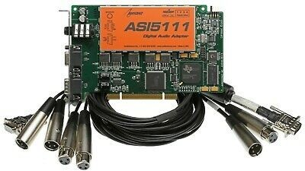
Figure 9: PCI Microphone connector card that directly supports XLR.

Both cases would defeat the power requirements or add even more additional hardware in order to connect to a PC. Since this is not widely supported either on PC or on embedded devices, most likely the project will not employ this connection standard even though it is very widespread in the microphone world.

Taking into the considerations into the study on XLR and observing that connection standard without the need for additional hardware would be highly beneficial to the design of the microphone subsystem, we defer to the reference figure to provide the most natural answer of USB (Universal Serial Bus). Note the universal keyword which will be far more flexible than the more obscure XLR-style connector.
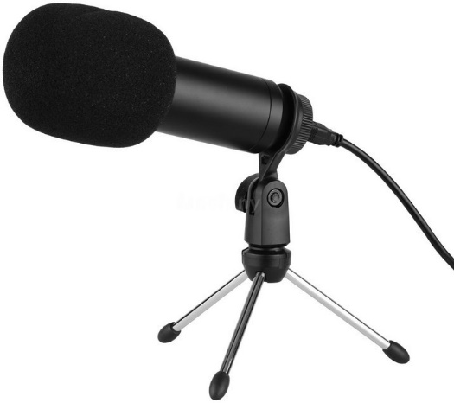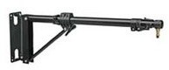
Figure 10: Monodirectional USB microphone and typical mounting system.

In contrast to the previous XLR microphones, which threatened to introduce an entirely new ecosystem of software and hardware due to connector incompatibility, the USB interface is widely available, comes in multiple size form factors, including miniaturized versions, and can draw a reasonable amount of power (5 watts at minimum from computer USB source ports) directly from the connected workstation.

Alternatively, many embedded computers such as the Arduino or Raspberry Pi we intend to use can also be purchased with either full USB or micro-USB support. These generally max out at 5W, but fortunately many of the consumer-class USB microphones use less than 5W of power for operations.

The altitude of the microphone outdoors requires a system to cancel noise introduced by the wind. Our requirements specify the wind-speed conditions the device must be able to operate under with minimal interference; in moderate wind conditions outdoors, a wind muff will be sufficient to suppress noise adequately.
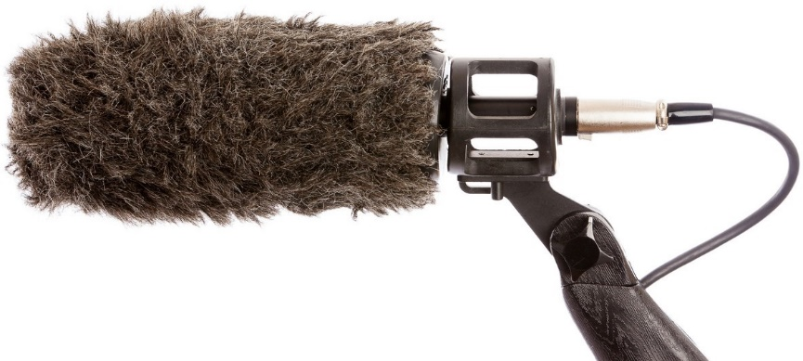
Figure 11: A microphone (using the XLR connector) with a fluffy wind-muff.

Motors:
The camera motion rig system we aim to create requires a motor system in order to perform the pan and tilt functions. 2 motors are required. One will point down into the base to rotate the camera rig and preform the pan function. The other will point into the camera and connect to the bracket in order to perform the tilt function. Both motors will connect to the electronic speed control unit in order to control the speed and direction of the pan or tilt and the full range of each function. As such, the motor system is dependent on the electronic speed control as a constraint on its power and current consumption. The motors should also rotate at a sufficient speed to capture athletic activities at a range of 25 feet up. The motors should also allow the camera to tilt from 0 to 180 degrees and pan from 0 to 180 degrees as well.

Brushed Motors:
Brushed motors use an electromagnetic design to drive the axel. A wire is coiled around an armature to create the electromagnet and the armature encases the commutator which houses the axel. The brushes are connected to the commutator and drive the current to the electromagnet. They control the direction of the current and thereby control the polarity of the magnet in the rotor so that they oppose or align with the permanent magnets outside of the rotor. These motors have two wires that deliver voltage, one for voltage and one for ground. This also means that it is easy to change the speed and direction by changing the voltage strength or direction, so in some cases a speed controller is not necessary. Brushed motors are also cheap because the materials are cheaper and don’t require expensive sensors. However, brushed motors also have shorter life spans because of the friction between the axel and brushes. The friction also makes it harder to rotate from rest.

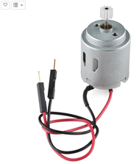
Figure 12: A brushed motor

The Micro Gearmotor is a brushed motor. The Micro Gearmotor model requires a minimum of 6-volts and has a maximum current draw of 1.6 amperes. Depending on the model, they can deliver 90 to 175 rotations per minute (rpm). The high operating voltage is not ideal since most boards support 5-volt power supplies. However, the small motor size is good for a compact design and the eternal gears make it easy to interface with gears on the frame that the camera sits on.

The Hobby motor is a brushed motor with a 1-volt minimum voltage and a 0.8 ampere maximum current draw. It can deliver 6600 rpm. This motor is by far the cheapest at a price of 2 dollars. This also makes it cheap to buy replacement parts since brushed motors have a shorter lifespan compared to other motors. We also get the lowest power consumption at a maximum of 2.4 watts at 3 volts from this motor which is ideal for a board that supports a 5-volt power supply.

The P28UK12 Piborg motor is a brushed motor with a 12-volt operating voltage and a 0.5 ampere maximum current draw. This motor can deliver 590 rpm at 12 volts. This motor is part of the P28UK12 series which comes in a variety of sizes so we can choose the appropriate size without changing the specifications of the motor. However, the 12-volt operating voltage makes this the most demanding brushless motor. It is saved by the low current consumption from being the most power-hungry motor.

Brushless Motors:
A brushless motor is a type of motor that has permanent magnets around the motor and no brushes. In place of brushes, they have control circuitry to detect the position of the rotor, hence the third pin. Brushless motors don’t have the burden of friction between the brushes and the axel, so they last longer and are more efficient. The use of a position sensor also makes them more accurate, so they have greater control for functions such as braking. They also have more power, so they spin faster too. However, because of the sensor and the parts, these motors tend to be more expensive. Speed controllers for brushless motors tend to be more expensive too, especially if they require a PWM.

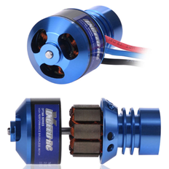
Figure 13: A Brushless motor

The Exceed RC Rocket 3015 is a brushless motor with a 12-volt minimum voltage and a 35-ampere maximum current rating. It provides 10,080 rpm. This motor is meant for remote control cars, so it is designed to take battery power. The high rpm is a little unnecessary for this project since the motor only needs to rotate the camera mount 180 degrees. It is also one of the more power-hungry motors that may not have proper support from a microcontroller as it would from a 12-volt battery supply.

The Exceed RC Rocket Airplane 86MB88 is a brushless motor similar to the Rocket 3015, but it is designed for remote control airplanes. It has a 12-volt operating voltage and a 32-ampere maximum current rating. It delivers a 9000 rpm. It is also suited to battery power. This model is a slightly less power-hungry motor but has all the same issues of the other Exceed motors.

The Exceed RC Optima 75M92 is a brushless motor meant for use in remote control airplanes. It has an 11-volt minimum voltage and takes a maximum current of 27 amperes. It delivers 47703 rpm. This is another high-power option that is suited to battery power and share similar issues with the others of this model. This is however, the most power hungry of the set at 330 watts.

The AEO Micro Gearbox is a brushless motor system with a gear assembly attached to the axel. It has a 7-volt minimum voltage and a 4.8-ampere maximum current rating. It can deliver at least 49140 rpm. This option has the three wires needed for a brushless speed controller, but no barrel connections. This motor would require either a barrel fitting for the end of the wires or a control board that uses screw terminal ports so we can use the bare wires. Also, since it has the gear assembly, it makes it easier to use. Consuming only 40 watts, this is most power efficient brushless motor. However, the 7-volt operating voltage still may be too much for the simpler control boards we are looking at for our project.

Servos:
Servos are similar to brushless motors in that they have 3 pins, but the control on a servo is much greater control. Servos are different from regular DC motors because they use pulse width modulation (PWM), so they require a more precise control board than regular motors. The PWM signal allows you to rotate the servo with more precise control by telling it what position to move to instead of controlling the speed of the rotation. This comes at the cost of freely rotating.

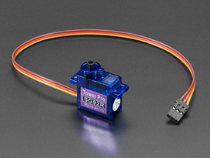
Figure 14: A micro servo

The Adafruit micro servo SG92R is a more controlled option with a range of 180 degrees of motion. It has a 3-volt minimum voltage requirement. To control the speed and position of the micro servo, the control board would need a PWM device. Micro servos are small, so they are easy to design a mount around. While there is no free rotation, the requirements of the pan and tilt functions don’t require full 360 rotation.

The Hitec HS-422 is a full-sized servo motor. It has a minimum operating voltage of 4.8 volta and a maximum current draw of 0.8 amperes. Compared to the micro servo, this one is slightly slower but otherwise similar. It offers the same range and precision of motion for slightly more power consumption. While larger, the servo size is still easy to design around and fits in most pre-made mounts.

Comparison:
The best option is the servo motors, though they are closely followed by brushed motors. Brushless motors Seem like a good option because they are highly efficient and long lasting, which are desirable in a product meant for long term use. However, these motors also require too much energy. They are also meant to be used with 12-volt batteries on remote control vehicles and consume a lot of power to work efficiently. Servos require significantly less power and have the accuracy of brushless motors because of the position sensor. They also have high torque which makes them easy to move from rest. Brushed motors are also a good low power alternative, just with less control precision because it has no position sensor. All options chosen were in a similar price range, so cost is not a determining factor in the decision.

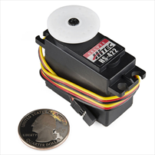
Figure 15: HS-422 servo

Between the micro servo and the HS-422 servo, the HS-422 is the best option. While the micro servo is slightly faster and cheaper it may also have less durability. The HS-422 is a full-sized servo that does take more voltage, but the difference is not significant. Also, it is more resistant to being burned-out by voltage fluctuations.

Motor | Price | Type | Voltage | Power (watts) | Current (amps) | RPM
Micro Gearmotor | 12.95 | brushed | 6 -12 | *0.42 – 19.2 | 0.07 – 1.6 | 175
Micro Gearmotor | 12.95 | brushed | 6 - 12 | *0.42 – 19.2 | 0.07 – 1.6 | 90
Hobby motor | 1.95 | brushed | 1 – 3 (12 max) | *0.11 – 2.4 | 0.11 – 0.8 | 6600
P28UK12 Piborg motor | 19.46 | brushed | 12 | *5.964 | 0.497 | 590
Exceed RC rocket 3015 | 10.16 | brushless | 12 - 14.8 | 300 | 1.2-35 | *10,080
Exceed RC rocket airplane 86MB88 | 11.86 | brushless | 12 - 14.8 | 280 | 0.6 - 32 | *9000
Exceed RC optima 75M92 | 10.95 | brushless | ~11.1V | 330 | 2.3 – 27.5 | 47730
AEO micro-gearbox | 21.95 | brushless | 7.4 – 8.4 | 40 | 4.1 - 4.8 | 49140
Adafruit Micro Servos | 5.95 | servos | 3 - 6 |  |  | *100
Hitec HS-422 Servo Motor | 14.99 | servos | 4.8 – 6 | *0.038 – 4.8 | 0.008 - 0.8 | *62.5
Table 5: Comparison of motor options

Electronic Speed Control:
The electronic speed control unit is part of the motor system and controls the speed and direction of the motors. While part of the same system as the main control board and motors, the electronic speed control is a separate component that can come from different manufacturers. This component takes input from the main control board and interpret it to drive voltage, and in some cases signal input, to the appropriate motor. These control units have a current rating that determines the maximum allowable current through the component. This would dictate the maximum current from the main control board and the motors as a constraint to prevent the board from being overloaded. Some control units have pulse width modulators to interpret the signal width and pass position information to brushless motors or servos. The speed control unit also has to be small enough to fit on the main control board.

RC speed controllers:
These small basic controllers are best suited for brushed motors on RC vehicles. They have the basic function of controlling the voltage delivered to the motors to control the speed of rotation. Some controllers can be advanced with integrated wireless communication, but any control board can have added functionality by connecting to another board through the connection pins.
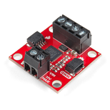
Figure 16: The Sparkfun Qwiic speed controller

The Readytosky RC motor controller is made specifically for remote control vehicles. It uses a 2-pin design for the motor interface, so it is best suited for controlling brushed motors. The board also has a 2-pin battery interface to get voltage and ground from the main board. It requires a minimum of 3 volts and has a maximum current rating of 20 amperes. The board also has a receiver integrated for wireless control so only one wire for power is needed. The product listing sells the controller in pairs, so the cost is about half that of other options.

The Sparkfun Qwiic has 4 pin connections for the motors and 2 pin connections to get power from the main board. This means it’s best suited for a pair of brushed motors, though you could adapt the pins for a brushless motor or servo and use 2 boards instead of one. However, this work-around would require getting a precise clock signal from the main control board to emulate a pulse width modulator for servos. The board also has screw port connections, so you only need to plug in the bare wire. No need to match up special connectors. It has a minimum requirement of 3 volts and a maximum current rating of 1.5 amperes. The 3-volt operating voltage requires a logic converter to interface with a 5-volt logic board. (control through I2C channels)

PWMs:
Pulse width modulators (PWMs) are needed for motors with a signal pin such as brushless motors or servos. These devices control the frequency of the signal and the motor interprets this information to control the speed or position. The 2 PWMs discussed are the Toshiba TB6612FNG H-Bridge and the PCA9685. Both are reasonable to use and do the same job, but how the boards use them is the main deciding factor. For instance, these boards take an eternal 5-volt power source to drive the motors in addition to the 3.3 volts the board needs to work, most use a typical barrel plug or terminator block, but some draw the power through I2C connectors or the GPIO pins. We want to minimize the number of input wires going to the device so we want a board that can support a single power source and has low power consumption. Also, some of these control boards can support extra functions with extra pins. This may be unnecessary for our needs and thus would just make our design more cumbersome.

Toshiba pwm
The Sparkfun Wireless Motor Driver supports 2 and 3 pin connections, so it can be used with any motor option. The Toshiba TB6612FNG H-Bridge can support 2 brushless DC motors at the same time and the GPIO pins are able to support 3-pin devices like brushless motors or servos. The board has a barrel plug to deliver power to the motors and can deliver power to the main board through the GPIO pin connections. If the motors have low power demands, then the driver can draw power from the main board through the VIN pin connection. The controller doesn’t support wireless communication, so it needs to go through the logic board with transmission capabilities or use another product such as an RC transceiver. It is also best suited for use with Arduino and Sparkfun products.
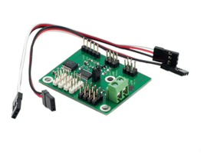
Figure 17: The Ultraborg servo driver

PIC16F1828 pwm
The Ultraborg PWM servo control board requires a 5-volt power source separate from the main logic board. However, it can also interface with any kind of board: Pi, Arduino, or other I2C devices. This is the most minimal board out of all the options with support for 4 motors and 4 I2C connections. The minimal design also means that it does not carry any support for a communication device. Any wireless communication would have to be supplied through the main board and communicated through the I2C connection.

PCA pwm
The Sparkfun Servo pHAT is a controller meant for 3-pin motor control. It has a minimum operating voltage of 2.3 volts. This HAT is made to interface with the GPIO pins on Raspberry Pi logic boards especially the Pi Zero, but it also has I2C ports to use with any brand of logic board. It’s USB-C port is used to drive power to both motors and the logic board so only one power line is needed. This board also has power protection so it can protect power sources from damage.

The PCA9685 Servo PWM for Pi Zero is a control board made to control 3-pin motors. It can easily attach to the GPIO pins on Pi devices. It has a 2.3-vlot minimum operating voltage and can take a maximum of 0.4 amperes. Unfortunately, the board requires a separate power supply with a common ground. Only low current power can be driven through the GPIO pins. It also only works with analog RC servos, so it limits the options of motors we can use. The PCA9685 is the PWM.

The Adafruit series of PCA9685 boards are similar to the Pi servo PWM and are made to work well with Pi devices. All devices in this series can support up to 16 motors and have 3.3-volt minimum operating voltages and 0.4 ampere maximum current ratings. There are a range of sizes thought which allows different capabilities. The smallest is the Adafruit bonnet which is made for use with the Pi Zero and has the choice of a barrel plug or screw port to supply power. This is also the cheapest option from all the speed controllers. The Adafruit PWM servo driver has a similar size and capability but only provides the connection for a screw port power supply. Then there is the Adafruit servo mini kit. This is a larger board meant for Pi 2 and up but carries a lot of extra pins that would be overkill for this project. The best option of this series would be to use the bonnet because it has the cheapest price and the minimum necessary capabilities to power the motors for this project.

Comparison:
Using a PWM control board seems to be the best option. Since servo motors are the best option from the previous section, we need a controller that supports the 3-pin connection and PWM for the motor control. We want low voltage with large enough current to avoid burning out. Most of the PWM control board options are 5-volt compliant. This means that they support servos that need 5 volts to operate and supply 3.3 volts to the board. Since all the PWM options share this specification, it cannot be a determining factor. We also want a design that is minimal but has enough flexibility to support other devices such as a wireless transmitter. The Ultraborg is the most minimal of the options, but it is also one of the more costly options. The Adafruit servo bonnet is the cheapest option and is minimal in design. It also offers flexibility to work with Raspberry Pi zero and up. The Sparkfun servo pHAT is also comparable in price but has the flexibility to use I2C connections to power the main board. Alternatively, we have the Sparkfun wireless driver, which is the most expensive option, but it has an easy-to-use design. The Sparkfun driver is made to take a wireless communicator and power the main control board through the GPIO pins. However, it can only work with the Sparkfun control unit. The best option would be to go with the Sparkfun servo pHAT because of its flexibility of connections and its minimal design. The wireless communication can be handled by the main control board, possible a PI Zero W which has built-in Wi-Fi capabilities.

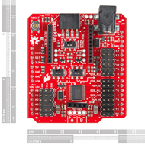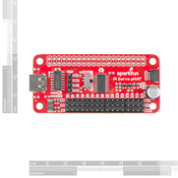
Figure 18: (a)Sparkfun motor driver, (b) Sparkfun servo pHAT

control unit | cost | voltage | current (amps) | note
Readytosky RC motor control | 14.99 | 3 – 9.4 | 20 | 2 pieces, meant for RC brush motors
Sparkfun Qwiic | 14.95 | 3.3 – 5 (11 max) | 1.2 -1.5 | 1 board supports 2 motors
Sparkfun wireless motor driver | 22.95 | 0.2 – 6 | 1.2 – 3.2 | 2 and 3 pin support
Sparkfun servo pHAT | 10.95 | 2.3 – 5.5 | 0.025? | power through RVR or usb
Ultraborg PWM servo control | 18.39 | 5 | ? | minimal design
Servo PWM Pi Zero | 15.04 | 2.3 - 5.5 | 0.025 – 0.4
Adafruit PCA 9685 servo driver | 14.95 | 2.3 – 5.5 | 0.025?
Adafruit PWM/Servo bonnet | 9.95 | 3.3 - 5 | 0.025?  1.3 back power | good for Pi zero
Adafruit 16-channel PWM/servo HAT for Pi | 17.50 | 5 – 6 | 1.3 (back power) | can support multiple servos/ motors
Table 6: Comparison of motor control options

Mount/Frame:
The frame is the part of the system supporting all of the electronic components. This includes the mount holding the camera, the gears connecting the tilt motor to camera bracket, and the mount connecting the main system to the tripod mount. Most of these parts can be 3D printed in ABS plastic for a custom fit, but the main frame supporting the camera can be made of metal if it is bought. The frame is constrained by the size of the system. All the components need to fit within the frame and the camera need to be able to fully articulate. In order to get the full range of the tilt, the camera needs to be high enough to see almost directly beneath it.

Bought option
Metal parts, more durable. Easy to find replacement parts for mass manufacture. But have to fit design around availability. Parts come in standard sizes. Expensive. Metal corrosion in poor weather depends on material options. All options come in kit versions, bundle with servos. Shared design

The Steering Gear mount is an aluminum mount meant for remote control boats and cars, but the design is generic enough to be adapted to our purposes. The aluminum material is good for durability and weather proofing. We can also find this mount design in the Mallofusa 2 DOF kit where the mount is bundled with 2 MG995 servos. By bundling these 3 items together, we can reduce the cost slightly. The mount is made of a C frame and servo platform with the panning servo serving as the base. The minimal design leaves the servos exposed and we also have to design a platform for the panning servo, so it sits on top of the control board without getting in the way of the electronics.
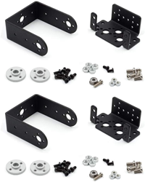
Figure 19: The Steering Gear mount

The Lynxmotion kit is another alternative with the same design but is bundled with the Hitec HS-422 servo. This servo is more power efficient and has a housing that is more weather resistant than the ones in the Mallofusa kit. However, this is the most expensive mount option.

The Dagu mini pan and tilt kit has 2 C frames and a mount for the tilting servo with the panning servo acting as the base. This design has issues similar to the mount option before. However, this kit uses micro servos, so the price is almost half that of the previous options. Smaller servos are also easier to design around.

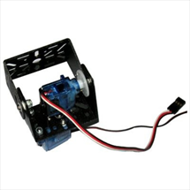
Figure 20: The Dagu min pan/tilt kit

The Adafruit Pan-Tilt kit also uses micro servos, but the frame is designed more tightly against the servos making it hard to add weatherproof housing around the servos. The smaller design also makes it difficult to mount larger cameras. The mount is made out of plastic, which is less durable and weather resistant as opposed to the metal options.

Built option
Instead of buying the mount pre-made, we can also design a custom mount for the servos with 3D printing. This would allow us to use a custom design that would make it easier to house the whole system in a weatherproof casing. It would also be cheaper since we would only pay for the material to print the parts. However, this option has its own problems. The mount would be printed in ABS plastic which is not as durable as the metal pre-made options. Also, the plastic will degrade in extended sun exposure which isn’t good for a camera meant for long term use in the Florida sun. We could always replace parts when they degrade, but since these are custom printed parts, they won’t be as easily to replace as pre-made products. The only practical option would be to buy an expensive 3D printer to keep relacing the parts. Also, we would need to use the 3D printer available in the Texas Instruments workshop or the library curriculum materials center on campus. That printer has limited availability, so we need to schedule enough time to get the parts printed, especially if they are detailed because the process could take hour if not days.

Comparison:
Buying a pre-made mount for the servos would be fast and easy but designing a custom mount would give more freedom to place the components. The best option would be to buy the parts since the plastic material poses so many issues to a long-term use device such as ours. It also would take too long to print the full design which would make it hard to test the prototype in a timely manner. The pre-made metal products will still need some parts to incorporate the mount with the control board and the housing.

All the pre-made options are available in a kit that bundles the servos with the mount, so this reduces the chance that the servos won’t fit with the purchased mount. Also, this helps to reduce the cost slightly since buying a kit is cheaper than buying the parts separately. Among the kits, the best option would be the Lynxmotion because it has a metal frame and the servos included draw less current than the ones included in the Steering gear. If we wanted to use the Hitech HS-422 with the Steering Gear mount, then the price would go up to 44 dollars, thus making the Lynxmotion the cheaper option. However, I we decide on a small enough camera, the next best option would be the Dagu kit. It uses micro servos, so it can’t support larger cameras, but with a small enough camera it is the cheapest and most durable option.

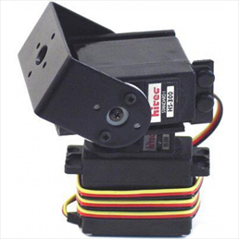
Figure 21: Lynxmotion kit

Product | Price of mount | Kit price | Material
Steering Gear Pan and Tilt | 13.99 | 23.49 (Mallofusa) | aluminum
Lynxmotion Pan and Tilt kit | 9.95 | 31.39 | aluminum
Dagu min Pan and Tilt kit | N/A | 14.16 | metal*
Adafruit Pan-Tilt kit | 4.95 | 18.95 | plastic
Table 7: Comparison of Pan-tilt mount kits

Main Control Board:
The motor that is responsible for panning, tilting, and zooming the camera system is operated indirectly, with commands conceptually streaming from the controller, through the workstation software, to the embedded MCU device, through the motor servo shield board, finally reaching and controlling the motors. In practice, our motor will be controlled by PWM (pulse width modulation).

Arduino Uno:
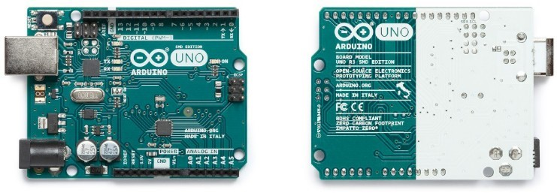
Figure 22: The Arduino Uno.

The Arduino can draw sufficient power for our application from the USB port of a workstation. The details of the specification can be found in the data sheet here:
https://www.mouser.com/datasheet/2/34/Arduino_A000073-1893642.pdf
The Arduino Uno Specs are as follows:

Input Voltage | 8 V
Operating Voltage | 5 V
PWM Digital IO Pins | 6
DC Current for IO Pins | 20 mA
Maximum-Voltage Output Pin | 5 V
Flash Memory | 32 kB
SRAM | 2 kB
Mass | 25 g
Table 8: Specifications for the Arduino Uno

Observe that the mass of the device is 25 grams. This is significantly smaller than the weight of many common motors we have examined in our research. Effectively, the mass of the MCU plus the shield chosen can be ignored.

Arduino Uno Source:
https://www.mouser.com/ProductDetail/Arduino/A000073? qs=8PMfw1Pw72VfrrCu0Mm0mA%3D
%3D&mgh=1&gclid=EAIaIQobChMIjqvMu9vd7wIVTweICR2O3ARwEAQYBSABEg JKYfD_BwE

IDE for Developing Arduino Software:
Another benefit of the Arduino is the level of software support for programming and flashing the device with the desired program. The Arduino IDE is written in C, C++, and Java and manages code, libraries, binaries, compilers, and handles connection to the Arduino over JTAG and serial interfaces that are abstracted away from the IDE user. This means that the Arduino IDE handles all connection details of the board for us. A nice feature of the well-supported development environment is the logical distance from the hardware during the programming process. The compiler libraries included support register-level programming, but you do not have to probe that closely to the hardware if you do not want to. Instead, a high-level digital interface abstracts those details away, allowing you to perform digital writes over several protocols, including I2C, with a simple function call.

Sparkfun Redboard:
The Sparkfun Redboard is an Arduino based device that supports servo drivers with the split 1 by 20 pin design. This board can handle power from 7 to 15 volts with 5-volt compliance voltage. It takes between 0.15 to 0.8 amperes of current through the voltage rails. The Redboard combines the functionalities of 3 Arduino products into a simple board with the best features. It’s compatibility with Arduino code makes it easy to use with lots of support for building a project from the online community. This board is also designed to be forward compatible with any new drivers, so it has longevity for long term use before needing to be replaced. However, the Arduino based design also means that it won’t interface with Raspberry Pi based HAT or control boards, so it is limited to drivers that support this design.

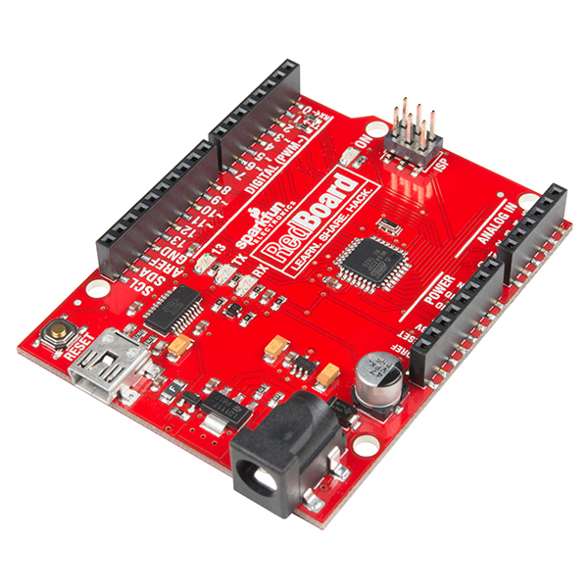
Figure 23: Sparkfun Redboard

The Pi Zero:
The rival family to the Arduino product line is the rising family of Raspberry Pi modules. Raspberry Pi produces single-board computers that are capable of running a full operating system but has special boards that may be called competitors to the Arduino boards, in particular the Pi Zero.

The Pi Zero, in a technical sense, cannot be called a direct analogue to the Arduino line because of their support for running full, non-real-time operating systems such as Linux. However, since they are miniaturized computers that allow us to write directly to the GPIO header pins, they provide all the support needed to control a motor shield just as the more bare-bones Arduino family.

A supremely visible marketing advantage over the Arduino Uno is the price, coming it at $5 before tax, four times cheaper than the Uno. Although it may seem the Pi’s ability to run a full operating system in tandem with the lower price beats out the Uno immediately, there is still hope for the Arduino perspective because of its extensive software libraries and shield support.
https://www.raspberrypi.org/products/raspberry-pi-zero/

Power/Data Link(connectors):
To power and transfer data from the computer to the camera we needed to choose an appropriate connector based on the current standard used with PTZ cameras today. After some research we found that it is common for both USB and power over ethernet connectors to be used. Our original goal was to find a suitable way to implement power over ethernet after using an ethernet adapter that would combine power and the data from the ethernet IN to an ethernet OUT which would connect to the camera itself, this device is known as a power over ethernet injector. Through research we learned that the way we prototyped was not standard in the industry and the easier and more productive way was to use a USB connection of some sort. By using a USB connection, we easily can pass data and power through one cable without the need for an adapter.

Power Over Ethernet Injector
In our earlier theoretical protypes for this project we planned to use power over ethernet which created the need to inject power into the ethernet cable transferring data from the laptop. Upon search we found the power over ethernet injector that perfectly fulfilled are theoretical need. The adapter first takes two inputs of power via dc power cable and data via ethernet cable and converts it to supply power and data via one single ethernet cable to PoE devices without the need for any other type of power. In some variations the injector is also able to detect the required power up to 15.4W after connected, which was in the bounds of our project.

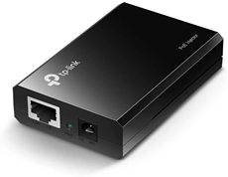

Figure 24: TP-LINK 802.3af Gigabit PoE Injector

The TP-Link injector easily enables PoE to any non-PoE device without the need to replace any components. It also has fast data transfer with both 1 Gigabit input and output ethernet speeds. Power can be delivered up to 328 ft away if desired. This injector also can auto detect power and deliver the required power supply for the powered device up to 15.4W.
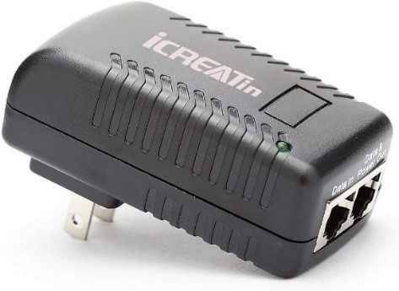
Figure 25: iCreatin Wall Plug PoE Injector

The iCreatin Wall Plug PoE Injector is the direct to wall injector variant that reduces overall price by getting rid of excess wiring altogether. For this design all you need is two separate ethernet cables and a DC power wall outlet. This injector also includes short circuit protection for Over Currents and Voltages. It can also protect devices from overloads over 500mA and high voltages exceeding 50V.

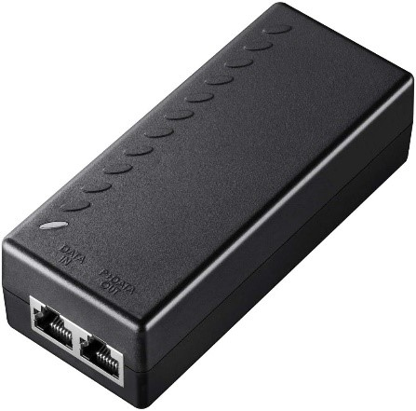

Figure 26: Cudy 30W Gigabit PoE+

The Cudy 30W Gigabit PoE+ converts a non-PoE Gigabit port to a PoE or a PoE+ Gigabit port. PoE+ differs from PoE as Power over Ethernet + can deliver up to 30 watts over ethernet cables compared to PoE’s 15.4 W. This injector also supports backwards compatibility so even PoE devices will work and be auto detected by the system.

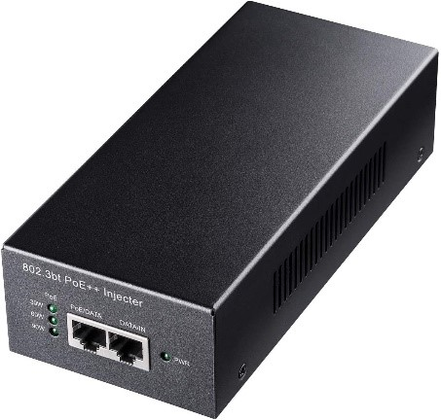

Figure 27: Cudy POE400 90W Gigabit Ultra PoE++

The Cudy POE400 90W Gigabit Ultra PoE++ comes equipped with auto sensing technology that delivers up to 90W to a PoE++ device all while supporting backwards compatibility for PoE+ (60W and 30W) and PoE (15.4W). It also has 1 Gigabit Ethernet input and output ports supporting a full duplex of 2 Gbps.

Comparison
For our project anyone of these injectors would work perfectly with our overall system, so if were to use PoE the best choice would be Tp-Link’s 802.3af Gigabit PoE injector. The reason this injector is the most suitable overall is its lower price and high speed. The iCreation injector is cheaper but the speed of only 100 Mbps may impact the video quality being sent over the ethernet. The worst choice would be Cudy’s POE400 90W Gigabit Ultra PoE++ because its specs are needlessly high-end and the power it can supply is far greater than needed. The price is also impacted as it is $62 more expensive than the closest injector in cost. Finally, Cudy’s 30W Gigabit PoE+ would be a good option if we required slightly more power but the Tp-Link is slightly cheaper and fulfills our needs.

Injector | Price | Power | Speed
Tp-Link 802.3af Gigabit PoE | $16.99 | Up to 15.4W | Up to 1000 Mbps
iCreatin Wall Plug PoE | $8.98 | Up to 24 W | Up to 100 Mbps
Cudy 30W Gigabit PoE+ | $17.90 | Up to 30 W | Up to 1000 Mbps
Cuddy POE400 90W Gigabit Ultra PoE++ | $79.90 | Up to 90 W | Up to 1000 Mbps
Table 9: Comparison of PoE injectors

Ethernet Splitter Adapter
Another device that came up in one of our drafts was the ethernet splitter which basically reverses the process of a power over ethernet injector. In the case that the laptop used were to provide power over ethernet and the camera only used the ethernet connection for data this option would split the power from the ethernet. Ultimately the discussion of adding this adapter was also the decisive moment where we decided to pursue the most standard cable connection in cameras today, the USB.

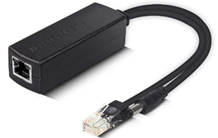
Figure 28: iPolex Active PoE Adapter

In the situation where an ethernet splitter would be used a good option is iPolex’s Active PoE adapter. It comes equipped to handle an input DC voltage of 44-57V and includes overvoltage protection. The data rate is 100 Mbps and its compatible with IP camera, IP phone wireless AP and most 12V Non-PoE devices. This adapter also ships in a pack of 2 and is competitive in price to single shipped alternatives.

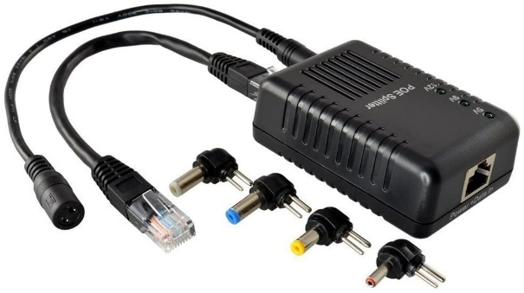
Figure 29: Amcrest Active PoE Splitter Adapter

An alternative to the iPolex splitter is Amcrest’s Active PoE splitter that includes an adjustable DIP switch for 5V, 9V, and 12V adjustable output. It can deliver power up to 328 ft and includes interchangeable cord tips to serve a multitude of different camera power types.
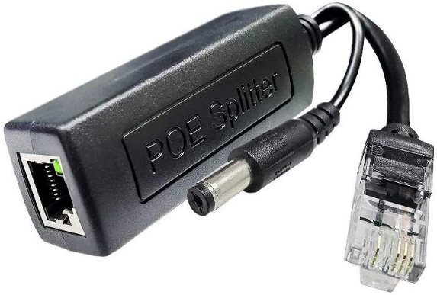
Figure 30: Steamemo Active PoE Power Over ethernet Splitter Adapter

Finally, the Steamemo’s Active PoE splitter adapter is the most cost-effective option out of the alternatives and has almost near identical features when compared to the iPolex adapter. This splitter comes with multiple protections such as overvoltage protection, short-circuit protection, and overcurrent protection. It also has a built-in isolation transformer, which enables it to protect and supervise regular operating of the equipment.

Comparison
In the scenario where using a splitter is feasible the best choice would be the Armrests’ splitter, the speed needed for transferring video is almost essential to be 1 Gbps when dealing with high quality video. Steamemo’s price and quality is hard to compete with but the speed alone disqualifies it from consideration. The iPolex splitter is individually cheaper than the Steamemo adapter however it is only sold in packs of two doubling the price making it an unreasonable choice as the specs are almost identical.

Splitter | Price | Output | Speed
iPolex Active PoE Adapter (2-pack) | $16.99 | 12 V | Up to 100 Mbps
Amcrest Active PoE Splitter Adapter | $19.98 | Adjustbale 5V, 9V, or 12V | Up to 1000 Mbps
Steamemo Active PoE Splitter Adapter | $8.99 | 12 V | Up to 100 Mbps
Table 10: comparison of PoE splitters adapters

Remote Control:
For this project we had three initial options for the remote controlling of our device, the Xbox One controller, the PS4 controller, and a generic wired controller. Originally in theory the PS4 controller was the most favored as many open-sourced options have sought to handle the porting of Sony’s PS4 controller to the non-native Windows operated PC. Since Microsoft designed both Windows and the Xbox One controller it was natural the great amount of support available to it on its own platform. The generic controller was also a good option since it was designed to work with as many platforms as possible, such as Android OS, multiple versions of Windows, and the PS3 console. When comparing the three the most practical to implement when using Windows happens to be the Xbox One Controller. On the Windows platform the Xbox one controller has the most up to date and well-maintained API library provided by Windows and it has the best ability to establish connection wirelessly. The API that would be responsible to connect the PlayStation 4 is no longer maintained or documented, even though it is stable and can be implemented the Xbox’s API is more desirable. Even though the generic controller is compatible with the Xbox’s API and cheaper its inability to connect to the controlled device wirelessly puts it a step behind the Xbox One controller.

PlayStation 4 Controller

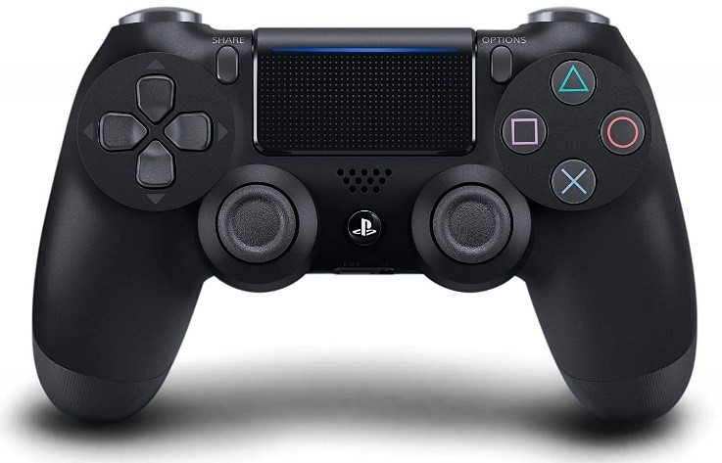

Figure 31: PlayStation 4 Controller

The PlayStation 4 controller, also called the DualShock 4, is manufactured and designed by Sony a Japanese multinational conglomerate which is one of the world’s largest manufacturers of consumer and professional electronics and related services. Since we are using PC, we originally assumed that the ps4 controller would be easier to implement as it has a lot of open-sourced adaptations. However, the windows operating has an API that interacts with the Xbox One controller better. Since support for the ps4 controller is no longer maintained we opted to use the latter. Also, the PlayStation 4 controller supports three-axis gyroscope and three-axis accelerometer which are used for motion detection.

Xbox One Controller
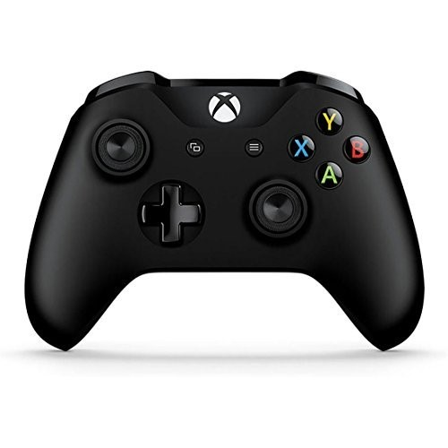

Figure 32: Xbox One Controller

The Xbox one controller is manufactured and designed by Microsoft an American multinational technology company that specializes in computer software among other related services. Most of Microsoft software is made for the PC which is the type of computer we have decided to use for this project. For this controller independent developer support was implemented from day one which allows for easy interaction with only a little experience in a programming language such as C++. Unlike the other controllers the Bluetooth capabilities of the controller are free to use for independent developers making wireless connection possible. The version of the controller we are using released in 2020 also has Micro-B connection capabilities as an alternative to Bluetooth.

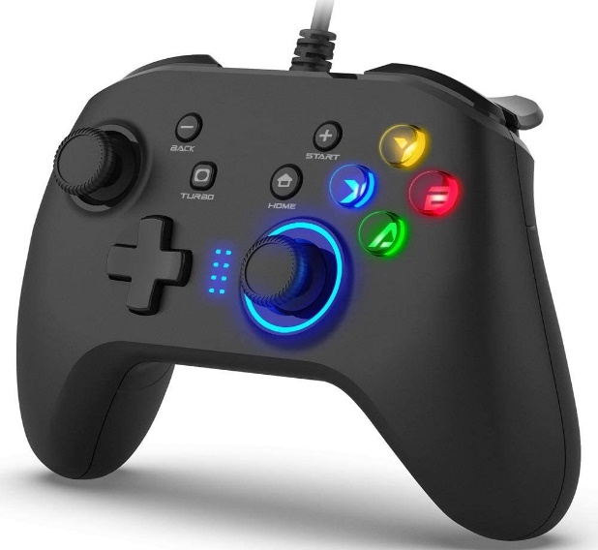

Figure 33: Generic Wired Gaming Controller

The generic controller is a wired gamepad that is compatible with Windows, Android OS, and the PlayStation 3 console. Its USB cable is 6.5 feet long which allows for ample space from the device being controlled. The controller also allows for customizable buttons that repeat commands even after they are pushed. The major draw to this controller is its low price and ability to handle the needs of this project.

Comparison
To serve the purposes of this project the Xbox one controller is the most suitable. The Xbox One Controller is closer in relation to the operating system most PCs run on in Windows and is heavily supported by most apps that use controllers when compared to Sony’s PlayStation 4 controller. The difference in support on Windows is clearly seen when noticing that the PlayStation controller is only compatible with a legacy Microsoft API called DirectInput which is no longer maintained and isn’t compatible with today’s Windows Store apps. However, the Xbox one controller uses a well maintained and up to date API knowns as the XInput Library, made specifically for it. Finally, the last thing considered when deciding which controller to use was the price. Currently, the Xbox One controller sells for $54.99, slightly cheaper than the PlayStation 4 controller’s $59.99 price tag. The generic controller also would use the DirectInput API and must be wired which are both undesirable attributes not worth its lower price point.

Controller | Price | Battery Life | Charging Interface | Wireless | Note
PlayStation 4 | $59.99 | 4-5 hours | Micro USB | Yes w/ Dongle for PC. | Controller batteries are non-removable and rechargeable
Xbox One | $54.99 | 10-20 hours if removable batteries are used | USB | Direct Bluetooth
Generic Controller | $26.99 | Unlimited | USB | No | Must always be wired to device.
Table 11: Comparison of remote controls

Design

Prototype:
Our design is made of two systems. The camera system controls the audio and video stream, connects the camera to the streaming software, and controls the zoom. The motor system controls the motors and the movement of the camera, the pan and tilt. Both systems are controlled by the laptop and remote control. The motor system takes external power from a plug-in power converter and receives instructions from the remote through a Wi-Fi receiver on the main control board. The camera system is connected through USB cable to get instructions from the remote and transmit the video stream to the streaming software through the laptop connection and provide continuous power to the camera.
Prototype schematic: place here

Hardware:
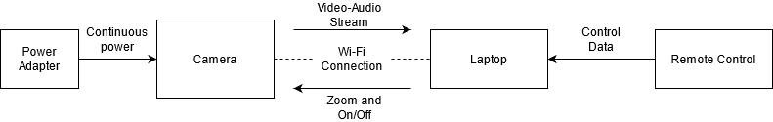
Figure 34: Block diagram of camera sub-system

The camera system uses an action camera which can is powered over USB connection and can transmit over wife or USB cable as well. The camera will take power through the USB cable to provide continuous power. The USB cable will also carry the audio and video data from the camera to the laptop. In order to use USB as both a power source and data transfer line, the USB cable will connect to the USB port of the laptop which keeps power from its charging cable. The laptop will use OBS streaming software to live stream the video to users through the internet. An Xbox One remote will connect to the laptop and control the on, off, and zoom functions of the camera.

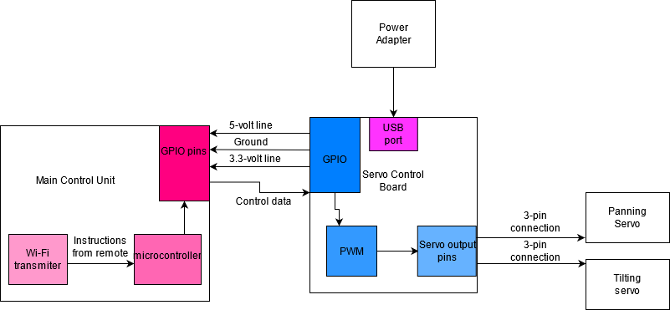
Figure 35: Block diagram of the motor sub-system

The motor system consists of 2 servo motors, an aluminum camera mount, a PWM board, and a main control board. The servos control the pan and tilt functions and connect to the mount physically to perform those functions. The servos draw power and signal response from the pin connections to the PWM board. The PWM changes the width of the on signal to tell the servos what position they should rotate to between 0 and 180 degrees as opposed to changing the speed. Speed can also be changed by simply changing the pulse width signal slower which has to be interpreted by the remote software. An external PWM is necessary for most control boards because they use Linux as an operating system. Linux doesn’t have a reliable clock especially when interfacing with multiple boards and devices. For servos, it’s important to have a consistent clock so that the senor on the servo doesn’t mistake an inconsistent clock with a shorter pulse width and cause the servo to jitter.
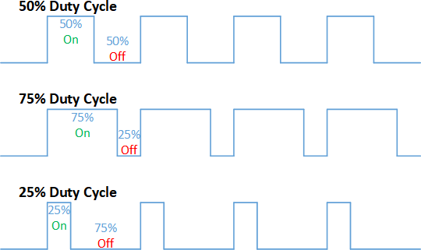
Figure 36: PWM example.

Pulse-width modulation controls the voltage provided to a device in a specified manner that decreases the amount of power relative to a constant DC signal of the magnitude of the peaks. According to the duty cycle, which is the ratio of the time the voltage is in the ‘on’ position vs. the ‘off’, a device receives many small bursts of power per second which enables us to control devices in a gradual manner. Some devices, such as very small motors or display panels, require that pulse-width modulation is used; if a DC-peak voltage were applied to the device, it may overheat, burn out, or otherwise damage the component.

Particularly in regard to motors, pulse width modulation allows us to control how far the motor pivots and how quickly it ends up traveling there. This in effect allows us to control the position and speed of the motor with minimal control hardware inside of the motor itself. The task is simply reduced to sending this alternative voltage waveform in the duty cycle that yields the speeds and position required.

This waveform can be crafted directly from a MCU’s (microcontroller unit) power supply and, using software libraries or even implementing it on one’s own, software written to control this process. However, entertaining the idea of implementing one’s own PWM signal raises some alarm bells related to reinventing the wheel.

The concept of PWM is so widespread that there are accessory boards designed specifically for controlling motors that implement PWM for us. This comes as no surprise for those with a background in robotics, where many so-called “hats” or “shields” on MCUs are already designed and available for purchase. These shields are accessory hardware to commonly available MCUs and implement popular functions in hardware for the designer’s convenience.

The interface through which the main MCU and the shield communicates are the GPIO pins. There are usually a few dozen GPIO pins on an MCU; since we only intend to control one motor-servo setup, we will have many pins to work with to provide power to our shield, and then indirectly from there to our motors.

The PWM board draws power from a USB 3 plug with an outlet power adapter. This is used to drive 5-volt power to the servos and draw 3.3-volt power to the board. The PWM board is also driving power to the main control board through the GPIO pins: the 5-volt power pin, the ground pin, and the data pins. Since power is delivered through the GPIO pins, there is no power security to prevent overloading and burning the board. Alternatively, we can also drive power through the I2C connection. I2C stands for inter-integrated circuit. This is a protocol used to connect a set of peripheral devices to a main control board easily. 2 bus signals, a clock signal and a data signal, are used to transmit the data between the two devices. I2C connections are open drain, meaning that they can’t drive high. This prevents overloading the board with power and protects against excessive power dissipation. (what is I2c and how does it do power protection?)

In order to reduce the number of wires needed to run to the system, we are implementing wireless control of the motor system through wi-fi. The main control board will support the wireless communication to the remote. Wi-fi control can be easily implemented using by syncing the transmitter and receiver on the same network. Once on the same network, the device will use internet protocol to search the local network for the remote’s IP address. With the IP address stored, the remote and the servo control board will use internet protocol to transmit information in internet frames. This method may pose challenges in areas with slow wi-fi or areas with none at all, so it is important to have a wired connection as a backup plan.

Block Diagram
The hardware block diagram in figure 37 illustrates the physical connections between subsystems in the device. The capture device is the controlling system for the audio-video subsystems, as well as directing the motor to the appropriate angles in order to frame the shot correctly and quickly. Any commands and media data are transmitted over the power-data line, where commands are brought in from the controller, and where the media is written to disk. The mount and tripod support the capture system, the weight of the cables connecting the workstation, capture device, and motor, providing stability and the altitude for media capture.
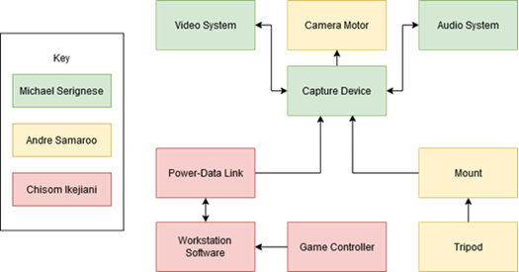
Figure 37: Hardware Block Diagram

Software:
The PTZ camera project software consists of three subsystems. The diagram in Figure 38 shows how the remotes software, interact with the laptops command center to finally interact with the main control board. The laptops command center and the remote’s software both are hosted on the laptop. The three subsystems run in tandem which allows the subsystems to stay in sync. In detail, this grants the physical camera system the ability to make precision movements as not long after the remote sends them and the computer handles the transfer. As the remote sends the command data to the computer, the computer’s command center sends it over to the main control board for interpretation while also processing the video data being received from the camera via USB. The main control board interprets the data received based on pre-written code stored in its RAM. The translated commands are then passed to the speed controller which directly controls the tilting motor and the panning motor. Finally, at the end of the desired movement the status and position of the motors are then reported back to the main control board.

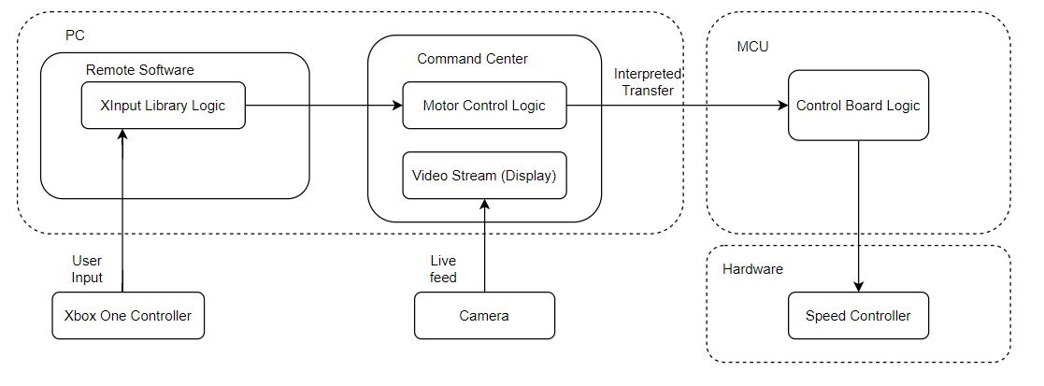
Figure 38: In-depth Software Diagram

Remote Software
The remote software takes advantage of a Windows API called XInput which enables applications to receive input from an Xbox Controller on Windows. The XInput API consists of functions that allow you to retrieve the controller state, this alone is the foundation of interpreting the controller’s commands. Retrieving the controller’s state is done very often to keep track of changes which are later transformed into motor movements.

Command Center
The command center is a custom written software application that is responsible for handling the video data being received from the camera and transferring the remote software output over to the micro control board. The video data is transferred to the command center via direct USB connection. In the command center the video data is displayed live and has the option to be recorded for later use.

Main Control Board Software
The Control Board Software is a custom API that translates the Motor Control logic in the command center into code the speed controller will be able to use. Since the motor controller will be an Arduino the translation of code will be relatively easy as C and C++ are closely related. The control board software will also keep track of the position of the pan and tilt motors and have safeguards in place to stop the arm from moving out of bounds.

Windows API
As mentioned before this project takes advantage of the Windows API which is a library of functions used freely for developers to interact with their projects. The API is a collection of commonly used functions when programming interfaces under the Windows operating system. The API receives support from a software development kit, the Microsoft windows API, which provides documentation and descriptions based on the Windows API.

The API is responsible for handling a lot of serial connections and applications with respect to the Windows operating system. Even though API’s belonging to this family lose support they are still stable enough to be used in development.

XInput Library
The XInput Library is a cross-platform API to be used on Xbox and Windows. When on windows it is provided as a DLL (Dynamic-link library) file directly installed on the operating system. There currently exits three versions of the XInput DLL, they each provide slightly different functionality and should be chosen based on the versions of Windows needed to be supported and the programming language to be used. XInput version 1.4 is packaged a as part of Windows 10 and should be used when building Universal Windows Apps, which are applications that can be used across the compatible Windows Devices, such as PCs, tablets, Xbox One console, and smartphones. Version 1.4 is also the only version that can be used in C++ or DirectX Window Store apps. XInput version 9.1.0 is a part of Windows Vista, Windows 7, and Windows 8. The 9.1.0 version should be used when the desired desktop app would be run on those versions of Windows while using basic library functionality. Finally, XInput 1.3 is considered legacy as it used to support Windows Vista, Windows 7, and Windows 8 before it was dropped. It is still possible to run version 1.3 to support down-level versions of Windows that aren’t supported by version 9.1.0.

DirectInput Library
The DirectInput Library is a part of Microsoft’s DirectX API that is used to process data from a multiple of controllers. The advantage this library has over others is its ability many different types of controllers even ones not directly native to the Windows platform such as the PlayStation 4 controller. DirectInput works by enabling an application to retrieve data from any kind of input device, through a process known as action mapping. Action mapping allows an application to pull data form an input device without having to know anything about the device itself. The biggest drawback to using the DirectInput Library is its drop of support and replacement by the XInput Library. The use of DirectInput is still highly common among developers as it is a powerful software needed to connect many different types of devices to Windows.

Comparison
In the case of choosing between the XInput and DirectInput libraries the former is the better choice. The controller of choice for this project the Xbox One controller is compatible with both these libraries however, the XInput library was made to support all features available to the Xbox one and later controllers. While the DirectInput library can handle basic interpretations from the Xbox one controller it can’t implement some of its newer features such as querying for the state of the controller, vibration effects and sound input and output functions. However, if the PlayStation 4 controller was used the only option would be the DirectInput library.

Library | Multiple Controllers | Supports PS4 Controller | Supports Xbox controller | Note
XInput | Up to 4 at a time | No | Yes | As of 2021, the XInput library is still supported and maintained.
DirectInput | 1 | Yes | Yes | No longer maintained or supported for troubleshooting.
Table 12: Comparison of API libraries for the controllers

Programming Languages
When researching the requirements for the software going to be written a need to select an appropriate programming language arose. As most problems can be solved in many ways so can programming problems, however in some cases there is a language that is suitable to solve the problem the best. There are three software systems that are a part of this project so one will require a properly selected language.

The primary choice of language for the workstation software should be easy to implement and maintain, fast enough to keep up with the remote audio-video data, and well-supported enough to provide the media and graphical software libraries necessary to complete the project with minimal reinvention of the metaphorical wheel. A clear choice satisfying these parameters, especially in the context of the Windows operating system, is C++. The C++ API is tightly integrated with the Microsoft Windows API. Furthermore, for the remote controller software system, the XInput library is the best-supported and well-documented library for controller interaction on Windows; it is also written in C++. This makes a very good case of using a pairing of C++ with the XInput library.

The second software system is the Command Center. This is the central hub of the workstation software that coordinates controller input, motor controls, and camera data flow on the workstation computer. Since the grounds for using C++ in the project are well established, the logic for the command center may also be implemented in the C++ programming language; however, an alternative for the graphical interface, which may shave off key development time, is NodeJS. NodeJS is basically a desktop version of JavaScript that runs outside of the web browser. There are many technologies that allow easy-to-design graphical interfaces available as simple libraries in NodeJS. Therefore NodeJS will also be considered in the implementation of the command center if the extreme flexibility of C++ is not required.

Finally, the software on the main control board. As this is an embedded system, a typical choice of software platform is ordinary C. There are also options for C++ in an embedded system, but the toolchain that is best-supported on Arduino, the Pi family, and especially other, less well-known MCUs is the GNU C toolchain.

Software Flowchart
In figure 39, the general overview of the software flow is awaiting commands from the workstation. The device awaits a power-on signal, and then listens for input related to powering off, audio and video sampling, PTZ actions for the motor, and responds to them appropriately.
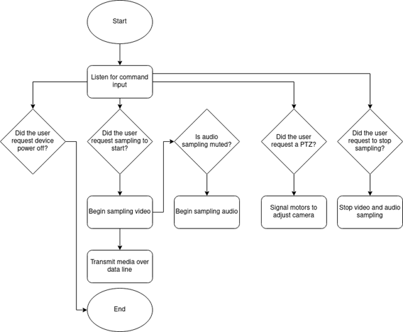
Figure 39: Software Flowchart

Testing:
Our project is to create a Pan-Tilt-Zoom camera for outdoor use. To test the functionality of our system, we will test the responsiveness of the motors, the responsiveness of the remote, and the durability of the system mounted to the tripod.

The remote will transmit signals to the laptop through a wireless connection that gets re-transmitted over wi-fi to the camera and motor systems. To test the response time, we will need to benchmark the data transmission rate. We can issue as series of commands from the remote control to see if the laptop can pick it up. Then if the laptop responds, we can see if the wireless transmission can send the signal out to the system. The time between the control and the movement of the motors or the zoom of the camera should be measured. We also want to see how well the system responds to opposing requests. For example, switching the motor from 0 to 180 degrees or making the camera go from a wide shot to full zoom. Testing these extremes will help determine if the response speed is fast enough to suit the needs of a sporting live stream.

We also want to see how well the transmission can send the video and audio information. Since we are sending the stream over wi-fi, frames can get lost or have a delayed response. This is compounded by streaming delay. It’s important that the camera transmits the data smoothly so that we don’t have issues when we stream the input to the public. The best test would be to run an internet reliability test. This will send the camera a number of internet packages and receive back the response packages. The number of frames dropped will be the error rate and the speed of the data will be the transmission rate. Ideally, we want a low loss with high speed.

Another important aspect of the project is the durability of the design. This camera has to survive the Florida weather and not shut down or short circuit. The electrical components will be in a weather-proof housing to protect them. To test the housing, we will use the mini wind tunnel at UCF that the mechanical engineering school uses. This will test the wind resistance of the housing unit and its strength to hold onto the tripod mount. We also want to test the system’s resistance to the rain so we would need to set up a small rain simulation using a hose or sprinkler. The housing will go through a test without the electrical components first to see if the case can keep water out. If the case remains dry on the inside, then we will test the system with the electronics on and operating. We will test the system to see if it fails under the conditions in either the motors, the camera, or the transmission.

Administrative

Budget:
The budget shown in Table 13 displays options for both ready made products and parts for systems we would build ourselves. There are three major categories for the products. There are the parts for the camera, parts for the controller, and parts for the mount. The computer workstation will just be the user’s computer with a user interface. A good option for a bought camera is a --- because it supports wireless video transmission and has the durability to withstand harsh weather conditions. We will build the motor system, so we are buying the motors and control units separately. This allows us to design our own system custom suited to our needs. While we will buy the mount, we hope to make the housing unit by 3D printing the parts with ABS plastic. Our budget also includes some spare parts, the servos, just in case we get malfunctioning servos from the kit. Our goal is to also get a spare control board, but it depends on the rest of the budget since we want to keep the cost below $300.

Item | Quantity | Price
Camera | 1 | $90
Microphone (if not built in) | 1 | TBD
Power-data link | 2 | $30
Main Control board | 1
Servo control board | 1 | $10
Game controller | 1 | obtained
Servos | 2 | $30
Mount kit | 1 | $31
ABS plastic filament | 1 spool | TBD
Total | --
Table 13: Budget

Milestones:
Table 14 outlines our milestone goals week by week. A majority of the first semester is spent on documentation and developing an initial prototype and writing the proper documentation. This semester we looked at all the possibilities to solve the problem of a long term PTZ sports camera. We developed a solution using our own motor system and wireless video transmission. A majority of the work was spent on researching different systems and how we could emulate them and writing the report. The second semester is about building the prototype, analyzing the initial results, and developing an improved system. We hope to have our parts by May, when the second semester starts. That way we can get to work on our prototype right away. Our goal is to test the protype and have time to revise the design so that we may implement our stretch goals.

Senior Design 1
Week | Milestone
1 | Form teams
2 | Brainstorm ideas
3 | DC1
4 | Investigate project idea
5 | DC2
6 | Determine what products are needed for project
7 | Draft parts requirements
8 | Divide report research into parts
9 | Assignment on standards
10 | Start first draft
11 | Work on report
12 | 45 page draft, order parts
13 | Write final pages
14 | 80 page draft
15 | Final draft
Senior Design 2
1 | Software plan, work on building motor sub-system
2 | Implement workstation software, communicate with motors wirelessly
3 | Communicate with camera, prototype housing
4 | Finish first prototype
5 | Initial testing
6 | Assess and revise prototype
7 | Remodel and rebuild housing, improve software
8 | Implement stretch goals if all goes well
9 | Second test and assessment
10 | Write final report
11 | Revise
12 | Final presentation
Table 14: Milestones

