Wearable PPG Biometric Tracking System

Initial Document: Divide and Conquer 1.0

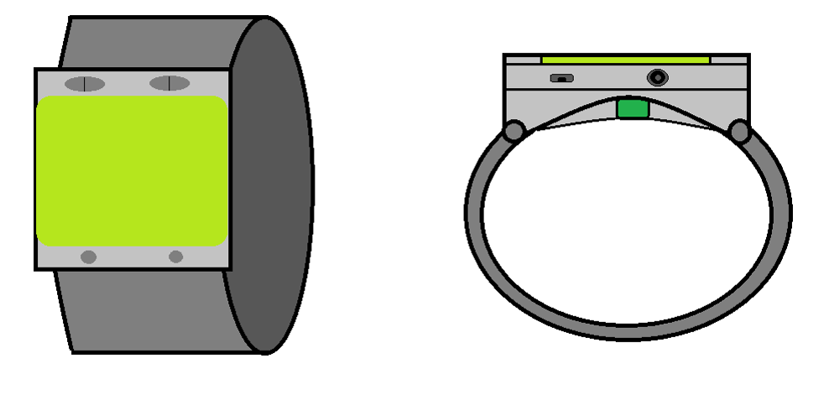

Group 2

Tyrone Morales
Christopher Bormey
Scott Perryman
Cody Showers
PSE
EE
EE/CpE
CpE

University of Central Florida
Department of Engineering and Computer Science
Senior Design 1
EEL4914 Spring 2022
Dr. Lei Wei, Dr. Samuel Richie, and Dr. Aravinda Kar

Divide and Conquer 1.0
Table of Contents
1.1 Introduction 1
1.2 Motivation 1
1.3 Goals and Objectives 1
1.4 Function of Project 2
2.0 Engineering Requirement Specifications 2
2.1 General Project Specifications 2
2.2 Photonics Specifications 2
2.3 Signal Analysis Specification 3
2.4 Physical/Power Specifications 4
2.5 Software Specifications 4
3.0 Prototype Representations 4
3.1 High Level Overview Diagram 4
3.2 Hardware Layout Block Diagram 5
3.3 Signal Analysis Block Diagram 5
3.4 Pre-Signal Analysis Block Diagram 6
3.5 Application Data Receipt Workflow 7
4 Budget and Financing 8
5 Project Milestones 9
5.1 Senior Design 1 Milestones 9
5.2 Senior Design 2 Milestones 10
References 11

1.1 Introduction
Mindful monitoring of one’s cardiovascular health is a useful habit to establish in the modern day as cardiovascular disease (CVD) is the leading cause of death worldwide. Identifying an individual’s personal cardiovascular biometrics, such as heart rate, is a good approach towards analyzing their risk for CVD, as well as monitoring progress towards better cardiovascular endurance. Obtaining accurate heart rate measurements have, for the most part, been conducted via the use of multiple ECG probes which measure the heart’s electrical activity. While the ECG method stands as a current standard of medicine, in recent years there has been a renewed interest of PPG methods.

Photoplethysmography (PPG) is a technology which measures the blood flow volume changes of an individual from a single area via the illumination and subsequent detection of scattered light from microvascular tissue. The reflected light is modulated via the blood flow variation to create a signal that is mainly shaped by the pulse rate and pulse pressure. PPG devices have attracted recent attention in the academic field of biomedical engineering due to the possible biometric information embedded in the acquired signal, as well as the attention of fitness companies due to their inexpensive and easy-to-use implementations.

1.2 Motivation
The motivation for this experiment is to explore the current state of PPG devices for personal health monitoring. Over the last 7 years, the number of scholarly articles and patents filed for PPG-related devices has grown significantly due to their promise for accessible health monitoring. This growth can be attributed to advances in sensor-related research and algorithm-based techniques for mitigating sources of inaccuracies and extracting critical biometrics for personal health, such as blood pressure and blood glucose. Given the ongoing research with respect to the accuracy of blood pressure measurements, our project will be constructed with the motivation of attempting to reach the current state of the art for educational purposes and should not be mistaken as a commercially ready device with respect to advanced biometric measurements.

1.3 Goals and Objectives
Our group aims to design and construct a wearable PPG device that can collect and send biometrics to a smartphone for convenient and easy health monitoring. The primary goal of the project is to be able to accurately derive and report the following: heart rate, heart rate variation (HRV), blood oxygenation and skin temperature. Utilizing advanced algorithms and possible machine learning techniques might allow for the extractions of other biometrics, such as blood pressure and blood glucose, which remain as secondary goals for the project. We plan on utilizing multiple LEDs of differing wavelengths to acquire PPG signals from various levels of tissues for better biometric extraction.

1.4 Function of Project
The function of the project is to provide individuals who use the device with an easy and convenient method for monitoring important biometrics. The information gathered from the device will be formatted and stored in such a manner that it can be used to understand the current cardiovascular health status. The information gathered will be stored for a given time period such that an individual can compare their current status to prior status as means to identify progress or concern.

2.0 Engineering Requirement Specifications
These requirement specifications are the metrics by which we are planning to accomplish the desired results of the project and measure their success. We have broken these requirements into a few categories. The categories are as follows, general, photonics, signal analysis, physical power, and application specifications.

2.1 General Project Specifications
General project specifications refer to broad requirements of the project that may not cleanly fit into a specific category but may be essential to the design.

Number | Description
1 | The device shall contain 4 modes of operation: Off, ON: Stand-by, ON: Data Acquisition, ON: Data Transmission & Presentation.
2 | The device shall be wearable.
3 | Device shall produce predictions for the following biometrics: Heart Rate, Heart Rate Variability, Blood Oxygenation, Temperature.
5 | Device should be compact. <TBR>

2.2 Photonics Specifications
Photonics Specifications refers to the requirements of the hardware relating specifically to the photonics modules required for the device’s operation.
Number | Description
1 | The illumination and detection module’s total volume should be less than 15% of the total device volume.
2 | Dynamic LED illumination to eliminate inaccuracies from skin pigment variations.
3 | The illumination and detection module must be designed such that ambient light interference is minimal.

2.3 Signal Analysis Specification
Signal Analysis specifications refers to the specific metrics of the performance and application of signal analysis in the system.

Number | Description
1 | A/D converter shall sample at a rate of at least 100Hz.
2 | Signal to noise ratio shall be at least 30dB.
3 | Introduced Quantization noise shall not break the SNR spec.
5 | Hardware latency should be less than .5 second <TBR>
6 | This process shall produce an estimation of heart rate, heart rate variability, blood pressure, blood oxygen content, and temperature no less than once every second when in data transmission and presentation mode.
7 | The bias of the distribution of any of the biometric predictions on any single user should not be more than 5% away from the true value.
8 | The variance of the distribution of any of the biometric predictions on any single user should be less than .75.

2.4 Physical/Power Specifications
Physical/Power specifications refers to the overall physical design of the device in the system and the power requirements of the external device.

Number | Description
1 | PCB no larger than 50mm x 40 mm
2 | Battery life of at least one hour
3 | Draws no more than 200 mA
4 | Weigh no more than 300g

2.5 Software Specifications
This section refers to the requirements of the application designed to receive, display, and store the data for the system.

Number | Description
1 | Wearable device should be able to communicate with another device to display the data.
2 | Application for hosting data must be able to maintain 12 months worth of metrics.
3 | Application should be able to securely separate data for individuals by each of the 4 metrics.
4 | Transmission connection to smart-phone must support a range of at least 3 ft.
5 | Data transmitted should prevent access by unauthorized devices.

3.0 Prototype Representations
This chapter will express the system at different levels of abstraction. Generally this chapter moves from high to low with a couple exceptions. Some sections express specific functions such as signal processing, Dataflow

3.1 High Level Overview Diagram
The planned system will incorporate the function of a designed device that uses LEDs and sensors to gather biometric data. It will then analyze the information gathered and use a communication protocol to push the results to another device for display and storage.

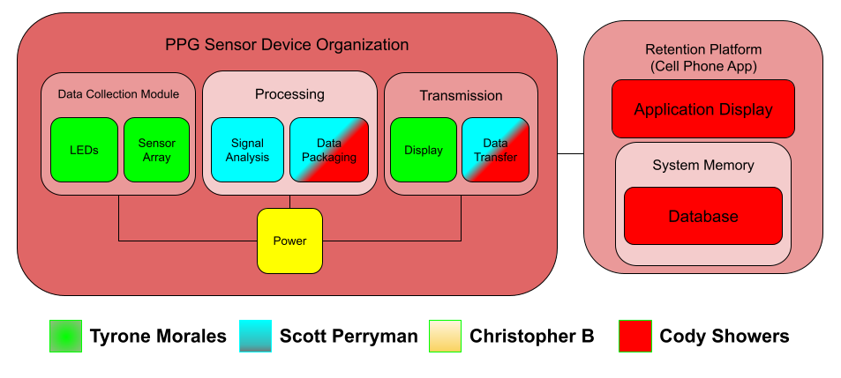

3.2 Hardware Layout Block Diagram
Currently every component of this block diagram is in the research stage, wherein no parts have been definitively chosen. We are yet to decide what combination of parts would deliver the portability, power consumption, and low cost qualities we are looking for.
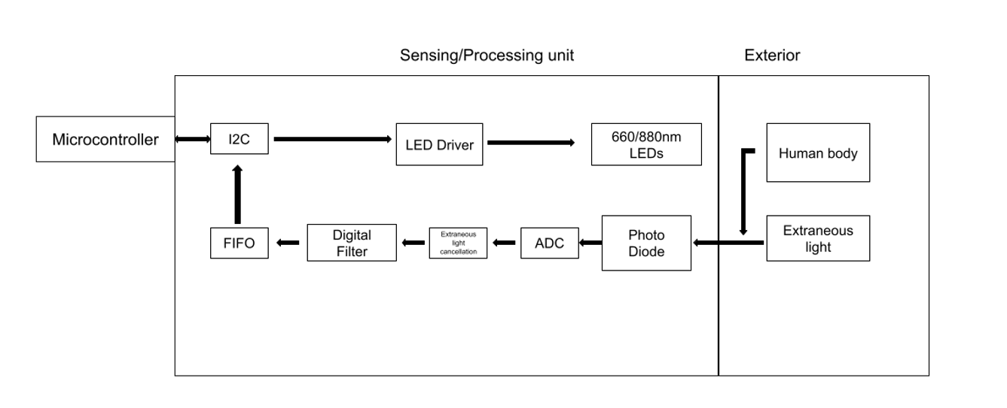

3.3 Signal Analysis Block Diagram
Below is a basic diagram of the signal processing system. The system starts with an incoming analog current signal from the photodiode sensor array. With the use of a transimpedance amplifier, we can convert the current signal to a voltage signal. From there we are going to do some basic signal preprocessing which will use several layers of active and passive filters to remove unneeded frequency components from the analog signal. The A/D converter coupled with a flip-flop array will allow us to convert the preprocessed analog signal to a digital signal with our desired sample frequency and resolution. Using several feature extraction techniques we can then predict and output the user’s biometrics.

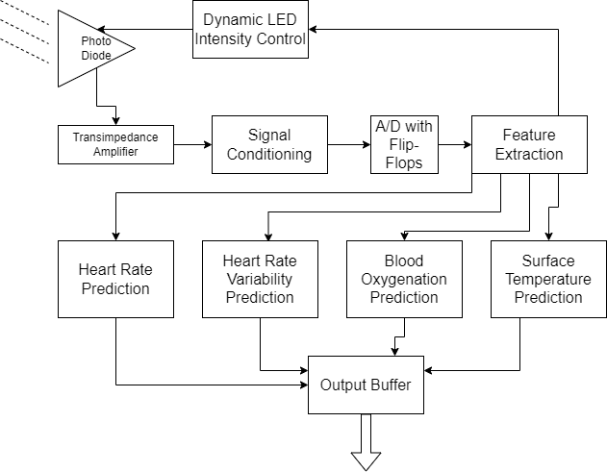

3.4 Pre-Signal Analysis Block Diagram
The device will have a pre-signal analysis block to ensure that the PPG signal going into the biometric extraction process is of adequate quality. Common sources of inaccuracies in readings are often the result of motion of region of interest (ROI) during signal acquisition and/or inadequate illumination for darker skin tones due to stronger absorption from larger melanin concentrations. The diagram below will provide feedback to the system and user such that these issues can be addressed before entering the primary signal analysis stage.
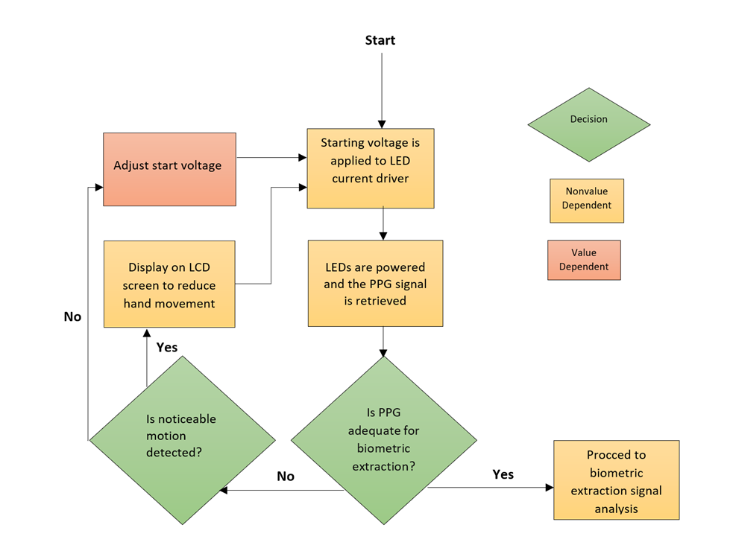

3.5 Application Data Receipt Workflow
The application will reside on a smart device ready to receive the signal from the designed device. The application will await data input from the device. Once received the application will be responsible to check to see if data transferred is valid. Upon a failed check data must be retransmitted. If the check passes, the results would then be decoded and displayed in the application. Meta-data would need to be wrapped into the data received from the device to store in the application database. Upon the storage step the application would reset and return to the awaiting data state.
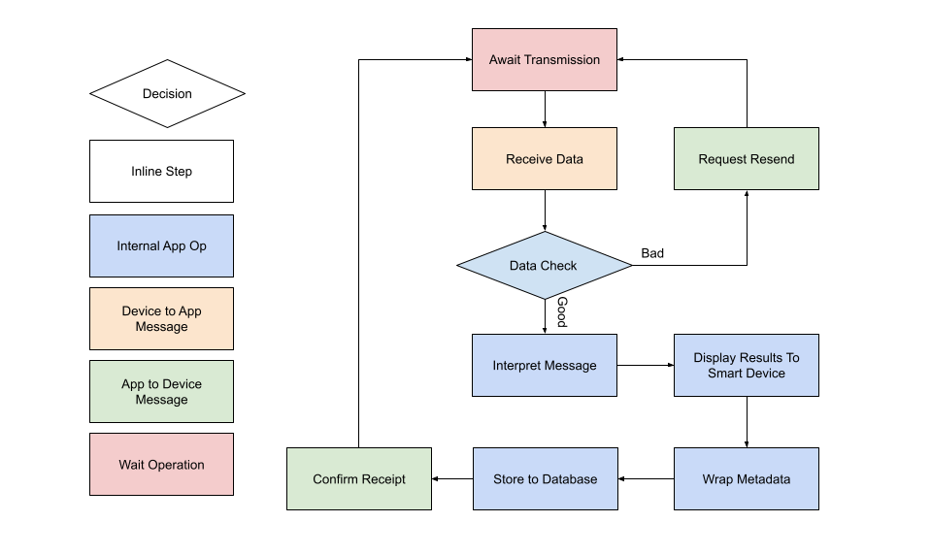

4 Budget and Financing
As of the creation of the divide and conquer 1.0 document, this project will be financed entirely by the project group members. When creating a wearable device, cutting edge technology that is smaller than a common wristwatch is not feasible on a budget made with four students in mind, therefore we have chosen components that are light and affordable at the expense of not being smaller than market competitors. The team has agreed upon a maximum budget of $300 per person, with the aim to make this project under $150 per person. Current budget estimates are tentative, as we have not finished the process of deliberating what parts we will be using in our first prototype. Decisions on what type of battery and power delivery system we use moderately affect our budget and convenience of the device. Currently, our high end estimate for the budget lies in the $300 range, with complications potentially raising this to $400 or more.

Item | Cost per item (USD) | Quantity
Small form factor Microcontroller | $15 to $50 | 1
Wrist wearable housing | $50 to $150 | 1
Photo diode | $1.37 | 1
Battery (Li-ion) | $10 to $20 | 1
PCB Printing | $10 to $50 | 1
BLE module | $4 | 1
530 nm LED | ~$2 | 1
660 nm LED | $2.50 | 1
880 nm LED | $0.66 | 1
ADC | $2.66 | 1
FIFO memory | $10 | 1
IR Sensor | $3.30 | 1

5 Project Milestones
This chapter is a listing of the intended milestones throughout the project from start until conclusion. It is broken up by in which class the prospective milestone will be reached.

5.1 Senior Design 1 Milestones
Week # | Dates | Milestone
1 | 1/10/2022 – 1/14/2022 | Form a group and formulate ideas
2 | 1/17/2022 - 1/22/2022 | First group meeting
3 | 1/24/2022 – 1/28/2022 | Meet bootcamp objectives and start on D&C V1.0
4 | 1/31/2022 – 2/4/2022 | Finalize D&C V1.0
5 | 2/7/2022 – 2/11/2022 | D&C V1.0 meeting  Work on D&C V2.0
6 | 2/14/2022 – 2/18/2022 | D&C V2.0 submission
7 | 2/21/2022 – 2/25/2022 | Begin work on 60 page paper
8 | 2/28/2022 – 3/04/2022 | 30/60 pages
9 | 3/07/2022 – 3/11/2022 | 40/60 pages
10 | 3/14/2022 – 3/18/2022 | 50/60 pages
11 | 3/21/2022 – 3/25/2022 | 60/60 pages, Assignment due
12 | 3/28/2022 – 4/01/2022 | Finalize research and design, achieve 80 pages
13 | 4/04/2022 – 4/11/2022 | 100 pages due
14 | 4/18/2022 – 4/22/2022 | Refine paper, finish last 20 pages
15 | 4/25/2022 – 4/29/2022 | Submit final report 120 pages  Order PCBs

5.2 Senior Design 2 Milestones
Week # | Dates | Milestone
1 | 5/16/2022 – 5/20/2022 | Update meeting, order missing parts
2-3 | 5/23/2022 – 6/03/2022 | Test sensor and data processing
4-6 | 6/06/2022 – 6/24/2022 | Get App/UI finished
7-10 | 6/27/2022 – 7/22/2022 | Finish prototyping/make final changes
11 | 7/25/2022 – 7/29/2022 | Deliver presentation
12 | 8/01/2022 – 8/05/2022 | Final report

References

[1] Castenda, D., et al. (2018). "A review on wearable photoplethysmography sensors and their potential future application in health care." Int J Biosens Bioelectron. 4(4): 195-202.

[2] Elgendi, M. (2012). "On the analysis of fingertip photonplethysmogram signals." Curr Cardiol Rev. 8(1): 14-25.

[3] Fine, J., et al. (2021). "Sources of inaccuracy in photoplethysmography for continous cardiovascular monitering." Biosensors 11(126).

[4] Ghamari, M., et al. (2016). "Design and protoyping of a wristband-type wireless photoplethysmographic device for heart rate variability signal analysis." Conf Proc IEEE Eng Med Biol Soc.: 4967-4970.

[5] Organization, W. H. "Cardiovascular diseases." Retrieved 1/30/2022, 2022, from https://www.who.int/health-topics/cardiovascular-diseases.

[6] Saha, S. "PPG-Signal-Processing." from https://github.com/ShoumikSaha/PPG-Signal-Processing.

