12/10/2009
University of Central Florida | The Autonomous Visual Rover

Group 2 | Diante Reid, Liem Huynh, Sean Day


Table of Contents

Table of Contents i
List of Tables and Figures iv
1.1 Executive Summary 1
2. Project Overview 3
2.1 Project Motivations 3
2.2 Project Goals 3
2.2.1 Introduction 3
2.2.2 Power Supply Goals 4
2.2.3 Range Finding Goals 4
2.2.4 Weapon System Goals 4
2.3 Project Requirements 4
2.3.1 Power Supply Requirements 5
2.3.2 Range Finding Requirements 6
2.3.3 Weapon system requirements 6
2.4 Risk Management 6
2.4.1 Introduction 6
2.4.2 Risk Mitigation 7
2.5 Milestones 9
3. Research 12
3.1 Introduction 12
3.2 Similar Projects 14
3.2.1 Previous Senior Design Projects 14
3.2.2 Other Projects 15
3.3 Hardware 17
3.4 Microcontroller 17
3.4.1 Motors 19
3.4.2 Power Supply 22
3.4.3 Chassis 25
3.4.4 Range Finders (IR / Ultrasonic Sensor) 26
3.4.5 PCB (Printed Circuit Board) 31
3.5 Software 32
3.5.1 Intro 32
3.5.2 Arduino 32
3.5.3 PCB123 34
3.5.4 CMUcam Software 35
3.6 Part Comparisons and Simulations 36
3.6.1 Battery Comparisons 38
3.7 Vision Sensor 42
3.7.2 Image Processing 43
3.7.3 Edge Detection 43
3.7.4 Blob Detection 44
3.7.5 CMOS vs. CCD Image Sensor 44
3.7.6 CMUcam2+ Technical Specs 45
3.7.7 CMUcam1 vs. CMUcam2+ vs. CMUcam3 50
3.7.8 AVRcam 55
3.7.9 Logitech QuickCam Orbit AF Webcam 57
4. Design 58
4.1 Introduction 58
4.2 System Architecture 59
4.2.1 Sensors Manager 60
4.2.2 Ultrasonic Sensors Data 60
4.2.3 CMUcam2+ data 61
4.2.4 Weapon Systems Introduction 62
4.2.5 Electric Guns 62
4.3 Controller 63
4.3.1 Control 63
4.3.2 Sensors Data 64
4.3.3 Navigation 64
4.3.4 Guidance 66
4.4 Batteries 67
4.4.1 Voltage Regulation 67
4.4.2 Powering the CMU camera 68
4.4.3 Solar Power Design 69
4.4.4 Powering the DC motor 70
4.4.5 Using an H-Bridge to Drive the Motor 70
4.5 Range Finding Design 71
4.6 Power Flow 71
4.7 Weapon System Implementation 72
4.7.1 Introduction 72
4.7.2 Powering the weapon system 73
4.7.3 Mounting locations of Hardware 73
4.8 Design Summary 74
5. Testing/Prototyping 75
5.1 Introduction 75
5.2 DC Motor/ H-bridge 76
5.3 Ultrasonic Sensor 78
5.4 Range Finding Test 78
5.5 Power Supply Life 79
5.6 Voltage Regulation Test 79
5.7 Chassis/Locomotion 80
5.7.1 DC Motor/H-Bridge turning wheels test 81
5.7.2 IR Detector/Reflector test 82
5.7.3 IR Detector/Reflector encoding wheel test 82
5.7.4 Chassis/Locomotion test with turning wheels 82
5.7.5 Locomotion test with IR detector/reflector 82
5.7.6 Locomotion test with ultrasonic sensor stationary target 82
5.7.7 Locomotion test with ultrasonic sensor moving target 83
5.7.8 Locomotion test with CMUcam2+ with stationary target 83
5.7.9 Locomotion test with CMUcam2+ with moving target 83
5.7.10 Locomotion test with all sensors 84
5.8 CMUcam2+ Main configuration 84
5.8.1 CMUcam2+ test using CMUcam2+GUI 86
5.8.2 CMUcam2+/Arduino interfacing test 86
6. Budgeting and Financing 87
6.1 Balance Sheet 87
6.2 Financing 88
6.3 Sponsorship 88
6.4 Suppliers 88
7. Conclusion/Final thoughts 89
7.1 Diante 89
7.2 Liem 89
7.3 Sean 90
8. Appendicies 90
8.1 Permissions 90
9. Bibliography 99

List of Tables and Figures

Figure 1.1.1 AVR Overhead View 2
Figure 2.4.1 Risk Scoring Matrix 8
Figure 2.4.2 Risk Management Table 9
Figure 2.5.1 Initial Milestone Chart 11
Figure 3.1.1 Top Level Overview 13
Figure 3.2.1 NASA Mar’s Rover 16
Figure 3.2.2 Cameras on Mars Rover 16
Figure 3.4.1 Arduino USB Board 17
Figure 3.4.2 Arduino Digital Layout Schematic 18
Figure 3.4.3 DC Motor 19
Figure 3.4.4 Hobby Servo 20
Figure 3.4.5 Stepper Motor 20
Figure 3.4.6 H-Bridge 21
Figure 3.4.7 Table listing the power needs present on the autonomous visual rover 22
Figure 3.4.8 Power Conversion 24
Figure 3.4.9 Flyback Regulator Circuit 25
Figure 3.4.10 AVR Chasis 26
Figure 3.4.11 Ultrasonic Sensor 28
Figure 3.4.12 Ultrasonic Sensor Comparison Table 29
Figure 3.4.13 Location of sensor 30
Figure 3.4.14 PCB123 Screenshots 31
Figure 3.5.1 Arduino Development Software 33
Figure 3.5.2 PCB123 Screenshot 34
Figure 3.5.3 CMUcamGUI Screenshot 35
Figure 3.5.4 Simulation of LT1109 voltage regulator 36
Figure 3.5.5 LT1109 voltage regulator circuit 37
Figure 3.5.6 Voltage Regulator Circuit 37
Figure 3.5.7 LM7805 Operational Block Diagram 38
Figure 3.6.1 Battery Comparison Table 40
Figure 3.6.2 Lithium Ion Charger 41
Figure 3.6.3 Lithium Ion Charger 2 42
Figure 3.8.1 CMUcam2+ 46
Figure 3.8.2 CMUcam2+ layout diagram 47
Figure 3.8.3 CMUcam2+ Digital Logic Configuration 49
Figure 3.8.4 CMUcam3 High Level Block Diagram 53
Figure 3.8.5 CMUcam Comparison Chart 55
Figure 3.8.6 AVRcam Block Diagram 56
Figure 4.1.1 AVR Block diagram 59
Figure 4.2.1 System Architecture 60
Figure 4.2.2 Airsoft Gun 63
Figure 4.3.1 Controls Block Diagram 63
Figure 4.3.2 Coordinate Frame Alignments 65
Figure 4.3.3 Guidance Diagram 67
Figure 4.4.1 Lithum Ion Battery Pack 67
Figure 4.4.2 Voltage Regulator Circuit 68
Figure 4.4.3 CMUcam2+ Power Ports 68
Figure 4.4.4 Solar Power Diagram 69
Figure 4.4.5 37mmX 33mm solar panel from Solarbotics 70
Figure 4.4.6 H-Bridge 70
Figure 4.6.1 Power Flow Diagram 72
Figure 4.7.1 Airsoft Gun Dimensions 72
Figure 4.7.2 Mounting 74
Figure 5.2.1 Arduino Pin Layout Diagram 76
Figure 5.2.2 Arduino Test Hook-up 77
Figure 5.3.1 Ultrasonic Sensor connected to Arduino 78
Figure 5.4.1 Range Finder Test Diagram 79
Figure 5.7.1 AVR Locomotion Test 81
Figure 5.8.1 CMUcam2+ CMOS Sensor Board 85
Figure 6.1.1 Table of Expenses 87

Executive Summary
Technology is the foundation to which our society is built on and has an impact on our everyday life. A major field of technology where innovation and advancement directly affects our civilization is robotics. According to Merriam-Webster dictionary a robot is a mechanism guided by automatic controls this includes washing machines, dishwashers, assembly line machines, and unmanned drones. For our senior design project we designed a fully autonomous object tracking robot called the AVR (Autonomous Visual Rover). Our inspiration for the AVR was to create a device that can help even out the battle field on the war front and keep soldiers safe. Recently the war front has changed dramatically from a normal theater such as a rural country side to urban environments such as cluttered cities and remote villages were the chances of collateral damage are immense. The AVR can be deployed to investigate and eradicate suspicious packages such as IEDs (Improvised Explosive Devices) without endangering the lives of soldiers.
The AVR is a light weight, quick and efficient rover equipped with obstacle avoidance, and image processing capabilities to track a given target. The base of the AVR came from the body of a dissected remote control car which we purchased off the internet. The CMUcam2+ vision sensor is mounted on two servos and connected to our custom designed printed circuit board, which also interfaces with the power supply and drive train system. The AVR is able to follow and track an object based upon the CMUcam2+ image processing abilities. It keeps a programmable distance of 10 inches from the object it is tailing and will also detects when the object turns or stops; it then adjusts accordingly to each action. Therefore, the AVR never actually comes in contact with the object it is tracking. The optional weapons system consists of an attached missile launcher that will fire if the object being trailed is stationary for longer than 15 seconds. The optimum operating environment for the AVR is a dry, well lit area indoors or outdoors. The design of the AVR is very flexible allowing for future upgrades such as solar power, GPS navigation, and Wi-Fi capabilities. The AVR has a budget of about $650, and will be completely funded by the three members of the group. Below is a picture of the body of the AVR.
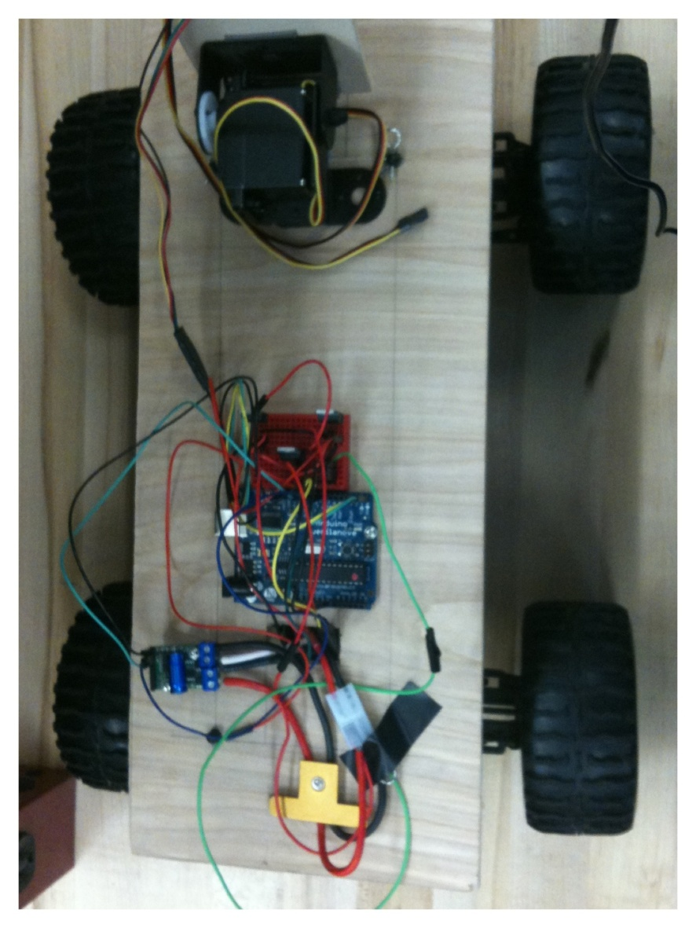

Figure 1.1.1 AVR Overhead View

In Senior Design I, we realized the need for a fully autonomous vehicle that can track an object without endangering humans. Through numerous meetings we developed the concept for a smart tail device which ultimately became the AVR. By the end of the first semester, the AVR’s design, implementation, and application was fully documented. The final phase occurred in Senior Design II, where the AVR was built and programmed to meet our set specifications, all miscalculations were addressed and fixed before the final presentation. The AVR is able to:
- Recognize any color object placed in front of the CMUcam2+ vision sensor
- Track an object in the x, y, and z coordinates
- Autonomously trail an object at a distance of 6 to 10 inches
- Fire a missile upon object when stopped for longer than 15 seconds
- Avoid any obstacle placed in front of object being tracked
Our final design documentation report is divided into parts based on the flow of the design used in creating the AVR. First in Chapter 1, we make a note of our motivation and goals that we were out to achieve, along with a project time line in the technical contents. Included in the following sections is our plan on how we perfected our design and when and how we met our set milestones. After that we will discuss the research involved in the creation of the AVR in Chapter 2. The research section is broken down into three subsections: introduction, hardware, and software. In the introduction we will discuss projects similar to the AVR including those found on the internet and previous senior design projects. The hardware and software sections detail each respective device and programming language used to complete the AVR. Furthermore we will do a comparison and contrast between the hardware we are using and other researched hardware. Following that in Chapter 3, we will discuss design including the blueprint we ultimately settled on and other designs which were considered but decided against. In addition in the design section we will discuss how each part is being integrated in order to work together as a system. Chapter 4 involves prototyping, where we’ll discuss the assembly of our first build and take a deeper look at how the software interacts with the hardware components. In Chapter 5 we discuss the testing processes involved with the AVR and explain the troubleshooting methods used to make the AVR function flawlessly. Chapter 7 explains our budgeting process, as well as how the parts were obtained. Chapter 8 serves as the conclusion where we talk about the different roles of each team member in the project, as well as our final thoughts on the project. The final chapter is the appendices and references, which includes permission emails and component datasheets. There is also a table of figures included in the document, as well as the works cited sheet.

Project Overview

Project Motivations
The Autonomous Visual Rover is a rover that is capable of recognizing an object and autonomously follows it. In today’s society robots play an integral role in our everyday lives. Robotics has wide variety of applications ranging from factory assembly lines to home appliances. One application that sparks our interest is how robots can be applied to a military setting. Everyday there are reports of soldiers being badly injured and disfigured by roadside bombs and IEDs therefore a device such as the AVR can be used to lessen this danger. By implementing the AVR enemies can be followed inconspicuously and efficiently without risking soldier’s safety. With the flexibility of the design it is also possible to view the area from a remote location and deploy self defense tactics if deemed necessary. In the workplace the AVR can be used to ensure that workers are doing their appointed job and not something else. This would help lead to an increase in worker productivity all the while cutting back on time lost by supervisors having to leave their office to check on others. Finally, we are motivated by this project because of our interest to learn more about robotics and control systems.

Project Goals

Introduction
The main goal of the AVR senior design project is to create a low cost, mobile, and flexible robot that can track objects based on image processing. The AVR will keep a distance of 10 inches from the object being tracked and followed. It will have a 0% fail rate. It will operate anywhere from 5 to 10 miles per hour. Finally, it will recognize change in motion and direction, when the object turns the AVR will turn and when the object comes to a stop the AVR will stop. The AVR will never come in contact the object being tracked and followed and will avoid obstacles in its path. This is all be accomplished autonomously through precise code.

Power Supply Goals
The autonomous visual rover has an extensive amount of powered electronics onboard its chassis. The technology being used can be used in my different ways, hence different power supplies can be implemented. For the scope of this project certain power supply goals will be try to be met during the design process. The components on board the AVR will be need to run off of a compact yet powerful battery that will allow the rover to run for extended period of time. The effective function of the power supply is a fundamental yet crucial goal for the correct functioning of the autonomous visual rover.

Range Finding Goals
The range finding system is a key element on the rover and will need to function accurately and efficiently to maintain our design requirements. The target object will be followed at a predetermined distance through the control of an array of electrical components working together to achieve a common goal. The sensing, driving, and control system are going to have to effectively communicate with each other to sustain the target distance to the object. Failure of the AVR to maintain its distance could result in damage to the vehicle or loosing track of the target object.

Weapon System Goals
For the project, we are simulating the AVR in a combat scenario so the rover will come outfitted with an onboard weapons system. Different goals will try to be achieved with the weapon system, but time and money will dictate how sophisticated the weapons system will become. The highest goal that will try to be achieved is to have the gun move around in unison with the cameras lens. This will give the gun greater accuracy and make it a more effective fighting machine. Another method would be to stationary mount the weapon which would be easier to implement and be more cost effective.

Project Requirements
Below are the requirements we will try to meet while designing this vehicle. Along with meeting these initial requirements, we will try to meet more additional requirements as listed below if time permitted.

Initial Requirements
- The AVR shall be able to autonomously track and follow a moving object.
- The AVR shall be able to operate on battery power and not other external source of power
- The AVR shall have a maximum weight of no more than 5 lbs.
- The AVR shall keep a minimum of 7 inches away from it target at all time.
- The AVR shall have a minimum ranging distance of 120 inches.
- The AVR shall not require any additional information other than the color of the target.
- The AVR shall be able to operate in brightly lit environment
- The AVR shall be able to operate both indoor and output
- The AVR shall be able to operate for more than one hour on a fully charged battery.
- The AVR shall have a top speed for no less than 1mph
- The AVR shall have a dimension of no more than 14x7x7 inches
- The AVR shall be able to operate in both hot and cold temperature
Additional requirements if time permitting
- The AVR shall be able to power itself when working in an outdoor environment if sunlight is available.
- The AVR shall be able to track and shoot its target once closer than 5 inches.
- The AVR shall be able to avoid obstacles along the way to the target
- The AVR shall be able to map its surrounding and navigate to a designated target without GPS.
- The AVR shall be able to categorize the target as moving or stationary
- The AVR shall be able to communicate and upload telemetry data to the user via Bluetooth
- The AVR shall be able to differentiate between its assigned target and another target with a different color.

Power Supply Requirements
The autonomous visual rover is going to be placed with the task of powering multiple powered electronic devices. There will be a power hungry camera and main driving motor that will be a great burden on the batteries. In addition, there will be multiple servos, microcontroller, and weapons systems that will be competing for power from the batteries. There are a few design requirements that will be met during construction of the AVR.
- The power supply should last at least an hour to give the AVR ample to complete a mission and give more time to prototype and test the vehicle
- Batteries must be able to fit on the bottom side of the chassis giving space for other components present.
- Must be able to sustain a regulated voltage during operation so parts do not become damaged or work inappropriately
- Be able to work in Florida weather

Range Finding Requirements
Given the key role of the range finding system in successfully completing a mission; certain requirement must be met during the design process. If the rover does not attain these requirements it could be disaster to the mission and cause damage to the rover. Below is a list of requirements that will be demanded of the range finding system.
- Be able to follow the target object at a predetermined distance
- Small enough to fit on the chassis without interfering with other components
- Easy to test and interface with our selected microcontroller
- Be able to run off of our 5 volt DC power supply

Weapon system requirements
To aid in the simulation of a combat situation a weapons system is going to be implemented on the autonomous visual rover. The requirements demanded upon the weapons system will change depending on time and money. Below are a few basic requirements that will be met in the construction of the weapons system.
- Will not interfere with other components working on the AVR’s chassis
- Mounted securely so it will not become loose and shoot an undesired target
- Be able to run off the battery that will be implemented into the rover

Risk Management

Introduction
In order to keep the project on schedule and to avoid any unnecessary problem, a risk mitigation plan has been drawn up. Risk management is an important factor of designing a successfully engineering project. Typically, people tend to ignore risk factors and wait until problems actually occur before they attempt to resolve the issues. A risk is not a problem. A risk is defined as a potential problem that has yet to occur. The first step of risk management is to identify the potential problem and make assessment of how big of an impact it will have on the project. That is to identify the consequence of failure. We then must ask ourselves how likely this problem will occur in the future. This will give us a sense of the likelihood of failure. Together the consequence of failure and likelihood of failure will give us a measure of how critical this future problem is.
After a risk and its potential impact has been identify, we must then find a strategy to reduce such risk. There are several strategies when it comes to risk management. These strategies include avoidance, mitigation, acceptance or transfer. At times, it is possible to avoid risks all together by planning ahead. For example, choosing to use a different part for the AVR if we know there is a chance of the part being out of stock in the future before we can get our hand on it is a way to avoid a possible risk. We can also choose to accept the risk because there is no way to get around it. Often times, accepting a risk will translate to the schedule being delayed or requirements not being met.
The most realistic strategy is mitigation. That is to reduce the impact of the risk as much as possible. Here we neither accept nor avoid the risk. We choose to reduce the risk as much as possible. One example of this is to spend more time to learn a new programming language if we know that such language is the only way to accomplish some task and we don’t have any other way around it. The last strategy is to transfer the risk. At the scope of this project, transferring risk is not an option. On projects with much larger scale, it is possible to essentially blame other people and pass on the risk to them without much impact on your own work. For this project, we will mostly focus on mitigating our risk. If possible, we’ll try to use the avoidance strategy also.

Risk Mitigation
Each risk item will have an associated impact value; we’ll call this the risk score. This score will measure how big of a risk it is. There are two factors in determining a risk score: the likelihood of failure and consequences of failure. These two values will determine a lookup value for the risk score ranging from 10% to 90% for minor risk and critical risk respectively. Refer to the picture below for a graphical representation of the scoring of a risk item. Notice that there is no 0% and 100% because 0% would mean that there is no risk and a risk at 100% value will mean that it will no longer be a risk but a problem. Solving problems is not the intent of risk management. The intent is to reduce possible future problems so it would never have to occur.

Figure 2.4.1 Risk Scoring Matrix

To successfully mitigate a risk, it must be broken down to many handling steps and within reach step there must be an action item of how we intent to reduce the risk. In theory, each handling step should reduce the risk score and we would like to end up in the green section of the risk-scoring chart from above. Each handling step will have its own associated likelihood of failure (LF) and consequence of failure (CF) as shown below in the following tables.

Handling Steps | Description | Impact | LF | CF | Score
Risk #1 | Lack of Computer Engineer in group | AVR will not be able to perform complicated algorithms | .5 | .9 | 70%
Step #1 | Sharpen up on programming |  | .5 | .7 | 60%
Step #2 | Select friendly development environment |  | .5 | .5 | 50%
Step #3 | Select open sourced hardware with internet tutorials |  | .3 | .3 | 30%

Risk #2 | CMUcam might not be in stock | Significant design change | .3 | .9 | 60%
Step #1 | Find alternative hardware |  | .3 | .7 | 50%
Step #2 | Leave room in design for hardware changes |  | .3 | .5 | 40%
Step #3 | Order part early in the semester |  | .1 | .1 | 10%

Risk #3 | Unable to finish initial document on time | Lower final grade, possible chance of retaking SD1 | .5 | .9 | 70%
Step #1 | Break down document and assign small parts to each members to avoid overlapping work |  | .5 | .7 | 60%
Step #2 | Have weekly meetings to track status |  | .5 | .5 | 50%
Step #3 | Set deadlines for each page count milestone |  | .5 | .3 | 40%
Step #4 | Motivate group members |  | .3 | .3 | 30%

Figure 2.4.2 Risk Management Table

Milestones
As a group we developed a timeline of milestones to reach in order to complete our initial design as shown below in figure 2.5.1. The development of the following milestone chart took into account each group member’s availability, as well as the general time frames for researching and buying parts. The first step toward completion of the project was to develop an initial design; this was completed on June 3rd shortly after the formation of our group. Next we needed to complete the first assignment of the class by creating submitted on the due date of g a proposal; we completed this task by meeting to brainstorm as a group and as individuals. We then met three times in the Harris Lab to write the proposal document as specified and submitted it on June 10th. On June 17th we had our first meeting with Dr. Richie in order to get approval of our initial design, add suggestions, and essentially finalize our plan. We designated our research time to start on June 4th and end on July 9th in order to give us ample time to meet the August 10th deadline. This research time period comprises chapter three of the final documentation and serves as the foundation of our knowledge of the hardware and software used, in addition to teaching us the majority of the technical jargon used in this presentation. Running parallel to our research period was our designated time period to define requirements and specifications for our project; we chose the dates of June 11th to July 16th. As each stage of development and research was being finalized we began to acquire parts for the AVR. The first purchase was made on July 2nd from sparkfun.com and entailed the Arduino USB Board and the Maxbotics LV-EZ1 Ultrasonic Range Finder. This first purchase was important because it allowed us to become familiar with the configuration and programming involved in making the microcontroller work with peripheral devices that help make up the AVR. After completing the research and specification pages we began to compose the final documentation which must was turned in on August 10th before 12 pm. After turning in the final documentation we took a week off and then began the building and testing phases so that we were able to meet our of having the AVR completely functional and running to design specifications on November 18th.

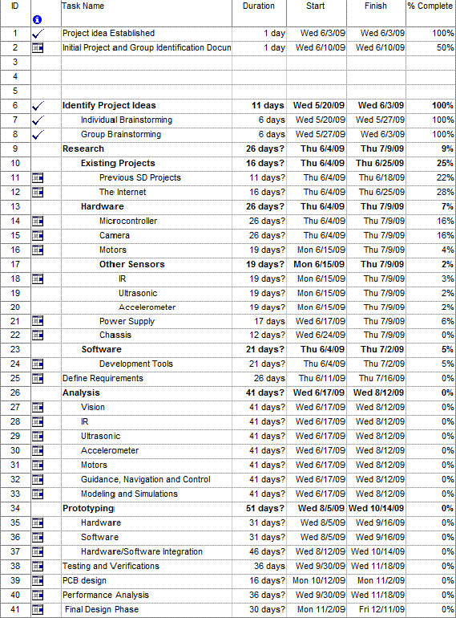
Figure 2.5.1 Initial Milestone Chart

The blueprint for our vehicle is laid out in Chapters 3, 4, and 5 of this Senior Design Documentation report. About a week after summer school ended we congregated and had a review of our final design documentation. It was necessary for us to read over each individual section in order to decide if any enhancements or additions could have been made to our design. Once the review phase was done we finished parts acquisition and began building our prototype. We designated that Diante was to handle tasks involving the CMUcam2+ vision sensor, Liem was responsible for tasks involving the Arduino microcontroller and Sean was responsible for the infrared sensors, ultrasonic sensors, accelerometers, and power supply. We then collaborated on putting each component together, testing, and programming the AVR.

After the class started back up, our team met again with our advisor in order to have our final design documentation reassessed. We did this early in the semester in order to allow time for any tweaks proposed by the advisor. This began our 2nd documentation draft on September 1st. We had all parts necessary for the assembly of the AVR by September 3rd. Then we began amassing the prototype of the AVR. We met to integrate each of our separate responsibilities into one, in order to achieve the goal of having a working prototype done by October 5th. From there we began testing the prototype to ensure that it met all requirements and goals set. After ensuring that the prototype had been thoroughly tested and was working properly we then began to work on the custom PCB through PCB123 software. After, the PCB layout was designed and submitted back to us we put together the final product. This was accomplished around November 21st. The final build was up and running early so that we could experiment with extra attachments such as solar power capabilities. Lastly, our final presentation took place December 4th 2009.

Research

Introduction
Research is a vital step in the decision making process when it comes to designing and building a device. The formulation of the AVR required extensive research in both hardware and software devices, some of which we were familiar with and others that were new to us. The AVR’s main purpose is to autonomously track and trail an object placed in front of it based on the image processing capabilities of the CMUcam2+. In addition, it will be able to avoid obstacles and determine between the specified color and other colors present. The basic top level overview of the AVR can be seen below in figure 3.1.1.

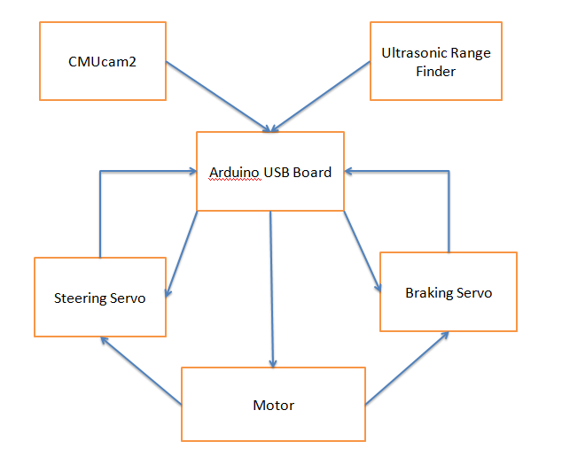
Figure 3.1.1 Top Level Overview

This chapter will start us out with section 3.2, which covers similar projects including those found through searching the internet and projects used in previous senior design classes. In order to build and perfect a system it is imperative that one must first understand how the initial system works. This leads us to section 3.3 which covers the hardware aspects of the AVR, where we will take an extensive look into microcontroller, vision sensor, motor, power supply, H-Bridge, accelerometer, and the use of ultrasonic and infrared sensors. For each component listed above we will thoroughly explain how and why we chose to use a certain model and then compare it to other competitors. Furthermore we will take a detailed look at how each individual component operates. Most of the integral parts of the AVR cannot function as stand-alone parts. They must have a central “brain” to convey which data must be manipulated and what can be thrown out. Because of this the microcontroller is one of the most important components in the design of a robotic device and ultimately becomes the most time-consuming aspect later on in the prototyping chapter. Section 3.3.1 will look into the microcontroller including the benefits of using a microcontroller over an FPGA and why we chose the Arduino USB Board. Section 3.3.2 will look over the differences in the three iterations of the CMUcam vision sensors and compare it to its competitors. Section 3.3.3 will mull over the motor being used for the AVR and how fast it will be able to travel. Section 3.3.4 deals with the power supply of the AVR and discusses the means to power such a vehicle. Some questions that will be addressed include: what voltage will the battery operate at? How much current is needed? Is an H-Bridge necessary? Also to be covered in 3.3.4 are voltage regulators and battery type (Ni-Cad or Ni-Mhd). In section 3.3.5 we take a look at the car used for the base of the AVR and what other options could have been used, such as building our own base from scratch. 3.3.6 through 3.3.9 covers the sensors used in the AVR and what purpose they serve. Section 3.3.10 will talk about the mobility of the AVR and how the H-Bridge was used to achieve optimum performance. Section 3.4 will detail the software used in controlling the AVR. Due to the fact that the AVR is completely autonomous it was critical that we were familiar with the language used because the control of it solely depends on how well we implement our code. If our code was incorrect then the different components would not have been able to interact and would have lead to a failure in the device which was not acceptable. Section 3.4.1 includes information which will provide an overview to the software used for the Arduino USB Board and its similarities to c-programming. In Section 3.4.2 the software used to create the PCB for the AVR will be thoroughly dissected. Finally, in Section 3.4.3 we will look into the software involved in programming the CMUcam2+ vision sensor and what languages it mimics.

Similar Projects

Previous Senior Design Projects
We chose not to invent a new technology in our idea and prototype design of the AVR, rather we chose to “re-inventing the wheel” by combining existing technologies. In the early stages of design for the AVR we used three fundamental steps to solidify our approach. The first step was to gather ideas through individual and group brainstorming; this is where we decided to design an autonomous follower. The second step was to research projects similar to our idea that have already been realized in order to decide which method would best suite our needs. Lastly, we combined the brainstorming with the existing projects to decide which method would prove best for the prototype AVR. Below I will chronicle previous senior design projects which helped to inspire our concept for the AVR.
The GPS Navigated Autonomous Convoy (GNAC) is a senior design project from spring of 2008 which also involves an autonomous follower car. The purpose of the GNAC was to create a convoy capable of operating completely autonomously in which the two vehicle convoy, using two remote control car bases and was able to navigate autonomously through a predetermined path. The Master car used GPS to plot the path where as the slave car used ultrasonic and infrared sensors to keep a certain distance and speed from the Master car. This project mimicked exactly what our initial design for the AVR entailed, we were going to use the Master/ Slave car concept the only difference was that our Master car was to be controlled by an IPhone. However, we saw that this project was fairly standard and wanted to accomplish a similar goal with a different method, hence the use of a vision sensor instead of a pre determined path from a GPS module. We were able to learn from this project how we could apply infrared and ultrasonic sensors to the AVR in order to keep the correct distance and speed from the object being tracked, in addition to how obstacle avoidance was to be implemented.
Another senior design project which we were able to learn from is the tailgate buddy which is from the spring 2009 semester. The tailgate buddy is a vehicle designed to be operated in either remote control mode or in autonomous mode where it follows its owner to the designated locations. Their vehicle was able to tow 100 to 150 pounds, contains a GPS logger, a 12 volt charger, and a 50 watt radio. They used a similar setup to the GNAC for their autonomous mode in which they used ultrasonic and IR sensors to communicate with a subject carrying a beacon device in order to calculate speed distance and avoid obstacles in their path. What we were able to learn from this project was how to possibly implement the weapons system on the AVR. The tailgate buddy used a mounted water gun to fire at obstacles in-between the vehicle and person, similar to our proposed missile system. They accomplished this feat by programming the microcontroller to activate the feature when the IR sensor was blocked, meaning an obstacle is in place. This method was to be used in the AVR because it was going to shoot a missile when an obstacle is placed in front of it for longer than 15 seconds.
Lastly, we were able to gain knowledge for the AVR by studying the Autonomous Mobile Robot (AMR) project from spring of 2009. The AMR most closely resembles the AVR because it uses a vision sensor for navigation and employs the use of infrared and ultrasonic sensors for obstacle avoidance. However, a disparity between our devices is that the AMR uses line following technology in which it follows a white line on the floor, where as the AVR can spot color in any direction and thus follow object to be tracked. By reading through this project we were able to look at possible vision sensors to be used on the AVR and we were able to decide that we didn’t want to design a line follower.

Other Projects
One of the most widely known remote control vehicles is the Mars Rover which was invented by the National Aeronautics and Space Administration (NASA) as seen in figure 3.2.1. The Rover is built to function like a living organism with and used to explore Mars’ surfaces including soil content and possibly traces of water in the hopes of finding life on the planet. The data and contents returned can also be used to support the advancement of human life here on Earth. The Mars Rover has many technological advances, such as remote shut off, the ability to communicate from Mars back to Earth - a distance of approximately 36 million miles, creating energy through solar power, and a three joint robotic arm. However, what interested us most about this project is the use of 9 cameras to function as the rover’s eyes, to aid in navigation as shown in figure 3.2.2. Specifically, the panoramic cameras are interesting because they relate to the AVR’s camera, albeit in a much more technologically advanced way, by using color to see the Martian landscape and then determines the direction of the Rover by being pointed at the sun to act as a heading sensor.

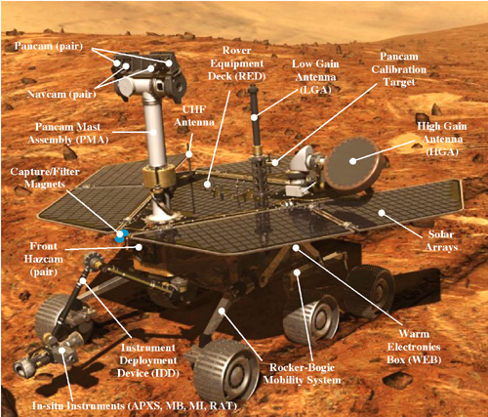
Figure 3.2.1 NASA Mar’s Rover
(Image Reprinted with Permission from NASA)

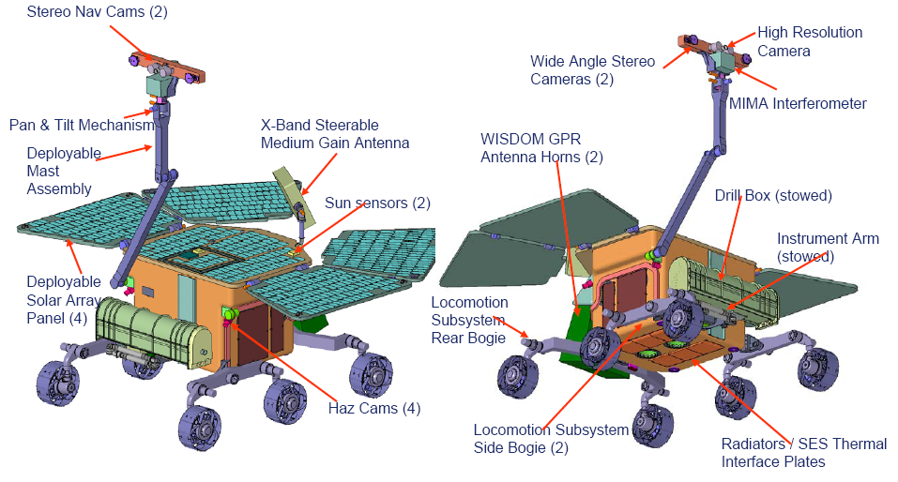

Figure 3.2.2 Cameras on Mars Rover
(Image Reprinted with Permission NASA)

Hardware

Microcontroller
Although there is a vast variety of microcontroller in the market that is suitable for our purpose of controlling the AVR, the ATmega family of microcontroller from Amtel stood out from the rest of the crowd. Reasons of selecting this particular type of microcontroller include its cost effective nature, vast amount of documentations available and ease of development.
With a group comprises of only electrical engineers, an easy development environment is very critical. There are many development tools for the ATmega microcontroller family available but one platform that stood out from the rest is the Arduino. Arduino is an open-source electronics prototyping platform based on flexible, easy-to-use hardware and software. Being an open-source platform, all documentations such as the reference design files are available to us. The Arduino board is straight forward enough that it can be built by hand or purchased preassembled. Our plan is to start the development on a purchased board and then later on design our own PCB with all the necessary component of the development board plus extra circuitry that are required for this vehicle using their provided design. Extra circuitry such as H-bridges to drive the motors will be integrated all together with the Arduino board in one compact PCB. Below is a picture of the Arduino USB board with a ruler for scaling purposes.
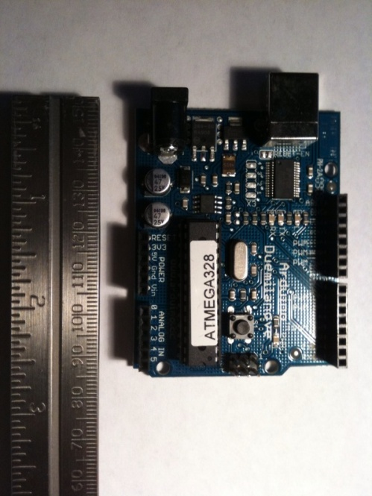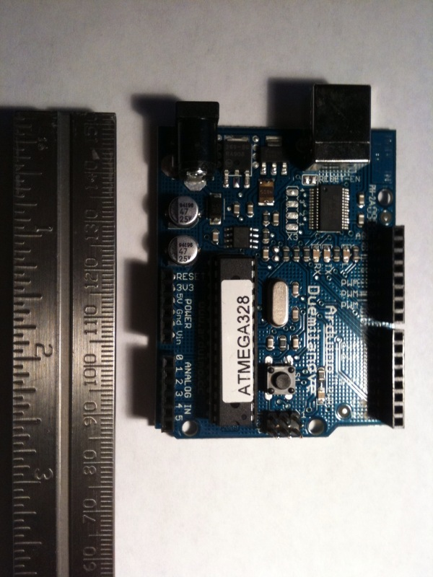
Figure 3.4.1 Arduino USB Board

The Arduino platform provides a simple programming environment with a good learning curve that can be picked up easily with minimal programming experience. Being an open source environment, there are a great number of examples and tutorial out there to speed up this learning process.
We chose the Arduino Duemilanove board that is the latest installment of the platform. One main advantage of this board is that it has a USB interface so most development work can be done on newer computers without having to go through a Serial interface. Another advantage of the Arduino platform is that the development software is cross platform. This will enable our group to development on both MAC and PC so the works done aren’t necessarily confined in the Senior Design lab. This will surely boost productivity.
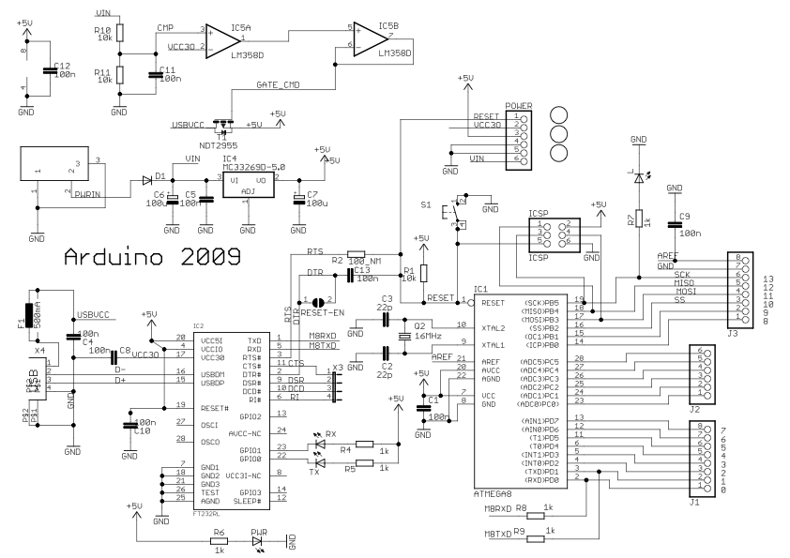
Figure 3.4.2 Arduino Digital Layout Schematic
(Reprinted from Arduino User Manual at http://arduino.cc/en/Main/ArduinoBoardDuemilanove)
As far as technical specifications, at the heart of the Arduino Duemilanove board is an ATmega328 microcontroller running at the clock speed of 16 MHz. The ATmega328 has 32KB of flash memory to store codes. This should be more than sufficient for our purpose. Of those 32KB, 2KB are reserved for the Arduino bootloader. As far as Inputs and Outputs, 14 digital I/O and 6 Analog inputs are available. Of those 14 digital I/O, 6 are used to provide PWM output. These PWM output are important since we will use those to drive the motors of the vehicle. The Analog inputs will be used to read sensors such as the IR and ultrasonic. Besides the digital and analog I/O mentioned above, there are also two serial ports to send and receive data. TTL serial data will be important since this is how we plan to communicate between the microcontroller and the CMUcam. The operating voltage for this board is 5V. Power can be either be supply from via USB plugged into a computer or by an external source such as battery. Recommended input voltage should be around 7-12V but not to exceed 20V. This is can be seen in figure 3.4.2 above.

Motors
During our research for the right kind of motor, we came across three types of motors: DC motor, RC servo and Stepper motor. In the following section we will discuss these three motors in pros and cons.

DC Motor
Comparing to the other types of motor, DC motor is the most powerful of them all due to a great amount of research and development for this particular technology. Good DC motors can have up to 90% efficiency but within the scope of this project, the DC motors we will be looking at probably operate around 40-60% efficiency. This is still pretty good for our purpose. A less efficient DC motor will just draw more currents from the power supply. DC motor comes from a wide variety of size. The ones we will be looking at should be spec around 2-8V. A slight disadvantage of DC motors is that it spins too fast for certain applications. An easy way to get around that is to use it with gear heads to slow down the revolution per minutes. DC motors can also be a little bit harder to mount wheels. A picture of the DC Motor is shown below in figure 3.4.3.
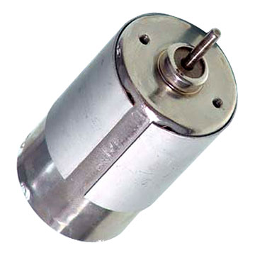
Figure 3.4.3 DC Motor
(Reprinted with permission from Sparkfun)

Hobby RC Servo
A more specialized version of the DC motor is the RC servo that is typically used in hobby vehicles as shown in figure 3.4.4. RC servo is nothing more than a DC motor with a gearbox already attached to it. RC servo usually comes with an on board controller to drive the DC motor inside of it. RC servo movement can be limited to 60-90 degrees. It is easy to mount wheels on RC servo since they are specially made to work with hobby vehicles.
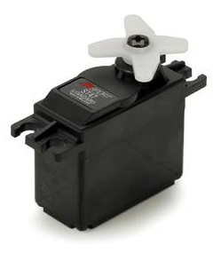
Figure 3.4.4 Hobby Servo
(Reprinted with permission from Sparkfun)

Stepper Motor
Stepper motors are very different from the two types of motor mentioned above. They also tend to be slower than your traditional DC motor but the trade off is that it is very precise when it comes to movement. Stepper motor would be good in applications such as controlling the turning wheels. Once positioned, stepper motors are great at staying in place until moved again. Stepper motors tend to be more bulky than DC servo since the design of it is very different. Shown below is a typical stepper motor.
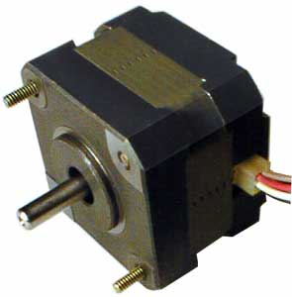
Figure 3.4.5 Stepper Motor
(Reprinted with permission from Sparkfun)

H-Bridge
The direction of currents used to drive DC motors dictates whether the motor will move clock wise or counter-clock wise. It is not possible to control a motor to go both Clock Wise and Counter Clock Wise using just one output. One way to get around that is to use a circuit called an H-Bridge. The shape of this circuit is implies by its name. H-bridges can either by build from a combination of discrete components such as transistors, resistors and capacitors or purchase in the form of an integrated circuit. Building an H-Bridge such as the one shown in figure 3.4.6 is fairly simple since the cost of integrated circuits is so low it makes more sense to purchase from a vendor. Another advantage of using integrated circuit H-Bridge is that they are capable of driving a lot more currents. Since most microprocessors only output a small amount of current. For the case of our Arduino board, digital output only have about 1mA output current. For most DC motors that is not sufficient to drive it. H-bridges can also serve as an amplifier to give us enough current to drive the DC motor in additional to control the polarity of currents. Since the motor we use is very powerful, it will drain a lot of currents so a high power H-bridge is necessary.
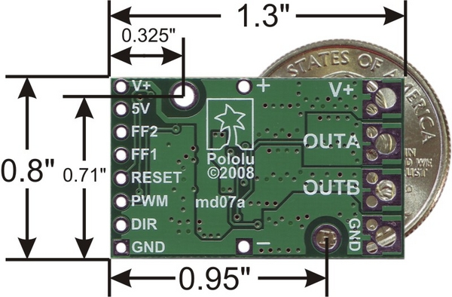
Figure 3.4.6 H-Bridge

The integrated circuit we plan to use is the High-Power Motor Driver 18v15 from Pololu. It is capable of driving up to 15A of continuous current and up to 170A of stall current. This H-bridge can be easily controlled using a digital signal and one PWM signal from the microcontroller. A high and low digital signal will set the direction of the motor to go CW or CCW. The speed of the motor will be controlled using PWM with duty cycle from 10%-100%. For our purpose a duty cycle of around 30% will be good enough since the motor we use is very powerful.

Power Supply

Abstract
The technology that is being employed in the autonomous visual rover could be used in both civilian and military settings. As a circumstance of the different ways to deploy an AVR, different power supplies are going to be needed. A good way to deploy an AVR in a civilian setting is to use it at an airport following around people with their luggage on board the rover. This would be beneficial to elderly or disabled people, and it could also benefit people with just too many bags to carry around them. A power supply for a situation like this would need to be very large and powerful so it could carry around heavy loads. The AVR technology could be applied to a full size vehicle; which in that case the power supply would be an internal combustion engine. In the case of the project we are creating we are simply going to prove that the technology used in the AVR is both reliable and practical. The power supply needs to be able to accommodate an array of parts that are going to be present on the AVR.
The entire vehicle runs off a 7.4v lithium ion battery rated at 2000 mAH which gives the vehicle a substantial run time between recharging. Lithium ion technology was the obvious choice because no other battery technology has a higher milliamp hour rating. When different parts on the AVR are operating they are going to cause voltage drops to occur; this could cause damage to a part or cause a part to act abnormally. To prevent these problem voltage regulators were used to sustain a constant voltage and eliminate any question on how much voltage a certain part is seeing. The 7805 voltage regulator was used on the car to power all of the onboard powered electronics. This class of voltage regulator can sustain a max current draw of 1amp. The max current draw is going to come from the H-bridge, which during normal operation will draw about 2amps of current. All parts on the rover will run at 5V. The Ardunio Duemilanove board is capable of supplying 40mA of current per I/O pin which is able to power most of the parts on the AVR. The power demands can be seen in the figure below.

 | Volts | Amps
Ultrasonic Sensor | 2.5-5 | 2mA
Motor | 2.5-5 | 30-60mA
Steering Servo | 3-6 | 5mA x1
CMU servos | 3-5 | 5mA x2
CMU Camera | 7-12 (recommended)  20 (max) | 200mA

Figure 3.4.7 Table listing the power needs present on the autonomous visual rover

Powering the CMU camera
The power that is going to be supplied to the CMU camera is going to run through a 5V voltage regulated supply so no voltage fluctuations will occur during operation possibly damaging components on the camera. The power going to the camera is needed to be able to supply at least 200mA of current to ensure that the part runs properly. The camera also comes with two servos that control the tilt and pitch of the camera so that it can track an object. They can either be run off of internal power or external power using an external servo power connector. The servos for the AVR are run using external power to ensure that they are getting an appropriate voltage. To prevent noise and possibly causing the servos to jitter a large valued capacitor was wired across the extra servo capacitor ports that are located on the CMU’s board. This will eliminate some of the ripple and make operation on the servos smoother.

Solar Power
Suppose that you need the rover to be able sustain a prolonged charge during a lengthy mission, one method to extend the battery life would be to use photovoltaic cells to recharge the battery. This would help to reduce cost because a smaller battery could be implemented so there would be no need to purchase a more bulky and expensive multi-cell battery. Two methods for using the solar cells were considered. The first method is to use a two battery system. One battery would be charged using a standard DC charging system that can be plugged into a wall socket or power supply. The other battery in the system would collect charge from the solar cells during operation and once the first battery went down; the AVR would automatically switch over to the secondary battery. This would substantially increase the run time of the AVR between recharging. The other method would be to use a single larger battery that would run exclusively off of solar energy. This would eliminate any need to purchase a DC charger and could reduce cost. A major drawback of this approach is during inclement weather when there is not enough sunlight hitting the photovoltaic cells to power the vehicle. The solar cells that would be implemented would be 6.7V polycrystalline solar cells that are capable of powering a 5V motor at full speed. When exposed to pure sunlight they will be capable of producing 20mA of current to recharge the battery. Acquiring space on the AVR’s chassis shouldn’t be a problem because the motion detection camera and sensing systems will be forward mounted leaving plenty of room on the back of the rover. Two cells with dimensions of 37mm x 33mm will be placed on the rear section of vehicle giving 2442 square millimeters of energy capturing space. During favorable weather conditions this will be enough o give a quick charge time for the battery.

Power Conversion
The autonomous visual rover has an array of parts that operate at the same voltage and different currents. For this reason, multiple regulators were used to prevent current overload in the regulator causing inconsistent voltage regulation. In this section different type of power regulation topologies will be researched and discussed and a solution to the rover’s power needs will be found. The figure below gives a brief explanation on what is going to be demanded of the vehicles power supply.
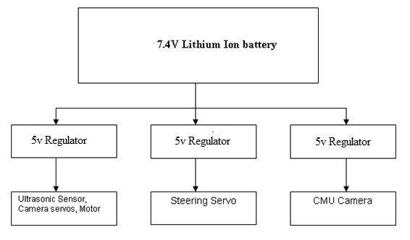
Figure 3.4.8 Power Conversion

Switching Regulators
For the purpose of the project switching regulators are going to be considered because they are capable of stepping up DC voltages, where its cousin the linear regulator is only capable of stepping down voltages. Another key advantage of switching regulators over linear regulators is its power efficiency. The increased efficiency is advantageous to battery powered system because it will prolong the batteries life. Additionally there is less heat dissipated with the increased efficiency so it can eliminate the need for implementing heat sinks on the board. Another key advantage of the switching regulator is its design flexibility. They are capable of producing multiple outputs that differ in magnitude and polarity that give the engineer more options to consider. For battery powered application such as the rover the quiescent current of the regulator becomes an important factor is prolonging the life of the battery. The quiescent current is the current the device uses when it is not in operation; a lot of regulators come with a shut down feature that allows the device to be turned off when not in use.

Flyback Regulator
The flyback topology is the most versatile topology of all the switching regulators. It allows the engineer to create one or more outputs given just a single input. It can create an output that is greater than or less than the input. The flyback topology gives the designer the ability to use it as a step up or step down converter. For this reason the flyback regulator is capable of powering multiple systems on the AVR. The figure below shows the basic operation of a flyback regulator. It is important to note that the polarity on the primary inductor is dot negative. When the switch is on there is only current going through the transformers primary windings. During this time the diode is not conducting current and the current going to the load is supplied by the discharging capacitor. When the switch is turned off the diode begins to conduct current and the current flows across the load and output capacitor. The capacitor during this time is able to replenish it’s charge that was lost during the switch on time.
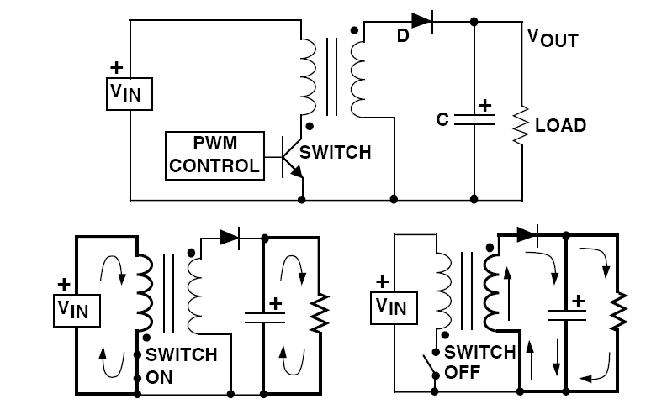
Figure 3.4.9 Flyback Regulator Circuit
(Permission Pending from Web-EE)

Chassis
The AVR as shown in figure 3.4.10 is essentially a robot on wheels so the type locomotion has already been narrowed down to either a vehicle on wheels or track. Since we are planning on using an existing RC car as our vehicle’s platform, it is easier to find a vehicle and four wheels as appose to a tank like platform with tracks. One attractive feature of a track platform is that it is easier to maneuver when in tight spaces. A track platform can very easily make sharp turns or perform a full motion 360 degrees turn without needing much space. To compensate for the less desirable turning angle, we will have to use better control algorithms working together with the sensors to tell the AVR to avoid such tight spaces.
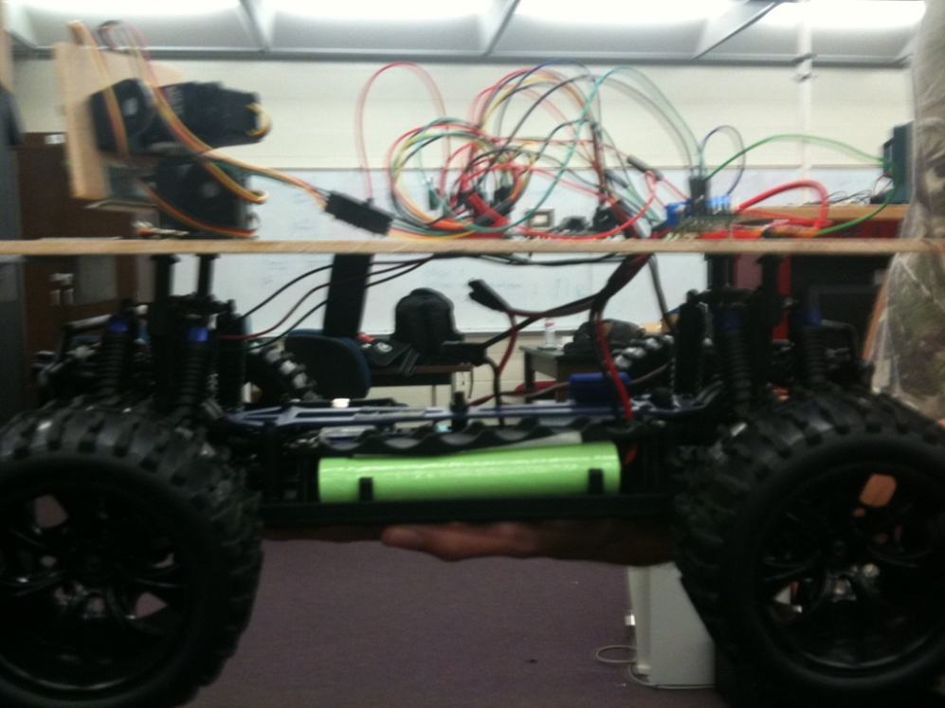
Figure 3.4.10 AVR Chasis

We chose the traditional two driven wheels on a single motor and two turning wheels as our vehicle’s platform. This type of platform can be easily found in most RC toys. Having one single motor for two driven wheel will reduce the amount of control we need to do and no performance will be sacrifice since a single motor is powerful enough to drive the AVR. The two turning wheels will also be controlled with a hobby servo. We decided that this minimal approach would save us a lot of time and resource to achieve a stable and usable platform for our vehicle.

Range Finders (IR / Ultrasonic Sensor)

Abstract
The selection of the Ultrasonic range finder needed to meet certain requirements that would fit the applications of our project. First of all, the sensor needed to be able to fit on the chassis along with the other components that would accompany it. Secondly, the power draw needed to be as low as possible to prolong the life of the lithium ion battery between recharging. Naturally the range finder needed to be easy to interface with our selected microcontroller to make prototyping and construction of the AVR go as smooth as possible. Of course, there are many other considerations when selecting an appropriate range finder, but these three considerations were of the most importance. The autonomous visual rover could be used in different settings and depending on the needs of the application different ultrasonic sensors could be used.

SRF08 Ultra sonic range finder
This sensor is a more advanced sensor that is capable listening to seventeen echoes with each ping. This allows the robot to determine the shape of the object or determining if an object such as a door is open. It communicates with the microcontroller using an IC2 bus which is a popular method of communication. There are a few disadvantages with this sensor. First is the size, the mounting of the sensor on the rover is going to be on the front bumper. The dimensions of the sensor to the dimensions of the width of the rover may be to close. There is concern that when the AVR turns the front wheel may run into the sensor causing damage to the part. Also is the price; though this range finder offers many features some are not necessary for the application of our project. The CMU camera is going to be in charge of the steering of the vehicle, the sensor is strictly going to be used to keep the rover within a predefined distance negating the need for additional features.

Ping Ultrasonic Range Finder
The ping sensor is a low cost sensor that provides an effective way to measure distance. It is connected with a three pin header that can be easily hooked up to a breadboard for testing. The output is a PWM signal that can be easily interpreted by the microcontroller to determine the object distance. The advantages of this sensor are its low cost and its east of interface with the microcontroller. Also the size of the sensor would be able to fit on the front of the vehicle without contacting the wheels. The main disadvantage it would present to the AVR is the way it is connected. This sensor would require wires to be run either close to the ground or around moving parts that could become tangled.

Maxbotics Ultrasonic Sensors
The Maxbotics Company offers multiple types of ultrasonic sensors. The main difference in these sensors is the width of the pulse that is emitted. The wider beam being more sensitive and the narrower beam being better suited for large object detection. The Maxbotics line of line of sensors also has multiple ways to interface the part with a microcontroller. They offer three different ways to communicate with the microcontroller; pulse width modulation (PWM), analog output, and a RS232 serial output. The pulse width modulation works by sending out a 40 KHz sound wave, when this signal is sent out the PWM pin is set to high; when the echo comes back the PWM pin goes back to low and the length of the pulse divided by two represents the distance to the object. The PWM output gives a pulse width of 147 microseconds/inch, which can be easily interpreted with a simple C program interfaced to the microcontroller. An even easier way to interpret object distance is the analog output. This output gives the object distance by the formula (Vcc/512)/inch. The size of the Maxbotics sensors are small compared to other sensor on the market (.785” x .870”); which is very important because the CMU camera and PCB board are going to take up a substantial amount of space on the chassis. In the picture below it is seen that the sensor is not much larger than a quarter. The Maxbotics EZ1 also has the lowest power draw of all the sensors we researched. With only 2ma of current draw it will help prolong the life of the battery between recharging. The sensor is going to have to compete with the power hungry CMU camera and servos which will take up most of the power draw. The picture below gives us the dimensions of the Maxbotics sensor being used.
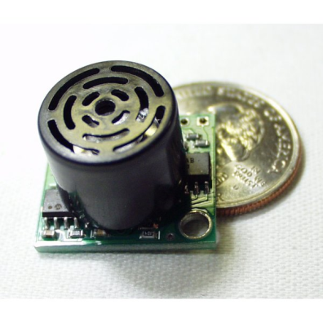
Figure 3.4.11 Ultrasonic Sensor
(Reprinted with permission from Maxbotics)

Beam Width Explanation
When considering an ultrasonic sensor you must decide what applications you are going to use it in. Are you going to need it to be very sensitive for situations like people detection and obstacle avoidance? Or sensors can be less sensitive for applications that call for detection of open doors or for use in high acoustic noise environments. Figure describes the different beam widths offered by Maxbotics to fit a broad range of applications. The purpose of the range finder is to keep the AVR within a certain distance of the target object; where the camera’s purpose is to control the turning of the vehicle. The EZ1 gave the AVR the best compromise of good sensitivity, without being overly sensitive and loosing the object in front of it. A wider beam generally is more sensitive, were the narrower beam is less sensitive. For the application of the AVR the sensor needed to be very sensitive so it could closely keep its distance from the object in front of it. The target following range was going to be between 3-5 feet. The Maxbotics EZ1 has a range of 0-254 inches, which is more than sufficient for our application.

Figure 3.4.12 Ultrasonic Sensor Comparison Table
(Reprinted with permission from Maxbotics)

Mounting the Sensor
For the purpose of testing the AVR, the rover needed to be able to follow around a target such as a human or another remote control car. The planned location of the ultrasonic sensor is going to be on the front bumper about five inches from the ground to avoid making contact with an object that could be lying down. The picture below shows where the sensor is going to be located on the front of the car and the approximate amount of space it is going to take up. The mounting is going to be done with brackets that will hold the sensor at all four corners ensuring a secure fit.

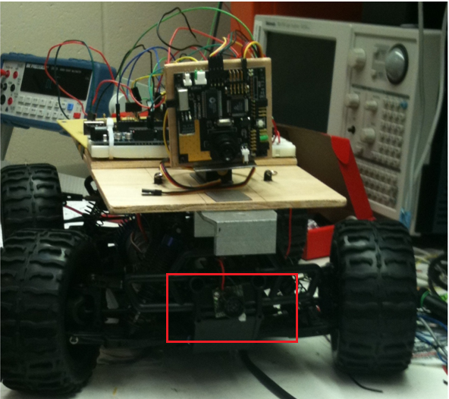
Figure 3.4.13 Location of sensor

Infrared vs. Ultrasonic
There are key advantages and disadvantaged to each type of range finding technology that will need to be compared in order to fit the applications needed for the AVR. Infrared sensors emit light that is emitted in a triangular pattern. When the light hits the object in front of it; it is reflected back and the angle at which it hits the sensor determines the distance of the sensor. The main advantage of infrared range finding is its cost. Most robotic infrared sensors only range from $10 to $20 which makes them very cost effective. There is also some key drawback to infrared technology. One is that light does night reflect the same way off of every object. The reading can vary from object of varying colors, shades, and shapes even though they are the same distance away. Probably the most important drawback of the infrared sensor is it can have interference from contact from direct sunlight. This would mean that the AVR would have to be used inside to avoid the sunlight which would negate a lot of applications that would we hope to achieve. Ultrasonic sensor use a high frequency sound pulse instead of light which makes them a better fit for use outside. Some disadvantages of ultrasonic sensing technology is that they are a little bit more pricey. A decent sensor would run about $30-$50. Also if they sensor was trying to range a sound absorbing material like a sponge or foam they sound pulse would not be reflected and no reading would be made. They are more advantages to ultrasonic technology than for infrared for the scope of the AVR. First is it accuracy, most midrange sensors have an rated accuracy within 2cm of the actual distance. This is more the sufficient to keep the rover within is programmed distance. Also light would not affect the sensor which would also the rover to be used in direct sunlight. Most ultrasonic sensors researched have more ways to interface with our microcontroller which more make them easier to use. Most come available with analog, pulse width modulation, and a RS232 serial output which makes them easy to interface with most any microcontroller.

PCB (Printed Circuit Board)
For compact footprint and a more professional appeal, we plan to combine most of our circuitry onto one single PCB. After the initial prototyping with the development board and breadboard, we will come up with a final design that can be printed out on a single circuit board. We plan to the surface mount soldering technique to put together our PCB. Although it might not be possible to surface mount all the components then through-hole soldering will have to come in play.
The process of printing out a custom circuit board is fairly easy to understand. A circuit design will be completed using a PCB design software and then send to a manufacturer to print out the PCB using their industrial grade equipments. The cost associated with printing a circuit board depends on the size of the circuit board and the number of layers. For our purpose, a 2 layer PCB is sufficient. 2 layers PCB tend to be fairly cheap compared to higher number of layers. Since most manufacturers encourage people to use their custom PCB software, the software to design such circuits tends to be free of cost.
As with all the other component of this vehicle, a great amount of research was put into this matter. We came across PCB design software called PCB123 from Sunstone Circuits. They provide an easy to use design software as shown below and the ordering can be done directly through the software so users can keep track of how much their PCB will cost as they design them.
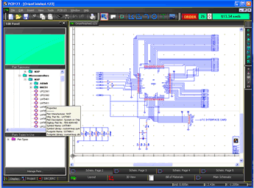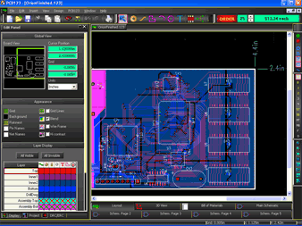
Figure 3.4.14 PCB123 Screenshots

The number one reason of choosing PCB123 is because we were offered a $100 credit at their store for our PCB needs. Through the “Sunstone Circuits – Partners in Education Sponsorship Program”, one of our group members were successfully secure a $100 sponsorship. We contacted Sunstone Circuit to introduce ourselves and inform them of our Senior Design project via email and they were interested in sponsoring us. In return we will mention their brand on our website and keep them in mind for our PCB needs in the future.

Software

Intro
There are a lot of different programs involved in this project. These software programs can be categorized as development and analysis tools that aid us in the designing process. Three major software programs involved in this project are the Arduino developing environment, the CMUcam2GUI and lastly the PCB123 design tool. For many engineering projects, software cost can take up a huge portion of the budget but lucky for us, all of our software programs are free of charge. The Arduino software is an open sourced developing environment that’s actively being updated by the same people who created the software. The CMUcam2GUI comes with the purchase of the camera and the PCB123 is free because they people who made that design wants to promote their PCB manufacturing business by giving the software away for free.

Arduino
The Arduino development tool is a cross platform tool (Windows, Mac, Linux) that is the glue between the Arduino software and hardware. Since the Arduino hardware is designed to be user friendly, the complementary software must also be easy to use. Most of the complicated hardware-software interfacing has already been done for us. The Arduino tool is basically a plug and play program that will work without much setup. Since our Arduino hardware comes with a USB interface, it is possible to program the hardware using newer computers.
Setting up the Arduino development tool is as easy as installing the driver for the USB interface and then install the Arduino development tool on to your computer. The process is the same for both Mac and Windows. After the software is installed, the user just have to pick the right USB port that their hardware is connected to and everything else is good to go.
Coding is Arduino is easy, most of the built in commands and function are pretty obvious to anyone with basic programming skill. The Arduino uses a language called “Wiring”. Wiring is very similar to C and that’s exactly what we’re looking for since we don’t have anyone in the group with an extensive knowledge of programming. Designed with novice users in mind, the software comes with a good library of built and functions that help interface each port on the Arduino board. For example, reading a value from one of the analog input port is as easy as calling a function named AnalogRead(). Outputting information through a port behaves the same. The function would then be AnalogWrite(). Outputting a PWM signal is as easy as calling a the DigitalWrite() function and give it a specific value as argument. Along with the built in software library, this software also comes with a lot of examples to help new users learn how to code. Figure 3.5.1 shows an example of the user interface for the coding used. The examples are really helpful to us since it can be quite difficult to start writing a program from scratch if you’re not a software person. We learned a great deal about coding for the Arduino just by reading the examples and testing out the codes.
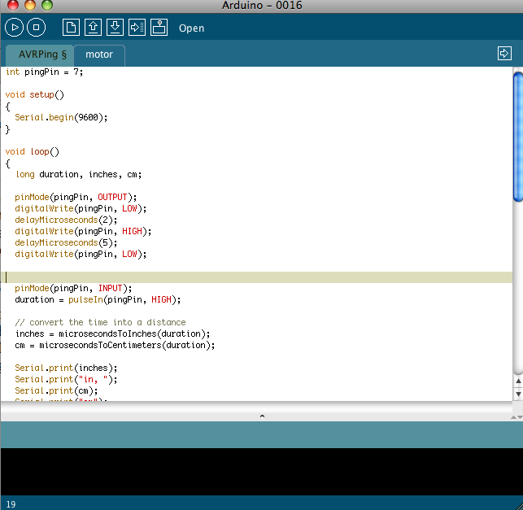
Figure 3.5.1 Arduino Development Software

The software is very easy to get familiar with. As seen from above, the interface is not clustered with a lot of buttons. Only the basics such as compile, stop, upload and debug are needed to successfully program the hardware. The tab features also help with the workflow by enabling the user to open up many codes at once and switch back and forward between codes with ease.
One great feature of the Arduino software is its ability to monitor the serial port. Using the built in “Serial” function, it is possible to monitor the codes in real time. For example, we can see the values of certain variable changes with time by printing out that value. This is a great way to monitor the motors position for testing and debugging. Not only this software is great for coding, it is also a very useful analysis tool to test hardware.

PCB123
PCB123 is a piece of software that enables the users to design printed circuit board from scratch. Towards the end of the 2nd semester once every members of the group have agreed to the final design, we will start designing the printed circuit board to replace the Arduino board and a few other circuits. The purpose is to integrate everything together so it will appear more professional and a smaller footprint. This software comes with an example that new users can learn from. A 3D view of one of the example PCB can be seen in the picture below.
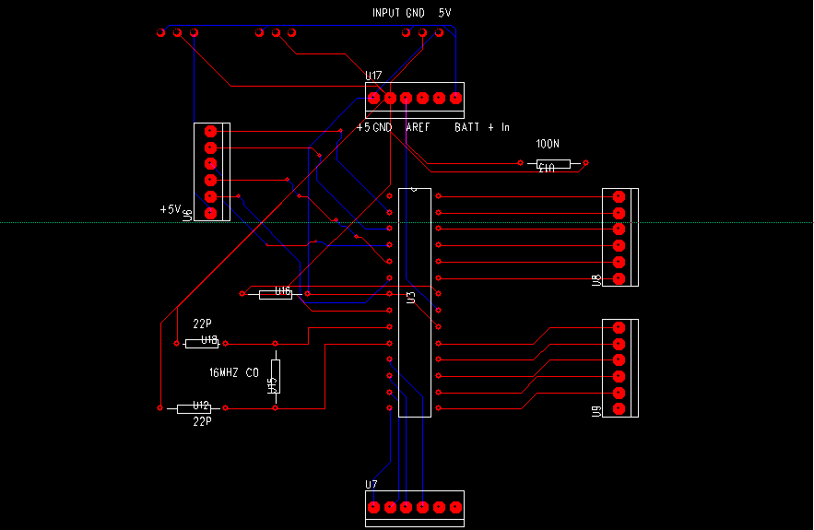
Figure 3.5.2 PCB123 Screenshot

This software comes with many tabs that will let the user visualize the whole process of designing their own printed circuit board. As seen from above the stabs include an overview layout of the whole circuit, 3D view, schematic views and lastly the bill of materials part that includes all the necessary parts to manufacture this PCB. Parts such are capacitors and resistors and transistors can be priced directly using this software upon placing it in the design. Different tabs serve different purpose. Initially, schematic layout of the all parts and wires will be place on the board first. After all the parts and wires have been connected in the schematic view, the real designing of the printed circuit board can begin. Using this software, we will be able to specify which size and shape the board should be in. We are not restricted to just a rectangle printed circuit board. The software also serve as a debugger that will help us correct issues and make sure everything is working correctly. Upon finishing the design, we can order the board directly from this software providing we are connected to the Internet. Ordering the printed circuit board directly from this software will minimize a lot of confusion between the user and the manufacturer since the same software is used. Since the cost of the board is updated continuously throughout the design, there will be no surprise on how much it will cost to make the PCB. This feature is also helpful if we are trying to be lean and minimize cost.

CMUcam Software
Although we will mostly use the serial port to interface with the camera, sometimes it’s hard to visualize what the camera is really seeing. All the data coming out of the camera are not readable by human therefore the good CMUcam people decided to make a GUI interface for the camera. This piece of software was coded in java and it is compatible with both Windows and Mac. The installing process is the same as the Arduino software. A USB driver is needed before the computer can communicate with the CMUcam2+.
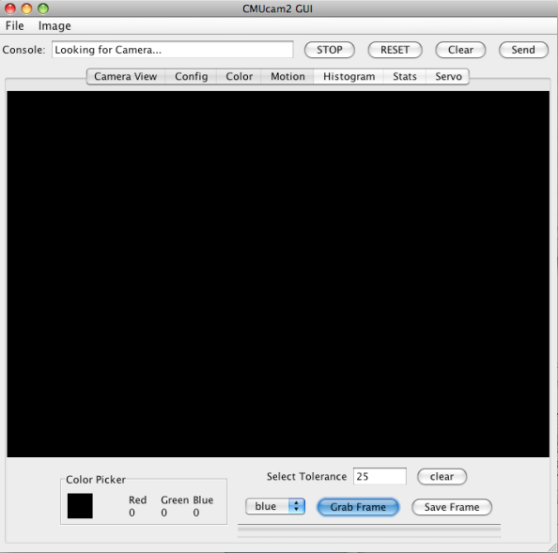
Figure 3.5.3 CMUcamGUI Screenshot
For analysis and design purpose, it helped to see what the camera is actually seeing. This tool came in handy for situations like that. Whatever you can do using serial interface with the camera you can do here with the GUI. Instead of sending in commands for the camera to read certain colors and track objects, in the GUI everything can be accomplished within a few clicks of buttons. Developing an algorithm for the vehicle makes a lot more sense when you can actually see from the point of the view of the camera. The GUI from figure 3.5.3 allows you to see the actual region that the camera is seeing and where the centroid of the tracked object is. You can also easily change which color to track right on the GUI. It is also possible to save frames for further analysis.

Part Comparisons and Simulations
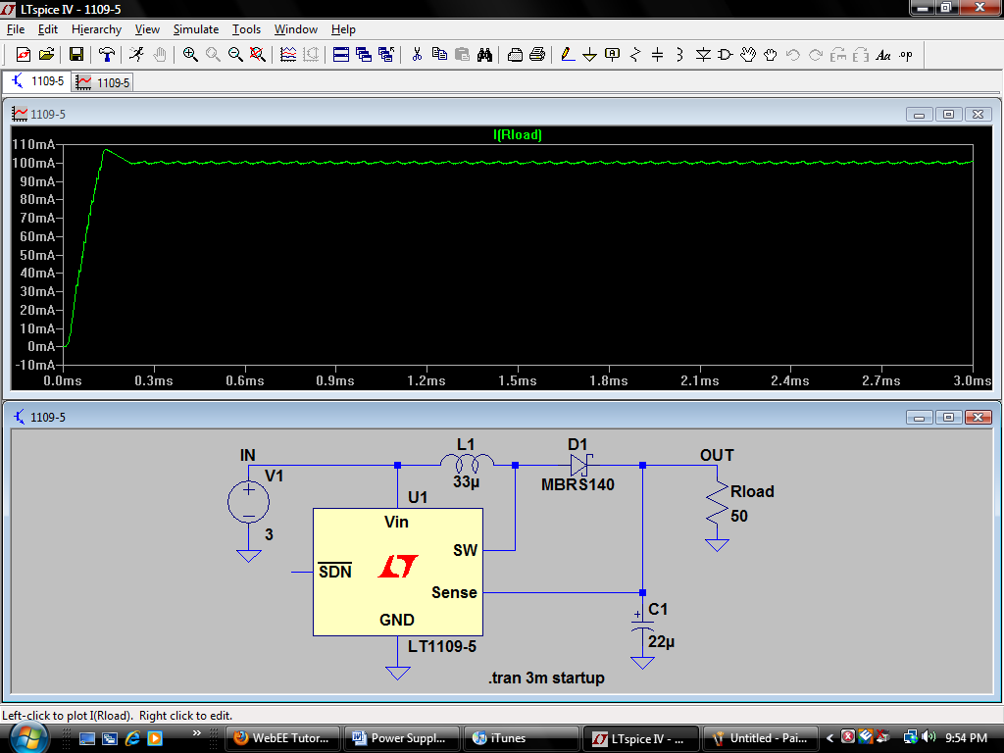
The linear technology company offers a free program called Ltspice that allows you run computer simulations on IC’s they offer. This will enable the designer to prototype a considered regulators before purchasing. Different external components can be changed to help the engineer meet his design requirements. Also linear technology offers free samples of their regulators to costumers because they want their customers to buy hundreds of IC’s at a time. Below is a computer simulation of the LT1109 voltage regulator. The Lt1109 is being considered because it cheap and easy to use IC they will meet the requirements demanded of it. This chip can deliver a regulated 5V at 100mA will be able to run multiple parts that are on the AVR. Also very little external components are required to make the chip function properly.

Figure 3.5.4 Simulation of LT1109 voltage regulator

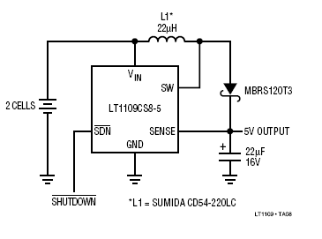
Figure 3.5.5 LT1109 voltage regulator circuit
(Permission Pending from Linear Technology)
Another regulator that gathered much attention is the PTN0405C voltage regulator produced by Texas instruments. It is capable of haveing an input of from 2.6V to 5.5V and can deliver up to 12W of power. The output voltage can be adjusted anywhere from 5V to 15V using a single external resistor. This is an extremely flexible product that would be able to power anything that is going to be used on the rover. A typical application of this IC is shown below. There are input and output capacitors and they should be carefully selected to reduce input ripple. The capacitors are also in place to reduce electrical noise that can in brought into the system.
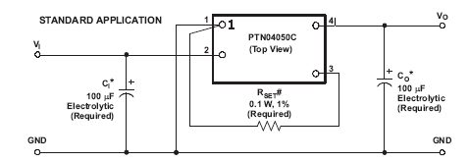
Figure 3.5.6 Voltage Regulator Circuit
(Permission Pending from Texas Instruments)

The final type of regulator that will be discussed is the LM7805 voltage regulator. It is a voltage regulator that outputs a constant voltage of 5 volts. A similar regulator the LM7807 is another regulator that output a voltage of seven volts that would be ideal to power the CMU camera. It is capable of outputting a current 1.5A if sufficient heat sinking is installed which is more than enough to power anything on the rover. It also comes available with short circuit protection and thermal overload protection. It is a step down regulator that can handle an input anywhere from five volts to eighteen volts. It is a simple three pin design. Pin one is the input, pin two is the regulated output, and pin three goes to ground. The block diagram below shows the LM7805 basic operation.
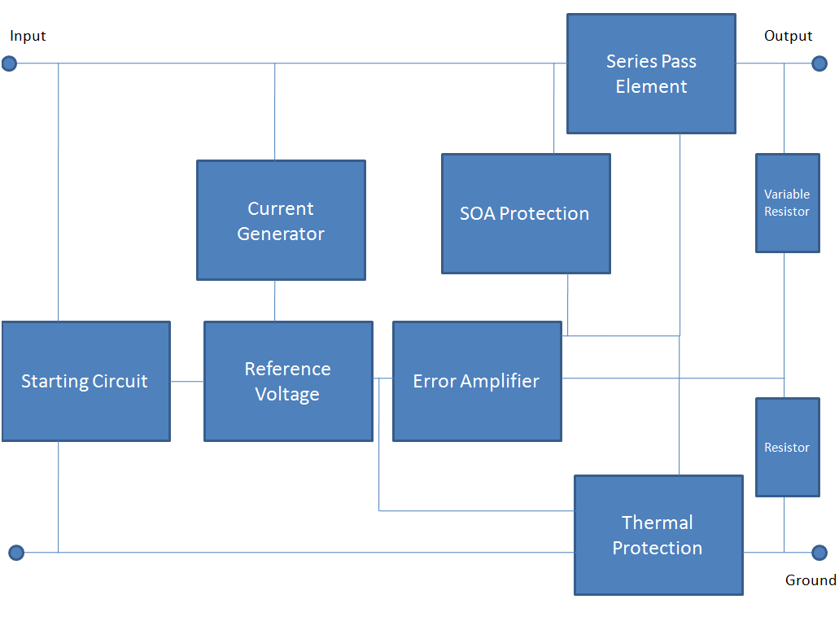
Figure 3.5.7 LM7805 Operational Block Diagram

Battery Comparisons
The AVR demanded a lot from it battery pack. When considering a type of battery we will have to make sure it will be able to keep up with the applications needed on the rover. Different battery technologies are going to be exhaustively researched and an appropriate battery solution will be found. The battery requirements include:
- Needs to be rechargeable
- Have a high mAH rating
- Be able to meet the space requirements
- Ability to interface with parts
- Quick Recharge / Slow discharge rate
- Cost effectiveness
- No “memory effect”

3.6.1.1 Nickel Cadmium
The nickel cadmium battery is a type of rechargeable battery that uses nickel oxide hydroxide and metallic cadmium as electrodes. The nickel cadmium cells usually come available with output voltages around 1.3V and are usually found in small electronics. If a higher voltage is demanded multiple batteries would have to be connected in series. There are advantages to using this type of battery technology. First of all the nickel cadmium battery is very immune to a deep discharge. Unlike other batteries such lithium ion which could become damaged if the battery is drained below a certain voltage; the nickel cadmium can be fully recharged even if it is completely drained. Also these types of batteries can survive more charge/recharge cycles. Nickel Cadmium cells are the ones you would find in a store in the AA or AAA form and are readily available. The drawback of the nickel cadmium battery is the capacity of the battery and they also suffer from the memory affect. The memory affect is when a battery is charged and discharged several times to the same level and when it is in use there would be a sudden drop of the voltage of the battery.

3.6.1.2 Nickel Metal Hydride
This type of battery technology is similar to the nickel cadmium type, but it has some key advantages. The most apparent advantage is it energy density. NiMH batteries can two to three time the charge of their cousin the nickel cadmium battery. This is of major priority to the rover because having to recharge the batteries all the time would cut down of testing and run time. NiMH also has the ability to be recharged several times with the side effect of the memory effect. They come readily available in AA and AAA form which would be able to fit underneath the chassis of the rover. They do come available in a “pack” form and they usually run around 9.6V and can go up to 1000mAH rating.

3.6.1.3 Lithium Ion
The lithium ion battery is the newest type of battery and becoming the most effective way to power robotic applications. The most key advantage that this type of battery technology would provide the rover is its energy density. Most li-ion pack are very compact, but can deliver and very high mAH rating. This is going to be paramount feature when the power hungry AVR is running with its array of electronic parts. They usually come available from 3.6V to 7.4V packages and can range from 200mAH to over 3000mAH. The highest mAH rated battery will be chosen for the AVR that will meet the size and budget requirements. Another advantage of using this type of battery is that they have a low self discharge rate compared to other types of batteries. NiMH and NiCD will lose up to 1.5% of their charge per; unlike li-ion batteries which can maintain their charge for months at a time. There are some drawbacks to this type of technology. First is the cost; because they are so complicated to manufacture the price of a li-ion battery is driven up. Also lithium ion batteries they are more difficult to recharge because there cells are sensitive to overcharging. For these reason a special charger would be needed to that would regulate the batteries charge. This would prevent damage to the battery and increase the life. These comparisons can be seen in the table below.

Battery Type | Price | Available Platform | Charging | Battery Capacity
Nickel Cadmium | Cheapest of the Three | AA, AAA, C, D configurations are available | 100mA to1A depending on the price | 100mAH-1500mah in AA or AAA form
Nickel Metal Hydride | More expensive, about $2.00/ea for AA | AA, AAA, C, D configurations are available | 100mA to1A depending on the price | 100mAH-2500mAH in AA or AAA form
Lithium Ion | Most expensive of the three | AA, AAA, also available in ‘pack’ form | Need special charger to prevent damage to cells | 100mAH-3200mAH in AA  500maH-8000mAH in pack form
Figure 3.6.1 Battery Comparison Table

3.6.1.4 Electrical Noise Due to Power Electronics
A major problem facing many robots is electrical noise produced by the power electronics. The AVR’s main motor that will be driving the wheels will only be a couple of inches away from the microcontroller. This can cause interference and affect the way the microcontroller behaves. A common solution to this problem is the use of a snubbing capacitor. A small capacitor usually around 1 microfarad would be connected across the leads of the motor. The basic principle behind this idea is to eliminate high frequency noise produced by the motor. Another solution being considered is the use of a sheet of metal acting as a barrier between the microcontroller and the motor. This would eliminate any RF signals passing through possibly causing malfunction in the rover.

3.6.1.5 Charging the Lithium Ion Battery
Lithium battery technology needs to be charged in a special way in order to prevent damage to the battery and increase the battery life. Most manufactures provide guidelines on how to properly charge the pack. Unlike other types of batteries, lithium ion batteries do not suffer from the ‘memory effect’ so the charge is the same from the 1st charge to the 500th charge. When charging this type of battery over charging becomes a concern and could even become dangerous if not done properly. If overcharged the lithium ion metallic material could build up on the anode which would cause the battery to become unstable. The pack could vent itself, often ending up with a small flame. For this reason, most commercial lithium ion chargers come with protection circuits that will cease the charging if it senses that it has become unsafe.
When selecting a charger for the AVR there is a wide variety of topologies to choose from. A battery charger like the one shown below comes with many unique features. It is capable of connecting to its supply current either through a wall power supply or a USB connection. The charger shown in figure 3.6.2 is capable of charging at 280mA which would mean that it would need several hours to fully recharge the battery that is being planned to be implemented on the AVR. A clever feature about this charger is that the battery will be able to remain connected to its load during charging so the battery will never have to be removed. This will enable that charger to be built into the chassis of the rover.
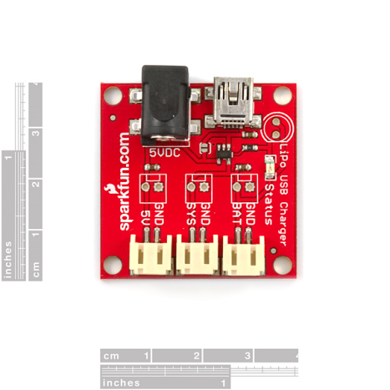
Figure 3.6.2 Lithium Ion Charger
(Reprinted with permission from Sparkfun)

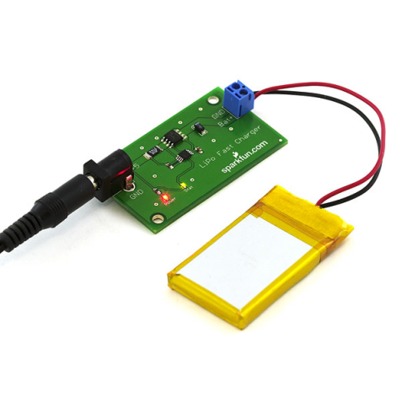
The charger shown below contains many convenient features that would benefit the AVR, but its low charging current brings up major concern. A charger like the one shown below is able to charge at a max current 1A which would charge our battery in about two hours. It uses a basic wall-wart power supply that runs at 5V/1A and uses basic JST connections.
Figure 3.6.3 Lithium Ion Charger 2
(Reprinted with permission from Sparkfun)

Vision Sensor

Introduction
As the scope of modern technology expands and the demands of everyday tasks become more stringent, it is important that the designs of robots are flexible in order to meet and exceed our demands. This means that robots must be versatile, user friendly, and efficient; with that in mind the AVR was able to meet all of the previously stated expectations. Our basic design for the AVR is a simple yet proficient mobile robot which uses image processing to see and track objects.

This section will thoroughly detail the research process used to choose the CMUcam2+ vision sensor as the eyes of the AVR. We will discuss the many different ways to use image processing for a robot including using a digital camera and Field Programmable Gate Arrays. In addition, we will explore other options of cameras that were considered for use on the AVR. Due to the fact that our group is fairly new to designing a robot and implementing image processing our goals are basic but must be met without error. The main function of the CMUcam2+ vision sensor is to accurately recognize an object based upon its color and work in conjunction with the microprocessor, motors, and servos in order to track our designated object. Once the system was confirmed to be working, we then fine tuned the image quality and accuracy of the color so that it was able to be used in many different environments and types of lighting.

Image Processing is a very intricate, complex system which takes a lot of time and is difficult to successfully implement with little to no experience in the field. A common problem with image processing is that it requires complex calculations and thus requires high performance from a microprocessor to shorten the time taken to process each image captured. The obvious solution to this problem is to use an advanced processor to calculate the algorithms; however this can prove to be too expensive. Therefore, alternative methods need to be taken to meet our budget constraints. We will take a look at the possible alternative methods in the following section.

Image Processing
Computer image processing is a very complex process that requires great knowledge and skill to be efficiently accomplished without the aid of software such as RoboRealm or CMUcamGUI. For the scope of our project it was determined that developing our own algorithms to handle our color tracking and motion detection was not a possible option do to the group having very little experience in this field. However, it is important to understand how this process was implemented in software so that we know how the camera performs its tasks. So in this section I will discuss how image processing works and some different techniques used to perform it.

Edge Detection
Edge detection is a method used to locate a given object or target. It works based on the principle that in images edges are areas where a jump in intensity from one pixel to the next occurs. Its advantage over other forms of detection is that it is able to reduce the amount of data processed by filtering out useless information but still keeps important structural properties of the image intact. One of the optimal methods to achieve edge detection is through Canny detection. Canny detection receives input as a gray scale image and outputs an image showing the positions of tracked intensity discontinuities. The Canny operator employs three steps to process an image. First, the image is smoothed to eliminate noise and by using Gaussian convolution. Next the operator applies a two dimensional first derivative operator to the newly smoothed image to find the image gradient in order to highlight regions of the image with high first spatial derivatives. Then the algorithm tracks along the top of these regions and suppresses any pixel that is not at the maximum by settings every pixel that is not actually on the ridge top to zero so as to give a thin line in the output. After that hysteresis is applied to further reduce the gradient array by tracking left over pixels that were not suppressed earlier. Hysteresis works by setting two thresholds, T₁ and T₂. If the T₂ < T₁ the pixel is set to zero, making it a non edge. If the magnitude is above the high threshold (T₂ > T₁), the pixel is made an edge. If the magnitude is between the 2 thresholds (T₂> x > T₁), then the pixel is set to zero unless there is a path to a pixel with a gradient above T₂ [12]. This use of hysteresis is to ensure that noisy edges are not broken up into multiple edge fragments. There are three parameters used to determine how the Canny operator will affect the image being processed. The first determining factor is the width Gaussian kernel used in during the smoothing phase. The second and third parameters are the upper and lower thresholds used by the tracker also known as T₁ and T₂. Generally, when the width of the Gaussian kernel is increased the detectors sensitivity to noise is reduced which causes a loss in some of the fine detail in the processed image. Also, localization error is in detected images increases as Gaussian width increases. The localization error in the detected edges also increases slightly as the Gaussian width is increased. For design purposes, the upper tracking threshold is usually set high and the lower threshold low in order to obtain good results. Setting the lower threshold too high will cause noisy edges to break up. Setting the upper threshold too low increases the number of spurious and undesirable edge fragments appearing in the output.

Blob Detection
A technique used by the developers of the CMUcam2+ is blob detection. Using the CMUcam2+ we were able to track user defined blobs at up to 50 frames per second. Blob detection is an algorithm used to determine if a group of connecting pixels are related to each other by detecting points and regions in the image that are either brighter or darker than the surrounding. This technique is very efficient when trying to identify separate objects in a scene or count the number of objects in a scene. To perform blob detection using a vision sensor such as the CMUcam2+ we first needed to grab an image. After that a threshold was set to only show the object in the image that we intended to be tracked. Then we determined the middle mass of the object which is where the average location of all pixels of the selected color occurs. If there is only one blob being tracked in the scene, the middle mass will always be located in the center of the designated object. However, if there are multiple blobs being tracked then each blob is looked upon as a separate entity. This is a simple solution because each blob will then be given a unique number and therefore the middle mass can be set for each individual blob in the image.

CMOS vs. CCD Image Sensor
When researching possible cameras it was important to know whether or not it is a charge coupled device (CCD) or complimentary metal-oxide semiconductor (CMOS) in order to understand how the camera will function. They both perform the same task of converting light into electrons but they go about it in different ways. CCD devices work by transporting charge across the chip and is then read at one corner of the array. Since CCD is an analog device an analog-to-digital converter is then needed to turn each pixel's value into a digital value. CMOS technology uses several transistors at each pixel to amplify and move the charge using wires; this allows each pixel to be read individually which makes the CMOS approach more flexible than CCD. Generally, CCDs are able to create higher-quality images than CMOS cameras because it is manufactured using a special distortion less process. On the contrary CMOS devices are developed using very traditional processes that are susceptible to the introduction of noise. Due to the fact that each pixel on a CMOS sensor has several transistors located next to it, the light sensitivity of a CMOS chip tends to be lower than CCDs. This is caused by photons hitting the transistors on the chip instead of the photodiode. On the other hand, CMOS sensors consume much less power than CCD devices which make them more suitable for a battery driven device such as the AVR. In some cases CCDs consume as much as 100 times more power than an equivalent CMOS sensor. Additionally, CMOS sensors are much cheaper in price than CCDs because it doesn’t involve a detailed specialized manufacturing process. The main drawback to using a CMOS sensor is that its resolution and light sensitivity tend to be much lower than CCD devices. Nevertheless for the scope of the AVR a CMOS vision sensor is the optimal choice because of its low power consumption and affordable price coupled with suitable resolution and image quality for the project.

CMUcam2+ Technical Specs
By researching numerous vision sensors and possible configurations, we determined that developing an original image processing system which is more efficient than those already available was beyond the scope of this project. That being said, we chose to use the CMUcam2+, shown in figure 3.8.1, which was created by The Robotics Institute at Carnegie Mellon University. The CMUcam2+ is a low-cost, low-power vision sensor for mobile robots that can perform many different kinds of on-board, real-time vision processing. It was devised using a SX52 microcontroller which is interfaced with an OV6620 Omnivision CMOS camera, all of which communicates via RS-232 or TTL Serial port. It has the following capabilities:
- Track user defined color blobs at up to 50 Frames Per Second (frame rate depends on resolution and window size settings)
- Track motion using frame differencing at 26 Frames Per Second
- Find the centroid of any tracking data
- Gather mean color and variance data
- Gather a 28 bin histogram of each color channel
- Process Horizontally Edge Filtered Images
- Transfer a real-time binary bitmap of the tracked pixels in an image
- Arbitrary image windowing
- Image Down Sampling
- Adjust the camera's image properties
- Dump a raw image (single or multiple channels)
- Up to 160 x 255 Resolution
- Supports baudrates of: 115,200 57,600 38,400 19,200 9,600 4,800 2,400 1,200
- Control 5 servo outputs
- Slave parallel image processing mode off of a single camera bus
- Automatically use servos to do two axis color tracking
- B/W Analog video output (PAL or NTSC, depending on camera module used)
- Flexible output packet customization
- Power Down Mode
- Multiple pass image processing on a buffered image
- Automatically use servos to do two axis color tracking. Servo 0 is for pan. Servo 1 is for tilt

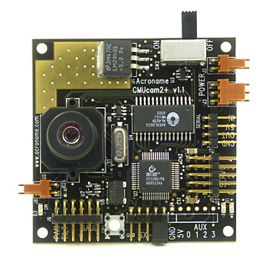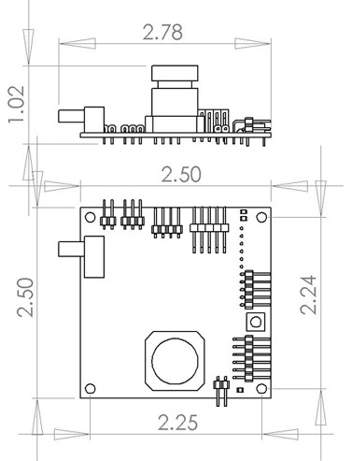
Figure 3.8.1 CMUcam2+
(Reprinted with permission from Acroname Robotics)

The primary function of the CMUcam2+ is to track and monitor highly contrasted regions, hence color tracking. The most common setup of the CMUcam2+ is shown in the diagram below:
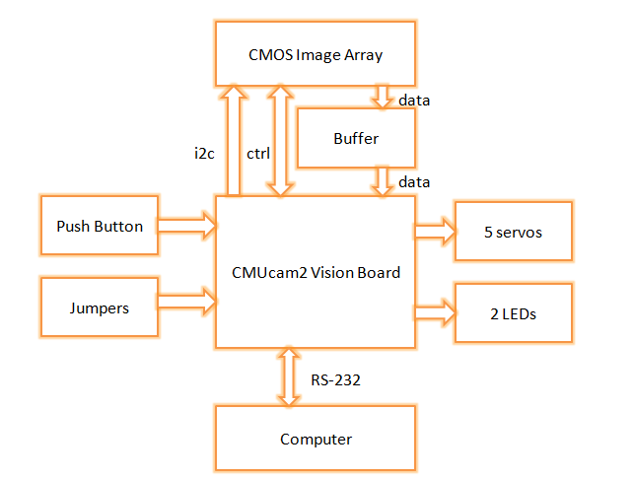
Figure 3.8.2 CMUcam2+ layout diagram

We were able to connect the CMUcam2+ through the TTL and RS232 serial port, where RS232 was the most common setup used. The inclusion of support for various baud rates allowed for the vision sensor to work with a wide range of processors both fast and slow. The CMUcam2+ is capable of performing in multiple modes including line mode, poll mode, demo mode and delay mode with each serving a special purpose. Line mode is used to retrieve low resolution binary images of colorful objects. This lends it to being helpful in performing sophisticated line following that includes branch detection and simple shape recognition. Poll mode is used for slow processors and allows the host processor to request just a single packet of data from the CMUcam2+, given slower processors the ability to effectively synchronize the data. Delay mode adds a as delay between individual serial data characters and lowers the total frame rate that can be processed.
The CMUcam2+ is able to convert an image in a series of pixels by gathering different colors of light through manufactured grids of boxes on its chip. These boxes are stimulated by the passing light and create different voltages that are proportional to the amount of light present. There is a red channel, blue channel, and two green channels in the CMUcam2+ as well as a range from 16 to 240 value of voltage for each channel. There is an extra green channel because the human eye is most sensitive to green and it also helps fill in the grid to be evenly spaced across the sensor. The sensor contains 356 columns and 292 rows of light sensitive cells arranged as a grid, using the RGB format. The camera module then takes data from 2 sensor rows at a time to generate each line output from the camera module. From there the CMUcam2+ then takes the data and outputs it as a shortened pixel data.
Now that the image has been broken into pixels it is possible to track color. This is done by specifying a minimum and maximum allowable value for the RGB channels, in order to specify a specific color. In the CMUcam2+ the maximum value is 240 and the minimum value is 16 for each channel. This can prove to be tricky because every color is represented by a unique mixture of values in the RGB channels and outside light must be accommodated for in the values picked to keep from obtaining unwanted results. Therefore, when selecting a range six values are chosen (min and max for each channel) creating a three dimensional box around the color of the object being tracked. The CMUcam2+ then bounds and processes the image inside the box. It is processed using a one pass algorithm that processes each new image frame from the camera independently. The algorithm uses a modified version of the Canny edge detection explained above in the image processing section. Basically, it examines every pixel row by row and based upon the range of colors specified by the user it marks a pixel as being tracked if inside the values. It then examines the pixels location as top most, bottom most, left most or right most. If a pixel is determined to be outside the box then the algorithm adjusts bounding box to contain it. It is possible for the bounds of the box to fluctuate from frame to frame because of the previously state fact. At the end of the image the horizontal and vertical sum of the tracked pixels are divided by the total number of tracked pixels to give a value of approximately where the center of the image lies. However, as in blob tracking it is more reliable to take the centroid (middle mass) of the object rather than using the bounding box. The confidence of the box is then calculated after each pixel has been checked using the total number of tracked pixels and the area of the bounding box. Noise filtering is used in the color tracking process to allow larger tracking ranges so that larger variations of pixel values can be used without causing unwanted colors to be tracked. This is done by using a counter to keep track of how many sequential pixels are in the current row before the current pixel was within the tracked color bounds. This value is then compared to the noise filter value and marked as a tracked pixel if above the filter value.
Another way the CMUcam2+ processes an image is through frame differencing. This basically identifies changes in a series of given images at different points in time. Coupled with known times and similar viewpoints it is possible to isolate objects that have moved through comparison. This function effectively allows the CMUcam2+ to perform motion detection. Internally, the CMUcam2+ references an 8x8 byte array in which each element of the array stores the average of a corresponding region on the main camera image. By default the green channel is used because it is more easily seen by the human eye but this can be changed based upon the situation. The input image is then broken down into an array of 8x8 byte blocks where changed is spotted by subtracting each block from the corresponding reference image block. If there is more data than the specified threshold then a change is flagged to have occurred.
The final way the CMUcam2+ identifies color is through histograms. Histograms are used to show the frequency and distribution of color values found in a given image. Every bar represents a color range for a specific channel: red, green or blue. The vision sensor can then divide the range of 16 to 240 up to 28 times and save it in different bins. The individual bins contain the number of pixels found in the image within the color bounds, with a separate histogram being produced for each channel of color, RGB. These histograms are then used to abstract the contents contained in the image. This aids in basic objective recognition, color balancing and distinguishing between various textures. When combined with pixel differencing histograms are able to provide useful information about the strength of visible edges to the camera. The digital schematic shown below is what makes each of these processes possible is shown below.
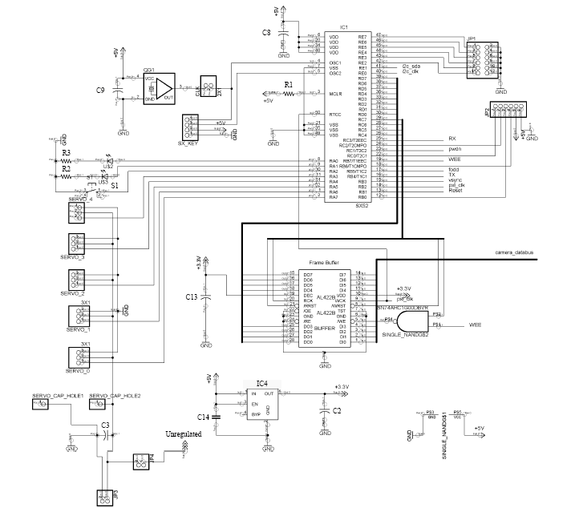
Figure 3.8.3 CMUcam2+ Digital Logic Configuration
(Reprinted with permission from CMUcam2 User Manual)

CMUcam1 vs. CMUcam2+ vs. CMUcam3
For the scope of this project we decided against using a normal web cam and writing algorithms to handle the image processing required because of our lack of experience in this field, as well as the complexity in nature of performing such a task. Therefore, we came to the conclusion that we needed to find a more beginner friendly method where the image processing is actually handled by the camera itself. In our search for this device we came across several options however we felt that the CMUcam, developed by students at Carnegie Mellon University, was the optimum choice for the AVR. Our decision was based off of its low cost, low-power usage, flexibility, and small form factor. In addition, the CMUcam is user-friendly in the sense that it contains software with a graphical user interface, rather having to work through DOS commands. Furthermore there is an abundance of information on well known flaws and solutions to common problems, as well as tips for optimal performance. Our next decision involved which iteration of the CMUcam to use first, second or third. When making this decision a few factors we took into account were price, size, flexibility, availability and whether it’s able to satisfy the demands of the AVR.
The CMUcam1 is the first of the three generations of the vision sensor and is at its core the most basic version. It operates at a paltry 17 frames per second and like the other iterations is able to track the position and size of a colorful or bright object. Some of its other features include:
- The ability to measure the RGB or YUV statistics of an image region
- automatically acquire and track the first object it sees
- physically track using a directly connected servo
- dump a complete image over the serial port
- dump a bitmap showing the shape of the tracked object.
The CMUcam1 uses an Ubicom SX28AC that runs at 75 MHz, as well as the Omnivision OV6620 CMOS camera. The CMUcam1 runs at the same speed as the CMUcam2+ but uses a different microprocessor and a lower resolution camera. The CMUcam2+ uses an SX52 processor and OV7620 CMOS camera. Additionally, the CMUcam2+ contains more RAM and ROM then the CMUcam1, 263 bytes to 136 bytes and 4096 vs. 2048 words, not to mention it contains more I/O ports. The addition of RAM and ROM are critical because it allowed more features to be added and the ability to process more intricate code and coding schemes. Another important difference between the two versions is that the CMUcam2+ has a frame buffer chip on board the microprocessor. This is significant because it allowed more complex processing due to the fact that the processing of the pixels no longer had to be done in real time between image rows and could be accessed as needed by pixel. This allows for faster processing in the CMUcam2+ even though the processors run at the same speed of 75 MHz. Additionally, this buffer allows multiple operations per each single frame and better frame dumps. A common problem with the CMUcam1 is that it could only send one column of data per camera frame, so different parts of an image were processed at different times which lead to smearing of quick objects. This error too is fixed by the frame buffer chip in the CMUcam2+. Furthermore this frame buffer allows lower baud rates to be managed more efficiently. The CMUcam2+ data from frame dumps and bitmap line modes do not change when the communications baud rate changes, the CMUcam2+ will communicate the same frame or bitmap data to the host processor no matter the baud rate. Finally, the buffer chip allows for optimal use of the camera. In the CMUcam1 it was necessary to lower the frame rate in order to synchronize the processor with the camera module. However, the CMUcam2+ is able to perform at top frame speed thanks to the frame buffer. This allows quicker automatic exposure and white balance adjustment and the addition of black and white analog video output, which can be used while the CMUcam2+ is processing image data but not in the CMUcam1.
In addition to having all the above listed features of the CMUcam1, the CMUcam2+ adds several new functionalities that will be beneficial to the AVR. These new functions include power saver mode, multiple servo control, enhanced color tracking, motion detection, histograms, pixel differencing and down sampling. The power saving mode allow the CMUcam2+ to go into a variety of sleep modes when it is not required to continuously process image data. When it is in sleep mode tracking commands cannot be used and servo control is disabled but by sending a command through serial connection will awake the camera and bring it back to full functionality. This sleep mode is very important because it cuts back on battery drain and the amount of times it will need to be recharged in addition to affecting the time in between charges. Next, the addition of being able to control multiple servos is another useful new feature. The CMUcam1 is only able to operate a single servo in streaming mode at specific baud rates, but the CMUcam2+ can operate up to 5 servos. Furthermore, in the CMUcam2+ the code used for the servos is a background process which helps the stability of the servos. Also, the CMUcam2+ can be programmed to automatically control pan and tilt functions of the servos and servo position will be updated by the CMUcam2+ every time it needs to compute color tracking data. These new servo features are important because it allowed added flexibility and mobility to the AVR causing it to be possible to track an object in x,y,z planes. Motion Detection or frame differencing is another new feature to the CMUcam2+. By using certain commands the CMUcam2+ was instructed to continuously compare a low resolution version of a captured image to new incoming images. The CMUcam2+ was then able to see if motion is taking place from reports by packets that indicate if any part of the image changes more than a specified amount. According to the CMUcam1 FAQ website, these packets can describe the centroid and extent of the changed image blocks or provide a bitmap of which image blocks have changed. It is possible to combine this mode with pixel differencing to make motion the detection more vigorous to changes in lighting. Histograms were used in the obstacle avoidance of the AVR. The information found by using histograms was used to summarize the appearance of a captured image, combined with additional programming in order to detect obstacles, specific objects, or locations. In pixel differencing mode, pixels are pre-processed before they are passed on to the rest of the CMUcam2+ code. This pre-processing step sends new pixel values to the rest of the code which are the difference between the current pixel value and the previous one. This means that everything is filtered out except for the vertical edges found in the image. This is an immensely powerful action and with additional programming on the host processor, it also could have been used to aid in obstacle detection. The combination of histograms and pixel difference are great features because the AVR has obstacle avoidance and these features were able to aide in how we implemented that system. The final new feature found in the CMUcam2+ not featured in the first iteration is down sampling mode. Down sampling mode allows for slightly faster processing due to the fact that id cuts down on the amount of pixels to process and transmit. It accomplishes this feat is done entirely in the software by reducing the resolution of the camera image before processing the image. The fact that it reduces the amount of information being processed and transmitted is a huge benefit because the reduced data size can reduce transmission time. For instance when working with a dumped image frame down sampling can reduce the data size and hence reduce the transmission time of by a factor of 2 or 4 or more. These are some of the features that were taken into context when comparing whether or not to buy the CMUcam1.
Next, we found it necessary to research the CMUcam3 and decide if it were a good choice for the AVR. The Cmucam3 is the newest version of the open source vision sensor and is by far the most feature laden of the three options. It is completely open source and allows for the use of custom C code Custom and executables can be flashed onto the board using the serial port with no external downloading hardware required. The figure below show the layout of the CMUcam3 which includes and Omnivision OV6620 CMOS Vision Sensor connected to an ARM7TDMI board. The processor used is a Phillips NPX LPC2106 that runs at 60MHZ and contains 64KB of RAM, as well as 128 KB of flash memory.
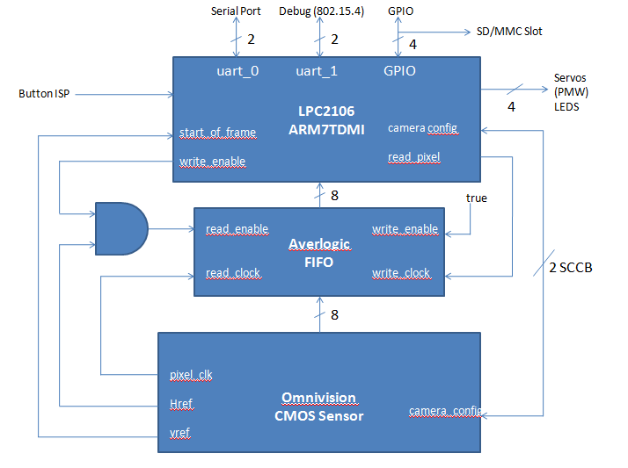Figure 3.8.4 CMUcam3 High Level Block Diagram

The CMUcam3 is able to emulate all of the features found in the CMUcam2+, as well as introducing new hardware features such as the new built in SD memory card slot. Other features included in are:
- Fully open source and programmable using GCC
- CIF resolution (352x288) RGB color sensor
- Open source development environment for Windows and Linux
- MMC/SD flash slot with FAT16 driver support
- Four-port servo controller
- Image processing rate of 26 frames per second
- Lua light-weight language interpreter for rapid prototyping
- Software JPEG compression
- Basic image manipulation library
- Arbitrary image clipping
- Image downsampling
- Threshold and convolution functions
- RGB, YCrCb and HSV color space
- CMUcam2+ emulation
- User defined color blobs
- Frame differencing
- Mean and variance data collection
- Raw images dumps over serial
- Histogram generation
- B/W analog video output (PAL or NTSC)
- FIFO image buffer for multiple pass hi-res image processing
- Wireless Mote networking interface (802.15.4)
- Tmote Sky / Telos Connection
- virtual-cam for prototyping on the PC
- CMUcam3-Frame-Grabber for viewing images on the PC.
Two new features found in the CMUcam3 that are not available in the CMUcam2+ which we liked were the SD card slot and the ability to connect to wireless networking interface. These are two great additions because in the original plan of the AVR we considered having it be able to transmit what it sees back to a computer screen so that it could be controlled from a remote location. Another function we considered was for the AVR to record its traveled path and then save it to a storage media in order to be played back later. Had we chosen this path it would have been an easy decision to choose the CMUcam3 as the vision sensor to be used on the AVR. However, we decided against these extra features rendering these new components unnecessary for the scope of the project. The CMUcam3 also features a faster processor and even face detection but for the scope of the project these features were not needed in order to accomplish the set goals. The main drawback which took it out of the running for use on the AVR is the price of $240. Our budget is around $400 to $500 dollars, meaning that the price of the CMUcam3 would have taken up half of our budget and severely cut back the extra optional features that could have been implemented once the AVR was up and running. Therefore, it was ruled that the CMUcam3 would not be used in our project.
In summary, the CMUcam1 was our initial choice because it cost the least and is smallest in size. However, its lack of availability, low frame rate, low resolution, and lack of control over multiple servos are disadvantages that were considered in our final decision. The CMUcam2+ has the advantage of containing the highest frame rate, the ability to track user defined color blobs and motion, control of up to 5 servos, and frame buffer memory which allows for more complex and faster processing than what is capable in the CMUcam1. Its drawbacks are that it’s more expensive than the CMUcam1 and lacks some of the extra features found in the CMUcam3 such as a SD slot and open source development. Although it contains the most features, due to budgetary constraints the CMUcam3 was removed from consideration. That being said, after weighing all of the above options we were able to conclude that the CMUcam2+ would best allow the AVR to function with optimum performance. Below is a chart of some of the main features we considered in our decision making process.
 | Price | Frame Rate | Resolution | RAM | ROM | SPEED
CMUcam1 | 109.99 | 17 fps | 80x143 | 136 bytes | 2048 words | 75 MHz
CMUcam2+ | 179.99 | 50 fps | 176 x 255 | 263 bytes | 4096 words | 75 MHz
CMUcam3 | 239.99 | 26 fps | 352x288 | 64 KB | 128 KB | 60MHz

Figure 3.8.5 CMUcam Comparison Chart

AVRcam
Another camera we considered while researching was the AVRcam from JROBOT. The AVRcam is similar to the CMUcam2+ in that it is a small, real-time image processing engine capable of tracking colorful objects. It is compiled of an Atmel AVR mega8 microcontroller and the Omnivision OV6620 CMOS image sensor and is capable of the following functions:
- Track up to 8 different objects of up to 8 different user-defined colors, at 30 frames per second
- Provide real-time tracking statistics such as number of objects, color, bounding box, and more through a standard serial port (UART)
- Tracked image resolution of up to 88 x 144 pixels (at 30 frames/second)
- Low power consumption (v1.1 of the hardware draws 5V at 57mA running at full speed)
- In-circuit re-programmability for the end user to add new capabilities
- Completely open-source software and hardware.

An Atmel AVR Mega8 provides the main processing needed by the system. The Omnivision OV6620 CMOS image sensor is connected directly to the mega8 to access important camera signals (pixel clock, horizontal and vertical sync, and the data busses). It also utilizes an AVR Tiny12, which is a small 8-pin microcontroller. This micro was added to the system to configure the OV6620 to output its clock signal on one of its pins. This clock signal is then used by the mega8 as its clock source. Having a single clock source shared between the mega8 and the OV6620 provides the necessary synchronization to allow the system to process the real-time stream of pixel data.
Similar to the CMUcam2+, the output of the AVRcam is sent out either through the RS232 serial connection or the TTL. The transmitter and receiver pins from the camera are connected to the receiver and transmitter pins of the main board, respectively. Below is the general block diagram of the AVRcam.

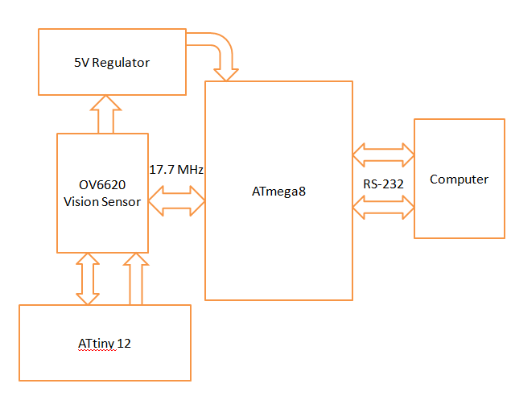
Figure 3.8.6 AVRcam Block Diagram

Also similar to the CMUcam2+’s CMUcamGUI, the AVRcam includes user interface software called AVRcamVIEW and is used to evaluate and testing the vision sensor for proper functionality. The AVRcamVIEW provides the following capabilities:
- Take full-color snapshots (176 x 144 pixels) with the system and display the images (both raw Bayer data and interpolated color data)
- Create a Color Map of colors to track based on a snapshot
- Adjust the precision of each tracked color (i.e. provide a range of acceptable R-G-B values for each color), allowing the user to adjust the Color Map to the surrounding environment
- Display the real-time tracking results of each tracked object (with color and bounding box information)
- Record a tracking session for playback at a later time
- Test the system out in multiple OS platforms that are supported by Java 1.5
- Completely open-source software
It can be seen from the above information that the AVRcam and CMUcam2+ closely resemble each other in functionality and general purpose. However, there are many differences between the two devices which made us choose the CMUcam2+ over the AVRcam for our project. The two advantages that the AVRcam possesses over the CMUcam2+ are price and ability to track multiple images. The AVRcam only costs $99 dollars which is a plus when considering budget and it has the ability to track up to 8 colors which is a good feature. But a drawback to the price is that the AVRcam comes completely unassembled and is not easily found for purchase. We were only able to find it for sale on two sites, the first was shipping from New Zealand and the other advertised as in stock but didn’t contain a way to add it to the online cart for purchase. Secondly, because our rover only needs to track one target the ability to track up to 8 objects is not needed. Some major shortcomings the AVRcam has when compared to the CMUcam2+ are that it can only control one servo, it doesn’t have a built on buffer chip, lacks motion detection and cannot perform histogramming. As explained in the previous section these were all important features that helped us choose the CMUcam2+ over the CMUcam1 and also the AVRcam. Additionally, there isn’t a very robust open source community on the web for it. We weren’t able to find much interface code for it or many projects using it for reference.

Logitech QuickCam Orbit AF Webcam
Another way to implement vision on a robot is to use a standard web cam that can be bought from any regular electronics store; this camera can then be interfaced to perform vision processing using RoboRealm software. We considered using the Logitech Quickcam Orbit AF Webcam which has the following features:
- Still image capture up to 8 megapixels (interpolated from native 2MP sensor); video capture up to 1600 x 1200 pixels, up to 30 fps
- RightLight technology ensures great image quality even in low lighting conditions
- Automatic face-tracking software and motorized tracking feature keep you in the picture
- Mechanical pan-and-tilt head turns left and right for 189° horizontal visibility and tilts up and down for 102° vertical visibility
- USB 2.0/1.1 interface
- Premium autofocus so images stay razor sharp, even in close ups.
- HD video at 960 by 720 pixels.
RoboRealm is a powerful robotic vision software application for use in computer vision, image processing, and robot vision tasks. It uses a point and click graphical user interface to simplify image processing and robotic control. This means that RoboRealm software in conjuncture with a webcam can be used to perform a variety of tasks including line following, color object tracking, remote control over internet and obstacle avoidance. This method was both cost effective and relatively simple since it requires a webcam, RoboRealm and a laptop. When combined with RoboRealm software we would have been able to use these feature to create an image processing tracking robot with a very high image resolution and picture quality. Not to mention, the motorized tracking feature would work similar to the use of servos on the CMUcam2+, so that object can be followed in different directions. However, it wasn’t plausible to have an entire laptop mounted to the AVR in order for it to be able to run autonomously. This would have made the rover overly heavy and less mobile because it would have required a very large base to hold all the components. In addition, this would have taken away from the flexibility in the design of the AVR and led to less add-ons being possible. Furthermore, since the software is completely point and click this method would not have meet the scope of what a senior design project should include because there would be little to no programming involved.

Design

Introduction
The AVR is a combination of a vision sensor, microprocessor, sensors, servos, a motor and software/code working in perfect harmony to perform the task of tracking a color based object. It is able to work indoors and outdoors in a dry environment and performs best in a situation where there are highly contrasting, intense colors. There were many ways we could have gone about creating a tracking robot, but we decided on using image processing because it allowed for more flexibility than using just ultrasonic range finding sensors to track and follow objects. Since the AVR does not stick to a rigid design we had the option of having extra add-ons once we were completely satisfied that it was running correctly by tracking a designated object with the correct distance in-between and adjusting to both change in speed and direction in the correct manner as well as avoiding added obstacles. Included in the possible add-ons were solar power capabilities, an adjustable weapons system and remote start up. In this section the entire scope of the AVRs design process will be explained by section. This includes the overall assembly (as shown in the block diagram below), mounting of components, parts being used and how each affects the overall functionality of the AVR.
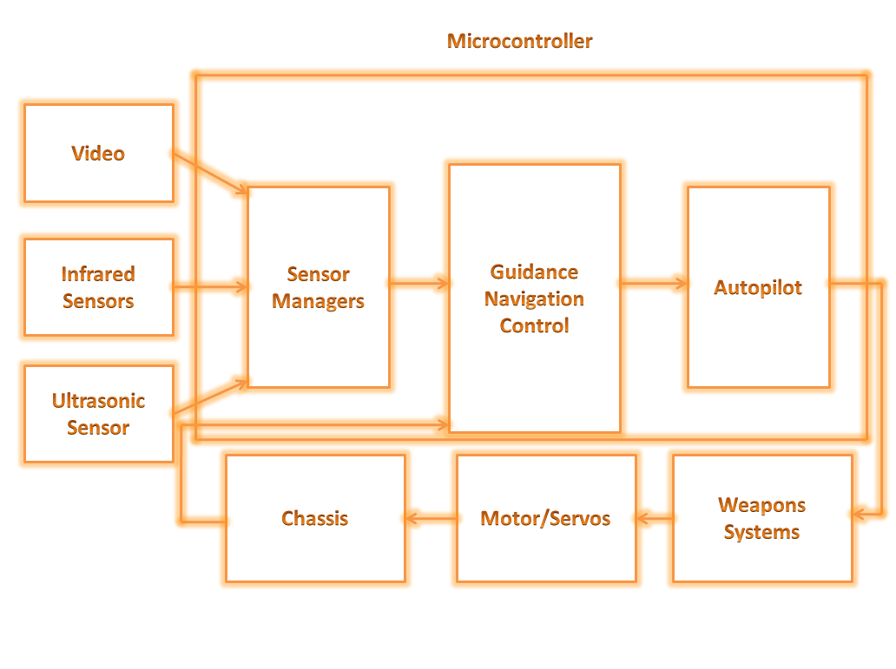
Figure 4.1.1 AVR Block diagram

System Architecture
The flowchart below shows a top-level overview of the AVR. This flowchart dictates the flow of data and all the processes involves in this autonomous vehicle. The target and environmental variables will be detected using the CMUcam2+ and the Ultrasonic Range Finder. The CMUcam2+ will detect a target and then process the information to obtain the target’s centroid location. After processing, the output of the CMUcam2+ will be a string of various data to be interpreted by the Sensors Manager. The Maxbotix Ultrasonic Range Finder behaves the same way. Ultrasonic signal bouncing off the target will be picked up by the range finder. The range finder will use those signals to create a Pulse-width Modulation signal and output that to the Sensors Manager. From those sources of information, sensor manager will be able to find out how fast the vehicle is going, how far is it away from the target and where is the target’s centroid. Those data will then be passed onto the controller functions to perform calculations that will ultimately be converted into voltages (Pulse-width Modulation) to drive the actuators. The actuators here would be the DC motors mounted on the chassis. This closed loop system shown in figure 4.2.1 will keep looping until the termination condition is met.

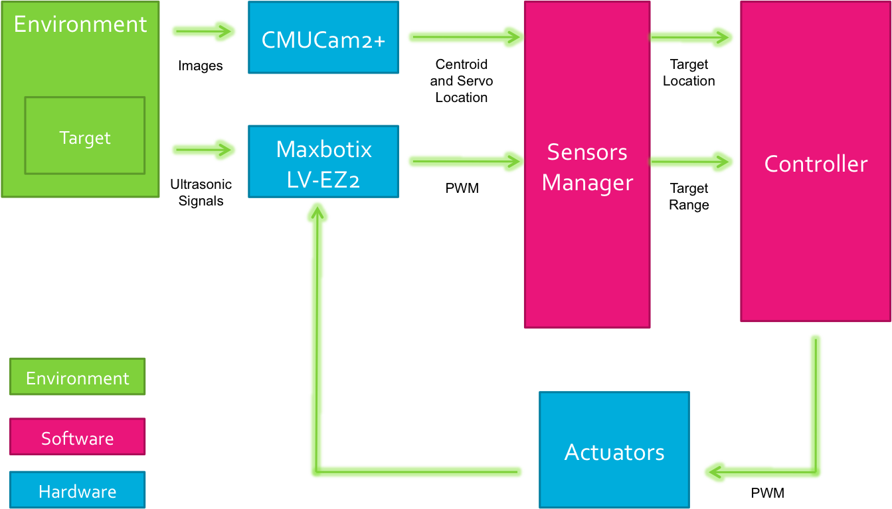
Figure 4.2.1 System Architecture

Sensors Manager
The sensors manager acts as an executive function that will mainly deal with the hardware-software interfacing of the vehicle. All raw sensor data will go through this function and the sensors manager’s job is to process these data so it can be fed to the guidance, navigation and control function.

Ultrasonic Sensors Data
The onboard hardware of the ultrasonic sensor will do most of the processing job but some work are still need to be done in order to translate the output data into the real distance between the sensor and its detected object. There are many possible ways to read the output data of this sensor such as direct connection to the serial port, analog data or digital data. The easiest way to interpret these data using a microcontroller without taking up the TX and RX port is through the Pulse Width port. The PW port of this ultrasonic sensor will output data in form of a pulse-width modulation signal. The distance can be calculated by dividing the pulse width by 147 microseconds per inches. For example: if an object is 10 inches away from the sensor, a value of 0.00147 will be read from the sensor’s output using the microcontroller’s digital in port. The microcontroller will then take this value and divide it by 147 microseconds to get the 10 inches. It is also possible to convert such values to the metric system using the microcontroller if desired. Now we have the right range and this function can be called anytime using the other functions to find out how far is the target is away from the vehicle.

CMUcam2+ data
Reading data from the CMUcam2+ is more complicated than the Ultrasonic Sensor. Since the CMUcam2+ is a much more complex piece of hardware. It has many operating modes and output data. For our purpose, we want to extra the location of the centroid of the detected object. Before any type of information can be extracted, the camera must be initialized to our liking. The camera will interface without microprocessor through the UART serial RX and TX port. Various things must be set first before meaningful data can be extracted. First and foremost, we have to enable raw serial data transferring and set the right baud rate so the camera would be able to communicate with the microcontroller. Baud rate effects how fast the data are coming into the microcontroller. For a stable and reliable signal, we chose the lowest baud rate which is at 9600.
After the connection has been established, a command from the microprocessor will tell the camera which color to track. This data must be format in a way that the camera will be able to understand. The format of this command should be in the form of a series of RGB values. The microcontroller must specify which color it wants the camera to track. 6 values will be given to the camera from the microcontroller. These values are as follow: [Minimum Red Maximum Red Minimum Blue Maximum Blue Minimum Green Maximum Green].
From those six values, the camera will be able to understand which color we want it to track. Initially, these values will be hard coded into the microprocessor. As a possible expansion, we will allow the camera to look at the object and define the color on its own before the tracking takes place. A further discussion on this topic will take place later within this document.
After a specific RGB value has been initialized, the camera will start to track that color. If an object of the color is found within the camera’s field of vision, the camera will start to track that color. Information about the object can be extracted using the color tracking command. The microcontroller will then ask the camera to output the available data of the centroid of that tracked object. The output of the camera will be a string of raw data that will need to be interpreted by the sensors manager function. The format of the raw data should follow: [mx my x1 y1 x2 y2 pixels confidence] with mx and my being the x and y location of the centroid of the tracked object. The x1 y1 x2 y2 values follow make up the output of the rectangle that is the region of the camera’s field of vision. From those 6 values, the microcontroller will be able to calculate and see where exactly is the object is relative to the vehicle. The confidence level will also give us a good sense of how good the raw data is. Using a certain threshold in the sensors manager, we can reject data with low confidence to ensure the accuracy of the location of the tracked object.
From the location of the centroid, the sensors manager function can calculate the location of the tracked object in relative to the location of the vehicle. This information will be useful to the controller function because by knowing where the object is we can successfully command the vehicle to move towards it. Along with ultrasonic sensor’s range, we now have the exact location of the tracked object. This information will be available to the functions of the vehicle at any given time.

Weapon Systems Introduction
One of the scenarios that an AVR could be used in is a military theater, and what good would the rover be if it couldn’t defend itself? Given this reason the rover will come equipped with an integrated weapon system. The weapon that is being researched is an airsoft gun. There were many reasons why an air soft gun is going to be used. First and most obviously is that it will not destroy or damage anything it shoots at. This will enable us to test the weapon system easily without harm to our person. An Airsoft gun fires a small 6mm plastic bb that travels around 500 ft/s. When hit by one of the bb’s it delivers a small sting but is relatively painless. Airsoft guns are powered in three different ways. The options include gas power, spring power, and electric power. The first two are out of the question because some sort of mechanical device is needed to fire the weapon. The obvious choice is electric power because it can be powered by on the onboard power supply and be controlled with the microcontroller. Electric powered guns are also capable of fully automatic fire that will replicate the use of a real machine gun.

Electric Guns
All electric airsoft guns come with some sort of battery built into them. For the case of the AVR, that battery will be removed and the onboard lithium ion battery will be used. The batteries power is used to move gears within the gun. The gears are there to pull back the bolt against a firing spring. The trigger and barrel allow the pellet to fire timely and accurately. The battery is directly connected to the small electric motor. The motor is equipped with three plastic gear sprockets that compress the bolt up against a spring. Once the bolt is fully compressed against the spring, the user pulls the trigger. The trigger sends a signal for the gears to release and allows the spring to fire the bolt forward at a fast rate. While the bolt is back, air gets trapped between the bolt and the pellet. When the bolt releases, a tremendous amount of air pressure builds up behind the pellet, firing it out of the barrel with a velocity that can be set from 150 to 500 feet per second. Below is a cutaway diagram of the internal working of the electric airsoft gun.
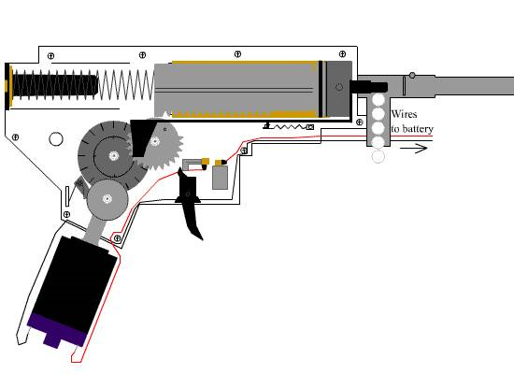
Figure 4.2.2 Airsoft Gun
(Permission Pending from shorty USA)

Controller

Control
For the vehicle to be autonomous, it must be able to process information from sensors and perform certain tasks on its own. For any type of autonomous task, a good control closed loop is necessary. Good sensor data are useless unless there is a way of interpreting it and calculate your error relative to the desired objective and then feeding it back. For our purpose, a basic PID controller will do the job.

Figure 4.3.1 Controls Block Diagram

PID is one of the most basic controllers in control theory. The proportional, integral and derivative terms are essentially gains that are multiplied individually to the errors and then summed up before multiplying it to the plant that will then be fed back to compare with the input and calculate the new error. Tuning the gain will result in the desired outcome. Each terms are independent of each other so it is not necessary to use all 3 terms unless need be. For our application, the Proportional term correspond to the distance between the vehicle and the desired object. The Integral term corresponds to the desired acceleration of the vehicle and lastly the Derivative term corresponds to the desired speed of the vehicle. For the scope of this project, only the P term will be use since we don’t have the necessary sensor to measure acceleration and the vehicle is assumed to be operating at low speed and its small enough that acceleration isn’t an important matter.

Sensors Data
Two important information that need to be known at all time will be the range of how far the target is away from the vehicle and the detection or where is it located relative to the position of the car within the field of visibility. For ranging purpose, our ultrasonic sensor should do the trick. Target detection will be done through the CMUcam2+.

Navigation
For this vehicle to be fully autonomous, it must be able to navigate itself through the environment. Vision based navigation will be a big part of this project but additional information from various sensors such as the ultrasonic sensor and the movement of the vehicle will also come to play. To stay within the scope of this project, the operating environment will be controlled. The environment will be in a brightly lit, indoor, room temperature, leveled ground with minimal obstacles. Information about its surrounding will be obtained through various sensors.

Range
The range of a detected object in front of the vehicle can be easily found by using the ultrasonic sensor. Most of the data processing work had already been done by the onboard electronics of the Ultrasonic sensor. Data obtained from the sensor will come back in a pulse width representation. With the right scaling factor, a simple computation will give us the extract range of the detected object in front of the vehicle.

Target Detection
Detecting and tracking an object can be a very difficult task without the right hardware. The sophisticated CMUcam2+ greatly simplified the process. One of the operating modes of the CMUcam2+ is color tracking. Simply put, the camera will use some signal-processing algorithm to isolate a given color within its line of sight and extract information about the location. Within the scope of this project, the operating environment of the AVR will be controlled. The target will be a bright colored object. Colors such as green, red, blue will most likely be used. The CMUcam2+ will be programmed isolate this bright colored object from everything else within its line of sight. The centroid of this bright colored object will be extracted and sends back to the microcontroller. Along with the location of the centroid, a confident level will also be sends back. Using the location and level of confident given, we can successfully track the object as it moves through time. The objective now would be to follow the object and always keep the centroid within sight. The detection data coming from the CMUcam2+ is pretty reliable since it has already been processed and filtered by the on board hardware.

Figure 4.3.2 Coordinate Frame Alignments

Since the AVR employed a Pan and Tilt system, we now have two coordinate frames to deal with (Body frame and CMUcam frame). Some calculation is required to align these two coordinates together. As seen in the figure below, the body frame will be fixed and CMUcam frame will make an angle with the body frame as the panning servo move in the horizontal axis. We will call this angle beta. Since all of the target’s data coming from the CMUcam will be in a form of x and y coordinate of the centroid, we just adjust this centroid value to represent the real target’s centroid location relative to where the vehicle’s body is pointing. The target’s centroid information coming from the CMUcam will be aligned to the body frame by adding an offset using the following equations:
(1)
(2)

Guidance
Detecting a target is one matter and getting there would be a totally different matter. After locating a target, the vehicle must find the most efficient way to reach its target without losing sight of the target.
The basic concept of following any object would be to figure out where it is and then move towards it. If the object happens to be out of sight, the vehicle would then try to turn either left or right to see if the object is there. If not, the vehicle would turn towards the same direction again and try to detect the object once more. This process will loop until the object is returned to the line of sight. At this point the vehicle will then move towards it once more and repeat the process while trying to minimize the distance between the vehicle and the tracked object. Using this basic algorithm, the vehicle will eventually reach its target. If the target is lost, the vehicle will go into search mode and will stay in search mode until an object is found. While in search mode, the vehicle will pan around using the CMUcam and search for objects.
To avoid fault detection and have a better confident in the tracked object, the controller will save the last 10 looks in an array and keep statistics of how many detections acquired within the last 10 looks. If the percentage of detections is higher than a certain threshold, the controller will know that it’s a good detection and then move on. If it’s a bad detection, no more action will be required until a good detection is found. Once a good detection is found, the controller will use the centroid value of the tracked object and determine how to command the turning wheels and the drive train. The flow chart below will explain the basics step that the controller will go through to determine the right commands for the actuators.

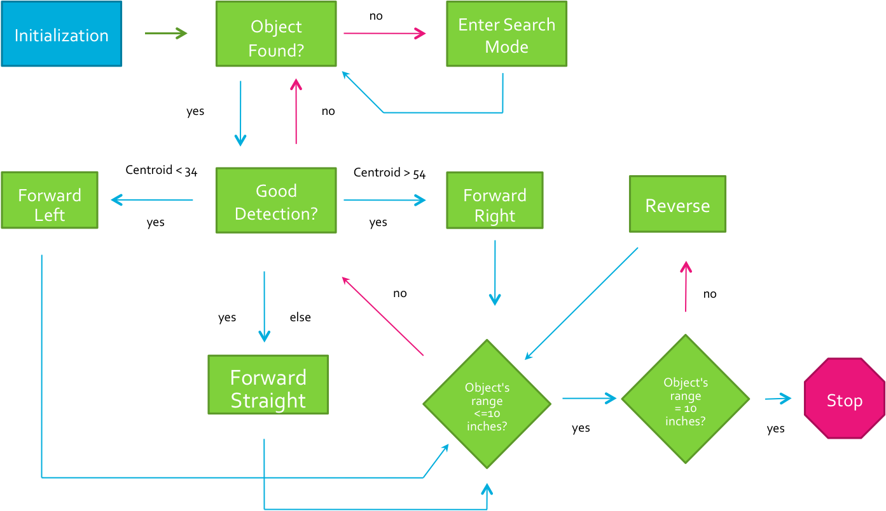

Figure 4.3.3 Guidance Diagram

Batteries
After exhaustive research lithium ion battery technology such as in figure 4.4.1 will be used on the AVR. This choice was made because it will be able to meet the goals that are demanded of the battery system. There was a debate whether to use a 3.6V or 7.4V battery. Both of the batteries could hold the same amount of energy, but the regulatory systems used to implement the battery would have to be compared. Components on the AVR vary on the input voltages they require so the choice of using 7.4V battery was made because the voltages could be easily stepped down or up to meet the manufactures requests. Also finding step up regulators that would meet out power needs is difficult. Step down regulators are more readily available. The battery that will be used is shown below and it is rated at 7.4V and can hold 2000mAH of charge. Under ideal condition a single battery should be able to power the rover approximately for four hours. It comes with a very common JST connector and can be charged with any single cell lithium ion charger. Along with the dual battery solar power design there would be enough charge to make the AVR have a very long run time.

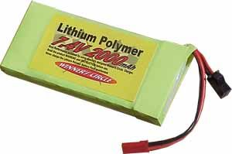
Figure 4.4.1 Lithum Ion Battery Pack
(Reprinted with permission from Sparkfun)

Voltage Regulation
After extensive research the choice of using the LM7805 voltage regulator was made because of its ease of use, cost, and availability. The LM7805 comes in a simple three pin DIP package that can be fitted to a breadboard and tested or can be solder to a PCB. This regulator powered to most of the parts on the rover. These regulators require very few external components and come with many useful features. These regulators, if needed, can become adjustable regulators with a few external components such as resistors and capacitors. Below is a circuit diagram on how the voltage regulator was employed. It will output a constant DC voltage.
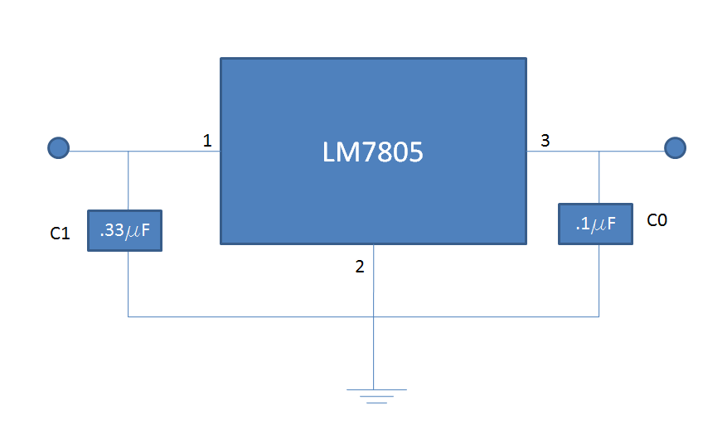
Figure 4.4.2 Voltage Regulator Circuit

Powering the CMU camera
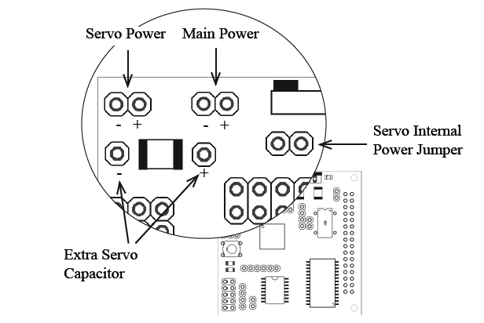
The power that was supplied to the CMU camera is going to run through a 5V voltage regulated supply so no voltage fluctuations will occur during operation possibly damaging components on the camera. The power going to the camera needed to be able to supply at least 200mA of current to ensure that the part runs properly. The camera also comes with two servos that control the tilt and pitch of the camera so that it can track an object. They can either be run off of internal power or external power using an external servo power connector. The servos for the AVR were run using external power to ensure that they are getting an appropriate voltage. To prevent noise and possibly causing the servos to jitter a large valued capacitor was wired across the extra servo capacitor ports that are located on the CMU’s board shown below. This will eliminate some of the ripple and make operation on the servos smoother.

Figure 4.4.3 CMUcam2+ Power Ports
(Reprinted with permission from CMUcam User Manual)

Solar Power Design
The solar cells that were considered for implementation were 6.7V polycrystalline solar cells that are capable of powering a 5V motor at full speed. When exposed to pure sunlight they will be capable of producing 20mA of current to recharge the battery. The design that was considered is the two battery design. One battery will be recharged with the standard lithium ion recharger. The second will be charged by the solar panels that are going to be rear mounted. A comparator switch would be installed between them which will compare the voltages of the two batteries. When one battery becomes too low it will automatically switch over to solar power dramatically increasing the run time of the rover. Below is a flow diagram on the operation of the solar power system.
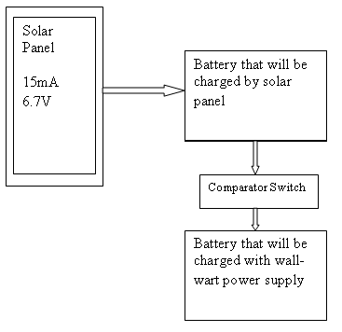

Figure 4.4.4 Solar Power Diagram

Acquiring space on the AVR’s chassis shouldn’t be a problem because the motion detection camera and sensing systems will be forward mounted leaving plenty of room on the back of the rover. Four cells with dimensions of 37mm x 33mm will be placed on the rear section of vehicle giving 4884 square millimeters of energy capturing space. This battery can be seen in figure 4.4.5. During favorable weather conditions this will be enough to give a quick charge time for the battery. Although this design would make the rover more energy efficient, unexpected costs and part failures during construction set back the schedule and the solar system could not be implemented.
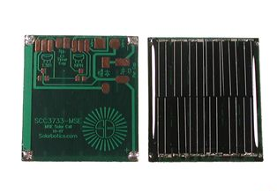
Figure 4.4.5 37mmX 33mm solar panel from Solarbotics
(Permission Pending from Solarbotics)

Powering the DC motor
The motor that was used for the project was a large DC motor that was capable of propelling the chassis to speeds over 40mph. These speeds were never reached during testing because of the ever present risk of a system failure. Of course, depending on the application different types of motors could be used. For our AVR the motor is going to run off a 5V DC motor that draws about 2amps current. With the array of parts present on the AVR running simultaneously there is concern over voltage drops. This comes of special concern because the battery is going to be run off of the same battery as the microcontroller. Indeed, we could use two batteries to power each part, but space and money will not permit this solution. The voltage drops that will be occurring in the system may cause the microcontroller to reset; loosing the code that is uploaded on to it. The uses of optical isolators were researched so that the motor and microcontroller can be separated.

Using an H-Bridge to Drive the Motor
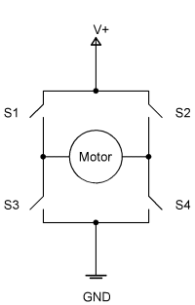
There are many advantages to using an H-bridge motor driver to power our rover. One is that the engineer is capable of controlling the direction of the current passing through the motor; which will give use the option of reversing the vehicle if it comes to close to the target object in front of it. The figure below gives the basic operation of an H-bridge motor controller.
Figure 4.4.6 H-Bridge

You can imagine the operation of the device as an array of four switches. Closing an opening certain switches will affect the direction of current through the motor. If switches S1 and S4 are closed and switches S2 and S3 are kept open the motor will spin forward. If you do the inverse of this the motor will spin in the opposite direction. One major concern is to avoid a problem called shoot through, which is when both of switches on one side are closed and the switches on the opposite side are open. This will cause a short from the power to the ground; causing excessive current to pass through the motors and the batteries which can cause thermal damage.

Range Finding Design
After researching the various types of ultrasonic sensors available to use the decision to use the maxbotics EZ2 ultrasonic range finder was made. The price, availability, size, and most importantly of all the ease of interface made it the appropriate choice for the sensor. The analog output on the sensor will be used to interface it with the microcontroller. The analog output gives a very easy way to interpret the distance the sensor is from the target object. The formula Vcc/512/inch gives the output voltage the sensor will send to the microcontroller telling the objects distance. Given this information a program can be loaded into the microcontroller to control the duty cycles of the motor. The following distance that is being set for the AVR is 24”. This should give us enough space to slow down the car if the object stops, but will also be within range of the camera.

Power Flow
After extensive research and comparing options for parts a varying topologies a final design has been reached to power the onboard electronics present on the rover. The flow diagram below can best detail what parts will be used and how the power is going to be delivered. It has been decided that a two battery system will be used with the solar power. This will give the rover the longest run time and allow for more time to test a prototype the vehicle.

Two Lithium Ion Batteries
7.4 Volts/2000maH
-One charged by wall power
-One charged by solar panels

LM7805
LM7807
Camera Servos
Steering Servos
Motor
CMU camera

Figure 4.6.1 Power Flow Diagram

Weapon System Implementation

Introduction
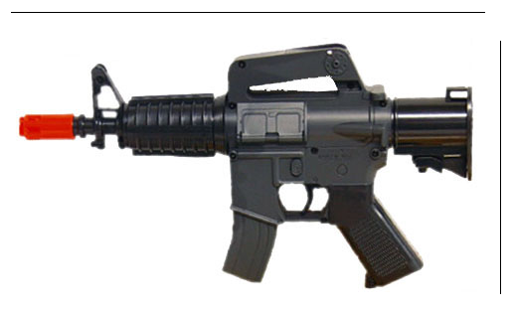The weapon system that was considered needed to fit around the range finding system and the CMU camera. If it blocks the view of either unit it will render them ineffective. The gun that would be used is a mini electric airsoft gun like the one shown below. Its dimensions are 8”x 5” in its raw form, but the gun’s outer shell will be removed and only the internal components will be used to fire the bb. The raised sights, stock, and magazine are strictly for aesthetic purposes and can be removed. Only the barrel, gears, motor, and firing assembly will remain; saving precious space on the chassis.

Figure 4.7.1 Airsoft Gun Dimensions

There are few ways that were considered to mount the weapons systems. One is too put it directly on the front bumper adjacent to the ultrasonic sensor and underneath the CMU camera’s lens. This may cause problems because during testing the car is sure to run into objects and this could damage the gun. It would also add to the overall length of the rover which would cause problem during cornering. The other is to mount it high above the CMU camera like a turret. A key advantage of this mounting method is that it will give us flexibility to adjust and aim the weapon. If time and budget permit; the gun will be able to move in sync with the CMU cameras servos allowing it to shoot wherever the CMU camera is looking. The third way is to mount it underneath the camera on the second deck. This would make it very secure, and out of the way of other components, but would not allow us to aim or move it.

Powering the weapon system
The particular airsoft gun was researched runs off of four AA batteries that are connected in series that are 1.5 volts each. This means that we need to supply it with at least 6 volts from our lithium ion battery. The motor within the gun drains about 50mA every time it fires which brings up some concern. When all of the components on the rover are running simultaneously it is going to drain a lot of current on the AVR. The rover at full tilt is going to drain about 2.5A of power and voltage drops across the system are a concern. One design change that is being considered is to run a two battery system. The main driving motor and the firing motor would be run off of one battery. The CMU cam, steering and cam servos, and microcontroller would be run of the other. This would reduce voltage drops in each system and the back EMF produced by the motors would not harm other components.

Mounting locations of Hardware
After considering all the electrical components that are going to be used on the rover a possible solution to space needs has been found. The idea is to use a second deck on the autonomous visual rover. Given in the picture below are the dimensions that are available to use to mount all the hardware. On the first deck is where the microcontroller and everything that controls the car will fit. Below the car is where the lithium ion battery will be installed. Small holes will be drilled into the chassis allowing wire to come up from the battery. As discussed before; the ultrasonic sensor will be mounted directly on the front bumper where its electrical connections can be easily reached. On the proposed second deck is where the CMU camera and weapon systems will be mounted. The deck is going to be made out of thin plate of aluminum connected to the bottom chassis with metal dowels. This will give the gun and camera a steady platform to be mounted to and a clear line of sight. Also it will put the components out of the way of the front wheels reducing the risk of damage to pricey components. The gun will be mounted sideways underneath the camera. Given the dimensions of the gun; it will match perfectly the width of the AVR.

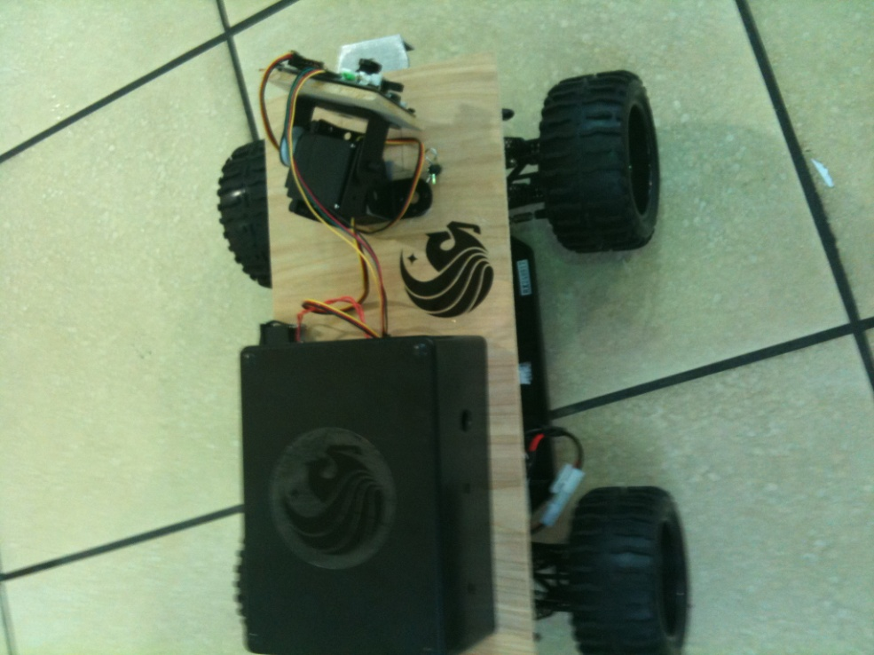

Figure 4.7.2 Mounting

Design Summary
The autonomous visual rover is well on its way to successfully completing its goals that where set prior to designing the vehicle. This design will serve of great importance to both military and civilian sectors alike. With exhaustive research by the entire group the design described in this document will be able to meet its required goals. The main purpose of the rover is to autonomously follow a moving object with out any outside input or direction. The secondary goals included implementing a weapons system to help simulate use of the AVR in a military setting. Also with the world shifting towards a ‘green’ economy solar power is being researched and designed into the project to help recharge the AVR’s batteries.
While the design is complete there is still much work to be done. Parts have already been ordered and tested and our group is well on its way to successfully creating the autonomous visual rover. The features that are included on the rover will be dictated by time and money as is most things in the world today. The main goal of the project is implementing the CMUcam2+ to track a moving object and is priority number one. Additional features will be added after that. The design described above is the ideal case for the project that we would like to accomplish. The beauty of engineering is running into problems and being able to figure them out, as we are sure to do during the construction phase of the AVR. The whole project has been modularized between group members so nobody is overwhelmed. Also this method will make each of us a master at our particular section of the project and help our trouble shooting abilities. The sections of the design were split up into control and software, CMUcam2+ interfacing and chassis, and power supply and range finding. Each member of the group did an exceptional job with their design portion and the project is shaping up to be a success.
A majority of engineering is done on the shoulders of others; there is no reason to “reinvent the wheel”. For this reason, our group signed up to many electronic and software forums to ask experts questions, as well as looked at similar projects so we could have a base to work from. Without this help designing the AVR would take a much longer time. Also with the generosity of companies aiding our learning experience they would kind enough to give us free samples and credit to purchase items on their website. As a whole the three engineers working on this project are looking forward to the challenges of the construction and prototyping phase.

Testing/Prototyping

Introduction
Testing was one of the most important steps during the successful completion of this project. It was important that the parts were tested both individually and as a whole when the prototype was initially assembled. Regardless of how many hours are spent researching and selecting components if they wouldn’t have worked to our set specifications the project would have been deemed a failure, which was unacceptable. This section will delve into how we tested each part separately as well as fully configured. Furthermore, we will discuss methods used to ensure that the AVR met all predetermined goals. Due to the fact that some components were able to operate right out of the box, while others require complex programming and wiring the amount of time we dedicated for testing each individual component varied.
While finishing the development and assembly of the prototype AVR we used a multi-phase format, in order to complete our prototype in an efficient manner. First, we completed the design phase of the AVR which included the development of schematics, drawings, PCB layout, all necessary simulations, and overall layout of the device. Secondly, we finished the testing of every part being used for the AVR. This was an essential phase to the project in order to ensure that each component we had was operating correctly; this included making sure all voltages and currents matched up as well as all necessary cables and converters were operational. The final phase of the prototyping stage was the complete assembly of the AVR.

The design phase of the AVR was crucial in our development of the AVR because it is where we laid out the schematics and how everything works together to create a fully functional device. During this stage we performed computer simulations and basic hardware tests to confirm that the design would work as a complete system. Following that we created a layout of the custom PCB used in the AVR in PCB 123 software. Once the design phase was completed we moved on to the crucial step of testing. As explained in greater detail in this paper, the testing phase was vital because each component is essential to the operation of the system that is the AVR. Even though the design involves interdependent systems, including the vision sensor, power supply, servos, and motors if the parts would not have been able to work in harmony the AVR would have failed to execute its appointed task. Through testing each and every part to the manufacturer’s standards before assembling the system, we were able to decrease the amount of time spent troubleshooting errors in our system. After verifying that every element was working correctly with zero percent error, we began the assembly of the AVR. The first subset of the assembling process was having our custom PCB manufactured. Then we handled the task of handling the electrical systems, including powering the device, wiring all components together, and soldering. Then we put everything together onto the chassis of the AVR in a manner that allowed optimum range and movement.

DC Motor/ H-bridge
The objective of this test is to see if the H-bridge SN754410 can control a small DC motor using the Arduino. This test was conducted with an Arduino USB board, a small breadboard, one SN754410 H-bridge chip, wires and a DC motor. The DC motor in this test has a blade taped to the rotating motor shaft and is mounted on a makeshift device to keep it in position acting like a fan.

Figure 5.2.1 Arduino Pin Layout Diagram

In order to test the DC motors properly, we needed an H-bridge to control the flow of current. Using the H-bridge SN754410 chip, it is possible to control a DC motor to go both directions (clockwise and counter-clockwise) without having to rewire. The H-bridge chip is wired to have two 5V VCC input. One is to power the chip itself, the other is to power the DC motor. Pin 1 on the H-bridge is connected to a HIGH PWM output from the Arduino to enable the DC motor, another word we want the SN754410 to know that we want to use only the left side pins at this time. Pin 3 and Pin 6 are hooked up to the two terminal of the DC motor. Pin 2 and Pin 7 are connected to two more PWM output from the Arduino. Since we are only controlling one DC motor, the other side of the SN754410 H-bridge can be leave as it. Lastly, Pin 4,5,13,12 should be grounded. Refer to figure 5.2.1 for exact locations of all the pins.
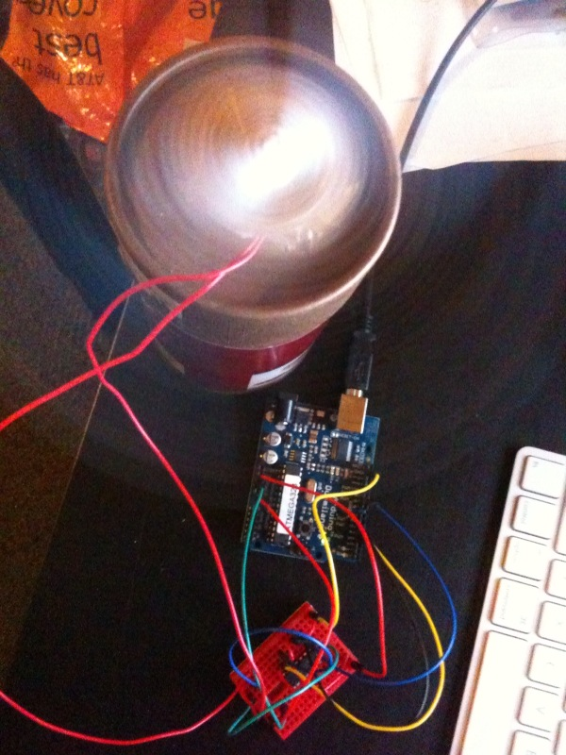
Figure 5.2.2 Arduino Test Hook-up

Using Pin 2 and Pin 7, we can control the polarity of the DC motor. For this test, the Arduino is programmed to loop Pin 2 on HIGH and Pin 7 on LOW for a delay of 10 seconds and then Pin 2 to LOW and Pin 7 to HIGH for another 10 seconds. This logic will in turn make the DC motor go clockwise for 10 seconds and then counter-clock wise for another 10 and repeat. As seen above, this test has successfully turned a DC motor into a rotating fan that has the ability to spin both clockwise and counter-clockwise direction. This test proved that we would be able to use the same setup to control the two back wheels to go forward and backward using the Arduino.

Ultrasonic Sensor
The objective of this test is to see if the Arduino is able to read data from the ultrasonic sensor and then using the data to convert the pulse width into a meaningful unit of length. For this test, we will use the PW output of the ultrasonic sensor and all units will be in inches. The layout of the ultrasonic sensor can be seen from the figure below. The PW port of the sensor will be hooked up directly to a digital pin of the Arduino and power, ground will also be provided by the Arduino USB board. The Arduino board is programmed to read the pulse width value from the ultrasonic and then translate that into inches by dividing by a specific value. The calculated distance will be output to the serial monitor of the Arduino software for verifying purpose. To perform this test, a textbook was held in front of the ultrasonic sensor at various distances. A ruler was used to measure the distances and then compare to the value being output by the Arduino serial monitor. The result is very accurate as advertised. Another useful piece of information gathered from this test is that the ultrasonic sensor will not be able to tell the range of any object that are closer than 5 inches and the max range of this ultrasonic sensor turns out to be around 145 inches. Below is a picture of the Arduino hooked up to the ultrasonic sensor.

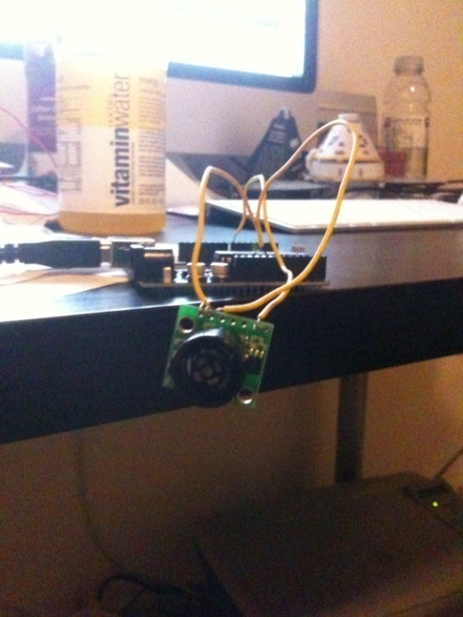
Figure 5.3.1 Ultrasonic Sensor connected to Arduino

Range Finding Test
The ultrasonic sensor is going to be tested through the use of a multi-meter. The goal of the project is to have the rover tailgate its target object at a range of 24 inches. The output that is going to be used is the analog output because of its ease of use. The sensor will be connected to a breadboard and hooked up to a power supply at 5 volts. The analog output pin will be connected to the multi-meter with an object in front of it. When the object is moved closer and farther away from the sensor the reading should change on the meter at a rate of Vcc/512/inch. This information then will be interpreted by the microcontroller and an appropriate duty cycles will be set to control the motor. At the desired range of 24 inches the motor will be commanded to shut off, and anything greater the motor will run until it reaches its target distance.

Object greater than 24” away?
Turn on Motor till target distance reached
Turn off Motor till target distance reached

Figure 5.4.1 Range Finder Test Diagram

Power Supply Life
The goal of the project is to have the rover be able to run for an extended period of time on a single charge. The two battery system that is going to be employed will extend the run time of the rover and prevent voltage drops and electrical noise from going into competing system. The main driving motor and firing motor in the gun will be powered by one of the batteries. The servos and microcontroller will be powered by the other battery. The first phase of the test will take place in the lab under ideal conditions. The calculated run time in the ideal case is about four hours with the 2000mAH battery with the main driving motors constantly running. The second phase of the test will occur in the field with all of the components installed and running. The field test will give us the most accurate approximation of the run time of the AVR. Different variable such as the speed of the object, starting and stopping, and firing will of course affect the power supply life.

Voltage Regulation Test
The voltage regulation test is vital to making the components on the AVR run as they should without them malfunctioning or getting damaged. With all of electrical components present on the rover voltage drops will be occurring causing problem with the operation of the rover. It is key that during construction that the appropriate voltage is being received during operation. Components will be turned on simultaneously and voltages at key points will be tested on the circuit with a multi-meter. To ensure appropriate functioning of the AVR the voltages will need to be within a certain tolerance as described by the manufacturer to ensure optimum performance. Once certain the appropriate power is being supplied the components for the AVR can then start being assembled.

Chassis/Locomotion
Taking the same setup from the DC Motor/H-Bridge test, this test will expand on that by placing the Arduino and breadboard on the vehicle chassis. The DC motor will be attached to a real set of wheels this time. The objective of test is to see whether one DC motor would have enough power to drive the while vehicle. Since this is just a locomotive test, only the two back wheels are hooked to the DC motor using a set of gears that already exist on the RC car we are using as our chassis. The turning is allowed to move freely without any control. No sensor will also be use for this test. The same Arduino code will be used here also. Instead of having the fan turn opposite the direction, it will actually move the vehicle forward for 10 seconds and backward for 10 seconds and then repeat. One major difference between this test and the DC Motor/H-Bridge test is the way power is being supplied. In the previous test, we powered everything using the USB interface coming from the computer. For this test, an actual 6V battery will be used as the power supply. This 6V battery comes with the RC car that we are using as the chassis so there has already been a housing for it. The battery housing is located right underneath the RC car seen below. Notice the turning wheels are not hooked up because that is not part of the objective of this test.
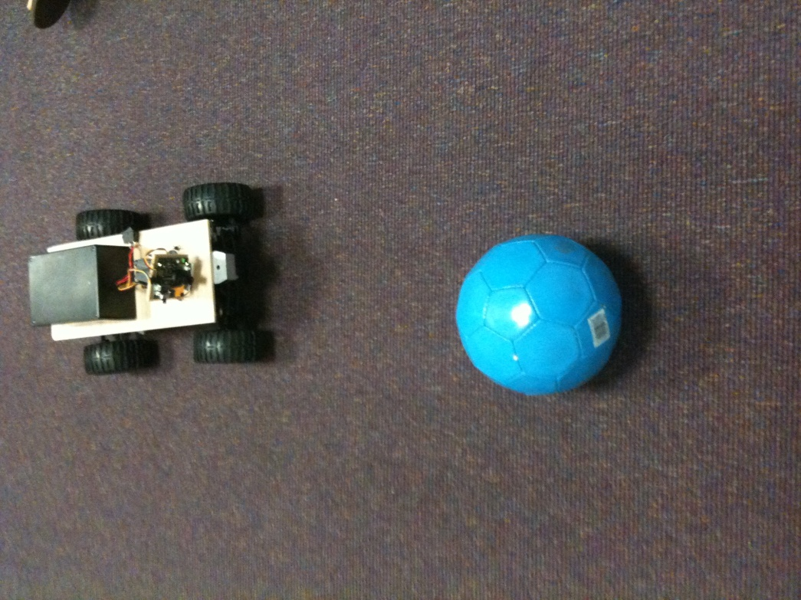
Figure 5.7.1 AVR Locomotion Test

As expected, the vehicle works without any problem. A few things are learned from this test. This test proved that we are able to power everything with just a 6V battery without any voltage regulator circuit at this time. This design might change since we don’t have any sensor hooked up for this test. This test also confirms the fact that one single DC motor is all it takes to move the vehicle. The vehicle moved fairly quickly. This test was done on a carpet floor so it is expected to run even faster on a flat and smooth surface such as concrete or tiles.
At the time of this writing, no further test is being done due to scheduling. There are a few more scheduled testing for later time. Future hardware testing will include but not limited to test the turning wheels and its DC motor, testing the CMUcam2+ hardware using the CMUcam2+GUI and also testing the CMUcam2+ with the Arduino. The goal is to have the CMUcam2+ talk to the Arduino via the UART interface. Below is a list of future tests that hadn’t been completed yet.

DC Motor/H-Bridge turning wheels test
Similar to the test for the back wheels, the objective of this is to control the turning wheels movement using the Arduino. This test will also give us a sense of how reliable the built in turning mechanism that comes with the RC car is. A study on the turning radius will also be conducted here. If the test result turns out worse than expected, we might have to change our design and use a stepper motor or an RC servomotor instead of the DC motor we have right now.

IR Detector/Reflector test
For this test, we will study the effect of how a fair of IR detector / reflector behave when in contact with a dark surface and then a light surface. This will give us a good idea of how well the Detector / Reflector will be able to read the encoding disk.

IR Detector/Reflector encoding wheel test
The objective here is to see if the IR Detector / Reflector pair will be able to accurately tell how fast the encoder disk is spinning. The IR circuit will most likely be mounted next to an encoder disk to watch for changes in color as the encoder disk spins around. A few speed tests will be used to determine if the circuit is working as intended. The encoder disk would be spins at different speed and test result would then be compare against each other. Different encoder design will also be used during these tests. We want to study the effect of having more or less resolution in the encoder disk. In theory, the more stripes will give us higher resolution data than fewer stripes. Also, different design encoder pattern will be use to see if we can get additional data such as the angle of the wheels relative to the IR circuit.

Chassis/Locomotion test with turning wheels
This test will incorporate the first locomotion test with the turning wheels. Additional coding will be required to have the wheels turn on different condition. Initially we will have some basic conditions where the vehicle will turn after a certain amount of time or have the wheels always turn to one direction so that the vehicle will go in circle. Different maneuvers will be tested here to make sure that this chassis is what we want in our final design. We also want to see how the chassis will react to certain maneuver.

Locomotion test with IR detector/reflector
A test with the IR detector/reflector circuit mounted next to the wheels to read the encoder disk to realistically measure the velocity of the wheel. The objective here is to measure the velocity of an actual moving vehicle. For this test, a variety of different speed will be used to find a correlation between the applied voltage to the DC motor and the actual speed of the vehicle. This information will be valuable to tuning the gain of the control loop.

Locomotion test with ultrasonic sensor stationary target
The objective of this test is to make assessment on how well the ultrasonic sensor can work the vehicle. A minimum range between the vehicle and an object is defined so that the vehicle will stop moving towards the object when the distance is less than this threshold. The Arduino board will be programmed using an if statement to control how the actuator should react to distance. At distance greater than the threshold, the actuators will keep the vehicle move forward. At a distance less than this threshold, the vehicle will stop for a few seconds and then move backward for a set amount of time and then repeat. This test will aid us in studying how responsive the ultrasonic sensor is on a moving platform.

Locomotion test with ultrasonic sensor moving target
This test is a more complex version of the stationary target using the ultrasonic sensor. A different algorithm will be used here. This algorithm is involves the Arduino reading in the target’s range and determine how the vehicle should move in order to keep the target in direct line of sight with the vehicle at all time. Simply put, we want to have a conditional statement to check and see whether the target is still in sight. If the target is not in sight, the vehicle will then attempt to turn itself by 90 degrees and check for the target again using the ultrasonic sensor. If the target is still not sight, the vehicle will attempt to turn again in the same direction until the target is back in its line of sight. Note that this will be in a controlled environment with no obstacles between the vehicle and its target. This test will tell us how responsive the system is as a whole. And it will also give us an idea of how to tune the algorithm to better track the target.

Locomotion test with CMUcam2+ with stationary target
This test shares some similarity to the stationary target test with the ultrasonic sensor and one of the differences is that the CMUcam2+ will be used here instead of the ultrasonic sensor. For this test, the target would be an object with a uniform bright colored body. The vehicle will try to move towards the target. This can be achieved by using the data provided by the sensors manager function to see where the centroid of the target is. The vehicle will keep itself oriented with the stationary object and move towards here. This test would not have a loop like the ultrasonic sensors test since we can’t really determine the range with just the camera. Since there is no looping, this test would be repeated a few times with the target placing at different positions.

Locomotion test with CMUcam2+ with moving target
The test above will be repeated once more with a moving object. The criteria for the target are still the same here. It must be a bright colored object and the color has to be uniform. The algorithm here is a little bit more involved than the ultrasonic sensor test for moving target; instead of only turning when the target is not in sight anymore, the vehicle will actively trying to orientate itself with the target all the time. This can be done through keeping the position of the vehicle relative to the centroid of the object at a minimal difference. If the centroid is off to the right or left a little, the vehicle would then turn in response to that difference to keep the target in sight at all times. This test will be initially conducted with a slow moving object and then slowly speed up the object and test whether the hardware and software can keep up with a fast moving target.

Locomotion test with all sensors
After all the parts are working properly, we want to combine all the sensors together incorporate everything the vehicle need to performance its objective. Both the ultrasonic sensor and the CMUcam2+ will be mounted on the chassis along with the IR detector / reflector reading the wheel motion. Since all sensors information will be available the microprocessor at this time, we will take advantage of them and use those data to feed into the control loop. The vehicle at this stage would be a test bed for the PD controller. Although this is listed as one test, it could possibly take a series of many tests actually get the PD controller to work properly and tuned. The objective here is to keep the vehicle as stable as possible without sacrificing any performance.
Our final design of the AVR will be based on the result of this series of many tests. Design adjustment will be address along the way to meet all requirements. At the time of this writing, an initial design has been drawn up but nothing is set in stone since most of the testing hadn’t been done.

CMUcam2+ Main configuration
The CMUcam2+ was our choice for the vision sensor used in the AVR because it’s flexible and easy to use, however it still required configuration in order to meet the needs of our project. The actual camera came mounted to the microprocessor shown below in figure 3.6, which took away any possible error in assembly of the two devices. So the first step that was taken to test the vision sensor was to connect it to a computer via serial cable and power it using a 6 to 15 volt power supply with a minimum of 200mA. The positive side of the power plug and the serial cable ribbon had to face away from the main components on the board and the serial pass had to be connected to the jumper. Next, the clock jumper was connected so that the clock could drive the processor on the board. Once successfully configured and wired, both LEDs turned on initially but only one will remained lit. In order to test the system we had to configure the software first. According to the user’s manual, when we connected the vision sensor to the serial port the communication protocol was set to:
- Set to 115,200 Baud
- 8 data bits
- 1 stop bit
- 0 parity bits
- Local echo on
- No flow control
- add line feed be should turned on.
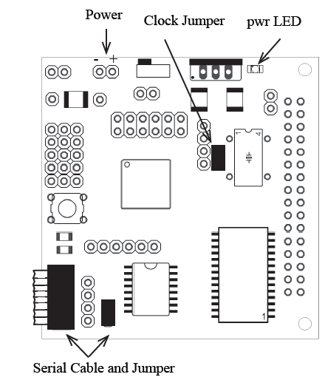
Figure 5.8.1 CMUcam2+ CMOS Sensor Board
(Reprinted with permission from CMUcam2 User Manual)
After these settings were made the terminal emulator showed the phrase CMUcam2+ v1.0 c6, meaning that it was successfully configured. To ensure that the serial port was configured correctly and that both send and receive were operating correctly, we had to start the software and type “gv” which gave us a confirmation of “ACK CMUcam2+ v1.0 c6.”
Since we knew the serial ports and the main board was operating correctly, we then tested the focus of the lens on the camera. This was the most important test to consider for the CMUcam2+ vision sensor because if the lens was out of focus the AVR would not have been able to see properly and thus would not have been able to function correctly. The method used to focus the lens is outlined in the user manual and involves using the CMUcam2+ GUI software. The first step taken to focus the lens was to view dumped images using the frame dump packets in the CMUcam2+GUI software. Once the CMUcam2+GUI software was running we sent a picture frame to the camera, which intern showed a picture on the computer screen of whatever the vision sensor was “looking” at. From this picture, we were able to determine if the picture was in focus or out of focus in scope of the requirements for our project. If the picture was out of focus we adjusted it by rotating the lens away from the base while continuing to dump frames until the picture reached optimum sharpness.
Once we finished doing these initial tests to ensure the camera was correctly configured and in focus we then tested the servos that we mounted the camera to. The servos are important because the AVR is able to track objects in all directions therefore these had to operate properly. We tested this by wiring the servos and the microprocessor to the camera, and then we took a color object and moved it around the camera in the x, y, and z directions to ensure that the camera was moving with it and was able to see the object. This process was done using the “Demo Mode” featured on the camera. This simply involved plugging the servos into their respective ports on the board, with port 0 being pan and port 1 being tilt and then holding down the power button until the LEDs began blinking. It was important to know that while this was being done the camera should not be pointed towards an object because the flashing LEDs represented the camera adjusting to the light in the room. Once it is determined that the servos were working properly in conjunction with the camera we took the next step of mounting the camera to the base for the AVR. Once fully assembled it was imperative that the device worked without flaws, so we checked the voltage levels using a multi meter to ensure that the board and camera were receiving proper voltage and current. We then needed to have it actually track an object to determine if our code was written tightly enough. This was extremely important because the device is fully autonomous therefore the code had to be as near to perfect as possible. We measured the distance from the object to the AVR in order to make sure it had the proper space between the two. Then we made sure that the camera was able to distinguish a tracked object from an object that should be avoided, involving the software used in the camera, the ultrasonic sensors, and microprocessor.

CMUcam2+ test using CMUcam2+GUI
This would be the first of many CMUcam2+ test. The objective here is to confirm that we actually have a working camera module and the part isn’t defected. Secondary objective would be to see how the camera behaves under different settings and operating environment such as low light, bright light, and no light. A color test will also be conduct to see how accurate the camera can see colors. Lastly, we would want to make assessment on the CMUcam2+’s tracking ability. The initial test will have the camera mounted on a fixed axis. One possible idea is to mount the CMUcam2+ on a servo to test the pan and tilt feature. If this turns out well, we might incorporate this feature into the AVR. Instead of just having the camera mounted on a fixed axis, we will have it pan and tilt to better track its target. This design might lead to many complications such as keep tracking of the camera location in relative to the body for the vehicle. We develop an algorithm that will be able to align the body of the camera and the body for the vehicle together.

CMUcam2+/Arduino interfacing test
After it has been confirm that the CMUcam2+module is working soundly, the next logical step would be integrating it with the Arduino software. This test will involve linking up the CMUcam2+ and the Arduino together using the UART interface. The two pieces of hardware would talk directly to each other. Using the Arduino software development tool and its serial monitor feature we will be able to see the message coming back and forward between the CMUcam2+ and the Arduino board. We will repeat the color tracking test here as we will do on the CMUcam2+GUI but this time the result won’t be displayed visually. The result would be in a form of a string of data that has information about the tracked target. This test would be useful for testing the sensors manager function.

Budgeting and Financing

Balance Sheet
In order to stay ahead of schedule, we decided to start ordering parts around the last month of the first semester of Senior Design 1. This gave us a good amount of time to test the parts and make sure that they functioned properly. Having the parts early we were able to avoid unnecessary delays such as parts being out of stock or temporarily unavailable. Also, having the parts early greatly improved our design decisions and analysis. All parts were ordered off various robotic hobby websites. Part numbers and total cost were recorded for the purpose of balancing our budget. Below is a table of all the parts we acquired for the final make up of the AVR.
Part Number | Part Name | Qty | Expected Cost | Real  Cost | Development  Cost
N/A | Basic Breadboard | 1 | $11.95 | $11.95 | $11.95
LV-EZ2 | Ultrasonic Range Finder Maxbotix LV-EZ2 | 1 | $27.95 | $27.95 | $27.95
N/A | Arduino Starter Kit | 1 | $49.95 | $49.95 | $49.95
SN754410 | H-Bridge | 3 | $12.00 | --- | $12.00
R245-CMUCAM2+-Plus | CMUcam2+ | 1 | $169.00 | $169.00 | $169.00
FT232R | USB to Serial kit | 2 | $29.00 | $29.00 | $58.00
n/a | Battery/charger | 2 | $55.45 | $55.45 | $55.45
HS-311 | RC servo | 2 | $25 | $25 | $25
ROB-09107 | H-Bridge | 1 | $39.95 | $39.95 | $39.95
n/a | Chassis | 1 | $109.00 | $109.00 | $109.00
LM 7805 | Voltage Regulator | 6 | $10.00 | $10.00 | $10.00
n/a | PCB | 2 | $100.00 | $0.00 | $100.00
n/a | Miscellaneous | 17 | $25.00 | $25.00 | $25.00
Total Cost | --- | 40 | $664.25 | $552.25 | $693.25

Figure 6.1.1 Table of Expenses

Financing
Due to the fun nature of our project, finding someone who would sponsor us was a difficult task. Therefore the whole group went into this project knowing that we would have to finance with our own money. After a meeting with Dr. Richie, we estimated our total cost to be somewhere around $500. That included everything we should, need from parts to equipments and software cost. The software portion was free of cost since we used open sourced software and the university’s computer labs. The most expensive part was the CMUcam2+ costing around $170. This camera is one of the main components which was critical to the successes of our vehicle. Being a group of 3 members, naturally the total cost was equally divided by 3. All members agreed to help finance the project out of their own pockets. In the end, our total budget once the AVR was completely built only exceeded our initial expectations by about $50 or so.

Sponsorship
As mentioned in the financing section, finding a sponsor for this project was a difficult task. But we did manage to find a sponsor that gave us a $100 store credit to manufacture printed circuit boards. This $100 helped reduce our initial cost estimate by a great factor. The nice people from Sunstone Circuit were generous enough to award us with this $100 store credit. In return we used their PCB123 software and also helped spread the word of their great services for all your PCB needs. We also promised to keep in touch with our Sunstone Circuit point of contact throughout the whole project and keep them informed of our progress. There also was an opportunity for them to showcase our success story on their website. Sunstone Circuit was our sole financial sponsor for this project.

Suppliers
Robotic is becoming increasingly popular so there are many suppliers that carry the parts we need. After researching around the Internet, we found SparkFun and Acroname. SparkFun is not only an online supplier, they also have a great website with tutorials and guides on topics related to electronics and robotic. SparkFun also have a great community based support system that enables customers to share information. As for the selections of part they carry, we found exactly what we need from them. The major purchase from SparkFun is our Arduino kit. At first we were planning on only buying the standalone Arduino USB board but after discussing with group members, we felt the need to buy an actual starter kit. The kit comes with the Arduino USB board and some factors electronics that helps us with our analysis including sample resistors, a few sensors, a mini breadboard and some wires to connect other parts with the Arduino board. Acroname is the other supplier we decided to do business with. The main reason we choose Acroname is because of the fact that they carry the CMUcam2+. There are a good number of suppliers that carry CMUcam2+ but Acroname is one of the few suppliers that carry the plus version of CMUcam2+. The advantage of having CMUcam2+ is that it comes in smaller packaging and it’s easier to interface with microcontrollers. CMUcam2+ was designed for the sole purpose of working together with another microprocessor.
These two suppliers seem to be very professional and helpful. Orders are processed and shipped out within the same day. All the parts we ordered are packaged well and came in perfect condition.

Conclusion/Final thoughts

Diante
In Senior Design 1 our main task was to develop an ideal for a worthy project that would encompass concepts of both hardware and software as it relates to electrical engineering. It was also important that the chosen idea would involve all aspects of the engineering classes taken in our last two years here at UCF. It is from these basic requirements that the AVR was born, a device that satisfies different categories of the electrical engineering discipline. Our concept went through many design stages in the first semester all of which were outlined in this very document. Once completed with Senior Design 1 and all the necessary documentation, the anticipation of building the AVR began to run high heading into the fall semester. Senior Design two proved to be an immensely time consuming but gratifying experience. Through all the testing and long hours in the lab to the jubilation of seeing the AVR work as desired during the final presentation, I was able to gain a new appreciation of all that goes into the design and construction of everyday products that we use. Now that Senior Design 2 is complete as I look back on the entire process of the two classes I feel that the experiences I had in each phase of each class will help me become a successful engineer upon graduation.

Liem
With the document coming close to being finish, I think we have made tremendous progress since the beginning of this semester and the page count really does measure how much we’ve learned within this short amount of time. We came into this class without a clear goal of what exactly that we wanted to design but all of that is very clear now. Our knowledge about robotics has grown a great deal. It is safe to say that we are very confident going into Senior Design II with great hope of completing this project on time. As of right now, we are well ahead on our schedule for Senior Design II. Most of the hardware has already been ordered and/or tested. We know exactly how to integrate everything together and what issues we must face ahead of us. Not only that our engineering knowledge has expanded, we have also learned to work well in a group and make compromises to keep the team function well. Everyone is well focused on the end result and ultimately we want to finish this project in a timely manner to graduate. I think that is the number one motivation for all of us.

Sean
Coming into senior design I was excited about the challenges the course was going to present to me. During my whole college career none of my knowledge that I have gained through the years has been put to real world use. This class provided me with the opportunity to test what I have learned. To be honest, the project that we are creating scares me a little because a lot of things we are trying to accomplish I have never done before. The most daunting task is interfacing the CMU camera with the microcontroller to control the steering of the AVR. This major step in the construction process has me the most worried. Interfacing the sensors, camera, servos, and motor together is really going to test my knowledge of electrical engineering I believe that if you don’t enjoy what you’re doing, especially in engineering, you will not succeed and failure will ultimately come. Even though I have the basic knowledge to create a project like this; a tremendous amount of research and testing to going to have to be done to reach the final goal. This is going to be my first taste of seeing a project through from beginning ideas to a working product. I am excited about creating the rover and cannot wait to see it up and running.

Appendicies

Permissions
Subject | RE: Permission to Use Picture in School Document
From | Stockman, Patti (HQ-JF000)
To | Diante Reid
Sent | Monday, August 03, 2009 7:58 PM

Excellent! Best wishes.

Patti
Ofc: 202-358-4787
Fax: 202-358-3063
From: Diante Reid [mailto:diante.reid@gmail.com]
Sent: Monday, August 03, 2009 7:58 PM
To: Stockman, Patti (HQ-JF000)
Subject: Re: Permission to Use Picture in School Document

Thank you very much for your response. Your information was incredibly helpful and I will be using these links to aid in my documenting process.
On Mon, Aug 3, 2009 at 7:45 PM, Stockman, Patti (HQ-JF000) <patti.stockman@nasa.gov> wrote:
Diante,
No FOIA request is required for this purpose. We at NASA are always pleased when members of the public (or other governmental units) are interested in using the products of our work. Check the links below and I think you’ll find there are very few restrictions on our imagery.

Have a look a the outline of NASA reproduction guidelines for use of images and emblems located on the Web at: http://www.nasa.gov/multimedia/imagegallery/reproduction_guidelines.html or http://www.nasa.gov/audience/formedia/features/MP_Photo_Guidelines.html

An outline of NASA copyright guidelines is located on the Web at:
http://science.ksc.nasa.gov/gallery/copyright.html

Responding to questions of this nature are not really a part of my job. I just happened to know where to direct you with respect to this question. However, for further clarification or other NASA questions, please send your inquiry to public-inquiries@hq.nasa.gov. Those folks specialize in getting answers to those outside NASA.

Thank you and best wishes to you and your team on your design document.

Patti Stockman
NASA Records Officer
Office of the CIO
Phone: 202-358-4787
Fax: 202-358-3063
From: Diante Reid [mailto:diante.reid@gmail.com]
Sent: Monday, August 03, 2009 7:42 PM
To: foia@hq.nasa.gov; Stockman, Patti (HQ-JF000)
Subject: Permission to Use Picture in School Document

Hello,

I am a senior at the University of Central Florida and I am currently a part of a three person group working on a robot design for our Senior Design class. We would like permission to include two pictures of the MARS Rover found on your website as a part of our final design document. Proper citation for the source of the pictures will be given in our bibliography. If you have any further questions please feel free to ask. Your response is greatly appreciated.
Thank You,

Diante Reid

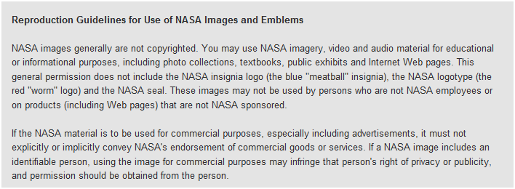
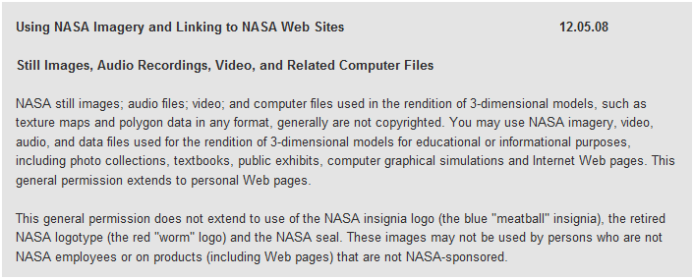
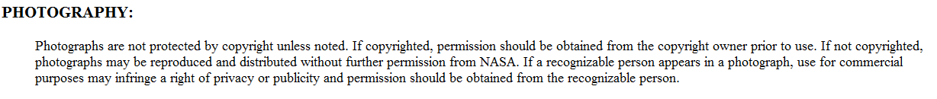

Subject | Permission to Use Picture in Document
From | Diante Reid
To | sales@acroname.com
Sent | Monday, August 03, 2009 7:32 PM

Hello,

I am a senior at the University of Central Florida and I am currently a part of a three person group working on a robot design for our Senior Design class. We would like permission to include two pictures of the CMUcam2+ found on your website as a part of our final design document. Proper citation for the source of the pictures will be given in our bibliography. If you have any further questions please feel free to ask. Your response is greatly appreciated.
Thank You,

Diante Reid

Subject | Re: Permission to Use Picture in School Document
From | Acroname Support
To | Diante Reid
Sent | Thursday, August 06, 2009 3:57 PM

Diante,
Thanks for your message and request. You are welcome to use these provided you have a link (www.acroname.com) at each picture and the images are properly sourced. Good luck with the rest of your design project!
On Aug 6, 2009, at 12:44 PM, Diante Reid wrote:
Hello,
I am a senior at the University of Central Florida and I am currently a part of a three person group working on a robot design for our Senior Design class. We would like permission to include two pictures of the CMUcam2+ found on your website as a part of our final design document. Proper citation for the source of the pictures will be given in our bibliography. If you have any further questions please feel free to ask. Your response is greatly appreciated.

Thank You,

Diante Reid
Acroname Support
support@acroname.com

Subject | Acroname photo
From | tim
To | diante.reid@gmail.com
Sent | Thursday, August 06, 2009 3:58 PM

You can certainly use the photos as long as Acroname is credited as the source.

Thank you,

Tim
Shipping, Sales and the guy who took the photo

Acroname Inc wrote:
>
>
> Begin forwarded message:
>
>> *From: *Diante Reid <diante.reid@gmail.com
>> <mailto:diante.reid@gmail.com>>
>> *Date: *August 6, 2009 1:44:44 PM MDT
>> *To: *info@acroname.com <mailto:info@acroname.com>,
>> support@acroname.com <mailto:support@acroname.com>
>> *Subject: **Permission to Use Picture in School Document*
>>
>> Hello,
>>
>>
>>
>> I am a senior at the University of Central Florida and I am currently
>> a part of a three person group working on a robot design for our
>> Senior Design class. We would like permission to include two pictures
>> of the CMUcam2+ found on your website as a part of our final design
>> document. Proper citation for the source of the pictures will be
>> given in our bibliography. If you have any further questions please
>> feel free to ask. Your response is greatly appreciated.
>>
>> Thank You,
>>
>>
>> Diante Reid
>

Hello Sean Day! Yes, you have our permission to use our photos for your report with the appropriate photo credits. Please pass our permission along to any of your fellow students who may have the same question.

Thanks, and good luck with your report!
AnnDrea Boe

__
Director of Marketing Communications
SparkFun Electronics
6175 Longbow Drive, Suite 200
Boulder, CO 80301
--
Spark Fun Electronics Technical Support
6175 Longbow Drive Suite 200
Boulder, CO 80301
techsupport@sparkfun.com
1-303-284-0979

From: <sday72@tampabay.rr.com>
To: techsupport@sparkfun.com
Subject: Permission to use online pictures
Hello my name is Sean Day and I am a senior at the University of Central Florida. I am currently working on a senior design report that requires me to design an autonomous robot. I am requesting use of the pictures that were on the sparkfun website. I am currently purchasing products from the sparkfun website and want to include the pictures in my report strictly for demonstative purposes. Credit will be given to the website. If you can get back to me as soon as possible it would much appreciated. Thank you
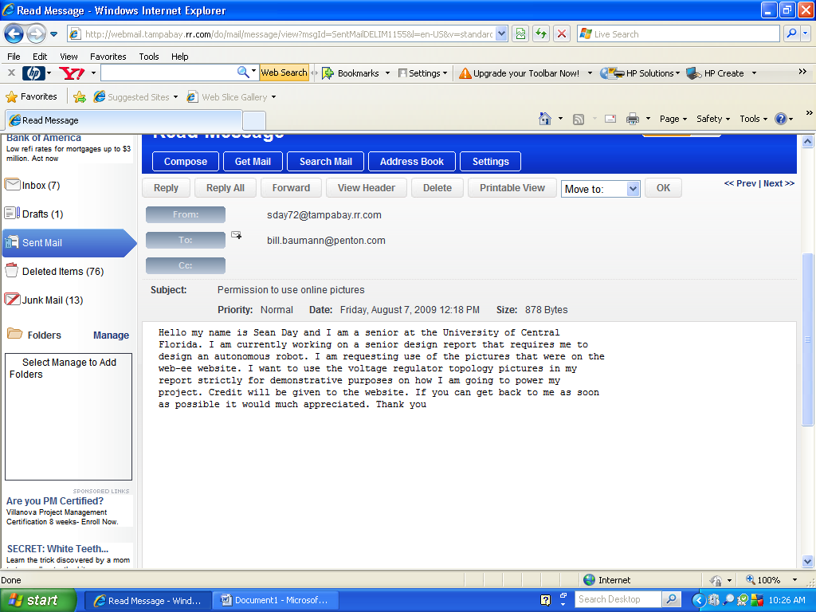
Permission granted! For research and reports you generally can use
anything since you're non-commercial, just so you know for the future,

best,
Illah Nourbakhsh

On Sat, August 8, 2009 10:39 am, sday72@tampabay.rr.com wrote:
> Hello my name is Sean Day and I am currently a senior at the University
> of Central Florida. I am currently building a motion tracking robot and
> using the CMU cam 2. I am requesting to use pictures out of the CMU
> camera's user manual to help me explain how I am going to use and
> interface your camera in my final report. Credit will be given of course.
> Thank you for your time
> Please use the photos.
Thanks for the support!
On Sat, Aug 8, 2009 at 9:35 AM, <sday72@tampabay.rr.com> wrote:
Hello my name is Sean Day I am currently a senior at the Uiversity of Central Florida. I am requesting to use a picture of maxbotic's to help me explain how to use and interface an EZ-1 ultrasonic sensor. Most imporatantly the bream width explanation. It will be used stricley for demonstrative purposes. Credit wil be given to the website of course. Thank you for your time.
--
Regards,
Bob Gross
CEO of MaxBotix Inc.
Web: www.maxbotix.com
Email: bob@maxbotix.com
MaxBotix, MaxSonar,EZ0, EZ1, EZ2, EZ3 and EZ4
are trademarks of MaxBotix Inc. This e-mail, and any
attachments thereto, is intended only for the use of
the addressee(s) named herein and may contain legally
privileged and/or confidential information. If you are
not the intended recipient of this e-mail, you are hereby
notified that any dissemination, distribution or copying
of this e-mail or content, and any attachments thereto,
is strictly prohibited.
If you have received this e-mail in error, please notify me
via return e-mail and permanently delete the original and
any copy of any e-mail and any printout thereof.

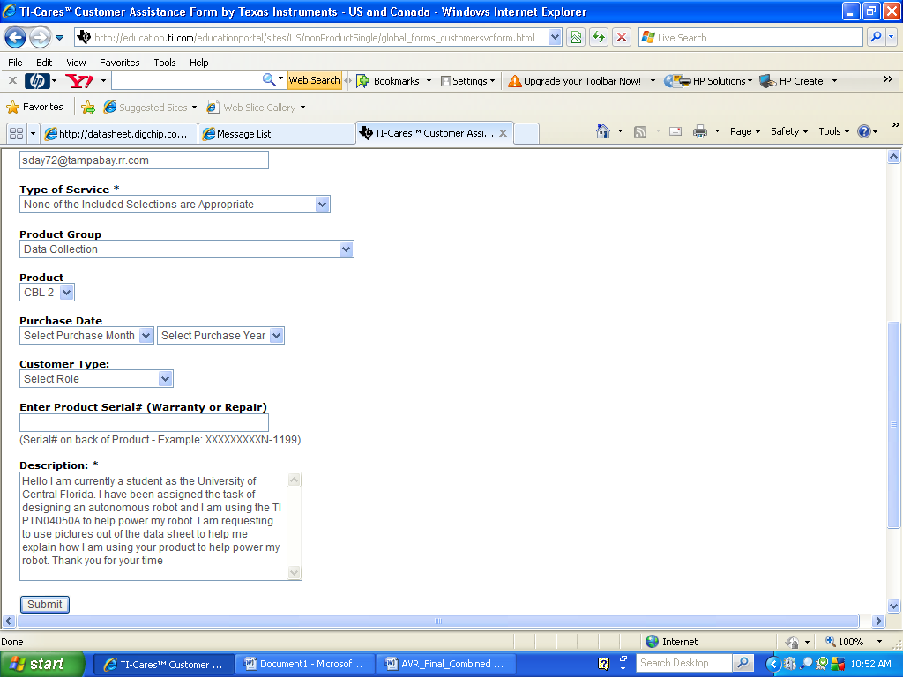
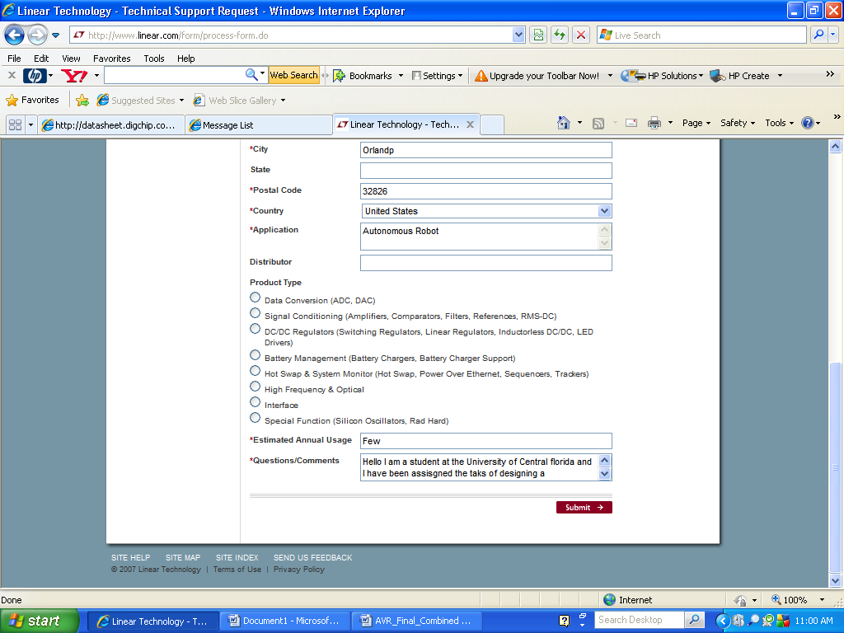
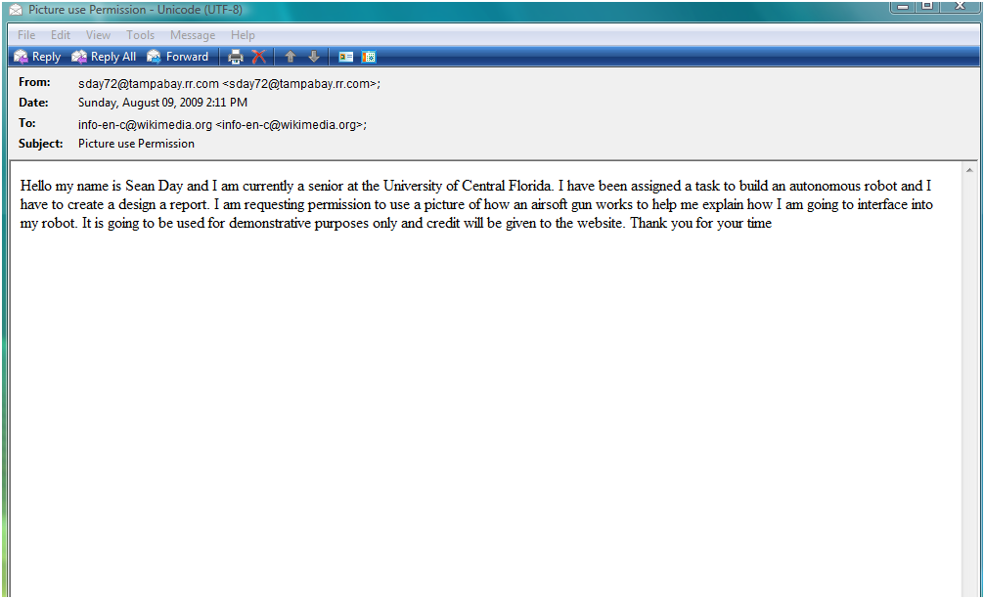

Bibliography
(2006, January). Retrieved June 19, 2009, from Maxbotics: http://www.maxbotix.com/
(2006, July). Retrieved June 27, 2009, from Wikipedia: http://en.wikipedia.org/wiki/Voltage_regulator
(2008, June). Retrieved June 18, 2009, from Wikipedia: http://en.wikipedia.org/wiki/Airsoft_gun
(2009, June 29). Retrieved June 29, 2009, from Hobby Engineering: www.hobbyengineering.com
(2009, July). Retrieved July 18, 2009, from Linear: http://www.linear.com
(2009, July 6). Retrieved July 6, 2009, from Sparkfun: www.sparkfun.com
Arduino. (n.d.). Retrieved 6 20, 2009, from http://www.arduino.cc/
Arduino Based Opitcal Tachometer. (n.d.). Retrieved 7 12, 2009, from http://www.instructables.com/id/Arduino-Based-Optical-Tachometer/
Arduino Serial Servo Control. (n.d.). Retrieved 6 7, 2009, from http://principialabs.com/arduino-serial-servo-control/
Charles L. Phillips, R. D. (1999). Feedback Control Systems. Prentice Hall.
DIY Drones. (n.d.). Retrieved 6 28, 2009, from http://diydrones.ning.com/
Freeduino. (n.d.). Retrieved 6 1, 2009, from http://www.freeduino.org/
Green, B. (2002). Canny Edge Detection Tutorial. Retrieved August 6, 2009, from Drexel Autonomous Systems Lab: http://www.pages.drexel.edu/~weg22/can_tut.html
Infrared Vs Ultrasonic. (2008, January 27). Retrieved July 14, 2009, from Society of Robots: http://www.societyofrobots.com/member_tutorials/node/71
Logitech - QuickCam Orbit AF Webcam . (n.d.). Retrieved August 6, 2009, from Webcams Product Info: http://www.bestbuy.com/site/olspage.jsp?skuId=8472468&type=product&id=1185265539488&IcsCsid=39-424-5-24256-0-24530-1446-0-1
(May, 2006). Retrieved June 24, 2009, from SolarBotics: http://www.solarbotics.com/
Orlando, J. R. (2004 ). Projects: AVRcam. Retrieved August 6, 2009, from JROBOT Building Robots instead of sleeping: http://www.jrobot.net/Projects/AVRcam.html
PCB123. (n.d.). Retrieved 6 28, 2009, from http://pcb123.com/
Peacock, C. (2005, June 15). CMOS Digital Image Sensors. Retrieved August 6, 2009, from Beyond Logic: http://www.beyondlogic.org/imaging/camera.htm
Power Regulation. (2009, July 27). Retrieved July 27, 2009, from web-ee: www.web-ee.com
PROGRAMMING - COMPUTER VISION TUTORIAL Part 2: Computer Image Processing. (n.d.). Retrieved August 6, 2009, from SOCIETY OF ROBOTS: http://www.societyofrobots.com/programming_computer_vision_tutorial_pt2.shtml
PROGRAMMING - COMPUTER VISION TUTORIAL Part 3: Computer Vision Algorithms. (n.d.). Retrieved August 6, 2009, from SOCIETY OF ROBOTS: http://www.societyofrobots.com/programming_computer_vision_tutorial_pt3.shtml
Robert Fisher, S. P. (2003). Canny Edge Detector. Retrieved August 6, 2009, from HYPERMEDIA IMAGE PROCESSING REFERENCE : http://homepages.inf.ed.ac.uk/rbf/HIPR2/canny.htm
Rotary Encoders. (n.d.). Retrieved 7 15, 2009, from http://www.arduino.cc/playground/Main/RotaryEncoders
Society of Robots. (n.d.). Retrieved 5 16, 2009, from http://www.societyofrobots.com/
University, A. R. (n.d.). CMUcam2 GUI Overview v1.0 for the CMUcam2 GUI v1.0.1. Retrieved August 6, 2009, from http://www.cs.cmu.edu/~cmucam/cmucam2/CMUcam2GUI_overview.pdf
University, A. R. (2003). CMUcam2 Manual v1.06 for the CMUcam2 v1.0 firmware. Retrieved August 6, 2009, from http://www.cs.cmu.edu/~cmucam2/CMUcam2_manual.pdf
University, T. R. (n.d.). The CMUcam1 Vision Sensor. Retrieved August 6, 2009, from CMUcam: http://www.cs.cmu.edu/~cmucam/home.html
University, T. R. (n.d.). The CMUcam2. Retrieved August 6, 2009, from CMUcam2: http://www.cs.cmu.edu/~cmucam2/faq.html
What is the difference between CCD and CMOS image sensors in a digital camera? (2000, April 01). Retrieved August 6, 2009, from How Stuff Works.com: http://electronics.howstuffworks.com/question362.htm
Wiring Programming Language. (n.d.). Retrieved 5 30, 2009, from http://wiring.org.co/

