
University of Central Florida

Smart Home Systems
Senior Design 1

Group 10
Vu Ha
Joel LeGros
Thien Luu
Daniel Moody

Summer Semester 2012
August 3rd, 2012

Table of Contents

1 - Executive Summary…………………………………………………………. 1
2 - Project description…………………………………………………………… 2
2.1 - Motivation…………………………………………………………… 2
2.1.1 - General Motivations……………………………………... 2
2.1.2 - Energy Efficiency………………………………………… 4
2.1.3 - Future Implementation………………………………….. 5
2.2 - Requirements and Specs………………………………………… 7
2.3 - Objectives…………………………………………………………... 9
3 – Research……………………………………………………………………... 10
3.1 - Phone Applications………………………………………………… 10 3.1.1 - Android Application……………………………………… 10
3.1.2 - IPhone Application………………………………………. 11 3.2 - Computer application……………………………………………… 12
3.2.1 - Java Based………………………………………………. 13
3.2.2 - Visual Basic Based……………………………………… 13 3.2.3 - Web Server………………………………………………. 14
3.3 - Voice command……………………………………………………. 15
3.3.1 - CMU Sphinx……………………………………………… 15 3.3.2 - Dragon Mobile…………………………………………… 16 3.4 - Video system……………………………………………………… 17
3.4.1 - OpenCV………………………………………………….. 18
3.4.2 – Cameras…………………………………………………. 19
3.4.2.1 - Logitech Quickcam Pro 9000………………... 19 3.4.2.2 - Logitech HD Webcam C525…………………. 19
3.4.2.3 - Logitech Alert 750n…………………………… 19
3.5 - Embedded Internet Server……………………………………….. 22
3.5.1 - Atmega644a…………………………………………….. 22
3.5.2 - The Spinneret……………………………………………. 22
3.6 - PJSIP……………………………………………………………….. 23
3.6.1 - SIP………………………………………………………... 23
3.6.2 - RTP……………………………………………………….. 26 3.6.3 - SDP………………………………………………………. 29
3.6.4 - VoIP………………………………………………………. 29 3.6.5 - SMS………………………………………………………. 30
3.6.6 - NAT Addressing…………………………………………. 31
3.7 - Lighting……………………………………………………………… 31
3.8 - Motion sensing…………………………………………………….. 33
3.8.1 - Basic types of 'motion' sensors………………………... 33
3.8.2 - How PIR Operation works……………………………… 34
3.8.3 - Ultrasonic Sensor Technology…………………………. 35
3.8.4 - Sensors Choosing………………………………………. 36
3.8.5 – Connecting………………………………………………. 37
3.9 - Digital to Analog Converters……………………………………… 38

3.10 – Codecs………………………………………………………........ 38
3.10.1 - Audio……………………………………………………. 38
3.10.2 - Video……………………………………………………. 38
3.11 - Main Circuit Board……………………………………………….. 40
3.11.1 - Microprocessor Considerations………………………. 40
3.11.2 - Printed Circuit Board…………………………………... 42
3.12 - Microcontrollers…………………………………………………… 43
3.13 - Home Security……………………………………………………. 45
3.13.1 - Integrating into home automation…………………….. 46
3.13.2 - The parts for home security…………………………… 48
3.13.2.1 - Wired sensors………………………………… 48
3.13.2.2 - Wireless sensors…………………………….. 50
3.13.2.3 - Passive Infrared Receiver (PIR)………….... 53
3.13.3 - RFID……………………………………………………... 55
3.13.3.1 - Security Concern…………………………….. 57
3.13.3.2 - Alternatives ………………………………….. 57
3.13.3.3 - Trade-offs ……………………………………. 58
3.13.3.4 - RFID access vs. Key access……………….. 58
3.14 - Communication Standards………………………………………. 58
3.14.1 - ZigBee…………………………………………………… 59
3.14.2 - Z-Wave………………………………………………….. 60
3.14.3 - X10………………………………………………………. 61
3.14.4 - INSTEON………………………………………………... 61
3.14.5 - Bluetooth………………………………………………… 62
3.14.6 - WiFi……………………………………………………… 62
3.14.7 - Communication summary……………………………... 66
3.15 - Air Sensors……………………………………………………….. 67
3.16 - Flood Sensors…………………………………………………….. 72
3.17 - AC thermostat…………………………………………………….. 72
3.18 - Back-up Power…………………………………………………… 75
3.18.1 - Backup Power Supply: Solar Power ………………… 83
3.19 - P2P………………………………………………………………… 83
4 - Design Summary……………………………………………………………... 84
4.1 - Software…………………………………………………………….. 84
4.1.1 - Class Diagrams………………………………………….. 87 4.1.2 - Flow Diagrams…………………………………………… 88
4.1.3 - Audio Software…………………………………………… 92
4.1.4 - Audio Flow Diagrams……………………………………. 94
4.2 – Hardware…………………………………………………………… 96
4.2.1 - Architectures……………………………………………… 96
4.2.2 - RFID………………………………………………………. 98
4.2.3 - Power Supply…………………………………………….. 100
4.2.4 - Main MCU and Processor………………………………..100
4.2.5 - JTAG connections……………………………………….. 108
4.3 - Parts List……………………………………………………………. 109

5 - Prototype Construction/Testing…………………………………………….. 110
5.1 - Parts Acquisition…………………………………………………… 110
5.2 - Hardware Implementation………………………………………… 110
5.3 - Software Implementation…………………………………………. 111
5.4 - Physical Prototype Build…………………………………………... 111
6 – Testing………………………………………………………………………… 113
6.1 - Sensors and Microcontroller Testing…………………………….. 113
6.2 - System Tests………………………………………………………...115
6.3 - Hardware Tests……………………………………………………...116
6.4 - Software Tests……………………………………………………… 117
7 - Project Actualization and Implementation…………………………………118
7.1 - Android Layout………………………………………………………120
7.2 - Spinneret Web Server………………………………………………121
7.3 - Xbee Control…………………………………………………...........123
7.4 – PCB Design…………………………………………………………125
8 – Project Management ………………………………………………………...126
8.1 – Budget and Financing…………………….……………………….126
8.2 – Milestone chart……………...………………………………………128
8.3 – Work Distribution……………………………………………….......128
9 – Final Summary
9.1 – Conclusion……………………………………………………….....129
9.2 – Final Summary……………………………………………………...129

10 – Appendix
Appendix A - Schematics
Appendix B - Permissions
Appendix C - Tables, Figures Index and Sources

1 - Executive Summary

This project is the culmination of the UCF engineering experience. One of the major goals in this project was to apply the education that’s been received here at UCF to the project. The group spans both Electrical and Computer Engineering areas of study here at UCF, so the goal was to employ areas of both of those disciplines into the project. This project has given us the opportunity to design schematics, work on printed circuit boards, use microcontrollers, wireless communication, and all the while integrating it with an original piece of software. Our approach for the home automation is based around comfort and intuitive customization for the end user. This project’s main way of doing that is by integration of the smart phone for ease and familiarity to interface the whole design. We chose this because these days, the majority of the people in the world own a smart phone. This makes the product not only very marketable, but also very convenient. Even in your own home, you are likely to have your phone with you at all times. Even if not directly on your person, it’s probably not very far. Maybe even in the next room. Our goal is to make the phone into the tv remote of your home. Another motivation is to help with environmental impact and energy efficiency potential for the smart home. Wasted energy can be prevented through a smart home system with the automation of lighting, and power. By using low powered embedded devices in the project, this helps keep energy consumption down for the house. Texas Instruments is the main contributor to that for our main microcontroller and processor. We chose a Texas instruments microcontroller with an ARM 9 processor to give us the power we needed, but also while remaining efficient on power consumption. One of the main motivations for the project was to send audio throughout the house wirelessly. This was a difficult feat, so we knew we needed help to figure this out. We found the help in a company in Orlando called Alcorn McBride. The company has years of experience and were a big help in guiding our beginning stages to figuring out how to do this. The first step to doing wireless audio was to find a protocol stack. Through a little bit of digging we found a free open-source multimedia communication library called PJSIP. This library employed two important protocols for our project. The two protocols, RTP and SIP, allow the audio to be transmitted wirelessly from the phone to our Texas Instruments microcontroller. This requires that the user’s phone and the microcontroller be connected to the Internet. The phone will gain access to a server to control functions of the microcontroller. This will allow the user to gain access to functions when not in the home as well. The ability of this communication will allow the user to be specific to what room in the house they are sending audio to as well as the house as a whole. Volume control and room selection will be directly controlled from an app via your mobile device and the central micro controller. An intercom will also be featured in this project. Using the intercom starts with the integration of your mobile device over wifi. The mobile device will use the PJSIP protocol stack to help the phone and embedded device talk over wifi. Sensors will detect what room you are in of the house so that the nearest speakers will dim in volume to avoid feedback looping into the microphone of your mobile device. Video will also be used to have surveillance of the front entrance to the house. Integrating the audio with this allows the user to communicate to that guest if they are unable to come to the door. Lights will also be controlled from the phone in the central app of the project. The ability to turn them on and off to any specific room will be available. There will also be an “all off” feature as well. This will be helpful for turning all lights off in the house when leaving for vacation or if no one will be home. The presentation for the project will be demonstrated through a scaled down version of the house. There will be two rooms. One will be acting as the living room, and one will be acting as the front door. We will also record a video presentation for later viewing upon the groups senior design website. This will go into detail on how the scalability of the project will work. As stated before, Alcorn McBride has been helpful in giving mentorship to the group. They are also helping us retain evaluation boards for our project so that we can make sure things are working ahead of time while we finish the design of our printed circuit board layout. Lastly, Dr. Richie is leading the senior design class and giving us guidance on our work as an additional resource.

2 - Project Description

2.1 - Motivations

2.1.1 - General Motivations

The motivation for developing smart home systems comes from many reasons, but most prominent are convenience, security, energy management, connectivity and luxury. Smart Home systems are one of the newer areas of research that have not been fully integrated into our society. This is because the research requires many other disciplines of research and engineering to produce a functional smart home. The cost of installing a smart home is also a large hindrance to the emergence of smart home systems into the market. The extra cost of the install is from the fact that even though a majority of homes were built in the near past, technology has been growing exponentially. This means that most homes were built before this technology was available, and this creates a barrier for the development and sales of smart home systems. However the technology is becoming better and cheaper, and this will help to make smart home systems an expense worth having when new homes are being built.

The biggest motivation behind smart home systems is the convenience. Convenience is really another way of saying “time saver”, and into day’s world where everything is moving faster, every second has value. Most of the technology we use today is based of convenience, for example cars get us where we need to go faster, phones get us information from other people faster, and computer’s get work done faster. Smaller conveniences in the home will be desirable because they allow the home to save the user time as well. There are already many convenient technologies in the home like the dishwasher, washing machine, and microwave ovens. These technologies are more mechanical in nature and often there are much less computerized conveniences in the home. A Smart home systems goal is to introduce the benefits of computerized technology. For example, when using the smart home system, the user will not need to walk around turning off lights, they can save that little bit of extra time by just pressing a button on their phone, or even have the lights programmed to shut off after a certain amount of time. Maybe there is some music on the user’s computer they would like to play on a sound system, smart home systems will allow the user to play the music from where ever they are without needing to go to their computer, find the song, and make sure the song is in a playable format for their sound system. There are many other small conveniences provided from the smart home.

Security is also a big factor in the emergence of smart home systems. With a sophisticated enough system, home security becomes a powerful tool that gives piece of mind and power to the user. Security systems are also a large deterrent for crime. The mere presence of a camera will put doubt in any criminals mind about committing a crime. There are already many security systems on the market available and in use today, however integrating the security system into the smart home gives the user a one stop access to everything in their home. If the smart home system integrates the smart phone into the system then this means that the user will always know the status of the security of their home.

Energy management has become a huge factor in deciding anything, due to the trend of increasing cost of energy. As civilization grows, it constantly needs more energy to power itself. This leads to heavy pressure on efficient use of energy. Smart Home systems help the user do this and save them money at the same time. The smart home system is able to monitor certain process that use energy in the house and can control the amount of energy being used. A primary example would be with lights. Lights are often left on when they don’t need to be. A smart home system can be set to turn that light off after a certain amount of time. Maybe the user doesn’t like that feature because lights will turn off randomly when they are watching TV or lying in bed. The smart home system allows the user control from his phone so it can be turned off, or set to turn off. This is also the case with many items that use electric power. Giving the user the control to turn things off like the AC, water heater, and TVs or computers allows the user to be more conscious of the energy use and control it accordingly.

Another reason for motivation on selecting this product is connectivity. The idea of connectivity is that having things connected results in communication or the transfer of information. By connecting everything in the home, so that everything can talk to each other, information about the home is easily attained. There are many benefits to increasing the amount of information available. Research and analysis are one of the main benefits because data extraction is much easier when things are connected into a single network. For example connectivity will lead to data extraction possibilities like how much power certain appliances or components are using. Connectivity also increases control over assets. By having the data to make informed decisions the control of the home is increased.

Luxury is also a factor in the smart home systems that are currently in use. Because of the high cost of smart home system, only those that can afford it will be able to use a smart home system. The high cost causes other reasons to be less prominent when deciding the motivations for a smart home. However luxury is not as concerned with cost and will not lose its value as significantly due to high cost.

Year | KwH Usage | Global Rank
2004 | 3,920,613,000,000 | #1
2003 | 3,854,767,000,000 | #1
2002 | 3,785,096,000,000 | #1
2001 | 3,717,663,000,000 | #1
2000 | 3,857,277,000,000 | #1
1999 | 3,706,014,000,000 | #1
1998 | 3,632,496,000,000 | #1
1997 | 3,510,984,000,000 | #1
1996 | 3,460,615,000,000 | #1
1995 | 3,370,975,000,000 | #1

Figure 1: Electric power consumption in KwH in US (1)

2.1.2 - Energy Efficiency

There are so many ways of bad habits of using electricity such as running space heaters under desks while air conditioning is on because buildings are over cooled, propping doors or windows open in retail stores or office buildings to mitigate over-cooling or to draw in shoppers, running heating and cooling systems at the same time due to improperly maintained, keeping lights on all day even though sunlight could be used, utilizing all of the lighting in a space when task-specific lighting would easily cover the area, leaving lighting, heating or cooling systems on during the night at levels that would be appropriate only for daytime occupancy when more people present, keeping computers, printers and computers on all night or over the weekend when they are not being used. Therefore, group feels the need to do something to change these habits. This smart home project comes up. People tend to waste electricity more and more over the years. As of 2010, about 4.5 trillion kWh electric powers consume by US nation. According to nationmaster.com United States is ranked number one of country uses most electricity in the world.

According to U.S. Energy Information Administration, American spends an average of $2,024 dollars per household per year to power the applications. If customers could invest this smart home system as little as possible upfront to lower the electricity bill later, it would be a great deal. This saving over the years will be more beneficial, especially in this economic situation. Consumers may all aware about the term “vampire power” as they plug in their widgets to the outlets and let the devices drawing the electricity in widgets’ standby mode without being actually turning on. The smart home project will help customers avoid this leaking power and save them the money.

2.1.3 - Future Implementation

There are many possible future implementations for the project, with adding extra features for the user, improves efficiency and better ways to interface the system, to its individual components and to the user. Some of these future implementations include heightened security features, “smarter” control for high smart devices, phone applications, audio/video features, touch screen control, wireless access, voice recognition, easier navigation on screen display, and simpler user installation.

One option for expanding on what is already there is to add the ability to record the information coming in from the microphone, voice recognition, and then proceed the voice for other purpose in other to help increase security for the user especially in the present day, home security is always needed no matter where home owner are. For some, a simple sound alarm system is sufficient. For others, they are not happy until their house is safer and more secured than the oval office. The system provides security for both those interested in a simple security setup, and those who looking for more than that can have better security measures. Through the use of video surveillance, the customers will be able to see who is at their front door, as well as be alerted if someone is standing out in front of the door. The system can alert the home owner via the touchpad, smart phones, in home alert system, email when someone is inside the home. The users can configure the system, whether they wish to set it to be armed in an away mode (highest secure mode), or a normal mode, or a low security mode. In addition to sending alerts to the user via the setup devices, the system can also be configured to alert the user via text message if the user would like.

The user can configure the system to alert 9-1-1 when the system is away mode and an intrusion get into the house, and he has been encountered. Whatever the user would like is up to them. On top of all this, the users can view status of their household, a log of comings and goings, and a live feed of the camera at the front door. This will be done by streaming the video over the internet using Wifi technology. With all of these features at the user’s disposal, the group feels like more than adequate security is being provided to those using the system. Additionally, video cameras could be mounted on the wall in all of the rooms in the house and outside to add to the security side of the system. However, users can also shut the camera off easily when they need privacy. The server would then have to be upgraded to allow mass storage and streaming of the audio and video.

Infrared motion sensor on adjacent wall would gain the chances of detecting subjects. Light sensors could be added to monitor the light intensity throughout the day and adjust the lights in the room accordingly. A sensor could watch for when the sun is shining through a window and close the blinds when it is. This would lower the incoming heat and thus would lower the power cost of the air conditioner. With more money, the group can always add more modules to give users more feature sets. The sensors are what drives the system, so with more sensors, more input can be received.

The more input the system can receive to track what is going on in the household, the more the design can allow the system to adjust to the current condition of the household and react to these changes. When outside lights being used are reaching the point where it equates to the same amount of light being generated by the electric lights, why not ensure these lights are not being used when they are not needed? The system should take advantage of the natural energies the earth provides. The system should react to outside temperatures, using the cooler air from the outside to cool the household when the weather is cooler rather than relying on the AC when it is not needed. The smart home system become smartest when these inputs automatically configure, adopt, and function seamlessly with both the user and nature, thus benefit the user. Furthermore, it can use all natural resources around the house in the most efficient way.

Another addition that could be made is a graphics based user interface panel in the house. As of now the only way to change the settings or monitor the system is via the internet; even though that meets all of a user’s needs, it would still be useful and handy to be able to access it without a computer. Along this line, the next thing to be added would be a smart phone application. Everything seems to be moving in the direction of mobile devices, so it is only logical that this project would as well. The user interface is a key portion of the project, developing more improved user interfaces that cater more to the user is a natural improvement of the prototype. The user should be able to customize the system to allow the system to adapt to the user, rather than forcing the user to adapt to the system.

One main context of the project is the use of a smart home to allow improved home security through modern technologies. The current feature sets include an automated lock, a security camera to monitor the entrance, and a log of when someone has entered and exited the household, what time, and if anyone is currently present in the household or isn’t. Security features for the project will be prototyped with a lot of nice to have features left off. Implementing surveillance cameras around the residence in different strategic places around the outside of the home is a big piece of the surveillance. With these cameras, they can be automated to alert the user when someone is detected in an area, and notify the user via text message or anyway else. All the cameras can be set to only activate upon another sensor being tripped in order to keep cameras in a “sleep mode” in order to conserve energy and keep the cameras from eating up extraneous amounts of power to observe nothing of value. Another security feature to implement with these cameras is to be able to wake them up and view them from a central control location as well as the touchpad controller. The group would like to make these features to create an environment that can replace the common alarm system most households have. With creating an away mode, it would even be able to be configured to have the household call 9-1-1 if the away mode is not deactivated within a certain threshold of time when someone enters then house, and alert all household residents via cell phone when someone enters the house; someone is detected around the house, climbing in windows, etc.

One high end feature the group would like to add to the system, given more time and funding, that would be audio/video streaming features. One feature would be to set up an audio system that allows the user to stream different audio/video in different rooms. As a person goes home, the smart home system will automatically recognize who enter the house by each individual key code which was assigned when setup the system, and then it will play his favorite songs/program. This would be a very desirable feature for those with large households who like to hold parties and “get- together” at their household and would like to provide different mood music depending on the room. Another feature would be to allow the users to play music from a portable device, like a phone or an iPod, from the main control center, as well as conventional audio like CD’s and radio. Room to room two way communications is a nice feature that many households have that could be incorporated into the system as well. A difficult but future audio design would be to set up a control system to change the volume level of different devices based on the background noise in the room. This would have an algorithm that would not only adjust the audio so that it would play louder if external noise in the room requires it, but also to recognize when the volume should be turned down because conversation is taking place in the same room as a device with audio and instead of the user having to turn the volume up and down when conversation is taking place, the audio would change seamlessly.

2.2 - Project Requirements and Specs

The following main processor requirements are applied to and carried out through the Texas instruments OLAM-L137 microcontroller
- The main processor shall be able to take in RTP packeting and SIP packing information from a wired and wireless Ethernet connection.
- The main processor must allow control from an smart phone and computer through use of a server
- All processes done on the main microcontroller shall be locked to a clock that will be located on the main board.
- The main processor shall be able to receive input from audio, video, surveillance, and sensors while also be able to send output for audio, video, and surveillance.
- The main processor shall be able to pass through Voice and music over Internet protocol information on an Ethernet jack.
- The main processor shall be able to control audio codecs and peripherals through I2C bus protocols.
- The following requirements apply to the lighting and power portions of the project. Both handle similar design aspects and purposes. The requirements are observed as:
- Lighting controllers must be able to receive a high data (on) or low data (off) signal to determine its status.
- Lighting shall receive these signals from the main processor through a controlled relay.
- The Power controllers shall have the ability to turn on and off power to a television set, home theater receiver, DVR cable service, gaming device, DVD/Blue ray player.
- The following requirements apply to the audio portion of the project. This applies mainly to the codec portion of the main board. These requirements are as follows:
- The main processor codec will need to have the ability to operate at different sample rates during the transmit and receive operations.
- The codec shall output a line level signal that will have a range of -8 dBu to +4 dBu.
- The codec shall output a speaker level signal that will have a range of +10 to +40 dBu at 4-8 ohms.
- The codec shall output a headphone level signal that will have either a low or high impedance range. A low impedance range shall consist of anywhere from 16 to 32 ohms. A high impedance range shall consist of anywhere from 100 to 600 ohms.
- The codec shall take in a microphone level signal anywhere from -60 to -40 dBu.
- The audio codec shall receive control information from an I2C bus.

The following requirements apply to the user interface portion of the project.

- The main processor shall allow control through an IOS and/or android application.
- The user interface for the phone shall have the ability to view out to the camera to the front entrance.
- The user interface for the phone shall have the ability to add new rooms, by giving the user the option to enter IP addresses for the embedded device in that room.
- New devices that are set up in the app will have choice of lighting, video, music, intercom, or security sensor.
- The music section of the app shall be required to gain access to the phone’s music library to select songs for playback.
- The music section shall be required to use transport controls that play, pause, stop, next, and previous the music track that is in its cue.
- The music section shall be required to adjust volume of the music being played.
- The music section shall be required to choose to do room selection for specific rooms around the house as well as all of the rooms at once.
- The intercom section shall be required to talk to the embedded Texas instruments devices located in the rooms around the house.
- The intercom section shall be required to adjust the volume of the communication being had between the phone and the selected room or rooms.
- The following requirements are provided for the printed circuit board design. They are meant to help avoid common problems of bad connections or poor layout design. Testing will follow these requirements to ensure that they are sound.
- Different layers shall be utilized to take advantage of separate signals, power, and heat transfer.
- Length of traces shall always be designed for the shortest path. This will help to keep signal length to different components to in as optimized as possible.
- Several techniques on reducing noise will be required to help optimize the printed circuit board layout:
- Covering as much area as possible with planes and layers for ground and power
- Keeping traces as thin as possible. 8 millimeters is a thickness that helps to reduce capacitive coupling that can pick up noise.
- Keeping the digital and analog circuitry as far away from each other as possible helps reduce the noise as well. Digital circuits can produce high frequency noises that can be induced into the analog side of the circuit.
- Avoid 90 degree turns. Instead use two 45 degree turns.

2.3 - Objectives

This project is trying to develop a design, prototype, and software for multi-purpose control devices in home and list supported interfaces. The project should be quickly to setup, low power consume, and easy to control over user interface.
Basic requirements to the design:
• Comfortably in using
• User-friendly interface
• Ethernet connected and ability to control over internet web base using web browser
Basic requirements to the equipment:
- Ethernet 10/100Mbit connect to the Internet
- Wi-Fi 802.11b/g/n standard connect to the Internet
- Motion sensors
- Light
- Security
- Streaming audio/video
- Loudspeaker audio output
- Voice recognition
- Keyboard and Monitor display
- Cellphones app
- Web browser interface control
- Computer program control
- Power supply
- Lithium as battery backup running on solar panel

3 - Research

3.1 - Phone Applications

This project will use smart phone applications that will provide limited control of the Smart Home system. The phone applications will include the important features of the system and be used mainly for notifications of the house status while the user is away from the home. This means the phone applications will need to connect to a server from the house over the internet. This server will need to be in some way connected to the back-up power supply to retain system integrity during a power failure. The two smart phone operating systems used will be Android OS and iOS.

3.1.1 - The Android Application

Creating simple applications for the Android OS is relatively easy. The Android OS was written based around a multi-layered operating system. This software stack system allows applications to have easy access to the hardware of the phone, while still maintaining efficiency and security. All applications are written in Java and the android operating system uses a Linux kernel to manage and run the hardware. It includes many standard C/C++ libraries, such as SGL (2D graphics), OpenGL (3D graphics), and SQLite etc. The android OS architecture also allows the applications to easily communicate with one another by using an underlying system of helpful applications, such as Views, Content Providers, Resource Managers, the Notification Manager, and the Activity Manager. The large variety of Views will speed up the development of our Android phone application. For example, they include graphical layouts and functions for useful components of applications like lists, grids, buttons, text boxes, and labels. The Content Provider allows applications to put their data into a shareable secure resource component where other applications can access it. The Resource Manager is an easy-to-use component that allows the application to access resources that are not part of the code, such as graphics, specific layouts, and configuration settings. The Notification manager allows applications to alert the user in the status bar and an Activity manager manages application lifecycles and provides easy navigation through the application’s activity stack.

An Application in the android operating system consists of 4 types of components: Activities, Services, Content Providers, and Broadcast Receivers. The main component is the Activity component. This is the component in which the UI exist. Each Activity is a single screen with UI features and it works independently of other activities. This means that most android applications are a series of activities or windows, which the user can navigate through. The Service component is a background component which does not display a UI. Its job is to run something in the background while the user is viewing other activity components. Examples include playing music, computing, or monitoring something in the background. Then there are the content provider components which are basically a database component. The application can store data in a content provider, and allow this data to be accessed by other applications. The broadcast receiver component simply listens for broadcast my by the operating system, and then can cause the application to take action the given event. For example the battery is low, the OS sends a broadcast, and the application turns off the music it is playing to conserve battery.

Most components are launched using an intent system. This system means that anytime any component needs to be used it must ask the android OS to launch the component. This is done by declaring intent to a certain activity. The benefit of this is security, because any component must first be screened by the OS for permissions, and this also allows the applications to run other components activities. This means that an application can launch a specific portion of an application without running the whole application. For example, an application wants to take a picture of something, instead of running the entire camera application, the application can call intent to run just the components of the camera application that take the picture. This means that applications can have many entry points at each component.

3.1.2 - iPhone apps

The iPhone OS is a multi-layered OS consisting of four layers from highest to lowest: The Cocoa Touch Layer, Media Layer, Core Services layer, and Core OS Layer. The project’s application will at most need to interact with the first three layers directly. Most of the application will be interacting with the cocoa touch layer. The cocoa touch layer is where most of the applications UI will come into play. It uses a Storyboard objects to create a map or tree of different screens. The storyboard object keeps track of how these different screens are connected and the current state of the application. The storyboards are very user friendly as most of the complex code is taken care of, meaning that the project’s iPhone application will be able to be developed in a short amount of time. The cocoa layer also has a multitasking manager. This allows the application to be put into the background, but remain in memory, meaning that resuming the application will be very fast, and performance will remain high when using other applications along with the project’s application. The cocoa layer also has gesture recognizers. These automatically will detect interfacing with the touch screen. It can detect a number of different screen interactions such as: tapping, pinching, dragging, swiping and rotating. These can all easily be integrated into the project’s application due to the cocoa touch layer taking care of the complex code for us.

The media layer and Core services layers are generally not directly interacted with most applications. Most applications will interact with these layers through the cocoa touch layer. However the media layer is responsible for sound and graphics. The project’s application will only be using 2D graphics. Most of the 2D graphics the group will need will be a part of the UIkit that comes with cocoa layer. The media layer also contains audio playback. It covers many different sound formats and has high quality playback and recording technologies. This will be important as the group is planning on implementing voice recognition on the iPhone application. The media layer also covers the video playback. The group may be able to have the iPhone playback a video feed from the door camera. The iPhone media layer can play specialized video formats such as .mov, .mp4 and .m4v. We will most likely need to convert to this type of format before it is sent to the iPhone. The core services layer includes basic requirements that our needed in most applications. It includes SQlite so that databases can be implemented into applications easily. It also includes XML support for easily create the graphics for the UI.

iPhone applications are coded in the Objective-C language on the Xcode IDE. The Xcode IDE is a Mac only application as it requires the latest Mac OS to run. Xcode is also the only IDE available for creating iPhone apps. Developing the iPhone will provide us with some technological problems due to these restrictions. Also in order to publish an iPhone app, there is a $99 fee to become an apple developer. Although it is not required to write the code and test the application on a simulator, if the application is to be put onto an actual iPhone then we will need to add this cost to our budget.

3.2 - Computer Application

The computer application will be where the user of the smart home system has the most control over the system. From the computer, they will be able to check video footage, check the status of the home, play music from selected speakers, and change the status of the home as they see fit. The UI will be programmed in either Visual basic or Java.

3.2.1 – Java Based

Programming the UI in Java will require the use of the AWT library. The AWT library includes many features like buttons, colors, and textboxes etc. In order to use the AWT library the group will need to employ the concept of containers and components. Containers contain components, and components are the graphical interface in which the user interacts with the program. The AWT library features four main types of containers: windows, frames, dialog, and panels. This project will use frames to create a window for other containers to exist in. the panel container is used in side of one of the window containers, for example the frame container. The panel container holds graphical components such as buttons or text boxes. Components will then be added to each frame as necessary.

The UI application can also act as a web server and may offer more security for an embedded web server to run on the network. Creating a network in java requires the java.net package. To create a server you must declare a server object called ServerSocket. The server socket takes in a port number to listen to for incoming data streams. When the ServerSocket is created, the application must then enable listening on the port. Now the java.net package can create DataInputStream and DataOutputStream for sending and receiving data on the port.

For this project only a small database will be used. IF the UI application is programmed in java a simple .txt file should suffice for recording data variables and still be fast enough to look up data and write data as needed. Writing data to a .txt file in java is similar to how the server functions in java works. First a DataInputStream or DataOutputStream must be declared. Using a .txt file as a database in java will require key phrases to be used for searching through the file. For example, if the number of motion sensors needed to be looked up, simply putting a string of MotionSensorNum followed by a space or newline will suffice. Although this method is much slower than using a SQL or SQLlite database when working with large amounts of data, it still can be fast enough when working with smaller amounts of data as in what this project will need.

3.2.2 - Visual Basic Based

The other option for the computer UI is to program it in Visual Basic. The downside of programming with visual basic is that the graphical UI is slightly generic and doesn’t give too much freedom; also Visual Basic programs require much more dependencies at runtime. The biggest problem with programming in Visual Basic is that it cannot be run on a Mac operating system. The upsides of Visual Basic are that it comes with many features for creating a graphical UI very quickly and easily. In visual Studio, all the details of the UI can be taken care of in a user friendly and quick graphical UI. This means that the code for all the UI will be created automatically. The other positive of Visual Basic is that it is easy to create databases. The databases are part of the visual studios UI and require very little programming, again visual basic will do most of the programming.

Creating the UI in Visual Basic requires the application to create windows forms. Windows forms are simply windows. Once the form is created, buttons, textboxes, and other graphical UI features can be simply dragged into position on the form from a toolbox. Creating function to the graphical UI requires double clicking the object, and then a window to code the function will be brought to the front. A list of all the objects functions can be viewed easily by using a dot to call a method from the object. When using the database function, most of the functions can be dragged and dropped from the project explorer in visual studio. This makes it very easy to add and remove things from a database by the user. This is not entirely necessary for users of the smart home system as database will not need to be managed by the user to much if at all.

Creating a web server in Visual Basic is similar to creating a web server in Java. For this project a simple web server should suffice. For example we will only need to send text strings through the internet to get any commands and data across. The project will not send audio or video over the internet, but instead will rely on the data to be at the home, and if the music is to be commanded to be played on the phone then only the command needs to be sent. To set the web server up on visual basic the application needs to use the Microsoft Winsock control package. It can do basic control of the ports. First set a port for listening too by declaring a socket control object, and then setting a localport variable to the port number to listen too. Then the application must call the listen method on the socket control object. Next the connection request protocol must be setup. If the socket is already in use then you must either close the current one or ignore the present one. Then when the socket is free to use you can accept a new connection request. The data needs to be taken from the socket before a new connection is opened. The data from the socket can easily be stored in a string. Use the getdata function on the socket control object to get the data and move it to a string. Once it is in a string format the data needs to be formatted a little bit to be used. The data will include some header text that needs to be removed.

3.2.3 – Web Server

The other option for a webserver on the computer is using the open source apache web server. The apache web server can be run as an embedded ftp server in java. An ftp server basically creates a connection between two computers and allows files to be transferred through this link via TCP connection. The Apache ftp server would allow the computer application to gather data from the smart home system via a text file. This is not using the full extent of the FTP server. The apache ftp server would also allow the user to send audio and video data through this link. However, an ftp client would have to be created on the phone applications to receive this data. Because the apache is a java embedded server, it should be able to run on both the android and the iPhone. The reason to use this more powerful server would be to send audio and video to and from the phone applications so that the user is able to interface with the smart home system while they are away. The main problem with the apache ftp server is that it is not a very secure system. The security is easily comprisable and data can be accessed. However the server can be set up in such a way that even though the security of the server is compromised, the security of the smart home can still stay intact. For example this can be done by limiting the amount of control that can be done through the ftp server. The ftp server could function only as a data transfer service for audio and video data’s. The system status and control could be run on a separate more secure web server not requiring an ftp server.

Another option for running the web server on the computer application is the jetty java embeddable web server. The jetty web server is an http web server. It has become a part of the eclipse foundation and easily installed on the eclipse IDE, a very popular IDE. Jetty is open source and is used in many of the latest open source projects due to its ease of use and learning. The jetty web server uses sockets to transfer data and handlers to transfer more complex data. It can be more secure then ftp and overall is simpler to implement. It can support a web page that is accessible through any device. This way a user could log in and see a web page as the user interface.

3.3 - Voice Command

This project will be able to take in speech when a button is pressed, determine what was said, then see if what was said was a command. Then depending if a command was spoken performs the correct action. Speech recognition is a new field of research that is starting to gain lots of momentum. There are open source and paid SDK available to use. The top open source resource is CMU Sphinx and the top paid SDK is Nuance Dragon Mobile SDK. Speech recognition software will be integrated into the phone apps, as well as into the microphones for use around the house.

3.3.1 – CMU Sphinx

The CMU Sphinx SDK includes two main toolsets for speech recognition: sphinx4 and pocketsphinx. Sphinx4 is much more versatile and easy to use. It can be integrated with other systems easily. It works much better when a large system is needed for more complex speech recognition. The pocketsphinx is not as powerful in terms of integrating with many system components required to process complex speech recognition, but for simple applications it is efficient and still relatively accurate. This project will only require several simple commands, so most likely only pocketsphinx will be used both for the phone applications and the computer application.

Using the pocketsphinx for simple speech recognition is relatively easy. First the program must initialize pocketsphinx by creating a configuration object that will tell pocketsphinx locations of certain files required. After it is initialized you can began decoding audio streams. Next a file needs to be opened that contains the audio file. The audio file type will need to be given in the initializing object. Pocketsphinx then reads the data byte by byte and decodes it into a format that it understands. Next pocketsphinx will call a function to create a hypothesis of what the words in the audio file were. It will return a string that contains the recognized speech. Pocketsphinx can also read audio from memory and not just from a file. This is useful if there is an audio file that you want to interpret several ways without have to reopen the file, or even if you want to manipulate the audio data without disturbing the original audio file. The data is first loaded into an array, then this array can read by a pocket sphinx function and decoded. Then the same function is called to create a hypothesis string of what was said in the audio.

Pocketsphinx will require a language model, in order to correctly identify words. This can be done with the toolset given from CMU sphinx, but for this projects application of speech recognition, the commands will be simple. This allows us to use some of the available web services that will build a language model for you for simple and small list of words. The web services already have lots of data required to build the language model. Pocketsphinx also offers the ability to adapt the language model to a specific user. This is not necessarily the user’s voice, or voice recognition, but it does allow the language model to more accurately fit a certain style of speech, for example accents.

3.3.2 – Dragon Mobile

The other option is to use Nuance Dragon Mobile SDK. This SDK is not open source, but has had more development. The Dragon Mobile SDK is much easier to use and develop. The technical work has already been done meaning that integrating the speech recognition software is much easier. Nuance has Dragon Mobile SDK’s specifically for iOS, android OS and windows OS. The SDK are free to test with but, if a product is being created then the software must be paid for.

In the Dragon Mobile SDK, at the top level there are only two things that the developer needs to work with, the recognizer and vocalizer. The recognizer is what takes in the audio. It is easily implemented with a button that starts the recording. The Dragon Mobile SDK takes care of enabling the recording hardware for you on the iOS. It’s also includes code to connect with the nuance server so that the audio file can be sent for processing. It claims to connect very fast and process the data in a second or two. It then sends back the text that was spoken. In order to connect to the server, an access key will need to be hard coded into the application. The access key is obtained by registering with Nuance as a developer of their speech recognition software. After the connection to the server has been authenticated, then the audio can be streamed and processing starts. First a recognition object needs to be created in the code and then initialized with a language type and a language model. The recognition object also needs to know where the audio stream will be coming from. When the recognition object is created and initialized, it will start the recording. There are several ways to stop the recording, namely with an event or a time elapsed function. These are specified when initializing the recognizer object. You can then check the results of the server at anytime during the recording or after the recording. For example if you want text to appear during the record then you must ask the server for the current results. The results are sent to a special object called the delegate that was created when the recognizer was initialized. When the recording is finished the server automatically updates the delegate with text recognized from the speech. If there are errors, for example the server could recognize anything from the speech, the delegate will be updated with an error signal, and this must be checked for when checking the delegate. The dragon mobile SDK also includes text to speech software, but for this project this will not be utilized.

This style of speech recognition is appropriate for applications in embedded processors like mobile phones. The embedded processors simply do not have the power or resources to carry out the algorithms of speech recognition therefore it is easier and faster to send the audio file to another site for processing. This is becoming even more efficient with cloud computing becoming more available. Cloud-computing of audio data works well because pieces of the audio data can be sectioned off and sent to different web servers on the internet for individual processing. This allows concurrent processing of the data. This project will use the voice control software to get text of the speech and when it is in that a string format, the speech string can easily be manipulated to tell the software what the command was and then software can send the correct signals for the hardware to do the correct action.

3.4 - Video System

One of the projects goals was to incorporate video surveillance as a security measure. Video surveillance can be used in a variety of different ways. Two ways the project may use video surveillance is for security when away from the home, and security when at the home. For example security when at the home would mean being able to see outside the user’s door without needing to open it. This would mean having a security camera outside the door and a way to display what the security camera sees while the user stays safely inside the house. The other way the security cameras can be utilized is by monitoring the home while the user is away. Recording the events that happen while away will give the user evidence and information on any events that took place at the home while away. The information can be used later depending on the situation.

3.4.1 – OpenCV

The project may use the open-source openCV software available. The openCV software has many features that allow the application to utilize webcams very easily. A webcam will be used due to the cost effectiveness and accessibility they have. Also there are libraries for accessing and using webcams available for use from other sources. The webcam chosen for the project will need to be compatible with other software that wants to access the camera. Some webcams are programmed to be only accessible with the manufacturer’s software. OpenCV has a list of webcams that can be utilized with OpenCV. Using OpenCV software will also benefit the project because it will allow for expansion of the video camera software. OpenCV will have many abilities that the project may not utilize but will be available if the project is to be continued on a later date.

One option is to run the video system within the computer application and not with a microcontroller. The software on the user’s computer can then translate the video data into a readable format that can viewed on the computer or sent to the phone applications for viewing. Also if the user is to record continually and save the video data for later then a large storage system will be required or the video footage will need to be reduced in quality. This option will be cheaper without the need of setting up a microcontroller to interface with the webcam; however it will require that the user have a compatible computer to run the software on. Alternatively setting up the camera to a microcontroller allows the system to incorporate video without needing to rely on the chance that the user has a computer. This also eliminates the ability to record and save large amounts of video footage. For this project however the goal is to be able to see who is at your door from your phone or your computer.

Streaming the video from the camera will require a powerful processor that can quickly decode and encode video data. This is also a problem with trying to use a microcontroller to interface with the camera. Because of these reasons, this project will most likely focus on running video system entirely in the software of the system. This means that the computer will interface with the camera and decode and encode the video. The computer application will connect with the phone application and need to send streaming video data through the internet.

The requirements for streaming video are very high, so another method can be implemented to stream video in a lower quality. This can be achieved by taking still images at a slower rate. Usually video is referred to still images being displayed at a rate of 30 FPS or faster. Using the camera to take images at a faster rate and then sending the images and displaying them one by one is another way to implement streaming video. The main difference is that the images do not use a video codec for compression. This method will making creating the software much easier, however the method is much less efficient. The FPS will be much lower, from 1 to 5 FPS, and will require less quality to do so. The slower FPS is needed because without using a video codec for compression, the FPS is severely limited by the data rate of the internet.

3.4.2 - Cameras

3.4.2.1 - Logitech Quickcam Pro 9000

The Logitech Quickcam Pro is a camera that has been tested with OpenCV and is a slightly older Logitech model meaning it is cheaper than the latest cameras on the market. The Logitech Quickcam Pro 9000 is a wired color web camera with video resolution of 640 x 480 pixels, and a still image shot of 1600 x 1200. The camera also comes with a microphone that could be utilized for conversations with someone near the camera, if speakers are also incorporated. It is powered by USB and includes automatic focusing. The camera does require a powerful processor, lots of memory and a windows operating system, meaning this camera will have to be run on the user’s computer with the UI software. The camera can be purchased from amazon.com for around $45-50 price range.

3.4.2.2 - Logitech HD Webcam C525

Another camera that may be used is the latest Logitech HD Webcam C525. No documentation of this camera being tested on openCV was found, but Logitech C525 use similar software to the predecessor, Logitech Quickcam Pro 9000, which has been tested on OpenCV so there is a high probability that this camera is also compatible with OpenCV. The other downside of using this camera is that it requires a top of the line computer system to run, and would also have to rely on the user’s computer system. When more power is needed from the user’s computer system then it is less likely the user will have a computer system able to handle the requirements. The upside is this camera has great video quality and is relatively cheap for the quality. The quality on this camera would allow you to easily identify people in videos, even if the subject is farther away. The camera is wired color camera with video resolution of 1280 x 720. It also has a microphone and an autofocus feature. The camera is powered through USB and will require a windows operating system. The camera is in the $50-60 price range.

3.4.2.3 - Logitech Alert™ 750n Indoor Master System – with Night Vision

Logitech Alert™ 750n Indoor Master System – with Night Vision is a complete video security system that you can set up yourself now with wide-angle night vision. It’s complete home video security that you can quickly and easily install yourself, and then monitor anytime, anywhere through an internet-connected computer or your iPhone, Android or Blackberry, or Google TV™ systems including Logitech Revue™. Moreover, you can get motion alerts sent to your email or smartphone. Logitech Alert 750n Indoor Master System comes with everything that you need to help protect what’s important to you: a smart camera with wide-angle night vision, powerful PC software and a free remote viewing account. Cameras that is capable of seeing the dark. It can see up to 50 ft. in complete darkness with the high power night vision illuminator. I also can recognize people and objects more easily whether it’s daytime or nighttime.

Your systems automatically can records video when motion is detected and also can send alerts to your email or mobile phone. Video security system is designed for Power over Ethernet installations. You can connect your cameras directly to a compatible, power over Ethernet (PoE) enabled router or switch, using an Ethernet cable and see Alert cameras with PoE.
You can see twice as much now even in complete darkness. The 130-degree, wide-angle night-vision lens can deliver up to twice the viewing area compared to standard cameras. And with high-definition video and high-powered illumination, it’ll be easier for you to recognize people and other objects in day or night condition. It is a complete digital video security system. You get everything you need to setup to help secure: a smart camera, powerful PC software, and free viewing of live video from Internet-connected computers anywhere and anytime in the world.

You can just install the Logitech Alert software, connect your HomePlug network adapter with your router, and plug in your cameras. It is a plug and play set up. HomePlug® Powerline technology lets you use your existing outlets and electrical wiring to connect to your network and transmit video without new wires or networking hassles. The Motion Zones technology in the system is for more precise motion detection, and to reduce false alarms. You can specify up to 16 motion-detection zones within the frame such as doors and windows.

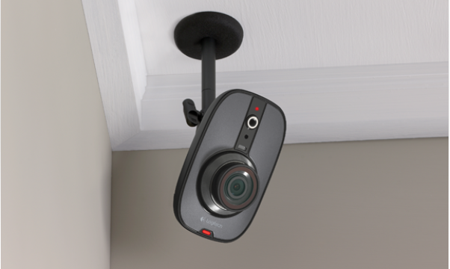
Figure 2: Logitech Alert™ 750n Indoor Master System, indoor camera.
Reprinted with permission of Logitech

Motion Trigger & Alert

The smart camera can automatically record video, and upon motion detection, system can send you alerts via mobile phone or email. There is a free web and mobile viewing. All you have to is log in to Logitech secure site and you can watch live camera feeds from an Internet-connected computer, anywhere in the world. You can even monitor your system on the go by simply download the free app on your iPhone, iPad, Android, or BlackBerry device. With the commander software, you can easily configure your video security system, watch live video, store video on your computer and review recorded video.

Available Remote management

To go further with the system, you can purchase optional premium services and manage your system remotely from any Internet-connected computers, and on the Logitech Alert Mobile Commander, available on iPhone, iPad, BlackBerry, and Android devices. You can access it when you need it. Also, you can record up to a week’s worth of videos on the included micro-SD card and automatically back up the videos to your computer when it’s turned on. With the DropBox extended capability, you can also add some reliability by storing the videos on DropBox cloud service.

Built-in microphone

The camera not only records video, but it can be enabled to record audio as well.
With the versatile mounting and easy expansion, you can place your camera almost anywhere using the included mounting kit. You aren’t limited your security to a single camera. You can easily expand your coverage to up to six cameras indoors or outdoors.

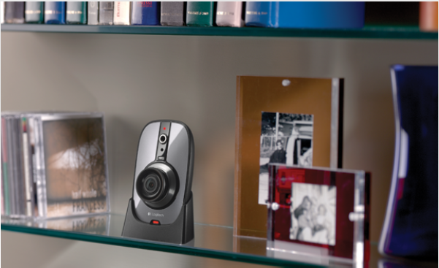
Figure 3: Logitech Alert™ 750n Indoor Master System, indoor camera.
Reprinted with permission of Logitech
3.5 - Internet Server

This project will require a server to be run on the internet so that phone applications can connect. They will then be able to get data on the systems current status such as what lights are on, what doors are open, or have any motion sensors been recently activated. It will also allow the smart home system to receive commands from the phone applications. Commands could include turning off a light or sending audio data. Depending on what type of microcontroller used, the server can support more powerful functions.

3.5.1 – Atmega644a

The Atmega644a is capable of supporting a small web server that can process limited commands like turning things on or off and simple signals to command other microcontrollers to start a new task. It would be capable of monitoring the Smart Home system and send status updates about the current smart home status to the phone applications. One possible device for this project is an embedded web server that uses the atmega644a. This part comes from tuxgraphics.org and is a cheap, yet powerful web server. It will not have the capacity to send audio and video data over the internet but it will be able to monitor the smart home system. The web server board has the following specifications:

Size: 50x80mm, 1.97x3.15 inch
27 available IO pins, 8 can be used as 10-bit ADC inputs
64K of Flash, 2K EEPROM, 4K RAM
Fuse bytes pre-set. The atmega644a runs with a 12.5 MHz system clock at 3.3V
Required power: 5.0V-33V DC, less than 1W

The available IO pins will be used for connecting the other hardware components of the smart home system. The board is relatively small, which is always useful to conserve the amount of space the system will require. The board also has a wide range of operating voltages and low power consumption. Because the board will need to be always running to keep the web server accessible at anytime, power consumption is an important factor for the internet server microcontroller. This board may be more then what the project needs, so other boards will need to be taken into account.

3.5.2 – The Spinneret

Another board that is was being considered for this project is the spinneret web server from parallax. This board is slightly more complicated and powerful with more features. However it is also slightly less customizable due to the complexity and specificity of the hardware. The spinneret web server contains two microcontrollers, the P8X32A Propeller, a powerful microcontroller from propeller, and the WIZnet W5100. Propeller designed the microcontroller especially for this board to give the processing power required to run the web server. The other microcontroller is the W5100, a microcontroller specific for Ethernet control, from WIZnet. The spinneret also has a real-time clock and microSD slot to record timestamps on all actions occurring in the web server. There are 4 GPIO for connecting to other devices, which is a limiting factor when choosing the board. The board is all open-source, including the hardware design and the firmware.

3.6 - PJSIP

In order to create streaming audio that is playable from your phone to your speakers, or from your computer to your speakers, the project will need to incorporate software that allows this. Streaming data is a more complicated task then simply sending a known amount of data with a clear end. When streaming audio or video the end of the audio stream is not known. This means the amount of data being transferred could be any size. There are many protocols in place to take care of this. PJSIP offers a wide variety of protocols with documentation to implement and modify the protocols.

3.6.1 - SIP

SIP stands for session invitation protocol. The main function of SIP is to setup the session. This means that SIP sets up the user location (network address), features to be used during the session (adding, dropping and transferring users during the session), and changes to available features during the session. This means that SIP is only responsible for setting up the connection defining what the connection should be like. SIP classifies those that are involved in the session in to two categories, the user client and the user server. The client request things from the server and the server will generate responses. There several different types of servers in SIP; the proxy server, the redirect server, the registrar server, and the location server. The proxy server relays request from server to server. This means that the user’s location is not necessarily known. The proxy server gets a request from a user server and decides that this request needs to be forwarded to another server. It then sends the request to the other server on its behalf. This is why it is called the proxy server because it generates request to other servers on behalf of the user or server that sent a request to it. The redirect server sends the request back to the client saying the request location has moved and can’t be located through this path. For example the client sends a request to get data from a server that is normally there. The server has recently moved and has put up a redirect server to direct all traffic to their new location. The redirect server is then able to tell all traffic requesting that original server to go to the server’s new location. The registrar server collects the locations of all users in the network. Usually a user will need to go through a registrar server to connect to other types of server and the location will be recorded. The most up to date location of all users is stored in a location server. SIP uses several commands to setup and communicate details about a session. The commands are listed in the following table.

INVITE | Invites a user to a session
ACK | used to tell whoever sent the invite the invite was received
BYE | closes the connection between users
CANCEL | terminates a request, used when an invite is received and ACKed, then declined
OPTIONS | describes the features available by the user and server
REIGISTER | registers the users location
INFO | send a mid-session signal
Table 1: SIP commands

When SIP is setting up a connection between two users, it will use two servers as proxies between the users. Each user’s SIP software will setup a server specifically for the streaming data connection that is about to be engaged. When the users want to send messages to each other, the message is first sent to the user’s corresponding server. For example, User A wants to send a message to user B in a real time streaming method. SIP will set up a server for each user. User A will then send this message to user A’s server. User A’s Server knows the location of all other servers. This is because when a server is being created it must register with a register server so that the location of all servers can be found through the register servers. So user A’s server gets the request to send a message to user B. It then looks up user B’s server location and forward’s the request to user B’s server. User B’s Server then receives the request and sends it to user B. The SIP servers also must send an acknowledgement message back when a request is sent to them. For example when user A sent its first invite to user A’s server, the server would send a TRYING response back for acknowledgment of the request. This acknowledgement also happens when server A forwards the request to server B.

When the invite request reaches user B, user B will send back an acknowledgement such as ringing in the case of a phone call. User B still needs to decide if they want to accept the invite request to the session. If the User B declines the invite request, then a cancel message is sent back through each of the servers and the no session will be set up. However, if the invite is accepted then the accept message is sent back through the servers to user A. User A then sends an ACK message to acknowledge it is ready to start the session. However the ACK message doesn’t use the server proxies, user A has gathered the location information of user B from the accept message and can now send the ACK message directly to user B. Once user B receives the ACK message, then the session is started and data flows in a bidirectional manner directly between the two users. This creates a 3 way handshake between the two users to help clarify the intent of both users. This process can be related to conversation between people. For example, a person would first ask if someone else would like to talk about something by saying hello or calling their name. The other person would then respond with a hello back or some type of confirmation that the hello was heard. Then the person who initiated would begin speaking what they needed to say. While this example is only a two way handshake before data is sent across, it still displays a fundamental need for confirmation and setup when trying to communicate. If no confirmation message was used then the data might start being sent before the intended receiver is ready to receive it. There must also be a message to declare that the communication is about to end. People do this in conversation by saying goodbye. People are polite though and will usually precede a goodbye with a reason of the goodbye. In SIP however manners are not required and the session continues until there is a BYE message sent from one of the users. When the BYE message is received then an ACK of the BYE message is sent and the session is closed.

The INVITE message contains a lot of details about setting up the session. These details are contained on one line strings in the following order of the table.

Request Line | Request line contains the method, location to send to, and the SIP version.
Via and Max Forward | local address of the person sending , and max hops the message can take
To | contains display name and location of person receiving request
From | contains the display name and location of person sending the request
Call-ID | a unique identifier used to identify the call
Cseq | keeps track of the message order so that messages can be received in order
Contact | contains the direct address of the person sending the message
Content-Type | describes the type of data being sent in the body of the message
Content-Length | describes the length of the body of the message
Table 2: SIP Request message

The response generated is in a similar format and represented by the following.

- Status line: contains SIP version, status code and the reason
- Via fields: the route taken from the invite request will be contained
- To: here the route taken from the invite request will be contained
- From: contains the display name and location of person sending the request
- Call-ID: a unique identifier used to identify the call
- Cseq: keeps track of the message order so that messages can be received in order
- Contact: contains the direct address of the person sending the message
- Content-Type: describes the type of data being sent in the body of the message
- Content-Length: describes the length of the body of the message
From the bulletins you can see that the messages are very similar. The only differences really are in the status line and via message. Once these two messages have been exchanged both sides of communication should know everything needed about each other to set up a session. The status line can have several different types of responses. It will also be a number in the format YXX, where Y is the response category and XX can be any number in that category. For example if the status line says 423, then this will be treated as a 4XX response. The response categories are as follows in the table.

1xx: provisional | request received, forward request
2xx: success | request received, and accepted
3xx: redirection | further action needed to complete
4xx: client error | request is invalid
5xx: server error | server failed to fulfill a valid request
6xx: global error | the request can’t be fulfilled by any servers
Table 3: SIP control codes

There are 4 ways to group the interactions between two users during a SIP session and they are organized into a hierarchy. Messages are the base unit and can only be response or request messages sent from a user. Then there is a transaction, which is comprised of all the request and response messages sent as the messages travel between servers to the final destinations. Then there is the dialog, the dialog consists of a grouping of transactions that is defined by the tags which are used as identifier during the dialog. Finally there is a call which consists of the dialogs used in that session.

When a session is initially being set up it uses registrar servers to identify the location of all the servers participating in the session. When the proxy server is set up for a user that server must register its location to the registrar server so that other server can find it. The registrar server stores the location of every server on a location server. The location server is where other server goes when the need the location of a server they are trying to send a request to.

3.6.2 - RTP

RTP stand for real time protocol, it sits above the UDP layer and was originally developed for real time multi-media party applications like Skype for example. RTP does not guarantee a timely delivery; it simply works in a fashion that organizes the data to arrive in a correct order and somewhat timely manner. RTP is made up of two distinct parts; the real time protocol which carries the actual real time data, and the real time control protocol which monitors the quality of service and gives information about all those participating in the RTP transfer.

RTP can be used in several different ways. The main application is usually for sending audio and video data packets in a streaming fashion. For each audio and video, 2 ports must be used. For example you want to stream audio data, one port will be used for the control signals that help regulate and monitor the streaming audio data. The other port will be used for the actual audio data packets. RTP has to try to keep the audio stream synchronous, but this can be a problem because the user that are engaged in a session will all have different bandwidths and max amount of data that can be streamed. RTP is able to deal with this by using a mixer. A mixer’s job is to adjust the data packets whether it is video or audio so that the data can all be streamed in a real time fashion. For example, two audio streams are attempting to be transported across a link that is unable to transport all the data in real time so it must slow down the rate of the audio data to transport it all. This would cause the receiver on the other side to get a slowed down version of the audio message. The packets would not be arriving in a real-time fashion. The mixers job is to take the audio messages and re-encode the audio in to a smaller packet of less quality, but now all the audio messages can fit across the link in a real-time fashion. So if the audio message was music, the music would be played real-time at a reduced bit-rate. RTP also uses translators to move data packets through firewalls. Because there is not a handshaking method used in RTP firewalls will generally not let RTP packets through. A translator is setup to create a secure connection through the firewall. This can be set up for example when SIP is creating a session, or at any earlier time before the audio packets start to stream through the network.

0 | 1 | 2 | 3 | 4 | 5 | 6 | 7 | 8 | 9 | 0 | 1 | 2 | 3 | 4 | 5 |  | 6 | 7 | 8 | 9 | 0 | 1 | 2 | 3 | 4 | 5 | 6 | 7 | 8 | 9 | 0 | 1
V |  | P | X | CC |  |  |  | M | PT |  |  |  |  |  |  | Sequence Number
Timestamp
Synchronization source identifier (SSRC)
Contributing source identifiers (CSRC)
Table 4: RTP packet Header
The RTP packet header sits on top of the UDP header. So it is a form of UDP except that it has methods to regulate the flow of data giving the ability to do real time streaming of audio and video. By looking at the details of the packet header, it can be seen more clearly how RTP is able to function. In the following table the top row represents the bit position in 32 bit standard format.

- V bits describe the version bit of the RTP
- P bit is set then padding is enabled. Padding is used to extend the header size if needed.
- X is the extension bit, if set then the header is extended by one header extension.
- CC is the CSRC count which describes the number of CSRC that follow the header.
- M bit is used by specific applications for applications level framing
- PT bits describe the type of data in the payload that comes after the header
- Sequence number keeps track of the order of data packets so they can be organized by RTP
- Timestamp bits keep track of the precise time so that real-time data streaming is possible
- SSRC bits is a random number used to identify the synchronization source
- CSRC list is list of contributors that have stored data in this packet as well.

RTP uses three of the attributes in the header field to maintain synchronization of the data. The SSRC lets the receiver know which source the data should be synchronized with. It uses that in relation to the sequence number to make sure that the order that data packets are received from the source are received in a correct order. Every RTP data packet that is sent from the same source will receive a sequence number that is incremented one more then the last one. This way the data packet can be kept synchronous and in order from that source. The timestamp is also used for synchronous play but is not enough because there is a chance that 2 data packets will have the same timestamp. The timestamp is mainly used to match audio and video data up so that they can be played together, but also is used in discovering the order in which packets should be delivered.

Application Level Framing is used in the RTP and is used to make RTP adjustable and modifiable so that it can be made to use for a wide variety of things. There are several fields in the RTP header that allow for this. The header extension bit allows the header to be extended and information important to a special application of the RTP can be stored in the extra space. The marker bit allows for a switch to be used to determine if the RTP packet header is being used in a generic sense or if the RTP packet is being used for a special application.

RTP uses special packets called RTCP packets to control the data. The main goals of RTCP is to give feedback of quality of data distribution, carries the persistent source name called the CNAME, and to observe the number of user that are currently engaged in a session. There are several types of RTCP packets. SR packets stand for sender report, this gives the transmission and reception statistics from participants that are active senders. RR packets stand for receiver report, and give the reception statistics from participants that are not active receivers. SDES packets are source description items which includes the CNAME. BYE packets are the RTCP standard for closing the connection. APP packets are specific control functions that are dependent on the application being used.

3.6.3 - SDP

SDP stands for Session Description Protocol. That means that SDP is used when other participants want to join a session. It describes the session in terms of media types and properties. It sends the information over the network and describes such details such as owner of the session, name of the session, coding of the session, and the synchronization. The inquirer can then decide if it would like to join the session.

3.6.4 - VoIP

The smart home system would like to achieve voice over IP technology. This is similar to a phone call except that the session can be much shorter, for example you will not need a user on the other end to accept the call, and this can be done by the system. That means that if you want to cast your voice over the smart home system audio outputs (the system speakers), you can simply talk into your phone. When you begin to speak into the phone the system will automatically broadcast your voice over the internet and can be played on any speakers you desire. For example someone is at the user’s door while they are away from the house. The system can send an alert that someone has entered the door area. You can then speak to them in a real time manner using VoIP.

VoIP uses internet protocol (IP) to send digitized voice traffic over the internet or private networks. An IP packet consists of a train of digits containing a control header and a data payload. The header provides network navigation information for the packet, and the payload contains the compressed voice data used for the intercom.

While circuit-switched telephony deals with the entire message, VoIP-based data transmission is packet based, so that chunks of data are packetized (separated into units for transmission), compressed, and sent across the network, and eventually re-assembled at the designated receiving end. The key point is that there is no need for a dedicated link between transmitter and receiver.

Latency will be an issue with the VoIP system and something that our project will want to minimize. A one-way latency is the time from when a word is spoken to when the person on the other end of the call hears it. Round-trip latency is simply the sum of the two one-way latencies. The lower the latency value, the more natural a conversation will sound. Current PSTN have a round trip latency of 150 milliseconds. This can be heard if you test a phone call with someone that is very close. By turning the volume up on each user’s speaker, an echo can be heard through the phones.

For VoIP systems, a one-way latency of up to 200 ms is considered acceptable. The largest contributors to latency in a VoIP system are the network and the gateways at either end of the call. The voice codec adds some latency – but this is usually very small by comparison (<20ms).

When the delay is large in a voice network application, the main challenges are to cancel echoes and eliminate overlap. Echo cancellation directly affects perceived quality; it becomes important when the round-trip delay exceeds 50 ms. Voice overlap becomes a concern when the one-way latency is more than 200 ms. The codec for the project can take advantage of dead time in a conversation by not transmitting any data. This is advantageous because there is a significant portion of a phone call and intercom message that is spent with dead time. Such "silence compression" techniques detect voice activity and stop transmitting data when there is no voice activity, instead generating "comfort" noise to ensure that the line does not appear dead when no one is talking.

3.6.5 - SMS

In order to inform the user of important alerts, such as security breach or power over usage, SMS technology can be employed. SMS stands for short message service. Most telephone service providers will provide a service that allows the user’s phone to receive text messages from an email. This means that in order to send a phone a text message warning about the smart home system, one only needs to send an email to the phone. This is not a normal email; it is translated into a text message that is sent over the telephone network. For example, the system would like to send a text message to the user on their phone. This can easily be done by sending an email to their phone number with the appropriate email concatenation in the address of the email sent. For example, on the Verizon wireless network, a user would send an email to 1234567890@vtext.com, where the digits represent the phone number. Even though it is not an actual email address created by the user, the telephone service provider creates a special email for receiving these kinds of text messages. Most telephone service providers provide this service. For the project to successfully utilize this service, the service provider of the user must be hardcoded into the code. The user could also use a non hard-coded solution; however this will increase complexity of the smart home system and also make the engineers of the system less important. A hard coded solution keeps the system more simple but also increases maintenance. There are also other ways to alert the user of a problem, for instance if they have smart phones they will be able to receive email messages. Also if the user has a smart phone they will be able to use the smart home system application for their phone if they have an IPhone or android phone. The application on the phone can then send alarms for these types of situations.

3.6.6 - NAT addressing

NAT stands for network translation addressing. NAT addressing is used whenever a local network needs to be connected to the world wide network. Nat addressing was a quick and simple solution until the IPV6 addressing could be fully implemented. To explain, the IPV4 addressing is running out of internet specific addresses due to the use of class addressing. Class addressing would allow a certain group to control a large number of IP addresses due to the way its set up. This was inefficient due to the fact that most groups that were using larger classes of IP addressing and were not necessarily using all of their addresses. Internet engineers soon came up with a solution to solve this problem. NAT addressing allows a group to use only the amount of IP addresses it needs. For example, NAT addressing allocates a certain number of IP address to a client. There is a minimum amount of IP address for that client, but when the client wants to address multiple servers or internet users, it will have a specified amount of addresses. This amount of addresses is created by the NAT addressing protocol. This makes for the most efficient use of the limited IP addresses on the internet.

3.7 - Lighting

One of many ways to use less electricity is turn on/off lights as need. Lighting is the first features that group wants to include in our wireless sense and control modules smart home project. It is important not only because it is convenient, but because it also will play an important part in reducing power consumption throughout the home by reducing light levels when not necessary, and can also play as a in home security system by illuminating the home when the residents are away on vacation or when approaching the home at night. Thefts may think the owners at home if the lightings know when to turn on/off. Group may even add hardware provisions for connecting an external light intensity sensor to further enhance the system. The on/off controller can also extend to other devices and can be used with a power monitor to shut an appliance off when not being used. Group also decide to include the smart lighting feature is that this will require the wireless sense and control devices to be outlet mounted modules. This may prevent other functions to be implemented in this project; however, the smart lighting features takes priority since it is the most popular and has applications for other smart home systems. Furthermore, the existing lighting control systems the group found are very expensive relative to cost of building a system.

This is the most basic and most common component of a smart home system. There are products made for post-construction homes which integrate on a plug and play basis, and there are products that are intended to be installed at the time of construction of the home. Since the system is designed as a post construction system group will focus on lighting systems of this type. There are smart lighting systems that support Insteon, ZigBee, Z-Wave, and X10 communication standards. Additionally, there are three basic levels of functionality in a smart lighting system. The simplest form consists of a system that includes a number of wall mounted control units that the lights plug into and a remote that controls the wall units to switch the lights on, off, or dim. An example system is the SMARTHOME RemoteLinc - Insteon Lamp Control Kit one can buy for about $135 and features include multiple user dim presets, control multiple lights separately or together with the same remote, and 150 feet of control distance. The figure 5 below can show how it works.

Figure 4: RemoteLinc Insteon Lamp Control Kit (3)
Reprinted with permission of Insteon

Another smart home system consists of a wall mounted units similar to those in a system above, except they have an infrared sensor and are controlled via a universal TV remote. An example system is the SMARTHOME brand IRLinc Receiver - IR to INSTEON Converter which then costs $100 and features one IR controlled wall unit and a mini remote. This particular system also has the added feature of a built in X10 transceiver that allows control of other X10 based lights throughout the house. The figure 6 below can show how it works.

Figure 5: IRLinc Receiver-IR to Insteon Converter (4)
Reprinted with permission of Logitech

The other consists of wall mounted controller with an Ethernet port that connects to a router and allows lighting control with a smart phone, computer, PDA, or any other Internet connected consumer device. An example system is the SMARTHOME SmartLinc - INSTEON Central Controller which costs $129 for the wall unit only. This system features stored light timers, device status feedback, and various other minor features. The figure 7 below can show how it works.

Figure 6: IRLinc Receiver-IR to Insteon Converter (5)
Reprinted with permission of Logitech

3.8 – Motion Sensors

3.8.1 - Basic types of 'motion' sensors

Motion sensors are employed to detect different types of human movement. Some are intended for local event sensing, some for area sensing:

Local Sensing: Local Sensing implies sensing of a motion at designated locations. Some of the motion sensors commonly used for this purpose are Visible/ Infrared light (LED/Laser) beam, Contact Switch, Piezoelectric Sensors, and Piezoresistive Sensors.

Passive InfraRed ( PIR ): The most frequent use of the PIR sensor is as an 'area' sensor. Whether it is to detect 'someone moving in the front yard', or 'someone moving in the room, or 'someone moving through a doorway' it is all technically the same sensor and logic. There is a simple electronic device which is sensitive to 'heat' emitted by warm or hot objects (like humans). The 'logic' of the PIR sensor is that it must detect 'significant change' of the normal level of heat within the 'field' of its view. The circuits that control it must be able to determine what 'normal' is, and then activate the switches when the normal field changes, as when a human walking through its area. It must also be able to allow slow changes within the field, and learn that as the new “normal” configuration. Furthermore, the sensors need to know when gradual changes such as the heat changes throughout the day don't cause a false alarm. This is a standard behavior of 'PIR' type sensors.

Area Sensing: Area Sensing implies sensing of a motion in a specific ‘Field of View (FOV)’. Motion sensors commonly employed for such application are Active/ Passive Infrared Motion Detector, Ultrasound motion detection sensor, Footstep Detection Sensing, Microwave Doppler sensor, and Video.

3.8.2 - How PIR Operation works

The lens of the PIR sensor divides monitored area into zones. As one’s move is captured in one of the zones, it assumes the area is occupied which means there is an object in its cover area. PIR sensors use a dual-element pyroelectric sensing device to detect occupancy. When one of the dual elements detects infrared energy before the other, it generates a positive pulse – a few milliseconds later, the other element produces a negative pulse, creating an “ON” state within the sensor.

Lens Importance: The fresnel is what the PIR sensor uses to “see” the room. The lenses are designed to minimize optical aberrations through the use of a totally aspheric surface, an aperiodic groove structure and constant depth grooves.
Sensor Placement: Unlike ultrasonic sensors, which can sometimes sense occupancy around solid barriers, passive infrared sensors must be able to “see” the area they need to control. Partitions and bookshelves will prevent detection in the blocked area. PIR sensors will also better sense motion when the movement is across the sensor’s field of coverage rather than directly towards or away from it.

Interferences: PIR sensors will lose their sensitivities as air temperature rises, rendering them far less effective at detecting occupancy. Although the use of carefully-tuned, high-quality, dual-element sensors, the PIR sensors are largely insensitive to temperature fluctuations. Visible light can cause PIR sensors to falsely activate or to not trigger upon occupancy because the temperature differential between background and subject is not great enough. PIR sensors need to utilize a daylight filter to reduce the negative effects of high density visible light.

Best Applications:
• Enclosed offices where sensors can have clear views of the entire area
• As a wall switch
• Areas with high air flow: computer rooms, laboratories
• Warehouses, hallways, high-ceiling-mount applications
• Areas that require direct line-of-sight viewing
• Spaces that need to mask off unwanted detection in certain areas

Poor Applications:
• Bathrooms (sensors cannot see in the partitioned and cloudy areas)
• Open office space with ceilings under 12 feet, requiring 360° coverage
• Oversize space
• Areas where storages, cabinets, and shelves can block the view
• Areas where minimal motions occur

3.8.3 - Ultrasonic Sensor Technology

Ultrasonic sensors are volumetric motion detectors which utilize the Doppler Principle to detect occupancy. They broadcast high frequency sounds above the range of human hearing to sense movement. Usually, ultrasonic sensors consist of several components: a transmitter, receivers, and processing electronics. They work by bouncing ultrasonic sound waves off objects in the room and measuring the amount of time it takes for the waves to return. Movement in the controlled area causes the sound waves to return to the receiver at a faster or slower rate, resulting in a Doppler shift and thus occupancy is detected.

Ultrasonic Operation: The Ultrasonic Sensors transmit a signal generated by a quartz crystal oscillator. A flat-plate, multi-directional transmitter plate broadcasts this signal into the controlled area. The transmitter plate should be round to guarantee even distribution of the ultrasound signal in the space. Receiver microphones should be electronic and tuned to the same frequency that the sensor is broadcasting on. For best results, they should also remain largely unaffected by temperature and humidity changes.

Sensor Placement: The Ultrasonic Sensors broadcast in three dimensions, thus the ultrasound will leave the sensor and bounce off the walls, floor, ceiling, and giving them the ability to sense smaller amounts of motion. In enclosed spaces, proper sensor placement is essential, as sensors can “see” out open doorways, resulting in false triggering. In addition, heavy air flow (from HVAC ducts or fans) can seriously impact ultrasonic sensor performance and result in false triggering. The sensors need to use special Signal Processing Circuitry to filter out air “noise” by checking for the small cyclical directional changes usually found in turbulent air. Movement by people usually creates a signal moving in only one direction. While this feature can help reduce false triggering, sensors should never be placed where air blows across them and where they can “see” out doorways. Room surfaces like carpeting, sound-absorbing partitions, and ceiling tiles will absorb ultrasonic sound, thus reducing ultrasonic sensor coverage. More sensors or sensors with better coverage may be necessary.

Best Applications
• Enclosed offices, larger conference rooms
• Areas up to 2000 square feet that can be considered enclosed
• Storage areas with cabinets and shelving
• Bathrooms (ultrasonic waves will bounce off of the partitions)
• Open office spaces and areas that require 360° coverage
• Hallways that are completely enclosed

Poor Applications
• Spaces that have lots of air turbulence
• Areas that require ceiling mounting heights over 14-16 feet
• Spaces that are not considered enclosed
• Spaces with areas of unwanted detection
• When aesthetics are a primary concern, the infrared sensors are preferable

The desire to detect the movement of people in a room is narrow down to optic sensors as figure 6 below. There are two types of optic sensors: visible and infrared. However, they are both required additional processing to determine if motion is present. The sensors working in the visible light with high resolutions is needed and also a processor to distinguish between the captured images. It is costly if purchasing a premade sensor and sleepless nights if trying to program the processor from scratch. As with audio, low resolution is needed because no recording or playback is required. With this in mind, a much more plausible rout is found in the infrared spectrum. A sensor can be combined with a processor to watch for the change in infrared intensity, and as both can be fairly cheap, this is the ideal motion sensor for this project.

3.8.4 - Sensors Choosing

There are so many motion sensors out there that can satisfy the group’s needs. They can be either brand name or no name. The cost is usually range from couple dollars to $40, $50 dollars apiece. However, the group focuses on low budget so group picking up parts that have price as low as possible, but also customizable later on when needed.
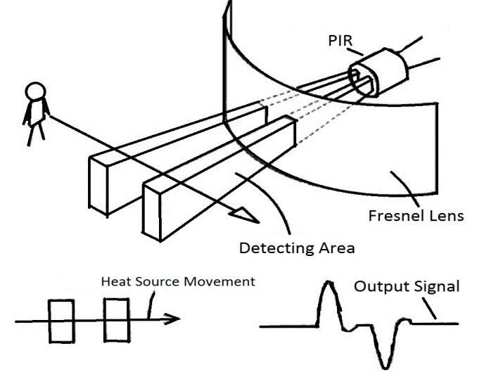
Figure 7: Motion Sensors Detecting (6)

The NaPi0n movement detection sensor is the qua-type pyroelectric. It has four receptors and short focal length lenses, thus it can detect even small movements. The NaPi0n can also distinguish temperature change between its target and its surroundings. The lowest temperature difference the NaPi0n can detect is 4⁰C or 7.2⁰F. What this means is the NaPi0n not only can detect the change of temperature in winter but also in summer where high temperature presents and the temperature differences are small. The NaPi0n sensors also have excellent noise resistance, noise from power supply, radiation noise.

RF Transceiver: For the RF transmission, the design will be using the Texas Instruments CC1101. It is perfect for the design’s application for several reasons: it is lower power, it is within the frequency range that is desired, and not many external features are needed. The standby current of this component is typically 0.2µA, and max current consumption is 14 mA depending on frequency of the signal. However, no current greater than 14 mA is needed for any broadcast frequency. It also has lowest wakeup time at 240uS. Frequency range can be used for these chips. Finally, the transmitter needs no external filters to use the chip, only an antenna to send the signal.

RF Receiver: The Texas Instruments CC110L is very similar to the Texas Instruments CC1101. It is a value line, low power RF receiver, which also operates in a similar frequency range. It offers the same features desired by the project in regards to its lower current consumption, its frequency, and its simplicity. The standby current of this component is typically 0.2µA. The current consumption by this component is typically under 14 mA, depending on frequency of the signal. No current greater than 14 mA is needed for any frequency that will be sampling.

3.8.5 - Connecting

Most PIR modules have a 3-pin connection at the side or bottom. The pin-out may vary between modules so triple-check the pin-out! It's often silkscreened on right next to the connection. One pin will be ground, another will be signal and the final one will be power. Power supply is usually from 3 to 5VDC input but may be as high as 12V. Sometimes larger modules don’t have direct output and instead just operate a relay in which case there is ground, power and the two switch connections.

The output of some relays may be 'open collector' - that means it requires a pull-up resistor. If you're not getting a variable output be sure to try attaching a 10K pull-up resistor between the signal and power pins. An easy way of prototyping with PIR sensors is to connect it to a breadboard since the connection port is 0.1" spacing. Some PIRs come with header on them already.

3.9 - Digital to Analog Converters (DAC)

These devices take a digital binary representation of an audio file and convert it to a continuous analog signal. Our project will be using 16 bits with 44.1 KHz sampling resolution. This is the Red-Book bit rate and sampling rate for CD quality audio. This is dictated by the Nyquist theorem which states that the sample rate should be at least twice the highest frequency being reproduced. The human ear can only perceive things as high as 20 Khz. This is how 44.1 Khz is decided upon for Red-Book sampling rates. Before sampled there is a lo pass filter that gets rid of higher frequencies to prevent any aliasing from happening. This will ensure an optimum quality for our project because of the higher bandwidth headroom. This should allow the use of cheaper and/or faster anti-aliasing filters of less severe filtering slopes. Using this will help to receive the most popular audio file formats from most mobile devices for our project.

3.10 - Codec Considerations

3.10.1 – Audio & Video

The following are codec considerations for the audio and video system parts of the project. There are many that range from being specific to computers and others that are specific to cell phones.

- MPEG-1 and MPEG-2 Audio Layer III (MP3): By using this encoding for music, it will greatly reduce the amount of data required to represent the audio recording while still sounding very close to the original recording. For example, an MP3 file that was created using the 128 Kbit/sec will result in a file that is about 1/11 the size of the original CD file that created from the original audio source. The original is a 16-bit 44.1 Khz audio file. These two uses psychoacoustics to reduce or limit the frequencies and that the human ear can't hear because of masking or because of attenuation. Bitrates go as low as 32 and as high as 384 Kbit/s. Layer III was derived from Adaptive Spectral Perceptual Entropy Coding (ASPEC). 128 Kbit/sec is considered the most acceptable quality for MP3. Any higher and there tends to be diminishing returns.
- G.711: This codec is the international standard for encoding telephone audio on a 64-kbps channel. G.711 is compressed using a companding technique. The m-law or A-law standards are used. This compresses each data sample to an 8-bit word, which gives an output bit rate of 64 kbps. The H.323 standard specifies that G.711 must be included as the standard for voice communication
- G.723.1: G.723.1 is a ACELP which stands for algebraic code-excited linear-prediction. The codec is dual bit rate. The encoding time frame for G.723.1 is 30 ms. Each frame can be encoded in 20 bytes or 24 bytes, which are basically 5.3-kbps or 6.3-kbps streams. The bit rates can be shortened through voice-activity detection and comfort-noise generation. The codec offers good fight against network imperfections—like lost frames and bit errors. G.723.1 is suitable for video-conferencing applications.
- G.729: This codec is a low-latency audio data-compression algorithm, which separates speech into 10-ms frames. It uses an algorithm called conjugate-structure ACELP (CS-ACELP). G.729 compresses 16-bit signals, which are sampled at 8 kHz via 10-ms frames into a standard bit rate of 8 kbps. The codec also supports 6.4-kbps and 11.8-kbps rates. This codec supports voice-activity detection and comfort-noise generation.
- GSM: This is generally known as the cell phone codec around the world. ETSI, or the European Telecommunications Standards Institute. GSM Full rate, which is generally regarded as the first, is where most of the rules and standards have started to follow. Speech that is taken into the codec is separated into 20 ms frames. Each frame is encoded into 260 bits.
- Speex: Speex, an Open Source/Free Software audio compression format. It is made to be used for speech codec’s. It was released by Xiph.org, with the goal of being a totally patent-free speech package. Like many other speech codec’s, Speex is based on CELP. It uses residue coding. It can code 8-kHz, 16-kHz, and 32-kHz linear PCM signals into bit rates ranging from 2 kbps to 44 kbps. Speex works well with network errors, and it supports voice-activity detection. Besides allowing variable bit rates, Speex also has the unique feature of stereo encoding.
- H.261: This codec was the first widely used video codec. It introduced the idea of segmenting a frame into 16 × 16 "macro blocks" that are tracked between frames to establish motion-compensation vectors. It is mainly targeted at videoconferencing applications over ISDN lines (p × 64 kbps, where p ranges from 1 to 30). Input frames are typically CIF (352 × 288) at 30 frames-per-second (fps), and output compressed frames occupy 64 kbps to 128 kbps for 10-fps resolution. Although still used today, it has been largely s outdated by H.263. Nevertheless, H.323 specifies that H.261 must be present as a standard for video communication.
- H.263: This codec is found a lot in videoconferencing. It works better than H.261 for all the bit rates. Input sources are usually quarter-common intermediate format (QCIF) (176 × 144) or CIF at 30 fps, and output bit rates can be less than 28.8 kbps at 10 fps, for the same performance as H.261. So whereas H.261 needed an ISDN line, H.263 can use ordinary phone lines. H.263 finds use in end markets such as video telephony and networked surveillance, and it is popular in IP-based applications.

3.11 – Main Circuit Board

3.11.1 - Microcontrollers and Processor considerations

The Analog devices ADSP-BF537 is a good candidate for our project for several reasons. It has the 16/32-bit architecture needed for multi-format audio that would be employed in our project. The 600 MHz Blackfin processor would be great from an efficiency standpoint. Using this for an embedded application would allow it to excel greatly. The processor also employed a reduced instruction set computing design that made for easier programmability and greater compatibility for different compliers. It has an Ethernet MAC 10/100 peripheral for IEEE 802.3-compliance. This would interface with the wireless router portion of our design. The controller has two dual-channel, full-duplex synchronous serial ports, that support eight stereo I2S channels. This would be likely used for our spdif inputs and outputs of our design. 48 general-purpose I/Os, allows for flexibility to meet other I/O in our design. The lights and sensors would like be employed by the use of these I/Os. Of those 48 GPIOs, 8 have high current drivers for more intense device requirements like an air conditioning unit or refrigerator if the project was to stretch out in that way. It has the compatibility of serial peripheral interface (SPI) to talk to the Texas instruments CC8520 and/or CC8530. This would allow it to control certain aspects of the Texas Instruments processors, like volume control and I/O patching and selection. The on-chip PLL would help to distribute clock timing pulses for the microprocessor and stereo audio for the project. The microprocessor also has a JTAG debug interface for testing purposes. This will help test our printed circuit board once it is completed. Managing its registers to test the combinational logic will do this.

Texas Instruments also has a great offering in their Pure Path wireless products called the CC8530. The CC8530 uses the RF range of 2.4Ghz frequency to stream audio wirelessly between two different devices. The CC8530 can use I2S, or Intersound Interchip Sound, to create a seamless connection with a secondary codec and digital to analog converter or analog to digital converter. This is commonly used for transferring digital audio signals. It also has the functionality of an SPI bus protocol. However, for audio purposes I2S uses an LR Clock so that to indicate whether your 16-bit words are going to the left or right channels. SPI works in 8 bit bytes, while I2S uses 16-bit words.

HID functions through USB can control, power, volume control, channel selection, and I/O. By using two of the chips, one to four channels of audio can be sent wirelessly at five or two Mbps with about 10.7 milliseconds of latency. This would likely be passing signal from a cd player or iPod at a level of -10 dBV, also known as the consumer level, to a power amplifier to a set of speakers. The best candidate is for this to be used to send this wireless signal to different rooms of a house to a set of powered speakers.

Session initiation protocol, or SIP, is commonly used for voice, video, and audio connection between two or more points. It’s been used for video surveillance to send messages to homeowners when motion detectors go off. It’s also been used for audio over IP for broadcasting. SIP is best known for the simple purpose of signaling phone calls in the IP domain. What is perhaps less often understood is the fact that SIP has little to do with the audio transfer itself. SIP carries out the call set up negotiation between two or more devices that wish to be in contact at the initiation phase, signaling call events (transfer requests, for example) during the connection, and call termination. SIP does not play a role in the actual audio/video delivery. In the SIP environment, audio carriage is almost always carried out using real-time protocol, with parameters and details being negotiated using SIP. The combined power of SIP and RTP can support VoIP as well video connections and audio contribution to studio environments. From this perspective, SIP provides a flexible architecture to enable device communication, mainly for point-to-point connections.

The role of audio over IP in with SIP can be very useful for mixing applications such as paging and public address with phone integration and services like background music and priority communications. Audio over IP goes beyond session initiation to network-based audio distribution. It can be connection-oriented or always present for unending audio streams. It is expected that SIP acts as the traffic cop for frequent connections, disconnections, busy signals and call re-routing. This is because phone systems must react to commands. SIP can negotiate choice of codec within an audio over IP network. SIP devices typically allow negotiations of the intermittent codec used on a per-connection basis, chiefly because bandwidth may be more important than audio quality in telephone communications. In other cases, a communication partner may not support the standard codec used for most connections. Audio over IP devices are intended to transmit music of very high quality, intelligible announcements and other audio, that are quality-critical, and thus typically use different codecs than those used for VoIP/phone calls. The session initiation protocol can automatically negotiate the use of a matching, VoIP-supported codec when SIP-capable devices are operating within the audio over IP domain. Although naturally inclined to use high-quality audio codecs, the SIP-enabled audio over IP device will accept 8 kHz voice quality if that is what is provided by the VoIP system.

The introduction of a SIP gateway is the most effective way to merge audio over IP distribution with an already established SIP-based phone system. This is most useful when you are directing background music, paging and public address to loud-speaker systems as opposed to simply routing phone calls. The gateway solution allows one device to translate a unicast SIP call to a broadcast/multicast in the audio over IP domain, for purposes such as group addressing. This allows use of the same codec to distribute a multicast announcement that the receiving devices understand.

A quality SIP gateway solution will also demand an access code to protect against unauthorized use. Security personnel roaming the building can use any office phone, dial the gateway and unlock the announcement capability on any capable device. Personnel can then select a group or zone, and the SIP gateway will translate the information into the audio over IP domain, enabling immediate, priority-based stream delivery to the audio over IP devices in the network.

The SIP gateway can also be programmed to prioritize announcements over other audio stream sources. The session initiation protocol will translate the priority announcement request only to the targeted groups or zones, allowing the general audio over IP streaming to continue uninterrupted in all other areas. This in essence is what it means when comparing the audio over IP and SIP concepts: a continuous stream, zoning and priority compared to temporary, exclusive connections.

Generally speaking, by using a SIP-based approach for telephone routing and communications, the user can simply add some audio over IP devices as extensions, provided they speak SIP. Existing paging systems can easily be added using just one SIP-enabled audio over IP device, perhaps with intelligent relays to select target zones. Premium devices can even output MP3 or AACplus background music while giving priority to SIP-based announcements. A SIP gateway makes sense as soon as group/zone announcements at various priority levels must be implemented into a (multi-channel) audio distribution system.

3.11.2 - Printed Circuit Board

The printed circuit board will be designed during the building stage. Group will try to use Eagle as the base software design to build the board. The reason group wait until this stage is group needs to verify if the design is valid before actually building the PCB. However, it is known by the group what are the designs basics need to be done. The group will look to build a simple board, either four or six layers, depending on the needs of the smart home project. A six layer board is preferred because the group will look to create a grounding plane to dissipate any heat, as well as a high power plane for any high power lines that are needed when conducting the electronics control. In the design thermal sensors will also be used when needed to help with heat dissipation. The board will use differential pairs to help reduce noise on the lines that are sending similar signals. The board will have horizontal and vertical routing layers to also help prevent noise. The board will try to avoid any predictable issues through trials whenever possible, and reducing as many irregularities and trace whenever possible. This process will come out fine as long as the group does a lot of trials. The final circuit board that needs to be made will be shipped to whenever company group decided later and print out.

3.12 - Microcontrollers

To communicate with the sensors, group also needs to connect the sensors to a microcontroller. There are so many microchips that manufactures offer on the market. Eight-bit microcontrollers are designed to interface with things that have simple inputs like switches, sensors, keyboards, and small displays. Eight-bit microcontrollers are optimized for low power and simple code. They will always be the easiest and most cost-effective solution for basic embedded control. The low-cost tools and fast time to market for developing with 8-bit MCUs make them an ideal choice when engineers need to solve problems quickly. The 8-bit MCUs have smaller code, lower power, and offer more robustness to environmental noise. Engineer’s need is something simple, something purpose-built, easy-to-use, and relatively inexpensive. That’s the proverbial “sweet spot” for low end 8-bit microcontrollers. Many microcontrollers are adding smarts to discrete or analog centric legacy designs where previously no electronics were needed. Others are adding Ethernet connectivity to take advantage of the internet for remote monitoring or control of embedded applications. Some 8 bit microcontroller’s integrated peripherals are included to help designers implement stylish and low-cost user interfaces with buttons and displays. As more electronic applications require low power or battery power, energy conservation becomes critical.

Most programmable 8 bit microcontrollers that are in use today are embedded in other machinery or consumer products including telephones, automobiles, household appliances and as well as peripherals for computer systems. The 8 bit is also called "embedded 8 bit controller." Some embedded systems are very sophisticated while others have minimal requirements for memory and programming length with a low software complexity. Input and output devices include relays, solenoids, switches, LCD displays and sensors for data such as temperature, light level or humidity. The eight bit microcontrollers have a wide operating voltage range of 1.8V to 5.5V, which makes them well-suited to use in electrically noisy environments like industrial controls and automation applications including implantable medical devices, power tools, toys, office machines, engine control systems, remote controls, appliances as well as other types of embedded systems. For hardware centric applications that need deterministic behavior, low sleep power consumption, robust electrical characteristics, and a real world interface, the 8-bit microcontroller is the best technical solution. Applications such as coffee machines, toasters, key fobs, security tokens, security system sensors, toothbrushes, PC fan controllers, thermostats and thousands of other applications. Microchip provides 8-bit, 16-bit and 32-bit MCUs that meet the need for the full range of embedded applications.

The 16, 32 bit microcontrollers can process large integers, run more powerful Operating System MacOS, Windows 7, enable more security, Internet connectivity, larger memory, more efficiency, more stimulating programs.

The Advantages of 32-bit Microcontroller over 8-bit are operating at high frequency, low active power requirement. We can reuse the code from 8, 16 bit programming, enhanced features for increasingly complex algorithms, cost reduction due to device aggregation, External connectivity - Ethernet, USB, CAN, Efficient real-time operations, Availability of tools. The biggest challenge for embedded manufacturers is the availability of the many differing architectures and implementations from different MCU vendors. There is a need to support every such architecture used in the projects and therefore the engineering efficiency. The 32-bit microcontroller in an embedded system has two-fold advantage in terms of executing code. The 32-bit MCU takes one clock cycle for execution of two bytes, which is twice as quick as compared to 8-bit and 16-bit. Fewer clock cycles means longer sleeping time and therefore energy saving, while smaller code size allows smaller memory size and therefore cost saving.

There are many transceiver out there can do this simple task. One of them is the CC2420. It is a single-chip 2.4 GHz IEEE 802.15.4 compliant RF transceiver designed for low-power and low-voltage wireless applications. CC2420 includes a digital direct sequence spread spectrum baseband modem providing a spreading gain of 9 dB and an effective data rate of 250 kbps. The CC2420 is a low-cost, highly integrated solution for robust wireless communication in the 2.4 GHz band. It complies with regulations covered by FCC CFR47 Part 15. The CC2420 provides extensive hardware support for packet handling, data buffering, burst transmissions, data encryption, data authentication, clear channel assessment, link quality indication and packet timing information. These features reduce the load on the host controller and allow CC2420 to interface low-cost microcontrollers. The configuration interface and transmit/receive FIFOs of CC2420 are accessed via an SPI interface. In a typical application CC2420 will be used together with a microcontroller and a few external passive components. CC2420 is based on Chipcon’s SmartRF®-03 technology in a 0.18 µm CMOS. Another transceiver group has found is the CC2500 which is also from TI. Its operation is similar to the CC2420 but as higher data rate 500 kbps. The main operating parameters and the 64-byte transmit/receive FIFOs of CC2500 can also be controlled via an SPI interface.
After debating, group decides to go with the CC430 family of ultralow-power microcontroller, specifically the CC430F614x series. This microcontroller system-on-chip configurations combining the excellent performance of the state-of-the-art CC1101 sub-1-GHz RF transceiver with the MSP430 CPUXV2, up to 32 KB of in-system programmable flash memory, up to 4 KB of RAM, two 16-bit timers, a high-performance 10-bit A/D converter with eight external inputs plus internal temperature and battery sensors, comparator, universal serial communication interfaces (USCIs), 128-bit AES security accelerator, hardware multiplier, DMA, real-time clock module with alarm capabilities, LCD driver, and up to 44 I/O pins. TI also provides tools and sample code footprint to help group do the jobs. In addition, microcontroller applications built on the Stellaris family have access to the ARM ecosystem of silicon, development tools, support, and software, and a breadth of instruction-set compatible performance options that exist only in the ARM architectural community.

3.13 - Home Security

The earlier forms of security systems were expensive. Throughout time, from the privileged citizens to emperors, people have had their own guards and soldiers patrolling their premise. Most people now a day have replaced these armed guards with a dog or a fake security sticker on the front yard and door.

In recent years, home security has become more affordable, easier with a wide range of options. A good system that covers your home for fire, entry, and monitoring would cost a couple thousand dollars, not bad for protecting you and your love ones.

You can combine security systems that go beyond this minimal level of protection with your home network. Guarding your house, you can start with simple systems, which would be protecting the perimeter of your house, ensuring that someone can’t open the front door without setting some alarm off. You can install sensors that detect intrusion at every potential entrance to your home. These sensors can be class breaking and magnetic contact sensors that can tell when a door and windows have been opened.

Smoke, carbon monoxide, and flood detectors are low power consumption device. They use little electricity and stay alert 24 hours per day, even if the alarm system is turned off. These devices can help you react to emergency as quickly as possible.

Passive Infrared (PIR) and microwave detectors around the house can tell when someone is moving around in an area. These sensors can help keep doors and window secure while you are in your home. You can turn these motion detectors on and off depending on your position, whether staying outside or inside your home, allowing you to move freely throughout different zones. You can easy assign a zone number or alphabet letter to locate specific spot on a keypad or control panel.

Audio and video entry systems are simple entry systems that can help you determine who is at the door before you open it, if you are to open the door at all. A door intercom, audio systems, can replace and standard doorbell. You can use both chime tones and intercom capabilities.
For the video, you can get different types of angled entry systems to see who is hanging at the front door, either soliciting or delivering. You can also integrate a VCR and record whenever someone activate or trigger an alarm in any specific area.

3.13.1 - Integrating into home automation

One of many great things about these security devices is that they are multiuse. A sensor usually just senses something but how you design the system to act on an alarm event is a different issue. If you tie these sensors into a home controller, then you can set different status for these sensors.
For example, if someone triggers and infrared sensor across your front yard while you are working at home, you can see a display video on a monitor in your office. If the same trigger happens while you are away on vacation, the system may instead message/call your phone. The smart home system can also turn on/off lights and other appliances while you are on vacation, giving the illusion that you are at home.

Sounding the alarm and calling in reinforcements also apply at time of emergency. Controlling and monitoring your security system is done by means of one or more keypad/display units. These wall-mounted devices let your arm and disarm your security system, display the current status, and provide a visual indication of any trouble situations such as open door or dead battery.
A smart system enables you to check the status of your home even when you are on vacation via a telephone or computer. You should also dial in and activate the system that you forgot to arm when you left. If something triggers the sensors, the system should have some following options such as sounding the alarm, notifying remote monitoring service, messaging or calling with recorded message for predetermined scenarios.

To be prepared for all sources of incidents that occur in your home, you need to draw some baselines for an appropriate respond.
The security system is there to protect your home when you are not around and to protect your home when you are around or both.
Home security system need to do at least three functions below
- Detection: system should be able to sound an alarm (or not depend on scenario) when a certain sensor is triggered.
- Response: system should be able to call for appropriate help (calling you, your family or neighbor).
- Prevention: should be able to help prevent problems before they occur (automatically turning on the outside light at night when someone approach the front, back entrance or garage).

The security system accomplishes the above functions in the following order. It should receive inputs from sensors and then processes the inputs in real time from all sensors. System should run preprogrammed checklists of to-do items then output the predetermined actions.

The basic commonly used sensors are contact sensors, PIR (passive infrared sensors and smoke detectors. In a smart system, you can add more variety of sensors to the package depend on your goal and budget.

Contact sensors are magnetic switches which in term use electromagnetic force to keep the switch closed (usually closed circuit switch) by mounting an actual magnet on the door and the switch on the door jamb itself. When the door is opens, the switch loss its electromagnetic force applied by the magnet then the circuit become open. The control module would receive a signal of the open switch then determine necessary output such as trigger an alarm or other course of action. The wired contact sensors are relatively cheap and widely available but it required lot of wiring to be done before installation. On the other hand, wireless model are tend to be more expensive but it is more versatile and is easier in installation.

Passive infrared receivers are device that see heat in its infrared spectrum. A series of lenses on the receiver’s cover guide a PIR’s vision which is fixed in one direction. PIRs are cheap now and relative small, can be mount on the wall or ceiling in inconspicuous manner. You can use PIRs to detect any intrusion early and take appropriate action when required.

Smoke detector is a device that you mount in the ceiling of your home to help you get clear in an emergency. These devices usually hardwired back to the control module of security to protect you. They don’t do much when you are not home. If it is integrated to a smart security system, it can help you to call in the help a lot quicker when you are away. Beside the smoke detector you should consider a carbon monoxide detector to help prevented any accident if you own a gas stove or anything that use fuel inside your home. Carbon monoxide is odorless, colorless and tasteless, so it is very hard to detect while you are inside your home, especially when you are sleeping. You should put one at where you sleep.

Sirens are essential to the security system by its visible and audible outputs. It can be useful in different situations such as output separate and distinct noise like steady for burglary and intermittent for fire. This device should be place as high and easily located as possible for maximum effect because siren can also be use to scare the intruder away.
Video and audio surveillance around your home

There are many systems on the market today already built in Wi-Fi and over IP technology. With a little background knowledge, you can choose a good system that fit your need and taste. The wired option is usually cheaper than the wireless counterpart. The ease of installation brings us to a decision toward the wireless system.

3.13.2 - The parts for home security

3.13.2.1 - Wired sensors

Since there are many choices of sensors on the market today, we can take a look at some of these widely available parts below.

SECO-LARM SM-200Q/WH Surface Mount Magnetic Contact Switch, normally Closed is the most basic sensor of any alarm system, and is a door and window Surface Mount Magnetic Contact Switch. This type of contact switch is for normally closed circuits, this means that the when the magnets are lined up, the switch is closed. This type of setup is ideal for monitoring doors, windows, and sliding doors. Measuring 2.48" long and half an inch high, they attach with wood or sheet metal screws to the frame of the door or window and the case or jam.

The SECO-LARM SM-200Q/WH Surface Mount Magnetic Contact switch is waterproof and mounted in a high-impact plastic case. Its rhodium plated contacts handle up to 100mA at 100 volts DC and are rated up to 50 million openings and closings. It can reliably operate in temperatures between -15°F and 160°F. The sensor's maximum operational gap is ¾". Mount the magnet on the door or window so that the two are in contact with each other when the door or window is closed. Slotted mounting holes make it easy to adjust the distance between the magnet and the sensor.

Specifications
Manufacturer: | SECO-LARM
Manufacturer Product No.: | SM-200Q/WH
Weight: | 0.05 lbs
Dimensions: | 2.48" x 0.5"
Compatibility: | Closed circuit systems
Table 6: SECP-LARM specifications

Aleph America PS-1541WGWSR Surface Mount Magnet Contact

The Aleph America Ps-1541WGWSR is a surface mount, high grade magnets, magnetic contact, has hermetically sealed switch, and Rhodium over gold reeds. It is a two-part device used to safeguard windows and doors. One part of the contact is a switch installed in the window or door jamb, the other contains a magnet and is placed on the window or door itself. By installing magnetic contact allows you to keep an eye on any locations where an intruder might force their way in, any noticeable shift in contact with the switch results in an alarm. This magnetic contact has a 1" wide gap and comes with 24" long wire.

Specification
1" Wide Gap Contact Switch
24" Long Wire
Normally Closed/Form A Output
Max Contact Rating 130VDC, 0.5A, 10W
Table 5: Aleph America PS-1541WGWSR Surface Mount Magnet Contact

Aleph America DC-1621WGW Press Fit Magnetic Contact

The Aleph America DC-1621WGW Press Fit Magnetic Contact is a two-part device used to safeguard windows and doors. One part of the contact is a switch installed in the window or door jamb, the other contains a magnet and is placed in the window or door itself. The Magnetic Contact has a 1 1/4" wide gap press to fit leaded contact switch, and it is crush resistant.

Specification
1 1/4" Wide Gap
3" Press to Fit Leaded Contact Switch
Normally Closed/Form A Contacts
Contact Rating 28 VDC - 500mA - 10W
3/8" Diameter
18" Wire Leads
Crush Resistant
Gold Plated Rhodium Reed Switch
UL Listed
Table 6: Aleph America DC-1621WGW Press Fit Magnetic Contact

Garage Door Contacts for open or closed contact circuit

You can use this heavy-duty magnetic Garage Door Contact Switch on garage doors, roll-up doors and other doors or gates where it may be difficult to mount regular magnetic contacts. Smaller magnetic switches have a small operating gap where the contact and magnet must be within half an inch for reliable operation. While those switches are fine for most doors and windows in a home, they just won't cut it for larger doors. These contacts can be as far as 2 3/4 inches apart and still operate. The sensor mounts to the floor and is made of a heavy-duty polished aluminum die-cast housing. The contact switch is completely sealed with in this housing. On your door or gate, mount the magnet to complete the system. It is mounted on an adjustable L-bracket and is easily adjustable horizontally and vertically. A flexible 24" stainless armored cable protects the wires as they run along the ground or up the wall.

Specifications
Manufacturer: SECO-LARM
Manufacturer Product No.: SM-226L-3
Compatibility: Use with Closed or Open Circuits
Housing: Aluminum die-cast
Cable Length: 24 in.
Rating: 0.02Amp./100VDC (max.)
0.2Amp./10VDC (max.)
3W (max.)
Rating: -15 deg. F to 160 deg. F (-15 deg. C to 70 deg. C)
Table 7: Garage Door Contacts for open or closed contact circuit

3.13.2.2 - Wireless

Optex TC-10U Wireless Door Contact for RCTD-20U Series

The Optex TC-10U door contact wireless transmitter is an easy way to add an extra level of security to the Optex system. It can be installed on either a door or window and has a 700 feet transmission range. Weatherproof design means that you can place the unit indoors or out (not in direct rain). In addition to acting as a door/window sensor, the TC-10U can be installed in the back box of any of Optex's battery operated, wireless-ready detectors for extended detection range and wireless notification to a RC-20U chime box and instantly monitor larger areas with minimal false alarms for a greater sense of protection.

GE Security 60-688-95 Crystal Micro Wireless Door/Window Sensor

GE Security 60-688-95 Crystal Micro Wireless Door/Window Sensor is a small size offers flexibility in applications with limited space, with user-replaceable lithium coin-cell battery. It uses GE Crystal technology for excellent performance with a Learn Mode technology provides quick and easy installation. It is low profile, blends into decor, and also compatible with ELK systems. The GE Security Crystal Micro Sensor is a small, inconspicuous unit that lets you monitor doors, windows, drawers, cabinets, or anything that opens and closes. This small sensor is excellent for installation in areas with limited space, and it’s brown in color and blends easily into surrounding decor. The sensor is powered by a 3-volt, lithium coin-cell battery with an estimated life of 5-8 years, and can be replaced by service technicians or the end user. Advanced circuit design helps extend battery life by conserving power when the sensor is tripped more than once within a 4-1/4-minute time period. The Learn Mode technology makes the Micro Door/Window Sensor quick and easy to install. The sensor is given a unique identification code at the factory, eliminating sensor programming. The Micro Door/Window Sensor sends battery and status signals to the security system's control panel, providing system users reassurance that the sensor is working correctly.

Specifications

Battery: 3V lithium coin-cell (CR2032)
Typical battery life: 5-8 years (depending on usage)
Technology: Crystal
Transmitter frequency: 319.5 MHz (crystal-controlled)
Transmitter frequency tolerance: ± 7 kHz
Bandwidth: 24 KHz
Modulation type: Amplitude Shift Key (ASK)
Unique ID codes: 16 million
Peak field strength: > 40,000 µV/m @ 3m
Magnetic sensitivity of Reed switch: 8-12 amp turns
Magnet type: Alnico (permanent)
Magnet dimensions: (LxWxD) 1.82" (46.22 mm) x .940" (23.87 mm) x .475" (12.06 mm)
Supervisory interval: 64 minutes
Operating temperature 10° F (-12° C) to 120° F (49° C)
Enclosure: ABS plastic, Chi Mei Polylac PA-717C
Weight: 1.8 oz. (51.03 g)
Sensor dimensions: (LxWxD) 1.75 (4.5 mm) x .80 (2.0 mm) x .50 (1.3 mm)

Skylink WD-434TL Household Alert Long Range Wireless Door/Window Sensor

Skylink WD-434TL is a long range household wireless door or window sensor, and it will notify immediately should a door or window be opened surreptitiously in your home. The Long Range Door/Window Sensor works by sending a wireless signal to the Household Alert Receiver, which in turn notifies you immediately of the breach with both audio and visual indicators. It notifies you when a protected door or window is open, Supervised Sensor would monitor the sensors and their battery condition automatically. Its operating range is up to 800 feet with easy set up, and is also FCC/IC approved.
Wireless Door/Window Sensor
Specifications
Manufacturer Skylink
Manufacturer Product No. WD-434TL
UPC 623459201097
Battery Type 1x 3v Lithium (included)
Maximum Range 800' line of sight
Manufacturer Warranty1 year, lim
GE Security TX-1510-01-1 DesignLine Recessed Door/Window Sensor

GE Security TX-1510-01-1 DesignLine Recessed Door/Window Sensor requires only one drill bit to install and is replaceable lithium battery lasts up to 5 years with a standard flush-mount and flanged tops. It has supervisory reports of battery and transmitter condition and also compatible with ELK systems. The GE Security TX-1510-01-1 DesignLine Recessed Door Contact is the industry's finest supervised, recessed door contact. Hidden within the door frame, the DesignLine contact is ideal for use when a discreet sensor is required.

Battery: CR2032, 3 VDC, 225 mAh, Lithium Coin Cell
Typical Battery Life: 5 years
Transmitter Frequency: 319.508 MHz (crystal-controlled)
Transmitter Frequency Tolerance: +/- 8 kHz
Bandwidth: 24 kHz
Modulation Type: Amplitude Shift Key (ASK)
Unique ID Codes: 16 million
Peak Field Strength: Typical 30,000 u V/m @ 3m
Magnetic Sensitivity of Reed Switch: 10 to 20 amp turns
Reed Sensitivity: .38-in. (.97-cm) gap
Magnet Type: Nd-Fe-B, N45
Magnet Dimensions (WxHxD): 0.7 in. (1.8 cm) long x 0.75 in. x (1.9 cm) diam.
Supervisory Interval: 64 minutes
Operating Temperature: 10 degrees F (-12 degrees C) to 120 degrees F (49 degrees C)
Enclosure: PC-540
Weight: 0.45 oz. (12.6g)
Dimensions: 1.55 in. (3.92cm) long x 0.87 in. (2.21 cm) diam.
Color: Belgian Grey
FCC Standard: FCC Part 15.

TriggerLinc - INSTEON Wireless Door Window Sensor (Open/Close)

TriggerLinc is a magnetic contact sensor that wirelessly controls lights and appliances throughout your house. When magnetic contact is broken, such as a door or window being opened, TriggerLinc can do things like turn on lights, set the thermostat to its comfort setting, or trigger a custom event in HouseLinc 2. It’ll be alerted when the back door sneaks ajar or the side window slides open. Useful for doors, windows, drawers, sheds, cabinets, and anything else that opens, TriggerLinc is a wireless, easy-to-use solution for adding convenience and awareness to any INSTEON-controlled home.

In the example illustration below, TriggerLinc is mounted to a door frame and the included magnet attaches to the door. When the magnet is separated from TriggerLinc (door opening) it sends a wireless RF signal to the nearest Access Point or other dual-band product which in turn relays the signal over your existing power wires to turn on linked devices such as lamps or wall switches. When the door is closed, TriggerLinc turns those same devices off. While at least 1 dual-band product is required when using an RF transmitter, at least 2 are recommended to ensure a reliable INSTEON network.
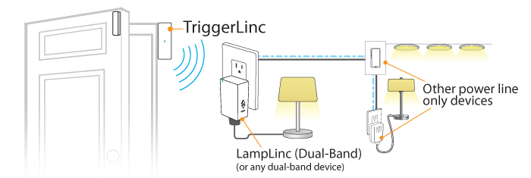
Figure 8 Reprinted with permission of Insteon.

3.13.2.3 - Passive Infrared Receiver (PIR)

Skylink Wireless INSTEON Motion/Occupancy Sensor

Skylink Wireless INSTEON Motion/Occupancy Sensor can turn on your INSTEON-controlled lights or appliances when you enter the room and turn them off after you've left. Integrating automation to your lighting, this motion sensor is good for areas of your home such as the laundry room, closets and the garage where lights commonly get left on. You can use this motion sensor for indoor or outdoor applications, and link it to a wall switch, plug-in lamps or appliances. You can have the motion sensor trigger your thermostat to a favorite comfort level when you enter your home or any room in your house.
There are additional features including an adjustable 'Off' countdown timer delay, night-only mode with adjustable light sensitivity settings, adjustable motion sensitivity, and wireless range of up to 150 foot. The sensor also has 40-feet field of vision and a pivoting mounting bracket. This INSTEON Wireless Motion sensor is a good to have for any INSTEON home automation network as an addition that will make your life more convenient, fun and energy-efficient. A 9 Volt battery is required for this sensor. Since the motion sensor only transmits RF signals, your home must have at least one Access Point or other dual-band product to interpret the command for controlling power line only devices.
When the sensor detects motion it sends a wireless RF signal to the nearest Access Point or other dual-band product which in turn relays the signal over your existing power wires to turn on linked devices such as lamps or wall switches. After a selectable time of no motion, the sensor turns those same lights (or appliances) off. The motion sensor also features a secondary dusk / dawn control feature that is accessible with computer controllers such as HouseLinc or ISY-99. It allows you to set a device or group of devices to activate when the photocell detects a change in light or dark conditions for more than 3.5 minutes. This is great for automatically controlling landscape lighting and more.

A Plug-In 9-Volt Power Supply (Battery Eliminator) can be used in place of a 9 Volt battery, eliminating the cost and trouble of regularly replacing the battery. To install, you just notch a small hole using a file or shear on the Motion Sensor battery door (for the power supply wire) and plug it in.

Note about PIR Sensors
As with all PIR (Passive Infrared) motion sensors, there are certain factors which can cause detection range and reliability to vary. Because PIR sensors rely on changes in heat to detect motion, you need be aware of the following factors that can affect PIR reliability when choosing a location to mount your INSTEON Motion Sensor:
- Rapid environmental changes
- Direct sunlight
- Direct wind from a heater or A/C
- Fireplaces

Also, note that certain types of treated glass may or may not act as an infrared 'wall' through which a motion sensor can detect. If you want to detect motion through glass, you need to test it in your particular application. Note that any accumulation of ice, snow or dirt on the Fresnel lens may also interfere with the motion sensor’s ability to detect motion.
The INSTEON Wireless Motion Sensor is a great energy-saver. Your lights will turn on when you enter and automatically turn off after you leave, so you’ll never have to worry about leaving your lights on. Also, INSTEON Wireless Motion Sensor has a built-in photocell, so it can be disabled during the day. If daylight is enough to light your house during the day, the motion sensor can leave the lights off, even when motion is detected. By using motion sensor to limit the amount of time lights are on is a great first step towards saving energy and protecting the environment. You can unlock more motion sensor options with HouseLinc from INSTEON. If you decide to get HouseLinc and you'll be able to make adjustments to the INSTEON Wireless Motion Sensor without having to touch it again. These adjustments include the following features.

You change the “Off” duration to anywhere between 30 seconds up to 2 hours. Indicator Intensity can control the LED indicator brightness. This is good when you have the motion sensor in a bedroom and don't want the distraction of the red LED when it's being activated.
You can adjust the sensitivity of the motion sensors photocell (light sensor). This allows you to set the amount of light the motion sensor is required to see before the sensor transmits a command.

Dusk or Dawn Photocell Sensor can save energy by ensuring lights are off at dawn or turn your porch lights on at dusk with INSTEON Motion Sensor's dusk or dawn feature. When used with supported INSTEON software or an INSTEON automation controller, motion sensor can also be used as a dusk/dawn sensor. After it has been bright for 3 and half minutes, motion sensor will send an “Off” command for its 'Group 2', which can be used to turn off lights and appliances or trigger a software event. Conversely, it will send an “On” command after it has been dark for 3 and half minutes.
You get notified when it's time to change the battery. INSTEON Motion Sensor has 2 methods of indicating the battery life is low:
- LED double-flashes after motion is detected (even if LED is disabled)
- On command is sent to 'Group 3', which can be utilized with INSTEON software or an INSTEON automation controller
For extended battery life, you need consider purchasing a 9V Lithium battery which can extend battery life by 4 times. If you have a need for the motion sensor to activate many links, using HouseLinc, ISY-99 or other INSTEON computer controller that supports this product can extend battery life.
Motion sensor has been manufactured with a surface that can be painted to blend in with your home decorations. This feature gives you the ability to decide exactly what color will give your motion sensor installation that professional finished look. It is recommended that you protect the Fresnel lens during the painting process. Any excess paint or residue may cause motion sensor to operate improperly.

3.13.3 - RFID

Radio-frequency identification (RFID) will be used as key to enter the house. The reason is to free the house owner’s hands. As he/she comes home from shopping malls or supermarkets his/her hands will be full, he/she cannot reach to the key in the pocket. The group initial thought was using the voice recognition to do this task; however, the cost is expensive and the software is too complicated as get the voice command and transfers it into text. From there, the software will analyze the text and send out the signal to the controller. Then the controller will accomplish the tasks.

RF Transceiver: range, configuration, and power consumption are important factors when selecting a RF sensor. Sensor range is affected by output power, sensitivity and selectivity, which in turn interfere the jamming of other signal sources and the ability to distinguish the desired radio from local device radio, microwave, phone, and Wi-Fi router. Selectivity is also important in RF design, especially when designing products in the 2.4GHz band, where interference from other equipment is likely. When making the RF radio selection, it is also important to understand the network configuration is which the smoke detector will be use: Point to Point, Star or Mesh Network, as it may impacted the radio, processor, memory and power requirements of the system.

Line Powered: Power over Ethernet integrates data and power over standard LAN connection. It provides uninterrupted 15W max (13W load), 48V nominal supply to the devices connected to the system. The power requirement for smoke detectors is well below the ~12.5W limit for powered devices and can be easily powered from PoE. This sort of implementation removes the need to run AC power to sensor locations, and reduces the cost of the power supply in the detector by requiring only DC/DC power conversion.

Radio-frequency identification is the use of a wireless non-contact system that uses radio-frequency electromagnetic fields to transfer data from a tag attached to an object, for the purposes of automatic identification and tracking. Some tags require no battery and are powered by the electromagnetic fields used to read them. Others use a local power source and emit radio waves (electromagnetic radiation at radio frequencies). The tag contains electronically stored information which can be read from up to several meters (yards) away. Unlike a bar code, the tag does not need to be within line of sight of the reader and may be embedded in the tracked object.

RFID tags are used in many industries. An RFID tag attached to an automobile during production can be used to track its progress through the assembly line. Pharmaceuticals can be tracked through warehouses. Livestock and pets may have tags injected and allow positive identification of the animal if they are ever lost and found by animal control center. RFID identity cards can give employees access to locked areas of a building easily, and RF transponders mounted in automobiles can be used to bill motorists for access to toll roads or parking faster without ever rolling down the windows.

The RFID tag can be affixed to an object and used to track and manage inventory, assets, and people. For example, it can be affixed to cars, computer equipment, books, mobile phones, etc.

RFID offers advantages over manual systems or use of bar codes. The tag can be read if passed near a reader, even if it is covered by the object or not visible. The tag can be read inside a case, carton, box or other container, and unlike barcodes, RFID tags can be read hundreds at a time. Bar codes can only be read one at a time.

In 2011, the cost of passive tags started at US$0.05 each; special tags, meant to be mounted on metal or withstand gamma sterilization, can go up to $5. Active tags for tracking containers, medical assets, or monitoring environmental conditions in data centers start at $50 and can go up over $100 each. Battery Assisted Passive (BAP) tags are in the $3–10 range and also have sensor capability like temperature and humidity.

RFID can be used in a variety of applications, such as: Access management, Tracking of goods, Tracking of persons and animals, Toll collection and contactless payment, Machine readable travel documents, Smartdust (for massively distributed sensor networks), Tracking sports memorabilia to verify authenticity, and Airport baggage tracking logistics.

Access control: High-frequency tags are widely used in identification badges, replacing earlier magnetic stripe cards. These badges need only be held within a certain distance of the reader to authenticate the holder. The American Express Blue credit card now includes a HighFID tag. In Feb 2008, Emirates Airline started a trial of RFID baggage tracing at London and Dubai airports.

Transportation payments: In many countries, RFID tags can be used to pay for mass transit fares on bus, trains, or subways, or to collect tolls on highways. Some bike lockers are operated with RFID cards assigned to individual users. A prepaid card is required to open or enter a facility or locker and is used to track and charge based on how long the bike is parked. The Zipcar car-sharing service uses RFID cards for locking and unlocking cars and for member identification.

3.13.3.1 - Security Concern

Since RFID tags can be attached to clothing, possessions, or even implanted within people, the possibility of reading personally-linked information without consent has raised privacy concerns.

Passports: In an effort to make passports more secure, several countries have implemented RFID in passports. However, the encryption on UK chips was broken in less than 48 hours. Since that incident, further efforts have allowed researchers to clone passport data while the passport is being mailed to its owner. Where a criminal used to need to secretly open and then reseal the envelope, now it can be done without detection, adding some degree of insecurity to the passport system.

3.13.3.2 - Alternatives

Door strike vs. Electromagnetic lock: Electromagnetic locks are an alternative method to electronically control door access. The advantage of this system is that the electromagnet can be bolted on to any existing door and the frame of the doorway does not have to be modified. The disadvantage to this system is that the electromagnet requires a constant supply of power and during power outages the door is unlocked. The door strike used by the RFID Smart Home only requires power during the unlock cycle, and remains locked during power outages.

USB vs. Serial port limitations: Using a serial port I/O signals, 0 - 12V, can be transmitted directly to the MCU using a wire. The MCU only has one serial port which is used to interface to the microcontroller. The MCU contains some USB ports, which can process 0-5 V I/O signals. A USB hub can be used to increase the number of USB ports. The number of serial inputs is limited to the number of ports on the MCU. When needed the USB ports also act as a power supply.

3.13.3.3 - Trade-offs

Wireless (Broadband Router) vs. Wired (USB): The extended range between the RFID reader and the MCU is the advantage of using a wireless connection. The MCU is already setup for a wireless connection but the card readers are not. A wireless interface would have to be connected to each card reader, increasing production cost. A wired method of communicating is less prone to interference, but is limited by distance.

3.13.3.4 - RFID access vs. Key access

Using a standard key to open a door takes less technical knowledge, and a key can be cheaply and easy replaced at a local hardware store. The disadvantages of using a key are that a key wears out over time, it can be easily duplicated, the lock can be broken, and the correct key can be difficult to find on a keychain. A passive RFID tag is cheap, may last longer, is distinguishable from keys, and does not require the turn of a door handle. In addition, the RFID entry key provides higher security to the house.
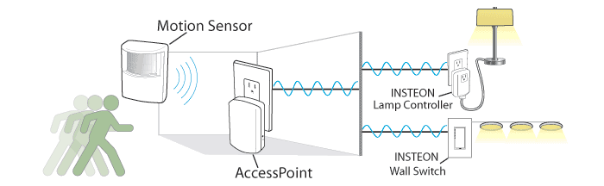
Figure 9: RFID
Reprinted with permission of Insteon

3.14 - Communication Standards

One of the most important goals of this project is to make an installation of the system non destructive to the home infrastructure and generally non invasive and easy to install. Wireless communications meet this goal the best; however there are a number of existing wireless standards that are optimized for smart home applications. Below is a summary of each standard with their respective strengths and weaknesses. Following the standard summaries, we will conclude with the selection of a particular standard that best meets the goals of our project.

3.14.1 - ZigBee

ZigBee provides a suite of high level communication protocols using small, low power digital radios based on the IEEE 802.15.4-2003 standard. The standard was developed specifically for Wireless Home Area Networks (WHANs) for use in smart home devices such as thermostats, light switches, lamps, power monitors, etc. The networks operate in the ISM band, typically around 2.4GHz at data rates up to 250kb/s and at a transmission ranges from 10m to 75m depending on the environment. The ZigBee specification is intended for relatively low data rate, secure mesh networks. It was designed to be simpler and less expensive than other WHANs, and also to be very low power so that small battery powered devices can use the standard and still achieve long battery life. The ZigBee standard is managed by the ZigBee Alliance; associations of companies that have developed standards promote interoperability between ZigBee devices.

The Radio Frequency for Consumer Electronics consortium worked with the
ZigBee Alliance to develop the ZigBee RF4CE standard which provides a universal communications protocol for home audio, visual, and control products.
That way different products from different manufacturers that adhere to the
RF4CE standard can integrate their devices into one unified mesh network. The
RF4CE standard includes various device profiles, two of the most important of which are the Home Automation profile and the Smart Energy profile. The Home
Automation profile specifies a protocol for managing displays, thermostats, lighting occupancy sensors, security systems, and other similar devices. The
Smart Energy profile specifies a communication protocol for monitoring and controlling devices such as smart lighting systems and climate controls. A ZigBee network is essentially an ad-hoc wireless mesh network. There are three basic types of devices in a ZigBee network: ZigBee coordinator (ZC), ZigBee Router (ZR) and ZigBee End Device (ZED). Every ZigBee network one and only one ZC, as it's the device that establishes the ZigBee mesh network. It is also used as a network bridge to other networks. A ZR can serve an application function was well, as serve as an intermediate router to pass data between other devices. A ZED functions as an application device only and will not relay data between other devices, therefore it is requires the least amount of memory and is the cheapest type of device to manufacture. If the network is beacon enabled, ZED can remain asleep most of the time and only wake up when polled by the ZC. Networks can also either be beacon enabled or non beacon enabled. In non beacon enabled networks, ZR devices are on all the time, listening to all activity on the network, while ZEDs may be asleep. While this enables faster response times by devices, they also consume more power. In beacon enabled networks, ZR devices periodically send out beacons to confirm to the other nodes that it is present in the network; however ZR and ZED devices can sleep in between beacons. This reduces the amount of power consumed by the devices; however it may slightly increase the response time of nodes to polls by the ZC since they must first wake up. In both modes, the protocol is optimized to minimize transceiver activity and keep power consumption to a minimum, and wake up latency is around 15ms which is much less than other standards such as Bluetooth.

There are a number of positive aspects to the ZigBee standard. First of all, it was designed from the ground up for smart home applications. The RF4CE standard and various device profiles are very useful in that it ensures compatibility between different products from different manufacturers for different application types, making development of an integrated system easy. The standard is open source, and also uses portions of the EM spectrum that is free to use for private applications, and getting rights to use the technology for commercial uses is relatively inexpensive. Perhaps one of the most important features is that the standard was designed to be low power, which is already and important factor in device designs, and will be even more so in the future. There are currently a number of ZigBee based smart home devices available for various applications such as door locks, thermostats, and window and door sensors. There are also a number of inexpensive MCUs available with built in ZigBee transceivers and free protocol stacks.

The standard is not perfect, however. The biggest limitation is that there are not nearly as many smart home devices available for ZigBee as there are for Insteon and X10. ZigBee also operates in the same portion of spectrum as Wi-Fi, so sometimes there are interference issues between those systems. And although the spectrum licensing is free for private applications, companies developing devices for commercial applications must pay licensing fees.

3.14.2 - Z-Wave

Z-wave is another type of wireless communication standard that works much like
a ZigBee or Wi-Fi connection does. It operates in the 900 MHz range, and asserts that this allows for better data communication. The ZigBee and Wi-Fi networks both operate on the 2.4 GHz ranges, and sometimes there could be a conflict of data transmission if both are running at the same time in the same area. Z wave is also more structured to an at home network than ZigBee. Some of the downsides are that it's a newer technology and not many partners in the Z-wave alliance43 are making this type of technology, so it's harder to locate 3rd party vendors or items that allow for "plug-and-play" type functionality that we want to demonstrate with our project. Other considerations such as power and performance seem to be a bit better with the Z wave. Companies like Black & 42
Decker, specifically Kwikset as a member of B&D, have joined both the ZigBee and Z wave alliances, allowing any module that operates on that type of network to be able to interact with a 3rd party device. This makes it very generic and easy implementable, which is a key selling point for this type of a project.

3.14.3 - X10

X10 is the most popular smart home device communication standard and has been around since the late 1970s. X10 is not a truly wireless standard, instead it relies on transmitting a modulated digital signal over existing home power wiring. X10 devices are usually plug into the wall where a lamp or other appliance is installed. Typically, a 120kHz carrier signal is used and one bit is transmitted at the zero crossing of the 60Hz power signal. The digital signal consists of an address field and a command field that is sent from a controller device to a controllable device. Commands can be as simple as "turn on" or "turn off", or the maser can poll the slave device for sensor data such as temperature sensor readings.

The strengths of X10 are that it is the most common smart home device communication standard and there are an abundance of X10 based devices available on the market that can do just about anything you can think of in the home. It also uses pretty simple, cheap hardware so it will keep the overall cost of devices down. It also does not compete with any other in home communication standards like ZigBee does with WiFi, for instance. There are also a number of important drawbacks and limitations to the X1 standard. Since X10 communication signals propagate over in home power wires, it is at the mercy of the topology of the in home wiring and devices must be placed at wall outlets. Often times, there are transformers that bridge different portions of the household wiring network which will greatly attenuate or block all together the X10 signal. Residual Current Devices designed to prevent electrical shocks also attenuate X10 signals that pass through them. Also, certain types of power supplies used in modern electronic equipment (such as computers, television sets, and satellite receivers) have built in capacitors that provide a low impedance path from the line to neutral, effectively diverting the high frequency X10 signal away from the hot line. Since X10 only transmits 120 bits per second, it is also a very slow protocol, and there is also no contention handling in the standard, so if two devices try to talk at the same time there will be a collision and data will be lost.

3.14.4 - INSTEON

Insteon is a common standard for connecting smart home devices. It is similar to the X10 standard and was intended to address the inherent limitations of X10 but also be backwards compatible with X10 devices. It is a two medium communications standard that uses a home's built in power wiring to communicate with other devices in a manner similar to X10, but also uses a RF transceiver to communicate with other devices wirelessly. In an Insteon network, all devices are peers so they can transmit, receive, and repeat any message on the network. Some improvements over X10 is that all Insteon devices act as repeaters so the entire network gets a transmitted message, and an acknowledgement based protocol is used. If a device does not receive an acknowledgement after it transmits a message, it retransmits until it succeeds. The wired based protocol also uses phase shift keying and synchronized message repeats. The 60Hz power signal is used to coordinate message repetition so that even with collisions, the devices are able to resolve the original messages.

Insteon based smart home devices are becoming ubiquitous and seem to be replacing the X10 standard. The hardware required for an Insteon transceiver is more complicated than an X10 transceiver, however it is still cheap enough to allow devices to be made inexpensively. Insteon also achieves higher data rates than X10 and more reliable communications. The RF signals can also penetrate walls in a home and allow devices to be placed away from power outlets. Insteon is a major improvement over X10 and is a suitable standard for modern devices, however it does have limitations. One important limitation is that most Insteon devices either operate in the wired mode or wireless mode but rarely both. Also, the wired based protocol is susceptible to high frequency interference on the power lines, and no troubleshooting tools are available to setting up Insteon networks as there are with X10 so corrections must be done trial and error.

3.14.5 - Bluetooth

Bluetooth is a very popular networking system these days. Almost all people with phones have a Bluetooth type of card installed in them, and there are many devices already out there that implement them, like the hands free headsets for cell phones that seem to be growing in popularity. As a network medium, Bluetooth has the connotation attached with it of being very reliable and secure. This is due to the built in 64 and 128 bit encryption systems established in the protocol. This makes it ideal for a security type of home networking system, and would add some type assurance to our product. However, there is a decently long list of downsides to using Bluetooth. Bluetooth as a product was not meant to be used at distance: it was meant to eliminate the need for two nearby technologies to have to be cabled together. Also, since they both operate at the 2.4 GHz frequency, there is some similarity about data transmission, but that's about where the similarity ends. Bluetooth can only transmit at a maximum speed of 1 Megabit per second, which is nowhere near fast enough especially if you have a network extended throughout your entire house. The protocol stack is also 250Kbytes, which is roughly 10 times larger than that of the ZigBee network. Also, the most killer aspect of this network is the connection rate. ZigBee boasts a connection speed of 30 milliseconds, whereas Bluetooth can take upwards of 10 seconds to recognize a new device.

3.14.6 - WiFi

Wi-Fi is probably the most common and widely used wireless standard by far. It has revolutionized the way that we communicate and has been a front runner in the wireless communications field. It uses the IEEE 802.11 specifications, and sets up a point to hub connection for accessing the network. The way system would work if group implemented it using this method would be to have the base station as a router and have all the nodes connect to it much like you connect your computers or laptops to a wireless network at your home. Some of the downsides group has all experienced - slow connection speed and no real security. The data rates are a bit slower than ZigBee - 11 and 54 Mbits/sec are the two going rates - and Wifi has no built in security to speak of. The connection itself can be troublesome also, as it can sometimes require up to 3-5 seconds locating the hub and connecting to the Internet. Lastly with the constant connection being established to the "router", there is very large power consumption as compared to the rest of the networks that group discussed so far in this section. One of the best things going for Wifi however is its network size,

Common terms when referring to wireless are 802.11b, 802.11g which use the 2.4 GHz ISM band which then may occasionally suffer interference from microwave ovens, cordless telephones and Bluetooth devices. 802.11b and 802.11g control their interference and susceptibility to interference by using direct-sequence spread spectrum (DSSS) and orthogonal frequency-division multiplexing (OFDM) signaling methods, respectively, and the newer 802.11n which then use 2.4/5GHz band to avoid the interferences.

Current 802.11 standards define "frame" types for use in transmission of data as well as management and control of wireless links.

Frames are divided into very specific and standardized sections. Each frame consists of a MAC header, payload and frame check sequence (FCS). Some frames may not have the payload. The first two bytes of the MAC header form a frame control field specifying the form and function of the frame. The frame control field is further subdivided into the following sub-fields:

Power Management: This bit indicates the power management state of the sender after the completion of a frame exchange. Access points are required to manage the connection and will never set the power saver bit.

More Data: The More Data bit is used to buffer frames received in a distributed system. The access point uses this bit to facilitate stations in power saver mode. It indicates that at least one frame is available and addresses all stations connected.

WEP: The WEP bit is modified after processing a frame. It is toggled to one after a frame has been decrypted or if no encryption is set it will have already been one.

Order: This bit is only set when the "strict ordering" delivery method is employed. Frames and fragments are not always sent in order as it causes a transmission performance penalty.

The next two bytes are reserved for the Duration ID field. This field can take one of three forms: Duration, Contention-Free Period (CFP), and Association ID (AID).

An 802.11 frame can have up to four address fields. Each field can carry a MAC address. Address 1 is the receiver, Address 2 is the transmitter, and Address 3 is used for filtering purposes by the receiver.

The Sequence Control field is a two-byte section used for identifying message order as well as eliminating duplicate frames. The first 4 bits are used for the fragmentation number and the last 12 bits are the sequence number.

The Frame Body field is variable in size, from 0 to 2304 bytes plus any overhead from security encapsulation and contains information from higher layers.

The Frame Check Sequence (FCS) is the last four bytes in the standard 802.11 frame. Often referred to as the Cyclic Redundancy Check (CRC), it allows for integrity check of retrieved frames. As frames are about to be sent the FCS is calculated and appended. When a station receives a frame it can calculate the FCS of the frame and compare it to the one received. If they match, it is assumed that the frame was not distorted during transmission.

Management Frames allow for the maintenance of communication. Some common 802.11 subtypes include: Authentication frame: 802.11 authentications begin with the WNIC sending an authentication frame to the access point containing its identity. With an open system authentication the WNIC only sends a single authentication frame and the access point responds with an authentication frame of its own indicating acceptance or rejection. With shared key authentication, after the WNIC sends its initial authentication request it will receive an authentication frame from the access point containing challenge text. The WNIC sends an authentication frame containing the encrypted version of the challenge text to the access point. The access point ensures the text was encrypted with the correct key by decrypting it with its own key. The result of this process determines the WNIC's authentication status.

Association request frame: sent from a station it enables the access point to allocate resources and synchronize. The frame carries information about the WNIC including supported data rates and the SSID of the network the station wishes to associate with. If the request is accepted, the access point reserves memory and establishes an association ID for the WNIC.

Association response frame: sent from an access point to a station containing the acceptance or rejection to an association request. If it is an acceptance, the frame will contain information such an association ID and supported data rates.

Beacon frame: Sent periodically from an access point to announce its presence and provide the SSID, and other parameters for WNICs within range.

Disassociation frame: Sent from a station wishing to terminate connection. It's an elegant way to allow the access point to relinquish memory allocation and remove the WNIC from the association table. Probe request frame: Sent from a station when it requires information from another station.

Probe response frame: Sent from an access point containing capability information, supported data rates, etc., after receiving a probe request frame.

Re-association request frame: A WNIC sends a re-association request when it drops from range of the currently associated access point and finds another access point with a stronger signal. The new access point coordinates the forwarding of any information that may still be contained in the buffer of the previous access point. Re-association response frame: Sent from an access point containing the acceptance or rejection to a WNIC re-association request frame. The frame includes information required for association such as the association ID and supported data rates. Control frames facilitate in the exchange of data frames between stations. Some common 802.11 control frames include: Acknowledgement (ACK) frame: After receiving a data frame, the receiving station will send an ACK frame to the sending station if no errors are found. If the sending station doesn't receive an ACK frame within a predetermined period of time, the sending station will resend the frame. Request to Send (RTS) frame: The RTS and CTS frames provide an optional collision reduction scheme for access points with hidden stations. A station sends a RTS frame to as the first step in a two-way handshake required before sending data frames. Clear to Send (CTS) frame: A station responds to an RTS frame with a CTS frame. It provides clearance for the requesting station to send a data frame. The CTS provides collision control management by including a time value for which all other stations are to hold off transmission while the requesting stations transmits. Data frames carry packets from web pages, files, etc. within the body, using RFC 1042 encapsulation and EtherType numbers for protocol identification.

The figure 8 below is used to illustrate how group can control the system. As the system can go online, group can use Internet to access home applications from everywhere even from the other side of the world as long as having connection to the Internet. Using the 802.11 technology to have access to smart home system

3.14.7 - Communication summary

The main requirements of the communication network by the system are that the network be nondestructive to the home, achieve reliable communications, relatively high overall network bandwidth compared to the bandwidth requirements of an individual device, have cheap transceiver hardware, facilitate low power system operation, and have sufficient information freely available for us to easily implement a robust system.

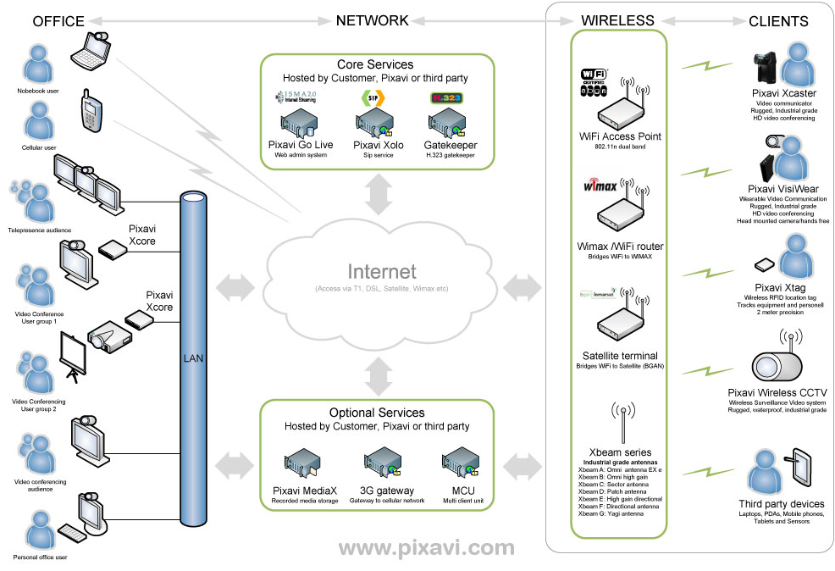
Figure 10: Wifi Communication over the Internet (7)
Reprinted with permission from SmartHome

The X10 is a very popular industry standard that would be cheap to implement, however it is antiquated and does not provide reliable enough communications, group did not select that standard. Z-Wave in theory is a good, modern standard with appropriate performance for our project; however, it is closed source which would prevent us from being able to get enough information about the protocol to implement a true Z-Wave network so it will not work for us. Bluetooth is an inexpensive technology that has been widely developed, however it does not have the transmission range or network scalability that group require for our application, so it is out. WiFi networks are ubiquitous, support very high data rates, good transmission ranges, and have free open source protocol stacks, however it requires expensive hardware and uses a lot of power, so it will not work for us. Insteon is a very appealing standard because it was designed for our application. It is relatively cheap to implement, has good transmission ranges and data rates, and has the added bonus of being compatible with X10 devices.

There are also many devices available for Insteon which would allow us to construct a cheap, robust system. The main drawback to Insteon is that it has limited low power capabilities, and development tools and protocol stack availability is limited. The ZigBee has all of the benefits of Insteon, plus more such as low power operation features, reliable communications, and the protocol is more robust in terms of controlling devices at a system wide profile level. There are also a number of cheap, powerful MCUs available with ZigBee transceivers built in as well as free powerful protocol stacks. The drawback to ZigBee is that it is not as widely used in smart home devices as X10 and Insteon based products, yet it has a better foundation and more potential than the other standards. If anything, it would be a plus to use ZigBee because group can further the proliferation of a superior technology. It is for all these reasons that group selects ZigBee as the wireless communications standard for wireless sense and control modules.

3.15 - Air sensors

Smoke and Heat Detector with End-of-Line Relay

You need to take smoke and heat detector in to account, your family or home can be endangered by fire. You can protect them from catastrophic fires with an reliable smoke detector that connects to your security system, and even supplies its own built-in power supervision relay. Standard hardwired smoke detectors for security systems are good, but usually require a separate power supervision relay to ensure proper operation, but this powerful unit has the relay built in. Combine that with its self-diagnosing feature that continually monitors its own sensitivity and operational status, and you'll have a failsafe fire warning system with a reliability level that simply can't be matched.

This life-safety device is designed to be hardwired via 4-conductor cable to a monitored or standalone security system. When it detects smoke, it triggers a loud 85dB audible siren and sends an alarm condition to the control panel. If the security system is monitored by a third-party monitoring company, security personnel can summon the local fire department to respond. It's the perfect way to protect your house whether you're away from home or sleeping soundly.
This unit should be connected to a home security system as the last smoke detector of a multi-detector zone. This is important because if power is lost to one of the smoke detectors on the zone, and no power supervision relay is installed, the security control panel will still "see" the end-of-the-line resistor and would not indicate trouble. But this smoke detector eliminates that problem, ensuring that you'll be alerted to maintenance requirements before it's too late.

Specifications

Manufacturer: Interlogix
Manufacturer Product No.: 449CSTE
Siren Volume: 85dB at 10 ft. (305cm)
Heat Detector - Fixed Temperature/Rate of Rise: 135°F & +/- 5°F (57.2°C +/- 2.8°C), 15°F/min & >104°F (8.3°C/min & >40°C)
Operating Temperature Range: 32°F to 120°F (0°C to 50°C)
Operating Humidity Range: 0 to 95% RH
Voltage: 8.5-33V DC
Dimensions: 6.1" (15.5cm) diameter x 1.85" (4.70cm) height
Color: White

Carbon Monoxide Detector

SafeAir Carbon Monoxide Detector

The silent killer known as carbon monoxide (CO) can harm yourself or your family. To protect you from this odorless, colorless and potentially deadly gas with a carbon monoxide detector and alarm built to the same high standards of those that protect industrial plants and hospitals. A built-in electrochemical sensor continuously monitors for CO and is unaffected by other airborne substances or temperature variations. Additionally, this carbon monoxide detector has quick response time, fast clearing time and superior false alarm immunity tower above the reliability levels of other CO alarms.
This life-safety carbon monoxide detector device is designed specifically for use with monitored security systems. When it detects potentially harmful levels of CO, it emits a loud 85dB audible alarm AND alerts security monitoring personnel who can summon help from local paramedics and fire departments.
The carbon monoxide alarm unit's contoured design and small size make it good for residential applications. A low 8mA current draw eliminates the need for an additional power supply and the carbon monoxide detector sensor connects to any zone of a hardwired security system via four-conductor cable.

The GE SafeAirTM 250-CO carbon monoxide (CO) detector is an accurate and reliable means of alerting building occupants of potentially dangerous levels of CO in the protected area. The internal electro-chemical sensor communicates with a sophisticated on-board microprocessor that accurately tracks CO levels over time.

This commercial-grade detection technology results in quick response, reliable sensing, fast reset time, and superior false alarm immunity. Its small size allows the 250-CO to blend inconspicuously with any decor, and its smooth contoured design is compatible with both residential and commercial environments.

Unaffected by normal indoor temperature variations, the GE 250- CO actually self-adjusts for environmental changes and operates reliably under a wide variety of conditions. It also monitors its own performance and automatically compensates for sensitivity drift throughout the course of its service life.

Like all CO detectors, the 250-CO has a limited service life. When it reaches this point, the 250-CO’s six-year end-of-life timer automatically triggers a warning, locally, at the control panel, and optionally, at a central monitoring station, indicating that the device should be serviced.

An integrated temporal four-horn provides local signaling capability for the 250-CO and it easily interfaces with any listed intrusion or fire alarm system by means of its 150mA output relay, which may be connected to the auxiliary input on the control panel. Its low current draw results in little additional demand on the system power supply.

The 250-CO fully complies with the latest UL 2075 requirements which allows for installation in a wide range of residential and commercial settings.

Standard Features
• Uses highly reliable, commercial-grade, electro-chemical sensing technology
• Self-diagnostics keep the device operating optimally throughout its service life
• Sensor is unaffected by fluctuations in normal indoor temperature
• Built-in trouble/power supervision relay
• 12 or 24VDC operation and 150mA relay contact configurable for normally open or normally closed operation
• Long-life six-year sensor
• Transmits sensor end-of-life to the control panel and central station if the system is monitored
• Fully listed to the latest UL 2075 CO standard for residential or commercial occupancies
• Large terminals ease wiring installation 14 to 22 AWG
• One-touch TEST/HUSH button simplifies local operation
• Integrated 85 dBa temporal 4-sounder for local notification
• On-board LED provides local alarm and trouble indication
• Inconspicuous footprint and attractively contoured design
• Adapter plate makes replacing GE 240-COe CO detector simple

Application

The SafeAir 250-CO Carbon Monoxide Detector is intended for ordinary indoor-dwelling unit applications in both residential and commercial occupancies, including single/multiple family residential occupancies, hotel rooms, dorm rooms, and other areas approved by the authority having jurisdiction (AHJ). The 250-CO detector can connect to either UL 985 (Household Fire Warning) or UL 864 (Commercial Fire) control panels. It is not intended for use in industrial applications such as gasoline refineries or parking garages, which require different listings. The 250-CO detector has an optional adapter mounting plate (to purchase the plate order P/N 250-COPLT-5PKG).

Selecting a suitable location is critical to the operation of CO detectors. You need to nstall the 250-CO in accordance with NFPA 720 Standard for the Installation of Carbon Monoxide (CO) Detection and Warning Equipment. You need place wall-mounted detectors at least 5 ft. (1.5 m) up from the floor. For ceiling mounted applications, place the detector at least 1 ft. (0.3 m) from any wall.
Recommended CO detector locations:
- Within 10 ft. (3 m) of all sleeping areas, including areas such as hotel rooms and dorm rooms.
- In a suitable environment: areas with a temperature range of 32 to 104°F (0 to 40°C) and with a relative humidity range of 0 to 90% noncondensing.
- In residential dwellings, locate detectors in every bedroom, within 10 ft. (3 m) of sleeping areas, and on each level. At a minimum, place one detector outside the sleeping areas.
Figure 11 Recommended locations for CO detectors
Reprinted with permission of SafeAir

Recommended CO detector locations in commercial occupancies:
- On every habitable level of the building based on an engineering evaluation considering potential sources and migration of carbon monoxide
- In any area required by local building codes, legislation, or authorities having jurisdiction
- On a firm, permanent surface

Specifications

Manufacturer: Interlogix
Manufacturer Product No.: 250-CO
Input voltage: 12V DC, supplied by a UL Listed control panel
Current consumption: Standby: 8mA
Alarm: 60mA max
Relay contact: 50mA @ 12V DC
Electrical configuration: NO, NC
CO alarm level: COc: 70 ppm/60-189 minutes
Operating temperature: 40F to 100F (4.4 to 37.8C)
Relative humidity: 15 to 90% non-condensing
Dimensions: Width:2.7" (6.9cm)
Length: 6.0" (15.2cm)
Depth: 1.4" (3.6cm)
Weight: 4oz (114g)
Color: White
Altitude: +/- 3,000 feet for best performance
Listings: UL2075

Minotaur Engineering WSI2 Water/Moisture Sensor with Audio
- Sensor detects moisture or leaks using 2 probes
- Water sensor sends signal to INSTEON I/O Linc unit
- Audio alert sounds when moisture is detected
- Only one I/O Linc is needed for multiple water sensors
You can catch leaks as soon as they start with a water-sensor system that triggers I/O Linc-connected lamps to flash and sounds an audio warning tone. The Water/Moisture Sensor with Audio for INSTEON I/O Linc can detect moisture on any non-conductive surface and send a signal to any INSTEON receiver in range via an I/O Linc.

The INSTEON Water/Moisture Sensor connects to the I/O Linc unit via three leads on a 5-foot cable. The sensor should be placed such that the two probes firmly touch the surface to be protected. It is recommended to use the included self-adhesive wire tie and holder to correctly position the sensor and hold it in place. Care should be taken such that the sensor is in a position so that if moisture occurs in the area, it does not "run" or drip away from the sensor.
The Water Sensor provides a way to sense moisture on any non-conductive surface and in conjunction with an Insteon I/O Linc unit sends a signal to any Insteon receiver in range. It interfaces to a standard I/O Linc device (can be purchased separately). The WSI2 also contains a local audio tone generator which triggers on sensing moisture.

The sensor is completely self-contained and preset at the factory. Three leads from the sensor attach to the I/O Linc terminals. The red lead should be attached to the leftmost terminal (marked 5v). The steel braid wire should be attached to the 2nd terminal (marked GND) and the black lead should be attached to the 3rd terminal (marked S). Double-check these connections and polarities before plugging in the Insteon module.

3.16 - Flood sensors

Minotaur Engineering WSI2 Water/Moisture Sensor with Audio
- Sensor detects moisture or leaks using 2 probes
- Water sensor sends signal to INSTEON I/O Linc unit
- Audio alert sounds when moisture is detected
- Only one I/O Linc is needed for multiple water sensors
You can catch leaks as soon as they start with a water-sensor system that triggers I/O Linc-connected lamps to flash and sounds an audio warning tone. The Water/Moisture Sensor with Audio for INSTEON I/O Linc can detect moisture on any non-conductive surface and send a signal to any INSTEON receiver in range via an I/O Linc.

The INSTEON Water/Moisture Sensor connects to the I/O Linc unit via three leads on a 5-foot cable. The sensor should be placed such that the two probes firmly touch the surface to be protected. It is recommended to use the included self-adhesive wire tie and holder to correctly position the sensor and hold it in place. Care should be taken such that the sensor is in a position so that if moisture occurs in the area, it does not "run" or drip away from the sensor.
The Water Sensor provides a way to sense moisture on any non-conductive surface and in conjunction with an Insteon I/O Linc unit sends a signal to any Insteon receiver in range. It interfaces to a standard I/O Linc device (can be purchased separately). The WSI2 also contains a local audio tone generator which triggers on sensing moisture.

The sensor is completely self-contained and preset at the factory. Three leads from the sensor attach to the I/O Linc terminals. The red lead should be attached to the leftmost terminal (marked 5v). The steel braid wire should be attached to the 2nd terminal (marked GND) and the black lead should be attached to the 3rd terminal (marked S). Double-check these connections and polarities before plugging in the Insteon module.

3.17 - Thermostat

INSTEON Thermostat

Thermostat can save you money on energy bills by remotely controlling and programming your thermostat. Program settings for 7 days, including daily, weekdays, weekends and individual days, it works with heat/cool systems, including advanced 2-stage systems. All settings preserved through power failures in non-volatile memory, it is perfect for anyone whose schedule varies throughout the week. With INSTEON technology, the ultimate in simplicity and reliability, use as an INSTEON controller: thermostat can activate other INSTEON devices when the temperature changes.

You want to control your home's thermostat from another room. You are able to cool (or heat) the house while you're at work, or check the temperature when you're on the road. With the INSTEON Thermostat, you can control your home's temperature whether you're at home or miles away, saving energy (and money) and maximizing comfort. You can simply replace your existing thermostat and link it to any INSTEON controller such as a RemoteLinc, KeypadLinc or your smart phone using a SmartLinc.

The INSTEON Thermostat also works like a standard thermostat with local control, four automatic modes and 7-day programmable settings--allowing independent settings for individual days, weekdays, weekends and every day so there’s no hassle with training your family on how to use it.

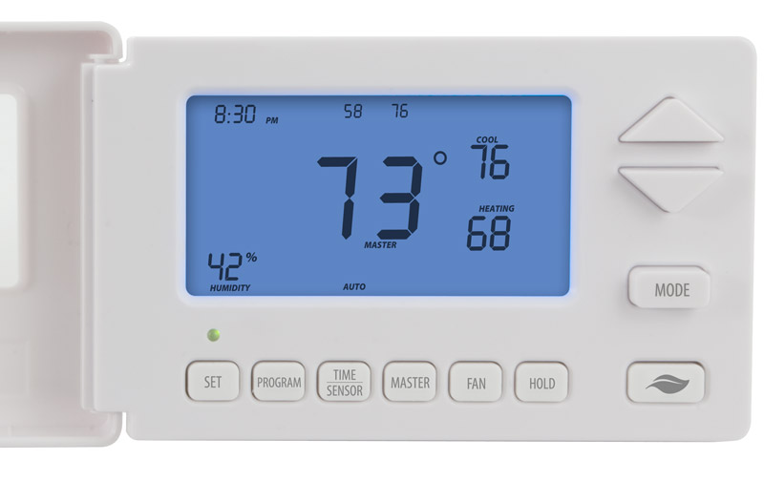
Figure 12: Insteon Thermostat
Reprinted with permission of Insteon

In addition to remote control, program the thermostat as an INSTEON controller to activate other appliances in your home based on temperature, humidity or mode changes. Here are just a few of the limitless scenarios:
- When the A/C kicks in, turn on your ceiling fans to help cool down your home faster and more efficiently
- Add INSTEON-compatible software such as HouseLinc and receive text messages if the temperature or humidity drops above or below your defined safe levels
- If the humidity level climbs too high, turn on a dehumidifier with an ApplianceLinc.
- Program a daily "Return" mode that turns on your A/C and switches on your outside lights so you come home to a relaxing, welcoming house
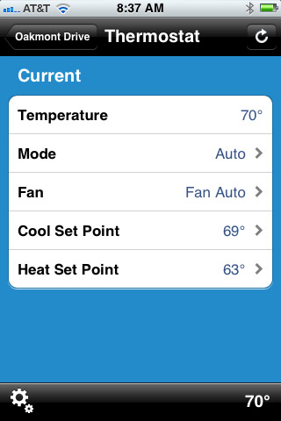
Figure 13: Insteon Application

This thermostat requires power from the furnace or A/C unit to function. If you do not have a "common" wire running between your thermostat and heating/cooling equipment, you may need either to run a new wire or to install an Add-A-Wire kit.
Because the INSTEON thermostat is an RF-only INSTEON product, at least one dual-band INSTEON device is required for it to communicate with your other INSTEON devices.
InSteon Specification
INSTEON Powerline Mesh Repeater: No
INSTEON RF mesh repeater: Yes
INSTEON controller: yes
INSTEON responder: yes
Maximum links/scenes: 400
LED: Red when Heating is active, green when Cooling is active, Off when when neither mode is active, blinks red or green during setup
LED Brightness: LED can be enabled or disabled locally or via software
Local Control: Yes
Commands Supported as Controller: On or Off
Commands Supported as Responder: On (beep) or Off
Software configurable: Yes
RF Range: Up to 50 meters open air
Phase Bridge Detect Beacon: No, RF only device
Mechanical
Mounting: Wall mount
Wire Connections:
Common 24V
Power 24V
Heat 1V
Heat 2V
Fan 2V
Cooling 1V
Cooling 1V
Screw Clamp Connections: Yes, 10 position
Case Color: White
Set Button: 1
Plastic: UV stabilized ABS
Beeper: Yes
Beep on Button Press: Optional (off by default)
LED: 1 dual-color red/green
Dimensions: 5.7"x 3.6"x 1.1"(14.5cm x 9.1 cm x 2.8cm)
Operating Environment: Indoors
Operating Temperature Range: 39° to 104°F (4°to 40°C)
Operating Humidity Range: 0-90% relative humidity
Storage Temperature Range: -4° to 158°F (-20°to 70°C)
Electrical
Voltage: 24VAC (supplied by furnace or air handler)
Frequency: 50/60Hz
Retains All Settings Without Power: Yes, saved in non-volatile EEPROM
Certifications: FCC, IC Canada, EN International
Standby power consumption: < 1 watt
FCC ID: SBP2441T

3.18 - Back-up Power

A blackout can happen almost at any time. The grid often may be down for days or even weeks. Backup power systems can supply electricity to critical loads or entire house when the grid is down. There are various kinds of emergency backup devices depending on the type of energy source they are using to produce electricity. When you are choosing the type of your system, the main things you get to decide are: the amount of backup electrical power you may need during a blackout and the length of time you want to produce it. You may want to add 10 to 20 percent safety margin for system derating and to prevent false tripping of your source's circuit breaker. Note, since many appliances have surge current exceeding their steady state current, you need to make sure your backup system has sufficient surge capacity to accommodate all the loads at start up. This is especially important for automatic systems. If you choose a manually activated system, you can turn off your loads before starting the backup source and then turn them back on sequentially. To properly size your system, you need to our size your load. The table below provides basic features of the main types of power back up sources. Electric generators are generally the least expensive source of power. For a short-term blackout, an emergency portable generator is the most popular low-cost solution. For a long-term emergency a natural gas or propane-powered stationary generator set with a transfer switch is probably the most cost effective solution. Such a system can provide electricity for as long as it has fuel. Home battery backup is less common because it is suitable only for short term outages. And unlike portable generators that can be refueled, a battery recharge needs a source of electricity. Alternative energies, such as photovoltaic energy are becoming increasingly popular due to various incentives and rebates. However, they are still more expensive types of home backup.
BACKUP POWER SOURCE
PORTABLE GENERATOR
MAIN FEATURES
- Runs on gasoline, diesel, propane, or natural gas (depending on the model)
- Power range: 500-17,500 W
- Gasoline models are good mainly for short-term outages
- Multi-fuel models running on LPG or NG may provide long-term power
PRO's
- Can be moved from place to place
- No professional installation is needed [unless you want to connect it to the house wiring via a transfer switch and/or to an external fuel source]
CON's
- Limited run time (less than a day before refueling) unless hooked up to an external fuel source
- Very noisy
- No auto start
- Requires maintenance
- Burns fuel even when it idles
NOTES
- Must be run outdoors only
- Potential fire and carbon monoxide hazard if used improperly
STATIONARY STANDBY GENERATOR (WHOLE HOUSE GENERATOR)
MAIN FEATURES
- Connects to the home wiring via a transfer switch
- Runs on diesel, propane or natural gas (depending on model)
- Highest power range (6kW -100's kW)
- The best type during long blackouts and as the whole house generator
- Typical transfer time with auto transfer switch: 10-30 seconds
PRO's
- Auto start option on many models
- Practically infinite run time when connected to natural gas line
CON's
- Expensive
- Requires professionally installed transfer switch and fuel line
- Requires maintenance
- Noisy
- Burns fuel even when it idles
NOTES
- Installed outdoors on a cement pad and connected via a transfer switch
BATTERY BACKUP WITH DC-AC POWER INVERTER / CHARGER
MAIN FEATURES
- Powers critical appliances via extension cords. May be permanently connected to the house wiring via a transfer switch
- Typical power for residential use: 5-10 kW
- Auto start systems have response time 16-36 ms
PRO's
- No maintenance required
- quiet
- May be installed indoor
- Low power consumption at no load (consumes power according to the actual load demand)
CON’s
- Limited run time (typically 2 to 12 hours) depending on the battery tank capacity
NOTES
- Look for a sealed deep cycle battery and a temperature compensated charger with a trickle mode to avoid battery overheating
BACKUP HOME GENERATOR VIA VEHICLE
MAIN FEATURES
- Good for short outages and to power only essential loads
- Typical power 300 W- 5000W depending on the car (hybrid is the best) and inverter
PRO’s
- Lowest cost
- No professional installation required
CON’s
- Engine must be ON all the time to avoid car battery discharge
- Power is limited by the rating of vehicle parts
- Limited run time
NOTES
- Exhaust fumes present potential hazard
SOLAR PANELS with a BATTERY SYSTEM and DC-AC INVERTER/CHARGER
MAIN FEATURES
- Photovoltaic (PV) panels charge battery bank
- Produces electricity only on bright days
- Can power stand alone AC loads or can be connected to the house wiring (in which case it requires a grid-interactive type of inverter with a transfer switch)
PRO’s
- Utilizes renewable energy
- quiet
- No maintenance required
- Defrays energy cost or even let you sell electricity back to utility
- Federal and state incentives
CON’s
- The most expensive type
- Limited run time [depending on the battery tank's capacity]
- Requires professional installation
NOTES
- In off-grid installations it's worth to supplement the system by a diesel or a propane genset
IND GENERATORS with BATTERY and DC-AC INVERTER
MAIN FEATURES
- A wind turbine converts wind energy into electric energy.
- Includes a battery bank, charger and grid tie DC-AC inverter with auto transfer switch
- May be used primarilly in rural areas
PRO’s
- Uses renewable energy
- Federal and state incentives
- Defrays energy cost or even let you sell electricity back to utility
CON’s
- Uses renewable energy
- Federal and state incentives
- Defrays energy cost or even let you sell electricity back to utility
NOTES
- In off-grid installations it's worth to supplement the system by a diesel or propane genset

The basics

Frequent blackouts lead to increasing interest in backup power devices. There are different types of backups depending on their operation and source of energy. Portable electric generators (or gensets) are designed to temporarily supply AC power by burning supplied fuels. As the name implies, this type of devices is for standalone (non-hardwired) applications. They are normally used to energize a few appliances via extension cords, although high-end models can power an entire home.

Besides home use, portable generators are utilized on construction sites and basically everywhere where the grid is not available. Currently, they are available in the range of 500W to 17.5kW. Their main advantages are they are generally cheaper than standby systems and may be used right away without the need of any special installation.

Choosing the fuel type

Depending on the design, genset's engine can run on gasoline, diesel, propane, or natural gas. Of course, each type has its pros and cons. Most small models are powered from the on-board tank- this is what makes these generators really portable. However, this also results in a short run time- typically it is less than twelve hours per tank. If you run such a device continuously at rated load you will need to shut it down several times a day for refueling. There are more expensive portable home generators that can be hooked up to an external fuel source (natural gas, LPG or diesel) and supply electricity for extended periods of time.

Figure 15: 4 kW gas portable electric generator
Gasoline-powered devices generally cost less than other types of gensets. There are Chinese-built models such as ETQ and Duro Star that are sold online for less than $100 per kilowatt. Some of them may have knock-offs of Honda engines. Normally, a cheap import is a cause for reliability concern. However, if you read customer reviews at various retailer sites, surprisingly, an average rating of imported gensets is not necessarily lower than that of domestic brands, such as Generac and Briggs & Stratton. You can buy for example a decent 4000W gas model for under $300. If you go by price alone, it may be your best choice. The main disadvantage of this type is when the grid is down the gas pumps may not work. To assure backup electricity during a wide-spread blackout you would need to store a substantial supply of stabilized gasoline. Note that unstabilized unleaded gasoline has very short shelf life- it can begin breaking down in about six months and can gum up the fuel system. Manufacturers of some stabilizers claim their products can extend gasoline shelf life to two years. If this is true, you would still need to replace your supply at least every other year. Alternatively, for a few hundred dollars consumers can convert practically any gas engine into a multi-fuel one with a third party conversion kit. Also note that if not properly maintained, a gasoline engine may have cold weather start up problems due to gum deposits. In any case, it requires frequent maintenance, such as periodic oil changes every 20 hours or so.

Portable diesel generators are more efficient, more quite, have the longest engine's life, but generally are the most expensive. Diesel also is the least flammable fuel source and has longer than gasoline shelf line, but it likewise may not be available during a blackout.

Propane can be easily stored in large tanks, has practically unlimited shelf life, and besides natural gas is the only fuel normally available during wide-spread outages.
There are also multi-fuel devices that offer more options when one type of fuel is not available. Usually a simple adjustment is needed to switch from one type of fuel to another. Although they are quite pricey, they still cost less than standby systems with the same wattage and you save on the electrical installation.

Features and Options

When choosing a genset, aside from rated wattage, type and cost, there are a number of features and accessories to consider. Cheap brands may sound like a lawn mower. So-called quiet models normally cost more. They are still noisy, although to a lesser degree. You can check if there are any noise restrictions in your neighborhood. Besides this, look for the following features: OHV engine, electric start (in addition to manual recoil), twist-lock receptacles, and oil gauge. If you plan to use your device without a transfer switch, a built-in GFCI would provide additional safety. Since a typical model may weight several hundred pounds, also look for wheels kit devices with wheels can be moved around by one person. If you need a clean sinusoidal voltage for sensitive electronics, consider inverter-generators. Unfortunately, they typically cost twice more than regular gensets. For a peace of mind it is preferable to have a part that is listed with the Underwriter's Laboratory (UL) or FM, or a respective safety agency in your country. As for wattage, be aware that portables are often advertised by their short-term starting watts rather than by continuous power

Connecting the portable generator

The most common method of hooking up your AC loads is by using extension cords. You just plug the cords into your genset outlets and run them through open doors or windows to the appliances you want to power. You need to be sure to use heavy duty outdoor-rated cords. You will need 3-wire cables for 120VAC outlets. Models rated above 5 kW usually also provide 120/240 output via their 30 or 50 A 4-hole receptacles. The required wire size depends on its length and the rated load current. As a rule of thumb, #12 AWG cord is sufficient for currents up to 20 A. Instead of running individual cables, you may use a 4-wire extension cord. It plugs into the high-current locking 120/240VAC receptacle of your generating set and provides several female outlets on the other end. Likewise, for a 120V locking outlet you can get a 3-wire cord splitter.
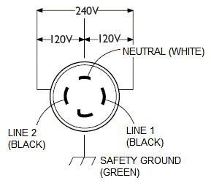
Figure 15: Generator outlet

The cords method perhaps is your only option if you are looking for a quick solution. However your lights and everything else that is directly connected to your house wiring will not be powered. You will need to figure out how to disconnect them one by one from the building wiring and then connect to the cords. You would have to go through all these troubles every time you need to use a generator. A more convenient and safe method is to hook up your power source to the house via a transfer system. It isolates genset from the grid and prevents back feeding into utility lines. Back feeding can hurt anyone working on the power line or coming in contact with a wire and is illegal. A transfer switch also protects your genset from damage if grid restores while it is running. Once you wired the switch, all you need to do is roll out your genset from storage and connect its high-current twist-lock receptacle to the inlet box via a single power cable. You can either buy a ready-to-use generator cord or get a proper plug and a socket and build it by yourself. See the diagram below for the pin out of a single-phase 125/250V 30A plug NEMA L14-30P. This method is safer and gives you more flexibility. However, obviously, it increases your cost and requires a professional installation. Most guides and reviews won't tell you that a genset with GFCI will not work with a regular transfer switch. You may need to get a special 3-pole transfer device or otherwise disable the GFCI, which is not quite safe and is not recommended. For everyone's safety, be sure your electrician turns OFF the main circuit breaker before starting the work. If you really must connect a genset to a building wiring without a redundant switch, be sure to move the main breaker in the service panel to the "OFF" position prior to connecting the genset. Note however, that this method is NOT recommended for a number of reasons. First, you would need to turn the main circuit breaker off before you connect a genset, and disconnect it before turning the service back on. If you accidentally do not follow the "proper sequence", you will be back feeding. Secondly, your main disconnect may not be rated for twice the line voltage (which may develop across it if you have AC voltage on both sides).

Safety

The owner’s manual will include the recommended safety rules. However you may want to know certain basic things in advance.
- Just like all engine containing devices, electric gensets should always be used OUTDOORS. You should locate it at least 15 feet away from the house to avoid carbon monoxide poisoning and fumes build up.
- A genset should never be connected directly into a wall outlet or your house unless it is isolated from the grid.
- Most portable generators need to be protected from rain and snow.

3.18.1 - Backup Power Supply: Solar Power

The group intends to use solar power and a battery to make a backup supply power in case main power line breaks down. Group needs to convert the heat from the sun into electricity by using solar inverter. The solar inverter is a critical component in a solar energy system. It performs the conversion of the variable DC output of the solar panels into a 50/60 Hz AC current that is then supplied directly to the electrical network. Communications capability need to be built in so that users can monitor the inverter and report on power and operating conditions, provide firmware updates, and control the inverter grid connection. Furthermore, the inverter can be controlled using Ethernet or wireless such as Bluetooth and Wi-Fi signal, IEEE802. The schematic is as figure 9 below and with permission from TI. There is a temperature wire to the solar power in order to measure the sun temperature. It will direct the panel to the highest possible direction of receiving the sunlight. The panel than transfer the heat to the power and store it to the battery. The MCU will control current overload and communicate with other devices.

A microcontroller is a center of the converter. The MCU runs the algorithms required to convert the DC voltage generated by the solar panels into the AC and supply it to the smart home system control. This MCU is programmed to control the necessary loops for all the power management functions necessary including DC/DC and DC/AC. It also control the output power through the algorithms called maximum power point tracking. The maximum output power depends on the operating conditions and varies from moment to moment due to input sources which then are tracked and adjusted according to the need of the system. This maximum power point is continuous monitored throughout the day. For systems with battery energy storage, the controller also controls the charging as well as switch over to battery power once the sun sets or cloud cover causes the output power supplied less. The controller contains advanced peripherals to improving control loop cycles. The MCU measures variables, such as the PV output voltage and current, and then adjusts the DC/DC or DC/AC converter by changing the PWM duty cycle. If anything happens, the MCU will automatically shut down the power line and will be able to reset itself after a period of time. The errors will then be output on the LCD display for the home owner convenient check.

Storage Battery
Battery Control
Charge Control
Solar Panel
Temp Sensor

C2000 MCU
Relay
Power Line
House

Figure 16: MCU Solar Panel Converter Control

The C2000 microcontrollers are the 32 bit devices with high performance integrated peripherals designed for real-time control applications that satisfy the need of the group. Its math-optimized core gives designers the means to improve system efficiency, reliability, and flexibility. Powerful integrated peripherals make C2000 microcontrollers the perfect single-chip control solution. C2000's development tools strategy and software (controlSUITE) from TI will create an open platform with the goal of maximizing usability and minimizing development time. The solar converter is hooked up at figure 9 above. The C2000 in particular is designed to read the ADC and adjust the PWM within a single clock cycle, so real time control is possible. Communications on a simple system can be handled by a single processor, more elaborate systems with complex displays and reporting on consumption and feed-in-tariff pay back may require a secondary processor, potentially with Ethernet capability like the Stellaris Cortex M3 parts. For safety reasons, isolation between the processor and the current and voltage is also required, as well as on the communications bus to the outside world. This will be done by adding relays circuit to the current lines. Whenever overloaded current is occur, switch will shut down the power line.

3.19 - P2P Networking

A peer to peer architecture is a distributed network architecture where each participating workstation has equivalent responsibilities and capabilities. All participants in the network have the ability to consume or provide resources without the need for centralized coordination instances. In the internet world, as one mention about P2P, people automatically think of big file transfer between computers all over the world. However, P2P can also apply into group’s project. The P2P is the additional demands on the systems for adding additional nodes to the network as they would also add additional capacity to group’s system. This approach would allow group’s project to distribute the workload between the base software and the devices making communication of wireless sensors more flawless. It would also increase the amount of total users capable of interacting with the system at the same time. Due to the decentralized nature of the P2P architecture, the system would be able to have a more robust notification deliver system as we would no longer have a "one to many" scheme. This would allow a peer to notify all other peers of their activities without going through an intermediate centralized server. However, on the other side this approach would add complexity to the deliver notification system due to coordination issues. If a flooding, or flushing, approach was taken for delivering notifications then there could be several duplicate notifications provided to the user making the system less reliable. This would lead to the need to have acknowledgement send back and forth throughout the distributed network adding additional load and complexity to the system. Also, it may not be necessary to have every peer capable of processing the same request as the main station. If every node was capable of processing its own request for service it would turn into one large distributed computing system. In order for this implementation to be successful there are issues that would need to be dealt with such as creating an algorithm for efficient world load distributions, synchronization of data and avoiding of race conditions, mutual exclusion, and many other issues that would add time and complexity to our design project. Therefore, although the P2P architecture would allow the project to be more adaptive to additional load, run smoother, and less reliant on a centralized server, it on the other hand also adds complexity with issues like coordination, workload distribution, and mutual exclusion.

4 – Design Summary

4.1 - Software

For the android and iPhone applications the design lay out should pretty much be the same. The applications will both have the same functionality. The goal is to get system to be able to monitor and control, audio data transfer, and video data transfer from the smart home system to the phone. The monitoring and control is the simplest task so that will be the group’s primary goal. Then once that system is set up the audio and video will be setup on top of that system. The phone applications will consist of pages or views that the user can navigate through.

The user will need some credentials to be able to access their smart home. The credentials would be things like user names, and passwords for access to the smart homes web servers. These will be hard coded into the application for more security and simplicity for the user and the developers. However this will decrease flexibility and adaptability because that means that the smart home system will be a specialized instance and won’t be transferable to others without a rebuild of the code. For this project it may be simpler to use a hard coded method, however if this project were to be commercialized then the user would need to be able to create credentials for the smart home system.

The main page of the smart home system will be a welcome page with links to the individual areas. From the main page on the phone applications, there will be buttons to navigate to the different sections of the smart home system. The main functionality of the phone applications will be status updates and control of the simple systems such as the lighting, motion and security sensors. The secondary goals for the project will be to implement phone controls for audio, video and AC thermostat. For the primary goals, the main page will have one button to get to the home status page. The home status page will consist of three different areas of the home and four if the thermostat control can be implemented. The home status page will display a simple form of statistics for the home in a quick and easy to read fashion. The lighting will display how many lights are turned on, and an approximation on how much power is being used by those lights. It will also include an estimate of how much money per hour the lights are using for the user to get a better idea of where the power bill is coming from. The motion sensors will have a simplified view of the house with a number displaying how many rooms have had motion detected in the last 1, 5, and 10 min timers. This will allow the user to see where in their house activity is happening and see where it came from too. The security sensors will show a simplified view of the security of the house by displaying a number for the number of doors or windows opened in the last 5 minutes, 1 hour, and 3 hours. The AC thermostat can show a display of what the current temperature is set too, and how much average power the AC has spent in that day, as well as the cost of that power. The user will be able to click a button to move to the sub sections of these components of the smart home security system.

By clicking on the lighting subsection of the smart home, the user will be able to see details on all the lights of the house. Each light will be displayed with a name and amount of time it has been on. The lights of the house can be set to turn of automatically if no motion is detected in a room for a certain amount of time. This feature will be optional as it can be inconvenient for the user to have lights turning off in a room if they are staying still in the case for example they are reading a book. Each light can be given a specific timer, in case there are certain lights the user want to shut off more frequently due to no motion detected, for instance a hallway light will receive many motion detection signals as people pass through to get to other rooms so it would be wise to set this type of lighting to a quicker shut off time. However for lights in the bedroom or living room, where people in the home generally relax and don’t move, no timer or longer timers should be set. This lighting display page will also show the details of each light. It will show how much power the light has used for the day, the average power the light uses per day, the average cost per hour of light, and the total cost of power of the light. The user will also have the power to shut off the lights manually if need be. This would be useful for example if the user forgot to shut off a light upon leaving the home, then checked the status of the home and realized a light was left on. Then they could instead of switching the lights timer settings just simply turn the light off.

The microcontroller for lighting will simply turn the lights on and off when the user’s computer detects a scenario where the light needs to be turned off, and send the signal to the microcontroller. For instance, when a timer turns off or a manual shutoff is executed. It will also need to record time in between these signals to know how much time the light was on or off. The data for the lights will be stored on the microcontroller, so that the server can update itself periodically. The microcontroller will send the user applications data on the current system status and the applications will send any commands performed by the user through the internet.

On the microcontroller there will need to be data variables for each of the lights to record all of the statistics. This can be created in a data structure depending on what type of programming language the microcontroller can run. The microcontroller will only update the values in the data fields when commands are issued. For example when a light is turned on then the time will be recorded into a data field. Then when the light is turned off the time will be recorded again and a total time on can be recorded. This can then be added to the total time on for the life of the light. Also the microcontroller can get the values of the cost of a kilowatt hour from the user applications and then record the cost of the light to display on the web server.

Creating the control software on the user applications for the lighting will require each light to be programmed as a new instance of a light object. The light object will need to retain values of the details of a light. This will need to be stored in a database on the user’s computer. In the software, the light object will be instantiated for each light of the house. It will have variables that record the value of the time running and how many watts the light runs at. There will be preset values for the user at 60W, which is the average power usage for a light, but upon initial setup the user will have the opportunity to change these. The computer software will communicate with microcontroller web server to get these values and also send the commands to execute changes to the system.

For the motion sensors the microcontroller will record changes received from the motion sensors and record the time that the change happened. This way the microcontroller will be able to calculate how long a motion sensor has not detected motion. The lighting system will then check room that it is located in to see how long the room has gone without motion. If the time the light is required to automatically turn off has passed then the light will shut off. This check can happen in time intervals of 20 seconds to a minute. The motion sensor will require data fields to know the room they are located in and the time the last time it sensed motion. The data fields of the motion sensors can then be sent to the user applications to show the user the activity in the house. Each room with a motion sensor will show a time of no motion detection and time of motion detection. For time of motion detection readings will need to be taken in time intervals. This time interval will be around 10 to 30 seconds, which is around the minimum time a person can move around in a room. A good example is the hall way scenario. Even if just walking through the hallway it will still take some amount of time, around the order of 10 seconds.

When the user clicks on the motion sensor button in the home monitoring display, then they will be able to view the data of motion sensing for each room. To create this in the software, room-motion objects will need to be created that will contain the data of the room. Each room will only need one motion sensor, so there for each motion sensor can represent one room. When a motion sensor is installed a new room-motion object can be created and the data for the object can be filled in and then start to receive data from the microcontroller about the status updates of the room.

4.1.1 – Class Diagram

There will need to be a class for each of the windows. Each window class will hold some values that are relatively static. In the HomeWindow class, there are several values that need to be displayed. These are simple stats that show a good overview of the home without taking up to much space or being too complicated. The other class windows will have similar value holders to display the status of the home. The window classes will need to have button functions that allow the user to navigate to the other windows. The Audio and Video windows will be relatively simple in terms of functions used in that class. They will however, require large complex packages from SDKs in order to do complex functions such as play music remotely, record voice, or stream video. The MonitorWindow Class will simply display the stats of the home.

For the components of the smart home system, using classes will be useful because it will allow multiple instances of that class to be created for the situations where there is more than one of that type of component. For example the Light class will most likely be instantiated several times, and each time it will represent a different light in the home. All the different component classes will require an ID field. The ID field will be unique to that individual component. For example if you had 3 lights, you would need 3 light objects to control them and each light object would need it own unique ID. In the case of the light component also the location and status should be know. Anytime a change is commanded in the system then the user should change the status of the component by using a function from that component class. In lights it has turnoff() function. This function would turn the light from on to off and off to on. The light component can only have two states, so that makes it simple to control. The components should also have some type of format for return their status in the case that system monitor want to check what the current status of any said component. Components like AC will have more functions because there is a more than one way for the user to interact with the component.

Figure 18: Class Diagrams

4.1.2 – Flow Diagrams

The figure 19 shows the flow of the application for the phones and the computer. It will be centered on the main display screen. The main display screen will display some simple stats, like the number of sensors, number of songs in library and recent activity near the camera. From the main display window, the user can then navigate to a different area through the use of buttons. If the user clicks the monitor home status button then they will be brought to another window where there will be more detailed statistics, like which lights are on, power usage, ac temperature and security settings. The will be buttons to look more closely at each area of the home system and then even more detailed statistics will be displayed with option to change them. If the user decides not to change anything in the system then they have the option to return home.

Figure 18: Software Flow Diagram

The user can also select to choose the audio features of the smart system. When the audio button is pressed from the main screen, the audio window will be displayed. This window will show the user library of songs that are stored either on the phone or the computer, the library will be shared. Upon selection of a song the music will began to be streamed to their sound system. They can then leave the audio window and do other things. The audio selection screen will also include playlist options. When the user wants the music to stop they press a button to stop the music. For the video system, from the main window the user presses the video button and this will lead them to the video monitor window. Here this will display a screen and stream video data from the camera. The user can then watch the video from this screen till they decide and the return home.

The hardware signals are displayed in figure 20. The first figure shows a status update and how the signals flow from the request to the MCU. The signals are taken in from the internet as IP data packets and then converted into digital signals by the MCU’s TCP/UDP. The data signals needed are then generated as a digital signal and then must be converted in to IP data packets to be sent back to the requester. When a signal is generated to control the MCU then the process is similar except that no return signal is generated. The signal is generated and travels through the internet as an IP data packet. When the signal reaches the MCU then it is converted into a digital signal and this digital signal is then processed. Depending on what the digital signal was destined for, it will then generate an analog signal and that analog signal will then send a control signal to the corresponding component. The component will then use the control signal to change its current state.
Figure 19: Signal Flow Diagram

The web server will be supported on the MCU and will communicate with the applications through the internet. In the figure the signal is generated from one of the applications. The web server receives the request for a status update and then begins to process the data. After all the data has been retrieved from the MCU it is then formatted to a format that is understood by the receiving end. The web server makes a response to the application that sent the request. The figure also shows how the MCU will change the status of the desired components when a command signal is received from either the phone or computer applications. The signal is sent through the internet in the form of IP data packets. When the signal reaches the MCU, the signal is then converted from IP data packets into a digital signal that is used within the processor of the MCU. The digital signal is processed and will tell the process what kind of signal it is. When the signal has been identified and understood it will then create an analog signal that will control the components. For example a voltage could be generated, giving the necessary voltage required to cause a relay circuit to change state.

Figure 20: MCU software flow for command sent

In figure 22, it shows how a signal to change the state of the web server is received and processed. The web server receives the signal and then processes it. Once the web server understands what the signal was, it then processes the control signals for either AC or a lighting change. The signal is then further processed so that it can decide more specific details like which light is to be changed, or what exactly is requested of the AC thermostat.
Figure 21: Software flow for update server

4.1.3 - Audio Software

Figure 23 shows the user interface of the phone. After pressing an app icon in the main OS of the phone, the user will then be brought to the home screen that is located in figure 23.

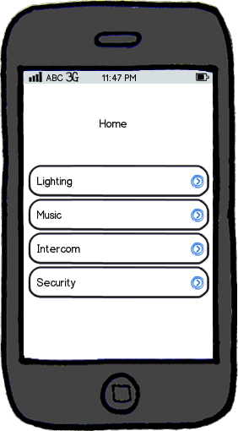
Figure 22: Home Screen

This figure is a mock up of the applications main page that populates the screen. These main navigation buttons will bring you to each of the automated parts of the home that are controlled within our project.

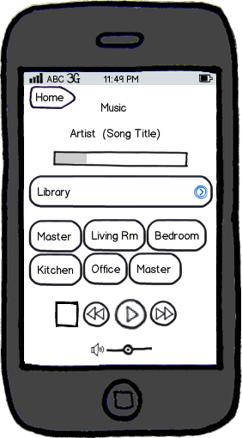
Figure 23: Music select screen

Figure 24 is the user interface of the phone once music is selected. Volume selection allows you to dial in the overall output being sent to the selected room. If no room is selected, then the phone outputs to the internal speakers that reside in the phone. A home button is located in the upper left corner to navigate back to the home page that is in the figure 23.

The timeline is also a feature in this section of the app to know how long the song is or how much time you have left before it ends. This is not meant to compete with some of the advanced features of the ipod or iphones music player, but to merely work in tandem with it. Taking advantage of the existing technology in the phone allows us to spend more time and energy on getting the networking audio side the app working for the user.

Figure 25 is the user interface of the phone once intercom is selected. The volume selection does much like you would expect it and allows you to adjust the overall output being sent to the selected room. Talk activates the internal microphone in the phone. It will act as a momentary latch allowing you to speak while you have your thumb on the button. If you double tap the talk button it is latched until you tap it a third time.

This feature will use the onboard echo cancellation of the iphone to filter out background noise as well as a feedback loop that might happen between the microphone and speaker. The main feature of this intercom is centered on the phone. Our first priority will be to get communication between the phone and any room working first. Navigation back to the home page of the app is also featured in the section.

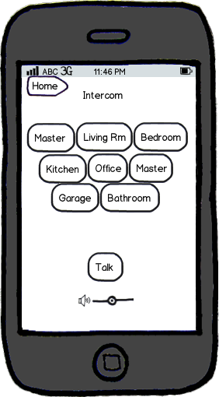
Figure 24: Play area select screen

4.1.4 – Audio Flow Diagrams

This flowchart shows how signals will be inputted and outputted through the Texas Instruments OMAP-L137. The analog signals represented here are for common operating decibels for audio signals. dBu specifically is represented for professional audio which uses its RMS measurement of .775 Vrms. The “u” stands for unloaded. This is the voltage level that gives 1 mW of power through a 600 ohm resistor.

In figure 13 below, you will see the flow diagram for the software portion of the audio of the project. Both music playback from your phone or computer happens here as well as intercom. Going through these options bring you to different choices ranging from the room selection to the library of songs you’d like to choose from to listen to on the system.

One of the advantages of using either android or iphone is that users will be able to take advantage of the vast library of songs and artists that have already been purchased and downloaded to the phone. By selecting a song from the library the user then has the option to select rooms that he or she desires to have it amplify into. This section of the app will also have a transport layer of controls to navigate the library as well as the song.

Figure 25: Audio Signal Flow Diagram

Play - If none chosen from library, then play first song in alphabetical order.
Pause – Freezes timeline of current song, but keeps song in cue.
Next – Advances to next track in album
Previous – single tap starts song from beginning. Double tap goes to previous track in album
Stop – Freezes playback and clears track from cue.

4.2 – Hardware

4.2.1 - Architectures

There were multiple design architectures that were considered for this project. One of the main objectives of this project was to reduce energy consumption by automatically turning off non-essential appliances when the room that those appliances were located in was not occupied. A simple motion sensor in each room would not work because a motion sensor would not register any activity in a room after someone stops moving, for example if someone entered a room and laid down to watch TV. One could mark that room as occupied once a motion sensor gets activated, but if someone leaves that room and enters another room,

Figure 26: Audio Software Flow diagram

the motion sensors in both rooms would be activated, and it would be difficult to determine which room was occupied. This fact dictated that a legitimate process for determining if a room was occupied or not had to be created.

The first design architecture included keeping a count of number of occupiers in each room by monitoring the number of people crossing through each doorway. Sensors would be placed on the outer edge of both sides of each doorway, so if the doorway sensor was activated on one side of a doorway and then the sensor was activated on the other side of the doorway, then it would be deduced that a person was leaving the room where the first sensor was activated, and entering the room where the second sensor was activated. This process, if implemented correctly, could produce an accurate room count for each room. The problem with this architecture was that after further analysis, it was decided that trying to keep a room count over a long period of time would leave the process open to large errors. Even rare errors could build up over time to produce room counts that were extremely erroneous.

After more consideration, determining whether a room was occupied based on the most recent sensor input data proved to be a more feasible architecture. There is a motion sensor set up in each doorway, so if someone goes through a doorway, the doorway sensor is tripped, and the data signal is sent to the main microcontroller. Once this occurs, the main microcontroller waits for sensor input activation from both of the rooms that share that doorway. Once one of the rooms sensors are activated, that room’s lights are turned on, and the other’s is turned off. If at any time the sensors of a room are activated, that room’s lights will turn on, and stay on until one of that rooms’ exit door sensors is tripped, and no activity is registered from that room.

The other method of reduction of energy consumption is turning fans on instead of the more costly alternative of air conditioning. The design architecture has never changed as it is an easier concept to implement. In each room, there is a temperature sensor, and if the temperature goes above the desired threshold, the fan will turn on. Once the temperature drops below the threshold, the fan will turn off. The only design consideration was where to be able to control the temperature threshold. Since the main control was initially going to be set in a graphical user interface residing on the main microcontroller that would be accessible via the internet, it was first decided that the temperature control threshold would be available only through the internet. After further consideration, it was decided that there would be a temperature display in each room where the user could view and adjust the temperature setting for the room specified.

There were multiple architectures considered to turn the outlets on and off. The design architecture that was settled on included connecting the microcontroller to a relay which, which is then connected to the outlet. This proved to be the safest, most effective, and most energy efficient architecture to control the state of the outlets.

4.2.2 – RFID

A radio-frequency identification system uses tags, or labels attached to the objects to be identified. Two-way radio transmitter-receivers called interrogators or readers send a signal to the tag and read its response. The readers generally transmit their observations to a computer system running RFID software or RFID middleware.

The tag's information is stored electronically in a non-volatile memory. The RFID tag includes a small RF transmitter and receiver. An RFID reader transmits an encoded radio signal to interrogate the tag. The tag receives the message and responds with its identification information. This may be only a unique tag serial number, or may be product-related information such as a stock number, lot or batch number, production date, or other specific information.

RFID tags can be either passive, active or battery assisted passive. An active tag has an on-board battery and periodically transmits its ID signal. A battery assisted passive (BAP) has a small battery on board and is activated when in the presence of a RFID reader. A passive tag is cheaper and smaller because it has no battery. Instead, the tag uses the radio energy transmitted by the reader as its energy source. The interrogator must be close for RF field to be strong enough to transfer sufficient power to the tag. Since tags have individual serial numbers, the RFID system design can discriminate several tags that might be within the range of the RFID reader and read them simultaneously.

Tags may either be read-only, having a factory-assigned serial number that is used as a key into a database, or may be read/write, where object-specific data can be written into the tag by the system user. Field programmable tags may be writing-once, read-multiple; "blank" tags may be written with an electronic product code by the user.

RFID tags contain at least two parts: an integrated circuit for storing and processing information, modulating and demodulating a radio-frequency (RF) signal, collecting DC power from the incident reader signal, and other specialized functions; and an antenna for receiving and transmitting the signal.

Fixed readers are set up to create a specific interrogation zone which can be tightly controlled. This allows a highly defined reading area for when tags go in and out of the interrogation zone. Mobile readers may be hand-held or mounted on carts or vehicles. The RFID frequency band described as table 1 below.

Signaling between the reader and the tag is done in several different incompatible ways, depending on the frequency band used by the tag. Tags operating on low and high frequencies are, in terms of radio wavelength, very close to the reader antenna, less than one wavelength away. In this near field region, the tag is closely coupled electrically with the transmitter in the reader. The tag can modulate the field produced by the reader by changing the electrical loading the tag represents. By switching between lower and higher relative loads, the tag produces a change that the reader can detect. At UHF and higher frequencies, the tag is more than one radio wavelength from the reader. The tag can backscatter a signal. Active tags may contain functionally separated transmitters and receivers, and the tag need not respond on a frequency related to the reader's interrogation signal.

Band | Regulations | Range | Data speed | Remarks
120–150 kHz (LF) | Unregulated | 10 cm | Low | Animal identification, factory data collection
13.56 MHz (HF) | ISM band worldwide | 1 m | Low to moderate | Smart cards
433 MHz (UHF) | Short Range Devices | 1-100m | Moderate | Defense applications, with active tags
868-870 MHz (Europe)  902-928 MHz (North America) UHF | ISM band | 1-2 m | Moderate to High | EAN, various standards
2450-5800 MHz (microwave) | ISM band | 1-2 m | High | 802.11 WLAN, Bluetooth standards
3.1–10 GHz (microwave) | Ultra wide band | Up to 200m | High | requires semi-active or active tags
Table 9: RFID Frequency Bands
An Electronic Product Code (EPC) is one common type of data stored in a tag. When written into the tag by an RFID printer, the tag contains a 96-bit string of data. The first eight bits are a header which identifies the version of the protocol. The next 28 bits identify the organization that manages the data for this tag; the organization number is assigned by the EPCGlobal consortium. The next 24 bits are an object class, identifying the kind of product; the last 36 bits are a unique serial number for a particular tag. These last two fields are set by the organization that issued the tag. Rather like a URL, the total electronic product code number can be used as a key into a global database to uniquely identify a particular product.

Often more than one tag will respond to a tag reader, for example, many individual products with tags may be shipped in a common box or on a common pallet. Collision detection is important to allow reading of data. Two different types of protocols are used to "singulate" a particular tag, allowing its data to be read in the midst of many similar tags. In a slotted Aloha system, the reader broadcasts an initialization command and a parameter that the tags individually use to pseudo-randomly delay their responses. When using an "adaptive binary tree" protocol, the reader sends an initialization symbol and then transmits one bit of ID data at a time; only tags with matching bits respond, and eventually only one tag matches the complete ID string.

4.2.3 - Power Supply

The smart home system will use current 120VAC in home outlet to operate. The system will be able to convert 120VAC to 9VDC using a power transformer.
- 120VAC to 9VAC transformer
- 9VAC full wave bridge rectified to create 7VDC rail (used by relays and 3.3VDC switcher)
- 7VDC input into 300mA/550 kHz switching power supply, output set to 3.3VDC (powers all components except relays)
- Safety switch to prevent overflow current
- Backup power supply feed 9VDC to the system

4.2.4 - Main MCU and Processor

The main processor that we have chosen for our project is the Texas Instruments OMAP-L137. This acts as our central hub for all of our projects communication, signal flow, and rendering of tasks. This processor was chosen based upon a number of needs from our project. One part of those needs is that it is able to perform a number of audio related tasks and features. The three main tasks for audio are: playing uncompressed .wav files across a network, allowing an intercom style feature set through a SIP based client protocol, and wireless streaming of the audio. See figure 28 below for the integration of these audio related features of the project.

This processor features Texas Instruments AIC3106 codec. See Figure below. This codec integrates Multichannel Audio Serial Port or McASP for short. McASP main function is to the control the audio stream. The codec basically takes an analog input from either the line-in or mic inputs, and samples that into a digital data that can then be processed by the DSP. The DSP will then perform any necessary tasks and end by using the codec to convert the digital signal back into an analog signal and output that to either the headphone or line out or both. An important feature set of the McASP is that it can operate at different clock rates for the transmitting and receiving operations.

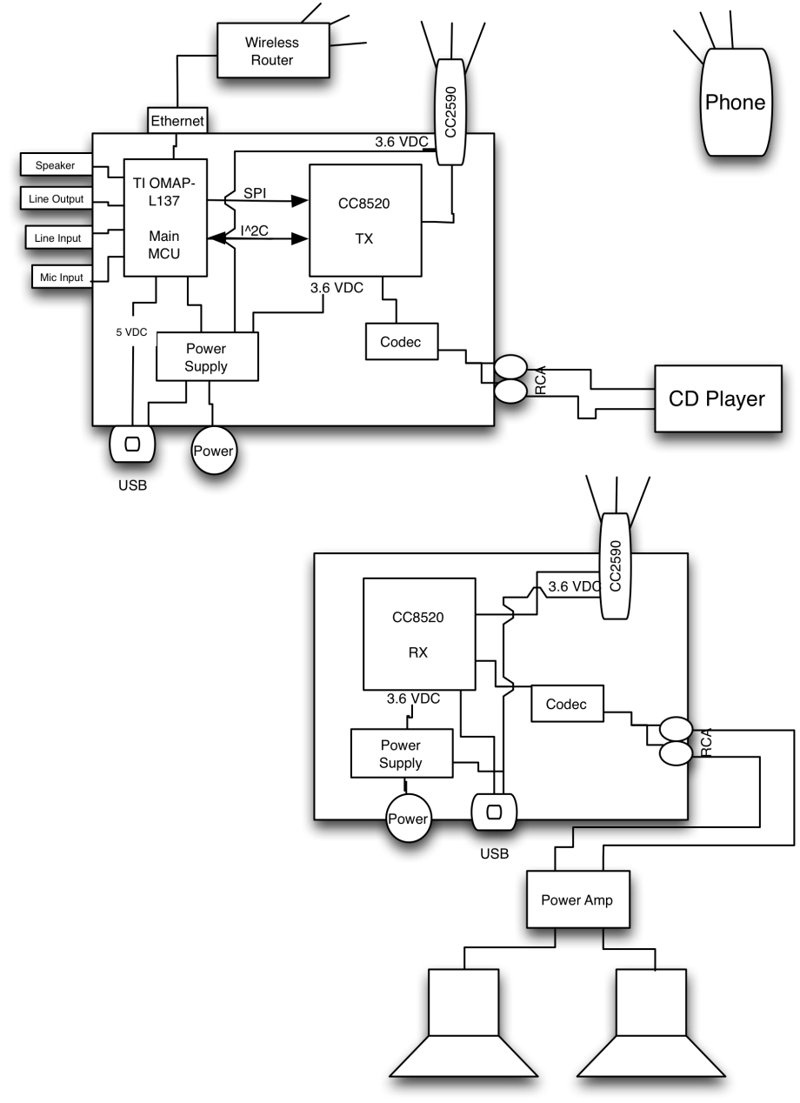
Figure 27 : Main Board Block Diagram

For example the system could take in information at say 44.1 kHz, and at the same time send out information at 48 kHz or 88.2 kHz. This allows for the flexibility to handle the multiple sample rates of audio that are encoded in today’s world. It does this by using a 24.576 Mhz oscillator to clock to the codec. The native sample rate generator splits up the normal system clock to come up with common audio frequencies. A codec register sets the sample rate. The codec itself is controlled through the I2C bus. It uses two serial channels to talk to the codec. One of these controls the internal configuration registers, and the other sends the digital audio samples. The control part of the channels is usually only used when setting up the codec. Otherwise it does not do anything while the audio is being sent.

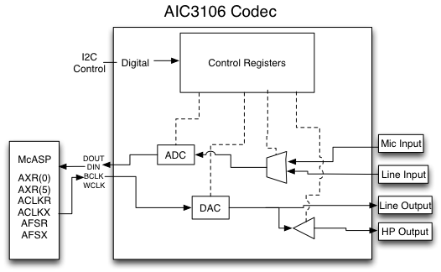
Figure 28: Audio Codec Block Diagram

The I2C bus is probably the best and most ideal way to interface control registers with different devices. I2C ROM is used through the serial bus. This allows us to setup the Ethernet physical layer and link with the codec. The format of the bus is show in the table 15 below

Start | Slave address |  | W | ACK | Sub Address | ACK-S | Data | ACK-S |  | Stop
Write Sequence
 |  | Start |  | Slave Address | R | Data | Stop
 |  |  | Read Sequence

Table 9: Ethernet BUS format

The addresses for the onboard peripherals are show below in table 16

Device | Address | R/W | Function
KSZ8893MQL | 0x5D | R/W | Ethernet Switch
TLV320AIC3106 | 0x1B | R/W | Codec
I2C EEPROM | 0x25 | R/W | I2C EEPROM
Table 10: Peripheral addresses

The schematic for the audio codec can be seen in figure 5 below. This is the full implementation of the Inputs and outputs which includes the line I/O, microphone,

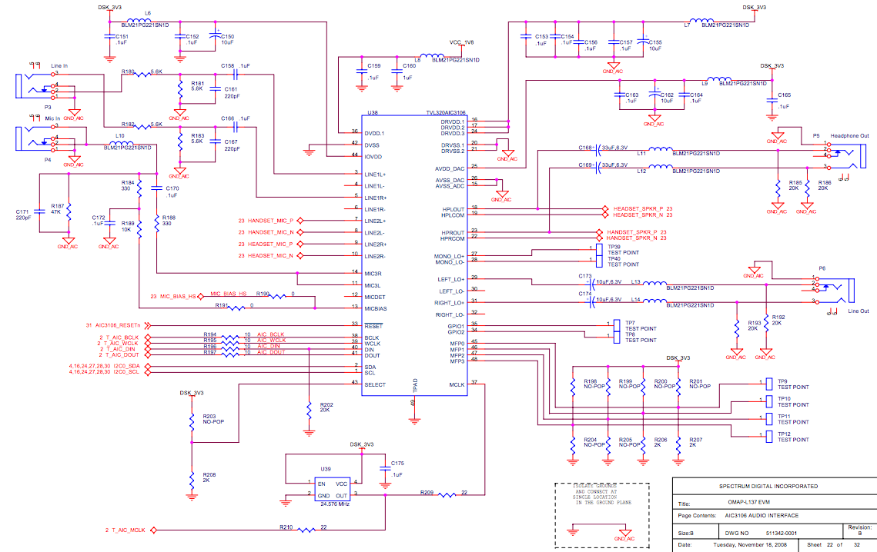
Figure 29: Audio Codec Schematic
As seen in figure 2, the codec accepts many inputs and outputs audio. For our project we have included a line input, microphone input, line output, and headphone output. Each one of these connectors are a 3.5 mm Jack that have a tip, ring, and sleeve. Signal is carried out on the tip and ring part of the connector. The ground is terminated onto the sleeve part of the connector. This can be seen in figure 6 below.

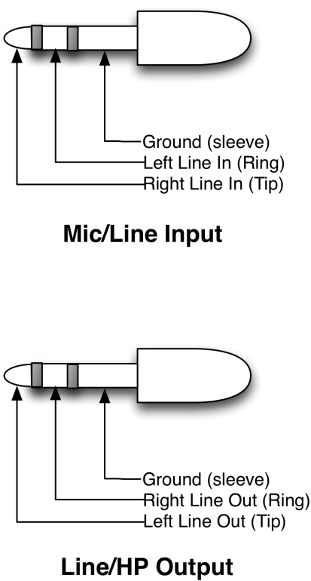
Figure 30: 3.5mm Diagram

To perform the intercom tasks the processor must have the ability to take in RTP packeting from our Internet protocol. The Ethernet integration of the processor allows us not only to take in this type of packeting, but also will allow us to loop through the devices and create an easier to manage system of routing the signal to multiple devices. The RJ45 connector is what is used here to connect a 10/100 Mbit isolated interface. See figure 6 below for the Ethernet integration. This helps the expansion of this project to reach anywhere from the smallest of homes to the largest of office buildings. This project uses a Micrel KSZ8893MQL Ethernet switch.

By using a MAC address with this it allows us to give the hardware a unique series of numbers and letters to identify the board. The actual Ethernet addresses are stored in the EEPROM of the I2C for the board. The first address must be an even number. The second address is the same as the first one with the addition of the number 1 right after it. To control the setup of the registers that are located in the switch, this can be done in the I2C bus. There will be green and yellow LEDS on the Ethernet jacks to let you know when there is a link that is established as well as when data is being passed through the controller.

The board will be powered by a +5V external power supply. Switching voltage regulators distribute power for several components of the board. The peripherals receive +1.8V, and the CPU receives +3.3V. This enters through a power input on the board from a 2.5 mm barrel-type connector.
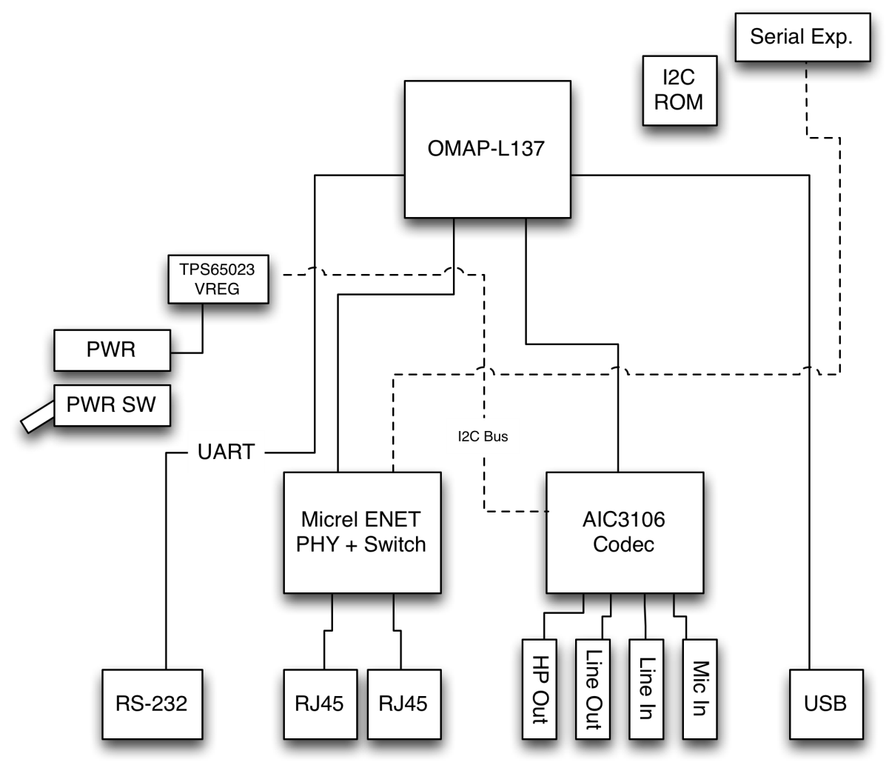
Figure 31: IC2 Bus and power block diagram

The schematic in Figure 33 is based around the Micrel KSZ8893MQL/MBL 10/100 ethernet switch. This switch offers three MAC addresses to be used for the project. One for the physical transceiver coming from the wireless router, one for the loop through ethernet for the next device, and one for the media independent interface, or MII bus. The MII bus basically allows diverse types of physical transceivers to be connected together. The switch allows for port mirroring as well. This is helpful for sending audio to all around the home at once.

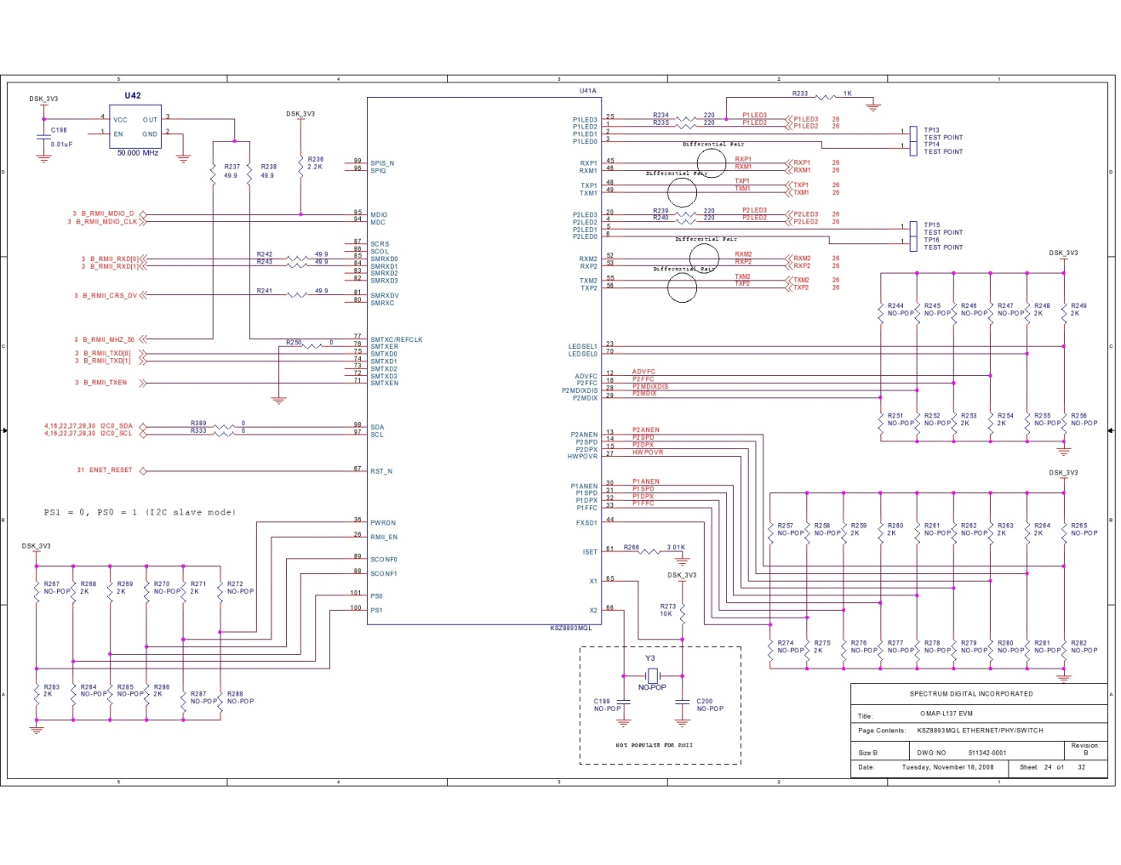
Figure 32: Ethernet Port control Schematic

The Micrel KSZ8893MQL has very nice power management functionality. This is built directly into the part, and will be taken advantage. Any physical transceiver port, or PHY port, that is not in use can be powered down. Adjusting the port control registers does this. The whole chip can also be powered down as another option. See the figure 33 to enable or disable power modes for the PHY ports.

Bit | Name | R/W | Description | Default | Reference
2 | Pwrsave | R/W | 0 = Enable power saving | 1 | Reg. 26, bit 2
2 | Pwrsave | R/W | 1 = Disable power saving | 1 | Reg. 24, bit 2
Table 11: MCU power modes

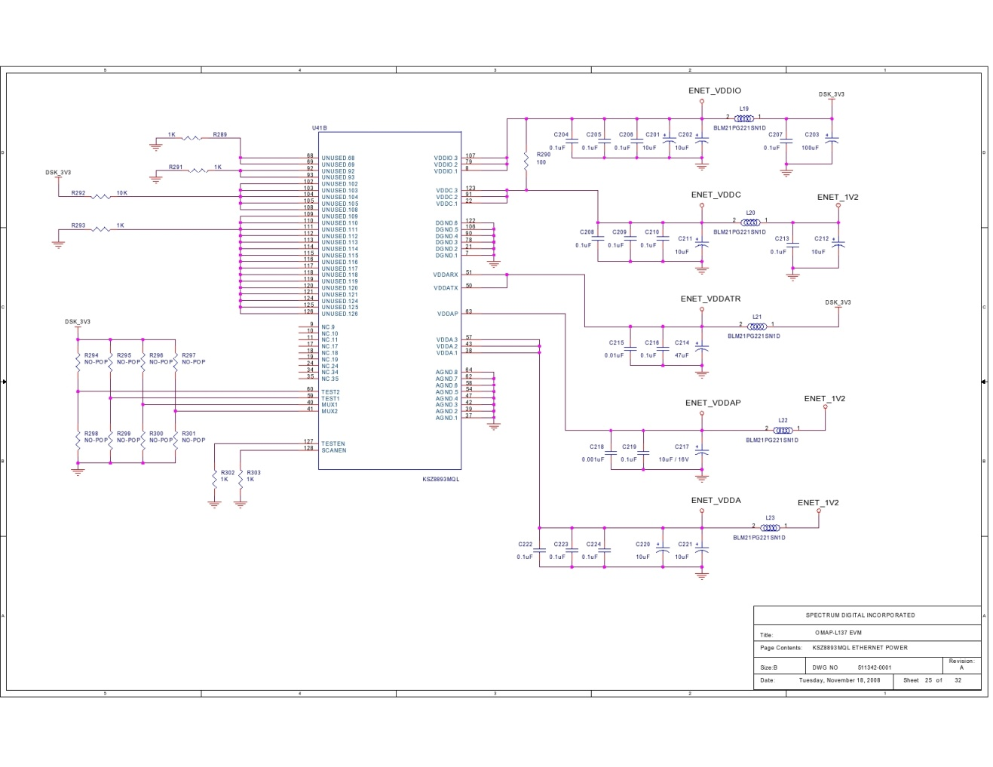
Figure 33: Ethernet Port control Schematic
The schematic of the KSZ8893MQL Ethernet Ports can be seen below in Figure 34 and figure 35
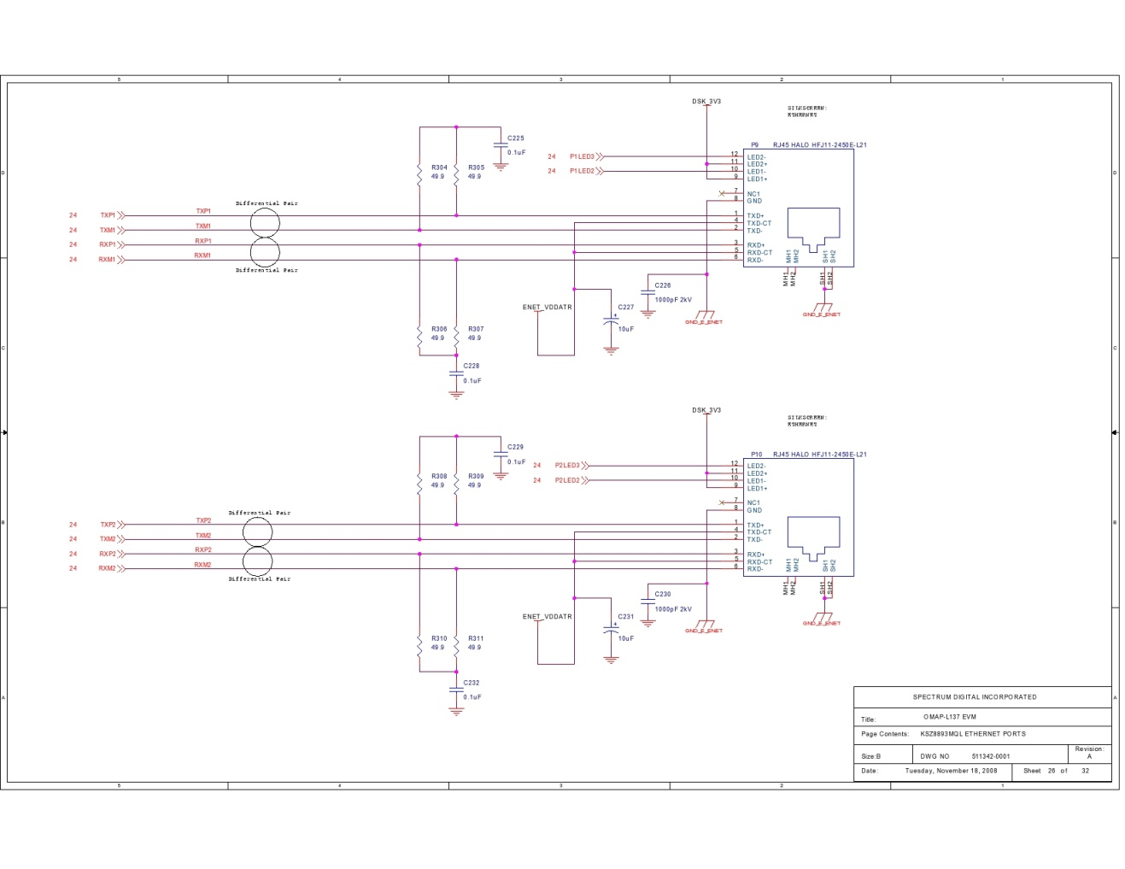
Figure 34: Ethernet ports Schematic

4.2.5 – JTAG connector

In order to work with and program the circuit board, JTAG will be used. The circuit board comes with an embedded JTAG processor and the necessary interface to use it. JTAG will allow the circuit board to be connected to a computer that can support a GUI and IDE to write the code for the circuit board. It also allows testing of the code directly on the board which is very useful for trying to debug code. In the figures below, it shows how the JTAG is connected to the rest of the circuit board and also shows where the connection to a computer can be made.

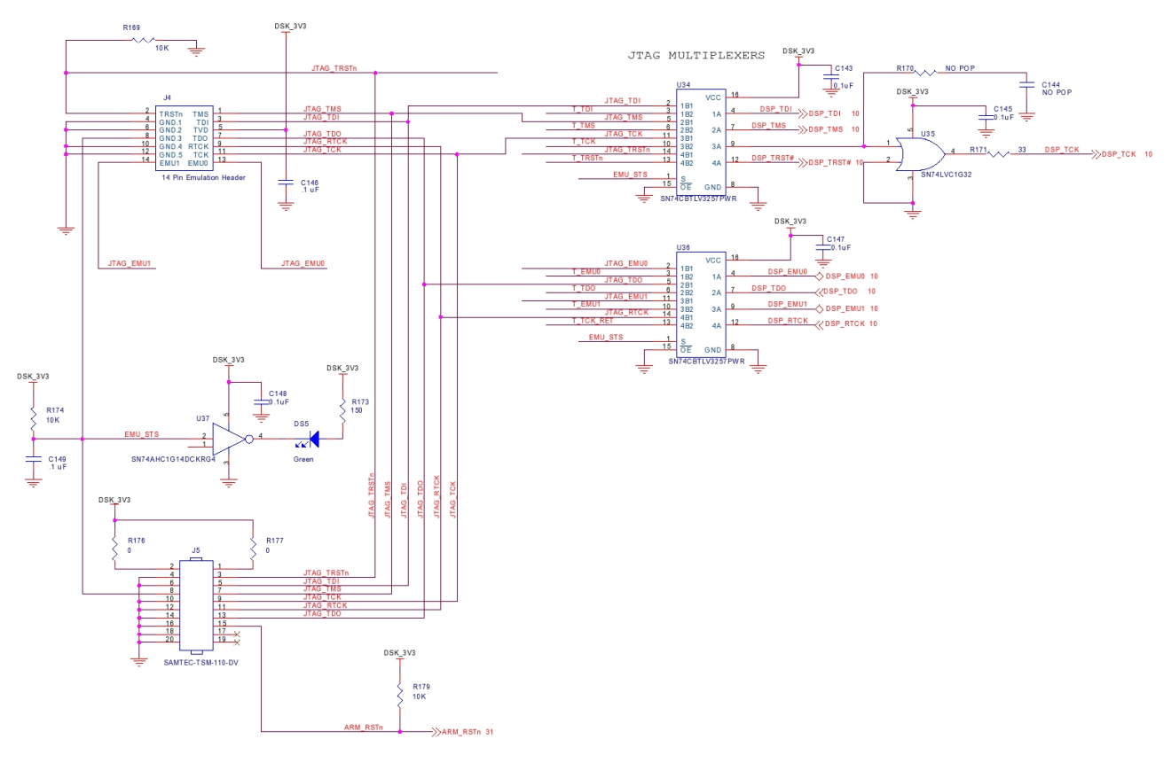
Figure 34: JTAG multiplexors

The schematic in the figure shows how the JTAG is multiplex into the circuit board. When the embedded JTAG USB is connected, the multiplexors select for the inputs from the JTAG. When the JTAG USB is not connected the multiplexors receive the inputs back from the circuit board. This allows a connection to be made with the computer and the computer feeds the circuit board the signals. This also allows code to be tested directly on the board. The other figure shows the embedded USB and how it connected to the JTAG multiplexors.

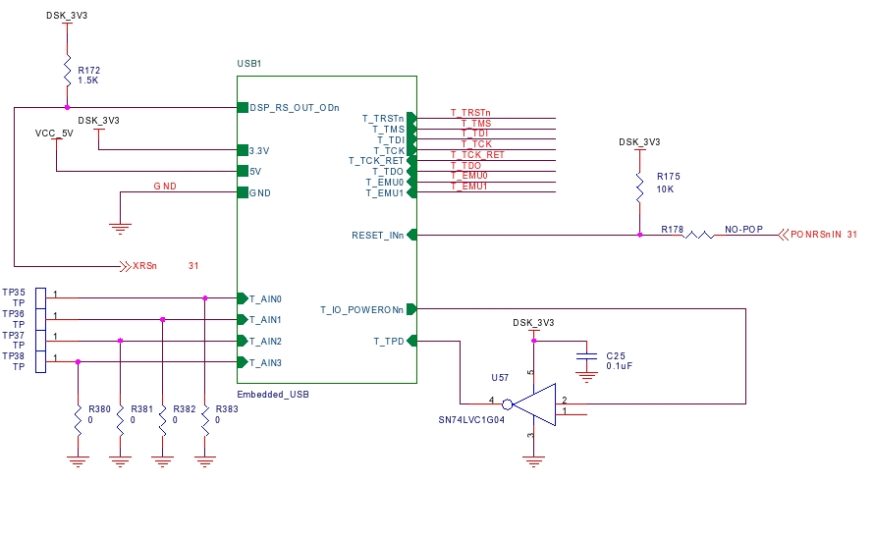

Figure 35: JTAG USB

4.3 – Parts List

EVMOMAPL137 | Evaluation Module for the Main Control Board
Dragon Mobile | Speech recognition SDK
OpenCV | Video SDK
PJSIP | Streaming Audio and Video SDK
Aleph America PS-1541WGWSR | Security sensor for door/window
SafeAir Carbon Monoxide Detector | Gas Sensor
INSTEON thermostat | Programmable thermostat
Interlogix ELE-541 CXT | smoke and heat detector
C2000 and CC430 Microcontrollers | Sensor microcontrollers
PIR SENSOR RE 200B/NaPiOn sensor | Motion sensor
Gateway laptop with Window 7 OS | Computer to run the software
HTC Thunderbolt Andriod Phone | Smart phone to run Android software
iPhone 4 | Smart phone to run iPhone software
Dayton Audio CS620W in wall speakers | Speakers to play audio
Pioneer VSX-455 Home Theater Receiver | Speakers to play audio
Table 12: Parts Lists

5 - Prototyping

5.1 - Parts Acquisition

There are many different parts to this project. Each part is a small piece however and this makes the project very component based. The main MCU selected will be preferred to be acquired from loan or given from a company. The Main MCU board will need to be rather powerful in order to satisfy all the requirements we have placed on it and this means that the boards available all run in the higher price ranges out of the budget of this project. In the past, many companies have donated or loaned the expensive parts, so there are high chances that we will be able to obtain board from a company’s free of charge and maintain our budget. In the small chance we are unable to obtain one the more expensive boards there are cheaper solutions that utilize less technology and also offer less features. These smaller boards will be able to stay in the budget in the case that a board was not donated or loaned to the project. Other required components are a windows or Mac PC to run the software. This can be obtained from the group members of the project, and more specifically a laptop will be available to do testing and prototyping on. The smart phones are also obtained from the group members who already own one. The group members own both an iPhone and an android phone for testing and prototyping in both environments.

The project also has many non essential pieces. This greatly helps the flexibility of the project. For example the project will use a large range of different type of sensors. There will be a large range of sensors to integrate into the project, including motion, PIR, Smoke/fire, flood, security, CO2, temperature and microphones. These parts are all relatively low in price, ranging from $5 to $60. We will require several of these sensors to integrate into the smart home system; however the system can still maintain functionality even though all of the sensors may not be used. Some components of the system will require small MCU boards to make them fully functional. These smaller MCUs are easy to acquire and very cheap. The system will also require a way to play the audio on the receiving end. This can be obtained from the group members who own audio amplifiers and receivers.

SDK’s used in this project are mostly open source and publicly available. For some of the hardware that is proprietary, the software will be made available from the company providing the hardware.

5.2 - Hardware implementation

The group will need to create the connections and design the small microcontroller modules at the component end. The main control board is to be obtained at the beginning of the semester so that the software development and testing can be completed as soon as possible. Then the other modules will be designed and integrated. The group will focus on first completing the simpler modules such as light control and motion sensor detection. This was the base of the system will be setup for the more complex configuration of the other sensors, thermostat and audio and video systems. This will help to guarantee that some final working product will be presentable in the case that group runs out of time developing the more complex systems like audio and video. Each group member will be assigned with focusing on managing one of the simpler task, however all group members will work together on each of modules and they will be completed one at a time. This allows a person to specialize, while still allowing the group to be able to pool its resources into one area for a quicker completion time.

5.3 - Software implementation

The project will consist of several areas of software development. First the computer application will be developed to communicate with the web server that is run on the main control board. This is because the communication with the server is a key component in the success of any of the other systems in the project. This is also why the main control board needs to be acquired as early as possible. The server on the main control board will also need to be developed at the same time. The control board web server will be very simple and only allow user with correct verification credentials to connect and get the system status and send commands. Once basic operation of the web server communication (sending and receiving) is complete, then the GUI of the computer application will be developed to a functional level. Final touches and aesthetic features will be added later. The android phone application will then need to be developed to communicate with the web server. This will be slightly quicker than the first time around because the web server will already be set up. Then phone GUI will be developed and aesthetics features will be added to the phone and computer applications. If there is still time the iPhone application will be developed. This is because the iPhone is less developer friendly and developer account will be needed to publish the iPhone application.

5.4 - Physical Prototype Build

The project will have a prototype built from the design of the circuit. For presentation purposes a miniature collection of rooms will be constructed to place the embedded components of the design. Using see through plexi-glass to construct the walls will allow the circuit to be seen by any outside viewer. The design must be compact, so that it can fit between a thickness of the wall while allowing speaker and microphone components to be utilized on the outside. To allow the outside wall components to be accessed by the user, a mounting bracket must be constructed to allow the printed circuit board to be sandwiched between the outside pieces of the wall. Tabs will be attached to the enclosure with locking screws. Allowing the tabs to turn will permit the backside of the enclosure to fit between the walls. A stopping tab will be placed on the bracket against the tightening side of the screw. As you tighten the screws it will bring the tabs closer to the to the stop tab forcing the mounting tab to an up and down position to clamp against the wall. See figures 17 and 18 below for this configuration.

Figure 38: Mounting Bracket Back View

Ethernet will connect to the back of this printed circuit board as well as loop through. The cost effectiveness of category 5 cables make this ideal for long runs in a home. Considering most buildings, like offices, have this infrastructure already in place, it will be easy to implement this system.
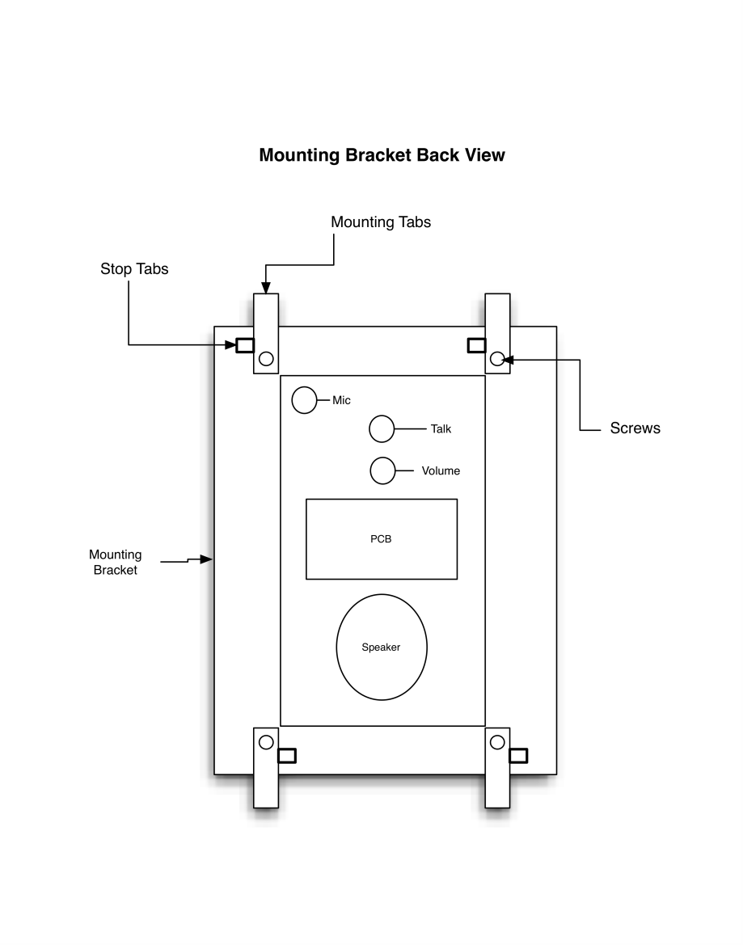
Figure 36: Mounting Bracket Front View
This is the side view for the mounting bracket of the PCB. As can be seen in Figure 39 this holds the speaker, microphone, and PCB.

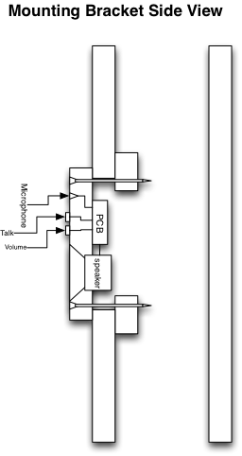

Figure 37: Mounting Bracket Side View

6 - Testing

6.1 - Sensors and Microcontroller Testing

As table 2 below, group tests each of the individual features of chosen microcontroller. Once every component has been determined that they are working correctly, group will then place the components in the motherboard. With that in place, group will then begin to test the board and the microcontroller altogether, as seen in the following table. Since group has to integrate all of the hardware pieces together as building the base board system, some of the test for each of the components will overlap.

Components | Testing Function | Testing Description
CC430 Microcontrollers | Power | If the microcontrollers work at 1.8V to 3.6V
 | Timers | If the timers to make sure they work correctly
 | Memory | If the memories work with the microcontrollers
 | USB/Memory Card | If USB can transfer data/command to controllers
 | Ethernet | If the microcontroller can go through the internet using Ethernet.
 | User Interface | If the microcontroller understand sensors’ input
 | Media Streaming | If the microcontroller can stream the music over the internet
PIR SENSOR RE 200B | Sensitivity | Waving hand, moving body to see if the sensors response
 | Distance | How far the sensors can sense
 | Power | Max 0.5mA/ 3V
 | Sensitivity Range | 20 feet
 | Communication | If the sensors can “talk” to the microcontroller
Table 13: Motion sensor test

Once the PIR is wired correctly, it’s a good idea to do a simple test to verify that it works the way it is designed. This test is also good for range testing. Simply connect 3-4 alkaline batteries (make sure 3.5VDC <Vout< 6VDC by checking with multimeter!) and connect ground to the (-) pin on your PIR. Power goes to the (+) pin. Then connect a basic red LED (red LEDs have lower forward voltages than green or blue so they work better with only the 3.3v output) and a 220Ω resistor (any value from 100Ω to 1.0KΩ. The LED and resistor can swap locations as long as the LED is oriented connection and connects between out and ground. When the PIR detects motion, the output pin will go "high" to 3.3V and light up the LED! When the breadboard is wired up, power it up and wait 30-60 seconds for the PIR to 'stabilize'. During that time the LED may blink a little. Wait until the LED is off and then move around or wave hands in front of it to see the LED light up!

The group also needs to check if the system responds to the signals correctly from the sensors, that the software are translating the meanings of the different signals received from the sensors, and that the software is reacting correctly to the signals that it is transmitted. The testing environment will be PC Software, Android, and IOS app and as well as the Hardware Test Environment created by the evaluation board. The group will be conducting the test first with the sensor processor hardwired anywhere in which RF transmission is being implemented. When this test is completed and the requirements of are verified, the tester will then re-run the same tests and re-test the system with all RF transmitter and receivers configured as called out by the design.
RF transceivers will be connect to the MCU, power up and test over the Internet if user can control the devices. With the design, to help reduce noise an RLC band pass filter will be applied which will filter out any signals that should not be received by the processor. Also, a digital signal conditioner will be used to process the digital signal being sent out by the processor and translate it into an Ethernet signal that in turn can be processed and broadcasted to the internet by the router.

Internet
Ethernet/Wifi Router

Microcontrollers

RF Transceiver
(Devices controllers)
RF Transceiver
(Sensor-Processors)

Figure 48: MCU control connect to RF transceivers

6.2 - System testing

In order to get all the different systems working and make sure they are working correctly in all scenarios, we will use a bottom up testing approach. This means that we will test the pieces individually and then slowly integrate more pieces into the entire system. This will allow the group to discover more quickly the cause of any problems that are found. By isolating the different systems, if an error occurs then we will already have the error isolated to that system, meaning there is less error checking needed to be done. As the test work their way to the entire system integration the group will then be able to see if the error occurs because two systems won’t work correctly together. Because the system has been tested individually, then the error must be isolated to the integration of the systems. We will also use a testing regimen that will test each system with every other system individually. This will show exactly where errors of system integration would be occurring.

6.3 - Hardware testing

There are many pieces of hardware in this project. Each piece must be tested individually to ensure that it is not the cause of some error that appears somewhere else in testing. When testing the hardware individually, the hardware will be connected and tested according to manufacture specifications. The sensors will need to undergo sense testing to make sure they are functional. For sensors a series of tests will be used that explore the threshold, range and size and then compare our test to the manufactures specifications. The MCU boards will need to have each of their components tested as well to look for errors. This includes voltage outputs, power outputs, memory, processing, and interface connections and pins.

The testing steps below outline what will be done to ensure that the hardware is responding and operating as it was originally designed. The project itself has many components to test and many points at which there can be a failure or hang-up that requires troubleshooting. This could lead to lots of frustration so it is very important to check all of the hardware components before moving onto the software. This will be done on a ground up approach by checking the signal flow starting with the device that is sending signals first, all the way through to the last component that will be receiving signal.

The main processor and components for our evaluation board will be the best place to start. Our microcontroller uses the Texas Instruments OMAP-L137. The chart below will illustrate what tests will be done to check its functionality. The best way to get started with this is to run the debug gel files and test files from spectrum digital in Texas Instruments Code Composer studio. Code Composer Studio Texas Instruments is an integrated development environment that includes a compiler for the OMAP-L137, source code editor, debugger, profiler, simulators, and real time operating system.

The following list of events can be used to test a component on the main MCU board of the project.

- ROM: Run debug Gel file in Code Composer studio to find out the ROM ID which is the revision number of the boot ROM.
- LEDS: We will run an example code that uses loops to turn on each LED until all 8 are turned on. The code will return a 1 if the LED is turned on, and a 2 if the LED is off.
- Codec: This test comes from the example code from Spectrum digital. It must be run after a system reset because the McASP state machine will hang and lock up. The aic3106_tone command runs a 1 Khz tone through the headphone and line output. If these are successful then the screen will return a 1 and 2, for headphone and lineout respectively. By looping the lineout back into the microphone and line input the code will return a 3 and 4 if successful.
- DIP Switches: This test runs code that links the DIP switches to the LEDS on the board. Flipping the DIP switches to the down position will turn the corresponding LED to the on position. Flipping the DIP switches to the up position will turn the corresponding LED to the off position.
- EEProm: This Test uses the I2C to check the EEProm. The test first creates a test pattern to write a page of data. It does this for 4 pages. Before doing that it clears the receive buffer, and then writes one page at a time. At the end it compares the tx and rx buffers to see if they are not equal. There is an error counter for each time that they are not equal. At the end if the errors == 0, then page has passed. Otherwise it prints the page that failed.
- EMAC: In this test, the code sets up the local Ethernet MAC addresses and check to see if the switch can send and receive packets of information. If it can't then it will return errors.
- RTC: The real time counter test checks to see if it can set new times that are passed by variables. If it can receive the times and passes then the program will return a 0. If it can't and the program fails it will return a 1.
- SPI: This test runs a code that writes a test pattern into four different pages and then verifies the content of those pages with an error flag. First it initializes the SPI interface. Then it erases the target area in the SPI flash. Then it writes to SPI flash with the test pattern. After that it clears the receive buffer and checks the pattern by reading the pages. It will return a 1 if it fails and a 0 if it passes.
- UART: This test is a simple loopback test which will write and then read back the byte sent to the RS232 connector. The code uses an error incrementer to which it will return if it reads any.
- USB Power: This test starts by running code to wake up the USB module. After that it then resets the USB module, and waits for it to power off. Once powered off it then starts the USB up again by powering it on. If the code returns a 1 then the test has failed and if it returns a 0 then it has passed.

6.4 - Software testing

The software testing will be tested in a bottom up fashion. Each of the pieces of each software component will need to be tested individually, then with all the other pieces of the software component, and finally with all software components working together. The software testing will take places after the hardware testing because the software is supported by the hardware, therefore the software can only work if the hardware is fully functional. The applications will have their GUI, functionality and responsiveness tested separately and then all together. For the MCUs software, only functionally and responsiveness will need to be tested. The web server will need to be tested individually on the MCU.

7.0 - Project Actualization and Implementation

The project’s goals were very ambitious, but due to limited time constraints, not all objectives were fully realized. The objectives were laid out in a prioritized fashion, in which the simpler objectives would be attempted first. The primary objective was to give control of the outlets through a smart phone application. Then the second objective, sensors and monitoring features would be attempted next. Streaming audio was the third objective and finally video monitoring would be the final objective. The way the objectives were order also allowed harder objectives to be attempted in the presence of a system architecture already set up.

Completing the control of power outlets was the first step to be completed. This objective also required that the entire system begin to take shape. The group began looking for a processor to run the web server on that would interact with the smart phone application. Originally the T.I. OMAP processor chip looked like the best choice, because it was powerful, able to support an OS, and specialized in digital audio and video processing. The OMAP would be sufficient for all the objectives; however the OMAP was also out of the group’s budget, as the entire development kit cost two thousand dollars. The group began looking for companies that would be interested in giving sponsorship or loaning the development kit. The group was unable to find and support, so the spinneret web server, a small and cheap web server, was readily available and looked sufficient in completing our primary objective. The spinneret web server was purchased in the first week of the design and testing phases, and the prototyping was able to begin.

The first objective had several initial problems to overcome, including, designing the beginnings of the smart phone application for communication, setting up a web server that could receive request over the internet from the smart phone application, and how to control power to the outlet. In programming the spinneret web server, a multi-socket web server program was used that was the winner of an open source contest held for the release of the spinneret. The contest winner was Mike Gebhard and his multi-socket web server program was available for use. Mike Gebhard also ran a website on a spinneret web server with instructions on how to set the web server up. The web server program was actually intended to run HTML web pages, which the group originally planned to try to include as a way to access and control the smart home system. The web server program had to modified slightly to allow for control of the power outlet modules.

At this point the group had been working on the prototype designs and implementation for a month, and it was time for the critical design review, which was essentially a progress report presentation given to the group peers. After the presentation, feedback was gathered about some of the design specifics of the project. For example, wireless technology was suggested, as the prototype designs were relying on wires to send digital control signals to the power outlets. The group had done research on the wireless technology available and decided to use the Xbee modules as they had the power to support all the objectives. They were also simpler and readily available which was key because after the critical design review there was only 2 months left before the project was due. This brought on another problem as to how to power the relay switches that were controlling the power to the outlets and the Xbee modules now that the modules would be wireless.

It was decided that designing a PCB would be best for powering the modules at the power outlets because the power could be drawn from the house’s 120V AC power lines. This would require a power system that could convert the 120V AC voltage to lower DC voltages used for the certain modules on the PCB. The PCB was then designed using ExpressPCB because of their simple software and quick production times. The PCB was designed and delivered in 3 weeks total time. Also at this time, the group got a response from a company about sponsorship. Alcorn-Mcbride, an audio engineering company, said they could help us attain the OMAP processor with a development board as a loan. The group began the setup of the OMAP board as well as testing the PCB and setting up an XBee wireless network. So far the group had only completed its primary objective and had just started working on its secondary objective with one month left before the project was due. After some initial testing of the OMAP processor, it was decided that getting the OMAP processor up and running and beginning to work on the audio processing software would take more time then was left. The audio and video objectives were dropped because the group needed give full attention to the primary and secondary objectives to make sure they were fully completed before the deadline.

In the final month of the project, building a demonstration setup and programming a complete application on the android phone were the only tasks left. The product went through 2 weeks of testing the hardware and software components, looking for potential problems. One of the problems that arose during testing was the fact that when the system was down there was a possibility that the power outlet would lose all functionality if it happened to be in the off state. This was then quickly countered by installing a manual switch that would allow the outlet to go into a normal-use mode so that it would be detached from the system. By the deadline the group had completed the first 2 objectives, and the project was in its final state ready for demonstration. The presentation of the project went smoothly and all the system components worked with no problems encountered during the demonstration. The following sections go into more detail of the project at its final state.

7.1 - Android Application Layout

The user will interface with the system through an Android smart phone. Setting up the UI on a smart phone increases its accessibility while allowing it to be portable. The Android platform was chosen because it is more developer friendly with a free application market and Java programming environment. The goal of the UI is to be lightweight, quick and easy. When first running the application it will start into a login screen. The user will need to enter a username and password which will be stored on the web server. When the user presses the login button, the application will then ask a DDNS service for the web server’s current IP address. Then after obtaining the IP address, the application will request the User and Module database text file from the web server. If the database does not respond the application will inform the user and not allow login. If communication is successful then the text file will be parsed and all the current users will be entered into a SQL database. The application will then look for the entered username and password. If the user database is empty, such as in the case that the system is being used for the first time, the application will prompt the user as soon as they enter the login screen and ask for the master user to be created. The system will not function without a master user and the master user will always be the first username and password entered into the system. The master user will have the ability to add, edit and delete other users as well as have access to all features of the system.

After successful login, the home screen will be entered and show a list of all modules currently active and display the latest status. The status can be updated with an update button and will also be updated anytime the user decides to turn an outlet on or off. The user can change the state of any module from the list by simply clicking on it. This will bring the user to a module detail screen showing the current settings of that module. Also available from the home screen will be the ability to add modules, log out, search logs. If the user is the master user they will be able to add, edit and delete users through the user administration button. The system will need to constantly be receiving updates in order to stay current with the status of house. This will be achieved by requesting updates from the server every time the user interacts with the application. The application will also request updates after a certain period of inactivity. This can be set by the master user depending on how often the user wants data to be downloaded from the web server. The User and Module database will need to be rather small in order for updates to function in a timely manner and will need a set limit on the maximum number of users and modules able to be created within a given system. The Log function will update only the most recent events that have occurred in the system. This will be done by organizing each day as an individual text file on the web server. The application will only update the log file by adding the days in a chronological order. For example the application cannot just grab one day from a month ago, it will need to grab all the days after that day as well. The user can select to update the log files for any date in the past and all logs from within the time period will be downloaded and entered into the database. Because this can take a long time depending on the size and history of the log, the user will be warned and asked if they would like to proceed anyways. Once the log files have been downloaded they will not need to be updated as the log files will not be changeable.

There will be two main modes of communication between the web server and the phone application, commands and database updates. All communication with the web server will be through http GET request. This is because the web server is run on a microcontroller and is limited in the kinds of internet protocols it can receive and understand. Fortunately everything needed by the system can be sent through simple get requests. The first thing the application does on startup is get the IP address of the web server. This is done by sending a get request to the domain name for the web server. The DDNS service will update a DNS to a dynamic IP address. The application gets a response from the DDNS service and then parses the IP address from the response. The most recent IP address is saved and used for construction URLs. The get requests are sent by constructing the URL from within the application dynamically depending on the user input. Apache libraries are used in sending and receiving data in HTTP. A command request to turn an outlet on or off is sent through the URL and is parsed at the web server. When requesting a database update, the file location is used in the URL. All requests must be answered with a response from the web server acknowledging that the request was received and handled correctly. If not then the user is notified that the server was unable to communicate.

7.2 - Spinneret Web Server

The web server is the heart of the smart home system. This web server enables access to the system through the local network (LAN) or through the Internet. The smart home server must be started in order to control system. Web servers are computers or microcontrollers that can host or store information and process the orders from user’s inputs. Every web server will be assigned a specific IP address or more fancy a domain name; therefore, users can easily type in and obtain data which is saved in the web server. The web server also needs a static IP address to keep the data constant.

In order to control our smart home system over the place through the Internet base, we need to upload our program to a web server and it will store our control program permanently, ready to use when needed. It will transfer or receive data from the android application on the phone and the XBee modules. The web server has to use low power consumption; up-time has to be reliable, at least 99.9%, thus data is available online all the time; it’s also needed to be easy to access and allow us controlling, modifying our “home’s brain” configuration with simple upload. Keep this in mind; we decided to use the Spinneret web server made by Parallax Inc. The web server will act as a controller and perform the loop check the units of whole smart home system. When it receives commands from the devices or from user inputs, it will check the traffic which means whatever commands come in first will be processed first, first come first serve basis. The Spinneret uses parallax P8X32A propeller chip. This chip is custom designed by parallax and has multi-processing. The chip itself has a small footprint of 12.3 x 51 x 3.41 mm dimension. The chip has a built-in interpreter that we can program it by using a high level language called “Spin”, the language itself has a low level feel to it, using assembly size declarations and accepting assembly language as correct syntax, and as well as low-level assembly language. The Spinneret web server is a completely open source project with all hardware and software available from the parallax website. It has architecture of 32-bits as well global RAM of 64KB. The chip also has I2C serial communication and requires the range of 2.7 to 3.3 VDC input to operate properly.

To upload our program to the Spinneret web server, we use an adapter called the “Prop Plug,” (which is a USB to Serial adapter). The adapter has a four pin header that allows for transfer, receive, reset (active low) the data, and ground (VSS) pin. It’s capable of a 3M baud for the asynchronous communication rate.
The Spinneret also has the WIZnet W5100 single chip. This chip allows for an Internet communication among our X-Bee modules and phone’s application through a 10/100 Ethernet control. This is all done without the need of an operation system, in other word no computer is needed once the main control program has been uploaded to the Spinneret, to keeps things simple and cost effective. The W5100 has an integrated TCP/IP stack as well as Ethernet MAC and PHY. It works safe at the voltage of 2 to 5.5 VDC. In addition, the web server operates safely because it includes a voltage regulator that can take in 5 to 12 volts and outputs 3.3V.

There will be two main modes of communication between the web server and the phone application, commands and database updates. All communication with the web server will be through http GET request. This is because the web server is run on a microcontroller and is limited in the kinds of internet protocols it can receive and understand. Fortunately everything needed by the system can be sent through simple get requests and get responses from the web server.
The first thing the application does on startup is get the IP address of the web server. This is done by sending a get request to the domain name for the web server. The DDNS service will update a DNS to a dynamic IP address. The application gets a response from the DDNS service and then parses the IP address from the response. The most recent IP address is saved and used for construction URLs.

The get requests are sent by constructing the URL from within the application dynamically depending on the user input. Apache libraries are used in sending and receiving data in HTTP. A command request to turn an outlet on or off is sent through the URL and is parsed at the web server. When requesting a database update, the file location is used in the URL. All requests must be answered with a response from the web server acknowledging that the request was received and handled correctly. If not then the user is notified that the server was unable to communicate.

The web server can be programmed in several languages, with open source compilers available on the parallax website; however parallax created the high level spin language especially for the propeller microcontroller. SPIN language is similar to python and is object orientated. The language itself has a low level feel to it, using assembly size declarations and accepting assembly language as correct syntax.

Fostering the open source work on the propeller and SPIN language, parallax has an object exchange section on their website, allowing users to upload SPIN object files. Parallax also held a contest when they released the Spinneret Web Server, which was one of their first kits to include their propeller microcontroller. This spawned a large amount of open source software for the propeller. This system utilizes many of the open source objects available from the parallax website.

The web server is run by the small propeller microcontroller, so one of the biggest challenges was creating the database that would store all the information about the user, current system status and logs. The main challenge in its implementation was that the limited amount of RAM on web server, so the code had to be designed in an efficient specific format allowing it to only be able to specifically complete the task required by this project.

There are three entities in the database, which include Users, Modules, and System Events. Each of these can be represented as a table and each will be stored in a text file on the SD card. The propeller uses string manipulation and parsing to search and edit the database. This method is rather slow but will only be imparted on the User and Module entities which will have a set limit to keep processing time low. The System Event log will not be edited or searched on the web server, only insertions will be made to the end of file. The entities will be organized using space characters as column separators and carriage return characters to indicate new rows.

The User file will contain a Master user as the first user in the database, and then nine other users for a total of 10 users allowed in the database. A User will contain a unique username, password, name and security level attribute. The Module file will contain up to 25 modules with each module containing a unique panID, outlet status, motion status, and security sensor status, location, and security level attributes.

For the System Event log file, the attributes will be date, time, type, description, user, module, and security level. The description attribute will be a short sentence describing the event. For this attribute periods will be used to indicate spaces within the text files on the microcontroller. The System Event log will also be created by separating the log information into separate days, containing each days with of events into one text file. This is for increased efficiency when updating the database to the phone applications and also so that the user can decide how much data they would like to download from the database.

7.3 - Xbee Control

The system uses Xbee Series 1 transceivers, which are small RF microcontrollers, to exchange data between the modules and the web server. The Xbee radios will be set up in a network with a master radio at the web server and slave radios at the power outlet modules. The slave radios will not transmit data unless they receive a request from the master to do so. This network mode is a simple communication protocol and ensures that the master radio will always only be receiving a single transmission at a time. If two or more slave radios were to try to transmit to the master radio at once, the master radio would not be able to understand the transmission.
In order to send out commands and get information on current states of the power outlet modules, the master radio will need to loop through all the slave radios, sending out queued commands and checking the status of each one as it moves through all the slave radios in the network. The master radio will be able to send commands to a slave radio in the order of twenty to fifty milliseconds. In the extreme case that there were twenty-five power outlet modules in the network and they all required fifty milliseconds to communicate with the master radio, then the system would take a little over a second to communicate with all of the radios. This is about the maximum time for detection from the motion sensors and security sensors. A flow diagram below in Fig X demonstrates how this process will work.

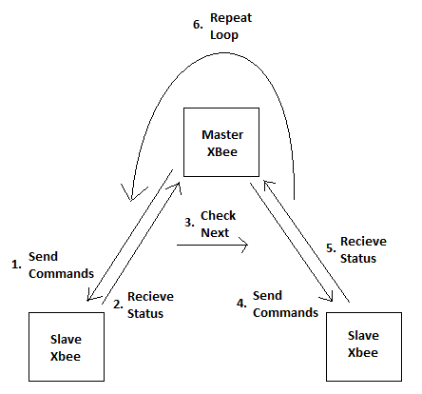

Figure 39: Xbee network setup for sending and receiving data. Master Xbee represents the Xbee at the web server and Slave Xbee represents Xbee at the power outlet modules.

The Xbee transceivers will only be sending digital I/O signals between each other. An I/O signal will be used for each of the power outlet’s sensors and relay switch control. There will be a total of 4 digital I/O pins used on the Xbee radios, one for each of the following: relay switch control, motion sensor output, manual switch output, and security sensor output.
When the master connects to a slave, it will send its digital I/O for the relay switch turning it to on state or off state, and the slave will send 3 digital I/Os for the for motion sensor, security sensor, and manual switch status.
The master XBee will use UART communication protocols to talk to the web server and tell the current state of the I/O pins and which slave it is currently talking to. The web server will record this data into its Module database file. Then the web server will respond by programming the Xbee to check the next slave in the network depending on how many slaves are in the database. This process will be repeated and all power outlets in the network will be checked.

7.4 - PCB Design

A printed circuit board had to be designed as part of the projects requirements. The group decided to use Express PCB’s software and manufacturing services to design and fabricate the printed circuit boards. Express PCB has a deal whereby you can fabricate 3 boards of the same design for $85.10. In this deal you are limited to a board size of 3.8 x 2.5 inches. However, this was a good because it allowed the group to stay within the confines of a one-gang sized wall box to attach the PCB to. The dimensions of a one-gang box are about 3.31 x 5.06 inches. The deal also allowed for two-layered boards to be designed. This helped achieve some of the tougher wiring as well as some space savings. Some of the other requirements are as follows:
- Allow AC voltage to be converted to DC voltage by using a rectifying bridge.
- Bring 5 VDC to door sensors and relay controller.
- Bring 3 VDC to wireless RF X-Bee and the motion sensors.
- Stabilize all DC voltages.
- Allow easy access to I/O pins and power.
- Minimize noise and ripple voltage
- Have the whole system draw at the most 3 watts.
The wireless modules can be effectively powered anywhere in a home where there is a circuit in the house. This can be achieved by interrupting the power of any circuit from the main breaker. To do this the first step is to take the power down by using a step down transformer.

The group found PCB mountable transformer by Amveco Manufacturing that had a small footprint of 1.95 x 1.95 x .76 inches. Using this allowed the group to bring the power down to 9 volts. Out of this the AC needed to be converted from AC to DC.

To rectify the voltage from AC into DC, a diode bridge, using the IN4007 diode, was designed. Full-wave rectification is achieved through the four-diode bridge. This can be seen at the top of Fig 1. After the bridge rectifier, the signal is smoothed out from any ripple by the use of a 1000 uF reservoir capacitor.
The use of two regulators was employed to supply voltages of 5 VDC and 3 VDC. The 7805 was used to supply 5 VDC to the door/window sensors and relay controller. The 9 VDC was enough to meet the required dropout voltage of 7 VDC of the 7805. This linear regulator performed well in testing to provide a steady voltage for those parts. The LM317 was used to supply 3.2 VDC to the X-Bee wireless RF slave module and the motion sensors. This is a positive variable voltage regulator, and is considered fairly popular in the world of voltage regulation. With the regulators three terminals it can provide 1.5 A over a voltage of 1.25 – 37 VDC. This provided a stable voltage and was flexible by adjusting resistors R1 and R2. This can be seen at the top right of Fig 1. The regulator has been varied to reach this 3.2 VDC by using a 100 ohm resistor for R1 and a 150 ohm resistor for R2. See equation 1 for this calculation.
$Vout=1.25\left(1+\frac{R2}{R1}\right)$ (1)
C2 and C3 are 47 uF capacitors being used to minimize noise coming off of the regulators.

The X-Bee is from the series 1 of X-bee modules and is used as a slave unit in our project to output signals to the modules components on the board. This is done through the easy layout seen at the bottom of Fig. 1. I/O 0 is used to used to send the control signal that is toggling the relays internal switch. When the inductor inside the relay sees an induced current from the control signal it will open and close. The relay is normally open so a manual switch was added onto I/O pin 1 to be operated as normally closed. This allows the outlet to operate independent of the android app like any normal outlet would. Digital I/O 2 is used for the motion sensor output. This takes in reading from that sensor and feeds it back to the master X-Bee. Digital I/O 3 is used for the door/window sensor. Both use 200 kOhm pull down and pull up resistors respectively.
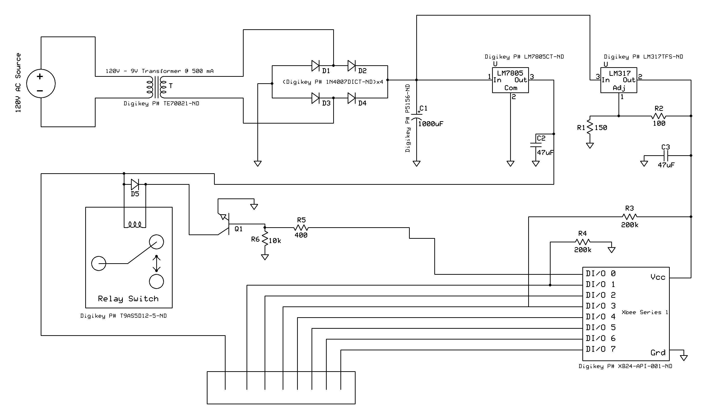
Figure 40: custom PCB schematic

8 – Project Management

8.1 – Budget and Financing

The project’s funding will be split up among the member of the group. Alcorn McBride and UCF have loaned Texas Instruments evaluation boards to the group. The group decided to do the smart home project for its flexibility and scalability. The project does have the ability to turn a little as we zero in on the scalability of our design. Therefore, planning for all possible budgetary outcomes of the project is a necessary step. Because this project is in its first stages, some parts require an extra quantity for allowing any errors in estimated numbers, or erroneous building mistakes for the design.

Table 21: Budget list

Item | Manufacturer | Quantity | Cost per unit | Total
Web server | Parallax | 1 | $59.99 | $59.99
Xbee Modules | Digi International | 9 | $21.99 | $197.91
Relay Switch | Generic | 2 | $5.00 | $10.00
GFCI outlet | Leviton | 2 | $10.00 | $20.00
Motion Sensors | Parallax | 1 | $10.00 | $10.00
PCB | ExpressPCB | 3 | $28.36 | $85.10
Door Sensor | Seco | 3 | $6.33 | $20.00
Circuit components | N/A | 3 | $30.00 | $90.00
 |  |  | Grand Total | $493.00
Table 14: Budget list
8.2 – Milestone Chart

June 5th, 2012 | Project selected, begin Research
June 25th, 2012 | Each member finishes 10 pages
July 15th, 2012 | Each member finishes 20 pages
July 30th, 2012 | Each member finishes 30 pages
August 2nd, 2012 | Proof reading and Editing finished
August 3rd, 2012 | Senior Design 1 paper Submitted
August 18th, 2012 | Phone Application prototype complete
August 25th, 2012 | Web server communicating with Phone App
September 20th, 2012 | Power outlet module prototypes
September 30th, 2012 | Phone app can switch relay switch
October 15th, 2012 | PCB design begins
October 30th, 2012 | PCB board finished
November 15th, 2012 | Software for phone, webserver and Xbee modules complete
November 19th, 2012 | Final testing and demonstration built
November 19th, 2012 | Demonstration complete

Table 15: Milestone chart

8.3 – Work Distribution

Figure 41: Work Distribution

9 – Final Summary

9.1 – Conclusion

We have learned so much information in our senior design project thus far. We are very excited to see what the future can hold for it. Whether it is something that can help us receive employment, allow us to utilize it for our own home, or for the shear fact that it has allowed us the opportunity to learn and apply the education we’ve received at UCF, senior design is a great experience. Not only has this project been helpful from an educational stand point, but also from a real world stand point. We’ve had the opportunity to talk to the folks at Alcorn Mcbride and receive advice from their senior engineer Jim Cartstenson. Not only has he been very generous with his knowledge and time, he’s been a great person to meet in the industry to gain advise and learn from as well.

There are many things that have been learned about not only the project, but about us as well. Working together in a group takes great effort and communication. Doing a project with UCF full time students takes a lot planning and effort, but once that effort and energy was focused and realized, the group has never been better. Knowing our limitations as a group has helped us to brainstorm and figure out solutions to the many design challenges and problems that can occur with a project of this scale and magnitude. Not knowing our limitations has also been exciting. The idea of the unknown is sometimes scary and challenging, but also exciting and addicting once progress and made and realized either between a group of people or an individual. Unfamiliar territory is one of the things that can help bring about good stress and pressure to help one grow as a person.

9.2 – Final Summary
Our smart home project thus far comprises of many different parts and sections. The projects scalability has made it very hard to narrow down what exactly is meant to be implemented into our objectives and goals for it. However, through careful thought and research we have decided to pursue wireless audio streaming for intercom and music playing from a mobile device. We’ve also decided to pursue wireless lighting control, video surveillance, and security. All of these components have made for a very challenging and detailed project. The research on everything helped to open up a new world to projects, companies, and standards/ways of people doing it. We have tried to take a piece from each of these to, not only learn from, but to hopefully improve upon as well. Basing everything around the control of the users’ smart phone is something that our group feels is a core object and design goal. With this control we will use an app to interface with all of the areas and avenues that our project will utilize in the design. Our hope is not only that we are able to complete this senior design project with a working prototype, but also that we would learn a lot from this real world type of experience. We also hope to give something back to a body of knowledge on the subject and have a lasting resource for others to draw on for the arena of smart homes.

Appendix A: EVMOMAPL137 Schematics are provided courtesy of Spectrum Digital, Inc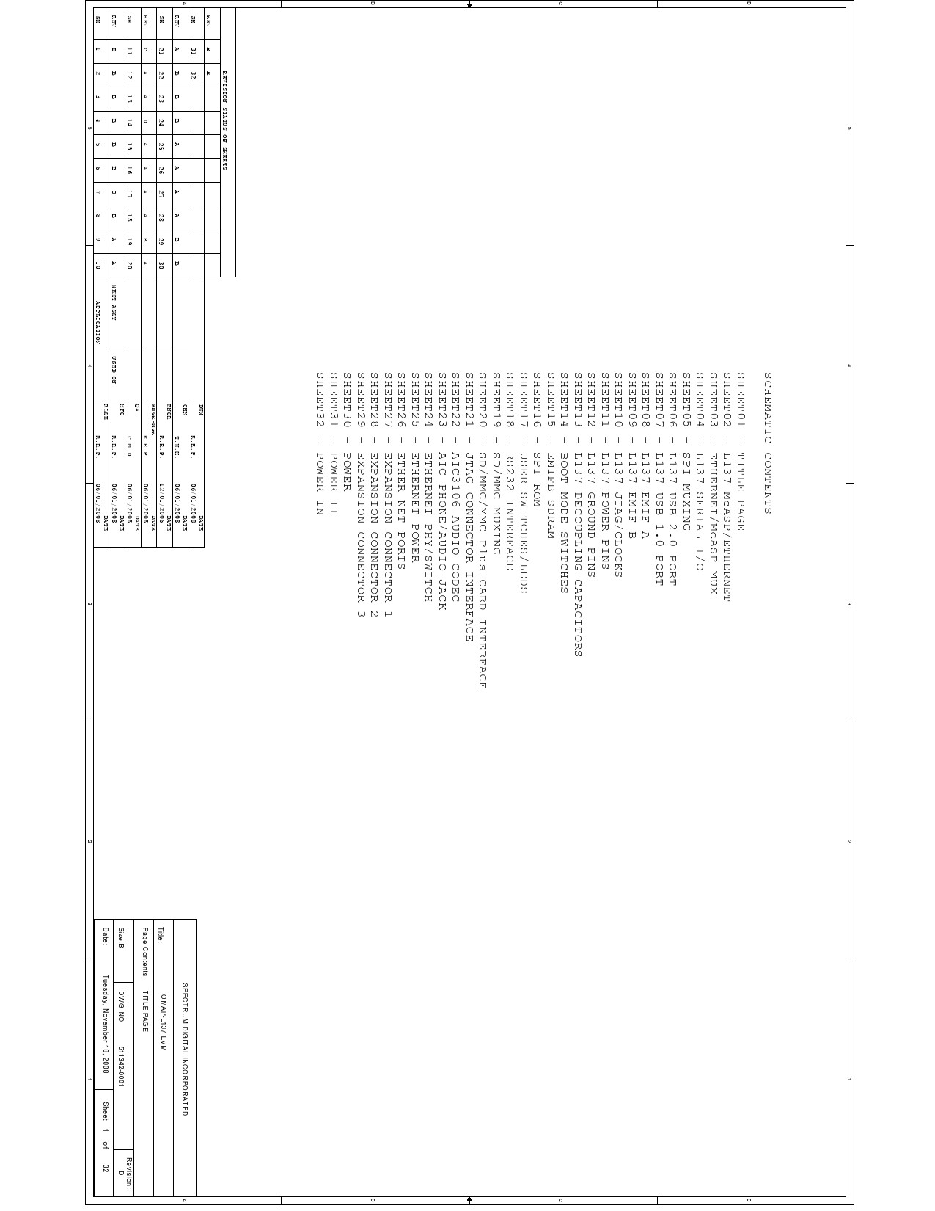
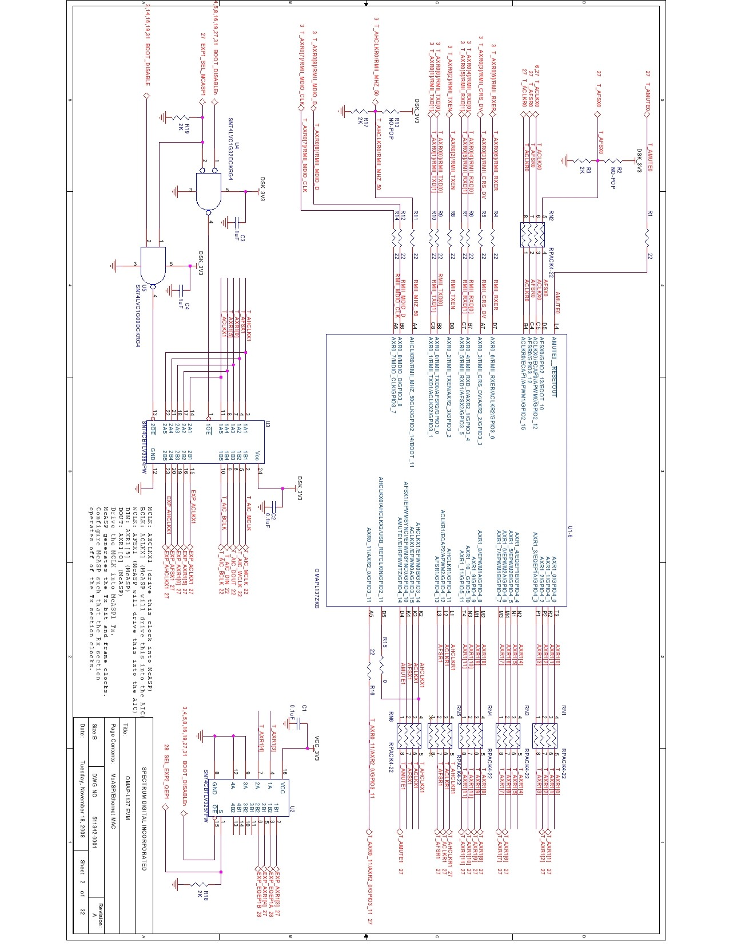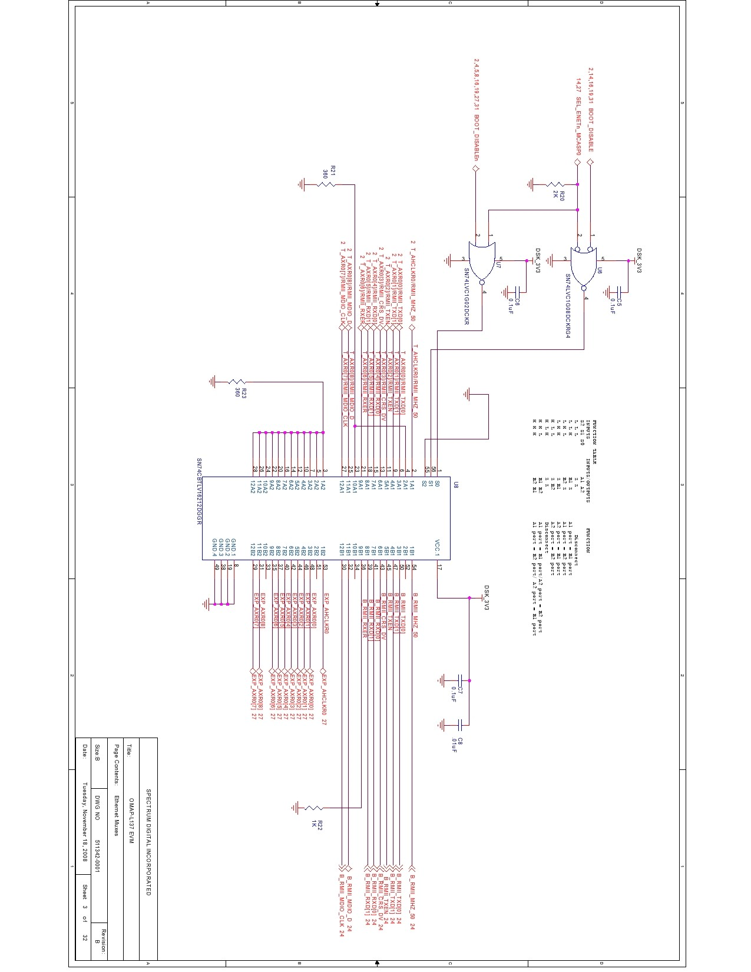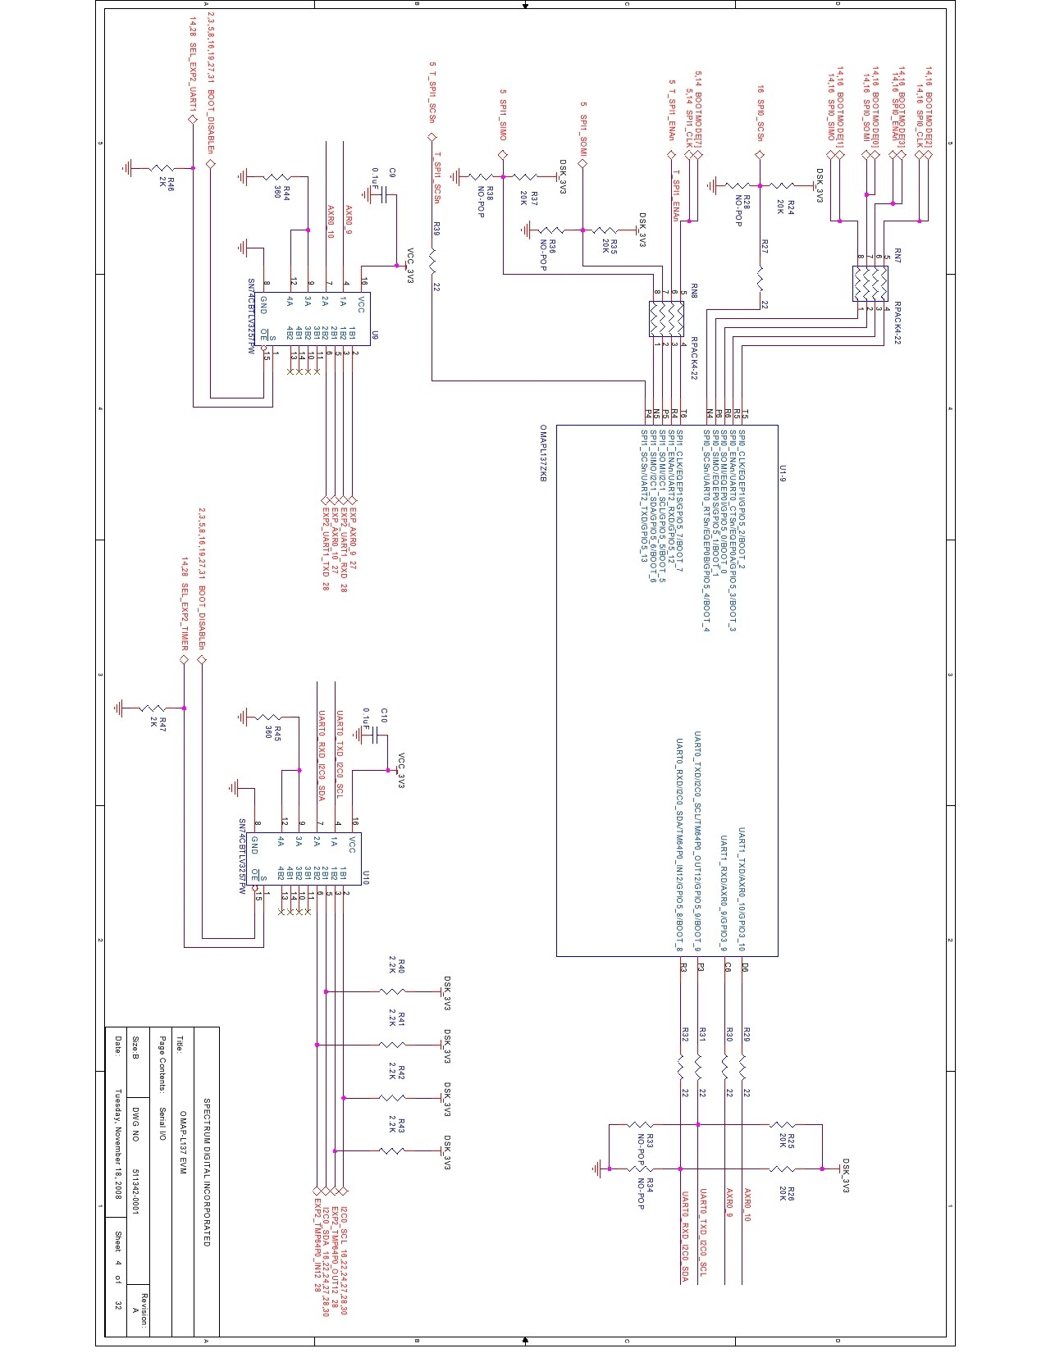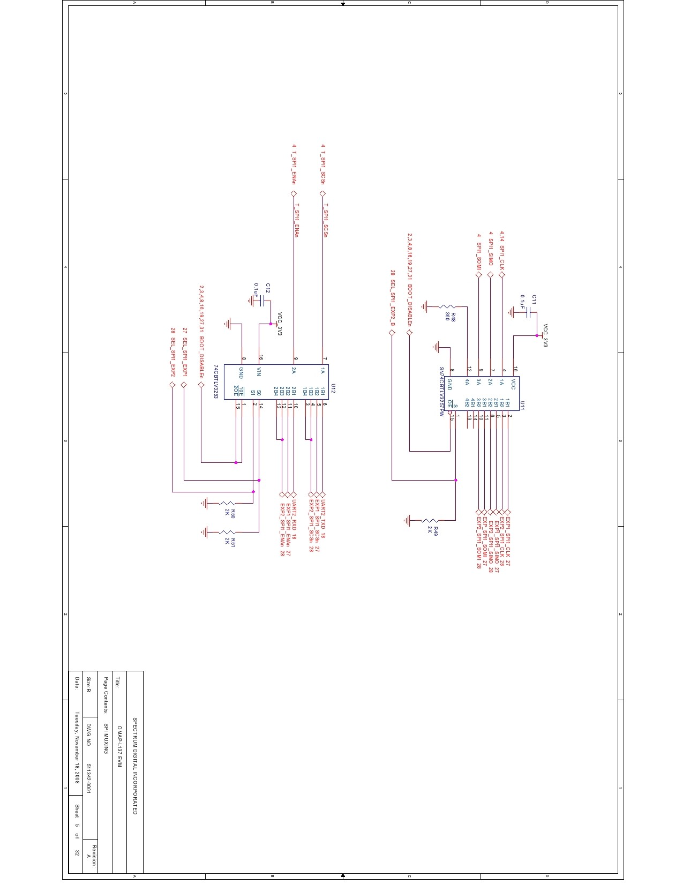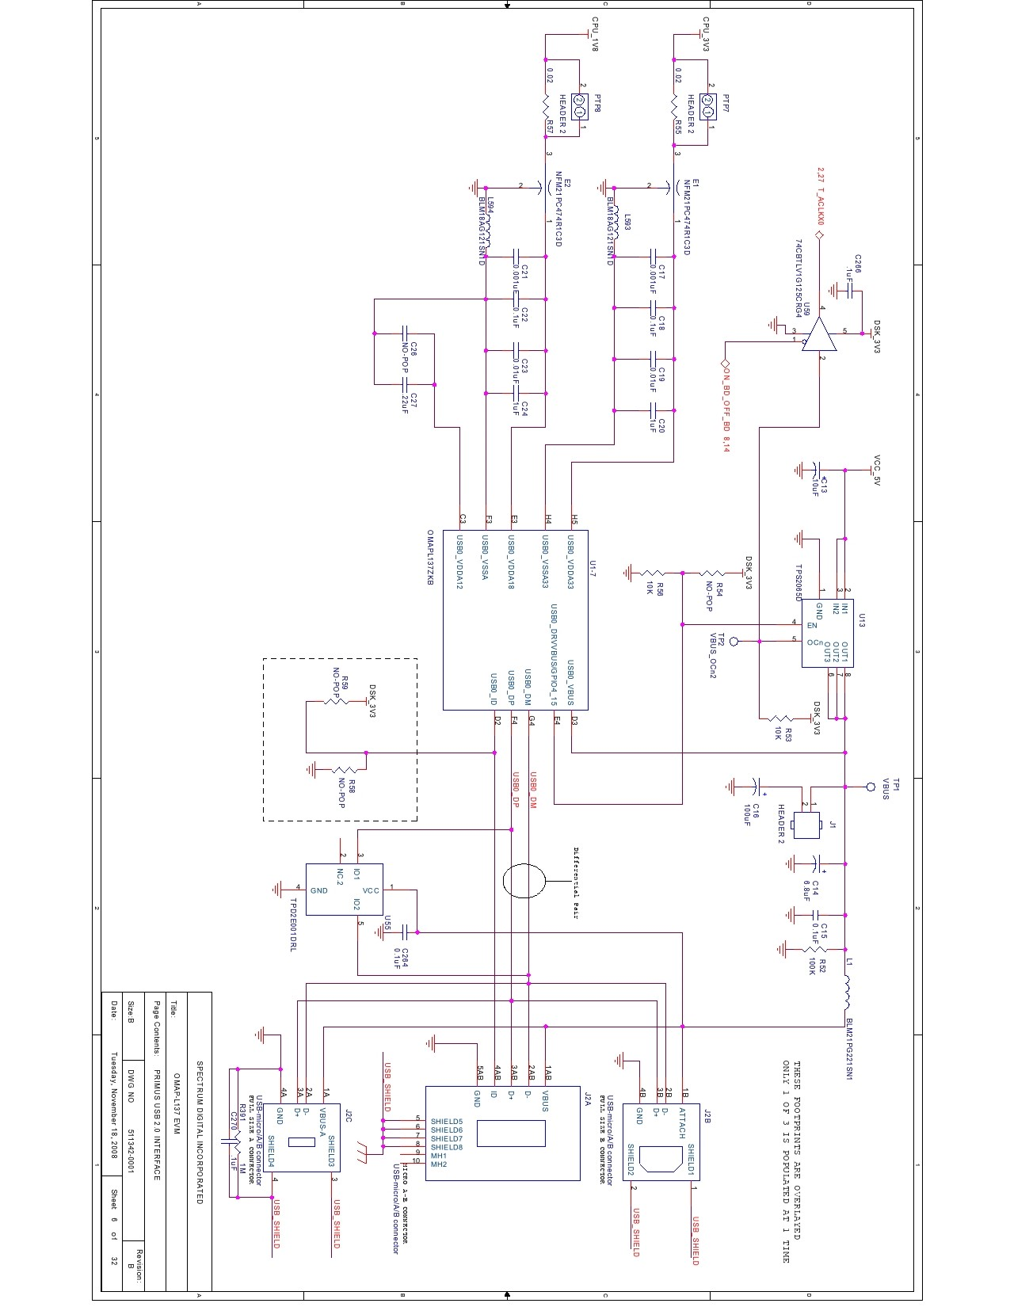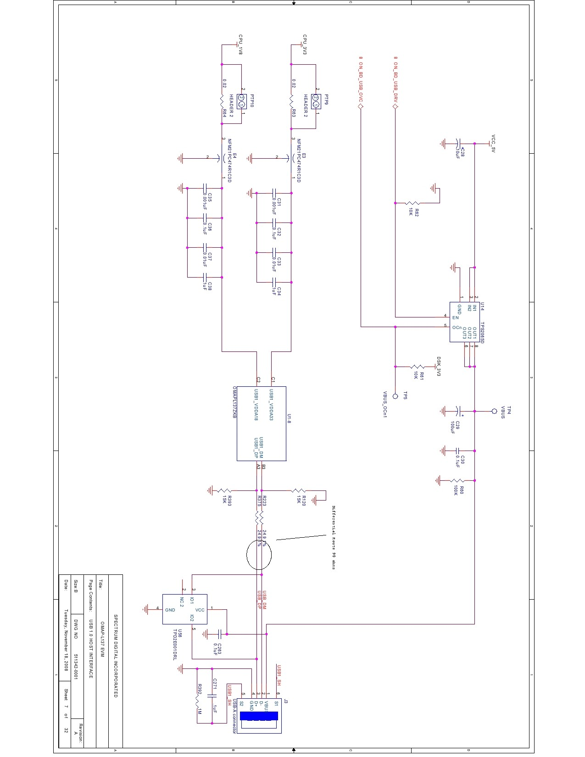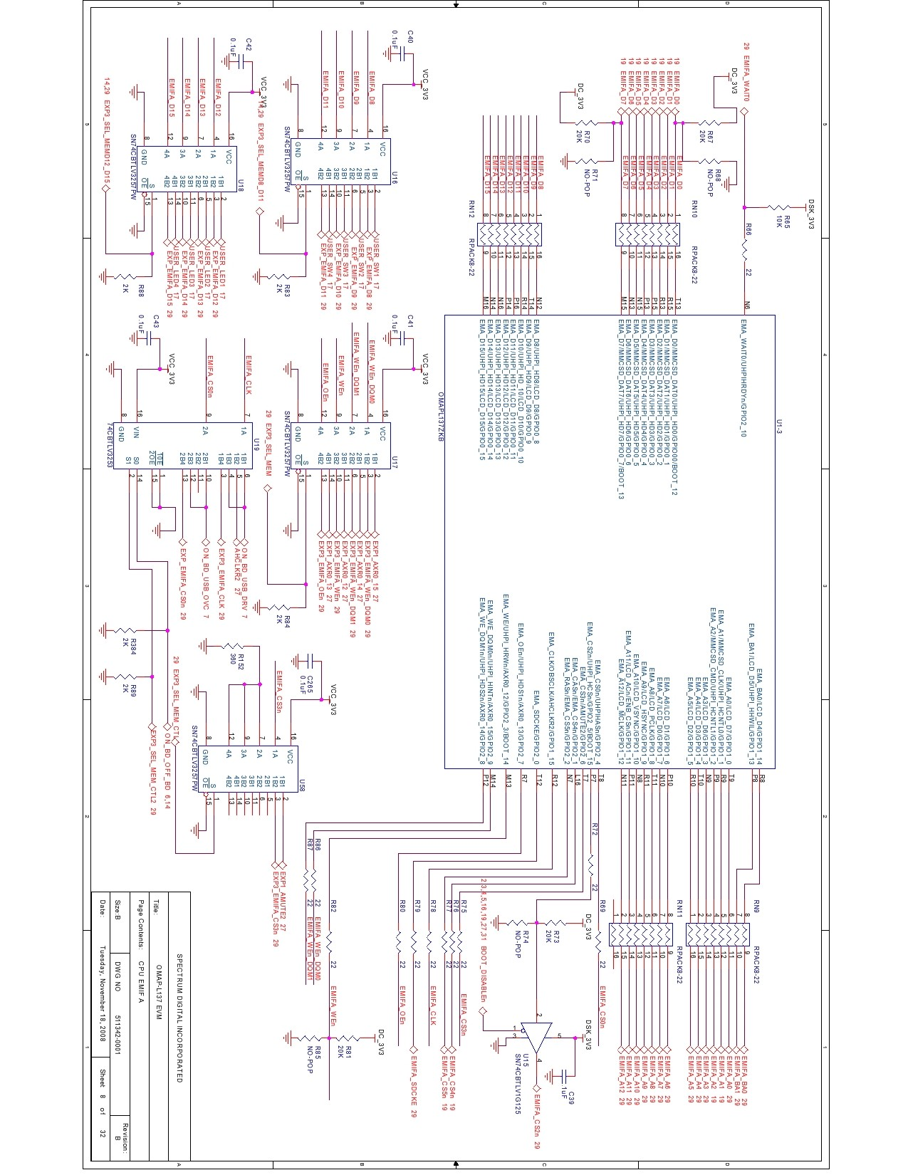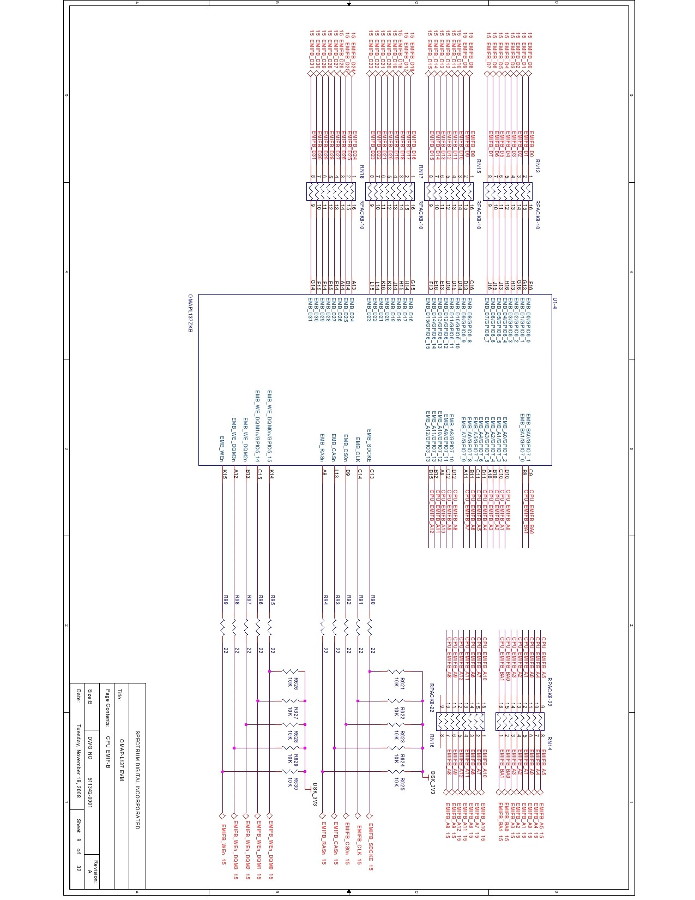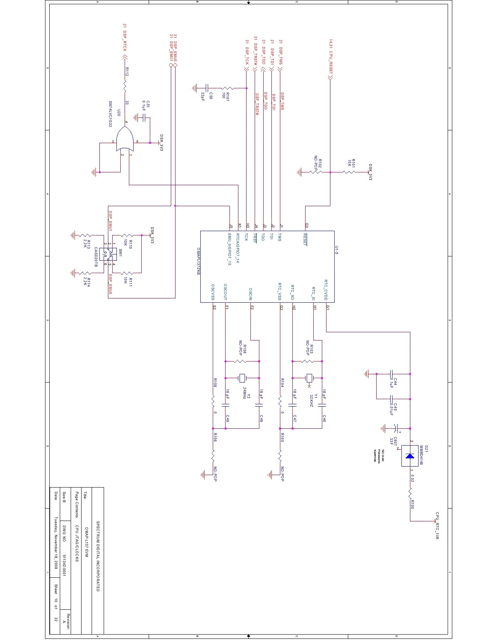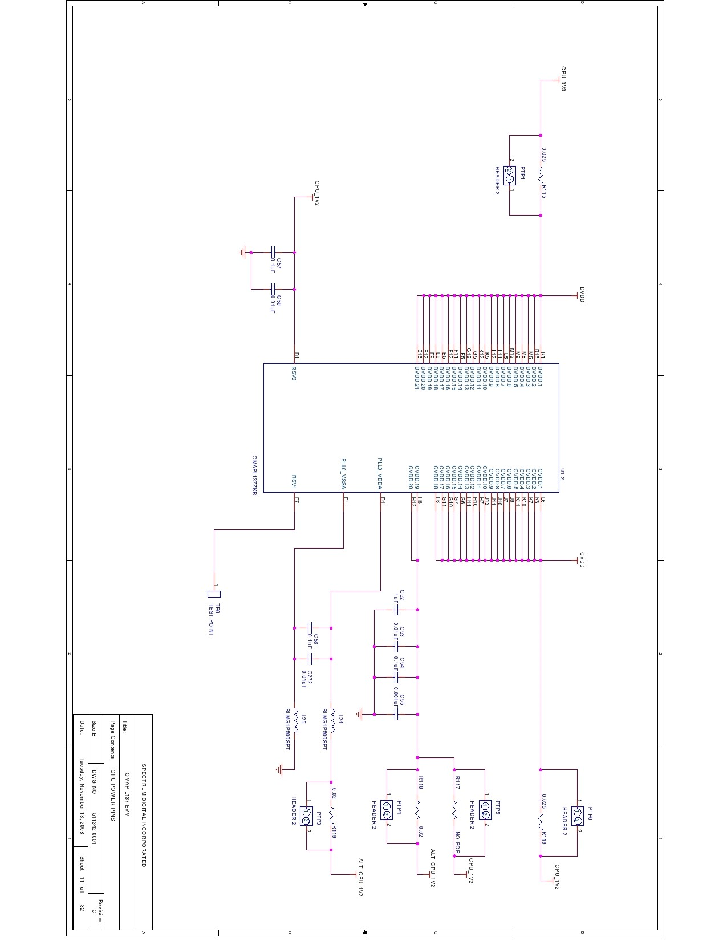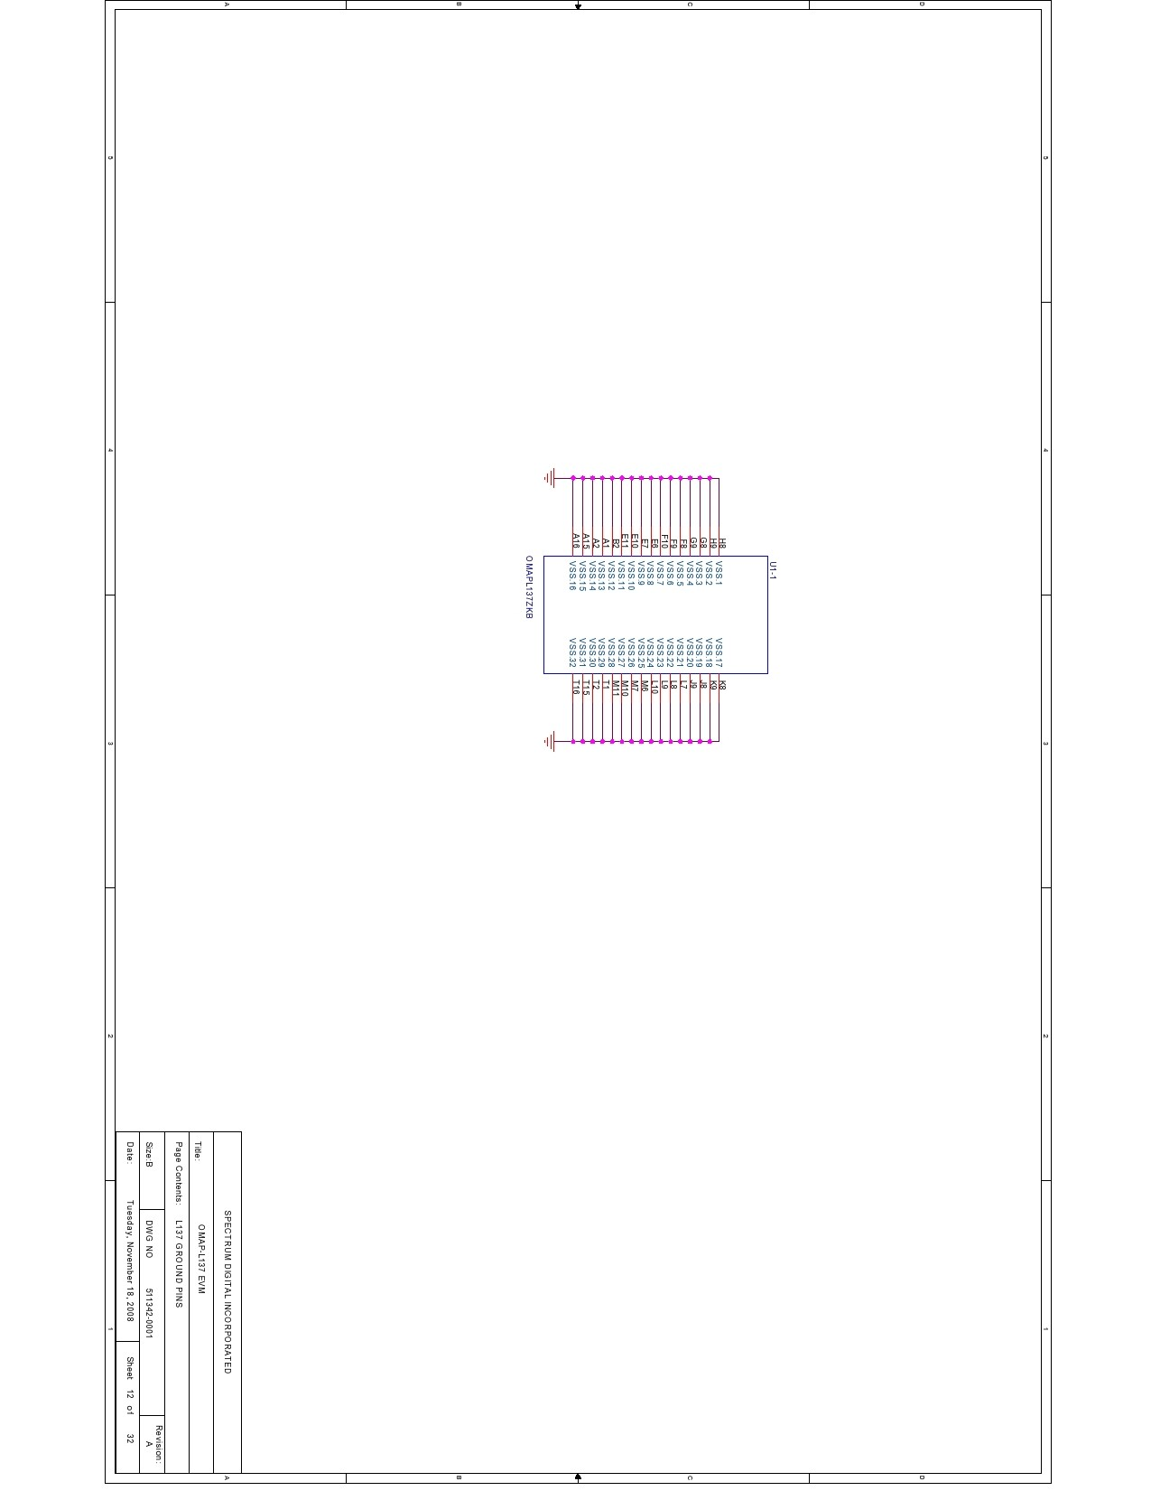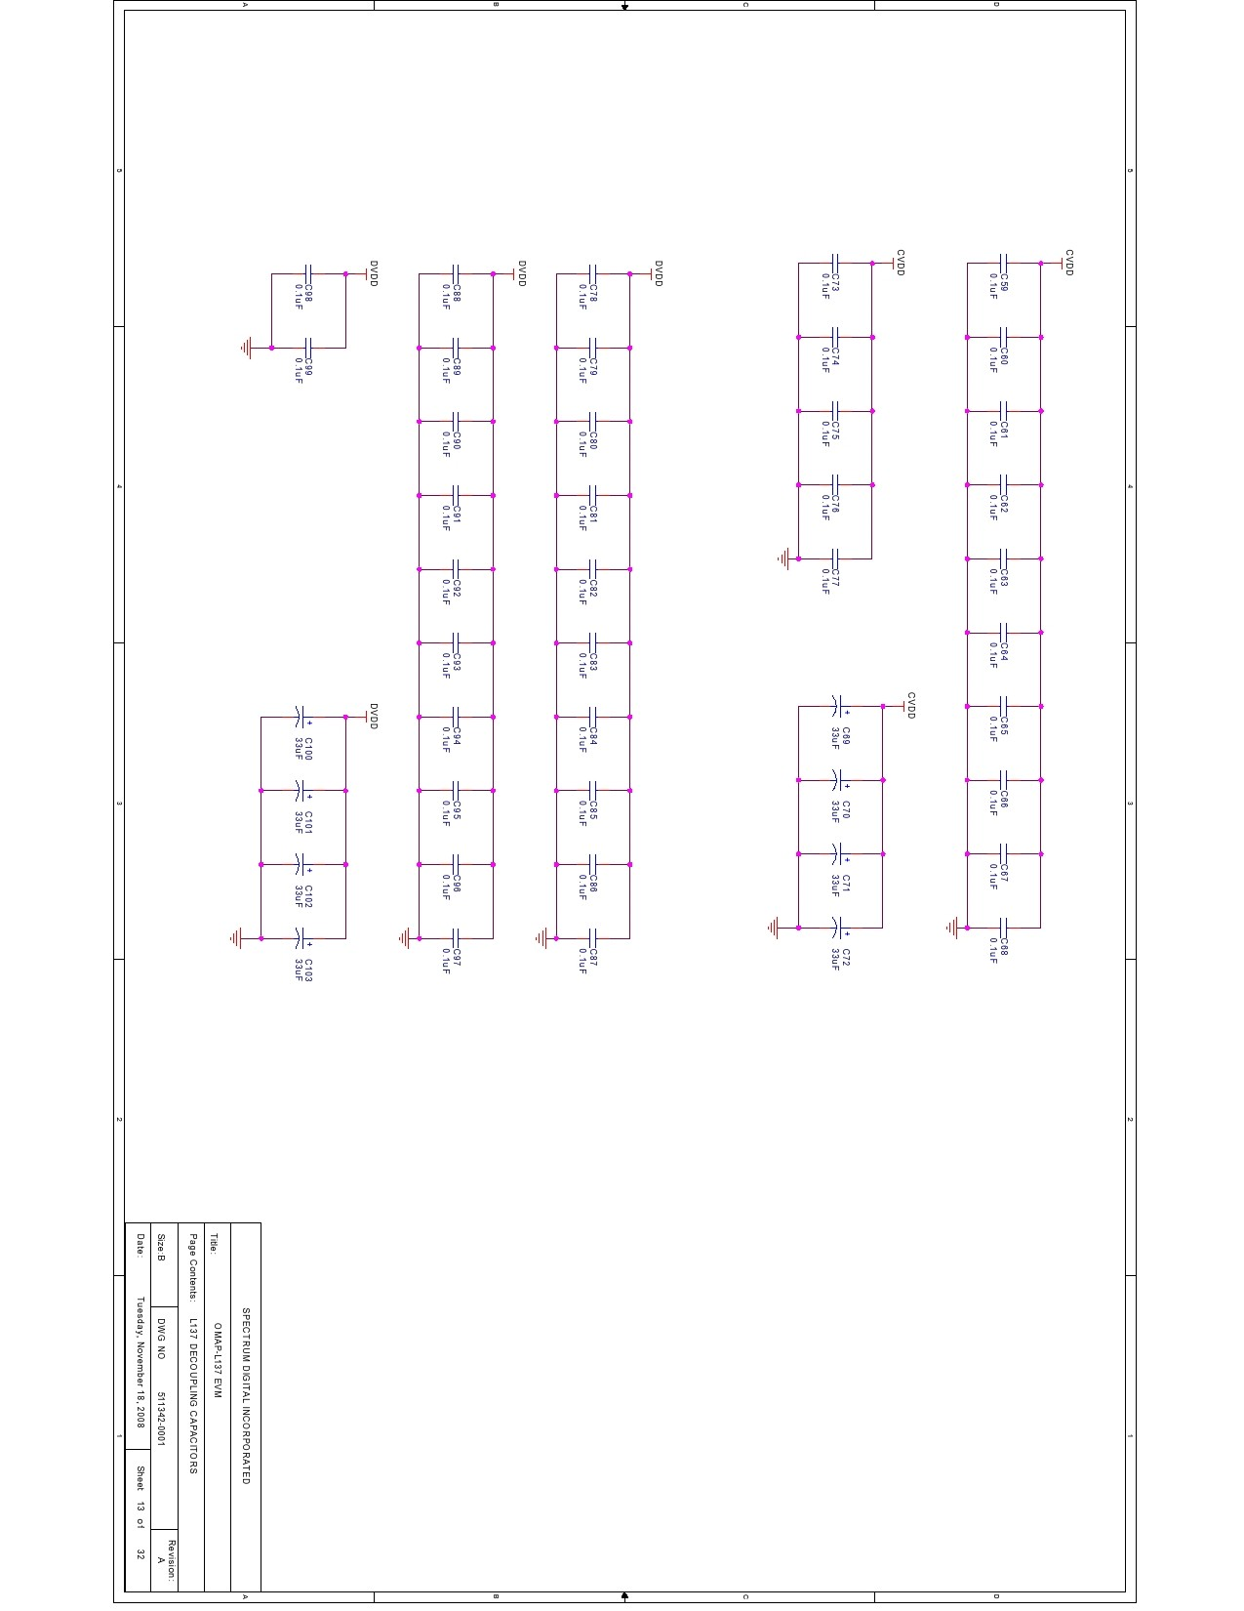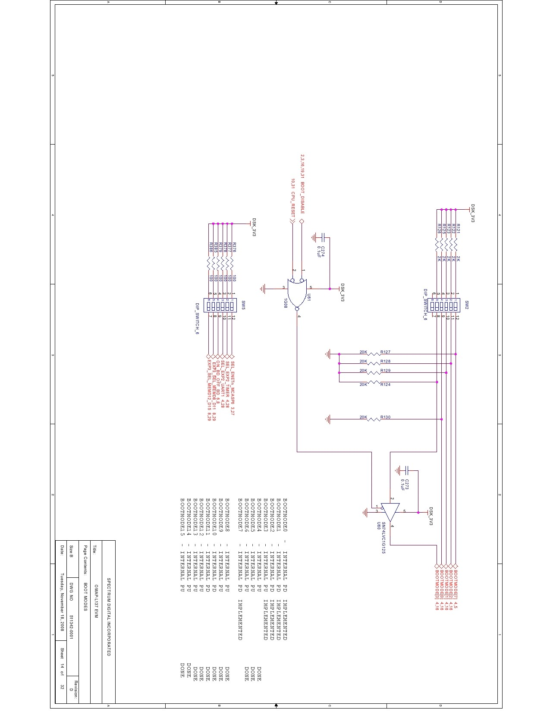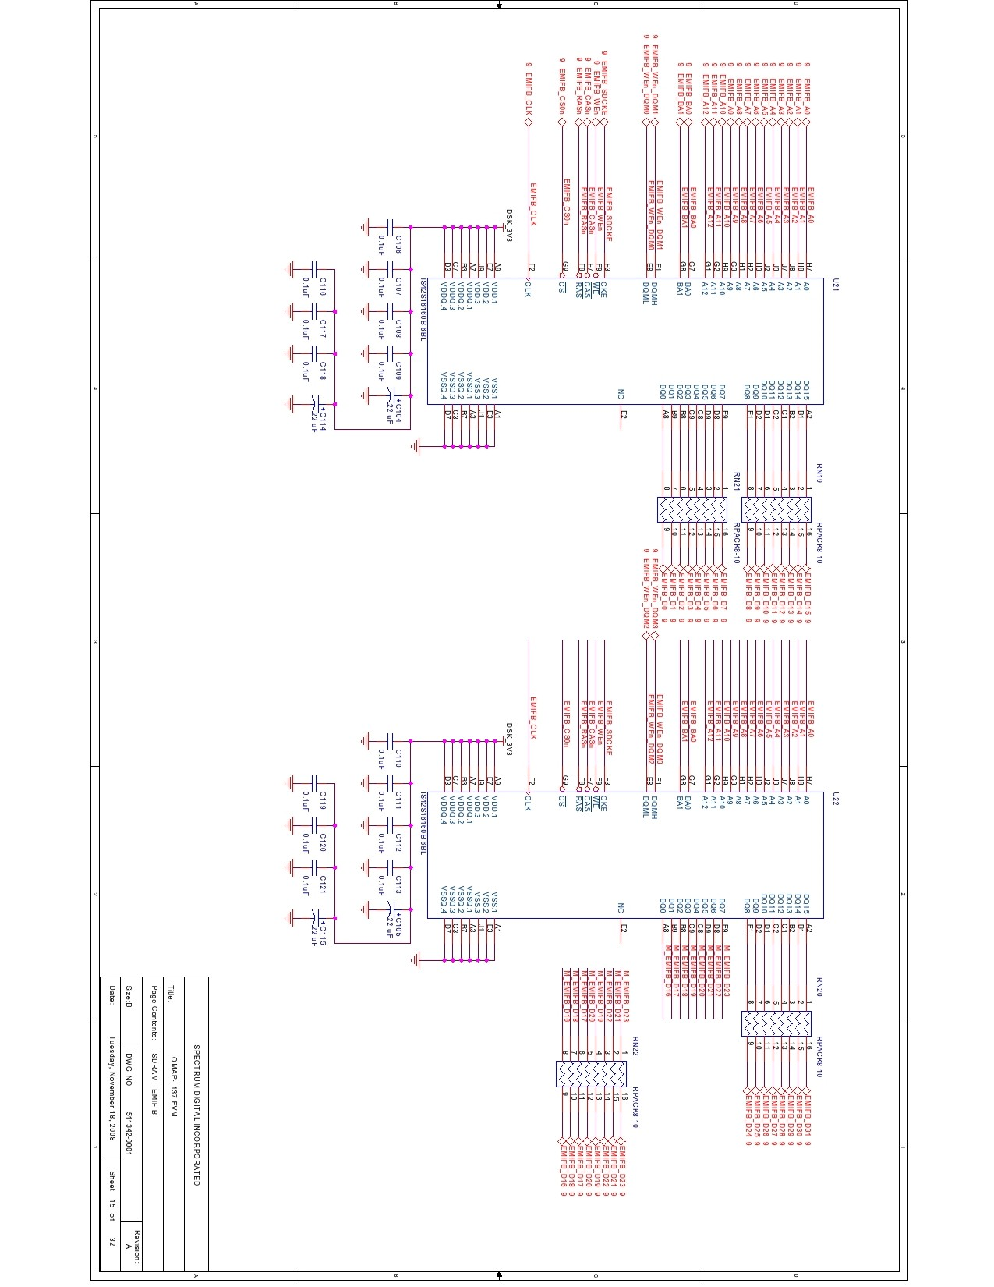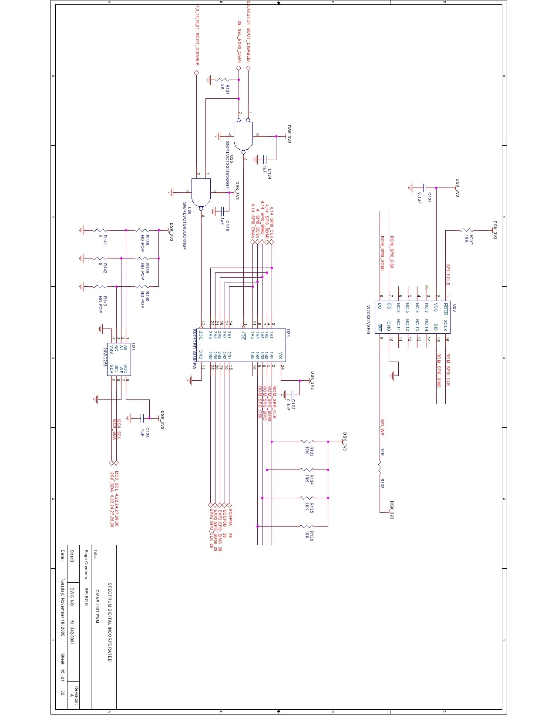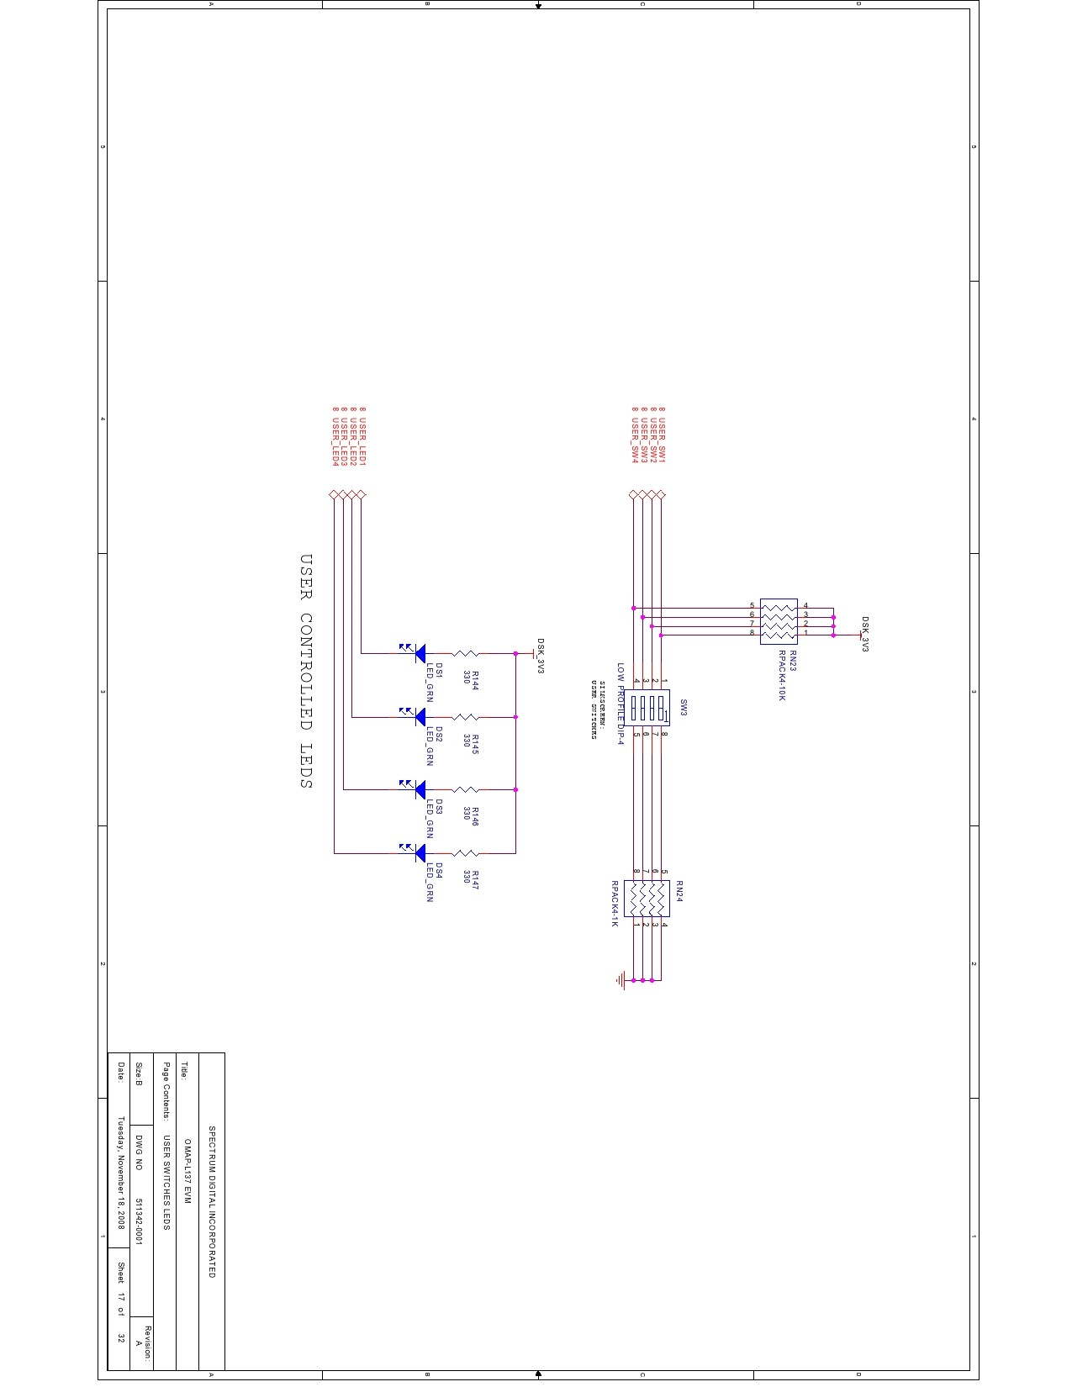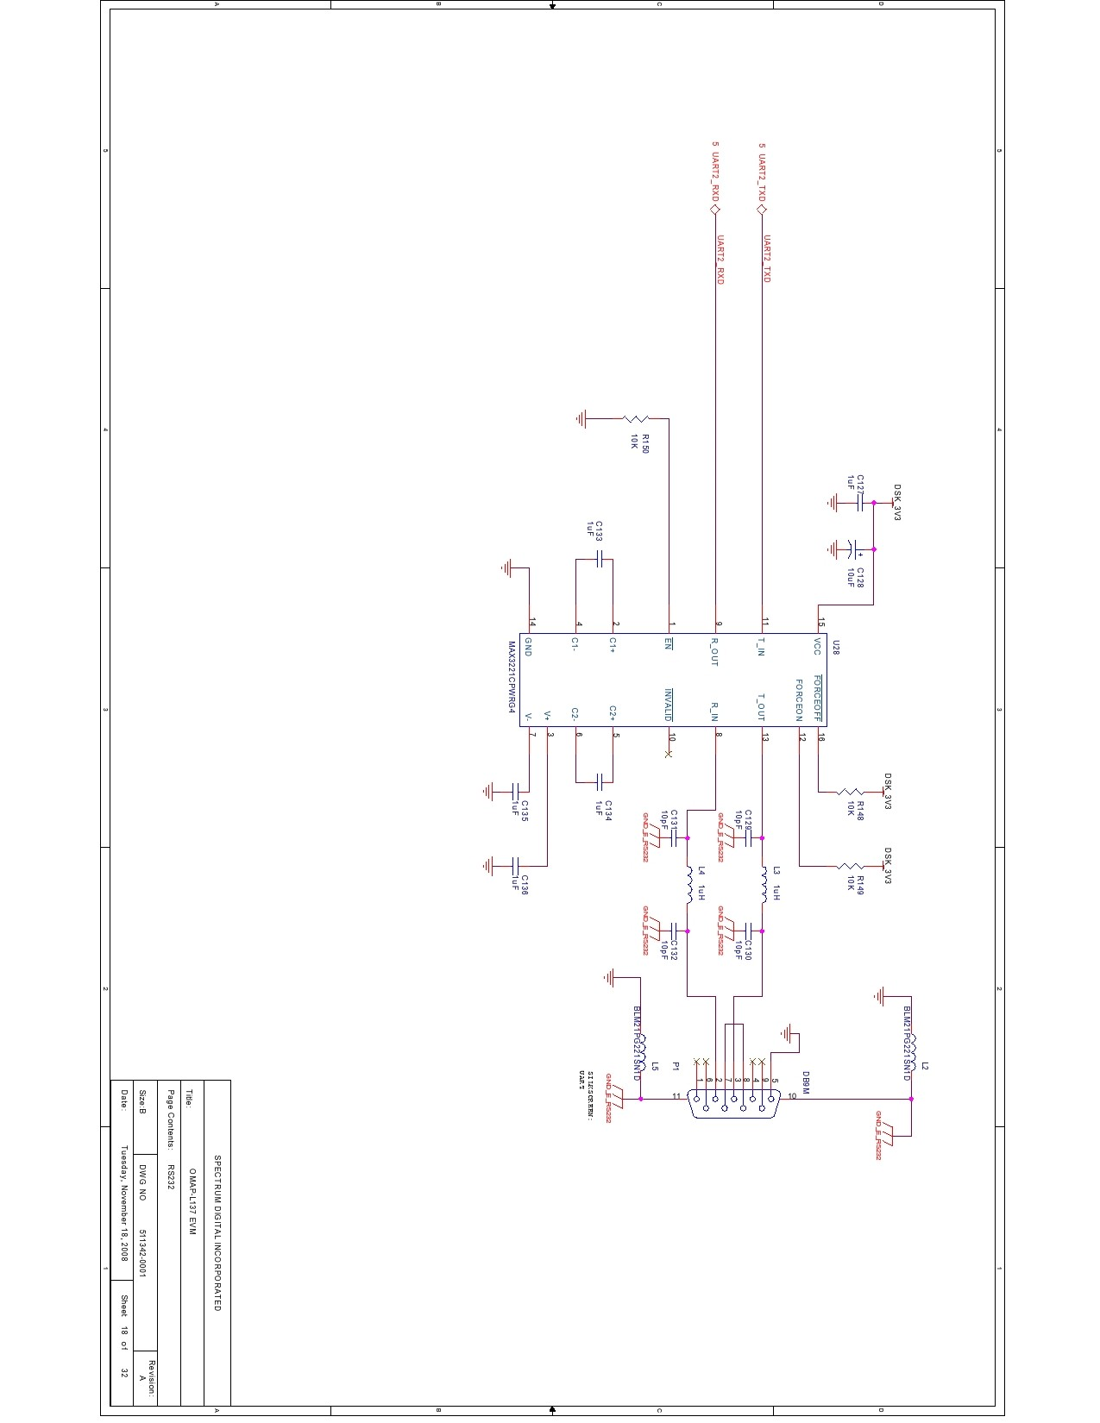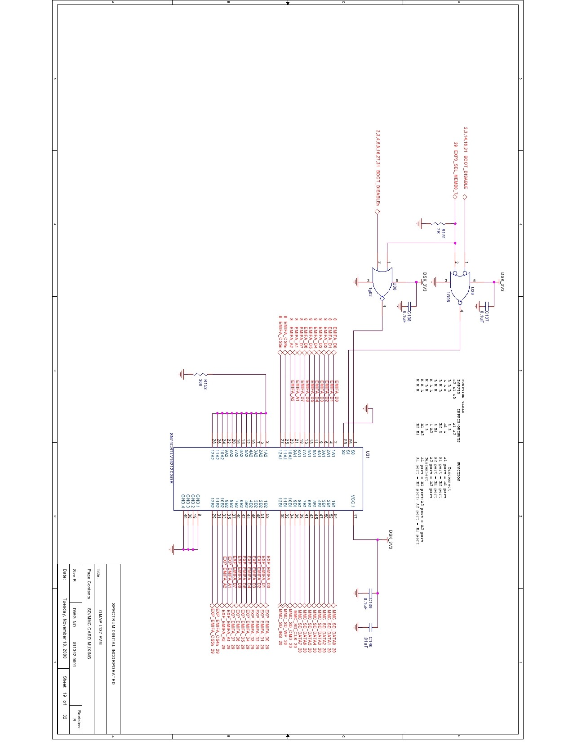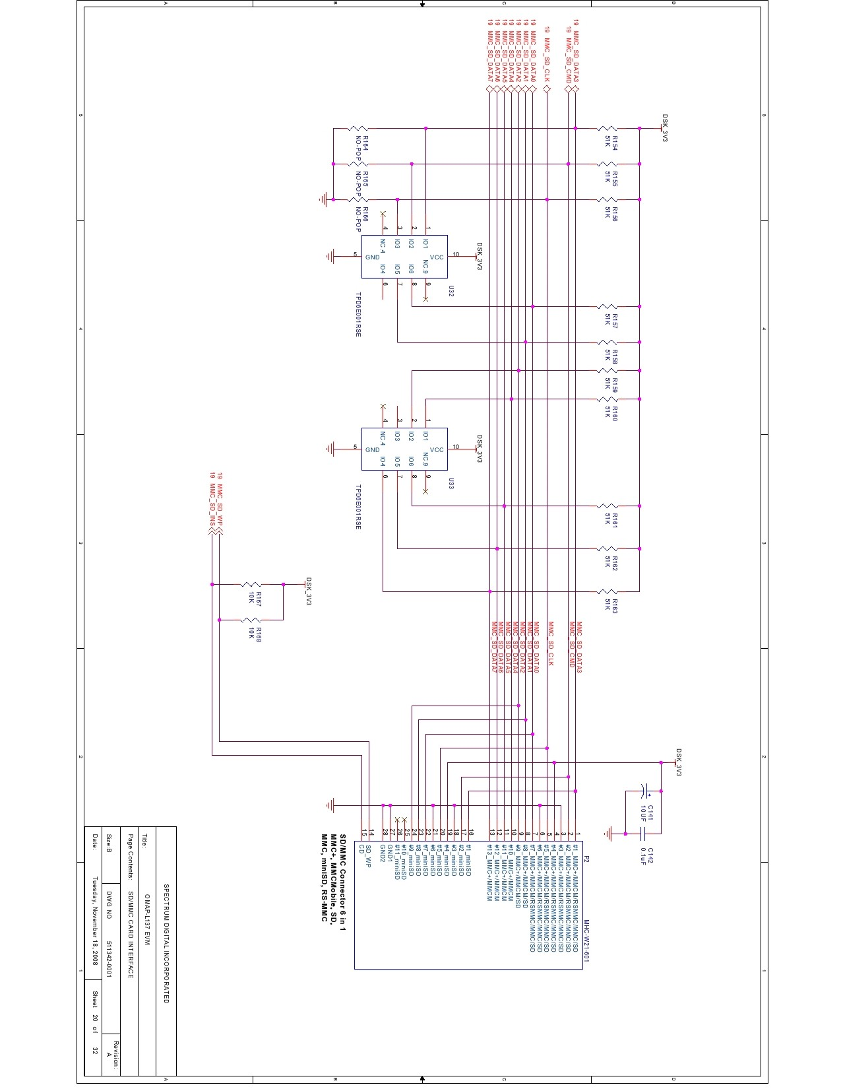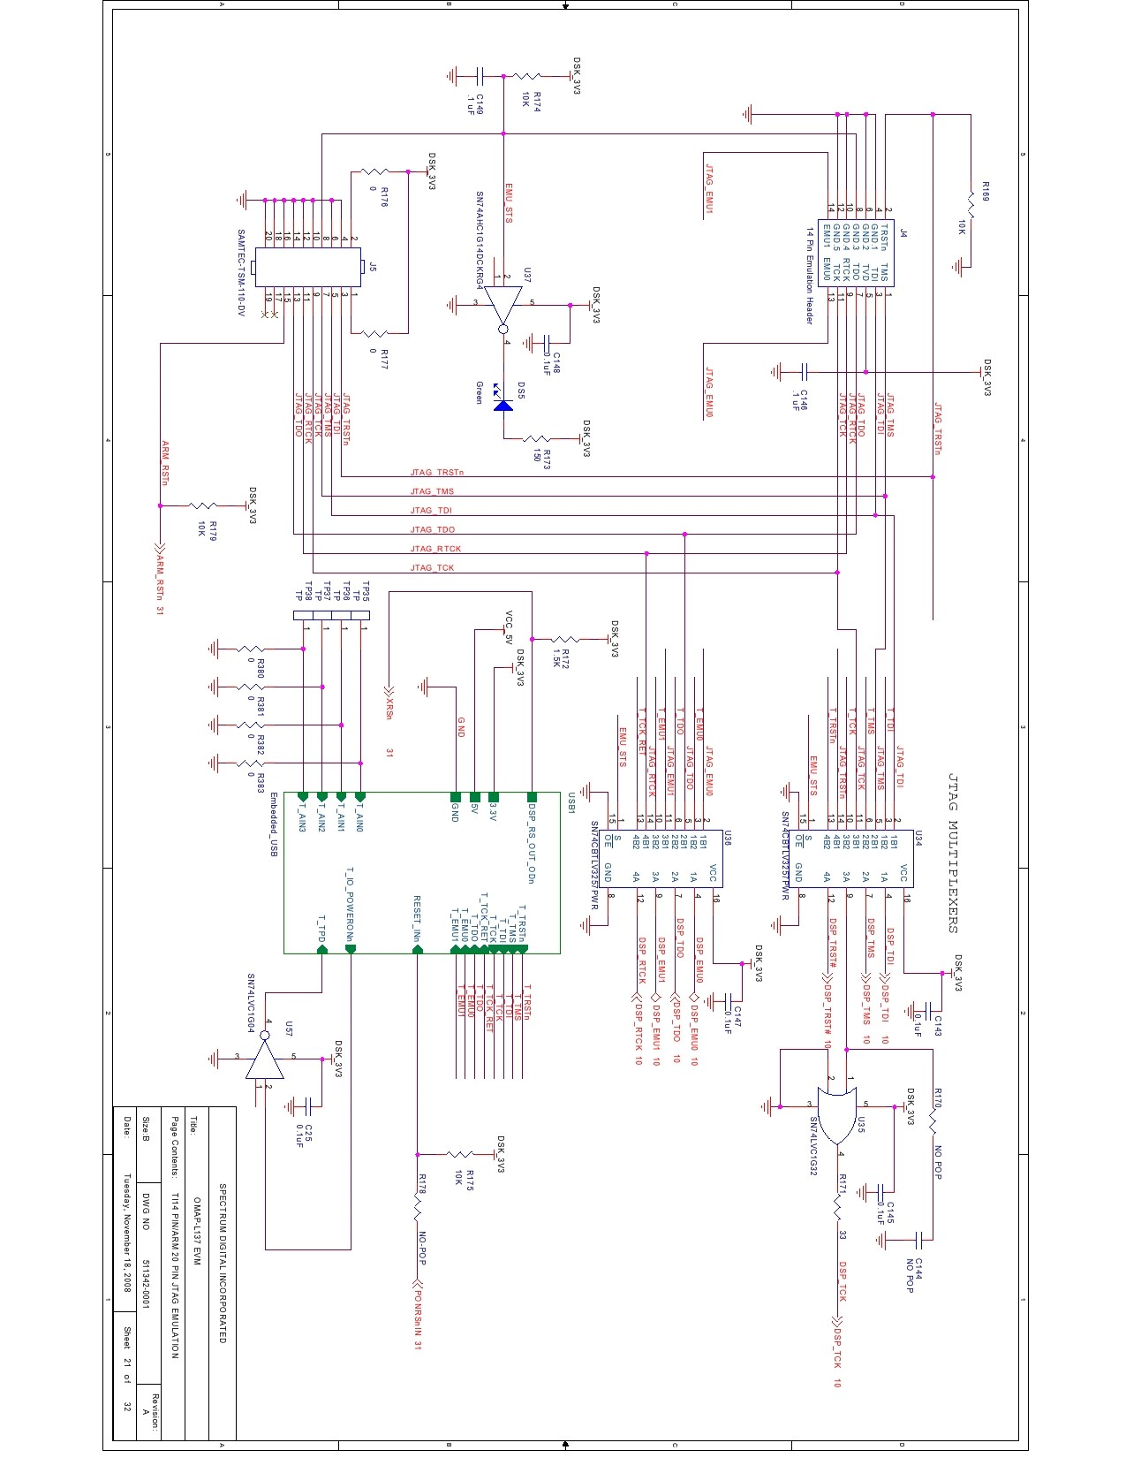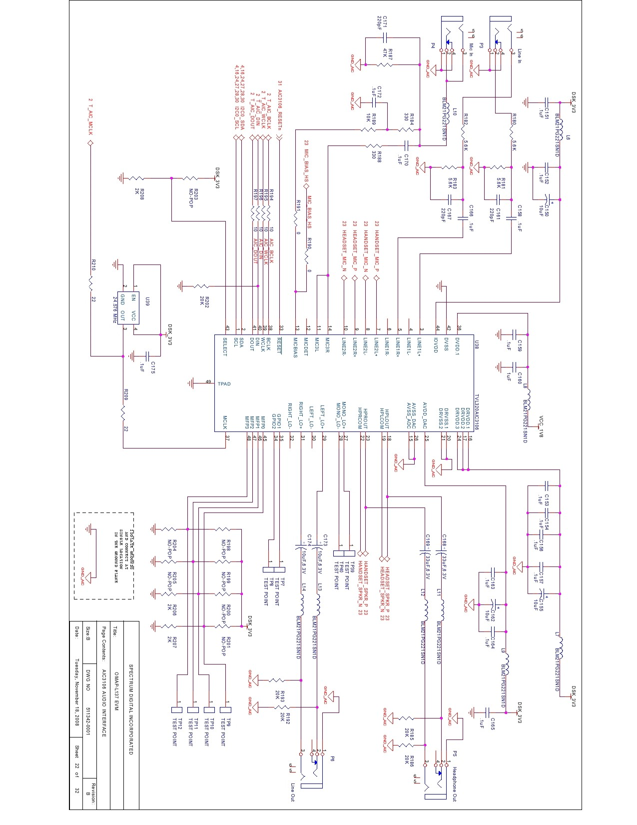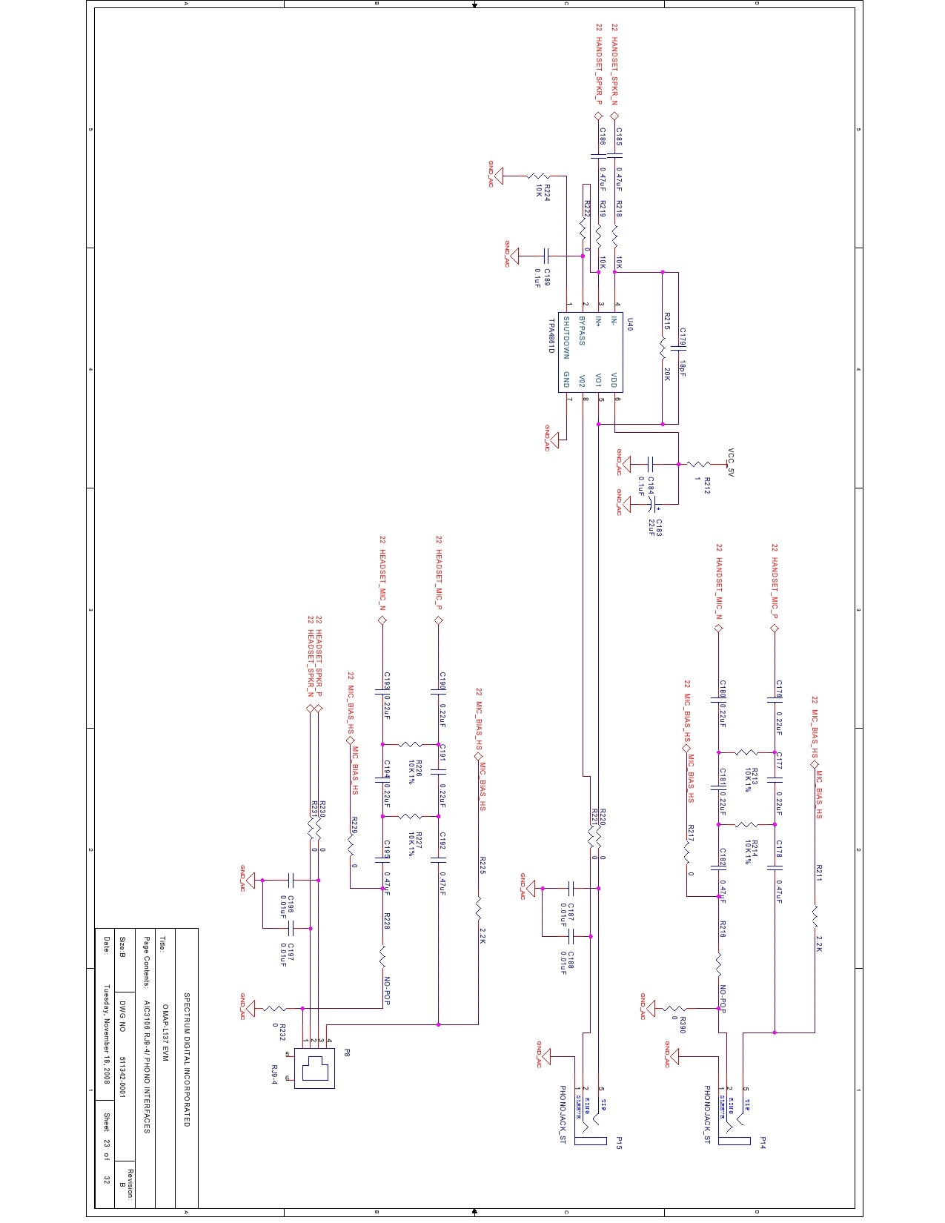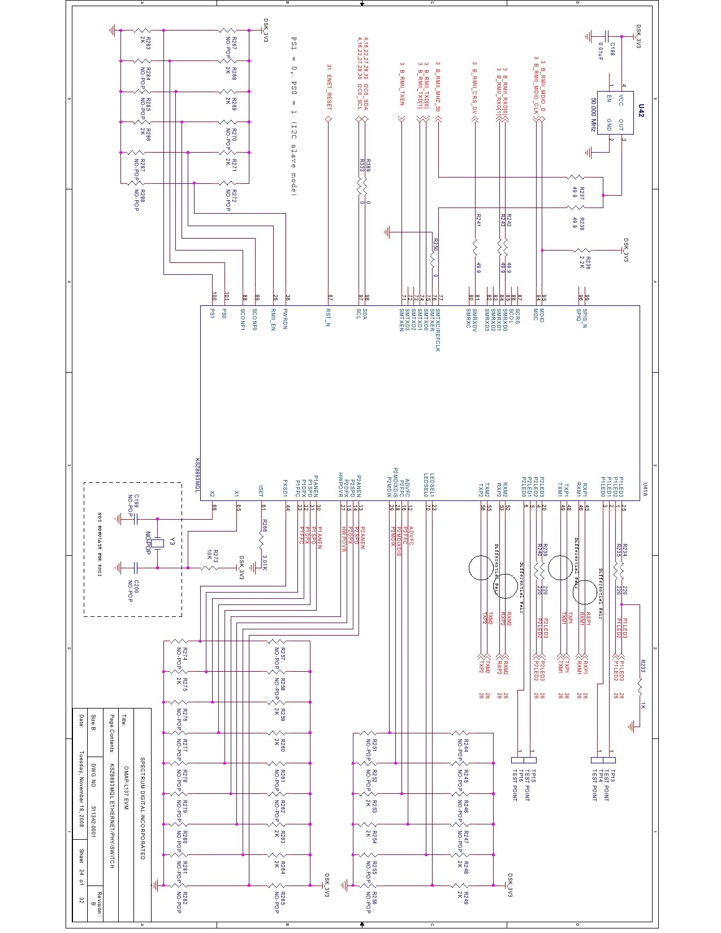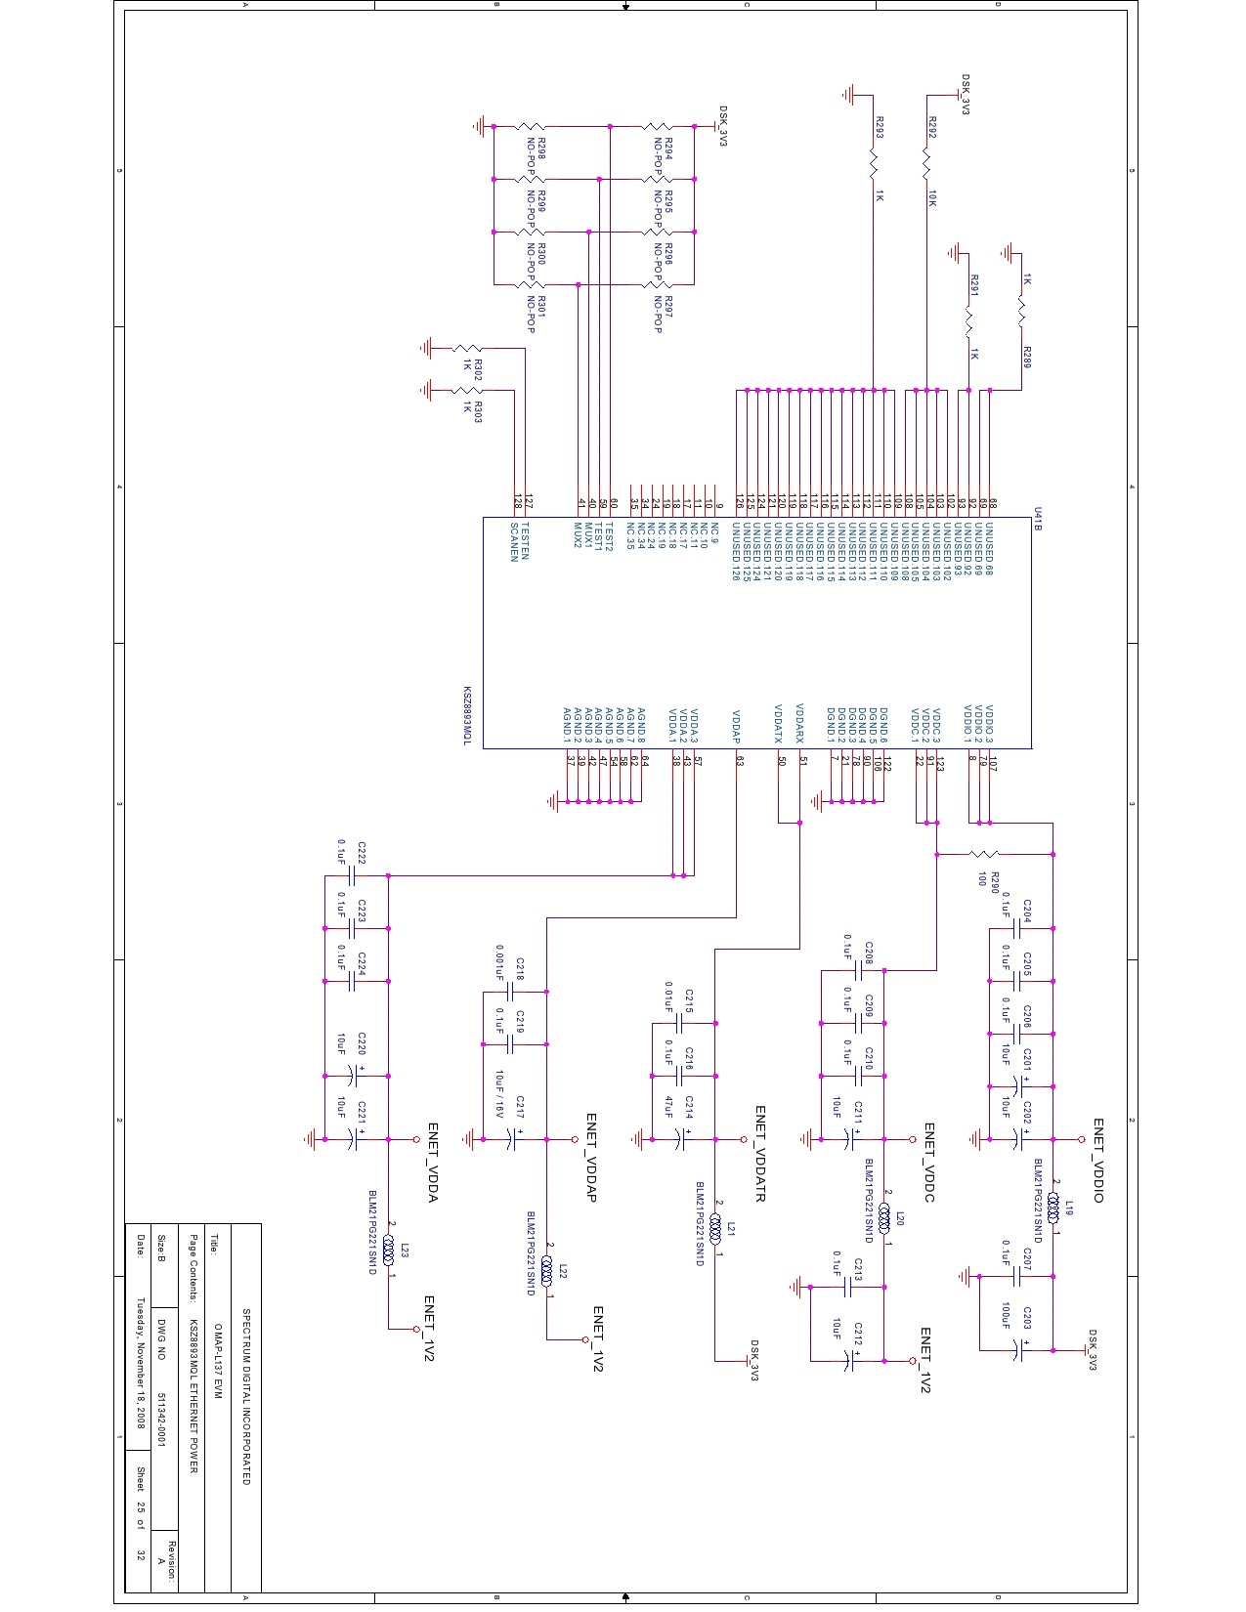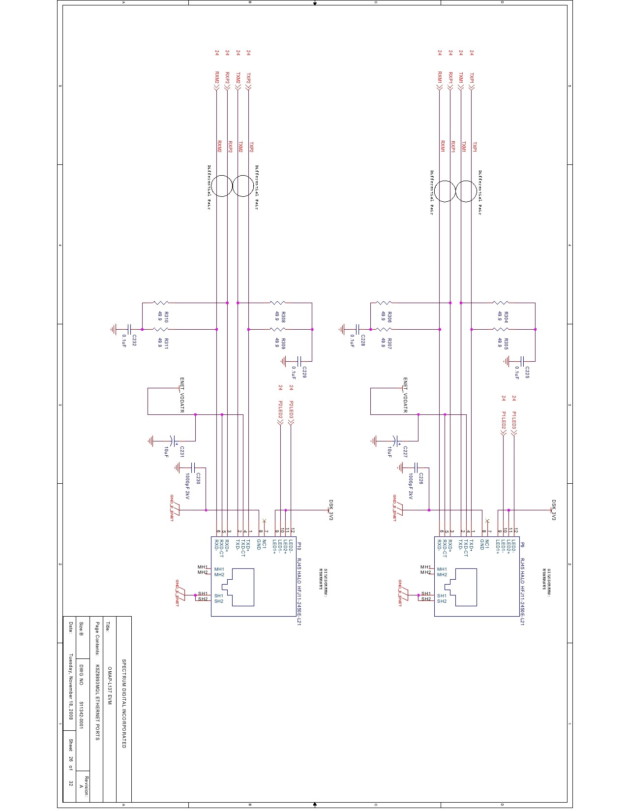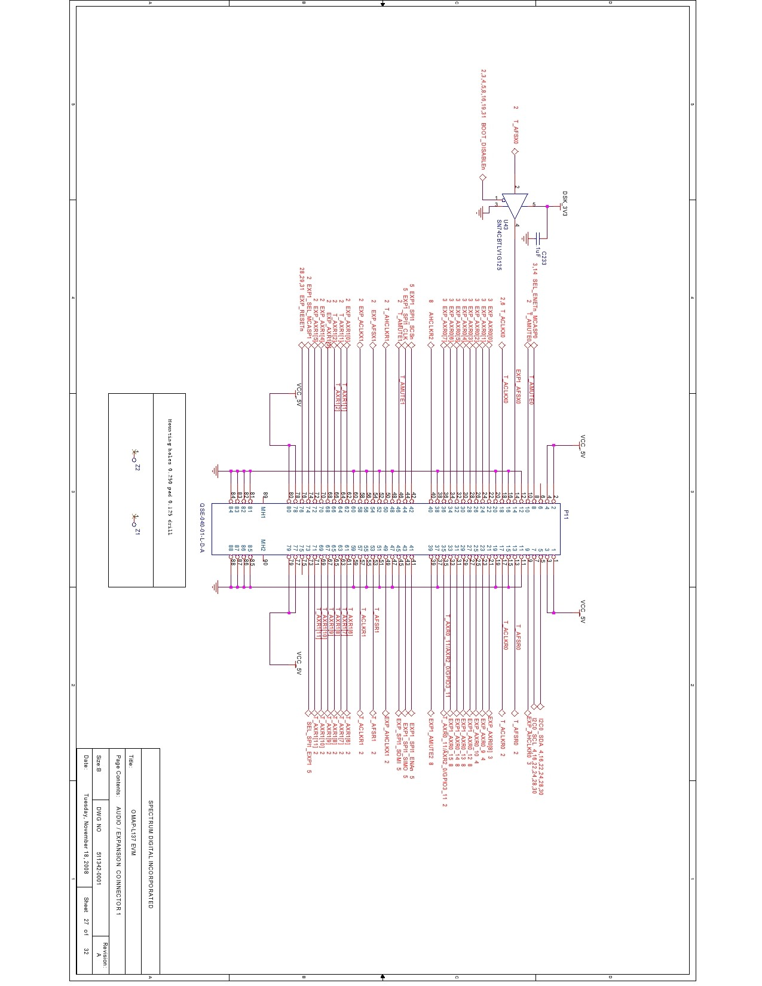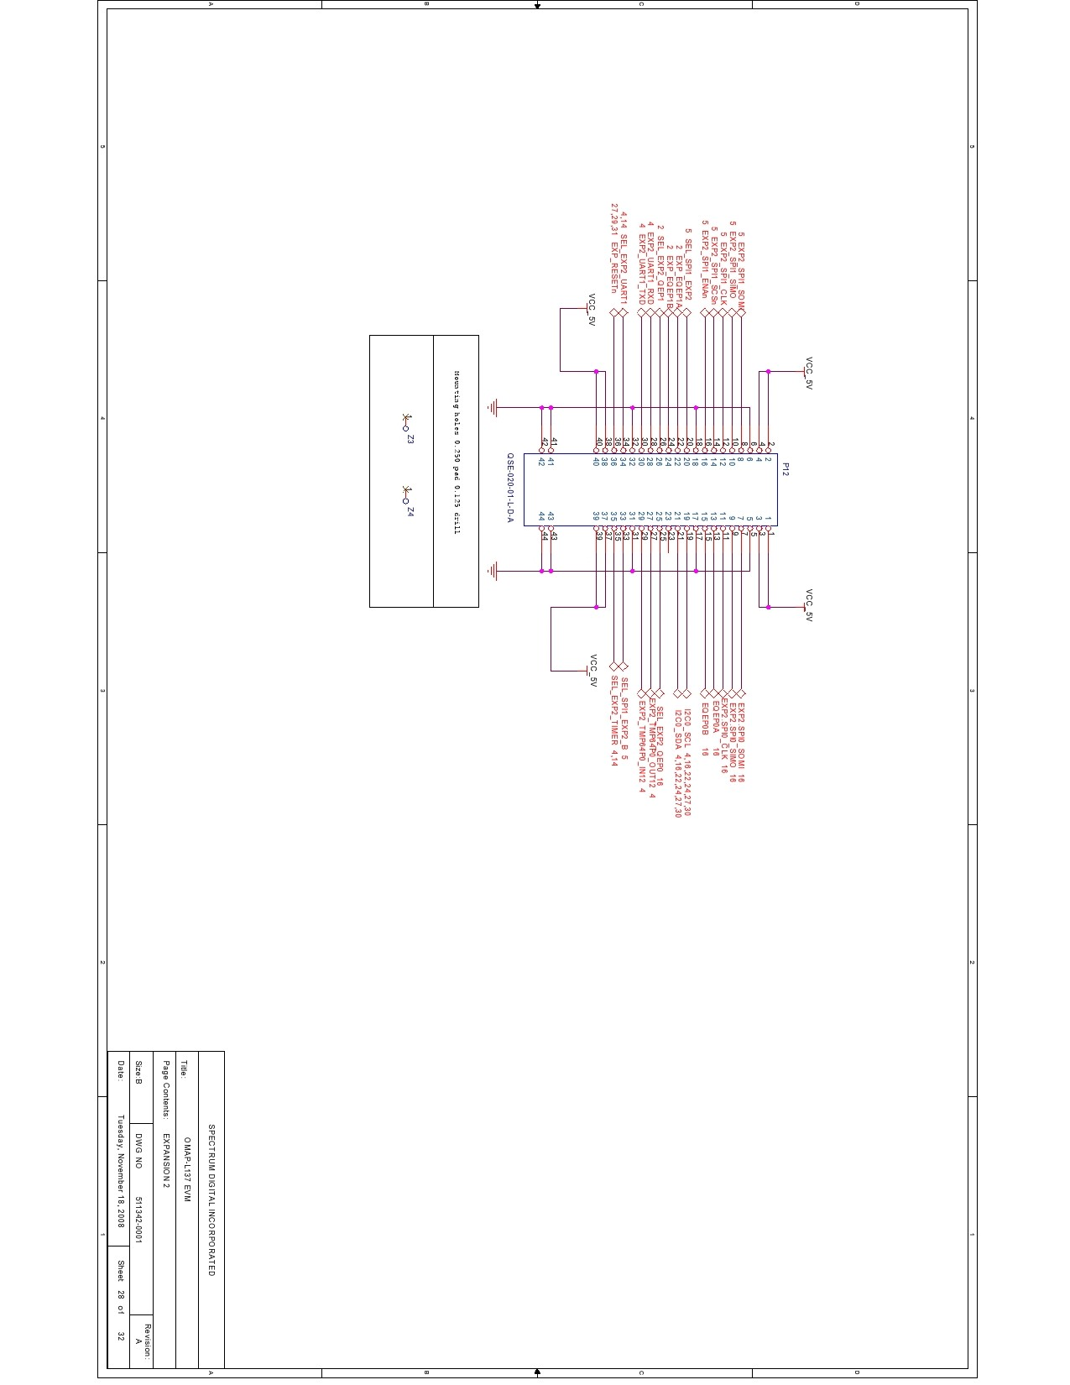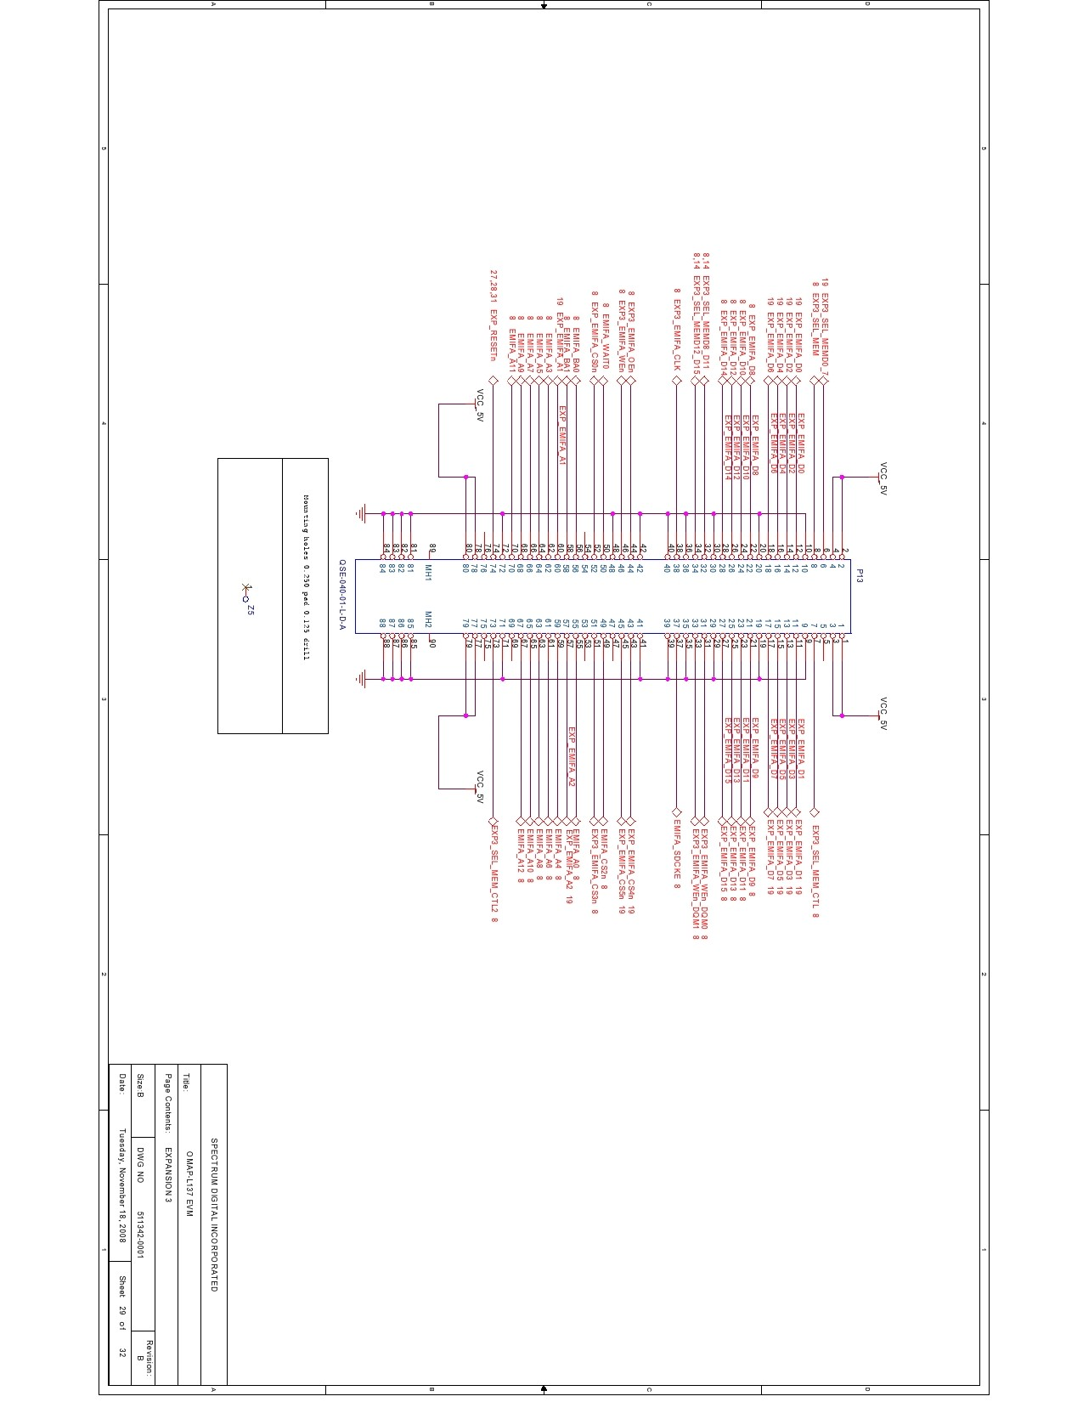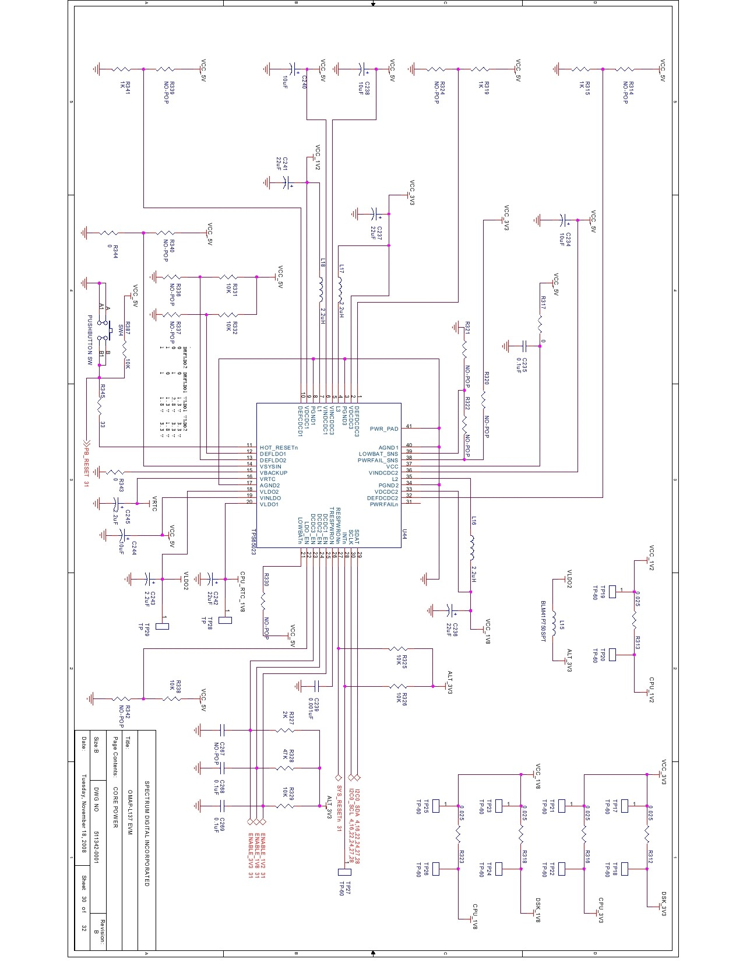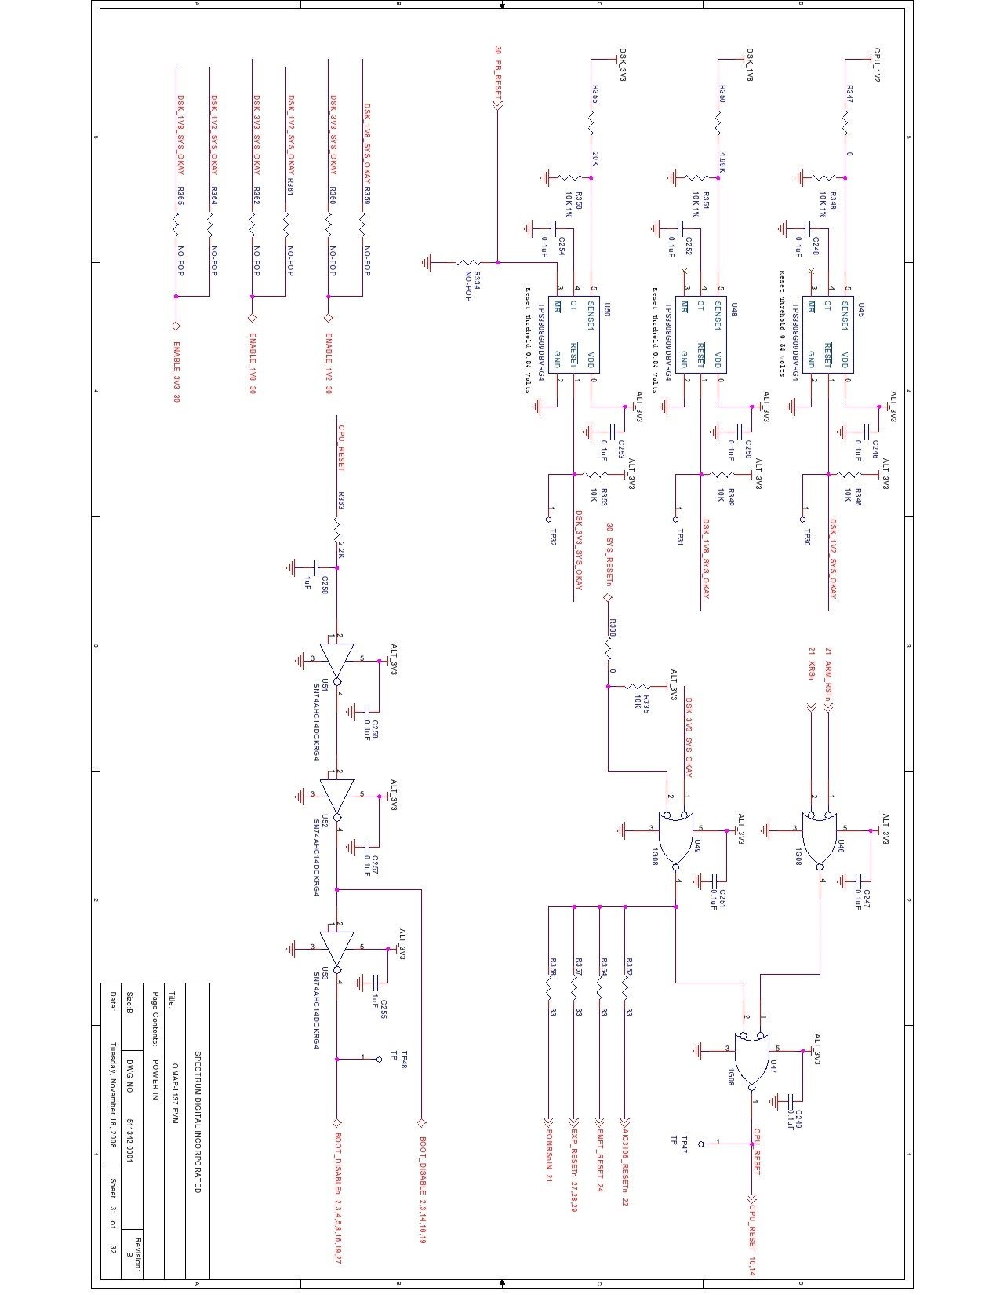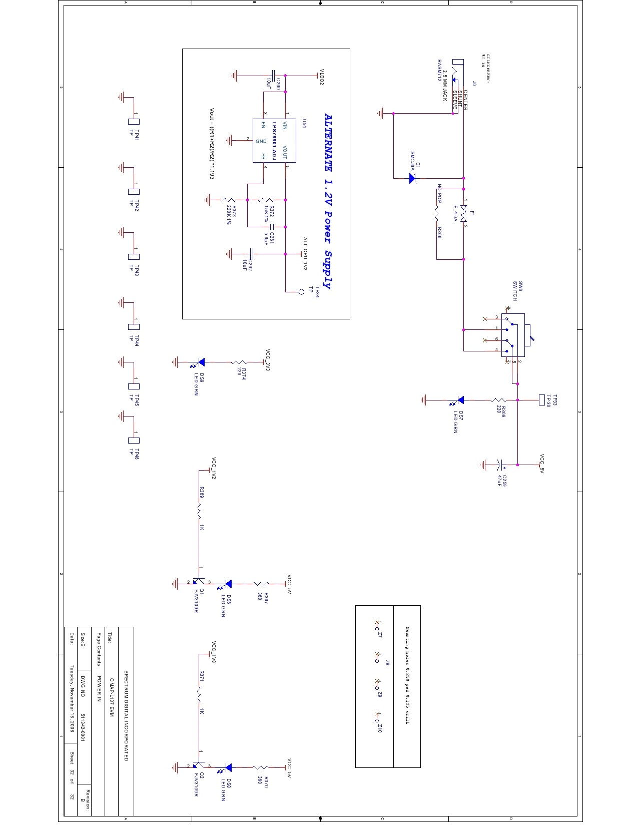

Appendix B: Permissions Emails
Spectrum Digital permission

From: Daniel Moody [mailto:dmoody256@gmail.com]
Sent: Friday, July 27, 2012 5:11 PM
To: Spectrum Digital Incorporated
Subject: Enquiry from Spectrum Digital Inc. Messsage:
Hello

We are a group of students working on a project for University of Central Florida. We would like to use the schematics drawn out in the schematics pdf for

EVMOMAPL137 (Revision D)

at this site

http://support.spectrumdigital.com/boards/evmomapl137/revd/

We are using the evaluation board in our project.

We would like permission to use the schematics in our project documentation.

Daniel Moody

Country:
United States

From: Spectrum Digital Sales <sales@spectrumdigital.com>
Date: Mon, Jul 30, 2012 at 8:40 AM
To: Daniel Moody <dmoody256@gmail.com>

Daniel;
You can use the schematics as long as you do the following:
1. You must use entire schematic sheet, no cut and paste.
2. You must keep the documentation block intact in the lower right of the page. The name of Spectrum Digital must be legible.
3. You must put this in your documentation: "Schematics are provided courtesy of Spectrum Digital, Inc"

When your project is done we would like to see a copy of your write up.It is interesting to us to see how our products get used.

regards,
Mike Strain
--------------------------------------------
| Mike Strain|
Spectrum Digital, Inc.|
12502 Exchange Drive, Suite 440| Stafford, TX. 77477
U.S.A.| T: 281.494.4500 x-113| F: 281.494.5310|
www.spectrumdigital.com---------------------------------------------

From: Daniel Moody <dmoody256@gmail.com>
Date: Mon, Jul 30, 2012 at 12:32 PM
To: Spectrum Digital Sales <sales@spectrumdigital.com>

Hey Mike,

thanks for the reply.

If we include all the schematic sheets in the appendix, may we also cut smaller pieces of the schematics for legibility purposes. All pieces will include a label describing what page number they are from and "Schematics are provided courtesy of Spectrum Digital, Inc"

i have attached an example in MS word.

Daniel

----------
From: Spectrum Digital Sales <sales@spectrumdigital.com>
Date: Mon, Jul 30, 2012 at 1:16 PM
To: Daniel Moody <dmoody256@gmail.com>

Daniel;
If you include all the schematics you can do a cut and paste.

regards,
Mike Strain --------------------------------------------
| Mike Strain|
Spectrum Digital, Inc.|
12502 Exchange Drive, Suite 440| Stafford, TX. 77477
U.S.A.| T: 281.494.4500 x-113| F: 281.494.5310|
www.spectrumdigital.com---------------------------------------------

Smart home pictures permission
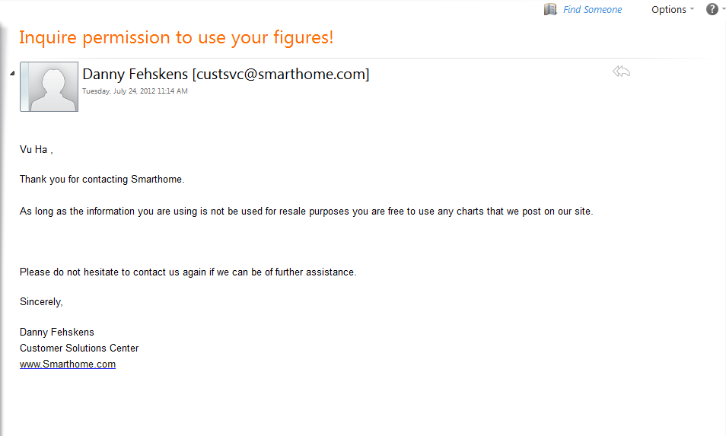

Insteon permission

Thien,

As long as you are only using them for a school project then they are ok to use.

Regards,

Steve Lee
INSTEON National Training Manager
Business Development
SmartLabs, parent company of Smarthome
Home Automation Superstore
Direct: (949) 221-0037 x168
Cell: (949) 294-2484
http://INSTEON.Net

Our #1 Core Value: We deliver a customer experience that earns our customers' loyalty and confidence

Smarthome Forum Home Automation Forum
Twitter SmarthomeInc & INSTEON
Facebook Like Us!
YouTube Watch Our Videos
Subscribe to the Smarthome Newsletter to receive exclusive deals

On Jul 21, 2012, at 12:32 PM, "andytmluu" <andytmluu@knights.ucf.edu> wrote:

Dear Steve Lee

My name is Thien Luu, and I’m a senior engineer student at University of Central Florida. I’m working on a smart home project for our senior design. I want to ask you if I can use your company products’ pictures on our project. Please lets me know if I can. Thank you.

Sincerely

Thien Luu
=======================================

Appendix C: Table, Figure Index and Sources

Table index

Table 1: SIP commands……………………………………………………….... 24
Table 2: SIP Request message………………………………………………… 25
Table 3: SIP control codes……………………………………………………… 26
Table 4: RTP packet Header…………………………………………………… 27
Table 5: SECP-LARM specifications………………………………………….. 49
Table 6: Aleph America PS-1541WGWSR specifications…………………… 49
Table 7: Aleph America DC-1621WGW specifications……………………… 50
Table 8: RFID Frequency Bands…………………………………………….. 99
Table 9: Ethernet BUS format………………………………………………… 102
Table 10: Peripheral addresses………………………………………………… 103
Table 11: MCU power modes…………………………………………………… 106
Table 12: Parts Lists…………………………………………………………….. 109
Table 13: Motion sensor test……………………………………………………. 114
Table 14: Budget list…………………………………………………………….. 127
Table 15: Milestone chart……………………………………………………….. 128

Figure Index

Figure 1: Electric power consumption in US…………………………………. 4
Figure 2: Logitech Alert™ 750n Indoor Master System, indoor camera…… 20
Figure 3: Logitech Alert™ 750n Indoor Master System……………………… 21
Figure 4: RemoteLinc Insteon Lamp Control Kit……………………………… 32
Figure 5: IRLinc Receiver-IR to Insteon Converter…………………………… 32
Figure 6: IRLinc Receiver-IR to Insteon Converter…………………………... 33
Figure 7: Motion Sensors Detecting…………………………………………… 36
Figure 8: Reprinted with permission of Insteon……………………………….. 53
Figure 9: RFID………………………………………………………………….. 58
Figure 10: Wifi Communication over the Internet…………………………….. 66
Figure 11: Recommended locations for CO detectors………………………. 70
Figure 12: Insteon Thermostat…………………………………………………. 73
Figure 13: Insteon Application…………………………………………………. 74
Figure 14: 4 kW gas portable electric generator…………………………….. 79
Figure 15: Generator outlet…………………………………………………….. 81
Figure 16: MCU Solar Panel Converter Control……………………………… 83
Figure 17: Class Diagrams…………………………………………………….. 88
Figure 18: Software Flow Diagram…………………………………………….. 89
Figure 19: Signal Flow Diagram……………………………………………….. 90
Figure 20: MCU software flow for command sent……………………………. 91
Figure 21: Software flow for update server…………………………………… 92
Figure 22: Home Screen………………………………………………………… 92
Figure 23: Music select screen…………………………………………………. 93
Figure 24: Play area select screen…………………………………………….. 94
Figure 25: Audio Signal Flow Diagram………………………………………… 95
Figure 26: Audio Software Flow diagram……………………………………… 96
Figure 27: Main Board Block Diagram………………………………………... 101
Figure 28: Audio Codec Block Diagram……………………………………….. 102
Figure 29: Audio Codec Schematic…………………………………………….. 103
Figure 30: 3.5mm Diagram……………………………………………………… 104
Figure 31: IC2 Bus and power block diagram………………………………… 105
Figure 32: Ethernet Port control Schematic………………………………….. 107
Figure 33: Ethernet ports Schematic………………………………………….. 107
Figure 34: JTAG multiplexors Schematic……………………………………... 108
Figure 35: JTAG USB…………………………………………………………… 109
Figure 36: Mounting Bracket front View……………………………………… 112
Figure 37: Mounting Bracket side View………………………………………. 113
Figure 38: MCU control connect to RF transceivers………………………… 115
Figure 39: Xbee network setup………………………………………………… 124
Figure 40: custom PCB schematic……………………………………………... 126
Figure 41: Work Distribution…………………………………………………….. 128

Equation Index

Equation 1: LM317 adjustable regulator………………………………………. 126

Sources
http://www.nationmaster.com/time.php?stat=ene_ele_pow_con_kwh&country=us
http://www.eia.gov/consumption/residential/reports/2009/consumption-down.cfm
http://www.smarthome.com/remote-lighting-control.html
http://www.ladyada.net/learn/sensors/pir.html
http://www.ti.com/lit/ds/symlink/cc2420.pdf
http://www.ti.com/product/cc430f6145#description
http://www.digi.com/technology/rf-articles/wireless-zigbee
http://compnetworking.about.com/od/homeautomationzwave/a/what-is-zwave.htm
http://www.smarthome.com/about_x10.html
http://www.webopedia.com/DidYouKnow/Internet/2005/peer_to_peer.asp

http://www.howstuffworks.com/bluetooth.htm

www.siptutorial.net

www.tuxgraphics.org

developer.android.com

developer.apple.com/library/ios/navigation/

www.javaworld.com/javaworld/jw-07-1996/jw-07-awt.html

fragments.turtlemeat.com/javawebserver.php

www.vbtutor.net/vb2010/index.html

cmusphinx.sourceforge.net/wiki/

dragonmobile.nuancemobiledeveloper.com/public/index.php?task=home

opencv.willowgarage.com/wiki/

http://electroschematics.com/6180/door-ajar-alarm/
http://svn.pjsip.org/repos/pjproject/trunk/pjsip-apps/src/samples/streamutil.c
http://support.spectrumdigital.com/boards/evmomapl137/revd/

