Configurable Wireless Headphones

Group Members

Member Name | Degree
Jackson Ritchey | Computer Engineering
Aaron Smeenk | Electrical Engineering
Kourtney Bosshardt | Computer Engineering
Keith Hargett | Electrical Engineering

Have you ever been in a situation where you want to listen to the T.V. or music at a decent volume without disrupting those around you? There are headphones for that. What if you want to do this while having the ability to be more than a foot away from the source of the sound? Imagine sitting on your couch in your living room listening to a movie while the person in the room next to you is unaware that you’re even watching a movie. Also, imagine you’re listening to music that is playing on your computer in your room, but you have to walk out of your room for a second. What if you could leave the room and still have the ability to listen to that music that is playing?
Our goal is to make an affordable and easy to use device that delivers a personal experience by customizing sound delivery from a data input/output device to each user within the range of a home. This will be achieved through wireless headphones. These headphones will communicate with a device that can be plugged into a computer or T.V. The device will transmit sound directly to the desired headphones. If two or more headphones are present, there will be an option to transmit the sound to one headset, two headsets, or all the headsets present. If there are multiple output devices present, a headset that is currently receiving sound from one device can tune into another device to hear what is being transmitted from that device. There will be administrative options to control this feature. The administrative and personal experience, i.e. volume control, will all be accessible by the user through an app and a web service. The app and webpage will have information regarding the volume of the headphones, the battery life of the headphones, and the amount of users currently listening through the same transmitter as you. Administrators will have options as to who can listen to the same transmitter and can shut off other user’s headsets that are currently tuned in to their transmitter.

- The system should have excellent sound quality across all connected devices
- The system shall maintain connectivity through the duration of use
- The system should be easy to turn on (device pairing)
- The system should have sufficient battery life for general use
Subsystem | Spec Requirements | Engineering Clarification | Justification
Data Conversion | 1 | 48,000 samples per second | audio standard
 | 1 | no less than 16 bits per sample | audio standard
 | 1 | synchronous channel sampling | audio standard
Data Transfer | 1, 2 | no less than 25’ of connected range | comparable competitive standard
Configuration app | 3 | device pairing shall occur in no more than 5 steps and no more than 2 complete attempts | based on market analysis for general user attention span
Power | 4 | battery life greater than 8 hours continuous use | comparable competitive standard
 | 4 | minimum 80% battery efficiency | comparable competitive standard
 | 4 | maximum operating temperature of 85$℉$ | safety standard

This project will not be very costly. The main costs will be divided into two categories, hardware and software. The only software costs will be the licenses required to use PCB design software. There are free PCB design software packages available, so this will not be factored into the budget. For hardware, the costs will be divided into two separate boards, the transmitter and receiver boards. Both boards will require a LiPo battery so that they can function while not plugged into a power supply. This battery doesn’t need to be extremely large so it should not cost more than twenty dollars. Each board will also require a microcontroller and a wireless transceiver. These two parts combined will cost around twenty dollars. The two boards will be relatively small so the cost of having them fabricated will probably be at most thirty dollars each. For good practice we can also add another forty dollars to factor in unexpected costs. Therefore an upper bound for the cost of this project is around $180.

Project Budget

Part | Cost($)
Battery | 20x2
Microcontroller | 10x2
Wireless transceiver | 10x2
PCBs | 30x2
Total | 140 + 40(unexpected cost)=180

Application Code

OAL

Drivers

RTOS
HAL
Firmware Design Pattern

HAL | Hardware Abstraction Layer. This is all of the port specific code that will be implemented. (Our group will have to implement this)
RTOS | Realtime Operating System. Manages task scheduling and memory management. We will pick the RTOS during development.
OAL | Operating System Abstraction Layer. A simple interface between RTOS and Application Code. (Out group may implement this or we could use existing one).
Drivers | Used to interface external hardware with the application code. (We will implement this).
Application Code | Code used to accomplish the particular task of the device. (We will implement this).

Analog In

Digital Out
Application Code

Samples the analog audio signal and sends it over wireless connection
Wireless Transmitter

External Configuration
Application
Wireless Data Exchange

Application Code | The firmware for the specific board and how it interacts with the hardware. The transmitter code will be responsible for managing its configuration settings, encoding analog audio signal, and sending it wirelessly to connected receivers.
Analog In | The amplified/filtered audio signal received from the plugged in speaker
Digital Out | Digitized data transmitted wirelessly to receiver board
External Configuration Application | A software client that connects to the board wirelessly and configures the device firmware settings. Could be web service or android app etc..

Digital In

Analog Out
Application Code

Receives data from transmitter and converts it to an analog signal
Wireless Receiver

External Configuration
Application
Wireless Data Exchange

Application Code | The firmware for the specific board and how it interacts with the hardware. The receiver code will be responsible for managing its configuration settings, receiving the audio data wirelessly, and converting it into an analog audio signal.
Analog Out | Output audio signal
Digital Out | Digitized data transmitted wirelessly to receiver board
External Configuration Application | A software client that connects to the board wirelessly and configures the device firmware settings. Could be web service or android app etc..

Hardware block diagram

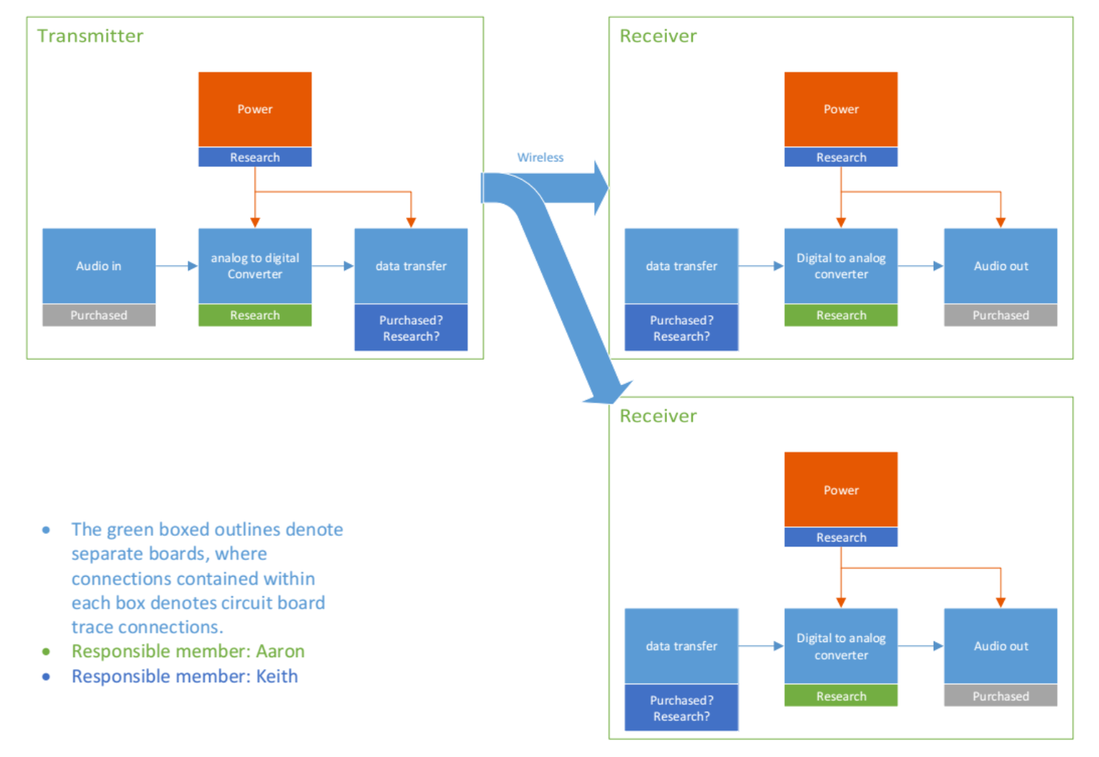

Initial Project Milestones

Summer
- Project Research - gather a body of knowledge on various technologies and technical standards.
- Project Specification - construct a larger table of specifications written to fulfill standard requirements and design objectives.
- Project Design - complete a project layout including schematics, diagrams and other tools needed to begin prototyping.
Fall
- Initial Prototypes - test individual components of design. Hardware prototypes will likely be made on solderless breadboard while software prototypes may involve the testing of written firmware.
- Secondary Prototypes - complete custom units to ensure that the design functions together as a whole.
- Final Product - fully implement design, tested and ready for use.

