HitSmart!
Julien Missial, Daniel Padron, Patrick Shickel, Alphonso Carty

Dept. of Electrical and Computer Engineering, University of Central Florida, Orlando, Florida, 32816-2450

Abstract — HitSmart is a training and analytics system designed to transform the way that boxers train and compete by analyzing various metrics of a boxer’s training session. These measurements can be used to track performance improvement or to compare results against competitors. The product consists of two boxing gloves, each containing circuits designed to record punch data, and a mobile application to which the gloves are connected. The mobile app allows users to track their training metrics for criteria such as hits per second , force per punch, calories burned, as well as a view for seeing performance improvement over time.

Index Terms — Body sensor networks, event detection, wireless communication, application software, punching, mobile communication.

I. Introduction.
The sport of boxing in America is on the rise, and with that comes a wave of athletes of all ages, eager to hone their skills. In order to do that, an athlete typically spends countless hours in the gym, week after week, hurling punches at a punching bag. This approach works, but it lacks in one critical area - tracking. In a typical training session, an athlete will have no insight into the strength of their punches, the rate of their attacks, or the calories that they have burned during the session. These are all important factors though, as the sport of boxing is all about endurance, focus, and power. Many attempts have been made to provide this sort of training session tracking, none of which are able to offer a compact and lightweight solution such that the athlete is unaffected by the presence of the tracking system.

- Constraints
HitSmart in its theoretical design needed to adhere to quite a few constraints. Based on its environment and usage, our device had to be lightweight, small, consume little power, and be able to survive the wet and shaky environment that it will operate in. As it stands, the HitSmart circuit is designed to weigh less than 1.5 pounds, fit onto the average human fore-arm length-wise, operates for at least 1 hour, and is encased in a shock protective casing.

- Design
With all constraints being considered, the group set out to make our idea a reality. After quite a bit of thought and conceptual problem solving, we decided on the following design.

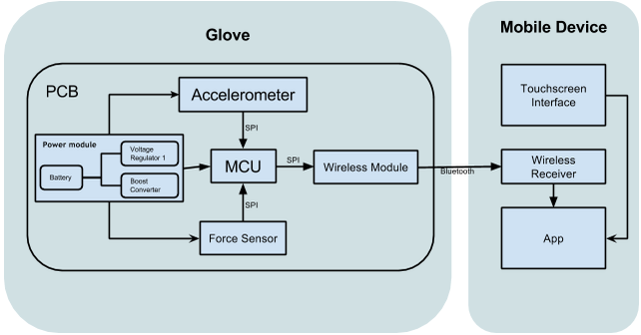

Fig. 1. Schematic Diagram of HitSmart!.

II. Sensors And Calibration.
HitSmart! reads in data from the training situation that the user is experiencing and synthesizes that data into other needed bits of information via software algorithms to feed the user the information that he or she is looking for. In this section, we will be covering the sensors that HitSmart! employs for the first part of its job. Seeing as how the metrics of a physical training session are all based around the motion and dynamics of the body and its parts, only two sensors are used to procure all of the information that we need: a force sensor, and an accelerometer.

- ADXL377 Accelerometer
The group elected to go with the ADXL377 triple axis accelerometer to satisfy all of our motion sensing. As the name implies, it is able to detect acceleration in three axes of motion. As an added bonus, it also has a differentiation function which allows us to also monitor velocity and an integration function for summing and averaging functionality. This device detects acceleration values in units of “g”, or 9.81 m/s², from -200 up to 200 on each axis and outputs voltage values in a linear fashion up to 3 Volts. This allows for an extremely simple and easy application of the device. With all of the aspects of the hands motion and position, we are able to determine almost everything about the form and ability of the user.

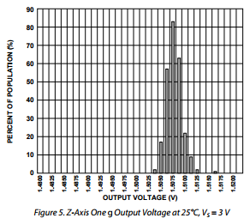

Fig. 2. Acceleration to Voltage output of Accelerometer.

- Accelerometer Calibration
The ADXL327 needs external capacitors that function as low pass filters to set the bandwidth at the output of its pins. These capacitors function as noise reduction and anti-aliasing. The ADXL has 32kΩ internal resistors and the group chose 0.1µF capacitors for an effective bandwidth of 50Hz.

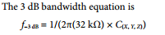

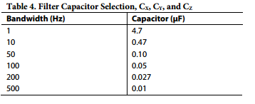

Fig. 3. Capacitor to bandwidth calibration.

- Flexiforce Force Sensor
As a matter of redundancy and complexity, we have also opted to use a force sensor as a part of our device. This force sensor is a piezo-resistor which adopts a varying resistance as more or less force is applied. Unlike the accelerometer, the force sensor has a logarithmic resistivity change per force applied. With the force sensor and accelerometer in tandem, we can identify the effective mass of the user’s hand and read and determine all of the factors of interests with a higher degree of accuracy.
The Flexiforce force sensor is a very thin, very pliable strip with a piezo-resistive head. It spans about 8 inches in length, which makes it great for our application. With these material dimensions and properties, we can have the head of the sensor be placed over the knuckles of the user and the line stretch to the wrist where all of the other circuitry is located. Its pliability is also great for how it will be used; the force sensors will be subjected to a large amount of shock, vibration, and other stressful forces both at the head and along its length. It simply must be flexible to satisfy the use its use in this application.
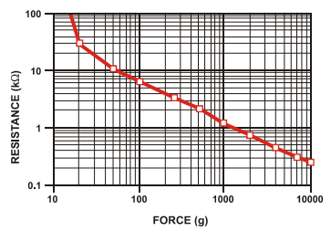

Fig. 4. Force to resistance chart of force sensor.

- Flexiforce Sensor Calibration
The Tekscan Flexiforce A201 series of force sensors must be calibrated so that they give correct force readings. Without the correct circuitry the sensors will give a non linear analog resistance reading. However, with the correct configuration we are able to use this same sensor and get a linear analog reading that is easily interpreted by a multimeter, or in this specific case, the analog to digital converter in our microcontroller. The documentation provided by Tekscan indicates three different circuit configurations: the single source, dual source and the voltage divider circuit. The single source circuit configuration was selected. This configuration is recommended for low power, battery sourced circuits such as ours. In addition, this circuit allowed the use of the full range of the A201’s force readings (0 - 1000lbs), making it perfect for application in the HitSmart.
The single source circuit consists of a low power op-amp used in a non-inverting configuration with the Flexiforce sensor resistance placed from the feedback node to ground. In addition, a capacitor is placed parallel to the feedback resistor to smooth out the output signal. Both the feedback resistor (R_{ref}) and the reference voltage (V_{ref} ) at the non-inverting input must be chosen so that the desired force to voltage curve is obtained.
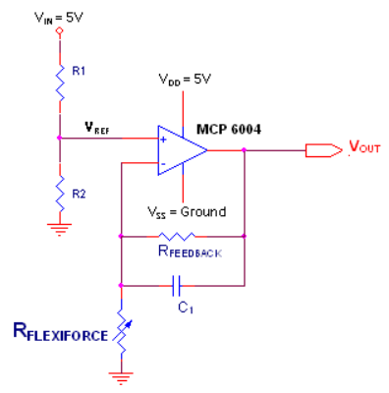

Fig. 5. The installation circuit of the force sensor.

By carefully placing known weights to the sensing area and recording the voltage output the sensor was calibrated with the correct values of components for the application. It was desired that the voltage output V_{out} had a range from 0 V at no weight applied to about 3 V with 500 Lbs applied. Weight values were tested up to 22.5 Lbs and the maximum weight was extrapolated linearly. The group went through five different combinations of these components until finally a force to voltage output that was useful to the application was achieved. The op-amp was supplied with a constant V_{dd} = 3.3V from the microcontroller while the op-amp’s reference voltage was realized through a voltage divider. The resistances used in the voltage divider were chosen so with a sufficiently high enough value in the kΩ range so that no excess current was drawn from our lithium polymer battery, increasing efficiency. At the same time, the values chosen were low enough so that it did not match the op-amp’s GΩ input impedance.

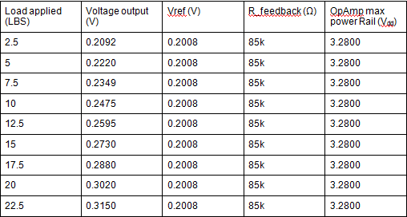

III. Microcontroller And Analysis of Data.
For this section, the central HUB of the device, the microcontroller and the way we’ve programmed the way it to analyze the data it receives will be covered.

- Microcontroller
We use the Adafruit's Bluefruit micro LE as our microcontroller board of choice. It is a combination of a ATmega32u4 microcontroller and a Bluefruit LE Bluetooth module. It is interfaced through USB and is programmable using the Arduino IDE programming environment.

- Function
The microcontroller takes in the voltage signals from the accelerometer and the force sensor, analyzes this data, and send the data of interest to the device which is running the mobile application. We have programmed the Bluefruit with the necessary algorithm to reassign the voltage signals we receive from the sensors back into actual force and movement numbers.
The microcontroller will be set to a sampling rate of 500 Hz to properly sample the acceleration during the punch and detect the peak events. The code in the microcontroller uses the positive acceleration in the longitudinal direction of the arm/fist as the main indicator, before computing the total acceleration. The microprocessor then integrates the readings from the three components and estimates the velocity; this velocity value is used to determine if there was an effective punch once it reaches a threshold value.
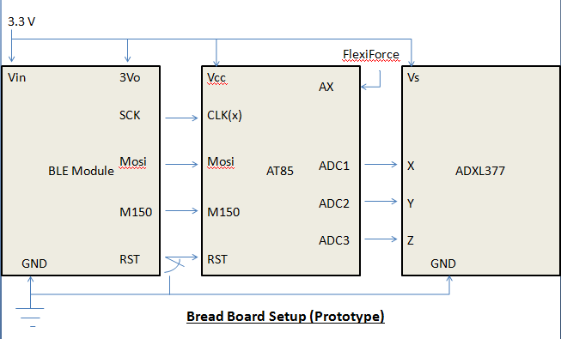

Fig. 6. Port to port schematic of the sensors and microcontroller.

In order to determine other aspects of the user’s training session such as the average force per hit, the rate of punches per second, whether or not to record an event as a proper punch or not, the type of punch, the maximum and average final velocities of the punches, and calories burned, we use various algorithms designed from scientific principles.

- Analysis Method
To start a session, the user simply taps the “start session” button on the app and the microcontroller takes the lead. The microcontroller samples data at a rate of 500Hz and produces force and acceleration plots with respect to time over the course of the session until the user hits the stop session button.
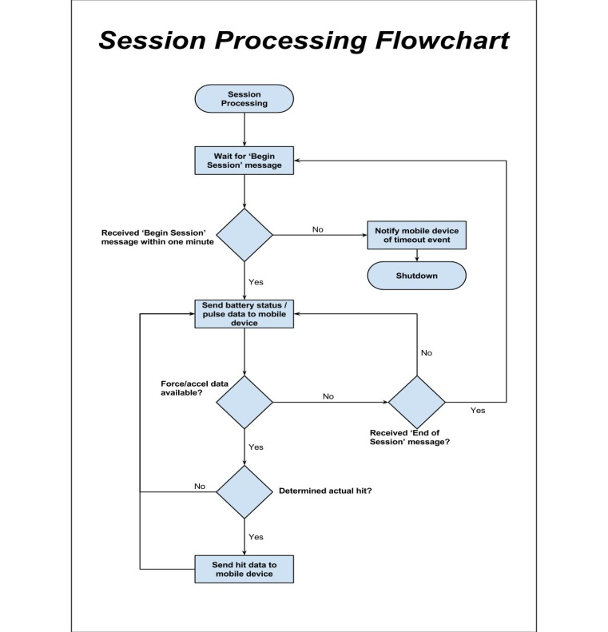
First, we determine the mass of the hands of the user. This is done with an algorithm that uses Newton’s second law of motion, F=ma. With the mass now known to us, we now have access to momentum and energy variable associated with the user’s training.

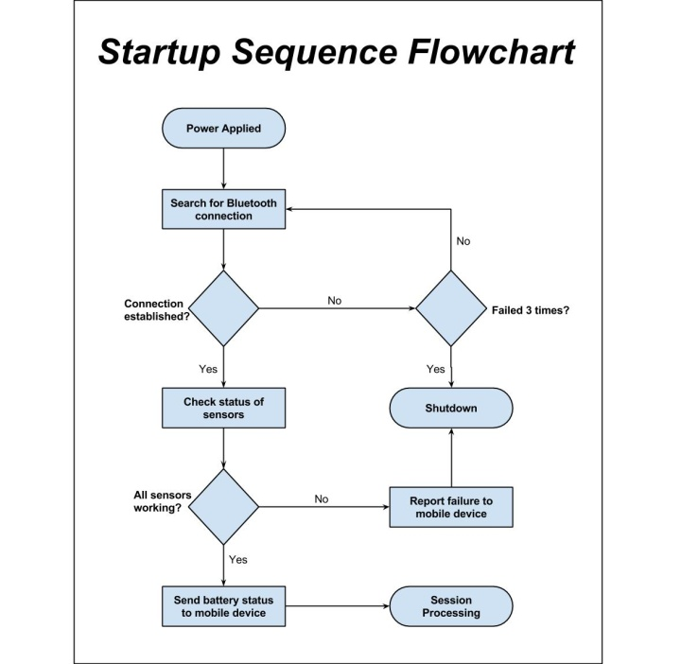

Fig. 7. The startup sequence flowchart.

We scan the acceleration plot collected by the sensors for the maximum recorded value and average throughout the graph for the acceleration values of interest. We also run a simple differentiation algorithm on the recorded acceleration charts to gather the associated velocity information. From here we can search it for the maximum velocity recorded and take the average of all of the punch velocities gathered.
In order to determine whether a punch was actually thrown or not, we considered the operating mechanics of a punch. We know that the muscles expand or contract quickly along a given line of motion. An upper and lower acceleration limit on a specific axis were established for this end. We established the y-axis of the accelerometer as the motion axis of interest and set the lower acceleration threshold to be 0.3g to indicate the start of a punch, and a negative value to indicate the reverse motion and subsequent end of the registration of the event as an official punch.
With these thresholds in place and all of the motion data in our possession, we use a counter algorithm to increase when the conditions for a punch are satisfied. This counts the punches and constantly updates the training statistics in real-time.

Fig. 8. The session processing flowchart.

With the mass of the user’s hand now known, we can also calculate the calories burned in the training session. By using the formula for the translational kinetic energy of a moving mass, KE = .5 * m* (v^2), we can measure the change in kinetic energy, and thus, the work done by the body to produce each punch. The algorithm to calculate calories burned calculates these work values, sums them, and multiplies them by 2. We multiply the result by two to represent the retraction of the arm to prepare for the next punch. Now with a value for the total work done by the muscles to produce this motion, we convert that value in joules to calories via the equation, 1 Joule = 0.239006 Calories.

IV. Power.
Being that our device must fit around the dimensional constraints of a hand and must run for at least two hours continuously, the selection of a battery became an important aspect of our project.

- Lithium-Ion Polymer Battery
A 105mAh rechargeable lithium polymer battery was selected for its favorable dimensions and the convenience of being rechargeable. At 0.6” by 0.7” and a thickness of 0.08” the LiPo battery fit snugly in the enclosure created for the HitSmart. In addition, the battery is able to be charged through the USB slot, forgoing the need to open the enclosure once it is deployed in the glove. the Adafruit Pro Trinket will be used to charge the battery from the 5V USB power. The MCP73831 LiPoly controller on-board is capable of supplying 100mA current over the right amount of time for longevity of the LiPoly battery.

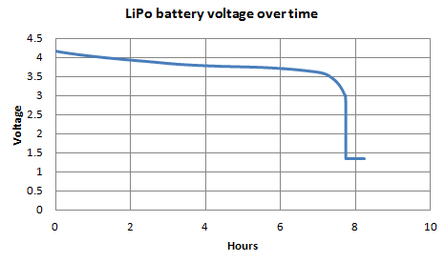

Fig. 9. LiPo battery voltage test over time.

The lithium polymer battery was subjected to a series of tests to show battery life. Under worst case use conditions with constant punch data being sent every six seconds continuously we found that the battery life is almost 8 hours. Shown above is the Lithium Polymer battery voltage shown vs time.

V. PCB And Schematic Diagrams.
The PCB schematics and board layout was done in Cadsoft Eagle 6.5. The group quickly found that using Eagle would allow for the quickest production. Libraries for all components used were readily available from all the component manufacturers so that no time was spent drawing up custom footprints for parts. The only exception was Microchip’s MCP6002 op-amp which had to be converted using Ultra Librarian software. In addition, the PC board house that the group opted to use accepted Eagle’s .brd files and thus there was no need to create Gerber files for manufacturing.
The final PCB design was chosen so that it would fit as a shield to the Adafruit Bluefruit Micro LE microcontroller. The final design incorporated all the needed components including the microcontroller, Bluetooth LE module, accelerometer and supporting sensor components in a package that is 2” by 0.9” with a thickness of a ¼ of an inch, perfect for our design constraints.

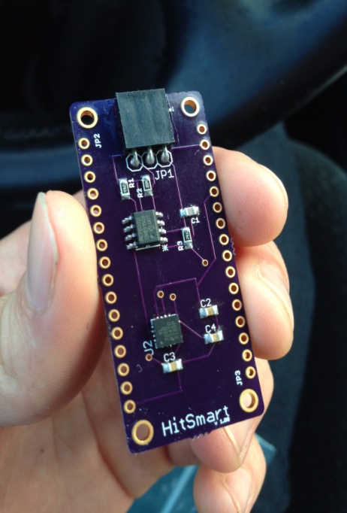

Fig. 10. The finished PCB.

The boards were manufactured by OSH park at an affordable price of three for $12. Components were obtained separately by the group and soldered by both Quality Manufacturing Services and the group themselves. Below is a figure of the group’s finalized PCB without the microcontroller and Bluetooth module.

VI. Mobile Application.
In this section we will elaborate on our software development process, starting with the Bluetooth integration from the Arduino board, the early design and development stages, getting the app to run a basic session, and finally, the social aspect and testing. Since we decided that we were going through with iOS as a development choice, it made sense to develop a plan for developing and testing. iOS (or iPhone Operating System) is the operating system developed by Apple. Unlike Google’s Android, iOS only runs on devices created by Apple, such as the iPhone, iPad, and iPod Touch. Released in 2007, iOS is closed source and has the second largest mobile market share – where iOS dominates is in app revenue. iOS is much more known for its uniformity amongst devices, and consistency.
To develop iPhone apps, the de-facto languages are Objective-C and Swift. Objective-C is an object-oriented language created by Apple with the C language. Objective-C is known for its lengthy syntax, and rather steep learning curve, but it is very robust.
Swift was developed in response to developers wanting a language that was easier to learn and develop with. It is rather new however, with its first stable version released a few months ago. In addition, Objective-C is required in many Swift programs anyway, which kind of defeats the purpose. We ended up choosing Objective-C mainly because of massive documentation for the Bluetooth.
The main downside to iOS is that only two of us on our team have MacBook Pros and iPhones, so development would entirely be limited to those two machines. Another slight drawback is deploying the app onto a physical phone: Android Studio and other Android IDEs will easily deploy a project on the phone for free, whereas Apple charges a developer $99 yearly for a Developer’s License, which allows phone deployment. Since we are dealing with Bluetooth an actual phone is needed for testing; a simulator will not suffice. However, one of the group members already had a Developer’s Account and was willing to share it with the group.

A. Bluetooth Integration
Before any new development was done, we had to make sure that data is being transmitted to the mobile app correctly through Bluetooth. For testing the group used Nordic Semiconductor's nRF8001 Breakout and an Arduino Uno. This combination was chosen due to the extensive amount of documentation available

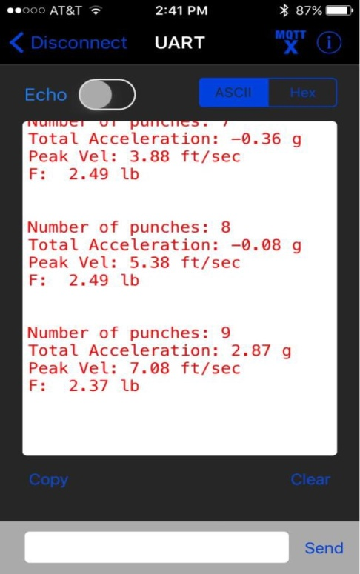

Fig. 11. Testing the Bluetooth connection via Adafruit’s open source nRF8001 app. This was done before development.

B. Early-Stage Design & Development
We knew in the early stages of development that HitSmart had to be well designed, centered around its core functionality. A lot of projects typically get less-than-anticipated results due to being too feature-heavy and not having focus; we definitely wanted to make sure that our core functionality was up to par with what we wanted.
As far as User Interface and Experience goes, we wanted an app with a modern but simple, and App Store-ready feel. Implementing modern trends such as material and flat design, our app appears professionally done. Our inspiration in the design of this app is Spotify, the music streaming service. Spotify is known for its dark and rich color scheme. We decided to go with a darker theme, with sharp colors and rich fonts.
Functionality-wise, we wanted to make sure that the design and development of HitSmart was focused on core features. A user should be able to easily turn on the app, run a session, and share their progress. We minimized the amount of screens in our original design and avoided fluff and redundancy in design.

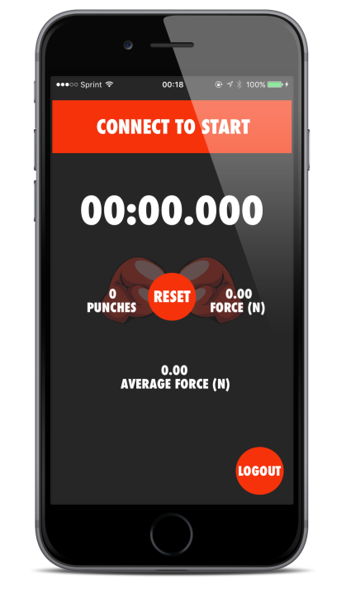

Fig. 12. HitSmart’s main screen.

C. Running a Session
After defining our scope for development and implementing our overall design, much of our focus was making sure a user as able to run a session from start to finish. A session is run once the connect button is pressed. The connect button activates a peripheral search for nearby compatible Bluetooth devices. Once a connection is made (as a side note, the app can also accept multiple simultaneous Bluetooth devices – a left and right glove for example, but we decided it would be in our best interest to stick to one glove for our constraint of time), the timer begins to run. A user can now perform his session, and disconnect when he or she is finished. The timer stops, and the user has the option of what to do with their progress, which is represented as a string value. The progress string contains the date, number of punches thrown, average force, and time elapsed.

D. Parse & Social Aspect
The social aspect to this app is important to us because we wanted another dimension to the project. After a user is done, we wanted them to be able to save or share their progress to other forms of social media. Using the built-in Social framework in Xcode, we implemented a way for the user to be able to share their session progress through many of the apps available.
In order to share however, a user will need an account. We will have to make sure the user can log in correctly and that their email and password is saved correctly. We will be using ‘Parse’ as a framework for managing accounts. Parse, a framework owned by Facebook, is a new go-to for creating and managing accounts, sending push notifications, data, web services, and even cloud storage. What makes it so highly recommended is its ability to easily be implemented into currently working apps. With support for just about every platform, Parse also has extensive documentation for its seemingly endless abilities and features.

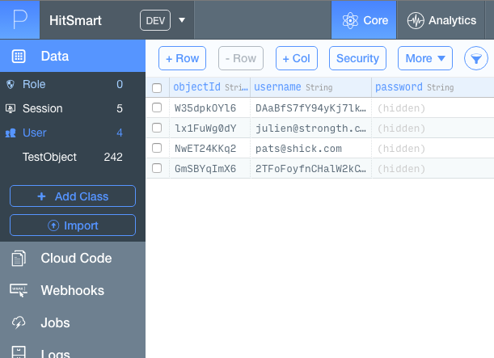

Fig. 13. Parse’s interface. This screen in particular shows how user data populates when it is sent to the cloud.

An account has to be created through Parse’s website, along with the new corresponding app. Once the app is created one can see the various things you can do with Parse. Setting up is relatively easy and there are tutorials on how to do so.

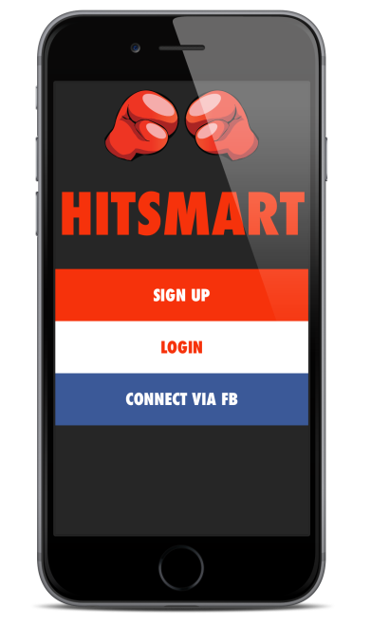

Fig. 14. HitSmart’s login screen. A user will be able to not only create and account with us, but log in through Facebook as well.
Data is sent to Parse using SQLite, a relational database management system. Xcode uses this for Core Data, and Parse uses it as the main form of communication between the app and the cloud. The example above shows data objects created from another project. These objects could represent accounts, scores, characters - pretty much anything! We will be creating data objects for user accounts.

E. Testing
As far as testing the different features of the app, it was fairly simple since it would be obvious in the display that certain features are working. This is the advantage that our project has that others don’t – our project is much more visible. Most of our user-facing and features testing would be able to be performed right in Xcode, and on our actual phones. For example, we can easily test if an account is made by checking the respective table in Parse. Every time an account is created a new entry will show up, with a username, password, and email address. We have tested the force values generated from the Bluetooth and our calculations were similar to known average force of a punch in real life (500 – 1500 N for a regular punch, about 5000 for a knockout blow).

VII. Conclusion.
This project has proven to be an incredibly valuable experience for each person in our group. We have applied the concepts and ideas that were introduced in class to bring our idea into reality. Additionally, the group came to understand the all the aspects of engineering that come together to bring a project into fruition.
All in all, this experience has shown us about ourselves, our communication skills, our relative skill sets, and engineering as a whole. Our device is fully functioning and works well in solving the problem that the group set out to fix.

References.
[1]FlexiForce Starter Kit Manual, 1st ed. South Boston, pp. 5,10.
[2] Adafruit.com, 'Adafruit Bluefruit LE Micro - Bluetooth Low Energy + ATmega32u4 ID: 2661 - $26.95 : Adafruit Industries, Unique & fun DIY electronics and kits', 2015. [Online]. Available: https://www.adafruit.com/products/2661. [Accessed: 12- Sep- 2015].
[3]Analog Devices, 1st ed. Norwood, MA: Analog Devices Inc, 2012, pp. 1-12.

The Engineers.

Patrick Shickel is a graduating Computer Engineering student. He has spent the past two and a half years developing embedded software as a College Work Experience Program (CWEP) student with Lockheed Martin Missiles and Fire Control. After graduation, he hopes to continue working in the field of Embedded Systems either with Lockheed Martin or elsewhere.

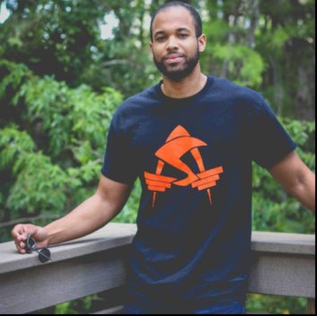
Julien Missial is a senior at the University of Central Florida. He is graduating with his Bachelor’s of Science in Computer Engineering in December of 2015. He is currently working as an iOS Developer at multiple companies while working at Lockheed Martin. He plans to further his career as a developer and designer.


Alphonso Carty is a senior at the University of Central Florida pursuing a double major in Electrical Engineering and Physics. After he receives his degree in Electrical Engineering he will continue to finish his coursework towards his Physics degree while also working on a small start-up business.


Daniel Padron was born in Austin, TX and grew up in Caracas, Venezuela and is graduating in December 2015 with a Bachelors in Electrical Engineering. His interests are micro electronics and microcontrollers. He hopes to work in designing and testing useful electronic gadgets.

