Senior Design Report




Group #11
Senior Design 1
University of Central Florida
Department of Electrical Engineering and Computer Science
Dr. Lei Wei

Anna Baranova Computer Engineering
Brian Bisplinghoff Computer Engineering
Minh Nguyen Electrical Engineering
Zachary Schwartz Computer Engineering

Project Narrative
Motivation:
Drowning is the second leading cause of death in children living in the United States with the majority of these deaths coming from children between the ages of 1 and 4. Many more children require emergency medical treatment due to nonfatal submersion injuries. Living in Florida, it is very common to own a backyard swimming pool. With children and a swimming pool, there is always reason to be at least a little worried for their safety. After all, it is not possible to be 100% sure of everything your child is doing every waking moment. This is where our device comes in.
The Aqua Sentinel 3000 is a device that will help parents protect their children from the dangers of a pool with a sleek and simple device. Unlike many of the current similar devices on the market, our device will feature 2-way communication through a convenient phone application. Since having to carry around an extra electrical device just for pool monitoring is annoying and cumbersome, we place the controller on the user’s smart phone so that they can always have it with them. Other devices also do not provide video monitoring of the pool area, which allows the ability to check once the alarm is going off if there is actually something wrong, remotely. Our device will also feature bracelets for the children to improve detection.

Goals and Objectives
The main goal of this project is to build a system that can detect when a child wearing a specialized bracelet falls into a swimming pool. The system will then send out alerts to the user’s cell phone and activate the video monitoring system. It’s also important that the alerts to the user’s cell phone are fast as time is of the essence in situations where a child’s life is in danger.
The device should be easy to use and install with most of the interface being on the mobile device. Once the main device is attached to the pool and the inside alarm connected, it should sync to the phone application and register itself. All physical components should be sturdy, but also easy to move if desired. The camera in particular should be resilient as it will be one of the easier parts to break in some way.

Functionality:
The device will use the wrist bands around the children's’ arms to detect if one of the children has fallen into the pool. It will then analyze this in the microprocessor and send out a signal to the parent as well as activating the video camera. It sets off both alarms to alert anyone nearby that the child is in danger. At the same time, the system will also send a wireless signal to the phone application and alert it that there is possibly a child in danger. This way if the parents are either inside the house or the child is with someone else they will be notified if the child has fallen into the pool immediately. The camera will also be enabled and live feed will stream to the phone app. This stream can also be turned on at will if the user desires.
Due to the remote nature of having the main unit by the pool, battery power will be needed to power the device. This power should be able to sustain itself for a reasonable amount of time and should alert the user when it is getting low well ahead of time. The video feed should remain off when not in use and the microcontroller should be in a low power setting in order to conserve power. Solar power should be the primary means of recharging the power supply as the device will already be outside. This would be very useful for uncovered pools but may cause issues for some pools with overhead covers.

Project Constraints
- Casing
  - Should be no heavier than 15 pounds
  - Should be no taller than 2 feet, no wider than 1 foot
  - Solid but detachable to the side of the pool
  - Water proof
  - Easy to set up
- Sensors
  - Detects if one of the children falls into the pool
  - Does not activate if other objects fall into the pool
- Android app interface
  - Capable of displaying constant video feed of pool area
  - Enable and disable the equipment/alarm remotely
  - Easy to navigate
- Communication protocols
  - Wifi module should be on device in house and have a range of at least 20 meters to sync with wifi connection
- Power supply
  - Low power device that can maintain at least 1 month of battery life if disconnected from solar
  - Solar power provides majority of energy
- Waterproof Camera
  - Display entire pool area
  - Capable of frequent exposure to water from pool/weather
- Speakers for poolside and in house
  - Capable of generating sound that can be heard anywhere in a family sized home

Block Diagram

All blocks are still currently being researched. Although the components will most likely stay the same, the connections and the way the features interface with each other are not set in stone. 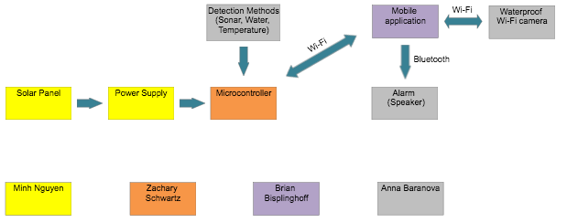

Figure 1. Hardware block diagram

Software Logic Flowchart
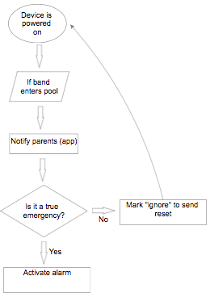
Figure 2. Software Logic Flowchart

The software will constantly check if the input, which would be the bracelet enters the pool. If so, it will proceed to send a notification to the mobile application on the parent's phones. If the device is powered off by the user, it will cause the system to not detect the bracelet going into the pool.

Engineering Trade-off Matrix
Nowadays to have a good product means, most of the time, to have the product customer wants to have despite countless competitors. In order to achieve such success marketing requirements have to be the same for demanding by a customer need and for supplying by product specification. Furthermore engineering requirements have to meet marketing requirements. Below is the correlation table of marketing and engineering requirements for the Aqua Sentinel 3000 project.

- = Positive Polarity , increasing requirements;
- = Negative Polarity, decreasing requirements;
↑ = Positive Correlation;
↓ = Negative Correlation;
↑↑ = Strong Positive Correlation;
↓↓ = Strong Negative Correlation;
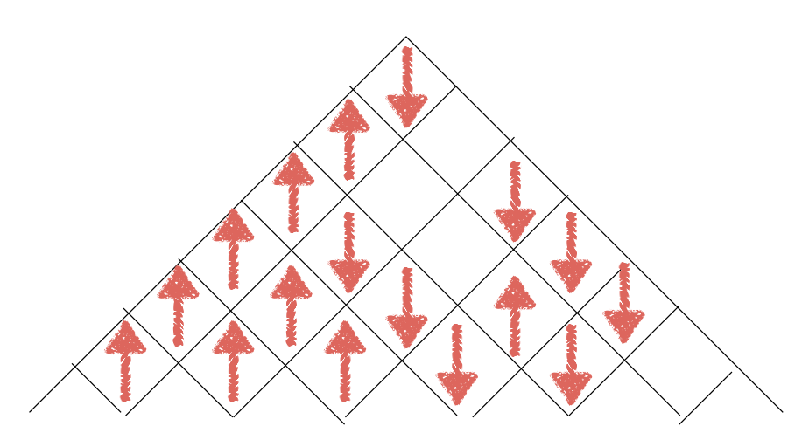

 |  | Efficiency | Weight Detection | Operation | Functionality | Battery Life | Wireless Signal | Cost
 |  | + | - | + | + | + | + | -
Reliability | + | ↑↑ | ↑↑ | ↑↑ | ↑↑ | ↑↑ | ↑↑ | ↓
Remotely accessible | + | ↓ | ↓ | ↓ | ↑↑ | ↓↓ | ↑↑ | ↓
Low Power | + | ↑ | ↑ | ↓ | ↓ | ↑↑ | ↓↓ | ↓
Waterproof | + | ↑ | ↑↑ | ↑↑ |  | ↓↓ |  | ↓↓
Ease of Use | + | ↑↑ | ↓↓ | ↓ | ↑↑ |  | ↓
Cost | - | ↓ | ↓ |  | ↓ | ↓↓ | ↓ | ↓↓
Target for Engineering Requirement |  | >85% | >15 lbs | < 3m, under water | >60% | > =1 month | >= 70 m | < $464

Figure 3. Engineering Trade-off Matrix

Proposed Budget
All the prices for the project are estimated and based on the online research, current monetary price and current selection of parts. Changes likely will happen as further exploration of all possible opportunities is done. All group members are responsible for splitting the costs of the project as no sponsor has been found for the project. It should also be kept in mind that additional units may need to be acquired if the primary ones are faulty or break for any reason.

Part Description | Price per Unit | Amount | Total Price
Temperat Sensor | $10.00 | 1 | $10.00
PCB for main device | $100.00 | 1 | $100.00
PCB for inside alarm | $20.00 | 1 | $20.00
WaterProof Speaker | $25.00 | 1 | $25.00
Speaker | $10.00 | 1 | $10.00
WaterProof  Video Camera | $70.00 | 1 | $70.00
Power Supply | $50.00 | 1 | $50.00
Transformers | $10.00 | 2 | $20.00
Misc(wires,amp, resistors,capacitors, transformers, etc) | $50.00 | 1 | $50.00
Packaging | $30.00 | 2 | $60.00
Bluetooth  Receiver & transmitter | $22.00 | 1 | $22.00
WIFI module | $7.00 | 1 | $7.00
Flotation device | $20 | 1 | $20
 | Total |  | $464.00

Table 1. Proposed Budget

Initial Project Milestones

Summer Semester (SD1)
Tasks | Start Date | End Date
Finalize Project Idea | 5/19 | 5/26
Project Discussion / Member Roles | 5/26 | TBA
Initial Project Document | 5/26 | 6/2
Individual and Group Research | 5/26 | 7/21
Draft of Prototype Design | 6/5 | 6/9
Table of Contents / 60 Page Draft | 6/9 | 7/7
Code Development and PCB Layout | 7/8 | 8/1
100 Page Document | 7/7 | 7/21
Final Document | 7/21 | 8/1
Fall Semester (SD2)
Test Components | TBA
Finalize and Order PCB | TBA
Build Prototype and Write Code | TBA
Final Testing | TBA
Final Report | TBA
Presentation | TBA

Table 2. Project Milestones

