Senior Design Report

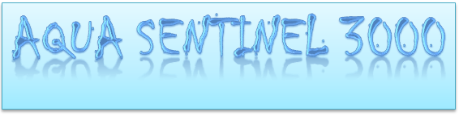


Group #11
Senior Design 1
University of Central Florida
Department of Electrical Engineering and Computer Science
Dr. Lei Wei

Anna Baranova Computer Engineering
Brian Bisplinghoff Computer Engineering
Minh Nguyen Electrical Engineering
Zachary Schwartz Computer Engineering

Table of Contents

1 Executive Summary 8
2 Project Narrative 10
2.1 Motivation 11
2.2 Goals and Objectives 11
2.3 Functionality 11
2.4 Engineering Constraints 12
2.5 Block Diagram 13
2.6 Software Logic Flowchart 14
2.7 Engineering Trade-off Matrix 15
3 Project Research 17
3.1 Microcontroller Considerations 17
3.1.1 MSP430G2553 17
3.1.2 MSP430FG4618 18
3.1.3 ATmega328 19
3.1.4 ATMEL SAM4SD32C 20
3.1.5 PIC16F887 21
3.1.6 Raspberry Pi 21
3.1.7 Microcontroller Conclusions 23
3.2 Sensors 24
3.2.1 Temperature Sensors 25
3.2.2 Ultrasonic Sensors 29
3.2.3 Pressure Sensors (Pressure Transducers) 35
3.2.4 Wearable Sensors 39
3.3 Camera 40
3.3.1 Logitech HD Webcam C525 40
3.3.2 Raspberry Pi Camera Module V2 41
3.3.3 Camera Selection 42
3.4 Speaker 42
3.4.1 Adafruit USB Powered Speakers 43
3.4.2 Smart Wi-Fi Alarm Siren 44
3.4.3 Audio Transducer with Siren Tone 44
3.4.4 Portable HYDRA Bluetooth Speaker 44
3.4.5 Speaker Selection 45
3.5 Solar panel 45
3.5.1 Why solar 46
3.5.2 Size 46
3.5.3 Power and energy 46
3.5.4 Battery 47
3.5.5 Types of Batteries 47
3.5.6 Solar Panel Cells 50
3.5.7 On-Grid vs Off-grid system 52
3.6 Wireless Communications 53
3.6.1 Communication types and Capabilities 54
3.6.2 Camera and Speaker Connections 55
3.6.3 Mobile Device 55
3.6.4 Bluetooth Technology 56
3.6.5 Band to Base Unit 56
3.6.6 Wi-Fi Technology 57
3.6.7 WPAN Technology 57
3.6.8 USB Wifi Dongle/Adapter 58
3.6.9 CC3120 TI SimpleLink Wi-Fi Network Processor 58
3.6.10 Serial Communication Technologies 58
3.6.11 Synchronous Serial Communication 58
3.6.12 Asynchronous Serial Communication 59
3.6.13 ZigBee Technology 60
3.7 Main Housing 60
3.7.1 Sealing Designs 61
3.7.2 Static O-ring Seals 62
3.7.3 Dynamic O-ring Seal 62
3.7.4 Gasket Design 62
3.8 Software Tools 63
3.8.1 Android 63
3.8.2 Apple IOS 65
3.8.3 Atmel Studio 65
3.8.4 Git and Github 66
3.8.5 Eagle CAD 66
3.8.6 Google Drive 67
3.8.7 Eclipse 67
3.9 PCB 67
3.9.1 Why PCB 67
3.9.2 Simulation 68
3.9.3 Layers 69
3.9.4 PCB vs Microcontroller 70
4 Design Constraints and Standards 71
4.1 Design Constraints 71
4.1.1 Economic and Manufacturing Constraints 71
4.1.2 Time Constraints 72
4.1.3 Environmental Constraints 72
4.1.4 Social Constraints 72
4.1.5 Sustainability Constraints 73
4.1.6 Health and Safety Constraints 73
4.2 Engineering Standards 74
4.2.1 802.11 Standards 74
4.2.2 Bluetooth Standards 74
4.2.3 Standards on Sensors 75
4.2.4 Solar Panels Standards 79
4.2.5 IEEE 12207 Software Life Cycle 81
5 Project Design 83
5.1 Hardware Design 84
5.1.1 Block Diagram and Task Assignment 84
5.1.2 Microcontroller Specifications and Usage 85
5.1.3 Power System 95
5.1.4 Sensors 99
5.1.5 Wearable Device 104
5.2 Software Design 107
5.2.1 User Interface 107
5.2.2 Mobile Application 107
5.2.3 Mobile Application Design 110
5.2.4 Mobile Application Functions 111
5.2.5 Embedded Software Design 112
5.2.6 Raspberry Pi and Main PCB Functions 117
5.2.6 Block Diagram and Task Assignment 118
6 Housing 119
6.1 Main Housing 119
6.2 Portable Housing 120
7 Testing Plan and Demonstration 123
7.1 Stages of Testing 123
7.2 System Functionality and Status 124
8 Administrative Content 126
8.1 Proposed Budget 126
8.2 Inventory 127
8.3 Tasking and Part Status 130
8.4 Project Milestones 131
9 Conclusion 133
10 Appendices 135
10.1 References 135
10.2 Permission Requests 140

List of Figures
1. Hardware Block Diagram and Task Allocation 13
2. Software Logic Flowchart 14
3. Raspberry Pi Models 21
4. Monocrystalline Silicon Cells 49
5. Polycrystalline Silicon Cell Solar Panel 50
6. Wireless Communication Statistics 53
7. Classic Bluetooth vs. Bluetooth Low Energy 55
8. Inter-Integrated Bus Configuration 58
9. SPI Bus Configuration 58
10. Asynchronous and Synchronous Communication 59
11. IOS and Android Version 64
12. 802.11 Wireless Standard 73
13. IEEE/EIA Software Life Cycle 81
14. High Level System Block Diagram 82
15. Hardware Block Diagram and Tasking 84
16. Main PCB Schematic 90
17. Raspberry Pi Zero 92
18. Solar Power Block Diagram 94
19. Power System Schematic 95
20. Solar Charge Controller 96
21. Solar Panel Schematic 97
22. Power Testing 98
23. BMP280 Breadboard Testing 100
24. Temperature Sensor Testing 101
25. Ultrasonic Sensor Testing 102
26. Analog Voltage Pin Testing 103
27. Wearable Device Diagram 104
28. Wearable Schematic 105
29. Android Application Interface 107
30. Mobile Application Flowchart 111
31. Pressure Sensor Flowchart 113
32. Temperature Sensor Flowchart 114
33. Speaker Flowchart 114
34. Ultrasound Sensor Flowchart 115
35. Software Flowchart 116
36. Block Diagram and Task Assignment 117
37. Plastic Dome 118
38. Platform for Microcontrollers 119
39. Housing for Wearable Device 120

List of Tables
1. Engineering Trade-off Matrix (House of Quality) 15
2. Microcontroller Comparisons 23
3. Temperature Sensors Technologies 26
4. Temperature Sensors Comparison 28
5. Ultrasonic Sensors Technical Characteristics 32
6. Ultrasonic Sensor Models 34
7. Pressure Sensors Technical Comparison 37
8. Pressure Sensor Models 38
9. Camera Comparison 41
10. Speaker Comparison 44
11. Solar Panel Comparison 46
12. Batteries 48
13. Solar Cell Comparison 51
14. Market Shares of Mobile Operating Systems 63
15. PCB vs Microcontroller 69
16. Bluetooth Standards 74
17. ATmega 3208 Operating Specs 85
18. ESP8266 Specifications 87
19. ATmega 3208 Pin Usage 88
20. Camera Module Specifications 93
21. System Requirements Status 123
22. Proposed Budget 126
23. Ordered Parts Track 127
24. Tasking 130
25. Project Milestones 131

1 Executive Summary

Drowning has been a major issue for people who own a pool. It is the second leading cause of death for children in the United State. Yet with today’s technology there is still a very small market for detecting drowning victims. Most technology are used for after the victims has already drowned. With the Aqua Sentinel 3000 we hope to build a system that a child can wear and that can detect when the child has fallen into the pool and alerts the parents that the victims is drowning. With our system the parents are alerted right away when a the child has fallen into the pool and they can watch a live stream so they would know where their child is in the pool. We hope by creating this system we can have an early warning when the child has fallen into the pool so it can prevent the child from drowning. It can thus reduce the parents worry when they are not immediately present with their child but still give them the enjoyment that comes with owning a pool.

The system consists of three main organizational units, the main unit that will sit by the pool and monitor the pool, the band that will be placed on the children to send out a signal when the child enters the pool, and the phone app which will act as the parents interface with the device. The main unit will be powered by solar panels to increase the environmental sustainability of the system but will require the unit to be in direct sunlight. Due to being close to the water, the housing being waterproof is of utmost importance, with a good portion of the research being dedicated to ways to ensure the functioning of the system in a wet environment. Similarly, the bands will need to be waterproof to function if the child falls into the pool, so similar research is done into materials that can be used. The sensor system must be able to function in this environment and after research it was determined that an ultrasonic system would be most effective in detecting the band. For the actual logic of the system, it was determined due to the high processing requirements of the video streaming, a raspberry pi zero will be used as the main logic unit of the device. The application will be developed for android and ios should time permit

The hardware design consisting of all circuitry and the printed circuit boards, including the main unit and each of the bands will be designed using eagle CAD software. This includes both the microcontroller pin layout design and the software development for the Raspberry Pi and the main MCU will be done in ATMEL Studio and Eclipse. This includes the software code for transmitting the data to the mobile application and processing the signals from the wearable device.

The software portion of this project will be very involved as this product has many different features and parts. The wearable device, main system, and the mobile application will be programmed using various computer languages such as C and Java. Coding in C language will be primarily used for the embedded programming, while Java will be used for creating the mobile application. A lot of the devices need to be in sync with each other so they can communicate properly to each other. For instance, the main system will need to communicate to the wearable band, mobile application, and the Raspberry Pi.

Our main goal is to design a product that will detect when a child has gone into the pool and alert the parents through the use of a mobile application. Currently there isn’t a smart sensor like this system that is available in the market. We want to design the software in a way that will make the product very reliable and efficient. Moreover, it will be important to use technologies and products that can operate with relatively low power consumption.

2 Project Narrative

The main purpose of the project narrative is to describe the group's motivation for choosing our project and giving a brief overview of the initial considerations and planning that went into the project. This includes an overview of the engineering constraints along with a house of quality visual analysis. Furthermore the distribution of work and a block diagram giving a visual representation of the project are also presented.

2.1 Motivation
Drowning is the second leading cause of death in children living in the United States with the majority of these deaths coming from children between the ages of 1 and 4. Many more children require emergency medical treatment due to nonfatal submersion injuries. Living in Florida, it is very common to own a backyard swimming pool. With children and a swimming pool, there is always reason to be at least a little worried for their safety. After all, it is not possible to be 100% sure of everything your child is doing every waking moment. This is where our device comes in.

The Aqua Sentinel 3000 is a device that will help parents protect their children from the dangers of a pool with a sleek and simple device. Unlike many of the current similar devices on the market, our device will feature 2-way communication through a convenient phone application. Since having to carry around an extra electrical device just for pool monitoring is annoying and cumbersome, we place the controller on the user’s smart phone so that they can always have it with them. Other devices also do not provide video monitoring of the pool area, which allows the ability to check once the alarm is going off if there is actually something wrong, remotely. Our device will also feature bracelets for the children to improve detection.

2.2 Goals and Objectives
The main goal of this project is to build a system that can detect when a child wearing a specialized bracelet falls into a swimming pool. The system will then send out alerts to the user’s cell phone and activate the video monitoring system. It’s also important that the alerts to the user’s cell phone are fast as time is of the essence in situations where a child’s life is in danger.

The device should be easy to use and install with most of the interface being on the mobile device. Once the main device is attached to the pool and the inside alarm connected, it should sync to the phone application and register itself. All physical components should be sturdy, but also easy to move if desired. The camera in particular should be resilient as it will be one of the easier parts to break in some way.

2.3 Functionality
The device will use the wrist bands around the children's’ arms to detect if one of the children has fallen into the pool. It will then analyze this in the microprocessor and send out a signal to the parent as well as activating the video camera. It sets off both alarms to alert anyone nearby that the child is in danger. At the same time, the system will also send a wireless signal to the phone application and alert it that there is possibly a child in danger. This way if the parents are either inside the house or the child is with someone else they will be notified if the child has fallen into the pool immediately. The camera will also be enabled and live feed will stream to the phone app. This stream can also be turned on at will if the user desires.

Due to the remote nature of having the main unit by the pool, battery power will be needed to power the device. This power should be able to sustain itself for a reasonable amount of time and should alert the user when it is getting low well ahead of time. The video feed should remain off when not in use and the microcontroller should be in a low power setting in order to conserve power. Solar power should be the primary means of recharging the power supply as the device will already be outside. This would be very useful for uncovered pools but may cause issues for some pools with overhead covers.

2.4 Engineering Constraints

- Casing
  - Should be no heavier than 15 pounds
  - Should be no taller than 2 feet, no wider than 1 foot
  - Solid but detachable to the side of the pool
  - Water proof
  - Easy to set up
- Sensors
  - Detects if one of the children falls into the pool
  - Does not activate if other objects fall into the pool
- Android app interface
  - Capable of displaying constant video feed of pool area
  - Enable and disable the equipment/alarm remotely
  - Easy to navigate
- Communication protocols
  - Wifi module should be on device in house and have a range of at least 20 meters to sync with wifi connection
- Power supply
  - Low power device that can maintain at least 1 month of battery life if disconnected from solar
  - Solar power provides majority of energy
  - Safe environment for solar panels
  - Safe environment/care for batteries of the solar panels
- Waterproof Camera
  - Display entire pool area
  - Capable of frequent exposure to water from pool/weather
- Speakers for poolside and in house
  - Capable of generating sound that can be heard anywhere in a family sized home
- PCB
  - To be waterproof and functioning
  - To have a pcb or microcontroller
  - Design for optimal used
- Safety
  - Mixing electrical components and water can be dangerous
  - Size of solar panels can cause a hazard
  - Batteries of solar panel can be a hazard if not handled correctly
- Time
  - Summer semester leave less time to think and do research on the project making it or acceptable to having more errors on the project
  - Each member have different time and schedule along with their own life at home so meeting and time to work on this project has to be adjusted
- Economic
  - Picking the best products for the best price
  - Staying within budget

2.5 Block Diagram

The main power source for the device are the solar panels. These will provide power to the entire system after being regulated by the power supply system. The microcontroller will then attempt to receive information from the bands if they are in range. If it senses that one has entered the pool, it will send an alert through wi-fi to the owner’s cell phone. The user can then send a signal back to set off an alarm or enable the video camera to stream directly to their phone to see the situation.

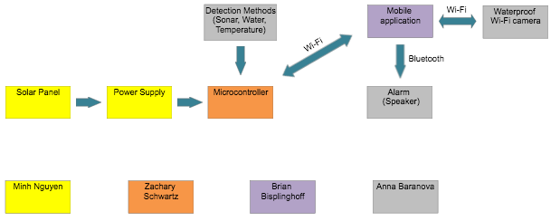
This block diagram will help us latter in the project so we can understand the structure of the system when we are building and test this project later on. We will be using this block diagram a lot in the future to better control our project. As you can see it is all color coded to match the person working on each step of the project. This is a very high level block diagram and further organizational structures are given in more detail later in the report. For now this is the primary overview of the project.

Figure 1: Hardware Block Diagram and Task Allocation

2.6 Software Logic Flowchart

The sensors will constantly check if the input, which would be the bracelet enters the pool. If so, it will proceed to send a notification to the mobile application on the parent's phones. If the device is powered off by the user, it will cause the system to not detect the bracelet going into the pool. Additionally, if a signal is sent to the main device to sound the alarm, the alarm that is attached to the main unit will sound until the parent disables the alarm. Finally, if video streaming is enabled from the mobile device, the main pcb will signal to the Raspberry Pi to forward the stream to the mobile application.

Below is a block diagram of the coding software we will be planning to used. The code will all start from when the child has fallen into the pool and what step to take and the loop it will follow for each events of the system. We also have a false switch install just in case the system runs into another input that isn’t the child drowning so we can cancel out that input and not alerts the parent or cause a big deal with the alarm system.
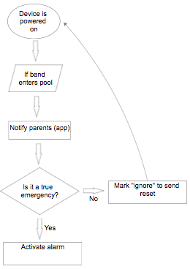
Figure 2: Software Logic Flowchart

2.7 Engineering Trade-off Matrix

Nowadays to have a good product means, most of the time, to have the product customer wants to have despite countless competitors. In order to achieve such success marketing requirements have to be the same for demanding by a customer need and for supplying by product specification. Furthermore engineering requirements have to meet marketing requirements. Below is the correlation table of marketing and engineering requirements for the Aqua Sentinel 3000 project.

- = Positive Polarity, increasing requirements;
- = Negative Polarity, decreasing requirements;
↑ = Positive Correlation;
↓ = Negative Correlation;
↑↑ = Strong Positive Correlation;
↓↓ = Strong Negative Correlation;

Table 1: Engineering Trade-off Matrix (House of Quality)

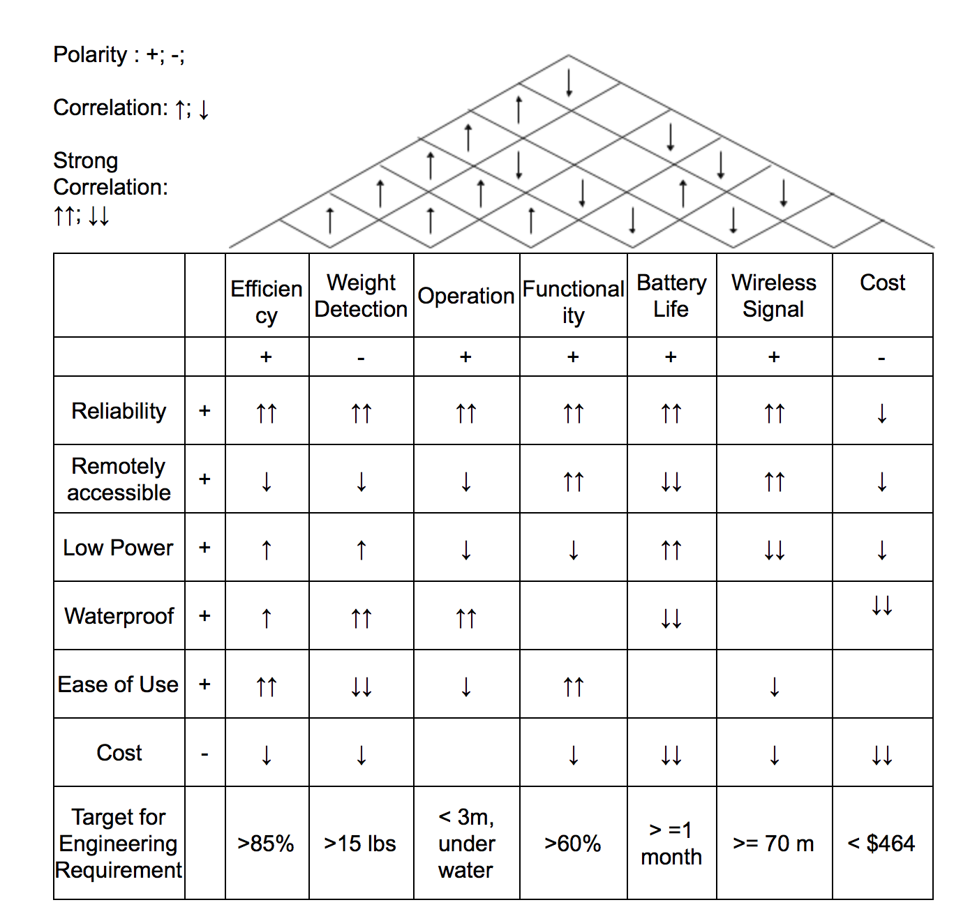

Our target requirements were chosen by looking at various products available on the market. We also considered the target audience for our product and what they may like or dislike about the design and functionality of the product. Many observations can be made from looking at the house of quality above. It easily can be seen that features such as waterproof and remote accessibility increase the cost. Furthermore, a lot of these advanced features require longer battery life and more knowledge in order to operate.

3 Project Research

This section of the report is concerned with investigation into each of the components that will be used to construct the project. The main sections are divided into microcontroller research, sensor research, camera and speaker research, wireless communication technologies, housing considerations, software to aid in development, and PCB design. These tasks were split between the members corresponding to the portion of the project they will focus on developing further.

3.1 Microcontroller Considerations

Several microcontrollers will now be evaluated for use in the project. The project will require one primary microcontroller in the main monitoring unit that will take care of communications between the phone app, sensors, speakers, camera, and wristband. There may also be a need for a microcontroller in each of the bands to be used depending on their complexity, which will be expanded upon as the project moves forward. Due to the other peripherals being currently unknown, many microcontrollers that are possible candidates will be researched for possible inclusion. One of the primary known concerns is ensuring the microcontroller can run on low power that will be able to be fully powered by solar, making a low power MCU for the main system a necessity.

3.1.1 MSP430G2553

When determining which microcontrollers to investigate, the MSP430G2553 is one of the first the team thought of due to its extensive use with the launchpad development board in the UCF curriculum. It is currently the most powerful unit in the 430G2xx family of microcontrollers and as such is the one which will be investigated from this family. This microcontroller is clocked at 16 MHz with 16 KB of non-volatile memory and 512 bytes of RAM with 16 bit register width. These should be sufficient for the project as more advanced computation will not be needed. One exception to this is if the video streaming must be processed by the microcontroller which would require a much more powerful processor. There are 24 gpio pins which should be more than enough for the main pcb. For serial communications it has 2 SPI modules, 1 UART module, and 1 I2C modules. If the bands are to contain microcontrollers the I2C module will be the most likely communication used as it would make sense to have the main controller as the master with each of the bands as a slave.

One of the main appeals of this microcontroller is the low power modes that are available, which would be useful in creating a device that is fully solar powered. The chip features five low power modes and one active mode. These low power modes feature varying combinations of clocks and DCO being active allowing for significant customizability depending on the needed functionality. The input voltage can range between 1.8V and 3.6V which further lessens the power consumption. In active mode the current draw is 230µA at 2.2V. In standby mode with the cpu off, this amount lowers to .5µA and lowering further to .1 when the microcontroller is off (RAM retention mode). The CPU can also be woken up from these low power modes in less than 1.5µS by the DCO which allows for rapid response time that is necessary for the project.

The MCU also features a 10 bit adc, 2 timers, 8 comparators on the inputs, and a watchdog timer. The adc could be a useful feature if the microcontroller were to be chosen for use in the armbands as a way to convert some analog temperature or pressure reading for sending to the main unit. The watchdog timer is also a useful feature for insuring the integrity of the device incase something goes wrong in the code that is recoverable. Though multiplication is not implemented in hardware in the device, more complex operations most likely will not be needed in this application. Additionally, the g2553 is most likely to be bought cheaply with the launchpad which provides a easy way to flash memory onto the device and test code. TI also provides code composer studio with their own compiler which will help in creating code efficiently for the device before it is transplanted to the main PCB.

It is worth considering that each group member still possesses a fully functioning launchpad from previous courses taken at UCF. For this reason the purchasing price of the G2553 can be greatly alleviated. This is particularly relevant if multiple are going to be necessary and each will require a microcontroller unit. The boards also come with an additional, though slightly weaker microcontroller that could be utilized for most applications the G2553 is capable of. Additionally each launchpad contains an oscillating crystal which can be utilized to provide a more accurate idle clock if this is deemed necessary by the group.

3.1.2 MSP430FG4618

Another microcontroller from TI, with a bit more processing power than the G2553, this unit is used in the experimenter’s board from TI that is used in the labs at UCF. The MCU features a clock rate of 8 MHz, 116 KB of nonvolatile memory, and 8 KB of RAM. It also has many more GPIO pins at 80 and features three DMA controllers that the G2553 lacks, allowing for more efficient movement of memory with no cpu interaction. The ADC comparator also is 12 bits wide allowing for more precise analog measurements if this is a relevant topic. However, this increased processing power comes at a cost with the FG4618 having a current draw of 400µA at 2.2V supplied and 1.3µA while in low power mode. All other specifications are the same or nearly the same as with the G2553. This may be an option if slightly more computing power is needed and the additional power consumption can be justified. Overall the specifications for this unit are very similar to most microcontrollers on the market.

In comparison to many of the other microcontrollers, it is worth noting that this board is only available through the fairly expensive TI experimenter's board. For this reason it should only be considered for primary development if the cost is warranted for the project. In this case, many of this MCU’s features are provided by other microcontrollers only better. It is still something to keep in mind if it can somehow be acquired cheaply either from the school or possibly from one of the group members already being in possession of one of the boards. If the other features of the development board are for some reason deemed to be beneficial to the project it could be worth reconsidering, but for now will mostly be included for completeness purposes.

3.1.3 ATmega328

We now turn to looking at ATMEL’s offerings of microcontrollers. The ATmega328 is one of the more popular on the market currently due to its general purpose nature and its inclusion in the Arduino Uno development board. Unlike TI’s microcontrollers, the ATmega features a harvard architecture which means separation of program and data memory. It features 1 MIPS per MHz throughput with 32 kB of flash program memory, 2 kB of data RAM, and 1kB of data ROM. In comparison to the MSP430 line, the ATmega sports stronger computing power. It also sports 23 GPIO pins, which should be more than enough for the project. For serial communications, it features 2 SPI modules, 1 USART module, and 1 I2C module, enough for most necessary communication. Of note is that the processor is only 8 bit, which could slow down the processing in some applications and could make writing assembly code more painful if that ends up being necessary.

This microcontroller also contains 6 sleep modes for low power operations. These sleep modes are the equivalent to low power modes with varying combinations of wake up sources and clocks active. The MCU has a wide ranging operating voltage between 5 and 1.8 V. This allows for low power operations on the lower side of this voltage range with active mode having a current draw of .2mA at 1.8V. In low power/standby mode the current reduces to .75 µA at 1.8V and in off/RAM retention mode, the current is only .1 µA. These low power modes make this unit very comparable to the msp430 and very good for our solar powered project. The ATmega also features a brown out detector that will reset the unit if it falls below the required input voltage levels.

As far as peripherals go, the mega features a 10 bit wide adc with built in temperature measurement. This could be particularly useful if temperature is used as the primary means of determining if the child has fallen in the pool or not. There are also four timers including two 8-bit, one 16-bit, and one separate real time with a dedicated oscillator. Additionally there is substantial documentation for this MCU due to its use in the Arduino board, one of the most popular development boards. This also brings to mind that the microcontroller can easily be purchased with an Arduino uno board to use for testing and debugging before the microcontroller would be placed in the main PCB. The Arduino IDE can then be used to make development simpler.

Particularly in regard to the software development of the board, Arduino sketches are very popular ways to facilitate microcontroller development. These are basically just libraries that Arduino users share easily between one another using the ATMEL studio IDE. It is also worth noting that as long as only a single MCU is necessary, one of the group members already has a board ready for use that could significantly cut down on the cost of the unit. While this is far from the most major concern when deciding between microcontroller units, it is something that should be taken into account due to the budget constraints in the project.

3.1.4 ATMEL SAM4SD32C

The SAM4SD32C is a much more powerful microcontroller from Atmel that is used in the more powerful Arduino boards. It features a 32-bit processor with a clock speed of 120 MHz. It also features 2048 kB of flash memory and 160 kB of static RAM. These specs make this microcontroller much more suited to intensive computational tasks which may place it out of the scope of this project. However, if the video is to be processed by the main microcontroller it could be a good consideration due possibly having the ability to do so. In addition, although it is much more powerful, it still maintains multiple low power modes to maintain energy efficiency. It has two UART modules, two USART modules, two I2C modules, and an spi module with additional communication options like USB 2.0 and a multimedia card interface providing a multitude of communication options. There are also up to 79 GPIO lines that provide more options than could possibly be utilized by the project.

For the low power modes, the SAM4SD32C also provides four low power modes in addition to its active mode. In these low power modes, the microcontroller has a current draw of between 27.6 and 32.2 µA with a supply voltage of 1.8V. One consideration is that to use the ADC, the supply voltage must be greater than 2.4V and to use the USB the supply voltage must be greater than 3.0V, which will lead to a slightly higher current. Although the power consumption for this unit is significantly higher than some of the others looked at, for the amount of computational power it brings it is still a very manageable amount.

This MCU includes not only a 16 channel ADC, it also includes a 12-bit wide DAC if digital to analog conversion is necessary in the project. The chip also sports data integrity checking as well as memory protection to insure the integrity of the product. It also contains an embedded voltage regulator which allows for easier integration with our solar power supply. Overall the device seems like it may be too much for what our project requires, but it is something to keep in mind if a much more powerful unit ends up being required. It is worth noting that in comparison to the Raspberry pi units, this is still simply a microcontroller in the end. For this reason it can be used to build a more reasonable PCB than if one of the pi boards were used.

3.1.5 PIC16F887

The 16F887 is one of the major offering from microchip technology which is characterized by their low cost high value offerings. Unlike many of the other microcontrollers on this list, this one is not utilized in any major pre-built development boards and so is more tailored to ground up design. It has a clock rate of 20MHz with 35 GPIO pins, which should be enough for use in the project. It has 8192 bytes of program memory with 368 bytes of static RAM and 256 bytes of EEPROM for data memory. In regards to serial communication, this MCU takes a different approach. It has only one line that can be configured to communicate through I2C, SPI, or UART. This could be an issue if multiple lines need to be configured at one time and may lead to some inefficiency.

For low power operation the microcontroller features a large range of operating ranges between 11µA and 220µ depending on the clock rate which can vary between 32kHz and 20 MHz. It also has an extremely low standby temperature of 50 nA and watchdog timer current of 1µA.

One not so obvious drawback to using this particular microcontroller unit is that there are not a lot of development resources out there for it. Because of this, many of the software programs will need to be constructed by hand. While this is certainly within the abilities of the group, it is important to consider the increased time that would need to be allocated in order to do this task. On top of this, due to the MCU not having any option of being bundled with a development board, all development would need to take place from the group design which could lead to longer and more difficult debugging sessions.

3.1.6 Raspberry Pi

Due to constraints imposed by the need for sending video feed to our mobile application, a standard microcontroller may not contain enough processing power to get the job done. For this reason, the team has decided to investigate into the possibility of adapting a SoC (System on Chip) unit for use as a stand in for a more traditional microcontroller. For this reason investigation into the viability for Raspberry PIs for use in the main unit is warranted. We will investigate several versions and conclude if they are necessary based on the needs returned from research in other areas. It is worth noting that these devices are designed more as tiny but fully functional computers and are more comparable to them than to a normal microcontroller on a printed circuit board. As such, power consumption will be higher as a necessity and considerations with regards to having so many components on one board should be taken into account. In addition, an operating system will need to be installed, though due to the high memory capacity of the pi this should not pose much of an issue as not much additional code will generally be required. It is also worth noting that due to the processor on the pi not being available other than with it, the requirement of having a complete, major PCB design may be more difficult to accomplish.

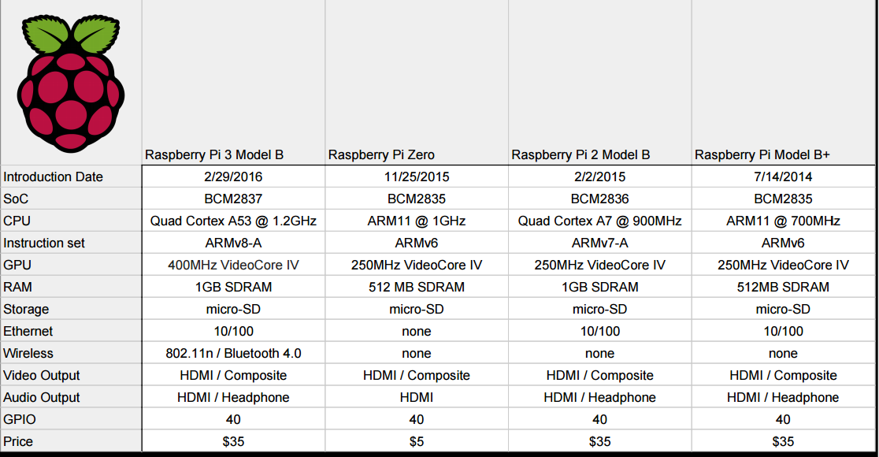
Figure 3: Raspberry Pi Models. Permission Given From Adafruit

3.1.6.1 Raspberry Pi Zero

The lower cost option offered by adafruit, the zero sports a Broadcom BCM2835 single core processor clocked at 1GHz with 512MB of RAM. This should provide more than enough overall processing power, with the main constraint being the video streaming. Note that this processor also uses the ARM architecture if some obscure assembly tasking is needed. This pi requires an input voltage ranging between 5.25 and 4.75V, though this voltage is decreased to 3.3V by a voltage regulator built into the pi. Because of this, there may be a way to reduce the input voltage to lower the power consumption if this is deemed necessary based on the power system specifications. This pi has a current draw between 180 - 200 mA while under normal operating conditions and 65-100mA when idle.

Though this version of the pi comes equipped with far fewer peripherals than its bigger brothers, it still sports many useful connectors. It has a mini hdmi cable that can be used to transfer video between the camera and the pi as well as a CSI camera connector which will most likely not be useful, but can be kept in mind. It also has a single USB port, though it can easily handle more USB inputs if a USB hub is connected. This will be extremely useful in connecting the device to wifi as many wifi adaptors are available in USB form. Finally, but importantly, it has 40 GPIO pin slots. These come without the male header pins so if they are to be used in that manner they will need to be soldered on. However, if additional expansions to the device are necessary having these could prove useful in adding additional electronic components.

One thing that could be of particular interest is the camera module that can be purchased as a package deal with this version of the pi. It is the only camera module that is compatible with this board, but it is most likely the most efficient for the price as well. If a different type of video camera is deemed necessary it may be required for the group to find another processor capable of doing the heavy lifting required for video processing.

3.1.6.2 Raspberry Pi 3 Model B

This is the most powerful currently available version of the pi. It sports a Broadcom BCM2837 quad-core ARM processor clocked at 1.2 GHz and 1GB of RAM. It also has a Broadcom VideoCore IV video processor which could make processing the video trivial. However, these improvements come at a cost. The device has an operating voltage between 5 - 5.25V, but requires a input current of 2A which is much higher than anything else looked at. For current draw, it generally has .58A under load and .31A while idle, which is again much higher and may cause problems with the solar powered power supply.

For components the pi 3 has more than could reasonably be used in the project. It has 4 USB ports meaning a hub would not be necessary. However, these seem like they would not be very useful as the device comes with a built in wi-fi module and Bluetooth module(4.1 and low power versions). It also has a camera serial interface and display serial interface which can be used for the video streaming. Additionally it has an HDMI port and 3.5mm audio-video jack if these communication types are needed. On top of all these built in modules, it again features 40 GPIO pins, this time with male headers pre-soldered on. This is fine though as I cannot imagine more peripherals would be needed with this device. Worth noting is that a sufficiently large SD card would need to be purchased to serve as the backing store for the unit, though any size would most likely be fine for the purposes of the project. Like the previous model of pi, an operating system needs to be installed in order to handle all the peripherals that are built into the pi.

3.1.7 Microcontroller Conclusions

Based on the microcontrollers that have been researched currently, there are a few paths that can be taken. First of all, if a microcontroller is needed in the bands that the children will wear, the ATmega 328 seems to be the clear choice in terms of flexibility, power efficiency, and computational power. This may also be a candidate for use in the main unit depending on the status of the video streaming. However, if a more powerful unit is necessary either the raspberry pi 3 or the raspberry pi zero should be selected for use in the main unit. The selection between these two units largely depends on the status of the power unit, with the zero having a definite edge in its power consumption, but lacking the pure processing power of the pi 3.

Due to the fact that the 430FG4618 is only available through the TI experimenter’s board which none of the group members have, it is most likely not of use in the project due to the high cost of purchasing this board. The PIC16F887 could potentially be of use in the armband, but due to the lack of features and development resources compared to the other MCUs, will most likely be out of the running. The MSP430G2553 is a reasonable choice, but in general lacked a few of the niceties of the ATmega, the only capability it has is more analog pins but this shouldn’t be a real concern for our project. The SAM could be a potential replacement for the raspberry pi, but due to the strict requirements involved with streaming video may still be impractical to use in comparison to the more powerful pi units.

Table 2: Microcontroller Comparisons
 | MSP430G2553 | MSP430FG4618 | ATmega328 | SAM4SD32C | PIC 16F887
GPIO Count | 24 | 80 | 22 | 79 | 35
Clock Frequency | 16 MHz | 8 MHz | 1 MIPS/MHz | 120MHz | 20 MHz
RAM | 512 Bytes | 8 kB | 2 kB | 160 kB | 368 Bytes
Storage Memory | 16 kB | 116 kB | 32 kB | 2024 kB | 4 kB
ADC | 10-bit | 12-bit | 10-bit | 16-bit | 8-bit
Low power current | .5 µA | 1.3 µA | .75 µA | 30 µA | 11 µA
Cost | $2.38 | $121.18 | $1.95 | $2.16 | $8.63
Additional Consideration | Available easily with launchpad development board. | Not available except with costly board. | Arduino libraries available to supplement development. | DAC available if necessary. | Low amount of development resources

3.2 Sensors

The main goal of our project is to send signal when an object drowns in a pool. In more concrete case, Sentinel 3000 should recognize two cases: if a child already in the pool and start drowning, and second case when a child enters pool water without parents/guardian knowledge. The sensor should capture both of these cases, send signal to alarm system in main device and send warning to a mobile device. Multiple sensors were research to find best fit for the project main idea.

3.2.1 Temperature Sensors

Temperature sensor is a device measures amount of heat energy released by a system. There are multiple variations of temperature sensors on the market exist. They measure temperature of gases, liquids and solids. So the use in water environment is possible and meets with one of our criteria for the sensor. Sensor can be contact and non-contact. Contact sensors require contact with an object to «sense» changes in energy of liquids, solids and gases. Non-contact sensors do not need contact with an object, they can «sense» changes by using radiation or convection. Such sensors used in liquids and gases. Sensors could be further divided into following categories: electronic, electro mechanical and resistive.

Fields of application of thermo sensors are wide, they can be used in environment controlling systems (inside buildings, inside of cooling systems, inside ventilation shafts), engines and overload protection, electrical thermo control systems, electrical thermo compensation systems, automobile electronics, and household use.[1]
Here are the most common types:
- Thermocouples
- Resistive temperature detectors
- Thermistors
- Infrared sensors
- Semiconductors
- Thermometers
- Thermostat

3.2.1.1 Thermostat

Thermostat is a temperature sensor with electromechanical principle of work. In is a contact sensor and commonly used to control heating/cooling elements to make sure the temperature is constant. Since it has an electromechanical principle, we would not consider this device further in research or use.

3.2.1.2 Thermistors

Thermistors are the most accurate devices. Resistance of the device reflect changes in temperature which are measured. It makes thermistors faster in responding time. Thermistors are inexpensive and easy to use devices, but they are commonly made of ceramic materials which make them fragile and easy to break. For this reason the group should be hesitant to include them as around pools it is very easy to accidentally break one due to roughhousing.

3.2.1.3 Resistive Temperature Detectors

Resistive Temperature Detectors are similar to thermistors, where change of temperature reflects on resistivity and measured. This devices are made of more «durable» metals such as platinum, nickel or copper, which makes them more durable and accurate as a device. The most common used resistive temperature detectors are made of platinum, which make the price of the device its main drawback.

3.2.1.4 Thermocouple

Thermocouple is a self-powered, thermoelectric, voltage device «senses» temperature by measuring changes in voltage. Two different metals in sensor have different temperature: one is kept constant, other metal measures temperature of environment. Differences in temperatures produce thermoelectric effect and voltage change measured. It is the most used sensors due to simplicity, low-cost, ability to «sense» in relatively long distance and self-pose. The most important property of the thermocouple is nonlinearity – the output voltage of the thermocouple is not linear with respect to temperature. Thus, to convert an output voltage to a temperature, it requires mathematical linearization.

3.2.1.5 Infrared Sensors

Infrared Sensor is non contact device “senses” temperature by detecting emitted infrared rays of surface into voltage output. Such sensors can be thermal and quantum and can be used in different applications such as climate control or medical devices. These devices are unable to be seen by the human eye. They use light sensors that detect only the infrared spectrum of light. It is possible to return the value for the reflected light to be processed by a analog to digital convertor in the system. This is done by analyzing the brightness of the object. It could be useful in the way that the light that is emitted will not be noticed by anyone including the child who is wearing the device. With several of the other sensors there is a worry that the additional overhead could make them undesirable to the end user. As such care must be taking in putting too much value solely on the effectiveness of the sensor and not enough into the practical applications.

Here is the table comparing advantages and disadvantages of types of temperature sensors described above. It goes through thermistors, resistive temperature devices, thermometers and infrared devices and details the advantages and disadvantages of each. It is worth noting that even though any of these units could be a valid choice in temperature sensing, using multiple of them is most likely not going to make a large difference in the effectiveness of the end product.

Table 3: Temperature Sensors Technologies
Thermistors | Resistive temperature detectors | Thermo-  couple | Infrared
resistance used to measure temperature | resistance used to measure temperature | used thermoelectric effect to measure temperature | captures emitted infrared rays and produces
most accurate, sensitive to temperature changes | made of more durable materials such as platinum | can measure temperature in long distance, resistant to contamination, self powered, low cost | can measure temperature from distance
made of fragile materials such as ceramic, | requires an external current source to function properly, high cost, slower response time | difficult to calibrate, not to accurate as RTD | affected by dust, humidity, fog, rapid changes in temperature

3.2.1.6 Choosing Temperature Sensor

Here are few sensors we picked to compare and choose for our project. Each of the sensors was considered in turn and the advantages and disadvantages of each was weighed and considered for our specific application. In considering the different sensors we were concerned both with the effectiveness of the sensor as well as the practical constraints that come with having a child wear the device at all times for monitoring.

First is the infrared temperature sensor MLX90614 Melexis Contact-less Infrared Sensor. It very tiny, can fit on quarter coin, and would fit into projected wearable device. Sensor measures IR light emitted of a remote objects and measures temperature in distance. Since the idea of the project is to find that time of nearly drowning event, change in temperature of an environment might be enough to capture such event. Temperature range of MLX90614 is from -70°C to +380°C. Measured angle is 90 degrees. This sensor comes in a metal can in rounded shape. Has four pins for power, ground, i2c clock and i2c data. It has 5V power and logic levels, low noise amplifier, 17-bit ADC and powerful DSP unit. The thermometer comes factory calibrated with a digital PWM and System Management Bus output. The factory default POR setting is SMBus [34]. Manufacturer is Microelectronic Integrated Systems (MELEXIS).

Another sensor we look at is the DS18B20. It is a waterproof and pre-wired thermocouple digital thermometer. Advantage of this device is you can measure temperature in distance and in wet conditions. Temperature range is from -55°C up to +125°C. Sensor works great with any microcontroller using a single digital pin, multiple sensors can be connected to the same pin. Devise consist of cable 91cm and 4mm in diameter, and stainless steel tube 30mm and 6mm in diameter. Three cables connected to power, ground and data. If fourth cable exists (copper), it is soldered to the wire shielding. This sensor can be used with 3V to 5.5 V of power/data.[33] Manufacturer is Maxim Integrated Products and the seller is sparkfun.com.

Third sensor we looked at is TMP36 temperature sensor. TMP36 is a low voltage, precision centigrade temperature sensor. It provides a voltage output that is linearly proportional to the Celsius temperature. It doesn’t require any external calibration and can sense temperature from −40°C to +125°C. It is small in dimension and as MLX90614 it can fit into quarter coin. TMP36 sensors have simple design, no moving parts, they are precise, never wear out, don't need calibration, work under many environmental conditions, and are consistent between sensors and readings. Moreover they are very inexpensive and quite easy to use. Two pins are connected to power and voltage, third pin is used to measure temperature, which is proportional to voltage output of this pin. Power supply for this sensor is from 2.7V to 5.5V. Since it is the analog temperature sensor, formulas to convert voltage output to temperature are needed and provided as:

Temp in °C = [(Vout in mV) - 500] / 10.

When using multiple sensor in one device, temperature measurements might be inconsistent, it indicates that the sensors are interfering with each other when switching the analog reading circuit from one pin to the other.[32] Manufacturer of this sensor is Analog Devices Inc.

Multiple suppliers are present on the market, one electronic store was chosen to assume that the delivery rate would be somewhat similar. Since the price and the compactness of the device important to the project, TMP36 is the choice, this sensor is compact, cheap and easy to set up. Additionally it does not have many of the drawbacks associated with the other sensors such as worrying about the safety of placing it on a child for extended periods of time. Waterproofing is the main drawback, but can be overcome with use of protecting cover/layer. Since the sensor will be on a pcb that will be contained in the housing, as long as the housing is sound the sensor should function correctly. If the housing ends up being a huge issue this could detract from the value of this sensor.

Table 4: Temperature Sensors Comparison
name | TMP36 | DS18B20 | MLX9061 | TD5 | PTS0603
manufacturer | Analog Devices Inc | Maxim Integrated Products | MELEXIS | Honeywell Sensing and Productivity Solutions | Vishay Beyschlag
price, $ | 1.50 | 9.95 | 15.95 | 3.03 | 2.25
size | compact | not compact | compact | compact | compact
power, V | 2.7 to 5.5 | 3 to 5.5 | 5 | 10 | -
sensor type | analog | thermocouple | infrared | RTD | RTD

Senior Design II correction:
In Senior Design II, we have decided to go with DS18B20 temperature sensor without waterproof covering. DS18B20 sensor is digital, compact, and accurate. Temperature range is from -55°C up to +125°C, it has low voltage operation (3 V to 5.5 V), ±0.5°C accuracy over temperature, stable with large capacitive loads, specified −55°C to +125°C operation, and low self-heating. Sensor works great with any microcontroller using a single digital pin, multiple sensors can be connected to the same pin. Different selection of temperature sensor had to be made due to change of bluethooth module of wearable device to wifi module ESP8266-01 which has digital pins only.

3.2.2 Ultrasonic Sensors

An Ultrasonic sensor (or sonar) is a device that can measure the distance to an object by using sound waves. It measures distance by sending out a sound wave at a specific frequency and listening for that sound wave to bounce back. By recording the elapsed time between the sound wave being generated and the sound wave bouncing back, it is possible to calculate the distance between the sonar sensor and the object. So, by using ultrasonic sensor we can detect motion been created in water. In our case motionless of an object have to be recorded in order to capture near drowning event.

Some objects might not be detected by ultrasonic sensors. This is because some objects are shaped or positioned in such a way that the sound wave bounces off the object, but are deflected away from an ultrasonic sensor. It is also possible for the object to be too small to reflect enough of the sound wave back to the sensor to be detected. Other objects can absorb the sound wave altogether (cloth, carpeting, etc), which means that there is no way for the sensor to detect them accurately. These are important factors to consider when designing using an ultrasonic sensor.[14] Overall ultrasonic sensors can be placed in category of an active motion detector sensors, whereas temperature sensors are passive.

Any moving object produces sound as a result of physical movement, which might be low or fast movement, and also depends on the medium that create the sound. However, these movements can be detected by using an ultrasonic sensor. The ultrasonic sound waves are sound waves that are above the range of human hearing and, thus, have a frequency above about twenty thousand hertz. Any frequency of above that is considered ultrasonic. In general, an ultrasonic sensor typically comprises of one or more ultrasonic transducer which transforms electrical energy into sound and vice-versa.[28] In ultrasonic sensors the output value is linear with the distance between the sensor and the target, sensor response is not dependent on the colors, transparency of objects, optical reflection properties, or by the surface texture of the object. These sensors are designed for contact-free detection, sensors with digital (ON/OFF) outputs have excellent repeat sensing accuracy, accurate detection even of small objects. Ultrasonic sensors can work in critical conditions such as dirt and dust and they are available in cuboid or cylinder forms, which is better for a freedom design. All of these could are advantages of sonar sensors. [29]
A human body won't reflect sonar waves back perfectly, but the latency or lag shouldn’t make that big of a difference since the sound wave's radius relative to the human body is large enough to reflect the waves back.

Ultrasonic sensing utilizing Time Of Flight (TOF) measurement techniques are used in liquid level and fluid identification sensing in the automotive, consumer and medical markets. Ultrasonic (TOF) sensing can yield high accuracy and high reliability with low-power consumption. In order to achieve the best cost-to-performance combination, care must be taken in selecting the proper transducer[15]. Here are the disadvantages of ultrasonic sensors we can have to overcome:

- ultrasonic sensors must view a high density surface for good results. A soft surface like foam and cloth has low density and absorb the sound waves emitted by the sensor;
- could have false responds for some loud noises such as air hoses;
- the ultrasonic sensors have a response time with a fraction less than other types of sensors;
- an ultrasonic sensor has a minimum sensing distance, which should be taken into consideration when choosing the sensor;
- some changes in the environment can affect the response of the sensor (temperature, humidity, pressure)

Ultrasonic sensors could be divided into following categories depending on its operating principles: thru-beam mode sensing, retroreflective mode sensing, and diffusive mode sensing.

3.2.2.1 Diffuse Mode Ultrasonic Sensors

Ultrasonic sensors are most commonly used in the diffuse mode. The principle of work of diffuse sensors are the the same as in photoelectric sensing. A single ultrasonic transducer is used as both emitter and receiver and is typically contained in the same housing as the evaluation electronics. Features of diffuse mode ultrasonic sensors are: simple installation, one sensing head, detection range depends on the surface properties and the pitch angle of the object, measuring frequency is lower then in a thru-beam sensors, background suppression, and reliable detection of difficult objects. Some of the diffuse sensors existed on the market could be converted to retroreflective mode operation via software parameterization.

3.2.2.2 Retroreflective Mode Ultrasonic Sensors

Ultrasonic retroreflective sensors, as diffuse mode sensor, detect objects within a specified sensing distance, but by measuring propagation time. The sender and receiver are located in the same housing. The ultrasonic beam is reflected by a fixed reflector. Objects that appear in the sound beam change the measured distance and absorb or deflect the sound. The sensor emits a series of sonic pulses that bounce off fixed, opposing hard surface. The sound waves must return to the sensor within a user-adjusted time interval; if they don’t, it is assumed an object is obstructing the sensing path and the sensor signals an output accordingly. Because the sensor listens for changes in propagation time as opposed to mere returned signals, it is ideal for the detection of sound-absorbing and deflecting materials such as cotton, foam, cloth, and foam rubber. As with diffuse mode, features of retroreflective sensors are: simple installation, one sensing head, and reliable detection of difficult objects, sound absorbing objects.

3.2.2.3 Thru-beam Mode Ultrasonic Sensors

Thru-beam ultrasonic sensors are similar to photoelectric thru-mean sensors and have the emitter and receiver in separate housings. If the ultrasonic beam is interrupted by an object, the switching output is activated. These sensors are ideal for applications that require the detection of a continuous object, such as a web of clear plastic. Features of thru-beam mode sensors are: large distance between emitter and receiver, fast response time, low susceptibility to interference, suitable for difficult operating conditions, fast response time, has two separate units to wire. Some manufacturers allocate another operating mode called Ultrasonic Double Feed Detection. Ultrasonic double feed detection sensors are based and performed using ultrasonic thru-beam sensors, consisting of an ultrasonic emitter and an ultrasonic receiver with integrated evaluation that are optimized for some particular applications. Such applications might be a label detection or adhesive strip detection, and so on. Double sheet control can detect three different states: no sheet, single, or double sheet.

Thru-beam mode is powerful in that it offers longer detection ranges and shorter response times than other ultrasonic sensors. However, a thru-beam sensor is more expensive since it requires both an emitter and receiver, as well as power for both. Diffuse mode works well with many common, simple applications. However, the biggest drawback of diffuse mode is that it can lose the echo when a target is present. Retroreflective mode is for objects which would otherwise be difficult to sense, including objects that are highly absorbent (clothing, textiles, dust, sand) or that have a smooth, angled surface. [42]

We will consider diffuse mode ultrasonic sensors, since it is easy to install, does not need retro-reflector, do not required alignments of transmitter and sensor, has acceptable cost, and available widely on the electronics market. Bellow is a table detailing various ultrasonic sensor characteristics. The diffuse mode, retroreflective mode, and thru-beam mode are considered and the advantages and disadvantages are all considered.

Table 5: Ultrasonic Sensors Technical Characteristics
Diffuse Mode | Retroreflective Mode | Thru-beam Mode
Transmitter and receiver in the same housing | Transmitter and receiver in the same housing | Transmitter and receiver in different housing.
Continuously emits sound wave to capture echo from object in range. | Uses retro-reflector to reflect emitted sound wave. If sound wave is not captured by receiver - there is an object between sensor and retro-reflector. | Transmitter sends sound wave and receiver captures it. When signal is lost an object is present between transmitter and receiver.
Easy to install | Easy to install | Hard to install / alignment is important
Can detect object in difficult angle | Moderate sensing distance | Longest sending distance
No reflector needed | Less expensive than thru-beam because simpler wiring | Most reliable when you have highly reflective objects
If background is close or sufficiently reflective, it is almost impossible to detect an object | May detect reflection from shiny objects | More expensive because separate light source and receiver required, more costly wiring
Used when both sides of the object cannot be accessed | General purpose sensing | Used in general purpose sensing and/or parts counting

Thru-beam mode is powerful in that it offers longer detection ranges and shorter response times than other ultrasonic sensors. However, a thru-beam sensor is more expensive since it requires both an emitter and receiver, as well as power for both. Diffuse mode works well with many common, simple applications. However, the biggest drawback of diffuse mode is that it can lose the echo when a target is present. Retroreflective mode is for objects which would otherwise be difficult to sense, including objects that are highly absorbent (clothing, textiles, dust, sand) or that have a smooth, angled surface. [42]

We will consider diffuse mode ultrasonic sensors, since it is easy to install, does not need retroreflector, do not required alignments of transmitter and sensor, has acceptable cost, and available widely on the electronics market.

3.2.2.4 Choosing Ultrasonic Sensor

As with temperature sensors the cost will be one of constraints we have to consider along with compact size and range of sensing device. Below are the ultrasonic sensors we consider to purchase. First is ultrasonic ranging sensor HC-SR04. This sensor provides 2cm to 400cm of non-contact measurement functionality with a ranging accuracy that can reach up to 3mm. Each HC-SR04 module includes an ultrasonic transmitter, a receiver and a control circuit [35]. It has four pins connected to power, ground, to trigger signal and to receive signal. Consider to the seller, this sensor is easy to set, has operating voltage of 5V, frequency 40 Hz and measure angle 15° [36]. Dimensions of a sensor 45x20x15 mm is somewhat compact for main housing, but not for wearable device.

Another sensor to consider is LV‑MaxSonar‑EZ1. This sensor is ultrasonic range finder and provides very short to long-range detection and ranging in a small package. It can detect objects from 0m to 6.45m. It has 20Hz reading rate, 42kHz ultrasonic sensor measures distance to objects. If object is close as 6 inches, there is no dead zone. Operating voltage is from 2.5V to 5.5V. The interface output formats included are pulse width output (PWM), analog voltage output (Vcc/512 volts per inch), and serial digital output (9600 baud). It reads from all three outputs[37].

Third sensor to consider is MB1200 XL-MaxSonar-EZ0. This sensor has the widest and most sensitive beam pattern of sensor manufacturer MaxBotix currently offer. The sensor is small in size, has 0 Hz reading rate, 42kHz ultrasonic sensor measures distance to objects, and read from all 3 sensor outputs: analog voltage, RS232 Serial and pulse width. In has no dead zone if object as close as 25 cm. Operating voltage is 3.3V to 5.5V. Dimensions are 19.9x22.1x25.11 mm.[38]

Size/dimensions will not be consider while comparing sensors since they are particularly in one category of sizes, Also none of this sensors are waterproof and they are not recommended to be used in wearable devices due to transmitting and emitting sound waves, which might be harmful. Below is a table comparing various ultrasonic sensor models that are available at this time for consideration in the project.

Table 6: Ultrasonic Sensor Models
name | XL-MaxSonar-EZ0 | HRLV-MaxSonar-EZ1 | HC-SR04 | RCVR 40KHZ | PING #28015
manufacturer | MaxBotix | MaxBotix | Elecfreaks | Murata Electronics | Parallax
price, $ | 49.95 | 34.95 | 3.95 | 6.80 | 29.99
range detection | Wide: Up to 2m | Wide: Up to 1.2m | Wide: up to 0.6m , beam angle 15° | beam angle 80° | beam angle 20°
Power, V | 3.3 to 5.5 | 2.5 to 5.5 | 5 | - | 5

The XL-MaxSonar-EZ0 is the best sensor from comparable, it reads data simultaneously from 3 outputs and has wide coverage, which could be enough to cover whole pool area. The sensor HC-SR04 is the cheapest one, but has the smallest cover area. In order to consider constraints of our project, we have to compromise and choose HRLV-MaxSonar-EZ1 ultrasonic range sensor. It is $15 cheaper than XL-MaxSonar-EZ0 and not as bad as HC-SR04 considering sound wave propagation of a sensor.

3.2.3 Pressure Sensors (Pressure Transducers)

Another type of sensors we researched are pressure sensors. Pressure is defined as force per unit area that a fluid exerts on its surroundings [2]. Most of pool securing devices use pressure sensors in their design to detect object entering water. The ability to capture pressure applied onto water surface by an object entering pool waters can help us reach one of the main focus of our project to alert parents or guardian when a child falls into a pool. There are different types of pressure measurements devises exists. Pressure sensor can measure pressure in gases or water by converting displacement into voltage or current [3].

There are three types of pressure sensors that were considered for this project. These are as follows:
- Strain Gauge
- Variable Capacitance
- Piezoelectric

3.2.3.1 Strain Gage

Strain gage are most common transducers uses Wheatstone bridge circuit design. Wheatstone Bridge is the circuit design representing two series of two resistors in parallel connected to voltage terminal and ground. It shows difference between parallel resistors and equals to zero when the system is balanced [4]. Since it was originally developed to measure unknown resistance to calibrate measuring equipment, such device can «pick» small changes in resistivity. Strain gage transducers used for different purposes, it can be applied to measure low or high pressure, measure absolute, gauge or differential pressure. Strain gauges are made of different materials and can further be divided into three categories.

Bonded foil strain gauges (BFSG) is one of three variation of strain gages are widely used in industry because of its quick response time on pressure changes.

Another type of strain gauge is the sputtered strain gage (SSG). Its manufacturing process bonds molecules between diaphragm, isolating layer and strain gauge elements. It makes sputtered strain gauge have longer life and it can be used in harsh environment [3].

Third type of strain gauges are semiconductor strain gauges. These sensors translates linearly proportional applied pressure into voltage or current and makes this device easy to use.

Even though strain gauge are widely used for different applications because of its fast response time, relative freedom from accelerating effects and ease of compensation for temperature effect, following disadvantages have to be considered: these sensors are unable to provide lower ranges, they have low level output, sensitive to vibration, long term drift, creep due to adhesive agents [5].

3.2.3.2 Variable Capacitance

A variable capacitance sensors is a capacitor with different capacitance. The length of dielectric material between two metals plates of capacitor changes and produces variable capacitance. The device measures changes in capacitance between metal diaphragm and fixed metal plates. Such sensors are stable in performance but hard to set up than most of pressure sensors.[6]

3.2.3.3 Piezoelectric

Such device uses principle of piezoelectric effect. Mechanical force applied to an object along certain planes and electric voltage produced. Voltage measured are proportional to applied force or stress .The voltage output obtained from the materials due to piezoelectric effect is very small and it has high impedance. Due to these constraints it may be necessary to supplement the device or have more than would be required for other, similar sensors, though it is still to be determined. To measure the output some amplifiers, auxiliary circuit and the connecting cables are required.[3]

3.2.3.4 Signal Conditioning Pressure Measurement

Bridge based sensor, in order to measure pressure more accurate, require some “help” of other devices, and some conditioning considerations have to be consider:

- Excitation
- Remote Sensing
- Amplification
- Filtering
- Offset
- Shunt Calibration
- Bridge Completion

Once voltage signal is measured, the value of a signal have to be converted into pressure units. Usually pressure sensors produced linear signal, but some hardware or software are necessary to make conversion. Such conversion formula depends on the sensor used, and usually provided with the sensor my manufacturer. A typical conversion formula will be a function of the excitation voltage, full scale capacity of the sensor, and a calibration factor. With all of these together it is then possible to properly measure the signal.

Full scale capacity (FSC) is the maximum pressure which the transducer should receive. Excitation Voltage (EV) is the recommended input voltage. Measured Voltage (MV) is the raw voltage returned by the sensor. Calibration Factor (CF) is the output of the transducer, usually expressed in mV per input V. Formula to calculate pressure from measured voltage are as follows:

Pressure = (FSC / EV)(MV / CF).[3]

After signal is properly scaled, it is necessary to obtain a proper rest position. Pressure sensors (whether absolute or gauge) have a certain level that is identified as the rest position, or reference position. The strain gauge should produce 0 volts at this position. Offset nulling circuitry adds or removes resistance from one of the legs of the strain gauge to achieve this "balanced" position. Offset nulling is critical to ensure the accuracy of your pressure measurement and for best results should be performed in hardware rather than software.[3] This is usually the case as software implementations can be rather approximate in comparison to fully realized hardware solutions. However, given no other alternative it may still be preferential to do a software implementation if other factors lend themselves to this strategy.

Table 7: Pressure Sensors Technical Comparison
Strain Gage | Piezoelectric | Variable Capacitance
Capable of DC response | Small size,  Wide temperature range,  Fast response,  Self-generating signal,  Rugged | Low hysteresis,  Good linearity,  Good stability
Large size,  Limited temperature range,  Low sensitivity | AC response only,  Vibration sensitive,  Low sensitivity,  High output impedance,  Temperature sensitive

3.2.3.5 Choosing Pressure Sensor

First choice is the pressure sensitive material, which can be used in wearable device and measure water pressure once submerged. Its called Pressure-Sensitive Conductive Sheet (Velostat/Linqstat). In has following characteristics: 280x 280x 0.1 mm, temperature -45°C to 65°C, heat sealable. Volume resistivity is less than 500 ohm/cm and surface resistivity less than 31,000 ohms/square cm [39].

BMP280 is another sensor to consider. It measures barometric pressure and temperature. This sensor especially designed for mobile applications. BMP280 sensor is 2x2.5x0.95 mm in dimensions (size of a quarter coin), is a low-cost, measures pressure from 300 to 1100 hPa (+9000...-500 m above/below sea level equivalence). Temperature range -40°C to +85°C.The BMP280 is based on Bosch’s proven Piezoresistive pressure sensor technology featuring high EMC robustness, high accuracy and linearity and long term stability, according to manufacturer [40].

Another sensor we looked at is Round Force-Sensitive Resistor (FSR) - Interlink 402. It is compact enough, not too expensive, FSR's are basically a resistor that changes its resistive value depending on how much its pressed. They are easy to use but not too accurate and would be a bad choice to measure exact weight pressed and they also vary some from sensor to sensor perhaps 10%, according to seller. Ranges of pressure is what could be considered when using this sensor. Dimensions are 56.77x18.48x0.55 mm, Since FSR acts on the mechanical pressure to sensor, its force sensitivity range is from 100g to 10kg, pressure sensitivity range from 1.5 psi to 150 psi and temperature range -30C to +70 °C [41].

Table 8: Pressure Sensor Models
name | Velostat/Linqstat | BMP280 | FSR
manufacturer | adafruit | bosch | sparkfun
Price, $ | 3.95 | 9.95 | 7.00
Pressure range | Infinite  500 Ω/cm (volume resistivity) | 300 to 1100 hPa | Infinite  100KΩ (light pressure) to 200Ω (max)
Temperature , °C | -45 to +65 | -40 to +85 | -30 to +70

Here the choice of pressure sensor does not look to obvious, all of the choices are good and can be potentially used. We will try the BMP280 sensor, the manufacturer promises an outstanding performance, compare to older versions. It also can be used as temperature sensor, then we can ignore the choice for the temperature sensor and use only this one. FSR is only $2 cheaper but it performance is varies from sensor to sensor. Velostat/Linqstat pressure sensor film is not explored enough by us to be 100% sure at this moment. Therefore BMP280 is the pressure sensor for the project.

Senior Design II edit:
Pressure sensor was omitted from the final proposal of the design and was not used in the final design and demo.

3.2.4 Wearable Sensors

In recent years, a wide range of wearable devices and sensors including accelerometers and gyroscopes, smart fabrics and actuators, wireless communication networks and power supplies, and data capture technology for processing and decision support [7], have been developed for clinical research and health monitoring. Various kinds of wearable sensors have emerged for different purposes with the development of sensing technologies.

Increasing demand for “sensing” applications impacted field of new materials by introducing new criteria for development, requirements and effective implementation of such applications. For our project it is important that the material, holding «sensor» had a comfortable design, long-term stability, light to none deformation, lightweight, flexible, and waterproof.

Flexible and wearable sensors have to provide ability to move freely and be comfortable without compromising the sensing ability. Thus, an important characteristic defining flexible sensors is their skin-like conformability and stretchability. Here are some of the types of such material with properties described above: Polyethylene terephthalate (PET), Polycarbonate (PC), Polyurethane (PU), Polyethylene naphthalate (PEN), Polyimide (PI), [11], Polydimethylsiloxane (PDMS), EcoFlex, DragonSkin, Silbione.[12][10]

“This group of flexible polymeric substrates and silicone elastomers provides a high degree of deformability and conformability on different surfaces with varied textures and geometries, rendering them viable candidates for use as one of the fundamental components of stretchable and wearable sensing devices”.[10].

One of the specific materials we considering for our project is Ecoflex rubbers. Ecoflex rubbers are platinum-catalyzed silicones [13]. It available on the form of paste, which after mixing can be applied on top of the sensor device and made into any form. Cured material is skin safe which is important to our specifications.

3.3 Camera

There is a wide range of choices when it comes to selecting a camera that will be used for this project. The most important features to consider are low power, durable, and quality. While we don’t need a very sophisticated camera, we do want the camera to be able to provide video that is of somewhat high quality so that the pool area can be properly viewed in the event of an emergency. As of now we have decided that the camera will be interfaced with the microcontroller, which means that the camera must be compatible with the MCU. This can be done by selecting a camera that can be plugged into the microcontroller via USB or by selecting a camera that can be attached by a ribbon cable. There are several advantages and disadvantages of the USB and ribbon cable which will be covered further in detail. The camera is going to be connected to the microcontroller and will be able to transmit video of the pool area to the mobile application using WiFi.

3.3.1 Logitech HD Webcam C525

When selecting a camera we need to focus on a camera that is compatible with a Raspberry Pi or a similar high performance microcontroller. The Logitech HD Webcam is plugged in via USB and would attach directly to the microcontroller. This webcam provides HD 720P video resolution, which would be sufficient quality for what we need. If we were to use a Raspberry Pi, it would be capable of being interfaced with the operating system (probably Linux) on the MCU. The basic requirements for this camera are 1 GHz, 512 MB ram, and obviously internet connection. The Raspberry Pi or a similar high performance microcontroller would meet these requirements of this webcam. The price of this camera is relatively cheap at $33. Being able to be plugged in using USB allows for more flexibility in positioning of the camera, and is also quite sturdier in comparison to a camera module attached by a ribbon cable.

However, there are downsides of using a camera that is plugged in using a USB cord. The USB camera will provide a slower frame rate and consume more power from the CPU. This could cause other processes on the microcontroller to be slower as moving data over USB to the CPU consumes more CPU power than a camera attached by a ribbon cable. This webcam as well as many other webcams are much easier to interface with Windows or Mac operating systems. However, since we are most likely going to be using a Raspberry Pi to handle the video streaming, it may be more difficult with the Linux operating system on the Raspberry Pi. Being that it only requires 1.5 Volts and is able to produce decent video quality, it should be sufficient for our project if we were to go with the USB route.

3.3.2 Raspberry Pi Camera Module V2

Another option for a camera would be the Raspberry Pi Camera Module V2. This camera is much lighter and smaller than the Logitech C525 Webcam. It is directly attached to the circuit board using a ribbon cable. Although the ribbon cable has less flexibility and is less durable than a USB camera, it does offer some advantages. The Raspberry Pi Camera module is capable of producing 1080P HD video and is able to adapt to many different light settings because it is equipped with a Sony IMX219 CMOS image sensor. This feature can be especially useful because the lighting around the pool area will vary dramatically based on the current weather. In general, the perks of the Raspberry Pi Camera Module V2 over the USB webcam are faster frame rate, better resolution, less resource intensive, and more compact.

Considering that we are most likely using the microcontroller for several different tasks, it will be advantageous to use this camera module because it will consume significantly less CPU power than the USB webcam. At 720P this module will be able to produce 180 frames per second, while at 720P for the C525 webcam, only 30 frames per second can be produced. Another advantage of the Pi camera module is that it is easier to interface with microcontrollers. There are various third party libraries available so that we can seamlessly integrate the camera with the microcontroller. This will allow for us to stream video to the mobile application with less difficulty and less issues. Although the ribbon cable that is included is 15 cm long, it should not be an issue given that we planned to have the camera module close by the microcontroller. The cost of this camera is $29 which is about the same as the C525 webcam. Since this camera module is specifically made to work with the Raspberry Pi’s, it requires 250 mA when operating, which can easily be handled. The cost of this module is 29$ making it relatively cheap just like the Logitech camera. The size and weight of this camera give us more flexibility when installing it to our device.

3.3.3 Camera Selection

The Raspberry Pi Camera Module V2 is the clear choice for our project. This camera will attach directly to the Raspberry Pi Zero W using a cable ribbon which is provided with the camera. The chart below breaks down the main features that are relative to our project. It can be seen that the Raspberry Pi camera module produces better video quality at a faster frame, all while consuming less CPU power and electrical power. Moreover, the Raspberry Pi Camera Module V2 will be directly compatible with the Raspberry Pi microcontroller allowing for easier integration of video streaming.

Table 9: Camera Comparison
Specifications | Raspberry Pi Camera Module V2 ($29) | Logitech HD Webcam C525 ($33)
Connection | Connects to CSI port | Connects to USB port
Video Quality | Supports up to 1080P video | Supports up to 720P video
Compatibility | Directly compatible with the Pi which will handle our video processing. | WIll not be able to support official drivers when using with the Pi.
Frame Rate | At 720P can produce 180 fps | At 720P can produce 30 fps
CPU Consumption | Consumes less CPU power | Resource intensive
Power | Producing 1080P video draws only 250 mA | Producing 720P video draws about 400 mA

3.4 Speaker

The purpose of the speaker is to play an alarm tone in the event of an emergency. The speaker will most likely be interfaced with the microcontroller using Wi-Fi/Bluetooth. If the speaker is interfaced with the microcontroller, than in an emergency, the parent will be able to send a signal to the microcontroller (from the mobile application) to tell the microcontroller to activate the alarm (speaker). This can also work by sending a signal directly from the mobile application to the speaker without ever communicating to the microcontroller. However, we plan to first communicate from the mobile application to the microcontroller and then to the alarm. For these reasons, it is important that the speaker/alarm we choose has Wi-Fi/Bluetooth technology or is directly plugged into the microcontroller that we use. This allows us to use a Wi-Fi/Bluetooth speaker that is powered by battery/outlet, a speaker that is powered by the USB hub on the microcontroller, or a speaker that is powered through an external USB hub. These three methods will be further analyzed.

Using a Wi-Fi speaker that is either plugged into an outlet or battery powered would work. Since audio cannot be transmitted through Wi-Fi, it would play a set alarm tone when activated during an emergency. Another method would be to use a speaker that has Bluetooth technology. Since the parent might not be home or may be at a far distance from the microcontroller, they would communicate to the microcontroller using Wi-Fi, and then the microcontroller would trigger the alarm using Bluetooth. The new Raspberry Pi’s and other high performance microcontrollers do have Bluetooth capabilities so this could work. Lastly, using a speaker that was powered and connected directly to the microcontroller using the USB powered hub could work depending on how much power was required. Although it would function and there would be a sound produced, the sound would be extremely subtle because of the power that would need to be drawn. Also if we did this option we would really have to use very low powered speakers. However, if we used an external USB hub that was able to supply a decent amount of power, we could use USB speakers that were able to play a loud alarm. There are many options for speakers we can use and they all depend on the amount of power supplied.

The best choice for our project would be USB powered speakers. This way the speakers can draw power from our main power supply directly, or through the Raspberry Pi USB hub. If we want to make the noise louder we can use an amplifier in addition to the speaker. The next best option would be to use a Bluetooth speaker. If this is chosen, the microcontroller would send an audio file (alarm tone) to the speaker in the event of an emergency.

3.4.1 Adafruit USB Powered Speakers

These speakers are very basic USB powered speakers that will work great for our project. They are connected through the standard 3.5 mm stereo plug on the Raspberry Pi’s or other microcontrollers. The USB cord can be connected directly to the USB hub on the microcontroller, or it can be connected to any external USB hub to draw power from. The frequency response of the speakers ranges from 100 Hz to 18 kHz and the power requirements at maximum volume are 5 VDC and 1 A peak. They are 4 Ohm impedance, 3 Watt speakers, so they are designed to work well with low power. The dimensions are small, which will help with portability. These speakers seem to be a great choice because there is not much that can go wrong with them. They will be directly powered by the same source as the microcontroller and everything is hardwired rather than being wireless. If we wanted to use an amplifier with these speakers we could but it would probably not be necessary. The cost for these speakers are only $10.

3.4.2 Smart Wi-Fi Alarm Siren

This alarm siren is more heavy-duty and probably would not be a good choice for our project because of the lack of portability. This siren plays a piercing 100 dB alarm sound and would only need to be activated via Wi-Fi. It would be compatible with the android application we make and the parent would be able to activate the siren in case of an emergency. The downside of this product is that it needs to be plugged into an outlet and requires more power than a small speaker. This will be tough for us to demo and probably wouldn’t be able to be fully integrated with our main solar power supply. This product is $40. The USB powered speakers previously covered would be a better fit because they require less power and can be hooked up to our main power supply.

3.4.3 Audio Transducer with Siren Tone

This audio module would be more electrically involved to implement and would need more power. The voltage range is 6 to 16 V and it can produce a 123 dB piercing alarm tone. Due to the amount of power it needs, it may be difficult for us to use and would probably need to be used on a separate microcontroller. The microcontroller that this module is integrated with would receive a signal to sound the alarm from the main microcontroller. This may be a good choice depending on the microcontroller that we end up choosing to use for our base unit.

3.4.4 Portable HYDRA Bluetooth Speaker

This 1 pound speaker is portable and has bluetooth capability. It would be able to play an alarm tone which would be sent via bluetooth from the microcontroller. It can hold charge for 8 hours, but if needed it can remain plugged into a power source at all time. The portable device has two 3.5 Watt speakers, which is more than enough for the alarm. The impedance is 4 ohms and the frequency response is 90 Hz to 20 kHz. In order for the device to be effective it must be at most 33 feet away from the device that is sending the bluetooth signal.

The speaker is a very durable design and is waterproof which makes it convenient for outdoor use. The cost of this product is $35. Since we plan to have our speaker, camera, and Raspberry Pie, all draw power from our main power supply, a Bluetooth speaker does not make a whole lot of sense for our project. Instead of paying more for a Bluetooth speaker that could receive the alarm tone wirelessly, we could just use a USB powered speaker that plugs into the 3.5 mm stereo plug on the main microcontroller. The Bluetooth speaker would only be worthwhile if we needed the speaker to be away from the main microcontroller.

3.4.5 Speaker Selection

Bluetooth and Wi-Fi enabled speakers are unnecessary for this project as they are more expensive and don’t offer any significant benefits over cheaper options (USB and hardwired). Since the speakers will be on the main unit, plugging the speakers in via USB or wiring directly onto the pcb are the best two options. The primary option is the USB speakers sold on Adafruit as they are able to produce loud volume and shouldn't be hard to integrate with the pcb. These speakers require relatively low amount of power and are inexpensive at only $10. The audio DC buzzer by PUI Audio Inc, is our second option. Although this module would work for our project, it is not the best choice mainly because the sharp tone it produces does not really represent an alarm sound. The table below compares the features of each of the products that may be used in the project.

Table 10: Speaker Comparison
Specifications | USB Speakers from Adafruit ($10) | Audio DC Buzzer Siren($31)
Current Supply | About 300 mA draw at half-volume | Requires 260 mA supply
Connection | Requires 3.5 mm stereo jack on PCB | Hardwired onto the PCB
Frequency | 100 Hz - 18 KHz frequency response | 3 KHz
Power | 5 V DC at max volume | 6 - 16 Voltage Range
Volume | Two 3 W speakers | 123 dB when operating at 12 V

Senior Design II edit:
We ended up using a Piezo Buzzer PS-1240, which has a current supply of 9 mA and was hardwired onto the PCB. This was the better option for our project as it does not require an aux input and was relatively low power. The frequency is 2 kHz to 10 kHz and can produce 60 dB sound when operating at 3 V power. The price of each speaker was only $1.50 which was cheap compared to the other options we looked at.

3.5 Solar panel

Solar panel is a clean energy source that free to access. It will be used to run the Raspberry pi video streaming in this system and main central unit. It will convert sunlight energy into usable energy and will have a battery to store it for days that are cloudy or on days that there isn’t as an abundant amount of sunlight.

3.5.1 Why solar

Solar panel is one of the most used clean energy on the market. Solar energy is versatile in such that it can be placed anywhere around the pool and doesn’t have to be lock into a power outlet. Using solar energy is also cheaper especially in Florida where plenty of sunlight rays shine everyday allowing the system to easily harness this energy. Using a power outlet is wasteful and in today’s markets less demanding than solar. Also if there is a thunderstorm and the power is lost they system will not be able to run which happens regularly in Florida. Wind energy need to have more wind and some pools have windscreen to block wind and this will not be as convenient as solar energy.
The trade-off for solar power is that buying a solar panel is not free and can cost quite a bit of money for a small budget project. Also solar panel system can be a hazard. For example the batteries could be toxic and the fuel need to be ventilated. It will also take a longer time to set up than a power outlet or just batteries.

3.5.2 Size

The size of the solar panel should be small and compact. The system that is using this solar panel is small and can be place anywhere. By making the solar panel small the system will be able to be freely placed anywhere around the pool. If the system is too big it can also be hazardous. The video streaming system need to be mount on a taller platform to capture the baby that might be in danger. So if they system is big and it falls it could do real damage to the user. The trade-off of making the system small is that it might not be powerful enough to used in the system. Picking the right size with enough power will also cost more.

3.5.3 Power and energy
The solar panel should provide enough power for the system to work. The raspberry pi alone used 1.5v along with other function like wifi and video recording a suitable amount of power is needed and yet too much power will increase in cost and size. Solar panels are usually sold in orders of 6v,12,24,48 etc… This system will need around 9v max. A 6v system will work fine for this system but a 12v system will be used instead for precaution measure.

Table 11: Solar Panel Comparison
 | 6v | 12v | 24v
Cost | 12-30 | 30-50 | 60-100
Size | Really small | Medium | Medium

3.5.4 Battery

There will be days where the weather will not permit for the solar panels to receive sunlights and there are days where the solar panels received nothing but sunlights. In order to regulate the extra energy and save it for a non sunny day a backup battery will be implemented.

3.5.5 Types of Batteries

In the market today there are many types of batteries but when it comes down to solar energy the most prefered method is to used deep-cycle batteries. Although other types of batteries out there will work like Nickel Cadmium (NiCd),Nickel-Metal Hydride (NiMH) and Alkaline, but they are inefficient and using them can even damage the solar panel. The trade-off from this is that most deep-cycle batteries cost more than a batteries that are commonly used. Because of these it can be a strain on our budget to pick the right batteries, so it is a good idea to select the best batteries for our project from the beginning to cut down on the costs.

3.5.5.1 Deep-Cycle Battery
These are the most preferred type of batteries for solar panels. Solar panels need to have deep discharge cycle for longer period of time. Normal batteries like automotive will discharge very rapidly and can cause damage to electrical components in the solar panels. While looking at deep cycles batteries there are three types of deep cycle batteries currently on today’s markets. The first is lead-acid which are usually cheaper but doesn’t last as long. Lithium-ion are the most commonly used batteries in everyday application and in solar panels will also work really well. They last a long time and their cycle is also the deepest in all the choices but they are also the most expensive of the choices. The last type is salt water batteries. This is a relatively new technology and not too practical in our case due to size and cost.

3.5.5.2 Lead-acid
These are the cheapest type of batteries and the most commonly used in clean energy. The disadvantage is that it doesn’t last as long and they do not cycle as long as the other types of batteries. Another disadvantage is that some lead-acid battery also need to be constantly maintain and also they in general are highly toxic so disposing of these batteries need to be done by professional. There are three common types of lead-acid batteries, AGM,gel and flood to select from.
AGM-Absorbed Glass Mat Lead-Acid Battery (VRLA): Is a type of valve-regulated lead-acid (VRLA) batteries. VRLA are type of sealed batteries which mean they can be easily mount in any orientation and it is a lot easier to maintain. AGM used a thin fiberglass film to hold captive the electrolyte. Also since it a seal type batteries when it is damage it won’t leak any of it harmful chemical or when needed it can still work efficiently in less ventilated area. AGM batteries technology are newer therefor they are more efficient and in most case work a lot better than the other two lead-acid batteries. Unfortunately the downside of this is the cost. They are also the most expensive out of the three batteries. For long use these batteries might be cheaper but for a quick one time use they are the most expensive.
Gelled lead-acid:

Most of the time AGM are oftenly mistaken for gelled lead-acid battery due to their similarities as both being a type of VRLA. They are both sealed type batteries so they can be easily mounted and and causes no leak when damage and can be use in less ventilated area. Also like AGM and unlike flood it is easy to maintain almost to the point that is is almost maintenance free and commonly called this. The main difference between the two is that AGM use glass while gel as it name suggested used a gel fumed silica and mix it with sulfuric acid to create a thick layer to trap the electrolyte. It is also an older technology and therefore is cheaper than AGM. A disadvantage in this is that is is also weaker than AGM and doesn’t last as long due to this AGM is more commonly used in the market today than gel, though both are good for consideration to use in our project.
Flooded lead-acid:
Also known as “wet cell” is the most commonly used of the three lead-acid batteries. They use a sulphuric acid electrolyte that fully submerges the battery plates. Unlike VRLA which are sealed batteries, flooded batteries are not seal. The reasons for this is because when flooded batteries are charged the sulphuric acid and turn into gas and need to be ventilated. Due to this flooded batteries can only be used in well ventilated area or have a high risk of intoxication. Also due to the sulphuric acid turning into gas the flooded batteries need to be constantly refilled. Lastly since it is not seal it can leak when damage make this battery a lot more dangerous than the other two. On the other hand flood batteries technology has been around for over 100 years which is a lot longer than the other two technology making it a lot cheaper than the other two. This batteries due to being cheaper for short project can be a perfect choice.

3.5.5.3 Lithium Ion
These are the best type of batteries. They have the deepest cycle and last a lot longer than lead-acid. They are more commonly used too than lead-acid battery in everyday uses.Their shapes and sizes are very flexible making it easy to design with other components. They are also seal and non-toxic which makes it a lot safer than lead-acid but they can also combust under pressure. Another con to lithium-ion which might make it a poor choice for this system is that they are really costly. First off Lithium-ion will last longer than lead-acid which already raise the price not to mention they need a personal housing in order to function which mean that is another investment that needed for the batteries raising the price again. Due to these dilemma compare to a lead-acid batteries they can cost anywhere from twice or even three times as much as lead-acid. So for project that is only 15 mins long having a batteries that cost three times as much will really affect the budget.

3.5.5.4 Saltwater
These batteries the most unlikely candidate to use for this project.They are a relatively new technology and really only one company makes these batteries (and that company already went bankrupt). The general purpose of saltwater batteries is used for a huge system like powering a building. Saltwater batteries are designed to be very large as they are not meant for small system like this project. And because of these design most system is way over budget for the system that is used for this project. If the system the solar panels is powering is indeed very large and require a big batteries then yes “pound for pound” saltwater batteries may be even cheaper than some lead-acid batteries. They also last a lot longer than lead-acid and almost as long as lithium-ion. So if the systems demands a lot of power than yes having a saltwater batteries system is almost similar to having lithium-ion batteries with lead-acid price, but those type of system are very rare and paying almost a grand for the batteries for this project is ill advised.
Table 12: Batteries
 | Lead-acid | Lithium | Salt
Size | Medium | Small | Very large
How long it last | Medium | Long | Medium
Cost | Cheap | Expensive | Expensive

We will probably go for the lead-acid since it is the cheapest and we don’t need the battery to last that long nor do we need that much power.

3.5.6 Solar Panel Cells
Choosing the right solar panel cells is extremely important. These cells could influences the cost,efficiency and even the safety of our system. There are two main types of solar cells in today’s markets which are crystalline silicon cell and thin film cell, both will now be considered and the pros and cons of each will be weighed.

3.5.6.1 Crystalline Silicon Cells
These are the most commonly used solar panel cells. They are created from cutting a silicon into layers which then transfer photon energy through the semiconductor layers N type and P types. Most crystalline silicon cells are usually more efficient than thinh film. When they convert sunlight to energy the conversion efficiency is around 20%. They are also more reliable and last longer than thin film. Most cells last as long as 25 or more years and most company will have a 25 years warranty on crystalline silicon cell.
The trade-off for this is that they are extremely heavier than thin film. Also since it’s not thin and stiff the flexibility in design for a crystalline cell is almost non-existence compared to that of a thin film. Price-wise they can cost a bit more. Yet most system still prefers crystalline silicon due to it been more reliable than thin film.
Monocrystalline Silicon cells
These were the first generation original solar cells. They are created by cutting a single layers of silicon ingot. Most of the time distinctive traits is due to this fact. As shown in the figure below
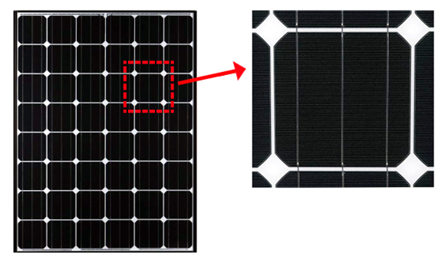
Figure 4: Monocrystalline Silicon Cells

As you can see most monocrystalline have their corner cut off. This is due to the impurity that are form when creating a square shape form a cylinder ingots. The impurity is then cut off to create a more rounded square shape. In fact solar panel 30 years ago used round shape cell instead of more modern square shape cells. They are also a more darker blue in color. The advantage of a monocrystalline cell is that since it is cut from a single silicon ingot it is the most efficient of all solar panel cells. It can have an solar conversion up to 25%. Of course due to this efficiency they are also the most expensive of all the cells in the markets.
Polycrystalline Silicon Cell Solar Panel
About early 2000’s if you wanted to buy a solar panels the only reasonable choice you have is monocrystalline. They were the most efficient and they only cost a relatively close to polycrystalline. Today polycrystalline has increase in efficiency to relatively close to monocrystalline and they still are cheaper than a mono cell.
Polycrystalline, unlike the single crystal silicon, are created by melting multiple smaller silicon crystals which results in loss of efficiency and then cutting them into layers. Polycrystalline has a lighter blue color and is more rectangular in shape due to the way it is process. As show in the figure below.
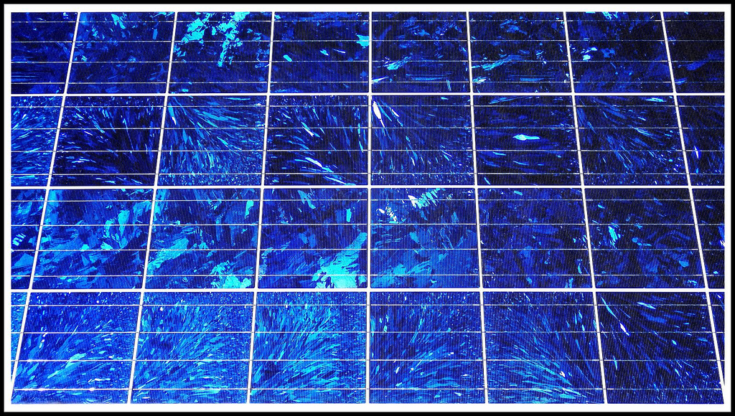
Figure 5: Polycrystalline Silicon Cell Solar Panel
Polycrystalline have an efficiency of around 20% which is still pretty high but it’s a little bit lower than monocrystalline. Due to these facts polycrystalline maybe the best choice for systems that are on a budget or system.

3.5.6.2 Thin Film
These are the cheapest of the three solar cells. The thin film cell technology is very new to the market today.They are created from a thin layer of non-crystalline silicon usually something like an amorphous silicon. Electronics mobile devices and motor vehicle are the main uses for these cells due to how extremely flexible and light compared to crystalline cells are making it easier for designer to create products and wide range of application.
These devices all on paper sounds like the perfect choice for most system but unfortunately they have a couple of major trade-off. For start they are very inefficient. Polycrystalline is a couple of percent less efficient than mono but it's still rather high compared to thin film. Thin film efficiency rate is around 10% that means that monocrystalline are over twice more efficient that thin film. Another trade-off of thin film is due to the nature of the product being thinh and flexible is that it is also very fragile compared to crystalline cell. For example it cannot withstand extreme coldness and can be easily cut, puncture or damaged. Due to these trade-off it might not be the best to use thin film for this current system. Below is a table detailing the various types of solar cells that also weighs the cost versus the size versus the efficiency to help the group come up with the best choice for the project.

Table 13: Solar Cell Comparison
 | Mono | Poly | Thin
Cost | Medium | Medium | Cheap
Size | Medium | Medium | Thin
Efficiency | Good | Good | Bad
Sturdiness | Good | Good | Bad

We will probably used the monocrystalline solar cell since they don’t cost that much more than polycrystalline but yet they still are a bit more efficient. Of course the the thin film is out of the question because we do not need it thinness in this project and lean more on efficiency and sturdiness. The polycrystalline are still a good choice to keep in mind if it turns out they are easier to acquire, but for now the monocrystalline seem to be the superior choice.

3.5.7 On-Grid vs Off-grid system

In solar panels you can have one of two types of system, one that stand alone by itself or an off-grid system or one that connect to a power utility grid.
On-Grid
On-grid are connected to a power utility grid system through inverter. The major benefit of this mean that they don’t need a backup device like a battery when they run low on power. This is helpful on days that there are no sunlights. For examples hurricane season in Florida will very likely limit the amount of sunlights for days or even weeks. When this happens unlike a off-grid system that will just stop working after the batteries die off, it will use the power in the utility grid to power the system. Another useful pros over an off-grid system is when there is too much power. If for some reasons there are extra power in the system the power will be transfer to the grid instead of shorting the solar panel and damaging the components. The cost also is cheaper since no extra supplies is need to power the system like backup batteries.
The trade-off for this is that it required a utility grid to be nearby to power the system. This results in limiting the flexibilities of placement of this system since it has to be fixed next to a power grid. Also setting up a grid system is a lot harder to do than a off-grid system and it is very taxing on time which for this project might not be very ideal.
Off-grid
Off-grid is the more commonly prefer system. Off-grid solar panel system do not need a utility grid it can hence “stand alone”. All system all build into the solar panel which makes setting the solar panel more flexible being not limited to having it next to a power grid. Other reasons that makes it more preferred is that it a lot simpler to set up. On-grid require special wires and knowledge to install the system onto a power grid, off-grid does not. Although it need a backup battery it is still a lot simpler than connecting to a power grid.
The trade off to a off-grid system is first off cost. Off-grid system can cost 3-4 times more than an on-grid system. Although this may be the case a smaller system the price is almost negligible compare to having it install to a power grid which might need to be professional done. Another tradeoff is that it doesn’t run on a power grid but a backup system. If there are days when sunlight is scared and the batteries runs out the system will lose all power since there are no other source of power connecting to the solar panel. This also isn’t a major trade-off since the project doesn't require a long period of time to power the system.

3.6 Wireless Communications

In our project, there are four main components that may need to communicate wirelessly. These four components are the main microcontroller (outside of pool), armband, speaker, and the parents’ mobile device. Some of these communications may or may not be done wirelessly. The armband, must of course communicate wirelessly because it will be attached to the child. The connection between the mobile device and the main microcontroller will also need to be done wirelessly. The speaker depending on how it’s implemented can be done wirelessly or directly into the stereo plug on the main microcontroller. There is also the issue of syncing the devices to the mobile application in the first place. Depending on how easily other connections are established it may be easier to do this over a separate channel than the internet. Also, communications regarding the status of different aspects of the project might also need to be dealt with. All of these factors demonstrate the importance of communications between all subsystems that make up the project.

3.6.1 Communication types and Capabilities

There are many options for how the data will be transmitted. We can of course use wireless methods such as Bluetooth, UART, and Wi-Fi, or we can use wired methods which may be advantageous in certain situations. Wi-Fi is best suited to communicate between two devices that may not be near other other. Wi-Fi is used to allow devices to connect to the internet so that they can have a means of communication. Bluetooth is very similar as it allows devices to communicate with each other as well. However, Bluetooth is used to pair two devices together so they can relay information directly with each other, without ever connecting them to the internet. If at all times the devices will be at a proximity of no more than 30 to 40 feet, then bluetooth would be the simpler option to go with. A Wi-Fi capable microcontroller will be absolutely necessary in this project so that the parent’s mobile phone can receive information from and send information to the base microcontroller, even if it is not near the microcontroller. Also, Wi-Fi would be necessary to transmit the video stream as Bluetooth does not have that capability. Although establishing a network and using Wi-Fi will be necessary, there may be ways bluetooth can be incorporated into this project. Below is a figure showing the different metrics that different protocols will use. Wifi is a clear frontrunner in many aspects, but Bluetooth does have strong abilities in the area of battery life. Though these are only a few specifications that make up each of these protocols, they are a good starting point for looking at the tradeoffs involved in choosing one technology over another.

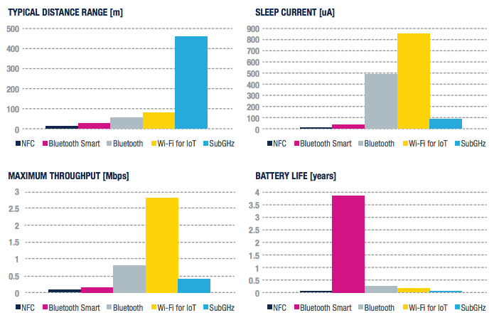
Figure 6: Wireless Communication Statistics

3.6.2 Camera and Speaker Connections

Due to the fact that we plan to have the camera and the speaker next to our base microcontroller, these connections will probably be wired. However, Wi-Fi and Bluetooth will come in handy when we need to communicate data between devices that may not be close in proximity. The base microcontroller on the outside of the pool must always be connected to Wi-Fi. This will allow for key information to always be accessible if needed, on the parent's mobile device. This of course is assuming that the parent’s mobile device has access to internet through data or Wi-Fi.

Regardless of how the camera is attached to the base microcontroller, we must use Wi-Fi to transmit the video stream to the mobile application. Wi-Fi is the only technology that is capable of transmitting the data in this situation. As long as the mobile phone has access to internet via data or Wi-Fi and the microcontroller is properly connected to the Wi-Fi, the video stream will be able to relayed to the phone in the case of an emergency.

The speaker may be wirelessly connected to the base microcontroller via Bluetooth or wired directly in using a stereo plug. If we were to use a Bluetooth speaker, the speaker must be paired with the base microcontroller. In the event of an emergency, the parent would relay to the base microcontroller to sound the alarm. It would then be the job of the microcontroller to send an audio file (alarm tone) to the speaker via Bluetooth. The mobile phone would not be setup to communicate with the speakers directly because the phone will not always be in close proximity to the speakers. The only reliable way to activate the alarm would be for the mobile phone to notify the Bluetooth-capable microcontroller to activate the alarm.

3.6.3 Mobile Device

The mobile device will need to have access to internet either using data or Wi-Fi. Given that the device has internet connection, it will be able to be wirelessly interfaced with the base microcontroller. This is assuming that the base microcontroller is properly connected to a network using Wi-Fi. Bluetooth would not be a reliable connection between the mobile device and the base microcontroller because Bluetooth can only function at distances of about 30-40 feet. The parents’ phone will need to have a stable connection to the internet in order to view the incoming stream without issues. If the connection is weak, the rest of the mobile interface features may be able to still function. However, the streaming feature will require a stable and strong connection in order to properly work [43].

3.6.4 Bluetooth Technology

Bluetooth may be able to be used for several tasks in our project. The first way Bluetooth can be integrated is to communicate from the armband to the microcontroller on the main unit. These Bluetooth equipped microcontrollers can be integrated by communicating to a UART on the main microcontroller. A Universal Asynchronous Receiver and Transmitter is used for communication with serial input and serial output devices. The perks of using this technology is that is saves costs due to wiring. This would enable the armband to relay specific data to the main microcontroller. If the child wearing the armband was at a distance of more than 30 feet away from the main microcontroller, which will be on the perimeter of the pool, there most likely will not be an established Bluetooth connection. This is not a huge issue because the purpose of the product is to only alert the parents in the case that the child jumped into the pool. As long as this bluetooth connection is reliable when the child is near the pool, the product would be fully capable of serving its purpose. The variations between classic Bluetooth technology and Bluetooth Low Energy technology are shown below.

As seen on the chart below Classic Bluetooth technology and Bluetooth Low Energy technology both operate using radio frequencies of 2.4 GHz. Using either of these technologies as a means of communication between the armband and the base unit may be an issue because of the pool water absorbing the signal. This signal may not be able to transmit if the armband becomes submerged in the water quickly. This would all depend on how the armband/child fall into the pool and how quickly the signal can be sent out before it is completely submerged.

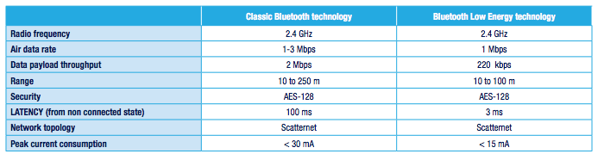
Figure 7: Classic Bluetooth vs. Bluetooth Low Energy

3.6.5 Band to Base Unit

Several technologies may be able to be used depending on how the armband is constructed and how testing goes. The simplest and most efficient way for the armband to transfer data/signal to the main microcontroller would be via Bluetooth. Testing will need to be done to see if the signal is consistently able to be sent, even if the armband is submerged in water. If this method is proven to be unreliable we will need to transmit the signal using much lower frequency waves than Bluetooth technology uses.

Senior Design II edit: For the wearable device, we ended up using an ESP8266-01 Wifi module because bluetooth would be unreliable as the child may be at a distance that is too far from the main unit. Although the Wifi module consumes more power, it allows the wearable device to communicate with the main unit at much larger distance
Another option for connecting the band to the base unit is to use ZigBee technology. ZigBee has a maximum data rate of 250 kbps, which is sufficient for sending a simple signal from the band to the base unit. The benefit of being a low data rate protocol is that it uses very little power in comparison to other wireless technologies. ZigBee operates within the 2.4 GHz frequency band and can operate at distances up to 50 meters.

3.6.6 Wi-Fi Technology

Wi-Fi technology is designed to connect electronic devices in a wireless local area network (WLAN). Devices that are within the WLAN or devices that are connected to the internet can exchange data or connect to the Internet at a data rate of 54 Mbit/s or more. This technology is based on the IEEE 802.11 standards operating in the 2.4 GHz (IEEE 802.11b/g/n) and 5 GHz (IEEE 802.11a/n/ac unlicensed bands available worldwide). Wi-fi will need to be used in order for the mobile application to communicate with the main PCB and the Raspberry Pi. There is no alternative to Wi-Fi that we could use to successfully implement the video streaming feature. Although Wi-Fi allows for fast data transmission, it requires more power to use. Wi-Fi is also more expensive in comparison to other simpler wireless connection methods. This technology would not be practical to use for communication between the main PCB and the band because fasta data transmission is not necessary and the power consumption would be too high.

3.6.7 WPAN Technology

A wireless personal area network (WPAN) is used to wirelessly connect an assortment of electronic devices. A WPAN is a short-distance network which is designed to work at ranges up to approximately 50 feet. Bluetooth is one of the most common WPAN technologies. WPAN based technologies have many advantages. One important feature is the ability of each device to lock out other specific devices, which prevents unnecessary interference or unauthorized access to information. Another key feature is that the technology has low power consumption. This is a great feature to have in a system that is already constrained in power usage due to relying on a solar panel as the primary form of energy. This could be a strong contender if the distance between the units is small.

3.6.8 USB Wifi Dongle/Adapter

A Wi-Fi adapter will not be necessary if we choose a microcontroller with built in Wi-Fi capability. However, if we choose a very basic microcontroller a Wi-Fi dongle can plug into a USB port to provide Wi-Fi. We may need to download a driver on the microcontroller to make it compatible. Although using a USB Wi-Fi adapter is typically cheaper than getting a Wi-Fi chip/module for a microcontroller, the adapters lack many useful features. Embedded Wi-Fi chips will have less compatibility issues with majority of the microcontrollers. The key feature that lacks with the USB adapters is that they don’t handle the TCP / IP stack. Later once a microcontroller is selected and it is determined if the Raspberry pi is a viable alternative, we will look at selecting particular units that are compatible. If the Raspberry pi is selected it will have built in capabilities that would invalidate this research.

3.6.9 CC3120 TI SimpleLink Wi-Fi Network Processor

In the case that we select a microcontroller that is not Wi-Fi ready, we can install this chip to allow the microcontroller to be connected to Wi-Fi. This chip is compatible with many microcontrollers and is relatively easy to attach to the circuit board. In terms of power consumption this chip allows for low-power internet connection. CC3120 SimpleLink consists of a Wireless Network Processor and Power-Management Subsystems, which will allow settings to be customized for maximum efficiency. Lastly, this chip has a dedicated ARM®Cortex®-M3 MCU, which offloads Wi-Fi and Internet Protocols from the application MCU. This option would be necessary if we needed better performance and certain features such as RESTful API support using an internal HTTP server. This is a normal and safe protocol to use for transfer of data.

3.6.10 Serial Communication Technologies

Serial communication involves sending data one single bit after another over a communication channel. Parallel communication involves sending many bits as a group over parallel channels. Parallel communication is not useful for long distance connections due to the high-cost of cables. In general parallel communication methods are more powerful but is not always the best method when working with simple microcontrollers. Serial communication can be set up using few I/O lines on a microprocessor which may be advantageous for us depending on the microcontrollers we end up using. USB, ethernet, SPI, and I²C are just some of the more common serial interfaces.

3.6.11 Synchronous Serial Communication

This form of communication features a controller device which sends a clock pulse to one or more devices. Every time the clock changes a single bit of data is exchanged between the devices. Serial Peripheral Interface (SPI) and Inter-Integrated Circuit (I²C) are two common forms of synchronous serial communication protocols. The controller device directs the peripheral devices when to acknowledge or ignore the bits that are traveling through the communication channel. The same data and clock lines are shared by all the devices that are part of a synchronous serial chain. SPI and I²C use different methods in order to direct the peripheral devices. In the I²C bus configuration it can be seen that only two connections are necessary between the controller and the peripherals. In a typical SPI bus configuration each peripheral gets its own chip select line, while all the other lines are shared.

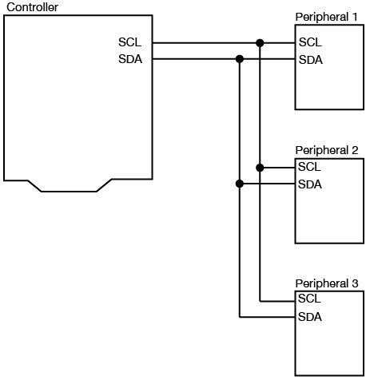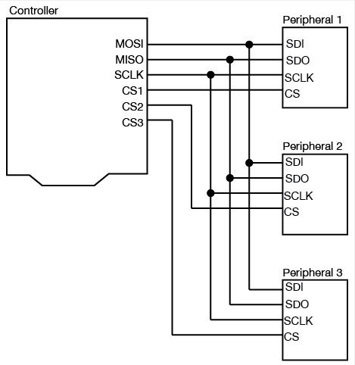

Figure 8: Inter-Integrated Bus Configuration Figure 9: SPI Bus Configuration

3.6.12 Asynchronous Serial Communication

In this form of communication, pulses representing the data are sent at a data rate which is mutually agreed upon. The receiver will listen to the data at the same data rate at which it is sent. The key difference between asynchronous and synchronous communication is in asynchronous communication, both devices have a clock and keep time independently of each other. Universal Asynchronous Receiver-Transmitter (UART) is a commonly used communication of this type. Moreover, it is a method that we may use in our project. In UART communication, the transmitting UART converts parallel data from the controlling device, into serial form and then sends it to the receiving UART. The receiving UART will then convert the serial data into parallel data for the receiving device.

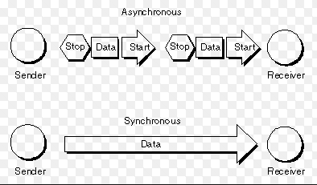
Figure 10: Asynchronous and Synchronous Communication

3.6.13 ZigBee Technology

ZigBee is used as a wireless solution that allows devices to communicate while consuming very little power. The protocol’s network architecture is very secure and reliable. Some advantages of the ZigBee protocol are encryption, low latency, collision avoidance, and support for mesh networks. This technology can be beneficial if used for the communication between the wearable device and the main system. The reason for this is because it will allow the wearable device to operate using a cheaper and smaller battery. ZigBee operates in 2.4 GHz, 900 MHz, and 868 MHz bands. The technology itself is described as a packet-based radio protocol that is intended for low cost, battery operated devices. This could be a solid option if security is a major concern in the project, though it may end up being overkill for the requirements.

3.7 Main Housing

Waterproof enclosures are used in all types of industry, from oil fields to iPhone cases. But the term “waterproof” is subjective and it needs to be determine how much of “waterproof” is enough for the project? The International Protection (IP) Marking System also called the “Ingress Protection” marking system, this system of evaluating electronics housings gives the understanding of meaning “waterproof,” by giving real tests that must be passed at different levels. The system has two unrelated numbers following the IP: The first number indicates the level of dust proof, the second indicates how waterproof an enclosure is. The most common markings used in the market for housings are IP67 and IP68.

The IP6x means that it’s dust proof and that no particles of dust can get inside. While that can be important, most industrial and consumer uses are more concerned about the waterproof rating. Dust proof is certainly not a given with waterproof design, but once seals protect against spraying water, most people will assume they protect against dust. For most applications, the lowest rating considered “water resistant” is IPx4. This describes many older watches and means that the interior parts will keep working after a splash of water, but any more water will be an issue. IPx5—if you spray protected housing with water from any angle, the interior parts keep working—but at this level, the spray is light. This is a good level for a “rain-proof” housing, and a lot of phone housings come from the factory with this as a basic level of sufficiency.

At IPx6, housing needs to be sprayed for several minutes with a 100-liter-per-minute jet at 15 psi. Most consumer electronics can’t handle this. So, our goal to protect out design enough to be compared with IPx5 rating. Effective sealing for high IP ratings has the potential to add product size and cost so it’s always best to know “how sealed is sealed” for you. Once its determined that you need to seal to a high performance standard the best policy is to keep it simple. Simple geometry, simple parting lines, and simple part interfaces and stack ups are all invaluable. Producing reliable seals in the context of real world manufacturing constraints is inevitably is a challenge. Here’s a short list of items to consider in simplifying design proposed by Andrew Weiman, Managing Partner Engineering and Commercialization, Bresslergroup [19]:

1. Start with circles – The easiest opening shape to seal is a circle because you can use standard o-rings and robust radial type seals, which provide uniform sealing force around the circumference.

2. When possible, avoid sealing between three (or more) part interfaces – three way seals can be achieved but ensuring proper gasket compression between three (or more) parts within standard part tolerances tends to be a manufacturing challenge.

3. Proper gasket glands are important – stand-alone gaskets need to be well supported on all sides. Gaskets “squirting” out of the pinch zone is a common source of seal failure.

4. Tolerances matter – The stiffer the parts, the easier to seal. For example, plastic enclosure deflection under the load of a gasket cannot be ignored. Likewise gasket compression percentage is something that needs to stay within a reasonable range [19].

3.7.1 Sealing Designs

There are many different types of seals, three of the most common are face gaskets, static o-ring seals, and dynamic o-ring seals.

3.7.2 Static O-ring Seals

Such design is good if the connection we are trying to seal is more or less round and the two mating parts are going to stay together forever. O-rings come in a wide variety of sizes, denoted by the “dash” number. Dash number is an ASTM designation that indicates a standard size. Generally, the larger the last two numbers the larger o-ring inside diameter I.D., while a larger first number indicates a larger cross-section diameter. When using an o-ring as part of the seal design, a groove needs to be design where the o-ring can sit. The groove design remains mostly the same, because only internal diameter for round seals, internal perimeter for non-round seal shapes, the percent stretch of the o-ring, the cross sectional diameter, and the percent squeeze need to be a concern[16].

Limitations of O-ring use are given as: “Although it has been stated that O-rings offer a reasonable approach to the ideal hydraulic seal, they should not be considered the immediate solution to all sealing problems. It has been brought out in the foregoing discussion that there are certain definite limitations on their use, i.e., high temperature, high rubbing speeds, cylinder ports over which seals must pass and large shaft clearances. Disregard for these limitations will result in poor seal performance. Piston rings, lip type seals, lapped fits, flat gaskets and pipe fittings all have their special places in hydraulic design, but where the design specifications permit the proper use of O-ring seals, they will be found to give long and dependable service.”[17].

3.7.3 Dynamic O-ring Seal

Dynamic O-ring sealing applications are considerably more involved than static applications due to the implied motion against the O-ring seal interface. O-rings are best when used on short-stroke, relatively small diameter applications. Millions of O-rings however, are used very successfully in reciprocating hydraulic, pneumatic, and other fluid systems which employ long stroke, large diameter seals. If designed properly, an O-ring seal will give long, trouble-free service.Preferably, metallic moving surfaces sealed by an O-ring should never touch, but if they must, then the one containing the O-ring groove should be a soft bearing material. It is impossible to run a highly polished piston rod through a hard bearing without inflicting scratches on the rod. It is likewise impossible to slide a hard piston in a highly polished cylinder and not inflict scratches on the cylinder wall. The scratches are usually caused by small hard particles that are loosened and picked up by the oil which sooner or later become jammed between the moving surfaces and score them. [18]

3.7.4 Gasket Design

As with o-rings, the compression needed to be considered for design and the thickness, based on the tolerances of the two mating faces. When bolted together, the surfaces will warp between bolts, so consider how to space the mounting hardware to keep the warp sufficiently minimal to still seal with the thickness of gasket you specify. If you bolt two parts together on the four corners, the center area will be further apart than the corners. If that gap is greater than the thickness of your gasket, a housing will leak. Likewise, if the gasket is too hard and doesn’t allow for the roughness of the two surface, a housing will leak—so, it is important to have gasket material soft enough to allow for some machining marks.

When beginning the design of the housing, lower resolution materials are great for getting the fit, function, and aesthetics right, before testing the actual waterproof capabilities of the design. 3D printed PLA is a great first pass to see the enclosure look, and materials like 3D printed ABS and Nylon can test part interfaces. And if custom gaskets will be required, printed rubber-like first prototype will be a good choice [16]

3.8 Software Tools

Due to the importance of the mobile application to the success of the project, as well as the necessity to program and debug the microcontrollers in the project, research into the tools and languages available to complete these goals is warranted. Any additional supportive tools to the rest of the project will also be investigated, including collaboration software.

3.8.1 Android

The android operating system is a unix-like mobile operating system developed by Google and released first in 2008. Since then there have been many updates and the current version is 7.1.2 Nougat that released in April 2017. In regards to market share, android is by far the most popular mobile operating system. In 2016 it made up 81.7% of all cell phone operating systems, a dominating amount that seems to be continuing upwards. As we want our product to be marketable to the largest group of people, it makes sense to develop primarily for android.

Table 14: Market Shares of Mobile Operating Systems
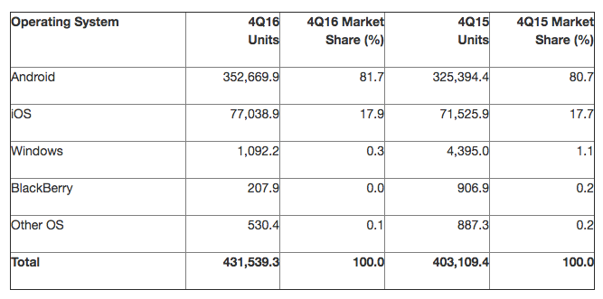

The platform that was made for android development is google’s android studio. Put out by Google in 2013, this IDE makes developing for the android platform as easy as possible. It has gradle build support with android specific code refactoring to allow bugs in the code to be fixed automatically. It uses the Java programming language primarily, with some support for doing certain tasks in C or C++. It also supports a couple of more obscure/newer languages such as Go, but these will not be utilized as nobody has any experience with them and they have much more limited API support. A large open source community also supports development for the platform should more advanced functionality that would be difficult to program alone be called for. These libraries are open source and so it is easy to pull all of the required functionality and implement it as needed.

As far as specific development tools beyond programming, android studio also has a drag and drop component interface that makes actually positioning the elements where you want them to be on the screen very simple. It also comes equipped with a built-in android emulator that will be useful since not all group members possess an android device of their own. This emulator could also be useful in insuring the product works on older versions of android as supporting older versions of the system can only expand our market. One last thing that makes this platform so great is it is heavily integrated with all of Google’s services, such as mapping. This could be very useful depending on the software requirements.

3.8.2 Apple IOS

Apple’s IOS operating system, while controlling a much smaller market share, is effectively the only other mobile operating system worth supporting due to the market shares of the others being miniscule in comparison. However, part of this difference in percentage of phones can be attributed to Apple’s marketing strategy. The ios operating system is only able to run specifically on Apple devices while android runs on any other hardware provider’s platform. Most development is done in either objective-C or the recently created swift, which is based heavily on objective-C. One nice thing about developing here as opposed to for android is how many fewer versions there are. As shown below, the distribution of versions is much more centralized than it is for android, which could make support for the application much easier.
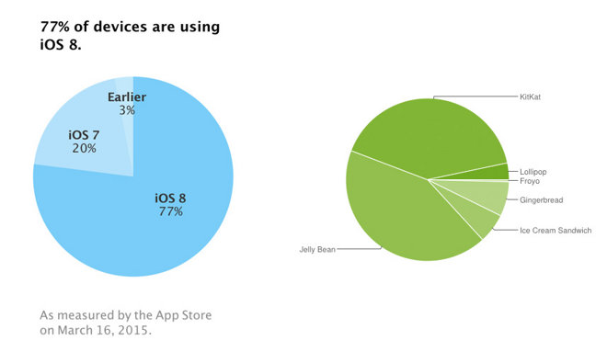
Figure 11: IOS and Android Versions

In developing for the ios device, generally Apple’s IDE xCode is used. Much like android studio, this IDE comes with a built in GUI building tool that should make laying out components very simple. The IDE also supports a number of languages including objective-C, swift, C, C++, Java, Python, and more obscure ones. This could be helpful if the group member assigned to app design is less comfortable coding in a new language and instead use one with which they are more familiar.

3.8.3 Atmel Studio

Atmel studio is the primary IDE for development on Atmel’s ARM and AVR based processors. If one of these microcontrollers is chosen for the project, this could be a useful tool in speeding up development. It has support for C, C++ and assembly code and can even import arduino sketches if it is found to be easier to develop those. It can connect to all atmel debuggers and development kits for ease of use. Additionally it has built in debug modes along with chip simulation to aid in the tedious process of debugging. It additionally houses a multitude of libraries and plugins to help developers focus on their application logic without having to right tedious code.

3.8.4 Git and Github

Git is version control software that is optimized for iterative software development. The primary use would be in keeping the code more organized while allowing versioning that aids in pinpointing where bugs are in code. Additionally it helps if multiple people are working on the same code as it allows merging and fixing of merge conflicts that would be nearly impossible by hand. Due to the large amount of software associated with creating a phone app in addition to code for at least one microcontroller, the team felt it would be useful to look further into ways to help with the problems implicit to software development. With git, each contributor would maintain their own local version history, called a repository, as well as a singular for everyone remote repository on github. This remote repository can be pushed to and pulled from, with the active user needing to resolve any conflicts in the code before committing.

Git is available through either a command line interface or several third party GUI vendors, available for free. All these GUI interfaces similarly allow for a more visual representation of the commit tree structure and allow for generally easier but less powerful interfacing compared to the command line interface. Source tree is the current client being used, but each contributor can have their own preferred interface and other options include tortoiseGit and Github desktop. The reason the client doesn’t matter is the remote repositories are stored in the cloud in github. Github features all the options that git offers and mimics the repository structure, but remotely so users can push and pull freely from and to the remote repository and insures that there is only one primary version of the software at a time.

3.8.5 Eagle CAD

Eagle is PCB design and schematic capture software for electrical design. It is used by many of the top circuit board makers including adafruit who makes the raspberry pi and arduino who makes the popular arduino boards. It is professional grade and normally would cost 100$ per person. However, a student version is free for three years and all the school computers have a copy. One of the biggest advantages of this software is the extensive libraries that come with it. Between the built in libraries supplied by manufacturers and the team that created it themselves, most of the necessary pcb components are available. The fact that it features schematic capture software and PCB in the same program is also nice for moving the design from schematics to circuit board. Also it is extremely easy to find additional schematic designs on code sharing sites such as github. This means that even if a part isn’t supported natively, hand made design is most likely not necessary as another user has made their implementation open source. This is a feature that is not to be underestimated.

3.8.6 Google Drive

Google drive is a collaboration platform that facilitates document transfer and editing. One of the biggest advantages of drive over other collaboration platforms such as Slack and dropbox is its integration with google docs. This will allow all group members to edit the same document simultaneously, eliminating the awkward back and forth that comes with attempting to compile the entire document at the end with only one person. It also features all of the other attributes of collaboration software and allows for the easy storage and transfer of files in one central location.

3.8.7 Eclipse

Due to the nature of the raspberry pi, being a fully functional computer with a fully functional operating system, it is necessary to develop programs that will run on it just as you would for any operating system. Eclipse is an open source IDE that is primarily used for java development, but features plugins that allow for development in a multitude of languages including C, C++, python, and many others. It also has built in git integration that can facilitate the transfer and sharing of the code base between group members. Additionally it has an extremely active community to assist new members in raspberry pi development, as well as software development in general. The community also sports a large amount of open source libraries that further facilitate in development and make Eclipse one of the most popular IDEs in use.

3.9 PCB

One major requirement of this project is to have a working PCB. A letter grade will be deducted if this isn’t meet. Aside from a grade requirement PCB is a clean ways to create a microcontroller that can help with the operation of the project. It also flexible so creating the design around a pcb can be a lot easier than other circuit.

3.9.1 Why PCB
Here we will compare PCB with other major circuit boards and we will see why PCB is a great way to create circuit board and that it’s not just a grade requirement. The other boards we will compare PCB to are breadboard and prototype board.

Breadboard:
Breadboard is the most commonly used circuit board for beginners. It is easy to used and required no soldering experiences. Due to this fact breadboard are also extremely cheap. A board itself cost less than $10 and since no soldering is needed you are able to replace broken component without having to replace everything in the circuit. Also test the circuit is extremely easy compared to PCB as it just swapping out parts with other parts as necessary without having to redesign.
The trade-off of pcb is that is not professional looking. It looks like a toy for kids (some even advertise as this) which make marketing to the general public rather hard. Another trade-off is that the components of the board can easily fall out since they are not solder onto the board. This cost a problem in the flexibility of most project design like our when the board need to be drop into the water.

Prototype board:
Prototype board are a little bit more advance than a breadboard and more closely related to a PCB. They are a bit more professional looking and are usually used to understand what a PCB is going to look like. They are also a bit cheaper than PCB because they usually used wire and the board itself is cheaper.

The trade off once more it’s how professional it looks. Most prototype board have wires and solder all over the place and is fine for testing but for the main product it won’t be the best choice.

PCB:
PCB is the most expensive of all the boards. If any components get broken or the design doesn’t work correctly the board has to be scrapped and starts from the beginning. This could cost a strain in the budget. That why it’s recommended to test out components and design before actually creating a PCB.
Although the cost is high it is the most profession and secured circuit board. All items are solder onto the board and all wires are printed making it smaller in size and more flexible for design.

3.9.2 Simulation

Simulating circuit design for PCB is extremely important because unlike the breadboard where components can be switch all the times. The PCB have to be created all at once and so if the circuit design doesn’t work, we have to start over and will cost us more time and money. By having a simulation before hand it limit the mistakes in our design.

Mutilism:
Is the main simulation program we have the most experience with since it is the main simulation we used for most electronic courses. The user interface is a bit easier to use than other circuit software. Mutilism cost a bit but most computer on campus in the engineering build has this program. The major trade-off of this program is that it cannot design PCB but simulates the way the circuit behaves.

ORCAD:
ORCAD is an autocad program for designing PCB. For specific PCB design this program can be very useful due to it own installed library and components. It also have more customer support because it’s a privately own software you pay more for getting help from the ORCAD company but sometimes you get what you pay for.
The trade off is that since it is a private company there not too much open source such as youtube that can help you in your design. Also it cost a lot more than open source cad program and the interphase is much more specific for certain designs.

Eagle:
Eagle is the most generally used in PCB design. The company has free open source program with plenty of libraries and components to buy from. There are many textbook and open source like youtube to help you get used to the interphase of this product. The trade-off to this is that unlike Mutilism there is still a major learning curve for our group. Most of us have never used Eagle before. Also Eagle is more for general uses so if we want an or specific libraries and components Eagle may not be the best choice.

3.9.3 Layers
PCB can have multiple layers. To save space we could stack as many layers and we can. Although it is safe space having more layers will cost more and can be a harder to design.
1 Layer:
Having one layer is very simple. It is easy to see and design. If any components is damaged it is also the simplest to salvage the remaining parts. It is also the cheapest to build. The trade of is the size, it will need more space since everything is done on one side. Since the size is bigger than most other layers the flexibilities will also be decreased and it will make it harder to design certain application.

2 Layers and 4 Layers:
These are the most commonly used layers. It safe more space than 1 layers but it’s still as isn’t that expensive but still cost more than a single layer. 2 layers have a layers on each side while 4 layers have power and ground embedded in the middle. This makes it smaller in size and can have more circuits doing more work on a single board. This will in turn increase the flexibility for this design and make it simppler for other applicatio. The trade-of for having more layers is that the design gets harder and everything is hard to savage when things goes wrong.
Any layers after 4 has roughly the same ideas and will just cost more to make and save more spaces. Layering can go beyond 35 layers so there isn’t really a limit on how many layers a PCB can have. It’s just depend on the necessity and budget of the project.

3.9.4 PCB vs Microcontroller
There’s not too much differentiation between microcontroller like the Raspberry and the Arduino aside from the facts that PCB doesn’t need to have a microcontroller. This makes it more flexible for more simple design. The trade off is the the microcontroller is already pre-build and can save you time. Also the microcontroller is guaranteed to work as for the PCB you have to design and implement yourself.

Table 15: PCB vs Microcontroller
 | PCB | Microcontroller
Require for project | Yes | No
Cost | Medium | Medium

We are probably going to use both since one is required and the other makes the project a lot easier.

4 Design Constraints and Standards

This section of the report deals with realistic constraints on the project and how they will be handled. Additionally, it details standards related to all aspects of the project. These standards differ from the constraints in that they are presented by organizations as proper form in engineering in order to promote safety, efficiency, and reliability.

4.1 Design Constraints

When designing any engineering project it is important to always keep in mind realistic design constraints that influence the development of the product. If these are not kept in mind from the inception of the project, inevitably the quality of the product will suffer or development time and costs will skyrocket. It is very easy also to get caught up in the idea of a product and the end goal without stepping back to think about what is realistically possible. For these reasons our team felt it was important to keep constraints in mind from the beginning of the project.

4.1.1 Economic and Manufacturing Constraints

In regards to funding of the project, the cost of components is important to keep in mind for several reasons. First is that the team does not have a sponsor to aid in funding. In many non-voluntary projects the costs are paid for either by the employer of the team, but in this instance the team must come up with all funding by themselves. For this reason, it is additionally motivational for the team to get correct estimates on the cost of the project so that they can prepare savings to spend on materials. It is additionally in the interest of the group to insure that all components of the project are correct in the first place, due to them having to pay for any replacement parts or parts that were not accounted for in the first place.

Additionally when dealing with economic constraints, it is in the best interest of the success of the product to have low cost of materials to insure a low selling point. Due to the nature of economics, if our product can be manufactured at a lower price point than our competitors, we will gain a market edge and will inevitably be more successful, assuming identical functionality. It is also important to keep in mind the availability of the various components, particularly in bulk if the device is to be mass manufactured. If a certain component must be individually purchased at a high price tag, it may end up bringing down the large scale production aspect of the project.

As far as creation of the prototype is concerned, the housing production is one of the major concerns. Due to limitation of resources for creation of solid materials to be used in the housing, the cost of producing the prototype housing will necessarily be higher than it would in mass production of units.

4.1.2 Time Constraints

The time constraint is definitely one of the most crucial constraints that will be present throughout the course of this project. This project has a strict deadline which is by the end of Senior Design II. Since this project is the first time our members have worked together, it will be important that we set deadlines and frequently communicate with each other to make sure we are all on the same page. It will be key for our team to stick to our schedule that we have set forth so that we have a high chance of being successful in what we have set out to complete. Moreover, it is necessary that we spend our time wisely and not let any issues hold us back.

Focusing and succeeding in the development of the PCB will be key to keeping us on track and finishing our project on time. It will be important to make sure that all team members have carefully reviewed the PCB design so that our first design has a higher chance of being successful. This is a piece of our project, that if not successfully designed, can cause the project to be significantly stalled and stressful. After designing the PCB, it must be tested immediately. If there is an issue, it must be resolved quickly so that a new order can be placed promptly.

4.1.3 Environmental Constraints

One of the fastest growing concerns in engineering is the product's impact on the environment. These are important to keep in mind first due to ethical concerns about the future of the planet and the environment on a broad scale. On a personal level designing something that adds unproportionately large amounts of pollution or consumes far too much energy will inevitably lead to greater struggles down the line and for future generations to deal with. On a more economical side, being able to market a product as environmentally friendly will increase demand from people sharing similar concerns about the health of the planet and may lead to a much more popular product. Our device achieves this primarily through the power supply for the main unit being powered solely through solar power, a good source of renewable energy. Because of this it is important that the device is able to benefit from this energy source and positioned in such a way as to get the optimal energy throughput from the solar energy source.

4.1.4 Social Constraints

Our main goal for designing this project is to create a product that will have the capability to save children from drowning. In order to accomplish this, our system must be affordable to many people. There are many ways to protect children from drowning, such as putting an enclosure around the pool or even placing a full safety cover on top of the pool. Our product, if successful, will achieve the same results at much lower price. Our product should easily be able to be installed. People who are not technically sound should be able to follow simple and concise steps in order to make sure this product is able to function correctly. The base unit, which will be on the perimeter of the pool should be lightweight and easily transportable by anyone that may use it.

4.1.5 Sustainability Constraints

Due to the nature of the device needing to be in constant monitoring mode, the longevity of the system is of utmost importance. If any part of the system fails to perform, the entire system will fail meaning each component must be designed to last. Also due to the nature of having a child's life being at risk in the event of system failure, the chance of any component malfunctioning must be as close to zero as physically possible. In reality it may be very difficult to insure this due to the nature of an electrical device being so close to water, which means the waterproof housing must be top quality to insure the continued functionality of the system. In addition to the main system needing to be waterproof, the wearable device will also need to be in prime condition. This is because it will surely be exposed to water, possibly multiple times and if at any one of those time it were to break, the child’s life could be at risk. Additionally it will need to be at least somewhat resistant to bumps as children generally fall down and run into things as they play.

4.1.6 Health and Safety Constraints

Our system must always be responsive and ready to perform efficiently if an emergency arises. Since this system is used for emergency situations it will need to be thoroughly tested so it can perform without faults. If the system is faulty and fails to notify the parent in an emergency it may lead to a child drowning. Parents using this system are relying on it to protect a child in the event that they end up going into the pool.

This system has many pieces and technologies involved. Although the device will be constructed carefully and thoroughly tested, there is always a chance that it will malfunction. It will be important that we design the product with certain features which will continuously monitor the state of the device. This will help make sure the parents are aware if the device is not correctly working.

Although there are several powered devices in this project, the armband will receive extra attention in regards to health concerns. This is because the armband will on the child's body. It will be important to make sure proper testing and research has been done so that there is no risk of harming the child. The armband must be able to function in a safe manner even if it is exposed to water when a child enters the pool. Dealing with electronics and water is always something that is important to take into account, but when a child is involved the stakes are raised even higher.

4.2 Engineering Standards

There are many standards that are important to consider while developing our project. Most of the standards that will be relevant throughout this project are related to wireless communications, microelectronics, and power supplies. Understanding and taking into account the standards for the many technologies we use will help ensure the end result works without interference and in a safe manner.

4.2.1 802.11 Standards

802.11 is a group of standards that include six wireless techniques that all use the same Layer 2 protocols. The 802.11a standard uses the 5 GHz frequency band and IEEE 802.11b and 802.11g use the 2.4 GHz frequency band. If 802.11b or 802.11g equipment operate in an unregulated frequency band, there could be interference from phones, microwave ovens, or other devices. The IEEE only sets specifications and does not test equipment for compliance. The Wi-Fi trademark is owned by a trade group, the Wi-Fi Alliance. Wi-Fi can mean 802.11a, 802.11b, or 802.11g, and it does include the security standard Wi-Fi Protected Access (WPA/WPA2). Wi-Fi capable products should note the frequency band (2.4 or 5 GHz) in which they operate. The maximum data rate varies drastically between the different standards as seen below.

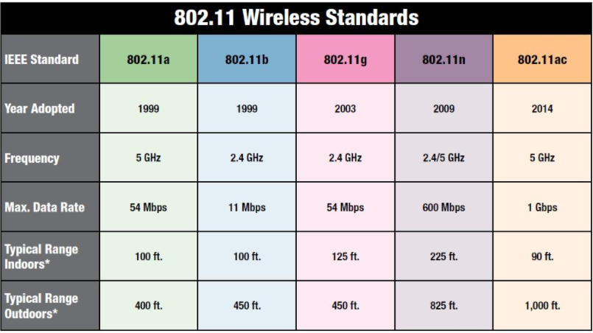
Figure 12: 802.11 Wireless Standards

4.2.2 Bluetooth Standards

Bluetooth is a wireless technology standard that uses short-wavelength ultra high frequency radio waves in the ISM band from 2.4 to 2.485 GHz to send data over short distances. Bluetooth uses frequency-hopping spread spectrum which is a radio based technology. Data is divided into packets which are sent on one of 79 designated Bluetooth channels. Each of the 79 channels has a bandwidth of 1 MHz and with Adaptive Frequency-Hopping activated, it typically performs 800 hops per second. Bluetooth Low Energy uses 2 MHz spacing, but has only 40 available channels. Bluetooth utilizes a master-slave structure and one master can communicate with up to seven slaves. The master directs the basic clock, which operates at 312.5 $μ$s intervals.

Table 16: Bluetooth Standards
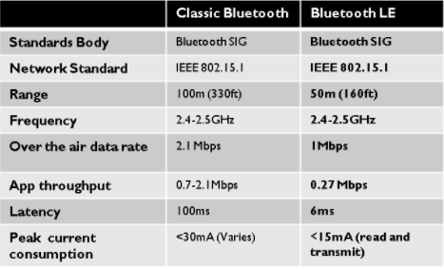

4.2.3 Standards on Sensors

Why do we need sensor standards? As in any other field the parts of different interest should be compatible, and if design required, can become as one system. Therefore standards are helping to keep consistence among different protocols and simplify the product development. In other words standards are important because they are building blocks of product development.

4.2.3.1 Temperature Sensor Standards

There are multiple temperature standards exists. They include standards of how to calibrate temperature, temperature scaling, resistance used, medical safety and so on. American Society for Testing and Materials International (ASTM International) is one of the organizations that have multiple standards involved in temperature sensor development. According to wikipedia.org “ASTM International is an international standards organization that develops and publishes voluntary consensus technical standards for a wide range of materials, products, systems, and services. Some 12,575 ASTM voluntary consensus standards operate globally.” It is not in our intense to design a temperature sensor but the sensor we will choose for the project have to imply with the standards related to the temperature sensor listed below. Here are some of the standards of ASTM related to temperature and calibration:

- E 1594-99 Standard Guide for Expression of Temperature. This guide covers uniform methods for expressing temperature, temperature values, and temperature differences and is intended as a supplement to IEEE/ASTM SI-10. IEEE/ASTM SI-10 document defining the primary American National Standard on application of the metric system. It emphasizes use of the International System of Units (SI), which is the modern, internationally accepted metric system. It includes information on SI, a limited list of units recognized for use with SI, and a list of conversion factors, together with general guidance on style and usage. The word "primary" implies that other metric standards in the United States should be consistent with this document.[21])

- E 344-01a...Terminology Relating to Thermometry and Hygrometry
- E 563-97 Standard Practice for Preparation and Use of Freezing Point Reference Baths
- E 1502-98 Standard Guide for the Use of Freezing Point Cells for Reference Temperatures
- E1750-02 Standard Guide for Use of Water Triple Point Cells

Other standards related to devices measuring temperature, electronic thermometers and others:

- E1104-98 Standard Specification for Clinical Thermometers Probe Covers and Sheaths
- E1112-00 Standard Specification for Electronic Thermometer for Intermittent Determination of Patient Temperature
- E1965-98 Standard Specification for Infrared Thermometers for Intermittent Determination of Patient Temperature
- E 1213-97 Standard Test Method for Minimum Resolvable Temperature Difference for Thermal Imaging Systems (MRTD)
- E 1311-99 Standard Test Method for Minimum Detectable Temperature Difference for Thermal Imaging Systems (MDTD)
- E 1543-00 Standard Test Method for Noise Equivalent Temperature Difference of Thermal Imaging Systems (NETD)
- E 1862-97 Standard Test Method for Measuring and Compensating for Reflected Temperature Using Infrared Imaging Radiometers
- E 1933-99 Standard Test Method for Measuring and Compensating for Emissivity Using Infrared Imaging Radiometers
- E 1934-99 Standard Guide for Examining Electrical and Mechanical Equipment with Infrared Thermography

Factor of safety while measuring temperature is important. Some of the measuring devices are build with hazardous or fragile materials, precocious and save handling are necessary. Here some of the ASTM standard related to such devices:

- E879-01 Standard Specification for Thermistor Sensors for Clinical Laboratory Temperature Measurements
- E77-98 Standard Test Method for Inspection and Verification of Thermometers
- E667-98 Specification for Clinical Thermometers (Maximum Self-Registering, Mercury-in-Glass)

Resistance in temperature measurements plays important role, some of the standards relate primarily to resistance temperature detectors:

- E 644-98 Standard Test Methods for Testing Industrial Resistance Thermometers
- E 1137-97 Standard Specification for Industrial Platinum Resistance Thermometers
- E 1652-00 Standard Specification for Magnesium Oxide and Aluminum Oxide Powder and Crushable Insulators Used in the Manufacture of Metal-Sheathed Platinum Resistance Thermometers, Base Metal Thermocouples, and Noble Metal Thermocouples

Another important standard related to temperature is how to get results of the temperature measurement to be consistent between different measurement devices. What are the temperature scale of a device and how it will relate to other scale on other device? ITS-90 is the standard of temperature scale. The International Temperature Scale of 1990 (ITS-90) was adopted by the International Committee of Weights and Measures in 1989. [20] Among replacing and adapting principles of previous standards (ITS-76), ITS-90 defined new higher temperatures such as Planck radiation law and more accurate measurements. Since then, ITS-90 is the main standard of temperature scale.

4.2.3.2 Pressure Sensor Standards

As with temperature sensors, pressure sensor development and pressure sensors applications are regulated by numerous certifications, standards.
It is not in our intention to design and build pressure sensor. For our project we will use approved pressure sensor available in the electronic market, but here are some pressure sensor standards each producer need to comply with in order to design an approved sensor.

- ASTM D5720-95(2009) Standard Practice for Static Calibration of Electronic Transducer-Based Pressure Measurement Systems for Geotechnical Purposes. This document covers the procedure for static calibration of electronic transducer-based systems used to measure fluid pressures in laboratory or in field applications associated with geotechnical testing. It used to determine the accuracy of electronic transducer-based pressure measurement systems over the full pressure range of the system or over a specified operating pressure range within the full pressure range.[22]
- ISA 37.3 Specifications and Tests for Strain Gage Pressure Transducers. This Standard establishes the following for strain gage pressure transducers: uniform minimum specifications for design and performance characteristics; uniform acceptance and qualification test methods, including calibration techniques and uniform presentation of minimum test data.[23]

ISA is The International Society of Automation “a nonprofit professional association founded in 1945 and sets the standard for those who apply engineering and technology to improve the management, safety, and cybersecurity of modern automation and control systems used across industry and critical infrastructure”[24].

- ASTM F2070-00 Standard Specification for Transducers, Pressure and Differential, Pressure, Electrical and Fiber-Optic. This standard covers the requirements for pressure and differential pressure transducers for general applications.[25]
- SAEJ1346 Guide to Manifold Absolute Pressure Transducer Representative Test Method
- SAE J1347 Guide to Manifold Absolute Pressure Transducer Representative Specification. These documents use the manifold absolute pressure (MAP) sensor to provide guidelines for specifying and testing sensors in the recently developed engine control systems.
- IEEE 1451.0. A Unifying Standard for Interfacing Transducers to Networks. One of the primary goals of this document is to achieve a data-level interoperability when multiple wired and wireless sensor networks are connected, each adhering to a different member of the IEEE 1451 family of interface standards. By providing a common set of commands, electronic data sheet formats, communication protocols, the IEEE 1451.0 standard facilitates interoperability by using shared code to implement the various features across different members of the IEEE 1451 family [26].

4.2.3.3 Ultrasonic Sensor Standards

International Organization for Standardization (ISO) have multiple standards related to ultrasonic testing and inspection.

- ISO 16810 Non-destructive testing - Ultrasonic testing - General principles. This document describes the specific conditions of application and use of ultrasonic examination, which depend on the type of product examined, are described in documents which could include product standards, specifications, codes, contractual documents and written procedures.
- ISO 16810 Non-destructive testing - Ultrasonic testing - General principles
- ISO 16811 Non-destructive testing - Ultrasonic testing - Sensitivity and range setting
- ISO 16823 Non-destructive testing - Ultrasonic testing - Transmission technique
- ISO 16826 Non-destructive testing - Ultrasonic testing - Examination for discontinuities perpendicular to the surface
- ISO 16827 Non-destructive testing - Ultrasonic testing - Characterization and sizing of discontinuities
- ISO 16828 Non-destructive testing - Ultrasonic testing - Time-of-flight diffraction technique as a method for detection and sizing of discontinuities. [27]

ASTM has multiple ultrasonic testing and examination standards here are some of them:

- ASTM E587 Standard Practice for Ultrasonic Angle-Beam Contact Testing. This practice covers ultrasonic examination of materials by the pulse-echo technique, using continuous coupling of angular incident ultrasonic vibrations [30]
- ASTM E494 Standard Practice for Measuring Ultrasonic Velocity in Materials.
- ASTM E317 Practice for Evaluating Performance Characteristics of Ultrasonic [30]
- Pulse-Echo Testing Instruments and Systems without the Use of Electronic Measurement Instruments [31]
- ASTM E797 Practice for Measuring Thickness by Manual Ultrasonic Pulse-Echo Contact Method [31]

We will look for appropriate for our project standard to test the ultrasonic sensor we chose. We will then select the standards corresponding to the sensor we have chosen. It is important to keep these in mind as ultrasonic sensors can possibly have unwanted side effects, particularly when dealing with being worn by a child.

4.2.4 Solar Panels Standards
There are three major companies that we look at when it comes to solar panels standards. They are International Electrotechnical Commission (IEC), Institute of Electrical and Electronics Engineers (IEEE), and American National Standard Institute (ANSI).

ICE deal with all electronic device and set standard internationally for all these electronic devices. IEEE is one of the most familiar institute that most electronic engineering major are used to and have been on top of standard of electronic. ANSI lastly is the standard set in America for electronic devices. We chose these three companies to have a more wide range of standard.

4.2.4.1 IEC

IEC 61215-1-1:2016:
This standards lay down how the crystalline silicon are extracted from the earth and the design qualification in open air climates. This standards determine the electrical and thermal characteristics of the module and the constraints of cost and time.

IEC 60904-1-1:2017:

This stands lay down the requirement for the voltage -current characteristics of multi-junction in a solar panels. In natural or simulated sunlight it is design to describes procedures for the measurement of the current-voltage characteristics.

IEC 60904-5:2011:
This standard gives the determination of the equivalent cell temperature. It is the standards that see how the cell will operate under extreme heat since most solar cell will be sitting in the sun all day. It is done so by creating artificial heat being charge by a voltage. All IEC standard can be found on the International Electrotechnical commission webstore at https://webstore.iec.ch/home.

4.2.4.2 IEEE

IEEE 1547.1 2005: This standard helps test the equipment interconnecting distributed resources with electric power systems. It purpose is to make sure all connection in connected correctly and that all power are following through it correctly.

IEEE 937-2007:
This standard help with installing the lead-acid batteries. The batteries can be toxic so handle with extreme care is highly recommended. This standard also help with maintain the batteries for longer life and with a safer environment so that the system can run longer.

IEEE 1361-2014 :
This standard help recommend the charging, test and evaluation of lead-acid batteries used in off-grid system.The batteries can be very toxic if not tested or handled correctly this stander help in this case so it can be safer to use.

IEEE P2030.3:
This standard helps test the energy storage system and application. Without this standard it will be harder to test how the system will store it energy and how it will be release.

All IEEE standards can be found on their website
http://www.solarabcs.org/codes-standards/IEEE/index.html

4.2.4.3 ANSI

ISO 50001:2011:
This standards help with establishing, implementing, maintaining and improving an energy management system. This will help company organization to follow a systematic approach in achieving continual improvement of energy performance.

ISO 9846:1993:
This standard help with the calibration of the solar panel. Sometimes the solar panel will release more power than it should or less power than it should if there isn’t a way to calibrate the solar panel it can really damage the system.
All ANSI standards can be found on their website
https://webstore.ansi.org/solar_energy/default.aspx#5

4.2.5 IEEE 12207 Software Life Cycle

The IEEE 12207 standard defines a standard for the lifecycle of software systems from the beginning of development until the system is retired. It does so through defining three separate processes that get broken down into various activities which get further broken down into the individual tasks that will accomplish the broader goals. The first broad process is the primary which includes acquisition, supply, development, operation, and maintenance. The acquisition defines the process by which the user obtains the product while supply is the process by which the product is actually distributed to the end user. Development is fairly self explanatory, detailing the initial development of the software. Operation is how the end user actually uses the software and maintenance describes how the software is maintained and updated once it is released.

The second broad process is the supporting process, which breaks down into eight different subcategories. First is documentation which describes how the software development is cataloged for future maintainers. The configuration management details the maintenance of the software and the maintaining of software integrity. Quality assurance makes sure the software is up to the quality that is defined for it. Verification and validation insure that the software meets all the predefined requirements and practically does what it is intended to do. Joint review details the collaborative effort in going back over the software. Audit is a more comprehensive process that goes through the entire project and ensures everything is in line. Finally problem resolution details the process for resolving any issues that appear in the previous support processes.

The organizational portion of the standard is more focused on the business and team management attributes of software engineering. Management relates to the team organization and reporting hierarchy that is inherent in all engineering projects as it relates to software products. Infrastructure is the backbone of the project and includes supporting software that must be acquired to effectively develop new software. Improvement details ways to focus on increasing the effectiveness of the development team while training details how to get new members up to speed on the current tools and goals of the project.
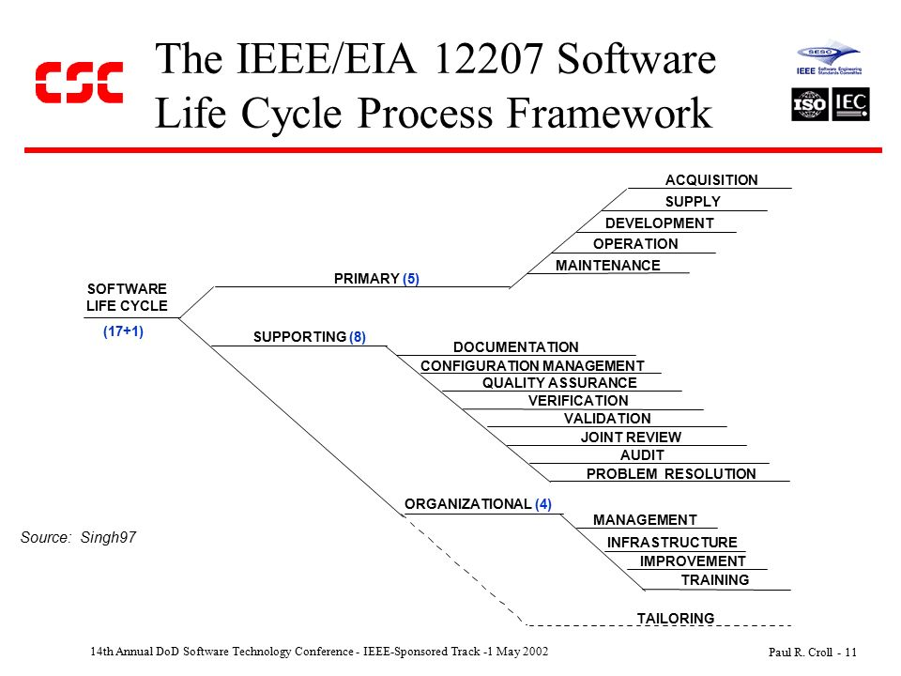
Figure 13: IEEE/EIA Software Life Cycle

5 Project Design

This portion of the report is concerned with the design implementation of the project. It is broken down first into the broad categories of hardware and software design and then further into subcategories that will cover all facets of the design process. Each section will feature block diagrams that additionally contain assignment of responsibilities as they are distributed between the group members. It is worth noting that due to the group containing three computer engineering students with only one electrical, the hardware design will be done partially by a computer engineering student.

Below is a high level overview of the system. Each individual block will be be gone into more detail throughout this section as to the exact implementation details. In particular, the solar panel and the corresponding power system, the pin design of the pcb, including its wifi, usb, raspberry pi connections and the band design will be discussed in the hardware section. The Android application, microcontroller code, and communications processing will all be discussed in the software design section.

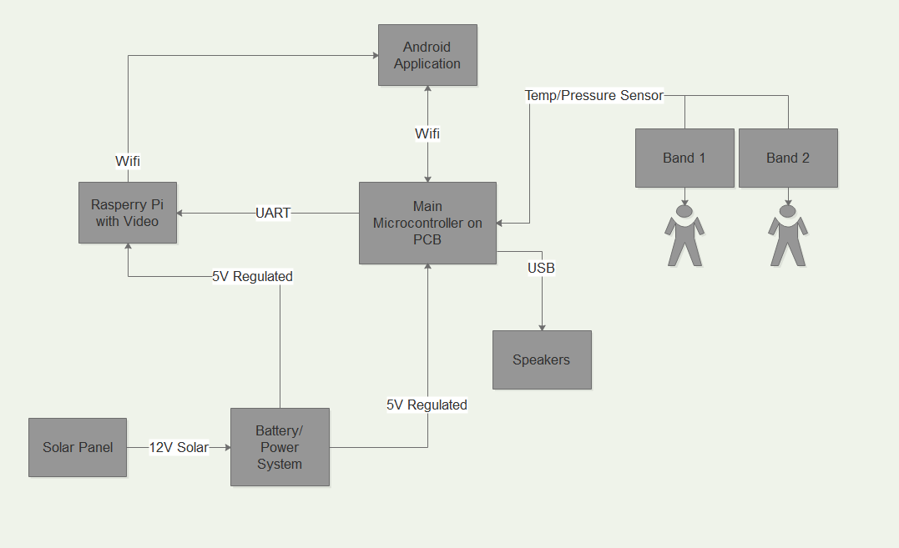
Figure 14: High Level System Block Diagram

5.1 Hardware Design

This section details the design of the hardware for the project, including the broad system design, implementation details for the main unit and its connections to the wifi module, the speakers, the raspberry pi with the camera unit, and the power supply. The power supply will also be detailed with the solar panel that must feature both a regulator and a rechargeable battery for backup power when the solar power is insufficient. There is also a section on the design of the band sub-system that will communicate with the main unit. Finally, the beginnings of the PCB design are detailed both for the major piece and each of the band subsystems.

5.1.1 Block Diagram and Task Assignment

The block diagram first describes the power system. The main source of all the power in the system is the monocrystalline solar panel that receives energy from the sun and transforms this energy into usable electric power through photovoltaic cells. There is then a controller than has three inputs with equal grounding. One of these inputs is the energy source itself, the photovoltaic cell. One of the others is the lead acid rechargeable battery which acts as a power storage system when the sun is not able to fully power the system. The last connection is the output to which the controller will send a constant 12V, assuming the battery doesn’t run out of energy while the solar panel is also not functioning. This then needs to be sent to a step down voltage regulator to maintain the 5V supply needed for both the ATmega and the raspberry pi to function. The power supply for the armbands will be a simple battery that will need replacing as it runs low. The power system will primarily be worked on by Minh Nguyen, the sole electrical engineer on the team, with support as necessary by the other members.

Next we move on to the main printed circuit board that houses the ATmega328 that acts as the brain of the system. The microcontroller rests in low power mode until the ultrasonic range finder sends a signal that it has encountered something. At this time several things will happen. The microcontroller sends a signal over the wifi that there is something wrong while simultaneously requesting the raspberry pi to prepare to send video if necessary. It then waits to receive signal back over the wifi and reacts differently depending on the signal received. If it receives a signal to set off the alarm, the alarm sounds until it is pressed again to be disabled. If a signal to start streaming the video is sent, the microcontroller again sends a signal to the raspberry pi, this time to begin streaming video to the parents phone. This portion of the project will be primarily handled by Brian Bisplinghoff, who is a computer engineering student.

Finally, the Raspberry Pi will be equipped with a camera module and connected to the main PCB by a UART connection. It will rest in low power mode until it receives signal to ready itself, and will remain in ready mode until it receives a signal to stand down. The pressure and temperature sensors are present on a separate, much simpler printed circuit board in the band that the children will be wearing. These will send a signal based on some predefined values that something is wrong if they are in range of the ultrasonic range finder. The sensors will then broadcast a signal that the rangefinder will pick up and communicate to the ATMega, which takes over from there. As it should be fairly infrequent for this to happen, the ATMega will remain in active mode regardless of the sensor until disabled from the phone application. The sensor design will primarily be handled by Anna Baranova who is a computer engineer.

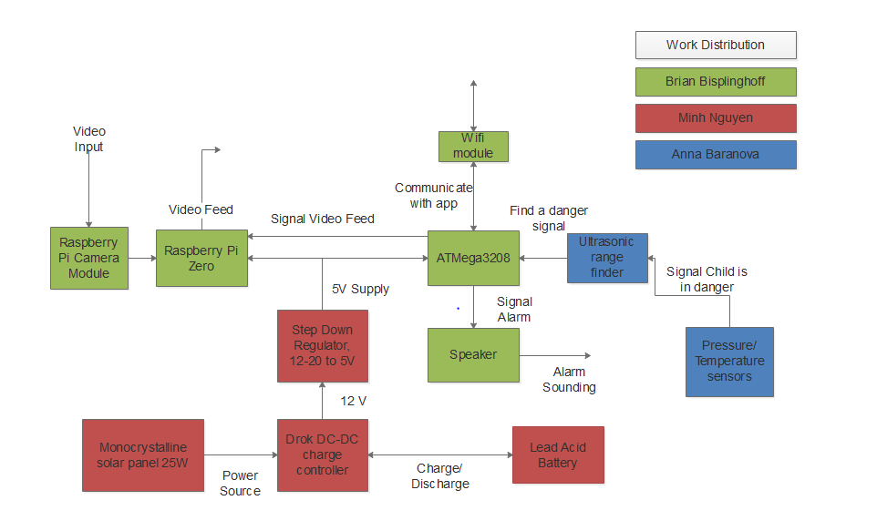
Figure 15: Hardware Block Diagram and Tasking

5.1.2 Microcontroller Specifications and Usage

This section of the hardware design consists of two sections. The first details the microcontroller chosen for integration into the main pcb that will be the focus of the system, the ATmega 3208. The second section details the Raspberry pi zero which was chosen to supplement the ATmega3208’s lack of functionality for video streaming that is required for the project. It is important to keep in mind that one of the main constraints of the project is the microcontroller and should a new one need to be swapped in due to unforeseen circumstances, the group should not be hesitant in this regard.

5.1.2.1 ATmega3208

The ATmega was chosen for its overall robustness and efficiency for the price. One of the biggest advantages of this microcontroller is that it comes with the Arduino Uno board that makes boot loading and testing the microcontroller that much easier. For prototyping purposes the initial testing can be done on the Arduino board before the microcontroller is desoldered and transferred to the test board/ the PCB when it is finished. This also saves the trouble of having to reconnect the microcontroller to a bootloader every time it needs to be reprogrammed in the early stages of troubleshooting. It is very important to keep in mind once the unit is mounted on the PCB it will be much more annoying to reload.

5.1.2.1.1 Operating Specifications

As far as constraints for the ATmega 3208 go, it is a fairly standard microcontroller. It can operate between 1.8 and 5.5 volts, with the lower voltage leading to less power consumption. The operating temperature is between -40°C
and 105°C, which shouldn’t be too big of an issue in relation to our project. It is worth noting due to the nature of the project being outside in addition to being solar powered, it is worth keeping an eye on the temperature levels to avoid them getting too high. Also of interest is that the data retention rate at 85°C is 20 years, which may be a limiting factor in the lifetime of the system, though this depends on the lifespans of the other components as well.

Table 17: ATmega 3208 Operating Specs
ATmega3208 Operating Specifications
Operating Voltage | 1.8 - 5.5V
Minimum operating temperature | -40°C
Maximum Operating Temperature | 105°C
Speed 1.8V/2.7V/4.5V | 4/10/20MHz
Power Consumption (low power mode) | .75µA
Power Consumption (active) | .2 mA
Data Retention | 20 Years at 85°C

It’s worth noting that the lower the voltage supplied to the microcontroller, the lower the clock rate. Because of this, it may take some time to figure out a sweet spot that balances out the processing power needs with the desire to have the lowest energy consumption possible. It is also worth noting that the operating temperature could get very hot based on the need for a waterproof housing combined with the need for solar energy to power the system. This is something that the team should notice and it may be necessary to test the temperature after the system has been running in full operating mode for awhile. This can be alleviated somewhat by always using the lowest power supply possible which will inevitably generate less heat and keep the temperature lower. If it turns out that this is a large issue, it may be necessary to come up with some type of heat dissipation construct to insure the continued operation of the microcontroller and the system as a whole.

5.1.2.1.2 WIFI Module

Because the ATmega 3208 is not configured well for WIFI communications, a separate module was necessary to sync it with the android application. The wifi module chosen for this project is the ESP8266, a standard wifi adaptor for embedded applications. An important feature/constraint of this particular module is that it idles at low power only utilizing 3.3V, but requires up to 5V during strenuous transmission time. This means that the power supplied to it must be able to fluctuate as needed and should be a focus of the power system design. This is because the wifi will sometimes require a large amount of current to properly push data through, while at other times will require minimum current to transfer data.

There are 8 pins in the wifi module, one is for Vcc, one is for common ground, one is an enable pin and one is for resetting the module. The other four pins are GPIO pins, but two of the pins are set aside as specialized rx and tx pins as this is usually what the module is used for. This model is a lightweight, low power unit, though the additional energy required to make it function should not be disregarded. In particular when the module is in transmission mode it uses a decent bit of extra current drawing 200 mA. This distinction is the reason why the input voltage must be capable of providing extra energy when it is demanded.

The module uses a standard TCP/IP connection to connect through the wifi. For the communications with the microcontroller it uses standard communication protocols like UART and SPI, through an I2C connection could be implemented in hardware by the group which could provide a more stable connection. The turnaround time is usually around 2ms which is the time from signal being sent to the module to it actual being transmitted over the network. Utilizing the two leftover GPIO pins, it’s also possible to directly send a sensor signal over the network instead of first going through the microcontroller, but this would require processing of the signal on the application as well as possible loss of information due to these systems not being optimized for analog signal.

Table 18: ESP8266 Specifications
Parameter | ESP8266 Implementation
Transmit Current | 200 mA
Receive Current | 60 mA
Standby Current | .9 mA
Protocal | TCP/IP
Turnaround time | 2ms
Microcontroller Connection | SPI/UART/SDIO 2.0

5.1.2.1.3 Pin Usage

The ATmega 3208 has a total of 28 pins. Of these, two are for reference ground, two are for reference supply voltage, one is for a reference voltage that’s used in the ADC, two are for an oscillating crystal to give better clock timing, and one is for resetting the microcontroller. The other 20 pins make up the GPIO pins of the system. Of these, 6 are used for analog signals and 14 are used for digital signals. Among the digital pins, two of them come pre configured for serial transmissions with one acting as a dedicated receive pin and the other acting as a dedicated transmit pin. Additionally 6 of the other digital pins can provide a pulse width modulated output.

For this project we will primarily be concerned with the digital pins for everything except the sensor receiver, which will be handled by the analog input. The usb that will connect to the speaker requires two digital pins to use which will be pins 4 and 5. The raspberry pi only requires a single high or low signal to tell it to begin or stop streaming video. The wifi requires four pins, two for communications one to reset the module, and one to control it being on or off which will be pins 2, 3, 11, and 12 respectively. The temperature sensor requires three pins, two for input and output as well as one for controlling its status. Finally, the reset pin will be attached to the power source with a resistor so that if the power spikes too high from the power source it will shut off, hopefully before any damage is done to the system.

As the project continues to develop, more pins are still available on the Atmega3208 that can be used. In particular a oscillating crystal will most likely be attached to pins 9 and 10 to steady the clock frequency when the unit is in low power modes. This way if timers need to be kept but the MCU is not doing real processing, the integrity of the system will be preserved. Additionally many more analog input pins are available if more sensors are deemed necessary.

Table 19: ATmega 3208 Pin Usage
Pin Usage for Main ATmega3208 Microcontroller
Pin Number | Description
1 | Reset, use with resistor attached to VCC to check for power voltage being too high
2 | Receive pin for communication with the wifi module
3 | Transmit pin for communication with the wifi module
4 | USB D- Connection
5 | USB D+ Connection
6 | Send signal to start up raspberry pi
7 | 5V VCC
8 | Ground
11 | Wifi power down
12 | Wifi reset
14 | Clock for BMP280
15 | Temp/pressure input
16 | Temp/pressure Output
17 | Temp/pressure CSB, end signal transfer

5.1.2.2 Schematic design

One of the main requirement of this project is to build a PCB. This has been emphasized since the start. Building a PCB isn’t easy since everything needs to be solder into place. So it is recommended and required to have a schematic design beforehand. This was done using eagle CAD software along with open source libraries found on github. After the design is later finalized it will be sent out for fabrication towards the beginning of senior design II. If it comes back faulty or just requires general improvements, a second PCB will be ordered after the appropriate changes are made.

The schematic is broken down to 5 major parts for the pcb. The main part of the PCB is the mcu the Atmega328. This will connect all other components together and regulate the entire system. It is the brain of the system and all important processing tasks will take place here. It should be self evident from the schematic as every connection can be traced back to this unit.

The raspberry pi is used to regulate the streaming process of this system it is also connect to the mcu in the schematic. The USB is to regulate the speaker. The sensor receiver is to regulate when the arm band send a distress signal informing the mcu that the infant has fallen into the pool. Then the WIfi mod will then send the text message and alarm to the parents. It is important to always supply the proper power to insure proper functioning of all parts. If one of these fails, the entire system will fall apart and it will not matter that every other part is functioning correctly.

There are also capacitor around the mcu to help regulated the voltage. Capacitors are usually used to clean out noise in the system. There are capacitor placed everywhere there is a power regulation like the vcc of the mcu or voltage controller. Lastly there is a resistor connect to the reset just in case of a power surge and the system needs to reset instead of damaging itself. Additionally, status diodes are used to monitor if certain traces have current running through them and displaying this information to the observer. These will be extremely useful in debugging the board while also assisting in maintenance once the full system is actually deployed for use.

The Schematic was done on Eagle cad with the help of the adafruit library. The adafruit library help picking out the specific components that the mcu needed. It also have basics parts like resistors, capacitor and usb making it easier to design than other library available. Additionally more libraries that are open source were discovered and used to increase the productivity of the group so that they did not have to do the design themselves. This is where designs for the Atmega, usb, wifi module, and sensor reciever all came from. Though it is possible to create these by hand if necessary, a quick google search for the relevent part will usually show that someone has already created it and made it freely available to help other electronics makers.

The mcu gets its power from the solar panel which is regulated through the voltage regulator. The mcu will then regulate the Raspberry pi camera, usb, wifi modulator and the sensor receiver. Additionally there is a controller that facilitates the voltage balance between the solar panel and the backup battery storage unit. This is necessary as otherwise it would be very difficult to maintain the proper voltage level that is necessary for the correct functioning of the system at all times. Below is the full schematic of the system.

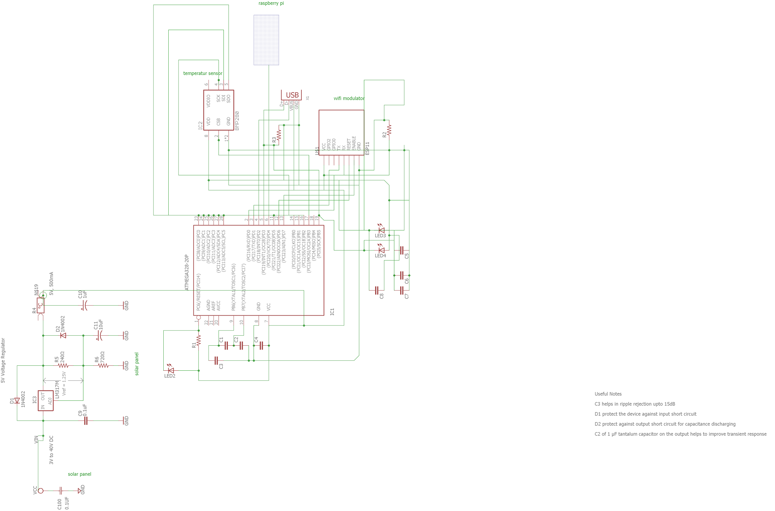
Figure 16: Main PCB Schematic

5.1.2.3 Raspberry Pi Zero

The Raspberry pi zero is a supplemental micro processor that was determined to be necessary in order to stream video to the mobile app. This is due to the ATmega not having enough processing power to handle the streaming as well as all its other tasking. However, by linking with the Raspberry Pi Zero equipped with a camera module, the system can benefit from the low power capabilities of having a lower strength microcontroller while having the strength of a raspberry pi to do the heavy lifting. The pi was also customized with a camera module specifically adapted to work with the pi. This alleviates any potential compatibility issues with using the pi.

5.1.2.3.1 Integration Overview

Another consideration is if it becomes necessary to transfer some functionality to a more high powered system (such as speaker integration) by already having the pi hooked up to the main pcb, integration will become a simple matter of adding the components to the zero. This was of particular concern with the compatibility of the speaker, though after further research into the matter one which was able to be acquired that should be compatible with the primary PCB.

The raspberry pi should only require 3 pins in order to function, unless further functionality is necessary later on in development. First it needs to be connected to the power source and reference ground through pins 2 and 6 respectively. It is important to note that the current draw of the pi is much higher than any other component in the pcb at 2A so care must be taken to insure the power system is capable of supplying enough current. Finally, a single receive pin will be used to monitor if video currently needs to be streamed as provided by the main mcu. It does not actually need to communicate back to the ATmega in anyway, unless other functionality or status updates are to be implemented. If this were the case, there are more than enough pins that adding such functionality should not be an issue further along in development. It would also be beneficial to have a similar resistor connection to the reset pin as in the main PCB to prevent overloading of the system.

Below is a picture of the Raspberry Pi Zero. It is connected to a camera so it can stream what is going on around the pool. It is in a small form factor so it can easily fit into a small housing can be easily placed anywhere around the pool that is needed. This makes it more convenient since the camera need to be high so that it can record everything around it. The pairing also came with a premade, sturdy case that can be used depending on the housing for the rest of the unit. If the raspberry pi can be incorporated into this than it should be used in place of the case. Otherwise, the case is a solid backup solution that seems to be mostly waterproof which is the main concern of the project.

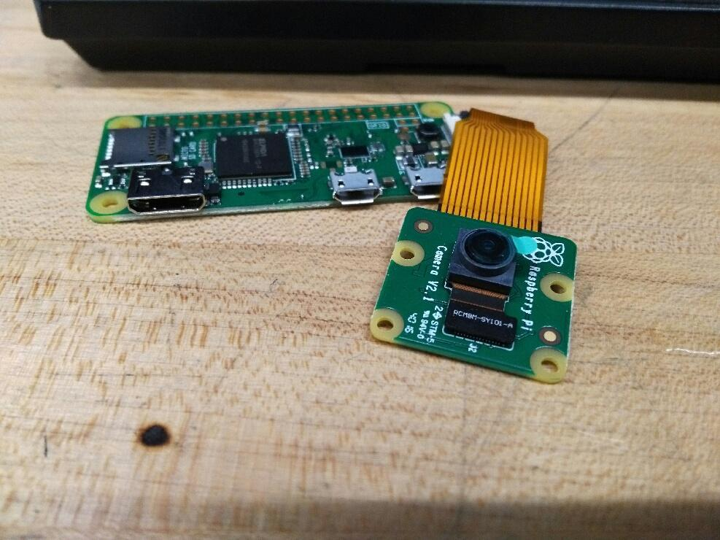
Figure 17: Raspberry Pi Zero

5.1.2.3.2 Raspberry Pi Limitations

While the raspberry pi is fully capable of functioning for embedded applications, it does require several workarounds that are not necessary for MCUs designed for embedded applications, as it is meant to be capable as a fully functioning computer. Because of this, upon starting the pi instead of running in an infinite loop as a microcontroller would, it loads an operating system that will then wait for user input much like a regular computer would. So the system has to be properly configured to start it’s required process upon startup. There are several open source libraries that can be used to achieve this goal and are meant to make adapting the pi to embedded applications much simpler. Also to insure the least amount of cpu power is used, the system should be cleansed of many unnecessary programs to insure the pi only needs to handle the transmission of the video signal.

The pi comes with many digital GPIO pins, but the zero requires the headers that wiring will attach to to be manually applied. Additionally, the pins only feature digital IO, not analog which means if any analog signals needed to be processed they would need to be run through the main microcontroller, or if it was not powerful enough need to be converted to some digital form before being transmitted for further processing. For heat considerations, the pi can operate safely between -40°C and 85°C, which means a heat sink may be necessary in order to insure the safe operation of the system.

5.1.2.3.3 Camera Module

The camera module is the main reason why the raspberry pi is used in the first place, so it is an important feature to keep in mind. It is connected to the raspberry pi through a ribbon cable slot which means if another ribbon cable peripheral is needed an additional slot will be required. The camera itself requires an additional 250mA of power from the power source on top of the 2A already required by the raspberry pi to operate. It is approximately 3g and sits in the case designed to house the raspberry pi and the camera together. It is designed to fit well with the pi as it is the most compatible module that is available.

The camera features the ability to take both pictures and video, which could be useful if video streaming is determined to be too costly and instead pictures could be taken and transmitted, a much easier operation. The video has three separate quality levels, 1080p30, 720p60, and 640 x 480p60 which will all have to be tested to determine which will provide the best experience to the end user. It is worth noting that this camera is the only one currently available that is compatible with the raspberry pi zero, so if some issue arises with it the entire model may need to be altered. Below is a summary of some of the important features of the V2 camera module, detailing the implementation of each of the most important parameters. While there are more things to consider about the module, they are mostly irrelevant for our use case.

Table 20: Camera Module Specifications
Feature | Camera Module V2 implementation
Still Resolution | 8 Megapixels
Video Modes | 1080p30 / 720p60 / 640 x 480p60
Weight | 3g
Current Draw | 250mA
Horizontal field of view | 62.2°
Vertical field of view | 48.8°
Pixel Size | 1.12µm x 1.12µm
Focal Length | 3.04 mm
Focal Ratio | 2.0

5.1.3 Power System

The power system is used to charge the pcb and the camera system. All power comes from the solar panel which is regulated by a solar panel controller and back up with a flood deep-cycle lead acid battery. This way when there is no sunlight the power will still be functioning and the system will still work. If this was not the case, the system would not function if there was no sunlight and be practically useless.

5.1.3.1 Solar Panel System and Testing

The solar panel is the main source of power in our system so to have a working system is very important. The solar panel is a 12v 25 watt monocrystalline off-grid system using 12 volts flood acid batteries. We used a solar charge controller to help regulate the backup batteries and the solar panels to the system and lastly the source is connected to the voltage regulator so it can then be connected to our pcb or and video camera. Additionally the wifi module may require as little as 3.3v to run properly but may also need to draw up to the 5V required by the rest of the system. Below is a block diagram of the solar panel system, with each of the components being represented by a different block and the connections by arrows.

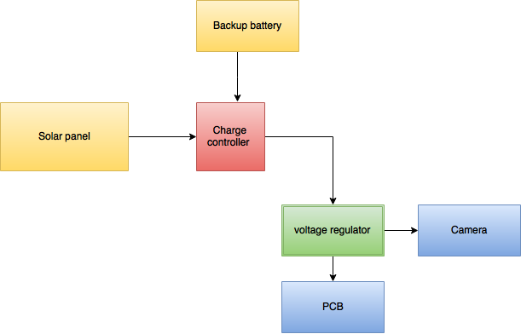

Figure 18: Solar Power Block Diagram

5.1.3.1.1 Schematic of solar panel and system

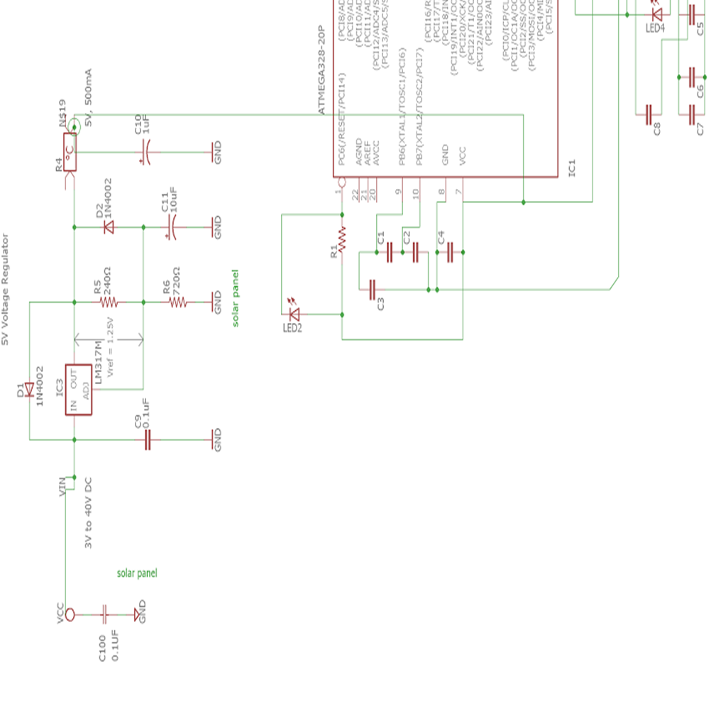
This is the schematic of the solar panel. It is basically a battery, as such we represent it as a vcc node. Although most schematic usually represent it with a node with an x in the middle, but it is basically the same thing. The schematic is showing that the solar panel is acting like a battery and then it voltage will then be regulated so it can transfer its voltage to different source like the pcb or a microcontroller. Either way this is how the solar panel will operate.

Figure 19: Power System Schematic

5.1.3.2 Solar Charge Controller

The charge controler is Mohoo model. It is the cheapest model on Amazon that has a led indicator to shows that it is working and which parts are working and which part isn’t. This device made it easy to test the solar panel and the battery. There is a light that shows if the solar panel is charging the battery and another light to shows if the batteries is full or not. To test that the charge controller is working we plug the solar panel and the battery into the controller then we measure the output of the control to make sure that the output is working. We then hook it up to a voltage meter to make sure the charge controller is just regulating the power and not shorting it. We also check to see if the led light is on that indicate that the solar panel is charging and that battery has power. When all three parts were working we knew that the charge controller is working. The only step left is to now test the system with actual sunlight while also hooking it up to the prototyped system.

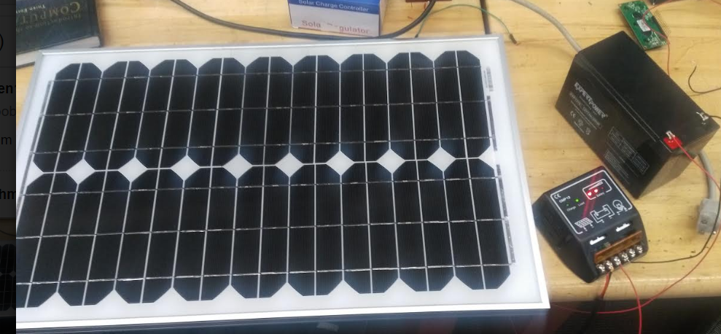
Figure 20: Solar Charge Controller

5.1.3.3 Battery
The battery is a deep-cycle flooded battery the most common battery used battery for solar panels. The model we used is ExpertPo. It a 12 v battery that is cheap and can handle the deep-cycle that a solar panel discharge. To test the battery we hook it up to a multimeter to test if the power and amp is what we order. When they both check out we then hook it up to the solar charge controller to make sure that the solar panel is indeed able to charge the battery.

5.1.3.4 Voltage Regulator

The regulator we used is called DROK Micro LED DC-DC. Unfortunately when buying this regulator we misread the description and bought a regulator that doesn’t have a step down function. So this regulator only amplify the voltage. We went back and bought another one with the same name except it is equipped with a step down function. We choose this brand because there is an lcd screen that display how much voltage is entering the regulator. Then there is also a button to switch the lcd screen to show how much output voltage is in the regulator. We find this very convenient and helpful when testing out equipment. It is also helpful to make sure at all time that the necessary voltage in going into each systems. This way no short circuit will happen and damage our equipment. To test this device we first hook a power source to the input. We then check to make sure that led screen is on and that it show how much voltage is coming into the regulator. We then press the button to switch it over the output. There is a golden knob next to the led screen to help control the output of the regulator. We can turn it to turn the voltage from 0-30v. Since most of our equipments voltage is in the range of 5-9 voltage we didn’t want to short circuit our equipments so we left our output at around 5 voltages.

5.1.3.5 Schematic of Voltage Regulator

As mention on the previous section the voltage regulator is meant to control a constant voltage so other system like. The diode is used to make sure the system keeps and maintain a constant dc voltage and make sure it won’t change into ac. The resistors are used to drop the voltage to the amount that is needed. Lastly the capacitor is used to filter out the noise in the regulator. This system is usually used to maintain all the voltages coming from the solar panel.

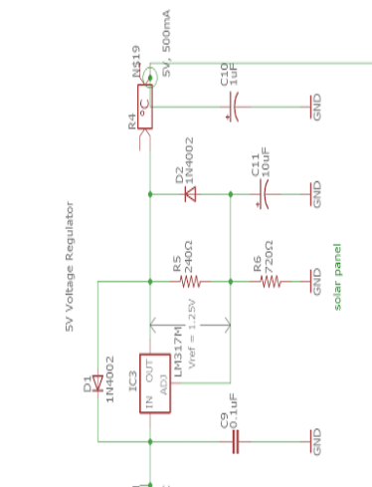

Figure 21: Solar Panel Schematic

5.1.3.6 PCB
Although we haven't bought the full pcb yet. We instead used a microcontroller the Arduino uno to simulate our pcb since its functions are similar. We hook up the Solar panel into the controller a output into the voltage regulator to get the 5 voltages needed to power the Arduino and not over voltage and damage the microcontroller. We then plug the output into the the vcc input and ground of the Arduino board. The Arduino has a build into power on indicator and and once we saw that it was working we knew that our systems works and is able to power the pcb. Below is a the picture of the solar panel hook up to the Arduino. This picture shows that both the solar panel system work and that it can power the Arduino board.
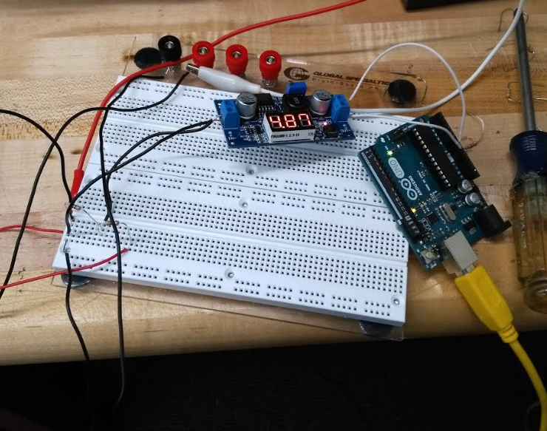
Figure 22: Power Testing

This picture also shows that the solar panels is connected to the controller and the batter is also helping power up this system (since there isn’t much sunlight) and going through the the voltage regulator it will power on the Arduino.

5.1.4 Sensors

This section of the hardware design is primarily concerned with the design of the sensor components in the system. These are very important as they are the way the systemd can actually read anything from the environment and make decisions based on it. It is also one of the components that could be easily susceptible to random component failure. For this reason, most of the design process in this section is dedicated to the proper and thorough testing of each component. The sensors are the last component that you want to fail when attempting to debug the problems in a system.

5.1.4.1 Pressure Sensor BMP280

Pressure sensor has two connecting method I2C and SPI. I2C is Inter-integrated Circuit Protocol is a protocol intended to allow multiple “slave” digital integrated circuits to communicate with one or more “master” digital integrated circuit. It is intended for short distance communications within a single device. Like Asynchronous Serial Interfaces (such as RS-232 or UARTs), it only requires two signal wires to exchange information. SPI is Serial Peripheral Interface is an interface bus commonly used to send data between microcontrollers and small peripherals such as shift registers, sensors, and SD cards. It uses separate clock and data lines, along with a select line to choose the device you wish to talk to.

Advantages of SPI: it’s faster than asynchronous serial, the receive hardware can be a simple shift register and it supports multiple slaves. It also has its disadvantages: it requires more signal lines than other communications methods, communications must be well-defined in advance, the master must control all communications (slaves can’t talk directly to each other, and it usually requires separate SS lines to each slave, which can be problematic if numerous slaves are needed. I2C protocol, in other hand, is more complex than with SPI, The signaling must adhere to a certain protocol for the devices on the bus to recognize it as valid I2C communications. I2C requires a mere two wires, like asynchronous serial, but those two wires can support up to 1008 slave devices. Also, unlike SPI, I2C can support a multi-master system, allowing more than one master to communicate with all devices on the bus. Data rates fall between asynchronous serial and SPI; most I2C devices can communicate at 100kHz or 400kHz. There is some overhead with I2C; for every 8 bits of data to be sent, one extra bit of meta data, the “ACK/NACK” bit, must be transmitted. The hardware required to implement I2C is more complex than SPI, but less than asynchronous serial. It can be fairly simple implemented in software.

For the testing purposes we will try both communication protocols, and further selection of protocol will be made based on the other parts of our project. Testing procedure is available on the resellers websites on the internet.

Equipment needed to test BMP 280: computer with pre-installed Arduino IDE software, microcontroller Arduino UNO, breadboard, wires, BMP280 sensor.

Connect Arduino UNO to the computer, download library for the BMP280 pressure sensor from the internet GitHub webpage: https://github.com/adafruit/Adafruit_BMP280_Library. Unzip folder and rename it to Adafruit_BMP280, place it to the Arduino project folder originally called Arduino/libraries/.

I2C wiring.
Wire sensor to microcontroller using following configuration:
- connect Vin to the power supply, 5V; Vin - this is the power pin. Since the sensor chip uses 3 VDC, we have included a voltage regulator on board that will take 3-5VDC and safely convert it down. To power the board, give it the same power as the logic level of microcontroller, 5V.
- connect GND to common power/data ground; GND - common ground for power and logic.
- connect the SCK pin to the I2C clock SCL pin on Arduino; SCK - is the I2C clock pin.
- connect the SDI pin to the I2C data SDA pin on Arduino; SDI is the I2C data pin.

Restart Arduino IDE, choose example to test under file. Open communication port 9600 Baud speed and see the result of pressure sensing environment temperature.

SPI wiring.
Wire sensor to microcontroller using following configuration:
- connect Vin to the power supply, 5V; Vin - this is the power pin.
- connect GND to common power/data ground; GND - common ground for power and logic.
- connect the SCK pin to Digital #13 (any pin can be used); this is the SPI Clock pin, it is an input to the chip.
- connect the SDO pin to Digital #12 (any pin can be used); this is the Serial Data Out / Master In Slave Out pin, for data sent from the BMP280 to processor.
- connect the SDI pin to Digital #11 (any pin can be used); this is the Serial Data In / Master Out Slave In pin, for data sent from your processor to the BMP280
- connect the CS pin Digital #10 (any pin can be used); this is the Chip Select pin, drop it low to start an SPI transaction. Its an input to the chip.

All pins are going into the breakout have level shifting circuitry to make them 3-5V logic level safe. So the voltage regulator is not required when connected by SPI.

Restart Arduino IDE, choose example to test under file. Open communication port 9600 Baud speed and see the result of pressure sensing environment temperature.

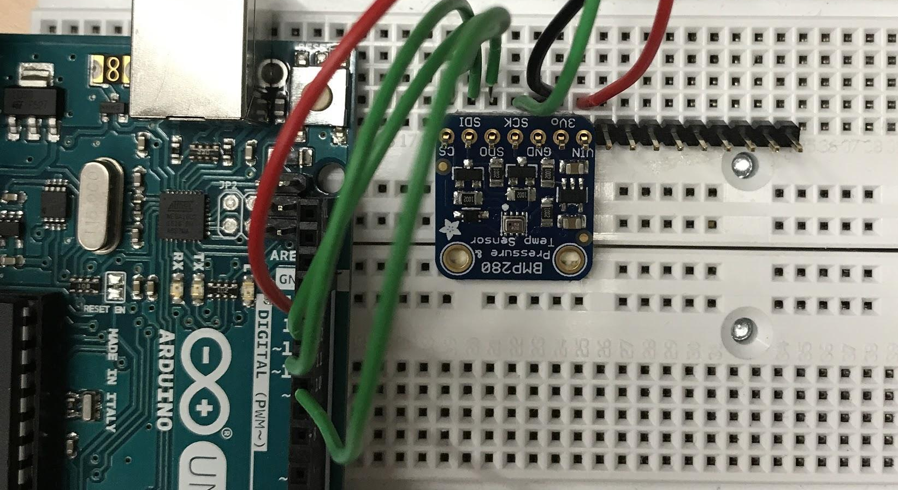
Figure 23: BMP 280 Breadboard Testing

5.1.4.2 Temperature Sensor TMP36 Testing

TMP36 is analogue sensor and can be easily tested using measuring equipment.
Equipment needed: TMP36 sensor, power supply, multimeter, communication wires( 2 banana plugs, 3 alligator clips), wires.

- connect 5V power supply. Use left and right pins, such that right pin is the ground and right is the power.
- connect multimeter in DC voltage mode to ground wire of power supply and to the middle pin.

Multimeter will read voltage output with is late can be converted to the temperature. For example, if voltage measured is 0.75V the room temperature is around 25°C. The formula to transfer voltage measurement into temperature are as follows:

Temperature (° C)= [ Voltage (mV) - 500 ] / 10

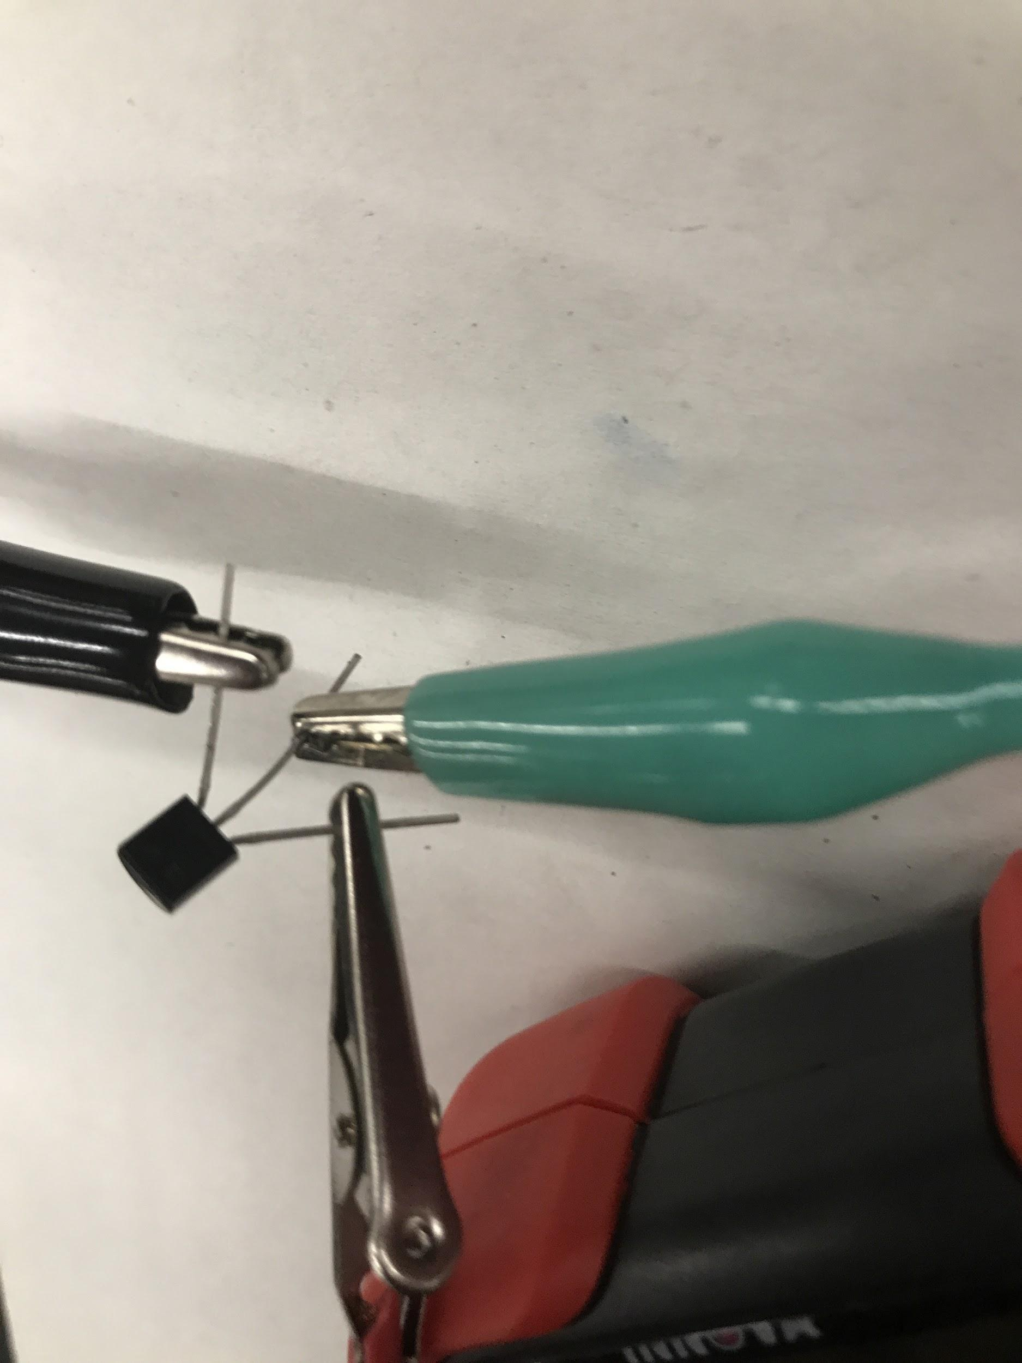
Figure 24: Temperature Sensor Testing

5.1.4.3 Ultrasound Sensor HRLV-MaxSonar-EZ Testing

To test sensor we will use quick start guide provided by MaxBotix manufacturer. It is recommended that the sensor tested first by using oscilloscope or multimeter. We will use multimeter. The ultrasonic sensor test can be managed in two different ways, using power supply and using analog voltage pin, we will explore both of them. This is necessary to ensure than both are working as described and capable of functioning at the necessary level.

Equipment needed: power supply, multimeter, wires, ultrasonic sensor HRLV-MaxSonar-EZ MB1013, white box ( flat target).

1. Supply power to the ultrasonic sensor test.
- Disconnect the power supply from any equipment.
- Turn ON the power supply; set the voltage to 5.0V DC
- Turn the power supply OFF and connect ground and V+ cables to the power supply.
- Connect the ground from your power supply to the GND pin on the HRLV‑MaxSonar‑EZ.
- Connect your power supply to +5 pin on the HRLV‑MaxSonar‑EZ.
- Turn ON the power supply; verify that the voltage is between +2.5V and +5.5V.

The HRLV‑MaxSonar‑EZ input power should be +5V DC. This system can operate from +2.5V to +5.5V. The current input should read ~3.1mA for +5V DC and ~2mA for +3.3V DC.

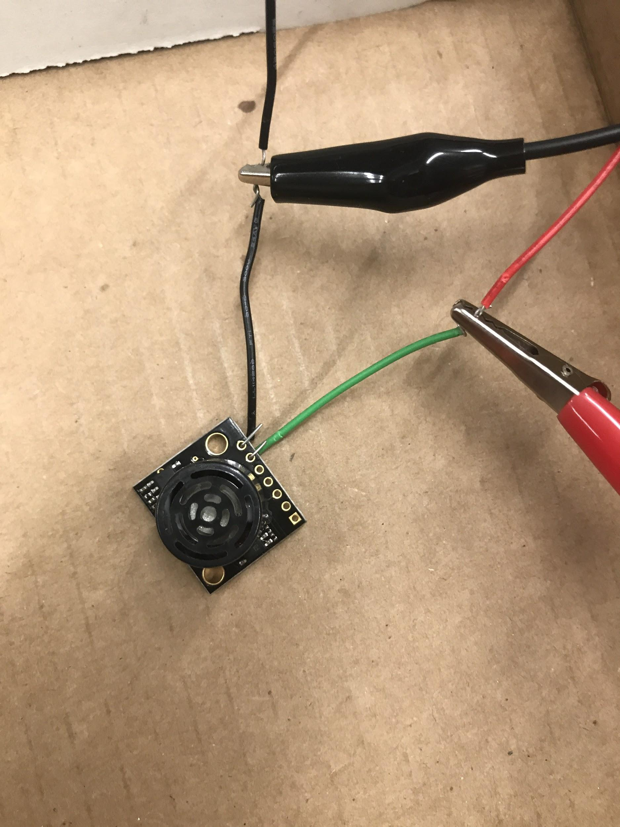
Figure 25: Ultrasonic Sensor Testing

2. The AN (analog Voltage pin) Output sensor test.

The analog voltage pin outputs a voltage which corresponds to the distance. The further away an object is from the sensor the higher the output voltage becomes which in turn will be measured by the multimeter. The sensor is designed to report the range to the closest detectable object. This could then be picked up by the main sensor receiver on the main unit to be further processed.

- Switch the multimeter to read DC voltage.
- Connect the ground lead of the multimeter to the ground on your power supply.
- Connect the power lead of the multimeter to the pin labeled AN on the HRLV‑MaxSonar‑EZ.
- The display should read the voltage output of the HRLV‑MaxSonar‑EZ.

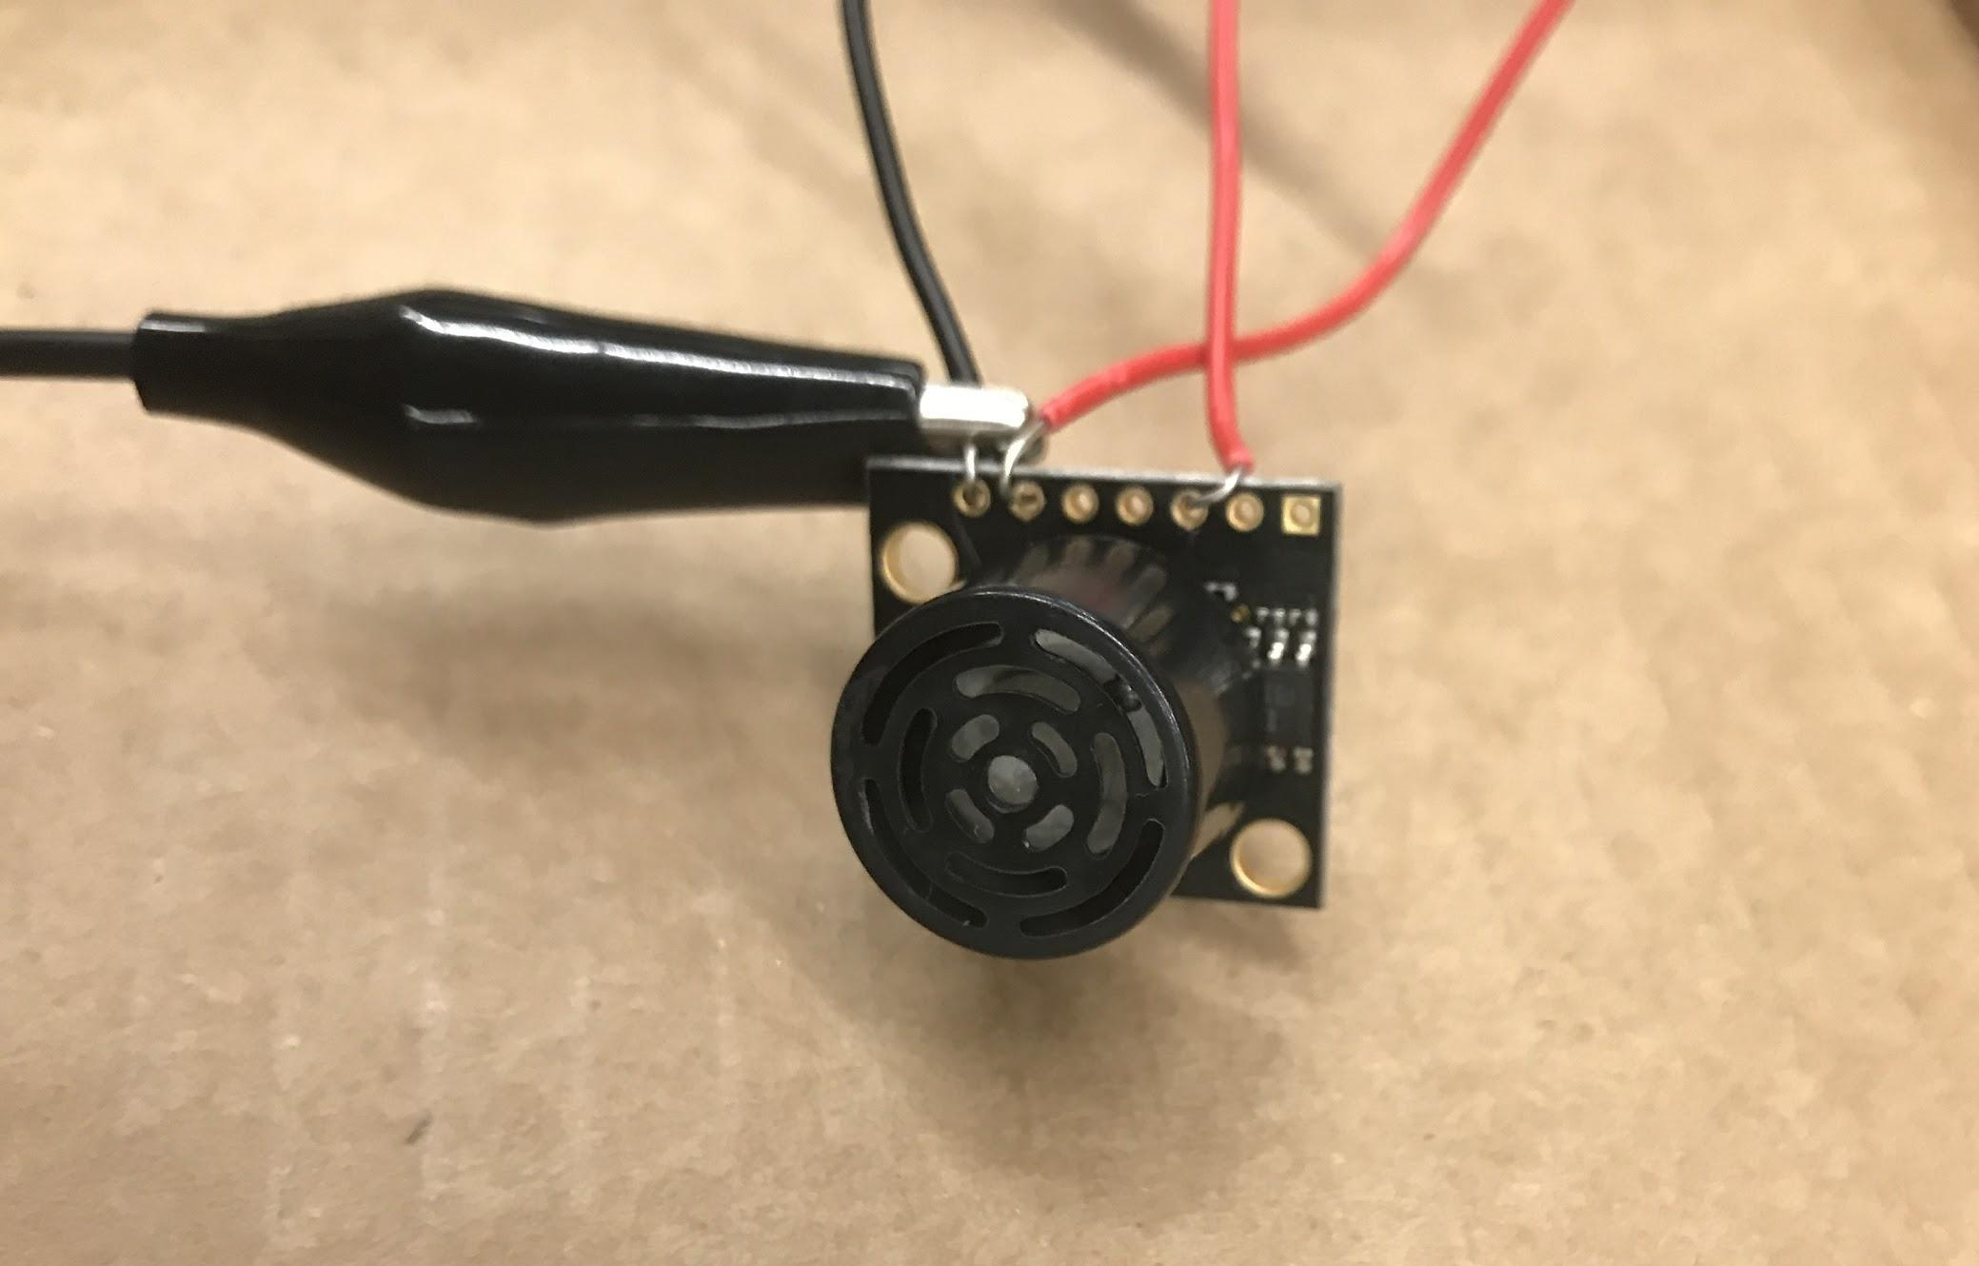
Figure 26: Analog Voltage Pin Testing

Calculating the Voltage Scaling:
Because the HRLV-MaxSonar-EZ output is scaled to the input power that is provided to the sensor, it is important to know the voltage scaling before calculating the range.
The formula for the voltage scaling on an HRLV‑MaxSonar‑EZ is:
[(Vcc/1024) = Vi]
Vcc = Supplied Voltage
Vi = Volts per 5 mm (Scaling)

Calculating the Range:
Once the voltage is known, it is easy to properly calculate the range.
The range formula is:
[5*(Vm/Vi) = Ri]
Vm = Measured Voltage
Vi = Volts per 5 mm (Scaling)
Ri = Range in mm.

5.1.5 Wearable Device

The wearable device will be put on the child and used as a sensor to send off a signal when the infant drop into the water. We will connect the sensor onto a pcb board and then a that can detect and send out a signal when the infant is in the water. The system is the only system in our project that will have its own power source since it is a wearable device and it needs to be wireless. Below is a diagram of the system. Here the wearable device id represented by the block of the armband.

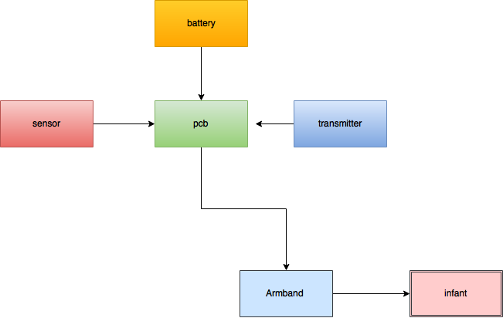
Figure 27: Wearable Device Diagram

The primary concern with the PCB for the wearable devices is in making them water proof. This is because the wearable device will have to withstand not only being submerged in practice, but also because it will require constant submergence when testing that the device actually functions correctly. Since water and electronics do not mix well, it is of utmost importance to consider this when designing both the PCB and the entire system as a complete unit.

5.1.5.1 Wearable Device Schematic

For the wearable device the current schematic is shown below. The current communications protocol is still under flux, so the wifi module may be replaced with some other serial communications device. Inevitably, the wearable will only need to send a single distress bit in the event that some constraint on one of the sensors is surpassed. While this could be done over wifi as the pool should be in the vicinity of wifi for the main unit to connect to the mobile application. Other than that the pressure sensor and the temperature sensor are both powered by 3V batteries as it is impractical to use any other means to power the unit. The reset pin is connected to the power source for safety precautions in case the voltage rises too high.

In the below picture the rx and tx pins are currently not connected to the sensors, but in the final product the tx pin will be connected to both of the sensors in order to effectively transmit a signal. This is for transmitting a “alarm bit” to the main PCB that will alert it that something is not right with the wearer. Some other options would be to include a simple serial communications device that could connect through Bluetooth and directly transfer the data without the need of TCP/IP protocol that comes with using wifi to connect to the internet. Additionally capacitors are added to stabilize the signals and insure the integrity of all the signals

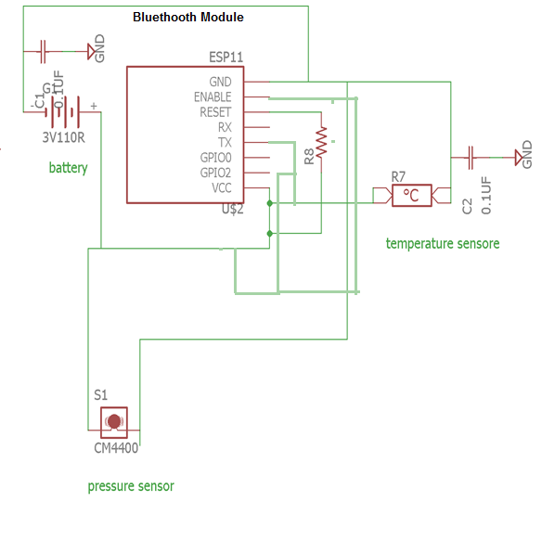
Figure 28: Wearable Schematic

Senior Design II edit: The final schematic for the wearable device was changed and we did not use a bluetooth module, and instead used an ESP wifi module since bluetooth has limited range in terms of connectivity. We also decided on a temperature sensor and ultrasonic range finder, and did not use a pressure sensor.

5.2 Software Design

The software portion of this project is critical in order to ensure the product will functional successfully. The bulk of the programming will be spent for the main PCB and the mobile application as they are responsible for majority of the data processing. The sensors and Raspberry Pi will of course need some configuring as well. The mobile application will be designed in a way that will make it easy to use for people who have no technical experience. Additionally more features can be added that allow advanced users to customize their application to their liking. For example, if one of the features is not going to be used by the patron, they could disable the feature and the rest of the UI could reformat to fit this new setting.

5.2.1 User Interface

It is important that the design of the mobile application is simple and organized so that the parents can efficiently use the features of the product. If the mobile application is difficult to use and organized carefully, this could have significant implications in a case of an emergency. The application will display a menu that will clearly label the main features. Each main feature will be allotted one page so that the user will not be confused by pages within pages. The four main features our application offers are checking that there is a connection to the main base unit, alerts when a child/armband enters the pool, video stream of the pool, and activating the alarm. The data these features provide must be easily displayed to the user so that the parent’s can act swiftly to protect the child who may be in danger.

Senior Design II edit: Instead of using a menu, the application we built has a main homepage with 2 buttons, a camera and an alarm button. On the camera page, the user will type in the IP and launch the video stream of the pool area. On the alarm page, the user will type in the IP and activate/disable the alarm on the main unit.

5.2.2 Mobile Application

After opening the application the user will see the home screen and the menu displaying the pages. There will not be a login or signup feature. The user will need to be connected to the internet and then connect to the base unit. The menu will have four tabs: connection, alerts, video, alarm. The connection tab will be where the user can confirm that there is a successful connection between the mobile application and the base unit. It will simply display “connection established” if connected or “No connection established” if it is not connected. If there is no connection the other features will not function. The alerts tab will display any significant changes that occur. If connection is lost or the band enters the pool, an alert will be generated and it can be viewed on that tab. The video tab will be where the user can enable the video stream option to view the pool. Lastly the alarm page will be where the user can navigate to in order to enable or disable the alarm (speaker).

When the band is turned on and placed onto the child, the parent should open the application and select the connection tab on the menu. This is where the parent will be able to confirm that there is a connection established with the main PCB. If there is not a connection then there will be a short prompt to input details in order to connect to the PCB. As long as the connection tab displays that there is a successful connection, the parent can be assured that if the band/child enters the water, that the application will receive an emergency alert.

In the case that an alert is generated, the application is built to receive a push notification. This way, even if the parent has their phone in their pocket, they will get a sound notification just as they would if they received a text. Receiving a push notification is better than receiving a text because the push notification will have a distinct sound. This will make it easier for the parent to know that an alert was generated. Any time the connection is lost or the child enters the pool, a push notification alert will be generated. All alerts can be viewed by navigating to the alert page, which is found on the main menu of the application.

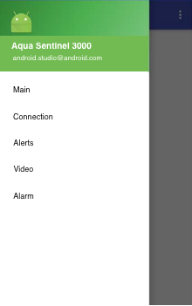

Figure 29: Android Application Interface

If the alert shows that the child/band has entered the pool, the parent can visit the video tab, which is found on the main menu. On this page there is an option to enable and disable the video stream. The video will not stream unless enabled to do so by the parent. If it can be seen that there is a true emergency, the parent should immediately call 911. The parent then can navigate to the alarm page to locate an enable and disable option. After pressing enable, the alarm that is connected to the main unit will sound, which will potentially allow for quicker help to arrive to the pool before the ambulance can make it.

The application will be available to download in Google Play and will be free for users to download. Before gaining access to publish the application in the Google Play store, we will need to sign up for a publisher account and pay the $25 registration fee. In the figure below the user interface of the application can be seen with the navigation drawer pulled out. The five tabs are shown: Main, connection, alerts, video, and alarm. When a push notification is received to the mobile device it will have an option to open the application up to the “alerts” page. The interface is clean and simple so the user can easily navigate through the application.

Senior Design II edit: Below is a picture of the GUI of our final application. There is 2 buttons, one to take the user to the camera page and one to take the user to the alarm page. To design the application, we ended up using MIT app inventor as it was simple and able to design the application the way we needed it to function. To emulate the applications throughout the design process we used android studio as it is fast and efficient. MIT app inventor also was helpful because it has real-time debugging on connected devices.
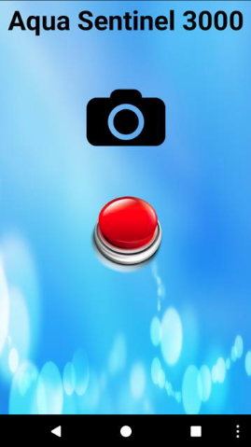

5.2.3 Mobile Application Design

Our two main choices for the platform were Android and iOS. Due to the fact that our team members has more experience with Java, Android was our final choice. Moreover, one of the biggest differences between iOS and Android is navigation. Android’s primary navigation pattern is a drawer menu. The drawer menu is more intuitive than the tab bar for our application. Android Studio will be an extremely helpful tool to develop our application as this is the official IDE for android. This IDE will offer code editing, debugging, and most importantly a build and deploy system that allows us to see the changes quickly. Using the instant run feature we will be able to see the changes to the application on an emulator. This IDE offers many code templates and github integration which will help give us a foundation to build upon. Starting with a standard template will allow us more time to work on the functionalities, which are more crucial to our project. Designing iOS mobile applications requires a computer running macOS. This could cause issues as not all of our team members own a mac computer.

A navigation drawer will be used as our main source for navigation throughout the application. It is essentially a panel that displays the app’s main navigation navigation on the left edge of the screen. Although it is not showing at all times, the user can easily make the drawer appear by swiping from left to right or pressing the app icon in the action bar. The steps to design this interface will be briefly explained. The user interface of the application will be declared with a DrawerLayout object acting as the root view. This object will contain of one view that is the primary layout when the navigation drawer is not showing. Moreover, the DrawerLayout object will hold another view that details the contents of navigation drawer.

Using the Wi-Fi peer-to-peer API the mobile application will be able to connect to both the raspberry PI to receive the video stream. The Wi-Fi P2P API’s consist of three main parts. The first are methods that allow for discovery, request, and connections to devices defined in the WifiP2pManager class. The second part are listeners that allow success or failure notifications WifiP2pManager method calls. This is especially useful because each method can receive a distinct listener which can be passed in as a parameter.

The last part is that the user is notified of specific events that are detected by the Wifi P2P framework. This is useful if the connection drops or when the initial pairing is attempted to be made. This connection would allow for direct connection between the mobile application and the Pi without an intermediate access point. However, this connection along with the connection to the pcb can be done using a router as the intermediate access point.

5.2.4 Mobile Application Functions

The goal is to design an intuitive mobile application that will allow the user to effectively communicate with the main PCB and Raspberry Pi Zero. The application will not display numerical or complicated data. Instead, it will send and receive appropriate signals to the PCB in order to receive alerts, activate the alarm, and receive the video stream. The flowchart below shows the processes that the user may go through. If there is no connection established between the PCB, PI, and mobile application, the application will essentially be useless. If all devices are properly functioning and connected, the functions displayed in the flowchart below will be able to be completed.

The mobile application is an extremely important part of this project as it is the main way to receive and send out communications with the main system. If the mobile application does not function properly, the entire system is rendered useless. This is because without connectivity with the parents there is no alert being sent. Without an alert to the parents, no action will be taken and the child’s life may be put at risk. For this reason the planning of the mobile application must be done with care, even though it is tempting to just start coding it up. It also may be useful to have a mobile application on both android and ios as this will reach the largest population of users and insure that the patron of the product is able to effectively use it.

More features of the mobile application could be added later should time permit. For example, one proposed idea is to have the mobile application display the status of each of the components using several metrics to determine their health. Another is to make the UI customizable and reformat itself based on the preferences of the user. For example a user could choose to have a button that automatically dialed 911 for emergency assistance. Or, if they felt this cluttered the screen too much they could disable this feature. Also there could be a general dashboard that could be customized in any number of ways by the user, such as colors or shapes of the buttons. Many of these functions could be permitted but it is more important to ensure that the main functionality of the application is sound. Below is a diagram detailing this main functionality and demonstrating how the software should respond to various external signals. It represents the overall software flow from input to output.
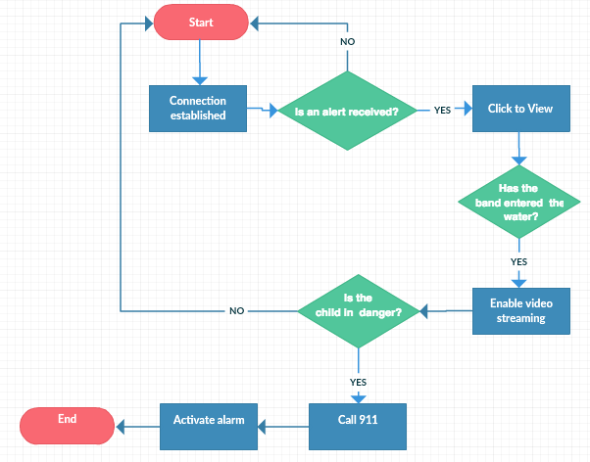

Figure 30: Mobile Application Flowchart

5.2.5 Embedded Software Design

Our project requires two P1CB. One is for main housing, another is for portable-wearable device. Let's start to look on main housing functions and what it consists of. First of all, main PCB has ultrasound sensor to sense water surface an signal if someone enters the water, second it has video camera which requires any-time access from mobile device. Third, main PCB has a speaker to send signal when triggered by sensor. Main PCB communicates using Wi-Fi and it is powered by solar. Portable device is communicating using bluetooth and power by DC voltage - battery.

Ultrasonic sensor of the main PCB requires object (in our case it is a child) to enter the sensing environment to be triggered. This should trigger alarm, send signal to speakers and send signal to mobile device to notify of the water entrance.

The wearable device main function is to check whether child is drowning. In this case, a child is already in water and guardians are aware of it. The sensor in wearable device triggers when not detected a few seconds and when pressure change is substantial.

When we consider embedded design we have looked at three embedded languages as a choice to develop code for the hardware: Embedded C, Embedded C++, and Assembly languages. Since C++ is a subset of C language the differences between them consist of more implementation, C++ is an object oriented, while C is more procedure oriented language. Both of those languages are based on the higher programming languages C and C++. C and Embedded C have same structure and rules. Most of the syntax and some library functions used by Embedded C are same as that of C, like variable declaration, conditional statements, arrays and strings, macros, loops, main function, global declaration, operational function declaration, structures and unions, and many more. Similar in C++ and Embedded C++.

Assembly language in other hand is low level programming language. It requires to program using simple commands because it can operate with two, maximum three registers at a time. The good about assembly language it is the low level and it «talks» to hardware components before the «other» programming levels do. It make assembly language fast to response. Assembly Language also has few mnemonic keywords and minimalistic syntax. But it requires more detailed programming, it is harder to write a code. It takes one instruction at the time, therefore algorithms have to be divided into many instruction. Using this procedure makes both writing code for the language as well as debugging the language very difficult. For this reason it is not preferred compared to writing in a more high level language.

In conclusion, even considering fast response of Assembly language, Embedded C and Embedded C++ programming language will be our choices to program microcontrollers for the project.

First, each component needs to be programs separate, and its outputs have to communicate to produce functionality of the whole. Following are sections detailing the realization of each of the important sensor communications in software.

5.2.5.1 Pressure Sensor Flow Design

Pressure sensor requires to read in data, compare it with previous results and decide whether to send output further, or continue to read in measurements. There are multiple scenarios need to be considered. First when a child is swimming in a water with no danger to him/her. In this case, there should not be any output (signal of danger). Pressure measurements taken in few samples are somewhat similar. Let’s say the measurement will be taken every 3 seconds. If a child knows how to swim and dive, he or she can spend underwater around 9 seconds without alarm being triggered. Past that output should be produced indicating a child is underwater for a long time. Second scenario is when a sensor is not giving measurement result to microcontroller. Again it could mean the sensor is broken, the sensor and a child is underwater and signal cannot be transmitted due to deep water, or a child wearing band is out of range. In all these three cases alarm should signal about the loss of pressure sensor measurement intake.

Since pressure sensor measures barometric pressure/air pressure, temperature of the air have to be considered. Knowing these two factors altitude can be precisely measured. We are not looking for precise measurement, the slight change in air temperature will not make effect to the pressure readings. Therefore we will not produce and implement algorithm translating pressure to altitude. We only will look at the pressure rising factor ( the higher pressure, the lower altitude). Further conversion of pressure, temperature and altitude could be found on internet web page:
https://www.mide.com/pages/air-pressure-at-altitude-calculator.

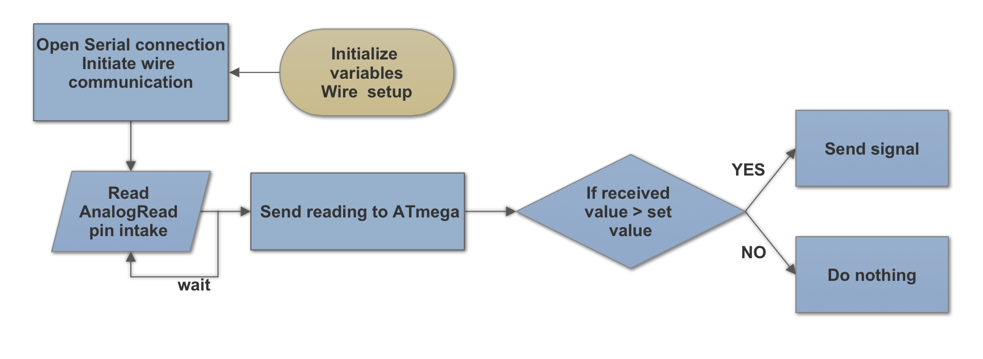
Figure 31: Pressure Sensor Flowchart

5.2.5.2 Temperature Sensor Flow Design

Temperature sensor on the wearable device needed to monitor well being of a child. Child body temperature has quicker response to atmospheric temperature, especially in very young age. Children heats up and cool off faster than adults. In Florida it is important to not overheat. Parents/guardians can check a child's temperature with mobile app. The main function of temperature sensor keep parents informed of current child’s temperature.

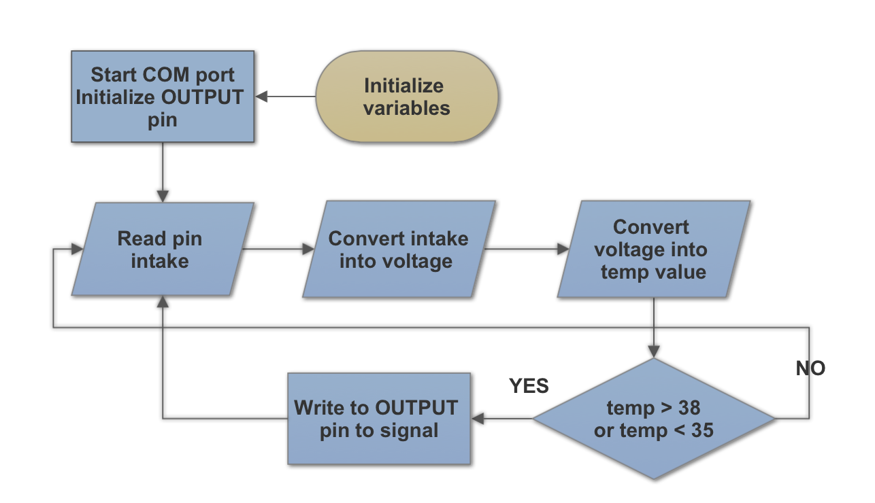

Figure 32: Temperature Sensor Flowchart

5.2.5.3 Speaker Flow Design

Speaker main function to produce sound/alarm when triggered. Trigger could come from two places, from main device, and from wearable device. Those two triggers are equally important. But when a child is in the water and this fact is known instance, the trigger should not comes off. It could be done by ignoring output from ultrasound sensor in main device, or sensor should not produce any output. It could be done by having OFF mode in either sensor output or speaker input. Speaker outputs frequency wave and we can output a melody instead of just an alarm. By choosing different frequency as notes, duration as tempo and beat of a note.

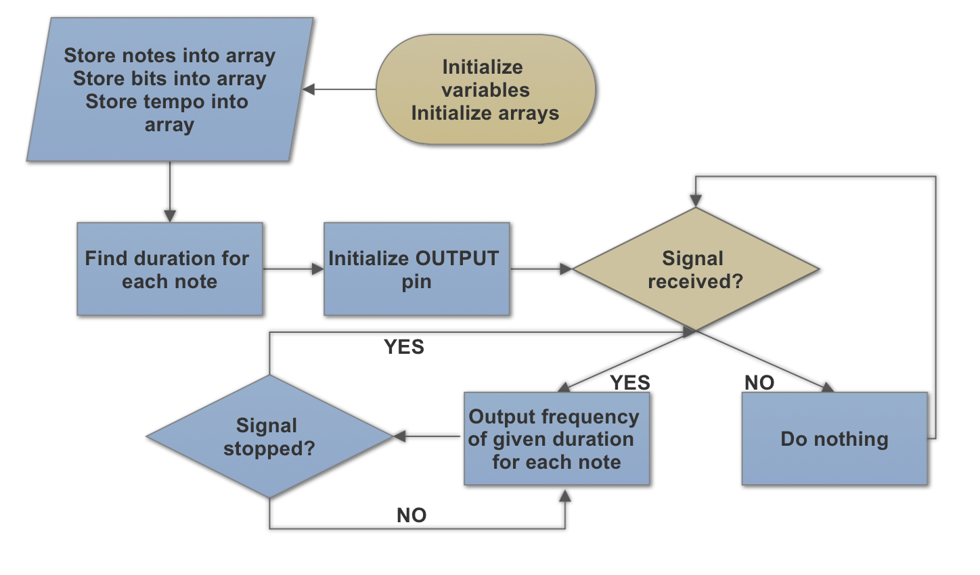
Figure 33: Speaker Flowchart

5.2.5.4 Ultrasound Sensor Flow Design

Ultrasound sensor main function is to detect an object/child entering water. Constant variation of an ultrasound measurements will differ a human being from a leaf or some debris falling to a pool, since a human being or an animal make movements. Readings of received measurements for few seconds will be enough to determine whether or not output should be produce to trigger the alarm.

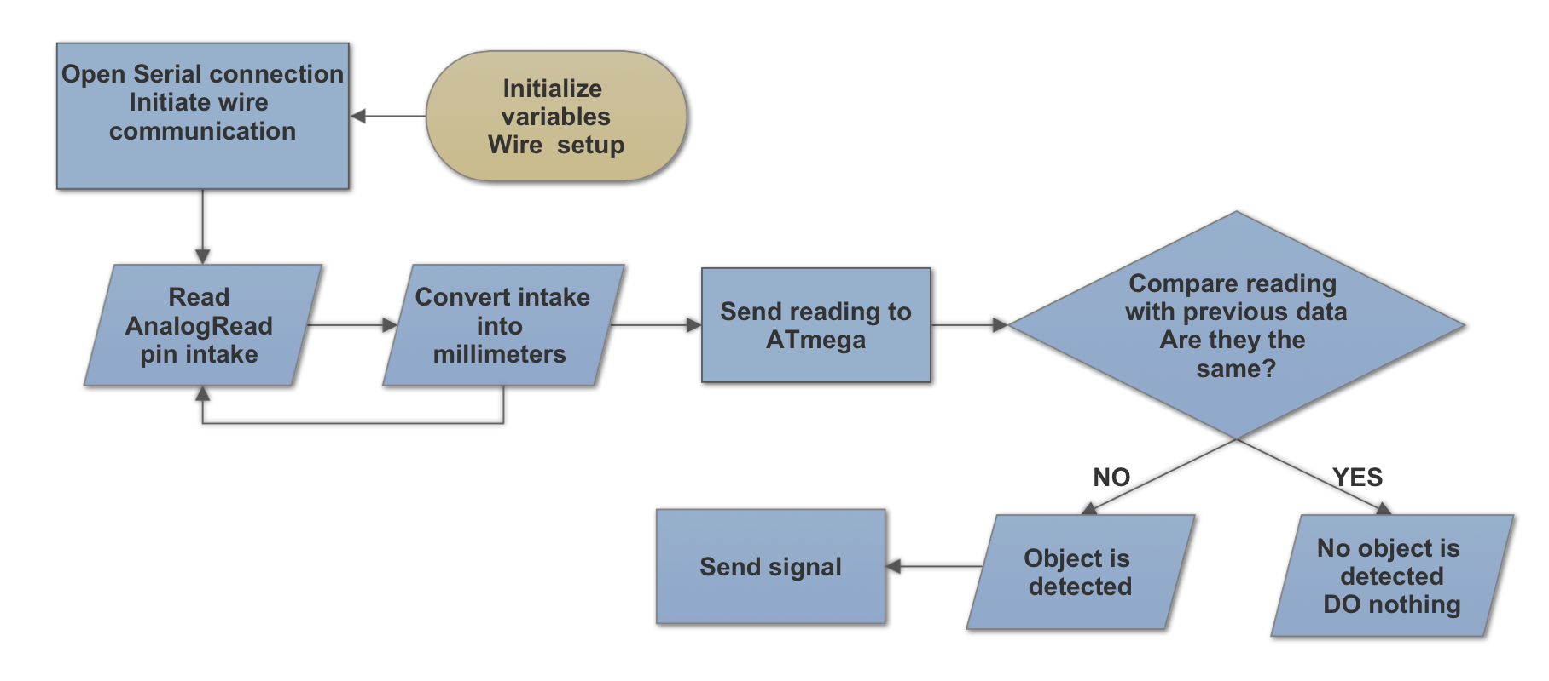
Figure 34: Ultrasound Sensor Flowchart

Video Camera is located in main housing and has its own microcontroller and raspberry Pi embedded board. It requires to output signal (video) when requested. Such request can be input by a guardian/parent in a mobile phone through application. Then the signal transmitted to main device, main device further request video to be send out. Video transmitted back to mobile phone. Such request can be completed when the main device is ON and powered, and have to be transmittable as long as required by a parent. This should be maintained until it is manually disabled by the parent to preserve the connection between the main unit and MCU.

Below we are shown the pcb schematic of the sensors. The two temperature sensor and the pressure sensor are connected to the wifi model which is then power by a small 3 v batteries. This system will them be placed in a housing so that it can be placed onto a child.

The system will then send a signal to the main pcb and it will notify if the child had indeed drowned. That is the main job of this system. To measure the change in temperature and to measure the change in pressure. Lastly if there is a drastic change in the sensor then it will send an alerts. This alert will then be processed and appropriate action will be taken in order to ensure that the child remains safe. Note that the sensors can be adjusted based on the supplied voltage to send different signals which could be used as a means of determining danger.

5.2.6 Raspberry Pi and Main PCB Functions

The main PCB will need to process and send out a variety of signals in order to make the project function. Essentially, the main PCB will act as an intermediate connection between the wearable band and the mobile application. This board is extremely important as it communicates with all devices that are part of this project. The flowchart below shows how the code will work to process and send out signals. The initial signal comes from the wearable band when water is detected. The main PCB does not send data or signals to the wearable band. After the main PCB has been alerted that the band has detected water, it immediately communicates with the mobile application to relay the information. When the information has been processed by the parent on the mobile application, the mobile application can then communicate to the PCB to activate the video stream and the alarm. The main board can activate the alarm if it is requested to do so from the mobile application. If the video stream is requested via the mobile application, the main PCB will send a signal to the Raspberry Pi. The Raspberry Pi will then begin the video stream and forward it to the mobile application. Both the video stream and the alarm will stay enabled until the mobile application has sent a signal to stop.

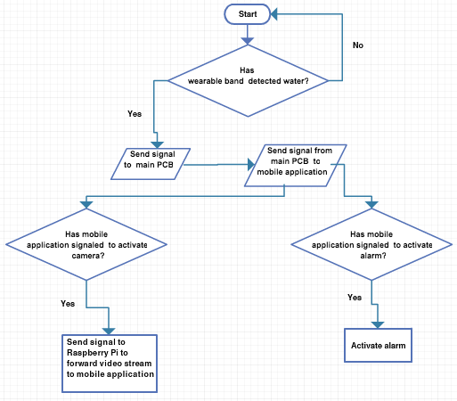
Figure 35: Software Flowchart

5.2.6 Block Diagram and Task Assignment

From the time the band detects water and signals to the main PCB, many processes need to be completed. First off, the sensor will need to programmed to send a simple signal to the PCB on the base unit acknowledging that water has been detected. Once the ATmega board has been notified, an alert will be transmitted to the android mobile application. It is at this time that the parent will view the alert on the mobile phone and send a signal to request the video stream. This is done by sending a signal to the PCB which then forwards the request to the Raspberry Pi. The Raspberry PI will then begin recording video and forward it to the mobile application. The block diagram below summarizes the process that has just been explained. Moreover, it can be seen who is responsible for handling the specific tasks that are displayed.

Raspberry Pi Video Streaming
Sensor Software
ATmega Embedded System Code
Android Application
Work Distribution
Zachary Schwartz
Anna Baranova
Video Feed
Gets feed to be processed
Analog Input
Alerts Main Unit
Only Sends Feed
Sends Alert and Receives Commands

Figure 36: Block Diagram and Task Assignment

6 Housing

This section details the mechanical design accompanying the electrical and software design. The main focus of this portion of the project is obviously waterproofing the devices as the band will of course need to be waterproof when it falls into the pool while the main housing should be at least very resistant to water as it will sit next to the pool. The first part of this section will detail the design of the main housing unit and what it will be held in place by. The second section will focus mostly on the band design and how it can be best made to be as waterproof as possible.

6.1 Main Housing

The main PCB, Raspberry Pi, camera, and speakers, will all be placed in a plastic enclosing which will be placed on the perimeter of the pool. The housing will protect the the components. We will design the housing in a way that allows the speakers to heard and the signals to not be blocked. It will be a clear dome structure that will block the components from being rained on. The microcontrollers and speakers will be elevated on a small platform. This will allow the dome to be over the top of the components without having to be fully enclosing it. The benefits of this structure are that it will not interfere with the signal and the alarm will be easier to hear when the speakers are activated.

After thorough research we could not find a perfect housing structure that was available to purchase. Getting the material and crafting the enclosure ourselves will be cheaper and more effective. The enclosure is not very complex as it just needs to shield the components from rain and provide a platform for the components to rest on. The dome and platform will be similar to the figures displayed below. The portion of the platform that the microcontrollers and speakers will rest on will be slightly larger than the size of the microcontrollers.

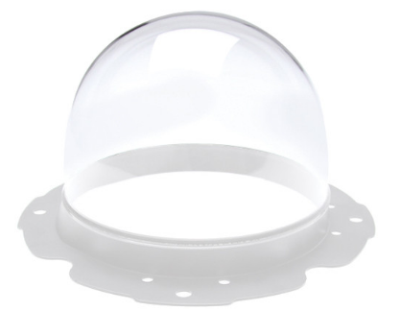
Figure 37: Plastic Dome
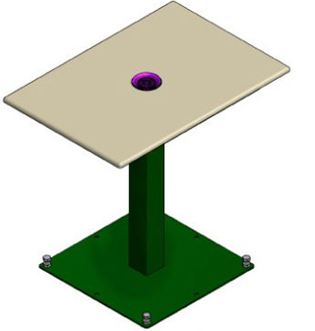

Figure 38: Platform for Microcontrollers

Since the components will be outside it will be important to cover the wiring so that damage is not done. Wire guard will be purchase for cheap and attached to all wires that are used to connect our devices. The battery will have its own simple housing the ensure it is not damaged by water. It will not be with the microcontrollers under the dome due to size constraints.

This portion of the project design will most likely be the last thing attempted by the group. While it is a very important aspect of the final product, at the same time it is one of the less necessary things with regards to actually creating a working prototype. Also none of the group members have very much mechanical design ability meaning that this will be a relatively difficult and strenuous without a lot of payoff for the faculty demonstration. Even though the presentation of the product is largely based on this section of production, it is not something electrical and computer engineering students are most comfortable with.

6.2 Portable Housing

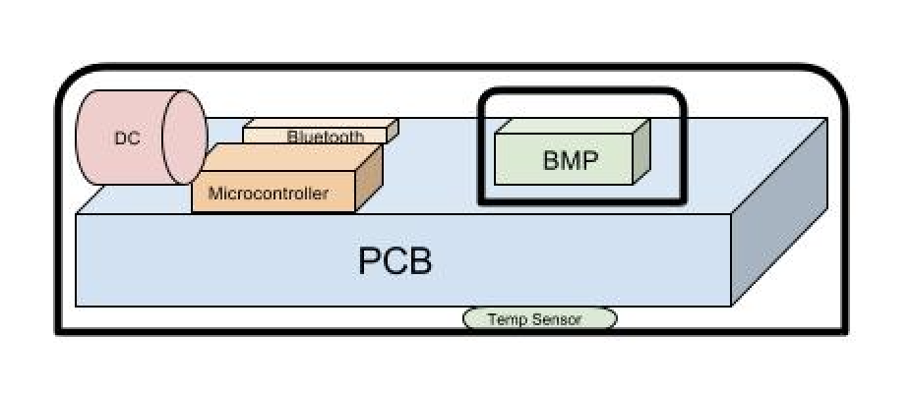
Wearable device housing as was mentioned in research part of the project have to be comfortable enough to not irritate a child's skin, be durable enough to hold a casual wear and tear, and be waterproof. Since main component of the wearable device is the pressure sensor, first we have to consider its characteristics and safety. According to manufacturer Handling Instructions, mounting of the pressure sensor have to be with great precociousness, and because of the recommended details, PCB of the wearable device could not be too small ( size of the sensor). Another consideration is water, IPx5 rated housing or higher need to be considered. Light and heat is the third consideration, it can influence measurements. Direct light and close heat have be avoided. Fourth consideration is the epoxy resin. Epoxy resin cannot be applied over sensor, it leads to unsymmetric stress distribution. Therefore, sensor should be covered by confinement walls and larger port hole on top of the sensor. Port hole should be covered by membrane made of porous material.

Figure 39: Housing for Wearable Device

The device itself could be covered in plastic film and then placed in silicone made container. Silicone alike material also could be sprayed over and then cut unnecessary or uneven parts. The other choice it to use 3D printer and print plastic housing in a rectangular shape. To keep the device in place, or to make it wearable, headband or armband needs to be attached. For such purpose technical slots will be made at two opposite sides of the housing. In order to make slots, the bottom sides have to be thicker. Elastic fabric of needed size is fitted through these slots to make one whole design.

Unlike with the main housing design, this portion of the mechanical design is integral to the successful demonstration and production of the finished product. From the beginning the mechanical abilities of the wearable device should be taken into account as throughout testing it will be necessary to drop the circuitry into the water. Without actually being able to resist being dropped into at least shallow water, the project will not be a success. So even though it may not be the preferred task of the group it should be one that is always kept in mind.

Senior Design II edit:
Research was made on encapsulation of electronics submerged in water. To protect secondary PCB rubber silicone was chosen. Smooth-on Dragon Skin Silicone Rubber, by Smooth-on, Inc. was chosen as it delivers skin effect, skin safe, flexible, easy to work with and not too costly. PCB of wearable device was fully submerged into liquid silicone to cover it completely, then an opening was made to give temperature sensor access to air to enable sensing capability.
For the main device PCB 3D printing of housing was chosen. Housing covers main PCB, Raspberry Pi Zero with RaspiCam module, and power battery. Free 3D printer, MakerBot Replicator 2, in the public library near main UCF campus was used and did not cost us nothing. The design was made with AutoDesk AutoCAD software. To hold Solar Panel, the stand was made of light metal panels purchased at one of the local hardware stores.

7 Testing Plan and Demonstration

This section of the document will describe the plans both for testing that the system functions as expected and the plan for demonstration to the faculty review panel. The first section details the stages of testing readiness that will be gone through throughout senior design 2 as the project continues to develop. The second details the current and desired functionality of the finished project.

7.1 Stages of Testing

There are three stages to the testing plan that will be detailed in this section. The first stage is the individual component/breadboard stage. In this stage all the components are tested individually to insure functionality that is adequate to proceed to mounting them on a pcb and full integration of the system. The components are each tested individually first and then together using a breadboard after it is established that each works individually. This stage also pends the development of at least a rudimentary application to test the communication between the microcontroller and the application (one of the group members phones should be adequate for this purpose). This stage is where the group is at now as of the writing of this paper, mainly waiting on the software production while continuing to test components.

The next stage of testing is the videotaped full demonstration. In this stage of development the system will be tested in a full size pool in the sunlight. It was concluded to be necessary to have this portion of the demonstration as it was deemed impractical to demonstrate a full size pool to the faculty. Because of this a pool will be required. Currently the group's plan is to use a ucf pool during a time when few people are there (once it gets out of the summer months), but if this plan fails one of the group members has a friend who has a pool that may be able to be used. Another important consideration is that the chosen pool must be close enough to a wifi hotspot to gain access, or the entire project will fail, due to the main unit needing to communicate with the android application for any type of interfacing.

The third and final stage of prototyping is the faculty demonstration. For this portion of the project, the technology needs to be able to be shown to the faculty in some way, along with the video recording from part 2. For this reason, the group has devised a plan to use a small, kid pool along with some type of doll to show the faculty the basic functionality. Along with this, the video that was recorded in part 2 of the test plan will also be shown to give a more full functioning view of the project. For the kid pool setup, the main device may need to be adapted in some way in order to accommodate the limitations of a small pool, but this will be addressed once part 2 has been achieved. The housing of the device may need to be revamped slightly but it should be doable considering the housing itself is one of the later tasks to be accomplished.

7.2 System Functionality and Status

This section of the report gives the status of the important functions that the system should have. Upon each of these functions being obtained, the system will be ready for demonstration to the faculty. It is meant to be a means of keeping track of what requirements have currently been achieved, as well as planning to ensure that all requirements are meant before demonstration time.

Table 21: System Requirements Status
Functionality | Status
Power system supplies a constant 5V to the system | Done
Solar panel provides sustainable energy to system | In progress
Communications between raspberry pi and ATmega established | Done
Graphical user interface with all buttons established on application | In Progress
Communications between main PCB and application established | In Progress
Band created and able to communicate with main PCB | In Progress
Phone alarm on signal from microcontroller | In Progress
Speakers activate on signal from phone application | In Progress
Video streaming activates on signal from phone application | In Progress
Band is waterproof | In Progress
This set of test requirements represents a fully functional overview of all facets of the project. First the power system must be capable of supplying the required voltage for all components to operate properly. This is important as without the correct voltage level different components may become damaged or simply not function properly. Next is the ability of the solar panel to provide proper energy to the system. This was a major motivator for the development of the project as many similar systems were not taking advantage of this seemingly obvious source of renewable energy. The communications between the raspberry pi and the MCU on the main PCB are imperative to get right as the video streaming will not function at all without it. The mobile application is the most important thing to get next as testing the rest of the project will be much more difficult without an effective way to visualize what is happening in the system.

The obvious next step is to get the mobile app and the main system to communicate with one another. This is done through getting the wifi adaptor to function properly as well as having the mobile app able to receive data. Once this is accomplished the next step is to get the band to be able to communicate with the main unit to send a danger signal, as this is the entire purpose of the project it is of primary importance. After the band is able to successfully send a signal, all of the capabilities following are to be enabled such as the mobile app being alerted, the alarm turning on, and video streaming starting. Finally, the last developments will be on making the components waterproof so they are actually usable outside of the laboratory.

8 Administrative Content

With any engineering project, there are additional management dealings that need to be addressed in addition to the engineering applications. This section simply covers the two main concerns with this by going over the budget and project milestones. It is important to keep in mind that these are only current up to the point of the writing of this paper and will need to be updated and maintained as the project continues to advance. This is due to the fact that there will always be unforeseen additional cost in any major design project as well as not everything going quite as planned requiring schedule/milestone adjustments to be made. Also both managements must meet the needs of the team so no one have to spend more time and resources than what they are willing to invest and the project will be completed in a timely manner. These are important skills for the group members to develop as they move into industry and past the theory of the engineering curriculum.

8.1 Proposed Budget

All the prices for the project are estimated and based on the online research, current monetary price and current selection of parts. Changes likely will happen as further exploration of all possible opportunities is done. All group members are responsible for splitting the costs of the project as no sponsor has been found for the project. It should also be kept in mind that additional units may need to be acquired if the primary ones are faulty or break for any reason. This table will be updated with the final totals for each component once the costs have been finalized at the end of the semester.

It is worth discussing that due to all of the members of the group having financial constraints on them in one way or another, it is important to attempt to adhere to the proposed budget as it will not lead to some members having to sacrifice further down the road. Though the group was unsuccessful in finding a sponsor to assist in the burden of financing the project, they are confident that as long as the costs do not far exceed what is expected, they can manage. As the project continues to evolve and more parts are needed and some are disposed of, this section serves as a good reference point to base how the group is doing off.

Below is the table that shows the proposed budget for the project. The major components that are too expensive to order multiple copies of will be limited to one order. For the cheaper units it will most likely be beneficial in the long run to order multiple copies to ensure that the part will be working when it is needed. If some part is needed that is not in the budget, it should be noted if it takes the place of some other part than could now be crossed off from the listing. The table shows a brief part description, the price of each unit, the amount that are to be ordered, and the total price that is paid.

Table 22: Proposed Budget
Part Description | Price per Unit | Amount | Total Price
Temperature Sensor | $10.00 | 1 | $10.00
PCB for main device | $100.00 | 1 | $100.00
PCB for inside alarm | $20.00 | 1 | $20.00
WaterProof Speaker | $25.00 | 1 | $25.00
Speaker | $10.00 | 1 | $10.00
WaterProof  Video Camera | $70.00 | 1 | $70.00
Power Supply | $50.00 | 1 | $50.00
Transformers | $10.00 | 2 | $20.00
Misc(wires,amp, resistors,capacitors, transformers, etc) | $50.00 | 1 | $50.00
Packaging | $30.00 | 2 | $60.00
Bluetooth  Receiver & transmitter | $22.00 | 1 | $22.00
WIFI module | $7.00 | 1 | $7.00
Flotation device | $20 | 1 | $20
 | Total |  | $464.00

8.2 Inventory

The main components of the project have been ordered and delivered. This comprehensive list will allow us to keep tracking of who bought what and allow us to easily stay within our budget. The items that have not been ordered yet are the PCB we designed, housing parts, and basic electrical supplies. Within the first couple weeks of Senior Design 2, we plan to have our PCB design finalized and ready to order. Our main focus was to get the parts that are absolutely necessary in order for our project to function properly. Basic electrical supplies and tools will be purchased or borrowed locally as needed throughout the semester. No later than halfway through Senior Design 2 we would like to have the housing supplies ordered.

Table 23: Ordered Parts Track
Item Name | Seller | Price per unit | Delivery price | Total Paid | Quantity | Purchaser
Raspberry Pi Zero w/ camera | Adafruit | 44.95 | 0 | 44.95 | 1 | Zach
USB Speakers | Adafruit | 10 | 0 | 10 | 1 | Zach
Mohoo 20A 12V/24V Charge Controller | Amazon | 10.98 | 0 | 10.98 | 1 | Brian
25 Watts Monocrystalline Newpowa  Solar Panel | Amazon | 45.99 | 0 | 45.99 | 1 | Brian
ExpertPower 12V 7 Amp lead-acid Battery | Amazon | 16.99 | 0 | 16.99 | 1 | Brian
DROK Micro LED DC-DC | Amazon | 10.29 | 0 | 10.29 | 1 | Brian
Wifi Module | Amazon | 8.89 | 0 | 8.89 | 2 | Brian
Ultrasonic Range Finder HRLV-MaxSonar-EZ1 | Sparkfun | 34.95 | 9.10 | 113.95 | 3 | Anna
Pressure Sensor (Adafruit BMP280) | Adafruit | 9.95 | 14.06 | 43.91 | 3 | Anna
Temp Sensor | Adafruit | 1.50 | 0 | 4.50 | 3 | Anna

Senior Design II edit:
Overall Project Spendings:

Item Name | Seller | Price per unit | Delivery price | Total Paid | Quantity | Purchaser
Raspberry Pi Zero w/ camera | Adafruit | 44.95 | 0 | 44.95 | 1 | Zach
USB Speakers | Adafruit | 10 | 0 | 10 | 1 | Zach
Mohoo 20A 12V/24V Charge Contr. | Amazon | 10.98 | 0 | 10.98 | 1 | Brian
16 GB Sandisk microSD | BestBuy | 30.00 | 0 | 30.00 | 1 | Zach
25 Watts Monocrystalline Newpowa  Solar Panel | Amazon | 45.99 | 0 | 45.99 | 1 | Brian
ExpertPower 12V 7 Amp lead-acid Battery | Amazon | 16.99 | 0 | 16.99 | 1 | Brian
DROK Micro LED DC-DC | Amazon | 10.29 | 0 | 10.29 | 1 | Brian
Wifi Module | Amazon | 8.89 | 0 | 8.89 | 2 | Brian
Ultrasonic Range Finder HRLV-MaxSonar-EZ1 | Sparkfun | 34.95 | 9.10 | 113.95 | 3 | Anna
Pressure Sensor (Adafruit BMP280) | Adafruit | 9.95 | 14.06 | 43.91 | 3 | Anna
Temp Sensor | Adafruit | 1.50 | 0 | 4.50 | 3 | Anna
PCB #1 | OSH Park | 93.23 | 5.00 | 98.23 | 1 | Minh
PCB #2 | OSH Park | 42.55 | 0.00 | 42.55 | 1 | Minh
Voltage regulator | Mouser  Elec./amazom | 1.56+7.99 | 7.99 | 27.54 | 12 | Minh
Wearable Battery | Battery Mart | 9.95 | 8.14 | 18.09 | 1 | Minh
Silicon Rubber | Amazon | 37.26 | 0.00 | 37.26 | 1 | Anna
USB 4 Port Extension | Amazon | 7.49 | 0.00 | 7.49 | 1 | Anna
Cables, Keyboard, Mouse | Amazon | 48.47 | 0.00 | 48.47 | 1 | Anna
Housing | Walmart | 28.17 | 0.00 | 28.17 | 1 | Anna
Wifi Modules | Amazon | 14.99 | 0.00 | 14.99 | 4 | Brian
Crystals | Amazon | 6.21 | 0.00 | 6.21 | 10 | Brian
Backup Microcontroller | Amazon | 17.49 | 0.00 | 17.49 | 4 | Brian
Speakers | Amazon | 17.99 | 0.00 | 17.99 | 3 | Brian

8.3 Tasking and Part Status

In this section we will discuss a preliminary plan for the tasks each member will be responsible for. Although we understand that all members will need to be flexible and assist in a variety of tasks, we felt it was extremely important to have a plan that we can refer to. Brian, Zach, and Anna will primarily be responsible for the software oriented tasks, while Minh will take care of the PCB design and the power systems. Since we have three computer engineers and only one electrical engineer, Minh will be regularly assisted by the other team members throughout the electrical design process.

Brian will mainly handle the embedded system programming for the main unit. Moreover, he will assist Minh in the design of the PCB. All members plan to spend time looking over the PCB design as it is very important our design will be successful. Zach will be responsible for creating the mobile application and making sure the camera successfully feeds video to the mobile application when requested. Anna’s focus will be programming the wearable device and ensuring that the sensors are properly working. Additionally the group will work on all of the mechanical designs as a unit. This is because none of the members are particularly proficient nor do they have a desire to do the mechanical design. Also several other tasks such as preparing power point slides and designing a group website still need to be done on the group level, even after the initial senior design documentation is finished. Below is a table that summarizes the main roles each member will have.

Table 24: Tasking
Brian | Main microcontroller programming
Zach | Mobile application
Minh | PCB design and power system
Anna | Wearable device design and programming
Group | Mechanical Design, presentations

8.4 Project Milestones

This section of the report documents the group's current milestones attained, as well as forecasting what to look ahead to in the implementation stage that is senior design 2. It is important to always keep in mind what stage the group is at and where they are headed to so as not to lose focus on what is important at any given time in development.

Table 25: Project Milestones
Summer Semester (SD1)
Tasks | Start Date | End Date
Finalize Project Idea | 5/19 | 5/26
Project Discussion / Member Roles | 5/26 | 5/27
Initial Project Document | 5/26 | 6/2
Individual and Group Research | 5/26 | 7/21
Draft of Prototype Design | 6/5 | 6/9
Table of Contents / 60 Page Draft | 6/9 | 7/7
Code Development and PCB Layout / Testing | 7/8 | 8/1
100 Page Document | 7/7 | 7/21
Final Document | 7/21 | 8/1
Fall Semester (SD2)
All components fully functional | TBA
Finalize and Order PCB | TBA
Build Prototype | TBA
Final Testing | TBA
Final Report | TBA

9 Conclusion

The reasons we chose to do this project are that we think the product has the potential to be very useful and that the idea itself is extremely open-ended. Being that the project is very open-ended, we were able to think about different features that can be built. This will make the creation of the project in Senior Design 2 very interesting as it will involve a broad skillset to complete. We will gain valuable experience from using several technologies, communication methods, and designing a mobile application.

The completion of this document was done in three main phases. First we researched technologies and products, then we selected the products and technology, and lastly we tested the parts we ordered. The Aqua Sentinel 3000 was an idea that we thought of from scratch as there is not a product that has the same features. This meant that we needed to be diligent in our research to make sure the project can be successfully completed. Although the project is not extremely complex, this document shows that there are a lot of features that will require a great deal of time to implement.

In order to design a product that could be used to prevent children from drowning and alert parents, we researched all the possible technologies and parts we could use. Moreover, we found that the best way to design our project would be to have a band that attaches to the child, a base communication unit on the outside of the pool, and a mobile application. This documentation explained the technologies that will be used for the interactions between different devices and why they have been chosen. Throughout the research process we analyzed the pros and cons of different devices and technologies. This knowledge will be helpful if we encounter obstacles in Senior Design 2 as we will be prepared to use alternative methods.

The group has considered potential issues that could arise during throughout the design process in Senior Design 2. The first problem that we may encounter is that the band may malfunction if it is completely submerged in water before the signal can be sent to the main unit. This will require further testing early in the design stage to ensure that the technology we chose is an appropriate choice. The second issue is the mechanical aspect of the project. While our group members have strong fundamentals in computer and electrical engineering, designing the structural portion of this project will be difficult. In this document, we have discussed several different methods to design the housing for this project.

Majority of the parts that will be used in the project have been purchased. The only items that have not been purchased are the custom PCB and the housing materials. All the items that were supposed to be purchased in Senior Design 1 have been purchased, which will allow us to get working immediately when Senior Design 2 begins. Our preliminary PCB design is included in this document and we plan to analyze it further to ensure our first order for the PCB will be successful.

Looking ahead to Senior Design 2, it is going to be necessary to meet up often in order to ensure that all tasking is completed on time. After the two week break in-between semesters, the group will meet and set deadlines for every week to make sure things are really getting done. Unlike Senior Design 1 which allows some leeway in when things are done, if the group falls behind in Senior Design 2 they may not be able to deliver their project on time. As every member of the group is ready to graduate and set out to accomplish great things, it is necessary for them to first overcome this final hurdle in their undergraduate career.

We regularly held meetings and discussed our findings to make certain that we were all in agreement. Moreover, we have clearly defined our roles in the design process and have a strong understanding of how we are going to navigate through the many steps. Although countless hours were spent deciding how certain features will be implemented, we are prepared to overcome any obstacles that may arise. Overall, we are extremely confident that this document thoroughly covers the design of the project and will be able to help guide us throughout Senior Design 2.

10 Appendices

10.1 References

1. Edgefx.in, Kits and Solutions. (n.d.). Know about Various Types of Temperature Sensors [Blog post]. Retrieved from https://www.edgefx.in/6-different-types-of-temperature-sensors-with-their-specifications/

2. Johnson, Curtis D, “Pressure Principles” Process Control Instrumentation Technology, Prentice Hall PTB.

3. National Instruments. (2012, November 15). How To Measure Pressure with Pressure Sensors [White papers]. Retrieved from http://www.ni.com/white-paper/3639/en/#toc2

4. Electronics Tutorial. (n.d.). Wheatstone Bridge [Blog post]. Retrieved from
http://www.electronics-tutorials.ws/blog/wheatstone-bridge.html

5. Lish Tom. (2012, April 28). What is a Strain Gauge Pressure Transducer? [Blog post]. Retrieved from https://www.setra.com/blog/strain-gauge-sensing-technology

6. Haresh Khemani. (2009, October 22). Capacitive Transducers or Capacitive Sensors or Variable Capacitance Transducers. Retrieved from http://www.brighthubengineering.com/hvac/53147-how-capacitive-transducers-work/

7. Chan, M.; Estève, D.; Fourniols, J.Y.; Escriba, C.; Campo, E. Smart wearable systems: Current status and future challenges. Artif. Intell. Med. 2012, 56, 137–156.

8. Orengo, G.; Lagati, A.; Saggio, G. Modeling wearable bend sensor behavior for human motion capture. IEEE Sens. J. 2014, 14, 2307–2316.

9. Lim JY, Kim SY. Yield strain behavior of poly(ethylene terephthalate): Correlation with yield stress behavior in strain rate, temperature, and structure dependence. Polymer Journal 2004; 36: 769–773.

10. Kenry, Joo Chuan Yeo and Chwee Teck Lim. (2016, September 26). Emerging flexible and wearable physical sensing platforms for healthcare and biomedical applications [Review article]. Retrieved from https://www.nature.com/articles/micronano201643

11.Waller JH, Lalande L, Leterrier Y et al. Modelling the effect of temperature on crack onset strain of brittle coatings on polymer substrates. Thin Solid Films 2011; 519: 4249–4255.
12. Khan S, Lorenzelli L, Dahiya RS. Technologies for printing sensors and electronics over large flexible substrates: a review. IEEE Sensors Journal 2015; 15: 3164–3185.

13. (n.d.) Ecoflex 00-30 [Product description]. Retrieved from
https://www.smooth-on.com/products/ecoflex-00-30/

14. (n.d.). What is an Ultrasonic Sensor. Retrieved from
http://education.rec.ri.cmu.edu/content/electronics/boe/ultrasonic_sensor/1.html

15. Texas Instruments. (2015, November). How to Select and Mount Transducers in Ultrasonic Sensing for Level Sensing and Fluid ID [Application report]. Retrieved from http://www.ti.com/lit/an/snaa266a/snaa266a.pdf

16. Brown Christian. (2016, July 11). Nothing Gets in: Waterproof Enclosure 101 ( and IP68) [Blog post]. Retrieved from
https://www.fictiv.com/blog/posts/nothing-gets-in-waterproof-enclosure-design-101-and-ip68

17. O-Ring Seals in the Design of Hydraulic Mechanisms, a paper presented at the S.A.E. Annual Meeting, January, 1947 by Mr. D. R. Pearl, Hamilton Standard Division of United Aircraft Corp.

18. Parker Hannifin Corporation. (2007). Parker O-Ring Handbook. Retrieved from https://www.parker.com/literature/O-Ring%20Division%20Literature/ORD%205700%20Parker_O-Ring_Handbook.pdf

19. Andrew Weiman. (2012, October 05). Tips on waterproofing components in harsh environments [Article]. Retrieved from
http://www.designworldonline.com/tips-on-waterproofing-components-in-harsh-environments/

20. ( 1989, October 24). The International Temperature Scale of 1990 [Standard ITS-90]. Retrieved from http://www.omega.com/temperature/z/pdf/z186-193.pdf

21. (2011, April 11). SI_10-2010 - American National Standard for Metric Practice [Standard IEEE/ASTM] Retrieved from http://ieeexplore.ieee.org/document/5750142/

22. (n.d.). Standard Practice for Static Calibration of Electronic Transducer-Based Pressure Measurement Systems for Geotechnical Purposes [Standard ASTM]. Retrieved from
http://webstore.ansi.org/RecordDetail.aspx?sku=ASTM+D5720-95(2009)
23.(1995). ISA-37.3-1982 (R1995) Specifications and Tests for Strain Gage Pressure Transducers [Standard ISA]. Retrieved from https://www.isa.org/store/isa-373-1982-r1995-specifications-and-tests-for-strain-gage-pressure-transducers/118179

24. (2017). About ISA [Description of organization]. Retrieved from
https://www.isa.org/about-isa/

25. ASTM F2070-00, Standard Specification for Transducers, Pressure and Differential, Pressure, Electrical and Fiber-Optic, ASTM International, West Conshohocken, PA, 2000, www.astm.org

26. James Wiczer. (2005). A Unifying Standard for Interfacing Transducers to Networks – IEEE-1451.0 [ISA Expo presentation]. Retrieved from
http://www.sensorsynergy.com/unifystds.pdf

27. https://www.iso.org/obp/ui/#iso:std:iso:16810:ed-1:v1:en

28. Adamu Murtala Zungeru. (n. d.). Design and Development of an Ultrasonic Motion Detector. [Paper]. Retrieved from https://arxiv.org/pdf/1303.1732.pdf

29. Intro Robotics. (2013, November 20). Types of Sensor for Target Detection and Tracking [Blog post]. Retrieved from
https://www.intorobotics.com/types-sensors-target-detection-tracking/

30. ASTM E587-15, Standard Practice for Ultrasonic Angle-Beam Contact Testing, ASTM International, West Conshohocken, PA, 2015, www.astm.org

31. ASTM E317-16, Standard Practice for Evaluating Performance Characteristics of Ultrasonic Pulse-Echo Testing Instruments and Systems without the Use of Electronic Measurement Instruments, ASTM International, West Conshohocken, PA, 2016, www.astm.org

32. Lady Ada. ( 2016, September, 04). TMP36 Temperature Sensor. Overview [Product description]. Retrieved from
https://learn.adafruit.com/tmp36-temperature-sensor

33. Maximintegrated. (2015). DS18B Programmable Resolution 1-Wire Digital Thermometer [Datasheet]. Retrieved from
http://datasheets.maximintegrated.com/en/ds/DS18B20.pdf

34. Melexis. (2013. February 28). MLX90614 family. Single and Dual Zone Infra Red Thermometer in TO-39 [Datasheet]. Retrieved from
https://cdn-shop.adafruit.com/datasheets/MLX90614.pdf
35. Sparkfun. (n.d.) Ultrasonic Sensor - HC-SR04 [Product description]. Retrieved from https://www.sparkfun.com/products/13959

36.Elecfreaks. (n.d.). Ultrasonic Ranging Module HC - SR04 {Datasheet].
Retrieved from
https://cdn.sparkfun.com/datasheets/Sensors/Proximity/HCSR04.pdf

37. Maxibotix. (n.d.). High Performance Sonar Range Finder MB1000, MB1010, MB1020, MB1030, MB1040 [Datasheet]. Retrieved from
http://www.maxbotix.com/documents/LV-MaxSonar-EZ_Datasheet.pdf

38. Maxibotix. (n.d.). High Performance Sonar Range Finder MB1200, MB1210, MB1220, MB1230, MB1240, MB1260, MB1261 MB1300, MB1310, MB1320, MB1330, MB1340, MB1360, MB1361 [Datasheet]. Retrieved from
https://www.maxbotix.com/documents/XL-MaxSonar-EZ_Datasheet.pdf

39. Lady Ada. (n.d.). Pressure-Sensitive Conductive Sheet (Velostat/Linqstat) [Product description]. Retrieved from https://www.adafruit.com/product/1361

40. Bosch Sensortec. (n.d.). BMP280. Digital Pressure Sensor [Datasheet]. Retrieved from
https://cdn-shop.adafruit.com/datasheets/BST-BMP280-DS001-11.pdf

41.Interlink Electronics. (n.d.). FSR® Integration Guide & Evaluation Parts Catalog With Suggested Electrical Interfaces [Guide]. Retrieved from https://cdn-learn.adafruit.com/assets/assets/000/010/126/original/fsrguide.pdf

42. Patricia Stafford. (2015, August 07). Retroreflective Mode: When Ultrasonic Sensors Rise to the Highest Challenges [Blog post]. Retrieved from
http://blog.pepperl-fuchs.us/retroreflective-mode-when-ultrasonic-sensors-rise-to-the-highest-challenges

43. Ittiam. (2015, November). Reliable Video Streaming Over Wi-Fi (Part 1) [Whitepaper]. Retrieved from
https://www.ittiam.com/wp-content/knowledge-center/whitepapers/WP011_Reliable-Video-Streaming-Over-WiFi-Part1.pdf

44. "ZigBee® Wireless Standard - Digi International." https://www.digi.com/resources/standards-and-technologies/rfmodems/zigbee-wireless-standard. Accessed 31 Jul. 2017.

45. "Wireless Standards: 802.11a, 802.11b/g/n and 802.11ac - Lifewire." 4 May. 2017, https://www.lifewire.com/wireless-standards-802-11a-802-11b-g-n-and-802-11ac-816553. Accessed 31 Jul. 2017.

46. "Specifications | Bluetooth Technology Website." https://www.bluetooth.com/specifications. Accessed 31 Jul. 2017.

47. "Serial Communication - learn.sparkfun.com." https://learn.sparkfun.com/tutorials/serial-communication. Accessed 31 Jul. 2017.

48. "Synchronous Serial Communication: The Basics – ITP Physical ...." 23 Oct. 2014, https://itp.nyu.edu/physcomp/lessons/serial-communication/synchronous-serial-communication-the-basics/. Accessed 21 Jul. 2017.

49. "Building Your First App | Android Developers." https://developer.android.com/training/basics/firstapp/index.html. Accessed 27 Jul. 2017.

50. "Creating a Navigation Drawer | Android Developers." https://developer.android.com/training/implementing-navigation/nav-drawer.html. Accessed 22 Jul. 2017.

51. "Raspberry Pi Zero v1.3 Camera Pack - Includes Pi Zero ID: 3170 ...." https://www.adafruit.com/product/3170. Accessed 17 Jul. 2017.

52. "MSP430G2x53, MSP430G2x13 Mixed Signal Microcontroller (Rev. J)." http://www.ti.com/lit/gpn/msp430g2253. Accessed 7 Jul. 2017.

53. "CC3120 SimpleLink™ Wi-Fi® Network Processor ... - Texas Instruments." http://www.ti.com/product/CC3120. Accessed 9 Jul. 2017.

54. "Magnetic Audio Transducer - CUI Inc. - Alarms, Buzzers, and Sirens ...." https://www.digikey.com/catalog/en/partgroup/magnetic-audio-transducer/66. Accessed 31 Jul. 2017.

55. "HD Webcam C525 Portable HD video calls - Logitech." https://www.logitech.com/en-us/product/hd-webcam-c525. Accessed 22 Jul. 2017.

56. "How it works | Bluetooth Technology Website." https://www.bluetooth.com/what-is-bluetooth-technology/how-it-works. Accessed 29 Jul. 2017.

57. "Streaming Video in Android Apps - Code Tuts - Envato Tuts+." 21 Apr. 2014, https://code.tutsplus.com/tutorials/streaming-video-in-android-apps--cms-19888. Accessed 24 Jul. 2017.

"Wireless Personal Area Network (WPAN)." http://www.cs.nccu.edu.tw/~jang/teaching/IntroWirelessComm_files/WPAN.pdf. Accessed 23 Jul. 2017.

"Wholesale Solar." https://www.wholesalesolar.com/. Accessed 21 Jul. 2017.

58. "PA Datasheet." http://www.atmel.com/images/Atmel-8271-8-bit-AVR-Microcontroller-ATmega48A-48PA-88A-88PA-168A-168PA-328-328P_datasheet_Complete.pdf. Accessed 14 Jul. 2017.

59. "PIC16F87XA Data Sheet - Microchip Technology Inc.." http://ww1.microchip.com/downloads/en/DeviceDoc/39582b.pdf. Accessed 17 Jul. 2017.

60. "Datasheet." 9 Jun. 2015, http://www.atmel.com/images/Atmel-11100-32-bit%20Cortex-M4-Microcontroller-SAM4S_Datasheet.pdf. Accessed 22 Jul. 2017.

61. "IEEE Standard for Developing Software Life Cycle ... - IEEE Xplore." http://ieeexplore.ieee.org/document/159431/. Accessed 14 Jul. 2017.

10.2 Permission Requests

