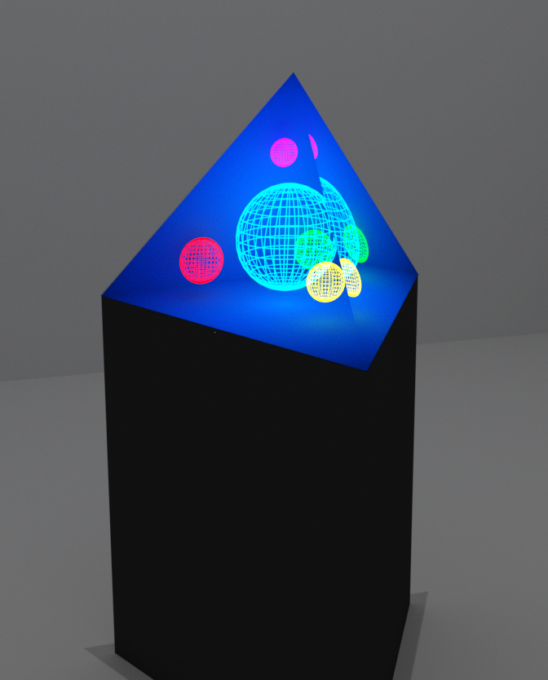

Multi-User Holographic System:

UCF Senior Design 1 Document

EEL4914 Group 14, Lei Wei, Summer 2017

Dane Bouchie, Cp. E.

Matthew Hosken, Cp. E.

Colburn Schacht, E. E.

Eric Smithson, Cp. E.

Introduction/Motivation
Virtual and Augmented Reality are two highly-anticipated technologies being researched and marketed today. Virtual Reality (VR) systems put the user inside a virtual environment to simulate new realities or provide easy accessible or simplified existing environments. Augmented Reality (AR) takes aim at adding features to our everyday existing reality such as notifications, virtual objects, and other ideas. Both methods use 3-dimensional illusions through head-tracking and stereoscopic imagery to provide real-time perspective which emulates object interaction in the real world.

Most implementations of VR/AR feature headsets such as HTC’s Vive and Microsoft’s HoloLens. In this project, we provide a different solution featuring a virtual display environment embedded in a display surface. Rather than display images overlaid over a user’s eyes, we explore applications in a 3-dimensional physical display object. And in addition, provide an experience where multiple users can interact with a single synchronized environment.

This device provides research in design and a platform for future research in the topic. Majority of motivation comes as an academic exercise and to create a unique experience. Due to relatively high expected costs, it is unlikely to be marketed. It is not targeted as a specific solution, but rather a proof-of-concept design.

Description
For our project, we will design a holographic system consisting of a virtual space embedded inside a display shape. The display shape will be a 3-dimensional surface (ex: cube, tetrahedron, etc.) and will allow users to interact with its virtual spaces, each featuring different applications. Multiple users will then be able to interact with a section of the display shape and view a synchronized application for collaboration.

The full 3-dimensional effect can be achieved through head-tracking and stereoscopic imaging. Stereoscopic imaging makes use of a user’s two eyes. One image is rendered and displayed on the left eye, and the other on the right eye. Since the two images are rendered from two different perspectives this creates one illusion of 3-dimensions to the user. This effect is the same effect used for 3D movies at current movie theaters. A lesser used second methods completes the effect. It requires knowing the user’s eye positions and tracks their head movement. By moving around a virtual object on a display, a user can see multiple perspectives of an object depending upon their position.

To achieve the first of these effects a 3D display surface will be acquired (ex: a 3D projector) along with 3D glasses. To achieve the second effect, a compact head-tracking system will be designed to attach to the existing glasses and track head movements (eye position).

The head tracking system can be designed using a form of triangulation. Knowing the 1-dimensional distance between one target point, and at least three different target points, and the relative 3-dimensional positions from each of the reference points from each other, we can calculate a system of equations to retrieve the target point’s 3 dimensional space. This effect can be used to calculate two target points on the corners of the glasses and allows us to calculate a majority of the orientation of the glasses. That is the x, y, z coordinates, yaw and roll. What is missing is the pitch which can be calculated through an additional sensors (the accelerometer + gyroscope).

From here the sensor data will be emitted from the glasses to the rendering computer via a data transceiver. The rendering system will compose of a high-end desktop capable of enough performance to render all graphics, and thus every aspect of the display shape. An engine running on the rendering system will take the user’s position and render the correct perspective as if the virtual environment was inside the shape. Lastly, rendered graphics are sent out and displayed on the display surface.

Using the rendering engine (ex: Unity), several applications will be designed featuring the key research points of the platform. One application will focus on a design topic. Another will focus on an entertainment topic. And one will focus on interactions between multiple users.

High-Level Requirements
1.0 | The device will simulate the viewing of a 3-dimensional image within the confines of the display surface.
1.1 | At least 2 users can interact with the same device simultaneously.
1.2 | When used properly, the device will not cause motion induced nausea for most users.
1.3 | The device will be open ended enough to market to innovator developers.
1.4 | The project will run at least one program demonstrating a design application.
1.5 | The project will run at least one program demonstrating an entertainment application (i.e. a game).
1.6 | The project will run at least one program which features at least two users interacting together simultaneously.

Table 1: High-Level Requirements

Specifications
2.0 | The display shape will be no larger than 1 cubic meter.
2.1 | The display will have a pixel density higher than 9 dpi.
2.2 | The display will run at a minimum of 20 frames per second refresh rate.
2.3 | The head tracking system will track position within a standard deviation of 10 cm.
2.4 | The head tracking system will track within an area of 0.25 m²
2.5 | The head tracking system will be responsive to 250 ms.
2.9 | The device will cost no more than $3000.

Table 2: Specifications and Engineer Requirements

House of Quality
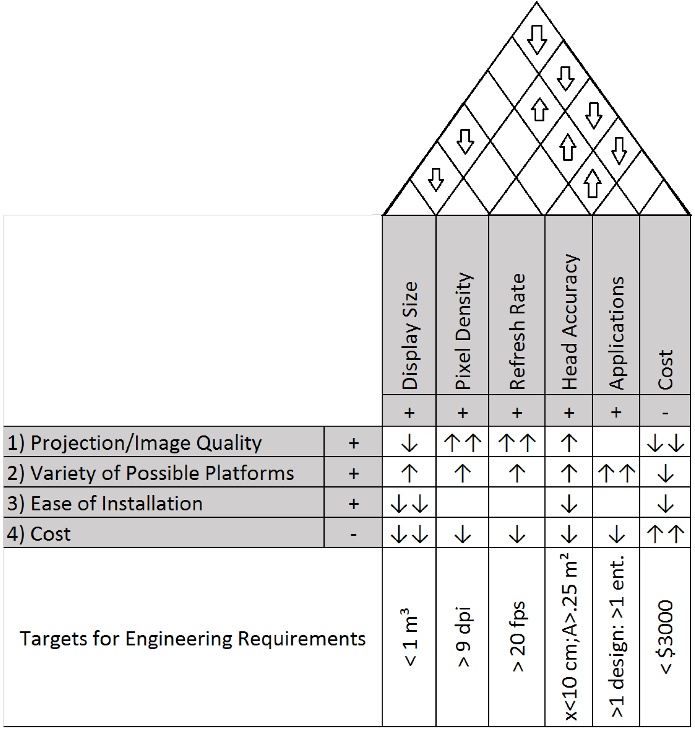

Figure 2: The complete House of Quality for Multi-User Holographic System

Project Block Diagram
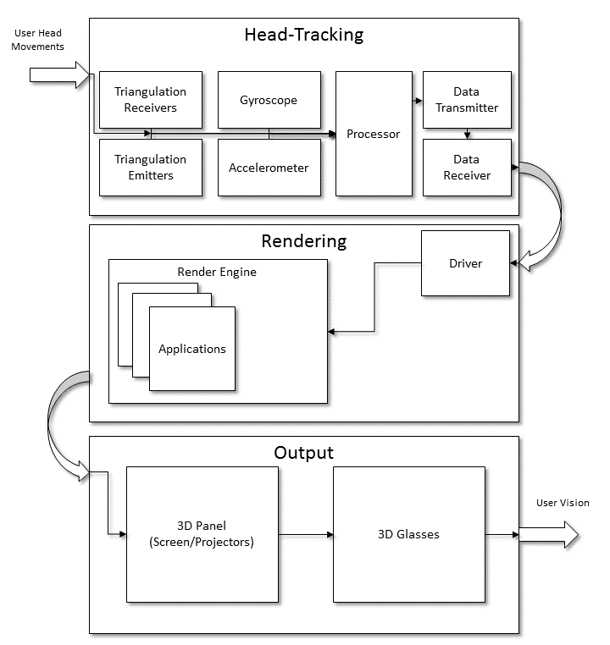
Figure 3: Project Block Diagram

Project Budget
Our project will have a larger budget compared to most senior design projects due to higher costs in the display technology. The project will still be self-funded however. Since we are not constrained to a specific amount (as with marketing), the only constraints are personal finance.

Item | Expected Quantity | Budget Allocation Per Item
Triangulation System Electronics (Parts) | 3 | $100
Triangulation System Board | 3-6 | $80
Desktop System (Rendering) | 1 | $0 (Pre-owned)
Integration Software | 1 | $60
Base Materials | N/A (1) | $300
Single Display Face (i.e. Projector/LCD Panel) | 3-4 | $600
3D Glasses | 3 | $100
Budget Total | N/A | $3000

Table 3: Project Budget

Project Milestones (Both Semesters)

# | Date | Description
1 | June 2 | Divide and Conquer - 10 pages
2 | Jun 9 | Updated Divide and Conquer - 10 pages
3 | Jul 7 | Draft Senior Design I Documentation - 60 pages
4 | August 1 | Final Paper Due - 120 pages
5 | August 1 | Have design for project fully completed
6 | August 15 | Begin Second Semester
7 | August 15 | Begin Hardware Assembly
8 | August 15 | Begin Software Development
9 | August 15 | Begin Machining and Assembling Housing for Projectors/Screens
10 | September 15 | Complete Assembly of 7, 8, 9
11 | September 21 | Complete Unit Testing of 7, 8, 9
12 | September 25th | Integration First Pass
13 | September 31st | Integration Second Pass (If necessary)
14 | October 7th | Integration Third Pass (If necessary)
15 | October 15th | Integration Testing (end to end testing)
16 | November 1st | Project Completion
14 | TBA | Committee Presentation
15 | TBA | Senior Design Expo

Table 4: Project Milestones

