Water Smart

University of Central Florida
Department of Electrical Engineering and Computer Science

Summer 2018 - Senior Design I
Dr. Lei Wei | Dr. Samuel Richie

Group 4

Kenyatta Samuels  Electrical Engineering | Winston Baptiste  Electrical Engineering | Marc Simon  Computer Engineering | Donald Miller  Computer Engineering

Table of Contents
1 Executive Summary 1
2 Product Description 3
2.1 Project Motivation 3
2.2 Project Objective 4
2.3 Project Features 5
2.4 Requirements Specifications 5
2.4.1 Major System Objectives 7
2.4.2 Major System Risks 8
2.4.3 Major Application Objectives 9
2.4.4 Non-functional Objectives 10
2.4.5 Relevant Standards 10
2.4.6 Design Impact of Life Cycle Process Standards 12
2.4.7 Software Testing 12
2.4.8 Information Technologies – Programming languages – C 12
2.4.9 Soldering Standards 13
2.4.10 Communication Standards 15
2.5 House of Quality 15
3 Constraints 16
3.1 Economic Constraints 17
3.2 Environmental Constraints 17
3.3 Social Constraints 18
3.4 Manufacturability Constraints 19
3.5 Health, and Safety Constraints 19
3.6 Sustainability Constraints 20
3.7 Time Constraints 21
3.8 Political, Ethical, and Consumer Constraints 21
4 Market Analysis 25
4.1 Market Segments 25
4.2 Competition 26
5 Relevant Technologies 28
5.1 Power System 28
5.1.1 DC/DC conversion 28
5.1.2 Linear Regulator 29
5.1.3 Inductive Switcher 29
5.1.4 Charge Pump 29
5.1.5 Designing DC/DC conversion 29
5.2 PCB Fabrication 30
5.2.1 Through-Hole vs Surface mount 30
5.2.2 Through-Hole 30
5.2.3 Surface Mount 30
5.2.4 Layers 31
5.3 Photovoltaic Cells 32
5.3.1 Monocrystalline Solar Cells 32
5.3.2 Polycrystalline Solar Cells 32
5.3.3 Thin Film Solar Cells 33
5.3.3.1 Amorphous Silicon Solar Cells 33
5.3.3.2 Cadmium Telluride Solar Cells 33
5.4 Sensors and Various Hardware 34
5.4.3 Soil Hygrometer Module 34
5.4.4 Environment Proofing 35
5.4.3 Calibration 35
5.5 Motion Detection 36
5.5.1 PIR Motion Sensor 36
5.5.2 Ultrasonic Sensor 37
5.5.3 Microwave Motion Sensors 38
5.6 Rain Detector 39
5.7 Actuator with Shutoff Valve 40
5.8 Flow Meter 42
5.9 Microcontroller 42
5.9.1 ATmega328P 42
5.9.2 Arduino Uno 42
5.9.3 Samsung ARTIK 710 43
5.9.4 TI MSP430G2 Launchpad 43
5.9.5 TI MSP430FG4618 43
5.9.6 Microcontroller Comparison 44
5.9.6.1 Power Consumption 44
5.10 Water Turbine Generator 47
5.11 Battery 49
5.12 Wireless Communication 50
5.12.1 What is Wi-Fi? 51
6 Design 66
6.1 Hardware Design 66
6.1.1 Hardware Block Diagram 66
6.1.2 Hardware Blocks: Selected Parts 68
6.1.3 PCB Designing 70
6.1.4 PCB Vendor Selection 70
6.1.5 Power Distribution 71
6.1.6 Hardware Schematic 74
6.2 Software Design Plan 79
6.2.1 Gathering Information 82
6.2.2 Use Case Diagram 83
6.2.3 Architecture 84
6.2.4 Database 85
6.2.5 Wireframes 86
6.2.6 Workflow Diagram 87
6.2.7 OS 93
6.2.8 Mobile vs Web App 94
6.2.9 Our App 95
6.2.10 Software Design Tools 96
6.2.11 Energia 96
6.2.12 Code Composer Studio 96
6.2.13 Balsamiq 96
6.2.14 Ionic Framework 97
6.2.15 Slack Communication 98
6.2.16 Software Data Flow Diagram 98
6.3 Software Functionality 99
6.3.1 Design Methodology 100
6.3.2 Version control 100
6.3.3 Cloud Services 102
6.3.4 Network Technology 102
6.3.5 ZigBee 102
6.4 Network Diagram 103
6.4.1 Network Flow Diagram 103
6.4.2 Network Topology 104
6.4.3 Sensor Unit 106
6.4.4 HUB Unit 109
7 Testing 113
7.1 Software Testing 113
7.1.2 Functionality Testing 113
7.1.3 Usability Testing 115
7.1.4 Interface Testing 117
7.1.5 Compatibility Testing 117
7.1.6 Performance Testing 117
7.1.7 Security Testing 118
7.2 Hardware Specific Testing 119
7.3 Water Turbine 122
7.4 Soil Sensor 122
7.5 Rain Sensor 123
7.7 Solder 123
7.8 Wi-Fi 124
7.9 ZigBee / Bluetooth 124
7.10 Motion Sensor 124
7.11 Water Solenoid Valve 125
7.12 Flow Sensor 125
8 Administrative Content 127
8.1 Member Contribution 127
8.2 Milestone Discussion 130
8.3 Changes of milestone 131
8.4 Bill of Materials 132
8.5 Budget Analysis 134
8.6 Project Summary and Conclusion 136

List of Figures
Figure 1: House of Quality 16
Figure 2: Market CAGRs [7] 25
Figure 3: IoT Device Shipments [7] 26
Figure 4: SparkFun Soil Moisture Sensor from Sparkfun 35
Figure 5: TMOEC Mini IR Pyroelectric Infrared PIR from AliExpress 37
Figure 6: Ultrasonic Sensor - HC-SR04 from Sparkfun 37
Figure 7: SODIAL Wireless Module Doppler Radar Microwave 38
Figure 8: Smart Electronics Snow/Raindrops Detection Sensor Module 3-3-5V with comparator from AliExpress 40
Figure 9: 1/4'' 12V DC Electric Plastic Solenoid Valve and a diagram of the mechanism from Electronic Solenoid Valves 41
Figure 10: G1 2inch DN15 Transparent Water Flow Meter Flow Meter Hall Flow Sensor Indicator Counter from AliExpress 42
Figure 11: Water Turbine Generator [1] 48
Figure 12: Yosoo DC Water Turbine Generator 12V [2] 49
Figure 13: OSI Layers 52
Figure 14: ZigBee topologies, ZC- ZigBee coordinator, ZR-ZigBee router, ZED-ZigBee end device. 55
Figure 15: Global Automated Irrigation System Market Share 63
Figure 16: A block diagram on the plan of connecting the components. 68
Figure 17: Physical Configuration 69
Figure 18: Software Data Flow Diagram 99
Figure 19: Network Diagram 103
Figure 20: Network Flow Diagram 104
Figure 21:Sprinkler Power Distribution (TI Webench Developed) 71
Figure 22:Water Solenoid Valve 72
Figure 23: Power Conversion for Flow and Motion Sensor (Eagle Developed) 73
Figure 24: Power Distribution for MSP430 and Wi-Fi 73
Figure 25. Version Control Diagram 101
Figure 26 Zigbee Mesh Topology 105
Figure 27 Sensor Unit Network Initialization 107
Figure 28 Sensor Unit Main State Diagram 109
Figure 29 HUB Unit Network Initialization 111
Figure 30: HUB Unit Main State Diagram 112
Figure 31: Components Acquired 119
Figure 32: Flow rate Data 126
Figure 33: Development Graph 82
Figure 34: Site Map 83
Figure 35: Database Diagram 85
Figure 36: Home Page, Forgot Password 88
Figure 37: New User, Connect System 89
Figure 38: Weather Page, Main Page 90
Figure 39: Schedule, Schedule Run 91
Figure 40: Zones, Zone X 92
Figure 41: Settings, Zone Settings 93
Figure 42: Smartphone Market Share 94

List of Tables
Table 1: Requirements 7
Table 2: Standards 11
Table 3: Solder Comparison 14
Table 4: Summary of pros vs cons of various PV cell technologies based on 2013 information. Cell efficiency information came from National Renewable Energy Laboratory (NREL) 34
Table 5 Summary of pros vs cons of various motion detection devices 39
Table 6 Microcontroller Power Consumption Comparison 44
Table 7 Microcontroller Cost Comparison 45
Table 8 Microcontroller Memory Comparison 46
Table 9 Microcontroller Clock Frequency Comparison 46
Table 10: Wireless Communication Advantages and Disadvantages 56
Table 11: Water Sense Specifications 65
Table 12: Software Design Steps 80
Table 13: Development Timing 81
Table 14: Use Cases 116
Table 15: Member Contribution 129
Table 17: Milestones 132
Table 18: Bill of Materials 133
Table 19: Project Budget 135

Executive Summary
This project is to design an irrigation system that would turn off when it detects either rain or an object in its field of view. With detecting rain, the system will turn off all its sprinklers directly at the base. It will remain off until it has stopped raining and soil hygrometers that are embedded in the ground have measured the saturation levels. Maximum saturation by rain will leave the system off until the next cycle. If saturation has not reached its maximum level after a shower, then the irrigation system will turn back on to reach maximum saturation. Now with detecting an object like a human or an animal, each sprinkler will cut off at its head as oppose to shutting off the entire system.
Rain detection will use a moisture sensor along with a Wi-Fi module. The Wi-Fi module will allow the system to connect to the local weather station for weather updates. These updates will work according with the rain sensor to turn on/off the system. For example, having between 60-80% chance of showers at 7 pm will cause the system to readjust its schedule time that may have been at 5 pm, to not turn on at all. Allowing the system to not engage at all for these sort of forecasts saves on what would have been wasted resources. In times where there is weather forecast of anywhere between 10-50% chance of rain the system will have to differentiate between having the system entirely off or turn on for a small duration. Given that it does not always rain with a certain weather forecast, implementing a moisture sensor and a Wi-Fi module will be checks and balances system.
Motion detection will feature a relatively new type of technology in smart irrigation. Proximity sensors will be placed at the base of each sprinkler head. Connections will be made to an actuator that will be placed within each individual pipe or zone pipe. Having calculated the maximum distance that each sprinkler waters will enable us to program the proximity sensors to detect roughly 10-15% outside of it. This will allow moving objects like vehicles, pedestrians, or animals to be able to walk on the side walk and or driveway without getting wet.
The system will be designed keeping in mind a relatively low production and operating cost. With easy installation as well. The use of solar technology will permit us to keep operating cost down. Having implemented soil hygrometers, these sensors will need to monitor the soil 24/7 which will continuously consume power from a 12V rechargeable battery. Sensors will use solar cells to recharge the 9V batteries. The actuators can have the option of using solar cells to supply power to a 9V battery supply. Another option is to feed the 9V battery off the main line of power that the pump works off. This will use a rectifier and a step-down transformer to gain acceptable voltages for operation.
As technology advances every day and applications become mobile, creating a mobile app for this project is essential. Giving the user the ability to change settings manually as they see fit. Showing saturation levels, water usage, and notifying the user of a potential broken pipe are amongst some of the features of the app. The user will be able to input the amount of watering the sprinkler will need to do for their grass/plants. Keeping in mind the primary motivation of conserving resources, this project can pay off with long-term use. Also, it has the potential to extend into bigger markets rather than just residential.

Product Description
Water Smart is a better way of watering your grass/plants. Being able to work with the local weather stations and use various sensors, Water Smart will allow the rain to do its job during downpours and come back online if the rain did not do a good enough job. Instead of physically having to get out of bed or stop what “important” task you are doing to adjust the sprinkler settings manually, you will be able to adjust the settings remotely from your phone. The system keeps in mind the prime motivation: that is water conservation. As the world is moving in the direction renewables, Water Smart will be integrating solar technology to power various sensors and actuators.
The upcoming section will contain:

- Our motivation and other influences for this project

- Our objectives expected for this system to perform

- Our detailed list and explanation for the requirements and specifications for the system being developed

Project Motivation
The idea of Water Smart came about when while driving to school one rainy day. Noticing that while there was a downpour, the sprinklers were still enabled. “What a waste right?” Having heritage from third-world countries, there are cases where there would be frequent water outages due to draughts and rupturing pipes from our parents. Most of the time our parents would yell at us for having the water running while brushing our teeth or showering. “You guys are fortunate to have access to water and all these resources,” they would say, ending the conversation there. Putting more thought into what our parents would always tell us, it was kept in mind the countries out there that do not have access to water at all.

Here in America tendency to take things for granted is familiar; being a first world country there is have easy access to many resources. There is food, water, shelter and even opportunities everywhere in America. Society today has become one of taking more than is needed and not caring about the aftermath. Water Smart is a system that allows us to take into consideration our water usage. Possibly saving millions of gallons each year. With these savings, it can be used to export to countries that do not have access to water and it can also be used during disaster relief projects. No over watering or under watering just optimal watering. This is our main motivation for Water Smart.

After coming up with the Water Smart System the thoughts of other things that can included in the system came about. Older sprinkler systems usually have their controls on the outside of the house or sometimes in the garage. Having to always stop what you are doing just to reprogram the system gets to become a big hassle. What if you are not going to be home for a few days? How are you going to adjust the settings manually if needed? The idea of making use of a mobile app which will enable the user to change the settings remotely whenever and wherever they are with an internet connection. Being able to monitor irrigation activities is something that the user is unable to do 24/7, with this application you can monitor everything. You can cut-back on watering during rainy seasons and increase on sunnier and drier seasons.

Project Objective
The objectives of the Water Smart system are quite simple. During a downpour or even a light rain, the system will turn completely off. Another objective of Water Smart is to be able to cut off when objects like humans, animals or vehicles come in its field of view.

Hardware The hardware will comprise of various sensors and actuators allowing the system to turn on/off accordingly. Hygrometers for saturation of soil, proximity sensors to object detection, moisture/rain sensors to detect rain/moisture in the atmosphere, and proximity sensors to detect moving objects like humans, animals, or vehicles. The project will be using actuators with ball valves that will cut on/off the system.

Software The software will comprise of logic that will tell the actuator to open/close given the desired conditions. This portion will also send feedback from the hygrometers to memory to be compared and stored with pre-existing saturation data inputted by the user. The application will give the user the ability to adjust settings manually and monitor conditions and usage.

Power Supply The power supply for this will make use of solar cells to power some of the sensors and the actuators. DC-DC converter will be designed to meet proper voltage requirements for each component. If project goes with connecting to the house power supply, then a design of a power supply that will work from the main power line in the pump will be created. A rectifier and step-down transformer will be designed accordingly to meet specifications.

Communication The system will communicate with local weather stations via Wi- Fi. Communication between the user and the controls through the app will be accomplished via Wi-Fi or RF modules. Communication from the sensors will work via $I^{2}C$ or SPI ports on the chosen MPU for this project.

Control System Water Smart control modules will be implemented on the designed PCB. The PCB will take the place of a microcontroller and will interface all the peripherals like the communications modules, and sensors. The PCB will also process information coming in from the sensors.

Project Features
The main feature of the system is to cut off during times of rain and function accordingly based on the saturation of the soil. There are multiple companies that are creating—and have created—smart irrigation systems that incorporate the features of the project. The company Tevatronic, incorporates sensors that optimize watering and fertilizing. The sensors can detect both under and overwatering. Another company called Skydrop, uses a controller that monitors the weather and will adjust the system based on the data.

A feature that has been found in in many or any smart irrigation systems at all is automatic shutoff for moving objects. Having sensors monitor specific zones for moving objects like humans, animal, or vehicles is somewhat of a new feature in smart irrigation. Having this feature zone based or individual sprinkler based is up by the user. Having this setup at the base of each zone will cut that zone off if a single sprinkler detects a moving object. With individual based, when an object walks in its field of view then it will cut that sprinkler off.

The implementation of Wi-Fi brings us to another feature which is the ability to receive weather updates from respective weather station. These updates will influence the system to adjust its settings for the specific readings. For example, during hurricane season in Florida there are weeks on end of anywhere between 60 to 80 percent chance of rain. With these readings, the irrigation system will more than likely be disabled for that day or week. Instead of coming on and measuring the moisture then turning off right after.

Requirements Specifications
The purpose of the System Requirements section is to outline the overall system and application requirements that will govern the development and implementation of the system. It will determine the functionality that is expected throughout the system. This in turn provides the criteria needed to test against in the testing section of the development.

Identifier | Requirement | Values
SCS-1 | System shall have the ability to properly water a residential landscape after initial calibration of soil moisture levels using soil moisture sensors | ¾” to 2” water per foot soil
SCS-2 | System shall have the ability to communicate over a 2.4Ghz Wi-Fi connection | 2.4GHz
SCS-3 | System shall have the ability to recognize and turn off when objects larger than a medium sized dog are detected by proximity sensors within 10-15% of the maximum distance the sprinkler stream is able to spray | 10-15% maximum distance of sprinkler stream
SCS-4 | System shall have a Cost of Production less than $300 | $300
SCS-5 | System shall cancel watering appointment when local weather data has 60-80% chances of precipitation for that same day | 60-80% precipitation from local weather station
SCS-6 | System shall measure soil moisture on a scale from 0 at driest to 880 at most saturated with an initial calibration | Scale from 0-880
SCS-7 | System shall have the ability to measure water flow from 1 to 30 liters per minute | 1-30L per minute
SCS-8 | System shall have soil sensors that will be able to monitor and provide soil data for at least a 24 hours period | 24 hours of soil moisture data
SCS-9 | System shall have no components consuming voltages greater than 5V | 5V
SCS-10 | System shall run without issue for 1hr when testing | 1 hour
SCS-11 | Output voltage from voltage regulator must stay constant with respect to voltage from power source within 2 mV | Within 2 mV of source
SCS-12 | With a full sun the solar panel shall provide 110mA of current | 110mA
SCS-13 | Smart controller shall weigh no more than 1.5 kilograms | 1.5 Kg
SCS-14 | Smart controller shall have dimensions no larger than 6x6x3 inches | 6x6x3in
Table 1: Requirements

Major System Objectives
The major system objectives explain what the engineers of this project would like to achieve in the design of their project. It explains the functions and characteristics expected at the end of the design process for users of the system. They give group members a goal to work towards in creating a feature rich irrigation system while also making sure the features are created with quality in mind. They are meant to integrate seamlessly with the system requirements which gives concrete values and numbers for what the system is required to do or contain.
- System shall have the ability to be remotely operated
- System shall have the ability to be controlled through a mobile application
- System shall have the ability to be controlled through a web application
- System shall have the ability to turn off during rainy conditions
- System shall have the ability to turn off when leak detected
- System shall have the ability to turn off given passing objects
- System shall have the ability to turn off when depressurized do to broken head
- System shall have the ability to be powered using renewable technology
- System shall have the ability to properly water a residential landscape after initial calibration of soil moisture levels using soil moisture sensors
- System shall have the ability to stop and start watering from a remote command on a web application
- System shall have the ability to turn off when rain is detected from rain sensor
- System shall have the ability to recognize and turn off given passing objects larger than a medium sized dog
- System shall switch into low power mode when not in use
- The power supply shall be able to power multiple sensors, processors, and peripherals
- The system shall have a blocking diode to reduce the current loss back into the solar panel when the system is running on battery
- System shall be easy to install
- System shall be low cost
- System shall be durable
- System shall not consume high levels of water
- System shall be unobtrusive
- System shall conform to relevant standards

Major System Risks
System risks indicate:
- Pipe leaks
- Sprinkler heads breaking
- Wi-Fi connection/bandwidth
- System Installation
- System Cost
- System obtrusiveness, specifically when customers need to cut grass
System User Characteristics
Location: Central Florida
Training: None
Age range: 18+
Language and Culture: English will be the main language
Educational Level/Qualifications: Any
Special Skills: None

Major Application Objectives
Similar to system objectives, they describe what the implementers want in the end design of the application. These are goals without concrete values but are kept in mind when evaluating whether the product was designed to the ideals of the implementers.
- Application shall be able to control system
- Application shall be able to schedule watering
- Application shall be able to display water consumption
- Application shall be able to turn off different zones of the system
- Application shall be supported on most android devices
- Application shall be supported on most recent browsers
- Application shall connect to the hardware via a wireless network

Non-functional Objectives
The system is somewhat self-contained in that the controller which comes as a part of the system is the main interface with the rest of the system hardware. Even so, the system relies on the use of either a web interface or a mobile app interface to set preferences and change preset settings. The system interfaces also with a network that has an internet connection. The focus of the nonfunctional objectives will be
- Availability
- Security
- Performance
- User-friendliness
- Usability
- Reliability

Relevant Standards
The major professional groups that created the standards that most affect this project include ABET, IEEE, ANSI, ISO, and IEC. ABET is the organization that accredits engineering programs such as that which the creators of Water Smart are a part of. Their standards are taught in classrooms of every accredited engineering institution and their standards are what many employers and other professional organizations use to assess the value of different educational programs. ANSI is an organization that accredit the procedures for voluntary standards for products, processes and services. There standards ensure consistency of product quality and ensure that the people developing products or participating in certain processes are qualified to do so through their certifications. They don’t make standards themselves, but organizations that do develop standards are accredited along with their processes through ANSI. ISO is a group of standards developing organizations around the world. ISO stands for international organization for standardization and they do much of the same things that ANSI and does except that as their name suggests, they are an international organization which gives them a larger scope for creating standards that will be accepted across the world. IEEE is known all over the world and needs no introduction nor explanation. As the biggest consortium of technical professionals in the world, their standards, publications, and other works have made huge impacts in the technological field.
Standards are important to consider when making the design of our project. These different standards provide ways for our project to be accepted commercially. Customers and future business partners can see the standards that were considered and use those as a basis to determine whether the smart irrigation system is truly a viable, trustworthy product. During this project, standards regarding different parts of the system were discovered and noted. These standards were collected and placed in the table below with the standard name, associated values, and any identifiers.
Identifier | Standard | Associated Values
IEEE 802.11 a,b,g,n | Wi-Fi | 1-108Mbps
 | Bluetooth 2.4GHz | Up to 3 Mbps, ~10-100 meters
RF4CE | ZigBee
IR, ISO/IEC15693 | infrared | 115Kbps-4Mbps
 | GPS
IEEE Std. 1013-2007 | Sizing for lead-acid batteries for stand-alone PV systems
IEEE Std. 1666-2011 | Defines SystemC – ANSI C++ library
ISO/IEC 9899:2011 | Interpretation of systems written in C
ISO/IEC/IEEE 29119 | Software Testing Standards
ISO/IEC/IEEE FDIS 29148:2011 | Systems and software engineering -- Life cycle processes -- Requirements engineering
W3C standards (HTML, CSS, JavaScript, Web APIs etc.) | Standards for building and rendering web pages
OASIS Standard 1.1 | Technical foundation describing proper implementation web service security.
Table 2: Standards

Aside from those mentioned in the table, any project regarding irrigation systems has relevant standards for Florida defined in the Florida Statutes Chapter 373. There it points out that all landscape and irrigation design are to be standardized according to the irrigation code defined in Florida Building Code, Plumbing Volume, Appendix F. From this irrigation code, local governments are required to use it to shape necessary Florida-friendly landscaping ordinances and to design landscape irrigation systems. The standards covered in the irrigation code include topics such as plans and drawings, system zoning, application uniformity, sprinkler selection, pumps, pipelines, automatic irrigation controllers, control valves, and materials. These standards are both easily accessible online at the URL stated below.
http://www.floridabuilding.org/fbc/commission/FBC_0317/commission_education_poc/823/823-0-MATERIAL.pdf

Design Impact of Life Cycle Process Standards
The ISO/IEC/IEEE FDIS 29148 standard has direction for the process and life cycle of software products. This impacts the software design team that will be considering what kind of life cycle they will be implementing in their design. These standards have been taken into account and the process will conform to them. Specifically when discussing the application of iterative and recursive processes in the life cycle, developers will use the Agile methodology for iteration and testing throughout to continually check for quality and reverse back whenever necessary to fix bugs.

Software Testing
ISO/IEC/IEEE 29119 Software Testing Standard is used to create consistency in software and define what proper testing is to determine a product is viable. This standard defines concepts and definitions, test processes, test documentation, test techniques, and keyword driven testing at the continuous development stage of development. Given that this isn’t a production level project, the size of the group is small, funds are limited, and time is restricted, the group will implement testing to the best of their abilities but will allow for flexibility in to finish on time. This does not mean that the quality will go down because proper testing isn’t done, it most likely means less features will be developed than the developers wish were in the final product so that the features that are sent out are high quality.

Information Technologies – Programming languages – C
ISO/IEC 9899:2011 standard gives definition to and specification for systems written using the C language. It defines the syntax, semantic rules, input and output data representation, and the constraints and limits of a system because it uses the C language. In our embedded programming, we will be using C to program the microprocessor to speak to the different sensors and to send data from the system out through the Wi-Fi module. This standard is one the group has no choice but to conform to, so the system will perform as expected.

Soldering Standards
To build the different printed circuit boards necessary for the design such as the main controller PCB and the other PCBs that will be located at the sprinkler heads, there needs to be a way to join the different metal components together to create the circuits needed. To do this the most popular method is to use a form of solder to surface mount the components snugly allowing for conductivity throughout the components. Solder is a form of filler metal that is heated to high degrees until it comes to a liquid form and melts down to the component joints connecting them to the circuit board. Typically, solder has a melting point lower than 450 degrees Celsius and is created as an alloy mixture of 99.25% tin and the other 0.75% is copper and possibly a bit of flux to reduce any oxidation. The application of solder mentioned means that it lies at the center of this project construction as an important part of making everything function correctly. As such, it makes sense to follow set standards that define the requirements and specifications to correctly apply solder in a given experiment. The largely accepted authority on soldering is the IPC with their standards, the IPC-J-STD-001 Requirements for Soldered Electrical and Electronic Assemblies and the IPC-A-610. It lays out everything regarding soldering including materials, verification criteria, and methods for creating high quality soldering connections. The process control is the main focus of the document as stated in the purpose of the document where it says “This standard describes materials, methods and acceptance criteria for producing soldered electrical and electronic assemblies. The intent of this document is to rely on process control methodology to ensure consistent quality levels during the manufacture of products. It is not the intent of this standard to exclude any procedure for component placement or for applying flux and solder used to make the electrical connection”. [36] This document has been largely cited and seem to be applied to the electronic product industry at large. The IPC even has a training and certification program with the certification necessary to become an Application Specialist.

Table 3: Solder Comparison
Comparison of Typical Solder Considered for Water Smart PCB
Common Name | Chemical Make up | Summary
BiSn | Bi 58% / Sn 42% | This product is usually considered the weakest of the 7 solders described in this table. The melting point is at 138 °C. The composition is similar to eutectic and are prone to high fracture rates due to low heat tolerance. It is best use with matte tin finishes and is not recommenced to be used with an existing SnPb finish.
SnPb  (Tin-Lead) | Sn 60% / Pb 40% | This solder is known for its use in many electronic devices. This solder is prohibited in the United States for plumbing applications because of the lead. The melting point is at 183°C and like BiSn it works with completely with matte tin finishes.
SAC305 | Sn 96.5% / Ag 3.0% / Cu 0.5% | This is a lead-free solder that is far stronger than the previous two solders. It is in compliance with ROHS and has a melting point at 219°C. Like SnPb and BiSn, it is compatible with matte tin finishes, but it is also compatible with existing g SnPb finishes as well. One of the advantages is it good with wetting Sn/Ag/Cu Alloy.
SnAg  (Tin-Silver) | Sn 96.5% / Ag 3.5% | With a melting point at 221°C and lead-free, this solder has become a very popular product in today’s market. It is the most used lead-free solder alloy. It can be paired completely with matte tin finishes, but it is not suitable for existing SnPb finishes.
SnCu | Sn 99.3% / Cu 0.5 % | With a composition of over 99% of pure tin and a melting point 227°C it is compatible with any existing SnPb finishes and completely works with matte tin finishes. One big advantage of Sn/Cu is that in wave soldering it does not dissolve any solder pot, impellors, and other equipment.
SN100 | Sn >98% / Cu <1.0% / Ni <1.0% | It is 98% pure tin and has a melting point at 232°C also because it is tin, it is compatible with existing SnPb and completely compatible with matte tin finishes.
SnPb(High-Temperature) | Sn 10% / Pb 99% | It has melting point at roughly 300°C and is completely compatible with matte tin finishes. Due to the high temperature tolerance it is most commonly used with flip-flops and other devices of that nature.

Communication Standards
IR, ISO/IEC15693, RF4CE, IEEE 802.11 a,b,g,n, and Bluetooth standards all are communication technology standards that give specifications for the different technologies that we will be using in our system. Not all of these will be used, but they will come into play when considering the speed, range, and efficacy of communication between the sensors, communication with the microprocessors, and communication with the applications created to take in data about the system and display them for the end user.

House of Quality
The user interfaces that serve as a part of the installation and setup and further configuration occur using either the web application or the mobile application. The house of quality is an analysis tool use for identifying the customer’s details about what the engineers will achieve to satisfy those needs. On the left side, each row is labeled with the customer’s needs. On the top of the table, each column is labeled with a technical requirement or design feature. The pyramid shaped roof is a matrix that displays how the design features correlate to each other. In our case, the technical requirements mostly have negative correlations meaning if one feature is increased or decreased, then the other feature will have the same effect. For example, if the product dimensions increase, then the cost will also increase.
Each column is also labeled with a direction of improvement. This will show whether after we will want to maximize or minimize the feature. For instance, the project would want to maximize the self-correcting feature and minimize the installation time. For the features that don’t necessarily need to be minimized or maximized, are labeled “target”.
The main table in the center of the house of quality shows the type of relationship between the functional requirements and the customer requirements. The relationships are identified as strong, moderate, or weak. Lastly, the bottom of each column shows the target values for each of the functional requirements. This part of the chart is very import because it will specifically show how the functional requirements will satisfy the customer’s needs. This will give the customer more assurance as to how the functional requirements will be maximized or minimized.
In Figure 1 on the next page is the figure for the House of Quality explaining the customers’ requirements--both explicit and implicit-- functional requirements, and the targets.

Figure 1: House of Quality

Constraints
In the engineering field, a constraint is a limitation or condition that needs to exist for the design to be satisfied. This constrains addressed in this project include economic constraints, environmental constraints, social constraints, manufacturability constraints, health and safety constraints, sustainability constraints, time constraints, political constraints, ethical constraints, and consumer constraints. These issues should be identified before the development of the design, that way a solution to the potential problems can be created ahead of time. The risk of ignoring the constraints would most likely lead to a project failure.

Economic Constraints
Water Smart system has many constraints that need to be address while designing. First, the economic constraints are important, especially to a group of college kids. Since the system will be made up of numerous hardware devices such as PCBs, microcontrollers, sensors, transceivers etc. The budget needs to be carefully managed. Although this project is not being the first ever smart irrigation system or introducing a modern technology, it may beat competitors with a lower manufacturing price, even more reason to cut costs where appropriate. Duke energy does offer sponsorships to teams that integrate some form of solar energy in their design.
Another economic constraint that should considered is that irrigation could lead to a decrease in surrounding fishing opportunities. If an irrigation system draws water from a large local source like a river, the resulting lower water levels will threaten the natural food chain. The local human populations who rely on fishing as their economic stability and food source will also, in turn, be negatively affected. If the local water source is depleted enough, then transportation opportunities may disappear also. For shipping, many large ships will need a significant amount of water to travel properly, without it, the local trade and economic activity will suffer.

Environmental Constraints
The environmental restraints for the design are the same for that of most irrigation systems. First off, the biggest environmental constraint will most likely areas with a scarce water supply. Even though one of the main objectives for Water Smart is to conserve water, the application will most likely be in areas where there is an abundance of water.
It must also be considered that for any irrigation system, there will be potential damage to downstream ecosystems due to the depleted water supply and water quality. The Water Smart design may be very appealing to farms and others in the agriculture business. If the product is used to farm crops, then the quality of the water becomes even more of a concern. Being aware of any drainage or waste that could contaminate the irrigation water supply is a must.
There is also the issues of soil salinization and waterlogging. Soil salinization may occur any time and irrigation draw water away from an area. After the area has lost a large amount of water, it’s left with an increase in salt concentration levels. This will affect the surrounding ecosystem making it harder for plants to absorb the nutrients from the soil. Water logging is the case where an area has been over watered. If the soil is over saturated with water for an extended period, this results in the increase of anaerobic conditions. The water logging condition make the plant root become unhealthy due to numerous chemical reactions such as a loss in soil iron and manganese oxide.
Another environmental constraint will be the surrounding terrain and the typical weather patterns. Based on the soil structure and the physical type of terrain, there could be potential for events such as landslides or even sinkholes. Not only should possible disasters be kept in mind but making sure that an irrigation system is not contributing to the process is just as important. For the potential solar power source of Water Smart, the surrounding environment should be known in order to know affect the abundance of sunlight to each of the solar panels. For example, say the targeted perimeter of water smart is located directly east of a large hill or ridge. If the system is schedule to water in the late afternoon, the sun may have set earlier than normal behind the ridge. There may also be a scenario where the target watering area is on a slope, then it would need to account for the possibility of future erosion from weather or even the system itself.

Social Constraints
The goal for water smart will ultimately be to save water, but ironically, there areas that need the water the most will likely not be attracted to the product. The water smart design is more of a luxury than a necessity. For this reason, most of the users will own property with quality landscaping, but they will also most likely be financially able to upgrade from an ordinary irrigation system.
Another social constraint to address is the need for data protection. We live in an age where one’s personal information is accessible from almost anywhere there is an internet connection. Even for big tech companies like Google and Facebook, data security has become an imperative narrative in the mainstream media. Smart Water will have multiple points of communication where ultimately that data will be sent through Wi-Fi to the user. This leaves opportunities for hackers to access the users’ home network with malicious intent like identity theft, spam, financial scams, etc. A way to overcome this concern of data security in the perspective of the user is to ensure that any significant data would be handle by large company services like Amazon Web Services, or Google.
Much like every emerging technology Water Smart’s interface for human interaction is aimed to be usable for even the most non-tech-savvy users. The Water Smart users do not necessarily have to be technologically inclined to use one of the systems, as they are intended to incorporate many automated features. But for a user to review the feedback from the system, such as the soil moisture levels, or rain level in certain areas, they should be able to navigate the interface is provided to them. As far as configuring the system and its schedules, that will take more tech skills, software specifically.

Manufacturability Constraints
When creating the Water Smart system, it must be considered the design constraints when building the prototype. The project may be able to use an existing irrigation system with sprinkler heads suitable for modification. If we decide that this approach is best, then research the existing patents and licensing if any will be needed. If the decision to create a prototype based on the design, we will need to decide on how the parts will be manufactured, and what materials will be used. For the first prototype a 3D printer can be used if an existing design to modify is not found.

Health, and Safety Constraints
An obvious health constraint for any irrigation system is the water quality, especially if the system is used to farm crops. Industrial, domestic and commercial sources of wastewater will raise health risks. Even though wastewater is a viable source of nutrient to plants, there short term a long term affects such as pathogens and soil salinity. The groups that should be aware of the health risks associated with Water Smart, are those who handle the crops, any agricultural workers and their families, anyone who consumes crops, milk or meat, and those who live close to the areas irrigated with waste water, especially those with vulnerable immune systems: children, the elderly, and the sick.
Since Water Smart incorporates technologies like radio frequency, there are possibly health risks associated with the magnetic and electric fields. This is much controversial and ongoing research on the radio frequency fields and their effect on biological systems. With technologies so relevant in our everyday lives, chances are that the users of Water Smart already experience daily exposure to wireless communications, such as cell phones, radio transmissions, or even magnetic resonance imaging. In comparison, Water Smart may pose a much lesser threat due to its relation to the user’s living area. The data transmission via radio frequency from Water Smart will take place outdoors and somewhat underground, versus a cellphone that spends most of its time in one’s pocket.

Sustainability Constraints

The first sustainability constraint that applies to every irrigation system is the ability to sustain a water source. The key to having a sustainable design is reduce the use of non-renewable resources and better control the use of renewable resources. In this case, rain would be the biggest contribution to Water Smart’s use of renewable resources. The plan to use solar energy to provide electrical power to the system is still considered. Both resources meet the need of the design with compromising the sustainability of probable future needs.

To help with the sustainability of Water Smart, the focus will be on reducing the spread of toxic materials and the use of non-renewable resources. The main resource that could be non-renewable would be a source of water that is not replenished regularly. More consequences of using a non-renewable water source are addressed in the environmental constraint section. We would also try to eliminate the use of a non-renewable power source, such as a battery. It is crucial to be aware of any contaminants in the water source. The spread of toxic materials will cripple the designs sustainability in the long term. If the owners of a Water Smart system decide to use fertilizer, the will be prone to spreading harmful chemicals to the surrounding ecosystem.
Although the Water Smart system will be placed mostly underground, to be able to sustain optimum functionality it should withstand extremely harsh temperatures. Water Smart should withstand temperatures above 100 degrees Fahrenheit which are frequently reached in areas like California and Arizona. It should also be able to withstand snow and sub-zero temperatures reached in the northern parts of the US like Minnesota and North Dakota. High wind speeds could also cause trouble, but if the materials are durable, the fact that the proximity of the sprinkler head are so close to ground should help withstand extremely high winds. Hail storms could be an issue. For this, the ability to withstand impact would have to be considered for the hardware. Design of sprinkler heads that are completely below ground and only rise when the weather is manageable are being considered. When selecting the electrical components and materials, consideration of the adverse conditions that they will be exposed to will be kept in mind.
Another sustainability constraint is the ability for Water Smart to remain practical business product, not that a modern technology will surpass Water Smart, but in terms of how long the product will be demanded. Right now, irrigation systems that provide landscaping and crops are viable in the market. But with the ever-changing climate and the unpredictability of water supply in certain areas, an unexpected drought or a city-wide water supply contamination could render Water Smart impractical.

Time Constraints
The time constraints from building Water Smart will shape the schedule for when each milestone should be completed. The project report, which will include all the research and design plans, will be completed by the end of the Senior Design 1 course. The 60-page draft will be completed by 7/6/2018, the 100-page draft will be completed by 7/18/2018, and the final document will be complete by 7/19/2018. These dates were selected so that the research and design phase will be ahead of schedule and the team could get an early start on the Senior Design 2 course work. The construction of a Water Smart prototype will be started by 8/12/2018 and the testing/redesign will be done by 9/15/2018. The final prototype will be completed by 10/25/2018, this is an ambitious date because we are expecting and preparing for any setbacks or barriers that take longer than expected. The peer presentation is on 11/15/2018 and the final report will be finished by 12/1/2018. The final presentation of Water Smart is on 12/4/2018.

Political, Ethical, and Consumer Constraints
Political forces and movements have been contingent upon public opinion as well as behind the scenes lobbying, possible corruption, self-indulgence and outside influences. Despite never reaching a unanimous agreement as to global hazards, such as global warming, one superfluous species becoming rare or extinct, a priority has been placed on water conservation efforts. The conservation of water is now typically at the forefront of concerns related to environmental hazards, as well as an impetus behind changing environmental laws and increasing fines. Political forces are behind different counties and, in some cases, even cities having ordinances related to applicable times as well as allowable irrigations systems due to their environmental laws.
Thanks in part to eco-activism amongst the population that at times transcends into the political climate, citizens are taking it upon themselves to contribute towards greener initiatives and more eco-friendly alternatives in their lives. With politicians supporting these efforts, not only are utility companies able to mandate these restrictions on water usage, but they are also able to regulations and if needed bill fines and fees for those that are in violation. These improper use of water fines are in addition to fines from the city. For the consumer in Orange County Florida that is merely wanting to water their lawn the following rules are what they must abide by per the utility company.
“Mandatory lawn watering restrictions specify the days when you may water. These days depend on whether you have an odd or even numbered address, and the time of year. Per County ordinance, the following restrictions apply to landscape irrigation regardless of whether the water comes from groundwater or surface water, from a private well or pump, or from a public or private utility: Outdoor irrigation is limited to one day a week during Eastern Standard Time (from the first Sunday in November until the second Sunday in March) and two days a week during Daylight Saving Time (from the second Sunday in March until the first Sunday in November). Water only if necessary and not between 10:00 a.m. and 4:00 p.m. Water for no more than one hour per zone.”[31]
The application interface will provide a remedy to watering on the allowable days by empowering the product owner to be able to set their days and times for watering their lawn. This customizable setting will be a primary default, so for example the user can specify to water on Mondays and Wednesdays at 12 noon until 1pm. However, the system will still intertwine these settings with secondary functions that will activate to still be able to engage the system only under applicable conditions (such as presence or absence of rain, and the presence or absence of a person(s) in motion near the lawn. User error would be a reason behind excess watering if the features are not properly set.
Another reason behind the policies being drafted for restricting water usage for homes are due to the alarming rate of water waste that comes from watering a lawn. “Wasting fresh water is a real concern. A recent study conducted with homeowners in central Florida found that, on average, 64 percent of the drinking water used by homes went to irrigation. In the summer months, this percentage increased to 88 percent. “Residential outdoor water use is Experts estimate that as much as 50 percent of this water is wasted due to overwatering caused by inefficiencies in irrigation methods and systems. (U.S EPA) This design would allow for significant savings at an individual and national rate. Even a ten percent reduction of water waste would result in millions of gallons of water saved annually because of the amount of water used for keeping outdoor vegetation sustained for moments when is truly necessary. Data could possibly be gathered to assist with determining the amount of water that was used in a month, meaning that the user can find trends for their water use.[32]
The laws that have been enacted in order to keep up with the importance of water usage have also been based on the current social climate and mood towards “going green” efforts. Candidates for local and national offices are often asked what their stances are on environmental issues, and their potential solutions. Seeing as though campaigns towards children and adults to be more conservative with their water usage. In Central Florida the following was drafter and codified in 2016 “The Central Florida Water Initiative (CFWI) was codified into law in 2016. The designation “Central Florida Water Initiative Area”, or CFWI area, includes all of Orange, Osceola, Polk, and Seminole Counties, as well as southern Lake County (Figure 2). Over the past decade, the St. Johns River Water Management District (SJRWMD), the South Florida Water Management District (SFWMD), the Southwest Florida Water Management District (SWFWMD), and the Florida Department of Environmental Protection (FDEP) have determined that the Florida Aquifer system is locally approaching the sustainable limits of use. Together, they are exploring conservation and alternative water supply (AWS) measures to meet the long-term water needs of the area. Although the prospective buyers would vary their mindset for purchasing the product would involve an engagement in activities such as seeking to reduce current utility costs, reduce carbon footprint, and feel more in control than existing systems into the fine tuning and tailoring of an everyday feature that impacts their daily lives.
It is an inherent social need to either fit in or stand out. Owning a home or property that allows you to be the decision maker regarding your maintenance needs is both an adult responsibility and privilege. Having a home or even business that is surrounded by lush and beautifully maintained bushes, plants, shrubs, and trees provides a finishing look to a property. A well-manicured lawn is not only sought after, but in places such as communities with a HOA it can be potentially required. “9." [32] There is also pressure regarding what kind of lawn to have. Apparently, a group of homeowners ended up in a legal dispute with their HOA due to the HOA wanting to dictate which plants could be planted around their property “The HOA said St. Augustine or Zoysia grass were permitted, but not Bahia. Bahia is very drought tolerant and doesn't need much fertilizer. But it also doesn't have the lush, green reputation of St. Augustine…” [33]. If an HOA area has the same exact type of lawn but each homeowner has different sprinkler systems, there is a chance that the lawns are not going to have the same homogenous attributes. Factors like knowing the layout you need to water or the “zones”, how often each zone is watered will create different outcomes for each household. A smart irrigation system will not differentiate between plant species and genus; however, it will identify when moisture is at sufficient levels so that overuse is not needed.
There are property owners who will have to decide how strong their forte for setting up a watering system that may induce difficulty due to the perceived difficultness of the installation, and the actual difficulty of the installation. While some may choose to have an installation by an irrigation expert, others may choose the do it yourself approach. When it comes to installing a system that will be a main source of your utility expenses, mishaps would result in damage to your property, as well as additional costs being tacked on to your monthly expenses. If using a technician there would be additional fees that may hinder some towards committing to the product for the tech’s installation. A buyer might also have time constraints for setting up and replacing their system with scheduling an irrigation technician to come out and complete the upgrade.
Consumers who already have a smart irrigation system would be less likely to change unless they are the type to constantly want to upgrade, and update to newer looks and features. The product would have to be very competitive to sway these buyers into abandoning their old systems already functioning and in use. Those who have the more traditional systems would have reluctant attitudes as well, that could stem from feeling as though there is nothing wrong with their old system, and that this new technology is encroaching on their nostalgic features.
Budgetary concerns are a main reason that home improvement may be delayed. Although the system will provide savings on the amount spent on water, this savings would be vague until the product was set up. Some people may save more than others. For a household that is in dire straits and worries about needing to keep their electricity running may feel that cutting back on wasted water will be helpful, but not having a concrete idea of how much they would save may hesitate to complete the transition. Their limited funds would make it difficult to switch over to a device that needs to be paid upfront and may cost several hundred dollars at one time. These households would first have to spend and wait to see if their investment has provided a reasonable and desirable return.[34]
Sprinkler systems are susceptible to intentional and unintentional damage, as well as vandalism. For the business or property owner looking to have a smart system having to spend more money before they have saved for replacing and repairing the system can hinder their attraction to becoming an owner of the smart system.

Market Analysis
The smart irrigation market is a great place to be given the expected growth in the coming years. Major factors include needs such as food production, water conservation, and reduction in the waste of current resources. Advances in wireless communication and sensor technology have all helped to create solutions to these major factors in the form of smart irrigation systems. These systems allow automated and efficient watering using intelligent sensor systems along with real-time data monitoring from local weather data. These features help provide reliable environment sustainability, decrease costs associated with manual labor, and reduce water waste from over watering. Market reports indicate growth at a CAGR anywhere from 13.1-17.2% by 2026 with a market value from $1.5-2.32 billion [1] [2].

Figure 2: Market CAGRs [7]

Market Segments
The market is segmented into focuses on the parts of the system, the technologies they choose to implement specifically with the smart controller, and their applications and regions. The parts of the system include the hardware such as the sensor system, communication modules, sprinkler heads, and the smart controller. Technologies include the type of sensors used such as soil sensors and rain sensors and local weather data input. The type of software, software platforms, and features can also be included. The type of application of the system is mainly one of two groups, agricultural, or farming, and non-agricultural. Non-agricultural applications include residential landscapes, parks, golf courses and schoolyards. The second group is particularly interested in the reduction of resource waste such as water, energy, and fertilizer which will also decrease costs associated with waste.

Figure 3: IoT Device Shipments [7]

Competition
Acceptance of smart-irrigation technology has been high in many regions such as the U.S., Europe, and the Asia-Pacific. The major players in the industry have taken measures to increase their competitiveness through creating mergers, partnerships, and product collaborations [3]. These major players include Hunter Industries, Netafim, Baseline Inc., HydroPoint, The Toro Company, Calsense, Blossom and Green Electronics LLC, Rachio, Galcon, Orbit Irrigation Products, Valmont Industries, Blossom and Telsco Industries Inc. [10] [11] [12]. These are all companies with developed solutions in the smart irrigation industry. The nascent nature of this market creates an environment where with each new competitor comes the possibility of transformative changes in irrigation practices.
The concept of a smart irrigation system has created a lot of competition amongst brands. Consumers are afforded with the ability to find reasonable priced items due to the fierce competition, with reduced settings and features around a nominal cost of 50- 60 dollars. Prospective buyers can also find more fully loaded systems in the range of a couple of hundred dollars. Using Home Depot, Lowe’s, Amazon and the like a plethora of can be found, however several that we will examine are as follows the Rain Machine 2018 EPA sense certified and Smart Irrigation Sprinkler Controller and Scotts Gro 7 Zone Controller.
Each products its different claims, with the Rain Machine claiming to “increase watering efficiency by gathering and processing weather information for your area, up to several days ahead of time (1). Features that buyers are in appreciation of include ease of installation, ease of use/ troubleshooting and being able to use an app via phone or tablet to monitor and make changes. All of the smart irrigation systems boast of these features, they differ in areas of how they store the data and the type of data that is stored. Users debating whether a smart irrigation system is secure enough would most likely appreciate that the Rain Machine’s product stores its data “locally on the Rain Machine itself”. This should serve as more of a protection against some hacking [27].
SCOTTS Gro 7 Zone Controller is similar in pricing to the Rain Machine. Roughly $150 and also gathers local weather input to assist with determining proper times to supply a lawn with water. It too can be controlled via an app on your phone, however not also on a regular desktop computer whereas the Rain Machine does have this function. The Scotts Gro 7 Zone Controller as the name suggests controls 7 zones, 1 less than the Rain Machine, but for the average household this still covers a sizeable area [29].
They both bear the Water Sense label which is provided by the Environmental Protection Agency. The label can be compared to how United States Department of Agriculture has qualifications to allow items to be branded as USDA organic. The EPA allows consumers to find items that are deemed to have met standards the EPA has set forth. This indicates that the irrigation system has either met or exceeded predetermined quantifiers from the Environmental Protection Agency for Per the EPA website:
• Perform as well or better than their less efficient counterparts.
• Are 20 percent more water efficient than average products in that category.
• Realize water savings on a national level.
• Provide measurable water savings results.
• Achieve water efficiency through several technology options [27].
The EPA provides consumers with a searchable database for items available for purchase that bear the seal. The database is not all inclusive as there is a potential for products to be in the process of achieving the establishment of the Water Sense label on upcoming production of goods [27].
The next system considered is somewhat different than the ones before but is useful in considering what a smart irrigation system looks like on a larger scale for uses such as agricultural farming. It’s also different in the emphasis being on the entire system and methods used throughout rather than the focusing on the effectiveness and ease of use of a smart controller. Netafim incorporates a smart system called NetbeatTM which provides automated irrigation but also fertilization and crop protection. It provides all the features mentioned before as staples of a smart irrigation system such as automated control, monitoring, and analyzation from the comfort of a smartphone using a mobile app or a web application using a traditional computer. Major features that set it apart include crop protection, fertigation, cloud integration, crop models incorporating over 50 years of agricultural knowledge and a user interface created with farmers in mind.

Relevant Technologies
In this section, the relevant technologies that are being considered for Water Smart will be further explained. There are many technologies that are related to Smart Irrigation. These technologies help in creating efficient water usage, accurate data collection and system monitoring. Also, these technologies help in efficient power distribution and communication. These technologies were all taken into consideration when deciding on the proper devices for our implementation.

Power System
All the components in the smart irrigation system will use a mobile power source. The 9V rechargeable button battery will be used for the power source for the sprinkler adapter and motion sensor. For the base it will use a 9V battery source. The batteries will be recharged from the solar panels during the day to reduce the frequency of battery changes.

DC/DC conversion
Though out the circuit it will have components that may not require the full voltage that the battery will provide. Direct current to direct current conversion is needed to go from one voltage to another without using alternate power sources. We use direct current to direct current converters in the circuit to have direct current power go from a power source to a load. The requirements for a DC-DC converter with be to either step up the voltage or stepdown the voltage. The decision on which will be used will be based on the node the power is being drawn from compared to the load at which the power is needed.
Converters come in multiple forms, some being more readily accessible with others being limited in access. The most common among the forms found would be two known as the linear, and the switcher type. What you will find the former converter is that the power is delivered constantly to and from the V_{in}. This V_{in} would be your power source to V_{out}, which is going to take the place as the load. Passive elements are used to regulate the current flow needed for the functioning of the device from the source to the load. The latter type of converter uses passive elements as well but to switch the on and off cycle by cycle. To assist in making a decision between which one of the converters you should use, it is important to consider the following three pieces of information; the amount of voltage that is being emitted, the rated current, as well as the voltage going in range. Efficiency percentage is a specification that is also important to a user looking to choose a voltage regulation circuit. This percentage is calculated by using the work going out and dividing this amount by the work going in. Additional factors to keep in mind when choosing a circuit design are both the costs of the circuit design as well as its size or stature.

Linear Regulator
Linear regulators don’t need that many external components for it to give the end Vout you are looking for. It is low cost most times and to make it work it only needs a few external components. Most of the time it is used in a circuit were V_{out} to V_{in} difference is narrow. Linear regulators also have a very good transient response time and has low noise with a lot of precision. The issues you may have with using this regulator is that it is not ideal for applications were you V_{in} is smaller then you Vout because the efficiency is not high. Based on this the main use of linear regulators is when stepping down voltage meaning the V-out is smaller than your V_{in}.

Inductive Switcher
Inductive switcher is a switcher kind of converter. There is an inductor in the center and a switch that goes on and off by drawing voltage through the circuit to the inductor and capacitor then the voltage is conveyed to the V-out. It is a decent decision for a stage up converter since it can give various yields utilizing one sort of converter and has a high productivity rating. The issue with this converter is the clamor and swell are higher then what you would discover in a straight converter. To arrange this sort of converter is troublesome and requires more segments then you would discover in a direct kind converter.[30]

Charge Pump
For charge pump it utilizes no inductor and is subject to the capacitor. This write is utilized for circumstance where low streams are required in the yield and the voltage distinction from contribution to yield is direct. To design this compose it require minimal outer segments making it appropriate for space limitation suggestions. The issues with this compose is that however it enables the capacity to change the voltages it can't change the current too well and has commotion.

Designing DC/DC conversion
To design the circuit for the DC/DC conversion will be using the help Texas Instrument free WEBENCH® Power Designer. The software takes your requirements and builds a customized power supply circuit. Using this software will save us time during the designing processes. We type in the input voltage which will be the output of the power supply we our using and type in the output voltage and current which will be the requirements of the component we are powering. Once the values are set we will see a list of possible designs to complete the task the task. Choosing the design will be done based on factors of cost, size, and efficiency. The design schematic chosen gives us the regulator suggested along with the components needed and placement to serve its purpose in voltage. The schematic chosen will be exported to the design program of the project choosing. Options of ORCad, Eagle and CAD software exporting to possible.

PCB Fabrication
Printed circuit sheets are found in relatively every electronic. It is the thing that bring every one of the parts of a task together. All through our day to day lives hardware, we utilize, for example, mobile phones, TVs, watches, radios, and even this workstation give a couple of cases of ordinary gadgets that convey this. Even though associating things together appear to be sufficiently basic in this segment we talk about the things we considered while making our PCB.

Through-Hole vs Surface mount
While examining the task with the educators we were told that we were required to utilize surface mounted parts rather through opening. The best way to have the capacity to use through gap was is we had a legitimate reason with respect to why it was required. When hearing this we were in perplexity with reference to why we would need to utilize one rather than the other. In this segment we will talk about what precisely is the distinction between the two driving us two.

Through-Hole
Through-gap mounting is depicted similarly as the name, it is parts joined on a PCB through a bored gap. The advantage of this is it gives a more grounded association between the two layers giving a higher unwavering quality. Items that have high worry for instance high temperatures or outrageous velocities may profit by this. Most circumstances you will discover it in aviation and military applications. An advantage that we found would be the most valuable was the capacity to utilize it for testing and prototyping due in light of the fact that it’s less demanding to change pieces out, make modifications and utilize the pieces for through gap on a breadboard. The thing is with a through gap directing parts are troublesome because of the gaps required which includes the necessity for a greater board. With the directing trouble and requirement at a bigger PCB the cost of the venture will increment. Fastening on the two sides of the board is required now and again. This procedure is additional tedious and gives space for blunder causing investigating when issues to be more troublesome.

Surface Mount
Surface mounting is depicted similarly as the name too, it is segments mounted on the surface of the PCB. It was made in the 1960s yet became better known in the 1980s. Most electronic equipment utilizes the surface mounting process in light of its lower cost. Without the need to drill openings the directing issue we found in through-holes are not as much or an issue in surface mount. Smaller components are utilized for surface mounting included without any openings being required for segments prompts a littler PCB estimate and speedier creation time. The way toward including surface mounted parts is less demanding for it just requires being patched on one side of the board as opposed to two. Tests have demonstrated that surface mount amid shake and vibration circumstances are steadier and entertainer better. The issues we have with the surface mount is prototyping. When we discover a need to supplant a segment or breadboard test it won't be as simple as it will be with a through gap. Additionally, when managing segment of the board that require disengaging and reconnecting a surface may not be perfect for it doesn't have a high resilience for mechanical pressure. Through surface mount has its troubles the cost and size give it motivation to be a necessity.

Layers
The components of a PCB are inter connected throughout the board, in some cases one component may be connected to multiple components. To link these component, we must come up with the best route that does not conflict with other routes needed. One of the main components with multiple connections is the power and ground. Rather than having an issue in which the ground conflicts with the power route we have layers. Options of having a single layer board is possible but this increase the size and limits the routes. Due to the number of component associated with this project a single layer PCB was not considered. Another option would be considering 4 to 20 layers, but this increases the cost and production time. So, to have options of better routes while still having a manageable cost and production time, we chose to create a two-layer circuit boards throughout the project.

Two-layer PCB benefits:

Size
- The size is smaller, enabling it to fit in an assortment of gadget

Cost
- Development cost is low, making it helpful for if we have a need to order multiple PCBs

Adaptability
- An adaptability of plan that makes it appropriate for an expansive scope of gadgets

Density
- Dense hardware making it reasonable for a scope of current applications

Fabrication
- Designing is simple, making it less demanding for fabricates the world over to get it

Though we have chosen the two layers for most of or components we have still placed the consideration of using a four layer if a reasonable requirement is found. The four layers does have its main benefits of durability because it is thicker and has more routes if the circuits get to be too complex.

Photovoltaic Cells
Introduced in the early 1950’s by three scientist Daryl Chapin, Calvin Fuller, and Gerald Pearson at Bell Labs. The creation of the silicon photovoltaic (PV) cell pave the way for solar cells as it is known today. Harvesting solar energy has an integral part in the total production of energy in recent years, with Germany leading in this race [1]. With price of solar cells dropping by more than 50% in the five years between 2008 and 2013, many companies are investing in this technology [2]. In this section it will discussed in detail the different types of photovoltaic (PV) cells that are being taken into consideration for this project’s power supply.
Most solar cells in today’s market—roughly 90%—are some type of silicon based, and of that percentage roughly 95% are made up of crystalline silicon [3]. It will be discussed below the two types of crystalline which is monocrystalline and polycrystalline.

Monocrystalline Solar Cells
Monocrystalline solar cells are the most efficient cells on the market today, with an efficiency rating of about 20%. Comprised of a very pure type of silicon, these cells are made from what are called "silicon ingots," which is a cylindrically shaped design that optimizes the overall performance. They are space efficient, the longest lasting, and as mentioned has the best performance. The major drawback of these cells are they are very expensive. A lot of the material is wasted in the cutting process to get their cylindrical design. This waste has an influence on the overall cost. Shading is also a problem. This can introduce damages to the PV cell because of reverse-bias stress, which can occur in operation when the cells are partially shaded [4].

Polycrystalline Solar Cells
Polycrystalline solar cells are the second type of crystalline based cell, having an efficiency rating of between 13-16%. These do not go through the same shaping process as monocrystalline cells go though. They are molded in from a square cast which means little to no silicon is wasted. This brings down the cost tremendously along with a lower purity of silicon being used. Having a lower efficiency rating is not the only drawback. Lower efficiency means they will not be as space efficient as its counterpart. Polycrystalline cells have a lower heat resistivity; meaning the cell will also become less efficient at higher temperatures. Shading is a problem here as well. Given these drawbacks, these cells are still preferred over monocrystalline because of their price [4].

Thin Film Solar Cells
Thin film solar cells are a newer type of solar cell compared to the crystalline cells. Their market influence is about 5% and their efficiency is less than both crystalline cells, with an efficiency of about 7-13%. The cost for these cells are cheaper for particular types, they are more flexible in nature, and have less negative effects due to higher temperature and shading. The major drawback of these cells is the efficiency which conveys to be less space efficient. They also breakdown fastest out of all the solar cells. Of these thin film solar cells, there are two commonly used photovoltaic substances, amorphous silicon and cadmium telluride solar cells. There is one more called copper indium gallium selenide solar cells which is still in the building stages and it is used more for commercial purposes [4].

Amorphous Silicon Solar Cells
Amorphous silicon cells have an efficiency of about 6%. This is far less than that of crystalline cells. Applications for these cells are usually on a smaller scale like the basic scientific calculators, and pocket lights. Stacking, which is the process of having multiple layers of amorphous silicon cells placed on top each other, have led to efficiency ratings up to 8%. This procedure is slightly expensive [4].

Cadmium Telluride Solar Cells
Cadmium telluride cells gives an efficiency rating of between 9-11%. These cells compete with the crystalline silicon cells and in recent years have beat them with their cost effectiveness [4].
Below in Table 3 is pros and cons of each of the four solar technologies explained in the previous paragraphs. The information is based on a study done by the National Renewable Energy Laboratory or NREL.

Table 4: Summary of pros vs cons of various PV cell technologies based on 2013 information. Cell efficiency information came from National Renewable Energy Laboratory (NREL)
Solar Cells | Monocrystalline | Polycrystalline | Amorphous Silicon | Cadmium Telluride
η Efficiency | 15-20% | 13-16% | 6-8% | 9-11%
Warranty | 25 years | 25 years | 10-25 years | n/a
Temperature Resistance | 10-15% drop at high temperatures | Worse than monocrystalline | Higher Heat tolerance | Higher heat tolerance
Cost | $0.75 /W | $0.62 /W | $0.69 /W | Cheaper
Area for 1 kWp | 6-9 $m^{2}$ | 8-9$m^{2}$ | 13-20 $m^{2}$ | 11-13 $m^{2}$
.

Sensors and Various Hardware
In the recent decades, sensors have become a part of life. Sensors are not all the same. There are sensors that monitor light, heat, sound, pressure, humidity, motion and list goes on. They take away the need of humans having to always monitor and readjust their system accordingly. Nonetheless, they are all respond to a physical stimulus and reacts to it by sending a signal to a control or monitoring device according to Merriam Webster. They make life easier. In this section it will be discussed in detail the different sensors that will be used in this project.

Soil Hygrometer Module
Soil hygrometers allow you to measure the moisture in the soil by having –in this case—2 probes acting as variable resistors. There are single probe hygrometers that are usually capacitive rather than resistive as the 2 probe ones. More moisture introduced to these probes will result in having a lower resistance and a higher SIG read out (on the one being consider for this project from Sparkfun). The SIG will allow us to take the analog signal out and connect it to the ADC on the PCB. Typical voltage requirement for these devices are between 3.3-5V DC. Below will be a picture of the sensor that will be considered the design.
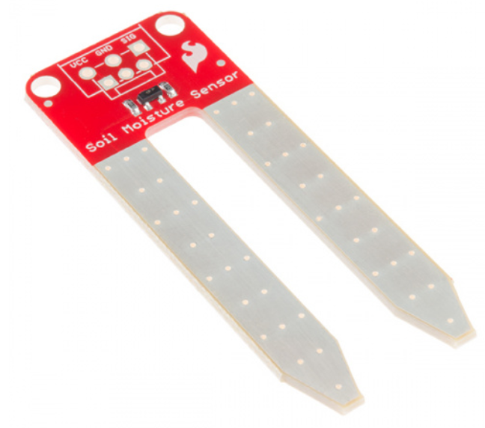
Figure 4: SparkFun Soil Moisture Sensor from Sparkfun

Environment Proofing
The modules that are to be consider for this project have a few drawbacks that will be needed to take care of to extend their life. When exposed to moisture for extended periods of time, these modules will oxidize at a much faster rate, so a finishing will need to be applied to them. Typical finishes are Electroless Nickel Immersion Gold, Immersion Tin, HAL or Lead-Free HAL (ROHS), or Immersion silver finishing to name a few. This project will incorporate Electroless Nickel Immersion Gold finishing since it has good oxidation resistance. It is advised to consult with the PCB fabricator before selecting a finishing [6].
Another important preservative measure is applying a conformal coating. Conformal coating is a protective chemical coating that is usually 25-75µm thick that ‘conforms’ to the circuit board topology, allowing you to have another means of protection. Coating all solder joints and surface mounted devices (SMD) [7]. The sensor will need to be able to handle harsh environments like hot summer days or chemicals from lawn/plant foods/fertilizers, so a conformal coating is necessary.

5.4.3 Calibration
For any system that will be using sensors, you will need to calibrate it accordingly so that the data has meaning to you. With this project, the readings may vary from the composition of the soil so do not expect the values from the lawn to be the same for plants. You should measure the soil when it is as dry as possible versus when it is completely saturated. The values that will be displayed on you PC—for testing purposes only—will vary even further depending on the microcontroller being used and the operating voltage. As an example, from Sparkfun, working at a voltage of about 3.3V will give reading of 0 for dry and about 540 for completely saturated. If the sensor is operating at 5V then the system will give read out a value of about 880 for completely saturated. The dry reading does not change from 0 for 5V.
After getting a better understanding of the values, you will need to test your own soil. Test it when it is dry and when it is completely saturated. It is advised to do more than one test to make sure the readings are consistent. These values will be coded to set the conditions for the system to turn on/off given dry/saturated environments.

Motion Detection
Back in high school the average teenager enjoyed attending various social events. Sometimes staying out past their curfew. While trying to re-enter the house undetected, a light suddenly turned on and then your parents came out. Then you were in trouble because your movement triggered the sensor on the flood light and made your parents aware of your presence outside. Motion detection is encountered on a daily basis from sliding doors at convenience stores to home security systems. They all follow the same objective which is to detect an object in its field of view and trigger a response, but they do not all use the same means of detection. There are three detection schemes that will be discussed as consideration for this project. It will not be discussed in this paper the use of active infrared motion detectors because these devices need a transmitter and a receiver. The transmitter and receiver have to align so this will make the system slightly harder to set up. This is not practical for this project.

5.5.1 PIR Motion Sensor
Passive infrared sensors are designed to detect the variations in the infrared energy of an object, usually a human or animal. The PIR sensor itself contains two slots (or two halves) which are formed from a special material that is sensitive to infrared. When a moving object is passing in the field of view of the sensor, the objects infrared will be picked up by the sensor. The first half of the PIR sensor captures the object and causes a positive differential change between the two halves triggering a reaction. If the object is still for a given period time then there will be no differential change, as if there was not detecting. When the object is removed from the field of view in a given time, the sensor will generate a negative differential change. The changes are what causes the sensor to detect an object.
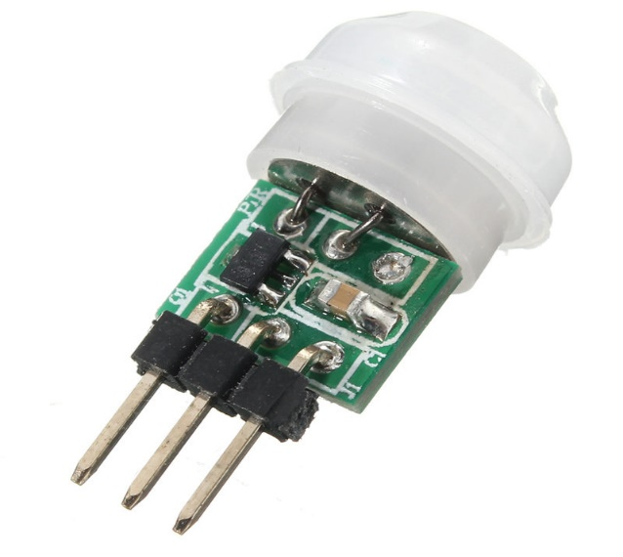
Figure 5: TMOEC Mini IR Pyroelectric Infrared PIR from AliExpress

They are low powered compared to other motion sensors and do not need a transmitter and a receiver. Small and very cheap, some PIRs that were seen online have a field of view of approximately 120 degrees and range of up to 7 meters, which is more than enough for this project. There are a few drawbacks as well. Objects that are too fast/slow may not be detected, higher false alarm rate and do not operate well at certain temperatures. Also, they do not perform very well in sunlight or darks settings. The most commonly used sensors are PIR sensors [8].

5.5.2 Ultrasonic Sensor
These sensors send out an ultrasonic wave or soundwave at a much higher frequency than a human can hear. The wave is then reflected from the moving object to the receiver and the distance is calculated. They require a transmitter and a receiver. Ultrasonic radars are based off the Doppler Effect. To the left is a picture of the sensor that is being considered for this project.
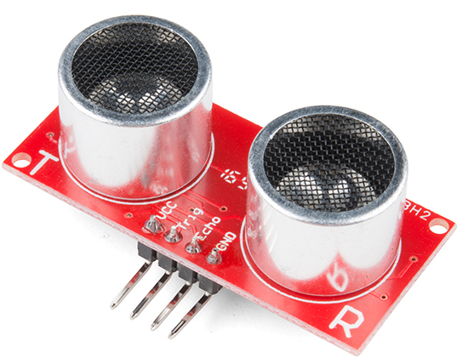
Figure 6: Ultrasonic Sensor - HC-SR04 from Sparkfun

What makes ultrasonic sensors good are their accuracy. They are insensitive to many factors like light, dust, mist, vapors etc. Since sprinklers will need to detect moving objects in sunny and sometimes darker conditions, these sensors seem like a much better buy. Their ranges are similar to PIR sensors of about 6-7 meters at most from what was found online and with this project’s scope. Plus, there were some of these sensors that were found online that were smaller than a U.S. quarter.
With greater accuracy comes a greater power consumption. These sensors they draw more current than that PIR sensors. The angle is not as great as that of the PIR sensors, having an angle of approximately 15 degrees for a price that is within the of this project scope. If this device is going to be used it will need to have two sensors to maximize its angle or the project will need to spend more money on a better sensor. More expensive ultrasonic sensors draw a much greater amount of current in the 100s of milliamperes range. Also, signals can irritate animals since they are in the range in which they can detect.

5.5.3 Microwave Motion Sensors
Microwave sensors follows the same logic as ultrasonic sensors, but they send out electromagnetic waves in the frequency ranges of 0.3 GHz to 300 GHz. These sensors have a transmitter, receiver, and give or take an alarm. The microwave that is sent out will strike a moving object at a specific frequency, altering phase of the signal. After analysis of the received wave, a flag will be raised from the change. It is safe to say the velocity of the moving object is proportional to the change in phase of the propagating signal.
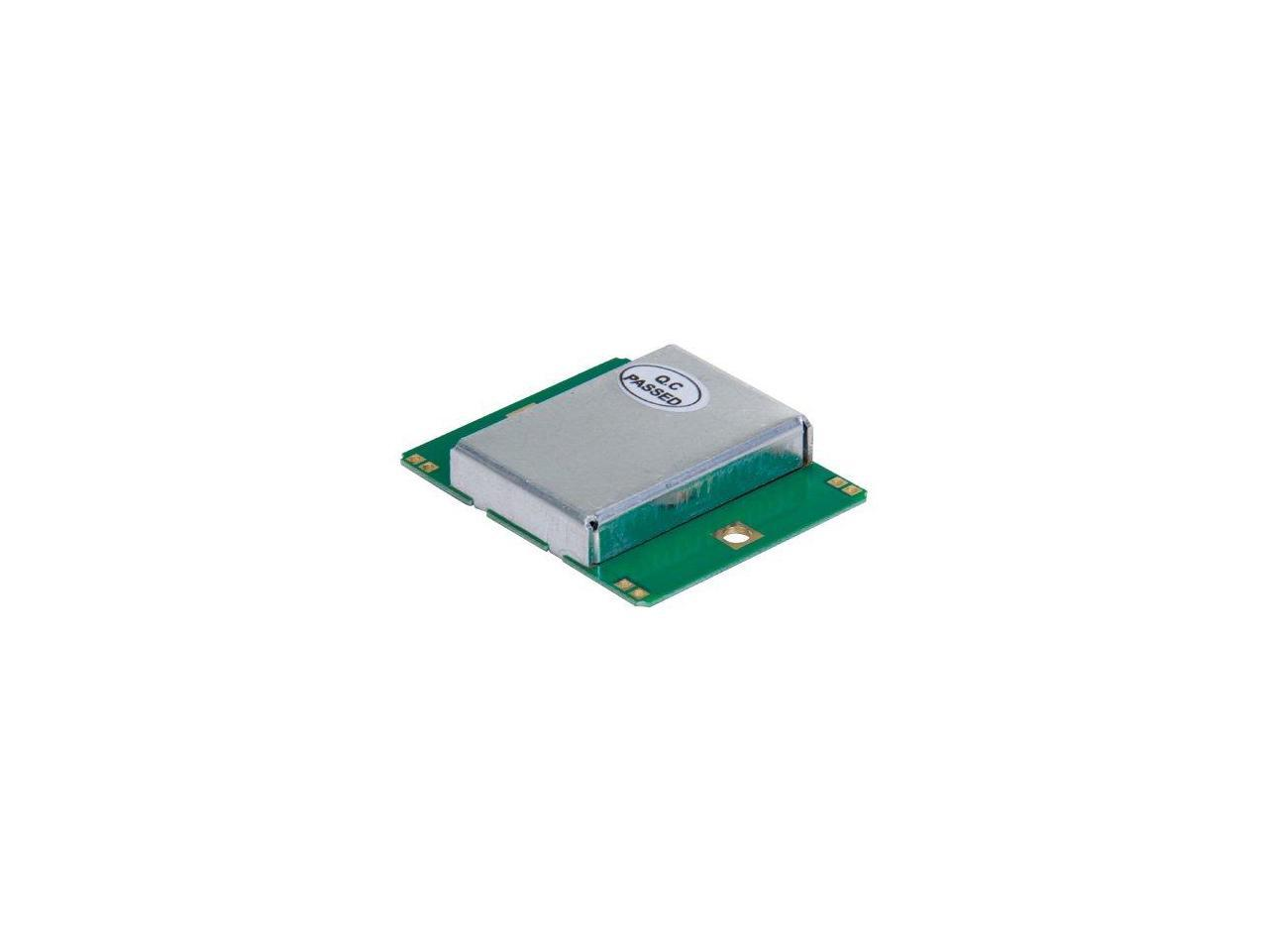
Figure 7: SODIAL Wireless Module Doppler Radar Microwave

These sensors have a few advantages. They can operate normally in harsh environments where heat cycles are not regular. Heat will not interfere with the sensor as it can with the PIR sensors. Also, they can penetrate the moving objects without damaging the detector. The range of these sensors are greater than their counterpart. There are still a few limitations to microwave sensors. The biggest one being that they are not able to continuously monitor which creates a blind spot for a moving object. They are more expensive that the other two sensors mentioned. As with ultrasonic sensors, they consume a lot of power.
The table below gives a brief overview of the pros vs cons of each sensor. The findings are based off components being considered for this project. Most of the components that were found were located on Sparkfun, Newegg, Adafruit, AliExpress, and Robot Shop to name a few. Even though PIR sensors are usually the cheapest out of the three, it was found on a few sites that the ultrasonic and microwave sensors were a cheaper price and met the specifications for this project. The Table 2 below will have the values from the various companies that are selling these devices.

Table 5 Summary of pros vs cons of various motion detection devices
Motion Sensors | Passive Infrared (PIR) | Ultrasonic | Microwave
Price Range | $0.82-$14.95 | $0.80-$24.95 | $0.49-$5.49
Power Consumption | Lowest | Lower | Highest
Interference | Highest | Lower | Lowest
Size | Smallest | Smaller | Largest
Accuracy | Lowest | Higher | Highest

5.6 Rain Detector
In the old days, sprinklers ran off timers by manually setting them up from the controls. With the invention of rain sensors, they allow you to work smarter not harder, literally. They work by allowing the rain water that will be hitting the metal plate to complete the circuit, generating a current. The more water that makes contact with the plate will result in larger currents to be generated and lower resistances.
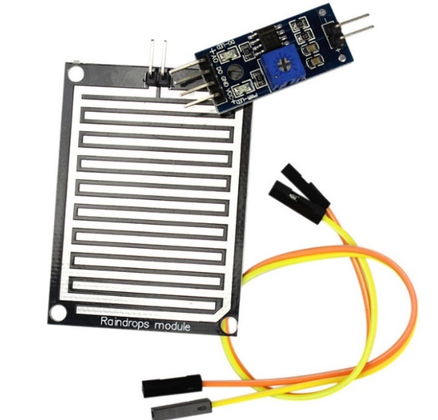
Figure 8: Smart Electronics Snow/Raindrops Detection Sensor Module 3-3-5V with comparator from AliExpress

For this project there are not very many variations to choose from when it comes to rain sensors. These sensors will have to communicate directly with the base in order to turn the entire system off. Along with the local weather station updates, the rain sensors will act as more of a failsafe in the case that the weather updates are off.

5.7 Actuator with Shutoff Valve
These components allow us to achieve the on/off or open/close mechanism needed for this project. An actuator is a motor which allows you to convert a given source of energy to torsional force that—in this case—will turn a valve within a section of a pipe. Actuators play an important role in our daily life. In plants, controlling various valve systems, to vehicles and their cruise control systems. Like with every actuator, there need to be a control signal in order to allow the device to do its job. The sensors will send out control signals to notify the actuator when to open/close or turn on/off the pipe in the case of under/overwatering, moving objects, or showers/storms.
For this project there are two types of actuators to choose from, 12V DC requirement or 110V AC requirement one. With the 12V actuator that was found, it consumes roughly 6 watts of power at about 500 milliamperes. This can drain the power supply relatively quickly since multiple sensors and communication modules drawing power as well from it. With typical residential sprinklers usually operating between 30-50 PSI, this device can allow pressures anywhere between 0–115 PSI.
This brings us to a problem within this project design of keeping the system small. Introducing a 12V component will call for the need of a bigger design in the power source. Producing 12Vs from solar panels increases the overall size tremendously. Going from the idea of having a setup the size slightly bigger than a human hand, to a set up that will be more than twice the size of a human’s hand. This is of course if the chosen route to go is with an individual head set up appose to the zone set up. Leading to the option of the 110V AC actuator.
Using the 110V AC actuator for sprinkler zones instead of just the individual heads will allow us to avoid increasing the size of the power source. Using AC for individual heads will need a connection from the actuator directly to the main controls. The main control unit will run off of AC power, or power directly from the home. Introducing this will not cause us to add more communication modules to the entire system. The soil hygrometers will already be communicating back to the main controls via a RF module. Motion detection communication will need to be set up to the main controls. After the data is analyzed from the various sensors, the main controls will send the respective signal to the actuator.
The biggest drawback with an AC setup for individual heads is having wires connected from all individual heads back to the main control unit which can cause greater complexity for installation. This can also drive up the price. Below is a pick of a 12V DC actuator with a valve.
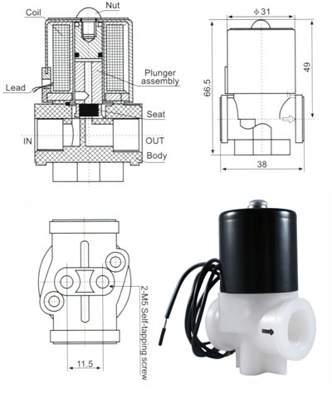
Figure 9: 1/4'' 12V DC Electric Plastic Solenoid Valve and a diagram of the mechanism from Electronic Solenoid Valves

5.8 Flow Meter
Flow meters allow you to monitor the amount of fluid flowing through a pipe. This meter will be placed at the base for each zone. The project will be using them as a way to tell if a pipe has been damaged. A broken pipe will have an increase in the flow rate of the water due to a drop in resistance. Below is a flow meter that is being considered for this project.
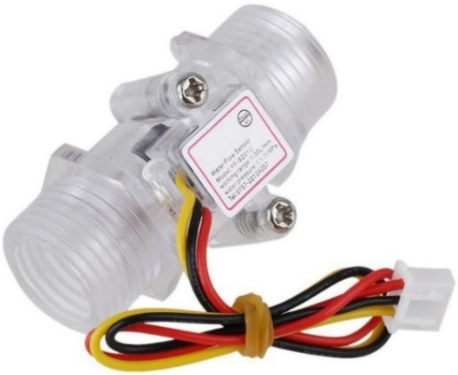
Figure 10: G1 2inch DN15 Transparent Water Flow Meter Flow Meter Hall Flow Sensor Indicator Counter from AliExpress

5.9 Microcontroller
The microcontroller will have many roles, to serve as the communication hardware for receiving and transmitting soil sensor data, rain fall data, motion detection data, flow meter data, and ultimately the controller for turning the system on and off. In the choice for a microcontroller, the processor being considered would best fit the said tasks. The technical capabilities are the most important factors in the decision but required learning curve with respect to programming and the team’s skills and experience was considered. The need to find a controller that is suitable while also keeping the cost within reason.

5.9.1 ATmega328P
The Atmega 328P is created by Atmel. It is a low power microcontroller that is used in the Arduino Uno. It has a total of 28 pins, 23 of which are input/output, 15 digital and 8 analogs. This should be enough to support the other components and sensors planned to be integrated. The operating conditions are 1.7 volts and 0.2 milliamps at 1 megahertz. There is also a few low power modes and sleep modes, ideal for Water Smart. Atmega does an excellent job of providing numerous resources like instructions and tutorials for this MCU.

5.9.2 Arduino Uno
The Arduino Uno seems to be a very popular choice across the internet. The features included in the Arduino Uno are: operating voltage of 5 V, Input Voltage (recommended): 7-12V, input voltage (limits): 6-20V digital I/O pins: 14 (of which 6 provide PWM output), analog input pins: 6, DC current per I/O Pin: 40 mA, DC current for 3.3V pin: 50 mA. The Uno has an XBee shield that is specifically designed for it. This would be ideal for Water Smart’s communication purposes if XBee transceivers are being used. The XBee shield makes it very easy to interface with the Uno for testing. Another attractive feature about the Arduino Uno is its compatibility with the ATmega328P. Uno would be able to be used for testing and after the PCB is made, could be migrated to the ATmega328P easily. Considering everything that this development kit offers, it seems too powerful for the project.

5.9.3 Samsung ARTIK 710
The Samsung ARTIK 710 is a powerful microcontroller with high performance for high end gateways with local analytics and processing. It specializes in applications for multimedia. This board is equipped with 8-core, 64-bit ARM Cortex A-53 processers with Wi-Fi, Bluetooth, and ZigBee thread. It also has ARM MALi GPU for multimedia, graphics applications,1GB RAM, 4GB flash (eMMC), Enterprise-class security with hardware secure element and Secure OS (710s), Ubuntu Linux package with multimedia, connectivity, graphics, power management and security libraries.

5.9.4 TI MSP430G2 Launchpad
This is the original Launchpad kit for the MSP430G2 series. The team is familiar with this device from a prior class, Engineering Analysis and Computation. While this microcontroller is not supported by Mac or Linux, it is supported on Windows. The integrated development environment by which this hardware is programmed is Code Composer studio. This platform is also familiar to the team from Embedded Systems and Engineering Analysis and Computation.
The features for the MSP430G2 include 14-/20 pin DIP socket, built in flash emulation for programming and debugging, two programmable LEDs, one power LED, one programmable button, one reset button 16kB Flash, 512B RAM, interruptible GPIOs (capacitive sense-capable), 16-bit timers, 8ch 10-bit ADC, Comparator, Serial Communication (USCI – I2C, SPI & UART). The price for this microcontroller is $10 and some members of the group still have theirs from the previous coursework.

5.9.5 TI MSP430FG4618
This microcontroller is also familiar to all electrical and computer engineering students at UCF. This is the devices used in the Embedded Systems course, where students perform multiple lab assignments with it. For students without any other microcontroller experience outside of coursework, this is arguably the most suitable.
The MSP430FG4618 has many low-power consumption modes, a feature appropriate from the Water Smart design. The active running mode consumes just 400 microamps and 2.2 volts at 1 megahertz. Another appealing feature this microcontroller has is a built in liquid crystal display. This would be very useful for testing purposes. There is also a total of 80 input/output pins on this microcontroller. This could very well support all the sensors that are planned to be incorporated and the communication and transceiver hardware. This MCU has many features and capabilities but also is more on the expensive side when comparing to other controllers.

5.9.6 Microcontroller Comparison
After reviewing several microcontrollers, the top 3 choices were compared to decide which were best for the Water Smart system. The factors that were taken into consideration were power consumption, Cost, Memory, and clock frequency. This helped eliminate those that were too expensive, too slow, too power-consuming, and those that could store the potential software for Water Smart.
5.9.6.1 Power Consumption
Battery life is a very important aspect of the Water Smart system. Since each device in the network needs to be accessible at any given time after installation, then every device needs to have a power source that is readily available. Of the two types of devices in the Water Smart system, the sensor unit, and the HUB unit, the sensor unit’s power is more concerning. This will be a remote device that will be placed somewhere isolated from the user’s house, meaning an electrical outlet cannot be used as its power source. It was decided that the sensor unit will be provided power from a solar cell and a water turbine that generates power while the system is running, a battery will also be used to ensure that the unit can power on while the water is not running. The operating voltage, DC current at 1 MHz and the power consumption of a select few of the considered microcontrollers were compared and the results can be seen below in table # Microcontroller Power Consumption Comparison.

Table 6 Microcontroller Power Consumption Comparison
Microcontroller | Lowest Operating Voltage | DC Current at 1 MHz | Power Consumption
MSP432P401R | 1.62 V | 0.08 mA | 0.129 mW
MSP430FG4618 | 1.80 V | 0.40 mA | 0.720 mW
ATmega328P | 1.80 V | 0.20 mA | 0.360 mW

The three microcontrollers that were under the most consideration was the MSP432P401R, MSP430FG4618, and the ATmega328P. The MSP series supports many different low-power modes. The specific features that were compared between the 3 were the lowest operating voltage supported by the controller, the DC current at 1 MHz, and the power consumption. The power consumption was simply calculated by multiplying the lowest operating voltage with the DC current at 1 MHz. The MSP432P401R came out on top with its extremely low power consumption. Considering that the MSP432P401R is a much more powerful microcontroller than the other two, the fact that it also has the least power consumption is very impressive.
5.9.6.2 Cost
The Water Smart system cost is one of the most important aspects of this project. As discussed in the economic constrains section, the cost to make and design this system could be where Water Smart beats the competing smart irrigation systems. With that in mind, a comparison was done between a select few microcontrollers, the results can be seen below in table # Microcontroller Cost Comparison.
Table 7 Microcontroller Cost Comparison
Microcontroller | Unit Price | Total System Price (x4) | System Price Increase
MSP432P401R | $8.10 | $32.40 | 279%
MSP430FG4618 | $15.89 | $63.56 | 642%
ATmega328P | $2.14 | $8.56 | 0%
The table above show the unit price, the potential system price and a system price increase with respect to the lowest cost system price. The system price increase was calculated by subtracting the lowest total system price ($8.56) from the total system price and the dividing by the lowest system price. The system price increases for the two MSP microcontrollers are very significant. Clearly, the cheapest unit price and total system price would be achieved by using the ATmega328P. Luckily, Texas Instruments offers a fully stocked cabinet of microcontrollers in the Texas Instruments innovation lab open to students. The MSP432401R and the MSP430FG4618 are both available to UCF students for free. This made it clear that if we obtained these microcontrollers, not only would it clearly be the cheapest option, but the amount of money saved in doing so would be very significant.
5.9.6.3 Memory
The Water Smart system has two units that collect, process, transmit, and receive data. For this reason, the memory capacity for each microcontroller was carefully considered. The two types of memory that were investigated were flash memory and random-access memory (RAM). From a software perspective, the flash memory is very important. This will determine the possible size of the written software. The flash memory is where the microcontroller stores its programming, even after the device is powered off. The random-access memory is volatile, meaning that it is temporary and when the device is powered off then the RAM will be lost. This memory is used during runtime of the programmed software and ultimately will determine how complex and how computation-heavy the code can be. The comparison of a select few microcontroller’s memory can be seen below in table 7 Microcontroller Memory Comparison.
Table 8 Microcontroller Memory Comparison
Microcontroller | Flash Memory | RAM
MSP432P401R | 256 KB | 64 KB
MSP430FG4618 | 116 KB | 8 KB
ATmega328P | 32 KB | 2 KB
As expected, the MSP432P401R has the most flash memory as well as RAM. The MSP432P401R is also the most expensive and the most powerful. The cheapest, ATmega328P, has the least amount of both flash memory and RAM. The MSP432P401R seems to be the most appealing microcontroller from a programming perspective. This amount of memory will be very ideal for containing the systems software code and also could handle most of the system processing. In conclusion, the MSP432P401R is the clear winner in terms of storage.
5.9.6.4 Clock Frequency
The clock frequency controls the speed at which the microcontroller executes and instruction. In other words, the higher the clock frequency, the fast the system will execute tasks. For the Water Smart system, there are some features that rely on the speed, such as the motion detecting sensor. If the clock frequency doesn’t process the motion sensors signal fast enough, the motion detecting sensor becomes useless. The clock frequency of a select few microcontrollers was compared, and the results can be seen in Table 8 Microcontroller Clock Frequency Comparison.
Table 9 Microcontroller Clock Frequency Comparison
Microcontroller | Clock Frequency
MSP432P401R | 48 MHz
MSP430FG4618 | 8 MHz
ATmega328P | 20 MHz
The results in Table 8 show that again the MSP432P401R is best. At a clock frequency of 48 MHz, this microcontroller is 6 times faster than the MSP430FG4618. By the time it takes for the MSP432P401R to perform 48,000,000 clock cycles, the MSP430FG4618 will have only performed 8,000,000 and the ATmega328P will have only performed 20,000,000. In terms of performance, the MSP432 will be the best bet in handling most of the systems processing and instruction execution
5.9.7 Microcontroller Choices: MSP432P401R & MSP430F5529
The MSP432P401R Launchpad created by Texas instruments, has many features ideal for Water Smart. It contains a low-power 32-bit Arm Cortex-M4F MSP432P401R which can handle all the Water Smart processing. It runs at 48 MHz with floating point and DSP acceleration. The power consumption is 80 µA/MHz active and 660nA RTC standby operation. The digital features include Advanced Encryption Standard (AES256) Accelerator, CRC, DMA, and HW MPY32. The memory features are 256KB Flash and 64KB of RAM. There are also 4 16-bit timers and 2 32- bit timers. The communication capabilities are up to 4 I2C, 8 SPI, and 4 UART. It also has a 40-pin launch pad development kit standard that leverages the Booster Pack plug-in module ecosystem. Also included is XDS110-ET, which is an open-source onboard debug probe featuring Energy Trace+ technology and application UART. There are also two buttons and two LEDs that can be used for user interaction. Finally, there is a backchannel UART through USB to PC. The development tools that support the MSP432P401R Launchpad include: ARM Keli MDK, Code Composer Studio IDE, Energia, GCC- open source compiler for MSP microcontrollers, and IAR Embedded Workbench.
While the MSP432P401R will serve as the main board, the MSP430F5529 will be used to develop the other remote boards where all of the sensors will be connected. Since the main board will be receiving and sending the data of multiple remote boards, it’s better equipped. The MSP430F5229 is a 16-bit ultra-low-power microcontroller. It has 128KB of Flash memory, 8KB of RAM, USB, a 12-bit ADC, 2 USCIs, 2 I2Cs, 4 SPIs, 2 UARTs, and 32-bit HW MPY. The low supply voltage range is 3.6V down to 1.8V with 4 low power modes, and a wake-up from stand-by mode which is 3.5 µs (typical). Also included is a unified clock system, comparator, serial on board programming, three-channel internal DMA and a basic timer with RTC feature.
It was decided to pick these microcontrollers based on the technical features, availability, price, and familiarity with the MSP series. The team also has experience with the development tools, Energia and Code Composer Studio. The code for programming this microcontroller will be written in the C language which all the team members are familiar with. As far as price, this is the best choice because of already attaining microcontrollers from the TI lab at UCF for free.

5.10 Water Turbine Generator
A water turbine generator uses the kinetic and potential energy of water to change it to mechanical work. This process is done by the turbine being spun by pressurized water and the turbine is connected to the generator which spins produces electricity. The electricity is sent to a battery to charge or end product. In between the end product or battery, you will have diodes or charging regulators to ensure the electricity is going one way. In Figure 3 you will see a display of the internal mechanics of a typical water turbine used in a dam.

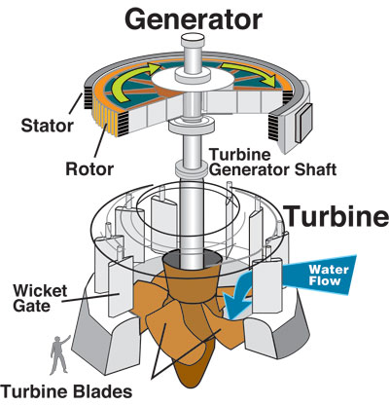
Figure 11: Water Turbine Generator [35](permission submitted to reproduce)

The development process will be absent of a large sized damn, however the presence of the mechanisms and components of the hydrogen generator displayed in the figure above, provides an internal understanding of how it will function. Due to the project dealing with pressurized water flow, it can have a miniature water turbine generator attached to the sprinkler system hose leading to the sprinkler head to give power for some of the components needed for this project. The project will be using a Yosoo DC Water Turbine Generator with the specifications based on Amazon website of:

- The output voltage :12V

- Wire resistance 10.5 ± 0.5Ω

- Insulation resistance 10MΩ (DC100 megger)

- Maximum pressure 0.6Mpa outlet closed

- Outlet opening maximum pressure 1.2Mpa

- Start pressure 0.05Mpa

- Generator life: ≥ 3000h [5]

The particular generator due to its size, capability of being added to the system and voltage. Below is a picture of the generator:
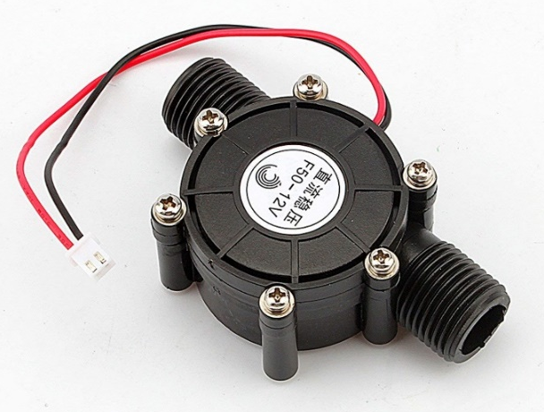
Figure 12: Yosoo DC Water Turbine Generator 12V [2]
The use of this turbine will be to power the components listed below:
- 12V Solenoid Valve: 6~12v
- Hygrometer: 3.3V ~ 5V
- Pressure Sensor: 4V ~15V
- Wi-Fi: 3.3-3.6V
- Motion Sensor: 5V
- 9V Battery Charger: 6~9V

5.11 Battery
In order to power some of the components during the time when the water is off due to time of day or someone walking by, batteries have been added to the system to accommodate the time when the water turbine was off. It is necessary to keep the space taken from the secondary power source minimal but carry enough power to power the components needing power during the time when the water turbine was not supplying power. It was also determined to not want to have to continuously change the battery. These requirements brought us to the decision of using a 9V and 720 mAh Li-Po Rechargeable Battery.

Specifications:

- Size: 9V

- Capacity: 720 mAh

- Chemistry: Lithium-Polymer

- Voltage: 9V DC

5.12 Wireless Communication
In this project, sensors will need to communicate to the main control unit to send data about saturation levels of the soil. The main control unit will need to also be able to obtain the local weather forecast. The system needs to have as few hardwire connections as possible in order to decrease the complexity of installation. Information from the sensors need to be relayed back to main controls in a timely fashion and has to be able to consume as little power as possible since the part of which has all the sensors will be utilizing batteries and solar cells. This section will go in depth about the different kinds of wireless communication schemes that can be applicable to Water Smart.
M.G. Marconi is credited as father of this technology after successfully establishing a radio link between a land station and a tugboat back in 1901. Wireless communication is a technology that allows you to transmit data or power from one device to another usually via air waves. Information is usually transferred in the form of electromagnetic waves, like infrared, satellite and radio frequency to name a few. Also, they do not require a hardwired connection which is the most important aspect. Since the adoption of wireless communication, there are wide range devices that use this technology ranging from cell phones to laptops, printers, speakers, and even televisions. Automakers are not only making it standard to have Bluetooth connectivity in vehicles, but they are now making their new models come standard with wireless charging.
Wireless communication, as mentioned before, would allow Water Smart’s sensors to communicate with the main control unit without having the hassle of connecting wires, which increases the complexity of installation. Also, it allows the system to have more a flush appearance. This is not only more aesthetically pleasing but it allows the system to be less to susceptible to broken connections from animal/bugs to corrosion from the weather/chemicals. Wireless communication is still susceptible to interference from electromagnetic waves from radio waves, power lines and even cellular waves. It is important to pick a technology that has the less prone to electromagnetic interference or EMI.
RF design requires an in depth understanding of mathematics, physics and some electronics. It is project in itself to create a device of this nature because of the elementary understanding the team has of RF design. Also, there are many measures to be considered like staying within the guidelines of the FCC or Federal Communication Commission and making sure RF is contained appropriately since high levels of this radio can cause health problems. So, for this project we will not create a wireless communication module from scratch since it is out of our scope. Because of such complexity, pre-existing modules will be selected from vendors and be matted to the PCB design.
The benefits of using already created modules is that the system can be limited to the number of obstacles that make it an unsuccessful project. It allows time to be saved and allocated elsewhere like PCB design or creating the mobile app. It is also cheaper in buying a module because creating a successful one could have a lot of trial and errors in order to have it barely working right. This means constantly buying more components which can be avoided. Also, there are modules compact enough to allow for a small PCB design which will allow for and overall smaller system. There are three wireless communication technologies that will be discussed that are appropriate for this project. ZigBee, Bluetooth, and Wi-Fi are the three being considered. There is another technology which is infrared, but it does not have the range capability needed and it is also prone to higher amount of interference. The three different types of communication will be discussed in further detail now.

5.12.1 What is Wi-Fi?
In society today, Wi-Fi has become a part of our everyday vocabulary. It is most commonly known to be utilized in our smart phones but has many more applications that just cellphone use. Wi-Fi is presently in many devices like laptops, printers, smart controllers, refrigerators and even televisions. So, what is Wi-Fi? It is a technology that gives device the ability to communicate with each other wireless or connect to the web without a wired connection. It represents a type of wireless local area network or WLAN for short that radio waves to transmit and receive messages. It is based on IEEE protocol 802.11 which is a network standard. The term Wi-Fi is a trademark of the Wi-Fi Alliance. The organization allows devices to carry the logo Wi-Fi only if the devices successfully completes certification testing. Wi-Fi commonly uses the 2.4 and 5 GHz radio bands which are usually displayed on modems. In the next couple of sections, the discussion will go into what IEEE 802.11 (all the modules considered for the project utilize MAC and PHY layers but will be explained in the Wi-Fi section) is and what is does.
      - MAC Layer
The IEEE 802.11 according to Wikipedia is “set of media access control (MAC) and physical layer (PHY) specifications for implementing wireless local area network (WLAN) computer communication in the 900 MHz and 2.4, 3.6, 5, and 60 GHz frequency bands.” The MAC layer is one layer that is part of a bigger system called the Open Systems Interconnection model or OSI which has seven layers including the Physical layer. The MAC and the Physical layers are the foundation of Wi-Fi. The (MAC) layer is a sublayer of the data link layer and it oversees addressing and channel access control mechanisms that allows several network nodes to communicate in a network. This layer takes data from the logical link control or LLC and adds a header and tail bytes to be then transmitted to physical layer which is the medium in which it travels on for transmission. Providing error-free transmission of information between multiple hosts sharing the same physical cable. MAC layer is the bridge between the Logical Link Layer and the Physical layer.
      - Physical Layer
The Physical layer is the layer as the name implies a physical medium that data/information travels on in bits. The medium in which the information travels on can be wired (Ethernet) or wireless (WNIC). This layer utilizes wireless network interface cards or WNIC –which connects a wireless radio-based computer card rather than an Ethernet cable--, connectors and interfaces, and cables to complete its layer. WNIC uses two modes of operation which are infrastructure and ad hoc modes. In an infrastructure mode the WNIC needs a WAP or web access point which is the central hub for all data to be transferred. In the ad hoc mode it does not require the WAP, it rather can interface with other wireless nodes directly.
In the image below will display the general idea of the OSI model with our focus on Layer 1 and Layer 2
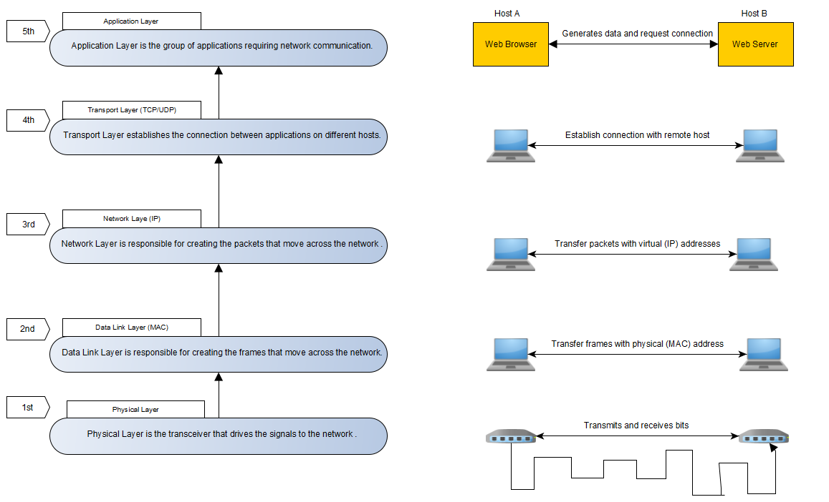
Figure 13: OSI Layers
5.12.1.3 Proper Security Measures
Since the creation of Wi-Fi, connections to devices has never been easier. Eliminating physical connections and allowing for communication with devices in your house when you are on the other side of the world has become a norm. But with many systems that has made life easier they have also made you more prone to security threats. It is important to use a Wi-Fi Protected Access (WPA2) encryption to protect your wireless network, older protection scheme was the WEP or Wired Equivalent Privacy are easily compromised by hackers. Also, it advised to have a strong SSID (wireless network name). Having your system hacked can allow for personal information to be stolen from devices connected to that network.
    - Bluetooth
Searching. Pairing. Connected. These are all familiar terms that is observed when connecting smart phones to our vehicle’s stereo. What is the actual bridge that allows for this wireless connection? It is Bluetooth and it allows devices to connect wirelessly enables them to communicate between each other similar to that of Wi-Fi but are limited to a shorter range. Communication is done by ultrahigh frequency radio waves in the ISM band from 2.4 to 2.485 GHz. Invented by Dutch electrical engineer Jaap Haartsen, in 1994, it was created as an alternative to the cable connected RS232. It was standardized by IEEE as IEEE 802.15.1 but Bluetooth has been managed by the Bluetooth Special Interest Group (SIG) since then. Any device that carries the logo of Bluetooth must first meet Bluetooth SIG Standards. There are a lot of devices today that carry this logo which include headsets, smartphones, laptops and portable speakers to name a few. Since the creation of the first Bluetooth technology, there have been 5 versions with a few revisions. For this Water Smart, it is not applicable to use Bluetooth v5, or v3, the focus will be on more v2.1 and v4.
      - How it works
Bluetooth as mentioned previous works in much shorter range. The Bluetooth RF transceiver (or physical layer) operates in the unlicensed ISM band centered at 2.4 GHz which is the range similar to Wi-Fi. The devices are managed using a star topology (which will be further explained in ZigBee’s section on Network Topologies) which allows them to synchronize to form a piconet (it is an ad hoc network linking wireless devices together). It’s worth noting that two or more piconets connect to form what's called a scatternet. The piconet contains a master and up to seven active slave devices. The slaves are only able to communicate the master, never to each other. Bluetooth is usually limited to the number of users synced to it. In a piconet, the physical radio channel is common to multiple devices that are matched to a common clock and frequency-hopping pattern. The master provides the synchronization references.
Further expanding on a piconet, devices in this configuration utilize specific frequency-hopping patterns that are determined by the master device. The hoping pattern is of a somewhat random ordering of the 79 frequencies of the ISM band. Hopping patterns can be modified to eliminate a section of the frequencies that are used by intrusive devices. This technique improves Bluetooth devices when they near static ISM systems, such as Wi-Fi networks. This is important because or Water Smart, if Bluetooth is selected along with Wi-Fi (for the main unit) they will not interfere with each other.
      - Classes, Pros, Cons
Bluetooth’s range have increased throughout the years with different models. There are three power classes that Bluetooth modules are defined by: Class 1—the highest— consumes 100 mW of power and has a max range of 100 m. Class 2 consumes 2.5 mW and has a max range of 10 m. Last, class 3 consumes 1 mW and has a max range of 1 m. All ranges are theoretical. The amount of data that can be transmitted per second will be listed in a table at the end of the communication section. Bluetooth so far seems ideal for each sprinkler to be able to communicate back to the main controls. Power consumption is lower than Wi-Fi, smaller which can minimize the size for Water Smart’s slave PCBs, and they are cheaper than Wi-Fi modules. The downside is the amount of data that can be transferred, and it is less secure.
    - ZigBee
The last communication technology that will be consider for this project is ZigBee. Relatively newer than the previous two communication systems prior, ZigBee, a standard developed by the ZigBee Alliance for personal-area networks (PANs). Based on IEEE 802.15.4 specification for low-rate wireless personal area networks (WPANs). These modules are small is size, low-powered, low data rate and works in a close proximity similar to Bluetooth. They operate at 868 MHz, 902-928MHz and 2.4 GHz frequencies. With a data rate of 250 kbps is great for two-way communication between sensors and controllers. The typical network topologies commonly used are the star, mesh and cluster tree topologies. They will be explained in detail later. ZigBee is cheaper and simpler than the other branded short-range wireless modules such as Wi-Fi and Bluetooth. This system has the ability to operate on different network configurations for master to slave or master to master. It can also operate in different modes which saves power. If routers are used, this network is able to be expanded, allowing many nodes to interconnect to each other enabling a bigger network.
There are over 1,000 devices listed as ZigBee certified. Many of ZigBee devices are mostly known to be used in devices which enables your homes to become smart like thermostats, lights and even door locks to name a few. ZigBee has a 128-bit symmetric encryption, so the information traveling around the network is pretty secure.

      - Network Topologies
ZigBee bolsters a few system topologies; be that as it may, the most regularly utilized setups are as mentioned before are the star, mesh and cluster tree topologies. Any topology comprises of at least one or more coordinator. In a star topology, the system comprises of one facilitator which is in charge of starting and dealing with the devices over the network. The rest of the devices are called the end devices, which are able to communicate back to the coordinator. This system is utilized where devices need to communicate back to central hub, in Water Smart this word be the sensors communicating back to the main controller.
The last two topologies, mesh and cluster tree, extension of ZigBee's network is accomplished by routers where the coordinator is responsible for enabling them. In these setups, devices are able to communicate to any adjacent node, providing redundancy for information. In an event of a failure of failure of a node(s), the information is then directed automatically to other devices on these topologies. The mesh topology is mostly used today because of its redundancy setup. With the cluster tree topology, each cluster consist of a coordinator with leaf nodes, the coordinator being able to connect to parent which starts the full network. The figure below shows a depiction of each topology.
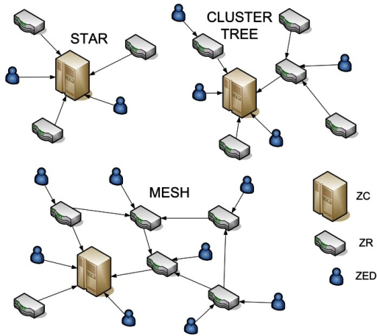
Figure 14: ZigBee topologies, ZC- ZigBee coordinator, ZR-ZigBee router, ZED-ZigBee end device. Permission to reuse.
    - Wireless Communication Conclusion
Each communication system discussed in earlier allowed for a deeper understanding of how they worked. One system is not better than the other but can implemented together in order to create the best communication network for Water Smart. Parameters that need to be considered range, amount of data needed to be transferred, power consumption, number of devices that can connect, and the price of each system. The goal is to keep the project’s cost as low as possible while creating a reliable and working system. It is for certain that a Wi-Fi will be needed due to the fact it is commonly used to connect one or more devices to a router that allow the devices to exchange information just like a wired LAN. With implementing Wi-Fi, precautions will need to be put in place to limit security threats. In the table below, will list the benefits of each system.
Table 10: Wireless Communication Advantages and Disadvantages
Wireless Communication | Wi-Fi | Bluetooth | ZigBee
Range | 2.4 GHz band reach up to 150 feet (46 m) indoors and 300 feet (92 m) | Class 1: up to 330 feet (100m) but typical range is 32.8 feet (10m) | 1-328 feet (1-100m)
Power Consumption | High | Low | Lowest
Bit Rate | 600 Mbps | 1-3.1 Mbps | 250 kbps
Frequency | 2.4 GHz/5 GHz | 2.4 GHz | 2.4GHz/ 915MHz/868MHz
Network Topology | Star | Point-to-Point, Mesh on Bluetooth 4.0, Scatternet, Star | Mesh, Star, Cluster Tree
Latency | 150 ms | 200 ms | 15 ms
Bandwidth (KB/s | 11,000 | 720 | 20-250
Network Size | 32 | 7 | Unlimited
Application Focus | Web, Email, Video | Cable Replacement | Monitoring & Control
  - Serial Communication
Serial communication will allow Water Smart’s communication modules to interface with the PCB enabling a two way a two-way communication scheme but what is serial communication? It is communication which allows a device to send data one bit at a time over communication channel or bus. Full duplexing, which is the most commonly used transmission mode and bidirectional, allows for both sender and receiver to transmit and receive a single bit of data at the same time. This is different from parallel communication which uses a transmission mode called half duplex which allows both sender and receiver to transmit and receive a byte of data one at a time. Serial communication despite only being able to transmit a bit a time is actually better than parallel communication for many reasons other than the modes of transmission. The advantages are that there are fewer conductors which limits the amount of EMI or electromagnetic interference which causes a phenomenon known as cross-talk. Installation cost usually lower and better for lone haul communication purposes. They are also becoming common in shorter distances as well. The clock skew issue which arises from the interconnections of the different channels becomes less of an issue with serial communication. Below in the figure 15 is depiction of full and half duplexing.
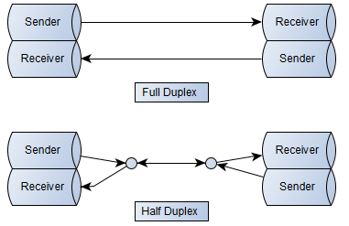
Figure 15: Depiction of Full and Half Multiplexing
In this section, we will discuss the various common types of interfaces which use serial communication. The typical ones are SPI, I²C, and UART.

    - SPI
SPI or Serial Peripheral Interface is a synchronous serial communication interface and the simplest protocol in general use which is utilized for short distance communication, most notably seen in embedded systems. It was developed by Motorola in the 1980s and is now Freescale and only real problem is that it is not a fixed standard like I²C and other protocols. Applications which use SPI are SD cards and LCD screens. Devices on this protocol can send and receive data in the full duplexing mode, which is depicted in figure # above. One device is set up as the master and the other device is the slave. The master device delivers the clock for both devices and a signal to select which enables the slave device, but the path followed by the data is identical in each. SPI essentially requires four wires. Two wires are assigned to the data connection with the nomenclature, assigned by Motorola, as listed; (MISO) or “Master In, Master Out” is the data output of the slave and (MOSI) or “Master Out, Slave In” is the data output of the master. The last two wires are assigned to the (SCLK) or Serial Clock (output from master) and the (SS) Slave Select. In the figure 16 below will give a better visualization of the 4-wire setup between two devices. It is important to include that there can be multiple slaves not just one but only one master for the multipole slave devices [23].
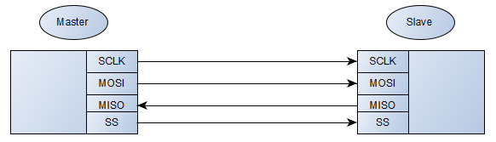
Figure 16: Depiction of the basic setup for SPI master and slave device
      - What Does It Mean?
So how does SPI actually work? SPI uses a synchronous bus which has a separate line(s) for data and a separate line(s) for the clock which allow for perfect synchronization. The signals coming from the clock tells receiver when to pull from the data line(s). The receiver can read at two instances on the clock signal which is the rising edge or positive edge as the name implies low to high or the falling edge or negative edge which is high to low. A particular edge is selected based on application which it is used for. After the edge is detected by the receiver, the data that is the data line(s) will be reading accordingly. The speed at which the data is being read is not as important due to the fact that the clock and data work together. One advantage of using SPI is the hardware used for receiving the data is usually a simple shift register. Which is simpler than the UART hardware—later explained in the Serial Communication section. Below in figure # shows the basic depiction of a synchronous set up [23]. 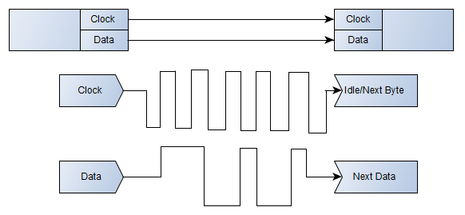
Figure 17: Data is read at the positive edge of the clock
As mentioned before, SPI, has one master and a slave or slaves as depicted in figure # above. The clock signal is generated on the master side which is usually called the SCLK. Data that is coming from the master to the slave is done so by the MOSI data line. If the slave has to respond back to the master, then it is done so via the MISO data line with the clock signals prearranged by the master [23].
The last of the 4-wire configuration of SPI, is the SS or Slave select. This notifies the slave when to wake up and receive/send data. SS is also used when multiple slave devices are connected, enabling the user to select the appropriate device they want to talk to. The line disconnects the slave from the SPI bus by having the SS line held at active low. The slave is activated as data is about to be sent by bringing the line to low. The line is brought back to high when the slave is finished being used. This mechanism relates to the latch input of the shift register which allows for the transferring of received data to output lines.
      - Connection of Slaves

When connecting multiple slave devices to an SPI interface, each slave will usually use its own SS line. It’s worth noting that it’s sometimes referred to as individually select. If the user is trying to communicate with one out of the many slave devices present, it can be accomplished by having the slave’s SS line that you are looking to communicate to/from go to low and keep the rest of the slaves at high. Having many slaves require more SS lines which moves away from the normal 4-wire setup of SPI. This is a big disadvantage to this set up.
The other method of connecting slaves is through a “daisy chain” which allows all the slaves to get updated together. The MISO of one slave connects to the MOSI of the following slave. The MOSI of the final slave connects to the MOSI of the master. This connection allows for all the slave shift registers to connect as one allowing for the master’s shift register length to become the sum of the lengths of the individual slave registers. This is usually done by the software. While SS line is kept active the slaves will allow data to be clocked through them visibly and will react to new data only at the release of the SS line. As mentioned before the slaves are all updated together, it’s not possible to update individual slaves with a daisy chain set up. Also, data overflows from one slave to the subsequent slave. In order to send data to a particular slave, enough data needs to transmit to reach all slaves.
    - UART
The UART which stands for universal asynchronous receiver/transmitter was first designed by Gordon Bell of DEC and it took up an entire circuit board called a line unit [24]. The main function of the UART is to transmit and receive serial data and provide full-duplexing capabilities along with strong communication and at good speeds. The hardware utilizes only two signal wires: Tx (transmitted serial data), Rx (received serial data). It different from SPI and the later explained I2C protocols because it does not operate via a clock signal synchronizing the data. Instead, a start/stop signaling method is used. In the next paragraph will explain in more detail more about how the UART works [25].
      - How UART Works
The UART assigns START and STOP bits to the data packets that are in route of transmission. Start, as the word implies, specifies the beginning of the data and stop specifies the end of it. This gives the UART a place where to start reading the data. The Tx line is usually held at a high, when data is not being transmitted. In order to start data transmission, the transmission line shifts from high voltage to low voltage for a clock cycle [25]. The receiver on the UART detects the first transition edge, the START bit. On the receiving end, the START bit allows the UART to beginning reading the incoming bits, sequentially, from the data pack at specified baud rate. The baud rate is the rate at which the bits are transferred per second. All bits are read until the STOP bit is reached.
The UART receives data from a data bus that is gets it data from a neighboring device like a microcontroller. The data is received via the UART in a parallel fashion. Data is transferred from the data bus to the transmitting UART in parallel form. It then assigns start, stop and parity bits—used for error detecting-- to the data packet before transmission. The data is then transmitted in a serial fashion, bit by bit via the Tx pin. On the other end, the UART that is receiving the bits, do so by reading each bit via the Rx pin. After all bits are received, the bits are put back into the parallel fashion that it was before the serial transmission. The assigned bits that were added are discarded. Lastly, the receiving UART transmits the data packet to the data bus on the receiving end [25].
    - I²C
The last serial communication protocol considered for Water Smart is I²C, which stands for Inter-Integrated Circuit. It was originally developed by Philips in 1982 and allowed 100 kHz for communication, 7-bit addresses and a maximum of 112 devices could be connected to the bus. It was later expanded to a 10-bit address space at a max of 400 kHz. Today, I²C is available to the public for without any requirement for a license. In the coming paragraphs, I²C will be explained in greater detail [26].
      - Why I²C?
What makes I²C so special? Like the UART, I²C utilizes two wires which are able to support up to 1008 slave devices. Full-duplexing is still accomplished with this protocol. What makes it very different from SPI is that it can support more than one master which enables multiple masters communication with multiple slaves. As mention before, devices can communicate at 100 kHz or 400 kHz, so it between asynchronous and SPI. It is worth noting that for every 8 bits sent, an extra bit for the “ACK/NACK” must be transmitted, this creates slight overhead. I²C gives you the versatility of the previous two protocols talked about [26].
      - The Workings
I²C uses two wires to control the SCL or Serial Clock line and the SDA or the Serial Data Line. Each I2C bus consists of two signals: SCL and SDA. Just like SPI, the master generates the appropriate clock signal but can be delayed by some slaves in times of abundant data, this is known clock stretching. I²C drivers are able to bring a signal line low but not high. Pull-up resistors are implemented to enable proper restoration when there is not device is low. It is common to see pull up resistors at a maximum of 4.7kΩ [26].
When sending a message, it is split into two frames. One frame is an address frame which allows the master device to inform the slave to the correct message be sent and the second frame is the data frames. When the SCL is low, data is placed on the SDA line and is then sampled as SCL is put back to high.
At the beginning, or start, slave devices become aware of transmission by having the SCL at high and SDA at low. In the situation where there are two masters fighting over the bus, the one that allows SDA to become low first has access to the bus. Next, the address frame is position of the SDA with the MSB first, and then an R/W bit. The last bit or the 9th bit of the entire frame, called the NACK/ACK bit. When the initial 8 bits are transmitted to the receiving device, it can take control of the SDA. But it is important for the device to not initiate a pull low before the 9th clock cycle because this can cause the device to interpret it as a not receive or not able to construe the message. At the data frame, data is able to be transmitted only after the address frame has been sent. Data is able to be placed on the SDA by master or slave—depends on the read or write function-- but is able to do so because of the continuous clock pulses that are generated by the master. Finally, the master generates a stop state after the data frames are sent. This is done by having SDA transition from 0 to 1 (low to high) after SCL has transitioned from 0 to 1 [4].
  - Smart Controllers
As mentioned in the market analysis section, the main developed products with a significant market share include Hunter Industries, Netafim, Baseline Inc., HydroPoint, The Toro Company, Calsense, Blossom and Green Electronics LLC, Rachio, Galcon, Orbit Irrigation Products, Valmont Industries, Blossom and Telsco Industries Inc. Generally, all of the devices have a set number of features that allow them to be called a smart irrigation system such as, automatic watering, weather prediction, water leak detection, web and mobile applications for ease of use or manual operation for set it and forget it convenience, and connectivity. The one thing that every system will undoubtedly market most is the smart controller. The popularity of different systems is shown in their current market shares shown in figure 15.

Figure 18: Global Automated Irrigation System Market Share
    - Weather Based Smart Controllers
One method of conserving water is by setting the watering schedule based on the local weather. Some systems create their own weather station there on premises while other systems use the nearest local weather station. Real-time data will allow controllers to decide to skip a watering session for example, if the precipitation chances for the day are up past 50%. Usually, the weather is based on zip code of the system. The draw back to the system, as many Florida residents know well, are the unpredictable weather conditions of an environment. The local weather station may have 60% chance of rain which is correct for a portion of the locality, but the location of the actual system may never feel that rain. Other times, Florida rain showers may cause the system to skip a watering session, but the shower may only last for 15 minutes and not water the landscape properly. Common weather-based systems include Rachio, Rain Bird’s ESP-42TME, and Toro’s Evolution controller.
    - Sensor-Based Controllers
Sensor-based systems implement their own weather analysis using strategically placed sensors to measure the environment. These systems are generally more accurate and efficient do to the real-time data transmitted from the sensors. Data such as soil moisture can tell when the landscape hasn’t been properly watered, and data coming from rain sensors can help with skipping watering session as they sense rain coming. These are best implemented alongside an onsite weather station to also tell when rain is coming prior to a watering session. If not, an afternoon shower paired with a morning scheduled watering session may cause overwatering and will reduce the water usage efficiency that smart irrigation systems are designed for. Sensor based systems include Baseline’s WaterTec S100 soil moisture sensor, Hunter’s Rain-Clik Wireless Rain Sensor, and Irritrol’s Climate Logic Wireless Weather Sensor.
    - Evapotranspiration-based Controllers
Evapotranspiration (ET) Controllers water based on the soil and the amount of water loss by the soil. They take into account things such as air temperature, humidity, rainfall, wind speed, solar radiation, and other data points. Technically they could be considered in the sensor-based systems, but the difference in focus warranted it to have its own section. This system is also very accurate and efficient in watering, but it depends on more data such as root depth, plant types, type of soil, latitude of location, and the application of the irrigation. It is mostly used in agricultural applications and places that need all of the data points that it uses to best grow whatever crops are being grown in a given season.
    - Example Smart Controllers
Below are highlights of the main advertised features of the devices that the companies use to set them apart from each other and from other unnamed devices in the smart irrigation system market.
    - Rachio Smart Controller
Prominent features include extended connectivity using dual band Wi-Fi and extended range with long-distance Flex radio, easy installation allowing for installation using wires from previous controllers as well as the ability to complete the setup using the Rachio mobile application, pinpoint forecasting using their trademarked Premium Weather IntelligenceTM Plus which gets the forecast for your exact location using over a 250,000 data sources along with flow meter data provided wirelessly. The controller integrates with other smart home products such as Google Assistant, Amazon Alexa, SmartThings, IFTTT, and Nest. One last thing to note when comparing competitor products is the clean and sleek looking controller hardware that they provide. [1]
    - Hunter Industries Pro-C
In their words, considered the “the most reliable and robust controller in the industry”. They boast an unparalleled modularity that allows it to be able to expand as need develops and affordability when there is no need to expand for residential areas. It has a dial for manual operation, upgrades, and programming. It does not include an app for remote operation and instead chooses to incorporate programming locally although it still contains many of the same popular features such as adjustment based on local weather conditions, evapotranspiration monitoring, and automatic watering using the programs on the controller. [2]
    - Smart Controller Program
Smart controllers have been already being explained to be great ways to save water, give customers more control, and better irrigate landscapes, but there is still a major benefit for Florida residents for having a smart controller with the water sense designation. Water Sense is a program created as a voluntary partnership that is being sponsored by the EPA to promote water-efficient products. Water Sense advertises certain water saving products that fall within their criteria of saving at least 20% of water, saving energy, and still providing high performance. The partnership extends to all industries that can help in outfitting homes with these products such as, homebuilders, irrigation companies, and utilities corporations. An excerpt of the specifications required for smart controllers to qualify for the program is shown below in the table. [28]
Table 11: Water Sense Specifications
The controller shall be capable of preserving the contents of the irrigation program settings when the power source is lost and without relying on an external battery backup.
The controller shall either be capable of independent, zone-specific programming or storing a minimum of three different programs to allow for separate schedules for zones with differing water needs.
The controller shall be capable of indicating to the user when it is not receiving a signal or local sensor input and is not adjusting irrigation based on current weather conditions.
The controller shall be capable of interfacing with a rainfall device.
The controller shall be capable of accommodating watering restrictions as follows: Operation on a prescribed day(s)-of-week schedule (e.g., Monday, Wednesday, Friday, Tuesday, Thursday, and Saturday; any two days; any single day, etc.)
Either even day or odd day scheduling, or any day interval scheduling between two and seven days.
Complete shutoff (e.g., on/off switch) to accommodate outdoor irrigation prohibition restrictions.
The controller shall include a percent adjust (water budget) feature.
The ability to set irrigation runtimes to avoid watering during a prohibited time of day (e.g., between 9:00a.m. and 9:00p.m.).
If the primary source of weather information is lost, the controller shall be capable of reverting to either a proxy of historical weather data or a percent adjusts (water budget) feature

Design
With extensive research on the relevant technologies needed for this project and considering the benefits and the drawbacks of all the technologies researched, taking in consideration the goals for low-cost and efficient, staying within the guidelines of standards specified, and the different features that can be accomplished if time permits, this section will go into detail about the complete design of Water Smart. The Design section will go over the selected hardware i.e. sensors, valves, communication modules, processors and etc. This section will also go over the required software needed to accomplish what Water Smart is intended to do.
In this section it will contain:
- Both hardware and software block diagrams for clearer picture of what is going on
- Required hardware and software, in detail, needed to have a complete functioning project
- Required schematics showing the interfacing of the various hardware components i.e. power conversion, communication, etc.

Hardware Design
Water Smart’s hardware consists of many sensors like motions sensors, soil sensors and flow meter. Wireless communication modules, actuators with shutoff valves, microprocessors, power supply, PVC, pipes and an apparatus of the entire system. The selected devices in this section will be expanded on in detail for by their functionality, the necessity for it being part of the entire system and the specifications of them. All the components specified in this section will need to meet the required specifications mention in Section 2.4 Requirements and Specifications.

Hardware Block Diagram
Given below is the hardware block diagram on how the hardware components will work together in order for the system to do what it is designed for. Water Smart main control unit will run off of 9V rechargeable battery that will be charged by mono-crystalline solar panels that supply 5V but will need boost converter circuit implemented in it for it to charge a 9V battery. It is recommended to use at least solar panels that supply 12V. Protection measure will be need i.e. overvoltage protection etc. The 9V will be regulated using a switching regulator in order to get the desired 5V for the rain sensor. The 9V will also be step down to 3.3V for the MCU. The MCU will power the Wi-Fi module and the ZigBee/Bluetooth module. Wi-Fi will enable weather updates from the local weather stations and enable the user to interface with the system. The ZigBee/Bluetooth module will be set as the coordinator/master device which will communicate the individual sprinklers. On the individual sprinklers, ZigBee/Bluetooth, which will require a step down from 9V to 5V, will be implemented and only talk back to the main unit. They will be the end-devices/slaves. The sprinklers will use a 12V water generator to charge a 9V rechargeable battery. The power from the battery will power a 6-12V actuator with a shutoff valve which is normally closed. Moving on, a flow meter will be implemented to notify the user if there is a broken pipe. The 9V will be stepped down to 5V to power an ultrasonic motion sensor to detect moving objects. The ZigBee/Bluetooth modules will be interfaced through the UART interface. Below in figure # will give a road map of how the components will come together to set up Water Smart.
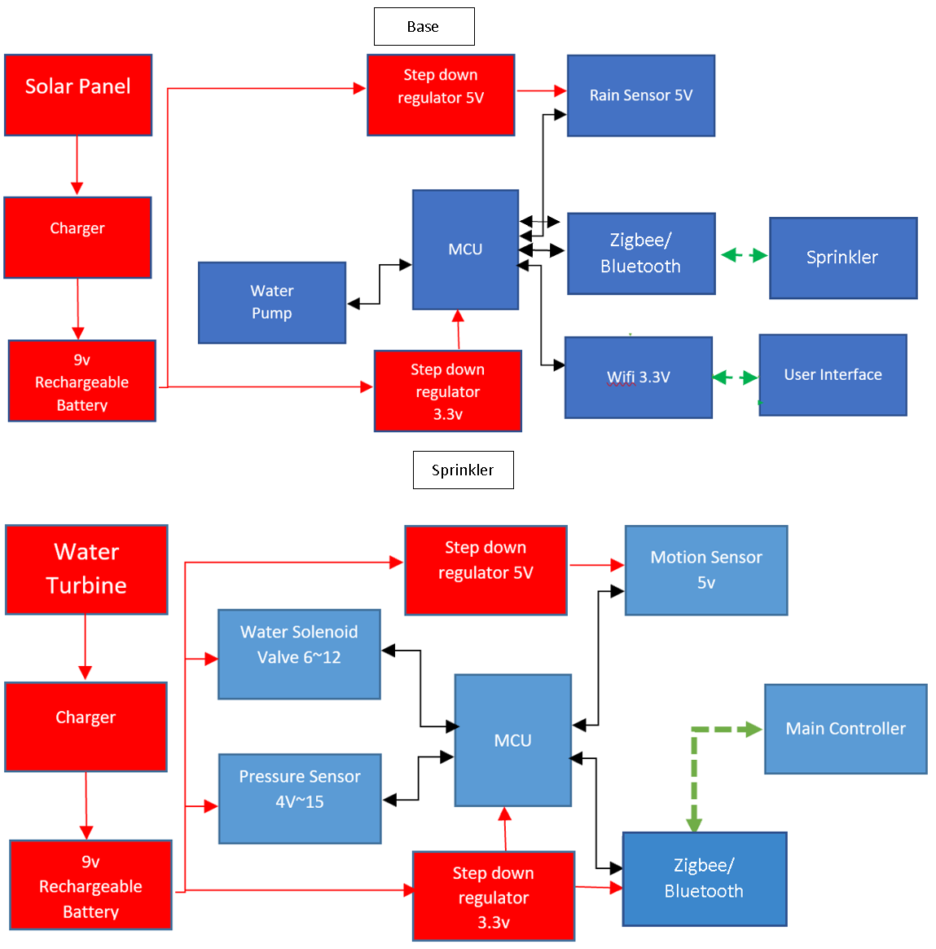
Figure 19: A block diagram on the plan of connecting the components.

Hardware Blocks: Selected Parts
This section will go into detail the various parts intended to be integrated together in order to create the Water Smart project. The components will try to follow the hardware block diagram in figure # above. It is worth noting that because of the time constraints that were given on some orders, the members of Water Smart instead ordered alternate parts to what will listed in Hardware Design only for testing purposes only. The intended components for this project have been ordered and are expected to come in during the first week of August.

The next figure will be an example of the components when attached to a home. It will show this display to have a better understanding of what will be going underground and what will be above ground. With Figure 14, you will be able to see how the four components underground will implemented that includes the actuator with valve, soil sensor, pressure sensor, and water turbine. The items will be placed in the same area to reduce the number of PCBs needed. All PCBs will include a Wi-Fi controller in order to be controlled and managed from the base.
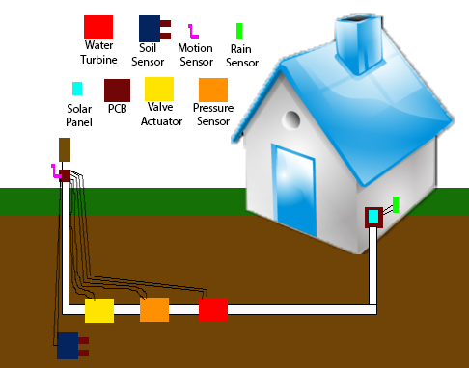
Figure 20: Physical Configuration
In the figure you will notice components required to be above ground. The Wi-Fi is above ground attached to the PCB due to signal interference. Motion detector due the need to detect motion was placed above ground. Another is the solar panel used to power the controller along without rain sensor is another item above ground. The rain sensor has been placed near the main controller because of its ability to be at a higher altitude and need for only one. The water turbine has been chosen to be used because of the space alternate power source would have consumed had the solar panels been chosen for the sprinkler controller.

PCB Designing
To design the PCB we will have voltage regulators that will be designed with the TI WEBENCH® Power Designer. The circuits that we obtain from the program are exported to the CAD program of this project choosing. Programs like OrCAD, Altium, KiCAD and others are option to import the designs from TI WEBENCH® Power Designer. Eagle is a free software with limitations on size within the free software, since the specifications of the PCBs will be within the minimal size this software will be our choice in completing the design. The other software like OrCAD had limitations on size and components for its free version, KiCAD would have to be paid for along with Atium. Since we were familiar with and found success in previous projects with the Eagle software as well brought us to the reasoning on choosing it to complete the designing process.
We begin with importing the TI-MSP430 board schematics to the eagle software and removing component we will not use for the project. We then find the locations for us to connect the components with in the reference PCB. We add the schematic from the DC/DC conversion and lead it to the designated power source and output. The components will lead to the MCU to control it powering up or collecting information. Once all components are connected correctly we will transfer it to the board design and find the best layout to allow all connections to connect without over breaking other paths. We will have one main controller but multiple sprinkler controllers with Wi-Fi attached to send signals between the base and microcontrollers. In total we will have to design two PCBs one for the base and one for the sprinklers. The board layout created will be transferred to the vendor selected as a CAD file.

PCB Vendor Selection
To choose the best vendor one of the main concerns is when we will get the board and how well it would come out in quality and display because it’s one thing to see it on computer and another too see it in person. In the project we will be using four PCB boards that will be interconnected. The issue we may encounter is one going bad. The goal is to purchase multiple boards in the case a burnout or error in assembly. If the issue is an error in layout then we will need to order whole new boards. Looking through manufactures like Tempo offered fast turnarounds within three days. One thing that they brought to our attention was that a good thing to consider was to export CAD instead of Gerber files. The Gerber files are 2-D ASCII files and popular to PCB designers. Most of the manufactures we considered can use Gerber files. The issue with the Gerber files is that it is distributed of multiple files where each contain a portion of the design if there is an issue with the design you will back and forth with the distributor. In worse cases you may have to create a whole new one. The benefit of Cad is that it is only one file and reduces to time consumed to find source errors. CAD files also undergo DFM check for errors to avoid the errors your distributor may find later. We are still going to create Gerber files but will be sending out we use CAD files predominantly due to the vendor Tempo preferring it. If a need to switch vendors presents itself, we will use the Gerber files if requested.

Power Distribution
The power distribution of the project was going to require the use of both multiple types of converters. In this section we will display and discuss the schematics for power sections on the project. With all the parts being powered by the 9V power source we use different converters and schematics to accommodate the different components to this project. Figure 21 is the overall diagram to the sprinkler system.
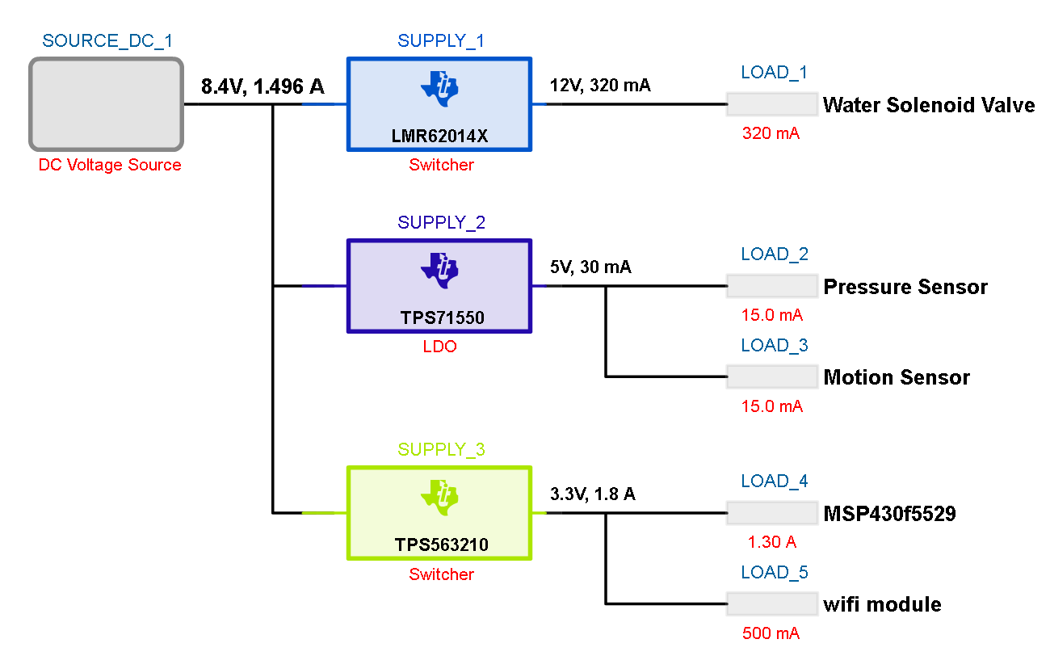
Figure 21: Sprinkler Power Distribution (TI Webench Developed)
We use LMR62014X switcher for the water solenoid valve. The switcher used at this section is to power only the water solenoid alone due to it being the only component with the requirement being to step up the voltage from 9V to 12V. In the diagram we placed 8.4V compensating if the battery does not give us the full 9V. In order to have a better understanding of what is done in this section you can take a look at Figure 22 shows the schematic for the water solenoid valve.
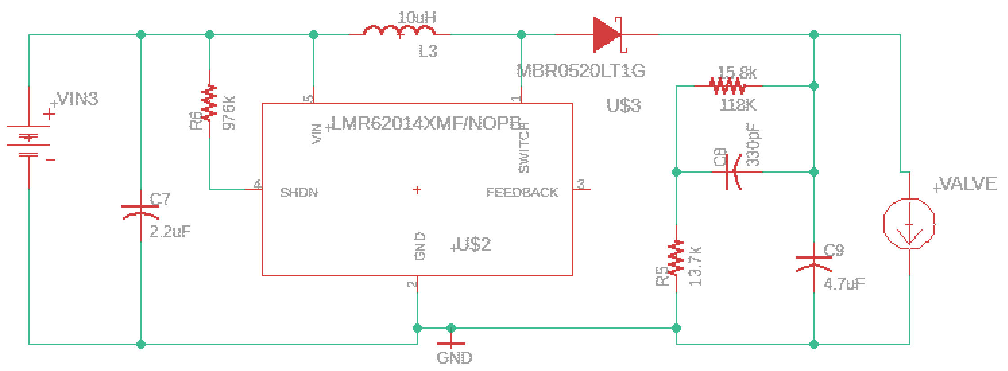
Figure 22: Water Solenoid Valve
In Figure 23 you will notice components outside of the switcher. Those components include capacitors, resistors, inductors, and a diode. The reason these components are added are to control the switcher to function the way we would like it to. For instance, based on the data sheet. An input capacitor is required to serve as an energy reservoir for the current which must flow into the coil each time the switch turns ON. This capacitor must have extremely low ESR, so ceramic is the best choice. Its recommend a nominal value of 2.2 µF, but larger values can be used. This capacitor reduces the amount of voltage ripple seen at the input pin, it also reduces the amount of EMI passed back along that line to another circuitry [30].
For the motion detector and flow meter we use the TPS71550DCKR LDO converter. This type of regulator is used due to it requiring a simple schematic and it only being required to step down the voltage. It is inexpensive and only has a few exterior components to control it. This was chosen based on TI WEBENCH giving it 92% efficiency rating compared to the switcher which was an 82%. The switcher would require more exterior components as well. Figure 23 is the schematic used for the power distribution of the motion and flow sensors displaying the reduced components compared to the switcher used for the water solenoid valve.
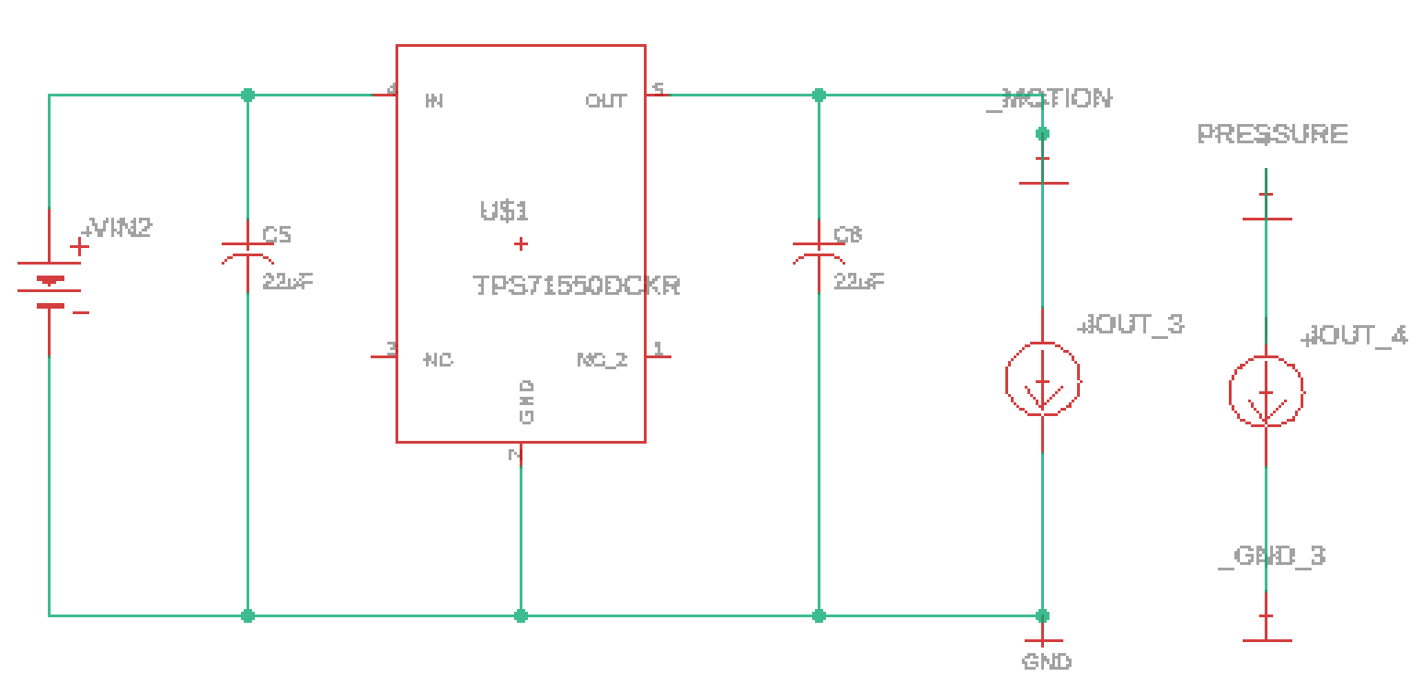
Figure 23: Power Conversion for Flow and Motion Sensor (Eagle Developed)
The MSP430 and the Wi-Fi have similar requirements when it come to power. If the Wi-Fi is over powered it has been known to fry as does the MSP430. The requirement was to go from 9V to 3.3V. The project uses TPS563210. The regulator is a switcher just as the LMR62014X was the only difference is that this is stepping down the voltage instead of stepping up. This regulator does not require the use of a diode as the previous switcher did. Figure 24 displays the schematic for switcher used for the MSP430 and Wi-Fi.
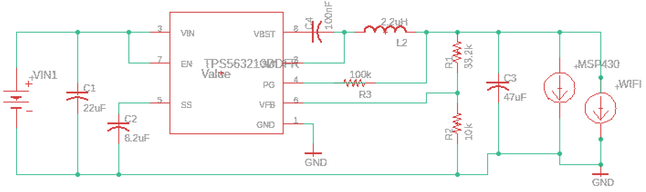
Figure 24: Power Distribution for MSP430 and Wi-Fi
The power schematics were chosen by the help of TI WEBENCH software. The reason for choosing different regulators based on components was to follow the power requirement based on the respective components datasheet.

6.1.6 Hardware Schematic
After testing the major components, we removed the parts of the MSP430 that were not required for the project. We left the programing connectors on the board to still allow a connection to the original board to program. The led was left on for testing purposes to mimic a sprinkler in order to avoid having to disconnect and reconnect the board. Two schematics were made one for the main base which would be near the home and another for sprinkler head locations.
      - Base Schematic

A 5V port is used and a switch port along with ground.This is being presented due to it being part of the schematic for the base. You can see that a switch is connect to the board, that switch is used to send a signal to turn on or off the power. The 5V connected is used to supply the required power for the relay. The relay will be used for the pump. Having this relay will allow integration for most water pumps. In this section the schematic detail for the base of the project will be viewed. The connection of the relay was brought forth to have an understanding on why it was part of the schematic. In Figure 7 you see the schematics for the main board.
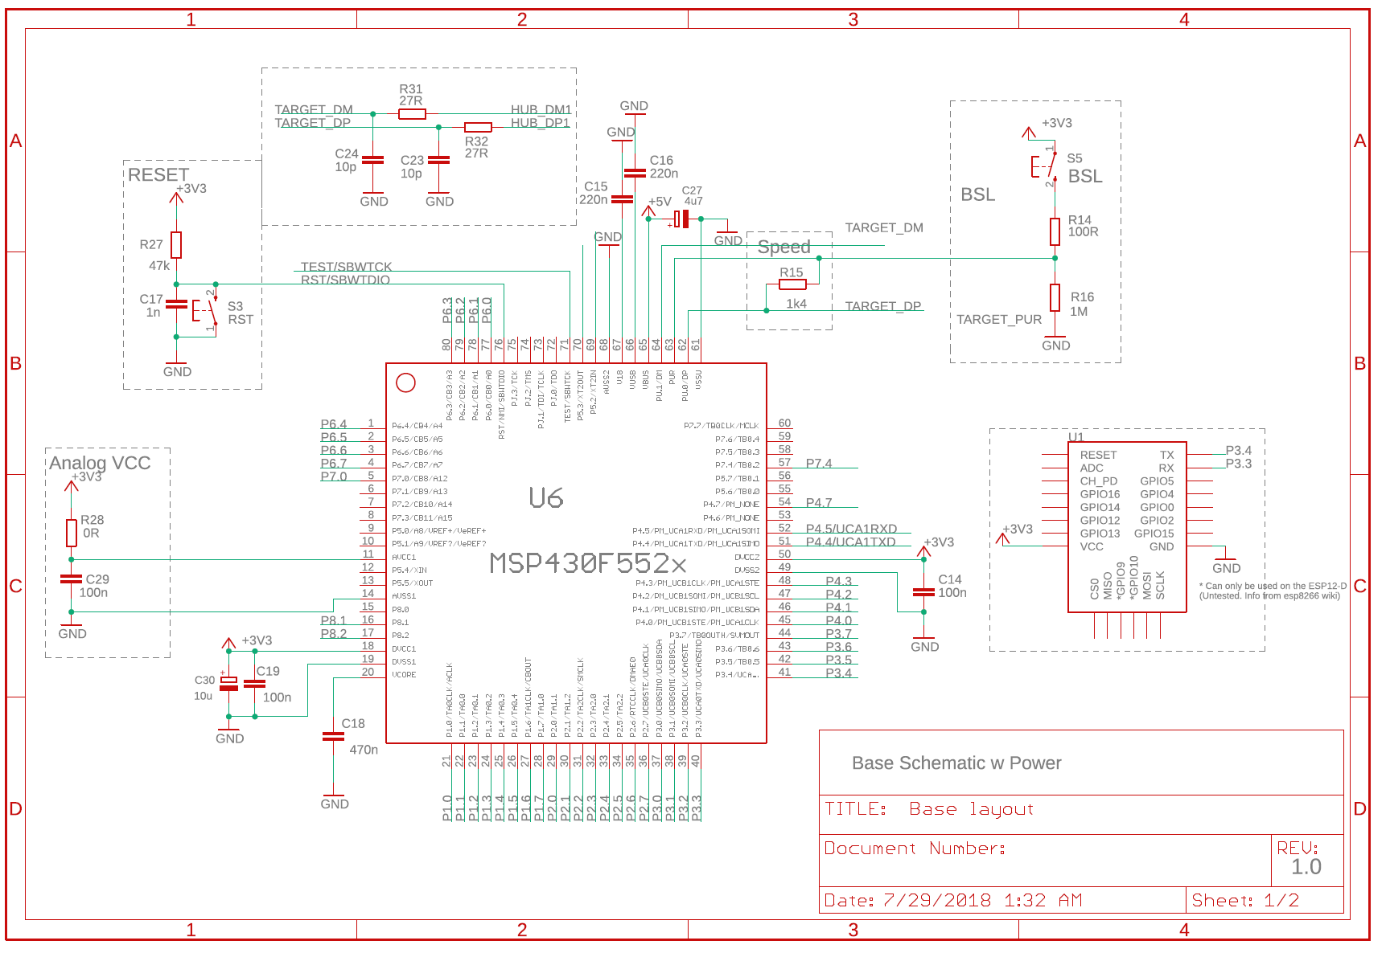
Figure 25: Main Base Schematic
The first schematic includes the main processor with the connection to the Wi-Fi. The reset button for cases were an emergency reset was required it remained on the board. The Wi-Fi only required power and data transmit and receive. Though the Wi-Fi has the ability to be the main base for the board, for this project it was only used to remotely send and receive information to and from the board, user interface and sprinkler head. The ports used to transmit and receive data was P3.4 and P3.3 respectively. The send will go to the receiver of the MCU and the receiver will go to transmit of the MCU. The Main base schematic has two pages to follow easier. The layout of the first page is the same on that will be used for the sprinkler head as well. The second page carries the external components of the project which changed based on it being the base or sprinkler head. It includes the connecters to program same as the original board but changed in type of connector. Let us take a look at Figure 8 were we have the second page of the base schematic.
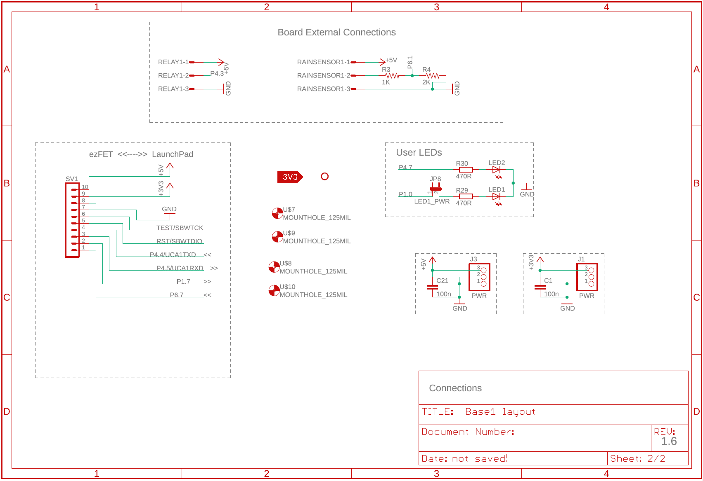
Figure 26: Base Layout
In this figure we have the connection to program the PCB similar to the original referenced MSP430. In the project the LEDs was left on for one to be used as a test light to resemble the sprinkler and also left the secondary LED to be reference for power. Two power connection are on one for 3V power and another for 5V power due to the alternating component requirements. The external components for this particular board will be the relay and the rain sensor. The relay will be using the 5V source and switch signal will be sent through P4.3. As explained previously regarding the relay, to trigger the relay we need a port programed to trigger it on or off. The rain sensor was connected was connected to the 5V and to a voltage divider leading to P6.1. P6.1 is an analog port which will be used to collect data from the rain sensor. This conclude the main board. Our next schematic will be on the sprinkler head in.
      - Sprinkler Head Schematic
For the sprinkler head the schematic is two pages as well, the first page will be the same layout as the main base. In which we will have the Wi-Fi connected. We have not added the Bluetooth yet due to the case the project may have a work around by only using the Wi-Fi. The Bluetooth was purchased for situation were the Wi-Fi would be an issue due to distance. The second page of the sprinkler head differs because of the components required. The project no longer required the use of a rain sensor at the sprinkler her due to the sprinkler drops mat affect results. The relay switch is still required due to the power being supplied to the solenoid being 6-12V it can be given with the use of the from the 9v battery and the use of the power supplied by the board. Figure 9 show the page two of the sprinkler schematics.
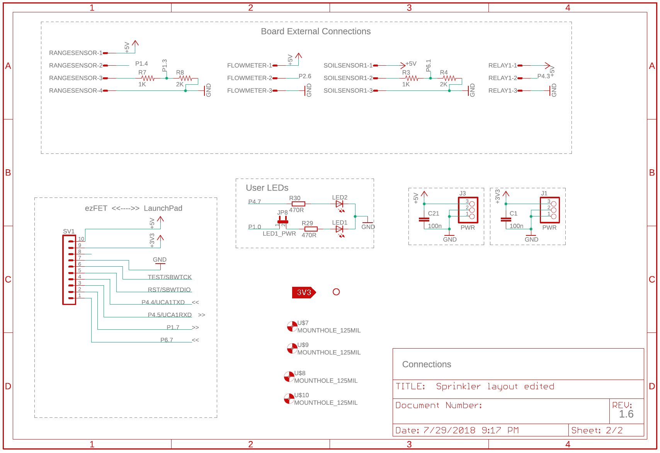
Figure 27: Sprinkler Schematics
For this schematic, the project still utilizes the programing section as describe in the main board. The LEDs are used for testing purposes and voltage sources for the board. New components differ from the main board are added that include the range sensor utilizing P1.4 for the trigger and voltage divider to P1.3, this used for the echo. The project range sensor has a voltage requirement 5V which is seen to be connected on the board. The next component added was the flowmeter which has a connection to P2.6 to send signals of how the water is flowing. This component also has requirement of 5V which is connected in the schematic. The last component added was the soil sensor which is connected using a voltage divider to P6.1. It uses the 5V power source. The relay is connected the same as the base. The project required the use of it to supply power to the solenoid valve. This concludes the schematic for the sprinkler system.

Software Design Plan
A solid product requires a solid plan. Proper software design and implementation is what can separate the difference between a quality product and a product that looks rushed, lacks features, doesn’t follow requirement guidelines etc. For this reason, the design was broken down into a set of steps. These steps were consolidated from common software design blogs that all tended to recommend the stages and stage artifacts. This helps to reduce spending on extra resources, changing of designs halfway through implementation and helps improve user experiences. Below is a table dictating what steps are to be taken, a small description, and the artifacts expected to come out of every stage.

Steps | Description | Artifacts
Gather Information | Research and discovery of relevant purposes, and goals | Written explanations in Senior Design document
Information Architecture | Decide on data, functionality, and organization and write them down | Site maps/User diagrams
Wireframes | Create screens, assign functions and data | Screen drawings
Workflows | Pathways users can travel within the app | InVision workflow model
Click-through models | Used to test wireframes and workflows. Experience wireframes on phone for testing | N/A
Style Guide | Building blocks of UI, consistency of theme and design throughout app | Colors, fonts, widgets used throughout design
Development Planning (Agile Model) | Divide tasks for each iteration | Plan
Development | Iteratively develop application with version control | Code
Testing – during development | Have applications tested by non-development part of senior design group for functionality, usability, and performance. Also performed in phases after each iteration of development. | N/A
Testing – after development | Set meetings with professors/TA’s or potential customers and have them use app | N/A
Table 12: Software Design Steps

After detailing what steps were necessary and what was expected to come out of them, the team came up with a schedule to hopefully stick to in order to remain on schedule for the deadlines we have set for us in this Senior Design project. Below in table 7 you’ll find the steps, starting periods, durations, and percentage completion. The graph also shows a comparison between what was planned and the actual periods and durations that each step took in the design process in table 7.
Table 13: Development Timing
Table of Data shown in the schedule graph. The Development, Test – During Dev, and Test – After Dev are stages that begin later in the process and thus have empty values for their actual start periods. The rest are currently in progress.
Figure 28: Development Graph
Figure 33 shows the percentage completion of each section in a list on the left side. The bar graph on the right gives a visual representation of the progress of work done and the lighter shades shows the estimated time left on each stage.

Gathering Information
The gathering information stage was spent mainly reading and understanding the process of software development. A lot of the process was known by team members who have been used to software development through internships. This made some of the research easier by making it focused. After creating the steps outlined in table 7 and coming up with a schedule, developers/designers began the first step to help create an idea of what the final product would need to look like. The artifact from that first step is the site map in figure 33 below. The site map outlines the basic design of the application as a web interface and the different pages that users can view when they navigate to the smart irrigation system website.
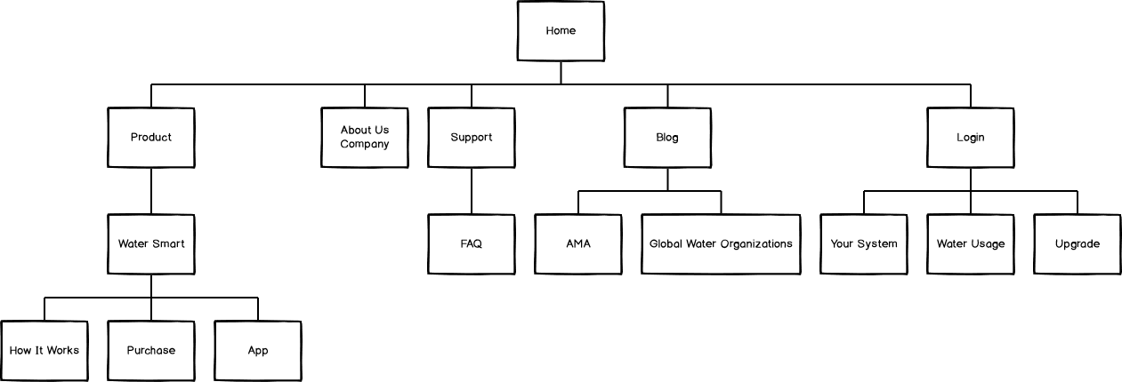
Figure 29: Site Map

Use Case Diagram
A use case diagram is a visual or graphical representation of the different interactions between the system and the different elements that are parts of the system. The actors in this use case diagram include the administrators which can view support requests and are able to view the system details as needed to help with maintenance and support as needed. The associations show the different use cases or set of actions that the different actors can take when using the system. It’s the simplest way to display what users will be able to do using the system software wise.
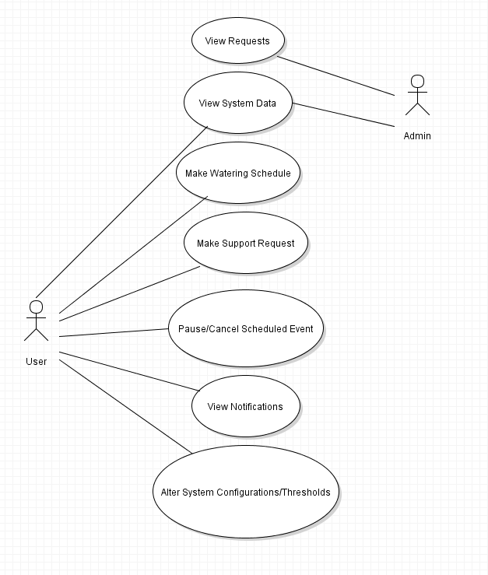

Architecture
In designing the mobile app, the three types of app architectures that we considered were the thin Web client, the rich client, and the rich user Interface. [2] After considering the purpose and use of our app, we decided that our mobile app would best be designed as a rich Internet application. Given that the app will always have to be connected to Wi-Fi to provide the details from the system, it makes sense to leverage that constant connectivity to offload processing work that the app needs. A rich client would’ve required the user’s device to also be where processing of things such as the business and data service layers. It also would be harder to install and later, maintain. In choosing between the thin Web client and the rich interface infrastructures, we prioritized making the user interface as user friendly, function rich, and appealing as possible. That along with the fact that we will only need limited access to the local resources on the smart phone meant that we could use the rich interface architecture to help reduce our app footprint to be as small as possible. In this part of the design, besides the architecture, other topics that will be determined include data, functionality, and organization. The outcome will be the building blocks for the next section, wireframes.

Database
A database is a form of storage for a collection of information or data. For this application, the data that will need to be stored includes user information for identification and profile creation, and system data such as soil moisture levels and water usage so that they can be used to provide users with visualization of their overall system operations and to be able to make configuration decision regarding their system. Using technology stacks such as WAMP or XAMPP, developers could design their own personal database to work alongside their application and host it themselves, but that would put an unnecessary burden on them. Products have been developed to take care of much of what is needed using cloud technology to be available everywhere all the time. Because of this, the team has decided to use two systems that provide useful tools to simplify the process and shoulder a lot of the work that would otherwise be on the developers. The first one is firebase, a Google created cloud database that is easy to use and provides authentication tools built in. Firebase will be used for storing user identifying information to aid with authentication, profile creation, and support tracking. Below is a picture of the basic database design rough draft in the form of an E-R diagram to display what some of the tables in the database will look like and the attributes associated with them.
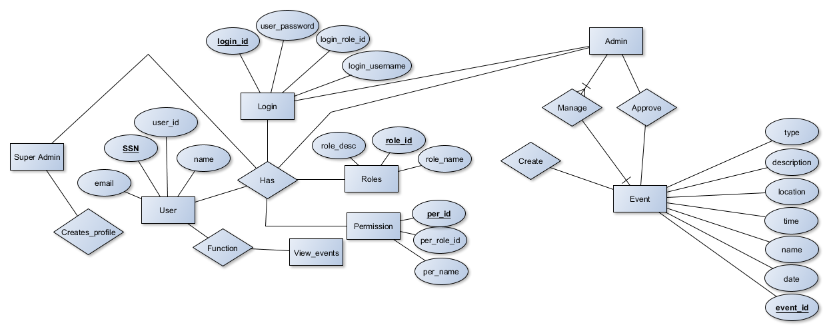
Figure 30: Database Diagram
The second cloud database system that will be used is ThingSpeak. ThingSpeak is a database designed specifically for Internet of Things (IoT) applications which is perfect to interface with this project using sensors, microcontrollers, and other peripherals that will need to speak wirelessly and send data. The part it will take care of is the storing and analyzation of data sent from the system using MATLAB. After analyzing, it provides visualization in the form of graphs to easily understand what the data means. It specifically works very well with the Wi-Fi modules used in the system, the ESP8266 Wi-Fi module. With this visualization and their provided API to show the information within the web application, users will be able to see the data and make educated decisions on how they want their system configured going forward such as to save more water or to increase watering in certain zones. Below is an example of how the data will be shown.
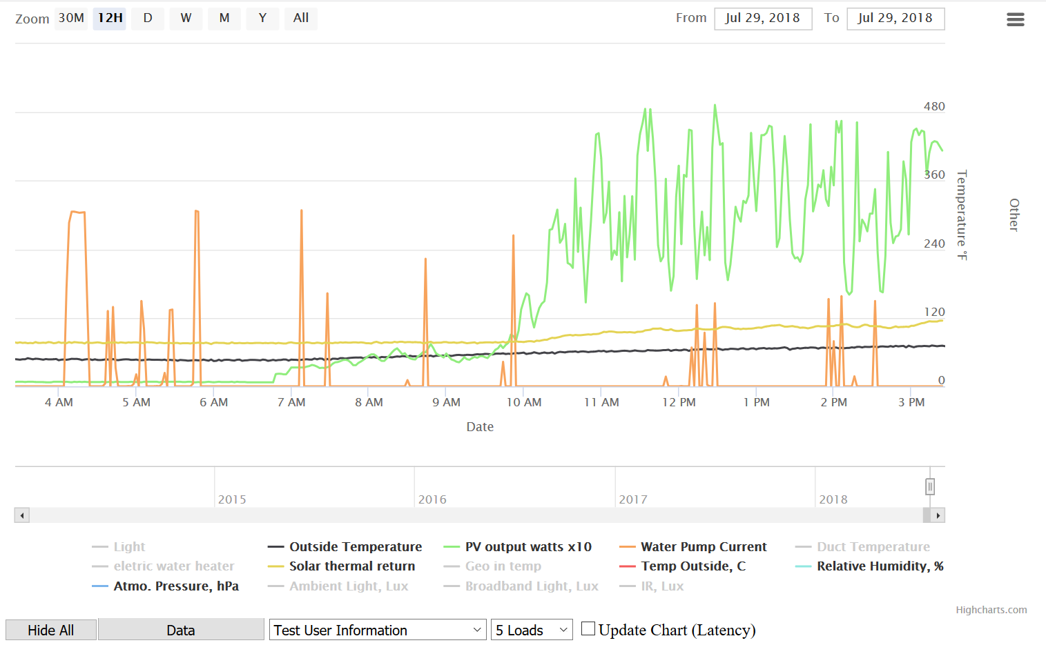
Figure 31 Example Data Visualization

This example is a very close representation of what the actual user graphs will look like. It is using example MATLAB code provided by ThingSpeak to create a graph showing data as time goes on about the system based on date of data requested and the time of the data.

Wireframes
Wireframes are the part of the project where we begin to visualize the application through sketching. These sketches are called wireframes in that they symbolize the skeleton of the final product, a blueprint if you will. [3] They show the structure and layout along with what the many screens of the app are supposed to look like. It begins very early on in the development process and thus is subject to change, but it gives a nice foundation upon which to build the rest of the application and provides a picture for developers to design towards. This is an important step and designing for usability, functionality, and ideation while not being so bloated with lots of graphics that may distract. All of the wireframes posted in this document were designed using Balsamiq wireframe design tool. They show how the team pictured how the application will end up looking so that developers have a goal to aim towards and a design to implement.

Workflow Diagram
The workflow diagram is often a forgotten or neglected part of the mobile app design process, though the importance of it can’t be stressed enough. This workflow details the user experience through the application and is also where designers and developers work together to come up with a polished, functional, user friendly product. If it hasn’t been obvious already, the user experience in the software is the most important part of a successful software product. Using the recently created wireframes the diagram is created to snow in more detail the paths a user can take throughout the application. It makes sure that every task expected of the application and of our system can be completed as specified. Responses to question such as what to do when a user inputs invalid input into a text field for logging in, or what occurs when there is no connection, are all taken into consideration in this step to insure there are no holes in functionality. Below is an example from Justinmind where the user flow takes the user from the account creation page to the feed page. The wireframe and user flows work well together and for this reason, the wireframes are posted along with a description that serves as a makeshift workflow of the paths users can follow throughout the app to do different tasks. These tasks include configuration, signing up, and operation of their smart irrigation systems.

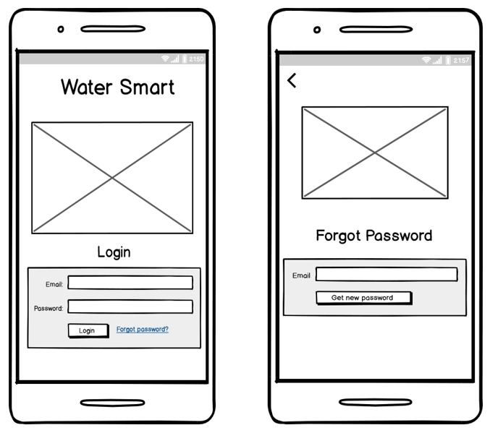
Figure 32: Home Page, Forgot Password
In the first wireframe, users will begin the app on the login page where they will either type in their already created login information for their account. If they have forgotten their login information, users are able to click the forgot password link to attempt to authenticate that they are authorized to use the account, and then the app will send them a temporary password to use to reset their password.
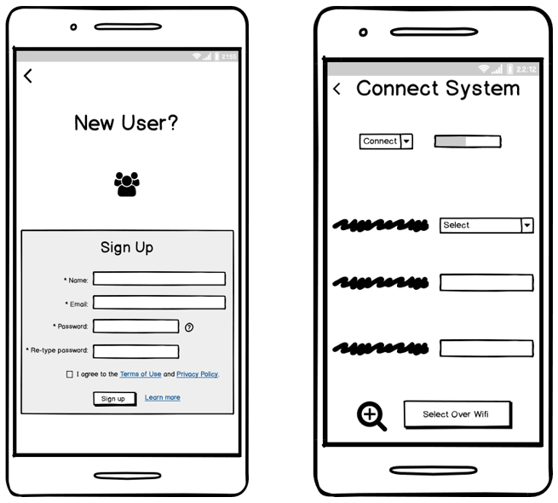
Figure 33: New User, Connect System
If the user is a first-time user with a recently set up system, they can use the sign-up screen to sign up for an account. Once connected the system will be able to download information and control their system remotely to be configured as the user likes.
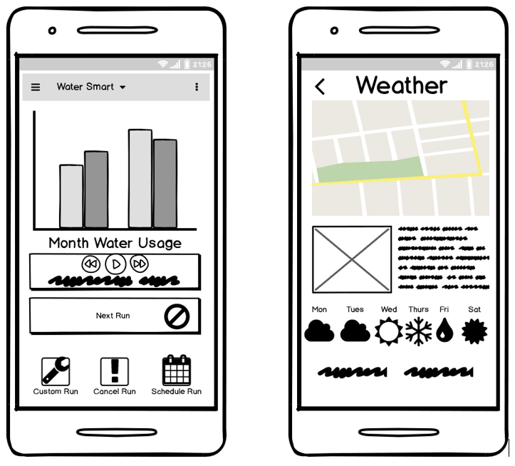
Figure 34: Weather Page, Main Page

Once logged in, figure 36 shows where users come to a home screen populated with important information users generally open the app to see. This way it reduces the need for more navigation throughout the app to see statistics that are often looked for such as water usage of the overall system. Also included on the home screen is a media bar to control the current watering session and a button indicating the date and time of the next scheduled run. From here users can click to cancel the next scheduled run or pause the current run. Under these options are quick access buttons to quickly schedule a custom run for a special case such as a new garden or plant in a zone, cancel any run, or create a new regularly scheduled run. If users don’t find what the task or information they are looking for on the home page, they can click on the menu in the left-hand corner to open a drop-down menu with other pages for more configurations and information. One of these options is the weather page, shown in figure 36 that will display local weather, in the users’ region and the weather station that it is pulling the information from.
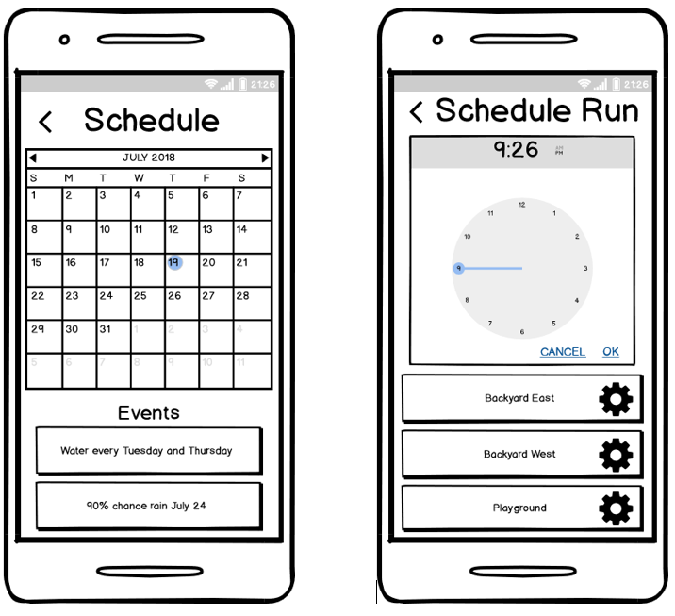
Figure 35: Schedule, Schedule Run

The schedule screen in figure 39 shows the currently regularly scheduled watering session for the month and also any custom watering sessions created from the home screen. It also shows any relevant events expected to occur taken from the weather station such as hurricanes, tornadoes, torrential rains etc. The schedule run screen in figure 39 shows what happens when a user clicks to schedule a run from the home screen. Here they can choose which zones they want to schedule a run for and set a time and date for the run as well. When users want to be specific, they can use the pages mentioned next referring to each zone individually.

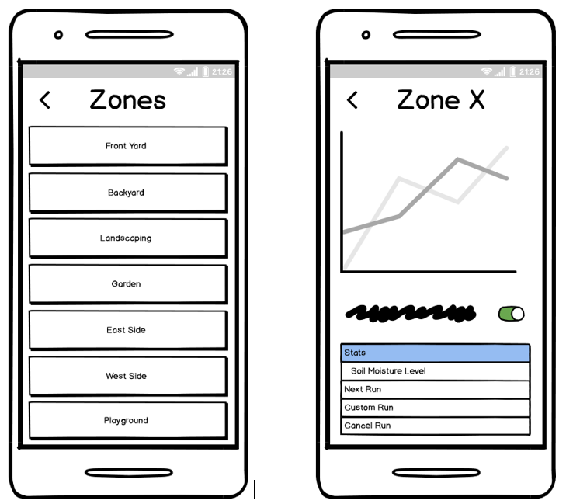
Figure 36: Zones, Zone X

Figure 40 shows the zones screen where users can see what zones they have created for their system. Here they can select a zone and be sent to the next screen, figure 40, where they will see information specific to that zone like soil moisture levels and water usage.
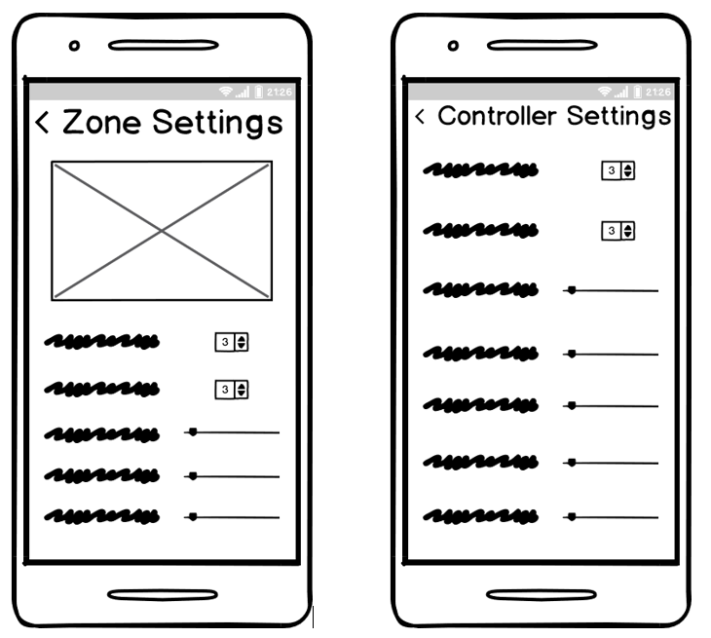
Figure 37: Settings, Zone Settings
The last two wireframes mentioned, figure 41 and figure 41, are figures showing what users will see if they navigate to the zones and controller settings in the application. Here is where they set preferences such as the water moisture threshold of when to automatically schedule a run do to dry soil, or at what amount of water used to stop watering. The zones setting page is similar but will be made different for each zone. This page can be reached from the zone page in figure 41 mentioned in earlier.

OS
In terms of performance and functionality, mobile apps do better when they are designed for a specific platform or designed to be native to a platform. The reason they work so much better is because they are able to better use the advanced hardware of that smart device. The support for the native languages are much better with a bevy of API’s created by platform providers that help to integrate phone features such as GPS, motion control, file system and storage, advanced user interactions, and advanced interface functionality. If an app requires high power or lots of resource use, the framework integration will make the resource accommodation easier and the fluidity of the application smoother. According to the International Data Corporation (IDC), in May of 2017 the market share of Smartphones was dominated to the tune of over 80% by Android. [1] Even though the numbers change somewhat when looking at just the United States, it still makes sense to design the app in a way that creates a larger customer base for our system. For these reasons, we initially chose Android as the platform for our main development with its native language Java. Later on, down the line we planned to also design an iOS based application to interface with our system as well.
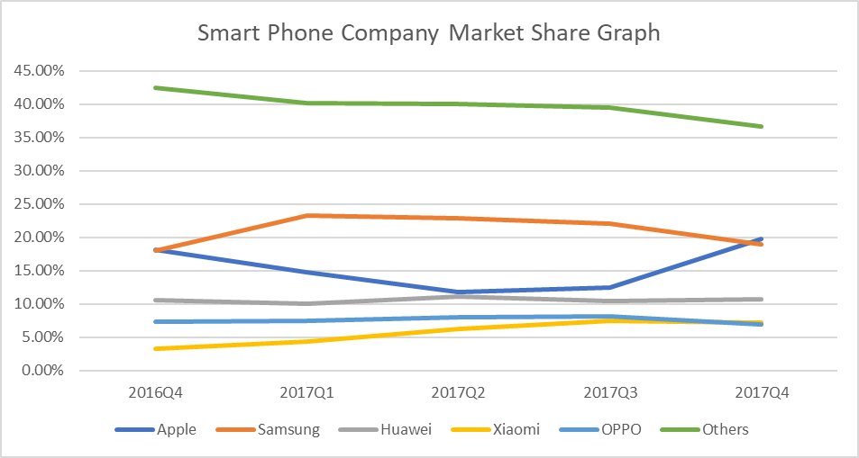
Figure 38: Smartphone Market Share

Mobile vs Web App
Mobile apps provide convenience that users like by being able to control their systems from the swipe of their fingers on a device they are likely to be carrying all the time. This way if any sort of issue arises such as a broken sprinkler head or a skipped watering appointment, or if a user were to need to schedule extra watering in a zone, users can quickly take out their phone and make changes as needed. These beneficial features that make a mobile app appealing are helpful, but they do not take the place of having a full featured web application or website made for desktops and laptops. The screen size of mobile devices and difficulty with heavy data entry tasks are a couple of the main reasons why mobile applications aren’t perfect by themselves. Using a mobile device, the onscreen keyboard can become cumbersome when inputting data for long periods of time. With the mobile app there are a few constraints that need to be considered differently than when creating a web app. Constraints include different device hardware and their specifications such as screen size, processing ability, battery life, memory, and security. If the app is too memory intensive, it can cause issues where the OS must either close the app or begin to sacrifice other cached data and slow down the operation of that program and other programs. These constraints mean that mobile apps need to be designed with a simpler architecture and UI and must be somewhat lightweight when it comes to using resources. This can be tough when also designing for full functionality and layer abstraction where multiple layers are created to separate the different concerns/functions, and to improve the reusability of the app code.

Our App
In developing the mobile app, we defined our target users as homeowners, renters, building managers, anyone who would manage an irrigation system in a residential or commercial environment. The mobile app will be first created on the Android platform, and later ported over to the iPhone platform. The app will be available for download in the Google Play Store and will be free for all users. On first launch, users will be greeted with a login screen where they will be able to login using a username and password if they have already created an account, or they can click on the “create an account” link to create an account there. The “create an account” process will also be where a user will link their account to an already installed system. Once logged in, user will see a home screen with basic information about themselves and their system such as their name, system version, next scheduled appointment, etc. At the top of the screen, users will notice a simple navigation bar with the name of the current page, a back button to return to go up a level of navigation, and a menu button marked by three horizontal lines. When users click on the menu button, a menu will pop out with options to quickly move to a specific page. Pages on the menu navigation and their functions are listed below:
- Home – Start page, manually run on or more zones, place system in hibernate mode for low power and long-term dormancy, local weather information
- Weather – More detailed weather information, change weather station
- Zones – Set settings for specific zones, zone status
- Status - View entire system status (on, off, running, stopped etc.), soil moisture levels, water usage and wind levels
- Schedule - View the next scheduled appointment, create new appointments, delete appointments
- History – Watering history including weather skips, soil saturation skips and wind skips,
- Account Settings – Make account updates
- Contact Us – Send system report, contact information for tech support
- Log Out – Log Out
These are the basic functionalities the application will have. Other features and pages may be implemented, but at the most basic level these must be there.

Software Design Tools
Below is a table of all the software design tools intended to develop a responsive web application and mobile application along with tools necessary for to gain data from and control sensors such as the w-fi, radio frequency, and soil sensors that will be the basis of our smart controller. There are any types of tools and as such the table gives a nice overview of the names, types, and provided environments for development, testing, simulation, sketching, and prototyping.

Energia
From the Energia website, Energia is “an open-source electronics prototyping platform started by Robert Wessels in January of 2012 with the goal to bring the Wiring and Arduino framework to the Texas Instruments MSP430 based Launchpad.” [6] Arduino is renowned for its ease of use and easy project creation using their IDE. The main purpose of using energia in our project is to help with rapid prototyping of our code with the Launchpad we’ll be using to test how our software running on the MSP430 MCU, interfaces with the different components that we will be using in our project. It’s very much like an IDE that coders normally use to develop software but stripped down to where easy code development and deployment is possible. Energia is portable and flexible with the ability to run on Mac OS, Windows and Linux. It is also able to integrate into popular IDEs as a framework or abstraction layer.

Code Composer Studio
As mentioned before, Energia is a stripped-down version of an IDE. The functionality and robustness that it doesn’t have is covered by using the Code Composer Studio. CCS is a full IDE with a large number of tools to compile, debug, build, and edit source code. It’s comparable to the very popular Eclipse IDE, but it also adds functionality specific to embedded development and debugging. [7] The main language that it is optimized for is C/C++. Right out of the box, CCS comes with support for all of TI’s processors and their microcontrollers which makes it a perfect fit for our project.

Balsamiq
In our design process, the wireframes and workflows are large parts of the foundation of our mobile application. The wireframes lay the skeleton that assigns functions, creates screens and allocates data. The wireframing process could be done using pencil and paper or whiteboards, but Balsamiq provides us with an intuitive design tool that helps with visualizing and making artifacts that can be stored for use later in the design process. When the developers have wireframes, it gives them a definite goal to code towards with no confusion or ambiguity as to the functionality and look of the final product. The workflows help developers as well, but mostly help in creating user stories detailed with the pathways that users can and will travel when operating the application.

Ionic Framework
The ionic framework is a software development kit that was created to be a hybrid between mobile and web applications. The Framework is used along with HMTL5, CSS, and JavaScript. [9] The focus for Ionic is the UI of the application, to make it user friendly, and make the look, the feel, and the interactions all smooth for a better user experience. It allows for those versed in using JavaScript type languages such as Angular to simply integrate this framework. The biggest benefit of using Ionic is the fact that it is open-source and completely free. Another great benefit is that Ionic is supported by Google which means developers have a host of support documents and proven developers that have tested and implemented applications already and shown how the framework can help create quality apps by extending Angular and making it easier to develop with. Ionic makes applications that mimic the “Native” characteristics mentioned earlier in the OS section. [10] For the longest time, there was no way to design applications for cross platform use without sacrificing the seamless integration benefits gained by developing using native languages for each platform. Ionic framework does it’s best to mitigate those issues and provides a way to create a larger audience for the smart irrigation application. IPhone users, Android users, Windows phone users, and users using the web can all participate and control their systems because of the Ionic framework.

Slack
Communication is one of the most important aspects when working in a team environment. Slack was our choice for a communication platform. It is mobile and web compatible and provides an easy interface for planning, scheduling, assigning, uploading, downloading and much more. Slack offers free file transferring with a 5 GB limit simplifying a way for our team to send important documents. Slack supports channels that can be divided up by team, project, or field of study. This was usefully for talking about specific areas in the Water Smart system. Slack is also capable of face-to-face communication, providing video calls and screen sharing. Slack ensures that the users data is kept secure with various standards such as SOC 2 Type II, ISO 27001, and HIPAA. There is also standard authentication protocols and support for two-factor authentication and encryption of data in transit and at rest. The alternate communication platform that was considered was GroupMe, which also would have served our team well.

Software Data Flow Diagram

The software data flow diagram shows where the data comes from, when and how it’s manipulated, and then where it is stored. The yellow boxes indicate the external entities where the data is generated. From the external entities, the data will either be processed (blue box) or stored (green box). This will help when writing the portions of code that handle data.
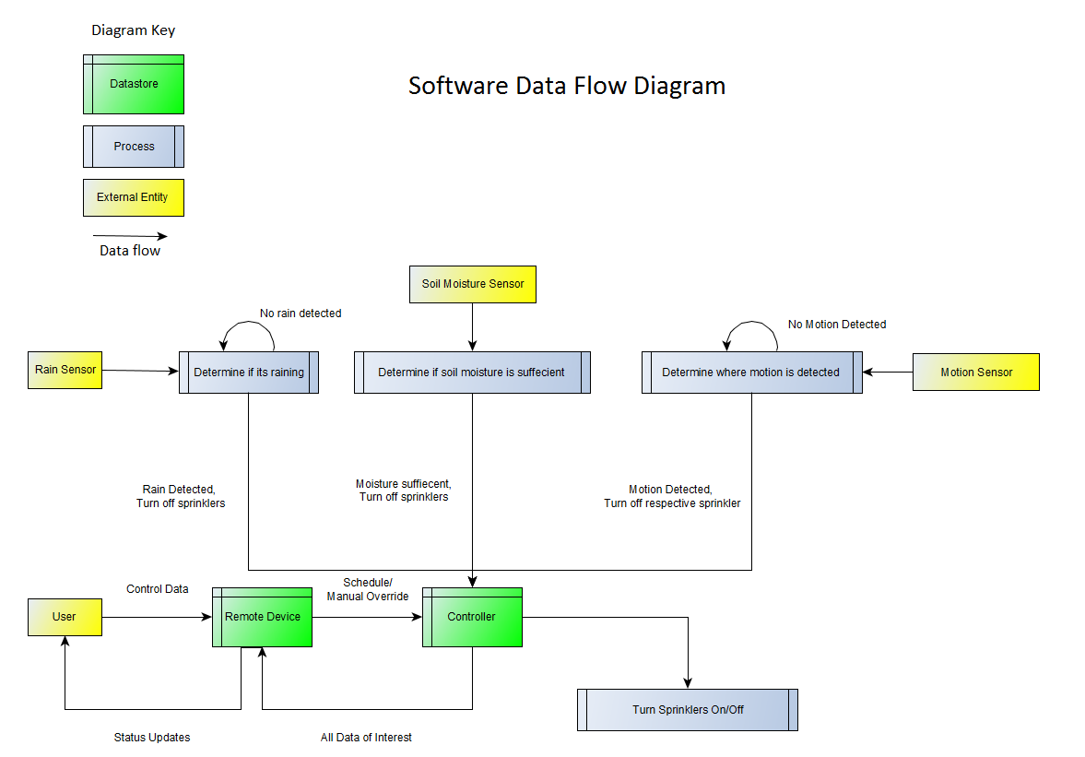
Figure 39: Software Data Flow Diagram

Software Functionality
There will a significant amount of software designed for the Water Smart system to function as intended. The backend of the software will handle the functionality for all the sensors and microcontroller communications. The types of data that will be transmitted and received will consist of soil moisture readings, rainfall measurements, motion sensor detection, flow sensor rates, and the control signals that will ultimately turn the system on and off. There will also be an initial constructor function to set up the hardware pin’s input/output direction and their initial states. A series of for loops and while loops along with delay functions will control most the functionality of the system.
The software data flow will be as flows: the moisture, rain, motion detection, and water flow sensors will be obtained through the input pins of the hardware. Then based on predetermined threshold values for each metric, the respective sprinkler head will be either turned on or off. This part of the coding is much like the coursework we had in the Embedded Systems class at University of Central Florida, preforming labs with the MSP430 microcontroller. Should we choose to use the MSP430 as the microcontroller or not, most of the concepts learned in through that course can translate to several other microcontrollers. As for the front end, the main PCB will have to upload the data of interest to the mobile and web platforms. There are many approaches for the front-end programming as far as environments, platforms, languages, toolsets, API’s etc. most likely HTML, CSS, node, angular or react native.

Design Methodology

There are many ways to divide the software development portion of a project into distinct phases. Some of the phases included in the software development life cycle are: requirements, design, implementation & coding, testing, deployment, and maintenance. The models and paradigms that we considered using for the Water Smart software were Waterfall, V model, Spiral, Prototyping, Incremental, Cleanroom and Agile.
One of the team member’s suggested that we use the Agile approach to the software development because it seems to be very popular at Lockheed Martin. Many software related job postings also have desired qualifications like training or experience with Agile methodologies. Agile software development values include individuals and interactions over processes and tools, working software over comprehensive documentation, customer collaboration over contract negotiation, and responding to change over following a plan.
Agile includes a framework called Scrum to help manage the work on software development. Since Scrum is designed for teams of three to nine developers, and the coding for Water Smart will mostly be done by two members, we may adopt only some of the key aspects. Once the software plan is fully developed, we can break down the programming into individual tasks. Then we can plan to do sprints, where we would plan to finish the task in an allotted amount of time. For larger projects these sprints may extend from two weeks to a month, but since Water Smart must be completed by the end of this fall, a weekly sprint may be the most suitable. We will implement daily scrums, where we will have 15-minute standup meetings to discuss progress and any necessary re-planning.

Version control
Version control is a very important part of software development. It is used to track and manage the changes to a software development project while also letting the members collaborate and change the same files. With version control, two developers may work on the same file while by isolating their own work through what is known as branches. This way, the changes that each member made to the code, can be compared, merged, or revert to a previous version.
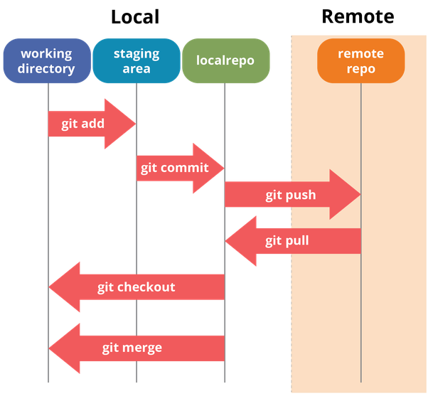
There are many version control systems to choose from including, Microsoft Team Foundation Server, Helix VCS, Git, Subversion, Mercurial, Rational ClearCase, CVS, Kiln and many more. We decided to use Git as the version control system based on the team’s experience with the tool and its overall popularity among developers. Git also offers features like lightning fast speed, ability to work offline, easily undo mistakes, backup security, and a staging area to determine specifically what changes will be made in the next commit. Below is a diagram showing how the Git commands are used.
Figure 40. Version Control Diagram

We also have many options when choosing a service for hosting a remote repository. GitHub seems to be the most popular service with a reported 28 million users in 2018, significantly more than its competitors like Bit Bucket and Microsoft Team Foundation Sever. GitHub also offers the ability to integrate with platforms like Amazon and Google Cloud.

Cloud Services

The software design requires a cloud service to store and retrieve data via Wi-Fi. There are many options to consider for this task. The first-choice option was Adafruit.io, this service offers a straightforward way to stream, log and interact with our data. It has a powerful API that well-documented and easily available to anyone. The available charts, graphs, gauges, logging and other dashboards that Adafruit.io offers are very appealing and well-designed. They also assure secure data control and management with private and public settings this service offers the capabilities that Water Smart needs, the only reason to seek other options is because of the price. Adafruit.io offers a free membership but only including 30 data points per minute, 30 days of data storage, and a 5-feed limit. The offer an upgraded member ship with unlimited feeds and 60 data points per minute and 60 days of data storage, but at 10$ a month or 99$ per year.

The other option that was the most viable was ThingSpeak. ThingSpeak is an analytics platform service that allows the users to visualize, aggregate, and analyze live data streams in the cloud. ThingSpeak offers a straightforward way to configure our devices to send data to ThingSpeak using popular IoT protocols. There is also provided documentation and examples of ThingSpeak interfacing with our chosen Wi-Fi module, the ESP8266. This also include application that can perform actions at predetermined times, react incoming data meets certain conditions, queue up commands for connected device, and a simplified way to communicate with web services and APIs via HTTP. The free version of this service offers ~8,200 messages/day, a message update interval limit of every 15 seconds, private channel sharing limit of 3.

Network Technology
The network technology will dictate how each device in the Water Smart system will communicate. There will be a set of standards and protocols that will be followed along with algorithmic implementations that will handle the data transmissions.

ZigBee
The ZigBee standard was chosen for Water Smart’s low powered wireless personal area networks (WPAN). ZigBee has been proven effective in many application, especially wireless sensor networks (WSNs) such as building control, plant monitoring, hospitals, and smart home automation. Comparing ZigBee to other wireless technologies, ZigBee consumes much less power than Bluetooth, Ultra-wideband (UWB) and IEEE802.11 Wi-Fi. Not only is ZigBee much less power demanding, but it is also the cheapest, compatible with many working frequencies, and can support more than enough devices than the Water Smart system will typically use. Although the data rate for ZigBee is inferior to Bluetooth, WI-Fi, and UWB, this isn’t a concern for the Water Smart Design. The devices that will be communicating will only be sending sensor data and system states or updates, ideal for ZigBee’s low data rate.

Network Diagram
The Water Smart Network Diagram shows the network architecture of the system. The three blue microcontrollers have sensors connected will represent the remote PCBs spread throughout the landscape, each equipped motion sensors, rain sensors, soils moisture sensors, flow sensors and the wireless communication module. Each will transmit packets containing their sensor’s data and state of the system to the green microcontroller. From there, the main microcontroller will analyze the data and turn the system on or off. The main microcontroller (green) will also send that data to a cloud service where from there it can be easily translated to the web platform and the mobile platform.
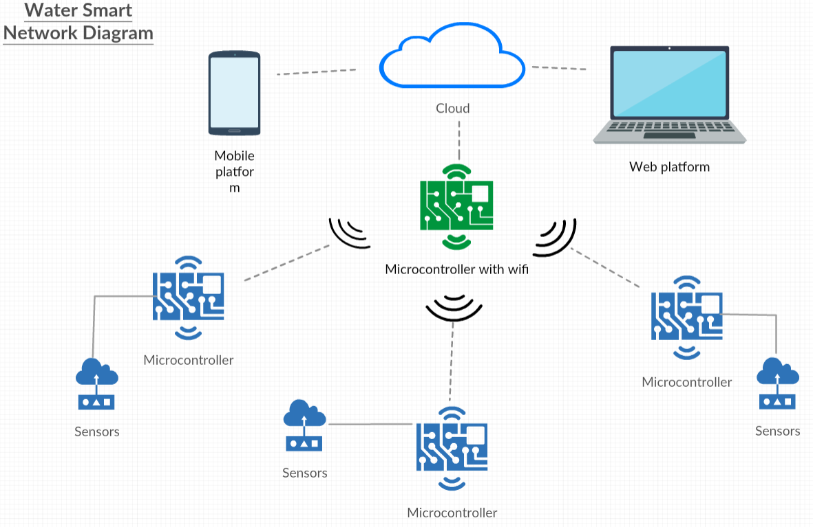
Figure 41: Network Diagram

Network Flow Diagram
The network flow diagram shows the communication between the microcontrollers. First the main controller will send a request to its communication module, then the communication module will send the packet data to the other microcontrollers’ communication module. Once the receiving module has the packet of data, it will relay the packet to the microcontroller and send an acknowledgement back to the transmitter. The graph should be interpreted with time on the y axis (top to bottom).

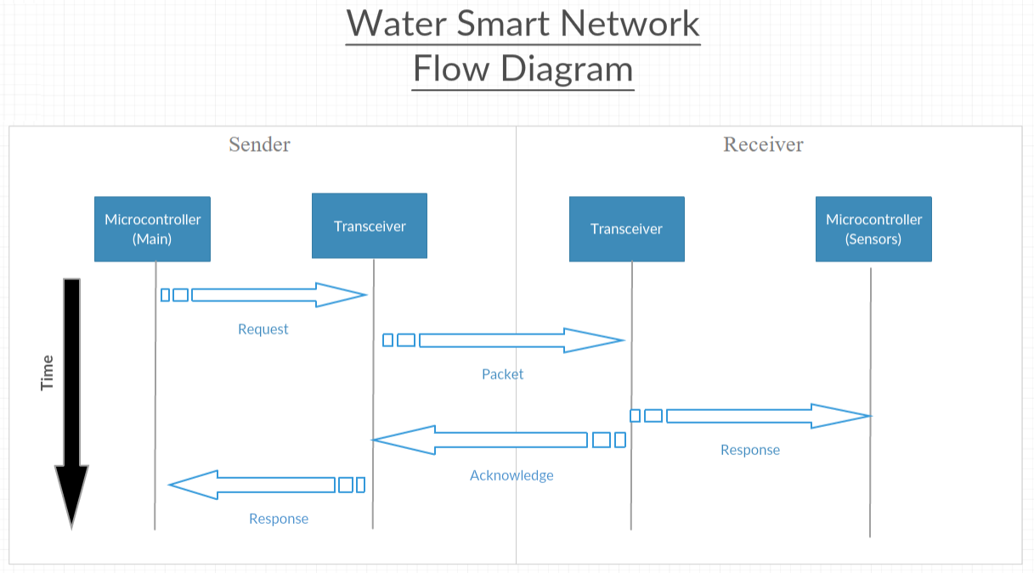
Figure 42: Network Flow Diagram

Network Topology
ZigBee supports several network topologies, the ones that were considered for the Water Smart network were the star, tree, and mesh configurations. Each topology consists of a coordinator node, router nodes and the end device nodes. In a star topology, there is one coordinator and connected to it are all the end devices. There are no routers in the star network, so the coordinator is responsible for the initialization and management of all end devices. The star topology is simple and easy to deploy, but the reason that it was not chose for Water Smart is because of the limited communication capabilities. If the Water Smart system was installed across a large landscape area, the coordinator (HUB unit) would still need to be able to establish a connection to each end device (Sensor unit). This would mean the coordinator would have to be placed in the center of all the end devices, and even then, they would be limited by the range of the RF transceivers. This is would be very inconvenient when installing the Water Smart system since the shape of the targeted watering areas is expected to vary.
The ZigBee tree topology is more suitable for Water Smart than the star topology. The tree network includes one coordinator, intermediate routers, and end devices. The routers in this topology extend the range of the network, unlike the tree topology. Direct communication can only occur between a parent node and its child node, but all nodes can still communicate with each other by sending the data message up the tree, until it reaches a parent node whose child node needs the data message. The issue that the tree topology has is the possibility of a router failure. If parent node loses a connection or fails in any way, then the children of that node are then isolated from the rest of the network. In the case of Water Smart, this could lead to a chain of end devices failures if a parent that is high the tree network fails.
The choice for the Water Smart topology is the ZigBee Mesh, also referred to as a peer-to-peer network. Compared to the other two, the mesh is the most flexible and supports the potential range requirements for Water Smart. The mesh network allows any router to communicate with any other router or the coordinator if it is still in range. This allows for many routes throughout the network, and by simply adding more devices can increase the range of the network. From a power consumption stand point, in a mesh network, the devices can be located closer together so that use less power. The best feature for the mesh network that ZigBee includes is its route discovery feature. If given a targeted node for communication, the discover feature will find the best route through the network. This makes the network self-healing, meaning that if a node were to fail during a data transmission, it will find an alternate path to the destination. Refer to figure 44 for the layout of the ZigBee mesh topology.
Figure 43: ZigBee Mesh Topology

Sensor Unit
The sensor units will be spread throughout the landscape and will transmit all its sensor and state data to the main HUB unit through the ZigBee mesh network. This sensor unit microcontroller will be programmed to perform several tasks such as detect and join the ZigBee network, test connection of its RF module to other sensor units and/or the HUB unit (coordinator), gather the equipped sensor data, send data through the network to the HUB, and send any data to other sensor units.
Upon start up, the sensor nodes will scan for the personal area network and will repeat this process until it is detected. Once the network is located, the sensor node will receive the required network configuration data. Then it will proceed to test the network connections, should the connection test fail, the unit will repeat the personal area network detection and receive the network configuration data again. Once the network connection is established, the sensor unit will perform a unit test generating data from one or more of the connected sensors, then it will transmit to the HUB unit. This is test is just verifying that the communication from the sensor unit to the HUB is working properly. After confirming valid communication, the sensor unit will enter the main state, where it will remain until another event will cause it to reboot or reconfigure. The processes, events and logical decision that were described for the sensor unit’s network initialization can be seen in Figure 20 below.
Figure 44 Sensor Unit Network Initialization
During the sensor unit’s main state, the device will perform most of the tasks it is responsible for. The functions of the sensor unit that the microcontroller must best programmed to execute are the following:
- Receive output data from soil sensor and send to HUB or another sensor unit
- Receive output data from motion sensor and send to HUB or another sensor unit
- Receive output data from pressure sensor and send to HUB or sensor unit
- Build and send packet data to HUB or another sensor unit
- Receive packet data from HUB or sensor unit
- Process packet data and execute state changes
- Operate valve actuator based on received packet data
While the sensor unit is in the main state and a data packet is received, first the sensor unit will determine if the packet has reached its destination. This can be made efficient by designing an algorithm and a packet data structure where only the first field of the packet is investigated, and there would be destination address. If the packet is routed to a different unit, then it will send the packet to its destination. If the packet is received has reached its destination, then the sensor unit will process the data. From the data, the sensor unit will execute the given task or tasks, such as operate the actuator. Once the all the commands from the data packet have been executed, the sensor unit will update its current state. It is important that the sensor node consistently updates its current state, this is so the end user can review the status of the system and be confident that the data is accurate.
During the main state, if any output data is received from the motion sensor, the soil moisture sensor, or the pressure sensor, then the sensor unit’s microcontroller will process the data and determine if there are any task to be executed. Once the tasks are executed, the unit will update its current state and build then send a new packet to the HUB unit. Even if there are no tasks to execute after receiving output data from any sensors, the sensor unit still needs to update its current state and send a packet so the HUB. This is because of a scenario for example, if the user wants to check the status of the soil moisture levels of his or her landscape, they should have the current statistics, or at least relatively current. If the sensor unit only had to send update to the HUB unit on the event of a state change, then there is a possibility that the soil moisture reading wouldn’t get updated until then.
An alternative scheduling algorithm that was considered for the event of when the sensor unit receives the output data from one of its sensors is to include that data in a new packet and send it to the HUB unit for processing and analyzing. Then the HUB will respond with a data packet containing the task to be executed. In other words, instead of the sensor unit determining the task, the HUB unit would. The reason this approach is not used is because of the excess data transmission and the execution time. If the HUB unit generated all the tasks, then the sensor unit would need to send one packet with the output sensor data, then the HUB would respond with the determined tasks, then the sensor unit would send its state update. That’s 3 data transmissions, versus one if the sensor unit just processed the data, executed a task, and then sent the packet containing the new current state. The sensor unit’s main state flow diagram can be seen in Figure 21 below.
Figure 45 Sensor Unit Main State Diagram

HUB Unit
The HUB unit is the main controller in the Water Smart system. It will act as the middle-man between the sensor units and the cloud, where the data of interest will be stored and displayed on a web based or mobile platform. The HUB unit will be equipped with a Bluetooth Module to communicate with the ZigBee Mesh network, and ESP8266 Wi-Fi module to communicate with the cloud service. There will be several functions that will need to be programmed into the HUB unit’s microcontroller
The programmed roles of the main HUB unit are as follows:
- Create/initialize the ZigBee Mesh network
- Detect all sensor units
- Detect available Wi-Fi network
- Configure the sensor units and add them to the network
- Track and manage the state of each sensor unit
- Transmit data packets to all sensor units
- Transmit all data to cloud service via Wi-Fi
- Receive data packets from all sensor units
- Receive data from cloud service via Wi-Fi
- Receive output data from rain sensor
- Analyze received data and determine next state of each sensor unit

Figure 28 HUB unit Network Initialization shows the processes, logic decisions and events that take place on the initial HUB boot up. The first process that occurs is the creation and initialization of the ZigBee mesh network. This main HUB unit will serve as the supervisor over the whole network. The next process is the detection and the addition of all sensor units that are seeking to join the network. Once all available sensor units are added to the network, a connection to the available Wi-Fi network will take place. After the connection to the Wi-Fi network, the HUB unit will test the Wi-Fi connection to ensure stability. This process will simply be a series of data transmission and verifications. If the testing fails, the HUB unit will attempt to reconnect to the Wi-Fi network and repeat the testing process.
Once the Wi-Fi connection is established, the HUB unit will test the connection to all of the sensor units. Like the Wi-Fi testing, the sensor unit testing will be a series of data transmission and verifications. If a connection to sensor unit fails, then the failure event will be logged and sent to the cloud via Wi-Fi and will then attempt to reconnect to the sensor unit. Once all the sensor units are checked, the HUB unit will enter its main state. From here, most of the tasks that the HUB unit is responsible for will be executed.
An alternative process that was considered but not chosen, is instead of testing the Wi-Fi first, to test the sensor unit’s connections first. The reason why this way is not used is because of the possibility of an endless failure loop. If the Wi-Fi connection is not established, and the testing for the sensor unit fails, there will be no way of knowing where the connection problem lies. Since the next step in the process is to retest the sensor unit connection, there is the possibility of the same failure over and over. The reason why the Wi-Fi needs to be established first is so if there is a failed test to connect the sensor units, the HUB can log it and send it to the cloud. That way the user will know specifically what the problem is and where to find it.
Figure 46 HUB Unit Network Initialization
Once the HUB unit enters its main state, it will only react to one of three events. The first scenario is when a data packet is received from a sensor unit. The HUB unit will process and analyze the data and determine if a state change is needed. For example, if the receive data contains soil moisture levels that are above a certain threshold, then the HUB unit will determine that if the water is running to that zone, then it needs to be shut off. The next step would be for the HUB unit to execute the state change (operate the actuator). The HUB unit would then build a packet containing the new state and send it back to the sensor unit who indicated the saturated moisture levels in the soil. The last process that the HUB unit would perform is uploading the current state of the system to the cloud, where the data can be displayed on the web or mobile interface.
Another event that will occur while the HUB unit is in its main state is when a data packet is received from the cloud. This packet will then be parsed and analyzed just like it data from the sensor units. For example, this data packet could be automatically generated from a web application where the user set up his/her daily watering schedule. The same tasks would be performed as stated before, execute a state change if needed, transmit the new data packet to all the sensor units, and finally, upload the state of the system to the cloud. The last scenario would be if the HUB unit received any output data from the connected rain sensor. The same protocol would be followed, this can be seen in HUB unit main state diagram in figure 23.
Figure 47: HUB Unit Main State Diagram

Testing
The testing of every component is very important in the engineering product development process. Confirming the compatibility, integration ability and functionality of each component was first established before testing the system. This portion of the engineering design process will determine important product characteristics such as quality, reliability and durability. Questions that we asked during this phase include: How will this product be used? Does each component satisfy its requirement? How long will this product last? What conditions will this product face? The unit testing for hardware and software are discussed below.

Software Testing
Users surveyed by Compuware have made clear that mobile applications do not get many chances when it comes to making a first impression. Their statistics show that 79% of users will only give an app one or two chances after the app has failed them the first time [5]. That is a maximum of three tries to get things right. This is the reason that the testing process is so important when creating an application. From experience and research on the web, the best implementation of testing occurs during the development process. This means that through iterative coding, code is tested for bugs and functionality issues throughout so that nothing big pops up at the end that will cause the app to fail. Tests are best used in many different forms such as automated and manual testing using actual devices and emulators and writing tests that are somewhat repetitive, and tests that are exploratory to allow for discovery of new bugs or difficulties that may arise through active use by a human being. Then consideration must be given to functional testing where things such as built in integration with hardware like GPS and network connectivity are tested, and non-functional testing where the UI, performance, and security are tested. This helps provide an all-around testing procedure that will help fend off huge failures in design, or development. The main thing is to devise a proper strategy that considers all these factors.

Functionality Testing
Functionality testing is to determine if our product functions as the specification details as well as the functional requirements laid out it should function which is stated in the Requirements Specifications section of this document. The tasks included in functional testing are explained below.
      - Test Links

In testing the links, we go through every page of the app which is listed in the site map, and test that all of the links go to where they are meant to and if there are any tokens or sessions values meant to be sent along that those work as well. There are outgoing or outbound links which take you to webpages that aren’t on the same domain as the current one being used and there are also internal links which stay on the same domain and take you to the different webpages on there. The internal links are described in the sitemap in figure 34 section 10.1. Another reason for this part is to check whether there are any orphan pages with no way of navigation to them. There needs to be some sort of link between all pages of the application so that users can reach them. We need to make sure that all of these links go somewhere and that none of them are broken.

      - Test Forms

The forms on the app are integral in making sure the application is usable and functional. Important forms include the sign-up form, the contact form, and forms for describing the system in general so it can be as efficient as possible. These are how information from users are received and one of the ways they can interact with their system and with support. Given how important they are, what should be tested regarding the forms? Well first should be the field validations making sure the correct data is entered in the fields and that data is stored or used as it should be. Second would be checking to make sure the default form values are correct. If there are fields with no default values because they require the user to provide the needed information, then these need to be checked that they do not allow the user to proceed without the necessary values and that they bring up an appropriate error to alert the user of the requirement. Last would be to go over any options to create forms, delete forms and form data, and the ability to view or modify forms.

      - Test Cookies

Cookies are the small files that get stored on the device that the user is using to access the application. They are used to remember active user sessions so that users aren’t required to continually login time and time again when they come to visit the website/application. Testing the cookies include making sure that the cookies are deleted when the user clears their cache or when the cookies expire meaning the memory of that session also is deleted. Once these are tested and delete correctly, the next login needs to be tested to make sure login information is required again to begin a new session.

      - Test HTML and CSS

This is testing for the styling of the UI and proper code. Tests include checking for any syntax errors, making sure the color schemes are readable and making sure they follow the proper standards listed above in the Requirements Specification section from organizations such as W3C, OASIS, and ISO. Developers need to make sure that no CSS tags cause 404 or other loading errors, and that any created ids, classes, and name attributes are not the same as ones already included as CSS standard tags. Similarly, syntax and tag checks are necessary for any JavaScript scripts to make sure that they don’t return errors. If the application is developed with any of these issues, this will affect optimization for Search engines. The web application needs to be crawlable to different search engines to help with marketing of the entire product, and to provide ease of access for users attempting to search for the site.

      - Database Testing

The system will be pulling data and displaying it to users to provide them a way to see things such as water usage and soil moisture levels. They can see current and past data to allow them to make configuration decisions and appreciate the benefits gained from using the irrigation system. Since users will be logging in and seeing their specific information they will also have identifying data that needs to be stored to authenticate and show them the correct information. The data needs to be available, accessible and correct always for this functionality of the web application to work. What this means is that the database needs to also function as expected by providing consistence, data integrity, and database related functionality. All the database queries written into the code need to execute and retrieve the proper data and the performance of the database needs to be very high, so users can operate the web application in real time with minimal delays. Usually there would be a lot of configuration and setup responsibility on the developer in making sure all of this is true, but with today’s technology, there are many cloud databases that take care of a lot of the performance portion so that all that is necessary is to make sure the database is designed properly, and the code is written properly so that queries to add, edit, delete, or modify data return the right information. Testing will be focused consistency, integrity, querying, and database connectivity.

Usability Testing
This is where the ease of use and user interaction is tested for the system. Topics considered include the ease of navigation, general appearance, user satisfaction, and the learning curve to use the application. How the user can navigate from web page to web page within the application is important to make sure that every task or function a user attempt is available and navigable within a reasonable number of clicks. All the buttons, boxes, controls, links should be evaluated. The main menu ought to be reachable from every web page. Another important part of usability testing is the content of the webpages. Is the content easy to understand and logical? Here we make sure the content makes sense, there are no spelling errors or vagueness in the writing, and all the content that is provided has meaning and purpose and isn’t just superfluous fluff. Also included in the content testing is making sure the format and styling of pages is pleasing to the eye. Colors, fonts, frames, tables, forms, and images should all be styled in a way that enhances the look of the webpages and increases the usability. Elements that provide methods specifically for this include search bars to allow users to do keyword searches and sitemaps that show the complete navigation of the site possibly in a tree format so that users can see exactly how to get there or can click on a link on the site map to go there quickly. A lot of the usability testing can be done with a set of use cases that when passed, satisfy the testing of the usability. Below is a table with example use cases.
No. | Use Case | Pass/Fail
1 | Mandatory fields are correct
2 | Application moves to the background when receiving phone calls
3 | Device can receive SMS and phone calls during app usage
4 | Page scrolling functions as expected
5 | Navigation between application pages is smooth
6 | Error messages function as expected
7 | Application automatic startup works
8 | Application works for 2G, 3G, and 4G
9 | Application is provided with a user manual
12 | Application display adapts to multiple screen sizes
13 | Keyboard displays when main action is to enter data
14 | Application resumes normally after lock screen
15 | Application behaves correctly when push notifications or messages from other applications come in
16 | Application functions correctly whether on Wi-Fi or cellular network connection
17 | Application receives correct data from irrigation system
18 | Data saves correctly and sends data to irrigation system
Table 14: Use Cases

Interface Testing
The main interfaces to consider are the web server to application server interface and the application server and database server interface. All the interactions and connections between these interfaces need to be error free and if there is an error such one that comes up due to a bad query, then the application server should be able to also catch them and display them for users. Error checking here could be done by attempting to see what occurs when a transaction is interrupted during execution and the issues that would occur with the connection if the web server were to unexpectedly restart. Most of the interface issues in this development could be mitigated by using common technology stacks that are well documented online so that issues that developers may run into most likely will have already been documented and have ready solutions.

Compatibility Testing
In designing a web application, compatibility is one of the most influencing parts of the web testing. One of the aspects of compatibility testing is the browser compatibility testing. Users will be using many different browsers to access the web application and their irrigation systems and because of this, the web application must be fully functional and usable across all the different browser. Configurations change from browser to browser and thus may force the application to behave different than intended. Specific areas that issues may be found include java scripts, AJAX calls, security checks, and validations. If these end up used a lot in the application, than browser compatibility testing ought to be stressed that much more. This means that the usability testing mentioned above will need to be done across all of the major browsers such as Chrome, Firefox, and Edge. Being able to consider this application cross platform and compatible means that different operating systems and hardware should be able to similarly use the web application to its full extent. Does the application recognize whether it’s being used on a mobile device versus when it’s being used on a normal desktop computer? Does it function well using a mobile browser versus a normal browser? The application should automatically take the screen size into account and format the UI properly based on that. This way, no matter what the device, it will still be a satisfactory experience for the user.

Performance Testing
Performance testing is used to check whether the application can operate under a given load or stress and the operation of the application using different internet connection speeds. Load testing will show the operation of the application as it would be when it is at its high load of users using the system at the same time. How will it react? Specifically, how do the form fields, login and sign-up pages, configuration pages, and data pages react? Stress testing will determine how the system operates passed its limits and to find its breaking point and then to determine how the application recovers after a crash. How is the data integrity and consistency of the database? Is the session immediately ended? This will also provide useful information in figuring out the scalability of the application.

Security Testing
The main purpose of security testing is to check for vulnerabilities that we may have allowed and to fix them. It makes sure that sensitive application data remains confidential and that unwanted scripts or access from outside actors aren’t allowed. There are a few tasks associated with security testing described by software testing help:

- Test by pasting internal URL directly into the browser address bar without login. Internal pages should not open.

- If you are logged in using username and password and browsing internal pages then try changing URL options directly. I.e. If you are checking some publisher site statistics with publisher site ID= 123. Try directly changing the URL site ID parameter to different site ID which is not related to the logged in user. Access should be denied for this user to view others stats.

- Try some invalid inputs in input fields like login username, password, input text boxes etc. Check the system’s reaction to all invalid inputs.

- Web directories or files should not be accessible directly unless they are given download option.

- Test the CAPTCHA for automating script logins.

- Test if SSL is used for security measures. If it is used, the proper message should get displayed when user switch from non-secure HTTP:// pages to secure HTTPS:// pages and vice versa.

- All transactions, error messages, security breach attempts should get logged in log files somewhere on the web server
These are only a few of the steps that can be taken to test for security, but they cover the base cases of what is needed. Our application does not accept payment nor does it store critical identifying information so when it comes to security breaches, the consequences aren’t as dire but they are important nonetheless because the functionality of the system could be compromised and cause issues for the users of the system.

Hardware Specific Testing
In this section we will give a summary of how we tested the main components of our smart irrigations system. The reason for this testing it to see how the parts work and if they fall in the specification we found within the datasheet given. As we test will be more aware of issues that may arise and how theses component work and what voltage is required for it to work as well as the current drawn from its use. The section will be updated as the project continues as changes may occur based on unforeseen conflicts. The Figure 31 shows the main components we have acquired the parts we have acquired thus far.

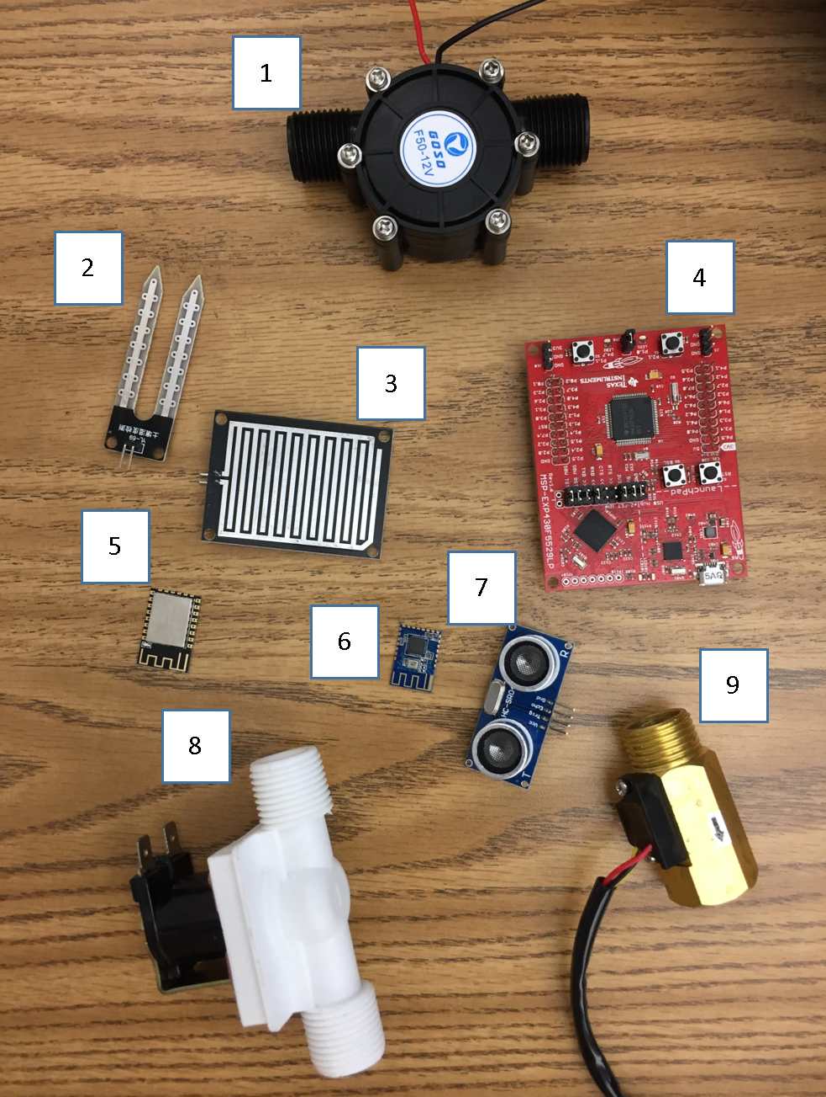
Figure 48: Components Acquired

We had the components connected to test below is the Figure 49
Based on Figure 31 we have the:
- Water Turbine
- Soil Sensor
- Rain Sensor
- Develop Board
- Wi-Fi
- ZigBee/ Bluetooth
- Motion Detector
- Water Valve
- Flow Meter
As you read further we will give details on how these components were tested.
We had the components connected to test below is the Figure 49
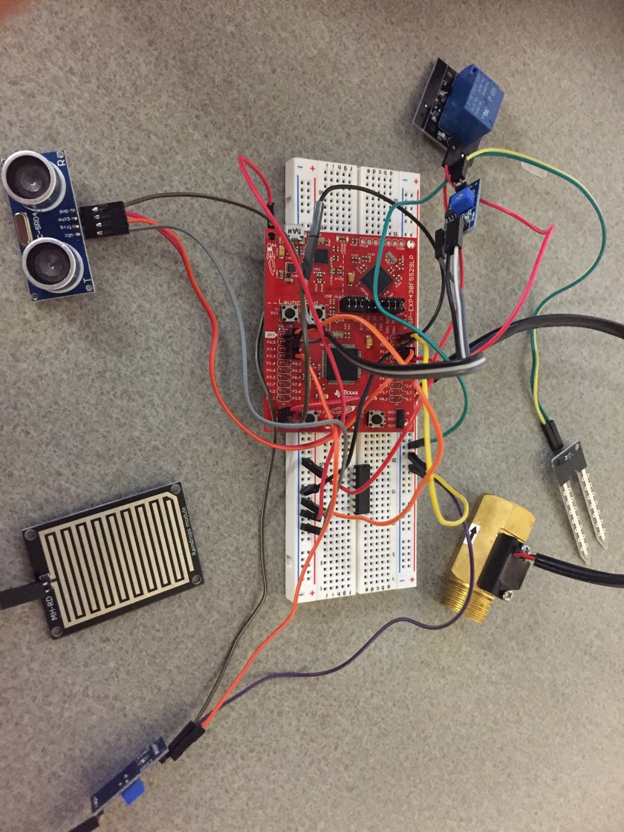
Figure 49: Breadboard connection

Water Turbine
To test the water turbine, we connected it to a multimeter to test the voltage found when water flows through. At first, we tested it with air by blowing air through the intake tube with strong lungs we were able to produce 12V. In order to test using water as you would find in a sprinkler system we connected the water turbine to the shower system using cold water to not damage any of the internal components. At low pressure we found that it gave at least 5V then as we increased the pressure the voltage increased as well. At max pressure we reached the 12V. After these tests we found that this water turbine will serve its purpose finding that it gives 12V at full pressure or at least 5V at lower pressure it will be enough to give the voltage required to charge our 9volt rechargeable battery.

Soil Sensor
The soil sensor works to measure the resistivity when applying moisture to it. As moisture is added the resistivity drops. So, in order to test this theory, we connected it to a multi meter dry and it gave a resistance of 65 MΩ +/- 10MΩ once water was applied the resistance dropped to 29KΩ +/- 10MΩ. Based on the information collected we can decipher that the moisture sensor works and that we should have the stopping value be 40KΩ in order for the soil to not be over watered. As the project progresses we will run more accuracy tests to perfect the value required. The test will include watering a plant for 30mins to see what value the soil sensor gives. We checked for the optimal depth of the soil sensor based on being in ground and if it has any effect on the circuity. When placing the soil sensor underground at depth of 6in it was still able to measure the moisture to drop to 30KΩ after being watered for 30 min. It was required to spray the soil sensor with resin to avoid corrosion. When doing this the resistance started at 30MΩ instead of the 60MΩ originally. Based on the information collected we now are informed the sensor will work for the task given of measuring moisture in the ground. The next way of testing was plugging it to the board
To connect the analog pin a voltage divider was required so the 5V was not returning the voltage to the MSP430 due to the MSP430 only being able to input 3V. Once connected we ran a code to see if it would to calculate moisture based on the voltage changed.

Rain Sensor
The rain sensor works like the soil sensor measuring resistivity. In order to measure it we tested it by submerging it in water to see if the resistance dropped. Then allowed it dry to see if the resistivity increased. We also attempted to test it by using a spray bottle to mimic rain. Using this method allowed us to know how sensitive the sensor was to getting wet. It seems to be a useful component to what we need but will need an encasement as we fear the connectors will be affected by the rain. As connected in the soil sensor we are required to connect a voltage divider to drop the voltage going into the MSP430.
  - Development Board
The development board we chose to work from was the MSP430F5529.To test it we connected some of the components acquired to see if the code work. We attempted at power it up using a function generator at 5V to see if the schematic was the being under stood correctly. This test was essential to understand what was not required in our PCB and where our power source would be placed. We tested the output of the board to see if the power was being routed accordingly.

Solder
For soldering there are a necessary set of materials necessary to be able to begin putting components together. These include a soldering iron, a rosin core solder, a soldering stand, and a damp sponge. These materials can all be purchased separately or can be purchased altogether in the form of a soldering system or soldering station. Also, for smaller applications, a soldering pencil may be all that is necessary. The problem with soldering pencils are that they are cheap, do not heat as well, and cannot regulate temperature to be usable for many applications. Most soldering irons are in the range of 20 to 60 watts with irons becoming more expensive with the more power that they have. Soldering irons with higher wattage are generally considered to be better than those with lower wattage. Without knowing much about soldering, one would think that higher wattage means higher temperatures but that is a misconception. The temperature of the iron for most quality irons is completely adjustable. This makes it so that when dealing with components that don’t do well with ridiculously high temperatures or with solders with lower melting points, there can be adjustments made so that the component isn’t burned, and energy isn’t wasted. The purpose of the extra power is to allow the iron to have more power in reserve which means the iron can heat for longer periods of time. Lower wattage irons lose heat faster which can cause bad solder joints. The next most important part is the solder itself. There are many types of solder, but to keep it simple it boils down to a difference between lead-based solder and lead-free solder. The electronics industry is moving away from lead-based solder due to health concerns with the health hazards that come with using lead. An important part of the solder as well is the flux that lies within the solder wire. The flux comes in the three main forms, water soluble, resin-based, and no-clean. Water soluble is useful in that it can easily be removed with warm water and a brush, but it also is somewhat of a nuisance in that it must be removed after application. The traditionally used flux is the resin-based flux. The last flux, no-clean is a flux used as its name describes, with no necessary cleaning involved. The flux is designed to enhance the electrical contact and mechanical strength that is within the solder joints created. It does so by cleaning the solder joint as the solder is applied and changing the surface tension which then increases the adhesive properties of the metal in the joint. The stand is for holding the soldering iron while needing to do other tasks such as finding and placing components, and the sponge is mainly for cleaning the iron after solder has filmed over or encrusted the iron during application. [37]

Wi-Fi
To test the Wi-Fi, we wanted checked to see if it can communicate to the other Wi-Fi module. The project required this to see if can have an alternate communication method other than the Bluetooth. The project also requires the Wi-Fi to be capable of connecting to the home network. The power was tested from the 3V supply slot from the MSP430. The TX and RX was connected to the communication slot on the MSP430. To ensure the power was connected properly a blue led notified power on the Wi-Fi. In Communication from the board to the Wi-Fi was made but the coded to communicate to a second communication was not set yet and code will be made in Senior Design 2.

ZigBee / Bluetooth
For the ZigBee / Bluetooth, we wanted to test if it was able to communicate with another ZigBee / Bluetooth. The project required the information from the component be sent to the main board to be handled accordingly. Due to time constraints and late arrival this test has not been done yet.

Motion Sensor
For the motion sensor we tested an Ultrasonic Sensor HC-SR04. For the test of this we connected it to our MSP430F5229 board to view how it worked. The MSP 430 was programed for the sensor to detect the distance when at field of view and see how far it can read. Based on the schematics it was found that it can measure 6-7 meters with field of view 15 degrees. To test the value found on the schematic it was placed it on a flat surface with a board starting at close proximity and the program recorded the distance as we pulled it away. Once leading to 5.7 meters it no longer read the distance. To test an alternate method within more of the scope of the project. A distance of 60 cm was set to have the led on the msp430 to turn off if an object came with in proximity. Figure 32 shows the connection made to have the test completed these connections will be the same connection made to have the s
To connect the echo pin a voltage divider was required so the 5V was not returning the voltage to the MSP430 only being able to input 3V.

Water Solenoid Valve
The water solenoid valve is used to stop the water flow to the sprinkler system. Since this component starts off closed. It was required to find out the amount power required to open the valve. The specification stated it will require 12V in order to open with a minimum of 6V. When testing these values, we found that at 12V it opened correctly without hesitation giving no downtime or waiting period. When attempting at 6V it had slight hesitation and brought fear that it may be an issue. After considering the case that the speed of opening would not be a big stress because we really had a focus of it turning off when required without hesitation. To have the valve closed we were simply required to remove the power source or turn it off and it closed. Knowing this allowed us an opportunity to use the 9V power source without a need for a DC/DC conversion. We still plan on stepping up the voltage to 12V to give it an optimal opening time while still considering a 9V to reduce power consumption.

Flow Sensor
The flow sensor tested was a ½ in to test the flow sensor, we had to see how accurate the flowmeter was working. We attached a pvc pipe to the flow sensor with the other end to a plastic bottle. We poured water in the funnel in the amount of 300ml and noticed the speed increase on the computer screen as we poured and at the end the amount poured was given. Looking at the data we found the it was off by 29mL, but we now know the error threshold Figure 32 is a screen capture of data collected as water was poured.
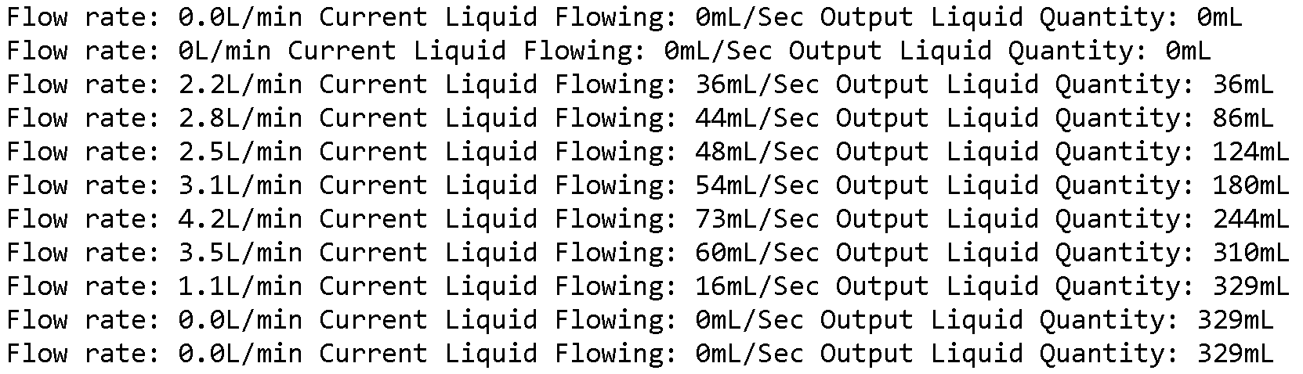
Figure 50: Flow rate Data
We will be using this to find drops in pressure. After this test we noticed we can also use it to find out the amount of water consumed by the sprinkler we will have to adjust our code to improve the accuracy of the reading. The connection to MSP 430 was made by connecting to the 5V source and having data connection made to the MSP430. Figure 6 shows the connections made for the flow meter.

Administrative Content
The creation of this project took lots of effort and overhead. Different members came into it with their respective sets of expertise and decided on sections relevant to those sets of expertise. Even with what was learned through coursework, there was still a lot of learning that was necessary on the parts of everyone to truly come up with everything contained in this document and to continue on with the full project prototyping and physical construction. This section is meant to elaborate on exactly what each member’s contributions were with a table of the sections worked on and the members associate with them. Also included is a discussion of the milestones of the project where major accomplishments were made showing real progress. Lastly in this section are tables regarding the budget for the project showing where the money came from to fund it and what the funding was spent on, and a running bill of materials table showing the status of relevant parts that need to be obtained or are already part of the inventory.

Member Contribution
The group consisted of two electrical Engineering Majors, Winston Baptiste and Kenyatta Samuels. The group also comprised of two Computer Engineering Majors, Marc Simon and Donald Miller. To focus on the aspect that strong suit our majors the project was split to have all hardware aspects dealing with power and electrical component connection be done by the Electrical Engineering Majors and all programming aspects be done by the Computer Engineers. To manage the project charge was taken by each member when necessary. We did not choose a leader because based on what the goal of the meeting was each member would take charge if the subject fell within their strong suit. We collaboratively chose the goals for each meeting to complete the tasks given to us. When things were missing that a member noticed we submitted through our group chat to decide on who can address it. We had extensive collaboration debates and discussion to decide on completions of sections.
Kenyatta Samuels came up with the project idea and had great organizational skills for documentation. He would bring the group together for meetings in order to complete the project requirements. Ahead of the team on getting his section completed and laying out the ideas on what the project would include. Teamed up with Winston Baptiste who has taken junior design and had experience with making an idea come to life. Winston was familiar with PCB design and what is required to complete the project. His past business experience assisted with project management and understanding the best route to reduce cost in project completion. Marc Simon brought a get to the point attitude and openness to ideas to complete the task after giving ideas of his own. His strong understanding of software and what is required to program the components made him a strong asset on the project. Marc also was great at professionalism of the document and had a strong interest in the embedded aspects of the PCBs. Donald Miller has history with programing to the expert level, knowing how to make it flow and work efficiently gave him a role that was essential to getting this project to work. Donald would point out the do’s and do nots of the project in order to not conflict with the programing aspects of the project. Together this team was unstoppable once figuring out what was required of them to complete the project was given. We split the documentation work accordingly based on the strengths of the member. Table 8 gives detail on how the project documentation was distributed.

Table 15: Member Contribution
SECTION | MEMBER
Executive Summary | Kenyatta
Project Motivation and Goals | Kenyatta
Objectives | Marc
Requirements Specifications | Marc
Relevant Technologies | Kenyatta, Winston
Requirements Specifications | Marc
Quality of House Analysis | Kyle
Research related to Project Definition | Marc
Existing Similar Projects and Products | Marc
Relevant Technologies | Kenyatta, Winston
Strategic Components and Part Selections | Kenyatta, Winston
Possible Architectures and Related Diagrams | Kyle, Winston
Parts Selection Summary | Kenyatta
Related Standards and Realistic Design Constraints | Marc, Kyle, Winston, Kenyatta
Standards | Kenyatta, Marc
Design impact of relevant standards | Kyle, Marc
Realistic Design Constraints | Kyle, Winston
Economic and Time constraints | Kyle
Environmental, Social, and Political constraints | Winston, Kyle
Ethical, Health, and Safety constraints | Winston, Kyle
Manufacturability and Sustainability constraints | Winston
Project Hardware and Software Design | Winston, Kyle
Initial Design Architectures and Related Diagrams | Winston, Marc, Kyle
Subsystem, Breadboard Test, and Schematics | Winston, Kenyatta
Software Design | Marc, Kyle
Summary of Design | Kenyatta
Project Prototype Construction and Coding | Marc, Kyle, Winston, Kenyatta
Integrated Schematics | Winston, Kenyatta
PCB Vendor and Assembly | Winston
Final Coding Plan | Kyle, Marc
Project Prototype Testing Plan | Kenyatta, Marc
Hardware Test Environment | Kenyatta, Winston
Hardware Specific Testing | Winston, Kenyatta
Software Test Environment | Marc, Kyle
Administrative Content | Winston
Milestone Discussion | Winston
Budget and Finance Discussion | Marc

Below we find the figure for the project creation distribution of roles in Figure 50.
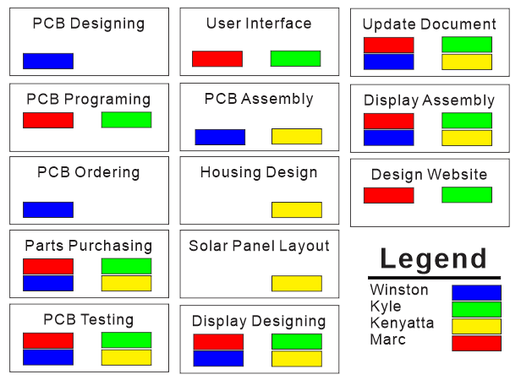
Figure 51: Division of Labor
Based on specialties and past experiences we have split the project completions. Most electronic components will be completed by the Electrical engineers and the programing aspects will be completed by the Computer Engineers. Kenyatta was given the task of solar panel layout due the layout being contingent on the housing design. The PCB ordering will be under Winston due to his understanding of the PCB designing. Kyle and Marc have the responsibilities that fall within their knowledge of programing and software design. When all is completed all members of the group will go through the document and setup the display.

Milestone Discussion
In this section we display the milestone thus far. We currently have acquired major components and created the schematic used for our PCB. Major components have been tested to ensure working in the correct manor. We have begun creating our PCB board layout and have decided how the project software will be implemented. Based on our current status we are on track to completing the project at its designated time frame.

Changes of milestone
Most of the major parts have arrive on time to test before completion of senior design 1. The time frame designated for parts testing has went from 7/06 to 7/16 some parts have not been tested yet, but enough information has been collected to begin building our schematic. PCB component placement may be left for Senior Design 2, but the schematic will be completed senior design 1. Our plan is to have the PCB ordered prior to the start of next semester we have placed the date to 8/12/2018. Our final document time frame has changed from 7/22/2018 to 7/28/2018 due to information components order is being recorded. Based on the changes in dates due to unforeseen circumstances we know that this happen within Senior Design 2, but we are ready to handle them accordingly.

Number | Milestone | Due Date | Status
Senior Design 1
1 | Project Choices | 5/18/18 | Complete
2 | Ideas | 5/28/18 | Complete
Project Report
3 | 10 page Divide & Conquer | 6/7/18 | Complete
3a | Divide & Conquer Update | 6/13/18 | Complete
4 | 60 page Draft | 7/5/18 | Complete
5 | 100 page Draft | 7/18/18 | In-Progress
6 | Final Document | 7/19/18 | In-Progress
Research & Design
7 | Begin Software Development | 6/16/2018 | In-Progress
8 | PCB Layout | 6/21/2018 | In-Progress
9 | Microcontroller Programming | 7/10/2018 | In-Progress
10 | Order Parts to Test | 7/05/2018 | In-Progress
11 | Recording & Data Abstraction | 7/14/2018 | In-Progress
12 | Finalize Software | 7/21/2017 | In-Progress
Senior Design II
13 | Build Prototype | 08/12/18 | In-Progress
14 | Testing & Redesign | 9/15/18 | In-Progress
15 | Prototype | 10/25/18 | In-Progress
16 | Peer Presentation | 11/15/18 | In-Progress
17 | Final Report | 12/01/18 | In-Progress
18 | Final Presentation | 12/04/18 | In-Progress
Table 17: Milestones

Bill of Materials
Table 14 below gives an overview of the parts used to create our smart irrigation system. These materials are subject to change and as they are purchased and evaluated will be cemented with the actual chosen parts to build the final product. The table describes the material, the current location/status of purchased, unpurchased, in our possession, in transit, etc. It also shows the number of units, quantities and costs to create an overall inventory value for tracking and documentation purposes.
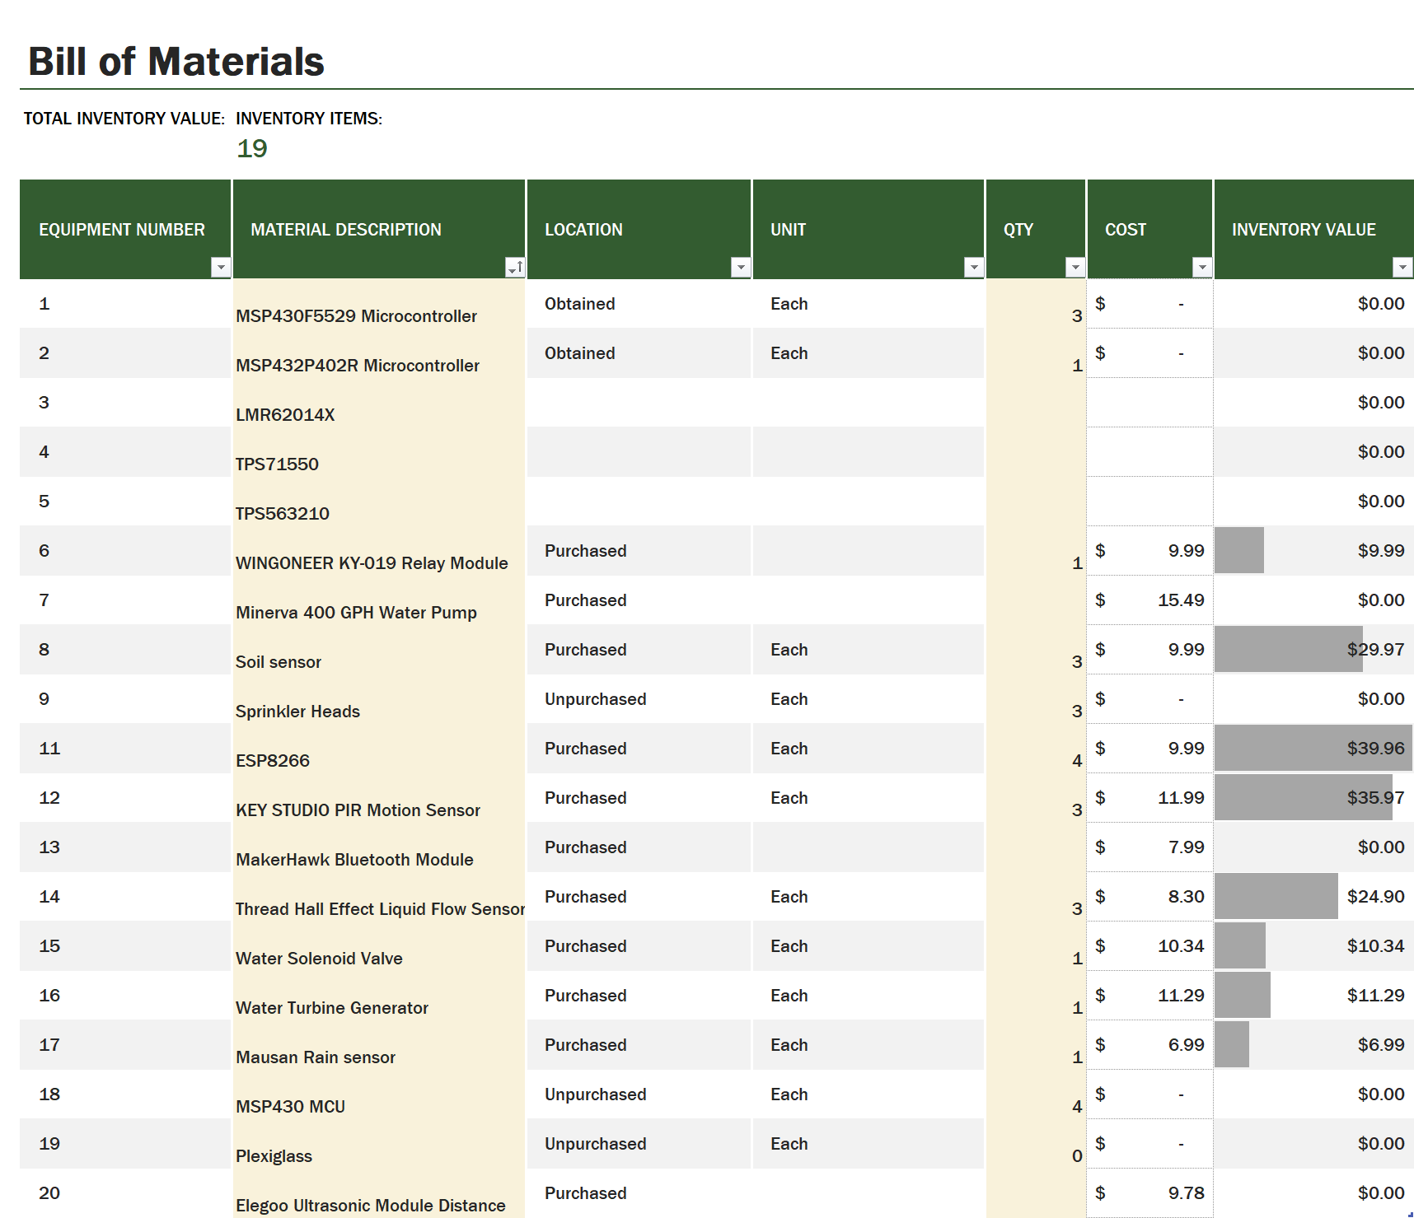
Table 18: Bill of Materials

Budget Analysis
Our budget for this project currently states that we will be personally funding using an equal amount from all group members. Our focus will be to make our best attempt to be frugal, while at the same time not sacrificing in terms of quality components and design. The project should not take us over $400, but our project budget will reflect a generous overestimate of the cost of parts to provide a buffer for any unforeseen circumstances. Although certain parts and costs are listed, we are intending to attain many of the parts using the TI lab which provides free TI components thanks to the technology fee paid by UCF engineering students. Also, we will be making use of parts we can each provide ourselves from past projects we’ve worked on through coursework or simply for fun. Hobby shops such as Skycraft Parts & Surplus also provide us another means to purchase components locally while remaining within our budget for prototyping purposes. In our project we will be implementing multiple sources of renewable energy including solar panels and are intending to apply for additional funding through Duke Energy Corporation which has offered to sponsor projects that integrate these kinds of things as a power source. Below you will find a table listing the different sources of income and expenses we are expecting to have.

Table 19: Project Budget

Project Summary and Conclusion
During the design and development process of Water Smart, many obstacles were encountered but after long nights and perseverance our team was able to overcome most of them. Even though this is not the first smart irrigation system, by providing another option for consumers we are helping conserve, reuse, and recycle energy and water. Water Smart has several features aimed to maximize convenience, usability, remote access, reliability, and durability. There are also many features that help minimize water usage, energy consumption, cost, installation time, and dimensions of the final product.
With a list of goals and objectives in mind we created a design that would use a motion sensor so the system would stop watering if someone walked by, a rain detector to stop the case of watering during a storm, a soil moisture sensor to prevent from overwatering, and a flow rate sensor to detect drops in pressure and locate where a potential break might be. Two microcontrollers along with Bluetooth and Wi-Fi modules were carefully selected to handle all the processing and communication that the Water Smart system required. The user interface for Water Smart was also carefully design. While this aspect could have been an entire project on its own, our team was very resourceful and found many tools to reduce the complexity of the user interface design process. Cloud services and web-based APIs were effective in designing a function and appealing interface.
One issue that was unexpected was the compilation of each team members reports for the 15, 10 and 5-page check points. Even though every member used Microsoft word to write their portions, the integration of the separate reports showed difficulty regarding format. The challenge was agreeing on and maintaining a consistent format throughout the project design. Throughout the whole semester, the team was always pressed for time. Between all the coursework in the condensed summer term, and the fact that most of the members on our team also had internships or full-time jobs, there was very little time outside of school and the office. This made it somewhat difficult to coordinate meetings, but after planning a weekly schedule, we found a routine that increased our overall productivity.
During the hardware design process, the team found that it was much more effective to research and integrate one component at a time, rather than as a one large system. It was also carefully decided what roles each team member would play in the whole design progression. Another challenged face was learning how use the development board for designing the PCB, specifically, what parts of the board were being used and needed to be translated in to the PCB.
During the software design process many obstacles became prevalent. Even though some of the software and tools were familiar like code composer studio, and the capabilities of the C language, there were still difficulties. The first problem was the selecting a communication module that would be not only compatible, but also easy to interface. It was found that the software to interface between the microcontroller and the Wi-Fi module was going to need more attention than anticipated. With only a fraction of experience gained from previous coursework, a significant amount of additional research was needed. Not only was the Wi-Fi programming somewhat troubling, but the Bluetooth module used for communication of each device also showed promising adversity. These obstacles could have been discouraging, but the team knew that it would be resolved by simply spending more time finding previous research that served useful. The reason we chose to do this project was to not only challenge ourselves, but because the Water Smart system is proven possible, effective, and because the objective behind the project will help make the world a better place.

References
[1] Richardson, Luke. “Solar Power History: Timeline & Invention of Solar Panels | EnergySage.” Solar News, EnergySage, 11 Apr. 2018, https://news.energysage.com/the-history-and-invention-of-solar-panel-technology/
[2] Rinkesh. “The Future of Solar Energy.” Conserve Energy Future, 25 Dec. 2016, www.conserve-energy-future.com/future-solar-energy.php.
[3] Davison, Alan. “Common Types of Solar Cells.” Solar Energy as Renewable and Alternative Energy, Solar Technology & Energy Information, www.altenergy.org/renewables/solar/common-types-of-solar-cells.html.
[4] Davison, Alan. “Common Types of Solar Cells.” Solar Energy as Renewable and Alternative Energy, Solar Technology & Energy Information, www.altenergy.org/renewables/solar/common-types-of-solar-cells.html.
[5] Maehlum, Mathias Aarre Maehlum Aares. “Solar Cell Comparison Chart – Mono-, Polycrystalline and Thin Film.” Energy Informative, 2013, energyinformative.org/solar-cell-comparison-chart-mono-polycrystalline-thin-film/.
[6] Printed Circuit Design Tutorial (D. PCB Finishing), 9 May 2012, www.goldphoenixpcb.com/html/Support_Resource/prdt/arc_119.html.
[7] “What Is Conformal Coating?” What Is Conformal Coating? | HumiSeal®, www.humiseal.com/conformal-coating/.
[8] “Mono vs. Poly Solar Panels Explained.” EnergySage, www.energysage.com/solar/101/monocrystalline-vs-polycrystalline-solar-panels/.
[9] “3rd Generation of Solar Panels - Thin Film.” DIY Solar Panels, 2 Oct. 2014, topdiysolarpanels.com/3rd-generation-of-solar-panels-thin-film/.
[10] “Smart Irrigation Market.” Global Smart Irrigation Market: Snapshot, Transparency Market Research, Jan. 2018, www.transparencymarketresearch.com/smart-irrigation-market.html
[11] Rohan, Mr. “Smart Irrigation Market Worth 1,504.6 Million USD by 2022.” Market Research Firm, Markets and Markets, www.marketsandmarkets.com/PressReleases/smart-irrigation.asp
[12] Thomas, Kevin. “Smart Irrigation Market Is Set to Experience Revolutionary Growth by 2017 – 2025.” Home - Crossroads Today, 22 May 2018, www.crossroadstoday.com/story/38244123/smart-irrigation-market-is-set-to-experience-revolutionary-growth-by-2017-2025
[13] Mattise, Jonathan, et al. “Global Smart Irrigation Market To Grow At A Cagr Of 1444 Till Year 2021 Finds New Market Research Report.” Barchart.com, EIN News, 8 Jan. 2018, www.barchart.com/story/home/923188/global-smart-irrigation-market-to-grow-at-a-cagr-of-1444-till-year-2021-finds-new-market-research-report
[14] Singh, Rahul, et al. “Global Smart Irrigation Controllers Market to Reflect a Robust CAGR of 13.3% During 2017-2025.” Global Smart Irrigation Controllers Market to Reflect a Robust CAGR of 13.3% During 2017-2025, Latest Market Reports, 19 Mar. 2018, www.latestmarketreports.com/2018/03/19/global-smart-irrigation-controllers-market-to-reflect-a-robust-cagr-of-13-3-during-2017-2025/
[15] Chau, Melissa, et al. “IDC: Smartphone OS Market Share.” IDC: The Premier Global Market Intelligence Company, International Data Corporation, www.idc.com/promo/smartphone-market-share/os.
[16] Dar, Hassan. “Architecture of Mobile Software Applications.” LinkedIn SlideShare, LinkedIn, 8 June 2015, www.slideshare.net/hassandar18/architecture-of-mobile-software-applications.
[17] Pashuk, Alesia. “Mobile Testing Process: How to Make It Efficient.” Penetration Testing Types Overview: Black, White and Gray Box, ScienceSoft, 14 Jan. 2018, www.scnsoft.com/blog/mobile-testing-process-how-to-make-it-efficient.
[18] Robles, Jorge. “The Role of Wireframing in Mobile App Design.” ChaiOne, ChaiOne, 11 Sept. 2017, chaione.com/blog/the-role-of-wireframing-in-mobile-app-design/
[19] Adiseshiah, Emily Grace. “Home.” Prototyping Tool for Web and Mobile Apps - Justinmind, Justinmind, 8 Feb. 2017, www.justinmind.com/blog/a-beginners-guide-to-user-flows-and-how-to-prototype-them-using-justinmind/
[20] “Code Composer Studio (CCS) Integrated Development Environment (IDE).” PC & Notebooks IC Solutions| Overview| TI.com, www.ti.com/tool/CCSTUDIO
[21] Wessels, Robert. “Prototyping Software to Make Things Easy.” Energia Reference - MSP430 LaunchPad, Energia Project, 20 Nov. 2017, energia.nu/
[22] “InVision | Digital Product Design, Workflow & Collaboration.” InVision Blog, www.invisionapp.com/
[23] Grusin, Mike. “Serial Peripheral Interface (SPI).” Sparkfun, learn.sparkfun.com/tutorials/serial-peripheral-interface-spi.
[24] “Universal Asynchronous Receiver-Transmitter.” Wikipedia, Wikimedia Foundation, 29 July 2018, en.wikipedia.org/wiki/Universal_asynchronous_receiver-transmitter.
[25] Keim, Robert. “Back to Basics: The Universal Asynchronous Receiver/Transmitter (UART).” All About Circuits, 20 Dec. 2016, www.allaboutcircuits.com/technical-articles/back-to-basics-the-universal-asynchronous-receiver-transmitter-uart/.
[26] “I2C.” Sparkfun, learn.sparkfun.com/tutorials/i2c.
[27] http://rainmachine.com/products/rainmachine-mini-8.html Accessed June 4th 2018
[28] EPA “Water Sense” La2017st updated on September 21, 2017 Accessed June 4th 2018
[29] https://www.scotts.com/en-us/products/gro-watering-solutions/grotm-7-zone-controller Accessed June 4th 2018
[30] http://www.ti.comit/ds/symlink/lmr62014.pdf Accessed July 19, 2018
[31] ScienceDaily, ScienceDaily, 25 Aug. 2015,
www.sciencedaily.com/releases/2015/08/150825083618.htm Accessed June 3rd 2018

[32]University of South Florida - USFRI. “USF Research & Innovation.” Office of Research & Innovation - University of South Florida, www.research.usf.edu/absolute-news/templates/usfri-template.aspx?articleid=3768. Accessed June 3rd 2018

[33] Kassab, Beth. “Lessons from HOA Lawsuit over Florida-Friendly Grass.” OrlandoSentinel.com, 8 Sept. 2016, www.orlandosentinel.com/opinion/os-hoa-fight-over-grass-beth-kassab-20160908-column.html

[34] Orange County Government. “Watering Restrictions.” Medical Services FAQ, www.orangecountyfl.net/watergarbagerecycling/wateringrestrictions.aspx Accessed June 3rd 2018

[35] Perlman, Howard, and USGS. “Hydroelectric Power: How It Works.” Livestock Water Use, the USGS Water Science School, water.usgs.gov/edu/hyhowworks.html.

[36] Soldering Subcommittee of the Assembly and Joining Processes Committee, National Standard for Soldering Task Group. “Requirements for Soldered Electrical and Electronic Assemblies.” Dynamix Technology, IPC, Feb. 2005, www.dynamixtechnology.com/docs/j-std-001ds.pdf.

[37] Engineering, Nuerochrome. “Choosing Solder.” Neurochrome , 2010, www.neurochrome.com/choosing-solder/.

[1.p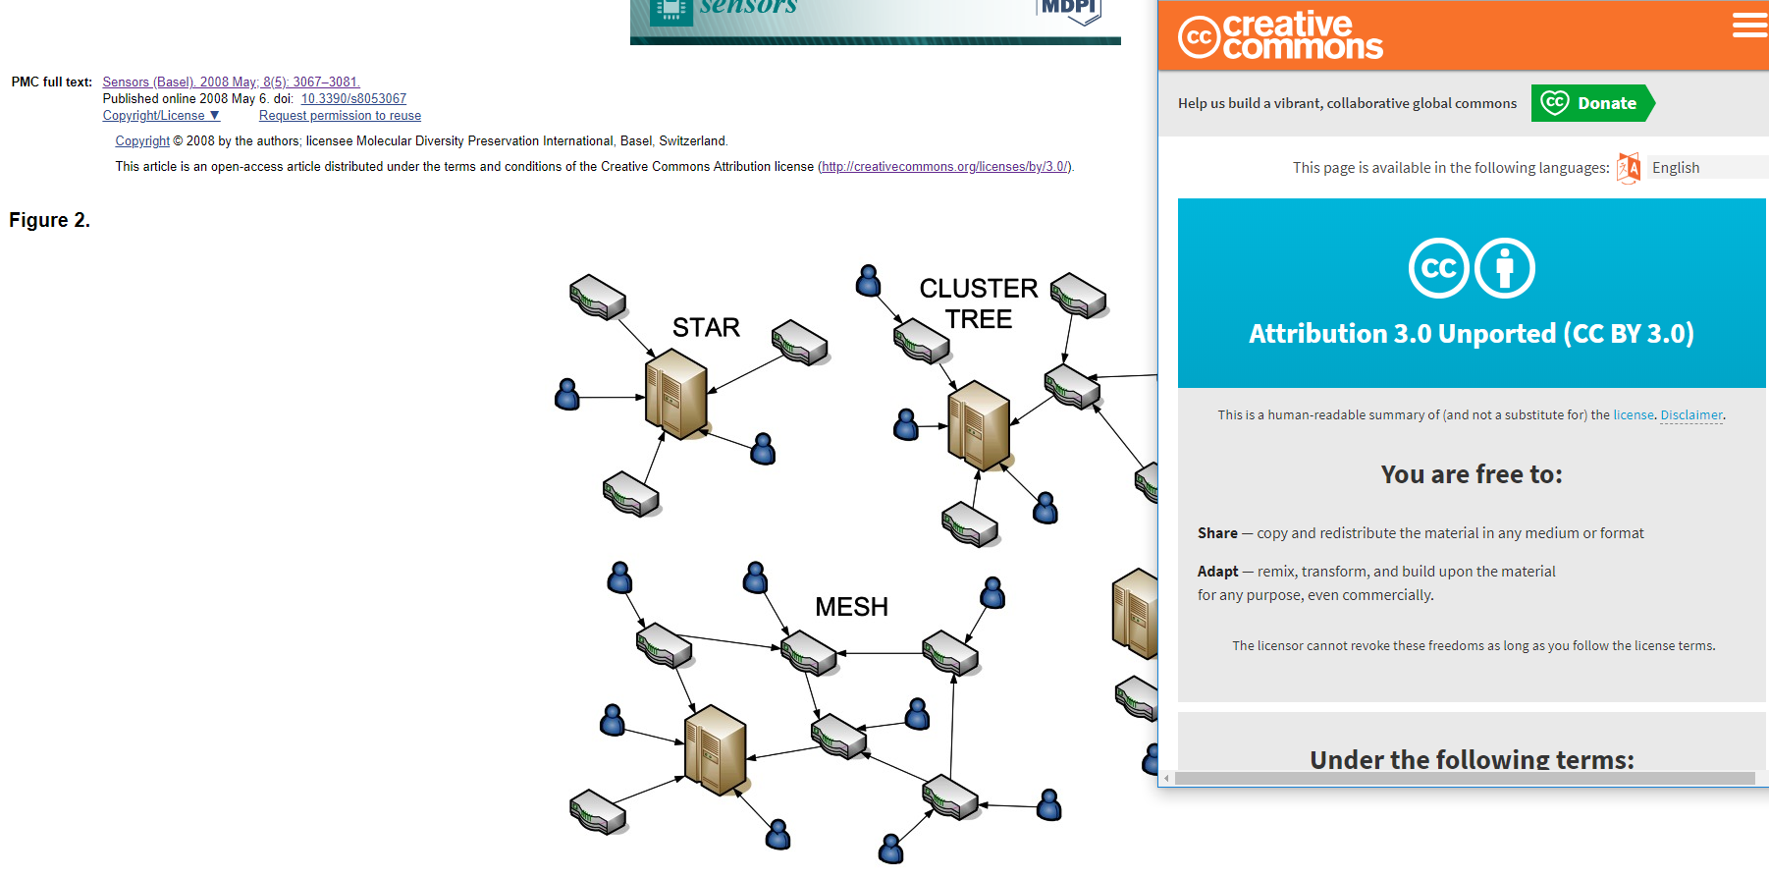 Permic

