FKAD In-Home Delivery Service - Senior Design Project
Ana Gomez, Dena Alawi, Fabio Pardo, and Karl Mama

Dept. of Electrical Engineering and Computer Science, University of Central Florida, Orlando, Florida, 32816-2450

Abstract — The main goal with Safe Home Delivery is to expand a commodity to the grocery delivery market by creating a safe, reliable, commendable in-home delivery alternative that allows homeowners to be absent and do their daily activities, while their groceries are delivered and put into place. To do this, the project involves a mobile application that will allow users to communicate with drivers. Also, to accomplish complete transparency a lockbox and a camera is implemented.

Index Terms — mobile application, restful api, switching networks, microcontroller, power.

I. Introduction
For as far back most of us can remember people have been going to grocery stores and supermarkets like Publix or Walmart to buy their household essentials, food, and sometimes even clothing. Whatever it may be that people are buying, they’d usually go to their local stores for just about everything. However, more recently we’ve noticed a new wave in our society that’s steered from the norm of shopping to online shopping. Most people today have ordered at least something from an online service provider like Amazon or eBay. Currently, companies are now transferring their knowledge of marketing and technology to the grocery store business. Walmart has even added the option to buy your groceries online, set a time to go to the store to pick up, and a Walmart employee carts your groceries to your parked car. Now it’s a race between companies like Amazon and Walmart for the in-home delivery market. The aim of this project will be to achieve a safe in-home delivery.
For our project, we created a lockbox that the homeowner will place on their front doorknob for when a delivery is meant to be taken place. The lockbox is linked to a fingerprint scanner for the delivery person to access during a specific time frame the delivery is meant to take place. Otherwise, if the delivery person is not there on time the fingerprint scanner will not be accepting any fingerprints. The fingerprint scanner is essential for authentication in this project. If the delivery is on time the fingerprint will authenticate the delivery person and dispense the house key. The lockbox is connected to the homeowners' Wi-Fi and with the dispensing of the key, the homeowner will be notified that the delivery has started with the press of the fingerprint.
Essentially, the delivery guy will be linked to the smart home delivery mobile application with a body cam, a GoPro in this case, on their person that will record the delivery in progress. The delivery person can then place refrigerated items inside of the homeowners' fridge or if none of the items are meant to be refrigerated then they will place such items on the inside of the home next to the front door. Finally, the recording will end once the key is placed back within the lockbox and the homeowner will be notified that the delivery has finished with a push notification.
The recorded delivery is then uploaded to youtube with a private status for only the homeowner to have viewer rights to the delivery for when they wish to rewatch.

II. Motivation
The motivation for this project is primarily to demonstrate our knowledge, apply what we have learned in our years at the university, display our abilities to self-learn material that we haven’t covered in previous courses, but most importantly to use all these tools to build a unique Smart Home Delivery product that can be possibly used in the real world.
The Smart Home Delivery option can be a new way for people to receive their packages and groceries more conveniently. With the ever-increasing demand of the 21st century for people to live busier lifestyles, the average homeowner values their time now more than ever before. While you’re at the gym, work, or just want to see your kids at soccer practice without having the voice in the back of your mind reminding you of much-needed shopping to be done. This delivery option will be beneficial to all.
Even for college students, we sometimes buy groceries and wait until everything is nearly depleted to go back again. More often, we end up eating sleep for dinner because finding the time to pull away from studying, projects, and homework to drive to a supermarket feels like a waste of time. Alternatively, if perhaps you may have the time and would prefer the commodity of having your groceries/packages delivered, that option will be available. Our motivation was inspired by personal experience and with the thought to create jobs and to make people’s lives easier. As we all know, time is valuable.
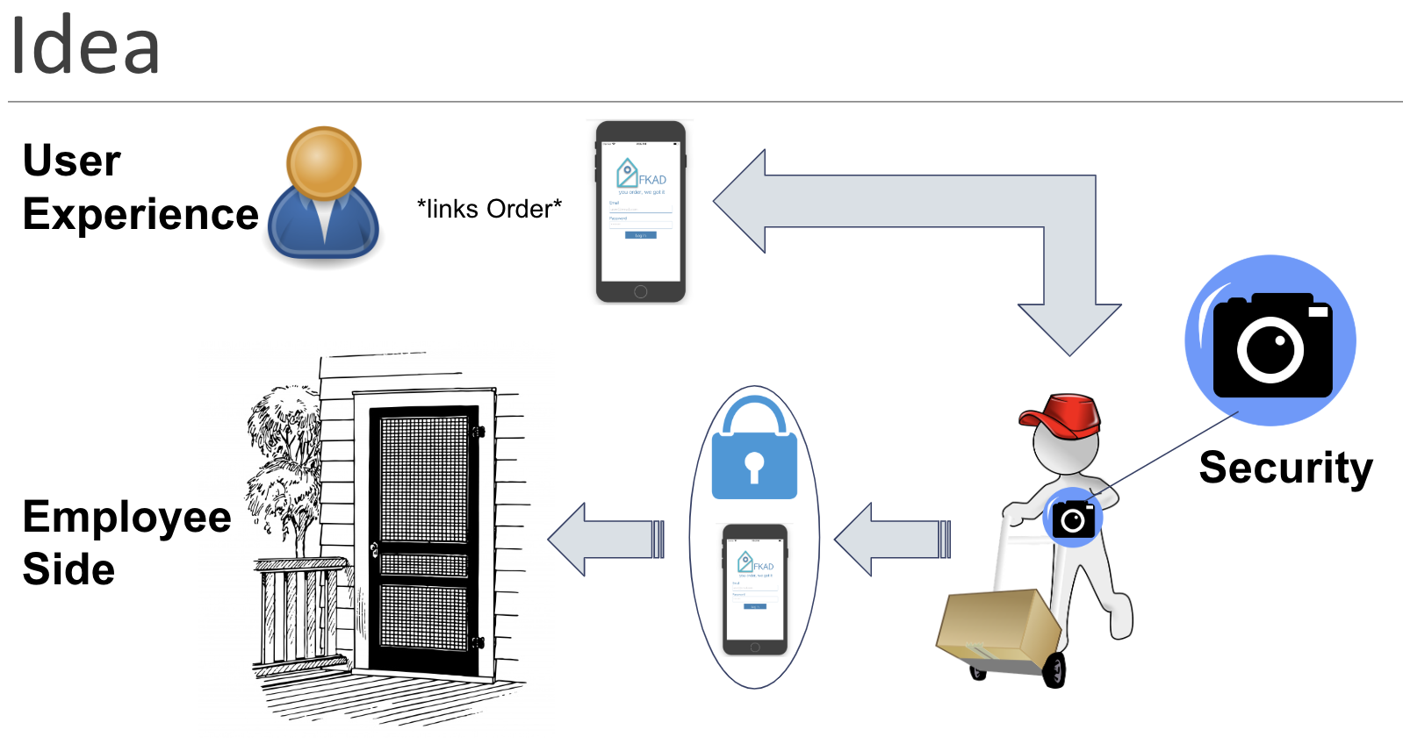

III. Software System Design
Our project consists of multiple software design parts, such as the React Native mobile application, GoPro functionality, YouTube’s API and more. Therefore this section will split all of them into their respective portions.
A. Architectural Design
The software architectural design represents the project as a collection of hardware and software components and their interfaces to establish the framework. In this case: the user interface, users, networking and database. On a higher level architecture, we see the relationship between the User Interface (UI), Users, Networking and Database. They all have responsibilities that are essential for the system to behave correctly. Fig. 3 demonstrates the integration of all components.
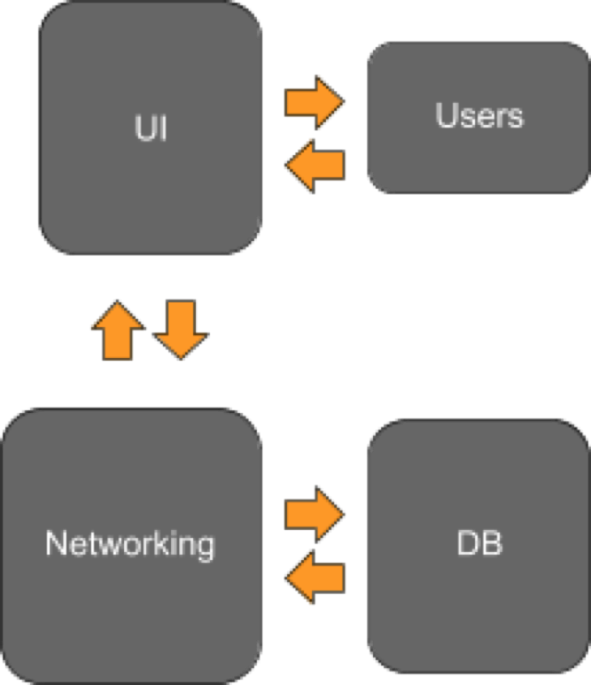
Fig. 1 UI, Users, Network and Database Relation

User Interface: the UI will be responsible for reading the user’s input and sending them to the backend. The UI
should be accessible and easy to use so that users without a technology background can use it.
Users: will be responsible for managing the accounts and applicable functions of the user. Responsible for storing and authenticating the user login information Some of the functions available to the user will be view driver’s records, view deliveries, view schedule, input hours, etc.
Networking: will be responsible for handling the backend of our application. The network should be able to receive and transmit data to the User Interface and to the Database.
Database: the database will handle the storage of all models being used by our system. The models include the Admin Model, the Driver Model, the Client Model, and the Delivery Model. The database will be hosted on a server that can be used to transmit and receive messages to the network.
B. Mobile Application
FKAD mobile application is implemented for customers and employees to communicate. The two users will have their own personalized account according to their necessities.
On one hand, we created the driver account so he or she has access to new orders made from all customers. They will have the option of accepting the order or ignoring it. If the order is accepted, then he or she is responsible for picking up the order and delivering it at the specified address. The driver will have access to all details about the order. Including, name and last name of customers, order number, store address, and home address. Plus, details of how the order must be delivered, for example, placing the milk inside the fridge, or just dropping it at the door. The driver will also have access to older orders that he or she has already completed. If the order was delivered inside, he or she will be able to watch a video of him/her performing the job.
On the other hand, customers will have their own personal account. They will only have access to their orders. They can create as many orders as they want as long as they fill out all the necessary information. That includes storing information, such as name and address, order number, and the name of who the order was placed. Also, delivery home address, date and time. Last but not least, the customer can have special requests, such as what elements from the order have to be located in the fridge or freezer.
Besides the customer placing orders, their account also allows them to watch a video of the completed orders, as well as having settings options. They can change their user information and notifications.
Generally speaking, everyone should have access to this delivery system. For this reason, the mobile application is developed in React Native. React Native is a JavaScript framework for writing real, natively rendering mobile applications for iOS and Android [1]. This allows us to generate an app in both operating systems in only one language, making it doable due to time restrictions. Also, this allows us to have the same design and implementations in any kind of phone. The user interface (UI) will behave equally. This will avoid confusions and inconsistencies.
The design of the User Interface is meant to be self-explanatory, from signing up to creating a new order. All options in the system are easily accessible. Including when logging in as a driver or customer. It is meant to be a smooth transition with no loopholes or tricks. For example, when logging in, the system is responsible for identifying who the user is, either an employee or a customer. Also, the menus are automatically changed to the correct user, this will only grant access to the correct information without routing to the wrong paths.
Overall, the goal of the mobile application in this project is to create a design that is comfortable and enjoyable for the user. It should attract the user to use this commodity multiple times and be satisfied with the service.
C. Database
Examining possibilities of databases, the team took a few things into consideration from a design perspective as well as a personal perspective, relating to their expertise on the matter. The team decided to implement a Restful API as a NoSQL database using amazon web services (AWS) and Node js.
From a design perspective, the system is designed to support a huge network of customers and employees, which means a scalable database had to be implemented. In addition, the engineers wanted a method that will allow them to continuously and easily change the database design as needed for frontend changes and future optimizations; a noSQL database in conjunction with a Restful design supports just that as it provides flexibility as well as scalability.
From a personal perspective, the engineers wanted to inspect working with amazon web services as it has been an outstanding implementation tool in the market for both small and big business. AWS provides three main services the engineers used for their implementation; API gateway, DynamoDB, and lambda.
API Gateway is used to design expected models of data transferred from and to the database. However, its main service is creating endpoints for the Restful design. Lambda is used to run Node js taking care of all the https request and communicating with the tables. Finally, DynamoDB is used to create the required tables needed for the system.
The system is designed with five tables to support all aspects and keep the database clean and to brace an object type design to follow the second form normalization rules. which was decided upon to avoid unnecessary data duplications. This allows the system to acquire an effortless chance of growth for future database administrators to easily grasp and be able to advance the overall design when new features are presented. The five tables related to the five main objects our system has; customer, employee/driver, lockbox, order, and authentication.
The database is accessed by more than one device at a time, a Restful design easily allows this. For example, the mobile application and the camera system needs to access the orders information to add an order or update the order with the recording respectively. Therefore, again another reason for using http endpoints and Restful design due to its independence as a server to support all devices.
Database costs were inspected, the cost was directly proportional to the amount of storage used. Therefore, when examining the video recording process, the team tried to avoid saving the recording onto the database. Later in this software section, the engineers explain how they used youtube’s services to support cutting on costs.
D. Camera and Video Recording
The camera being used for this project is the GoPro Hero 4. As a group, we chose this camera because of its availability for one of the group members. This camera was also chosen for its unofficial library that was created by KonradIT on GitHub. The library had all the necessary factors for our project that include: opening/closing the shutter lens, beginning/ending a recording, and specifying the last recorded media file on the camera. All of which was exactly what we required for the project.
The only challenge that we faced was that the GoPro required a device to be connected to its personal WiFi so that it may receive and function specific commands that were sent to it. This challenge was surpassed and it is talked about into more detail in the communication, Raspberry PI section of this document.
F. YouTube API
The whole purpose of this senior design project is to execute an in-home delivery with backable proof that nothing within the home was damaged, altered, or have a reason for the homeowner to distrust in the service. In order to execute this, we needed a measure that will back the delivery driver’s proof of a well-placed delivery. Which is why we included the GoPro Hero 4’s Video Recording capabilities that were touched on in the previous subsection. However, because we’re using an AWS free service for students for our Database there would be no way that we could save our video files onto a remote database, and saving deliveries on our customer’s mobile devices would not be ideal. Thus, the reason as to why we chose to use YouTube’s API.
YouTube’s API gives us the freedom to upload as much as possible, considering we don't surpass its insanely high quota, for free and best of yet to have each upload be a privacy setting of unlisted. What unlisted means is that a user can attempt to search for the video using its Title, Tags, Author, etc; the user will not find the video without the video key.
You can find the key at the end of any youtube video you are watching, for example, “https://www.youtube.com/watch?v=5O2QMmyzlSg”. The last bit of the youtube link: ‘5O2QMmyzlSg’ is the key for that specific video. With the use of YouTube’s API and Tokland’s YouTube API Library on GitHub once we upload a video we’re returned with that video’s key. That key is then uploaded to the AWS database from which we get from the mobile application to its respective customer.
Next, with the use of YouTube’s API the mobile application allows the customer to watch the delivery that just took place within their home with the click of “Watch Video” with the respective order. The delivery driver can also have the option to watch their previous delivery with the use of the YouTube API. Both the recording and the uploading of the videos for their respective orders are accomplished with the use of scripts that run on a raspberry pi as a slave to the PCB. More of this is explained in the raspberry pi portion of this paper.
G. Communication [ Raspberry PI ]
As the team approached Camera integration, a few communication matters arised. The output is the following; the team is using a raspberry pi to integrate camera control as well as mainly running software in python. One of the main aspects the engineers were looking into and to why a raspberry pi was used is due to the fact that whichever hardware is controlling camera recording is on the same wifi network as the camera. In addition to requiring libraries to be saved in storage for live execution.
The raspberry pi will be constantly running a program to detect when a driver is accessing a customers house and stops recording, as well as downloading and uploading the session to the customers’ account when locking the house. For this to occur, the Engineers decided to use a (PWM) Pulse Width Modulation Pin to signal the different scenarios. Pulse Width Modulation is a way to send analog signals using digital methods, which was the perfect solution to communicating with the raspberry pi. The same high signal is received from the PCB when a successful fingerprint scan goes through and the logic in the program running detects whether a driver is accessing or locking the house.
The program has been designed to figure out which order is currently being delivered to upload the video recording to the correct customer. To do so, each lockbox has its own serial number which is asked by from the user at signup. In addition, the database has been altered to the initial design to support this security measure.
Again, one of the main reasons to using a raspberry pi is for connection with the gopro using wifi; as mentioned above, the running programs need internet to make the required database changes, both box related and order related changes. to do so, the raspberry pi is expected to alter between two different wifi, the gopro and one with internet access. As raspberry pi is running linux, a few modifications to the wifi client files were needed and executed at run time.
To continuously run the program from boot up, the engineers looked into what linux can provide to support such a task. linux using services, which are scripts that are configured to decide what program to run at boot up and when. Therefore, a service was implemented to run the designed program.

IV. Hardware Architecture Design
Analyzing the goals and the now specified requirements, the engineers developed the architecture style that would be implemented for the hardware components. There are many alternatives which could be designed while meeting the project requirements. However, the engineers decided that the best way to meet the size requirement was to develop a system for all the components onto a single PCB (Printed Circuit Board), with everything soldered onto the board.
The final design contains accessible headers for all of our external components, as well as an onboard USB to Serial Converter which allows for communication between a computer and our Microcontroller (MCU) if it is needed. As well as a Wi-Fi Module Chip that allows for communication with a server which shows the user when someone opens and closes their door. Our single PCB has a design for simplicity and compactness, due to this PCB being fitted into a pocket in our lockbox. The lockbox design is aimed for a slim and compact design with overall measurements of 3.50 inches (Width) by 5.90 inches (Length) by 2.08 inches (Height), which is described below in subsection A.
A. FKAD Lockbox
The FKAD lockbox is a general standard lockbox, but the design is slim in cubic measurements and less thick than most lockboxes. The lockbox was originally planned to have a Liquid Crystal Display (LCD) on the front telling the driver whether his or her fingerprint or access code was correct or incorrect. But this was not accounted for due to certain specifications and spacing wouldn’t be met. The design is quite different since there is a servo motor being utilized. Instead of a pocket for the solenoid end to enter when locked the top portion has a concave area where a string would be tied to the wing of the servo motor, turning one direction will either tighten the string or loosen the string. The lockbox can be seen in Fig.2.

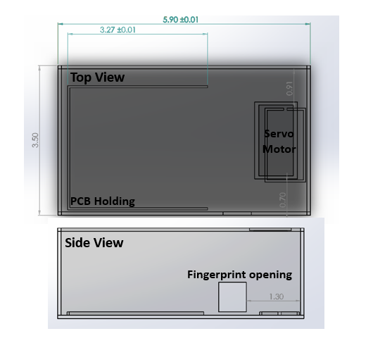

Fig. 2 FKAD Lockbox Schematic
V. Hardware System Design
The electrical design will be discussed in detail in the upcoming subsections, which include the various components that were interfaced together through the MCU to create the FKAD lockbox. The components each subsection utilizes will be discussed, especially in regard to why they are necessary to meet the project goals and requirements, and which component was ultimately chosen to meet the functionality necessary for each subsection and why.
In Fig. 3 below, the electrical block diagram is shown, which is a simplified version of our devices schematic and includes all of our major components as well as the interface (SPI, UART, PWM) they communicate on.

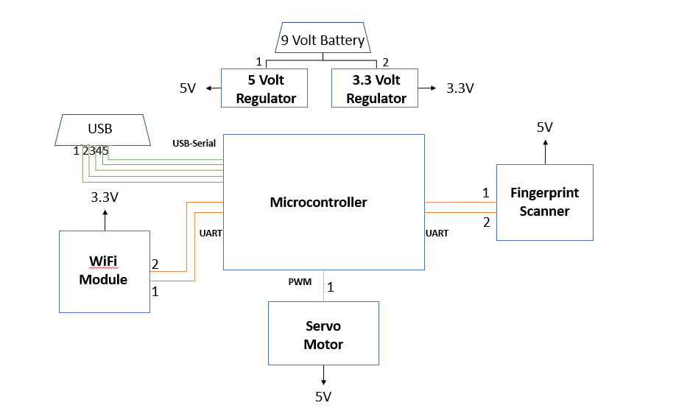

Fig. 3 Electrical Block Diagram with Connection Types
A. Microcontroller
Synchronization and control of the data being processed between the Fingerprint Scanner, Wi-Fi Module, and the Servo Motor require central control logic. There are many options to help aid the FKAD lockbox, but a microcontroller was utilized as the central control logic and is best suited as a low power central control logic device.
The ATMEGA256016-AUR was chosen as the main control logic because it is a high performance, low power, expandable 8-bit microprocessor with a great amount of Input / Output (IO) pins. The 100 flexible IO pins allow for communications over UART, SPI, and I2C which two of the three are mainly used and are necessary for the components that are integrated into the FKAD design. The ATMEGA2560 allows for easy programming methods whether it is boot loading a certain operating system and as well as uploading our code for the FKAD system.
The microcontroller is the heart of the device. It serves as a communicator between our multiple components and essentially everything is connected to it. If a component needs to communicate with another component (such as the Fingerprint Scanner and the Servo Motor), the ATMEGA2560 handles this communication, as well as USB Universal Serial Bus) communication and whether to tell the WiFi module to send or receive data.
The main reason for choosing the ATMEGA2560 is that it has multiple Universal Synchronous / Asynchronous Receiving Transmitting (UART) ports, as well as the simple and quick programming methods. It also draws a minimal amount of power, which is ideal for our application because our lockbox ultimately hopes to be used for long period of times without switching batteries continuously.
B. Fingerprint Scanner
The primary function of the FKAD lockbox is to distinguish who is entering and leaving the household at any given time, as well as updating the homeowner at what time these scenarios happened. Having a high-level security setting, ease of use and low power consumption are the main reasons why this security measure was chosen. The device can also be positioned where any point of access is easily achievable.
The direct function of the Fingerprint Scanner is that it will allow the drivers to enter the household, it will read the fingerprint, and that fingerprint is sent to the microcontroller and if this fingerprint is in the database and accepted for that household the driver is allowed in.
The device that was chosen was Fingerprint Sensor sold by AdaFruit™. This component meets all of the needs the FKAD lockbox requires, as well as an internal storage that contains the fingerprints and a great number can be stored. It takes less than 1 second to read any fingerprint. It has a small compact size and a small window size; its power range is well within our requirements and the great thing this device can operate with a 3.3 Volt supply or 5 Volt supply and has a security level of 3 out of 5. Also, the data being sent through the UART interface can be varied allowing for use with many control logic devices.
C. Communication
The FKAD lockbox specifically needs communication technology to send data to a server to tell whether their door has been open or closed. If this was not the case, then the communication would be used a second authentication factor, and this will be done by having the driver use an application that communicates with the communication device (wirelessly). The way this would be accomplished could have been utilized by Bluetooth due to less complexity, as well as low power consumption. But, in this case, a Wi-Fi module chip is used to account for this communication, although it does consume quite more power than a Bluetooth module. The Wi-Fi module is easy to setup it uses the UART configuration to send and receive data, whether it is posting to a server (it is in our case) or subscribing to a server to pull certain information from that server.
The Wi-Fi module that’s chosen for the FKAD lockbox is the ESP8266-01. Due to its compactness and ease of use this device was chosen, also it can be utilized as a standalone component where a single component can be used directly with it. But, due to multiple components needing to communicate and communicate efficiently this is used as a shield for the ATMEGA2560. Flexibility is another huge thing for this device it can be set as an access point and it can connect to itself to allow for connection to a server, but that consumes quite some power; therefore, this device is used as a client that connects to a hotspot or a centralized WiFi spot.
The specifications of this device are quite spread out well. It uses a small amount of power when it is receiving data from a server and a fair amount of power when transmitting data to a server. It has a built-in 32-bit microcontroller if needed to use as a standalone programmer (not applicable to the FKAD lockbox), has an internal clock of 80 megahertz, and a memory of 32 kilobytes instructions. In terms of security, it has Wired Equivalent Privacy (WEP) or Wi-Fi Protected Access (WPA/WPA2) and it has a standard frequency range of 2.4 gigahertz.
D. Power Circuit
This design does not contain DC/DC converters, instead, it contains two Linear regulators one for 5 volts and another for 3.3 volts. It is ideal to use DC/DC converters due to high efficiency, but for our design the 3.3 volt regulator will roughly supply less than 100 milliamps and for the 5 volt regulator it will roughly supply less than 600 milliamps if the servo motor is active and if it is not active it supplies less than 200 milliamps. Therefore, if more current were to be needed a DC/DC switching (Buck converter) would be utilized. Both regulators take in 9 volts and drop that down to the corresponding voltages.
The regulators chosen are the LM7805 (5V regulator) and the AZ1117EH-3.3 (3.3V regulator). These two regulators are placed in parallel due to both devices only having to supply one ampere of current if needed and this reduces the amount of power being consumed by both regulators. If placed in series the 5-volt regulator would have to supply twice the current and if this scenario was utilized then a DC/DC converter would be the most ideal case for this project. For long life lasting a design, there are no external nor onboard charging or timing devices to determine when the battery should be used or charged.
E. Other
The servo motor does not necessarily relate to our electrical design, but it is placed here for ease of use and it is used for RC planes or small controlled vehicles. It consumes less power than a common solenoid, as well as having a smaller footprint, and the speed of how the motor can be controlled as well through code.
The second authentication factor which was described earlier in subsection C: Communication is an application that is used by the driver and each driver has their own authentication number that is unique to them; therefore, if any other person with the same application were to try and enter the household the FKAD lockbox would not distribute the key, this is incorporated with the fingerprint scanner, but this is a second variation of the FKAD lockbox.
VII. Conclusion and Stretch Goals
To conclude, this project simulates a third party between customers and vendors. Where anyone that has access to a smartphone has the opportunity to a better delivery service. This commodity includes software and hardware implementation, that with the proper implementation it brings a safe, reliable, home system delivery to the market.
A. Software Summary
The mobile application is almost the entirety of the projects’ software portion. The application will be able to communicate the homeowner and the driver. The delivery drivers electronic components with the fingerprint scanner for the key-box to dispense and begin a recording event. The web application will be connected to a YouTube API to enable a recording event that will be unlisted/private from YouTube's live broadcasts on their side of the web service. The client/homeowner will be able to then later view the video that has taken place on an embedded YouTube playlist that will be available from the AWS storage, that stores the links of specific dates that deliveries took place with the help of anchors for each date. The client/homeowner will have their FKAD in-home delivery service sign up registered with the google client to enable all these features considering that Google owns YouTube and will make this feat a breeze.

B. Hardware and Embedded Summary
To be brief, the FKADs’ PCB design supports integration with the ESP8266 Wifi module, AdaFruit™ Fingerprint Scanner, Servo motor, in addition to the integration with the raspberry pi in support of camera communication. The entire system is powered using a 9 volt battery. On the embedded Software portion, two main programs were designed controlling PCB and camera communication running on the microcontroller and raspberry pi respectively.

C. Stretch Goals
For future implementation, this project has some stretch goals that would allow the system to grow in different businesses. One, is getting the recording to be live, live streaming the full delivery for customers to have more reliability and know what is occurring at the instance the driver goes inside their home. Another stretch goal is creating a third user, administrator. This will allow the admin to add and delete employees. Also, admin would be able to keep track how drivers perform, as well as, creating a schedule for all employees. On a far-fetched goal, the security measures and video recording could be better implemented, more cameras with better angels.

Acknowledgment
The authors would like to acknowledge the support and dedication of Dr. Lei Wei and Dr. Richie, first and foremost, for the extreme lengths they have gone in educating and guiding our research for this project.
We also offer our thanks and gratitude to the professors who have so kindly agreed to review our project we have worked so hard on.

References
[1] Eisenman, Bonnie, “Learning React Native” O’Reilly | Safari, O’Reilly Media, Inc., December 2015.

