UCF Senior Design 2

UV Water Purification and In-line Monitoring with Spectroscopy

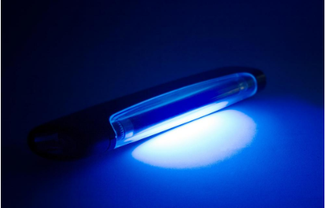

Initial Project Document

Group 5

Kendra Kordack Photonic Engineering
Bradley Blackburn Electrical Engineering
Grant Cooper Electrical Engineering
Lucas Heredia Computer Engineering
Sponsors: Ocean Insights & BCI Technologies

Table of Contents
1. Executive Summary 1
2. Project Description 3
2.1 Motivation 3
2.2 Goal 3
2.3 Related Work 4
2.3.1 Life straw 4
2.3.2 Brita Water Pitchers 6
2.3.3 UV water bottle cap 9
2.4 Engineering Specifications 11
2.4.1 Power supply 11
2.4.2 Solar Power System 11
2.4.3 Charge Controller 12
2.4.4 Microcontroller 12
2.4.5 Display 13
2.4.6 User Interface 13
2.4.7 Filtration System 13
2.4.8 Water Quality 14
2.4.9 Water Monitoring 14
2.5 Demonstration of Specifications 14
2.6 Sponsor 15
2.7 Block Diagram 16
2.8 Engineering Trade-off Matrix 16
3. Research & Parts Selection 18
3.1 Research 18
3.1.1 Solar Power System 19
3.1.2 Charge Controller 25
3.1.3 Voltage Conversion and Regulation 29
3.1.4 Battery 31
3.1.5 Pump 35
3.1.6 Water cleaning 36
3.1.7 Water Analysis 42
3.1.8 User Interface 48
3.1.9 Microcontroller 50
3.2 Part Selection 51
3.2.1 Solar Panel 51
3.2.2 Charge Controller 53
3.2.3 Battery 55
3.2.4 Microcontroller/ Microcomputer 56
3.2.5 Pump 59
3.2.6 Filtration and UV System 60
3.2.7 Spectroscopy 62
3.2.8 Temperature Sensor 70
4. Design Constraints and Standards 72
4.1 Design Constraints 72
4.1.1 Power System 72
4.1.2 Solar Power 73
4.1.3 Filtration System 74
4.1.4 Spectroscopy 75
4.1.5 Temperature Sensor 76
4.1.6 User Interface 78
4.1.7 Display 80
4.2 Standards 81
4.2.1 Solar Power System 81
4.2.2 Battery 82
4.2.3 Water Analysis and Testing 83
4.2.4 Spectroscopy 83
4.2.5 Water Quality 84
4.2.6 Filtration System 86
4.2.7 Display 87
4.2.8 User Interface 88
5. Design 91
5.1 Hardware 91
5.1.1 Solar Power System 91
5.1.2 Microcontroller / Microcomputer 93
5.1.3 Filtration System 101
5.1.4 Power Supply 102
5.1.5 User Interface 105
5.1.6 Water Analysis 106
5.2 Overall Design 109
5.3 Software 112
5.4 Flowchart 114
6. Overall Integration 115
6.1 PCB Design 115
6.2.2 Pump 118
6.2.3 Temperature Sensor 119
6.2.4 Microcomputer 119
6.2.5 Touch-Screen Display 121
6.2.6 Major components Unable to be Tested 123
7. Administrative Content 124
7.1 Budget 124
7.2 Project Milestones 125
8. Conclusion 127
9. Appendix 129
9.1 Complications 129
9.2 References 129
9.3 Copyright Permissions 135
9.4 Data Sheets 136

Executive Summary
Having access to clean water and food are the very basic requirements for human life. Nonetheless, having a reliable and, more specifically, a clean supply of water is a requirement for the development and maintenance of any civilization. The earliest evidence of humans filtering water is present in Sanskrit writings dating back to 2000 B.C. Back in these times water was filtered by exposing it to the sun, or by boiling it with fire, or by filtering it using sand. Making sure the water was clean was the most effective form of maintaining good health for its citizens and this stands true even today. If clean water is not available to a population, how will they counteract the spread of diseases? How will they be able to combat the existing spread of diseases without clean water? It seems that without access to clean water, the spread of disease is easier, and life itself is put in jeopardy. The struggle to solve this issue has always been a challenge and even today in many places around the world, including the United States, people do not always have access to safe, clean drinking water. Having a sufficient way to clean water for people is an elementary influence into the emergence of this project.
Unclean water can carry bacteria, viruses, and many harmful pollutants. Mainly all places use some sort of filtration system to clean water. These filtration systems often become so immense that they can be impossible to install in certain places. Cleaning water also consists of chlorination. These chlorination systems can also be very expensive and using your own chlorine tablets can be tricky and lead to drinking harmful water when not used properly. A newly used and widespread form of water cleaning is the use of Ultraviolet (UV) light. This type of water treatment can sometimes be more effective on certain bacteria that grows in water, than other water cleaning techniques. UV cleaning can also be inexpensive as the technique becomes more adapted within modern society, and greater advancements in low power UV LEDs or UV lamps.
With the recent pandemic of COVID-19, the fear of bacteria and virus spreading has become the priority for many people. This does not just include airborne pathogens but also water-based ones. Even as a mainly airborne and surface contracted virus, COVID-19 has the potential to live in water. Although, it is still questionable whether it can live in water and be concentrated enough to harm humans. Other harmful pathogens such as E-Coli, Hepatitis A, and Salmonella are common within unclean water and are sought to be extinguished in the water supply. These harmful pathogens along with sediments, metals, and chemicals that make water dirty and harmful are the inspiration behind our UV water cleaning system.
While UV water cleaning systems have been implemented in water treatment, there are not many systems running off solar power and none that have an analyzation component. Which is similar in function to other water filters like LifeStraw, where the user can confidently assume the water is clean. But those portable water filters do not work well filtering chlorine and heavy metals. Hence this project will serve as a better solution by providing higher quality water. In addition, as the system is being powered by a solar, the system becomes very versatile. It is perfect to be used outdoors on hiking, fishing, hunting and other outdoor adventures. But it could also be used inside houses where people may wish for an additional high-quality water filtering system.
The solar powered UV water cleaning system will also be reliable and intuitive to use. It will require very little maintenance, if any, and it will last many years filtering thousands and thousands of gallons over the years and the customers will always be confident that the water is indeed clean.

Project Description
The section below will define the overall goals, motivations, and specifications for our solar powered UV water cleaner. These qualities will be set and described here but, are subject to modification as the project evolves into its final form. The consensus of what this project will be is a solar powered, water filtration system, that utilizes ultraviolet light. There are four engineers that took part in this project, two electrical, one computer, and one optical engineer. The objective is to properly meld the different components of the filtration system, the solar power system, and water analysis system to provide a successful filtering system that is user friendly. The qualities by which inspired this project and the goals of the final product will be elaborated in the following section, followed by much more design, research, and information regarding our Solar Powered UV water cleaning system.

Motivation
In the fall of last year (2019) a global pandemic was beginning from the spread of a virus called COVID-19. Although COVID-19 has not been reported in the water supply, there are many bacteria, viruses, and harmful chemicals that contaminate water. Considering the repercussions of contracting viruses like COVID-19, it is easily a great motivation to take some preemptive steps to clean water from all sorts of contaminants. Contaminated water is often consumed in areas where there is no access to clean drinking water or no method to clean the contaminated water. So, exploring this idea of a new and relatively young market of water cleaning is beneficial. This is what motivated our group to produce a system that is easily accessible, easy to use, and able to stop the ingestion of harmful bacteria, viruses and chemicals.

Goal
Our goal for this project is to create a system that is portable, solar powered, and able to clean water to drinking standards. If the system is solar powered, it could be used in remote areas with little to no drinking water. If the system is portable it can be moved from area to area, where clean water might not be accessible. Lastly, if the system can analyze the water, consumers will know how safe it is to drink or if they need to use water from a different source to clean. Although this system is meant to make water drinkable, there are certain situations in which contaminants and toxins can still pass through, especially if there is a high density of certain contaminants/toxins in water. If this is the case and the water still was not clean enough to drink the consumer would be aware and try to find a different water source or reclean the water. To accomplish this goal, we have determined three main objectives to demonstrate. The first objective we want to demonstrate is the system being run off solar power. The second objective to demonstrate is the spectroscopy system giving an analysis of the output water. The final objective we are going to demonstrate will be an interactive user interface that displays information about the solar power system, spectroscopy, and temperature.

Related Work
Clean drinking water is needed everywhere, therefore the motivation to create devices that can clean water quickly and efficiently are common. We have reviewed multiple different products and projects, using aspects from some and learning from others. The devices below are other alternatives to portable water cleaning. We compare them to our system to the following devices and detail what makes each device unique. After researching the following products, we are also able to integrate certain ideas from the specifications and types of equipment used. We also review the specifications for each device so they can be compared to our system specifications.

Life straw
One of the similar products already in the market is the LifeStraw (figure#), designed by Vestergaard. Designed to support vulnerable populations around the world around the world against diseases and without access to safe water. LifeStraw takes the shape of a cylindrical tube the user can put one end directly in contaminated water and sip from the other end. It weighs approximately 2 ounces and it is very portable.
Specifications:
- LifeStraw personal water filter includes mouthpiece cap, bottom cap and detachable lanyard
- Filtration technology: Membrane microfilter (0.2 microns)
- Filter lifetime: 1,000 gallons (4,000 liters). Pores clog over time as filter is used; reaching end of life when water cannot pass through.
- Product Weight: 1.62 oz (0.10 lbs)
- Product Length: 9’’ x 1.20’’
- BPA Free materials
- Recyclable
- No replaceable parts
- User’s manual provided in English, French, German and Chinese

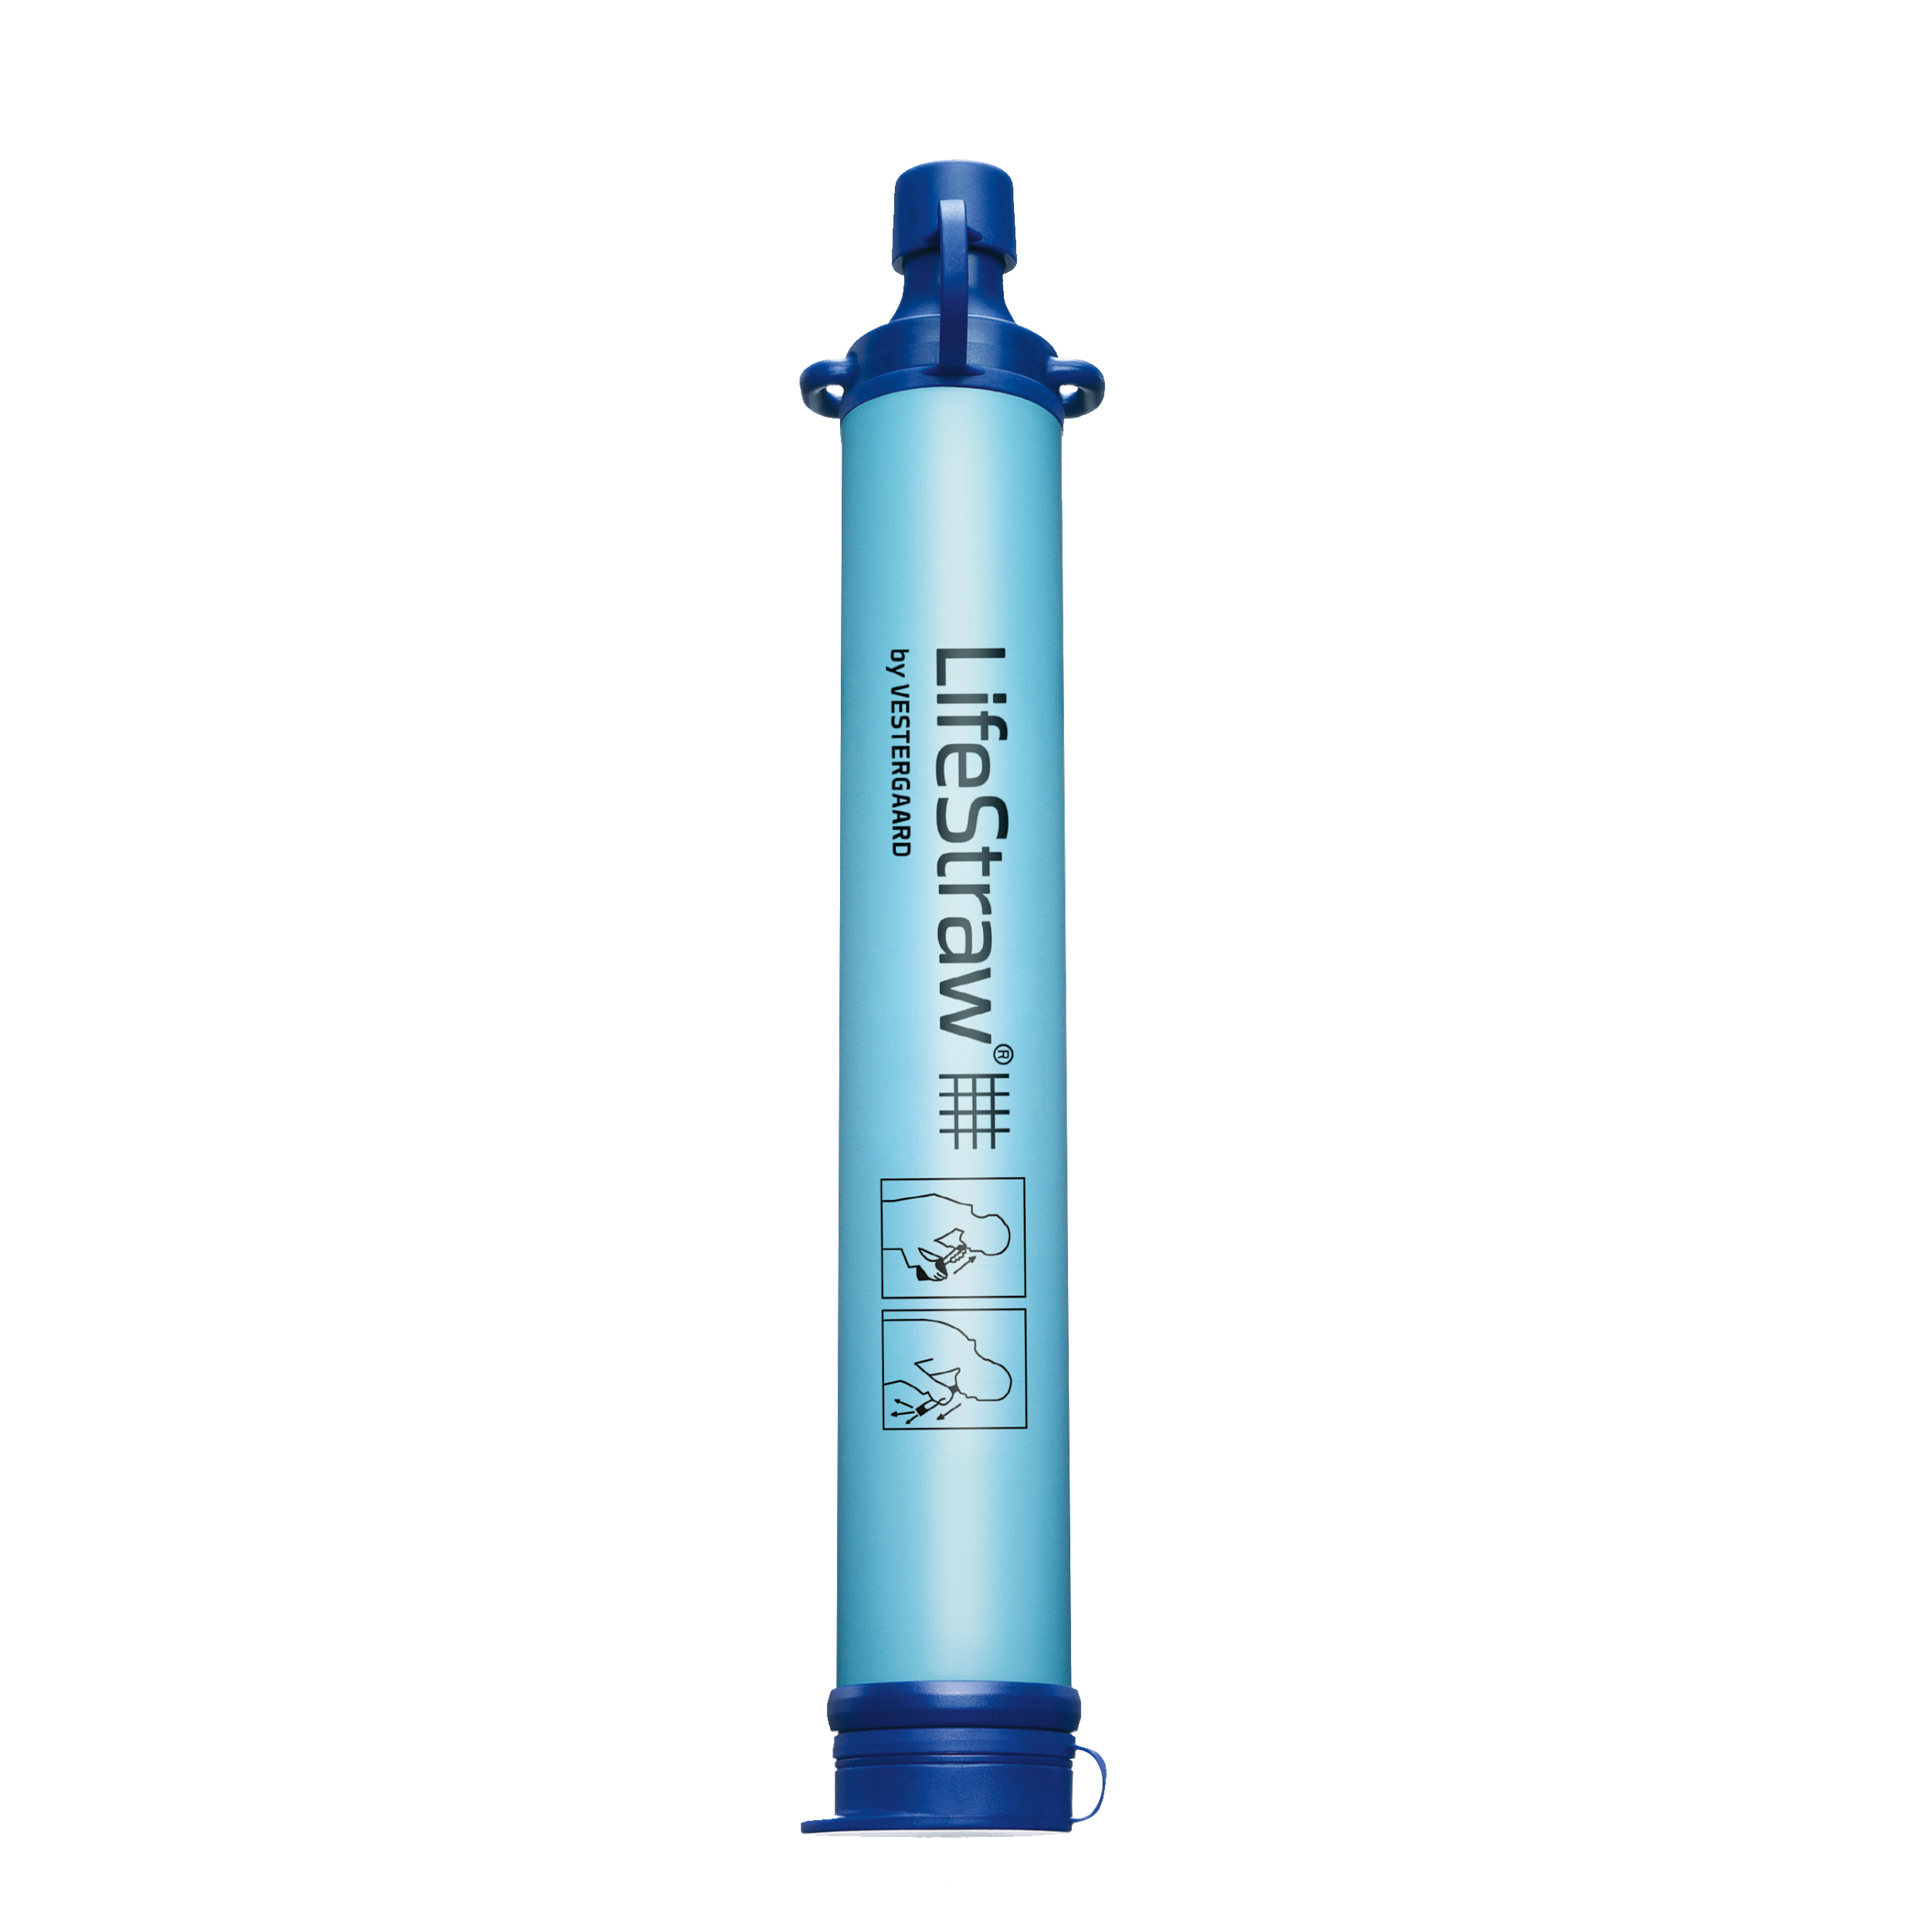
Figure 1: Life straw
According to “Journal Health line” a person should drink on average 8 ounces glasses or approximately 2 liters of water per day. This can vary according to the person's weight, height and gender. Life straw has a durability of approximately 4000 liters of filtration. Meaning if a person only means hydration was the LifeStraw, supposedly by filtering some local pond, the user would be able to get the amount of water necessary for up to 5.5 years. It is difficult to compare our system in terms of reliability to the LifeStraw. Our filter contains several filters inside of it, basically connected in series. The individual filters inside our filter are more reliable than this filter, but the whole system together was not tested for reliability. LifeStraw uses a microbiological membrane to filter parasites and bacteria out of the water.
One of the bacteria it is tested for is E.coli, a bacteria commonly found in the intestines of warm blooded organisms. Some strains of E-coli are harmless but others, such as Shiga toxin-producing E.coli, can cause severe symptoms of food poisoning. This bacterium is transmitted mostly by raw meats and uncooked food, but it is also presented in pathogenic pools or in lakes where the water is warm enough for the Pathogen to survive. This bacterium is destroyed by properly cooking foods. Life straw removes up to 99.9999% of this bacterium in the filtration process. In addition to that LifeStraw can also filter parasites, such as giardia and cryptosporidium, and microplastics.
The main advantage of this filter is its portability and weight. It is way lighter and thus more portable than our system, because of how light it is, it is also more resistant to impact. In case of drop, or other mechanical collision. Unless someone is actively trying to break it, the straw is more resistant than our filtering system in regard to mechanical damage. Our filter system has many electronic components, that although very well protected inside manufactured cases, they are still susceptible to damage. For example, it features a 13,000 dollars spectrometer. No one would like to drop that.
One of the advantages of our system, in terms of reliability, is its resistance to higher temperatures. LifeStraw only resists temperatures up to 60 degrees Celsius. Practically it cannot be used even near that, since the user must sip the water using its mouth. If the water being filtered is even close to that temperature the user can burn himself. Our filter also checks the temperature of the water using an infrared sensor.
Although the straw can filter pathogens effectively it cannot remove inorganic matter, or be harmful to humans, the straw also doesn't improve the water taste or smell. The product specifications contain information about removing microplastic residue and particles up to 2 microns. But in the product specification it doesn't say anything about inorganic matter. The filter also doesn’t improve the taste of the water and as specified before. The membrane can clog as well, the user is expected to blow air into the tube periodically to impede membrane from clogging.
Because the membrane can clog easily, and the user is required to use their own lung power to filter the water. The amount of effort required to get the wanted amount of water might not be pleasing to the user. While in our system, after the water goes through the input channel. The very first filter the water goes through is a sedimentary filter. This filter can be easily replaceable, and it will ensure that the later filters won’t be clogged.
Although Life straw do their own independent water testing against EPA and NSF standards, the filter is not NSF certified. Finally, there is not a way to verify what kind of contaminants exist in water after going through the filter. The filter does not include any type of sensor to detect the quality of the water in the output, while ours does.

Brita Water Pitchers
Another similar product to both our system and the life straw is the Brita water pitchers. These water pitchers are commonly used across the United States. They are made for everyday use for people who don’t have a filtration system for their kitchen sink. Although most tap water in the US is safe to drink, it can look cloudy, and have a weird taste and/or smell. These pitchers a made to make tap water a little safer and more desirable to drink. Brita has multiple different products; the specifications below are base off their basic filters that are used in the pitchers.
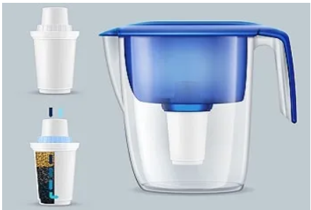
Figure 2: Brita pitcher and filter
Specifications:
- System tested and certified by the WQA against NSF/ANSI Standards 42 and 53
- BPA Free
- Filter no more than 2 gallons a day
- Needs to be change after 40 gallons have been filtered
- Weight: 4.8 ounces (.3 lbs)
- Dimensions: 5.3 Inches (H) x 14 Inches (W) x 2.5 Inches (D)
The specification above refers to the water pitchers with regular filters, but Brita pitchers can have a long last filter or regular filter, the only main difference between the two filters is that the long last filter, lasts three times longer than the regular filter. Both filters are said to remove Zinc, Cadmium, Chlorine, Copper, Mercury, and Lead. The following figure from Brita filters data sheet shows the testing for the NSF/ANSI guidelines for the contaminants.
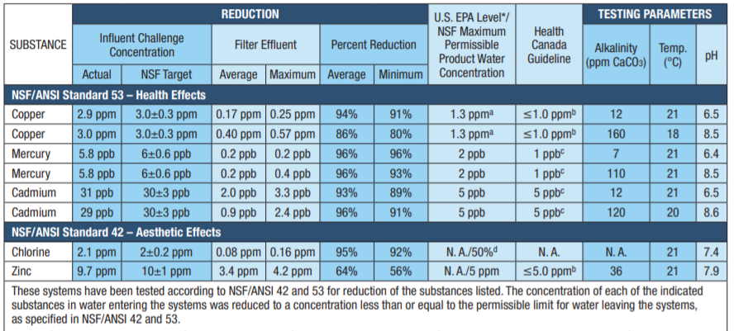
Figure 3: Brita filter testing for NSF guidelines
To remove these contaminants the filter uses a coconut based activated carbon filter. The inside of the filter is shown in the figure 2. While activated carbon filters can remove these contaminants, they do not remove all nitrates, dissolved minerals, or bacteria and viruses. Since these filters are mainly designed for improving tap water and tap water is typically treated for bacteria and harmful organisms, these filters do not need to remove everything.
Since the Brita filter has no in-line testing, you must keep track of how often and long you use the filter in the pitcher. If the filter isn’t changed regularly, there’s are strong probability the filter isn’t filtering as much as it should. In certain pitchers, they offer a way to keep track of when you should change your filter shown in figure 4. This button is purely dependent on the user and has no way of interfacing with the filter. The filter change indicator is activated when you pour, and measures water use based on 8 fl. oz. pours; indicator logic does not account for product misuse.
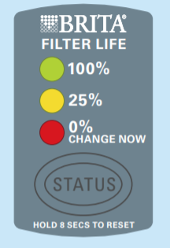
Figure 4: Figure 4: Brita filter change indicator

Although the Brita filters/pitchers are good for improving tap water, they would not be feasible to fully clean water from a random source for drinking. The filters are only NSF/ANSI certified for five contaminants, while there are over 90 different contaminant the NSF sets standards for. This product is expected to be used on water that has already been treated for harmful bacteria and viruses, while the goal of our system will be able to clean water that has had no treatment whatsoever.
Since the goal of our system is to clean untreated water completely, we need more than just a single filter. But while researching this product we found that one of the filters that might work best in our system would be an activated carbon filter. While this system doesn’t accomplish cleaning untreated water entirely and in-line monitoring, it does use a type of filter we plan on integrating into our system and has a change indicator that can help determine when the filter needs to be change/when the water quality is going down.

UV water bottle cap
The premise of this product is to use an UV LED inside the cap of the water bottle in order to sterilize the water using UV light. The water must not, however, contain any debris in it. Also, the inside of the bottle should be coated in metal for maximum efficiency. Developed by CrazyCap the product, with the same name (figure #), is a cap with an embedded UV LED light on it. This cap is made specifically to fit CrazyCap water bottles. But it also fit Cola style bottles in the sizes of 9 oz.12 oz, and 17 oz bottles of size. It was designed to fit CrazyCap UV bottles. But the cap can be purchased separately if needed. The Led is placed in the bottom of the cap and it shines the UV light directly in the water contained inside the bottle. The LED shines a beam of light with a frequency of 278 nm. This is enough to sterilize both the water and the bottle itself. In our system we are using a light beam of similar frequency but with higher intensity.
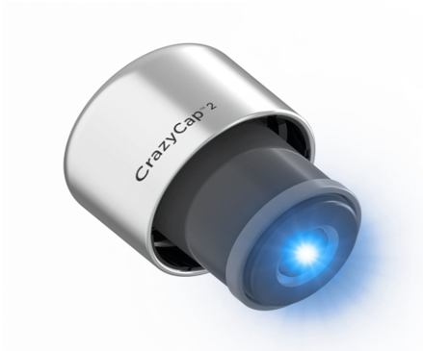
Figure 5: CrazyCap
Specifications:
- Touch Sensor
- Deep UV
- Photo-Cleaning
- No filters (no maintenance required)
- No port
- Insulated
- FDA certification
- IPX7
- 304 Stainless
- 3rd party Laboratory tested
- 5% of the profit goes to charity

The premise of this product is to use an UV LED inside the cap of the water bottle in order to sterilize the water using UV light. The water must not, however, contain any debris in it. Also, the inside of the bottle should be coated in metal for maximum efficiency. Developed by CrazyCap the product, with the same name (figure #), is a cap with an embedded UV LED light on it. This cap is made specifically to fit CrazyCap water bottles. But it also fit Cola style bottles in the sizes of 9 oz.12 oz, and 17 oz bottles of size. It was designed to fit CrazyCap UV bottles. But the cap can be purchased separately if needed. The Led is placed in the bottom of the cap and it shines the UV light directly in the water contained inside the bottle. The LED shines a beam of light with a frequency of 278 nm. This is enough to sterilize both the water and the bottle itself. In our system we are using a light beam of similar frequency but with higher intensity.
Normally this kind of LED would contain mercury in order to create the high frequency light wavelength. Causing the LED to contaminate the water. Little particles of mercury can fall in water. Mercury is a toxic heavy metal that is known to cause neural tissue damage. It is difficult for the human body to get rid of mercury if ingested. According to the instructions, it takes 2 minutes to completely clean the water using the UV. In our system the water is exposed to the UV for less than a second. UV cleaning is more efficient when the water is flowing instead of sitting still. So, the design of this system is inefficient in that sense. Our system also features UV cleaning. It shines the laser in the water while it is flowing through the pipes.
As previously discussed, UV systems are effective for killing pathogens. It doesn’t however remove any organic or inorganic substance. From the water. The UV system is also heavily impaired if the water has debris in it. Because pathogens can hide behind the particles and thus still survive. In this system no previous filtration is made to ensure the water is completely free of debris. But in our system, before the Water reaches the UV cleaning phase. It already went through 2 other filtration systems, the carbon filter and the sedimentary filter. The latter reduces the number of debris in the carbon filter. So, in our system it is guaranteed that the water will have no debris by the time it reaches the UV cleaning system.
The bottle is preprogrammed with two modes: normal mode and “Crazy mode”. In the end it is just a nomenclature of leaving the light on for 2 minutes with medium intensity or 1 minute with high intensity. The bottle cap contains a touch sensor that turns on the LED. The battery lasts approximately 30 days if 1 charge in normal mode is used daily. Which means that the battery supports 30 minutes with the LED on. The cap is also more portable than our system. It is very small and can be taken anywhere. It must be charged though. On top of that, the cap is naturally versatile, because it can be used as an LED to clean surfaces not only be limited to be used in water. Since it is an UV LED connected to a battery the cap can be easily removed from the bottle and used to sterilize other surfaces. The cap is unreliable though Since the LED is used for long periods of time. Also the system is loose. There is little protection to the parts so making it susceptible to mechanical damage.

Engineering Specifications
The section below consists of various specifications that we as a group decided that our UV water cleaning system should exhibit. As the project evolves these will be subject to change as some specifications may be met with budgetary or time constraints. These specifications regard the power supply, solar power system, water analysis, and the user interface.

Power supply
The power supply needs consist of a solar panel source that then converts light energy into electric power to supply the system. The specifications are as follows:
- Off grid operation implemented through solar power, which will charge the battery when necessary.
- Rechargeable battery (batteries) that will supply voltage to the system. These will implement operations during night and daylight hours.
- A charge controller will control the charging of the battery. This will follow the recommended duty cycle of the battery, charging and discharging when needed.
- The size of the system will depend on the power specifications of all major electrical components. This will dictate the size of the solar panel and battery combination.
- The aim is for an 8-hour operation minimum on a fully charged battery.

Solar Power System
The solar system will be required to produce enough power to charge the battery or batteries in order to power the UV cleaning system. As this will be the main charging component of the system it is important to make sure it stays within certain specifications. These are as follows:
- Must remain sizable for the system as a whole to remain portable.
- Be able to produce enough power to charge the battery with just one days’ worth of sunlight. This is about 200 Watts. (calculated in the design section)
- Provide power in the nominal voltage range of 12V depending on the battery of choice.
- The solar panel of choice should achieve decent efficiency rates in order to capture as much power as the system needs.

Charge Controller
The charge controller will be taking the power output of the solar panel and charging the battery or batteries with it. The charge controller is a crucial component in this system because it can contribute to many losses in power when charging the battery, so the right choice is important. A few specifications are as follows:
- Provide the system with protective components such as reverse current protection and over charging protection.
- Should be able to charge the battery using the solar panel with one days’ worth of sunlight power.
- If time permits a charge controller will be made through custom circuitry by our electrical engineers.
- If the budget permits a controller that displays the battery charge percentage and power usage will be used.

Microcontroller
A microcontroller is needed to interface between different portions of the system. If the electronics in our system are not communicating, we are not able to run the system. To accomplish the microcontroller needs to meet the following standards:
- The microcontroller/microcomputer must be able to interface the QEPRO-RAMAN+ spectrometer, from Ocean Insights.
- The microcontroller\ microcomputer must be able to handle an operating system if it cannot be interfaced directly
- In case the spectroscopy cannot be interfaced directly, the microcomputer should have at least 2GB RAM
- The microcomputer must feature at least 1 USB2.0 or a USB3.0 connection
- The microcontroller should feature a standard library whose goal is to simplify the design
- In case the spectroscopy cannot be interfaced directly, the microcomputer must have a processor of similar processing power like Intel Core II duo @ 1.4 GHz or AMD Anthlon Neo X2 @ 1.6 GHz or better
- In case the spectroscopy cannot be interfaced directly the microcontroller must have at least 1GB of disk space

Display
A user display is needed with the user interface to display specific properties of the system. To accomplish this the display will have the following standards:
- The display must be able to connect to the chosen microcomputer/ microcontroller
- The display size must be around 200 mm tall to 100 mm wide
- The display must be LCD
- The display should be touchscreen
- The display should be able to resist temperatures from 5 degrees Celsius to 50 degrees Celsius

User Interface
A user interface would make our system easier to use and provide more information on what is going on inside the system. To accomplish this the display will have the following specifications:
- The UI should show the water temperature
- The UI should show the spectra analysis
- The UI should show a user triggered timer for the user to find the time it takes for the water to be cleaned and analyzed
- The UI should show the battery voltage
- The UI must have a welcoming page prompting the user
- The UI must take an adult less than 5 minutes to navigate
- The UI must show if the Solar Panel is actively charging the battery
- The UI must be pleasing to the eye

Filtration System
To ensure water quality a filtrations system is being used. The filtration system being integrated will be chosen based on research and certain specifications. In order to maintain the filtrations system quality the following specifications are used:
- Must include a class C UV lamp
- Gallons per minute (GPM) of the pump must be smaller than GPM of the UV filter
- Must include a 5-micron sediment filter
- Must include an activated carbon filter
- Must flow rate of 2.9 gallons per minute
- UV bulb replaced after every 9000 hours of use which comes out to a little more than one year
- Sediment filter changed every 3 months or when change in flow rate is observed
- Activated Carbon filter replaced every 3 months or when change in flow rate is observed

Water Quality
Water quality is distinguished by concentrations of microbiological, organic, and inorganic contaminants in the water. There are certain physics characteristics of water that can also define the quality of water such as temperature and pH. The water should be clean enough to be consumed, in order to accomplish this the following specifications are needed:
- Free of sediment
- Free of heavy metals
- Odorless
- Minimum exposure of 16,000 µwatt-sec/cm^2 to UV lamp
- Have a temperature no higher than 60°F (15.55°C) and no lower than 50°F (10°C)
- Little to no Benzene
- Little to no Zinc Cyanide
- Little to no Arsenic

Water Monitoring
To ensure the water is quality enough to drink, the water coming out of the system must be monitored. It is being monitored with spectroscopy to avoid adding unnecessary chemicals and for quickness of results. The specifications for the system are as followed:
- Excitation source with wavelength 785nm
- Raman spectrometer tool that measures wavelength shift
- Powered by solar system (4.5-5.5V)
- Can be monitored while moving
- Temperature monitored by IR sensor
- Spectroscopy system using OceanView software

Demonstration of Specifications
Upon completion of the UV water cleaning system, there will be a few specific specifications that will be explicitly demonstrable during normal operation. These will include a successful spectroscopy reading of the water, full solar and battery power capabilities, and successfully interpreting data through the user interface. These specifications will demonstrate the group’s overall engineering capabilities by implementing a successful system through the various topics learned throughout our college careers.
To successfully read the filtered water via spectroscopy, the different components supplied to us by Ocean Insights will be put together and put into action. While filtering the water is one goal, it is not the main application of this project. The filtering system is simply just a tool we are using to implement engineering feats like successfully reading the cleanliness of the water. The way to know if the spectroscopy readings are correct will be whether the specific contaminants, Benzene, Cyanide, and Arsenic, are absent within the water. This is done by analyzing the response of the light once it is refracted by the water. If the contaminants are not detected, then the spectroscopy reading would be declared correct and successful.
Next, a full solar and battery power dependence of the system will be demonstrated by a few characteristics. First, the solar power system must be able to charge the battery fully with an average amount of sunlight each day. Without the battery being charged, the system will not have a regulated source of voltage to power it as sunlight is a periodic resource. Next with the battery charged it should have the capacity to run the system for a minimum of 8 hours. Due to budgetary constraints, this parameter may be changed in order to spend the money where it is needed. This part of the project requires a decent amount of electrical knowledge along with various calculations because the solar system must be designed in order to support the entirety of the load. If this is done properly, all the other components and specifications will be within throwing distance.
Lastly the final demonstrable characteristic of this project will be a successfully implemented user interface. The user interface will be doing more than just offering a means of control to the user. It will also display and interpret live data from the spectrometer, to various status sensors that will be utilized around the system. The goal is to read live data from the spectrometer that will show the user that the specified contaminants are indeed non-existent in the water. This is done through a complex system of programming that will decode the information from the spectrometer and put it into an easy to understand form for the user. The interface will also offer some control over the system, starting and stopping the water pump as well as turning on the UV light for filtration.

Sponsor
Although Spectroscopy is the best form of analysis without modifying the water composition, certain spectroscopy techniques can be very expensive. There are ways to make low cost spectrometers at home, but require a lot of background, design, and time. To review a homemade cost-effective high-performance Raman spectrometer, refer to reference 29. For our project, we are constrained by time and money so we reached out to a company that could loan us spectroscopy components. Ocean Insights is a company focused on spectroscopy solutions and is willing to lend us tools for the Raman analysis of water. We reached out to them at the beginning of the semester asking if they would be interested in contributing to our project. They were willing to lend us spectroscopy equipment and advice throughout our project. By helping our project, Ocean Insights can showcase their products being used in our project, as well as forming a relationship with the university students. Since this type of system for water analysis is so expensive, if this product were to be commercialized different techniques for water analysis should be explored.

Block Diagram
The diagram below distributes workload based on each group member’s field, although assigned to an individual, everyone can work on every task if needed. Grant will be taking care of the voltage conversion and water filtration systems. These will consist of the overall circuitry designs that will power each component of the system, as well as which pump, and filter types will be used. Brad will be working on the Solar power system. This will not only include the solar design, but it will also deal with the size and type of the battery and charge controller. Along with the integration of this to power the system. Kendra is the optical engineer in the group who will be tasked with implementing spectroscopy into the system. This consists of implementing and building the provided spectroscopy components from Ocean Insights. Lastly Lucas will be tasked with the microcontroller and display components. These will talk to the entire system and be able to let the user have control of it, as well as see live updates for the water analysis.
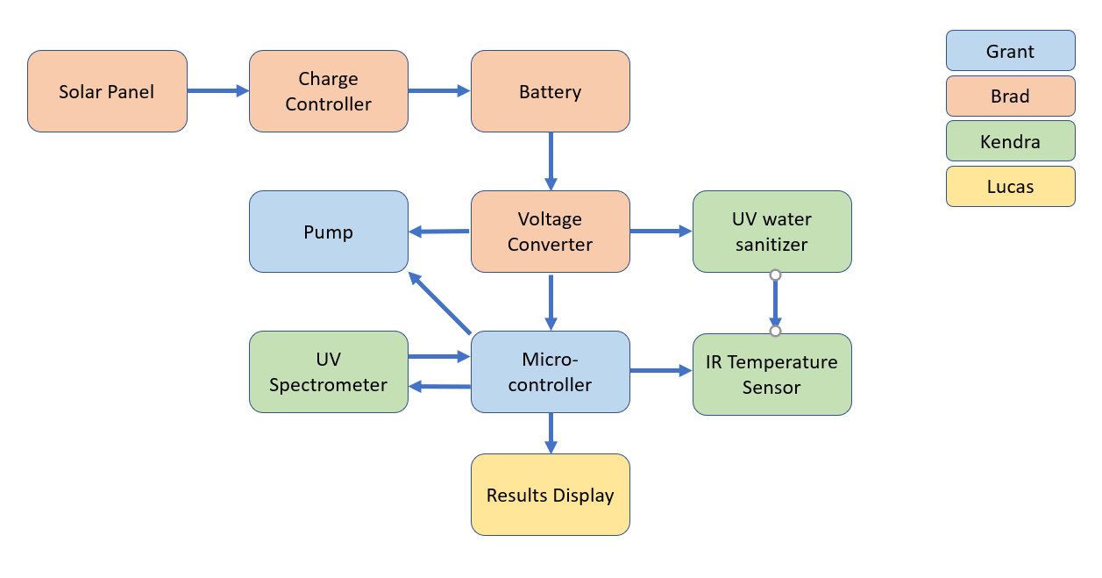
Figure 6: Group Block Diagram
  - Engineering Trade-off Matrix
An engineering trade-off matrix an agreement among the project team, the customer, and the executive sponsor that is used to manage change during the project. In our case the “customer” would be our professors and the sponsor are Ocean Insights. The matrix shows what kind of properties we trade-off for quality. The following table outlines the engineering trade-off for our water cleaning system.
Table 1: Engineering trade-off matrix
Marketing Requirements | Engineering Requirements
Marketing Requirements |  |  | Cost | Weight | Solar Power System | Battery Life | Spectroscopy Accuracy | User Interface | Energy Efficiency
Marketing Requirements |  |  | - | - | + | + | + | + | +
Marketing Requirements | User Friendly | + | ↓ | ↑ | ↑ | ↑ | ↑↑ | ↑↑ | ↑↑
Marketing Requirements | Low Cost | - | ↑↑ |  | ↓ | ↓↓ | ↓↓ | ↓ | ↓↓
Marketing Requirements | Portability | - | ↓ | ↑↑ | ↓↓
Marketing Requirements | Maintenance | - | ↓ |  |  | ↑ | ↑ |  | ↓
Marketing Requirements | Water Quality | + | ↑ |  |  |  | ↑↑
Marketing Requirements |  |  | < $400 | < 10 kg | Solely relying on Solar Power | > 8 hrs without sunlight | Free of Specific Contaminants | Operable by anyone | Limiting power loss

Research & Parts Selection
The section below summarizes the research done on different ways the system can be approached by breaking it down into individual components. Each part of the system was broken into section and evaluated alone, then compared to the system to ensure accuracy. After analyzing which approach was best the specific parts for that approach were research and analyzed so for the best integration into the system. These parts and processes researched below are unlikely to change but have the ability of being modified or edited until the project is complete. These parts have been ordered and will be tested to ensure they are functioning properly and can be fully integrated into the system during senior design II.

Research
The Solar Powered UV Water Filtering project that our group has chosen to tackle required a vast amount of research, in various areas of the engineering field. This research was split among the members of the group in order to properly distribute time, to better meet the deadline. The division of the workload was dished out by the educational major of each group member, which can be observed in the task diagram depicted in Section 2.7. This also ensures that each engineer in the group can focus on their specific study of the field and fulfill their senior design requirements. Most of the research done was via the internet for the best research documents and solutions to our application of the project. This also consisted of contacting various sources for permission purposes, individual design, and group collaboration throughout the process.
There are four major components of the project that were tasked to each engineer, the solar power system, the user interface, the water analysis, and the integration of the water filtration system. There were also sub-topics that needed to be addressed like the unique circuitry to make all the components work together, and the microcontroller that will process a lot of the information. Research regarding solar power systems and water filtration systems were tasked to the two electrical engineers. These two sections of the project require the most electrical analysis because this is where the most power is produced and consumed in the system. The electrical engineers will also put time into the overall electrical circuitry that will meld the entire project together, and later be designed as a PCB board. Next the user interface was tasked to the computer engineer of the group. The user interface requires the most data interpretation and control over the system, via programming of a microcontroller. This will be the backbone of expressing the collected data to the user and ensuring everything works properly. The last system of interest that needs to be researched is the water analysis system. This was tasked to the optical engineer of the group because it will analyze the water through light refraction and response. This will be done with spectrometer equipment loaned to the group from Ocean Insights, that will need to be assembled and designed to work together with the rest of the system. With this successfully implemented the system will be able to detect if the water is indeed clean and up to quality standard.
The below section will show the research put into the solar powered UV water cleaning system. This process was one of the most important pieces in the project in order to get each section of system to properly work together. It will simplify the design process so the engineers will fully understand how to implement each component properly and convey the idea to any user.

Solar Power System
Photovoltaic (PV) devices, better known as Solar Power devices, are arguably the fastest growing source of renewable energy of the twenty first century. Within the next few years, PV devices are predicted to provide the world with roughly 1 trillion watts of power. This has come from a greater than expected growth and expansion of the solar industry in recent years. This expansion has been aided by rises in demand, lowered costs, and, in the US, federal tax credits for investing in solar. Solar panels can range in many aspects such as size and output. For off grid application, the systems generally operate between 12 to 24 volts accompanied by batteries. Other grid tied systems operate at higher voltages which are usually used in commercial and residential applications. Below will offer a detailed explanation of how these components work, the types of solar panels, specifications, and on/off grid applications related to solar panels.
How solar panels work:
In simplest terms, a solar panel will convert light energy to electrical energy that can be used to power various electrical systems. The component that does the work in each solar panel is a solar cell, or photovoltaic (PV) cell, there is a collection of these that are spread out throughout each panel. Solar cells are made of semiconductors that can transfer the light energy into electrical energy. When light energy from the sun, also termed as photon particles, hits these semiconductors it is absorbed and energizes electrons within the semiconductor material. These electrons that are energized are termed to be “knocked loose” or “free” from their hole counterpart. This process is called generation, which can be thought of as the generation of free electrons. This in turn allows them to travel freely through an electrical path. This creates the means for which current can be created.
The general set up of these solar cells is a layer system with an anti-reflective coating above two layers of semiconductor material, a P-type layer and N-type layer. The anti-reflective coating allows for photons to pass through and be used by the semiconductor materials. This is needed because the silicon material in the semiconductors are very reflective and will reflect the incoming photons away. The P-type semiconductor material has an abundance of holes, while the N-type semiconductor material has an abundance of electrons. Holes are the absence of an electron, where an electron could be located in an atom lattice. Since there is this absence of an electron there is no negative charge inhabiting that location, and holes are often referred to as positively charged carriers. Electrons are referred to as negatively charged carriers and are the primary carrier of electricity.
A more detailed explanation of the transfer process of light energy into electrical energy is as follows. Once the solar cells, or semiconductors, absorb enough photons the electrons in the N-type layer get energized. Free from any constraints, these electrons are now able to move around and create current. At the same time the junction between the two semiconductor materials, defined as a P-N junction, creates a built-in electric field. This is created by the overall positive charge on the P-side and a negative charge on the N-side. This electric field creates the means by which the electrons can move, and the direction in which they can move. This in turn creates a flow of current when the semiconductor is connected to a load, successfully transferring light energy to electrical energy. This process is depicted in the below picture.
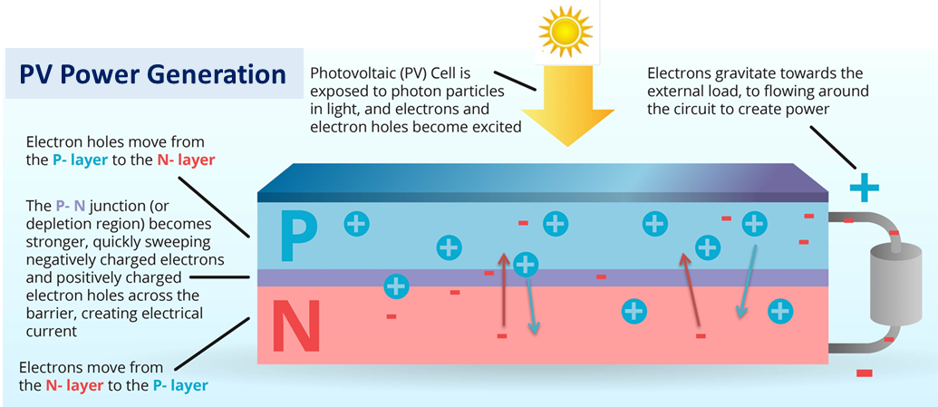
Figure 7: The process of light energy being transferred into electrical energy via solar cell [11]
By connecting each cell with leads, in other words positive and negative leads, the current can be taken out and used externally. The two leads will now have a potential delta between each other which is referred to as voltage. This combination of voltage and current dictates the power, in watts, that each solar cell or panel can create.
Types of solar panels:
When beginning the search for solar energy options, one must recognize the different types of solar panel applications, and conclude which option is best for their situation. In many cases people are limited to cost because solar systems can get very expensive, and very fast. But when it comes to solar, higher costs usually leads to better, more efficient technology. So, knowing what you are dealing with is very important. There are a few major types of solar cell technology that are widely used today which include monocrystalline silicon, polycrystalline silicon, and thin-film solar cells. Monocrystalline solar panels (Mono-SI) and polycrystalline solar panels (Poly-SI) are the first group of solar panels. While thin-film solar cell technology is the second, newer group and are still being explored in research to create more efficient designs.
The discovery of monocrystalline solar panels is not the first type of photovoltaic success, but it is the first breakthrough for solar cell technology. In 1918, Jan Czochralski, a scientist from Poland found a way to produce monocrystalline silicon. This aided the construction of monocrystalline solar cells, which first began emerging in 1941 [13]. Monocrystalline Solar panels are constructed through Czochralski’s method, where a silicon crystal, or seed, is placed in a mass of molten silicon. The crystal seed is then brought out of the molten silicon, which has solidified into a layer on the outside of the seed. This new silicon structure is referred to as an ingot. Before the ingot is fully cooled down, it is sliced into pieces forming silicon wafers which can be used as solar cells. This Monocrystalline structure is one of the most efficient forms of solar panel technology, a resultant of the high purity levels of silicon in the finished product. This gives a distinct uniform dark appearance to the solar panel, seen in Figure 7. The purity of the silicon also contributes to great efficiency rates of over 20% [14]. More positive traits to accompany their high output are their size, their life span, and their thermal robustness. These panels are very space efficient, are of the longest lasting panels, and operate well even under high temperature applications. All of this does come with a larger price tag as the process of producing these solar cells is quite meticulous compared to its polycrystalline counterpart.
Polycrystalline structures emerged shortly after monocrystalline structures, but it wasn’t until the 1990’s that polycrystalline solar cells became widely sought after. The way this new structure is made is like that of the monocrystalline one in that it also starts with a silicon crystal seed. The seed is similarly dropped into a mass of molten silicon but not taken out. The difference in this process is that the molten silicon is now set aside to cool. This cool down process is what forms its distinct rigid, crystal looking structure within the solar cells, shown in Figure 7 below. The polycrystalline silicon production process is much cheaper and faster than that of making the monocrystalline silicon, making it a great choice for budget based solar applications. But of course, it has a few downsides, such as, lower space efficiency, shorter lifespan, and lower efficiency rates. The larger sized panels make this type of structure less thermally robust and the cheaper production method results in a lower output efficiency of about 15% [14]. Although, in recent years researchers have begun developing polycrystalline solar cells that are becoming close to the efficiency levels of their monocrystalline partner.
After the discovery of monocrystalline and polycrystalline solar cells came the thin-film solar module. In 1985 the University of New South Wales, Australia created one of the first of these modules, and shortly after in 1986, ARCO Solar introduced the first mass produced thin-film photovoltaic module [13]. This design differs greatly from the previous two designs because they are made with a different base material, which is a different silicon or sometimes other materials. These most commonly include amorphous silicon, and cadmium telluride solar cells. The process that is used to produce these is referred to as depositing. Manufacturers deposit the previously listed photovoltaic materials onto a substrate such as glass or metal. While each panel can be made up of different material, they all fall into the same thin-film category. As the name describes them, these solar panels are made of thin-film layers allowing them to be flexible. This also ensures that the end user can use them in many different applications. They are also the cheapest option because they use less material and are the easiest to make. While they are the cheapest and easiest to make, they also take up a lot of space, they have a short lifespan, and the product is not that efficient, around 10% (For amorphous silicon). This is a reason why most thin-film technology is used in commercial solar applications because contractors have the means to replace them often, as well as the space needed to make these installations worthwhile.
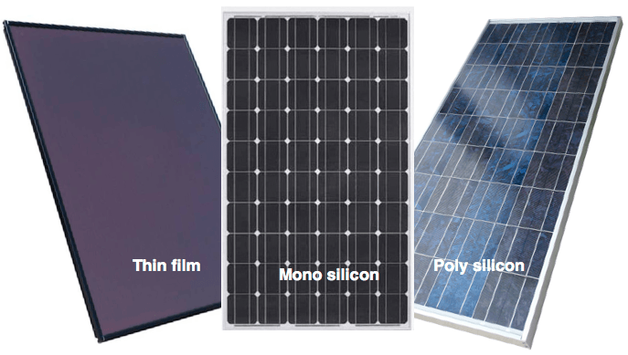
Figure 8: Thin-film (right), monocrystalline (center), and Polycrystalline (left) [15]
With modern day technological expansion, there are far more solar panel types out there, and some are emerging with exceptional efficiency rates. Not only that, but since the solar energy industry is on the rise, prices are drastically decreasing which is further pushing the development of new designs. For example, a recent design referred to as Concentrated PV cells have achieved efficiency levels of about 40%. To achieve this there are curved mirrors that surround the solar cells, concentrating the sunlight directly toward the cells. Another type that is still in the research phase is the Biohybrid solar cell. This experimental solar idea is supposed to mimic the process of photosynthesis, converting chemical energy to electrical energy. Unfortunately, these types of panels cannot be utilized in the UV cleaning project but are great options that will soon be much more affordable for residential work.
In Table 2 below there is a comparison of the different characteristics that were just previously examined from the three major types of solar panels.
Table 2: Solar Cell Comparison
Solar Cell  Category | Advantages | Disadvantages | Efficiency | Appearance
Monocrystalline | -High lifespan  -Thermal Robustness  -Space efficient | -Expensive | ~20% | -Solid Dark blue  -Rounded edges
Polycrystalline | -Inexpensive  -Fast production | -Shorter lifespan  -Takes up more space | ~15% | -Blue crystal like look  -Rigid edges
Thin-Film  (Amorphous Silicon) | -Medium cost  -Easy production  -Flexible | -Shortest lifespan  -Take up the most space | ~10% | -Solid dark blue/black

Specifications:
Each solar panel has an associated data sheet that specifies different parameters about that solar panel. These parameters include electrical specifications as well as general information that can help consumers decide which panel is right for their application. There are two types of conditions that the solar panels are operated under to determine these specifications, standard test conditions (STC) and Normal operating cell temperature (NOCT). STC are conditions where the solar panel operates at its peak performance. These include operation at a solar cell temperature of 25 degrees Celsius (77 degrees Fahrenheit), optimal light intensity of 1000 watts per square meter, and a perpendicular sun angle with the panel. Solar panels do not operate in these conditions all the time. So solar panel manufacturers give another set of parameters at the NOCT conditions. These offer a more realistic insight to how the solar panel will likely operate. This includes the light intensity being lowered to 800 watts per square meter which results in lower and more realistic ratings of the performance. Understanding these parameters, in both sets of conditions, is very important when it comes to the design process of electrical systems that use solar. In any engineering feat, the goal is to optimize performance and efficiency. So, in this solar powered UV water cleaning project, these parameters will indeed be addressed when the design process comes. A few different parameters that get measured for a solar panel specification sheet are shown in Figure 8 and further explained in the list that follows.
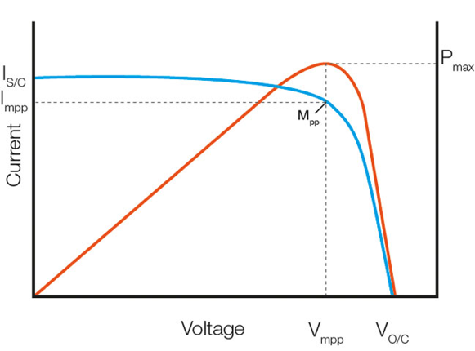
Figure 9: Power output graph of a solar panel, expressing peak operation [28]
- Open circuit voltage (Voc)
  - This is the voltage of the solar panel when there is no load connected to it, thus no current is flowing, and the panel is open circuited. (See Figure 8)
  - To test for this, connect a multimeter on each of the leads, measuring voltage.
  - This is the maximum voltage the solar panel can supply under STC, this is the value to use when pairing your panels with a charge controller.
- Short circuit current (Isc)
  - This is the highest current the panel will produce and is the value to use when determining the correct charge controller to use. (See Figure 8)
  - To test for this, connect a multimeter to both leads measuring current.
  - This is the current output when the solar panel has no load connected to it.
- Maximum power point, voltage, and current (Pmax, Vmpp, Impp)
  - Pmax is the optimal point in a solar panel’s power output, where maximum power point voltage (Vmpp) and current (Impp) occur. (See Figure 8)
  - Pmax = Vmpp x Impp
  - Efficiency at this point is at a maximum.
  - For an MPPT charge controller, this is the target operational point that the controller tries to maintain.
- Nominal voltage
  - This is the advertised voltage of a specific solar panel, but the panel does not always operate at this voltage.
  - Used to group battery based solar systems.
  - A solar panel that operates at a nominal value of 12V outputs voltages up to around 22V. Which the charge controller will use to charge a 12V battery that is also operating at about 14V when fully charged.
- Module efficiency
  - The average measurement of solar panel efficiency for the solar panel; the light energy conversion to electrical energy.
  - Ranges between 10% for older panel designs to 40% for newer designs.

Charge Controller
The solar power system in this UV water cleaning project utilizes a solar panel and battery combination. The solar panel cannot simply power everything all the time due to its fluctuations in power output, which is why a battery is needed. But how does the battery get power to operate and recharge? That is where the solar panel and charge controller come into play. In this project’s application, the entire system will operate off-grid. The charge controller is essentially a voltage and current regulator for the solar panel. In doing so it optimizes the battery’s charge during operation and can extend its lifespan by keeping the charge level within an appropriate operational range. This is all affected by how well the charge controller can respond to the power output changes of the solar panel. Depending on the light intensity hitting the panel, the power output can change dramatically, and quite quickly. For example, if it’s a cloudy day and the sun finally begins to peak out, the solar panel will begin to output a higher voltage and current. If the charge controller wasn’t put into place, this drastic change in power could damage the battery or even the electrical load of the system.
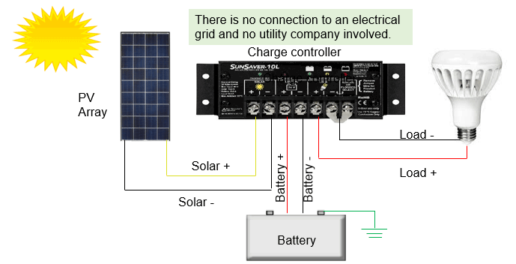
Figure 10: An application of a charge controller in an off-grid solar system with a DC load [16]
Functions of charge controllers:
Charge controllers offer more functions than they may seem to. There are a couple functions of charge controllers that offer a bit of extra utility, which include blocking reverse current and preventing battery overcharge. Which are solely basic level features that virtually every charge controller will have. Some of the better controllers offer more functionality such as, prevention of battery over-discharge, overload protection, and a user interface that shows different statuses of the system. The following section will go into detail about these different functionalities.
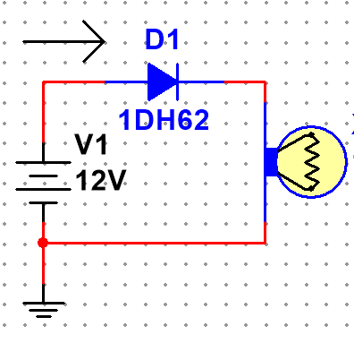
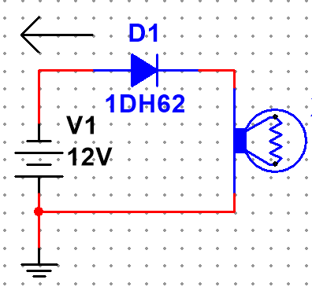
Blocking reverse current is an easy part of optimizing battery performance during nighttime or low light operation. A solar panel pushes current into the battery during daylight hours or under enough light situations. In times of darkness or low-level light intensity, the solar panel can draw current from the system and act as a load. There are other situations like faults or malfunctions in the solar system that can cause similar effects. The losses associated with this are relatively low but getting around this issue is quite simple. One way of doing this is by using a semiconductor or diode that will act like a one-way door for current. A Multisim model has been made on the right, to show how this protection circuit works. When current flows in the correct direction, toward the load (labeled by the arrow) the diode is on and lets the current pass through to power the load. In this example the way to show reverse current protection, the power source will be flipped. This simulates current flowing in the opposite direction. In this case, shown to the right as well, the direction of current is represented by the arrow which is backwards. Consequently, the diode is not activated, and the load cannot be turned on, successfully acting as a reverse current protection system. In our solar polar system, the power source will be a solar panel and battery combination so in that case the load will stay on even when the solar panel is not outputting any power. But the depictions to the right (Figures 11 and 12) offer a great explanation for how this reverse current protection works. Another way of doing this is putting in a relay or mechanical switch in the path of the current flow behind the solar panel. The relay can be calibrated to be off during low level light hours and on during high level light hours, which can also do the same type of protection.
Figure 11: Current Schematic
Figure 12: Current Schematic
Figure : SEQ Figure \* ARABIC 7: Depiction of reverse current
The next charge controller feature to address is maintaining and controlling the charge, or voltage level of the battery. First let us look at the overcharge protection that controllers offer. Batteries are only meant to store so much charge, if this limit is exceeded and the voltage of the battery gets too immense it can damage the battery or the entire electrical system. In this case the battery could just die and stop working, but it could also get much more dangerous than simply dying. When charge is continually introduced to a fully charged battery, the water and acid mixture inside the battery can begin to boil. This can obviously cause heat to start dissipating from the battery, but the reaction also releases hydrogen inside the battery cells which is flammable. This buildup of gasses and heat can cause significant pressure and even seepage of hydrogen within the battery case. Once enough build up occurs the battery is essentially a small ticking time bomb. So how do charge controllers get around this? Quite easily, they reduce or stop the flow of charge into the battery when it becomes fully charged. This is explained by controller type in the next section.
Types of Charge Controllers:
There are four types of controllers that all regulate the charge from solar panels shunt, series, pulse-width modulating (PWM), and maximum power point tracking (MPPT). For shunt charge controllers, the solar panel is short circuited when the battery is beginning to receive too much charge. This is the simplest and cheapest application of charge control. Series charge controllers are similar, but they do the opposite. Instead of short circuiting the solar panel a series controller will open the circuit, stopping any current flow until the battery needs to be charged again. PWM controllers are designed to regulate the charge of the battery by changing the amount of current that is reaching the battery. This is done by a variable power output depending on the battery storage level. Slowly lowering the amount of charge going into the battery, once it reaches its capacity level. PWM controllers top off the battery level by keeping it in a “trickle” state of charge. Once the battery is charged fully, the controller does this by constantly supplying a small amount of power to keep the battery topped off. MPPT are similar to PWM controllers because they essentially do the same thing by decreasing current flow as the battery nears full capacity. The difference is that MPPT controllers are more efficient. They match the voltages of the panels and battery; this is done by adjusting the input power from the solar panel to capture as much power as possible. This is also done on the output side for the battery to match the battery with the solar panel. Different characteristics of all four controllers can be seen in Table 3 below.
For this project only the PWM and MPPT charge controllers will be considered in order to offer the most protection for the system. If time permits, a simple protection system may be built and implemented via custom made circuitry made by the group. But to ensure the full and uninterrupted progress on the project, this will not be made for now. Some other characteristics to take into consideration about PWM and MPPT controllers are cost, application, and an understanding of the charge controlling process.
As stated above, PWM and MPPT charge controllers both change the power output depending on the battery charge level, but they obviously do so in a slightly different manner. Pulse-width modulation controllers act as a switch in between the solar panel and battery. When the battery is very low the “switch” or controller is on, this is referred to as bulk charging mode. When the battery is close to full, the controller is switched from the on and off position to retain the battery voltage and slowly build up to the target voltage. This section of charging is referred to as the absorption stage. Lastly when the battery is up to the target voltage rating, the controller again performs the switching process to maintain, or top off the battery. This is the final stage called the float stage. The on and off switching of the controller is where the term pulse-width modulating comes from. The PWM controller is a low-cost option that works better for smaller systems where efficiency is not of importance. These are systems with less than 400 watts of load usually and can be used in off or on-grid systems.
On the other hand, the maximum power point tracking (MPPT) controllers are seen as DC to DC converters. They regulate the input and output power in order to operate in the most efficient manner. As explained in the Solar Specifications section, the maximum power point is the point of optimal performance for a given solar panel. The MPPT charge controller, as its name implies, always tries to get the battery and solar panel to operate at this point. The way they do this is by regulating the solar panel voltage down to the target voltage of the battery. In doing this, current is increased at the equivalent ratio that voltage is dropped, and this is where the similarity to a DC to DC converter comes from. What the controller also does, and where it gets its name, is monitor the maximum power point of the solar panel. This maximum power value changes throughout the day based on light intensity, panel temperature, and what point the panel is in its lifespan. Depending on the maximum power value of the panel, it adjusts the output side for the battery to match the solar panel. MPPT controllers can be used in small or large systems, mainly in places where efficiency is of importance. They are better for larger systems though because of this high efficiency and consequently they last longer than PWM controllers. The greater functionality comes with a larger price tag and the MPPT controller is best for off-grid applications because they are more reliable.
Table 3: Comparison of different types of charge controllers
Charge Controller | Cost | Efficiency | Means of Charge Control | Application
Shunt | -Cheapest | -Greater than 70% | -Short circuit solar panel | -High or Low voltage  -Low cost systems
Series | -Cheapest | -Greater than 70% | -Interruption of current after panel | -High or Low voltage  -Low cost systems
PWM (Pulse-Width Modulating) | -Cheap, cost effective for consumers | -75% to 80% | -Pulse interruption to raise and maintain battery voltage | -Low voltage  -Residential  -On or Off Grid
MPPT (Maximum Power Point Tracking) | -Expensive, worthwhile for commercial consumers | -94% to 99% | -Regulates input power to match battery target voltage | -High voltage or Low voltage  -Commercial  -On or Off Grid

Voltage Conversion and Regulation
On paper and in simulation software, battery or power supply voltages are a set unchanging value. Unfortunately, in the real world a 12V battery’s voltage can vary from 10.5-14V. This fluctuation of voltage can irreversibly damage the hardware it is powering, and thus it is very important to have proper voltage supply regulation.
Power supply circuits are categorized by whether the input or output voltages are DC or AC, that is Direct Current and Alternating Current, respectively. We call a circuit that converts AC to DC rectifiers. A common example of a rectifier circuit is a simple everyday phone charging brick which changes the 120V AC signal at 60 Hertz, to a 5V DC signal usable for charging our phones. The opposite conversion circuits that convert DC to AC are called inverters. A common example of an inverter circuit is in a charge controller which can change 20V DC from a solar panel to 120V AC signal at 60 hertz, so it can be added to the grid. AC to AC circuits are conveniently named AC-AC converters, and DC to DC circuits are conveniently named DC-DC Converters. AC-AC converters are used in the utility industry to convert power between a 50Hz grid and a 60Hz grid. DC-DC circuits are used in most mobile devices to maintain the voltage at a fixed value regardless of the voltage value of the battery. These outputs can either be regulated or unregulated. A regulated output voltage and current remains constant even when the load and input voltage change.
Since our project will only use DC voltage, DC-DC converters will be our central area of focus. There are two main types of regulated DC-DC converters we must choose between for our power supply; linear voltage regulators and switching regulators. These regulators are explored and explained further in the below section.
Linear Voltage Regulators:
Linear voltage regulator can range in complexity from just a Zener diode and a few resistors to an operational amplifier (which itself contains more than 20 transistors) paired with a bipolar junction transistor (BJT) or MOSFET and capacitors with additional circuitry for short circuit and thermal protection. Luckily, linear voltage regulators are some of the most used circuits and you can buy them as convenient 3-terminal integrated circuits. Linear voltage regulators vary from switching regulators in their simplicity, low cost, reliability, and low noise; however, they are inefficient which becomes more of a concern in higher power applications. Typical efficiencies for linear regulators are below 50%. The same function can often be performed much more efficiently by a switching regulator power supply, but a linear regulator may be preferred for light loads or where the desired output voltage approaches the source voltage. Linear voltage regulators make sense with light loads since the power wasted due to inefficiency will be small enough to be insignificant. They can be preferred when output voltage is close to input voltage because their power consumption is P = (Vin - Vout) *Iout (Iin is roughly equal to Iout). The smaller the difference between Vin and Vout, the smaller the power consumed by the regulator will be. It is important to note that for linear voltage regulators, Vin must always be greater than Vout. Moreover, linear voltage regulators are characterized by their dropout voltage which stated the minimum voltage difference between Vin and Vout. A typical value for this is 2V but some low dropout regulators (LDOs) can get the dropout voltage down to .9V. Alongside drop out voltage, it is also important to check for specific linear regulator’s maximum input voltage, maximum voltage differential, and maximum current rating.
The most common types of linear voltage regulators are labeled “Fixed” three terminal regulators. They are available in +3.3V and plus or minus 5 V, 6 V, 9 V, 12 V, or 15 V, when the load is less than 1.5 A. They are usually labeled as "78xx" series or “79xx” in which 78 indicates a positive value, 79 indicates a negative value, and the xx will give the regulated voltage output (05 = 5V). An example of this is the L78xx series from STMicroelectronics. Which can be seen below in Figures 12 and 13, showing the external design and a general depiction of the internal circuitry. These are often accompanied by decoupling capacitors which act to smooth out the signal by removing the AC component and leaving the DC. This is what will most likely be used in the project to transfer voltage from source to the various components that need to be powered.
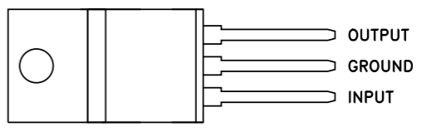
Figure 13:The external design of a general L78xx from STMicroelectronics [65]
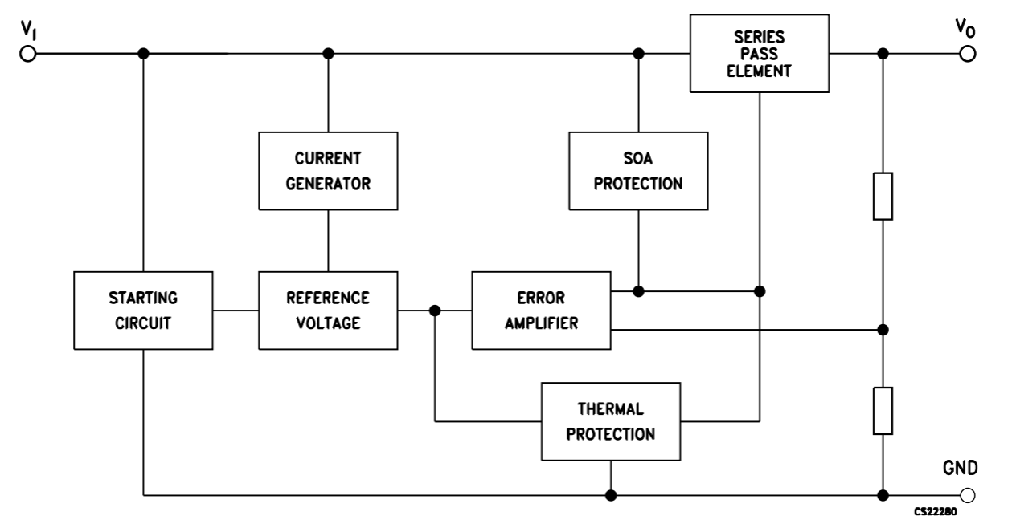
Figure 14: : A general interpretation of the internal circuitry design of the above L78xx [63]
Switching regulators:
A switching regulator is a voltage regulator that uses a switching element to transform the incoming power supply into a pulsed voltage, which is then smoothed using capacitors, inductors, and other elements. A pulse width modulator is used to turn a MOSFET on and off which charges a capacitor and inductor. If a higher voltage is needed the pulse will be larger and if a lower voltage is needed the pulse will be smaller. Typically, switching regulator circuits are even more complex than linear power supplies. However, these power supplies are more efficient and can utilize smaller components than linear power supplies. A typical efficiency of a switching regulator is 80 to 90%. There are 3 types of switching regulators; buck, boost, and buck-boost. Buck regulators take a larger input voltage and reduce it. Boost regulators take a smaller input voltage and increase it. Buck-boost regulators can both raise or lower the output voltage depending on load requirements. It is important to note for all switching regulators that, just like a transformer, when the output voltage is raised, the output current will be lowered and vice versa. One of the main disadvantages of switching regulators is the introduction of noise to the circuit from the constant switching. This noise can be seen as the low frequency output ripple (LF ripple) and high frequency output noise (HF noise). To address this problem, low pass filters are usually added to the output of a switching regulator.

Battery
Choosing the right battery always comes down to a balancing act. In an ideal world, a battery would have very high energy density, deliver 1000 charge/discharge cycles, and would be paper thin. Realistically, engineers must look at the available technology and weigh them accordingly. There are a variety of different characteristics that must be examined when choosing the correct battery for our design. One of the most obvious distinctions is that any battery used in a solar powered system must be rechargeable.
Batteries can further be classified by whether they are starting batteries or deep-cycle batteries. Starting batteries are usually used for starting automotive engines and are not designed for deep discharge. They have many thin plates designed for maximum surface area, and therefore maximum current output, which can easily be damaged by deep discharge. If a starting battery were used in our system, it would very quickly fail due to mechanical stress. Deep cycle batteries have much thicker plates that deliver less peak current but can withstand frequent discharge. Starting batteries are usually rated at "CCA", or cold cranking amps, or "MCA", Marine cranking amps - the same as "CA". Any battery with the capacity shown in CA or MCA may or may not be a true deep-cycle battery. It is sometimes hard to tell, as the term “deep cycle” is often overused and sometimes used in automotive starting battery advertising.
Although battery life spans can be provided in datasheets, these values are almost always inflated by unrealistic operating conditions. The realistic answer is that the lifespan of a deep cycle battery will vary considerably with how it is used, how it is maintained and charged, temperature, and other factors. For example, a golf cart battery can be destroyed without even being used in less than a year if left sitting in a hot garage or warehouse without being charged. It is almost impossible to get a fixed value for lifespans. As the temperature of the battery increases, its lifespan is shortened. For every 15 degrees F over 77, battery lifespan is cut in half. Conversely, every 22 degrees F a battery is operating at below 77 degrees F, its lifespan will increase by about 60%.
Depth of Discharge (DoD) refers to how much energy is recommended to be cycled into and out of the battery in each cycle for optimum battery lifespan. DoD is expressed as a percentage of the total capacity of the battery. This value can be exceeded but will drastically shorten the useful life of the battery. Battery life is directly related to how deep the battery is cycled each time. If a battery is discharged to 50% every day, it will last about twice if it is cycled to 80% DOD. If cycled only 10% DOD, it will last about 5 times as long as one cycled to 50%. An average DOD of around 50% is usually preferred for the best storage vs cost factor.
Another characteristic of batteries are their capacities. The standard unit of measure used is the Amp hour. The standard rating is an amp rating taken for 20 hours. What this means for a 100 AH rated battery is this: Draw from the battery for 20 hours, and it will provide a total of 100-amp hours. That translates to about 5 amps an hour. (5 x 20 = 100). The higher the internal resistance, the higher the losses while charging and discharging, especially at higher currents. This means that the faster a battery is used (discharged), the LOWER the AH capacity. Conversely, if it is drained slower, the AH capacity is higher. This is important because some manufacturers and vendors have chosen to rate their batteries at the 100-hour rate - which makes them look a lot better than they really are. For example, the same battery could have a 400AH 100-hour rating and a 360AH 20-hour rating. It is also useful to note that batteries will not reach their full capacity until fully cycled 10-30 times. A brand-new battery’s capacity will be 5-10% less than what it is rated at. Capacity also varies with temperature. Capacity is reduced as temperature goes down and increased as temperature goes up. This can explain why a car battery may be dead on a cold winter morning, even though it worked fine the previous afternoon. Varying from 77 degrees F, battery capacity will go down by 20% at 32 degrees F and increase by 12% at 122 degrees F.
Self-discharge is a phenomenon that describes the gradual loss of charge when a battery is inactive. Over time, A minuscule amount of the chemical substances inside the batteries reacts even without any connections between the electrodes. Those internal reactions reduce the stored charge of the battery and thus decrease the capacity of the battery little by little. The rate at which a battery loses its capacity due to this varies widely between battery types.
Arguably the most important occurrence to avoid when operating a battery is thermal runaway. Thermal runaway occurs when a cell, or area within the cell, achieves elevated temperatures due to thermal failure, mechanical failure, internal/external short circuiting, and electrochemical abuse. At elevated temperatures, exothermic decomposition of the cell materials begins. Eventually, the self-heating rate of the cell is greater than the rate at which heat can be dissipated to the surroundings, the cell temperature rises exponentially, and stability is ultimately lost. The loss in stability results in all remaining thermal and electrochemical energy being released to the surroundings. All batteries are capable of this, but some are much more susceptible. Luckily, thermal runaway can’t be caused by elevated environmental temperatures alone. If it were to be triggered by solely environmental temperatures the battery would have to be on fire. The three main factors that can result in thermal runaway are internal short circuit, Overcharging, and excessive current when charging. Internal short circuits would have to result from mechanical impact e.g. a high fall which is very unlikely with our project. Overcharging and excessive charging will both be controlled by our charge controller.
Finally, a battery can either be sealed or unsealed. Unsealed batteries can emit dangerous gasses such as hydrogen and oxygen and sealed don’t. Usually unsealed require more upkeep. The remaining characteristics of batteries are mainly self-explanatory and don’t warrant further elaboration such as charge/discharge rate. Now that we can properly understand the characteristics of batteries, different types of batteries are compared. Specifically, our research will focus on the typical batteries that are used in solar systems; flooded lead acid, absorbed glass mat (AGM) lead acid and lithium ion.
Flooded Lead Acid:
Lead acid batteries were invented in 1859 by French physicist Gaston Planté and are the earliest type of rechargeable batteries. Flooded lead acid batteries were the first variation of them and have been used for decades in off grid energy storage systems. Their biggest benefit of the flooded lead acid is that they are the least expensive option for energy storage. They're very robust and hard to damage but that is about all they have going for them. The downside of lead-acid is that they have a relatively short life and a lower depth of discharge (DoD). Recommended DoD is specified by manufacturers and in lead acid batteries it is not recommended to exceed 50%. Furthermore, lead acid batteries can be very heavy so they are usually used in applications where this is not a factor. Since they are unsealed, they require good ventilation as they release hydrogen and oxygen during charging, and then watering to make up that hydrogen and oxygen.
Absorbed Glass Mat (AGM) Lead Acid:
AGM has a multitude of advantages over flooded lead acid. They tend to have a lower internal resistance, which makes for better power delivery and faster charging. An AGM lead acid can charge up to five times faster than flooded. AGM offers a depth-of-discharge of around 80%, much better than flooded. They're maintenance free ("maintenance impossible"), which can be nice if they're sitting unused for part of the year. This is because they are sealed batteries. They will release no fumes and since all the electrolyte (acid) is contained in the glass mats, they cannot spill, even if broken. This also means that since they are non-hazardous, the shipping costs are lower. Furthermore, loss of charge due to self-discharge is 5 to 50 times less than traditional flooded batteries. AGM batteries are also the best suited to withstand freezing. The only real disadvantage to AGM batteries compared to flooded ones is the cost. They're more expensive than flooded, ranging from 1.5x to 2x more.
Lithium Ion:
The final type of battery used for energy storage with solar panels are Lithium ion batteries. Lithium-ion batteries can be found in a broad range of devices, from phones, to electric automobiles, to military and aerospace applications. They are the fastest growing battery system. Although lead acid batteries make up the majority of rechargeable batteries, A few lithium-ion types are starting to make their appearance but are much more expensive than lead-acid and most charge controllers do not have the correct set points for proper charging. There are many types of lithium ion batteries but the only type worth looking at for our system are the Lithium Iron Phosphate (LiFePO4). This is because all other lithium ion batteries need an immense amount of care to be taken to avoid thermal runaway while LiFePO4 have excellent safety, with great thermal stability, high current ratings, long cycle life, and tolerance to abuse. Lithium Iron Phosphate (LiFePO4) is an extremely stable lithium chemistry when compared to almost all other lithium chemistries. Lithium ions are used where high energy density and lightweight is of prime importance. Higher energy density is great for capacity but comes with the downside of making them more susceptible to thermal runaway. They have a DoD recommendation of 80% to 100% which far exceeds that of lead-acid. They also have a much greater cycle life than the lead-acid batteries. They are very delicate and protection circuits are required for safety measures. Lithium ion batteries are sealed just like AGM so there is no need to worry about dangerous vapors. The main disadvantage for these batteries is the cost, being much higher than AGM.

Pump
There are many types of water pumps available, each with their own pros and cons. Flexible Impeller Pumps utilize rotating impellers to generate suction and move fluid. As the impellers rotate the succession of blades draws in liquid and moves it to the discharge outlet. The system is depicted in Figure 14.A. The pros of these pumps are that they are compact and simple, since it consists of just one rotating part. They can be mounted at any angle and can pump a wide range of liquids. They cannot however run dry without risking damage. To “run a water pump dry” is to run it when the casing and hose are not completely full of water. Pumps are usually meant to pump very specific types of fluids and will overheat when pumping air if not designed to. Furthermore, they can easily become clogged by small amounts of debris.
Another type of pump is the centrifugal pump. They like the impeller pump use spinning impellers but differ in that they use centrifugal force to move the fluid. The rotating impellers speed liquid and move it to the outside of the casting toward the discharge port. The system is depicted in Figure 14.B. One of the biggest advantages of this pump is that it can pump the largest volume of water compared to the others. One of the biggest caveats of this pump is that it is not self-priming. "Self-priming" in this context means that the pump can use liquid stored in its housing to generate a vacuum on the suction line. Self-priming pumps can expel air before it pumps the water and can pump from above the water.
Finally, there are diaphragm pumps. These pumps use variable volume pump chambers and check values to move fluid. As diaphragm rises, liquid is pulled into the pump chamber while the outlet valve is pulled close. When the diaphragm is lowered, liquid is forced out the outlet valve while the intake valve is pressed shut. More chambers ensure smoother operation. Citation. The system is depicted in Figure 14.C. The pros of this pump are that it is self-priming up to 10ft and can be run dry. They are quieter and have a smaller current draw than other pumps. The cons are that they have a limited volume and are sensitive to dirt and debris, so a good pre-filter is usually required.
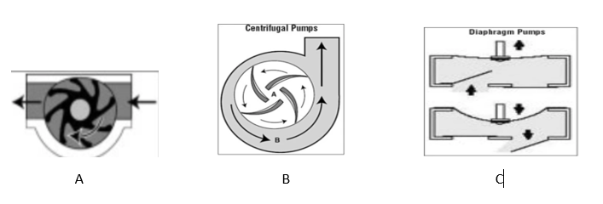
Figure 15:Types of Pumps
With our envisioned UV water sanitizer drawing water up from a local source it makes the choice of the diaphragm pump obvious. The self-priming capacity and dry run capacity of diaphragm pumps adds both functionality and convenience to our design. Diaphragm pumps can either be manual or automatic. Not manual in the sense that one would have to exert physical energy rather than electrical energy to power the pump but it that the pump would be controller of the users by an on off switch. Manual pumps are great for when you want to know exactly when your pump runs, how long it runs, how much water it pumps. Conversely, automatic pumps feature a mechanism that will start the pump in certain conditions, typically a float switch or by the opening of a faucet. By choosing an automatic pump we can very intuitively control the water flow by opening and closing a faucet.

Water cleaning
The research covered here includes multiple ways of cleaning water and our reasoning for choosing. After analyzing each method, we are able to choose the best form of water cleaning. The method used in the system might be a combination of multiple techniques to ensure the best water quality. Even though certain ideas and processes might’ve been chosen originally research might prove that they are not the best course to take. Also, due to financial constraints, some of the best methods of water cleaning methods might not be feasible.
Filtration System:
Before looking at different types of filtration and purification devices it is important to note that no filters or treatment systems are 100% effective in removing all contaminants from water. Usually, the more expensive the system is, the more contaminants in the water it can address and the higher percentage of them it can remove. There is no one size fits all solution to water purification. Instead, it is important to test your water source locally and address the contaminants identified. Each source requires its own custom solution.
Doing senior design online during a global pandemic makes the need to remove pathogens from water more prevalent than ever. A recent study revealed that it takes 100+ days to remove 99.9% of COVID-19 from unfiltered tap water at 4°C and 10 days at temperatures of 23°C. Therefore, the main goal of our purification system will be to remove pathogens from our water supply. To effectively achieve this goal, it is first important to look at all available types of filtration systems to decide which can best meet our specifications and requirements.
Sediment Filters:
Sediment filtration is the most common and basic form of water filtration and is used in every aspect of water treatment. It works very well at removing sediments like rust, dust, silt, heavy metals, and other large particles in water. Sediment filters are categorized by their micron rating which says the size of the smallest particles that are guaranteed to not pass through. The way sediment filters work is very straight forward. The filter will have a rated pore size, 5 microns for example, and only particles smaller than 5 microns will be able to flow through. The particles that don’t pass through will accumulate on the filter progressively until it needs to be replaced. Although water will not be safe to drink after passing through the sediment filter, it is normally the first step in a complete water filtration system. Without a sediment filter, particulates would disrupt down line systems, clogging and putting strain on the other filter which in turn would damage the system.
Activated Carbon Filters:
Activated carbon filters consist of fine carbon powder that is held together and remains static by a bonding agent. The high porosity powder results in a large sponge like surface area capable of absorbing large amounts of contaminants. Activated carbons filters work by two methods. Firstly, most carbon filters have NSF Class I ratings. This means that they remove 85% of particles sized 0.5-1 micron. This is a much smaller rating then sediment filters which typically don’t filter any smaller than 5 microns. Secondly, the positively charged activated carbon attracts all the negative charged chemicals in the water like chlorine and sulfur that can give water bad taste and odor. Activated carbon filters are usually added to a total system to make the water taste clean and fresh with no unwanted odors. Typically, they are the next step in water filtration after a sediment filter. They could be used without a sediment filter, but this would greatly reduce their lifespan. These filters can remove some strains of bacteria, but viruses, with a typical micron rating of .004 to .1, can easily pass through. Activated carbon filters really flourish in removing metals like lead, copper, mercury, chemicals like chlorine and pesticides, and organic compounds that affect the taste and smell of water, rather than treating pathogens.
Reverse Osmosis:
Fundamentally, reverse osmosis takes water and forces it under pressure through a very dense membrane. The low mineral content water is forced through and stored in a tank and the high mineral content water and debris are flushed to the drain. This membrane is so dense that it will even prevent bacteria from passing though. The problem is that if the membrane is constantly subjected to bacteria, the bacteria will eat holes in the membranes. Then it will pass not only the bacteria through, but the high mineral content water as well. Thus, even though reverse osmosis has the capacity to remove bacteria, it should never be its primary function and water should be disinfected before entering the system.
Distillation:
On the more rudimentary side of filtration there are water distillation systems. They work by heating water up until it turns to steam. When the steam cools in a different area of the filter, it condenses back to water leaving contaminants behind. This process clears the water of bacteria and virus as long as the water boils for over one minute. Unfortunately, the whole water distillation process takes quite some time to produce only a small output of distilled water, which makes the application limited (mostly used for industrial processes only).
Ion Exchange (IX) or Water Softening:
Ion exchange is the process of removing undesirable heavy metal ions from water and replacing them with other ions with the same electrical charge from the ion-exchange resin. The IX resin is composed of positively charged sodium ions that capture the scale forming positively charged calcium and magnesium ion in water. Water softening is a very specialized treatment of water and does nothing to address bacterial or viral presence in water.
Chemical Disinfectants:
Chlorination is the most widely used method for disinfecting water supplies in the United States. The near universal adoption of this method can be attributed to its convenience and to its highly satisfactory performance as a disinfectant, which has been established by decades of use. Chlorine inactivates a microorganism by damaging its cell membrane. Once the cell membrane is weakened, the chlorine can enter the cell and disrupt cell respiration and DNA activity (two processes that are necessary for cell survival). But chlorine is not only toxic to microorganisms, but for humans as well. Exposure to chlorine can cause irritation to the eyes, nasal passages and respiratory system. Chlorine gas, which is the least expensive form of water chlorination, can be fatal if inhaled at a concentration as low as 1000 ppm (parts per million). Additionally, chlorinated water has been associated with increased risk of bladder, colon and rectal cancer. In Europe, chlorination has been discontinued by many communities for these reasons.
Although chlorination is very successful at killing bacteria and viruses, it can be unsuccessful in treating protozoan cyst and parasites like Cryptosporidium and Giardia. Cryptosporidium and Giardia were not microorganisms of concern until approximately 10 years ago when Milwaukee was hit with a waterborne disease epidemic. Milwaukee drinking water is surface water, which had become contaminated with high concentrations of Cryptosporidium at the time. Over 100,000 people came down with Cryptosporidiosis and over 400 people died. After, the USEPA recognized that they needed to consider these organisms and include them within their drinking water guidelines. Testing was done and it was found that chlorine was not effective against either of the protozoa. A vacuum chlorinator is the most typical kind of chlorinator, it is shown in Figure 16. This is one of many types of chlorine disinfectant systems, but if we were to use another process to remove the chlorine from water which increases the complexity and parts of the system. Since the goal is a portable system, chlorination would not work best for this goal, and if not careful with removing chlorine, can be harmful.

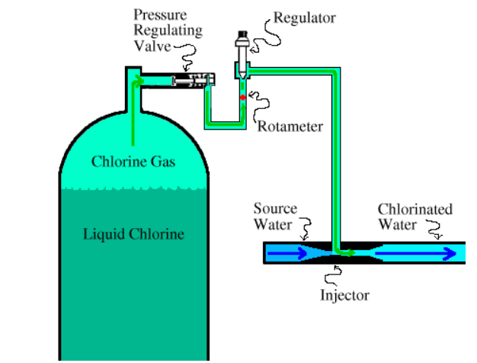
Figure 16: Chlorination Process [32]
UV Cleaning:
Ultraviolet (UV) light is higher in energy than the visible spectrum and attractive for cleaning applications due to its strong germicidal ability. Water purification using UV was explored in the early 1900s but abandoned due to high operating costs, faulty equipment, and other methods of water purification [5]. Due to the motivation of the project we believed it was necessary to add a UV cleaning system to make sure no pathogens can grow in the water. UV light has three different wavelength zones, the wavelengths having the germicidal properties are referred to UV-C, which are wavelengths that range from 100nm to 280 nm [5]. Figure 17 shows the different types of UV light on the electromagnetic spectrum. The typical UV treatment device consists of a cylindrical chamber housing the UV bulb along its central axis. A quartz glass sleeve encases the bulb; water flow is parallel to the bulb. A UV system housing should be of stainless steel to protect any electronic parts from corrosion. Ultraviolet water treatment effectively disables viruses, Cryptosporidium, protozoa, cysts, E. coli, coliforms, typhoid fever, giardia, hepatitis, and bacteria. A common misconception of using UV light to disinfect water is that the UV radiation eliminates the pathogen when in fact, it does not remove the pathogen, it only neutralizes it. Pathogens with thicker cells require a higher power UV lamp or longer exposure, so UV filters will be rated at gallons per minute (GPM) which quantifies the disinfection speed of the system. UV filters cannot be used alone though. Since UV rays can only travel in a straight line, if there are particles bigger than 5 microns, microorganisms can hide behind them and avoid exposure.
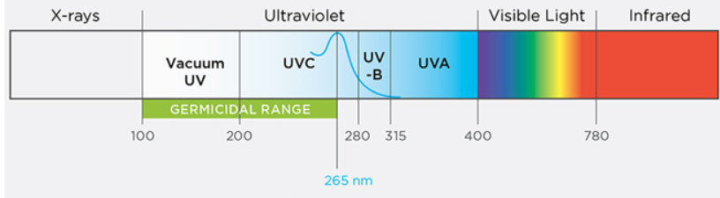
Figure 17: Electromagnetic spectrum showing UV spectrum [24]
Power and time are very important to pay attention to when using UV as a disinfectant. Each pathogen has its own amount of time it needs to be exposed to UV radiation to be neutralized. The exposure time is reported as "microwatt-seconds per square centimeter" (uwatt-sec/cm^2), and the U.S. water standards require a minimum exposure of 16,000 µwatt-sec/cm^2. The following figure is from the water-research.net and shows how long common bacteria and viruses need to be exposed to a 100% lethal dosage of UV light. Since we are not monitoring the power of the UV consistently, we are choosing to treat the water for longer so that each bacterium experiences enough exposure. This is in case we are not at 100% power; we want to make sure the water is still treated and safe. One of the bacteria in the table, Escherichia Coli (E. coli), needs 0.36 seconds of 100% lethal dosage to be inactive. This does not mean our water is not treated, it just means the bacteria may still be in the water but inactive and harmless.
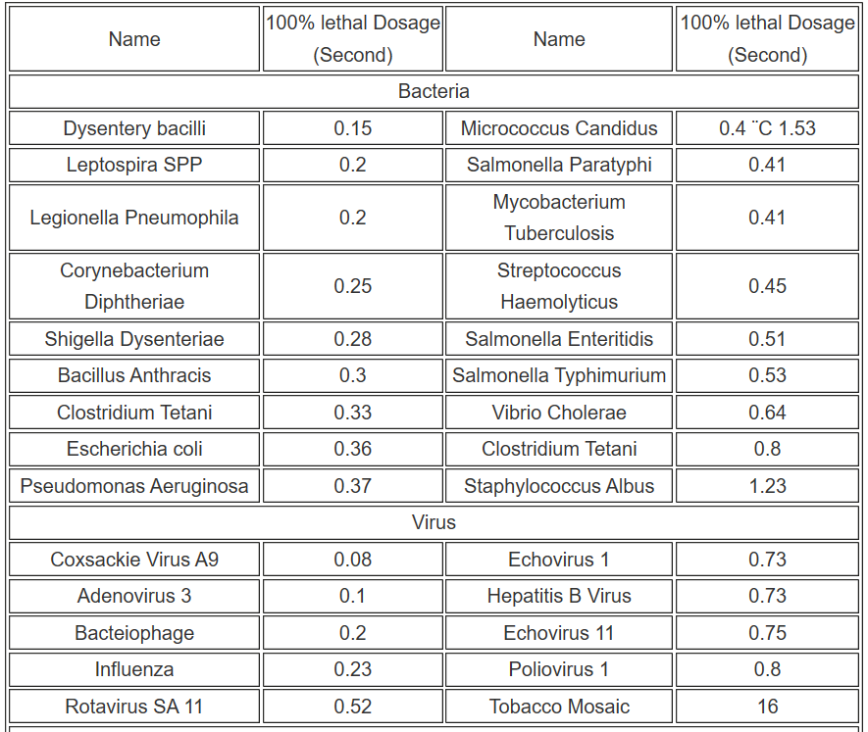
Figure 18: Chart showing time certain bacteria and viruses need to be exposed to UV light at 16,000 μW-sec/cm² [5]
The two options for UV disinfection are LEDs and Lamps. The main property to consider when comparing these two options for the system is intensity. The less intensity, the longer the water must be treated. If we chose LEDs, we would need many wires together throughout the system and multiple tests to make sure all the water is covered by the light. We would also have to wire and make sure all the LEDs were outputting the same amount of power, if one LED is not putting off enough power to treat the water, there might be parts of the water that still contain pathogens allowing them to reproduce and re-contaminating the entire water sample. For small systems that don’t need to clean a lot of water at once, LEDs would be good because you can tailor the wavelength they give off, they are inexpensive, and you wouldn’t need many, but for our system we do not believe they are the best choice. A UV lamp can evenly disperse power around the entirety of the cleaning tank, and we will only need to purchase one instead of many. LEDs also have a large wavelength spectrum, meaning you would have to tailor and monitor multiple LEDs to make sure they are emitting the desired wavelength. The two figures below show one UV lamp compared to a strip of 18 LEDs. As you can see the lamp emits UV light in all directions due to the cylindrical shape, while the one strip of LEDs would only emit light in one direction. Comparing these, we would only need one UV lamp versus many strips of multiple LEDs. Figure 18 is a picture of a simple UV lamp which looks like the one we will be using in our system. The UV source in the filtration system we are using is a SterilumeTM-EX UV lamp with a wavelength of 254nm.
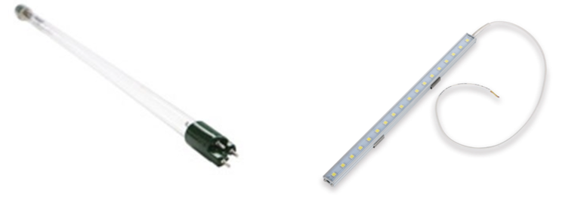
Figure 19: UV lamp and UV LED strip [30,31]

Water Analysis
There are many ways that industry and residential water companies analyze the water that gets used by the end consumer. In order to guarantee our system cleans water up to standard, we wanted to add in a monitoring system. This is one characteristic that should make the project stand out from most other water filtration systems. Most portable systems do not have quality monitoring because it can be expensive or too big to integrate into a portable system. There are many, many water quality parameters that are taken into consideration as well as many ways of checking these parameters. A few commonly used waters tests include temperature, pH, nitrates, dissolved solids & salinity, turbidity, bacteria, and spectroscopy tests. These are just a few types of tests as these tests have become much more complex over the years. For example, spectroscopy analysis which will be used in this project is a more advanced method of water analysis.
A fundamental factor in water analysis would be pH levels, which are a means of measuring water’s acidity or alkalinity. The pH scale generally ranges from 0 to 14, with 7 being neutral, 0 being acidic, and 14 being alkaline. Ideally fresh water lies at a pH level of 7, being neutral, which means the amount of Hydrogen (H+) and Hydroxyl (OH-) ions are equal. Salt water on the other hand is more alkaline having more Hydroxyl ions in it than Hydrogen ions. This characteristic makes fresh water much more vulnerable to changes in pH level, where salt water has minerals that block out changes in pH. Naturally the decomposition of organisms and materials creates carbon dioxide (CO2), this produces a carbon-based acid that ultimately increases acidity in the water. Other unnatural aspects like increased emissions contribute to this as well. Luckily there are natural ways of dealing with this like limestone, which is often also used in water softening techniques. pH levels can dictate whether a fluid is harmful or beneficial for humans and is an important part in water analysis and cleaning.
Another type of water quality test is the turbidity test, which is a measure of the water’s cloudiness. Like spectroscopy, a measurement of light passing through the water is used. When there are solids in the water, the light is unable to pass through completely, and thus creates a higher turbidity rating. These solids in the water can range from microorganisms to just typical sediment. Turbidity influences the previous aspect of pH levels as well. With higher turbidity, organisms such as plankton cannot reproduce or survive, so they decay. This raises the pH level in the water. Along with this, since the water now has a shade darker to it than that of clear water, it will now retain temperature and heat much more. This cloudiness of the water can lead to contamination, and in nature it can even kill the fish from clogging their gills. So as one could assume, this can also be harmful to humans and needs to be dealt with.
Overall, we would like to test for specific contaminants in the water therefore pH testing and turbidity testing are not the kind of analysis we are looking for. Since we are also evaluating temperature, we are looking at more than just contaminants, but due to the time constraint of the project we are not able to add every analysis technique. In the future we might be able to look at adding pH and turbidity testing into the system while still allowing it to be portable, therefore every aspect of water quality if recorded. Lastly, the water analysis that will be used in this project includes spectroscopy and temperature analysis. These processes are explored and explained further in the section below.
Contaminants:
There are multiple approaches to testing the quality of water, some approaches only test for one kind of contaminants. There are different techniques for analyzing organic compounds, inorganic compounds, bacterium, and pathogens. Our overall goal is to find a form of analysis that can look for all or most of the types of contaminants. Inorganic ions such as nitrate, nitrite, and fluoride can be analyzed by ion chromatography [47]. Chromatography is a laboratory technique that involves separating a mixture and measures concentrations of ionic species by separating them based on their interaction with a resin [48]. Chromatography can also identify cations such as lithium, sodium, and ammonium. This technique doesn’t identify heavy metals, bacterium, or pathogens. To accomplish chromatography, we would need to take samples of the clean water to a lab and have a specialist conduct the analysis for us. The equipment needed for this method is shown below in figure 19. This technique requires too much equipment, a second location, a specialist, and doesn’t test for all the contaminants we are looking for; therefore, this would not be the right method of analysis to choose.
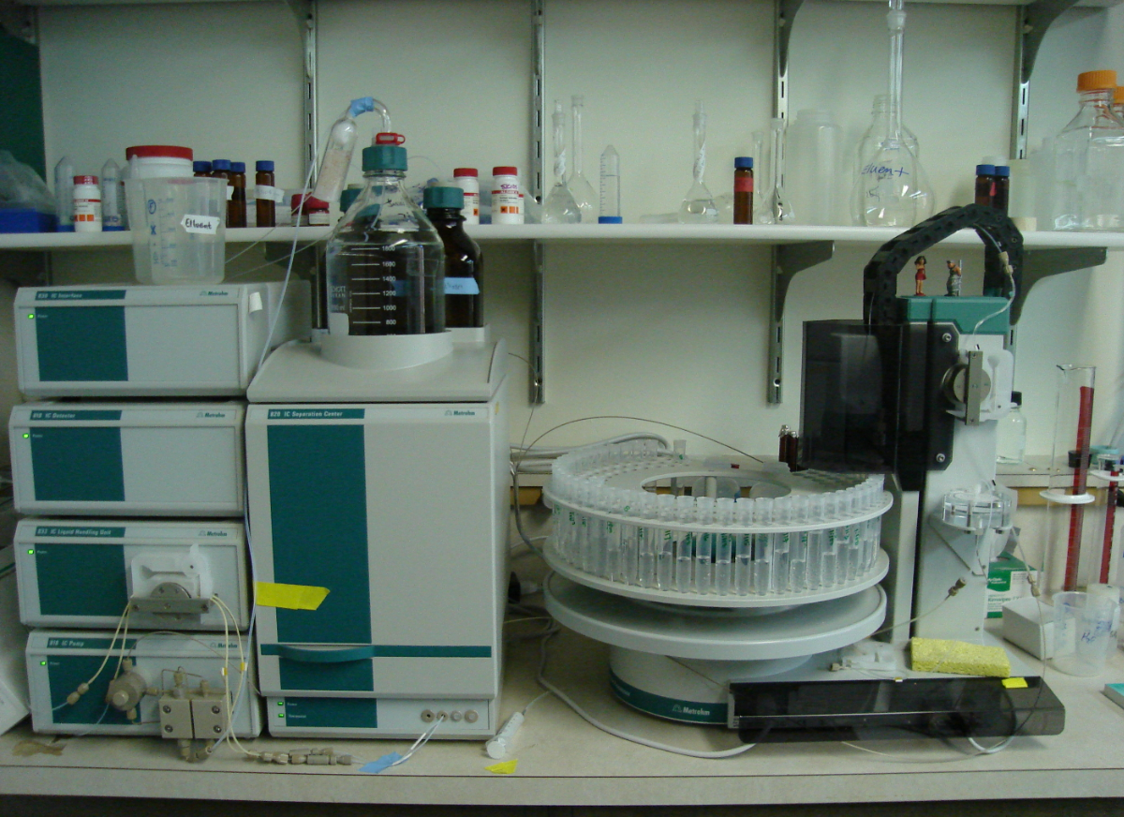
Figure 20: Chromatography equipment and process [48]
Water analysis for contaminant can also be done by inductively coupled plasma mass spectrometry. Inductively coupled plasma mass spectrometry (ICP-MS) is is a type of mass spectrometry that uses an Inductively coupled plasma to ionize the sample. It atomizes the sample and creates atomic and small polyatomic ions, which are then detected [67]. This type of analysis is very dependent on the stages of sampling, preservation, transport, and storage of water samples. They must be performed in such a way that contaminations are not introduced into the sample and all the determined elements remain in solution, ICP-MS allows determining more than 60 elements in each sample with detection limits lower than nanograms per liter for uncommon elements (rare earth elements, U, Th, etc.) and micrograms per liter for common elements (B, Mn, Zn, Cu, Ni, etc.) [66]. Although with this type of spectrometry you can determine multiple elements, the water sample must be handled with such care that anything small could ruin the analysis. This would not be reasonable in a system that is going to be transported or sent to areas with little access to cleaning. The equipment for the technique is also unreasonable to integrate into a portable cleaning system and extremely expensive. The figure below shows an ICP device at the Rausser College of Natural Resources. The only reasonable sense in which we could use this technique would be to send samples of our water to a facility with this device, which defeats the purpose of inline monitoring.
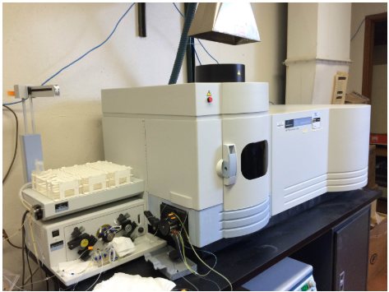
Figure 21: Inductively coupled plasma mass spectrometer [68]
Another form of contaminant analysis is called light spectroscopy. Spectroscopy, more specifically vibrational spectroscopy, measures a molecules vibrational energy level by exciting it with a light source and measuring the shift in wavelength [1]. This method of analyzation can give insight into the chemical composition of certain molecule and many other properties that can expand scientific knowledge in different molecules. Spectroscopy is often looked at for chemical and biological analysis, precisely infrared and Raman spectroscopy, due to the ability to analyze samples without adding or modifying the sample. Another spectroscopy technique used to analyze biological compounds is fluorescence spectroscopy. There are many types of spectroscopy that could fit for water analysis, but our goal is to choose one in which we can look for the largest variety of contaminants. The figure below shows a few simple ways to set up Raman spectroscopy systems. Compared to the two systems above this approach seems more reasonable to integrate into our design. Overall, if we wanted to look for multiple kinds of contaminants, we felt a spectroscopy approach for analysis was the best fit.
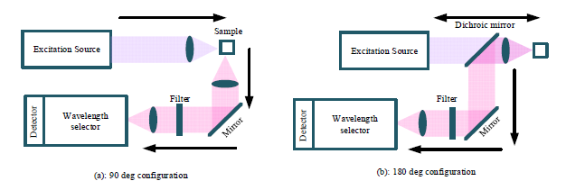
Figure 22: Simple Raman set ups with 90- and 180-degree orientations [1]
Temperature:
The temperature of water is also associated with the national standards of drinking water. Many things can affect the water's temperature inside and outside of the system. The speed of which the water is moving through the system can lower the temperature, while the UV cleaning treatment could raise the temperature of the water. The standards state the water should be between 50°F (10°C) and 60°F (15.55°C). The temperature of water is important because of its influence on the chemistry. At higher temperatures chemical reactions happen quicker than at low temperatures. Groundwater is typically at a higher temperature which lets it dissolve more minerals. Depending on where the water put into the system comes from this can pose a problem. Groundwater can have too high of a temperature and river water can have too low of a temperature. The temperature of the water is also greatly affected by the geographical area on earth. Currently we have no temperature controlling system if the water is too hot or cold, but we will have a temperature monitoring system in place. Even if we cannot control the temperature of the water, monitoring it shows that compounds are more likely to reproduce in hotter temperatures and if the temperature is unfavorable a different water source should be used.
We would like to be able to monitor the water's temperature without inputting and wiring a device inside the tank. The best option for this would be using an IR temperature sensor, because they are contactless and can read moving objects, therefore we would be able to monitor the temperature while it's moving through the system. One thing to note about IR temperature sensing is that it will only read the surface temperature of water. We don’t anticipate this to be a problem because the water being measured will not be very deep, therefore we believe the surface temperature we measure will be an accurate representation of the water's temperature. Another motivation for using an IR temperature sensing system is because in our current pandemic they are using IR temperature reading in certain places, including airports, to ensure people traveling do not have fevers and are not spreading the virus. They are also using this because it is contactless, effective, and quick. We wanted to incorporate as much technology being used for the pandemic into our system in a unique way. Infrared temperature sensors have wavelengths with range from 700nm to 1400nm, this means it might be possible to use the excitation source from the spectrometer to also measure the surface temperature of the water using a beam splitter. If we are not able to use the spectroscopy source in temperature analysis, we would need to purchase an infrared source with a corresponding infrared sensor.
There are also IR temperature sensors that do not require a separate source. There are sensors that measure the amount of infrared energy that comes off of an object. These sensors are a good approach because you don’t have to buy two separate pieces of equipment, but these sensors also have a small field of view, so they must be rather close to the object you are trying to measure or it will pick up another object’s infrared energy. These sensors might also be a good fit because they consume less electricity than two pieces of equipment and are able to be easily set up without too much alignment. Also, since we are measuring the water temperature through glass, if we used a source into a sensor, the glass would disperse the light and we would have to use a lens to correct and it would take a lot of aligning. Since the system is supposed to be portable, aligning a laser source would not be able, because if it moves even the slightest, the system would have to be open and the laser re-aligned.
Human analysis:
The human body is an amazing machine. At the Metropolitan Water District of Southern California (MWD). About 3 times a week, bottles of water are given to professional water tasters to test the quality of the water. Even though the lab has a 6 million dollars water analyzer the most sophisticated impurity detection devices are humans itself. The human palate and sense of smell are the two chemical detecting senses humans have. The test is done in the following way. Three men are given water to analyze. The test is always done with more than one man at a time, since participants are more sensitive to different tastes and odors. The liquid was poured in Styrofoam cups and distributed among the analyzers. Then, each one takes a sip of the water and is asked to record their findings. Then, each of the 3 participants described the water as swampy, rubbery etc.
The palate is an evolutionary characteristic evolved through the years to detect pathogens and harmful substances in food and water. “The human nose is more sensitive than any analytical equipment we have''. Said Michael J.Mc Guire. Turns out just by evaluating the taste of the water, we can detect the existence of contaminants and evaluate how harmful it is. Machines, on the other hand are, are more precise in terms of finding the specific concentrations of the substance. It is difficult to make sense of the data machines in what they should detect though. In this water treatment facility those professional water analysts are used to point out the machines in the correct direction. The machines used to analyze the water are extremely sophisticated; they can detect one part per trillion. But it doesn’t necessarily know what finding a specific concentration means. Also, some impurities detected in the range of one part per billion can be economically impossible to purify and of any health concern whatsoever.
The water analyst together with the machines are responsible to help to detect impurities. For example, if the water is swampy it might indicate the presence of algae in an then. Similar professionals are also used in beverages companies, in the production of beer and soft drinks for example. They are trained to improve their palate beforehand. They say that ideal water should have almost no taste and should not: “leave a bad taste in the mouth afterwards”.
Water should not be drunk in its purified state. Absolute water H2O. It is isotopic to the body and it can drain the cells. If the water taste is too bland it could indicate that it is devoid of minerals. This is one of the reasons why spring water tastes better than water filtered directly in the house. By aiming to improve the taste of the water in the filter it will mean the water is cleaner and healthier in the end. That is why in our system we added the UV light system, which can improve the water taste and smell.

User Interface
Back in the day, programs were interacted with user commands. Like Linux’ shell terminal or windows command prompt. I will talk more about it in the operating systems section. Then, user interfaces were created. User interfaces, also called UI, are the front end of the software application. Their purpose is to allow users to interact with the software application in a more intuitive and user-friendly manner. User interfaces also decrease the number of bugs in the system, by limiting the user interaction. A very popular way of doing that is providing buttons and Text Boxes for the user to interact with. If the user can only interact with the application by clicking on buttons inside the user Interface. There will be a smaller amount of input to check. User interfaces come in very different shapes and forms, some of them are very creative in an artistic sense.
Almost all software programs have some type of graphical user interface, or GUI. Programs that feature a GUI generally have different types of graphics control objects, such as: buttons, toolbar, windows, etc. In some websites the GUI can be very complex and sophisticated both on the front end and in the back end. For example, in websites the UI often needs to handle web application attacks by using protection programs in the backend. If there is a textbox to get input from the user, some malicious user can run an injection attack for example. The idea of making GUIs for operating systems, created two of the largest tech companies of all times, Microsoft and Apple. Windows (Figure 23) and Macintosh (Figure 22) revolutionized the market by making computers accessible to the general population. Their intuitive UI allows users to jump right in and start using the program right away.
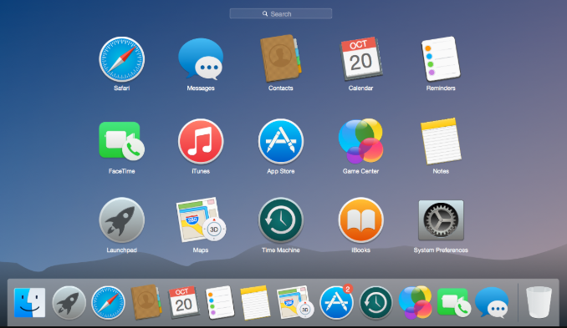
Figure 23: Mac Operating System

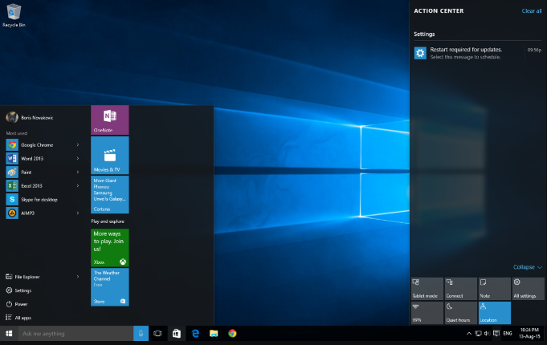
Figure 24: Windows operating system
As you can see, both Windows GUI and Macintosh GUI resemble one another. Both have the trash can symbol, for example. Also, both have a picture in the back of their desktop panel, a panel that easily allows access to other programs. But they are still different. Those similar elements help users to navigate between different operating system GUI without having to re-learn how to navigate a UI from scratch. One of the most important parts of designing user friendly UI is to make it like other famous UI designs. We will be designing a GUI for our application, prompting the user. This is an important component of the project since a bad UI can make the user confused and angry, for not being able to make the machine work as it wishes. Everybody knows how frustrating it is to have a machine that doesn’t work as expected.
The spectrometer outputs a graph showing peaks in the Spectra. The distance and size of those peaks are used to locate particles and pathogens. Those peaks though are in the order of millions. We have a couple of options to handle this data. Our first idea was to use a microcontroller, and then solder it to a PCB (printed circuit board). By doing this we would be cutting costs. In order to do this, we would need to break down the data in a stream. This stream would feed it to the controller using low level programming commands. Using this design, we would be feeding just enough data to fill the microcontroller memory while making it still operable. If this was accomplished, we would be able to decrease the cost of the overall system by reducing the number of assembled parts. This approach proved to be ineffective though, due to several reasons. One of them is that the data stream, even if broken down it would still be too big to fit in memory of any of the microcontrollers we searched. It would still be possible to break the data, by processing little chunks each a time. That process of course would be very time demanding and on top of that it would reduce the accuracy of the measurements. Besides, it would require a design in the byte range. This method would be extremely difficult to code. It uses very low-level functions. And the software would not be manageable. Even with the benefit of some libraries those microcontrollers feature like the Arduino library it would still be difficult.
The UI will be shown on a small Display on the side. The software will prompt the user. At the end of the filtration system the display will show what is the concentration of the element we are measuring using Raman spectroscopy. The UI will feature a done message intending to inform the user if the filter runs out of water. The display will be mounted in the side of the filter and its size should be big enough for users to see clearly.
The UI will display information about the system in 3 separate screens. In all 3 of those screens, the top right corner will contain 2 little icons. The first icon will display the battery charge. The second icon will inform if the solar panel is outputting enough energy to charge the battery or not. The first screen will be a standard welcoming screen waiting for the user to input the water. It will contain a wallpaper image in the back and a message in the center of the screen prompting the user to input the water. When the system detects that water was inputted, it will move to the next screen. The second screen will display a timer indicating how much time left until the water is ready. The last screen will contain several bar graphs indicating the amount of a couple of inorganic compounds including Arsenic. Close to the bar graph that will be a qualitative indicator. Saying if the amount of the compound is excellent, acceptable or unacceptable.

Microcontroller
Microcontrollers are used in a wide variety of locations, being cooking utensils, mice, keyboards, etc. This technology is very useful also because of its size and versatility. The demand for microcontrollers has just increased in the last decades. Even in 1971 when Texas instruments started advertising TMS1802 designed for applications run in calculators, cash registers, and different measurement instruments the demand was big. Or, when Intel launched the Intel 8048. This chip was widely integrated into several different PC keyboards at the time. Microcontrollers are a viable cheap option to implement simple automation features and applications that require little processing power.
Today microcontrollers are produced in the order of billions a year. The advancement of technology, and with Moore's law still holding, the processing power of computers continues to increase more and more while its size continues to shrink. The increase in processing power, and memory, allowed microcontrollers to become more sophisticated to deal with increasingly hardware demanding tasks. In the software, the development libraries and other software abstractions made them easier to program, as well as less prone to bugs.

Part Selection
The section below will address and explain the different parts that were selected for this project, in order to implement everything successfully. These parts have been chosen based on research between companies and quality. It will expand on the different features, costs, and types of parts being used and why they will be used.

Solar Panel
For this UV cleaning project, the group was constrained to a budget so designing the solar panel system needed to be well thought out. It did come as a surprise as to the amount of power required to fully charge a battery and run the system for the original specified time, which was a full 24 hours of operation. If the system were to be powered for 24 hours straight, the system would need three times the amount of solar power than it has now, which was just unrealistic for our project constraints. So, the operational time specification was lowered to 8 hours in order to better fit the budgetary constraints of the group. Which allowed the group to purchase a smaller sized solar power system. The solar panel utilized in this project can be seen below in Figure 25, with one zoomed out and zoomed in respectively.
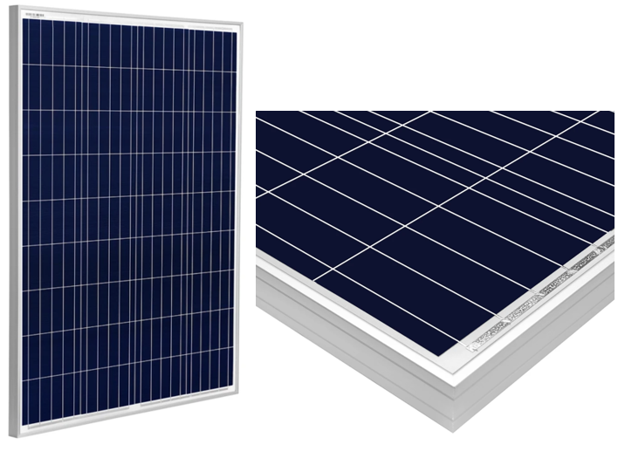
Figure 25: Depiction of polycrystalline panel with zoomed in portion [45]
The system will utilize two polycrystalline solar panels that were bought from Amazon for $239.00. This was right in budget for the group and will provide just enough power to fully charge the battery with an average amount of sunlight per day. The purchase came as a package deal from a company called Sun Gold Power with two 100-Watt polycrystalline solar panels and a charge controller was included. Originally the goal was to get higher efficiency rated components for the project, like monocrystalline solar panels, but this quickly made the group go over budget. So, the general agreement was to keep everything affordable, resulting in the purchase of the two polycrystalline solar panels. Although these solar panels generally have a lower efficiency rate compared to monocrystalline solar panels, they will certainly get the job done. Each solar panel will provide 100 watts of power at a nominal voltage of 12 VDC which will be used to charge the battery. They both have dimensions of 36 x 26.3 x 1.1 inches and weigh 14 pounds. This was larger and heavier than preferred, but once the group started designing the solar power system and began buying parts, it was soon realized that this will have to make do. More important electrical and general specifications associated with these solar panels are in the data sheet in Figure 26 below. Overall, this set of solar panels should serve as a great power source for charging the battery in this system and was just within budget, making them a great candidate for purchase.
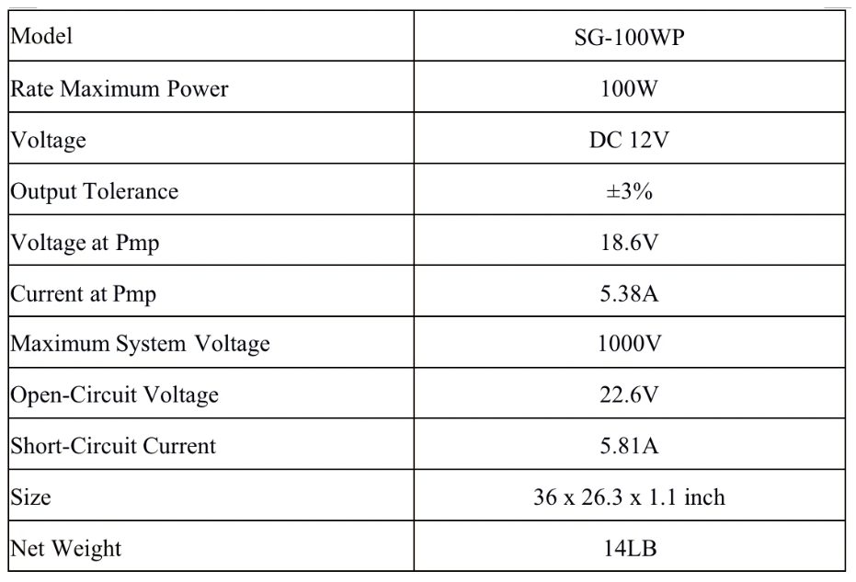
Figure 26: Data sheet of the solar panels utilized in this project [45]

Charge Controller
When looking for a charge controller for this project, the group needed to stay within budget. So, the charge controller that was purchased for the project was part of a package deal which included two solar panels as well. Although this restricted the group to using whatever type of charge controller that was included in the set. The charge controller that was purchased should offer all the means of charge regulation that the system will need. As described in the above research section, this will serve as the charging component for the battery, taking the solar panel power and distributing it to the battery when it needs charge. The specific charge controller being utilized in the solar power system is pictured below in Figure 27.
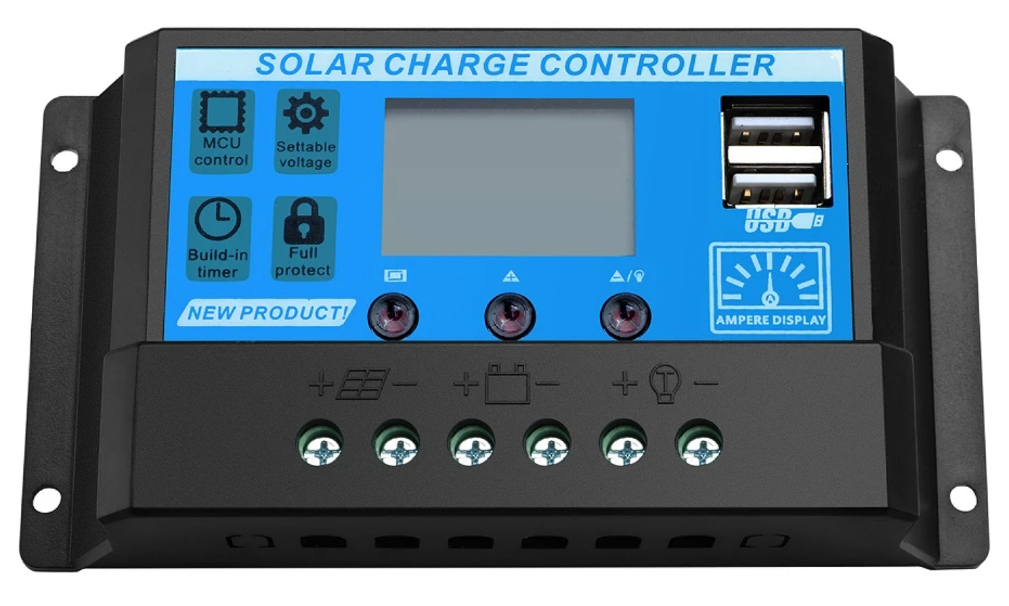
Figure 27: Frontal photograph of the PWM charge controller used in this project [45]
The specific charge controller that was purchased is a 20A, PWM solar charge controller. It features two USB sockets that can be used for any standard USB charger and can charge two devices through these ports at the same time. Although that is just an added, luxurious feature, it could serve a purpose to power various components within the system like the LCD screen or micro controller. This PWM charge controller also includes a few protections features that as well will exceed its performance such as, overcurrent protection, short circuit protection, inverse connection protection, and low and high voltage protection. These features will serve to protect itself as well as the different components it is connected to in the case of a bad wiring job, or just normal operational obstacles that will be faced. A more straightforward data sheet is located below in Figure 28, that expresses the electrical specifications that are associated with this charge controller.
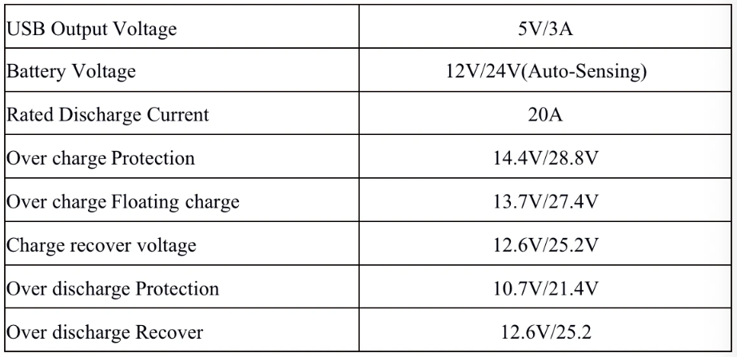
Figure 28: The data sheet associated with the PWM charge controller utilized in this project [45]
The charge controller also has a collection of features that serve as a user interface. First the front of the controller, as seen in Figure 27, has three buttons that let the user traverse the different modes and settings. There are fourteen main functions that the charge controller lets the user use or change. These include battery type, load output timer, charge voltage setting, low voltage disconnect and reconnect setting, solar trigger and delay voltage, short circuit protection setting, PWM charging enable, output mode control, charging and discharging ampere display, controller body temperature display, and, finally, real time PV voltage display. These will be utilized to adjust performance, or change it depending on the operation of the system. The controller also offers six error alarm messages via the LCD screen, that appear as E01, E02, and so on. These include battery low and high voltage warning, output over current warning, output short circuit warning, high temperature warning, and PV over-voltage warning. All of these functions may or may not be utilized fully but hopefully they can be utilized to the system’s advantage.

Battery
Fortunately for the group, a battery was loaned from BCI Technologies that they had laying around and had no use for, see Figure 28 below. This saved the group about $150 to $200. Although the specific type of battery that was being loaned was out of the group’s control, it just so happened to fit the needs of the system very nicely. The battery is also quite bulky weighing in at around 50 pounds and having the dimensions 10.2 x 8.4 x 6.6 inches, but this is what was needed to power the system. From the solar power design section, the system needs about 1000Wh of power per day. If you divide this by the nominal voltage of the battery, 12V, you get amp hours and a value of about 83Ah per day. This is the rating that is used in battery classification, so the system needed a battery of about this size.
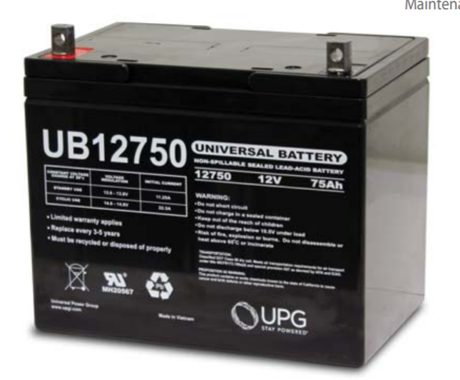
Figure 29: UPG Universal Battery, UB12750, No. 46082 [46]
The battery that is being loaned for the project is a Universal Power Group (UPG) battery, model No. UB12750 and UPG No. 46082, which can be seen above in Figure 29. It is rated for 75Ah, at a nominal voltage of 12V. This is slightly less than the calculated amp-hour rating in the design section, but luckily these calculations were rounded up at each stage, so this battery should serve as a good fit for the project. The type of battery is a sealed lead acid battery. Although these are not as great characteristically as lithium ion batteries, this specific one has great advantages. In this situation the battery is being used as a cycle battery, being charged and discharged continuously. The UB12750 should work great in this application because it has a great depth of discharge for the first 200 cycles. The battery can be discharged by 100% for about 200 cycles and 80% for the next 230 cycles. While this project will most likely be used for demonstration mainly, this battery will enable the system to work for much longer than needed. Additional electrical specifications can be seen from the battery’s datasheet below in Figure 30.
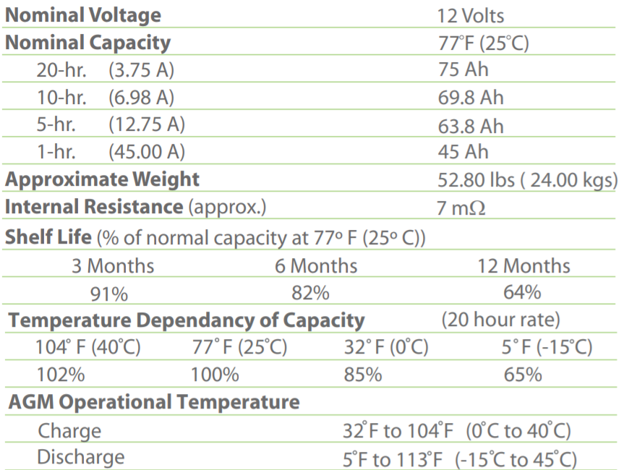
Figure 30: Datasheet for a UB12750 battery being used in this project [46]

Microcontroller/ Microcomputer
Microcontrollers, like Arduino (depicted in Figure 30) and MSP430 series from Texas Instruments, feature standard libraries built by their respective manufacturers. These are intended to simplify the development process, for both hobbyists and engineers. Nonetheless, microcontrollers are still generally programmed using low level programming languages, such as C or C++. For this project we tried to work on the highest level possible. Designing something from scratch can be very time consuming and, even worse, can carry a lot of bugs. Those bugs can carry over to the final product and even jeopardize the success of the project. Fixing them later can be even more time demanding. Since time is the biggest constraint in this project, we will try evading designing things from scratch, even if it ends up being more costly. But by reducing the size and the cost of the microcontroller this will enable our project to cut costs and become more portable. Also, depending on the features we will decide to add in the future, we might add an additional microcontroller to the system. The other microcontroller will have different specs depending on the functionalities.
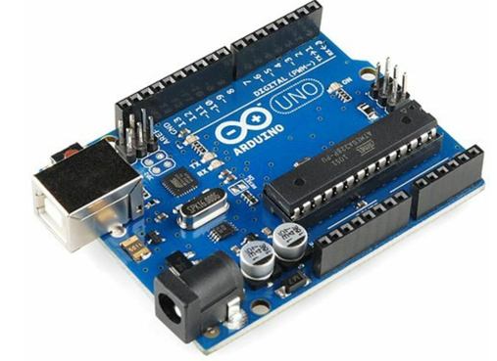
Figure 31: Arduino
Initially we assumed the input signal from the spectrometer was an analog signal, but we later discovered it is a digital signal and the only way to interface the spectrometer with the microcontroller is to use an USB and use Ocean Insights prebuilt libraries. This left us with a couple of options. To execute a spectrometer application program from ocean insights itself (Ocean View). Or to use OmniDriver and Spam, libraries developed by Ocean Insights to control the spectrometer. Spam is lower level, OmniDrive is higher level. I will discuss more about both methods later. But nonetheless these the specifications of Ocean View were used to estimate the minimum requirements of the microcontroller used in the system.
Raspberry pi 3 model A+:
This microcomputer features:
- A 4 core Cortex-A53 (ARM v8) 64-bit with 1.4Ghz for the processor architecture.
- VideoCore VI Graphics Card.
- 512 MB RAM memory DDR2
- 1 ethernet port capable of transmitting data at a rate of gigabits
- 2 Micro HDMI ports
- 1 MicroSD socket
- A 3.5 mm audio jack
- A Wi-fi connection of 2.4GHz and 802.11 b/n/ac
This computer only has 512 MB of RAM, so the only operating systems compatible with this model would be the ones that utilize Linux. It features 1 USB2.0 port, which works because only one USB port is necessary to connect to the spectrometer. It features 40 ID_SD pins to connect the temperature sensor being used, as well as other analog sensors that may be utilized in the project. Since the model does not have enough memory for any other operating system, Windows would not be an option. This model also does not support Ocean View for the same reason. It would, however, support our custom application. It is 28% cheaper than the other raspberry model though.
There are several different microcomputers on the market. One alternative to the raspberry pi models is the rock64 model (depicted in Figure 31). This microcontroller is like the raspberry pi models in size, being 85mm to 56mm, about the size of a credit card. The size of this microcomputer qualifies for our project. Just like the raspberry pi it could be placed in a waterproof box. The chipset features up to 4GB of RAM memory, our application plus the OS should spend 2 GB of Ram total, so the amount of memory in the system is also good. This system is a cheaper option to its counterpart, the raspberry pi, but interfacing it with a touchscreen display might be more problematic. Since the rock64 chipset doesn’t feature a compatible display like the raspberry pi. So, interfacing the system with the display might be a little harder. Installing an operating system and connecting it to the spectrometer will be of similar challenge though.
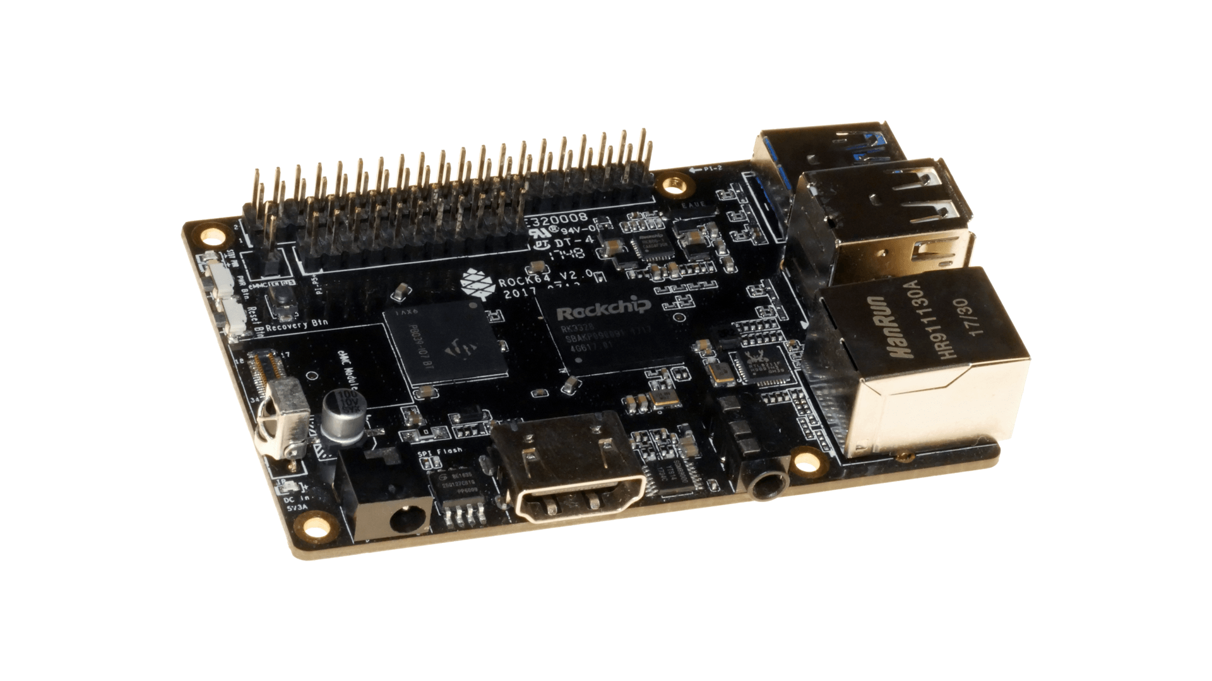
Figure 32: Rosck64
Rock64 is manufactured and designed by the company “Pine”. It is made to be a small credit card size reliable single board computer. It provides an eMMC module socket as well as a microSD to expand the hard drive, required to store the operating system. The computer is compatible with android 7.1 plus Debian and other Linux distributions.
Specifications:
- Rockchip Quad-core SOC with Mali 450MP2
- · LPDDR3 RAM (up to to 4GB)
- · Giabit Ethernet
- · MicroSD slot
- · SPI flash 128 Mbit
- · 4k Digital Video Out
- · 2x USB 2.0 Host
- · 1x USB 3.0 Host
- · PI-2 Bus
- · P1-P5 Bus
- · IR R/X Port
- · Real Time Clock Port (RTC)
- · Power over ethernet (POE)
- · A/V Jack
- · Power, reset and Recovery Buttons
- · 3.5 mm Barrel Power (5V 3A) Port

Pump
Considering all the above our team decided upon a Flojet 03526-144A Triplex Diaphragm Automatic Water System Pump (I will refer to it as the Flojet henceforward). The Flojet is shown in Figure 32 below. There were many attractive features about this pump that made it the best fit for our design. Firstly, the Flojet is a self-priming pump and can run dry, without water and not damage itself. Furthermore, this pump was intended to be used on a marine vehicle or an RV, so it runs off 12V DC instead of 120V 60 hertz AC. Our system is utilizing solar power, which is all DC voltage, so by using this pump we will not need DC to AC conversion. This makes the voltage regulation and supply much simpler and more efficient. The motor inside automatically turns on once the 12V DC is connected to the motor, so there will need to be a switch or control signal. But not having to worry about a variable speed motor will simplify the water system. It also pumps at an average rate of 2.9 GPM, at around 10 psi. This pairs nicely with our UV sanitizer system which operates at around 3.5 GPM. Although the pump has a slightly lower flow rate, this allows for a prolonged exposure to the UV light which can work to disable more resistant pathogens. Finally, at a price of $63.99, it was the most cost-effective module our team could find. This fit nicely within the groups budget and was the final decision maker for the pump.
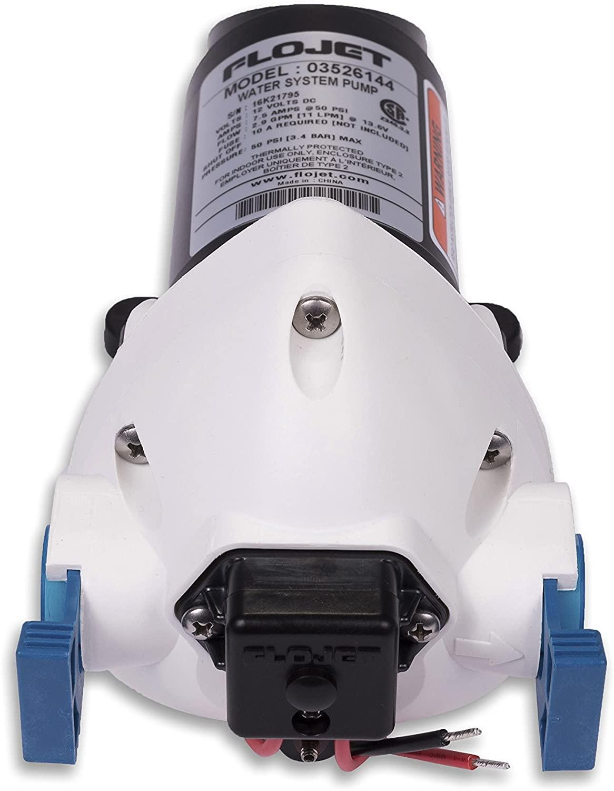
Figure 33: Flojet Pump 03526-144A Triplex

Filtration and UV System
From the above systems, it was concluded that the best choice of water filtration system for our project’s needs is the UV system. These systems, paired with filters, work exceptionally great in getting rid of the most important pathogens. UV filters do this in a timely manner unlike distillation and do not add any potentially harmful chemicals to the drinking water unlike chlorination. These systems cannot be used independently though. Our UV system will be accompanied by a filter system which includes a sediment filter to remove larger sediment that microorganism could possibly hide behind, as well as, an activated carbon filter to remove smaller particles and remove bad odor. This will also serve to take some of the most harmful heavy metals like lead and mercury out of the water. This combination will serve as a great way to effectively clean the water that will later be analyzed with spectroscopy.
The highest quality ultraviolet filters used in chemistry labs usually and can cost over $5000. Residential systems can easily cost $700 up to the prices of the industrial ones. The main difference in cost of UV systems is capacity and collection of optional features like sensors that monitor the effectiveness of the bulb, or filter lifetime. The system that is being utilized for this project is a Viqua VT4-DWS/12 from Viqua, which is shown on the left in Figure 33 below. The VT4-DWS model comes in a few different configurations including a DSW, DSW11, and DSW/12. There is also a smaller model that is made called a VT1-DSW shown on the right in the figure below. The only differences between the large and big ones are the size, and flow rate. Both models come in AC and DC configurations as well.
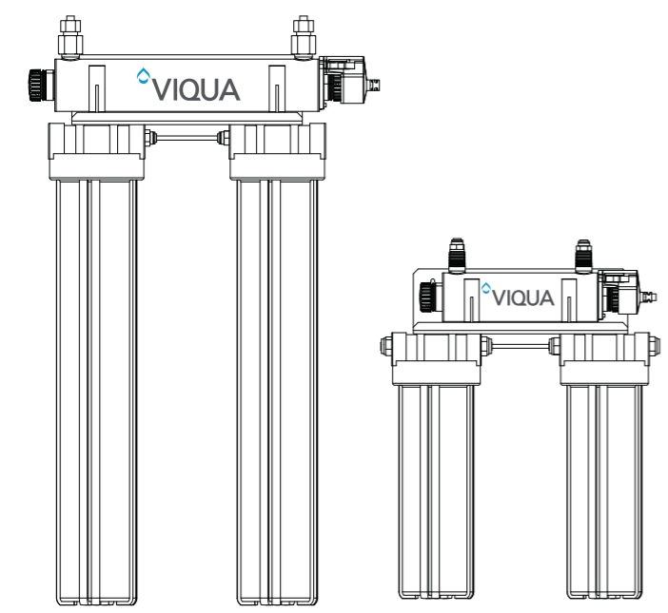
Figure 34: A depiction of the Viqua VT1 (right) and the VT4 (left) models from the data sheet [64]
The Viqua VT4-DSW/12 that was purchased for this project, has the following features, and the figure below will provide a more in-depth chart of these. The system has a flow rate of about 3.5 GPM which corresponds to a 96% successful UV treatment. For our overall design, we also needed a DC powered system which is perfect because this model runs off a 12V DC as well. The UV system was the second most power consuming piece of the puzzle at a 19-Watt power consumption. Although it uses a decent amount of power, it should be powered easily and will pair nicely with the pump we have selected for the system. More importantly, the system is specifying that it is a great source of filtration when it comes to bacteria, chlorine, lead, and cloudiness. This is optimal for this project as it will give a clean source of water for our spectroscopy analysis.
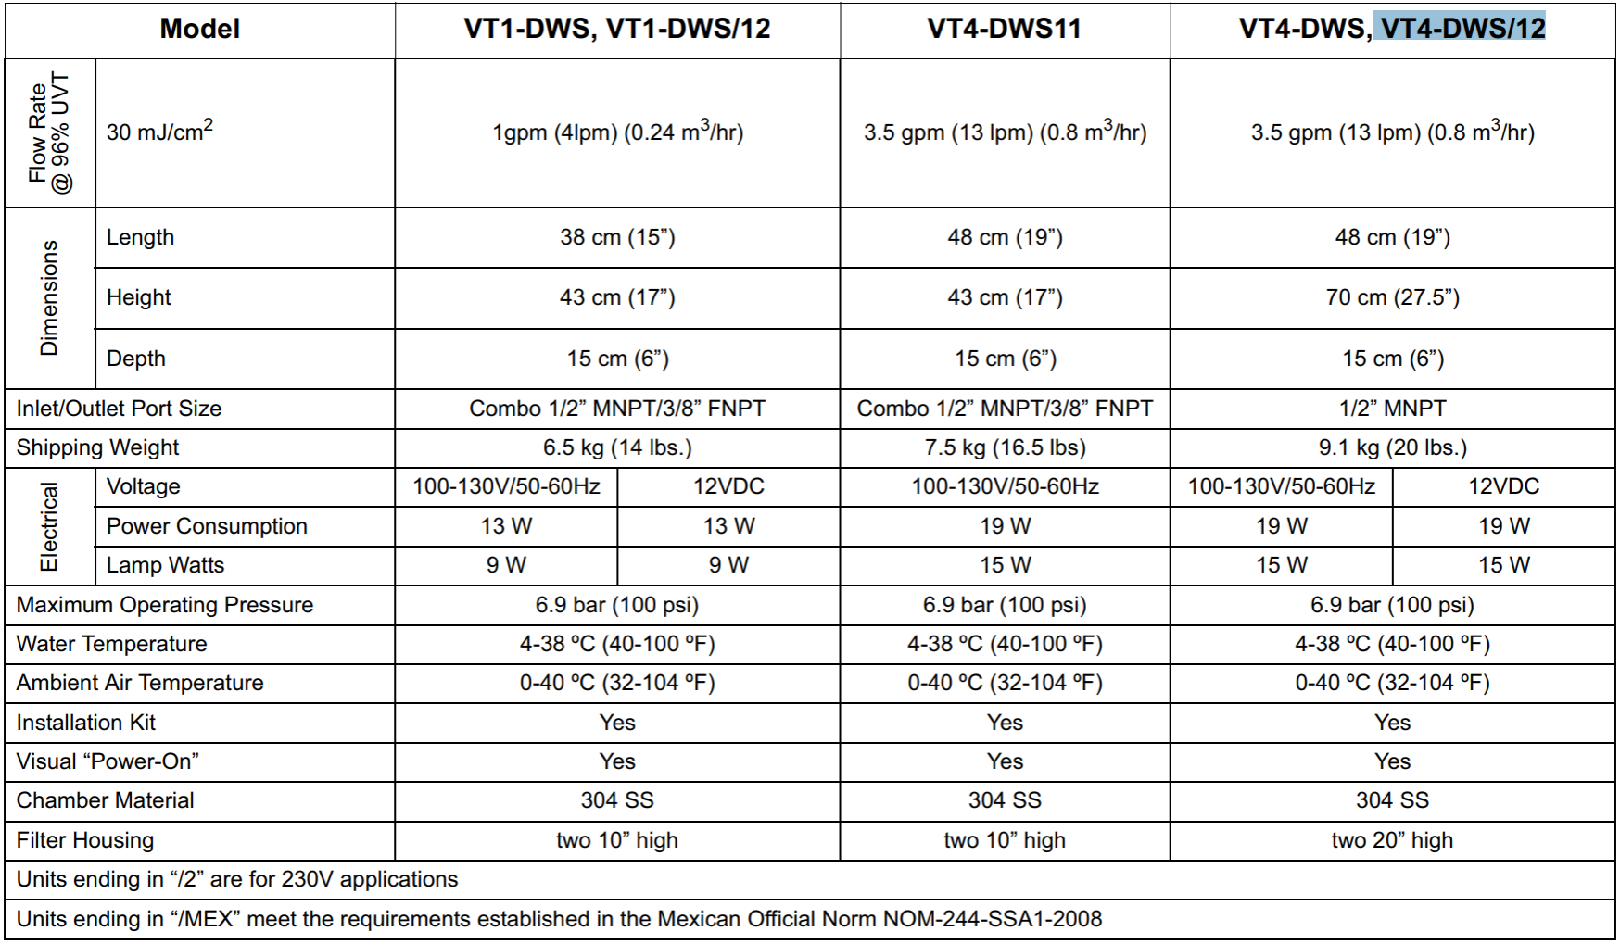
Figure 35: Specification chart from the data sheet on the VT collection [64]

Spectroscopy
Infrared (IR) spectroscopy is typically used to examine the structural analysis of molecules in samples and is also a technique based on absorption, since we don’t need to know the exact structural analysis of the molecules in the water this is not the right technique to choose. IR spectroscopy is also not a good choice for water analysis due to the strong light absorption of water. Since water has such a high absorption, inputting a broad range of wavelengths as the excitation source would not be the most effective way of analysis. With Raman spectroscopy, you choose one specific wavelength for your excitation source instead of using a small spectrum of wavelengths, which makes Raman spectroscopy ideal for water analysis.
Fluorescence spectroscopy can be useful when analyzing water, but mainly for biological compounds. This specific method relies on the light source exciting electrons and making the matter inside the water fluoresce. Fluorescence spectroscopy can detect fluorescent dissolved organic matter, but for our system we want to be able to detect more than just fluorescent organic matter. In theory we would like to be able to detect inorganic chemicals, radionuclides, and disinfectants alone with organic chemicals and dissolved matter. The other compounds are not natural fluorophores and sometimes dyes need to be added to a sample for certain matter to fluoresce. Adding dyes to our water could be counterproductive and the goal of this system is additive free water analysis. This method of spectroscopy would make the water quality analysis less diverse.
Figure 36 from compares the energy level diagrams for IR absorption, Raman, and Fluorescence spectroscopy [1]. This demonstrates how each spectroscopy technique works on the energy scale.
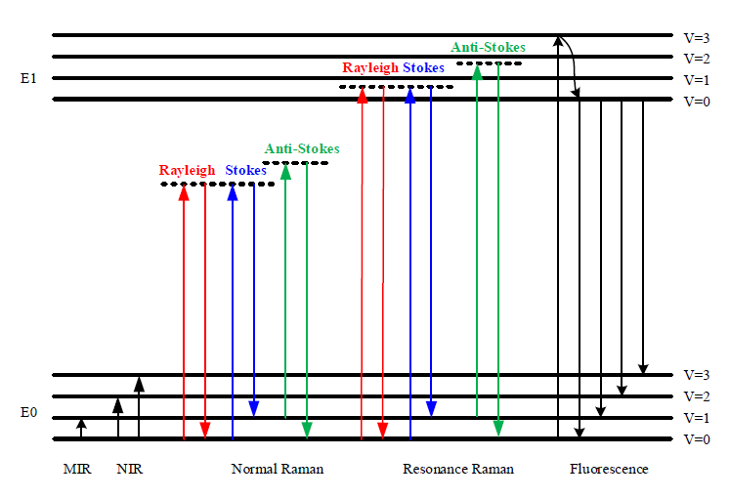
Figure 36: Energy level related to IR absorption, Raman Spectroscopy, and Fluorescence emission [1]
Water is a weak Raman scatterer, which makes this spectroscopy technique superior to infrared absorption and fluorescence. In 1970 Raman spectroscopy was first used to investigate organic contaminants in water, but due to the lack of sensitive instruments and strong fluorescence interference other methods were explored [1]. With the advancements in technology Raman spectroscopy has become a very popular technique for analysis.
After determining Raman Spectroscopy was the best technique for our system, we had to choose whether stokes or anti-stokes Raman spectroscopy. In anti-stokes Raman spectroscopy the photons in the excitation source collide with the molecules in the sample and take on some of the molecule’s energy, the energy gain in the photon is then measured by the wavelength shift. In Stokes Raman spectroscopy, the photons in the excitation source collide with the molecule and give the molecule some of its energy. This lost energy in the photon is then measured which is manifested in the wavelength shift. Stokes shifts occur at lower energy, higher wavelengths, and are more common than an anti-stokes shift. Figure 37 shows the energy level diagrams for bother Stokes and Anti-stokes Raman Scattering, in which anti-stokes scatters at a higher vibrational state than stokes, making stokes stronger than anti-stokes. The following figure, Figure 38, shows what the output that is being measured in stokes scattering, anti-stokes scattering, and fluorescence scattering will look like compared to the input.
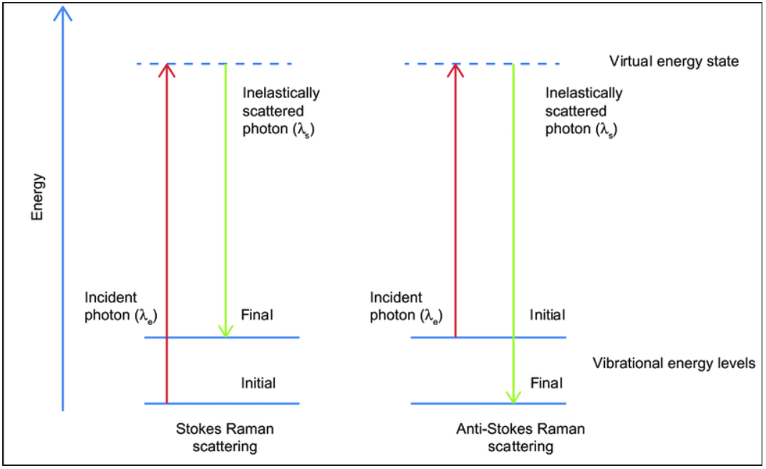
Figure 37: Energy level diagrams for stokes and anti-stokes Raman Scattering [6]
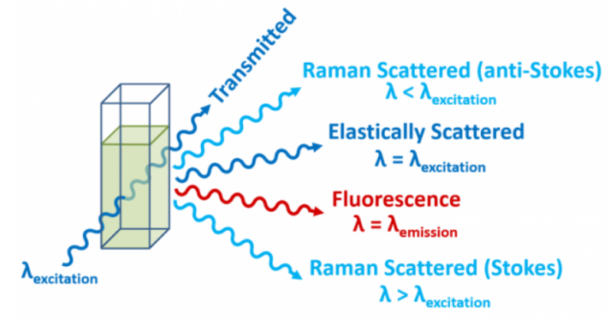
Figure 38: Visualization of different spectroscopy techniques [23]
When doing Raman spectroscopy, you can choose multiple excitation sources such as, near infrared, visible, and UV. Selecting the excitation source for Raman spectroscopy is extremely important. Each excitation source has its own advantage and specific use. In Figure 39, from “Raman Spectroscopy for In-Line Water Quality Monitoring”, it shows a couple commercial lasers for each source and the applications they are mostly used for [1]. The different wavelengths can overlap on applications, for example both a UV and visible source can be used to analyze semiconductors. As well as each excitation source has specific Raman spectroscopy techniques that they are associated with. The compounds you can find in the water are dependent on the wavelength of the excitation source. As stated above there is a possibility of fluorescence interference when doing Raman spectroscopy in water, to avoid this interference the best option would be to use a near infrared source. Since we are borrowing the system from Ocean Insights, we also must keep in mind what systems they have and are able to lend us. After discussing their equipment and what compounds we hope to find, we found that an NIR source is best for our system. The NIR source Ocean Insights can lend us, produces wavelength 785nm.
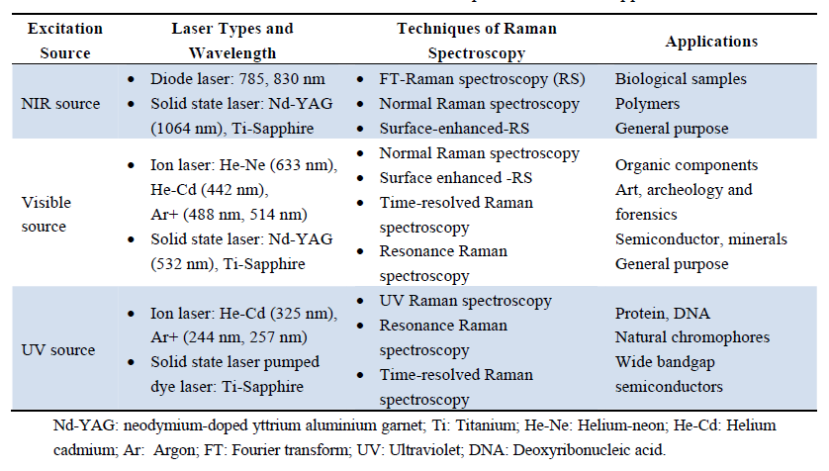
Figure 39: Comparison of commercial excitation sources for Raman Spectroscopy [1]
Choosing an NIR source leaves us to choose three different types of spectroscopy techniques, Fourier Transform (FT) Raman, Normal Raman, and Surface Enhanced Raman. The main difference for FT Raman spectroscopy is the use of an interferometer. The measured signal is the interferogram in time domain, and the Raman spectrum can be obtained by the Fourier transformation of the interferogram [1]. Not only is this an extremely complicated technique, but most commercial Raman spectrometers are not FT Raman. The figure below shows a simplified block diagram of an FT Raman Spectrometer from the paper in reference 1.
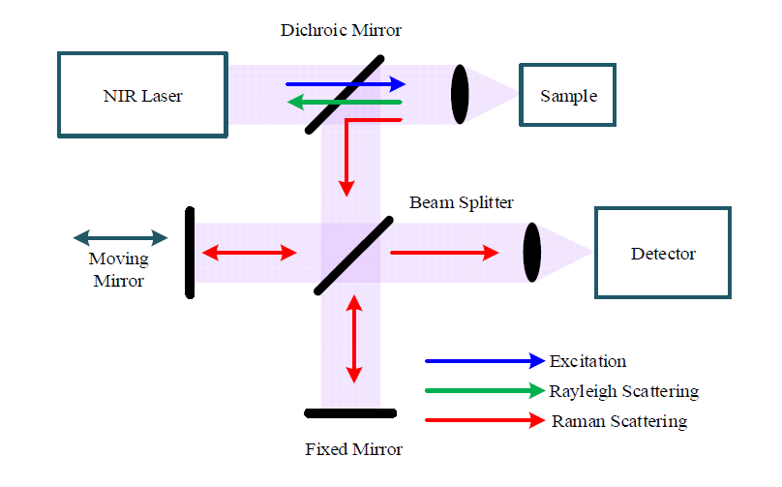
Figure 40: Simplified FT-Raman Block Diagram
Surface Enhanced Raman Spectroscopy (SERS) is an advanced Raman technique that is the most efficient technique for very low concentration detection. This is a pre-concentration technique and has a very complicated and time-consuming setup. Which means for our in-line monitoring system, SERS would be out of reach. Due to both constraints of FT-Raman and SERS we feel normal Raman spectroscopy would work best with our system. When the equipment is received, we may be able to modify and add parts that allow for better detection, but until we are able to use the equipment, we will be unsure.
There are many standards stated by the National Primary Drinking Water Regulations by the US government about what organic and inorganic substances and their concentration can be in drinking water. These standards are further analyzed in section 4.2.5. Although it is possible to monitor all these standards with Raman Spectroscopy, it is unreasonable and out of reach for this application. Therefore, we chose three compounds off the government standards list to look for when Raman Spectroscopy. Due to the motivation of this project our ideal compound to find is COVID-19, but since the virus has only been around a short time, all the information we need to identify with Raman Spectroscopy isn’t available. We also do not have the resources to find the spectra of COVID-19, and therefore cannot use our own scientific data. Since using Raman scattering to identify COVID-19 is not an option, we decided the three compounds we chose have a drastic impact on someone’s health if they are in drinking water. Another goal was also to show the diversity of Raman Spectroscopy, therefore the compounds chosen are from three different categories. We chose a heavy metal, organic chemical, and an inorganic chemical. Below are the EPA approved levels of each contaminant in water.
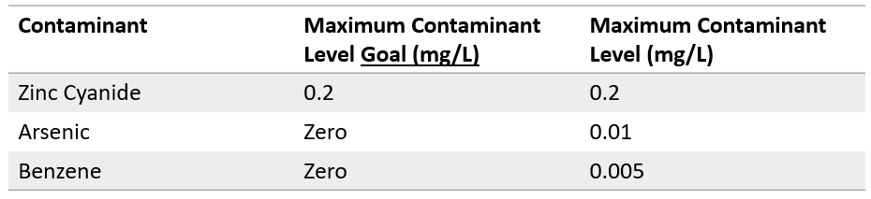
Figure 41: EPA approved levels for Zinc Cyanide, Arsenic, and Benzene
The first compound we chose is Zinc Cyanide. This compound is an inorganic, it can come from discharge of metal, fertilizer, and plastic factories. This compound can cause nerve damage and thyroid problems [3]. We chose this compound because if ingested in an area with little access to drinking water, meaning little access to medicine and doctors it can cause serious damage and suffering. It is a compound we want to make sure isn’t present. Figure 42 shows the Raman spectra of Zinc Cyanide.
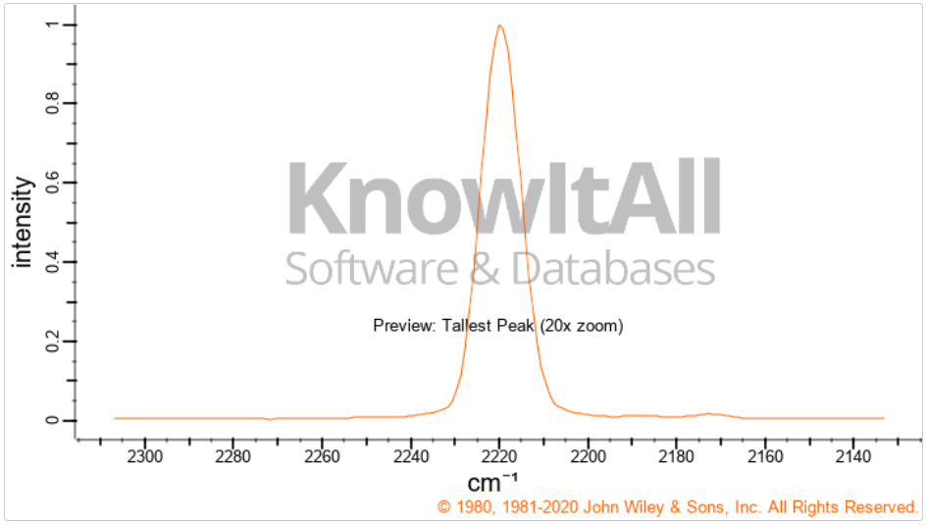
Figure 42: Raman Spectra of Zinc Cyanide from SpectraBase [49]
The second compound we have chosen is Benzene. Benzene is an organic chemical that can contaminate water due to discharge of factories and leaching from gas storage tanks and landfills [3]. This compound can cause anemia and increase a person’s risk of cancer. Again, an important compound to make sure isn’t in clean drinking water, due to life threatening purposes. Even with modern medicine, this compound can affect you for life, or possibly end it. Figure 43 shows the Raman spectra of Benzene.
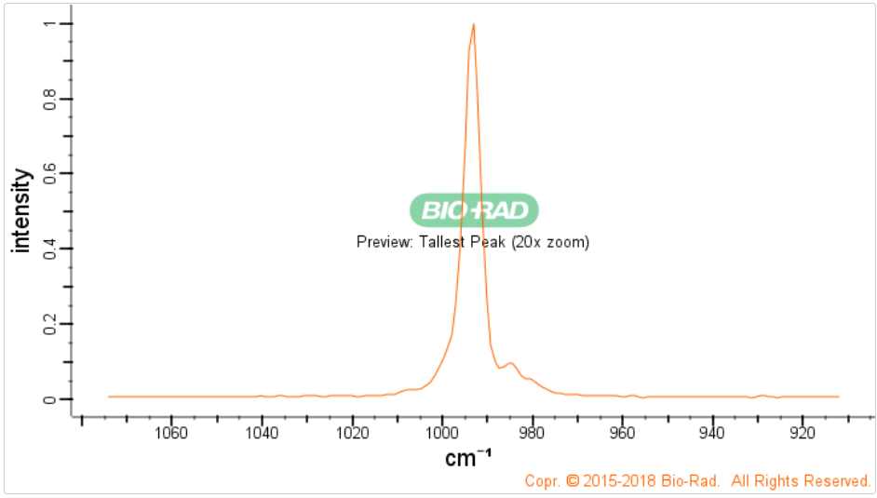
Figure 43: Raman Spectra of Benzene from SpectraBase [28]
The last compound we will be looking for is Arsenic. Arsenic is a heavy metal that can contaminate water through natural deposits, orchard runoff, and runoff from glass and electronics production.³ Arsenic is commonly found in contaminated ground water and can cause skin damage, problems with circulatory system, increased risk of cancer, and possibly death. Due to the commonality of arsenic in groundwater, we figured it would be an important chemical to look for with Raman scattering to prevent these health concerns. Figure 44 below shows the Raman Spectra of Arsenic.
Another approach to proving the water exiting the system is safe for drinking is by comparing the Raman spectrums of drinking water that already meets the national standards to the spectra of the water exiting the system. To accomplish this, we need to first use the Raman spectrometer and excitation source borrowed from Ocean Insights to take the spectra of bottled drinking water and use the spectra as a control, before building the spectrometer and source into the system.
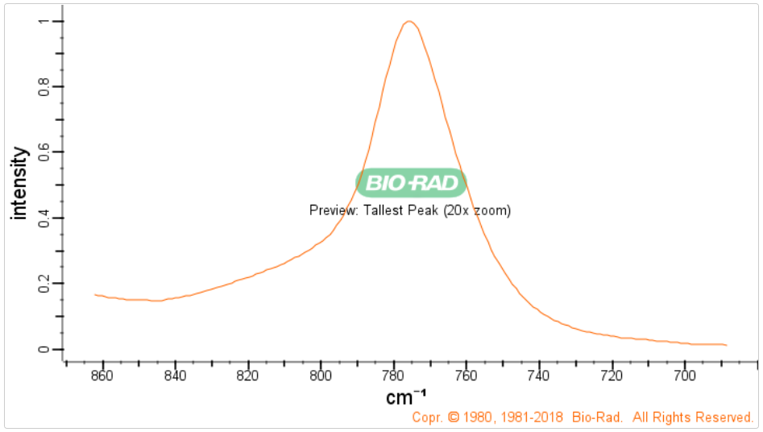
Figure 44: Raman Spectra of Arsenic from SpectraBase [12]
Our spectroscopy system wasn’t sensitive enough to produce these Raman footprints, so to test the system we chose three other substances. We chose laundry detergent, because it contains benzene, snake poison, and chlorine tablets. We put a water mixture of each of these in the same glass tube the clean water would be flowing through so we could get the most accurate reading possible. The test tubes are shown below:

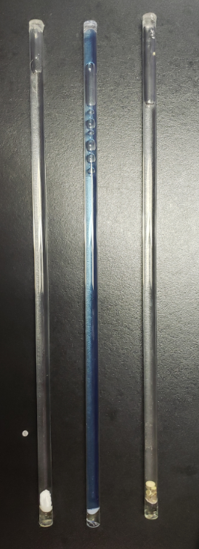
Figure 45: Contaminant Test Tubes [12]

The components Ocean Insights is lending us are a spectroscopy system and excitation source tailored for the spectroscopy system. The exact components we are being lent are still unknown but based on similar products on their website we have been able to assume certain properties of the system. The spectrometer uses a software called OceanView to read the spectral shift, which is further discussed in the User Interface section. Since we are unaware of the exact Raman Spectrometer, we are receiving we have based our system specifications on the only high-resolution spectrometer Ocean Insights sells. There may be slight modifications, but the specifications of the Raman spectrometer below will be similar if not the same to the one shown below:
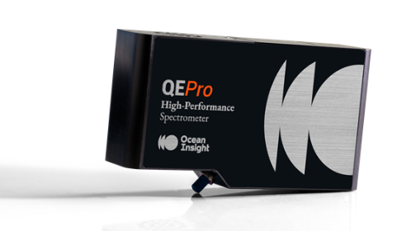
Figure 46: Ocean Insights commercial Raman Spectrometer
Ocean Inisght didn’t have any QEPro spectrometers to lend, therefore they lent us one of their first test modules every built, shown below:
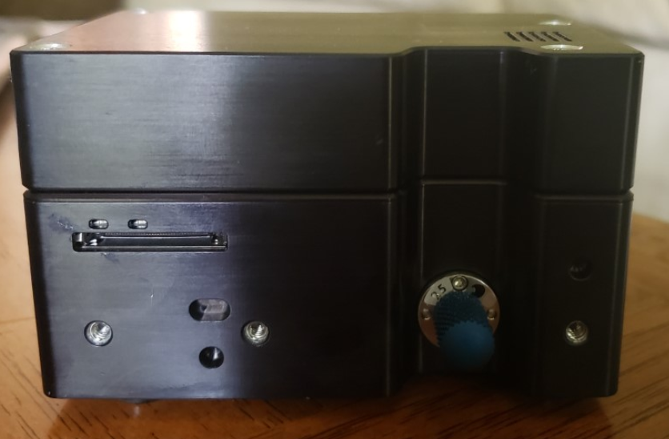
Figure 47: Raman Spectrometer lent
It is connected and powered by a computer with a USB C cable. For the spectroscopy, the input is a SMA fiber connector. Inorder for spectroscopy to work, we also needed a laser module. For this system we needed an NIR laser module that lased at 785nm. Ocean Insight was able to lend a fiber connected laser module as well, that is shown below:
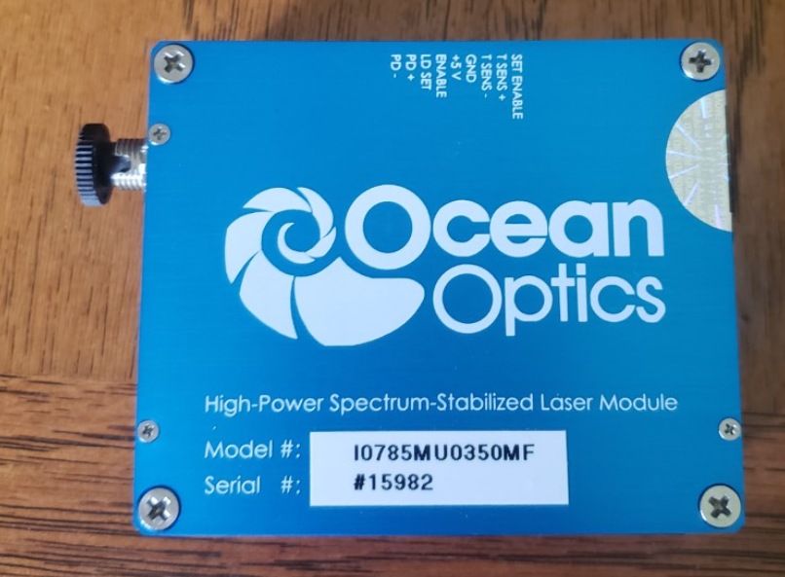
Figure 48: 785 nm Laser Module

Temperature Sensor
When choosing an IR temperature sensor, there are a lot of different choices to consider. There are two main types of IR temperature sensing, directing an IR beam into a sensor, and the other is a sensor that detects the IR energy directly from an object. After evaluating cost, we found that it wouldn’t be applicable to buy a separate IR source and sensor, so we decided on an IR sensor that is able to detect the IR off a source. This left us with two main options.
The first option we considered was a digital thermopile sensor shown in Figure 49 and the second option in Figure 51 is a non-contact temperature sensor. Both temperature sensors work off the same principal of measuring the IR energy all objects emit. The main difference between the two sensor is how we would integrate them into the system and the field of view. The first sensor consists of an absorber, which is thermally isolated from a frame and in series connected thermocouples. When the absorber is pointed towards an object with a temperature different from the absorber, then the power emitted by object and absorber differs as well. There is a netto radiative heat flow to/from the absorber which is heating/cooling the absorber. This resulting temperature difference between absorber and frame is converted by the thermopile into a voltage. In Figure 46 shows the cross section of the first sensor in which you can see the field of view is dependent on the size of the window. The diameter of the window is shown in Figure 46 which is about 3.8 mm, giving a relatively small field of view. The other problem we would be facing is mounting and integrating the sensor. The site where we found this sensor did not have any related products that would help mount the sensor. Since its connected via three pins we need a specific connector, this connector would then have to make sure the connector able to be relatively close to the glass tube where the water would be. There were multiple design constraints when taking this sensor into account, which is why we looked for other options.
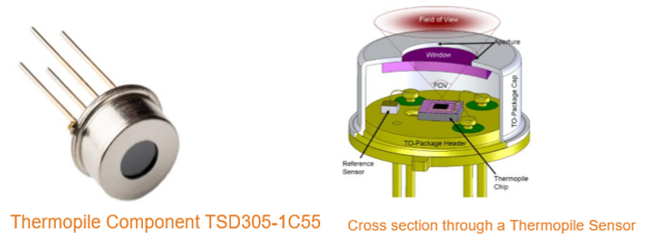
Figure 49: Thermopile Sensor from TE connectivity Data Sheet [69]

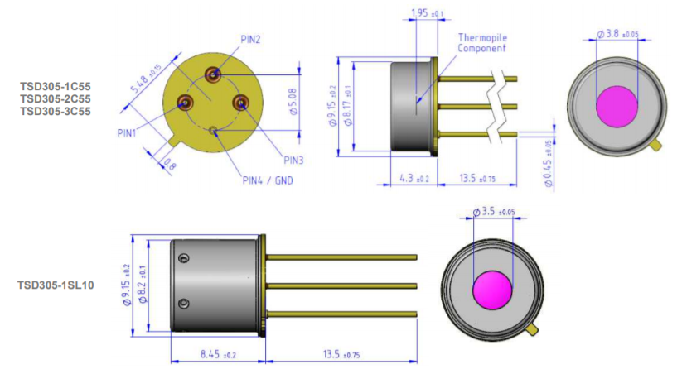
Figure 50: Cross Section of Thermopile sensor [69]

The second sensor not only solved the design constraints we faced but also has a larger window diameter of about 14mm giving a larger field of view of longer distances. Although the second sensor was more expensive, due to the design constraints and uncertainty of how to properly integrate the first sensor, we chose the second sensor. We are also positive we can interface the second sensor with the microcontroller we chose.
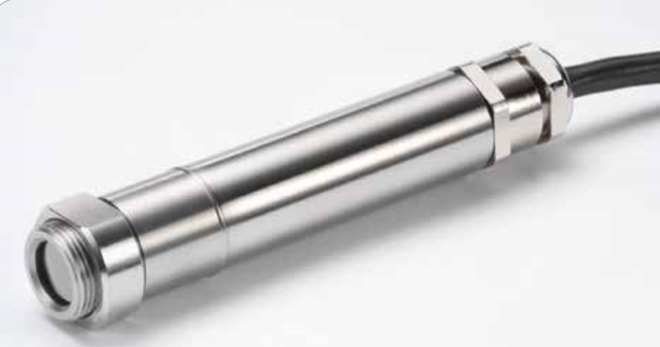
Figure 51: Contactless temperature sensor from Allied Electronics Data Sheet [70]
Since this was the temperature sensor chosen, the field of view and design constraints are outlined in section 4.1.5.

Design Constraints and Standards
The following section outlines the design constraints we were faced with when researching the integration of the major components. We not only discuss the constraints we may face, but also the steps we can take to avoid or correct these constraints. New design constraints can develop as the project progresses. This section also outlines the standards describing our system. The standards are a brief overview of all the standards we believe apply to our system. This section also can be modified and corrected as our project progresses.

Design Constraints
The following section describes the constraints faced when designing the system. The constraints entail both the individual component constraints and the entire system constraints. All currently known constraints are detailed below, although when building the system, we might run into more design constraints that we must reevaluate. The solutions to these constraints are also subject to change when trying to integrate all the parts into the system

Power System
When designing your power supply system, the basics involve thermal management, noise management, proper filter design, and choosing proper wire characteristics. One of the greatest concerns for a power supply circuit board is the removal of excess heat. Thermal pads and heat sinks are a common solution to this problem. Thermal pads are pre-formed squares or rectangles of solid material (often paraffin wax or silicone based) commonly found on the underside of heatsinks to aid the conduction of heat away from the component being cooled (such as a CPU or another chip) and into the heatsink. The heat sink is a passive heat exchanger that transfers the heat generated by an electronic or a mechanical device to a fluid medium, often air or a liquid coolant, where it is dissipated away from the device, thereby allowing regulation of the device's temperature. Furthermore, it is a good idea to space high power components away from each other. Components that tend to generate high heat should be sparsely placed on your board, as much as possible. This placement helps minimize high-temperature concentrations that are more likely to be problematic during PCB assembly reflow. For surface mount devices (SMDs), using vias liberally can remove heat from high power components. Through-hole vias have good thermal dissipation properties and can be used to quickly remove heat from components and the board surface.
As previously stated, both linear regulators and switching regulators will create unwanted noise in the circuit. For linear regulators, this issue can be easily addressed by adding bypass capacitors to the circuit. This works because any signal can be looked at as having two components, a purely DC signal and purely AC signal. A DC signal cannot flow through a capacitor so it will go directly to the linear voltage regulator. The higher the frequency of an AC signal is, the easier it can transfer through a capacitor so the AC component will be pulled to ground, away from the linear voltage regulator. Thus, the linear voltage regulator will have less variation in the input signal and thus less variation in the output signal.
Switching regulators may require a more robust filter, usually a RC or LC filter. The LC filter is more efficient and gives better results than the RC filter, but for basic power supplies an RC can be used. Ideal capacitors and inductors don't dissipate any power, whereas resistors do. One advantage is therefore that LC filters are more efficient than RC filters. Often, it's not the actual waste of power that is the driving factor, but the mechanics required to get rid of the heat. Lamp dimmers often need to fit into small spaces where keeping them cool would be difficult. Another advantage is that LC filters attenuate more in the stop band. These are double-pole filters. RC and RL filters are single pole. Well into the stop band, a single pole filter attenuates by the frequency ratio to the roll off point. In log space, that's 20 dB per decade. A two-pole filter is like two poles applied in series. They attenuate by the square of the frequency ratio to the roll off point, which is 40 dB per decade in log space. One of the most important specifications of a LC filter is its self-resonance frequency. This is the point when an inductor stops behaving like an inductor and instead behaves like a capacitor. For frequencies after this point, the inductor slowly has less AC blocking capabilities and noise may be able to pass through to the downstream circuit. The higher the SRF rating of the inductor, the better the inductor is at filtering high frequency noise. The performance of your filtering circuitry depends upon selecting the appropriate component values for filter components, inductance, capacitance, and resistance. As actual component values available may not match calculated values you should choose the combination of component values that provide the best response as determined through simulations.
Power supply currents may be quite high; therefore, it is imperative to ensure that trace widths and copper thickness or weights are able to carry the needed currents. For high power circuits, make sure that your board can withstand the temperature levels that will be generated by choosing materials with an appropriate coefficient of thermal expansion (CTE).
Again the high current values were going to be the most arduous aspect of the design.In regards to clearance; IPC-2221 Generic Standards on Printed Circuit Boards specifies the distance between traces to prevent dielectric breakdown depending on voltage differences. The width of traces is set by the current, and how much we want the temperature to rise. In regards to Trace Width: Also defined by PC-2221 Generic Standards on Printed Circuit Boards. The width of the trace is set by the current, and how much we want temperature to rise. Moreover,Copper Thickness is measured in oz/ft2 weight of copper poured in a 1ft x 1ft area. The more copper the better thermal management the PCB will have.When looking at Edge Spacing, its recommended that components are placed at least .01mm away from the edge. It was Important to note that no silk screen should be placed over pads. It will distort the distribution of heat when soldering. Furthermore, solder mask must be placed between paths to prevent a short circuit. Designers must be aware of the ground plane layout when doing high accuracy measurements, Analog audio signals, High A/DC measurements, or low signal levels. They should especially be aware when a circuit contains High speed digital signals (USB), dealing with RF signals, and when using switch based power supplies or DC to DC converters.The most effective solution to reduce high-frequency noise involves choosing an inductor with high self-resonant frequency . When this isn’t possible, boot resistors, snubber circuits, ferrite beads or feed through capacitors can be used. DC to DC converters have output ripple noise and radiate electromagnetic interference (EMI).We also considered using an Isolated circuit. Circuits that are sensitive to noise can benefit from having their ground broken up and separated from noisy circuits that could cause problems.Low output capacitance therefore more readily and safely allows multiple isolated DC to DC converters to be placed in parallel on the same DC bus. High output capacitance found in non-isolated buck-boost converters can create safety challenges when many units are placed in parallel on the same DC bus. Large capacitance stores a lot of energy to discharge incase of an accidental short. Typically, we use isolated power supplies when voltage is high (+42.5V) for safety reasons. Input filters are a successful method to reduce EMI. They protect any sensitive circuit from excessive input or output voltage ripples. Input filters prevent high frequency voltage on the powerline after passing through the power converter. When designing an input filter, it is important to avoid instability, large inrush current, and degrading the loop response. Coupling and Decoupling capacitors are used to remove high frequency noise as well. When creating a regulator, it’s critical to locate the regulator at the point of load. If a voltage is regulated and then even just a foot there will be a voltage drop over the wire that may drop the voltage below the threshold voltage of sensitive equipment. Switching regulators require high frequency filtering, done with an inductor cap passive circuit. This is because switching circuits are much noisier than linear regulators. Most critical paths in a switcher layout are the AC current loops. AC current loops need short low inductance paths, they are the highest priority. Switch node SW must be as short as possible. It is universally recommended to have a full ground plane underneath switching power supplies. The reason for this is the magnetic field, when close will cancel each other out reducing EMI. Duty cycle nodes should be protected from AC high power paths as much as possible. Switch nodes should be far away from other circuitry and other switchers. Analog signal feedback can be corrupted by high current paths and so for that reason an analog ground plane will be added for them to reference. Typically, there is a common point to tie the analog feedback ground back to the switcher ground. It’s good practice to use Vin, Vout, and ground for a heatsink, not the switching node. Vsense should be away from ACAP. Keep inductors separated to avoid coupling them. When laying out the PCB it is good practice to start with the switcher. Cout should be next to the magnetic element forming a LC filter. Design should be made with thermal dissipation in mind. The larger the circuit and higher the switching the more complex the design becomes. On all the PCBs, thermal vias were placed underneath the IC. This successfully dissipates the heat generated inside. The ideal size for a thermal via is a .3mm inner radius and .6mm outer radius. When dealing with large currents track widths can grow quite large. This would make small pin connections impossible. Luckily it is ok to pass high current through a small track width if it is attached to a larger trace or plane. This is because the resistance of the short, narrow PCB trace is small, and any heat generated there will be drained into the wide copper area, which acts as a heat sink.

Solar Power
Solar power is surely an up and coming technology as an energy resource, but it comes with its constraints and complications. For our group the main difficulties that are faced with using solar power would be space, and cost. This is because our original plan called for a portable system, but solar panels take up lots of space. There are portable solar panels out there but as one would imagine, they are quite expensive. These expensive solar panels are usually made of greater materials, which brings with them a high efficiency rate. So, when tackling this project there were a few things to really think about when it came to making the system with solar.
To start off, solar panels take up a lot of space. This is one of the reasons solar has had such a hard time expanding in past years. For it to be practical and to benefit modern society, solar farms need to be built. In other words, they require and take up vast amounts of real estate. For this project, originally the goal was to make a portable system for the end user. Yet when you want to power 100 Watts of hardware completely off grid, you need a large battery and a large solar power system. Another part of the original plan was to have the system run for a full 24 hours. This was quickly dialed back to 8 hours when the group realized that this would require a minimum of 600 Watts worth of solar panel to achieve this. That would require 6 general solar panels each of which can be 3 feet squared and only produce 100 watts of solar power. This would certainly make the system far from portable and would break the bank. Which leads into the next constraint, the cost.
The cost of the solar panels that were considered for the project needed to be less $250, due to budgetary constraints. Even at this price, that might only buy someone one top of the line 100- to 200-watt solar panel on Amazon or elsewhere on the internet. With cost in mind, this was the ultimate decision maker behind making the call to dial back the run time. The budget for the group just was not able to handle such a large solar power system. With the change in run time requirement, the system would be able to be powered with 200 watts worth of solar power. Not only saving space on the overall design but also saving the group some money.
Although solar panels take up a lot of space and are expensive, which were the main causes for concern, the group was able to find a great deal on 2 solar panels. The purchase was a package of two 100-watt polycrystalline solar panels, with a charge controller for $239.00. This deal was right within budget and would successfully power the system for the required time. It was unfortunate that the original plan was not realistic for the budget, but this solar power set up should serve as a great, long lasting alternative to spending almost $1000 on just solar parts.

Filtration System
To understand the design constraints of the filtration system, you need to look at all the parts that it consists of. The system will contain a pump, two filters and a UV cleaning system. There were a few concerns right off the bat. These would be the cost of the whole system, the size of the system, and the flow rate needed for filtration.
The cost of the pump was not so much of a concern because any 12V DC pumps are relatively cheap compared to 120V AC pumps, but the cost of the filtration system itself is usually a decent charge. Since the system was not being designed by the group and the choice to buy it, the price tag increased a lot. The system that was chosen was the Viqua VT4-DSW/12 with a price of just over $400. It was the most expensive part of the project up to the end of Senior Design 1 but included all that we needed. It included two filters, a sediment filter and a carbon filter, as well as a UV water chamber. These three features will confidently clean the water to ensure that the water we are analyzing is free of impurity. Next the size of the system was not much of a concern until the system was purchased. The original design called for a portable set up, but once the solar power system was designed and the purchase of the filtration system this was questionable. The dimensions of the filtration system is 19” x 17” x 6” which would have been large for a portable system, but will fit nicely in the non-portable dolly design that was thought of. Lastly the flowrate of the pump and filter system needed to be relatively similar. The filter system has a max flow rate of 3.5 gallons per minute, so the size of the pump needed to be around this value. The pump that was chosen, the Flowjet 03526-144A Triplex pump, has a flow rate of just under 3 gallons per minute. This will provide the system with proper filtration of the water. The combination of pump and filter system to make up this large part of the project, was not the hardest component to decipher but these were the constraints that needed to be taken into consideration.

Spectroscopy
Our current main design constraint with the spectroscopy of the water is being unaware of exactly what kind of system Ocean Insights will be loaning us. Although we are very sure it will be a laser excitation source and Raman spectrometer.
If we are given a laser excitation source, we will be shooting the laser through a glass tube, the refractive index of the glass needs to be found. When the refractive index of the glass is and the density of the glass, so we know how it will affect the beam. Depending on the specific material of the glass and the refractive index, the light will disperse. Without knowing the excitation source, we are unable to know how the light will disperse and what kind of glass tube would be ideal for this system. The glass tube the water will be analyzed in will most likely be like Figure 52.

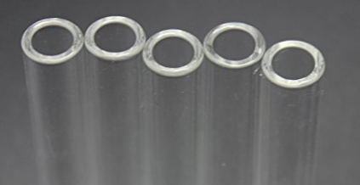
Figure 52: Glass Tubes that will be used for analysis system
The likely light dispersion through the glass tube will look like the schematic below. Until the excitation source and glass tube are known we cannot calculate how much the light will disperse, so we know what focusing lens to buy and where to place it. We also need to know the information of the spectrometer receiving the light from the excitation source, so we are aware of where the focusing lens can be placed. Since the system is portable, the analysis needs to be compact, we are not able to choose a lens.
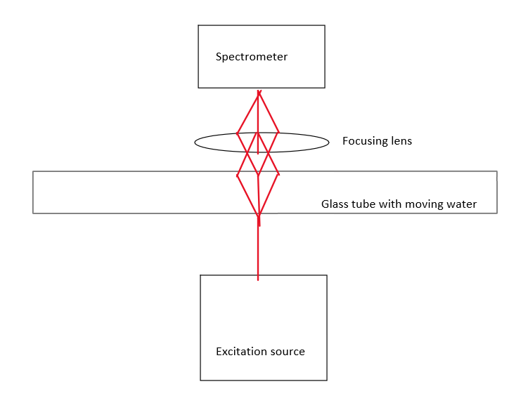
Figure 53: Potential laser beam path through glass tube
Another design constraint we are facing is making sure the laser excitation source doesn’t interfere with any other part of the system. To overcome this, we plan on building a laser safe box around the spectrometer system with a portion of the glass tube. This would help the laser not interact with the temperature sensor and ensure safety.
Our ultimate constraint with the spectroscopy system is data processing. Since we can’t see the footprint Raman shifts, we have to write an algorithm to process the data and interpret what it might mean.

Temperature Sensor
The IR temperature sensor chosen has a field of view to distance from the object being measured ratio. In Figure 54 the distance from sensor to object being measured (in inches) is shown in contrast to the sensor's field of view compared to the models of this sensor. The sensor we ordered is the PC21, which means our sensor can be placed, at most 8 inches away from the glass tube. We would prefer to place it closer to ensure the most accurate reading. Until we know what kind of spectrometer we are receiving, we cannot design the casing for the analysis portion of the system. This means we don’t know yet how far the sensor will have to be placed but it cannot be more than 8 inches. The figure 55 shows the field of view table of different models with available temperature readings. Again, our sensor is in the first section of the table, showing two available models. We chose the second model, the PC21MT-x, that will read from 0°C to 250°C because we do not believe that the water we be below 0° degrees, if it was, it would be able to run through the system.
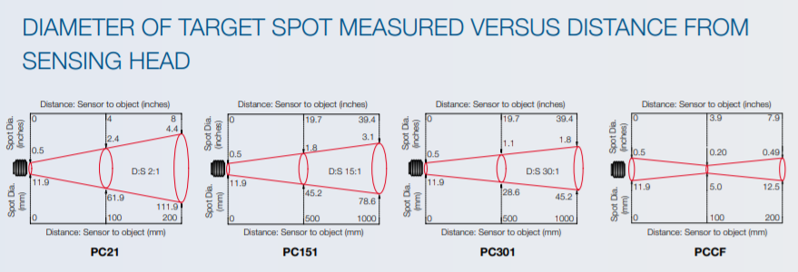
Figure 54: Field of view of Allied Electronics Contactless Temperature Sensors [70]
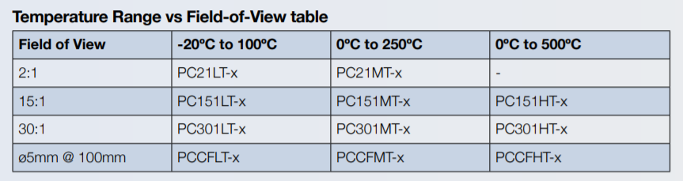
Figure 55: Field of view compared to Temperature Readings and Model [70]
Another constraint for the temperature sensor would be mounting it, without knowing the exact spectroscopy system we are unsure of how to set up the final temperature evaluation section of the system. The website where the temperature sensor was bought offers two mounts, which might be necessary once we find out the spectroscopy system and design the evaluation section of the system. These mounts are shown below:
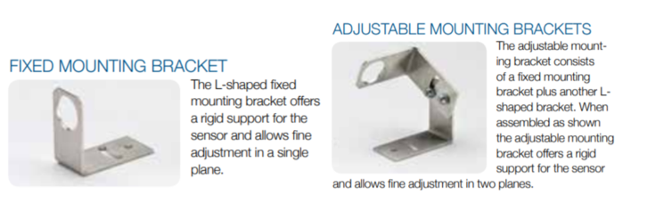
Figure 56: Possible Brackets for Temperature Sensor [70]
When mounting the IR sensor we have to take into account how close it will be to the spectroscopy source, because if it is to close, since the source will be 785nm (Near Infrared) is could alter the temperature reading of the water by including the temperature of the laser source. This is also dependent on the power of the spectroscopy source. Also, when mounting the IR sensor, we must take the field of view into account. The brackets don’t seem to be longer than 8 inches on the bottom so they should be able to be placed close to the glass tube. Also, the fixed mounting brackets base it behind where the sensor would be facing, so there would be no constraints when using this bracket, besides what the bracket would be mounted on.
The final constraint for the temperature system is that the IR only measures the surface temperature. Being that the IR source will be directed at a glass tube in which the water is flowing through, the IR sensor will pick up the temperature of the glass. We believe this will still be an accurate approximation of the water temperature because, if the water is running through the glass tube for long enough, they will eventually become the same temperature. Also, if the glass tube is hotter or colder than the water, when the water is traveling through there will be heat exchange between them and it will give an accurate approximation for the temperature of the water.

User Interface
Constraints are one of the big parts of any project. In this section I will talk about some of the constraints we faced designing the User interface. The java programming language will be the standard programming language used to develop the application. Because of the interface software with the spectrometer. Java until contains collections of frameworks, classes and event models used in java. This will control the User interface, by doing the following tasks.
The features of the project the UI must have are:
- A way for the user to know the Temperature
- A must be intuitive.
- It must show the graphic of inorganic impurities levels
- It must show the battery charge
- It must show the temperature of the water
Design Impact of UI standard:
One of the biggest constraints related to UI design will be the chosen framework for the GUI design. A framework is a collection of libraries that provide the fundamental structure that will support the development of the application. Frameworks exist to simplify the general problems faced when developing an application. It gives the developer standard features such as: windows, buttons, bars, lists etc. Different frameworks change the overall feel of the UI. And restrain the types of components the UI has. The elements of the frameworks allow developers to design the application piece by piece.
It would not be possible to design a custom framework for this project because of time constraints. Designing a custom framework, also adds a layer of complexity completely unnecessary. Making Those buttons classes stable is a project more complex than this one.
Another constraint when designing the UI are the features presented on it. The frameworks we choose will need to have good enough elements to portray our features effectively. Different frameworks have different ways of aligning elements in it etc. In swing for example. By using Eclipse, we can use higher level abstraction to lay down the components of the GUI, or we can align the components of the frame by writing the code, by using standard libraries. Different frameworks are more difficult to align and set up then others. Using a framework our group members already know saves time, as opposed to learning a new framework from scratch. Learning a framework from scratch is very viable though. Because components repeat very frequently.
It narrows down to which frame contains the components we need as well as the it is compatible with the interfaces.
Frameworks:
Swing is a framework that is part of the JFC (Java foundation classes). Since our application will be written in java, swing is one of the possible frameworks we can use. Swing possesses a group of features, and many interactive components for building GUI. It features components that are: capable of drag and drop, sorting etc. Using swing though will lock us with its features. I don’t think swing based GUI looks sophisticated. But since I am used to programming GUIs in swing, we might save time. By choosing to swing we are stuck with its looks and feels.
It was decided that the user will interact with the screen by a touch screen instead of a button pad. But if necessary, we can skip the touchscreen all together if the application doesn’t contain any button to interact with. Making the UI only visual and not interactable in any sense. But if it contains any interactable component such as a button. We must only consider touchscreen displays.

Design constraints:
In the UI design we are constrained by the complexity of the design itself. The whole purpose of the UI is to inform the user. The users of course may have various cultural backgrounds. Our product is designed to not only be used in the United States. People from different countries should also be able to also use the product. The user might not understand English, but the application will be in written English and no translations will be available for the application. Users of different regions should still be able to use the system. This will be accomplished by using visual cues.
The size of the display is very important when thinking about the design of the Ui. Putting enough elements in the screen so that the user can access it reliably is an important design decision. The complexity of the UI look is another of our constraints. In the specification it is a requirement for the UI to be intuitive. The number of buttons in the screen is, for example, something to keep in mind. If all the information is displayed in a single screen. This will not only make the UI more confusing. It will make the size of the elements smaller on average. This problem can be solved by increasing the number of screens in the application.
By increasing the number of interactable elements in a screen we can convey more information to the user about the water. But it can overwhelm the user with information if not managed properly. Having many elements on the screen. We do not have an exact constraint for the number of stages in our application. We can make as many as we wish if it makes the application concise, with the intention to prompt the user better. But again, the more screens we design the more likely we are to have bugs transmitting information from one class to the other. We are also limited by time when designing multiple stages in the application.

Display
Display constraints restrict the variety of displays that can be used for this project. There are many displays available in the market. Those displays vary in price, size, connectivity, and features. The constraints were analyzed thoroughly in order to select the display to fit in the system. So, the system can fulfill the requirements of the project in terms of design budget etc.
Time and Money constraints:
Designing a display from scratch using a crystal would be impossible. It requires very expensive machinery and very sophisticated expertise that we do not have. The next layer of abstraction would be interfacing an existing display with the rest of the system. Even getting a functional display and interfacing it with the rest of the system might be too complicated. Because of the variety of display connections. For example: some displays require to be powered independently and have information be transmitted by a display port. Other displays are wired directly in the board. It would be wise to save time by getting a display that is easier to set up with the microcomputer. A standard display guaranteed to connect with the microcomputer might be preferred even though it might be more expensive. Adopting this standard might save a lot of time in the long run. The trading of time vs cost is unclear. But having, for example, a display that cannot be powered directly by the microcontroller can significantly increase the complexity of the power system. Thus, hindering the project because of the limited time to design the system.
Display can be of varied costs. It can be in the range of 3000’s of dollars for a big 4K definition touchscreen display, at the same time some displays may cost as little as 20 dollars. But again, those cheap displays don’t fill the requirements for not supporting touchscreen capabilities, or for not being big enough. Since other parts of the systems need to be bought and added, ideally, we would be spending less than 100 dollars on the display. Unless we can get a good advantage, in terms of time saved, by choosing a specific display. Then we would be willing to spend an extra 50 dollars totaling 150 dollars for the display. Overall, the system should not be over 2000 dollars.
Reliability constraints
As previously said, we will be only interfacing the system existing display models to our system. By all means, we cannot manufacture a display from scratch being able to cut the crystal and embedded the system is done by very complex machines. Capital that we do not have access to. But one of the characteristics of design the majority of displays is that they have a low reliability. The display on the size of the case should be somewhat reliable. The touchscreen display is the only way for the user to interact with the application, so if it stops functioning the user will not be able to interact with the pane. Replacing the pane can be difficult since the case is sealed. So, the panel must be somewhat resistant. The display panel needs to be resistant to impact.
Of course, one of the constraints we face dealing with the display is that it cannot be bigger than the case it is embedded in. But on top of that, the bigger the display the more energy it will consume. The size of the display is directly related to the battery in the system. And by choosing to increase the size of the display it will decrease the amount of time the system can run continuously. The battery size constrains the display design. It is important however to have a display big enough so users can easily interact with the components. And the bigger the display the more components we can put in each in the UI.

Standards
The following section outlines the standards that apply to our project. There are eight kinds of standards that can be applied to every project. Below are our basic and products outlined for the individual parts of the system and the entire system. Some of the standards are based on legal and established standards while others are personal standards, we believe are viable to apply to our system. We believe this is necessary since we haven’t found another system exactly like ours, so there are certain standards we must imply ourselves. Another type of standards are specifications which are outlined in chapter 2. All standards can change as the project evolves since parts may be added or removed to the system.

Solar Power System
With the expansion of the solar industry and incorporation into residential markets, the solar industry needed to lay down some standards. These standards for photovoltaic performance were created by the International Electrotechnical Commission (IEC). This commission laid forth a set of rules regarding the testing processes, testing conditions, and performance requirements for the quality of solar cell modules. The quality aspect of solar cells was addressed by these rules as well, which deal with the performance of each cell under certain test conditions, as well as the obvious safety concerns that come with solar cell technology. For example, as solar power started to expand and technology became more advanced, efficiency levels became a standard. This means that marketed solar panels should have a minimum requirement for their performance if they were to be mass produced or sold. Also, solar panels create DC voltage which is arguably more dangerous than AC voltage, therefore safety standards were also needed to be set in motion.

Battery
As electrical components and, more importantly, battery operated devices became more widely used, the IEC decided to set forth rules and regulations for batteries. These regulations state testing and safety specifications for all batteries, chargeable and non-chargeable. Like solar panel testing, battery testing has been made standard for each type of battery. Safety requirements were also set into place in order to keep consumers safe under unintended use and misuse. Also depending on the location of the consumer, the battery regulations and specifications may change. Some information that is typically overlooked are these safety recommendations such as operating temperature and operating power. Without these regulations to make batteries safe under the unintended conditions, the consumer as well as producers would be in danger as many batteries have the capabilities to combust.
Part of these regulations is putting manufacturing dates on each battery, but each manufacturer has their own technique. A couple examples are shown below:
- Douglas Batteries
  - Use alphabetical letters to symbolize the year of manufacture, followed by a number to represent the month.
    - Ex: S02 = 2000, February
- Delphi Batteries
  - Use numerical values to represent the year of manufacture, followed by a letter that represents the month.
  - Also featuring two more characters that indicate the location of which the battery is produced to operate in.
    - Ex: 0BN3 = 2000, February
Other standards like the BCI number show the size, terminal configuration, and terminal polarity. These numbers/labels include UB, UI, 24, 65, 51, and many more. This is mainly for north American batteries though, as other nations use different labeling standards to depict the classification of their batteries. For example, Asia uses Japanese JIS standards most of the time and the label includes more than just size and terminal characteristics. These often tell the user the ampere hour, the battery type and even if and what type of application that the battery is recommended for.
There are many more standards that have been placed on battery production and use by the IEC. For example, IEEE 1013-2019 is the most up to date standards document that expresses the recommended practice for sizing lead-acid batteries for standalone photovoltaic systems. These associations have made much more regarding the subject and each standard document can be purchased and used. But for this project, as it is not going to be marketed to the public, we shall stay within the necessary standards as we proceed.

Water Analysis and Testing
The American Society of Testing and Materials (ASTM) sets is an international standards organization that develops and publishes voluntary consensus technical standards for a wide range of materials, products, systems, and services. One of the services they publish standards for is water testing. ASTM's water testing standards are instrumental in specifying and evaluating the methods and facilities used in examining the various characteristics of and contaminants in water for health, security, and environmental purposes [58]. These water testing standards allow concerned local government authorities, water distribution facilities, and environmental laboratories to test the quality of water and ensure safe consumption.
There are over 100 different published standards for water analysis dependent on technique and contaminant being tested for. If you would like to review all the published water testing standards issues by ASTM please visit https://www.astm.org/Standards/water-testing-standards.html. As Raman Spectroscopy for in-line water quality monitoring isn’t a commonly used practiced or commercialized, there is not a specific publication of standards that’s apply to our system. There are some standards that outline plasma spectroscopy methods, but since they are very different methods, we are not able to base our standards off those publications. They also have a publication for identification of chemicals by fluorescence spectroscopy, but since we are testing for more than just chemicals and not using fluorescence spectroscopy, we are not able to use these standards. Although we are not able to use them, they can be a decent basis for certain aspects of spectroscopy standards. These standards are further detailed in reference 59. Since there are no standards publications we can use for our specific scenario, we decided to focus on standards addressing only Raman spectroscopy. These standards are defined in the next section.

Spectroscopy
The ASTM has five publications defining standards on Raman spectroscopy, but only three are applicable to our project. The first publication is “Standard Guide for Raman Shift Standards for Spectrometer Calibration”. These standards cover Raman shift values for common liquid and solid chemicals that can be used for wavenumber calibration of Raman spectrometers. They also provide reliable Raman shift values that can be used as a complement to low-pressure arc lamp emission lines which have been established with a high degree of accuracy and precision [60]. We can use these standards when calibrating our spectrometer and viewing the Raman shifts. The entirety of these standards is in reference 60.
The second publication we can apply is “Standard Guide for Testing the Resolution of a Raman Spectrometer”. The resolution of a spectrometer is extremely important, it determines what shifts you can capture. These standards cover the design for routine testing and assessment of the spectral resolution of Raman spectrometers using either a low-pressure arc lamp emission lines or a calibrated Raman band of calcite [61]. We can refer to these standards when testing the resolution of the spectrometer before integrating it into our system. Although we are unaware of the exact Raman spectrometer we are receiving and if it is exactly applicable to these standards, we still believe we can reference them. The entirety of these standards is outlined in reference 61.
The last publication we feel we can apply is “Standard Guide for Relative Intensity Correction of Raman Spectrometers''. These standards outline a relative intensity correction procedure that will enable the intercomparing of Raman spectra acquired from differing instruments, excitation wavelengths, and laboratories. These standards can be used when comparing the spectrum of our water and contaminants to other spectrums of the same molecules, found with different instruments. These standards regulate the peaks seen and determined between different labs and brands of spectrometers. These standards are needed to keep consistency between labs and experiments. The entirety of these standards are outlined in reference 62.

Water Quality
Ingesting unclean water can cause sickness and in some cases death. Due to these risks the Environmental Protection Agency (EPA) issued standards in which drinking water must abide by. In 2018 the EPA published the drinking water standards and health advisory tables. There are multiple tables outlining the chemicals and their concentration allowed in drinking water. Since the EPA sets regulations for over 90 contaminants, these tables are attached in the appendix due the length and amount of information provided [57].
Another standard the EPS has for drinking water is called Secondary Drinking Water Regulations. These regulations are non-enforceable and regard cosmetic effects. Even though these standards are non-enforceable, they are good to follow. Since we are focusing on removing taste and smell, both cosmetic effects of water, we outlined the EPA standards in the table below.
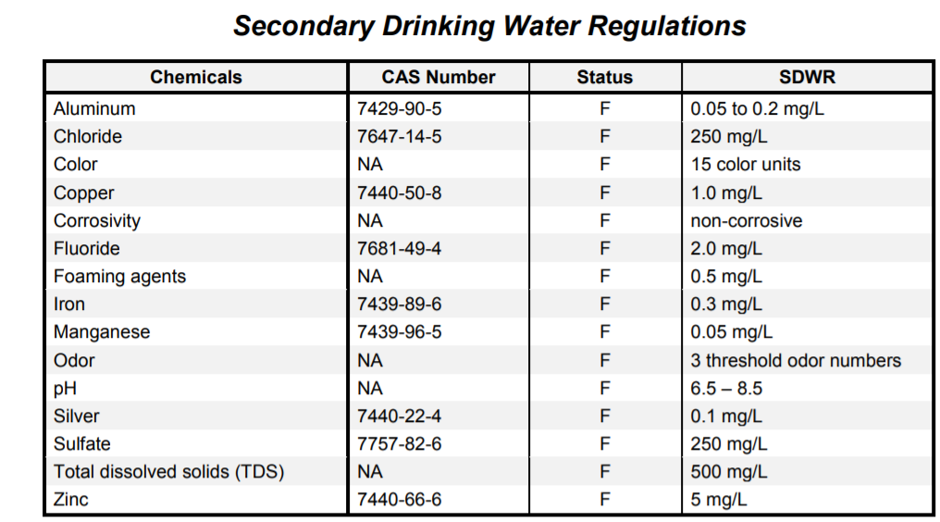
Figure 57: Secondary Water Standards from the EPA [57]
The EPA also sets regulation rules for both chemical and microbial contaminants. The regulations are summarized below, to be fully educated on each rule you should visit https://www.epa.gov/dwreginfo/drinking-water-regulations.
Chemical: The chemical contaminants were promulgated in phases collectively called the Phase II/V Rules or the Chemical Contaminant Rules. These rules regulate over 65 contaminants in three contaminant groups:
- Inorganic Contaminants (IOCs) (including nitrate and arsenic),
- Volatile Organic Contaminants (VOCs), and
- Synthetic Organic Contaminants (SOCs)
Microbial:
- Ground Water Rule:
  - EPA issued the Ground Water Rule (GWR) to improve drinking water quality and provide protection from disease-causing microorganisms. Water systems that have ground water sources may be susceptible to fecal contamination. In many cases, fecal contamination can contain disease causing pathogens. The purpose of the Ground Water Rule (GWR) is to reduce disease incidence associated with harmful microorganisms in drinking water [57].
- Stage 1 and 2 Disinfectant/Disinfection by Products Rule: (This rule doesn't apply to our system since we are not using any chemical disinfectants.)
  - The Stage 1 Disinfectants and Disinfection Byproducts Rule (DBPR) reduces drinking water exposure to disinfection byproducts. The Rule applies to community water systems and non-transient non-community systems, including those serving fewer than 10,000 people that add a disinfectant to the drinking water during any part of the treatment process [57].
  - The Stage 2 DBPR strengthens public health protection by tightening compliance monitoring requirements for Trihalomethanes (TTHM) and Haloacetic acids (HAA5). The rule targets public water systems (PWSs) with the greatest risk [57].
- Surface Water Treatment Rules:
  - The purpose of the Surface Water Treatment Rules (SWTRs) is to reduce illnesses caused by pathogens in drinking water. The disease-causing pathogens include Legionella, Giardia lamblia, and Cryptosporidium [57].
  - The SWTRs require water systems to filter and disinfect surface water sources. Some water systems are allowed to use disinfection only for surface water sources that meet criteria for water quality and watershed protection [57].
Right-to-Know:
- Consumer Confidence Report Rule:
  - This rule is followed by all major water suppliers
  - Each year by July 1st you should receive a Consumer Confidence Report (CCR), also known as an annual drinking water quality report from your water supplier. Your CCR tells you where your water comes from and what's in it [57].
- Public Notification Rule:
  - The Public Notification Rule (PN) is part of the Safe Drinking Water Act. The rule ensures that consumers will know if there is a problem with their drinking water. These notices alert consumers if there is risk to public health. They also notify customers:
    - if the water does not meet drinking water standards;
    - if the water system fails to test its water;
    - if the system has been granted a variance (use of less costly technology); or
    - if the system has been granted an exemption (more time to comply with a new regulation).
Since unclean drinking water can be very dangerous, it makes sense on why the EPA would have many strict standards. We do not have the equipment to test every single standard the EPA enforces, since we are not mass producing this product. We will still try to hold the water to these standards the best we can. If we find an issue and/or are not following these standards, we will change the system to follow the standards to the best of our ability.

Filtration System
Just as there are standards for water quality, there are standards for the systems cleaning the water. Even though there are no federal regulations for filters and purifiers, there are voluntary national standards and NSF International protocols have been developed that establish minimum requirements for the safety and performance of these products to treat drinking water. The following standards we feel apply to our system and will follow are outlined below from Reference 65.
- NSF/ANSI 42
  - Filters are certified to reduce aesthetic impurities such as chlorine and taste/odor. These can be point-of-use (under the sink, water pitcher, etc.) or point-of-entry (whole house) treatment systems [65].
- NSF/ANSI 53
  - Filters are certified to reduce a contaminant with a health effect. Health effects are set in this standard as regulated by the U.S. Environmental Protection Agency (EPA) and Health Canada. Both standards 42 and 53 cover adsorption/filtration which is a process that occurs when liquid, gas or dissolved/suspended matter adheres to the surface of, or in the pores of, an adsorbent media. Carbon filters are an example of this type of product [65].
- NSF/ANSI 55
  - Ultraviolet treatment systems use ultraviolet light to inactivate or kill bacteria, viruses and cysts in contaminated water (Class A systems) or to reduce the amount of non-disease-causing bacteria in disinfected drinking water (Class B) [65].
The sediment filter we are using in the filtration system is the AWP110 and it is produced by VIQUA. According to VIQUA’s website, this filter is Formaldehyde free and NSF 42 certified. The carbon filter we are using is the C-01PB and also made my VIQUA. According to VIQUA’s website, this filter is also NSF 42 certified. The UV lamp we are using is the S330RL also sold by VIQUA, although no certifications are listed for this lamp, its purpose is to kill bacteria in the water which would label it as a class A system. These three standards will be followed to the best of our ability.

Display
There are many ways of showing images to users. Many creative displays are available in the market. An example of that is a pane made with LEDs. The LEDs are coordinated to show the image. In this model the LED works as a pixel. There other types of displays in this project we will be using a LCD display. In this section we will discuss the standards in the display’s components for this project. The display is directly interfaced with the microcomputer. constraints directly relate to the microcontroller constraints. The port connection display must be compatible with the computer used.
Resolution:
The display resolution indicates the number of distinct pixels in each dimension displayed. The more pixels the more information and definition of the image displayed. The clear the image. Most Screens Resolutions are typically standardized at 1024x768, 1366x768 etc. The popular terms HD, 1080p describe the resolution of a screen. The following table reflect the resolution standards:
5K | 5120x2880
4K | 3840x2160
Ultra HD | 3840x2160
2K | 2560x1440
WUXGA | 1920x1200
Full HD  1080p | 1920x1080
HD  720p | 1280x720
360p | 480x360
Table 4: Resolution Standards
RASPberry pi Display
Raspberry pi Touchscreen Display is a display designed by the raspberry pi foundation that is compatible with all raspberry pi models. Those displays contain a DSI (Display serial Interface) ribbon Cable. This ribbon cable contains 15-pins that connect directly into the raspberry pi DSI connector. Using this cable interface is much better than using the traditional pins. By using the traditional pins, especially when transmitting color information, the connection is not as reliable, or as fast, resulting in decreasing the quality of the image.
HDMI
High definition multimedia Interface. HDMI is one of the interface standards for transmitting video and audio data. It has been marketed since 2003. It supports transmission of color and audio. It is used in many kinds of displays, very common usage on TVs. HDMI is backwards compatible and can transmit from 4.9 Gbps to 10.2 Gbps. It also can support a refresh rate of 120 Hz.
Touchscreen Capacitive touch
Touchscreen is a technology that enables users to interact directly with the screen. Previous touchscreen technologies only enabled a single touch at a time. But capacitive touchscreens. the ones used in cellphones, use a single chromium layer. When the skin contacts this layer, it discharges the screen. This discharge is detected by the LCD IC controller and it processes the information.

User Interface
Standards in the user interface should be used to simplify the design. Standards are everywhere in engineering, they can help interfacing, and designing, the system. Regarding the UI standards, I will be talking about the software’s that will be used to develop the UI. Those software are used in industry, and are supported by developers, and available documentation created throughout the years. Those standards enable higher order development. Be it by enabling the compatibility of a language with the OS, or by enabling higher level features that can be used directly without any bugs or performance issues
Java Development Kit Version 14
JDK is one of the key technology packages used when programming in java. Java Development kit is a package, developed by OracleCorporation, used for creating java-based software. JDK contains the java Compiler. That is used to interpret the .java files that are saved as plain text. The compiler then renders the file into executable class files. JDK 14 is supported by Oracle. JDK packages although. The source is available, it is not open source. It is not open source. Being copyrighted by oracle.
Java Virtual machine
Java It is the standard java program used to run the application. Together with JDK and JRE it creates the full development environment. Created by Oracle, JVM main goal is to enable java code to be executed in any Operating system. The virtual machine is the standard all java applications run in. It optimizes memory used in the heap stack, and also contains the famous Java garbage collector ending memory leaks. So, in a sense the java JVM, controls the resources of the application. It is constantly updating for performance reasons. Not having a programmer to allocate memory directly makes the software run slower. But again, it decreases the amount of abstractions in the program.
Java runtime Environment
JRE is an on-disk program that enables the creation of the virtual machine. JRE works together with JVM in order to execute java applications. It is developed by oracle. JRE is the software responsible for compiling the application in your system. JRE contains the java class loader, and the java virtual machine. The loader is responsible for loading the class and connecting directly to the java libraries and the java virtual machine. It is a container for the applications components responsible for coordinating their activities.
SWING
Based on the AWT API, swing is a lightweight GUI toolkit, part of the JFC (java foundation Classes). Swing one of the frameworks library that can be used to develop the application GUI. Swing library contains standard components such as: button, tables etc. as stated above. It contains light weight features and it is entirely written on java. It is also easy to build using Eclipse SWT, created by IBM, that enables a more drag and drop approach to the design as opposed to lines of code.
AWT
Another Lightweight java embedded framework. AWT stands for Abstract window Tookit. AWT is also a part of JFC in java, and it was used to build swing. AWT provides basic facilities to develop GUI application. AWT components feature buttons, menus, and top-level windows. The main characteristic of AWT is that all the components have a natural GUI object.
Java FX
Developed by oracle, JavaFX is a framework made for making desktop applications, as well as rich internet applications. JavaFX was designing to replace the swing library, as the standard GUI library for Java SE. It runs across multiple devices. It is also compatible across different platforms such as Linux, Microsoft, and mac. JavaFX is also linked to the CSS styling. Having higher end components features for the GUI. Being more modern it is also more customizable.

Design
The following section outlines the individual and over designs of the water cleaning system. Each system is designed to the best of our ability without having the parts. Once the parts have been ordered and tested, we will begin building the system based on the designs shown below. These designs will be set and described here but, are subject to modification as the project evolves into its final form.

Hardware
Designing the hardware so that it all fits together and is portable can have challenges. We are trying to overcome this by having multiple design ideas for each part of the system and combining them all together. Since we are all working on separate parts of the system, it can be difficult to take every group members’ parts into consideration and think about the system. We have all tried to share our ideas and take everyone’s’ parts into account when designing the hardware. The hardware design ideas are shown below separately and as a whole and can change when trying to integrate all the parts together.

Solar Power System
To design the solar system the power specifications of each component must be known. For preliminary purposes the maximum power consumption estimates for each component will be used to design the solar power system, these are listed below. This will ensure that the solar power can sustain the UV cleaning system for at least the required time duration. At first the goal was to have a system that would power itself all day, but it was quickly shown that a full 24-hour operational system was out of budget. So, in order to stay in budget, we decided that 8 hours of operation per day, with 1 days’ worth of autonomy will be the goal. One day of autonomy is one day’s worth of operation that the system can sustain itself without sunlight, this being another 8 hours of operation. Below will offer an explanation and walk through to how a solar power system is sized, and will dictate the size of the solar panel, and battery that will be used in this project.
Power consumption estimates:
The following components are the main power consuming parts that will make up this project. Their power consumption ratings are estimates that either came from the components data sheet or were used from similar products for design purposes. For example, spectrometer rating being used has come from the highest power consuming spectrometer that Ocean Insights offers. This is because the spectrometer components that will be used in the project are being donated from Ocean Insights, which do not include everything that a normal spectrometer purchase includes. As stated above, the other components have either been estimated or taken from a datasheet.
Ocean Insights Maya 2000 Spectrometer: 2.5 Watts
Viqua VT4-DWS11 Water Filter System: 20 Watts
Flojet 03526-144A Water System Pump: 52.8 Watts
Microcontroller: 10 Watts (maximum estimate)
LCD Display Screen: 10 Watts (maximum estimate)
Solar Power System Calculations:
The following subsection will go through the process of finding the size of the solar system needed to power our UV water cleaning system. Take note that each of the values were rounded up in order to guarantee smooth powering operation of the system. The power consumption values listed above are the overall power load of the system when added together. We will denote this as ‘L’ and it carries the unit of Watts.
L = 2.5 + 20 + 52.8 + 10 + 10 = 95.3 Watts
As stated above, in order to guarantee that there are no powering hiccups or issues, we will round this up to 100 Watts.
Next, we want the load expressed in Watt-Hours per day. This will be the amount of power consumption of the system per day. Our goal is to have 8 hours of operation per day, which we will express as ‘H’ in units of hours per day. Thus, the load in units Watt-Hours per day, denoted at L_{pd}, is as follows.
L_{pd} = L x H = 100 Watts x 8 Hours/Day = 800 Wh/day
This value is what is used to pick out the battery size. In theory, the battery should be able to support at least one day of operation on a full charge. This is our 1 day of autonomy. So, the battery needs to have an 800-watt capacity. Once again, for security purposes we will round this up to 1000 watts to ensure no powering issues.
Next, we need to figure out the solar array, or panel, size needed to charge this size of a battery in one day. Here in Florida, there is an average of 5.6 hours of solid, direct sunlight per day. During that 5.6 hours, the solar array needs to produce 1000 watts of power to charge the battery fully. Solar panels are advertised by their nominal voltage and power output. So, we will divide the battery capacity by the amount of sunlight hours per day to find the solar array size, denoted as ‘P’ in Watts.
P = 1000 Watt-Hours / 5.6 Hours = 178.6 Watts
Solar panels do no not come in such specific values so we will, once again, round this up to 200 Watts.
This is the process by which a solar panel and battery combination is calculated. In summary, it is necessary to find the overall load in watts, then determine the number of hours per day that the system needs to be used and multiply the two. After that multiply by the amount of days of autonomy to get an overall wattage that the battery will need to be able to sustain on a full charge. This is then divided by the amount of sunlight per day that the system will receive. Then that gives the size of the solar panel needed to charge the battery in one day of average sunlight.

Microcontroller / Microcomputer
The original idea was to use a microcontroller to run the application we designed. The other option, the microcontroller would need to run reliably two main programs. The first program (OceanView) designed by ocean insights, the company that loaned us the spectrometer. Therefore, the microcontroller would need to meet the system requirements by Ocean Insights spectrometer program in terms of memory, processing power storage. On top of that the microcontroller would also run the program that outputs the relevant information about the water to the user. This last program, designed by our team, gathers information from ocean insights programs and displays in an LCD display mounted in the case In a UI we designed. This program would not be as costly. If the microcontroller run a Linux operating system, the whole thing would be accomplished by system functions run in the command line and pipelining in shell computing.
The systems requirements of the program Ocean View proved to be too expensive, in terms of processing power for any commercially available microcontrollers. Therefore, we decided to use a microcomputer to handle the data from the spectrometer. We do, however, plan on using another microcontroller to handle the data from some sensors we will be adding on the case. For example, the temperature sensor.
Since the Ocean insights program is compatible with Linux, Mac and Windows, the microcomputer will need to meet the requirements for the chosen Operating System. Therefore, fulfilling the requirement, the microcontroller/microcomputer must be able to interface the QEPRO-RAMAN+ spectrometer, from Ocean Insights”. The system features a 12 volts battery. The microcontroller can be powered normally by a 5 volts pin. So, the microcontroller cannot be powered directly by the battery. But a circuit can be added to reduce or to augment the voltage to any required number. Thinking about those constraints, we will decide which microcontroller to pick.
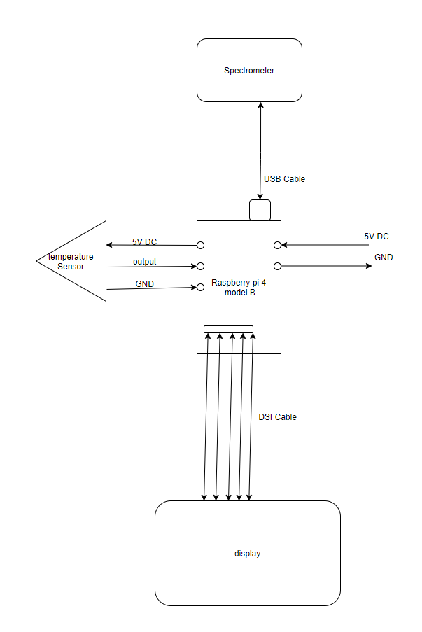
Figure 58: Microcomputer Schematic
Raspberry PI:
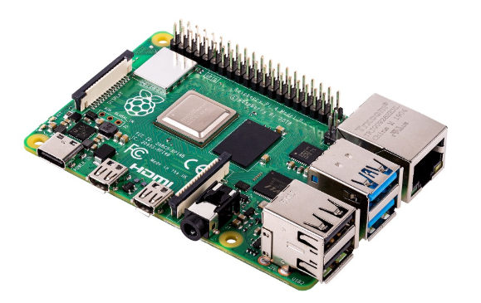
Figure 59: Raspberry PI
This hobbyist microcomputer is one of the most popular computers in the world. We decided to use this small computer because of its costs, and handle capabilities. the hardware is completely open, in case we need to overclock it, and it handles most of the operating systems we might end up working on. Its role in this project is to process the data it receives from the spectrometer. connected using an USB cable. This microcomputer is nice because it is compatible with all the necessary operating systems. And mostly, since it is popular, since it is popular a lot of hardware was created for it with a simple interface. We might reduce the problems, regarding interfacing the display, if we get a display that is already compatible.
There are different types of raspberry pi in the market. We are looking between 2 main ones. Raspberry Pi 4 B (Figure 55) and raspberry pi 3 model A+. The chip can also be easily powered by a 5 volts direct current source. Meaning it can be easily powered by the battery. The Raspberry pi is not waterproof therefore we will put it inside of a waterproof case.
One of the advantages of using a raspberry pi is that there is a display that can be bought separately, designed to be used in all raspberry Pi microcomputers. Both raspberry pi models are compatible with the Raspberry pi display.
Design:
So, in case we do use the raspberry PI, it is worth getting the raspberry touchscreen display as well, since it will make it easier to interface the microcontroller to the display. Allowing us to focus on more difficult parts of the project. Another advantage of using this microcomputer is the online documentation available online. Using a raspberry Pi would substantially decrease the complexity of those basic setup connections. Setting up the operating system, the display compatibility connection.
Economic:
In the economic sense Raspberry Pi 4 B costs 35 dollars. Raspberry Pi 3 model A+ costs $25. They account for very little of the overall cost of the system.
Raspberry pi 4 B:
This Raspberry Pi 4B microcomputer features:
- A 4 core Cortex-A72 (ARM v8) 64-bit with 1.5Ghz processor architecture.
- A VideoCore VI as a GPU and has
- a selectable range of RAM from 1GB to 4GB ram.
- an Ethernet port capable of transmitting data at a rate of gigabits
- 2 Micro HDMI ports
- 1 MicroSD socket
- A 3.5 mm audio jack
- A Wi-fi connection of 2.4GHz and 802.11 b/n/ac
Buying this model with 4 GB RAM would be enough for the operating system and ocean View program. It features two USB3.0 ports, more than enough. It features a MicroSD socket that can be used as the computer hard drive. The processor and memory are compatible with the program Ocean View, and Linux / Microsoft operating systems. It also features wi-fi. wi-fi is important if we choose to use windows because windows updates frequently.
Pin Schematic of Raspberry Pi:
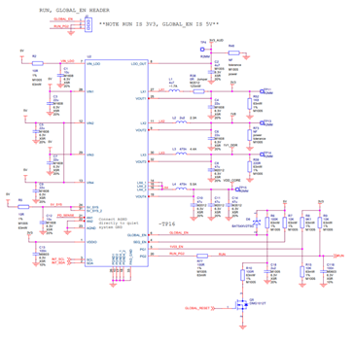
Figure 60: PIN Schematic
Displays:
The display will be connected to the microcomputer and will be mounted on the side of the case. The display must be big enough for the user to easily see all components of the user interface. Making the display too small will decrease the visibility of the UI. Making it too big will increase the cost of the display itself and the ability to damage it. On top of that, if the display is touchscreen, by decreasing the size of the display it will inevitably make the size of some interactable UI components smaller. This might make it hard for the user to interact with the UI. Decreasing their overall satisfaction with the product. It might also increase the average time required for the user to learn how to use the system effectively. Going against the requirement. “Users should be able to easily use the UI”. Therefore, we looked for displays that were about 20 cm wide and 10 cm tall.
One of the decisions we made was if the display would be touchscreen or not. If the display is not touchscreen, we will add a small mechanical pad for the user to interact with the UI. The pad would have buttons to scroll through the options displayed. This feature directly affects the development of the UI. It changes how the user interacts with the overall system. It affects the reliability of the system as well. Since touchscreen displays generally have a shorter longevity than mechanical buttons. In case the Display is touchscreen the user will use the screen itself to interact with the UI. Therefore, making the display more expensive. It would be cheaper to add the mechanical pad than to get a touchscreen display.
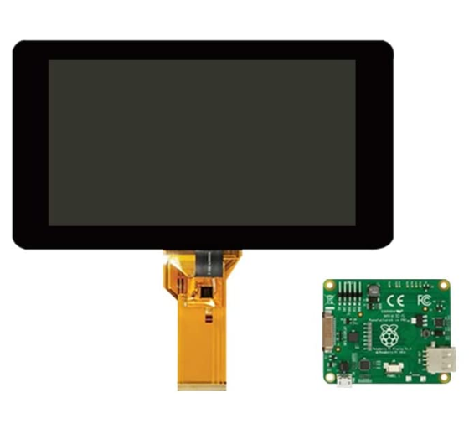
Raspberry pi touch Display:
Figure 61: Touch Screen Display
Figure : Raspberry pi model 4 B
LCD touch display made to connect with raspberry pi. It connects to the microcomputer using a DSI connector or a HDMI cable. This display is useful because it is designed to work with all raspberry Pi computers. Making it easier to set up. The display contains an integrated library that provides 3D acceleration called FKMS mode. This is good if we decide to add 3D components to the interface. The display resolution is 800x480 RGB LCD display. It operates in temperatures from -20 C to +70 C. This display has the advantage of being operable at high and low temperatures. So very hot or cold water cannot damage it. Its resolution is not high enough to run Ocean View (Ocean insights program). So, using this monitor will not allow us to use Ocean view to interface the spectrometer. But we would still be able to run our custom designed application. Also, this display features a touchscreen. So, using this display we would be opting to make the UI interactable.
Operating systems:
The definition of an operating system is a software that securely multiplexes and abstracts system resources. Operating systems have been historically related to the architecture which they run. Since the spectrometer will be connected to a computer, and not a microcontroller, it is important to select an adequate operating system. The program from ocean insights (Ocean View), runs on Linux, Windows and Mac. So those three operating systems were the only ones considered. The operating systems in this project will be responsible for handling the external devices, the spectrometer and the display.
A thorough analysis of each operating systems’ advantages and disadvantages was necessary. Criteria such as memory requirement. processor power, hard drive disk space, graphics card, display size, easiness to manipulate, pre-installed software, were considered when selecting the OS. The lighter the OS processing the more we can save on the hardware.
Windows:
Famous Microsoft operating system. In this option Microsoft owns the software and sells the license. This implies that in case we do need to modify the operating system in some way we would not be able to because it is against their user agreement. Also, if we mass manufacture, we wouldn’t be able to replicate the software.
It is compatible with both 32-bit and 64-bit systems. It's empirical to use the most updated version of windows for security reasons. Getting a previous version, such as windows XP or 7, does not make economic sense. Because the license is the same price. In case we choose windows as the operating system in a microcomputer we will use windows 10.
Below are systems requirements for windows 10 the following tables was taken from Microsoft website and it is not our original work:
- Processor: 1 Gigahertz (GHz) or faster compatible processor or System on a Chip (SoC)
- Ram: 1 gigabyte (GB) for 32-bit or 2 GB for 64-bit
- HardDrive: 32GB or larger hard disk
- Graphics Card: Compatible with DirectX 9 or later with WDDM 1.0 driver
- Display: 800x600
Internet Connection:
Internet connectivity is necessary to perform updates and to download and take advantage of some features. Windows 10 Pro in S mode, Windows 10 Pro Education in S mode, Windows 10 Education in S mode, and Windows 10 Enterprise in S mode require an internet connection during the initial device setup (Out of Box Experience or OOBE), as well as either a Microsoft account (MSA) or Azure Activity Directory (AAD) account.
In addition to the system specification requirements, windows 10 has additional requirements for its features. The user must have a Microsoft account logged in Microsoft. This can be bypassed altogether by using the same account for every filter and not allowing the user to interact with it. Microsoft windows must have access to the internet to perform its updates. This means we would need to add a wi-fi to the system to update it. Windows has a lot of pre-built software installed. One of them is the prebuild, touchscreen mode, featured by windows. This touchscreen mode, as the name says, makes it easy to set up touchscreen. Some distributions of Linux, like arch, require you to download customizable software for the OS to communicate with it. Windows generally has less compatibility issues than in Linux specially when dealing with peripherals. In case some unforeseen problem occurs, we might use this OS as a backup plan.
Economic:
Using Windows would make the system more expensive since the software license costs $139. It would also add the implied cost of a wi-fi to the system.
Design impacts:
Using Windows could decrease the amount of compatibility issues that we can incur designing the system in the long run. Especially if we need to coordinate sensors with the microcomputer. Using windows, however, limits how much we can optimize the OS for our application. It also would affect the UI development, since the user would need to periodically update the system using a Wi-Fi.
MAC OS:
Apple does not sell the Mac OS separately. In case we decide to use Mac OS we must also buy an apple computer. The most feasible option would be buying an ipad with enough power for running the application. Our custom program would be an app for the ipad, making the application an IOS app. Using this option would significantly increase the cost of building the system, for no real purpose. Therefore, it was excluded.
Linux:
Linux is the most used operating system on the planet if you include embedded systems and servers. There are several Linux distributions. The great advantage of this operating system is that most of the distributions are free. Linux was made to be an open source software. It runs on a free license. This gives some amazing advantages. It allows the OS to run programs for any purpose. Including malicious ones. Or embedded the program in a software and use it commercially. Most important of all, it is completely open source. So, it allows us to study the operating system inner working itself and modify it as we see fit. It also allows us to redistribute the copy as much, as necessary. So, if we are to mass manufacture our product, the software in it would be free. There are many Linux distributions, but the ones we might use in the systems are: Linux Mint, Manjaro, Debian, Ubuntu, Solus, Fedora(paid), Arch. Different distributions have different requirements. And each one of them has different pros and cons.
Ubuntu:
Ubuntu is one of the most modern Linux distributions. Microsoft dominates around 87% of the personal computer market. Linux, in comparison, only had about 1% of the market share. Even though Linux was proven to be safer, more reliable, and better performance wise. Linux, however, has worse usability than windows. Usability is the term referring to how difficult it is to use the OS without previous knowledge. How efficient the user is to achieve a specific goal and how likely are they to solve a problem in the system. Ubuntu is one of the distributions aiming to increase the usability of Linux.
Ubuntu attempts to improve the user experience by devising creative application interfaces. There were several attempts to implement this OS in schools because it would be free. But a study done on students shows that overall windows ranks better in usability than Ubuntu. Meaning students still prefer windows than Linux because it is easier to use. Ubuntu has similar windows GUI components making it easier for users that migrate from windows, but it doesn’t have all interfaces provided in windows. One of the advantages of using Ubuntu in our system is that it features a program to interface the touchscreen feature from the display just like windows. The OS is also free, it is not copyrighted in any shape or form. Ubuntu desktop edition minimum requirements are higher than in windows, although it runs smoother. It requires 4GB ram memory, a 2GHz dual core processor and 25 GB of hard-drive space. This can be circumvented by getting the lightweight Ubuntu flavor (Xumbuntu or Lumbuntu). Xumbuntu Only requires 512MB of memory and a dual core processor with 1.5GHz.
Programming Languages:
C: Low level programming language, vastly used in embedded systems. I am very familiar with this language. It is a very fast programming language, since the program is directly compiled. We will be required to process the core processes of Raman Spectroscopy if we do implement them. But with all the abstraction we will need for the spectrometer. Pure C will not be enough. It makes sense to implement some functions in it though, but not the whole application. Mainly because of time constraints. We will try to gravitate to a more object-oriented language for the system architecture. But we might end up using C for Small Functions.
C++: Also, very fast programming language. It has some object-oriented features; I am also familiar with the language. It is directly compiled just like C. We will try to develop the code in this language at some point. But still I never designed an UI in C++. And normally the ones I’ve seen are not very appealing. It is a good language for the architecture of the program.
Java: Main language I am planning to write the program is object oriented although it is still reasonably fast. In case we do use this language, we will need to download the JDK build. I also designed UI and different types of applications using Java.

Filtration System
When we decided the best course of action was to purchase a filtration system instead of building it, there was a lot of research done to decide which system was best. Most of the research done was to make sure the filtration system was the best quality, but we also had to take size and integration into account. The Ultraviolet Water Disinfection System VT4-DSW/12 along with a Flojet 03526-144A Triplex water pump was chosen as the filtration system for the project. The size of the system has dimensions of 19” x 17” x 6” (48cm x 43cm x 15cm) not including the pump, but we expect the entire system should fit fine with all the other equipment. We plan on putting the filtration system in a box or panel, away from the primary circuitry components. Once the system pieces are pooled together the system will need to talk to the rest of the system properly.
That is where the integration of the filtration system comes in. Once the box or panel is made, that will house the water system, the control and powering circuitry will need to be integrated into this. This will consist of the on and off signal for the pump and the UV system. Within this section will include the spectroscopy system, but that will be explained in further sections. The PCB will take a signal from the user interface that will tell the pump to turn on. At this point, we would want the UV light to turn on as well in order to start cleaning any water that might have passed through the system already. The uncleaned water will enter the system and first flow through the sediment filter that will pick up any large contaminants. After that a carbon filter will filter the water, taking out chlorine components such as, volatile organic compounds, taste, and odor. Finally, the water will enter the UV chamber, where it will take care of any bacteria that has made it that far in the system. A general layout of this process can be seen below in Figure 62. At this point the water should be effectively cleaned and sent to the water analysis stage.
The group decided not to design and build a full filtration because upon review of the entire project, the conclusion was made that this was not needed. The analysis of the water, power system, and user interface were confirmed to be the main characteristics of the project that would demonstrate the engineering requirements for graduation.

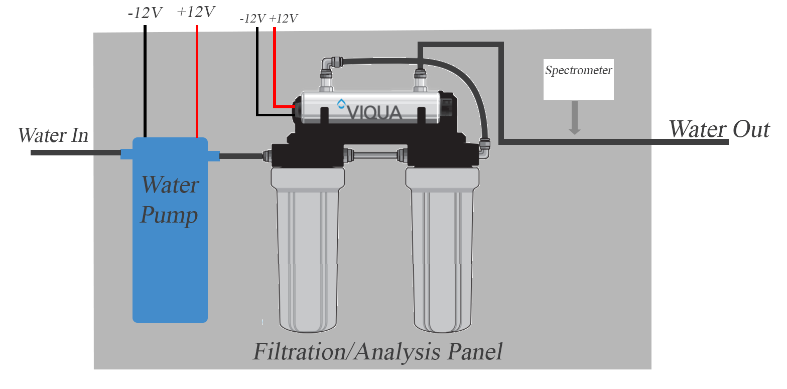
Figure 62: Process Schematic of the water Filtration System

Power Supply
Power supply design is an essential part of any electronic application design. Each individual component has its own set of requirements including maximum current, supply voltage, maximum wattage, and much more. Just one second of improper supply can irreversibly damage an electrical component, wasting money and delaying projects as one my need to order new parts. Our design calls for two regulated outputs.
The first output will supply 12V to the pump and UV filter which have a maximum current draw of 7.5A and 1.583A respectively. Adding these values together gives a total current draw of 9.083A. As an extra precaution, an extra 33% was added to the maximum current draw requirement giving a desired maximum current of roughly 12A. Thus, the first supply will be regulated at 12V and have a maximum current rating of 12A.
Secondly, the next power requirements are 5V for the Raspberry pi and spectrometer which will have a maximum current draw of 3A and .5A respectively. Adding these values together gives a total current draw of 3.5A. As an extra precaution, an extra 33% was added to the maximum current draw requirement giving a desired maximum current of roughly 4.5A. Thus, the second supply will be regulated at 5V and have a maximum current rating of 4.5A.
The last power requirement is 24V for the PyroCouple temperature sensor, which will have a maximum current draw of only 20mA. As an extra precaution, an extra 50% was added to the maximum current draw requirement giving a desired maximum current of roughly .03A. Thus, the second supply will be regulated at 24V and have a maximum current rating of .03A.

The project does include a 3.3V LCD touch screen but no power supply design was required for this since it simply connects to the Raspberrypi for supply. This screen will draw about .5A max but this has been considered in the Raspberry Pi calculations. Only two connections between the LCD and Raspberry Pi are required; power from the Pi’s GPIO port and a ribbon cable that connects to the DSI port present on all Raspberry Pis.
To aid in the power supply design, we used Webench Power Designer. Webench Power Designer is an online tool proved by Texas Instruments (TI) where input and output specifications are used to create a custom power supply circuit. This tool provides advanced circuits that are very efficient and provide protection from short circuits and thermal issues. It also allows users to optimize either efficiency, sizing, or price. Since voltage regulators could be sampled for free the cost of different regulators was of no concern. The main attributes our team wanted to optimize were efficiency and low amount of parts. Also, since no team member was familiar with soldering the smallest size component used on the power supply was 0805. This gave us much more room for error compared to tiny 0603 or 0402 components. Knowing that our battery will be a 12V battery whose voltage can vary from 10.5V to 14V and the first, two outputs are less than or equal to 12V, voltage regulators were necessary for them. Webench power designer was used to create the right voltage regulator.
For the first output supply voltage, the voltage and current requirement is 12V at 12A, which will be powering the pump and the UV cleaning system. The voltage regulator that was chosen was the LM34936RHFR 30-V Wide VIN Synchronous 4-Switch Buck-Boost Controller. The figure below shows the schematic developed to work with this IC to achieve the desired current and voltage outputs. Since this power supply consumes the most current, it was important to try to optimize our design for efficiency. This schematic ensures an efficiency rating of 97.9%, which will help decrease our overall power waste and has a low cost and the lowest possible BOM (bill of materials) count.
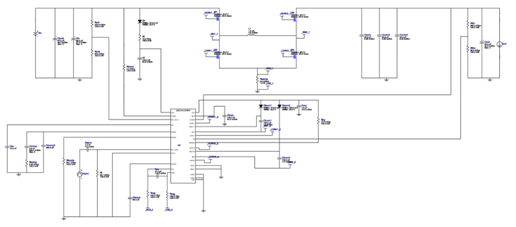
Figure 63: Webench Schematic
For the second power supply, an output of 5V at 3A for the Raspberry Pi is needed. It also can only be powered by a USB-C connection. It is not possible to specify within Webench that a USB-C connection is needed, so the PCB will be made, and a male head of a USB-C will be attached to it. The USB-C cable has 24 different pins on it and can seem like a daunting task to implement but it is only required to use two pins when supplying power and not data. Although only 3A is required for the Pi, when accounting for the spectrometer, LCD and adding on an extra 33% just for redundancy, the needed output current is 4.5A. The voltage regulator that was chosen was the LMZ22005TZX/NOPB 5A SIMPLE SWITCHER Power Module with 20V Maximum Input Voltage. The figure below shows the schematic developed to work with this IC to achieve the desired current and voltage outputs. The best part of this schematic design is its extreme simplicity and low BOM. Compared to the previous power supply it has a lower efficiency, around 90% with a 1.5A draw, it consists of just 6 parts compared to the previous designs 44.
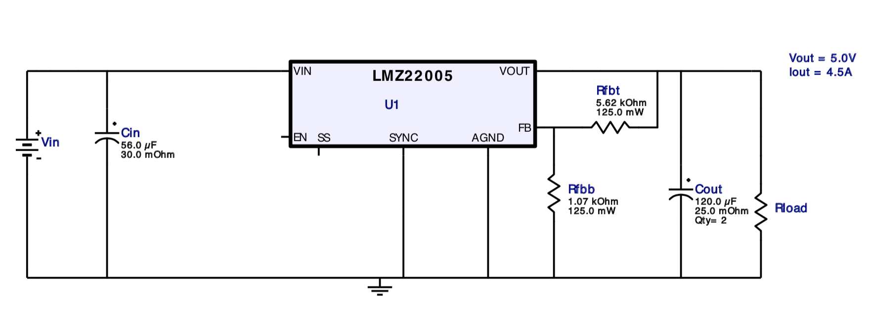
Figure 64: IC Schematic

For the final output supply voltage, the voltage and current requirement is 24V at .3A, which will be powering the temperature sensor. The voltage regulator that was chosen was the TPS61170QDRVRQ1 Automotive 3V to 18V Wide Input Range, 1.2A Boost Converter. The figure below shows the schematic developed to work with this IC to achieve the desired current and voltage outputs. Since this power supply consumes the least amount of current, it was important to try to reduce the BOM. The lowest BOM count possible was 11. Analysis of the design revealed that the maximum power wasted from this schematic is .14W which is insignificant to our system.
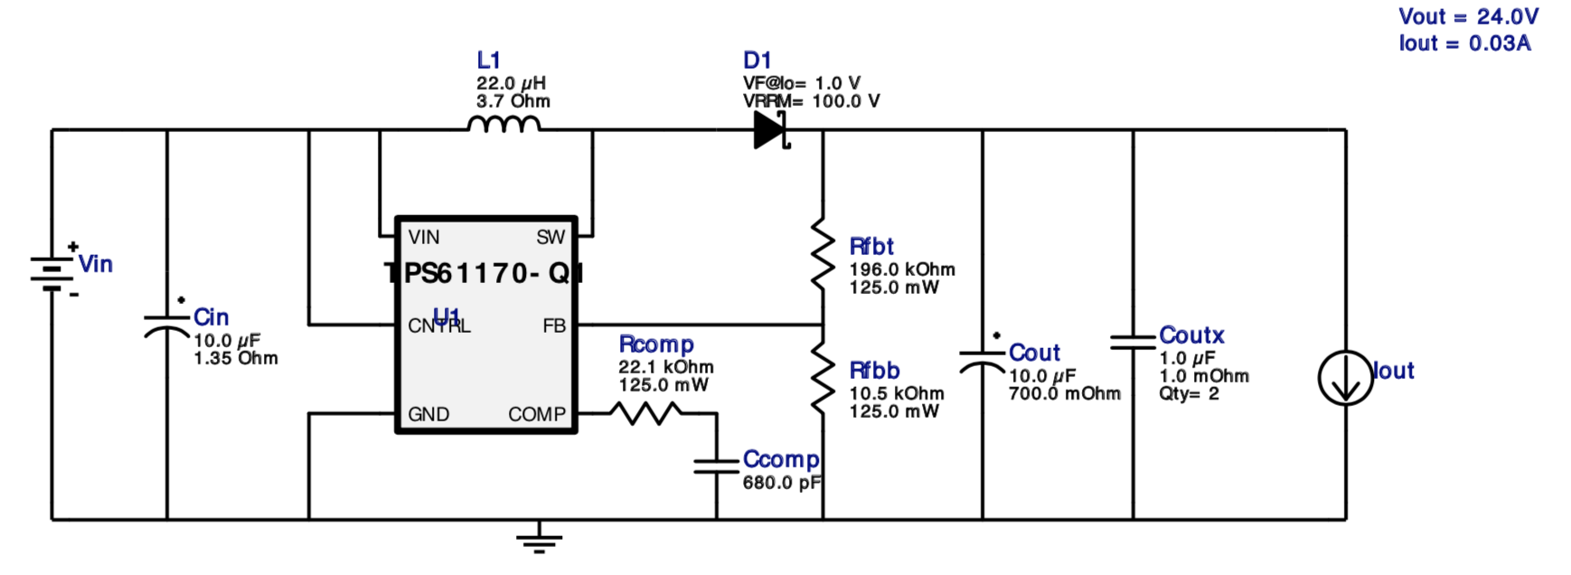
Figure 65: Schematic
Upon further design of the power supply, it became prevalent in research that motors (basically pumps) and RaspberryPi’s can interfere with each other a lot. Pumps and Motors are very noisy devices and can end up resetting or turning off a microcontroller as a result. It is highly recommended that two separate power supplies be used to avoid this issue. Flyback diodes on relay coils and capacitors over the microcontroller seem to help prevent this, but this will remain a main concern when designing the schematic and PCB. Using two separate battery sources is a possible solution to this but will take up more space and cost more money so we have chosen to not pursue this avenue of solution. As of now the components for these schematics have been ordered and will be implemented on the PCB board as soon as its design is finished.

User Interface
After much thought about what the user interface should look like. It all narrowed down to its goals that the group has set forth. These include that the application must show the user the temperature of the water, the inorganic components and pathogens in it, and if the peripherals are working properly. The user Interface will show or be able to show the battery power, the solar charge input, and output. These features will be subtly displayed either all the time or be able to be accessed by the user. Once the water is introduced to the system a clock will start, which will be indicating how long until the filtration process is finished. With that thought in mind, this is something that could appear on the side of the screen as a peripheral. For the analysis of the water coming from the spectrometer, the user must wait until the computer finishes processing this data for it to be displayed. Dealing with these characteristics, we decided to have 3 screens in the user interface. These three main screens will consist of a welcome screen, a water analysis screen, and a loading screen for the said analysis. If time permits there may be additional features that will be included in the user interface and different screens. An example of two screens has been given below in the following figures.
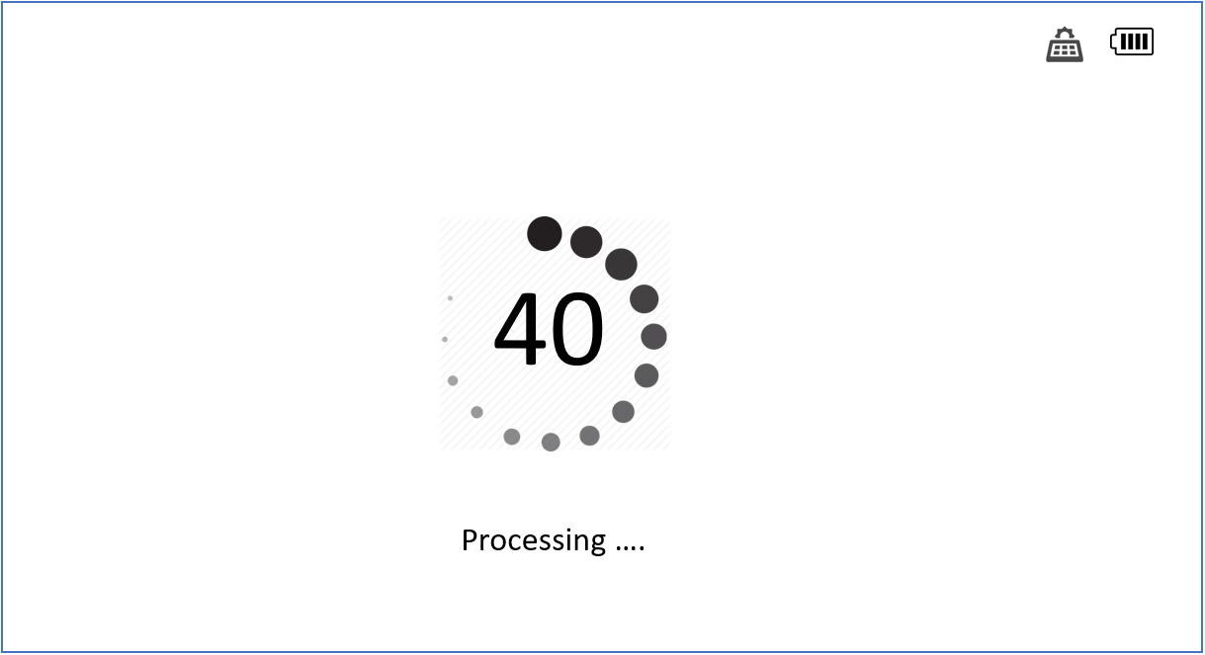
Figure 66: UI Loading Screen
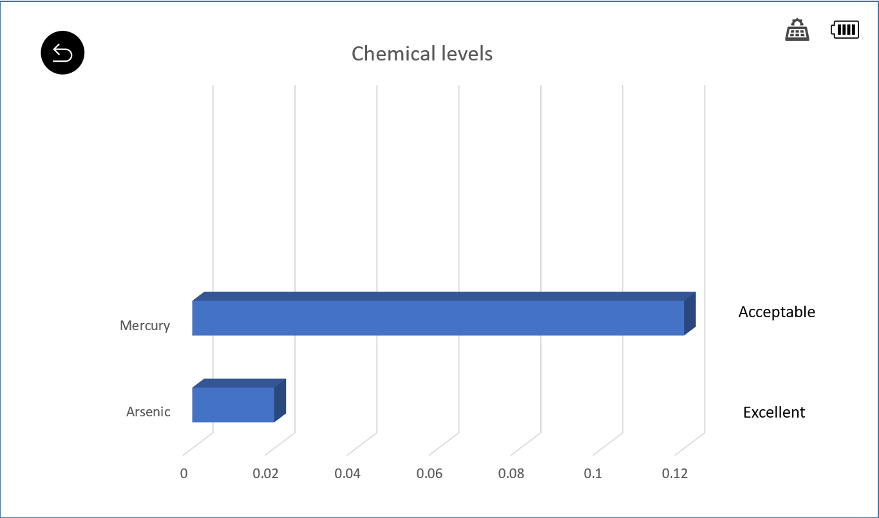
Figure 67: Components comparison of Spectrometer Screen

Water Analysis
To ensure the quality of the water and show an optical engineering application, the water will be analyzed via spectrometer and temperature sensor. A spectrometer will serve as a means of looking inside the composition of the water after the filtration process, while the temperature sensor will give us some data.
Spectroscopy:
The exact system Ocean Insights will be lending us is still unknown, but we are able to come up with possible designs based on background knowledge of spectroscopy and overview of products on Ocean Insights website. Based on the theory of Raman spectroscopy we should be able to perform it on moving water, but due to the unknowns of the system we are being lent and not having performed Raman spectroscopy before, we provided two designs. One design is for Raman spectroscopy done on moving water, and the other is Raman spectroscopy done on still water. There are also spectroscopy systems that use what is called a Raman probe, but we have little reason to believe they will be lending us a system that uses probes and therefore we do not have a possible design. There is also a possibility, based on the system we receive, that we will have to include more optics, but those specifics are still unknown. The light dispersion due to the glass tube is addressed in section 4.1.4.

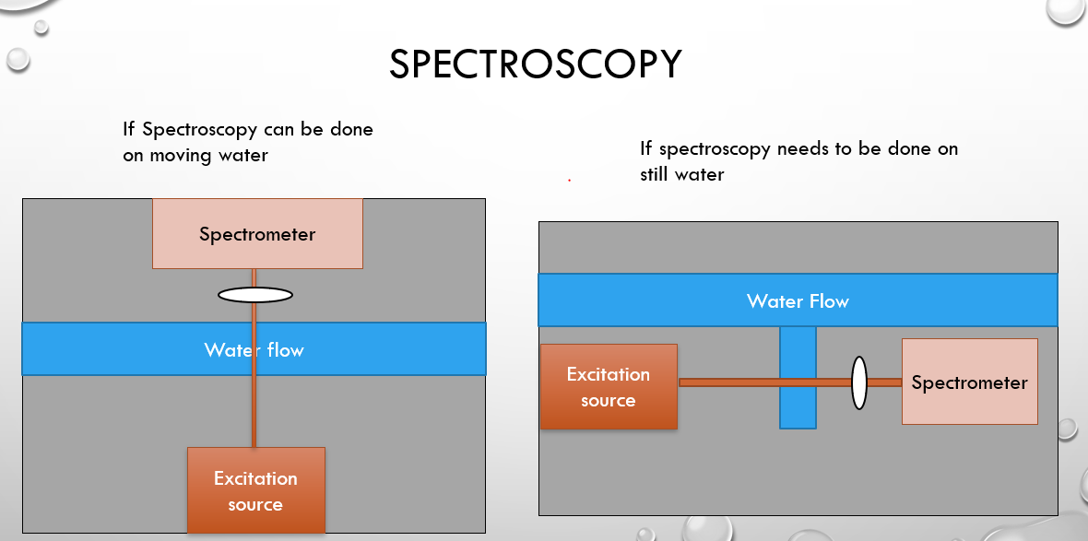
Figure 68: Possible design of Spectroscopy Analysis
The final spectroscopy system needed multiple components to collimate and focus the light, the final design of the system is shown below:
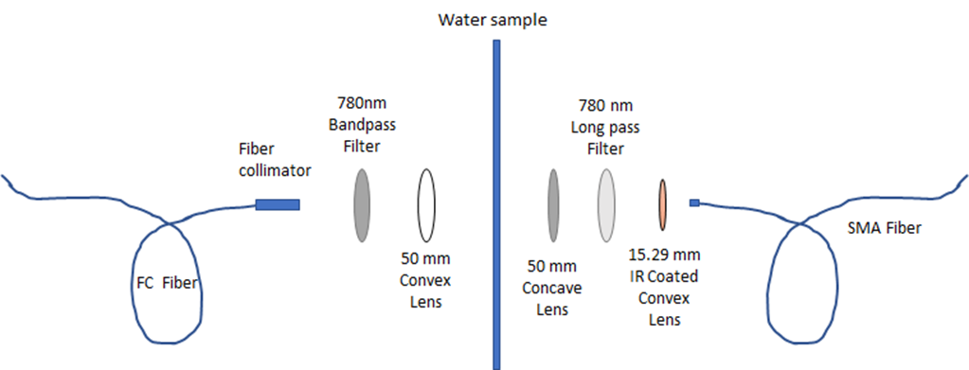
Figure 69: Final design of Spectroscopy Analysis
Temperature Monitoring System:
Since the current excitation source for the spectroscopy is unknown, we have 2 possible designs for the IR temperature sensor. In the first design we can use the excitation source from the spectroscopy system with a beam splitter because it is a near infrared source emitting at 785nm and infrared temperature sensors can pick up anywhere form 700nm-1400nm. The other design will be used if we are not able to use the spectroscopy excitation source, we will have to purchase an IR laser that the temperature sensor will then pick up. Since IR temperature sensor can be used on moving objects, we do not have to make any special edits to the water flow.
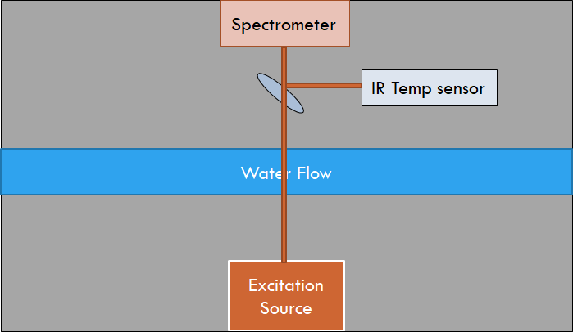
Figure 70: Temperature Sensor Design Using Spectroscopy Excitation Source
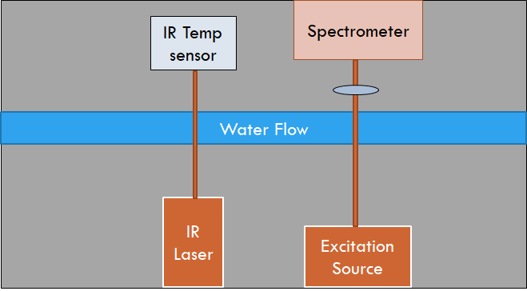
Figure 71: Temperature Sensor Design Using its own IR Source
After choosing the temperature sensor the above designs are no longer plausible, therefore the figure below shows the new design layout using the contactless IR temperature sensor ordered and outlines in section 3.2.8.
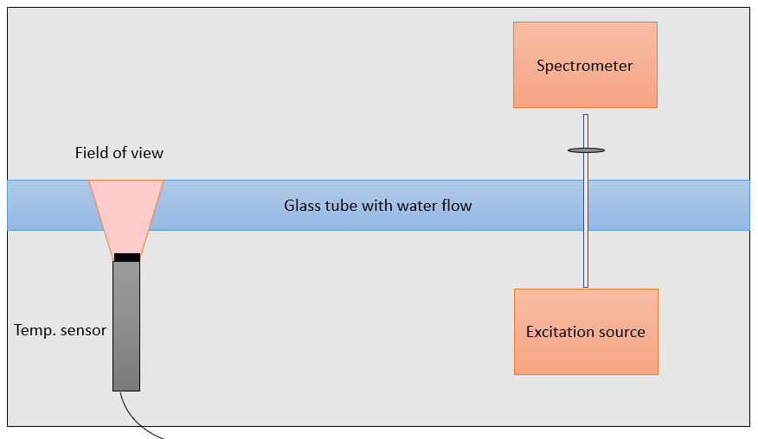
Figure 72: Most Recent design of Temperature Sensor

5.1.7 Control Relay System
It was quickly realized that the RaspberryPi should not directly turn on the loads of the system, as this type of current draw would likely damage it. So, incorporation of a control relay system was necessary. The RaspberryPi also only provides output signals at around 3.3V which does not have enough power to flip a 12V relay, so to boost the output signal an Opto22 G4PB8H I/O board^{[78]} was used. This gives us the capability to output up to 60VDC at 3A if needed, but in this project 12VDC logic will be used. These output signals will control the Automation Direct 781-1C-SKT relays that will act as switches to connect each component to its corresponding PCB power supply. This System separates the small level hardware from the heavy loads of the system.
Since the RaspberryPi does not have the capability to run all the loads directly off of it, there needed to be some separation between the Pi and the loads via Relays. Also, the Pi does not send a strong enough signal in order to control the provided relays, so another boost of the signal was needed via an Opto22 G4PB8H I/O board. The Opto22 G4B8H I/O board will utilize 60V/3A rated output modules which will act as a switch in order to transfer a 12V control signal. This 12V signal will be brought from the 12V power supply PCB which will activate the relays, in turn connecting the components to their respective power supplies, and ultimately turning them on via the output signal from the Pi.

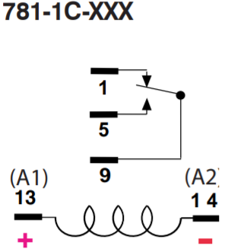
Figure 73: Pin out for the 781-1C-SKT [77]

The relays that are being used are Automation Direct 781-1C-SKT relays which run off of a 12V coil. These relays are rated to pass a signal up to 28VDC at 15A and will act as the switch between each component and their respective power supply PCB. The wiring of the relay (visualized in the figure 73 above) will be as follows; the supply voltage will be connected to pin 9 of the relay, the corresponding load will be connected to pin 5 (the normally open contact), a -12V will be connected to pin 14, and the +12V control signal wire will be connected to pin 13. Between pin 13 and 14 there is a coil that, when activated, connects pins 9 and 5, which will turn on the specific component. Pin 1 will not be used in this design, but it can be utilized as a feedback signal to show that the component is supposed to be turned on at that moment. Below a more in-depth depiction of the overall wiring and outline of the control relay system is provided.
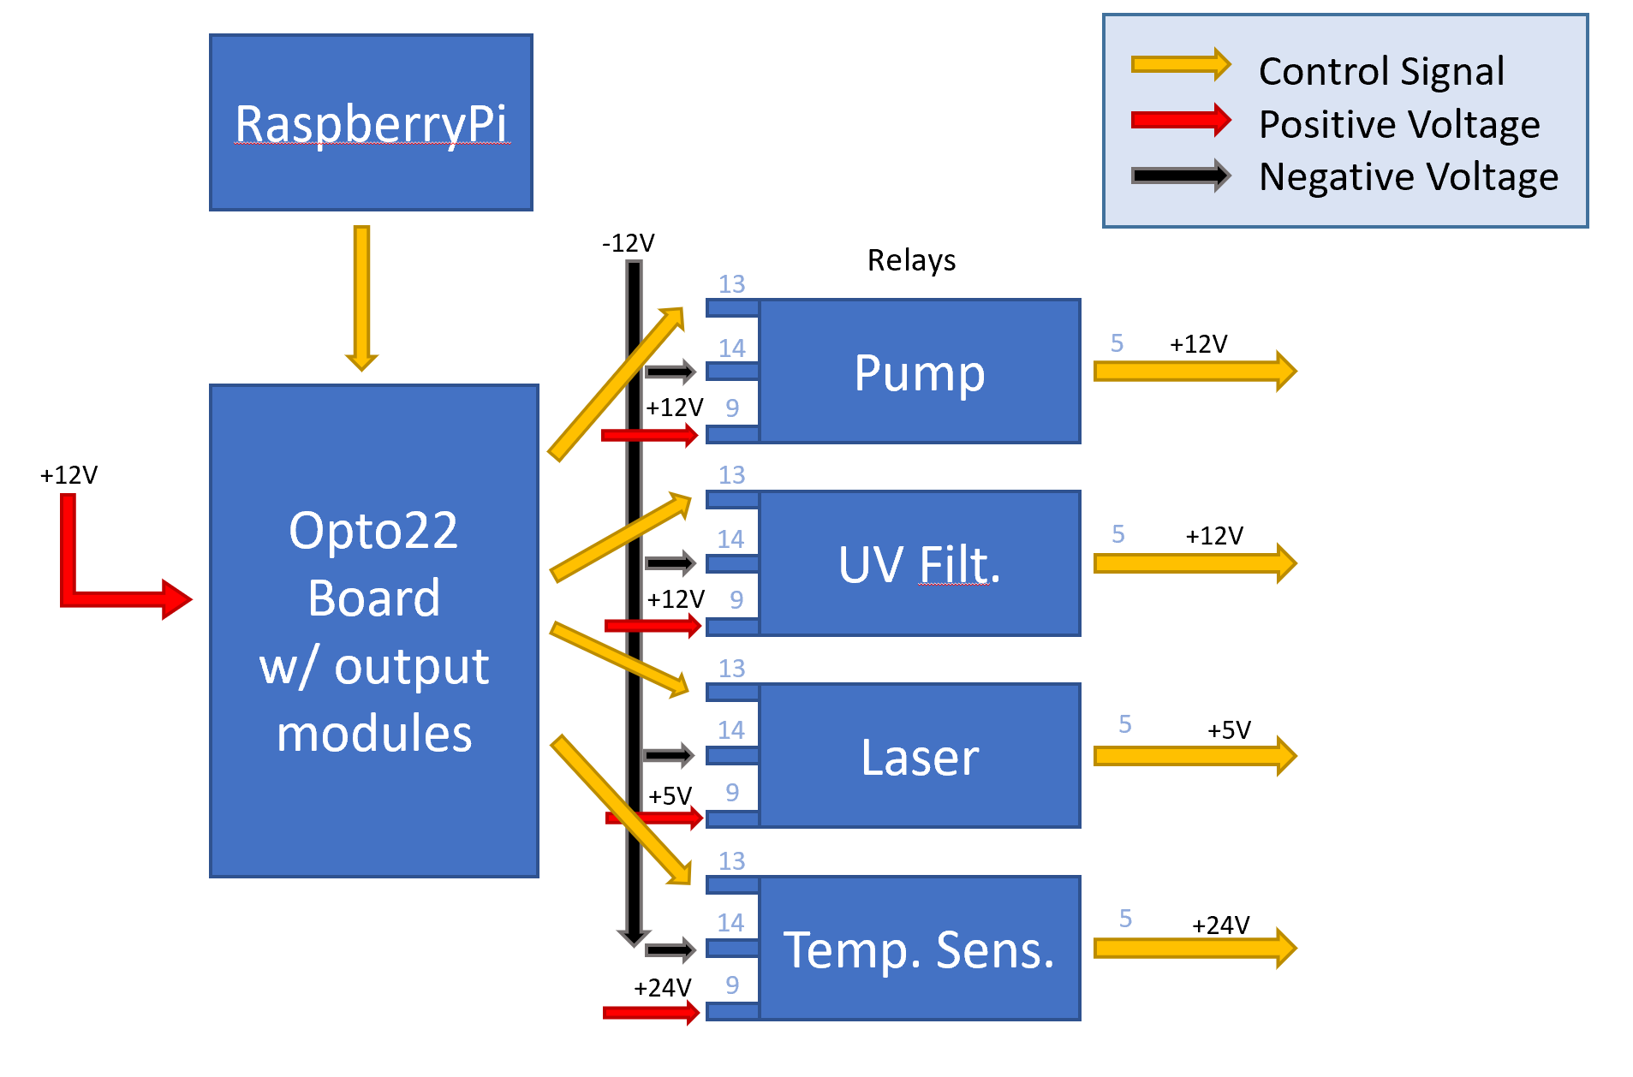
Figure 74: Wiring schematic for the control relay system

Overall Design
Our original goal was to make the system portable therefore we would have liked it to be no bigger than a desktop. We figured the best way to combine all the parts of the system would be into a box. Unfortunately, after designing the power system for the project, the group quickly realized that the overall system was probably unable to be portable. Each of the solar panels take up almost 9 square feet, and the battery alone weighs about 40 to 50 pounds. Therefore, after the first design of the system, we realized we needed to make some changes.
The First Design:
For the first design, we were looking into a box type of set up. We would need the outside of the box strong enough to hoist the solar panels, while the rest of the components were housed inside the box, and have the input water coming into it, and out once it was clean. This design would make the input of the water easy, all you need is to pump the water into the box and have it come out the other side. So the cube design seemed to be optimal for what we are trying to accomplish, which can be seen in the figure below.
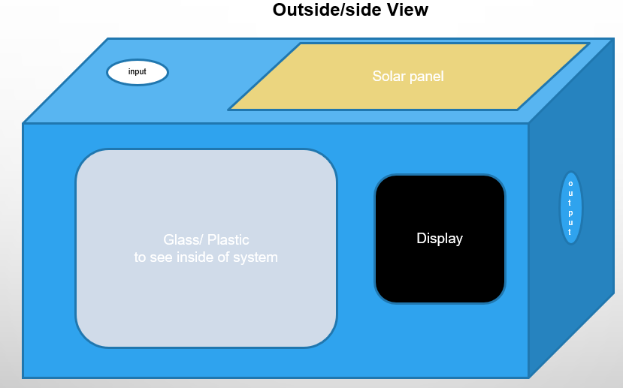
Figure 75: First Design of the Outside view of the System
Our first plan was to design and assemble the filters and cleaning system, but due to the time constraint and amount of mechanical/plumbing work was involved we did not feel it was feasible. The design in Figure 75 was made before we decided to purchase the filtration system, but it is still relevant as to what the inside of the system will look like. Our idea was to have the water come inside the box and enter two filters, a sediment filter and a carbon filter. These would take out any large contaminants that would obstruct the UV bulb from cleaning the water fully. Then lastly it would enter the UV chamber and exit the system as clean water, ready to be analyzed by the spectroscopy equipment.
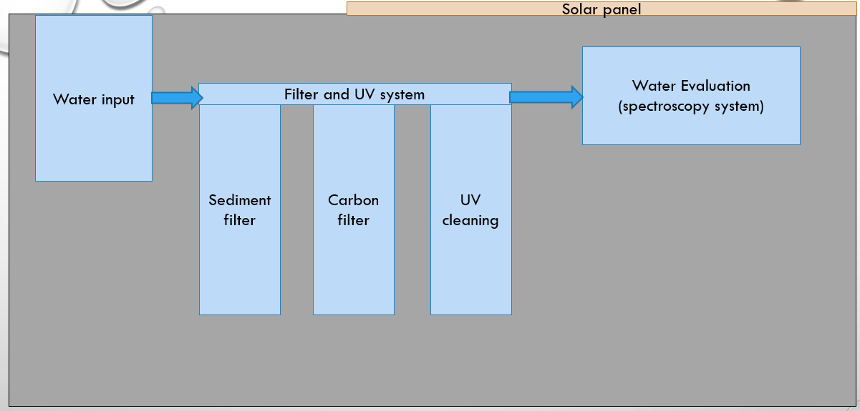
Figure 76: First Design of the Inside of the System
The Second Design:
After realizing that the portability standard was going to be much too difficult to accomplish, a new design was thought up. Thus, the most realistic idea the group agreed on was to at least make the system maneuverable and that is where the dolly design came into play. The dolly design will offer a way to have everything held together on one solid structure and make it to where it can be transported easily. A side and front view of a 3D model can be seen below. This design was made by Brandon Aguayo, a UCF Architecture Graduate that generously donated his time to help the group better depict this idea.
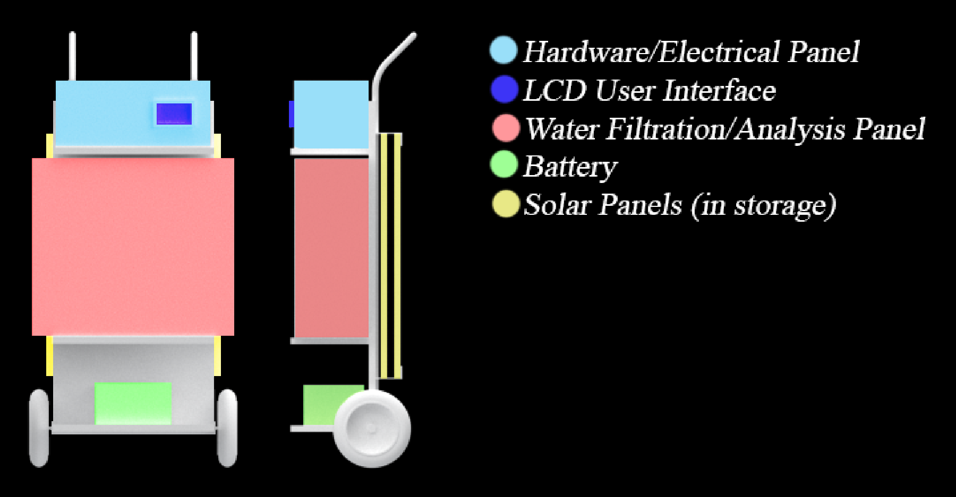
Figure 77: Newest Overall Design of the System
In the figure above, you can see that the battery will rest at the base of the dolly, above that will be the filtration and analysis panel, followed by the user interface and hardware panel. The solar panels are bulky, and it was not seen to be advantageous to have them permanently mounted to the structure, so the idea was made to where they will have a storage place on the backside of the dolly. These will be able to be removed and placed in an area that is receiving sunlight. By having the solar panels separate and not bound to a specific spot on the structure, they can be angled toward the sun to pick up the most sunlight throughout the day. This was seen to be the easiest and most practical design thus far and will likely resemble the final project.
What is not depicted in this 3D design is the water flow components and the power connections. For the water flow, the idea will be to have a port on either side of the water panel that will allow a hose to be fed in and out of it. This panel should be waterproof around these areas, but a water port would be smart to include, in order to let any water in the panel to escape in the case of a leak. For the power connections, which will consist of all the data inputs, outputs, and power signals, the idea will be to run some PVC piping along the backside of the panels. These will be the means of communication between the power system, user interface, and all the hardware.
The implementation and communication between the control system and various components will be the ultimate factor on whether the project is successful. So, this design would be subject to change if this is jeopardized in any way. But this dolly design serves as the best practical idea as of now and will likely resemble the final built project for our solar powered UV water cleaning system.
Final Built Design:
The final design came out to be quite like the second “dolley” design and worked great. The only distinct difference between the two would be that the solar panels were too large to mount on the back side of the dolley. In real world applications, this would not be an issue as the dolley would be sized accordingly or the solar panels would be sized accordingly. Below is a photo of the system, fully built to the design constraints laid out in this document.
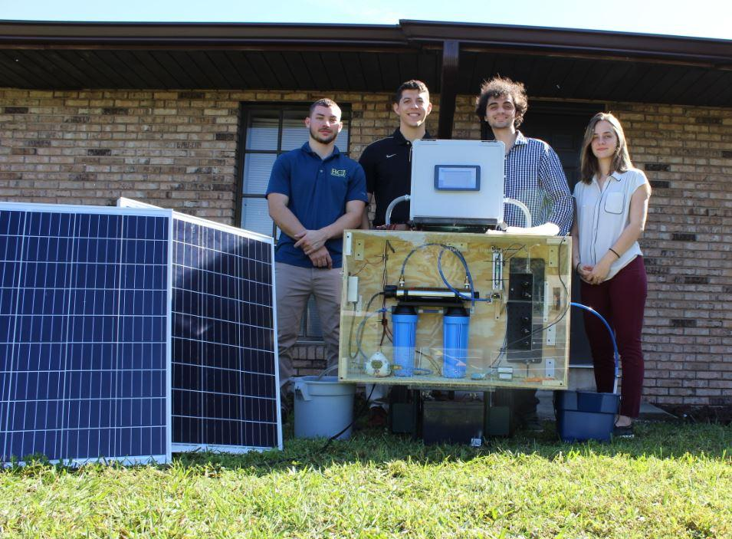
Figure 78: Final prototype and group picture

Software
Hardware refers to the physical components of a computer. Hardware of computers, in the traditional sense, only deals with binary type data (0’s and 1’s). Also known as machine language, lays the foundation, which everything is built on top of. In the laboratories of IBM, a new form of hardware technology is being developed. Quantum computer hardware, work in a way that is fundamentally different from traditional computers. This modern technology aims to change the whole field of computation. The quantum computer deals with Q-bits instead of regular bits. Q-bits advantage is that they can store more information than the traditional bits. A bit can only store a 0 or a 1, a Q-bit can theoretically store infinity amount of data. The disadvantage of the Qubit is they are much less reliable and are still not economically viable. A lot of basic research is being done in IBM to improve Regular computer hardware can is very reliable in terms of transmitting information. Out of 1 million bits transmitted only 1 bit mess up. All the abstractions in computer architecture are made on top of that. The hardware of a computer, composed of memory, CPU, GPU and other millions of components, all made to store, transmit, process binary data. Billions and billions of binary data are processed by the CPU every second.
The term Software engineering was popularized after a conference in 1968. When the problems of building increasing robust and complex software applications were frankly discussed. The necessity of better tools and methodologies became apparent. It is a very young profession; it only exists for 50 years. This demand kindled the birth of the first programming languages. Ever since the improvement of programming languages was tied to the improvement of software. On top of that methodologies for the development process were created too. Software is an abstract term to refer to the instructions the computer uses to perform useful tasks. The official definition of software is: The instructions programs and data used to operate computers by making logical decisions. Software is generic. Still without software the computer is just rock with wires. Because software was such a generic term, and because of the wide scope of functionalities programs have, Other terms were created: Scripts, applications, programs etc. In industry they are used interchangeably. Software is built on top of other software. Even in the beginning. Lower level programming languages were used to write higher level ones. This process of using previous software to model new one is called abstraction. All different types of program abstractions that run on the device.
Abstractions are very interesting. Abstractions in software engineering enable us to isolate features and problems and create tools to automate them. In addition to that, it modifies the way of implementing processes in the future. Because of the tight schedules required to develop programs in industry, making software abstractions is essential to any project that involves software successful. It would be unfeasible to make programs using only hardware level instructions. And choosing the correct programming language to work on a project can save months. For programmers, creating abstractions and building on top of them is the only way to effectively create software. Then after the new software is implemented and the code properly refactored, new abstractions are created. Those abstractions become the new industry standard. So the software development progresses. Abstractions don’t come without downsides. For Example: by choosing a certain operating system, we are limited to use programs that are only compatible with that specific operating system. Therefore, by trading the OS we make tradeoffs between different features. If necessary, we could also design the OS. This would be, of course, not necessary and counterproductive. Using an already established OS it gives us a huge array of programs to use.
In this project, choosing the right abstractions will be the most crucial part for our success. If we could find a proper abstraction, we could save weeks of work instead of designing everything from scratch. It can also be our downfall. Not being able to solve a compatibility issue or being stuck trying to solve a bug. Not being able to use the abstraction correctly. Not being able to interface between two components properly. The company that produces the spectrometer we are getting has a couple of options regarding which level of abstraction we can work on. From all the way to the application level to coding embedded systems. That software they feature are discussed further. But all those problems may arise so preparing for them in advance is the smartest.
Ocean View:
The information below in Figure 79, is from Ocean Insights’ Ocean View Manual documents, which shows the minimum system requirements in order to operate Ocean View.
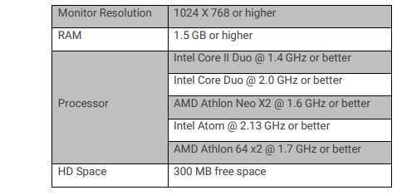
Figure 79: System requirements for Ocean View
OmniDriver is a development kit designed to write custom software For Ocean optics Spectrometers. OmniDriver is compatible with Windows, Mac and Linux Operating systems. It is an integrated Software to control the Spectrometers using commands. OmniDriver Features set acquisition parameters such as time and acquire spectra. It was developed in java and it uses some libraries included in windows, Macintosh and Linux systems. Also allowing developers to create applications that interact with multiple spectrometers at once and synchronize them. This will be done via USB from the spectrometer.
It features multiple languages for developments.
C
C++
C#
Borland Delphi/Pascal
Java
LabView
Visual Basic
As well as multiple interfaces
.net
C++( Visual Studio Linux gcc/ Linux)
OmniDriver features various high-speed data acquisition. In order to get the spectra as fast as possible it puts all the data at once on a pre-allocated buffer. It also features various functions to reduce the noise and smooth the curve spectra. Some of it is achieved by controlling the lights inside the spectrometer, some it is achieved by noise suppression algorithms. It is important to control the lights well because they can cause noise in the sensor if not properly coordinated.
SPAM (Spectral Processing and Math):
This Add-on library gives a lot of low-level spectrometer functions such as peak finds, radiometric color analysis, etc. It is used in combination with OmniDriver for simplification. Otherwise it is designing the whole regression and analysis algorithms from scratch.

Bug/ debugs
Our first UI prototype was developed and tested in a windows system, using SceneBuilder. SceneBuilder provides a drag and drop functionality to build User Interfaces, and it exports the interface built to FXML ( javaFx files). We were motivated to use this program because it provides modern looking elements, and it was fairly intuitive to use. Unfortunately, we didn't make sure the JavaFx files would function in a Linux operating system. We assumed the UI was modular and could have been easily transferred to another computer, such as the raspberry pi.
The following is the picture of the first prototype GUI:
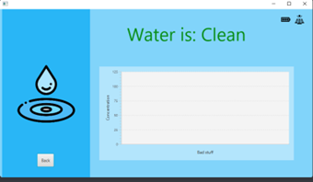
Figure 80: GUI Prototype

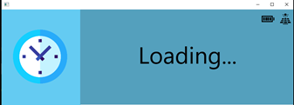
Figure 81: GUI Loading screen
Java code is not directly converted to executable, it is run in the Java Virtual Machine. It makes sense that special libraries are required to control embedded hardware components, such as IO signals. These libraries are distinct for each hardware running the system. The raspberry pi is very popular, and it is used for many projects, so we were able to find a library that enabled us to control embedded features using java, PI4J. But this library was outdated for the raspberry pi we bought, we bought model 4B, PI4J is only compatible with raspberry pi 3 and below. Nonetheless, we were able to solve this problem by using Sqlite, and a python script, to control the IO. Since Sqlite is compatible with java the java program would update values in a sql table and the python script, running on the background, would check this table, every fraction of a second, and based on what it contained it would control the sensors using IO signals and interface it back to the UI.
By successfully controlling the IO using a python script, we got the conclusion that we could create a UI using a python library as well if needed. We still wanted to use java because neither OceanView nor the omnidriver software is compatible with python. So, if we only used python, it would be difficult to gather the data from the spectrometer. Another way of accomplishing that was by converting the spectrometer data in some other format, upload it to a database, and process the data stored with another python script. Also, the raspberry pi IO was designed to be controlled using python scripts. The raspberry pi foundation launches the python library together with the computer itself. Another reason, for trying to continue to use java, was the steep learning curve required to learn the modern looking libraries in python, we were looking at the library Qt to design the new GUI. There are, however, easier libraries to design UIs in python, but they are not as modern looking. One of those libraries we found was guizero. This graphical user interface library was intended to be used as a backup in case we didn’t have time to build another GUI using Qt. So, we made a GUI containing everything to control the system, the pump, the UV, the temperature sensor, and the laser using the guizero library. In the end the Qt GUI was never implemented and it ended up being our final GUI, and the original javaFX GUI was scrapped.
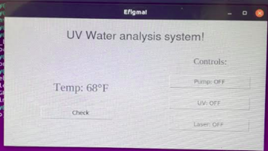
Figure 82: Final GUI
The original temperature sensor was also difficult to interface with the raspberry pi, as mentioned above the temperature sensor outputs a 4-20mA current signal, this signal cannot be interpreted directly to the raspberry pi. Since the raspberry pi doesn’t have an analog port to read the signal. So, we decided to implement a backup temperature sensor DHT22, in case the first one failed we were still able to get a temperature signal regardless, this backup sensor, however, is more imprecise, it possesses a higher failure rate than the first one. But it was easily interfaced with the raspberry pi using the python DHT22 library. We were able to successfully implement this sensor. As for the original temperature sensor, we found the module PI-SPi-8AI+ that converted analog signal to serial signal, this module was compatible with the raspberry pi, enabling us to read an analog voltage signal and sending it to the raspberry pi, via IO ports. So, all that was left was to make a circuit to convert the current signal to voltage signal. This circuit was simply passing the current through a resistor and recording the voltage value. So, we were able to get the signal to the raspberry pi. We still had to calibrate it.
We used the formula below to do the signal conversion, first we were able to read the sensor base value by using the sensor to measure the temperature of ice. Since the minimum temperature the sensor can read is 0 °C and Ice temperature is below than 0 °C. This meant that at 0 °C the sensor would be outputting 4 mA, the base value, the maximum temperature the sensor can read is 250 °C, at which it would be sending 20 mA, doing the calculations you can discover the scalar value.
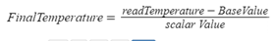
Using this module created another problem, its library, widget lord, is only compatible with the Raspian OS, the standard raspberry pi operating the system; we were originally running Ubuntu 18 LTS. But, since this module worked so well, and all other libraries used were also compatible with the Raspian OS, we decided to change the OS running in the raspberry pi and migrate all libraries to it. In the end, we were able get the original sensor working as it showed in our demo.

Flowchart
There is a specific way we expect to have our equipment run, while some equipment may overlap, there is a general outline of the way the system is expected to work. The following flowchart outlines the flow of operation for the overall system:
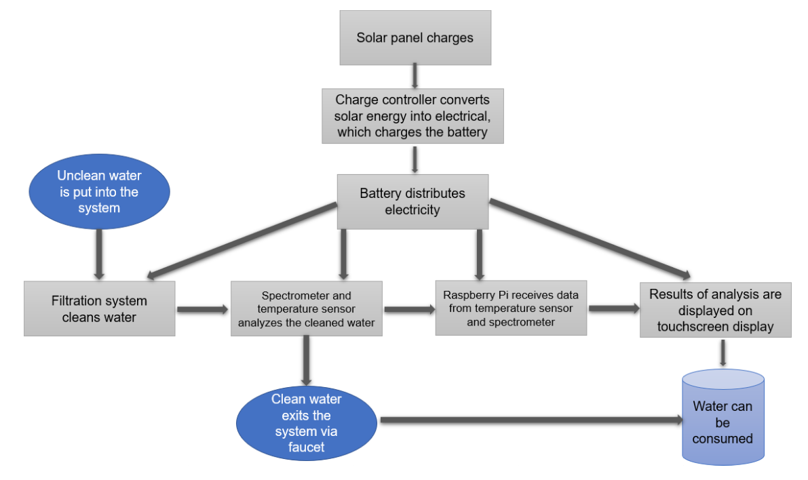
Figure 83: Flowchart Representing System Process

Overall Integration
The following section details the amount of integration we can accomplish in senior design 1. This includes designing a printed circuit board (PCB) and breadboard testing the major component of the system. When all equipment is tested, and the PCB is designed we can start the full system integration.

PCB Design
When using Webench power supply designer, multiple schematic and PCB file types are available. We choose to use Easily Applicable Graphical Layout Editor or EagleCAD. EagleCAD was preferred because of its enormous number of electrical and electronic components and its intuitive user interface. Normally the microcontroller would be a key component on the overall PCB and schematic design but since our project required the more robust Raspberry Pi, no microcontroller was included in the final schematic. The final schematic and PCB will only need to include our power supply designs as all other components cannot be mounted on the board and require simple wiring. When we do receive our spectrometer, a separate PCB may be needed to establish communication lines between it and the Raspberry Pi. No relays were required to turn on and off components since UV lights are recommended to never be turned off to avoid downstream contamination. Furthermore, the water pump operates when it senses pressure change downstream and thus does not need to be electronically controlled. The power supply schematics were already provided in the last chapter so just the PCBs will be shown below. It is important to note that it would save money to implement the PCBs all on one board, but the free version of Eagle limits the size of boards to 100mm x 80mm. This is barely large enough for just one power supply design and thus three different PCBs are used. All required ICs were ordered from TI and passive components were purchased using the BOM manager tool from Digikey. The outputs of the PCBs voltage regulators shown below respectively as follows: 12V 12A, 5V 4.5A, and 24V .03A
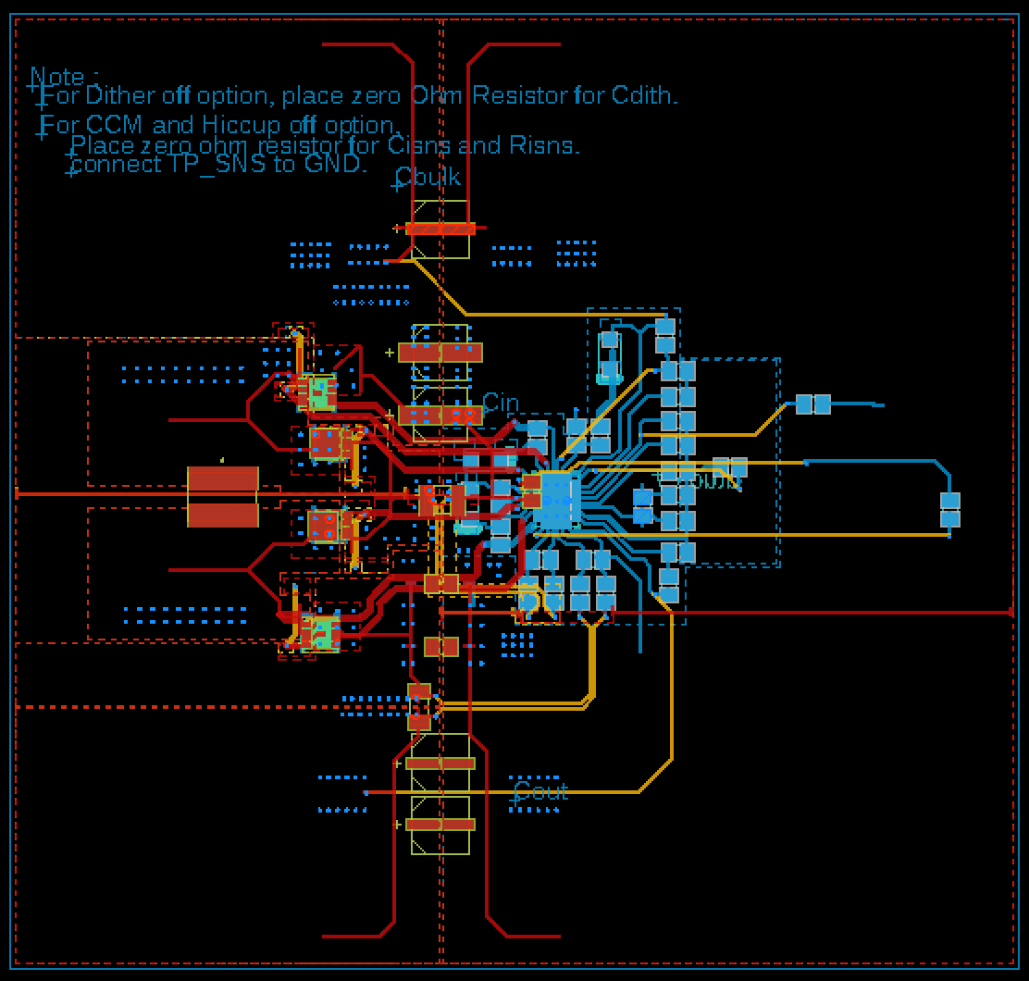
Figure 84: First PCB Design
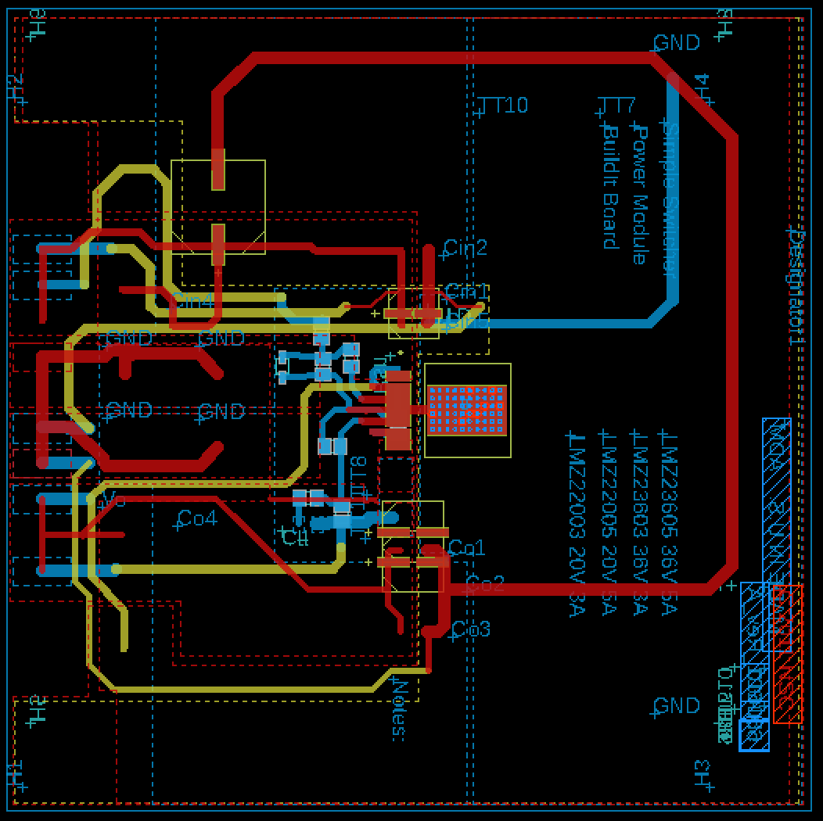
Figure 85: Second PCB Design
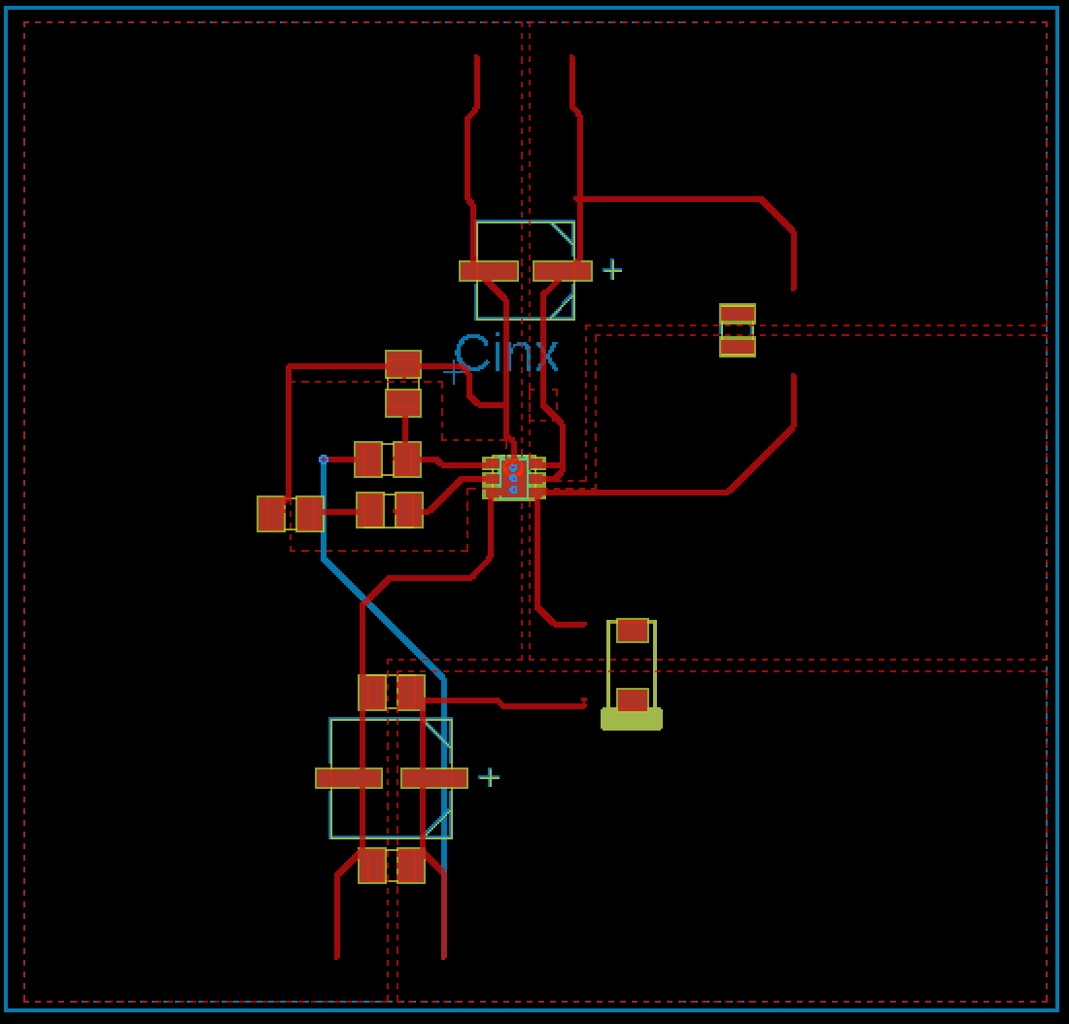
Figure 86: Third PCB Design
As we continued to design our PCB, we ran into many issues using EAGLE. When importing CAD files from Webench all of the components would be corrupted and stop us from adding them to the library. Furthermore, Webench only produced schematics and PCB layouts for 4-layer boards and we thought this was unnecessary. Instead we opted to use Webench as a schematic generating tool. Since Eagle was out of the picture, we began using EasyEDA and found it much more intuitive and bug free. Using the same IC’s as above, we developed the 2-layer PCBs, paying much attention to detail since they dealt will large current draw. The Final PCBs for the 5V, 24V and 12V regulators are displayed below.
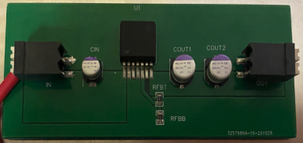
Figure 87: 5V PCB
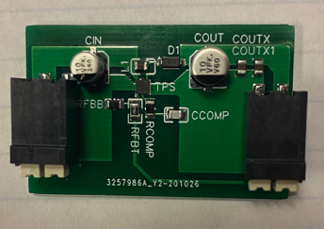
Figure 88: 24V PCB
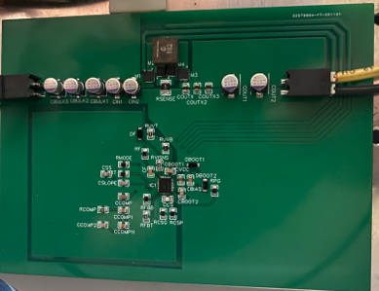
Figure 89: 12V PCB
  - Major Component Testing
Before we can build the entire system, we must test the major components that were ordered. If we don’t test each individual component before integrating in the system, it could damage other components or cause a time constraint while we wait for a new part. If our major components are not functioning accurately then we are unable to integrate them into the system. Below is each major component tested to ensure they are working properly.
    - Solar Power System
The solar power system will obviously consist of two solar panels, a PWM charge controller, and a battery. In order to test the operation of the system, it was best to operate these three parts together. Based on the instructions given in the solar panel and charge controller purchase, the system was put together. First the battery terminals are to be connected to the charge controller, via wire to the middle two wire ports on the charge controller. Next the solar panel is to be connected the same way to the charge controller in the two far left terminal ports. Then lastly, the load will be connected to the far-right terminals. The polarity of each item and sequence of installation is very important, as not following these steps can lead to damage within the charge controller. The final test set up was in the afternoon, under full and mostly perpendicular sunlight, and can be seen in the figures below. Once the charge controller was connected to the battery, and since the battery had enough charge, the charge controller successfully turned on. Once everything else was connected, the display on the charge controller showed the voltage at which the load terminals are being regulated at. This can be changed to show the voltage being produced by the solar panel, as well as the battery voltage by alternating through the different settings. This test was performed on both solar panels to ensure proper operation. Luckily both worked and these will be ready to implement further into the project.
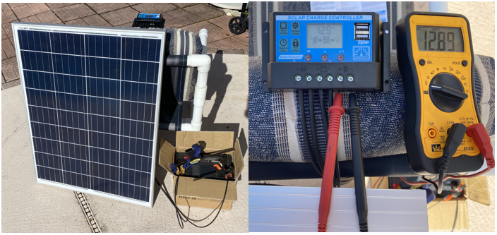
Figure 90: Solar Panel and Charge Controller Being Tested with Output Voltage

Pump
The pump will be responsible for pushing the water through the filtration system, without this the water might not be filtered properly or filtered at all. The pump runs off a 12V DC signal that will come from its respective voltage supply from the PCB. In order to test the pump, the pump was connected to the battery of the system. The battery provides a strong 12V DC signal, enough to get the pump started. The importance of this is that the pump requires more power than the rest of the components. There is an inrush of current in order to turn the pump on, which is higher than the operating current. Therefore, the pump needs a strong, stable 12V DC signal to run.
In order to test the pump, it was connected to the battery that will be used in the overall system. A 10A fuse was put in series with the pump in order to provide some protection during this testing process. Once the pump was connected to the battery directly, it immediately turned on. There was no water that the pump could push, but this pump is able to run dry. Therefore it was safe to test the pump even though it was just pushing air. The pump had a decent amount of vibration while running, so this will need to be taken into consideration when the final design is built. The pump will need to be securely fastened in order to keep everything inside the filtration box safe. The pump worked like it should and should be ready to be implemented into the system once the final design is made.

Temperature Sensor
The temperature sensor will monitor the temperature of the water to ensure the proper water quality, but before it could be implemented, we needed to test its functionality. The sensor runs off a 24V DC signal and outputs a standard 4-20 mA signal that represents the temperature of whatever it is looking at. The sensor is a UV temperature sensor, so it does not have to directly touch whatever it is measuring. So, testing the sensor was really not that much of a challenge.
The way the temperature sensor was tested was by using a 24V DC power supply, which was linked in with a 0.5-amp fuse in order to provide a bit of protection. The power supply takes the 110V AC signal from the outlet and converts it to 24V DC. Secondly to measure the current output rating of the sensor, a multimeter was put in series with the sensor negative lead. Therefore, wherever the temperature sensor pointed and read, the multimeter would read the current rating from 4 to 20 mA. To show full functionality, the sensor first was pointed at nothing, so it essentially read the room temperature and displayed a 5.45 mA reading. Next a pan was heated up and the sensor was pointed at the pan to output a reading of 13.63 mA. Although the reading is not directly in the form of temperature, this reading will be converted by using the overall operational range of values that the 4 to 20 mA signal represents. The testing of the temperature sensor can be seen below in both settings.
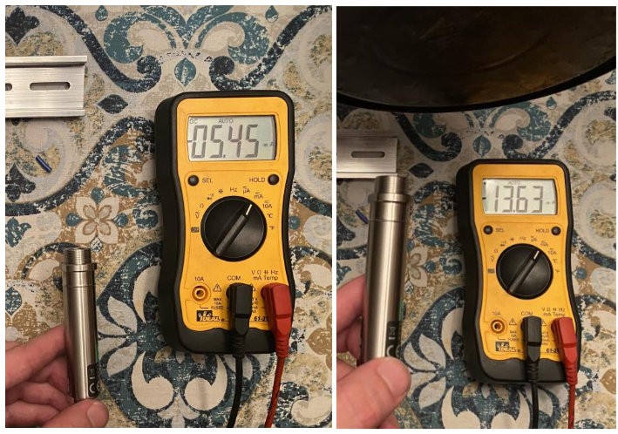
Figure 91: Temperature Sensor being Tested, by Showing Change in Voltage

Microcomputer
We ended up deciding to use the raspberry pi as the microcomputer for this project. Getting a raspberry pi will facilitate interfacing the display with the OS, so we have more time to focus on perfecting the design of the application for this project. In order to ensure the microcomputer will be successfully interfaced with the rest of the components the microcomputer must be tested. The Microcontroller will be responsible for running the application we will design, interface the temperature sensor, interface the microcontroller, and interface the display. Unfortunately, we still did not receive the spectrometer. So, there is no way to directly test the microcomputer with the spectrometer. We know, however, all the spectrometer specs. As defined in the specifications the spectrometer can only be interfaced with a USB port. So just by testing the USB ports in the microcomputer, if it works reliably, will be enough to make sure it can connect with the spectrometer. On top of that, the spectrometer firmware is only compatible with certain operating systems. In this test we will install Ubuntu in a SD drive, to run the program.
The test will be connecting the microcomputer to the peripherals, a mouse and a monitor, to test the USB ports, since the peripherals connect with serial connection. Then, the goal of the test will be showing the Ubuntu desktop screen. If the Ubuntu operating system is successfully installed, it will mean that it will be compatible when connected to the spectrometer, since the spectrometer is cross compatible among several different Operating systems, including Ubuntu. The microcomputer DSI connector must also be tested, but this will be done together with the Display. Once the computer loads Ubuntu in using the HDMI port connection and a monitor. The touchscreen display DSI ribbon cable will be connected to the DSI connector in the microcomputer.
The microcomputer will be powered by an USB-C 5V with up to 2A. Using a standard phone plug. Later when the microcomputer is embedded in the actual system it will be powered by a wired connection to the 5V PIN and the GND PIN. But for the sake of testing the hardware. In this test it will power using the USB. To ensure the microcomputer hardware is properly working.
Then an SD drive of 64GB will be inserted in the SD socket of the Raspberry pi. This socket will serve as a hard drive for the OS. Then, in order to install the OS a bootable USB driven containing Ubuntu will be inserted in the USB socket. This step will itself test the USB socket being used to install the OS. After loading the kernel, the bootable drive will prompt to the Ubuntu installation page. After the disk partition is set up, and it installs itself without any hardware conflicts the OS should load. The next step would be making sure the connector is functional. Below picture of the functioning computer connected to a monitor.
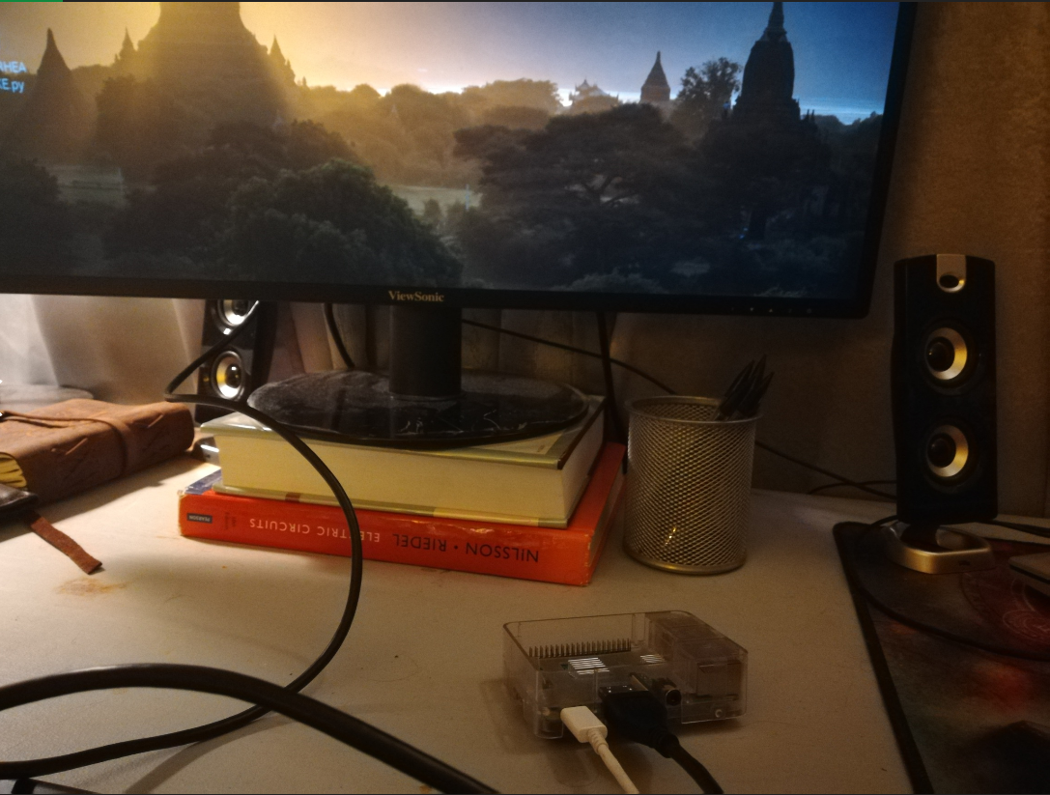
Figure 92: Microcomputer being Tested

Touch-Screen Display
The touchscreen display will also be tested in this project. We discussed and decided that the system would be more user friendly if we use a touchscreen panel, as opposed to a mechanical pad. Although the pad is more reliable, choosing the touchscreen gives the system a better overall look so we decided to go with this design. We decided to pick the raspberry pi touch screen display for this project. Since we are using the Raspberry pi Microcomputer. The dimensions of the display are 194mm x 110mm x 20 mm. The size of the viewable screen is 155mm x 84 mm. For the sake of this project the size is adequate, and it will fit nicely with the UI.
The touchscreen display increases the amperage draw from the system. Since it is powered by the raspberry pi itself. So, a higher USB connector power source is required. In the user manual of the display, it explains how the product should only be connected to a power supply with a minimum of 1.8 amps current draw. The first test performed will be connecting the Display with the DSI cable and to the DSI port. The DSI port contains 15 PINs. The DSI connector pinout is described below:
Socket S2 Pin | Function
1 | GND
2 | Data Lane 1 N
3 | Data Lane 1 P
4 | GND
5 | Clock N
6 | Clock P
7 | GND
8 | Data Lane 0 N
9 | Data Lane 0 P
10 | GND
11
12
13 | GND
14 | +3.3V
15 | +3.3V

Table 5: PIN verses Output
The connector transmits the positive and negative parts in the signal, this technique is described as differential signaling. The voltage of the signal is in the order of 0.2V being very small and power efficient. Pins 2 and 3 make the data lane 1, pins 8 and 9 make the data lane 0. Using the data lanes to transmit information is the same technology used in modern cell phones. This technology came from the necessity of high rate data transfer without the expenditure of too much power.
In the dual lanes system, the stream of data(bytes) is divided between the lanes. Bit 0 goes through lane 0 and bit 1 goes through lane 1. Then markers are added to coordinate the reliable transmission. In each packet of data, it contains a header indicating the datatype, the size, and the ECC checksum.
After connecting the display and making sure it is stable the only thing left is to test the capacitor touchscreen. Ubuntu has an embedded software to detect touchscreen functionality, just like Windows, so no installation is necessary. The touchscreen is a very modular feature if it connects to the microcomputer and works once, it would be able to do it again once mounted. In order to test the touch, screen a draw program will be used. Gimp 2.8.6 is an image editor. That is available in the Ubuntu software store for free. Although a very simple procedure. Just using the touchscreen to paint the entire screen is a very good method for verifying the functionality of it. If everything runs smoothly everything is checked and ready.

Major components Unable to be Tested
There were two main components that were unable to test before senior design 1 ended. The components are the spectroscopy system and the filtrations system. These components should be able to be test within the two-week period before senior design two or within the first week of senior design two. The reasoning behind this complication is further described in apex section 9.1.

Administrative Content
The following section outlines two major administrative components of our project. In order to distribute cost equally and make sure we kept the overall cost under $2,000, we outlined the cost of each individual component in a budget. The other component keeping of project on track was the milestones. Each step of the project is outlined for senior design 1 and 2. Not only are the steps outlined but they are also divided among each group member based off specialty and the block diagram. Overall, these two aspects kept and continue to keep our project on track and budget.

Budget
The budget for this project was aimed to be about $1000 split between the four group members, which has been met so far. The budget of ordered parts chosen in chapter 3 is shown below in the budget table. These will be further tested and double checked for functionality in order to expand the design process quickly. The PCB, panel box, and miscellaneous circuitry components are still in the order process until the final design for these are complete.
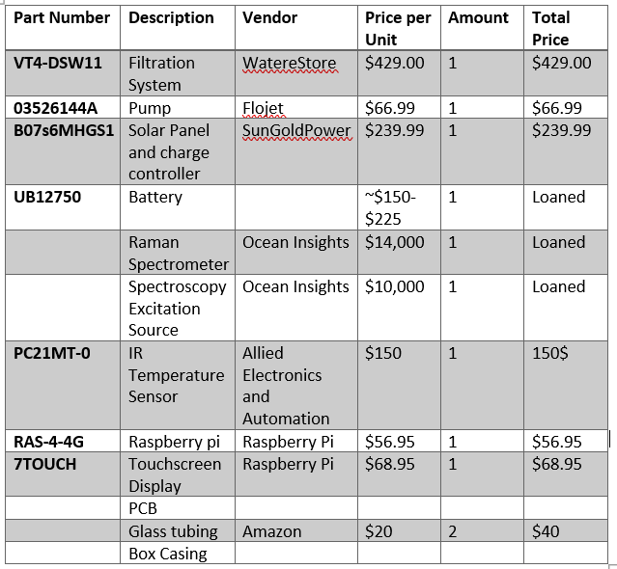

Project Milestones
The table below outlines our project milestones throughout the entirety of the project, and Senior Design 1 semester. Starting with brainstorming ideas and ending with our final presentation, each step of the project was outlined and assigned to either an individual or the group. A due date was put in place for each milestone to ensure the project stays on track and can be completed in a two-semester period. The section of the milestones for Senior Design 2, can be modified as obstacles may come up when trying to build the system.
 | Task | Start | End | Status | Responsibility
Senior Design I
1 | Ideas | 5/4/20 | 5/20/20 | Completed | Group 5
2 | Project Selection and Role Assignments | 5/13/20 | 5/20/20 | Completed | Group 5
 | Project Report
3 | Initial Document: Divide and Conquer | 5/20/20 | 5/29/20 | Completed | Group 5
4 | Table of Contents | 5/29/20 | 6/5/20 | Completed | Group 5
5 | First Draft | 5/29/20 | 6/22/20 | Completed | Group 5
6 | Final Document | 5/29/20 | 7/28/20 | Completed | Group 5
 | Research, Documentation, & Design
7 | Spectroscopy/water monitoring research | 5/20/20 | 7/1/20 | Completed | Kendra
8 | UV water cleaning source research | 5/20/20 | 7/5/20 | Completed | Kendra
9 | UV water cleaning chamber design | 5/25/20 | 7/5/20 | Completed | Group 5
10 | Spectroscopy monitoring design | 5/25/20 | 7/6/20 | Completed | Kendra
11 | Automated system design/research | 5/25/20 | 6/28/20 | Completed | Lucas
12 | Spectroscopy interface research/design | 5/25/20 |  | On Going | Kendra
13 | Type of Filter Research | 5/25/20 | 6/22/20 | Completed | Grant
14 | Microcontroller | 5/25/20 | 7/1/20 | Completed | Lucas
15 | LCD Display | 5/25/20 | 7/1/20 | Completed | Lucas
16 | Solar Panel/Charge Controller | 5/25/20 | 7/5/20 | Completed | Brad
17 | Battery | 5/25/20 | 7/5/20 | Completed | Grant
18 | Final Design | 5/25/20 |  | Completed | Group 5
19 | PCB design | 5/25/20 | 7/25/20 | Completed | Brad and Grant
20 | Order and Test Parts | 5/25/20 | 8/23/20 | Completed | Group 5
Senior Design II
19 | Order PCB designed | 7/1/20 | 8/31/20 |  | Group 5
20 | Build Prototype | 8/23/20 | 11/15/20 | Completed | Group 5
21 | Testing and Redesign | 9/15/20 | 11/20/20 | Completed | Group 5
22 | Finalize Prototype | 10/20/20 | 11/10/20 | Completed | Group 5
23 | Peer Presentation | 12/2/20 | 12/2/20 | Completed | Group 5
24 | Final Report | 10/20/20 | 12/2/20 | Completed | Group 5
25 | Final Presentation | 11/18/20 | 12/2/20 | Completed | Group 5

Conclusion
After initiating the idea of a portable water cleaning device, we had basic assumptions and ideas of the major components, specifications, and designs we would use. To make sure these were all plausible ideas we had to conduct research into the best components needed. Our first step to accomplish this was assigning specifications to each portion of our system. If we chose specification, then we would have a basis for which we could choose the best piece of equipment. to ensure quality, we conducted research into multiple approaches to best accomplish our specifications. After determining an approach, we then had to choose the equipment that could execute our desired approach. More research was put into comparing equipment not only for the approach but from certain vendors as well.
When choosing our desired equipment, we had to consider functionality, design, and cost. Our main approach was to choose the equipment and then try to integrate it into the design. There were a few pieces of equipment in which we chose then found out it wasn’t possible for our desired design and found a version of that equipment that would work with our design. Before we had chosen equipment, we also attempted to conduct overall designs so we would be able to reference what kind of equipment would work in our system. To guarantee we chose to prime equipment for this system, we had to overcome design constraints. Although there was equipment that might not have caused multiple/in any design issues, it may have been at the expense of quality. We did have to make modifications to our original design and in some cases, we had to re-design totally.
To keep the project on track we set multiple groups individually and as a group. We set dates to have research for the parts done by individuals and set meetings to discuss what equipment we feel would work best and if they would work with the system. With the time constraint of about six months we determined by the end of senior design one we needed to have our major components ordered and our final designs made. We were able to complete this with some minor complications.
The biggest complication we have faced throughout the development process is the lack of information on the spectroscopy system. This issue forced us to assume certain properties of the spectroscopy system that affect other equipment in the system. We had to assume power input of the spectroscopy system so we were able to choose a solar system that could accommodate every piece of equipment in the system. We were also forced to assume which compounds we could find with the spectroscopy system based on other Raman peaks of those compounds. Although we didn’t know the exact system, we were able to find similar systems and other research that led us to these assumptions. Even though we believe we have determined most of the correct properties of the spectroscopy system, they are still just assumptions. This means when we do receive the spectroscopy system there may be some changes to the system if our assumptions were not correct.
Overall, the goal is to have a system that will provide portable clean water with both filters and a UV cleaning system. The system should also have in-line water quality monitoring to ensure the water leaving the system is clean enough to consume. Solar power makes this a feasible system for places with no clean drinking water and no places to install entire filtration systems. This system will also not use any harmful chemicals or chemicals in general to clean and test the water, making it less work and cutting out potential chemical contamination. The water quality evaluation system in this will also be faster than most water quality evaluations, where they must take a sample of the water to a second location. The LCD display will provide an easy to read version of what the spectroscopy evaluation shows. We believe our approach to solving this goal was accurate and have accomplished the basis for our project. Our next steps will be to build the system using the equipment ordered and testing it for quality assurance.

Appendix
The following section contains the required content needed for this paper.

Complications
The following sections outline the complications we faced with the major components in our system.
    - Filtration System
The filtration system that was shipped to the group was unfortunately the wrong model, so it needed to be sent back. As of now, the system is still in the shipping process on its way to the group. Unfortunately, this mistake by the dealer has led to the postponing of the testing process of this system. It can be guaranteed that as soon as the system arrives in the hands of the group, it will be tested and then the build process can start.
    - Software libraries
Raspberry pi library configuration:
We had compatibility issues connecting the JavaFX library and the raspberry. JavaFX used to be supported by the java runtime environment, but, since the java 6 update, it ceased to be supported. JavaFX, is now supported by the javaFX open-source foundation. Therefore, we had to download, and load, the libraries in the java virtual machine separately. We were able to download and add the libraries to the JVM, but we were not able to use them. Apparently, in addition to loading the libraries in the project, it is required to configure the java virtual machine itself to make it compatible. I was able to configure the Java virtual machine on windows, but not on Linux, which is the OS the raspberry pi operating on.

    - Spectrometer

Since our sponsors were still figuring out which spectroscopy system to loan, we were not able to test this component. This has caused a few issues with our project but must make intellectual assumptions about the project in order to make sure this project is built on time.

References
[1] Zhiyun Li, M. Jamal Deen, Shiva Kumar, & P. Ravi Selvaganapathy. (2014).
Raman Spectroscopy for In-Line Water Quality Monitoring- Instrumentation and Potential. https://doi.org/10.3390/s140917275
[2] Chaplin, M. (2000). Water Absorption Spectrum. Retrieved June 24, 2020, from http://www1.lsbu.ac.uk/water/water_vibrational_spectrum.html
[3] National Primary Drinking Water Regulations. (2020, February 14). US EPA. https://www.epa.gov/ground-water-and-drinking-water/national-primary-drinking-water-regulations
[4] Andor. What are the basic principles of Raman Spectroscopy. Oxford
Instruments. https://andor.oxinst.com/learning/view/article/raman-spectroscopy
[5] Oram, P. B. G. (2014). UV Disinfection Drinking Water Treatment. Water
Research Watershed Center. https://www.water-research.net/index.php/water-treatment/water-disinfection/uv-disinfection

[6] McGregor, Hanna, Wang, Wenbo, Short, Michael, & Zeng, Haishan.
(2016). Clinical utility of Raman spectroscopy: current applications and ongoing developments.
[7] National Primary Drinking Water Regulations. (2020, February 14). US EPA.
https://www.epa.gov/ground-water-and-drinking-water/national-primary-drinking-water-regulations
[8] Van de Vossenberg, J., Tervahauta, H., Maquelin, K., Blokker-Koopmans, C.
H. W., Uytewaal-Aaarts, M., Kooij, D., van Wezel, A. P., & van der Gaag, B. (2013). Identification of bacteria in drinking water with Raman spectroscopy.
[9] Arsenic. (2018, February 15). World Health Organization WHO.
https://www.who.int/news-room/fact-sheets/detail/arsenic
[10] Temperature and Water. (n.d.). USGS.
https://www.usgs.gov/special-topic/water-science-school/science/temperature-and-water?qt-science_center_objects=0#qt-science_center_objects
[11] How Solar or Photovoltaic (PV) Cell Works. (2018). EBooksheir.
https://sheir.org/edu/how-solar-cell-works/
[12] ARSENIC ACID - Raman Spectrum. (2020, July 2). SpectraBase.
https://spectrabase.com/spectrum/8hEqyFdSVma
[13] Lenardic, D. (2015, December 23). Photovoltaics - Historical Development.
http://www.pvresources.com/en/introduction/history.php#:%7E:text=The%20first%20silicon%20monocrystalline%20solar,materials%20for%20solar%20cell%20production.
[14] Types of Solar Panels (2020) | GreenMatch. (2020, March 10).
https://www.greenmatch.co.uk/blog/2015/09/types-of-solar-panels
[15] Newkirk, M. (2014, August 25). What are monocrystalline, polycrystalline and thin
film solar panels? — Clean Energy Reviews. CLEAN ENERGY REVIEWS. https://www.cleanenergyreviews.info/blog/pv-panel-technology
[16] Solar Charge Controllers | Got Questions? Get the Answers Here. (2020, April 27).
Morningstar Corporation. https://www.morningstarcorp.com/solar-charge-controllers
[20] Gridling, G., & Weiss, B. (2007). Introduction to microcontrollers. Vienna
University of Technology Institute of Computer Engineering Embedded Computing Systems Group.
[21] Christensson, P. (2009, March 31). User Interface Definition. Retrieved
2020, Jun 25, from https://techterms.com
[22] https://www.oceaninsight.com/globalassets/catalog-blocks-and-images/manuals--instruction-old-logo/software/omnidriver_programming_manual.pdf
[23] Raman Scattering in Fluorescence Emission Spectra | Common Errors.
(2020, January 27). Edinburgh Instruments. https://www.edinst.com/blog/raman-scattering-blog/
[24] Moore, A., Glass, K. (2014, November 25). Could Ultraviolet Light
Technologies Help Prevent The Spread Of Ebola? Photonics Online. https://www.photonicsonline.com/doc/could-ultraviolet-light-technologies-help-prevent-the-spread-of-ebola-0001
[25] Thundera Multimedia. (2020, March 17). Infrared Temperature Sensors -
Sure Controls. Sure Controls Inc. https://www.surecontrols.com/infrared-temperature-sensors/#:%7E:text=Infrared%20temperature%20sensors%20sense%20electromagnetic,onto%20one%20or%20more%20photodetectors.
[27] Bloggers. (2020, June 14). IV-curve Archives - MG Energy Systems. MG
Energy Systems. https://www.mgenergysystems.eu/tag/iv-curve/
[28] Wit, W. A. P. F. (2020, July 2). Benzene. SpectraBase.
https://spectrabase.com/compound/IG4vKOtLCxH
[29] Montoya-Rossi, E., Arbildo-López, A., & Baltuano-Elías, Ó. (2015). A
homemade cost effective raman spectrometer with high performance.
[30] Sterilight S5RL Replacement UV Lamp. (n.d.). Serv-A-Pure.
https://www.servapure.com/Sterilight-S5RL-Replacement-UV-Lamp_p_2049.html
[31] UV LED 4W Light Bar Aluminum Strip 12V-24V Black Light Ultra Violet
Purple. (n.d.). 12Vmonster Lighting and More! https://www.12vmonster.com/products/12-uv-led-4w-light-bar-aluminum-strip-12v-24v-black-light-ultra-violet-purple
[32] Chlorination Equipment. (n.d.). MECC.
https://water.mecc.edu/concepts/chlorequipment.html

[33] The community. (2012). System Requirements « Xubuntu. Xubuntu.Org.
https://xubuntu.org/requirements/

[34] Dawson, M., DeWalt, B., & Cleveland, S. (2016). The case for UBUNTU
Linux operating system performance and usability for use in higher education in a virtualized environment.

[35] Linear regulator. (2020, May 22). Retrieved July 01, 2020, from https://en.wikipedia.org/wiki/Linear_regulator

[36] Linear Regulator and Switching Regulator ＜What is the Difference Between Linear and Switching Regulators?＞. (n.d.). Retrieved July 01, 2020, from https://www.rohm.com/electronics-basics/dc-dc-converters/linear-vs-switching-regulators
[37] Hua, J. (2019, April). Output Noise Filtering for DC/DC Power Modules. Texas Instruments . https://www.ti.com/lit/an/snva871/snva871.pdf?ts=1593786586726&ref_url=https%253A%252F%252Fwww.google.com%252F
[38] Automation, T. (2019, September 13). The Key Fundamentals of Power Supply Design for Circuit Boards. Retrieved July 03, 2020, from https://www.tempoautomation.com/blog/the-key-fundamentals-of-power-supply-design-for-circuit-boards/
[39] Krenning, D. (n.d.). Which Water Pump is Right for You? Retrieved July 03, 2020, from https://www.usaadventuregear.com/blogs/blog/which-water-pump-is-right-for-you
[40] What's the Best Battery? (2017, March 21). Retrieved July 03, 2020, from https://batteryuniversity.com/learn/archive/whats_the_best_battery
[41] Choosing Home Water Filters & Other Water Treatment Systems. (2014, June 03). Retrieved July 03, 2020, from https://www.cdc.gov/healthywater/drinking/home-water-treatment/water-filters/step3.html
[42] Hancock, N. (2016, November 27). What is Chlorination? Retrieved July 03, 2020, from
https://www.safewater.org/fact-sheets-1/2017/1/23/what-is-chlorination
[43] Sediment Filtration vs Carbon Filters. (n.d.). Retrieved July 03, 2020, from https://metrowaterfilter.com/faq/sediment-filter-different-carbon-filter/
[44] Water Doctors. (2018, January 01). Reverse Osmosis v. Carbon Filtration. Retrieved July 03, 2020, from https://h2odoctors.com/reverse-osmosis-v-carbon-filtration/
[45] S. (n.d.). 2 X 100 Watt Polycrystalline Solar Panel Kit. SunGoldPower. Retrieved July 16, 2020, from https://sungoldpower.com/collections/solar-panel/products/100w-polycrystalline-solar-panel-solar-module-2pcs-kit#specification_1
[46] UPG (Universal Power Group). (n.d.). Sealed Lead-Acid Battery. Http://Files.Upgi.Com:8086/UPGFileService.Svc/GetSpecSheet/46082 . Retrieved July 16, 2020
[47] Analysis of Drinking Water Contaminants | Thermo Fisher Scientific - NL. (n.d.). ThermoFisher. https://www.thermofisher.com/nl/en/home/industrial/environmental/environmental-learning-center/water-quality-analysis-information/analysis-drinking-water-contaminants.html#drinking
[48] Buckner, M. (n.d.). Ion Chromatography. Bio-Geochemical Methods. https://serc.carleton.edu/microbelife/research_methods/biogeochemical/ic.html#:%7E:text=Ion%20chromatography%20is%20used%20for,%2Dbillion%20(ppb)%20range.
[49] ZINC CYANIDE - Raman Spectrum. (n.d.). SpectraBase. https://spectrabase.com/spectrum/22afzi8zziQ
[50] Ward, M. (2019, March 11). The Ultimate Water Test--the Palate. Los AngelesTimes. https://www.latimes.com/archives/la-xpm-1985-06-13-me-10669-story.html
[51] Gunnars, K. B. (2020, April 21). How Much Water Should You Drink Per Day? Healthline. https://www.healthline.com/nutrition/how-much-water-should-you-drink-per-day
[52] LifeStraw Water Filters & Purifiers. (n.d.). Not Found. Retrieved July 26, 2020, from https://www.lifestraw.com/products/lifestraw.
[53] World Health Organization: WHO. (n.d.). E. coli. Who. Retrieved July 26, 2020, from https://www.who.int/news-room/fact-sheets/detail/e-coli
[54] Jackson, D. (2012). Software Abstractions: logic, language, and analysis. MIT press. https://thecrazycap.com/pages/how-it-works-1
[55] Wirth, N. (2008). A brief history of software engineering. IEEE Annals of the History of Computing, 30(3), 32-39.
[56] Public Lab contributors. (n.d.). 7 Ways to Measure, Monitor, and Evaluate Water Quality. Public Lab. https://publiclab.org/notes/anngneal/12-08-2017/7-ways-to-measure-monitor-and-evaluate-water-quality
[57] EPA. (2020, May 21). What are Water Quality Standards? US EPA. https://www.epa.gov/standards-water-body-health/what-are-water-quality-standards
[58] American Society of Testing and Materials (ASTM). (1996–2020). Water Testing Standards. ASTM. https://www.astm.org/Standards/water-testing-standards.html
[59] Standard Practice for Identification of Chemicals in Water by Fluorescence Spectroscopy. (2012). Annual Book of ASTM Standards, 11.02. https://doi.org/10.1520/D4763-06R12
[60] Standard Guide for Raman Shift Standards for Spectrometer Calibration. (2014). Annual Book of ASTM Standards, 03.06. https://doi.org/10.1520/E1840-96R14
[61] Standard Guide for Testing the Resolution of a Raman Spectrometer. (2014). Annual Book of ASTM Standards, 03.06. https://doi.org/10.1520/E2529-06R14
[62] Standard Guide for Relative Intensity Correction of Raman Spectrometers. (2013). Annual Book of ASTM Standards, 03.06. https://doi.org/10.1520/E2911-13
[63] L78 Dtasheet. (n.d.). Www.St.Com. Retrieved July 26, 2020, from https://www.st.com/content/ccc/resource/technical/document/datasheet/41/4f/b3/b0/12/d4/47/88/CD00000444.pdf/files/CD00000444.pdf/jcr:content/translations/en.CD00000444.pdf
[64] Owner’s Manual Models: VT1-DWS, VT4-DWS, VT4-DWS11. (n.d.). Viqua.Com. Retrieved July 26, 2020, from https://viqua.com/wp-content/uploads/MNL520181-R_RevP-EN.pdf
[65] NSF International. (2020, July 12). NSF Standards for Water Treatment Systems. https://www.nsf.org/knowledge-library/standards-water-treatment-systems
[66] Karandashev, V., Leikin, A., Khvostikov, V., Kutseva, N., & Pirogova, S. (2016). Water analysis by inductively coupled plasma mass spectrometry. Inorganic Materials, 52(14), 1391–1404. https://doi.org/10.1134/S0020168516140053
[67] Wikipedia contributors. (2020, July 15). Inductively coupled plasma mass spectrometry. Wikipedia. https://en.wikipedia.org/wiki/Inductively_coupled_plasma_mass_spectrometry
[68] Inductively Coupled Plasma Spectroscopy Facility. (n.d.). UC Berkeley Rausser College of Natural Resources. https://nature.berkeley.edu/icp
[69] TE Connectivity, “Digital Thermopile Sensors”. 09/2018. https://www.te.com/content/dam/te-com/documents/sensors/global/tsd-digital-thermopile-application-note.pdf
[70] Allied Electronics, “PyroCouple Compact Non-Contact Temperature Sensor with optional Dual Output” 03/2014. https://www.alliedelec.com/m/d/041b7846c30dfd91f02d93736bbaaea6.pdf
[71] Application Framework. (n.d.). Techopedia.Com. https://www.techopedia.com/definition/6005/application-framework
[72] Vis, P. J. (n.d.). Raspberry Pi LCD DSI Display Connector. Peter Vis. https://www.petervis.com/Raspberry_PI/Raspberry_Pi_LCD/Raspberry_Pi_LCD_DSI_Display_Connector.html
[73] Team, H. D. (2003). Abstract Window Toolkit Framework. Apache Harmony. http://harmony.apache.org/subcomponents/classlibrary/awt.html
[74] Tyson, M. (2020, January 17). What is the JDK? Introduction to the Java Development Kit. InfoWorld. https://www.infoworld.com/article/3296360/what-is-the-jdk-introduction-to-the-java-development-kit.html
[75] Wilson, T. V. (2020, July 27). How HDMI Works. HowStuffWorks. https://electronics.howstuffworks.com/hdmi.htm#pt3
[76] (2020, May 6). STANDARD TOUCHSCREEN PRODUCTS. TouchNetix. https://www.touchnetix.com/standard-touchscreen-products/
[77] Automation Direct. (01/01/18). 78 Series Electromechanical Relay Selection Guide [Dataset]. Automation Direct. https://cdn.automationdirect.com/static/specs/78relays.pdf
[78] G4 DIGITAL O/I MOUNTING RACKS. (2017). Https://Documents.Opto22.Com/0274_G4_Dig_I_O_Racks_Header_data_sheet.Pdf. https://documents.opto22.com/0274_G4_Dig_I_O_Racks_Header_data_sheet.pdf

Copyright Permissions
The following section will express the different copyright permissions that were requested and confirmed. Any other permissions for information used from the references above were requested but never confirmed.
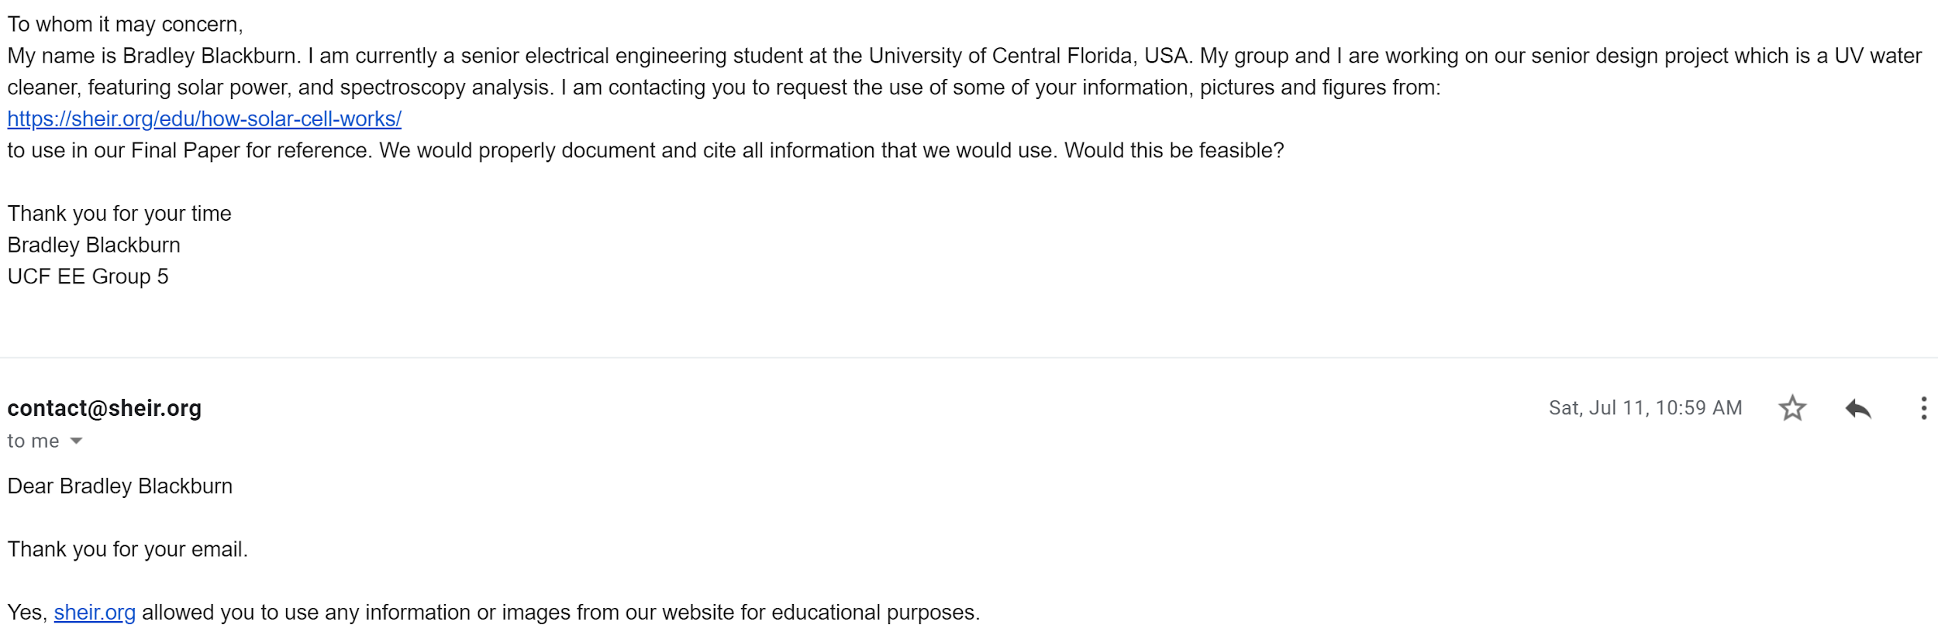
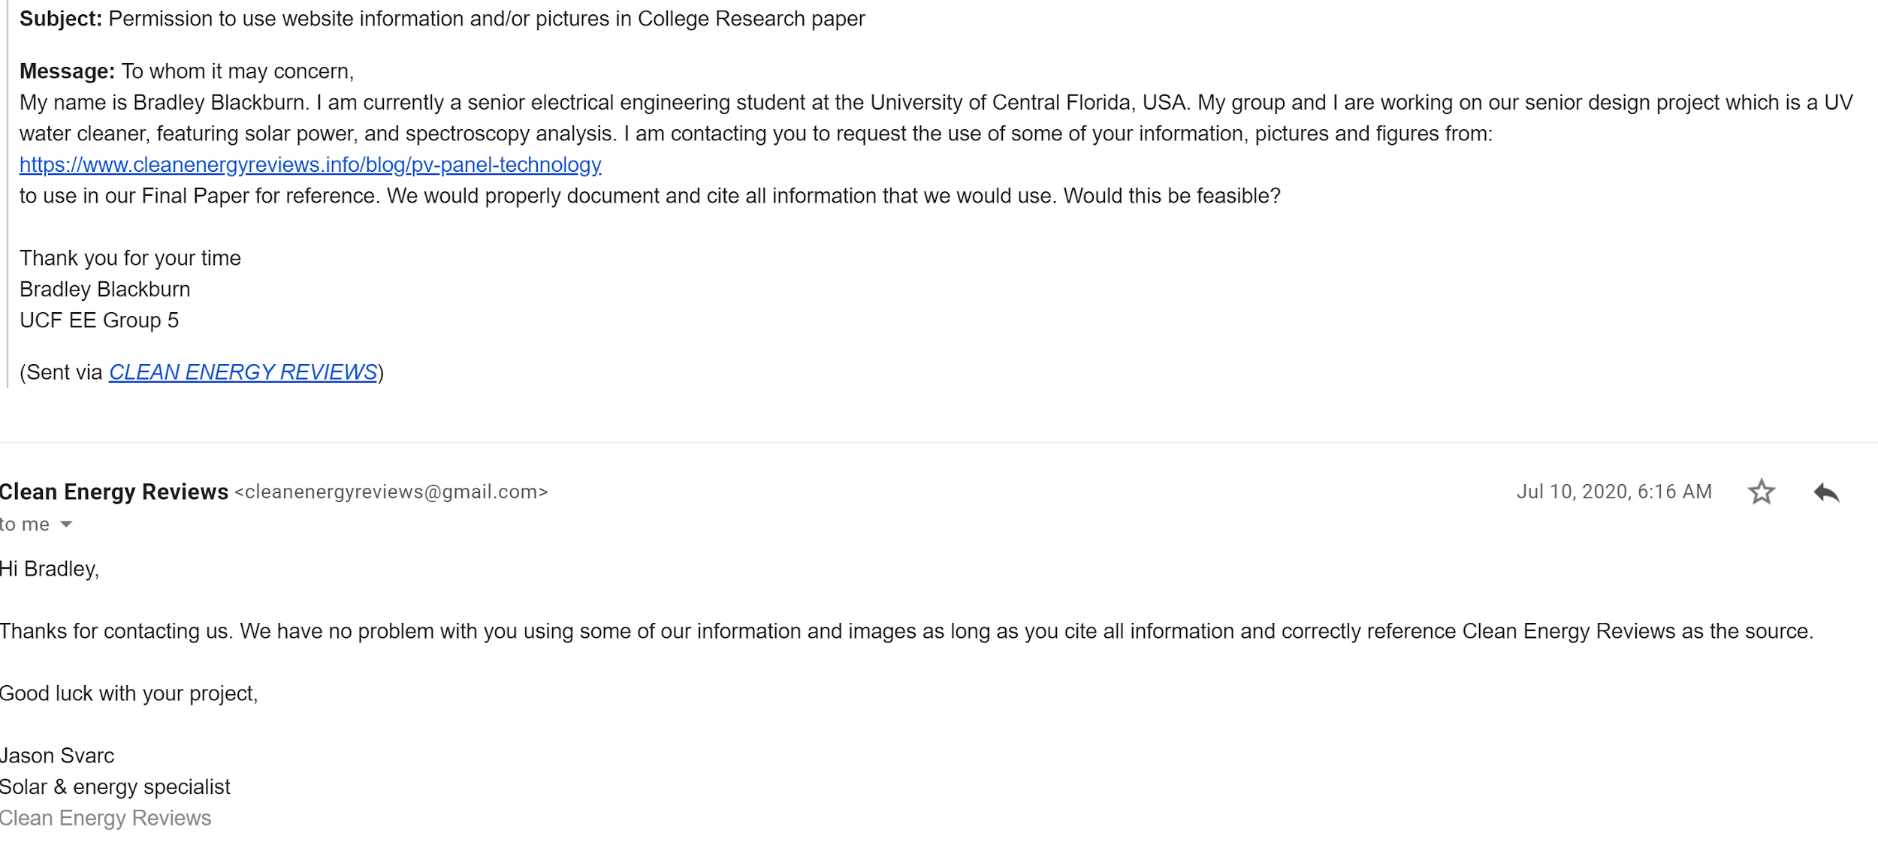

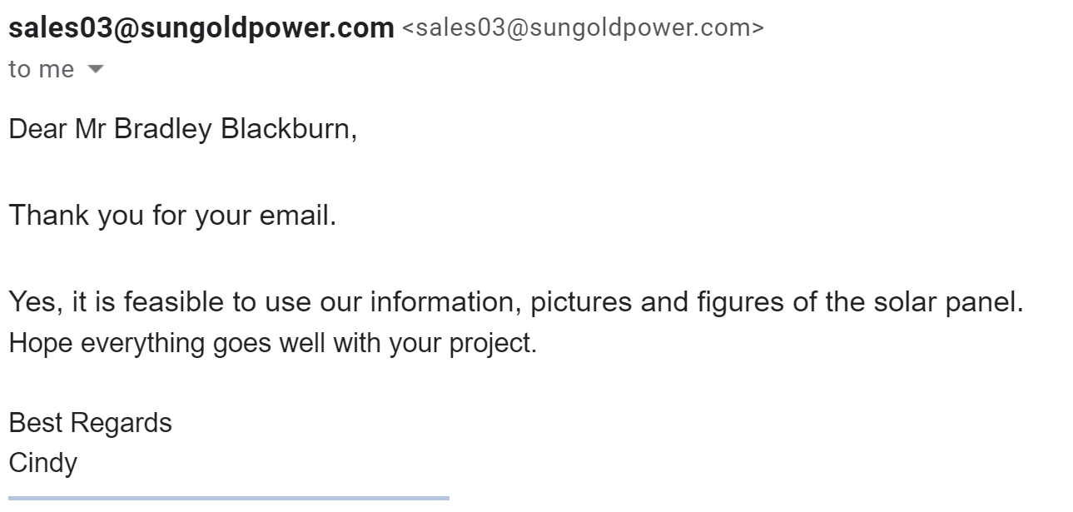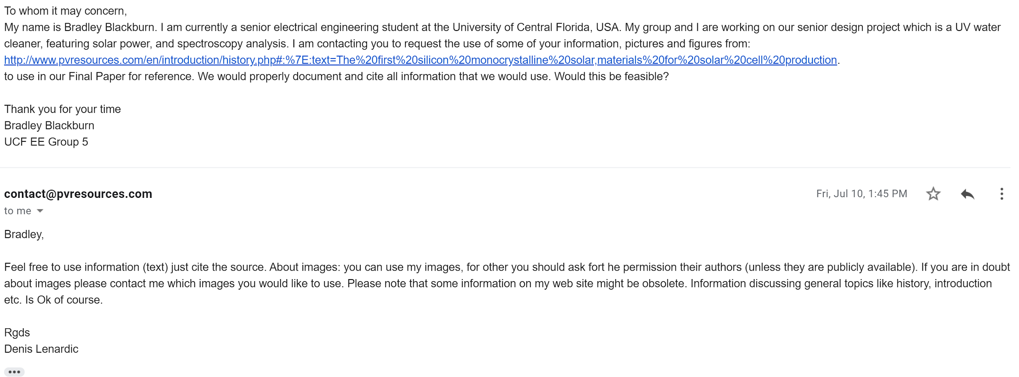

Data Sheets
- EPA Drinking Water Standards and Health Advisory Tables:
https://www.epa.gov/sites/production/files/2018-03/documents/dwtable2018.pdf
- Temperature Sensor Data Sheet:
https://www.alliedelec.com/m/d/041b7846c30dfd91f02d93736bbaaea6.pdf
- Filtration System Data Sheet:
https://cdn.shopify.com/s/files/1/0659/5447/files/Viqua_VT1_or_4_DWS_Brochure.pdf?11617088697646685420
- Raspberry pi Data Sheet:
https://www.raspberrypi.org/documentation/hardware/raspberrypi/bcm2711/rpi_DATA_2711_1p0.pdf
- Touchscreen Display Data Sheet
https://www.raspberrypi.org/documentation/hardware/display/7InchDisplayDrawing-14092015.pdf
- Solar Panel and Charge Controller Data Sheets:
https://sungoldpower.com/collections/solar-panel/products/100w-polycrystalline-solar-panel-solar-module-2pcs-kit#specification_1
- Battery
http://files.upgi.com:8086/UPGFileService.svc/GetSpecSheet/46082
- Control Relays
https://cdn.automationdirect.com/static/specs/78relays.pdf

