Super Boat Lift Boss
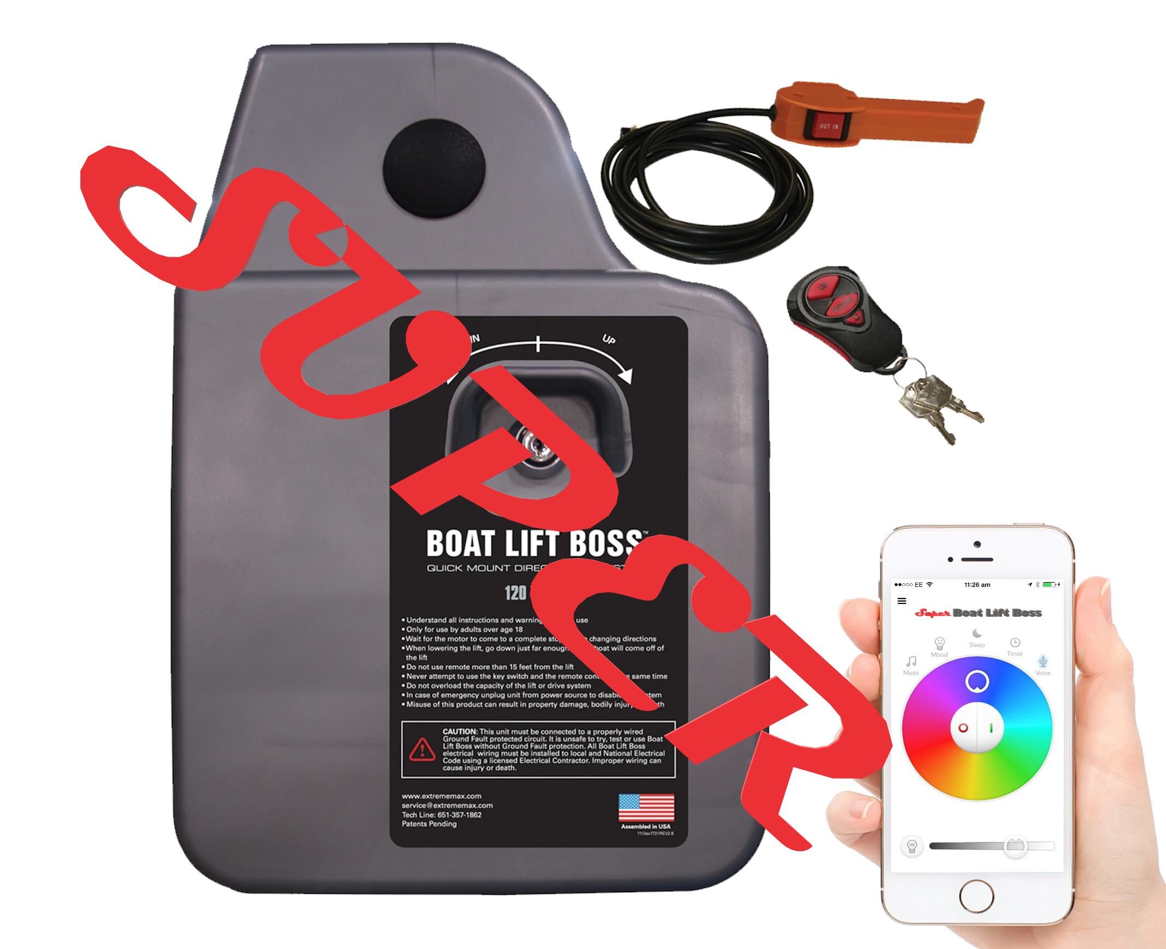
EEL 4914 - Spring 2020

Group C members:
Hesham Zidan -- Electrical Engineering
Andrew Melvin -- Electrical Engineering
Lucy Golebiewski -- Computer Engineering
Nader Abd El Rasol -- Computer Engineering

Sponsor: Herb Gingold
Company: RV-Intelligence
Website: https://www.rv-intelligence.com/

Table of Contents
1.0 Executive Summary .................................................................................................. 1
2.0 Project Description..................................................................................................... 2
2.1 Project Motivation and Goals
2.2 Objectives
2.3 Requirements Specifications
3.0 Research related to Project Definition....................................................................... 4
3.1 Existing Similar Projects and Products ………………………………………….#
3.1.2 Boat Lift Boss ………………………………….…………………………#
3.1.3 Lift Tech Marine Boat Lift Motor ………………………………………..#
3.1.4 Speed Control of Brushless DC Motors Using Arduino ……………...#
3.1.5 Using a DSP Controller to Control A Three-Phase Induction Motor...#
3.2 Relevant Technologies ………………………………….…………………………#
3.3 Strategic Components ………………………………….…………………………#
3.4 Possible Architectures and Related Diagrams …………………………………#
4.0 Related Standards and Design Impact...................................................................... 5
4.1 Related Standards ………………………………………………………………....#
4.1.1 Waterproof Seal Standard – IP67 ……………………………………...#
4.1.2 Design Impact of Waterproof Seal ……………………………………..#
4.1.3 Bluetooth Security - SP 800-121 Rev. 2 ……………………………....#
4.1.4 Design Impact of Bluetooth Security …………………………………..#
5.0 Universal Power Input
5.1 DC/DC 12-48 Vin, 48 Vout Boost Converter
5.2 DC/DC 48 Vin, 12 Vout Buck Converter
5.3 AC/DC Converter
6.0 Realistic Design Constraints …………………………………………………………….. #
6.1 Economic and Time Constraints
6.2 Environmental, Social, and Political Constraints
6.3 Ethical, Health, and Safety Constraints
6.4 Manufacturability and Sustainability Constraints
7.0 Hardware and Software Design Details ………………………………………………....#
7.1 BLDC Motors .................................................................................................#
7.2 User-Device Interface and Communication ....................................................#
7.2.1 1DX Module ......................................................................................#
7.2.2 DRV8312-C2-Kit ...............................................................................#
7.2.3 Bluetooth ……………………………………….…………………………#
7.2.4 Bluetooth Implementation ……………………………………………….#
8.0 Project Prototype Construction and Coding ..............................................................#
8.1 App Development ..........................................................................................#
8.1.1 App Development Framework ..........................................................#
8.1.2 App Design .......................................................................................#
8.1.3 Application Ascent/Descent Logic ……………………………...……...#
8.1.4 Weather Information …………………………………………………….#
8.1.5 RGB Lighting …………………………………………………………….#
9.0 Project Operation ………………………………………………………………………….#
10.0 Project Prototype Testing ……………………………………………………………….#
10.1 Hardware Testing
10.1.1 DC/DC Converter Testing……………………………...………………#
10.1.2 AC/DC Converter Testing………………………………………………#
10.2 Software Testing ………………………...………………….……………………#
11.0 Administrative Content ............................................................................................#
11.1 Milestone Discussion ....................................................................................#
11.2 Budget and Finance Discussion ...................................................................#
11.3 Bill of Materials ……………….…………………………………………………..#
Appendix ……………………………................................................................................. #

List of Figures
Figure #: Existing Boat Lift Boss Motor ........................................................................... #
Figure #: Lift Tech Marine Boat Lift Motor ………………………………………………….. #
Figure #: Untitled 1 …………………………………………………………………………..... #
Figure #: Untitled 2 …………………………………………………………………………..... #
Figure #: Untitled 3 …………………………………………………………………………..... #
Figure #: Untitled 4 …………………………………………………………………………..... #
Figure #: Untitled 5 …………………………………………………………………………..... #
Figure #: Untitled 6 …………………………………………………………………………..... #
Figure #: Possible Architectures and Related Diagrams ………………………………..... #
Figure #: Bluetooth Low Energy Secure Connections Pairing ………………………….... #
Figure 5.1.1: 12 V Input (Green) and 48 V Output (Red) ……………………………….... #
Figure 5.1.2: 48 V Input (Green) and 48.2 to 52.2 V Output (Red) …………………….... #
Figure 5.1.3: Variable Input DC/DC Regulated Boost Converter ………………………... #
Figure 5.1.4: 18.4 A Output (Blue) at 48 V Input …………………………………………... #
Figure 5.1.5: 12V-48V to 48.00V @ 20A ………………………………………………….... #
Figure 5.1.5a: Duty Cycle …………………………………………………………………….. #
Figure 5.1.5b: Magnitude Spectrum ……………………………………………………….... #
Figure 5.1.5c: Vout and Iout vs. Time ……………………...……………………………….. #
Figure 5.1.5d: PCB Top and Bottom View ….……………………………..……………..... #
Figure 5.1.6: Dual Phase Topology …………………………………………………………. #
Figure 5.2.1: 12 – 24 Volt Voltage Regulator Circuit ……………...………………………. #
Figure 5.2.2: 12 Volt Output With Trimpot Set to 2.5k Ohms .……………………………. #
Figure 5.2.3: 24 Volt Output With Trimpot Set to 9k Ohms ….………...…………………. #
Figure 5.2.4: High-Current Adjustable Regulator Circuit ...……………………………….. #
Figure 5.2.5: 2.48A Current Output, 24.8V Voltage Output ………………………………. #
Figure 5.2.6: 48 to 12 Volt Step Down Regulator Circuit @ 10 Amps ..…………………. #
Figure 5.2.6a: Start Up Cycle ……………………………….……………………………….. #
Figure 5.2.6b: Vout Steady State ………...…………………………...…………………….. #
Figure 5.2.6c: Magnitude Spectrum …………..…………………………………………….. #
Figure 5.2.6d: Vout and Iout vs. Time ……………………...……………………………….. #
Figure 5.2.6e: PCB Components View ……………………………...……………………… #
Figure 5.3.1: AC/DC Converter Design 1 Schematic …………….……………………….. #
Figure 5.3.1a: Vout p-p of Design 1 ……………………………..………………………….. #
Figure 5.3.1b: Gain vs Freq for Ln = 5 of Design 1 ………………….……...…………….. #
Figure 5.3.1c: Freq vs Output Current of Design 1 .……………………………………….. #
Figure 5.3.2: AC/DC Converter Design 2 Schematic …….……………………………….. #
Figure 5.3.2a: Vout p-p of Design 2 …………………………………..…………………….. #
Figure 5.3.2b: Gain vs Freq for Ln = 13.5 of Design 2 ……………………...…………….. #
Figure 5.3.2c: Freq vs Output Current of Design 2 ………………………….…………….. #
Figure 7xx: Current vs. Torque ……………………...…………………...………………….. #
Figure 7xx: PWM I vs. N*m ….……………………………………………………………….. #
Figure 7xx: Magnetic Field Direction …………………………………….………………….. #
Figure 7xx: Rotating Magnetic Field ……………………………………..………………….. #
Figure 7xx: Current Sequence as a PMW Signal ………………………………………….. #
Figure 7.2.2: Block Diagram for a Typical Motor Drive System ………………………….. #
Figure 7.2.3: Bluetooth BR/EDR vs Bluetooth Low Energy …………………..………….. #
Figure 8.1.2: App Home Screen Prototype …………………………………..…………….. #
Figure 8.1.3: Flowchart of the Ascent/Descent Buttons ………………….……………….. #
Figure 8.1.4a: Weather Screen Prototype ………………………………………………….. #
Figure 8.1.4b: Flowchart Showing Weather Tab ………….……………………………….. #
Figure 8.1.5a: RGB Light Screen Prototype ……………………………………………….. #
Figure 8.1.5b: RGB Flowchart ……………………………………...……………………….. #
Figure 9.0: Installation of Boat Lift Motor ………………………………..………………….. #
Figure 10.1.1a: DC/DC Converter Test Set Up ……………...…………………………….. #
Figure 10.1.1b: Turn-on and Turn-off Times ……………………………………………….. #
Figure 10.1.1c: Transient Response ……………………………………….……………….. #
Figure 10.1.2a: Twisted-pair Cable Measuring Method ………………………….……….. #
Figure 10.1.2b: Twisted-pair Cable Measuring Method ……………………….………….. #
Figure 10.1.2c: Contact Measuring Method …………………………………………….….. #

List of Tables
Table 1: House of Quality ............................................................................................... #
Table 2: 12-48 Volt Step Up Converter System Information ……................................... #
Table 3: 48 to 12 Volt Step Down Regulator System Information ……………………..... #
Table 4: Properties of Design 1 and Design 2 Compared ……………………………...... #
Tablex: Senior Design 1 Milestones ……..……………………...………………………..... #
Tablex: Senior Design 2 Milestones ……..……………………...………………..………... #
Tablex: Estimated Project Budget and Financing ………………..……………..………... #
Tablex: AC/DC Converter BOM ……..………………………......………………..………... #
Tablex: Step Up Converter BOM ……..………………………....…………………..……... #
Tablex: Step Down Converter BOM ……..……………………...………………..………... #

1.0 Executive Summary
The Super Boat Lift Boss project will facilitate a user-friendly way to lift boats above water. Boat lifts often require the turning of a physical wheel to operate, which can be physically demanding for some. There is currently a product on the market made by Extreme Max to replace these old wheels. The Boat Lift Boss is an automated motor system controlled by a key switch and remote control. This allows users to easily lift their boats above water without the need of physical activity. While this is a very useful tool, we are going to improve this system by adding enhanced features and multiple control options.

Our new Super Boat Lift Boss motor will use a brushless DC motor that can run on AC or DC power to drive the boat lift. The new system will also have several easy to use options to control the motor. Users can choose between the new “Super Boat Lift Boss App” which can be installed on their phone or used through the web browser on their computer, a battery powered remote control, or a manual keyswitch. The wireless communication between the motor and the app will be completed with wifi and bluetooth low energy. This allows users to operate their boat lift from different areas of their property at the push of a button.

Along with this ease of operation, the Super Boat Lift Boss will have extra features such as enhanced security methods, weather information, lights, and music. The system will notify the owner if the boat lift is activated, ensuring that the customer will always be aware of its use. If time permits, more security features will be added. Weather is important information to know when going out on a boat, so we will be using different sensors to test the weather information at the dock. Data such as temperature, wind speed, and humidity will appear on the user’s application. Additionally, the device will have the ability to power and operate RGBW LEDs on the user’s dock using the Super Boat Lift Boss app or remote. Once these features are complete, speakers may be added to the motor to allow users to play music on their dock.

This project will improve upon the current iteration of the Boat Lift Boss on the market with new and improved features to accommodate the customer’s desire for an all-in-one kit that acts as a lift, security, and ambiance control center for their dock space. The most important features for this project are the user application and the option for universal input. Once these are complete, the team will add the extra features of security, weather, LEDs, and music. With all of these features, the Super Boat Lift Boss will be everything customers need and more. This project will take a lot of dedication in both hardware and software engineering. Two of our members are electrical engineers and two are computer engineers, so together we will come up with the best possible solutions for this product. Working together with our sponsor will be a great way for the students to learn the skills needed to be successful after graduation. Not only will we develop our engineering skills, we will create a useful product. The Super Boat Lift Boss has the potential to be a product that benefits people around the world, so we want to make it a great product.

2.0 Project Description
This section describes the background information behind the Super Boat Lift Boss project. An important part of understanding why we are making this boat lift comes from understanding our motivation and objectives.

2.1 Project Motivation and Goals
The motivation behind creating this project stems from two different sources. The first motivator for creating this project is to apply the skills and knowledge learned from studying at the University of Central Florida to a project. This project will increase our understanding of the engineering principles learned in school by applying it to a hands-on project. The project involves extensive efforts to develop hardware and software that work together to create an automated boat lift. The hardware principles learned from electrical engineering courses will be applied to the brushless DC motor and AC/DC power supply. The software knowledge from computer engineering classes will help the students program the microcontrollers and create the mobile application. Along with increasing our knowledge and experience, this project will build our team communication skills to prepare us for working in our careers.

The second motivator behind this project is our sponsor, Herb Gingold. This project involves the creation of a product requested by Extreme Max products. The Super Boat Lift Boss is an improvement on their current product, The Boat Lift Boss. These improvements will help Extreme Max compete with competitors with similar products on the market. Our sponsor will be supplying the products and manufacturing needed to make this project the best that it can be. This motivation makes the team want to work harder to provide a good product for this company. Overall, this project will provide the students more experience and a product for Extreme Max.

2.2 Objectives
The objectives of this project is to provide a safe and easy way for boat owners to activate their boat lift. An automated boat lift is good, but a universally powered boat lift controlled with a mobile application is better. We want to make a product that is good enough for Extreme Max to compete with their top competition, Lift Tech Marine. This company has a boat lift motor with a mobile application for activation.

We need to make our product an improvement on not only the Extreme Max Boat Lift Boss, but the Lift Tech Marine Boat Lift as well. It is difficult to understand why some products perform better on the market than others, but we will do everything in our power to outperform the other competing products. Hopefully we will be able to produce a unique product that customers are willing to buy over competing brands.

One of the main objectives of this project is to create a useful product that can compete against its competitors, but we also want to improve upon our engineering skills. With the help of our sponsor we will come up with inventive ways to complete this project. The real objective is to learn as many things from this project as we can to increase our engineering capabilities.

2.3 Requirements Specifications:
This project has many specific requirements needed to create the best product possible. These requirements have been used to create the designs of this product.
- The system will use a brushless DC motor drive
- The system will have universal power input:
- AC 115 - 220 V, 50-60 Hz
- DC 12 - 48 V
- The system will operate at 20A at 48V for 1kW output
- The system will be controlled via 4 different devices:
- Manual Key Switch
- Battery Powered Remote Control
- Mobile Application
- Web Application
- The device communication will be done with BLE bluetooth and Wifi 802.11b/g/n
- The communication range will be between 38m and 100m
- The system will use a Murata 1DX Bluetooth/Wi-Fi Module
- The system will use a Texas Instruments C2000 MCU Piccolo-DRV8312-C2-KIT
- The system will have dynamic testing to monitor multiple variables while in use
- The system will calculate boat height using back EMF differential
- The system will operate with a max boat weight of up to 6,200 lb
- The system will have an ascent speed of 1’ min to 4.5’ max per minute based on load
- The system will have a descent speed of 1’ min to 4.5’ max per minute based on load
- The system will have an “Alert” activation safety feature whenever the boat lift is in use
- The system will use position sensing for safety specifications
- The system will have audio streaming functionality featured on the mobile application
- The motor will have a connection for RGBW LEDs to light up the dock (12 - 24 V)
- The system will have a stand alone, attachable Motion Sensor (BLE beacon) for the boat ignition
- The system will have sensors to test weather information:
- Temperature
- Humidity
- Wind Speed

Utilizing the above requirements, we have created a house of quality in Figure # to determine the importance and correlation of the engineering requirements.
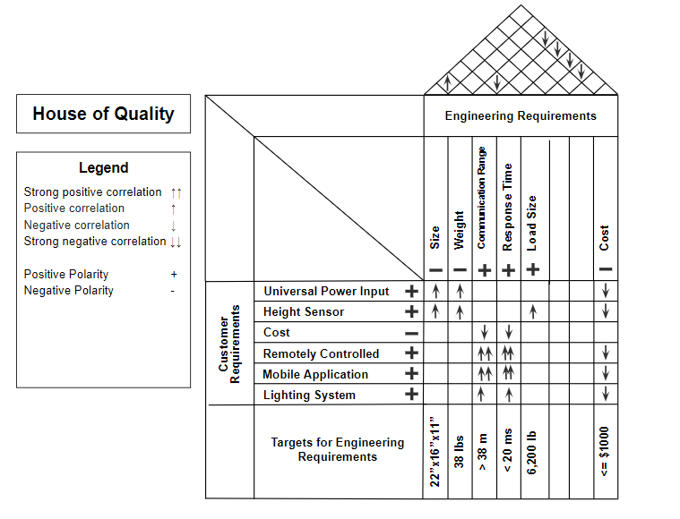
Figure 1: House of Quality

The House of Quality in figure 1 clearly shows the most important requirements for this specific project. This visual diagram provides an alternative way to view the requirements instead of just a list formation. We can see how cost relates to each requirement and whether the requirement will cost a high amount or low amount of money. The diagram shows the engineering requirements along with the customer requirements and how each one relates. For this project, the universal power input is very important along with the mobile application. The engineering requirements are important because they must be able to lift 6,200 pounds. The lighting system is of lower importance, but it is still a factor we need to consider when designing the system.

3.0 Research related to Project Definition
This section shows the research done to define the project design.

3.1 Existing Similar Projects and Products
Researching similar projects and ideas helped to determine how possible our design is. Building from previous research and products allows engineers to be more successful in innovating new products.

3.1.2 Boat Lift Boss
There is currently a product sold by Extreme Max called the Boat Lift Boss that replaces the physical turn wheels used in boat lifts. This product is a motor that can be controlled with a key or a wireless remote, but there is no mobile application for control. The motor is designed to plug directly into a ground fault protected circuit to receive a voltage of 120 Volts. It is advertised to have quick, quiet operation with the safest direct drive system available. The motor casing is sealed for weather protection and includes all-weather resistant electronics.
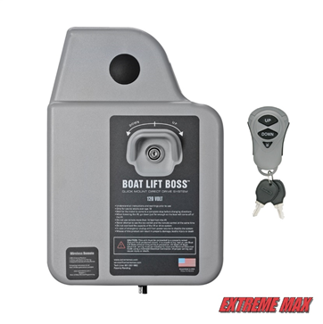
Figure # : Existing Boat Lift Boss Motor

This motor does not accept both AC and DC power supplies, which is one of the requirements of our project. The Super Boat Lift Boss will be an improvement on the current Boat Lift Boss. It is a brushless DC motor that uses back emf applications to control the height and speed of the boat lift. Additionally, instead of just using a remote control we will also be using a mobile application with Bluetooth BLE to control the motor. The design and purpose of the Boat Lift Boss will be applied to the new design of the Super Boat Lift Boss.

3.1.3 Lift Tech Marine Boat Lift Motor
A company called Lift Tech Marine has created direct drive boat lift motors operating at 110 Volts AC or 12-24 Volts DC. In this company’s design, the user must choose either an AC or DC power supply. In our design, we will be able to support both power supply options in one motor. This motor can be controlled via key switch, remote control, or their new Lift Tech Marine Remote Phone Application. The mobile application is like
ours, however, it only communicates with Bluetooth.
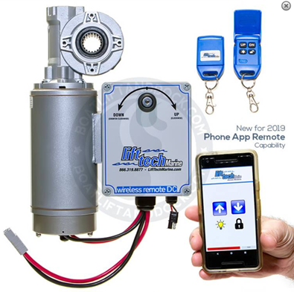
Figure # : Lift Tech Marine Boat Lift Motor

We want the Super Boat Lift Boss application to communicate with both Bluetooth and Wi-Fi. The Lift Tech Marine Boat Lift is Boat Lift Boss’s main competitor, and largely the reason it needs a new model with more advanced features and a mobile application to control it. The Lift Tech Marine mobile application has four simple features: Up, Down, Lights on/off, and Lock. While our application will be simple and user friendly like theirs, we will have additional user options. Along with the Up/Down features, we will have weather information and controls for the colors of the lights.

3.1.4 Speed Control of Brushless DC Motors Using Arduino
Research and projects have been completed which control a BLDC motor using Arduino and a mobile application. In 2017 Amity University completed a study on speed control of Brushless DC motors. In their system, a mobile application was used to control the motor via Bluetooth. The Bluetooth signal is sent from an android mobile application through a Bluetooth module connected to an Arduino Uno. There are different tutorials online for this exact project. Specifically, an HC-05 Bluetooth module was connected to an Arduino Uno microcontroller to control the speed of a 1400kV BLDC motor. To control this Arduino, a mobile application called Arduino Bluetooth Controller was used. In this system, the motor was used for demonstration and was not controlling anything. In our system, we will not be using an Arduino Uno, we will use the DRV8312-C2-KIT with a Murata 1DX Bluetooth/Wi-Fi module. Once we can control the motor with our mobile application via Bluetooth and Wi-Fi, it will be able to control the boat lift.

3.1.5 Using a DSP Controller to Control A Three-Phase Induction Motor
Projects using Digital Signal Processing to control motors have become more common in the past few years. One project relevant to our design is from Indiana University. While their motor is not a brushless DC motor, the software concepts are very similar. This project focuses on programming a DSP controller to control a three-phase induction motor. Specifically, this project includes the Texas Instruments TMS320C24x DSP controller. This controller was used to generate the PWM pulses for the three phase inverter circuit. In our project, we will be using a DC Motor Kit which includes the TMS320F28035 controller.

The previous project used a space vector PWM peripheral. The TMS320C24x controller generates a regularly timed interrupt at the PWM switching frequency. In the interrupt service routine, the software computes duty-cycle values for the signals to drive each of the three legs of the inverter. The students for the project wrote a program in the C language to set up a time base and controlled the motor by calculating the vector components of the vectors responsible for switching the power transistors of a 3 phase inverter. The speed of the motor was controlled by varying the frequency of the inverter circuit. We can control the speed of our motor with similar methods to maintain safety in the boat lift system.Utilizing research from past DSP controlled projects like this one has been beneficial in designing our motor. Even though we are not using a three-phase induction motor, using the DC motor kit to program the brushless DC motor is very similar to this project.

3.2 Relevant Technologies
The general idea of the super boat lift boss is to have the ability and convenience of controlling your devices through your phone but also have the option to control it in many other ways if you don’t have your phone on you. Most of those devices are considered smart home devices.
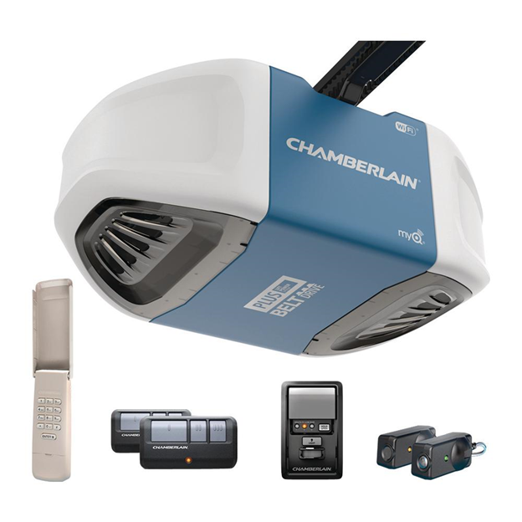
Figure #: Chamberlain Garage opener
A similar device that is used for a different application is the Chamberlain B750 3/4 HP Equivalent Ultra-Quiet Belt Drive Smart Garage Door Opener. It is a garage door opener that uses an electric motor to open and close a garage door. The device is controlled through an app called myQ. The app design is very simple and very similar to the design we are going for. The home screen features a button in the middle of the screen to either open or close the door.
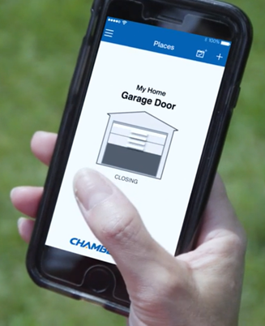
Figure #: Chamberlain Garage opener App
The device can also be controlled through a keypad that can be placed outside the garage door. It opens the door if the correct combination is entered or if the RFID physical keys are placed near it. Our device will also have the option to be activated with a physical key and can be controlled by buttons on the device itself.
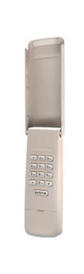
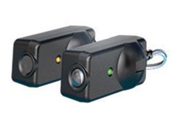
Figure #: Garage opener RFID keys and Keypad

It can also be controlled with a controller that has physical buttons that open, close or lock the garage door and control the garage door light. Our device will also have a remote controller but will use a Bluetooth signal instead of a radio signal like the garage door opener. Our controller will also have a color wheel to control the RGB lights as well as buttons to control the motion of the boat lifter and buttons for music controls
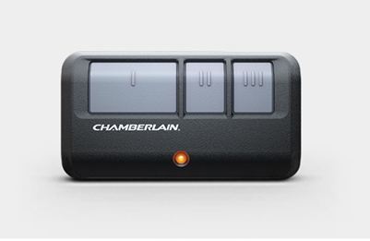
Figure # Chamberlain Garage opener remote control
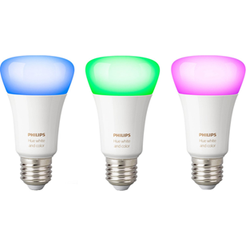
The super boat lift boss also has RGB light control. A similar device that is on the market is the very popular Philips hue smart bulbs. The bulb is controlled through the hue app. The bulb is RGB. In the app you can choose specifically what color you want the bulb to emit. You also have the option to choose from preset colors and you can set the light to perform light shows such as making the light cycle through the colors or making the light fade in and out like a breathing effect.
Figure #: Philips Hue RGB bulbs
Our device will have those features as well. Through the app the user will be able to set the color of the lights to a single color or choose for preset lights shows or make their own light show.
Weather detection is one of the features we will have in the Super Boat Lift Boss. a device that is on the market that is similar to what we’re are trying to achieve with our device is Lufft’s WS10 Smart Weather Sensor it is an All-in-one weather sensor with measurement of temperature, relative humidity, air pressure, wind velocity / direction, precipitation amount / intensity / type, UV index, sun direction, brightness and twilight and global radiation.
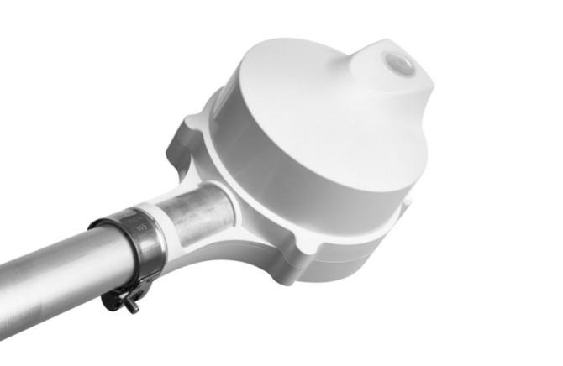
Figure# WS10 weather detector

It is meant to be placed on rooftops. And transfers the weather data through Wi-Fi or RS485. It uses Capacitive, Doppler radar, silicon pyranometer, thermal sensors to gather the weather data.
The WS10 measures 10 weather parameters. Our device will only provide information on 3 parameters: ambient temperature, humidity and wind speed. The goal with our device is to provide an overview of the conditions that would affect the boating experience for the user, not a total report on the current weather. We will be using a wind speed sensor, temperature sensor along with information from a weather forecasting service to get the weather information and display the average to the user.
We will also have the device transmit the sensor information to the Super Boat Lift Boss app through Wifi and Bluetooth and will be compared with weather information that will be provided directly to the user’s phone then displayed in the weather page in the app.

Another function of our device will be music streaming. We will do this in two ways.
The first is using a streaming service that the boat lift boss can connect to directly. A device from Asus called the ASUS clique R100. It is a wireless streaming network audio player that streams music from Spotify using the AllplayUnterstützung service.
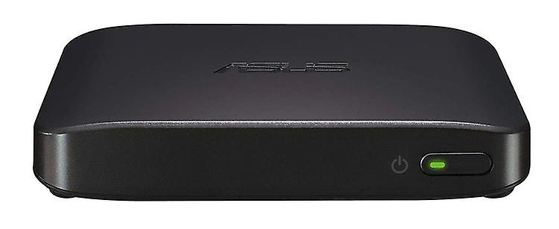
Figure ## Asus Clique R100

It allows the user to plug in any audio device to play the music through.it can also send the music stream through bluetooth to other devices that the music can be played through such as bluetooth speakers.
The music streaming in our device will work in a similar way as we will stream the audio from the internet using services like AllplayUnterstützung to the device directly so it doesn’t have to be sent to the phone first then to the device. This will make the stream more smooth and will free up the bandwidth in the connection between the device and the user’s phone.
The ability to send the audio to other bluetooth devices and play it through there might be added to our device in the future but will not be added at this time due to the added production cost.

****3.3 Strategic Components (Discuss reasoning behind component selection)

3.3.1 Main processor
The first choice our main control unit in this device for us is the Texas Instruments C2000 F2804x processor. We chose this model because it was designed specifically to make developing motor control systems easier. They added many new features to make this possible such as increasing analog integration of the device, boosting the CLA co-processor support, and also introducing more tools and software, which will help make developing our device easier and faster.
It also has two cores, a main CPU plus CLA processing core. We will be able to take advantage of TI’s CLA motor library which will allow us to more simply configure the device.
In order to use the actual Piccolo unit in our device we will need to first use a development kit that can handle controlling a high voltage motor. We will be using one of those development kits and using TI’s development suite called Control Suite to test the kit and run sample projects to help us determine the best approach to programming the Piccolo for use in our device. Having two cores gives us the ability to dedicate one core to control the motor’s speed and direction while we will program the other one to communicate with the rest of the peripherals and manage the rest of the device’s features. it features UART, I2C, SPI, and CAN2.0. we will be using UART to communicate with the app.
Our second choice will be the C2000 F2803x 32-bit MCU with 400 MIPS. as with the previous choice it has two cores 1xCPU and 1xCLA. Also has UART, I2C, SPI, and CAN2.0. It works perfectly for what we need it for as it provides all the advantages of the F2804x and can also be programmed with the TI controlSuite and Code Composer. The F2803x is the previous iteration of the F2804x so it has a very similar architecture.
Our third choice will be the newest version of this processor series. It adds PGAs but other than that has the same characteristics as the other two choices. Being the most recent model it gives the advantage of being optimized to be compatible with Code composer and control suite, as well as having the most up to date technical documentation.
All of our choices for the main processor of our system come as part of DIMM100 Control Cards that are compatible with our motor control kit. They all have UART communication as well which we need for to facilitate communication between the processor and the bluetooth/Wifi module.
We chose the C2000 F2804x because of it’s high speed which we will need because of the many operations that the processor will be controlling at once. The processor will send data to and receive data from the bluetooth/wifi module as well as control the RGB lights and control the motor speed and motion. The C2000 F2805x is newer and cheaper but has a lower frequency; it might not be able to process all of these operations at once so we went with the F2804x even though it is more expensive.

Processor | Frequency | On-Chip Memory | Temperature Options | Serial Port Peripherals | Price
F2804x | 100-MHz | 64K × 16 Flash  10K × 16 SARAM  1K × 16 OTP  4K × 16 Boot ROM | T: –40°C to 105°C  S: –40°C to 125°C  Q: –40°C to 125°C | Communications Port Peripherals  Serial Peripheral Interface (SPI) Module  Serial Communications Interface (SCI)  Inter-Integrated Circuit (I2C) Bus  Universal Asynchronous Receiver/Transmitter (UART) | 1ku | $8.76
F2803x | 60 MHz | Flash, SARAM, OTP, Boot ROM Available | T: –40°C to 105°C  S: –40°C to 125°C  Q: –40°C to 125° | One Serial Communications Interface (SCI) Universal Asynchronous Receiver/Transmitter (UART) Module  Two Serial Peripheral Interface (SPI) Modules  One Inter-Integrated-Circuit (I2C) Module  One Local Interconnect Network (LIN) Module  One Enhanced Controller Area Network (eCAN) Module | 1ku | $8.76
F2805x | 60 MHz | Flash, SARAM, Message RAM, OTP, CLA Data ROM, Boot ROM, Secure ROM Available | T: –40°C to 105°C  S: –40°C to 125°C  Q: –40°C to 125°C | Three Serial Communications Interface (SCI) (Universal Asynchronous Receiver/Transmitter [UART]) Modules  One Serial Peripheral Interface (SPI) Module  One Inter-Integrated-Circuit (I2C) Bus  One Enhanced Controller Area Network (eCAN) Bus | 1ku | $5.32
Table ## comparing the different processor choices

3.3.2 Motor Control Kit
Our first choice for the motor control kit is DRV8312-C2-KIT. It is compatible with all of our choices for the main microprocessor. It is a DIMM100 controlCARD based motherboard evaluation module. The DRV8312-C2-KIT is a motor control evaluation kit for spinning three-phase brushless DC (BLDC) and brushless AC (BLAC). We will be using a brushless DC motor so this kit works perfectly for our project.

The second choice would be the DRV8302-HC-C2-KIT which is a DIMM100 controlCARD based motherboard evaluation module. The DRV8302-HC-C2-KIT is a motor control evaluation kit for spinning three phase brushless DC and brushless AC (BLAC) just like the DRV8312 kit. The only difference is that it uses a DRV8302 module instead of a DRV8312 module which has a lower operating voltage range but a higher operating temperature range.

The DRV8301-HC-C2-KIT is our third choice. Just like the other two kits it is a DIMM100 controlCARD based motherboard evaluation module. It is a motor control evaluation kit for spinning three phase brushless DC and brushless AC (BLAC). This kit uses the DRV8301 which has a similar operating voltage and temperature range as the DRV8302. We compare the specifications of each motor control module in the table below.
`Module | Voltage range | Control I/F | Special features | Operating temperature range (C) | Price
DRV8312 | 10.8v to 70v | 3xPWM | Integrated FETs | -40 to 85 | 2.62 | 1ku
DRV8302 | 6v to 65v | 6xPWM, 3xPWM | Buck Step Down Converter, Current Sense Amplifier, Hardware Management I/F | -40 to 125 | 2.20 | 1ku
DRV8301 | 6v to 65v | 6xPWM, 3xPWM, 1xPWM | Buck Step Down Converter, Current Sense Amplifier, SPI/I2C | -40 to 125 | 2.20 | 1ku
Table## compering our options for motor control kits

We chose the DRV8312 kit because of its higher max voltage as it will be driving a motor that will have to lift very heavy boats. So the higher voltage is prefered.

3.3.2 Control Card
In order to control the motor we need to add a control card to the DRV kit, we looked at some possible choices from Texas Instruments. The main choice is the Piccolo TMS320F28035 Isolated controlCARD which is a DIMM100 based controlCARD that is compatible with all of our choices for the motor control kit. It has a small form factor and has an on board mini usb port that will make programming the F2804x processor. It also has a F28x analog I/O and digital I/O to DIMM interface and takes 5 volts to operate.
The second choice for us will be the TMDSCNCD28035 F28035 Piccolo controlCARD. Just like the TMS320F28035 it is a DIMM100 based control card it has the same processor and a very similar form factor and takes 5V to operate as well.
Our third choice would be the TMDSCNCD28069 F28069 Piccolo controlCARD. It has the same characteristics mentioned for the other two control cards as well as a similar form factor.
All of the boards had similar software features as well. They could be programmed and configured with the code composer IDE and controlSuite.
The choices for the control card were very similar and fairly close in price. Any of them could have been used for our project. We had the TMS320F28035 as our first choice because of availability reasons.

Control Board | interface | Price
TMS320F28035 | F28x analog I/O and digital I/O to DIMM interface | $69
TMDSCNCD28035 | Isolated RS-232 interface | $80
TMS320F28035 | F28x analog I/O, digital I/O and JTAG signals to DIMM interface | $59
Table ## comparing the options for the control board

3.3.3 Bluetooth/Wifi module
Our first choice for the bluetooth/wifi module is the murata 1DX it is a bluetooth/wifi module that is capable of bluetooth LE. it is very efficient and has been used in similar projects before. The one drawback to it is that it has no on board processor so we will need to rely fully on the main microcontroller to handle all of the device's processing needs. Our second choice would be the murata 1MD module. It has all the benefits of the 1DX with the added advantage of having an on board processor. This would alleviate some of the workload off the main control processor for the device. The main drawback to it and the reason it wasn’t our first choice is its price. It is more expensive than the 1DX.
We considered a few more modules that were similar to the 1DX in that they are radio only bluetooth/Wifi modules. They vary in operating temperature, voltage range, data rate over WLAN and price. Here is a table comparing the specs for the modules
Module | Max freq. | Operating temperature range | Bluetooth version | Supply voltage range | WLAN data rate | price
1DX | 2483.5 | -30 to +70 | 5.1 BR/EDR/LE | 3.35 to 4.2 | 11, 54, 65 Mbps | $13.20
1MD | 2483.5 | -20 to +70 | 4.1 LE | 3.3 | 11, 54, 65 Mbps | $30
1CX | 5825 | -20 to +75 | 5 BR/EDR/LE | 3.35 to 4.2 | 11, 54, 65, 150, 866 Mbps | $16.99
1PJ | 5825 | -30 to +85 | 5.0 BR/EDR/LE | 3.135 to 3.465 | 11, 54, 65, 150, 433 Mbps | $18
1LV | 5825 | -20 to +70 | 5.0 BR/EDR/LE 2MPHY | 3.2 to 4.4 | 11, 54, 65, 78 Mbps | $16.03
1CQ | 5825 | -20 to +70 | 5.0 BR/EDR/LE | 3.135 to 3.46 | 11, 54, 65, 150, 866 Mbps | $17
Table # Comparison between different possible choices for bluetooth/Wifi Modules
Even though some of the modules have a bigger temperature range or higher data rate or a higher frequency, the deciding factor for us was the price as this is meant to be a part of a product that will be mass produced. The 1DX is also the smallest in size and has enough power and speed to perform the tasks we need without compromising too much.
3.3.4 Bluetooth module for remote
In addition to the physical buttons and the app the super boat lift boss will be controlled by a bluetooth remote. Our first choice for the bluetooth module for the remote is the 1BX bluetooth module from murata. It is a bluetooth 4.2 BR/EDR/LE with a max data rate of 3 Mbps. it operates in a frequency range of 402MHz - 2480MHz and uses serial communication UART which we will use for communication between all parts of the device. The biggest advantage we have with the 1BX is that it is made specifically for this type of application. It has a very small form factor and runs on a very low current.
Our second choice is the Type 1GR it is a Shielded Ultra Small Bluetooth 4.1 LE Module .it uses the 2.4GHz frequency, has an on board antenna and has a max data rate of 1Mbps. It also uses UART serial communication. The main advantage with the 1GR is that it has an on board processor, the ARM Cortex-M3 which will be a easy way to implement the color selector wheel on the remote and omit the need for a dedicated microprocessor on the remote.
The third choice is the murata MBN52832. It is a Shielded Ultra Small Bluetooth 5.0 LE Module that has an on board processor, the ARM Cortex-M4, an on board antenna, has a max data rate of 1 Mbps, uses UART and SPI serial communication. With the MBN52832 we would have the advantage of not needing a dedicated microprocessor and we would have the added advantage of having bluetooth 5.0 which the Bluetooth module on the Super Boat lift boss is capable of. This would increase the range of the remote drastically.
The choices for the bluetooth module for the remote controller of the Super Boat lift boss can change the design of the whole remote, as two of the three omit the need to have a dedicated processor. And having different versions of bluetooth would make the range and data speed vary drastically.
We chose the 1BX as it had all the features we needed and kept the design simple and had good price and most importantly has a small form factor and runs of very little power which would make the remote batteries last for a long time.

Bluetooth Module | Bluetooth | Frequency | Processor | Chipset | Operating Temperature
Type 1BX | 4.2 BR/EDR/LE | 2.4GHz | none | Qualcomm Single-Chip Bluetooth Dual Mode CSR8811 SoC | -30 °C to +85 °C
Type 1GR | 4.1 LE | 2.4GHz | ARM Cortex-M3 | Cypress (CYW20736) | -20°C to 85°C
MBN52832 | 5.0 LE | 2.8GHz | ARM Cortex-M4 | Nordic (nRF52832) | -40°C to 85°C

3.4 Possible Architectures and Related Diagrams

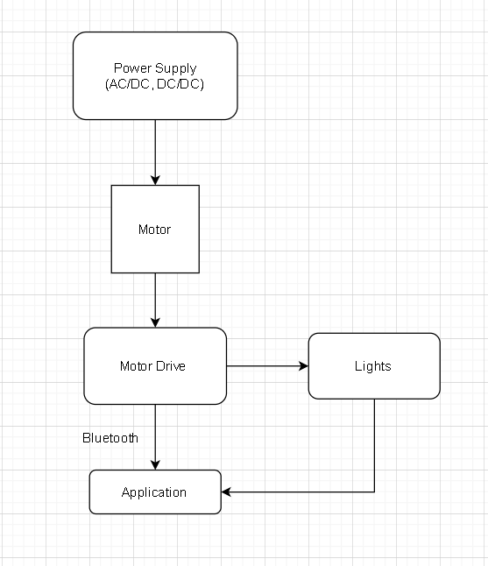

Software Leads
Lucy - Application development, BLE, and piccolo mcu
Nader - Application development, Wifi, and murata 1DX

Hardware Leads
Andrew - DC/DC booster, universal power input drive, DC brushless motor
Hesham - AC/DC converter and controller embedded software (e.g rotary encoder)
4.0 Related Standards and Design Impact
This section will discuss different standards that can be applied to the Super Boat Lift Boss. The standards will increase safety and make the design more regulated.
4.1 Related Standards
When designing a system, it is important to follow standards. Engineering standards are documents that explain the detailed specifications in design for certain products, systems, or processes. Standards are made to regulate products, meet the minimum performance requirements, and ensure safety for both the user and engineer. Standards can be made by many different organizations. Common organizations used for standards today include the Institute of Electrical and Electronics Engineers (IEEE), the American National Standards Institute (ANSI), the American Society for Testing and Materials (ASTM), International Electrotechnical Commission (IEC), and the National Resource for Global Standards (NSSN).
The NSSN was launched in 1997 and is a partnership between ANSI and other organizations to provide a search portal for standards. This serves as a single point to search for information on many different approved standards, including both international and domestic. IEEE is a global nonprofit organization that is working toward development, implementation, and maintenance of technology-centered products and services. This organization has developed a Standards Association to develop different standards in many different technological industries. Most of the standards found for this project are from IEEE Standards Association and IEC. IEC is an international organization that is one of the world’s leading organizations for the preparation and publication of International Standards for all electrotechnology devices. Utilizing these resources, we have found a few standards that can help guide the design of this project.
4.1.1 Waterproof Seal Standard – IP67
The Super Boat Lift Boss motor will remain outside in all types of weather conditions. Since it will always be next to the water, the motor will need special weather protection to ensure the components remain safe and dry. The International Electrotechnical Commission (IEC) has created a group of standards to determine the best water resistant or waterproof sealant for different purposes. The standard includes IP codes with different numbers representing different levels of weather resistance. To determine the correct IP code for this project, it is important to consider different weather conditions this motor may be placed in. The first code value determines the protection against the ingress of solid foreign objects. Since salt and fog are common things near boat lifts, levels 5 and 6 were taken into consideration. Level 5 includes dust protection but does not entirely prevent the intrusion of a large quantity of dust. This would not be ideal for sitting near salt water for a long period of time. Level 6 has complete protection against dust contact, which would be ideal for our purpose. We have chosen IP6x for the protection against solid objects.
The second digit in the IP code represents the protection against the ingress of water. It is important that this motor is waterproof since it will be used as a boat lift and encounter water very often. The codes 1 through 6 are weather resistant, with increasing resistance as the digit increases. We want to ensure that just in case the motor falls into water, the owners will have the chance to retrieve the device without damage. For this purpose, we needed to decide between code 7 and 8. Both levels include waterproof sealant to protect a device for 30 minutes. Level 7 protects from immersion up to a depth of 1 meter, while level 8 protects with a depth of more than 1 meter (usually 1.5 meters). Since this device will be near the shore, the depth of the water should not be deeper than level 7 provides. For this purpose, we have chosen level 7 water protection for this device. Together, the codes we have chosen led us to choose the standard IP67. This means that it will be protected from total dust ingress and water immersion up to 1 meter.
4.1.2 Design Impact of Waterproof Seal
The waterproof sealant is one of the last steps to completing the project, so we will not need to complete this for several months. However, we need to keep in mind that there will be an IP67 sealant when designing the motor. It must be in a compact design, with the most vulnerable parts towards the center of the design for maximum protection. Without a waterproof sealant, the motor would not be able to remain outside during all weather conditions. This seal will allow the Super Boat Lift Boss to be installed next to a body of water without being affected by salt, fog, or water damage. The seal is essential to the final product of this design.
4.1.3 Bluetooth Security - SP 800-121 Rev. 2
It is important for any wireless communication to have a secure connection. Without proper security implementations, adversaries can intercept the signal and either steal information or alter the signal. This standard, SP 800-121, specifies different security implementations to provide the basic security services for Bluetooth connection. These services include authentication, confidentiality, authorization, message integrity, and pairing/bonding. For the Super Boat Lift Boss, it is important that authentication and authorization is secure. The only people allowed to access this boat lift should be the owner and users given special permission by the owner. This standard will help the programmers apply correct security standards to protect the users from having their signals compromised.
The Bluetooth we are using for this project is Bluetooth Low Energy, which has different security than Bluetooth BR/EDR/HS. This is because Bluetooth low energy must support computationally and storage-constrained devices. There are different mode levels of security detailed in this standard, but for our purposes Security Mode 1 Level 4 would be the most secure choice. Level 4 is recommended for devices using Bluetooth Low Energy, because it requires Secure Connections. It is possible to use Security Mode 1 Level 3 for our project, but it is recommended to use the most secure mode possible. The low energy feature that we are using requires authenticated low energy Secure Connections pairing with Elliptic Curve Diffie-Hellman (ECDH) based encryption. During encryption, there is a secret symmetric key generated. For Bluetooth Low Energy, this key is called the Long Term Key rather than the Link Key. The Long Term Key is generated by one device and securely sent over to another device during pairing. In low energy secure connections, the key is a result of a key agreement and thus does not need to be distributed over the link. Instead of Secure Connections, Legacy Pairing is an option for Bluetooth connection. Low energy Legacy Pairing uses similar methods to other Bluetooth versions; however, it is possible for eavesdropping to occur. This is a security threat to our project because if an attacker eavesdrops on the Bluetooth connection, they will be able to see when the user activates their boat lift. This could potentially cause problems with home security, as the attacker would know when the boat lift was activated and therefore when the user’s home is left unattended. Due to this security risk, our team decided to use Bluetooth Low Energy Secure Connections Pairing as opposed to Legacy Pairing.
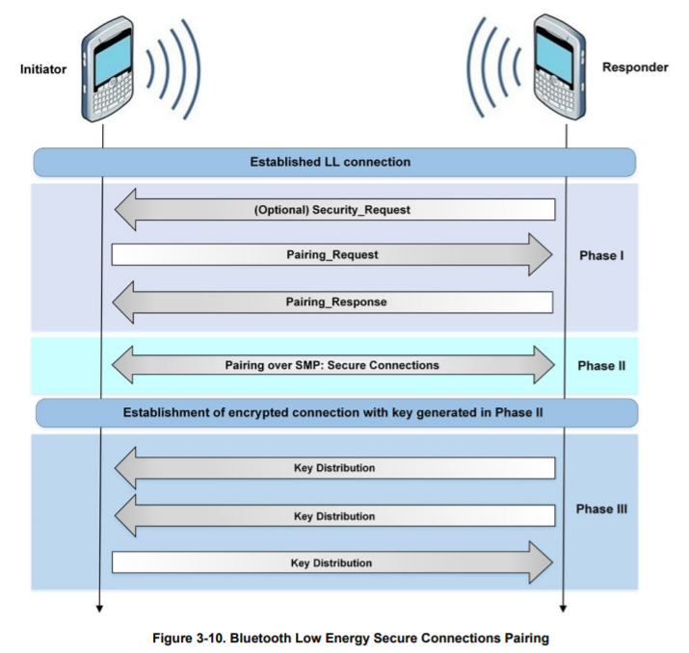
Figure #: Bluetooth Low Energy Secure Connections Pairing
The Secure Connections pairing begins with two devices sharing their pairing features. These features include their I/O capabilities, authentication requirements, and maximum encryption key size requirements. Then, the public keys are shared. This key distribution is referring to the Long Term Key (LTK), not a Short Term Key (STK). Using these keys, data is sent through the Elliptic Curve Diffie-Hellman (ECDH) based encryption. Using this security standard, we can ensure that we have a secure connection between the user’s mobile device and the 1DX Murata module.

4.1.4 Design Impact of Bluetooth Security
The Bluetooth security standard is a necessary part of this project to create a secure communication connection between the mobile application and our motor. This standard provides the guidelines we need to pair the devices securely. If we did not have security implementations for this project, users could have their boat lifts at risk of interference. If an attacker intercepted the signal, they could control the boat lift without the user’s knowledge. The boat could potentially be stolen, but there are less obvious security risks as well. If an attacker is monitoring the boat lift information, they could record information about when the user activates the boat lift. With this, the adversary would know when the boat was gone and potentially when the users left their home unattended. This could pose a dangerous security threat to the home of the users. It is important that the connection is secure for this product to reduce the risk of hackers entering this system.
4.1.5 PCB standards
The Association Connecting Electronics Industries (IPC) is a trading company in charge of standardizing the production requirement of some electronic equipment. Also, these standards are created to provide electronic manufacturing industries a set of rules and procedures to follow. Some standards includes:
● Printed board
● Printed electronics
● Design standards
● Assembly
● Embedded Technologies
● Electronic enclosures
IPC-221B are standards used and followed for printed board designs used in commercial PCBs. These standards are general requirements for component required and PCB designs. Some standards needed are the following:
● IPC-T-50 Terms and Definitions
● IPC-2615 Printed Board Dimensions and Tolerances
● IPC-D-325 Documentation Requirements for Printed Boards
● IPC-ET-652 Guidelines for Electrical Testing of Unpopulated Printed Boards
These standards will help to build this project in order to achieve the desired outcome. The product will have reputation, reliability and profitability. Moreover, this universal standard will be approved for global usage.
4.1.6 Wireless standards
Since this device is using a Wi-Fi module, we will need to comply with all of the standards of wireless Wi-Fi communication ( IEEE 802.11). In order to accomodate for our device, our budget, computing power, and simplicity, the most compatible version of this standard to move forward with would be 802.11g. This set of standards encompasses most Wifi devices, with backwards compatibility to the original 802.11 standards. These standards encompass the 2.4 GHz frequency range as well, which is most likely what will be supported in our Wi-Fi modules. Since this device uses a bluetooth module, which the IEEE 802.15 standards need to be followed. These standards is similar to the wifi module standards which are from the 802 standards family of IEEE, yet these standards focuses more on module of shorter range, medium access control (MAC) (L2CAP, LMP, and baseband) and physical layer (PHY) (radio).
4.1.7 Testing Standards
There is a useful standard provided by IEEE (IEEE 1012-2016 - IEEE Standard for System, Software, and Hardware Verification and Validation) that covers the entire cycle of the product that we are producing, which covers the verification and validation processes. This will allow us to make sure that all of our requirements are accounted for in an organized manner.
4.1.8 Reliability standards
Reliability standards are protection standards against legal terms in order to demonstrate the product’s full functionality for the duration estimated in the life span. These standards ensure that the product will have a meaningful use to the customer. If the product performs most of their features but it does not charge or the system goes down regularly, it can be considered as a defect product and can create issues in the future. These standards protect the buyer and provide a guideline for the developer on how reliable the product needs to be.
Following these standards also protects the developer from any legal liability as for the product to be sold legally it would have to meet these reliability standards on the hardware side. The product would have to be reliable on the software side as well and the app will get regular updates to keep it operating properly.
4.1.9 Programming Standards
Ionic uses the World Wide Web Consortium (W3C) which is the standards organization for the Web. Together, industry leaders and the public work together to develop web standards, which are a set of protocols, specifications, and technologies that define the Web Platform.
5.0 Project design
The design of this project can be split into two main areas, Hardware design and software design. In hardware design we focus on the design of the circuits of the device, the different modules used and the PCBs that will hold those components. In software design we focus on the design of the app and the integration of software and hardware when we code the piccolo.
5.1 Hardware Design
In this section we discuss the specifics of how we designed our PCBs, what hardware components we will be using and how we will be using them.
5.1.1 Universal Power Input

One of the most important design requirements is that the Super Boat Lift Boss has the capability of universal power input which ensures that the consumer can use either landline AC power rated from 110 to 230 volts as to cover domestic and international standards or the consumer can use DC battery power using a standard rated 12 volt battery or running up to four of these batteries in series to get a combined 48 volts to optimize the driving power of the Super Boat Lift Boss. Regardless of whichever power option the consumer chooses, the Super Boat Lift Boss will regulate the power input using either an AC to DC converter or a DC to DC step up converter to achieve the desired minimal output of 48 volts. The system will operate at 20 amps using the regulated 48 volts to create a one-kilowatt output to drive the DC Brushless Motor as well as the PCB which includes the Piccolo MCU and 1DX Radio Module.

5.1.2 Variable Input DC/DC Regulated Boost

To ensure the system is supplied with a constant 48 volts of DC power regardless of if the consumer supplies the system with the minimum requirement of a 12 volt power supply or the optimized 48 volt supply, a variable input DC-to-DC Boost or “Step-Up” converter will be implemented. A DC-to-DC boost converter works essentially by “stepping up” the supply voltage of the input by using a MOSFET as a switch linked to a pulse width modulated signal which governs the flow of current. This allows an inductor to store energy when the FET is “on,” then when the FET is switched “off,” drops that saved voltage along with the input voltage over a capacitor and the load which in turn steps up the output voltage incrementally, yet at an incredibly fast rate. This ensures the final desired output voltage can be achieved almost instantaneously whenever the circuit is connected and operated. This is great for batteries as their voltage often varies for a multitude of reasons such as the ambient temperature in the area and humidity as well as internal cells aging causing weaker discharge, so having the boost converter ensures the required 48 volts should be maintained regardless of the possible fluctuation in battery voltage, barring the battery or series of batteries can maintain their respective operating minimum voltage while under load. With an increase in the output voltage comes a decrease in the output current as well due to conservation of power, ie power (P) = voltage (V) * current (I). This inverse relationship between voltage and current will provide a means to calculate on a simpler scale (i.e. excluding power consumption of parts, heat dissipation, internal noise, etc.) the required power output of 1 kilowatt by allowing the required output voltage to fluctuate above 48 volts, ensuring the 20 amps can be achieved. Using the fundamentals of a DC/DC Boost Converter and an understanding of voltage regulation using diodes and transistors, a mockup circuit was created and then modified using circuit designs found online as reference to give the desired requirement specifications which includes taking a variable input of 12 volts to 48 volts, stepping it up rapidly and regulating it to a 48 volt output to power all the components of the Super Boat Lift Boss which includes all the components installed on the PCB, the buck converter that will provide a 12 volt or 24 volt output for the customer to plug in LED lighting, all while operating at 20 amps to get a desired power output of 1 kilowatt for the brushless motor drive.

By design, a Step-Up voltage converter can build up a significantly high output voltage if left unchecked. To rectify this issue, Zener or Schottky diodes can be implemented as a means to govern a desired output voltage. An additional transistor near the output when combined in parallel with these diodes essentially creates a means to regulate the output voltage. Our design will take advantage of this design aspect using these components to create the desired Variable Input DC/DC Regulated Boost Converter circuit that will be implemented as part of the power system for the Super Boat Lift Boss.

When initially designing the Variable Input DC/DC Regulated Boost Converter circuit, a simple DC/DC Boost converter was created using designs found online. The issue quickly became how to adequately control the pulse width modulation signal and how to regulate the output on the load as the voltage climbed incredibly fast and went unchecked during simulation reaching well past the desired output voltage. More research was done to find an optimal circuit design that could facilitate the requirements given for the DC/DC Boost Converter. Through this research it was discovered that by simply adding a Texas Instruments LM555 then the pulse width modulation could be easily controlled. Based on the datasheet, LM555 could operate with a minimum of 12 volts from the supply voltage, has a low power dissipation and could function at high operating temperature. The first issue was addressed, implemented and worked to step up voltage at a roughly 50% duty cycle when simulated on LTSpice.

Next, various diodes were implemented into the circuit near the load as a means to regulate the voltage output to the desired 48 volts. First a Schottky diode was implemented into the design as a means to limit the output voltage to the desired 48 volts. However, when the simulation was ran with the minimum 12 volt input, the output would cap out around 46 volts. Through testing it was found that two Zener diodes in parallel with the Zener breakdown voltage values of 18 volts and 30 volts respectively gave the desired voltage output of 48 volts with the minimum input voltage of 12 volts (9.6 volts in nonideal conditions) and the maximum input voltage of 48 volts. The graphs for these min and max results can be seen below in Figures 1 and 2 showcasing the output voltages respectively as well as the Variable Input DC/DC Regulated Boost Converter circuit in Figure 3.

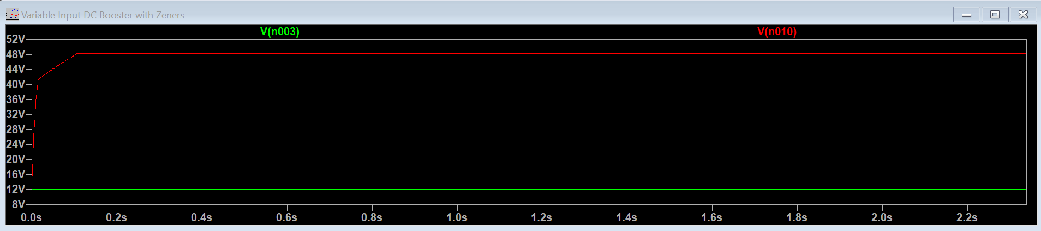
Figure 5.1.1: 12 V Input (Green) and 48 V Output (Red)

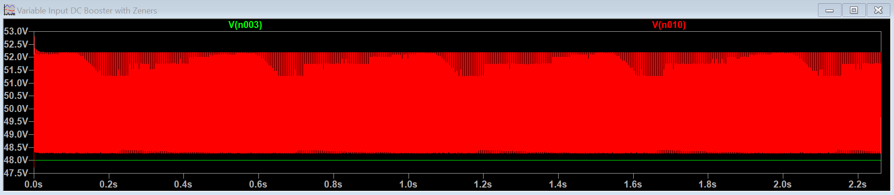
Figure 5.1.2: 48 V Input (Green) and 48.2 to 52.2 V Output (Red)

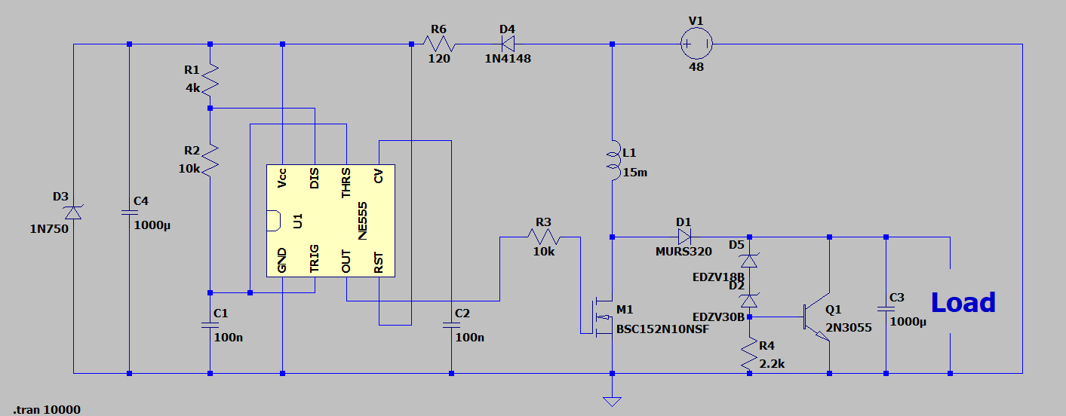
Figure 5.1.3: Variable Input DC/DC Regulated Boost Converter

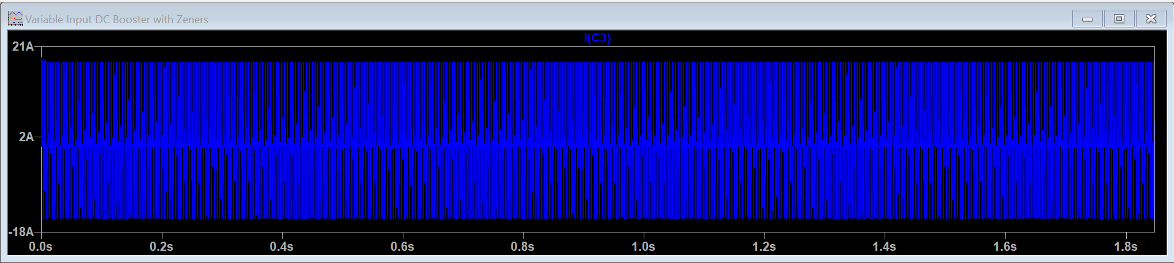
Figure 5.1.4: 18.4 A Output (Blue) at 48 V Input

The desired output voltage was attained, however the desired output current of 20 amps was not. The circuit design when simulated only supplied 18.4 amps maximum when running at full power along with having some components changed out. The graph showcasing this result can be seen above in Figure 4. This output current proved insufficient as the desired power output of 1 kilowatt could not be attained with this amperage. This design was scrapped as a result and more research was conducted on applicable parts and circuits that could fulfill the required specifications.

Eventually the LM5122 “Wide-Input Synchronous Boost Controller With Multiple Phase Capability” from Texas Instruments was found. When looking at the datasheet for the part, the main feature of the LM5122 is that it has the capability of taking an input voltage of 4.5 to 65 volts and outputting up to 100 volts, which encompasses the requirements for our DC/DC booster of 12 to 48 volts input and outputting a regulated 48 volts. In reading what applications it is best used for, it is ideal for 12V, 24V, and 48V power systems as well as a high-current boost power supply. The LM5122 would prove the backbone for the next circuit design.

Texas Instruments online circuit designer “Webench Power Designer” was used to create the circuit through a quick link found on the LM5122’s datasheet. At the “Webench Interactive Preview” window, Vin was input using a voltage minimum of 12 volts to a voltage maximum of 48 volts, Vout was input as 48 volts, Iout was input as 20 amps, and finally the ambient temperature was set to 55 degrees Celsius. The circuit can be seen below in Figure 5.
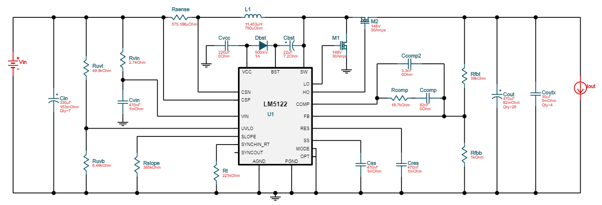

Figure 5.1.5: 12V-48V to 48.00V @ 20A

The design was implemented and kicked back a circuit with one caveat; “the selected FET junction temperature is exceeded above the maximum rating.” This resulted in the circuit being created using two ideal FETs (M1 and M2 respectively on the circuit) both being simulated with the attributes of VdsMax = 148 Volts and IdsMax = 30 Amps. In looking at the requirements of the FETs, it was found that the two FETs could be replaced using the SUP85N15-21 “N-Channel 150-V (D-S) 175 °C MOSFET” from Vishay Siliconix which has a VdsMax = 150 Volts and an IdsMax = 50 Amps. Since the two ideal FETs could be replaced with realistic components at a reasonable cost given the requirements, the design was kept and simulated. The simulations (Figures 5.1.5a, b and c), system information (Table “12-48 Volt Step Up Converter System Information”), and PCB layout (Figure 5d) can be seen on the next few pages of figures.

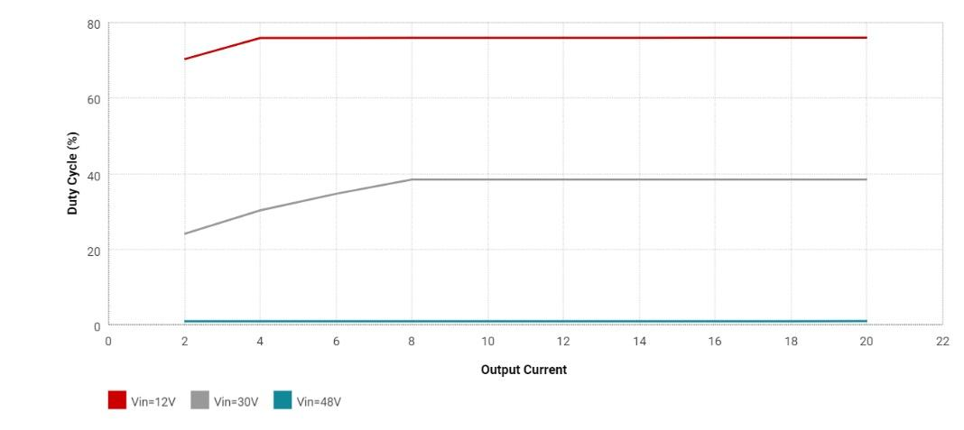
Figure 5.1.5a: Duty Cycle

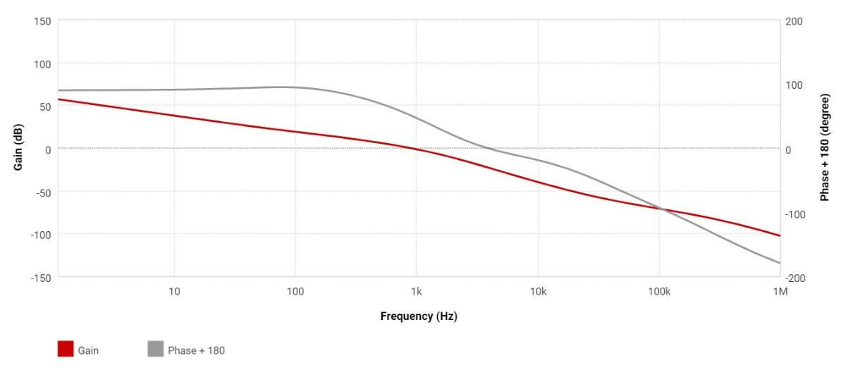
Figure 5.1.5b: Magnitude Spectrum

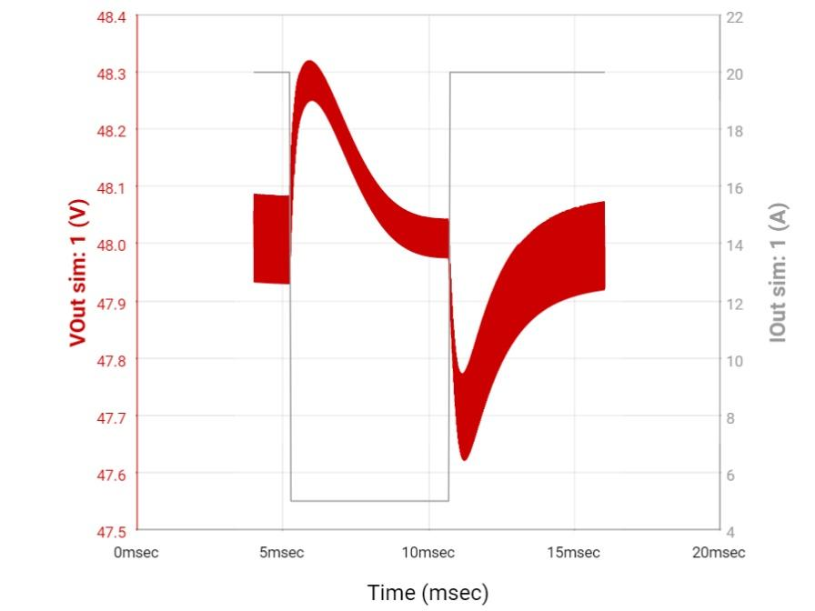
Figure 5.1.5c: Vout and Iout vs. Time

12-48 Volt Step Up Converter System Information
Name | Value | Category | Description
Vout | 48 V | System Information | Operational Output Voltage
IC Tolerance | 18 mV | IC | IC Feedback Tolerance
Cin IRMS | 5.62 A | Capacitor | Input capacitor RMS ripple current
Cin Pd | 689.56 mW | Capacitor | Input capacitor power dissipation
Cout IRMS | 35.24 A | Capacitor | Output capacitor RMS ripple current
Cout Pd | 3.92 W | Capacitor | Output capacitor power dissipation
Coutx IRMS | 472.64 mA | Capacitor | Output capacitor_x RMS ripple current
Coutx Pd | 279.24 µW | Capacitor | Output capacitor_x power loss
L Ipp | 19.46 A | Inductor | Peak-to-peak inductor ripple current
Ipp percentage | 23.33% | Inductor | Inductor ripple current percentage (with respect to average inductor current)
L Pd | 5.24 W | Inductor | Inductor power dissipation
Duty Cycle | 76.02% | System Information | Duty cycle
Frequency | 40.72 kHz | System Information | Switching frequency
Pout | 960 W | System Information | Total output power
Iin Avg | 80.88 A | IC | Average input current
IC Ipk | 93.14 A | IC | Peak switch current in IC
Mode | CCM | System Information | Conduction Mode
Vin p-p | 425.28 mV | System Information | Peak-to-peak input voltage
Vout p-p | 300.04 mV | System Information | Peak-to-peak output ripple voltage
Phase Marg | 59.79 ° | System Information | Bode Plot Phase Margin
Cross Freq | 269.92 Hz | System Information | Bode plot crossover frequency
Low Freq Gain | 65.49 dB | System Information | Gain at 1Hz
Gain Marg | -18.08 dB | System Information | Bode Plot Gain Margin
Vout Actual | 48 V | System Information | Vout Actual calculated based on selected voltage divider resistors
Vout Tolerance | 3.50% | System Information | Vout Tolerance based on IC Tolerance (no load) and voltage divider resistors if applicable
Vin | 12 V | System Information | Vin operating point
Iout | 20 A | System Information | Iout operating point
Cin Pd | 689.56 mW | Power | Input capacitor power dissipation
Cout Pd | 3.92 W | Power | Output capacitor power dissipation
Coutx Pd | 279.24 µW | Power | Output capacitor_x power loss
L Pd | 5.24 W | Power | Inductor power dissipation
Total BOM | NA | System Information | Total BOM Cost
BOM Count | 58 | System Information | Total Design BOM count

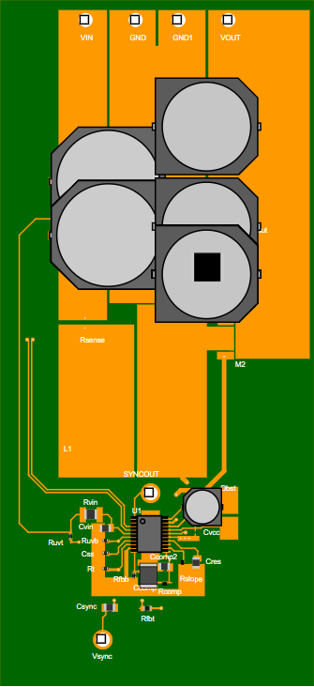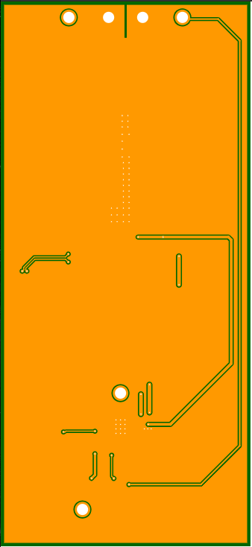
Figure 5.1.5d: PCB Top and Bottom View

After further testing through simulation and an evaluation of components from the sponsor, this design would prove near impossible to implement in the real world due to thermal issues on the chip and the fets requiring an unrealistic rds_on of 1.03 µΩ, an oversight on my part while implementing the fet from Vishay as the replacement for the ideal fets. A new design would need to be implemented which would negate where issues seemed to keep manifesting. Through consultation on the design and its shortcomings, it is encouraged and decided upon to implement a two-phase system as a means to get the proper output voltage and current while maintaining realistic specifications on all parts involved. A move away from TI Webench for this design in favor of LTpowerCAD was taken as the latter’s software had more options available for customizing the requirements of the two-phase DC/DC Booster.

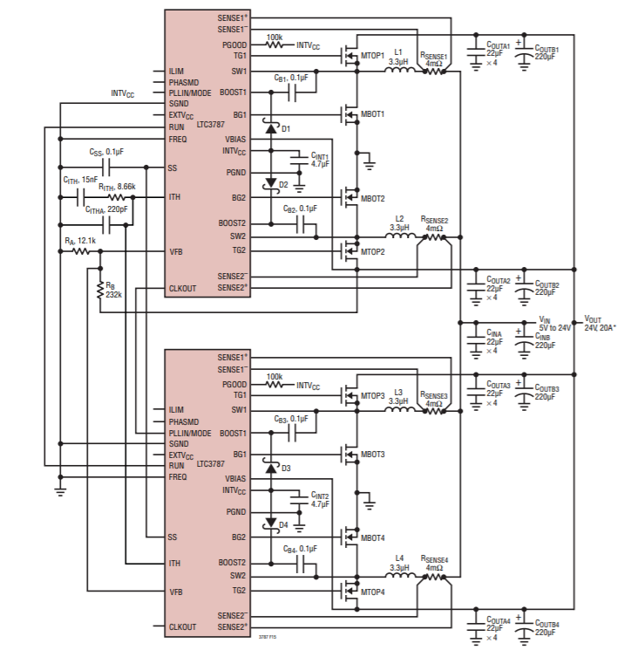

Figure 5.1.6: Dual Phase Topology

5.1.3 12-24 Volt Voltage Regulator Circuit

Another important requirement specification is that The Super Boat Lift Boss will have a selectable power supply of either 12 or 24 volts for connecting RGBW LEDs to light up the customer’s dock, providing ambient light. To power this selectable power supply, a simple voltage regulator circuit is initially implemented as the start for the design. This voltage regulator circuit serves to step down the available 48 volts from either the AC/DC converter or the DC/DC boost converter to a selectable voltage.

To allow the client the ability to select either a 12 volt output or a 24 volt output for their dock LEDs, a trimpot is implemented into the circuit design. This proved more cost efficient than implementing two separate resistors and a proper switch as additional wiring and space would be needed. The trimpot in itself will function as the switching mechanism. Essentially this is done by having the trimpot have two “set” positions to give the desired voltage outputs. When the trimpot is at its 9k Ohm setting, the regulated voltage will be roughly 24 volts and when the trimpot is set to 2.5k Ohms, the regulated voltage will be roughly 12 volts. The voltage regulator and its respective circuit settings for desired outputs of 12 volts and 24 volts can be seen below on Figures 5.2.1, 2, and 3.

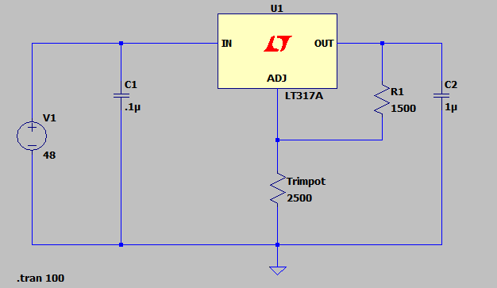
Figure 5.2.1: 12 – 24 Volt Voltage Regulator Circuit

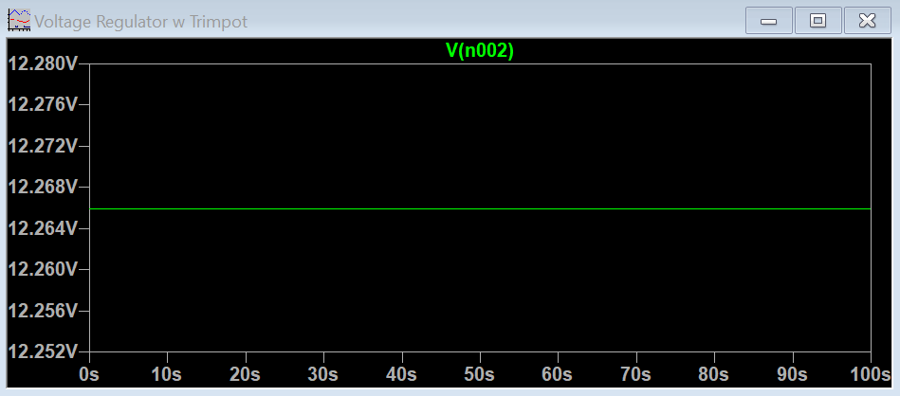
Figure 5.2.2: 12 Volt Output With Trimpot Set to 2.5k Ohms

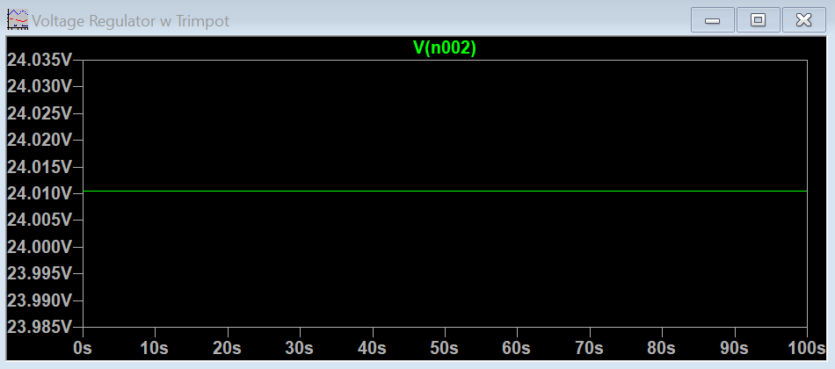
Figure 5.2.3: 24 Volt Output With Trimpot Set to 9k Ohms

The circuit is then modified to allow high current output functionality. Resistor values for R1 and R2 are changed accordingly to accommodate changes to the circuit and control the regulation properly. The new value for R1 is 240 Ohms, and the trimpot R2 is set to 4.5k Ohms to give an output voltage of 24 volts or 2.1k Ohms to give an output voltage of 12 volts. Figure 5.2.4 below shows the circuit design and Figure 5.2.5 shows the new circuit’s voltage and current output when the voltage is stepped down to 24 volts from the 48 volt input.

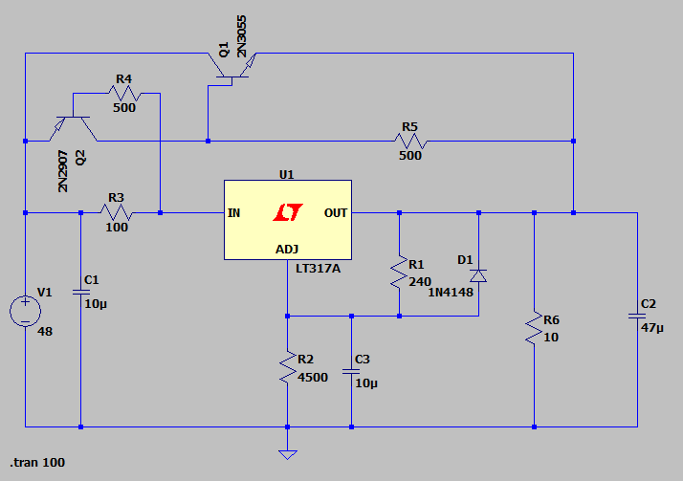
Figure 5.2.4: High-Current Adjustable Regulator Circuit

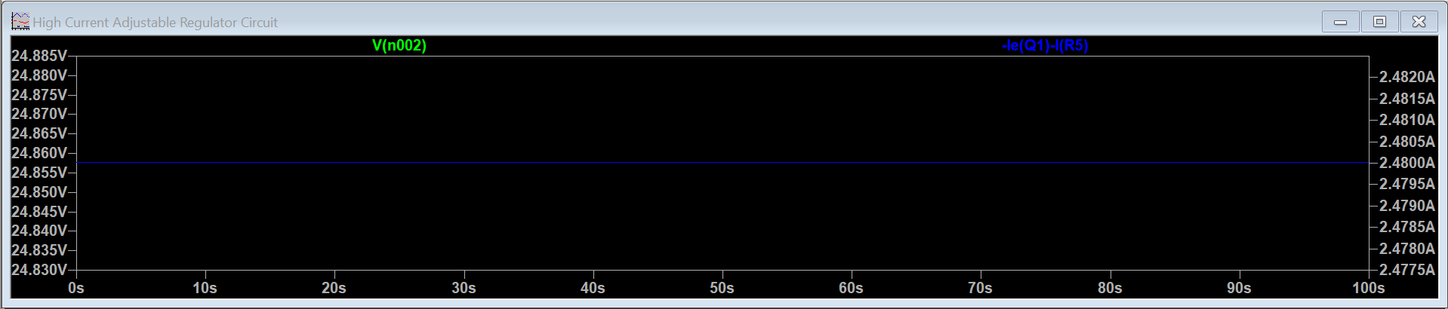
Figure 5.2.5: 2.48A Current Output, 24.8V Voltage Output

With the high current adjustable buck converter design working as intended with respect to output voltage, the next step was to decide on the desired output amperage to power the LED strips which in turn would dictate how much more the output current would need to be stepped up. Through some thorough research of LED strips on the market, multiple points of consideration were to be taken to decide on a final output current.

First, it was found that the average length of each strip is 5 meters or 16 feet and 4.85 inches. Most LED strips on the market are sold in a single “wheel” containing the aforementioned 5 meters which will be used as a metric during this discussion. Next it was found that the LED strips came in different densities per strip. What the density means with respect to the strip is how many LEDs are on each strip per meter. A low density strip on average has about 30 LEDs per meter and requires 12 watts to run a full wheel, while a medium density strip has on average of anywhere between 60-72 LEDs per meter which requires 24 watts per wheel and finally a high density strip has on average 120 LEDs per meter which requires 36 watts per wheel. This factor contributes to a higher wattage per strip as well which will affect how much power will need to be supplied to facilitate a proper working condition. Most LED strips will work slightly under voltage or amperage but will sacrifice performance in the process, if not inevitably failing. A higher density LED strip gives off a brighter, more cleaner light output whereas lower density light strips tend to have a more “dotted” lighting effect due to more space being between the LEDs while also being dimmer given the power source. It can be seen based on the research that the power draw and brightness from the lights are proportional so the next metric of consideration is how many meters of lighting the average dock will need to be properly illuminated.

Boat docks come in a plethora of sizes depending on the boat size, location, water depth, etc. The average dock for a smaller size boat could be something along the lines of 20’ x 6’ or roughly 120 square feet and the average dock for a larger boat could be 35’ x 8’ or roughly 280 square feet. Many factors of how the dock is built can be considered but really we are only worried about the perimeter of the dock as that would be the likely placement for most LEDs and thus our metric for consideration. In taking the average of the two presented cases based off our research, we can estimate the average dock being 200 square feet. The average LED wheel of medium density which contains 16’ 4.85” needs 24 watts to power and function properly at optimal brightness output. If our system outputs 12 volts at 10 amps for a total power output of 120, then we can fully power 5 wheels of LEDs or 82 feet and a quarter inch of LED strips around the perimeter of the dock space.

Based on the research, it is finalized that the buck converter will output 12 volts and 10 amps with no adjustable output for simplicity. Our finalized parameters were used as inputs on the Webench Power Designer and it kicked back a suitable design with no ideal components or issues to note at a reasonable cost and size. The circuit can be seen below in Figure 5.2.6. The simulations (Figures 5.2.6a – 6d) system information (Table “48 to 12 Volt Step Down Regulator System Information”), and PCB layout (Figure 5.2.6e) can be seen on the next few pages of figures.

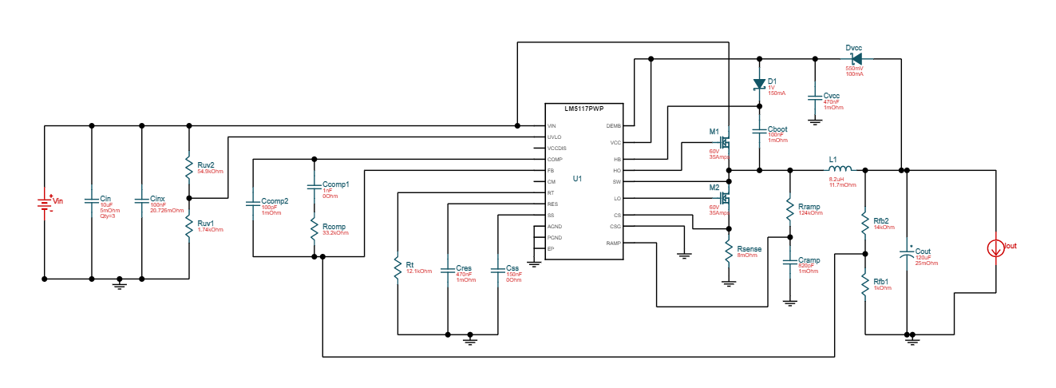
Figure 5.2.6: 48 to 12 Volt Step Down Regulator Circuit @ 10 Amps

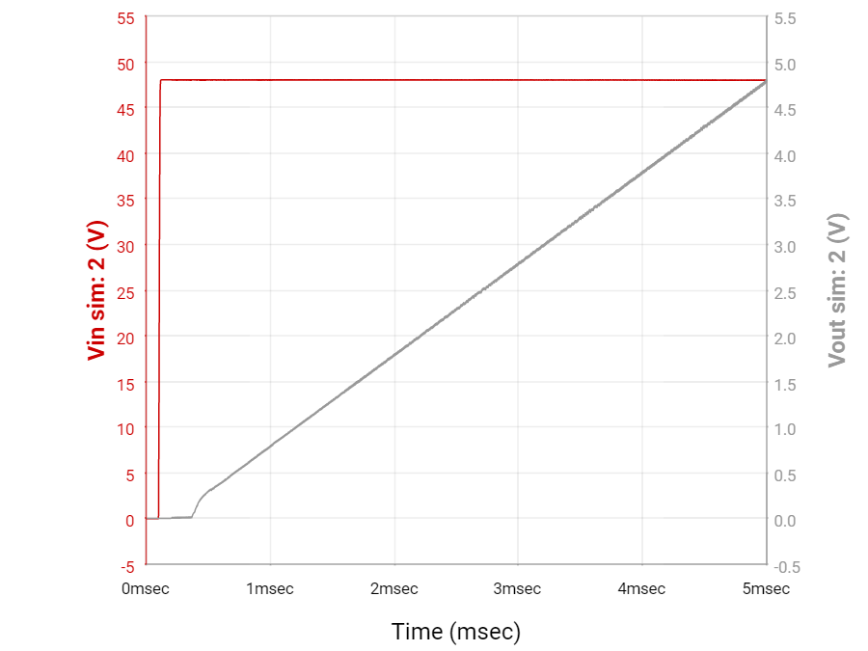
Figure 5.2.6a: Start Up Cycle

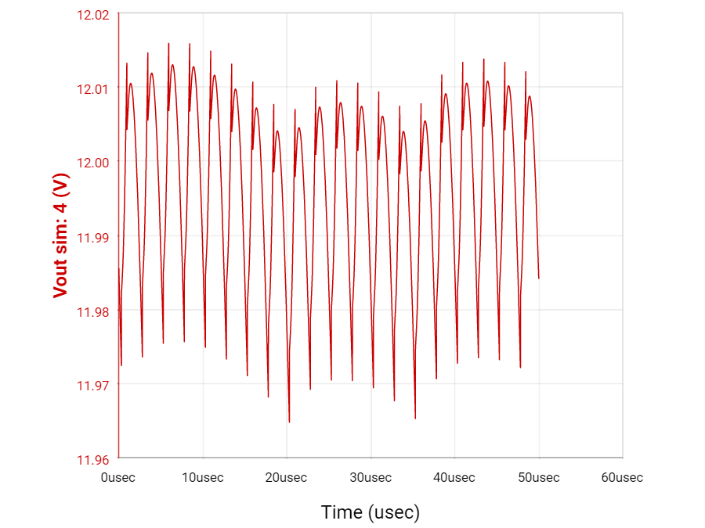
Figure 5.2.6b: Vout Steady State

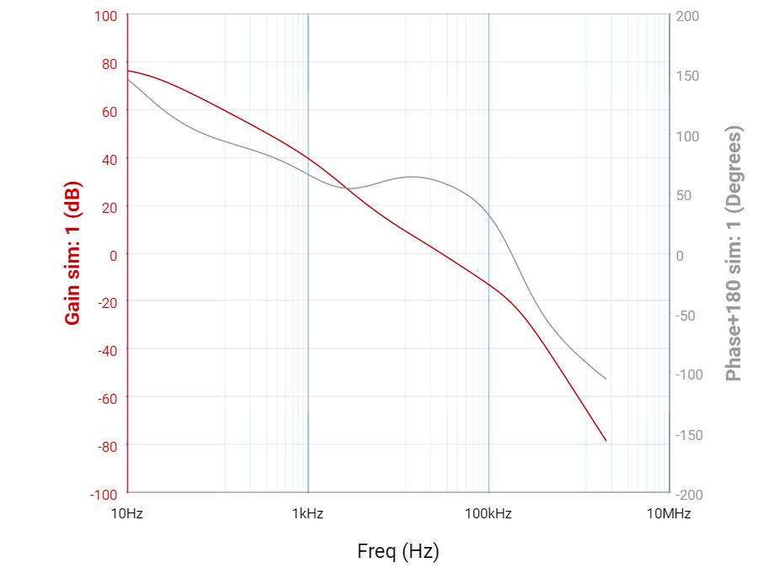
Figure 5.2.6c: Magnitude Spectrum

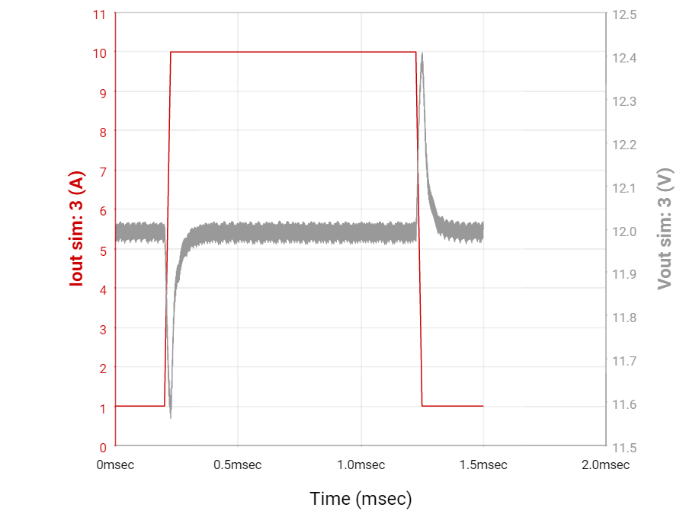
Figure 5.2.6d: Vout and Iout vs. Time

48 to 12 Volt Step Down Regulator System Information
Name | Value | Category | Description
Vout | 12 V | System Information | Operational Output Voltage
IC Tolerance | 12 mV | IC | IC Feedback Tolerance
Cin IRMS | 4.39 A | Capacitor | Input capacitor RMS ripple current
Cin Pd | 32.08 mW | Capacitor | Input capacitor power dissipation
Cout IRMS | 809.28 mA | Capacitor | Output capacitor RMS ripple current
Cout Pd | 16.37 mW | Capacitor | Output capacitor power dissipation
L Ipp | 2.8 A | Inductor | Peak-to-peak inductor ripple current
Ipp percentage | 28.03% | Inductor | Inductor ripple current percentage (with respect to average inductor current)
L Pd | 1.18 W | Inductor | Inductor power dissipation
Duty Cycle | 25.67% | System Information | Duty cycle
Efficiency | 95.70% | System Information | Steady state efficiency
Frequency | 398.53 kHz | System Information | Switching frequency
IC Tj | 51.82 °C | IC | IC junction temperature
ICThetaJA | 40 °C/W | IC | IC junction-to-ambient thermal resistance
IC Pd | 545.54 mW | IC | IC power dissipation
Pout | 120 W | System Information | Total output power
Iin Avg | 2.61 A | IC | Average input current
IC Ipk | 11.4 A | IC | Peak switch current in IC
Mode | CCM | System Information | Conduction Mode
Vout p-p | 70.09 mV | System Information | Peak-to-peak output ripple voltage
M1 PdSw | 754.11 mW | Mosfet | M1 MOSFET switching losses
M1 PdCond | 486.4 mW | Mosfet | M1 MOSFET conduction losses
M1 Pd | 1.24 W | Mosfet | M1 MOSFET total power dissipation
M2 PdSw | 140.52 mW | Mosfet | M2 MOSFET switching losses
M2 PdCond | 1.55 W | Mosfet | M2 MOSFET conduction losses
M2 Pd | 1.69 W | Mosfet | M2 MOSFET total power dissipation
M1 Tj | 98.23 °C | Mosfet | M1 MOSFET junction temperature
M2 Tj | 123.15 °C | Mosfet | M2 MOSFET junction temperature
FootPrint | 598 mm² | System Information | Total Foot Print Area of BOM components
Vout Actual | 12 V | System Information | Vout Actual calculated based on selected voltage divider resistors
Vout Tolerance | 3.41% | System Information | Vout Tolerance based on IC Tolerance (no load) and voltage divider resistors if applicable
Vin | 48 V | System Information | Vin operating point
Iout | 10:00 AM | System Information | Iout operating point
Cin Pd | 32.08 mW | Power | Input capacitor power dissipation
Cout Pd | 16.37 mW | Power | Output capacitor power dissipation
L Pd | 1.18 W | Power | Inductor power dissipation
IC Pd | 545.54 mW | Power | IC power dissipation
M1 PdSw | 754.11 mW | Power | M1 MOSFET switching losses
M1 PdCond | 486.4 mW | Power | M1 MOSFET conduction losses
M1 Pd | 1.24 W | Power | M1 MOSFET total power dissipation
M2 PdSw | 140.52 mW | Power | M2 MOSFET switching losses
M2 PdCond | 1.55 W | Power | M2 MOSFET conduction losses
M2 Pd | 1.69 W | Power | M2 MOSFET total power dissipation
Total BOM | $7.69 | System Information | Total BOM Cost
Total Pd | 5.43 W | Power | Total Power Dissipation
BOM Count | 26 | System Information | Total Design BOM count

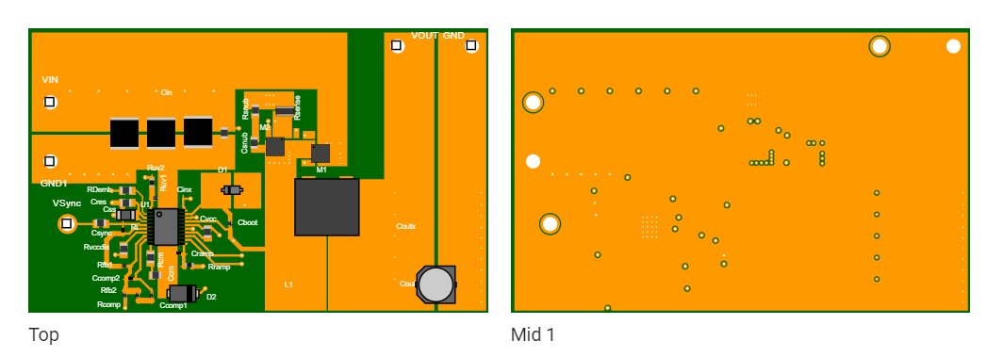
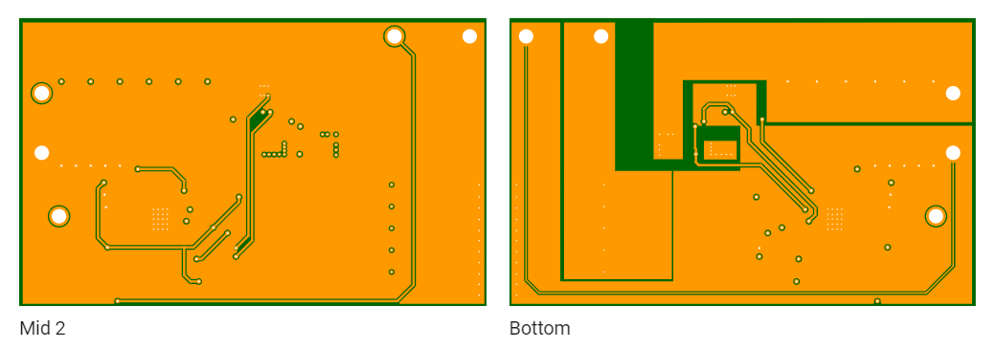

Figure 5.2.6e: PCB Components View

5.3. AC/DC Converter:

Power can be transported through conductors as direct current (DC) or alternating current (AC). AC is the most used in transporting huge bulk of power; this is due to less power losses AC impose on the wires (unlike DC). Also, AC has lower distribution cost, provides easier ways to change the voltage which is by the help of transformers, and it is a safer and more efficient source for supplying to homes. AC/DC converter has many components that are essential for it to function properly, which are input filter, transformer, rectifier, power stage, regulator, power factor correction component.

Input filer is an essential component of the AC/DC component as every other component is dependent on it. One of the functions of the filter is to prevent any electromagnetic noise resulting from the power supply switching source to go to the main power line and damage connected equipment. Another function of the input filter is to filter the frequency and prevent undesired frequency from the AC side to flow to the end of the converter which will cause damage. Moreover, input filters usually have resistors or varistors that will limit the voltage to prevent any risks of overvoltage that might occur in the power supply. A rectifier is the most important component of the AC/DC converter; it is where the conversion of AC to DC occurs.

Rectifiers are made with diodes where current is only allowed to flow in one direction which enables the AC current to be rectified. Rectifiers can be full-wave rectifiers or half-wave rectifiers. In fact, some rectifiers use more complicated semiconductor components other than diodes such as thyristors. Silicon controlled rectifiers (SCR) and triodes are used in more sophisticated rectifying schemes; they act as relays where small voltages are used to control higher magnitude of voltages and currents. Other active semiconductor components such as MOSFETS are also used in rectifying topologies. Active components are used where higher efficiency is required; they are more efficient than diodes because diodes have higher voltage drops across them which means higher power losses.

Transformers in AC/DC converters step down the AC voltage. Significant role of the transformer in a converter is the galvanic isolation that it provides; the transformer connects the mains power with the subsequent circuits through electromagnetic induction rather than physical connection which provides a safer mechanism that prevents any extra energy loss through additional wires or any sparks or electric shocks. Electromagnetic induction property of the transformer is important in that it restricts the energy that would cause damage to be stored in the transformer's magnetic flux. The property of storing energy in the transformer proves very critical when designing an AC/DC converter as it indicates how efficient a transformer can be when maintaining the required voltage potential regardless of any change in the load. Similar to the transformer, output circuitry in AC/DC converters that are composed of reactive elements are used after the rectification stage as energy storage elements. These storage elements are vital as they act as a source that keeps the output voltage at a fixed value regarding any change in the load. By using active elements and feedback loops to know the voltage and the current to the load, we can control the amount of energy to be transferred to these storage reactive elements and thus keeping the output voltage constant. This process of injecting energy to the reactive elements to maintain the output voltage is called regulation. Regulation is a very important aspect in AC/DC converters in order to keep the load voltage constant. Output voltage has to be constant or a few percentages below or above the nominal voltage value. If not, there will be overvoltage and undervoltage that can cause fuses and damage the circuitry of the converter. This is particularly harmful to microelectronic devices. As mentioned before, reactive elements store energy, and regulation is set by controlling the energy transferred to these reactive elements which will keep the load voltage constant. However, power in these reactive elements will deplete over time which will change the load voltage, and thus a feedback control system using active elements is implemented to recharge these elements. A regulator consists of switching elements which will be on the primary side of the transformer of the converter. A well designed switch will have the characteristics of having a very low impedance when it is ON and a very high impedance when it is OFF.
Power stage controls the power delivered to the load. It firstly controls the power that transfers from the primary side to the secondary side of the transformer. The power stage controls power delivered by means of frequency. It has a switch that is controlled by a pulse width modulation. Depending on the amount of power needs to be delivered to the load, the switch functions accordingly.

Power factor correction is very critical when it comes to designing an AC/DC converter. In order to improve the efficiency of the converter, different power factor correction techniques are implemented. Power factor correction aims to reduce the reactive power of the system that might transfer to the mains power and also to increase the real power and thus increasing efficiency. Switch-based power supplies including AC/DC converters have a high chance of producing a non-sinusoidal waveform which causes a phase angle difference between the voltage and the current. This leads to power factor to become less than unity and causes power losses. These power losses will then cause harmonic pollution that might be transferred to the mains neutral line and damage other devices as well. So, an efficient design aims to have a higher power factor to avoid any harmonic pollution. To prevent such harmful harmonics, institutions began to set harmonic requirements of regulations. Power factor corrections can be passive or active. Switches can be controlled by using MOSFETs; however, MOSFETs are not efficient as they have impedance and will cause losses. Switches are either controlled using pulse with modulation (PMW) through changing the duty cycle where the switch turns on and off. The other method to control a switch is by adjusting the frequency for when the switch turns on and off. Converters can employ non-resonant regulation topology or resonant typology. Non-resonant topology uses a more complicated switching method.

On the other hand, resonant topology uses a more convenient technique where switching occurs when the alternating current sinusoidal waveform is at precisely at point zero which proves to be more efficient and produces less power losses. In addition, synchronous rectification using active semiconductors such as MOSFETs proves to be much more efficient than rectification using diodes. MOSFETs produce very hard ON (very low impedance) and small voltage drop when switching is in sync with AC current provided to the system. Moreover, there are two main techniques by which the regulator knows when to turn the switches on or off.

These two techniques are either voltage control or current control. Voltage control technique is when the load voltage is measured and then compared with the nominal voltage through a feedback loop, then the output voltage is adjusted to be within an acceptable range of the nominal voltage. Current control, on the other hand, adds a second inner loop measuring the inductor current. When both output voltage and inductor current are measured, the load parameters are adjusted accordingly. Regulation, furthermore, can implement either continuous mode or discontinuous mode. In continuous mode, the inductor is continuously conducting and its current never goes to zero. This causes less ripple and less noise. However, because the inductor current is never zero, energy is lost. In discontinuous mode, the inductor current becomes zero at times. Consequently, the load gets its energy from storage capacitors. Discontinuous mode is more efficient; however, it has disadvantages of causing more ripples than the continuous mode.

Types of converters vary depending on the topology they are based on. Typologies vary from flyback and buck-flyback designs. These topologies are cheap and have low cost components as well as relatively few components . Flyback converters are based on step up/step down (buck-boost) converters. Inductors in the flyback converters are replaced with transformers so that galvanic isolation of the input and the output is presented. Essentially, flyback converters have the same properties of the buck-boost plus input and output isolation. For the flyback converter, the primary winding of the transformer has a transistor (MOSFET) and the secondary winding has a diode. The total current of the flyback model is the same as the total current of the buck-boost module with an inductor except that the current in the flyback module with the transformer is distributed in a different way between the windings. Both the magnetic fields of a basic buck-boost converter with one winding of an inductor and the flyback converter with two windings are the same. The two-winding transformer of the flyback transformer is called a “flyback transformer”.

This transformer does not share the same characteristics of an ideal transformer in the way that the flyback transformer does not allow current to flow at the same time in both its windings. The polarity of the windings of the transformer are opposite to each other presenting a 1:n turns ratio in addition to producing a positive voltage. This scheme proves to better optimize the functionality of the converter as well as its efficiency. To better understand the flyback topology. The non-ideal flyback transformer can be replaced with an ideal transformer that is paralleled with its magnetizing inductance Lm. This magnetizing inductance is assumed to behave according to the physics of the inductor. When the circuit is in steady state operation, the volt-second balance must be satisfied. In other words, the windings average voltages are zeros. The magnetizing inductance Lm added in parallel with the ideal transformer is the same as the inductance L of the original one-winding buck-boost converter. When the transistor on the primary winding operates, the input energy is stored in the magnetizing inductance Lm. The diode on the secondary winding on the other hand takes the stored energy in the magnetizing inductance and transfers it to the load.

Flyback converters are usually used in applications that have a power range approximately between 50-100 W. They are also used in applications with high-voltage power supplies. Flyback converters have many advantages: firstly, they have a relatively low component count. If additional output is needed, then only one capacitor, one diode, and one winding are needed to be added. The second advantage is that the peak transistor voltage value is equal to the combination of the dc voltage that is acquired after rectification and the reflected voltage of the transformer V/n. If there is any additional voltage to be seen, then it is usually due to the leakage inductance of the transformer. These leakage inductance causes voltage spikes. One way to eliminate such spikes is by designing a snubber circuit. A snubber circuit usually consists of a resistor and a capacitor connected in series and are parallel with the switch. Flyback converters have also disadvantages such as high losses as well as higher input and output capacitance. In addition, because of the gap between the windings of the transformers, flyback converters have more electromagnetic interference. They also produce ripple current.

AC/DC Converter Circuit Design:

We will need two power stages:
Power Factor Correction (PFC). This boosts the rectified AC line voltage up to about 400Vdc. 400V is used in order to be higher than the peak voltage for universal AC (in order to use a boost regulator, Vout must be higher than Vin).
In this design, we only need to support 120Vac, you can use a PFC boost voltage of something like 200Vdc.

The PFC goes like this:

AC Input → bridge rectifier → PFC boost power stage → DC boosted voltage (200V or 400V)

Because of the power scale in this design, a 2-phase interleaved (180° out of phase) PFC boost would be best. Similar to the dc/dc design, this keeps currents low enough that standard components can be used. After the PFC boost, we have a semi-regulated DC voltage to work from. Important to recognize that the PFC stage is NOT ISOLATED. So the second power stage is a dc/dc, with isolation. For this we can use resources such as On Semi and TI and see what they recommend. It maybe be a LLC (resonant) converter or another popular choice which is a phase-shifted full-bridge. Probably two phases as well. Unfortunately,we are probably going to need custom magnetics (transformers and maybe even the PFC boost inductors) to do this because of the power levels.TI makes a 2-phase PFC boost. For the second stage, isolated 200V (or 400V) to 48V, we can see what TI and On Semi have for this.
Another option that will work – the brute force method – but it will not meet power factor requirements.A 1kW step-down power transformer, with lower voltage AC output. Since we are trying to get to 48V, the transformer would need about a 36V AC output. Using some big rectifiers on that, and some bigger filter capacitors, the output will be 48V(ish) Vdc. The transformer gives you safety isolation.Not regulated, so 48Vdc will follow the AC line. Note – without PFC, there will be large current spikes on the AC input (as the bridge rectifier re-charges the output capacitors). That means that input wiring and fusing will need to be bumped up.
In the US, far as I know, there is no requirement for PFC, except if we are to go for Energy Star compliance. PFC is required for most other countries. In Europe the spec is EN61000-3-2, which requires PFC for anything consuming more than 75W. So legally we don’t need this in the US.

Using Texas Instruments’ WEBENCH, we have run some designs for AC/DC converters, and below are two designs that are efficient and function efficient. Design 1 schematic shown in figure below and design 2 schematic is shown in figure below. In addition, the properties of the two designs are compared in the table below.

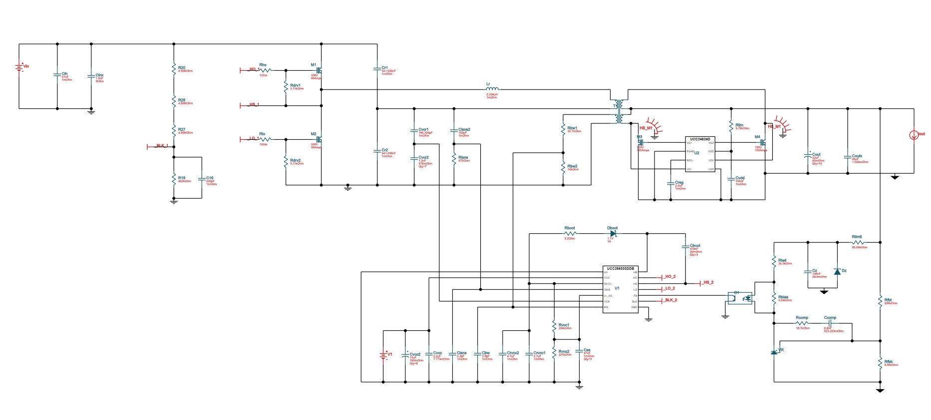
Figure. AC/DC converter design 1 schematic.

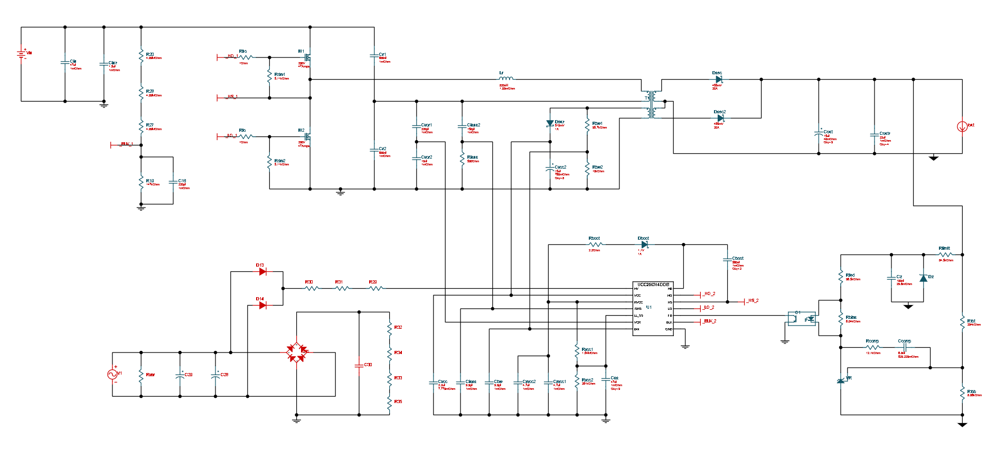
Figure. AC/DC converter design 2 schematic.

 | Design 1 | Design 2
Vout | 48 V | 48 V | System Information | Operational output voltage
Iin Avg | 9.02 A | 9.02 A | IC | Average input current
Vout p-p | 809.81 mV | 1.28 V | System Information | Peak-to-peak output ripple voltage
Frequency | 56.13 kHz | 57.68 kHz | System Information | Switching frequency
Frequency_ | 56.13 kHz | 57.68 kHz | System Information | Switching frequency
Resonant Frequency | 100.15 kHz | 150.71 kHz | System Information | Resonant frequency
Ln | 5 | 13.5 | System Information | Inductor ratio (Lm/Lr)
Qf | 227.62 m | 120.12 m | System Information | Quality factor
Pri Wind Magnetising IRMS | 19.12 A | 19.65 A | Transformer | Primary winding magnetizing RMS current
Pri Wind Load IRMS | 12.19 A | 12.19 A | Transformer | Primary load RMS current
Input Power | 991.8 W | 1 kW | System Information | Total Input power
ICThetaJA |  | 74.7 °C/W
U1 RThetaJA | 74.7 °C/W |  | System Information | U1 IC junction-to-ambient thermal resistance
U2 RThetaJA | 108.4 °C/W |  | System Information | U2 IC junction-to-ambient thermal resistance
Pout | 960 W | 960 W | System Information | Total output power
Cout IRMS | 6.79 A | 7.55 A | Capacitor | Output capacitor RMS ripple current
Coutx IRMS | 2.88 A | 2.12 A | Capacitor | Output capacitor RMS ripple current
Vout Actual | 46.47 V | 46.47 V | System Information | Calculated based on selected voltage divider resistors
Vout Tolerance | 1.97% | 1.97% | System Information | Based on IC tolerance (no load) and voltage divider resistors if applicable
Vin | 110 V | 110 V | System Information | Vin operating point
Iout | 20 A | 20 A | System Information | Iout operating point
BOM Count | 83 | 72 | System Information | Total design BOM count
Table 4. Properties of design 1 and design 2 compared

The characteristics of the two designs are compared in the graphs below. Output voltage vs output current, voltage gain vs frequency, and frequency vs output current are compared below.
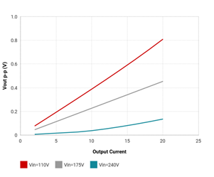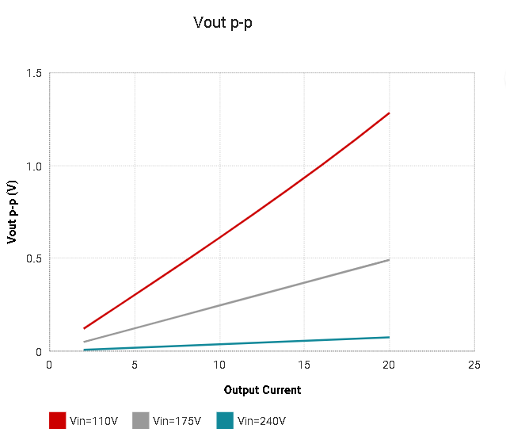

Figure. Vout p-p of design 1. Figure. Vout p-p of design 2.

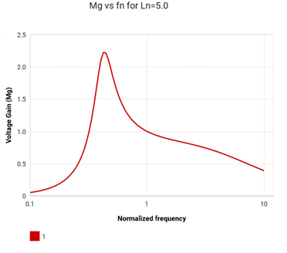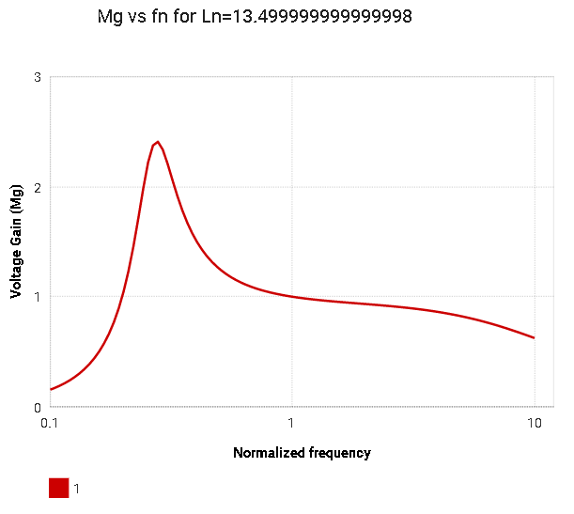
Figure.Gain vs freq for Ln = 5 of design 1. Figure.Gain vs freq for Ln = 13.5 of design 2

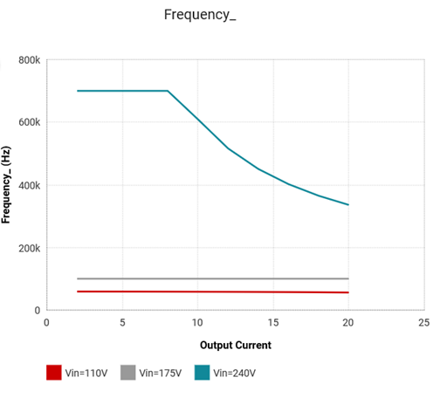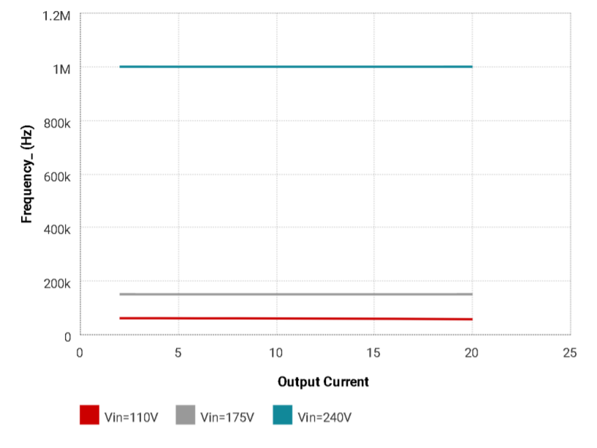
Figure.Freq vs output current of design 1. Figure.Freq vs output current of design 2.

5.2 Piccolo C2000 F28044
We will be using the Texas Instruments C2000 F28044 device (also referred to as the piccolo) as our main control unit in this device. We chose this model rather than other models from TI because it was designed specifically to make developing motor control systems easier. They added many new features to make this possible such as increasing analog integration of the device, boosting the CLA co-processor support, and also introducing more tools and software, which will help make developing our device easier and faster.
The Piccolo has a CPU plus CLA processing core, these will be the only processors we will use in our device as the Murata 1DX module has no on board processor and will only act as a radio. The piccolo also has control peripherals, such as PWMs and eCAPs. It also features onboard analog integration, communications and a security module for device protection.
The main core in the F28044 has a max frequency of 100 MHz which will be crucial as that speed is needed for handling all the processes associated with the advanced features that we will be adding to the device such as RGB lighting, transmitting the weather sensor data to the user’s phone through the 1DX module. the F28044 has 128 KBs of flash memory that we can will use to store some data that we will either send to the app through the 1DX bluetooth/Wifi module or store data that we will use for other computations such as the position of the boat and the direction the boat lift is moving the boat.
One of the best features however is the fat that to make developing motor control-based systems easier on developers TI added a C-programmable CLA motor library which will allow us to more simply configure the device exactly how we want and even allow us to run all sorts of tests to test the different functions of the device.
In order to use the actual Piccolo unit in our device we will need to first use a development kit that can handle controlling a high voltage motor. We will be using the DRV8312-C2 Kit with a TMS320C280044 control card. We will use TI’s development suite called Control Suite to test the kit and run sample projects to help us determine the best approach to programming the Piccolo for use in our device. We will also use this kit to test many parts of our design.

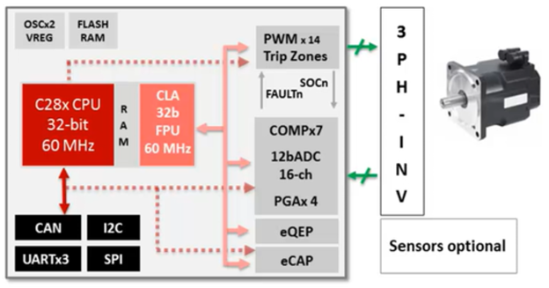
Figure #: Untitled 6
Having two cores in the Piccolo gives us the ability to dedicate one core to control the motor’s speed and direction while we will program the other one to communicate with the rest of the peripherals and manage the rest of the device’s features. The CLA core will be the one controlling the motor while the C28x core will be used to control the RGB lights, send and receive data to and from the 1DX Bluetooth/Wifi module and also decode and stream the audio played from the phone.
Focusing on the communication part of the Piccolo’s function in the device, it features UART, I2C, SPI, and CAN2.0. we will be using UART to communicate with the app through the 1DX. We will be using TI Control Suite to develop the software for the Piccolo and NXP i.MX to configure the 1DX to receive the data from the Piccolo and transmit it.
6.0 Realistic Design Constraints
When designing the device we had many constraints. One of the main constraints was the components we need to use. Since we are designing the device for RV-intelligence, we had to pick parts from their suppliers. We were lucky to find parts from those suppliers that fit our design perfectly.
Another restriction was the software we were using to design the circuits for the device. We decided to use KiCAD even though we did not have much experience with it because our sponsor preferred KiCAD. This is opposed to the program we had experience with, Eagle. This became a good learning experience because we learned how to use a new PCB design program.
A restriction we had when designing the application was keeping the main function of the device visible on every page. This main function is raising and lowering the boat. The application design had to include this operation in every page. The mobile application also had to have a very simplistic, intuitive, and easy to use design. We were able to accomplish this simple design by using the Ionic 4 framework. Their base designs are very simple and intuitive.
Since the Super Boat Lift Boss is based off of the original boat lift motor, the Boat Lift Boss, we need to keep the components within a certain size range. To be compatible with the boat lifts, we must follow their guidelines. This should not be a problem because we are not making the motor.
Since this motor is intended to allow both AC and DC power input, we must design circuits to convert the power. The AC/DC circuit is not an easy task to accomplish. When the circuit was originally designed on Webench, there were ideal components within the system. This provided the team with a new realistic design constraint because we had to make sure all of these components would work in a realistic environment. The ideal components must be taken out of all of our circuit designs and replaced with realistic solutions.
6.1 Economic and Time constraints
Since this project was sponsored by RV-intelligence we did have economic constraints. We were constrained by the cost of the end product though as this product is meant to be mass produced, so we had to make certain decisions to cut the cost of production. For example we chose to use a radio only module for communication instead of a module with a chipset which cut the cost by 2%.
The budget goal for the application is very low because the funding should be spent on the hardware side. As many as possible free APIs and coding platforms need to be used. The weather API could have been $15.00, but we decided to go with a free subscription with limited features.
Time constraints are prevalent in any project, but this one definitely had the most time constraints. With four members and a sponsor, it was difficult to find time that everyone is free. We were able to conquer this problem by using Whatsapp to communicate.
The biggest time constraint for the entire project was time because we were unable to meet in person to work on the project. This huge constraint was due to being forced to stay home to avoid COVID-19. In March 2020, as the project was beginning to take off, everyone was affected by this big change. Some of the members had to return home to a different city and others had to work extra shifts. This time constraint was very unexpected and caused a very large delay on progress.
Since our meeting time was no longer available, the group resorted to video chatting on Google Hangouts, Webex, and Zoom. While we were able to use online communication devices, it did not compare to the face to face meetings we wanted to have. Designing the PCBs proved to be difficult remotely. Instead of taking a few hours, meetings were prolonged due to internet speed and technical difficulties. Overall the inability to meet impacted our group heavily.
6.2 Environmental, Social, and Political constraints
To determine the environmental constraints of this project, we had to think of where the boat lifts are generally located. Whether it be freshwater or saltwater, boats are lifted out of the water. The Super Boat Lift Boss needs to be durable enough to survive in all different types of weather conditions. Rain, snow, wind, and fog are all examples of potential problems for this boat lift. To solve these potential problems, we will be sealing the motor with waterproof sealant of the type IP67. This will provide protection from water up to 1 meter in depth and particles of dust like salt.
In addition to different types of weather, being outside means that this device will be in contact with wildlife. It is important that we do not allow any electricity to escape the outside covering of the motor. Working with AC power can be dangerous, and it is important to create a safe environment. If a seagull or other sea bird lands on the motor, we do not want it to affect the bird in any way.
Political constraints involve the entire planet. In March of 2020, the Corona Virus started spreading rapidly in the United States which forced many businesses to temporarily close down. It also forced the schools to close and for us to stay home to avoid contracting the virus. This meant that the PCB manufacturer was not operating so we couldn’t get our design manufactured. The lab we were supposed to use for testing was closed as well so we couldn’t do any tests to validate each part of our design.
6.3 Ethical, Health, and Safety constraints
The Boat Lift Boss has an electric motor that is capable of lifting very heavy objects. We had to make sure to include a few safety features in our device to prevent the motor from overheating, to keep from failing and dropping the object it’s lifting, to protect the device from the elements, and to avoid any shorts or surges happening in the circuits.
It is important that the motor does not overheat and burn out the system or cause a fire. Since we are working with AC power, the circuits can become very dangerous. We must use the experience of our sponsor to create a safe design for our power circuits. The device will most likely be placed on wooden docks which could possibly catch fire. A small surge in power could create a spark and cause many more problems. It is important that we follow proper safety precautions when it comes to heat within the circuit. Not only is the heat dangerous, and short or surges in power could damage the system and harm the users.

Since the boat lift is raising boats weighing up to 6,200 pounds, it is very important that the motor is capable of this. If there is an error and the boat drops to the water, this could cause damage to the user’s boat or even injure the user. When accidents occur, any kind of injury could be a result. We must make sure accidents are not very likely to occur by implementing as many safety precautions as possible. We will provide many tests on this motor before lifting actual boats. In addition to dropping the boat, we want to make sure the boat can not be lifted too far up. If the boat is already raised, the application will not allow the user to raise it more. If the boat is lowered as much as possible, the user cannot use the application to lower the boat. These safety features will protect the motor from being overworked and causing other problems.
There will be an outer covering on the motor to keep it safe from the outside weather elements. Not only can water damage the internal components, if the outer sealant develops rust it could cause safety problems. Users may touch the motor in some way and cut themselves on the rust. This injury could get infected and cause more problems for the user. We do not want the users to develop any injuries from using this product.
For the software, we had to make sure that the app was secure and couldn’t be exploited to get the user’s information. We also had to implement a few security measures to make sure only the intended user is able to use the super boat lift boss such as the user getting a notification on their phone every time the super boat lift boss is used.
These extra security measures will help the users information be protected. If an attacker accesses the boat lift, the user will be automatically notified. This way they can notify the company that their system has been compromised. An eavesdrop attack may not seem dangerous, but even if an attacker eavesdrops on the signals they can gather valuable information. Utilizing the data, they can determine the users routine and possibly steal their boat. It is our ethical responsibility to provide the necessary safety measures for this application. While the sponsor does not want to have a sign in page, it may be a necessary entity to add for security. This will be determined later on in the application development process.
6.4 Manufacturability and Sustainability constraints
A manufacturing constraint we had was we had to use a PCB manufacturer that our sponsor provided. This worked to our advantage though as we could get PCBs in a short amount of time that we can use for all types of tests. Testing how much the device could handle when it comes to wear over time wasn’t possible for us to do in the limited time we had to design and test the device.
Since this device will eventually be sold to customers, it is important that it can be manufactured efficiently. The system should be easily repeatable to create working duplicates to sell. We had to keep this in mind when designing the prototype. This also caused us to keep the costs at a minimum to provide the most affordable product possible.
It is also important that the device does not waste a great deal of energy because it will be operating for several years. The motor is meant to last for a long time and it should not burn out quickly due to inefficiency. Due to this, we were trying to choose efficient components for our system. We also provide a connection to LEDs because they have a very low power consumption.

7.1 BLDC Motors:
Brushed DC motors use brushes to supply electric energy to the rotating commutator. When the commutator rotates, the direction of the current in the rotor changes which changes the polarity which keeps the rotor rotating in one direction. However, brushless DC motors do not use brushes to supply electric energy to the rotor. Instead, the rotor itself is a permanent magnet that rotates, and the coils are located on the stator. Since the coils are located on the stator in a fixed position, brushes and a commutator are not needed.
BLDC motors has many advantages over brushed DC motor as they are:
- More efficient; for the same input, BLDC motors will convert more electrical energy to mechanical producing larger output than brushed DC motors. One reason for that is that brushes produce friction and thus limit the output produced.
- More controllable; BLDC motors use different feedback mechanisms to detect the position of the rotor and the change in the polarity. The time from which the polarity is changed from north pole to south pole can determine the speed of the rotor. The speed of the rotor is fed to the motor driver which can then adjust the speed and appropriately control the motor.
- More durability; the brushes and the commutator in the brushed DC motors tend to lose efficiency and wear down which is due to the contact it makes with the moving stators. Thus, the absence of the brushes and the commutator in BLDC motors gives them superior durability and longer life.
- Less noise; in brushed DC motors, electric noise happens due to sparks made by the contact between the brushes and the moving commutator. These sparks create undesired electric noise. Again, lack of brushes and commutators in BLDC motors results in no such noises being made.
- Smaller and less heavy.
- Better torque/speed tradeoffs and characteristics; BLDC motors have the ability to control or maintain torque at different speed
- More reliable
- Fast dynamic response

Moreover, some disadvantages that BLDC motors have are:
- They cost higher to build as compared to brushed DC motors.
- BLDC motors control schemes can be very complex and expensive.

Brushless DC motors are used widely in almost every field; it is used in the manufacture of medical equipment, appliances, aerospace equipment, and almost every industry. Brushless DC motors use power switches instead of brushes instead

There are two ways to control BLDC motors; the first is by using sensors, and the other way is by measuring back EMF. Sensors cost more, increase complexity of the design due to extra wires being added, and reduce reliability which can happen because parts of the sensors are susceptible to contamination due to weather or dirt.

For a three phase BLDC motor, rotating the rotor 360 degrees clockwise while applying positive current at each phase, the torque with respect to the angle diagram is given in figure. The torque for each phase is at its maximum when the rotor is halfway between the north and the south pole of the phase. As seen in figure the torque of phase A, B, and C are all the same except that there is 120-degree angle between them because these phases are physically separated from each other by an angle of 120 degrees.

In order to keep the rotor rotating in the clockwise direction, the torque should be positive. To control such motor using the currents, apply the following rules:
- Positive current that produces positive torque is left as it is
- Positive current that produces negative torque is reversed so it produces positive torque
- When torque transitions from low to high or from high to low, current is turned off

Applying these rules will give the current and torque waveforms shown in figure. Applying the previous rules gives a synchronized positive torque rotating in clockwise direction. From figure, for the torque waveform, for each commutation interval, two phases are contributing to positive torque and one phase is contributing zero torque which result in a constant torque which is the combination of the flat torques of the two phases. In addition, for each commutation interval, one phase has positive current, another phase has negative current and the other phase has zero current.

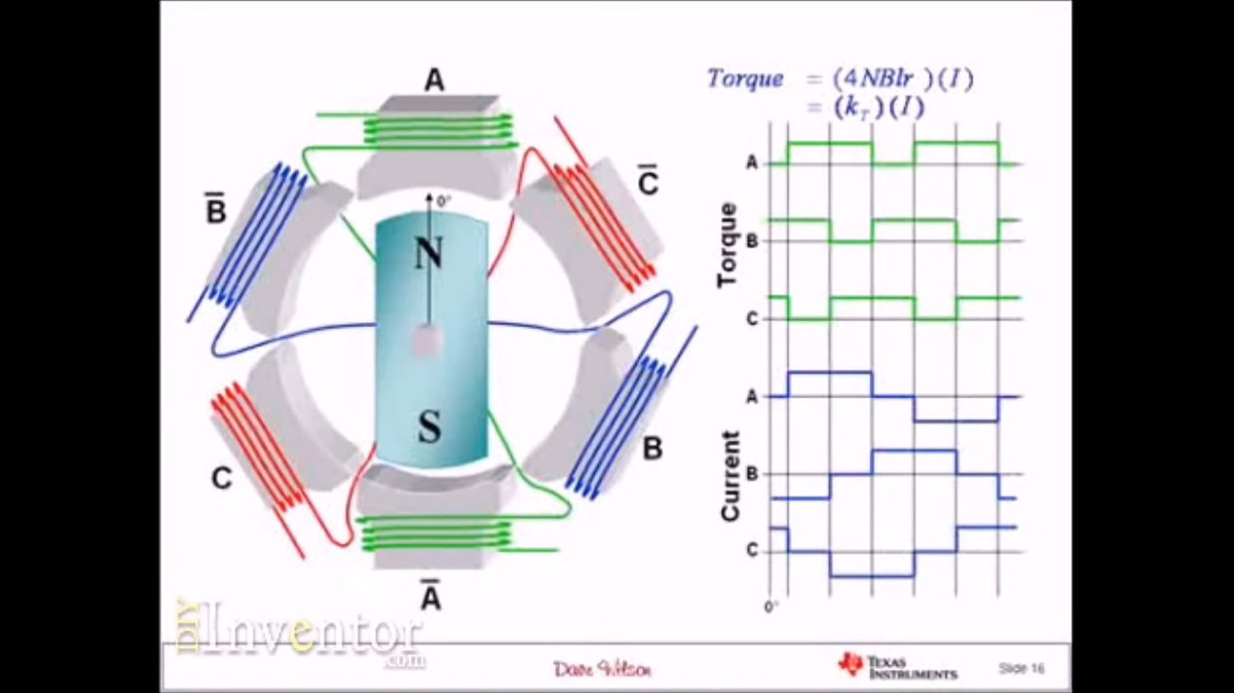
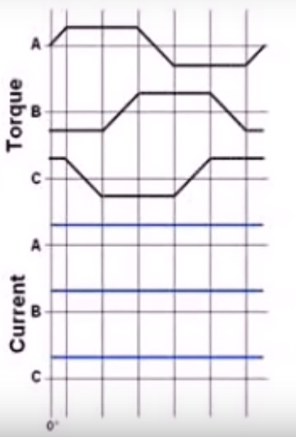
Figure. Current vs torque Figure.

To control the motor, the position of the rotor must be known. One way to know the position of the rotor is using Hall sensors, another way is by measuring back EMF. During a commutation interval shown in figure, BEMF is measured on the coil that is unenergized.

In Terms of Flux:

For a three-coil motor, with phases U, V, and W, the coils of the phases are interconnected. So, applying current at phase U which flows to phase W creates magnetic fluxes in both phases U and W. These two fluxes will create a resultant flux as shown in figure. The rotor will be forced to rotate in the direction of the resultant flux until the rotor is aligned with the arrow of the resultant flux where the north pole is on the tip of the arrow. By switching the flux continuously, the rotor will continuously chase the resultant magnetic flux and thus will keep rotating.

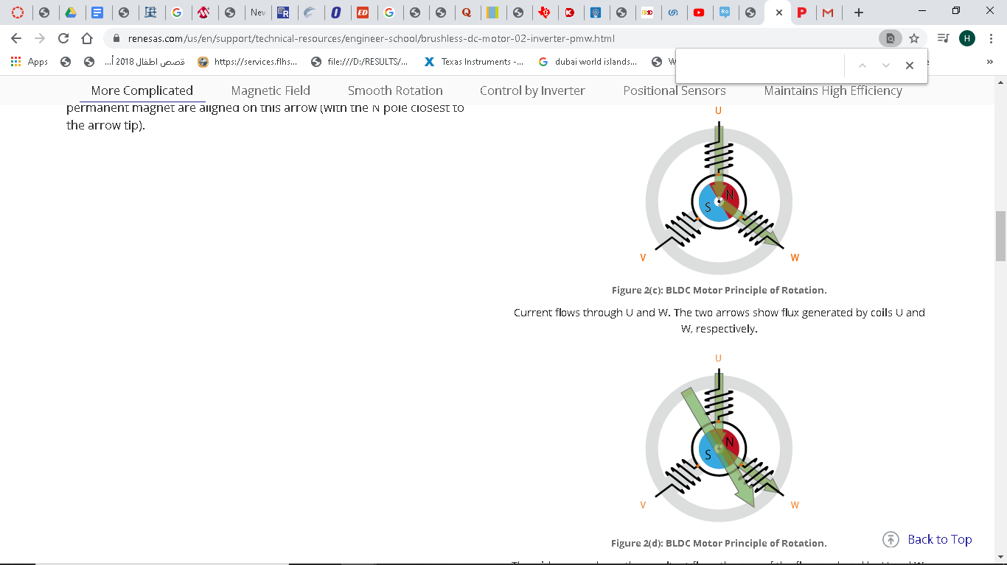
Figure. Magnetic field direction Figure. Rotating magnetic field

In addition, by varying the fluxes through the phases by carefully manipulating the current will cause the rotor to rotate smoothly and will prevent any resulting mechanical noise and vibrations. This process of differing the fluxes through the phases to achieve a smoother rotation.
Because in BLDC motors, current is reversible and one way to reverse current is to use brushes and a commutator, but because BLDC motors do not have brushes, current reversing and controlling is achieved through a special inverter circuitry which is dependent on PMW in its design. By increasing the duty cycle of PMW, voltage increases, and reducing the duty cycle reduces the voltage.

Methods to Control the Motor:

BLDC motors can be either sensor-based or sensorless. In a sensor-based control scheme, Hall-effect sensors are used to detect the position of the rotor, giving feedback to MCU and a driver, which then switch appropriate transistors, mainly metal oxide semiconductor field-effect transistors (MOSFET) or insulated-gate bipolar transistors (IGBT), to produce the appropriate sequence of current in the coils.

Unlike the sensor-based BLDC, sensorless BLDC use BEMF from the three coils in a 6-to create a trapezoidal voltage waveform for each phase. The outputs for the Hall-effect sensors and BEMF outputs are shown in figure below The zero-crossing point of each phase occurs when the coil at that phase is unenergized. The combination of the zero-crossing points of each phase will help determine the correct sequence for energizing the coils; The MCU produces a pulse width modulated signal (PMW) to trigger appropriate transistors in the motor driver which then control the sequence of the currents through the coils.
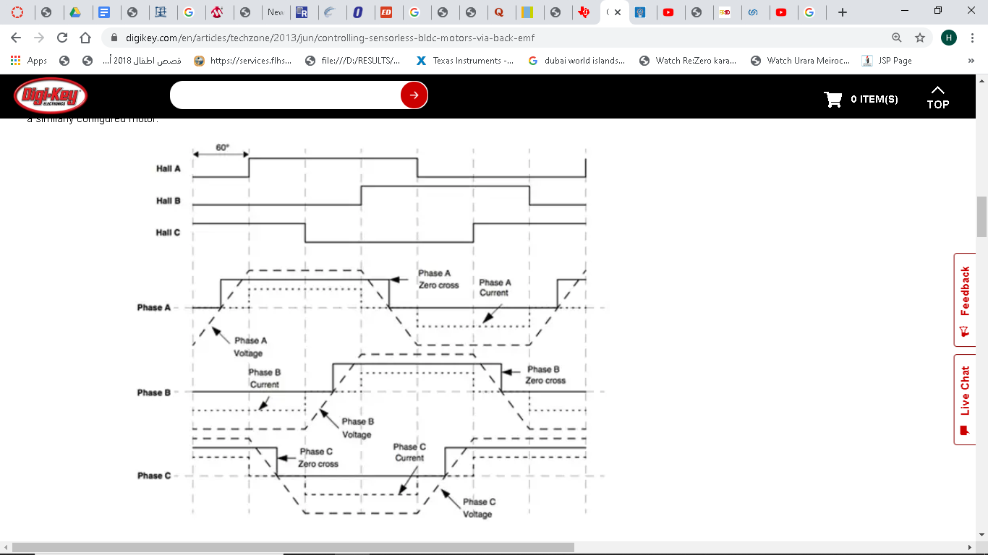
Figure. Current sequence as a PMW signal.

One way to measure the BEMF is to use comparators to compare the BEMF to half the DC bus voltage. In this scheme, a comparator is connected to each coil. One disadvantage of this method is that inaccuracy can occur if the windings have different characteristics. If so, the waveforms produced may be shifted to the left or right away from the zero-crossing point. The motor will still function; however, a lot of current might be drawn. This problem is fixed by connecting three resistors parallel with the motor windings creating a neutral point in the middle. The BEMF is then compared with this neutral point.

Another way to measure BEMF is by using analog-to-digital converters (ADC). Through this method, BEMF is fed to the MCU where the signal is sampled by the ADC. The BEMF signal is translated by the ADC then compared to the digital translation of the zero-crossing point. If they match, then the next coil energizing scheme is initiated.
One major drawback of BEMF motor control scheme is that BEMF is proportional to the speed of the motor, so if the motor is not moving then there will be no BEMF generated and thus the position of the rotor will be not known. Starting the motor in an open loop configuration will solve such a problem, the coils will be pre-energized. At the beginning, the motor will start operating slowly until it creates sufficient BEMF which will be adequate for the control scheme. Since BEMF is dependent on the speed of the motor, sensorless BLDC are not useful for any application that has a slow-moving motor.

Sensors in general cannot be used in an environment where they are susceptible to immerse in liquid. In addition, sensor-based BLDC motors are more expensive, more complex in design with more wires and connections, and are also a cause of irregularity and thus less reliable. Therefore, in this design, we will use BEMF motor control schemes.

7.2 User-Device interface and Communication:

One of the main goals of this project is to give the user multiple options on how to communicate with and operate and operate the device. The user can operate it using a switch on the device itself or using a bluetooth remote or through an app which will be available to them on android, IOS and as a web app to use on their computers.

7.2.1 1DX Radio Module

In order to control the device remotely we decided to use a bluetooth module. We had to find one that was capable of operating in BLE (Bluetooth low energy). We had a good number of bluetooth modules, primarily we had to choose between two types of modules, either a radio only module or a module that includes an onboard chipset. We settled one choice for type. The Murata 1DX radio only type and the 1MD module with an onboard processor.

The case for the Murata 1MD is that it would be more advantageous since we can program it to handle some of the processing needed for the devices features such as controlling the RGB lights, the weather reporting system and the audio streaming which would free up the DSP to only handle the processes for controlling the motor . The disadvantages for it were that the onboard processor might not have been able to handle the load of having these processes run simultaneously but the more important reason and the reason that made us choose the 1DX instead was the price. The price difference was not massive but as a product meant for mass production it meant that price difference would have made a significant increase in production cost in the long run.

We decided to use the 1DX module ,which is a radio only module, for a few reasons. It made the hardware design simpler, it is cheaper than other modules that include a chipset which cuts down significantly on production cost, and it is BLE capable.

The 1DX is a small and high performance module based on Cypress CYW4343W combo chipset whichThe 1DX module is a high performance module that is based on Cypress CYW4343W combo chipset. It supports WiFi 802.11b/g/n + Bluetooth 5.1 BR/EDR/LE up to 65Mbps PHY data rate on Wifi and 3Mbps PHY data rate on Bluetooth. The WLAN section supports SDIO v2.0 interface and the Bluetooth section supports high-speed 4-wire UART interface and PCM for audio data. It is also very compact in size and doesn’t require a lot of power to run which makes it perfect for our design. The disadvantage of the 1DX is that it can not do any processing on board, so all the device’s features will be handled by the DSP increasing the load on its processor which might lead to some errors.

We’ll need to make more effort to optimize our code in order for our processes to run faster on the microcontroller to compensate for the lack of an extra processor.

The main function of the 1DX will be to send data about the device such as operating temperature, boat position and weight to the app and receive instructions from the user through the app and the remote control and send those instructions to the microcontroller to be processed and executed.

BLE will be the bluetooth mode that the 1DX will operate in. BLE has many advantages, the main one being it’s low power consumption. Bluetooth LE devices can operate on a small battery for years, that’s because BLE remains in sleep mode until a connection is intilated. The connection time is usually a few milliseconds unlike normal bluetooth which might take around 100 ms and consumes more power but can send more data, which we don’t need for this project.

Wifi will also be used mainly for audio streaming as it is faster than bluetooth. We have two options for this feature that we will need to choose from. The first is to stream audio through the phone/PC or have the device connect to a music service through the internet and play music that way. The Wifi will also be used in the two way communication system between the app and the device.

7.2.2 DRV8312 Motor Kit

In order to control our brushless DC motor, we are using a three phase BLDC Motor Kit with DRV8312 and a Piccolo MCU. This is a motor control evaluation kit for spinning three-phase brushless DC and brushless AC motors. A typical setup for this kit can be seen below in Figure #.
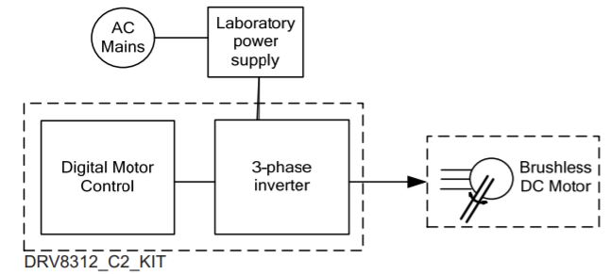
Figure #: Block Diagram for a Typical Motor Drive System

This kit is compatible with both sensored and sensorless trapezoidal commutation platforms. Inside the DRV8312 C2 Kit is an ISO controlCARD socket. This socket is made to be compatible with the Piccolo C2000 TMS320F28035 Isolated controlCARD. This card has a built-in isolated XDS100 emulator. The controlCARD is a board-level module that fits into the three phase inverter baseboard. The board supports up to 50 Volts and 3.5 Amperes. The Piccolo C2000 line of microcontrollers have advanced CPUs capable of signal processing, DC/DC power conversion, and motor control. The TMS320F28035 has a device-specific Enhanced Pulse Width Modulator (ePWM) which can be used in this project to control the brushless DC motor. This is controlled by the High-Resolution Pulse Width Modulator (HRPWM) module. It extends the time resolution capabilities of the digital pulse width modulator (PWM). The HRPWM is based on micro edge positioner (MEP) technology. This means that this microcontroller is capable of positioning an edge very finely by subdividing one coarse system clock of a conventional PWM generator. For the Super Boat Lift Boss, it is important that this clock is precise to control and read the data from the BLDC Motor. We will be using PWM to compute different information such as speed and height of the boat, so it is important that the clock is as precise as possible.

For this project we are learning how to control the HRPM capabilities by controlling the main three extension registers. These high resolution registers are the Time Base Phase, Counter Compare A, and Time Base Period registers. We will be using Edge Mode for precise control of the rising or falling edge. The decision has not been made as to which edge we will be using, but this will be done further along in the project. Since we will be using Digital Signal Processing (DSP), Timer 2 will be used in the application. Timer 0 and TImer 1 will be used in other user applications.

In order to control this microcontroller, we will be using Code Composer Studio version 7. Along with this development environment, the C2000 microcontrollers come with a control suite of development tools. A mobile application will be created using Visual Studio and Ionic 3. This mobile application will communicate with the 1DX WiFi / Bluetooth module connected to the DRV8312 C2 Motor Kit. Once the signal is received, the DRV8312 Kit will be configured to control the BLDC Motor. The controlSUITE contains the software necessary to code the DRV8312 Kit through the Piccolo C2000. There are example programs provided in this software package that we will be using to create our system.

7.2.3 Bluetooth

Bluetooth is a wireless technology standard that was developed to transmit data over short distances. This hands free communication method has changed the way humans interact with their devices. Our team had to decide which type of Bluetooth technology fits best for our project. Bluetooth operates in the 2.402 - 2.481 GHz range within the ISM 2.4 GHz frequency band. Most classic bluetooth devices can transmit data in a range of 10 meters, or 33 feet. The max range seen by classic bluetooth is with version 2.1, which achieved a range of 100 meters. However, this range can be reduced by obstacles and noise. In 2011, Bluetooth 4.0 arrived which is now called Bluetooth Low Energy. This name arrived due to the low power consumption it achieved. BLE operates in the same range and ISM band as classic bluetooth, but it remains in sleep mode until a connection is initiated. Bluetooth 4.0 (low energy) had the same range as classic bluetooth, but Bluetooth 5.0 (low energy) achieved a maximum range of 1,000 meters. This range is ten times the range of past bluetooth connections. BLE also achieves a must faster connection time, connecting devices in a few milliseconds as opposed to over 100 milliseconds. The key technology goals of Bluetooth low energy (compared with Bluetooth BR/EDR) include lower power consumption, reduced memory requirements, efficient discovery and connection procedures, short packet lengths, and simple protocols and services.
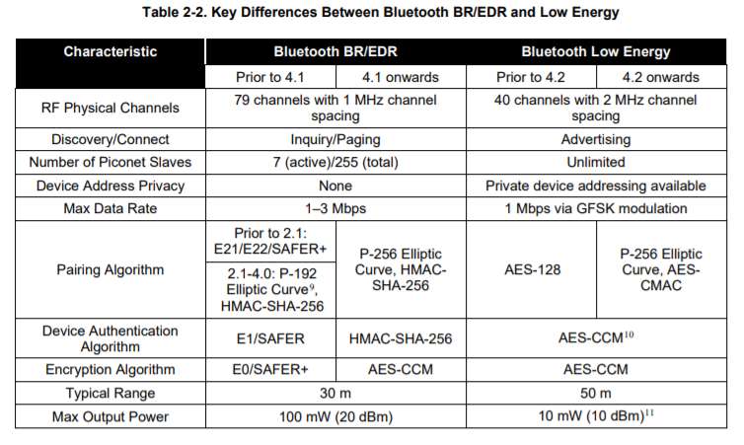
Figure #: Bluetooth BR/EDR vs Bluetooth Low Energy

For our project, we are using Bluetooth Low Energy because it is more efficient, faster, and achieves a further range. Classic Bluetooth can send more data and is better for voice calls, but we do not need voice or video calls. We will be transmitting signals to the motor’s MCU to direct it to be turned on or off. This does not need large amounts of data. If we used classic Bluetooth for this purpose, it would waste battery life and cost more money. Using BLE should allow our motor to run for years without affecting the battery with bluetooth. To integrate this BLE, we will be using a Murata 1DX Wi-Fi and Bluetooth module.The Type 1DX module is a small and high performance module based on Cypress CYW4343W chipset. It supports Bluetooth 5.1 Basic Rate, Enhanced Data Rate, and Low Energy; we will be using Bluetooth 5.1 Low Energy. This data rate

is up to 3 Mbps and supports high-speed 4-wire UART interface. The newest feature of Bluetooth 5.1 is called Direction Finding. This enhances location services and allows the system to detect the direction and location of an emitted signal. This could be useful to detect where the user is standing when they activate the boat lift. For our project this is not a necessary feature, but with extra time it could be used to gather extra user information.

7.2.4 Bluetooth Implementation
Implementing Bluetooth Low Energy into our application is an essential part of the software portion of this project. Ionic provides a Javascript API for iOS and Android devices to connect to bluetooth. The plugin provides the code to scan for peripherals, connect to a peripheral, read values from characteristics, and write values to characteristics. All of the access is through service and characteristic Universal Unique Identifiers (UUIDs). These numbers are guaranteed to be globally unique.

In general, there are two devices in BLE communication: the central and the peripheral. In our project, the central is the phone connecting through our mobile application. The peripheral will be the 1DX WiFi/Bluetooth module that will be connected to our main control system. The peripheral will be advertising a service and will allow the mobile device to write data to it via its characteristic. This data exchange will be communicating instructions to the microcontroller to control the motor. When the user opens the Super Boat Lift Boss mobile application, the home page will automatically prompt a scan for nearby peripherals.

8.0 Software Design
This section discusses the construction and coding of the software portions of the project. We will discuss the framework chosen and why we chose it. Then we will discuss the design of the application along with implementations of the designs. Flowcharts will visualize the logic behind the important pages of the application. These clowcharts will demonstrate the code we will be writing for the software.

8.1 App Development and Framework

One of the main features that set the Super boat lift boss apart from other similar devices on the market is the ability to interact with it through your phone or computer, that’s why the development of the app was one of the most important aspects of this project.

To develop the app we had a few choices for app development frameworks: Flutter, React Native, NativeScript and Ionic.

All of these frameworks allow us to develop multi-platform apps but instead of using Swift, ObjectiveC, Java or Kotlin we will only need to use JavaScript for React Native, NativeScript and Ionic and Dart for Flutter.

Flutter is a software development kit and framework developed by Google to develop apps using their software language, Dart.
The way that it works is that the Dart code can be compiled to a native code that can run on our target devices. It gives us an advantage in that it allows us to build a more complex user interface as most of the UI elements come with preset configurations that are very customizable. It also gives us the convenience of having a development kit and all the advantages that come with it such as extensions, development server, live-updating of our app on an emulator or real device and of course compiling the code.

React Native is a technology/ framework developed by Facebook. that uses JavaScript and the React library to build a user interface composed of React components. Which are a set of pre-built components instead of HTML tags which will be compiled to native code by the React Native toolchain.


NativeScript is a framework that uses JavaScript to build mobile apps and it has two versions: pure JavaScript/ TypeScript, with Angular and with Vue.js. It gives us the option of working with different frameworks. So it allows us to build on elements from other frameworks to develop the interface we want. It also has it’s own pre-built components like Flutter and React Native. It does not work with HTML.

Ionic allows us to build a webapp that can be wrapped by a native app that hosts a webview. We create the app using web development tools and languages such as HTML, JS and CSS. This also allows us to have the webapp be available through any browser which makes it accessible through a computer as well as a smartphone. Ionic 4 includes a huge suite of components and a lot of tools that make app development easier such as a development server for running your app on an emulator/ real device with live-updating and it also bundles the app into shippable packages. It also has many packages that allow us to use the device’s features such as the camera and the microphone.

While apps developed by Ionic have the worst performance (as they are webapps not native apps like we would get with the other frameworks) we decided to use it for two main reasons. First is that it produces an app that is accessible through a browser on any computer making it available on more devices. Second for our purposes the app’s performance isn’t a concern as not much computation is done on the user’s device, it is mainly meant as a means to control the super boat lift boss. Plus the suite of components that is included with Ionic 4 will make the app look great and simpler to develop.

8.2 App Design

Operating the boat lift boss is the main function of the app, so when designing the app we had to keep that in mind. We have two main directions to take when designing this app, both of which have the main page or initial screen of the app to be the controls for the device. An up and down buttons to control the motion of the motor. For all the other features we will either have a side menu or tabs on the bottom of the screen to switch between pages. The pages include a status page that shows information like the weight of the boat, the battery level of the device or will show that it is connected to a constant power source like an outlet.

There will also be a weather tab that shows information relevant to boating such as wind speed, temperature and humidity. It is important to know the temperature, chance of precipitation, and wind speed when planning to have a boat day, and this information will be available without the need to switch applications. It will have an RGB page that controls the RGB LED lights. Through the application, the user will be able to control the colors of the lights with a color wheel and save custom colors. This will allow a customizable ambiance on the dock of the users. There will also be a music tab that lets you choose what service to use for the audio streaming if we decide to go that route. Finally there will be a settings page that lets the user configure some of the app’s features and the super boat lift boss’s features.

The app will also utilize notifications in many ways. A notification will pop up when the user gets close to the super boat lift boss that will have up and down buttons to raise or lower the boat. If the boat is raised or lowered by any other means other than the app a notification will be sent to the user’s phone letting them know that their boat is being moved.

All of our design choices for this app will be to make using it as simple as possible putting the main function of the device first and all the other more advanced features in side tabs or pages that will be easy to get to and easy to get back from to the main page to control the super boat lift boss.
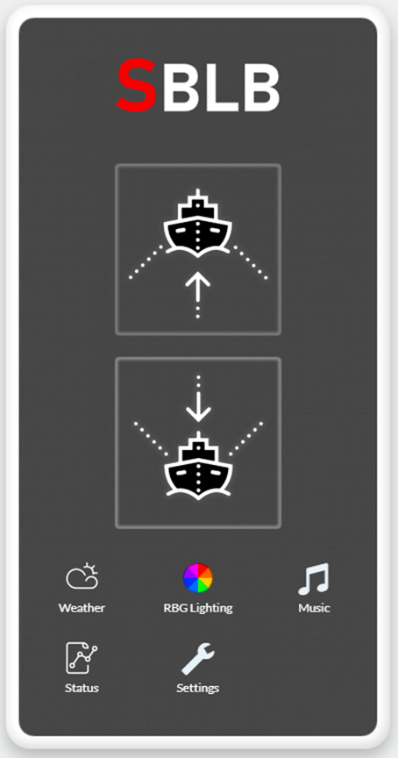
Figure ## app home screen prototype

8.2.2 Application Logic Behind Boat Ascent / Descent
As mentioned before, the most important aspect of the mobile application will be its ability to control the boat lift. There will be an Ascent, Descent, Automatic Ascent, and Automatic Descent button. Accompanying these buttons will be icons to clearly show users which buttons they need to push to control the boat lift. These icons will be displayed in every page to allow the user to control the boat lift at any time. For example, if the user is on the Weather page and wants to lower their boat they just push the button at the top of the screen. This will redirect the program to the ascent/descent logic.

Once pushed, the software system will verify that the correct button was pushed to avoid problems. For example, if the boat was already raised and the user pushes the ascent button, we do not want to put unnecessary strain on the motor. The code will verify the height of the boat in the lift using data sent from the DRV8312 Motor Kit. If the user pushes the Ascent button and the boat is already raised, the application will notify the user that the boat is already raised. If the user pushes the descent button and the boat is already lowered, the application will notify the user that the boat is already in the water. The logic behind these decisions can be seen visually in Figure #. These safety precautions will help avoid unnecessary problems from user error. The position information will be calculated using Pulse Width Modulation from the Piccolo MCU and be sent through the 1DX module to the mobile application.

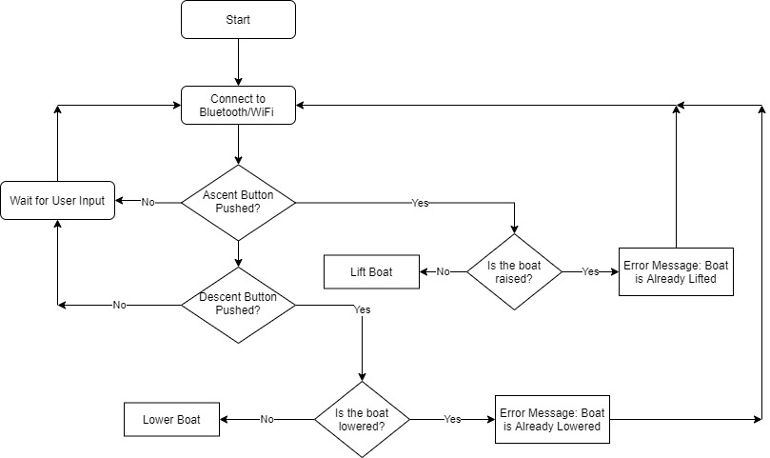
Figure #: Flowchart of the Ascent/Descent Buttons

With the two buttons designated for the ascent and descent of the boat, there will be automatic options. In the automatic descent, the motor needs to be able to sense when the boat reaches the water. There are several different ways to approach this problem. One design we could do would be to have a calibration setting in which the user pushes the manual down button to lower the boat until it hits the water. This calibration in the software would remember the height that the boat dropped for future descents. While this solution is possible, it requires more work from the user. The user would have to calibrate the motor and if the water levels rise they would need to recalibrate the system. Ocean tides change twice a day, so it is very likely that the boat will be lowered during high tide and low tide. In some places this may not make a difference, but since tidal ranges vary so greatly around the globe, it could make a huge difference. In the Bay of Fundy in Canada, the tidal range can be as large as 16.3 meters (53.5 feet). Due to this range, we must find a better solution.

The approach the team is taking towards this problem involves measuring the current needed for the motor to lift the boat. When the boat is at the top and beginning to lower, the motor will be holding up a significant amount of weight. This large amount of weight will be drawing great amounts of current from the system. As soon as the boat hits the
water, the weight will be released from the motor and there will be a significant current drop. Our plan is to monitor this current drop and send a signal back to the mobile application. Once this signal is received, the mobile application can display to the user that the boat has hit the water. The notification can be displayed in the application home page, sent as a notification, and/or sent as audio to the user.

A similar solution will be used to tell the user that the boat has been lifted completely. In the automatic ascent, the motor needs to sense when the boat has reached its mechanical stop at the top. The current will increase when the boat lifts from the water,but eventually the boat will hit the mechanical stop placed at the top of the boat lift. Once the motor is locked, the current will spike significantly. We will have a capacitor in place to handle these massive spikes because when the current spikes up, the voltage will drop down. The goal is to have the motor stop working when it hits the mechanical stop, so we need just enough capacitance to do this. When the motor stops, a signal will be sent back to the mobile application to notify the user that the boat has been lifted.

While this approach is good, we can improve upon it by implementing safety features. Since pulse width modulation is being used by the Piccolo MCU, we can count the pulses it takes to raise and lower the boat. If the boat reaches the water before the correct amount of pulses are counted, there could be something wrong. The same thing would happen if the boat is raised in less than or more than the correct number of pulses. This safety feature would allow the software to monitor the position of the boat based on pulse time. Similarly, we could improve this system to work with the high and low tides. The user can set the geographic location and the lunar time when purchasing the motor. Once calibrated, the system should be able to use the timers to adjust the correct amount of pulses needed to raise or lower the boat. This would be a more complicated feature of the project and is not necessary, but would be beneficial to include in the final product.

8.2.3 Weather Application
The second page of the application contains information on Weather. The user will set up their location in the settings page and the weather based on that location will be used. It will display temperature, wind speed, and chance of precipitation. We will be gathering this information from a weather API. To decide which one to use, we had to do research to determine the best fit for this project. For the boat lift, it is important to have current weather information along with a forecast for the day. We do not need a complicated design, just enough information to tell the user if the weather is okay to go out on their boat. The design prototype can be seen in Figure #####.

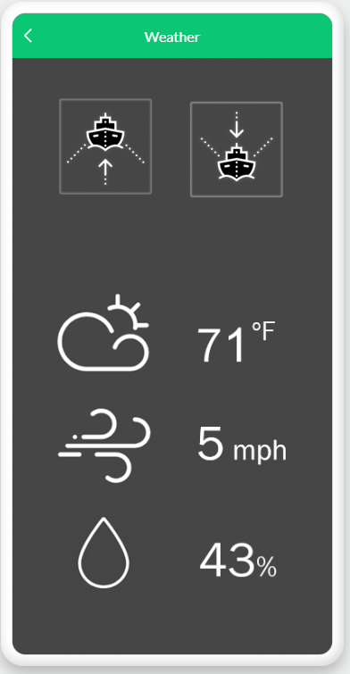
Figure ## Weather screen prototype

The development framework we have chosen to work with, Ionic 4, has several helpful resources online. To gather the data we need to display the information, we can pull information from a weather API such as Forecast.io. This is an accurate source of hyperlocal weather information that many developers use for weather applications. Forecast.io is also known as the Dark Sky API and can be implemented into any application as long as the developer signs up for an account. It is unclear as to whether this API is free, but there is a free trial that we can use to begin.

Instead of going directly to Forecast.io, we can use pre-designed templates for weather applications. There are several different templates to choose from. Weather Today is an application created with Ionic 3, Angular 5, Cordova, and Typescript. It is a full application with a login, registration, home, side menu, search bar, profile, and settings. This is too complicated for our purpose because we want the simplest application possible. We could use bits and pieces of this template, but since there are other options we need to consider them all. Weather Forecast is another template that is too complicated, including many different options and settings. Even though it is complicated, the Weather Forecast template is simple and elegant. It is a better choice than Weather Today, but still not the best choice.

There is a simple design template called the Modern Weather App that was built with Ionic 3 and Angular 4. It has a modern design with animations and 48 different weather icons. This application uses the Yahoo Weather API so our users would be able to enter weather information for any location. The only other template that competes with the Modern Weather App is the Weather App Pro Ionic. This is a weather application that includes a graph of temperature for the chosen city. It was also built with Ionic 4. Both of these templates are $15.00, so for now we are deciding we should not purchase an API. Our sponsor would prefer to use a free source for weather information.

After researching the different weather API options, OpenWeatherMap seems to be the most promising cost-effective option. This API provides different collections to provide information for every application. There are different subscriptions to the Current Weather API, but only the base is free. We could upgrade our subscription at a later date if we want to include more data. The subscription we are using is the Free API within the Current Weather and Forecasts collection. This includes current weather information, 5 day / 3 hour forecasts, weather alerts, UV index, and weather maps 1.0. This is more than enough information to provide data to our users. Once the Weather tab is pressed, the application will retrieve the data from OpenWeatherMap to display the correct data on the screen.

Whichever API we choose to use, the logic will be relatively the same. When the Super Boat Lift Boss application is started, the connection to the weather database will begin. This can be seen in the flowchart in Figure #.
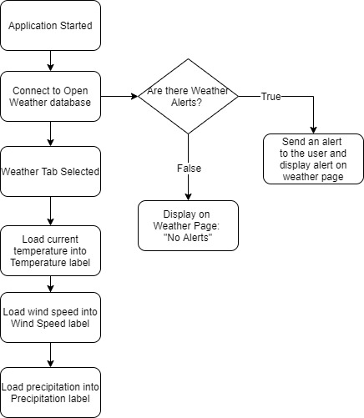
Figure #: Flowchart Showing Weather Tab

The first thing we want to do is discover any weather alerts in the area. If there is a weather alert, it is important that the user knows. The alert will be sent to the user through a push notification, along with a display label in red on the Weather page. If there are no alerts, we will display on the page “No weather alerts.” Once the Weather Tab is selected, we will retrieve the weather information from the API and load it into the display labels.

8.2.4 RGB Lighting
A good selling point of this project is the ability to hook up strips of LEDs to the motor. The motor will have a PCB designed to deliver the correct amount of power to the LED strips and the application will have a tab to select the colors. Once the RGB Lights tab is selected, two options will be displayed: Preset Colors and Custom Colors. If the Preset Colors choice is selected, the color wheel will not be activated unless there are no preselected colors. If there are no preset colors, the wheel will be activated for the user to select a color. Once they have decided which color or colors they want, they can press a “save” button. The color wheel will be deactivated and the preset colors will be sent over to the piccolo. If the user wishes to delete preset colors, they can go to the settings to clear the saved colors. The main focus of this page is selecting the colors with the color wheel. The plan for our RGB Lighting page can be seen in Figure ###.

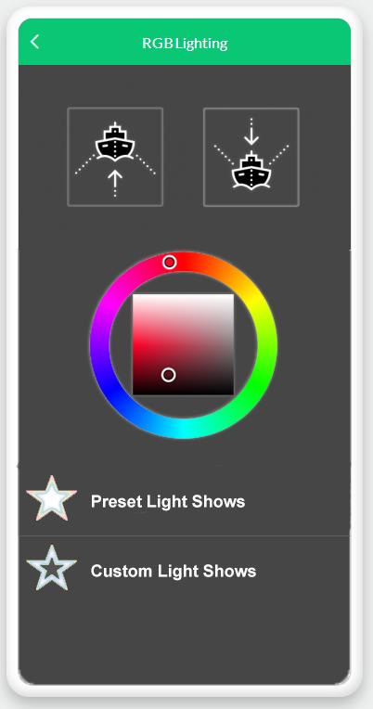
Figure ##: RGB Light screen prototype

If the Preset Colors option is not selected, the Custom Colors option will automatically be selected. This will activate the color wheel and allow the user to choose a color for their LEDs. Once they select their chosen color, the data will be sent over to the piccolo to change the LED colors. This logic can be seen in the flowchart in Figure #. Like all of the other tabs, if the boat ascend/descend buttons are pressed, the program will be diverted back to the logic for lifting and lowering the boat. This allows the user to always have access to their boat lift, even if they are updating the colors of the LED strips. The color wheel we are implementing will come from a predesigned package for ionic. There are a few options to choose from, but after doing some research the farbtastic color picker looks the most promising.
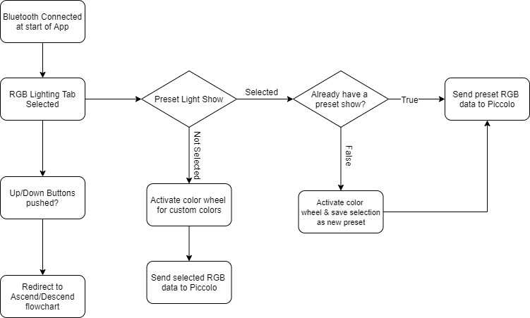
Figure #

The color wheel we are using is an implementation for ionic called angular-farbtastic. This is based on the farbtastic color picker plugin. Farbtastic uses layered transparent PNGs to render a saturation gradient inside of a hue circle. This allows the user to select the color and the saturation of the color. If for some reason the color wheel does not integrate well into our program, there is an ionic color picker we can use. This color picker will not display a wheel, but there will be plenty of color options for the user to select. Either implementation will allow the user to select colors to customize the ambiance of their dock.

The most complicated portions of the color selection will be the ability to save preset colors and the logic to control the piccolo. Once the team is able to work with the piccolo, we will be able to correctly set up ways to send the color data to the motor. We will be relying on past implementations of the color wheel for the color selection, but sending the data will have to be completed by the team.

8.2.5 Music
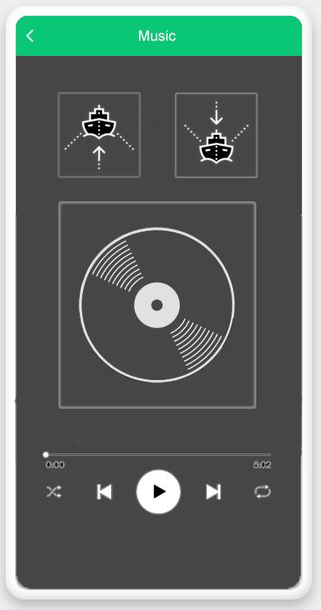
Figure # Music Screen Prototype

For the music tab the design will be very straight forward. The boat lift up and down buttons will remain at the top of the screen so the user can still control the boat lift from this page as well as all the other pages. Below that will be the album cover or the image associated with the song the user is playing. Below the album cover will be the seek for the song so the user can skip to any part of the song they wish to go to, below that are the music controls. play/pause, forward, back, shuffle, and repeat. We made our design this way so it looks familiar to the user and will be intuitive to use instead of going for a unique spin on it that might confuse the user.

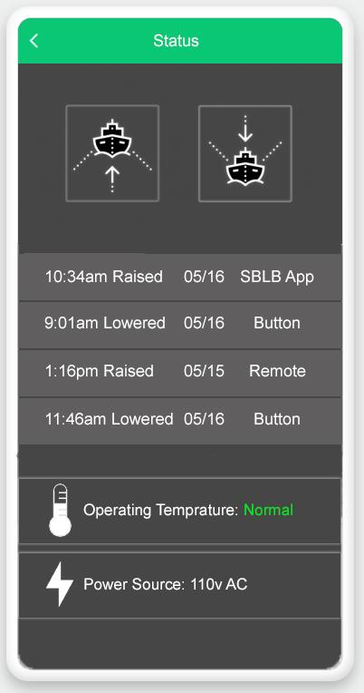
Figure # Status screen prototype

For the status page the app will show information about the device. The page will have the boat lift controls on top as with all the other pages. Below that the app shows the four most recent times the device was activated and by what method were they activated and if the boat was raised was lowered. Below that it will show the operating temperature for the most recent operation of the device. That way if it was higher than normal the user would be able to see that before any damage would be done to the device. Finally below the operating temperature it will show what the power source whether it is AC or DC and it will show the voltage being supplied.
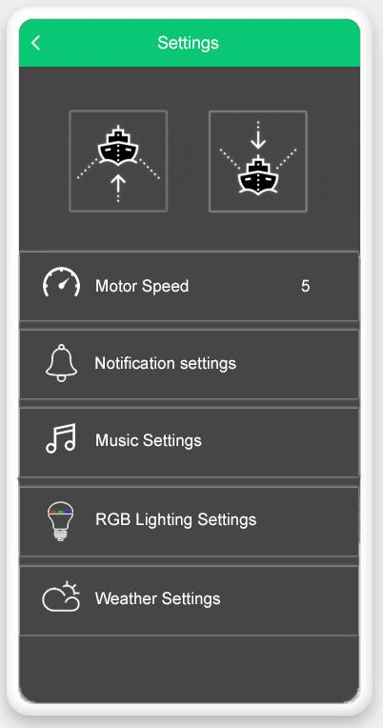
Figure # Settings Screen Prototype

The last page in the app will be the settings page. Here the user can configure the device in many ways. First, they will be able to set the speed of the motor when raising or lowering the boat. They can choose a value between 1 and 10 with 10 being the fastest speed the motor can operate safely. Next will be the notification settings. Here the user can configure what type of notifications the app can show on the user’s phone. By default the app will give a notification for every time the device is used. It will say whether the boat is being raised or lowered and by the physical buttons on the device or by the bluetooth remote. The user can change that so they could turn off those notifications either temporarily or indefinitely. In the music settings tab the user will be able to set the streaming service of their choice. In the RGB lighting settings the user will be able to set a time out for the lights as well as control the brightness of the lights. In the weather settings tab the user will be able to choose whether the temperature be shown in Celsius or Fahrenheit.
8.3 Backend software components

8.3.1 Wifi/ Bluetooth LE connection
Since we will be using the Ionic framework to build our app we will be using the Cordova plugin to facilitate and manage BLE and wifi connections.
For the Android and IOS ports of the app the bluetooth LE will work perfectly with the Cordova plugin but the functionality will be limited on windows devices, but this will not be an issue as we intend to have PCs connect to the device through wifi rather than bluetooth which Cordova also has an implementation for. We will also be using the network plugin to manage all of our connections, add connection timeouts and login validation which will connect to our security modules.

8.3.2 Security components
In order to make sure that the only person that can control the device is the owner of the device we will add some security plugins to better protect the owner and the device from unauthorized use.

For front end security we will use Identity Vault which will add a native security layer to protect the user’s data and the device data. Identity Vault has many features that will make our device more secure and we will combine it with other plugins such as Android Fingerprint Authentication and Touch ID to make the app more convenient will keeping it as secure as possible.

We will also use Offline Storage to store the user’s data and the seriel number and authentication information for the user’s device. This will allow us to have a layer of security without the need for a server and without the need for the user to create an account or even be connected to the internet to authenticate and connect to their device.

We will add a plugin called Auth Connect that adds login, logout, and token refresh to our app. For the time being we will only be using Offline storage for user authentication but we will add Auth Connect as a backup for if we ever decide to switch to it or have it as a one time online authentication method.

9.0 Project Operation
The Super Boat Lift Boss is an improvement upon the Boat Lift Boss motor, so the installation process of the motor is similar. To install the motor, the user will need a 9/16” socket with ratchet, a 9/16” wrench, and an optional 10 mm wrench. The rest of the supplies are provided by Extreme Max. The installation process can be seen in the diagram in Figure #.

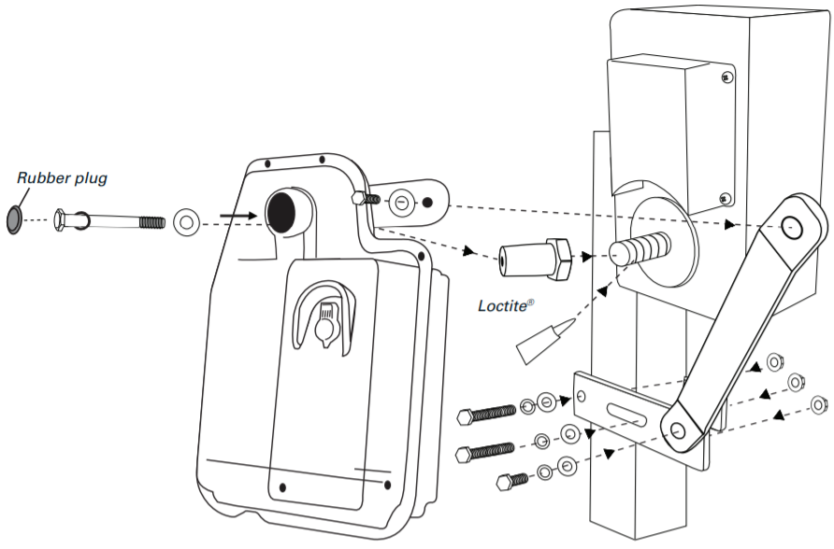
Figure #: Installation of boat lift motor

To start the installation process, the wheel must be removed. To do this, the user must put the lift in the lowest position until there is no tension on the cable. The fastener from the center wheel must be removed and then the wheel must be turned counterclockwise until it is unthreaded from the winch box. The ratcheting brake system must be removed because the Super Boat Lift Boss has its own built in brake system. If the current brake system is not removed, damage can occur. The winch cover should be reinstalled and tightened before the new motor is installed.

Once the wheel and brake system have been removed, the Super Boat Lift Boss can be installed. Seen in Figure #, the Loctite needs to be applied to the threads on the input shaft of the winch box. Next, the user must thread the tapered drive shaft to the boat lift and tighten it by hand. The Super Boat Lift Boss is then ready to be pushed onto the tapered drive shaft. The motor can be secured with the washers shown in the diagram.
The last part of installation involves assembling the two piece lower clamp around the lifts vertical upright. This can be seen in detail in the Boat Lift Boss installation manual. The bolts must be tightened completely and the rubber plug must be reinstalled.

Once the motor is installed, the user can begin using their new boat lift motor. They can begin by using their key to manually switch on the boat lift. This will make sure that the motor is working correctly before connecting the application. The user can also use the key fob to control the motor from less than 15 feet away. The key fob and the manual switch should not be used at the same time to prevent error. Either of these methods of control may be used whenever the user wishes to do so.

To begin the application, the user can go to the Super Boat Lift Boss Control website or go to their app store to download the Super Boat Lift Boss Control application. Once installed, the user will see the home page. The lift and lower buttons will be displayed largely on the home screen so that the user can easily access the controls. In order for the mobile application to connect with the boat lift, the user must turn on their Bluetooth. They must set up a pairing with the boat lift for the first connection. Once connected, the devices should remember each other for future use. If the connection is forgotten, the user must reconnect with the motor. After the connection is set up, the motor is ready to be controlled.

Once they operate their boat lift with the up and down buttons, they have a choice to adjust lighting controls and view weather data. The user can choose either customize colors or preset colors. For the first use of the application, there will be no preset colors. The user can choose to make a new preset color and save it to the database. The color picking will be done with a color wheel for people to easily choose which color they prefer.

If the user wants to view weather information, they must enter their boat lift’s location. To do this, they can go to the settings page to update their location for accurate weather data. The location can be changed through settings at any time. The weather page will display useful information like temperature, wind speed, and precipitation. The user can navigate to the weather tab at the bottom of the screen at any time they need. If there is a weather alert in the area, a notification will be sent to the user along with a message on the weather page.

10.0 Project Prototype Testing
One of the most important aspects of any design project is testing. The testing phase of the project will allow our team to determine if a prototype is prepared to enter the production stage. For this project, testing is extremely important for the safety of the boats being lifted. If the motor is not able to lift 6,200 lbs, it would not be safe to lift boats. The application must be able to connect with the motor without problems to accurately control the motor. To ensure that all of these different parts of the project work together, testing on both hardware and software must be completed.

****10.1 Hardware Testing
****10.1.1 DC-DC booster testing:
Turning on and off voltage levels and timing:
DC/DC converters operate under a certain voltage range. In order to test the design that it properly functions under the right voltage ranges, a dc source, usually adjustable, is used to provide the input voltage. On the output side, a dc load is used to simulate the output load current as well as the powered device. The minimum input turn-on voltage of the DC/DC converter is tested by turning the converter on using the nominal input voltage, at the same time the load supplies the output rated current. We then keep decreasing the input voltage until the output current or power starts to decrease.
Testing that the DC/DC converter functions at the maximum rated load can be achieved by minimizing the input voltage and turning it on and off and measuring the output current and voltage. Noise and ripple at the output is also measured to determine if the stability at the output is affected by the minimum input voltage. Additionally, to make sure that the correct voltage is applied at the input of the DC/DC converter, the dc power supply remote sense leads should be used. Remote sense should also be used on the dc load so that the proper measurements are done.
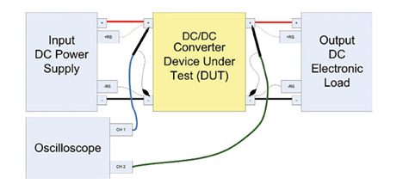
Figure. DC/DC converter test setup
Figure below shows the turn-on and turn-off times. Turn-on time is the time when the minimum input voltage is set on to the time when the output voltage reaches its peak and becomes within its limits. Turn-off time, on the other hand, is the time when the output voltage becomes zero and when the input voltage reaches a value below the specified minimum input voltage value.
In addition to the turn-on and turn-off timings, hold-up timing test is a test that is used to make sure that the DC/DC converter still functions properly even though undesired low input voltages and interrupts. Hold-up, turn-off, and turn-on tests use the same set-up. Usually, DC/DC converters have some type of interrupt or signals that detect any faults at the input. Such interrupt triggers the hold-up timing test.
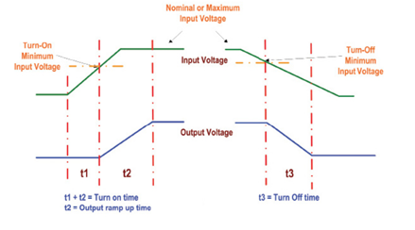
Figure. Turn-on and turn-off times
Another test to ensure that the output voltage remains within the voltage regulation limits is the output line regulation test. This test makes sure that the output voltage is within the regulation limits while changing the input voltage between minimum to maximum while maintaining the load at either highest or nominal current value. This test works as follows: the output voltage is measured while changing the input voltage from highest to lowest voltage and monitoring any voltage deviations at the output. Voltage tolerance is then expressed as volts or as percentage of the accepted voltage. Output regulation is expressed by the following formula. R_{o} = (|V_{omax} – V_{omin}|/ V_{onom})*100. Where V_{omax} is the output voltage when the input voltage is set to maximum.0, V_{omin} is the output voltage when the input voltage is set to minimum, and V_{onom} is the output voltage at its nominal value.
Output load regulation test, on the other hand, also aims to test that the output voltage is within voltage regulation limits. However, the method to do so in this test is different from the way it is done in the output line regulation test. In this test, the output voltage is measured, and voltage deviations are monitored and recorded while changing the load current from maximum to minimum. Load regulation percentage is determined using the following formula: L_{R} = (|V_{oio} – V_{oim}|/ V_{onom})*100. Where V_{oio} is the output voltage when the load current is maximum, V_{oim} is the output voltage when the load current is minimum, and V_{onom} is the nominal output voltage.
Another important test to take into accounts is output transient response deviation and time test. This test aims to study and monitor the system behavior in cases when there are abrupt changes in the load current by measuring the output voltage deviations in addition to the time the voltage takes to return to the nominal value. The test is done by applying the maximum and the minimum current at the load by using a dc electronic load and changing between them at a steep rate; in other words, make a sudden transition between the maximum and minimum load current, then we observe the output voltage reaction and response time. Figure below explains the process through a waveform of the load current and output voltage reaction and response time.
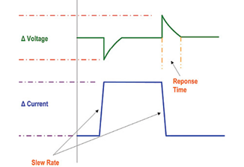
Figure. Transient response
Moreover, another test is the output voltage ripple and noise test. It is a test to measure the noise, ripple, and the periodic and random deviations of the output voltage. By knowing and measuring the noise and the ripples at the output, the efficiency of the DC/DC converter to filter noises and ripples. DC/DC converters by design have a lot of internal frequencies that affect the output frequency of the converter. Using an oscilloscope, these output noises and ripples can be measured. They also can be measured by using an electronic dc load that can show the voltage ripples measurement functions. It is also very useful to decrease the length of the wiring ground on the voltage probe to prevent damaging noises.
Output over-current protection test aims to detect if the load connected to the DC/DC converter depletes more current than the maximum rated current of the converter. The test aims to protect the converter through two main (most used) typologies. The first typology is hiccup-mode current limit and the second is fold-back current limit. In the hiccup-mode current limit typology, when the current at the load increases beyond the converter’s maximum rated current, the output turns off and turns on again. If load current is still higher than the converter’s current limit, then the output turns off again. Thus, the output toggles on and off. In the fold-back current limit typology, when the load current increases beyond the converter’s rated current, the output voltage then decreases and thus restricts the load current.
Output over-voltage protection test, on the other hand, aims to check the functionality of the output voltage protection circuits that are built inside the DC/DC converter. The built-in over-voltage protection circuit is to release a fault signal and turn off the converter if the voltage at the output of the converter exceeds the output maximum rated voltage. To test the over-voltage protection circuit, voltage at the output can be increased (if it is an adjustable output voltage) until the over-voltage protection circuit activates. If, however, there is no programmable output voltage, then an external voltage source can be used where it is used on the converter’s output terminals. The voltage when the over-voltage protection circuit activates is then recorded and then compared with the circuits rated limits.
Output operating temperature and over-temperature protection is a test to measure the temperature range at which the converter is functional. DC/DC converters, by design, usually have over-temperature protection circuits that are built in. Their role is to detect if the temperature increases or decreases outside the converter’s operating temperature range and then turns off the converter. The converter’s operating temperature range can be simulated using a thermal chamber that can increase and decrease the temperature of the converter. The test will be done by applying maximum current at the load and also maintaining the output voltage in the voltage regulation limits. Then, the temperature of the converter is measured until the over-temperature protection circuit activates and shuts down the converter. The temperature of the converter can be measured by using infrared thermal measurement equipment or even thermal probes.
The efficiency of the DC/DC converter is another parameter to be tested. Determining the efficiency of the converter helps us determine the internal power depleted by the converter and thus the power losses. To determine the efficiency of the converter, we take into accounts the nominal input voltage and the nominal output load. Then we measure the input and output voltages, the input and output currents, and the input and output power. The efficiency is then calculated using the following formula: E_{p} = [|V_{out}*I_{out}|/ (V_{in}*_{Iin})] *100. Where V_{out} is the output voltage of the converter, I_{out} is its output current. V_{in} is the input voltage of the converter, I_{in} is its input current.
10.1.2 AC/DC Converter Testing:
Output voltage accuracy test:
This test aims to measure the output voltage of the AC/DC converter with respect to the input nominal voltage. This test is done by setting the output at full load, applying the nominal input voltage, and then measuring the output. The formula of the output voltage accuracy is the following: output voltage accuracy = [(V_{out} – V_{nom})/V_{nom}]*100, where V_{out} is the output voltage, and V_{nom} is the nominal output voltage. In addition, output load regulation and output line regulation tests will be conducted similarly for AC/DC converters as for the DC/DC converter using the same formulas.
Conversion efficiency test:
The conversion test aims to measure how well the AC/DC converter converts the AC power to DC. This test is done by applying the nominal power at the input, applying full load at the output, and then measuring the output voltage. The conversion efficiency formula is given as the following: efficiency = [(I_{out} * V_{out})/P_{in}]*100, where I_{out} is the output current at full load, P_{in} is the nominal input power, and V_{out} is the output voltage to be measured. Since the input is AC, there will be a phase difference between the input voltage and the input current that occurs due to the inductance and capacitance in the internal circuit of the converter and this may lead to the distortion of the current waveform at the input.
Ripple and noise test:
Ripples and noises are sinusoidal variations mixed with the DC output. These noises and ripples affect the accuracy of the DC output. There are three ways we can measure the ripple and noise; the first is twisted-pair cable measuring method. In the twisted-pair cable measuring method, a twisted-pair cable preferably 20AWG with two ends. One end is connected to the output voltage terminal of the AC/DC converter output, and the other end is connected to a 0 V terminal (ground). Then we add a resistor and a capacitor in parallel, and we use the oscilloscope as shown in figure below.
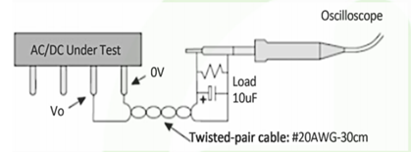
Figure. Twisted-pair cable measuring method
The second method to measure the ripples and noises is the parallel cable method shown in figure below. Using two parallel copper foil tapes, connected by two capacitors in parallel. One capacitor is a high-frequency ceramic capacitor and the other capacitor is an electrolytic capacitor. Usually the voltage drop of the copper foil tapes should be very small compared to the output of the converter, less than 2%.
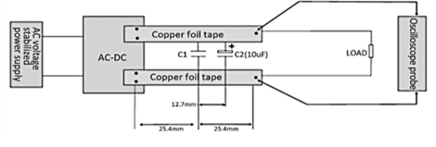
Figure. Twisted-pair cable measuring method
The third method is the contact measuring method. This method gets rid of any noise interference received by the oscilloscope. Some noises are collected by the oscilloscope’s ground. In the contact measuring method, the oscilloscope is directly connected to the output voltage and ground at the same time; the tip of the oscilloscope is connected to V_{out} and the grounding ring of the oscilloscope is connected to the ground terminal of the AC/DC converter. Figure below shows the contact measuring method.
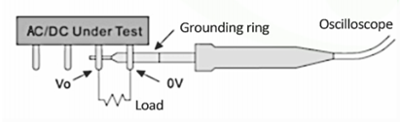
Figure. Contact measuring method

10.2 Software Testing

Software testing is very important within any system, but it is crucial for this program to work without flaws to accurately control the boat lift. There are several different testing methods to ensure that every path is tested accurately and completely. This section will outline different software testing methods we could use and how the team will be implementing them within this project. The order of this discussion does not correlate with the order of the tests being completed.
Before completing formal testing, the team can utilize exploratory testing as a quick overview of the program. This process involves the tester going through the program and making sure everything is functioning as planned. As the tester goes through the application, it is important to take note of the different paths explored. This testing process will be beneficial as a base to design which areas need further testing. In the Super Boat Lift Boss application, it is important to make sure all the different tabs can be switched back and forth efficiently. Each tab must be selected, and all the options should be selected to simulate a user using this application. As the application responds to our input, we will be taking notes to find potential bugs.
Functional testing will focus on testing the software output. This includes the signals to run the motor and control the lights. For initial testing we will not need to use a boat attached to the motor. If the motor responds to our input this will be sufficient enough to show that the application communicates effectively with the motor. The real testing of the motor will occur once all the components come together for a final product. It is necessary that the boat lift can sense when to finish lifting or lowering the boat. This will be tested in the hardware testing, but we will be testing the process again in the software testing. The LED output is another output necessary for the success of the application. When the user selects a color for the LEDs, the lights should turn on and change colors. We will have to test both the custom colors and the preset colors to make sure that the output is responding correctly. In this functional testing we will be making sure all of the outputs respond correctly, accurately, and quickly.
Backend testing will be utilized to test the database of the Super Boat Lift Boss. This does not involve the GUI because it targets only the backend of the program. We will be testing directly from the database with a few queries to make sure the database is working correctly. For this program there is not a large database, but it is still an important part of the application. The database will contain the data the user enters such as location, boat lift height, and preset colors. We will test the database’s response to several different locations around the world to make sure it responds correctly. If the user enters an invalid address, the program should prompt the user to enter a valid location. These locations will be stored as a longitude and latitude to obtain the most accurate information from the weather API. We must make sure that the database accurately stores these longitude and latitude values. The color presets must be saved correctly within the database to accurately control the LEDs. The database must be able to be cleared and rewritten when the user wants to change the preset color. This backend testing will help prevent data loss and data corruption.
An important part of the software design is its ability to work on multiple platforms. Ionic gives us an easy way to implement our design on mobile devices and web browsers. Each operating system reacts differently to different programs, so we need to perform tests to make sure it is compatible with all these different platforms. Browser compatibility testing will be used for the web application to ensure that it runs on different browsers and operating systems. We will need to test the application on Internet Explorer, Google Chrome, Safari, and Firefox to make sure that it is compatible on these different web browsers. In addition to the different browsers, we will need to test these on different operating systems. We have access to both Windows and Mac operating systems but may not be able to test it on Linux. We must also test to see if the mobile application is compatible with android and apple operating systems. It is important to make sure that all of the operating systems have the same GUI with the correct proportions. We will run different test cases while signed into each of these platforms. Not only must we make sure the web application and mobile application are compatible, we must also check to see if users can access the web application from a mobile browser. While this is not a top priority, we must account for all the different access methods for our Super Boat Lift Boss application.
The users will be downloading the mobile application from the mobile app store, so it is essential that the installation process runs smoothly. We will be completing installation and uninstallation testing to make sure there are no errors from these processes. We will need to install the application on different devices and perform different tests on the program. Then we need to uninstall the program to make sure everything runs as it should. We want to make sure the databases are cleared with uninstallation to prevent data from being vulnerable. When the program is reinstalled into that device, it should not contain the same data that it did prior to uninstallation. If a security patch must be installed, there could be potential errors. It is a good idea to test the installation of new updates and security patches before releasing the application to the market.
The Super Boat Lift Boss application is heavily dependent upon its images to show what each button is used for. This means that it is very important for the Graphics User Interface (GUI) to be executed correctly. GUI testing is essential for this project to make sure the application runs correctly. It is important for all the images to be displayed correctly in the correct location and size. It is especially important for the ascent and descent buttons to be displayed on all the tabs and react to user selection. The options to switch to different tabs must be displayed correctly and not be cut off from the bottom of the screen. All the text and buttons must be evenly spaced to provide the most visually appealing GUI as possible. The radio buttons used for the color mode selection must appear correctly and react properly to a selection. It is important for all the different graphic components to interact with the user properly, but for the GUI testing it is more about the visual appearance of the application. This testing will most likely be done on each operating system as part of the compatibility testing.
One of the requests from the sponsor for the mobile application is for it to be as user friendly as possible. Usability testing is a very important part of this mobile application. We want this application to be used by people with a wide range of comfort with technology. To do this, we plan on showing the application to a variety of people. Our parents would be a good start to test the application on people without prior knowledge of the application. We need to see if they can successfully navigate the different pages and figure out how to control the boat lift. Each tab should be easily accessed, and the user should understand what each tab is for. If it is too difficult for our parents to navigate, we must redesign the GUI and add helpful hints. We will take note from different test users to see different suggestions they may have to increase usability. We could test the application on our peers as well, but most of our peers are very experienced with technology and it would not be a good basis for usability. We want this application to be user-friendly for people with limited knowledge of technology. This will ensure that everyone can use this application to control their boat lift.
The application must be user-friendly for everyone to use, but it also must be durable enough for a monkey to use. A testing method known as Monkey Testing is a way to randomly input values into a program to see how it reacts. The application should have ways to prevent random data from causing a safety hazard or crashing the program. We will test this by opening the application and pressing random buttons. This could happen if the application is not closed before a user puts their phone in their pocket. Random buttons could be pressed, and it is important that the boat lift does not break as a result. This accidental input is why we have implemented security measures within the buttons to lift and lower the boat. If the boat is already raised to the top of the lift, it will not respond if the lift button is pushed. The same security measure is implemented for the other button. If the boat is already in the water and the descend button is pushed, the application will not lower the boat and an error message will be shown. Random button pushes from the lights will not be too much of a safety hazard, but we will implement a timer to shut off the lights after a certain length of time. It is important to test these random selections to prevent random errors from occurring.
While we aim to prevent crashes within the program, it is always possible that they will still happen. If the Bluetooth connection does not work or the Wi-Fi has connection problems, our program must be able to recover. We will use Recovery Testing to make sure the system can recover from failure. If the application is transmitting data during the failure, once the system is recovered the data should continue to transmit or restart the transmission. It is important that the system recovers quickly from crashes to be as user-friendly as possible. To test this, we can connect the device to the Wi-Fi and then turn off the modem. The application should show an error message that the Wi-Fi is not working. When the Wi-Fi is turned back on, the system should continue data transmission. The same process can be used for the Bluetooth connection. The Bluetooth connection to the 1DX Murata module is essential for the success of this project. If the connection fails, the system should be able to recover quickly and continue the transmission signals. This will be one of the most difficult aspects of the program to test.
One of the ways a program may crash is if it has too much stress on the system. If there are too many database queries or information overload, the whole program can crash. Stress Testing will verify the stability and reliability of the program. We want to make sure that even under harsh conditions the program will not crash. To prevent too many database queries, we can put a limit on the amount of information that the database will accept. Another problem that could occur is if there are too many signals being sent to the piccolo. If the user continually pushes all the buttons and color selections, it could overload the piccolo and cause a crash. We need to implement ways to prevent an overload of data. The Stress Testing will show the team where we need to focus on preventing data overload.
Security is a huge problem in the modern world of technology. Hackers are always trying to get into systems and steal information. The Super Boat Lift Boss application needs to be secure to prevent outsiders from eavesdropping on their activity. Security Testing can be implemented to test how secure our system is. The software should be secure from malicious viruses and worms trying to steal data. If an eavesdropper can access the boat lift data, they can know when the user is using their boat. This is a great way to plan to steal the boat or rob their house while they are gone. Security is also important because if this application is not secure, attackers can use it to access the files in the user’s phone or computer. We must test different security risks to ensure that both the mobile and web applications are as secure as possible. We can utilize vulnerability testing to find all the different vulnerabilities within the system. This will show us if there are any critical defects within the security of our system.
As we are testing the system, it is important to test each individual module along with the entire system together. To test the individual modules, we will be utilizing the concepts of Unit Testing. This is where we will run test cases on each individual function of the code. We need to write these test cases to test the function of each page and each sub function within the different pages. We must make sure that each individual piece of the system is working before combining it all together for an overall test. Once we connect all the pieces of this system, we can run end-to-end testing. This involves testing the complete application environment. Each piece of the system must work together including the database, communication signals, and piccolo controller. We need to run the system all together, testing both the software and hardware. The project will not be completed without running the entire system several times. We need to test all the different paths a user can take to reduce the risk of problems occurring. This end-to-end testing is a very important last step in the testing process.
Before releasing this application, the sponsor will most likely want to perform both Alpha and Beta testing. Alpha testing will be done by the project team to do a complete check for any extra bugs we did not find before. This test is meant to simulate real-time behavior to automatically test for any bugs. We will need to write test cases to complete this portion of testing. The Beta testing will probably be done by the company selling this product. This would be a formal software test to make sure that there are no failures within the application. If the test is successful, the application will be accepted, and we can count our project as a success. If it fails, we will have to carry out major revisions before they would be willing to accept this application.

Test Cases
There are also a few additional test cases for making sure that the device communicates back and forth between each other, shown in Table below.

Test Case 1 Pairing Device
Action: Pair page on the start-up page
Reaction: Connect the device through serial communication. Send the user to the homepage of the Device.
Test Case 2 Controlling the Device
Action: Select either up/down control from the on any page of the app
Reaction: Send the up/down signal to the hardware device. The device will be lowered/raised when the user presses the down signal button until the user releases the button and if the user presses the button twice, the boat will be lowered or raised to the specified limits.
Test Case 3 Weather Detection
Action: Click the weather tab.
Reaction: Request temperature to the device through serial communication using a weather sensor. Get information and compare it to the weather service information.
Test Case 4 Checking device information
Action: Click on the status page.
Reaction: User will be sent to the status where it will display information about the last four actions performed by the device along with operating temperature and power source.
Table X: Software test cases for the Super boat lift

11 Security concerns
In its essence the super boat lift boss is a smart home device. It connects to the users Wifi and to the user’s phone, this makes it a target for hackers. It also can be a target for thieves trying to steal the user’s boat. In this section we look at these concerns and vulnerabilities and come up with solutions to make the device more secure.
Security Concern | Reason
Unauthorize connection to device | One main security concern is connection of unauthorized users to the device. If an unauthorized user connects to the device, he/she will have the entire access to the device and to lower the boat at any convenient time. This is a big concern because it can result in getting the boat stolen.
Connection/System Hack | A big concern is the possibility that hackers can exploit vulnerabilities in the device’s security to get into the user's home network and gain access to other devices on the network. This is a concern with all smart home devices.
Simultaneous Connections to device | One security concern, it will be multiple authorized connections to the device. If two authorized users are connected to the device and give two different inputs at the same time, such as raising the boat and lowering the boat. The device will not be able to fetch the which instruction to perform which can cause a glitch to the device or other unpredictable outcomes.

Security Concern | Solution
Unauthorize connection to device | In order to prevent unauthorized users getting a hold of the device, it has been decided to request a pin number every time a personal device wants to connect to the device. This pin number will be set by the authorized user at the setup stage of the device.
Connection/System Hack | To prevent hackers from connecting to the SBLB though the internet. And accessing the local network, the SBLB will only connect to devices on the local network.
Simultaneous Connections to device | For this concern, the user will be able to send the instruction to the device from one personal device at a time. This will be achievable using the First Come First Serve queue. This way the device will receive one instruction at a time per one single user. Once this authorized user stops using the app, it will be available for the next connection and ready for future instructions.

11.0 Administrative Content
To properly complete a project, it is important to plan as much as possible. In this section, we discuss our milestones and budget planned for this project. The milestones will be an overview of when we would like to have the different portions of our project completed. The budget is a plan of how we will allocate our funding from RV Intelligence. It is important to follow our plan, however it is not necessary to follow it exactly. If we need to make adjustments later in time we will be able to do so.

11.1 Milestone Discussion
This section discusses the team’s planned milestones for the Super Boat Lift Boss. Some dates correlate to the due date in EEL4914, while others were produced by the project team. This project began in the Spring Semester starting January 2020, with the expectation to be completed by the end of the Fall Semester in November 2020. Our first milestone began with Divide and Conquer part 1, due at the end of January. This consisted of the requirements, objectives, block diagram, milestones, and budget planning. We were able to complete this milestone by the due date and make improvements for Divide and Conquer part 2. Throughout January and February the team remained on track with research and project documentation. As the deadline approached for the initial 30 pages of documentation, the world began to flip upside down. COVID-19 overwhelmed the news and our lives and it began to slow down the progress of our project. We continued to research and design the Super Boat Lift Boss, but life stresses began to impede our performance. We recovered and passed the 30 page mark soon after the due date, but it has been difficult to overcome this setback. The milestones have been shifted slightly for documentation, but we were able to prevail and create the documentation needed to complete this semester. The data displayed in Table # shows the different milestones planned for this project in EEL 4914.

Milestone | Due Date
Divide & Conquer 1 | 1/31/2020
Create detailed requirement list | 2/07/2020
Divide & Conquer 2 | 2/14/2020
Research AC/DC Power Supplies, DC motor, etc. | 2/21/2020
SD1 Documentation (30 pages) | 3/01/2020
Begin App Development | 3/03/2020
SD1 Documentation (60 pages) | 3/20/202
Begin PCB Design with KiCAD | 3/25/2020
SD1 Documentation (80 pages) | 3/27/2020
Complete DC/DC PCB | 4/01/2020
SD1 Documentation (100 pages) | 4/03/2020
SD1 Final Documentation | 4/21/2020
Table # : Senior Design I

Once the design portion of the project is complete, we will begin developing the PCBs and connecting the whole system together. By August we would like to have the mobile application complete. We will begin testing the application and complete software testing by September 2020. This will allow us to use the mobile application to test the hardware. The PCBs should be completed around the end of August 2020. We do not have specific dates set for our milestones for the Fall semester because we do not know how the workload for the semester yet. These are rough estimates of the months we would like to have different parts completed.

We have made the month of September 2020 the busiest month because we would like to have the project as finished as possible by October. This will allow the team to complete testing and add additional components by November 2020. Ideally, we will be completely finished as soon as possible so we have plenty of time to fix bugs and errors. The milestones we have set up for the Fall 2020 semester can be seen in Table #. Once again, these dates are subject to change once we progress further on the project.

Milestone | Due Date
Complete Mobile Application | August, 2020
Complete PCBs - DC/DC, AC/DC | August, 2020
Complete Mobile Application Testing | September, 2020
Connect PCBs | September, 2020
Testing and Design Changes Phase 1 | September, 2020
Final Additions and Changes | October, 2020
Testing and Design Changes Phase 2 | November, 2020
Final Build | November, 2020
Table # : Senior Design II

The final completed and tested project is set to be completed in November 2020. This will allow us to prepare for the Senior Design showcase. The dates for this showcase have not been announced, but we are prepared to adjust our timeline according to the schedule released in the Fall.

11.2 Budget and Finance Discussion
To properly design this project, it is important to create a budget. It is essential to know which parts to order and how expensive they will be, before building the product. This section discusses the planned monetary expenses needed for the Super Boat Lift Boss project. The budget plan for this project can be seen in Table # below.

Part | Estimated Price
Bluetooth/Wifi Module | $18
BLDC Motor Kit DRV8312-C2-KIT | $349
Brushless DC Motor | $100-200
Custom PCB | $300-400
Electrical Components (transistors, resistors, capacitors, regulators, ICs, etc) | $20 - $50
Table #: Estimated Project Budget and Financing

This project is sponsored by RV-Intelligence with an expected R&D budget of $1000. We will be allocating this money to the different parts of this project. The Bluetooth/ Wi-Fi module from Murata, the 1DX, costs about $18.00. This will be integrated into our custom PCB, which will be one of the most expensive parts of this project. The custom PCB will cost anywhere between $300.00 and $400.00 because it will contain several different circuits. We will be using KiCad to design these circuits, so there is no additional cost for PCB design software. The brain of the system comes from the BLDC motor kit containing the piccolo controller. This will be another high expense due to its complexity. The DRB8312-C2 kit will cost about $349.00. The other expenses noted is the actual motor itself and the electrical components. These products come in a range of prices and we will be ordering the most affordable options.

The software development does not have allocated funding because we are using the free development software of Ionic 4. We will be using free APIs to gather weather information at the request of the sponsor. Any additional packages we will include such as the color wheel will be public and free to use. The software portion of this project will be the most affordable.

The cost of manufacturing is not included in this budget because we will be working with the sponsor at his workshop. This will drastically cut down the costs of building. The sponsor will allow us to use his workshop fully stocked with tools, parts and equipment required to complete this project. Any additional parts required or requested will be purchased by RV-Intelligence.

11.3 Bill of Materials
In addition to our overall budget, we have several different BOMs for our PCB designs. They have them separated into three different designs. The first chart displays the BOM for the AC/DC converter. Since this circuit is more complicated than the other two, it has more components to purchase. The other two BOMs are DC/DC converters. The first one is a step up converter for the power supply to the motor drive and all internal components. The second BOM is for a step down converter to power the LED strips. All three of these designs are essential to the construction of our PCB, so we thought it would be beneficial to include within this report. This data can be seen in the following tables.

AC/DC Converter BOM
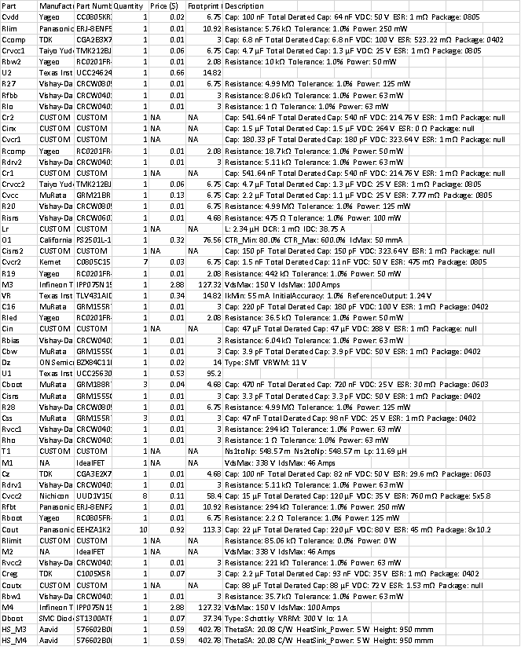

Step Up Converter BOM
Part | Manufacturer | Part Number | Quantity | Price ($) | Footprint (mm²) | Attribute
Cvin | MuRata | GRM21BR72A474KA73L | 1 | 0.16 | 6.75 | Cap: 470 nF Total Derated Cap: 210 nF VDC: 100 V ESR: 1 mΩ Package: 0805
Rt | Vishay-Dale | CRCW0402221KFKED | 1 | 0.01 | 3 | Resistance: 221 kΩ Tolerance: 1.0% Power: 63 mW
Ruvb | Vishay-Dale | CRCW04026K49FKED | 1 | 0.01 | 3 | Resistance: 6.49 kΩ Tolerance: 1.0% Power: 63 mW
Cbst | Chemi-Con | EMVE630ADA220MF80G | 1 | 0.13 | 73.96 | Cap: 22 µF Total Derated Cap: 22 µF VDC: 63 V ESR: 7.2 Ω Package: F80
Rfbt | Yageo | RC0603FR-0739KL | 1 | 0.01 | 4.68 | Resistance: 39 kΩ Tolerance: 1.0% Power: 100 mW
L1 | CUSTOM | CUSTOM | 1 | NA | NA | L: 11.45 µH DCR: 750 µΩ IDC: 131.43 A
Cout | Panasonic | EEV-FK1J471M | 26 | 0.74 | 399 | Cap: 470 µF Total Derated Cap: 12 mF VDC: 63 V ESR: 82 mΩ Package: J16
U1 | Texas Instruments | LM5122MH/NOPB | 1 | 1.9 | 71.4
Coutx | TDK | C5750X7S2A106M230KB | 4 | 0.86 | 53.9 | Cap: 10 µF Total Derated Cap: 17 µF VDC: 100 V ESR: 5 mΩ Package:
M1 | NA | IdealFET | 1 | NA | NA | VdsMax: 148 V IdsMax: 30 Amps
Cin | Panasonic | EEV-FK2A331M | 7 | 0.81 | 483 | Cap: 330 µF Total Derated Cap: 2.3 mF VDC: 100 V ESR: 153 mΩ Package: K16
Rfbb | Vishay-Dale | CRCW04021K00FKED | 1 | 0.01 | 3 | Resistance: 1 kΩ Tolerance: 1.0% Power: 63 mW
Css | MuRata | GRM155R61A474KE15D | 1 | 0.02 | 3 | Cap: 470 nF Total Derated Cap: 470 nF VDC: 10 V ESR: 1 mΩ Package: 0402
M2 | NA | IdealFET | 1 | NA | NA | VdsMax: 148 V IdsMax: 30 Amps
Dbst | CUSTOM | CUSTOM | 1 | NA | NA | Type: ? VRRM: 64 V Io: 1 A
Rcomp | Yageo | RC0201FR-0718K7L | 1 | 0.01 | 2.08 | Resistance: 18.7 kΩ Tolerance: 1.0% Power: 50 mW
Ccomp2 | TDK | C2012C0G1H332J060AA | 1 | 0.03 | 6.75 | Cap: 3.3 nF Total Derated Cap: 3.3 nF VDC: 50 V ESR: 0 Ω Package: 0805
Ruvt | Vishay-Dale | CRCW040249K9FKED | 1 | 0.01 | 3 | Resistance: 49.9 kΩ Tolerance: 1.0% Power: 63 mW
Rvin | Yageo | RC1210FR-072R74L | 1 | 0.03 | 14.7 | Resistance: 2.74 Ω Tolerance: 1.0% Power: 500 mW
Rsense | CUSTOM | CUSTOM | 1 | NA | NA | Resistance: 575.19 µΩ Tolerance: 0.0% Power: 0 W
Ccomp | Kemet | C1812C823J5GACTU | 1 | 0.87 | 23.1 | Cap: 82 nF Total Derated Cap: 82 nF VDC: 50 V ESR: 0 Ω Package: 1812
Cres | Taiyo Yuden | TMK212BJ474KD-T | 1 | 0.02 | 6.75 | Cap: 470 nF Total Derated Cap: 470 nF VDC: 20 V ESR: 1 mΩ Package: 0805
Cvcc | CUSTOM | CUSTOM | 1 | NA | NA | Cap: 220 µF Total Derated Cap: 220 µF VDC: 25 V ESR: 0 Ω Package:
Rslope | Yageo | RC0201FR-07365KL | 1 | 0.01 | 2.08 | Resistance: 365 kΩ Tolerance: 1.0% Power: 50 mW

Step Down Converter BOM
Part | Manufacturer | Part Number | Quantity | Price ($) | Footprint (mm²) | Attribute
U1 | Texas Instruments | LM5117PMHX/NOPB | 1 | 1.85 | 71.4
M1 | Texas Instruments | CSD18543Q3A | 1 | 0.25 | 18.49 | VdsMax: 60 V IdsMax: 35 Amps
Cinx | TDK | C2012X7R2A104K125AA | 1 | 0.03 | 6.75 | Cap: 100 nF Total Derated Cap: 100 nF VDC: 100 V ESR: 20.73 mΩ Package: 0805
L1 | Coilcraft | XAL1010-822MEB | 1 | 1.71 | 159.6 | L: 8.2 µH DCR: 11.7 mΩ IDC: 17.1 A
Rsense | Susumu Co Ltd | PRL1632-R008-F-T1 | 1 | 0.2 | 10.92 | Resistance: 8 mΩ Tolerance: 1.0% Power: 1 W
D1 | Comchip Technology | CDBW46-G | 1 | 0.03 | 13.1 | Type: Schottky VRRM: 100 V Io: 150 mA
Rt | Yageo | RC0201FR-0712K1L | 1 | 0.01 | 2.08 | Resistance: 12.1 kΩ Tolerance: 1.0% Power: 50 mW
Cboot | MuRata | GRM155R71C104KA88D | 1 | 0.01 | 3 | Cap: 100 nF Total Derated Cap: 100 nF VDC: 16 V ESR: 1 mΩ Package: 0402
M2 | Texas Instruments | CSD18543Q3A | 1 | 0.25 | 18.49 | VdsMax: 60 V IdsMax: 35 Amps
Ruv2 | Vishay-Dale | CRCW060354K9FKEA | 1 | 0.01 | 4.68 | Resistance: 54.9 kΩ Tolerance: 1.0% Power: 100 mW
Rfb1 | Vishay-Dale | CRCW04021K00FKED | 1 | 0.01 | 3 | Resistance: 1 kΩ Tolerance: 1.0% Power: 63 mW
Cout | Panasonic | 20SVPF120M | 1 | 0.44 | 73.96 | Cap: 120 µF Total Derated Cap: 120 µF VDC: 20 V ESR: 25 mΩ Package: 6.3x6
Cramp | MuRata | GRM033R71E821KA01D | 1 | 0.01 | 2.08 | Cap: 820 pF Total Derated Cap: 820 pF VDC: 25 V ESR: 1 mΩ Package: 0201
Cin | TDK | C5750X7S2A106M230KB | 3 | 0.86 | 53.9 | Cap: 10 µF Total Derated Cap: 12 µF VDC: 100 V ESR: 5 mΩ Package:
Rramp | Vishay-Dale | CRCW0603124KFKEA | 1 | 0.01 | 4.68 | Resistance: 124 kΩ Tolerance: 1.0% Power: 100 mW
Rcomp | Vishay-Dale | CRCW040233K2FKED | 1 | 0.01 | 3 | Resistance: 33.2 kΩ Tolerance: 1.0% Power: 63 mW
Ruv1 | Vishay-Dale | CRCW04021K74FKED | 1 | 0.01 | 3 | Resistance: 1.74 kΩ Tolerance: 1.0% Power: 63 mW
Ccomp2 | MuRata | GRM033R71C101KA01D | 1 | 0.01 | 2.08 | Cap: 100 pF Total Derated Cap: 100 pF VDC: 16 V ESR: 1 mΩ Package: 0201
Rfb2 | Vishay-Dale | CRCW040214K0FKED | 1 | 0.01 | 3 | Resistance: 14 kΩ Tolerance: 1.0% Power: 63 mW
Cres | Taiyo Yuden | TMK212BJ474KD-T | 1 | 0.02 | 6.75 | Cap: 470 nF Total Derated Cap: 470 nF VDC: 20 V ESR: 1 mΩ Package: 0805
Cvcc | Taiyo Yuden | TMK212BJ474KD-T | 1 | 0.02 | 6.75 | Cap: 470 nF Total Derated Cap: 470 nF VDC: 20 V ESR: 1 mΩ Package: 0805
Css | Panasonic | ECPU1C154MA5 | 1 | 0.17 | 10.92 | Cap: 150 nF Total Derated Cap: 150 nF VDC: 16 V ESR: 0 Ω Package: 1206
Ccomp1 | MuRata | GRM1555C1H102JA01J | 1 | 0.01 | 3 | Cap: 1 nF Total Derated Cap: 1 nF VDC: 50 V ESR: 0 Ω Package: 0402
Dvcc | Panasonic | DB2S31600L | 1 | 0.03 | 5.13 | Type: Schottky VRRM: 30 V Io: 100 mA

11.4 Task Delegation
To complete this project in time and to best utilize the skills of each team member we split the tasks required to complete this project among the team members. Each member got a task that best utilized their skill set and fit their previous experience.
The computer engineering majors were tasked with the components and parts of the device that required programming and communication while the electrical engineering majors focused on creating circuits to connect all the parts together and to provide power. The table below has a detailed explanation of each team member's specific tasks.

Team member | Task
Nader Abd El Rasol | - Designing the circuit for the piccolo.  - Coding the piccolo.  - Testing the motor control.  - Testing advanced features (Music streaming, weather, RGB light controls).  - Designing the circuit for the bluetooth/wifi module).  - Configuring the communication between the piccolo and the 1DX.
Lucy | - Designing the circuit for the piccolo.  - Coding the piccolo.  - Testing the motor control.  - Testing advanced features (Music streaming, weather, RGB light controls).  - Designing the circuit for the bluetooth/wifi module).  - Configuring the communication between the piccolo and the 1DX.
Andrew | - Designing the DC/DC step up converter to power the motor drive and other subsystems.  - Designing the DC/DC step down converter to power external RGB lighting.  - Simulation and testing of DC/DC circuits.
Hesham | - Designing the AC/DC voltage regulator to power the motor drive and other subsystems.  - Simulation and testing of AC/DC circuit  - Research on use and implementation of BLDC motors.  - Research on testing of integral hardware components

12.0 Summary and Conclusions
The Super Boat Lift Boss will be an innovative new product designed to compete with other smart boat lifts on the market. There is a demand in the small boat industry for automated boat lifts because people do not want to physically turn a wheel to lift their boats anymore. This is why new boat lifts are becoming popular such as the Boat Lift Boss by Extreme Max and Lift Tech Marine’s Boat Lift. This competition prompted Extreme Max to ask RV Intelligence to provide a smart phone operated boat lift. Our sponsor has worked with us to design the new product, the Super Boat Lift Boss.

The boat lift we designed will accept both AC and DC power supplies, something none of the other boat lifts offer. To accept AC power, we have designed an AC/DC converter. This complicated circuit has been one of our biggest challenges. It is very dangerous working with AC power supplies, but we have the help and experience from our sponsor. Creating a circuit without the use of ideal parts posed a problem, but we have discussed different ways to replace the ideal parts. We will be working with experienced engineers to provide as much safety as possible. Since we need to accept both AC and DC power, we also created a DC/DC step up converter to convert the 12V to 48V. The 48 V is needed to run the brushless DC motor. Both of these converters will be used to provide universal power acceptance.

Another improvement on the current boat lift is the ability to power LED strips. These LED strips are used to light up docks, but users often have trouble setting up a power supply for them. The Super Boat Lift Boss will have output connectors to supply power to LEDs. This requires a DC/DC step down converter. Most LEDs run on 12V, so we designed a circuit to convert the 48V used in the motor to 12V for the LEDs. This circuit along with the other two converters were designed using Webench and KiCAD. We concluded that Webench does not always output an accurate, realistic circuit. Some of the components were ideal and we needed to make adjustments to make the circuits realistic. With the help of our sponsor we were able to adjust the circuits accordingly.

The motor and LEDs will be controlled by the mobile and web application. This application will help the Super Boat Lift Boss compete with other boat lifts using smart devices. The Boat Lift Boss offers a remote control to activate the boat lift, but the Super Boat Lift Boss will offer both the remote and an application to use on mobile devices. Not only can the users access the controls with a smartphone, there will be a website available to control the motor with any device with internet connection. The application will control the motor by connecting to the Piccolo C2000 controller. This connection is made possible by the Murata 1DX module. The communication signals will be sent through Bluetooth BLE from the mobile device to the 1DX. The website will be sending data through Wi-Fi.

The Super Boat Lift Boss application will control the lifting and lowering of the boat, customize the colors for the LEDs, and provide weather information. The most complicated part of this will be the control of the motor through digital signal processing. We will use dsp to keep track of the height and speed of the boat lift. This will be completed through code for the piccolo controller. The LEDs will have different color options sent from the mobile application. This allows for the maximum customization of the user’s dock. The last major component of the application is the weather information. This weather data will be pulled from a free public weather API. To provide the boat users with the best boating experience, it is important that they know the temperature, wind speed, and chance of precipitation. This weather information will be displayed on the weather page of the application along with any weather alerts in the area. It is especially important that the user knows if there are weather alerts before going out on the water.

All of these moving pieces will come together at the end of this project to create the Super Boat Lift Boss. As we complete each piece of the project, we will test the modules individually. The hardware and software must be tested separately before integrating them together. Once the individual components are successfully tested, we will use a variety of testing techniques to test the system as a whole. One of the biggest problems posed with testing is finding an object that weighs 6,200 lbs to test the motor. Thankfully our sponsor has access to RVs and other heavy objects that we can use to test the motor.

13.0 Appendix
“IEC.” IEC 60529:1989 AMD1:1999 AMD2:2013 CSV | IEC Webstore | Water Management, Smart City, Rural Electrification, webstore.iec.ch/publication/2452.
Parker, Max. “IP67 Vs IP68: Waterproof IP Ratings Explained.” Trusted Reviews, 11 Feb. 2019, www.trustedreviews.com/opinion/what-is-ip68-ip-ratings-explained-2947135.
John, et al. “Guide to Bluetooth Security.” CSRC, 8 May 2017, csrc.nist.gov/publications/detail/sp/800-121/rev-2/final.
Zhenyu Yu and David Figoli, “AC Induction Motor Control with TMS320C240 Using Constant V/Hz Principle and Space Vector PWM Technique”, DSP Digital Control Systems Applications Texas Instruments, Houston, TX. pp 267-289
IEC 60529, “degrees of Protection Provided by Enclosures (IP Codes),” Ed. 2.1 (Geneva: International Electrotechnical Commision, 2011)

