University of Central Florida
Department of Electrical & Computer Engineering
EEL 4914
Senior Design I
Slate
Multi-Input Wireless Macro Keypad

Project Documentation
Divide and Conquer, Version 2.0

Group 8 Team Members: Project Coordinators:
Diego Agudelo, CpE Dr. Lei Wei
Andhres Bolano-Melendez, CpE Dr. Samuel Richie
Samuel Chodur, EE
Jacob Goodman, CpE

June 25, 2021


Table of Contents
1 Project Description 3
1.1 Team Member Introduction 3
1.2 Project Motivation 3
1.3 Goals and Objectives 3
1.4 Features and Functions of Slate 3
1.5 Marketing Analysis 4
2 Requirements Specification 6
2.1 Engineering Requirements 6
2.2 Constraints 7
2.3 Related Standards 7
2.4 House of Quality 7
3 Project Block Diagram 9
3.1 Hardware Block Diagram 9
3.2 Power Path Management Block Diagram 9
3.3 Software Block Diagram 10
3.3.1 Software Use Case Diagram 10
3.3.2 Programming Language Considerations 11
3.4 Visual Representation 11
4 Project Budget Estimate and Financing 12
4.1 Development Budget 12
4.2 Single Unit Bill of Materials (BOM) 12
5 Initial Project Milestones 13
5.1 Senior Design I & Senior Design II 13
Figures and Tables
Table 2-1: Engineering Requirements 6
Table 2-2: Engineering Constraints 7
Table 2-3: Related Engineering Standards 7
Figure 2-1: House of Quality 8
Figure 3-1: Hardware Block Diagram 9
Figure 3-2: Power Path Management Block Diagram 9
Figure 3-3: Software Block Diagram 10
Figure 3-4: Flowchart of Slate's Configuration 10
Figure 3-5: Initial 3D renderings of Slate 11
Table 4-1: Development Budget 12
Table 4-2: Single Unit Bill of Materials (BOM) 12
Figure 5-1: Project Milestone Gantt Chart 13

Project Description

Team Member Introduction
The Slate project is made up of four team members, each with a unique and diverse set of background and skills. Diego Agudelo is seeking his BSCpE in the Comprehensive Track besides school he is furthering his business in custom automotive lighting and is interested in finding employment related to hardware design. Andhres Bolano-Melendez is seeking his BSCpE in the Comprehensive Track with the goal of finding employment in software development for one of the FAANG companies. Samuel Chodur is seeking his BSEE in the Communication and Signal Processing Track. Samuel is currently employed as a Data Analyst but is interested in finding employment related to embedded software design. Jacob Goodman is seeking his BSCpE in the Comprehensive Track. Jacob is an incoming hire to SK Hynix as a Technical Marketing Engineer in 2022. Currently there are no customers, sponsors, or significant contributors to the project.

Project Motivation
Some may argue that the most valuable resource on earth is a person’s time. Saving a few seconds over a lifetime can lead to more goals being achieved, more unique opportunities being experienced, and an overall more relaxing lifestyle. Any moment that can be made more productive compounds and results in a life filled with satisfaction. Slate is meant to enhance productivity and efficiency during our user’s creative workflows.

Goals and Objectives
The goal of this project is to have a fully functioning customizable multi-input wireless macro keypad that combines a touch-display with multiple physical inputs to provide macro functionality to the user in a compact and robust form-factor. Slate would allow for the user to configure key data to be displayed back on the built-in display. These features allow for the user to navigate their device in a more efficient way and monitor important aspects of their work without information being lost on their main output device.
The design of Slate will be a mixture between portability and functionality, while still maintaining an aesthetic that easily blends into the desktop of most users. We want the users of Slate to be proud of their device. It should be a device that catches the eye of all types of computer users when perusing the shelves or scanning digital advertisements and reviews. Slate aims to give users additional customization, choice, and flexibility they didn’t know they could benefit from.
The intuitiveness of the device must be clear from the first use. We hope to avoid a steep learning curve by making the most basic and useful functions immediately apparent whilst still providing the customizability sought after by the power user. Ideally, Slate becomes as important of a peripheral to the power user as their mouse and keyboard. The ultimate goal is for every user of Slate to wonder how they ever got along without it.

Features and Functions of Slate
The function of this project is to assist the user with an additional interface of “one-push” macros. The device is a mixture of a programmable touchscreen, physical switches, and rotary encoders. The programmable touchscreen would provide mainly application-specific macros, with the user able to select from multiple pages and profiles of digital “buttons” that execute a programmed macro or routine function. Physical switches can be customized in functionality but ideally remain the same between applications, serving as generalized macros across the OS. Rotary encoders assist the user in level, timeline, and scaling-based tasks, such as adjusting volume, scrolling the video timeline in editing software, or zooming in and out on a photo.
After brainstorming and investigating products like Slate, the main features and functions of Slate were identified. The results of this investigation are listed below:
- Includes a user interface via touch screen, physical keys and rotary encoders.
- The entire system should be portable.
- Provides user-programmable macros.
- Uses standard, user-serviceable switches for physical keys.
- Interfaces wirelessly with accompanying device.
- USB or Battery can power the device.
- USB connection can charge device and provide data transmission to PC.
- Programmable via mobile application with Bluetooth connection.
- Programmable RGB LEDs for physical keys to denote function.
- Haptic feedback for touchscreen input.
- Onboard speaker to provide audio feedback.
- User can select from multiple macro functions at any given time.
- User can program the macro keypad using complementary software.

Marketing Analysis
Similar products exist but do not offer the level of choice, flexibility, and/or affordability that our project offers. Products researched to determine feature addition and gap closure include:
- Elgato Streamdeck (4.6 x 3.3 x 0.8") $150 (6.7 oz / 190 g)
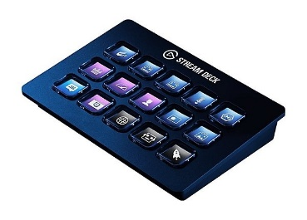
- Loupedeck Creative Tool (6.3 x 5.9 x 1.2") $550 (12.9 oz / 365 g)
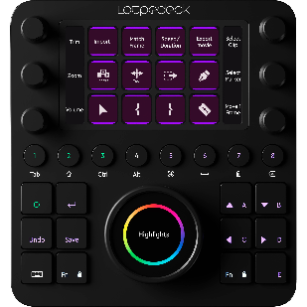

- DIY Macro Key-switch Keypad (typically 4 x 4 x 2") ~$100 (7 oz / 199 g)
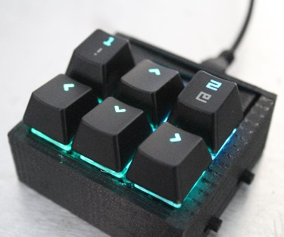
Products such as the Streamdeck give the user buttons with customizable screens that denote their function and allow for multiple profiles. This was the main influence for adding a touchscreen to our product. The Streamdeck does not provide any additional physical inputs however, and only operates while wired via USB. Loupedeck products are the most similar to our design and give a good blend of physical and digital inputs, but its high price and wired operation allow space for our product to contend. Many macro keypad projects from DIY enthusiasts exist as well that only use standard key-switches. While this may be the lowest cost option, they are often not built with wireless functionality and only provide static key-switches that require the user to remember their programmed function. For these reasons we’ve focused on a compact, wireless-capable macro keypad that blends both highly customizable digital inputs and traditional physical inputs to give the user as much choice as possible.

Requirements Specification

Engineering Requirements
The engineering requirements specify the technical and budgetary needs of the design. The performance requirements are arguably the most important requirements and are often characterized by time, accuracy, throughput, or percentage error. The functionality requirements describe the type of functions the system should perform. The requirements identified for Slate are shown in the table below:
Engineering Requirement | Justification
- Slate’s touch screen shall have a perceived latency less than 100ms. | Perceived latency of the touch screen is an important factor for users of macro-keyboard devices.
- Slate’s physical keys shall have a perceived latency less than 100ms. | Perceived latency of physical keys is expected to be imperceivable for most products on the market today.
- Slate’s touch screen will have input accuracy greater than 99%. | Users of similar devices expect their inputs to be read accurately.
- Slate shall operate for at least five hours from battery power alone with 100% utilization. | Based upon current products in the market.
- Slate shall provide at least six programmable macro functions. | This allows for a suitable number of functions while not requiring an exuberant amount of memory.
- Slate’s touch screen will have input accuracy greater than 99%. | Misinterpreted inputs will lead to user frustration and ultimate product failure.
- Slate shall maintain all functionality when powered via USB. | Users will expect all functionality to remain the same no matter the power source.
- Slate shall maintain all functionality when powered via internal battery. | Users will expect all functionality to remain the same no matter the power source.
- Slate’s battery shall be rechargeable. | A rechargeable battery is something that is expected in nay portable device in today’s market.
- Slate’s battery will charge when connected via USB. | Minimizing the amount of accessories Slate requires leads to a better user experience.
- The total cost of developing the system should not exceed $1,000. | The group has a limited budget and should not be expected to spend exceedingly for the project.
- The total for manufacturing cost and parts should not exceed $100. | To be considered competitive in the market space, the price of the final product must be affordable.
Table 2-1: Engineering Requirements

Constraints
The constraint requirements are created from limitations imposed by the environment or stakeholders.
Engineering Constraint | Justification
- The size of the prototype should not exceed 6" x 6" x 2". | Slate should be easily transportable and blend in with most user setups.
- The weight should not exceed 12oz / 340g. | Slate should be easily transportable.
Table 2-2: Engineering Constraints

Related Standards
A thorough understanding of the standards applicable to any project is an essential part of the design process. Some of the related standards that have been identified during our initial planning of this project are listed below.
Governing Body | Designator | Description | Creation Date
IEEE | 828 | Configuration Management in Systems and Software Engineering | February 6, 2012
IEEE | 802 | LAN / MAN | ~
IEEE | 802.15.1 | WPAN / Bluetooth | September 11, 2009
IEC | 62680 | USB interfaces for data and power | February 16, 2021
ISO/IEC/IEEE | 29119 Series | Software Testing | September 2013
Table 2-3: Related Engineering Standards

House of Quality
To better show the interrelationships between our target engineering specifications and the market features of the Slate we created a House of Quality (HOQ). The HOQ is a primary tool used during the quality function deployment (QFD). This QFD encompasses marketing, design, and manufacturing which is represented as a series of matrices that resembles a house. These matrices relate our marketing goals with our engineering requirements by showing us important tradeoffs when adding features to our Slate. 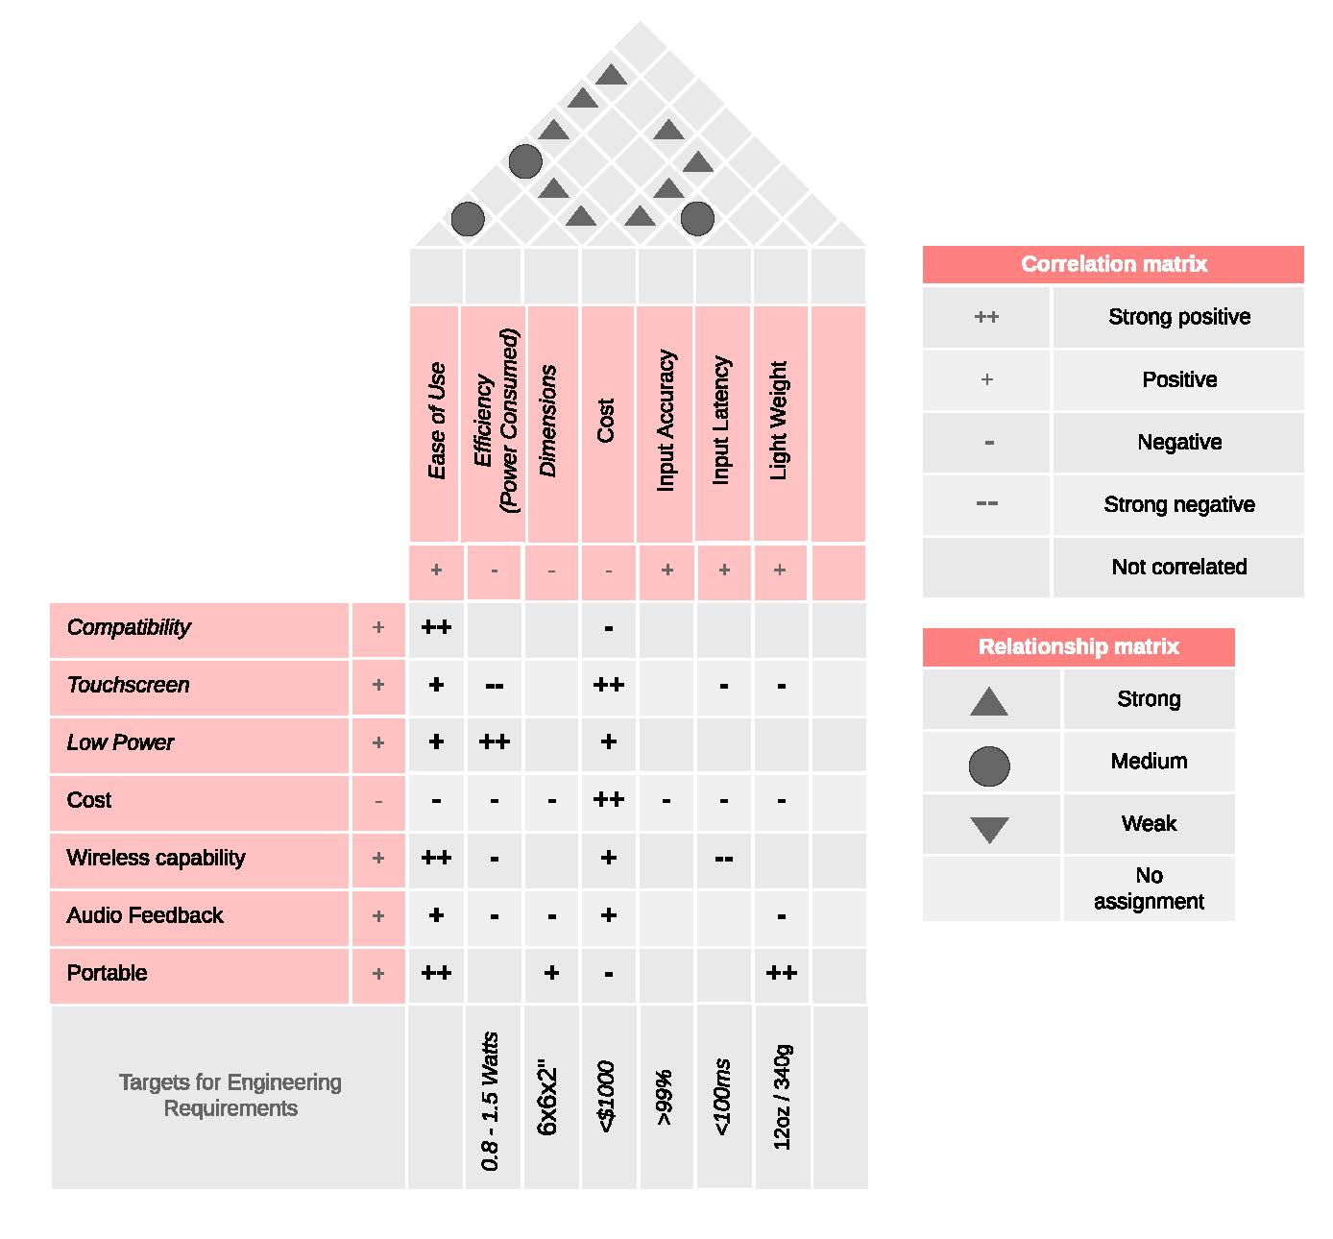
Figure 2-1: House of Quality

Project Block Diagram

Hardware Block Diagram
A diagram representing the hardware system is shown in Figure 3-1. The hardware for the design of Slate will consist of four major components which include the power subsystem, the communication subsystem, the microcontroller unit, and the user interface.
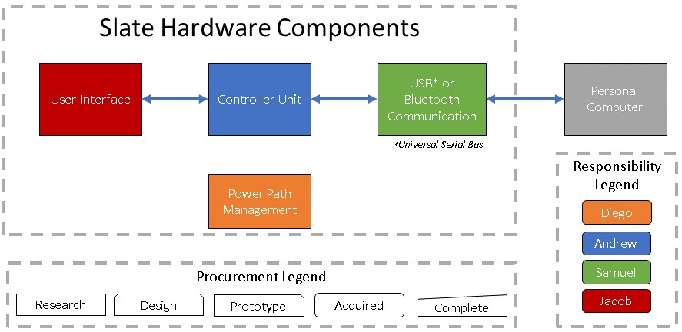
Figure 3-1: Hardware Block Diagram

Power Path Management Block Diagram
Power for Slate will be provided from USB when available and via an internal battery when USB is not available. A high-level view of this system is shown in the following figure.
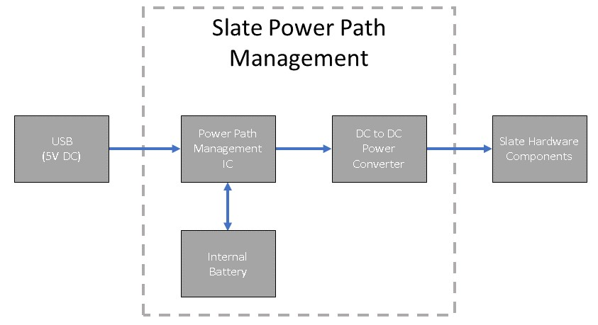
Figure 3-2: Power Path Management Block Diagram

Software Block Diagram
A diagram representing the overarching software system is shown in the following figure.
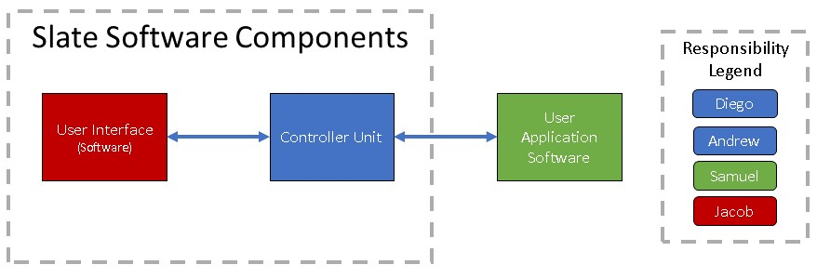
Figure 3-3: Software Block Diagram

Software Use Case Diagram
The key interactions the user will have with Slate and its configuration software are shown in the flowchart below:
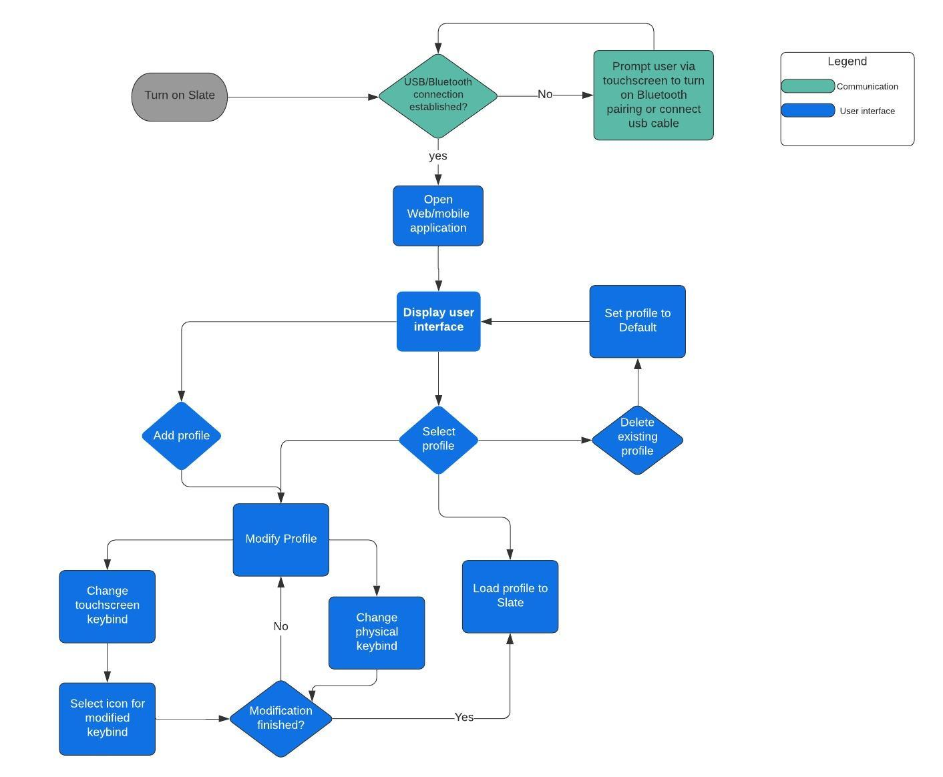
Figure 3-4: Flowchart of Slate's Configuration

Programming Language Considerations
The two software languages we will be considering for flashing to the controller unit is C and CircuitPython. Both have their advantages and disadvantages: C favors performance while CircuitPython has a simpler method of flashing the controller (if the controller supports the memory requirements) and shorter development time due to ease-of-programming.

Visual Representation
The following image which is subject to change is a rough rendering of what our product will look like. The main idea behind this rendering is to make the device as user friendly as possible, the closest to the user is the touchscreen which allows for customizable commands/programs that can be added. Then above follows a joystick and two nobs. At the top of the device there will be a total of 10 buttons that will also be customizable by the user. The enclosure that holds all the components will be 3D printed. For the purpose of Slate, we will be using PLA filament. The cost of building will be provided by Slate team member, Diego Agudelo, since he has a 3D printer at his disposal. If by any means he cannot print out the enclosure we will use the 3D printer supplied in the TI Innovation Lab at UCF. As far as which type of filament we are currently leaning towards PLA instead of ABS, PETG, TPU, and PC. We will further explain why we chose PLA later on.

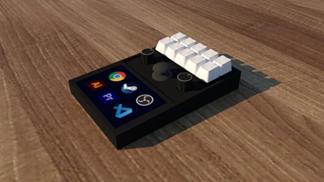
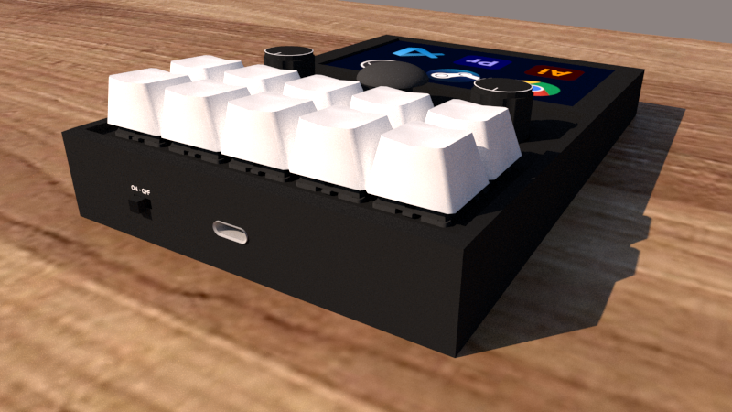
Figure 3-5: Initial 3D renderings of Slate

Project Budget Estimate and Financing
The costs associated with this project will be self-funded. The budget currently is set at a couple hundred dollars in which will split equally among the four project members. Currently, no equipment has been acquired, besides what is already in each team member’s possession. The initial components required for prototyping this project plan to be obtained by August 1, 2021. This target date allows for enough lead time to research the required components in their entirety and enough lag time to prototype, test, and build a finished product.
We identified several of the main cost areas that will be necessary for the realization of Slate. These main cost areas are the Microcontroller Unit, the Power System, the USB Communication System, the Bluetooth Communication System, the User Interface, the hardware enclosure, and the cost of manufacturing. Many of these cost areas overlap, i.e., the Power System and the USB Communication system, but the prices associated with our budget in Table 1 were identified independently of one another. We chose this approach because we would rather overbudget than underbudget so any unforeseen costs that may arise throughout the development of our project can be mitigated.

Development Budget
Cost Area | Price (USD) | Quantity | Total (USD)
Development Board | $25 | 1 | $25
Development 3.5” Touchscreen | $40 | 1 | $40
3000mAh 3.7V Lithium Battery | $14 | 1 | $14
Total |  |  | $79
Table 4-1: Development Budget

Single Unit Bill of Materials (BOM)
Cost Area | Price (USD) | Quantity | Total (USD)
Microcontroller Unit | $15 | 1 | $15
Power Components | $13.50 | 1 | $13.50
Battery | $14 | 1 | $14
USB-C Connector | $5 | 1 | $5
MX-Style Key Switch | ~$0.65 | 10 | $6.50
PS2-Style Joystick | ~$2 | 1 | $2
Rotary Encoder | ~$1.75 | 2 | $3.50
3.5” Touchscreen | $25 | 1 | $25
Hardware Enclosure | $10 | 1 | $10
Manufacturing/Shipping Fees | $10 | n/a | $10
Total |  |  | $ 104.50
Table 4-2: Single Unit Bill of Materials (BOM)
As the necessary parts required to build these components are identified, a more accurate budget will be produced. This more accurate budget will include the costs to build several prototypes, and the last version of Slate.

Initial Project Milestones

Senior Design I & Senior Design II
The following Gantt chart shows our expected milestones throughout senior design 1 & 2.

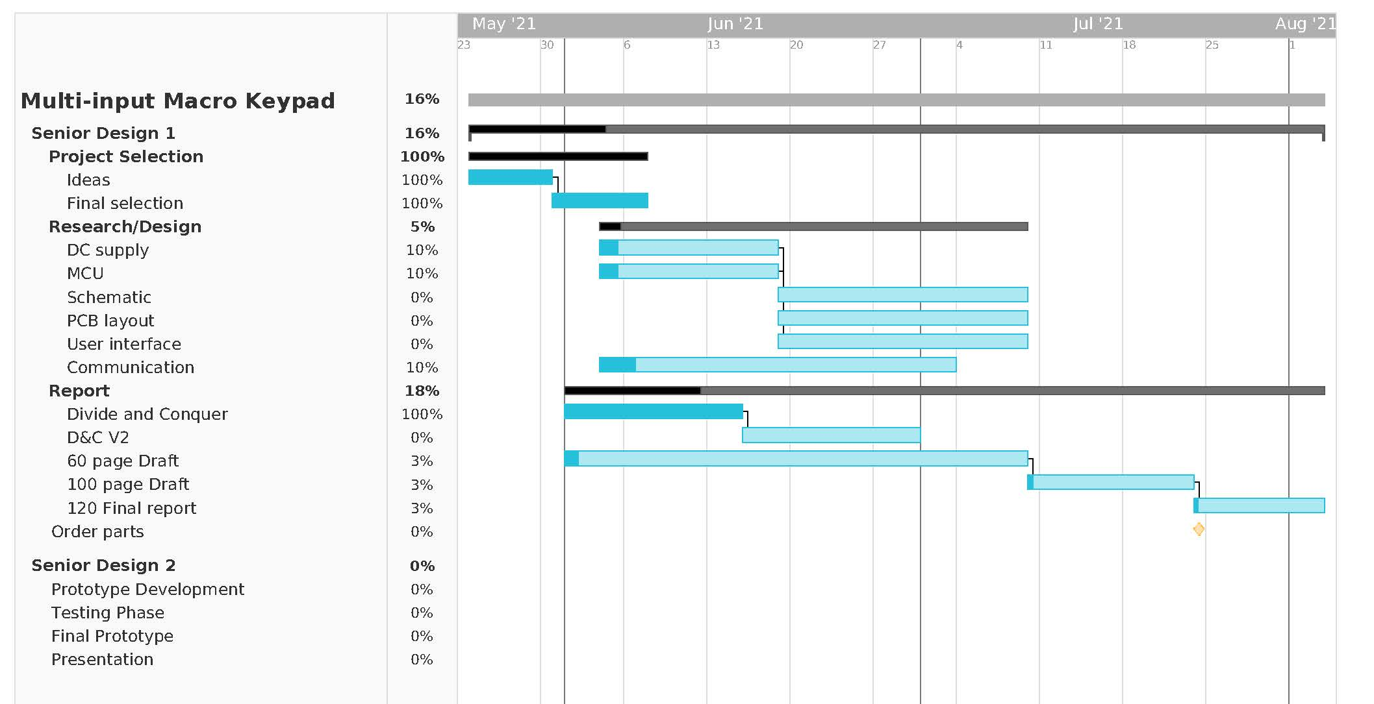
Figure 5-1: Project Milestone Gantt Chart
The majority of June will be spent documenting our technology investigations and meeting the report requirements. While in July a working prototype will be built, and our group will start ordering the parts for the definitive version of the Slate. In SD2 the Slate will go through the final production sequences and begin an extensive testing phase. Once the final workable prototype is built, preparations for the demonstration will begin.

