Spring 2022 Senior Design 2
Live Bolt Smart Lock

Department of Electrical and Computer Engineering
University of Central Florida
Final Draft
Group 22 (F)
December 2, 2022

Linda Anyosa - Electrical Engineering
Mohamed Faizel - Computer Engineering
Andrew O’Reilly - Electrical Engineering
Joel Shaw - Computer Engineering

1. Executive Summary 1
2. Project Description 2
2.1 Project Motivation and Goals 2
2.2 Objectives 2
2.3 Requirements Specifications 3
2.4 Quality of House Analysis 5
3. Research Related to Project Definition 7
3.1 Existing Similar Projects and Products 7
3.1.1 Ring Doorbell 7
3.1.2 Google Nest Doorbell 7
3.1.3 Yale Lock Integration 8
3.1.4 August Smart Lock 8
3.1.5 Nuki Smart Lock 9
3.2 Computation and Control Device 10
3.2.1 Arduino Line 10
3.2.1.1 Arduino Uno 11
3.2.1.2 Arduino Mega 11
3.2.2 Raspberry Pi Line 12
3.2.2.1 Raspberry Pi Model 3B+ 12
3.2.2.2 Raspberry Pi Model 4 12
3.2.3 Texas Instruments MSP430 Line 13
3.2.3.1 MSP430FR6989 Launchpad 13
3.2.3.2 MSP430G2553 Launchpad 14
3.2.4 ESP Wi-Fi Module Line 14
3.2.4.1 ESP32 15
3.2.4.2 ESP8266 16
3.3 Sensors 16
3.3.1 Voice/Phrase Recognition 16
3.3.2 Face Recognition 17
3.3.2.1 Computer Vision 17
3.3.2.2 Intel RealSense ID 17
3.3.2.3 Xbox Kinect 18
3.3.2.4 Smart Phone Face ID 18
3.3.3 Near-Field Communication 20
3.3.4 Infrared Sensor 20
3.3.5 Security Camera 20
3.3.6 Keypad 21
3.3.7 Fingerprint Scanner 21
3.4 Power Sources 22
3.4.1 Solar Panel 22
3.4.2 AC Power 22
3.4.3 Conventional Battery Pack 23
3.5 Locking Methods 23
3.5.1 Electric Strike Locks 24
3.5.2 Magnetic Locks 24
3.5.3 Dead bolt Locks 25
3.6 Feedback System 26
3.6.1 LED/Buzzer on Physical Device 26
3.6.2 Application Notifications 26
3.6.3 LCD Display 27
3.6.4 OLED Display 27
3.7 Parts Selection 28
3.7.1 Computation and Control Device 28
3.7.2 ReSpeaker 4-Microphone Array 28
3.7.3 Smart Phone Face Identification 28
3.7.4 HiLetgo NFC Module 29
3.7.5 HC-SR501 Infrared Sensor 29
3.7.6 ArduCam Security Camera 30
3.7.7 Keypad 30
3.7.8 Rechargeable Battery Packs 30
3.7.9 Traditional Dead-Bolt Lock 30
3.7.10 Feedback System 31
3.7.11 Parts Summary 31
4. Related Standards and Realistic Design Constraints 31
4.1 Standards 32
4.1.1 Wi-Fi Standards (802.11) 32
4.1.2 Bluetooth Standards (802.15.1) 32
4.1.3 RFID Standards 33
4.1.4 NFC Standards 33
4.1.5 Measurement Standards 33
4.1.6 Deadbolt Lock Standards 34
4.1.7 Battery Standards 35
4.1.8 Face Recognition Standards 36
4.1.9 Programming Best Practices 36
4.1.10 Apple App Store and Google Play Store Standards 37
4.1.11 Design impact of relevant standards 39
4.1.12 Printed Circuit Board Standards 39
4.2 Realistic Design Constraints 40
4.2.1 Knowledge constraints 40
4.2.2 Economic constraints 40
4.2.3 Time constraints 42
4.2.4 Environmental constraints 43
4.2.5 Energy constraints 44
4.2.6 Social constraints 44
4.2.7 Political constraints 44
4.2.8 Ethical constraints 44
4.2.9 Health and Safety constraints 46
4.2.10 Sustainability constraints 46
4.2.11 Manufacturability constraints 46
5. Software Design Details 47
5.1 Initial Design Architecture 47
5.2 Mobile Application Pros and Cons 48
5.2.1 LAMP Stack 48
5.2.2 MERN Stack 48
5.2.3 MEAN Stack 49
5.3 UX Design 49
5.4 Preliminary UI Design 50
5.4.1 Preliminary Design 1 50
5.4.2 Preliminary Design 2 53
5.4.1 Application Navigation 56
5.4.2 Use Case Diagram 57
5.5 Logo Design 58
5.6 Bluetooth Pairing 59
5.7 MQTT/Mosquitto 60
5.8 Development Environment 60
5.9 App Store Publishing Process 61
5.10 Google Play Store Publishing Process 61
5.11 Mobile Stack Technologies 62
5.11.1 MERN Stack Reasoning 62
5.11.2 JavaScript 62
5.11.3 Ajax 63
5.11.4 JSON 63
5.11.5 JSX 63
5.11.6 JSON Web Token 64
5.12 React Native Components 64
5.12.1 VirtualizedList 64
5.12.2 Pressable 65
5.12.3 KeyboardAvoidingView 66
5.13 Database Structure 66
5.13.1 MongoDB Creation and Syntax 68
5.14 Near Field Communication (NFC) 69
5.15 iOS FaceID/TouchID Implementation 69
5.16 Transmission Control Protocol (TCP) 71
5.17 User Datagram Protocol (UCP) 72
5.18 Live CameraFeed 73
5.19 Google Drive API 74
6. Hardware Design Details 74
6.1 Preliminary Hardware Design 75
6.2 Hardware Selections 76
6.2.1 Arduino Keypad 76
6.2.2 Raspberry Pi 4B+ 77
6.2.2.1 Raspberry Pi Microphone 77
6.2.2.2 Raspberry Pi Camera Module 78
6.2.3 PIR Motion Sensor 79
6.2.4 High Torque – Metal Gear Servo 79
6.3 Power Distribution 80
6.4 3D Printing 81
6.5 Electronics Placement/ CAD Models 82
6.5.1 Lock Box Prototype 82
6.5.1.1 Lock Box CAD Model 83
6.5.2 Security Box Prototype 85
6.5.2.1 Security Box CAD Model 86
6.6 Summary of Design 88
7. Printed Circuit Board Integrated Schematics 89
7.1 PCB Terminology 89
7.2 PCB CAD Software 91
7.2.1 KiCad 91
7.2.2 EAGLE 91
7.2.3 CAD Software Decision 92
7.3 Printed Circuit Board Designs 92
7.3.1 Security PCB Design 93
7.3.2 Lock PCB Design 94
7.4 PCB Vendor and Assembly 96
8. Project Prototype Testing Plan 98
8.1 Hardware Test Environment 98
8.2 Hardware Specific Testing 98
8.2.1 MCU Testing 98
8.2.2 Deadbolt Knob Design Testing 100
8.2.3 Electrical Components Testing 103
8.2.3.1 ESP8266/Arduino Programming 103
8.2.3.2 ESP Wi-Fi Communication 104
8.2.3.3 HC-SR501 IR Sensor 105
8.2.3.4 Membrane Keypad 106
8.2.3.5 HiLetgo NFC Module 106
8.2.3.6 High Torque Servo Motor 107
8.2.3.7 Raspberry Pi Dependencies and Packages 107
8.2.3.8 Arducam 108
8.2.3.9 Phrase Recognition 108
8.2.4 Battery Testing 110
8.2.5 Final Hardware Product 110
8.3 Software Test Environment 111
8.4 Software Specific Testing 112
8.4.1 Types of Testing 112
8.4.2 Testing Frameworks 113
8.4.3 Jest 114
8.4.4 Mocha 114
8.4.5 Cypress 114
8.4.6 Jasmine 115
8.4.7 Selenium 115
9. Administrative Content 116
9.1 Milestone Discussion 117
9.2 Software Development Gantt Chart 118
9.3 Hardware Development Gantt Chart 119
9.4 Budget and Finance Discussion 120
Appendices 121
Appendix A: References 121
References 121

1. Executive Summary
It’s every homeowner’s dream to discover an all-in-one security system with affordability to the consumer’s access. With a growing and competitive market of security systems, there is a lack of cost flexibility of how much security would be provided to the consumer. What makes our project different than other security systems it incorporates home monitoring and entry control through our mobile application and Keypad on our security box. We accomplished this by designing a mobile React Native application that pairs with the Hardware and interfaces with the lock to the homeowner deadbolt. Hence the introduction of the project, Live Bolt.

One of our main objectives we sought initially when discussing Live Bolt as a concept was to ideally have a functioning system to present in the senior design showcase. Part of that included decreasing the likelihood of bugs, it being operational, and provide home monitoring to users. Our application was created to be aesthetically presentable with user friendly compatibility. As a team, we know that installation of any home system requires handy tools, so we are designed both the security and home monitoring box to have installation ease with an enclosed placement to harness the electronics. Further objectives to building Live Bolt will have its own section and be explained into more details.

Building the mechanism and harnessing the compatibility to a phone application would require having components in mind. To share the data between the hardware and software of the system, a Raspberry pi and an MCU will satisfy these requires. Although these components don’t consist of the whole system, it would bring together the data exchanged to control the open/close lock and push notifications for home monitoring. Other hardware and software design choice will be elaborated further given the research and design done to execute our goal.

After developing the ideal design, we overcame realistic design constraints. These included a wireless connection throughout the system, aesthetic presentation of the system, and ease of battery change. Ethical challenges from the construction of the system were considered with the intention of preventing a security breach. External data will be for citational and referenced purposes only to keep the consumers privacy secured.

As a group we provide variety of experience ranging of two computer and two electrical engineers. We want to challenge ourselves in different ranges of developing an application, creating a PCB, learning about CAD, and implementing IoT to our understanding. Developing Live Bolt gave us that gateway to design and explore engineering concepts we wanted to learn.

2. Project Description

2.1 Project Motivation and Goals
The main motivation for creating this project was from our individual experience in package theft. In an instance that a package has been labeled delivered but, not within the front door or close radius of a home can be bothersome to a customer. A package is ideally something of a need or want from a consumer. Why not monitor/report any front door activity through a security system? In this question, we came with the idea of building a security system to monitor and allow front door access to delivery workers with a one-pin code to reliably deliver the package within a home. Although this idea grants entrance, there must be an automated lock to open and close the door for a home. Therefore, we decided to expand upon this project to include variety of access control for the consumer. It’ll logically make sense to not only have a locking mechanism for delivery worker but to include forms of entrances for the consumers own usage. We wanted to introduce a software application to harness the access control to a consumer with the usage of their cell phone. Additionally, this motivation of creating an application would challenge and utilize the team’s software skills in building a reliable security system that could potentially be used in industry. Our goal was to create a reliable low-cost security system with multiple methods of home/package safety for the consumers of tomorrow. We wanted to challenge the current security market by creating a new product. In doing so, we tried to keep the system as user-friendly as possible while keeping it as secure as possible. We achieved these goals by creating a lightweight security system that can be placed in desired monitoring areas (e.g., home, shed, garage), distributing power to electronic hardware, and establishing a connection between the lock and phone application. We also tried to keep the costs of hardware low while maintaining quality to make this product accessible to low-income families.

2.2 Objectives
Our main objective for the project is to design an innovative security and integrated lock system that combines the features of available systems in the market into a package. Our project stands out, due to us offering the many features in access control and home monitoring with an affordable price in mind. This all was geared to ensure optimal quality, functionality, and aesthetics to our customers home and style. How we targeted these objectives was by researching existing home security and locking systems on the market. Looking at access control we took into consideration versatility about how a homeowner would like to open their front door. With security measures, we researched forms of home monitoring and effectiveness at keeping a property secured. These two objectives were the focus when developing the hardware and software for the project. With our mobile application we focused on adhering to commonly held design standards to usability, maintaining an always-online internet connection, and including a variety of access and monitor methods to ease user accessibility. Additionally, we’d tried to ensure that our system works with most preexisting locks. Creating a compact/portable system was our priority when engineering the smart lock design throughout our choice of buying electrical/mechanical parts. For the requirement of including a designed PCB, we tried to make ours as compact as possible to achieve our objective of a compact system. From the team’s knowledge and capabilities, we ensured through testing that we were delivering a fully functioning product that our customers would love.

2.3 Requirements Specifications
For the design of our Live Bolt product, we’d like to incorporate a mixture of all the following research we’ve conducted on home security and access control devices. The list below in Table 1, Table 2, Table 3, and Table 4 will include requirement specifications on hardware and software execution of our senior design project. We split these requirements to security system, access control, application, and design. They each will respectfully go over the requirement, solution, and ways we verified these specifications.

Table 1: Requirement specifications for Security System Features
SECTION | REQUIREMENT | SOLUTION | VERIFICATION
Security System (SS)
SS.1 | Notifying motion sense to consume | Controlled through a MCU (IR motion detector) | Integrate sensors to application
SS.2 | Home monitoring | 5 Megapixel, 2592 x 1944 image resolution, 1080p video resolution | Viewable video stream sent from camera
SS.3 | Time stamps unlock attempts | Sensing | Send message to user when attempts are made
SS.4 | Single use PIN numbers for guests/ delivery workers | Application interface for one-use code | Send a text message to guest with one-use code
SS.5 | Alarm system | Integrate LEDs and buzzers | Send message to app when alarm system is triggered

Table 2: Requirement specifications for Access Control Features
SECTION | REQUIREMENT | SOLUTION | VERIFICATION
Access Control (AC)
AC.1 | Allow consumer to access application in more than 1 way​ | Android/iOS application | Publish to App Store/Google Play Store
AC.2 | Allow door to be locked/unlocked in 3+ methods​ | Unlock/lock remotely via mobile application with touch ID authentication​  Primary PIN code via keypad​  Guest PIN code via keypad​  Door locks 10 seconds after unlocking​ | Notification sent when door is locked/unlocked​  LED blinks once for correct PIN and twice for incorrect PIN​  Guest PIN will only work once before being invalidated​

Table 3: Requirement specifications for Application Features
SECTION | REQUIREMENT | SOLUTION | VERIFICATION
Application (A)
A.1 | Simple and user-friendly UI/design | Design application off of a Figma Template and hold to the design standards outlined by the Google and Apple App Stores. | Use a variety of methods to test code, including end-to-end tests using Jest and Puppeteer.
A.2 | Live Bolt must be always-online to mobile application | Using a MERN stack with a React Native Frontend, API served over a Heroku hosted Node.js server with a MongoDB Backend. Request will always be server due to the API living on the cloud. | Display message to user if connection is lost
A.3 | Accessibility | Lock/Unlock Button, TouchID for Lock/Unlocking, Activity Log for any lock/unlock attempts, Camera Monitoring when motion is detected from PIR sensor. | Integrate all 4 methods of access and verify through end-to-end testing using Jest and Puppeteer.

Table 4: Requirement specifications for Design Features
SECTION | REQUIREMENT | SOLUTION | VERIFICATION
Design (D)
D.1 | Locking door system | High torque servo to turn lock, 10 kg*cm with about 170 degrees range of motion. 3D Printed cover for deadbolt turn knob | Servo is successfully able to turn the knob cover enough to lock/unlock door every time
D.2 | Harness electronic parts in casing | Selected PETG as the case for Live Bolt | Compared filaments in the current market: PLA, ABS, PETG
D.3 | Rechargeable Batteries | Design a reliable battery system to change AA batteries and/or recharge a battery pack | Understand power requirements for electronic parts

2.4 Quality of House Analysis
Before constructing Live Bolt, we created a house of quality for our system to ensure the highest quality of our product between engineering requirements and marketing requirements. The House of quality matrix, shown in Table 5, allows us to identify the level of importance and devise a strategy on how to achieve our requirements. Before beginning to identify the importance for each requirement, creating a legend for the correlation, relationship, and improvement of direction for our system is indicated below the table. In our table we highlighted what wad stated in our goals such as portability, security protection, sensors, battery life, etc., in engineering requirements. Now this must align with customer requirements within the quality or product and user preferences. This would market to customers with the understanding that our team puts their usability/ flexibility first. With the weight column ranging from 1-10, we identify cost and user interface as top priority to make it accessible and user-friendly as possible to be purchased by a larger audience.
Engineering and customer requirements go together when finding the direction of improvement needed to be done in our system. As engineers, the house of quality outlines ways we can improve our design why considering a consumer desire. With Live Bolt, we intent to maximize improvement although intuitively we could overcome engineering constraints.
Table 5: House of Quality for Live Bolt
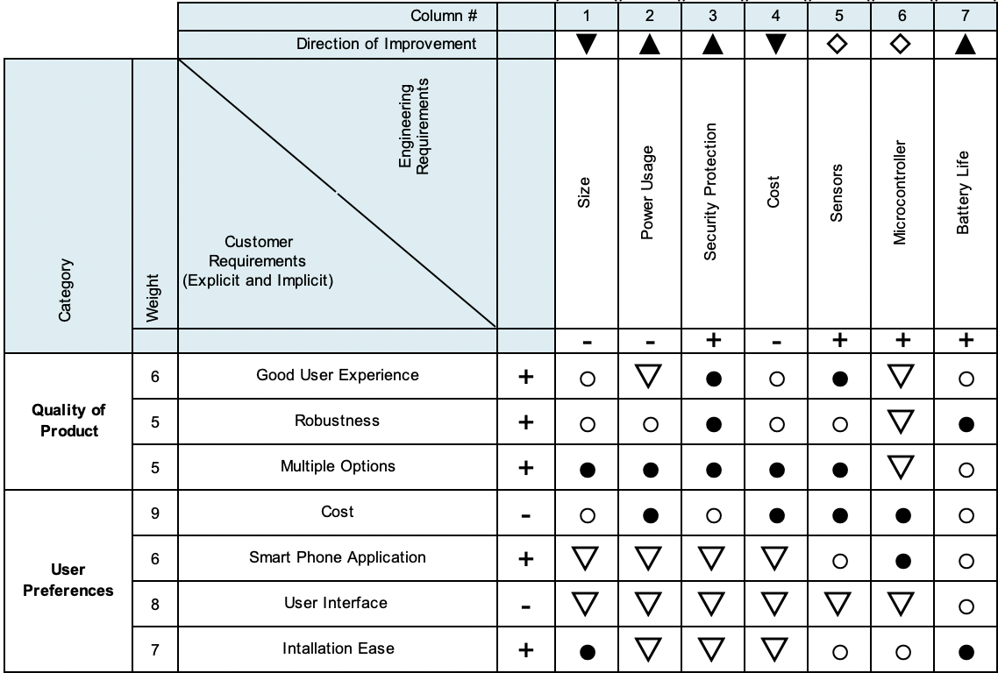
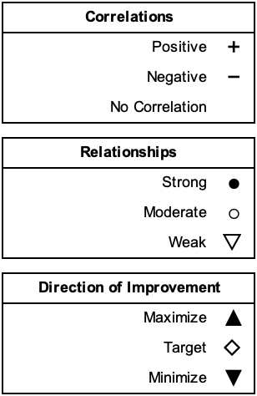

3. Research Related to Project Definition

3.1 Existing Similar Projects and Products
Home security and access control integrated in homes today are at an abundant. With this growing market, we would like to formally research about existing products and seek improvement in their systems. This research helped inspire the design for Live Bolt.

3.1.1 Ring Doorbell
Ring video doorbell provides variety in the sense that there are different features of home monitoring installation: wired, battery powered, and bundles leading to solar power or security included. Ring doorbell is customized to reach as many consumers as possible no matter the circumstance of the front door, hence the variety of options. Additionally, with Ring’s growing reputation, they provide flexibility to consumers with different option in monitoring their home. From buying one of their products, it includes motion detection; application integration of notifying the consumer of front door activity; and see, hear, speaking que to visitors in real time.

There are some downsides to including one of the Ring video doorbell to one’s home. One main reason being that there are so many options to choosing a reliable doorbell into one’s home. With that comes variety of options for how to determine one’s monitoring. Many options include variety but could be overwhelming to a customer. Additionally, to use one of their products it includes a monthly subscription plan from additionally purchasing the device. Another problem with ring doorbell is that it requires a strong Wi-Fi connection that essentially must be provided by the consumer. Information exchange between the device and application will be hindered if not provided with a strong network. This research is great notes on how to make our Live Bolt system enhanced and more available to the public. We would like to obtain features that the Ring doorbell incorporates like motion sensing and application availability while subtraction the subscription plan. Live Bolt differs since there’ll also be access control of entering a home through the application. We also take reference of the Ring application to apply towards our application user interface.

3.1.2 Google Nest Doorbell
Another product like Live Bolt is the Google Nest Doorbell, Google’s attempt at a home security monitoring system. It has many features such as a camera, doorbell, sound detection and familiar face detection. Moreover, the setup is wired to configure with an existing doorbell system or can run wirelessly. Google has made it possible to integrate the doorbell with the rest of the Google Nest environment. Features the Nest Doorbell that Live Bolt will include are the camera monitoring system, face detection, and app integration. However, unlike the Nest Doorbell, Live Bolt allows for multiple unlock methods and gives the user can unlock log report through the application interface. It additionally differs in that it is a door locking security system compared to Nest Doorbell which only offers video and audio monitoring. Through this comparison between the two systems, we can see clearly that Live Bolt is the more cost-effective option than the Nest Doorbell. The Nest Doorbell only offers Doorbell monitoring of your existing system while Live Bolt steps up the security of your system.

3.1.3 Yale Lock Integration
Google Nest Doorbell has the capability to interface with the Yale electronic door lock. The Yale lock is a keyless smart lock, similar to Live Bolt, that incorporates a digital keypad. Yale allows for a passcode you can give to people you trust that you can disable at any time. It also offers self-locking features, and the ability to lock/unlock through a phone application. With Live Bolt, we will combine features from both the Nest Doorbell and Yale Lock to enhance safety and security in a single product.

3.1.4 August Smart Lock
The August Lock is a Smart Lock system like many of the others we researched which integrates directly onto an existing deadbolt system. It does require some unscrewing to integrate however August does include videos to guide users through the process. One benefit is that the August lock doesn’t prevent you from using your traditional key so that option is still available to use. It includes an Auto Lock and Auto Unlock feature which allows for geofencing to be used to determine if the user is leaving or heading toward the home. It also allows for the ability to use a smartwatch to lock and unlock the door without having to bring out your phone.

The lock has a mobile app which allows many features including controlling multiple locks, inviting other people to manage the locks, temporary guest keys, an activity timeline, and additional security with the option of mobile bio authentication through the smartphone. These are useful features and many of which we are including in our Live Bolt system to strengthen its security and usability. Additionally, the August Lock does have multiple models to choose allowing customers to choose what locking system works best for them. The pricing of their most costly locking system, the Wi-Fi Smart Lock, comes to 229 USD which is comparable to the wired version of the Google Nest Doorbell. Additionally, if customers end up getting a cheaper model and want to add the August Wi-Fi Bridge to get all the features the total cost is the same as or less than the cost of the Wi-Fi Smart Lock.

There are downsides to August’s Smart Locks. For one the newest generation released by August, although smaller and less bulky than the previous generation, has a smaller battery life. The 3rd generation had a battery life ranging from 6 to 12 months where the current 4th generation has a battery life from 3 to 6 months. Additionally, the batteries for the 4th generation are not the standard AAA or AA batteries and are instead CR123A batteries. These batteries are both more difficult to find and expensive to purchase than normal replaceable batteries. A drawback from August lock comes to auto unlocking connectivity. Auto lock works well for when the lock is able to connect to Bluetooth easily. However, it doesn’t work as well when it fails to connect before the User reaches the door making them wait.

Another issue can happen when the door unlocks but the user takes too long to open it. If the user lives in an area where they must climb stairs or use an elevator the door can unlock and then relock before the user reaches. This also becomes a convenience issue for the user as it could force them to use their key or have to unlock the lock again from their phone. Another issue with the August lock and most other smart locks is the lack of RFID and Near-Field Communication (NFC). The August Lock already supports smartwatch integration and allowing for NFC unlocking would be a useful feature. It would eliminate the need to take out your phone or open the app allowing for the user's device to be held close to the lock to open.

3.1.5 Nuki Smart Lock
The Nuki Smart Lock is another product that caught our attention as we were researching our project. It is a smart lock system that directly integrates onto an existing locking system. There is no need for screwdrivers or other tools to install the system as it uses a physical key to lock and unlock the door as if a person was turning the lock themselves. This way of integrating the system allows it to be compatible with many door locks. Nuki has recently revamped their product line with the 3.0 series offering a normal and pro model. Both share many of the same features aside from the pro having a Wi-Fi module in addition to its Bluetooth module, and a rechargeable battery where the normal uses 4 AA batteries. In our Live Bolt system, we will be providing only one product so users will not have to worry about product tradeoffs like with Nuki’s products. Nuki also provides smartwatch integration in addition to their mobile app allowing for you to unlock your door from your smartwatch. They also allow the ability to create and assign digital keys to family and friends which is like a feature we took our own inspiration from in the Live Bolt system.
We did see downsides to the Nuki Smart Lock 3.0 series which we have taken note of in designing the Live Bolt system. The first is that not all locks work with Nuki’s system so customers will need to check their compatibility guide before purchasing a lock. Another is that for the normal lock model any Wi-Fi actions the user wants to do will need the Nuki Bridge, one of Nuki’s many accessories. The Nuki Bridge has a Wi-Fi module allowing for the base model lock to connect to Wi-Fi. The Pro model comes with this feature in the box. Without the Wi-Fi module in the Pro or Nuki Bridge with the base model users lose out on features like Smart assistants, and Remote management. This significantly limits the users experience and these are features we have implemented into Live Bolt without the need for accessories.

Another downside of the Nuki is cost. The base model is 149 € which is 169 USD, and the Pro is 249 € which is 305 USD. This is already a high cost for the system, and it doesn’t consider the price of the many accessories Nuki offers to enhance the Smart Lock experience. From a Keypad to open your door with a code to the Door Sensor which enhances the sensing of the system, Nuki offers many accessories which can feel vital to a better experience. Lastly, the Nuki system does not include a camera for both models. Lacking this feature makes seeing who is at your door impossible, however Nuki does include an activity report in the app for monitoring. This is limited however to Nuki products that can connect to Wi-Fi. The Live Bolt system has a camera for viewing activity outside the door allowing for the user to know what is always happening.

3.2 Computation and Control Device
To execute our objective for Live Bolt, there’ll need to be control and wireless communication between the servo and/or sensors to the application. Choosing the right control device played a large role to our design; therefore, we dove into the various options to what control devices are on the market and their characteristics for delivering performance.

3.2.1 Arduino Line
The Arduino line of microcontrollers operates from an ATmega chip. The specific model of Arduino varies depending on the application. The two that we have narrowed down to are the Arduino Uno and Arduino Mega. Both operate at 5V, are programmed via USB A/B; however, they have a lot more differences than similarities that will be outlines below. Figure 1 shows the Uno and Mega boards side by side while Table 6 outlines the main differences between each board.

Table 6: Arduino Uno vs Arduino Mega Comparisons
Characteristic | Uno | Mega
Cost | $20 | $42
Size | 68.58 mm x 53.34 mm | 101.6 mm x 53.34 mm
Processor | Atmega328p | ATmega2560
Clock Speed | 16MHz | 16MHz
Flash Memory | 32kB | 256kB
Pin Count | 20 | 70

3.2.1.1 Arduino Uno
The Arduino Uno is a smaller microcontroller, with a size of 68.58 millimeters by 53.34 millimeters. Since it is physically smaller, it has fewer pins, with 14 digital pins and 6 analog pins. The Arduino Uno also has a 16MHz Atmega328p processor and 32kB of flash memory. These microcontrollers can be purchased in the range of $20.

3.2.1.2 Arduino Mega
The Arduino Mega is physically much larger than the Arduino Uno, at 101.6 millimeters by 53.34 millimeters. Since it is longer it has more pins, 54 digital pins and 16 analog pins, 50 more pins than the Uno. It has a 16MHz ATmega2560 processor and 256kB of flash memory. These models are usually around $42.

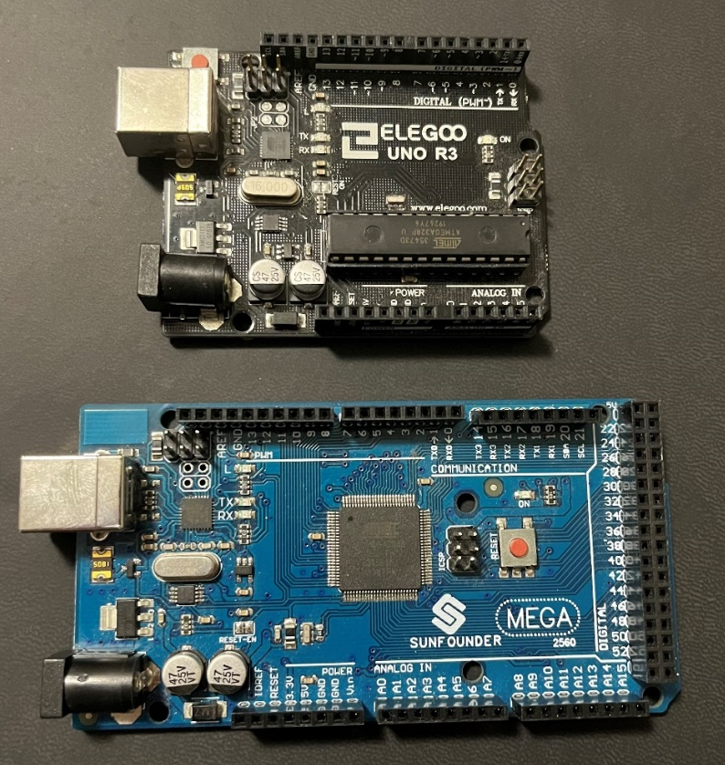
Figure 1: Reproduction Arduino Uno (Top) and Arduino Mega (Bottom) running ATmega architecture

3.2.2 Raspberry Pi Line
The Live Bolt System will need a more powerful processor to host the application and process voice recognition. The Raspberry Line of computation devices would easily serve this need. A Raspberry Pi is essentially a small computer and can run an operating system and programs. The two Raspberry Pi boards we will look at are the Model 3B+ and the newer Model 4. Both are 85.09 millimeters by 55.88 millimeters, house 40 GPIO pins, and operate off 5V. They are also capable of Wi-Fi natively. Figure 2 shows each board side by side while Table 7 outlines the main differences between each board.

3.2.2.1 Raspberry Pi Model 3B+
The Model 3B+ is an older model, but not obsolete by any means. With a 1.5GHz Quad-Core Broadcom BCM2837B0 processor and 1GB DDR2 RAM, the Model 3B+ can handle multiple processes at once. It has one HDMI port, four USB 2.0 ports, and ethernet. It is also powered through either a micro-USB or a GPIO pin header to supply power. These models usually cost around $35.

Table 7: Raspberry Pi 3B+ vs Raspberry Pi 4 comparisons
Characteristic | Model 3B+ | Model 4
Cost | $35 | $45
Size | 85.09 mm x 55.88 mm | 85.09 mm x 55.88 mm
Processor | Broadcom BCM2837B0 | Broadcom BCM2711
Clock Speed | 1.5GHz | 1.5GHz
Flash Memory | 1GB DDR2 RAM | 1GB, 2GB, 4GB DDR4
Pin Count | 40 | 40
Input/Output | 1 HDMI, 4 USB 2.0, Ethernet | USB-C,2 micro-HDMI, 1 HDMI, 2 USB 2.0, 2 USB 3.0

3.2.2.2 Raspberry Pi Model 4
The Model 4 is the successor to the Model 3B+. It has improvements to the processor, now a 1.5 GHz Broadcom BCM2711. The RAM has also been updated to DDR4, with options for 1GB, 2GB, and 4GB. The power is now supplied through a GPIO pin or USB-C and there are two micro-HDMI ports rather than one full HDMI port. Two of the four USB 2.0 ports were also replaced with two USB 3.0 ports. The 2GB model costs about $45.

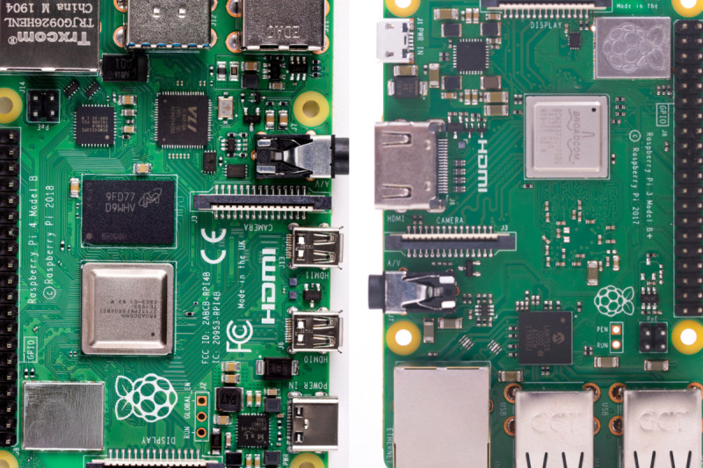
Figure 2: Raspberry Pi 4 (Left) and Raspberry Pi 3B+ (Right) [1]

3.2.3 Texas Instruments MSP430 Line
Texas Instrument microcontrollers offers one of the best analog in the industry with affordability as its best option. The MSP430 line is 16-bit MCU including flexible, integrated analog components, such as ADCs, DACs, and Op-amps; Integrated LCD controllers for displaying information; and devices with USB2.0 for communication with PC or application updates. As undergraduate engineering students at UCF, our classes have introduced two known microcontrollers from TI: MSP430FR6989 and MSP430G2553. Figure 3 shows each board side by side while Table 8 outlines the main differences between each board.

Table 8: MSP430FR6989 Launchpad vs MSP430G2553 Launchpad comparisons
Characteristic | MSP430FR6989 | MSP430G2553
Cost | $24-$60 | $40
Size | 76.2 mm x 50.8 mm | 69 mm x 51 mm
Processor | MSP430FR6989 | MSP430G2553
Clock Speed | 16 MHz | 16MHz
Flash Memory | 16KB | 128KB
Pin Count | 83 | 24
Input/Output | LCD, I2C, SPI, Micro USB | Micro USB

3.2.3.1 MSP430FR6989 Launchpad
The MSP430FR6989 provides ultra-low-power FRAM platform uniquely embedded and a holistic ultra-low-power system architecture to increase performance at lowered energy budgets. Additionally, the MSP430FR6989 includes features of a 16-Bit RISC architecture up to 16-MHz Clock, integrated LCD driver with 320 segments, and multifunction input/output ports. The board is 76.2 millimeters by 50.8 millimeters. A few parameters from this microcontroller (MC) include a 128 kB non-volatile memory, 2 KB of RAM, 12-bit SAR ADC, No USB port, 2 I2Cs and 4 SPI. Due to high demand, these are currently out of stock in the TI website, but alternative websites offer this microcontroller from $24 - $50.

3.2.3.2 MSP430G2553 Launchpad
The MSP430G2553 is like the FR6989 MC from the fact that it is also an ultra-low-power missed signal MC with a built in 16-bit timer. It has low supply-voltage range of 1.8 V to 3.6 V. The G2553 is a 16-bit RISC architecture and a basic clock module configuration with a 24 capacitive touch enabled I/O pins. This board is 69 millimeters by 51 millimeters. There is no LCD driver or USB port in this MC. Note that an online purchase will equate to the price of just a chip but, the whole controller would summarize to $40.

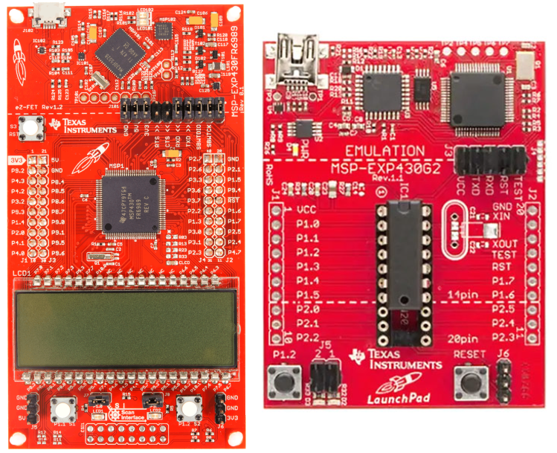
Figure 3: MSP430FR6989 Launchpad (Left) vs MSP430G2553 Launchpad (Right)

3.2.4 ESP Wi-Fi Module Line
The ESP line of microcontrollers are low-cost controllers with wireless capabilities that are great for internet-of-things and home automation projects, like the Live Bolt. If we choose to include Wi-Fi into the microcontrollers of the Live Bolt system, it might be better to opt for an ESP device over another microcontroller since Arduino and MSP430 do not have Wi-Fi natively. Both modules come with Wi-Fi and are programmed via the Arduino integrated development environment (IDE). Figure 4 shows each board side by side while Table 9 outlines the main differences between each board. We will use this table to determine which would be more ideal to move forward in our design and begin testing outcomes we might desire with the ESP Wi-Fi module line. Comparing the two models will show importance to not only price and functionality but to how we can easily integrate this our Live Bolt system. Meaning the use of the PCB and compartment for this project.

3.2.4.1 ESP32
The ESP32 is a very powerful development board with a 160MHz clock frequency, 34 GPIO pins, 16 PWM channels, SRAM, and Flash RAM. These models also include a touch sensor, temperature sensor, and hall effect sensor. It operates on the HT40 40Mhz spectrum of a 2.4GHz Wi-Fi band. One major difference between the ESP32 and ESP8266 is that the ESP32 includes Bluetooth 4.2 and Bluetooth 5.0 with Bluetooth Low Energy (BLE). The dimensions are 54.6 millimeters by 27.94 millimeters by 13 millimeters (respective to length by width by height) and costs anywhere from $6 to $12.

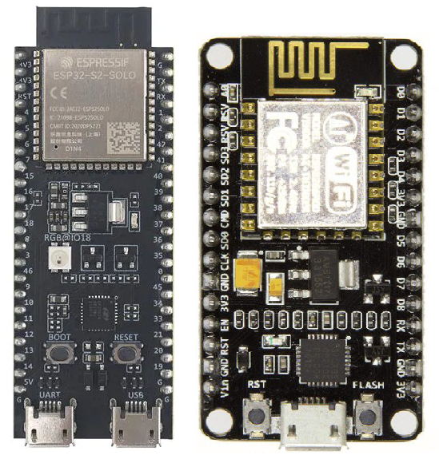
Figure 4: ESP32 (Left) vs ESP8266 NodeMCU (Right)

Table 9: ESP32 vs ESP8266 comparisons
Characteristic | ESP32 | ESP8266
Cost | $6 - $12 | $3 - $6
Size | 54.6 mm x 27.94 mm x 13 mm | 48 mm x 26 mm x 13 mm
Clock Speed | 160MHz | 80MHz
Pin Count | 50 | 25
Input/Output | Touch, temperature, hall effect sensors, micro-USB, Bluetooth 5.0, 40MHz 2.4GHz band. | Micro-USB, 20MHz 2.4Ghz band

3.2.4.2 ESP8266
The ESP8266 is less powerful than the ESP32 but is still very useful for the application of this project. There is a breakout board for development that is called the ESP8266 NodeMCU, that we will be considering. It has an 80MHz clock frequency, 17 GPIO pins, and 8 PWM channels. It lacks any Bluetooth capabilities and operates on the HL20 20MHz spectrum of the 2.4GHz Wi-Fi band. It also lacks the touch sensor, temperature sensor, and hall effect sensor that is present on the ESP32. Since it lacks some features, it is smaller and cheaper, coming in at 48 millimeters by 26 millimeters by 13 millimeters (respective to length by width by height) and $3 to $6.

3.3 Sensors
The application for including sensors within our system is to include variety in access control for unlocking a door and provide home monitoring. We will detail the options for choices that could be provided in Live Bolt.

3.3.1 Voice/Phrase Recognition
Since the Raspberry Pi is processing the voice recognition software, a microphone is needed that is compatible with the Raspberry Pi. The microphone must also produce clean voice captures to be used in Artificial Intelligence applications. The voice input will be processed, and the program will determine whatever was said. If the word is a registered trigger word, the system will unlock the door. It would be best to incorporate multiple microphones into an array to get the best voice capture.

3.3.2 Face Recognition
For increased security, we would like to include some form of biometric facial recognition on the Live Bolt system. This can be implemented in a variety of ways, which are outlined below. Our main goal is to have a system that is as accurate as possible at detecting a registered face and rejecting unregistered faces. Overall cost, size and computing time can be greatly impacted depending on the method that is decided.
Table 10 outlines the differences between explored facial recognition methods.

3.3.2.1 Computer Vision
The Live Bolt will have a feature that unlocks the door when a registered face is detected. There are a few ways to go about this. The first method considered was to use a simple webcam and incorporate computer vision image processing methods through machine learning. This method would require a very large dataset of every person using the face identification features. The datasets would need to consist of at least 1000 photos of the person to start reliably detecting. It would require even more photos at different angles and light levels to increase consistency. Once a dataset is created, the photo captured during the unlock attempt would be passed through a convolutional neural network and eventually compared to the dataset. The output of the network would be a prediction if the subject is the same one as in the training dataset. Ideally, an accuracy of 99.5% or greater would be given every time for a positive match, and as close to 0% as possible for a negative match. Due to the limitations of computing hardware and convolutional neural network training times, this method isn’t the most reliable, so it would have to be combined with another form of access like the keypad, to ensure safety.

3.3.2.2 Intel RealSense ID
The second possibility that was researched was 3D mapping technologies like Intel RealSense ID and Xbox Kinect. 3D mapping, or photogrammetry mapping, allows for something in real life to be measured and projected onto a screen in the form of a 3D map or model. The measurement consists of taking small bits of data from different points around whatever you are mapping to create a depth map. One key advantage to 3D mapping for facial recognition, besides for more reliable recognition, is that the 3D map creates depth of someone’s face. This keeps someone from simply showing a photo or model of someone else to the camera and have that be accepted as the target face. The process of using a photo of someone to trick a facial recognition system is known as spoofing.

Intel has developed a technology called RealSense ID that utilizes 3D mapping techniques to rapidly authenticate someone’s face. They have all-in-one products that are ready to be used in a variety of applications straight out of the box, such as their F455 product. They also provide their architecture for custom designs in their F450 product. The features of the F455 will be focused on for the sake of this project. The F455 is 32.5 millimeters x 62 millimeters x 11 millimeters and has a viewing angle of 56° × 78°. It needs a Window, Linux, or Android operating system to operate. These devices have a 1:1,000,000 false acceptance rate (0.0001%), a 99.76% true acceptance rate, and a spoof acceptance rate of less than 0.1%. This makes them extremely secure and fit for a security lock application. Both models come with a system on the chip (SOC) which is an integrated circuit for computing and processing. They are also equipped with two 1920x1080 resolution cameras, IR sensor, 3D dot projector, and a light for more accurate capture. The Intel RealSense ID F455 is available for about $105.

3.3.2.3 Xbox Kinect
Microsoft has developed a product called Kinect for their line of Xbox gaming consoles that also utilize 3D mapping technology, for a gaming application rather than a facial recognition application. Since it is designed for gaming, it is meant more for detecting the body’s of players for motion-based video games. The camera is equipped with a 30 frames-per-second 640x480 pixel resolution color camera and a 320x240 pixel resolution depth camera. The cameras also have a 57° × 43° viewing angle. The lower resolution isn’t best for catching finer details, like what would be on a person’s face. The way it is able to track bodies is by creating a virtual skeleton of up to two players on the screen. These skeletons have 20 joints per player and can track when the player moves one of their joints, like their legs or arms. The Xbox 360 Kinect is 76.2 millimeters x 279.4 millimeters x 76.2 millimeters. The module costs about $20 used.

A new version of the Kinect has been released for the newer Xbox One console and has an updated 1920 x 1080-pixel resolution 30 frames-per-second color camera and 512 x 424 pixel resolution depth camera that are able to track up to six active players. The newer model also has 26 joints that it tracks, rather than 20. It is smaller than the original Kinect, with a size of 66.8 millimeters x 248.92 millimeters x 66 millimeters and it costs approximately $80.

3.3.2.4 Smart Phone Face ID
The most well-known method of Face Recognition is the methods used on modern cell phones to unlock them. This section will mainly focus on the Apple iPhone Face ID and Android Face Authentication HIDL. They work similarly to the 3D depth scanner of the Intel RealSense ID technology. Since most people have a phone with face identification capabilities, this would be a good way to save space on our module while still maintaining quality face recognition. 90% of smart phones are expected to include some form of biometric facial recognition by 2024 [2]. They are also advantageous due to being able to detect someone’s face with minor differences form the training dataset, such as if they were wearing sunglasses or if they grew a beard. Both platforms also have open-source application programming interfaces (APIs) for app developers to program them. Since this method incorporates the user’s phone, there would be little to no cost associated with it. This would in turn keep the overall cost of the product lower, while also keeping the product size smaller since it would not need to house larger cameras or processors for face detection.

Since the group has an Apple iPhone 13, that phones specifications will be considered. The iPhone 13 is equipped with Apple’s TrueDepth camera technology. This includes a camera that is capable of up to 3840 x 2160 pixels (4K) photos or video recording at 60 frames-per-second. The camera relies on a dot projector, similar to the Xbox Kinect, to detect enrolled faces. Over 30,000 dots are projected onto a user’s face and it is able to detect whether the user is enrolled or not based on their facial structure. The TrueDepth camera is designed to work indoors, outdoors, or even in total darkness.

Table 10: Comparisons Between Facial Recognition Methods
Characteristic | Computer Vision | Intel RealSense ID F455 | Xbox One Kinect | Smart Phone (iPhone 13)
Depth Camera Resolution | Dependent on webcam | 1920 x 1080 pixels | 512 x 424 pixels | 30,000 dots
Color Camera Resolution | Dependent on webcam | 1920 x 1080 pixels | 1920 x 1080 pixels | 3840 x 2160 pixels
Frames per second | Dependent on webcam | 90 | 30 | 60
Detection Method | 2D Neural Network matching face to database | 3D dot projection/facial mapping | 3D Depth/joint tracking | 3D dot projection/facial mapping
Physical Size | Dependent on webcam | 32.5 mm x 62 mm x 11 mm | 66.8 mm x 248.92 mm x 66 mm | 147 mm x 72 mm x 7.65 mm
Viewing Angle | Dependent on webcam | 56° × 78° | 70.6° x 60° | 120°
Cost | Dependent on webcam | $105 | $80 | $830

3.3.3 Near-Field Communication
Near-Field Communication (NFC) is a popular use in today technology of contact-less communication from using radio frequency. This technology is used to primarily to exchange data within two devices through a touch gesture. The NFC controller needs to be connected with antenna transmit and receive all NFC communication frames to the NFC Forum Device. Using the NFC forum device was an integration we thought of using in the software in our application for Live Bolt and while making sure it could be recognized by the chip that was to be placed in our design. Since NFC is very flexible in operating in different modes, the most ideal application of NFC to Live Bolt would be through Host Card Emulation. We ultimately decided against the use of NFC communication in LiveBolt due to inherent difficulties using NFC on iPhone devices. We thought about using NFC cards but though that would not be an appropriate solution in a consumer product.

3.3.4 Infrared Sensor
The infrared sensor is integral to the security system because it will help to identify is someone has entered in front of the Live Bolt lock. Any Infrared sensor that is compatible with Arduino or Raspberry Pi would be fine for our application. Ideally it would have 2-5 feet of detecting distance.

Using an infrared sensor for motion detection rather than another method like computer vision or ultrasonic sensing is beneficial because it can detect changes in temperature that the other sensors cannot, and therefore can tell is a human or animal is being detected. An ultrasonic sensor would trigger whenever anything gets into range, such as leaves or other debris.

3.3.5 Security Camera
The Live Bolt system includes a security camera for the customer to view a live feed of the area in front of their door. The security camera has two main requirements: a high Field-of-View and good resolution. This way it can view the largest area with the most clarity. Since most cameras are compatible with Raspberry Pi models, we needed to compare USB cameras, like webcams, to integrated camera modules that connect to the Raspberry Pi via ribbon cables. A secondary requirement for the camera is how much space it will take up. It will need to be mounted to the outdoor module of the Live Bolt, so it would be better for it to be as small as possible while maintaining Field-of-View and resolution quality.

3.3.6 Keypad
The number keypad will be used by guests to unlock the door with a one-time code that is 4 to 6 digits. If there was a single code that always unlocked the door, those keys would begin to fade and make it easy for an intruder to guess the code. The main requirement for this keypad is for it to be weatherproof, mainly from rain since it will be on the outside module, so it must be made of waterproof plastic or metal. An alphanumeric pad could be useful for added security; however, a numeric pad would also be fine for the scope of this project. There are many types of keypads available that fit these requirements such as membrane keypads, dome-switch keypads, and capacitive keypads.

A membrane keypad is probably the most popular option for products that require labeled buttons. They work by having two layers that are separated by an air gap. When the top layer is pressed by a user, it completes the circuit and allows the computer to know which button was pressed. Dome-switch keypads are similar to membrane keypads, except they are more mechanical and provide a tactile click when pressed. The sound and touch feedback help usability. Dome-switch keypads also have incredible reliability, being able to be clicked between one and five million times. Capacitive keypads act similarly to the membrane keypad, except when you press, it charges a capacitor. The change in the capacitors charge is detected and the computer can determine which key was pressed.

3.3.7 Fingerprint Scanner
Fingerprint sensors allow for biometric scanning of a person’s unique fingerprint. This is a very safe option for a lock application since it is difficult to replicate someone else’s fingerprint. Fingerprint scanners are a great way to replace or substitute other forms of access control such as passwords or keys, which can be lost, stolen, or forgotten. Fingerprint scanners have applications for physical access control like for doors, but also for access to computers and other cyber systems. The main types of fingerprint scanners are optical scanners, capacitance scanners, and ultrasonic scanners [3].

Optical scanners are the most common form of biometric fingerprint scanning. They work by using light to create a digital copy of whatever finger is placed on the scanner. This copy is then compared to stored prints in a database to confirm whether to grant access.

Capacitance scanners work similarly to the optical scanners except instead of light creating a copy, the copy is made through voltages stored in a capacitor. An issue with optical scanners that is remedied with the capacitance scanners is that optical scanners can detect someone’s fingerprint by a copy, like on a piece of tape. This is not the case for capacitance scanners, and they are therefore more expensive.

Ultrasonic scanners use ultrasonic waves to hit the pattern on a finger and bounce the waves back to create a print. This method does not need to be included in its own sensor module either, it can be included under glass or a phone, at, or any device. This type of scanner is still being researched so there aren’t many modules available.

If we pursue a fingerprint scanner, we will most likely use an optical scanner due to the all-round effectiveness of them. There are two scanners we have researched.

3.4 Power Sources
All the computational devices we have identified operate off 5V. This means we will need a reliable power source that can output 5V for a very long time. To identify the main source of power to operate our system, we will look at a variety of options to execute its functionality.

3.4.1 Solar Panel
Powering our system from solar panels was an early goal that we wanted to research more. Since solar panels do not output their peak voltage 100% of the time, a battery pack would also need to be included to keep the system running. A panel rated for at least 5V would be required. A possible issue with using solar panels is that the lock system might be shaded from the sun, making any solar panel useless. Solar panels also use up more space, and we would like to keep the system as compact as possible.

3.4.2 AC Power
The most reliable method to power the system would be to tie it to the 120V, 60Hz, AC power used to supply power to the rest of the home. However, this would mean that when the house loses power for any reason, the lock would also lose power. This means we would need to include a supplementary battery pack anyway in case loss of power occurred. Working with 120V is also potentially dangerous for the engineers designing the system, and the customers installing it.

If we decide to use AC power supplied from a home, there will be a need for electromechanical relay switches on our PCB. Relays are essentially electromagnets and switches combined into a single module. They contain a coil that produces a magnetic field when a current is applied. This magnetic field then pulls a mechanical switch closed and allows for current to travel to the electronics. Relays have been used in applications for electronics that are tied to AC power for many years. They have been the main choice for this application due to being inexpensive, easy to use, being available at different voltage ratings, can be used with both AC and DC voltage, and they keep the original electrical signal unmodified [4]. For the case of Live Bolt, a relay module would be beneficial due to having other components pre-installed that allow for direct connection to AC voltages.

Ease of installation is something we are working hard towards and having to tie the system to a house power system may not be safe for someone who is unexperienced. This method would also not be plausible for someone living in an apartment complex.

3.4.3 Conventional Battery Pack
Including a battery pack seems like the best method to supply power to the system. Since both Arduino and the Raspberry Pi operate off 5V, a pack of at least 5V is required. Most batteries are more or less, but not exactly 5V. This means that the battery supply will most likely need to be stepped up or down to 5V to meet power consumption needs.

A major issue with batteries is that they will inevitably run out of charge and the system will lose power. We would like to make the battery packs easily swappable and rechargeable so customers can always have power to their system. Rechargeable AA batteries typically output 1.25V, so including four in series would provide us with the 5V we need. Since we want to include rechargeable batteries, something like a Lithium Polymer battery would not be the best choice for the engineers or the customer These types of batteries are very easy to mishandle by someone without experience and can lead to fire, smoke, or explosions if over or undercharged.

3.5 Locking Methods
Arguably the most important feature of this product is how it will physically lock a door and keep unwanted visitors out. The main methods that were considered for this project were electric strike locks, magnetic locking mechanisms, and traditional dead-bolt locks. Included in our objective, we want to make sure that there is a clear sense of security to the homeowner, hence the reason for including a good locking method. Something important that we are considering when looking at locks is how they behave under fail conditions. We would like the lock to remain locked if power is lost or if the program malfunctions, rather than unlocking. Below are the options we’ve discussed as a team that would be liable for improving security when designing Live Bolt.

3.5.1 Electric Strike Locks
Electric strike locks and magnetic locks are both typically incorporated into doors of most institutional and commercial buildings, like schools or shops. An electric strike lock, seen in Figure 5, operates very similarly to a dead-bolt lock, except that instead of a human turning the bolt, an electric impulse causes the bolt to strike into place. A benefit of the electric strike lock is that once it is locked, it no longer needs an electrical signal and can keep the door from opening.

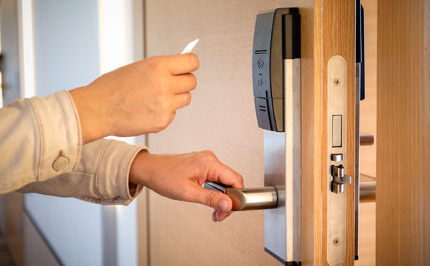
Figure 5: Example of an Electric Strike Lock on a Door [5]

3.5.2 Magnetic Locks
Magnetic locks, seen in Figure 6, feature an electromagnet on the doorframe and a piece of metal attached to the door. When the door is closed, the magnet and metal will make contact. Then, if an electrical signal is sent through the magnet, it will activate and attract the metal piece, causing the door to remain locked closed. The electrical signal for both locks can be sent via multiple methods but are typically sent from a key card reader or keypad. The magnetic lock needs a constant source of power to remain locked, or else the door will be able to be opened.
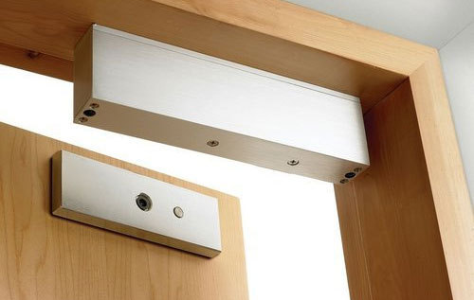
Figure 6: Magnetic Lock on Door [6]

3.5.3 Dead bolt Locks
A traditional dead bolt lock, seen in Figure 7, is what is seen in most homes. It operates by having the user manually turn a thumb knob located on the inside of the home. When this knob is turned, the bolt is struck into place, blocking the door from being opened. To automate this task for the purpose of the Live Bolt system, having a servo motor turn the bolt would be best because it allows the door to be locked or unlocked remotely without the need for a person to physically be at the door.

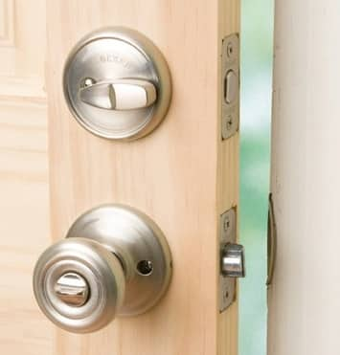
Figure 7: Traditional Dead Bolt Lock on Door [7]

Most commercial smart locks on the market opt for a method of having customers unscrew the doorknob off their door and attach a unit that houses the servo motor to the inner mechanisms of the lock. Another method requires the thumb knob to be fitted with a cover. A servo motor will then turn this cover, and therefore the knob, to unlock the door. A downside to this is that not every door thumb knob is the same shape and size, making the cover hard to replicate for different doors.

3.6 Feedback System
In creating Live Bolt, we want to ensure that there’s home monitoring within the vicinity of the home. From that outcome, it’s only logical to include a feedback system to the homeowner about any undisclosed guests within their property. This will help enhance the responsiveness and security of our system. The following feedback systems will be considered to take place in our design.

3.6.1 LED/Buzzer on Physical Device
One tactical way to prevent intruders from entering a home is through a reactive system. When an alarm goes off it typically does resign well within the situation. In our design, we essentially want to incorporate a buzzer/ flashing LEDs onto the physical device when entering through force. That way the intruder is indicated that our system is aware that there is entry and will notify the homeowner. These reactive systems may result in the intruder not entering the home which would be in favor of the customer. Visual deterrents such as these can help prevent a potential break through immediate feedback which will prove useful in our system.

3.6.2 Application Notifications
An added feature we’d like to incorporate is to provide notification through an application of someone unlocking the door, movement within the door entrance, and whether there’s been a force entrance. This will be done with the use of our sensors cooperating with the raspberry pi. This information will then be relayed to our mobile application for the user to evaluate. The user interface will have the option of being sent notification of the following home indication. With including mobile notifications, we hope to provide security to our consumers knowing that their homes will be monitored 24/7.

3.6.3 LCD Display
An onboard display might be useful to include onto the lock so the user can get feedback without taking out their phone to view the app. One option for this is a Liquid Crystal Display. These are easily found for microcontrollers and can be fixed to any housing. Some things that can be displayed would be welcome messages, an “Access granted” or “Access denied” message, and the current keycode being entered. Most text-based LCDs are based on the Hitachi HD44780 chipset. Liquid crystal displays made for microcontrollers typically can only display two rows of sixteen characters, which would limit what we are able to display. These modules have sixteen pins, including a register select pin, read/write pin, enable pin, eight data pins, Vo, +5V, GND, backlight +, and backlight -. When using an Arduino, only twelve of these pins are required to function. The display can be used in 8-bit mode, meaning it uses pins D0 – D7, or in 4-bit mode with pins D0- D3. Table 11 below shows the function of each of the pins on the board. Rather than writing to each individual register of the display, the LiquidCrystal library can be used to simplify the process [8].

Table 11: Pin functions on LCD Display
Pin name | Function
Register Select (RS) | The Register select pin controls which register in the LCD’s memory the data is being written.
Read/Write (R/W) | Changes between read or write for the LCD’s registers
Enable (E) | Enables writing to registers
8 Data Pins (D0 – D7) | The bits of the data being sent. Each pin represents high or low.
Display Contrast (Vo) | Adjust the display contrast
Voltage in (+5V) | Input voltage
Ground (GND) | Ground
LED Backlight positive (LED+) | Turn LED backlight on
LED Backlight negative (LED-) | Turn LED backlight off

3.6.4 OLED Display
Another option for a display is an Organic Light Emitting Diode (OLED) Display. OLED differs from LCD in that each pixel is individually lit, rather than all the pixels being lit by a single backlight. Because of this main difference, OLED usually has more vibrant colors and consumes less energy, it also allows for the ability to add more characters to the screen than the 32 allowed on a typical LCD display. The display we researched was the SSD1306 0.96 inch I2C OLED Display.

The SSD1306 only has four pins, compared to the 16 of the LCD display. Thee pins are Vin, GND, Serial Clock (SCL) and Serial Data (SDA). There are also libraries readily available for programming this display with Arduino. There is much more variety with what you are able to display, including shapes, colors, and words of different fonts. Each pixel can be individually updated, meaning you can even create images on the screen.

3.7 Parts Selection
After considering all the possible parts listed above, we have narrowed down what we think would best fit the design we have created. All the parts chosen are listed below. Each part and its technical specifications will be discussed further in Section 7.1 Hardware Selections. A breakdown of each components cost and where they were sourced is in Table 20: Bill of Materials.

3.7.1 Computation and Control Device
It was decided that for the computational device, that a mix of using a Raspberry Pi and ESP8266 would provide the best combination of processing power. The Raspberry Pi is responsible for interfacing with the microphone for phrase detection, the security camera for video streaming, and hosting the phone application. The ESP8266 will process the NFC scanner input, the number pad input, and the passive infrared sensor. The output for the ESP8266 will be the security system, which consists of an LED and buzzer.

3.7.2 ReSpeaker 4-Microphone Array
For the voice capture device, we opted for the Seeed Studio ReSpeaker 4-Microphone Array. This product is designed for all Raspberry Pi models. It has four microphones, one in each corner of the board. This allows for a higher quality sample to be collected and used by the Raspberry Pi for phrase detection. This board is based on the AC108 quad-channel analog-to-digital converter (ADC) for high quality voice capturing.

3.7.3 Smart Phone Face Identification
Due to cost, computing, and size constraints, it makes the most sense to utilize the Apple iPhone Face ID and Android Face Authentication HIDL that is already built into most user’s cell phones. This will mean that most of work that goes into this section will be done through the smart phone application. Both iPhone and Android have open-source libraries that can be used to include the face recognition features of their platforms on our application.

3.7.4 HiLetgo NFC Module
The HiLetgo PN532 NFC kit is made up of a key card, key ring, and the actual NFC module that supports NFC/RFID reading and writing. It operates at 5V for I2C and UART communication, and 3.3V for SPI communication. The module is very small and can easily be incorporated into the final product.

The communication protocols supported by this module are Inter-Integrated Circuit (I2C), Serial Peripheral Interface (SPI), and High-Speed Universal asynchronous receiver-transmitter (HSU). There are two switches that act on binary logic to change the communication protocol of the board. The required programming libraries and pins connected change depending on the protocol chosen. These protocol options are shown in Table 12.

Table 12: Communication protocols for NFC Reader
Protocol | Switch 1 | Switch 2
HSU | 0 | 0
I2C | 1 | 0
SPI | 0 | 1

3.7.5 HC-SR501 Infrared Sensor
The Stemedu HC-SR501 PIR Motion Sensor was chosen for the infrared sensor because it is a passive infrared sensor. This means that it can detect changes in temperature in its viewing area to see if a human or animal is in view. Passive infrared sensors are the most-used type of motion detector for security applications so this will be easily integrated into the final design. When someone enters its viewing area, it will output a high voltage level. After they leave, it will go back to a low voltage output. This sensor features an option to adjust the delay time and block time. Delay time is how long after someone leaves its sensing area that it will remain outputting a high voltage before outputting a low voltage. Block time refers to the amount of time after going back to a low voltage before it can be triggered and set to a high voltage again. The delay time can range from 0.5 seconds to 200 seconds and the block time can range from 0 seconds to over 100 seconds. These delays are adjusted via potentiometers on the board itself, which eliminates the need for any programming with a microcontroller. This sensor offers a range of about 5 meters and a viewing angle of about 100 degrees or less.

3.7.6 ArduCam Security Camera
The biggest requirement for the camera is to have a small form factor while retaining enough quality to be a good choice for security applications. The ArduCam is a camera module that interfaces with any Raspberry Pi module via the 15-pin ribbon cable on the top of most Raspberry Pis. The ArduCam offers 1080-pixel resolution at 30 frames-per-second video quality and a viewing angle of 54 degrees by 41 degrees.

3.7.7 Keypad
The group opted to go with a simple matrix membrane keypad that can interface with most microcontrollers, including the chosen ESP8266. It is a 4 x 4 pad with buttons for numbers zero through nine, letters a through d, as well as special characters for “*” and “#”. It also comes with an adhesive on the back to be easily fixed to our final design.

3.7.8 Rechargeable Battery Packs
We have opted to go with rechargeable battery packs to power each module of the design. We have decided to include rechargeable AA batteries in these packs. The technical specifications such as how many batteries in each pack and how much power they will produce will be discusses further in section 7.2 Power Distribution.

3.7.9 Traditional Dead-Bolt Lock
To keep the installation as simple as possible, it was decided to keep the traditional deadbolt design on the door and instead have a servo motor turn the thumb turn that sets/unsets the dead bolt in place. The servo motor that was chosen has a torque of 10 kg*cm and can rotate up to 170 degrees. Typically, a servo motor with at least 180 degrees turn radius is desirable, but since we only need to turn the lock 90 degrees to lock/unlock it, 170 degrees is more than enough.

The reason behind this decision was because we would like to make installation as easy as possible for customer. We felt that removing the need to unscrew the current door lock to install a new one, and instead fix the product right over an existing lock contributes to this goal.

3.7.10 Feedback System
The way the system provides feedback to the user will be in two ways. The first method will be by indicators on the physical system. If an attempt to unlock the door fails, a buzzer will beep, and an LED will flash to indicate that the attempt was unsuccessful. The second method will be via the phone application. When a attempt to unlock is made, it will send a notification to the application and indicate whether the attempt was successful or not.

3.7.11 Parts Summary
Table 13, below, provides each category of hardware that was identified for the Live Bolt, and the specific part that was chosen to fill each requirement.
Table 13: Summary of Live Bolt Hardware.

Table 13: Summary of Live Bolt Hardware
Category | Part Chosen
Computational Device | Raspberry Pi 3B+ and ESP8266
Phrase Recognition | ReSpeaker Four-Microphone Array
Face Recognition | Smart Phone Face Identification (Apple iPhone Face ID and Android Face Authentication HIDL)
Near-Field Communication | HiLetgo Near-Field Communication Module
Infrared Motion Sensor | HC-SR501 Infrared Motion Sensor
Security Camera | ArduCam Security Camera for Raspberry Pi
Number Pad | 4x4 matrix membrane keypad
Power Source | Rechargeable battery packs
Locking Method | High-torque servo controlled dead bolt
Feedback System | Phone application and physical LEDs/buzzers

4. Related Standards and Realistic Design Constraints
This section outlines all standards for common technologies that we have identified as useful to the development of Live Bolt. This section also explores realistic design constraints that we will inevitably face. These constraints must be kept in mind throughout the development process. There will be constraints specific to our project, as we have safety and security of the user in mind with our lock system.

4.1 Standards
Within the area of Engineering Design and project creation, there are several standards to follow. These standards are important because they directly affect the way we design our Live Bolt system and the technologies we will use. Our Live Bolt system will utilize a few of these standards as it operates. We will need to adhere to these standards when including Wi-Fi, Bluetooth, RFID, and NFC technologies in the Live Bolt system.

4.1.1 Wi-Fi Standards (802.11)
Originally, the first standard for Wi-Fi was created in 1997 by the Institute of Electronics Engineers (IEEE). It was called IEEE 802.11 and had a network bandwidth of only 2 Mbps. This is very slow compared to the most recently accepted Wi-Fi 6 standard, also known as 802.11ax, which can support up to 10 Gbps. Since the creation of the 802.11 standard there have been many Wi-Fi standard iterations which each have their own advantages and disadvantages. As a result of this just because a standard has been approved by IEEE does not mean that it may be the best in every situation. As such the Wi-Fi standard we chose to use was taken into careful consideration when we designed the Live Bolt system.

As mentioned before the most recent Wi-Fi standard that was approved was Wi-Fi 6 back in 2019 by IEEE. This is the Wi-Fi standard that will be used primarily in our system. We will be using a Raspberry Pi in our system which uses the 802.11ax standard or Wi-Fi 6. This standard supports simultaneous connections on both 5 GHz and 2.4 GHz Wi-Fi devices. It also boasts a bandwidth of at most 1300 Mbps when using the 5 GHz connection and 450 on the 2.4 GHz. [14]

4.1.2 Bluetooth Standards (802.15.1)
Bluetooth or IEEE 802.15.1 was originally first standardized by IEEE like Wi-Fi. It was first introduced in 1998 and has since had its standard management transferred to the Bluetooth Special Interest Group (SIG). This group manages Bluetooth standards which manufacturers must follow if they want to include the technology in their devices.

The Raspberry Pi uses Bluetooth 5 technology. Bluetooth 5 was released on December 6th, 2016 and introduced many improvements over the past generation. Bluetooth 5 provides support for Bluetooth Low Energy, or BLE, which is a subset of Bluetooth 4.0 technology that is aimed at supporting low power applications. Some of the new features of Bluetooth 5 includes options to double the speed while reducing the range and quadrupling the range at the cost of the data transmission. [17]

4.1.3 RFID Standards
RFID is a technology that uses electromagnetic fields to uniquely identify items. A typical RFID system involves the interaction between RFID tags and readers. There are many regulations and standards that are in place for RFID. These guidelines are in place to protect people and animals from harm that certain frequencies can cause.

There is not a central organization that manages RFID communication. Instead, there are several industries and organizations that have set their own standards for RFID communications. Additionally, each country can set its own rules for the frequency bands allowed for RFID communication. These bands are also known as the ISM, Industrial Scientific and Medical, bands on the electromagnetic spectrum. These are a portion of radio wave bands laid out on the spectrum reserved specifically for scientific, industrial, and medical purposes.

4.1.4 NFC Standards
NFC is a similar technology to RFID. It is a communication protocol set that allows two devices to communicate over a small distance, roughly 4 centimeters. NFC technologies are mainly used to facilitate contactless payment systems.

The actual standards for NFC communication are based on similar standards to RFID. These standards include ISO/IEC 14443, ISO/IEC 18000-3, FeliCa, and those defined by the NFC Forum. These standards deal primarily with identification, proximity, and contact card regulations in use with NFC. ISO/IEC 14443, and ISO/IEC 18000-3 are important NFC standards as the first deals with the way identification cards can store information. The second deals with the way RFID communication can interface with NFC technology.

One card we investigated using was the HiLetgo PN532 Module kit for both our NFC and RFID communications. It supports reading and writing for both technologies. Several cards and standards work with the kit such as ISO/IEC 14443-4 cards, FeliCa cards, and Innovision Jewel cards. The kit uses I2C, SPI, and High Speed UART for communication. [16]

4.1.5 Measurement Standards
To keep the design process of the project consistent, we would like to note that our design will keep in the international System of Units (SI). This choice was determined because it used universally in technical and scientific research to avoid confusion when converting between units. This would help those unfamiliar with the imperial system since it’s less popularly used. Specifically, we would like to keep all set measurements in design to millimeters (mm) when obtaining dimensions.

4.1.6 Deadbolt Lock Standards
Every lock needs a locking mechanism, and the Live Bolt system is no different. The locking mechanism we will be using for our project will be a deadbolt lock. Deadlocks, like many other tools we will be using, have standards in place that will assist us in our design.

There are a few different ways deadbolt locks can be configured. These include the Single Cylinder Deadbolt, Double Cylinder Deadbolt, One-Sided Deadbolt with Outside Trim, and One-Sided Deadbolt Without Outside Trim. A single cylinder deadbolt is a two-sided lock where the outside side has a key slot to turn, and the inside part of the lock has a thumb turn. With the double cylinder deadbolt there is a key slot on both sides of the lock allowing a key to be used from the inside and outside of the door. A one-sided deadbolt with outside trim involves a plate being placed on the outside of the lock with a thumb turn on the inside of the lock. This allows the lock to be opened from the inside only. A one-sided deadbolt without outside trim is a configuration where there is nothing on the outside of the lock but there is a thumb turn on the inside. Like the one-sided deadbolt with outside trim configuration the lock can only be opened from the inside with the thumb turn. [15]

ANSI Grading System was formed to have a standard procedure to test the production quality of a lock. It was developed by the Builders Hardware Manufacturers Association (BHMA). There are currently 3 grades ranging from Grade 1 to Grade 3. Grade 1 is the most secure grade while Grade 3 is the least. Grade 3 locks are the least secure locks and are the locks used in many homes and residences. They also consist of a 5/8-inch latch bolt. They are the least expensive of the 3 grades and should not be used in situations that require maximum security. These locks are typically easy to fiddle with and can be picked easily to unlock.

These locks are not recommended if the customer has enough money or access to another Grade. Additionally grade 3 deadbolt locks are tested to maintain functionality for at least 800,000 cycles. They also are tested to resist 2 strikes from at least 75 pounds of force. Grade 2 locks are used on many residential houses and buildings. They are a bit more expensive than grade 3 locks but pay off with the increased security they offer. This grade is also built to withstand 800,000 cycles and is a 5/8-inch latch bolt. This grade can withstand 5 strikes from 75 at least pounds of force.

Grade 1 locks are the strongest of all 3 grades, however they are the most expensive. As such they are used in many commercial applications and applications that require the best quality locks. They are tested and certified to withstand 1,000,000 cycles for usage. This grade can handle 10 blows from at least 75 pounds of force. Similarly, to the other 2 grades this grade also is a 5/8-inch bolt lock [15]. We will be using the image in Figure 8 to continue our design process for the lock box.

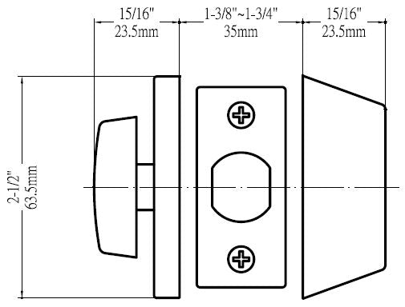
Figure 8. Deadbolt lock size standards

4.1.7 Battery Standards
When designing a system, it’ll need a source of power to have all the electronics running and functioning. Our design choice for powering the components was through AA batteries. AA Batteries is a single cell cylindrical dry battery. It falls in the line of General Batteries with the standard number International Electrotechnical Commission (IEC) 60086. They’re commonly known for being in portable electronic devices that can be disposable or rechargeable. AA cells will typically have a 1.2 – 1.5 V terminal voltage unless specified by the manufacturer. The American National Standards Institution (ANSI) standardized AA battery size in 1947. AA cell measures 49.2 – 50.5 mm in length (with button terminal) and 13.5 – 14.5 mm in diameter. [9]

4.1.8 Face Recognition Standards
With Facial Recognition Technologies on the rise there are standards in place to regulate how they should be used. The Facial Identification Subcommittee creates standards and guidelines for facial recognition technology. The four main standards are ASTM E2916-19e1, ASTM E3115-17, ASTM E3148-18, and ASTM E3149-18. ASTM E2916-19e1 deals with the terms used for discussing digital and multimedia device testing. ASTM E3115-17 deals with guidelines for the capture of facial images within facial recognition systems. ASTM E3148-18 deals with standards relating to the taking of facial images of deceased people. ASTM E3149-18 deals with standards for comparisons between different facial images. Since facial recognition technologies are new there are still many standards currently under development for facial recognition technology.

4.1.9 Programming Best Practices
Now for a view of some specific coding standards. The following are some of the best programming practices:
1. The first is regarding limiting the use of global variables. These include rules explaining which data types should and shouldn’t be declared global variables.
2. The second is that standard headers should be used when working with different modules. This helps for easier understanding and maintenance of code. Some things that the header should contain include the name, date it was created, the modification history, and the author of the module.
3. Third are standards on naming conventions for variables, constants, and functions. They should be given meaningful and easy to understand names so that people unfamiliar with the project can understand their purpose. Global variables should use camelcase lettering with the first word having a lowercase letter and the following words being capitalized, for example localVariable. Global variables on the other hand should have the first letter of each word be capitalized, for example GlobalVariable. Constant variables should only use capital letters, for example CONSTANT.
4. Fourth is guidelines regarding indentation. Indentation is especially important due to the readability of the code.
5. Fifth is regarding handling error return values and exception handling. The general guideline is that functions encountering errors should return 0 or 1 to indicate whether an error has occurred or not.
6. Sixth is to avoid using a programming style that is hard for everyone working on the project to understand. This makes present and future development more difficult as the code is written. It also makes testing and debugging much harder later.
7. The seventh is that identifiers should not be used for multiple purposes. This means that each variable should be given its own unique name, making it distinguishable from other variables. By giving each variable its own unique name confusion can be avoided when referencing that variable.
8. Eighth is that any code written should be explained through good documentation. Comments should be provided and easily understandable to make code simple to follow.
9. Ninth is that any functions written should not be long. Long functions make code difficult to understand and follow so shorter functions are preferred.
10. Lastly avoiding the use of GOTO statements is preferred. GOTO statements ruin the structure of the code where they are placed. This makes reading the program more difficult as it is harder to follow along with where the statement jumps to. [10]

4.1.10 Apple App Store and Google Play Store Standards
We released our mobile application, which will act as a Companion for our Live Bolt system, to both the Google Play and Apple App store. As such we will needed to follow the standards and guidelines laid out by both corporations to get our application approved.

Google Play has several policies regarding what developers can and can’t do when developing applications for their platform. The following are the main policies listed to follow for publishing an application to the Play Store:
1. The first of which is regarding restricted content. This includes restrictions regarding child endangerment, inappropriate content, financial services, real-money gambling, illegal activities, user generated content, and unapproved substances. This group of guidelines is included primarily to protect users from illegal, inappropriate, and deceptive content.
2. The next is impersonation which includes when a new application tries to fake being an existing application. This could be something as simple as containing the same image, using the full name or part of an existing app's name. It also ranges to the extreme to an app attempting to be another app in the store. This restriction is important as it seeks to protect the user from downloading a fraudulent app that is not what it claims to be.
3. Another guideline is restrictions against intellectual property. This protects existing developers with restrictions on Copyright, Trademarks, and counterfeit content. New and existing applications are not allowed to impose on the intellectual property of an existing application.
4. The next guideline deals with user privacy and device protection. This policy deals with protecting user data and specifies how an application is allowed to use the existing technology on a device. It seeks to prevent device, network, and permissions abuses as well as deceptive behavior within applications.
5. The next policy deals with Monetization and Ads. This is a broad category that deals with paid distributions, ad-based models, in-app payments, and subscriptions. This also includes the use of Google’s billing system, free trials, introductory offers, and managing of subscriptions. It also places regulations on ads and how they can appear in applications. Ads can’t be deceptive and can’t be disruptive for the user experience. Without these restrictions users are placed at risk and Google’s reputation for safe applications would sink.
6. The next policy relates to store listings and promotions. This affects how the app appears to users, such as on the applications store page, on the google play store. This is to prevent spammy store listings, poor quality promotions, or companies finding ways to falsely boost reviews for their product.
7. The next policy deals with spam and the minimum functionality an application needs to remain on the store. An application needs to function well and not include unfinished content to prevent the user from using it. Apps that crash and degrade the user experience or spam the user with content are not appropriate for release on the store.
8. The next policy deals specifically with malware. Specifically, applications that contain any malicious content such as viruses, binaries, framework modifications, and potential harmful applications.
9. The last policy for google applications is regarding unwanted software. This deals with software that is maliciously placed to download alongside an application, send information against the user while using the application, or fails to be completely transparent with the user about applications intentions. [11]

Apple similarity to Google has several policies in place to ensure the safety of its app store. The guidelines include:
1. App Store Review Guidelines which cover policies related to design, safety, performance, business, and legal information.
2. App Store Identity Guidelines relating to guidelines involved in using marketing tools that lead back to the Apple Store product page. It also covers using Apple App Store badges in all marketing material to link back to the app page.
3. The next policy deals with App Store Promo Artwork Guidelines which only applies to applications that decide to create their own promotional artwork. These included guidelines on creating original artwork and submitting promotional artwork for review to Apple before they can be used.
4. The next policy deals with Apple Wallet Guidelines. This deals with using the Apple Wallet and Add to Apple Wallet buttons in apps, as well as other material related to the app.
5. Human Interface Guidelines are next. They deal with integrating UI resources to create a smooth and Universal experience across Apple’s many platforms.
6. The final set of policies are regarding Apple Pay Marketing Guidelines. This policy deals with the ways and methods developers can let customers know they can use Apple Pay. This can be both through marketing as well as the application itself. [12]

We took these considerations into account as we designed the mobile application for LiveBolt.

4.1.11 Design impact of relevant standards
When designing our system many of the standards we have discussed will limited our design in some capacity. As such we needed to consider these standards closely when designing our product.

One instance of this are the standards previously talked about in section 4.1.1 based on technology that must communicate wirelessly. As such the limitations of wireless technology compared to wired technology will impact our system. Wi-Fi may limit the time it takes for our Raspberry Pi with our mobile application. Although we are using a recent version of the Wi-Fi standard it is fallible. As such we will be limited to the normal constraints of Wi-Fi based on the connectivity of our devices, interference mediums, and congestion. These constraints could be reduced by using a wired connectivity medium such as ethernet, however this becomes more inconvenient for the user to use. Wi-Fi 6, although newer and faster than the previous generation, is still relatively new in its adoption.

As previously discussed, Bluetooth 5 was on consideration in our Live Bolt system. Bluetooth is a type of Personal Area Network, or PAN, which is a type of computer network designed to operate within the space around a person. As such Wi-Fi holds an advantage over Bluetooth in terms of connectivity. However, the introduction of Bluetooth 5 brought significant improvements to the range and connectivity over Bluetooth 4.0. This will help with connecting with mobile devices that use Bluetooth 5.

Both RFID and NFC work over a set distance like Bluetooth. NFC has a set range of 4 centimeters or less which is ideal for close communication. This is a bit different than the range of RFID tags and readers which can vary greatly. NFC unlocking of the lock will require the device to be in very close proximity to the Live Bolt system. The range of NFC is really it’s only downside however this downside also provides a huge benefit. NFC is more secure than RFID because of its restricted range which prioritizes the secure connection made. For NFC if someone wanted to interfere with the connection, they would need to be very close to the devices that are communicating. With RFID data can be read from potentially many feet or yards away. This is already a problem with RFID readers which can detect information from credit and debit cards left out in the open. We want to avoid security issues like this as much as possible in our system.

4.1.12 Printed Circuit Board Standards
Like most design processes, are there are standard put in place for PCB design by the Institute of Printed Circuit (IPC) that can be applied to designs. The Institute of Printed Circuit maintains the standards for PCB design that thousands of people and companies comply with. There are many small aspects of a design that may be overlooked, such as planes, pad sizes, thermal considerations, and trace distance. The most important standard would be the IPC-2221 standard. This is a very generic standard that goes over most of the aspects of PCB design in a general sense. We used some of the standards within IPC-2221, like component mounting and multilayer rules, when creating the printed circuit board for Live Bolt. IPC-2222 is also important as it goes into those often-overlooked things like hole size, mechanical properties, board assembly, planes, and scoring the board.

4.2 Realistic Design Constraints
Seeing as we will be designing a Smart Lock system, we know that we will be up against several design constraints. These constraints will had varied impacts on the overall development of our product.

4.2.1 Knowledge constraints
One of the biggest constraints on our design was our current knowledge. No one in our group had prior experience designed a Smart Lock system before so it was a new learning experience for us all. Additionally, our team is made up of 2 computer and 2 electrical engineers with varied levels of experience. We also integrated a wide variety of communication technologies for unlocking mechanisms for the lock. These technologies included Wi-Fi connectivity, fingerprint scanning, and keypad unlock to name a few. We also successfully integrated the mobile application to act as a companion for the Smart Lock system. Not all of us had worked before with a Raspberry Pi and interfacing it with an application. That was a whole other area that we will had to explore while we developed the product. Another important aspect that we learned through research was testing our design once we completed it. That was appear of the design that we focused more on as the end of our second semester came to a close. With that both the hardware and software elements of our design were both tested to ensure accuracy. We didn’t want to justify software bugs or hardware breakdowns just because this was our first time designing this system. Our classes and previous work experiences have laid a solid foundation for us to build upon when we tackled these issues.

4.2.2 Economic constraints
Of course, economic concerns are going to come into play when working on a project like this where funding will be provided by the team. We happen to also be an unsponsored team so most of the funding came from our own pockets. As such the price of the project couldn’t be very expensive. The more expensive our project was the more money we had to pay out of pocket. This is a significant constraint as if we had a high budget, we would have more room for experimentation and a better-quality product overall.

As of right now we have been able to keep our total budget down. Our estimated total is 215 dollars which takes into account the actual cost of components and the price of the components we already had access to. Our actual cost was 135 dollars removing the components we already had access to. This is a very good cost for both as it is low enough that it was affordable for each member of the tam. It also left flexibility that if more money was required, such as with parts that fluctuate slightly in price, it should not cause an issue. We also were able to exclude some items that we already have from our price list. These items include the Pin Pad, Wires, LEDs, and other minor electrical components. This helped reduce the price while helping the cost of the project to not become a major constraint.

Another economic constraint involved the Covid-19 pandemic. Although it has nearly been 2 years since the virus broke out and the quarantine began, we are still feeling the effects. Most notably is the chip shortage among different technological sectors. Likewise, the demand for many different commercial items that use silicon chips has still not been met like previously before the pandemic. This has driven up the prices of things that rely on these chips. Although the automobile and interactive entertainment industries have been notably affected, they are not the only ones. When searching for parts for our project we ran into a couple parts that had been affected. These products were the Raspberry Pi 4 and the Jetson Nano. Both product versions came out around the beginning of pandemic and were readily available when things shutdown. However now as one of the aftereffects of the pandemic it is difficult to get them both for several reasons. The most significant is the price increase for them both. For instance, the Raspberry Pi 4 is set to retail at around 45 dollars for the 2 GB model. However, upon comparing online sellers like Amazon, eBay, and Newegg we were able to see listings for the same model anywhere from 80 dollars and up. For the Jetson Nano the situation is worse. The Jetson Nano originally cost 59 dollars for the 2 GB model and 99 dollars for the 4 GB model at launch. When looking at online retailers, now the prices have gone up from 200 to 500 for both models. Additionally, at many of these retailers’ stock is sold out, making obtaining both harder. Fortunately, a member of our group was able to obtain a Raspberry Pi 4 during the pandemic for personal use that we were able to use for our project. If this were before Covid-19 obtaining these would be more readily available. Ultimately, we went with the Pi due to one of our members having one already and the overall goals of our project. Many of the other parts we acquired prices were affected by price increases from Covid-19.

4.2.3 Time constraints
Time also became a big constraint as we attempted to design our Smart Lock. The first major constraint with time was how long we have to complete our project. We only had roughly a year in total to finish our project which included research, design, building, and testing. We realized that even though this seems like a lot of time its not, roughly 8 to 12 months. We circumvented this by gathering our parts early, researching parts of our design, and designing some fundamental components before fall this year. This way we got ahead with what needed to be complete for our project to combat the time crunch. The constraint of time also caused us to need to cut out or modify features we were unable deliver within the time frame given. We had already begun doing this while we were still planning and researching our design. We originally wanted to use facial detection using a camera we would include in our Smart lock system. However, this would require training a model for facial detection as well as testing that model for anticipated behavior. This would already be a decent chunk of time that we would have to work on our project. When talking about it again as a group we decided to just use the touch unlock through the mobile device. This is much easier to implement since the feature is already built into the mobile device. We just prompt the user to scan their fingerprint on their mobile device which is a better time tradeoff. These considerations helped us save time while keeping the original features we intended to implement.

Another reason why time became a constraint is due to our schedules. Our team has 4 different people all with varying lives. We all had certain class schedules, work schedules, personal obligations, clubs, and other activities going on in our lives. Additionally, our schedules inevitably continued to change when we took into Senior Design 2 in the fall semester. As such we couldn’t all always be available when we need each other. Working around each other’s schedules was something that we needed to keep in mind when we begin to build our project. We planned to get around this by trying to meet regularly in Senior Design 2. While we worked on our paper we met once a week but with Senior Design 2 we grew to meeting multiple times a week to work together.

A significant factor that affected our time was due to the pandemic. Previously in the economics section we discussed how Covid-19 had led to an increase in prices that can be seen especially with devices that use chips. Many of these products were sold out which can made it difficult to find places that still did have them in stock. Waiting for a product to come back in stock stood the chance of taking a lot of time. Many times, it was unknown when they will come back in stock and often, they tended to be popular enough to sell out again quickly. This leaded to price increases like the ones that we discussed in the Economics section. As such we started to collect our components earlier so that we could try and get around these inconveniences. Another issue that goes along with this was shipping times. Shipping times can vary largely depending on the seller. We had to wait about 2-3 weeks for our PCB’s to arrive at one point in the semester. Availability as we discussed earlier can also influence shipping times as they can cause them to become extended. These delays can be anywhere from a little inconvenience of a few weeks to as great as a few months. The amount of time that a part takes to come often delayed us from being able to work with that component. In the worst case it caused us to reconsider working with that component even to the extent of removing it from our design or considering another technology. Unfortunately shipping times are out of our control so we could only do our best to obtain the parts earlier so we could plan accordingly later.

Another time constraint we were aware of was workload management and deadlines. There were differing degrees of work and tasks as we begin constructing our design. There were also both hardware and software components that needed to be developed for us to be successful in our design. We had the electrical engineers in our group work on the hardware while the computer engineers work on the software. Of course, there was some overlap as we all wanted to know about the other various parts of the system. As for managing the workload we used a Gantt chart for mapping out where we should be in our project over time. This helped keep us on track and help us to know where we should be and what we should have been working on at a given time. We used a task board like Trello to help us keep track of tasks that need to be done and listed priorities for each task. By giving higher priority tasks which were crucial to our design done first we were able to add in the things we absolutely need for our project. Workflow management was absolutely crucial, especially as deadlines began to get closer. The better were at managing the work we need to do to complete our task the easier it became to meet the expectations for each deadline. For example, our Senior Design 1 paper was made much easier by dividing the number of pages we should have by our members and then us writing pages over the course of the entire semester.

4.2.4 Environmental constraints
Environmental constraints refer to a way which the product will interact with and change the environment around it. Since this lock will be fastened to a home’s door, it will not take up lots of space. It is also relatively quiet and won’t make enough sound to contribute to sound pollution. The main source of negative environmental impact will come from the battery power source. Batteries need to be carefully disposed of, or they can decay and leak acids into landfills. This acid can eventually find its way to water sources and contaminate them. Solutions to this battery waste problem will be discussed in the next section, Energy Constraints.

4.2.5 Energy constraints
As previously mentioned, incorporating batteries into our design has the potential to create negative environmental effects. To solve this problem, we have included rechargeable batteries that can easily be swapped out with other batteries once they run out of power. The next energy constraint that was identified is extending the battery life as much as we can to maximize the time between needing to change out the battery pack. This was done by incorporating low power mode functions into our microcontrollers. Low power mode is like putting the device to sleep, and waking it up with a certain trigger action, like pressing a button. Since the lock only needs to be used a few times a day, it can be in low power mode for the remainder of the time it is not in use. This should significantly increase the time each battery pack can be in use.

4.2.6 Social constraints
Social constraints refer to how our product will impact customers and society. Things to consider are cultural norms and customs in the areas we will be using our product. A specific social constraint for Live Bolt comes from its face recognition capabilities. Some people may be uncomfortable with the use of face recognition technologies due to their possible malicious uses around the world. The Live Bolt phone application will allow the ability to toggle face recognition on or off to remedy this situation. Live Bolt also come with the social constraint of trusting smart systems. With an evolving technology era, more homes are becoming smart but, some customers are traditional. Although this won’t reach older audiences, we do have to recognize the coming generation prepared for smart homes. Live Bolt will be a representative for evolving smart homes through security and access control.

4.2.7 Political constraints
Political constraints refer to our product’s impact on any governmental bodies. This product should have no impact, positive nor negative, on any government body, nation, or group, and therefore has no political constraints associated with it.

4.2.8 Ethical constraints
Maintaining proper ethical standards is just as important to being an engineer as technical knowledge is. A great standard to follow is the code of ethics developed by the Institute of Electrical and Electronics Engineers. The codes are as follow:
We, the members of the IEEE, in recognition of the importance of our technologies in affecting the quality of life throughout the world, and in accepting a personal obligation to our profession, its members and the communities we serve, do hereby commit ourselves to the highest ethical and professional conduct and agree:

I. To uphold the highest standards of integrity, responsible behavior, and ethical conduct in professional activities.
1. to hold paramount the safety, health, and welfare of the public, to strive to comply with ethical design and sustainable development practices, to protect the privacy of others, and to disclose promptly factors that might endanger the public or the environment.
2. to improve the understanding by individuals and society of the capabilities and societal implications of conventional and emerging technologies, including intelligent systems;
3. to avoid real or perceived conflicts of interest whenever possible, and to disclose them to affected parties when they do exist;
4. to avoid unlawful conduct in professional activities, and to reject bribery in all its forms;
5. to seek, accept, and offer honest criticism of technical work, to acknowledge and correct errors, to be honest and realistic in stating claims or estimates based on available data, and to credit properly the contributions of others;
6. to maintain and improve our technical competence and to undertake technological tasks for others only if qualified by training or experience, or after full disclosure of pertinent limitations;
II. To treat all persons fairly and with respect, to not engage in harassment or discrimination, and to avoid injuring others.
7. to treat all persons fairly and with respect, and to not engage in discrimination based on characteristics such as race, religion, gender, disability, age, national origin, sexual orientation, gender identity, or gender expression;
8. to not engage in harassment of any kind, including sexual harassment or bullying behavior;
9. to avoid injuring others, their property, reputation, or employment by false or malicious actions, rumors or any other verbal or physical abuses;
III. To strive to ensure this code is upheld by colleagues and co-workers.
10. to support colleagues and co-workers in following this code of ethics, to strive to ensure the code is upheld, and to not retaliate against individuals reporting a violation. [13]

The group will strive to follow these guidelines to the best of our ability and integrity. This code of ethics will remain in the back of our minds during each major stage of the project. Since the Live Bolt is a door lock, we need to ensure the safety of the customer and their belonging. Specific safety constraints will be discussed in the next section.

4.2.9 Health and Safety constraints
Health and Safety Constraints refer to the consideration of the health and safety of not only the customer but also the engineers developing the product. Constraints identified for customers are ensuring that only the customer and people they allow, such as friends or delivery workers, can unlock the lock. Under no other circumstances should the door be able to unlock. This is important because if unauthorized users can enter someone’s home, the customers’ belongings and well-being could be in danger. A safety constraint identified for both the engineers and the customer is related to the battery pack. If exposed to extreme climates, like heat or weather, the batteries and other electrical components may malfunction and cause unwanted issues like leakage or fires. We have kept this in mind while designing and building the product, and testing to make sure the product is safe for consumer use.

4.2.10 Sustainability constraints
Sustainability constraints refer to the longevity and robustness of the product. Since a portion of the product (the camera, PIR sensor, and keypad) will be placed on the outside of the door, the product will need to be able to withstand most environmental factors. Since the engineers are based in Florida, there are specific requirements that need to be considered for the casing of the product. It is enclosed to aid waterproofing to withstand rain and humidity in the air and have proper airflow to prevent overheating components. A solution to these constraints has been to make the housing out of some waterproof material, such as plastic or corrosion resistant metal.

4.2.11 Manufacturability constraints
Manufacturability constraints refer to issues that may arise while building the product. Our design relies on a cover placed around the thumb knob to turn it. A major issue identified with this project is that most locks do not have the same shape of thumb knob. We have worked to design a universal knob cover that is able to be placed most knobs. This constraint plays into a bigger constraint we have identified, being that the product should be easy to install for the consumer. We chose the knob cover so that the customer will not have to unscrew and dismantle portions of their lock, which is seen in most commercial smart locks. Our team would also desired to make the product as small and compact as possible. We did not want it to look too bulky and intrusive on consumers' doors. This was achieved by designing a compact PCB and housing for all the sensors and other components.

Due to the design choice of not unscrewing the door at all during installation, it was difficult to decide how to connect the inside module and outside modules since we cannot pass wires through the hole that the lock is normally set in. We created the solution through using Wi-Fi connectivity so that each module could communicate with each other and the home network.

Another manufacturability constraint was access to lab equipment to design and create the product. A portion of our design was be 3D printed, and this will cost both time and money. We used both the TI lab as well as friends both of which could not always be relied upon assist us. There were also many services online and locally that provide access to 3D printers. These services will be expanded on in a later section.

5. Software Design Details

5.1 Initial Design Architecture
The initial design for the logic of the mobile application is displayed below in Figure 9. When the user first opens the app, they are asked to either log in with their account credentials or create a new account. To create an account, a valid email address is required as well as providing their phone number for alerts. A confirmation email is sent to their account after creating the account, to ensure that the account information is secure. Once they successfully login, the user is sent to the home page and can use the app.

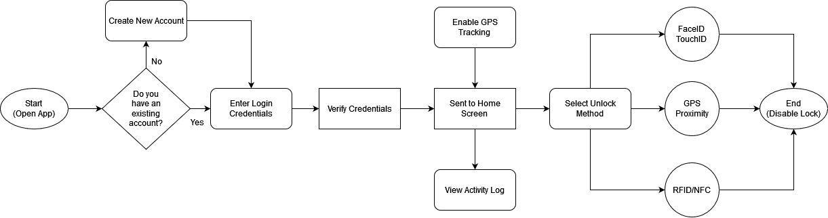
Figure 9: Lock/Unlock Flowchart

The primary function of this application is the ability to unlock/lock the physical lock on the hardware. Additionally, the user is able to access a log of previous lock and unlock attempts by logging in to their account. The application will be available on both Android and iOS, with the iOS version utilizing the facial recognition hardware present in newer iPhones for easier access control.
To protect the user’s privacy, our application will only use this feature once the user enables it.

5.2 Mobile Application Pros and Cons
While the decision to include a companion app to Live Bolt was a simple one, there are many kinds of mobile application frameworks to use, each with different combinations of various technologies. This section will give some information on some commonly used full stack applications, as well as any advantages and disadvantages that would come from using those technologies for our application.

5.2.1 LAMP Stack
A LAMP stack is a full stack application comprised of a Linux operating system, an Apache web server, a MySQL database, and can use either Python or PHP as its programming language. Some team members have had experience creating a LAMP stack, so the learning curve would not be as high as opposed to using a more complex stack type. Python as a programming language is very simple to use and has no shortage of support libraries to use. However, Python completely lacks any sort of native mobile framework to use for our application. If we were to use a LAMP stack, we would need to use a framework that has cross-platform functionality such as Kivy or BeeWare. Another problem is the difficulty that comes from using two programming languages when creating the application, Python/PHP for the server-side and JavaScript for the client-side. Switching between two languages can add some unexpected challenges for us on the software end that would be resolved by using a different type of stack.

5.2.2 MERN Stack
On the other hand, a MERN stack uses Node.js as its runtime environment and Express.js as its server-side framework. React is used as the client-side framework with a MongoDB database. Since MongoDB is a NoSQL database, it does not use schemas, but instead stores entries as binary JSON objects. This gave us an additional measure of flexibility when creating our database of users. Using React as the JavaScript library has its benefits as well, with the React Native framework being well suited for mobile development. Since Node.js uses JavaScript for the backend, our team only needed to use a single programming language for our application. This reduced the time needed to learn any new technologies since anyone with a solid grasp of JavaScript was able to contribute to the development process. This also applies to Express since it is simply a web framework built off Node.js.

5.2.3 MEAN Stack
A MEAN stack is very similar to the previously mentioned MERN stack but uses AngularJS as its framework instead of React. AngularJS differs from React by being an actual MVC framework, opposed to React simply being a JavaScript library. Instead of using components like React, Angular uses directives to teach the browser new syntax. Angular is also continuously maintained by Google, ensuring that there are many resources at our disposal if we planned to use this framework. Angular also uses HTML in its development process, which some team members already have experience working with. However, this makes the learning curve of Angular much steeper when compared to React, which was designed to only use JavaScript.

5.3 UX Design
When designing our user experience, our team’s philosophy was focused on readability and consistency. Our aim was to create an app that felt like a natural extension of the capabilities of the physical Live Bolt. We initially considered creating a web application instead of a published mobile app in order to save time on development. However, there are many issues to consider when creating a web app meant to be accessed by phones. Since many phones have unique screen sizes, the native web app would have to adjust to every screen size in order to provide consistency. This would be difficult to achieve without using a CSS library that automatically scales UI elements, such as Bootstrap. Even so, our team determined that using a native web app was not worth the tradeoff in customizability. There are many smart lock companion apps on both the Google Play Store and the App Store, so we desired to create an experience that would be immediately recognizable and unique for the consumer.

Even so, original ideas are exceedingly rare to come by. During the design process, our team studied apps of various functions, on both the App Store and Google Play Store. Most, if not all, apps use the same core principles and tools when it comes to the user experience. Above all, apps that are considered to have good UX design are created with the user first and foremost. The user must be able to navigate the app without being confused or overwhelmed by its layout and any interactive elements must be clearly defined such that the user immediately knows that they can interact with them. Adhering to such accessibility principles ensures that users are not excluded from using our app for any reason.

As mentioned in Section 3.1, many smart locks nowadays come with their own companion apps. For example, products such as the August Smart Lock and Nuki Smart Lock have unique mobile apps. These apps usually allow the user to perform the same function of enabling and disabling the lock remotely. Additionally, most apps track the activity of the physical device as a viewable log. Since our team decided to include similar functionality in our mobile application, we took inspiration from these kinds of apps to create our own unique user experience.

5.4 Preliminary UI Design
As of the initial design for the UI home page, we planned to have the initial mockup for Figure 10 inspire the drafting for the whole application. The Live Bolt application design takes influence from existing home access/ monitoring applications to formulate simplicity to the user.

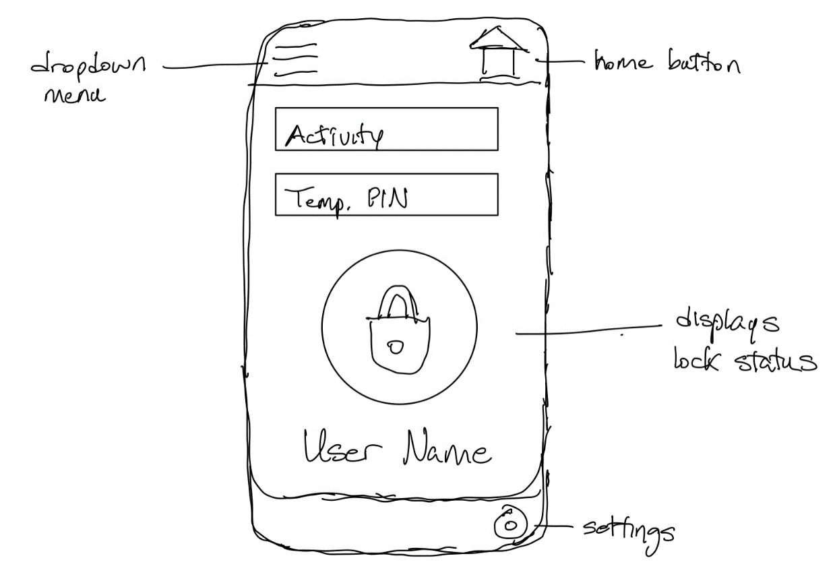
Figure 10. Initial Sketch of Application Main Interface

5.4.1 Preliminary Design 1
At the beginning of development, our team used Figma to create rough designs for several of the pages for our app. Figma is a web-based graphical tool that can be used to create both app designs and prototypes. Using the free starter level functions, our team was able to come up with a variety of potential user interfaces. Additionally, Figma also has a companion app on iOS and Android that allows users to see how their designs look on phone screens. The initial color palette chosen for design one is shown in Figure 11.


Figure 11: Color Palette 1

Below in Figure 12, the screen on the left represents the prototype Login page of the Live Bolt companion app, while the right screen is the prototype page that users are taken to if they select the Sign up here prompt. As mentioned before, this layout is very commonly used for login pages for apps on both the App Store and the Google Play Store. Additionally, if the user forgets their password for whatever reason, they can recover their account by selecting the Forgot your password? prompt on the bottom of the screen.

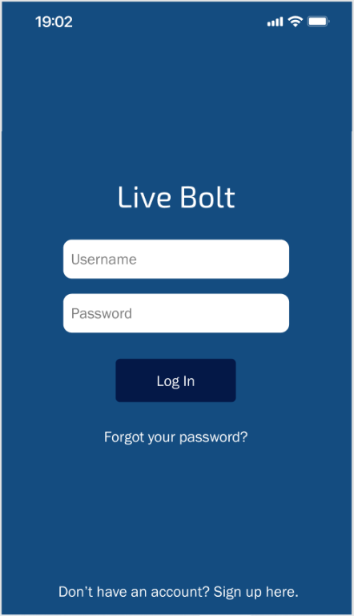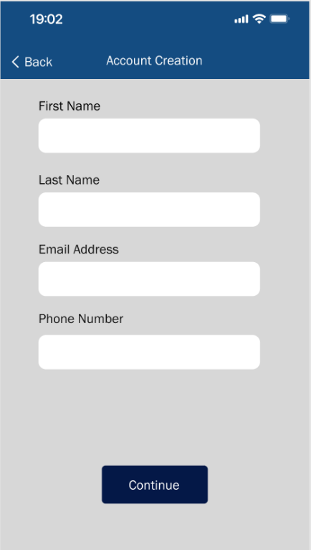
Figure 12: Sample Login/Register Page 1

The first screen a user is taken to in this prototype depends on whether they are a new or existing user, also modeled in the use case diagram shown earlier. An existing user will be taken to the lock screen, shown on the right of Figure 13, where they can then access any nearby Live Bolt devices.

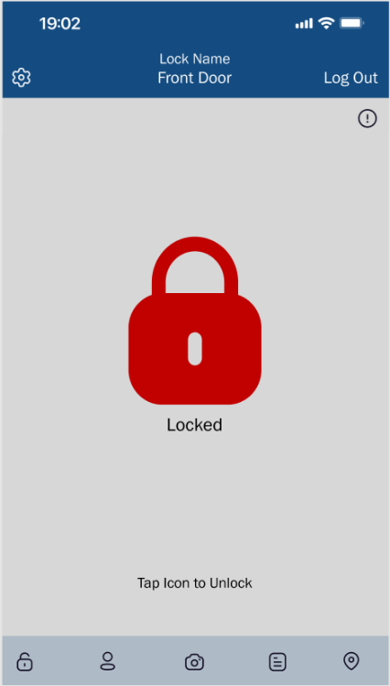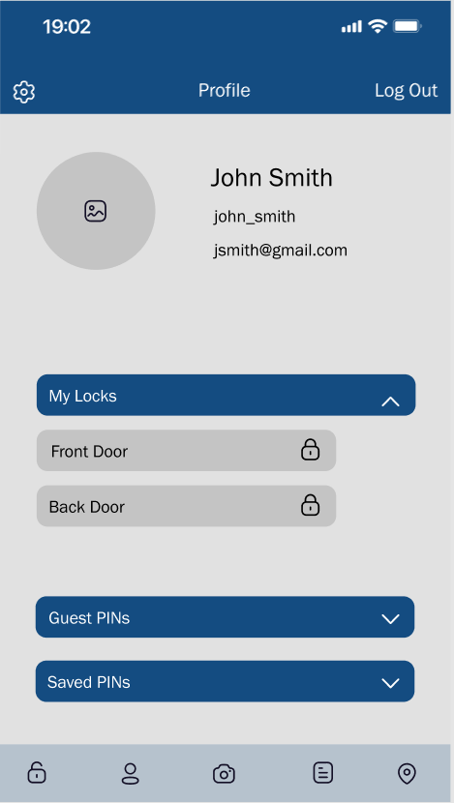
Figure 13: Sample Home/Profile Page 1

The screen will then show the status of the lock, with a green icon designating a deactivated lock and a red icon designating an activated lock. The profile screen is where the user is taken after login if they are on a freshly made account. The screen displays the user’s contact information, along with an optional profile picture.

Our team planned to implement a method of modifying a user’s account credentials through the profile page. The planned method is to have the user select the field that they wish to be changed, such as the username or the email address, and then be taken to a page where they must first enter their password before being able to enter in the new value of the field. Unfortunately, our team was not able to implement this feature due to time constraints in the development process.

The version of the settings page shown in Figure 14 displays all of the planning user options that will be included in the companion application. Our team will add more functions if needed as the development process continues. As shown above, the settings page also includes a search bar for ease of use. Selecting one of the bars below the search bar will send the user to a separate page with more options depending on the subject selected.

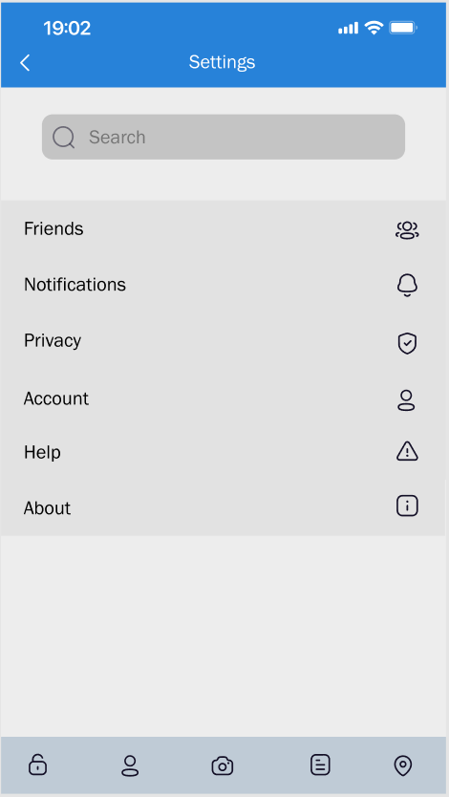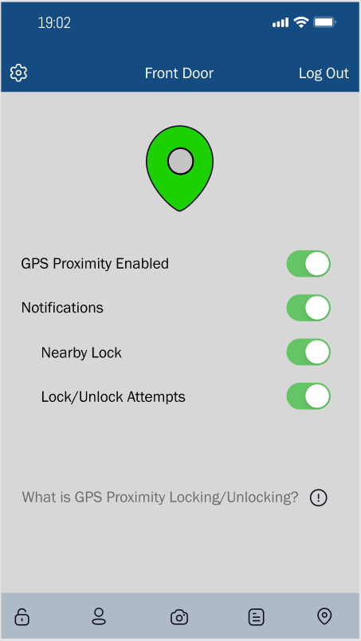
Figure 14: Setting/GPS Proximity Pages 1

5.4.2 Preliminary Design 2
The second design is shown below. The color palette, shown in Figure 15, for this design is shades of pink rather than shades of blue, like used in the first design. The color palette we decided to use for our app was meant to be visually pleasing, yet distinctive enough to make an impression on our users. Blue is a very non-aggressive color for many people and is well rendered on most mobile devices, even on older devices with limited color capabilities. For text rendering, gray works quite well due to its contrast with darker colors without being overly bright and unreadable. An alternative color scheme was also created before we decided on our main color scheme, which is also shown above.

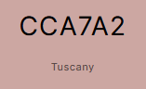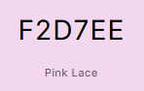
Figure 15: Color Palette 2

Figure 16, Figure 17, and Figure 18 are the new mockups for the second design. Most of the features remain the same as the first design. It is important to note that this version of the login page does not include the Live Bolt logo and instead has a placeholder, since the logo was not finalized at the time of creation.

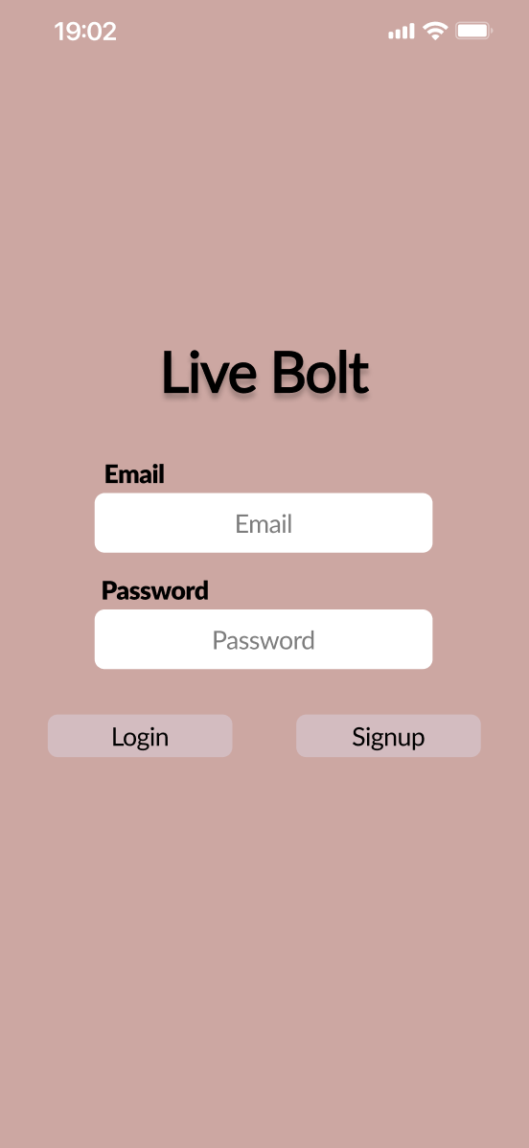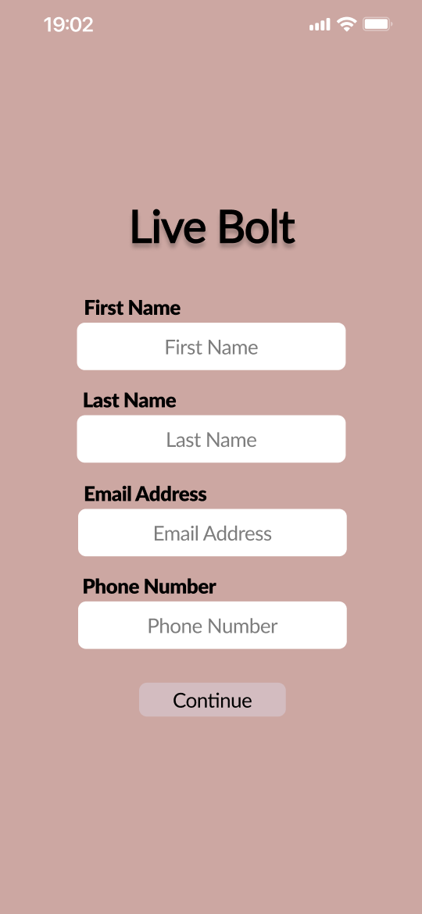
Figure 16: Sample Login/Register Page 2
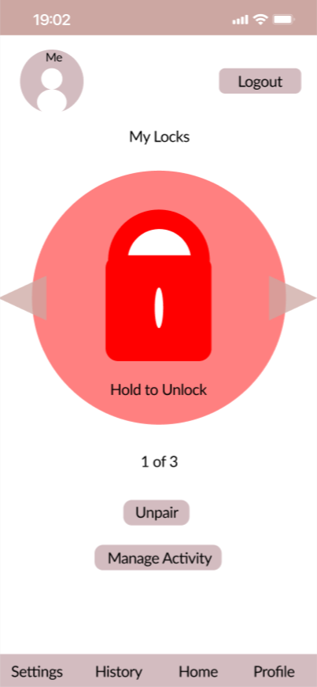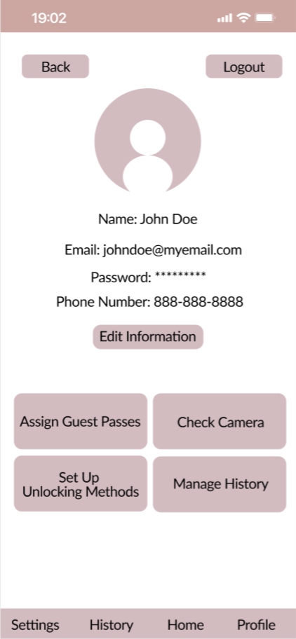
Figure 17: Sample Home/Profile Page 2

The alternate version of the Home and Profile pages shown here sport a different layout then the previous version, opting to use more text instead of icons to inform the user of the application’s functionality. It is also important to note that the GPS Proximity function is not available through the action bar on the bottom of the screen and is now accessed through the Set Up Unlocking Methods button on the Profile Page. This version of the Home page also has the unpairing function as a button as opposed to an option in the Settings page like the previous version implemented.

The Check Camera and Set Up Unlocking Methods buttons are not included in the other design, as that version was created prior to those features being a part of the Live Bolt device. However, the companion app will include these features regardless of the app design chosen. Manage History is also a new button added to the Profile screen which takes over the spot of the Activity Log button that was located on the action bar at the bottom of the screen.

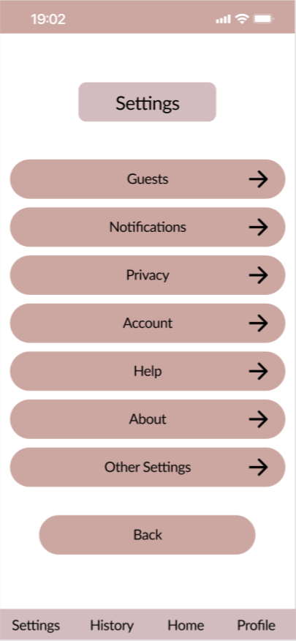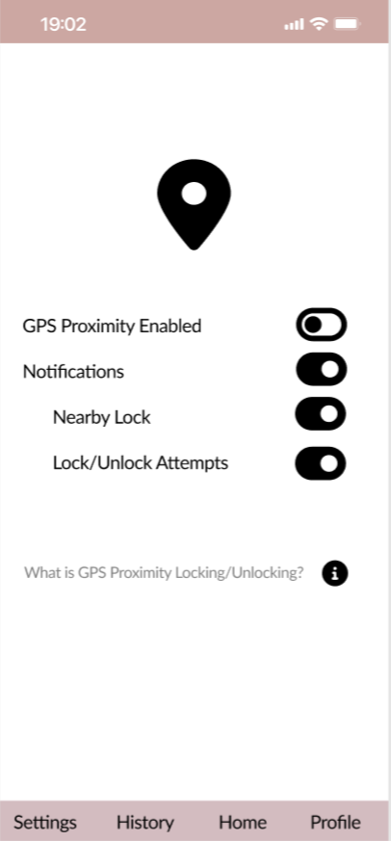
Figure 18: Settings Page 2

The settings page also sports an alternate design, using more defined bars and arrows instead of icons. It also lacks a search bar, but our team plans to add one if the options in the Settings page exceed the length of the screen at any point. The GPS Proximity page maintains the same layout as the previous design, except now having a black and white color scheme for added contrast.

5.4.1 Application Navigation
When designing our application, we wanted to make our application as intuitive as possible. We took much inspiration from other Smart Lock systems currently available on the market as discussed in Section 3.1. We decided to create flowcharts to demonstrate the intended functionality of each page of our application to clarify what our goals were. The flowcharts were created using diagrams.net, a free tool for creating diagrams and charts.

Figure 19 shows the functionality when loading up the application to reaching the home screen. The user navigates through the different options when opening the app and navigating the login page. In our diagram we represent the mixture of the login and signup flowchart to what page will be showed next following error in login, signup, or access after login.

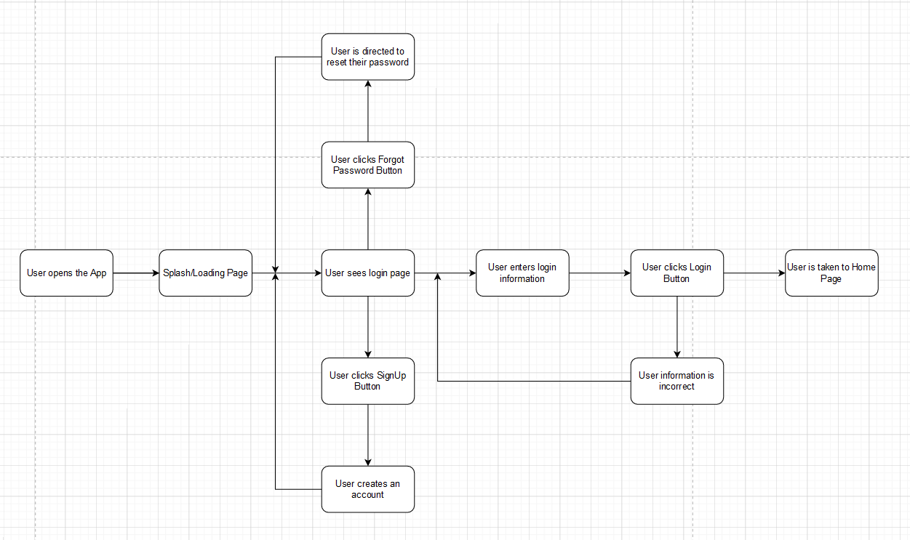
Figure 19: Login and Signup Navigation Flowchart
The Login page will have to two options, either the user forgot their password or login page to enter their credentials. In the option of the forgetting the password, the user will then be redirected to reset the password to because there was a change in the password. In the case of login (with a previously returning user), they will enter their login information, hit the login button, and then finally will be taken to the home page.

When a user is signing up, the diagram is referenced downward to what will be introduced afterward when the user sees login page. As formality when creating a new account, the user clicks signup button, creates an account with username and password, and will be redirected to the user login page.

This concluded the overall diagram flow chart before the user enters the main home page of the application. This portion of the diagram adds value to the portion of not only the back end but the front end of where the user will be direction for each action taken.

5.4.2 Use Case Diagram
A Use Case Diagram is used to describe and model the way actors interact with a system. The diagram for the Live Bolt companion app is shown in Figure 20.

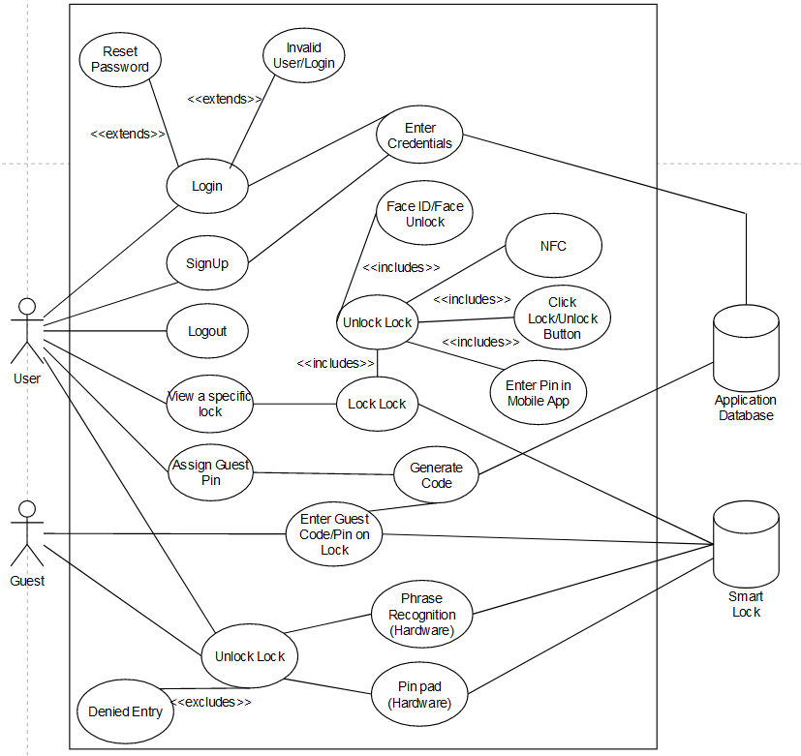
TouchID Unlock
Figure 20: Use Case Diagram of Application including both Hardware/Software Unlocking Mechanisms

5.5 Logo Design
When creating a logo for any sort of product, the aim is to produce a unique design that reflects the brand or product that is being sold to consumers. Our team sought to create a logo that was simple and appealing in design, while accurately conveying the function of the Live Bolt Smart Lock to consumers. This section will contain several preliminary concepts that were created before our team decided on a final selection.

Most of these logos were created using the Adobe Express tool and Inkscape with some slight adjustments made in GIMP. The preliminary sketch is given in Figure 21 while the one with GIMP adjustments is given in Figure 22.

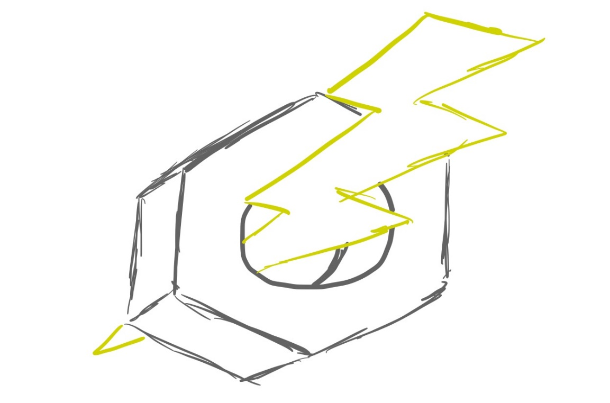
Figure 21: Sample Application Initial Logo Sketch

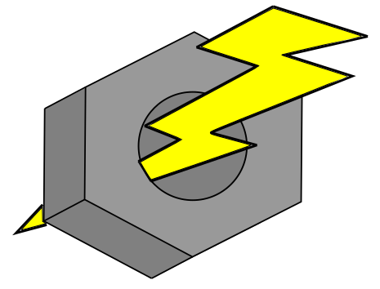
Figure 22: Sample Application Logo Mockup in Inkscape

5.6 Bluetooth Pairing
For a user to connect to a physical Live Bolt lock using the companion app, there are several methods or protocols that our mobile app could have use, each with their own advantages and disadvantages. One of the most popular methods of connected to external devices from a smartphone is using Bluetooth pairing. Although Bluetooth is not the method we ended up using we still listed it hear for comparison. According to the Android Developers website, there are three steps when a mobile application seeks to make a Bluetooth connection [2].

- Find nearby Bluetooth devices.
- Connect to a particular Bluetooth device.
- Transfer data with the connected device.

While the website talks about Bluetooth functionality in an Android environment, these steps are general enough to also apply to web and iOS applications. Since data will be transferred between the physical lock and the user’s phone, the connection must be secure to maintain the device’s integrity and security.
Our team determined that in order for our app to perform these functions, it would need to use an available plugin or API to get Bluetooth functionality. Since this app is meant to be cross-platform, implementing Bluetooth would have be significantly more difficult than the alternatives. For this reason and more, our team ultimately decided to use the MQTT protocol to communicate with the Live Bolt.

5.7 MQTT/Mosquitto
As previously mentioned in the previous section, our team decided to use the MQTT messaging protocol instead of the Bluetooth standard for the Live Bolt companion app. Unlike Bluetooth, MQTT is extremely lightweight and portable which makes it a very suitable option for our app’s functionality. However, in order for both our companion app and physical unit to communicate with each other using the MQTT protocol, they need to connect to a Mosquitto server. A Mosquitto server, or an Eclipse Mosquitto broker, is a open source message broker that uses MQTT as its primary protocol. By having our app and Live Bolt device connect to a topic on a publicly available Mosquitto server, they are able to send variables to each other. These values allow the Live Bolt to lock or unlock itself from the use of the companion app.

5.8 Development Environment
When creating a program of any sort, a development environment is needed for programmers to edit and debug their source code in an easy-to-use space. While it is possible to edit code straight from the command line or using a simple text editor, using a development environment allows for us to fix syntax errors and track variables. Nowadays, many integrated development environments (IDEs) also include compliers to debug code.

Due to its simplicity and abundance of native tools for React development, we decided to use the Expo CLI development environment and the Virtual Studio Code IDE for editing source code. Expo CLI is a command line application that can be installed on any terminal of choice and serves as an interface between the developer and the React app. On the other hand, Visual Studio Code (VScode) is a text editor created and supported by Microsoft that is available on Windows, MacOS, and Linux. VScode includes support for both JavaScript and Node.js, making it a very desirable choice for our team. The installation instructions and documentation of both the Expo CLI environment and the VScode IDE are provided in the references section below [16].

5.9 App Store Publishing Process
As with any online platform or marketplace, the Apple App Store has its own unique guidelines and recommendations for developers who seek to publish their apps. Most of these standards are described above in Section 4.1.8 and will be referenced throughout this section. In addition to adhering to proper programming standards, our app must also adhere to the various design, compatibility, and legal standards detailed in the App Store Review Guidelines [6]. In the case that our team decides to publish our app on the App, we will submit our app along with any metadata via App Store Connect. According to the Apple Developer website, 50% of submitted apps are reviewed in under 24 hours and over 90% are reviewed after 48 hours.

To avoid potential issues with submitting our app for review, we will continuously test and debug our app and ensure that it runs well on all available platforms. Additionally, we will adhere to the App Store’s privacy guidelines by always asking our users for permission to use their data in a clear and understandable manner. To avoid a rushed schedule, we will submit our app well ahead of our planned release date to account for any unexpected issues that may arise during the review process.

5.10 Google Play Store Publishing Process
The publishing process for the Google Play Store differs from the App Store process in several ways. The platform used for publishing to the Play Store is Google Play Console, which is used for development, review, and publishing. In order to start the review process, we must first publish a draft version of the application. To proceed to the review stage, the app must not have any detected errors. Just like the App Store process, our app will be rigorously tested to ensure that our users will not encounter bugs or crashes.

Additionally, there are two types of publishing our app can undergo: standard publishing and managed publishing. Standard publishing allows any updates or changes to all existing apps, with a waiting period of up to 7 days for review. Managed publishing lets the developer control where any changes are published after their app has been successfully cleared for release, allowing for greater version control over the standard method. The Google Play Console Help page also details every possible status for an app or update [7]. Since we are planning for a cross-platform release, we would like our app to be reviewed and given the status for production in order to ensure that both releases occur in the same timeframe.

5.11 Mobile Stack Technologies
After researching and analyzing various stack types, those of which were mentioned in Section 6.2, our team eventually decided what stack application our mobile app would be. This section details the reasons behind our decision, as well as any technologies being used that have not been mentioned so far.

5.11.1 MERN Stack Reasoning
Ultimately, we chose to create our application using a MERN stack for a variety of reasons, many of which are described above in Section 5.6.2. As mentioned earlier, a MERN stack comprises of a MongoDB database, a Node web server, an Express web framework, and a React client-side. Since most of our team had a measure of familiarity with developing a MERN stack in previous classes, namely in Processes of Object-Oriented Development, there was not as much learning required to create our app using a MERN stack.

5.11.2 JavaScript
JavaScript, along with HTML and CSS, are the main building blocks for any kind of web application. It is a high-level language, along with languages such as C#, Ruby, Python, and Java. It is important to maintain that Java and JavaScript are separate languages, though they share similarities in syntax. JavaScript is also incredibly popular, with over 97% of websites using the language client-side for web page behavior [8]. This code usually executes client-side to load new pages, generate user results, and control web page animations. The amount of JavaScript libraries is incredibly large and several of them control large parts of the web development process. Many of them are used in our app which are further explained below.

5.11.3 Ajax
While Ajax is not a library, it is an important technology that is often used in web development. Short for Asynchronous JavaScript and XML, it is the method the XMLHttpRequest object uses to communicate with the web server. Most important about Ajax is its ability to operate asynchronously, meaning that it can exchange data and update a web page without needing to reload the page. Additionally, the data that is sent and received can be in several formats, including JSON, XML, and even text files [9]. The Mozilla Developers website contains the documentation of Ajax, along with an introductory article through which most of this data was taken from.

5.11.4 JSON
JavaScript Object Notation (JSON) is a data-interchange format based on the conventions of the JavaScript programming language. While it does use much of the syntax used in JavaScript, JSON is completely language-independent and can be used with any programming language, though it commonly sees uses in high-level object-oriented languages. JSON usually is comprised of two kinds of data structures: a collection of name/value pairs and an ordered list of values. In most programming languages, these are both realized as arrays or lists. Due to its simple and effective structure, JSON is used for all sorts of data transfer operations in web development.

5.11.5 JSX
JSX is simply a syntax extension of JavaScript that is commonly used with React. Though it contains elements of HTML syntax, JSX still has all the benefits of JavaScript without sacrificing the benefits of a template language such as HTML or CSS. The main function of JSX is to produce React elements, which are the main building blocks of any React application. JSX uses rendering in order to implement React elements into browser DOMs, which has several advantages over the traditional method of DOM traversal and manipulation. Unlike browser DOM objects, React elements are plain objects and much cheaper to make. These developer-created elements work together to form React components, which can be described as the React equivalent of JavaScript functions. Like a function, these components accept certain properties (or props) as parameters and generate a React element to be used in the user interface. These components can be used in other React applications in the same way a JavaScript function can be used in a different program.

5.11.6 JSON Web Token
With our mobile application having several technologies communicating with each other, it is important to also maintain data integrity during the development process. JSON Web Token (JWT) is an open standard that defines a compact way for securely transferring information between entities as a JSON object [reference needed]. There are many reasons to use JWT as a method of securing data, such as verifying the identity of a sender or recipient of data and authorizing specific users to use an application.

The structure of a JWT consists of three parts: a header, payload, and signature. The header contains the token type and algorithm, which in most cases would be JWT and a standard signing algorithm such as HMAC SHA256 respectively. The payload usually contains information concerning the user and the type of claim being made. Lastly, the signature ensures that none of the contents of the token were altered in any way. The result after encoding is three URL strings separated by dots, a format that is easily passed through in HTML and HTTP settings.

5.12 React Native Components
As mentioned in previous sections about React Native, components are an extremely important feature of the Native framework. Components that are commonly used in cross-platform applications include the View, Text, Image, and StyleSheet components [17].These are the most basic units of React Native development and can be further modified to suit any application’s needs. React Native also provides OS specific components for iOS and Android only apps, though our team did not utilize them due to our app’s cross platform nature. This section will describe some of the more specific or unique components that our app use.

5.12.1 VirtualizedList
The VirtualizedList component is a convenient alternative to the traditional FlatList and SectionList components. According to the React Native documentation, VirtualizedList is recommended for use with immutable data instead of plain arrays [18]. This makes this component a perfect fit for the Account Settings page since the options available to the user will be constant regardless of account status. VirtualizedList also has the advantage of improving memory consumption and performance by only rendering the items currently displayed on the screen. Our app has a large variety of options available, so being able to only render the relevant options for the user will improve the user experience. Figure 24 shows an example of what our options menu would look like on an iOS device using the VirtualizedList component. Memory optimization
and app performance are especially important to our team and is reflected throughout our development process.
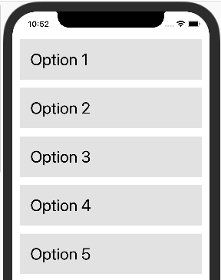

Figure 23: Virtualized List on iPhone Example

5.12.2 Pressable
The Pressable component is a recent addition to React Native, first introduced in version 0.63 [19]. More specifically, Pressable is a component wrapper that can detect states of interaction on a defined element or its children. For example, a button can implement this wrapper to be able to detect a user holding a touch input for a specified amount of time. Our team used this component for our lock activation/deactivation function on our Lock Status Screen. Figure 25 displays all the possible use states of the Pressable component.

The diagram shows that not only does the Pressable component track the amount of time that the user spends holding a selection, but also tracks the moment that the user releases the selection as well. The state that Pressable uses to distinguish simple button presses and button holds is the onLongPress state. The component takes a timestamp and starts out in the onPressIn state when a selection is detected. If a certain amount of time passes before the Pressable switches back to the onPressOut state, it will detect the user is holding the button and change the state to the onLongPress state until it detects that the user is no longer holding the button.
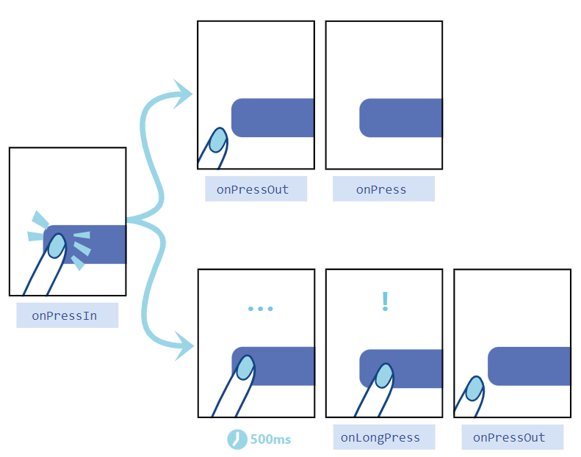
Figure 24: Pressable State Diagram, courtesy of React Native

5.12.3 KeyboardAvoidingView
The KeyboardAvoidingView component helps with the screen formatting of an application when the touch keyboard is needed by adjusting the screen’s height and padding. Many of the screens in our companion app have search bar functionality, making this component an easy and effective way to maintain the overall feel of the app layout without compromising on general functionality. It is important to note, however, that this component behaves differently on iOS and Android devices. The React Native documentation recommends using the behavior attribute to prevent any unwanted effects from using the KeyboardAvoidingView component [20].

5.13 Database Structure
The database our application will use will need to contain several types of user data including logins, passwords, user activity, emails. It must be structured in a manner that our app will be able to efficiently search for any information it needs at a moment’s notice. A well-designed database typically has the following traits [18]:

- Efficient access to data
- Supports long-term maintenance of data integrity
- Clean and consistent structure
- Avoids redundant storage
- Accurately reflects the structure of the problem

To create a database with these principles in mind, our team first created a preliminary entity relationship diagram of the database. An entity relationship diagram (ERD) is used to map out the structure and relationships present in the database. The ERD modeling of our database is shown below in Figure 26, complete with variable types and entity relationships.

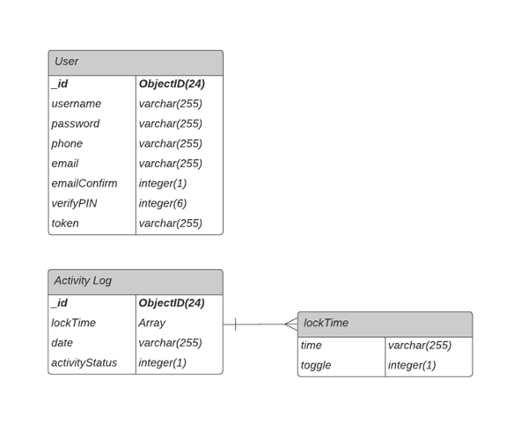
Figure 25: Entity Relationship Diagram

Outlining an ERD before designing the actual database comes with many benefits to the overall creation process. For example, making changes with an ERD is far easier than having to modify the database’s data directly, especially since adjusting data can be very risky as the scale of the database increases. Additionally, the creation of a visual aid helps with keeping track of all the needed data in one easy-to-read diagram, which makes it useful for gathering requirements and specifications.

As shown above, the database for our companion app consists of three entities: users, activity logs, lock times. A user entity contains relevant information such as their name and email address, as well as a unique ID. The activity log objects consist of a date string and an array of timestamps detailing when the lock was interacted with. It is important to note that all attributes in bold are primary keys, all of which are IDs in the case of this database. The data type is also listed next to its corresponding attribute, mostly comprising of integers and character strings.

5.13.1 MongoDB Creation and Syntax
Before creating a MongoDB database, a cluster must first be established and granted access to through the MongoDB shell. Once that is done by the user, the database can store new objects by inserting them through the Command Line Interface (CLI). For those who wish to use a more accessible interface, the MongoDB Compass is a GUI which can perform the same functions as the CLI. While our team was comfortable with using the CLI as our main interface, we decided to use Compass in order to manage our database more intuitively, as it is more complex than any other our team has worked on.

As mentioned before in previous sections, MongoDB is not an SQL language, meaning that we can store objects without restrictions as fields will be dynamically created to store any objects with new or unique fields. While in MySQL, an object with a new field had to wait for the user to manually create the field before being stored. Doing otherwise in this scenario would generate an error for the user. For example, the command to insert a user with the attributes included in would look something like this:

db.user.insert({id: 123456, name: "Joe Smith", address: “123 Fake Street”})

In the case of this command, ‘db’ is the name of the database and ‘user’ is the name of the table. Of course, this only includes the ID, name, and address of the user but can be modified to add the other required fields using the same format displayed. Figure 27 displays two BSON objects, a User and an ActivityLog, in the MongoDB Compass interface.

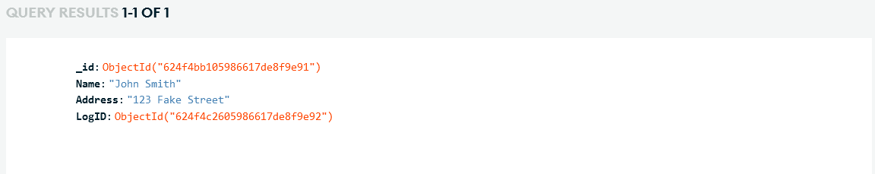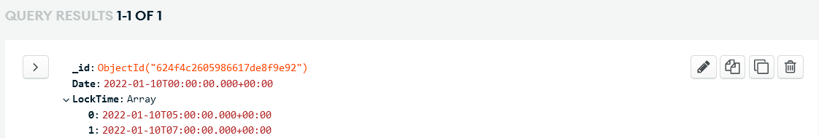
Figure 26: User and ActivityLog Objects

Both have an ObjectID field which serves as both an index and a foreign key for other objects. The LogID field in the User object is the ObjectID of the ActivityLog object, relating both objects together for quick and reliable access.

5.14 Near Field Communication (NFC)
The possibility of using NFC, as mentioned in section 4.1.4, was considered as a potential unlock method via the companion app. NFC connections are made from 4cm or less between two NFC capable devices. This connection allows for small amounts of data to transfer, which would be a value toggle in this case in order to lock or unlock the physical lock. However, there were some issues that prevented our team from implementing this feature on both iOS and Android devices.

The implementation of NFC with Android devices differs from that of iOS devices. Android devices can facilitate an NFC connection between android devices or an NFC Tag. Android supports the following 3 methods of using NFC:
1. Reader/Writer mode allows an NFC device to read and/or write to an NFC tag or sticker.
2. P2P mode, which is used by Android Beam, allows for an NFC device to send data to other devices.
3. Card Emulation mode is what it sounds like. It allows an NFC device to function like an NFC Card which can be used for things such as contactless mobile payment. [21]

For iOS devices the implementation is slightly different. Apple’s Core NFC Framework allows for NFC tags of types 1 through 5 stored in the NFC Data Exchange Format (NDEF). It also allows NFC tags to be written to and read. As in the name of the Framework implies Core NFC requires a device that supports NFC. [22]

5.15 iOS FaceID/TouchID Implementation
FaceID and TouchID are two features included in most modern iPhones released after 2017. TouchID was first introduced with the iPhone 6 in 2014, while the FaceID feature was first included with the iPhone X in 2017. The TouchID sensor on an iPhone is located in the Home button, which allows the user to unlock their device using their thumbprint. However, Apple has since discontinued the TouchID feature on newer models of iPhones and iPads, with the FaceID now being the standard method of accessing the device.

FaceID is a facial recognition technology developed by Apple for both the iPhone and iPad. Replacing the previously used TouchID system, FaceID can be used to perform a variety of functions alongside user verification such as authenticating purchases and signing in apps. The sensor used for FaceID is located on the top of the device, just above the screen. Consisting of three modules, the FaceID sensor shines infrared light upon the user’s face and creates a 3D facial map using a projected grid of dots. The map is then referenced with a previously saved face in the system and confirms that the two maps match, authenticating the user [23].

Early in the design process, our team determined that implementing these features for our companion app would dramatically improve the user experience of the Live Bolt. Additionally, many other apps available on the App Store and Google Play Store use the FaceID feature for user authentication. In order to include both features on our app, we needed to utilize a cross-platform library. There are several libraries that we considered using, but for simplicity this document describes only two: LocalAuthentication and react-native-biometrics. UML class diagrams for both of these libraries are included below in Figure 28 and Figure 29.

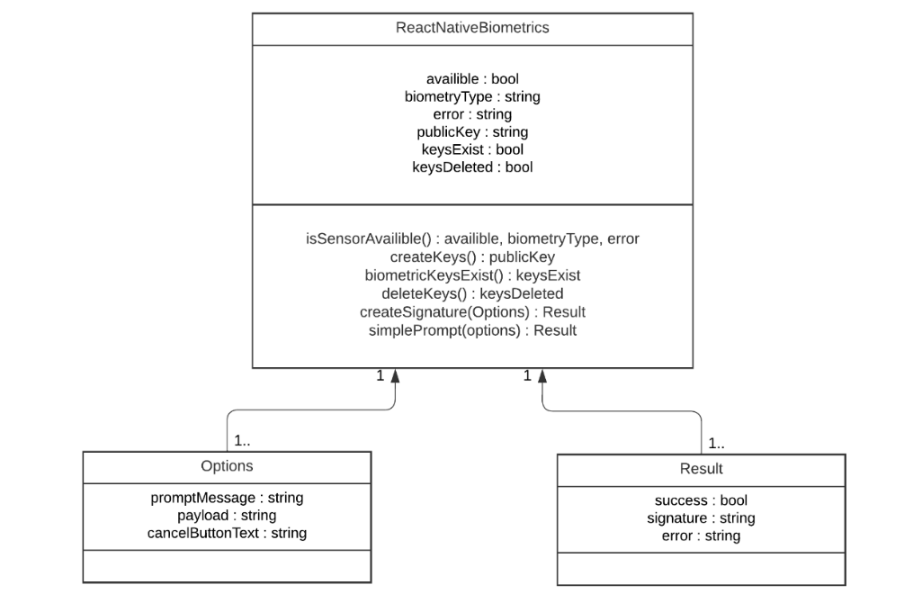
Figure 27: React Native Biometrics Diagram
Though these two APIs have the same functionality, they do differ in their implementation of biometric authentication. LocalAuthentication is an API native to Expo, as opposed to react-native-biometrics being a React Native module. LocalAuthentication also is able to interact with Android’s Biometric Prompt feature, which react-native-biometrics lacks. The Expo API can also allow the user to verify via passcode if the json package returned does not have the sufficient parameters, although our app will not be using this function. It is also important to note that LocalAuthentication is actively maintained and developed by Expo and seeing continuous updates, while the React Native library has not been updated as consistently.

On the other hand, react-native-biometrics has significantly more compatibility with the React Native framework and also works for cross-platform applications. A noticeable advantage of the React Native module is its relative simplicity compared to its Expo counterpart. However, both APIs use the Promise class to verify or deny users who interact with their device’s biometrics. Fortunately, even if one of these biometric-related APIs has a disadvantage that prevents our app from fully relying upon it, the flexibility of React Native allows us to use both to have a more complete package to use for connecting the user’s device to the physical Live Bolt device.

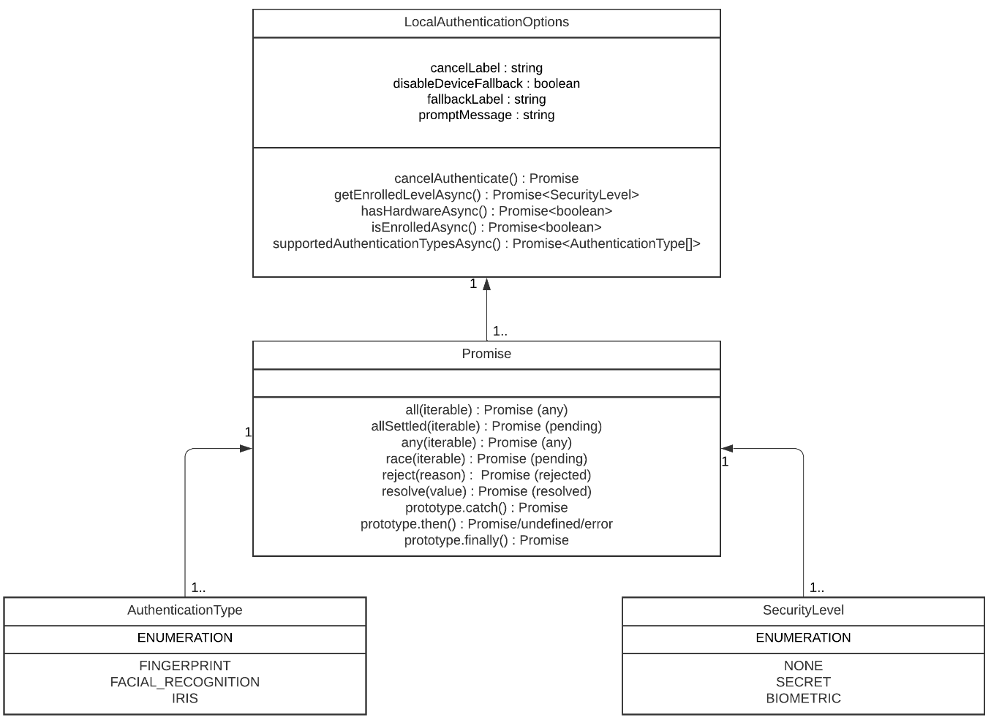
Figure 28: Local Authentication Diagram

In the end, our team decided to use the LocalAuthentication library to integrate user biometrics into the mobile application. Our app’s repository was built upon the Expo framework for ease of use and testing, so it made sense to use a library built in mind for the specific framework.

5.16 Transmission Control Protocol (TCP)
TCP is a network protocol that creates a connection between two hosts to send data. TCP is a connection-oriented protocol, so it requires a connection to be established before any data transfer takes place. This protocol is widely used for its reliability due to guaranteeing delivery of data and packets in the same order they were initially sent. Some additional benefits of TCP are error free delivery of packets and concurrence control. Within the protocol there is a client host and a server host. The server is always listening for a request to be made from the client host. The client must provide the IP address and port number of the server its trying to contact. It also must provide its own port number and IP address so that the server knows where to send confirmation data that the packet was received. Once the connection is established packets can be transferred between the two hosts. Additionally, a TCP server can support multiple hosts due to a socket being created for each new client connection. Reliability as discussed earlier, in TCP is made possible by the use of acknowledge (ACK) signals. It’s through this that when packets are received by the server an ACK is sent to signify the packet was received. If a packet wasn’t received after a certain amount of time or some noise changed some of the data in the packet the data can be resent to the server. TCP does take longer than UCP to send a packet due to the required connection setup in order to guarantee that the data is correctly transferred over. TCP will be used to create the connection between our mobile application and the Raspberry Pi and MCU. This creates a safer and more reliable communication for our Live Bolt companion app where we want security to be the focus. [24]

5.17 User Datagram Protocol (UCP)
UDP is a sibling protocol to TCP. This protocol also facilitates the data transfer between different hosts. It is a connectionless protocol meaning that it does not create an explicit connection between the client and the server. TCP can be thought of as a handshaking of data between two host. UDP doesn’t do any of that initial setup and is thought of to be a “best efforts” service. A UDP client only sends the destination IP address and port number of the server it is trying to send data to. As a result of the UDP is much simpler to implement and is faster to send data than TCP. However, it does suffer from this in terms of reliability. Data sent via UDP can be lost or received out of order. UDP is typically used in applications where reliability is not the main concern but speed. These include multimedia services like YouTube, or Netflix where if packets are lost or received incorrectly the data can just be resent. UDP implements a checksum in order to verify if the data received was correct. The checksum is computed on the client end and put into the UDP checksum field when sent. It is then recomputed on the server side and compared with the value computed by the client in the UDP checksum field. If the values are different, then we know that some of the data has been lost or received incorrectly. Unfortunately, this solution does not solve all errors because the checksum field itself could be affected by noise during the data transfer.

5.18 Live CameraFeed
Within the hardware section we mentioned the Raspberry Pi and how through the PIR motion sensor we are able to detect motion. This motion then triggers a picture to be taken by the camera and sends that image to the google drive folder where then it is delivered to the application through an API. This allows for images to be delivered to the user in real time whenever motion is detected outside of the system.

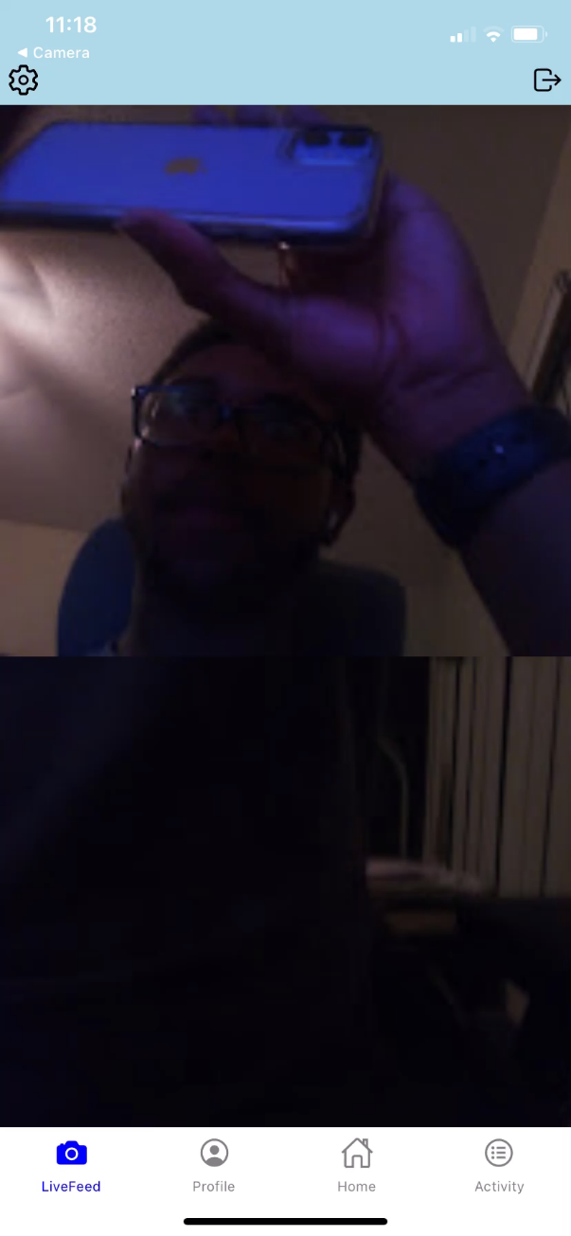
Figure 29: Photos retrieved by the Mobile Application

5.19 Google Drive API
We are using the Google Drive API to deliver the images to our front end react application. We found that this was a good way to store the images without it impacting the performance of our database by directly storing the images within it. On the Raspberry Pi side we are using the Pydrive library for Python to upload the images to our google drive folder. The Pi authenticates automatically with the folder through the use of a service account. Service accounts make it very easy for automated or repeated requests to access content via the Google Drive API without the need to sign in. This data is secured through the credentials.json file which is generated once by the google cloud console once a service account is created. Within the react application on the LiveFeed Screen our hosted Node.js API sends a request whenever the LiveFeed Screen is clicked. This request access the WebView links of the last 10 images in the Google Drive folder which is then displayed onto the LiveFeed Screen for the use to view.

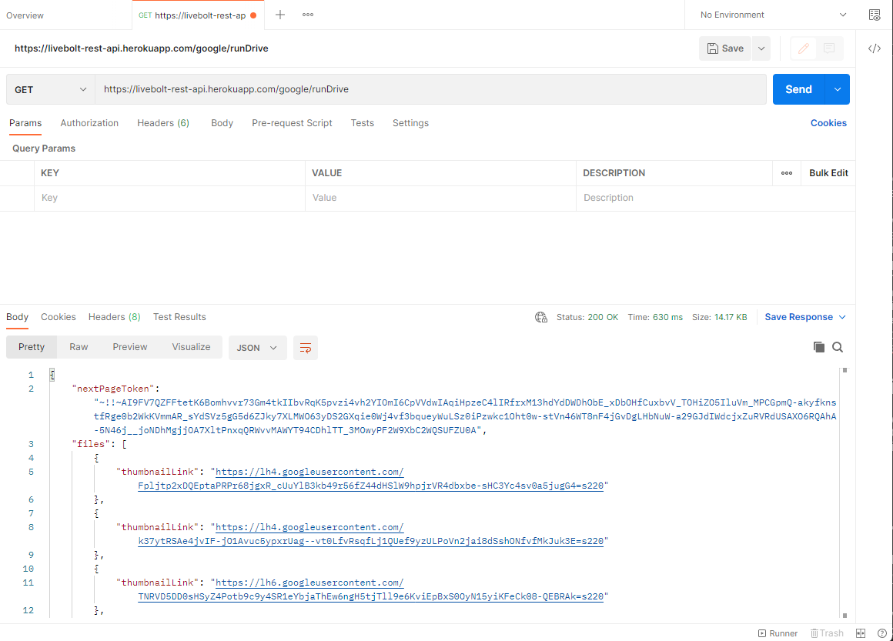

Figure 30: Photo Links fetched with Postman

6. Hardware Design Details
This section outlines the hardware that was used in the Live Bolt system and their technical specifications. Our boxes and their process to 3D model and print will also be discussed further in the report in addition to housing the components. We’ve outlined the components used in Live Bolt and components that were not suited to our project. There is also a brief description of how the hardware is used in Live Bolt.

6.1 Preliminary Hardware Design
Live Bolt was designed from the inspiration of a knob case enclosed on a deadbolt knob. The design houses the servo motor that’ll create the turning gesture in the compartment. This factor eliminates the need to unscrew the doorknob and make modifications to it. Installation for the lock will be as simple as adding two-sided tape or Velcro to the door. Figure 30 below shown below is a preliminary concept of the lock design on a door.

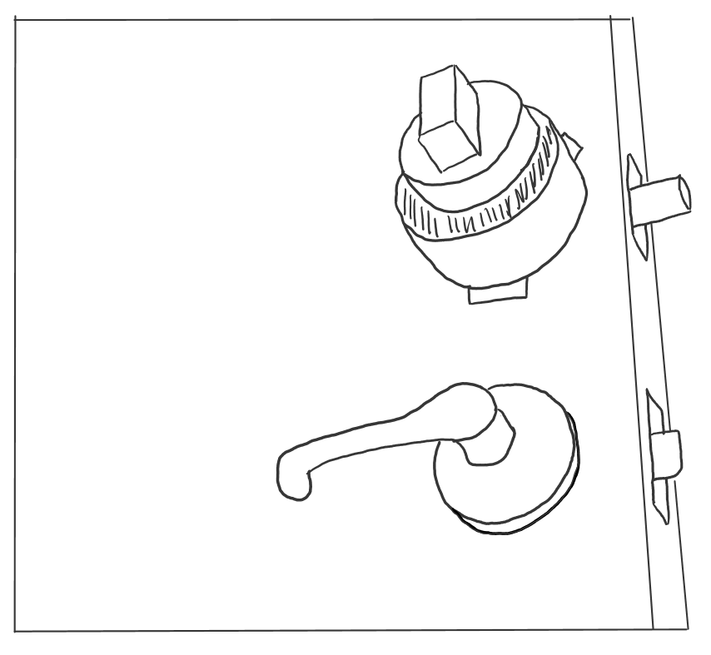
Figure 31: Deadbolt doorknob cover, fitted onto a door lock

Figure 31 shows a close-up view when looking at the design from a bird’s eye view. To understand the sketch better it is a 3D printed case that has a servo motor protruding out making the wires exposed but is attached to the dead bolt cover. The side pieces sticking out of the circular knob encompass are double sided tape that will attach the door to ensure stick. It is designed to have easy installation for the consumer and hold the lock in place.

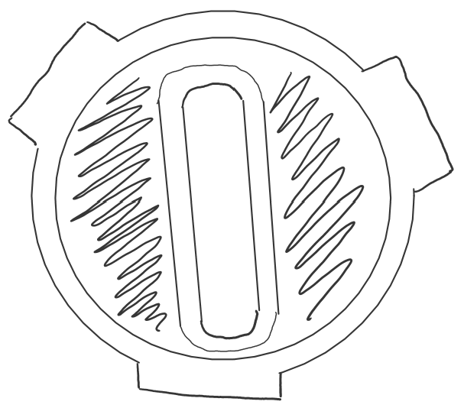
Figure 32. Frontal view of the Doorknob Cover

This preliminary design is a great start to how we want the lock to work but it would not be ideal to go with design because we want the electronics hardware concealed and not exposed to a consumer. Therefore, we included all the electronics in a box compartment. We made sure to complete our objective we must make sure that there’s enough control access to the user. Hence the introduction of a security box.

We included a security box to have additional access control and home monitoring. As a group included a security box option just for the sake of providing home monitoring and will include access control on the box. This portion is further discussed in the later sections of this report. You will also begin to see our CAD model design and changes that have been created to keep up with the modifications needed.

6.2 Hardware Selections
Previously selected in section 3, we chose all the hardware components that’ll be placed into our design. Our following selection would be to understand how pins will need to be configured in the MCUs.

6.2.1 Arduino Keypad
We ended up using a 4x4 Arduino keypad, collecting the reading of the number and/or letter is a simple connection based on the division of rows to columns. Better analogy of the keypad configuration is shown in Figure 32. When no buttons are pressed, the columns are read as HIGH, and rows are read in LOW. When a button is pressed then the column is pulled to LOW from the current. From this observation of the MCU, it’d know the column in place so the roles would switch then the rows on HIGH. From the rows on HIGH and columns on LOW, the MCU can find the location of the button when the column pins retrieve back to HIGH. In our design, we will use this to configure in the MCU and have the reading acknowledge the numbers and letters. Source for understanding the pin configuration is represented from the is from the resource of circuit basics [25].

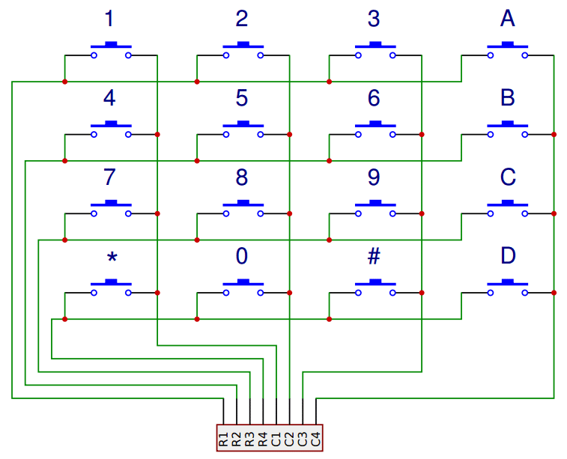
Figure 33. Arduino Keypad Configuration

6.2.2 Raspberry Pi 4B+
We included a Raspberry Pi due to its numerous features: multimedia performance, memory, and connectivity. By incorporating this microcontroller, it allowed us to have wireless camera access with a live feed into the Live Bolt application. The selection was based on the ease of compatibility with the pi as shown in section 8.

6.2.2.1 Raspberry Pi Microphone
We did not include the raspberry pi microphone in our product. The initial idea was to have phrase detection as another form of access control but decided to scrap the idea based on time constraint and over engineering. The Pi already running two severs for the application and camera so including a microphone would not be feasible. Additionally, the pin connections take up all the pi while we needed a power source into the pin of the pi to turn it on. Excluding this choice of the microphone lead the following aspects that were missed out. The ReSpeaker 4-mic array would’ve been the choice to connect onto the raspberry Pi. The ReSpeaker includes an AC108 quad-channel ADC design for microphone arrays. One thing to note about this purchase is that it’ll be objectively used for the microphone.

In addition to have choosing this speaker is the availability including LEDs. As a group we wanted to indicate to a user from outside (e.g security box) whether a passcode was or was not inserted correctly. The LED choice from the microphone would’ve been useful but again, due to the over engineering portion, we opted out that choice. Including the microphone array would’ve been included in the security box so the user can have another form of entry. How we would’ve taken advantage of this devices is by using phrase detection from the user and having that correlate to the pi and continue that communication to unlock the door. Further elaboration about the communication will be discussed during testing in section 8.

6.2.2.2 Raspberry Pi Camera Module
We wanted to maximize the use of the Raspberry Pi by incorporating the use of a Mini Camera Module. This would provide valuable usage to the pi and include security measures in the Live Bolt project. Our intended idea was to buy a low-cost add-on camera that is compatible with the models 4B, Pi 3B+, Pi 3B, Pi 2, and Model A/B/B+. Meaning that we were going to buy an Arducam which includes an angle view of 54 x 41 degrees with the capability of processing videos of 1080p30, 720p60, and 640x48-p60/90. The camera connects to the BCM2835/BCM2836 processor on the Pi via the CSI bus which carries a high bandwidth link of pixel data to the processor. An image of the connection is shown in Figure 33.
However, due to one of the Live Bolt teammate, we had accessibility to use a Raspberry Pi Camera. Just from the simplicity of its already provided before creating a budget was cost saving. The Raspberry Pi Camera includes the same features as an Arducam and is more accessible to the Raspberry Pi. The pin connection to the Pi is the same too.
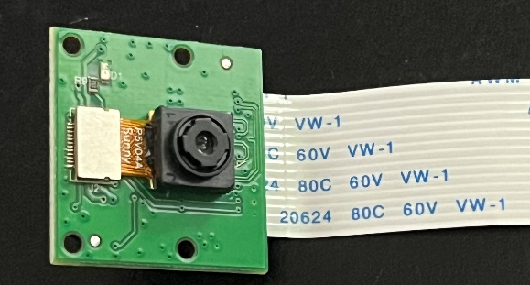
Figure 34. Arducam

6.2.3 PIR Motion Sensor
The PIR motion sensor is a part of the security portion of the design to detect front door activity. The sensor we chose is from Stemedu HC-SR501 since it is known for being energy efficient, high quality, and provides long service life. This sensor provides sensitivity adjustments of 3 – 7 meters and time delay ranging from 3 seconds to 5 minutes. The sensor cone even includes 100 degrees of coverage. We took advantage of these features as a trigger to the raspberry pi to take a captured image from the camera. The PIR motion sensor was integrated to the Pi (in the security box) and relay activity to then turn on the camera. An image of the pin configuration for the sensor is shown in Figure 34.
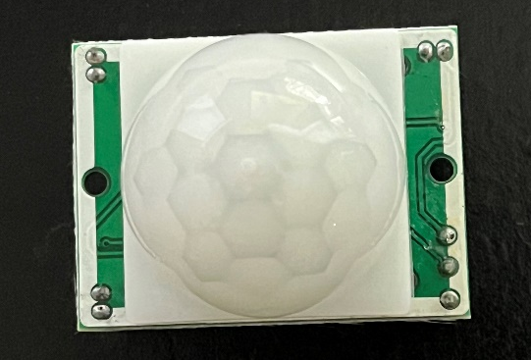
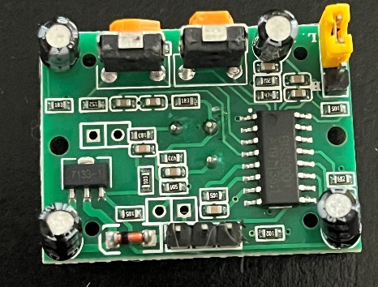
Figure 35. PIR Motion Sensor Layout

6.2.4 High Torque – Metal Gear Servo
Based on a similar experiment of a smart lock we chose this High Torque Servo motor. Its features provide a rotation of 120 degrees (60 in both directions) with the flexibility of up to 170 degrees. It is a light weight of 62.14 4 gh size dimensions of 40.7x19.7x42.9 mm. We used the servo to turn the knob in the deadbolt with the plastic horns provided by the kit chosen. We achieved this through 3D printing different models that would turn the knob and attach to the plastic horns.

The design of the 3D printed knob varied through testing to see which achieved a better effective outcome. Further elaboration of the knob design will be talked about in the hardware testing section. Image of the servo and plastic horn purchased is shown in Figure 35. This will be compatible lock box PCB design to turn the knob and supplied with a 5V battery pack. Horns used for the servo will be varied per testing design in turning the knob meaning it will be a straight plastic horn shown in the figure or an x-horn. There were are other horns available from sellers online that we kept on hand in case the current one did not achieve what we needed them to. There are ones in the shapes we already have, but larger or smaller. There are also completely different shapes we considered experimenting with, such as the 6-legged star horns.

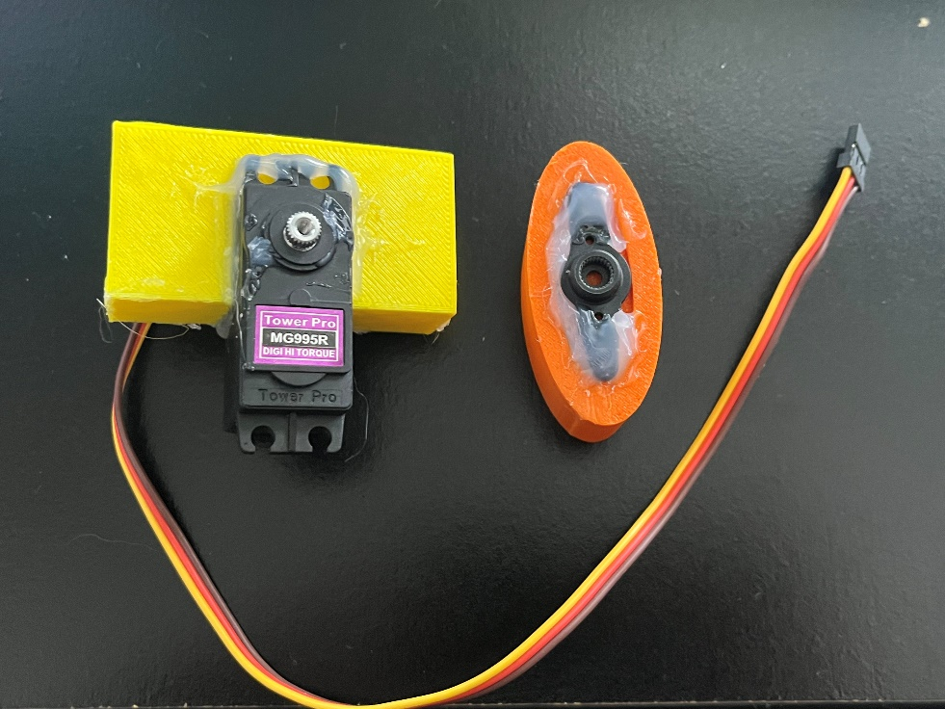
Figure 36. Servo Motor and Plastic Horns

6.3 Power Distribution
Our system is complex in the sense that each component will require a voltage input to keep the system running. Since our design requires microcontrollers, sensors, Wi-Fi module and a servo, it was essential to make sure that each respective component functioned properly and ran given the power source provided. Before we determined a power distribution system, we collected data on the operating voltage for each component.
Table 14 below is a list of the components used and their voltage requirement. With this list we have a better outline for the power requirement in our system. Based on the data collected, we created a 12V battery pack to place onto each pack in order to add to the longevity of the systems. These were purchased and placed within their own compartment with each respective box. Both boxes will have the option for removing a cover case and recharging the battery packs. Battery packs used for the boxes can be shown in bill of material in section 10.

Table 14: Component Power Requirements
Component Section | Power Requirement | Location of Hardware
Sensors
Raspberry Pi Camera | Source from Raspberry Pi | Security
Motion Sensor PIR Detector | 4.5 – 20 V | Security
Microcontrollers
Raspberry Pi | 5 V | Security
Microchip
ESP12F | 3.3 V | Lock
Servo Motor
High Torque – Metal Gear | 5 V | Lock

6.4 3D Printing
The lock and security box were built with the choice of 3D printing. In essence, we could’ve used different sets of materials to build our boxes, however, our goal is to build Live Bolt is a lightweight portable product. Hence the choice of creating our prototype box was from 3D printed filament.

The filament of choice to create a durable/ temperature standing design is our highest priority. We wanted to make sure that the customer was obtaining a long-lasting product. Hence, we narrowed down the choice of using PETG filament for ease of printing quality and temperature durability.

PETG filament includes are strength quality of 119 – 184 pounds; it’s ability to stand with cold and hot temperatures without cracking; and its ability to be recyclable after usage. PETG filament is recommended to not be used outside where it is faced through UV rays or moisture; however, since this is a prototype and we’re limited to manufacturing materials, it’s best to showcase our design first from an enclosed box and later incorporate durable outdoor material. Choosing PETG as our filament for Live Bolt didn’t seem to be a problem since it won’t be over-exposed to UV radiation or drastic temperature change.

Aside from the filament choice for a 3D printer, we wanted to keep our design within the constraint of being 3D printed. From just general research of printing dimensions for 3D printers, we see that they’re 150x150x150 mm. In form of consideration, we made sure our design for the lock and security box was less than or equal to 150 mm in length, width, and height.

6.5 Electronics Placement/ CAD Models
After researching the desired electronic parts, it was essential to organize the electronic placements for our design. From our objective, we wanted wireless intercommunication between the lock and security system to the app. Since we decided to work with two aspects for our project, this design was split into an indoor and outdoor design where they will respectively unlock the door and provide home monitoring. A free-handed/ CAD sketch was mocked up using solid works based on the selection of the hardware. Under this section, you’ll see how we developed the design for the boxes.

6.5.1 Lock Box Prototype
This project is designed specifically to use a dead bolt lock therefore, we integrated hardware to perform the locking/unlocking sequence at the command of the consumer. Meeting our objective for the project, we kept the design of the lock as minimal and compact as possible.

There are three main components that are harnessed onto the lock box: high-torque standard servo motor, 12V battery pack, and the PCB. The servo oversees turning the knob in the dead bolt; the 12V battery pack supplies power to the servo motor and PCB; and the PCB contains the circuit and ESP12-F for the wireless connection to command the servo to unlock/lock the door.

All dimensions of the electronics have been taken into consideration when we design the length, width, and dead bolt diameter in the box. The customer will see a 147x80 mm box. More elaboration about the design of the box will be further discussed in the next section in CAD modeling. How we organized the component in the box will be shown in the free sketch in Figure 36. This sketch is not to scale (NTS). The final dimensions were 147mmx80mmx65mm.

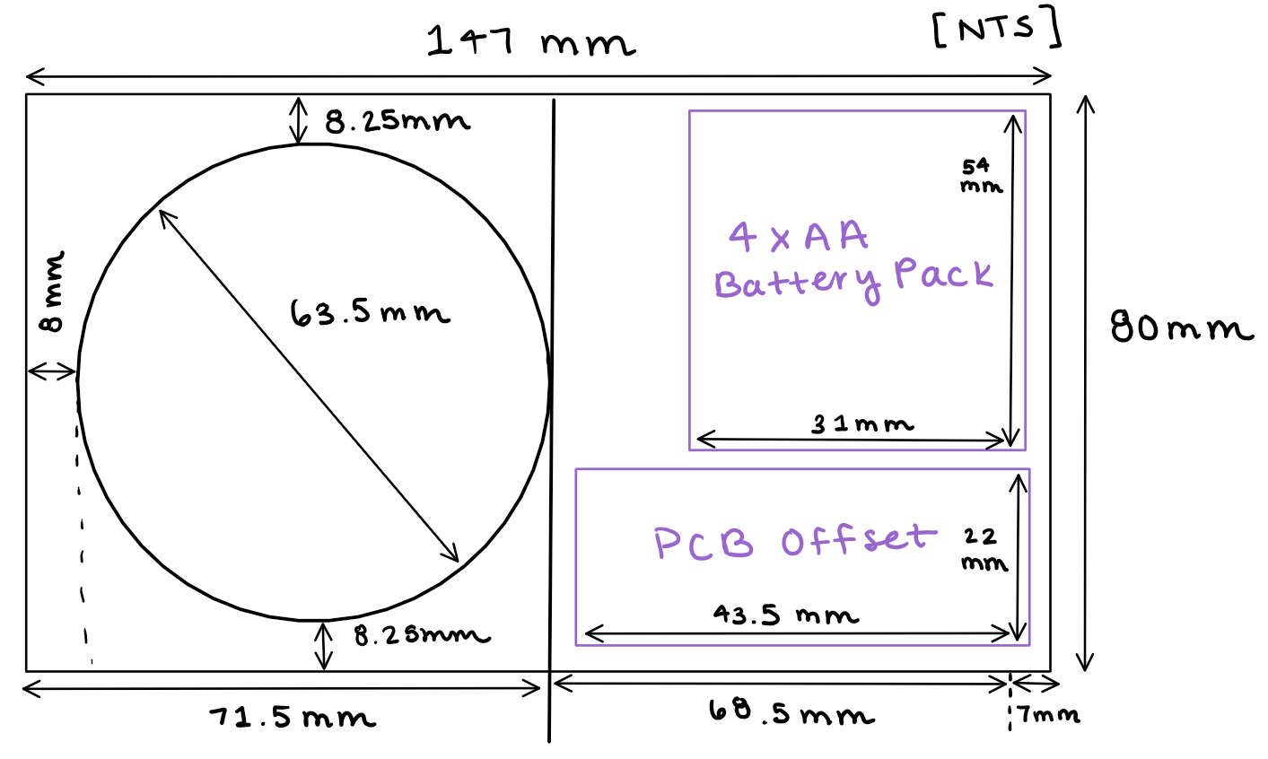
Figure 37. Lock Box with components

6.5.1.1 Lock Box CAD Model
Since we have the general layout of where the electronics will be placed in our casing, the next step was to create a model of the box. As we said previously, the dimensions will be 147x80 mm for the length and height. The width of the box is determined by accounting the size of the servo motor and holder. Concluding for the team to choose an extrusion of 65 mm. Other than that, our overall dimension should be able to harness our components.

A unique portion of the design is the casing. A consumer has easy access to the batteries with the use of the back panel. We mentioned earlier in the report that the design for Live Bolt would have rechargeable batteries. Separating the case with a back panel would allow this objective to be accomplished. It’ll open the back portion of the case so the consumer can access the 6x AA battery pack and change when necessary. The CAD model of the idea is shown in Figure 37. In the lock box case, you can also see two extrusion points enclosing the dead bolt knob. This addition was required so the servo motor is enclosed and in place.

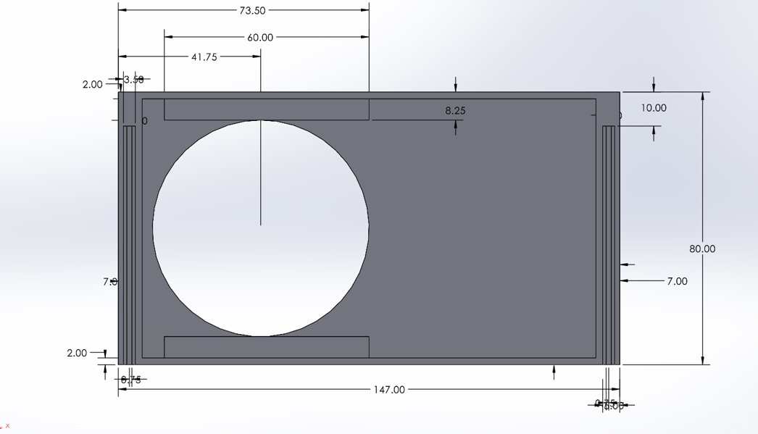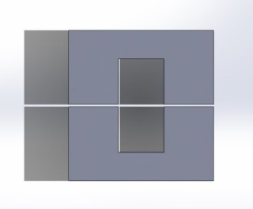
Figure 38. Lock Box CAD dimension model

Figure 38 is an extension of the lock box case with the railing system to open and close the lock box. The image shows an assembly of what a complete lock box would look like. Ideally, this choice should fit to scale on most deadbolt knob. This figure would be a representation of how the back casing will be accessible to the consumer and how they’ll be able to achieve the battery change when necessary.

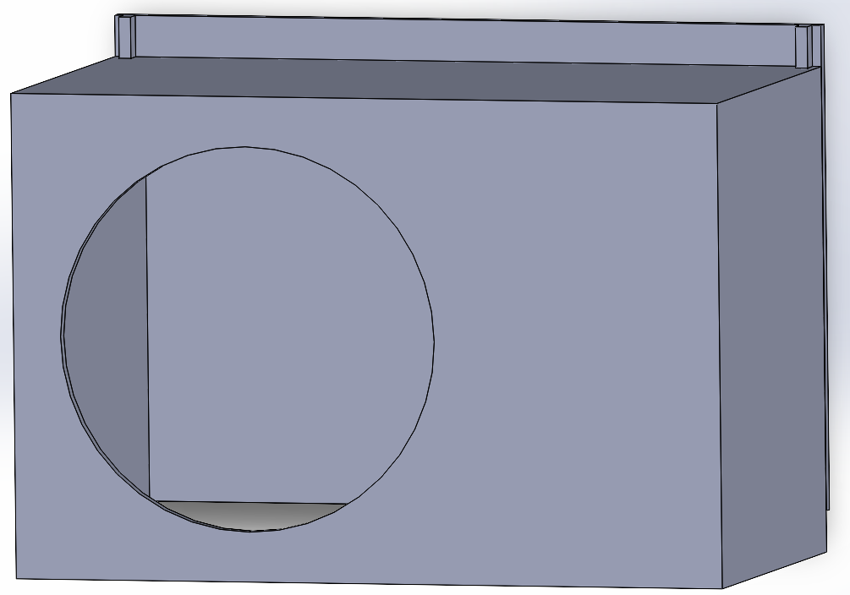
Figure 39. Lock Box assembled with removeable back

6.5.2 Security Box Prototype
The security box prototype design for Live Bolt will be built to accommodate the electronics to compensate with the requirements we laid out for home monitoring, home entrance, and wireless updates to the application. To complete the requirements, we narrowed down all the electronic parts to perform those actions, along with collecting their dimensions to comprise all the settings into a compact security system.

The outside perspective that’ll be viewed by the customer will be a 150x82 mm box with cuts to represent the positions for the Raspberry Pi Arducam, PIR motion sensor, LED light, and Arduino keypad. The most interactive aspect outside of the box will be the keypad. A user can see and physically interact with the keypad for the home entrance Arducam and PIR motion sensor will be the security portion of the project. Their objective is to monitor and relay information about front door activity to the application. Including these components in our design will cover security object in our project.

The interactive portion of the box that is not viewed by the customer is the access to speech detection. Using a Raspberry Pi Microphone and relaying speech detection to the raspberry pi is way we wanted to incorporate access control to the customer. Since this microphone is flushed into the box, security breach from speech detection will be lowered since there is no outside acknowledgement of an entrance code.

Within the Live Bolt box, we will include a Raspberry Pi, MCU (PCB offset), NFC Reader, Raspberry Pi Microphone, and a rechargeable battery component. In the sketch for Figure 39, the box was designed to equate the size of the microcontrollers in parallel to compensate for the needs of the electronics, e.g., Arducam and PIR motion sensor. One thing to note that is missing from the sketch is including the design for the rechargeable battery. Although this is not in the sketch it something that will be included in the box behind the microcontrollers. The sketch also shown is not to scale (NTS) with representing dimensions, but the next section of the report will show an accurate scaling.

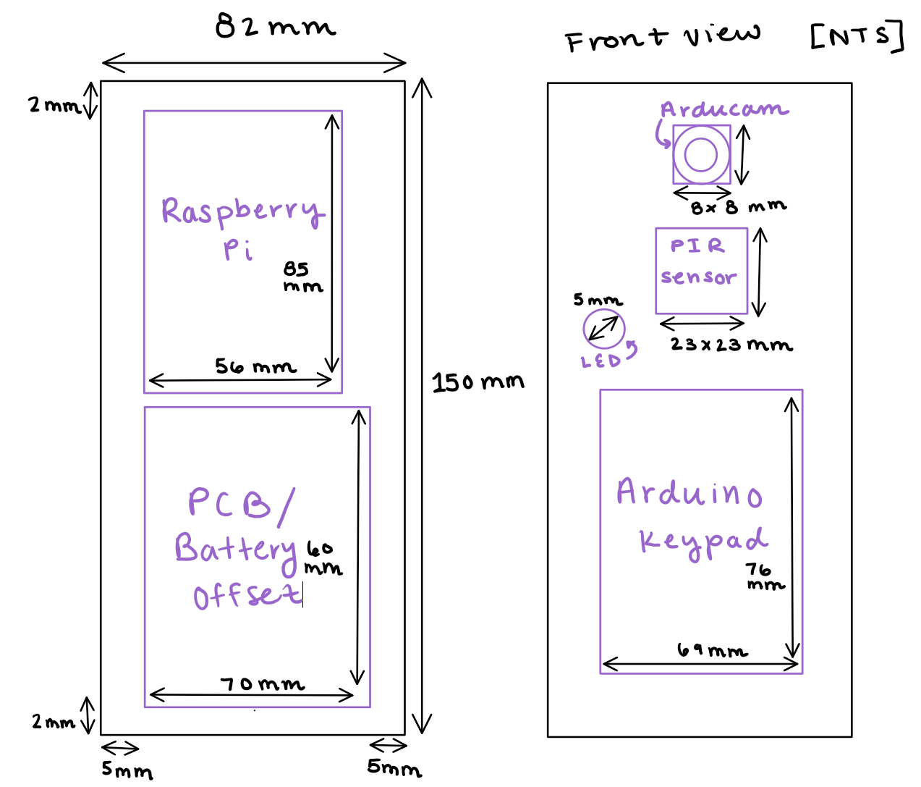
Figure 40. Security Box with components

6.5.2.1 Security Box CAD Model
After collecting the total dimensions of the components within the security box, it was easy to design a CAD model. We have two parts of the security box, the font and back panel. Using the same objective of battery access, the back portion of the box will provide this capability. They will both vary in design based on what’ll be required from each and come together in a railing system.

The back portion of the box includes 4 screwdriver holes and a railing system to mount onto the wall and then connect to the box. The box that harnesses the electronic components will have cuts for the Raspberry Pi Camera, PIR motion sensor, and slit cut for the Arduino Keypad. It is scaled to provide the detection reading of the PIR 100-degree cone area and open space to include the keypad. This would amount to 150x82 mm in length and height. The width shown in Figure 40 is the offset amount we predict we’ll need for the electronics. With this design, we hope to make the security box have ease in mounting and access to the battery.

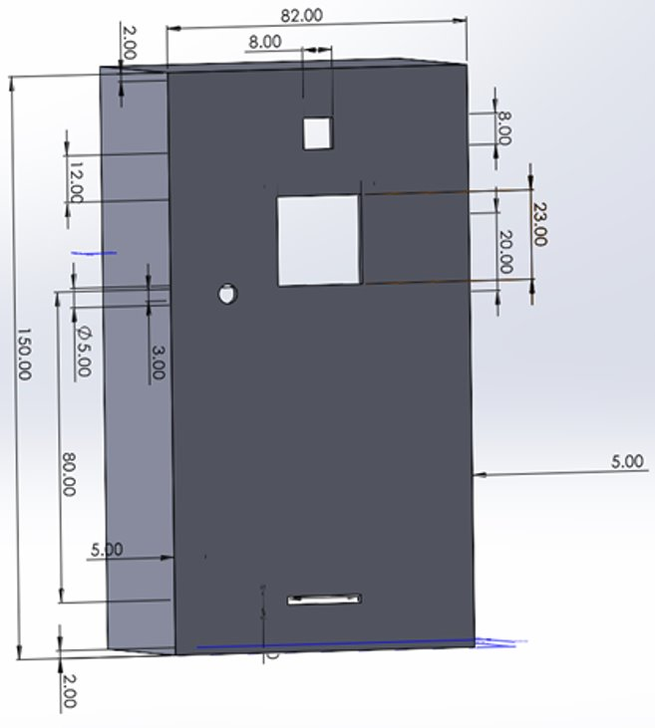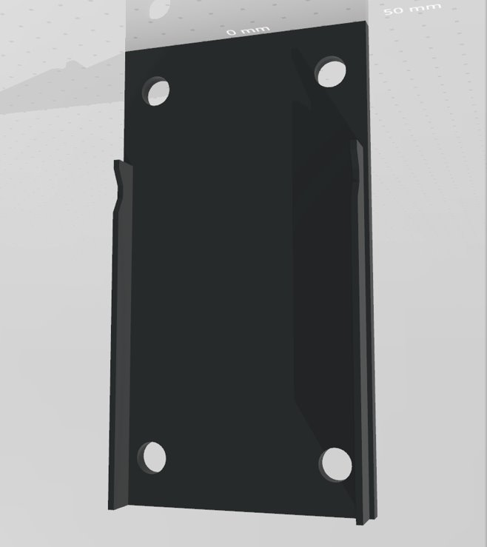
Figure 41. Security Box CAD dimension model

In Figure 41, we outlined the hardware for the box when fully assembled. There’ll be a clipping method in this railing system that would lock the box in place and secure the mounting to the wall. Note that including holes onto the security box would require home mounting. This can be mounted on a door or a wall. Technically, there is no need for mounting aside from aesthetic/ hole exposure, but a user can do what they want.

When collecting the measurements for the pi camera, PIR Senor and Arduino keypad slit, there was the use of a caliper tool. Compared to the online resources’ measurement, our parts were not accurate to what was being measured in the caliper tool. The caliper allowed us to move forward with box design knowing that every hardware will fit correctly.

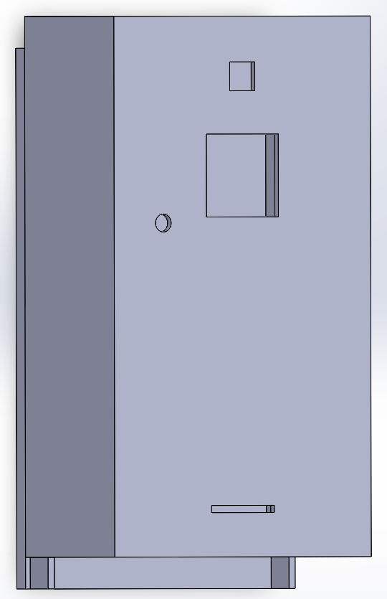
Figure 42. Security Box assembled with removable back

6.6 Summary of Design
In hardware, we discuss what components are included but not the overall interaction of the system. Although Live Bolt is split into two aspects (lock and security), they’re integrated together to perform the objective of home access and monitoring. In Figure 42 we see how the microcontrollers, Wi-Fi module, and electrical hardware come together to provide the overall concept of what make Live Bolt a functioning home access and security system. The arrows pointing through the diagram represent their relationship within the system and whether their representation in the graph is an input or output.

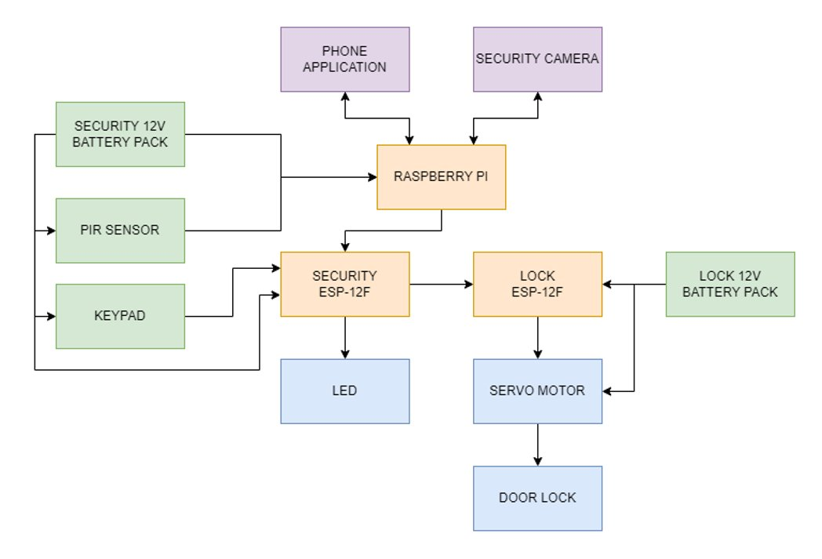
Figure 43. Hardware Design Block Diagram

7. Printed Circuit Board Integrated Schematics
To achieve a concise and compact final product, a printed circuit board was designed after the breadboarding phase of the project. This section will outline all aspects of the PCB design process as well as the ordering and assembly. The PCB CAD software will also be determined in this section, for there are multiple user application that can execute our desired design.

7.1 PCB Terminology
Before we go into the designs created for our two PCBs, we will go over some common terms used in printed circuit board design. This is important to understand what choices we are making and to give necessary background to understand why these choices were made.

Table 15 provides some common terms and abbreviations regarding PCB terminology and their respective explanations.
Table 15: Common PCB Terms
Term | Explanation
CAD | Computer-aided Design. This refers to the software used to design a PCB.
Component | Components are what make up the circuit of the PCB. They get attached to the board after it is designed and printed.
Copper | Copper is a conductive metal that laminates most PCBs
DRC | Design Rule Checks are an automated process ran by the CAD software to ensure the PCB is ready to be printed. They find potential errors such as holes or traces being too close together, or errors in the circuitry.
Footprint | A footprint is a digital representation of a component that acts as a placeholder while designing the PCB. Usually, footprints have the component specifications like size to ensure everything fits properly on the board.
FR-4 | The most common material PCBs are made of. It is a glass reinforced epoxy resin.
Gerber FIle | Gerber Files are files of the PCB that outline each layer of the design. They are sent to vendors who will print the board.
IC | Integrated Circuits are chips that house very small circuits that help to keep the overall PCB organized and neater. ICs have many uses and applications, from voltage regulators to timers and more.
Pad | A conductive spot for components to be soldered to the board.
Silk Screen | The silk screen is a nonconductive layer on the board, usually reserved for logos or words. It is useful to label specific spots in the silk screen to refer to them during assembly.
Solder Mask | Solder Mask is a nonconductive layer that covers most of the board. It insulates copper traces to negate shorting of the circuit.
SMT | Surface Mount Technology is a way to connect components to the board. Surface mount components are rested on pads and soldered directly to the board. Most consumer electronics rely on SMT.
Through Hole | This is the alternative to SMT and refers to the leads of electrical components being passed through holes in the PCB and soldered into it. This method uses up more space but is usually easier to do.
Trace | Copper traces are what conducts the electricity between each component. They are etched into the solder mask so that only the underlying copper remains.
Via | A via is a conductive hole in a PCB that can connect different layers of the board, such as components on the top of the board connecting to components on the bottom of the board.

7.2 PCB CAD Software
There are many computer-aided design (CAD) tools that allow for the design and testing of printed circuit boards. The two that we considered for this project are KiCad and Autodesk EAGLE.

7.2.1 KiCad
KiCad is a free design suite for designing and simulating printed circuit boards that was developed in 1992. Since it is free of cost, there is a variety of tutorials and resources online. This makes the learning curve for KiCad much better for new designers. It offers Simulation Program with Integrated Circuit Emphasis (SPICE) simulation, open-source footprint libraries, and a 3D-view of the PCB once it is designed. Figure 43 shows a screenshot from the PCB designer/editor in KiCad.

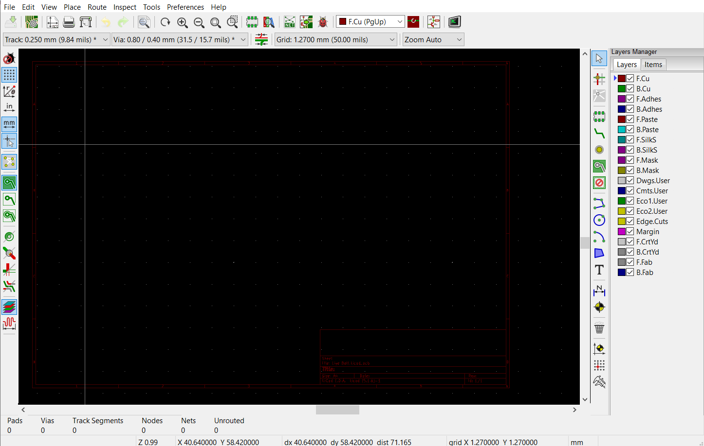
Figure 44: A screenshot of the PCB design window from KiCad

7.2.2 EAGLE
EAGLE, designed by Autodesk in 1988, is another CAD software for PCB design. EAGLE stands for Easily Applicable Graphical Layout Editor. Unlike KiCad, it is not free and instead offers a subscription-based model. However, University of Central Florida students get Eagle for free with their student emails. Since EAGLE is closed source, there aren’t as many online resources as possible and customization options, and it is a bit harder to start using when compared to KiCad. EAGLE was used as the CAD software of choice in the EEL 3926L Junior Design course at UCF, so students do have some experience with it.
EAGLE also offers the option to collaborate with others on a single design and dynamically update the design. Figure 44 shows a screenshot from the PCB editor in Eagle.

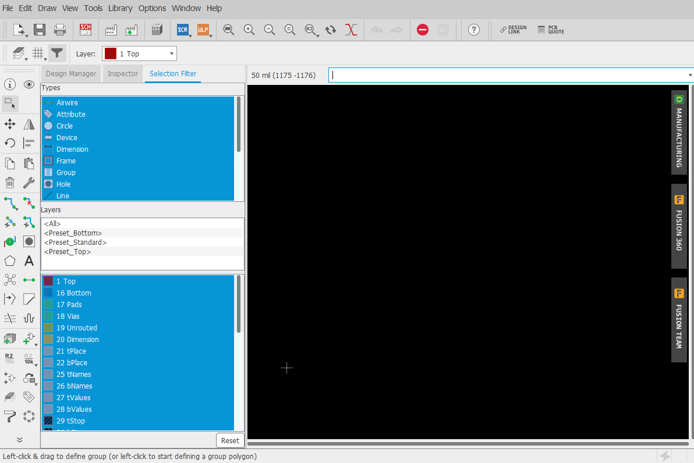
Figure 45: A screenshot of the PCB design window from Eagle

7.2.3 CAD Software Decision
Due to the advantages like, being free of charge, having a low skill level, and having open-source libraries and tutorials online, the team decided to create our circuit and PCB design in KiCad.

7.3 Printed Circuit Board Designs
This section will outline the printed circuit board designs and the process to create them. Since this project is broken up into the indoor (lock) module and outdoor (security) module, there will be separate sections for each.

7.3.1 Security PCB Design
The components chosen for our security circuit, shown in Figure 45, all have different power requirements, as shown in section 7.2. Due to this, we will need to have varying voltage levels throughout the printed circuit board. Our current design currently has only a single 12-volt battery pack as the power source, so we will need to incorporate voltage regulators.

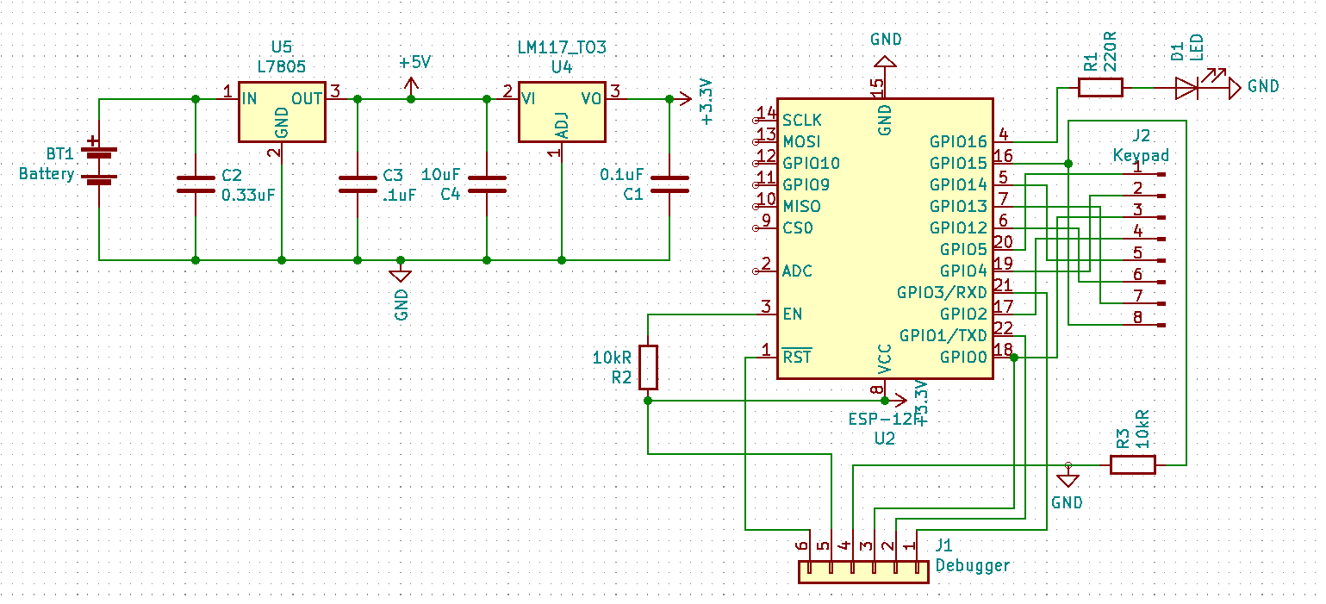
Figure 46: Security Module Circuit Schematic
The 12V battery pack is stepped down to 5V using a L7805 voltage regulator, and then that is stepped down once more to 3.3V using a LM11733 voltage regulator. The 5V are then used to power the raspberry pi while the 3.3V are used to power the ESP-12F. Both regulators are linear and are using bypass capacitors with values found in each component’s data sheet. We originally had resistor-based voltage divider circuits in place of this regulator circuit but decided using linear regulators would be safer and more energy efficient since voltage dividers waste lots of energy through dissipated heat.​ The PCB design can be seen in Figure 46.

Another consideration that was made was how readily available schematics and PCB footprints are for each of the parts we chose. We were able to find these online for every part including the ESP-12F module. The keypad only requires 8x1 pin headers be fixed to the board. We also included pins to connect the ESP-12F to a debugger in case we need to reprogram it after it has been soldered, this is seen by the x1 pin headers.

The battery pack will be soldered directly to pads on the board. Components are a mix of through hole and surface mount technologies. The battery pack wires and ESP-12F will be mounted to the board, while the voltage regulators, and pin headers are all through hole. Figure 47 shows the the security PCB 3D model generated by KiCad.
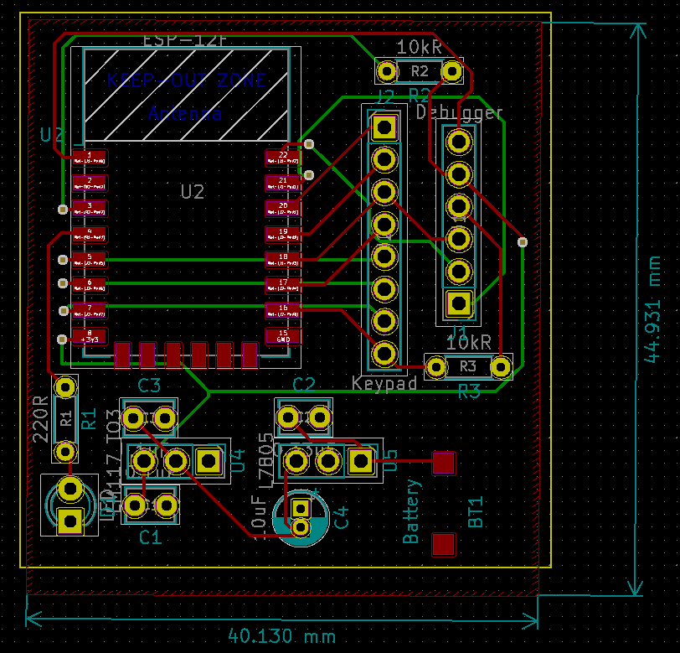
Figure 47: Prototype Security PCB Design

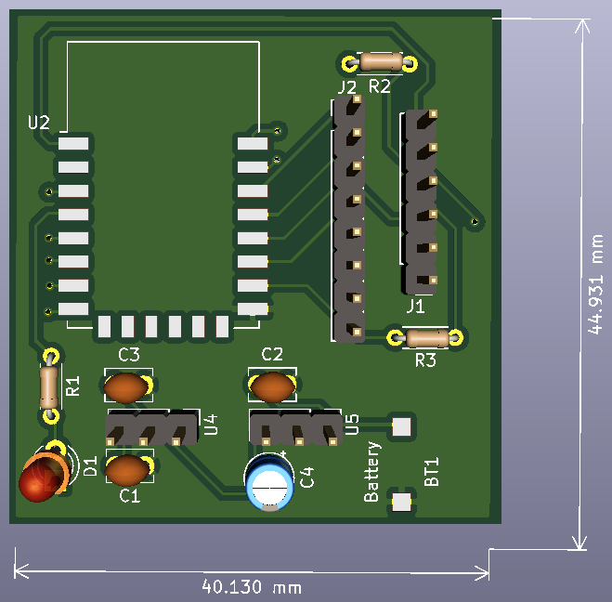
Figure 48: 3D Prototype PCB Model

7.3.2 Lock PCB Design
The design for the locking module is similar to the security module. This PCB has pads for a battery pack, pin headers for the servo motor and debugger, through holes for a voltage regulators, and a pad for the second ESP-12F chip to be surface mounted. Figure 48 shows the KiCad schematic for the lock circuit.
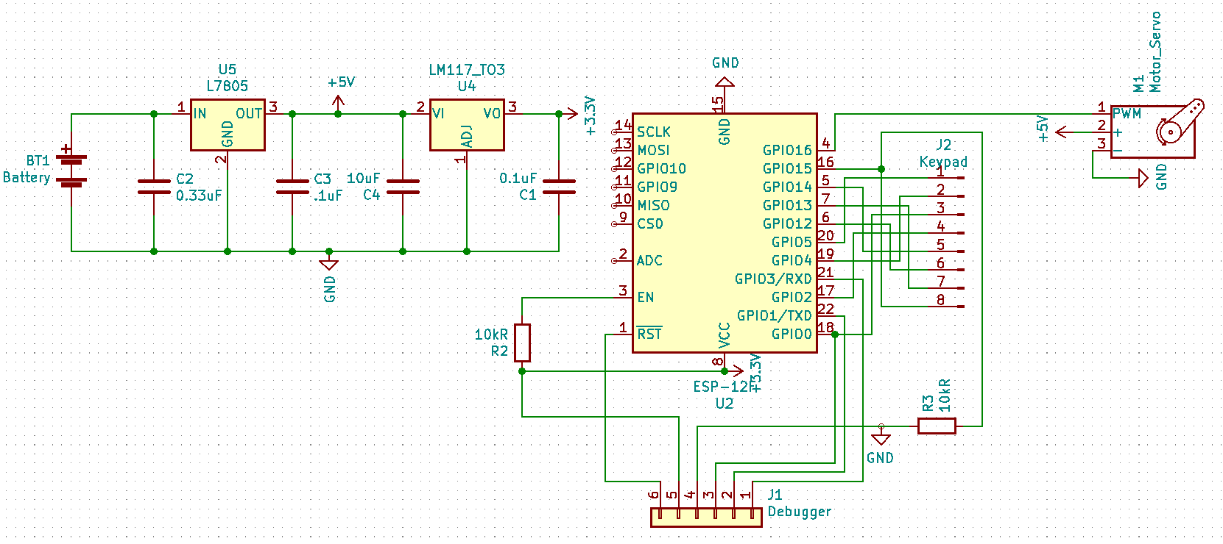
Figure 49: Lock Circuit Schematic
The components for this PCB are used to communicate with the security module, and then turn the dead-bolt knob when the unlock criteria are met. The ESP-12F runs at 3.3 volts, while the servo motor runs at a minimum of 4.8 volts. Because of this, we will need to have a 5-volt battery pack for the servo motor, and then step down the voltage again to 3.3 volts like in the security module to power the ESP chip. Figure 49 shows the circuit in the PCB editor.

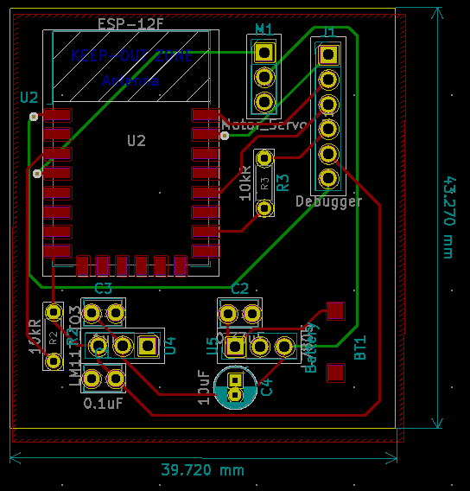
Figure 50: Prototype Lock PCB Design

The 3D model view of the PCB is shown in Figure 50.

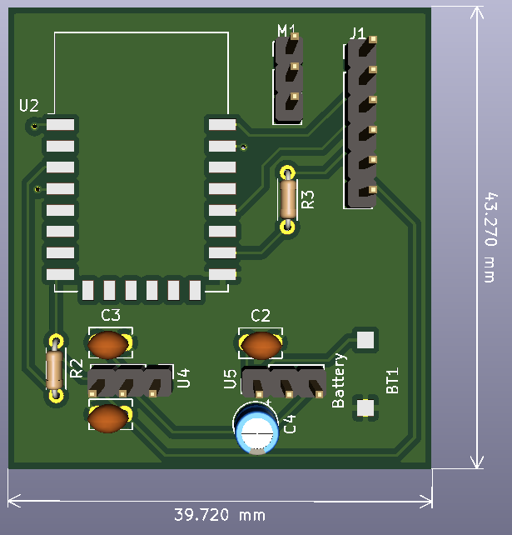
Figure 51: Front Lock PCB 3D Model

7.4 PCB Vendor and Assembly
The process of getting a PCB printed is simple. Once the design was completed, the gerber files and drill hole files were exported and sent to a vendor. Once they had the gerber files, the number of layers, size of the board, thickness, color, and quantity are all defined. There are numerous vendor options online to get a PCB printed and mailed.

The option we chose to pursue was JLCPCB due to having positive experiences with them in the past for printing PCBs. JLCPCB services over 20,000 orders daily and produce 6 million PCBs each year. They ship to over 170 countries and have an on-time delivery rate of 99.97%. Depending on the size and complexity of the board, they offer prices as low as $2 for 5 boards, excluding shipping. They also offer PCB surface mount assembly, since the process for surface mount soldering is more complex than through hole. There is also a feature for surface mount technology boards called SMT Stencils. This option allows the surface mount pads to arrive with solder already applied, which makes it very easy to place the component on the pads and simply melt the solder until the component falls right into place. The University of Central Florida Senior Design Lab also includes a reflow oven to solder surface mount technology products. This is a great option for us to use when we begin soldering our surface mount components. Figure 52 shows the JLCPCB order page and the various options given when ordering a PCB.

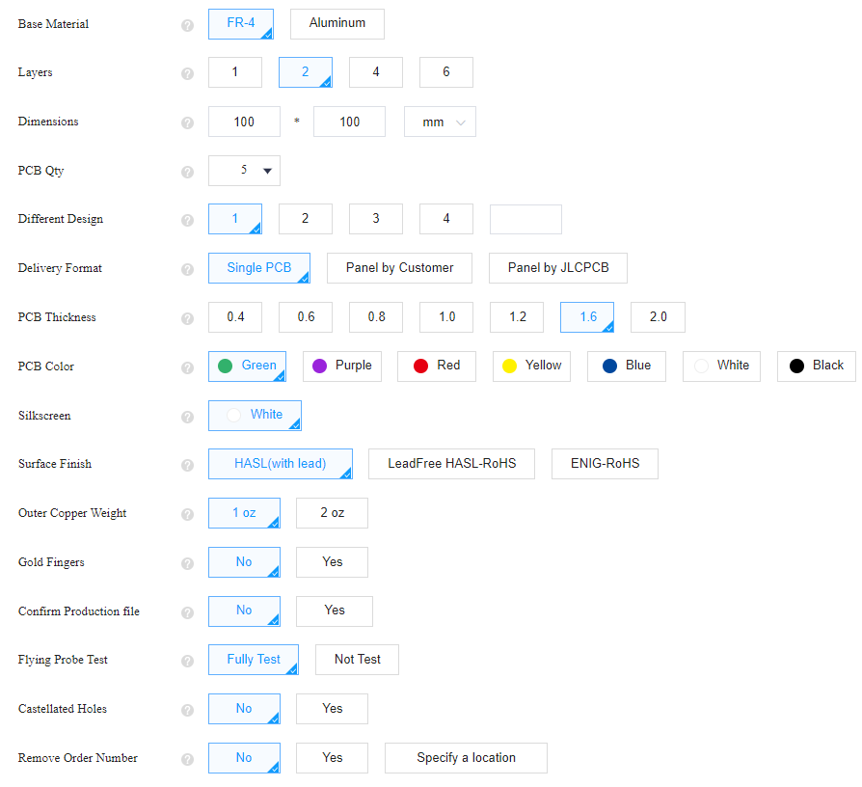
Figure 52: JLCPCB PCB Order Options

For a JLCPCB standard PCB, meaning two layers and less than 400 millimeters by 500 millimeters, JLCPCB is able to start and finish production in one to two days. Once production was finished, the board was ready to be shipped. Our board was not larger than 150 millimeters by 150 millimeters, s for a two-layer board of this size, the price of production equates to $13.40. This is made up of a $4.00 engineering fee and $9.40 for the actual board. Table 16 gives the prices and shipping times for delivering to the United States of America for a two-layer 150 millimeter by 150 millimeters board.
Table 16: JLCPCB Shipping Costs and Delivery Times
Shipping Method | Cost | Delivery Time | Restrictions
DHL Express Worldwide | $22.97 | 3-7 business days | ≤10000kg
DHL Express Economy | $21.66 | 5-8 business days | ≤11.5kg
UPS Express Saver | $22.97 | 6-9 business days | ≤10000kg  ≤120x70cm
FedEx International Priority | $20.70 | 5-8 business days | ≤10000kg  ≤121x121cm
Global Direct Line Saver | $11.69 | 6-16 Business days | ≤1.8kg  ≤$150
Economical Global Direct Line | $9.73 | 10-18 business days | ≤1.8kg  ≤$150

Since we are trying to minimize prices, we chose Economical Global Direct Line. We ordered our parts early, so a 10 to 18 business day delay was not an issue for us. We also had a first-time coupon to use, that made the PCb and shipping only cost $4 overall.

8. Project Prototype Testing Plan
How we tested Live Bolt will be split into hardware and software components.

8.1 Hardware Test Environment
Designing Live Bolt comes with two components that is iterated throughout the document: a lock and security box. The lock box will only function with the use of a deadbolt lock while the security box just needs a brick, concrete, or stucco wall to mount onto. How we initially tested Live Bolt in an environment was on our doors in our apartment homes. The product can eventually be mounted to a door permanently for extended use.

Mounting requires a sturdy wall and since we’re in an apartment complex, we’d like to avoid any consequence for drilling into a wall. Solution to presenting the mount and show in the senior design show case would be to create our own concrete wall. Meaning that we’d use a cement block to prove mounting. The reason to creating this prototype environment is to present the scenario for when it comes to demonstrating Live Bolt.

8.2 Hardware Specific Testing
The hardware testing encompasses ensuring the electronic components, PCB design, and housing choices all worked as intended and could be all interfaced together to create the final product. This further elaboration would outline our team strategy when understanding what was tested when building Live Bolt and creating our final product. Also outlining steps/ procedures that provides guidance in finishing our product from conducted research.

8.2.1 MCU Testing
To test the Raspberry Pi’s and ESP’s functionality with the application, a connection between the two was established. We planned to use one of two methods to do so. The first method would require establishing a Bluetooth connection between the mobile device and Raspberry Pi. The second method would involve setting up a Wi-Fi access point on the Raspberry Pi so a mobile device can connect to it.

A Bluetooth connection between the devices would allow for testing and connecting to the application when there is no Wireless network available. Some user made APIs exist to make this connection easier to establish between the devices. One such library is bluedot which a provides both a communication API for setting up connections, a Mock API for testing connections, and a mobile Application for controlling the PI over the connection. [26] This functionality would allow us to test the connection between the various parts of our system without having to spend a lot of time getting things set up. Additionally, we can use bluedot’s mobile application to troubleshoot certain functions of Raspberry Pi and MCU, such as locking and unlocking the lock. To pair the devices using Bluetooth we will need to follow the following steps:

On phone:

- Open Settings
- Select Bluetooth and make your phone “discoverable”

On Raspberry Pi:

- Click Bluetooth ‣ Turn On Bluetooth (if it’s off)
- Click Bluetooth ‣ Make Discoverable
- Click Bluetooth ‣ Add Device
- Your phone will appear in the list, select it and click Pair

On the phone and Raspberry Pi.

- Confirm the pairing code matches
- Click OK [27]

Alternatively, the command line can also be used to facilitate the connection. This can be done by entering a series of commands into the prompt to create the connection.

Setting up a Connection using Wi-Fi has the benefit of ranging long distances and tends to have a stronger connection when compared to Bluetooth. The access point that we set up will facilitate a Transmission Control Protocol (TCP) connection for communication between the devices. TCP Connections create a more secure, reliable connection between devices. Although it is slower than its sibling protocol UDP it is more dependable making it a good option for setting up the connection. The following are the steps needed to establish a TCP connection between the Raspberry Pi Server which will listen for request from the phone Client:

- Set up Raspberry Pi as Access Point.
- Set up Raspberry Pi as TCP Server to listen for connections.
- Connect phone (TCP Client) to Raspberry Pi via Wi-Fi to the access point and send socket connection over.
- Send data from phone to Raspberry Pi. [28]

This functionality will be accomplished following the official guide for setting up a Wireless Access Point on the Raspberry Pi:

- Verifying the Raspberry Pi is set up correctly before beginning
- Install Access Point and Management Software
- Set up the Network Router
- Ensure Wireless Operation
- Configure the Access Point Software
- Running the new Wireless Access Point

As long as a Bluetooth or Wi-Fi connection is in place, we will be able to test the functionality of the system as a whole. We ended up going with the Wi-Fi method and it is discussed further in a later section.

8.2.2 Deadbolt Knob Design Testing
In the earlier portion of the report, we mentioned that knob design would vary since all deadbolt knobs vary in sizing. From this understanding, our objective is to have the lock box be versatile with all deadbolt doors. We came up with two design solutions to complete that objective. One thing to note before we created the design is that knob will be 3D printed & fit onto the servo motor’s plastic horns. We used one of two different types of plastic horns for these motors based on the change of design. In Figure , it is using one long horn already provided by the servo motor package and was super glued together. After being placed together it was connected to the servo motor and do a turning configuration as if one would turn to unlock the knob.
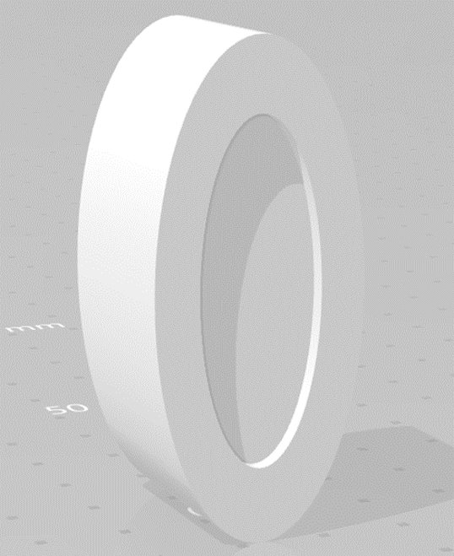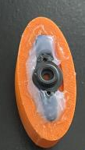
Figure 53. Solidworks Straight horn Design 2
This design has its flaws since it’ll be a fixed shape to place onto a dead bolt knob. All knobs come in different shapes and could on how this design would perform. Ideally a perfect shape knob would turn with ease however there is no standard knob placed on every dead bolt. Dimension of the design would be 55 x 25 x 20 millimeters with respect to length x width x height. The reason for choosing these dimensions was so it can fit onto the knob and turn effectively while having an opening to cover the whole dead bolt (as discussed in section 6). Width size is chosen to be slightly big to fit encompass any knob but to also ensure there’ll be a turn from the servo motor.

In Figure 52, we have an image of a cylinder with two holes. To explain this better, we will be using that image with a x-horn for the servo motor meaning there’ll be 4 legs protruding from the horn. The cylinders will be there to cause the movement of the knob and be secured to the horn with the small holes. The dimensions were chosen based on dimensions provided from the plastic x-horn. Each hole provided from the x-horn is to be around 4.95 mm apart in distance. This will be inserted by a pin to hold in place to the x-horn. The 20 mm in height will be the standard size to when the looking at the distance between x-horn and knob. That standard will also be implemented when discussing on design 2.

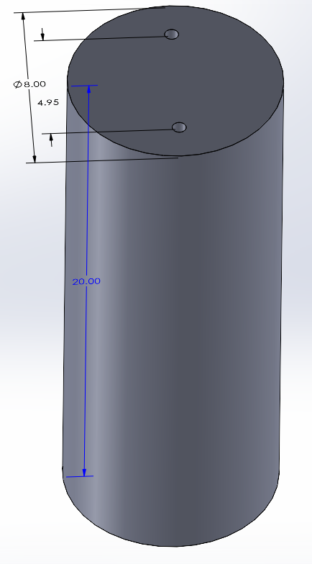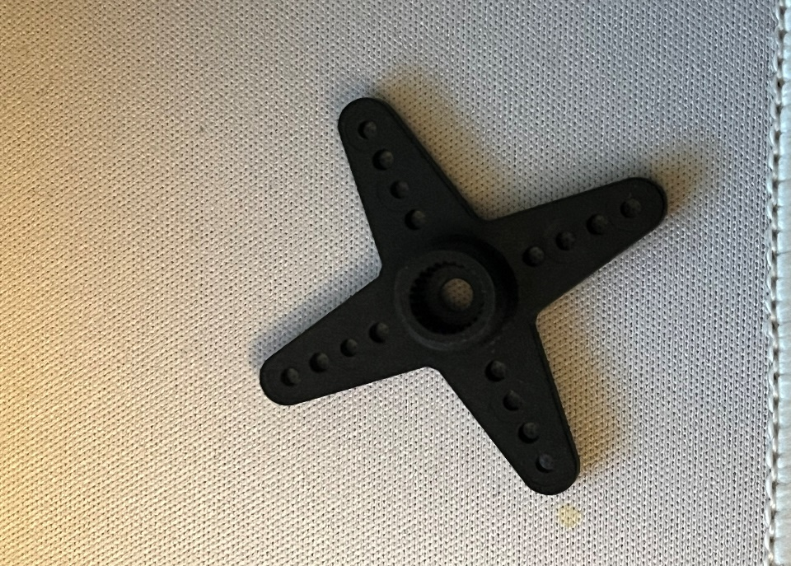

Figure 54. Solidworks X-horn Design 1

These two designs have their own respective choice for making a great outcome when performing the unlocking mechanism; however, they’re not perfect and were tested to ensure that there’ll be a great outcome. Table 17 outlines the pros and cons for each design. Although we will talk about what type of factors they bring, these are all assumptions we understand that could bring risk into the lock box. Testing these designs provided better clarification on performance and construction. The team had access to 3D printers so we were able to print both designs and test them to determine which design was best applicable to the Live Bolt system. We opted to go for the first design where the servo horn is super glued to the 3D printed part.

Table 17: Pros and Cons for knob design
Knob testing | Pros | Cons
Design 1 | Provides better flexibility to customize to knob sizing | Four pin design risks breakage
Design 1 | Creates ease in movement of the servo | Requires extensive work for 3D printing
Design 1 | Easy to install | Not easy to replace
Design 2 | Durable | Causes a lot of friction making knob turn difficult (overworking the servo)
Design 2 | Easy design | Fixed sizing therefore might not adjust to deadbolt knobs
Design 2 |  | Requires more filament printing

8.2.3 Electrical Components Testing
This section will go into detail how we will go about setting up and testing each component individually before we integrated them together for the final design of the Live Bolt system.

8.2.3.1 ESP8266/Arduino Programming
Programming the ESP8266 NodeMCU is very similar to the way any Arduino board is programmed. There are a few things you must set up first, however.

- First you must go to Preferences in your Arduino IDE and enter: http://arduino.esp8266.com/stable/package_esp8266com_index.json into the “Additional Boards Manager URLs” section since the ESP8266 isn’t running native Arduino architecture.
- Then you must install the ESP8266 board package within the Board Manager menu. The option should be there if the URL was placed correctly in the previous step.
- Plug in your ESP8266 into the computer via a micro-USB. If a low-quality cable is used, the computer may not be able to read that the board is plugged in.
- Once plugged in and recognized, the computer should automatically download drivers. If it does not, you can manually install the CH340 drivers from the internet.
- Once everything is correctly installed, you can select “NodeMCU 1.0 (ESP-12E Module)” from the board menu.
- Select the new COM port in the Port menu.

With these steps completed, the ESP8266 was ready to be programmed. There are some differences with programming an ESP8266 vs an Arduino. One major difference is that when defining pins, the Arduino allows you to use the number of the digital pin. Digital Pin 6 = D6 = 6. On the ESP8266 NodeMCU breakout board, the digital pin number does not correlate with the number you define in the code. This means you need to refer to a pinout sheet when coding. The number you define for each pin correlates to the respective GPIO pin. This means that D6 on the development board would be defined as “12”, since it is the GPIO12 pin.

There is also a way to program the ESP8266 and Arduino without plugging it in to the computer and uploading the code through a serial connection. This method is known as Over the Air programming. You can set this up via the Arduino IDE. An example code in the IDE called “BasicOTA.ino” provides the framework for this process. With the ESP8266 or Arduino plugged in to the computer, you have to configure your Wi-Fi parameters. After running the code and saving it to the board, unplug it. You can now power it with a portable power source such as a battery. When the board has power, you’ll see a new port in the tools that you can select. There are a few Over the Air functions that you must put into your original sketch code, and once that is done, you can upload the sketch and your board should have received it wirelessly.

The Over the Air method of uploading code to the ESP8266 or Arduino would come in handy once we solder the chip to our designed PCB, since we will not have a micro-USB port to upload sketches to it. This means we can make small changes to our code without having to desolder and resolder the microchip every time. In the end, instead of using OTA techniques, we added pin headers to the board to attach a debugger for reprogramming.

8.2.3.2 ESP Wi-Fi Communication
One of the main features that allows the Live Bolt system to function is the connection between the security module and the lock module. This connection is established due to the ESP-12F’s Wi-Fi capabilities. Establishing this connect was relatively easy to do. One board is considered the Server while the other is considered the Client. The Server is what is the access point for the Client to connect to. The Client connects to the Wi-Fi access point of the Server by uploading credentials that are defined by the user.

An arbitrary Wi-Fi name and password was chosen, and they must match up between the Server and Client. Both boards communicate via the User Datagram Protocol (UDP) communication protocol. UDP is useful for this application because it is relatively simple to set up. After UDP was configured for each board, the Server listened to the UDP port for packets to be sent from the Client. In our case, the Client is the security board sending data to the lock board, which is the Server. When the Server receives a packet from the Client, it will know whether to turn or not turn the servo motor [29].

8.2.3.3 HC-SR501 IR Sensor
The IR sensor does not require any microcontroller to function. This mean that it can be hardcoded into a circuit. The main set up required for this component is configuring the sensitivity (range) and time delay of the sensor. There are two potentiometers on the board that can be turned to adjust these parameters. Since we would like to detect motion in front of the lock, the range was set to 1-3 meters to get a decent coverage. The delay was also set to 3 seconds, so it doesn’t trigger again for the same person passing by. There is also a pin jumper in the corner of the module to change between single trigger mode or repeat trigger mode. Single trigger mode will change the state of the sensor whenever motion is detected. Repeat trigger mode will turn the sensor on when motion is detected, and after a delay it will turn it back off until motion is detected again.

Repeat trigger is more useful for our application because we want to detect motion and then wait for more motion afterwards. The final consideration for this sensor when setting up is that it needs up to a minute after receiving power to calibrate and get acclimated to the environment it is placed in. To test if the component works, an LED and 330-ohm resistor was connected to the sensors output. After calibration, when motion is detected, the output will go high and light up the LED. The test setup is shown in Figure .

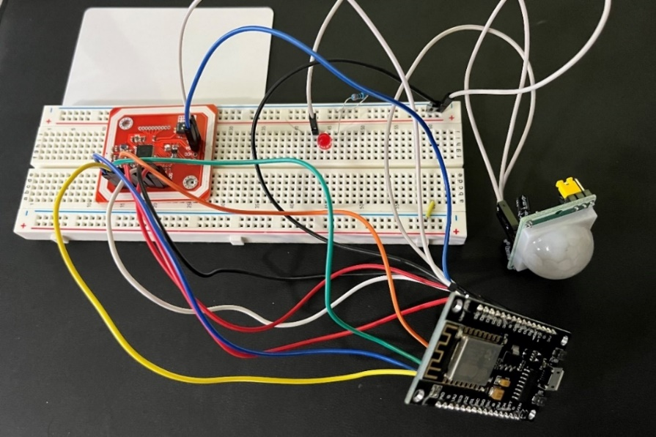
Figure 55: Hardware Development of NFC (Left) and PIR Sensor (Right)

8.2.3.4 Membrane Keypad
The keypad is simple to test with the ESP8266 and requires very little setup. In the Arduino IDE, a character array is created to mimic how the keypad looks. By using the Keypad.h library, the character can be printed when the corresponding button is pressed. For testing, the character is printed to the serial monitor in the Arduino IDE. For the actual product, the code inputted will be compared to a set pin code and will either grant or deny access to the user. The keypad test setup is shown below in Figure 56. Each of the eight pins on the keypad is connected to a digital pin on the ESP8266, D1 through D8.

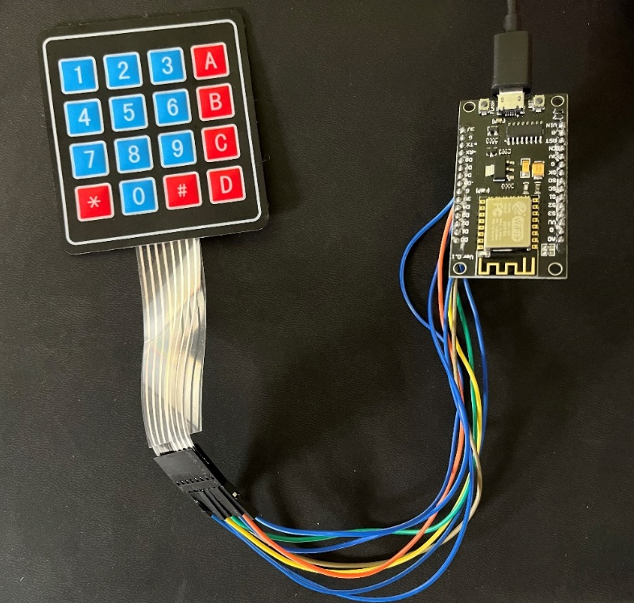
Figure 56: Hardware Development of Membrane Keypad

8.2.3.5 HiLetgo NFC Module
The HiLetgo PN532 module comes unsoldered, so header pins need to be soldered on to connect it to the final PCB design. For development, jumper cables were inserted into the header holes.
There were initially issues testing the PN532 module with the ESP8266, due to lack of digital pins, and errors with communication protocols. This led us to use the Arduino ATMega328pu microprocessor for NFC capabilities on the live bolt system. The chosen protocol was SPI due to only requiring 4 pins to be connected to the chip, rather than 6 that are required with I2C. With I2C, the IRQ and RSTQ pins are also required.

Testing the NFC reader with the ATMega chip was relatively simple once the correct pins were connected. There are libraries for the PN532 module that include test examples. The example ran was able to output the code of whatever NFC tag that was held to the module into the Arduino IDE serial monitor. Three tags were tested, being an NFC keychain, a keycard, and the Apple iPhone Apple Pay feature. All worked as expected, and this code can be modified to be used with the Live Bolt system. Figure 55 shows the development of the NFC module, along with the previously mentioned infrared sensor.

After further testing, it was decided to not use the NFC module or Arduino processor in order to simplify the design and ensure the other access control methods were adequately designed.

8.2.3.6 High Torque Servo Motor
The Servo chosen for this project is called the Tower Pro MG995. The servo motor functionality was tested through simply connecting the servo motor to a pin of the ESP8266 along with ground and 5V to supply its mobility. In a sense of programming and testing the servo moving. That is through the pin and having a servo library enabled. From then it was programmed to sweep positions through the desired position. Since this servo is designed to provide 120 degrees of rotation, we created a loop to go 60 in each direction to perform the testing of the servo.

8.2.3.7 Raspberry Pi Dependencies and Packages
Raspberry Pi (rpi) as described previously is a 1.4 GHz 64-bit quad-core processor. In essence, it’s a small computer that can run through dependencies and packages depending on what desired from the output of the rpi. Before even beginning to power the rpi, some initialization testing that would add value would be from downloading the operating system image onto one’s desktop to initialize a microSD card and boot the rpi capabilities. The next course of action is to insert the microSD card onto the rpi and plug in the micro-USB in the power supply to have it just power on. Two small LEDs on the side of the board will begin to turn on once there is a reading from the power supply and connection of the microSD. Additional requirements to run/ interact with the rpi would be to connect a keyboard and mouse on the USB ports located on the side.

If a user is doing the bare minimum in just turning on and loading up the operating system there should be no form of complication in proceeding with this step.

8.2.3.8 Arducam
Navigating Arducam, there’s a couple of functionalities that should be mentioned when implementing its full uses. A great example that is worth mentioning is libcamera. Libcamera is an open-source camera stack that is used by raspberry pi in developing the camera software library. Testing the camera operation requires the following steps:

- Opening raspi-config tool in terminal
- Run sudo raspi-config
- Select Enable camera and hit enter
- Hit Finish and the program will reboot

When testing the camera, there was a possibility of the camera module not working. A way that the manufacture recommends to do is run apt-get update and sudo apt-get upgrade before starting the trouble shoot. Another way we want to ensure proper function is by making sure there’ll be enough power supply to the camera module to the raspberry pi. Running vcgencmd get_camera would provide an ouput of supported=1 and detected=1. In the situation that support =0, it indicates that that the camera is not enabled. When detected=0 the camera is not correctly connected which can come from the ribbons not attached properly [30]. A better configuration of the Arducam camera module can be seen interfaced with the Raspberry Pi in Figure 57.

8.2.3.9 Phrase Recognition
The Respeaker is an array of four microphones that work with the Raspberry Pi. To begin testing, the array needs to be mounted to the Raspberry Pi in the proper orientation, so every pin corresponds to the correct header. The microphone array can be seen mounted in Figure 57. Then the Respeaker Seed voice card must be installed to the OS on the Raspberry PI. In Audacity or another audio editing application, the input channels need to be configured to the AC108 4 channel, corresponding to the 4 AC108 microphones. Now the array should be configured to act as a microphone. There are also LEDs on the board, but since they will be placed inside the housing of the Live Bolt system, we do not need to program them.
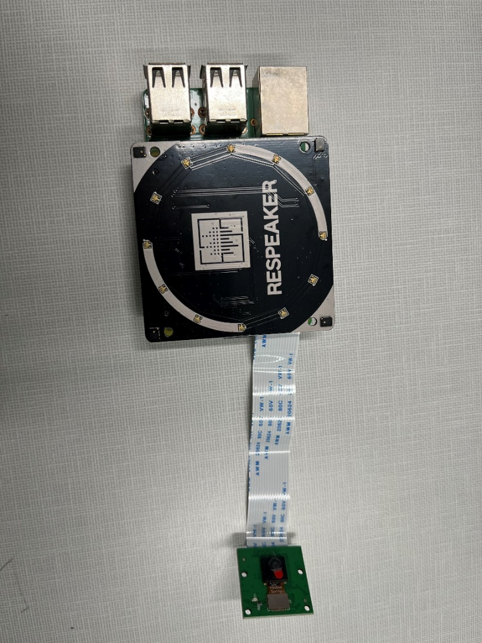
Figure 57: Microphone array and Arducam camera interfaced with Raspberry Pi

Now that the microphone is set up, software needs to be created to enable phrase detection. The programming language of choice for this is Python due to its ease of use and plethora of online materials to work with. There are a variety of packages for speech recognition in Python, such as:
- apiai
- assemblyai
- google-cloud-speech
- pocketsphinx
- SpeechRecognition
- watson-developer-cloud
- wit

Apiai and wit even offer natural language processing capabilities. Natural language processing allows for not only capture of words, but also emotion. Since we only need to recognize a spoken word to act as a passcode for the lock, recognizing emotion is irrelevant and we will not be considering natural language processing in the design. SpeechRecognition actually makes use of many of the APIs listed and allows for each one to be called and compared against each other. This makes SpeechRecognition the most versatile option and the best choice for the phrase detection software. The code works by using th Recognizer class for each specific API. The class won’t work without an audio data type to pass through it, which is the voice captured by the microphone or from an audio file.

To capture voices in real-time, another library is required, PyAudio. PyAudio allows for the .Microphone() class to be used with SpeechRecognition. Now the .listen() method can be called to listen to voices live. From here, the system can detect what the voice said, and simple if logic statements can be called to do different things based on the phrase detected. One final thing to note is that sometimes there will be ambient noise, due to the lock being outside. To circumvent this, the adjust_for_ambient_noise() method of the Recognizer class can be called to equalize the audio. It does this by listening to the first bit of the recording and calibrates to that noise level to try to compensate for it. While not perfect, it can help for minor ambient noise like birds chirping or leaves blowing.

Along with the NFC and Arduino, the Phrase recognition system was abandoned to focus on the other systems previously mentioned.

8.2.4 Battery Testing
Testing Live Bolt’s batteries was split into checking the locking and security system. We talked in the power distribution section about the require power for each device. Testing the battery pack in the lock box was as simple as inserting the AA batteries into a 12V battery case and measuring the outcome with a digital multimeter. As for the security box batteries, it was a similar process. Making sure that the desired output of approximately 5V and 3.3V were both checked using a multimeter. We wanted to ensure this step is complete and there is no error is the pack that is purchased before plugging this onto the PCB for the lock and security box. We wereable to connect these ends from just soldering the open circuit ends to the PCB.

8.2.5 Final Hardware Product
Below in Figure 57 is the final hardware design. Inside the Security module on the left is the Raspberry Pi 4B, Keypad, ESP, PCB, and 12V battery pack. Inside the Lock module on the right is the other ESP, PCB, 12V battery pack, and servo motor. The servo horn is covered by the orange door thumb turn cover, which turns the door lock into the locked or unlocked position.

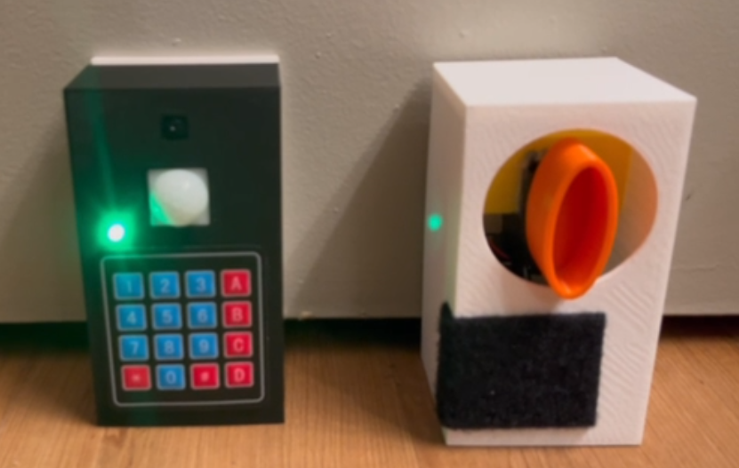
Figure 58: Final Hardware Design of Security Module (Left) and Lock Module (Right)

8.3 Software Test Environment
Just as important it is to write clean code is to test that written code. This is more easily accomplished by a software testing environment. The key areas in a Software testing environment include:

- System and applications
- Test data
- Database server
- Front-end running environment
- Client operating system
- Browser
- Hardware includes Server Operating system
- Network
- Documentation

When first setting up the Test environment several factors should be taken into consideration. Some tests may not run locally on a computer so a server test environment may need to be created. Some tests may require a network connection to be established before tests can be run. Some testing frameworks can be run on different browsers or software’s to be used in conjunction when testing. Additionally test data may need to be provided to ensure the functionality of the program. Many companies use a portion of their production data as test data which is something we will consider when we begin testing.

Some of the common challenges to a Test Environment include:

- Planning how resources will be used.
- Shared usage of the testing Environment by the team.
- The time required to set up the test environment.
- Variations in the way the test environment must be configured when dealing with different types of tests.

Some of the best practices to a Test Environment include:

- Clarifying the Testing Requirements.
- Checking connectivity of hardware and software components before testing.
- Making sure that all the required hardware and software had been correctly installed.
- Planning a routine usage of the testing environment.
- Automating any tools and their dependencies. [31]

8.4 Software Specific Testing

8.4.1 Types of Testing
Within Software Testing there are different types of testing. Each one has a specific focus in mind as the reason for its use. Choosing the right testing type will also determines the type of testing frameworks we will use during our design. All have importance however for our project we will discuss the most common below.

Before we can discuss specific tests, we first must look at Automatic versus Manual testing. As both names suggest manual testing is done by a person running each test themselves using various tools. This can be quite expensive in both time and money. Additionally, humans are subject to error resulting in inaccurate results. Automatic testing on the other hand involves a machine running tests independently of a person. These scripts can be run by the computer a set interval of time and is typically much faster than manual testing.

- Unit Tests involve testing individual methods and functions used by components of software. These test typically are cost effective and can be run quickly.
- Integration Tests test how well different parts of an application work together. These are useful for testing two parts of an application that rely on each other such as the database and frontend.
- Functional Tests focus on the business requirements of a piece of software. This deals primarily with the outputs of different functions without focusing on what preforms the action. These tests only verify what is produced by whatever is being tested.
- End-to-end Tests verify a user’s behavior through software within an application environment. By using End-to-end tests human behavior can be tested more rapidly and the application flow can be tested for accuracy.
- Acceptance Tests, like functional tests, are tests that check business requirements. These tests require the entire application to be functioning before and test for user actions within the application.
- Performance Tests put the system under stress to test the software when it is under a substantial load.
- Smoke Tests are quick test designed to check basic functionality of a program. They are useful primarily after a new build has been released and is being tested to see if it requires further, more expensive testing. [32]

8.4.2 Testing Frameworks
The 5 different testing frameworks we considered for our project include Jest, Mocha, Cypress, Jasmine, and Selenium. Ultimately, we ended up using Jest conduct our software testing. We will be discussing more about each one in each of the following sections. Each one has its own uses and implements at least 1 of the major models in automated testing.

- The Linear Scripting Framework involves the creation and execution of tests in an incremental order. The tests are produced and run individually under this model. This model is based on the concept of record and playback.
- The Modular Testing Framework is based on the concept of abstraction. Independent tests are developed, and an abstraction layer is used to hide the tests from the application.
- The Data Driven Testing Framework uses tabular storage of the input and expected output results when testing.
- The Keyword Driven Testing Framework involves using data tables and keywords to analyze actions that occur during tests. It is an extension of Data Driven Testing.
- The Hybrid Testing Framework is a combination of a couple other frameworks including modular, data-driven and keyword testing. This framework is used frequently in end-to-end testing.
- The Test-Driven Development Framework (TDD) includes automated unit testing that pushes forward software development. This framework type allows for rapid development of ode as well as confidence in the systems reliability.
- Behavior Driven Development Framework (BDD) stems from Test-Driven development but differs in how tests focus more on system behavior. [33]

8.4.3 Jest
Jest is a popular JavaScript testing framework created by Meta. It is known most distinctly for its simplicity. Some of the key features it provides includes requiring limited configuration, snapshots, isolated tests, and well documented API. Just after installation is set to run without requiring much groundwork out of the box. Snapshots allow for easer tracking of object in real time as testing is being done. Tests are also isolated by separating the processes that run them. Additionally, Jest is well documented both by the creators as well as the large community that uses the Framework. Jest works with a variety of languages and tools including those being used in our MERN stack. Jest is simple to install and can be easily through entering one of the two following commands into the command line: “npm install --save-dev jest” or “yarn add --dev jest”. [34] Ultimately all of these benefits let to us using Jest for our software testing.

8.4.4 Mocha
Mocha is a JavaScript testing framework that runs on Node.js through the browser. Mocha can be used for both synchronous and asynchronous testing. Mocha also used frequently with Chai, a well know assertion library for Node.js. Mocha’s default interface is Behavior-driven development (BDD) which helps developers create more predicable behavior within developed code. Behavior-driven development rose out of an offshoot from Test-Driven development (TDD). Mocha can be installed easily by using the command “npm install mocha” in the command line. [35] [36]

8.4.5 Cypress
Cypress is a frontend testing framework that allows for developers to create faster and more reliable tests. Cypress addresses the major areas of software testing including:

- Setting Up Tests
- Writing Tests
- Running Tests
- Debugging Tests

Cypress is similar to Selenium, discussed in section 9.4.7, however differs in its architecture and lacks some of the same restrictions that hold Selenium back from further use. With Cypress’s end-to-end, integration, and unit tests can all be implemented. Cypress also includes the freely available cypress ecosystem which includes Test Runner for running test and a dashboard interface for keeping track of recorded tests. Cypress also includes the following features:

- Time Travel which includes screenshots capture as tests run. These screenshots can be viewed to see further information regarding any issues that happen.
- Debuggability is present in how errors are easy to read, availability of debug tools, and stack traces.
- Automatic Waiting allows for automatic waiting for commands before the rest of your code runs. As such commands to manually make a program wait are not needed when testing.
- Spies, Stubs, and Clocks involves managing how timers, server responses, and functions run.
- Network Traffic Control as it sounds allows for management of network traffic.
- Consistent Results are made possible by not relying on or integrating existing programs.
- Screenshots and Videos are made available as the test runs. They can be viewed through the Command Line Interface as the program runs.
- Cross Browser Testing allows for Cypress to run on multiple different browsers to ensure functionality.

All of this made Cypress a compelling alternative option for testing our development. [37]

8.4.6 Jasmine
Jasmine is a testing framework for JavaScript. Because it was developed for JavaScript it runs on any languages or tools that implement JavaScript, like React. Jasmine has easy to understand syntax and supports asynchronous testing. It also allows for using test doubles through the use of spies. Additionally, it can facilitate Frontend testing through the Jasmine-jQuery extension. Jasmine can either be added to Node.js or to a browser itself. Only 3 simple commands need to be run before Jasmine can be used for testing. As a result of this the set-up process for Jasmine is relatively easy. Additionally, Jasmine has a significant documentation base making it quick to find references for any issues are run into. There is also an active community for the framework which was definitely a solid alternative choice for testing our application. [38]

8.4.7 Selenium
Selenium is at its core a few tools for automating web browser testing. Selenium has an IDE can easily be downloaded as an extension for Google Chrome and Firefox. The extension is easy to use and has good documentation on their website. It also has a domain-specific language, Selenese, that allows for tests to be written and translated into many popular languages. Selenium has a couple tools available as part of its suite. These tools include the Selenium IDE, client API, Remote Control, WebDriver, and Grid. The IDE as discussed before manages test scripts, automated testing, and code completion. The client API allows for tests to be written in different programming languages which are translated to Selenese through calls to the Selenium API. Selenium Remote Control is a server that allows for automated tests to be run in a browser. The Selenium WebDriver includes an interface that communicates instructions to make content work the same across browsers. The Grid allows for tests that would typically run-in browsers to run on remote machines. Selenium’s wide array of tools make it a compelling option for us as a Testing Framework. [39]

9. Administrative Content
Designing a smart door lock and security system has been a challenging yet fun and rewarding experience for the Live Bolt team. All the administrative tasks like sharing documents and creating meetings were done through a group chat platform known as Discord. Discord played a large role in allowing the group to always keep an open line of communication during the design process. It has the capability for text communication as well as voice calling and screen sharing features.

In addition to constantly communicating online, the team also met up in person once a week. Since the members all had lots of outside obligations, such as work and class, Friday mornings at 9:30 am were decided to be the recurring meeting time. The team usually opted to meet in the engineering atrium or library study rooms. The purpose of these weekly meetings was to provide updates on each member’s specified area. We broke down the project into two main areas: hardware design and software design. Software design mainly includes the phone application and the User Experience design. Hardware design includes the prototyping of the circuit and PCB design, and the design of the housing that will hold the components.

Our team was made up of two computer engineering students who focused on the app and database, and two electrical engineering students who focused on the circuit, PCB, and 3D design of the housing. Separate meetings were held on occasion for each sub team to get more work done. By splitting the team this way, we were able to divide the work up and complete the design process much quicker. The division of labor can be seen in Figure 58.

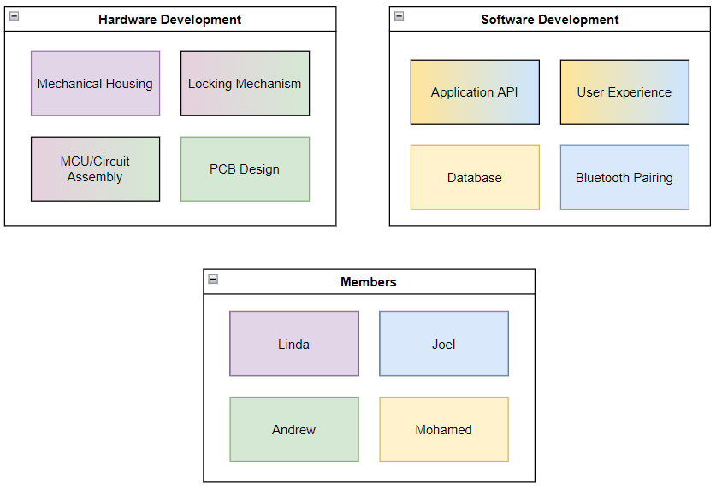
Figure 59: Division of Labor for Live Bolt

Going into Senior Design 2, the team continued to carry out this division of duties when creating the application and physical product. Physical testing had already begun for most of the hardware of the project in Senior Design 1 and was continued into Senior Design 2.

9.1 Milestone Discussion
In Table 18 and Table 19, shown below detail our plans of researching and completing our senior design project. Table 18 focuses on our milestones worked on in Senior Design I while Table 19 lists our milestones for Senior Design 2.

The milestones column lists the tasks we accomplished during each semester. The duration column lists the number of weeks we devoted to each milestone. The dates column lists the deadlines we completed the milestone by to keep on track. As we continued working on and researching our project, we revisited these milestones frequently.

Table 18: Senior Design 1 Milestones
Milestone | Duration | Dates
Brainstorm | 1 Week | January 14
Select Project | 1 Week | January 21
Divide and Conquer | 2 Weeks | February 4
Research | 4 Weeks | March 4
Table of Contents | 1 Week | March 11
60 Pages Due | 2 Weeks | March 25
Edit Draft | 3 Weeks | April 15
Finalize Report | 1 Week | April 22
Submit Final Report | 1 Week | April 29

Table 19: Senior Design 2 Milestones
Milestone | Duration | Dates
Source Remaining Parts | 2 Weeks | September 2
Build Prototype | 4 Weeks | September 30
Test and troubleshoot | 3 Weeks | October 21
Finalize Prototype | 3 Weeks | November 28
Final Presentation | 2 Weeks | November 29
Final Report | 1 Weeks | December 2

9.2 Software Development Gantt Chart
The Gantt chart shown in Figure 59 was created using the TeamGantt website and covers all the major software planning and development tasks for the Spring 2022 semester. The timeline of this chart is from January 9th to April 29th, four months into the semester. The two categories, Research and Design, contain several smaller tasks with their completion percentages displayed as well. At the time of writing this section, all research tasks have been completed and almost half of the application’s design has been done. The main tasks being worked on now are the design of the application’s UI and population of test data to the application database. Most of the software planning and design were done by two members of the team, with much of the work divided evenly between them.
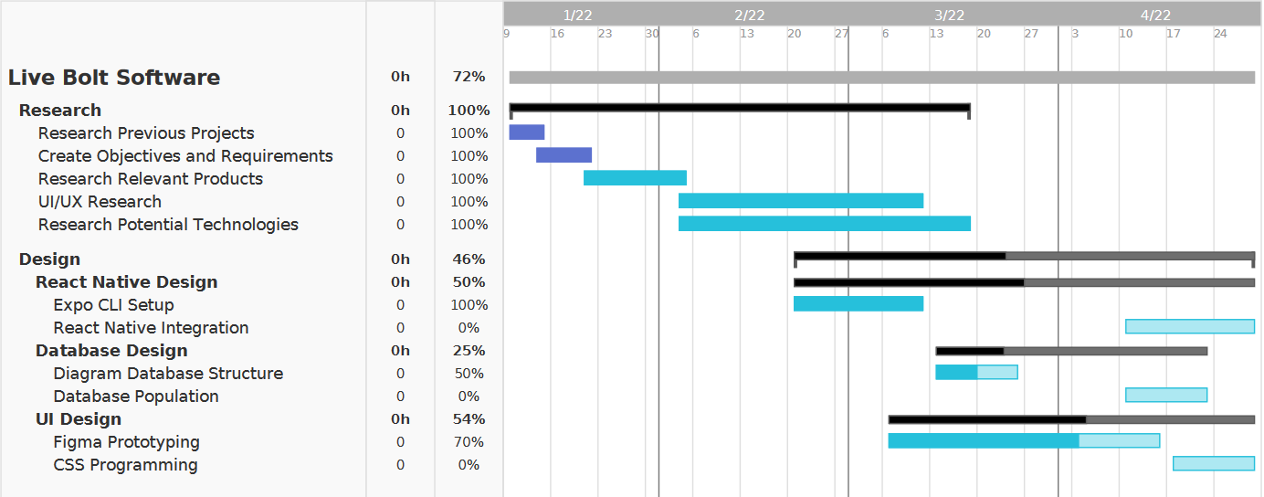
Figure 60: Software Development Gantt Chart

9.3 Hardware Development Gantt Chart
In Figure 60, the senior design 1 hardware development process is highlighted. The outline consists of a crossing from February to May showing our preliminary research to finalizing the design for our senior design report. A couple of important mentions to the gantt chart is that the dark blue represents finished, purple means in progress but behind, pink is present actions and light blue it future actions.

This Gantt chart extends to senior design 2 to outline our goals and keep track of future progress.
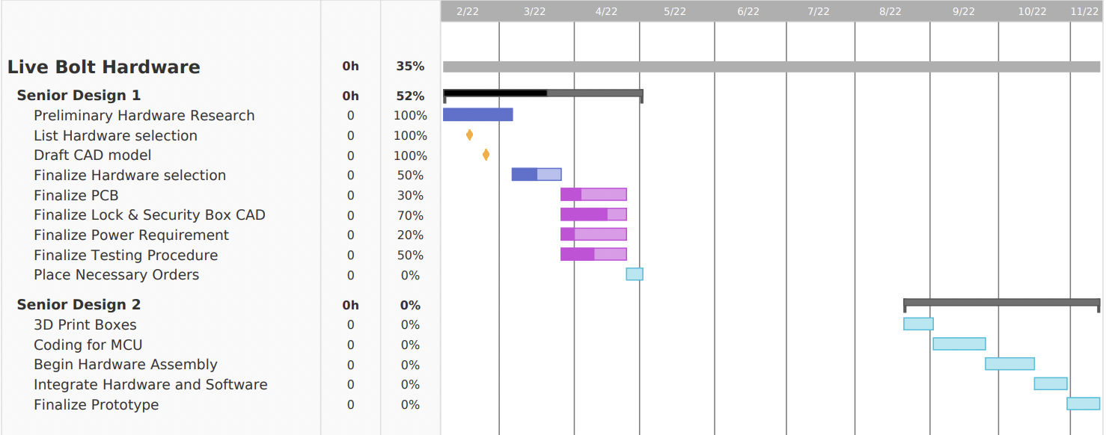
Figure 61: Hardware Development Gantt Chart

9.4 Budget and Finance Discussion
A goal was to make Live Bolt as cost-effective as possible while maintaining quality in the build and design. This was due to two main reasons: wanting to keep costs down for any hypothetical consumer who purchases the system, and lack of outside sponsorship for this project. All costs associated with Live Bolt’s development are being directly funded by the four team members. Development for the Live Bolt system cost approximately $136 for a fully working product. This is within the team’s original budget and is relatively cheap and cost effective. The cost would be higher to produce more however, since the team would need to purchase more components that they already had before. We would have to purchase more ESP8266s, keypads, LEDs, and Raspberry Pis, which would drive up the production cost.
Table 20 outlines the parts we have identified for the product and their costs. Most items are marked as 2 needed, so there will be backup components in case any malfunction. The price per single unit and total price are both listed. Items marked as $0 indicate that the team already has them, so there is no need to include those costs in the final price. The final row also provides the total cost of all components and the amount of money each member of the group will contribute.

Table 20: Bill of Materials
Part Description | Qty Needed | Price/Unit | Estimated Total Price
Raspberry Pi 3 | 1 | $0 | $0
LED’s | 1 | $0 | $0
Assorted Wires, LEDs, Buzzer, and other electrical components | - | $0 | $0
Camera | 2 | $15 | $30
Keypad | 2 | $0 | $0
NFC Reader | 2 | $9 | $18
IR Motion Sensor | 2 | $8 | $16
Raspberry Pi Microphone Array | 2 | $29 | $58
High Torque Servo | 2 | $20 | $40
Lock Battery Holder | 1 | $2 | $2
Security Battery holder | 1 | $7 | $7
PLA 3D Printing Filament | 1 | $22 | $22
ESP8266 | 2 | $0 | $0
PCB Printing | 2 | $24.86 | $49.72
Doorknob and lock for Testing | 1 | $0 | $0
3D Printing Security Box | 1 | $6 | $6
3.3V Voltage Regulator | 1 | $9.40 | $9.40
Total Members | 4 | $60.68 | $242.72

Appendices

Appendix A: References

References

[1] | [Online]. Available: https://magpi.raspberrypi.com/articles/raspberry-pi-4-vs-raspberry-pi-3b-plus.
[2] | [Online]. Available: https://www.biometricupdate.com/202001/biometric-facial-recognition-hardware-present-in-90-of-smartphones-by-2024.
[3] | "Fingerprint Scanners: What are the Different Types?," Almas Industries, [Online]. Available: https://almas-industries.com/blog/fingerprint-scanners-types/.
[4] | "Controlling AC Devices with Arduino," DroneBot Workshop, [Online]. Available: https://dronebotworkshop.com/ac-arduino/.
[5] | [Online]. Available: https://www.wynnslocksmiths.com.au/electric-strike-magnetic-lock-difference/.
[6] | [Online]. Available: https://www.hvrmagnet.com/blog/what-is-electromagnetic-lock-and-how-it-works/.
[7] | [Online]. Available: https://www.frontrangelocksmith.com/blog/the-best-lock-for-your-home-is-your-lock-really-safe/.
[8] | "Liquid Crystal Displays (LCD) with Arduino," Arduino, [Online]. Available: https://docs.arduino.cc/learn/electronics/lcd-displays.
[9] | "AA battery," [Online]. Available: https://en.wikipedia.org/wiki/AA_battery.
[10] | "Coding Standards and Guidelines," [Online]. Available: https://www.geeksforgeeks.org/coding-standards-and-guidelines/ .
[11] | "Developer Content Policy," [Online]. Available: https://play.google.com/about/developer-content-policy/.
[12] | "App Store Review Guidelines," [Online]. Available: https://developer.apple.com/app-store/review/guidelines/#performance.
[13] | [Online]. Available: https://www.ieee.org/about/corporate/governance/p7-8.html.
[14] | [Online]. Available: https://developer.android.com/guide/topics/connectivity/bluetooth.
[15] | [Online]. Available: https://github.com/rusel1989/react-native-bluetooth-serial#events.
[16] | [Online]. Available: https://code.visualstudio.com/docs.
[17] | [Online]. Available: https://reactnative.dev/docs/components-and-apis#basic-components.
[18] | [Online]. Available: https://reactnative.dev/docs/virtualizedlist.
[19] | [Online]. Available: https://reactnative.dev/docs/pressable.
[20] | [Online]. Available: https://reactnative.dev/docs/keyboardavoidingview.
[21] | "Near field communication overview," [Online]. Available: https://developer.android.com/guide/topics/connectivity/nfc.
[22] | "Core NFC," [Online]. Available: https://developer.apple.com/documentation/CoreNFC.
[23] | [Online]. Available: https://support.apple.com/en-us/HT208108.
[24] | "TCP," [Online]. Available: https://developer.mozilla.org/en-US/docs/Glossary/TCP.
[25] | K. Pattabiraman, "Circuit Basics," [Online]. Available: https://www.circuitbasics.com/how-to-set-up-a-keypad-on-an-arduino/. [Accessed 2022].
[26] | "Blue Dot," [Online]. Available: https://bluedot.readthedocs.io/en/latest/index.html.
[27] | "Pair a Raspberry Pi and Android phone," [Online]. Available: https://bluedot.readthedocs.io/en/latest/pairpiandroid.html.
[28] | "TCP Communication with Android via wifi," [Online]. Available: https://raspberrypi.stackexchange.com/questions/66700/tcp-communication-with-android-via-wifi.
[29] | "How To Setup Communication Between Two ESP8266 Using Arduino," siytek, 30 March 2020. [Online]. Available: https://siytek.com/communication-between-two-esp8266/. [Accessed 20 April 2022].
[30] | "Cameras for Raspberry Pi," December 2021. [Online]. Available: https://www.arducam.com/docs/cameras-for-raspberry-pi/introduction/.
[31] | "Test Environment for Software Testing," [Online]. Available: https://www.guru99.com/test-environment-software-testing.html#3.
[32] | "The different types of software testing," [Online]. Available: https://www.atlassian.com/continuous-delivery/software-testing/types-of-software-testing.
[33] | T. B. A. Test Automation Frameworks – Why. [Online]. Available: https://www.testingxperts.com/blog/test-automation-frameworks.
[34] | "Jest," [Online]. Available: https://jestjs.io/.
[35] | "Mocha," [Online]. Available: https://mochajs.org/.
[36] | "Mocha.js, the JavaScript test framework: A tutorial," [Online]. Available: https://blog.logrocket.com/a-quick-and-complete-guide-to-mocha-testing-d0e0ea09f09d/#whatismochajs.
[37] | "Cypress," [Online]. Available: https://www.cypress.io/.
[38] | "Jasmine," [Online]. Available: https://jasmine.github.io/.
[39] | "Selenium," [Online]. Available: https://www.selenium.dev/.
[40] | "Introduction to Expo," [Online]. Available: https://docs.expo.dev/.
[41] | "Publish your app," [Online]. Available: https://support.google.com/googleplay/android-developer/answer/9859751?hl=en#zippy=%2Capp-status.
[42] | "Usage statistics of JavaScript as client-side programming language on websites," [Online]. Available: https://w3techs.com/technologies/details/cp-javascript/.
[43] | "Getting Started," [Online]. Available: https://developer.mozilla.org/en-US/docs/Web/Guide/AJAX/Getting_Started.
[44] | "Guidelines," [Online]. Available: https://developer.apple.com/app-store/guidelines/.
[45] | "802.11 Standards Explained: 802.11ax, 802.11ac, 802.11b/g/n, 802.11a," [Online]. Available: https://www.lifewire.com/wireless-standards-802-11a-802-11b-g-n-and-802-11ac-816553.
[46] | "How to Choose a Deadbolt - The Deadbolt Guide," [Online]. Available: https://www.doorware.com/specials/help-center/deadbolt-guide.cfm.
[47] | "Near Field Communication Technology Standards," [Online]. Available: http://nearfieldcommunication.org/technology.html.
[48] | "Bluetooth Standards and Technology," [Online]. Available: https://www.digi.com/solutions/by-technology/bluetooth-standards.
[49] | "Referential Integrity and Relational Database Design," [Online]. Available: http://web.mit.edu/11.521/www/lectures/lecture10/lec_data_design.html.
[50] | "Test Environment for Software Testing – A Detailed Guide," [Online]. Available: https://www.softwaretestingmaterial.com/test-environment/?utm_source=rss&utm_medium=rss&utm_campaign=test-environment.
[51] | "Top 3 JavaScript Testing Frameworks with their Pros and Cons," [Online]. Available: https://www.rlogical.com/blog/top-3-javascript-testing-frameworks-with-their-pros-and-cons/.
[52] | [Online]. Available: https://www.hackster.io/petewarden/recognizing-speech-with-a-raspberry-pi-50b0e6.
[53] | [Online]. Available: https://stt.readthedocs.io/en/latest/index.html.
[54] | [Online]. Available: reactnative.dev/docs/components-and-apis.
[55] | "Setting up a Routed Wireless Access Point," [Online]. Available: https://www.raspberrypi.com/documentation/computers/configuration.html#setting-up-a-routed-wireless-access-point.
[56] | [Online]. Available: https://support.apple.com/en-us/HT208108.

Appendix B: Figures
Figure 1: Reproduction Arduino Uno (Top) and Arduino Mega (Bottom) running ATmega architecture 11
Figure 2: Raspberry Pi 4 (Left) and Raspberry Pi 3B+ (Right) [1] 13
Figure 3: MSP430FR6989 Launchpad (Left) vs MSP430G2553 Launchpad (Right) 14
Figure 4: ESP32 (Left) vs ESP8266 NodeMCU (Right) 15
Figure 5: Example of an Electric Strike Lock on a Door [5] 24
Figure 6: Magnetic Lock on Door [6] 25
Figure 7: Traditional Dead Bolt Lock on Door [7] 25
Figure 8. Deadbolt lock size standards 35
Figure 9: Lock/Unlock Flowchart 47
Figure 10. Initial Sketch of Application Main Interface 50
Figure 11: Color Palette 1 51
Figure 12: Sample Login/Register Page 1 51
Figure 13: Sample Home/Profile Page 1 52
Figure 14: Setting/GPS Proximity Pages 1 53
Figure 15: Color Palette 2 54
Figure 16: Sample Login/Register Page 2 54
Figure 17: Sample Home/Profile Page 2 55
Figure 18: Settings Page 2 56
Figure 19: Login and Signup Navigation Flowchart 57
Figure 20: Use Case Diagram of Application including both Hardware/Software Unlocking Mechanisms 58
Figure 21: Sample Application Initial Logo Sketch 59
Figure 22: Sample Application Logo Mockup in Inkscape 59
Figure 23: API for react-native-ble-plx 61
Figure 24: Virtualized List on iPhone Example 67
Figure 25: Pressable State Diagram, courtesy of React Native 68
Figure 26: Entity Relationship Diagram 69
Figure 27: User and ActivityLog Objects 70
Figure 28: React Native Biometrics Diagram 72
Figure 29: Local Authentication Diagram 73
Figure 30: Deadbolt doorknob cover, fitted onto a door lock 75
Figure 31. Frontal view of the Doorknob Cover 76
Figure 32. Arduino Keypad Configuration 77
Figure 33. Arducam 78
Figure 34. PIR Motion Sensor Layout 79
Figure 35. Servo Motor and Plastic Horns 80
Figure 36. Lock Box with components 83
Figure 37. Lock Box CAD dimension model 84
Figure 38. Lock Box assembled with removeable back 84
Figure 39. Security Box with components 86
Figure 40. Security Box CAD dimension model 87
Figure 41. Security Box assembled with removable back 88
Figure 42. Hardware Design Block Diagram 89
Figure 43: A screenshot of the PCB design window from KiCad 91
Figure 44: A screenshot of the PCB design window from Eagle 92
Figure 45: Security Module Circuit Schematic 93
Figure 46: Prototype Security PCB Design 94
Figure 47: 3D Prototype PCB Model 95
Figure 48: Lock Circuit Schematic 95
Figure 49: Prototype Lock PCB Design 96
Figure 50: Front Lock PCB 3D Model 96
Figure 51: Back Lock PCB 3D Model 97
Figure 52: JLCPCB PCB Order Options 98
Figure 53. Solidworks Straight horn Design 2 102
Figure 54. Solidworks X-horn Design 1 103
Figure 55: Hardware Development of NFC (Left) and PIR Sensor (Right) 107
Figure 56: Hardware Development of Membrane Keypad 107
Figure 57: Microphone array and Arducam camera interfaced with Raspberry Pi 110
Figure 58: Division of Labor for Live Bolt 117
Figure 59: Software Development Gantt Chart 119
Figure 60: Hardware Development Gantt Chart 120

Appendix C: Tables
Table 1: Requirement specifications for Security System Features 3
Table 2: Requirement specifications for Access Control Features 4
Table 3: Requirement specifications for Application Features 4
Table 4: Requirement specifications for Design Features 5
Table 5: House of Quality for Live Bolt 6
Table 6: Arduino Uno vs Arduino Mega Comparisons 10
Table 7: Raspberry Pi 3B+ vs Raspberry Pi 4 comparisons 12
Table 8: MSP430FR6989 Launchpad vs MSP430G2553 Launchpad comparisons 13
Table 9: ESP32 vs ESP8266 comparisons 16
Table 10: Comparisons Between Facial Recognition Methods 19
Table 11: Pin functions on LCD Display 27
Table 12: Communication protocols for NFC Reader 29
Table 13: Summary of Live Bolt Hardware 31
Table 14: Component Power Requirements 81
Table 15: Common PCB Terms 90
Table 16: JLCPCB Shipping Costs and Delivery Times 98
Table 17: Pros and Cons for knob design 104
Table 18: Senior Design 1 Milestones 118
Table 19: Senior Design 2 Milestones 118
Table 20: Bill of Materials 121

